Operating Manual
NOAA/CMDL THD Aerosol Sampling System
Last Updated – APRIL 3, 2002

Table of Contents
1. General description 2
1.1. Maintenance Checklist 4
1.1.1. Daily Tasks 4
1.1.2. Weekly Tasks 4
1.1.3. Monthly Tasks 4
1.2. Contact information 4
2. Maintenance 5
2.1. Check System Parameters and Logging Status - (Daily Task) 5
2.2. Check water level in reservoir (Daily Task) 5
2.3. CN counter butanol level (Daily Task) 5
2.4. Changing the PSAP Filter (Daily Task) 6
2.5. Changing Impactor Films in Humidifier Rack - (Weekly Task) 7
2.5.1. Removal of Impactors 7
2.5.2. Cleaning of Impactors 8
2.5.3. Re-assembly 9
2.6. Change Carousel Filters (Weekly Task) 9
2.6.1. Preparation 10
2.6.2. Change the impactor films 10
2.6.3. Changing the filters 10
2.7. System Leak Test - (Weekly Task) 11
2.8. Nephelometer Span Check - (Weekly Task) 12
2.8.1. Plumbing 12
2.8.2. Operation 13
2.9. Changing Nephelometer Lamp 13
2.10. Nephelometer Calibration 13
2.11. System Clock 14
3. Computer Operation 15
3.1. Startup 15
3.2. Shutdown 15
3.3. Archiving and Backing-up Data 15
3.4. Aerosol Data Logger Program 15
3.4.1. General Operation 15
3.4.2. Display 16
3.4.3. Main Menu <esc> 17
3.4.4. Instruments Menu <esc><I> 17
3.5. System Configuration 19
3.6. Computer display pictures 20
4. Safety 20
4.1. Heater Control 20
4.2. Electrical Safety 21
5. Specifications 21
5.1. Power Draw at 115 V DC 21

General description
The Trinidad Head (THD) Aerosol Sampling System is an automated system for measuring aerosol light scattering as a function of wavelength, aerosol light absorption, and condensation nuclei. The light scattering as a function of relative humidity is also measured. 1 and 10 um impactors are used to measure these properties for aerosol less than 1 and 10 um, respectively. The main components are a three wavelength nephelometer (TSI model 3563), a light absorption photometer (Radiance Research PSAP) and a Condensation Nucleus Counter (TSI mode 3760). Filter measurements are also made in conjunction with PMEL of the ionic composition of the aerosol. sea salt, non-sea salt (nss) sulfate, methanesulfonate, NH₄⁺, nss K⁺, Mg⁺², and Ca⁺ for sub-micron and super-micron size ranges

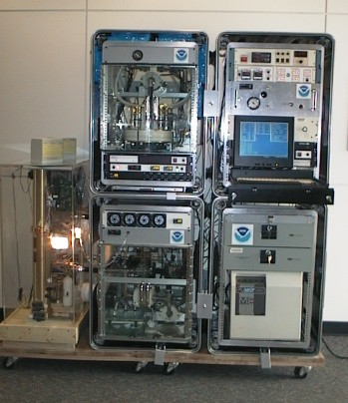

The system generates the following information:
- Total and backwards scattering coefficients time series at 450, 550 and 700 nm wavelengths in two size ranges
- Total and backwards scattering coefficients time series at at 450, 550 and 700 nm wavelengths in two size ranges as a function of relative humidity
- Absorption coefficient time series at 565 nm in two size ranges
- Condensation nuclei concentration time series
- Mass concentration of sea salt, non-sea salt (nss) sulfate, methanesulfonate, NH₄⁺, nss K⁺, Mg⁺², and Ca⁺ for sub-micron and super-micron size ranges

From the measurements the following parameters can be calculated:

- Single scattering albedo at about 550 nm in two size ranges
- Angstrom coefficient
- Hemispheric backwards scattering fraction in two size ranges
- f(rh)

Maintenance Checklist
The system is mostly automated but there are some tasks that need to be performed on a daily, weekly or monthly basis. These are listed below and are described in more detail in Section 2 – Maintenance. There is also a binder of instrument manuals for each of the instruments and other system components.

Daily Tasks
1. Fill out daily checklist
2. Check logging status: letters at bottom of screen should be: *ABcFGHLMNOuv
Upper and lower case DOES matter, and the leading asterisk is required!
3. Check butanol level in CN counter and add butanol if needed
4. Add distilled water to humidifier rack reservoir (if less than half full)
5. Change PSAP filter

Weekly Tasks
1. Change filter carousel and carousel impactor film
2. Nephelometer span checks
3. Change humidifier impactor films
4. Leak test (if weather permits)
5. PSAP reference filter change
6. Mail carousel filter samples to NOAA/PMEL

Monthly Tasks
1. Mail PSAP filters and daily check lists to NOAA/CMDL
2. Check supply levels of PSAP filters, distilled water, impactor films, plastic bags, butanol, ethanol.
3. Check air filter on front of PC, clean if necessary

Contact information
Main Contact: Secondary Contacts:
Pat Sheridan Betsy Andrews
Email: patrick.j.sheridan@noaa.gov Email: betsy.andrews@noaa.gov
Office Phone: 303-497-6672 Office Phone: 303-497-5171
Home Phone: 303-494-1461 Home Phone: 303-442-5142

John Ogren
Email: john.a.ogren@noaa.gov
Office Phone:303-497-6210
Home Phone: 303-499-4079

Anne Jefferson
Email: anne.jefferson@noaa.gov
Office Phone: 303-497-6493
Home Phone: 303-579-9013

Maintenance

Check System Parameters and Logging Status - (Daily Task)
Time required: 5 minutes
Tools/supplies: Daily check list
Overview: There are a few system parameters that are not recorded and hence need to be checked manually. A daily checklist is used to record the values and is mailed back to CMDL at the end of each month with the used PSAP filters.

1. Fill out daily checklist (and weekly/monthly on back of sheet if applicable)
2. Check that letters on bottom of computer screen are exactly: *ABcFGHLMNOuv

Check water level in reservoir (Daily Task)
Time required: 5 minutes
Tools/supplies: distilled water
Overview: The humidifier condenses water vapor onto particles after they exit the reference nephelometer, but before they enter the humidified nephelometer. The condensed water vapor exits the system and must be replenished.

The water reservoir needs to be refilled whenever the level in the reservoir gets below ~1/2.
If reservoir has lost lots of water in a short period of time this may indicate a leak! Inspect for water around the system or for an RH value in the second nephelometer above 90%. If there is a leak a) turn off humidifier heater and preheater b) unplug the water pump c) enter a log message in the computer <esc><M>reservoir leak!!<enter>

Lift the attached fill funnel above the top of the reservoir bottle. Slowly pour distilled water into the funnel. Do not fill reservoir above the bottom of the red tape line.
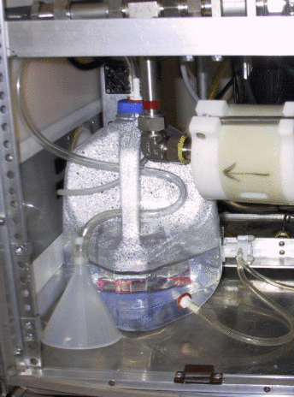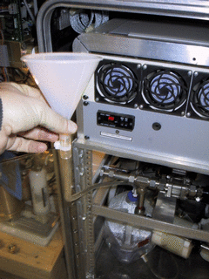

CN counter butanol level (Daily Task)
Time required: 5 minutes
Tools/supplies: butanol fill bottle
Overview: The CN counter condenses butanol vapor onto particles in the sample line to grow them to a size so that they can be seen and counted by the instrument optics. The condensed butanol goes out the exhaust stream to the butanol trap and fresh butanol must be added to the counter to replenish the supply.

Check the butanol level – it should be about ½ way up the view port. Do not overfill.
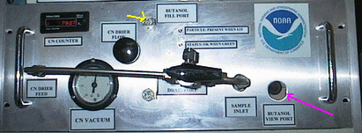

If butanol needs to be added connect the butanol fill bottle to the butanol fill port. Loosen the cap on the butanol bottle and fill the CN counter until the butanol level shown in the view port is acceptable.

Changing the PSAP Filter (Daily Task)
Time required: 5 minutes
Tools/supplies: PSAP Filter Kit
Overview: The PSAP filter transmittance degrades as particles collect on it. To ensure valid measurements the filters need to be changed.

Is the PSAP filter transmittance above 0.9? (Look at Tr value, in picture is 0.799)
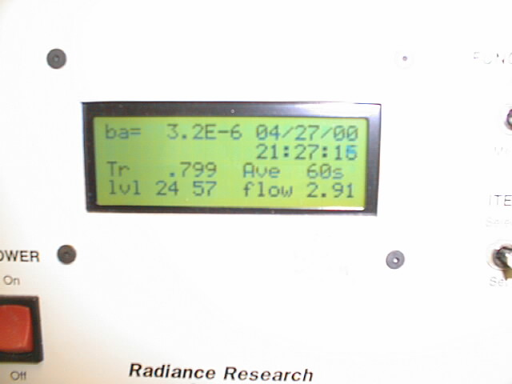
If not, the filter needs to be changed.

1. In the Aerosol Data Logger window, press <Esc><I><L><F> to signal start of a filter change.
2. Turn the flow down to zero using the knob on the right side of the PSAP.
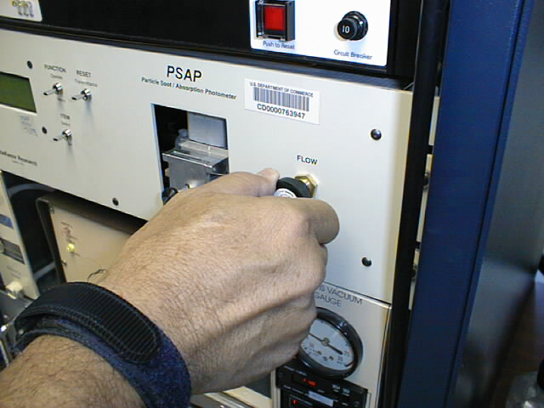
3. Unscrew the black knob on the sampling head, raise the lockdown panel, and remove the filter holder.
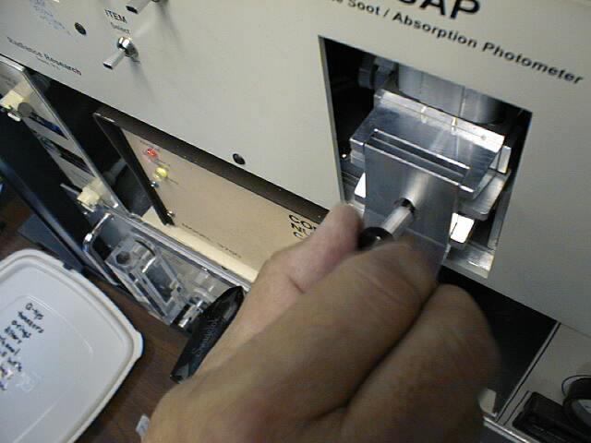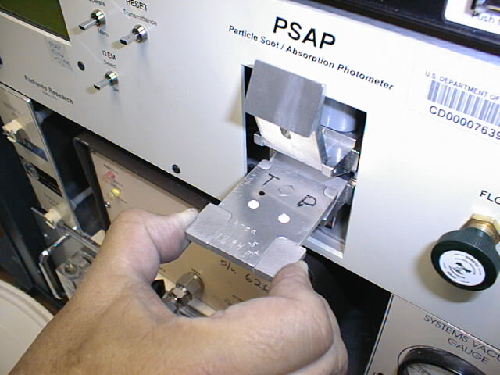
Sample
ref
Samplee
ref
4. Remove the filters. It is only necessary to replace the reference filter once per week. Place the sample filter (the left-hand one) in a small zip bag and label the bag with the station name and the date the filter was pulled out of the PSAP. The label should have the format: YYMMDD-THD (so December 13, 2000 would be labeled: 001213-THD). Write your initials on the bag.

5. Place new filters in the filter holder. The white side of the filter should be facing up.
Re-insert the filter holder into the sampling head; secure the lockdown panel with the black knob. Make sure the lower lip of the lockdown panel goes under the bottom edge of the sampling head.

6. Set PSAP flow to approximately 1.2 liters per minute.
7. On the PSAP, press the “RESET Transmittance” switch up and verify that Tr=1.000 on the display of the PSAP.

8. Press <Esc> <I><L><F> to signal end of the filter change. Verify Transmittance = 1.000 before answering the “Y” when asked, “Have you pressed the RESET Transmittance switch?”
Note: the data acquisition software will do this step automatically, about 2 minutes after the transmittance returns to 1.0, in case you forget this step.

Changing Impactor Films in Humidifier Rack - (Weekly Task)
Time required: 20 minutes
Tools/supplies: a 1 1/8” wrench, and the impactor kit
Overview: It is necessary to change impactor films to ensure the impactor size cut is accurate. Changing impactor films involves disconnecting the impactor units and disassembling them so that the impaction film can be replaced. Change films more frequently than weekly if large particle deposits are observed.

Removal of Impactors
- Turn off humidifier heater and preheater on Watlow control box. (See picture below.)
Pink shows location of humidifier heater and preheater switches on CN/PSAP/Control rack.
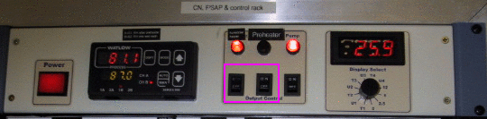

- <Esc><M> Enter message "Heaters off, starting impactor servicing".
- <Esc><I><A><A> to select “bypass analyzers”. This closes a solenoid valve and notifies the computer that impactors are off-line. Close the Whitey ball valve behind the 10 um impactor by rotating 90 degrees to left.
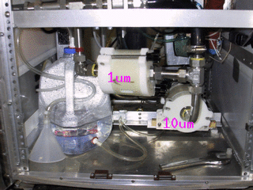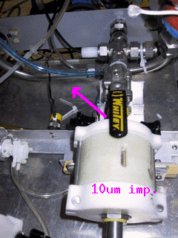
- Using 1 1/8” wrench, loosen the fitting marked with red tape and disconnect the 4 fittings that are marked with yellow nail polish. Carefully remove impactors. Be careful of the water tubing and heater cables so as not to disturb them.
- Place impactors on a flat clean surface. Use a large clean Kimwipe or printer paper.

Cleaning of Impactors
HINT: If you lay aside the cleaned pieces in order of removal, it will be easier to reassemble afterwards.
- Unscrew black knobs on 10-um impactor, and fold down the side arms.
- Remove top piece, clean inside (including inlet) with alcohol, tissue, and cotton swabs.
- Remove impactor jet plate, clean both sides with alcohol, tissue, and cotton swabs.
- Remove spacer ring, wipe clean.
- Remove old impaction film, discard
- Remove impaction plate, clean both sides with alcohol, tissue, and cotton swabs.
- Remove bottom spacer ring that impaction plate sits in, wipe clean.
- Clean inside of outlet fitting.
- Replace bottom spacer ring.
- Replace impaction plate.
- Spray an impaction film with a thin coat of silicone lubricant spray. Place film, with the sprayed side facing up, onto the impaction plate.
- Replace spacer ring.
- Apply a generous coating of silicone vacuum grease to the impaction cup on the top surface of the impactor jet plate (only on 10-um impactor).
- Replace impactor jet plate.
- Replace top cover
- Tighten assembly back together with black knobs

Re-assembly
- Reinstall impactors in system being careful not to strip threads on fittings. Tighten all fittings by hand and then again with 1 1/8” wrench. Don’t forget to tighten the fitting with the red tape that was loosened.
- Open Whitey valve by rotating handle 90 degrees to right (so it is parallel with flow).
- <Esc> <I><A><A> again when the impactors have been re-installed, to “unbypass analyzers” and to resume data logging. The ball valve message is asking if you have opened the Whitey valve. Enter ‘Y’ once the valve is open.
- Turn preheater and humidifier heater switches on Watlow box back on.
- <Esc> <I><N><S><Z> to start a nephelometer zero cycle
- Enter a log message: <esc><M> "System back on-line after impactor servicing and zeroing.” <enter>

Sketch of impactor
Side view Top view

Inlet

Jet plate

Top spacer ring

Impactor film

Impaction plate

Bottom spacer ring

Outlet

Change Carousel Filters (Weekly Task)
Time required: 30 minutes
Tools/supplies: Kimwipes, new canister of filters, old canister of filters, glovebox, 1 1/8” wrench, silicon spray.
Overview: Aerosol filters need to be removed from the carousel weekly and sent in to be analyzed.

Preparation
1. Prepare glovebox by putting down new Kimwipes and a new pair of outer gloves. Every other week or when you notice holes in the vet gloves replace them (you will need to tape these gloves on).
2. Turn on glove box pump.
3. Prepare a clean flat surface for changing the impactor films.
4. Type ‘<ESC>, <I><F><F>’ to select filter change and notify the computer that the filters are off line.
5. Close manual Whitey ball valve, which is above filter carousel, behind impactor by moving it 90 degrees clockwise so that it is perpendicular to the flow.
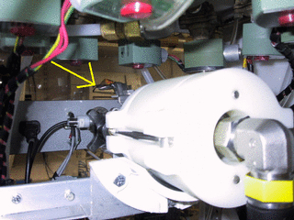
6. Release 8 white tubes with the quick connect/disconnect fittings, and disconnect the fitting at the elbow on the black tubing connecting the impactor to the carousel.
7. Place the carousel and a canister of filters (write start date on outside) in the glovebox, close the glove box and turn on the pump.
8. Back at the rack, disconnect fitting near valve so the impactor can be removed.

Change the impactor films
1. Wear gloves
2. Unscrew the black knobs and remove outer white sleeve. Make a note of the order of each section so that they can be put back in the correct order.
3. top section: clean out grease using methanol and Kimwipe; apply new grease
4. Section 2 (>10 μm particles): throw out film; clean section; spray a film from the plastic bag with silicon lubricant and place in holder with spacer ring on top
5. Section 3 (1-10 μmm particles): take out film with tweezers and place in old ‘S’ Petri dish. Clean section; Place new ‘B’ film on the stage, let sit for a minute and then return to ‘B’ Petri dish. This is the new ‘background’ film. Put new ‘S’ film on stage, place spacer ring on top and put impactor back together.
6. Place impactor back in rack.

Changing the filters
1. Take lid off carousel; black knobs first, then white knobs, turning knobs in counter-clockwise direction. (If you have difficulty doing this, try doing this outside of the glove box but put a note in the filter box when you do.)
2. Take out the red discs from the old container. Remove filters from carousel and stack in the old container in reverse numerical order (8 to 1), putting a red disc in between each filter. Put on the container cap and screw down.
3. Clean the carousel with alcohol. Place the new filter samples in the carousel, matching up the filter number with the carousel number.
4. Put top back on carousel, turn white knobs then black knobs
5. Put carousel back in the rack, attach the quick connects (orange-to-orange and black-to-black). Attach black hose to impactor.
6. Open Whitey valve by rotating handle 90 degrees clockwise so it is parallel to the flow.
7. Type ‘<ESC>,<I>,<F>,<F>’ to end filter change and begin filter sampling.
8. Record stop date on old sample container, put in box along with Petri dishes to mail to PMEL:
Theresa Miller phone: 206-526-6220
NOAA/PMEL email: tmiller@pmel.noaa.gov
7600 Sand Point Way NE
Seattle, WA 98115

System Leak Test - (Weekly Task)
Time required: Approximately 10 minutes
Tools/supplies: Large white HEPA filter with 2” cup fitting
Overview: It is important to test the aerosol system for leaks to ensure that measurements are made on outside/conditioned air and not on inside air. Two diagnostics are used to test the aerosol system for leaks: the pressure drop and the CN counts. Note this is easier/quicker with 2 people – one person to place and remove the filter at the saddle port and one person to enter the observed values for pressure drop and CN counts.

DO NOT attempt this procedure during stormy weather; SAFETY FIRST!! ☺

Enter a log message <esc><M> ”Starting leak check” <enter>.

Turn off the humidifier heater and preheater.

Bring up the aerosol monitors window <esc><I><A><W>.

Turn valve on back of CN counter box to ‘Neph’ position (i.e., it’s perpendicular to flow into the CN counter inlet).
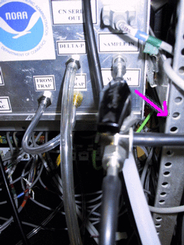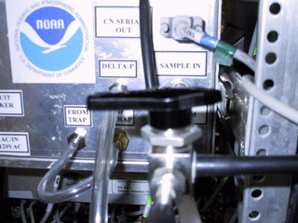

Enter a log message <esc><M> “Ambient CN count= value; dp_Neph_imp= value” <enter>. (The CN counts value is in the lower left corner of the screen (below the aerosol monitor window) and the dp_neph_imp value is in the center of the screen (center bottom of the aerosol monitor window).)

Climb up to the saddle port at the base of the 8” PVC, undo the pins and remove the saddle port. Place the filter with the metal cup securely on top of the exposed 2” metal inlet stack.
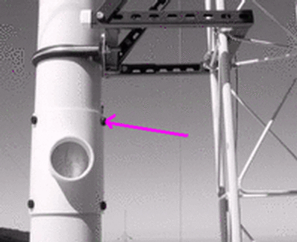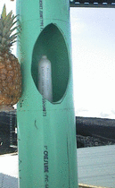

Enter a log message <esc><M> “Filtered CN count= value; dp_Neph_imp= value” <enter>.
Acceptable ranges for these two variables when the filter is on the stack are:
dp_neph_imp > 20 CN_counts < 50
If the observed values are outside these ranges, there may be a leak in the system. A likely location to check is the connections on the impactors. If tightening those fittings doesn’t help, call the CMDL contact person.

Remove the filter and replace saddle on 8" PVC.

Return the CN counter value to Inlet position (i.e., parallel to CN inlet sample).

Turn on the humidifier heater and preheater.

Nephelometer Span Check - (Weekly Task)
Time required: Approximately 40 minutes
Tools/supplies: None
Overview: The nephelometer span check confirms that the nephelometer calibration is correct. The procedure is mostly automated, although the valve on the CO₂ tank needs to be manually opened and closed. This procedure needs to be done when there is water in the humidifier, so it should be started between 15 and 30 minutes after the hour (based on the PC clock time)

Plumbing
The plumbing for a span check is as follows: CO₂ tank → Regulator→ Flow control Valve → Rotameter→ Copper tubing→ Plastic tubing→ Blue balston filter → wet neph. CO₂ inlet
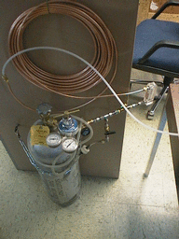

Operation
Turn off the humidifier heater and preheater. (see above)
Open CO₂ tank valve

Press <Esc> <I><O><C> to begin span checks (this will go through both nephelometers).
The computer will prompt you for CO2 tank pressure and flow rate and will notify you when the span check is over and display the calibration results. You will need to toggle between nephelometer windows to check both nephelometer’s span check results. Typing these sequences: <Esc> <I><N><W> and <Esc> <I><O><W> a couple times each will take you to each nephelometer’s window and the corresponding span check results.
Conduct a second span check if the average deviation is more than 4% for either nephelometer.

Close CO₂ tank valve when finished.

When done with the span check, turn on the humidifier heater and preheater.

Changing Nephelometer Lamp
The CMDL scientist will let you know if this needs to be done. The nephelometer lamp usually last about six months. Typically, scientists watching the station data (lamp voltage and current) at CMDL can tell about a week ahead of time when the lamp is going to go. We like to change the lamp before it goes due to the possibility that when the lamp goes it could cause further damage to the nephelometer. Detailed instructions for changing the nephelometer lamp are given in the TSI nephelometer manual on page 8-13.

Nephelometer Calibration
The nephelometer should only need to be calibrated after shipping to THD and will typically be done by the CMDL scientist visiting the site. The weekly span checks (section 2.8 above) are used to ensure that the calibration is valid.

- Disconnect the 9 pin data logging cable from nephelometer.
- Connect 9 pin calibration cable from Comm port #1 (9 pin output on back of PC) to the nephelometer.
- Use TSI neph icon in NOAA folder

Do steps 1-F (Press the letter or number to accomplish each function)
- Select Air as the low span gas.
- Select CO2 as the high span gas.
- switch value filter (This puts the Nephelometer filter inline)
- start data collection-low gas (Wait 300 seconds after this command)
- clear buffer (Wait 300 seconds after this command)
- store low span gas data
- toggle blower to off (Doesn’t really do anything since we don't use the blower)
- use bypass analyzers command: <esc><I><A><A>
- feed CO2 into line (Press the red button on the Nephelometer, the button should light up to indicate that the value is open. Check the CO2 is flowing and set correctly on the CO2 flow meter.)
- start data collection-high gas (Wait 300 seconds after this command)
- clear (Wait 300 seconds after this command)
- store high span gas data (After this the new calibration values should be displayed at the top of the screen. Check that they are some what near the Current values. If they are near the current values use the new values, if they are far away something may be wrong with the nephelometer. It may be necessary to do a second calibration if the old and new values are not near each other. Un-bypass the analyzers: <esc><I><A><A>
- Write calibration label (We use the format of "data, neph serial number, calibration gases, person that did the calibration and where" i.e., "000426, #1034 AIR+CO2 DJD@MLO")
- Save cal data (K2 & K4) to nephelometer (This saves the new calibration data to nephelometer).
- Zero with clean air (This does a nephelometer zero)

- <F10> to quit the calibration.
- Select "Exit" to quit the calibration software.
- Close valve on CO2 tank.
- Disconnect the calibration 9 pin cable and reconnect the 9 pin data logging cable.
Return to the CP program by <CTRL><Esc> and select "CMDL Aerosol System (CP)"

System Clock
The system clock is displayed in the lower right corner of the Aerosol Data Logger window. The system clock should be set to UTC which is 7 hours different than THD local time (PDT). The clock is synced automatically using the GPS unit.

Computer Operation

Startup
Typically, the computer is activated with the rest of the atmospheric sampling system by switching on the UPS and Raw power bars located in the upper back of the rack. The computer should boot the operating system, OS/2, and start the CP program which begins data logging. The lowest of the three mouse buttons by the track ball is equivalent to a left mouse button and is used to select something. The upper of the three mouse buttons is equivalent to a right mouse button. Typing the sequence <Control> <Esc> brings up a windows list for changing between windows.

Shutdown
Exit aerosol data logger (<Esc> <Q>)

Double left-click on shutdown icon

Turn off power (power switches on back of rack to shutdown the whole system.)

Archiving and Backing-up Data
Note: This is typically done automatically, these steps are need only if manual archiving is required. The data archives are standard “ZIP” format. The data files are plain ASCII, tab-delimited, with headers. “A*.TXT files contain 1-minute averages. “M*.TXT” files contain snapshots (every 22.5 minutes) of system status info.

Saving to hard disc
If up-to-the-minute data are desired, press <Esc> OS in Aerosol Data Logger to close current files and start new files.

Activate “CP” window (left-click in window, or left-click on “CP” icon in Launch Pad)

Double-click “Archive Data” icon. This saves the raw (binary) data in c:\cp\archive\raw\rYYMMDDx.zip. It also converts the binary data to plain ASCII and stores them in c:\cp\archive\tYYMMDDx.zip (the ‘x’ is a code for the current hour of the day).
Backup to floppy.

Saving to floppy
Activate “CP” window (left-click in window, or left-click on “CP” icon in Launch Pad)

Insert floppy. Double click icon “archive data to floppy”.

Aerosol Data Logger Program

General Operation
Press <Esc> to access menus, <Esc> to abort from any menu or entry box without any changes

Press <Enter> to accept the current entry or highlighted item.

Menu entries can be selected with the arrow keys or pressing the boldface shortcut key for the desired selection.

When choosing menu options that will change how data is logged (for example, changing filter duration) you will be asked for the access code. This is to make you think, before it gets changed, if the option you are choosing is something that really needs to be changed. The access code is the four letters: cmdl.

Display
The “base” display consists of three lines at the top for error messages, a status line at the bottom, and central window for displaying current values for ambient measurements. Status windows for specific windows can be displayed (or hidden) by pressing <Alt> plus the code letter for that instrument.

A = Aerosol system
B = Best UPS
F = Filters
G = GPS
H = Humidograph
L = PSAP (CLAP)
N = Nephelometer (dry)
O = Nephelometer (wet)
u = μMAC-1050 A/D I/O system – aerosol instruments
v = μMAC-1050 A/D I/O system – filters

The bottom status line gives the free disk space and system clock (right side), and a status code for active instruments (center). Lowercase code letters mean that instrument is not logging data, uppercase letters means logging is enabled for that instrument. If a letter is absent, then that instrument is not present or not responding.

Normal operation is indicated by the code *ABcFGHLMNOuv which is interpreted as follows:
*-- data from enabled instruments is being logged (if absent, no data are being logged)
A – aerosol data system active and logging enabled
B – Best UPS active and logging enabled
c – CN contamination control algorithm active (not logged)
F – Filters active and logging enabled
G – GPS active and logging enabled
L – PSAP active and logging enabled
M – system monitor file logging (always present)
N – nephelometer (reference/dry) active and logging enabled
O – nephelometer (humidified/wet) active and logging enabled
u - μMAC1050 A/D I/O subsystem active, but not logging (if uppercase, raw voltage are being logged, which can quickly generate huge files).
v - μMAC1050 A/D I/O subsystem active, but not logging

Main Menu <esc>
Pressing <Esc> brings up the main menu, with the following choices (shortcut keys in <brackets>):

Message Log <M> – allows the user to make an entry in the system log file. Think of this as an on-line logbook, and use it liberally. Each entry can be at most 80 characters long, and each entry is recorded with a time stamp. These log entries are included in daily email messages to CMDL scientists and used when editing the data.

New Average <N>– force termination of the current average and start a new average

Instruments <I>– activates the instrument control menu

Options <O>– activates the options menu

Quit <Q>– exits the program

Instruments Menu <esc><I>
Aerosol monitor <A>– activates menu for aerosol system control functions

Nephelometer <N>– activates reference (dry) nephelometer control menu

Nephelometer <O>– activates reference (wet) nephelometer control menu

PSAP <L> – activates PSAP/CLAP control menu

Humidograph <H> - activates humidograph control menu

Filters <F> - activates filter system control menu

GPS <G>- activates GPS control menu

uMAC-1050 <U>– activates the μMAC-1050 control menu-for aerosol system

uMAC-1050 <V>– activates the μMAC-1050 control menu-for filter carousel

Best UPS <B>– activates Best UPS control menu

Each of the instrument control menus has the same top two lines, which toggle the state of data logging and window visibility for that instrument. The other entries are specific to that instrument.

Aerosol Monitor Menu <esc><I><A>
Logging end/ Logging start <L> context-sensitive function to enable/disables logging of aerosol parameters

Window hide/Window unhide <W> changes visibility of status window

Analyzers bypass/Analyzers unbypass <A> context-sensitive function to bypass/unbypass the continuous analyzers

Scanning cut points <S> turns off switching between impactor size cuts

Cut coarse/Cut fine <C> context-sensitive function to toggle between sub 10 μm and sub 1 μm cut size

Analyzer flow <Q> goes to menu for controlling flow thru instruments (e.g., mass flow controller). 1 volt corresponds to 10 lpm; the typical setting is 3 V to get 30 lpm. (This option is only used on aircraft systems.)

Nephelometer Menu <esc><I><N> or <esc><I><O>
Logging end/ Logging start <L> context-sensitive function to enable/disables logging of nepholometer parameters

Window hide/Window unhide <W> changes visibility of status window

Span Check /Abort Span Check <C> context-sensitive menu to start/abort a CO₂ span check.

Send command <S> Activates a menu for sending selected commands to the nephelometer. Not normally used except for troubleshooting.

PSAP Menu <esc> <I><L>
Logging end/ Logging start <L> context-sensitive function to enable/disables logging of PSAP parameters

Window hide/Window unhide <W> changes visibility of status window

Start filter change/ End filter change <F> Context-sensitive menu to start/end a filter
Use this function to prevent data logging during a PSAP filter change, and to generate automatic log file entries when PSAP filters are changed.

Filters Menu <esc> <I><F>
Logging end/ Logging start <L> context-sensitive function to enable/disables logging of filter parameters

Window hide/Window unhide <W> changes visibility of status window

Filter change <F> context-sensitive function to notify system that the filters will be changed. Changes to “Filter start” when changing..

Filters bypass/Filters unbypass <T> context sensitive function to allow manual bypassing of filter samples
Filter duration <D> Changes the duration of the NEXT filter (not the current filter). Duration is set in hours.

Filter duration <N> forces immediate switch to next filter

Q Filter Flow <Q> goes to menu for controlling flow thru instruments (e.g., mass flow controller). 1 volt corresponds to 10 lpm; the typical setting is 3 V to get 30 lpm. (Only used on aircraft systems.)

Heater power <H> Set in watts

Humidograph Menu <esc> <I><H>
Window hide/Window unhide <W> changes visibility of status window

Disable/enable scanning <S> start or stop the humidifier from humidifying

Set Channel A <A> Sets RH set point of reference nephelometer

Set Channel B <B> Sets RH set point of humidified nephelometer

Set Channel C <C> Sets pump direction and speed. (range between -20 and 100)
0 = not pumping
15 = pumping water at 15% power into humidifier
-20 = pumping water backwards out of humidifier at 20% power

Set Channel D <D> Sets whether the high-range flow valve is open (H) or closed (L).

GPS Menu <esc> <I><G>
Logging end/ Logging start <L> context-sensitive function to enable/disables logging

Window hide/Window unhide <W> changes visibility of status window

Disable/Enable auto-sync of clock <A>

Sync PC clock to GPS <S>

Change display waypoint <C>

System Configuration
System configuration information is stored in the CP.INI file, located in the same directory as the CP.EXE executable. These are the only two files required by the aerosol data logger program.

Computer display pictures
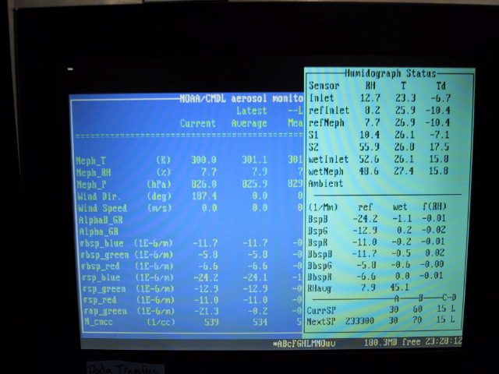
This is what the CP window display should typically look like. The dark blue window is the basic display of parameters from the reference nephelometer, psap, cn counter and several other measurements. The aqua blue window on the right is the humidograph window. It provides information on parameters measured by the reference and wet nephelometers and displays what the humidograph setpoint parameters currently are and what their next setpoint is.

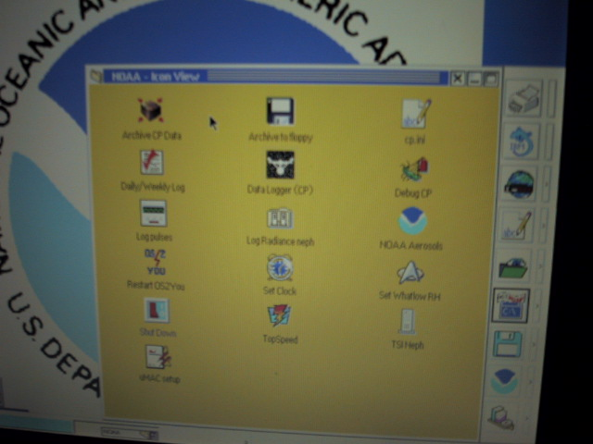
This is the icon screen. It shows icons for archiving data, starting CP and other processes. Once you’ve clicked on the CP icon to start the CP process, you need to type <control><esc> to bring up a menu and choose ‘Data logger (CP)’ to actually get to the CP window display.

Safety

Heater Control
If the pump fails, any of the heaters (stack, humidifier rack inlet, preheater, humidifier, filter rack inlet) could overheat because the PID sensors don’t have flow past them. There is a high-temperature cut out switch on the heaters, which limits the temperature on the outer tube to about 80 degrees Celsius.

Electrical Safety
We have insulated the electrical connections inside the rack, so that it is safe to perform standard tasks inside the rack (e.g., changing impactor films) with the power on. However for non-standard tasks (e.g., replacing the humidifier), you should always remove power from the rack and the instruments you are working on..

Specifications

Power Draw at 115 V DC
Equipment | Draw (A) | Surge (A)
Carbon vane pump | 8.6 | 20
Diaphragm pump | 2.4 | 12
Bypass blower | 1.3 | 3
Cooling fan | 2.7 | 3.5
Aerosol System | 9.0
Typical Parameter Values
Window | <Alt> key | Parameter | Typical | Lower limit | Upper limit | Action
Aerosol Sampling Status | A | RH_sample | 40 | 0 | 45 | Check inlet heater
 | A | T_sample | 25 | 10 | 40
 | A | T_rack | 30 | 20 | 35 | Check air conditioner
 | A | T_pumpbox | 32 | 25 | 40
 | A | Q_analyzer | 30 | 28 | 32 | Check pump, adjust flow
Aerosol dP sensors | A | dP_Neph_imp | 2 – 10 | 2 | 13 | Check for leaks around impactors
 | A | dP_CNC_vac | 700 | 650 | 750 | Check CN pump
 | A | dP_pitot | 70 | 60 | 80 | Check carbon vane pump
CN counter | A | Drier flow | 8 | 7.5 | 8.5 | Adjust valve
Best UPS | B | Inverter | OFF
 |  | Charger | ON
 |  | AC Volts IN | 113 | 110 | 120 | Fix generators
 |  | AC Volts OUT | 121 | 118 | 125
 |  | AC Amps OUT
 |  | Output Load VA |  |  |  | Check that all systems are drawing power, and than nothing unauthorized is connected to UPS
 |  | Battery DC V | 13.9 | 13 | 14 | Possible UPS malfunction
 |  | Frequency | 60 | 50 | 70 | Fix generators
PSAP | L | Flow | 3.0 | 2.5 | 3.5 | Adjust flow
 | L | Transmittance | 0.9 | 0.7 | 1.0 | Change filter
 | L | I_sample | 250000 | 90000 | 300000 | Check light source
 | L | I_reference | 570000 | 250000 | 300000 | Check light source
 | L | Filter change | FALSE | FALSE | FALSE | You forgot to press <Esc>ILF after last filter change.

Window | <Alt> | Parameter | Typical | Lower | Upper | Action
Neph_N & Neph_O | N & O | Bkg_tot_Blue | 2.0E-5 | 1E-7 | 5*typ.
 |  | Bkg_tot_Green | 1.8E-5 | 1E-7 | 5*typ.
 |  | Bkg_tot_Red | 1.6E-5 | 1E-7 | 5*typ.
 |  | Bkg_back_Blu | 6.0E-6 | 1E-7 | 5*typ.
 |  | Bkg_back_Grn | 5.0E-6 | 1E-7 | 5*typ.
 |  | Bkg_bak_Red | 4.0E-6 | 1E-7 | 5*typ.
 |  | MODE | NBXX | BBXX | ZBXX | Any other value is an error
 |  | P_hPa | 1000 | 950 | 1020
 |  | SecToGo | 30000 |  |  | Must decrease by one every second
 |  | Sample_T | 300 | 290 | 320 | Check room temperature
 |  | Inlet_T | 297 | 290 | 320 | Check room temperature
 |  | Next_Z | Xx:57:00 |  |  | Possible error in CP.INI entry for [Neph] ZeroAt= entry.
 |  | GreenRef | 4.0E+5 | 3.0E+5 | 5.0E+5 | Lamp may be failing.
 |  | Lamp_V | 13 | 10 | 14 | Lamp may be failing
 |  | Lamp_I | 5.7 | 5 | 7.5 | Lamp_V times Lamp_I should be 75.0
Humidograph | H | refNeph | 30% | 0% | 40%
 |  | wetNeph | Varies | 0% | 95%
 |  | RH_S1  (RH after preheater) | 30% | 0% | 40% | Check humidograph system
 |  | T_S1  (T after preheater) | 297 | 290 | 320 | Check humidograph system
 |  | RH_S2  (RH after humidifier) | varies | 0% | 97% | Check humidograph system
 |  | T_S2  (T after humidifier) | 297 | 290 | 320 | Check humidograph system
uMAC & vMAC | U & V | Room Temp | 38 | 30 | 40 | Check room temperature
 |  | Power supply | 5.0 | 4.9 | 5.1 | Power supply bad?

