Mapping the Invasive Species Chinese Tallow
Elijah Ramsey III¹, Gene Nelson¹, Amina Rangoonwala², and Robert Ehrlich³
US Geological Survey Research Center¹, Johnson Controls World Services Inc.², National Wetlands Research Center, 700 Cajundome Boulevard, Lafayette, Louisiana 70506^{1,2},
C & E Enterprises, 1048 S. Oak Hills Way, Salt Lake City, UT 842108³
elijah_ramsey@usgs.gov

In a progression of papers, we described newly developed remote sensing tools to map the localized occurrences and regional distribution of the widespread and gregarious invasive species; Chinese tallow (Sapium sebiferum) (Figure 1). These developments relied on newly available Hyperion sensor hyperspectral data collected from the EO1 satellite platform. Although directed at mapping and monitoring tallow, remote sensing hyperspectral technologies advanced here have decreased deficiencies that are at this time preventing widespread mapping of invasive plants in the United States and internationally. We expect methods developed as part of this project will provide a template for mapping and monitoring other invasive species within the native landscape in differing geographic areas.
Since introduction into the US in the late 1700’s, Chinese tallow has spread from South Carolina south to Florida and from Texas west to Arizona and Southern California. It is continuing its rapid advance and once it gains a foothold, removal is extraordinarily difficult. The best defense is an aggressive offense, detect early and eradicate. Its spread is creating extensive and irrevocable damage to native communities and although of critical importance to the survival of many native habitats and wildlife and the viable operations of many public and private lands, the actual distribution of the Chinese tallow menace has yet to be mapped. Not only would the ability to map the location of this invasive be critical to documenting the spread of this invasive and to eradication efforts, but monitoring capabilities would be essential for assessing success of various controls. Nationally, identification by regional mapping and a method of regular monitoring are keys to addressing the infestation of all non-native plants within the United States. Before this research, the technology for detecting and mapping Chinese tallow and other non-native plants was not available for operational use.
Remote sensing of Chinese tallow. By all accounts, except in senescence, Chinese tallow mixes spectrally and structurally into the matrix of native plants. In other words, it is hard to detect. Furthermore, we found that in this period of infestation, pure stands of tallow trees rarely occurred and where they did, the stands were narrow and fragmented with dimensions rarely more than 5 m. Dominantly, tallow trees are mixed intricately and at a low density within the matrix of similar coastal and adjacent upland native vegetation. The necessary trade-off is between the need for high spatial resolution and the need for regional coverage.
High spatial resolution photography: a proof of concept study. The first attempt to map Chinese tallow with remote sensing data used airborne color-infrared photography (1:12,000) to simulate low spectral but high spatial resolution satellite and airborne image and digital video data (Ramsey III, E., G. Nelson, S. Sapkota, E. Seeger, and K. Martella, 2002. Mapping Chinese tallow with color-infrared photography. Photogrammetric Engineering & Remote Sensing, 68, 251-255). Mapping occurred when the senescing Chinese tallow with bright red leaves presented a high spectral contrast within the native landscapes (Figure 2). To simulate low spectral but high spatial resolution satellite and airborne image and digital video data, CIR photography was scanned at a 1.0 m spatial resolution or less and classified for the occurrence of bright red leaves associated with senescing Chinese tallow. Classification accuracies higher than 95% confirmed high spatial resolution data can be used to monitor Chinese tallow infestations (Table 1) but the mapping was personnel intensive and spatial coverage was severely limited (<5 ha).
EO1 Hyperion image data. To overcome this challenge, high spectral resolution data that offered subtle spectral discrimination was used to compensate for the use of moderate spatial resolution data that offered regional coverage. The Hyperion sensor onboard the EO1 satellite provided the necessary high spectral resolution data at a reasonable cost and a spectral unmixing tool provided the necessary subpixel Chinese tallow detection. Even with the appropriate hyperspectral data and spectral mapping tool, detecting the normally low percent occurrences of Chinese tallow within the matrix of native plants required identifying subtle spectral differences within the remote sensing image data. Atmospheric spectral leveling diminishes the ability to determine subtle spectral differences, and therefore, to determine changes in canopy composition, in this case, tallow percent occurrences. Atmospheric removal allows extraction of the canopy reflectance from the sensor signal maximizing the potential spectral distinctiveness (information, tallow percent occurrences) of the each reflectance spectra.
Generating canopy reflectance. To obtain the necessary subtle detection accuracy while maintaining spatially extensive coverage, a model strategy was generated and implemented that transformed the Hyperion image data into accurate renditions of the canopy reflectance (Ramsey III, E., and G. Nelson, in review). The model strategy accounted for atmospheric influences, the view and sun geometries, and illumination of the target and used a whole image approach coupled with site-specific canopy reflected radiance measurements to transform the EO1 Hyperion apparent reflectance image data into highly accurate reflectance data (Figure 3). Overall, hyperspectral reflectance spectra generated with the atmospheric correction and normalization model strategy followed expected spectral trends and contained expected prominent features. Differences in the observed and model modeled canopy reflectance spectra were most often low or nearly non existent, and where relatively higher differences existed, these were most likely associated with problems in the comparison not in the model generation. Typical differences between the observed (site-specific) and modeled (Hyperion) reflectances would be expected to range from ±1.0% to ±1.6% in the visible and ±5% in the near infrared wavelengths in 95% of the model simulations. These comparisons verified that our strategy successfully produced highly accurate and detailed renditions of canopy reflectances at the time the Hyperion data was collected. The high accuracy supplied the highest spectral detail possible necessary for the subtle spectral discrimination and detection of the red Chinese tallow leaves in the matrix of native vegetation.
Generating characteristic spectra. Once accurate spectral detail was obtained, a spectral subpixel extraction algorithm operating on the EO1 Hyperion site-specific corrected and normalized canopy reflectance data was used to provide realistic and predictive characteristic spectra that represented the percent occurrence of pertinent and dominant landcover spectral characteristics occurring at the time of the Hyperion image collection (Ramsey III, E., G. Nelson, R. Ehrlich, A. Rangoonwala and K. Martella, in review, Generation and validation of characteristic spectra from EO1 Hyperion image data for detecting the percent occurrence of invasive species, specifically Chinese Tallow). Collected leaf spectra provided evidence for the expected variance and variety of forms of canopy reflectance spectra characterizing the pertinent land covers. In addition to their use in atmospheric correction, site-specific canopy reflectance spectra provided a direct link between the site composition variance directly influencing the canopy reflectance and the canopy reflected radiance measured at the sensor. Simultaneous collection and subsequent classification of 35-mm slides provided dominant site-specific compositions at the time of the Hyperion image data collection. Mixing proportions associating the modeled characteristic spectra with the site compositions were compared with compositions generated from the site-specific slide classifications. This final comparison insured that the modeled characteristic spectra adequately portrayed the dominant canopy reflectance variance existent during the image collection.
Using the input site-specific reflectance spectra sets (n=34, about 400 nm to 925 nm), the sub pixel extraction model found 5 characteristic spectra that adequately represented the site-specific and also the corresponding Hyperion imaged canopy reflectance spectra data sets. Both sets of site-specific and Hyperion characteristic spectra were similar (Figures 4 and 5). One characteristic spectrum represented percent occurrences of senescing cypress-tupelo and leaf-off and brown foliage. Two others represented shadows and green vegetation percent occurrences. The shadow and green vegetation variances were correlated. The fourth characteristic spectrum was somewhat related to the percent occurrence of yellow tallow and yellowing foliage. The final characteristic spectrum was visually and statistically associated with the percent occurrence of red Chinese tallow. About 81% (n=34) and 78% (n=33, one site excluded) of the composition variances associated with the red tallow site-specific and imaged characteristic spectra, respectively were explained by the site-specific compositions generated in the site-specific slide classification (Figures 6 and 7). The implemented methodology including validation and verification insured the modeled characteristic spectra were both physically realistic and predictive, and thereby these spectra could more likely be spatially and temporally extended, and used with other sources of hyperspectral sensor image data.
Mapping the percent occurrence of Chinese tallow. The final objective was to implement methods designed and tested in the previous studies and provide a realistic and accurate representation of the spatial distribution of the percent occurrence of Chinese tallow within the Hyperion coverage. Using results generated in the previous studies (accurate canopy reflectance spectra and realistic and predictive characteristic spectra) we transformed corrected and normalized Hyperion reflectance image data into composition images with a subpixel extraction model (Ramsey III, E. A. Rangoonwala, G. Nelson, and R. Ehrlich, in review. Mapping the invasive species, Chinese Tallow with EO1 satellite Hyperion hyperspectral image data and relating tallow percent occurrences to a classified Landsat Thematic Mapper landcover map). Composition images were related to green vegetation (combining the green and shadow characteristic spectra), senscent foliage and senescing cypress-tupelo forest, red Chinese tallow, and a final composition image that was slightly related to yellow tallow but mostly did not correspond to any observed land cover feature. Statistical and visual comparisons confirmed successful portrayal of these landscape features at the time of the Hyperion image collection (Figures 8 to 13) .
In a final analysis, the percent occurrence of red tallow as a surrogate for Chinese tallow was linked to land covers generated with Landsat Thematic Mapper image data as a first step to establish the sensitive and susceptible of various ecosystems to risk of invasive establishment (Figure 14) . Results suggested the highest percent occurrences and widest distribution of tallows were located (1) on the numerous and ubiquitous topographic highs and levies within and lining the ubiquitous coastal canals, (2) scattered throughout fallow fields or along fence rows separating active and non active fields, and (3) in disturbed or more open canopy woody wetland deciduous forests (including cypress-tupelo forests), upland woody land evergreen forests (dominantly pines), and upland deciduous and mixed forests. Additionally, pine and in one case cypress plantations were often highly contaminated by tallow trees. In all, narrow linear features (levies, fencelines, cheniers,) and scattered trees and small isolated stands (cultivated and fallow fields, topographic highs in marshes, disturbed and open forests canopies) are mixed with the native vegetation in the TM pixel and amalgamated within the landcover classification. Newly created remote sensing techniques relying on Hyperion hyperspectral image data and a specialized subpixels extraction model provided identification of subtle spectral anomalies caused by the occurrence of red tallow that was not possible with the coarser spectral resolution Landsat Thematic Mapper image data. Linkage of these occurrences with the Landsat Thematic Mapper landcover map dramatized those ecosystems containing the highest levels of tallow and those activities that enhanced tallow establishment.

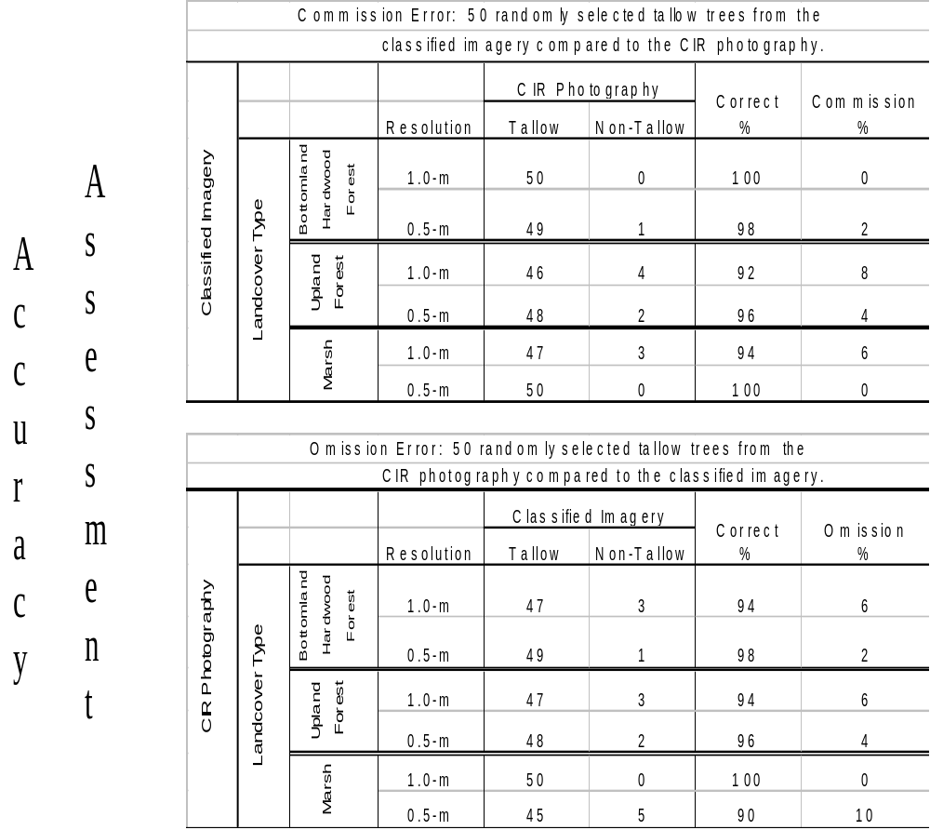
Table 1. Accuracy assessment of classified 0.5 and 1.0 m CIR photography

