Hobe Sound National Wildlife Refuge

Comprehensive Conservation Plan

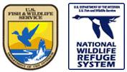

U.S. Department of the Interior
Fish and Wildlife Service
Southeast Region

December 2006

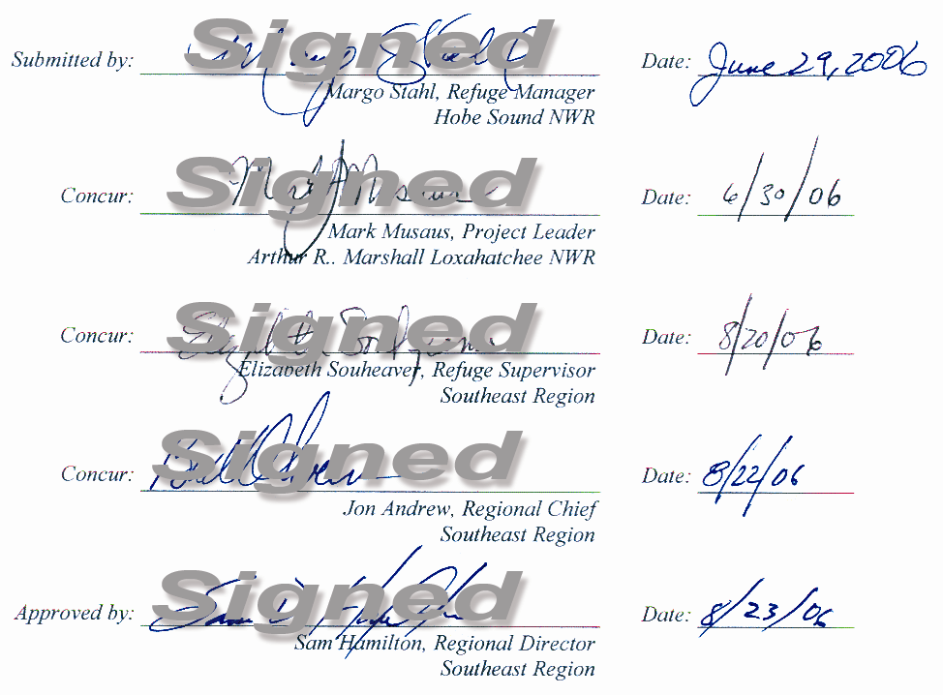

Hobe Sound National Wildlife Refuge

Comprehensive Conservation Plan

U.S. Department of the Interior
Fish and Wildlife Service
Southeast Region
Atlanta, Georgia

January 2007

Table of Content

section a. comprehensive conservation plan
I. BACKGROUND 1
Introduction 1
Purpose Of and Need For The Plan 2
Planning Process 2
Fish and Wildlife Service 3
National Wildlife Refuge System 4
Hobe Sound National Wildlife Refuge 4
Location, Establishment, and Importance 4
Refuge Purposes 7
Facilities 11
Staffing and Funding 11
Ecosystem and North American Context 11
Legal and Policy Guidance 16
II. Planning Issues and Opportunities 19
Introduction 19
Identifying the Issues 19
Wildlife Habitat Management 19
Public Use: Recreation 20
Public Use: Education and Public Awareness 22
Partnerships 22
Historical Resources 22
Administration 23
Significant Refuge Issues 24
Visitor Use 24
Resource Protection 24
Administration 26
III. Refuge Environment 27
Physical Environment 27
Climate 27
Air Quality 27
Noise/Traffic 27
Geology and Soils 28
Hydrology 29
Water Quality 29
Biological Environment 30
Mainland Tract 30
Indian River Lagoon 38
Jupiter Island Tract 42
Exotic Species 51
Socioeconomic Environment 52
History of Martin County 52
Land Use and Values 56
Demographics 56
Resource Economics 58
Recreation Use 58
Cultural Environment 62
Prehistoric Influences 62
Historic Influences 62
Modern Influences 63
IV. MANAGEMENT DIRECTION 65
Introduction 65
Refuge Vision 65
Refuge Goals 66
Comprehensive Conservation Plan Summary 66
Goals, Objectives, and Strategies 67
Goal 1. Wildlife Habitat and Population Management 67
Goal 2. Resource Protection 72
Goal 3. Wildlife-Dependent Recreation and Environmental Education 74
Goal 4. Administration 78
V. PLAN IMPLEMENTATION 81
Introduction 81
Project Summaries 81
Staffing and Funding 88
Partnership Opportunities 89
Step-Down Management Plans 91
Monitoring and Evaluation 94
Plan Review and Revision 94

Section B. Appendices
I. GLOSSARY 95
II. References and Literature Cited 103
III. LEGAL MANDATES 109
IV. REFUGE BIOTA 117
V. PUBLIC INVOLVEMENT 137
Summary Of Public Scoping Comments 137
Draft Plan Comments and Service Response 147
VI. COMPATIBILITY DETERMINATIONS 167
VII. Intra-Service Section 7 Biological Evaluation 177
VIII. Subtropical Florida Partners-in-Flight Bird Conservation Plan:
Section 2 Avifaunal Analysis 203
IX. EXISTING AND POTENTIAL PARTNERS 211
X. CONSULTATION AND COORDINATION 213
XI. Finding of No Significant Impact 215

LIST OF FIGURES

Figure 1. Location of Hobe Sound National Wildlife Refuge in relation to other refuges with similar habitats in Florida 5
Figure 2. Location of Hobe Sound National Wildlife Refuge in relation to adjacent state lands 6
Figure 3. Location of Jupiter Island and mainland tracts of Hobe Sound National Wildlife Refuge in relation to Indian River Lagoon/Intracoastal Waterway 8
Figure 4. Jupiter Island tract of Hobe Sound National Wildlife Refuge and the Indian River Lagoon, in the context of community development 9
Figure 5. Mainland tract of Hobe Sound National Wildlife Refuge and the Indian River Lagoon,in the context of community development 10
Figure 6. Upper east coast ecosystem subregion within the South Florida Ecosystem 12
Figure 7. High priority bird species abundance and seasonal use, Hobe Sound National Wildlife Refuge 14
Figure 8. Vegetation on mainland tract, Hobe Sound national Wildlife Refuge 31
Figure 9. General distribution of scrub in Florida, adapted from Davis, 1967 32
Figure 10. Location of seagrass beds in relation to Hobe Sound National Wildlife Refuge 41
Figure 11. Vegetation on Jupiter Island tract, Hobe Sound National Wildlife Refuge 43
Figure 12. Location of mosquito impoundments, F1, F2, and F3, on Hobe Sound National Wildlife Refuge 46
Figure 13. Number of sea turtle nests observed on refuge by species 1991-2002 47
Figure 14. Annual number of green turtle (Chelonia Mydas) nests, Hobe Sound National Wildlife Refuge, 1973-2002. Data analysis by Ecological Associates, Inc. 47
Figure 15. Annual number of loggerhead turtle (Caretta caretta) nests, Hobe Sound National Wildlife Refuge, 1973-2002. Data analysis by Ecological Associates, Inc. 48
Figure 16. Annual loggerhead turtle (Caretta caretta) hatchling productivity, Hobe Sound National Wildlife Refuge, 1997-2002. Data analysis by Ecological Associates, Inc. 48
Figure 17. Percentage of marked sea turtle nests depredated, Hobe Sound National Wildlife Refuge, 1997-2002. Data analysis by Ecological Associates, Inc. 50
Figure 18. Exotic wildlife reported on Hobe Sound National Wildlife Refuge 53
Figure 19. Exotic vegetation on Mainland Tract, Hobe Sound National Wildlife Refuge 54
Figure 20. Exotic vegetation on Jupiter Island Tract, Hobe Sound National Wildlife Refuge 55
Figure 21. Socioeconomic profile of Martin County, Florida 1980-2000 57
Figure 22. Location of recreational and administrative facilities at Hobe Sound National Wildlife Refuge 60
Figure 23. Summary of public use on Hobe Sound National Wildlife Refuge* 61
Figure 24. Proposed wildlife habitat and population management activities for Hobe Sound National Wildlife Refuge 69
Figure 25. Location of existing and proposed recreational and administrative facilities on Hobe Sound National Wildlife Refuge 76
Figure 26. Summary of project costs for Hobe Sound National Wildlife Refuge 82
Figure 27. Annual cost of existing and proposed staff positions for Hobe Sound National Wildlife Refuge 90
Figure 28. Step-down management plans/completion dates 93

SECTION A. COMPREHENSIVE CONSERVATION PLAN

I. BACKGROUND

Introduction

The Hobe Sound National Wildlife Refuge sits as an oasis of pre-contact Florida ecology bisecting the burgeoning urban growth centers to the north and south of the cities of Jacksonville and Miami, respectively. Part of the refuge is situated atop ancient sand dunes that reflect the cycles of deposition and erosion in response to sea-level changes during the last 65 million years. These dunes and their associated lagoons served as important ecological environments that provided subsistence to tribal groups living here prior to European colonization and American settlement. Early in the 20th century, the rush to develop Florida resulted in a great loss of native habitats. However, this refuge=s very existence was borne out of the vision of conservation-minded residents who conveyed lands to the Fish and Wildlife Service in an effort to preserve and protect such rare and threatened species as mermaid-like manatees; chattering scrub jays; and lumbering, gargantuan leatherback sea turtles. In an effort to protect the ecosystems at Hobe Sound, one of those settlers, Joseph V. Reed, established the Reed Wilderness Seashore Sanctuary in 1967, a registered national landmark. This sanctuary is located at the north end of what is now Hobe Sound National Wildlife Refuge. The refuge is located not far from Pelican Island, the birthplace of the National Wildlife Refuge System, where 100 years ago, President Theodore Roosevelt in essence made a promise to the American people to set aside a network of lands and waters for wildlife.

The Fish and Wildlife Service has developed this Comprehensive Conservation Plan for Hobe Sound National Wildlife Refuge to guide management and resource use over the next 15 years. The refuge vision focuses on protecting wildlife and plants and promoting stewardship of all natural resources through public participation and partnerships. To carry out this vision, the plan identifies funding, staffing, and operation and maintenance needs of the refuge.

The plan=s overriding consideration is to carry out the purposes for which the refuge was established. Fish and wildlife resources are the first priority in refuge management, while public use (appropriate wildlife-dependent recreation) is allowed and encouraged, as long as it is compatible with, or does not detract from, the refuge=s mission and purposes.

Major issues addressed in this plan include the following:

- Ever-present threat of invasion by exotic species;
- Need to promote biological diversity;
- Context of land-use changes around the refuge boundaries;
- General habitat and wildlife protection;
- Recreational opportunities and public access;
- Environmental education; and
- Community/interagency partnerships.

Based on these issues, a range of alternatives was identified that could be implemented within the time frame of the plan. From these alternatives, the Service has selected a recommended course of action for managing the refuge. This plan contributes to the achievement of the South Florida Ecosystem Plan, the South Florida Multi-Species Recovery Plan, and the Partners-in-Flight Initiative.

Purpose Of and Need For The Plan

As directed by the National Wildlife Refuge System Improvement Act of 1997, comprehensive conservation plans are to be developed for all national wildlife refuges by 2012. This plan for Hobe Sound National Wildlife Refuge will identify the role of the refuge in supporting the mission of the National Wildlife Refuge System, and provide guidance in refuge management and public use activities. The plan articulates the Service=s management direction (goals, objectives, and strategies) for the next 15 years.

The plan is needed to:

- Articulate a vision statement, framing future management of the refuge;
- Provide refuge neighbors, visitors, the public, and government officials with an understanding of the Service=s management actions within and around the refuge;
- Ensure that the refuge=s management actions are consistent with the mandates of the National Wildlife Refuge System;
- Provide long-term guidance and continuity for refuge management; and
- Provide a basis for the development of annual budget requests for operational, maintenance, and capital improvement needs.

This comprehensive conservation plan has been developed to address important natural resource, compatible wildlife-dependent recreation, and administrative needs. To be specific, there is a need to restore and conserve diverse habitats, species populations, and biological integrity; conserve natural and cultural resources through partnerships, protection, and land acquisition from willing sellers; provide opportunities for appropriate, compatible wildlife-dependent recreation, environmental education, and interpretive programs; and provide effective and efficient administration of the refuge.

Planning Process

This comprehensive conservation plan outlines a new vision for the refuge and combines two documents that are required by federal lawBa comprehensive conservation plan required by the National Wildlife Refuge System Improvement Act of 1997, and an environmental assessment required by the National Environmental Policy Act of 1969, as amended.

In compliance with these Acts, the refuge has been actively seeking public involvement in its comprehensive planning. The Acts also require the Service to seriously consider all reasonable alternatives to major actions on refuges, including a Ano action@ alternative.

In developing this plan, the Service completed a 4-step planning process as follows:

- Established and organized a planning team for the purpose of developing a refuge comprehensive conservation plan;
- Held a public meeting to identify the important opportunities, concerns, and issues relating to the future management of the refuge;
- Prepared a draft plan for public review and comment; and
- Incorporated public review as appropriate

On July 16-17, 1998, the Service assembled a planning team at the refuge headquarters to begin the scoping process for developing a draft plan for the Hobe Sound National Wildlife Refuge. The planning team was composed of representatives from the Service, Florida Department of Environmental Protection, Florida Park Patrol, Florida Fish and Wildlife Conservation Commission, South Florida Water Management District, Martin County, Town of Jupiter Island, University of Florida, and Florida Atlantic University. The planning team members are listed in Section B, Environmental Assessment.

The team developed a draft vision statement for the refuge and identified a number of issues and concerns that were likely to affect the management of the refuge. The planning team also identified several goals for the management direction of the refuge and planned the agenda for a public scoping meeting.

The public scoping meeting was held in Hobe Sound, Florida, on August 18, 1998. Attendees of this meeting identified a variety of issues, concerns, and opportunities for future management of the refuge. The comments from the public scoping meeting and those expressed on the comment sheets are summarized in Appendix V.

Following the identification of the issues and opportunities, the planning team began the process of preparing sections of the draft plan and environmental assessment. Information concerning the refuge=s physical, biological, and socioeconomic environment was compiled and is described in Chapter III, Refuge Environment.

At subsequent planning team meetings, possible alternatives for the management of the refuge were identified. This planning process uncovered the additional need over the next few years to acquire remaining tracts of lands that might be developed and lost to wildlife protection as a result of the urban and suburban development that continues to sprawl across Florida.

The draft plan was distributed to officials of federal, state, and local government agencies; private organizations; and the general public for review and comment. A public meeting was held on
February 26, 2004, to present the pros and cons of each alternative and to obtain additional comments from the public.

Fish and Wildlife Service

Although the Fish and Wildlife Service is the primary federal agency responsible for conserving, protecting, and enhancing the Nation=s fish, wildlife, and plant populations and their habitats, it shares these responsibilities with other federal, state, tribal, local, and private entities. The Service enforces federal wildlife laws, administers the Endangered Species Act, manages migratory bird populations, restores nationally significant fisheries, conserves and restores wildlife habitat such as wetlands, and helps foreign governments with their conservation efforts. It also oversees the Federal Aid Program that distributes hundreds of millions of dollars in excise taxes on fishing and hunting equipment to state fish and wildlife agencies.

The mission of the Fish and Wildlife Service is to work with others to conserve, protect, and enhance fish, wildlife, and plants and their habitats for the continuing benefit of the American people. As part of its mission, the Service operates more than 540 national wildlife refuges covering over 95 million acres. These areas comprise the National Wildlife Refuge System, the world=s largest collection of lands specifically managed for fish and wildlife. The system supports over 800 species of birds, 220 species of mammals, 250 reptiles and amphibians, 1,000 fish, and countless species of invertebrates and plants. Of course, a primary importance is the recovery of 282 threatened or endangered species found on refuge lands.

National Wildlife Refuge System

The mission of the National Wildlife Refuge System, as defined by the National Wildlife Refuge System Improvement Act of 1997, is Ato administer a national network of lands and waters for the conservation, management, and where appropriate, restoration of the fish, wildlife and plant resources and their habitats within the United States for the benefit of present and future generations of Americans.@

The Act establishes wildlife conservation as the primary mission of the National Wildlife Refuge System. Refuges will be managed to fulfill the mission of the National Wildlife Refuge System; fulfill the individual purposes of each refuge; and maintain the biological integrity, diversity, and environmental health of the system.

While wildlife will have first priority in refuge management, appropriate and wildlife-dependent recreational uses (e.g.,, hunting, fishing, wildlife observation, wildlife photography, and environmental education and interpretation) or other uses may only be allowed after they have been determined, by the refuge manager, to be a compatible use. Further, appropriate and wildlife-dependent recreational uses are legitimate and priority public uses and are to receive enhanced consideration over other public uses in planning and management.

National wildlife refuges provide important habitats for native plants and many species of mammals, birds, fish, amphibians, reptiles, insects, and invertebrates. They also play a vital role in protecting threatened and endangered species. Refuges offer a wide variety of wildlife-dependent recreational opportunities and many have visitor centers, wildlife trails, and environmental education programs. In the year 2000, more than 30 million people visited national wildlife refuges to hunt, fish, observe and photograph wildlife, and participate in educational and interpretive activities (Fish and Wildlife Service 1997a). As visitation increases, significant economic benefits are generated to local communities. On a national basis, refuge visitors contribute more than $400 million each year to local economies.

Hobe Sound National Wildlife Refuge

Location, Establishment, and Importance

Hobe Sound National Wildlife Refuge is one of the few remaining publicly owned sand pine scrub communities and one of the largest contiguous sections of undeveloped beach in southeastern Florida. Refuge habitats are important to threatened and endangered species such as the scrub jay and sea turtles, which are also found at Lake Wales Ridge, Pelican Island, Archie Carr, and Merritt Island National Wildlife Refuges (Figure 1).

Hobe Sound Refuge is in southeastern Martin County, near the town of Hobe Sound, Florida
(Figure 2). Figure 2 highlights the approved acquisition area of the refuge. There are two small tracts of land in St. Lucie County that are also within this acquisition boundary. Jonathan Dickinson, Atlantic Ridge, Seabranch Preserve, and St. Lucie Inlet Preserve state parks are in the immediate vicinity of the refuge. Personnel at these state parks and those at Hobe Sound Refuge collaborate in their efforts to restore and maintain sand pine scrub habitat, as well as to protect threatened and endangered species of plants and animals.

Figure 1. Location of Hobe Sound National Wildlife Refuge in relation to other refuges with similar habitats in Florida
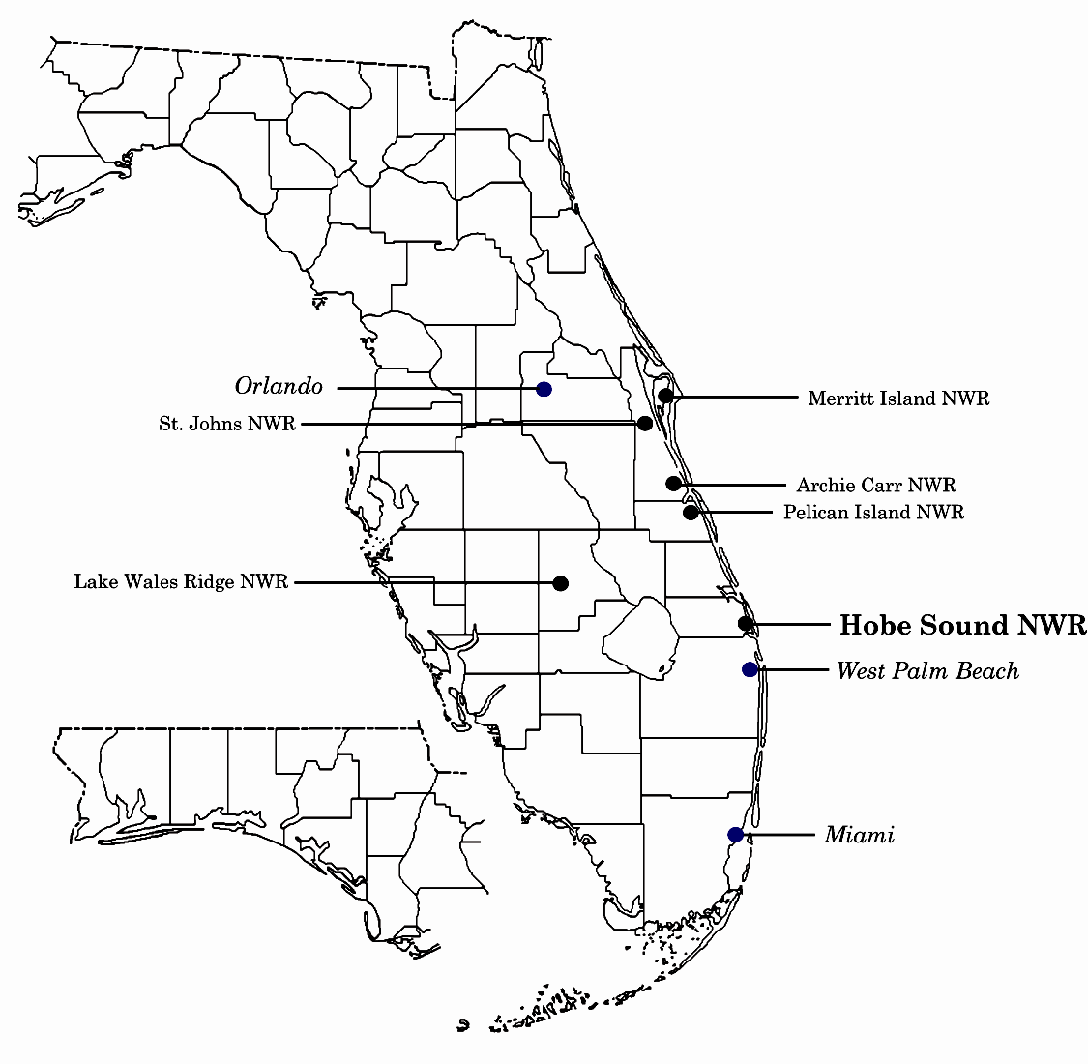

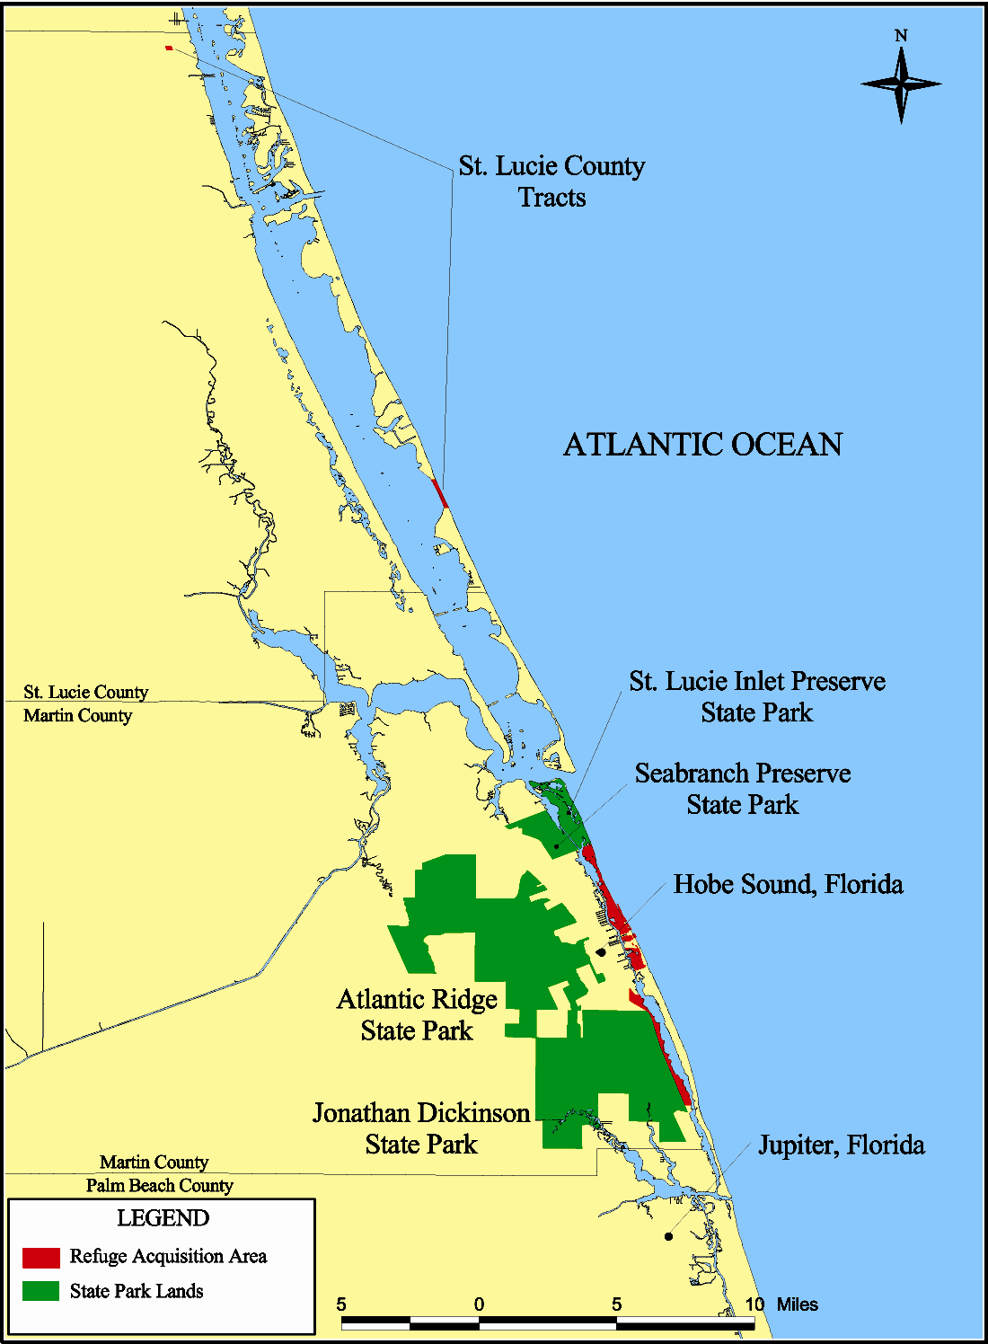
Figure 2. Location of Hobe Sound National Wildlife Refuge in relation to adjacent state lands
A close-up view shows that the refuge is bisected by the Indian River Lagoon into two tractsBa Mainland Tract and the Jupiter Island Tract (Figure 3). The Mainland Tract is bordered on the west by U.S. Highway 1 and Jonathan Dickinson State Park, on the east by the Indian River Lagoon, and on the north and south by private landowners. The Jupiter Island Tract shares its northern boundary with St. Lucie Inlet Preserve State Park and its southern boundary with private landowners.

The portions of the Indian River Lagoon adjacent to the refuge are more commonly known as Hobe Sound, Peck Lake, and the Intracoastal Waterway. The Indian River Lagoon, which is
inhabited by the endangered West Indian manatee, has been designated as an estuary of national importance. Major threats to the lagoon=s ecosystem are excess nutrients, sediment loads, and toxic chemicals associated with intensive development along its shores (Figures 4 and 5).

The refuge was established in 1969, through the foresight and generosity of the Joseph V. Reed Family and other Jupiter Island residents, with an approved acquisition boundary of approximately 400 acres. The refuge originated from its designation as the Reed Wilderness Seashore Sanctuary and its National Landmark status in 1967. Today, the refuge consists of more than 1,000 acres, including the 300-acre Mainland Tract and the 735-acre Jupiter Island Tract. Most of the refuge was donated by private citizens and The Nature Conservancy primarily for the conservation of threatened and endangered species and preservation of undeveloped vistas.

The refuge provides habitat for nearly 40 species listed as either threatened, endangered, or species of special concern by the state or federal government. Of particular importance to these species is the largest remnant of sand pine scrub habitat, the nearly 10 miles of mangrove communities along the Indian River Lagoon, and 3.5 miles of Atlantic Ocean beach. This beach is one of the most productive sea turtle nesting areas in the southeastern United States.

Refuge Purposes

As indicated in the legislation authorizing the establishment of the refuge, and in land acquisition authorities and documents, the conservation of threatened and endangered fish, wildlife, and plants is paramount. Development of fish and wildlife-oriented recreational opportunities must consider this conservation mandate.

The refuge was established A...to conserve (A) fish or wildlife which are listed as endangered species or threatened species... or (B) plants....@ 16 U.S.C.1534 (Endangered Species Act of 1973); A...suitable for (1) incidental fish and wildlife-oriented recreational development, (2) the protection of natural resources, (3) the conservation of endangered species or threatened species....@ 16 U.S.C. 460K-1 (Refuge Recreation Act of 1962); A...for use as an inviolate sanctuary, or for any other management purpose, for migratory birds.@ 16 U.S.C. 715d (Migratory Bird Conservation Act of 1929); A...conservation, management, and restoration of the fish, wildlife, and plant resources and their habitats for the benefit of present and future generations of Americans.@ (16 U.S.C. 668dd(a)(2) (National Wildlife Refuge System Administration Act of 1966); A...for the development, advancement, management, conservation, and protection of fish and wildlife resources.@ 16 U.S.C. 742f(a)(4) (Fish and Wildlife Act of 1956).

This purpose and the mission of the National Wildlife Refuge System are fundamental to determining the compatibility of proposed uses of the refuge. The compatibility of these uses is discussed in Appendix VI.

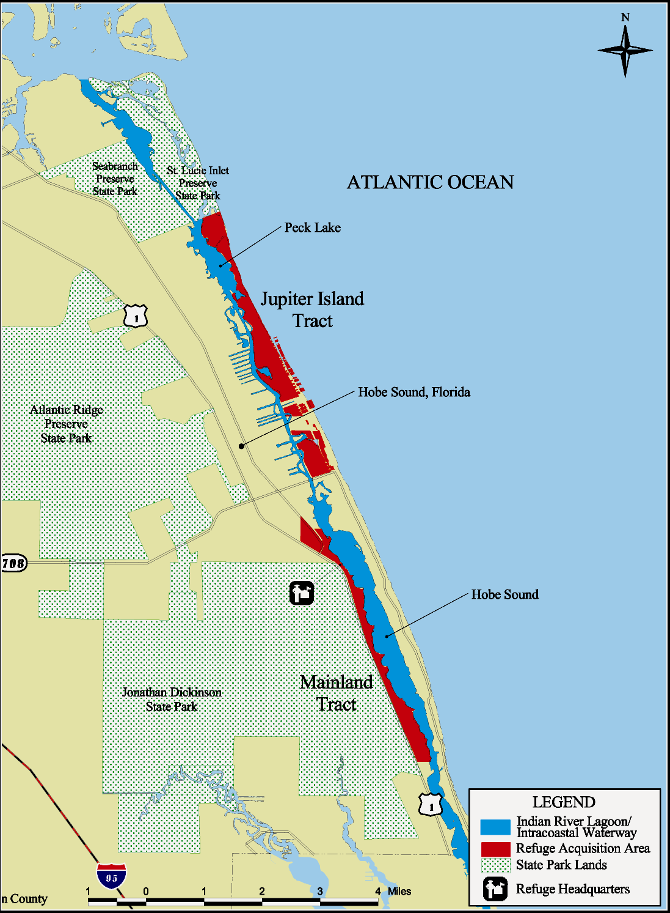
Figure 3. Location of Jupiter Island and mainland tracts of Hobe Sound National Wildlife Refuge in relation to Indian River Lagoon/Intracoastal Waterway
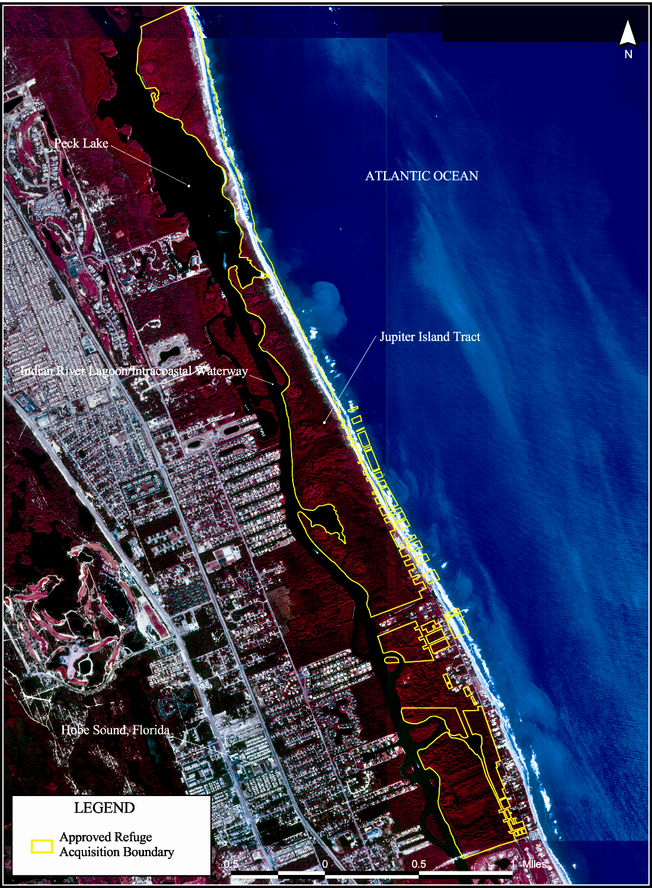
Figure 4. Jupiter Island tract of Hobe Sound National Wildlife Refuge and the Indian River Lagoon, in the context of community development
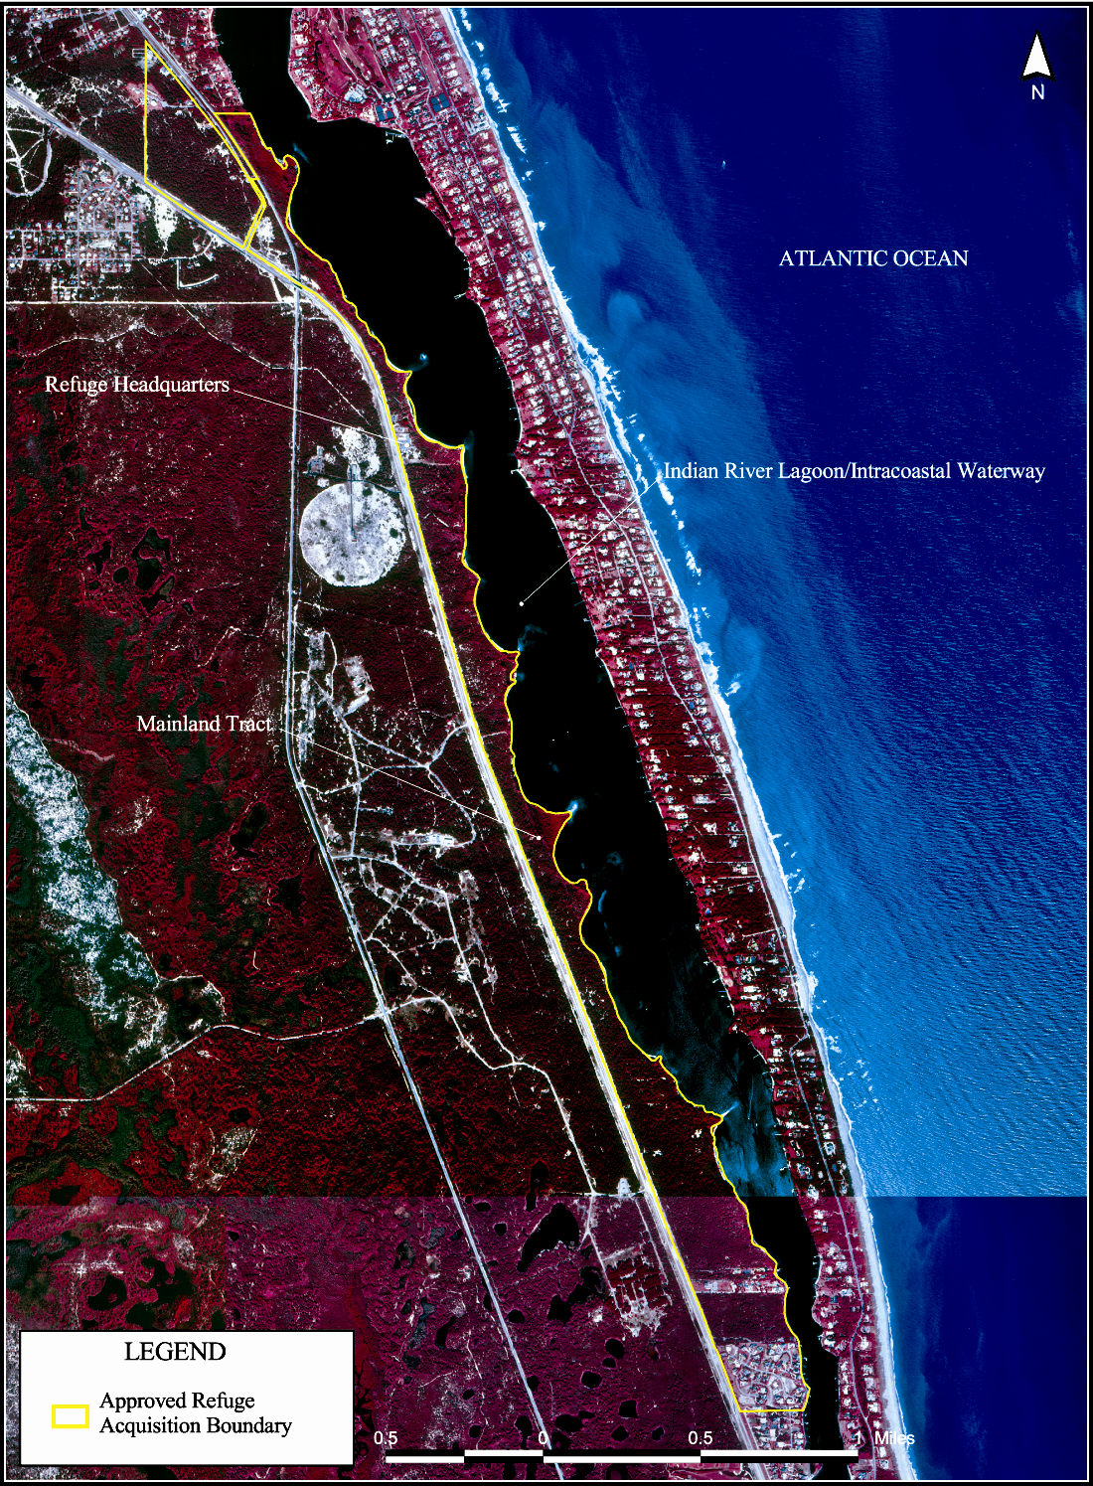
Figure 5. Mainland tract of Hobe Sound National Wildlife Refuge and the Indian River Lagoon,in the context of community development
Facilities

The headquarters area, the main entrance to the refuge, is 2 miles south of County Road 708 on U.S. Highway 1 (Figure 3). Under construction at this time, the headquarters of the refuge will consist of a new administration and visitor center building, an environmental education classroom, two residential buildings, and a maintenance building. Located at this site is a Seminole chickee (an open pavilion), which serves as an environmental study and staging area for visitors who use the sand pine scrub trail or access trail to the Indian River Lagoon.

The original administration building, constructed in the 1950s as a motel, was destroyed during the 2004 hurricane season. It provided limited space for refuge personnel and the Hobe Sound Nature Center, Inc. Established in 1973, the Hobe Sound Nature Center is a non-profit environmental education organization and a cooperating association of the refuge. The new headquarters will
contain office space for both the refuge staff and Nature Center personnel, as well as a larger interpretive museum for the public. The Jackson Burke Education Center was constructed in 1998, with funds raised by the Nature Center. The Nature Center is actively involved in public outreach programs, which support and foster the refuge. Due in large part to this relationship, the refuge enjoys a great deal of public support.

The refuge beach, the second entrance to the refuge, is located on Jupiter Island approximately 1.5 miles north of the intersection of County Road 708 and North Beach roads (Figure 3). This entrance contains a paved parking lot, entrance fee booth, primitive restroom facilities, two dune cross-over boardwalks, and a foot trail to the beach.

Staffing and Funding

Hobe Sound Refuge is a minimally staffed satellite of the A.R.M. Loxahatchee National Wildlife Refuge in Boynton Beach, Florida. The Hobe Sound Refuge staff is made up of three permanent employees: a manager, a law enforcement officer, and a maintenance worker. The staff is supplemented by seasonal positions, including a biological technician, maintenance worker, and two fee rangers. The refuge shares its budget with Loxahatchee Refuge, which in Fiscal Year 2006 totaled over $4 million for payroll and operation needs, and an additional $8 million in special or one-time funding. Hobe Sound Refuge operates on approximately $225,000 per year.

Ecosystem and North American Context

Role of the Refuge in the South Florida Ecosystem

In recognition of the ecosystem complexity in south Florida, a South Florida Ecosystem Plan was completed by the Service=s South Florida Ecosystem Team (Fish and Wildlife Service 1998). This plan identified the goals, objectives, and strategies for this ecosystem and the major issues associated with eight ecosystem sub-regions. The plan is one of the first such efforts specifically targeted at recovering multiple species over a large geographic area. Management activities on the refuge, located in the Upper East Coast Ecosystem Subregion (Figure 6), are consistent with the South Florida Ecosystem Plan. These activities include the reduction of exotic and invasive species; enforcement of laws to protect wildlife resources on the refuge; coordination with other agencies regarding the Intracoastal Waterway and its many issues; promotion of public awareness about the imperiled scrub ecosystem; provision of appropriate wildlife-compatible recreation; and, maintenance of facilities and equipment at or above Service standards.

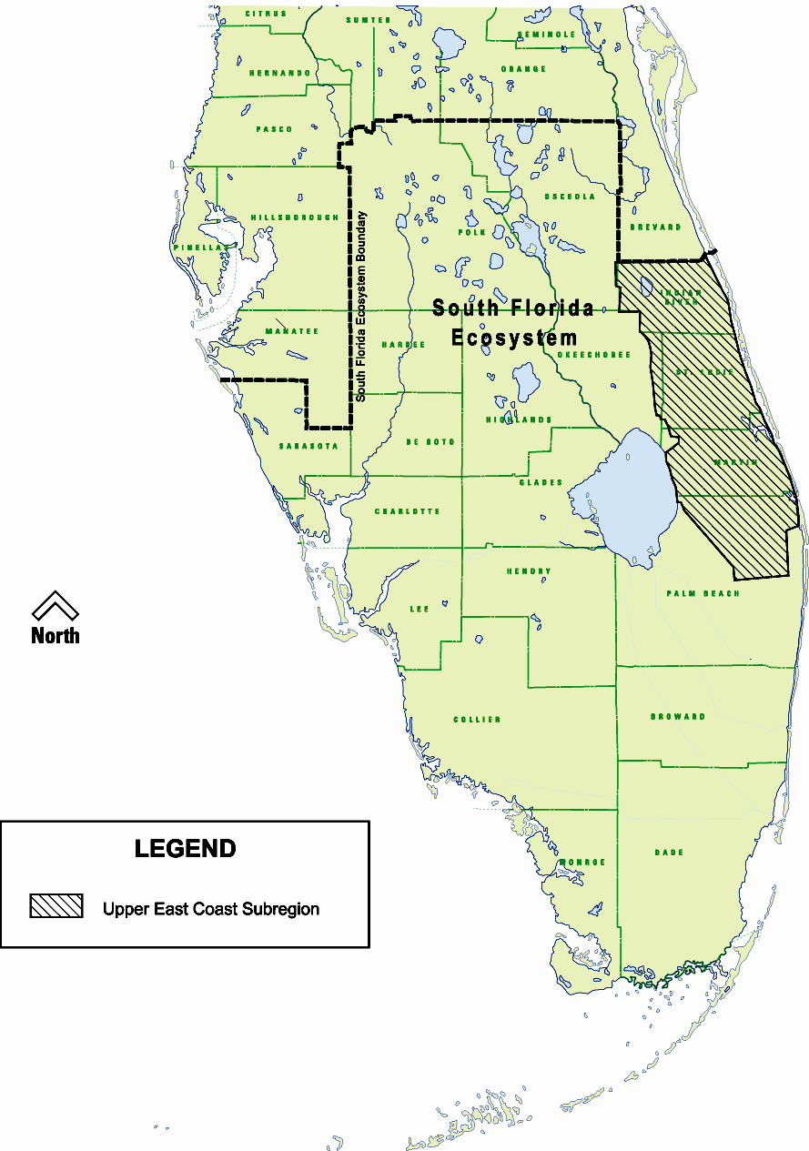
Figure 6. Upper east coast ecosystem subregion within the South Florida Ecosystem
The refuge is represented on the South Florida Ecosystem Team, which is comprised of Service field stations in an area from Vero Beach, south to the Florida Keys, and west to Ft. Myers. This diverse team works together to accomplish Service priorities, which include protection and management of federal trust species through the sharing of skills, expertise, equipment, and personnel for special projects.

Recently, the refuge has taken a more active role in partnership efforts to protect and enhance habitats and wildlife, both on and off the refuge. Staff have participated on committees to heighten public awareness of the following: feral cat impacts on wildlife; damaging effects of bright lights on sea turtle nesting success; damaging and costly problems caused by exotic animals and plants; actively managing the imperiled coastal scrub plant community; and efforts to enhance the dwindling estuarine habitats and seagrass beds.

Since more than 91 percent of endemic scrub habitat has been lost from south Florida, active management of refuge=s scrub is vitally important to the multi-species approach to ecosystem management. In recent years, the staff has improved working associations with other natural resource agencies. This concentrated effort established new partnerships and has directly benefited the refuge=s ability to manage the scrub habitat as a part of a landscape mosaic, instead of as an isolated tract. This encompassing foresight will improve scrub conditions on the refuge and on other undeveloped lands where the refuge may have cooperative agreements in the upper coast of south Florida.

Role of the Refuge in Restoration of the Indian River Lagoon

The Intracoastal Waterway immediately bordering the Hobe Sound Refuge headquarters is one of the most productive and species-rich portion of the Indian River Lagoon, which is considered the most productive estuary in the United States. North of the headquarters, the lagoon drains into the Atlantic Ocean at the St. Lucie Inlet, where the refuge beach tract is located. To the south of the refuge, the lagoon connects to the Atlantic Ocean at Jupiter Inlet. The draining of the Everglades in the early 20th century resulted in large freshwater flows into the lagoon, wreaking environmental havoc. An interagency study of the restoration of the southern portion continues, which is focused on reducing the amount of Lake Okeechobee water reaching the lagoon. In addition, a number of agencies monitor the lagoon for turbidity, chemical contamination, and saline levels. The refuge staff helps state agencies monitor public use of these waters. This cooperation enhances wildlife protection along refuge shores. See Chapter III for a discussion on water quality in the lagoon and surrounding waters.

Partners-In-Flight Program

Diminishing numbers of migratory birds (Hagen and Johnston 1989; Finch and Stengel 1992) stimulated the formation of Partners-In-Flight, an international organization to address the needs of non-game migratory birds. The Service is a member of the Partners-In-Flight Program, which includes coordination among federal, state, and non-governmental agencies; industry; and conservation groups to promote research, land protection, and education about migratory birds. The refuge is part of the Atlantic Flyway, one of the primary migratory routes of bird species that breed in temperate North America and winter in the tropics of the Caribbean and South America. More than 116 species of neotropical migratory birds have been recorded passing through the South Florida Ecosystem. More than 129 bird species migrate to the ecosystem to overwinter, and another 132 species breed in the ecosystem. Because this ecosystem is located near Cuba and the West Indies, it draws Caribbean species that rarely appear elsewhere in North America.

In 1995, the Service prepared a list of migratory non-game birds of management concern in the United States. This was done to stimulate a coordinated effort by federal, state, and private agencies to develop and implement comprehensive and integrated approaches for managing selected species. The South Florida Ecosystem supports many of these species (Appendix IV).

The refuge=s mangroves and sand pine scrub provide important feeding and resting areas for neotropical migratory birds, including the common yellowthroat (Geothlypis trichas), Cape May warbler (Dendroica tigrina), blackpoll warbler (Dendroica striata), Connecticut warbler (Oporornis agilis), yellow-billed cuckoo (Coccyzus americanus), and black-whiskered vireo (Vireo altiloquus). (Roberts and Tamborski 1993; Rare and Endangered Biota of Florida 1996). In 2006, Hobe Sound Refuge was made a part of the South Florida Birding Trail.

National Shorebird Conservation Plan

The refuge is in the Southeastern Coastal Plains/Caribbean Region, one of twelve regions in the U.S. Shorebird Conservation Plan. For some species of shorebirds designated as high priority in the Florida Peninsula, the refuge provides feeding and resting areas, as well as nesting habitat during migration (Figure 7). For example, the endangered piping plover, uncommonly seen on the refuge, uses it as a stopover site during fall and spring migration. Although the refuge is not designated as a strategic migrational site by the Western Hemisphere Shorebird Reserve Network, the refuge contributes survey data to the network.

Figure 7. High priority bird species abundance and seasonal use, Hobe Sound National Wildlife Refuge

High Priority Species* | Relative Importance of  Southern Coastal Plain** | Abundance and  Seasonal Use of Refuge
Piping Plover | B, M, W | Uncommon, Spring, Fall, Winter
American Oystercatcher | B, W | Occasional, Winter
Wilson=s Plover | B, W | Uncommon, Winter  Common, Spring, Summer, Fall
Buff-breasted Sandpiper | M | Not Observed
Marbled Godwit | M, W | Rare
Solitary Sandpiper | M | Not Observed
Stilt Sandpiper | M, W | Not Observed
Semi-palmated Sandpiper | M | Observed
Short-billed Dowitcher | M, W | Common, Winter
*Categories Ia and Ib, Highest and High Priority Species, Subtropical Florida and Peninsular Florida Partners-in-Flight Bird Conservation Plans: Section 2: Avifaunal Analysis.
**Brown, S., C. Hickey, and B. Harrington (eds.). 2000. United States Shorebird Conservation Plan. Manomet, MA
Manomet Center for Conservation Sciences. 60p.
B=Breeding; M=Migrating; W=Wintering.
B,M,W=High concentrations, region extremely important to the species relative to the majority of the other regions.

Historically, the state-listed least tern and the Wilson=s plover have traditionally used the Jupiter Island Tract for nesting. The refuge is the southernmost natural area remaining along the eastern Atlantic coast where these birds could successfully nest. However, the loss of the above high tide beach front and vegetation encroachment on the backdune have significantly reduced potential nesting habitat. As a consequence, both species have declined in numbers on the refuge. To exacerbate the plight of these species, some of the best remaining habitat is subject to extensive use by beachgoers, which causes disturbance during the nesting period. With significant effort and funding directed toward providing adequate nesting conditions and reducing human disturbance, it is believed that the refuge could make an important contribution toward population increases.

North American Waterbird Conservation Plan

The Waterbird Conservation for the Americas initiative was launched in 1998, to provide a continental framework and guide for conserving waterbirds of North America, Central America, and the Caribbean. A product of the initiative is the North American Waterbird Conservation Plan (James A. Kushlan et. al., 2002). The plan provides for the conservation and management of 210 species of waterbirds, including seabirds, coastal waterbirds, wading birds, and marsh birds. The refuge contributes to the implementation of this plan by providing potential habitat for the little blue heron, tricolored heron, reddish egret, white ibis, and wood stork.

Atlantic Coast Joint Venture and Florida Waterfowl Focus Areas

Since the first settlers arrived, more than 50 percent of the United States= original 220 million acres of wetlands, upon which waterfowl depend, have been destroyed, often causing dramatic declines in numerous waterfowl populations.

Recognizing the importance of waterfowl and wetlands to North America and the need for international cooperation to promote their well-being, the Canadian and United States governments developed a strategy to restore waterfowl populations to 1970s= levels through habitat protection, restoration, and enhancement. The strategy was documented in the North American Waterfowl Management Plan, which was signed in 1986 by the Canadian Minister of the Environment and the United States= Secretary of the Interior. This plan identified important waterfowl habitat areas, established habitat and population goals, and established interstate/international partnerships, called joint ventures, to implement plan goals.

In 1997, the Atlantic Coast Joint Venture continued to build upon its firm foundation as Florida became its 17th state partner. Hobe Sound National Wildlife Refuge is part of the Atlantic Coast Joint Venture. Additionally, the northern end of the Jupiter Island Tract of the refuge lies proximate to Upper St. Johns and Adjacent Coast Focus Area, a waterfowl focus area delineated by the State of Florida. Contained within this Focus Area is the Indian River Lagoon/Intracoastal Waterway, which is considered an important resource for wintering waterfowl in Florida. The lagoon provides habitat for waterfowl, such as green-winged teal, mottled duck, mallard, northern pintail, American wigeon, ring-necked duck, and lesser scaup. While the refuge does not have jurisdiction over the Indian River Lagoon, collaboration with federal and state agencies to improve and maintain the quality of its habitat contributes toward meeting the goals of the North American Waterfowl Management Plan.

National Bird Conservation Initiative

The National Bird Conservation Initiative is a vision for the future of bird conservation in North America. In the United States, this initiative evolved out of recognition among conservationists of the value of coordinating and integrating the conservation planning, implementation, and evaluation efforts to achieve a comprehensive, landscape-oriented approach to conservation.

Out of this collaboration has come an over-arching framework for integrating the conservation of all birds across all habitats under the National Waterfowl Management Plan, Partners-In-Flight Plan, U.S. Shorebird Conservation Plan, and the National Waterbird Conservation Plan. Recently, the Atlantic Coast Joint Venture Office, associated with the North American Waterfowl Management Plan, has begun planning and implementing Aconservation of all birds across all habitats@ in several bird conservation regions identified by the National Bird Conservation Initiative.

Hobe Sound Refuge is in the Peninsular Florida Bird Conservation Region. Mentioned as priority species in the National Bird Conservation Initiative, for which Hobe Sound Refuge (or adjacent lands and waters) provides potential habitat, are the Florida scrub jay, swallow-tailed kite, short-tailed hawk, wood stork, brown pelican, limpkin, black skimmer, tern, black-whiskered vireo, lesser scaup, ring-necked duck, mottled duck, short-billed dowitcher, piping plover, dunlin, and red knot, as well as a variety of herons and egrets.

Legal and Policy Guidance

In addition to the refuge=s authorizing legislation and the National Wildlife Refuge System Improvement Act of 1997, the legal and policy guidance for the operation of national wildlife refuges is contained in some of the more important documents or Acts listed below. For a description of policies and key legislation, see Appendix III.

- Executive Order 1312- Invasive Species (2/3/99)
- National Wildlife Refuge System Improvement Act of 1997
- National Wildlife Refuge System Administration Act of 1966 (16 U.S.C. 668dd-668ee)
- Refuge Recreation Act of 1962 (16 U.S.C. 460k-460k-4)
- Title 50 of the Code of Federal Regulations, Subchapters B and C
- Refuge Manual
- Fish and Wildlife Service Manual
- Endangered Species Act of 1973 (16 U.S.C. 1531-1543)
- Migratory Bird Conservation Act of 1929 (16 U.S.C. 715-715d)
- Migratory Bird Hunting and Conservation Stamp Act (16 U.S.C. 718-718h)
- Migratory Bird Treaty Act of 1918 (16 U.S.C. 703-712)
- National Environmental Policy Act of 1969 (PL 91-190, 42 U.S.C. 4321-4347)
- Bald Eagle Protection Act of 1940 (16 U.S.C. 668-668d)
- American Indian Religious Freedom Act (P.L. 95-341, [1978], 92 Stat. 42 U.S.C.1996)
- Antiquities Act (P.L. 59-209, approved 6/8/1906, 34 Stat. 225, 16 U.S.C. 431-433)
- Archaeological Resources Protection Act (P.L. 96-95 [10/31/1979], as amended by P.L. 100-555 [10/18/1988] and P.L. 100-588 [11/3/1988], 93 Stat. 721, 16 U.S.C. 470 aa et seq.)
- Archaeological and Historic Preservation Act (P.L. 93-291 [1974, 88 Stat. 1974], amending Reservoir Salvage Act, 16 U.S.C. 469)
- Executive Order 13007 - Sacred Sites (5/24/1996)
- National Historic Preservation Act (P.L. 89-665 [1966], 80 Stat. 95, as amended by P.L. 96-515 [1980], 94 Stat. 2987; P.O. 102-575 Title 40 (1992), 106 Stat. 4600)
- Native American Grave Protection and Repatriation Act (P.L. 101-601 (1990), 104 Stat. 3048, 25 U.S.C. 3000-3013, 18 U.S.C. 1170)
- Marine Mammal Protection Act of 1972, as amended (16 U.S.C. 1361-1421h)
- National Fire Plan
- Lacey Act of 1900 (16 U.S.C. 667E, 701; 18 U.S.C. 42-44; 62 Stat. 285), as amended
- Executive Order 11987 (1977) - Exotic Organisms

In addition to the Fish and Wildlife Service Manual, important policies influencing refuge planning and management include:

- Compatibility Policy (2002);
- Biological Integrity, Diversity, and Environmental Health Policy (2001); and
- Draft Land Acquisition Planning Policy (2001).

A vision document entitled AFulfilling the Promise@ now guides the National Wildlife Refuge System and was used in the development of this comprehensive conservation plan. The vision document states the following beliefs of the Fish and Wildlife Service:

- Refuges are places where wildlife comes first;
- Refuges are anchors for biodiversity and ecosystem-level conservation and the system is a leader in wilderness preservation;
- Lands and waters of the system are biologically healthy and secure from outside threats;
- The Refuge System is a national and international leader in habitat management and a center for excellence where the best science and technology are used for wildlife conservation;
- Strategically located lands and waters are added to the Refuge System until, in partnership with others, it represents America=s diverse ecosystems and sustains the nation=s fish, wildlife, and plant resources;
- The Refuge System is a model and demonstration area for habitat management, which fosters broad participation in natural resource stewardship.

II. Planning Issues and Opportunities

“…and perhaps the most remarkable part of their generosity was the raising of money to purchases the mile of land just north of the southern end of Jupiter Island for The Nature Conservancy and later to the Interior Department of five hundred acres on the north end of the island in 1976.”
Permelia Reed

Introduction

Creating a vision of the future for the Hobe Sound National Wildlife Refuge came easily for some and more cautiously for others. Although comprehensive conservation planning officially began in 1998, this was preceded by visioning in the implementing legislation and the establishment authority of the refuge in 1969. Honoring this legacy and early in the development of this plan, the pre-planning team, made up of Fish and Wildlife Service personnel, identified issues and opportunities that were likely to be associated with future management of the refuge. This list was derived from team knowledge, meetings with intergovernmental partners, a public scoping meeting, and written comments submitted by the public. This document allows all who participated in the process, as well as those who are newcomers to the process, to gaze once again into the future and glimpse what the refuge can and should be.

Identifying the Issues

The public scoping meeting, held on August 18, 1998, at the Hobe Sound Civic Center, provided the public with an opportunity to assist the refuge in identifying issues and concerns. Approximately 70 people were in attendance at the meeting. Following a 15-minute presentation concerning the refuge, attendees were divided into small groups, with the group discussions facilitated by a consultant and planning team members. The comments of each group, following a structured format, were recorded on flip charts. While some of the comments are significant to the future of the refuge, many are not within its sole jurisdiction and others are completely outside its jurisdiction.

Responses to comment sheets, distributed at the public scoping meeting and at the refuge, and handwritten letters on postcards provided information on issues and concerns of importance to the public. The comment packet and a summary of the comments can be found in Appendix V.

The excitement and enthusiasm of the participants cannot be easily imparted. In some cases, good suggestions have already been implemented. The alternatives considered for managing the refuge incorporated many of these issues and concerns.

The issues of main concern to the public were categorized into wildlife habitat management, recreation, education and public awareness, partnerships, historical resources, and administration.

Wildlife Habitat Management

- Restore and manage species and the habitats they occupy so that the native biodiversity of the refuge is enhanced. Many citizens expressed a desire for biological surveys and inventories to monitor plant and animal species on the refuge, especially those listed as threatened and endangered. A few attendees were particularly concerned with the management of the least tern nesting colonies on the Jupiter Island Tract.

- Reduce and/or eliminate exotic species from the refuge. Most of the participants wanted the Australian pines removed from the barrier island (to support sea turtle nesting) and from the shoreline. They were also concerned about Brazilian pepper and Old World climbing fern. Some present wanted to see the refuge staff consider alternative control methods for invasive species. A number of citizens wanted to see the areas of the refuge impacted with exotics restored to their natural states by physically removing the exotics and replanting with natives. A few expressed concern that only exotics be removed and the native plants be left alone, and that aesthetics should be considered and large strands of dead trees removed. Some also wanted to see an increased effort to remove exotic animals from the refuge.

- Address sea turtles by protecting, restoring, and managing their habitat through means such as habitat acquisitions, limiting or eliminating lights (e.g., floodlights and street lights on North Beach Road) during hatching season, and increasing law enforcement to prevent poaching. Many people felt the refuge should help educate the local community about lights on the beach during the sea turtle nesting season. A few disapproved of night-time turtle walks, stating the turtles should be left alone while laying their eggs. Others wanted to see the development of volunteer groups to protect hatchlings and help guide them to the water. Others were concerned about the mammalian predation of sea turtle nests, and wanted to see the predator population controlled. Still others wished to see an increased level of sea turtle monitoring, and also habitat restoration and acquisition of additional habitat.

- Consider the use of prescribed burns to enhance habitat and manage fuel loads, especially the sand pine scrub area on the mainland. Many people stated that the refuge has not burned, either by prescribed burn or wildfire, for a number of years and would like to see a prescribed burn implemented in the sand pine scrub to provide optimal scrub jay habitat, and also to help the sand pines regenerate. Many citizens are concerned about the possibility of catastrophic wildfire if the refuge does not actively reduce the fuel load by prescribed burns and/or mechanical treatments.

- Expand refuge resources by acquiring adjacent land and the management authority of offshore resources, possibly in conjunction with St. Lucie Inlet Preserve State Park. Some of the citizens would like to see the refuge obtain the U.S. Coast Guard property near the refuge boundary on the island and actively manage it for sea turtle habitat, control of exotics, and to conduct other needed habitat management activities. A few suggested refuge management should try to acquire management authority of offshore resources, possibly in conjunction with St. Lucie Inlet Preserve State Park. Others would like to see the Service enforce boating use and speeds and provide more manatee protection.

Public Use: Recreation

- Enhance the public=s use of the beach by providing more public access and more amenities and by maintaining boat access to Peck Lake. Many people requested more public access to the refuge beach, in particular, the Peck Lake area. These citizens would like the Peck Lake access to remain open to boaters and beach users, and the trails maintained leading from the lake to the ocean. A wildlife observation platform at Peck Lake was requested. A few wanted a section of the beach designated for surfers, while others asked that a section be allotted for clothing-optional sunbathing. The crowd seemed to be split on the issue of personal watercraftBsome requested that it be outlawed, while others did not want restrictions on any vessel. Several citizens requested upgrades to the beach facilities. Many would like a permanent, state-of-the-art bathroom facility and outside showers. A few asked for picnic pavilions and still others expressed concern about impacts of increasing public use at the beach. The latter group expressed that they like the remoteness of the beach, and do not want to see the parking lot expanded. One group requested that attaining a beach pass be made easier.

- Allow boating, surf fishing, and more fishing access on the mainland and consider installing a dock and inlets at Peck Lake. Many in attendance requested more fishing access to the Indian River Lagoon along the mainland. Some requested a dock at Peck Lake, while others opposed such additions and any plans for a future walkway constructed from the Jupiter narrows to the refuge. A few asked that no anchoring restrictions be imposed.

- Keep the refuge cleaner and expand the ways the public could assist in trash removal efforts. A number of citizens expressed concern about litter on the refuge. Some suggested a volunteer task force, or perhaps the local boys scout troop could perform regular clean-ups. Others asked that more trash receptacles be placed on the refuge. Several suggested posting ATRASH IN - TRASH OUT@ signs, while others mentioned providing trash bags so people could pick up trash as they enjoy the refuge. Some think the refuge should provide plastic bags and scoops for pet owners. A few mentioned that the Center for Marine Conservation (now called The Ocean Conservancy) is performing a 5-year litter survey, and think that the refuge should be added to this survey.

- Support recreational and educational uses, as long as commercial recreation is not allowed. Hunting and fishing must have a minimal impact on the environment. Many of those present did not want to see commercialization on the refuge. Some were also concerned about what possible negative impacts hunting and fishing would have on the refuge and would like to see such activities kept to an absolute minimum. (Because of the proximity of refuge lands to people, hunting is not allowed.)

- Make the refuge accessible for only those human uses that are compatible with the refuge=s native wildlife. Some stated concerns about overuse of the refuge. They enjoy the quietness of the refuge and do not want to see it spoiled. They do not want to see night access or camping on the refuge. They want refuge management to quantify visitor impacts and determine the refuge=s human carrying capacity. Many feel dogs should be leashed at all times, while others feel dogs need only be under control but not necessarily leashed. Other citizens requested that more of the refuge be open to visitors in appropriate areas.

- Support hiking by lengthening existing nature trails, installing more trails in other parts of the refuge, and installing more signs that identify plants and describe the natural area.

- Many stated the need for more than one nature trail. They would also like the trails to be longer and to have more interpretive signs identifying significant plants and facts about the surroundings. Some stated that the nature trails are excellent as they are now.

- Preserve current uses like shelling and expand to include a permanent restroom facility, high water markers to record storm surges, and better access for canoes. A few people stated a request for better canoe and kayak access to the island. Some would like high water markers to record past, present, and future storm surges.

- Maintain the refuge=s beach tract and renourish the beach. Some stated the need for beach renourishment in order to stabilize the refuge beach and prevent erosion caused in large part by the St. Lucie Inlet. In kind, prevent Abreak through@ caused by storm surges at the Peck Lake area. A few opposed beach renourishment. Others asked that the mosquito impoundments and spoil sites be restored.

Public Use: Education and Public Awareness

- Enhance environmental education by increasing the amount of programs that target population niches such as: children and their families, schools, senior citizens, youth camps, and adult education classes. Many would like to see enhanced public education. They suggested conservation summits for children and families to help children learn about the environment. Others would like to see public education trails developed specifically for children. Some suggested special programs in middle schools for students who might be interested in volunteering at the refuge and given the rank of AJunior Ranger.@ Some citizens requested more education to address problems rather than levying fines (e.g., a kiosk about what litter does to the environment instead of fining offenders). A few stated that the current Nature Center is doing an excellent job.

- Increase the number of interpreters, provide more printed interpretive information, increase the number of trails used for interpretation events, and expand to provide more events during the evenings and on weekends. Many citizens requested more interpretive signs on the nature trail and headquarters area. Several in attendance requested evening and weekend programs to accommodate those who work during the weekdays. Some also wanted an interpretive trail through the mangroves near the beach parking lot. Many also stated the need for additional turtle walks to accommodate more people.

- Increase publicity by creating a management plan, which advertises the refuge through all media formats. Create more refuge pamphlets and add directional signs to the refuge. Some stated that the refuge needs to be more visible in the community by adding links to its Internet web page, and the interpretive programs should be more heavily advertised. Others expressed maintenance and restoration work should be advertised so the public would be aware of and support such activities. Also, many feel the public should be made aware of the various passes available to the refuge.

Partnerships

- Create cooperative relationships with other agencies and the community for joint projects.

- A few at the meeting stated local environmental organizations need continuity of management plans. Some want to see the restriction of jet skis by joint agency coordination, while others say there should be no restriction of any vessel. A few citizens suggested the refuge cultivate partnerships with volunteers, inmates, and local civic groups.

Historical Resources

- Conduct archaeological surveys prior to beach renourishment, preserve the shell mounds on the mainland, and devote a section of the local library to historical information about the refuge. Some at the meeting suggested that the ancient shell mounds on the refuge need to be preserved. Others requested a library devoted to local history be started at the refuge. A few people expressed a desire for archaeological surveys on the refuge, especially prior to beach renourishment projects. Still others requested the restoration of the sand mine on the mainland section of the refuge (near the intersection of U.S. Highway 1 and Dixie Highway).

Administration

- Increase the number of staff (all classifications) and volunteers to provide more recreational opportunities, wildlife habitat management, educational programs, and eradication of exotics. Some stated concerns that the refuge needed a larger staff to efficiently care for all the needs of the refuge and its visitors. Others requested Aproactive@ refuge management, while others felt that the refuge manager should keep accurate written records to provide continuity for successive managers to address the unique characteristics of the refuge.

- Improve refuge headquarters= accessibility by improving existing ramps, providing more signs at refuge headquarters, and providing directional signs on Interstate 95 and the Florida Turnpike. Many requested that more signs be posted on local roadways to make locating the refuge easier. Others asked that the refuge be maintained as accessible as possible, and requested that the existing handicap ramps be improved. Some present would like the fire lanes posted as access to the Intracoastal Waterway for fisherman. Still others requested that the parking lots not be expanded, but the refuge should supply transportation from remote areas as needed. Several people stated that the refuge should create partnerships with other local agencies and provide connecting sidewalks/bike paths/roller blade paths to get to the refuge.

- Maintain safety of refuge users and the environment by implementing such measures as providing lighting at the headquarters parking lot, installing an emergency phone at headquarters and fee booth, developing a plan for an oil spill or hazardous waste response, and developing an action plan to remove safety hazards (e.g., abandoned wells and structures). There was concern about the safety hazard posed by derelict wells and other abandoned structures on the refuge. Some would like to see the refuge implement a hazardous waste emergency response plan.

- Restrict any land swaps of refuge lands because the land was provided for the refuge and not for other uses. Consider purchasing land adjacent to the refuge to create green ways. Many people felt strongly about the issue of the refuge considering land swaps with local landowners. Most felt the current refuge property needs to remain undeveloped and managed for its original purpose of wildlife habitat. Others would like to see the refuge acquire more land surrounding its boundary to create buffer zones and green ways between it and developed lands.

- Upgrade the refuge=s public facilities, including the headquarters building and visitor center. The new building must be constructed in a manner that maintains the look of the refuge. If new buildings are constructed, they should be an integral part of the land. Many people commented on the need to upgrade the refuge=s facilities, but they also urged caution about overbuilding. They stressed that a new headquarters building should blend well with the surroundings and be landscaped with aesthetics in mind. A few citizens stated that the only necessary development needed on the refuge is to expand the beach parking lot.

Significant Refuge Issues

Utilizing the issues identified by the public and by Service staff, the core planning team identified those issues most significant to the refuge over the 15-year life of the comprehensive conservation plan. These issues include visitor use, resource protection, and administration.

Visitor Use

As with so many other refuges in the system, Hobe Sound Refuge is faced with a growing demand for visitor use. Historically, the refuge has maintained a Afavorable@ balance between wildlife protection and visitor use. However, as the human population in south Florida increases, so does the demand for outdoor recreation; further stressing its natural communities. During the public scoping meeting, many people identified a desire for improved facilities, better access, and additional recreational activities on the refuge. Many areas that could serve as new trails require access along North Beach Road on Jupiter Island. This will present difficulty for some private property owners who are concerned about the traffic flow along this narrow access road, which serves as the only vehicular access for the refuge to its 735 acres on Jupiter Island.

Although the refuge will not compromise the protection of the ecosystem, numerous opportunities exist to enhance the visitor experience without impacting the resources. More opportunities for visitor use will be available upon completion of the new refuge headquarters and visitor center. The facility will include an environmental learning center with interpretive displays and a gift shop.

Resource Protection

Invasive Species

“Today, the island is almost completely masked out by a seemingly solid, high hedge of Casuarinas. These trees were not planted until 1916; prior to that time one could have viewed the island in an unbroken sweep.”
Joseph V. Reed

Many hazards threaten the integrity of the delicate South Florida Ecosystem, and perhaps none are as ominous as those imposed by invasive exotic plants. Within the refuge, these invaders threaten to displace two of three natural communities. The Atlantic Coastal Dune, which supports some of the most productive sea turtle nesting areas in the nation, is under constant threat of colonization by Australian pines. This species is very salt tolerant and can rapidly overtake the foredune. The tall bushy trees shade the dune eliminating conditions favorable for plants that stabilize the dune. Without a vigorous control effort by refuge staff and/or contractors, the coastal dune community would certainly be over-run by this and other aggressive species such as Brazilian pepper, beach naupaka, mahoe, periwinkle, rosary pea, and snake plant. The unique hammock communities are very susceptible to being overrun by invasive plants because of their locations, moist microclimate, relatively small sizes, and history of little attention.

Speed Boats and Wakes

A third refuge plant community is also at risk of severe degradation. The mangrove wetland community found lining the shores of the Indian River Lagoon is receding along much of its range on the refuge. High energy wakes spawned from increased boat traffic continually bombard the eroding shoreline. These waves prevent red mangrove propagules from establishing in the soil. Erosion is compounded by the increasing boat traffic in the Intracoastal Waterway, personal watercraft intrusion into shallow waters, the absence of slow speed zones along the refuge, and a lack of enforcement of slow speed zones outside main channels.

The refuge contains a significant acreage of coastal strand and tidal swamp habitats. These habitats will be, and probably already are, affected by ongoing sea-level rise. Predicted rises, based on the research of the Intergovernmental Panel on Climate Change, suggest that a 5 cm sea-level rise in 50 years would exact consequences for the resources, purposes, and objectives of this refuge that would elevate issues, such as boat wakes, to even greater significance.

Within the last few years, increasing evidence of the importance of the Indian River to sea turtles has been documented. Juvenile sea turtles, primarily green sea turtles, utilize the Indian River for early development and are impacted by speeding boats (Bresette et al., 2002).

Although Florida manatees are found at the shores of the refuge property, they live in state jurisdictional waters. However, protection of this species is considered a mandate of the Fish and Wildlife Service. Threats of population declines stem from degraded habitat, specifically seagrass beds, vessel collisions, and natural causes such as red tide. Although the state has implemented the majority of protective measures to address watercraft-related mortality, the enforcement of Aspeed zones@ is addressed at all levelsB-federal, state, and local. Service law enforcement officers, who either work at refuges or are assigned to special details, also enforce the manatee protection zones. Any attempts to minimize effects of boat traffic in the Indian River Lagoon would assist both the recovery of mangrove wetlands, manatee populations, and juvenile sea turtles..

Fire

Coastal sand pine scrub has evolved as a fire-dependent community over the last 100,000 years. Only in recent history have humans occupied the landscape and altered the natural fire regime by standardizing the practice of fire suppression. Though seemingly noble, these intentions have served to not only alter the natural composition of the community, but have also increased the likelihood of catastrophic wildfire. As the trees age, fallen debris (e.g., needles, leaves, and branches) accumulate on the forest floor. This thick carpet is an extremely combustible fuel that, when dry, ignites quickly and burns rapidly.

Attempts to undertake prescribed burning on this landscape have proven extremely difficult due to the very restrictive weather conditions associated with the refuge=s proximity to a federal highway. Mechanical treatment of this sand pine scrub requires evaluation to determine whether it can serve as an adequate substitute for fire unless future prescription will allow closure of the federal highway.

Refuge Boundaries

Today, the refuge exists largely as a compilation of disjunct lots and blocks of land. Much of the property is contiguous, however, the north end of the island and the south end of the mainland appear as a mosaic of public and private lands. Many undeveloped private lots are dispersed throughout the refuge. These in-holdings, some greatly infested with exotic plants, act as seed sources that spread to neighboring natural communities. Consolidating the refuge would provide a contiguous wildlife corridor while preserving the integrity of the natural system. It would enable better and more efficient management activities. These lands have been identified and could be acquired through a variety of means including purchase at fair market value, cooperative agreements, or donations.

Beach Erosion

Since the completion of the St. Lucie Inlet in the late 19th Century, the shoreline south of it has been rapidly eroding. Without our intervention, the northern end of the barrier island could conceivably erode through to the Indian River Lagoon as it did in 1963. Among the more obvious problems associated with this scenario is the loss of one of the most productive sea turtle nesting beaches in Florida.

Beach renourishment and revegetation of the foredune have been used as temporary remedies. Significant evaluation of beach renourishment on sea turtle nesting activities on Jupiter Island has shown thus far that beach renourishment, if conducted properly and using a highly beach compatible sand source, can provide suitable sea turtle nesting habitat and has little effect on the ability of hatchlings to emerge from the nest. Over the years, refinements in beach renourishment techniques have resulted in improved grain size selection, sand borrow site locations, escarpment prevention, and improved placement to avoid and minimize impacts to hard bottom reef communities. Significant evaluation of beach renourishment on sea turtle nesting activities on Jupiter Island has shown thus far that beach renourishment is necessary to provide these turtles with the habitat necessary to sustain their populations, and has little effect on the ability of hatchlings to emerge from the nest. The biological factor that has the greatest effect on reproductive success is depredation by raccoons and armadillos (Ecological Associates, Inc.).

Many municipalities and property owners have chosen to construct concrete walls along the dune's edge to protect their communities and homes from erosion. Although these walls (known as beach armourment) protect the properties, they exacerbate beach lossBhabitat, which is required by nesting and feeding shorebirds and nesting sea turtles. While renourishment and replanting projects have helped slow the erosion rate, neither provides a long-term solution to the problem. A comprehensive study is needed to investigate possible alternatives that would protect the land and enhance wildlife habitat.

Administration

When established in 1969, Hobe Sound National Wildlife Refuge was one of only a handful of south Florida refuges. A.R.M. Loxahatchee National Wildlife Refuge was given administration and oversight of the refuge in the late 1970s. For several years, Hobe Sound was considered to be a refuge with few issues and relatively little public use. Today, nearly 120,000 people visit the refuge annually.

Substantial improvements have been made to increase support for the refuge. Nevertheless, staffing remains unchanged; budgets still compete with higher priority concerns; and the growing issues at Hobe Sound Refuge are not adequately addressed. It was the consensus of the planning team that the Service should evaluate whether to continue the current management structure, to cluster Hobe Sound Refuge with another refuge that has similar resource issues, or to launch it as a separate refuge.

III. Refuge Environment

"When the dredge came down the Indian River; he had no difficulty persuading the dredge master (with permission from the War Department) to place the fill from the dredge in his swamp-which there-upon became high and fertile land."
Permelia Reed

Physical Environment

Climate

Located in southeast Florida, Hobe Sound National Wildlife Refuge is characterized by a subtropical climate. Temperatures very rarely fall below freezing in the winter months and often reach mid- to high-90s in the summer months of July, August, and September. Temperatures measured at the Palm Beach International Airport weather station range from an average annual maximum of 83ºF to a minimum of 67ºF (Winsberg 1990). The average January temperature is 65.1ºF, and the average August temperature is 81.8ºF.

Specific weather data for the refuge is gathered from a fire weather station located at nearby Jonathan Dickinson State Park. According to this data, the refuge receives an average of 50 inches of rain per year, with most of it occurring from June through November.

During the wet season, thunderstorms that result from easterly trade winds and land-sea convection patterns occur almost daily. Wet season rainfall follows a bimodal pattern with peaks during May-June and September-October. Tropical storms and hurricanes also provide major contributions to wet season rainfall with a high level of variability and a low level of predictability. During the dry season, rainfall is governed by large-scale winter weather fronts that pass through the region approximately every 2 weeks. High evapotransporation rates in south Florida roughly equal mean annual precipitation (U.S. Army Corps of Engineers 2002).

Air Quality

The existing air quality within Martin County is considered good, and the region meets current National Ambient Air Quality Standards. This condition is not expected to change in the immediate future (U.S. Army Corps of Engineers). Prescribed burning at the Jonathan Dickinson State Park temporarily reduces air quality during certain times of the year.

Noise/Traffic

Noise at the headquarters area is influenced by traffic along U.S. Highway 1 moving at a speed limit of 55 mph. The noise levels are expected to gradually increase in the future, as this highway is presently being widened. The populations of the surrounding municipalities of Hobe Sound, Stuart, Jupiter Island, and Jupiter are increasing faster than the national average, resulting in an increase in vehicular traffic.

Traffic noise is heard by visitors using trails, which hinders the outdoor experience somewhat. The perception of traffic noise by wildlife is not well understood. However, more importantly than the traffic noise is the habitat dissection from U.S. Highway 1 through the sand pine scrub. This dissection results in significant road kill on a routine basis as animals attempt to cross the highway. This also results in difficulty in recruiting wildlife populations to the narrow strip of sand pine scrub land that is bordered by the highway on one side and the Indian River Lagoon on the other side.

Geology and Soils

The refuge is comprised of two separate tracts of land bisected by the southerly portion of the Indian River Lagoon. The beach tract is known as the Jupiter Island Tract and is composed of 735 acres of a barrier island. The upland tract is west of the beach on a 300-acre mainland site, referred to as the Mainland Tract.

According to the reference book, ASoil Survey of Martin County, 1989 USDA@ the refuge includes two broad soil groups: 1) soils of the sand ridges and coastal islands; and 2) soils of the tidal swamps. Soils of the sand ridges and coastal islands are composed of the soil complex known as Palm Beach-Canaveral-Beaches. Tidal swamp soils allow wetland vegetation to flourish and appear as isolated pockets on both the Mainland Tract and the Jupiter Island Tract. Seventeen different soil types exist throughout the refuge resulting in a wide variety of sub-habitats within the ecosystem.

Mainland Tract - Geology

The Mainland Tract is situated on a relic dune rising as high as 50 feet above sea level. This ancient dune is part of the Atlantic Coastal Ridge, formed during the Pleistocene (about 10,000 years ago) and Holocene epochs. Elevation in nearby Jonathan Dickinson State Park ranges from sea level to 92 feet. This ancient sand dune is characterized by siliceous sandy, well-drained soils. The scrub ecosystem is probably the oldest plant community in Florida. The scrub habitats in southern Florida became established in the Pleistocene and sand ridges, which were deposited originally as coastal dunes formed by two processes: beach ridge deposition from changing sea levels and wind blown deposition (Austin 1999).

Mainland Tract - Soils

Soils on the Mainland Tract of the refuge are predominately associated with those of the southern section of the Atlantic Coastal Ridge. According to Austin (1999), AThe sands on the scrub ridges are fine and white near the surface. They are quartzose with little calcareous or organic content and are locally known as Asugar sand.@ Geologists believe that their Asugary@ appearance results from having been heavily leached of calcareous and organic materials. Technically, the sands are called St. Lucie Fine Sand, the most abundant phase, or Lakewood Fine Sand. St. Lucie sands range from white to gray in profile and may reach 50 feet in depth. Lakewood may be almost as deep but only the top 24 to 36 inches are white; below there is a yellow subsoil. As with most soils in the Mainland Tract, they are moderately to extremely well drained and permeable and are deep sand of marine origin. They are slightly to strongly acidic, are of low natural fertility, and make relatively poor agricultural land (Fernald 1989).

Jupiter Island Tract - Geology

The 735-acre Jupiter Island Tract has very little elevation ranging from sea level to 12 feet. The entire barrier island was formed through the deposition of marine sediment caused by fluctuating sea levels. The barrier island beach is subject to accretion and erosion. The erosion process is partly attributed to the nearby St. Lucie Inlet, with water flowing to/from the Indian River Lagoon and inhibiting the littoral drift of sand in a southerly direction. The Atlantic Ocean side of the barrier island is a high-energy shoreline. The erosion potential along this section of shoreline is greater than at many other locations of Florida because the continental shelf narrows continuously from northern Florida to southern Florida. Once south of Jupiter Inlet, the effects of a narrower shelf are offset partly by wave sheltering by the Bahama Banks offshore. Jupiter Island lacks this sheltering, so its sediment transport and erosion potential are relatively higher. The sand deposited in the inlet is periodically dredged and pumped onto the beach. In March 1963, a severe storm caused the Atlantic Ocean to break through a narrow portion of the island. This natural inlet created near Peck Lake was usable for navigation. In fact, due to its more gentle currents, it was actually preferred over the nearby man-made St. Lucie Inlet. However, due to increased shoaling in Peck Lake and severe degradation to adjacent southerly beaches, the inlet was closed by the Army Corps of Engineers in August 1964.

Jupiter Island Tract - Soils

Five soil types comprise the Jupiter Island portion of the refuge. These soils, known as Palm Beach-Canaveral-Beaches soils complex, are described as nearly level to sloping, well-drained soils that are sandy throughout and contain shell fragments. Soils of the tidal swamps are composed of the soil complex known as Bessie-Okeelanta Varient-Terra Ceia Varient. These are described as Anearly level, very poorly drained organic soils; some have a clayey layer in the substratum, some have sandy substratum, and some have more than 50 inches of organic material. Isolated pockets of tidal swamp soils exist on the Jupiter Island Tract as well as in small areas of the Mainland Tract.

Hydrology

The majority of the 300 acres of the Mainland Tract of Hobe Sound Refuge is atop a relic dune of the Atlantic Coastal Ridge. This tract is composed of very permeable soils of the Paola series. The water table averages greater than 6 feet in depth. Bordered on the east by the Indian River Lagoon, these soils readily leach and drain into the brackish water of the lagoon. The extreme permeability of the soils allows only those plant species adapted to very dry conditions to exist. Several low-lying, mostly freshwater wetlands transverse the refuge draining from U.S. Highway 1 into the lagoon. These wetlands are subject to saltwater intrusion affected by tidal cycles.

The 735-acre Jupiter Island portion of the refuge has lithology (i.e., physical character and composition of sediment or rock) similar to that of the Mainland Tract with two major aquifers, a shallow (non-artesian) surficial aquifer approximately 150 feet below the land surface and the Floridian (artesian) aquifer approximately 600 to 1,500 feet below the land surface. It is the surficial aquifer that supplies most of the potable water in Martin County, and slightly more than half of the water to Jupiter Island residents. Much of the rain that falls on Jupiter Island infiltrates the shallow unconfined aquifer, while the rest runs off or remains on the surface where it adds to the Indian River Lagoon system, the mangrove community, and the tidal creeks on the refuge (St. Lucie Inlet Preserve State Park Management Plan 2002). Three mosquito impoundments exist on the Island Tract, but are, for the most part, filled in or choked off by exotic plants.

Water Quality

Human activities have degraded water quality in large areas of south Florida during the last century. Water in urban and agricultural canals commonly has high concentrations of nutrients and toxic compounds compared to water in marshes that are remote from canals. Drainage of nutrients and contaminants from urban and agricultural lands has degraded lakes, streams, canals, and estuaries of the region (McPherson and Halley 1997). In addition, discharge of nutrient-laden sewage and storm water runoff into canals also carries bacteria, viruses, oil and grease, toxic metals, and pesticides. The urban canal water discharges into coastal waters or enters the groundwater system and the public water supply (Klein et. al., 1975). The alteration of freshwater flows to the estuaries along the coast of Florida has reduced water quality of these habitats. Diseased fish and an increase in stranded and dying dolphins have been attributed to a decrease in water quality of the lagoon
(Harbor Branch Oceanographic Institute 2002). A fish kill in August 2002, along the refuge beach of Jupiter Island, was believed to be attributable to discharges of water from Lake Okeechobee and associated canals (Port St. Lucie News, August 10, 2002).

The County Coalition for Responsible Management of Lake Okeechobee and St. Lucie and Caloosahatchee Estuaries and Lake Worth Lagoon is an association of nine counties (Lee, Hendry, Glades, Highlands, Palm Beach, Martin, St. Lucie, Okeechobee, and Osceola) that is influenced by Lake Okeechobee and its water management. The coalition represents the interests of approximately 2.2 million people in the 9-county area. The coalition is extremely concerned with issues associated with Lake Okeechobee discharges that impact the Indian River Lagoon and the St. Lucie Estuary, as well as other important water bodies and the natural resources that are sustained by them.

Fertilizers are widely used in south Florida to maintain high levels of agricultural productivity. From July 1, 1990, through June 30, 1991, fertilizers sold in south Florida contained 127,000 metric tons (140,000 tons) of inorganic nitrogen and 50,800 metric tons (56,000 tons) of phosphate (McPherson and Halley 1997). Nutrient loading from the Everglades Agricultural Area and urban areas has significantly increased nutrient concentrations, particularly phosphorus, in the South Florida Ecosystem (Stober et. al., 1996).

Herbicides, such as atrazine, bromocil, simazine, 2-4-D, and diuron, which have the highest rates of application, are among the most frequently detected pesticides in Florida's surface waters. By far the most frequently detected insecticides in surface waters are the chlorinated hydrocarbons that are no longer used in the state, such as DDD, DDE, DDT, dieldrin, and heptachlor (Shahane 1994). These are also the most frequently detected pesticides in bottom sediments (Shahane 1994). For the St. Lucie River Estuary, which is north of the refuge, the pesticides ametryn, atrazine, hexazinone, bromacil, norflurazon, and simazine are in the top ten as far as the number of times detected in the estuary from 1992 to 1997 (Florida Department of Environmental Protection 1998).

Biological Environment

The refuge provides habitat and protection for approximately 40 plant and animal species listed as either threatened or endangered by federal and state agencies (Appendix IV). Nevertheless, the refuge has very limited information about its resources, since they have not been adequately described or surveyed. Much work needs to be done to describe, both qualitatively and quantitatively, the habitats and resources of the refuge.

General descriptions of the biological resources of the 300-acre Mainland Tract, the Indian River Lagoon, and the 735-acre Jupiter Island Tract are provided.

Mainland Tract

The primary vegetation classes on the Mainland Tract consist mainly of sand pine scrub, wetland, mangrove, and hammock habitats (Figure 8).

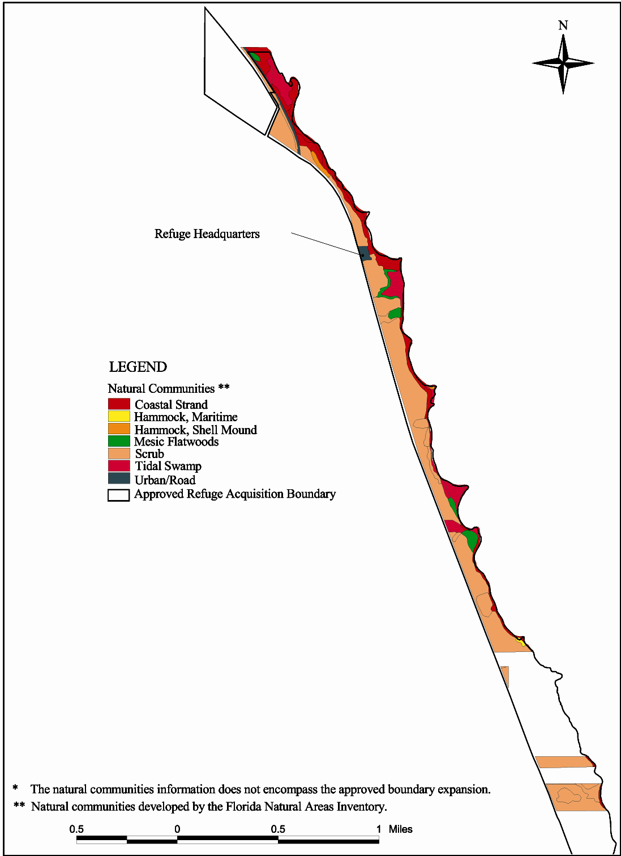
Figure 8. Vegetation on mainland tract, Hobe Sound national Wildlife Refuge
Figure 9. General distribution of scrub in Florida, adapted from Davis, 1967
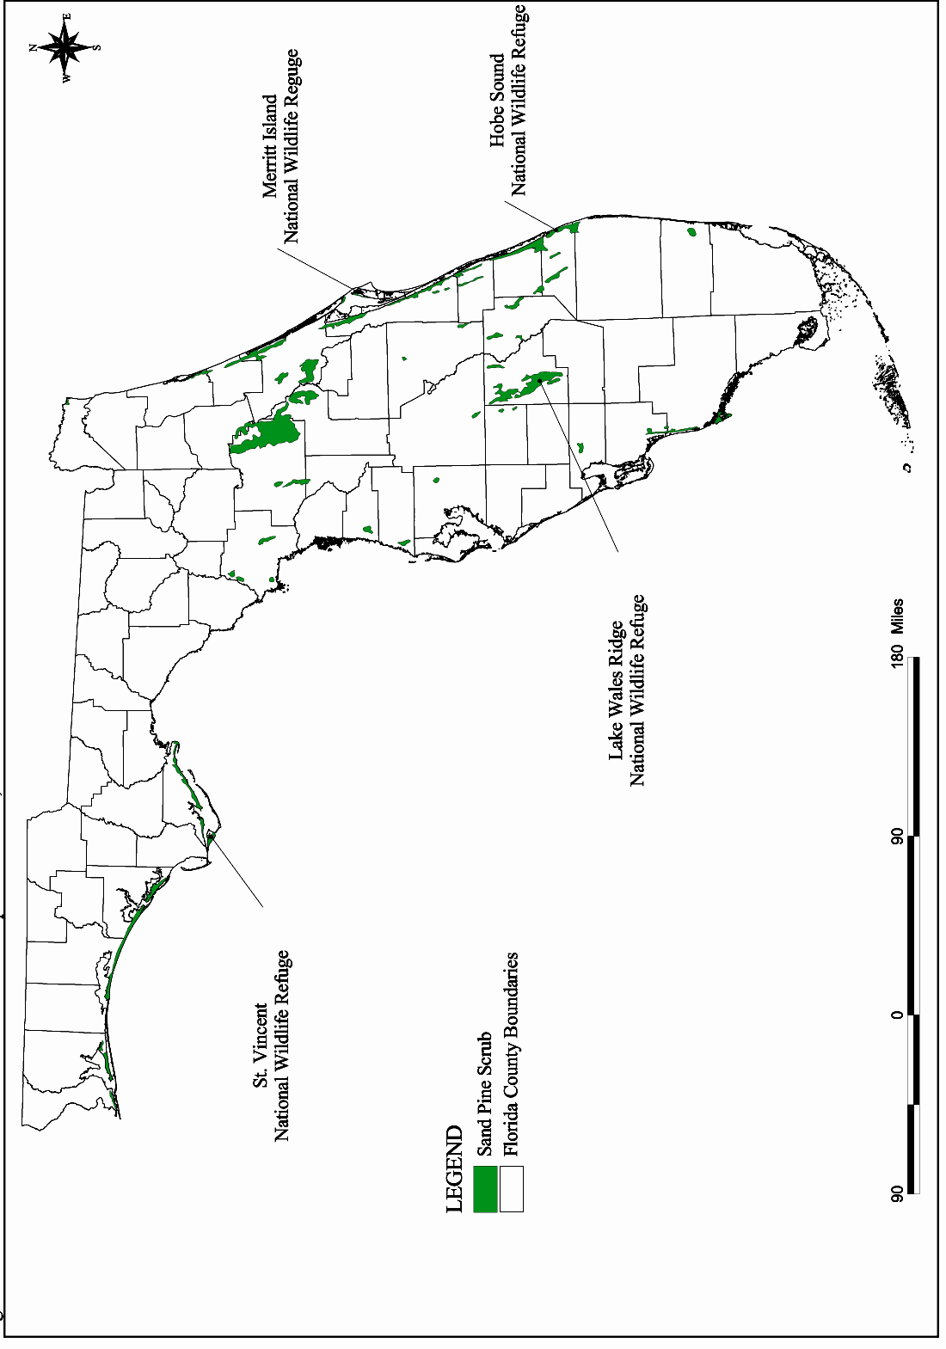

Sand Pine Scrub

Distribution and Characteristics. Compared with other ecosystems in Florida, scrub habitat is scattered across the landscape with concentrations along coastal and central ridges in peninsular Florida (Figure 9). In the panhandle, scrub is restricted to a narrow strip along the Gulf coast and on barrier islands. Scrub is frequently cited as Florida=s most distinct ecosystem; physiognomy and composition are quite distinct from
surrounding habitats and between 40-60 percent of scrub species are considered to be endemic. Scrub habitat, a xeric vegetative community, contains a biological treasure of plants and animals adapted to life on scattered ridges of sand. There are more endangered or potentially endangered wildlife species located here than in any other habitat in Florida. The ancient origins of these sand dune communities date back to the Pliocene savannahs and provide a relic example of an extremely old and formerly extensive ecosystem (Deyrup and Eisner 1993). Of the original distribution of Florida scrub ecosystem, only 10 percent remains, the rest replaced by citrus groves and housing developments.

Currently, the highest, oldest, and driest areas of the refuge are composed primarily of mature sand pine trees (Pinus clausa); hence the habitat is referred to as a sand pine scrub habitat. The scrub midstory consists of dense growing xeric plants such as Chapman=s, myrtle, and sand live oak; varnish leaf; rosemary; gopher apple; and saw palmetto. The scrub understory is also relatively closed, supporting many species of lichens, grasses, and forbs which cover the scrub floor (Fernald 1989). At lower elevations, a more mesic environment supports slash pine and dense understory growth of saw palmetto, coin vine, gumbo limbo, Spanish lime, staggerbush, and many forbs (Richardson 1977).

Fire Ecology. Sand pine cones require stress, like fire, to open and release seed, while shrubby species like scrub oaks quickly regenerate from stored energy in their roots. Shade intolerant species like scrub mints will respond to the increased duration and intensity of light from seed sources. Although the first prescribed burn on the refuge took place in January 2002, half of the sand pine scrub community is between 45 and 65 years old. This age roughly marks late-middle senescence of the scrub community. Some studies have concluded that the sand pine scrub community should be managed on a 15- to 25-year rotation, with many native species becoming absent after 20 years (Roberts and Cox 2000). Sand pines become sexually mature 15 to 17 years after their seeds are released by fire. Until a prescribed fire that jumped from Jonathan Dickinson State Park over to the refuge in 2006, the age of the youngest stand on the refuge was over 30 years. Those trees were found in the area setback by wildfire in 1971. Several new sand pines have regenerated without fire following mechanical treatment, which is a disturbance that mows or chops the scrub habitat, opening the canopy to allow sunlight to penetrate. Sand temperatures reached sufficient intensity to release pine seeds. Research is necessary to evaluate mechanical versus prescribed fire as methods to rejuvenate this habitat. Attempts at creating bare ground through prescribed fire have met with mixed success (Greenberg 2003). Bare ground and open areas in the scrub are necessary to attract and maintain other species, such as the scrub jay.

Wildlife. The most common mammals are the gray fox, bobcat, white-tailed deer, raccoon, Virginia opossum, striped and eastern spotted skunk, eastern mole, least shrew, mice species, gray squirrel, and perhaps up to five bat species.

The birds of sand pine scrub habitat are the Florida scrub jay, northern mockingbird, northern cardinal, blue jay, Carolina wren, chuck-will=s widow, mourning dove, white-eyed vireo, eastern towhee, osprey, great horned and eastern screech owls, red-bellied and downy woodpeckers, great-crested flycatchers, and northern bob-white. In its position in the North American Continent, Florida is a natural funnel for neotropical migratory birds (e.g., warblers, vireos, tanagers, orioles, and thrushes), which depend on scrub habitat areas for forage, cover, and rest prior to their long flight to Central and South America. Occasionally, wood storks are observed flying over the Mainland and Jupiter Island tracts. For many years, bald eagles have nested across U.S. Highway 1 in Jonathan Dickinson State Park and are occasionally observed flying over the refuge.
Gopher tortoises occur on the refuge as well as the scrub lizard, corn snake, black racer, and green anole. Seven wildlife scrub species are evaluated in greater detail as follows:

Florida scrub jay (Aphelocoma coerulescens)

Federal and State of Florida Threatened Species

The Florida scrub jay is endemic to the scrub habitat of Florida and is genetically and behaviorally different from scrub jays of the western United States. Its range has been considerably reduced by development, which has resulted in fragmented distribution of scrub habitat.

The jay has extremely specific habitat requirements within the scrub, including an open canopy and open understory (Fernald 1989). Historically, habitat at the refuge supported a breeding population of scrub jays, however, much of the scrub canopy has closed and there is dense undergrowth of vegetation. Scrub habitat on adjacent Jonathan Dickinson State Park supports a larger, but declining scrub jay population (Roberts, pers. comm. 2002).

Gopher tortoise (Gopherus polyphemus)

State of Florida Species of Special Concern

This species prefers xeric habitats with an abundance of herbaceous ground cover, an open canopy and sparse shrub cover; this early successional scrub habitat is similar to the habitat requirements of the Florida scrub jay (Franz 1986; Cox et al., 1987; Fernald 1989). The tortoise burrows 6 feet down, for an average of 15 feet, into a well-drained sandy soil to prevent dessication and to regulate body temperatures.

The gopher tortoise is designated as a keystone species in the scrub habitat of the refuge. Burrows are known to provide habitat for up to 81 species of vertebrates and invertebrates. Thirty-two commensal vertebrate species use the burrows, including the listed eastern indigo snake, Florida pine snake, and gopher frog, which are described below. Tortoise dung provides the major food source for many invertebrates, which, in turn, are food sources for the Florida mouse and gopher frog (Jackson and Milstrey 1989; Cox et al., 1987; Fernald 1989).

The 1978 survey of gopher tortoise habitat on the refuge resulted in the discovery of two abandoned burrows on the southernmost part of the refuge. In 1986, seven gopher tortoises were released, and in 1992, four additional tortoises were released with the hope that they would form a local population. Later that same year, a follow-up survey revealed six burrows at the site: four were active, one was inactive, and one was abandoned.

In the winter of 1998-99, a portion of the sand pine scrub was surveyed for tortoises. Twenty-two burrows were found: five were active, seven were inactive and ten were abandoned. Relatively few tortoises are thought to be left on the refuge because the habitat has almost reached a climax successional stage.

Eastern indigo snake (Drymarchon corais couperi)

Federal and State of Florida Threatened Species

The eastern indigo snake has decreased dramatically throughout the United States due to loss of habitat. It has a home range between 125 to 250 acres, is diurnal, and feeds on small mammals, birds, frogs, lizards, and other snakes (Richard Roberts, pers. comm. 2002). Gopher tortoise burrows are particularly important to the indigo snake, since they can provide winter shelter and protection from dessication (Fernald 1989). Since gopher tortoise burrow habitat is relatively scarce on the refuge, sightings of indigo snakes may also be lower as a result. An underground survey of gopher tortoise burrows is needed to determine the population level of the indigo snake and other species that inhabit these burrows.

Florida pine snake (Pituophis melanoleucus mugitus)

State of Florida Species of Special Concern

This snake feeds on small mammals, birds, and lizards. It is closely associated with gopher tortoises (Fernald 1989), as indicated by the fact that 85 percent of its life is spent in gopher tortoise burrows. Surveys of gopher tortoise burrows are needed to assess the current status of this species on the refuge.

Florida gopher frog (Rana capito)

State of Florida Species of Special Concern

This frog occurs in both active and inactive gopher tortoise burrows, but it prefers the former (Fernald 1989). It requires temporary grassy ponds for breeding, which could drive the frogs to move elsewhere. Periodic surveys of known gopher tortoise burrows on the refuge are needed to determine the presence of this species. In a survey conducted in 1999, no frogs were found (Gilligan 1999).

Florida mouse (Podomys floridanus)

State of Florida Species of Special Concern

This species is restricted to the State of Florida, and it has one of the narrowest habitat ranges of any Florida mammal (Fernald 1989). It requires fire-maintained, dry, upland vegetative communities located on deep, well-drained sandy soils. The current status of this species on the refuge is unknown. During small mammal live-trapping surveys, conducted in 1999 and 2000, no Florida mice were trapped.

Scrub lizard (Sceloporus woodi)

State of Florida Rare Species

According to Fernald (1989), this species is endemic to Florida, occurring in sand pine scrub and associated xeric communities. It needs dry, well-drained sandy soils with numerous patches of open, bare sand and high sun exposure. To maintain suitable habitat conditions, periodic major disturbances of the canopy and ground cover are essential to preserve local populations. During the 1999 survey, this species was commonly found on the refuge (Gilligan 1999).

Plants. Plants are the best indicators of the sand pine scrub community. Over 75 species are found in this habitat. The following 13 plants, native to sand pine scrub habitat, are evaluated in greater detail.

Giant wild pine (also known as swollen wild pine) (Tillandsia utriculata)

State of Florida Endangered

As described in Long and Lakela (1971), this epiphyte=s leaves may reach nearly 7 feet in height. Large plants often fall to the ground and continue to grow, flower, and fruit normally. The plant dies after flowering. This species is known to occur in the sand pine scrub habitat of the refuge, although its abundance is unknown. Its presence is threatened by the invasion of an exotic weevil that appears to prefer wild pine for food, which, in turn, kills the plant.

Large-leaved rosemary (also known as large-flowered rosemary) (Conradina grandiflora)

State of Florida Endangered Species

This endemic shrub can reach over 3 feet in height, with few slender, usually curved branches (Long and Lakela 1971). This endemic Florida species is usually found in sandy soil in scrub habitat and it occurs on the refuge. The abundance of this species on the refuge is unknown.

Sand dune spurge (Chamaesyce cumulicola)

State of Florida Endangered Species

This endemic small herb has smooth, string-like, flexible stems and is found in south Florida (Long and Lakela 1971). It shows a strong preference for disturbed, open areas, especially railroad rights-of-way and roadsides adjacent to scrub (Bradley et al., 1998). This species occurs on the refuge, though no population estimates have been made.

Nodding pinweed (also known as scrub pinweed) (Lechea cernua)

State of Florida Threatened Species

This small perennial herb can reach up to 2 feet in height, with leaves about 0.4-inch long, and 0.2-inch wide. It primarily inhabits sunny open areas of scrub (Bradley et al., 1998) and occurs in sand scrub vegetation (Long and Lakela 1971). This species is known to occur on the refuge, but its abundance is unknown.

Reflexed (inflated) wild pine (also known as curly wild pine) (Tillandsia balbisiana)

State of Florida Threatened Species

These erect or pendent epiphytes grow on shrubs and trees in scrub habitat (Long and Lakela 1971). It occurs on the refuge, but the population size is unknown. It is also at risk due to an exotic weevil, which kills the plant.

Shell mound prickly pear cactus (also known as common prickly pear) (Opuntia stricta)

State of Florida Threatened Species

Long and Lakela (1971) describe this perennial species as reaching almost 7 feet in height, with few to many green flowers. The cactus can be found in open and sunny areas of the refuge. Unfortunately, it is thought to be endangered due to predation from the exotic moth (Cactoblastus cactorum) (Bradley et al., 1998).

Lakela=s mint (Dicerandra immaculata)

Federal Endangered Species

This fragrant smelling mint was introduced to the refuge in 1991, to save it from extinction. Plants were taken from the last remaining population near Vero Beach and Fort Pierce, Florida. They were planted near the headquarters trail and in the Asand pit.@ Ongoing monitoring efforts, conducted by the Fish and Wildlife Service=s Vero Beach Ecological Services Office, and the Bok Tower Gardens, have shown plant growth and new seedling establishment in most areas.

Giant leather fern (Acrostichum danaeifolium)

State of Florida Threatened Species

This fern is confined to small wetlands located at the base of the scrub land hills. Small patches exist in this limited environment.

Geiger tree (Cordia sebestena)

State of Florida Endangered Species

This tree, although occurring on the refuge, is north of its natural range. Its presence is most likely a horticultural escapee.

Inkberry (Scaevola plumieri)

State of Florida Threatened Species

Habitat is being overtaken by its exotic relative, beach naupaka (Scaevola sericea). The invasive beach naupaka plant grows quickly and completely covers the sand. The growth pattern prevents the native inkberry from sprouting, spreading, or competing with the beach naupaka.

Four-petal pawpaw (Asimina tetramera)

Federal Endangered Species

This species has yet to be found on the refuge, but a population exists across U.S. Highway 1 in Jonathan Dickinson State Park.

Burrowing four-o=clock=s (Okenia hypogaea)

State of Florida Endangered Species

This plant has not been recorded on the refuge; however, it is present at nearby Blowing Rocks Preserve, which is owned by The Nature Conservancy.

Golden polypody (Phlebodium aureum)

State of Florida Threatened Species

This species roots in the boots of native cabbage palms. Its preferred growing location limits its ability to spread. No effort has been made to determine the occurrence of this species on the refuge, but it would most likely be in the hardwood hammocks.

Wetlands

In some areas of the Mainland Tract, the steep hillside plunges into small depressional wetlands which contain giant leather fern, swamp and royal ferns, American beauty berry, and cabbage palm. The invasive species known as Old World climbing fern (Lygodium microphyllum) is an ongoing problem in the wetland areas, requiring continual control. Lygodium can completely cover and smother all plants including canopy trees.

Mangroves

Mangroves line the shoreline of the Indian River Lagoon. Generally, the red mangrove (Rhizhophora mangle) colonizes the fringes of the waterway with its aerial prop roots providing shelter for numerous marine animals. Mangrove prop roots decrease shoreline erosion by dampening the impact of high-energy boat wakes. The resulting water clarity facilitates seagrass growth and establishment. Black mangrove (Avicinnia germinans), with its vertical pnuematophores, is generally found immediately inland of the red mangrove. The white mangrove (Laguncularia racemosa ) is found on slightly higher elevations behind the black mangroves. Buttonwood (Conocarpus erecta) is also commonly found associated with the mangrove community, occupying higher ground inland and out of direct contact with brackish water.

A large percentage of mangroves have been disturbed by excessive wave action, removed prior to the establishment of the refuge, or overtaken by invasive exotic plants. A mangrove re-planting program is ongoing at the refuge in partnership with the Environmental Learning Center of Vero Beach. An exotic plant removal program is also ongoing to maintain the shoreline clear of exotic plants, primarily Australian pine and Brazilian pepper, which interfere with mangrove restoration.

Hammocks
Three hammock habitats comprised of hardwood tree species grow atop Native American Indian shell middens. Species include such tropical trees as mastic, ironwood, marlberry, red and white stopper, black stopper, paradise tree, poisonwood, white indigoberry, coral bean, lancewood, Jamaica caper, and strangler fig. Hammocks are excellent refugia for neotropical migratory birds, land crabs, tree frogs, and other animal species which need high humidity and/or dense cover. Although hammocks occupy a very small percentage of the refuge=s acreage, they comprise about 20 percent of the plant diversity on the refuge (Bergh 1998).

Indian River Lagoon
The Indian River Lagoon is the most biologically diverse estuary in the United States. Because of its diversity, it has been designated as an Estuary of National Importance. In an estuary, salt water from the ocean mixes with fresh water from the inland; an estuary is of critical importance as a breeding, staging, and resting area for fish, shellfish, reptiles, birds, and mammals.

The Indian River contains 1,800 species of wildlife and plants and it supports one of the most productive aquatic faunas in the continental United States (Woodward-Clyde 1994). Species are supported by natural communities, namely, freshwater inlets and seagrass beds, oyster and clam beds, and diverse land forms and substrates. They are also supported by altered habitats such as spoil islands and mosquito impoundments.

The growing population of south Florida, and its associated demand for limited water resources, is affecting south Florida=s estuaries, including the Indian River Lagoon. Fresh water, destined for estuaries, is being diverted for municipal and agricultural consumption, dams for irrigation, weirs for flood control, storm water collection and treatment systems, and drainage canals. These diversions in the natural cycle change the quantity and timing of water flows downstream to the estuary.

In addition to water diversions, removing vegetation from the land and replacing it with an impervious surface can affect the natural flow of water to an estuary. Removal of the vegetation eliminates the uptake of water, and adding impervious surfaces cuts percolation of water into underground aquifers. The cumulative effect is that the estuary gets higher than normal freshwater input during the wet season and lower than normal freshwater inputs during the dry season.

Fish
South Florida has a great diversity of fish species. Of the 1,800 species identified in the Indian River Lagoon, at least 700 of them are fish species (Indian River Lagoon National Estuary Plan 1996; Woodward-Clyde 1994). More than twice as many species of fish occur in the southern half of the Indian River Lagoon, probably because of climate, presence of hard bottom and reef habitat, and the presence of several inlets to the Atlantic Ocean (Woodward-Clyde 1994).

According to G. Gilmore et al., 1981, several major fish habitat types occur in the lagoon: freshwater tributaries and canals; canal and river mouths; mosquito impoundments; mangrove marshes; open sand bottoms; grass flats; lagoon reefs; and Atlantic inlets. These diverse aquatic habitats foster the abundance of fishery resources that bring fishermen in great numbers to the refuge. The Florida Committee on Rare and Endangered Plants and Animals (1992) has developed a category system, similar to, but not the same as the federal designations, to which various fishes are assigned. These categories are Threatened, Rare, and Species of Special Concern. The word AThreatened@ means that the species are likely to become endangered in the state within the foreseeable future if current trends continue. ARare@ includes species that are potentially at risk because they are found within a restricted geographic range or habitat in the state or are sparsely distributed. ASpecies of Special Concern@ warrant special attention because they are vulnerable to exploitation or environmental changes and have experienced long-term population declines. The species assigned to the listed categories below are those that have been observed on the refuge.

Threatened: Atlantic sturgeon (Acipenser oxyrinchus); opossum pipefish (Microphis brachyurus lineatus); mangrove rivulus (Rivulus marmoratus); bigmouth sleeper (Gobiomorus dormitor); river goby (Awaous tajasica); and slashcheek goby (Gobionellus pseudofasciatus).

Rare: Mountain mullet (Agonostomus monticola).

Species of Special Concern: Lake Eustis pupfish (Cyprinodon variegatus hubbsi); mangrove rivulus (Rivulus marmoratus); striped croaker (Bairdiella sanctaeluciae); and spottail goby (Gobionellus stigmaturus).

Many of these species follow the Gulf Stream and other currents into the south Florida area. The opossum pipefish and many gobies depend on brackish water conditions for reproduction, such as those found at the mouth of the St. Lucie River, although opossum pipefish have been found in Lake Okeechobee (G. Gilmore, Harbor Branch Oceanographic Institute, pers. comm. 1996).

The favorite edible sport fish caught at the refuge include red drum (Sciaenops ocellatus); spotted sea trout (Cynoscion nebulosus); snook (Centropomus sp.); snapper (Lutjanus sp.); shark (30-40 species); summer flounder (Paralichthys dentatus); spot (Leiostomus zanthurus); bluefish (Pomotomus saltatrix); Atlantic mackerel (Scomberomorus maculatus); weakfish (Cynoscion regalis); pompano (Trachinotus carolinus); and Atlantic croaker (Micropogonias undulatus). The state threatened species of sport fish, common snook (Centropomus undecimalis), is recovering from low population numbers in recent years.

Seagrasses

Florida=s shallow coastal areas support six species of seagrass: manatee grass (Syringodium filiforme); turtle grass (Thalassia testudinum); shoal grass (Halodule wrightii); star grass (Halophila engelmanni); paddle grass (Halophila decipiens); and Johnson=s seagrass (Halophila johnsonii). The most common grass in the Indian River Lagoon is manatee grass (Syringodium fliliforme). The grass beds with the greatest density occur in shallow water where the salinity is fairly consistent. About 60 species of drift algae are growing on or found interspersed with marine grass beds. They begin as attached forms but eventually break away, providing refugia for invertebrates, fish, and other algae.

Importance. Seagrass beds are considered some of the most productive habitat in the estuarine system. They are important as nursery grounds for many fish species. Grass beds are used as cover or foraging habitat by 29 fish species and the Atlantic bottlenose dolphin. They also serve as critical food sources for the endangered West Indian manatee. In addition to being productive habitats, seagrass beds improve water quality by removing nutrients, dissipating the effects of waves and currents, entrapping silt, and stabilizing bottom habitats.

Issues. In September 1998, the National Marine Fisheries Service listed Johnson=s seagrass as threatened under the Endangered Species Act of 1973. Its distribution is limited to the Indian River Lagoon from Melbourne, south to Hobe Sound, and further southward to Lake Worth Lagoon and Biscayne Bay. A decision on designation of critical habitat for Johnson=s seagrass is pending. See Figure 10 for the distribution of Johnson=s seagrass at the refuge.

The seagrass communities of south Florida have experienced substantial declines in acreage and quality in recent years. Since the 1940s, an estimated 30 percent of the seagrass communities have been destroyed in estuarine habitats. This percentage of loss is also the case for the Indian River Lagoon. More than 59,306 acres of seagrasses have been eliminated since 1987. The cause of this loss includes such factors as: degraded water quality, freshwater flow management problems, severe temperature variability, and dredging from boat propellers (Haddad and Sargent 1994). It has been estimated that propellers alone have caused 64,200 acres of seagrasses to be moderately or severely damaged (Haddad and Sargent 1994). Seagrass beds in Monroe and Dade counties, which are located south of Martin, Collier, and Lee counties on the southwest Florida coast, have experienced the heaviest damage from propellers.

Sea Turtles: Juvenile sea turtles use the Indian River Lagoon in their developmental stages (Bresette, M.J., et al., 2002)

Mammals

Florida manatee (West Indian manatee). Manatees use the Indian River Lagoon, adjacent to the refuge, predominately during the winter months to the delight of visitors. The relatively sheltered waterway provides a resting and feeding area for the manatee as it travels south to the warm waters of the Riviera Beach power plant. It forages primarily on seagrass beds and secondarily on over-hanging mangroves and submerged, rooted, or floating species of plants. In 1976, nearly 10 percent of the state=s manatee population was observed migrating through the lagoon along the refuge (Lund 1976; Packard 1981; Lefebvre and Powell 1990). Today, fewer sightings are recorded.

Ecological studies of seagrass beds and their use by manatees were performed at the refuge in 1976 and during 1988-1989. Seagrass beds appeared to be declining in area and productivity due to silt, propeller dredging, and increased water turbidity from excessive power boat speeds.

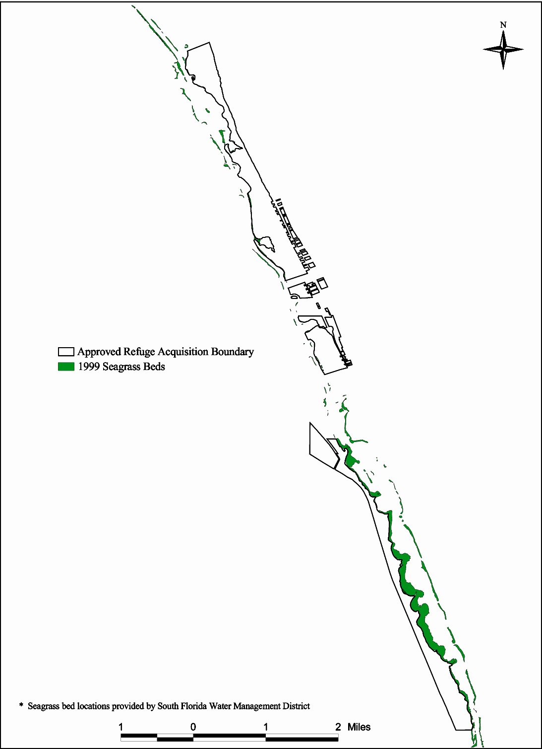
Figure 10. Location of seagrass beds in relation to Hobe Sound National Wildlife Refuge
Boating along the waterway is the largest threat to the manatee. Along the refuge, the state regulated slow-speed zone for boats ends at Bridge Road, leaving 3 miles of unregulated speed along the refuge boundary and another significant portion along the Peck Lake area. Propeller wounds and blunt force trauma are two of the common causes of mortality. Blunt force trauma can occur from power boats, as well as from personal watercraft.

In addition to boating impacts, red tides and cold stress are other common sources of manatee mortality. While some manatees remain in both Hobe Sound and Jupiter Sound areas throughout the year, others migrate up the coast. Deteriorating water quality, turbidity, and lack of food contribute to the stress of migrating manatees.

Atlantic bottlenose dolphin. The only Indian River Lagoon resident cetacean is the Atlantic bottlenose dolphin (Tursiops truncatus). Hundreds of dolphins, protected by the Marine Mammal Protection Act of 1972, are known to occur throughout the lagoon. They feed on small fish, such as mullet, spotted sea trout, silver perch, Atlantic croaker, and oyster toadfish. The average dolphin eats about 9 kilograms (20 pounds) of fish per day (Woodward-Clyde 1994). Based on the estimated population level in the lagoon, dolphins probably consume about 1,000,000 kilograms (2.2 million pounds) of fish annually (Woodward-Clyde 1994).

Dolphins frequent seagrass beds in the summer, presumably due to the supply of pinfish, pigfish, and mullet. In the winter, they are thought to move offshore; however, Beeler et al., (1988) believe that the resident dolphin population in the lagoon does not go out into the Atlantic Ocean, but rather that transient dolphins from ocean populations may come into the lagoon in the summer.

Studies conducted in1983 revealed that about 20 dolphin strandings a year occur in the lagoon (Woodward-Clyde 1994). More recently, a fungal skin disease that causes lesions and secondary bacterial infection is on the rise, infecting at least 12 percent of the population. Some scientists suspect that the dolphin=s immune system is being suppressed by chemicals or biological agents (i.e., toxic dinoflagellates) that occur in the Indian River Lagoon. Dolphin skin is sensitive to changes in water salinity.

Reefs

Reefs are a prominent coastal resource in the South Florida Ecosystem, which contains several kinds of coastal reef assemblages: worm reefs, vermetid reefs, and the more familiar coral reef. The refuge supports the northernmost coral reef in the United States. The southern third of the Indian River Lagoon contains a reef-like habitat, created by dredging along the edges of the Intracoastal Waterway, which supports aquatic life such as gorgonian corals and other invertebrates. Also, in the Atlantic Ocean, adjacent to the refuge, are expanses of hard bottom, which support invertebrate growth, many juvenile fish species, and juvenile green sea turtles.

Jupiter Island Tract

The refuge=s 735-acre Jupiter Island Tract is composed primarily of Atlantic coastal dune, Australian pine-lined lagoonal shore, mangrove swamps, mosquito impoundments, and 3.5 miles of sandy beach (Figure 11).

Atlantic Coastal Dune

Three vegetative zones progress from ocean to inland: the foredune, the middledune and the backdune. The foredune is nearest the ocean with characteristic plants such as sea oats, marsh

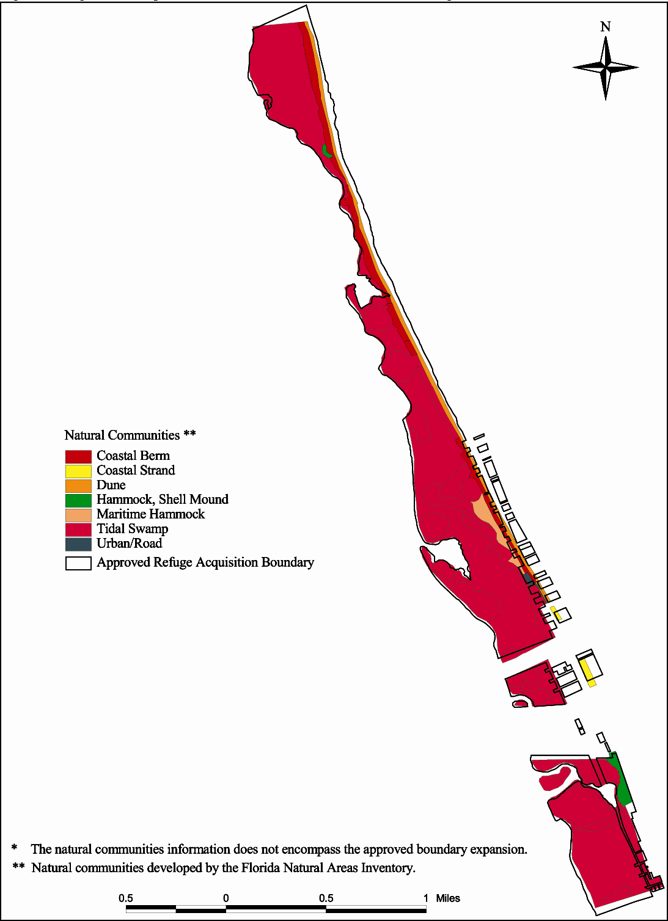
Figure 11. Vegetation on Jupiter Island tract, Hobe Sound National Wildlife Refuge
elder, bay bean, railroad vine, and sea purslane. The middledune is inhabited and stabilized by sea oats, bay cedar, beach sunflower, ink berry, beach star, black bead, and coastal panic grass. The backdune is furthest from the ocean and supports the following native plants: saw palmetto, seashore elder, sea grape, pigeon plum, Spanish bayonet, stinging nettle, and prickly pear.

While there are no records documenting the occurrence of beach jacquemontia (Jacquemontia reclinata) on the refuge, according to the Multi-Species Recovery Plan (1999), this species once occurred on Jupiter Island in Martin and Palm Beach counties. Currently, the northern most extent of the species occurs 10 miles south of the refuge on Juno Beach (Palm Beach County). Beach jacquemontia is a perennial vine which is found in open areas on the crest and lee sides of stabledunes (Austin 1979). Loss of habitat and beach erosion led to listing this species as endangered on November 24, 1993 (58 FR 62050). Considerable interest exists in the potential for restoring beach jacquemontia to the refuge in partnership with Fairchild Tropical Gardens. Due to positioning of the refuge within the Atlantic Flyway, the refuge dune and beach serve as important resting and foraging areas for migrating shorebirds.

The southeastern beach mouse (Peromyscus polionotus niveiventris) is a subspecies of the old field mouse that occurs in habitats along the east coast of Florida. This species= historical range encompassed the eastern counties of Volusia to the north, Broward to the south, and Martin, where the refuge is located. Due to the extensive development in coastal habitats, this species has been extirpated in the southern counties, and now only exists in Volusia and Brevard counties, and in a few places in Indian River and St. Lucie counties. No formal surveys of the refuge have been conducted to document its presence. However, its favorite food source, sea oats, have become reestablished on the refuge in recent years suggesting that reintroduction of the beach mouse could be possible.

Mangroves

Three species of mangroves can be found along the shoreline of the Jupiter Island interface with the Indian River Lagoon. Many species of invertebrates, including threatened species of mangrove crabs (Aratus pisonii and Goniopsis cruentata), are believed to exist in this habitat.

Australian pine and Brazilian pepper are more pervasive on this side of the lagoon than the Mainland Tract at this time.

Mosquito Impoundments

“Jupiter Island lay dormant, visited only by Indians intermittently and by mosquitos incessantly.”
Joseph V. Reed

In Florida, impounding marshes and mangrove swamps for mosquito control began in Brevard County in 1954. The practice spread to other counties bordering the Indian River Lagoon until, by 1970, most of the impoundments were completed. There are 192 impoundments along the Indian River Lagoon (Rey and Kain 1991). A mosquito impoundment is simply a marsh or mangrove swamp, which has been totally or partially enclosed with an earthen dike. Impoundments allow the swamp to be flooded during the mosquito breeding season thus preventing the mosquitoes from laying eggs on moist soil. The salt marsh mosquitoes (Aedes taeniorhynchus and Aedes sollicitans) will not lay their eggs upon standing water.

There are five mosquito impoundments in Martin County, of which three (totaling 625 acres) are on the refuge (Figure 12). These are identified as F-1, F-2, and F-3. Very little information is available about these impoundments other than that they have been breached in several locations and no longer function as mosquito control impoundments. Today, they are mostly brackish due to the loss of water control structures. While the impoundments were intact, as many as 18 alligators were observed in 1979.

The town of Jupiter Island is working with the refuge to restore these impoundments in partnership with the refuge with funding from the government’s cooperative conservation fund.

Hammocks

Several hardwood hammocks exist on the Jupiter Island Tract. At least one is over a Native American Indian shell midden. Hammocks thrive on a limestone substrate. The dense canopy from oak trees, pigeon plum, red stopper, white stopper, marlberry, and strangler figs creates high humidity levels and higher temperatures. Hammocks are very important to migratory birds and contain 20 percent of all the refuge plant diversity.

Sandy Beach

This 3.5-mile tract of sandy beach attracts hundreds of visitors every year. Sea turtles and migratory shorebirds are the most important of these visitors.

Sea turtles. Of the seven species of sea turtles occurring worldwide, the refuge is a nesting ground for three: loggerhead (Caretta caretta); green (Chelonia mydas); and leatherback (Dermochelys coriacea). Two other species, the hawksbill (Eretmochelys imbricata) and the Kemp=s ridley (Lepidochelys kempii), are occasional visitors and occur in the coastal waters adjacent to the refuge (Florida Department of Environmental Protection 1998 and Ecological Associates 2002). All species mentioned above are protected under the Endangered Species Act of 1973, and Florida Statute, Chapter 370.12, as either threatened (loggerhead) or endangered (green, leatherback, hawksbill, and Kemp=s ridley). The refuge=s beach is of critical importance to marine turtle nesting as the coastline from Brevard County to Broward County accounts for 80 percent of the loggerhead nests worldwide.

Florida=s green turtle nesting population is also important on a worldwide scale, because it is one of the largest remaining in the Caribbean Sea and western Atlantic Ocean. Like the loggerhead, more than 90 percent of green turtle nests in the United States occur between Brevard County and Broward County (Meylan et al., 1995). Florida is the only area in the continental United States where leatherback turtles nest regularly. More than 80 percent of Florida=s leatherback nesting occurs in Martin, Palm Beach, and Broward counties (Meylan et al., 1995 and Florida Department of Environmental Protection 1997).

Nesting Success

During the 2002 sea turtle nesting season, 1,062 loggerhead, 143 green, and 33 leatherback turtle nests were recorded along the refuge=s beach (Figure 13). When compared to annual data since 1973, this represents below average nesting for loggerhead, and above average nesting for green and leatherback turtles. Despite the somewhat lower than average nesting by loggerhead turtles during 2002, regression analysis indicates that nesting data for all three species exhibit increasing trends from 1973 through 2002 (Figures 14, 15, and 16).

Figure 12. Location of mosquito impoundments, F1, F2, and F3, on Hobe Sound National Wildlife Refuge
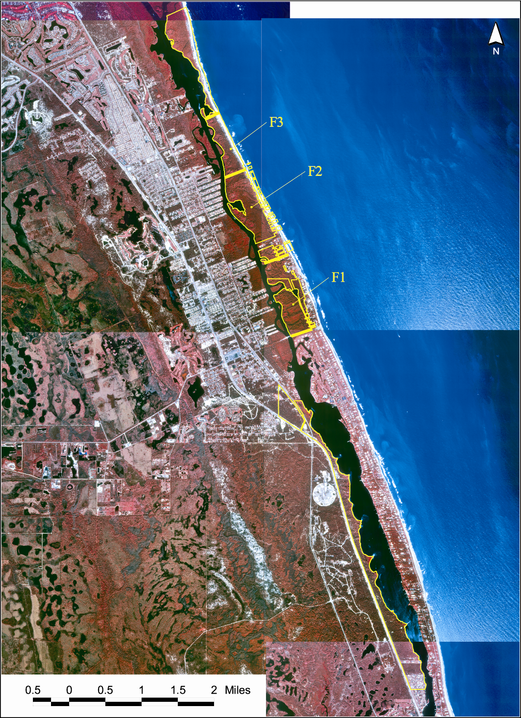

Nest Predation Rates and Control Efforts

Incubating sea turtle eggs and hatchlings are vulnerable to a variety of native (e.g., raccoons, ghost crabs, foxes, coyotes, crows and night herons) and non-native (e.g., fire ants, feral hogs and armadillos) predators. In earlier years, it was estimated that more than 90 percent of nests on the refuge were destroyed by raccoons. Utilizing proactive control measures, nest depredation rates dropped to an acceptable level (1.0 to 6.7 percent per year) through 1986. However, from 1987

Figure 13. Number of sea turtle nests observed on refuge by species 1991-2002

Species | 1991 | 1992 | 1993 | 1994 | 1995 | 1996 | 1997 | 1998 | 1999 | 2000 | 2001 | 2002
Logger-head | 1862 | 917 | 1546 | 1714 | 1376 | 1373 | 1155 | 1562 | 1384 | 1399 | 1259 | 1062
Green | 6 | 33 | 6 | 47 | 9 | 69 | 14 | 81 | 18 | 133 | 16 | 143
Leather-back | 7 | 2 | 5 | 9 | 24 | 2 | 16 | 15 | 33 | 36 | 58 | 33
Total | 1875 | 952 | 1557 | 1770 | 1409 | 1444 | 1185 | 1658 | 1435 | 1568 | 1333 | 1238

Figure 14. Annual number of green turtle (Chelonia Mydas) nests, Hobe Sound National Wildlife Refuge, 1973-2002. Data analysis by Ecological Associates, Inc.

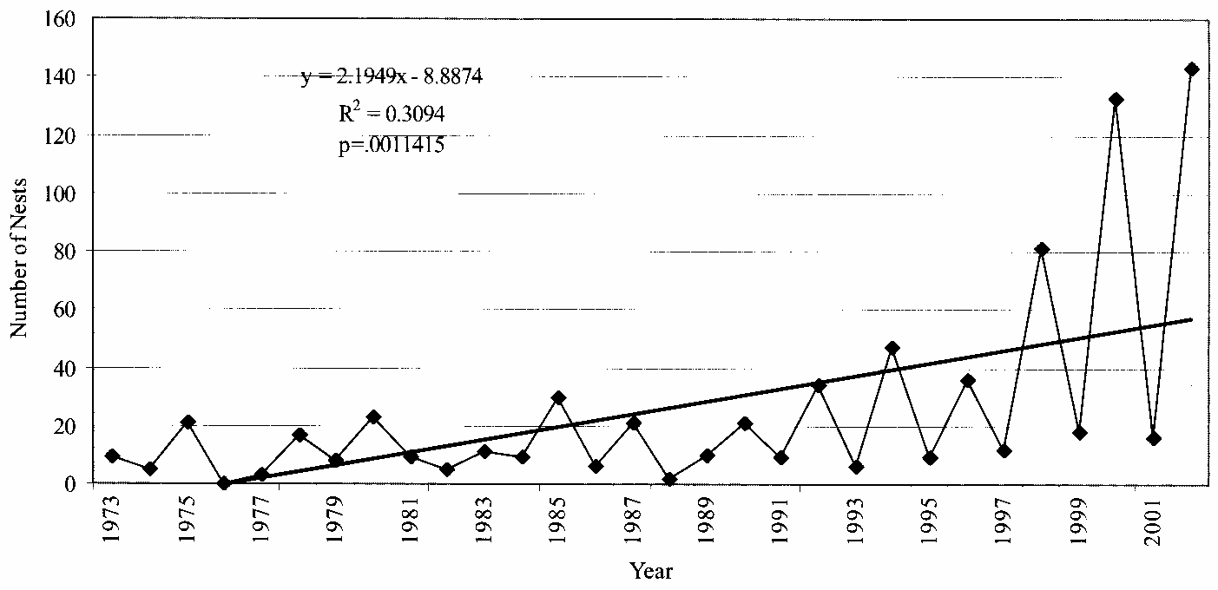

Figure 15. Annual number of loggerhead turtle (Caretta caretta) nests, Hobe Sound National Wildlife Refuge, 1973-2002. Data analysis by Ecological Associates, Inc.
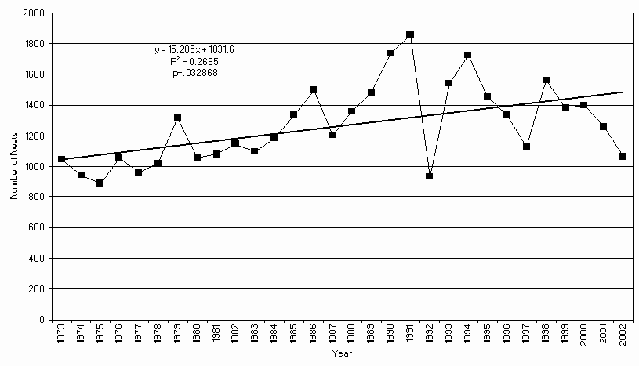

Figure 16. Annual loggerhead turtle (Caretta caretta) hatchling productivity, Hobe Sound National Wildlife Refuge, 1997-2002. Data analysis by Ecological Associates, Inc.
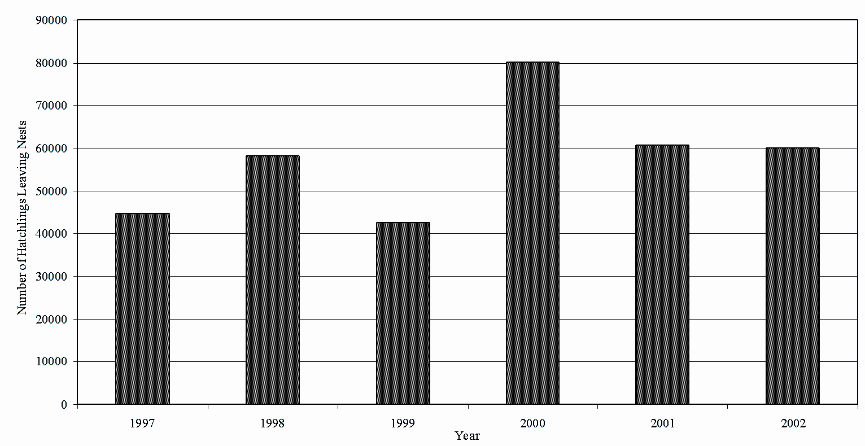

through 1991, raccoon depredation rates exceeded 13 percent. In 1988, armadillos were first discovered to be predators of sea turtle nests on the refuge. By 1991, the depredation rate increased to 20 percent. Since 1992, armadillos are considered to be the primary predator of sea turtle nests on the refuge (Bain et al., 1997 and Ecological Associates 2002). The overall predation rate reached a high of 61 percent in 1997; armadillos accounted for 75 percent of the nest loss.

Nine-banded Armadillo:
This native of southwestern North America has expanded its range into Florida but one or more introductions of armadillos also occurred along the east coast of Florida as early as the 1920s. They now occur throughout the state. Armadillos can be a nuisance to homeowners by digging up lawns and carrying diseases, such as St. Louis encephalitis, leptospires, arboviruses, and leprosy (Layne, J, 1997).

Very little documentation exists of armadillos depredating sea turtle nests on other nesting beaches in Florida. Although most of the foods eaten by armadillos are soft-bodied invertebrates, armadillos have been observed to excavate and consume reptile eggs (Breece and Dusi 1985). Significant levels of armadillo depredation on sea turtle nests have only been reported for a few areas, including the refuge and other Jupiter Island beach, Merritt Island National Wildlife Refuge and beaches near Sarasota. Armadillos are difficult to trap but through the combined efforts of USDA-APHIS and refuge personnel, over 40 armadillos have been removed from the refuge nesting beach during the years 1999-2004 (Ecological Associates, Inc., 2005).

The continued application of proactive measures to control predation is necessary to minimize turtle egg and hatchling loss. To that end, in 1999, the refuge contracted the services of the USDA to apply existing technologies to reduce the predation rate. The overall predation rate (all species combined) has dropped from 60.8 percent in 1997, to 10 percent in 2002 (Engeman et al., 2002) (Figure 17). Difficulties in contracting and funding resulted in an increase in predation to 21 percent in 2004 but dropped back to 13 percent in 2005 (Ecological Associates, Inc.).

Effects of Beach Erosion on Nesting Habitat

The loss of sea turtle nesting habitat due to wave action and erosion is a major concern to the refuge. To partially combat the effects of beach erosion, sand fences were erected in 1972 to build dunes. Typically, sand fences are constructed of narrowly spaced wooden or plastic slats or plastic fabric. Sand fences must be placed properly to assure that movements of adult turtles and emergent hatchlings are unimpeded (National Marine Fisheries Service and Fish and Wildlife Service 1991). From 1974 to 1978, and again from 1997 to 1999, sea oats were planted to build and stabilize the dunes. Sea purslane was planted from 1975 through 1978, for the same purposes (Bain et al., 1997). Extensive erosion along the northern beach of the refuge has exposed the stumps of black and red mangroves, and Australian pine extends into the water. This situation has created hazardous conditions for nesting turtles and hatchlings. Extensive efforts to remove Australian pine from the beach have enhanced turtle nesting success.

Beach renourishment projects have been the primary method with which to control the ongoing beach erosion process. Beach nourishment involves pumping, trucking, or scraping sand onto a beach to restore sand lost by natural erosion forces (National Marine Fisheries Service and Fish and Wildlife Service 1991). Beach renourishment has occurred numerous times over the last three decades. Since 1965, 2,308,300 cubic yards of sand have been placed on Jupiter Island, north of the refuge.

Figure 17. Percentage of marked sea turtle nests depredated, Hobe Sound National Wildlife Refuge, 1997-2002. Data analysis by Ecological Associates, Inc.

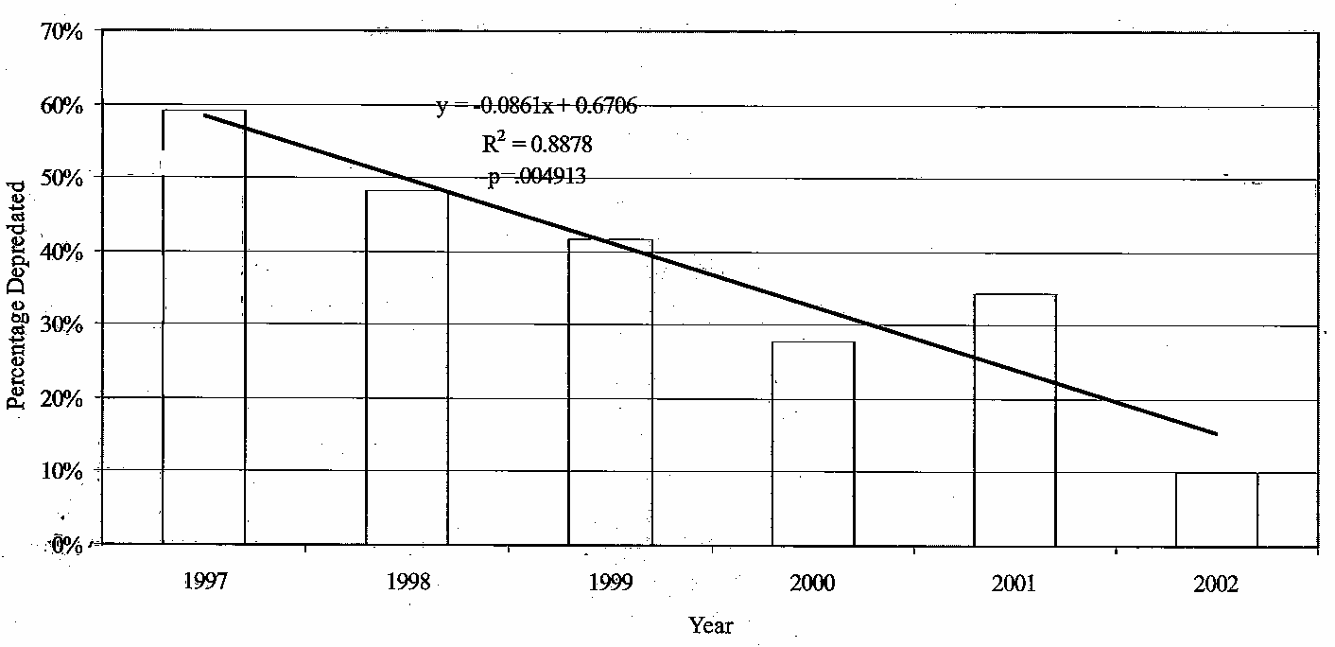

Between the 1996 and 1997 sea turtle nesting seasons, dredged sand was placed along two regions of refuge beach. Extensive escarpments were observed throughout the 1997 season within both of these filled areas, and they appeared to have a large impact on nesting sea turtles during that year. However, the size and persistence of escarpments were greatly reduced by the 1998 season and has had little effect, since then, on the turtle=s ability to access suitable nesting habitat.

Efforts to improve beach renourishment, in partnership with a variety of state, county, and federal agencies, have resulted in better composition of material placed on the beach, better timing and duration of renourishment, and improved evaluation of impacts to nearshore habitats. Concerns have been raised about the potential to impact essential fish habitat through renourishment actions. Essential fish habitat, within the limits of the refuge, includes the marine water column and sand bottom, as well as coral reef, hardbottom and macroalgae, including sargassum. Hardbottom habitat and coral reefs are also designated as Habitat Areas of Particular Concern for snappers, groupers, and spiny lobster. Refuge actions with respect to beach renourishment must take into consideration impacts to resources both within and outside its jurisdiction.

Birds. Although the Jupiter Island beach is significant for sea turtle nesting, the importance of this same beach to migratory birds cannot be underestimated. In 1974, 225 least terns were recorded nesting on the Island Tract at Peck Lake on a backdune area cleared of Australian pines. Additional observations were not recorded until 1998 when 11 nests and 17 fledglings were observed on the narrow foredune strip. These positive signs in nesting result from the removal of exotic Australian pine and retardation of dune vegetation. Nesting attempts declined and were thwarted by inadequate habitat space and human disturbance in 1999, 2000, and 2001 (Marian Bailey, pers. comm. 2003) It is common to observe little blue and tricolored herons and snowy egrets foraging along the Intracoastal Waterway and ocean coast. However, nesting habitat is not available on the refuge for these species.

Piping plovers are occasionally observed on the beach, usually during fall migration; however, they are also seen on nearby beaches during the breeding season and winter months. Refuge biologists are cooperating with state and local biologists to conduct a winter census of piping plovers on nearby beaches, including the refuge. This census will provide more information on the seasonal use of the refuge by non-breeding plovers. Additional study is needed to determine the contribution that the refuge makes toward the recovery of this species.

Exotic Species

A discussion of the biological environment of the refuge would not be complete without a major discussion of exotic species.

Wildlife

Some exotic wildlife survives due to the refuge=s northerly geographic location. However, the refuge seems to be immune to many of the exotic wildlife species that commonly occur in extreme south Florida. As urban areas expand, the likelihood increases that new species may become established. South Florida supports more introduced animal species than any other region in the continental United States (Simberloff et al., 1997). (See Figure 18 for a list of exotic wildlife species that occur on the refuge.)

The greatest exotic mammal threat to the refuge is the nine-banded armadillo. Raccoons and armadillos are major predators of endangered sea turtle nests and eggs. Often, armadillos fail to find the egg chamber, leaving it vulnerable to secondary predators such as fire ants. The refuge currently humanely controls armadillos and raccoons under an approved Predator Control Plan with technical assistance and support from USDA.

The European starling is the most common exotic bird species observed on the refuge. It is the most common exotic bird found throughout North America and populations now number in the millions. Parrot and parakeet species occur as free-flying flocks and likely pose no threat to native wildlife species. They may, however, help to spread the seeds of non-indigenous exotic plants.

At least four species of exotic animals have naturalized populations in south Florida. Exotic lizards, such as the brown anole, Indo-Pacific gecko, and Mediterranean gecko, are the primary concerns. The brown anole may prove to be a predator of the Florida scrub lizard and/or the six-lined racerunner and has already impacted native green anole populations (Marian Bailey 2003). It does compete for space and food and is common throughout south Florida. Geckos are commonly found in refuge buildings, being particularly visible at night. They primarily feed on insects, and their effects on native wildlife are poorly understood. The Cuban brown tree frog is a confirmed resident and predator on native tree frogs.

Exotic insects, such as the imported red fire ant, German cockroach, Oriental cockroach, Mexican elongate twig ant, Florida bromeliad weevil, and Asian tiger mosquito, have been documented as occurring on the refuge. Fire ants pose a significant public health risk and are secondary predators on sea turtle eggs and hatchlings. They also displace native, less aggressive ant species and prey on native insects. The Martin County Mosquito Control periodically treats larval mosquitoes during severe outbreaks on Jupiter Island. The Florida bromeliad weevil kills the giant wild pine and reflexed wild pine and has decimated large bromeliad populations near the refuge. The weevil has been documented as killing giant wild pine at the refuge (Marian Bailey 2002).

A recent concern is over the threat of spread of the lobate lac scale insect from Palm Beach County where it is killing many species of native trees. A survey performed by the USDA, April 2003, found no evidence of the insect on the refuge or at the neighboring Jonathan Dickinson State Park.

Plants

A number of non-native invasive plants inhabit the refuge. These plants compete with native species for space and are of limited value to wildlife compared with their native counterparts. These alien plants, lacking natural predators and insects to keep them in check, rapidly expand, forming dense monotypic forests and thickets, which are undesirable to humans and wildlife.

A number of exotic plants are found on the Mainland Tract, including Australian pine (Casuarina equisetfolia); Brazilian pepper (Schinus terebinthifolius), common bamboo (Bambusa vulgaris); golden bamboo (Phyllostachys aurea); Surinam cherry (Eugenia uniflora); rosary pea (Abrus precatorius); melaleuca (Melaleuca quinquenervia); lantana (Lantana camara); beach naupaka (Scaevola sericea),
and Old World climbing fern (Lygodium microphyllum) (Figure 19). Old World climbing fern, a native of Asia, was first found in Martin County in the late 1950s (Beckner 1968). This species prefers wet sites and grows particularly well along the ecotone between wet and dry habitats. This species has heavily impacted over 15 acres of habitat on the refuge and remains one of the most significant exotic species problems that face the refuge.

Fourteen exotic plants are found on the Jupiter Island Tract. Of these, Australian pine, Brazilian pepper, and beach naupaka (Scaevola sericea) are the most detrimental to native plants. As shown in Figure 20, Australian pine and Brazilian pepper are very prevalent on the Jupiter Island Tract.

Beginning in 1981 and continuing through the present, much of non-native plant control activities on the refuge have focused on removal of Australian pine from the Jupiter Island Tract's dune. Brazilian pepper was introduced in the late 1800s as an ornamental shrub. This widely adaptable and aggressive tree rapidly invades disturbed sites, such as fence rows, roadsides, canal banks, dredge spoil sites, and abandoned farmland. It also invades pine flatwoods, sand pine scrub, cypress swamps, freshwater marshes, and mangroves. Beach naupaka, a native of Hawaii, was first reported in south Florida in the mid 1970s. It is one of the top five most invasive plants on the refuge. Naupaka is most frequently found on the foredune to middledune, the western edge of the Jupiter Island Tract, and the eastern edge of the Mainland Tract, which borders the Indian River Lagoon. In 2006, significant efforts began to remove Australian pine along the lagoon shoreline, as well as Brazilian pepper and Old World climbing fern.

Socioeconomic Environment

History of Martin County

Hobe Sound National Wildlife Refuge is located within Martin County, although land acquisition possibilities could include additions from St. Lucie and Palm Beach Counties. Martin County was established in 1925, when a large portion of Palm Beach and a smaller section of St. Lucie counties were combined.

Figure 18. Exotic wildlife reported on Hobe Sound National Wildlife Refuge

Exotic Wildlife | Breeding Status
Birds
European starling (Sturnis vulgaris) | yes
parakeet spp. | No
parrot spp. | No
Mammals
feral pig (Sus scrofa) | Yes
nine-banded armadillo (Dasypus novemcinctus) | yes
feral cat (Felis domesticus) | yes
house mouse (Mus musculus) | yes
black rat (Rattus rattus) | unknown
Norway rat (Rattus norvegicus) | unknown
Reptiles
brown anole (Anolis sagrei sagrei) | yes
Indo-Pacific gecko (Hemidactylus garnotii) | yes
Mediterranean gecko (Hemidactylus turcicus turcicus) | yes
Amphibians
Cuban brown tree frog (Osteopilus septentrionalis) | yes
Invertebrates
Mexican elongate twig ant (Pseudomyrmex gracilis) | yes
imported red fire ant (Solenopsis invicta) | yes
German cockroach (Blatella germanica) | yes
Oriental cockroach (Blatella orientalis) | yes
Asian tiger mosquito (Aedes albopictus) | yes
Florida bromeliad weevil (Metamasius callizona) | yes
Cactus moth (Cactoblastis cactorum) | yes

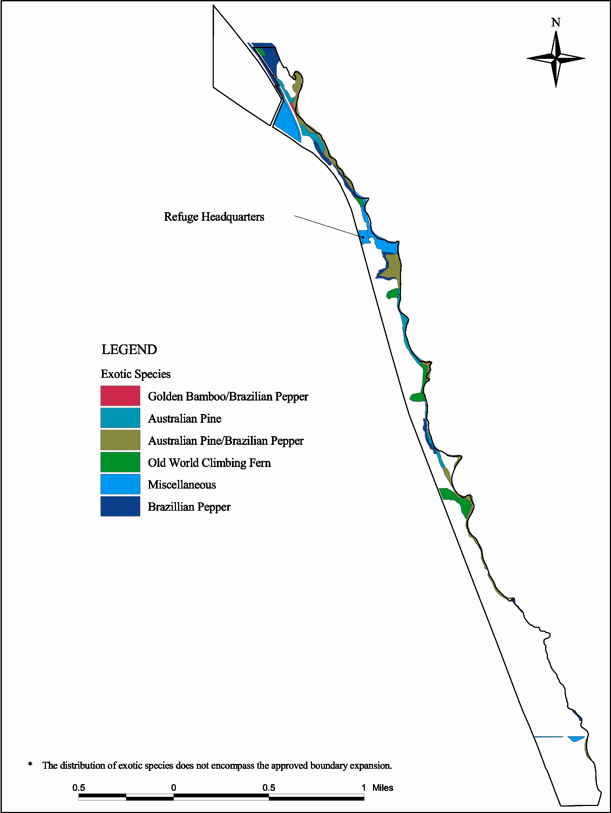
Figure 19. Exotic vegetation on Mainland Tract, Hobe Sound National Wildlife Refuge
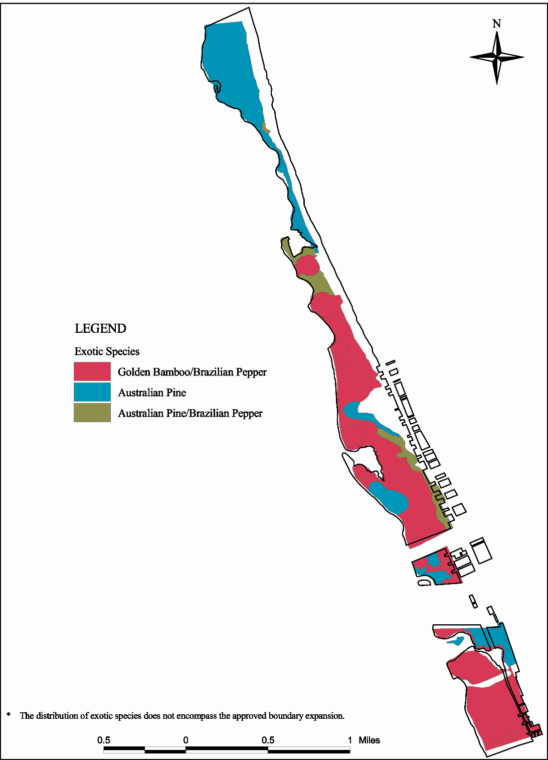
Figure 20. Exotic vegetation on Jupiter Island Tract, Hobe Sound National Wildlife Refuge
The county was named for John W. Martin, the Governor of Florida from 1925 to 1929. Prior to statehood in 1845, the coast and inland were inhabited or traversed by several Native American tribes, including the Ays, Calusa, and Seminoles. During the colonial period, other native peoples were driven south from Georgia into the general region. The Spanish controlled much of the area until 1819, when it was transferred to the United States.

Transportation has always been part of Martin County=s history. Located on Florida's Treasure Coast, Martin County is the site of several shipwrecks from the 1700s when Spanish ships carrying treasures wrecked offshore during hurricanes. Ships from other countries have met the same fate over the years and have added to the local lore. During the early 1900s, Henry Flagler=s Florida East Coast Railway was developed and ran through Martin County on its route from Jacksonville to Miami. Citrus and pineapples could be shipped north by rail and the first tourists began arriving south soon thereafter. Much later, many Martin County communities were negatively impacted by the development of the highway system, which bypassed many smaller towns throughout the county.

Martin County was formed when local residents became upset over excessive taxes from Palm Beach County. Locals lobbied Governor John Martin and others. Martin County was formed on May 29, 1925. Stuart became the county seat. Later in the 1920s, land speculation in Florida peaked and then declined. Many land investors pulled out of the state. This economic downturn was furthered by devastating hurricanes in the late part of the decade, which wiped out many agricultural crops, houses, and businesses. It took nearly two decades for the local communities to recover. From the 1940s through the 1960s, the county began to grow, mostly through in-migration from the north. Starting in the 1970s and into this current period, many of the in-migrating residents are from south Florida. Martin County is one of the fastest growing areas in the state.

Land Use and Values

Over the period of 1980 to 1995, the population and density of Martin County have increased more than 70 percent. Nevertheless, the majority of land (54 percent) remained in agricultural production. Important agricultural products in Martin County included citrus, sugarcane, and ornamental crops. Martin County is roughly 12 percent forested, primarily by pine and other softwoods. Of the forested land, approximately 29 percent is owned by the state and 1 percent by the county, while 35 percent is corporately owned and 35 percent is individually owned.

Increasing land values in Martin County have influenced the average value per acre of farmland and buildings. The average increased 44 percent over a 10-year period from a little more than $2,000 in 1982, to $3,000 in 1992. The 1992 farmland and building average in Martin County was more than 50 percent higher than the state average for that same period ($3,189 and $2,037). Total value of agricultural crops increased 95 percent over that 10-year period, even though total farm land decreased almost 30 percent. Most of the total value (88 percent) is attributable to crops (including sugarcane, citrus, and greenhouse crops), while livestock, poultry, and related products contribute a much smaller portion (12 percent).

Demographics

Over the 10-year period from 1980 to 1990, the population and density of Martin County increased nearly 60 percent (64,014 to 100,900). In the decade between 1990 and 2000, Martin County grew an additional 26 percent (from 100,900 to 126,731), while the State of Florida grew by 24 percent and the rest of the country grew by 9 percent (Martin County Demographic Characteristics Report,
December 2001) (Figure 21.) This increase has been due entirely to in-migration.

Figure 21. Socioeconomic profile of Martin County, Florida 1980-2000

Characteristic | 2000 | 1990 | 1980
Population (Number) | 126,731 | 100,900 | 64,014
Population Density (Pop./sq miles) | 228 | 182 | 115
Race/ethnicity (Percentage)
Caucasian | 89.9 | 88.9 | 90.4
African American | 5.3 | 5.9 | 7.1
Hispanic | 7.5 | 4.4 | 2.1
Native American | 0.3 | 0.2 | 0.2
Asian | 0.6 | 0.6 | 0.2
Education
Percentage of population over 25 with a high school degree | 85.3 | 79.7 | 70.3
Percentage of population over 25 with a college degree | 26.3 | 20.3 | 15.9

Like many counties in south Florida, Martin County=s population has become more diverse. Caucasian and African American populations decreased as a percentage of the total population from 1980 to 1990, while the Hispanic and Asian populations have more than doubled. The education level of the population is slightly higher than the state average.

In the year 2000, the U.S. Census Bureau reported Martin County=s median age at 48 years, compared to the State of Florida=s median age of 41 years and a national median age of 34 years. There is an age disparity based on the location of people within the communities of Martin County. The year 2000 data shows the median age in the coastal communities of Hutchinson Island, Sewall=s Point, and Jupiter Island is 61 years. The urbanized areas of the city of Stuart and surrounding locations have a median age of 52 years. The inland farming communities of western Martin County and Indiantown have a median age of 27 years.

Martin County has become increasingly popular as a vacation spot or winter home for many individuals. It is estimated that during the peak seasonal months, the population is 28 percent greater than the permanent population (Martin County Demographic Characteristics Report, December 2001). The county=s average family wage in the year 2000 was $52,924, ranking it among the highest in the State of Florida. Jupiter Island was ranked as the wealthiest community in the nation for the fourth year in a row by Worth Magazine, with an average home sale value of $4 million. In general, the residents of Martin County who are likely to visit the refuge are seasonal visitors who are interested in wildlife interpretation, over the age of 50, and well-educated. Nevertheless, a large percentage of recreational visitors are fishermen who live in the area year-round.

Resource Economics

Estuarine and marine fish are integral to the economy of south Florida and reflect, to a large extent, the health of aquatic systems and the South Florida Ecosystem as a whole. An estimated 94 percent (by weight) of commercially and recreationally important marine fish species of south Florida=s Atlantic coast are dependent on estuarine habitats for critical life processes (Chambers 1991). The estuarine and coastal ecosystems of south Florida and the refuge provide a nursery for a wide variety of fish and shellfish species, which support offshore fisheries in the south Atlantic. The Indian River Lagoon is a key nursery area for various marine species, including spotted sea trout, red drum, snook, and croaker. The lagoon provides half of Florida=s east coast fish catch and 90 percent of the state=s 750,000-pound clam (Mercenaria campechiensis and M. mercenaria) harvest (Indian River Lagoon National Estuary Plan 1998).

In September 1998, the National Oceanographic and Atmospheric Administration reported that Florida was ranked first in saltwater recreational fishing. There were 4.4 million saltwater fishing participants, including more than 2 million out-of-state tourists who took 24 million fishing trips. Florida anglers spend hundreds of millions of dollars each year fishing for Atlantic croaker (Micropogonias undulatus); red drum (Sciaenops ocellatus); spotted sea trout (Cynoscion nebulosus); snook (Centropomus sp.); snapper (Lutjanus sp.); grouper (Epinephelus sp.); shark (30-40 species); and spiny lobster (Panulirus argus).

In 1997, the National Marine Fisheries Service reported that the top ten species caught were herring (caught for bait); Atlantic croaker; spotted sea trout; pinfish (Lagodon rhomboides); summer flounder (Paralichthys dentatus); spot (Leiostomus xanthurus); black sea bass (Centropristis striata); bluefish (Pomatomus saltatrix); Atlantic mackerel (Scomberomorus maculatus); and weakfish (Cynoscion regalis). It also reported that there were 272 commercial fishing license holders and 12 wholesale seafood dealers in Martin County. County commercial landings generated a dockside value of $1,071,529.

Recreation Use

National and Regional Context

According to the 2001 National Survey of Fishing, Hunting, and Wildlife-Associated Recreation for Florida, for people 16 years and older, there were 3.1 million participants in fishing, 226,000 participants in hunting, and 3.2 million wildlife watchers. In the 4-county (Palm Beach, Martin, St. Lucie, and Indian River) state planning region encompassing the refuge, there were 62 million participants in outdoor recreation in 1992. Of these participants, 47 percent were tourists, 39 percent were residents of the region, and 14 percent were Florida residents located outside of the region. The most popular outdoor recreation activities were saltwater beach activities, bicycle riding, fishing, hiking, picnicking, and nature study. The activities with the highest projected facility needs for the year 2000 included freshwater and saltwater non-boat fishing, hiking, bicycling, and horseback riding.

Numerous recreational and educational activities and services are also provided by nearby state lands, such as Jonathan Dickinson State Park, Seabranch Preserve State Park, and St. Lucie Inlet Preserve State Park. These include boating, fishing, camping, and wildlife observation.

Refuge Recreation Use

Access to the refuge occurs primarily through three public use areas: the headquarters area on the mainland, the beach parking lot and dune walk-overs on Jupiter Island, and the Peck Lake area 2 miles north of the parking lot dune walk-overs (Figure 22).

As shown in Figure 23, a large majority (nearly 78 percent) of the refuge=s visitors participate in interpretation and nature observation. The visitor museum and exhibits run by the Nature Center attract families that enjoy the displays, as well as the snakes, lizards, fish, insects, birds, and other creatures found within the scrub habitat of the refuge. Others enjoy walking to the Indian River Lagoon to watch pelicans, osprey, herons, egrets, and a variety of shorebirds along its sugar sand beach or walking along the short sand pine scrub trail. Beach-related recreation, such as swimming, surfing, shelling, or sunbathing, is the second most popular activity on the refuge. Saltwater fishing is the third most important activity occurring on the refuge. The refuge is open for day-use only; camping is not permitted.

Wildlife Observation and Photography. Wildlife observation and photography, notably of birds, manatees, and dolphins, can occur at most locations along the Indian River Lagoon where access permits. Other observation sites are found along U.S. Highway 1, at the headquarters area, at the Sand Pine Scrub Trail, and along the beach and Peck Lake crossover.

Interpretive Programs. The new headquarters and visitor center, along with its Jackson Burke Educational Center and classroom, hosts lecture programs, sea turtle walks, an environmental education school for school groups, and an environmental education day camp during the summer. The beach area and Peck Lake area have interpretive displays.

Fishing/Hunting. Sport fishing occurs in the sound, on the beachfront, and in Peck Lake Lagoon, except for those areas that are posted closed. Only rods, reels, or poles and lines are permitted; these must be attended at all times. Fishing use is governed by both state and refuge regulations. Hunting is not allowed on the refuge for a variety of reasons, including the narrow lay of the land, the number of rare species, the close proximity to developed areas, and safety issues.

Boating/Canoeing. Boating (e.g., motor or sail), canoeing, kayaking, and personal watercraft are permitted in the Intracoastal Waterway and in the Peck Lake area. Boat access is along the Intracoastal Waterway, but no docking or launching facilities are available at the refuge. The waterway is patrolled by law enforcement officers from the Florida Fish and Wildlife Conservation Commission, the Martin County Sheriff=s Office, the Coast Guard, and the Fish and Wildlife Service.

Recreation Economics

Data concerning average recreational expenditures per visitor-day by specific activities for the Southeast Region (Laughland and Caudill 1997) show that non-consumptive activities (e.g., swimming and sunbathing) and saltwater fishing, which are major refuge recreational activities, contribute to Martin County=s economy. Each visitor-day of non-consumptive activities, on average, produces about $12 in spending for residents, and nearly $36 in spending for non-residents (1992 dollars). Saltwater fishing produced significantly higher spending averages for non-residents ($81), but less for residents ($20). Refuge visitation and the accompanying spending by visitors undoubtedly contribute to the economy of Martin County.

Figure 22. Location of recreational and administrative facilities at Hobe Sound National Wildlife Refuge
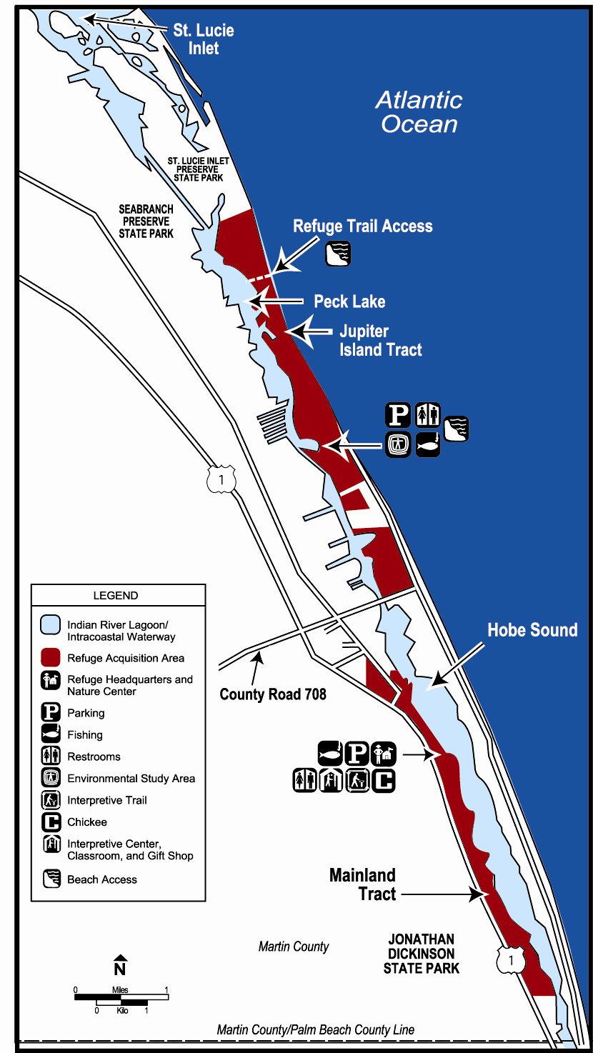

Figure 23. Summary of public use on Hobe Sound National Wildlife Refuge*

PUBLIC USE: | YEAR
PUBLIC USE: | 2002 | 2001 | 2000 | 1999
Total Visitors | 111,014 | 109,267 | 113,659 | 121,682
Interpretation and Nature Observations | 86,126 | 17,121 | 23,009 | 21,616
Environmental Education | 30,521 | 38,132 | 32,321 | 36,555
Beach and Water Use | 34,329 | 92,877 | 96,610 | 103,429
Saltwater Fishing | 14,126 | 15,621 | 18,237 | 6,000
VISITOR FACTORS:
Number of Visitors | 111,014 | 109,267 | 113,659 | 121,682
Percent Beach Related | 85% | 85% | 85% | 85%
Single Entry Vehicles | 2,702 | 1,915 | 1,885 | 1,568
Golden Age Passports | 392 | 501 | 551 | 465
Golden Access Passports | 4 | 0 | 31 | 0
Duck Stamps | 80 | 103 | 143 | 178
Golden Eagle Passports | 13 | 8 | 7 | 7
Golden Eagle Upgrades | 4 | 6 | 1 | 0
Total Fees | $38,190 | $44,377 | $44,826 | $40,411
*Information is derived from the Hobe Sound National Wildlife Refuge Annual Narratives, Calendar Years 1999-2002.

Cultural Environment

“These people neither sow nor plant any manner of thing whatsoever; nor care for anything but what the barren sand produce.”
Jonathan Dickinson 1696

Prehistoric Influences

By the time European explorers stepped foot on the Florida peninsula, five tribal groups were associated with the east coast of Florida. These groups were the Timucua to the north, and the Ays, the Guacata, the Jeaga, and the Tequesta to the south. All tribes were known to collect shellfish and other marine and aquatic resources, which resulted in large shell and bone middens near their villages (Andrews and Andrews 1985). Most of what is known about these groups was gained from the diary of a shipwrecked Englishman who was forced to travel up the Florida coast. This Englishman was the now renowned Jonathan Dickinson. His account is an important look at the lives of the indigenous population of Florida. Jonathan Dickinson State Park is adjacent to the Hobe Sound National Wildlife Refuge.

The prehistoric indigenous people of Florida engaged in intensive shellfish collecting and resulted in many of the shell middens evident today. The Joseph Reed Shell Ring (8MT13) is a semi-circular mound of oyster shells between 700 and 800 feet in diameter and rising up to 2 meters in height at the refuge on the Jupiter Island Tract. Little research had been conducted in the area of Hobe Sound National Wildlife Refuge until 1980, when four sites were recorded (Fryman et al., 1980). A recent study by Russo and Heide (2002), discusses the significance of this most impressive site in detail.

Ten state-listed archaeological sites are either on the refuge or very near its boundaries. All sites have the chronology of being labeled Apre-historic, period unknown@ and may be eligible for listing on the National Register of Historic Places. The 8MT6 site (near Olympia light), the 8MT7 site (at the northern end of Jupiter Island), the 8MT9 site (also on Jupiter Island) and the 8MT13 site were the earliest recorded sites. The ARolling Hills Site@ (8MT374) is a shell midden on a former xeric dune in the Florida Master Site File environmental setting. The Hobe Sound #1 site, listed as 8MT1280, is a shell midden in a tropical hardwood hammock. A site known as 8MT1279 is also a shell midden located in a tropical hammock setting. The Hobe Sound #2 site is 8MT1286, a large shell midden in a tropical hardwood hammock and scrub environmental setting. The Simpson Hill site (8MT375) is a shell scatter on a xeric dune in the right-of-way of U.S. Highway 1. The Hobe Sound #3 site, 8MT1287, is a shell midden in a scrub/xeric hammock environmental setting.

Historic Influences

The First Spanish Period (1513-1763) was mostly concerned with the shipping routes of the Spanish that hugged the Florida coast. Little was known about the interior of the state until Ponce de Leon=s visit in 1513, and little was known after his foray into the interior. As outposts were established on the east coast, there is documentation of native-European hostilities recorded near the Hobe Sound National Wildlife Refuge. The disease and trouble that the Spanish brought with them to the natives may have contributed to their migration to the south.

Little development of land was initiated until the Second Spanish Period. It is during this time (1783-1821) that Eusebio Maria Gomez was awarded a land grant (1815) that is now part of the refuge. This land, petitioned from the Spanish government, was described as A12,000 acres on the shores of Jupiter Island and of the River St. Lucia@ (U.S. Works Project Administration, Spanish Land Grants, Con 627, III: 186-187, in Fryman et al., 1980). Although the legal status of the land has changed hands several times, the name Gomez, as in AGomez Tract@ or AGomez Grant,@ is still used to refer to the land on the Hobe Sound National Wildlife Refuge.

Modern Influences

Another settler to the area is a person by the name of Peck, who settled on the shores of what is now referred to as Peck Lake (Fryman et al., 1980). A Georgia cotton farmer and banker, Samuel H. Peck is said to have settled here with his family around 1837 and departed around 1845 (Hutchinson 1998).

Settlement of the general area was facilitated by the work of the Florida Coast Line Canal and Transportation Company created in 1881. This company worked at improving the inland waterway from the St. Johns River to Key Biscayne (Fryman et al., 1980). By the mid-1880s, settlers were established in settlements of Scots and English pineapple growers. Initially, homesteaders used the waterways to receive and send supplies and agricultural products. By 1894, the Florida East Coast Railway was established and new transportation and job opportunities increased settlement of the area (Weed et al., 1982). The railroad greatly increased the ability of farmers to transport their crops to market.

The development of the area continued when the Olympia Improvement Association purchased the Gomez Grant from the Indian River Association and set about making plans to create an extensive community. By 1932, the Hobe Sound Company purchased portions of the old Gomez Grant. Shortly afterwards, the town of Hobe Sound was established (Hutchinson 1998). With the help of an initial 173-acre tract donation by the Reed family, the Hobe Sound National Wildlife Refuge was created on September 30, 1969.

From the 1940s through the 1960s, Martin County began to really grow, mostly through in-migration from the north. Starting in the 1980s through today, many of the new in-migrating residents are from south Florida. Martin County is part of the Treasure Coast and one of the fastest growing areas in the state.

IV. MANAGEMENT DIRECTION

“I went up there a little while ago. I took friends in the boat up the river; and there’s nothing like it. There will be nothing like it-ever: It’s a wilderness marvel but it’ll be really a marvel in fifty years-a hundred years from now. There’s so little of that natural world left. Never did Dad make a better decision than that one.”
Nathaniel Reed

Introduction

There are many challenges in managing the refuge. Goals and objectives are the heart of any plan and require critical thinking and thoughtful effort. Thus, in a tiered approach, the reader will find described in this chapter, the refuge vision statement and proposed plan for managing the refuge over the next 15 years.

The planning team evaluated four alternatives for managing the refuge, and selected the Ecosystem Emphasis Alternative as the Apreferred alternative@ since it best serves the purposes and vision of the refuge. The other alternatives evaluated were: Maintain Current Management; Biological Emphasis; and Public Use Emphasis. These alternatives were described in Section B, Environmental Assessment, of the Draft Comprehensive Conservation Plan for Hobe Sound National Wildlife Refuge.

In essence, the preferred action will result in increased protection of threatened, endangered, and trust species; increased invasive exotic plant eradication and control; habitat restoration; protection of migratory shorebird and songbird stopover sites; restoration of imperiled scrub habitat; enhanced resident wildlife populations; cultural resource protection; and increased compatible wildlife-dependent public uses.

A common theme throughout this plan is that wildlife conservation assumes first priority in refuge management. Public uses are allowed if they are appropriate and compatible with wildlife and habitat conservation, the refuge vision, the purposes and mission of the National Wildlife Refuge System, and consider the impact to surrounding landowners. Specifically, wildlife-dependent recreational uses (e.g., fishing, wildlife observation, wildlife photography, and environmental education and interpretation) will be emphasized in keeping with the needs of adjacent landowners.

Refuge Vision

Hobe Sound National Wildlife Refuge serves as a beacon of hope that wild places can still exist in south Florida. It is the reflection of the generous and farsighted early residents of Jupiter Island who were inspired by its beauty and who sought to protect it from the onslaught of development. As a result, Hobe Sound National Wildlife Refuge is an outstanding example of an Atlantic coastal ridge and barrier island environment.

Through scientifically careful ecosystem management, inspirational environmental education, and creative partnerships, this public asset will be protected, restored, and enhanced. The refuge will someday be a contiguous tract of land that provides safe corridors for native wildlife and plants to flourish, and where wildlife abundance and high-quality facilities will attract thousands of students and visitors each year. As the south Florida landscape continues to undergo change through development, Hobe Sound National Wildlife Refuge will serve as a sanctuary for threatened and endangered species, as well as an oasis for people who wish to experience what the early days of Florida were like. The refuge will hopefully inspire others to protect other wild places for future generations.

Refuge Goals

The following four goals were developed in keeping with the refuge=s vision and purposes:

Wildlife Habitat and Population Management
Restore and conserve diverse habitats, species populations, and biological integrity.

Resource Protection
Conserve natural and cultural resources through partnerships, protection, and land acquisition.

Wildlife-Dependent Recreation and Environmental Education
Develop appropriate and compatible wildlife-dependent recreation, environmental education, and interpretation programs that lead to enjoyable experiences and a greater understanding of fish, wildlife, and habitat conservation.

Administration
Implement an appropriate management regime for the refuge and improve infrastructure; add support staff to meet the needs of an expanding visitor public and to facilitate responsible biological, maintenance, and law enforcement programs.

Comprehensive Conservation Plan Summary

The management plan outlines the enhancement of wildlife populations and associated habitats over the next 15 years, while improving the student and visitor experience. The goals, objectives, and strategies of this plan reflect that the refuge is a portion of the much larger south Florida Atlantic coastal system. The actions considered and taken to implement this plan will affect the Atlantic Coastal Ridge; barrier island; Indian River Lagoon; state, county, and local municipalities; and adjacent landowners.

A majority of the comments made during the public scoping meeting and subsequent written comments on the draft conveyed a desire to protect the natural resources of the refuge and to educate the public about these resources. The priority of the refuge will remain to conserve and restore native populations of threatened and endangered species. However, the National Wildlife Refuge System Improvement Act requires that the Service facilitate quality and safe opportunities for wildlife-dependent recreation in a way that is compatible with refuge purposes and the Refuge System mission. The decisions to allow or prohibit certain public uses, as determined by the professional judgment of the refuge manager, are based upon the refuge=s purpose and potential adverse effects of these proposed uses on the natural resources of the refuge (Appendix VI). A wide range of partnering opportunities will be actively pursued and fostered to protect natural and cultural resources.

The refuge will be managed using an ecosystem approach to maintain natural processes or to mimic those processes of a natural fire regime and natural vegetative succession. Maintaining a healthy sand pine scrub community with successful populations of endemic species is a priority for the refuge. The refuge will work with state and private organizations to implement a sand pine scrub habitat restoration plan for areas along the length of the Atlantic Coastal Ridge.

The refuge will play a greater role in determining compatible uses and management activities on the Indian River Lagoon. It will provide input to agencies involved with managing the seagrass beds, manatee populations, and maintaining the Intracoastal Waterway and its inlets.
The refuge will collaborate with the Florida Inland Navigation District and the Florida Department of Environmental Protection to remove exotic species and manage spoil islands and mounds on the mainland and barrier island along the Indian River Lagoon for wildlife. Mangrove wetlands will be restored along the length of the refuge.

Successful dune restoration on the barrier island will require an intensive investigation of dune dynamics and the effects of inlet creation and maintenance. Beach renourishment projects on Jupiter Island will be closely monitored to ensure that an appropriate substrate is available for populations of shorebirds and benthic invertebrates, as well as a compatible beach for nesting sea turtles.

Invasive exotic plants and animals will remain the focus of intensive management on the refuge. Contracts will continue to be established with the private sector to remove exotic plants and sea turtle predators; refuge staff will monitor the effects of removal efforts. The refuge will support efforts to reduce and halt the spread of feral cat populations (estimated at 25,000 to 50,000) in Martin County.

Providing quality environmental education and interpretation will also remain a primary focus of the refuge. The partnership with Hobe Sound Nature Center, Inc., will be enhanced to explore new roles in the community and region.

Goals, Objectives, and Strategies

The goals, objectives, and strategies presented below are the Service=s responses to the issues and concerns expressed by the planning team, by the public at the open meeting, and comments submitted by the public. The goals, objectives, and strategies are presented in hierarchical format. Following each goal is a list of objectives, and under each objective is a list of strategies. The Plan Implementation section identifies the projects associated with various strategies.

These objectives and strategies reflect the Service=s commitment to achieve the mandates of the National Wildlife Refuge System Improvement Act of 1997, the mission of the National Wildlife Refuge System, and the Endangered Species Act of 1973. The refuge=s purposes guided the development of the vision and goals for the refuge. The Service intends to accomplish these goals, objectives, and strategies during the next 15 years.

Goal 1. Wildlife Habitat and Population Management

Restore and conserve diverse habitats, species populations, and biological integrity.

Discussion: Management will seek to protect and enhance state and federal listed species and trust species as a priority. In all management actions, the possible impacts to trust species will be examined before an action is taken.

In place of single species management, ecosystem and landscape habitat management will be emphasized. With this emphasis, the removal of exotic plants and the restoration of native plants will support genetically diverse populations of native wildlife. All native populations of non-invasive plants and wildlife will be fostered to enhance the health of these species.

Native habitats of the barrier island and Atlantic Coastal Ridge will be managed in accordance with historical patterns of succession. The sand pine scrub will be treated with a mechanical process and prescribed fire to emulate the effects of natural wildfire, without the associated risks to property and life. This technique will hopefully generate optimum conditions for endemic species and the overall
health of the community. The effectiveness of the technique will be evaluated as part of an active biological monitoring program. Because this management method is relatively new and somewhat controversial, adaptive management will be responsive to evaluation results.

The Atlantic coastal dune will be managed to protect its shoreline from erosion and to provide optimal beach conditions for nesting sea turtles and shorebirds. The vegetative community will be managed for a diversity of native plants and wildlife. Monotypic stands of exotic plants, as well as invasive natives, will be treated, burned, and monitored according to an approved dune management plan. Isolated hammocks contribute 20 percent of the vegetative species found on the refuge and are critical for migrating birds. Hammocks are imperiled due to invasive species encroachment. These special areas will be reclaimed and allowed to grow pest free.

The mangrove swamps lining the banks of the Indian River Lagoon will be protected from erosion and exotic infestation. Historical mangrove wetlands will be restored using current and improved planting techniques. Partnerships and volunteer assistance will be pursued.

Objective 1: Manage 125 acres of sand pine scrub within the Atlantic Coastal Ridge by mimicking the natural fire regime (Figure 24).

Strategies:

- Update the Sand Pine Scrub Habitat Restoration Plan by 2007, and in the same year, begin implementing the revisions. This plan will continue its focus of prescribed burning but will also explore new options of disturbance to mimic the natural fire regime. It will enhance feeding, nesting, and roosting components for scrub community species.
- Monitor the effects of the refuge=s sand pine scrub management plan on wildlife and the vegetative community.
- Foster partnerships with the Florida Park Service, The Nature Conservancy, the U.S. Forest Service, the Bureau of Land Management, Martin County, and others to assist with the inventory of scattered sand pine scrub sites; develop improved plans for fire and mechanical disturbance; and monitor the recruitment of native species and overall habitat response.
- Encourage other state, county, local, and private property owners to use the developed management techniques to treat aging sand pine scrub tracts along the Atlantic Coastal Ridge.
- Actively control invasive exotic species invading from ruderal or disturbed areas.
- Support and implement listed species recovery plans.
- Attempt to maintain a visual screen of U.S. Highway 1 from Jupiter Island using native plants.
- Prevent habitat destruction from all-terrain vehicles through enhanced law enforcement.

Figure 24. Proposed wildlife habitat and population management activities for Hobe Sound National Wildlife Refuge
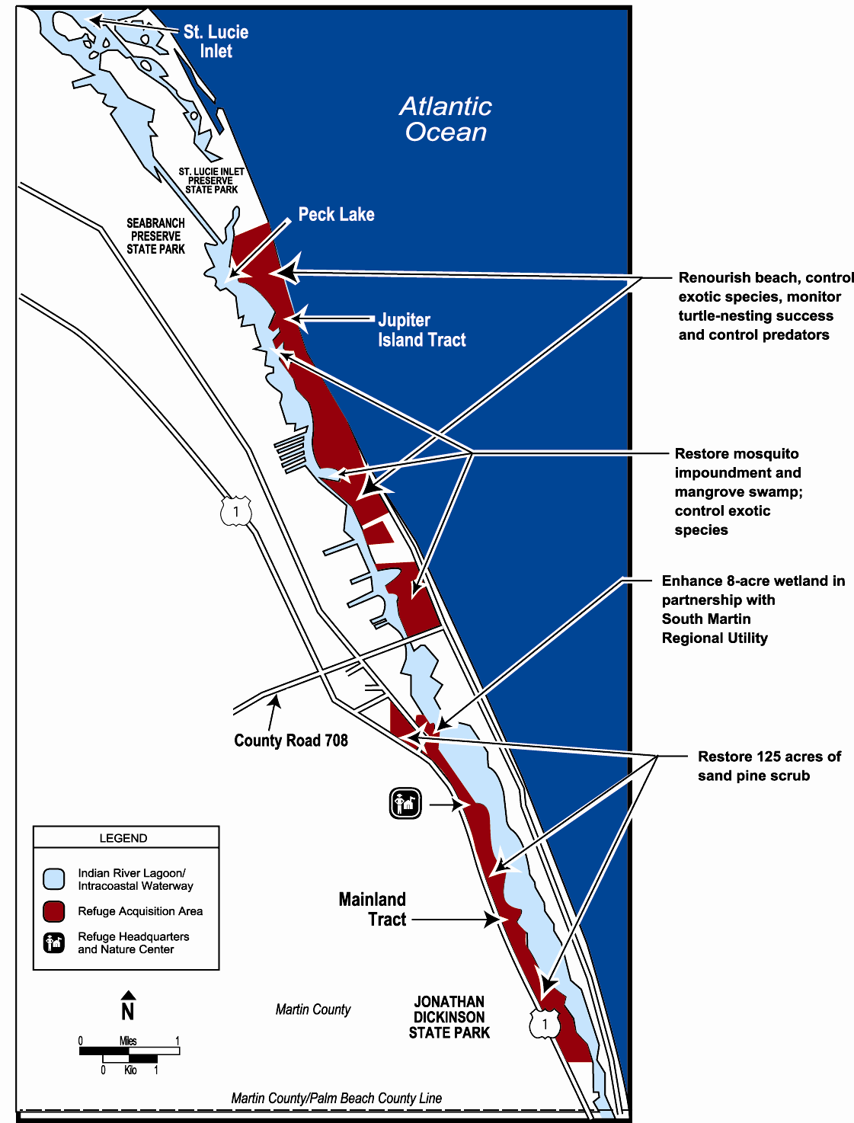

Objective 2: Restore 100 acres of the native Atlantic coastal dune system on the Jupiter Island Tract by 2010.

Strategies:

- Draft a coastal dune habitat management plan by 2008, to include appropriate restoration techniques, exotic species control, renourishment, and revegetation.
- Remove and control invasive exotic plant species on the Atlantic coastal dune system, including Australian pine, beach naupaka, Brazilian pepper, Old World climbing fern, and other Categories I and II species (Figure 24).
- Install sand fencing compatible with sea turtle nesting, in appropriate areas, for dune restoration.
- Continue supporting beach renourishment efforts until a more effective alternative is developed.
- Monitor the effects of beach renourishment on sea turtle nesting, shorebird usage, native vegetation, benthic invertebrates, erosion, near-shore habitat, and public use. (Management decisions about renourishment will be based on this information.)
- Use partnerships and volunteers to implement an aggressive management plan that will encourage historical native species diversity.
- Develop and support volunteers in restoration efforts.
- Maintain and foster partnerships with St. Lucie Inlet Preserve State Park and adjacent private landowners to prevent reinfestation of all exotic plants on the foredune.
- Support and implement listed species recovery plans.

Objective 3: Restore and conserve 300 acres of mangrove and hammock systems by 2010.

Strategies:

- Develop a mangrove swamp restoration plan by 2007. This plan will restore the three mosquito control impoundments through partnerships with Jupiter Island, Martin County, and private landowners (Figure 24). Water levels should be managed for native fish and bird species, invasive exotic species control, and biting insect control.
- Foster partnerships and volunteers to promote healthy mangrove, wetland, and hammock communities on the barrier island.
- Draft and implement an exotic pest plant removal plan by 2008. The plan will identify sensitive habitats, such as hammocks and trust species, to prioritize exotic plant removal efforts. The plan will emphasize the aggressive treatment and removal of all of the exotic vegetation within 15 years, with the ultimate goal of maintenance level control that encourages native species recruitment. Quarterly exotic removal efforts will take place until the plan identifies more appropriate time frames.
- Convert dredge spoil sites to natural communities by 2016 with partnerships from Jupiter Island, the Florida Inland Navigation District, Army Corps of Engineers, Martin County Mosquito Control, and others.
- Restore 50 percent of the degraded mangrove habitat along the Indian River Lagoon.
- Explore methods to mitigate impacts of the boat wakes on the mangrove shoreline.
- Support and implement listed species recovery plans.
- Explore avenues to reduce boat speeds near the refuge.

Objective 4: Monitor, map, and inventory all federal trust and state listed species, populations, and habitats by 2012, to provide a basis for refuge management actions, to measure accomplishments, and to implement adaptive management.

Strategies:

- Create a comprehensive biological community inventory and monitoring plan by 2010. Follow standardized inventorying and monitoring protocols for all trust species, when available. Implement regionally used inventory and monitoring protocols in case standardized methods are not established.
- Compile historic data and establish a continuous data collection and analysis program.
- Develop a geographic information system capability at the refuge. This capability will enable the refuge to map biotic and abiotic attributes and monitor changes in these attributes in response to management scenarios.
- Assess the demographic characteristics of scrub community flora and fauna, as well as trust species.
- Monitor changes in wildlife, fish, and habitat, and implement adaptive management techniques as appropriate.
- Support the Partners-in-Flight initiative by implementing appropriate migratory bird surveys.
- Collaborate with area universities and other research facilities to enhance the recovery of trust species, natural communities, and native species, as well as to control exotics.

Objective 5: Provide conditions to achieve 75 percent sea turtle hatchling emerging success (i.e., the percentage of hatchlings that successfully emerge from the nest and reach the beach surface).

Strategies:

- Implement and monitor the effects of an active predator control plan, which seeks to reduce nest predation levels at or below 10 percent (Figure 24).
- Reduce beach erosion to provide a sufficient amount of habitat for nesting sea turtles. This also helps reduce predation.
- Increase partnerships with other law enforcement agencies to prevent poaching of sea turtles and their nests.
- Control exotic plants, especially Australian pines on the foredune.
- Continue participation in the State Index Nesting Beach Survey program, which collects nesting data to monitor population trends.
- Monitor turtle hatching success by evaluating: (1) a minimum of 20 percent of the loggerhead nests or 100 nests, whichever is greater; and (2) all endangered sea turtle nests (e.g., green and leatherback sea turtles).
- Continue participation in the Sea Turtle Stranding and Salvage Network, which documents dead and injured sea turtles along the U.S. coast.
- Advance knowledge about and contribute to sea turtle biology by reporting results of refuge efforts in peer-reviewed journals.

Objective 6: Provide favorable feeding, nesting, and roosting habitat for trust species on 75 percent of the refuge.

Strategies:

- Enhance habitats of trust species through habitat management techniques such as prescribed fire, exotic plant control, and restoration.
- Ensure that wildlife requirements are met in the context of multi-species management.
- Provide data and perform analysis to update the Multi-Species Recovery Plan for South Florida.
- Enhance nesting success for migratory songbirds and shorebirds by reducing human disturbance and providing quality nesting, roosting, and foraging habitat.
- Implement appropriate management actions, including temporary beach closures to reduce the impacts of visitor use to shorebirds.
- Participate in, contribute to, and attend meetings of Partners-In-Flight, Shorebird Network, Manatee Working Groups, Exotic Pest Plant Council, Scrub Jay Recovery Team, Native Plant Society, and other professional organizations.

Goal 2. Resource Protection

Conserve natural and cultural resources through partnerships, protection, and land acquisition.

Discussion: Many of the resource management problems with which a refuge manager is concerned (e.g., air pollution, water quality, and exotic plants) originate outside the refuge boundary. To address these often significant problems affecting the wildlife and plant communities of the refuge, management seeks to develop partnerships with state and county natural resource agencies; conservation organizations; and perhaps most importantly, neighboring landowners. It is through a common mission, which emanates from a partnership, that a healthy ecosystemBand refugeBcan be achieved.

Hobe Sound National Wildlife Refuge will not only enhance existing partnerships, but also seek new ones to advance the protection of the natural and cultural resources of the South Florida Ecosystem. Among the critical issues to be addressed by these partnerships are invasive exotic plants, water quality, beach erosion, commercial development, coastal lighting, and cultural and natural resource poaching. Public awareness and education are keys to resolving many of these resource issues. As a partner, the Service would monitor progress in addressing existing threats to the refuge; identify future threats; offer technical advice; evaluate potential land acquisition opportunities from willing sellers; and promote and execute public awareness and education programs. It is through these roles that the refuge seeks to become a community leader in natural and cultural resource protection.

Objective 1: Establish cooperative agreements and memorandums of understanding, and pursue joint funding opportunities with government agencies and non-governmental organizations to protect the ecosystem and promote public awareness and use.

Strategies:

- Develop a memorandum of understanding with the town of Jupiter Island=s Public Safety Department, Martin County Sheriff=s Office, the Florida Fish and Wildlife Conservation Commission, and the Florida Park Patrol to enhance the protection of natural and cultural resources, the visiting public, and the facilities of the Jupiter Island and Mainland tracts.
- Develop new and continue existing partnerships for research and monitoring of exotic and invasive species with the Florida Exotic Pest Plant Council, the Treasure Coast Upland Invasive Plant Working Group, and the Florida Department of Environmental Protection=s Bureau of Invasive Plant Management.
- Promote the development of a non-profit facility to propagate native plants to be used for restoration efforts on the refuge and in the surrounding communities.
- Actively pursue grants and funding opportunities with regard to environmental and cultural education, exotic plant control, spoil site restoration, mangrove wetland restoration, and sand pine scrub management.
- Partner with the Service=s Office of Ecological Services and the Florida Fish and Wildlife Conservation Commission to identify areas within the Indian River Lagoon that have high manatee mortality, as well as to establish and enforce appropriate protection zones, educate the public, and host public meetings.
- Explore the development of a partnership with organizations such as the Marine Life Center, Juno Beach Florida, to aid in the rehabilitation of selected species of marine life.
- Collaborate with the Hobe Sound Nature Center, Inc., to enhance both on- and off-refuge curriculum and an in-service training for teachers.
- Enhance cooperation and communication with the Florida Department of Environmental Protection; Martin County; and the Hobe Sound Nature Center, Inc., to improve sea turtle interpretive programs and to develop marine mammal and other natural resource related programs.
- Coordinate with the Florida Department of Transportation to erect directional signs for the refuge along U.S. Highway 1.

Objective 2: Work with partners to improve aquatic habitats bordering the refuge that are essential to manatees, sea turtles, fish, and other species.

Strategies:

- Partner with state and county agencies to enhance and restore seagrass and hard bottom habitats, and to conduct research projects to assess and monitor impacts from boating, dredging, and freshwater releases.
- Partner with Loblolly Bay residents to monitor boating impacts to seagrass beds near Peck Lake.
- Coordinate with agencies, such as Florida Department of Environmental Protection, National Estuary Program, Florida Inland Navigation District, Martin County, Army Corps of Engineers, South Atlantic Fishery Management Council, Atlantic States Marine Fisheries Commission, National Marine Fisheries Service, South Martin Regional Utility, and South Florida Water Management District, for the restoration and enhancement of the Indian River Lagoon and near-shore Atlantic habitats.

Objective 3: Work with adjacent communities to protect and enhance neighboring lands for native wildlife and plants.

Strategies:

- Promote greenway development, exotic free buffer zones, and wildlife corridors to connect natural land tracts, where appropriate.
- Encourage neighboring residents to maintain a healthy buffer along the refuge=s boundary.
- Promote communication with adjacent landowners to restore and maintain native habitats on their properties.
- Recruit volunteers with botanical skills to assist with preparing landscape plans for refuge neighbors. These plans would focus on elimination of exotics and encourage the use of native plants.
- Encourage the town of Jupiter Island and Martin County to adopt and enforce an ordinance that requires homeowners to remove all Category I invasive exotic plants from their yards within 5 years.
- Develop partnerships with the Jupiter Island Garden Club and the town of Jupiter Island to promote (through an educational program) the use of native plants in the landscaping of new homes, subdivisions, and large-scale developments nearby.
- Partner with current adjacent landowners to manage inholdings for optimal plant and wildlife habitat.

Objective 4: Enhance and develop partnerships with other agencies to protect natural resources, both on and adjacent to the refuge.

Strategies:

- Establish and/or update memorandums of understanding with neighboring law enforcement agencies.
- Pursue the possibility of joint training programs with law enforcement agencies.
- Cooperate with other agencies in support of their efforts to control and regulate vessel traffic and speed in the Intracoastal Waterway.
- Cooperate with other agencies to identify and report contaminants on roadways and near-shore waters to assure cultural and natural resource protection.
- Continue to expand and improve the partnership with USDA, National Wildlife Research Center, Florida Park Service, and Ecological Associates to ensure continued sea turtle predator management efforts.
- Increase law enforcement patrols to prevent unpermitted removal of resources, such as saw palmetto berries and Cladonia lichens.
- Pursue mitigation from those parties responsible for causing beach erosion, mangrove destruction, and other damage.
- Minimize species exposure to contaminants on the refuge by implementing current spill plans.

Objective 5: Enhance mechanisms for cultural resource protection by 2009

Strategies:

- Write and implement a Cultural Resources Protection Plan by 2009.
- Comply with federal and state historic preservation mandates.
- Continue to partner with the National Park Service and the South East Florida Archaeological Society to inventory and assess the refuge=s cultural resources.
- Work with local law enforcement agencies to eliminate looting and vandalism of cultural resource sites.
- Determine the significance of known cultural resources (i.e., site limits, activity areas, chronology, and integrity of archaeological deposits).
- Develop and implement procedures for obtaining input from Native American tribes regarding management, public use, and interpretive activities.
- Stabilize appropriate sites as needed to avoid further damage.
- Develop partnerships, including local universities and archaeological groups, to provide tours to the public, while protecting cultural resources.

Goal 3. Wildlife-Dependent Recreation and Environmental Education

Develop appropriate and compatible wildlife-dependent recreation, environmental education, and interpretive programs that lead to enjoyable experiences and a greater understanding of fish, wildlife, and habitat conservation by the public.

Discussion: The refuge will provide opportunities for compatible wildlife-dependent recreation. These opportunities will create a greater awareness of the biological environment and instill a conservation ethic in refuge visitors. Recreational fishing, wildlife observation, wildlife photography, and environmental education and interpretation will be allowed as primary public uses of the refuge (Appendix VI). Recreational hunting will not be allowed for a variety of reasons, including the limited size of the refuge and its proximity to developed communities/highways. Compatible wildlife-dependent uses will receive priority in the implementation of this plan.

The refuge has enjoyed a long and successful relationship with the Hobe Sound Nature Center, Inc. Established by Jackson Burke and Elizabeth Kirby for the Jupiter Island Garden Club, this Nature Center opened its doors to the public in 1973. Since then, it has hosted nearly 500,000 visitors. Through a cooperative agreement, the Nature Center provides environmental education for all ages and interpretation to refuge visitors, area school groups, and community centers. To support these efforts, the refuge provides administrative services such as office space, utilities, maintenance of grounds and buildings, and equipment. As we move into the 21st Century, this unique symbiosis is expected to bring notoriety to the Nature Center and the refuge as a regional leader in environmental education and wildlife conservation. With expansion of the refuge headquarters and Nature Center into a new facility, the partnership will be able to advance its common mission to instill a greater awareness in the public=s eye of the delicate balance between man=s enjoyment of, and protection for, the Atlantic Coastal Ridge and barrier island environments.

Objective 1: Increase public accessibility to new areas of the refuge by 20 percent and enhance other opportunities by 50 percent for fishing, wildlife observation, and wildlife photography, as long as these opportunities do not conflict with wildlife needs.

Strategies:

- Enhance interpretive kiosks at Peck Lake (Figure 25).
- Monitor and reduce impacts from boat landings.
- Explore the feasibility of extending a water line to the refuge=s beach parking lot to enable the development of a rinsing shower and a drinking fountain.
- On the Jupiter Island Tract, maintain existing primitive restroom facilities, construct outdoor foot shower, and create interpretive trail behind the sand dune to Indian River Lagoon.
- Create a new trail (up to 3 miles) on the Jupiter Island Tract. The trail will begin at the beach parking lot; wind through the coastal strand, mangroves, and mosquito impoundments; and end at the Indian River Lagoon.
- Construct an interpretive trail to the mosquito impoundment through the mangroves at Lake Francis.
- Construct an interpretive boardwalk to view an enhanced wetland area in partnership with South Martin Regional Utility.
- Construct new Service offices, Nature Center, exhibit area, gift shop, and restrooms at the headquarters area. (Under construction at this time.)
- Extend and enhance the scrub trail from the headquarters area to the Indian River Lagoon.
- Create two additional access points for fishermen from U.S. Highway 1 to the Indian River Lagoon by converting firebreaks to trails.
- Install monofilament recycling box at each new access area.
- Increase interpretive signs on all trails throughout the refuge.

Figure 25. Location of existing and proposed recreational and administrative facilities on Hobe Sound National Wildlife Refuge
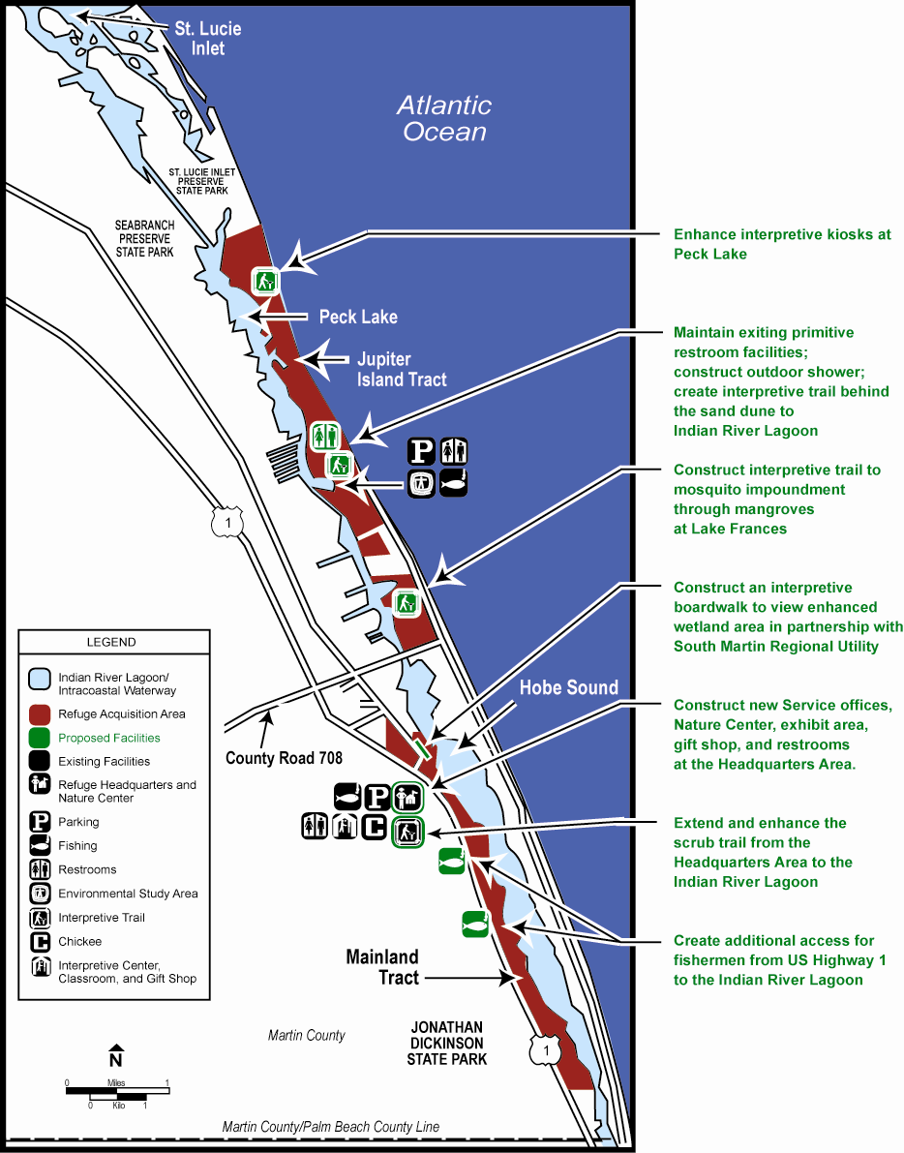
Objective 2: Expand partnership with the Hobe Sound Nature Center, Inc., and explore the development of new environmental education opportunities, both on and off the refuge, targeted toward students beyond the elementary school level and toward adults.

Strategies:

- Develop an environmental education curriculum, which is focused on biotic communities (e.g., sand pine scrub, barrier island, and Indian River Lagoon) common to the refuge, St. Lucie Inlet Preserve State Park, Jonathan Dickinson State Park, and the Blowing Rocks Preserve.
- Develop an environmental education program that uses volunteers as roving guides.
- Coordinate satellite downlinks with the Service and area schools and create a downlink site when the new learning center comes on-line.
- Develop an interactive web site to provide current information about ongoing and new refuge projects and Nature Center activities and program schedule with links to supporting sites.
- Create a video that showcases refuge biological systems, visitor facilities, and Nature Center environmental education and interpretation programs.
- Address, in the lecture series, key issues of concern to the refuge and the Service.
- Promote a Aleave no trace@ ethic through education and appropriate signage.
- Use environmental education, targeted toward homeowners and builders, to promote the use of native plants in landscaping.

Objective 3: By 2007, assist the Nature Center to expand experiences to 100,000 visitors per year and guarantee a healthy work environment for staff and volunteers. To accommodate the planned annual visitation and to also attract a greater spectrum of the community, the center will set lengthier and more convenient hours of operation, provide staff on the weekends, and accommodate multiple school and meeting groups.

Strategies:

- Work with the Hobe Sound Nature Center=s Board of Directors to showcase the center=s vision, generate community interest, and raise funds.
- Develop new partnerships to promote development of the center.
- Design the learning center to be aesthetically pleasing to the community and to fit into the sand pine scrub landscape.
- Provide a classroom/meeting area for presentations and to show videos.
- Provide adequate work space for a growing volunteer force and staff.
- Develop a library containing current and historic documents pertaining to refuge management, research, inventory, and monitoring projects.
- Provide space for wildlife art exhibits and contests.
- Develop exhibits to display the ecology and management of natural communities (e.g., dune dynamics, biodiversity of tropical hardwood hammocks, and healthy sand pine scrub management).

Objective 4: Expand opportunities for environmental interpretation.

Strategies:

- Create, replace, and maintain interpretive/educational signs.
- Initiate ranger-guided and self-guided tours to explain the ecology of the South Florida Ecosystem.
- Initiate annual photo and art contests.
- Collaborate with the Southeast Florida Archaeological Society and the Hobe Sound Nature Center to develop and implement a cultural resource interpretive program.

Objective 5: By 2008, add 50 volunteers to assist with resource protection, environmental education, and interpretive programs.

Strategies:

- Explore opportunities for greater public investment in the refuge.
- Expand the volunteer force to increase the number and frequency of beach clean-ups, exotic vegetation removal, and native plantings.
- Explore the feasibility of creating an Aadopt-a-beach@ program within the community.
- Train roving volunteer interpreters.
- Add volunteer coordination to job description of additional staff hired.

Goal 4. Administration

Implement appropriate management regime for the refuge and improve infrastructure; add support staff to meet the needs of an expanding visitor public and to facilitate responsible biological, maintenance, and law enforcement programs.

Discussion: When Hobe Sound National Wildlife Refuge was established 37 years ago, few people could have envisioned the vital role that this refuge would play in protecting globally imperiled wildlife and habitat. Nevertheless, over the years, this Asleepy little refuge@ found itself engaged in major controversies, endangered species issues, large partnerships, maintenance backlogs, exotic species invasions, law enforcement issues, and visitation in the hundred thousand plus category.

Objective 1: The refuge will add 4 key positions to its staff to achieve the goals, objectives, and strategies of this plan.

Strategies:

- Create a management structure that offers greater flexibility in meeting the resource needs of the refuge.
- Develop a permanent staff to achieve the vision, goals, and objectives of this plan.

Objective 2: Replace the existing administrative headquarters building, Nature Center, and maintenance shop with a facility that is safe, efficient, and worthy of a national wildlife refuge.

Strategies:

- Work with the Nature Center to raise funds for interpretive displays.
- Ensure that Refuge Operating Needs System (RONS) and Maintenance Management System (MMS) projects submitted to the Service=s Regional Office are well designed and appropriately prioritized.

Objective 3: Procure and maintain safe equipment to facilitate maintenance of grounds, buildings, and facilities, and provide appropriate equipment to conduct proposed biological inventories and monitoring.

Strategies:

- Replace faulty and old equipment.
- Either replace or bring all quarters and building structures up-to-code.
- Train personnel in safety compliance.

V. PLAN IMPLEMENTATION

Introduction

The future of this and most national wildlife refuges is dependent upon a public constituency that is knowledgeable of refuge resources and mandates, as well as environmental issues, and that is willing to work toward resolving them. To build and maintain this needed constituency, this plan not only provides actions to protect, restore, and conserve wildlife habitat, but also provides expanded educational and appropriate, compatible, wildlife-dependent recreational opportunities. Developing partnerships among our constituencies is the common theme to implement these actions and opportunities. Promoting the refuge as an asset of Martin County will enhance its image and help expand local support. To achieve the proposed management plan for the refuge, this section identifies 18 projects, staff development and equipment needs, staffing and funding needs, partnership opportunities, step-down management plans, and a biological monitoring and evaluation plan.

Project Summaries

Listed below are project summaries and their associated costs for facility development and maintenance; biological baseline data collection, manipulation and interpretation; exotic plant control; habitat restoration; and land acquisition over the next 15 years. The cost for each project is shown in Figure 26. While this project list is not intended to be all inclusive, it does reflect the basic needs supporting the outlined goals and identified by the public, planning team members, and refuge staff, based upon available information.

Wildlife Habitat and Population Management

Project 1. Control Invasive Exotic Plants

To protect the biological integrity of the refuge, exotic plants must be reduced and controlled. They threaten to change the landscape to a degree that imperils the ecosystem. Although it is impractical to believe that all exotics could be completely removed from the refuge, it is possible to curtail their spread and to reduce their populations to a maintenance level that an expanded refuge staff could control through an aggressive program.

The first step is to develop a restoration plan feasible for private contractors, agency partners, private landowners, and volunteers to implement and accomplish within 10 years. With the help of an effective environmental education program, partnerships could be developed with the community and other natural resource agencies to accomplish this goal.

Many areas of the refuge are heavily infested with monoculture stands of Australian pines and Brazilian peppers. Several other Category I invasive exotic plants are spreading so quickly that they rival these two traditional nemeses. This plan would include wholesale removal of these stands followed by the planting of native species. It is imperative to plant native species a short time after the removal of exotics; otherwise, the area would soon become re-infested.

Follow-up treatments are vital to keep invasive plants from outgrowing the newly established native plants. Each area of treatment will need to be monitored and re-treated as needed every few years.

Figure 26. Summary of project costs for Hobe Sound National Wildlife Refuge

PROJECTS | INITIAL PROJECT COST | RECURRING BASE COST
1. Control Invasive Exotic Plants | $280,000 | $180,000
2. Monitor Habitat and Wildlife Populations | 75,000 | 20,000
3. Implement Sand Pine Scrub Management Plan | 30,000 | 30,000
4. Restore and Monitor Mangrove Wetland Impoundments (3 total) | 500,000  (150,000per impoundment) | 30,000  (10,000 per impoundment)
5. Restore and Monitor Coastal Dune System | 25,000 | 25,000
6. Control Shorebird and Sea Turtle Predators | 15,000 | 15,000
7. Conserve Indian River Lagoon | 150,000 | 25,000
8. Control Beach Foredune Erosion | 250,000 | 50,000
9. Protect and Interpret Cultural Resources | 150,000 | 25,000
10. Acquire Land to Protect Unique Plant and Wildlife Habitats | 15,000,000 | ---
11. Develop Beach/Lagoon Trails and Observation Platforms | 125,000 | 25,000
12. Expand and Enhance Sand Pine Scrub Trail | 125,000 | 25,000
13. Develop and Install Informational Signs | 100,000 | 10,000
14. Provide Running Water and Restroom Facilities at the Beach Access Area | 100,000 | 25,000
15. Step Into the Computer Age | 20,000 | 10,000
16. Develop New Environmental Learning Center and Headquarters Facility | 1,200,000 | 50,000
17. Meet/Fulfill Heavy Equipment Needs | 75,000 | 25,000
18. Renovate Shop | 250,000 | 10,000
Grand Totals:
without land acquisition  with land acquisition | $3,345,000  $18,345,000 | $580,000

Among the more popular methods of exotic plant control are mechanical clearing, chemical treatment, and prescribed fire. None of these methods would be entirely successful if used alone. However, a combination of all three have a good chance of success with follow-up monitoring and spot re-treatment as needed.

To provide funding and equipment for this project, there are many opportunities to partner with various agencies and organizations; thus the Service would not solely bear the burden of the expense. The estimated first-year cost of this project is $280,000, with a recurring cost of $180,000 per year.

Project 2. Monitor Habitat and Wildlife Populations

There is a great need to inventory and map vertebrate, invertebrate, and plant communities on the refuge. Focusing on indicator and/or trust species, inventory data are essential to developing detailed step-down management plans. To gather these data, the refuge is proposing to add additional biological staff.

Collecting and mapping inventory data for trust species is a high priority task for this refuge. Inventories of other species would follow as resources become available. Habitat management strategies will be formulated based on the requirements of candidate and trust species and sensitive habitats. Inventories will be carried out periodically to monitor changes in biological populations in response to habitat management strategies. All inventorying, mapping, and monitoring will be accomplished using standard data gathering and monitoring techniques.

Information generated from monitoring efforts will be incorporated into a geographic information system database. Coordination with other natural resource agencies and universities will be necessary to accomplish this task. Many opportunities for research assistance are available through cooperative agreements with universities and nonprofit conservation organizations.

In addition to monitoring biological responses to habitat management actions, long-term monitoring of visitor impacts to the natural community will be emphasized. These data will allow the refuge manager to determine whether or not the refuge=s resources can support additional recreational opportunities and in which locations. The estimated first-year cost of this project is $75,000, with a recurring cost of $20,000 per year.

Project 3. Implement Sand Pine Scrub Habitat Management Plan

Many of the native forest communities in the southeastern United States have evolved in response to natural catastrophic disturbances, such as fires, hurricanes, and tornados. The sand pine scrub community of the refuge is one such community. However, human settlement of the region has served to minimize the frequency and duration of wildfire. When wildfires occur, they are usually suppressed and quickly extinguished to prevent loss of life and property. To conserve the unique balance of this disturbance-dependent community, the refuge will implement a management plan to mimic these catastrophic events keeping public safety the utmost in mind.

The sand pine scrub community is unique in comparison with other pine dominated communities, since it tends to burn very hot, very fast, and completely to the ground. As a result, succession is usually set back to a very early stage with little ground cover and no canopy. The sand pine scrub habitat on the refuge is bordered to the north and south by residential communities. For this reason, the refuge, in partnership with the Florida Park Service, The Nature Conservancy, Martin County, and others, has developed a plan to reset succession to its earliest stage and continue to do so at intervals mimicking natural processes. The full implementation of this scrub restoration management plan will provide a mosaic of optimal habitat for native species and reduce the threat of catastrophic wildfire. This newly crafted plan will incorporate mechanical disturbance followed by prescribed fire to treat sand pine scrub in an urban interface. If this technique is successful, it may be used across the state to manage thousands of acres of sand pine scrub.

Prescribed fire is also a useful tool for eliminating large monocultures of exotic plants, which threaten native ecosystems. Implementation of the fire management plan will contribute to achieving the objectives of the South Florida Multi-Species Recovery Plan for several threatened and endangered species. The project will require continual monitoring of threatened and endangered species, maintenance of mechanical clearing machinery, and the use of fire crews. The estimated first-year cost of this project is $30,000, with a recurring cost of $30,000 per year.

Project 4. Restore and Monitor Mangrove Wetland Impoundments

As part of wetlands restoration, the refuge will partner with the town of Jupiter Island, the Hobe Sound Land Company, and Martin and St. Lucie counties= mosquito control districts to reconstruct and manage former mosquito control impoundments to create 125 acres of improved mangrove and tidal wetlands. The project will require a biological inventory, construction of water control structures, improvements to existing levees and dikes, long-term monitoring, and seasonal water level manipulation.

The project, which has already been embraced by refuge partners, will facilitate tidal flushing; increase dissolved oxygen levels; provide fisheries= breeding grounds and subsequent wading bird foraging areas; and provide biological control of biting insects. The estimated first-year cost of this project is $150,000 per impoundment, with a recurring cost of $10,000 per year, per impoundment.

Project 5. Restore and Monitor Coastal Dune System

In partnership with the Florida Department of Environmental Protection, Bureau of Invasive Plant Management, and possibly the Jupiter Island Garden Club, the refuge will restore the coastal strand community. The project will require the complete removal of all invasive exotic plants, including Australian pine, Brazilian pepper, beach naupaka, carrot wood, wedilia, and others, followed by successive re-treatments. While some natural recruitment of native plant species is expected, this effort would be facilitated by replanting native species. The schedule for replanting will be coordinated with beach renourishment projects to provide the greatest benefit for dune accretion. This project will significantly support sea turtle nesting efforts, prevent the extirpation of threatened and endangered plant populations, and facilitate shorebird use and nesting. The estimated first-year cost of this project is $25,000, with a recurring cost of $25,000 per year.

Project 6. Control Shorebird and Sea Turtle Predators

For species such as sea turtles and least terns, the refuge, due to its limited nesting habitat, can only play a limited role in their conservation and recovery. The beach area on the Jupiter Island Tract provides nesting habitat for sea turtles, where eggs are deposited and hatchlings emerge to move into international waters of the Atlantic Ocean, Gulf of Mexico, and/or Caribbean. For the short time span when the female comes ashore to dig the nest and lay her eggs, the refuge will provide protection from poaching activities. For the subsequent 2 to 3 months that the eggs need to incubate and hatch, the refuge will provide protection not only from poaching but also from wildlife, such as raccoons and armadillos. While refuge officers provide the necessary protection from poachers, contractors like the U.S. Department of Agriculture, Animal Plant Health Inspection Service, will implement current mammalian predator control techniques to achieve a 75 percent hatching success rate. The refuge will focus on reducing and maintaining the natural predation rate (as incurred from native predators) to 10 percent or less, and will focus eliminating nest depredation by any exotic species. The estimated first-year cost of this project is $15,000, with a recurring cost of $15,000 per year.

Resource Protection

Project 7. Conserve Indian River Lagoon

The Indian River Lagoon is regarded as the most productive and biologically diverse estuary in the United States. The portion of the lagoon near the refuge is known for manatees, sea turtles, river otters, seagrass beds, mangrove shorelines, great fishing, and great birding.

Presently, the two sections of the Intracoastal Waterway that allow boat wake and vessel speeds of 25 miles per hour border the refuge. All other sections are limited to minimum wake and slow speeds. The high energy wakes produced by large, fast moving vessels result in significant shoreline erosion on the refuge. The high energy wakes produce degraded mangrove communities along the shoreline. The mangrove propagules are unable to take root in the turbulent waters, severely hindering regeneration. In an attempt to halt shoreline erosion, a planting procedure developed by the Environmental Learning Center of Vero Beach is currently being tested on the refuge. If successful, a large-scale planting will be conducted to conserve these mangrove communities of the refuge.

In addition to shoreline erosion, high energy wakes result in high populations of exotic plants along the shoreline. Large stands of exotic Australian pine line the lagoon shoreline at the refuge. Removal of these pines would allow for recovery of the mangrove community. However, these trees provide a visual buffer for the residents of Jupiter Island, as well as provide nesting sites for numerous ospreys. Replacement trees, such as native palms, would serve to replace the visual buffer and osprey nesting platforms could supplement native trees for nesting habitat.

In recent years the lagoon has lost a tremendous amount of seagrass and benthic habitats; the very communities that make it so unique. The seagrass and hard bottom habitats provide food and shelter to many interjurisdictional species of fish, crustaceans, and mammals.

The refuge will provide support to other agencies, as well as to other divisions within the Fish and Wildlife Service to promote the recovery of this ecosystem. As part of the increased role of protecting the lagoon, the refuge will implement an active water quality monitoring program, expand its mangrove restoration efforts and invasive species control, and provide aquatic species and bird survey information. The estimated first-year cost of this project is $150,000, with a recurring cost of $25,000 per year.

Project 8. Control Beach Foredune Erosion

Since the construction of the St. Lucie Inlet to the north of the refuge, more than a half-mile of beach has been forfeited to the Atlantic Ocean. Erosion is so great that it threatens to breach the narrow strip of land and create an inlet into the Intracoastal Waterway, as briefly occurred in 1963. On the refuge, the entire 3.5 miles of dune are in need of some degree of restoration.

Erosion can only be slowed by sound dune stabilization management in concert with beach renourishment and sand transfer projects. In recent history, efforts have been made to protect beachfront properties by constructing jetties or sea walls. These Ashoreline hardening@ projects have long-term detrimental impacts, especially for nesting sea turtles.

Associated with beach renourishment is the need to replant native species on the foredune and backdune areas. Species, such as sea oats, act as sand nets and trap the substrate as it is washed over by the incoming tide. Aside from the benefits of dune stabilization, replanting is labor intensive and involves a tremendous supply of nursery raised plants. To address this situation, partnerships could be developed with local nurseries and volunteers. A dune and coastal strand restoration plan will be developed for this project. The estimated first-year cost of this project is $250,000, with a recurring cost of $50,000 per year.

Project 9. Protect and Interpret Cultural Resources

The refuge contains many culturally significant areas within its boundaries. In the past, one of the most significant areas, the Joseph Reed Mound, was severely degraded by erosion due to storms and tidal fluctuations. Thus, an immediate need exists to identify all sites, define their cultural significance, and stabilize them before further erosion or degradation occurs. In partnership with the Southeast Florida Archaeological Society, appropriate trails can be created to allow public viewing of some of the sites. As required by the Archaeological Resources Protection Act and others, it is the duty of each land management agency to identify, research, and protect cultural resources, and provide cultural interpretation for the public. The estimated first-year cost of this project is $150,000, with a recurring cost of $25,000 per year.

Project 10. Acquire Land to Protect Unique Plant and Wildlife Habitats

The refuge expanded its boundary in 2004 to include the potential to acquire four tracts of land, including an 11-acre sand pine scrub site that contains the second largest population of the federally endangered Lakela=s mint; a 7-acre stretch of very productive sea turtle nesting beach on Hutchinson Island; a 65-acre parcel of sand pine scrub nearly adjoining the northern refuge boundary and owned by The Nature Conservancy; and a 4-acre site of Atlantic beach and dune, also located very near the refuge=s current boundary on property owned by the U.S. Coast Guard. All are ecologically significant and have been determined to be valuable additions to the refuge. Additional efforts are underway to consolidate the acquisition boundary by acquiring selected in-holdings on a willing-seller basis. Several residents have asked to swap parcels of land with the refuge. Other residents own submerged properties at the north end of the island. The refuge will work with its Realty Division and the Solicitor’s office to determine how best to accommodate these requests. Many partners have been identified to share acquisition costs and/or management collaboration, including donation of property, fee purchase, refuge overlay, and direct transfer. The estimated cost of this project, excluding any potential partnerships, is $15,000,000.

Wildlife-Dependent Recreation and Environmental Education

Project 11. Develop Beach/Lagoon Trail and Observation Platforms

To accommodate the increasing demand for compatible wildlife-dependent visitor opportunities, the refuge will expand its existing trail network to include a beach/lagoon trail

One proposed trail would originate at the beach parking lot and another at the Lake Frances mosquito impoundment. Both would enter the coastal strand community and wind through the mangrove swamp to the Indian River Lagoon. Turning back through the coastal strand, the trails would extend east, eventually leading the visitor out to the beach. There, the visitor would emerge from the vegetation, choose to either walk north along the beach to the St. Lucie Inlet Preserve State Park, or south to the refuge parking area. Informational signs would be positioned along the length to guide and inform the visitor. Boardwalks and foot bridges would be installed in sensitive areas to minimize the negative effects of high foot traffic. The trails would not be longer than 3 miles and would function simultaneously as an access for refuge staff to conduct exotic plant control activities. Developed in partnership with the community of Jupiter Island, these trails can be created without negatively affecting the residents of the island. The estimated first-year cost of this project is $125,000, with a recurring cost of $25,000 per year.

Project 12. Expand and Enhance Sand Pine Scrub Trail

The 1/2-mile sand pine scrub trail, originating from the headquarters area, is very popular with bird watchers, naturalists, and school groups. In fact, many requests have been received to lengthen the trail along the coastal ridge. To meet the public=s need, the existing trail would be extended approximately 3 miles. To extend the trail in a southerly direction would cause minimal disturbance to the scrub community. A relatively concealed overlook of the Indian River Lagoon would be constructed at a natural contour along the trail. Along the trail, there would be an opportunity to interpret an Indian Shell Midden. Informational signs would be positioned along its length. As with the beach/lagoon trail, this extension would facilitate exotic plant control efforts. The estimated first-year cost of this project is $125,000, with a recurring cost of $25,000 per year.

Project 13. Develop and Install Informational Signs

To better direct visitors, road signs are needed along Bridge Road (Martin County 708), and U.S. Highway 1. Wildlife crossing signs (e.g., gopher tortoise) are desperately needed to alert drivers of the potential to injure wildlife.

Many of the informational signs on the refuge are in a state of disrepair and need to be replaced. In particular, new signs are needed at the refuge headquarters; at the beach; and along several areas of the refuge, including the Peck Lake entrance. The estimated first-year cost of this project is $50,000, with a recurring cost of $10,000 per year.

Project 14. Provide Handicap Accessible Restroom Facilities at the Beach Access Area

A majority of the public commenting on the draft plan requested that the Service not install better restroom facilities at the refuge beach. Currently, restroom facilities are portable toilets positioned on a concrete slab and concealed by a privacy fence. No running water exists at the refuge beach. The decision to supply running water to the beach parking lot is at the discretion of the South Martin Regional Utility and the town of Jupiter Island; if either are favorable to supplying water, deed restrictions may have to be renegotiated. Even if only non-potable water could be supplied at the refuge beach, a single foot shower/rinsing structure could be positioned outside the restroom facility for hikers, swimmers, fishers, and surfers. The refuge will install handicap accessible facilities but will not construct new restrooms for public use. The estimated first-year cost of this project is $25,000, with a recurring cost of $5,000 per year.

Project 15. Step into the Computer Age

Currently, the refuge=s web site contains a written narrative of basic refuge facts. The refuge can expect to more effectively reach the public and advance environmental education with an upgraded, interactive web page. In addition to the narrative, the web site would contain several color photos. The text would be expanded to include current refuge and Nature Center interpretive programming schedules, up-to-date information on threatened and endangered species conservation, and linkages to related information.

One of the more exciting programs to post on the upgraded website would be a video, taken with a digital camera, showing sea turtle nesting and the subsequent hatchling emergence and scramble to the surf. In addition, a nest Acam@ could be installed to monitor young osprey. In either case, web viewers would be provided a real-time link from the refuge. The estimated first-year cost of this project is $20,000, with a recurring cost of $10,000 per year.

Administration

Project 16. Construct New Environmental Learning Center and Headquarters Facility

This project was initiated in 2006 following the demise of the old headquarters building during the hurricanes of 2004. The new structure will contain a learning center with a reception area, gift shop, and interpretive displays, as well as office space for refuge and Nature Center staff and volunteers.

Attracting more than 100,000 visitors annually, a facility was needed to convey the vision of the refuge, to bring pride to the organizations that educate a growing public, and to reflect the issues that will advance the cause of conservation. The construction budget for the new headquarters and nature center is approximately $1,000,000, with a recurring cost of $50,000 per year.

Project 17. Meet/Fulfill Heavy Equipment Needs

While chemical treatment is an effective means to control exotic plants, obtaining access to treatment areas is extremely difficult. Thus, a small tractor with a set of attachments (e.g., bucket, backhoe, root rake, and bushhog) is need to cut trails into heavily infested areas and also remove the thick tangles of biomass that remain after treatment. The tractor could maintain and extend existing trails, as well as create new trails and boardwalks for non-consumptive wildlife uses. A tractor could also be used for day-to-day refuge maintenance and provide needed support for many construction projects. The estimated coast of this project is $75,000, with a recurring cost of $25,000 per year.

Project 18. Renovate Shop

The maintenance staff has been supported in a pre-fabricated metal shop building that abuts the headquarters facility. Inadequate space prevents the storage of all equipment that warrants protection from the elements. Poor airflow has resulted in higher temperatures, limiting the amount of time workers can utilize their workplace. A renovated facility is needed to correct these problems and to allow for storage of new heavy equipment associated with invasive species control identified in other projects. The estimated cost of this project is $250,000, with a recurring cost of $10,000 per year.

Staffing and Funding

The Hobe Sound National Wildlife Refuge is a satellite of A.R.M. Loxahatchee National Wildlife Refuge, which is located in Boynton Beach, Palm Beach County, Florida. The refuge shares its budget with its parent refuge and relies on it for partial staffing and administrative support. The refuge was recently considered for stand-alone status and even though it was found to not be feasible at this time, it may be reconsidered during the 15-year life of this plan.

The refuge is currently approved for three permanent positions: a refuge manager (GS-0485-12); refuge law enforcement officer (GS-025-7); and a maintenance worker (WG-4749-8). Two seasonal fee clerks are also presently employed. The annual cost for the refuge, including the salary of the three permanent positions, is approximately $300,000.

Due to the volume of refuge visitors (more than 100,000 per year), coupled with growing visitor inquiries via telephone and in writing, accumulating administrative duties, and increasing need to address a myriad of environmental issues, the refuge needs to add 4 additional staff: an office assistant, a wildlife biologist, a refuge ranger, and a maintenance helper. The annual cost of each of these positions is shown in Figure 27.

An office assistant is needed to handle the tremendous number of administrative duties (namely phone calls, correspondence, regional office requests, and daily walk-ins) so that the refuge manager can focus on strategic refuge activities.

A biologist is crucial to the accomplishment of the objectives outlined in this plan. This person would collect key data, monitor critical wildlife populations and habitat conditions, take a lead role in the control of exotic plants, and both draft and implement resource management plans. In the past, a biologist and temporary seasonal biological technicians from Loxahatchee Refuge conducted surveying and monitoring activities of selected resources and provided oversight of wildlife issues, including sea turtle nest surveys during the summer months. Recently, sea turtle monitoring has been contracted out to Ecological Associates, Inc., through a partnership with the U.S. Department of Agriculture and Martin County. However, many significant issues, especially those related to threatened and endangered species have gone unattended due to the lack of an on-site biologist.

Currently, the maintenance worker is charged with the duties of facility, equipment, vehicle, and grounds, as well as exotic plant control. These tasks have proven overwhelming for one person. The refuge is in need of at least one more permanent maintenance position that would help greatly in reducing the backlog of maintenance projects.

The refuge ranger (public use) would assist the Hobe Sound Nature Center staff with environmental education and outreach programs, as well as coordinate other volunteer programs. The primary responsibility of the position would be to operate the newly constructed visitor center, develop and continuously update the refuge website, and provide volunteer coordination and ranger-guided activities.

The fee clerks are often the only Service representatives that greet the public at the fee booth located at the beach parking lot. These two individuals provide visitor information, handle complaints, answer questions, manage the parking lot, accept fees, sell passes, monitor visitor concerns, offer first aid, and provide passive law enforcement. Part-time coverage at the fee booth still enables the refuge to collect approximately $50,000 a year in fees.

Partnership Opportunities

To achieve the goals and objectives of this plan, maintaining existing partnerships and developing new ones with a variety of resource agencies, organizations, and individuals are essential (for a list of existing and potential partners see Appendix VIII). Partnerships would not only enable the refuge to fulfill plan objectives, but would also help minimize costs.

To address its single greatest threat, invasion of exotic plants into native communities, the refuge will need to foster existing relationships with the Florida Department of Environmental Protection, Bureau of Invasive Plant Management; Bureau of State Parks; Treasure Coast Upland Invasive Plant Working Group; and Archie Carr and Merritt Island National Wildlife Refuges. In addition, the refuge will seek new partnerships with the town of Jupiter Island, the Marine Resources Council, and the
Figure 27. Annual cost of existing and proposed staff positions for Hobe Sound National Wildlife Refuge

TITLE | GRADE | STATUS | ANNUAL COST¹
Refuge Manager | GS-0485-12/13 | Existing | 67,500
Office Assistant | GS-0303-7 | Proposed | 46,400
Wildlife Biologist | GS-0486-7/9/11 | Proposed | 62,000
Refuge Officer | GS-0025-5/7 | Existing | 46,200
Refuge Ranger (Public Use) | GS-0025-5/7/9 | Proposed | 41,900
Maintenance Mechanic (Facilities) | WG-4749-8 | Existing | 42,300
Maintenance Helper | WG-4749-5 | Proposed | 31,200
Fee Clerk (Seasonal) | GS-0025-3 T | Existing | 11,800*
Fee Clerk (Seasonal) | GS-0025-3 T | Existing | 11,800*
Annual Staff Costs |  |  | $337,500
Annual Fixed Costs (e.g., phone, waste disposal, fuel, and electric) |  |  | $55,000
Miscellaneous expenses (Equipment repair and replacement [e.g., trucks, ATV=s, boat, power equipment, office equipment], predator control, facilities maintenance, small re-construction projects, and biological support equipment.) |  |  | $220,000
Total Annual Costs When Plan is Fully Implemented |  |  | $612,500**
¹Salary and benefits paid by the Service
T=Temporary or Seasonal Position
*Funding generated from fee collection
**Figure does not reflect start-up costs (administrative) associated with new employees.

Florida Inland Navigation District, and will develop a volunteer restoration work force. Exotic plant control and native community restoration will benefit all refuge programs and facilitate the achievement of many refuge goals and objectives.

To develop a regionally significant environmental education program, assistance will be sought primarily from the Hobe Sound Nature Center and others, such as The Nature Conservancy, the Audubon Society, and Martin County. The new environmental learning center will require input and assistance from many such organizations and individuals from the local community.

The refuge has a very rich cultural heritage, which can be described and showcased using partnerships with the National Park Service, the Southeast Florida Archaeological Society, and area universities. Preservation, education, and interpretation of archaeological resources will be a primary focus of the refuge, as outlined in national policies.

The sand pine scrub community is fast disappearing from the south Florida landscape. The refuge will take a proactive role in managing its small stand and take the lead on developing partnerships with public land management agencies, housing and commercial developments, and private property owners to manipulate isolated tracts off the refuge for the maintenance of the community and recovery of its 15 to 20 protected endemic species.

As land is quickly developed to meet the needs of the growing south Florida population, many local municipalities, counties, and state agencies, as well as private non-profit organizations, are actively acquiring land parcels with unique or imperiled habitats in an attempt to prevent their destruction. More and more frequently, the refuge is approached by these organizations to aid in managing these parcels. To these ends, the refuge will create partnerships to acquire environmentally sensitive lands and provide guidance, technical expertise, and when possible, hands-on assistance to manage these tracts.

Step-Down Management Plans

While a comprehensive conservation plan is a strategic plan that guides the management direction of the refuge, a step-down management plan provides specific guidance on such activities as habitat, fire, and public use management As with a comprehensive conservation plan, step-down plans are developed in accordance with the National Environmental Policy Act, which requires the identification and evaluation of alternatives and public review prior to their implementation.

By 2008, the refuge will have completed step-down plans for law enforcement; mangrove community and mosquito impoundment management; cultural resource protection; coastal dune management; land protection; environmental education; biological inventory and monitoring; and exotic plant control. Two additional plansBthe sand pine scrub and predator controlBhaving received previous public review, will be updated (Figure 28). To assist in preparing and implementing the step-down plans, refuge staff will develop partnerships with local agencies and organizations.

Law Enforcement
Completion 2008
The purpose of this plan is to provide a ready reference to Service, regional, and local police regarding refuge policies, procedures, and programs concerning refuge law enforcement. It will describe the refuge from a law enforcement perspective and discuss the primary law enforcement objectives of the refuge. It will address the type(s) of jurisdiction on the refuge and procedures for operating within those jurisdictions. It will describe the legal limitations and how they are related to other federal, state, county, and local law enforcement agencies. Topics included will be preventive law enforcement, boundary and other signing, reporting of incidents and suspicious activity, routine law enforcement patrols, procedures for normal vehicle stops and night patrols, burglar alarm responses, drug interdiction or eradication procedures, cooperation with other agencies, search and rescue, and crowd control.

Sand Pine Scrub Management (Update)
Completion 2007
This plan, completed in 1999, will be updated to outline the maintenance of a healthy sand pine scrub community. The plan will incorporate new information acquired since its implementation and include a fire regime, rotations, and mechanical applications. The plan will be updated to include neighboring scrub sites and provide technical assistance to other agencies and organizations.

Mangrove Community and Mosquito Impoundment Management

Completion 2007
This plan will address three strategies, namely hydrology restoration, exotic plant removal, and replanting, for restoring the mangrove community within the three mosquito impoundments on the refuge. Prior to restoration of the impoundments, the plan will describe inventory and surveying protocols, water level management for native species and biting insect control, and monitoring. This plan will be prepared in collaboration with the town of Jupiter Island.

Cultural Resource Protection
Completion 2009
This plan will build on the information gathered by researchers from the National Park Service, Southeast Florida Archaeological Society, and local universities to protect and interpret the cultural resources on the refuge. The plan will emphasize protection of significant sites and include inventory, research, and interpretation.

Predator Control (Update)
Completion 2007
This plan, completed in 1999, will be updated to re-evaluate current control techniques to include lethal and non-lethal methods. The plan will describe the process to achieve less than 10 percent depredation of sea turtle and shorebird nests and protocols for monitoring effectiveness, and will relate to the ongoing sea turtle nest monitoring program.

Visitor Services
Completion 2010
This plan will address appropriate, compatible, and wildlife-dependent recreational opportunities including facility upgrades, handicapped accessibility, pets, types of recreation, and other visitor services.

Coastal Dune Management
Completion 2010
This plan will include the inventory, management, and follow-up monitoring for a healthy native dune community. The plan will outline exotic plant control, native species recruitment and planting, dune conservation and renourishment, and sea turtle and shorebird nesting.

Land Protection Plan
Completion 2010
As indicated earlier, sand pine scrub and other environmentally sensitive habitats, which were once prevalent in the landscape surrounding the refuge, are rapidly being eliminated through development. These habitats are important for trust species, such as indigo snakes and other threatened and/or endangered wildlife.

In collaboration with partners, such as Florida State Parks, The Nature Conservancy, Martin and St. Lucie Counties, town of Jupiter Island, and adjacent private landowners, the Land Protection Plan will identify lands needing protection outside of the refuge boundary, identify the most appropriate owner, establish priorities for acquisition, and method of acquisition (e.g., fee title and easement). This region-wide collaborative approach to land protection will not only create sufficient blocks of habitat to meet wildlife needs, but also create wildlife corridors by linking environmentally sensitive habitats. During the course of the planning process, planning team members identified approximately 3,300 acres of imperiled environmentally sensitive habitats outside of the acquisition boundary.

Exotic Plant Control
Completion 2009
This plan will identify current infestation levels of the major exotic or invasive plants and outline methods for control and monitoring. It will also address minor infestations and less invasive exotic plant species. It will address the complex issue of bringing exotic plants to a maintenance control level as quickly as possible, and will include the use of chemical herbicides, mechanical eradication, and prescribed fire.

Environmental Education
Completion 2010
This plan, prepared in collaboration with the Nature Center, will reflect the objectives and strategies of the comprehensive conservation plan and address environmental education guidelines following Sunshine State standards. As a part of this plan, an educational curriculum will be created that follows the plan and Fish and Wildlife Service guidelines for environmental education.

Biological Inventory and Monitoring
Completion 2010
This plan will describe inventory and monitoring techniques and time frames. All plant communities and associations on the refuge, as well as all trust species (e.g., migratory birds including shorebirds and neotropical passerines), listed species (e.g., federal and state threatened, endangered, and species of concern, as well as plants listed by the state as commercially exploited), and key species shall be inventoried, and population trends will be monitored. These data are essential to guide wildlife habitat management on the refuge.

Figure 28. Step-down management plans/completion dates

Step-Down Plan | Completion Date
Sand Pine Scrub Management (Update) | 2007
Mangrove Community and Mosquito Impoundments | 2007
Predator Control (Update) | 2007
Law Enforcement | 2008
Coastal Dune Management | 2008
Exotic Plant Control | 2009
Cultural Resource Protection | 2009
Visitor Services | 2010
Land Protection | 2010
Environmental Education | 2010
Biological Inventory and Monitoring | 2010

Monitoring and Evaluation

Adaptive management is a flexible approach to long-term management of biotic resources that is directed over time by the results of ongoing monitoring activities and other information. More specifically, adaptive management is a process by which projects are implemented within a framework of scientifically driven experiments to test the predictions and assumptions outlined within a plan. To apply adaptive management, specific survey, inventory, and monitoring protocols will be adopted for the refuge. The habitat management strategies will be systematically evaluated to determine management effects on wildlife populations. This information will be used to refine approaches and determine how effectively the objectives are being accomplished. Evaluations will include ecosystem team and other appropriate partner participation. If monitoring and evaluation indicate undesirable effects for target and non-target species and/or communities, then alterations to the management projects will be made. Subsequently, the refuge=s comprehensive conservation plan will be revised.

Specific monitoring and evaluation activities will be described in the step-down management plans.

Plan Review and Revision

This comprehensive conservation plan will be reviewed every 5 years to determine the need for revision. A revision will occur if and when significant information becomes available, such as a change in ecological conditions or a major refuge expansion. The plan will be augmented by detailed step-down management plans to address the completion of specific strategies in support of the refuge=s goals and objectives. Revisions to the comprehensive conservation plan and the step-down management plans will be subject to public review and NEPA compliance.

SECTION B. APPENDICES

I. GLOSSARY

Adaptive management A process in which projects are implemented within a framework of scientifically driven experiments to test predictions and assumptions outlined within the comprehensive conservation plan. The analysis of the outcome of project implementation helps managers determine whether current management should continue as is or whether it should be modified to achieve desired conditions.

Alternative A set of objectives and strategies needed to achieve refuge goals and the desired future condition.

Anadromous Going from salt water to fresh water; such as salmon, shad, snook, or tarpon.

Approved acquisition boundary A project boundary which the Director of the Fish and Wildlife Service approves upon completion of the detailed planning and environmental compliance process.

Bio-accumulation The process in which industrial waste, toxic chemicals, or pesticides gradually accumulate in living tissue, or in the food web/chain.

Biomass The total mass, or amount of material, in a particular area.

Biological diversity The variety of life forms and its processes, including the variety of living organisms, the genetic differences among them, and the communities and ecosystems in which they occur.

Biological integrity The biotic composition, structure, and functioning at genetic, organism, and community levels comparable with historic conditions including the natural biological processes that shape genomes, organisms, and communities.

Biota The plant and animal life of a region.

Buffer A multi-use transitional area designed and managed to protect core reserves and critical corridors from increased development and human activities that are incompatible to wildlife. In this document, agricultural lands are also considered buffer lands.

Calusa An Indian tribe of south Florida, now thought to be extinct.

Canopy A layer of foliage; generally the upper-most layer in a forest stand. It can be used to refer to mid- or under-story vegetation in multi-layered stands. Canopy closure is an estimate of the amount of overhead tree cover (also canopy cover).

Catastrophic wildfire Fires which historically occurred in the area prior to the 1900s, usually once every decade during severe droughts; fires had potential due to their intense nature, to physically alter a particular plant community.

Category 1 Florida Exotic Pest Plant Council has developed three ranking categories to classify the invasiveness and threat of exotic plants to the natural environment. Category I species are those invading and disrupting native plant communities in Florida. This definition does not rely on the economic severity, or geographic range of the problem, but on the documented ecological damage caused.

Compatible use An appropriate wildlife-dependent recreational use or any other use on a refuge that is within the mandates laid down in the National Wildlife Refuge System Improvement Act of 1997; the intent of the Congress in the Act of 1997 or in the AFinal Internal Draft@ document of appropriate uses on a national wildlife refuge. The refuge manager may also determine if an activity will or will not materially interfere with or detract from the fulfillment of the mission of the System or the purposes of the refuge.

Comprehensive Conservation A document that describes the desired future conditions of a refuge and provides long-range guidance and management direction in order to accomplish the purposes of the refuge, contribute to the mission of the refuge system, and to meet other relevant mandates.

Cooperative Agreement A simple habitat protection action in which no property rights are acquired. An agreement is usually long-term and can be modified by either party. Lands under a cooperative agreement do not necessarily become part of the National Wildlife Refuge System.

Corridor A route that allows movement of animal species from one region or place to another.

Cultural resources The physical remains of human activity (e.g., artifacts, ruins and burial mounds) and conceptual content or context (as a setting for legendary, historic, or prehistoric events, such as a sacred area of native peoples) of an area. It includes historically, archaeologically, and/or architecturally significant resources.

Diversity Variety; usually used in reference to the number of species or living organisms in a given area, including some reference to their abundance.

Ecosystem A dynamic and interrelated complex of plant and animal communities and their associated non-living environment.

Ecosystem approach A strategy or plan to protect and restore the natural function, structure, and species composition of an ecosystem, recognizing that all components are interrelated.

Ecosystem management Management of an ecosystem that includes all ecological, social, and economic components which make up the whole of the system.

Ecotone A transitional zone between two habitat types or adjacent communities.

Endangered species Any species of plant or animal defined through the Endangered Species Act as being in danger of extinction throughout all or a significant portion of its range, and published in the Federal Register.

Endemic species Plants or animals that occur naturally in a certain region and whose distribution is relatively limited to a particular locality.

Environmental assessment A systematic analysis to determine if proposed actions would result in a significant effect on the quality of the environment.

Epiphyte A plant that grows on another plant but is not parasitic and produces its own food by photosynthesis, such as orchids, air plants, lichens, and mosses.

Estuarine Deposited in an estuary; an inlet or arm of the sea where salt water and fresh water meet.

Exotic species A non-indigenous or alien species, or one introduced to this state, either purposefully (horticulture trade) or accidentally that escaped into the wild where it reproduces on its own, either sexually or asexually. Any introduced plant or animal species that is not native to the area and may be considered a nuisance.

Fee title The acquisition of most or all of the rights to a tract of land. There is a total transfer of property rights with the formal conveyance of a title. While a fee title acquisition involves most rights to a property, certain rights may be reserved or not purchased, including water rights, mineral rights, or use reservation (the ability to continue using the land for a specified time period, or the remainder of the owner=s life).

Feral A wild, free-roaming animal; may be a domestic escapee.
FONSI Finding of No Significant Impact. A document prepared in compliance with the National Environmental Policy Act, supported by an environmental assessment that briefly presents why a federal action will have no significant effect on the human environment and for which an environmental impact statement, therefore, will not be prepared.

Fuel Living and dead plant material that is capable of burning.

GIS Geographic Information System. A computer based system for the collection, processing, and managing of spatially referenced data. GIS allows for the overlay of many data layers and provides a valuable tool for addressing resource management issues.

Goals Descriptive statements of desired future conditions.

Habitat The place where an organism lives. The existing environmental conditions required by an organism for survival and reproduction.

Herbicide A chemical agent used to kill plants or inhibit plant growth.

Hydrological Involving water flows or their distributions as related to evaporation, or flow to freshwater marshes, marshes, seas, estuaries, etc.

Hydrology The scientific study of the properties, distribution, and effects of water in the atmosphere, on the earth=s surface, and in soil and rocks. A hydrologic model is a type of simulation which takes into account the known behavior of water in the form of mathematical formulas and computer models that allows one to mimic the movement of water in a known area.

Indicator species A species of plant or animal that is assumed to be sensitive to habitat changes and represents the needs of a larger group of species.

In-holding Privately owned land inside the boundary of a national wildlife refuge.

Invasive species A native or non-native plant that has flourished beyond its normal constraints, due to changes in its natural environment.

Keystone species A species unique to, or dependent upon, a specific habitat; that one of a number of associated parts or things that supports or holds together the others.
Listed species Any species of fish, wildlife, or plant that has been determined to be Aat risk@ by a state or the federal government agency. In this document, at risk may include threatened, endangered, species of special concern, species of management concern, or species included in the Convention of International Trade in Endangered Species.

Lygodium Genus for Old World climbing fern; an invasive vine from Southeast Asia and Africa introduced in the 1950s, or earlier, by the nursery trade as an ornamental vine; rapidly displacing native vegetation in the refuge and other areas of south Florida. Extremely disruptive to natural habitats such as the Everglades; a Category I. Scientific name: Lygodium microphyllum.

Midden A slightly elevated mound composed of shell fragments and other debris left as waste by native Indians; shell mounds found throughout the ecosystem constructed by native Indians.

Migratory The seasonal movement from one area to another and back.

Monotypic Consisting of one type or species, such as exotic vegetation. Examples include single crops or Casuarina Aheads.@ Scientific studies have shown that monotypic stands of vegetation generally provide poor wildlife habitat.

Mitigation Avoiding or minimizing impacts of an action.

Monitoring The process of collecting information to track changes of selected parameters over time.

Multi-Species Recovery Plan A plan developed in 1999 and spear-headed by the Service to address listed species and their habitat needs in south Florida.

National Environmental Policy Act Requires all federal agencies, including the Service, to examine the environmental impacts of their actions, incorporate environmental information, and use public participation in the planning and implementation of all actions. Federal agencies must integrate this Act with other planning requirements, and prepare appropriate policy documents to facilitate better environmental decision making.

National Wildlife Refuge System A national network of lands and waters administered for the conservation, management and, where appropriate, restoration of the fish, wildlife, and plant resources and their habitats within the United States for the benefit of present and future generations of Americans.
Native A species occurring in Florida at the time of European contact (1500 AD). With respect to a particular ecosystem, a species that, other than as a result of an introduction, historically occurred or currently occurs in that ecosystem.

Neotropical migratory birds Birds that migrate from North America back and forth to South or Central America. These birds usually breed in North America and Awinter@ in the Carribean, or South or Central America. Usually this term is inclusive of many passerines (perching birds) and shorebirds.

Partnerships A mutually beneficial, joint relationship between two agencies or an agency and landowner, etc.

Passerine The largest bird group composed of small perching birds. Examples include northern cardinals, blue jays, warblers, sparrows and wrens.

Preferred alternative The Service=s selected alternative identified in the Comprehensive Conservation Plan.

Prescribed fire A planned or intentional fire set by resource land managers to improve or restore wildlife habitat and reduce potentially dangerous fire fuel loads, also known as Acontrolled burn.@

RONS Refuge Operationing Needs System. A national database that contains the unfunded operational needs of each refuge. Projects included are those required to implement approved plans and meet goals, objectives, and legal mandates.

Refugia A place of shelter, safety, or protection from danger.

Restoration management Management actions to return a vegetative community or ecosystem to its original, natural condition. To bring a disturbed site or an area changed from its native state back to its historic structure, including water regimes, plant community, and wildlife components. In this document, restoration can refer to exotic plant removal, planting native plants, and /or reintroductions of native plants or animals.

Ruderal A botanical term for plants growing in waters or disturbed places (e.g., roadsides and fire breaks).

Scoping Process for determining the scope of issues to be addressed by a comprehensive conservation plan and for identifying the significant issues. Involved in the scoping process are federal, state, and local agencies, private organizations, and individuals.

Service Fish and Wildlife Service; the federal agency, under the Department of the Interior, which guides the management of the refuge.
Shrub A plant usually with several woody stems; a bush. A shrub differs from a tree by its low height

Species A group of organisms all of which have a high degree of physical and genetic similarity, generally interbreed only among themselves, and show persistent differences from members of allied groups of organisms.

Step-down management plans Plans that provide the details necessary to implement management strategies and projects identified in the CCP

Strategy A general approach or specific actions to achieve objectives

Threatened species Those plant or animal species likely to become endangered species throughout all or a significant portion of their range within the foreseeable future. A plant or animal identified and defined in accordance with the 1973 Endangered Species Act and published in the Federal Register.

Trust species Specifically, species that are federal responsibility and include migratory birds, threatened and endangered species, anadromous fish, and certain marine mammals. The term is broadly used in this document to include federal, state, and internationally listed species, including threatened, endangered, species of special concern and species of management concern. Also known as Alisted species.@

USDA United States Department of Agriculture; a federal agency.

Vegetation Plants in general, or the sum total of the plant life in an area.

Wetland Areas, such as lakes, marshes, and streams, that are inundated by surface or ground water for a long enough period of time each year to support, and do support under natural conditions, plants and animals that require saturated or seasonally saturated soils.

Wildfire An uncontrolled fire started naturally by means such as lightning, or accidently/intentionally by man. Due to its intense nature, it=s often more damaging to native plant communities and resident wildlife.

Wildlife-dependent recreation Uses on a national wildlife refuge that involves hunting, fishing, wildlife observation, wildlife photography, and environmental education and interpretation as identified in the National Wildlife Refuge System Improvement Act of 1997.

Wildlife management The art and science of producing, maintaining, benefiting, and/or enhancing wildlife populations and their associated habitats.

II. References and Literature Cited

Andrews, E.W. and C.M. Andrews (eds.) 1985. Jonathan Dickinson's Journal. Port Solerno, Florida: Florida Classics Library.

Austin, Daniel., Penelope N. Honychurch and Steve Bass. 1999. Coastal Park Plant Guide. A pocket guide to the native trees, shrubs, and vines of Boca Raton=s hammock and mangrove parklands. City of Boca Raton Department of Parks and Recreation. 76p.

Bain, Rachel, Sue Jewell, Joseph Schwagerl and Burkett S. Neely Jr., 1997. Sea turtle nesting and reproductive success at the Hobe Sound National Wildlife Refuge (Florida: 1972-1985). Fish and Wildlife Service internal document.

Beckner, J. 1968. Lygodium microphyllum, another fern escaped in Florida. American Fern Journal 58:93-94.

Beeler, E., T.J. O=Shea and D.K. Odell. 1988. AMarine mammals in the Indian River Lagoon.@ In Indian River Lagoon Estuarine Monograph. D.D. Barile (ed.). Marine Resources Council of East Central Florida, Florida Institute of Technology. Melbourne, Florida.

Bergh, Chris. 1998. Proposal for non-native invasive plant control and habitat restoration. Hobe Sound National Wildlife Refuge. Fish and Wildlife Service internal document.

Bradley, Keith A, Woodmansee, Steven W., and George D. Gann. 1998. Scrub Hypericum Survivorship and Seeding Recruitment Report. Florida Division of Forestry Plant Conservation Program, Tallahassee, Florida.

Bresette, M.J., J.C. Gorham, and B.D. Peery. 2002. Initial assessment of sea turtles in the southern Indian River Lagoon System, Ft. Pierce, Florida Indian River Lagoon: Pages 271-273. in Mosier, A., A. Foley, and B. Brost (compilers), Proceedings of the Twentieth Annual Symposium on Sea Turtle Biology and Conservation. NOAA Technical Memorandum NMFS-SEFSC-477. 369 pages.

Brown, S., C. Hickey and B. Harrington (eds.). 2000. United States Shorebird Conservation Plan. Manomet, Massachusetts: Manomet Center for Conservation Sciences. 60p.

Chambers, J. R. 1991. Coastal degradation and fish population losses. In AStemming the tide of coastal fish habitat loss.@ R.H. Stroud (ed), Proceedings of the Marine Recreational Fisheries Symposium (14:45-51). National Coalition for Marine Conservation, Savannah, Georgia.

Cox, A. C. and R.E. Roberts. 1998. Species response to scrub habitat management of the Atlantic Coastal Ridge. (Unpublished).

Ecological Associates, Inc., 1997. Annual Report. Hobe Sound National Wildlife Refuge Sea Turtle Nesting Report. Fish and Wildlife Service internal document.

Ecological Associates, Inc., 1998. Annual Report. Hobe Sound National Wildlife Refuge Sea Turtle Nesting. Fish and Wildlife Service internal document.

Ecological Associates, Inc., 2002. Results of 2001 Sea Turtle Monitoring at Hobe Sound National Wildlife Refuge.

Engeman, R.M., S.A. Shwiff, B. Constantin, M. Stahl and H.T. Smith. 2002. An economic analysis of predator removal approaches for protecting marine turtle nests at Hobe Sound National Wildlife Refuge. Ecological Economics 42: 469-78.

Engeman, R.M., R.E. Martin, B. Constantin, R. Noel and J. Woolard. 2003a. Monitoring predators to optimize their management for marine turtle nest protection. Biological Conservation. 113:171-178.

Fernald, R.T. 1989. Coastal xeric scrub communities of the Treasure Coast Region, Florida: a summary of their distribution and ecology, with guidelines for their preservation and management. Florida Game and Fresh Water Fish Commission, Nongame Wildlife Program Technical Report No. 6. Tallahassee, Florida. 125pp.

Finch, D.M. and P. Stengel, eds. Status and management of neotropical migrant birds. USDA Forest Service Gen. Tech. Report RM 229, Forest and Range Experiment Station, Fort Collins, Colorado.

Florida Committee on Rare and Endangered Plants and Animals. 1992. Rare and Endangered Biota of Florida: Volume II. Fishes. University Press of Florida. Gainesville, Tallahassee, Tampa, Boca Raton, Pensacola, Orlando, Miami, Jacksonville, Florida.

Florida Department of Environmental Protection. 1997. Florida Sea Turtle Stranding and Salvage Network Database. Florida Marine Research Institute, St. Petersburg, Florida.

Florida Department of Environmental Protection. Florida Statewide Nesting Beach Survey Program, Department of Environmental Protection. 1993-1997 data.

Florida Department of Environmental Protection. 1998. Draft St. Lucie Estuary Issue Team Interim Plan. Department of Environmental Protection District Office, Port St. Lucie, Florida.

Fryman, M.L., D. Swindell III, and J.J. Miller. 1980. Cultural Resource Reconnaissance of Hobe Sound National Wildlife Refuge, Martin County, Florida. Cultural Resource Management, Inc., Tallahassee, Florida.

Gilligan, K. 1999. Wildlife Survey Prior to Sand Pine Removal Project at Hobe Sound National Wildlife Refuge. (Unpublished). USFWS Internal Biological Report. Hobe Sound National Wildlife Refuge.

Gilmore, R.G., C.J. Donahoe, D.W. Cooke, and D.J. Herrema. 1981. AFishes of the Indian River Lagoon and Adjacent Waters, Florida.@ Harbor Branch Foundation, Technical Report No. 41.

Gilmore, R.G., Jr. 1996. Personal communication, August 29, 1996, Harbor Branch
Oceanographic Institute.

Haddad, K. and F. Sargent. 1994. Scars under the water. The Florida Naturalist. Winter: 9-11.

Harbor Branch Oceanographic Institute. 2002. Personal communication.

Hagen J.M., III and D.W. Johnson (eds). 1992. Ecology and conservation of neotropical landbirds. Smithsonian Institute Press. 609pp.

Humphrey S. R., editor. 1992. Rare and Endangered Biota of Florida Vol I, Mammals,
University Press of Florida. Miami, Florida.

Hutchinson, Janet. 1998. History of Martin County. Stuart, Florida: Historical Society of Martin County.

Indian River Lagoon National Estuary Program. 1996. The Indian River Lagoon: Our Heritage at Risk B The Indian River Lagoon Comprehensive Conservation and Management Plan. Sponsored by the St. Johns and South Florida Water Management Districts in cooperation with the U.S. Environmental Protection Agency. Melbourne, Florida.

Indian River Lagoon National Estuary Program. 1998. What you should know about the Indian River Lagoon. Fact sheet. Indian River Lagoon Program, Melbourne, Florida.

Jackson, D.R. and E.G. Milstrey. 1989. The fauna of gopher tortoise burrows. Pages 86-98 in Diemer, J., D. Jackson, J. Landers, J. Layne and D. Wood (eds.). Proceedings: Gopher tortoise relocation symposium. Nongame Wildlife Program Technical Report No. 5. Florida Game and Fresh Water Fish Commission. Tallahassee, Florida.

Klein, H., J.T. Armbruster, B.F. McPherson, and T.J. Buchanan. 1975. Water and the South
Florida Environment. U.S. Geological Survey Water-Resources Investigations 24-75.

Layne, J. 1997. Nonindigenous Mammals. Pages 157-186 in Strangers in Paradise; impact and management of nonindigenous species in Florida (Simberloff, D., D. Schmitz, and T. Brown, eds.).

Laughland, A., and J. Caudill. 1997. Banking on nature: the economic benefits to local communities of national wildlife refuge visitation. Fish and Wildlife Service, Washington, D.C. 118p.

Lefebvre, Lynn W., and James A. Powell. 1990. Manatee Grazing Impacts on Seagrasses in Hobe Sound and Jupiter Sound in Southeast Florida During the Winter of 1988-1989. U.S. Fish and Wildlife Service National Ecology Research Center Sirenia Project. Report prepared for U.S. Marine Mammal Commission.

Long, R.W., and O. Lakela. 1971. A flora of tropical Florida. University of Miami Press, Coral Gables, Florida, USA.

Lund, Frank 1976. Manatee (Trichechus manatus) Usage of the Hobe Sound National Wildlife Refuge. March-July 1976. U.S. Fish and Wildlife Service internal report.

McPherson, B.F. and R. Halley. 1997. The South Florida EnvironmentBA Region Under Stress. U.S. Geological Survey Circular 1134. U.S. Geological Survey Information Services, Denver, Colorado.

Meylan, A., and A. Mosier, 1995. Sea turtle nesting activity in the State of Florida, 1979-1992. Florida Marine Research Publication 52:1-51.

Myers, R. and J. Ewel. 1990. Ecosystems of Florida. Orlando: University of Central Florida Press.

National Marine Fisheries Service and U.S. Fish and Wildlife Service. 1991. Recovery Plan for U.S. Population of Loggerhead Turtles. National Marine Fisheries Service, Washington, D.C. 64p.

Odum, W.E. and C.C. McIvor. 1990. Mangroves. Pages 517-548. In: R.L. Myers and J.J. Ewel (eds.) Ecosystems of Florida. University of Central Florida Press; Orlando, Florida.

Packard, Jane M. 1981. Abundance, distribution, and feeding habits of manatees (Trichechus manatus) wintering between St. Lucie and Palm Beach Inlets, Florida. Written in Department of Ecology and Behavioral Biology, University of Minnesota, for Fish and Wildlife Service.

Rare and Endangered Biota of Florida, 1996. Volume V Birds, Edited by James A. Rodgers, Jr., H.W. Kale II, and Henry T. Smith. University Press of Florida 688 pp.

Rey, Jorge and Tim Kain. 1991. A guide to the salt marsh impoundments of Florida. University of Florida. ISBN 0-9615224-3-7; 482pp.

Richardson, Donald R. 1977. Vegetation of the Atlantic Coastal Ridge of Palm Beach County, Florida. Florida Scientist Vol. 40, No. 4, 281-330.

Roberts, Richard. Personal Communication. Jonathan Dickinson State Park.

Roberts, R.E. and A.C. Cox. 2000. Sand pine scrub vegetation response to two burning and two non-burning treatments, pp. 114-124. In W. Keith Moser and Cynthia F. Moser (eds.). Fire and forest ecology: innovative silviculture and vegetation management. Tall Timbers Fire Ecolocy Conference Proceedings, No. 21. Tall Timbers Research Station, Tallahassee, Florida.

Roberts, Richard and Cary Tamborski, 1993. Blackpoll Warbler Mortality During Fall Migration at a Tower in Southeastern Florida. Fla. Field Nat. 21(4):118-120.

Russo, Michael and Gregory Heide. 2002. The Joseph Reed Shell Ring. The Florida
Anthropologist. Volume 55 (2): 67-84.

Shahane, A.N. 1994. Pesticide detection in surface waters of Florida: Toxic Substances and the Hydrologic Sciences, p. 408-416.
Simberloff, D., Don Schmitz, and Tom Brown (eds.). 1997. Strangers in Paradise; Impact and Management of Nonindigenous Species in Florida. Island Press. 467pp.

St. Lucie Inlet State Preserve Unit Management Plan, 2002. Florida Department of Environmental Protection, Division of Recreation and Parks. (In preparation.)

Stober, J., D. Scheidt, R. Jones, K. Thornton, R. Ambrose, and D. France. 1996. South Florida Ecosystem Interim Report. Monitoring for Adaptive Management: Implications for Ecosystem Restoration. EPA-904-R-96-008. U.S. Environmental Protection Agency, Science and Ecosystem Support Division, Atlanta, Georgia.

U.S. Army Corps of Engineers. 2002. Indian River Lagoon B South Final Feasibility Report and Supplemental Environmental Impact Statement, Jacksonville, Florida. 444p.

U.S. Bureau of the Census. 2000. Martin County, Demographic Characteristics Report, December.

U.S. Department of Agriculture. 1979. Soils Survey of Martin County Area, Florida. Natural Resources Conservation Service.

U.S. Fish and Wildlife Service. 1997. Southeastern Fisheries and Aquatic Resources Strategic Plan. Washington, D.C.

U.S. Fish and Wildlife Service. 1998. South Florida Ecosystem Plan. Vero Beach, Florida.

U.S. Fish and Wildlife Service. 2001 National Survey of Fishing, Hunting, and Wildlife-
Associated Recreation. 115pp.

U.S. Fish and Wildlife Service. May 1999. South Florida Multi-species Recovery Plan.

Weed, C.S., L.J. Campbell and P.M. Thomas. 1982. Literature Review and Cultural Resources Survey of the U.S. Coast Guard Light Station, Jupiter Inlet, Palm Beach County, Florida. New World Research Report of Investigations No. 59.

Winsberg, M. D. 1990. Florida Weather. University of Central Florida Press, Orlando, Florida.

Woodward-Clyde Consultants. 1994. Biological Resources of the Indian River Lagoon. Woodward-Clyde Consultants, Tampa, Florida. Prepared for the Indian River Lagoon National Estuary Program. Melbourne, Florida.

III. LEGAL MANDATES

National Wildlife Refuge System Authorities

The mission of the Fish and Wildlife Service is to conserve, protect, and enhance the Nation=s fish and wildlife and their habitats for the continuing benefit of the American people. The Service is the primary federal agency responsible for migratory birds, endangered plants and animals, certain marine mammals, and anadromous fish. This responsibility to conserve our Nation=s fish and wildlife resources is shared with other federal agencies and state and tribal governments.

As part of this responsibility, the Service manages the National Wildlife Refuge System. This system is the only nationwide system of federal land managed and protected for wildlife and their habitats. The mission of the National Wildlife Refuge System is to administer a national network of lands and waters for the conservation, management, and where appropriate, restoration of the fish, wildlife, and plant resources and their habitats within the United States for the benefit of present and future generations of Americans.

Hobe Sound National Wildlife Refuge is managed as part of this system in accordance with the National Wildlife Refuge System Administration Act of 1966, as amended by the National Wildlife Refuge System Improvement Act of 1997, the Refuge Recreation Act of 1962, Executive Order 12996 (Management and General Public Use of the National Wildlife Refuge System), and other relevant legislation, executive orders, regulations, and policies.

Key Legislation/Policies for Plan Implementation

The Hobe Sound National Wildlife Refuge Comprehensive Conservation Plan describes and illustrates management area projects with standards and guidelines for future decision-making and may be adjusted through monitoring and evaluation, as well as amendment and revision. The plan approval establishes conservation and land protection goals, objectives, and specific strategies for the refuge and its expansion. Compatible recreation uses specific to the refuge have been identified and approved by the Refuge Manager. This plan provides for systematic stepping down from the overall direction as outlined when making project or activity level decisions. This level involves site-specific analysis (e.g., Forest Habitat Management Plan) to meet National Environmental Policy Act requirements for decision making.

Lacey Act of 1900 (16 U.S.C. 667E,701; 18 U.S.C. 42-44; 62 Stat. 285), as amended. This Act provides that the responsibilities of the Department of the Interior include preservation, distribution, introduction, and restoration of game birds and other wild birds. It authorizes regulations for the introduction of American or foreign Abirds or animals@ into new locations and provides criminal penalties for the interstate transportation of wildlife taken in violation of state, federal, or foreign laws; also amended by Executive Order 11987.

Antiquities Act (1906): Authorizes the scientific investigation of antiquities on federal land and provides penalties for unauthorized removal of objects taken or collected without a permit.

Migratory Bird Treaty Act (1918): Designates the protection of migratory birds as a federal responsibility. This Act enables the setting of seasons and regulations including the closing of areas, federal or non-federal, to the hunting of migratory birds.

Migratory Bird Conservation Act (1929): Establishes procedures for acquisition by purchase, rental, or gift of areas approved by the Migratory Bird Conservation Commission.

Migratory Bird Hunting and Conservation Stamp Act (1934): Authorized the opening of part of a refuge to waterfowl hunting.

Migratory Bird Hunting and Conservation Stamp Act (16 U.S.C. 718-718j, 48 Stat. 452), as amended: The ADuck Stamp Act,@ of March 16, 1934, requires each waterfowl hunter, 16 years of age or older, to possess a valid federal hunting stamp. Receipts from the sale of the stamp are deposited in a special Treasury account known as the Migratory Bird Conservation Fund and are not subject to appropriations.

Refuge Revenue Sharing Act (16 U.S.C. 715s) Section 401 of the Act of June 15,1935, (49 Stat. 383) provided for payments to counties in lieu of taxes, using revenues derived from the sale of products from refuges. Public Law 88-523, approved August 30,1964, (78 Stat. 701) made major revisions by requiring that all revenues received from refuge products, such as animals, timber and minerals, or from leases or other privileges, be deposited in a special Treasury account and net receipts distributed to counties for public schools and roads. Public Law 93-509, approved December 3, 1974, (88 Stat. 1603) required that moneys remaining in the fund after payments be transferred to the Migratory Bird Conservation Fund for land acquisition under provisions of the Migratory Bird Conservation Act. Public Law 95-469, approved October 17, 1978, (92 Stat. 1319) expanded the revenue sharing system to include National Fish Hatcheries and Service research stations. It also included in the Refuge Revenue Sharing Fund receipts from the sale of salmonid carcasses. Payments to counties were established as follows: on acquired land, the greatest amount calculated on the basis of 75 cents per acre, three-fourths of one percent of the appraised value, or 25 percent of the net receipts produced from the land; and on land withdrawn from the public domain, 25 percent of net receipts and basic payments under Public Law 94-565 (31 U.S.C. 1601-1607, 90 Stat. 2662). This amendment also authorized appropriations to make up any difference between the amount in the fund and the amount scheduled for payment in any year. The stipulation that payments be used for schools and roads was removed, but counties were required to pass payments along to other units of local government within the county which suffer losses in revenues due to the establishment of Service areas.

Land and Water Conservation Fund Act of 1948: This act provides funding through receipts from the sale of surplus federal land, appropriations from oil and gas receipts from the outer continental shelf, and other sources of land acquisition under several authorities. Appropriations from the fund may be used for matching grants to states for outdoor recreation projects and for land acquisition by various federal agencies, including the Fish and Wildlife Service.

Refuge Recreation Act of 1952: This Act authorizes the Secretary of the Interior to administer refuges, hatcheries, and other conservation areas for recreational use, when such uses do not interfere with the area=s primary purposes. It authorizes construction and maintenance of recreational facilities and the acquisition of land for incidental fish and wildlife oriented recreational development or protection of natural resources. It also authorizes the charging of fees for public uses.

Wilderness Act of 1954: Public Law 88-577, approved September 3,1964, directed the Secretary of the Interior, within 10 years, to review every roadless area of 5,000 or more acres and every roadless island (regardless of size) within National Wildlife Refuge and National Park Systems for inclusion in the National Wilderness Preservation System.

Fish and Wildlife Act (1956): Established a comprehensive national fish and wildlife policy and broadened the authority for acquisition and development of refuges.

Fish and Wildlife Coordination Act (1958): Allows the Fish and Wildlife Service to enter into agreements with private landowners for wildlife management purposes.

National Environmental Policy Act of 1959 (P.L. 91-190,42 U.S.C. 4321-4347, January 1, 1970, 83 Stat. 852) as amended by Public Law 94-52, July 3, 1975, 89 Stat. 258, and Public Law 94-83, August 9, 1975, 89 Stat. 424). Title I of the 1969 National Environmental Policy Act requires that all federal agencies prepare detailed environmental impact statements for Aevery recommendation or report on proposals for legislation and other major federal actions significantly affecting the quality of the human environment.@ The 1969 statute stipulated the factors to be considered in environmental impact statements, and required that federal agencies employ an interdisciplinary approach in related decision-making and develop means to ensure that unquantified environmental values are given appropriate consideration, along with economic and technical considerations. Title II of this statute requires annual reports on environmental quality from the President to the Congress, and established a Council on Environmental Quality in the Executive Office of the President with specific duties and functions.

National and Community Service Act of 1960 (42 U.S.C. 12401:104 Stat. 3127), Public Law 101-610, signed November 16,1990, authorizes several programs to engage citizens of the United States in full- and/or part-time projects designed to combat illiteracy and poverty, provide job skills, enhance educational skills, and fulfill environmental needs. Several provisions are of particular interest to the Fish and Wildlife Service.

American Conservation and Youth Service Corps: A federal grant program established under Subtitle C of the law, the Corps offers an opportunity for young adults between the ages of 16-25, or in the case of summer programs, 15-21, to engage in approved human and natural resources projects which benefit the public or are carried out on Federal or Indian lands. To be eligible for assistance, natural resource programs must focus on improvement of wildlife habitat and recreational areas, fish culture, fishery assistance, erosion, wetlands protection, pollution control and similar projects. A stipend of not more than 100 percent of the poverty level will be paid to participants. A Commission established to administer the Youth Service Corps will make grants to States, the Secretaries of Agriculture and Interior and the Director of ACTION to carry out these responsibilities.

Refuge Recreation Act (1962): Allows the use of refuges for recreation when such uses are compatible with the refuge=s primary purposes and when sufficient funds are available to manage the uses.

Land and Water Conservation Fund Act (1965): Uses the receipts from the sale of surplus federal land, outer continental shelf oil and gas sales, and other sources for land acquisition under several authorities.

National Wildlife Refuge System Administration Act of 1966, as amended by the National Wildlife Refuge System Improvement Act of 1997, 16 U.S.C. 668dd-668ee. (Refuge Administration Act): Defines the National Wildlife Refuge System and authorizes the Secretary of the Interior to permit any use of a refuge provided such use is compatible with the major purposes for which the refuge was established. The Refuge Improvement Act clearly defines a unifying mission for the refuge system; establishes the legitimacy and appropriateness of the six priority public uses (hunting, fishing, wildlife observation, wildlife photography and environmental education and interpretation); establishes a formal process for determining compatibility; established the responsibilities of the Secretary of the Interior for managing and protecting the System; and requires a comprehensive conservation plan for each refuge by the year 2012. This Act amended portions of the Refuge Recreation Act and National Wildlife Refuge System Administration Act of 1966.

Architectural Barriers Act (1968): Requires federally owned, leased, or funded buildings and facilities to be accessible to persons with disabilities.

National Environmental Policy Act (1969): Requires the disclosure of the environmental impacts of any major federal action significantly affecting the quality of the human environment.

Endangered Species Act of 1973 (16 U.S.C. 1531-1544, 87 Stat. 884), as amended: Public Law 93-205, approved December 28, 1973, repealed the Endangered Species Conservation Act of
December 5, 1969 (P.L. 91-135, 83 Stat. 275). The 1969 act amended the Endangered Species Preservation Act of October 15, 1966 (P.L. 89-669, 80 Stat. 926). The 1973 Endangered Species Act provided for the conservation of ecosystems upon which threatened and endangered species of fish, wildlife, and plants depend, both through federal action and by encouraging the establishment of state programs. The Act authorizes the determination and listing of species as threatened and endangered; prohibits unauthorized taking, possession, sale, and transport of endangered species; provides authority to acquire land for the conservation of listed species, using land and water conservation funds; authorizes establishment of cooperative agreements and grants-in-aid to states that establish and maintain active and adequate programs for threatened and endangered wildlife and plants; authorizes the assessment of civil and criminal penalties for violating the Act or regulations; and authorizes the payment of rewards to anyone furnishing information leading to arrest and conviction of anyone violating the Act and any regulation issued thereunder.

Rehabilitation Act (1973): Requires that programmatic and physical accessibility be made available in any facility funded by the Federal Government, ensuring that anyone can participate in any program.

Clean Water Act (1977): Requires consultation with the U.S. Army Corps of Engineers for major wetland modifications.

Executive Order 11987 (1977): Federal executive agencies shall, to the extent permitted by law, restrict the introduction of exotic species into natural ecosystems on lands and waters that they own, lease, or hold for purposes of administration.

Executive Order 11988 (1977): Each federal agency shall provide leadership and take action to reduce the risk of flood loss and minimize the impact of floods on human safety, and preserve the natural and beneficial values served by the flood plain.

Executive Order 11988, Flood plain Management: The purpose of this Executive Order, signed May 24, 1977, is to prevent federal agencies from contributing to the Aadverse impacts associated with occupancy and modification of floodplains@ and the Adirect or indirect support of flood plain development.@ In the course of fulfilling their respective authorities, federal agencies Ashall take action to reduce the risk of flood loss, to minimize the impact of floods on human safety, health and welfare, and to restore and preserve the natural and beneficial values served by flood plains.@

Fish and Wildlife Improvement Act of 1978: This act was passed to improve the administration of fish and wildlife programs and amends several earlier laws, including the Refuge Recreation Act, the National Wildlife Refuge System Administration Act, and the Fish and Wildlife Act of 1956. It authorizes the Secretary of the Interior to accept gifts and bequests of real and personal property on behalf of the United States. It also authorizes the use of volunteers on Service projects and appropriations to carry out volunteer programs.

Emergency Wetlands Resources Act (1986): The purpose of the Act is ATo promote the conservation of migratory waterfowl and to offset or prevent the serious loss of wetlands by the acquisition of wetlands and other essential habitat, and for other purposes.@ The Act also requires the Secretary of the Interior to establish a National Wetlands Priority Conservation Plan, requires the states to include wetlands in their Comprehensive Outdoor Recreation Plans, and transfers to the Migratory Bird Conservation Fund an amount equal to import duties on arms and ammunition.

North American Wetlands Conservation Act (103 Stat. 1968; 16 U.S.C. 44O1~4412) Public Law 101-233, enacted December 13, 1989, provides funding and administrative direction for implementation of the North American Waterfowl Management Plan and the Tripartite Agreement on Wetlands between Canada, the United States and Mexico. The Act converts the Pittman-Robertson account into a trust fund, with the interest available without appropriation through the year 2006, to carry out the programs authorized by the Act, along with an authorization for annual appropriation of $15 million plus an amount equal to the fines and forfeitures collected under the Migratory Bird Treaty Act. Available funds may be expended, upon approval of the Migratory Bird Conservation Commission, for payment of not to exceed 50 percent of the United States= share of the cost of wetlands conservation projects in Canada, Mexico, or the United States (or 100 percent of the cost of projects on federal lands). At least 50 percent and no more than 70 percent of the funds received are to go to Canada and Mexico each year.

Environmental Education Act of 1990 (20 U.S.C. 5501-5510; 104 Stat. 3325): Public Law 101-619, signed November 16, 1990, established the Office of Environmental Education within the Environmental Protection Agency to develop and administer a federal environmental education program. Responsibilities of the Office include developing and supporting programs to improve understanding of the natural and developed environment, and the relationships between humans and their environment; supporting the dissemination of educational materials; developing and supporting training programs and environmental education seminars; managing a federal grant program; and administering an environmental internship and fellowship program. The Office is required to develop and support environmental programs in consultation with other federal natural resource management agencies, including the Fish and Wildlife Service.

Federal Noxious Weed Act (1990): Requires the use of integrated management systems to control or contain undesirable plant species; and an interdisciplinary approach with the cooperation of other federal and state agencies.

Americans with Disabilities Act (1992): Prohibits discrimination in public accommodations and services.

Executive Order 12996. Management and General Public Use of the National Wildlife Refuge System (1996): Defines the mission, purpose, and priority public uses of the National Wildlife Refuge System. It also presents four principles to guide management of the system.

Executive Order 13007 Indian Sacred Sites (1996): Directs federal land management agencies to accommodate access to and ceremonial use of Indian sacred sites by Indian religious practitioners, avoid adversely affecting the physical integrity of such sacred sites, and where appropriate, maintain the confidentiality of sacred sites.

National Wildlife Refuge System Improvement Act of 1997: Public Law 105-57, amended the National Wildlife Refuge System Act of 1966 (16 U.S.C. 668dd-ee), and provided guidance for management and public use of the refuge system. The Act mandates that the refuge system be consistently directed and managed as a national system of lands and waters devoted to wildlife conservation and management. The Act establishes priorities for recreational uses of the refuge system. Six wildlife-dependent uses are specifically named in the Act: hunting, fishing, wildlife observation, wildlife photography, and environmental education and interpretation. These activities are to be promoted on the refuge system, while all non-wildlife-dependent uses are subject to compatibility determinations. A compatible use is one which, in the sound professional judgment of the Refuge Manager, will not materially interfere with, or detract from, fulfillment of the National Wildlife Refuge System mission or refuge purpose(s). As stated in the Act, AThe mission of the system is to administer a national network of lands and waters for the conservation, management, and where appropriate, restoration of the fish, wildlife, and plant resources and their habitats within the United States for the benefit of present and future generations of Americans.@ The Act also requires development of a comprehensive conservation plan for each refuge and that management be consistent with the plan. When writing a plan for expanded or new refuges, and when making management decisions, the Act requires effective coordination with other federal agencies, state fish and wildlife or conservation agencies, and refuge neighbors. A refuge must also provide opportunities for public involvement when making a compatibility determination.

Historic Preservation Acts include:
Antiquities Act (16 U.S.C. 431 - 433) B The Act of June 8, 1906, (34 Stat. 225) authorizes the President of the United States to designate as National Monuments objects or areas of historic or scientific interests on lands owned or controlled by the United States. The Act required that a permit be obtained for examination of ruins, excavation of archaeological sites, and the gathering of objects of antiquity on lands under the jurisdiction of the Secretaries of Interior, Agriculture, and Army, and provided penalties for violations.

Archaeological Resources Protection Act (16 U.S.C. 470aa - 47011) B Public Law 96-95, approved October 31, 1979 (93 Stat. 721), largely supplanted the resource protection provisions of the Antiquities Act for archaeological items. This Act established detailed requirements for issuance of permits for any excavation for or removal of archaeological resources from Federal and Indian lands. It also established civil and criminal penalties for the unauthorized excavation, removal, or damage of any such resources; for any trafficking in such resources removed from Federal and Indian lands in violation of any provision of federal law; and for interstate and foreign commerce in such resources acquired, transported, or received in violation of any state or local law.

Public Law 100-588, approved November 3, 1988 (102 Stat. 2983), lowered the threshold value of artifacts triggering the felony provisions of the Act from $5,000 to $500, made attempting to commit an action prohibited by the Act a violation, and required the land managing agencies to establish public awareness programs regarding the value of archaeological resources to the nation.

Archaeological and Historic Preservation Act (16 U.S.C. 469-469c) B Public Law 86-523, approved June 27, 1960 (74 Stat. 220), and amended by Public Law 93-291, approved May 24, 1974 (88 Stat. 174), directed federal agencies to notify the Secretary of the Interior whenever a federal, federally assisted, or licensed or permitted project may cause loss or destruction of significant scientific, prehistoric, or archaeological data. The Act authorized use of appropriated, donated, and/or transferred funds for the recovery, protection, and preservation of such data.

Historic Sites, Buildings and Antiquities Act (16 U.S.C. 461-462, 464-467) B The Act of
August 21, 1935 (49 Stat. 666), popularly known as the Historic Sites Act, as amended by Public Law 89-249, approved October 9, 1965 (79 Stat. 971), declared it a national policy to preserve historic sites and objects of national significance, including those located on refuges. It provided procedures for designation, acquisition, administration, and protection of such sites. Among other things, National Historic and Natural Landmarks are designated under authority of this Act. As of January 1989, thirty-one national wildlife refuges contained such sites.

National Historic Preservation Act of 1966 (16 U.S.C. 470-470b, 470c-470n) B Public Law 89-665, approved October 15, 1966 (80 Stat. 915), and repeatedly amended, provided for preservation of significant historical features (buildings, objects, and sites) through a grant-in-aid program to the states. It established a National Register of Historic Places and a program of matching grants under the existing National Trust for Historic Preservation (16 U.S.C. 468-468d).

The Act established an Advisory Council on Historic Preservation, which was made a permanent independent agency in Public Law 94-422, approved September 28, 1976 (90 Stat. 1319). That Act also created the Historic Preservation Fund. Federal agencies are directed to take into account the effects of their actions on items or sites listed in, or eligible for listing in, the National Register of Historic Places. As of January 1989, ninety-one such sites on national wildlife refuges are listed in this Register.

IV. REFUGE BIOTA

Rare fish species within the contiguous area of Hobe Sound National Wildlife Refuge, including Indian River Lagoon and Atlantic Ocean*

Common Name | Scientific Name | State Listing
Common snook | Centropomus undecimalis | S-T
Atlantic sturgeon | Acipenser oxyrinchus | S-T
Opossum pipefish | Microphis brachyurus lineatus | S-T
Mangrove rivulus | Rivulus marmoratus | S-T
Bigmouth sleeper | Gobiomorus dormitory | S-T
River goby | Awaous tajasica | S-T
Slashcheek goby | Gobionellus pseudofasciatus | S-T
Mountain mullet | Agonostomus monticola | S-R
Lake Eustis pupfish | Cyprinodon variegatus hubbsi | S-SSC
Mangrove rivulus | Rivulus marmoratus | S-SSC
Striped croaker | Bairdiella sanctaeluciae | S-SSC
Spottail goby | Gobionellus stigmaturus | S-SSC
*Florida Committee on Rare and Endangered Plants and Animals status categories only.

__________________________
S-T State Threatened means the species is likely to become endangered in the state within the forseeable future if current trends continue.

S-R Rare includes species that are potentially at risk because they are found within a restricted geographic range or habitat in the state or are sparsely distributed.

S-SSC Species of special concern warrant special attention because they are vulnerable to exploitation or environmental changes and have long term population declines.

Threatened and endangered species found on Hobe Sound National Wildlife Refuge

Common Name | Scientific Name | State  Listing | Federal Listing
Reptiles

Green sea turtle | (Chelonia mydas) | E | E
Loggerhead sea turtle | (Caretta caretta) | T | T
Eastern indigo snake | (Drymarchon corais couperi) | T | T
Florida gopher frog | (Rana capito) | SSC
Florida pine snake | (Pituophis melanoleucus mugitus) | SSC
Gopher tortoise | (Gopherus polyphemus) | SSC
Leatherback sea turtle | (Dermochelys coriacea) | E | E
Mammals

Florida mouse | (Podomys floridanus) | SSC
West Indian manatee* | (Trichechus manatus latirostris) | E | E
Southeastern beach mouse | (Peromyscus polionotus niveiventris) | T | T
Birds

Bald eagle | (Haliaeetus leucocephalus) | E | T
Black skimmer | (Rynchops niger) | SSC
Brown pelican | (Pelecanus occidentalis) | SSC
Florida scrub jay | (Aphelocoma coerulescens coerulescens) | T | T
Least tern | (Sterna albifrons) | T
Little blue heron | (Egretta caerulea) | SSC
Osprey | (Pandion haliaetus) | SSC
Peregrine falcon | (Falco peregrinus) | E
Piping plover | (Charadirus melodus) | T | T
Southeastern American kestrel | Falco sparverius paulus | T
Tricolored heron | Egretta tricolor | SSC
Wood stork | Mycteria americana | E | E
Plants

Bay cedar | Suriana maritima | E
Beach jacquemontia | Jacquemontia reclinata | E | E
Beach star | Cyperus pedunculatus | E
Burrowing four-o=clock | Okenia hypogaea | E
Florida perforate cladonia | Cladonia perforata | E | E
Four-petal pawpaw | Asimina tetramera | E | E
Geiger tree | Cordia sebestena | E
Giant leather fern | Acrostichum danaeifolium | T
Golden polypody | Phlebodium aureum | T
Inkberry | Scaevola plumieri | T
Johnson=s seagrass* | Halophila johnsonii | E | T
Lakela=s mint | Dicerandra immaculata | E | E
Large-flowered rosemary | Conradina grandiflora | E
Nodding pin weed | Lechea cernua | T
Shoestring fern | Vittaria lineata | T
Sand dune spurge | Chamaesyce cumulicola | E
Twistpine prickly pear cactus | Opuntia compressa | T
Wild-pine, giant | Tillandsia utriculata | E
Wild-pine, reflexed | Tillandsia balbisiana | T
*Manatees and Johnson=s seagrass are found in state water adjacent to the refuge.

_______________________
E= endangered
T= threatened
SSC= species of special concern

Birds known to occur on Hobe Sound National Wildlife Refuge

Seasonal Abundance Seasonal Appearance
a=abundant Spring=MarchBMay
c=common Summer=JuneBAugust
y u=uncommon Fall=SeptemberBNovember
o=occasional Winter=DecemberBFebruary
r=rare

Common Name Spring Summer Fall Winter

Common Loon o u
Horned Grebe u
Pied-billed Grebe u u u c
Northern Gannet o o
American White Pelican o u
Brown Pelican c c c c
Double-crested Cormorant u u u u
Anhinga u u u u
Magnificent Frigatebird o u
American Bittern o o
Least Bittern o o o o
Great Blue Heron u u u u
Great Egret u u u u
Snowy Egret c c u u
Little Blue Heron u u u u
Tricolored Heron c c u u
Reddish Egret r
Cattle Egret u u u u
Green Heron u u u u
Black-crowned Night Heron o o o o
Yellow-crowned Night Heron u c c u
White Ibis c c a c
Glossy Ibis o o
Roseate Spoonbill r
Wood Stork u u u u
Black Vulture u u c c
Turkey Vulture c u a a
Wood Duck u u u
Green-winged Teal o
American Black Duck r
Mottled Duck o o
Mallard o
Common Name Spring Summer Fall Winter
Northern Pintail o
Blue-winged Teal o u u
Northern Shoveler r
Gadwall r
American Wigeon o
Canvasback r
Redhead r
Ring-necked Duck o
Lesser Scaup o
Hooded Merganser o
Red-breasted Merganser u
Ruddy Duck r
Osprey u u c c
Swallow-tailed Kite o o
Bald Eagle u o u u
Sharp-shinned Hawk o o
Cooper=s Hawk o o
Red-shouldered Hawk u u u u
Broad-winged Hawk o o
Red-tailed Hawk u u u u
American Kestrel u c c
Merlin o
Peregrine Falcon o o
Northern Bobwhite u u u u
Clapper Rail u u u u
Common Moorhen o o o o
American Coot o o
Black-bellied Plover u u c
Wilson=s Plover c c c u
Semipalmated Plover c c c
Piping Plover u u u
Killdeer u u u u
American Oystercatcher o
Greater Yellowlegs u u u
Lesser Yellowlegs u u u
Willet c u c c
Spotted Sandpiper u u u
Marbled Godwit r
Ruddy Turnstone u u u
Red Knot r
Sanderling c c c
Semipalmated Sandpiper u u u
Western Sandpiper o u
Common Name Spring Summer Fall Winter
Least Sandpiper u u c
Dunlin u u c
Short-billed Dowitcher u u c
Long-billed Dowitcher u u u
Common Snipe o
Laughing Gull u u u u
Bonaparte=s Gull u u u
Ring-billed Gull o
Herring Gull u u u
Great Black-backed Gull o
Gull-billed Tern o
Caspian Tern u o u c
Royal Tern u u u u
Sandwich Tern u u u
Common Tern u u u
Forster=s Tern o o u
Least Tern a c c
Black Tern o
Black Skimmer u u u u
Rock Dove o o o o
Mourning Dove a a a a
Common Ground Dove a a a a
Yellow-billed Cuckoo o o
Mangrove Cuckoo r
Eastern Screech Owl u u u u
Great Horned Owl o o o o
Barred Owl o o o o
Common Nighthawk u u u
Chuck-will=s-widow u u u u
Whip-poor-will u u u
Chimney Swift o o o o
Ruby-throated Hummingbird u u u u
Belted Kingfisher c u c c
Red-headed Woodpecker u u u u
Red-bellied Woodpecker u u u u
Yellow-bellied Sapsucker o o u
Downy Woodpecker o o o
Hairy Woodpecker o o o o
Northern Flicker u u u u
Pileated Woodpecker u u u u
Eastern Wood-Pewee u u o
Eastern Phoebe u u o
Great Crested Flycatcher u u u u
Common Name Spring Summer Fall Winter
Eastern Kingbird u u u
Gray Kingbird o u o
Purple Martin o o o
Tree Swallow u u u
Blue Jay c c c c
Florida Scrub jay c c c c
American Crow u u u u
Fish Crow a a a a
Brown Creeper r
Carolina Wren c c c c
House Wren u u c
Ruby-crowned Kinglet u u u
Blue-gray Gnatcatcher u u c
Hermit Thrush u u u
American Robin u u c
Gray Catbird u u c
Northern Mocking Bird c c c
Brown Thrasher c c c c
Cedar Waxwing o o u
Loggerhead Shrike u u u u
European Starling u u u u
White-eyed Vireo u u u u
Solitary Vireo u u u
Red-eyed Vireo o o r
Black-whiskered Vireo o o o
Orange-crowned Warbler u u u
Northern Parula u u u u
Yellow Warbler o o o
Cape May Warbler o o o
Black-throated Blue Warbler o o o o
Yellow-rumped Warbler u u c
Yellow-throated Warbler u o u u
Pine Warbler u u u u
Prairie Warbler u u o o
Palm Warbler o o u
Blackpoll Warbler o o
Black-and-White Warbler u u c
American Redstart o o o
Prothonotary Warbler o o
Ovenbird u u u
Common Yellowthroat u u u u
Hooded Warbler o o
Yellow-breasted Chat o o
Common Name Spring Summer Fall Winter
Northern Cardinal u u u u
Rose-breasted Grosbeak o o
Indigo Bunting o o o
Painted Bunting o o o
Eastern Towhee u u u u
Chipping Sparrow o o u
Field Sparrow o
Savannah Sparrow o o u
Grasshopper Sparrow o o o
Sharp-tailed Sparrow r
Bobolink o o
Red-winged Blackbird u u u u
Eastern Meadowlark o o o o
Rusty Blackbird o
Boat-tailed Grackle u u u u
Common Grackle u u u u
Orchard Oriole o o
Spot-breasted Oriole o o o o
Baltimore Oriole o o o
Pine Siskin r
American Goldfinch o o u
House Sparrow o o o o

Mammals, reptiles, and amphibians known to occur on Hobe Sound National Wildlife Refuge

a=abundant
c=common
u=uncommon
o=occasional
r=rare
ex=exotic

Common Name Status

Mammals
Virginia Opossum u
Nine-banded Armadillo u
Eastern Cottontail o
Marsh Rabbit u
Gray Squirrel c
Eastern Woodrat r
Hispid Cotton Rat o
Florida Mouse o
Raccoon c
Eastern Spotted Skunk u
River Otter o
Gray Fox u
Bobcat o
West Indian Manatee o
Feral Hog ex
White-tailed Deer u

Reptiles
Alligator o
Loggerhead Turtle o
Atlantic Green Turtle o
Leatherback Sea Turtle o
Florida Box Turtle o
Gopher Tortoise u
Indo-Pacific Gecko ex
Green Anole c
Brown Anole ex
Florida Scrub Lizard c

Common Name Status
Southeastern Five-Lined Skink c
Ground Skink u
Six-lined Racerunner c
Southern Black Racer c
Southern Ring-Neck Snake r
Eastern Indigo Snake u
Corn Snake u
Yellow Rat Snake u
Scarlet Kingsnake r
Eastern Coachwhip u
Rough Green Snake o
Florida Pine Snake o
Eastern Coral Snake u
Eastern Diamond-Backed Rattlesnake o
Dusky Pigmy Rattlesnake u

Amphibians
Oak Toad u
Green Treefrog u
Barking Treefrog u
Squirrel Treefrog u
Cuban Treefrog ex

Plants known to occur on Hobe Sound National Wildlife Refuge 2001

Order/Family Scientific Name Common Name Habitat

Agavaceae Agave decipiens Wild Century Plant SP
Sansevieria hyacinthoides* Bowstring hemp, Iguana tail DI
Yucca aloifolia* Spanish bayonette, Aloa yucca BH

Aizoaceae Sesuvium portulacastrum Sea purslane BH

Alismataceae Sagittaria lancifolia Bulltongue arrowhead SW

Amaranthaceae Alternanthera maritima Seaside joyweed BH
Iresine diffusa Juba=s bush LH

Amaryllidaceae Crinum americanum String lily, Seven sisters SW

Anacardiaceae Metopium toxiferum Poisonwood, Florida poison tree TH
Schinus terebinthifolius* Brazilian pepper DI
Toxicodendron radicans Poison ivy TH

Annonaceae Asimina reticulata Netted pawpaw

Apocynaceae Allamanda cathartica* Golden trumpet DI
Catharanthus roseus* Madagascar periwinkle DI
Rhabdadenia biflora Mangrove vine SW

Aquifoliaceae Ilex cassine Dahoon holly

Araliaceae Schefflera actinophylla* Schefflera, Octopus tree DI

Arecaceae Cocos nucifera* Coconut palm BH
Sabal palmetto Cabbage palm LH
Serenoa repens Saw palmetto SP

Asclepiadaceae Cyannchium scoparium (Unknown) TH
Funastrum clausum White twinevine TH

Asteraceae Ambrosia artermisiifolia Common ragweed DI
Baccharis halimifolia Saltbush, Eastern baccharis SW
Balduina angustifolia Coastalplain honeycombhead
Bidens alba var. radiata Beggarticks, Bidens DI
Bidens bipinnata Spanish needles DI
Borricha frutescens Sea ox-eye (Unknown) BH
Carphephorus odoratissimus Vanilla leaf SW
Chrysopsis scabrella Coastalplain goldenaster SP
Conyza canadensis Canadian horseweed DI
Emilia fosbergii Florida tassel flower
Emilia sonchifolia Lilac tassel flower DI
Eupatorium capillifolium Dog fennel DI
Eupatorium serotinum Late eupatorium TH
Order/Family Scientific Name Common Name Habitat
Gamochaeta pensylvanica Pennsylvania everlasting DI
Helianthus debilis Cucumberleaf sunflower BH
Heterotheca subaxillaris Camphor plant
Hierocium gronovii Hawkweed (Unknown) TH
Iva imbricata Beach elder, Seacoast marshelder
Mikania cordifolia Florida keys hempvine
Mikania scandens Climbing hempvine SP
Palafoxia feayi Feay=s palafoxia SP
Pectis glaucescens Sanddune cinchweed
Pityopsis graminifolia Narrowleaf silkgrass
Pluchia ordorata Saltmarsh fleabane (Unknown) SW
Solidago odora var. chapmanii Chapman=s goldenrod DI
Solidago stricta Wand goldenrod BH
Sphagneticola trilobata* Bay Biscayne, Creeping oxeye BH
Tridax procumbens* Coat buttons DI
Verbesina virginica Iceweed, White crown beard SP

Avicenniaceae Avicennia germinans Black mangrove SW

Bataceae Batis maritima Turtleweed, Saltwort BH

Blechnaceae Blechnum serrulatum Swamp fern, Toothed midsorus SW
fern

Boraginaceae Cordia sebestena* Largeleaf Geiger tree TH
Heliotropium curassavicum Seaside heliotrope BH
Tournefortia graphalodes Sea lavender (Unknown) TH

Brassicaceae Cakile lanceolata Coastal sea rocket BH
Lepidium virginicum Pepper grass DI

Bromeliaceae Ananas comosus* Pineapple DI
Tillandsia balbisiana Northern needleleaf SP
Tillandsia recurvata Small ballmoss SP
Tillandsia utriculata Spreading air-plant SP

Burseraceae Bursera simaruba Gumbo-limbo TH

Cactaceae Opuntia humifusa Devil=s tongue, prickly pear
Opuntia stricta Erect prickly pear BH
Selenicereus pteranthus* Princess of the night DI

Capparaceae Capparis cynophallophora Jamaican caper TH
Capparis flexuosa Bay-leaved caper TH

Caricaceae Carica papaya Papaya TH

Caryophyllaceae Paronychia americana American nailwort BH
Stipulicida setacea Pineland scaly pink SP

Casuarinaceae Casuarina equistifolia* Australian pine BH
Order/Family Scientific Name Common Name Habitat
Casuarina glauca Grey sheoak BH

Chenopodiaceae Atriplex cristata Crested saltbush BH
Chenopodium ambrosioides Mexican tea DI
Salicornia virginica Virginia glasswort SW
Suaeda linearis Annual seepweed SW

Chrysobalanaceae Chrysobalanus icaco Icaco coco-plum TH
Licania michauxii Gopher apple SP

Cistaceae Helianthemum corymbosum Pine barren frostweed SP
Helianthemum nashii Florida scrub frostweed SP
Lechea cernua Nodding pinwood SP
Lechea deckertii Deckert=s pinwood SP

Combrecaceae Conocarpus erecta Buttonwood mangrove TH

Combretaceae Laguncularia racemosa White mangrove SW

Commelinaceae Commelina diffusa* Climbing day-flower SP
Commelina erecta Whitemouth day-flower SP
Tradescantia spathacea* Boatlily, oyster plant DI

Convolvulaceae Ipomoea alba Tropical white morning-glory
Ipomoea imperati Beach morning-glory BH
Ipomoea pes-caprae Bayhops BH

Crassulacaeae Kalanchoe daigremontiana Devil=s backbone DI
Kalanchoe delagoensis Chandelier plant DI
Kalanchoe fedtschenkoi Lavender scallops DI

Cucurbitaceae Melothria pendula Guadeloupe cucumber
Momordica charantia Balsam pear SP

Cupressaceae Juniperus virginiana var
silicicola Southern red cedar LH

Cyperaceae Bulbostylis ciliatifolia Capillary hairsedge
Cladium mariscus ssp. Jamaicense Jamaica sawgrass SW
Cyperus croceus Baldwin=s flatsedge SW
Cyperus ligularis Alabama swamp flat sedge SW
Cyperus nasii Sedge (Unknown) SW
Cyperus odoratus Fragrant flats sedge SW
Cyperus retrorsus Pine barren flat sedge
Cyperus rotundus Purple nut-sedge SW
Cyperus strigosus Strawcolor flat-sedge BH
Cyperus surinamensis Tropical flat-sedge
Remirea maritima Beach star BH
Rhynchospora colorata Star rush, Whitetop SW
Rhynchospora megalocarpa Sandyfield beaksedge SW
Scleria triglomerata Whip nutrush

Order/Family Scientific Name Common Name Habitat
Davalliaceae Nephrolepis exaltata Boston fern LH

Dioscoreaceae Dioscorea alata* Water yam DI

Empetraceae Ceratiola ericoides Rosemary, Sand heath SP

Ericaceae Gaylussacia dumosa Dwarf huckleberry
Lyonia fruticosa Coastalplain staggerbrush SP
Lyonia lucida Fetterbrush lyonia SP
Monotropa unifora Indian pipe SP

Euphorbiaceae Chamaesyce blodgettii Spurge, Limestone sandmat BH
Chamaesyce cumulicola Coastal dune sandmat
Chamaesyce hypericifolia Graceful spurge
Chamaesyce Coastal beach sandmat, BH
mesembryanthemifolia
Cnidoscolus stimulosus Finger rot, Tread softly SP
Croton glandulosus Vente conmigo, Tropic croton DS
Croton punctatus Gulf croton, Beach tea BH
Drypetes lateriflora Guiana plum
Euphorbia polyphylla Lesser Florida spurge, Scrub spurge
Jatropha integerrima Peregrina
Phyllanthus abnormis Drummond=s leaf-flower BH
Poinsettia oyathophora Wild poinsettia (Unknown) BH

Fabaceae Abrus precatorius* Rosary pea DI
Acacia auriculiformis* Earleaf acacie BH
Caesalpinia Poinciana, Nicker BH
Canavalia rosea Bay bean, Seaside bean BH
Centrosema virginianum Butterfly pea DI
Chamaecrista fasciculate Sleeping plant SP
var. fasciculate
Crotalaria pallida var. obovata Smooth rattlebox DS
Crotalaria pumila Low rattlebox DS
Crotalaria retusa Rattleweed
Crotalaria rotundifolia Rabbitbells
Dalbergia ecastophyllum Coin vine, Fish poison
Dalea feayi Feay=s prarie clover SP
Desmodium incanum Tickclover
Erythrina herbacea Eastern coral bean
Galactia regularis Eastern milkpea
Galactia volubilis Downy milkpea
Indigofera hirsuta Roughhairy indigo
Lupinus diffusus Oakridge lupine SP
Medicago lupulina Black medic
Mimosa quadrivalvis Fourvalve mimosa
Rhynchosia cinerea Brownhair snoutbean
Senna pendula Valamuerto, Christmas senna
Sophora tomentosa Yellow necklace pod BH
Vigna luteola Deerpea DI

Order/Family Scientific Name Common Name Habitat
Fagaceae Quercus chapmanii Chapman=s oak SP
Quercus geminata Sand live oak SP
Quercus myrtifolia Myrtle oak SP

Goodeniaceae Scaevola plumieri Gullfeed, Inkberry BH
Scaevola sericea* Beach naupaka BH

Guttifenae Calophyllum inophyllum* Alexandrian laurel

Iridaceae Sisyrinchium angustiflium Blue-eyed grass
Sisyrinchium xerophyllum Jeweled blue-eyed grass

Juglandaceae Carya floridana Scrub hickory SP

Lameaceae Monarda pectinata Pony beebalm DI
Lamiaceae Conradina grandiflora Largeflower false rosemary SP
Dicerandra immaculata Lakela=s mint SP
Piloblephis rigida Wild pennyroyal SP
Trichostema dichotomum Forked blue-curls

Lauraceae Cassytha filiformis Devils gut SP
Nectandra coriacea Lancewood TH
Persea borbonia Red bay LH
Persea humilis Silk bay SP

Loasaceae Mentzelia floridana Poorman=s patch BH

Lythraceae Ammania coccinea Scarlet anumania (Unknown) TH

Malvaceae Hibiscus tiliaceus Mahoe
Kosteletzkya virginica Saltmarsh mallow TH
Sida acuta Common wireweed,
Southern sida DI
Thespesia populnea* Seaside mahoe BH

Moraceae Ficus aurea Strangler fig TH
Morus rubra Red mulberry TH

Myricaceae Morella cerifera Wax myrtle LH

Myrsinaceae Ardisia escallonioides Marlberry TH
Myrsine floridana Guianese colic wood

Myrtaceae Eugenia axillaris White stopper
Eugenia foetida Boxleaf stopper, Spanish stopper
Melaleuca quinquenervia* Cajeput tree LH
Syzygium jambos* Rose apple TH

Nyctaginaceae Boerhavia diffusa Red spiderling DI
Guapira discolor Longleaf blolly TH
Okenia hypogaea Burrowing 4 o=clock, BH
Beach peanut
Order/Family Scientific Name Common Name Habitat
Olacaceae Ximenia americana Tallowwood SP

Oleaceae Forestier segregata Florida privet TH

Onagraceae Gaura angustifolia Southern beeblossom
Oenothera humifusa Seaside primrose BH
Oenothera laciniata Cutleaf evening-primrose

Phytolaccaceae Phytolacca americana Pokeweed BH
Rivina humilis Rouge plant LH

Pinaceae Pinus clausa Sand pine SP
Pinus elliotii Slash pine

Plantaginaceae Plantago virginica Virgina plantain

Plumbaginaceae Plumbago scandens Wild plumbago LH

Poaceae Andropogon capillipes Chalky bluestem
Andropogon floridanus Florida bluestem SP
Andropogon glomeratus Bushy bluestem
var. pumilus
Aristida condensata Piedmont threeawn
Aristida gyrans Corkscrew threeawn
Bambusa glaucescens* Golden goddess bamboo DI
Bambusa vulgaris* Common bamboo DI
Bothriochloa pertusa Pitted beardgrass
Brachiara mutica* Paragrass (Unknown) DI
Cenchrus echinatus Southern sandspur BH
Dactyloctenium aegyptium* Crowfoot grass DI
Dichanthelium aciculare Narrowleaf panicum BH
Dichanthelium commutatum Variable panicgrass
Dichanthelium dichotomum Cypress panicgrass
var. ensifolium
Dichanthelium sabulorum Hemlock rosette grass
var. thinium
Digitaria ciliaris Southern crabgrass
Distichlis spicata Salt grass BH
Eremochloa ophiuroides Centipede grass
Eustachys petraea Pinewood fingergrass DI
Melinis repens* Rose natal grass DI
Muhlenbergia capillaris Hairawn muhly
Oplismenus hirtellus Bristle basketgrass
Panicum amarum Bitter panicum BH
Paspalum distichum Knotroot paspalum BH
Paspalum setaceum Thin paspalum
Schizachyrium sanguineum Crimson bluestem
Setaria parviflora Marsh brittlegrass SP
Spartina patens Saltmeadow, Cordgrass SW
Sporobolus virginicus Seashore dropseed SW
Stenotaphrum secundatum St. Augustine grass SW
Order/Family Scientific Name Common Name Habitat
Uniola paniculata Sea oats BH
Urochloa maxima Guineagrass

Polygalaceae Phlebodium aureum Golden polypody TH
Polygonella ciliata Hairy jointweed SP
Polygonella fimbriata Sandhill jointweed SP
Polygala grandiflora Showy milkwort
Polygonella polygama October flower SP
Polygonella robusta Largeflower jointweed

Polygonaceae Antigonon leptopus* Coral vine DI
Coccoloba diversifolia Pigeon plum TH
Coccoloba uvifera Sea grape BH

Pteridaceae Crostichum danaeifolium Inland leather fern SW
Pteridium aquilinum Bracken fern DI

Rhamnaceae Colubrina asiatica* Asian snakewood TH
Krugiodendron ferreum Leadwood, Black ironwood LH

Rubiaceae Chiococca alba West Indian milkberry TH
Ernodea littoralis Coughbush, Beach creeper TH
Galium hispidulum Coastal bedstraw
Psychotria nervosa Seminole balsamo LH
Randia aculeata White Indigoberry TH
Richardia grandiflora Large-flower mexican clover DI
Richardia scabra Rough mexican clover DI
Spermacoce assurgens Woodland false buttonweed SP

Rutaceae Amyris elemifera Torchwood LH
Zanthoxylum clava herculis Hercules club BH
Zanthoxylum ragara Wild lime (Unknown) LH

Salicaceae Salix caroliniana Coastal plain willow SW

Sapindaceae Cupaniopsis anacardioides* Carrotwood BH
Dodonaea viscosa Florida hop-bush
Exothea paniculata Inkwood TH

Sapotaceae Sideroxylon tenax Tough bully SP
Sideroxylon foetidissimum False mastic SP

Scrophulariaceae Nuttallanthus canadensis Canada toadflax DI
Russelia equisetiformis* Fountain bush DI

Selaginellaceae Selaginella arenicola Sand spikemoss SP

Simaroubaceae Simarouba glauca Paradise tree TH

Smilacaceae Smilax auriculata Earleaf greenbriar SP
Smilax laurifolia Laurel greenbriar LH
Order/Family Scientific Name Common Name Habitat
Solanaceae Capsicum annuum Cayenne pepper TH
Physalis viscosa Ground cherry BH
Solanum ptychanthum Black nightshade SP
Solanum erianthum Potato tree LH

Surianaceae Suriana maritima Bay cedar BH

Urticaceae Boehmeria cylindrica Smallspike, False nettle TH
Paietaria floridana Pellitory TH
Urera lobata Aramina
Verbenaceae Callicarpa americana American beauty-berry LH
Glandularia maritina Coastal mock vervain BH
Lantana camara Lantana
Vitex trifolia* Simpleleaf chastetree DI

Vitaceae Parthenocissus quinquefolia Virginia creeper LH
Vitis rotundifolia Muscadine grape SP
Vitis rotundifolia Munson=s grape SP
var. munsoniana
Vittaria lineata Shoestring fern TH

Key to abbreviations of Habitat:

BH- Beach and Strand
TH- Tropical Hammock
LH- Low Hammock (oak and palm)
SP- Florida Scrub
PF- Pine Flatwoods
WP- Wet Prairie
WM- Wetland Mosaic
SW- Swamp
DI- Disturbed
* Exotic

Exotic plants found on Hobe Sound National Wildlife Refuge (arranged in approximate order of dominance)

Common Name | Scientific  Name | EPPC  Category* | Location**  ML &/or BI
Australian pine | Casuarina equisetifolia | I | ML BI
Brazilian pepper | Shinus terebinthifolius | I | ML BI
Beefwood /  suckering Australian pine | Casuarina galuca | I | ML BI
Scaevola / half-flower / beach naupaka | Scaevola sericea | I | ML BI
Carrotwood | Cupaniopsis anacardioides | I | ML BI
Seaside mahoe | Thespesia populnea | I | ML BI
Old World climbing fern | Lygodium microphyllum | I | ML
Wedilia | Sphagneticola trilobata | II | ML BI
Latherleaf | Colubrina asiatica | I | ML BI
Sea hibiscus /mahoe | Hibiscus tiliaceus | II | ML BI
Climbing cassia / Christmas cassia / Christmas senna | Senna pendula | I | BI
Earleaf acacia | Acacia auriculiformis | I | ML BI
Natal plum | Carissa grandiflora | I | ML BI
Tropical almond | Terminalia catappa | II | BI
Asparagus fern | Asparagus densiflorus | I | ML BI
Common bamboo | Bambusa vulgaris | ? | ML
Surinam cherry | Eugenia uniflora | I | ML
Rosary pea | Abrus precatorius | I | ML
Melaleuca | Melaleuca quinquenervia | I | ML
Lantana | Lantana camara | I | ML
Kalanchoe (3 species) | Kalanchoe diagermontiana, fedtschenkoi, and tubiflora | ? | ML
Oyster plant | Rhoeo spathacea | I | ML
Bowstring hemp | Sanseveria hyacinthoides | II | ML
Sisal hemp | Agave sisalana | I | ML
Non-native fig | Ficus sp | I & II | ML
Madagascar periwinkle | Catharanthus roseus | ? | ML
Natal grass | Rhynchelytrum repens | II | ML
Senegal date palm | Phoenix reclinata | II | ML
Hedge bamboo | Bambusa multiplex | ? | ML
Golden trumpet | Allamanda cathartica | ? | ML
Snake cactus | Cereus pteranthus | ? | ML
Cogon grass | Imperata cylindrica | I | ML
Schefflera | Schefflera actinophylla | I | ML
Vitex | Vitex trifolia | ? | ML
Oleander | Nerium oleander | ? | ML
Date palm | Phoenix dactylifera | ? | ML

______________________
*The Florida Exotic Pest Plant Council (FPPC) categorizes exotic (non-indigenous) and invasive plants in to two Categories ( I or II) based on the ecological impact that these species will have on native plant communities. The definition does not consider the economic severity or geographic range of the problem.

Category I species are invading and disrupting native plant communities in Florida. Category II are species that have shown a potential to disrupt native plant communities. These species may become ranked as Category I, but have not yet demonstrated disruption of natural Florida communities.

**Plants designated as A ML@ only are generally found on the mainland tract; plants designated as ABI@ only are generally found on the barrier island tract.

V. PUBLIC INVOLVEMENT

Summary Of Public Scoping Comments

Future Management of

Hobe Sound National Wildlife Refuge

Comment Packet

The U.S. Fish and Wildlife Service is beginning to develop a comprehensive conservation plan for Hobe Sound National Wildlife Refuge that will guide it management direction. We would like to know the issues and concerns about the refuge that are important to you. To provide you with information about the refuge and the planning process, the Comment Packet is divided into three sections: Background Information, Comment Sheet, and Mailing Request Form. If you would like to give us your ideas, please complete the Comment Sheet. If you also wish to be on our mailing list for further information, please complete the Mailing Request Form. You may return some or all of the sections to the refuge mailing address found inside or outside the Packet.

Background Information

National Wildlife Refuge System. The U.S. Fish and Wildlife Service is the principal Federal agency responsible for conserving, protecting, and enhancing the nation=s fish and wildlife and its habitat. As a part of its major responsibility for migratory birds and fish, endangered species, and certain marine mammals, the Service manages the National Wildlife Refuge System. The Refuge System began in 1903 when President Theodore Roosevelt designated Pelican Island, a pelican and heron rookery in Florida, as a bird sanctuary.

The Refuge System, now consisting of over 540 refuges, is a Anetwork of lands and waters managed for the conservation, management, and where appropriate, restoration of the fish, wildlife and plant resources and their habitats within the United States for the benefit of present and future generations of Americans@ (Refuge Improvement Act of 1997). In the management of the Refuge System:

- Wildlife has first priority;
- Recreation uses are allowed as long as they are compatible with wildlife conservation; and
- Wildlife-dependent recreational uses will be emphasized.

Refuge Environment. Hobe Sound National Wildlife Refuge, 25 miles north of West Palm Beach, Florida, consists of a 735-acre Jupiter Island Tract and a 300-acre Mainland Tract. The island tract consists of mangrove swamps and coastal sand dunes. The mainland tract consists of sand pine-scrub oak forest. The sand dunes provides critical nesting habitat for loggerhead, leatherback, and green sea turtles. The refuge is also important to numerous endangered and threatened species such as eastern indigo snake, Florida scrub jay, and gopher tortoise. In spite of its small size, the Hobe Sound National Wildlife Refuge carries out an extensive environmental education program with the assistance of the one-site Hobe Sound Nature Center staff. In addition, refuge volunteers offer assistance to refuge staff to carry out their resource management programs.

The vision for this refuge is:

Hobe Sound National Wildlife Refuge is an outstanding example of an Atlantic coastal ridge and barrier island environment. Through ecosystem management, environmental education, and partnerships, this public asset will be protected, restored, and enhanced.

Comprehensive Planning. The Fish and Wildlife Service is beginning to develop a plan to guide the direction of the refuge over the next 15 years. A planning team, consisting of persons from government agencies and state universities, has been assembled to: gather information about the refuge environment; identify problems affecting the refuge; evaluate the impacts of various management alternatives; and recommend a plan of action to the Fish and Wildlife Service.

In keeping with the National Environmental Policy Act (NEPA), the Fish and Wildlife Service will look at, and seriously consider, all reasonable alternatives in the development of the plan. The planning team will actively seek public input in the preparation of the comprehensive plan. To carry out the project, the Fish and Wildlife Service has begun a six-step planning process:

Step 1. Gather information on the refuge environment.
Step 2. Hold a public meeting to identify issues and concerns.
Step 3. Identify management alternatives, and evaluate their effects.
Step 4. Prepare and release a draft comprehensive plan and environmental assessment.
Step 5. Hold a public meeting on the draft plan and environmental assessment.
Step 6. Prepare a final comprehensive plan.

Involvement Opportunities. The U.S. Fish and Wildlife Service is looking for your ideas concerning its management direction. Please give us your ideas at a public meeting on August 18, 1998, at 7 p.m. at the Hobe Sound Civic Center. This meeting will give you an opportunity to:

- Learn more about the refuge.
- Express ideas about issues, concerns, and needed management programs.
- Share your vision for the refuge.

This packet will be given to everyone who attends the public meeting. If you cannot attend the public meeting, please complete the comment sheet and mail it to: Hobe Sound National Wildlife Refuge; U.S. Fish and Wildlife Service, P.O. Box 645, Hobe Sound, FL 33475-0645.

The packet provides:

- Background information on the refuge, the refuge system, and the planning process;
- A way to share your concerns, ideas, and thoughts on refuge management; and
- An effective way to make certain your thoughts will be taken into consideration.

The comment sheet should be returned to the refuge no later than September 18, 1998.

Summary: Comment Sheet

Early on in the process of developing the comprehensive conservation plan, the planning team requested input from the public regarding the management direction of the refuge. The following explains how the information was gathered and analyzed.

A. Written Comments

Two types of comment sheets were used. A simple, open sheet requesting ideas was developed early in the process while a more complex comment packet was developed by staff members and planning team members from the University of Florida. Comment sheets or packets could be picked up from the refuge headquarters, the visitor center, or from law enforcement officers. Comment packets were also sent out with each telephone and mail request. Individual letters were encouraged. The comment period was over three months long to allow as many people as possible to contribute and to ensure the public had adequate time to respond.

B. Analysis of Open Comment Sheets and Complex Comment Packets

The two types of comment sheets and letters were analyzed for content. For this statistical analysis, each question was examined as well as responses within each question (if they were multiple). Some respondents did not answer every question, and others gave numerous answers to a single question. Issues and concerns that were received in the open comment sheets and letters were integrated into the analysis. Each issue was counted and analyzed separately.

C. Public Scoping Meeting

A public meeting was held by the refuge to gather public comment. A summary of the public comments generated at that meeting was prepared. A comprehensive list of all verbal comments recorded at the meeting was prepared. No attempt was made to statistically analyze these comments although they were reviewed and assisted in guiding the development of the comprehensive conservation plan.
Question 1. What do you value most about the refuge?

Topics | Number of Responses | Percentage
Nature Center | 1 | 0.99
Hunt/Fish | 1 | 0.99
Beaches | 1 | 0.99
Administration | 2 | 1.99
Other | 3 | 2.97
Unanswered | 3 | 2.97
Education | 6 | 5.94
Coastal/Sand Pine Ecosystem | 14 | 13.86
Public Access | 14 | 13.86
Undeveloped | 15 | 14.85
Beauty/Solitude | 16 | 15.84
Wildlife Protection/Observation | 25 | 24.75
TOTAL | 101 | 100

Question 2. What are your major concerns about: the refuge, current refuge management, or its future direction?

Question 3. Listed below are come of the issues concerning the future management of the refuge. In developing the new plan, how important are these issues to you?

Issues (Number of Responses) | Not Important | Important | Very Important | Don=t Know/  No Opinion
Protecting wildlife habitat (49) | 0.00% | 12.25% | 87.75% | 0.00%
Increasing law enforcement to prevent poaching, vandalism (49) | 12.24% | 42.86% | 42.86% | 2.04%
Making the refuge more accessible to the public (49) | 42.86% | 32.65% | 24.49% | 0.00%
Protecting threatened and endangered wildlife (49) | 2.04% | 14.29% | 83.67% | 0.00%
Providing opportunities for wildlife viewing or hiking (47) | 14.90% | 46.80% | 38.30% | 0.00%
Addressing urban development around the refuge (48) | 14.58% | 25.00% | 52.08% | 8.34%
Conserving native plants and animals (49) | 0.00% | 24.49% | 75.51% | 0.00%
Providing more recreational opportunities (49) | 57.14% | 26.53% | 16.33% | 0.00%
Preserving beaches and dunes (49) | 4.08% | 24.49% | 71.43% | 0.00%
Protecting the whole biological system (49) | 0.00% | 12.24% | 87.76% | 0.00%
Working closer with neighboring landowners and businesses (47) | 10.64% | 51.06% | 34.04% | 4.26%
Controlling the spread of exotic or invasive plants (49) | 2.04% | 30.61% | 65.31% | 2.04%
Protecting water quality (48) | 0.00% | 31.25% | 68.75% | 0.00%
Educating the public about wildlife and cultural resources (49) | 10.20% | 38.78% | 48.98% | 2.04%
Limiting public access if needed to protect wildlife (49) | 2.04% | 38.78% | 57.14% | 2.04%
Only package comment sheets were used in this question.
Question 4. Are there other issues of concern to you?

Topics (Number of Responses) | Percentage
Hunt/Fish (1) | 0.78%
Beaches (1) | 0.78%
Reducing Lighting for Sea Turtle Survival (1) | 0.78%
Keep Beach Open to Dogs (1) | 0.78%
Reduce Motorized Boating near Refuge (1) | 0.78%
Increase Access to Beach, Peck Lake, and Trails (2) | 1.55%
Water Quality Issues (2) | 1.55%
Visitor Center (3) | 2.32%
Restrooms/Showers (4) | 3.10%
Increase Access (5) | 3.87%
Exotics/Pollution (6) | 4.65%
Unanswered (6) | 4.65%
Maintenance (10) | 7.75%
Other (11) | 8.53%
Management/Ownership (11) | 8.53%
Management of Habitat/Future Direction (12) | 9.30%
Development/Privatization (17) | 13.18%
Protection of Ecosystem/Wildlife (17) | 13.18%
Limit Access (18) | 13.94%
TOTAL 129 RESPONSES | 100.00%

All packet and open comment sheets used.

All comments answered in questions 2 and 4, and again in 6 and 7, were combined due to the similarity in meaning. Repeated comments were only counted once. All packet and some open comment sheets were used.
Question 5. Have you ever visited the refuge?

Number of Responses | Yes (Percentage) | No (Percentage) | Unknown (Percentage)
51 | 86.27% | 5.88% | 7.84%

All packet and open comment sheets used.

Question 6. Listed below are some of the recreational activities occurring on the Hobe Sound National Wildlife Refuge. Please check which activities, if any, you would like to do.

Question 7. What other activities, if any, would you like to do?

Activities (Number of Responses) | Percentage
Increase Watercraft (1) | 0.41%
Horseback Riding (1) | 0.41%
Extended Hike Path (2) | 0.83%
Guided Nature Walks (3) | 1.24%
Unanswered (4) | 1.65%
Running/Jogging (10) | 4.13%
Other (11) | 4.55%
Canoeing/Kayaking (23) | 9.50%
Fishing (24) | 9.92%
Photography or Painting (24) | 9.92%
Interpretation/Environmental Education (29) | 11.99%
Hiking (32) | 13.22%
Beach Use (37) | 15.29%
Wildlife Observation (41) | 16.94%
TOTAL 242 RESPONSES | 100.00%

All packet and open comment sheets used. Comments repeated in question 7 were not entered twice.
Question 8. What activities, if any, should not be allowed on the refuge?

Activities (Number of Responses) | Percentage
Exotics (1) | 1.15%
Fires (1) | 1.15%
Horseback Riding (1) | 1.15%
Drinking (3) | 3.44%
Developments (3) | 3.44%
Anything Harmful (4) | 4.60%
Nude Sunbathing (4) | 4.60%
Loud Music/Loud Recreation (4) | 4.60%
Camping (7) | 8.05%
Hunting (8) | 9.20%
Other (8) | 9.20%
Land Vehicles (off-road) (13) | 14.94%
Jet Skis (Personal Watercraft) (15) | 17.24%
Unanswered (15) | 17.24%
TOTAL 87 Responses | 100.00%

All package comment sheets used. No open comment sheets used, those comments were already analyzed in question 2.
Question 9. Where do you reside most of the year?

Location (Number of Responses) | Percentage
Boca (1) | 1.96%
Delray (1) | 1.96%
Fort Pierce (1) | 1.96%
Greenacres (1) | 1.96%
Juno Beach (1) | 1.96%
Lake Worth (1) | 1.96%
Royal Palm Beach (1) | 1.96%
Jupiter Island (2) | 3.92%
Palm City (2) | 3.92%
Port St. Lucie (2) | 3.92%
Tequesta (2) | 3.92%
West Palm Beach (2) | 3.92%
Other (2) | 3.92%
Martin County (3) | 5.89%
Stuart (4) | 7.85%
Unknown (7) | 13.73%
Hobe Sound (18) | 35.29%
Total 51 Responses | 100.00%

All package and open comment sheets used.
Question 10. Are you attending the public meeting as a member of an organization? If yes, what is its name?

Number of Responses | Yes (Percentage) | No (Percentage) | Unknown (Percentage)
51 | 13.72% | 62.75% | 23.53%

Organization (Number of Responses) | Percentage
Ecological Associates, Inc. (1) | 14.29%
Florida Outdoor Writers Association (1) | 14.29%
Hobe Sound Nature Center (1) | 14.29%
Martin County Audubon Society (1) | 14.29%
Martin County Plant Society (1) | 14.29%
Research Aquiculture (1) | 14.29%
Treasure Military (1) | 14.29%
TOTAL 7 RESPONSES | 100.00%

All package and open comment sheets used.

Question 11. Where did you obtain the comment sheet?

Options/Number of Responses | Percentage
Audubon (1) | 1.96%
Unknown/Unanswered (5) | 9.80%
Hobe Sound and Loxahatchee NWRs (6) | 11.76%
Mail (17) | 33.34%
Scoping Meeting (22) | 43.14%
TOTAL 51 RESPONSES | 100.00%

All package and open comment sheets used.

Draft Plan Comments and Service Response

Introduction

More than 70 individuals attended the public meeting on February 26, 2004, at the Hobe Sound Civic Center to review and comment on the draft comprehensive conservation plan. These individuals are a remarkably knowledgeable group that supports the protection and management of Hobe Sound National Wildlife Refuge. The refuge wishes to thank the many agencies and individuals that took their time to comment on the draft plan.

Most commenters support Ecosystem Emphasis as the proposed alternative, are complimentary of the draft document, with a few exceptions, and suggest that increased funding and collaboration with partners are needed for the plan to succeed. Most individuals are residents of the area, have strong affection for the refuge, and want to maintain the beauty, relative isolation, and vistas that the refuge has offered them over many years. The final management plan includes strategies for restoring and protecting the vistas, yet accomplishes the purposes of the refuge by protecting and managing scrub-shrub habitat for endangered species.

Mainland Tract

Purpose of Management

Sand pine scrub habitat, an ecosystem on the Mainland Tract, is very important to threatened and endangered species. In fact, only a remnant of this habitat exists in Florida. Much of it has been lost to condominiums and other development.

Public Comments
Commenters indicated, in the conveyance of the deed to the Service, that it was the intent of the owners to both protect this valuable ecosystem and keep it “green” and in a “natural state” to maintain the view from Jupiter Island. It is their understanding that “conservation of threatened and endangered species and preservation of undeveloped vistas" is the primary purpose of the refuge.

Commenters went on further to emphasize that maintaining view is a first priority of island residents, as opposed to improving the habitat for endangered species by way of removal of exotic plants. The removal of vegetation has resulted in noise from traffic on U.S. Highway 1 and increased the amount of light. Any new construction of buildings should be designed to maintain vistas. Removal of vegetation is acceptable to some as long as the vistas are maintained.

Service Response
The land was conveyed “for and in consideration of the good work being done by the Fish and Wildlife Service” …and “to further the aims and objectives of the Grantee’s program in this connection” …”subject to the reservation for water rights.” Copies of the original deeds are available for review at the refuge headquarters.

The Service is committed to protect this valuable ecosystem, but to do this requires an enhancement of the existing vegetation. To refuge personnel, the presence of invasive species, despite looking to others as green or natural, must be removed and replaced with native vegetation. Without native vegetation, native animals are unable to find suitable habitat. The lack of suitable habitat is the reason why so many animals are threatened or endangered on the refuge.

In the future management of the vegetation, the Service desires to protect vistas by creating a buffer strip of an acceptable width and by replanting thinned areas with native vegetation. Residents can be assured that any new construction will be designed to protect vistas. To the ends of protecting and restoring vistas, while at the same time enhancing the vegetation, refuge personnel are anxious to solicit the assistance of Jupiter Island residents.

Public Comments
One commenter stated that management priorities ought to be preserving habitat, monitoring the indigenous wildlife, educating children, deeply committed local citizens, and tourists.

Another said that priorities should be, in the following order: preservation, improving communication with the general public, and finally accommodating human needs.

Service Response
The mission of the Fish and Wildlife Service, working with others, is to conserve, protect, and enhance fish and wildlife and their habitats for the continuing benefit of the American people. As indicated in the legislation authorizing the establishment of Hobe Sound Refuge, and in land acquisition authorities and documents, the conservation of threatened and endangered fish, wildlife, and plants is paramount. Development of fish and wildlife-oriented recreational opportunities must consider this conservation mandate.

Habitat Management Techniques and Their Effects

Vegetative Removal

Public Comments

Some commenters advocated thinning as opposed to total vegetative removal.

Service Response
There are several techniques for addressing habitat improvements: Prescribed burning, mechanical treatment, and chemical treatment. The refuge desires to implement the most effective techniques while at the same time maintaining vistas. As indicated in a previous response, the refuge can set aside a buffer strip and recover views by planting native vegetation.

Public Comments
Some commenters questioned the effects of noise and light from U.S. Highway 1, by removing the vegetation, on scrub jays.

Service Response
The requirements for scrub jay recovery are well documented. Primary needs are for suitable vegetation. The impact of habitat restoration on noise and light is considered much less significant to these birds.

Public Comments
Under Habitat Management, Objective 3 states that it would “restore and conserve 300 acres of mangrove and hammock systems by 2016. One commenter suggested that this objective include a strategy to include monthly and quarterly removal of EPPC Categories I and II exotic species, even though the removal plan is not scheduled until 2008. Other commenters suggested, to protect the biological integrity of the refuge, that a comprehensive exotic treatment plan, including funding and proposed work by volunteers and contractors, needs to be completed.

Service Response
In 2004, the refuge established an interagency partnership to address invasive species issues on a regular and rotating basis. All EPPC Categories I and II species are in the process of being mapped and are being treated either via contract or via the interagency strike team. Volunteers are always welcome to assist us!

Fire

Public Comments
While habitat management is recognized by some to improve the habitat for endangered species and lessen the threat of wildfire, they are uncertain if current management will be successful. One commenter said that if prescribed burning, on a 40-50 year rotation, is the best approach to improving habitat for scrub jays, it is questioned how the current removal of the vegetation will result in fire-dependent seedlings and ultimately a scrub jay population. Commenter suggested collaboration with Jonathan Dickinson State Park to determine the effects of habitat management on increase of scrub- jays.

Service Response
In the comprehensive conservation plan, it is clarified that a partnership has existed between the refuge and its neighbor, the Jonathan Dickinson State Park, with respect to creation of improved scrub- jay habitat. On the refuge, both prescribed burning and mechanical treatment are being used to create the needed habitat. Research proposals, to evaluate the specific differences between the various management techniques, have been submitted, but remain unfunded. Preliminary results of the two techniques suggest that that sand pine scrub restoration, using mechanical techniques, is equally effective as prescribed burning.

Public Comments
To improve scrub habitat, several commenters support the use of fire as a management technique coupled with mechanical techniques. They also recognized that the use of fire complicates management of the refuge.

Service Response
See response to the previous comment. The commenter is correct in stating that prescribed burning at the Hobe Sound Refuge is significantly more difficult to carry out than burning across the highway at the State Park, due to the location of the highway with respect to smoke direction.

Reforestation

Public Comments
Seven commenters suggested the development of a plan to reforest cleared scrub-shrub habitat, using native plants (e.g., sable palms). The first step, however, is to cease cutting operations. It was suggested that a buffer zone be created to screen the view from island residents. Some suggested the idea of marshalling the help of island residents in replanting efforts.

Service Response
We agree with the commenters suggested actions, and are working with the town of Jupiter Island to establish committees to set aside buffer zones and replant appropriate areas.

Erosion

Public Comments
Commenters from Jupiter Island wondered whether or not the proposed trail construction would cause erosion. They also wondered if exposure of the water view from the road would be a distraction to drivers.

Service Response
We are aware of the potential effects of trail construction on erosion. The refuge will take steps to avoid and minimize these effects. Water views are prevalent in Florida and are not considered hazardous to drivers.

Island Tract

Habitat Management - General

Public Comments
Non-native plants behind the dune on Jupiter Island can reduce the abundance of native plants and subsequently cause erosion. Although a draft coastal dune plan will not be completed until 2007, it was suggested that non-native plants be removed annually until the plan is completed.

Service Response
We agree with the commenter. Monitoring and retreatment is an on-going exercise. To date, we have been able to eradicate non-native plants from the dune line inward 300 feet. In addition, further inland from the dunes, Australian pines have been removed from the spoil islands. These downed pine trees will need to be burned. The public and surrounding communities will be notified prior to any burning.

Public Comments
It was suggested that sea grape be trimmed so that the ocean view is not obscured. This trimming would prevent erosion and increase plant diversity by promoting the growth of smaller plants (e.g., sea oats, beach elder, and railroad vine).

Service Response
Sea grape is an important native plant whose trimming is controlled by the State of Florida. Following written requests, and with adherence to State guidelines, permission has been granted to trim the height of selected trees to improve the views for Jupiter Island residents. These requests are usually granted with a number of stipulations that include removal of nearby invasive species.

Beach Renourishment

Public Comments
The draft plan calls for beach renourishment as a means of reducing beach erosion and increasing habitat for nesting sea turtles. Biologists seem to differ on the effects of beach renourishment on sea turtles. On the one hand they have evidence that beach renourishment not only increases nesting habitat, but helps reduce predation. Others say that beach renourishment does not necessarily increase the number of sea turtle nests in an area. Further, little is known about the effects of beach nourishment on shore birds, benthic fauna, and fish, which use the beach and near-shore habitat. Another problem mentioned was the effects of erosion of the renourished beach on the hard bottom, worm-rock reef located east of the refuge. It was also pointed out that near-shore reefs provide important habitat for juvenile green turtles.

Service Response
The refuge, like the rest of Jupiter Island, has an ongoing need to maintain beaches, primarily for nesting sea turtles but also for migratory birds. In addition, a large storm eroded through to the Intracoastal Waterway at the Peck Lake area of the refuge in 1965. It was renourished that same year to avoid major problems in the Intracoastal Waterway. The narrowness of the beach at the north end of the island requires continued surveillance and renourishment to avoid this potential connection again.

Much has been learned about beach renourishment over the years that can be implemented to avoid and minimize problems, such as beach slope, escarpments, compaction, and grain size. Worm reefs and other hard-bottom areas are quite resilient to sand movement and beach renourishment. The refuge will seek to ensure that the most appropriate technology is used to minimize potential impacts associated with renourishment.

Predator Control

To achieve a refuge objective of 75 percent survival rate for sea turtle hatchlings, predator control (for such animals as raccoons and armadillos) is necessary on the refuge. Generally, predator control occurs during the turtle nesting season.

Public Comments
The armadillo, in particular, is very destructive to sea turtle nests, and therefore, the document needs to provide information about this predator. Also, it was recommended that to reduce predation levels to 10 percent or less will require additional efforts to remove armadillos beyond the nesting season.

Service Response
Additional information about the impact of non-native armadillos on sea turtle nests has been added to the comprehensive conservation plan. We are evaluating our ability to remove armadillos outside the nesting season, but at this time we are targeting only those animals that have a direct impact on nests.

Public Comments
Some commenters were concerned about the humane treatment of predators. As an alternative to lethal method, it was suggested that a non-lethal method be used, such as human surveillance or exclusionary devices. It was suggested that the refuge solicit new ideas concerning non-lethal techniques from agencies and non-governmental organizations and develop with these parties.

Service Response
The refuge has been partnering with the U.S. Department of Agriculture, Animal and Plant Health Inspection Service (APHIS), to carry out predator control activities. They have evaluated numerous humane techniques to remove predators of sea turtles and have found that the techniques presently employed are the most humane known to date.

Public Comments

Some commenters wish to review the current predator control plan and the revised plan in 2006.

Service Response
A copy of the predator control plan can be viewed at the refuge headquarters or it can be obtained by request.

Mosquito Impoundments

Public Comments

Restore the mosquito impoundment. What will be done with the pests?

Service Response
Restoring mosquito impoundments at the refuge should reconnect flow with the Indian River Lagoon that was impeded during the creation of the impoundments. This reconnection will improve the ability for fish to access the mangrove areas and feed on mosquito larvae. In addition, removal of invasive species of plants will allow for regrowth of native species, which will attract more birds to the area and restore the ecosystem. Mosquitoes and sand flies should be reduced by the restoration work. Mosquito treatment will occur by the Martin County Mosquito Control District, if necessary.

Inventory, Mapping, and Monitoring

As indicated in the draft plan, there is a great need to inventory and map vertebrate, invertebrate, and plant populations on the refuge.

Public Comments
Commenters suggested that inventory and mapping of both animal and plant populations should be a high priority, particularly for listed species.

Service Response

The Service agrees and has initiated inventory of plant populations.

Public Comments
Commenters pointed out that the refuge is important for shorebirds and migratory birds. Additional information is needed on these species, their habitats, and management.

Service Response
We concur about the importance of the refuge to shorebirds and migratory birds. While substantial information is available, it is too lengthy to include in the comprehensive conservation plan.

Public Comments
Commenters from Jupiter Island pointed out that the all-terrain vehicle (ATV), which checks turtle nests before daylight, awakens residents due to noise and lights.

Service Response
We will pass this concern along to the town of Jupiter Island. However, we believe that the ATV that checks turtle nests on the refuge beach is located far north of any residential area.

Public Comments
Commenters suggested that an inventory and mapping of hard bottom habitats, because of their importance to green turtles and other marine species, should be incorporated into the planning process.

Service Response
Comment noted. We are hopeful to be able to inventory and map these habitats in partnership with the State of Florida; the State presently holds jurisdiction over the waters that border the refuge.

Public Comments
Commenters suggested the need for funding the survey and mapping of archaeological sites, the protection of these sites within the refuge, and continuing partnerships with individuals and organizations.

Service Response
Comment noted. The refuge has a partnership with the Southeast Florida Archaeological Society, which monitors the Joseph Reed Shell Mound. All known shell mounds are protected on the refuge and new surveys are anticipated.

Land Protection/Acquisition

Public Comments
Commenters are concerned about the protection of lands, both inside and outside the refuge, through land acquisition. Of particular concern is a tract in St. Lucie County that provides a nesting area for sea turtles, a 54-acre tract outside the boundary, which contains many threatened and endangered flora and fauna species, and also an environmentally valuable tract within the refuge boundary, which can possibly be exchanged for refuge lands. One commenter suggests increasing the buffer zone contiguous to the refuge as this is 54 acres of pristine scrub habitat and it should be left pristine. The water company could be a partner to do this.

Service Response
When the refuge boundary was first identified and delineated, only existing refuge lands were placed within this legal boundary. Since then, through our land acquisition planning process, some additional unique lands have been identified and placed within this acquisition boundary. Such is the case with the 54-acre tract for sea turtle nesting in St. Lucie County. Expanding the refuge acquisition boundary greater than 10 percent of the current acreage requires Washington Office approval. The land acquisition boundary is being expanded within this 10 percent level to incorporate some additional areas.

Public Comments

What is the timetable for the acquisition of properties?

Service Response
All properties to be acquired by the refuge must first be placed within the acquisition boundary of the refuge. Purchases are from willing sellers only and the government pays fair market value.

Facility Development

General

Public Comments
Take it slow. Be cautious how you move forward with the plan. Less is more. Leave the refuge alone and keep it in its pristine character.

Service Response
We understand the desire by many in the community to maintain the special qualities of the refuge that are so attractive to its present users. Efforts to replace antiquated and unsafe facilities will be undertaken cautiously but with the desire to improve the overall use of the refuge by the community. Since the hurricanes of 2004, a new headquarters building and new quarters are being constructed to replace the damaged and destroyed buildings. The new buildings are being constructed in such a way as to ensure the overall aesthetics are in keeping with the environment. These replacement facilities will not be visible to the residents of Jupiter Island.

Public Comments
Commenters want facilities as they are. Present facilities are adequate. No running water. There is no need for trash cans.

Service Response
We appreciate the fear that new facilities will draw increased numbers of visitors to an area that must be managed for wildlife first. Facilities will only be improved to maintain safety for refuge users and will be maintained to preserve the beauty of the area.

Public Comments
Commenters suggested reopening Peck Lake Inlet. This would flush the Indian River, enhance sea grass beds, and improve water quality.

Service Response
The issue of opening the Peck Lake Inlet is beyond the jurisdiction of the Service. The environmental impact of such a proposed action would be significant, must be evaluated by multiple agencies, and have the input of the community that would be affected by this action. It is quite possible that, without beach renourishment in the Peck Lake area, such an opening might occur naturally, which would have potentially catastrophic consequences.

Public Comments
Instead of expansion of services, commenters desire a refuge that is well maintained, protects and preserves values, discourages growth of exotic plants, and encourages native plants.

Service Response
We concur with the commenter and will strive to accomplish these goals. No major expansion of services is anticipated.

Public Comments
Maintain the refuge in its natural state rather than creating trails, observation towers, and other features.

Service Response
The refuge must strike a balance between providing public use opportunities and protecting wildlife habitat. We believe that improved opportunities for the public to observe and enjoy wildlife ultimately benefit the refuge and its mission.

Public Comments
The Florida Department of Transportation would be interested in further discussions concerning wildlife crossings and habitat dissection. Any refuge improvements that require new access or improvements to existing access points would require a permit to use the Department of Transportation’s right-of-way.

Service Response

The refuge would request permission for any new access areas from U.S. Highway 1.

Public Comments
Commenters are concerned about proposed parking lot in Coast Guard Beach area. They are also concerned about alterations to the Mainland Tract, including increased signage, construction of trails, observation tower and other construction, and north beach restroom facilities.

Service Response
We appreciate the fear that new facilities will draw increased numbers of visitors to an area that must be managed for wildlife first. Facilities will only be improved to maintain safety for refuge users and will be maintained to preserve the beauty of the area. No additional parking is anticipated.

Public Comments

The deed conveying the island portion of the refuge forbids construction of restroom facilities.

Service Response
We have found no such restriction in documents conveying the island portion of land to the refuge. However, we understand the concern to maintain primitive facilities so that visitation does not increase beyond the capacity of the refuge for protecting wildlife.

Public Comments
Community does not want a lot of changes. Increased tourism will impact residents, wildlife, and marine fauna.

Service Response
See previous responses. The intent of the refuge and the mission of the Fish and Wildlife Service are to protect wildlife and their habitats for the continuing benefit of the American people.

Public Comments
Commenters point out that the proposed developments (directional highway signs, advertising the refuge, expanded parking lots, additional buildings, increased fishing, and weekend and evening access) are incompatible with the refuge’s mission.

Service Response
Wildlife comes first at all national wildlife refuges. Hobe Sound Refuge is no exception. However, without the support of the public, refuges would be unable to perform their essential missions. Refuges support priority public uses that require some basic infrastructure. Hobe Sound Refuge wants to accommodate visitors to the refuge as long as they do not negatively impact the resources we are here to protect. All new visitor use requests are scrutinized for compatibility with the refuge mission. For instance, weddings are not allowed, picnicking is not allowed, horse back riding is prohibited, and use of metal detectors is prohibited, just to name a few.

North Beach Road—Jupiter Island

Public Comments
Some people would like more public restrooms and access to water. Others want no further expansion of services (kiosks, restroom facilities, outdoor showers, and running water) on North Beach Road. They said that these expanded services would only promote surfing, picnics, and beach parties. The purpose of the area should be for conservation and/or preservation, and therefore it should be left in its natural state. Several commenters felt that a small restroom with a sink and 2 stalls would be satisfactory.

Service Response
Camping, picnicking, and other large gatherings are prohibited activities at the refuge. Basic services, which are provided in a safe manner, are appropriate without jeopardizing the purposes for which the refuge was established.

Public Comments

Will bringing outdoor showers and other facilities attract people who will “camp out?”

Service Response
We do not believe that a freshwater shower or foot wash will contribute to illegal activities.
Parking—Jupiter Island

Public Comments
Comments varied about additional parking on Jupiter Island. Some said that they had no problems parking at the beach. Others said that a third parking lot at the north end of the island would increase visitation to the refuge and adversely affect the turtle nesting area.

There is enough parking at the north end of Jupiter Island. Additional parking facilities would need to be monitored and therefore place a burden on the Jupiter Island Police. Parking lots do not add to the natural beauty of the refuge.

Service Response
There are no plans to increase the size of the beach parking lot or are there any plans to provide additional parking.

Public Comments
The deed, conveyed by the Hobe Sound Company, donating the Jupiter Island portion to the refuge forbids any additional parking at the existing parking lot or on any other property that the refuge might acquire.

Service Response
We have not seen any language to that effect. However, as mentioned above, there are no plans to provide any additional parking.

Public Comments

Some commenters are opposed to parking of automobiles and bicycles along the North Beach Road.

Service Response
On numerous occasions during the height of the season, automobile activity exceeds parking limits at the beach. Many cars wait patiently to acquire a parking space when one becomes available. A line of cars can sometimes occur during this time, which places a great burden on our refuge personnel as well as on the North Beach Road. At no time are cars allowed to park along the roadside.

Parking—Coast Guard Beach Property

Public Comments
Since the Coast Guard owns this property, it is inappropriate for the Service to suggest partnering with the town of Jupiter to create a parking lot.

Service Response
The refuge is not proposing a parking area, particularly in an area that is being restored. People have been attempting to park in that area already and the intent of the statement was that a discussion be held concerning the feasibility of such continued parking, not a recommendation. If the town of Jupiter Island wishes to maintain the site free from all development, including parking, the refuge would certainly support that position.

This property should remain zoned for conservation/preservation and remain in a completely natural state, since it is a major turtle nesting area. In addition, there are so few natural dune areas left in south Florida. If this property becomes part of the refuge, then it will be managed for these purposes.

Public Comments
The Coast Guard property should be left alone. A parking lot would bring more people on the roads and create a demand for restroom facilities.

Service Response

We concur.

Trails

Public Comments
Some commenters are in favor of the construction of a short nature trail, to explore the various ecotypes, from north of the refuge parking lot. In addition to being short, the trail should be simple and safe.

Service Response
Any trail at the north end of the parking lot will be natural and avoid disturbance to native plants. It will most likely utilize the natural beach as much as possible and reduce impacts to dune areas. The trail will likely be part of an access trail that will be created and utilized to remove invasive Australian pines and Brazilian peppers.

Public Comments
Will the new trails on Jupiter Island be in compliance with the main thrust being conservation? Or will they be off-trail degradation and trash problems?

Service Response
Yes, we will utilize trails that are constructed during the process of removing invasive plants and trees and be limited to foot traffic. Use of trails minimizes the opportunity for off-trail degradation and usually focuses foot traffic to prescribed areas.

Buildings

Public Comments
While there appears to be support for the construction of a new headquarters building and a Hobe Sound Nature Center, to expand educational programs, there is concern about the impact these structures might have on the view from Jupiter Island.

Service Response
The new headquarters and visitor center will not be visible to the community of Jupiter Island. They are less intrusive and more aesthetic than the older 1950s motel, destroyed during the hurricanes of 2004, which was utilized for these purposes.

Public Comments
Buildings should be minimal and aesthetically pleasing to the community: one story, not too large, constructed with natural wood surface or coloring, fit into the sand pine scrub landscape, and perhaps most importantly, be of low profile so as not to obscure the view from Jupiter Island and Highway 1.

Service Response

We concur with the suggestions of the commenter and intend to proceed accordingly.

Signage

Public Comments
The majority of the residents on Jupiter Island would like to protect a quiet lifestyle and at the same time protect habitat for natural phenomena, such as trees, plants, animals, birds, turtles, and other wildlife. To these ends, increased signage or to engage in other promotional efforts will only have a negative effect on these goals by attracting more people to the refuge. At the same time, others felt that it would be desirable to improve the visibility of the refuge sign by trimming around it.

Service Response
As stated in previous responses, we strive to protect the wildlife and their habitats for the continuing benefit of the American people. Wildlife comes first. Signage will only be erected in consultation with the town of Jupiter Island and in accordance with its ordinances.

Public Comments

Why is a directional sign on U.S. Highway 1 needed?

Service Response
The refuge has received numerous phone calls asking for directions to the Nature Center or headquarters building. In addition, many deliveries are delayed or lost due to inadequate signage. Since the directional signs were erected by the Department of Transportation, these calls and related problems have been substantially curtailed.

Public Comments
On north beach, a sign is needed to convey the rules.

Service Response
There are signs at the entrance to the refuge that convey rules. We will discuss the possibility of additional signage with the town of Jupiter Island.

Lighting

Public Comments
People are concerned about the effects of increased amounts of lighting on sea turtle nesting and migratory birds. A suggestion was made to collaborate with Jupiter Island, Hobe Sound, and other surrounding communities to develop dark sky ordinances.

Service Response
We concur that increased lighting from the surrounding community may have a negative impact on the movements of sea turtle hatchlings toward the sea. In 2005, researchers observed several instances of disoriented turtle hatchlings, which need to reach the ocean as rapidly as possible. It is strongly suspected this disorientation is caused by background light in the sky. We will work with the community to improve night lighting.

Peck Lake

Public Comments

Add a toilet facility at Peck Lake.

Service Response
We do not believe that a toilet facility at Peck Lake is a compatible use of the refuge in this area. In addition, it would be extremely difficult to service such a facility in this remote location.

Public Comments
What changes will occur at Peck Lake regarding parking and access? Can we alleviate congestion? How will we maintain the shoreline on the eastern shore of Peck Lake?

Service Response
We need to replace informational signage at the Peck Lake area to increase knowledge of the rules in the area and to educate visitors about the value of this habitat for migratory birds and sea turtles. Ideas to alleviate boat congestion will be entertained as long as no permanent structures, such as ramps, are erected in the area. In addition, increased efforts to eradicate invasive species of plants are expected.

Public Use Management

Beach

Public Comments
It is recommend that dogs be leashed at all times when on the beach to minimize impact on native wildlife, such as the least tern, which is an indicator species. The impact on other bird species needs to be examined as well. Suggest signs prohibiting pedestrian/dog access to nesting periods for shorebirds and sea turtles.

Service Response
Due to already documented pressures on beach nests, roosts, and foraging birds in the southeast, pets will not be allowed on refuge beaches on the Atlantic Ocean.

Public Comments
Some residents enjoy walking and swimming on beautiful, natural beach. They are concerned that the refuge might be closed to these activities because of a wildlife issue.

Service Response
We understand this concern but must remind the residents that wildlife comes first at a national wildlife refuge. We will certainly work with residents and visitors alike to promote the priority public uses of the refuge while protecting these special natural resources.

Given the importance of the refuge to shorebirds and migratory birds, it may be necessary, during the fall and spring, to curtail or possibly suspend public use in selected areas of the refuge that harbor the greatest number of shorebirds. Wildlife conservation is of high priority in the management of the refuge.

Public Comments
In the crowded areas, it is desired to have staff to promote safety, education, and preservation. The rules need to be spelled out in these areas.

Service Response
Our law enforcement officer is usually able to make the rounds in crowded areas during the day to remind people of our rules and regulations. Our park rangers are available to answer questions and address safety concerns. We will strive to improve our signage and gain better cooperation from the public during the height of the winter season.

Boating: Peck Lake

Public Comments

For safer and better dockage for boats, renourish the beach on the intracoastal side.

Service Response
Beach renourishment has never been attempted on the intracoastal side to our knowledge. Boat wakes are a continual problem for shorelines in the Indian River and would likely negate the temporary benefits of new sand placement. We have been evaluating the issue of access to the refuge from the Intracoastal Waterway at Peck Lake and have decided to avoid permanent docks.

Public Comments
To facilitate access for handicapped/elderly visitors, designate a drop-off pickup only in front of the path for shuttle boats.

Service Response
We wish to work with the visitors from Loblolly Bay to ensure a safe visit to the refuge without impacting the refuge habitat.

Public Comments
To alleviate overcrowding, consider building the bird observation tower south of the existing pathway to the south cove of Peck Lake to draw visitors to a secondary pathway.

Service Response
At this point, we are not considering an observation tower. Certainly, we will consider the best location for such a tower, when and if the decision to build such a structure is revisited.

Public Comments
It is suspected that boating activity along Peck Lake shoreline may be impacting sea grasses, and as development increases in Hobe Sound, the problem may get worse. It is suggested that the Service assess the damage and monitor the situation. If boat landings are impacting sea grasses, then a few boat slips may be necessary and boat landings would be prohibited.

Service Response
The Service is working with the South Florida Water Management District and the Florida Department of Environmental Protection to protect and enhance sea grass areas of the refuge shoreline. We concur with the commenter that boats can cause impacts to these areas. Following the hurricanes of 2004, sea grass beds were dramatically modified. We would like to avoid boat slips if possible.

Safety

Public Comments
A commenter suggested removing 6-8 pointed wood stakes, which are visible at low tide. The stakes are located about 15 feet south of refuge marker 2.

Service Response
Thank you for your observation of this safety hazard. You are correct in reporting that the hazard is only visible at low tide. We will attempt to remove this hazard.

Public Comments
I am concerned about the parking lot that is not locked and incidents do occur. I live next to the parking lot and I am concerned for my family.

Service Response
We understand your concern and have locked the gate in the past when a law enforcement officer was able to open the gate each day at sunrise. Unfortunately, this is not always possible. We will evaluate other options and also attempt to purchase an automatic gate at this entrance.

Public Comments
To reduce the possibility of auto accidents, a commenter suggested painting a yellow stripe in the road where the curve begins (south of the fee booth) up to the fee booth and placing a sign with the message, "Keep to the Right," for oncoming traffic.

Service Response
We agree with your concern for traffic flow at the entrance to the parking lot. We have installed a speed bump and yellow stripe as you have suggested. Thank you.

Administrative

Management Oversight

Public Comments
Hobe Sound National Wildlife Refuge is administered by Loxahatchee National Wildlife Refuge. To reduce the inefficiencies in the ability of Hobe Sound Refuge to carry out its mission, it is recommended that Hobe Sound Refuge be independent of Loxahatchee Refuge oversight.

Service Response
There are pros and cons of being a satellite refuge. Although Hobe Sound Refuge was recently considered for stand-alone status, it was determined to not be feasible at this time. Stand-alone status may be reconsidered during the 15-year life of the comprehensive conservation plan.

Staffing and Funding

Public Comments
To achieve its full wildlife and habitat potential, a larger staff and budget is needed. Over the years, the refuge has received less funding and resources.

Service Response
Adequate funding has been an ongoing challenge for the more than 545 refuges that make up the National Wildlife Refuge System. Even with this challenge, exciting improvements are occurring to facilities and habitats on the refuge.

Public Comments
With the backlog of maintenance the Service is facing nationwide, commenter doubts that the administration will consider the refuge a pressing priority. Given this situation, it is recommended that many of the excellent observations and recommendations be trimmed from the plan.

Service Response
The comprehensive conservation plan, which will guide management direction over the next 15 years, still allows for the critical mission of the refuge to be accomplished. The Service continues to rely, in part, on partnerships with other government and non-governmental organizations to help achieve its mission.

Public Comments
A commenter suggested the Service not hire 6 new people to implement a plan when the exact human requirements have not been objectively defined.

Service Response
We have attempted to identify the need for more employees to undertake a variety of tasks. These employees include a volunteer coordinator, a biologist to monitor the species on the refuge, a second maintenance worker, and a secretary.

Public Comments
The kiosk at the North Beach Road refuge entrance should be staffed to keep an eye on things and educate visitors.

Service Response
We concur. The fee booth is occupied during the core hours of the day and throughout the winter season. The fees that are collected pay the salaries of park rangers that are stationed at the fee booth and cover the maintenance costs for such items as interpretive signage, trails, boardwalks, observation platform, and portable toilets.

Public Comments
By 2008, the refuge plans to add 50 volunteers to assist with resource protection, environmental education, and interpretive programs (Goal 3, Objective 5 in Draft Plan). It was suggested that for volunteer recruitment and coordination efforts to be successful, one of the additional staff should have volunteer coordination in their job description.

Service Response
The refuge had to eliminate the volunteer coordination position and reduce the goal in the comprehensive conservation plan.

Public Comments
There will likely be insufficient funds for the proposed projects because of their high costs (Figure 26, Page 123 in Draft Plan). For each of the 18 projects, it is suggested that their priorities and potential funding sources be identified.

Service Response
The purpose of the comprehensive conservation plan is to outline management goals and objectives for the refuge over a 15-year period, and when accomplished will ensure that the refuge meets the purposes for which it was established. The projects are listed in priority order. Partnerships and increasing cooperation with other government and non-governmental organizations will assist the refuge in implementing many of them.

Partnerships

Public Comments
The town of Jupiter Island and the Hobe Sound Nature Center value the working relationship with the Service and hope that it will continue.

Service Response
We also value the working relationship that we have with the town of Jupiter Island. After all, the refuge would not exist but for the gracious donation of land from the Joseph Reed family and others of Jupiter Island.

Public Comments
The South East Florida Ecological Society (SEFAS) wishes to partner with the Service to accomplish cultural resource protection plans as outlined in Goal 2, Objective 5, and Goal 3, Objective 4. This organization is willing to assist any professional archaeologists, if they are needed.

Service Response
We appreciate the partnership with SEFAS. You have already been assisting us with evaluating the shell middens following the hurricanes, and helping us with educational displays and programs. We look forward to an expanding partnership with you.

Public Comments
The refuge is fortunate to be buffered by four state parks, which are managed for ecosystem protection. The plan’s viability will be enhanced by partnerships with state and local communities.

Service Response
We agree that we are very fortunate to have the state as a key partner with us in our goal of habitat protection.

Public Comments
In Goal 2, Objective 4, the enhancement and development of partnerships with other agencies is important for the protection of natural resources on and off the refuge. The U.S. Department of Agriculture, Wildlife Services, has worked together for several years to significantly reduce predation on the refuge. It was suggested that Wildlife Services should be considered more prominently as a partner, especially when it is considered that St. Lucie Inlet Preserve and State Park also has to partner with Hobe Sound National Wildlife Refuge and USDA to assure success of the predator control efforts.

Service Response
The partnership with the USDA, Wildlife Services, has been one of our most favorite success stories! The refuge does enjoy partnering with Wildlife Services but the predator control is carried out under contract. The refuge pays USDA to perform the predator control.

Public Comments
Commenter suggests that the document needs to emphasize that the success of the sea turtle nesting program can be attributed to Hobe Sound National Wildlife Refuge's partnership with state, federal, namely, USDA, Wildlife Services, and the private sector; National Wildlife Research Center; Florida State Park Service; and Ecological Associates. Such a partnership has been well documented in the scientific literature

Service Response

So noted.

Private Property Rights and Liabilities

Public Comments
People have a number of questions concerning the rights and liabilities of private landowners within the refuge boundary.

Service Response
A number of private property owners own small parcels of land along the shoreline of the wildlife refuge. Most of these parcels are under water at high tide. As far as we know, none of the lots offer opportunities for building construction or have the opportunity for development of any kind. Visitors are not informed. The refuge has never had any difficulties with these landowners. At some point in the future, the refuge would like to offer these landowners an opportunity to donate their lands in exchange for a letter that would provide them with tax benefits. There are a number of individual questions from a single private property owner that could be handled case-by-case.

Habitat Management-Permit Requirements

Public Comments
Proposed wetland restoration activities may require a permit or other authorizations from the South Florida Water Management District (SFWMD). Work conducted seaward and landward from the Coastal Construction Control Line may require a permit from the Department of Environmental Protection. Applicants should contact the SFWMD staff to schedule a pre-application meeting prior to such work.

Service Response

We concur and have coordinated our proposed restoration work with the SFWMD.

Public Comments
As indicated by a commenter, the USDA, Wildlife Services, has developed a protocol for monitoring wildlife populations, predators in particular, along the beach since 2000. This protocol, which has been very successful in reducing nest predation, has been published in the scientific literature. It was suggested that the literature citation be included.

Service Response

We agree with the commenter and will add to our literature citations to be more inclusive.

Public Comments
The Draft Plan mentions two tracts in St. Lucie County. The Department of Environmental Protection would like to see more information on these properties.

Service Response
We will expand our discussion of these two tracts of land. However, at this time it is our understanding that one tract of land that contains Lakela’s mint has already been protected but the beachfront property was lost to development.

VI. COMPATIBILITY DETERMINATIONS

Introduction

This Compatibility Determination describes the wildlife-dependent and other uses that may be included in the public use program under the preferred alternative (Alternative 2-Ecosystem Emphasis) and determines the conditions under which each use is considered compatible with the purposes and vision of the refuge and with the mission of the National Wildlife Refuge System. This determination applies to all lands within the existing and proposed refuge acquisition boundary.

Under the National Wildlife Refuge System Administration Act of 1966, the Refuge Recreation Act of 1962, and the National Wildlife Refuge System Improvement Act of 1997, the Service may not permit recreational uses on a national wildlife refuge unless these uses are first determined to be compatible wildlife-dependent uses. The Improvement Act now requires that the needs of fish, wildlife, and plant resources on national wildlife refuges come first. All public uses must be compatible with these resources. A use is compatible if it is determined that the activity does not materially interfere with, or detract from, the fulfillment of the National Wildlife Refuge System mission or the purposes of the refuge. Furthermore, compatible activities which depend on healthy fish and wildlife populations will be recognized as priority public uses. The 1997 law established the priority public uses to be hunting, fishing, wildlife observation, wildlife photography, and environmental education and interpretation.

Refuge Uses: The following uses were evaluated to determine their compatibility with the Refuge System mission and the purposes of the refuge: 1) fishing; 2) wildlife observation and photography; 3) environmental education and interpretation; 4) research; and 5) pets on refuge. A description and anticipated biological impacts for each use are addressed separately in the following compatibility determinations.

Refuge Name: Hobe Sound National Wildlife Refuge.

Establishing and Acquisition Authorities: 16 U.S.C. 1534 (Endangered Species Act of 1973) and 16 U.S.C. 460K-1 (Refuge Recreation Act of 1962).

The refuge was established through the foresight and generosity of Jupiter Island residents in 1969 with an approved acquisition boundary of approximately 400 acres. The refuge originated from its designation as the Reed Wilderness Seashore Sanctuary and its Registered National Landmark status in 1967. Today, the refuge consists of over 1,000 acres, including a 300-acre Mainland Tract and a 735-acre Jupiter Island Tract. Most of the refuge was donated by private citizens and The Nature Conservancy primarily for the conservation of threatened and endangered species and preservation of undeveloped vistas.

The refuge provides habitat for nearly 40 species listed as either threatened, endangered, or of special concern by the state or federal government. The refuge protects part of the last remaining sand pine scrub habitat in south Florida. In addition, nearly 10 miles of Indian River Lagoon shoreline supporting mangrove communities and 3.5 miles of Atlantic coastal beach are preserved and managed by the refuge. This coastal beach supports one of the most productive sea turtle nesting beaches in the southeastern United States.

Refuge Purposes: As indicated in the legislation authorizing the establishment of Hobe Sound National Wildlife Refuge, the conservation of threatened or endangered fish, wildlife, and plants is paramount in its management. Development of fish and wildlife-dependent recreational opportunities must consider this conservation mandate.

The refuge was established A...to conserve (A) fish or wildlife which are listed as endangered species or threatened species... or (B) plants....@ 16 U.S.C.1534 (Endangered Species Act of 1973); A...suitable for (1) incidental fish and wildlife-oriented recreational development, (2) the protection of natural resources, (3) the conservation of endangered species or threatened species....@ 16 U.S.C. 460K-1 (Refuge Recreation Act of 1962); A...for use as an inviolate sanctuary, or for any other management purpose, for migratory birds.@ 16 U.S.C. 715d (Migratory Bird Conservation Act of 1929); A...conservation, management, and restoration of the fish, wildlife, and plant resources and their habitats for the benefit of present and future generations of Americans.@ (16 U.S.C. 668dd(a)(2) (National Wildlife Refuge System Administration Act of 1966); A...for the development, advancement, management, conservation, and protection of fish and wildlife resources.@ 16 U.S.C. 742f(a)(4) (Fish and Wildlife Act of 1956).

National Wildlife Refuge System Mission: The mission of the National Wildlife Refuge System, as defined by the National Wildlife Refuge System Improvement Act of 1997, is:

... to administer a national network of lands and waters for the conservation, management, and where appropriate, restoration of the fish, wildlife and plant resources and their habitats within the United States for the benefit of present and future generations of Americans.

Other Applicable Laws, Regulations, and Policies:
Antiquities Act of 1906 (34 Stat. 225)
Migratory Bird Treaty Act of 1918 (15 U.S.C. 703-711; 40 Stat. 755)
Migratory Bird Conservation Act of 1929 (16 U.S.C. 715r; 45 Stat. 1222)
Migratory Bird Hunting Stamp Act of 1934 (16 U.S.C. 718-178h; 48 Stat. 451)
Criminal Code Provisions of 1940 (18 U.S.C. 41)
Bald and Golden Eagle Protection Act (16 U.S.C. 668-668d; 54 Stat. 250)
Refuge Trespass Act of June 25, 1948 (18 U.S.C. 41; 62 Stat. 686)
Fish and Wildlife Act of 1956 (16 U.S.C. 742a-742j; 70 Stat.1119)
Refuge Recreation Act of 1962 (16 U.S.C. 460k-460k-4; 76 Stat. 653)
Wilderness Act (16 U.S.C. 1131; 78 Stat. 890)
Land and Water Conservation Fund Act of 1965
National Historic Preservation Act of 1966, as amended (16 U.S.C. 470, et seq.; 80 Stat. 915)
National Wildlife Refuge System Administration Act of 1966 (16 U.S.C. 668dd, 668ee; 80 Stat. 927)
National Environmental Policy Act of 1969, NEPA (42 U.S.C. 4321, et seq; 83 Stat. 852)
Use of Off-Road Vehicles on Public Lands (Executive Order 11644, as amended by Executive Order 10989)
Endangered Species Act of 1973 (16 U.S.C. 1531 et seq; 87 Stat. 884)
Refuge Revenue Sharing Act of 1935, as amended in 1978 (16 U.S.C. 715s; 92 Stat. 1319)
National Wildlife Refuge Regulations for the Most Recent Fiscal Year (50 CFR. Subchapter C; 43 CFR 3101.3-3)
Emergency Wetlands Resources Act of 1986 (S.B. 740)
North American Wetlands Conservation Act of 1990
Food Security Act (Farm Bill) of 1990 as amended (HR 2100)
The Property Clause of the U.S. Constitution Article IV 3, Clause 2
The Commerce Clause of the U.S. Constitution Article 1, Section 8
The National Wildlife Refuge System Improvement Act of 1997 (Public Law 105-57, U.S.C. 668dd)
Executive Order 12996, Management and General Public Use of the National Wildlife Refuge System, March 25, 1996
Title 50, Code of Federal Regulations, Parts 25-33
Archaeological Resources Protection Act of 1979
Native American Graves Protection and Repatriation Act of 1990

Compatibility determinations for each description listed were considered separately. For brevity, the preceding sections from ARefuge Uses@ through AOther Applicable Laws, Regulations, and Policies@ are only shown once; however, they are part of each descriptive use and become part of that compatibility determination if considered outside of the plan.

Description of Use:

Fishing
Sport fishing is a common and highly enjoyable public use on the refuge and in the surrounding area. Fishing opportunities are available either in the Atlantic Ocean along the refuge beach on north Jupiter Island or within the Intracoastal Waterway, known as the Indian River Lagoon, which is accessed from the Mainland Tract of the refuge.

Approximately 20,000 saltwater anglers annually visit the Atlantic Ocean beach along Hobe Sound Refuge to fish. A substantially lower number of highly devoted anglers routinely fish in the Indian River Lagoon near the headquarters area. To promote this high-priority use, development of increased public access to the Indian River Lagoon through the refuge along U.S. Highway 1 is proposed in the comprehensive conservation plan. Sufficient access is available for beach anglers at the north end of Jupiter Island.

Availability of Resources: With the implementation of the preferred alternative, sufficient resources should be allocated for this activity to administer its use at the current and proposed levels. A few new facilities are required to accommodate additional access, such as signage and parking.

Anticipated Impacts of Use: Recreational fishing, including any fishing events, should not adversely affect fishery resources, wildlife resources, endangered species, or any other natural resources of the refuge. There may be some limited disturbance to certain species of wildlife and some trampling of vegetation if anglers do not stay on designated paths; however, this should be short-lived and relatively minor, and would not negatively impact biological values of the refuge. Known bird rookery sites do not occur at locations currently popular for fishing activities; therefore, disturbance should not be a problem. If disturbance is identified as a problem in future years, areas would be closed during the nesting season to eliminate this concern.

Problems associated with littering and illegal take of fish would be controlled through education and law enforcement activities. Providing information to refuge visitors about rules and regulations, along with increased law enforcement patrol, would keep these negative impacts to a minimum.

Public Review and Comment: This compatibility determination was provided for public review and comment during the Draft Comprehensive Conservation Plan and Environmental Assessment comment period, which began on January 26, 2004, and ended on March 10, 2004.

Determination (check one below):

Use is Not Compatible
X Use is Compatible with Following Stipulations
Stipulations Necessary to Ensure Compatibility: Fishing is allowed in accordance with State of Florida regulations and licensing requirements, as well as specific refuge regulations. Conflicts between anglers, especially between commercial and recreational fishermen, and other non-consumptive uses (e.g., wildlife observation and environmental education) have grown more frequent over the years, and do have the potential to flare up during the opening of lobster season and when runs of fish bring out many anglers. Associated violations, such as taking under-sized fish, use of too many unattended poles, and littering, can be minimized by a continued law enforcement presence. The following stipulations would help ensure that the refuge fishing program is compatible with refuge purposes:

- Fishing allowed during daylight hours only; evening hours permitted only during special events.
- All fishing tackle must be attended at all times.
- Signs shall be posted reminding anglers to only use designated paths to avoid bringing in exotic plant seeds on shoes or trampling of vegetation.

Justification: There are no public boat launching facilities at the refuge. Fishing access is primarily land-based, although some boats do beach or anchor close to shore. To maintain a quality fishing experience, the refuge may need to designate time and space zoning of recreational fishing at the heavily used Jupiter Island beach walk-over areas.

Fishing is a public use activity that according to the National Wildlife Refuge System Improvement Act of 1997 is a priority use and should be provided where appropriate and compatible. Improved access would reduce erosion and habitat disturbance, while providing additional quality fishing opportunities.

Mandatory 15-Year Re-evaluation Date:_____11/29/2026____

Description of Use:

Wildlife Observation and Photography
Non-consumptive wildlife observation uses, such as birdwatching, hiking, beach walking, swimming, and nature photography, are major public uses at the refuge. It is estimated that over 100,000 visits/year are attributed to wildlife observation and related activities at Hobe Sound Refuge. The beauty and remoteness of the area draw thousands to the refuge.

It is anticipated that an increase in non-consumptive wildlife-dependent uses would occur over the next few years as facilities and access are increased and as improved directional signage is provided.

Availability of Resources: Adequate funding exists to ensure compatibility and to administer the use at its current level. However, to provide safe, quality wildlife observation and photography opportunities, additional fiscal resources are needed, as outlined in the comprehensive conservation plan, to improve access, develop wildlife observation points, and provide directional/interpretive signs.

Anticipated Impacts of Use: Wildlife observation and photography activities might result in some disturbance to wildlife, especially if visitors venture too close to a least tern bird colony or disturb migratory species resting along the shoreline. Foot trails, boardwalks, and wildlife observation platforms would be located in such a way as to minimize disturbance that could occur in sensitive areas. If unacceptable levels of disturbance are identified at any time, sensitive sites would be closed to public entry. Some minimal trampling of vegetation also may occur.

Other potential negative impacts are caused by visitors violating refuge regulations, such as littering, walking or sitting on dunes, illegally taking plants or wildlife, or releasing pets and other wildlife.

Public Review and Comment: This compatibility determination was provided for public review and comment during the Draft Comprehensive Conservation Plan and Environmental Assessment comment period, which began on January 26, 2004, and ended on March 10, 2004.

Determination (check one below):

Use is Not Compatible
X Use is Compatible with Following Stipulations

Stipulations Necessary to Ensure Compatibility: Prior to construction of support facilities, applicable permits would be obtained from local, state, and federal regulatory agencies to reduce the possibility of negatively impacting wetlands, cultural resources, or protected species. Law enforcement patrols of public use areas would continue to minimize violations of refuge regulations. Refuge roads would be closed to the public during extremely wet periods, such as flooding, to prevent road damage and for visitor safety. Wildlife observation and photography would be monitored to document any negative impacts. If any negative impacts become noticeable, corrective action would be taken to reduce or eliminate the effects on wildlife. Corrective actions may involve the restriction of locations that are available for this use.

Justification: Wildlife observation and photography are important and preferred public uses at Hobe Sound Refuge and within the National Wildlife Refuge System. The National Wildlife Refuge System Improvement Act identified wildlife observation as a priority public use to be facilitated on refuges. It is through permitted, compatible public uses such as this, that the public becomes aware of and provides support for our national wildlife refuges.

Mandatory 15-Year Re-evaluation Date:_______ 11/29/2026________

Description of Use:

Environmental Education and Interpretation
Environmental education and interpretation are activities that seek to increase the public=s knowledge and understanding of wildlife, national wildlife refuges, ecology, and land management and thereby contribute to the conservation of natural resources. The Hobe Sound Refuge is noted for its partnership and cooperating association with the Hobe Sound Nature Center, which is located at the refuge headquarters.

Availability of Resources: Established in 1973, the Hobe Sound Nature Center is a non-profit environmental education organization and a cooperating association of the refuge. The new refuge headquarters will contain office space for both the refuge staff and Nature Center personnel, as well as a larger interpretive museum for the public. The Nature Center also raised funds to construct a classroom to host school groups and other visitors.

Through a cooperative agreement, the Nature Center provides environmental education for all ages and interpretation to refuge visitors, area school groups, and community centers. The Nature Center has its own budget, but it relies on the refuge to provide administrative services such as office space, utilities, maintenance of grounds and buildings, and equipment.

The management of a volunteer program is essential to successfully implement the environmental education and interpretive program in association with the Nature Center. To these ends, a permanent park ranger (interpretive/public use specialist) would be added.

Anticipated Impacts of Use: Construction of facilities, such as boardwalks, lengthened trails, kiosks, and observation platforms, would alter small portions of the natural environment on the refuge. Proper planning and placement of facilities would ensure that wetlands, threatened or endangered species, or species of special concern are not negatively impacted.

Some environmental education and interpretive activities may impose low-level impacts (e.g., trampling of vegetation and temporary disturbance to wildlife species) on the sites used for these activities. However, these impacts are negligible compared with the benefits derived by educating the next generation of Americans. Educational activities held off-refuge would not create any biological impacts on the resource.

Public Review and Comment: This compatibility determination was provided for public review and comment during the Draft Comprehensive Conservation Plan and Environmental Assessment comment period, which began on January 26, 2004, and ended on March 10, 2004.

Determination (check one below):

Use is Not Compatible

X Use is Compatible with Following Stipulations

Stipulations Necessary to Ensure Compatibility: Enhancing our partnership with the Nature Center, zoning of visitor activities by time and space, clustering public use facilities, proper monitoring, educating visitors, and providing enforcement would ensure compatibility with the purposes of the refuge and mission of the National Wildlife Refuge System. Through periodic evaluation of trails and visitor contact points, the visitor services program would assess resource impacts. If future human impacts are determined through evaluation to be detrimental to important natural resources, actions would be taken to reduce or eliminate those impacts. Major portions of the refuge would remain undeveloped, without public interpretive facilities.

Justification: Environmental education and interpretation are identified in the National Wildlife Refuge System Improvement Act as activities that should be provided on refuges, where appropriate and compatible. Educating and informing the public through structured environmental education courses, interpretive materials, lectures, and guided tours about migratory birds, endangered species, wildlife management, and ecosystems would lead to improved support of the Service=s mission to protect our natural resources.

Mandatory 15-Year Re-evaluation Date:_______ 11/29/2026_______

Description of Use:

Research
The large number of endemic threatened and endangered species, in addition to the globally imperiled sand pine scrub habitat and nesting sea turtle habitat, draw many scientists to request permits to undertake research on the refuge. This activity would allow university students and professors, non-governmental researchers, and governmental scientists to conduct both short- and long-term research projects. The outcome of this research would result in better knowledge of our natural resources and improved methods to manage, monitor, and protect refuge resources.

The refuge would support, for example, research of neotropical migratory birds, sand pine scrub amphibians and reptiles, mangroves, fisheries, offshore habitats, mosquito impoundments, beach renourishment, exotic plant and animal surveys and control techniques, manatee protection, and seagrass bed surveys. Efforts would be made to expand partnerships with local universities and community colleges, such as Florida Atlantic University and Indian River Community College, to conduct research associated with the recovery of many plant and animal species.

Availability of Resources: The existing staff reviews and administers the special use permit requests and monitors use as part of routine management duties.

Anticipated Impacts of Use: There can be some negative impacts from scientific research on the refuge. Impacts, such as trampling vegetation, all-terrain vehicle use, and temporary disturbance to wildlife, would occur. A small number of individual plants or animals may be collected for further study. These collections would not likely adversely affect refuge plant and animal populations. Removal of plant and animal material from the refuge, as well as the potential to accidentally introduce exotic plants and animals, must be carefully controlled and monitored. Some other impacts from research would include: (1) noise disturbance by helicopter, airplane, airboat, truck, or car, which may temporarily displace wildlife; (2) physical presence of people or equipment, which could temporarily displace wildlife; (3) ground disturbance by stirring of sediments from walking on site or the use of equipment; and (4) water disturbance (churning) from equipment. Despite these impacts, the knowledge gained from carefully considered and properly exercised research would provide information to improve management techniques and better meet the needs of trust resource species. Special use permits would contain restrictions necessary to ensure that research activities are compatible.

Public Review and Comment: This compatibility determination was provided for public review and comment during the Draft Comprehensive Conservation Plan and Environmental Assessment comment period, which began on January 26, 2004, and ended on March 10, 2004.

Determination (check one below):

Use is Not Compatible
X Use is Compatible with Following Stipulations

Stipulations Necessary to Ensure Compatibility: Each request for use of the refuge for research would be examined on its individual merit and evaluated in collaboration with the Ecological Services Field Office in Vero Beach, Florida, the regulatory branch of the Fish and Wildlife Service in south Florida. Questions of who, what, when, where, and why would be asked to determine if requested research contributes to the refuge purposes and could best be conducted on the refuge without significantly affecting the resources. If so, the researcher would be issued a special use permit, including any conditions or restrictions necessary to ensure compatibility. Requests to remove plant or animal material for commercial purposes would be particularly scrutinized. Progress would be monitored and the researcher would be required to submit annual progress reports and copies of all publications derived from the research. The refuge would not directly supply personnel or equipment to provide access for non-refuge personnel, unless arrangements were made prior to the issuance of the special use permit. The refuge manager reserves the right to delegate a staff member to accompany permittee(s) at any time. Staff and resource availability would be determined by the refuge manager based on current refuge priorities and work plans. If a permittee needs assistance from refuge staff, the permittee(s) must request the assistance when applying for the permit. It is assumed that the permittee(s) would provide the appropriate support staff and equipment.

It is often necessary to gain information on refuge resources through the collection of samples for scientific purposes. These samples may include animals, plants, soil, and water and can provide valuable information to the refuge on population characteristics, contaminants, nutrients, and individual health. Collection of plants also may assist in the development of biological controls for exotic species, such as Old World climbing fern. All animals would be collected following currently approved techniques as specified by scientific societies, including the Society for the Study of Amphibians and Reptiles, the American Society of Mammologists, the American Ornithological Society, the Ichthyologists League, the Entomological Society of America, and the Xerces Society.

Surveys that disturb wildlife or vegetation often are necessary to gather information needed for refuge monitoring, research, and management. Surveys allowed under this compatibility determination include visual and auditory surveys of vegetation, mammals, birds, reptiles, amphibians, and insects and other invertebrates. These surveys may be completed any day of the year, at any and all hours of the day or night; surveys may be completed within a few hours or may take days, weeks, months, or years to complete.

Surveys would be conducted using standardized methods that minimize the impacts to wildlife. Access for surveys would be by approved means. These sampling and survey procedures assist the Fish and Wildlife Service to fulfill its mission by furthering local fish and wildlife conservation; increasing scientific knowledge; and helping further regional, national, and worldwide networked efforts to conserve wildlife and fisheries resources. The incidental taking of other wildlife species, either illegally or unintentionally, may occur. However, incidental take would be very small and would not directly or cumulatively impact current or future populations of wildlife either on this refuge or in the surrounding areas. Implementation of an effective law enforcement program and development of site-specific refuge regulations/special conditions would eliminate most incidental take problems.

Justification: The benefits derived from sound research provide a better understanding of species and the environmental communities present on the refuge. These benefits far outweigh any short-term disturbance or loss of individual plant and animals that might occur.

Mandatory 10-Year Re-evaluation Date:_____ 11/29/2021_______

Description of Use:

Pets
Dogs on leashes have been permitted on the refuge since its establishment. In the past, this use occurred on the Jupiter Island beach (Atlantic Ocean) and along trails (Intracoastal Waterway). While the occurrence of pets is not a wildlife-dependent priority use, it is done in conjunction with enjoyment of the natural surroundings, including wildlife. Like most beach use, it is more prevalent on weekends and holidays than weekdays.

Availability of Resources: There would be an increased cost to the refuge to provide adequate control of this issue, including increased surveillance, doggie walk bag distribution stations, and improved signage.

Anticipated Impacts of Use: Some members of the public perceive that dog presence is either not appropriate or incompatible with wildlife, particularly along the beach. It is suspected that dogs may disturb wildlife. Dogs may dig turtle nests and flush nesting, roosting, and foraging birds, such as least terns and migratory birds, near the Peck Lake area.

The refuge anticipates that as beach and trail use increases, the potential for problems with dog use will intensify.

Public Review and Comment: This compatibility determination was provided for public review and comment during the Draft Comprehensive Conservation Plan and Environmental Assessment comment period, which began on January 26, 2004, and ended on March 10, 2004.

Determination (check one below):

Use is Not Compatible
X Use is Compatible with Following Stipulations

Stipulations Necessary to Ensure Compatibility: Due to already documented pressures on beach nests, roosts, and foraging birds in the southeast, dogs will not be allowed on refuge beaches on the Atlantic Ocean. Refuge staff will monitor dog use on the uplands and Intracoastal Waterway and document problems as they may occur. Should the refuge manager find that dog use materially affects wildlife on those portions of the refuge the compatibility of this use will be reconsidered. Where dogs are allowed on the refuge, dog owners must be reminded of the leash law when entering the refuge, either through signage or refuge staff, and doggie walk bags for feces collection and instructions for disposal must be provided to dog owners. Law enforcement must be increased to ensure these stipulations are enforced throughout the refuge.

Should these stipulations become insufficient to address this issue the following new procedures will be considered and implemented with sufficient notification to the public: (1) prohibit dogs from the entire refuge; or (2) prohibit dogs from additional selected and posted areas of the refuge.

Least tern nesting areas will be posted as closed to public access during critical nesting periods near the Peck Lake area of the refuge. The actual area and timing of closure necessary to eliminate disturbances will be determined based on the best professional judgment of refuge staff.

Justification: Most dog owners are particularly careful and responsible but there have been problems between public use, pets, and bird use at beaches. However, no such documentation exists for the uplands and Intracoastal Waterway and therefore this use can continue in these habitats. Historically, this has been a public use on the refuge. Many people consider dogs their companions as they undertake the priority public uses of fishing and wildlife observation. Unless the problem of dogs off leashes increases or if impacts to wildlife are documented on areas other than beaches, it would be unfair to penalize the majority of visitors who comply with the leash law in order to curtail this use without more documentation and public input.

Mandatory 10-Year Re-evaluation Date:_______ 11/29/2021___________

Approval of Compatibility Determination

The signature of approval is for all compatibility determinations considered within the comprehensive conservation plan for Hobe Sound National Wildlife Refuge. If one of the descriptive uses is considered for compatibility outside of the plan, the approval signature becomes part of that determination.

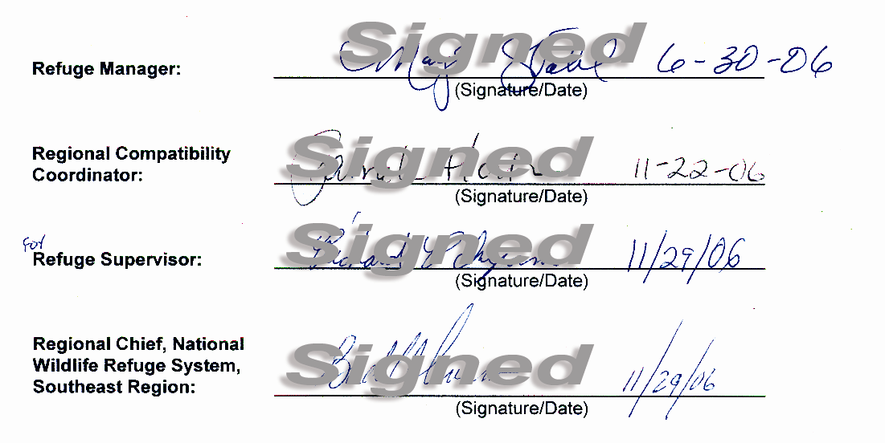

VII. Intra-Service Section 7 Biological Evaluation

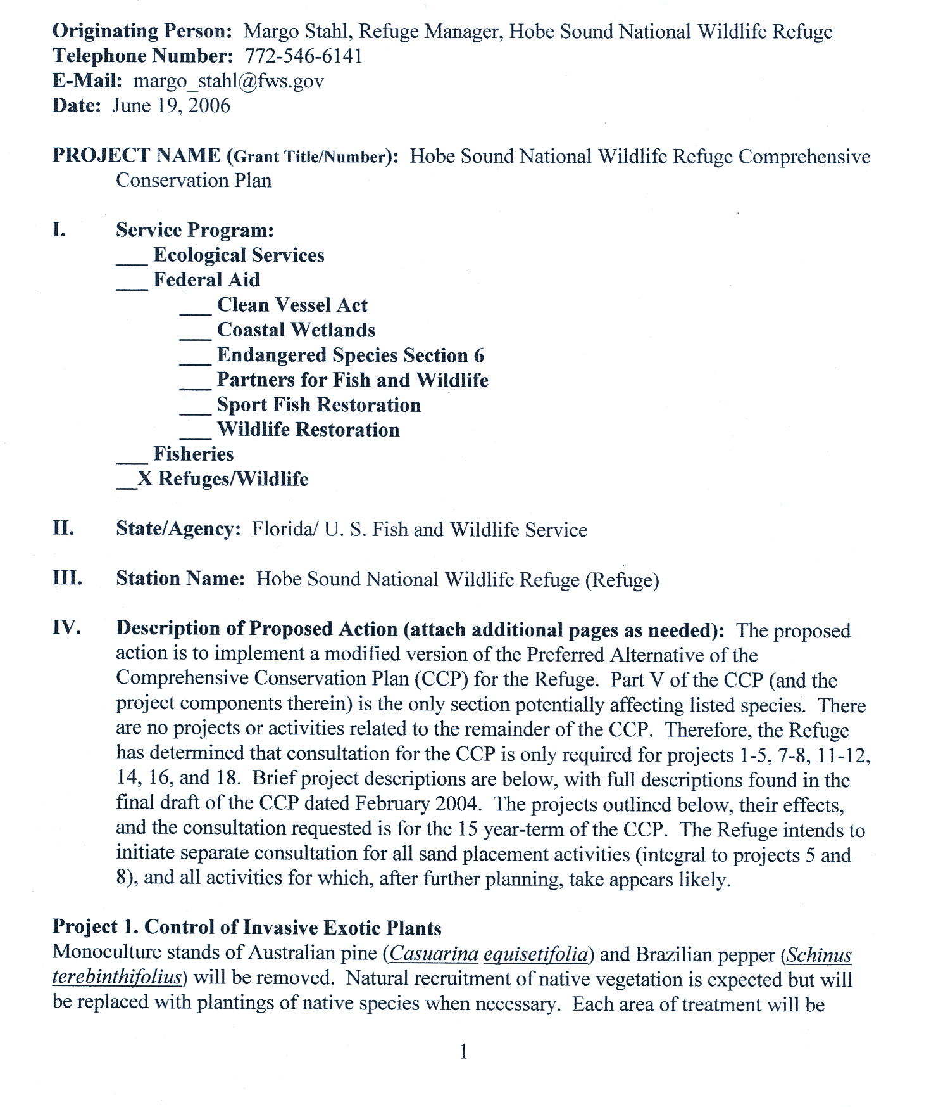
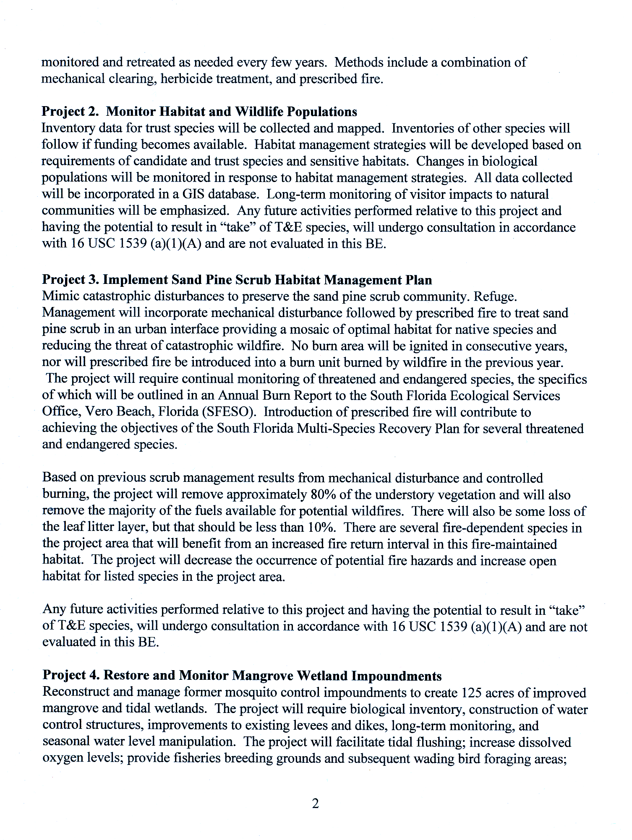
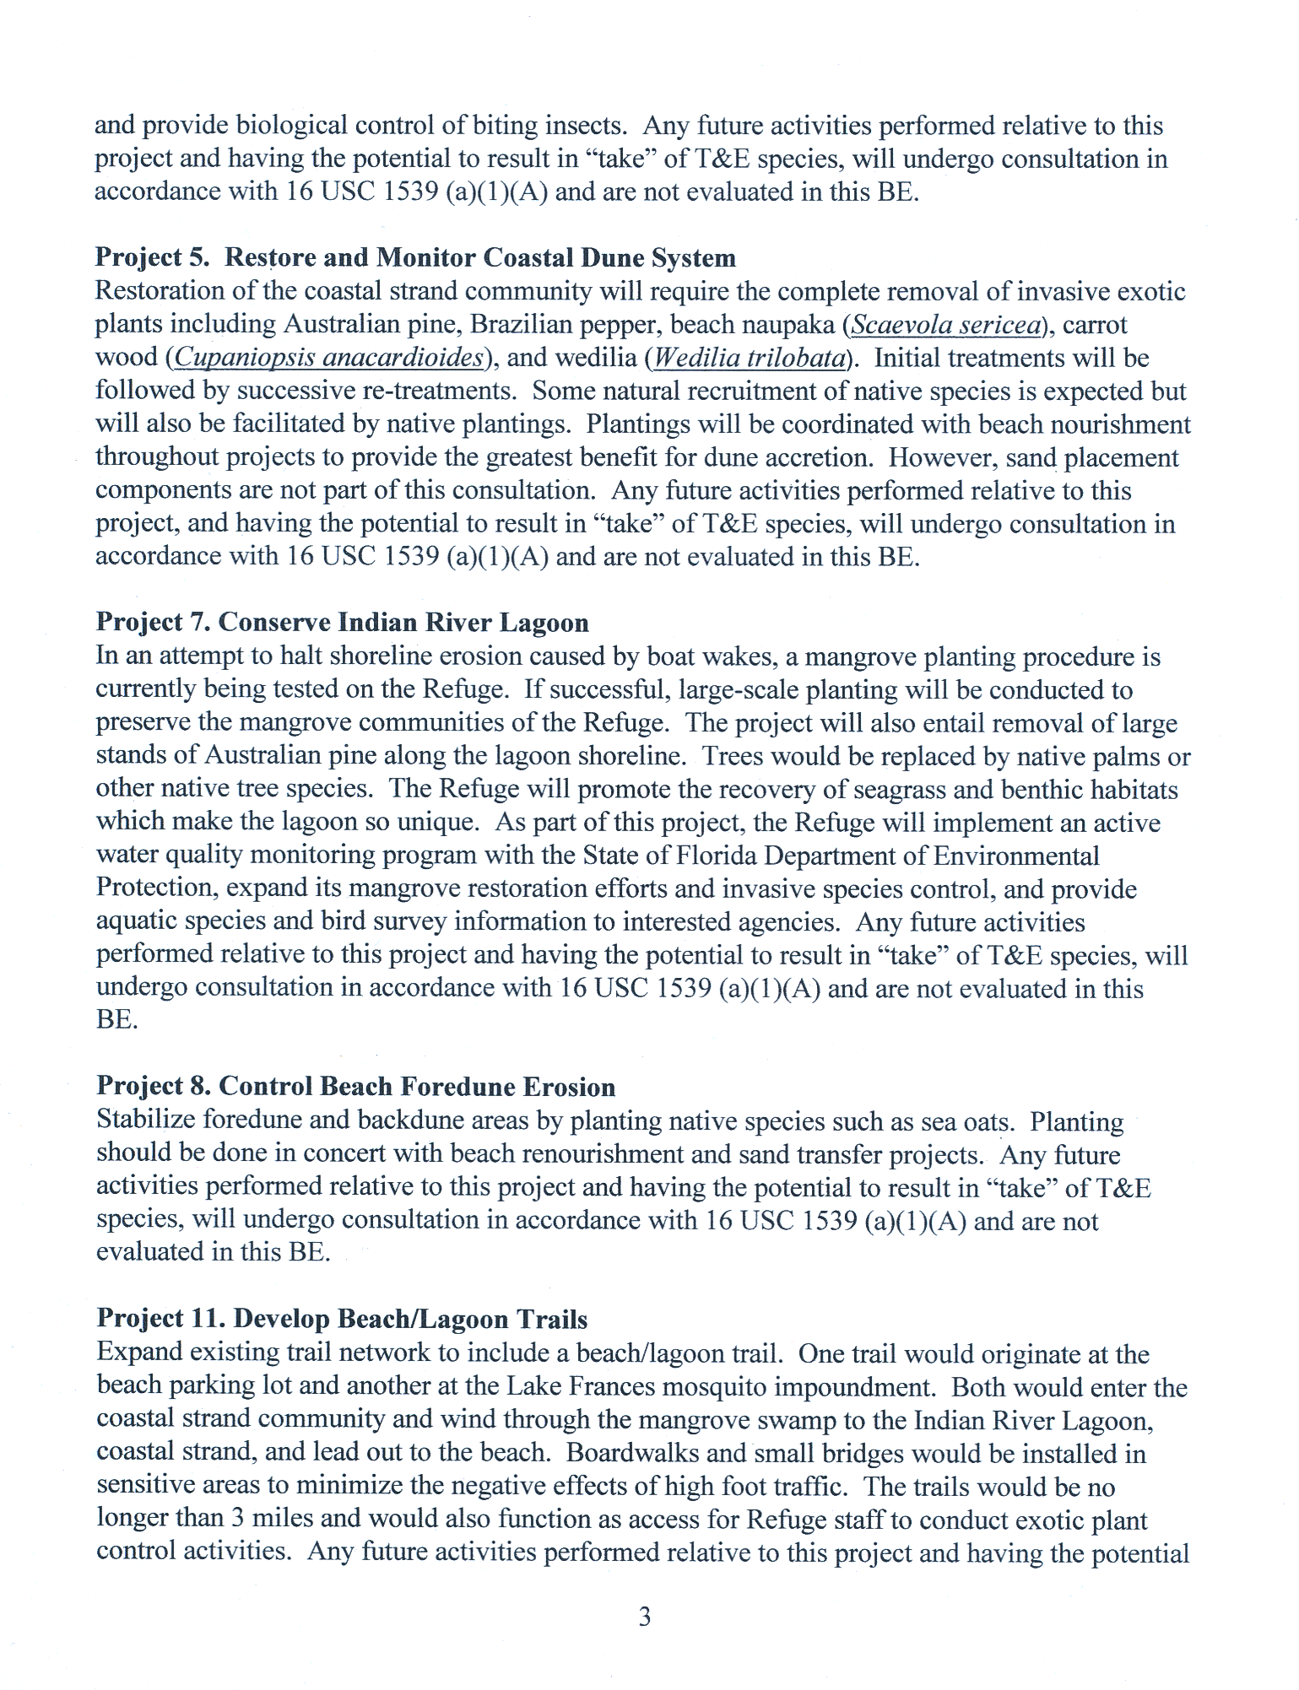
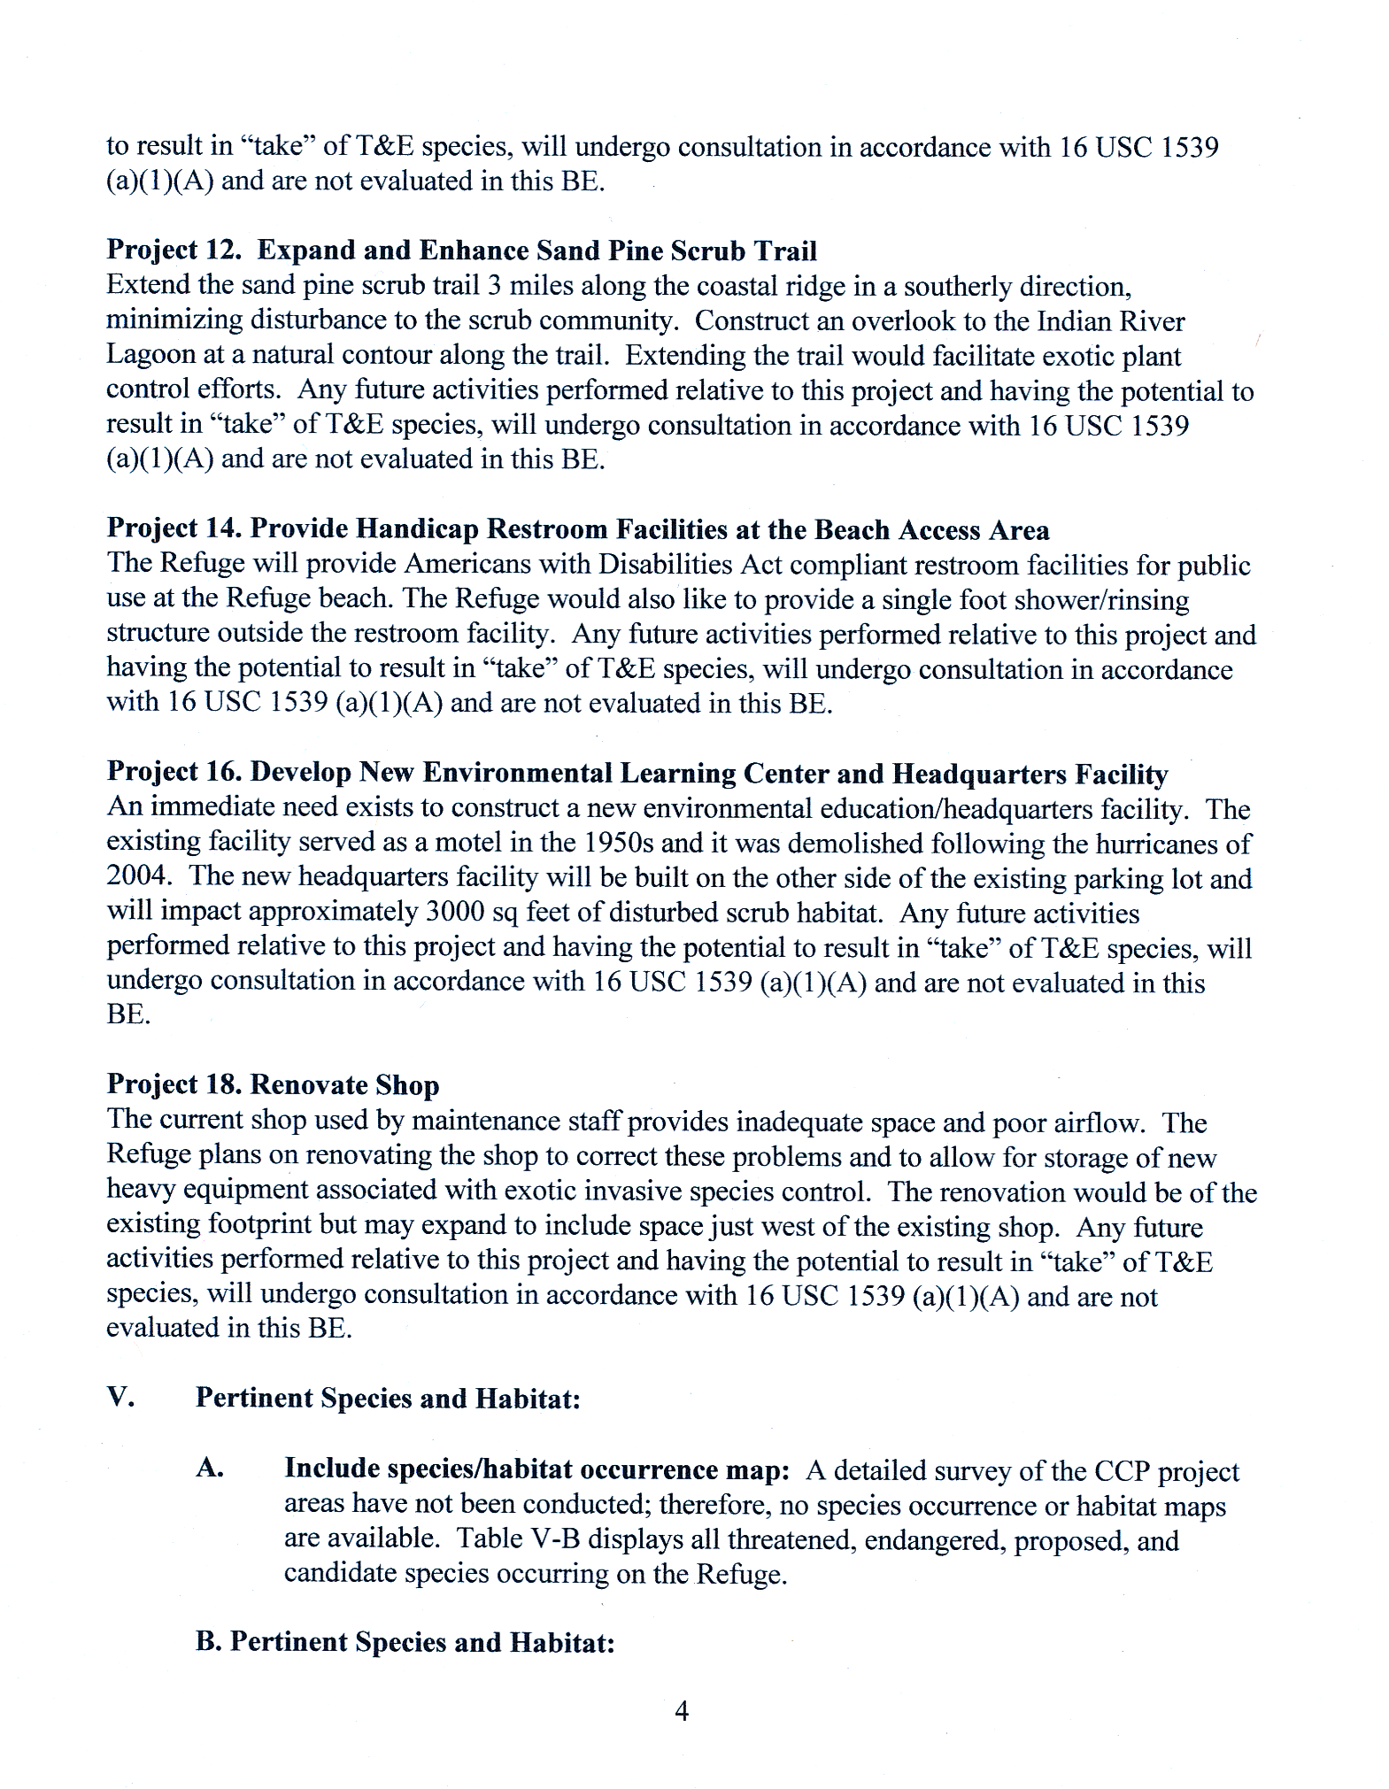
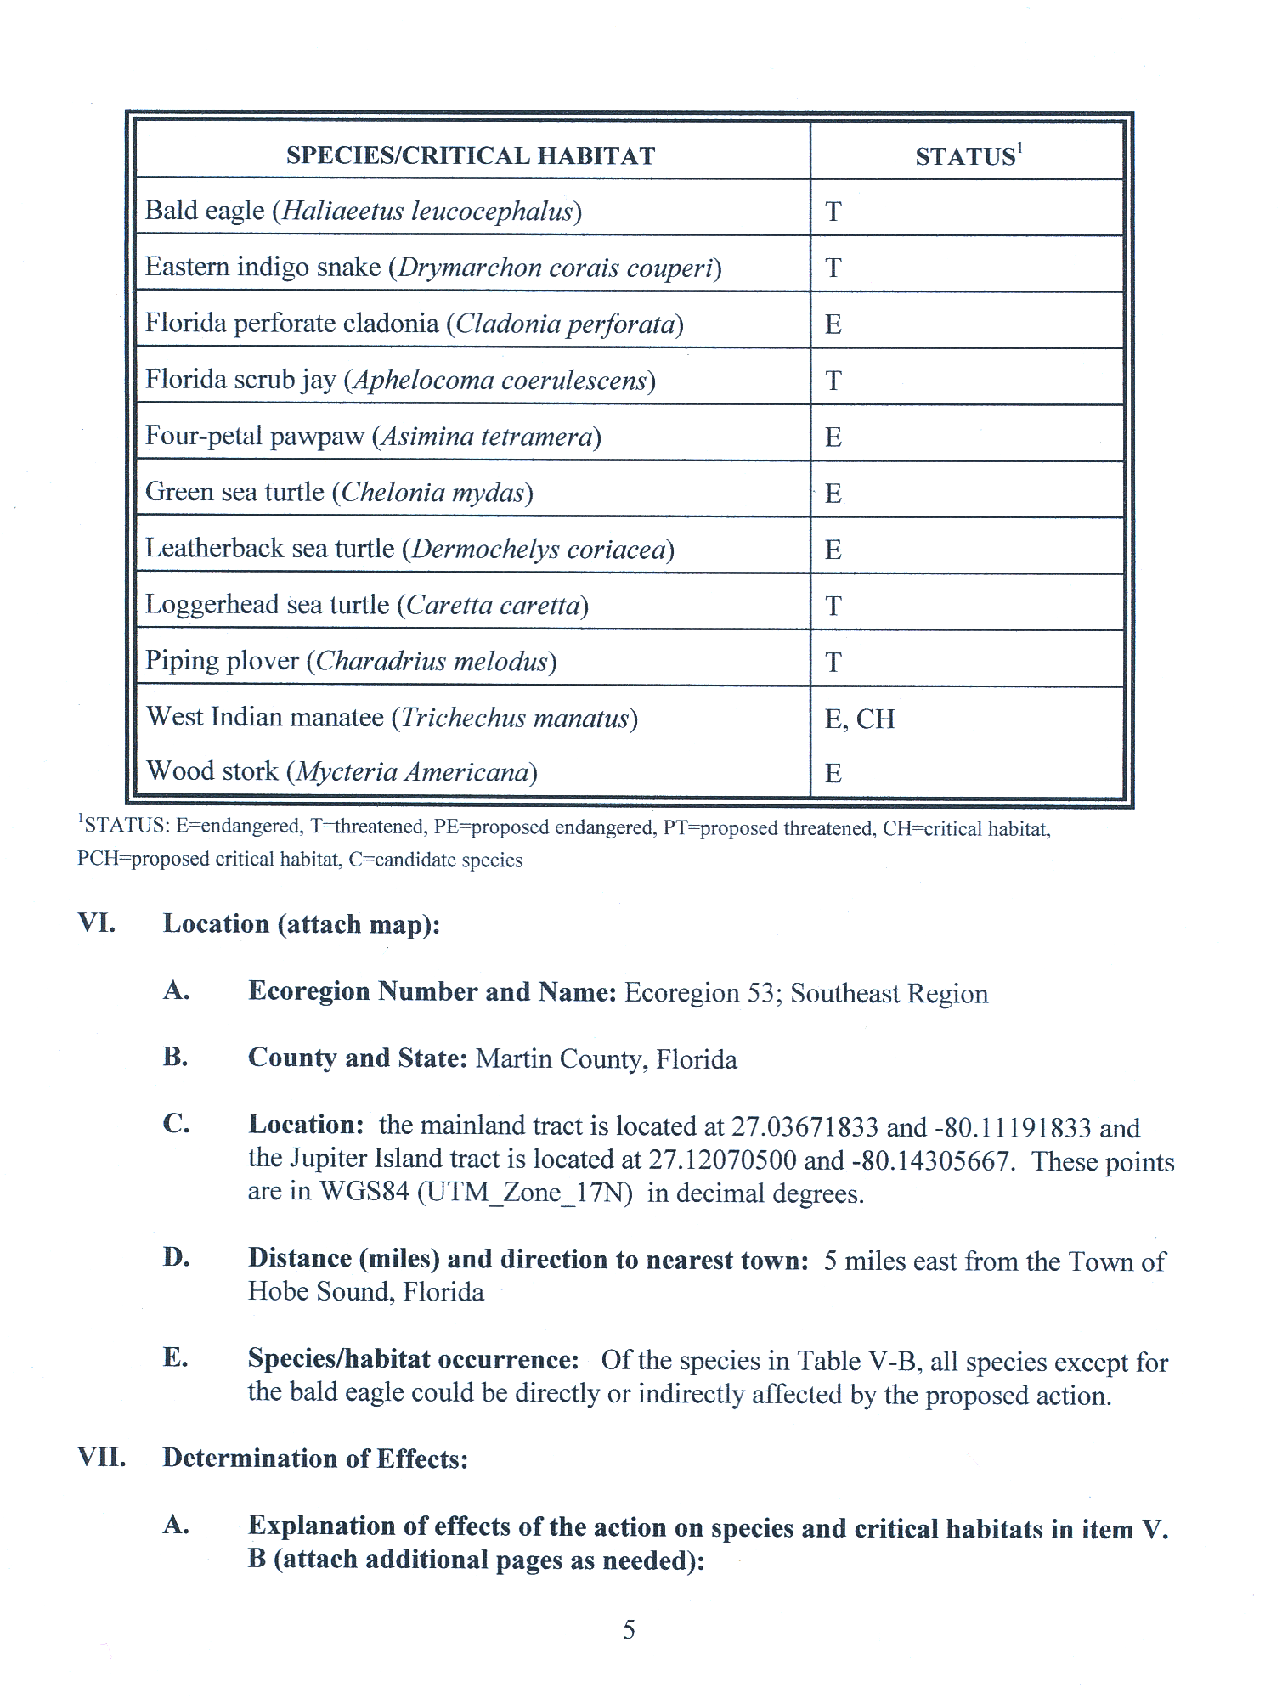
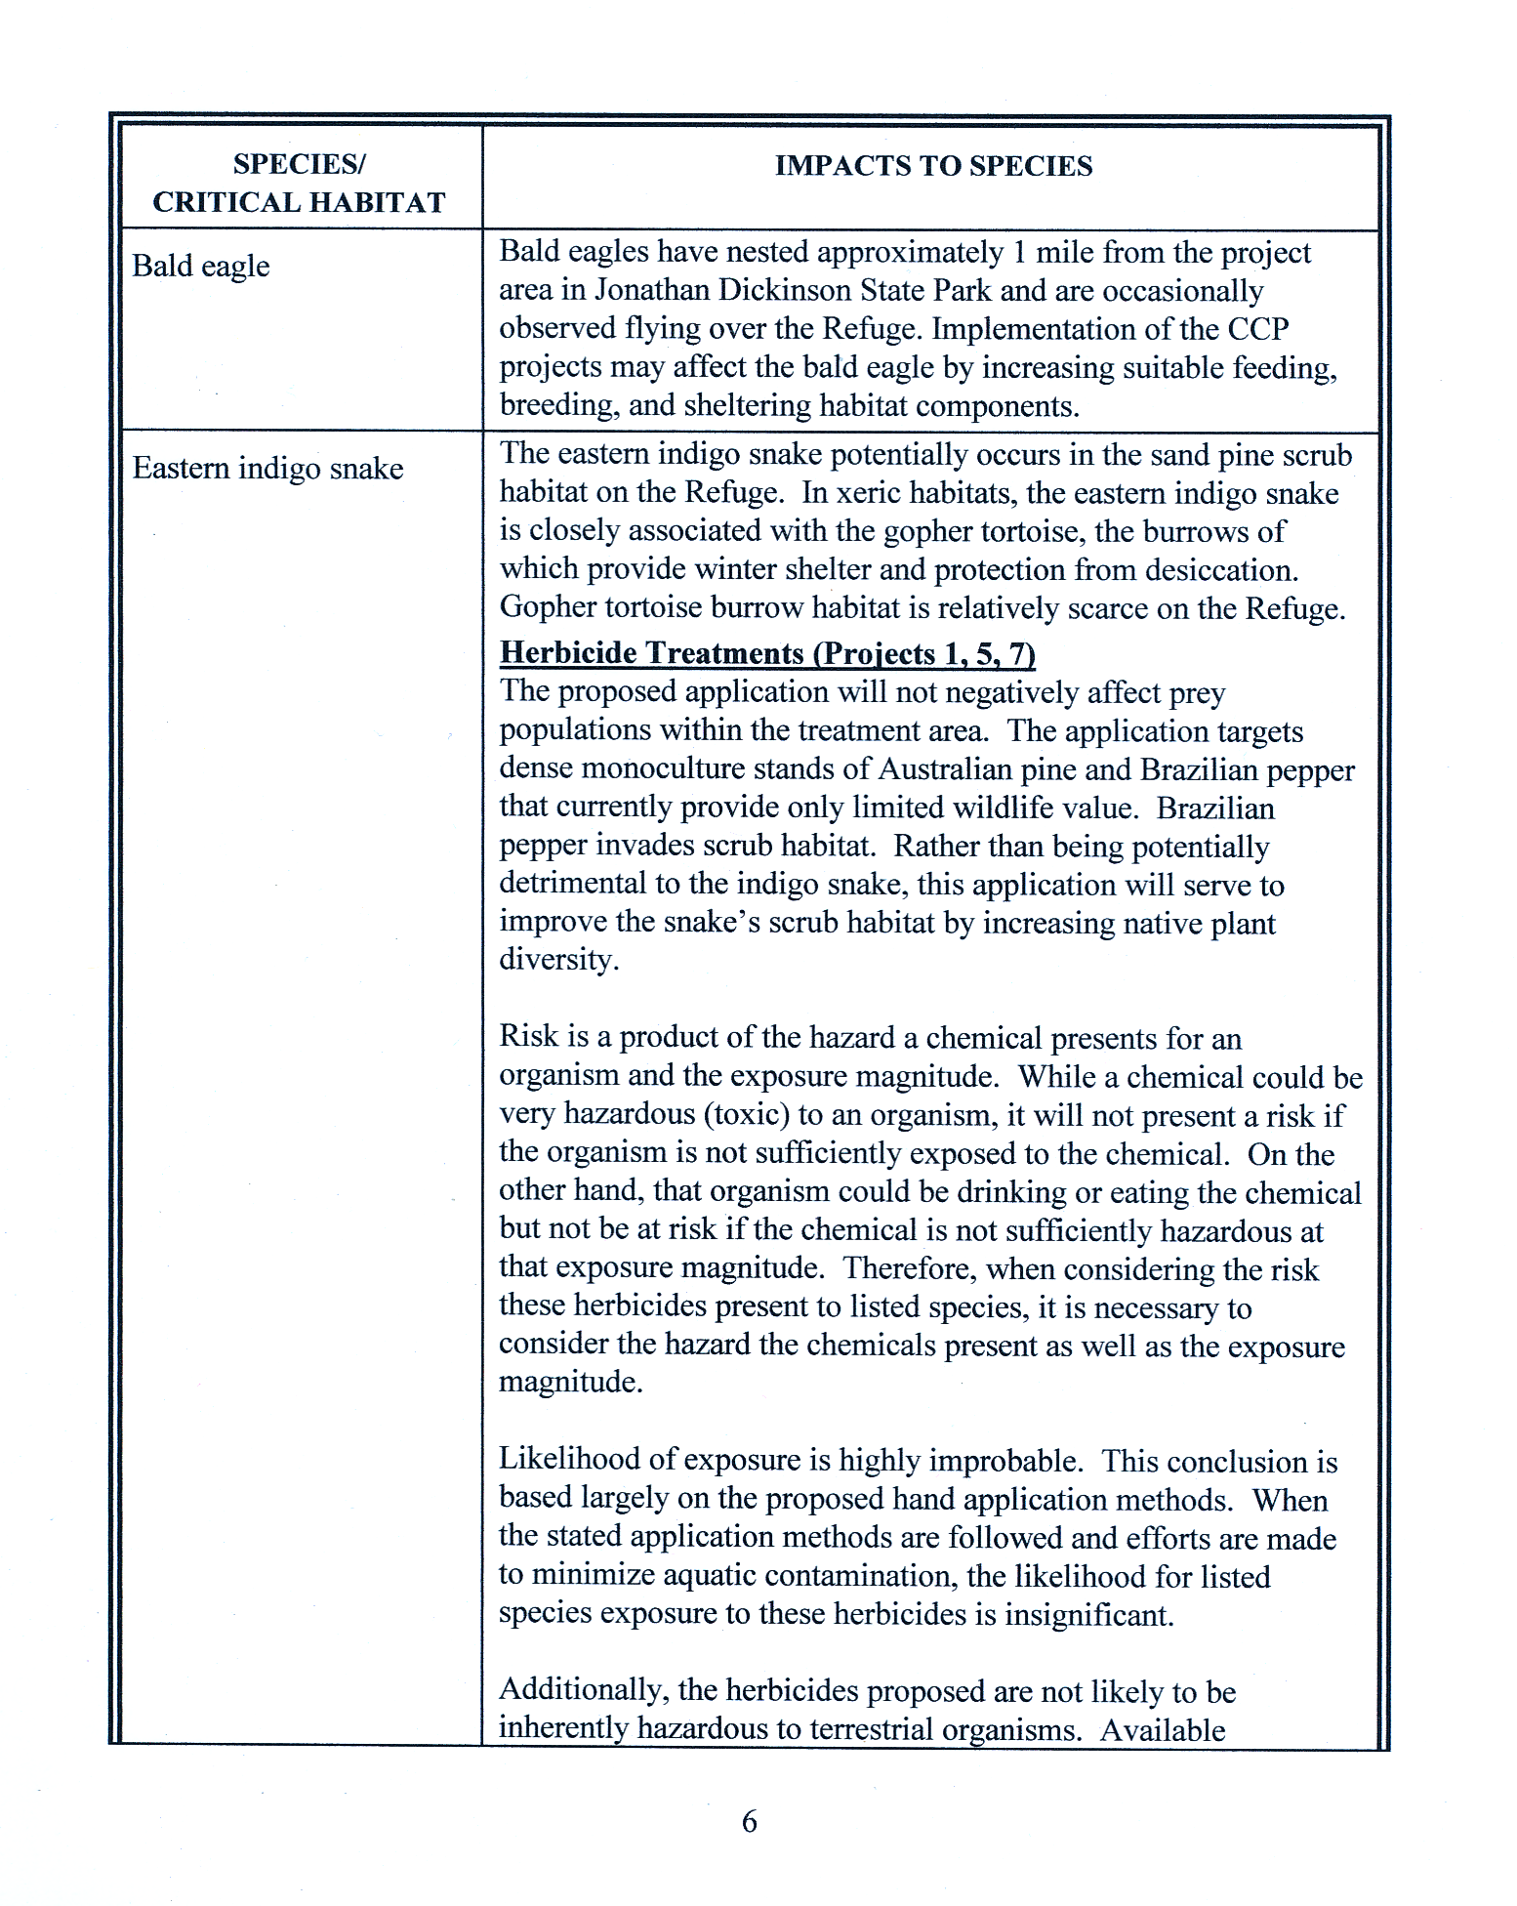
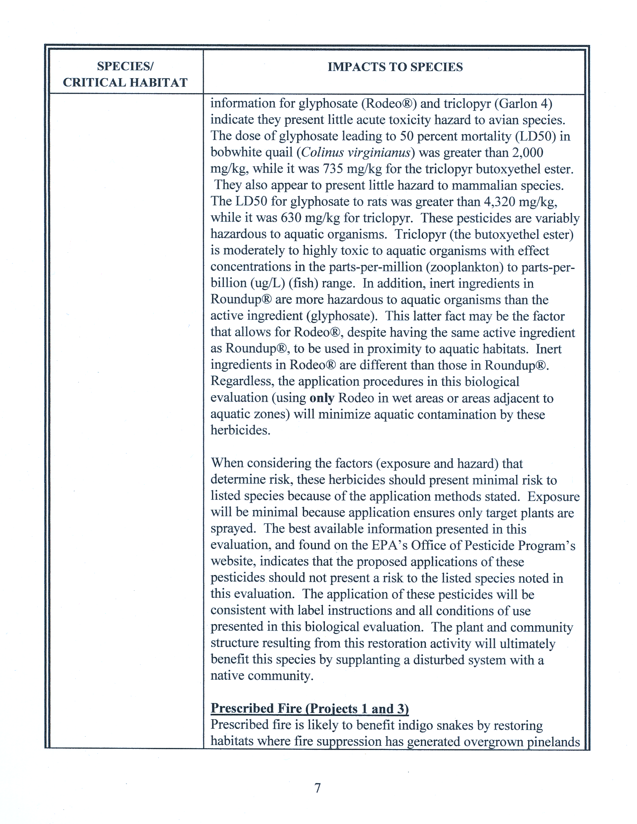
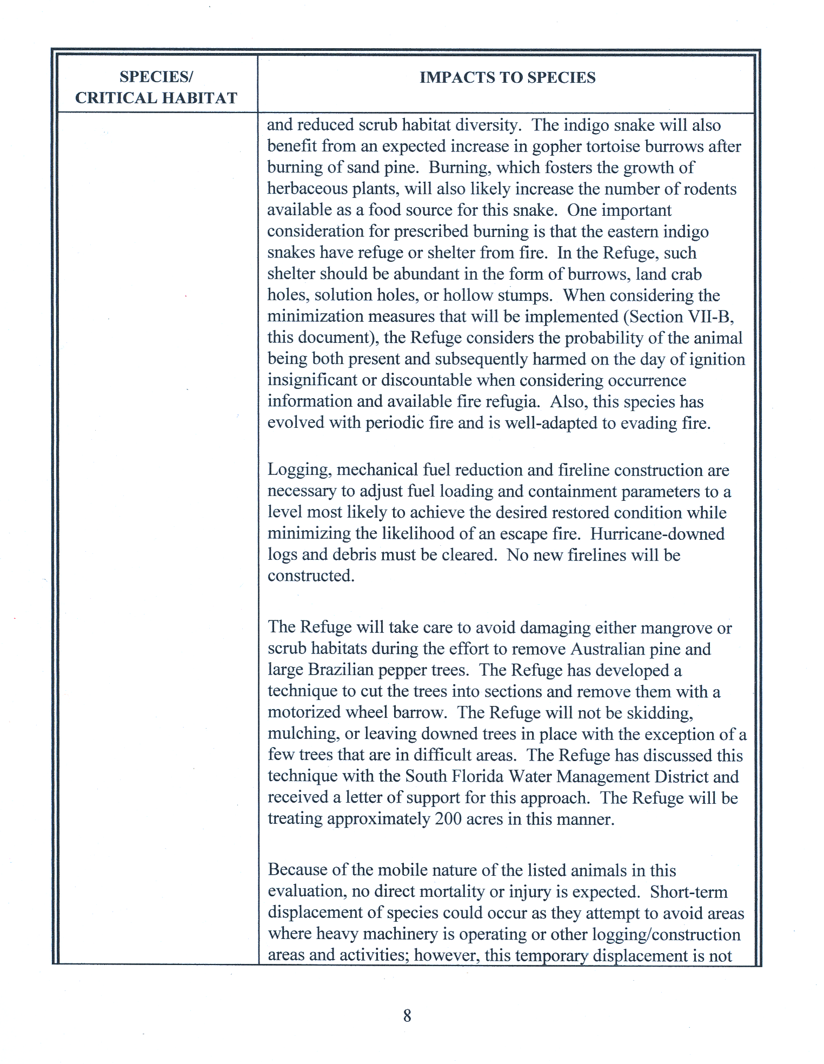
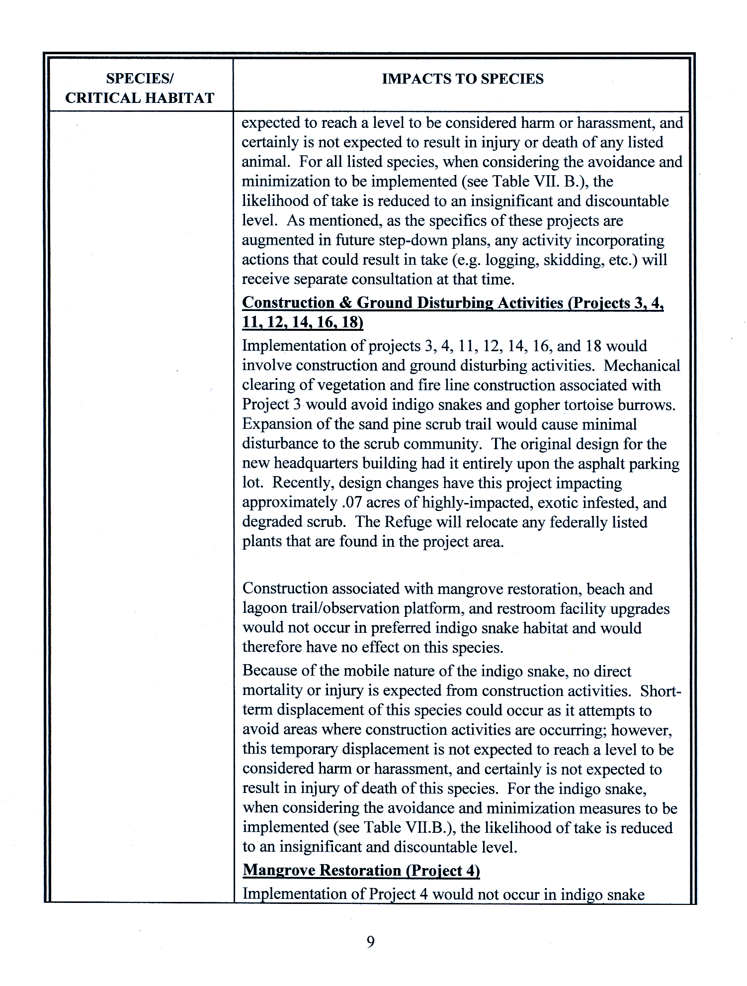
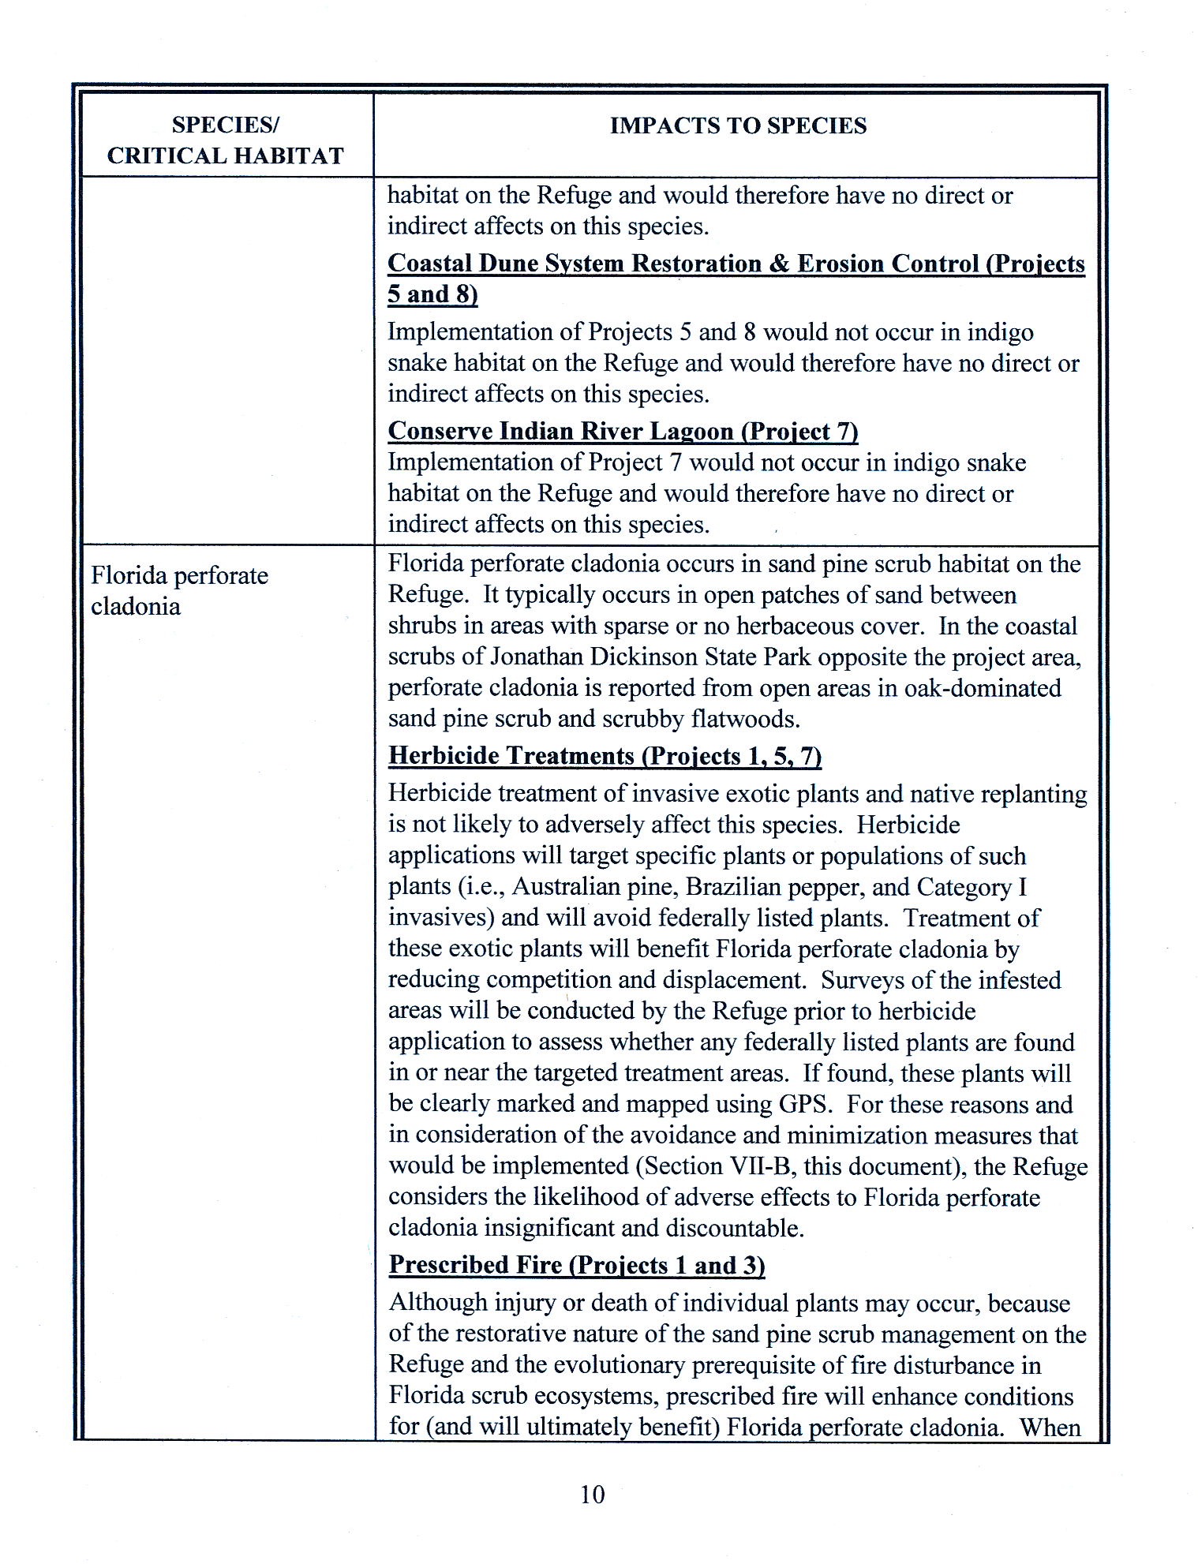
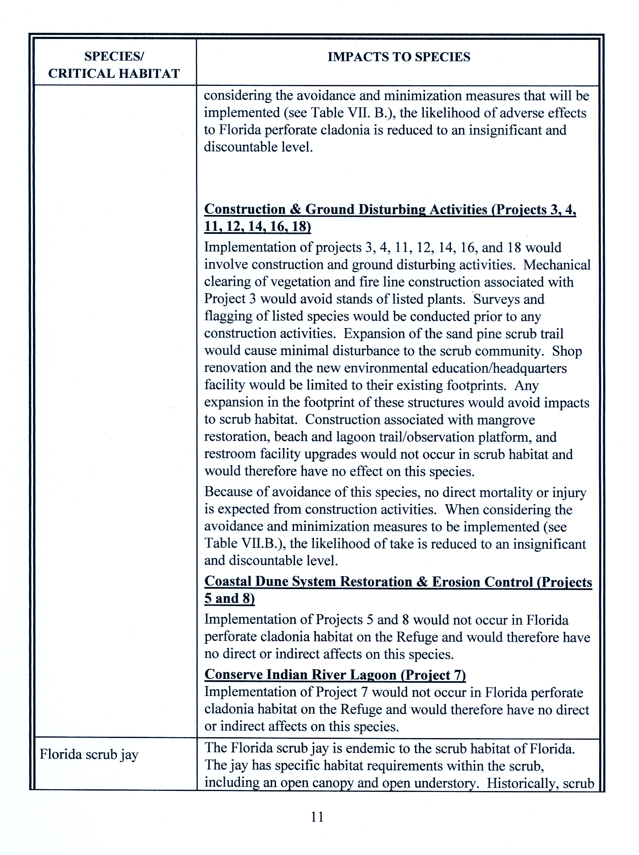
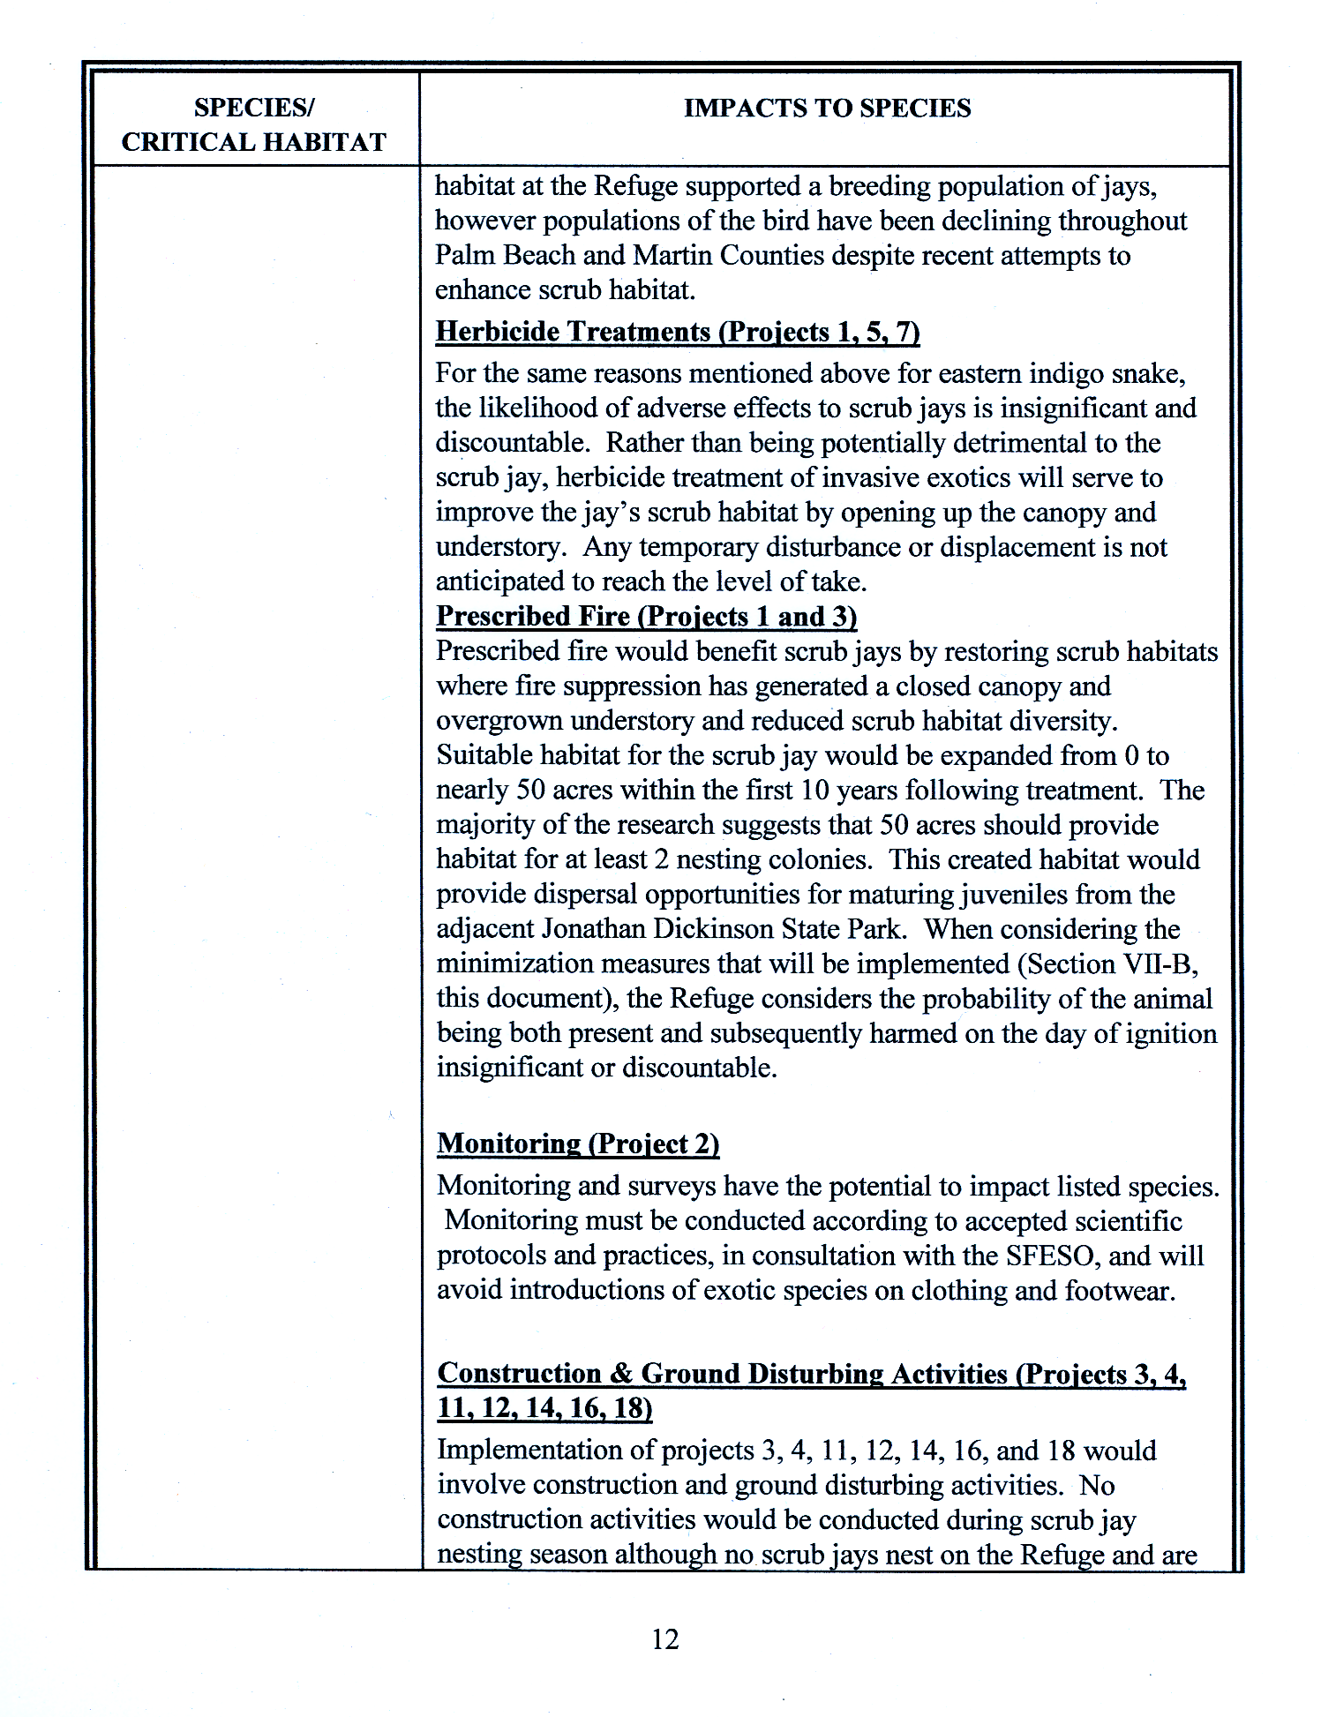
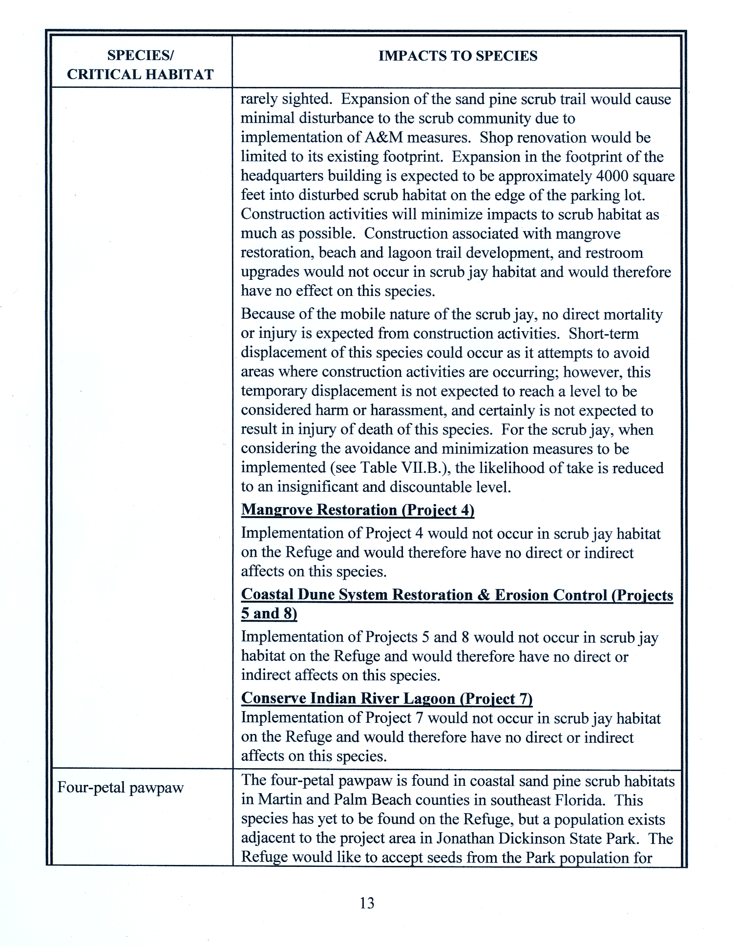
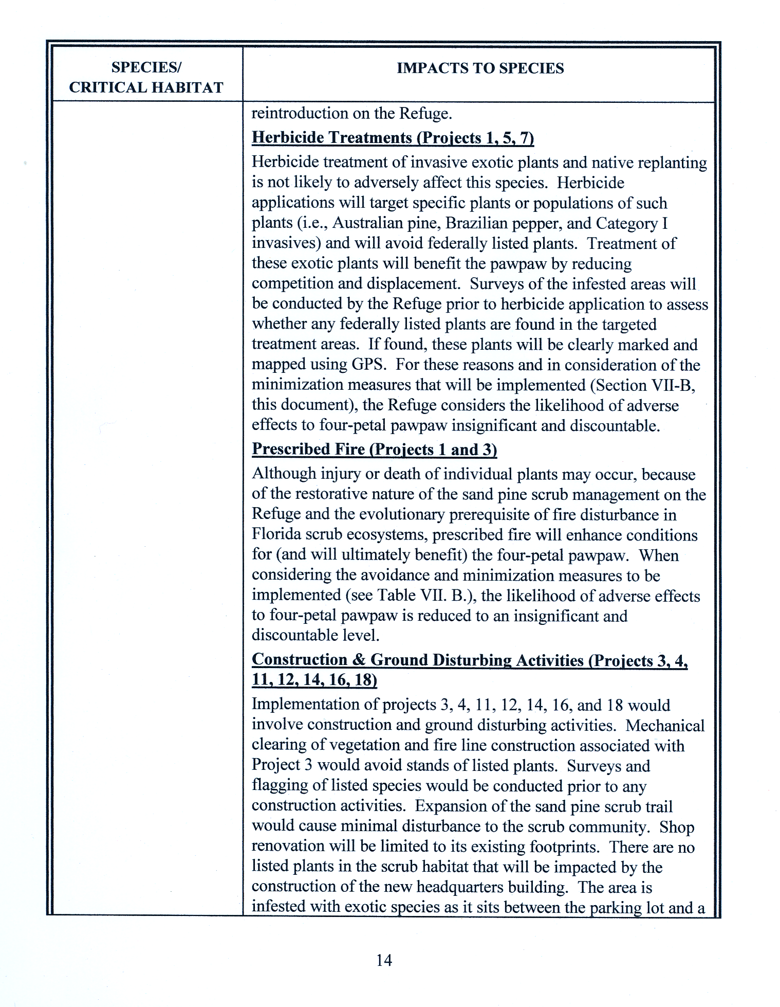
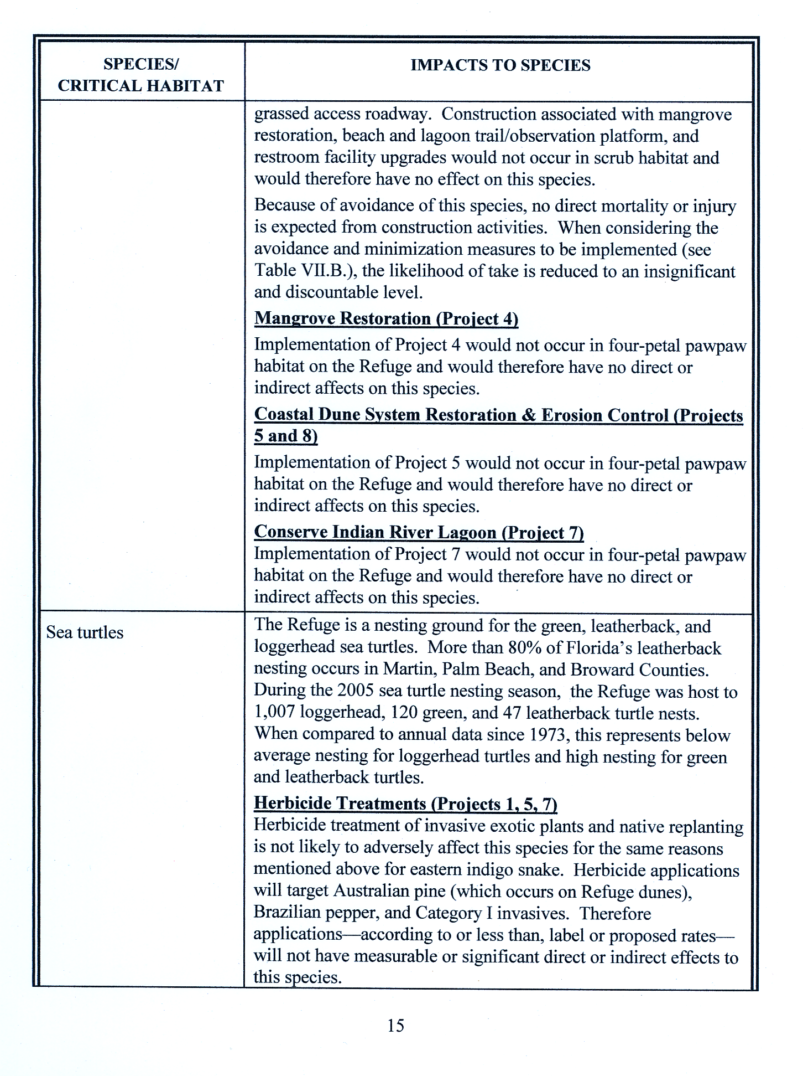
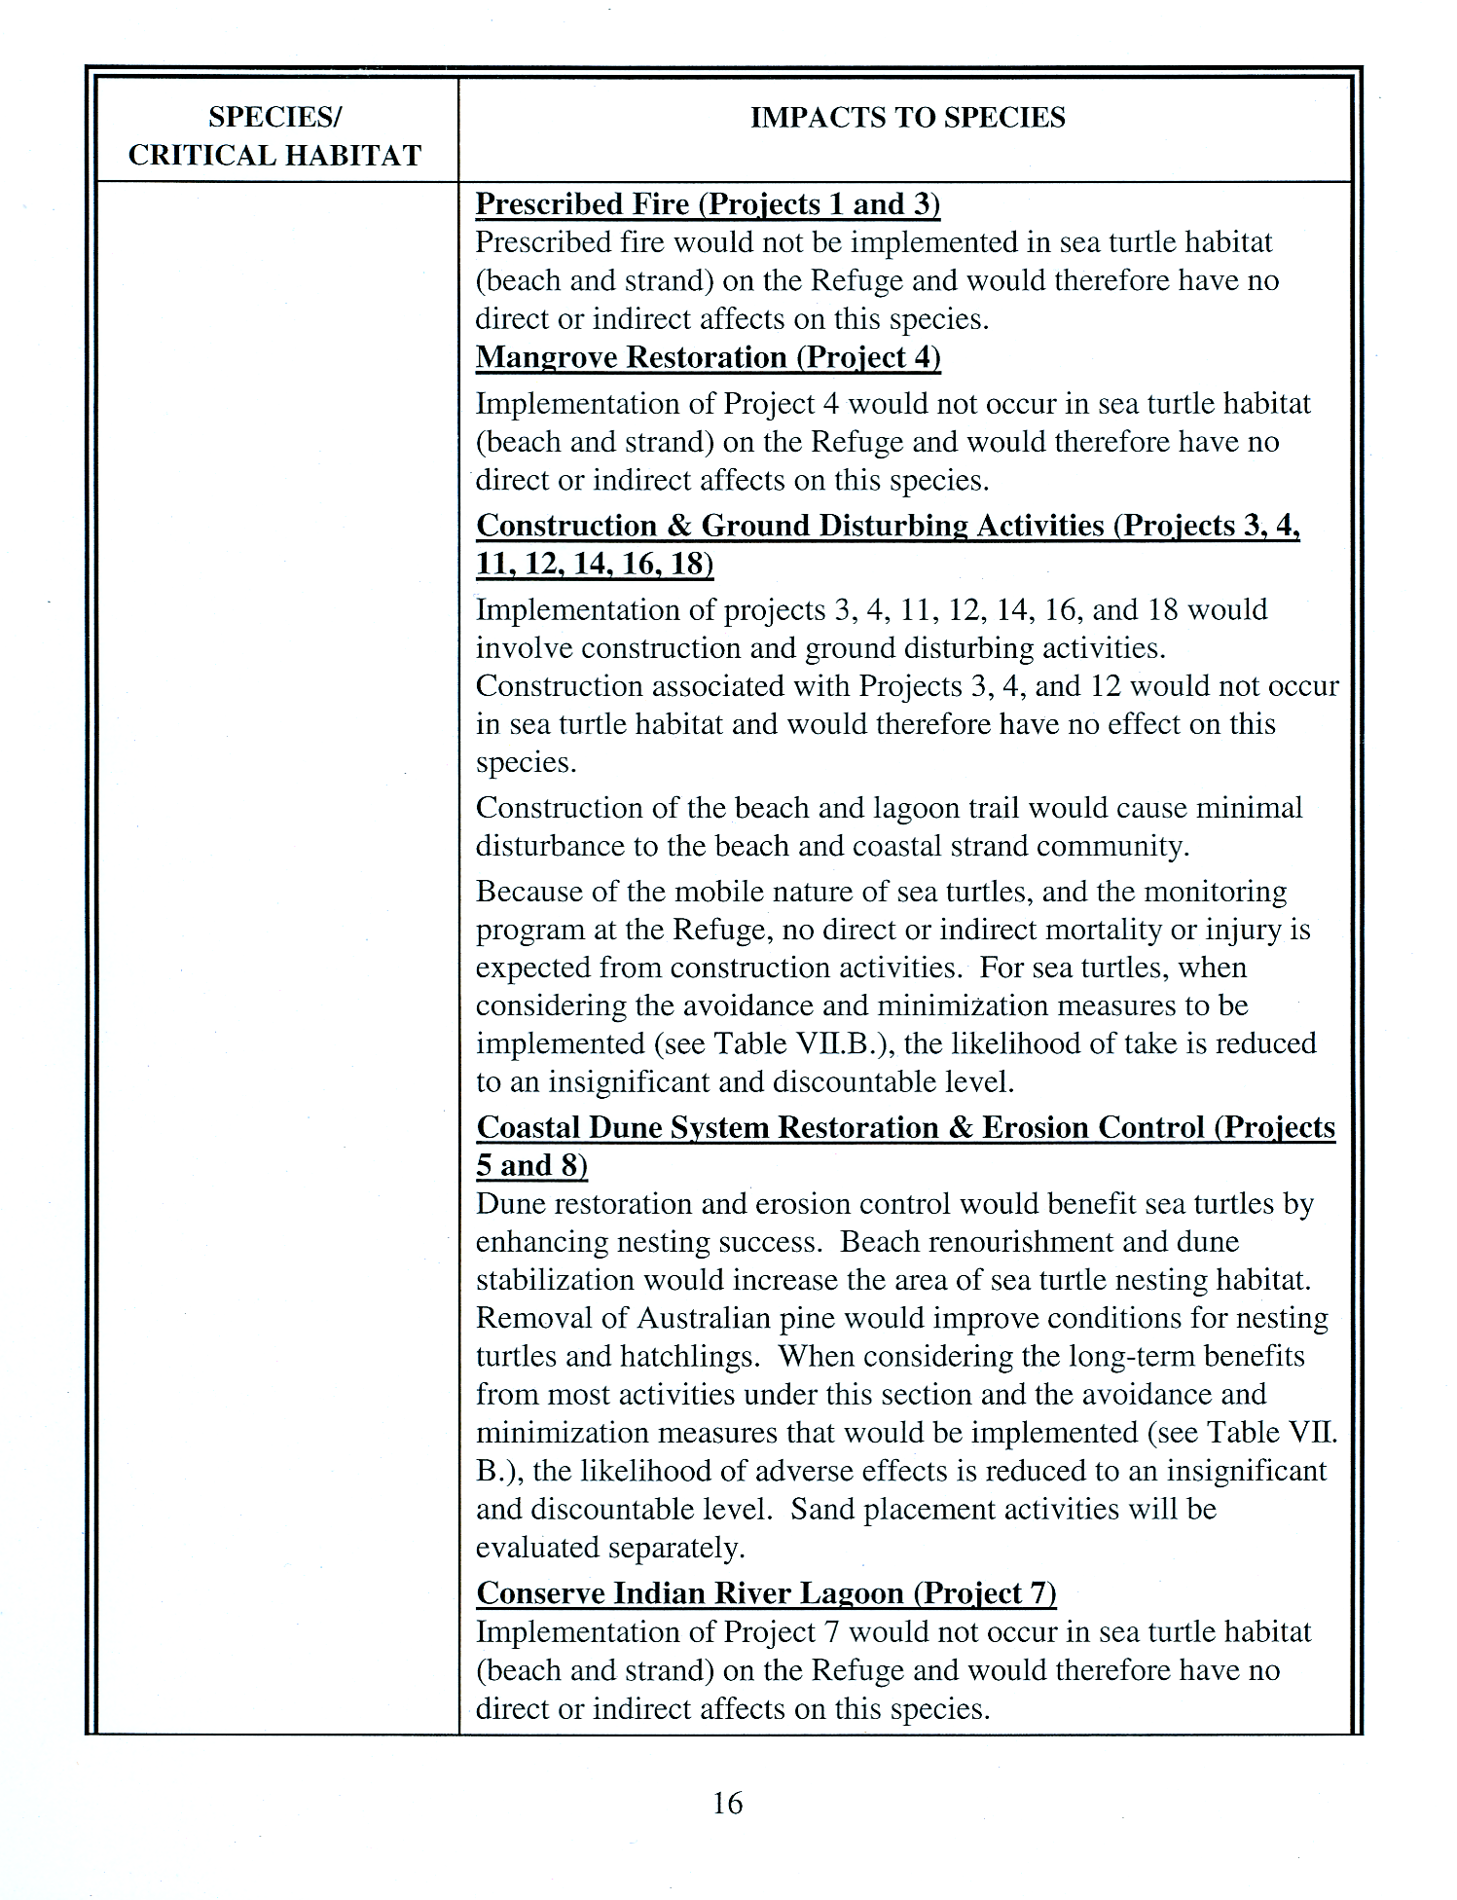
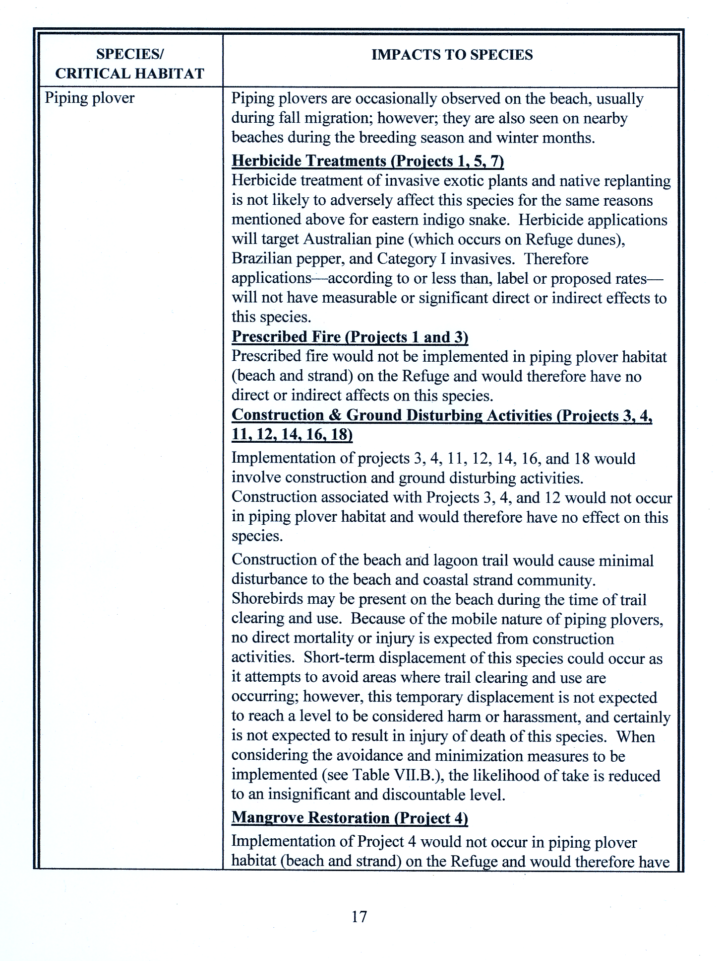
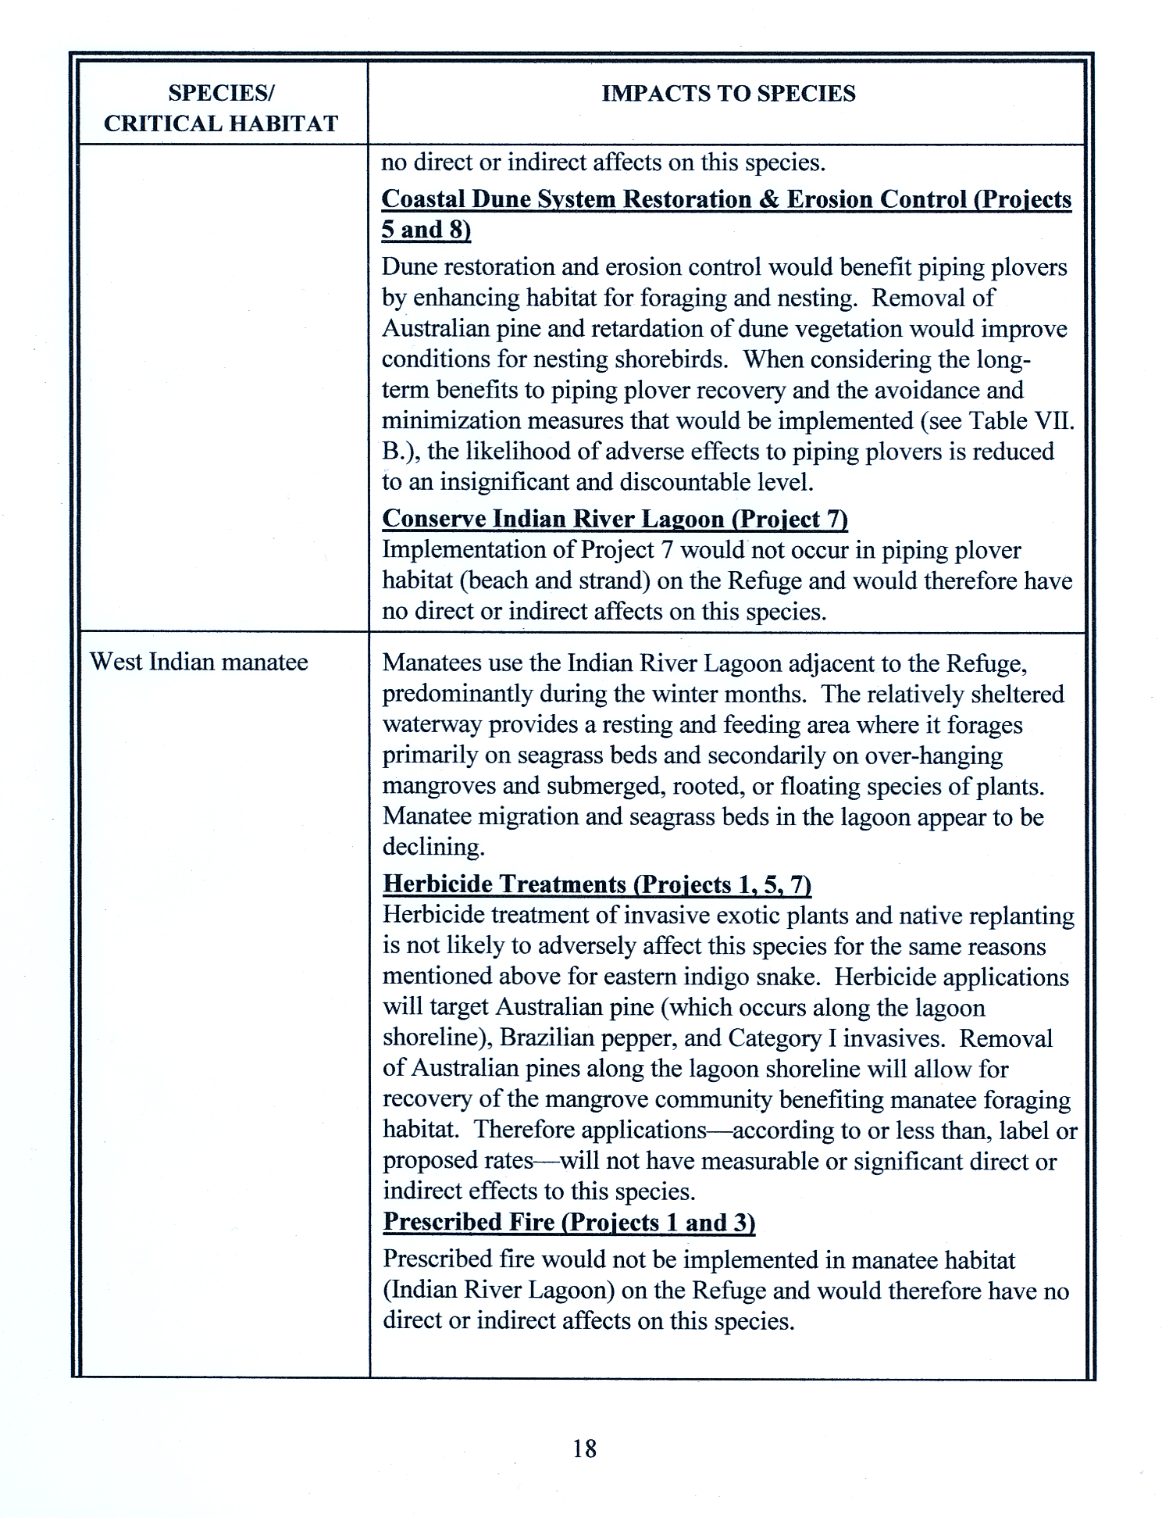
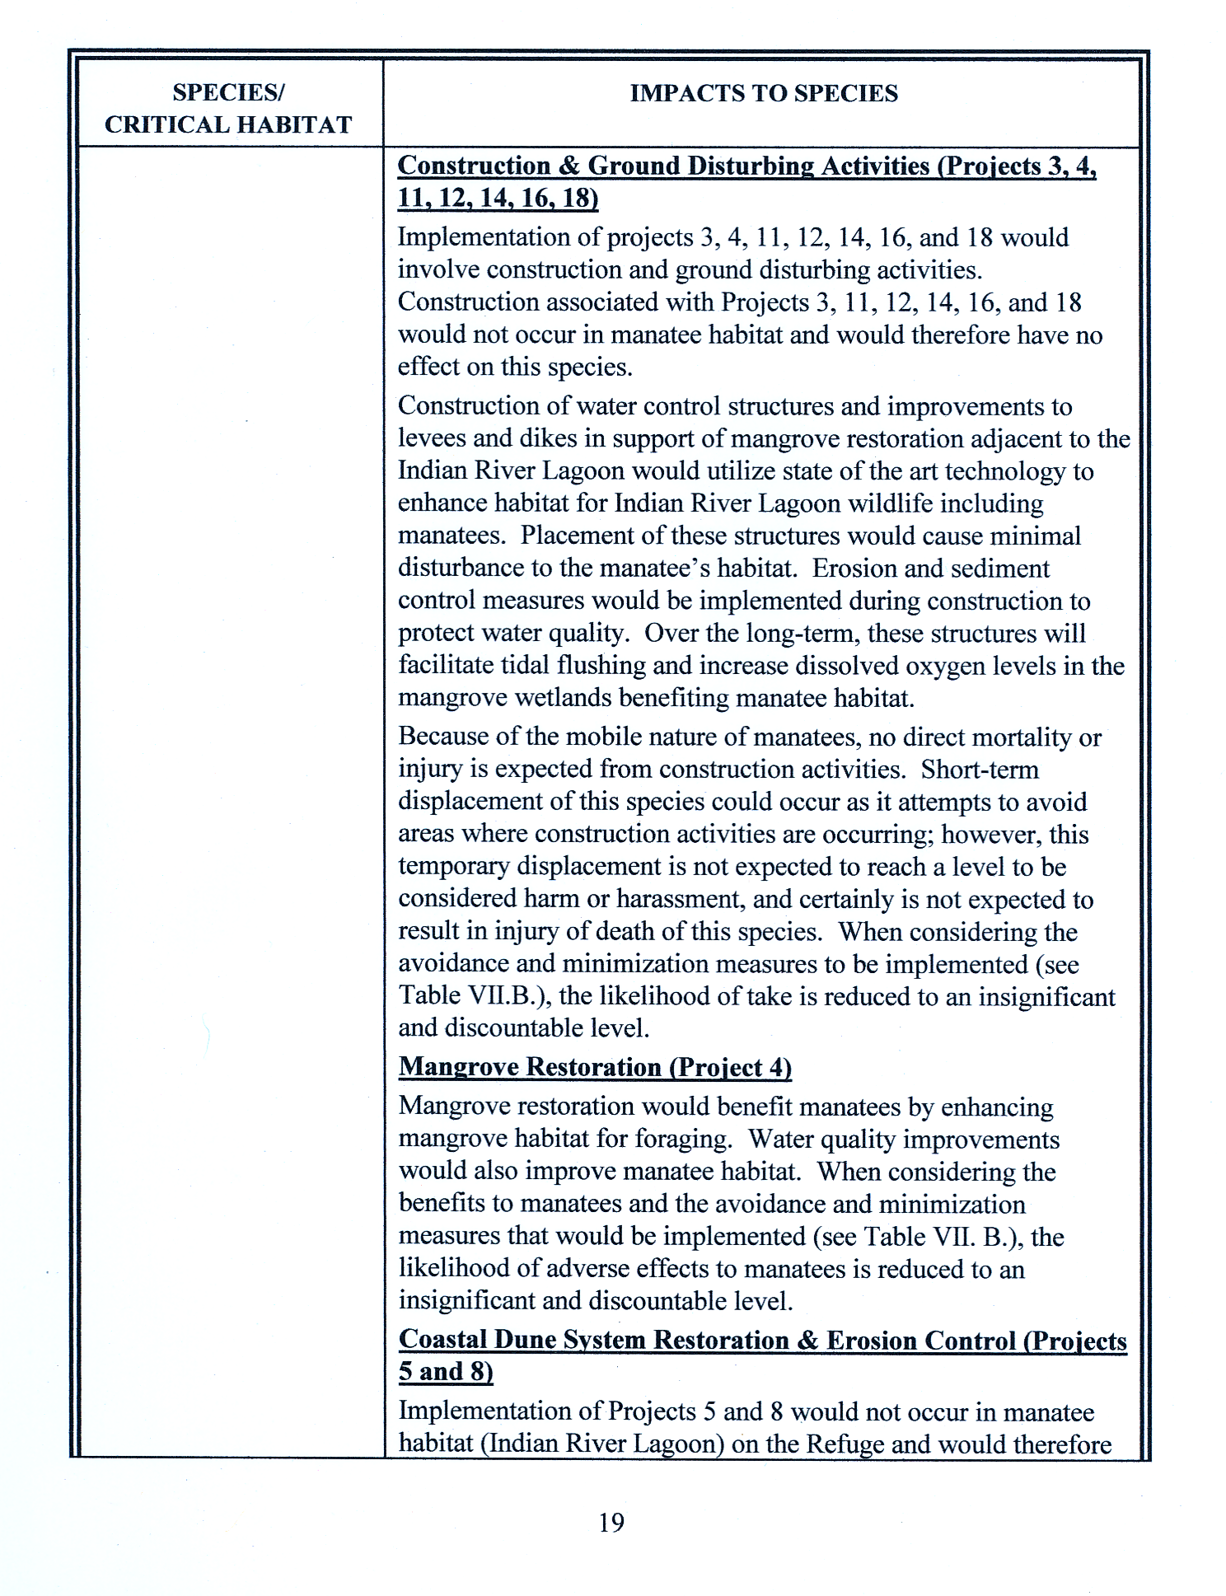
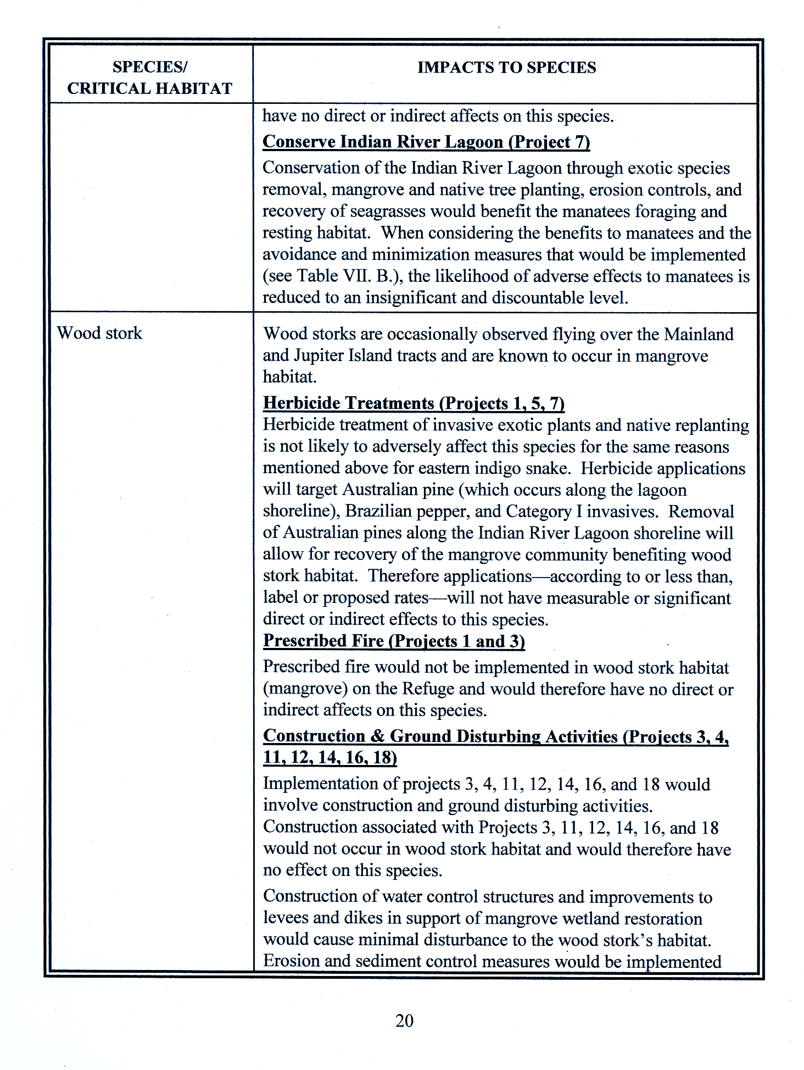
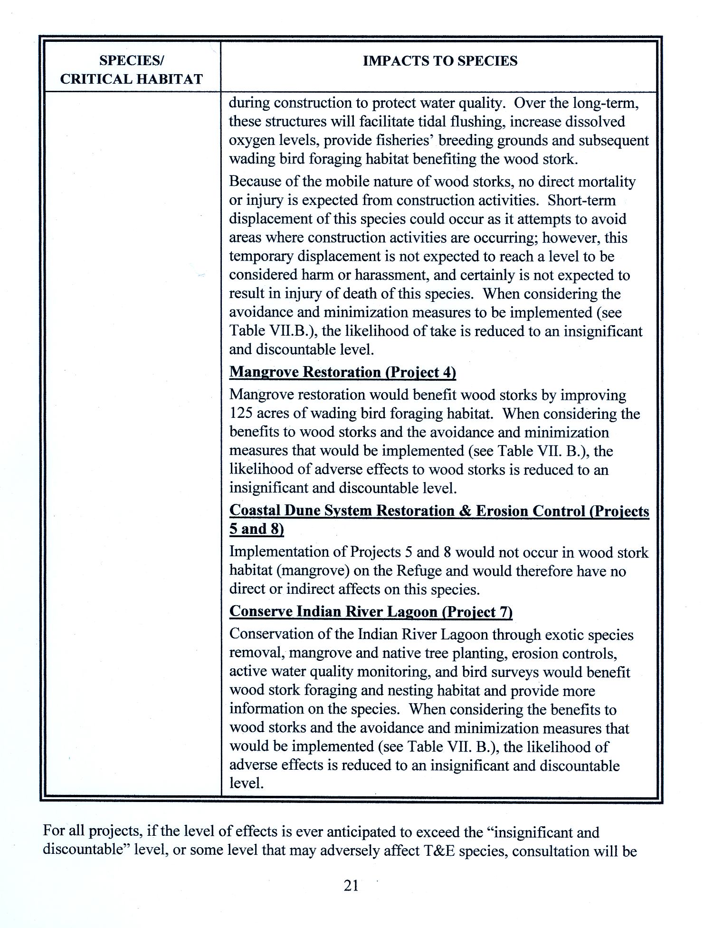
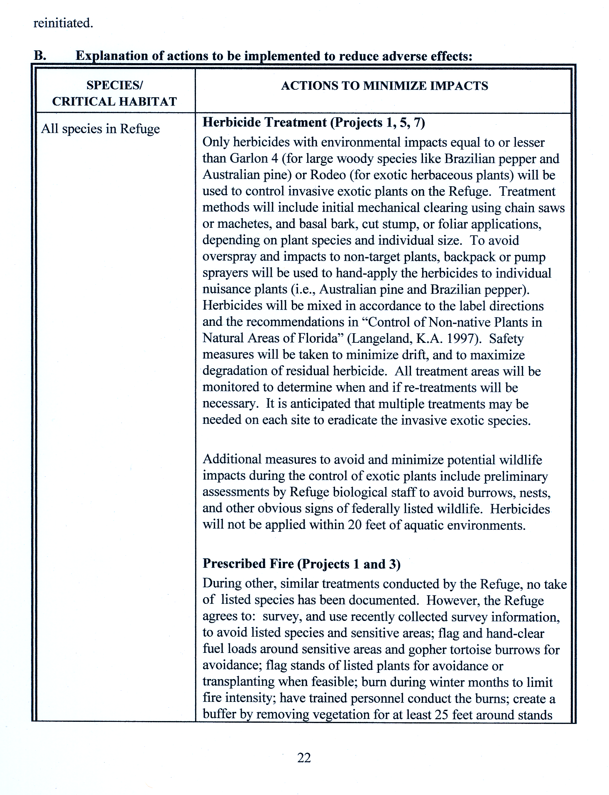
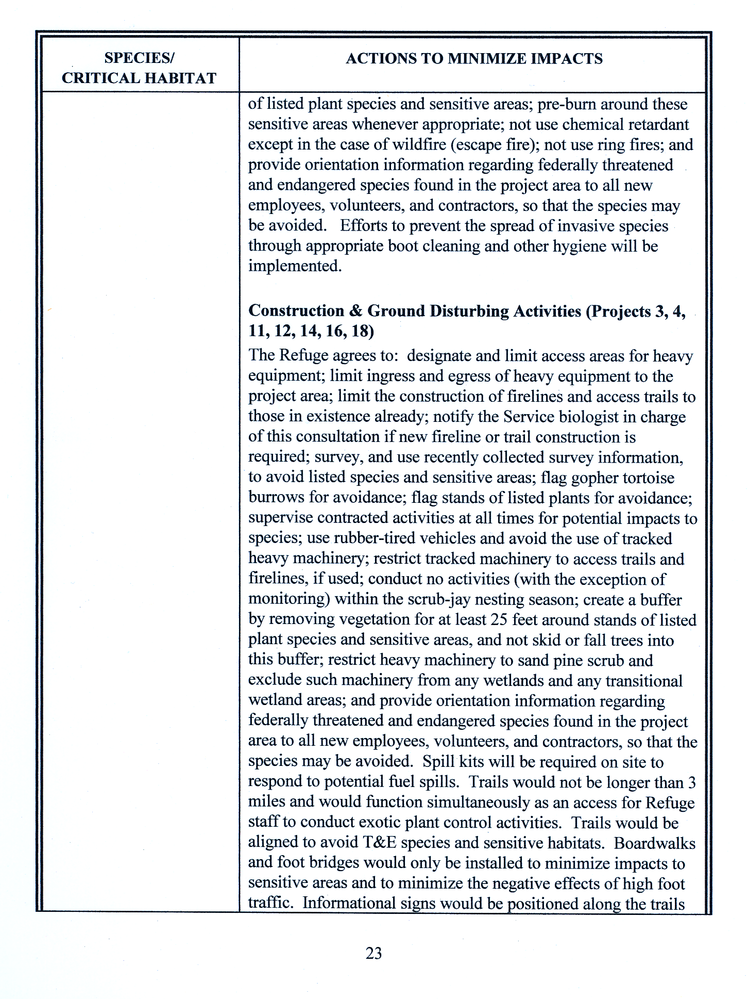
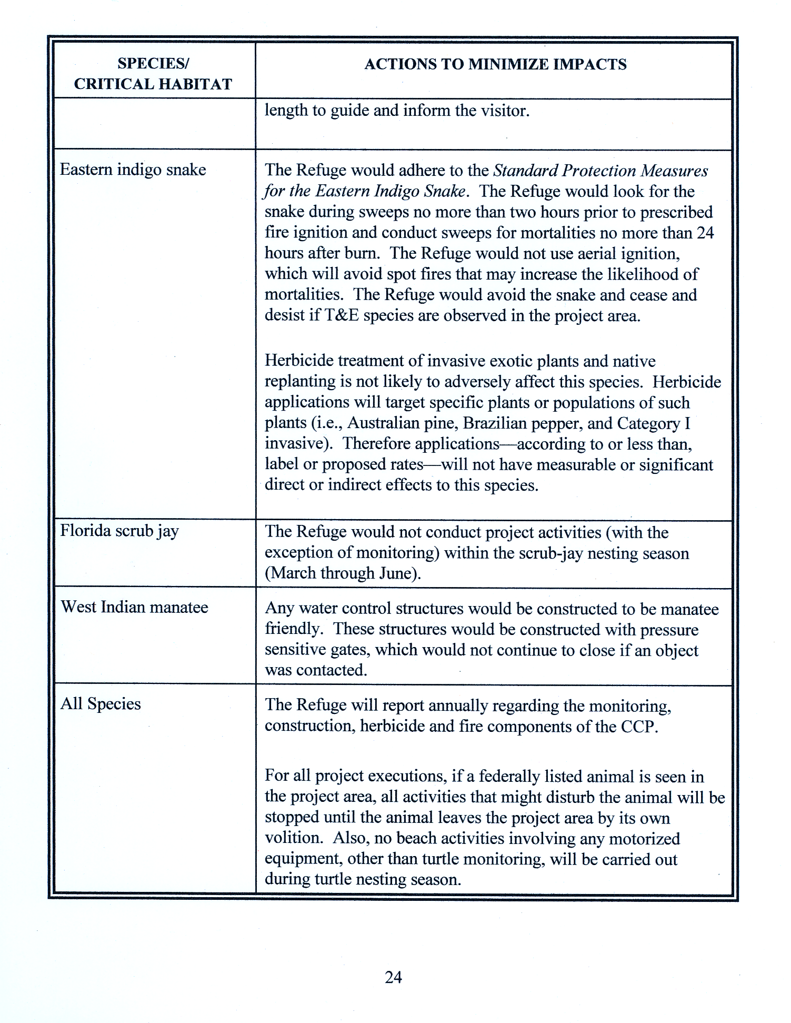
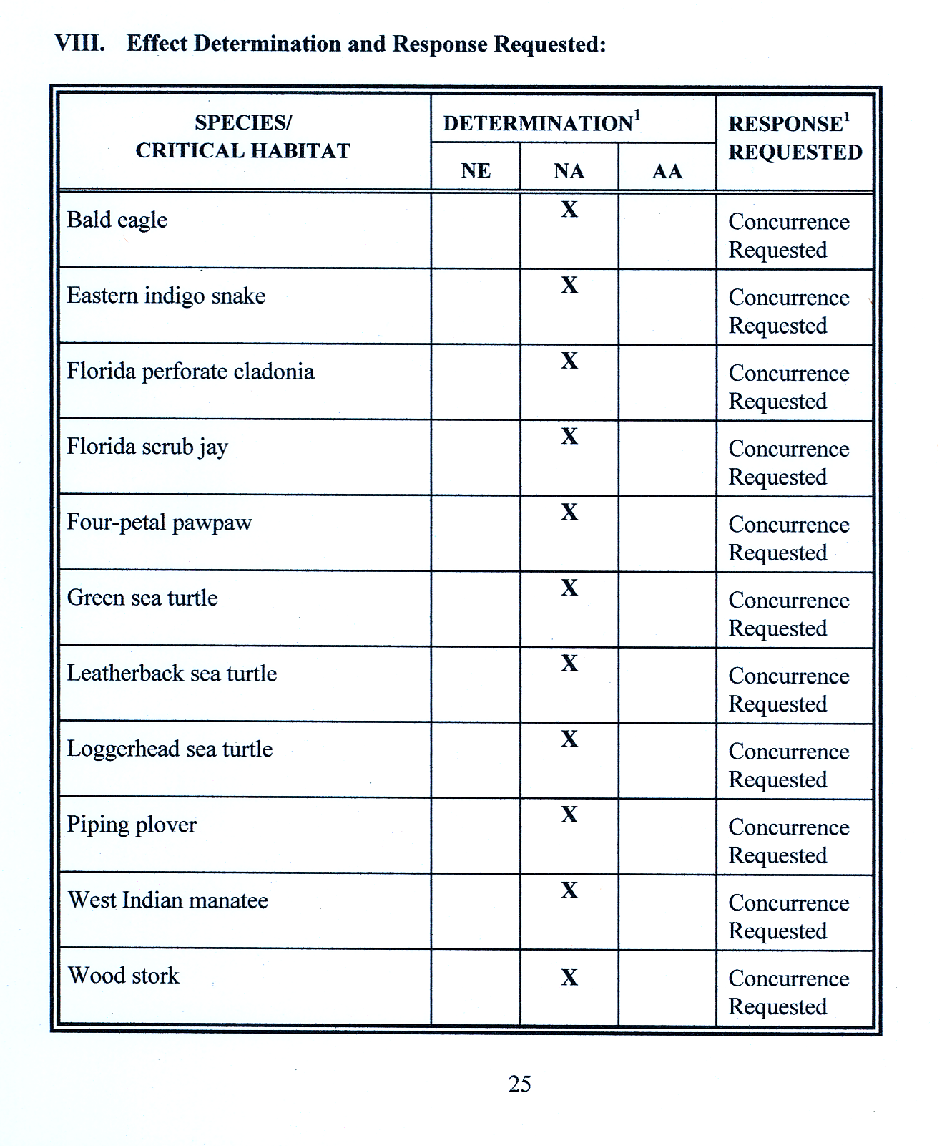
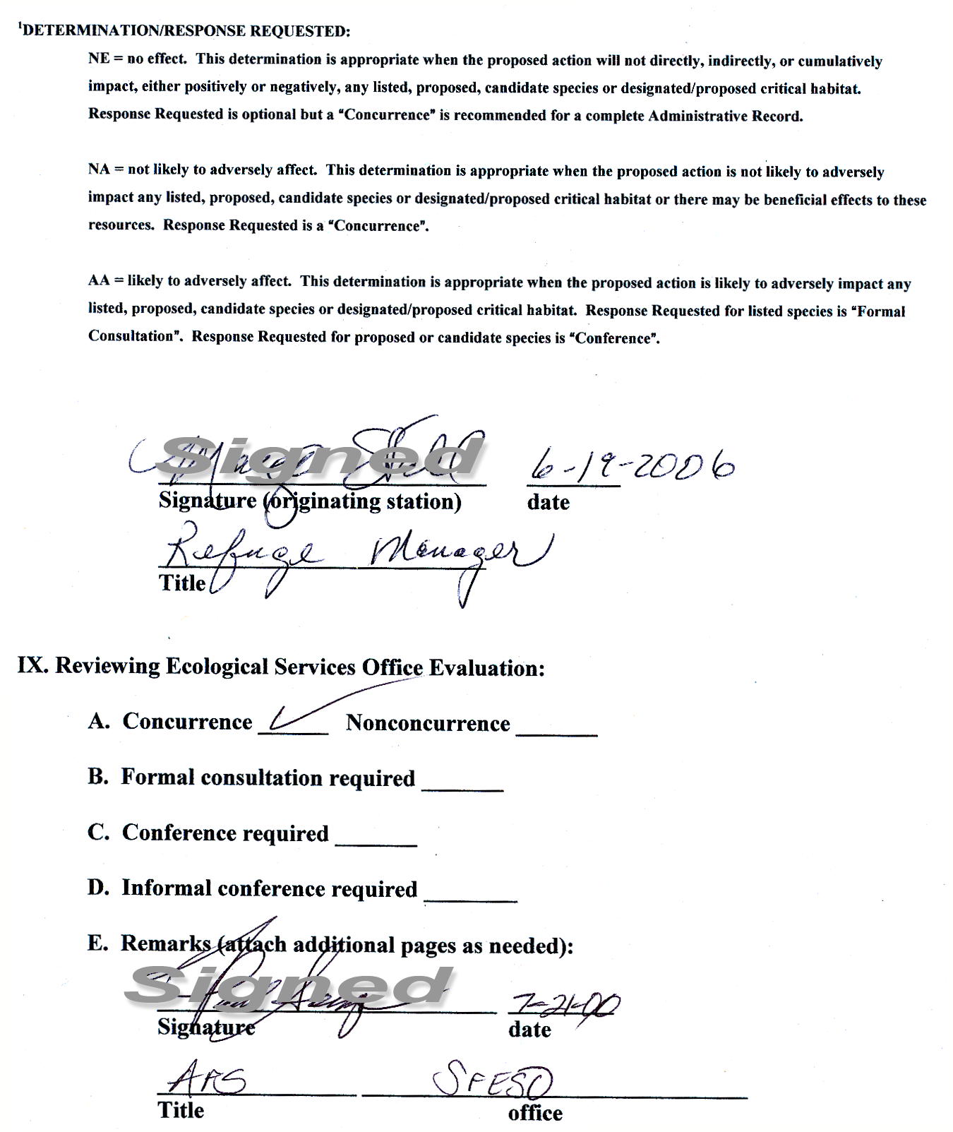

VIII. Subtropical Florida Partners-in-Flight Bird Conservation Plan: Section 2 Avifaunal Analysis
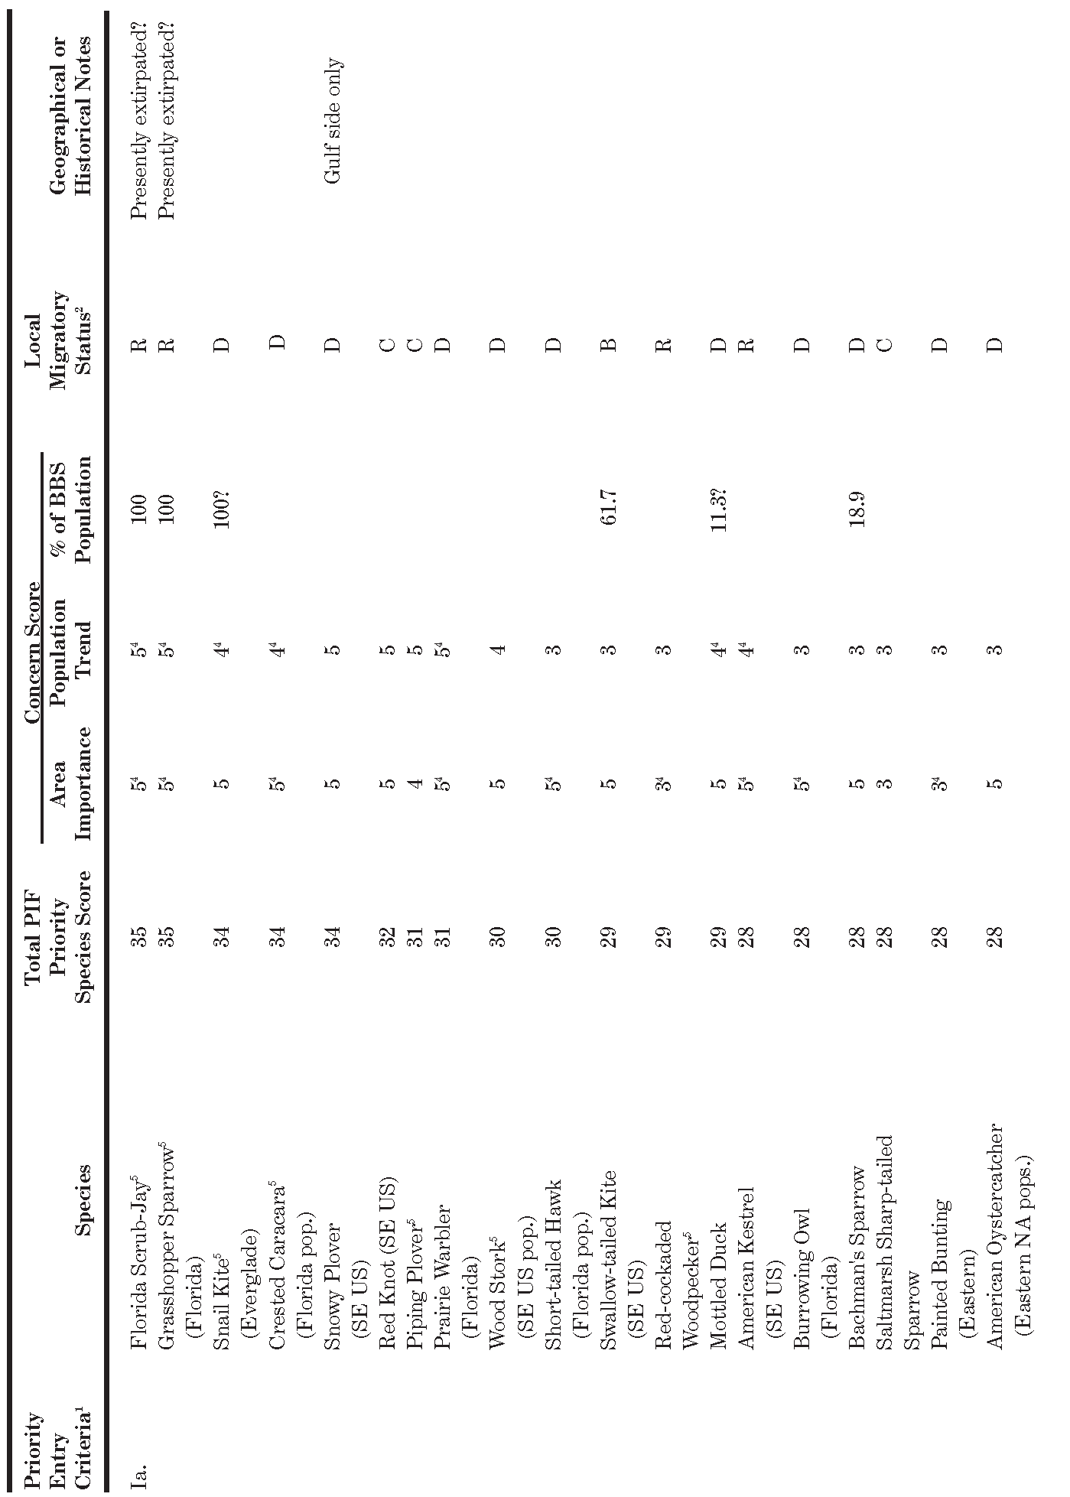
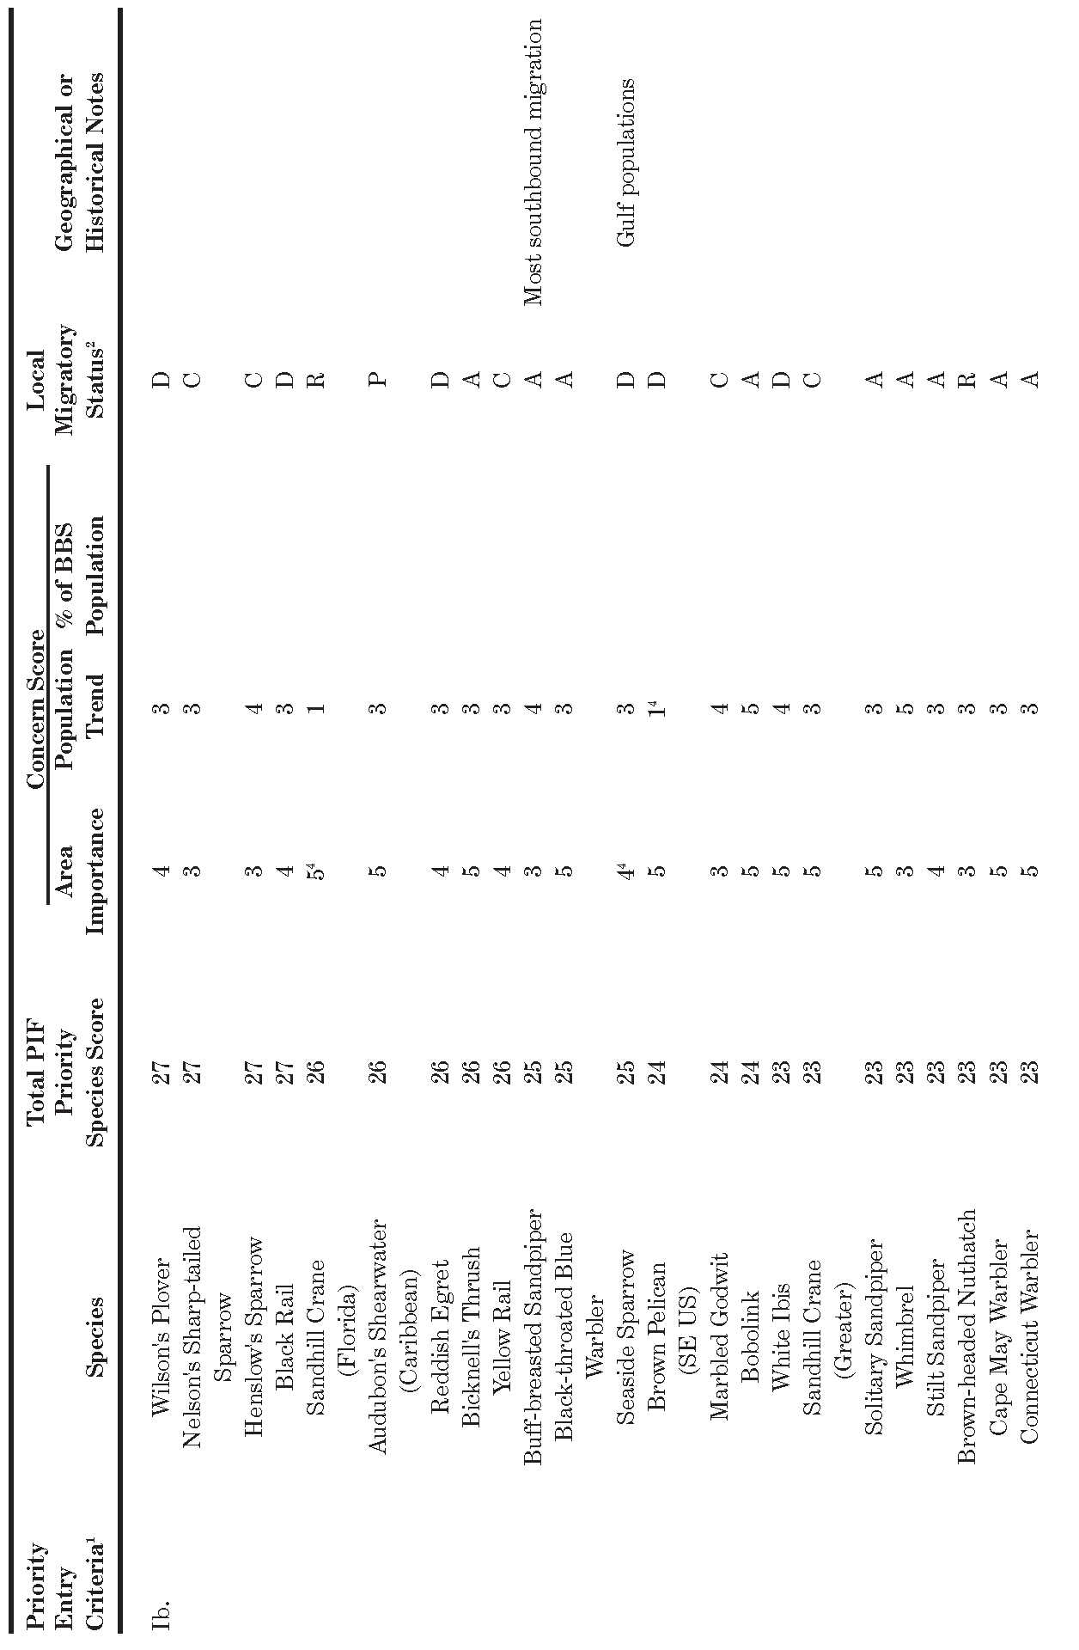
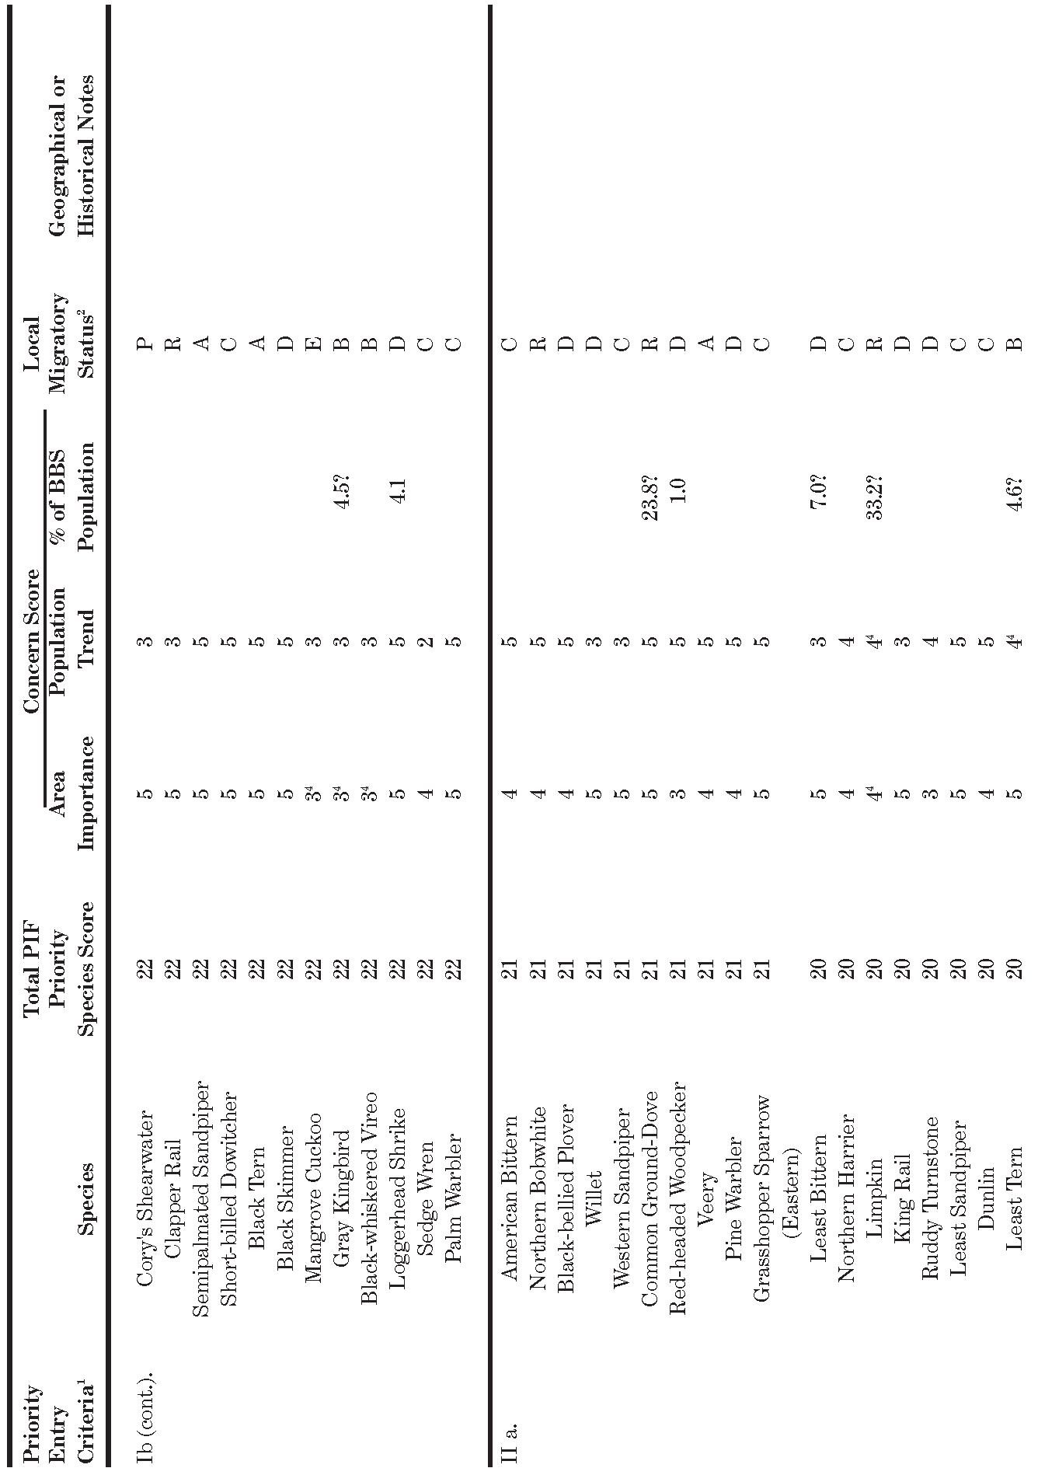
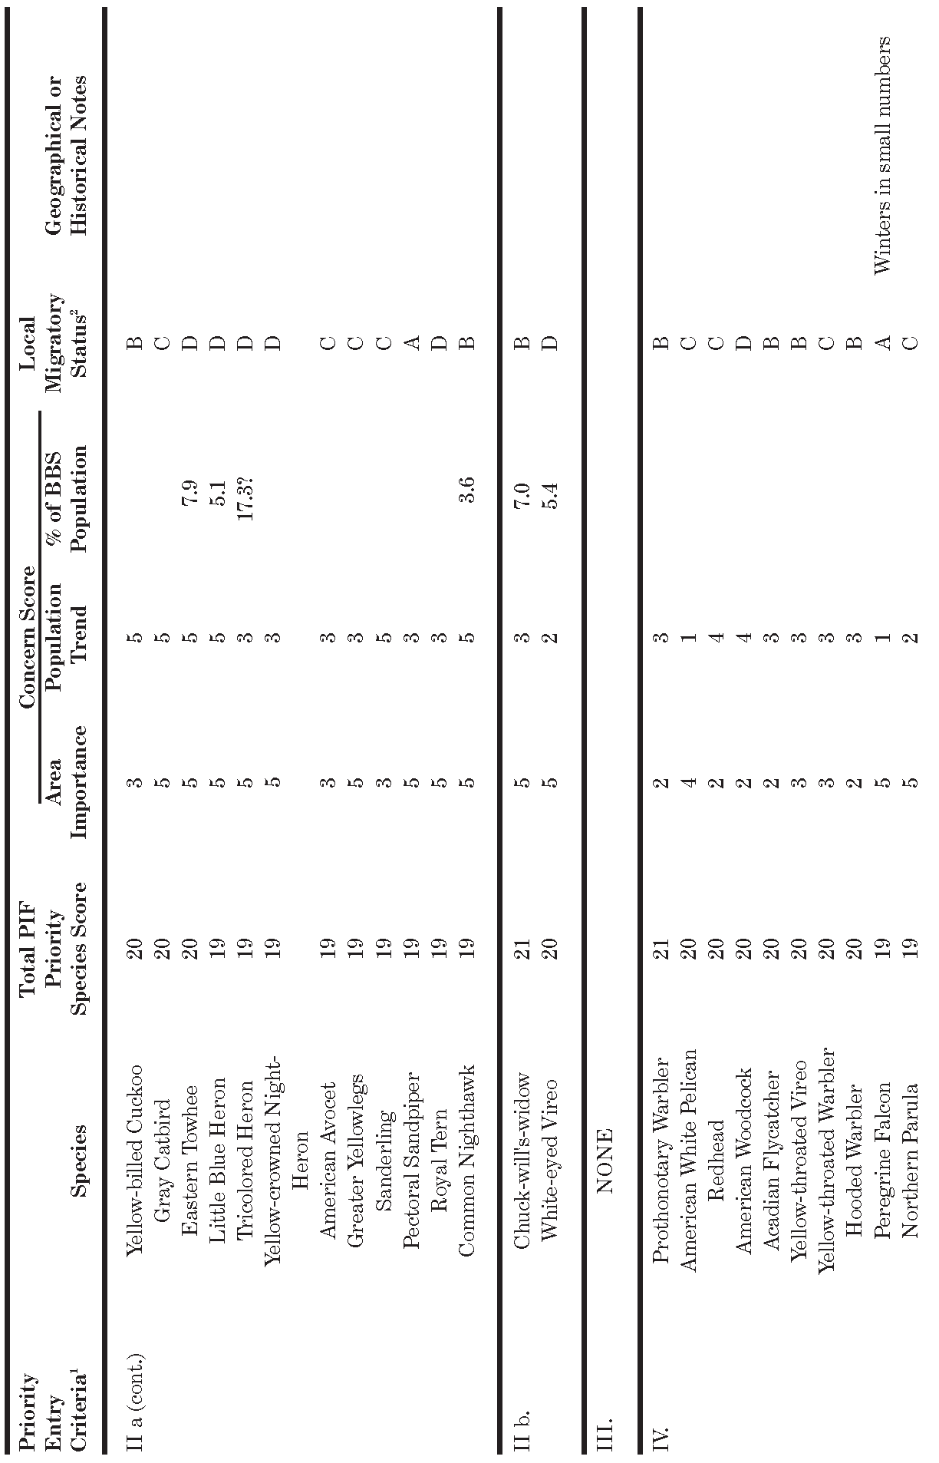
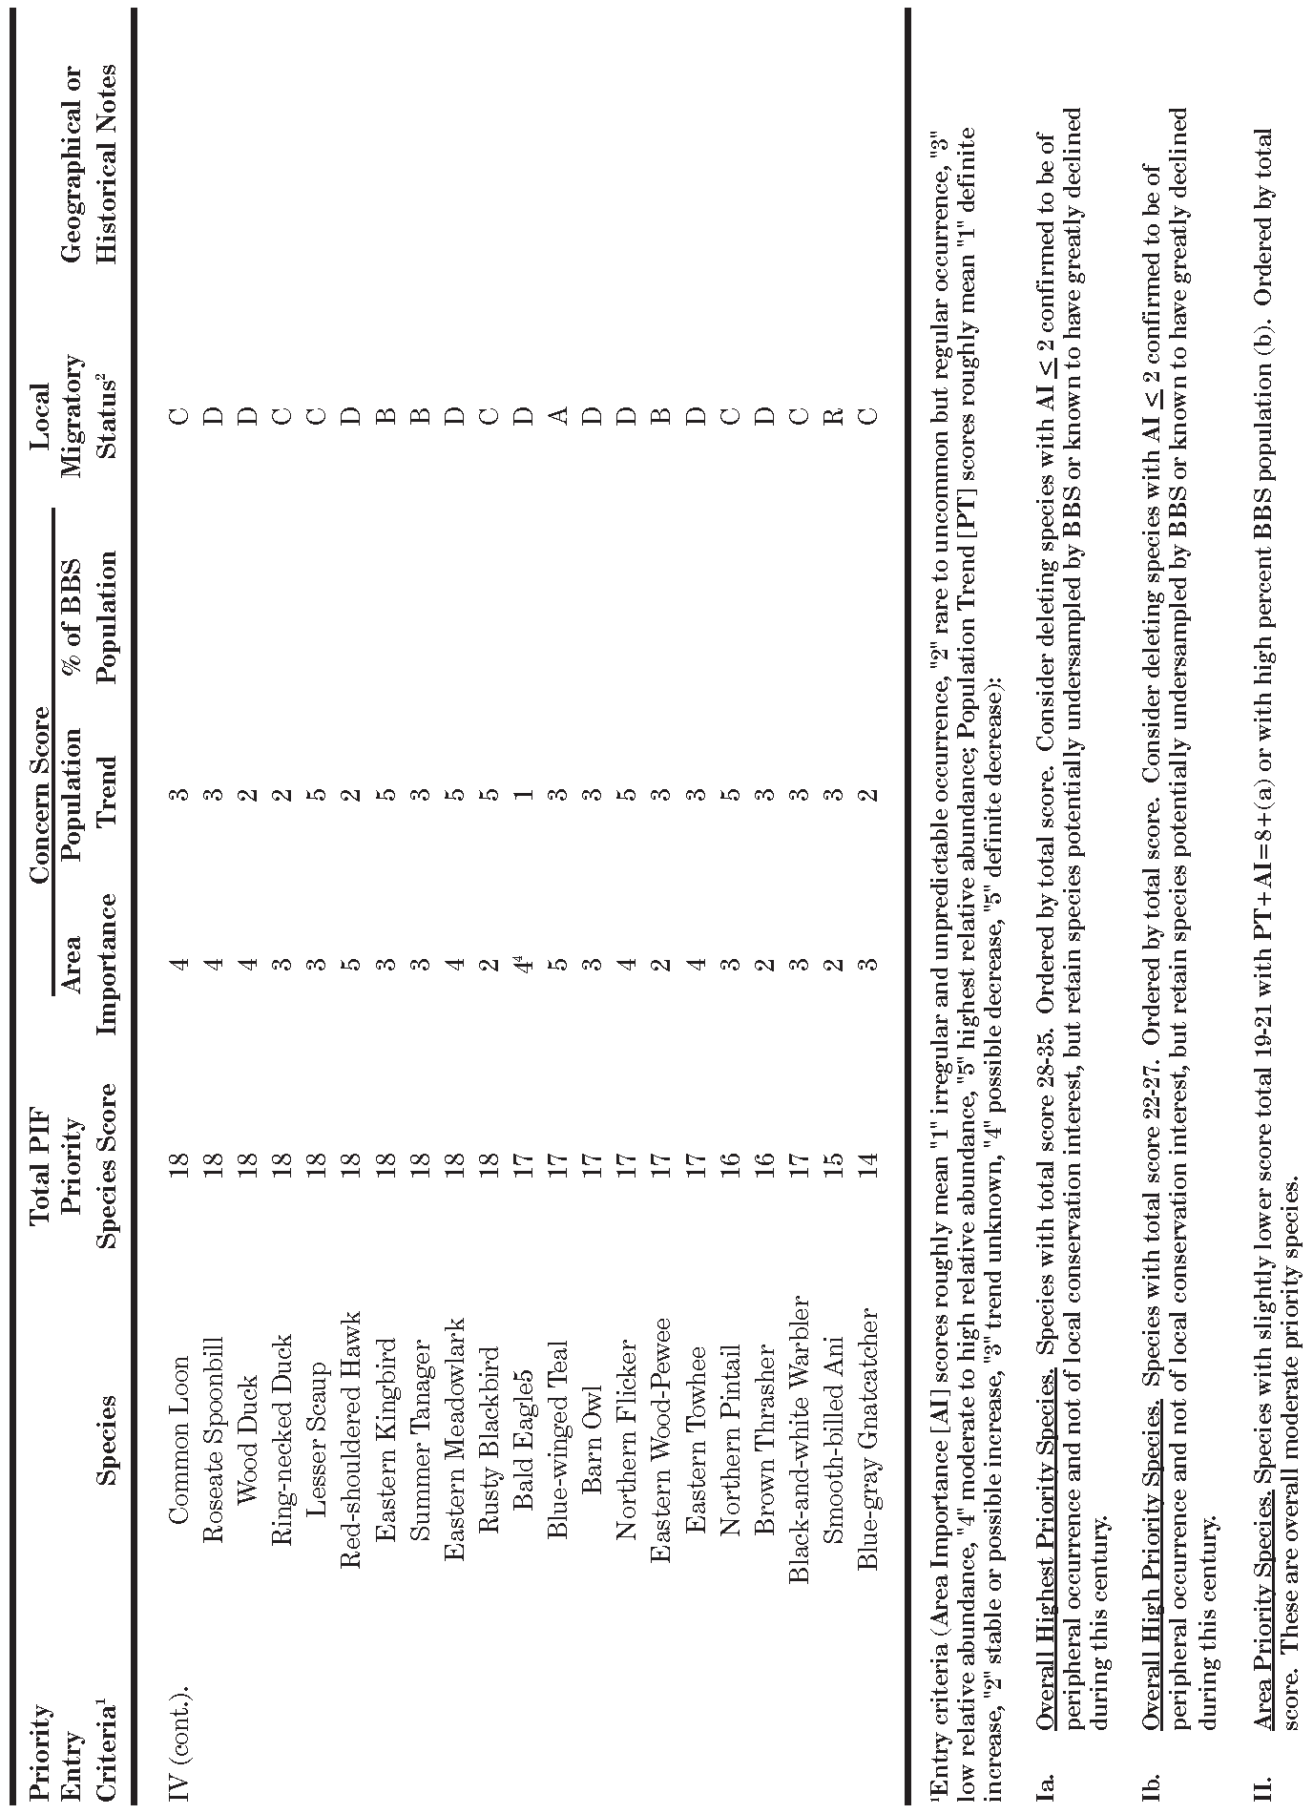
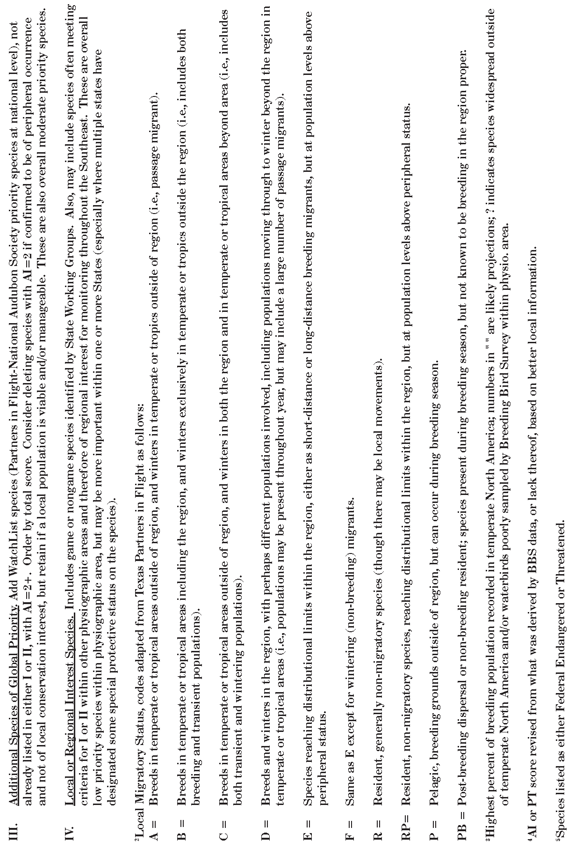
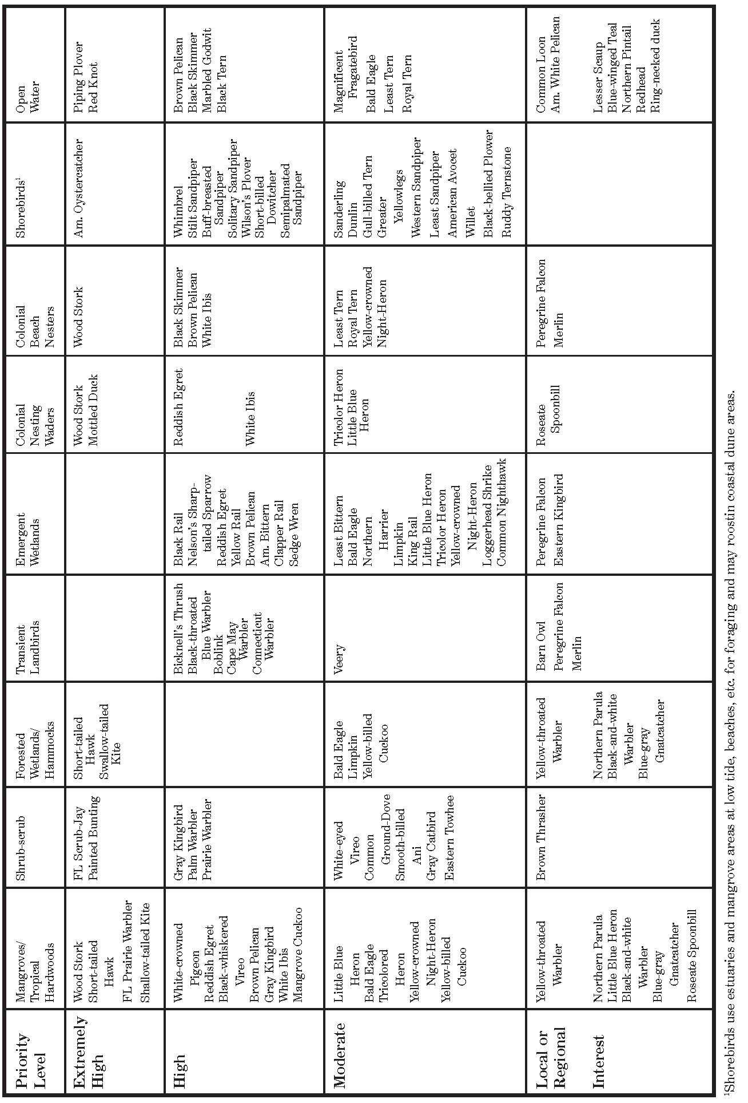

IX. EXISTING AND POTENTIAL PARTNERS

Federal, State, and Local Agencies

Florida Inland Navigation District
Florida Fish and Wildlife Conservation Commission
Florida Department of Environmental Protection
Florida Marine Patrol
Florida Oceanographic Society
Florida Park Service
Indian River Marine Resources Council
Jupiter Island Police
Martin County Sheriff
Martin County Fire and Rescue
Martin County Mosquito Control District
National Oceanic and Atmospheric Administration
South Florida Interagency Fire Management Council
South Florida Water Management District
South Martin Regional Utility
St. Lucie County Mosquito Control District
Town of Jupiter Island
Treasure Coast Regional Planning Council
U.S. Army Corps of Engineers
U.S. Bureau of Land Management
U.S. Coast Guard
U.S. Geological Survey-Biological Research Division
(Florida Cooperative Fish and Wildlife Research Unit)
Martin County Commission
U.S. Department of Agriculture
Animal and Plant Health Inspection Service
Wildlife Services
National Wildlife Research Center

Private Landowners
South End Improvement Group, Inc.
Hobe Sound Land Company

Universities and Other Learning Institutions

Jupiter Community High School
Martin County School Board
Palm Beach Community College
Florida State University
Florida Atlantic University
St. Lucie County School Board
University of Florida
University of Miami
Indian River Community College

Organizations

Bush Wildlife Hospital
Ecological Associates, Inc.
The Nature Conservancy
Marine Resources Council
Martin County Audubon Society
Harbor Branch Oceanographic Institution, Inc.
Hobe Sound Chamber of Commerce
Hobe Sound Nature Center
Jupiter Island Garden Club
Seminole Tribes of Florida
Southeast Florida Archaeological Society
Treasure Coast Wildlife Hospital
Native Plant Society

X. CONSULTATION AND COORDINATION

The planning team was composed of representatives from the Service; Florida Department of Environmental Protection; Florida Fish and Wildlife Conservation Commission; Florida Atlantic University, Department of Anthropology; University of Florida, Department of Recreation, Parks, and Tourism and Institute of Food and Agricultural Sciences; and the town of Jupiter Island.

The planning team met on three occasions (June 16, 1998; October 8-9, 1998; and January 13-14, 1999) to develop a draft vision statement, and goals, objectives, and strategies for the refuge. Selected team members were also involved in writing various draft sections of the plan.

The team conducted a public scoping meeting on August 18, 1998, to help determine the important issues and opportunities (see Chapter II, Comprehensive Conservation Plan). Based on the issues and opportunities generated at this meeting, the team=s knowledge of the refuge environment, and insights from additional scoping conducted by the Refuge Manager, Margo Stahl, this plan was prepared for public review and consideration. Dr. Pat Bidol-Padva served as the facilitator for the planning team meetings and the public scoping meeting and the public meeting during the draft plan review.

The planning team was made up of the following:

Bruce Arrington, Wildlife Biologist, Fish and Wildlife Service, A.R.M. Loxahatchee National Wildlife Refuge, Boynton, Beach, Florida

Marian Bailey, Wildlife Biologist, Fish and Wildlife Service, Nisqually National Wildlife Refuge, Olympia, Washington

Chris Bergh, Conservation Program Manager, The Nature Conservancy, Summerland Key, Florida

David Erickson, Ph.D., Refuge Planner, Fish and Wildlife Service, Southeast Regional Office, Atlanta, Georgia

Alan Flock, Deputy Project Leader, Fish and Wildlife Service, Savannah Coastal Refuges, Savannah, Georgia

Stephen M. Holland, Ph.D., Associate Professor, Department of Recreation, Parks and Tourism, University of Florida, Gainesville, Florida

Skye Wheeler Hughes, Staff Archaeologist, Panamerican Consultants, Inc., Tampa, Florida

Steven G. Jacob, Ph.D., Associate Professor, Department of Behavioral Sciences, York College of Pennsylvania, York, Pennsylvania

Richard Kanaski, Regional Archaeologist, Fish and Wildlife Service, Savannah Coastal Refuges, Savannah, Georgia

William J. Kennedy, Ph.D., Associate Professor, Department of Anthropology, Florida Atlantic University, Boca Raton, Florida

Tracey McDonnell, Refuge Program Specialist, Fish and Wildlife Service, Arlington, Virginia

Beth Morford, Wildlife Biologist, Florida Fish and Wildlife Conservation Commission, Tequesta, Florida

Evelyn Morris, Lt., Florida Fish and Wildlife Conservation Commission, District 2, Department of Environmental Protection, Jupiter, Florida

Mark J. Musaus, Project Leader, Fish and Wildlife Service, A.R.M. Loxahatchee/Hobe Sound National Wildlife Refuges, Boynton Beach, Florida

Ryan Noel, Deputy Refuge Manager, Fish and Wildlife Service, Rocky Mountain Arsenal National Wildlife Refuge, Commerce City, Colorado

Serena Rinker, Interpretive Specialist, Fish and Wildlife Service, A.R.M. Loxahatchee/Hobe Sound National Wildlife Refuges, Boynton Beach, Florida

Dick Roberts, Biologist, Florida Department of Environmental Protection, Division of Parks and Recreation, Hobe Sound, Florida

Suzanna D. Smith, Ph.D., Associate Professor, Institute of Food and Agricultural Sciences, University of Florida, Gainesville, Florida

James Spurgeon, Town Manager, Jupiter Island, Florida

Margo Stahl, Refuge Manager, Fish and Wildlife Service, Hobe Sound National Wildlife Refuge, Hobe Sound, Florida

David Viker, Assistant Refuge Supervisor, Area II, Fish and Wildlife Service, Southeast Regional Office, Atlanta, Georgia

Dawn Whitehead, Supervisory Biologist, Fish and Wildlife Service, Ecological Services= Office, Austin, Texas

XI. Finding of No Significant Impact

Hobe Sound National Wildlife Refuge

Comprehensive Conservation Plan

Hobe Sound, Florida

A. Introduction
The U.S. Fish and Wildlife Service proposes to protect and manage certain fish and wildlife resources in Martin County, Florida, through the Hobe Sound National Wildlife Refuge. An Environmental Assessment has been prepared to inform the public of the possible environmental consequences of implementing the Comprehensive Conservation Plan for Hobe Sound National Wildlife Refuge. A description of the alternatives, the rationale for selecting the preferred alternative, the environmental effects of the preferred alternative, the potential adverse effects of the action, and a declaration concerning the factors determining the significance of effects, in compliance with the National Environmental Policy Act of 1969, are outlined below. The supporting information can be found in the Environmental Assessment, which was Section B of the Draft Comprehensive Conservation Plan for Hobe Sound National Wildlife Refuge.

B. Alternatives
In developing the Comprehensive Conservation Plan for Hobe Sound National Wildlife Refuge, the Fish and Wildlife Service evaluated four alternatives: Alternatives 1, 2, 3, and 4.

The Service adopted a modified version of Alternative 2 (Ecosystem Emphasis) as the “Preferred Alternative” for guiding the direction of the refuge for the next 15 years. Following public comment, the Service decided to remove or downsize selected projects to help maintain the special qualities of the refuge that make it so special to the community. The overriding concern reflected in this plan is that wildlife conservation assumes first priority in refuge management and that wildlife-dependent recreational uses are allowed if they are compatible with wildlife conservation. Wildlife-dependent recreational uses (e.g., fishing, wildlife observation, wildlife photography, and environmental education and interpretation) will be emphasized and encouraged.

Alternative 1. Maintain Current Management (No-Action Alternative)
Alternative 1 represents no change from current management of the refuge. Although efforts would continue to restore sand pine scrub habitat, the refuge would not actively pursue restoration projects and conduct monitoring to evaluate the success of the projects. There would be limited efforts to re-create scrub or barrier island natural fire regimes or to explore alternative disturbance mechanisms.

Dune and mangrove swamp restoration and other restoration/enhancement projects would occur sporadically. On the barrier island, dune restoration would not be a priority; however, beach re-nourishment would continue along with incidental replanting of sea oats and other native dune plants. Limited efforts would be made to restore or enhance mosquito impoundments, dredge/spoil sites, seagrass beds, or mangroves.

Habitat restoration efforts would be limited, as would removal of invasive exotic plants. For example, little effort would be made to remove Australian pines adjacent to the Indian River Lagoon and there would be no effort to restore the subsequently disturbed areas. Increasing loss of wildlife habitat, due to advancing exotic plants, would result not only in a decimation of state and federal listed species, but also in a decrease in species diversity.

Monitoring efforts would occur only for selected, highly visible trust species. Monitoring of sea turtle nests would continue, as would predator control activities. Migratory bird and gopher tortoise surveys would continue only through volunteer assistance. Limited vegetative community inventorying, monitoring, and mapping would occur only with special one-time funding.

The Hobe Sound Nature Center, Inc., would continue to provide the same level of environmental education opportunities. Recreational opportunities would continue to include access to the Atlantic Ocean beach, to the Indian River Lagoon at the headquarters area, and along the 1/4-mile interpretive trail through the scrub habitat. Improvements to visitor services would be limited and visitors would not have the most up-to-date brochures, educational information, and exhibits possible.

Alternative 2. Ecosystem Emphasis (Preferred Alternative)
The preferred alternative, Alternative 2, is considered to be the most effective management action for meeting the purposes of the refuge by increasing populations of threatened and endangered species and providing compatible wildlife-dependent recreational activities.

In place of single species management, ecosystem and landscape level habitat management would be emphasized. In all cases, possible impacts to trust species would be examined before taking any management action. With the emphasis of an ecosystem approach, individual species and their habitats would benefit.

Native habitats of the Barrier Island and Atlantic Coastal Ridge would be managed in accordance with historical patterns of succession. The sand pine scrub would be treated with a mechanical process followed by prescribed fire to reproduce the effects of wildfire without the associated risks to property and life. This technique would only be used to provide the most appropriate conditions for endemic species and overall health of the community, as prompted by an active biological monitoring program.

The Atlantic coastal dune system would be managed to protect its shoreline from erosion and provide optimal beach conditions for nesting sea turtles and shorebirds. The vegetative community would be managed for a diversity of native plants and wildlife. Monotypic stands of exotic plants, as well as invasive natives, would be monitored and treated or burned according to the approved dune management plan.

Mangrove swamps, lining the banks of the Indian River Lagoon, would be protected from erosion and exotic infestation. Through the use of partnerships, historical mangrove wetlands would be restored. A strong effort would be made to develop a number of partnerships with other federal, state, and county agencies and with non-government organizations and universities.

Ecosystem management assists in developing diverse wildlife populations. A systematic removal of exotic plants and the restoration of native plant communities would result in genetically diverse native wildlife populations. Protection and enhancement of state and federal listed threatened, endangered, and trust species would be a high priority. All native populations of non-invasive plants and wildlife would be fostered to ensure future health of the species.

The refuge would develop limited new facilities such as trails, kiosks, and interpretive areas. Opportunities to enjoy the beauty and serenity of this refuge would be moderately expanded and maintained to protect the safety and health of the visiting public. Public educational programs of the Nature Center would be expanded.

Land acquisition, from willing sellers, would continue within the approved refuge acquisition boundary. Efforts to expand the boundary to include the ability to accept new lands would continue.

Alternative 3. Biological Emphasis
Under this alternative, over 1,000 acres of the refuge would receive intensive management to maximize wildlife benefits. Full-scale habitat restoration programs would be planned for the mainland scrub tract, including prescribed fire or a disturbance mechanism. Native scrub vegetation would be planted to provide optimal habitat for the refuges many listed species.

Barrier island restoration would include upland and coastal strand, mosquito impoundments, spoil sites, mangroves, and seagrass beds. Sensitive areas, such as hammocks and isolated wetlands, would be restored. All exotic and invasive plants would be identified, and a plan for their control or eradication would be written and implemented. Complete habitat restoration would closely follow exotic plant removal.

Every effort would be made to inventory, map, and monitor indicator species of macro- and micro-invertebrates, vertebrates, terrestrial and aquatic insects, flowering and coniferous plants, algae, moss, fungus, and lichens (including native and exotic) to understand the biotic communities on the refuge. A state-of-the-art geographic information system would be developed and maintained. With this information, it would be possible to evaluate the effects of management techniques on biotic communities.

Ground, ocean, and intracoastal water quality issues would be evaluated and monitored. Biological studies would be implemented to contribute to the de-listing process.

Public education efforts about the Atlantic Coastal Ridge and barrier island ecosystem would continue. Public access would be restricted from many areas, including Peck Lake, so that the effects on wildlife would be negligible. Beach and mainland facilities would remain the same or be cut back as needed to protect the resources.

Alternative 4. Public Use Emphasis
In this alternative, the refuge would allocate a greater share of the budget to public use as opposed to resource management. With this focus, efforts to inventory, monitor, and manage the biological and archaeological resources would be limited. Volunteers who would be trained in plant and animal identification and ecosystem ecology would carry out these efforts.

Similar to other alternatives, wildlife-dependent recreation uses, such as environmental education and interpretation, fishing, wildlife observation, and wildlife photography, would remain priority public uses. At the same time, these public uses would be managed so that there would be minimal impact to wildlife. Increased access would be provided throughout the refuge.

The environmental education and interpretive programs both on and off the refuge would be expanded. Ecotourism, adult lecture series, and an expanded in-service teacher-training program would be supported. Ecotourism would be permitted at the Peck Lake area with appropriate boat landing sites.

Existing interpretive trails would be lengthened. New trails, observation towers, and photo blinds would be created both on the mainland and beach tracts. Firebreaks from U.S. Highway 1 to the Indian River Lagoon would be converted into trails for canoeing, kayaking, and fishing access.

Public use facilities would be expanded at the beach parking lot and improved on the Mainland Tract. To increase visitation, a radio message program would be established. Placement of directional signage on all roads leading to the refuge would increase visitation. A large visitor center, complete with state-of-the-art interactive interpretive displays and two classrooms would be needed to accomplish this alternative=s goals and objectives.

C. Selection Rationale
A modified version of Alternative 2 is selected for implementation because it directs the development of programs to best achieve the refuge purpose and goals; emphasizes conservation of threatened and endangered species (e.g., loggerhead, green, and leatherback sea turtles) on the Jupiter Island portion of the refuge, as well as over 40 other rare species (e.g., gopher tortoise, scrub jay, eastern indigo snake) on the mainland portion of the refuge; and Florida manatee and other aquatic species associated with Indian River Lagoon; collects habitat and wildlife data; and ensures long-term achievement of refuge and Service objectives. At the same time, the alternative provides balanced levels of compatible public use opportunities consistent with existing laws, Service policies, and sound biological principles. It provides the best mix of program elements to achieve desired long-term conditions.

Under Alternatives 2, all lands within the approved 1,160-acre acquisition boundary will be protected, maintained, and enhanced and lands outside the boundary will be prioritized for land protection best achieving national, ecosystem, and refuge-specific goals and objectives. In addition, the action positively addresses significant issues and concerns expressed by the public.

D. Environmental Effects
Implementation of the Service’s management action is expected to result in environmental, social, and economic effects as outlined in the comprehensive conservation plan. Habitat management, population management, resource protection, and visitor service management activities on Hobe Sound National Wildlife Refuge will result in an increase in threatened and endangered species; enhanced wildlife populations; and opportunities for wildlife-dependent recreation and environmental education. These effects are detailed as follows:

1. Mosquito Impoundments
Mosquito impoundments would be reconnected through the possible construction of water control structures. Water levels would be managed for fish, wading birds, and control of biting insects. Water would be held and released seasonally, thus directly affecting the local hydrology of those portions of the barrier island. This action would create tidal wetlands, where now only seasonally moist soils exist. Restoring the functional value of wetlands by reconnecting them to the Indian River Lagoon would have a positive impact on fish, aquatic invertebrates, and the vegetative communities and a negative effect on exotic plants.

2. Vegetation
Exotic plants would be aggressively controlled to achieve 50 percent removal within 15 years, resulting in an accumulative positive impact on native vegetation. The plan would encourage volunteer support and agreements with local plant nurseries to promote plantings of native species. Fifty percent of the spoil sites would be converted to mangrove wetlands. Native communities would be restored and all spoil sites would be converted to either upland hardwood hammocks or removed to restore tidal influences.

3. Sand Pine Scrub Community
Removal of exotic plants in the disturbed areas would minimize the need to constantly maintain these areas to prevent their spread. Contractors would be used throughout the year to control Australian pine, Brazilian pepper, Old World climbing fern, mahoe, rosary pea, and others. Limited access trails would be cut into greatly disturbed areas to facilitate plant removal. In addition, these trails could provide opportunities for wildlife observation and photography. This intensive exotic removal program would have a positive effect on the biotic community.

The indirect and cumulative effects of fire or mechanical clearing would restore health to this aging scrub community. Initially, these would have a negative direct effect on the scrub community, since most of the native plants (or at least the above-ground portions) in the project area would be disturbed either by fire or mechanical treatment. Fire or mechanical disturbance would have a direct effect on individual plants and to species that require a late seral stage, however, managing this community for earlier succession would have overall indirect and cumulative, positive effects.

Some of the scrub habitat (approximately 50 acres) would be spared from fire and/or mechanical disturbance. This area would serve the few species, such as lichens, that require older growth and act as refugia for wildlife during fire and mechanical treatment elsewhere on the refuge.

4. Coastal Strand Community
Native species would be planted on the foredunes and backdunes. Sand fence installed according to turtle safe guidelines would be evaluated to foster dune accretion. This action would increase the area of potential habitat for the vegetative community. Regulations protecting the dune from visitor impacts would be strictly enforced. More signs notifying visitors to stay off the dune would be placed along its length. Fire and mechanical disturbance would be used, where appropriate, to control exotic plants and maintain the native community. It is expected that these treatments would eliminate 95 percent of the exotic plants.

5. Mangrove Wetlands
Positive direct, indirect, and cumulative impacts would result with the implementation of this alternative. Efforts would be made to work with boat users to evaluate a slow speed/minimum wake zone in the Intracoastal Waterway along the length of the refuge. This action would slow or reduce the erosion process to the mangrove community, thus creating a positive indirect and cumulative impact. Red mangroves would be planted in areas that are the most prone to erosion. Installation of water control structures and pumps in old mosquito control impoundments would restore healthy mangrove wetlands. This action would create an additional 200 acres of exotic-free mangrove wetlands on the Island and potentially increase the numbers of fish species and wading birds utilizing the wetlands.

6. Sea Turtles
Additional resources and funding would be committed to ensure that sea turtle hatching success is increased to 90 percent. Animals identified as primary nest predators would be removed from the population and improved techniques and excluding devices would be evaluated and applied, if appropriate. Positive and cumulative impacts for protected coastal species are expected.

On the other hand, implementation of this alternative would require strict enforcement of refuge regulations concerning unconfined domestic animals. This alternative would limit the negative impacts of public use activities on sea turtles.

7. Shorebirds
An educational program would be developed to inform the public about beach areas to be closed to protect nesting colonies, should this action be needed. Prior to the nesting season, the public would be alerted to the location of least tern nesting sites, and early in the nesting season, the refuge would step up its law enforcement presence, including enforcement of existing animal leash laws. Should this prove inadequate, owners would be denied access with pets during the nesting season. Some of the negative effects associated with public visitation would be mitigated by the implementation of a more aggressive predator control program.

Least tern nesting would be positively affected. Public use of the refuge beach would be restricted to the area located south of the Peck Lake crossover trail during the nesting season.

8. Beach Renourishment
Beach renourishment, which involves the transfer of sand from offshore sites, would continue. Sand renourishment, implemented properly, is beneficial to sea turtles, least terns, and other shorebirds, since beach habitat is temporarily restored.

However, beach renourishment does have some negative effects on sea turtles. Escarpments, as great as 5 feet, generally form the first winter after completion of the renourishment project. In some instances, escarpments are leveled by winter storms. In other instances, they remain well into the season and function to deter sea turtles from nesting. Although the contractor is required to till the deposited sand prior to the next turtle-nesting season, the substrate is likely to become very compact as it settles. This compaction hinders and can, in some cases, prevent sea turtles from excavating the egg chamber. Much knowledge has been gained over the years in proper renourishment techniques. However, the long-term effects of various renourishment substrates on sea turtle nesting are still being researched.

9. Protected Scrub Species
Under this alternative, restoration of the mainland coastal ridge to earlier successional stages would have moderate negative direct impacts to all scrub species of management concern occurring on the refuge. These species are the gopher tortoise, eastern indigo snake, Florida scrub jay, Florida gopher frog, Florida mouse, Florida pine snake, and scrub lizard. Individuals of some species may be killed during heavy equipment use and during prescribed burns due to extreme heat. Populations of other species, especially those that share burrows with gopher tortoises, may only incur loss of habitat or food. Many species commonly retreat to subterranean burrows to escape the heat and flames of fire. Forested buffers excluded from mechanical harvest and prescribed fire would serve as wildlife refugia during these events.

10. West Indian Manatee
The refuge would work closely with other agencies and the boating public to place greater emphasis on reducing vessel speed and wake along its boundary. The Florida Inland Navigation District would keep manatee zone signs posted along the Intracoastal Waterway. The refuge would also coordinate and collaborate with the Florida Fish and Wildlife Conservation Commission, Marine Division, and the Jupiter Island Public Safety Department, Marine Units, to enforce the existing speed restrictions.

The above actions would reduce the number of vessel collisions and disturbance to manatees, and assist in the reduction of water turbidity levels. Suspended sediment, caused by excessive high-speed vessel traffic, eventually settles to the river bottom covering vegetation (e.g., seagrass beds) and hard bottom habitats. Boater compliance and decreased boat speed and wake would reduce negative direct, indirect, and cumulative impacts to manatees.

Water control structures can be a cause of manatee mortality. To minimize these negative effects, any water control structures in the mosquito impoundments would be constructed to be manatee friendly. In addition, these structures would be constructed with pressure-sensitive gates, which would not continue to close if an object was contacted

11. Migratory Birds (excluding shorebirds)
Active management of the sand pine scrub community and hammock restoration would likely result in greater species diversity and abundance of migratory birds.

Use of prescribed burning would have a direct but short-term negative effect on bird population levels because of decimation or displacement of insect populations. However, the long-term effects would be positive.

Early successional scrub would provide greater numbers of insects, small mammals, and increased quantities of seeds, berries, and acorns. After scrub restoration, snags would remain on which raptors and passerines could perch and on which woodpeckers and wood ducks could nest. Exotic plants would be removed from freshwater wetlands and hardwood hammocks would provide more suitable habitat for birds. Reduced boat speed and wake in the Intracoastal Waterway would attract greater numbers of wading birds that feed along the shores and in the mangrove swamps. The Indian River Lagoon would also support greater numbers of diving ducks and loons. Reduced boat speed would allow aquatic vegetation to reestablish, which would support greater populations of bird prey.

12. Other Wildlife
Continuation of well-designed and implemented beach renourishment projects, reduced vessel speeds in the Intracoastal Waterway, improved water quality, seagrass bed monitoring, exotic plant removal, and mosquito control impoundment restoration would positively affect most species of wildlife. Enhancements to the biological communities would be primarily directed at trust species, but all flora and fauna would be considered prior to any action taken. Many of the trust species serve as indicator species that reflect the health of the biotic community. Therefore, in principle, if management activities were directed toward promoting ideal conditions for these species, other populations would benefit as well.

13. Cultural and Historic Resources
Scientific investigations, such as plant and animal inventories, geographic information system analysis and mapping, archaeological investigations, and geomorphic studies, are planned. The databases generated from these investigations would enhance the refuge's ability to monitor and protect cultural resources under its jurisdiction.

A refuge-wide comprehensive archaeological survey would be conducted to generate a site-predictive model. The resulting technical report would provide specific recommendations for future research and site protection measures. Partnerships with universities and other pertinent entities to conduct archaeological research would be actively pursued and fostered.

One of the focal points of the environmental education program would be to provide increased public awareness of the region’s past cultural histories, the fragility of archaeological sites, and the nature of human-habitat interactions. Ties with the current-day Miccosukee and Seminole nations are further encouraged, particularly for input into the management of sites important to these groups, as well as an opportunity to educate others about their history and use of resources present within the refuge.

14. Wildlife-Dependent Recreation, Environmental Education, and Interpretation
Some fire breaks along the mainland tract would offer increased access to fishing in the Indian River Lagoon, if the Florida Department of Transportation would grant right-of-way privileges along U.S. Highway 1. The increased use associated with providing access to these trails would also remedy the constant maintenance associated with reopening the firebreaks.

The extension of existing and creation of some new wildlife trails would provide greater opportunities for the public to passively enjoy wildlife on the refuge. An extension of the scrub trail would be constructed as an overlook that would provide additional viewing opportunities of the Indian River Lagoon.

Swimming, surfing, shelling, sun bathing, walking, photography, and painting would continue to be permitted activities on the barrier island. Hiking, fishing, photography, painting, and wildlife observation would continue to be permitted activities on the Mainland Tract, unless temporary beach closure is necessary to protect nesting shorebirds.

The refuge would assume a larger role in environmental education and interpretation responsibilities. A refuge ranger and volunteers would work with the Nature Center and its staff to expand programs and to provide more information to visitors. Ranger guided tours would be conducted on the beach and scrub trails. Current facilities would be refurbished and informational kiosks would be updated. Positive direct, indirect, and cumulative impacts would be expected from an expanded program.

D. Potential Adverse Effects and Mitigation Measures

1. All Refuge Species

a. Herbicide Treatment
To control invasive exotic plants in scrub-shrub habitat, and coastal strand community, and on the shoreline of the Indian River Lagoon will, as one treatment measure, require the use of herbicides. Only herbicides with environmental impacts equal to or lesser than Garlon 4 (for large woody species like Brazilian pepper and Australian pine) or Rodeo (for exotic herbaceous plants) will be used to control invasive exotic plants on the refuge.

Treatment methods will include initial mechanical clearing using chain saws or machetes, and basal bark, cut stump, or foliar applications, depending on plant species and individual size. To avoid overspray and impacts to non-target plants, backpack or pump sprayers will be used to hand-apply the herbicides to individual nuisance plants (e.g., Australian pine and Brazilian pepper). Herbicides will be mixed in accordance to the label directions and the recommendations in “Control of Non-native Plants in Natural Areas of Florida” (Langeland, K.A. 1997). Safety measures will be taken to minimize drift, and to maximize degradation of residual herbicide.

Additional measures to avoid and minimize potential wildlife impacts during the control of exotic plants include preliminary assessments by refuge biological staff to avoid burrows, nests, and other obvious signs of federally listed wildlife. Herbicides will not be applied within 20 feet of aquatic environments.

b. Prescribed Fire
An alternative to herbicide treatment is the use of fire to control invasive exotic plants in the sand pine scrub community. During other, similar treatments conducted by the refuge, no adverse effects to listed species were noted. However, the refuge will take the following actions: survey, and use recently collected survey information, to avoid listed species and sensitive areas; flag and hand-clear fuel loads around sensitive areas and gopher tortoise burrows for avoidance; flag stands of listed plants for avoidance; burn during winter months to limit fire intensity; have trained personnel conduct the burns; create a buffer by removing vegetation for at least 25 feet around stands of listed plant species and sensitive areas; pre-burn around these sensitive areas whenever appropriate; not use chemical retardant except in the case of wildfire (escape fire); not use ring fires; and provide orientation information regarding federally threatened and endangered species found in the project area to all new employees, volunteers, and contractors, so that the species may be avoided.

c. Construction and Ground Disturbing Activities
A number of the planned projects involve trail, facilities development, or other actions that will impact land surface. In these developments, the refuge will designate and limit access areas for heavy equipment; limit ingress and egress of heavy equipment to the project area; limit and avoid the construction of new fire lines and access trails; notify the Service biologist if new fire lines are needed; survey, and use recently collected survey information, to avoid listed species and sensitive areas; flag gopher tortoise burrows for avoidance; flag stands of listed plants for avoidance; supervise contracted activities at all times for potential impacts to species; use rubber-tired vehicles and avoid the use of tracked heavy machinery; restrict tracked machinery to access trails and fire lines, if used; conduct no activities (with the exception of monitoring) within the scrub jay nesting season; adhere to the Standard Protection Measures for the eastern indigo snake; create a buffer by removing vegetation for at least 25 feet around stands of listed plant species and sensitive areas, and not skid or fall trees into this buffer; restrict heavy machinery to sand pine scrub and exclude such machinery from any wetlands and any transitional wetland areas; and provide orientation information regarding federally threatened and endangered species found in the project area to all new employees, volunteers, and contractors, so that the species may be avoided. Spill kits will be required on site to respond to potential fuel spills. Trails would not be longer than 3 miles and would function simultaneously as an access for refuge staff to conduct exotic plant control activities. Trails would be aligned to avoid threatened and endangered species and sensitive habitats. Boardwalks and foot bridges would be installed in sensitive areas to minimize the negative effects of high foot traffic. Informational signs would be positioned along the trails length to guide and inform the visitor.

2. Eastern Indigo Snake
The refuge would adhere to the Standard Protection Measures for the eastern indigo snake. The refuge would look for the snake during sweeps no more than two hours prior to prescribed fire ignition and conduct sweeps for mortalities no more than 24 hours after burn. The refuge would not use aerial ignition, which will avoid spot fires that may increase the likelihood of mortalities. The refuge would avoid the snake and cease and desist if threatened and endangered species are observed in the project area.

Herbicide treatment of invasive exotic plants and native replanting is not likely to adversely affect this species. Herbicide applications will target specific plants or populations of such plants (e.g., Australian pine, Brazilian pepper, and Category I Invasive). Therefore applications—according to or less than, label or proposed rates—will not have measurable or significant direct or indirect effects to this species.

3. Florida Scrub Jay
The refuge would not conduct project activities (with the exception of monitoring) within the scrub jay nesting season (March through June).

4. Sea Turtles (Green, Leatherback, and Loggerhead)
Beach quality sand suitable for sea turtle nesting, successful incubation, and hatchling emergence would be used for beach renourishment. Beach renourishment activities would not occur from May 1 through October 31, the period of peak sea turtle egg laying and egg hatching, to reduce the possibility of sea turtle nest burial, crushing of eggs, or nest excavation.

If beach renourishment is conducted during the period from March 1 through April 30, surveys for early nesting sea turtles would be conducted. If nests were found in the area of beach reconstruction, the eggs would be relocated by trained and permitted individuals according to standard and accepted protocols. If beach renourishment were conducted during the period from March 1 through April 30, nighttime surveys for nesting leatherback sea turtles would be conducted. If turtle nests were located in the area of the beach reconstruction, the eggs would be relocated. If beach renourishment is conducted during the period from November 1 through November 30, surveys for late nesting sea turtles would be conducted. If nests were constructed in the area of beach reconstruction, the eggs would be buffered and protected.

Immediately after completion of beach renourishment and prior to the next three nesting seasons, beach compaction would be monitored and tilling would be conducted as required by March 1 to reduce the likelihood of impacting sea turtle nesting and hatching activities. The March 1 deadline is required to reduce impacts to leatherbacks that nest in greater frequency along the South Atlantic coast of Florida.

Immediately after completion of beach renourishment and prior to the next three nesting seasons, monitoring would be conducted to determine if escarpments are present and escarpments would be leveled as required to reduce the likelihood of impacting sea turtle nesting and hatching activities.

5. West Indian Manatee
Water control structures would be constructed to be manatee friendly. These structures would be constructed with pressure sensitive gates, which would not continue to close if an object was contacted.

6. Wildlife Disturbance
Disturbance to wildlife at some level is an unavoidable consequence of any public use program, regardless of the activity involved. Obviously some activities innately have the potential to be more disturbing than others. All preferred alternative public use activities contained in this document have been carefully planned to avoid unacceptable levels of impact.

As currently proposed, the known and anticipated level of disturbance of the preferred alternative is not considered significant but can be managed to reduce impacts to known wildlife species and populations present in the area. Providing access for fishing opportunities allows the use of a renewable natural resource without adversely impacting other resources. General wildlife observation activities may result in minimal disturbance to wildlife. If impacts from the expected additional visitor uses were determined to be above the acceptable threshold for wildlife, those uses would be discontinued or rerouted to other, less sensitive areas.

The expanded environmental education and interpretation program would slightly affect wildlife populations as a result of direct interaction and observation. The benefits to the ecosystem resulting from a more educated public would far outweigh any negative effect, in the form of disturbance to individual organisms.

As indicated above, initial disturbance to wildlife and habitat would occur during the construction of new facilities such as the education center/office, beach restroom, boardwalk trails, law enforcement boat ramp, and observation platform. Short-term negative effects to air quality, noise, and soils within the project site would be expected and measures to protect the environment would be taken. Allowing these recreational opportunities would help to maintain and build public support for the refuge.

Monitoring activities through wildlife inventories and assessments of public use levels and activities would be conducted, with minor adverse impacts to resources expected. These public use activities would be adjusted, as needed, to limit disturbance to acceptable levels. No dogs (or other pets) would be allowed off leash on the refuge because of their potential to cause disturbance to wildlife. Where dogs are allowed on the refuge (uplands and Intracoastal Waterway), dog owners must be reminded of the leash law when entering the refuge, either through signage or refuge staff, and doggie walk bags for feces collection and instructions for disposal must be provided to dog owners. Due to already documented pressures on beach nests, roosts, and foraging birds in the southeast, pets are not allowed on refuge beaches on the Atlantic Ocean. Excluding pets from the entire refuge is a likely possibility in the future if violations of the leash law continue to occur.

7. User Group Conflicts
As public use levels increase, unanticipated conflicts between user groups could occur. Programs would be adjusted, as needed, to eliminate or minimize each problem and provide quality, appropriate, and compatible wildlife-dependent recreational opportunities. Experience has proven that time and space zoning (e.g., establishment of separate use areas, use periods, and limits on the numbers of users) is an effective tool in eliminating conflicts between user groups.

Under the preferred alternative, wildlife observation, wildlife photography, walking, shelling, sunbathing, surfing, and swimming would occur on the refuge beach or in adjacent state controlled waters. Despite the 3.5 miles of beach, conflict between the beach users occurs already on certain days when fishing is exceptional, surf is high, and solar radiation is ideal. A beach zoning option may be proposed to address conflicts in the future.

With roughly 9 miles of shoreline on the mainland along the Indian River Lagoon, conflicts between users (e.g., those participating in fishing, snorkeling, and diving; environmental education for school groups, scout groups, and summer camp students participating in aquatic programs) are not anticipated.

8. Effects on Adjacent Landowners
Implementation of the preferred alternative is not expected to negatively affect adjacent landowners. The positive impacts would include higher property values, reduced risk of wildfire, less intrusion of invasive exotic plants, increased opportunities for viewing wildlife, and a more aesthetically pleasing view.

Some impacts that may occur are higher frequency of trespass onto adjacent private lands by refuge visitors, temporary smoke from prescribed fires, noise associated with traffic, and increased view of U.S. Highway I from loss of large exotic trees. The refuge would take every measure to prevent and/or minimize these impacts by clearly marking refuge boundaries, carefully preparing and conducting prescribed fires, maintaining existing parking facilities at the beach access area, and replanting near the highway with other native species of trees.

9. Land Ownership and Site Development
Proposed land acquisition efforts by the Service would result in changes in land and recreational use patterns, since all uses on national wildlife refuges must meet compatibility standards. Most of the lands identified in the proposed acquisition boundary are currently undeveloped. The lands selected for acquisition would be maintained in a natural state; managed for native wildlife populations; and opened to wildlife compatible public use, if feasible. This leads to a concern related to strategic growth. Significant land acquisition should be considered within the context of sea-level rise. Land prices in this area are significant and will continue to increase. From the standpoint of strategic growth, this highlights the need to consider the threat posed by sea-level rise to the long-term sustainability of the refuge and its purposes.

Potential development of the buildings, trails, and other improvements could lead to minor short-term negative impacts on plants, soil, and some wildlife species. Efforts would be made to use recycled products and environmentally sensitive treated lumber when building the boardwalks and observation towers. The Headquarters/Nature Center building would be re-constructed in such a way as to be aesthetically pleasing to the community and to minimize any additional impact to native plant communities. All operations would comply with the requirements of Section 404 of the Clean Water Act, National Historic Preservation Act, and other applicable regulations.

F. Coordination
The management action has been thoroughly coordinated with all interested and/or affected parties. Parties contacted include:

All affected landowners
Congressional representatives
Governor of Florida
Florida Fish and Wildlife Conservation Commission
Florida State Historic Preservation Officer
Florida Department of Environmental Protection
NOAA National Marine Fisheries Service
Florida Department of Transportation
Treasure Coast Regional Planning Council
South Florida Water Management District
US Department of Agriculture--Wildlife Services
Town of Jupiter Island
Martin County Board of Commissioners
Conservation organizations
Interested citizens

G. Findings
It is my determination that the management action does not constitute a major federal action significantly affecting the quality of the human environment under the meaning of Section 102(2)(c) of the National Environmental Policy Act of 1969 (as amended). As such, an environmental impact statement is not required. This determination is based on the following factors (40 C.F.R. 1508.27), as addressed in the Environmental Assessment for the Hobe Sound National Wildlife Refuge:

1. Both beneficial and adverse effects have been considered and this action will not have a significant effect on the human environment (Environmental Assessment, pages 145-163).

2. The actions will not have a significant effect on public health and safety (Environmental Assessment, page 164).

3. The project will not significantly affect any unique characteristics of the geographic area such as proximity to historical or cultural resources, wild and scenic rivers, or ecologically critical areas (Environmental Assessment, pages 149-161).

4. The effects on the quality of the human environment are not likely to be highly controversial (Environmental Assessment, pages 145-163).

5. The actions do not involve highly uncertain, unique, or unknown environmental risks to the human environment (Environmental Assessment, page 165).

6. The actions will not establish a precedent for future actions with significant effects nor do they represent a decision in principle about a future consideration (Environmental Assessment, pages 164-165).

7. There will be no cumulatively significant impacts on the environment. Cumulative impacts have been analyzed with consideration of other similar activities on adjacent lands, in past action, and in foreseeable future actions (Environmental Assessment, page 165).

8. The actions will not significantly affect any site listed in, or eligible for listing in, the National Register of Historic Places, nor will they cause loss or destruction of significant scientific, cultural, or historic resources (Environmental Assessment, pages 159-161).

9. The actions are not likely to adversely affect threatened or endangered species, or their habitats (Environmental Assessment, pages 149-159).

10. The actions will not lead to a violation of federal, state, or local laws imposed for the protection of the environment (Environmental Assessment, pages 164).

H. Supporting References
Fish and Wildlife Service. 2004. Draft Comprehensive Conservation Plan and Environmental Assessment for Hobe Sound National Wildlife Refuge, Martin County, Florida. U.S. Department of the Interior, Fish and Wildlife Service, Southeast Region.

I. Document Availability
The Environmental Assessment was Section B of the Draft Comprehensive Conservation Plan for Hobe Sound National Wildlife Refuge and was made available in January 2004. Additional copies are available by writing: U.S. Fish and Wildlife Service, 1875 Century Boulevard, Atlanta, GA 30345.



