TD-02-023

05/24/02

Results from Parametric Studies and Testing Splicing Technology Using Superconducting Current Transformer

S. Bhashyam, N. Andreev, E. Barzi, C. Boffo, D.R. Chichili,V.V. Kashikin,
I. Terechkine, S. Yadav, A. Zlobin

- Introduction

Full scale cold tests on the previous two cosθ dipole model magnets revealed that the weak spot was in the splice region introduced during the fabrication process. The observed quenches occurred in the Nb₃Sn cable at the beginning of the splice. Preliminary analysis attributed the cause to be damage in the strands due to mechanical deformations that arise while handling the cable during various stages of the splicing process. This led to a modification in the design of the splice area and the splice fabrication technology that almost completely eliminates any mechanical movement in the cable during various stages of the magnet assembly. The splicing technology has provisions for applying quantifiable pressures on the NbTi/Nb₃Sn cable stack in order to ensure good splice quality and also monitor mechanical motions at different points near the splice area using dial indicators during all stages of the splicing operation.

These changes in the splicing technology were introduced before the start of production of HFDA-04 and the ultimate test of the new technology is during the actual full scale cold test of the magnet at 4.2K. However, in order to get quick feedback on the splice technology and the also “fine tune” some of the parameters (such as pressure to be applied on the cables during the actual splicing operation) the superconducting current transformer that was designed and fabricated at FermiLab was used as an effective tool. The splice region can be tested at 4.2K and 22 kA current. The splice resistance which is an indicator of splice quality can be accurately measured using this apparatus. Some preliminary results on testing the current splicing technology using the transformer has been provided in [1]. Extension of this testing was carried out through repetitive measurements in order to establish confidence in the splicing technology. In addition, the effect of mechanically deforming the Nb₃Sn unspliced or Nb₃Sn/NbTi spliced cable on I_{c} degradation was studied by applying quantifiable deformations to these cables in the transformer fixture. This provided a useful indication on the magnitude of the allowable or tolerable mechanical displacements that can occur during the splicing operation in the actual magnet. This note summarizes some of the results obtained from these studies.

- Description of the Superconducting Current Transformer:

Design

The superconducting current transformer essentially consists of a primary winding made of 64 turns of SSC inner layer strand made of NbTi and a secondary winding that consists of a regular part made of Rutherford-type NbTi cable (STARBRITE coated 1-mm NbTi strand) formed into a U-shape and an insertion part that is made of Nb₃Sn cable. The splice is made between the regular part and the insertion part using a custom made splicing fixture. The splice length is kept consistent with the length in the actual magnet. The superconducting current transformer is shown in Figure 1 and the fixture used to perform the splicing operation is shown in Figure 2. For detail descriptions on the design, operation and commissioning of the transformer refer [1]. The short sample test facility with the existing cryostat test environment is used to house the current transformer and the availability of this facility is what makes the slice testing feasible maintaining the same environmental conditions as that seen by the actual magnet.

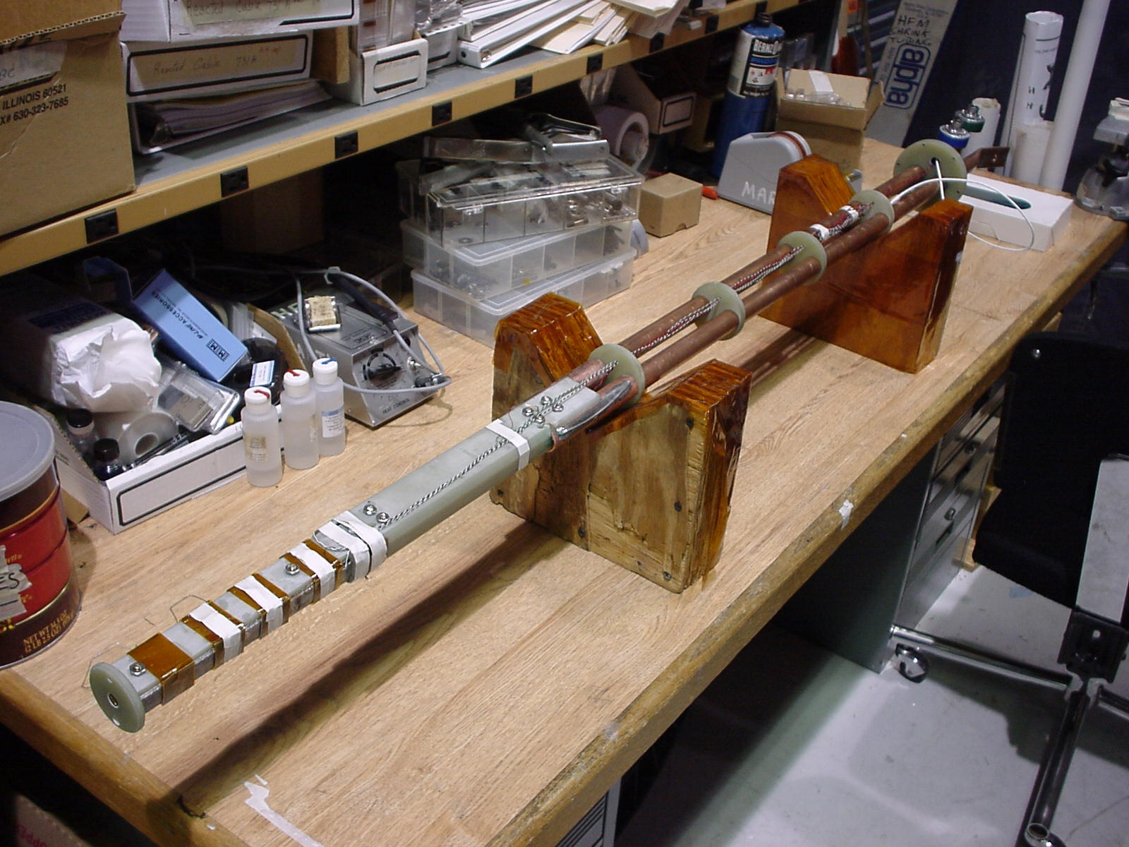

Figure 1 : Superconducting current transformer

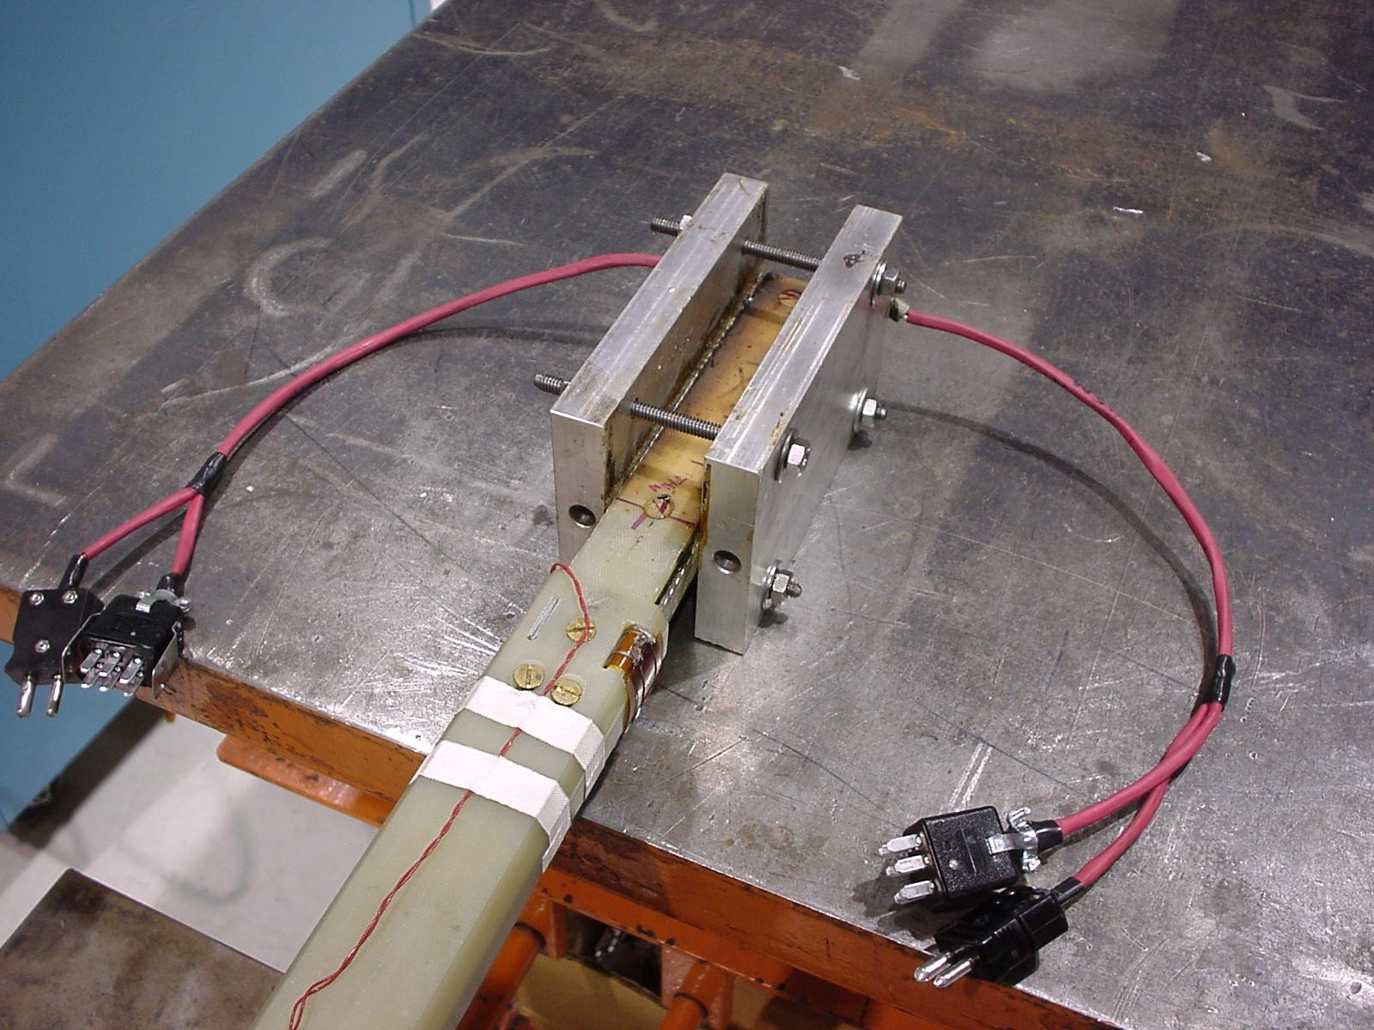

Figure 2: Splicing fixture used to apply pressure on the Nb₃Sn/NbTi cables

Splice Resistance Measurements

The current in the secondary winding is measured using the voltage from a Rogoswski-type pickup probe and subsequently integrating the voltage using an electronic integrator. The details on the Rogowski-coil and the measurement procedure can be found in [1]. The current ramp cycle in the primary winding was optimized such that the current in the secondary winding which comprised of the spliced Nb₃Sn cable reached the target value of 20 kA or above without quenches occurring during any part of the cycle. The optimized current cycle of the primary and the resulting secondary current cycle that was arrived upon as a result of several trials is shown in Figure 3. A spot heater was used to locally quench the secondary in order to accelerate the decay process before re-ramping the primary.

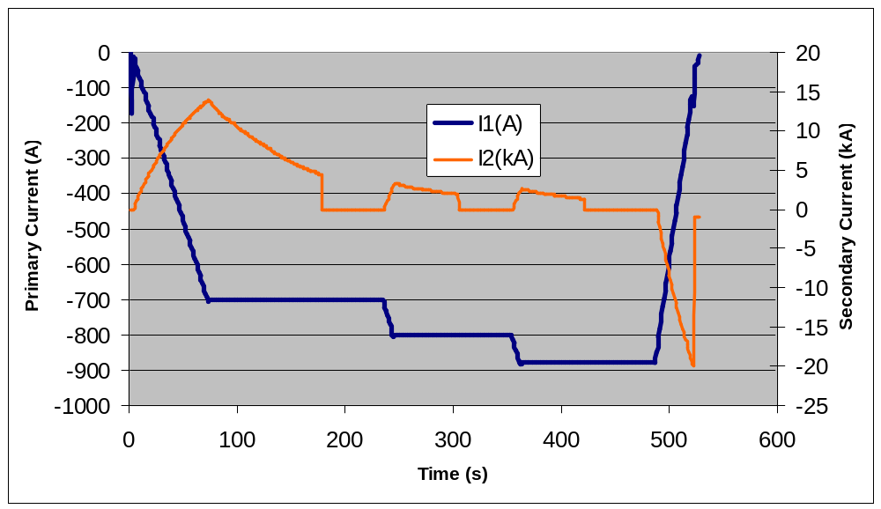

Figure 3: Primary and secondary current cycles

The splice resistance was measured using the decay part of the secondary current using the following equation to curve fit the experimental data.

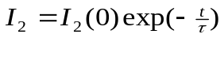 (1)
where I₂ is the secondary current, t is time and is the time constant given by

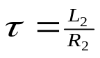 (2)
where, L₂ = 0.23 μH is the known value of inductance of the secondary winding and R₂ is the splice resistance. Since the splice resistance is known to be a function of current, the splice resistance was always measured starting from the secondary current of about 13 kA which corresponds to first decay of the secondary current. A typical curve fit of the secondary decay current that is used to extract the splice resistance is shown in Figure 4. The resistance measured using this approach is the combined resistance of both the splices in the secondary circuit. Thus the splice resistance per side will be one-half the measured value. All splice resistance values reported in this note are splice resistances of a single splice.

The maximum current that is achievable in the secondary is 22.5 kA primarily due to the quench behavior of the transformer [1] and limitation in the primary current source (1 kA maximum). An increase in the splice resistance will result in a lower value of secondary current. Thus there is an interplay between splice resistance and secondary current in the superconducting transformed device. The polarity switcher described in [1] which will be commissioned shortly will result in much higher secondary currents.

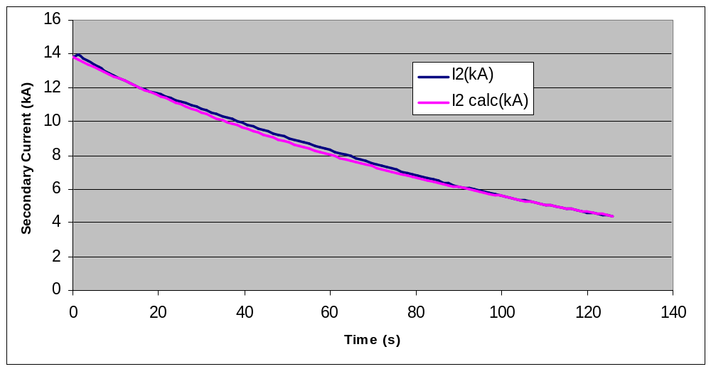
Figure 4: Typical curve fit of secondary current used to measure splice resistance

Magnetic Fields Comparisons

A comparison between the magnetic fields present in the splice area of the superconducting transformer and the splice area at the ends of the actual magnet was done in order to ensure that the two environments were identical. Details of the magnetic analysis are presented in [2]. In summary, the field present in the splice region of the superconducting transformer is about 1.6T as compared to 1T present in the magnet splice region indicating that the testing environment is more conservative in the transformer

- Experimental Setup

The objectives of this study were two-fold. The first was to quantify the effects of mechanical deformation of Nb₃Sn cable in both its spliced and unspliced configuration on critical current degradation and splice resistance. The second was to correlate splice resistance with applied pressure on the Nb₃Ti/Nb₃Sn cables. The details of the thought process leading to the experimental setup that closely approximates the conditions in the magnet will be described in this section

Mechanical Deformation

Following the quenches that took place in HFDA-02 and HFDA-03 in the splice region, the splice area has been re-designed such that cable motion is prohibited during all stages of the magnet assembly. The redesigned splice region is shown in Figure 5.

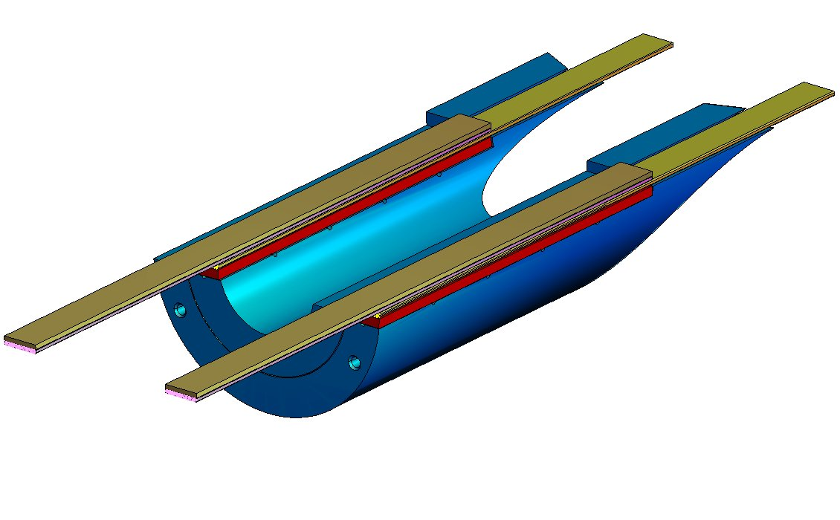

Figure

Figure 5: Splice region after modifications to the design to prevent cable displacements

The design modifications involved moving the splice area into the end saddles and supporting the Nb₃Sn cable by means of a ceramic plate (shown in red) that is glued to the end saddle (shown in blue). Although in principle the design should completely eliminate cable displacements one cannot preclude occurrences of “micro” motions of the Nb₃Sn cable. The Nb₃Sn cable is known to be extremely brittle and susceptible to damage even under very small strains. However, one must note that displacements by themselves are not detrimental to cable damage. This is true because rigid motions can occur without inducing any strain in the strands of the Nb₃Sn cable. This situation will arise if the cable is completely unclamped or the clamp is very far away from the point where the cable is subjected to displacements. Therefore from the point of view of minimizing risk of damaging the cable during the splicing operation in the magnet it is preferable to leave the Nb₃Sn cable that is coming out of the half coil completely unclamped. For the investigation conducted in this work with the transformer we decided to clamp the Nb₃Sn cable very close to the end of the splice since this represents the worst case condition in terms of risk to damaging the cable and would provide conservative limits on allowable displacements during magnet splicing. The maximum strains in the strands of the Nb₃Sn cable would occur in the vicinity of the clamp.

Strains can be induced in the strands of the Nb₃Sn cable as a result of displacements before or after splicing. We investigated both situations. In the first situation strains occur in the Nb₃Sn cable due to displacements solely in the Nb₃Sn cable whereas after splicing the strains induced in the Nb₃Sn cable occur due to displacements in the sandwich of Nb₃Sn/NbTi cable that are perfectly bonded together and behave as one composite cable. The two situations are illustrated in a top view of the cables in Figure 6.
Bottom surface rigidly supported by ceramic plate
Direction of cable displacement
Direction of cable displacements
Nb₃Sn cable
NbTi cable
Nb₃Sn cable
clamp
clamp
Bottom surface rigidly supported by ceramic plate

Figure 6: Displacements before and after splicing

In the second case shown in Figure 6 there is a considerable stiffness change going from the composite Nb₃Sn/NbTi cable to the Nb₃Sn cable.The effect of this stiffness reduction on displacements and hence strain on the Nb₃Sn cable will be described later in this report.
The Nb₃Sn samples were reacted in a specially made reaction fixture that consisted of clamps to prevent cable movement during reaction. The samples in the reaction fixture are shown in Figure 7. Rutherford type cable without a stainless steel core made by LBNL was used. For details of the cable parameters refer[3]. Three Nb₃Sn samples were made. The reaction cycle used to react the two of the splice samples was the same as that used in the production of the dipole models. A short reaction cycle was used to react the remaining third sample. The three samples will be numbered specimens 5, 6 and 7. The short cycle specimen #7 was rendered unusable because of tin burts in the specimen. After reaction the clamps in the reaction fixture were removed on specimens 5 and 6 and the Nb₃Sn cable with the remaining portion of the fixture that included a 1/8” ceramic plate that supports the cable in a manner shown in Figure 5 was mounted on the table top and rigidly held using clamps. The Nb₃Sn cable was clamped using a c-clamp and two stainless steel shims wrapped with kapton insulation. The clamp was located 10 mm beyond the end of the splice. Four dial indicators were introduced at 8mm, 24mm, 92mm and 160mm measured from the clamp. The dial indicators are designated as D1, D2, D3 and D4, respectively, for future reference in the report. The experimental setup is shown in Figure 8. Deflections were applied incrementally to the tip of the cable by introducing G10 shims. Note that the dial indicator D4 records the applied displacement at the tip of the cable.

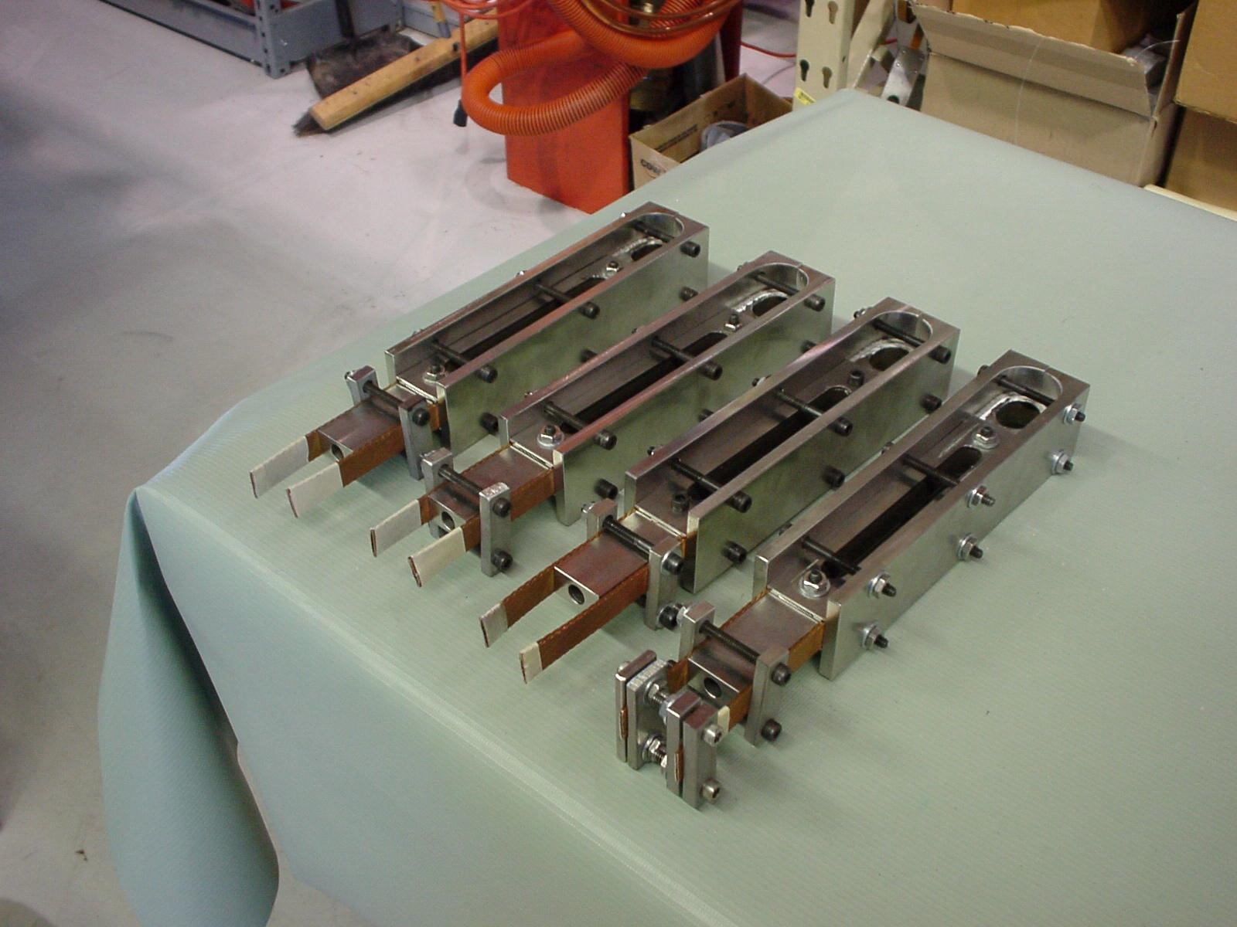

Figure 7: Samples of theNb₃Sn cable in the reaction fixture
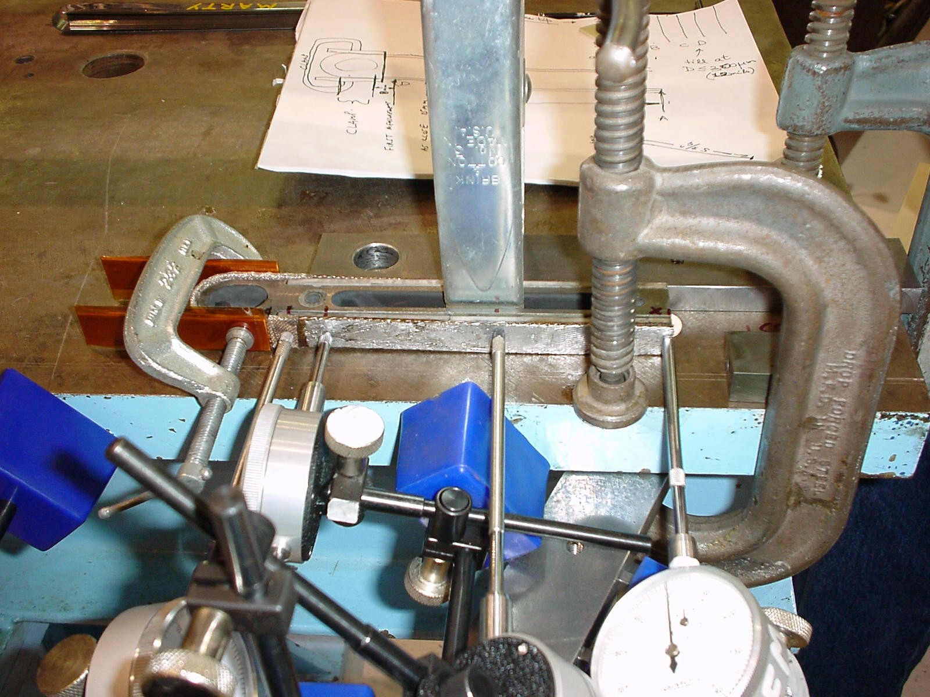
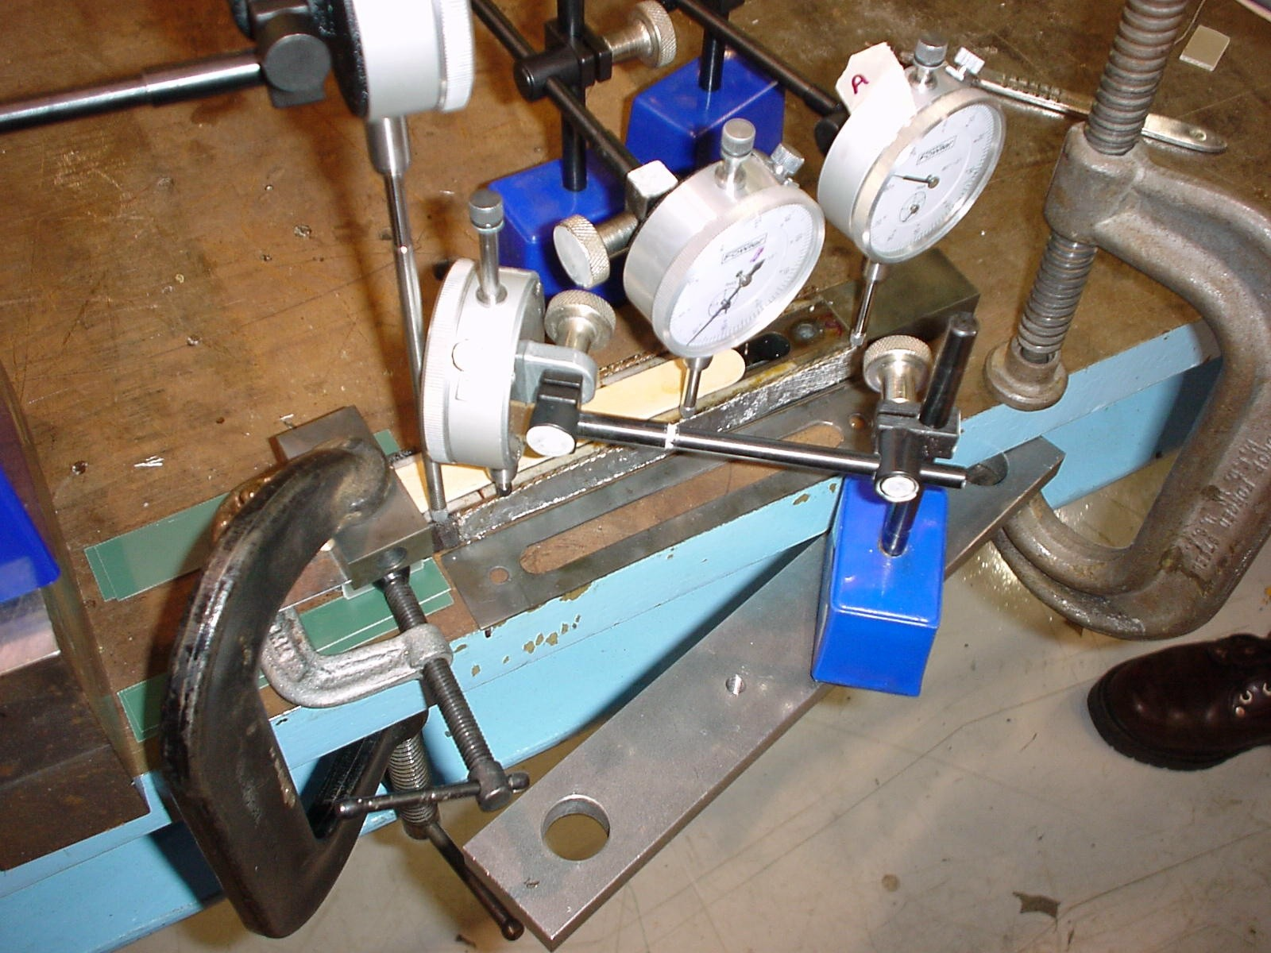

Figure 8: Experimental setup for applying and measuring deflections before splicing in the two modes

Deformations were applied in two modes. The first was in a plane parpendicular to the face of the cable (referred to as out-of-plane) and the second was in a plane parrallel to the face of the cable (referred to as in-plane). The total applied deflection in the first case was 17 mm and in the second case was 4 mm measured at the tip of the cable. Figure 9 and 10 show the the Nb₃Sn cable in the deformed condition in the two modes. The shims were then removed, the specimens were allowed to go back to their nominal state, inserted back into the transformer, spliced and finally tested by energizing the transformer.
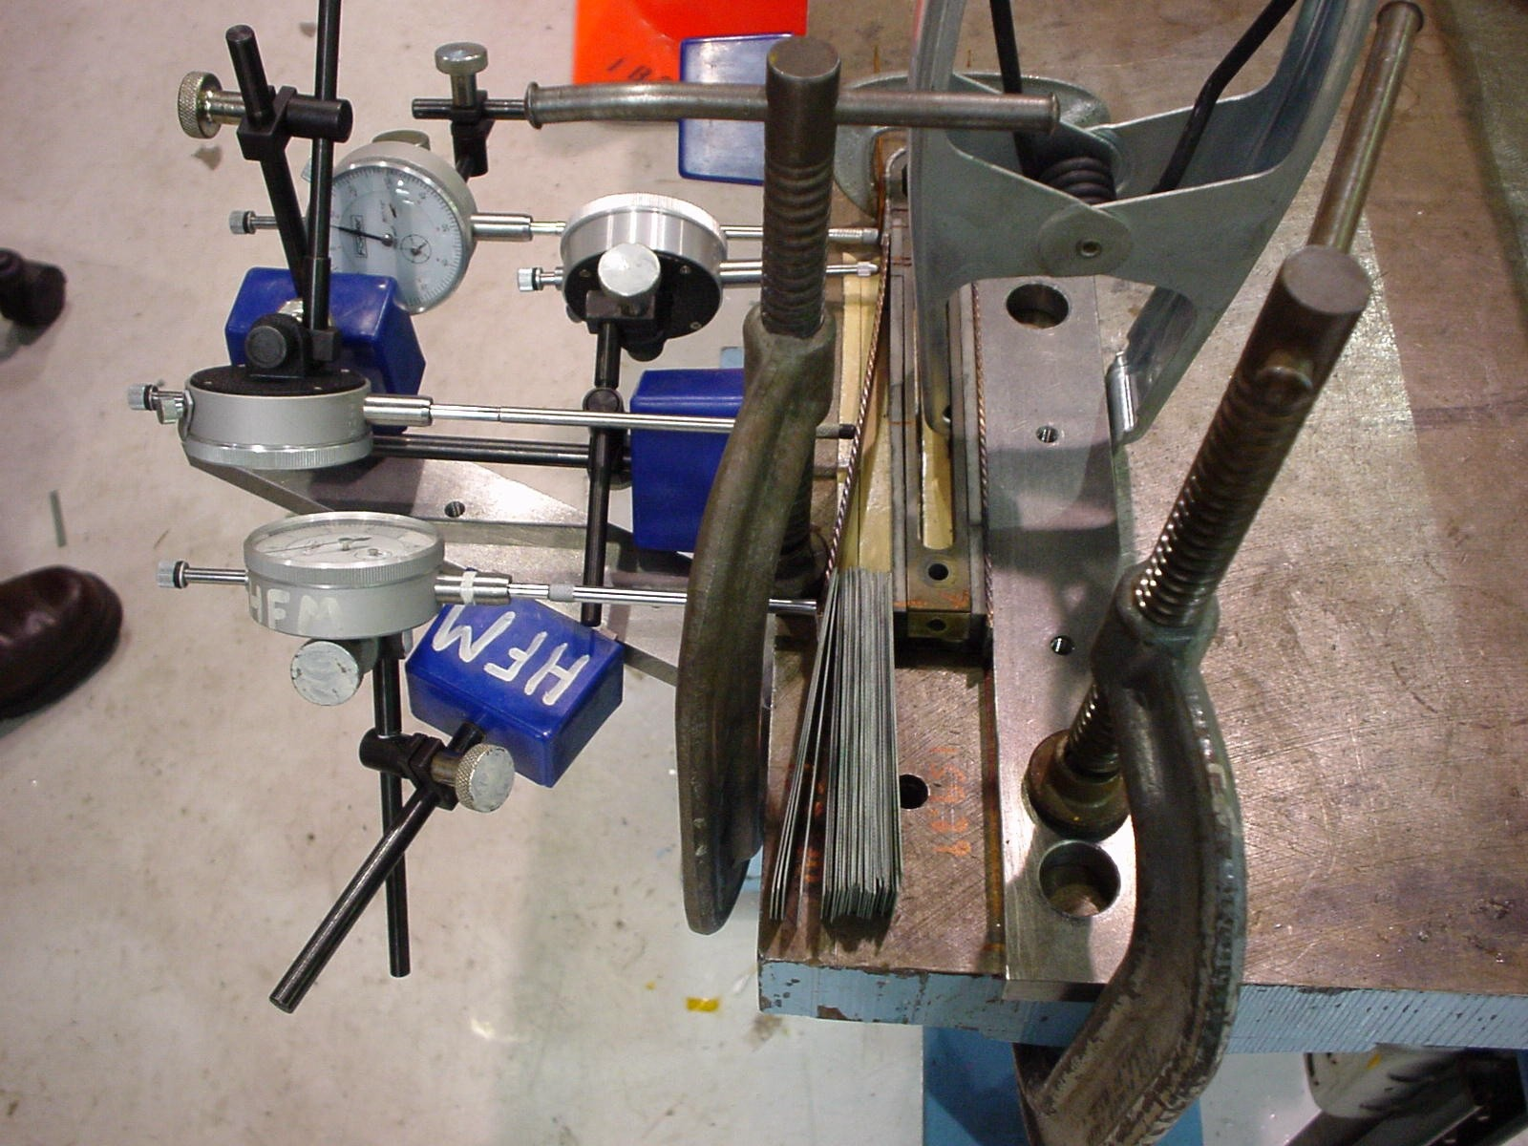
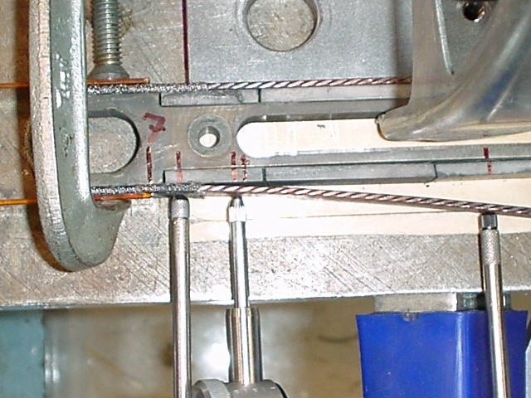

Figure 9 : Nb₃Sn cable (specimen #5) after deformation in the “out-of-plane”mode with a close-up view on the right
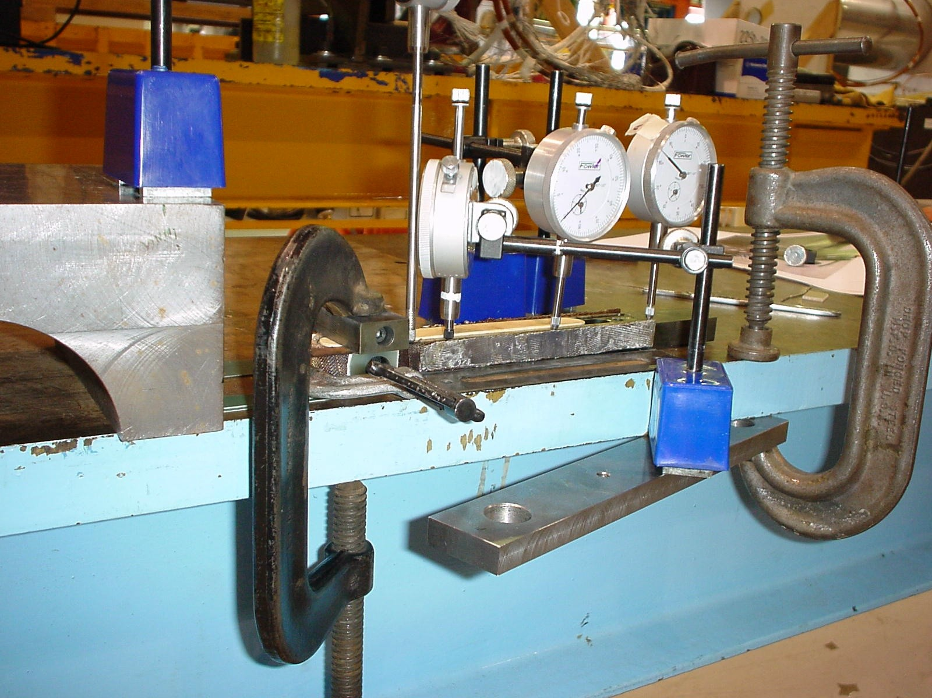

Figure 10 : Nb₃Sn cable (specime #6) after deformation in the “in-plane” mode

Deformations studies on the Nb₃Sn cable after splicing were performed on a different sample that was left over from the previous round of splice testing. This had identical cable parameters with the exception that there was a 25 μm stainless steel core.This sample is numbered as specimen 4. As with the unspliced Nb₃Sn samples, known deformations were applied by introducing stainless steel shims in an incremental manner to total deflections of 5mm, 10mm and 15mm. After each of these applied deflections, the specimen was unloaded and tested by exciting the transformer. Figure 11 shows the experimental setup used to apply and measure displacements of the spliced Nb₃Sn cable. This setup differs from the setup used for the unspliced cable in that there are two dial indicators (one on each side) located 5 mm from the clamp. A micrometer was used instead of a dial indicator to record tip displacements

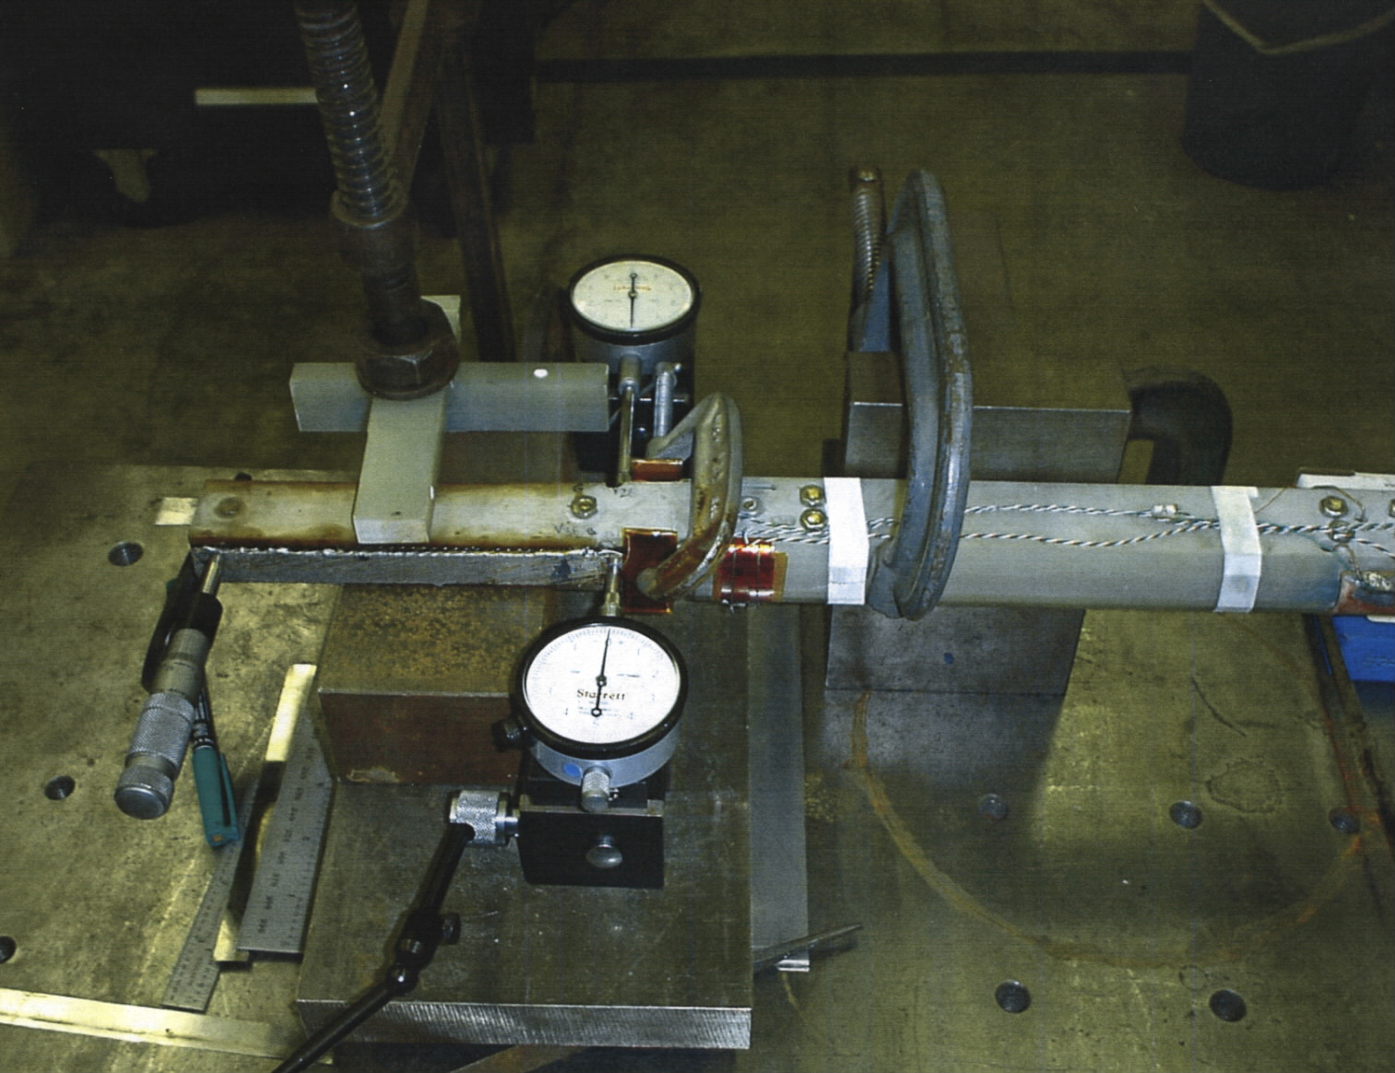

Figure 11 : Experimental setup to apply and measure displacements on spliced Nb₃Sn cable

Splice Resistance vs Pressure Correlation

The splicing fixture was used to apply pressure to the Nb₃Sn/NbTi cable. Figure 13 shows the setup of the splicing fixture. The fixture essentially consists of two aluminum plates with four case hardened stainless steel bolts that can be tightened to bring the plates together and apply pressure on the cable. The aluminum plates have a hole machined at the center that runs throughout their length to accommodate heater rods. The rods are heated until the solder melts along the entire length of the splice and the four bolts are sequentially tightened using a torque wrench. Figure 12 shows the splicing fixture with the bolts and the heater rods inserted. Torque values of 15 in-lbs, 30 in-lbs, 60 in-lbs, 150 in-lbs, 200 in-lbs and 250 in-lbs were applied on the four bolts of splicing fixture. During this entire process, water is circulated through cooling tubes to ensure that the components of the transformer such as the Rogowski coil that are located away from the splice area do not get excessively heated. After applying each of these torque values, the splice specimen is cooled down, the stainless steel wires are wrapped around the cables, the G10 clamps are put back and the specimen is tested by exciting the transformer.

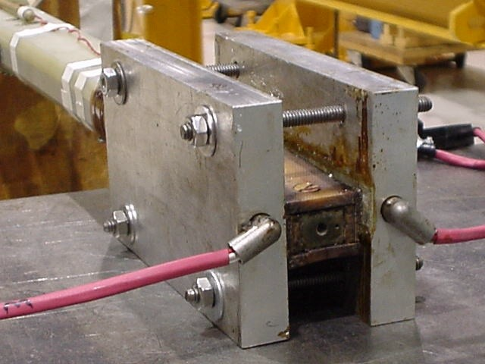

Figure 12 : Splicing fixture with bolt locations and heater rods

The torque wrench measures the applied torque on the bolts on the splicing fixture. From a practical standpoint it would be necessary to quantify the real pressure on the cable for a given torque on the bolts. Analytical expressions are available that relate torque to bolt loads but these expressions have a large amount of uncertainty built into them. One such expression that relates bolt load and applied torque is given by

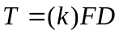 (3)
where, F is the bolt load, D is the nominal bolt diameter (=0.25” for bolts in the transformer splicing fixture) and k is a friction factor. A major portion of the torque that is applied is used to overcome friction between any pair of articulating surfaces in the joint and only the remaining is used to develop useful tension in the bolt. Lower values of k imply that the surfaces in the joint are well lubricated. In practice it is very hard to estimate the value of k and this is the cause for the uncertainty in being able to accurately estimate bolt load using equation 3. Values of k ranging from 0.1 to 0.2 are recommended in mechanical engineering handbooks [4]. A value of k=0.1 was used here. The accuracy of this estimate can be confirmed from the calibration discussed in the next paragraph. Equation (3) can be transformed to relate applied torque and stress, P (in MPa), on the cable. The resulting equation is given by

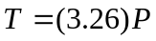 (4)

A calibration was performed by using a calibrated capacitance gage that measures the pressure or stress on the cable as a function of torque. The width of the gage is the same as the cable width = 0.6 inches. The curve shows a “flattening” trend around 200 in-lb torque. That is, there is no additional increase in stress on the cable with a corresponding increase in torque. However, the torque wrench was still recording increasing values of torque. This indicates that the bolts are still getting loaded but the load is not being transferred to the cable. This could be due to excessive deflection of the plates of the splicing fixture at very high values of torque. The reaction force at the center of the fixture at this value of torque is significantly high and can be estimated to be around 32,000 lbs from the calibration curve. The calibration curve of pressure versus applied torque is shown in Figure 13. The analytical results based on equation 4 are also presented on the same graph. The data point at 200 in-lbs pressure has been removed and a linear curve fit of the remaining three data points of 50 in-lbs, 100 in-lbs and 150 in-lbs has been used to estimate stresses at 200 in-lb and 250 in-lb of torque.

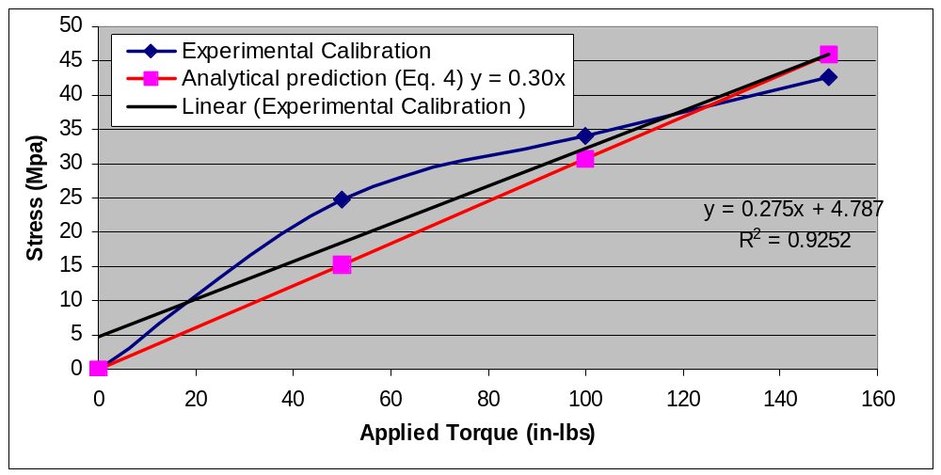
Figure 13 : Stress versus applied torque calibration curve

The analytical expression with k=0.1 is in good agreement with the linear fit obtained from the experimental calibration data. The estimated value of k=0.1 can also be used to analytically predict the stress on the cable as a function of torque for the splicing fixture used to perform the splicing operation in the actual magnet. The resulting expression is (note: two bolts of nominal diameter 0.5” are used to apply pressure in the magnet splicing fixture)

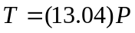 (5)

Equation (5) implies that to get the same pressure on the cable using the magnet splicing fixture we require four times the torque that is need in the transformer splicing fixture. It is possible that frictional losses may be lower in magnet splicing fixture reducing the value of k and thus decreasing the torque that is needed to achieve a desired stress on the cable. To confirm this a calibration has to be performed on the magnet splicing fixture similar to the one performed on the transformer splicing fixture.

Results and Discussion

The results obtained from the two pronged study using the experimental procedure and setup described in the previous section are discussed in this section. Before proceeding to the discussion on mechanical deformations and critical degradation it is important to note the history of operations (such as splicing/unsplicing, deformation and application of pressures) and the corresponding transformer test results for the three samples #5, #6 and #7. This data is presented in Table 1. It can be seen that each specimen has been through multiple cycles of splicing, unsplicing, deforming and re-splicing. Specimen 6, in particular went through more number of cycles of these operations including applying different amounts of pressure during the splicing operation. In spite of the repetitive cycles of splicing, unsplicing, deforming and re-splicing, the splice resistance and current variations were reasonably small and did not result in any permanent degradation of the Nb₃Sn strands. This provides sufficient confidence in the robustness of the splicing technology.

Specimen # | Operation Sequence | Splice Resistance  (nano-ohms) | Secondary Current I2(kA) | Comments
4 | virgin sample after reaction | 1 | 22.5 | Specimen from previous round of splice testing with 25μm core
4 | Deformed to 5mm out-of-plane after splicing | 1 | 22.5 | No quench, deformations applied to Nb3Sn/NbTi cable
4 | Deformed to 10mm out-of-plane after splicing | 1.1 | 19.8 | Quench at 19.8 kA,  deformations applied to Nb3Sn/NbTi cable
4 | Deformed to 15 mm out-of-plane after splicing | 1.2 | 19.3 | Quench at 19.3 kA,  deformations applied to Nb3Sn/NbTi cable
5 | Virgin sample after reaction | 1.1 | 22 | Specimen from current round of splice testing w/o core
5 | Specimen unspliced, deformed to 17 mm out-of-plane before splicing and re-spliced | 1.6 | 19.5 | No quench
6 | Virgin sample after reaction | 1.2 | 21.5 | Specimen from current round of testing w/o core
6 | Specimen unspliced and re-spliced without any deformations | 1.4 | 20.5 | No quench
6 | Specimen unspliced, deformed 4mm in-plane and re-spliced | 2.1 | 17.6 | No quench
6 | Splice area heated , solder allowed to melt and specimen re-spliced after applying 4 MPa pressure | 2.2 | 16.5 | No quench, heating allows strands to relax and attain nominal positions within the cable
6 | Splice area heated , solder allowed to melt and specimen re-spliced after applying 8 MPa | 1.7 | 18.6 | No quench, heating allows strands to relax and attain nominal positions
Specimen # | Operation Sequence | Splice Resistance  (nano-ohms) | Secondary Current I2(kA) | Comments
6 | Splice area heated , solder allowed to melt and specimen re-spliced after applying 16 MPa | 1.4 | 20.5 | No quench, heating allows strands to relax and attain nominal positions
6 | Splice area heated , solder allowed to melt and specimen re-spliced after applying 42 MPa | 1.2 | 21.5 | No quench, heating allows strands to relax and attain nominal positions
6 | Splice area heated , solder allowed to melt and specimen re-spliced after applying 69 MPa | 1.1 | 21.8 | No quench, heating allows strands to relax and attain nominal positions
Table 1: History of operations and test results on specimens 4, 5 and 6

Mechanical Deformations and Critical Current (I_{c}) degradation

Table 2 shows the results obtained from the deformation study performed on the unspliced Nb₃Sn cable for the in-plane and the out-of-plane modes. This table has been generated from the subset of operations performed in Table 1 (on specimens 5 and 6) that consisted of mechanically deforming the Nb₃Sn cable. The splice resistance and the current for these samples in their undeformed states are also shown. The splice resistances after deformation in the two modes increased from their nominal values with corresponding decrease in current values. No quenches were observed indicating no irreversible damage in the strands of the Nb₃Sn cable. This was confirmed by the following process. The tested specimen 6 after the 4mm in-plane deformation was heated in the splice area until the solder had completely melted, the bolts in the splicing fixture were completely loosened so that the strands in the two cables could relax and go back to their nominal positions. After that a very high torque of 150 in-lbs was applied and the two cables were spliced back and the specimen was re-tested. The splice resistance and critical currents went back to their nominal values of 1.2 nano-ohms 21.5 kA, respectively.

Displacement @ tip (mm)  Dial indicator D4 | Displacement @ clamp  Dial indicator D1 | Secondary Current  I2 (kA) | Splice Resistance  (nano-ohms)
Sp #5 undeformed | ---- | 22.0 | 1.1
Sp #6 undeformed | ---- | 21.5 | 1.2
17 mm(out-of-plane sp#5) | 250 μm | 19.5 | 1.6
4 mm(in-plane sp#6) | 200 μm | 17.6 | 2.1
Sp#6 after 4mm in-palne deformation and 42 MPa pressure | ---- | 21.5 | 1.2
Table 2: Results from deformation study on unspliced Nb₃Sn cable

There is a more pronounced increase in splice resistance and decrease in secondary current for the specimen deformed in the in-plane mode than the specimen deformed in the out-of-plane mode. One possible explanation for the increase in resistance is that the strands in the Nb₃Sn cable get disturbed from their nominal positions. This creates air gaps between the strands of the Nb₃Sn cable and the strands of the NbTi cable which were in contact before deformation. Moreover, the bigger resistance increase for the specimen deformed in the in-plane direction indicates that this mode of deformation is more severe from the standpoint of risk to damaging the strands of the Nb₃Sn cable.

The displacements recorded by the four dial indicators are plotted as a function of coordinate –X along the length of the cable as shown in Figure 14a and 14b for the two modes of deformation. X=0 corresponds to the location of the clamp. A remark was made earlier that both the specimens had gone through one cycle of splicing and unsplicing. The unspliced Nb₃Sn cable had a layer of tin solder coating from the previous splicing operation. Thus the cable was, in effect, behaving like a pre-tinned cable making it stiffer than a virgin cable. To compare the relative stiffness increase, the deflection measurements were repeated on specimen 7 which was defective from a conductor standpoint but structurally identical to a good reacted Nb₃Sn cable. These displacements are also plotted on the same graphs as Figure 14a.

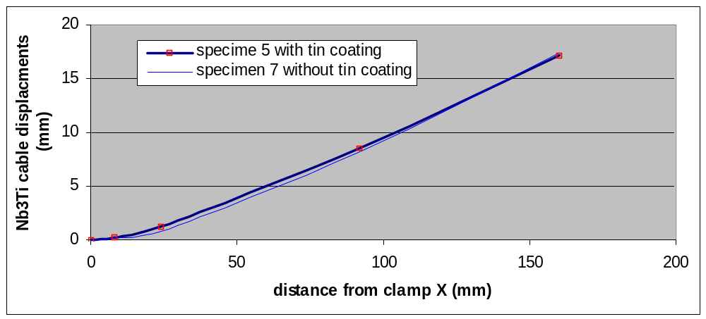Figure 14a : Out-of-plane cable displacements as a function of X coordinate

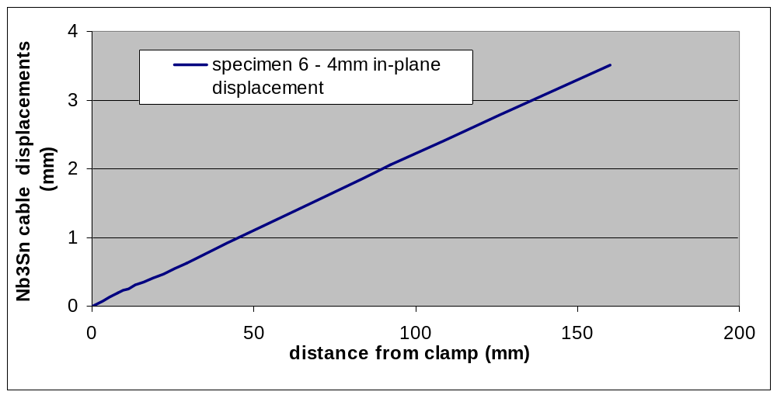
Figure 14b : In-plane cable displacements as a function of X coordinate

As can be observed the difference is very small. However, one observation can be made by comparing the two deflection curves. Specimen 5 with the tin coating is “stiff” in the splice area (X=10 to X=160) due to tin coating and “soft” beyond the splice (X=0 to X=10). Thus there is discontinuous change in stiffness going from the “stiff” material to the “soft” material. This discontinuity is relatively small for the case of a tin coated specimen but could be significant if the spliced cable composite of Nb₃Sn/NbTi is being deformed as shown in Figure 6. The stiffness change results in a bigger displacement and consequently a bigger strain in the “soft” region than in a situation where there is no stiffness change as that in a pre-tinned specimen. This can be seen in Figure 14a. The displacement near the clamp measured by dial indicator D1 is 250 μm for the tinned specimen (#5) as compared to 177 μm for the un-tinned specimen (#7). The experimental data can be curve fit with a cubic polynomial which is the displacement profile for a cantilever beam. The resulting polynomial is given by,

(6)

The above equation can be differentiated twice to yield curvature as a function of X

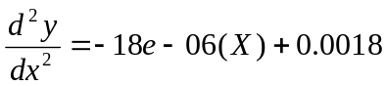 (7)

As can be seen from equation 7, the curvature (and hence strain) is a maximum at X=0 or at the clamp. This argument leads to the next equation that relates strain in the cable to curvature.

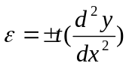 (8)

where t is half thickness of the cable = 0.91 mm. From equations 7 and 8 the strain at X=0 can be calculated to be ±0.001638 or a magnitude of 0.16%. The calculation of strain in the individual strands and filaments is more complicated due to the transpositional pitch in the strands. The strains in the cable will have to be transformed using a tensor transformation. As a first order approximation, for small pitch angles, the strains in the strands can be assumed to be the same as strains in the cable of about
0.16 %.

The deflection behavior for the in-plane direction is almost linear. That is, there is very little straining in the specimen except possibly at the clamp where there could be a steep change in slope and hence large curvatures and large strains. It was difficult to quantify this effect with the available resolution of the measurements.

Table 2 summarizes the results obtained from the deformation study on the spliced composite Nb₃Sn/NbTi cable (specimen #4).

Displacement @ tip (mm)  Micrometer | Displacement @ 5mm from clamp | Secondary Current  I2 (kA) | Splice Resistance  (nano-ohms)
Undeformed | ---- | 22.5 | 1.0
5 | 75 μm | 22.5 | 1.0
10 | 175 μm | 19.8 (quench) | 1.1
15 | 300 μm | 19.8 (quench) | 1.2
Table 3: Results from deformation study on spliced Nb₃Sn sample

The splice resistance increased marginally with a corresponding drop in current when the deflection was increased from 5mm to 10mm and from 10mm to 15mm. The resistance increase is much smaller compared to the increase that was seen in an unspliced Nb₃Sn cable. This can be explained by the fact that once the cables are spliced the strands are held in position by the solder material and do not have the same freedom to move around when deformed. It was not completely clear if quenches were observed at tip displacements of 10mm and 15mm due to excessive strain and damage in the strands or due to a host of other possible reasons. However, it is unlikely that these quenches were due to mechanical degradation since the reduction in current would be much more dramatic in such as case. The displacements near the clamp are higher than the displacements that were seen in an un-spliced Nb₃Sn cable due to the stiffness discontinuity that was discussed earlier.

Splice Resistance and Pressure Correlation

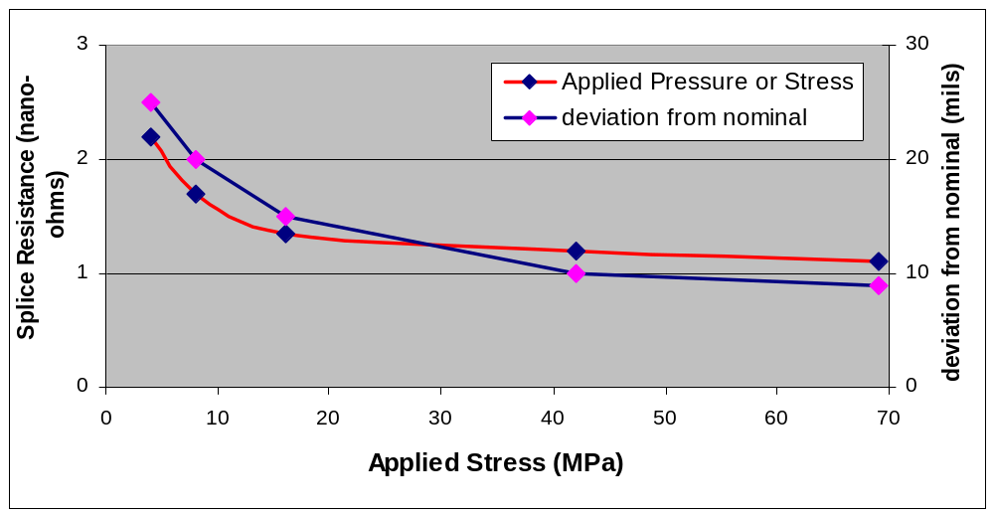
Figure 15 : Splice resistance/thickness deviation versus applied pressure (specimen # 6)

The results from the second part of the study correlating splice resistance and pressure/stress on the cable are presented in the graph shown in Figure 15. The applied values of torque are converted to stress on the cable using the calibration curve shown in Figure 13. The deviation from nominal thickness is also shown on the same graph. The splice resistance curve shows a plateau after 15MPa pressure indicating that any additional increase in pressure will not result in reduction of splice resistance. The curve shows an asymptotic behavior with the splice resistance approaching 1 nano-ohm at very high pressures. The deviation from nominal thickness also shows a plateau but less pronounced indicating that as the applied pressure increases, the thickness of the composite Nb₃Sn/NbTi cable approaches the nominal value.

- Conclusions

  - The superconducting current transformer was used effectively to obtain quick feedback on the new splicing technology.
  - The results obtained after several cycles of operations outlined in Table 1 indicate that the splicing technology is robust
  - The measurements made after deforming the Nb₃Sn cable in both its unspliced and spliced configurations indicate that there is a substantial tolerance of the Nb₃Sn cable to mechanical deformations. This provides a “cushion” for allowable cable motions during the splicing operation in the magnet.
  - The splice resistance versus pressure correlation provides a guideline on the pressure that can be applied on the cables during actual magnet splicing to get a splice resistance that is close to nominal of 1 nano-ohm. This value of the pressure would also be dictated by other considerations such as minimizing risk of damaging ground insulation and strip heaters while performing splicing operation on the actual magnet.
  - The splice resistance versus pressure correlation also revealed that there is an optimal value of pressure beyond which no-additional improvements can be achieved in splice resistance and would only pose greater risk to damaging the conductor or other components in the magnet.
  - The transformer can be used as a fast turn-around test engine to perform other parametric studies in the future.

References

[1] N. Andreev, E. Barzi, S. Bhashyam, C. Boffo, D. R. Chichili, S. Yadav, I. Terechkine, A. Zlobin, “Superconducting Currrent Transformer for Testing Nb₃Sn Cable Splicing Technique” Technical Note, TD-02-014, FNAL, April 2002.
[2] V.V. Kashikin, “Peak Field in Superconducting Current Transformer” Technical Note, TD-02-015, FNAL, April 2002.
[3] D. R. Chichili, N. Andreev, E. Barzi, V. V. Kashikin, I. Terechkine, S. Yadav, R Yamada and A. Zlobin, “Nb₃Sn Cos(θ) Dipole Magnet, HFDA-03 Production Report” Technical Note, TD-01-064, FNAL, September 2001.
[4] E.A.Avallone and T. Baumeister III, “Mark’s Standard Handbook for Mechanical Engineers” Tenth Edition, McGraw-Hill Publications.

