POLAR Spacecraft Status As of: Tues, 03 June 03 16:00 EST
(changes from last week in bold border)
Subsystem/  Component | NOAA-11H  Standby PM  STIP data only | NOAA-12D  Standby AM  STIP data only | NOAA-14J  Standby AM  STIP data only | NOAA-15K  BACKUP AM  GAC data only | NOAA-16L  PRIMARY PM  GAC&LAC data | NOAA-17M  PRIMARY AM  GAC&LAC data
LAUNCHED | 09/23/88 | 05/14/91 | 12/30/94 | 05/13/98 | 09/21/00 | 6/24/02
CNTL OBP | OBP2 | OBP2 | OBP2  OBP1 inoperative | OBP2  since 4/24/03 | OBP2  Analog telem drifting | OBP2
BUS | A-BUS  XSU-1 | B-BUS  XSU-1 | B-BUS  XSU-2  XSU-1 inoperative | B-BUS  XSU-1 | B-BUS  XSU-1 | B-BUS  XSU-1
BUS VETO | NO | NO | NO | NO | NO | NO
ADACS | DEGRADED  (Y, Z- Gyros Failed) Reduced Gyro S/W | NOMINAL  RGmode=Monitor Normal mode | NOMINAL  Rgmode=Disabled  SS check Disabled when mode=YGC | OK  Rgmode=Monitor  Normal mode  Gyro-3 Off | NOMINAL  Rgmode=Disabled  Normal Mode  Gyro-3 investigation  Gyro channel-B investigation | NOMINAL  Rgmode=Disabled  Rwheel auto swap from X to S while in YGC mode on 6/1. Mode commanded back to normal 6/1, wheel commanded back to X on 6/2
RXO | PRI  BU random enables  ETCUP +70 mSecs | PRI  BU random enables  Update of +1250 ms plan for 6/6 | PRI  BU random enables ETCUP –7.3 Msec  Update of –150 ms planned for 6/10 | PRI  ETCUP -8 mSec  Update of +100 ms plan for 6/10 | PRI  ETCUP –5.1 mSec  Update of –100 ms planned for 6/10 | PRI  ETCUP -1 msec  Update of –100 ms planned for 6/10
CLOCK DIV | 2 | 2 | 2 | 2 | 2 | 2
MIRP | ON | ON | ON  External Sync.  Rephase Disable  Rephased Daily | ON  External Sync, Rephase Disable.  Rephased Daily | ON  External Sync,  Rephase Enabled | ON  Internal Synch  Rephase Enabled
TIP SIDE | 1 | 1 | 1 | 2  Since 4/24/03 | 1 | 1
DTRs | 1A, 2B, 3, 4A Safestate - 2B, | 1, 3, 4, 5B  Safestate- 1B | 1, 2B, 3A, 5 Safestate- 1B | 1, 2, 3, 4 Safestate 1B EOT | 1,2,3,4A  Safestate 3A  4B TOAR 418  (STIP only) | 1,2,3,4  Safestate=1B  DTR2-SSR  DTR5 TOAR 420
VTX | OFF | 1  since 4/20/03 | OFF  Since 8/14/02 | 1 | OFF  Inop since 11/15/00 | 2
BTX | 2 | 1 | 2 | 1 | 1 | 2
STX | 3 – TIP  1,2 - Playback | 1 – HRPT;  2,3 - Playback | 3 – HRPT  2, 1 – Playback | 1, 2, 3 - degraded;  2 Omni–HRPT; 4- Playback | 1 – HRPT;  2– Playback;  4 – Playback  3 --Degraded | 3 – HRPT 1&2 Playback  4 – TIP  STX 3 TOAR 424  STX 4 TOAR 423
POWER  (Array offset, charge and eclipse states, sun angle) | Array Off -30°  Since 6/19/02  Eclipse all year  Sun angle 79  Steady Trend  Battery 1& 2 Charge Rate to MRC 5/30 for 5/31 eclipse. Back to LRC 6/3  Batt3= LRC  VT1,2=6/8  VT3 = 8/11  Charge state safe  trip disabled | Array Off 0°  Eclipse Season  Peaks 22 Jun 03  Sun Angle at 37 Uptrend to 38 in mid-June  Battery Charges LOW RATE 10/22  V/T=4 | Array Off -55°  Since 4/29/02  Sun Angle at 35  Uptrend to 36  Batt Charge= LRC  V/T=8/11  Eclipse Season  Peaks 6/20  Shunt Degradation TOAR 425 | Array Off -45°  Since 1/25/01  Sun Angle at 35 Topped out, steady trend  Battery Charges LOW RATE 10/22  V/T=7/9  Eclipse Season  Peaks 6/15 | Array Off -40°  Since 7/16/02  Eclipse all year  Sun Angle 66  UpTrend to 68 on 6/15  Batt2A TOAR 403  Batts 1-3= LRC  V/T=4/8 | Array Off. –35  Since 7/1/02  Eclipse all year  Sun Angle at 70 Steady Trend  Batts 1-3= LRC  V/T=4/8  TOAR 416 on Batt2A temp
AVHRR | OFF  Failed Power Supply | ON  Nominal | ON  Scan Motor degraded 5/1/03 STATUS=RED | ON  Occasional Scan motor surges. Last  incident, 3/30/02 | ON  Nominal (3B)  3A-B switch disabled | ON  Nominal (3A&B)  3A-B switch enabled
AMSU-A1 |  |  |  | ON  Ch14 inoperative  Ch11 inoperative | ON  TOAR 415 on primary PLLO chans 9-14 bias shift.  TOAR 417 on Backup PLLO  Status=Yellow | ON  TOAR 413 Chan-3 popcorn noise  TOAR 414 on PLLO chans 9-14 bias shift.  TOAR 421 on Channel-7 elevated NEDT’s noise
AMSU-A2 |  |  |  | ON | ON  Space Position-2 | ON
AMSU-B |  |  |  | ON  Bias in All Channels. Motor current surge 5/20 | ON  Space Position-3 | ON
HIRS | OFF  Filter Wheel Anomaly | INOP  Filter Wheel turned OFF 10/17. Electronics On | ON  Operational | ON  Operational  FW in Hi power,  FW Heaters OFF  Filter Motor current surges. Last incident  31 May 03 | ON  Nominal | ON  1 Pixel cross track misalignment .
MSU | OFF  Antenna Failed | INOP  Scan Motor turned OFF 3/12/03  Electronics ON. | ON  Scan motor and antenna problems
SSU | ON |  | ON
DCS | ON | ON | ON | ON | ON  Nominal | ON  Nominal
SARR | ON  Low signal |  | ON | ON-A  All AGC Mode  Intermittent failures for 243MHz A&B | ON-A  All AGC Mode  (B-side Receiver in FG mode)  243 MhZ INOPERATIVE. | ON-A  Nominal  All AGC Mode
SARP | ON  Nominal |  | OFF  Failed Power Supply | ON  Nominal  RCVR B/W = 2 | ON  Nominal  RCVR B/W = 2 | ON  Nominal
SEM |  | ON  Elec-CH-HVPS=4  Prot-CH-HVPS=0 | ON  Elec-CH-HVPS=0  Prot-CH-HVPS=0  1 of 4 Telescopes inoperative | ON  Nominal  E-CDEM-HVPS=2  Since 1/14/03  P-CDEM-HVPS=0 | ON  Nominal  E-CDEM-HVPS=4  P-CDEM-HVPS=4  since 4/15/03 | ON  Nominal  E-CDEM-HVPS=2  P-CDEM-HVPS=3  since 2/18/03
SBUV | INOP  (Grating motor turned OFF 5/29/03  Electronics and Heater remain ON |  | ON  Occasional  Reduced Grating Drive Motion |  | ON  AMSU EMI causing erratic Behavior from PMT cathod, in range 3 No corrective action possible | ON  Nominal  Anode Mode
SADPOS |  |  |  | N/A | ON  ENABLED  MFactor =50%  Disabled 5/31 01:46 to 06:30Z then Re-enabled for solar eclipse | ON  ENABLED  Disabled 5/31 01:46 to 06:30Z then Re-enabled for solar eclipse
 | N11 | N12 | N14 | N15 | N16 | N17

COMMENTS/CHANGES:
NOAA-11 With end-of-life testing officially completed, the SBUV grating motor was powered off (electronics and heaters remain
on) at 19:55Z on 5/29/03. It is not expected to be re-activated. Currently, reducing the number of N11 supports to
1 per day is under consideration by NOAA management with no decision yet forthcoming.

In response to EMOSS predictions of possibly lower than healthy voltage outputs during the 31 May solar eclipse l, EMOSS engineers increased the Battery 1 and 2 charge rates on N11 to Medium (from low). Battery 3 remained at low rate because it is considered less healthy than 1 or 2. This operation was performed for precautionary purposes on 30 May at 21:20Z and both batteries were commanded back to low rate charge on 2 Jun at 15:15Z. The spacecraft experienced no unanticipated problems during the two eclipse events to which it was subjected.

NOAA-12. EMOSS engineer Jim Sheperd has generated plans to perform a clock update on N12 by adding 1250 mSecs on a pass
scheduled for 6 Jun at 11:45Z.

N12 apparently went through the solar eclipse with no significant problems. However, there is no data on N12 for the time that it experienced the eclipse so detailed analysis is not possible

NOAA-14: AVHRR scan motor current improved over the past week although imagery remains corrupted (Illustration 1).

In order to keep the command clock within +/- 75 msecs (1 AVHRR pixel) EMOSS has generated and submitted plans to the scheduling office to perform an N14 clock update of –150 msecs on 10 Jun 03

Extrapolation analysis on N14 battery voltages have indicated that N14 will be able to make it through peak eclipse (20% darkness NLT 20 June) with ample margin to avoid an undervoltage trip (illustration 2). Analysis of N14 battery performance during the solar eclipse of 31 May shows nominal performance, in-line with predictions derived by the EMOSS model (illustrations 2 and 9a)

Starting 5 Jun, N14 SBUV standard operations will be pared back in order to reduce SOMS SBUV conflicts. This change will entail discontinuing the execution of SOMS command procedure SBUGSB and a reduction to once a week for running procedures SBGRTDV2, 14SPLD1, and SBLAMPCO. No user impact is expected because of adequate coverage by newer spacecraft that are also supporting the SBUV program.

NOAA-15: Extrapolation analysis on N15 battery voltages have indicated that N15 will be able to make it through peak eclipse
(20% darkness on 17 June) with ample margin to avoid an undervoltage trip (illustration 3). Analysis of N15 battery performance during the solar eclipse of 31 May shows nominal performance, in-line with predictions derived by the EMOSS model (illustrations 3 and 9a)

On 31 May at approximately 13:00Z, shortly after all solar eclipse events were completed, the N15 HIRS filter motor experienced a “typical surge” accompanied by a typical increase in temperature. These values have since returned close to nominal. Imagery analysis indicates but does not confirm that this event had a negative impact on data quality. (Illustration 4)

In order to keep the command clock within +/- 75 msecs (1 AVHRR pixel) EMOSS has generated and submitted plans to the scheduling office to perform an N15 clock update of +100 msecs on 10 Jun 03

NOAA-16: EMOSS engineers continue to monitor the status of N16 gyros whose performance characteristics changed recently (as
reported 20 May 03.). Currently gyro performance remains well within spec. However, EMOSS ADACS engineer Jim Sheperd has determined that the values on the A-channel are “cleaner” than those on the B-channel, and is suggesting a that a switch to the A channel be considered (Illustration 5.)

On 31 May at 01:00Z SADPOS software was disabled for the entire duration of the solar eclipse event which started at 01:30Z. EMOSS engineer Jon Woodward verified the status of this software by dumping the GDSADCTL (SAD Control Status) status word at the next available pass. At 07:00, the stored command table re-enabled SADPOS software which was again verified by Jon Woodward by dumping the SADPOS Status word on a successive pass. Analysis of N16 battery performance during the solar eclipse of 31 May shows nominal performance, in-line with predictions derived by the EMOSS model (illustrations 6 and 9b)

STX-3 performance testing will be implemented on 3 and 4 Jun out of stored commands. During these tests the satellite will rise with STX 1 and STX 3 transmitting HRPT. All data playbacks for these revs will be taken on STX2. Wallops will configure the backup 13m antenna to feed STX 1 and STX 3 data to the PAS system which will record both channels for engineering analysis. PAS is to be configured to the backup system only and the tests should not interfere with operational activities. This test is being conducted to determine the possibility of RF spectrum monitoring equipment offsets at the Wallops CDA and to help determine the actual capability of the anomalous STX-3 transmitter on N16.

In order to keep the command clock within +/- 75 msecs (1 AVHRR pixel) EMOSS has generated and submitted plans to the scheduling office to perform an N16 clock update of -100 msecs on 10 Jun 03
NOAA-17: In order to keep the command clock within +/- 75 msecs (1 AVHRR pixel) EMOSS has generated and submitted plans
to the scheduling office to perform an N17 clock update of -100 msecs on 10 Jun 03

On 31 May at 01:00Z SADPOS software was disabled for the entire duration of the solar eclipse event which started at
01:30Z. EMOSS engineer Jon Woodward verified the status of this software by dumping the GDSADCTL (SAD Control Status) status word at the next available pass. At 07:00, the stored command table re-enabled SADPOS software which was again verified by Jon Woodward by dumping the SADPOS Status word on a successive pass. Analysis of N17 battery performance during the solar eclipse of 31 May shows nominal performance, in-line with predictions derived by the EMOSS model (illustrations 7 and 9b)

Another precautionary measure to prepare N17 for the solar eclipse event was the EMOSS recommendation to place
the attitude control mode into YGC. This was recommended because the EMOSS eclipse model predicted (accurately) that a yaw update would occur while the spacecraft was being eclipsed. In this eventuality, the spacecraft would likely autonomously switch to YGC mode and it was determined that it was better to manually command the spacecraft to YGC rather than have flight software take control. The switch to YGC was implemented nominally on 30 May at 14:45Z. While planning the switch, EMOSS engineers had considered the risks and benefits of clearing the FORCE YGC MODE flag which occurs when YGC mode is manually commanded. Clearing this flag would have prevented the software from performing a passive wheel test and possibly switching to the Skew reaction wheel (as occurred on 9 Oct 01 with N16). However, clearing the flag also disables the backup potential of the Skew wheel and, if an actual wheel failure occurs, prevents the skew wheel from being autonomously activated to replace the failed wheel which could result in a far more severe anomaly. By not clearing the flag, engineers were cognizant that the likelihood of passive wheel tests and inadvertent wheel swaps were significant. This is because while in YGC mode, yaw error rates are significantly higher than when in normal attitude control mode, very often greater than the 1 degree threshold (for 20 seconds) that causes the test to initiate. Since either choice had negative possible outcomes, the team decided on the least risky course and decided to keep the FORCE YGC MODE flag uncleared.

On 1 Jun at 15:03:58, the yaw error value exceeded the threshold for initiating a passive wheel test. At the time the test
was running, a sun moon incursion occurred in quadrant 3 which caused the reaction wheels to rapidly spin up 400 RPM in a short period of time in order to compensate. The passive wheel test measures delta wheel speeds over a 13 second duration. If the delta value is between 5 and 160 RPM the test passes. Less than 5 RPM during this interval and the software assumes the wheel is stuck. Greater than 160 RPM and the software assumes the wheel is “running away”. In either of those cases, the test fails. If the test fails, it is re-intiated. If the test fails 4 times in a succession, the software turns off the offending wheel and turns on the Skew wheel. This is what happened to N17 during this passive wheel test. At 15:04:02Z, the flight software initiated the Skew wheel to take over yaw control and powered off the X wheel even though there was nothing actually wrong with it (illustration 8).

At 15:30, the first pass after the autonomous wheel switch, SOCC controllers noticed the swap had occurred and called engineers. Renee SmitherDearing, Jim Sheperd, Jon Woodward and Jeff Devine responded to the call and performed analysis on the situation. Once the situation was determined, it was decided to switch back into attitude normal mode a day earlier than had been originally planned. This switch and a command to clear the YGC Mode flag was implemented on 1 Jun at 20:30Z. This had the immediate effect of reducing the yaw errors to significantly below the 1 degree PWT threshold. On 2 Jun at 20:05Z, the X- wheel was turned back on, the skew wheel was turned off and N17 was back in its standard operational configuration.

The reason this situation occurred was because everything worked exactly as it was supposed to. Lessons learned to prevent future occurrences of this situation could include the following:
- Minimizing the time duration of time that FORCED YGC mode is sustained. Rather than leaving it in YGC all weekend, it could have been left in that mode for only the 6 hours encompassing the solar eclipse event for which it was originally initiated.
- Reduce the possibility of unnecessary passive wheel tests by “opening up the limit” on yaw errors values and/or the duration that the value is sustained while in YGC mode
- Increase the high delta value for failing a test or the number of test faiures required before a swap occurs.
- Software patch to disable passive test if a sun-moon intrusion flag is set.
- Developing yaw value filtering software to offset the “noisier” yaw values associated with YGC mode..

On Wednesday June 4 N-17 revs 4898 (0202z) and 4906 (1601z) have been scheduled to test STX 3 performance. On these revs the satellite will rise with STX 1 and STX 3 transmitting HRPT. All data playbacks for these revs will be taken on STX2. Wallops will configure the backup 13m antenna to feed STX 1 and STX 3 data to the PAS system which will record both channels for engineering analysis. PAS is to be configured to the backup system only, these tests should not interfere with operational activities. This test is identical to the one being performed on N16

MISC: Meetings supported by EMOSS personnel this week included the AMSU Channel-3 noise Tiger Team, the TOAR
Board, and a NOAA-N and N’ discussion for 1.33 a mbps waiver.

EMOSS developed a new STK bases solar eclipse model that allowed EMOSS to predict potential anomalies that might occur during the solar eclipse event. Post event analysis (illustrations 9a and 9b ) has shown this model to have been very accurate during the most recent solar eclipse thus validating the models utility for future events.
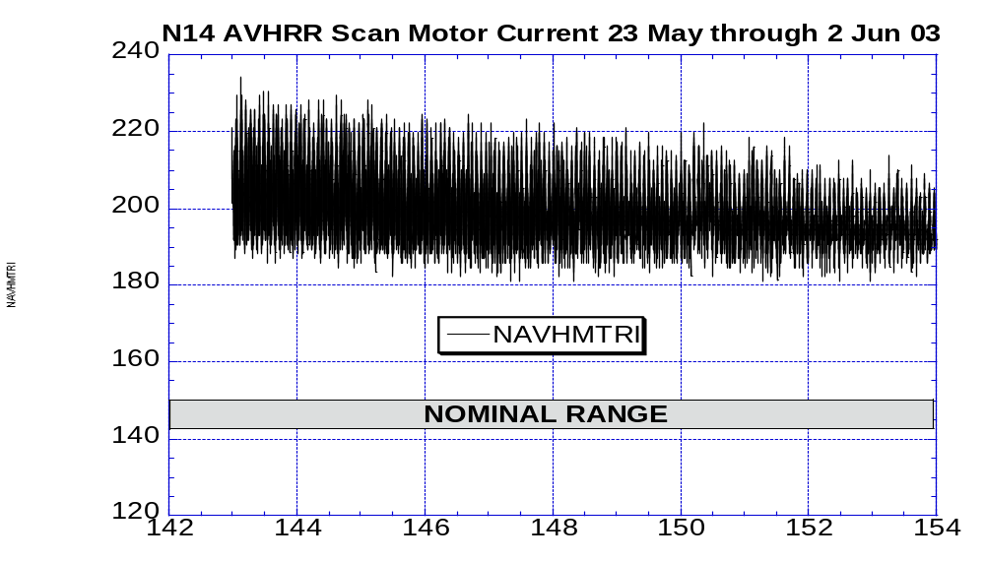

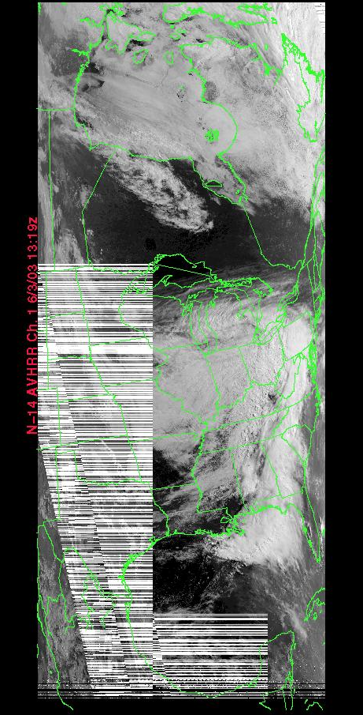
AVHRR Image taken 3 Jun 03 at 13:30Z

Illustration 1: N14 AVHRR health analysis
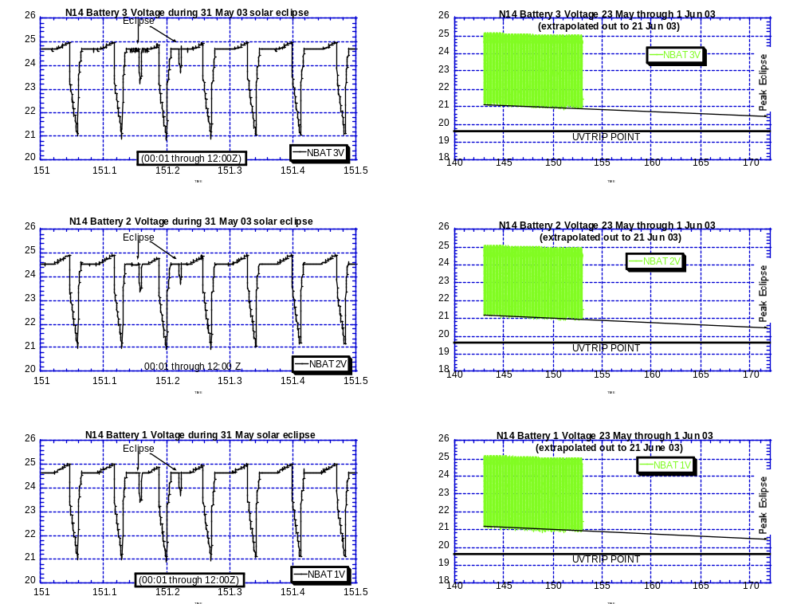

Illustration 2: N14 EPS performance during solar eclipse and eclipse season

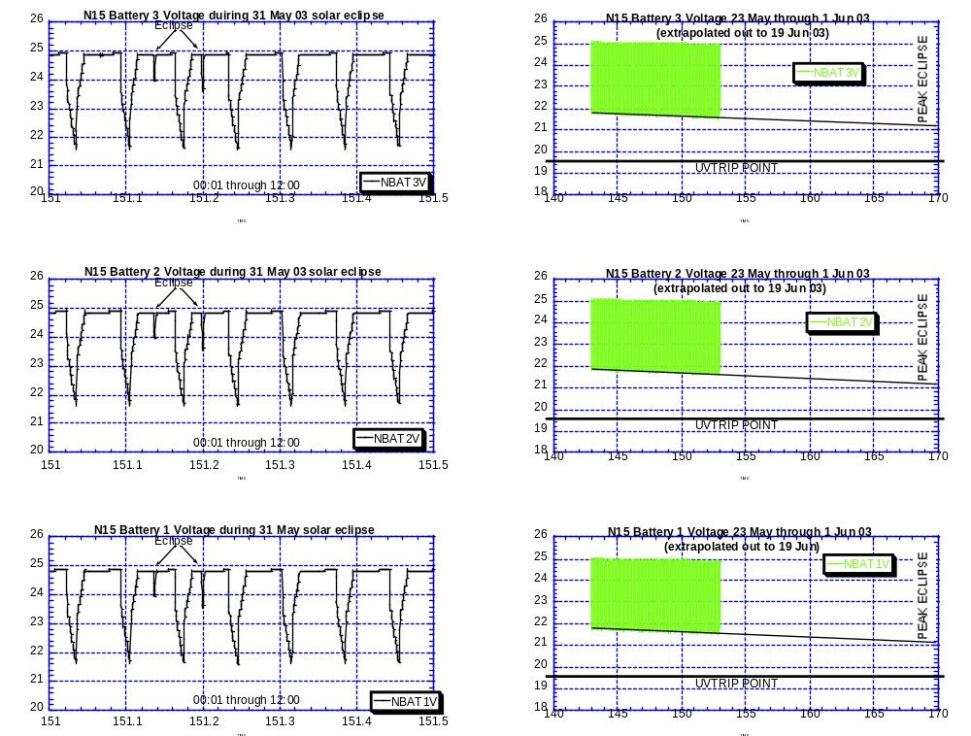

Illustration 3: N15 EPS performance during solar eclipse and eclipse season

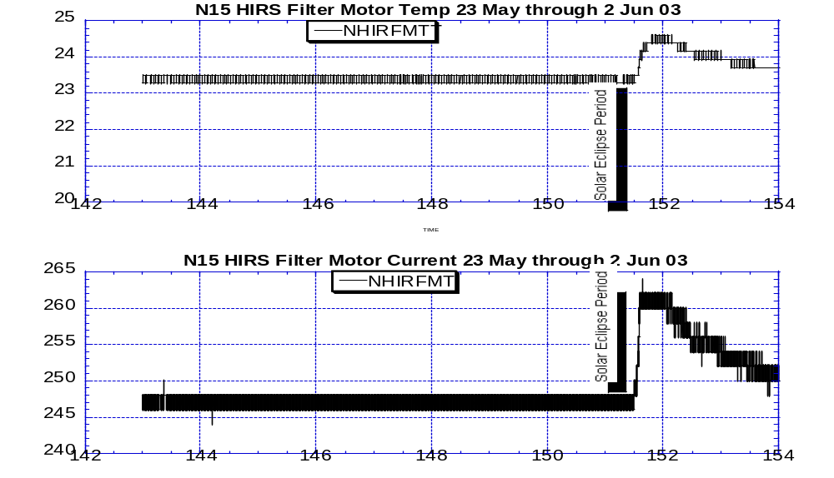
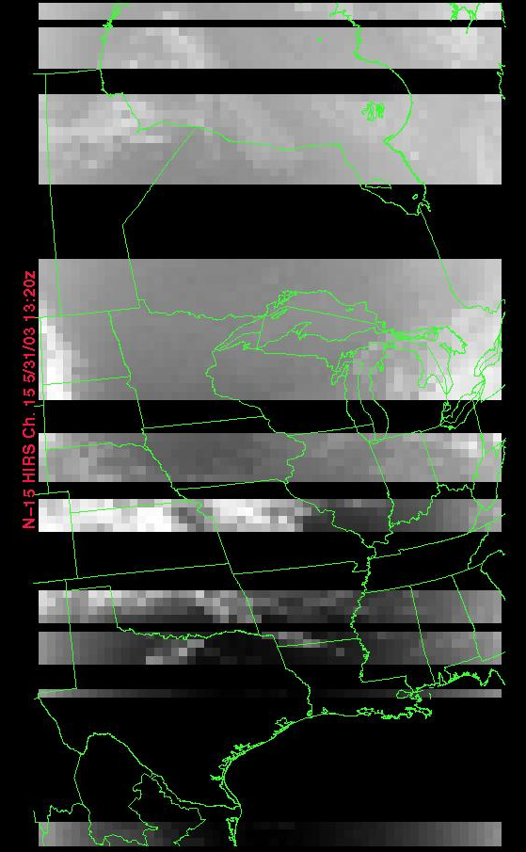
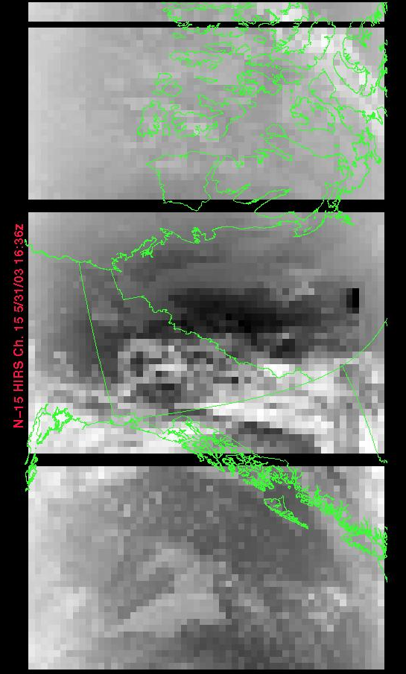
N15 HIRS 31 May 13:30Z N15 HIRS 31 May 16:40Z

Illustration 4. N15 Peak HIRS surge analog and imagery analysis for 31 May 03

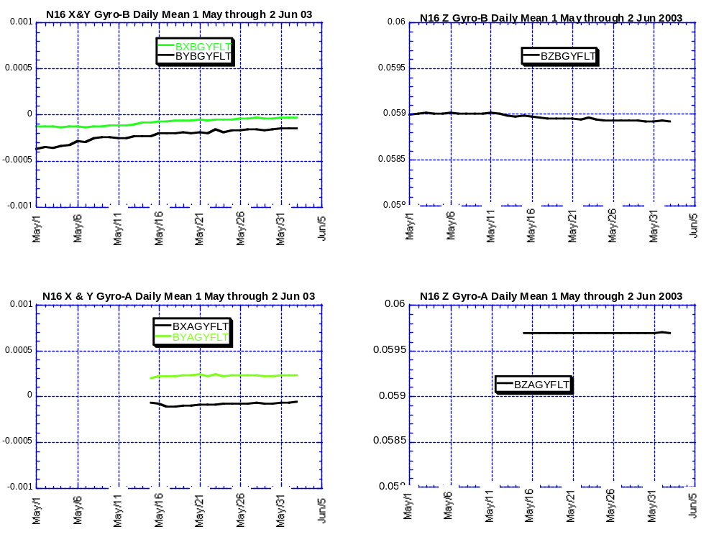

Illustration 5: N16 A vs B Gyro performance over the past month
(A-gyro data set incomplete)

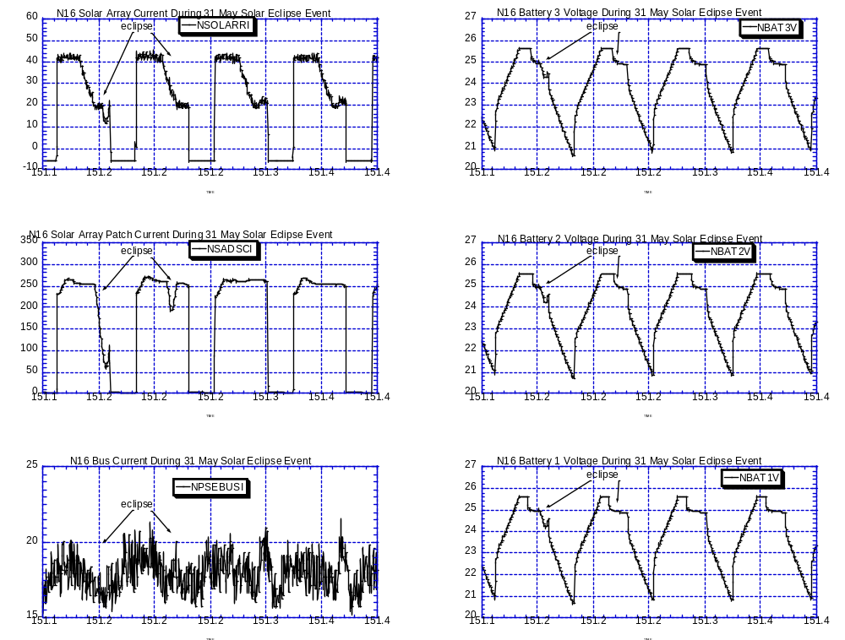

Illustration 6: N16 Solar Eclipse Event EPS analysis
31 May 03 (02:20 through 09:30Z)

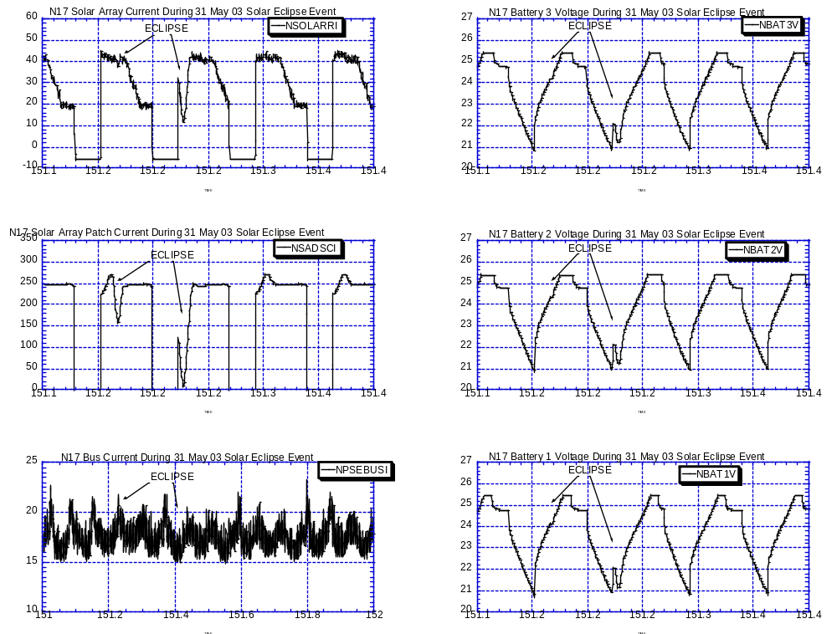

Illustration 7: N17 Solar Eclipse Event EPS analysis
31 May 03 (02:20 through 09:30Z)

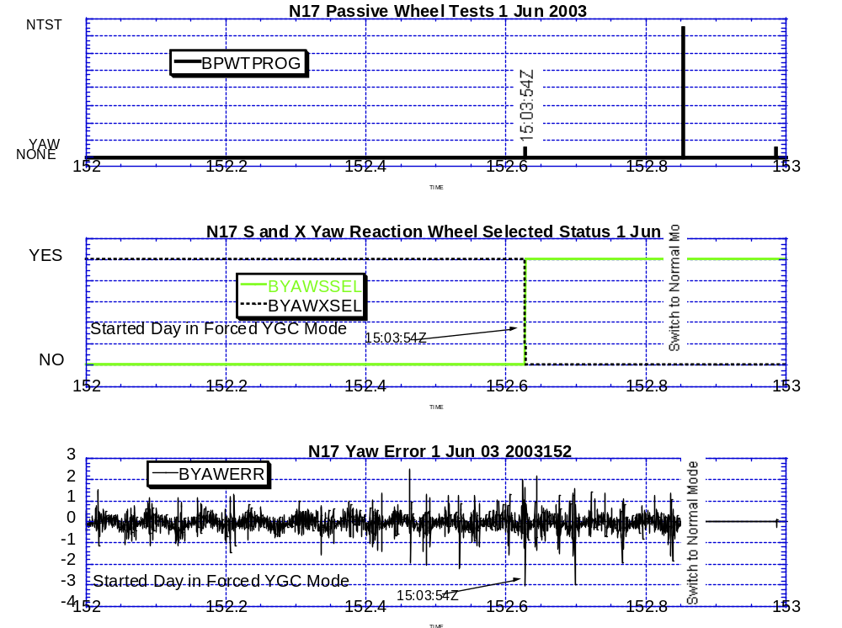

Illustration 8: N17 Autonomous Wheel Swap Analysis

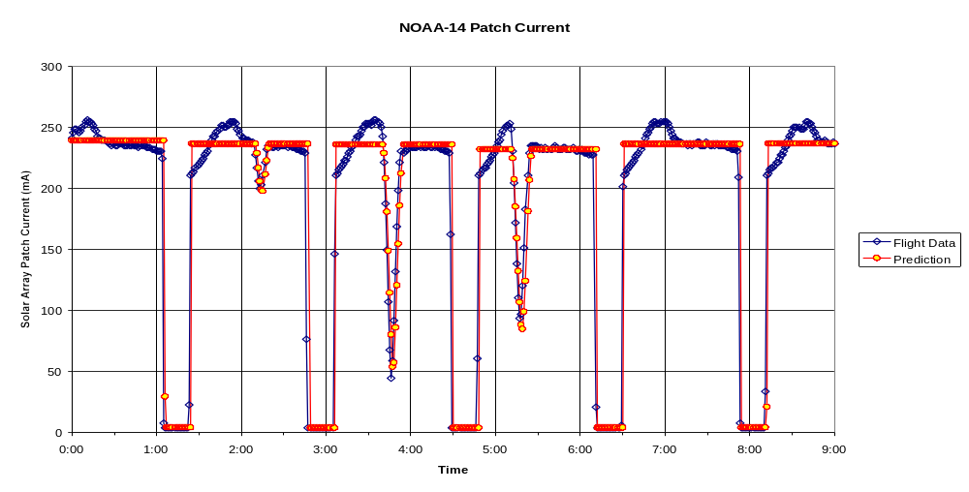
Illustration 9a: EMOSS eclipse model verification results
N14 Predicted (blue) vs Actual (red) Solar eclipse times

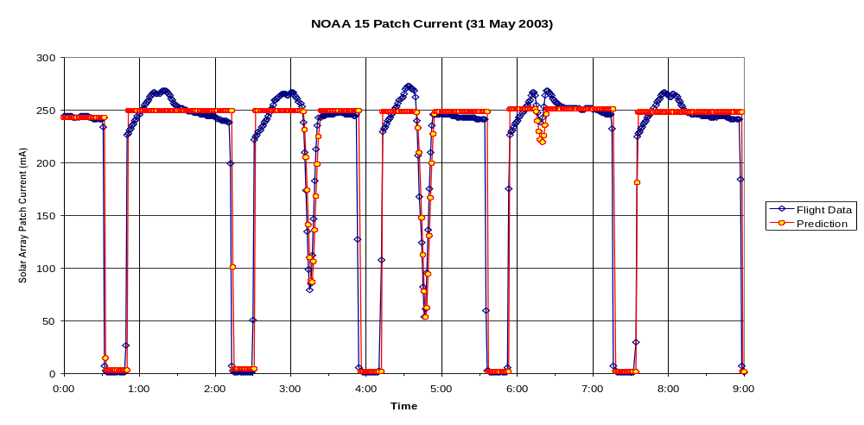

N15 Predicted (blue) vs Actual (red) Solar eclipse times
Illustration 9b: EMOSS eclipse model verification results

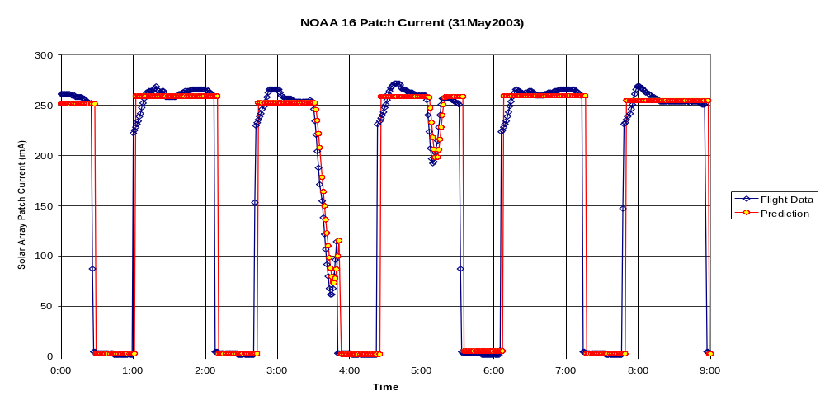
N16 Predicted (blue) vs Actual (red) Solar eclipse times
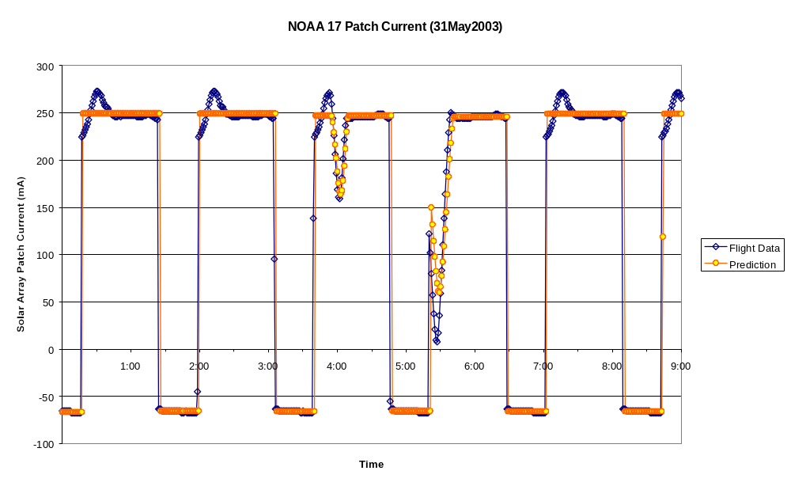
POLAR SPACECRAFT TIP CLOCK ERROR

NOAA-14: As of 04/23/03 the TIP clock is corrected daily by –-7.3 msec to compensate for drift.
NOAA-15: As of 04/23/03 the TIP clock is corrected daily by –-8 msec to compensate for drift.
NOAA-16: As of 04/23/03 the TIP clock is corrected daily by –5.1 msec to compensate for drift.
NOAA-17: As of 04/23/03 the TIP clock is corrected daily by -1 msec to compensate for drift.
NOAA-11: As of 09/03/02 the TIP clock is corrected daily by +70 msec to compensate for drift.

NOAA-17: The TIP clock was corrected by –75 msec on 3/27/03 (23:59Z) to eliminate the clock offset.

N12: Plans to ADD 1250 mSecs to spacecraft command clock on 6 June
N14: Plans to Subtract 150 msec from spacecraft command on 10 June.
N15: Plans to ADD 100 msec to spacecraft command clock on 10 June.
N16: Plans to Subtract 100 msec from spacecraft command clock on 10 June.
N17: Plans to Subtract 100 msec from spacecraft command clock on 10 June.
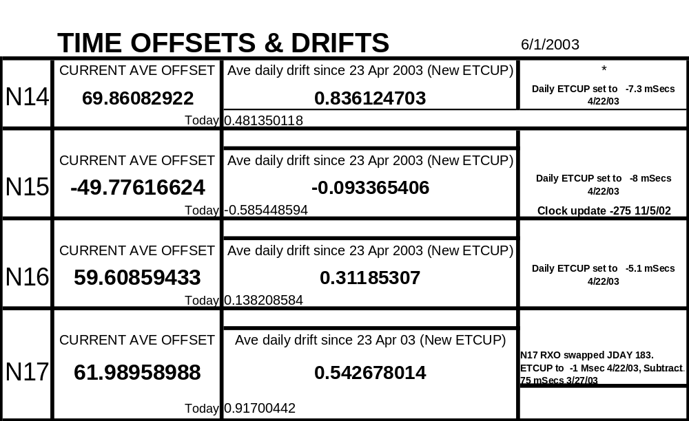

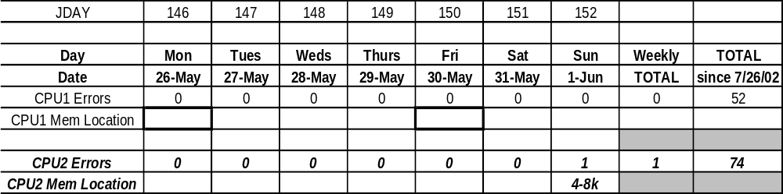
N17 CPU Single Event Upset (Error) Scrubs, Weekly Report

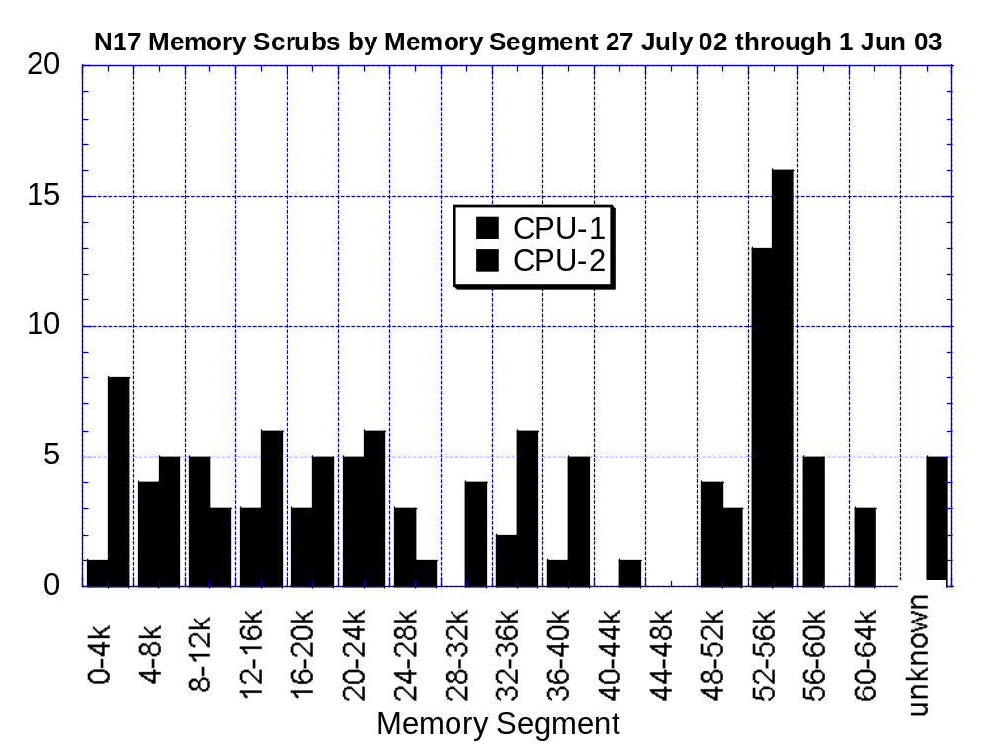

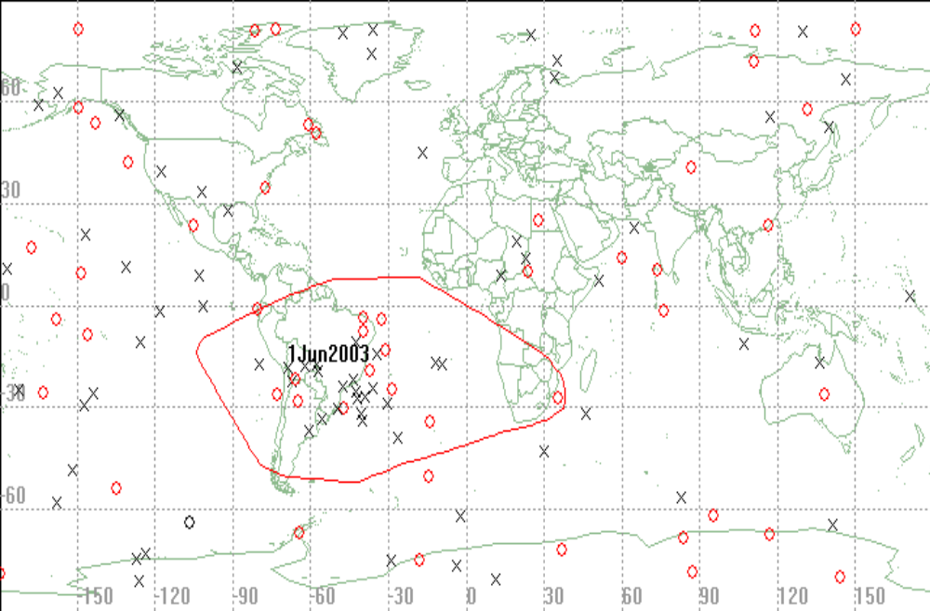
NOAA-17 Scrubber Hits by Geographic Occurrence from 19 2003 through 25 May 2003:

Red/Circle = CPU#1 Black/X = CPU#2

PACS DATA AVAILABILITY (%)
May 23, 2003 through May 29, 2003
JDAY 143-149

 |  |  | NOAA15 | NOAA14 | NOAA11 | NOAA16 | NOAA17
Friday | 05/23 | 143 | 99.9 (a) | 100.0 | 100.0 | 100.0 | 100.0
Saturday | 05/24 | 144 | 100.0 | 100.0 | 100 | 99.9(b) | 99.8 (c)
Sunday | 05/25 | 145 | 99.9 (d) | 100.0 | 100.0 | 100.0 | 99.9(e)
Monday | 05/26 | 146 | 100.0 | 100.0 | 100.0 | 99.9 (f) | 100.0
Tuesday | 05/27 | 147 | 100.0 | 100.0 | 100.0 | 100.0 | 99.9(g)
Wednesday | 05/28 | 148 | 100.0 | 100.0 | 100.0 | 100.0 | 99.9 (h)
Thursday | 05/29 | 149 | 99.3 (i) | 100.0 | 100.0 | 100.0 | 100.0

Comments:

- Rev 26111/W: G4B noisy; 98.8% recovered 3DL 11PE.
- Rev 13755/F: G2A noisy; 98.7% recovered.
- Rev 04742/W: G4B noisy; 99.0% recovered.
- Rev 26153/F: G3A noisy; 98.8% recovered.
- Rev 04766/F: G3B noisy; 98.7% recovered.
- Rev 13784/F: G3B noisy; 99.5% recovered 1DL.
- Rev 04786/F: G4A noisy; 99.9% recovered.
- Rev 04800/F: G2A noisy; 99.9% recovered.
- Rev 26203/W: G3B noisy; 99.0% recovered.

DTR Inf. (*):
NOAA-11 DTR 1B -Inoperative.
DTR 2A/B -Frequently noisy
DTR 4B -Frequently noisy
DTR 5A/B -Inoperative
NOAA-12 DTR 5A -Inoperative.
DTR 2B -Occasionally noisy and short
NOAA-14 DTR 4A/B -Inoperative.
DTR 3B -Unreliable playbacks, Removed from operations.
DTR 2A -Inoperative, DOY/200
NOAA-15 DTR 5A/B - Inoperative
NOAA-16 DTR 5A/B -Inoperative
DTR 3A -safe state change 1B
DTR 4B –Inoperative 1/12/03
NOAA-17 DTR 5A/B-Inoperative 2/16/03 Anomaly

Acronyms:
DL – Drop lock(s) PE - Parity Error(s) DQR - Data Quality Report
BE - Bit Error(s) DAR - Data Accountability Report MFR - Multi-Function Receiver

