First
U. S. Geological Survey
Karst Interest Group
Workshop
February 12-16, 2001
St. Petersburg, Florida

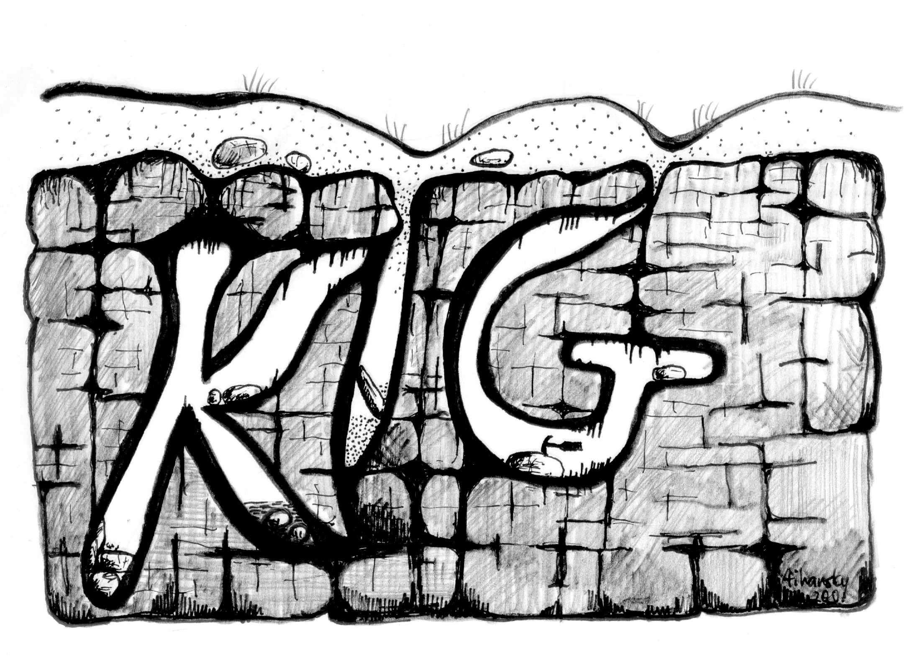

_______________________________________________

MONDAY, February 12
At USGS Center for Coastal Geology
600 4th St.
St. Petersburg Florida 33701
1:00 - 4:30pm Leaky Coastal Margins Working Group
4:30 - 5:30pm Registration for KIG Workshop
4:30 - 7:00pm Social (food/drink fun)

TUESDAY, February 13
At St. Petersburg Hilton Hotel
8:00-8:20 REGISTRATION
Moderator: Eve L. Kuniansky
8:20-8:40 Opening Remarks
Karst Ecosystems
8:40-9:00 Karst landscapes and the importance of three dimensional data in protection of cave and karst resources by Rick Olson (NPS)
9:00-9:20 The ecological role of the karst wetlands of southern Florida in relation to system restoration by William F. Loftus (USGS), Maria Cristina Bruno (NPS), Kevin J. Cunningham (USGS), Sue A. Perry (NPS), and Joel C. Trexler (Florida International University)
Natural Resource Development in Karst Areas
9:20-9:40 Water-resources reconnaissance of Íle de la Gonâve, Haiti by Joseph W. Troester (USGS) Michael D. Turvey (USEPA)
9:40-10:00 BREAK
Geologic Framework of Karst Systems
10:00-10:20 Geologic framework of karst features in western Buffalo National River, Northern Arkansas by Mark R. Hudson, David N. Mott (NPS) and Charles J. Bitting (NPS)
10:20-10:40 Geologic framework of the Ozarks of south-central Missouri—Contributions to a conceptual model of karst by Randall C. Orndorff (USGS), David J. Weary(USGS), and Stanka Sebela (Karst Research Institute, Slovenia)
10:40-11:00 The relation between structure and saltwater intrusion in the Floridan Aquifer System, northeastern Florida by Rick M. Spechler (USGS)
11:00-11:20 Hydrology, hazards, and geomorphic development of gypsum karst in the northern Black Hills, South Dakota and Wyoming. Jack B. Epstein (USGS)
11:20-11:40 BREAK
Aquifer Hydraulics in Karst Systems
11:40-12:00 Exchange of matrix and conduit water with examples from the Floridan aquifer by Jonathan B. Martin and Elizabeth J. Screaton (University of Florida)
12:00-1:20 LUNCH
Moderator: Alan W. Burns
Programs within DOI That Involve Karst
1:20-1:40 Proposed National Atlas Karst map by Randall J. Orndorff, Jack B. Epstein, and David J. Weary (USGS)
1:40-2:00 Using science to change management perspectives at Carlsbad Caverns National Park by Paul A. Burger and Dale L. Pate (NPS)
2:00-2:20 Karst research needs on public lands in southeastern New Mexico. By James Goodbar (BLM)
2:20-2:40 National Cave and Karst Research Institute: History, status, and future by Zelda Chapman Bailey (NPS/USGS)
2:40-3:00 BREAK
Numerical Modeling in Karst
3:00-3:20 Steps toward better models of transport in karst aquifers by David Loper (Florida State University)
3:20-3:40 Comparison among ground-water flow models and analysis of discrepancies in simulated transmissivities of the upper Floridan aquifer in ground-water flow model overlap areas by Nicasio Sepulveda (USGS)
3:40-4:00 Hydrogeology and ground-water flow simulation of a karst ground-water basin in the Valley and Ridge physiographic province, Hixson, Tennessee by Connor J. Haugh (USGS)
Poster Session / Social
4:30-6:30 Food and Drinks At USGS Center for Coastal Geology
Travel times along selected flow paths of the Edwards aquifer, Central Texas. By Eve L. Kuniansky, Lynne Fahlquist and Ann F. Ardis (USGS)
Direct linkages between onshore karst aquifers and offshore marine environments: Crescent Beach Spring, Florida. Christopher D. Reich, Peter W. Swarzenski, Jack L. Kindinger, James G. Flocks, T. Don Hickey, and Rick M. Spechler (USGS)
Hydrogeologic characterization of a “transitional” karst aquifer, south-central Louisville, Kentucky by Charles J. Taylor (USGS)
Submarine Ground-Water Discharge in Upper Indian River Lagoon, Florida. By Peter W. Swarzenski, Jonathon B. Martin and Jaye C. Cable (USGS/UF/LSU)
Emergency response sampling of air from caves following a diesel fuel release, Chickamauga-Chattanooga National Military Park, Lookout Mountain, Tennessee by Connor J. Haugh, Michael W. Bradley (USGS)
Delineation of recharge areas for karst springs in Logan Canyon, Bear River Range, Northern Utah. Lawrence (Larry) E. Spangler (USGS)
Characterization of the karstic Biscayne aquifer in southeastern Florida using ground-penetrating radar, digital optical borehole images, and cores by Kevin J. Cunningham (USGS) and Alexander Aviantara (Colorado School of Mines)
WEDNESDAY, February 14
At St. Petersburg Hilton Hotel
Moderator: Zelda C. Bailey
Cave and Spring Species and Habitats
8:00-8:20 Freshwater macrofauna of Florida karst habitats by Stephen J. Walsh (USGS)
8:20-8:40 Preliminary data on microcrustacean communities from ground waters in the southern Everglades by Maria Cristina Bruno (NPS), William F. Loftus (USGS), and Sue A. Perry (NPS)
Geochemistry of Karst Systems
8:40-9:00 Geochemistry of the upper Knox Aquifer in Tennessee by Michael W. Bradley (USGS)
9:00-9:20 Inorganic carbon flux and aquifer evolution in the south central Kentucky karst by Chris Groves (Hoffman Environmental Research Institute, Western Kentucky University) and Joe Meiman (NPS)
9:20-9:40 BREAK
Geophysical Methods in Karst
9:40-10:00 Surface geophysics investigation of a chemical waste landfill in northwestern Arkansas by Gregory P. Stanton and Tony P. Schrader (USGS)
10:00-10:20 Borehole geophysical applications in karst hydrogeology by Frederick L. Paillet (USGS)
10:20-10:40 Subsurface characterization of selected water bodies in the St. Johns River Water Management District, northeastern Florida by Jack L. Kindinger (USGS), Jeffrey B. Davis (St. Johns River Water Management District, FL), James G. Flocks (USGS)
10:40-11:00 Geophysical investigations of upward migrating saline water from the Lower Floridan to the Upper Floridan Aquifer, central Indian River region, Florida by James G. Flocks, Jack L. Kindinger, Peter W. Swarzenski (USGS), and Jeffrey B. Davis (St. Johns River Water Management District, FL)
11:00-11:20 BREAK
11:20-11:40 Preliminary field study applying alternating electric current to ground water to locate conduit flow paths in a contaminated karst aquifer near Lewisburg, Tennessee by Gregg E. Hileman and William J. Wolfe, (USGS)
11:40-12:00 Geophysical characterization of pre-Holocene limestone bedrock underlying the Biscayne National Park reef tract, Florida by Phil Kramer (University of Miami) and Richard Curry (NPS)
12:00-1:20 LUNCH
Moderator: Norman Granneman
Contaminant Transport in Karst
1:20-1:40 Preliminary conceptual models of chlorinated-solvents accumulation in karst aquifers by Connor J. Haugh, William J. Wolfe (USGS)
1:40-2:00 Seasonal and short-term variability in chlorinated solvent concentrations in two karst springs in middle Tennessee by James J. Farmer and Shannon D. Williams (USGS)
2:00-2:20 Geochemical and microbial evidence of fuel biodegradation in a contaminated karst aquifer, southern Kentucky, June 1999 by Tom D. Byl, Gregg Hileman, Shannon D. Williams, and James J. Farmer (USGS)
2:20-2:40 Preliminary investigation of passive adsorption samplers for monitoring volatile organic compounds in karst springs by Shannon D. Williams and James J. Farmer (USGS)
2:40-3:00 BREAK
3:00-3:20 Use of oligonucleotide hybridization probes and polymerase chain reaction to determine the source of fecal contamination in karst terranes by Tom D. Byl and J.J. Farmer (USGS)
3:20-3:40 Saline groundwater, sewage and NIMBY in the Florida Keys by Eugene A. Shinn, Christopher D. Reich, T. Don Hickey, and Ann B. Tihansky (USGS)

Tracers in Karst
3:40-4:00 Quantitative approaches in characterizing karst aquifers by Charles J. Taylor and Earl A. Greene (USGS)
4:00-4:20 A multitracer approach for assessing the susceptibility of ground-water contamination in the Woodville karst plain, northern Florida by Brian G. Katz (USGS)
4:20-4:40 BREAK
4:40-5:00 The use of artificial tracers to determine ground-water flow and the fate of nutrients in the karst system underlying the Florida Keys by K.evin S. Dillon, D. Reide Corbett, William C. Burnett, and Jeffrey P. Chanton (Florida State University)
5:00-5:20 In-cave dye tracing and drainage basin divides in the Mammoth Cave Karst Aquifer, Kentucky by Joe Meiman (NPS), Chris Groves (Hoffman Environmental Research Institute, Western Kentucky University), and Shannon Herstei, ( Utah State University)
5:20-5:40 FIELD TRIP GUIDE: Karst Features and hydrogeology in west-central Florida—A field perspective by Ann B. Tihansky and Lari A. Knochenmus (USGS) LOGISTIC FOR TOMMORROW

THURSDAY, February 15 –FIELD TRIP
8:00 am FIELD TRIP – Bus will depart from St. Petersburg Hilton Hotel (will return about 5:30pm)

FRIDAY, February 16
At USGS Center for Coastal Geology
8:00-9:00 Discuss GOALS OF KIG QUESTIONAIRE Results
(Alan W. Burns and Norman Granneman)
9:15-11:15 Breakout Sessions
Session 1 - Leaky Coastal Margins Project Proposal Development (led by Peter Swarzenski, Coastal Marine and Geology Program)
Session 2 - Ground-Water Resources Program, Karst Aquifer Systems (led by Norman Grannemann, Ground-Water Resources Program)
Session 3 - Research Needs and Priorities for Cave and Karst Systems (led by Zelda Bailey, National Cave and Karst Research Institute)
11:15-12:00 General Session and Wrap Up – Eve L. Kuniansky

The workshop and proceedings were sponsored by Bonnie A. McGregor, Eastern Regional Director, and co-hosted by Wanda C. Meeks, Southeastern Regional Hydrologist, and Lisa L. Robbins, Director of the Center for Coastal Geology, all of the U.S. Geological Survey.

The planning committee for this workshop was: Eve L. Kuniansky, workshop coordinator, Zelda C. Bailey, Alan W. Burns, Norman Grannemann, Randall C. Orndorff, Albert T. Rutledge, Ann B. Tihansky, Patrick Tucci, Peter W. Swarzenski, and Steven J. Walsh. We sincerely hope that this workshop promotes future collaboration among scientists of varied educational backgrounds and improves of our understanding of karst systems in the United States and it’s territories.
Carolyn Casteel, Georgia District, assisted in the final proceedings layout and printing, Ann B. Tihansky, Tampa, Florida Subdistrict, not only planned the field trip, but also, did the artwork for the KIG logo, and Erica J. Heeg, St. Petersburg Office, helped with meeting logistics. Their assistance is greatly appreciated.

