Cadet Knowledge Book designed by 2Lt Glenn D. Booker

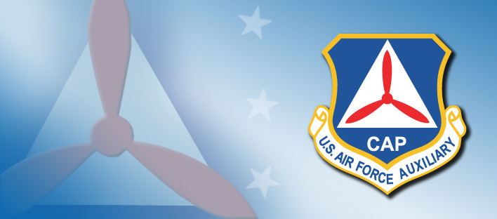
Civil Air Patrol
Cadet General Knowledge Book
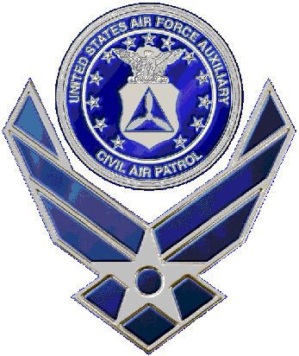
On the Web:
National: ______www.cap.gov__________
Regional: ______mer.cap.gov___________
Wing: ________scwg.cap.gov___________
Squadron: ____scwg.cap.gov/sumter_____

Cadet Information:
Name: _______________________________________
Phone Number: _______________________________________
CAPID: _______________________________________
Birth Date: __________/__________/__________
Join Date: __________/__________/__________
Squadron Name: _____Sumter Composite Squadron__________
Charter Number: _____MER-SC-075_______________________

Emergency Contact:
Name: _______________________________________
Phone Number: _______________________________________
Cell Phone: _______________________________________
Relation: _______________________________________

Cadet Oath
I pledge that I will serve faithfully in the Civil Air Patrol cadet Program, and that I will attend meetings regularly, participate actively in unit activities, obey my officers, wear my uniform properly, and advance my education and training rapidly to prepare myself to be of service to my community, state and nation.

CAP Mission Statement
Civil air Patrol, America’s Air Force auxiliary, building the Nation’s finest force of citizen volunteers… Performing missions for America.

CAP Motto
Semper Vigilans – Always Vigilant

Squadron Motto
South Carolina’s Finest

Core Values
Integrety, Volunteer Service, Excellence and Respect

Civil Air Patrol Core Values establish the standards by which members are expected to conduct themselves. The values serve as the ethical framework for CAP’s service to America.
2

Cadet Enlisted Grade Insignia
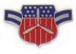 |  | 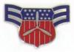 |  | 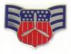
Airman  C/Amn |  | Airman 1st Class  C/A1C |  | Senior Airman  C/SrA
 | 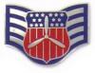 |  | 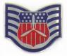
 | Staff Sergeant  C/SSgt |  | Technical Sergeant  C/TSgt
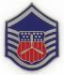 |  | 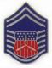 |  | 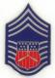
Master Sergeant  C/MSgt |  | Senior Master Sergeant  C/SMSgt |  | Chief Master Sergeant  C/CMSgt

Cadet Officer Grade Insignia
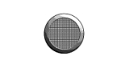 | 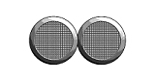 | 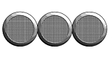
2nd Lieutenant  C/2d Lt | 1st Lieutenant  C/1st Lt | Captain  C/Capt
Major  C/Maj | Lieutenant Colonel  C/Lt Col | Colonel  C/Col

7

Table of Contents:

Chain of Command ........................................................................ 1
Cadet Oath .................................................................................... 2
CAP Mission Statement ................................................................. 2
CAP Motto ..................................................................................... 2
Squadron Motto ............................................................................ 2
Core Values .................................................................................... 2
CAP Mission ................................................................................... 3
Safety Pledge ................................................................................. 3
Definitions .................................................................................. 3-4
History of CAP ................................................................................ 4
Regions of CAP ............................................................................... 5
Wings of CAP ................................................................................. 5
5 Aspects of Followership .............................................................. 5
Air Force Knowledge ..................................................................... 5
Phonetic Alphabet ......................................................................... 6
Achievement List ........................................................................... 6
Cadet Enlisted-Level Grade Insignia .............................................. 7
Cadet/Senior Officer Level Grade Insignia ..................................... 8
CAP Manuals/Regulations ............................................................. 9

CAP Manuals/Regulations:

Index 0-2 | Numerical listing of all CAP Regulations
CAPR 20-1 | Organization of CAP
CAPM 39-1 | CAP Uniform Manual
CAPR 39-2 | CAP Membership
CAPR 39-3 | Award of CAP Medals, Ribbons and Certificates
CAPR 52-10 | CAP Cadet Protection Policy
CAPR 52-16 | CAP Cadet Program Management
CAPP 50-2 | CAP Core Values
CAPP 50-5 | Introduction to CAP
CAPP 52-6 | Cadet Programs, Mentoring
CAPP 52-7 | Cadet Orientation Flight Syllabus
CAPP 52-14 | Staff Duty Analysis Guide
CAPP 52-18 | CAP Physical Fitness Program
CAPP 151 | Standards, Customs and Courtesies

9

Senior Member Grade Insignia
Flight Officer | Technical Flight Officer | Senior Flight Officer
2nd Lieutenant | 1st Lieutenant | Captain
Major | Lt. Colonel | Colonel
Brigadier General | Major General | Lt. General
Chain of Command:
Senior Staff

National Commander: ________________________________

Regional Commander: ________________________________

Wing Commander: ________________________________

Group Commander: ________________________________

Squadron Commander: ________________________________

Cadet Staff

Cadet Commander: ________________________________

Cadet Deputy Commander: ____________________________

Cadet Executive Officer: ________________________________

Cadet First Sergeant: ________________________________

Cadet Flight Commander: ________________________________

Cadet Flight Sergeant: ________________________________
Phonetic Alphabet:
A | = | Alpha | J | = | Juliet | R | = | Romeo
B | = | Bravo | K | = | Kilo | S | = | Sierra
C | = | Charlie | L | = | Lima | T | = | Tango
D | = | Delta | M | = | Mike | U | = | Uniform
E | = | Echo | N | = | November | V | = | Victor
F | = | Foxtrot | O | = | Oscar | W | = | Whiskey
G | = | Golf | P | = | Papa | X | = | X-ray
H | = | Hotel | Q | = | Quebec | Y | = | Yankee
I | = | India |  |  |  | Z | = | Zulu
Achievement List:
NOTE: Items in Bold are Milestones

Curry | = | Airman
Arnold | = | Airman First Class
Fiek | = | Senior Airman
Wright Brothers | = | Staff Sergeant
Rickenbacker | = | Technical Sergeant
Lindbergh | = | Master Sergeant
Doolittle | = | Senior Master Sergeant
Goddard | = | Chief Master Sergeant
Armstrong | = | *No Grade Promotion*
Mitchell | = | Second Lieutenant
Flight Commander | = | *No Grade Promotion*
Administrative Officer | = | First Lieutenant
Public Affairs Officer | = | *No Grade Promotion*
Earhart | = | Captain
Leadership Officer | = | *No Grade Promotion*
Aerospace Ed. Officer | = | *No Grade Promotion*
Operations Officer | = | Major
Logistics Officer | = | *No Grade Promotion*
Cadet Commander | = | *No Grade Promotion*
Eaker | = | Lieutenant Colonel
Spaatz | = | Colonel

6
CAP Mission:
--The Cadet Program: to develop and motivate the youth of the country to leadership and responsible citizenship through an interest in aviation.
--Aerospace Education: of the general public in support of aerospace power.
--Emergency Services provide humanitarian assistance in peacetime and domestic disasters.

Safety Pledge:
As a Civil Air Patrol member I pledge to promote an uncompromising safety environment for myself and others, and to prevent the loss of, or damage to Civil Air Patrol assets entrusted to me. I will perform all my activities in a professional and safe manner, and will hold myself accountable for my actions in all of our Missions for America.

Definition of Leadership:
Leadership is the art of influencing and directing people in a way that earn their obedience, confidence, respect and loyal cooperation in achieving a common objective.

Definition of Military Discipline:
The mental attitude and state of training which renders obedience instinctive under all conditions. It is founded upon respect for, and loyal cooperation towards properly constituted authority.

3

DoD Definition of Hazing:

Any conduct whereby someone causes another to suffer or be exposed to any activity that is cruel, abusive, humiliating, oppressive, demeaning or harmful.

History of CAP:

- Civil Air Patrol was created on December 1, 1941, one week before the attack on Pearl Harbor.
- During the first 18 months of the Civil Air Patrol, members reported 173 U-boats sighted, sank 2, and flew 86,865 missions over coastal waters for a total of 244,600 hours (approximately 24 million miles).
- In 1943, Civil air Patrol was reassigned from the Office of Civilian Defense to the war Department and placed under jurisdiction of the army air forces.
- On May 26, 1948, Congress passed Public law 557 which permanently established Civil Air Patrol as the Auxiliary of the new U.S. Air Force. This law also gave the secretary of the Air Force the authority to provide financial and material assistance to the organization.
- On July 1, 1964, Civil air Patrol was incorporated as a non-profit organization.
4
Regions of CAP: | Wings of CAP:
- Northeast | - 50 States of the U.S.
- Southeast | - District of Columbia
- Middle East | - Puerto Rico
- Rocky Mountain | 5 Aspects of Followership:
- North Central | - Self-Discipline
- Great Lakes | - Attitude
- Pacific | - Integrity
- Southwest | - Listening
 | - Respect for Authority

Founding of the U.S. Air Force: 18 September 1947

U.S. Air Force Mission: to deliver sovereign options for the defense of the United States of America and its global interests – to fly and fight in Air, Space, and Cyberspace.

U.S. Air Force Core Values: Integrity First, Service Before Self, Excellence in All We Do.

U.S. Air Force Vision: Air Force people building the world’s most respected air and space force... global power and reach for America.

U.S. Air Force Academy Honor Oath: We will not Lie, steal or Cheat, nor tolerate among us anyone who does. Furthermore, I resolve to do my duty and live honorably, so help me God.

5

