GRADE STABILIZATION STRUCTURE

PRACTICE INTRODUCTION

USDA, Natural Resources Conservation Service―Practice Code 410

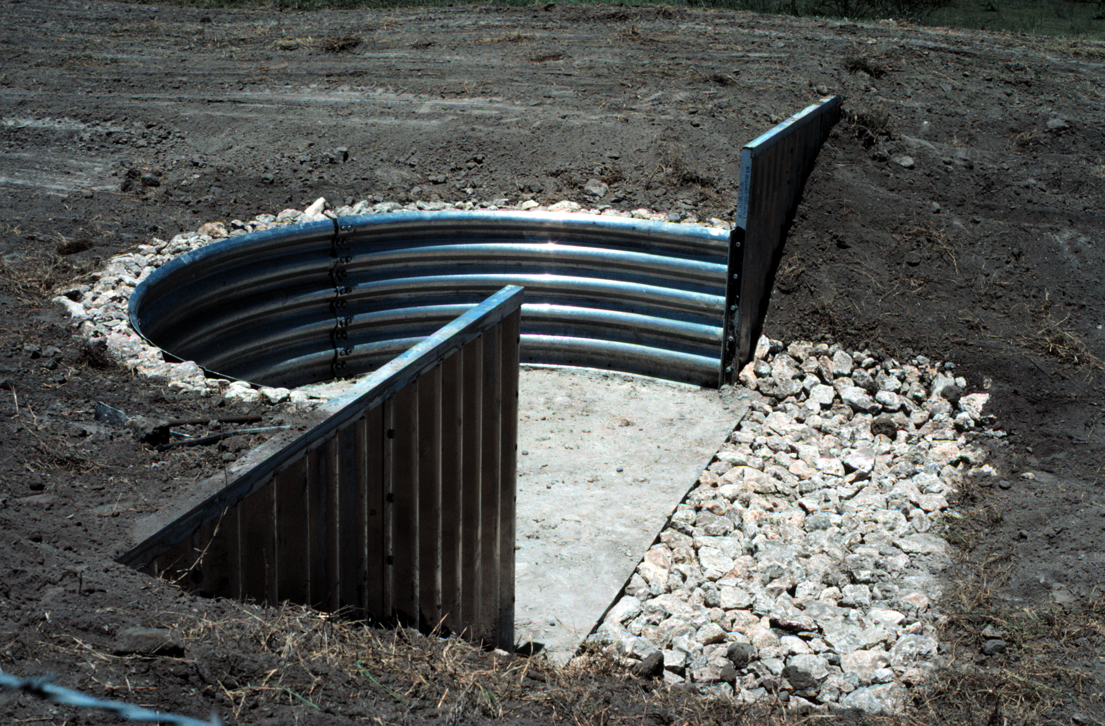

GRADE STABILIZATION STRUCTURE
A grade stabilization structure is used to control the grade and headcutting in natural or artificial channels.

PRACTICE INFORMATION
Grade stabilization structures are installed to stabilize the channel grade and control erosion to prevent the formation or advance of gullies and headcuts. The practice is used in areas where structures are necessary to stabilize the site. Grade stabilization structures are not designed to regulate flow or water levels in a channel area.
Special attention is given to enhancing fish and wildlife habitat where enhancement is practical. The practice is also helpful in reducing pollution from sedimentation.
Grade stabilization structures are located so that the elevation of the inlet of the spillway is set at
an elevation that will control upstream headcutting.
A wide range of alternative types of structures are available for this practice, and an intensive site investigation is required to plan and design an appropriate grade stabilization structure for a specific site.

COMMON ASSOCIATED PRACTICES
Grade Stabilization Structure is commonly used in a Conservation Management System on a variety of land uses with practices such as Nutrient Management (590), Pest Management (595), Contour Farming (330), and other erosion control practices.
For more information, refer to the practice standard in the NRCS Field Office Technical Guide and associated specifications and design criteria.

I.2. (-) Head cutting and channel erosion
I.6 (-) Overland and gully erosion
I.8 (-) Downstream deposition
I.7 (+) Ponding behind structure
I.1 (+) Channel stability
C.1 (+/-) Income and income stability (individuals and community)
I.9 (+) Surface water quality
I.3 (+) Upstream sediment deposition
2. Decrease slope above structure
C.2 (+) Fishable and swimmable waters; reduced health and safety issues for humans, domestic, and wild animals.
I.11 (-) Fossil fuel use
Initial setting: Cropland, nonirrigated, subject to water erosion
D.1 (-) Water velocity
I.4 (+) Crop production
1. Stabilize grade and control erosion in natural or artificial channels
3. Prevent the formation of advance of gullies
I.5 (+) Aquatic and animal habitat
I.10 (-) Tillage
Grade Stabilization Structure
5/2002
I.12 (-) Greenhouse gas emissions
C.3 (+) Air quality of the airshed
Grade Stabilization Structure (410)
Start
Note: Effects are qualified with a plus (+) or minus (-). These symbols indicate only an increase (+) or a decrease (-) in the effect upon the resource, not whether the effect is beneficial or adverse.

LEGEND
#. Created by practice
D. Direct effect
I. Indirect effect
C. Cumulative effect
Pathway
(+) increase; (-) decrease

