CATALOGING EXERCISE: Example A

Cover (title page substitute):


From Contents page:
TDM Review
A publication of the Association for Commuter Transportation
Volume IX, Number II

Published quarterly for members of the Association for Commuter Transportation (ACT) by UrbanTrans Consultants, Inc.

Editorial Board located in Washington, D.C. (also the location of ACT National Headquarters)

From page 5:

“Mission Statement: ACT supports its members in their efforts to enhance mobility, improve air quality, and conserve energy through Transportation Demand Management (TDM) activities.”

Cataloger has in hand:
Spring 2001 = Volume IX, Number II
Summer 2001 = Volume IX, Number III
2002, Issue 3 = Volume X, Number III
2003, Issue 1 = Volume XI, Number I
2003, Issue 2 = Volume XI, Number II
2003, Issue 3 = Volume XI, Number II [sic]
2004, Issue 1 = Volume XII, Number I
2006, Issue 1 = Volume IV, Number I [sic]

From LC/NAF:

110 2 Association for Commuter Transportation
410 2 ACT
CATALOGING EXERCISE: Example B

Title page:

From preface:
JTL : Introducing the Journal of Turkish Literature

The Journal of Turkish Literature, published annually by the Center for Turkish Literature at Bilkent University, Ankara, Turkey, is the first and only international scholarly journal in English devoted in its entirety to Turkish literatures from their outset to the present day.

From LC/NAF:
110 2 Bilkent Universitesi. $b Turk Edebiyatı Merkezi
410 2 Bilkent Universitesi. $b Center for Turkish Literature [diacritics not reproduced]
CATALOGING EXERCISE: Example C (page 1 of 2)

Title screen (home page):
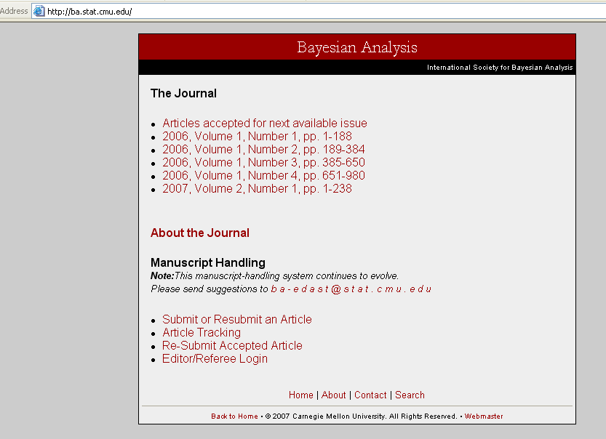

From “About” page:


From: “Contact” page:
Department Of Statistics
Carnegie Mellon University
Pittsburgh, PA 15213
USA
CATALOGING EXERCISE: Example C (page 2 of 2)

First issue:
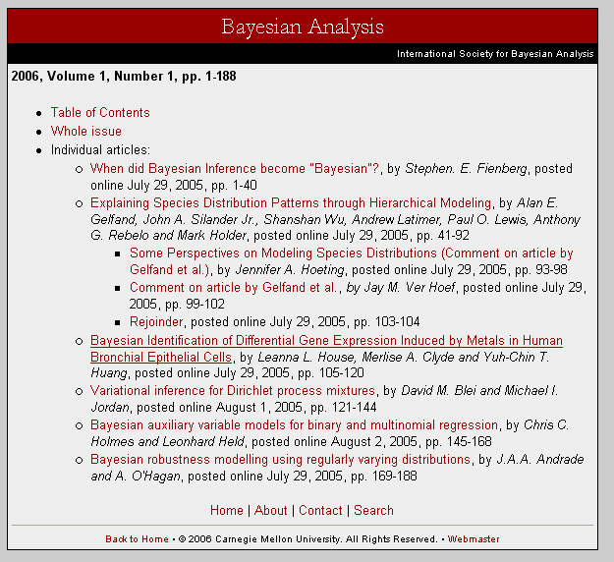

Latest issue: 2007, Volume 2, Number 1

From LC/NAF:

110 2 International Society for Bayesian Analysis
410 2 ISBA

110 2 Carnegie-Mellon University. $b Dept. of Statistics
CATALOGING Work Form
Type: |  | a |  | ELvl: | I | Srce: | d | GPub: |  | Ctrl: |  | Lang:
BLvl: |  | s |  | Form: |  | Conf: | | | Freq: | | | MRec: |  | Ctry:
S/L: |  | 0 |  | Orig: |  | EntW: |  | Regl: | | | Alph:
Desc: |  | a |  | SrTp: |  | Cont: |  | DtSt: |  | Dates:
022 | - -
041 | _ -
043 | - -
090 | - -
1_ _ | _ -
245 | _ _
246 | 1 _
246 | 1 _
246 | 3 _
250 | - -
260 | - -
300 | - -
310 | - -
321 | - -
362 | 1 - |  | Began with
4_ _ | _ _
500 | - -
500 | - - |  | Description based on ; title from
500 | - - |  | Latest issue consulted:
515 | - -
538 | - -
546 | - -
6_ _ | _ 0
6_ _ | _ 0
7_ _ | _ _
7_ _ | _ _
7_ _ | _ _
8_ _ | _ _
856 | 4 _ |  | $u
CATALOGING Work Form
Type: |  | a |  | ELvl: | I | Srce: | d | GPub: |  | Ctrl: |  | Lang:
BLvl: |  | s |  | Form: |  | Conf: | | | Freq: | | | MRec: |  | Ctry:
S/L: |  | 0 |  | Orig: |  | EntW: |  | Regl: | | | Alph:
Desc: |  | a |  | SrTp: |  | Cont: |  | DtSt: |  | Dates:
022 | - -
041 | _ -
043 | - -
090 | - -
1_ _ | _ -
245 | _ _
246 | 1 _
246 | 1 _
246 | 3 _
250 | - -
260 | - -
300 | - -
310 | - -
321 | - -
362 | 1 - |  | Began with
4_ _ | _ _
500 | - -
500 | - - |  | Description based on ; title from
500 | - - |  | Latest issue consulted:
515 | - -
538 | - -
546 | - -
6_ _ | _ 0
6_ _ | _ 0
7_ _ | _ _
7_ _ | _ _
7_ _ | _ _
8_ _ | _ _
856 | 4 _ |  | $u
CATALOGING Work Form
Type: |  | a |  | ELvl: | I | Srce: | d | GPub: |  | Ctrl: |  | Lang:
BLvl: |  | s |  | Form: |  | Conf: | | | Freq: | | | MRec: |  | Ctry:
S/L: |  | 0 |  | Orig: |  | EntW: |  | Regl: | | | Alph:
Desc: |  | a |  | SrTp: |  | Cont: |  | DtSt: |  | Dates:
022 | - -
041 | _ -
043 | - -
090 | - -
1_ _ | _ -
245 | _ _
246 | 1 _
246 | 1 _
246 | 3 _
250 | - -
260 | - -
300 | - -
310 | - -
321 | - -
362 | 1 - |  | Began with
4_ _ | _ _
500 | - -
500 | - - |  | Description based on ; title from
500 | - - |  | Latest issue consulted:
515 | - -
538 | - -
546 | - -
6_ _ | _ 0
6_ _ | _ 0
7_ _ | _ _
7_ _ | _ _
7_ _ | _ _
8_ _ | _ _
856 | 4 _ |  | $u

