Introduction to Stellarators and to the National Compact Stellarator Experiment (NCSX)

Allan Reiman
National Compact Stellarator Experiment (NCSX) is in construction phase at PPPL.

- NCSX to be completed in 2009 at estimated cost ~ $94 million.
Operating budget expected to be similar to that of NSTX.
- When complete, NCSX will embody new type of stellarator configuration, combining desirable features of optimized stellarators and advanced tokamaks.

Six of the grad student seminars to be devoted to stellarators.

This Talk
- Introduction to stellarators.
- Physics configuration design of NCSX.
- Issue of equilibrium flux surfaces.
Invention of Stellarators Grounded in a Key Insight
Early 1950’s: Recognition that some desirable properties of magnetic fields are lost when symmetry is imposed.
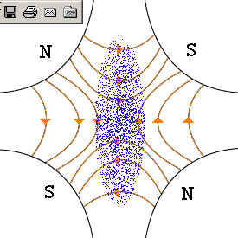
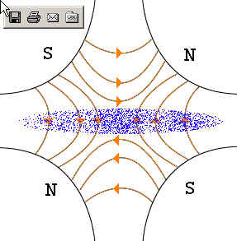
Particle accelerators: strong focusing. (Courant, Livingston, Snyder)

Early implementation used magnetic quadrupoles in alternating directions.

Transformed subsequent accelerator design.

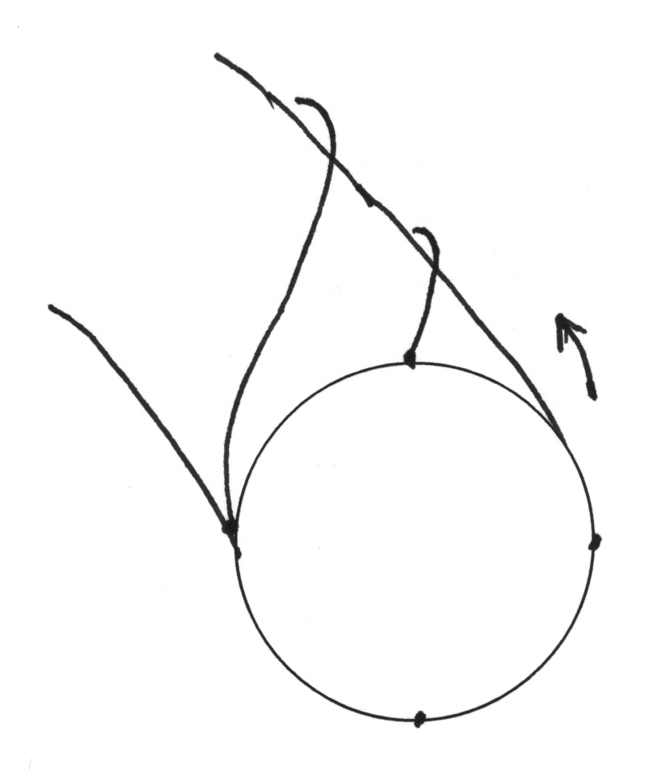
I
I
Classical implementation adds rotating magnetic quadrupole to toroidal guide field.
Application has encountered difficulties which have taken many years to overcome.
Magnetic confinement of plasmas: rotational transform, etc. (Spitzer)
- Rotational Transform: Introduction

Purely toroidal field cannot confine plasma in torus:
+ + + +
- - - - - -
E
ExB
Drift in torus where B = B 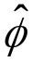
The solution: Wind field lines helically around torus.
Charges neutralize by moving along field line.
ι ≡ ⟨ no. poloidal transits ⟩ / ⟨ no. toroidal transits ⟩ ≡ 1/q
B
flux surface = projection of field line onto φ=0 plane.
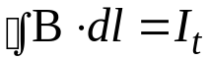
In axisymmetry, need toroidal current.
In tokamaks, observed confinement τ ∼ I_{t} (fixed P).
B = B

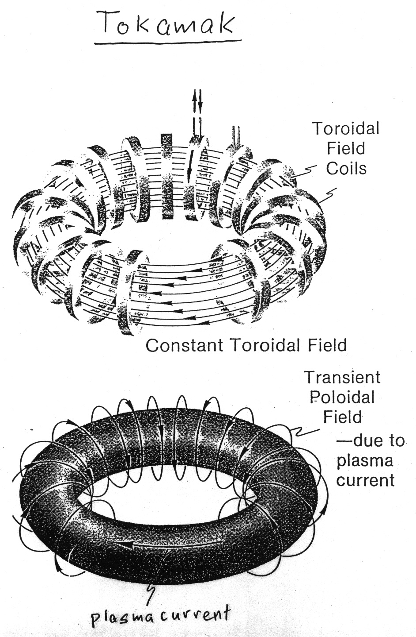
A 3D Magnetic Field Can Produce Rotational Transform Even with I_{t} = 0
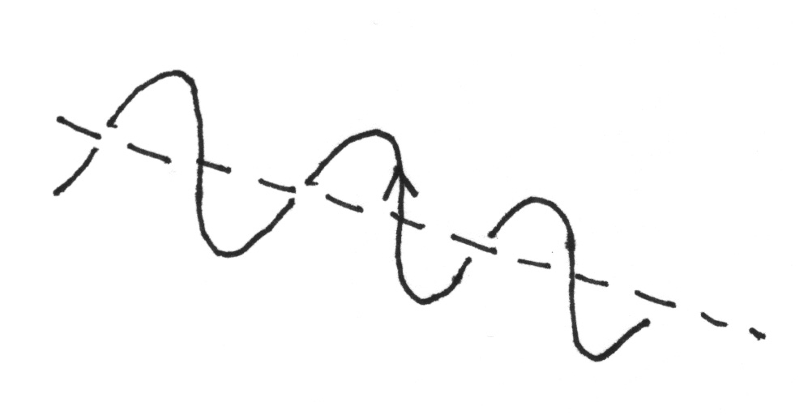
I
I
helical coils
helical coils
TF coil
Classical Stellarator
1st order effect of small helical current: spiraling of field lines
2nd order effect: Different magnitudes of fields on inside and outside gives drift in poloidal direction.
(analogous to particle drifts)
Data indicates that scaling of confinement with rotational transform is approximately the same, independent of whether ι generated by current or 3D field.
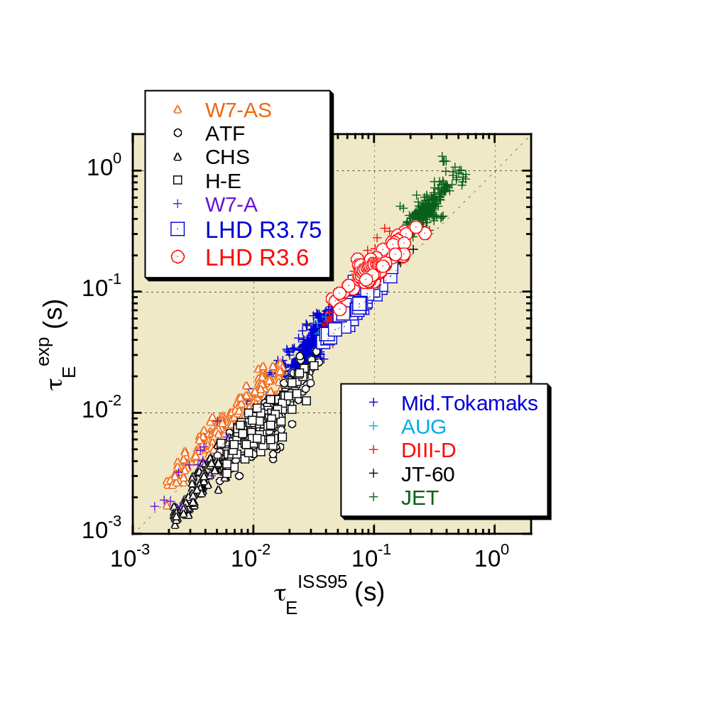
(Data from Fujiwara, 4/03)
Nonaxisymmetry Also Provides Additional Control over Properties of Field that Affect Stability

- Global shear: ι’.
- Local shear: pitch of field line.
- Magnetic well, dV/dΨ_{t}, where V(Ψ_{t}) is volume within flux surface containing toroidal flux Ψ_{t}. (Also 2nd order for small helical field.)

In Practice, Stellarators Rarely Disrupt
- Present day stellarator experiments do not disrupt in normal operation, even when pushing parameters.
  - e.g. density limit gives slow loss of energy on transport time scale.
- W7AS team has been able to induce disruptions in specially prepared scenarios (e.g. ramping through m/n = 2/1 rational surface in plasma with very low shear and current profile predicted to be tearing unstable.)
Introduction of Nonaxisymmetry Also Brings with it Some Difficulties
stochastic
region
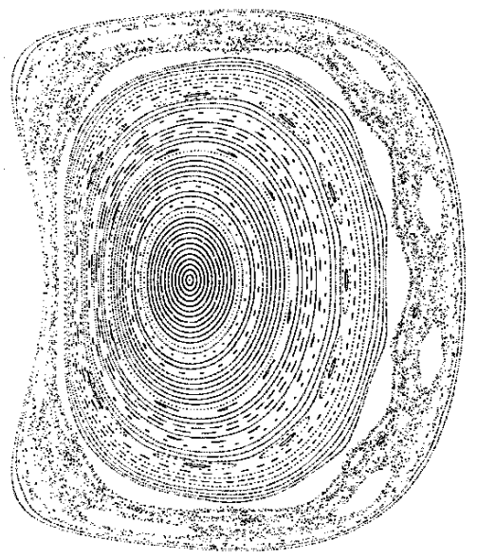
- Potential loss of flux surfaces
  - Can generally remove resonant vacuum fields that break flux surfaces without affecting physics properties, but flux surfaces at finite beta remains an issue.

Poincare plot from PIES calculation at β = 3%.

Continues to deteriorate with iteration.
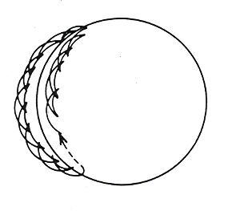
Introduction of Nonaxisymmetry Also Brings with it Some Difficulties (continued)
- Drift trajectories generally not well behaved.
  - Can give large neoclassical transport at low collisionality.
  - Confinement of energetic alpha’s a particular issue.
superbanana orbit
- Increased complexity of coils and support structure.
  - Difficult to assess quantitative impact on reactor costs at this time.
  - Will need to evaluate trade-offs relative to tokamak in terms of e.g.: feedback control systems for external kinks; current drive systems, including those required for neoclassical tearing mode stabilization.
  - Some small degree of nonaxisymmetry will not greatly impact cost.
Contemporary stellarators rely on modern developments in theory and computation to address these difficulties.

- Transport:
  - Classes of configurations identified for which three-dimensionality does not adversely impact transport. e.g. “quasi-symmetric” configurations. To be discussed in seminars by Harry Mynick.
  - Contemporary stellarator design uses “optimization” codes to target good drift trajectories while also incorporating other desirable features.
- Flux surfaces:
  - Two codes developed to calculate equilibrium flux surfaces: PIES code (Princeton), HINT code (Japan).
  - NCSX used PIES code to help guide design with good surfaces.
  - Optimization procedure adopted by W7X verified to provide good surfaces. (Princeton-German collaboration on PIES calculations for W7X.)
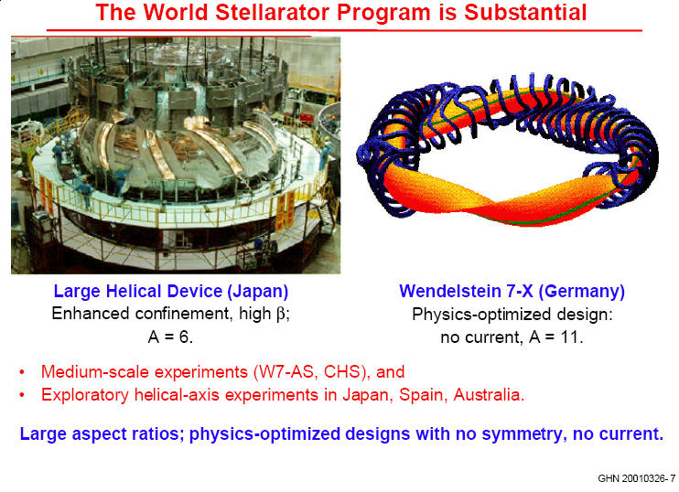
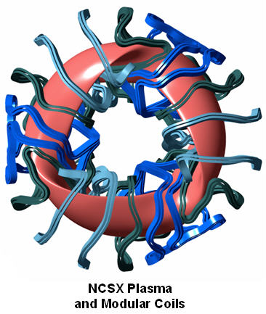
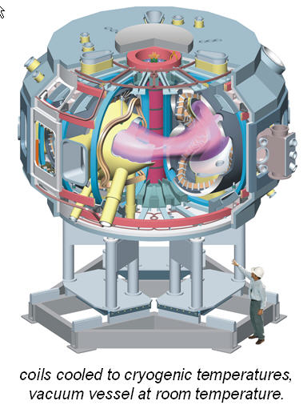
NCSX design combines favorable features of advanced tokamaks with those of drift-optimized stellarators.

Design strategy:
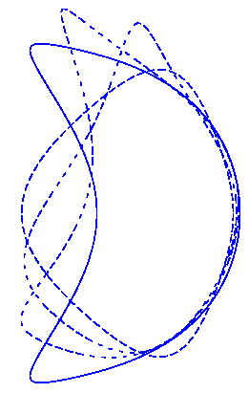
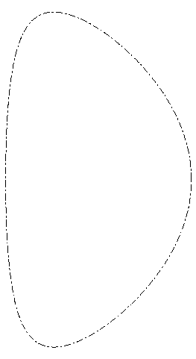
- Use advanced tokamak equilibrium as starting point.
ARIES
c3
- Use numerical optimizer to introduce 3D deformation to address tokamak problems while preserving desirable tokamak properties.
- Key tokamak issues addressed:
  - Reduce or eliminate need for rf current drive.
  - Stabilize neoclassical tearing modes via rotational transform profile.
  - Stabilize external kink modes and vertical instabilities via shaping.
PIES Calculations for NCSX: 1. Identification of Fixed Boundary Equilibria with Intrinsically Good Flux Surfaces

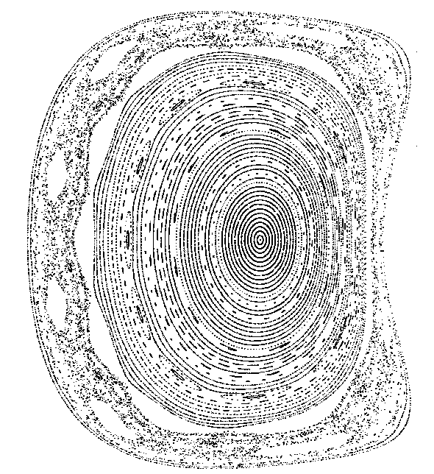
stochastic
region
φ = π/3
Poincare plot for an early candidate configuration, C82, at
β = 3%. The shape of the boundary has been specified (“fixed-boundary” equilibrium).
PIES Calculations for NCSX: 2. Design of Coils to Preserve Flux Surfaces

An optimizer has been built around the PIES code to modify the coil design to heal islands while preserving desired physics and engineering properties.

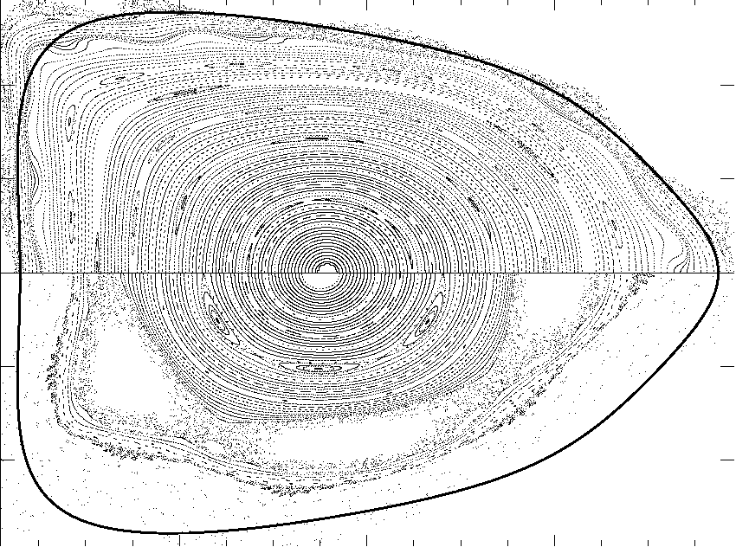
Converged, free-boundary PIES calculation with healed coils.

PIES calculation with original coils.
Continues to deteriorate as iteration proceeds.
plasma boundary in VMEC
calculation with unhealed coils.
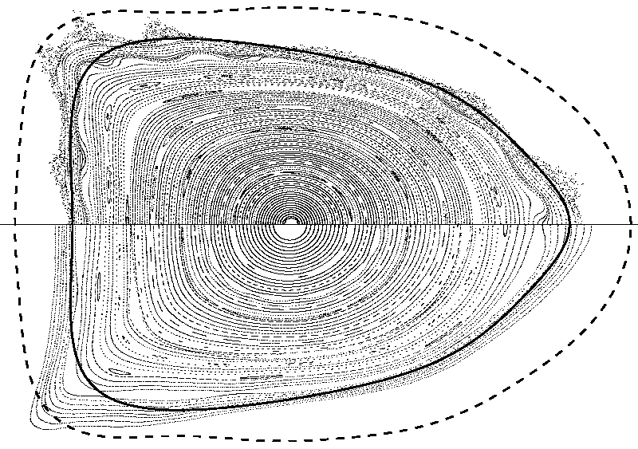
Multi-Filament Model Improves Flux Surface
Converged free-boundary PIES calculation using single-filament model for coils.
Calculation with multi-filament model.
first wall
plasma boundary in VMEC calculation
with unhealed coils.
Experiments on the W7AS and LHD Stellarators
Have Seen a Soft β Limit


W7AS: German stellarator with R = 2 m,
a ≤ 0.18 m, 5 periods.

Operated until mid 2002.

Modular coils for W7AS

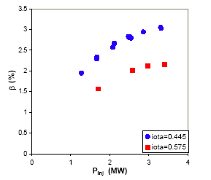

Variation of 〈β〉 versus injected beam power P_{inj} for (a) ι_{vac}(0) = 0.445, B = 0.9 T,
n_{e} = 2.4 x 10²⁰ m⁻³, I_{CC} / I_{M} = 0.15 and
(b) ι_{vac}(0) = 0.575, B = 1.25 T,
n_{e} = 1.7 x 10²⁰ m⁻³, I_{CC} / I_{M} = 0.14.

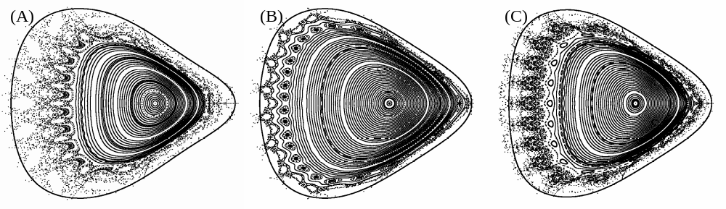PIES equilibrium calculations find region of chaotic field lines that broadens with increasing β
PIES calculated flux surface topologies at the triangular symmetry plane for: (A) ICC=0 and ⟨β⟩ = 1.8%, (B) ICC=-2.5kA and ⟨β⟩ = 2.0%, (C) ICC=-2.5kA and ⟨β⟩ = 2.7%. In each case, the dark line is the VMEC calculated plasma boundary.

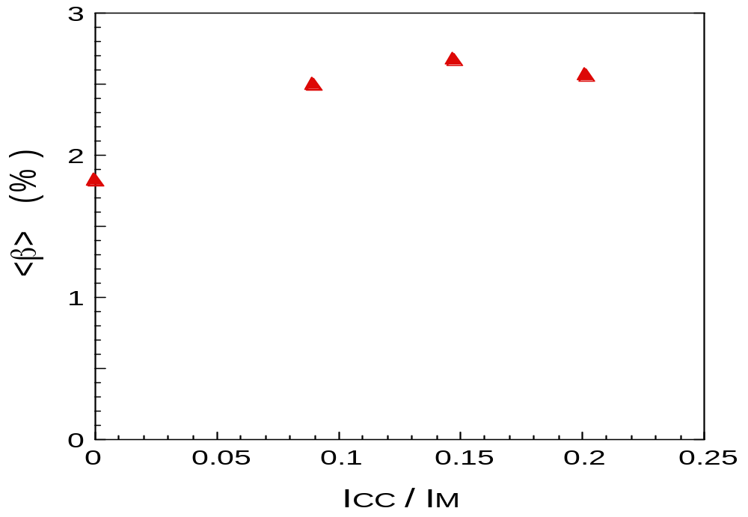
The current in the divertor control coil substantially affects the achievable β on W7AS.
Variation of peak-⟨β⟩ versus the divertor control-coil current I_{CC} normalized by the modular coil current, for B=1.25 T, P_{NB} = 2.8 MW absorbed and ι_{vac}= 0.44.
PIES code run for these parameters.
Island width zero for vacuum field.
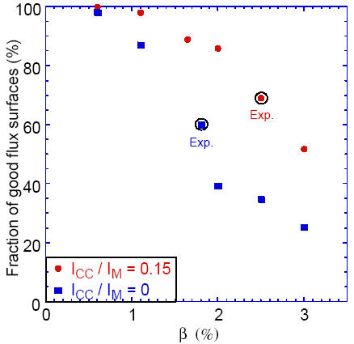
Same trend emerges from PIES β scan for two different values of control coil current.
Fraction of good flux surfaces versus β as predicted by PIES for two different values of the control coil current for the W7AS stellarator. The circles indicate the PIES calculations done for the experimentally achieved value of β.
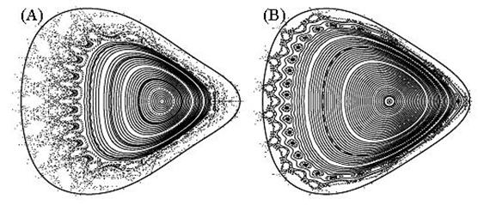
I_{CC} = 0, ⟨β⟩ = 1.8%
I_{CC} = -2.5kA, ⟨β⟩ = 2.0%
VMEC calculated plasma boundary
For a given value of β, width of stochastic region calculated to be larger for I_{CC} = 0.

