 |  |   Agricultural Research Service
National Sedimentation Laboratory
Channel and Watershed Processes Research Unit
Oxford, Mississippi 38655

Acoustic Imaging of Sediment Impounded by a
USDA-NRCS Flood Control Dam, Oklahoma

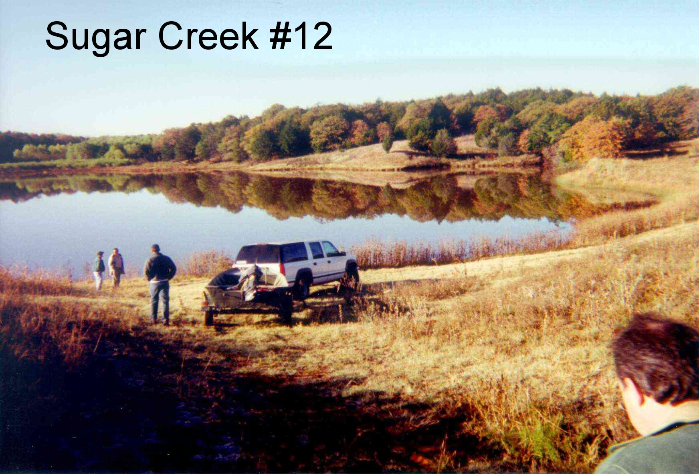
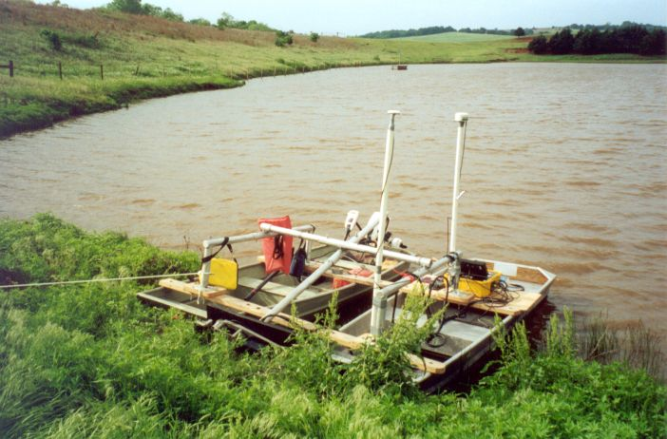
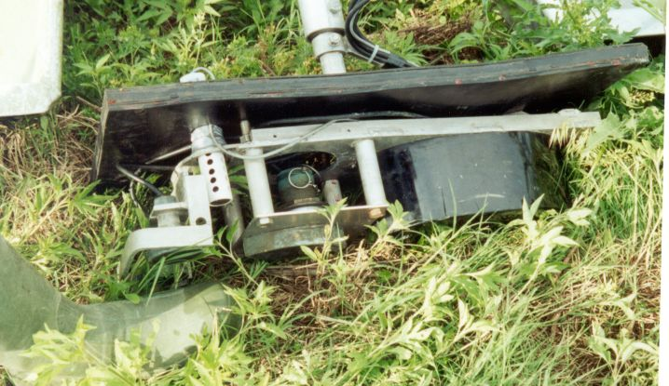
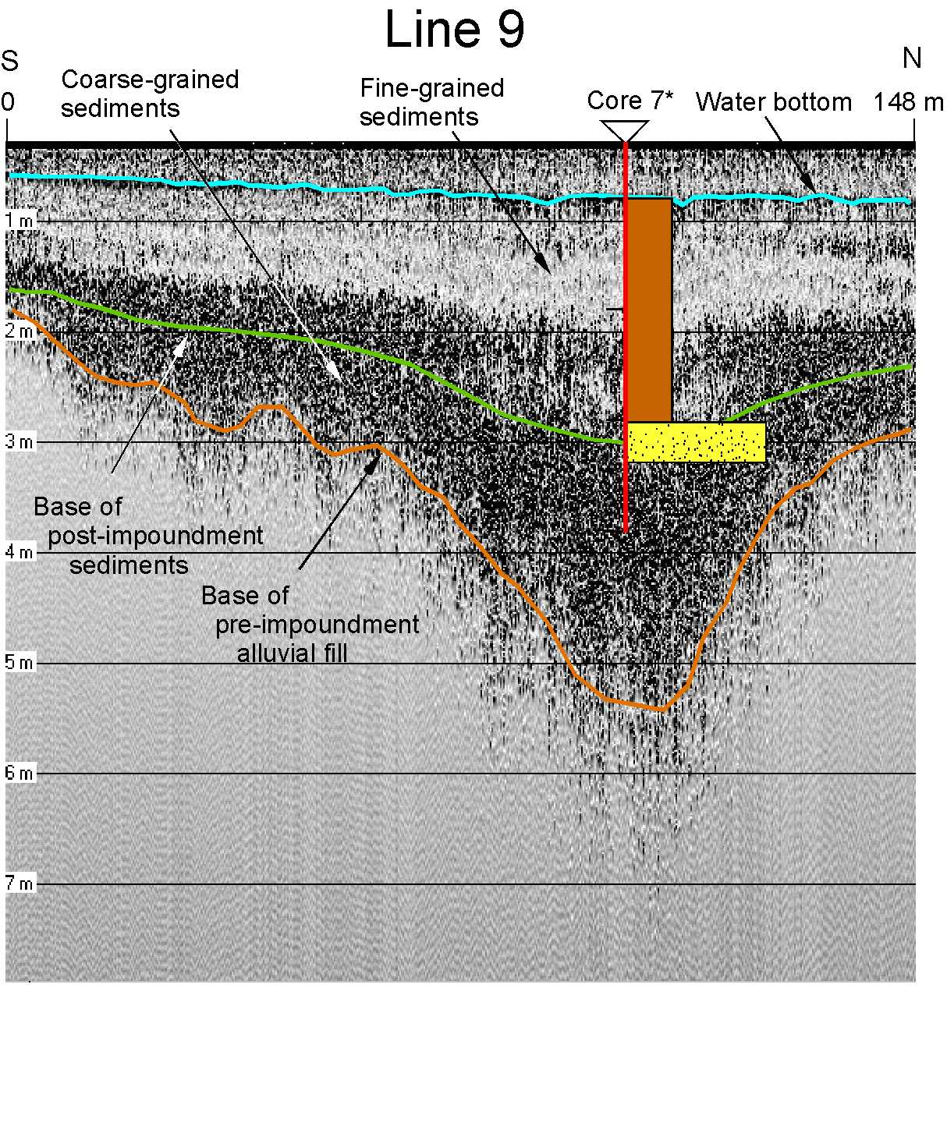

By John A. Dunbar, Peter M. Allen, and Sean J. Bennett

Research Report No. 22 | September 2001

Executive Summary

Since 1948, the USDA-NRCS has constructed nearly 11,000 upstream flood control dams in 2000 watersheds in 47 states. Over two-thirds of these dams have a design life of 50 years. Because of population growth, land use changes, and time since construction, sediment pools are filling, some structural components have deteriorated, safety regulations are stricter, and the hazard classification has changed for some dams. Before any rehabilitation strategy can be designed and implemented, the sediment impounded by these dams must be assessed in terms of the structure’s efficiency to regulate floodwaters and the potential hazard the sediment may pose if reintroduced into the environment. This report represents the completion of a demonstration project designed to evaluate the application of acoustic technology for the purpose of imaging the sediment impounded by a flood control dam.

One field site was chosen for this project. Sugar Creek #12 is located near Hinton, OK, and it is a relatively small lake with a mud bottom and fairly shallow water depths. Previous studies have shown that excessive sedimentation rates have significantly decreased storage capacity. Moreover, historic land use of cultivated fields of cotton and peanuts suggests that agrichemicals may be present in the lake sediments.

In May 2001, a subsurface sediment survey was conducted in the reservoir pool at Sugar Creek #12 using an acoustic profiling system. The system can comprise up to five acoustic transducers with operating frequencies of 200, 24, 24, 12, and 3.5 kHz, a receiving hydrophone, and a signal processor that controls the acoustic profiling, data collection and processing, and navigational systems. This portable system was deployed from two Johnboats. Because of water depth limitations and equipment difficulties, only the 200 kHz transducer was used during the survey.

All collected data were post-processed to amplify the acoustic signals at depth and to remove reverberations or multiple sound waves due to the shallow water depth. The acoustic survey successfully identified numerous stratigraphic horizons within the subsurface. These stratigraphic horizons agree extremely well with sediment core data previously collected. By combining the acoustic and sediment core data, the distribution of sediment thickness, hence sediment volume, is mapped. The total sediment thickness deduced using the acoustic system agrees very well with the total sediment recovered in the core. Further analysis of the data is not possible because of the limitation of using only the 200 kHz transducer.

This pilot project successfully demonstrated the application of acoustic technology for conducting fast, cost-effective sedimentation surveys within flood control reservoirs. Improvements to the existing system have been identified that will ultimately enable its application in all reservoirs regardless of size, water depth, and composition and thickness of deposited sediment.
Table of Contents

Executive Summary 2
1. Introduction 8
1.1 Federal Program for Flood Control 8
1.2 Current Status of Small Watershed Program 9
1.3 Problem Statement 9
1.4 Previous Work 9
1.5 Focus of Current Report 10
2. Field Site 11
2.1 Sugar Creek #12 11
3. Sediment Coring 14
4. Acoustic Survey System 17
4.1 Acoustic Profiling System 17
4.2 Survey Procedure 21
4.3 Digital Processing of Collected Acoustic Data 21
4.4 Interpreting the Processed Data 26
4.4 Mapping Volumetrics 46
5. Discussion 51
6. Conclusions 52
7. References 54

List of Figures

Figure 2-1. Photograph of Sugar Creek #12 looking directly south showing earthen embankment on left, spillway channel in far distance, and reservoir (November 1999). 12
Figure 2-2. Photograph of Sugar Creek #12 looking toward the southwest showing the reservoir and the main tributary on right (November 1999). 12
Figure 2-3. Base map of Sugar Creek #12 constructed from a hand-held global positioning system receiver with differential corrections applied. Shown are the outline of the lake, the centerline of the earthen embankment, the primary spillway drain, and the cement dam marker. All positions are in UTM coordinates. 13
Figure 3-1. Base map of Sugar Creek #12 showing locations of all cores (numbered 1-10). Arrows show flow direction of major tributaries entering the reservoir. All positions are in UTM coordinates. 15
Figure 3-2. Stratigraphic logs of cores obtained at Sugar Creek #12 (see Figure 3-1 for exact location). cl—clay, st—silt, s—sand, and gr—gravel. 16
Figure 4-1. Photograph of Sugar Creek #12 showing the survey vessels (May 2001). 19
Figure 4-2. Photograph of Sugar Creek #12 showing the survey vessels, GPS antennae, and transducer mast and transducer pod (May 2001). 19
Figure 4-3. Photograph of acoustic profiling system (May 2001). 20
Figure 4-4. Photograph of multifrequency transducer pod (May 2001). 20
Figure 4-5. Map of Sugar Creek #12 acoustic survey. Positions of acoustic profiles Line 9 through Line 15 are shown and line length is given in meters. Circles with crosses indicate the locations of 10 cores collected by Bennett and Cooper (2001). Coordinates are given in UTM. 23
Figure 4-6. Unprocessed field record of 200 kHz acoustic data collected along Line 9. See Figure 4-5 for line position. The water column is clear at a depth of 0.5 m on the south end of the line, increasing to 0.75 m on the north end. 24
Figure 4-7. Field record of 200 kHz acoustic data collected along Line 9 after digital processing. See Figure 4-5 for line position. 25
Figure 4-8. Processed Line 9 with interpretation. See Figure 4-5 for line position. The position of Core 7 from Bennett and Cooper (2001) is projected onto the line from a distance of 19 m. 28
Figure 4-9. Processed Line 10 with interpretation. See Figure 4-5 for line position. The position of Core 10 from Bennett and Cooper (2001) is shown. 29
Figure 4-10. Processed Line 11 with interpretation. See Figure 4-5 for line position. 30
Figure 4-11. Processed Line 12 with interpretation. See Figure 4-5 for line position. 31
Figure 4-12. Unprocessed (left) and processed and interpreted (on right) Line 12. See Figure 4-5 for line position. 32
Figure 4-13. Processed Line 12 with interpretation. See Figure 4-5 for line position. 33
Figure 4-14. Processed Line 15 with interpretation. See Figure 4-5 for line position. Location of Core 7 projected onto the core from a distance of 19 m. 34
Figure 4-15. Composite profile formed from the south end of Line 11 and the north end of Line 9. See Figure 4-5 for line positions. Location of Core 7 projected onto the line from a distance of 19 m. The intersection between the two lines is shown in red. 35
Figure 4-16. Composite profile formed from the south end of Line 9 and the east end of Line 14. See Figure 4-5 for line positions. The intersection between the two lines is shown in red. 36
Figure 4-17. Composite profile formed from the south end of Line 9 and the east end of Line 15. See Figure 4-5 for line positions. Location of Core 7 projected onto the line from a distance of 19 m. The intersection between the two lines is shown in red. 37
Figure 4-18. Composite profile formed from the south end of Line 10 and the west end of Line 11. See Figure 4-5 for line positions. The intersection between the two lines is shown in red. 38
Figure 4-19. Composite profile formed from the south end of Line 10 and the east end of Line 14. See Figure 4-5 for line positions. The intersection between the two lines is shown in red. 39
Figure 4-20. Composite profile formed from the south end of Line 10 and the east end of Line 15. See Figure 4-5 for line positions. Location of Core 7 projected onto the line from a distance of 19 m. The intersection between the two lines is shown in red. 40
Figure 4-21. Composite profile formed from the east end of Line 11 and line 12. See Figure 4-5 for line positions. The intersection between the two lines is shown in red. 41
Figure 4-22. Composite profile formed from the west end of Line 11 and the north end of Line 13. See Figure 4-5 for line positions. The intersection between the two lines is shown in red. 42
Figure 4-23. Composite profile formed from the west end of Line 11 and the west end of Line 14. See Figure 4-5 for line positions. The intersection between the two lines is shown in red. 43
Figure 4-24. Composite profile formed from the east end of Line 11 and the north end of Line 15. See Figure 4-5 for line positions. Location of Core 7 projected onto the line from a distance of 19 m. The intersection between the two lines is shown in red. 44
Figure 4-25. Stratigraphic columns and radioactive ¹³⁷Cs emissions (becquerels per gram; Bq/g) for Cores 4, 7, and 9 taken at Sugar Creek #12 (Bennett and Cooper, 2001). For the stratigraphic logs, grain size and lithologic descriptions are based on observational criteria. The peaks in the distributions of ¹³⁷Cs coincide with the 1964 datum, and some samples near the top and bottom of each core had zero emissions. 45
Figure 4-26. Contour map of water depth in Sugar Creek #12 during the acoustic survey. All positions are in UTM coordinates. 47
Figure 4-27. Contour map of base of sediments in Sugar Creek #12. All positions are in UTM coordinates. 48
Figure 4-28. Contour map of the sediment thickness in Sugar Creek #12 derived from the processed and interpreted acoustic data. All positions are in UTM coordinates. 49

List of Tables

Table 2-1. Changes in land use within the watershed of Sugar Creek #12 (percentages based on 2,016 acres; values are estimates). Information provided by the USDA-NRCS field office in Hinton, OK. 11
Table 4-1. Comparison of thickness of impounded (post-construction) sediment determined by Bennett and Cooper (2001) from sediment core data and those determined herein using acoustic technology. 50

Acknowledgments

We thank L. Caldwell and G. Miller, USDA-NCRS, Stillwater, OK for assisting and cooperating in the reservoir surveys and for reviewing the report. B. Elder, USDA-NRCS, Hinton, OK provided logistical assistance at the Sugar Creek #12. R. Wells and D. Wren assisted in all previous sediment coring activities.

Author contact information:

 | John A. Dunbar  Department of Geology  Baylor University  P.O. Box 97354  Waco, TX 76798-7354 | Peter M. Allen  Department of Geology  Baylor University  P.O. Box 97354  Waco, TX 76798-7354 | Sean J. Bennett  USDA-ARS  National Sedimentation  Laboratory  P.O. Box 1157  Oxford, MS 38655

1. Introduction

1.1 Federal Program for Flood Control
In response to devastating floods of the 1930’s and 1940’s, Congress enacted legislation for the construction of flood control dams on small tributary streams. The Flood Control Act of 1944 (PL-534) authorized 11 projects in the United States. Since 1948, more than 3,400 flood control dams have been constructed in the 320 subwatershed projects covering more than 35 million acres in 12 states (Caldwell, 1999).

In 1954, Congress enacted the Watershed Protection and Flood Preventaion Act (PL-566), commonly referred to as the Small Watershed Program (Caldwell, 1999). Since that time, more than 6,300 flood control dams have been constructed in 47 states as well as Puerto Rico and the Pacific Rim, covering over 109 million acres.

The Pilot Watershed Program provided the transition between PL-534 and PL-566 (Caldwell, 1999). More than 400 flood control dams were constructed in 62 projects in 33 states, covering almost 3 million acres. In addition, the RC&D Program has provided technical and financial assistance to local sponsors for the planning, designing, and construction of more than 200 flood control dams since the 1960’s.

In total, the U.S. Department of Agriculture, Natural Resources Conservation Service (USDA-NRCS) and its cooperators have constructed over 10,943 flood control dams in 47 states. More than $8.5 billion (1997 dollars) of federal funds and over $6.0 billion of local funds have been invested in these projects since 1948. This $14.5 billion infrastructure provides over $1 billion in benefits annually.

The primary purposes for these structures were to prevent flooding and to protect watersheds. Other dams were built or have evolved into structures for water management, municipal and industrial water supply, recreation, and the improvement of fish and wildlife, water quality, and water conservation. Local sponsors were to provide leadership in the program and secure land rights and easements for construction. The USDA-NRCS was to provide technical assistance and cost-sharing for the construction of these dams.

Flood control dams typically consist of an earthen embankment 6 to 20-m high with a principal spillway made of concrete pipe 0.3 to 1.8-m wide (Caldwell, 1999). Because the dams were built on small streams in the upper reaches of watersheds, upstream drainage areas range from 1.6 to 16 km². The majority of these dams were planned and designed for a 50-year service life. The inlet pipe of the principal spillway is placed at an elevation that would provide water retention for the design storm and storage for sediment accumulation. Each reservoir also has an emergency or auxiliary spillway for safe conveyance of water around the embankment when runoff rates exceed storage capacity.

1.2 Current Status of Small Watershed Program
At present, more than half of the dams constructed are older than 34 years and more than 1,800 will reach their 50-year design life within the next 10 years (Caldwell, 2000). A rapid survey conducted in April 1999 revealed more than 2,200 dams in need of immediate rehabilitation at an estimated cost of more than $540 million. The primary issues of dam rehabilitation are: replacement of deteriorating components, change in hazard classification, reservoir sedimentation, failure to meet dam safety regulations, failure to meet resource needs of the watershed, inadequate land and water rights, inadequate community benefits, and the potential transfer of responsibility. Common approaches to address rehabilitation typically involve dredging the reservoir to remove accumulated sediment, raising the dam to increase storage capacity, and removing or decommissioning the dam.

Rehabilitation of aging watershed flood control dams is critical to Oklahoma. Since 1948 more than 2,100 watershed flood control dams have been constructed including 1,140 in the Washita River Basin, which was one of the original 11 watershed projects authorized by PL-534. Many of these dams are in critical need of rehabilitation (Caldwell, 2000).

1.3 Problem Statement
Before any rehabilitation strategy can be designed and implemented, the sediment impounded by these dams must be assessed in terms of the structure’s efficiency to regulate floodwaters and the potential hazard the sediment may pose if reintroduced into the environment.

For a given lake within an embankment flood control structure, the USDA-NRCS needs to determine (1) the volume of sediment deposited, (2) the rates of sedimentation, (3) the quality of sediment with respect to agrichemicals (related to agricultural practices) and other contaminants, and (4) the spatial distribution of the sediment quality. To this end, demonstration projects were designed to evaluate technologies, methodologies, and protocols for the cost-effective characterization of sediment.

1.4 Previous Work
Bennett and Cooper (2001) completed a study designed to evaluate technologies, methodologies, and protocols for the cost-effective characterization of sediment impounded within flood control reservoirs. Three field sites were examined. Sugar Creek #12 and Sugar Creek #14 are located near Hinton, OK, and historic land use of cultivated fields of cotton and peanuts at Sugar Creek #12 suggests that agrichemicals may be present in the lake sediments. Sergeant Major #4 is located near Cheyenne, OK, and it has become the sole water supply for the town of Cheyenne.

Seismic profiles were successfully obtained in each of the three reservoirs in Oklahoma. However, the very shallow water depths at Sugar Creek #12 and Sugar Creek #14 caused unwanted noise in the seismic signal, and the processed data were virtually impossible to interpret. The seismic profiles at Sergeant Major #4 showed a number of distinct interpreted seismic reflectors in the subsurface.

Ten continuous, undisturbed cores of lake sediment were successfully obtained at Sugar Creek #12. These cores were composed of sand, silt, and clay, but most of the deposited sediment was silt and clay in nearly equal proportions. Four continuous, undisturbed cores of lake sediment were successfully obtained at Sergeant Major #4. These cores were composed of poorly sorted gravel, sand, silt, and clay. Select seismographs showed modest correlation to the stratigraphic boundaries observed in the sediment cores

The analysis of sediment quality included 50 different pesticides, herbicides, PCBs, heavy metals, elements, and other contaminants. A total of 57 sediment samples obtained from these reservoirs were analyzed. Results from testing these sediments showed very good overall sediment quality. Residual breakdown products of DDT and methyl parathion were found in low concentrations in all three reservoirs but such concentrations pose no health concern.

By using radioactive Cesium (CS-137) emissions as a dating technique, relatively high rates of sedimentation were deduced at Sugar Creek #12, presumably related to a basin-wide historic conversion of forested areas to cropland and knickpoint erosion and channel degradation above the reservoir. The historic conversion of cropland to native seed grasses within the watershed of Sergeant Major #4 has resulted in relatively low rates of sedimentation.

1.5 Focus of Current Report
Since the subsurface imaging of the sediment using geophysical techniques employed by Bennett and Cooper (2001) was not entirely successful, an alternate technique was sought. The goal of the present report was to evaluate the applicability of multifrequency acoustic profiling for determining the amount and distribution of sediment impounded within a flood control reservoir. To achieve this end, it was necessary to image the water bottom and the base of reservoir fill sediments with as much clarity as possible. A secondary requirement was the ability to image internal stratigraphy within the sediment column as an aid to mapping sediment quality parameters within the sediment fill. Both capabilities would support efforts to rehabilitate aging flood control reservoirs.

2. Field Site

2.1 Sugar Creek #12
Sugar Creek #12 is located near Hinton, OK, and it is a relatively small lake (19 acres) with a mud bottom and fairly shallow water depths (0.6 to 2 m; Figures 2-1, 2-2, and 2-3). Dam construction was completed on April 6, 1964. This structure has an upstream drainage area of 2,016 acres. The main stream supplying the lake is considered unstable due to the presence of actively migrating knickpoints, and excessive sedimentation rates have significantly decreased storage capacity. No boat ramp is available, and access for small vessels is difficult but tolerable.

Historic land use data for the watershed of Sugar Creek #12 are not very extensive. In the mid-1960’s near the time of dam construction, the watershed was primarily covered with trees and pastureland (Table 2-1; data provided by the USDA-ARS field office in Hinton, OK). Between the mid-1960’s and the mid-1980’s, apparently all forested areas were converted to cropland that included peanuts, cotton, and small grains. Since the mid-1980’s, approximately 40% of the cultivated land has been converted to pastureland with no change in the amount of grassland and tree-lined drains. Cultivated fields of cotton and peanuts suggests that agrichemicals may be present in the lake sediments.

Table 2-1. Changes in land use within the watershed of Sugar Creek #12 (percentages based on 2,016 acres; values are estimates). Information provided by the USDA-NRCS field office in Hinton, OK.

 | Time Interval
Land Use | mid-1960’s | mid-1980’s | Present
Trees | 55 | 0 | 0
Improved Pastureland: Bermuda, Plains  Bluestem, and Lovegrass | 10 | 27 | 50
Cropland: Peanuts, Cotton, and Small  grains | 25 | 65 | 41
Native Grasses and Tree-Lined Drains | 10 | 8 | 9

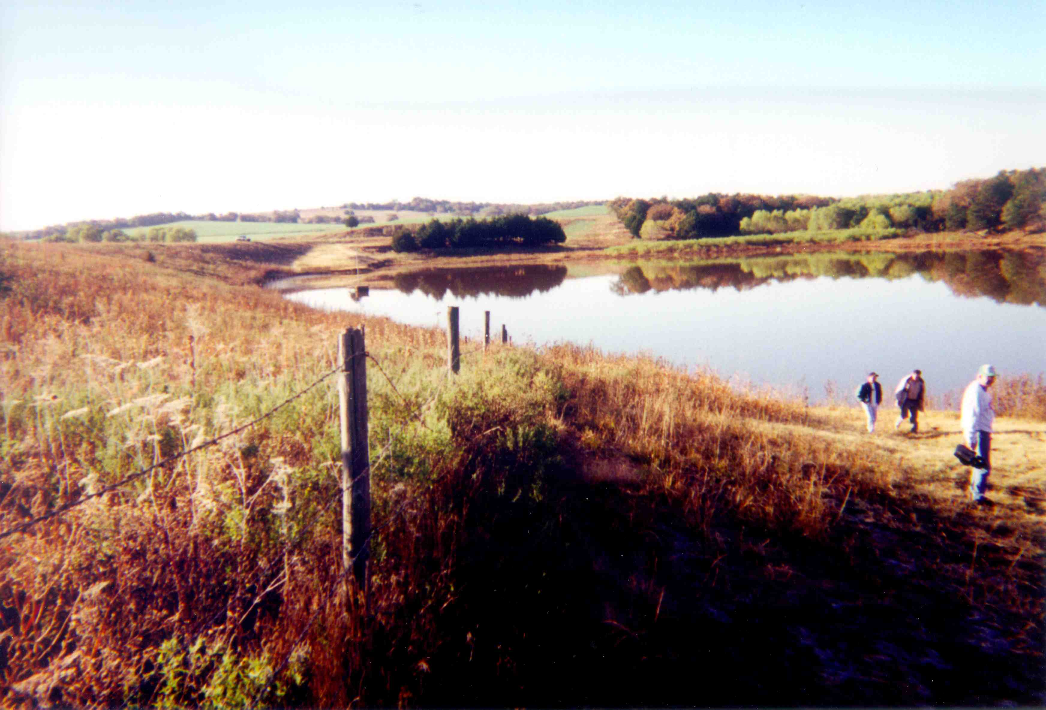
Figure 2-1. Photograph of Sugar Creek #12 looking directly south showing earthen embankment on left, spillway channel in far distance, and reservoir (November 1999).

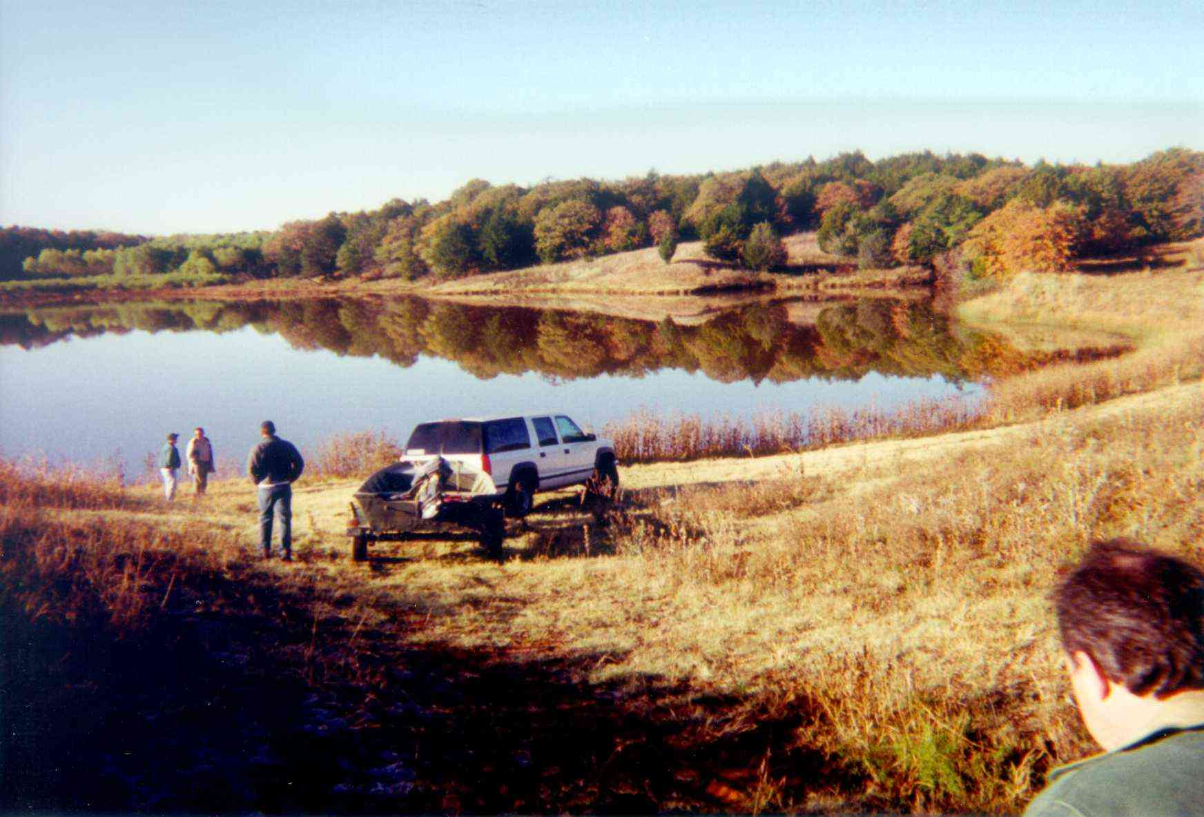
Figure 2-2. Photograph of Sugar Creek #12 looking toward the southwest showing the reservoir and the main tributary on right (November 1999).

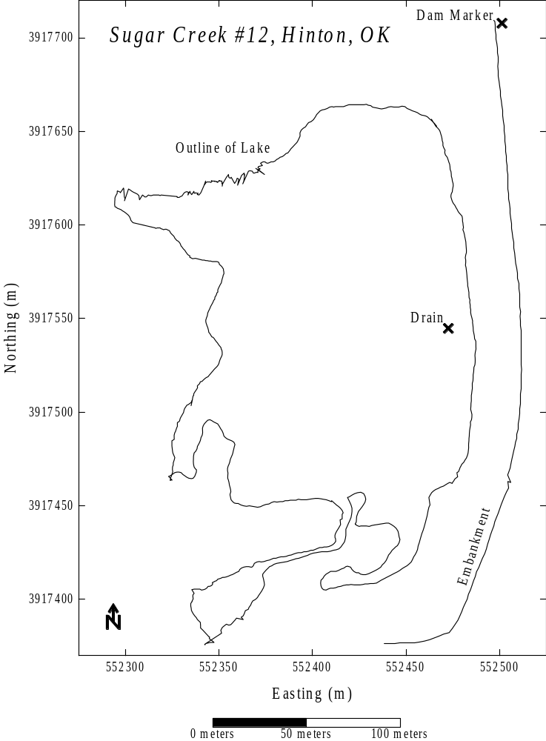
Figure 2-3. Base map of Sugar Creek #12 constructed from a hand-held global positioning system receiver with differential corrections applied. Shown are the outline of the lake, the centerline of the earthen embankment, the primary spillway drain, and the cement dam marker. All positions are in UTM coordinates.

3. Sediment Coring

Vibracoring is a common approach for obtaining undisturbed cores of unconsolidated sediment in saturated or nearly saturated conditions (Lanesky et al., 1979; Smith, 1984). Vibracoring works on the principle of transferring a high-frequency vibration to a thin-walled core pipe held in a vertical position on the sediment bed. The vibrating pipe causes the liquefaction or fluidization of sediment only at the core-sediment interface, thereby allowing the pipe to penetrate the sediment with little resistance and without disrupting sediment stratification.

A commercially available vibracoring system was used by Bennett and Cooper (2001) to obtain sediment cores. This system uses a 1-HP motor that drives a pair of weights (masses) eccentrically mounted on two shafts and housed within a water-tight aluminum chamber. When in operation, the masses rotate in opposite directions causing the chamber to vibrate at frequencies ranging from 6000 to 8000 RPM depending upon the sediment substrate. The chamber (driver) is connected to the top of an aluminum irrigation pipe 1.5-mm thick, 76-mm wide, and over 3-m long and cabled to a 4.2-m high aluminum tripod fitted with a battery-operated winch. Since the driver is sealed, the entire system can be immersed in water. A simple check valve placed into the flange connecting the core pipe to the driver induces internal suction during core extraction. The tripod is mounted to a raft that can be easily carried and assembled on site, towed with a small boat, and anchored into position.

Once the core was driven into the sediment, the vibrating motion was stopped and the winch lifted the core to the water surface. When successful, the core typically had a hard sediment bottom that acted as a seal. If excessive sand or gravel was present at the bottom of the core, the entire contents of the pipe would be lost during lifting. The position of the raft was recorded with a hand-held GPS receiver whose data were differentially corrected using available base station information. The core was transferred to the boat and transported to shore. Each core was opened on site by cutting the aluminum pipe length-wise on both sides with a circular saw, and the top half of the pipe was carefully lifted from the sediment.

Ten continuous, undisturbed cores were obtained by Bennett and Cooper (2001) at Sugar Creek #12 and their positions are shown in Figure 3-1. These cores ranged in length from 1.3 to 3.1 m and were extracted from water depths ranging from 0.5 to 3 m. Stratigraphic columns of all cores are shown in Figure 3-2. In general, the cores are composed of sand, silt, and clay. Very thick accumulations, up to 2.4 m, of silt and clay are common (see Cores 1, 2, 7, and 10, Figure 3-2). Many of these thick silt and clay units have thin-bedded sand units (ca. 5 to 20 mm) within them (see Cores 4, 9, and 10, Figure 3-2). Layers rich in organic material such as vegetation are also common. Virtually no gravel is observed.

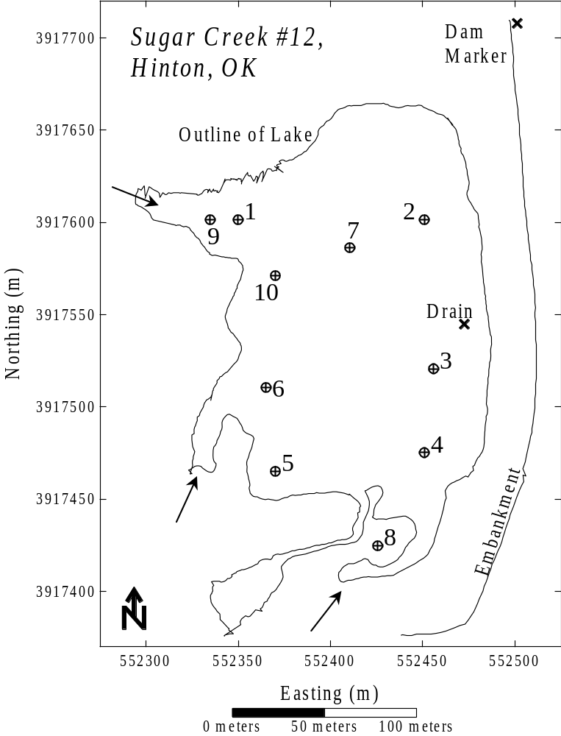
Figure 3-1. Base map of Sugar Creek #12 showing locations of all cores (numbered 1-10). Arrows show flow direction of major tributaries entering the reservoir. All positions are in UTM coordinates.

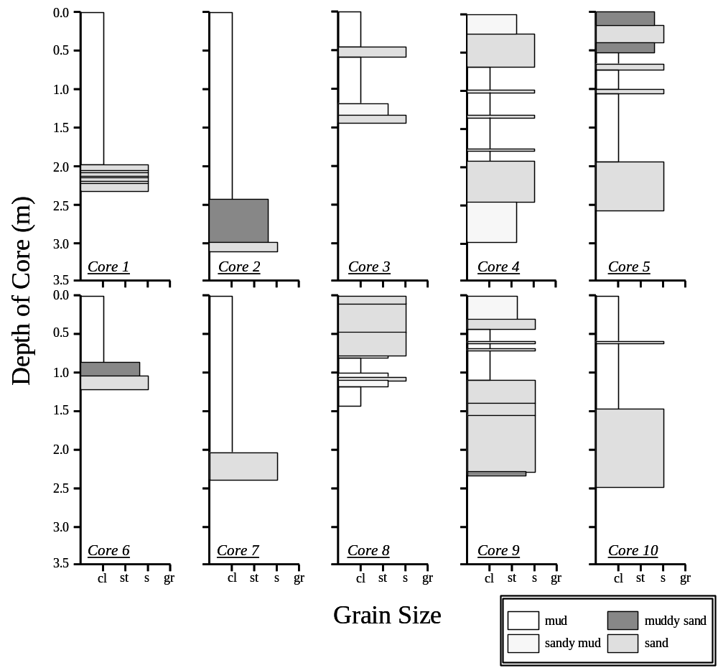
Figure 3-2. Stratigraphic logs of cores obtained at Sugar Creek #12 (see Figure 3-1 for exact location). cl—clay, st—silt, s—sand, and gr—gravel.

4. Acoustic Survey System

4.1 Acoustic Profiling System
The acoustic profiling system used herein was developed in collaboration between Baylor University and Specialty Devices, Inc. of Plano, TX (SDI; Dunbar, et al., 1999; Figure 4-1 to 4-4). The system was originally intended to be used in sediment surveys of large water supply reservoirs, but the commercialized version has been used to survey lakes, harbors, and rivers as well. The prototype electronics module includes one computer that controls the acoustic profiling, another that controls navigation, a built-in computer monitor, and a differential GPS navigation system. All of these components are contained in one, suitcase-sized water-resistant box. The prototype module weighs 15 kg. In the commercialized version, both subsurface profiling and navigation operations are controlled by a single, faster computer, resulting in an electronics module that is smaller and lighter. Power for the electronics and acoustic source is supplied by a 12 volt marine battery. Depending on the number and type of acoustic transducers used, the sound source may weigh between 25 and 75 kg. Hence, even though the system was designed for large reservoir surveys, deployment in small floodwater retention reservoirs is logistically practical.

The system images the bottom and sub-bottom sediments with up to five widely separated acoustic frequencies at a time. For large reservoirs, with water depths of 5 to 50 m and sediment fill thickness of 1 to 10 m, acoustic transducers with central frequencies of 200, 24, 24, 12, and 3.5 kHz are used. During acquisition the system collects traces using each transducer independently in rapid succession in round-robin fashion. The high-frequency signals provide a sharp image of low-density fluid mud at the water bottom, whereas the low-frequency signals penetrate many meters of sediment to image the base of sediment fill, even in areas of high sediment accumulation. The limitation of the 12 and 3.5 kHz transducers is that they require a minimum of 3 to 5 m of water depth to produce usable records while adding significantly to the weight of the sound source (50 kg).

As is typical of mature floodwater reservoirs, the water depth in most of Sugar Creek #12 was less than 1 m deep during the survey. Hence for the Sugar Creek #12 survey, the 12 and 3.5 kHz transducers were removed from the source pod. The resulting source pod, which includes the 200, 48 and 24 kHz transducers and frame, weighs 25 kg (Figures 4.2 and 4.4). The 24 and 48 kHz transducers require 1 to 2 m of water depth to produce usable records. During the survey, an extra control box that had been added to the system as an experiment was erroneously omitted. Without this extra control box, the 24 and 48 kHz would not work. Because most of the lake is less than 0.6 m deep, it is unlikely that the 24 and 48 kHz data would have been usable, even if it had been collected. Hence, the Sugar Creek #12 test was conducted with the 200 kHz transducer alone.

In surveys of water supply reservoirs with boat ramps and significant water depth, the profiling system is deployed from a 24-ft pontoon boat. As is typical of floodwater retention reservoirs, boat access to Sugar Creek #12 is limited to those that can be hand carried to the shore. A pair of 12-ft Johnboats joined together with an aluminum frame (Figures 4-1 and 4-2) provides a stable platform from which two or three people can work in water depths as little as 6 inches. The boats are powered with a 4 HP outboard motor or an electric trolling motor for low-speed profiling. The sound source is deployed on a mast between the two boats that holds the transducers at a constant depth below the surface and in a fixed position relative to the GPS antenna (Figure 4-2). Control over the transducer location in some fashion similar to this is required to achieve precision water depth information and sub-meter horizontal positioning accuracy.

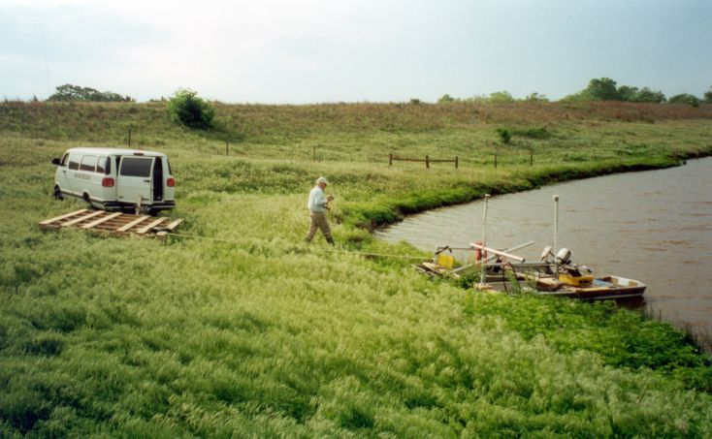
Figure 4-1. Photograph of Sugar Creek #12 showing the survey vessels (May 2001).

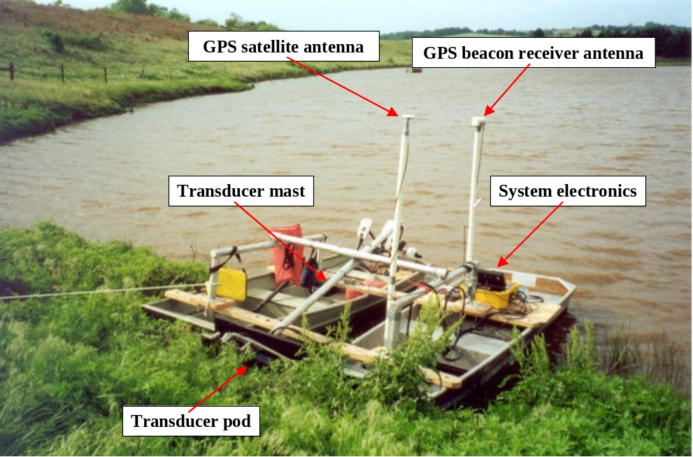
Figure 4-2. Photograph of Sugar Creek #12 showing the survey vessels, GPS antennae, and transducer mast and transducer pod (May 2001).

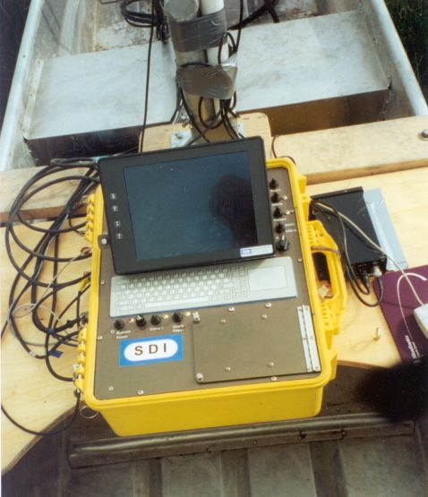
Figure 4-3. Photograph of acoustic profiling system (May 2001).

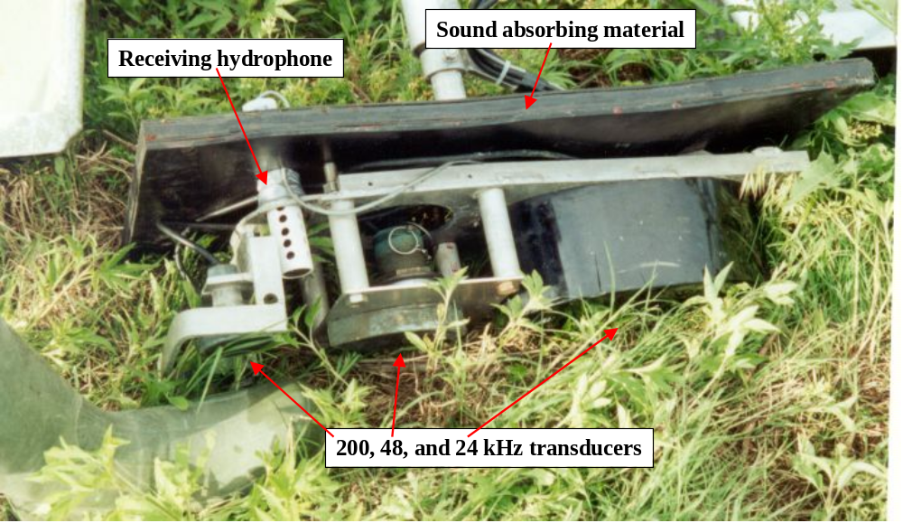
Figure 4-4. Photograph of multifrequency transducer pod (May 2001).

4.2 Survey Procedure
Conventional sediment surveys are conducted by collecting data along a series of parallel profiles at a set spacing that provides adequate spatial coverage, plus a number of tie lines to insure consistency in interpretation between profiles. During the survey, the pre-planned lines and the current boat location are displayed on the system monitor as the boat is navigated. DGPS corrections are received from U.S. Coast Guard beacons so that the location of the boat can be determined with sufficient accuracy to guide it down the line in real-time. For the Sugar Creek #12 survey, a strong correction signal was received from a station at Sallisaw, OK, which broadcasts at 299 kHz and 200 BPS. However for purposes of the survey, acoustic profiles were collected in different orientations with the goal of sampling the range of sediment thickness and water depths in the lake rather than to maximize the spatial coverage (Figure 4-5).

4.3 Digital Processing of Collected Acoustic Data
Figure 4-6 shows an unprocessed field record of the 200 kHz acoustic data collected along Line 9. Below the water bottom, the record is dominated by the first and second water bottom multiples. These events correspond to sound pulses trapped in the water layer and multiple reflected energy between the water bottom and the water surface. These reflectors are not associated with sediment layers within the subsurface. The deeper parts of the record (Figure 4-6) are dominated by scattered returns from the lake sediments from depths exceeding 5 m. The base of the sediment is not recognizable from these raw, unprocessed data.

The main difference between conventional bathymetric surveying and subsurface profiling is that subsurface profiling involves more extensive digital processing and interpretation of the collected data. The goal of post-survey processing is to correct the recordings for wave propagation effects that interfere with the subsurface image. Two corrections were applied to the Sugar Creek #12 data. The first, called spherical divergence, scales the traces by a factor that increases with time, such that the normal decay in amplitude of the signal with travel distance is removed. In relatively deep water, this is normally the only correction that is needed. However in shallow water typical of flood control reservoirs like Sugar Creek #12, reverberation within the water layer tends to mask the true subsurface returns. The reverberations are produced as signal pulses are reflected between the water surface and the water bottom. The second correction, called predictive deconvolution, is a standard tool used to remove such multiples. It works by filtering out components of the trace that are predictable, based upon earlier parts of the trace. The repeated arrivals of pulses trapped in the water layer fall into this category and are effectively removed by this processing technique (Figure 4-7). To facilitate routine application of this process to the subsurface data, a custom implementation is used that reads the binary field records produced by the SDI system, performs the predictive deconvolution, and writes a processed file in the same format.

For the example shown in Figure 4-7, predictive deconvolution with a prediction distance of 50 microseconds (10 times the dominate wave period) was applied to remove the water bottom multiples. In the processed record, the water bottom is more distinct, the multiples are largely removed, and a gradational base of sediment is observable as compared to the unprocessed record of Figure 4-6. All data collected were processed in a similar fashion.

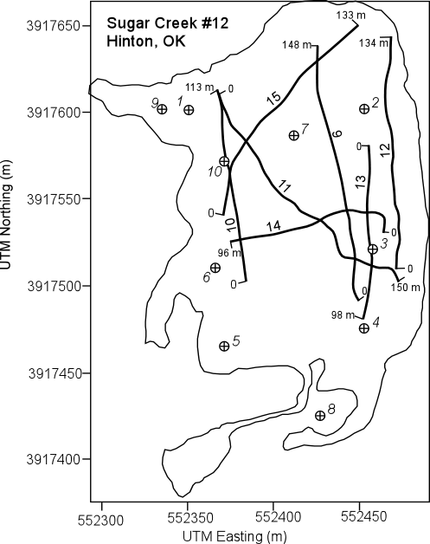
Figure 4-5. Map of Sugar Creek #12 acoustic survey. Positions of acoustic profiles Line 9 through Line 15 are shown and line length is given in meters. Circles with crosses indicate the locations of 10 cores collected by Bennett and Cooper (2001). Coordinates are given in UTM.

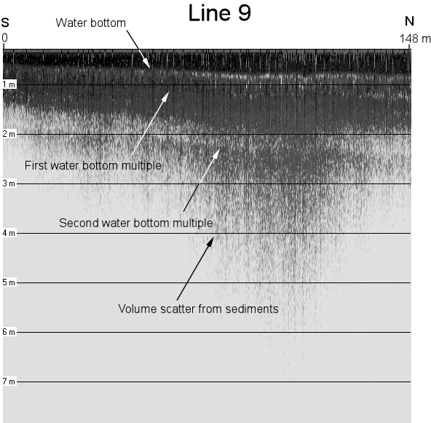
Figure 4-6. Unprocessed field record of 200 kHz acoustic data collected along Line 9. See Figure 4-5 for line position. The water column is clear at a depth of 0.5 m on the south end of the line, increasing to 0.75 m on the north end.

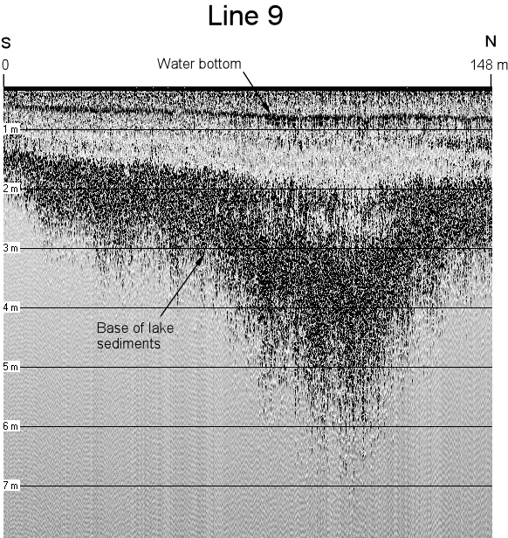
Figure 4-7. Field record of 200 kHz acoustic data collected along Line 9 after digital processing. See Figure 4-5 for line position.

4.4 Interpreting the Processed Data
Once the profiles are in an interpretable form, the task is to identify the stratigraphic surfaces of interest and to trace them along each profile. This is accomplished using a custom interpretation program “Depthpic” that reads and displays the SDI binary files. The user traces the water bottom and subsurface horizons by drawing on the displayed acoustic data using the computer mouse. The depth and horizontal position of each interpreted point is exported to a file that can be read by a mapping program. For the Sugar Creek #12 survey, a velocity of 1470 m/s is used to represent the average velocity of both water and sediment, which is a typical velocity for fresh water. It may overestimate the velocity of the clay-rich sediments by as much as 3% and it may underestimate the speed in the sand-rich sediments by as much as 2%.

The interpretation of the acoustic data began with Line 9, which crosses the deepest part of the sediment pool (Figure 4-8). The water bottom is clear and traceable on this and all other profiles (shown as a blue line, Figures 4-9 to 4-14). Below the bottom, three distinct acoustic facies (a package or layer of sediment) can be defined, based upon the scatter intensity level. Approximately the first meter of sediment below the bottom on all the profiles is acoustically transparent. The transparent acoustic facies is associated with shallow fine-grained sediment. In places the transparent facies contains darker streaks that thicken towards the flanks of the basin, such as near the north end of Line 9 (near the 148 m end Figure 4-8). Where one of these streaks was cored (Figure 4-9), it is associated with a coarse-grained layer within the fine-grained sediments. These darker streaks are interpreted as coarse-grained wedges shed from the flanks of the basin during prolonged low stands. However, no attempt was made to map these small packages.

At depths greater than about 1 m below the current lake bottom, all the records show a rapid increase in the scatter return level, causing the displays to turn from light gray to speckled-black. This zone is called the intermediate-scatter intensity facies. On Line 9 (between the blue and green lines, Figure 4-8), the scatter intensity within this facies decreases towards the center of the basin, as if the source of the scatter is depositionally controlled within the lake environment. However, the onset of the intensity increase does not correlate with a recognized textural change within the cores.

Below the intermediate-scatter facies is an interval of high-scatter intensity. The scatter intensity within this facies does not decrease toward the center of the basin as does the overlying intermediate-scatter intensity facies. Hence, in the center of the basin on Line 9 (between the orange and green lines, Figure 4-8) and Line 15 (Figure 4-14), the distinction between the intermediate- and high-scatter intensity facies is clear. On the flanks of the basin, the difference between these two facies is subtle. The interface between the intermediate- and high-intensity scatter facies correlates with the interface between fine-grained and coarse-grained sediments in Core 7 on Line 9 (Figure 4-8) and Line 15 (Figure 4-14) and Core 10 on Line 10 (Figure 4-9). This interface also correlates with the base of post-impoundment sediment interpreted from ¹³⁷Cs analysis of Cores 4, 7, and 9 (Figure 4-25). Therefore, the acoustically transparent and intermediate-scatter facies correspond to the post-impoundment sediment fill.

On all lines, the high intensity scatter facies exhibits a gradational base, in which the scatter amplitude decays over an interval of about 0.5 m. The onset of the decay maps as an irregular surface that is consistent from line to line (see composite Figures 4-15 to 4-24). The surface reaches a maximum depth of 5.5 m below the water surface on Line 9 (Figure 4-8 and 4-15), at a point along the trend of the main inlet to the lake. This surface is interpreted as the base of pre-impoundment sediments, which likely takes the form of sand-rich alluvial sediments and soils.

Figure 4-8. Processed Line 9 with interpretation. See Figure 4-5 for line position. The position of Core 7 from Bennett and Cooper (2001) is projected onto the line from a distance of 19 m.

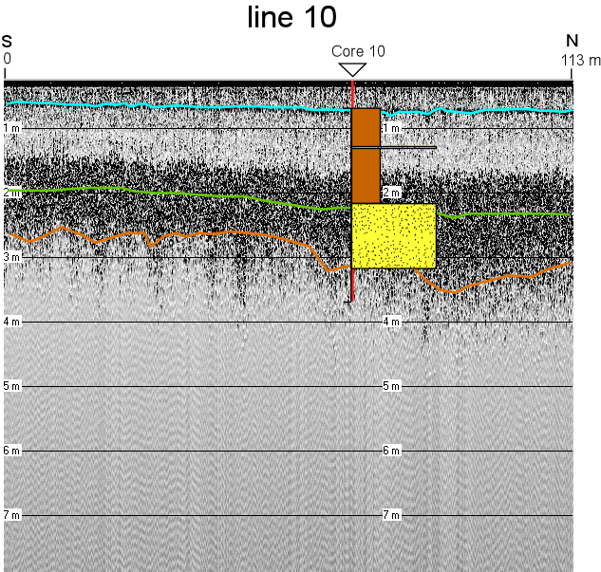
Figure 4-9. Processed Line 10 with interpretation. See Figure 4-5 for line position. The position of Core 10 from Bennett and Cooper (2001) is shown.

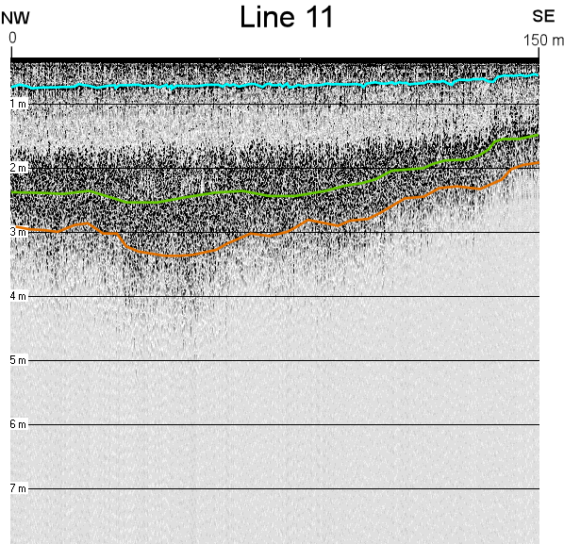
Figure 4-10. Processed Line 11 with interpretation. See Figure 4-5 for line position.

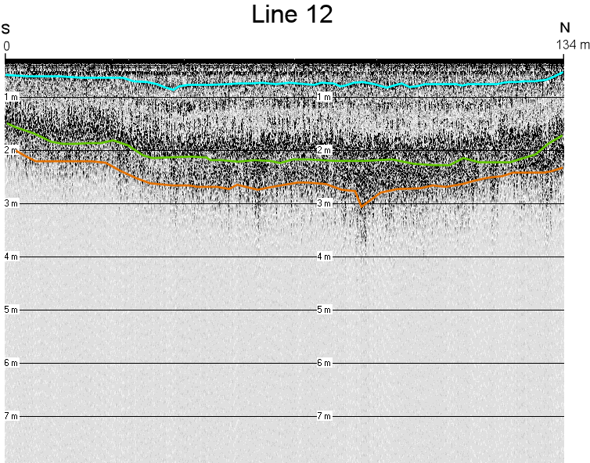
Figure 4-11. Processed Line 12 with interpretation. See Figure 4-5 for line position.

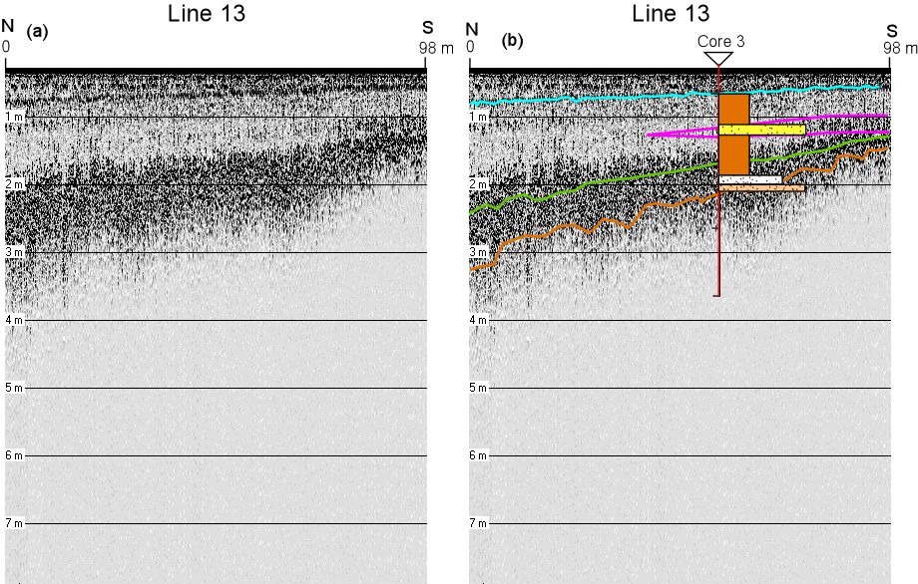
Figure 4-12. Unprocessed (left) and processed and interpreted (on right) Line 12. See Figure 4-5 for line position.

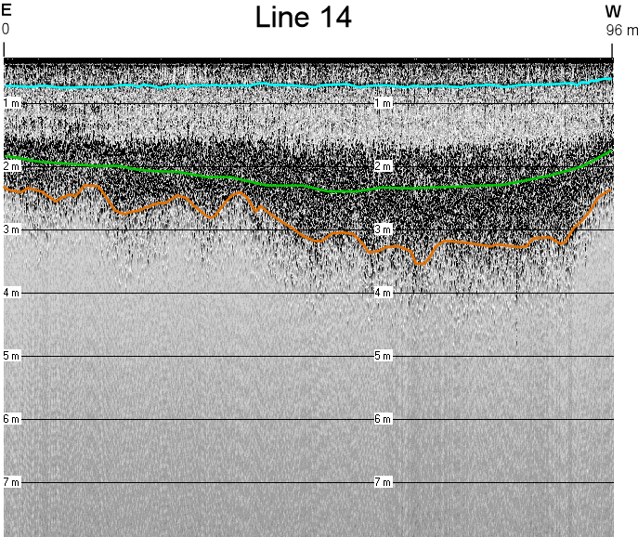
Figure 4-13. Processed Line 12 with interpretation. See Figure 4-5 for line position.

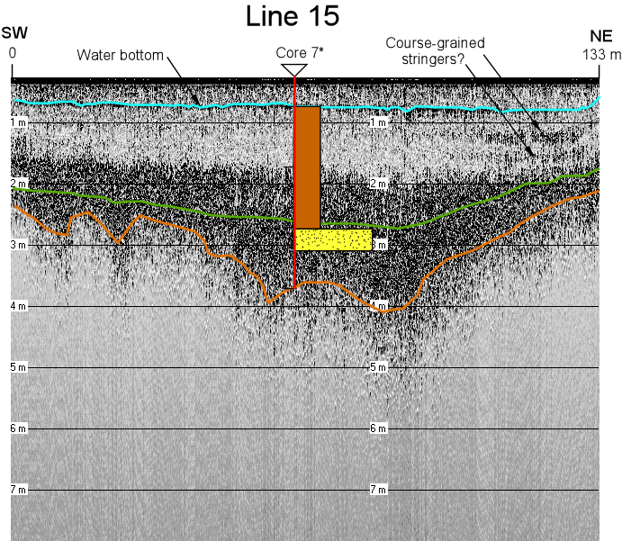
Figure 4-14. Processed Line 15 with interpretation. See Figure 4-5 for line position. Location of Core 7 projected onto the core from a distance of 19 m.

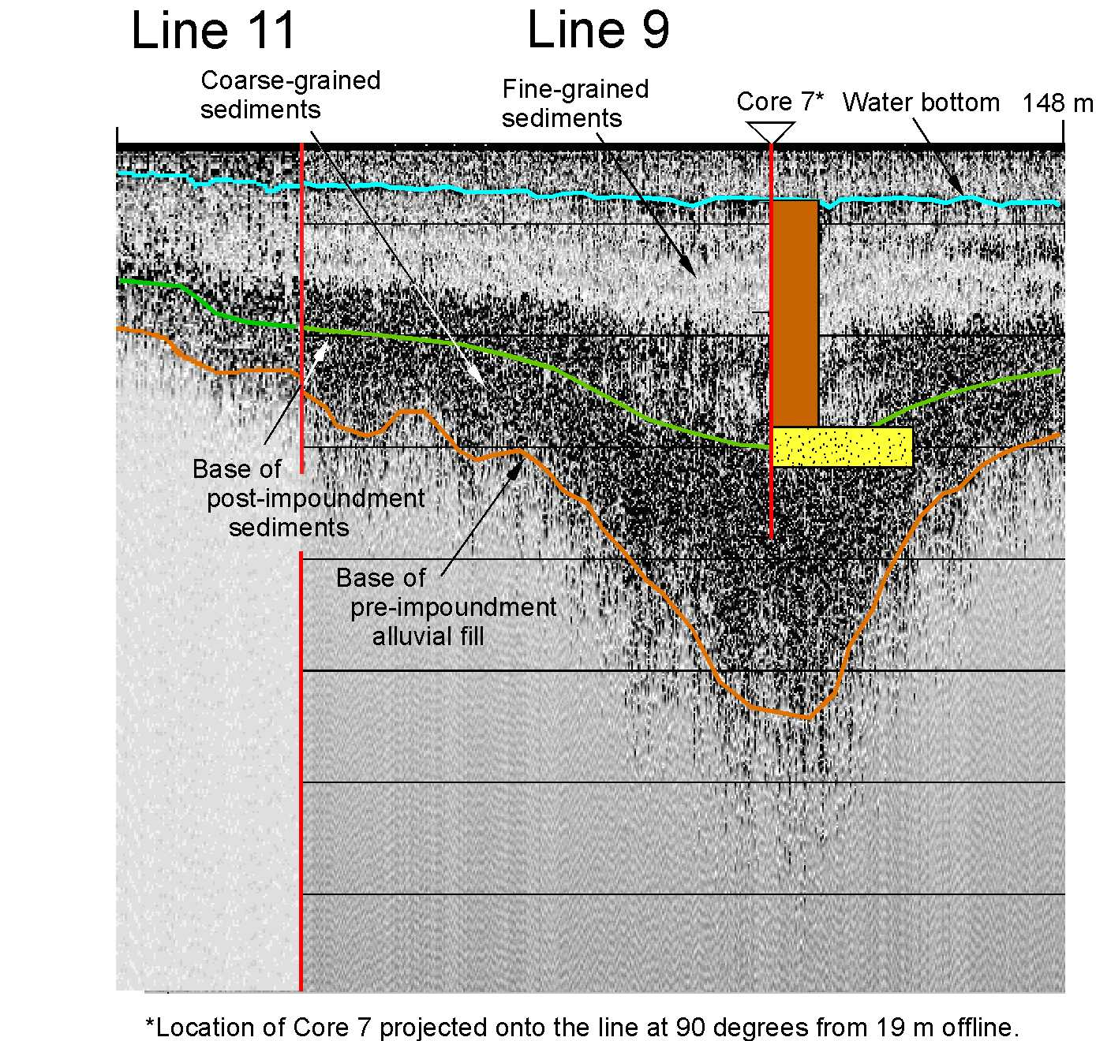
Figure 4-15. Composite profile formed from the south end of Line 11 and the north end of Line 9. See Figure 4-5 for line positions. Location of Core 7 projected onto the line from a distance of 19 m. The intersection between the two lines is shown in red.

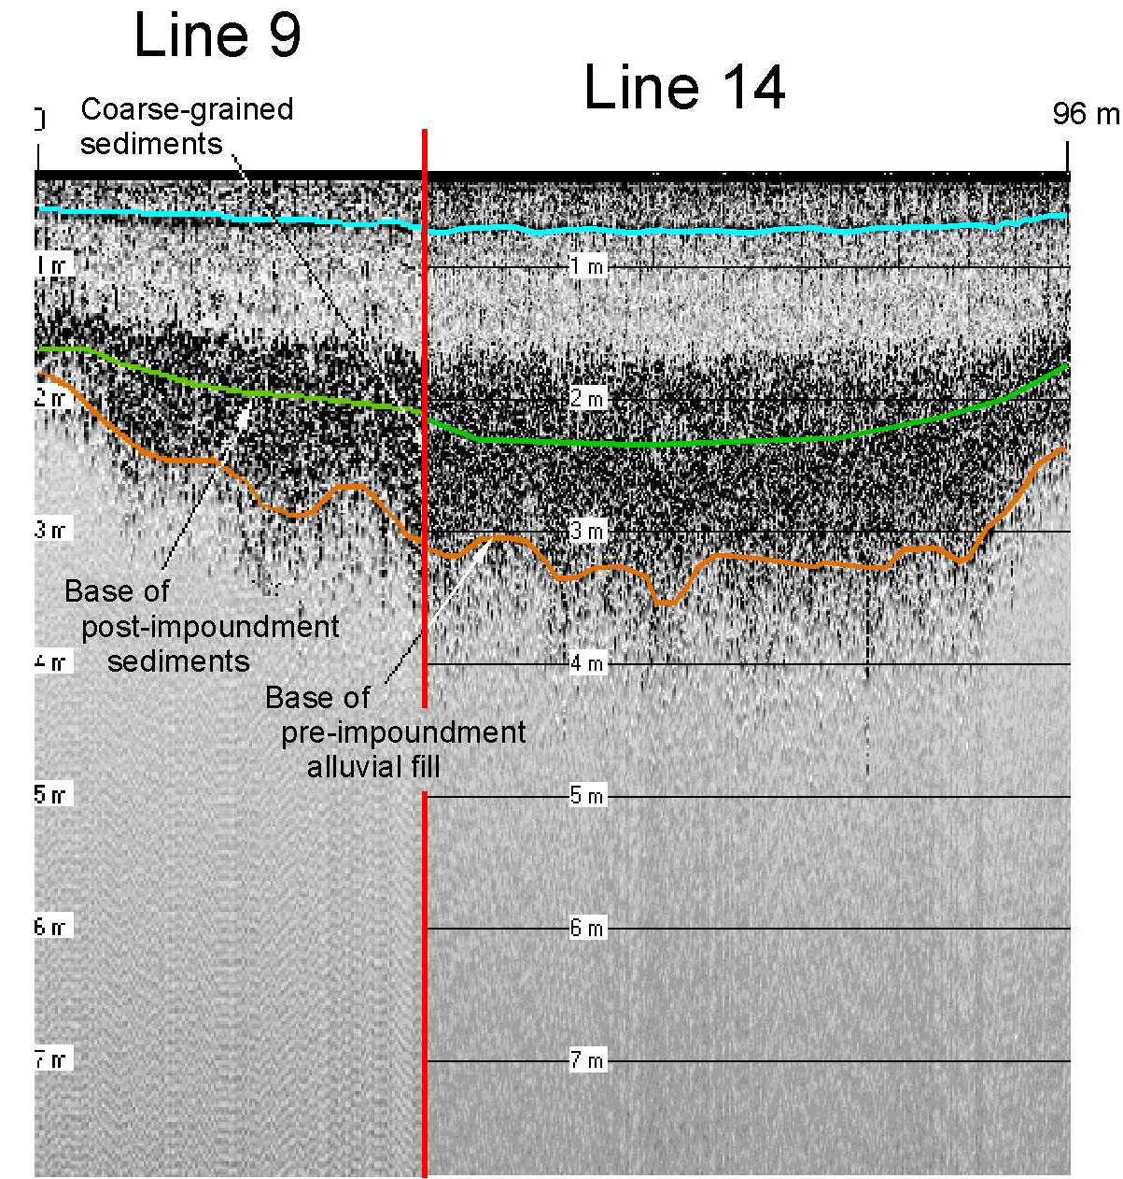
Figure 4-16. Composite profile formed from the south end of Line 9 and the east end of Line 14. See Figure 4-5 for line positions. The intersection between the two lines is shown in red.

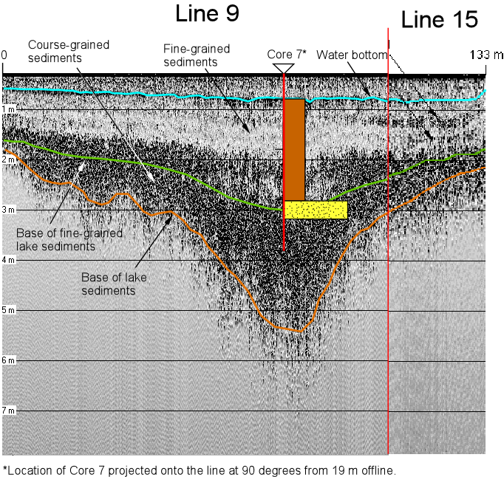
Base of pre-impoundment alluvial fill
Base of post-impoundment sediments
Coarse-grained stringers
Figure 4-17. Composite profile formed from the south end of Line 9 and the east end of Line 15. See Figure 4-5 for line positions. Location of Core 7 projected onto the line from a distance of 19 m. The intersection between the two lines is shown in red.

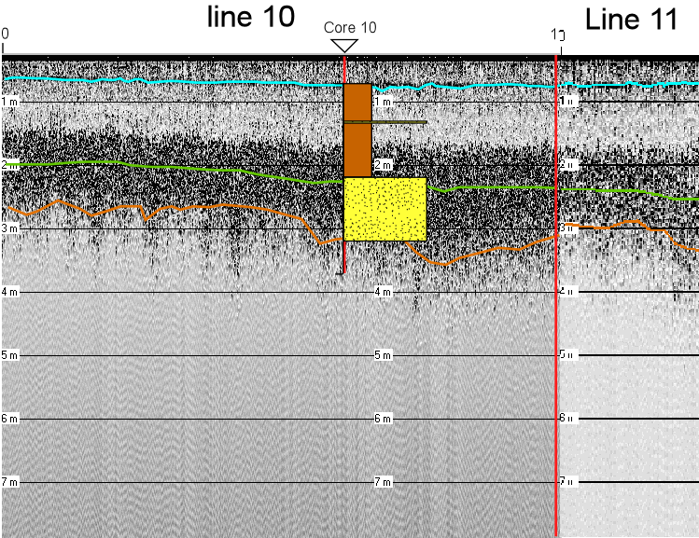
Figure 4-18. Composite profile formed from the south end of Line 10 and the west end of Line 11. See Figure 4-5 for line positions. The intersection between the two lines is shown in red.

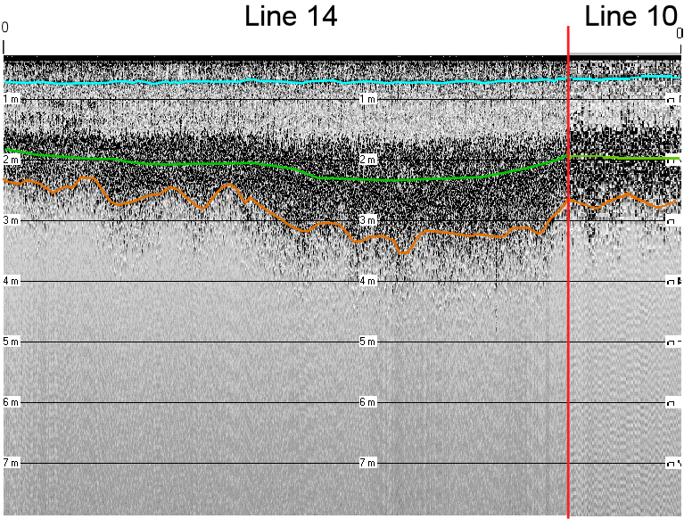
Figure 4-19. Composite profile formed from the south end of Line 10 and the east end of Line 14. See Figure 4-5 for line positions. The intersection between the two lines is shown in red.

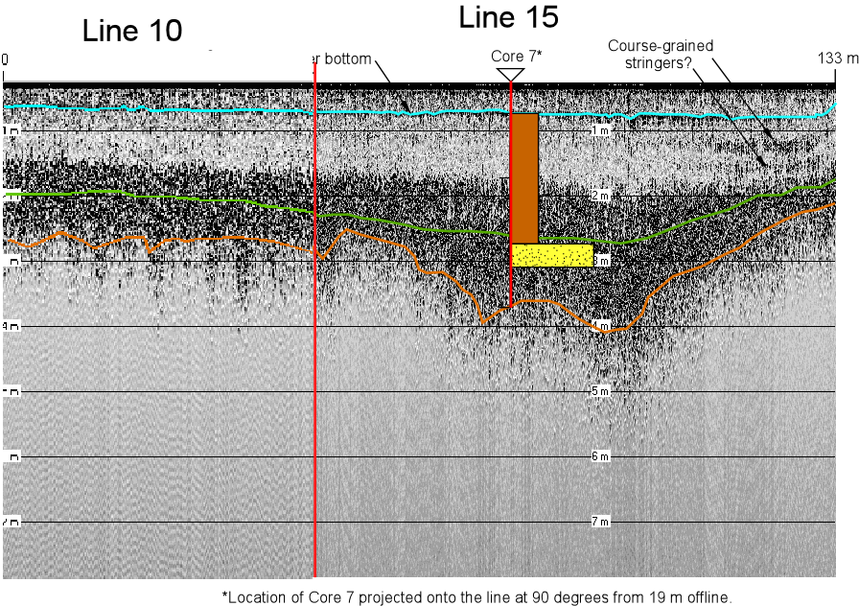
Figure 4-20. Composite profile formed from the south end of Line 10 and the east end of Line 15. See Figure 4-5 for line positions. Location of Core 7 projected onto the line from a distance of 19 m. The intersection between the two lines is shown in red.

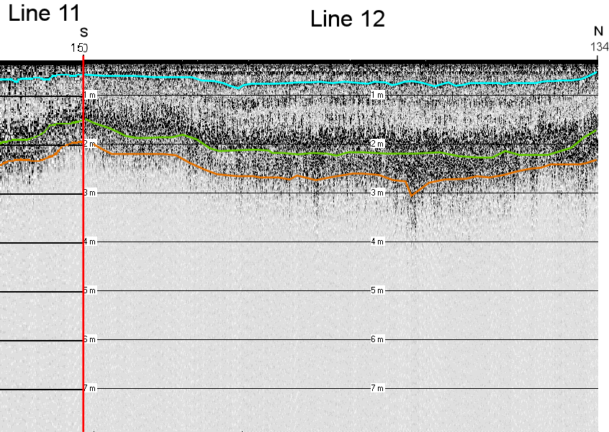
Figure 4-21. Composite profile formed from the east end of Line 11 and line 12. See Figure 4-5 for line positions. The intersection between the two lines is shown in red.

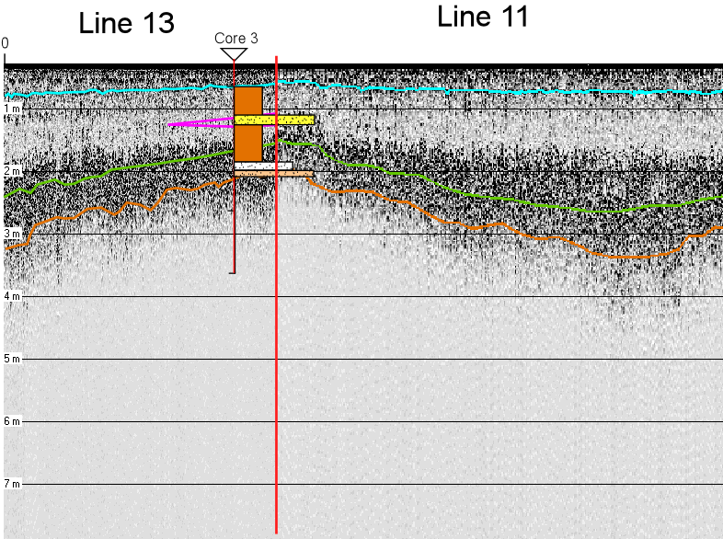
Figure 4-22. Composite profile formed from the west end of Line 11 and the north end of Line 13. See Figure 4-5 for line positions. The intersection between the two lines is shown in red.

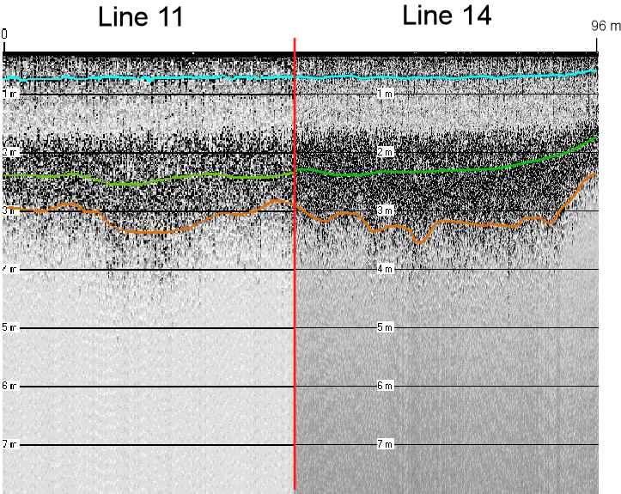
Figure 4-23. Composite profile formed from the west end of Line 11 and the west end of Line 14. See Figure 4-5 for line positions. The intersection between the two lines is shown in red.

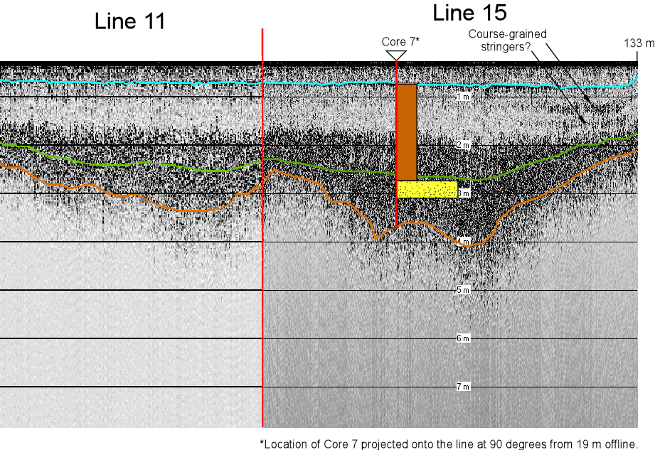
Figure 4-24. Composite profile formed from the east end of Line 11 and the north end of Line 15. See Figure 4-5 for line positions. Location of Core 7 projected onto the line from a distance of 19 m. The intersection between the two lines is shown in red.

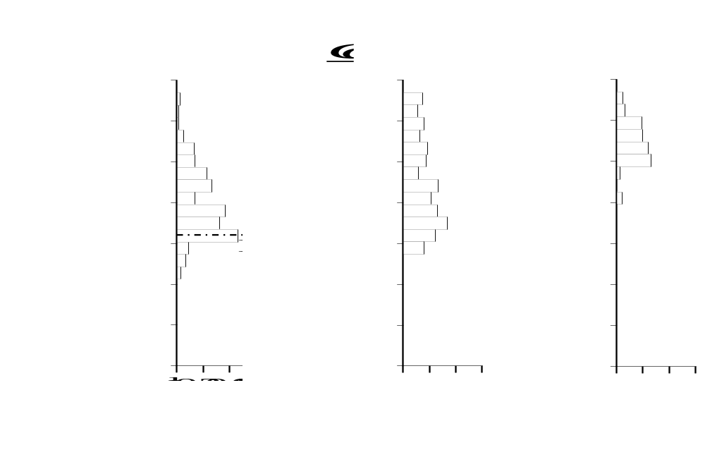
Figure 4-25. Stratigraphic columns and radioactive ¹³⁷Cs emissions (becquerels per gram; Bq/g) for Cores 4, 7, and 9 taken at Sugar Creek #12 (Bennett and Cooper, 2001). For the stratigraphic logs, grain size and lithologic descriptions are based on observational criteria. The peaks in the distributions of ¹³⁷Cs coincide with the 1964 datum, and some samples near the top and bottom of each core had zero emissions.

4.4 Mapping Volumetrics
The acoustic survey of Sugar Creek #12 was intended as a demonstration of the system rather than as a detailed volumetric determination of impounded sediment. A program of more closely spaced profiles covering the complete lake would be required to produce accurate water and sediment volume estimates. However, contour maps of water depth (Figure 4-26), depth to the base of sediments (Figure 4-27), and thickness of sediment (Figure 4-28) were constructed to demonstrate how such analysis could be performed with the data the system produces. To generate the water and sediment depth maps, the interpreted depths and horizontal positions for each profile were exported from Depthpic to an ASCII file of x, y, z values. These were read by Surfer™, gridded using a minimum curvature procedure, and contoured. The contour maps generated by Surfer™ were then exported to a drafting program to make the final figures. The sediment thickness map (Figure 4-28) was generated in the same way, except that the sediment isopach thickness (the difference between the depth to the base of sediment and the water depth) was exported directly from Depthpic.

The resulting maps are likely to be most accurate in the northern part of the lake, where the greatest concentration of acoustic profiles lies and least accurate in the extreme southern part of the lake, which were not surveyed. The sediment thickness map indicates a maximum sediment thickness located along the axis of the main inlet in the northwest corner of the lake. In comparison to the data collected by Bennett and Cooper (2001), there is excellent agreement between acoustically determined sediment thickness and the thickness observed in Cores 2, 3, 6, 7, and 10 (Table 4-1).

Since the survey was restricted to the flooded pool, not all of the sediment deposited was taken into account. According to Larry Caldwell (USDA-NRCS, personal communication), much sediment, especially the coarse-grained size fractions, gets deposited within the tributary arms entering the reservoir. These sediments were not surveyed here, yet their contribution to the total volume of deposited sediment, hence reservoir storage capacity, can be significant.

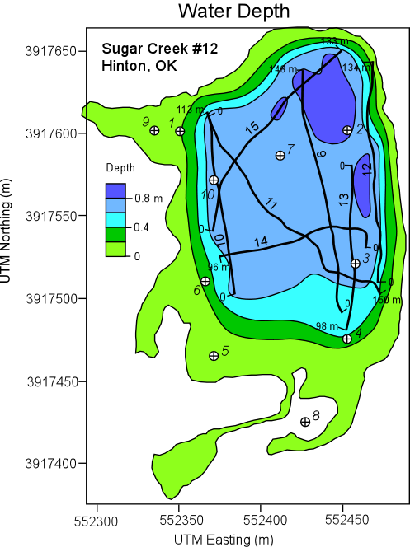
Figure 4-26. Contour map of water depth in Sugar Creek #12 during the acoustic survey. All positions are in UTM coordinates.

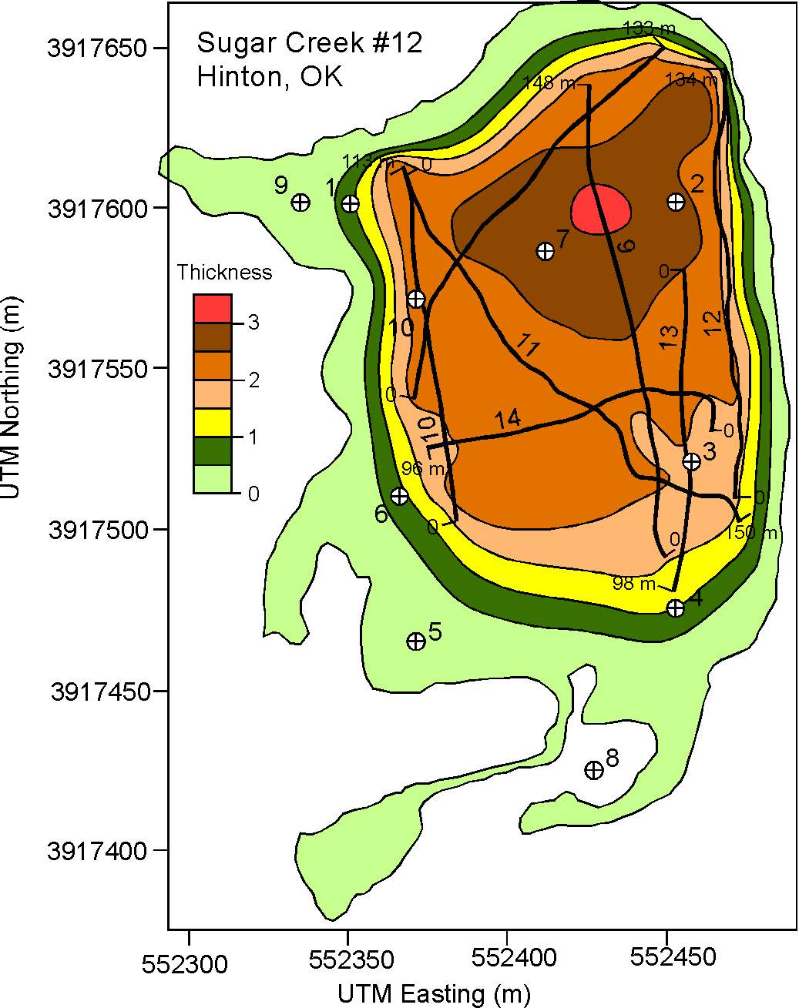
Figure 4-27. Contour map of base of sediments in Sugar Creek #12. All positions are in UTM coordinates.

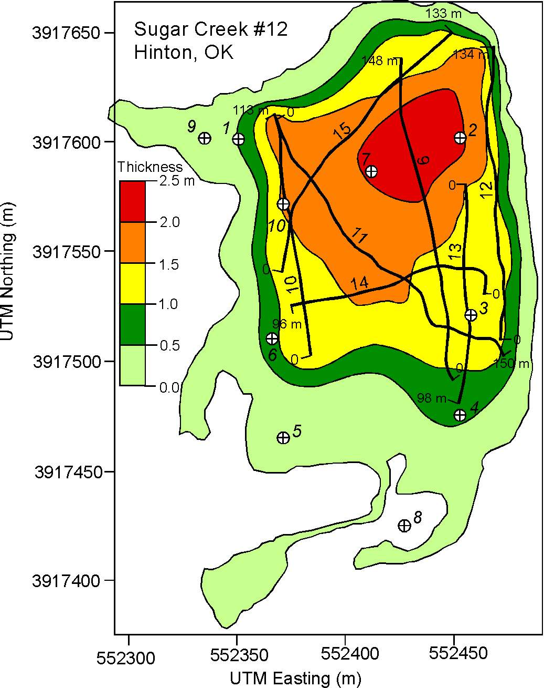
Figure 4-28. Contour map of the sediment thickness in Sugar Creek #12 derived from the processed and interpreted acoustic data. All positions are in UTM coordinates.

Table 4-1. Comparison of thickness of impounded (post-construction) sediment determined by Bennett and Cooper (2001) from sediment core data and those determined herein using acoustic technology.

Core | Thickness of Impounded (Post-Construction)  Sediment (m)
Number | Bennett and Cooper (2001) | Present Study
1 | 1.98 | Outside range of data
2 | 2.44 | 2.0
3 | 1.14 | 1.2
4 | 1.93 | Outside range of data
5 | 1.93 | Outside range of data
6 | 1.04 | 0.7
7 | 2.03 | 2.1
8 | 1.45 | Outside range of data
9 | 1.09 | Outside range of data
10 | 1.47 | 1.5

5. Discussion

The SDI acoustic profiling system in its current configuration produced interpretable images of the water bottom and the base of sediment fill, satisfying the primary goal of the survey. However, there were limitations in the survey as it was conducted with the current system. First, the spatial coverage of the lake was limited to areas with more than 0.25 m of water to accommodate the dimensions of the current transducer pod and the draft of the boats. To produce accurate surveys of this and similar lakes, it would be necessary to measure both water depth and sediment thickness in as little as a few centimeters of water. The ideal system and survey vessel (or amphibious vehicle) would work and provide acoustic coverage from zero water depth at the lakeshore, continuously out to water depths of several meters.

The second limitation was uncertainty in tracing the base of sediment fill. Because of the gradational character of the 200 kHz acoustic response of the basal surface in Sugar Creek #12, the basal surface can only be traced with an accuracy of ±0.25 m with 200 kHz data alone. If the basal surface were consistently picked wrong within this level of uncertainty, the associated total sediment volume could be in error by 25% or more. A possible solution to this and the water depth limitation would be to add two new frequencies to the system which bracket the existing 200 kHz transducer. An additional 100 kHz transducer would be operable in essentially zero water depth and would provide a sharper image of the basal surface. An additional 400 kHz transducer would image the water bottom in only a few centimeters of water. Finally, to operate the system from the shore through water only a few centimeters deep it would be necessary to switch from using boats to a small amphibious vehicle.

The acoustic images of the sediment fill in Sugar Creek #12 contained acoustic-stratigraphic features that correlated well with a thin coarse-grained layers observed in previously collected cores. Hence, the secondary objective of imaging stratigraphic surfaces within the sediment fill was also achieved with the current system. There were also acoustic-stratigraphic features in the data that did not correlate to observed textural changes in the cores. The most unusual aspects of the Sugar Creek #12 profiles is the intermediate- and high-scatter acoustic facies and the gradational nature of the basal surface. These features have not been observed in other small reservoirs.

6. Conclusions

Since 1948, the USDA-NRCS has constructed over 10,000 upstream flood control dams in 2000 watersheds in 47 states, most with a design life of 50 years. The watershed projects, which represent a $14 billion infrastructure, have provided flood control, municipal water supply, recreation, and wildlife habitat enhancement. Because of population growth and land use changes through time, sediment pools are filling, some structural components have deteriorated, safety regulations are stricter, and the hazard classification for some dams has changed.

Before any rehabilitation strategy can be designed and implemented, the sediment impounded by these dams must be assessed in terms of the structure’s efficiency to regulate floodwaters and the potential hazard the sediment may pose if reintroduced into the environment. To this end, a demonstration project was designed to evaluate the application of acoustic technology to determine (1) the thickness of sediment impounded within a flood control reservoir and (2) the spatial distribution and characteristics of the sediments within the pool.

One field site was chosen for this demonstration project. Sugar Creek #12 is located near Hinton, OK, and was constructed in 1964. It is a relatively small lake with a mud bottom and fairly shallow water depths. The main stream supplying the lake is considered unstable due to the presence of actively migrating knickpoints, and excessive sedimentation rates have significantly decreased storage capacity. Moreover, historic land use of cultivated fields of cotton and peanuts suggests that agrichemicals may be present in the lake sediments.

In May 2001, an acoustic survey of the reservoir sediments was conducted using an acoustic subsurface profiling system. The system can comprise up to five acoustic transducers with operating frequencies of 200, 24, 24, 12, and 3.5 kHz, a receiving hydrophone, and a signal processor that controls the acoustic profiling, data collection and processing, and navigational systems. This portable system was deployed from two Johnboats. Because of water depth limitations and omitted equipment, only the 200 kHz transducer was used during the survey.

All collected data were post-processed to amplify the acoustic signals at depth (spherical divergence) and to remove reverberations or multiple sound waves due to the shallow water depth (predictive deconvolution). Once processed, the acoustic data can be interpreted and subsurface stratigraphic horizons can be identified.

The acoustic survey successfully identified numerous stratigraphic horizons within the subsurface. These stratigraphic horizons agree extremely well with sediment core data previously collected. By combining the acoustic and sediment core data, the distribution of sediment thickness, hence sediment volume, is mapped. The thickness of the impounded sediment deduced using the acoustic system agrees well sediment core data previously recovered. Further analysis of the data is not possible because of the limitation of using only the 200 kHz transducer.

This pilot project successfully demonstrated the application of acoustic technology for conducting fast, cost-effective sedimentation surveys within flood control reservoirs. Improvements to the existing system have been identified that will ultimately enable its application in all reservoirs regardless of size, water depth, and composition and thickness of deposited sediment.

7. References

Bennett, S.J., and C.M. Cooper, 2001, Characterizing the sediment impounded by USDA-NRCS flood control dams, Oklahoma. A final report prepared for the USDA-NRCS, Stillwater, OK. USDA-ARS National Sedimentation Laboratory Research Report No. 20, 135pp.
Caldwell, L.W., 1999, Rehabilitating our nation’s aging small watershed projects. Presented at the Soil and Water Conservation Annual Conference, Aug. 8-11, Biloxi, MS.
Caldwell, L.W., 2000, Good for another 100 years: The Rehabilitation of Sergeant Major Creek Watershed. Presented at the Association of State Dam Safety Officials, September 28-30, 2000, Providence, RI.
Dunbar, J.A., P.M. Allen, and P.D. Higley, 1999, Multifrequency acoustic profiling for water reservoir sedimentation studies. Journal of Sedimentary Research, 69, 521-527.
Lanesky, D.E., B.W. Logan, R.G. Brown, and A.C. Hine, 1979, A new approach to portable vibracoring underwater and on land. Journal of Sedimentary Petrology, 49, 654-657.
Smith, D.G., 1984, Vibracoring fluvial and deltaic sediments: Tips on improving penetration and recovery. Journal of Sedimentary Petrology, 54, 660-663.

