POLAR Spacecraft Status As of: Tues, 27 Sept, 16:00 EST
(changes from last week in bold border)
Subsystem/  Component | NOAA-12D  AM 16:51=AN  STIP data only | NOAA-14J  AM: 20:39=AN  STIP data only | NOAA-15K  AM: 18:06=AN  GAC data only | NOAA-16L  PM: 14:41=AN  GAC&LAC data | NOAA-17M  AM: 22:25=AN  GAC&LAC data | NOAA-18N  PM 14:00=AN  GAC & LAC data
LAUNCHED | 05/14/91 | 12/30/94 | 05/13/98 | 09/21/00 | 6/24/02 | 5/20/05
CNTL OBP | OBP2 | OBP2  OBP1 inoperative | OBP2 | OBP2 | OBP2 | OBP2
BUS | B-BUS  XSU-1 | B-BUS  XSU2 (XSU1 inop) | B-BUS  XSU-1 | B-BUS  XSU-1  XSU1 TOAR 444 | B-BUS  XSU-1 | B-BUS  XSU-1
BUS VETO | NO | NO | NO | NO | NO | NO
ADACS  X=Yaw  Y=Roll  Z=Pitch | Nominal Mode  RGmode=Monitor  Gyro chans=XYZ | Nominal Mode  Rgmode=Disabled  Gyro chans=XYZ  SS check Disabled when mode=YGC | Nominal Mode  Rgmode=Monitor  Gyro-3 Off 6/26/00 Gyro chans=AAB  N2 Low PSI invalid | Nominal Mode  Rgmode=Monitor  Gyro-3 Off 6/10/04  Gyro chans=AAA | Nominal Mode  Rgmode=Monitor  Gyro-3 Off 6/10/04  Gyro chans=AAB  Gyro-2 investigation | Nominal Mode  Gyro-A MIMU-2  Z-wheel -Pitch  TOAR 447. Array slew test 21-23 Sept
RXO | PRI  BU random enables  daily bias+6.5 mS | PRI  BU random enables daily bias–7.0 mS | PRI  daily bias -8 mS  +100 mS 31Aug04 | PRI  Daily Bias –5.5 mS  -100 mS 31Aug04 | PRI  Daily Bias –3 mS | PRI  No daily bias
CLOCK DIV | 2 | 2 | 2 | 2 | 2 | 2
MIRP | External Synch  Rephase Enabled | External Synch  Rephase 0730 Daily  Plan to change to once per orbit | External Synch Rephase 0730 daily | External Sync  Rephase each orbit | External Sync  Rephase Enabled | External Synch  Rephase Enabled
TIP SIDE | 1 | 1 | 2 (4/3/03)  3 Channels inop | 2  since 4/18/05 | 1  Analog telem drifting | 1
Recorders  (DTR, SSR) | DTRs 3A, 4, 5B  Safestate 5B | DTRs 1, 2B, 5 Safestate- 1B | DTRs 1, 2, 3, 4 Safestate 1B EOT | DTRs 1, 2, 3, 4A  Safestate 3A  4B STIP only | DTR 1,3,4 / SSR 2  Safestate=DTR 2B  As of 21 Sept | SSRs 1,2,3,4,5  Current spikes  TOAR 450  Plan SS switch to 5 b date TBD
VTX  (APT data) | #1 ON  137.50 MHZ | OFF (nominal)  Since 8/2/05 | #1 ON  137.50 MHZ | INOP/Off  OFF since 11/15/00 | #2 ON  137.62 MHZ  Conflict with N14 | #2 ON  137.9125 MHZ  Swap to #1 postponed until TBD
BTX | #1  136.77 MHZ | #2  137.77 MHZ | #1  137.35 MHZ | #2  137.77 MHZ | #2  137.77 MHZ | #1  137.35 MHZ
STX  1 = rcp 1698.0 mhz  2 = lcp 1702.5 mhz  2 omni=rcp  3= rcp 1707.0 mhz  4= rcp 2247.5 mhz | 1 – HRPT;  2,3 - Playback | 3 – HRPT  2, 1 – Playback | 2-Omni HRPT  Power drop  TOAR 446  4-Playback  1,2,3-Degraded | 2 – HRPT  1– Playback  Swapped 8/30  4 – Playback  3 low power unused | 3 – HRPT  TOAR424 low power  2 & 4 Playback  1-Standby  STX-1 Power drop TOAR 443. | 1 - HRPT  3 - Playback  Swapped 8/30  2-Playback  4-Test & Standby
POWER  (Array offset and CANT angle, charge & V/T rates, eclipse states and sun angle)  Solar eclipse intermittently for 5 hours on 3 Oct 05  All spacecraft | ArrayOff +60  since 6/23/04  Full Sun  Sun Angle 19 downtrend to 12 mid-Oct 05  Batts 1&2=LRC  Batt !&2 V/T=4  Shunt degraded  SA CANT=37 degs | Array Off -55  Since 8/21/03  Considering move  Eclipse all year  Sun angle 48  Steady trend  Batts 1-3= LRC  Batts 1&3V/T=7/11  Batt2 VT=8/11  SS trigger =18.98  Shunt Degraded  SA CANT=22 degs | Array Off -45  Since 1/25/01  Full Sun  Sun Angle 8 downtrend to 2 degs on 10 Oct 05  Batts 1-3= LRC  V/T=7/9  SA CANT=37 degs | Array Off -40  Since 7/16/02  Eclipse all year  Sun Angle 49  Downtrend to 41 on 30 Oct 05  Batts 1-3= LRC  V/T=4/8  SA CANT=22 degs | Array Off. –40  Since 1/29/04  Eclipse all year  Sun Angle at 68  Steady trend  Batts 1-3= LRC  V/T= 4/8  SA CANT=37 degs | Array Off. -40  Since 6/6/05  Array 360 slew test occured 21 & 22 Sept  Eclipse all year  TOAR 453 on  Batt C/D ratio  Batts 1-3=LRC  Batts 1-3 V/T=4/8  SADE -1 7/29/05  SA CANT=22
AVHRR | Nominal | Degraded  Scan motor current surged 24 Sept bar. Worsened 27 Sept. Imagery bar codes  Channels 2&4 APT | Nominal  Rare major scan motor surges. Last  Incident 11/18/04 | Degraded  Bar code imagery since 24 Sept  TCE24 OFF 4/14/04  Channel 3B only. | Nominal  3A-B switch enabled | Nominal  3A-B switch Disabled 8/05/05  Channel 3B only
AMSU-A1 |  |  | Operational  Ch14 inoperative  Ch11 inoperative | Operational  Primary PLLO chans 9-14 bias shift.  Backup PLLO inop.  Channel 9-14 noise | OFF/INOP  Since 10/30/03  Survival heat on. | Nominal  Full Scan mode
AMSU-A2 |  |  | Nominal | Nominal  Space Position-2 | Nominal | Nominal  Full scan mode
AMSU-B |  |  | Operational  Bias in All Chans.  Motor surges most recent 11/14/04  degraded data on Chan-3 since 4/30 | Operational  Space Position-3  IPD reports channel 8 degradation | Nominal | Replaced by MHS
HIRS | OFF/Inop  Turned off 6/23/05  For power balance  Filter Wheel turned OFF 10/17/02. | NOMINAL  Operational  Occasional loss of Fwheel synch | NOMINAL  Yellow status  Since 16 May 05  FW Abrupt return to nominal  TOAR 445 CLOSED 7/12/05  FW mode=Hi Powr  FW Heater OFF | Operational  High levels of imagery radiometric noise  TOAR 441 open  Occasional major FM surges, most recent  12/9/04 | NOMINAL  1 Pixel cross track misalignment . | Operational  Status downgraded to Yellow 15 Aug 05  TOAR 448  Noise in long wave  channels 1-12.  Increased degradation since  21 Sept
MHS/MIU |  |  |  |  |  | Nominal  Space View=0  1 Pixel point error TOAR 452 closed operation is nominal
MSU | OFF/Inop  Turned off for power balance  6/23/05 | Operational  Scan motor and antenna problems  End of life test plans underway
SSU |  | Nominal
DCS | Nominal | Nominal | Nominal | Nominal | Nominal | Nominal  DRU’s 1-7 On  DRU-8 TOAR 449 turned off 6/13
SARR |  | Nominal | Operational  A-Side, AGC Mode  Intermittent failures for 243MHz A&B | Operational  Mode =AA  A-side, AGC Mode  (B-side in FG mode)  243 MHz = INOP. | Nominal  A-side  All AGC Mode | Nominal  A-Side  All AGC Mode  Since 15 Aug 05
SARP |  | OFF  Power Failure | Nominal  RCVR B/W = 2 | Nominal  RCVR B/W = 2 | Nominal | Nominal  A-side 23 May
SEM | ON/Nominal  Turned on 8/30/04  Elec-CH-HVPS=4  Prot-CH-HVPS=0 | Operational  Elec-CH-HVPS=0  Prot-CH-HVPS=0  1 of 4 Tscopes inop  Autonomous TED shutdown 24 Sept commanded back on the same day | Nominal  E-CDEM-HVPS=2  P-CDEM-HVPS=0 | Nominal  E-CDEM-HVPS=5  P-CDEM-HVPS=4 | Nominal  E-CDEM-HVPS=2  P-CDEM-HVPS=3 | Nominal  Turned on  6 June at 14:05z
SBUV |  | Degraded  Grate motor sticks  Flex memory 3 (giant step) ops suspended 12/2/03  Reduced operations  Transient anomaly  1 Sept 05 |  | Operational  Degraded Ozone data  Backup Diffuser inop  Primary Diffuser deployment problem TOAR 426  AMSU EMI causing erratic Behavior in PMT cathod, range 3 | Nominal  Anode Mode  Plan sweep mode  Standard Ops Procedure changes  forthcoming | Nominal  Anode mode  since 6 July 13:30z
SADPOS |  |  | N/A | ON  Enabled MFactor50%  Timer = 12 mins | ON  ENABLED  Timer = 12mins | ON  Enabled  Timer =12 mins
THERMAL  Heaters, louvers  TCE’s | Nominal  TCE’s back to nominal configuration following 7/25/04 UVtrip. | Nominal | TCE26 & 15H  Telem invalid  TOAR 432  TCE24L&25L (HIRS & AVHRR) failed 5/13/98  RCE thermostat failed 5/13/98  Thermal downtrend occurring on spacecraft | Nominal  TCE24 OFF 4/14 (AVHRR H&L)  HIRS Filter heater turned OFF 1/18/05 | TCE3H Batt 2A heater failed ON, turned off 8/26/03 TOAR 428  CLOSED 9/14/04 no corrective action possible.  AMSU-A1 survival heaters on 10/29/03 | All TCE’s active
 | N12 | N14 | N15 | N16 | N17 | N18
COMMENTS/CHANGES:

NOAA-12: On 24 Sept (JDAY 267) engineers responded to a call from the POES controllers that a problem
had occurred with the N12 SEM. After analyzing the situation it was noted that the SEM-TED autonomously shut off its high voltage at 07:43. This is a known problem with pre-KLM SEMs that requires the TED be reinitialized. A series of Command sent at 15:50z to recover the instrument. The electron bias was commanded to level 2 inadvertently. It was later commanded to level 5 (which was what users had stated the value had been prior to the shutdown). Prior to the anomaly the electron bias level telemetry read about 1.55 and after the recovery it read about 0.55. On 26 Sept the CP was modified and another attempt was made to set the level to 5. Once again the value did not match what it had been prior to the shutdown. Therefore, the level was kept at this value while additional investigations into their settings are undertaken. Another attempt to set the level to 3 on 27 Sept at 23:50z.

NOAA-14: On 24 Sept (JDAY 267) at approx 11:21z (four hours after N12 SEM-TED lost synch) the N14 AVHRR experienced a
large scan motor current surge (up to 282 mAmps) with no corresponding surge in scan motor temp. By 11:52z the same day, the scan motor current returned back to its nominal range of approximately 150 mAmps. This surge caused bar codes to appear in AVHRR imagery which cleared up the next day at 07:30z when the MIRP rephase enable executed out of stored commands (as it does at this time each day). Following its recovery, the scan motor remained nominal for the next several days (although it appeared to be operating in a wider range than in previous weeks). However, early on 27 Sept, the scan motor current, this time accompanied by the scan motor temperature again surged to even higher levels where it has remained up to this time (illustration 1). Imagery is now completely bar coded. In response, plans are in effect which will enabled MIRP rephasing once per orbit over the South Pole (as it is done on N16) rather than only once per day at 07:30z. This may help clear up some of the imagery. The implementation of this change is scheduled to occur within the next week.

Battery voltage continue to run slightly on the low side (illustration 2). The power engineer is studying the efficacy of slightly decreasing the solar array offset in the coming days. No plans are yet in place for such a move.

Discussions between EMOSS, NOAA and ORA engineers continue on the possibility of performing MSU end-of-life testing whereby spacecraft pitch rotation will be ceased for as long as one full orbit while the MSU continuously views deep space. No date has been proposed for this test, nor has “final official approval” yet been forthcoming. However, EMOSS engineers continue analyzing the risks and implementation strategies for performing such a test if and when it is approved. For planning purposes only, the team is using a mid-November implementation data (while actual implementation must occur before ORA moves into NSOF.)

NOAA-15: The N15 spacecraft remains in a thermal downtrend although which should continue as the sun angle on the spacecraft works its way down to approximately 2 degrees in mid-October. The N15 AMSU’s were nominal during the past week (illustration 3) as was AVHRR and the HIRS (illustration 4). All other N15 subsystems including ADACS (illustration 5) were performing nominally, from an engineering perspective, at the time of this report.

NOAA-16: The N16 AVHRR scan motor began to operate within a more erratic current range starting 20 Sept with spikes
beginning to occur on an irregular basis (illustration 6). By 24 Sept (JDAY 267, the same day as N12 SEM and N14 AVHRR anomalies) bar codes began to appear on the imagery. MIRP rephasing over the South Pole each orbit continues to correct the bar codes but at the current time this correction usually is not sustained for even a single orbit and so almost every GAC and HRPT image now contains at least some bar coding (illustration 7 and 8). This anomaly has become somewhat typical of the N16 AVHRR which in the past two years has exhibited a variable cycle of degradation followed by improvement. No actions or reconfigurations are planned to compensate for this situation. The N16 AVHRR remains yellow in status and the TOAR written against it in Oct 2004 is closed. Otherwise, the N16 HIRS was unchanged from last week (illustration 9) while the ADACS (specifically Y Gyro filtered data) became slightly more erratic as moon incursions into the earth sensor began to wane during the past two days (illustration 10).

NOAA-17: There were no changes from last week. The remaining N17 AMSU’s, the AVHRR and HIRS were all nominal and
stable during the past week (illustration 11 and 12). In addition, the gyros on N17, which had recently shown some tendencies toward instability, remained generally stable during the past week (gyro-2 more so than gyro-1 see illustration 13). Regardless, both the gyros on N17 are operating at, or near all time highs and increased vigilance over them will be maintained into the foreseeable future.

The safe state recorder on N17 was changed from DTR1B to DDR2B to better utilize the solid state recorders and free up one additional recorder. This change was performed on 9/21/05 at 14:18:30.

NOAA-18: The VTX transmitter (APT data) swap which was originally planned to occurred on 27 Sept has been postponed until
an as yet determined date.

The solar array 360 degree slew test was flawlessly implemented over the course of three days last week: 20 Sept (macro and spacecraft re-configuration loads), 21 Sept (360 degree reverse solar array slew), 22 Sept (360 degree forward solar array slew and reconfigure back to standard operating profiles). In addition, EMOSS engineers provided data to NASA and factory engineers who have performed some preliminary analysis: Engineers did notice a difference in the frequency and the amplitude of the pitch attitude error during the slew but more analysis will be required before any conclusions can be drawn.

Another interesting sidelight from this test is that the N18 HIRS long wave channels, which had been improving in recent weeks, began to degrade starting at about the time of the first solar array slew on 21 Sept, a 360 degree reverse slew during the dark portion of the orbit lasting from 16:15:40 through 16:43:05z (illustration 14). Analysis and discussion is ongoing at this time in trying to determine if the slew caused the HIRS degradation or if it was merely coincidence (or some of both). Contrary to the first slew operation, there was no apparent coincidental change in HIRS channel noise that occurred during the second array test which ran on 22 Sept from 16:05:20 through 16:23:40z. Furthermore, other than noise count increases on the HIRS long wave channels, neither of the slews appeared to have had any effect on the HIRS hardware and engineering values (i.e. filter motor current, housing temps etc). Illustrations 15-25 provide some graphical depictions at a one second update rate of the effects of these array moves as they pertain to the HIRS, ADACS and EPS subsystems. For more details on this situation go to the following web address:

http://www.orbit.nesdis.noaa.gov/smcd/spb/multisensor/hirs/.

N18 will have its safestate recorder changed in within the next week (although the actual date remains TBD). The safe state recorder on N18 will be changed from DDR1B to DDR5B to better utilize the solid state recorders and free up one additional recorder.

Misc: A solar eclipse (moon blocking the sun) will be intermittently experienced by all POES spacecraft on 3 Oct between
07:35 and 13:27z. Using the EMOSS eclipse model which has proven highly accurate in the past it was determined that no reconfigurations are necessary at this time.

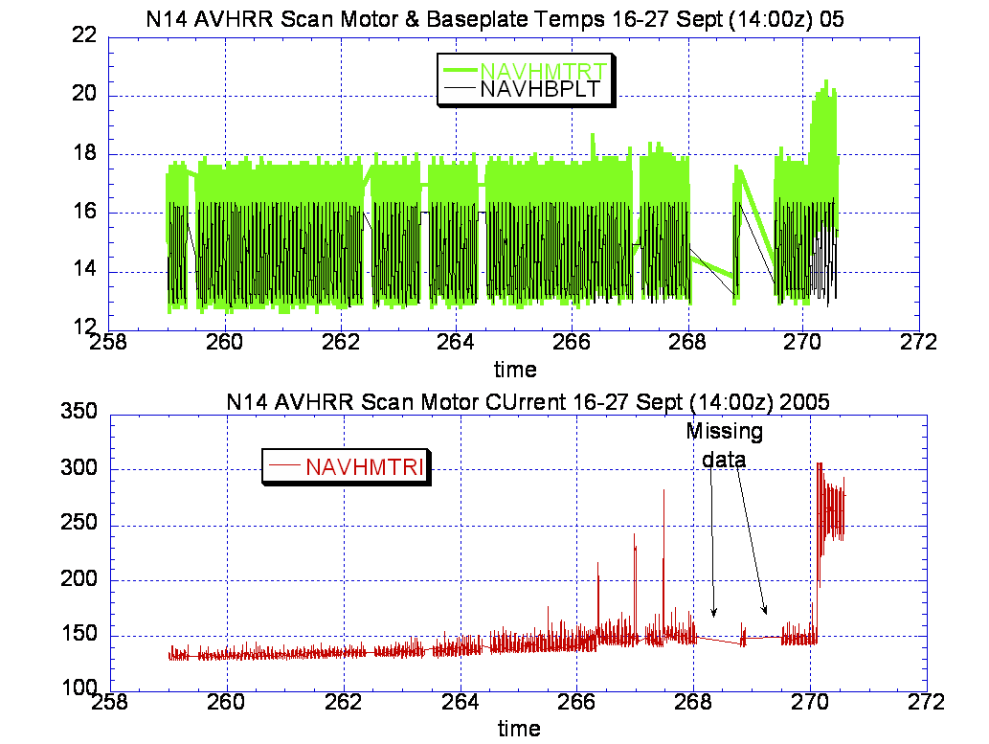

Illustration 1: NOAA-14 AVHRR Health Analysis
(Imagery bar codes resulted from the 24 Sept surge but after MIRP rephasing imagery returned to nominal. However, since the big surge on 27 Sept, all imagery is bar coded. Data gaps caused by reduced number of N14 passes in recent days)

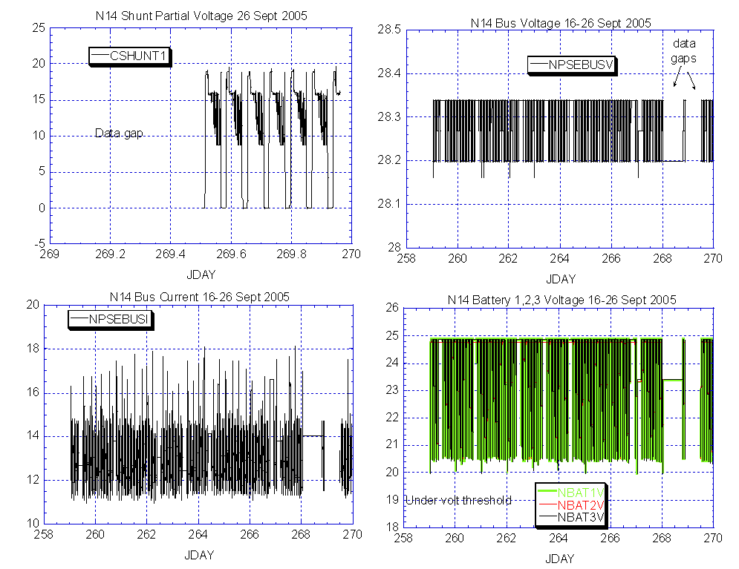

Illustration 2: N14 Power Balance Analysis
(Battery voltages getting a little lower than desired although still well above undervoltage threshold. Turning on APT data, not likely given the AVHRR anomaly, could change this equation. Possibility of a small solar array offset move being recommended in the coming days.)

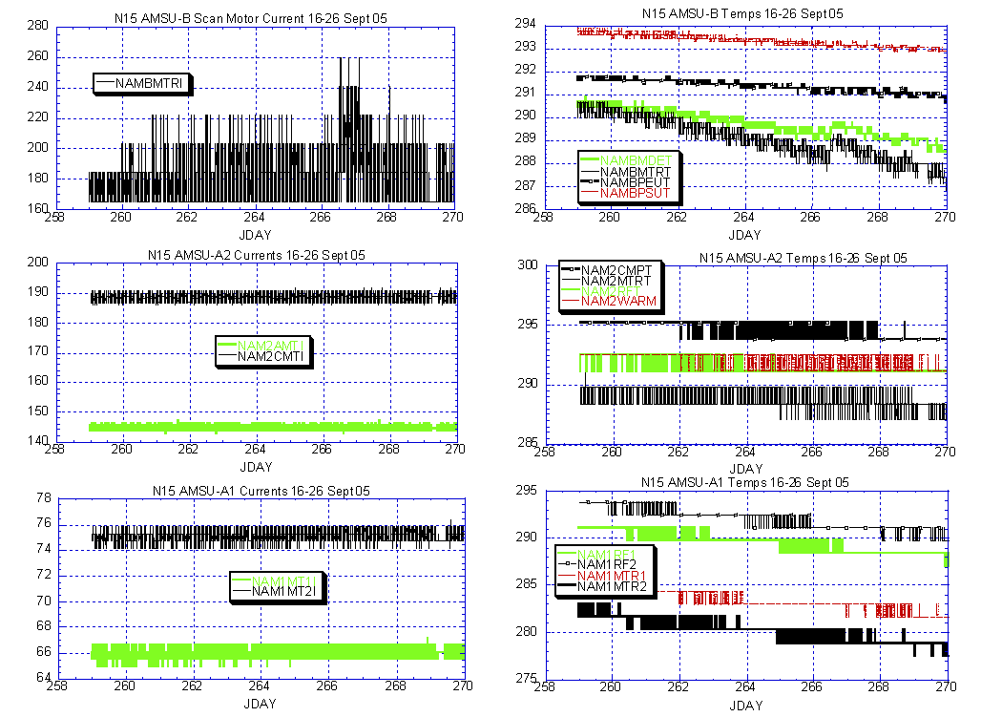

Illustration 3: N15 AMSU Health Analysis
(Nominal with a continuing thermal downtrend which is expected to last for 1-2 more weeks.)

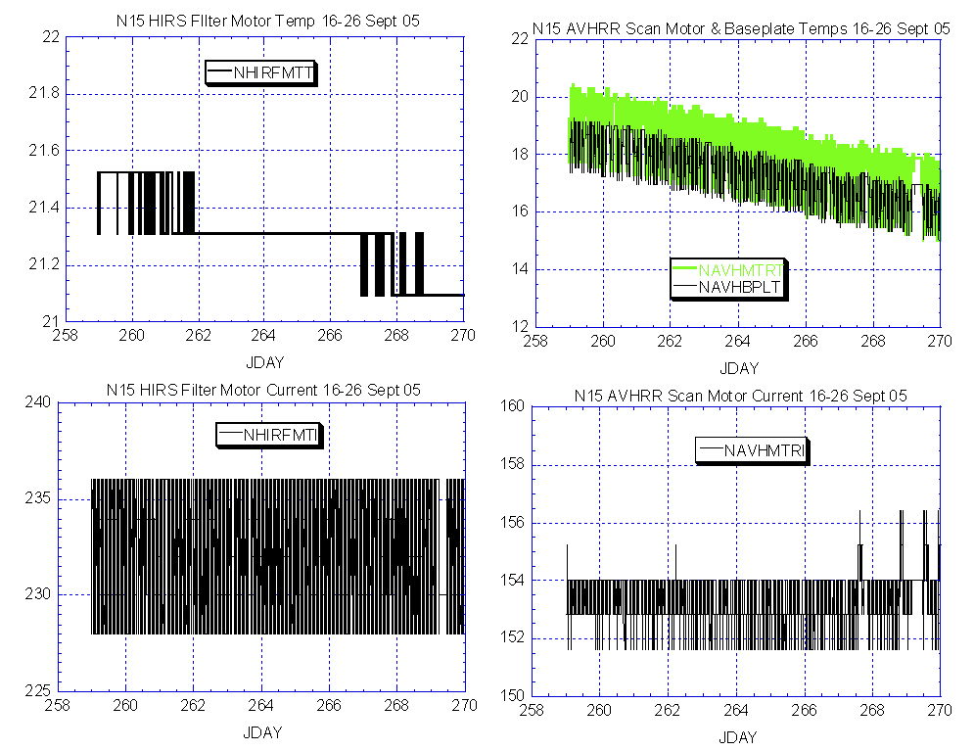

Illustration 4: N15 HIRS and AVHRR Health Analysis
(Nominal and stable.)

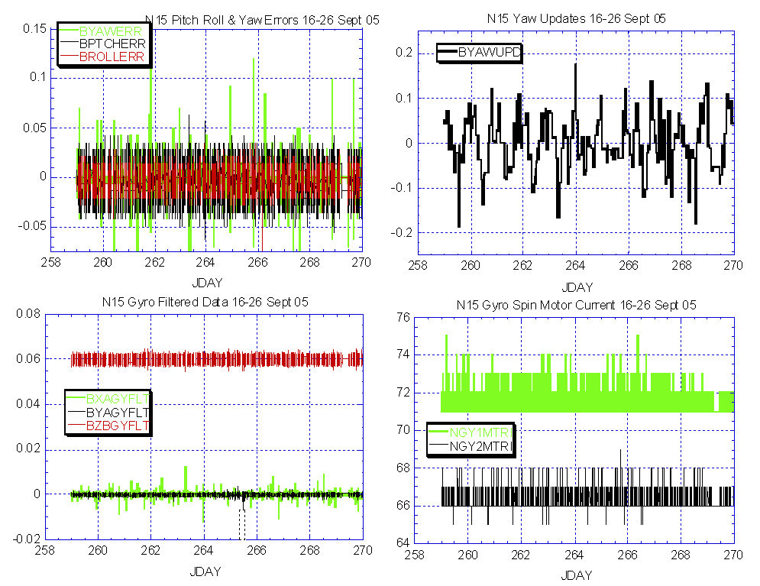

Illustration 5: N15 Attitude Control Health Analysis
(Generally nominal and historically stable, but will continue to be closely scrutinized by engineering, especially gyro-1.)

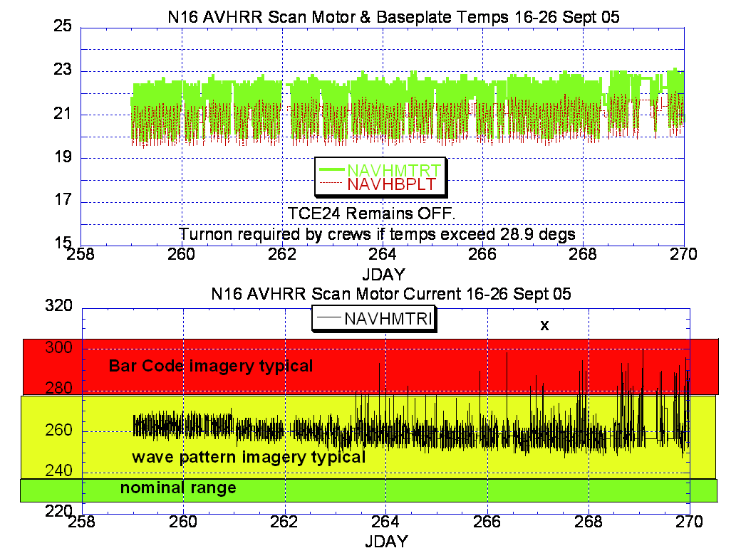

Illustration 6: N16 AVHRR Health Analysis
(Degradation started on 20 Sept (JDAY 263) but bar code imagery didn’t become prevalent until 24 Sept.)

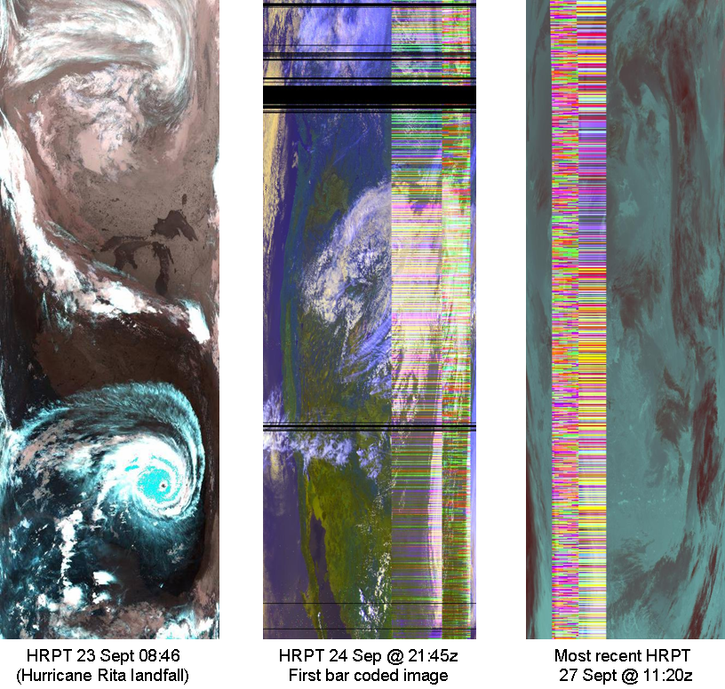

ILLUSTRATION 7: N16 AVHRR Imagery Analysis
(Bar codes started on JDAY 267, 24 Sept, and have become more prevalent since.)

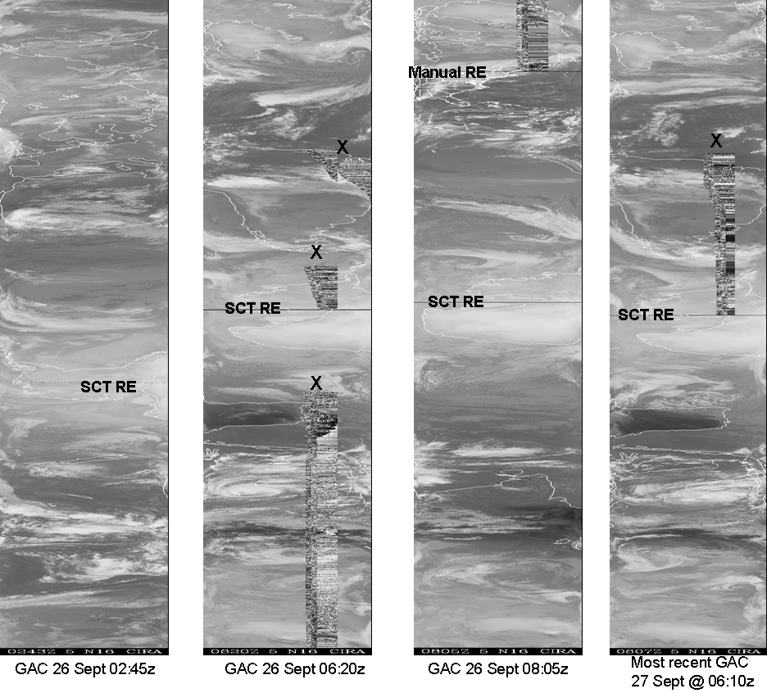

ILLUSTRATION 8: N16 AVHRR GAC Analysis
(Prevalent bar codes but highly variable with or without MIRP rephasing. X indicates where bar codes start. In some case they go away without MIRP rephasing in others they require rephasing. No synch delta plots are available this week because of problems with the archive system.)

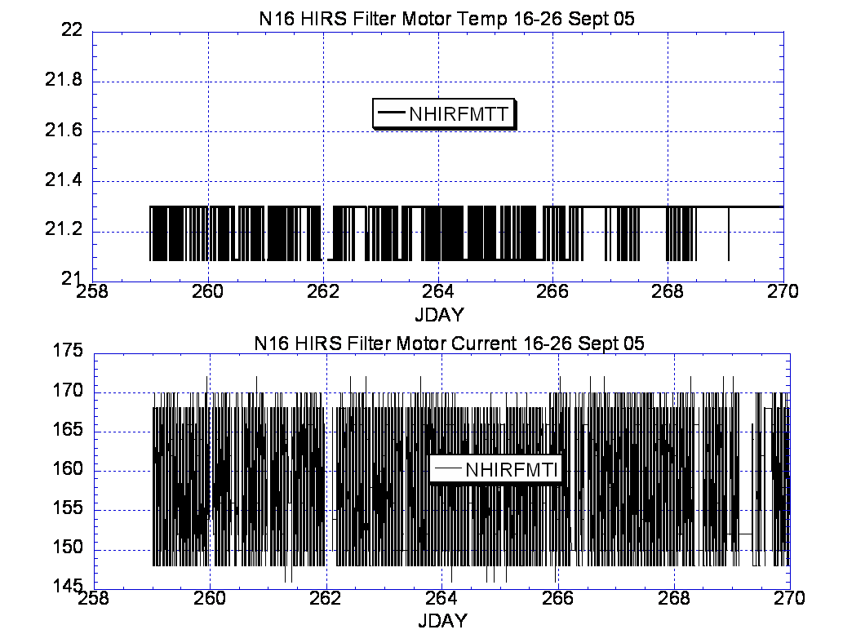

ILLUSTRATION 9: N16 HIRS Analysis
(Generally nominal and stable.)

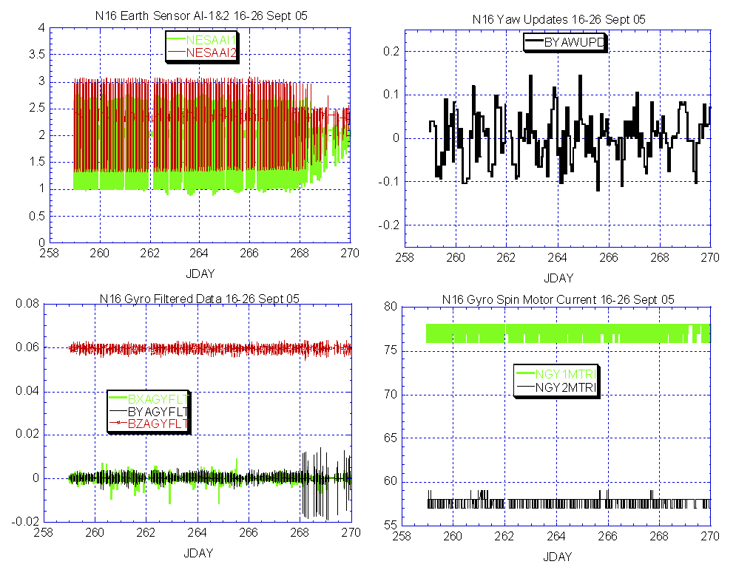

Illustration 10: N16 ADACS Analysis
(Generally nominal with some erratic performance in the Y_gyro filtered data as the spacecraft comes out of moon intrusion.)

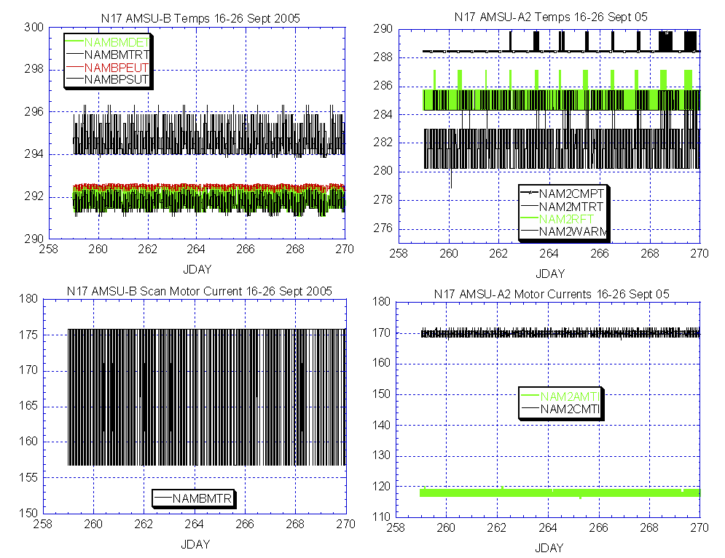

ILLUSTRATION 11: N17 AMSU Analysis
(Nominal and stable.)

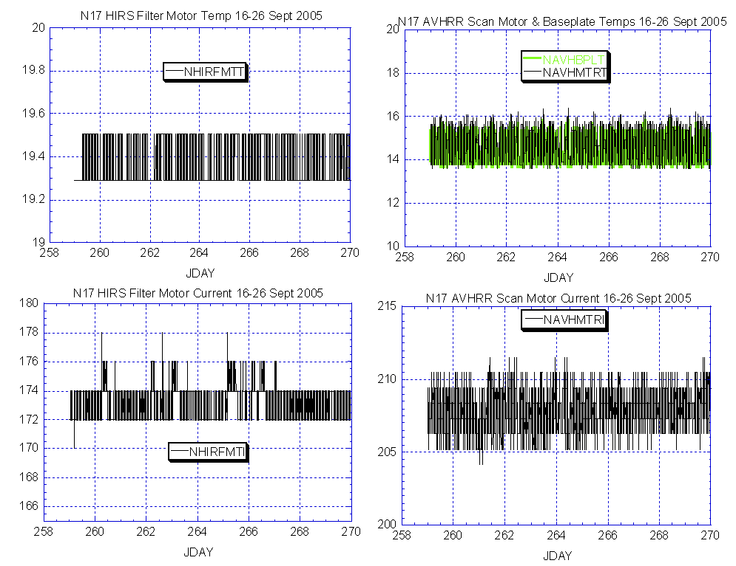

Illustration 12: N17 HIRS and AVHRR Analysis
(About the same as last week, nominal and stable.)

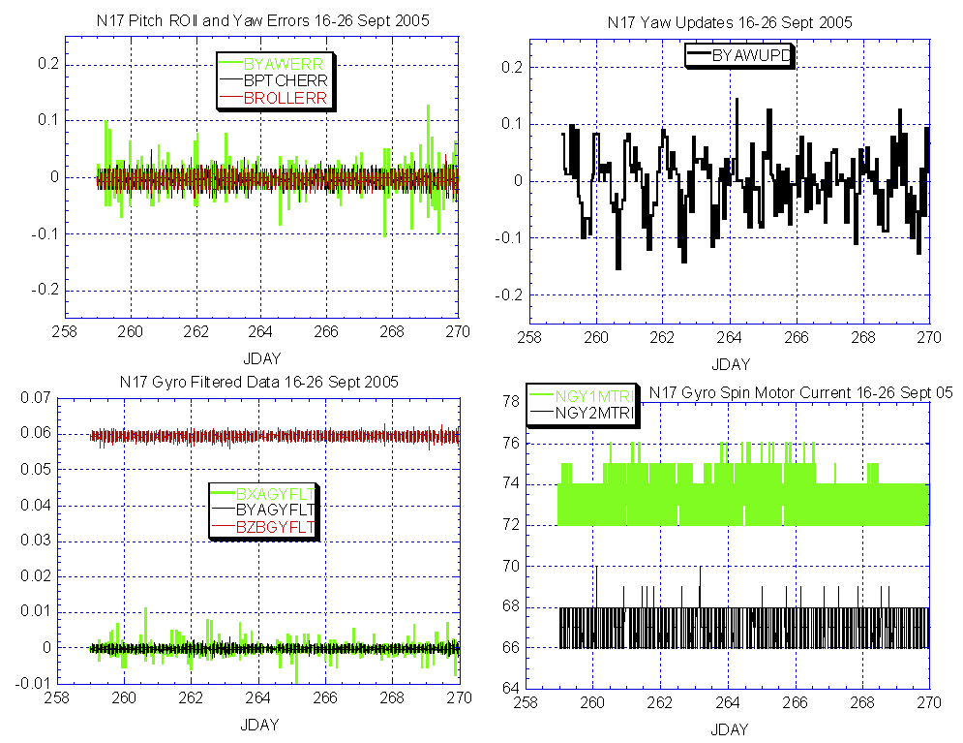

Illustration 13: N17 ADACS Health Analysis
(About the same as last week. EMOSS continues to closely monitor gyro performance.)

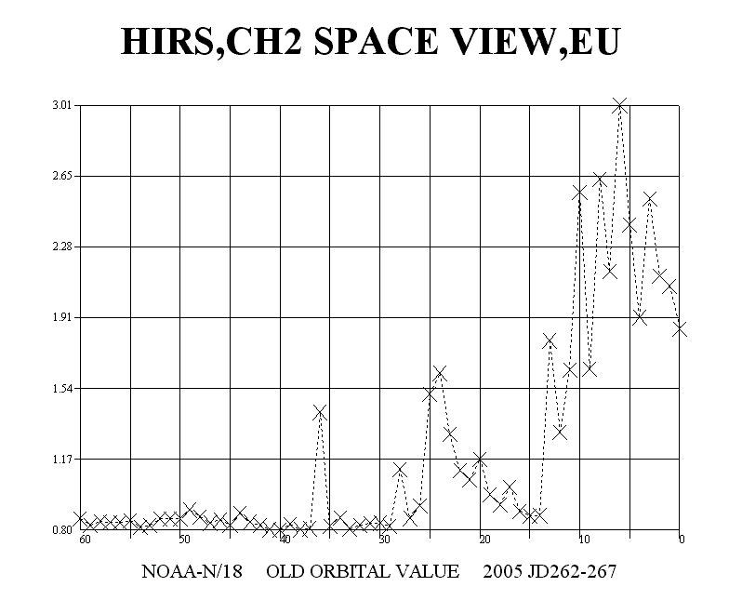

Array
Test start

Illustration 14: N18 HIRS Channel noise relative to Array Slew Test Implementation
(First instabilities occurred at about the same time as the first (longer) slew operation. Coincidence or cause and effect? Investigation is ongoing.

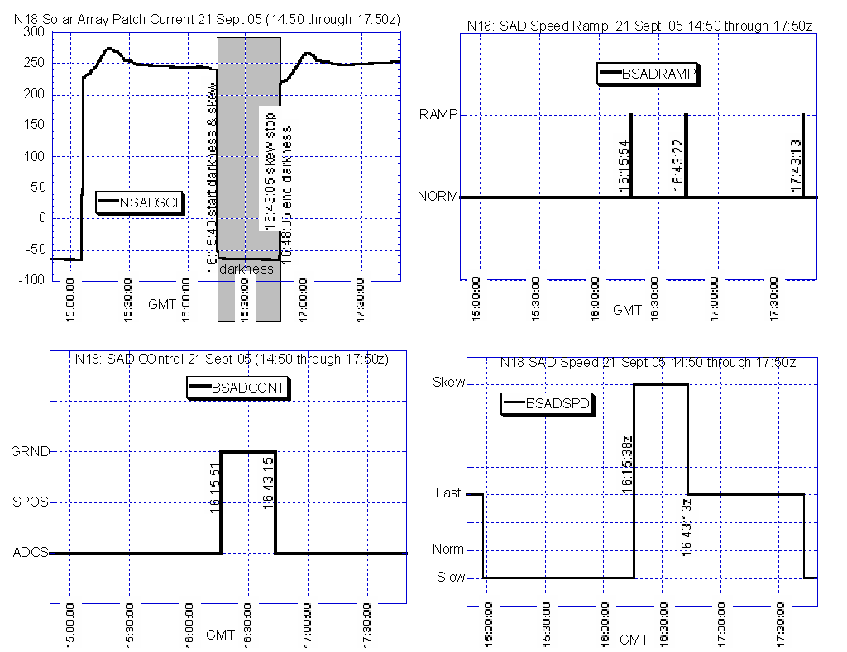

Illustration 15: N18 Solar Array Drive Analysis for Test #1 on 21 Sept.
(Slew started at 16:15:40z and ended at 16:43:05z. Nominal execution.)

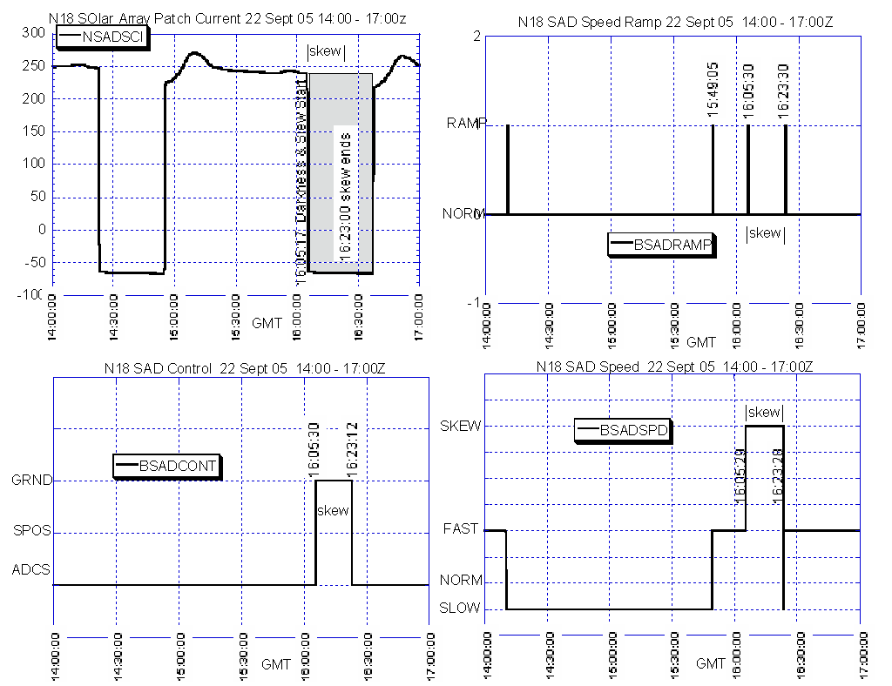

Illustration 16: N18 Solar Array Drive Analysis for Test #2 on 22 Sept.
(Slew started at 16:05:17z and ended at 16:23:00z. Nominal execution.)

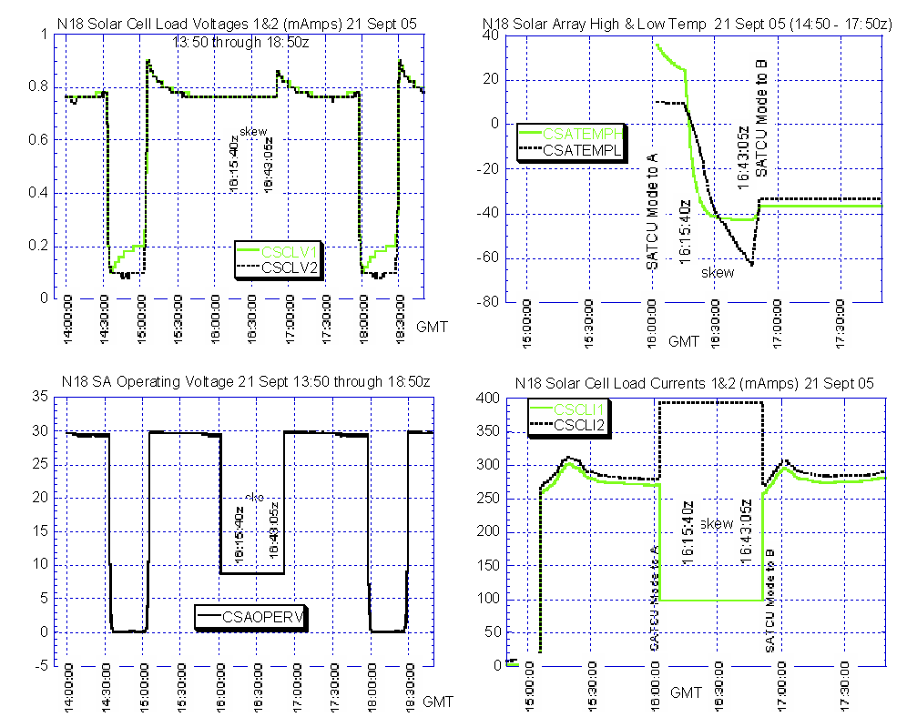

Illustration 17: N18 Solar Array Drive SATCU data Analysis for Test #1 on 21 Sept.
(Slew started at 16:05:17z and ended at 16:23:00z. Nominal execution.)

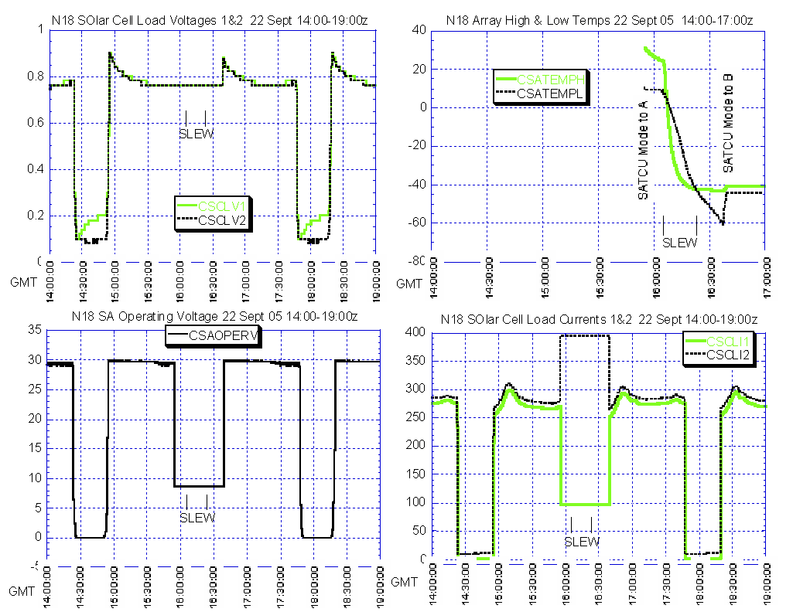

Illustration 18: N18 Solar Array Drive SATCU data Analysis for Test #2 on 22 Sept.

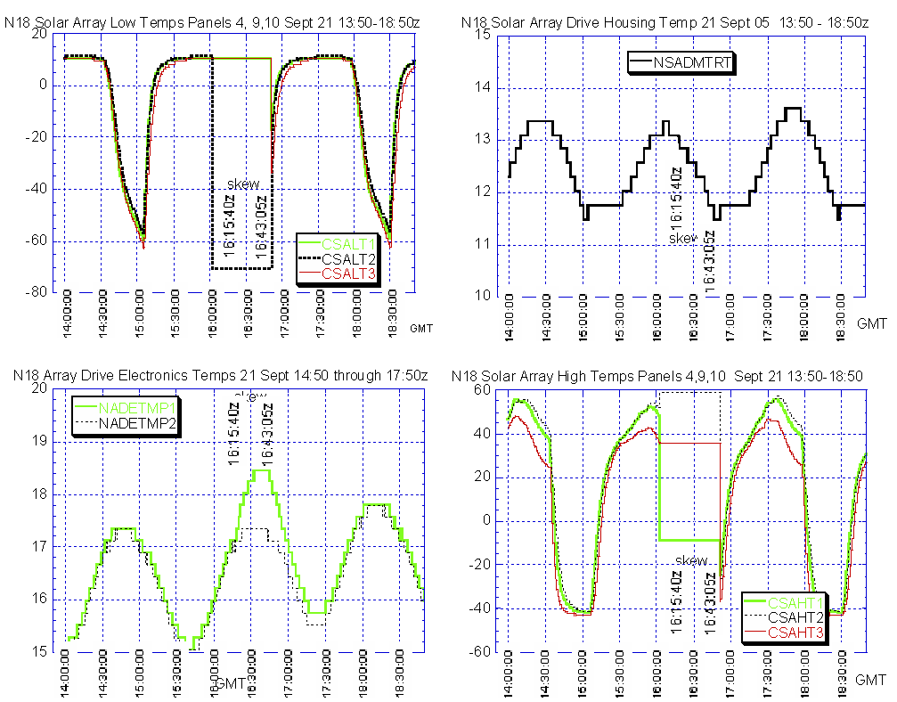

Illustration 19: N18 Solar Array Drive SATCU and Analog data Analysis for Test #1 on 21 Sept.

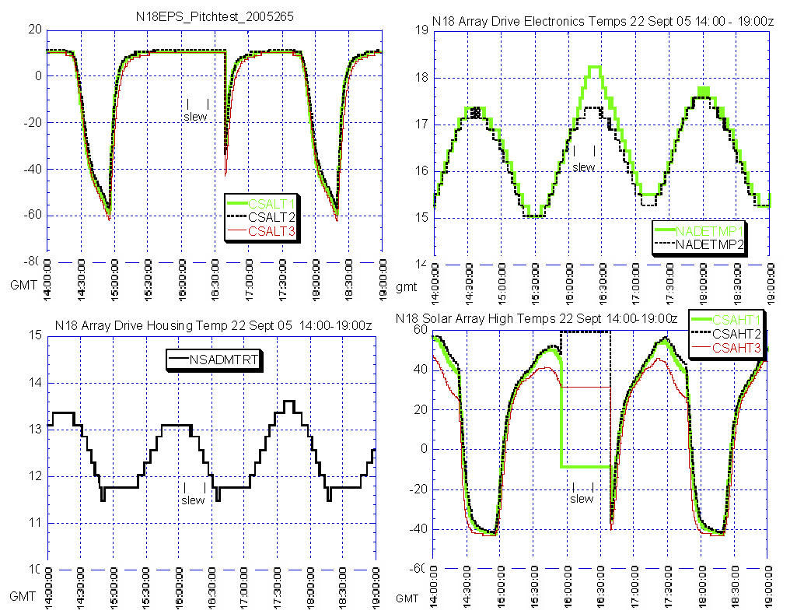

Illustration 20: N18 Solar Array Drive SATCU and Analog data Analysis for Test #2 on 22 Sept.

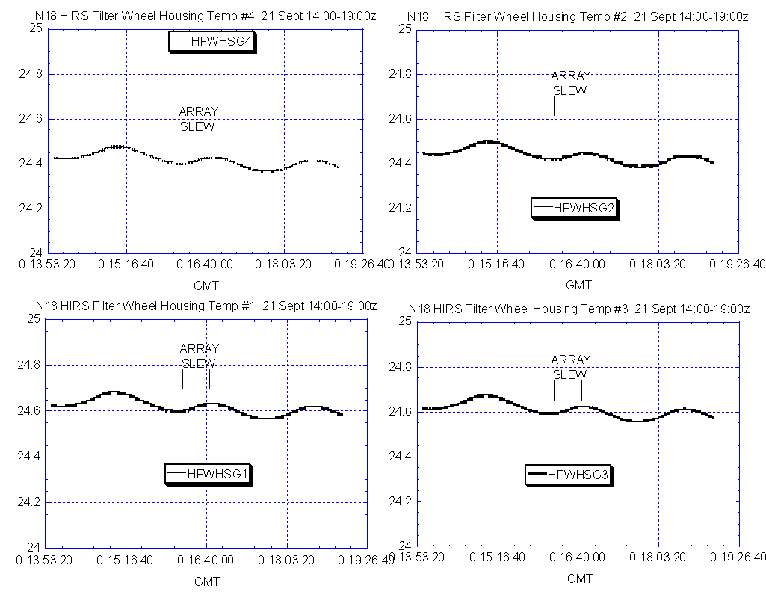

Illustration 21: N18 Solar Array Drive Test #1 on 21 Sept Relative to HIRS DIG-A telemetry samples

(No obvious effect on Filter Wheel Housing temps. Similar outcome when analyzing the 22 Sept test. )

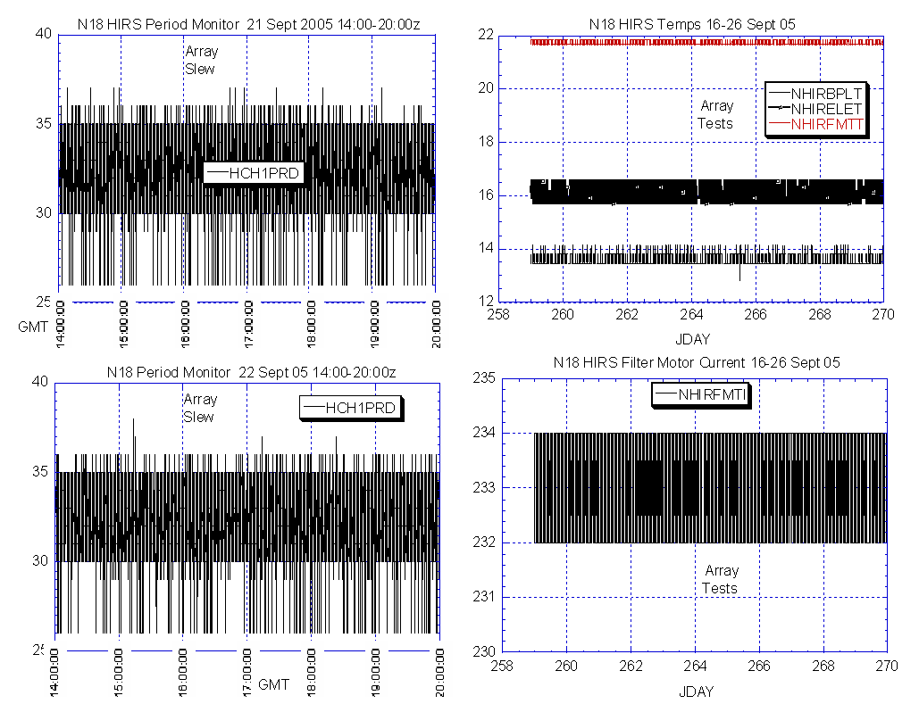

Illustration 22: Additional HIRS Health Analysis short and long term views

(No obvious effect from the Array move tests on 21 & 22 Sept)

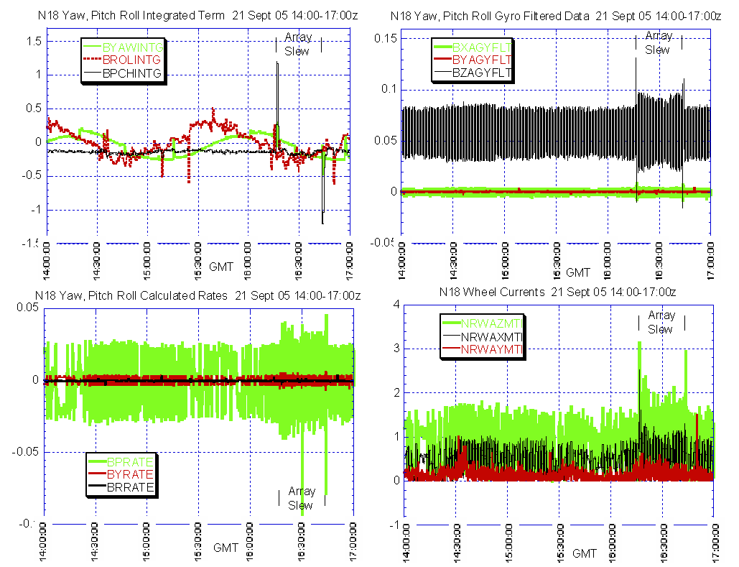

Illustration 23: Test #1 (21 Sept) ADACS Health Analysis

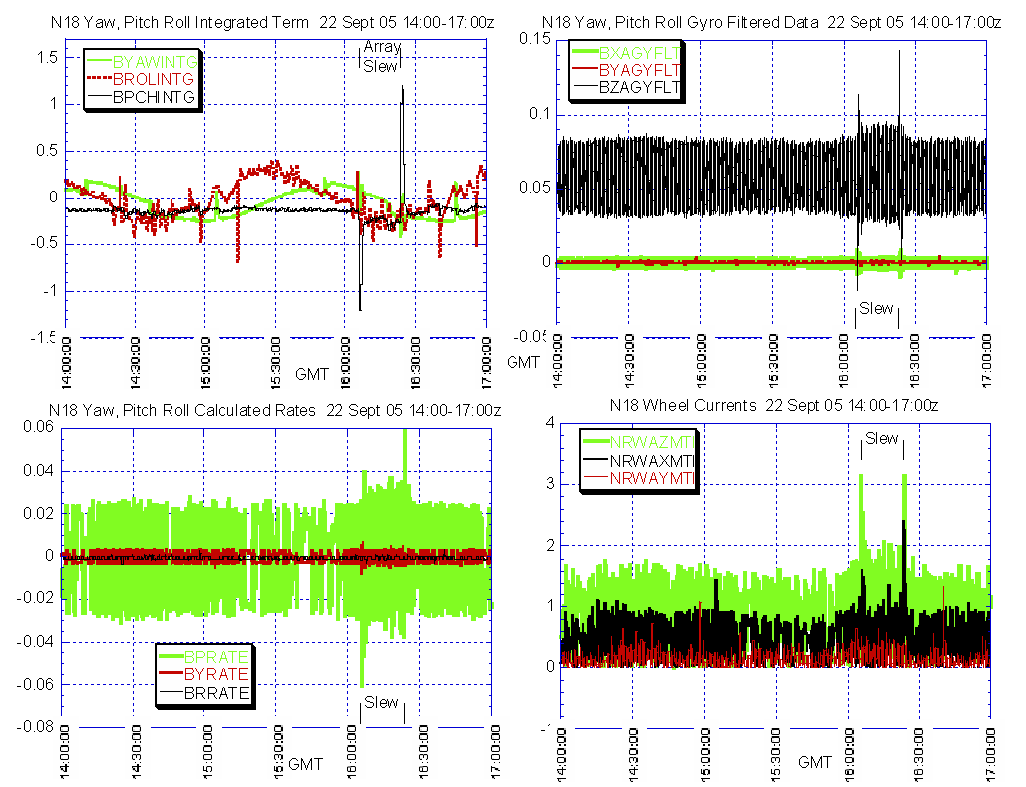

Illustration 24: Test #2 (22 Sept) ADACS Health Analysis

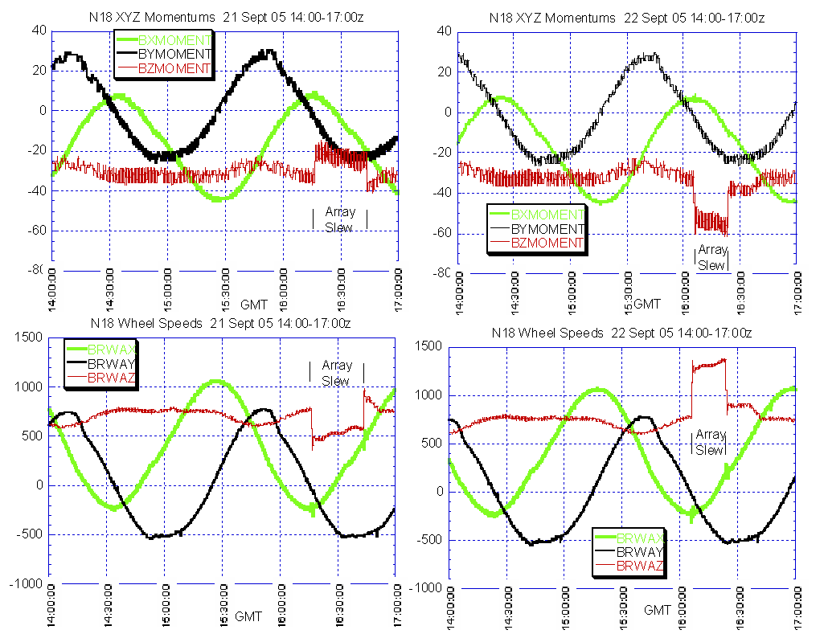

Illustration 25: Side by side comparison of Rwheel speeds from each solar array test.

