Petition for Amending the National List of the USDA’s
National Organic Program

DL- Methionine, ML-Methionine Hydroxy analog, and DL-Methionine-hydroxy analog calcium-for use only in organic poultry production

A Synthesized Essential Amino Acid

Submitted December 17, 2007 by:
Dave Martinelli, on behalf of the Methionine Task Force
(Please refer to the first attachment to this petition for a list of Task Force representatives.)

Introduction:

The Methionine Task Force requests that 7 CFR §205.603(d)(1) be amended, by removing the reference/annotation date of “October 8, 2008”, and therefore submitting DL-Methionine to the standard process for sunset review of allowed substances on the National List.

Petitioners are required to provide the following information as applicable:

Category for inclusion on the National List:
- This request is to remove the annotation date currently listed on synthetic methionine [MET] in Section 205.603 of the National List as a synthetic substances allowed for use in organic livestock production thereby submitting MET to the standard sunset process for review of materials on the National List.

Common name:
- The three names in the title of this document are the most widely used common names. They are however the common names associated with specific manufacturers. Throughout this petition the term “Methionine” will be used to refer to the natural form of the amino acid and the term MET will be used to refer to any synthetic analog.

Chemical Structure:
- The formula for Methionine is H₂NCH₃SCH₂CH₂COOH.
Other Chemical Structures;
DL-Methionine CH3-S-CH2-CH2-CH(NH2)-COOH
Methionine Hydroxy Analog CH3-S-CH2-CH2-CH(OH)-COOH

Manufacturers name, address and telephone number
- There are three major manufacturers of MET world wide:
Adisseo
3480 Preston Ridge Road, Suite 375. Alpharetta, GA 30005 Phone 678-339-1513
Degussa Feed Additives
1701 Barrett Lakes Blvd., Suite 340 Kennesaw, GA 30144 Phone 800-955-3114
Novus International, Inc.
530 Maryville Centre Drive St. Louis, MO 63141 888-906-6887

List of uses, rates and applications for crops and livestock uses, mode of action for handling uses:
- Typically added to poultry feed rations at the following rates:
- Laying Hens: 0.001% (1-3 lbs per ton of feed)
- Broilers: 0.0025% (5 lbs per ton of feed)
- Turkeys: 0.0025% (5 lbs per ton of feed)

Sources and detailed description of manufacturing procedures:
The following text is taken from the May 21, 2001 Methionine Livestock TAP Review:

Methionine may be isolated from naturally occurring sources, produced from genetically engineered organisms, or entirely synthesized by a wide number of processes. While methionine has been produced by fermentation in laboratory conditions, racemic mixtures of D- and L- methionine (DL-Methionine) are usually produced entirely by chemical methods (Araki and Ozeki, 1991). Methionine can be produced from the reaction of acrolein with methyl mercaptan in the presence of a catalyst (Fong, et al., 1981). Another method uses propylene, hydrogen sulfide, methane, and ammonia to make the intermediates acrolein, methylthiol, and hydrocyanic acid (Degussa). The Strecker synthesis can be used with ⟨-methylthiopropionaldehyde as the aldehyde (Fong, et al., 1981). A recently patented process reacts 3-methylmercaptopropionaldehyde, ammonia, hydrogen cyanide, and carbon dioxide in the presence of water in three reaction steps (Geiger et al., 1998). Other methods are discussed in the 1999 Crops Amino Acid TAP review. DL-methionine hydroxy analog calcium and DL-methionine hydroxy analog forms are considered to be alpha-keto acid analogues in which the amine group has been replaced by a hydroxy (OH) group. These forms are converted to the amino form in the bird by transamination in the liver, using non-essential amino acids such as glutamic acid (Cheeke 1999; Leeson 1991). These forms are produced by reacting hydrogen cyanide with an aldehyde that has been treated with a sulfite source to form a cyanohydrin. The aldehydes used are prepared from either hydrogen sulfide or an alkyl mercaptan with an aldeyhde such as acrolein and are then hydrolyzed using sulfuric or hydrochloric acid (USPO 1956).

Regulatory status with EPA, FDA or state authorities:

The following text is taken from the May 21, 2001 Methionine Livestock TAP Review:
Regulated as a nutrient / dietary supplement by FDA (21 CFR 582.5475). The Association of American Feed
Control Officials (AAFCO) set the standard of identity for DL-methionine as containing a minimum of 99%
racemic 2-amino-4-methylthiobutyric acid (AAFCO, 2001). The AAFCO model regulation states that “the term Methionine Supplement may be used in the ingredient list on a feed tag to indicate the addition of DL-Methionine” (AAFCO, 2001). AAFCO also lists a feed definition for DL-Methionine hydroxy analogue calcium (min. 97% racemic 2-amino-4-methylthiobutyric acid, 21 CFR 582.5477) and DL-Methionine hdyroxy analogue, (min. 88% racemic 2-amino-4-methylthiobutyric acid, 21 CFR 582.5477).
Chemical Abstract Service (CAS) number or other product number, samples of labels:

The following text is taken from the May 21, 2001 Methionine Livestock TAP Review:

Chemical Names:
2-amino-4-methylthiobutyric acid and
⟨-amino-©-methylmercaptobutyric acid

Other Names:
DL-methionine, D-methionine, L-methionine,
Met, Acimethin

CAS Numbers:
59-51-8 (DL-methionine)
63-68-3 (L-methionine)
348-67-4 (D-methionine)

Other Codes:
International Feed Names (IFN):
DL-methionine: 5-03-86
DL-methionine hydroxy analog
calcium: 5-03-87
DL-methionine hydroxy analog: 5-30-28

Physical properties of the substance and chemical mode of action: including environmental impacts, interactions with other materials, toxicity and persistence, effects on human health, effects of soil organisms, crops or livestock:

The following text is taken from the May 21, 2001 Methionine Livestock TAP.

Properties:
L-Methionine: Colorless or white lustrous plates, or a white crystalline powder. Has a slight, characteristic odor. Soluble in water, alkali solutions, and mineral acids. Slightly soluble in alcohol, insoluble in ether. MP 280-82°C. It is assymetric, forming both an L- and a D- enantiomer. Methionine hydroxy analog (MHA) is available in liquid form.
Action:
Amino acids form protein. Of the 22 amino acids found in body proteins, the National Research Council lists 13 as essential in poultry diets, and these must be consumed in feed. These 13 are: arginine, glycine, histidine, isoleucine, leucine, lysine, methionine, cystine, phenylalanine, proline, threonine, tryptophan, and valine (NRC 1994). Five that are deemed critical in poultry rations are methionine, cystine, lysine, tryptophan, and arginine (North, 1990).
Animals convert dietary protein into tissue protein through digestive processes. Proteins are metabolized by animals through two phases: catabolism (degradation from body tissue to the free amino acid pool) and anabolism (synthesis into body tissue). Amino acids utilized as proteins are primary constituents of structural and protective tissues, including skin, feathers, bone, ligaments, as well as muscles and organs.

Combinations:
Amino acids are combined in feed rations of grains, beans, oilseeds, and other meals with antioxidants, vitamins, minerals, antibiotics, and hormones (Pond, Church, and Pond, 1995). Methionine is a precursor in the diet to cystine, and the amount needed in the diet depends on the amount of cystine also present. Requirements for methionine are frequently cited in terms of methionine plus cystine, because methionine converts to cystine as needed.

OFPA 2119(m) Criteria:
(1) The potential of such substances for detrimental chemical interactions with other materials used in organic farming systems.
The primary chemical interaction is the dietary intake by animals. While many of the interactions may be regarded as beneficial, excess methionine in a diet may cause deficiencies in other amino acids and induce toxicity (D’Mello, 1994). Methionine, while often one of the most limiting amino acids, is also one that readily goes to toxic excess. Small excesses of methionine can be deleterious (Buttery and D’Mello, 1994). Errors in feed formulation or excess supplemental methionine can actually depress growth and development at levels of
40 g/kg (4.0%) (Baker, 1989, NRC 1994). Excess methionine exacerbates deficiencies of vitamin B-6, which results in depressed growth and feed intake (Scherer, 2000). Growth depressions resulting from excess supplemental amino acids include lesions in tissues and organs (D’Mello, 1994). Methionine is “well established as being among the most toxic of all amino acids when fed at excess levels in a diet” (Edmonds and Baker, 1987 cited in Scherer, 2000).

(2) The toxicity and mode of action of the substance and of its breakdown products or any contaminants, and their persistence and areas of concentration in the environment.
While it is nutritionally essential, methionine excesses are far more toxic to poultry than similar excesses of tryptophan, lysine, and threonine (National Research Council, 1994). Force feeding methionine to excess can result in death to chicks (National Research Council, 1994). However, NRC acknowledges that such toxicities are unlikely in practical circumstances for poultry, in that an amino acid toxicity requires a particularly high level of an amino acid relative to all others. Supplemental levels fed to poultry are usually fed at lower levels, ranging from 0.3 - 0.5% of the diet. Susceptiblity of an animal to imbalances and excesses is influenced by the overall protein supply, and animals that are fed relatively high levels of protein are more tolerant (Buttery and D’Mello,
1994).

A dosage of 2 g / mature cat / day (20 to 30 g / kg dry diet) for 20 days induces anorexia, ataxia, cyanosis,
methemoglobinemia and Heinz body formation resulting in hemolytic anemia (Maede, 1985). Rat studies of methionine is significantly toxic in excess (Regina, et al., 1993). High levels of methionine were found to be toxic to hepatic cells and liver function of the rat models. The results of this study indicated that the Biochemical reason for the extreme sensitivity of mammals to excess dietary methionine is thought to be due to the accumulation of toxic catabolites, most notably, S-adenosylmethione, resulting in liver dysfunction. L-methionine has an acute LD50 of 4,328 mg/kg (rat) (NIEHS, 1999b). NIEHS carcinogenicity and teratogenicity are not available, but reports positive mutagenicity (NIEHS, 1999b). Methionine is stable in crystalline form at standard temperature and pressure.

(3) The probability of environmental contamination during manufacture, use, misuse or disposal of such substance.
Synthetic production of DL-methionine involves a number of toxic source chemicals and intermediates. Each of the several manufacturing processes used to produce DL-methionine was rated as either “moderately heavy” to “extreme” (Fong, et al., 1981). Newer processes have not replaced many of the feedstocks. Several of the
feedstocks are likely to result in ruptured storage tanks, leaking chemicals, and releases into the environment.
The methionine production process is listed by EPA as a hazardous air pollutant (40 CFR 63.184).
Methyl mercaptan can react with water, steam, or acids to produce flammable and toxic vapors (Sax, 1984). The EPA rates methyl mercaptan fires as highly hazardous and can cause death by respiratory paralysis (EPA, 1987). Acrolein has a toxicity rating of 5 (on a scale of 1 to 6 with 6 being most toxic) (Gosselin, 1984) and it is also an aquatic herbicide (Meister, 1999). The acrolein process involves several steps that render it synthetic as well (1994). Acrolein itself is an extreme irritant.
Hydrogen cyanide is produced by further processing of methane and ammonia. Hydrogen cyanide is a gas that is highly toxic. Hydrogen cyanide has a toxicity rating of 6 and is one of the fastest acting poisons known to man (Gosselin, 1984). Exposure causes paralysis, unconsciousness, convulsions, and respiratory arrest. Death usually results from exposure at 300 ppm concentrations for a few minutes. Manufacture of hydrogen cyanide is a significant source of atmospheric release of cyanide (Midwest Research Institute, 1993). Ammonia is a corrosive agent. Methane is a central nervous system depressant (Gosselin, 1984).

(4) The effect of the substance on human health.
Methionine is essential in small amounts in the human diet, and is sold over-the-counter as a dietary supplement. The L- form of methionine is used extensively in human medicine for a variety of therapeutic purposes, including pH and electrolyte balancing, parenteral nutrition, pharmaceutical adjuvant, and other applications. It is in fact one of the top 800 drugs in human medicine (Mosby, 1997). Methionine may cause nausea, vomiting, dizziness, and irritability and should be used with caution in patients with severe liver disease (Reynolds, 1996).

The D- form of methionine is not well utilized by humans (Lewis and Baker, 1995). Individuals may have allergic reactions to the D- isomers or a racemic mixture of DL-methionine. While a number of amino acids are considered GRAS for human consumption and as feed supplements, DL-methionine is not (see 21 CFR 172, 21 CFR 184, and 21 CFR 570.35). DL-methionine is unique among amino acids cleared for food use in that it is the only one listed that explicitly says it is not for use in infant feed formulas (21 CFR 173.320). When heated to decomposition, methionine emits dangerous and highly toxic fumes (NIEHS, 1999).

(5) The effects of the substance on biological and chemical interactions in the agroecosystem, including the physiological effects of the substance on soil organisms (including the salt index and solubility of the soil), crops and livestock.
Interactions and Imbalances
Protein is required for body development in all growing birds, and layers also need a good proportion since eggs consist of 13-14% protein. Broilers also need high energy diets as they are commericially raised to grow rapidly to reach about 4.4 lbs in 8 week at a desired food conversion rate of 1.8 (consuming less than 8 lbs of feed total) (Sainsbury, 2000). This is a 50-55 fold increase inbody weight by 6 weeks after hatching, which leads to a high amino acid requirement to meet the need for active growth (NRC 1994). The dietary requirement for protein is actually a requirement for the amino acids contained in the dietary protein. Protein quality is related to the proper balance of essential amino acids in the diet. The presence of nonessential amino acids in the diet also reduces the necessity of synthesizing them from the essential amino acids (NRC 1994).

Amino acids in the body are constantly in flux between three states: stored in tissue, oxidized from tissue to free amino acids, and digested and excreted as uric acid. If some nonessential amino acids are low, they may be synthesized from others in the free amino acid pool, or degraded from those stored in tissue. Deficiencies or excesses of a particular amino acids can cause problems in availability of other amino acids (Buttery and D’Mello 1994; Baker 1989). Intact proteins (as in natural grains) are more slowly available in the digestive system, while pure sources of amino acids are more bioavailable than intact-protein sources (Baker, 1989). Excesses of some amino acids in an unbalanced source of crude protein can reduce feed intake and depress amino acid utilization (Pack, 1995). Depressed feed intake and growth at excess intake levels of protein has recently been attributed to insufficient supply of vitamin B-6 which is required to metabolize the sulfur amino acids (Scherer and Baker 2000).

The requirement for sulfur containing amino acids of methionine, cystine, and cysteine can be misjudged due to inaccurate accounting for the availability of cystine in the diet (NRC, 1994).

Other cases have shown significantly higher weights and faster gains from amino acid (lys+met) supplementation (Slominski et al, 1999). Also, the digestibility of practical ingredients, such as corn and soybeans, appears to be on the order of 85% or more (NRC, 1994).

Amino acid requirements may be affected by environmental temperature extremes, basically because of the effect on feed intake, but amino acid supplementation will only affect weight gain if it improves feed intake (Baker 1989; NRC 1994). Interactions between deficiencies of methionine and several vitamins and minerals have also been documented, and suggest that other dietary factors in addition to total protein have an effect on the efficency of amino acid utilization (Baker, D.H. et.al, 1999).

Environmental Impact
Managing the nitrogen cycle is seen as a challenge to livestock producers (Tamminga and Verstegen, 1992; Tamminga, 1992; Morse, no date). Poultry layer operations are experiencing increased costs and regulations for manure management (Sloan, et al., 1995). Supplementation with amino acids may allow dietary protein and excretory nitrogen levels to be reduced with a minimum reduction in egg output and no loss in weight gain in broilers (Summers, 1993; Sloan et al., 1995, Ferguson, et.al 1998). Excess ammonia build up in poultry houses can be a hazard to workers and birds if not properly ventilated (Ferguson, 1998).

Feeding systems that reduce levels of protein fed using amino acid supplementation are not the only means identified to reduce nitrogen pollution from animal manure. Other potential solutions include lower animal densities; more frequent rotations; better manure storage, handling, and application techniques; use of enzymes; improved processing of the feed; and selection of more appropriate land and locations to graze and shelter animals (Archer and Nicholson, 1992; Tamminga, 1992; Tamminga and Verstegen, 1992). Increased digestiblilty of protein in feeds suplemented with microbial phytase provided better availabilty of most of the amino acids other than lysine and methionine and allowed for reduced P and Ca levels in feed, a goal in reducing phosphorus overload from poultry manure (Sebastian 1997). Another study found that reduced crude protein and energy content were needed in enzyme supplemented broiler diets, although availability of individual amino acids were not improved equally and were still deemed to need balancing (Zanella, et al 1999).

One grower reported success with innovative housing design that allows twice daily cleanout of manure, combined with a commercial composting operation (La Flamme, 2001). Manure from organic operations has potential added value to organic crop farmers seeking to avoid manure from conventional operations. Some markets in the EU require that imported crops are documented to be grown free of “factory farm” manure, requiring additional verification from U.S. certifiers (McElroy, 2001).

Impacts on Bird Health
A number of reports cite a benefit of methionine supplementation on reduced immunologic stress (Klasing, 1988; Tsiagbe et al, 1986). Immunologic stress is considered to be a response to microbial challenges, in these experiments due to injections of E. coli and Salmonella and other pathogens. This causes decreased feed rates and lower rates of growth. Chicks that received deficient levels of methionine were more subject to an impaired immune response. These experiments seem to be more applicable to a high density confinement system or high density production system in terms of bird treatment, and may not be very relevant to an organic system approach.

A problem exacerbated by excess methionine is hepatic lipidosis, a condition of excessive fat in the liver commonly associated with caged birds and is related to the fact that wild diets are much lower in fat than seed diets fed to captive species (Aiello, 1998). This can be mangaged by a well balanced diet, and is reportedly not a problem in free range birds in organic systems (Krengel, 2001). Enteritis is a disease frequently observed in poultry that do not have access to the soil and green growing plants (Titus, 1942). Well managed pasture would prevent this cause of the disease.

Reduced feathering has been reportedly linked to lack of methionine and cystine (Elliott, no date). Many other factors are also involved, including deficiencies of other amino acids, vitamins, zinc, feather pecking in cage systems, and cannibalism (Elliot, NRC 1994). Increased protein level is correlated with reduced feather loss and cannibalism (Ambrosen, 1997).

(6) The alternatives to using the substance in terms of practices or other available materials.
Birds raised on pasture with access to insects and worms historically did not need supplementation (Morrison, 1951), and smaller scale pastured operations have success without the need for synthetic supplements (Salatin, 1993). Pasture quality will vary according to field conditions and the season. However, free range poultry on well managed pasture are able to supplement their diets with insects, annelids, and fresh green forage (Smith and Daniel, 1982). The two most limiting amino acids, methionine and lysine, are found in richest sources in proteins of animal origin. Common natural sources of these amino acids have traditionally been fish meal and meat meal, especially for starter chicks and broilers (Sainsbury, 2000). The USDA organic program final rules do not allow the use of meat meal as feed for poultry or mammals and may or may not allow fish or crab meal (7CFR 205).

Diets can be formulated without supplemented synthetic acids to meet the objective of adequate methionine percentages, but this usually requires an increase in crude protein level of the diet (Hadorn, 2000). Many studies have been done to identify a cost effective method of lowering protein content by supplementing with methionine and lysine. Often the control treatments are non-supplement grain based diets. A comparison study using supplemented and non-supplemented diets found that adequate dietary methionine can be attained, at a cost of higher intake of protein and less protein efficicy ratio (Emmert 2000). Another study fed a control diet using only corn and soy to satisfy amino acid levels compared to reduced protein supplemented with methionine and lysine, and these treatments were considered successful because performance was not lowered in 4-5 experiments (Harms, 1998).

Rice and casein offer potential novel available sources of methionine (Lewis and Bayley, 1995). Yeast protein has long been known as a rich protein source relatively high in methionine+cystine (Erbersdobler, 1973; National Research Council, 1994), as well as phosphorous and B-complex vitamins (Morrison, 1951). As a natural feed supplement, NOSB should advise whether yeast is considered agricultural and required from organic sources or permitted as a natural substance. Other potential sources of available methionine for poultry appear to be sunflower meal and canola meal (Waibel et al., 1998). These natural sources are all currently of limited availability in organic forms. Alfalfa meal is reported to be a good additional protein source, though difficult to blend in commercial formulations. Optimally balancing these nutrients may be challenging to feed processors and livestock producers.

Feed sources with high percentages of methionine are bloodmeal, fish meal, crab meal, corn gluten meal, and sunflower seed meal (National Research Council, 1994). If fish meal were permitted, there is a lack of supply that does not contain ethoxyquin, a synthetic antioxidant not permitted under the final rules. A limited supply of fish meal preserved with natural tocophorols has gone mostly into the pet food market (Mattocks, 2001). Corn gluten and sunflower seed meal are not currently very available in organic form, and feed formulators and nutritionists have reported difficulty in meeting NRC requirements for methionine based on currently available organic plant protein sources (Mattocks, Morrisson, Simmons, 2001). One feed mill operator feels he can meet even broiler needs with a combination of crab meal (at 75 lbs/ton or 3.75%) and organic corn gluten (Martens, 2001). Crab meal is a by-product of crab processing and not treated with preservatives but has limitations due to salt content. Another certified feed mill produces layer and range broiler rations without synthetic amino acids based only on plant products, including corn, soy, barley, oats, wheat, field peas, and flaxmeal. These products are labeled at a minimum of 0.3% met and 0.6% lysine, but reportedly achieve good results (White 2001, VOG).

NRC requirements for amino acids and protein are designed to support maximimum growth and production. The recommended levels for methionine in poultry depend on species, stage, and level of feed consumption. For chickens, recommendations for layers range from 0.25% to 0.38% and for broilers 0.32 - 0.50%. NRC notes that maximum growth and production may not always ensure maximum economic returns when protein prices are high, and that if decreased performance can be tolerated, dietary concentrations of amino acids may be reduced somewhat to maximize economic returns (NRC, 1994). Methionine is known to have a direct effect on egg weight (size) and rate of lay, and is used by some producers to manipulate egg production to meet market needs, such as to increase egg size in younger birds, reduce it in older birds, or produce more eggs in off peak market periods (NRC 1994; Harms 1998; Simmons 2001). A reduction in rate of gain in broilers (longer time to finish) would be an outcome of lower than optimal methionine levels. Unless the diet contained other forms of sulfur containing amino acids (cystine or cysteine), problems with inadequate feathering might be encountered (Simmons, 2001).

Temporarily confined poultry can be fed a practical organic corn / soybean ration. Depending on market conditions and on how other parts of the standards evolve, novel organic products can be developed as supplements. Among the potential alternative sources include organic dairy products such as casein (National Research Council, 1982 and 1994).

Macroorganisms commonly found in healthy pasture soils cannot be discounted as a source of nutrient cycling in free-range poultry systems. Given the natural feeding habits of poultry and other birds, the use of earthworms is a logical source of protein in chicken feed (Fisher, 1988). Earthworm populations in a pasture depends on a number of factors (Curry, 1998). The amino acid content of earthworms will vary depending on species and food source. However, earthworms have been found to accumulate and concentrate methionine found in the ecosystem in proportions greater than for other amino acids (Pokarzhevskii, et al., 1997). As a feed supplement, earthworms have been found to equal or surpass fish meal and meat meal as an animal protein source for poultry (Harwood and Sabine, 1978; Toboga, 1980; Mekada et al., 1979; and Jin-you et al., 1982 all cited in Edwards, 1998).

Earthworms can play a role in moderating nitrogen losses as well. Enzyme treatment of feedstuffs can improve amino acid availability and also reduce nitrogen pollution (Tamminga and Verstegen, 1992), as can changes in stocking density, rotations, and manure handling.

(7) Its compatibility with a system of sustainable agriculture.
In 1994 the NOSB recommended that feed and feed supplements be produced organically. When considering the review of feed additive vitamins and minerals, an NOSB statement of principles advised that non-synthetic viamins and mineral sources are preferable when available. The NOSB also advised that a farm plan should reflect attempts to decrease or eliminate use of feed additives when possible (NOSB, 1995).

A constraint to optimal production in modern organic systems that are not able to utilize pasture based systems appears to be adequate organic sources of the first limiting amino acid, methionine. The allowance of isolated amino acids facilitates the use of the lowest cost, non-diverse corn-soy ration. It is the basis of conventional confinement animal production systems which may be considered as antithetical to the principals of organic livestock production. The source and method of production of synthetic amino from non-renewable fossil fuels and toxic chemicals is also questionable in compatibility with system of sustainable agriculture.

The use of synthetic amino acids increases animal production by increased efficiency of protein conversion, which lowers feeding costs and reduces nitrogen content of the waste output. While this is not by itself unsustainable, synthetic amino acids discourage the integration of a whole-systems approach to cycling nutrients, particularly nitrogen, as part of an integrated crop-livestock production system. Allowance of synthetic sources of amino acids may discourage market development of organic plant sources, such as seed meals.

Increased efficiency of protein conversion reduces the amount of nitrogen excreted (Summers, 1993; deLange, 1993). The cycling of nutrients from animals is part of an integrated farming system, and the environmental effects of manure management requires looking at the big picture (Archer and Nicholson, 1992). What is viewed as a liability in confinement animal systems—nitrogen production—is seen in cropping systems as a limiting factor resource. Reduction of nitrogen pollution may require improved range or pasture management, and with that either more frequent rotations or lower stocking rates

Safety information, including a MSDS (Material Safety Data Sheet) and report from National Institute of Environmental Health Studies (NIEHS):

A MSDS for DL Methionine is attached to this petition. A search of the National Institute of Environmental Health Sciences (NEIHS) website for Methionine and DL Methionine yielded no Substance Reports.
Petition justification statement which states why the synthetic substance is necessary, alternatives that could be used, beneficial effects to the environment, etc:

Overview / History
In 2001, synthetic methionine [hereafter referred to as MET] was approved for use in organic poultry production for use until October 2005. Three Technical Advisory Panel reviews were conducted prior to this approval. In 2005, there was a petition to extend the deadline to October 2008. This petition was approved unanimously by both the Livestock Committee and the NOSB. This approval allowed for the continued use of MET since the US organic poultry industry has historically used MET.

For the past six years, organic poultry producers have worked to reformulate feed rations without MET. Although methionine is the primary limiting amino acid in poultry, the industry collectively believed that we would be able to reformulate organic feed without it. For example, in conventional poultry production, synthetic lysine (the second limiting amino acid for poultry) is routinely added to the diet. And yet, organic poultry producers have been able to successfully formulate feed without lysine. However, our methionine reformulation efforts have not been successful and the organic poultry industry still remains dependant upon synthetic MET as a supplement.

As will be discussed in more detail below, the 2001 TAP Review referenced a number of potential feed ingredients that could be used in lieu of synthetic MET. Unfortunately, while some of these alternatives have more methionine content than the typical ingredients in a poultry diet, none of the alternatives are particularly rich in methionine. Therefore, reformulation with these ingredients has not yet proved successful.

During this same time, university research has been conducted on alternative breeds to determine whether heritage or slower growing breeds would have a lower methionine demand than the widely used commercial breeds. However, Prof. Anne Fanatico’s work at the University of Arkansas has demonstrated that heritage and slow growing breeds have the same methionine demand as commercial breeds.

At this point in time, neither the industry’s feed reformulation efforts nor the breed research has resulted in viable alternative to the use of MET.

The Methionine Task Force [hereafter referred to as MTF], consists of US organic poultry producers, many of whom were raising chickens organically even prior to the national standards. The MTF has existed since the first MET petition was approved and has continuously conducted and sponsored research into alternatives to MET. The MTF has evaluated an array of alternatives to MET and in turn has solicited voluntary contributions from its members to fund research on these alternatives. The results of these efforts are discussed in this petition.

Why MET is Necessary
The primary benefit to MET use is animal health and welfare. As referenced in the TAP review from May 21, 2001:

A number of reports cite a benefit of methionine supplementation on reduced immunologic stress (Klasing, 1988; Tsiagbe et al, 1986). Immunologic stress is considered to be a response to microbial challenges, in these experiments due to injections of E. coli and Salmonella and other pathogens. This causes decreased feed rates and lower rates of growth. Chicks that received deficient levels of methionine were more subject to an impaired immune response.

The TAP review goes on to postulate that the impaired immune response is a result of high density confinement, which if true, would not be as relevant in an organic system. However, the trials conducted by the MTF reflect lower growth rates when MET is reduced or eliminated, even in a less densely populated organic environment.

The TAP review also notes that “reduced feathering has been reportedly linked to lack of methionine and cystine (Elliott, no date).” The TAP reviewer appropriately notes that there may be other factors involved, including the deficiencies of other amino acids. Nonetheless, it needs to be restated that organic poultry producers have eliminated all other synthetic amino acids from the feed ration. Therefore, supplying sufficient balances of the other amino acids is continually challenging, and occasionally is not achieved. Consequently, the use of synthetic MET is even more critical in organic poultry production since one of the typical solutions (supplementation with other synthetic amino acids) is not available.

The traditional signs of methionine deficiency (feather picking, cannibalization, incomplete feather development, excessive mortality) have been well documented in scientific literature. All of these symptoms raise questions about animal health and welfare in the absence of methionine.

To help the MTF better understand the implications of attempting to raise chickens without MET, a number of ranch trials have been conducted. Additional trials are either underway or currently being designed for implementation in 2008.

A layer trial is underway at the University of Minnesota, sponsored by Organic Valley/CROPP Cooperative. This trial is evaluating the performance of a control group (standard organic diet) against a diet excluding MET, but using high methionine corn in the place of standard organic corn. The trial is not yet concluded, but preliminary results show good performance on both groups, suggesting that a diet with high methionine corn may be adequate to eliminate the use of MET. However, it will take a substantial amount of time to confirm these results, and if successful to implement growing high methionine corn on a commercial scale necessary to substitute for MET.

The Methionine Task Force has also sponsored several broiler farm trials in the past year. The broiler trials consisted of 4 groups:

- Standard organic diet (control group)
- Standard diet, but without MET
- Standard diet, excluding MET, but including Betaine*
- Standard diet, excluding MET, but including Betaine and Corn Gluten Meal

*Betaine is an alkaloid commonly used in poultry diets. It is a methyl donor which spares methionine in the bird. It is currently approved for use in organic production.

In all cases, the control groups performed the best, followed by group 4 (Betaine & Corn Gluten Meal). Field observers could readily pick out the non MET groups, particularly group 2. These birds were smaller and less developed. All of the non MET groups had unfavorable feed conversions and meat yields relative to the control group.

In the broiler trials, the traditional signs of a methionine deficiency were not seen in any of the groups without MET. Although these findings are encouraging, it needs to be pointed out that the trials consisted of small lots of birds raised in test housing. We recognize that most organic producers grow chickens in a commercial setting with a higher level of basic challenges (e.g. disease, rodents, housing quality). Chickens given low levels of methionine may perform acceptably in an ideal setting, but the same birds may exhibit the traditional signs of methionine deficiency in a commercial setting.

Health through good nutrition is the fundamental key to successful organic livestock production. Unlike conventional production, there is little recourse available to a producer once disease manifests. MET is considered a “Maintenance Nutrient” added to organic poultry rations only in amounts necessary to achieve the basic nutritional level necessary to maintain good health and avoid disease. In trial settings, with optimal housing, MET deficiencies may not have tipped the balance towards disease outbreaks and corresponding performance breakdowns. But MTF members are very concerned that on the practical scale of commercial poultry production, different results may be experienced. Additional trials on a larger scale will be attempted in 2008 to address this point.

The higher feed conversions seen in the “no methionine” trials have other implications. Higher feed conversions mean that more organic grains need to be produced and fed. From a whole systems perspective, this does not appear to be a prudent utilization of resources and our limited organic acreage.

Synthetic MET is a relatively modern material, only available to poultry producers since the early 1950’s. So the obvious question becomes, if methionine is so critical to bird health and welfare, how were chickens raised prior to the availability of MET? The answer has several elements:
- Prior to the inclusion of MET in the feed ration, diets were typically supplemented with meat and bone meal to add incremental methionine to the diet. Attached are sample rations from the 1940’s which indicate how farmers met the nutritional needs of the birds before the advent of synthetics. Under NOP standards, meat and bone meal are not acceptable feed ingredients for livestock.
- When going back to the pre-MET era, eggs and birds were typically much smaller. For example, prior to 1955, broilers averaged less than 3.3 lbs live weight. Flocks also experienced much higher levels of mortality and poorer feed conversion. A chart illustrating US Broiler Historical Bird Performance over time is attached for reference.
- We feel that raising undersized chickens, with higher mortality and higher feed conversions, is unacceptable from an animal welfare and good poultry husbandry perspective.

Discussion of Alternatives
The Methionine Task Force has commissioned a Literature Review to identify the methionine needs of poultry, summarize the organic livestock standards nationally and internationally, and discuss the viability of potential alternatives. This review as conducted by Dr. Bonny Burns-Whitmore at the California State Polytechnic University in Pomona, CA. A summary of this report is attached.

The TAP review identified several potential feed ration alternatives. One of the important findings in this Literature Review is that while all of these alternatives carry “more” methionine than the traditional Corn and Soybean Meal poultry diet, they do not carry “sufficient” methionine to meet the bird’s methionine demand unless included at very high rates (resulting in other nutritional imbalances).

In addition, many of the alternatives cited in the TAP review are either not available in organic form, or are only available in organic form in a very small quantity (i.e. not commercially available). A Table entitled SUMMARY OF METHIONINE SOURCES is attached for reference.

Status of Most Viable Alternatives
- Alternative Feed Ingredients
High Methionine Corn
As evidenced by the University of Minnesota / Organic Valley trials (ongoing), high methionine corn is one alternative feed ingredient with considerable promise. Much of the work to develop these hybrids has been done by Dr. Walter Goldstein of the Michael Fields Agricultural Institute.

Methionine levels with these hybrids are typically are two times the levels of standard organic corn. Per the ongoing University of Minnesota / Organic Valley trial, this level of methionine may be sufficient for laying hens. But with turkeys and broilers, even though corn is a large part of the organic poultry diet (60% or more), this higher level of methionine alone is not sufficient to eliminate the need to use synthetic MET.

Nonetheless, this alternative still looks promising in that:
  - Although presently still in the Research and Development phase, high methionine corn could be ready on a commercial scale within five years.
  - When used in conjunction with other feed ration additives (e.g. Betaine), this corn may eliminate the need to use MET.
  - The Methionine Task Force has committed funding for seed trials going on now in Chile and Hawaii. These trials are enabling the Michael Fields Agricultural Institute to accelerate the rate of hybrid experimentation, expand the stock of seed supply, and increase the number of planted acres in the US in 2008.

The significant challenges encountered with this alternative thus far include:
- Agronomic viability
Farmers continue to express concerns about higher moisture levels and poorer yields in the first round of hybrids. Balancing the poultry producers demand for high methionine with the organic farmers demand for high yields has proven difficult.
- Time constraints
Significant research needs to be done in both corn production trials and poultry trials with new high methionine corn diets. Even with the multiple crop cycles offered by utilizing Chile and Hawaii, it will be years before the commercial viability of this alternative is tested and known.
- Economic consequences
Significant capital is required to continue the research and bring high methionine corn to a commercial scale. In addition, farmers will need to be financially incented to grow high methionine corn, rather than standard organic corn hybrids. As a result, high methionine corn will need to carry a price premium over standard organic corn. The level of premium, and therefore the economic impact to the US organic poultry producers, is completely unknown.

Corn Gluten Meal
As referenced earlier, the best bird performance in the broiler trials resulted when corn gluten meal was included in the feed ration. In Dr. Bonny Burns-Whitmore’s report, several feed producers indicate that organic corn gluten meal is available. However, no member of the Task Force has ever been able to source this product in organic form. As the MTF understands it, the problem is two fold:
- Process
The corn gluten meal manufacturing process appears to be inherently in conflict with organic principles. Unless an alternative processing technology were to be used, the manufacturing process is unlikely to meet the organic criteria. For example, sulphurous acid is used in the fermentation and steeping process. The current production standards and technologies will have to change to resolve this issue.
- Inputs
The current corn gluten plants are all “conventional” operations which do not segregate their input sources (organic vs. non-organic). The plants are large and require huge input volumes to maintain their productivity. No current plant in the US is appropriately sized or economically incented to segregate out organic inputs.

MTF members continue to hear that there may be some interest in developing organic processing materials (e.g. high fructose corn syrup) which in turn might lead to the production of organic corn gluten meal (as a by-product). The MTF members would be very interested in this product if developed, as a potential nutritional balancer for poultry rations.

Insect Meal
At the NOSB Meeting in November 2007, the MTF became aware of a company (Neptune Industries) that is working on a project to develop organic insect meal for the aquaculture producers. According to company literature, this product is high in methionine and offers great potential for the US organic poultry industry as well. Much information (protein percentage, methionine levels, availability, etc.) still needs to be gathered and flock trials will need to be performed. Nonetheless, this alternative offers potential as a long term solution.

- Naturally Produced MET
The MTF is most intrigued by the development of methionine produced naturally through fermentation methods. To poultry producers, this represents the most effective and likely economically viable alternative. Unfortunately, to date the science in this area is contradictory. Dr. Billy Hargis from the University of Arkansas is on record with the MTF indicating that “…I am sorry that it does not look like the simple idea of selecting for high methionine content producing natural flora has a probability of success.”

Nonetheless, the MTF has initiated discussions with Dr. Steve Ricke, Food Safety Endowed Chair and Director of the Center for Food Safety, University of Arkansas. Dr. Ricke has committed to reviewing this possibility further with the intention of developing a method to produce methionine naturally.

In addition, the MTF continues to take inquiries from private firms who believe that development of this product is possible. The MTF envisions that it will continue to work with any and all parties on developing such a product.

- Genetic Selection
At the time of the last petition in 2005, it was felt that part of the solution to eliminating MET from organic poultry production lay in finding suitable alternative or heritage breeds as well as commercial hatcheries willing to produce sufficient quantities for the organic market. This area of research was being pursued by Prof. Anne Fanatico at the University of Arkansas. Subsequently, this research has been completed, with the surprising finding that heritage and/or commercial slow growing breeds have the same methionine demand as the more widely used, faster growing commercial breeds.

Within the commercial breeds, however, there may be sufficient variability to select for those birds with lower methionine needs. For example, the broiler farm trails conducted to date by the MTF indicate that there is a wide range of performance within the “No Methionine” groups. Even without MET being added to the diet, some of the birds in these groups performed remarkably well—similar to the standard diet control groups. The wide range of performance variability suggests that even within the commercial breeds there is the potential to genetically select for birds that perform acceptably even with lower levels of methionine.

This selection process will take time and it is unknown what other unintended traits may manifest themselves. While genetic selection through selective breeding offers potential for broilers, no such results with layers have been observed. This is clearly a very long term solution requiring significant additional research before it could be considered truly viable.

Conclusion:
Methionine is the first limiting amino acid in poultry. Sufficient levels of methionine must be found in a poultry diet, balanced appropriately with the other feed ingredients. Without supplemental methionine and a nutritionally balanced diet, bird health and growth performance suffer.

Poultry growing has advanced tremendously in the last fifty years. Prior to the advent of synthetics, farmers supplemented the diet with ingredients that are not allowed in organic production (e.g. bone meal, meat meal, meat scraps). Chicken mortalities were higher and feed conversions poorer, indicating that overall raising standards and animal husbandry were well below current standards.

The MTF members are united in the belief that MET can eventually be eliminated from organic production.

However, with less than one year before the current annotation expires, several things are apparent:
- The US organic poultry industry is not currently able to eliminate MET from organic poultry rations
- Although the MTF has identified several viable alternatives to MET, none of them are currently commercially available
- The ongoing cycle of annotations and petitions every three years has become problematic for the NOSB, the NOP, and organic poultry farmers

Consequently, we now petition for the removal of the date of October 1, 2008 from the listing of synthetic methionine [MET] in Section 205.603 of the National List as a synthetic substance allowed for use in organic livestock production as a feed additive for poultry, and submit MET to the standard sunset review process.

In this petition, we have gathered a significant amount of information in order to substantiate our case. We have presented it here as openly, honestly and transparently as possible in the hopes of stimulating an open, honest and transparent discussion among the NOSB, the NOP and the organic community. We look forward to this discussion and offer our further services in order to clarify, elaborate or in any other way assist the process.

Final Note: this petition focuses on chicken since the MTF members have the greatest expertise in chicken, but MET is currently allowed in all organic poultry production. Consideration needs to be given to the potential impact of MET to other organic poultry such as turkeys, ducks, geese, game birds, and ratites.

Commercial Confidential Information Statement - describing information that is considered to be confidential business or commercial information:
- None of the information submitted in this report is considered confidential.

LIST OF ATTACHMENTS AND STATUS
Current as of December 14, 2007

- Methionine Task Force Members –attached

- MSDS Sheet for DL Methionine –attached

- Poultry Diets from the 1940’s –attached

- US Broiler Historical Bird Performance –attached

- A Review of Recent Scientific Research of Methionine –attached
- Summary of Methionine Sources –attached

Methionine Task Force Members

Company Name | Representatives
Eberly Poultry | Bob Eberly
Kreamer Feed | Bob Schwartz, Steve Smelter
Heritage Poultry | Chris Pierce, Mel Gehman
Organic Valley / CROPP Cooperative | David Bruce, Jim Pierce
Chino Valley Ranchers | David Will, Steve Nichols
Free Bird Chicken / Hain Celestial | Joe DePippo, Hank Correll
Organics Unlimited | Ken Rice
Foster Farms | Sun Kim, Norm Ramos
Coleman Natural Foods | Dave Martinelli, Mike Leventini
Hidden Villa Ranch | Mike Sencer
Pete and Gerry’s Organic Eggs | Jesse Laflamme
SonCrest Eggs | Randy Boone

Material Safety Data Sheet (MSDS) for DL Methionine
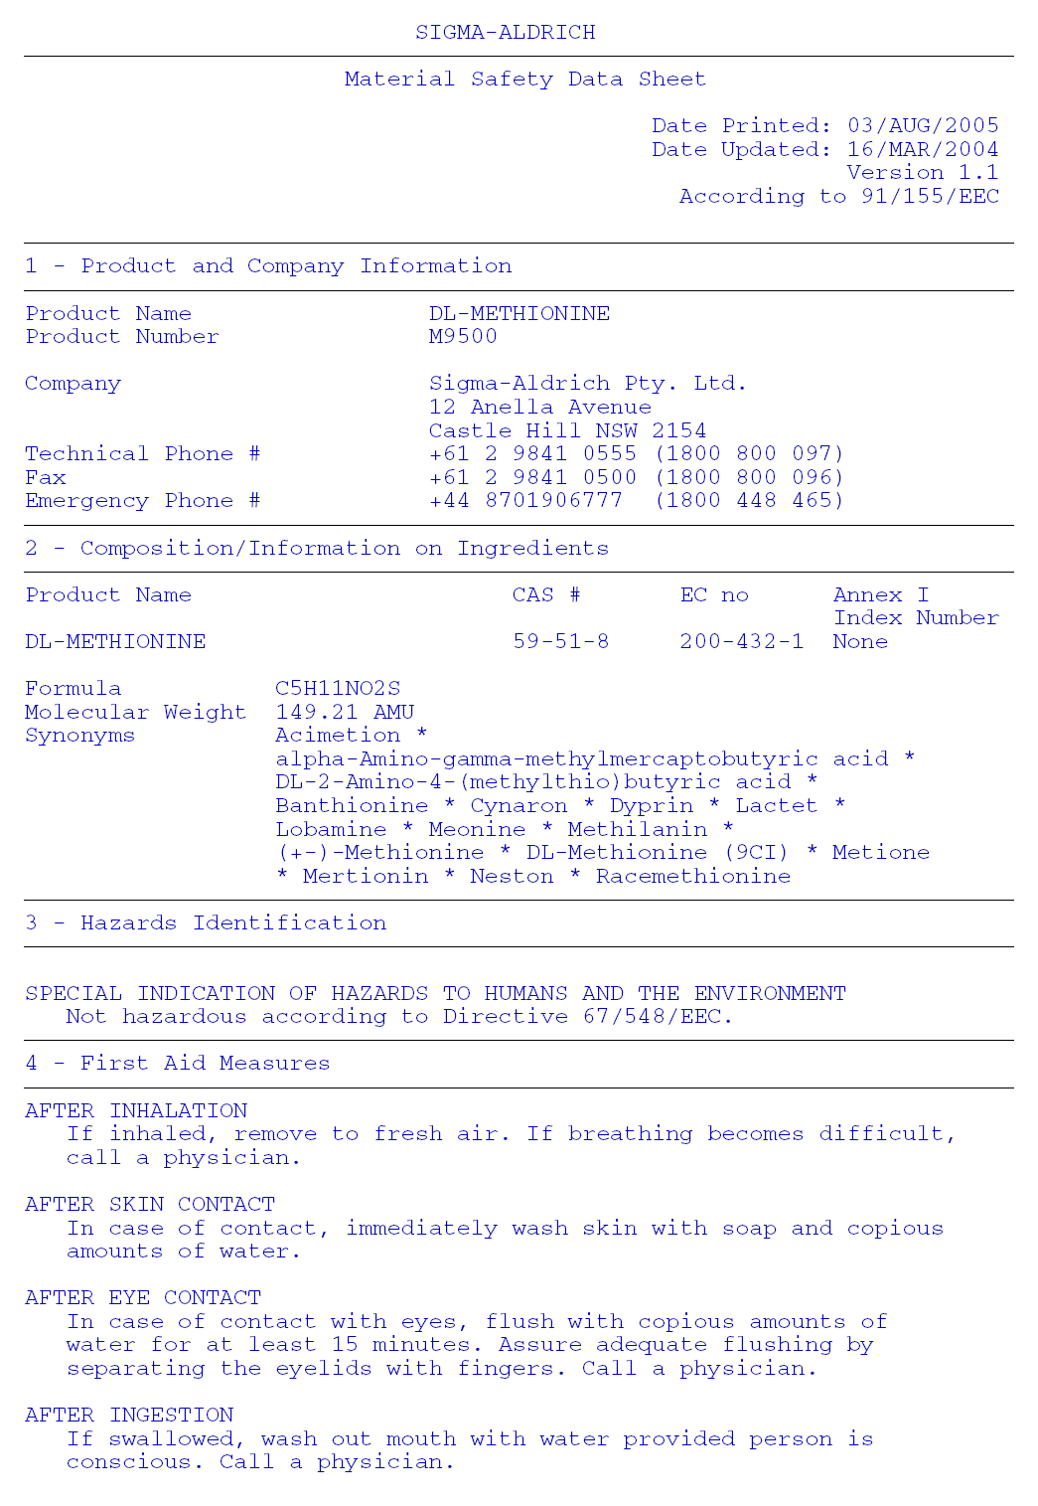

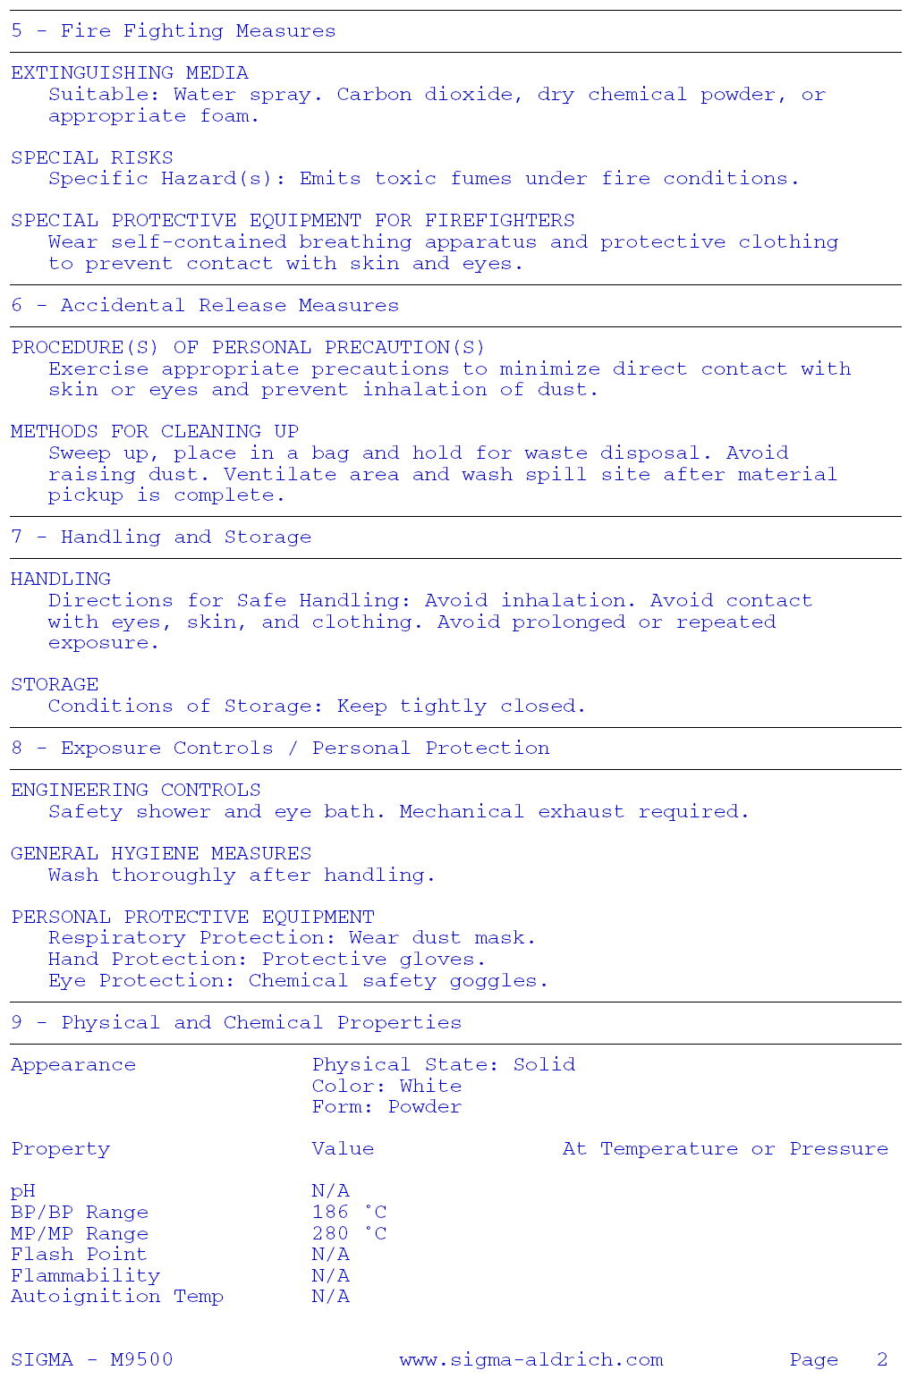
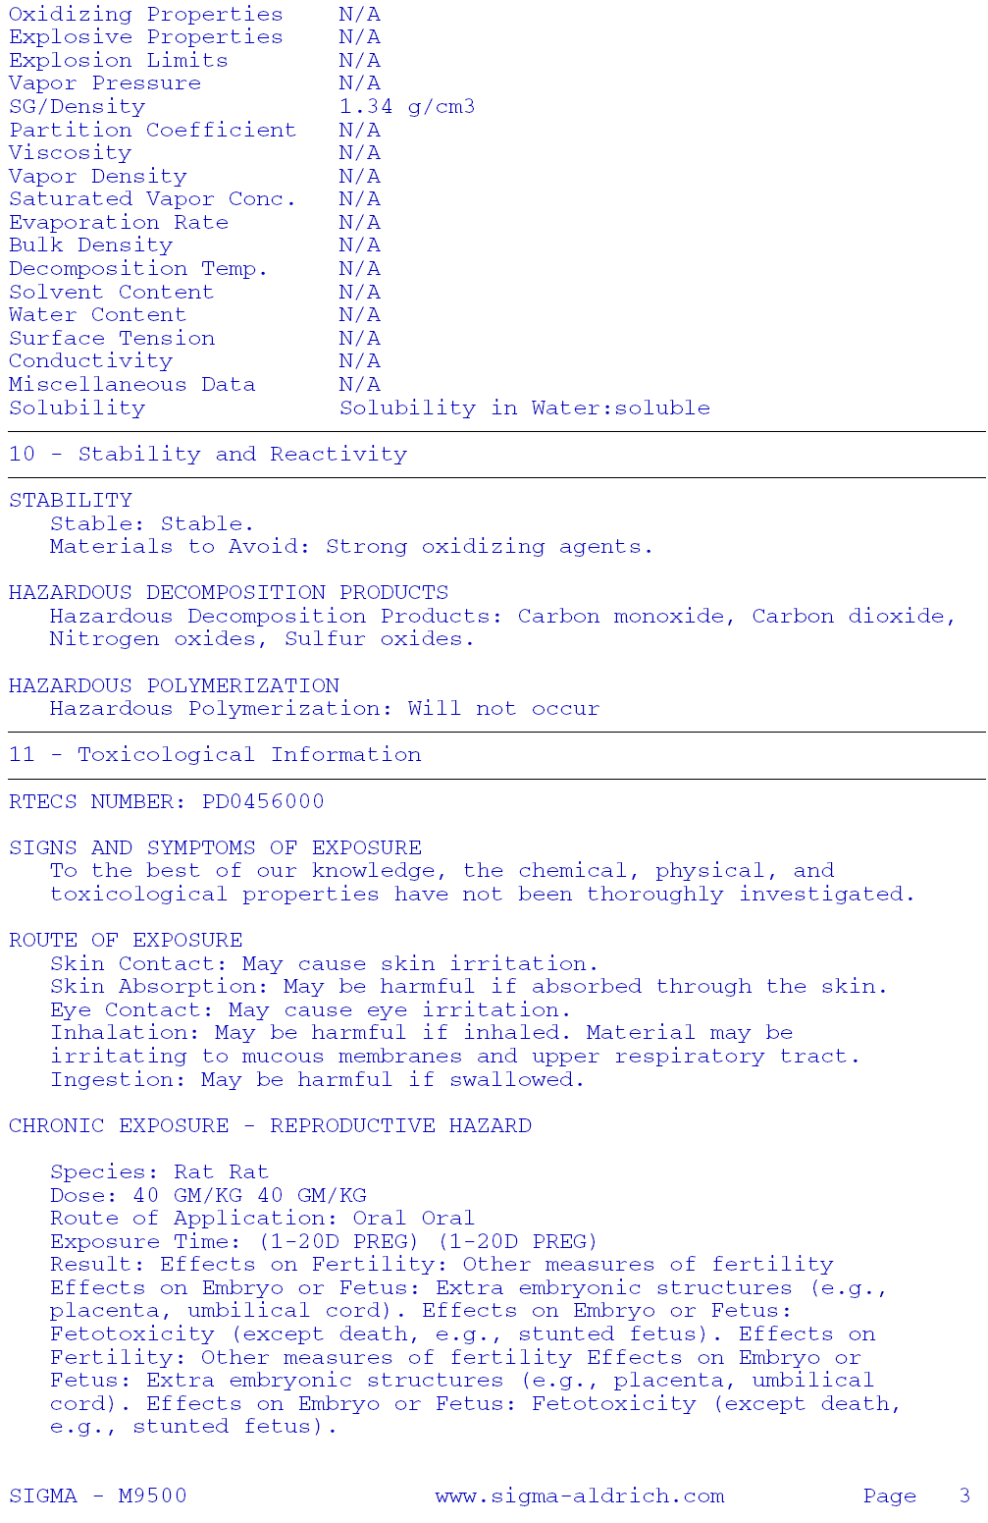
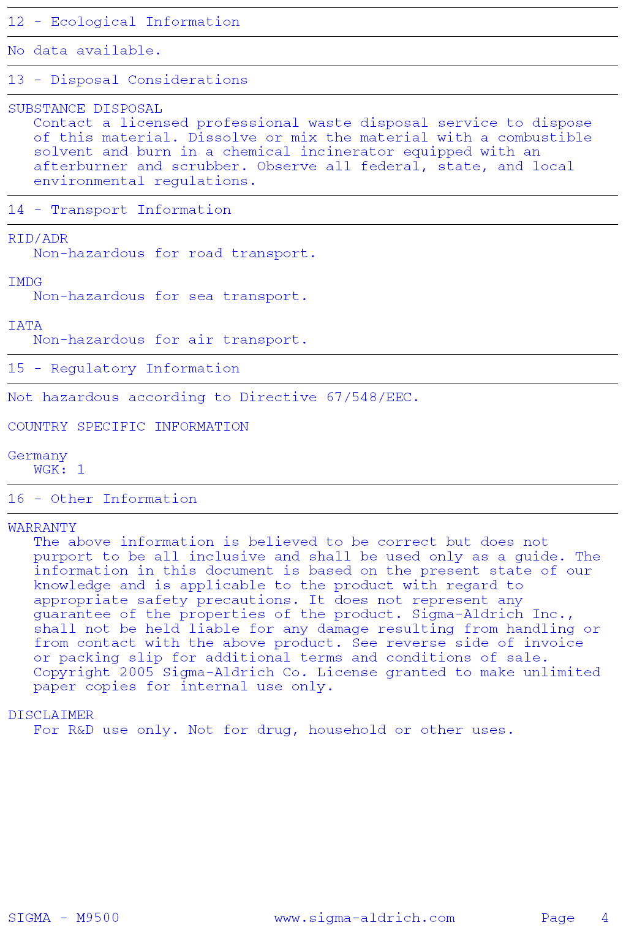

US Broiler Historical Growth Performance
Source: Poultry USA, Watt Publications, February 2002
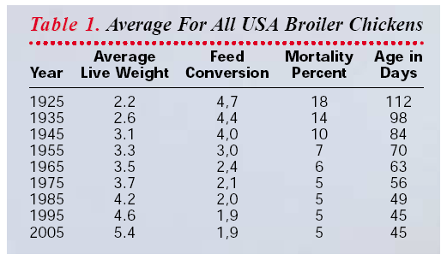

Poultry Diets from the 1940’s
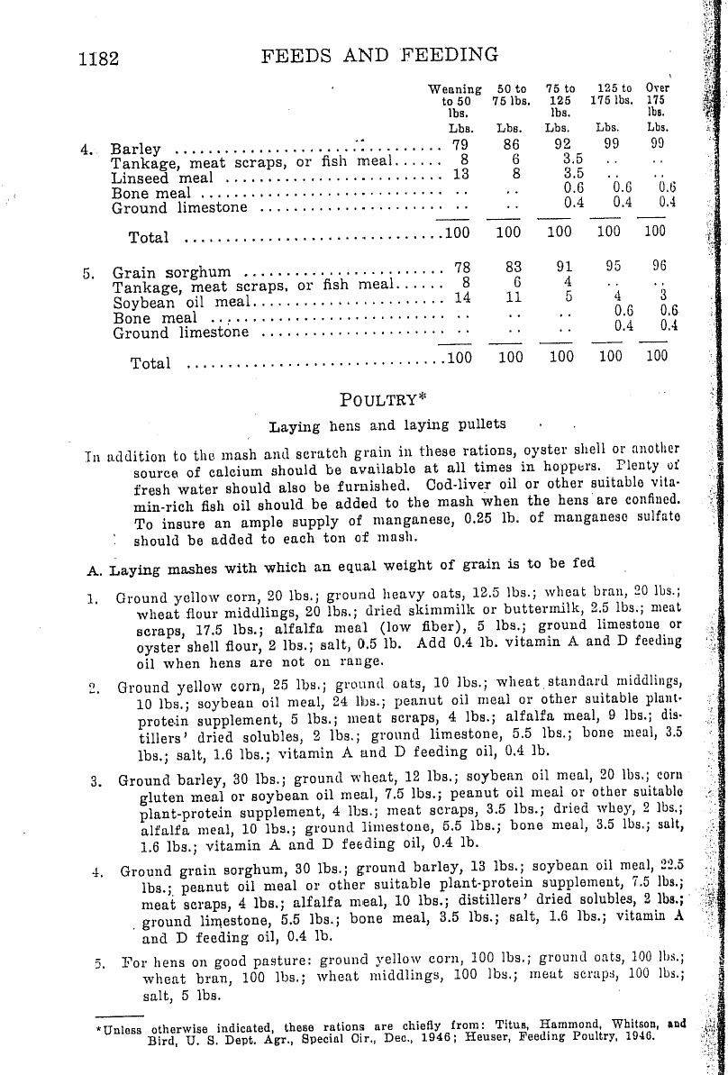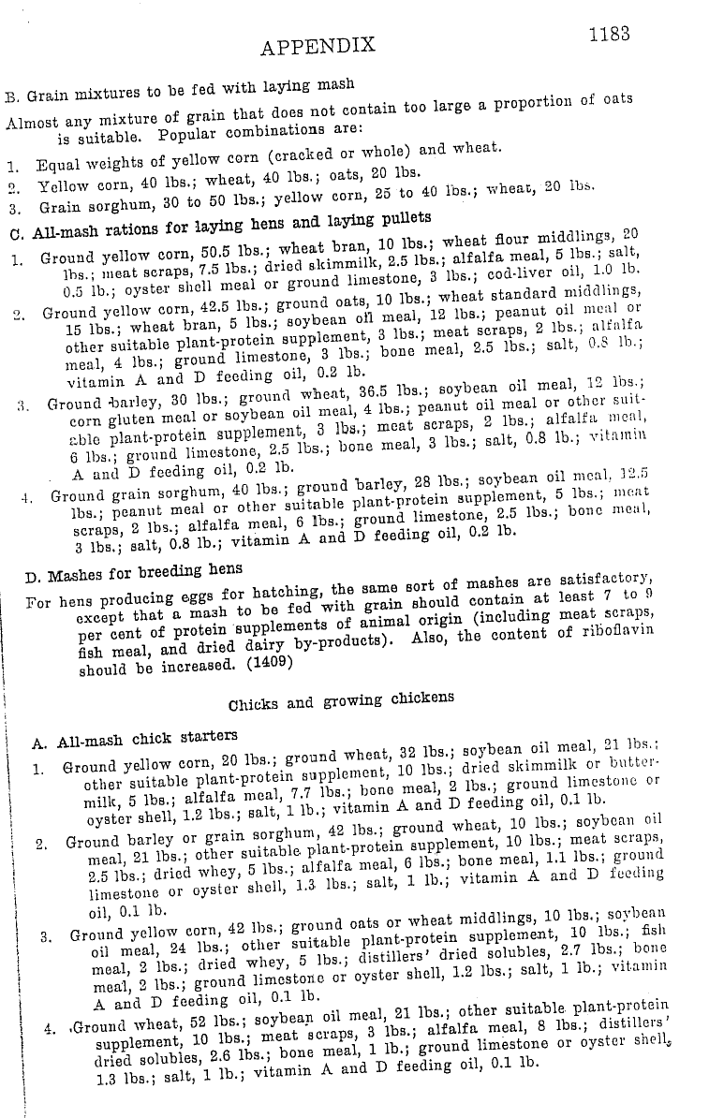

SUMMARY OF METHIONINE SOURCES

Alternative | Approx.  Methionine % | Synthetic | Natural | Organic | Commercially Available | Other Comments
Dl Methionine | 99.00 | Yes |  |  |  | Included as 0.001-0.0025% of ration
Corn | 0.18 |  |  | Yes | Yes | Currently in Poultry Ration
Hi Methionine Corn | 0.36 |  |  | Yes | No | In R&D Phase
Soybean Meal | 0.60 |  |  | Yes | Yes | Currently in Poultry Ration
Sesame Meal | 1.26 |  |  | Yes | No | Deficient in Lysine
Sunflower Meal | 0.72 |  |  | Yes | No | Relatively Low Methionine
Canola Meal | 0.75 |  |  | Yes | No | Relatively Low Methionine
Alfalfa Meal | 0.20 |  |  | Yes | No | Very Low Methionine
Corn Gluten Meal | 1.50 |  | Yes |  |  | Not available in organic form
Flax Meal | 0.50 |  |  | Yes | No | Relatively Low Methionine
Blood Meal | 1.00 |  |  | No |  | Not allowed: Animal By Product
Insects | Unknown |  |  |  | No | Pilot project under development
Earthworm Meal | 1.60 |  |  |  | No | Not being produced
Crab Meal | 0.50 |  |  |  |  | Not available in organic form
Meat Meal | 0.81 |  |  |  |  | Not allowed: Animal By Product
Rice | 0.22 |  |  | Yes | No | Very Low Methionine
Casein | 2.56 |  |  | Yes | No | Ratio of methionine to cystine is poor
Milk Powder, Skim | 0.79 |  |  | Yes | Yes | Relatively Low Methionine
Potato Protein | 1.60 |  | Yes |  | No | Not available in organic form
Fish Meal | 1.68 |  | Yes | ?? |  | Not available in organic form, ratio of methionine to cystine is poor

