USDA Foreign Agricultural Service
GAIN Report

Global Agriculture Information Network
Template Version 2.09

Required Report - public distribution
Date: 10/4/2006
GAIN Report Number: RP6050
RP6050
Philippines
Food and Agricultural Import Regulations and Standards
Export Certificate Report
2006

Approved by:
Emiko Purdy
FAS Manila
Prepared by:
Pia Abuel-Ang

Report Highlights:
This report lists main health and sanitary certificates required by the Philippine government that must accompany U.S. food and agricultural exports to the country.

Includes PSD Changes: No
Includes Trade Matrix: No
Annual Report
Manila [RP1]
[RP]
DISCLAIMER

This report was prepared by the Office of Agricultural Affairs (OAA) of the USDA/Foreign Agricultural Service in Manila, Philippines for U.S. exporters of food and agricultural products. While every possible care has been taken in preparation of the report, information provided may no longer be complete nor as precise as some import requirements are subject to frequent changes. It is highly recommended that U.S. exporters ensure that all necessary customs clearance requirements have been verified with local authorities through your foreign importer before the sales conditions are finalized. FINAL IMPORT APPROVAL OF ANY PRODUCT IS SUBJECT TO RULES AND REGULATIONS AS INTERPRETED BY BORDER OFFICIALS AT THE TIME OF PRODUCT ENTRY.

Please contact OAA/FAS/Manila at agmanila@usda.gov if you have any comments, corrections or suggestions.

Section I. Summary of All Required Export Certificates

Note:
DA – Department of Agriculture
DOH – Department of Health
BAI – Bureau of Animal Industry
NMIS – National Meat Inspection Service
BPI – Bureau of Plant Industry
BFAD – Bureau of Food and Drug
BFAR – Bureau of Fisheries and Aquatic Resources

Product(s) | Title of Certificate | Attestation Required on Certificate | Purpose | Requesting  Ministry
Poultry & Poultry  Products | FSIS 9060-5,  Meat & Poultry Export Certificate of Wholesomeness  (Annex-I) | See Section III.A | Food Safety | BAI/NMIS
Meat & Meat  Products | FSIS 9060-5,  Meat & Poultry Export Certificate of Wholesomeness | See Section III.B | Food Safety | BAI/NMIS
Beef & Beef  Products | FSIS 9060-5,  Meat & Poultry Export Certificate of Wholesomeness | “The meat was derived from cattle less than 30 months of age”  see Section III.B | Food Safety | BAI/NMIS
Live Animals | VS Form 17-37, Certificate of Inspection of Export Animals/ U.S. Origin Health Certificate  (Annex-II) | see Section III.E | Health | BAI
Milk & Milk Products | International Health Certificate | see Section III.B | Health | BAI
Fresh Fruits and Vegetables | PPQ 577,  Phytosanitary Certificate  (Annex-III) | see Section III.C | Free from quarantine pests and conform with current phytosanitary requirements. | BPI
Fish & Seafood Products | International Health or Sanitary Certificate  (Annex-IV) | see Section III.D | Health | BFAR
Pet Food & Animal Feedstuff | PPQ 578,  Phytosanitary Certificate  (Annex V) | see Section III.F | Safety | BAI

Section II. Purpose of Specific Export Certificate(s)

All imported food and agricultural products are required to comply with the Philippines’ food, health and phytosanitary laws. All food and agricultural products, including plant products that enter the Philippines, are required to pass through procedures designed to check that they are not contaminated with any pest and that they are fit for their intended use.

The health and phytosanitary regulations and procedures applied on imported agriculture and food products are broadly similar for all types of products. Under Philippine import laws, it is the responsibility of the importer to ensure that any product entering the Philippines customs territory is in full compliance with Philippine health and phytosanitary regulations.

The enforcing authorities will check for compliance by inspecting the goods and relevant import/export documentation and decide on whether the goods may enter the Philippines.
In cases of non-compliance, the goods may be required to be treated before being released or they may be rejected and ordered destroyed or disposed of outside the Philippines.

Section III. Specific Attestation Required on the Export Certificate(s)

A. Poultry Products: All U.S. poultry products must be accompanied by an FSIS Meat & Poultry Export Certificate of Wholesomeness (FSIS 9060-5).

SPECIFIC CERTIFICATION REQUIREMENTS

- Poultry Feet: “This certifies that the poultry feet, oil sacs or duck tongues specified above have been processed in compliance with the regulations governing the inspection of poultry and poultry products (9 CFR Part 381) as promulgated by the Secretary of Agriculture, and are sound and adulterated so far as can be determined by external examinations and acceptable for human consumption according to Hong Kong standards.”

- Poultry for Further Processing and Re-export to Japan: “The meat and meat products described herein were processed under sanitary conditions in accordance with laws and regulations of the United States which have been deemed to be equivalent to the inspection laws of Japan”

“There have been no outbreaks of fowl pest (fowl plague) for at least 90 days in the United States. Further, in the area where birds for export (meat) were produced (such an area being within a minimum radius of 50 kilometers from the production farm), Newcastle disease, fowl cholera, and other serious infectious fowl diseases, as recognized by the United States, have not occurred for at least 90 days.”

The slaughter date, name, address and official establishment number of the U.S. production plant must also be provided in the remarks section of the FSIS certificate or separately on a FSIS letterhead certificate.

B. Red Meat and Red Meat Products: All U.S. meat and meat products must be accompanied by an FSIS Meat & Poultry Export Certificate of Wholesomeness (FSIS 9060-5).

SPECIFIC CERTIFICATION REQUIREMENTS

- Beef and Processed Beef Products:

“The meat was derived from cattle less than 30 months of age.”
“The product contains no specified risk materials including brain, skull, eyes, trigeminal ganglia, spinal cord, tonsils, intestines, vertebral column, and dorsal root ganglia.”

- Tallow: “The protein-free tallow covered by this certificate has been tested for content of insoluble impurities with the result below 0.15% in weight.”

The above certification statement will be included on the export certificate based on the presentation of a certificate issued by an independent laboratory. Moreover, the protein-free beef tallow may be derived from animals of any age.

- Products Made With Beef Imported from Australia and New Zealand: “The beef was derived from beef legally imported into the United States from Australia or New Zealand.”

In addition the product must be accompanied by the copies of the health certificates issued by Australian and New Zealand inspection officials.

- Collagen: “Source cattle should not be older than thirty (30) months, devoid of nerves and other BSE specified risk materials (SRMS); the collagen casing should come from the skin of healthy ambulatory and not downer cattle; and the collagen casing should be prepared from hides and skins, except those coming from the head.”

- Other Red Meat and Red Meat Products: “No specific language required”

For complete import requirements please visit:
http://www.fsis.usda.gov/regulations_&_policies/Philippines_Requirements/index.asp

C. Fresh Fruits and Vegetables: All fresh fruits and vegetables from the United States must be accompanied by an APHIS Phytosanitary Certificate (PPQ 577). Only
Federal Phytosanitary Certificate issued by a duly authorized Plant Quarantine Officer from the country of origin will be accepted by Philippine authorities.

CERTIFICATION REQUIREMENTS

- The shipment must be absolutely free from soil.
- The shipment must be free from Mediterranean Fruitfly (Ceratis Capitata), Mexican Fruitfly (Anastrpha Ludens), West Indian Fruitfly (Anastrepha Obliqua), Sapochilla Fruitfly (Anastrepha Serpentina), Sapochilla Fruitfly (Anastrepha Serpentina), Oriental Fruitfly Bactrocera Dorsalis) and Coddling Month (Cydia Pomella).

D. Fish and Seafood Products: All fish and seafood products must be accompanied by an International Health or Sanitary Certificate executed by the competent Authority from the country of origin.

CERTIFICATION REQUIREMENTS

The following information should appear on the packaging and on the accompanying documents:
- the country of origin written out in full;
- species of fish/fishery products weight and content;
- address of supplier; and
- BFAR Inspection stamp mark (frozen fishery/aquatic products imported in bulk intended for further processing are not covered by this requirement)
E. Live Animals: All live animals from the United States must be accompanied by an APHIS Certificate of Inspection of Export Animals (VS Form 17-37) and/or a U.S. origin Health Certificate.

Live Horses: The animals must be accompanied by a U.S. Origin Health Certificate issued by a veterinarian authorized by the U.S. Department of Agriculture and endorsed by a Veterinary Services (VS) veterinarian. The certificate shall contain the name and address of the consignor and the consignee and a complete identification of the animals to be exported. The following information should be included: Additional information may be obtained from:

CERTIFICATION STATEMENTS
- The United States is free of contagious equine metritis (CEM), glanders, dourine, and African horse sickness.
- The animals were born or raised or have been in the United States for at least 6 months prior to export.
- The animals originated from premises where there have been no outbreaks of the following diseases for the last 6 months and individual animals are free from clinical evidence of such diseases: ulcerative lymphangitis, equine infectious anemia, equine encephalomyelitis, equine influenza, equine rhinopneumonitis, equine viral arteritis, vesicular stomatitis, Salmonella abortivoequina, strangles, and piroplasmosis prior to export.
- The animals were treated against internal and external parasites on ___________ (date) with _________________________ (name of product) within 30 days prior to export.
- The animals were not vaccinated with any live or attenuated vaccine within 14 days of export.
- The animals were maintained in isolation so as to have no direct contact with other non-tested animals from the time the testing began until export.
- The animals have been vaccinated for equine encephalomyelitis using killed vaccine not less than l5 days and not more than 6 months prior to export.

For complete import requirements please visit:
http://www.aphis.usda.gov/vs/ncie/iregs/animals/rp_eq.pdf

Live Swine: The swine must be accompanied by a U.S. Origin Health Certificate issued by a veterinarian authorized by the U.S. Department of Agriculture (USDA) and endorsed by a Veterinary Services (VS) veterinarian. The certificate must provide the names and addresses of the consignor and consignee, the names of the ports of embarkation and destination, complete identification of the animals, and the total number of animals. It must also provide the following certification statements and the dates and results of the indicated testing.

CERTIFICATION STATEMENTS
- The United States is free of African swine fever, classical swine fever (hog cholera), and foot-and-mouth disease.
- The premises of origin and the swine have been free of clinical evidence of atrophic rhinitis, erysipelas, leptospirosis, parvoviral disease, pseudorabies, swine dysentery, swine influenza, transmissible gastroenteritis (TGE), and vesicular stomatitis for the last 180 days prior to export.
- The swine originate from brucellosis-free States or validated brucellosis-free herds.
- The swine originate from pseudorabies-qualified herds.
- The swine originate from premises where tuberculosis has not been diagnosed for the last 12 months prior to export.
- The swine have been isolated from any additions to the herd for the last 30 days prior to export.
- After due inquiry, I am satisfied that the swine have not been fed garbage at any time.
- The swine will be transported to the port of embarkation in cleaned and disinfected vehicles.
- The swine have not been vaccinated against pseudorabies.
- The swine were injected on_____________, which is within 7 days prior to export, with longacting oxytetracycline at a rate of 20 mg/kg.
[Note: this statement is not required for swine tested for leptospirosis as prescribed below.]
- The swine have not been vaccinated for parvoviral disease.
OR
- The swine were vaccinated for parvoviral disease on___________
with________________, a USDA-licensed, inactivated vaccine.
[Note: the swine must not have been vaccinated with a live parvovirus vaccine.]

For complete import requirements please visit:
http://www.aphis.usda.gov/vs/ncie/iregs/animals/rp_po.pdf

Live Cattle: The cattle must be accompanied by a U.S. Origin Health Certificate issued by a veterinarian authorized by the U.S. Department of Agriculture (USDA) and endorsed by a Veterinary Services (VS) veterinarian. The certificate must provide the names and addresses of the consignor and consignee, the names of the ports of embarkation and destination, complete identification of the animals, and the total number of animals. For complete import requirements please visit:

http://www.aphis.usda.gov/vs/ncie/iregs/animals/rp_hc_cattle_011906.pdf

Live Birds/Day-Old-Chicks/Eggs: All imported fowl, day-old-chicks, eggs and/or hatching eggs should be accompanied by a valid health certificate issued shortly before shipment by the Veterinary Authority at the point of embarkation.

CERTIFICATION REQUIREMENTS FOR DOMESTIC POULTRY

- That the domestic poultry are free of any signs of infectious and contagious disease.

- That the domestic poultry are hatched from eggs from accredited pullorum-free flock and had not been exposed to dangerous communicable disease for 60 days (an accredited pullorum-free farms is one in which all birds over four months are tested with whole blood agglutination test with negative results). Random sampling should be carried out thereafter to ensure the pullorum-free status. Bacterial culture for Salmonella pullorum when needed, should be attempted using approved methods.

- That no case of Fowl Plague, Newcastle Disease, Avian Encephalomyelitis, Avian Leucosis, Marek’s Disease, Infectious Bursal Disease, Duck Virus Enteritis, Duck Virus Hepatitis or any infectious and contagious disease has occurred in the farm of origin for the last six months.

- The domestic poultry are hatched in an incubator in which no eggs from fumigated flocks have been introduced and hatched and the incubator is fumigated or disinfected prior to set and hatched.

- The domestic poultry are packed directly from the incubator into new boxes for export and have no contact with any birds other than the domestic poultry.

CERTIFICATION REQUIREMENTS FOR EGGS

- The eggs come from an accredited pullorum-free flock and from known duck virus hepatitis-free flock.

F. Animal Feed Stuff and Pet Food: All animal feed stuff and pet food must be accompanied by an APHIS Phytosanitary Certificate (PPQ-578). There are no specific certification language required for U.S. animal feed products.

Meat and Bone Meal: Mammalian meat and bone meal is currently prohibited for export to the Philippines while poultry meat and bone meal is eligible for import into the Philippines.

Section IV. Government Certificate Legal Entry Requirements

Import Regulations for Meat and Meat Products: Philippine regulations require that all importers to secure a Veterinary Quarantine Clearance (VQC) certificate from BAI prior to importing meat and meat products. VQCs for imports from the United States are valid for 60 days. Moreover, the date of shipment of goods as reflected in the bill of lading/airway bill should not be earlier than the date the VQC was issued.

More information on the importation of meat and meat products into the Philippines may be obtained from http://bai.da.gov.ph/

Beef and Beef Products: In January 2004, the Philippine Department of Agriculture issued Memorandum Order No. 33 (MO 33), which provided new requirements for beef and beef products imported from the United States. Only beef and processed beef products derived from cattle under 30 months of age are currently allowed entry into the country. Other specific requirements include: only deboned and deglanded muscle cuts of beef from healthy and ambulatory cattle devoid of nerves and any specified risk materials (SRMs) will be allowed entry. Moreover, the production or slaughter date of the cattle must be provided on the packaging label.

On June 24, 2005, the DA temporarily suspended issuance of VQCs for beef and beef products from the United States following the confirmation of a second BSE positive cow in the United States. On July 28, 2005, the DA issued Memorandum Order No. 13 (MO 13) lifting the temporary suspension of beef imports from the United States subject to the same requirements as stated in MO 33. BAI has reiterated that all processed beef products (i.e., corned beef, sausages, etc.) must also be certified as having met the above requirements.

Beef Tallow: The DA also allows the importation of protein-free tallow certified as having insoluble impurities below 0.15% in weight.

Others: Products derived from beef from Australia or New Zealand must be certified as having been legally imported from said countries. For collagen casings of bovine origin, BAI requires additional FSIS certification that the product was prepared from hides and skins other than that coming from the head.

Import Regulations For Fish and Seafood: In 1999, the Bureau of Fisheries and Aquatic Resources (BFAR) issued the implementing rules and regulations for Republic Act 8550 (RA 8550) or the Fisheries Code. This order now requires all importers to obtain quarantine permits prior to importation. Moreover, the importation of fresh/chilled/frozen fish and fishery/aquatic products is allowed only when certified as necessary by the Secretary of Agriculture. Only the importation of fresh/chilled/frozen fish and fishery/aquatic products for canning and processing purposes and those undertaken by institutional buyers is exempt from such certification. Further, all importation must satisfy the Hazard Analysis and Critical Control Point (HACCP) standards as provided under Section 67 of RA 8550.

Additional information may be downloaded on fish and fish product importation from http://www.bfar.da.gov.ph/

Fish and fishery/aquatic products to be imported into the Philippines shall meet the following standard and requirements:

- International Health Certificate - Fish and fishery/aquatic products coming into the Philippines intended for distribution and for further processing shall be certified by authorized or competent regulatory agency from the country of origin. The International Health certificate shall be issued on the basis that the following requirements have been met:

- Fish and fishery/aquatic products meet the quality of fresh fish prior to freezing shall be graded accordingly to size.
- The fishery products must be handled and processed hygienically in processing plants and/or freezer vessels.
- Frozen fishery products must be kept and maintained at -18°C or lower during transport.
- Fish and fishery/aquatic products must be subject to visual inspection for parasite check. Fish infested with parasites, must be removed from the batch.

The International Health Certificate shall be supported with the following laboratory test results, which shall not exceed the indicator organisms, such as:

- Total viable count 10/gram
- E. coli 10 to 100/gram
- Salmonella absent in 25 gram sample
- Shigella absent
- Vibrio cholerae absent

The International Health Certificate shall accompany the consignment of fish and fisher/aquatic products and shall be presented as part of the documentation requirements upon arrival.

- Special Health Control Requirements - Fish and fishery/aquatic products covered by the following families: Scombridae (tuna and tuna-like species and mackerel) and Clupeidae (sardines) shall be subject to chemical analysis for histamine. Examinations shall be carried out in accordance with internationally recognized methods. The results of the test shall not exceed 20 mg/100 gm. And shall be included in the Health certificate requirement.

- Packing and labeling requirements - Fish and fishery/aquatic products must be packed under hygienic condition to preclude contamination from lubricants, oils, fuels or any hazardous substances. Packaging materials shall not impair the sensory attributes of the fishery products and shall not transmit harmful substances. Packaging materials used for fresh fish held under ice should be provided with adequate drainage for melted water.

The following information shall appear on the packaging and on the accompanying documents:

- the country of origin written out in full
- species of fish/fishery products weights and content
- address of supplier
- BFAR Inspection stamp mark

Frozen fishery/aquatic products imported in bulk intended for further processing are not covered by this requirement.

- Storage and transport - Fish and fishery/aquatic products, during storage and transport, shall be stored at temperature requirement for specific products. Chilled fresh fish and fishery products shall be stored and maintained at 0 to 4°C. Frozen fishery products, with the exception of frozen fish in brine intended for canning shall be stored at -18°C or below during transport, allowing not more than 3 degrees upward fluctuation in temperature.

Import Regulations for Fresh Produce: The Bureau of Plant Industry (BPI) regulates imports of fresh fruits and vegetables. All imports of fresh produce require a valid Plant Quarantine Clearance issued by BPI. These permits are applied for by the Philippine importer for each shipment. Shipments of fresh fruits and vegetables must be accompanied by a USDA Phytosanitary Certificate (PC) issued at the port of origin. Import permits for fruits and vegetables need to be secured prior to exportation from the United States. The date of shipment should not be earlier than the date the import permit was issued.

More information on import requirements for fresh fruits and vegetables may be downloaded from http://bpi.da.gov.ph/Services.html

Import Regulations for Pet Food: Requirements for pet food are similar to import procedures for meat and meat products. BAI requires foreign manufacturers of processed dog and cat food and/or Philippine importers to apply for accreditation and to be registered with BAI prior to importation. All pet food products entering the Philippines need to be accompanied by a sanitary certificate issued by the relevant U.S. regulatory body. Like meat products, a VQC needs to be secured from Animal Feeds Division of the BAI before the goods are shipped out of the United States.

Section V. Other Certification/Accreditation Requirements

Minimum Access Volumes: The Philippines is a signatory to the World Trade Organization and has lifted quantitative restrictions (QRs) on imports of food products except for rice. Tariff-Rate Quotas (TRQs) still remain on a number of sensitive products such as corn, poultry meat, pork, sugar and coffee. Minimum Access Volumes (MAV) has been established for these commodities. Please refer to GAIN Report RP6009.

Registration of Processed Food Products: All processed food products offered for retail sale in the Philippines must be registered with the Bureau of Food and Drug. Registration of imported products may only be undertaken by a Philippine entity, although some documentation and, for certain types of products, samples need to be provided by the exporter. Products have been divided into two categories with distinct sets of registration requirements and procedures. Additional information is available from GAIN Report RP6029.

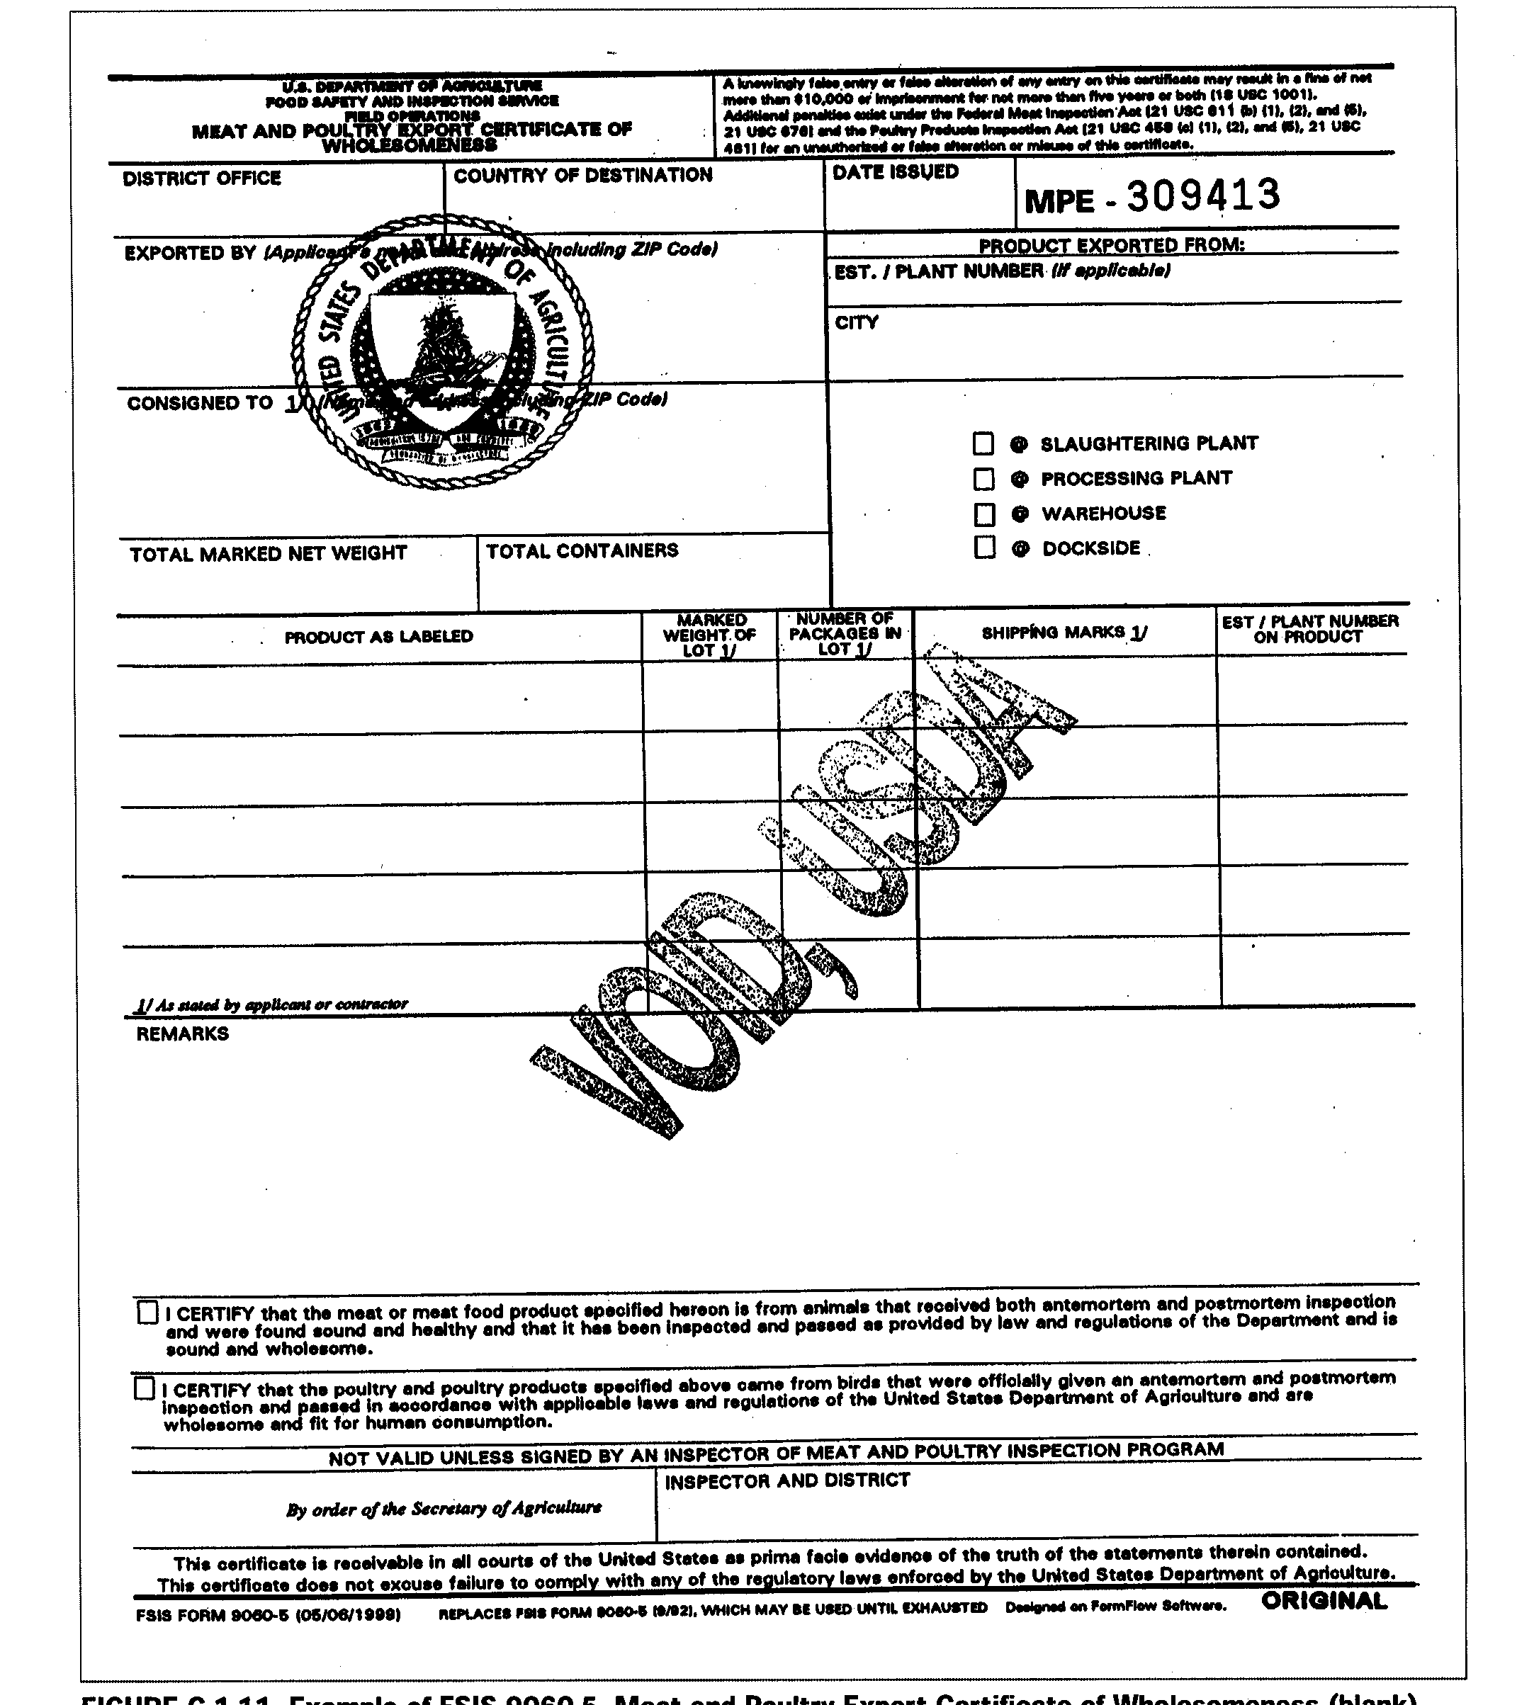
Annex I.
Annex II.
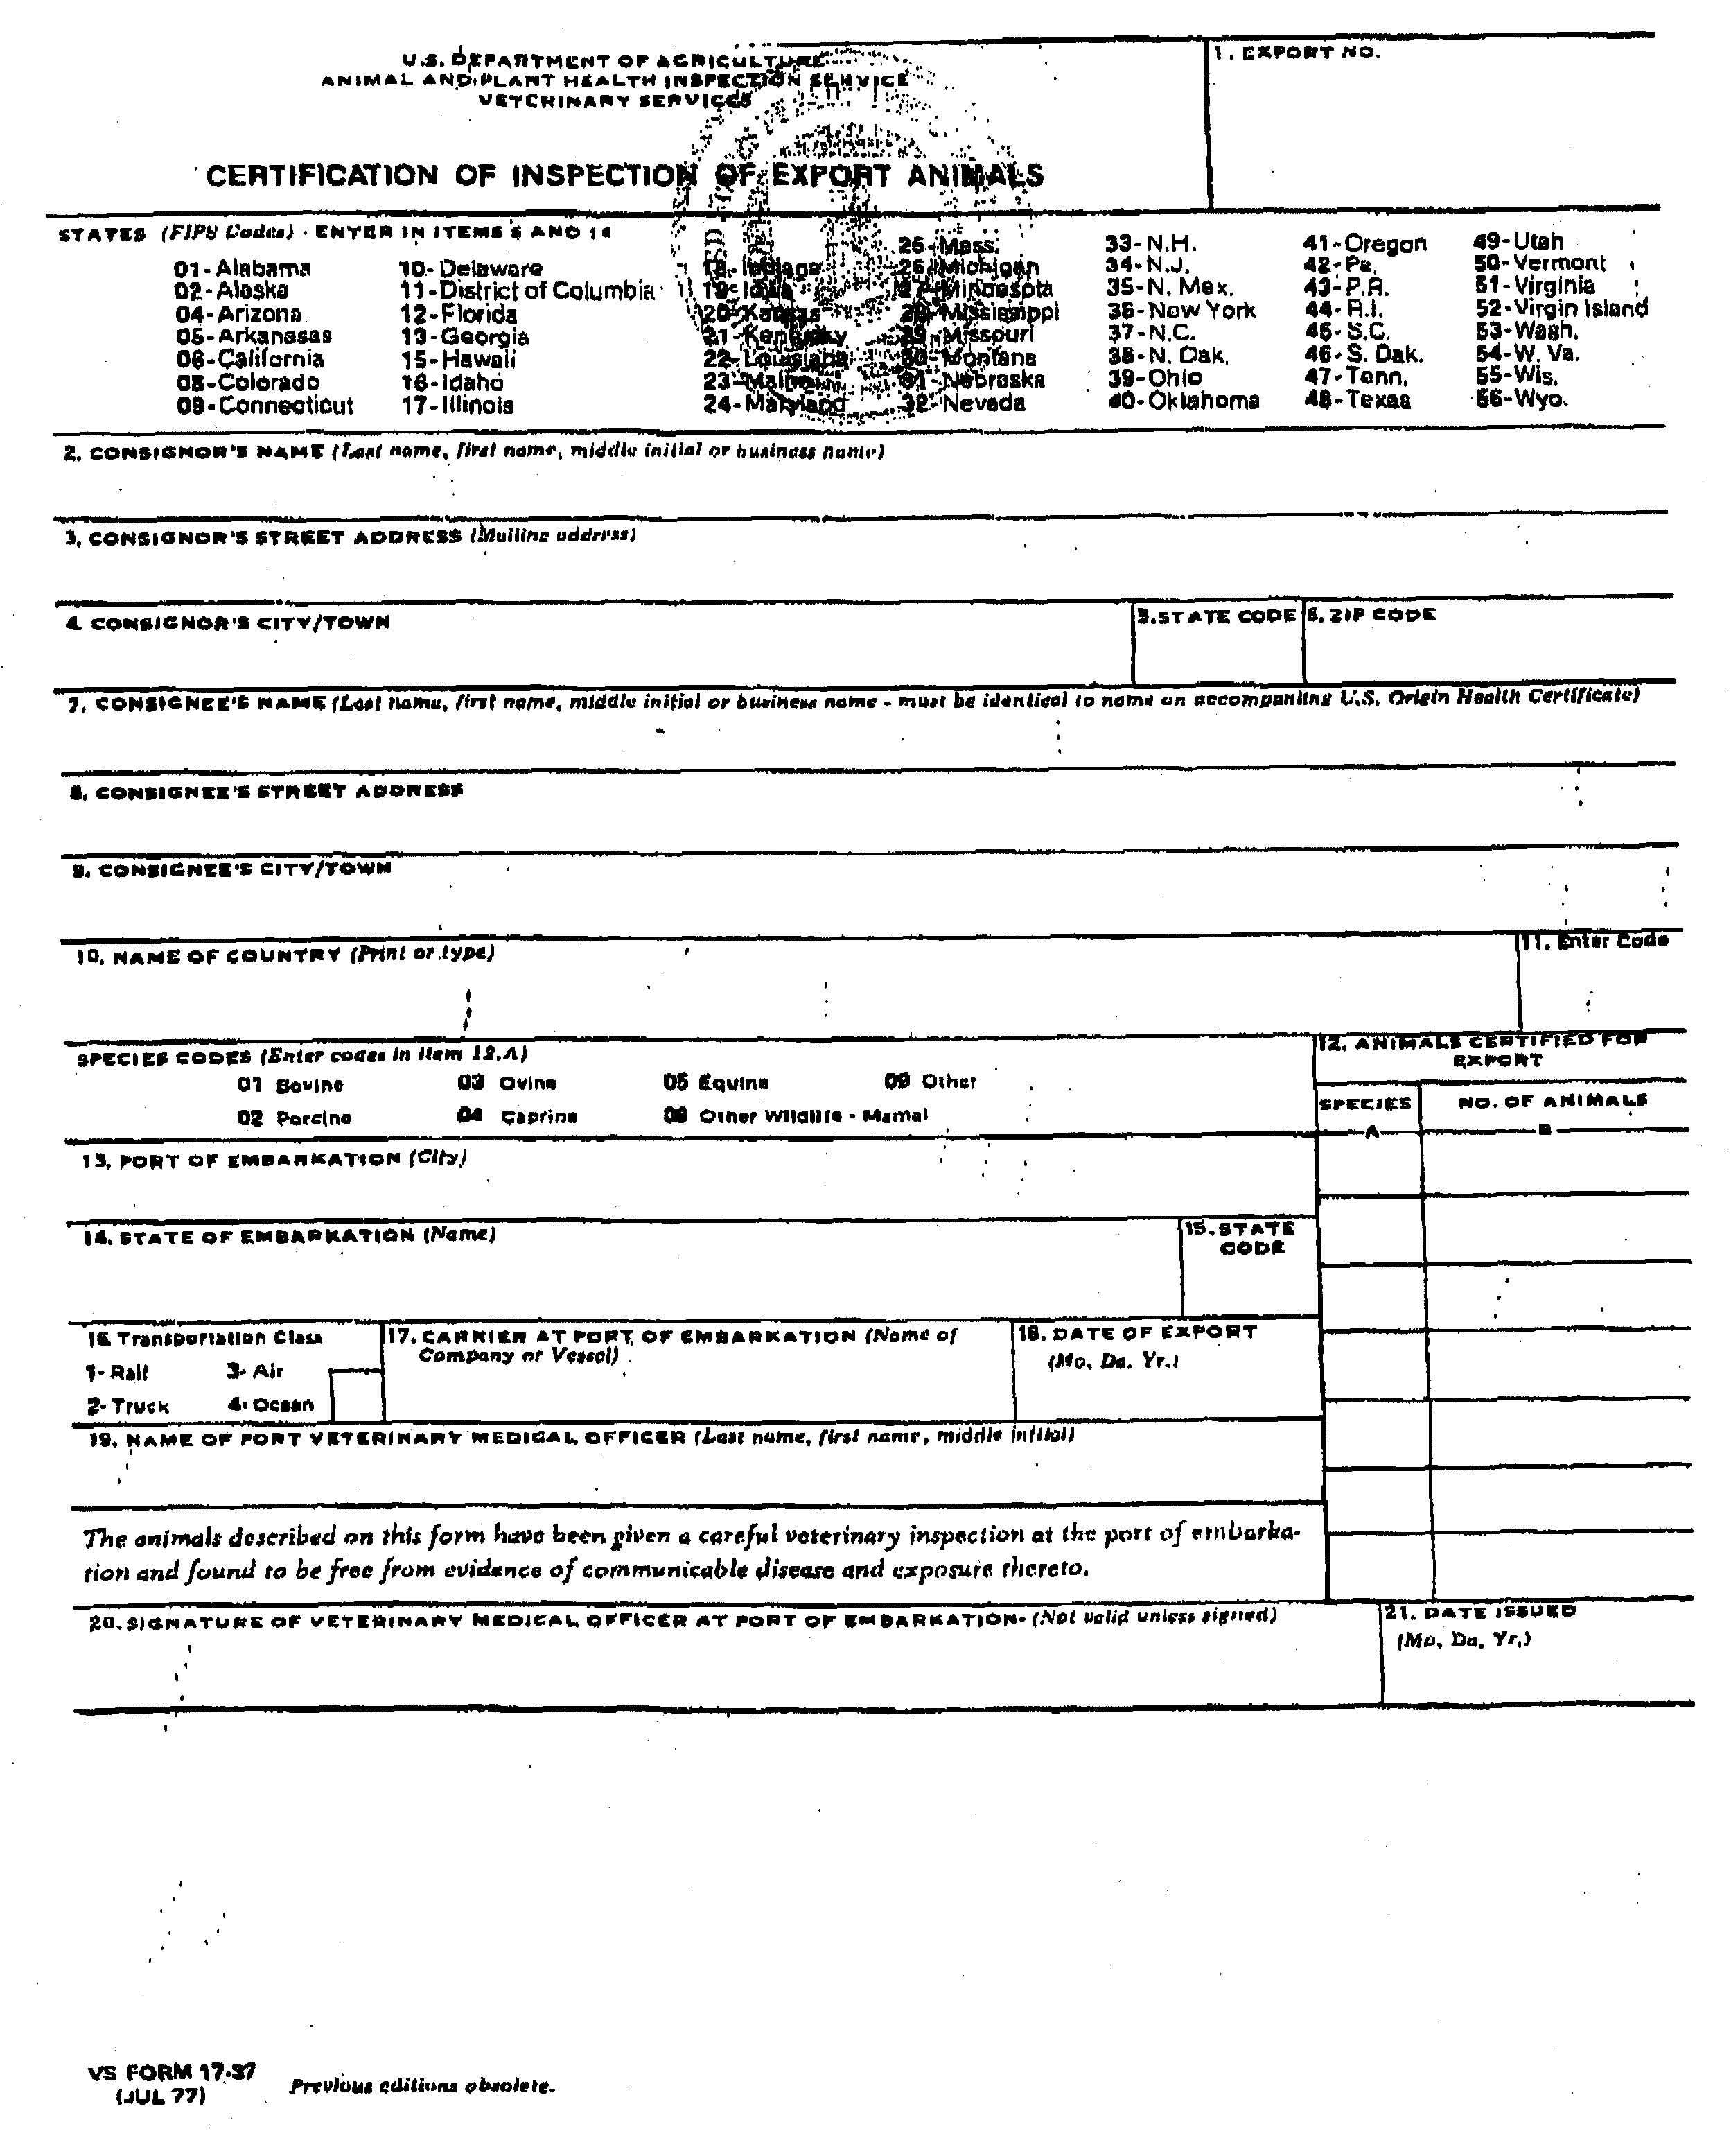
Annex III.

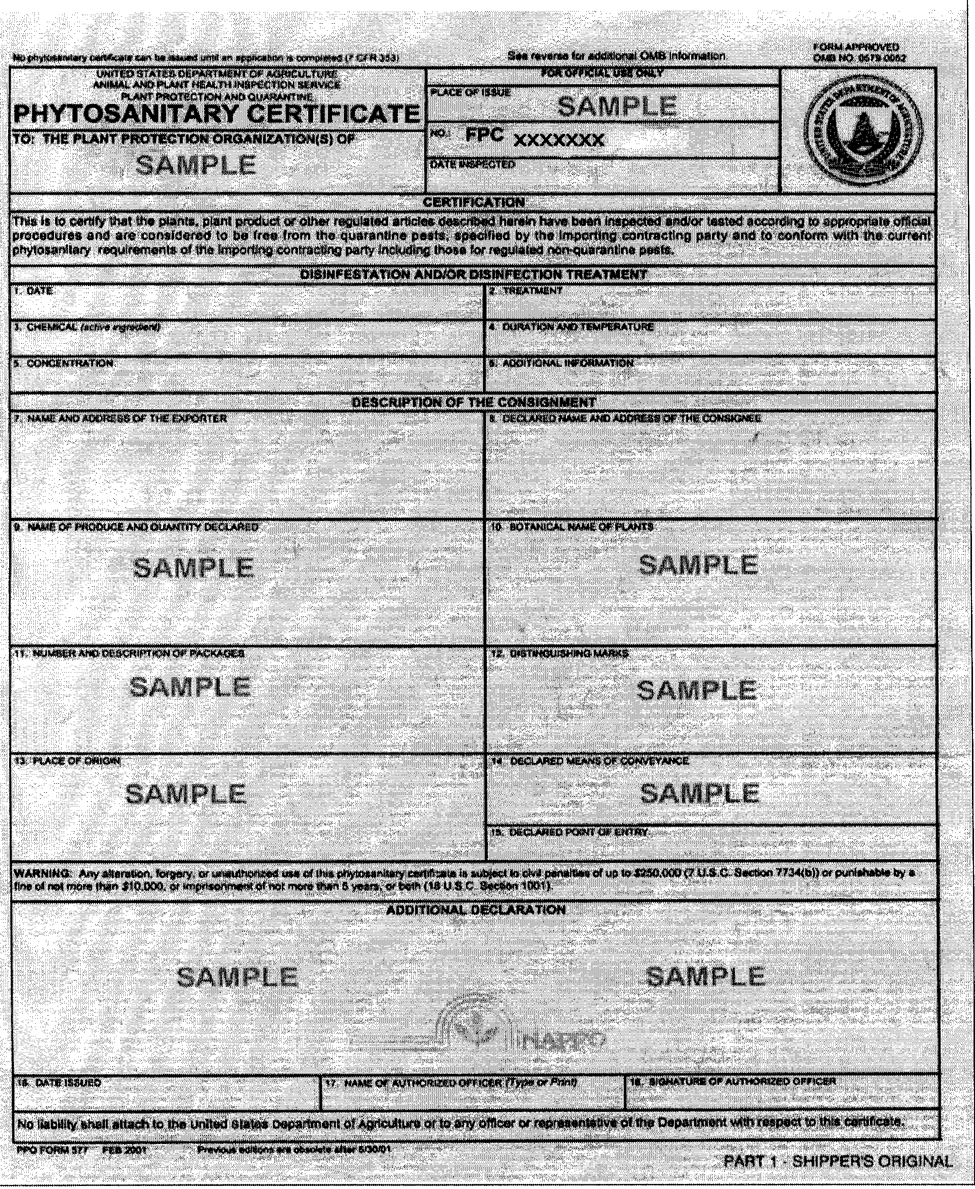
Appendix IV.

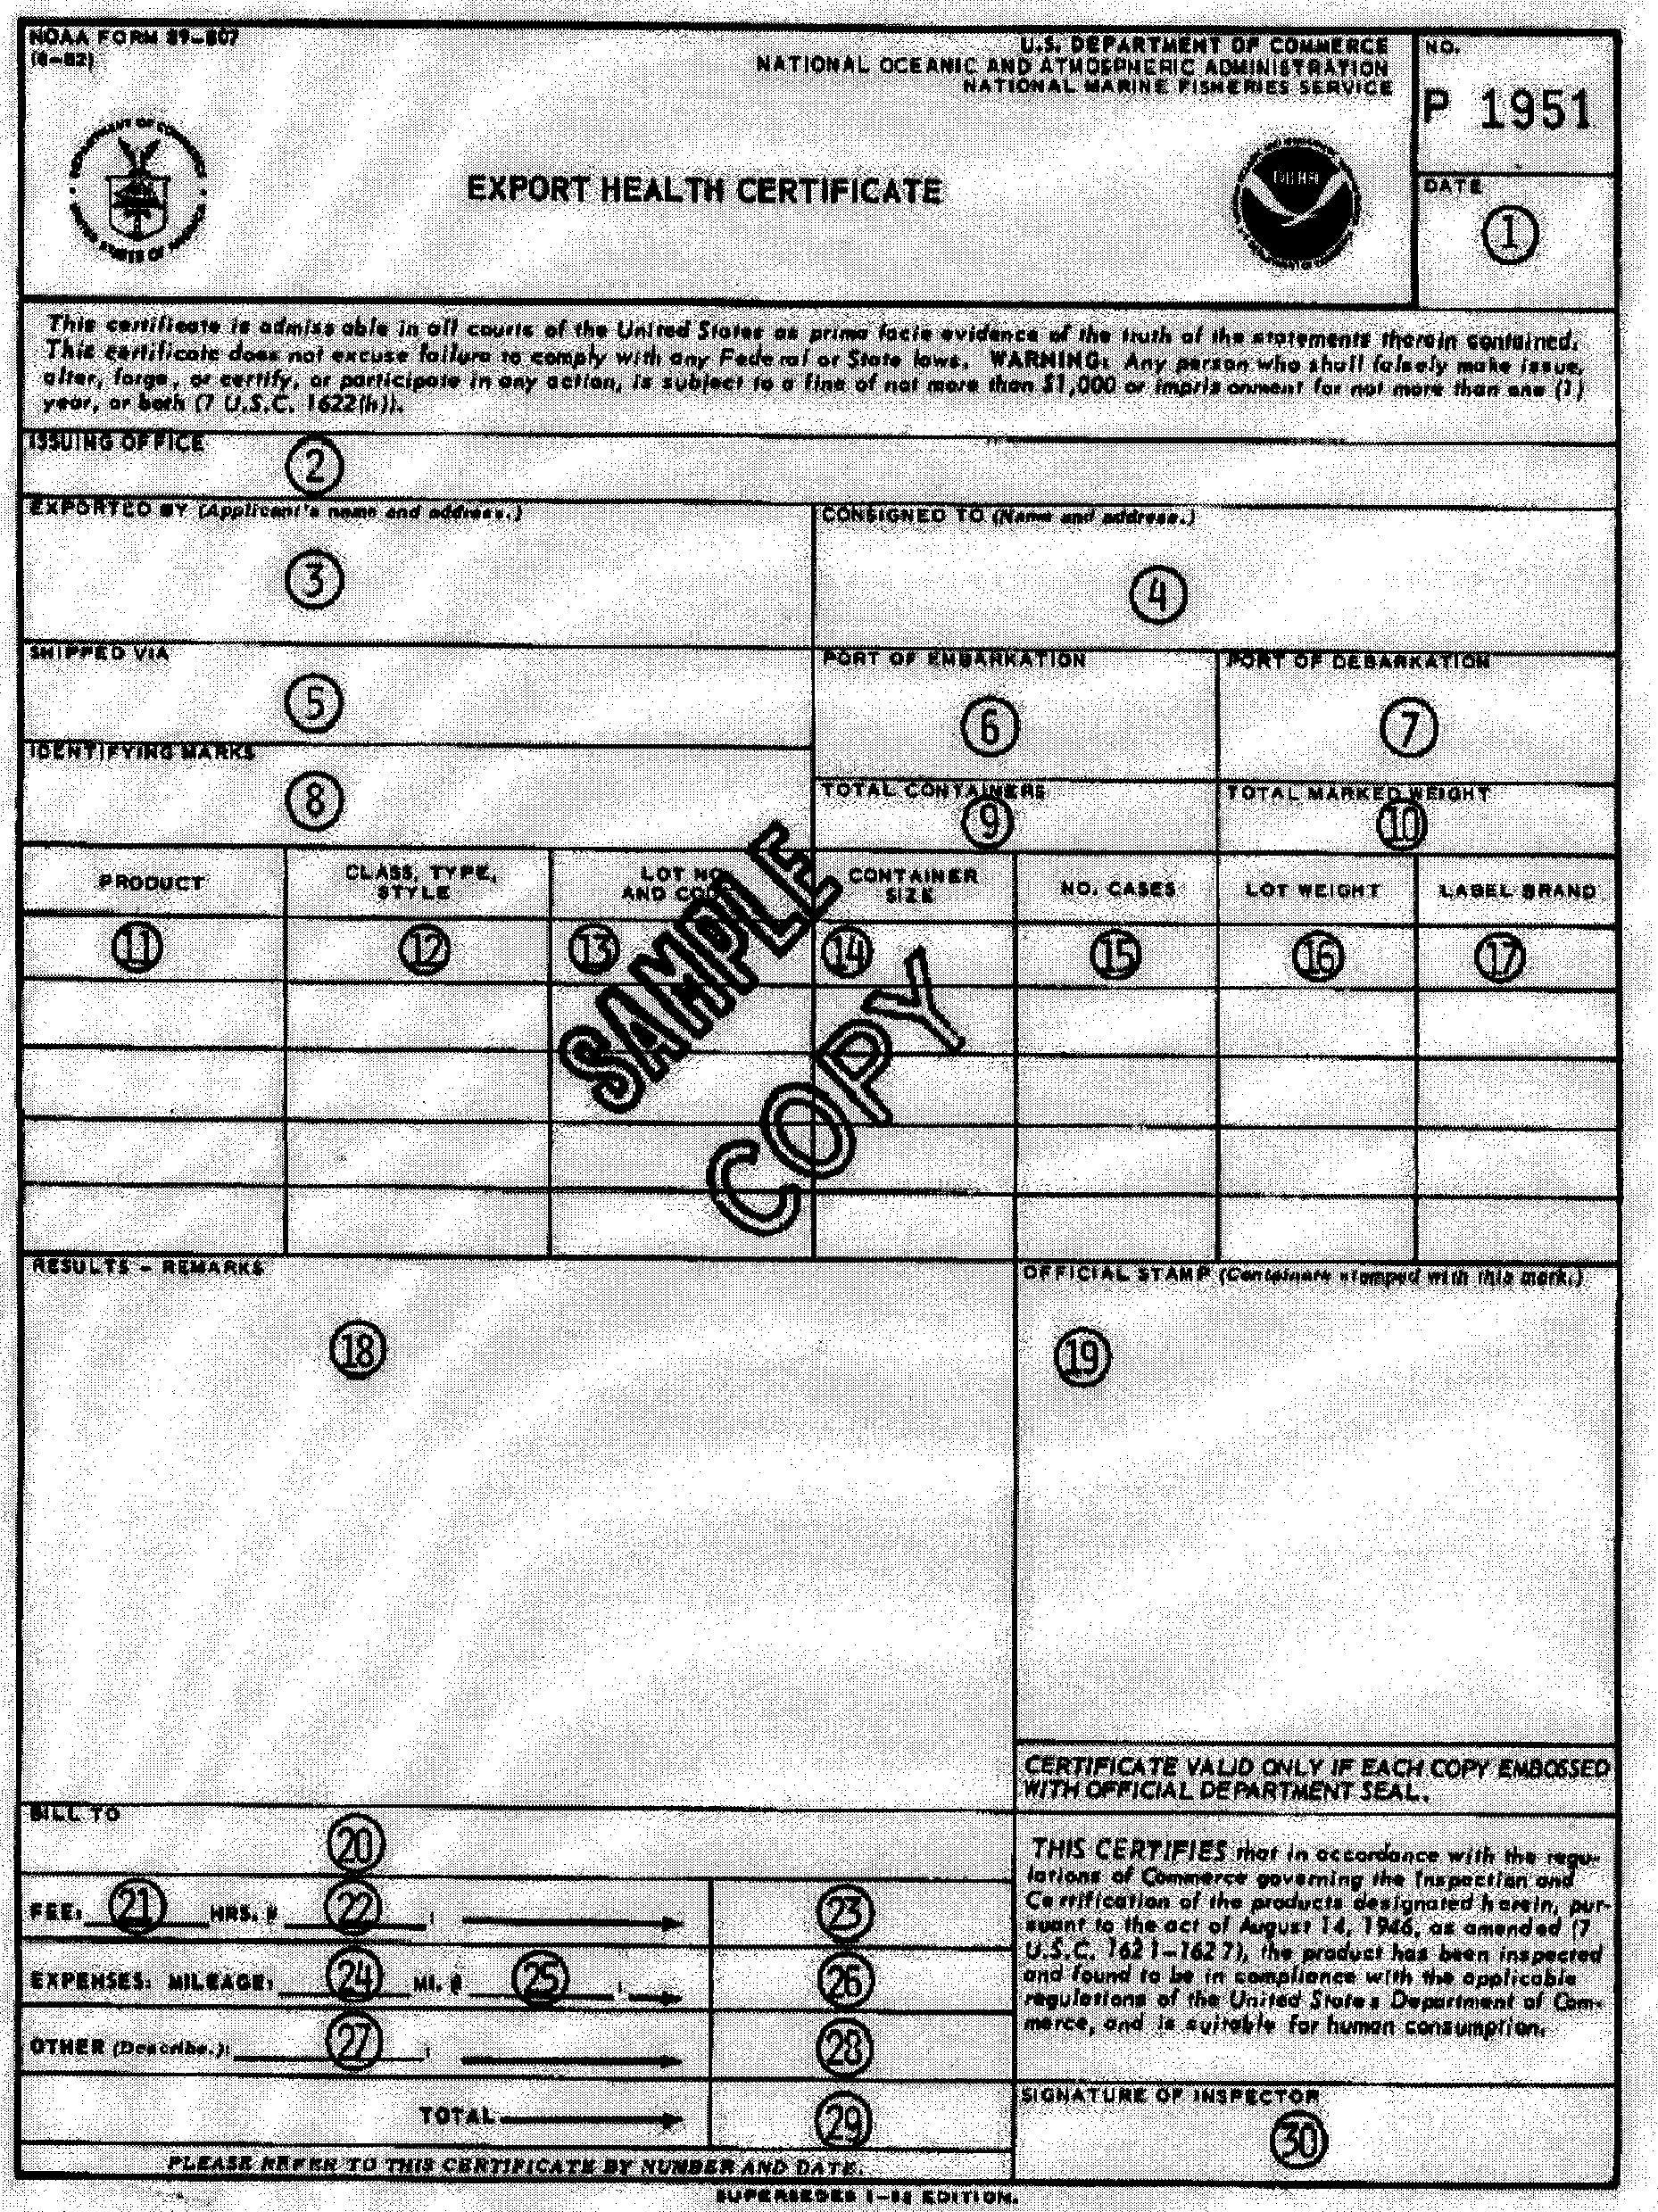

Appendix V.



