Section 14. Down Woody Debris and Fuels
14.0 INTRODUCTION 3
14.1 DEFINITION OF DOWN WOODY DEBRIS 3
14.2 SAMPLING METHODS 4
14.3 LOCATING AND ESTABLISHING LINE TRANSECTS 4
14.3.1 CWD transects 4
14.3.2 FWD transects 5
14.4 TRANSECT LINE SEGMENTING 6
14.4.1 SUBPLOT NUMBER (SUB PL) 7
14.4.2 TRANSECT (T) 7
14.4.3 CONDITION CLASS (CC) 7
14.4.4 BEGINNING DISTANCE (DIST1) 7
14.4.5 SLOPE PERCENT (SLP PCT) 8
14.4.6 ENDING DISTANCE (DIST2) 8
14.5 TALLY RULES FOR COARSE WOODY DEBRIS (CWD) 9
14.6 TALLY RULES FOR CWD WHEN THE PIECE LAYS ACROSS MULTIPLE CONDITIONS 12
14.7 MARKING CWD 13
14.8 RECORDING PROCEDURES FOR CWD 13
14.8.1 SUBPLOT NUMBER (SUB PL) 13
14.8.2 TRANSECT (T) 13
14.8.3 CWD SLOPE DISTANCE (CWD DIST) 13
14.8.4 SPECIES (SPC) 14
14.8.5 DIAMETER AT POINT OF INTERSECTION (TRAN DIAM) 15
14.8.6 DIAMETER AT THE SMALL END (SML DIAM) 16
14.8.7 DIAMETER AT THE LARGE END (LRG DIAM) 16
14.8.8 TOTAL LENGTH (TOTAL LENGTH) 16
14.8.9 DECAY CLASS (DECAY CLASS) 16
14.8.10 IS THE PIECE HOLLOW? (HOL?) 17
14.8.11 CWD history (CWD HIST) 18
14.9 SAMPLING METHODS FOR FINE WOODY DEBRIS (FWD) 19
14.9.1 SUBPLOT NUMBER (SUB PL) 20
14.9.2 CONDITION CLASS (CC) 20
14.9.3 COUNT OF PIECES IN THE 0.01 TO 0.25 INCH DIAMETER SIZE CLASS (SMALL_FWD) 20
14.9.4 COUNT OF PIECES IN THE 0.25 TO 1.0 INCH DIAMETER SIZE CLASS (MEDIUM_FWD) 20
14.9.5 COUNT OF PIECES IN THE 1.0 TO 3.0 INCH DIAMETER SIZE CLASS (LARGE_FWD) 21
14.9.6 REASON FOR AN UNUSUALLY HIGH COUNT OF FWD (REASON_HIGHCOUNT) 21
14.9.7 RESIDUE PILE ON TRANSECT? (RP_on_transect?) 21
14.10 DUFF, LITTER, AND FUELBED DEPTH MEASUREMENTS 22
14.10.1 Subplot number (SUB PL) 23
14.10.2 Transect (T) 23
14.10.3 Duff and litter sample taken at sample location? (DL_SAMP) 23
14.10.4 Duff depth (DUFF_DEPTH) 24
14.10.5 Litter depth (LITTER_DEPTH) 24
14.10.6 Depth of the fuelbed (FUELBED_DEPTH) 24
14.11 FUEL LOADING ON THE MICROPLOT 24
14.11.1 SUBPLOT NUMBER (SUB PL) 25
14.11.2 LIVE SHRUBS PERCENT COVER (L_SHRUB_PC) 26
14.11.3 LIVE SHRUBS HEIGHT (L_SHRUB_HT) 26
14.11.4 DEAD SHRUBS PERCENT COVER (D_SHRUB_PC) 26
14.11.5 DEAD SHRUBS HEIGHT (D_SHRUB_HT) 26
14.11.6 LIVE HERBS PERCENT COVER (L_HERB_PC) 26
14.11.7 LIVE HERBS HEIGHT (L_HERB_HT) 27
14.11.8 DEAD HERBS PERCENT COVER (D_HERB_PC) 27
14.11.9 DEAD HERBS HEIGHT (D_HERB_HT) 27
14.11.10 LITTER PERCENT COVER (LITTER) 27
14.12 SAMPLING RESIDUE PILES 27
14.12.1 SUBPLOT NUMBER (SUB PL) 29
14.12.2 CONDITION CLASS (CC) 29
14.12.3 PILE AZIMUTH (PILE AZM) 29
14.12.4 SHAPE (SHP) 29
14.12.5 and 14.12.6 LENGTH 1 and LENGTH 2 (LNG1, LNG2) 30
14.12.7 and 14.12.8 WIDTH 1 and WIDTH 2 (WID1, WID2) 30
14.12.9 and 14.12.10 HEIGHT 1 and HEIGHT 2 (HT1, HT2) 30
14.12.11 PILE DENSITY (PDENS) 30
14.13 ACKNOWLEDGEMENTS 30

14.0 INTRODUCTION
Down woody debris (DWD) is an important component of forest ecosystems across the country. DWD is dead material on the ground in various stages of decay. Wildlife biologists, ecologists, mycologists, foresters, and fuels specialists are some of the people interested in DWD because it helps describe the:
- Quality and status of wildlife habitats.
- Structural diversity within a forest.
- Fuel loading and fire behavior.
- Carbon sequestration – the amount of carbon tied up in dead wood.
- Storage and cycling of nutrients and water – important for site productivity.
There are two categories of DWD:
- Coarse Woody Debris (CWD) - dead pieces of wood > 3.0 inches in diameter, and
- Fine Woody Debris (FWD) - dead branches, twigs, wood splinters 0.1 to 2.9 inches in diameter
In the past, scientists estimated the amount of CWD and FWD from small, local inventories or from a few research studies that focused on mature and old growth forests. Little was known about the characteristics of woody debris in managed forest stands or in forests that originated after logging (compared to those originating naturally after fire). The USDA Forest Service Pacific Northwest Forest Inventory and Analysis program (PNW-FIA) recognized the need for extensive information on DWD across the landscape, and began collecting CWD data in the late 1980’s. CWD protocols developed by PNW-FIA were piloted by FHM between 1998 and 2000. Full implementation on Phase 3 plots in 2001 establishes a national database that contains DWD and other fuels information across a variety of forest strata.

Any crew member can learn to collect down woody debris data. If untrained members of the crew are available to help, they can locate, measure, and flag transect lines and record the condition class information for the transect segments.

14.1 DEFINITION OF DOWN WOODY DEBRIS
CWD:
In this inventory, CWD includes downed, dead tree and shrub boles, large limbs, and other woody pieces that are severed from their original source of growth and on the ground. CWD also includes standing dead trees (either self-supported by roots, severed from roots, or uprooted) that are leaning > 45 degrees from vertical. Also included are non-machine processed round wood such as fence posts and cabin logs.

For multi-stemmed woodland trees such as juniper, only tally stems that are dead, detached, and on the ground; or dead and leaning > 45 degrees from vertical.

CWD does not include:
- Woody pieces < 3.0 inches in diameter at the point of intersection with the transect.
- Standing dead trees leaning 0 to 45 degrees from vertical (this is a snag).
- Dead shrubs, self-supported by their roots.
- Trees showing any sign of life.
- Stumps that are rooted in the ground (i.e., not uprooted).
- Dead foliage, bark or other non-woody pieces that are not an integral part of a bole or limb. (Bark attached to a portion of a piece is an integral part).
- Roots or main bole below the root collar.

FWD:
In this inventory, FWD includes downed, dead branches, twigs, and small tree or shrub boles that are severed from their original source of growth. FWD can be connected to a larger branch, as long as this branch is on the ground and not connected to a standing dead or live tree. Only the woody branches, twigs, and fragments that intersect the transect are counted. FWD can be connected to a down, dead tree bole or down, dead shrub. FWD can be shrub twigs, as long as the shrub is a woody species. FWD must be no higher than 6 feet above the ground to be counted.

FWD does not include:
- Woody pieces > 3.0 inches in diameter at the point of intersection with the transect.
- Dead branches connected to a live tree or shrub; or to a snag or dead shrub.
- Dead foliage (i.e., pine or fir needles, or leaf petioles).
- Bark fragments or other non-woody pieces that are not an integral part of a branch, twig, or small bole.
- Small pieces of decomposed wood (i.e., chunks of cubical rot)

14.2 SAMPLING METHODS
DWD is only sampled in accessible forest conditions intersected by the transect. If a transect crosses a nonforest condition, the boundaries of the condition are recorded (see section 14.4) but no DWD or fuels measurements are taken along this portion of the transect. The majority of DWD in the inventory is sampled using the line intersect sampling method (also called planar intercept method). In this method, transects are established, and individual pieces of CWD or FWD are tallied if the central axis of the piece is intersected by the plane of the transect. In addition, each piece must meet specified dimensions and other criteria before being selected for tally. Special procedures apply when a CWD piece lays across a condition class boundary (discussed later). Transects will always be used to sample FWD. Transects will be used to sample CWD when crews are able to see and measure individual pieces.

The line intersect method is not practical for sampling CWD when it is part of machine-piled windrows or slash piles, or part of log "jumbles" at the bottom of steep-sided ravines. In these situations, individual pieces are impractical to tally separately and are labeled as “residue piles”. A different sampling method is used to tally and measure CWD residue piles (see Sampling Residue Piles, section 14.12).

14.3 LOCATING AND ESTABLISHING LINE TRANSECTS
Transects are established on each subplot if the subplot center is accessible (i.e., not census water, access denied, or hazardous), and there is at least one forest land condition class mapped within the 24-foot radius subplot (CONDITION STATUS = 1). Transects begin at the subplot center and extend 24 ft to the edge of the subplot. The location of condition class boundaries are recorded along the transect. It is extremely important to lay out the transect in a straight line to avoid biasing the selection of pieces and to allow the remeasurement of transect lines and tally pieces for future change detection.

14.3.1 CWD transects

Three transects are established that originate at the subplot center and extend out 24-feet horizontal distance (the radius of the subplot) at azimuths of 30, 150, 270 degrees (Figure 14-1).

This transect configuration was chosen to
avoid sampling bias on sloped land, where it is possible that CWD may be oriented in one direction. This configuration of transects should pick up CWD logs that are lying parallel to the slope, perpendicular to the slope, and across slope.

14.3.2 FWD transects

One transect is established on each subplot, along the 150 degree azimuth. FWD is tallied within 3 size classes. Because FWD is generally present in higher densities, a shorter transect will pick up an acceptable amount of tally. The transect begins at 14 feet (slope distance) from the subplot center and extends out either 6 or 10 feet (slope distance) depending on the FWD size class, as follows:
Category of FWD | Size Class | Diameter range | Transect length | Transect location
Small FWD | 1 | 0 in to 0.24 in | 6 feet | 14 to 20 feet
Medium FWD | 2 | 0.25 in to 0.9 in | 6 feet | 14 to 20 feet
Large FWD | 3 | 1.0 in to 2.9 in | 10 feet | 14 to 24 feet

Note that the FWD transects are slope distance not horizontal distance. The formulas used to estimate biomass from the data contain an adjustment for slope.

To simplify the reference to FWD size classes, 0 to 0.24 inch is labeled as small, 0.25 inch to 0.9 inch is labeled as medium, 1 inch to 2.9 inches is labeled as large. Fire managers call these 1 hour, 10 hour, and 100 hour fuels.

It is helpful to have a size gauge available until your eye is ‘trained’ to recognize the 3 size classes. Examples include a plastic or cardboard card with 3 notches cut for each size class, or a set of 3 dowels representing each size class.

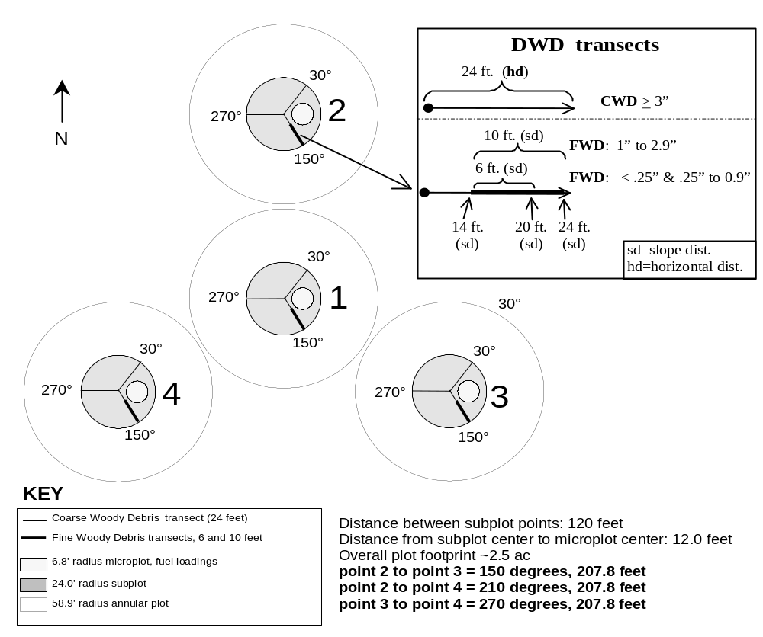

Figure 14-1. Plot layout for sampling CWD, FWD, and fuels.
Figure 14-1. Plot layout for sampling CWD, FWD, and fuels.

14.4 TRANSECT LINE SEGMENTING
Transect lines are segmented to determine the length of transect that occurs within each mapped condition class intersecting the line. A segment is a length of transect that is in one condition. Segments are identified by recording the BEGINNING and ENDING SLOPE DISTANCES from subplot center out to the end of the subplot. In the office, the segmenting data will be combined with CWD distances to determine which condition class each piece falls in (condition classes are not assigned to CWD pieces in the field). If more than one condition is found on the FWD transects, the segmenting information recorded here will provide the length of transect in each condition.

Starting at the subplot center and working towards the fixed radius plot boundary, each segment of transect line in a different condition class is delineated and recorded as a separate record. On each record, the BEGINNING and ENDING SLOPE DISTANCES are recorded for each condition class encountered. The first record for each transect will have a beginning distance (DIST1) of 0 feet. If only one condition class occurs on the transect line, only one segment is recorded. The transect must extend a total of 24 feet horizontal distance.

On subplots where a transect intersects a boundary between condition classes, the transect continues across the boundary into the adjacent class. Although DWD is only sampled in accessible forest conditions, all CONDITION CLASS BOUNDARIES (BEGINNING and ENDING Distances) are recorded on each transect.

Individual pieces of DWD intersected by a transect are tallied or counted if they meet the tally rules for CWD or FWD specified in the sections that follow. It is expected that the majority of FWD transects will be in one condition, but if the condition class changes along the transect, a count is recorded for each condition. Again, the segmenting data recorded here will identify which condition class is associated with each count.

If the ENTIRE 24 ft subplot is non-forest, enter codes for SUBPL, T, CC, followed by zeros in the remaining fields.

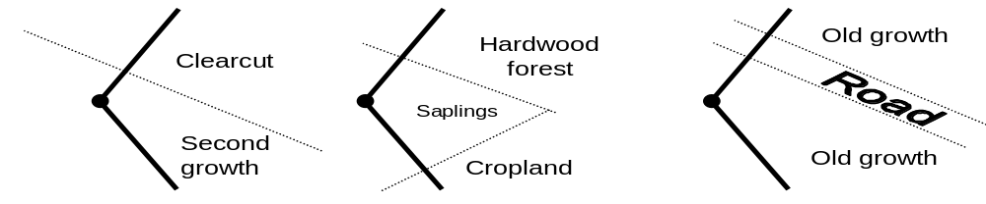
Figure 14-2. Transects are installed across condition class boundaries.

Marking the transect line
Transect lines should be marked with a pin or small piece of flagging at the end of the line (24 ft, horizontal distance) to help the QA staff identify the path of the transect during the check-plot procedure. Because the tolerance for the transect azimuth is +/- 2 degrees, the line might have been laid down in a slightly different direction from the check-plot crew. This could affect the location of diameter measurements for CWD pieces as well as identifying whether a CWD piece is a valid tally piece. It is also helpful to mark the point where the FWD transect begins (14 ft, slope distance).

Transect Segmenting Tally Guide
 |  |  |  | BEGIN |  | END
 | SUB | T |  | SLOPE | SLOPE | SLOPE
 | PL | T | CC | DIST1 | PCT | DIST2
ITEM # | 1 | 2 | 3 | 4 | 5 | 6
 |  |  |  | (ft) | % | (ft)
 | X | XXX | X | XX.Y | XXX | XX.Y
NOTE: Although DWD is only sampled in accessible forest conditions,
all condition
class boundaries (beginning and ending distances) are
recorded on each transect.

14.4.1 SUBPLOT NUMBER (SUB PL)

Record a 1-digit code indicating the subplot center from which the transect originates.

When collected: All tally segments

Field width: 1 digit

Tolerance: No errors

MQO: At least 99% of the time

Values: 1 to 4

14.4.2 TRANSECT (T)
Record a 3-digit code indicating the transect on which a condition class is being delineated.

When Collected: All tally segments
Field width: 3 digits
Tolerance for the code: No errors in the transect code
MQO: At least 99% of the time
Tolerance for the azimuth : +/- 2 degrees
MQO: At least 90% of the time

Values:
Code | Azimuth tolerance | Definition
030 | 30 degrees +/- 2 degrees | Transect extends 30 degrees from subplot center
150 | 150 degrees +/- 2 degrees | Transect extends 150 degrees from subplot center
270 | 270 degrees +/- 2 degrees | Transect extends 270 degrees from subplot center

14.4.3 CONDITION CLASS (CC)
Record a 1-digit code indicating the number of the condition class for the transect segment. Use the same code assigned to the CONDITION CLASS on the subplot or elsewhere on the plot. The first segmentation record for each transect will have the same Condition Class Number as assigned to the subplot center.

When collected: All tally segments
Field width: 1 digit
Tolerance: No errors
MQO: At least 99% of the time
Values: 1 to 9

14.4.4 BEGINNING DISTANCE (DIST1)
Record a 3-digit code. Record the location (using slope distance) on the transect line where the transect intersects the boundary with the adjacent condition class nearer to the subplot center. The first record for each transect will have a BEGINNING DISTANCE of 0.0 ft. Each subsequent record will have a BEGINNING DISTANCE equal to the ENDING DISTANCE of the previous record. Measure to the nearest 0.1 ft.

When collected: All tally segments
Field width: 3 digits
Tolerance: +/- 1.0 ft
MQO: At least 95% of the time
Values: 0 to 99.9

14.4.5 SLOPE PERCENT (SLP PCT)
Record a 3-digit code indicating the average slope percent along the transect within the condition class being segmented. When only one condition class is present on a transect, slope percent is the average slope percent along the entire transect. Measure to the nearest 5%.

When collected: All tally segments
Field width: 3 digits
Tolerance: +/- 10%
MQO: At least 90% of the time
Values: 5 to 135

14.4.6 ENDING DISTANCE (DIST2)
Record a 3-digit code. Record the location (using slope distance) on the transect line where the transect exits the condition class being delineated and intersects the boundary with a different condition class further away from the subplot center. If no other condition classes are encountered, record the location (using slope distance) of the end of the transect line. Measure to the nearest 0.1 ft.

When collected: All tally segments
Field width: 3 digits

Tolerance: +/- 1.0 ft
MQO: At least 95% of the time
Values: 0.1 to 99.9

Note: The TALLY program will calculate and display the horizontal distance of each segment and indicate how far the crew member has to walk (in slope distance) to reach 24 ft horizontal distance.

The combined horizontal distances of all segments must add up to 24 ft.

14.5 TALLY RULES FOR COARSE WOODY DEBRIS (CWD)
- Coarse woody debris (CWD) is sampled in accessible forest land conditions only.
Tally a piece if its central longitudinal axis intersects the transect, and the condition class is accessible forest land at the point of intersection (Figure 14-3). The entire piece is assigned to this condition.
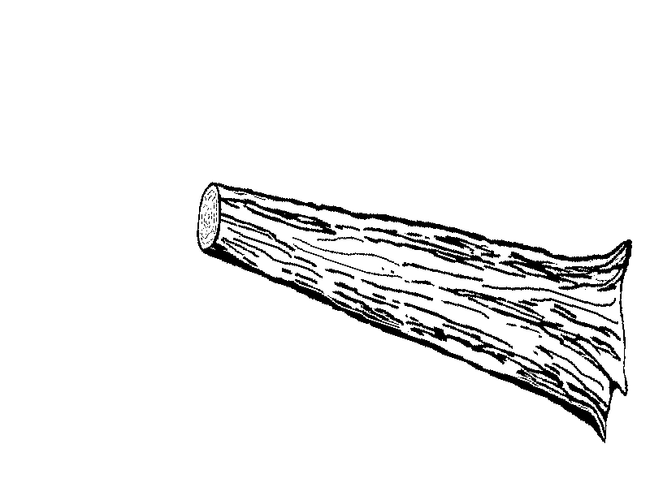
Condition class 1
(accessible forest land)
Central
longitudinal
axis
Transect
line
Point of intersection

Figure 14-3. Tally rules for CWD.
- Tally dead trees and tall stumps that are leaning > 45 degrees from vertical. Do not tally live trees or standing dead trees and stumps that are still upright and leaning < 45 degrees from vertical. Follow the same rules for down trees (LEAN ANGLE) as outlined in the ‘Tree and Sapling Data’ section. Most CWD will be laying on the ground. The crew's judgment is final on whether or not a tree, snag or stump is leaning more or less than 45 degrees.
- The minimum length of any tally piece is 3.0 feet. When CWD pieces are close to 3 feet, measure the length to the nearest 0.1 ft to determine if it is >3.0 ft.
- Tally rules depend on the decay class of the piece.
Diameter is > 3” for at least 3.0’. Tally if intersected by the transect in this segment.
3”
diam.
Diameter is < 3”
Do not tally (as CWD) if intersected
by the transect in this segment.
Decay classes 1-4
(see section 14.8.9)

For decay classes 1 to 4: tally a piece if it is > 3.0 inches in diameter at the point of intersection with the transect. The piece must be > 3.0 feet in length and > 3.0 inches or more in diameter along that length. If the intersect diameter is close to 3.0 inches, measure the diameter to the nearest 0.1 inch to determine if the piece qualifies (Figure 14-4).
For decay class 5: tally a piece if it is > 5.0 inches in diameter at the point of intersection and > 5.0 inches high from the ground. The piece must be > 3.0 feet in length and > 5.0 inches or more in diameter along that length. The reason for treating decay class 5 pieces differently is because they are difficult to identify, especially when heavily decomposed. Only pieces that still have some shape and log form are tallied—humps of decomposed wood that are becoming part of the duff layer are not tallied.
Figure 14-4. CWD tally rules for decay classes 1-4.
- Tally pieces created by natural causes (examples: natural breakage or uprooting) or by human activities such as cutting only if not systematically machine-piled. Do not record pieces that are part of machine-piled slash piles or windrows, or that are part of a log "jumble" at the bottom of a steep-sided ravine in which individual pieces are impractical to tally separately. Instead, sample these piles according to instructions on Sampling Residue Piles (see section 14.12). A slash pile or windrow consists of broken logs, limbs, and other vegetative debris.
- Tally a piece only if the point of intersection occurs above the ground. If one end of a piece is buried in the litter, duff, or mineral soil, the piece ends at the point where it is no longer visible. Measure the diameter and length at this point.
- If the central longitudinal axis of a piece is intersected more than once on a transect line or if it is intersected by two transect lines, tally the piece each time it is intersected (uncommon situation, see Figure 14-5).
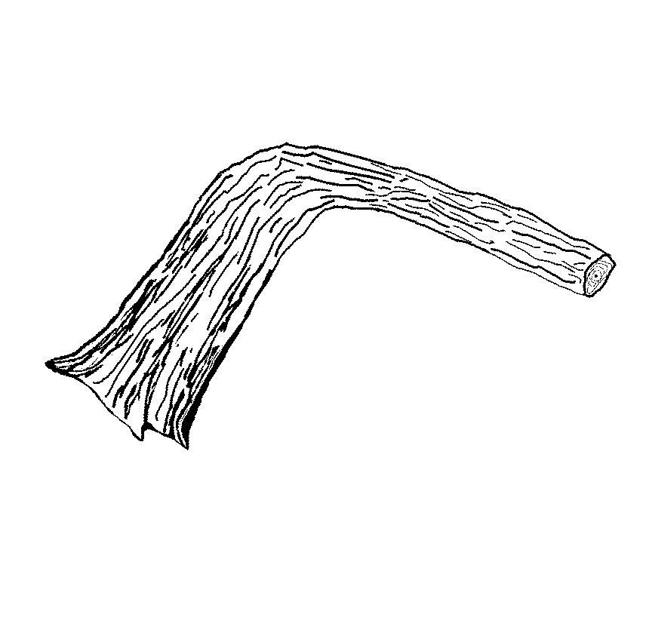
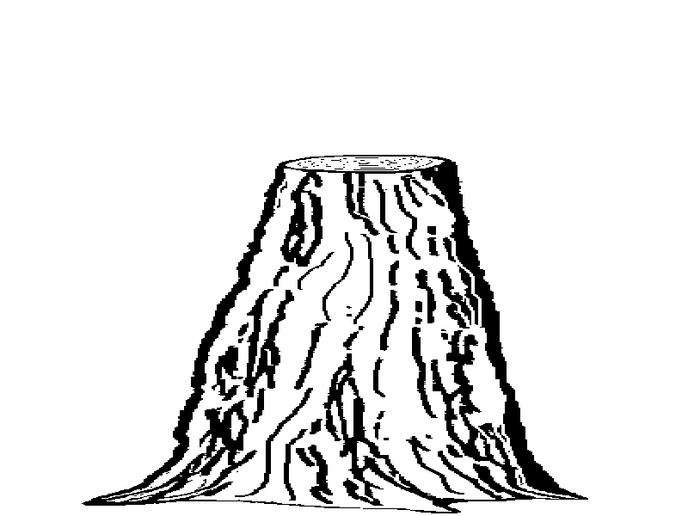
Figure 14-5. CWD tally rules: intersections.
Points of intersection
Tally piece twice
Tally piece twice

- Tally a piece only once if the subplot center falls directly on the central longitudinal axis of the piece. Tally the piece on the 30 degree transect and record the CWD Distance as 001.
- If a piece is fractured across its diameter, and would pull apart at the fracture if pulled from either end, treat it as two separate pieces. If judged that it would not pull apart, tally as one piece. Tally only the piece intersected by the transect line.
- If a piece is split along its length, would pull apart at the split if pulled from either side, and the split was due to the piece falling or to the impact of another piece or object, then treat it as two separate pieces. If judged that it would not pull apart, tally as one piece. Tally only pieces intersected by the transect line.
- Do not tally a piece if it intersects the transect on the root side of the root collar. Do not tally roots.
- When the transect crosses a forked down tree bole or large branch connected to a down tree, tally each qualifying piece separately. To be tallied, each individual piece must meet the minimum diameter and length requirements. In the case of forked trees, consider the "main bole" to be the piece with the largest diameter at the fork. Characteristics for this fork such as length and decay class should pertain to the entire main bole. For smaller forks or branches connected to a main bole (even if the main bole is not a tally piece), characteristics pertain only to that portion of the piece up to the point where it attaches to the main bole (see Figure 14-6).

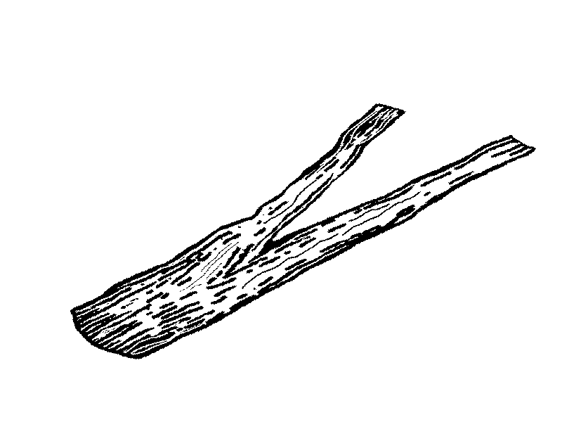
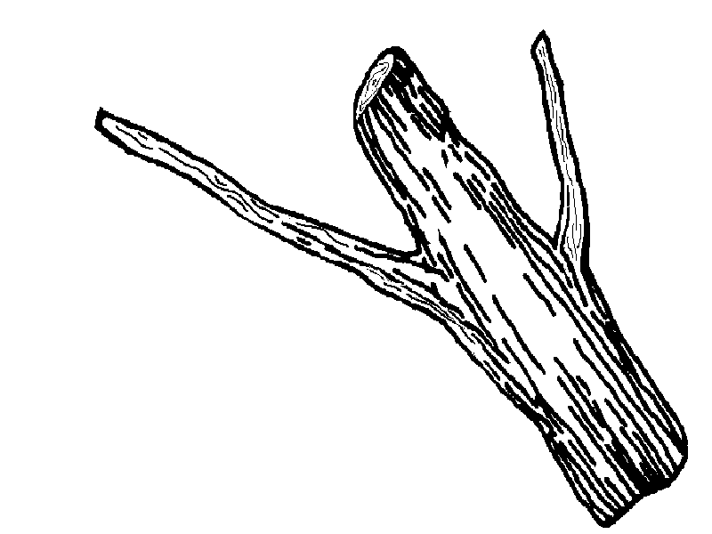
Larger diameter fork
is considered the
main bole
Each fork is tallied as a separate piece
Transect line
Diameter
at fork = 20"
Diameter at
fork = 10"
Length of main bole
Length of second fork
Diameter = 3"
Diam. 15”
Large branch tallied as one piece
Main bole
(not tallied)
Length of log
Figure 14-6. CWD tally rules for forked trees.

14.6 TALLY RULES FOR CWD WHEN THE PIECE LAYS ACROSS MULTIPLE CONDITIONS
- The entire piece is assigned to the condition class found at the point of intersection with the transect. Tally the piece if the condition class at the intersection is accessible forest land (CONDITION_STATUS = 1) (Figure 14-7).
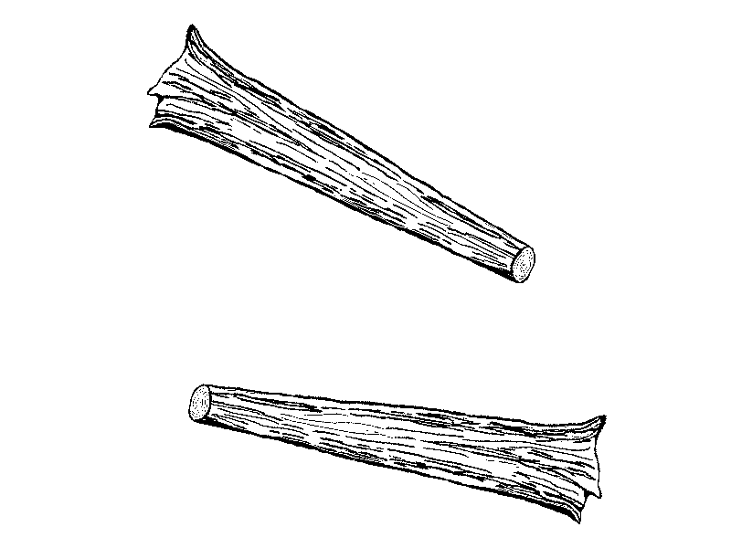
Condition class 2
Condition class 1
Log 1
Log 2
Condition class
boundary
Log 1 is assigned to CC #1
Log 2 is assigned to CC #2
Transect line

Note Crews do not actually record a condition class for each piece. The computer ‘assigns’ the piece to a condition class by comparing the recorded distance to the piece with the beginning and ending distances recorded for each condition class boundary.

Figure 14-7. CWD tally rules when the piece lays across two or more condition classes.

- If a transect intersects a piece exactly on a condition class boundary (a rare situation), the entire piece should be assigned to the condition class which contains the large end of the piece. Because the data recorder actually does the ‘assignment’ by keeping track of the location of the piece in relation to each condition class mapped along the transect, crews need to force the piece into the correct condition. This is done by recording a value for the slope distance of the piece that is either 0.1ft greater or less than the slope distance of the condition class boundary (and intersection point). See Figure 14-8.

Large
end
Condition
class 1
Condition
class 2
CWD is assigned to CC #2
Figure 14-8. CWD tally rules for condition class boundaries.
For example:
Slope distance to the point of intersection and the beginning
boundary of condition class #2 is 15 feet.
The large end is in CC#2, so…
record the CWD DIST as 15.1 feet.
This forces the CWD piece into CC#2.

3. If a transect intersects a nonforest condition (e.g., a road) no CWD is tallied.

14.7 MARKING CWD
Marking CWD is optional. Marked CWD is an aid to future crews returning to the plot for a QA check or to remeasure the plot at the next remeasurement period. Nails can be used to mark the location of the point of intersection, if the piece is in decay class 1, 2, or 3. Position the nail on top of the piece, and if possible, drive the nail into the piece so that about 1 inch of the nail is left exposed. Stop driving the nail if the next blow means breaking the piece or seriously disturbing the location of the piece. Please see section 14.4 Transect Line Segmenting, for information on the required marking of the transect line.

14.8 RECORDING PROCEDURES FOR CWD
Record each piece on a transect as a single line entry, completing the items indicated with "X"s on the CWD tally guide. If no CWD pieces are tallied on a transect, press MENU DONE at the 1st line of the menu. The combination of a recorded transect segment in a forest condition along with no CWD records will indicate that transect was actually installed but no CWD was found (e.g., a “zero tally” transect ).

The tolerance for the total number of pieces (> 3 inches, transect diameter) tallied across all transects on the plot is : +/- 2 piece or +/- 5%, whichever is greater for the plot.
(note: always round up to a whole piece count when using the 5% option)

CWD TALLY GUIDE
 |  | SUB |  | T |  | CWD |  |  |  | TRAN |  | SML |  | LRG |  | TOTAL |  | DECAY |  | HOL? |  | CWD
 |  | PL |  |  |  | DIST |  | SPC |  | DIAM |  | DIAM |  | DIAM |  | LENGTH |  | CLASS |  |  |  | HIST
Item # | 1 |  | 2 |  | 3 |  | 4 |  | 5 |  | 6 |  | 7 |  | 8 |  | 9 |  | 10 |  | 11
 |  |  |  |  | (ft) |  |  |  | (in) |  | (in) |  | (in) |  | (ft)
 | X |  | XXX |  | XX.Y |  | XXX |  | XXX |  | XXX |  | XXX |  | XX |  | X |  | X |  | X

14.8.1 SUBPLOT NUMBER (SUB PL)

Record a 1-digit code indicating the number of the subplot center from which the transect originates.

When collected: All tally pieces

Field width: 1 digit

Tolerance: No errors

MQO: At least 99% of the time

Values: 1 to 4

14.8.2 TRANSECT (T)
Record a 3-digit code indicating the transect on which the piece is sampled.

When Collected: All tally pieces
Field width: 3 digits
Tolerance: No errors
MQO: At least 99% of the time
Values: 030, 150, 270 (see 14.4.2)

14.8.3 CWD SLOPE DISTANCE (CWD DIST)
Record a 3-digit code indicating the slope distance from the subplot center to the point where the transect intersects the longitudinal center of the piece. Measure and record to the nearest 0.1 feet. CWD SLOPE DISTANCE is an important item because it will be used to assign the CWD piece to a condition class by comparing the recorded distance to the piece with the recorded BEGINNING and ENDING DISTANCE to the CONDITION CLASS BOUNDARY. CWD DIST is also used to locate the piece for QA and remeasurement in future inventories. If two or more pieces have the same slope distances, record the top piece first.

When Collected: All tally pieces
Field width: 3 digits
Tolerance: +/- 1.0 ft
MQO: At least 90% of the time
Values: 0.1 to 99.9

14.8.4 SPECIES (SPC)
Record a 3-digit code indicating the species of the piece. Species codes are the same as those used for trackable trees (see Appendix 4 of the P2 field guide). Because CWD includes the tally of large shrub boles and woody vines, enter a code of ‘01’ for SPC if the tally piece is a shrub or vine.

Species identification may be uncertain for some pieces. Make an educated guess. The piece's bark (either attached or sloughed and laying beside the piece), branching pattern (if the branches are still present), or heartwood smell (particularly if cedars, Douglas-fir, or western hemlock) may provide clues. Observe the tree species currently on the site. On remeasurement plots, see what tree species were tallied in past inventories. One way to distinguish hardwoods from softwoods is by the type of decay present. Hardwoods usually have a white or grayish stringy rot, while softwoods usually have a reddish-brown blocky rot. If it is not possible to identify the species, attempt to estimate if it is softwood or hardwood. Enter code 299 for unknown softwood or 998 for unknown hardwood. If all else fails, enter the unknown SPECIES code (999).

When Collected: All Decay Class 1 to 4 tally pieces
Field width: 3-digits
Tolerance: No errors
MQO: At least 80% of the time (when reasonable)
Values: See species codes for the trackable tree tally in Appendix 4 of the P2 field guide.

Measuring Diameters
The diameter is most commonly measured by holding a tape above the log, at a position perpendicular to the length (Figure 14-9). It is useful to carry a steel carpenters retracting tape to measure diameters. Other methods include wrapping a tape around the bole if possible, holding a straight-edge ruler above the piece, or using calipers.
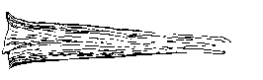
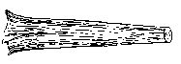
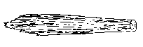
3.0 inch diameter
6.0 inch diameter
18.0 inch diameter
Small end diameter tapers to 3” before the end of log
Small end diameter measured at the point before the log splinters or crumbles
Large end diameter measured at the point that best represents the overall log volume. (before the wood crumbles and falls apart due to decay)
DIAMETER MEASUREMENTS

Figure 14-9. Diameter measurements

For pieces that are not round in cross-section because of missing chunks of wood or "settling" due to decay, measure the diameter in two directions and take an average. Estimate the longest and shortest axis of the cross-section ("A" and "B" in Figure 14-10), and enter the average in the diameter field. This technique applies to intersect, small-end, and large-end diameters.
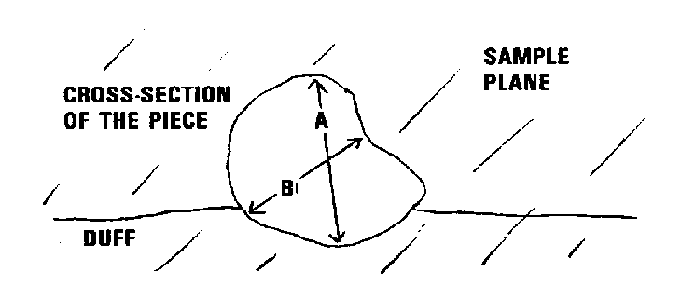
Figure 14-10. Estimating the diameter of pieces that are not round in cross-section.

If the transect intersects the log at the decayed or splintered end (Figure 14-11) (i.e., the portion where we do not consider it part of the log because it is falling apart), record the diameter at this location as the intersect diameter, but record the large end and small end diameter according to our established rules (i.e., at the points where they best represent the log volume). If the splintered end appears to be two separate pieces (i.e., a major split located just at the end) – in this situation treat it as one log and take a diameter around the end (take 2 measurements if it is odd shaped). Length would be measured between the large and small end diameters.

Large end diam measured here


small end diam measured here

(Trans)

Figure 14-11. Example of decayed end intersecting the transect

14.8.5 DIAMETER AT POINT OF INTERSECTION (TRAN DIAM)
Record a 3-digit code indicating the piece's diameter at the point where the transect intersects the longitudinal center of the piece. The diameter is recorded to the nearest inch. If the diameter is close to 3 inches, measure the diameter to the nearest 0.1 in to determine if the piece is actually >3.0 in and a valid tally piece.

When Collected: All tally pieces
Field width: 3 digits
Tolerance: Pieces < 20.0 in. diameter: +/- 3.0 in
Pieces > 20.0 in. diameter: +/- 20%
MQO: At least 90% of the time
Values: 3 to 200

14.8.6 DIAMETER AT THE SMALL END (SML DIAM)
Record a 3-digit code indicating the diameter at the piece's small end. The diameter is recorded to the nearest inch. The small end diameter occurs either at (1) the actual end of the piece, if the end has a diameter > 3.0 inches, or (2) at the point where the piece tapers down to 3.0 inches in diameter. If the end is splintered or decomposing (sloughing off), measure the diameter at the point where it best represents the overall log volume. Use the same measuring procedures described in 14.8.5 (see Figure 14-9). Not recorded for Decay Class 5.

When Collected: All Decay Class 1 to 4 tally pieces
Field width: 3 digits
Tolerance Pieces < 20.0 inches diameter: +/- 2.0 inches
Pieces > 20.0 inches diameter: +/- 10%
MQO: At least 90% of the time
Values: 3 to 200

14.8.7 DIAMETER AT THE LARGE END (LRG DIAM)
Record a 3-digit code indicating the diameter at the piece's large end. The diameter is recorded to the nearest inch. The large end will occur either at a broken or sawn end, at a fracture, or at the root collar. If the end is splintered or decomposing (sloughing off), measure the diameter at the point where it best represents the overall log volume. Use the same measuring procedures used for 14.8.5. Not recorded for Decay Class 5.

When Collected: All Decay Class 1 to 4 tally pieces
Field width: 3digits
Tolerance: Pieces < 20.0 inches diameter: +/- 2.0 inches
Pieces > 20.0 inches diameter: +/- 15%
MQO: At least 90% of the time
Values: 3 to 200

14.8.8 TOTAL LENGTH (TOTAL LENGTH)
Record a 3-digit code indicating the total length of the piece to the nearest foot. Total length is the length of the piece that lies between the piece's recorded small and large end diameters (14.8.6 & 14.8.7). For Decay Class 5, small and large end diameters are not recorded for a log, therefore the length is measured between the two physical ends of the log. For curved logs, measure along the curve. The minimum log length is 3.0 feet before it is a valid tally log. When the length is close to 3.0 ft, measure the length to determine if the piece is actually >3.0 ft.

When Collected: All tally pieces
Field width: 3 digits
Tolerance:
+ / - 20%
MQO: At least 90% of the time
Values: 3 to 250

14.8.9 DECAY CLASS (DECAY CLASS)
Record a 1-digit code indicating the decay class of the piece. Code the decay class which predominates along the recorded TOTAL LENGTH (14.8.8) of the piece. Use the guide below (which differs from decay class descriptions for snags) to determine decay class for CWD.

When Collected: All tally pieces
Field width: 1 digit
Tolerance: +/- 1 class
MQO: At least 90% of the time
Values:

Decay  Class | Structural  Integrity | Texture of  Rotten Portions | Color of  Wood | Invading  Roots | Branches and Twigs
1 | Sound, freshly fallen, intact logs | Intact, no rot; conks of stem decay absent | Original color | Absent | If branches are present, fine twigs are still attached and have tight bark
2 | Sound | Mostly intact; sapwood partly soft (starting to decay) but can’t be pulled apart by hand | Original color | Absent | If branches are present, many fine twigs are gone and remaining fine twigs have peeling bark
3 | Heartwood sound; piece supports its own weight | Hard, large pieces; sapwood can be pulled apart by hand or sapwood absent | Reddish- brown or original color | Sapwood only | Branch stubs will not pull out
4 | Heartwood rotten; piece does not support its own weight, but maintains its shape | Soft, small blocky pieces; a metal pin can be pushed into heartwood | Reddish or light brown | Through-out | Branch stubs pull out
5 | None, piece no longer maintains its shape, it spreads out on ground | Soft; powdery when dry | Red-brown to dark brown | Through-out | Branch stubs and pitch pockets have usually rotted down
Note: Decay class 5 pieces can be difficult to identify because they often blend into the duff and litter layers. They must still resemble a log, therefore, the first tally rule is that they must be > 5.0 inches in diameter, > 5.0 inches from the surface of the ground, and at least 3.0 feet long. Decomposed logs that are slightly elevated ‘humps’ on the ground are not tallied.

Decay classes: The chart above was developed primarily Douglas-fir in the Pacific Northwest. At the present time, there are no other charts available to use to describe decay classes for other species or locations. Concentrate on the structural integrity and texture when estimating a decay class for CWD logs. A new series of charts will be developed in the future to better assess a variety of species and geographic locations. Crews are asked to keep a record of what they observe on different species, and relate that to a particular decay class code. This will aid in creating new tables that are more relevant to the diversity of species encountered.

If a log is case hardened (hard, intact outer sapwood shell) but the heartwood is rotten, code this log as a decay class 2 with a hollow code of “Y”.
Decay class 1 should be reserved for ‘freshly fallen’ logs that are completely intact (i.e., recent windfalls, or harvest).

14.8.10 IS THE PIECE HOLLOW? (HOL?)

Record a 1-digit code indicating whether the piece is hollow (see Figure 14-12).

When Collected: All Decay Class 1 to 4 tally pieces
Field width: 1 digit

Tolerance: No errors

MQO: At least 90% of the time
Values:

Code | Definition
Y | A piece is considered hollow if a cavity extends at least 2 feet along the central longitudinal axis of the piece, and the diameter of the entrance to the cavity is at least 1/4 of the diameter of the piece where the entrance occurs. The entrance occurs at the point where the circumference of the cavity is whole -- the point where wood is present completely around the circumference of the cavity. The length of the cavity begins at this point
N | Does not meet criteria for being a hollow log

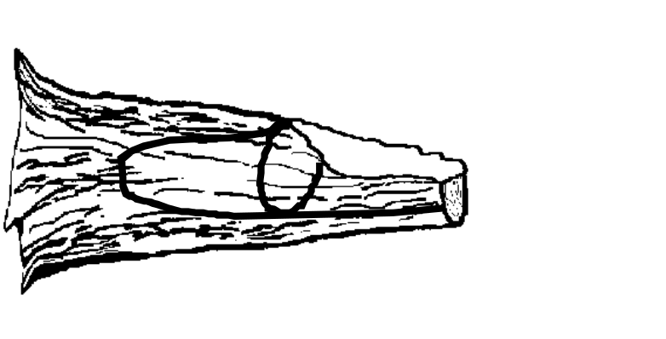
The entrance is the first point on the piece with wood all around the cavity
The diameter at the entrance of the cavity must be > ¼ of the total diameter of the log at that point
Length of cavity must be > 2.0 feet, before it is classified as a hollow log.

Figure 14-12. Determining if the piece is hollow.

14.8.11 CWD history (CWD HIST)
Record a 1-digit code that indicates whether the piece of CWD is on the ground as a result of harvesting operations or as a result of natural circumstances. One objective of this item is to identify those pieces that are considered logging residue. If the piece appears to have fallen to the ground as a result of natural causes such as decomposition or windfall, enter a code of 1. This category would include blown out tops, snapped off boles, wind-fallen trees on clearcut edges, and trees that basically collapsed and fell over due to decomposition.

If the piece is on the ground as a result of RECENT (within the last 15 years) harvesting activity, either because the tree was cut down with a chainsaw (or other device) or pushed over by harvesting equipment (bulldozer), enter a code of 2. A code of 2 would be considered logging residue (usually you are in the middle of a recent clearcut).

If the piece is on the ground as a result of OLDER (more than 15 years) harvesting activity, enter a code of 3. This would be a situation where you tally an old decomposing log that has a sawn end – if it appears that the log was cut and left on site, then enter a code of “3”.

If a piece is on the ground as a result of incidental harvest (such as a standing tree was cut for firewood or small clearing), enter a code of “4”. Incidental harvest involves a few trees and is not a part of a major organized harvesting operation.

If you cannot decide the history of the CWD log, classify it as “unknown”, and give it a code of “5”.

When Collected: All Decay Class 1 to 4 tally pieces
Field width: 1 digit
Tolerance: No errors
MQO: None

Values:
Code | Definition
1 | CWD piece is on the ground as a result of natural causes
2 | CWD piece is on the ground as a result of major RECENT harvest activity (<= 15 yrs old)
3 | CWD piece is on the ground as a result of OLDER harvest activity (>15 yrs old)
4 | CWD piece is on the ground as a result of an incidental harvest (such as firewood cutting)
5 | Exact Reason Unknown

14.9 SAMPLING METHODS FOR FINE WOODY DEBRIS (FWD)
- Fine Woody Debris (FWD) is sampled in accessible forest land conditions. The length of FWD transects are measured in SLOPE DISTANCE--no correction is applied to obtain a horizontal distance. The FWD transects start at 14.0 feet SLOPE DISTANCE and extend for 6.0 or 10.0 feet SLOPE DISTANCE. Estimates of FWD biomass calculated in the office, will include a slope correction factor obtained from the transect segmenting data on the subplot.

- Only sample FWD that intersects a plane from the ground to a height of 6 feet.

- FWD is sampled in three size classes, on the 150 degree azimuth transect. Two of the FWD size classes (0.01 to 0.24 in and 0.25 to 0.9 in) are counted on a 6 foot transect, from 14 to 20 ft. Pieces in the 3rd size class (1.0 to 2.9 in) are counted on a 10 foot transect, from 14 to 24 ft (see section 14.3 for details on transects). These transects overlap. Note: individual diameters are not recorded for FWD. Transects begin outside the subplot boundary to avoid sampling of trampled areas where numerous measurements are made on trees and understory vegetation, etc.

- Count a piece of FWD if it intersects the transect, and the condition class is accessible forest land at the point of intersection. Only count a piece if the twig, branch, wood fragment, or shrub/tree bole are woody. Do not count pine or fir needles or non-woody parts of a tree or shrub.

- Accumulate the number of pieces counted within each size class and enter the total count on one record for the subplot (unless there are >1 condition classes). If there is no tally on a transect, enter zero’s for the count.

- Accurate counts of FWD can be conducted efficiently up to about 50 pieces for small and medium size classes, and up to 20 pieces for the large size class. After that, crews can begin estimating counts in a systematic fashion. Transects that fall on very dense FWD where counting is nearly impossible, can be subsampled and calculated. For example, an accurate count can be conducted on a 2.0 ft-section of the transect and then multiplied by 3 to provide an estimate for the 6 foot transect, as long as the crew feels that the remaining transect has a similar density of FWD pieces.

- If a transect intersects a large pile of material such as a wood rat’s nest or a recently fallen tree (with many attached fine branches), crews should estimate a count based on #6 above, but also enter a code indicating that this is an unusual situation (see REASON_HIGHCOUNT below).

- If rocks, logs, or other obstructions are present along the transect (14 to 24 ft section) include any FWD that is present on top of these obstructions in the respective FWD counts. If the obstructions are so large (huge boulder) that you can not see the top surface, assume the count is zero in this area, and continue counting if there is transect line beyond the boulder.

- If a residue pile intersects the FWD transect at any point along the 14 to 24 ft section, do not measure FWD on this transect. It is too subjective determining exact boundaries of the pile, and how they relate to the exact point on the transect line.

To identify this situation, code Yes of No in the variable RP_on_transect? which indicates that a residue pile has intersected the transect line. The Default for this variable will be set to No, and crews can then change this when the situation occurs.

- If a transect crosses a condition class boundary, record the CONDITION CLASS number and enter a count for each condition on separate records. Transect lengths within each condition class will be obtained from the transect segmenting data entered for the subplot.

FINE WOODY DEBRIS COUNT TALLY GUIDE
 | SUB |  | CC |  | SMALL |  | MEDIUM |  | LARGE |  | REASON FOR |  | Residue Pile?
 | PLOT |  |  |  | FWD |  | FWD |  | FWD |  | HIGH COUNT |  | RP on Transect?
ITEM # | 1 | 2 |  | 3 |  | 4 |  | 5 |  | 6 |  | 7
 | XX | X |  | XXX |  | XXX |  | XXX |  | X |  | X

14.9.1 SUBPLOT NUMBER (SUB PL)

Record a 1-digit code indicating the subplot center from which the transect originates.

When collected: All tally segments

Field width: 1 digit

Tolerance: No errors

MQO: At least 99% of the time

Values: 1 to 4

14.9.2 CONDITION CLASS (CC)
Record a 1 digit code indicating the number of the condition class that pertains to the FWD count.

When collected: All tally segments

Field width: 1 digit

Tolerance: No errors

MQO: At least 99% of the time
Values: 1 to 9

14.9.3 COUNT OF PIECES IN THE 0.01 TO 0.25 INCH DIAMETER SIZE CLASS (SMALL_FWD)
Record the number of pieces counted in this size class along the transect segment. An accurate count should be conducted up to 50 pieces. If the count exceeds 50, the transect can be subsampled to estimate a total count for the transect segment (see 14.9.6)

When collected: On the 150 degree transect
Field width: 3 digits
Tolerance: 0 to 50 = +/- 20% of the total count for the entire plot
Tolerance: 51 to 100 = +/- 25% of the total count for the entire plot
Tolerance: 100 + = +/- 50% of the total count for the entire plot (14.9.6 should have a code > 0)
MQO: None
Values: 0 to 999

14.9.4 COUNT OF PIECES IN THE 0.25 TO 1.0 INCH DIAMETER SIZE CLASS (MEDIUM_FWD)
Record the number of pieces counted in this size class along the transect segment. An accurate count should be conducted up to 50 pieces. If the count exceeds 50, the transect can be subsampled to estimate a total count for the transect segment (see 14.9.6)

When collected: On the 150 degree transect
Field width: 3 digits
Tolerance: +/- 20% of the total count for the entire plot
MQO: None
Values: 0 to 999

14.9.5 COUNT OF PIECES IN THE 1.0 TO 3.0 INCH DIAMETER SIZE CLASS (LARGE_FWD)
Record the number of pieces counted in this size class along the transect segment. An accurate count should be conducted up to 20 pieces. If the count exceeds 20, the transect can be subsampled to estimate a total count for the transect segment (see section 14.9.6).

When collected: On the 150 degree transect
Field width: 3 digits
Tolerance: +/- 20% of the total count for the entire plot
MQO: None
Values: 0 to 500

14.9.6 REASON FOR AN UNUSUALLY HIGH COUNT OF FWD (REASON_HIGHCOUNT)
Enter a code that applies to the situation encountered on the transect. Enter a code if any of the counts on a transect are greater than 100 pieces.

When Collected: When any count on the transect >100
Field width: 1 digit
Tolerance: No errors
MQO: None
Values:
Code | Definition
0 | FWD is not unusually high
1 | High count is due to an overall high density of FWD across the transect
2 | Wood Rat’s nest located on transect
3 | Tree or shrub laying across transect
4 | Other reason

14.9.7 RESIDUE PILE ON TRANSECT? (RP_on_transect?)
Enter a code that indicates whether a residue pile intersects the FWD transect segment. The default is always “N” , crews will enter a “Y” if the situation is encountered on the transect.

When Collected: On all FWD transects (between 14 and 24 feet)
Field width: 1 digit
Tolerance: No errors
MQO: None

Values: N= No; Y = Yes

14.10 DUFF, LITTER, AND FUELBED DEPTH MEASUREMENTS
Depth measurements are sampled in accessible forest land conditions. The depth of the duff layer, litter layer, and overall fuelbed are important components of fire models used to estimate fire behavior, fire spread, fire effects, and smoke production. These measurements are taken at the 24-foot location on each transect. An average depth will be calculated in the office and stored with other information about the condition class on the plot. If a residue pile, log, rock, or other obstruction intersects the transect at the 24 ft location, do not measure the duff or litter depth. But, DO measure the fuelbed depth IF the obstruction is a log or residue pile.

Definitions:
- Litter is the layer of freshly fallen leaves, needles, twigs (< ¼ inch in diameter), cones, detached bark chunks, dead moss, dead lichens, detached small chunks of rotted wood, dead herbaceous stems, and flower parts (detached and not upright). Litter is the loose plant material found on the top surface of the forest floor. Little decomposition has begun in this layer.

Litter is flash fuel – so think about it as the loose material that is exposed to the air, capable of igniting quickly and carrying a fire across the surface of the forest floor.

Litter does not include bark that is still attached to a down log, or rotten chunks of wood that are still inside a decaying log or log end (i.e., if a decayed log end has a lot of rotten cubes or pieces laying on a log surface and exposed to air, they are considered part of the log and not litter – fire would burn differently if it hit a pile of rotten punky wood chips, cradled by the unrotted sapwood shell). If these rotten chunks have spilled out to the ground and are actually on the ground surface, then they would be included in the litter layer.

Litter does not include cowpies. These are more like duff (but are not duff) than litter.

Microplot estimates: As you look down on the microplot, litter is the material that you see covering the surface area of the 6.8 ft radius plot.

- Duff is the layer just below litter. It consists of decomposing leaves and other organic material. You should see NO recognizable plant parts, the duff layer is usually dark decomposed organic matter. When moss is present, the top of the duff layer is just below the green portion of the moss. The bottom of this layer is the point where mineral soil (A horizon) begins.

- The fuelbed is the accumulated mass of dead, woody material on the surface of the forest floor. It begins at the top of the duff layer, and includes litter, FWD, CWD, and dead woody shrubs. In this definition, the fuelbed does not include dead hanging branches from standing trees.

Measurements:
Depth measurements will be taken at the 24 foot (slope distance) location on each transect. If a log, rock or other obstruction occurs at the sample location, do not measure duff or litter depth, regardless of what is on top of the obstruction. However, if the obstruction is a log, proceed with the fuelbed depth estimate.

Indicate if the duff and litter depths were measured on the transect by recording Yes or No in the variable called DL_SAMP. The default is “Yes”, indicating the depths WERE sampled. A value of “No” indicates an obstruction occurred at 24 feet, and that no sample was taken. If a value of “No” was entered AND a measurement for the fuelbed depth was entered – this would indicate that the obstruction was a log, and that fuelbed depth was required.

Duff and Litter: Carefully expose a shallow profile of the forest floor by digging out an area at the sample point using a knife, hatchet, or other tool. Estimate the depth of each layer with a ruler to the nearest 0.1 inch. If there is a log, rock, or other obstruction on the surface at the sample point, do not measure the litter or duff depth (record DL_SAMP = N) ; a value of 99.9 will be entered by the TALLY program for each depth.

As you dig the hole for this measurement, if you encounter a rock, root, or buried log – stop the depth measurement at this point.

The height of the litter should be measured at the top of the loose material located at the sample point on the transect. Try to preserve the conditions of this location by walking around this point, so the QA staff will measure the same height as the original crew.

Fuelbed: Measure the height of the fuelbed from the top of the duff layer (just below the litter) to the highest piece of woody debris found at the transect point. Round to the nearest 0.1 foot. If a rock or other obstruction (other than a log) occurs at the 24 ft sample location, do not measure fuelbed depth.

DUFF, LITTER, AND FUELBED TALLY GUIDE
 | SUB |  | DL_SAMP | DUFF | LITTER | FUELBED
 | PLOT | T |  | DEPTH | DEPTH | DEPTH
ITEM# | 1 | 2 | 3 | 4 | 5 | 6
 |  |  |  | (in) | (in) | (ft)
 | X | XXX | X | XX.Y | XX.Y | XX.Y

14.10.1 Subplot number (SUB PL)

Record a 2-digit code indicating the subplot center from which the transect originates.

When collected: All tally segments

Field width: 1 digit

Tolerance: No errors

MQO: At least 99% of the time

Values: 1 to 4

14.10.2 Transect (T)
Record a 3 digit code indicating the azimuth of the transect.

When collected: All tally segments

Field width: 3 digits

Tolerance: No errors

MQO: At least 99% of the time

Values: 030, 150, 270 (see 14.4.2)

14.10.3 Duff and litter sample taken at sample location? (DL_SAMP)
Record a 1-digit code indicating if the depth of the duff and litter layer was measured.

When collected: At 24 feet on each transect

Field width: 1 digit

Tolerance: No errors

MQO: At least 99% of the time
Values: Y= the measurement was taken (default)
N= the measurement was not taken because of an obstruction

14.10.4 Duff depth (DUFF_DEPTH)
Record a 3-digit code indicating the depth of the duff layer, to the nearest 0.1 inch.
When collected: At 24 feet on each transect
Field width: 3 digits
Tolerance: +/- 0.5 inch
MQO:

Values: 0 to 99.9

14.10.5 Litter depth (LITTER_DEPTH)
Record a 3-digit code indicating the depth of the litter layer, to the nearest 0.1 inch.

When collected: At 24 feet on each transect
Field width: 3 digit
Tolerance: +/- 0.5 inch
MQO:

Values: 0 to 99.9

14.10.6 Depth of the fuelbed (FUELBED_DEPTH)
Record a 3-digit code indicating the depth of the fuelbed layer, to the nearest 0.1 foot.
If the fuelbed depth is >0 and < 0.1 ft enter 0.1ft. In this situation finer depth resolution will be obtained from the duff and litter measurements.

When collected: At 24 feet on each transect
Field width: 3 digits
Tolerance: +/- 20%
MQO:

Values: 0 to 99.9

14.11 FUEL LOADING ON THE MICROPLOT
Another component of the total fuel loading on a plot is the biomass of live and dead understory material. The 6.8-ft radius microplot will be used to estimate the percent cover and height of live and dead shrubs, live and dead herbs (includes grasses) and litter. Fuel loading is estimated in accessible forest land conditions on the microplot. Enter one value for all forested conditions combined.

Shrubs are plants with woody stems. Herbs are non-woody herbaceous plants, but also include ferns, moss, lichens, sedges, and grasses. Although many forbs and grasses will die by the end of the growing season, an estimate of live and dead biomass on a given date will help fire modelers predict the phenology of herbaceous material during the year, allowing them to estimate fire danger patterns across the landscape.

PERCENT COVER is estimated for each of the five fuel categories (shown below) in 10-percent classes. For live fuels, estimate the percent of the microplot area that is covered by live plant material. Include whole plants that are entirely green (or alive) and the live branches on plants that are a mixture of live and dead plant parts. Include live branches or leaves that extend into the microplot area from a plant that is actually rooted outside of the microplot. Do not include herbaceous material above 6 feet (i.e., moss, ferns, lichens, epiphytes that are growing in tree branches above 6 ft).

For dead fuels, estimate the PERCENT COVER using the same procedures as live fuels, but include plants that are entirely dead and branches or leaves that are dead but still attached to a live plant. Dead plant material must be clearly visible. Do not include dead material that has fallen to the ground. Cover estimates are made by visualizing an outline around the dead material (with all ‘air’ space included) and accumulating this across the microplot area.

An estimate of the total HEIGHT of the shrub and herbaceous layers is also needed to calculate biomass and fuel loadings. Record a HEIGHT estimate for each fuel category, except litter. Height is estimated for the tallest shrub on the microplot.

Cover Class Codes
Code  6.8 ft. radius  Microplot | Percent Cover
00  Fuel Categories  Live Shrubs  Dead Shrubs  Live Herbs  Dead Herbs  Litter | Absent
01 | Trace ( < 1% cover)
10 | 1 – 10%
20 | 11-20%
30 | 21-30%
….
90 | 81-90%
99 | 91-100%

Microplot Cover Estimation Guide (Hint: 8.5” x 11” = about 0.5% coverage)
% | area (sq ft) | radius (ft) | square (ft)
1 | 1.45 | 0.68 | 1.20
10 | 14.52 | 2.15 | 3.81
20 | 29.04 | 3.04 | 5.39
30 | 43.56 | 3.72 | 6.60
40 | 58.08 | 4.30 | 7.62
50 | 72.60 | 4.81 | 8.52
60 | 87.12 | 5.27 | 9.33
70 | 101.64 | 5.69 | 10.08
80 | 116.16 | 6.08 | 10.78
90 | 130.68 | 6.45 | 11.43
100 | 145.2 | 6.80 | 12.05

MICROPLOT FUEL LOADING TALLY GUIDE
SUBPLOT | LIVE SHRUB % | LIVE SHRUB HT | DEAD SHRUB % | DEAD SHRUB HT | LIVE HERB % | LIVE HERB HT | DEAD HERB % | DEAD HERB HT | LITTER  %
1 | 2 | 3 | 4 | 5 | 6 | 7 | 8 | 9 | 10
X | xx | xx.y | xx | xx.y | xx | xx.y | xx | xx.y | xx

14.11.1 SUBPLOT NUMBER (SUB PL)

Record a 1-digit code indicating the subplot center from which the transect originates.

When collected: All microplot fuel samples

Field width: 1 digit

Tolerance: No errors

MQO: At least 99% of the time

Values: 1 to 4

14.11.2 LIVE SHRUBS PERCENT COVER (L_SHRUB_PC)

Record a 3-digit code for the cover class that indicates the percent cover of the microplot area covered with live shrubs. See cover class codes above.

When collected: All microplot fuel samples
Field width: 3 digits
Tolerance: +/- 1 class
MQO: 85% of the time
Values: 0 to 99

14.11.3 LIVE SHRUBS HEIGHT (L_SHRUB_HT)
Record a 3-digit code indicating the height (at the tallest point) of the live shrub layer to the nearest 0.1 foot. Measure heights < 6 ft and estimate heights > 6 ft.

When collected: All microplot fuel samples
Field width: 3 digits
Tolerance: +/- 0.5 feet
MQO: At least 90% of the time
Values: 0 to 99.9

14.11.4 DEAD SHRUBS PERCENT COVER (D_SHRUB_PC)

Record a 2-digit code for the cover class that indicates the percent cover of the microplot area covered with dead shrubs and dead branches attached to live shrubs if visible from above. See cover class codes above.

When collected: All microplot fuel samples
Field width: 2 digits
Tolerance: +/- 1 class
MQO: 85% of the time
Values: 0 to 99

14.11.5 DEAD SHRUBS HEIGHT (D_SHRUB_HT)
Record a 3-digit code indicating the height (at the tallest point) of the dead shrub layer to the nearest 0.1 foot. Measure heights < 6 ft and estimate heights > 6 ft.

When collected: All microplot fuel samples
Field width: 3 digits
Tolerance: +/- 0.5 feet
MQO: At least 90% of the time
Values: 0 to 99.9

14.11.6 LIVE HERBS PERCENT COVER (L_HERB_PC)

Record a 2-digit code for the cover class that indicates the percent cover of the microplot area covered with live herbaceous plants. See cover class codes above.

When collected: All microplot fuel samples
Field width: 2 digits
Tolerance: +/- 1 class
MQO: 85% of the time
Values: 0 to 99

14.11.7 LIVE HERBS HEIGHT (L_HERB_HT)
Record a 3-digit code indicating the height (at the tallest point) of the live herbaceous layer to the nearest 0.1 foot. Maximum height is 6 feet.

When collected: All microplot fuel samples
Field width: 3 digits
Tolerance: +/- 0.2 feet
MQO: At least 90% of the time
Values: 0 to 99.9

14.11.8 DEAD HERBS PERCENT COVER (D_HERB_PC)
Record a 2-digit code for the cover class that indicates the percent cover of the microplot area covered with dead herbaceous plants and dead leaves attached to live plants if visible from above. See cover class codes above.

When collected: All microplot fuel samples
Field width: 2 digits
Tolerance: +/- 1 class
MQO: 85% of the time
Values: 0 to 99

14.11.9 DEAD HERBS HEIGHT (D_HERB_HT)
Record a 3-digit code indicating the height (at the tallest point) of the dead herbaceous layer to the nearest 0.1 foot. Maximum height is 6 feet.

When collected: All microplot fuel samples
Field width: 3 digits
Tolerance: +/- 0.2 feet
MQO: At least 90% of the time
Values: 0 to 99.9

14.11.10 LITTER PERCENT COVER (LITTER)
Record a 2-digit code for the cover class that indicates the percent cover of the microplot area covered with litter. Litter is the layer of freshly fallen leaves, twigs, dead moss, dead lichens, and other fine particles of organic matter found on the surface of the forest floor. Decomposition is minimal. See cover class codes above.

When collected: All microplot fuel samples
Field width: 2 digits
Tolerance: +/- 1 class
MQO: 85% of the time
Values: 0 to 99

14.12 SAMPLING RESIDUE PILES
The line transect method is not practical when sampling CWD within piles and windrows. Piles and windrows will be located and sampled on the subplot plot, regardless of whether they intersect a transect.
Piles and windrows created directly by human activity and log piles at the bottom of steep-sided ravines in which individual pieces are impossible to tally separately, are more efficiently sampled by using the following instructions. However, loose CWD in piles created by wind throw, landslides, fires, and other natural causes should be tallied using line transects unless it is physically impossible to measure the pieces in the natural pile.

For a pile to be tallied on a subplot that contains forest land, all of the following criteria must be met (Figure 14-13):
- The pile's center must be within 24 horizontal feet of subplot center,
- The pile's center must be in an accessible forestland condition class, and

- The pile contains pieces of CWD > 3 inches diameter that would be impossible to tally separately.

Use the PDENS variable to estimate the percent of the pile that contains woody material > 3 inches .

The pile is assigned to the condition class in which the pile center lies.

Apply the following steps to determine the center of a pile or windrow:
- Determine the longest axis of a pile.
- Determine the midpoint of this axis.
- Project a line through this midpoint that is perpendicular to the axis determined in step 1.
- Determine the midpoint of the segment of this projected line that crosses the pile.
- This is the center of the pile.

Piles that cross the 24-foot fixed-radius subplot boundary: If the center of a pile is within 24 horizontal feet of subplot center, tally the pile, recording the dimensions of the entire pile even if part of the pile is beyond 24 feet. If the center of a pile is more than 24 horizontal feet of subplot center, do not tally the pile or any portion of the pile.

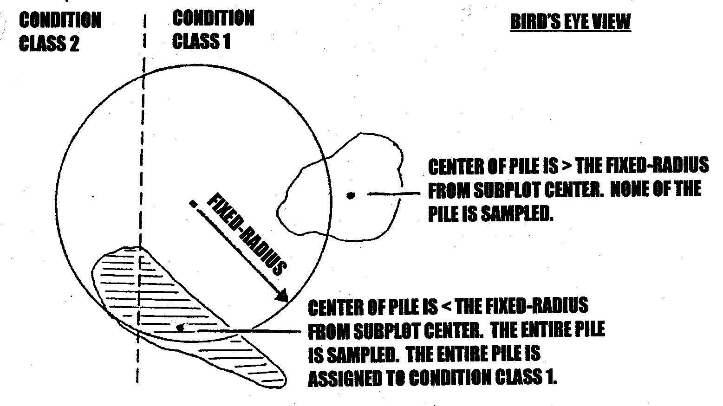

Figure 14-13. Residue pile selection examples.

Record each residue pile on a subplot as a single line entry, completing the items indicated with "X"s on the pile tally guide.

RESIDUE PILE TALLY GUIDE
 | SUB | CC | PILE | SHP | LNG1 | LNG2 | WID1 | WID2 | HT1 | HT2 |  |  | PDENS
 | PL | CC | AZM
ITEM # | 1 | 2 | 3 | 4 | 5 | 6 | 7 | 8 | 9 | 10 |  | 11
 |  |  |  |  | (ft) | (ft) | (ft) | (ft) | (ft) | (ft) |  | (%)
 | X | X | XXX | X | XX | XX | XX | XX | XX | XX |  | XX

14.12.1 SUBPLOT NUMBER (SUB PL)
Record a 1-digit code indicating the subplot number.

When collected: Record for all sampled residue piles
Field width: 1 digit
Tolerance: No errors
MQO: At least 99% of the time
Values: 1 to 4

14.12.2 CONDITION CLASS (CC)
Record a 1-digit code indicating the number of the condition class to which the pile is assigned.

When collected: Record for all sampled residue piles found on the subplot.
Field Width: 1 digit
Tolerance: No errors
MQO: At least 99% of the time
Values: 1 to 9

14.12.3 PILE AZIMUTH (PILE AZM)
Record a 3-digit code indicating the azimuth from the subplot center to the pile. This azimuth centers on the pile so that it can be relocated. Hit menu DONE for subplots on which no piles are tallied.

When collected: All sampled residue piles
Field width: 3 digits
Tolerance: +/- 10
MQO: At least 90% of the time
Values: 000, 1 to 360

14.12.4 SHAPE (SHP)
Record a 1-digit code indicating the shape of the pile. Determine which of the 4 shapes diagrammed in Figure 14-14 most resembles the pile and record the dimensions. Pile dimensions should be ocularly smoothed out when making estimates. Average the unevenness of protruding pieces.

When collected: When 14.12.2.3 is >0
Field width: 1 digit
Tolerance: No errors.
MQO: At least 90% of the
time
Values: 1 to 4

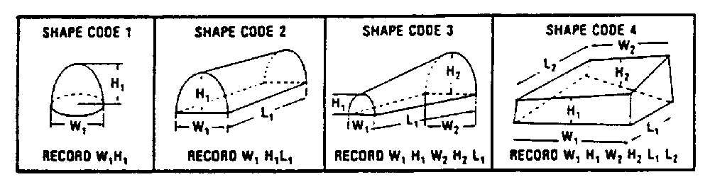

Figure 14-14. Shape codes.

14.12.5 and 14.12.6 LENGTH 1 and LENGTH 2 (LNG1, LNG2)
Record a 2-digit code indicating the length of the sides of the pile. Estimate to the nearest foot. LENGTH 1 may often equal LENGTH 2.

When collected: When 14.12.2.3 is >0, and LNG1 for shapes 1,2,3 and LNG1 & LNG2 for shape 4
Field width: 2 digits
Tolerance: +/- 10%
MQO: At least 90% of the time
Values: 1 to 99

14.12.7 and 14.12.8 WIDTH 1 and WIDTH 2 (WID1, WID2)
Record a 2-digit code indicating the width of the sides of the pile. Estimate to the nearest foot. WIDTH 1 may often equal WIDTH 2.

When collected: When 14.12.2.3 is >0, and WID1 for shapes 1,2; WID1 & WID2 for shapes 3,4
Field width: 2 digits
Tolerance: +/- 10%
MQO: At least 90% of the time
Values: 1 to 99

14.12.9 and 14.12.10 HEIGHT 1 and HEIGHT 2 (HT1, HT2)
Record a 2-digit code indicating the height of either end of the pile. Estimate to the nearest foot. HEIGHT 1 may often equal HEIGHT 2.

When collected: When 14.12.2.3 is >0, HT1 for all shapes; HT1 & HT2 for shapes 3,4
Field width: 2 digits
Tolerance: +/- 10%
MQO: At least 90% of the time
Values: 1 to 99

14.12.11 PILE DENSITY (PDENS)
Record a 2-digit code estimating the percent of the pile that consists of wood. Things like air, soil, rock, plants should be factored out of the estimate. Estimate to the nearest 10 %.

When collected: When 14.12.2.3 is >0
Field width: 2 digits
Tolerance: +/- 20%
MQO: At least 75% of the time
Values: 1 to 99

14.13 ACKNOWLEDGEMENTS
Contact information for the National Advisor for this indicator is: Karen Waddell, USDA Forest Service, Pacific Northwest Research Station, P.O. Box 3890, Portland, OR 97205 or email kwaddell@fs.fed.us .

DOWN WOODY DEBRIS –
TRANSECT SEGMENT DATA FORM

HEX # ________________ DATE ____/____/____

CWD TRANSECT SEGMENTS
SUB  PL | T | CC | SLP DIST1  (0.1ft) | SLP DIST2  (0.1ft) | SLP  PCT | HOR DIST  (0.1ft)
xx | Xxx | x | xxx.y | xxx.y | xxx | xxx.y

FWD DATA FORM

HEX # ________________ DATE ____/____/____

FINE WOODY DEBRIS COUNT
SUBPLOT | CONDITION CLASS | SMALL FWD 0.1” TO 0.25” | MED FWD  0.25” TO 1” | LARGE FWD 1” TO 3” | REASON FOR HIGH COUNT | RESIDUE PILE ON TRANSECT?
x | X | xxx | Xxx | xxx | x | x

COARSE WOODY DEBRIS DATA FORM

HEX # ________________ DATE ____/____/____ PAGE ____ OF____

SUB | TRAN | CWD | SPC | TRAN | SML | LRG | TOTAL | DECAY | HOL? | CWD
PLT | TRAN | DIST | SPC | DIAM | DIAM | DIAM | LENGTH | CLASS | HOL? | HIST
1 | 2 | 3 | 4 | 5 | 6 | 7 | 8 | 9 | 10 | 11
x | xxx | xx.y | xxx | xxx | xxx | xxx | xx | x | x | x
FUELS ASSESSMENT DATA FORM

HEX # ________________ DATE ____/____/____

MICROPLOT FUEL LOADING
SUBPLOT | LIVE SHRUB % | LIVE SHRUB HT | DEAD SHRUB % | DEAD SHRUB HT | LIVE HERB % | LIVE HERB HT | DEAD HERB % | DEAD HERB HT | LITTER  %
 | xx | xx.y | xx | xx.y | xx | xx.y | xx | xx.y | xx
1
2
2
4

DUFF, LITTER, FUELBED ASSESSMENT DATA FORM

HEX # ________________ DATE ____/____/____

DUFF, LITTER, & FUELBED DEPTHS

SUBPLOT | TRANSECT | DL_SAMP | DUFFLITTER DEPTH | LITTER DEPTH | FUELBED DEPTH
x | xxx | X | xx.y | xx.y | xx.y

RESIDUE PILE DATA FORM

HEX # ________________ DATE ____/____/____

RESIDUE PILES

SUB PL | CC | PILE AZM | SHP | LNG1  (ft) | LNG2  (ft) | WID1  (ft) | WID2  (ft) | HT1  (ft) | HT2  (ft) | PILE DENS
xx | x | xxx | X | xx | xx | xx | xx | xx | xx | Xx

