

American Competitiveness Institute
JCAA/JG-PP LEAD-FREE SOLDER PROJECT
NASA CONTRACT NO. NAS10-0329
Final Report
Mechanical Shock Environmental Testing of Tin-Lead and Lead-Free Circuit Boards

DISTRIBUTION STATEMENT: Distribution authorized to U.S. Government agencies, NASA, and personnel who have direct involvement in the program. Other requests for this document shall be referred to NASA. WARNING: Contents are not considered Company proprietary and is approved for public release
SUBMITTED TO:
Kurt Kessel, Project Integrator
Kurt.Kessel-1@ksc.nasa.gov
Joint Council on Aging Aircraft
Joint Group on Pollution Prevention
NASA – John F. Kennedy Space Center
SUBMITTED BY:
AMERICAN COMPETITIVENESS INSTITUTE
One International Plaza
Philadelphia, Pennsylvania

American Competitiveness Institute

Final Report
Mechanical Shock Environmental Testing of Tin-Lead and Lead-Free Circuit Boards

CONTRACT NO. N00014-01-C-0050
ORIGINATED BY:
 | Fred Verdi, AMERICAN COMPETITIVENESS INSTITUTE | DATE
APPROVED BY:
 |  | DATE
APPROVED BY: |  | DATE
APPROVED BY: |  | DATE

Abstract

The American Competitiveness Institute (ACI) performed a series of Environmental Stress Tests for the Joint Council of Aging Aircraft / Joint Group of Pollution Prevention ( JCAA / JG-PP) Lead Free Soldering Program. The objective was to determine if Lead Free soldered hardware was equivalent to or better than its Tin lead (SnPb) counterpart. The program’s test vehicle was manufactured by BAE Systems in Irving, Texas. The JCAA / JG-PP test vehicle was soldered with Tin lead (SnPb) as a baseline, Tin silver copper (95.5Sn3.9Ag0.6Cu , also known as SAC solder alloy), tin silver copper bismuth ((92.3Sn3.4Ag1.0Cu3.3Bi , also known as SACB), and stabilized tin copper (99.3Sn0.7Cu0.05Ni also known as SNiC solder alloy).
Two types of Mechanical Shock tests were performed. The first Mechanical Shock test was performed using the test procedure MIL-STD 810F; Method 516.5; Procedure 1. This is the “Crash Hazard Test” for the flight equipment. The test was performed on all 3 axes. Two components soldered with SACB failed during the tests. The balance of the SnPb and Lead Free soldered components passed this mechanical shock test with no failures.
The second Mechanical Shock test was performed to a modified version of MIL-STD 810F; Method 516.5; Procedure 1, where the test vehicle was tested in the Z-Direction only, at increasing levels of snock to failure. The mechanical shock levels reached in this test were well above those in the first mechanical shock test. Most assemblies survived the first 300 shocks of these higher levels up to level 2.3 (75 g level) without experiencing any significant number of failures. These results are reported here. At the dramatically increased levels of shock (>100 g) failures of the copper traces of the test multilayer board and perhaps the connectors on the test vehicle masked any further failures of either the lead-free or tin-lead soldered hardware, and therefore did not yield credible results for either the lead-free or tin-lead soldered samples. Across all test levels and component types, where results couild be interpreted, the SnPb soldered hardware performed comparably to or better than the SAC and the SACB soldered hardware.
Post test data analysis indicates that the failures recorded above the purposely excessive shock levels graeater than approximately 100 g were not solder joint failures, but test vehicle and/or measurement equipment failures.
Based on limited FMA conducted at the ACI, we have determined that the BGA devices indicating failures in the extremely high g (above 75g) shock tests, did not fail in the solder joints. The few noted BGA failures, even in the ultra high g shocks applied, were determined to be copper trace failures in the multilayer board substrate to which the BGAs were mounted, at the trace-BGA land neck area. These failures of the test vehicle board traces, perhaps in combination with connector intermittent failures, at the high g shock levels, make any results for the extremely high g shocks (greater than 75 g) suspect, and so are not reported here. The only conclusion that can be made for these high shock values regarding tin-lead vs. lead-free solder systems, is that neither system failed in the solder joints Because of circuit board and/or connector failures at the extremely high g shock levels no further conclusions are possible.
Table of Contents

Abstract 4
List of Tables 6
List of Figures 7
Acronyms 8
Summary 10
1 Mechanical Shock Tests 11
Mechanical Shock Test 1 - Test Procedure 12
Mechanical Shock Test 1-Test Results 15
Mechanical Shock Test 1-Failure Analysis 16
2 Mechanical Shock Test 2 19
Test Procedure 19
Mechanical Shock Test 2 -Test Results 24
2.2.1 Component TSOP-50 25
2.2.2 Component TQFP – 144 26
2.2.3 Component TQFP – 208 27
2.2.4 Component PLCC – 20 28
2.2.5 Component PDIP – 20 29
2.2.6 Component BGA – 225 30
2.2.7 Component CLCC – 20 31
3 Mechanical Shock Test Failure Mode Analysis 32
Mechanical Shock Test – Procedure 32
Failure Analysis 33
Test Procedure Critical Review 38
Test Observations 40
4 Chemical Analysis of Solder Alloys 41
Test Methods: 41
Results: 41
5 Discussion 42
6 Conclusions 47
Mechanical Shock Test-I 47
Mechanical Shock Test-II 47
7 Acknowledgements 49
8 Appendices 50
Appendix A: Mechanical Shock Testing Procedure 51
Raw Test Data Mechanical Shock Test Level 2: Board 28 1
Raw Test Data Mechanical Shock Test Level 2: Board 29 2
Raw Test Data Mechanical Shock Test Level 2: Board 64 3
Raw Test Data Mechanical Shock Test Level 2: Board 65 4
Raw Test Data Mechanical Shock Test Level 2: Board 97 5
Raw Test Data Mechanical Shock Test Level 2: Board 98 6
Raw Test Data Mechanical Shock Test Level 2: Board 170 7
Raw Test Data Mechanical Shock Test Level 2: Board 171 8
Raw Test Data Mechanical Shock Test Level 2: Board 136 9
Raw Test Data Mechanical Shock Test Level 2: Board 137 10
Raw Test Data Mechanical Shock Test Level 2: Board 198 11
Raw Test Data Mechanical Shock Test Level 2: Board 199 12

List Of Tables

Table 1: Mechanical Shock I Testing Level 12
Table 2: Mechanical Shock II Testing Levels 19
Table 3: TSOP-50 Failure Data 25
Table 4: TQFP – 144 Failure Data 26
Table 5: TQFP-208 Data 27
Table 6: PLCC-20 Failure Data 28
Table 7: PDIP-20 Failure Data 29
Table 8: BGA-225 Failure Data 30
Table 9: CLCC-20 Failure Data 31
Table 11: EDX Chemical Analysis Results (weight %) 41

List Of Figures

Figure 1: JCAA / JG-PP Test Vehicle Mounted On Vibration Table 12
Figure 2: Test Level 1.1 Power Spectrum Density Graph 13
Figure 3: Test Level 1.2 Power Spectrum Density Graph 13
Figure 4: Test Level 1.3 Power Spectrum Density Graph 14
Figure 5: Test Level 1.4 Power Spectrum Density Graph 14
Figure 6: Mechanical Shock Test 1 Test Results 15
Figure 7: Board 135, U3, TQFP-208 has continuity around the component, both top and bottom side 16
Figure 8: Board 135, U3, TQFP-208 has sufficient toe solder and heel solder and typical solder joints. 16
Figure 9: Board 135, U62, TSOP-50 rings out from test point to adjacent pins, but not to opposite pins (top), out from adjacent test point to adjacent pins but not from row to row (bottom). 17
Figure 10: X-ray inspection did not show any internal defects 17
Figure 11: Pseudo-microsection showing separation on end gull wing lead 18
Figure 12: Microsection showing complete separation of solder joint, confirming 18
Figure 13: SEM Micrograph does not show distinct intermetallic growth. 18
Figure 14: Test Level 2.1 Power Spectrum Density Graph 20
Figure 15: Test Level 2.2 Power Spectrum Density Graph 20
Figure 16: Test Level 2.3 Power Spectrum Density Graph 21
Figure 17: Test Level 2.4 Power Spectrum Density Graph 21
Figure 18: Test Level 2.5 Power Spectrum Density Graph 22
Figure 19: Test Level 2.6 Power Spectrum Density Graph 22
Figure 20: Test Level 2.7 Power Spectrum Density Graph 23

Figure 21: Dye-N-Pry Process: Board 97, SnAgCu/SnAgCu, BGA U6, PCB trace failure at BGA Ball 15R. Land Pads lifted cleanly, separating at the conductor to land pad interface indicating a cracked conductor. The area of separation was also oxidized. 34
Figure 22: Dye-N-Pry Process: Board 97, SnAgCu/Sn/AgCu, BGA U6, PCB trace failures in the corner of the BGA. Land Pads lifted cleanly, separating at the conductor to land pad interfaces indicating a cracked conductors. The area of separation was also oxidized 34
Figure 23: Board 29, SnPb MANUFACTURED, BGA U44, Solder Ball crack on the Component side, No failures of this type found but small amount of cracking seen. 35
Figure 24: Board 29, SnPb MANUFACTURED, BGA U44, PCB trace failure at BGA Ball 1R. 35
Figure 25: Board 97, SnAgCu/SnAgCu, BGA U44, PCB trace failure at BGA Ball 1R 36
Figure 26 : Board 97, SnAgCu/SnAgCu, BGA U44, PCB trace failure at BGA Ball 2R. As can be seen this failure could cause intermittent electrical failures. 36
Figure 27: Board 97, SnAgCu/SnAgCu, BGA U44, PCB trace failure at BGA Ball 1B. As can be seen this failure could cause intermittent electrical failures 37
Figure 28: Board 97, SnAgCu/SnAgCu, BGA U44, Solder ball crack on component side, no failures found but small amount of cracking seen. 37
Figure 29: Board 29, SnPb MANUFACTURED, BGA U44, PCB trace failure at BGA Ball 1R, illustrating a complete failure 44
Figure 30: Board 97, SnAgCu/SnAgCu, BGA U44, PCB trace failure at BGA Ball 1B. As can be seen this failure could cause intermittent electrical failures. 44
Figure 31: Example of PCB Trace failures in the corner of the BGA. Land Pads lifted cleanly, separating at the conductor to land pad interfaces indicating a cracked conductors. The area of separation was oxidized 45
Figure 32: Example of Solder Ball cracked on the component side. No failures of this type found but small amount of cracking seen 45
Figure 33: Test Fixture 55

LIST OF ACRONYMS

ACI | American Competitiveness Institute |  | SnCu |  | Tin-Copper Alloy Solder
Ag | Silver |  | SnPb |  | Tin lead Solder
Au | Gold |  | T_{g} |  | Glass Transition Temperature
AuPdNi | Gold-Palladium-Nickel |  | TQFP |  | Thin Quad Flat Pack
Bi | Bismuth |  | TSOP |  | Thin Small Outline Package
CLCC | Ceramic Leaded Chip Carrier
Cu | Copper
DoD | Department of Defense
EPA | Environmental Protection Agency
I/O | Input/Output
JCAA | Joint Council on Aging Aircraft.
JG-PP | Joint Group on Pollution Prevention
JTP | Joint Test Protocol
JTR | Joint Test Report
NASA | National Aeronautical and Space Administration
Ni | Nickel
OSP | Organic Solderability Preservative
Pd | Palladium
PDIP | Plastic Dual-Inline Package
PLCC | Plastic Leaded Chip Carrier
PTH | Plated-Through Hole
RoHS | Reduction Of Hazardous Substance
SAC | tin-silver-copper solder alloy
SACB | tin-silver-copper-bismuth solder alloy
Sn | tin
SnAgCu | tin silver copper solder alloy
SnAgCuBi | tin silver copper bismuth solder alloy

Summary

Based on the components and boards which have undergone Mechanical Shock testing, the tin-lead (SnPb) solder joints, the tin silver copper (SnAgCuBi - SAC) solder joints, and the tin silver copper bismuth (SnAgCuBi - SACB) solder joints were not the root cause of any recorded failure in mechanical shock. It was determined by failure analysis that the few failures noted were caused by packaging or wiring defects, and only at the extremely high mechanical shocks. Based on the mechanical shock tests performed, the Tin silver copper (SnAgCu) Lead Free solder joints and the Tin silver copper bismuth (SnAgCuBi - SACB) solder joints reliability were equivalent to Tin lead (SnPb) solder joints.
In the first Mechanical Shock Test, the Tin lead (SnPb) and Tin silver copper (SnAgCu - SAC) soldered assemblies passed the environmental stress screening testing described in MIL-STD 810F; Method 516.5; Procedure 1. The Tin silver copper bismuth (SnAgCuBi - SACB) soldered assemblies had three (3) TQFP-208 components and one (1) TSOP-50 component which failed, but failure analysis revealed that none of these were solder joint failures, but workmanship or component defects.
In the second Mechanical Shock Test, at the lower levels of shock (< 100 G Peak) the Tin lead (SnPb) performed slightly better than the Lead Free Tin silver copper (SnAgCu - SAC) and the Tin silver copper bismuth (SnAgCuBi - SACB) soldered assemblies. At the higher mechanical shock test levels (> 100 G Peak), Tin lead (SnPb) performed better than the Lead Free Tin silver copper (SnAgCu - SAC) and the Tin silver copper bismuth (SnAgCuBi - SACB) soldered assemblies. This difference is minimal and dependent upon the type of electronic package used.
Based on very limited FA (Failure Analysis) conducted at the ACI, we have determined that the few BGA devices that indicated failures in the high g shocks of shock test 2, did not fail in the solder joints at all. The few failures noted were determined to be copper trace failures, at the trace-BGA land neck area.

Mechanical Shock Tests

The ACI Mechanical Shock Tests utilized a Ling Electronics B335 Vibration Systems at BAE Systems in Lansdale, Pennsylvania. A detailed description of the test procedure is listed in the Appendix A.
ACI executed two separate Mechanical Shock tests for the program.
The first test was based on strict adherence to MIL-STD 810F; Method 516.5; Procedure 1, which is typically used for hardware certification for ground based and flight based hardware at four levels of shock. As required by this standard, shocks were applied in all three primary axes for this first test.
The second test was a modified version of MIL-STD 810F; Method 516.5; Procedure 1, in which the intention of JG-PP was to test the boards at increasing levels of shock until the solder joints of all the components on the PWAs failed. It was judged by the JG-PP committee that these extreme shocks be administered in the Z-axis only.
Unfortunately, at high levels of shock in this second shock testing progression, the copper traces on the substrate multilayer board and/or the connectors linking the assembled components to the test equipment failed before the solder joints failed. Only short, incomplete cracks in the solder joints of the components, much smaller than would cause solder joint failure, were detectable in FA (failure analysis). The only complete fractures visible in FA cross sections of soder joints from the second test were within the copper traces of the substrate multilayer board.
Continuity testing was performed before and after each round of tests. Any failure found was confirmed with the Anatech Event Detector. During the test, all hardware was continuously monitored per IPC SM 785 and IPC-9701 test standards. These standards require that electrical interruption lasting greater than 0.2 µsec and continuity excursions greater than 300 Ω, are considered failures when detected. During testing, intermittent failures were found. We defined an intermittent failure as a component/substrate daisy-chained circuit which showed a failure using the event detector that could not be confirmed by manual testing or that did not reappear at higher shock levels. The daisy-chained component/substrate circuits showing intermittent failures were identified, noting when these “failures” occurred during the tests.
First test failures were readily attributable to assembly and/or rework workmanship effects not related to solder joint integrity for either the lead-free or the tin-lead solder joints.
The second (progressively higher g) shock test, with the subsequent FA, determined that the lead-free soldered assemblies performed similarly to tin-lead (SnPb) soldered assemblies at extremely high shock stress levels, up to the point where the copper traces of the substrate multilayer board and/or the connectors linking the component/substrate daisy-chains to the test equipment, failed. Both tin-lead and lead-free joints survived these high levels of shock, but the board and/or connectors did not.

Mechanical Shock Test-Procedure 1 - Test Procedure
ACI performed the Mechanical Shock Tests for Shock Test 1 in the X, Y, and Z axes. Table 1 illustrates the testing levels performed at each step. Figure 1 demonstrates how the test vehicles were mounted on the vibration table.
\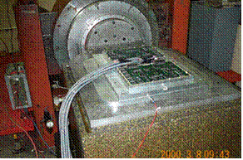 | 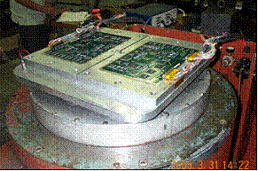
Figure 1: JCAA / JG-PP Test Vehicle Mounted On Vibration Table
Test Set One: 12 Boards
Test Vehicle Board Number | Manufactured With (Solder Alloy) | Reworked With (Solder Alloy)
62-63 | SnPb | SnPb
168-169 | SnPb | SnAgCu
196-197 | SnPb | SnAgCuBi
Table 1: Mechanical Shock Test-Procedure 1 Testing Level
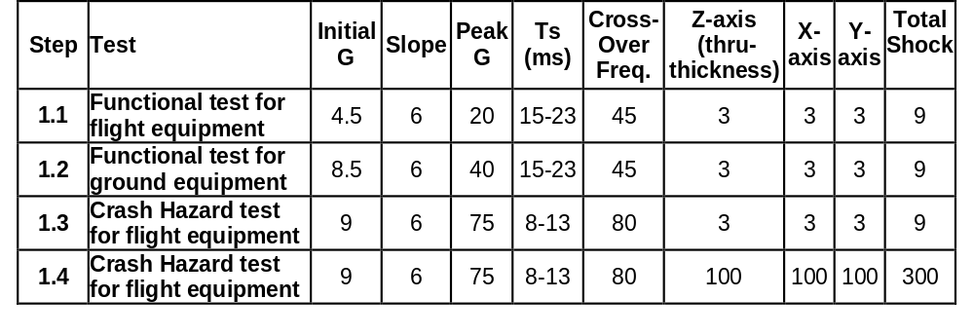
The following are examples of the Mechanical Shock Test-I Power Spectrum Density graphs for Test Steps 1.1 through 1.4, illustrated in Figure 2 through Figure 5. The Mechanical Shock Test-I Power Spectrum Density Graphs and Frequency Response Graphs for all three axes are located in Appendix B.
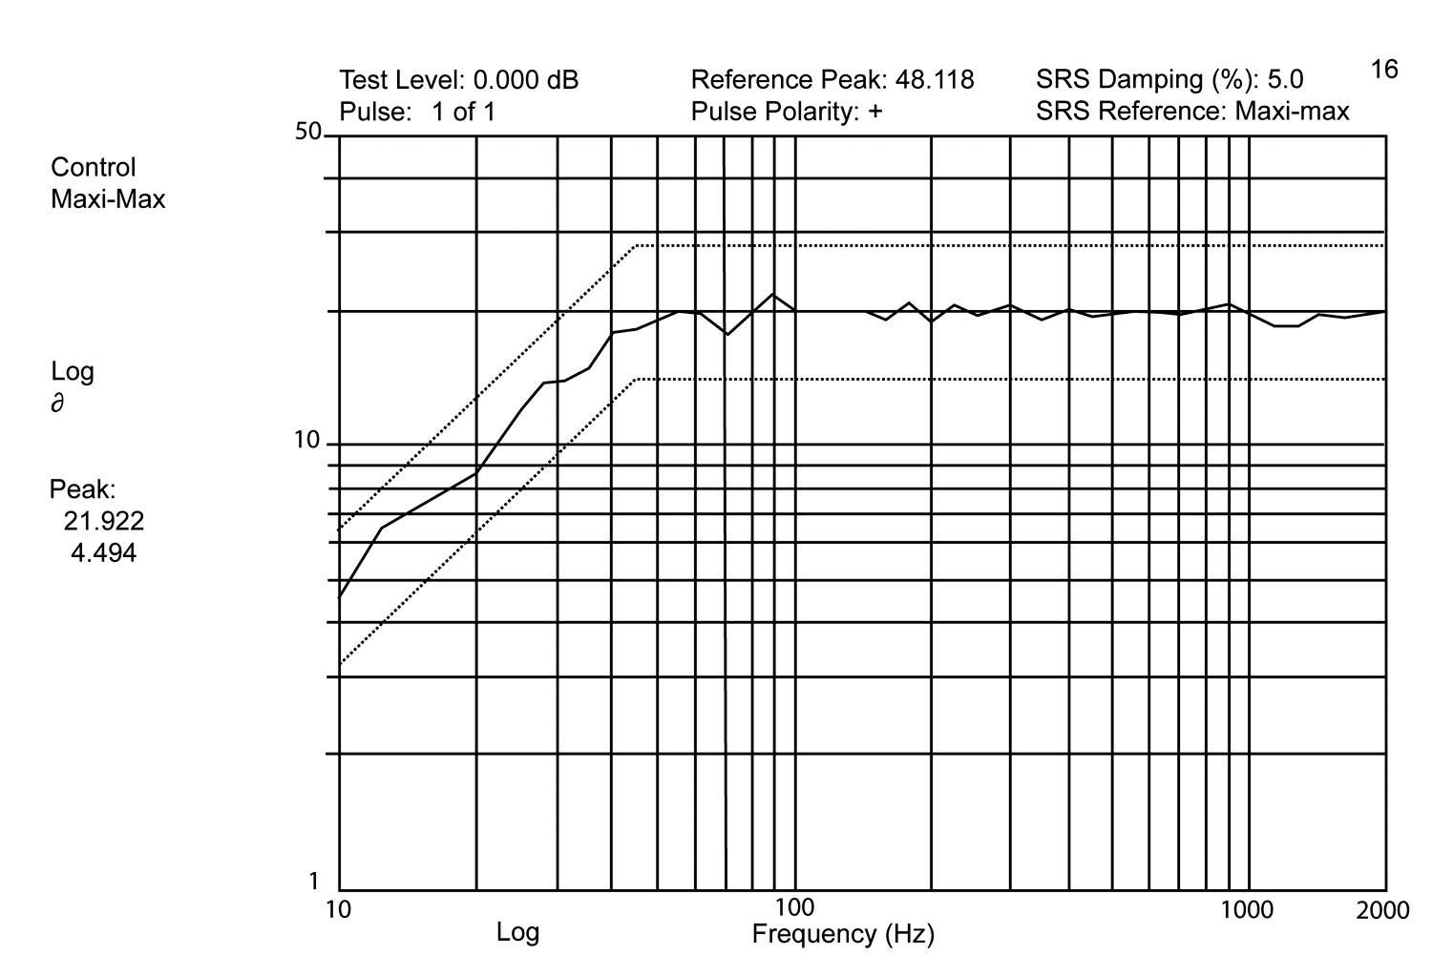
Figure 2: Test Level 1.1 Power Spectrum Density Graph
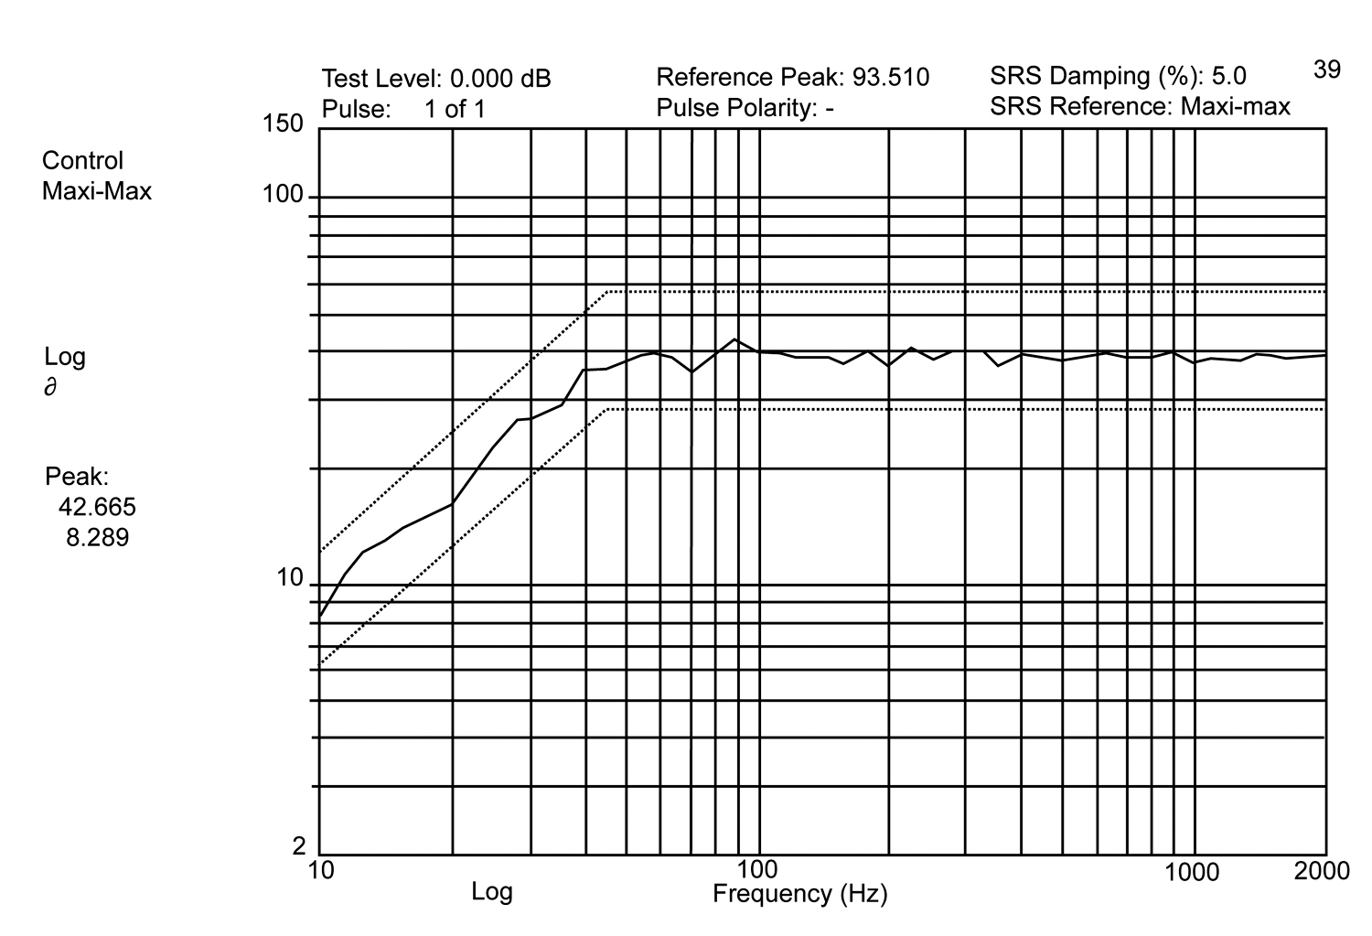
Figure 3: Test Level 1.2 Power Spectrum Density Graph
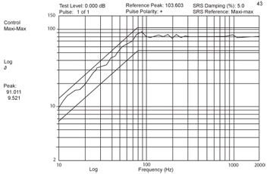
Figure 4: Test Level 1.3 Power Spectrum Density Graph
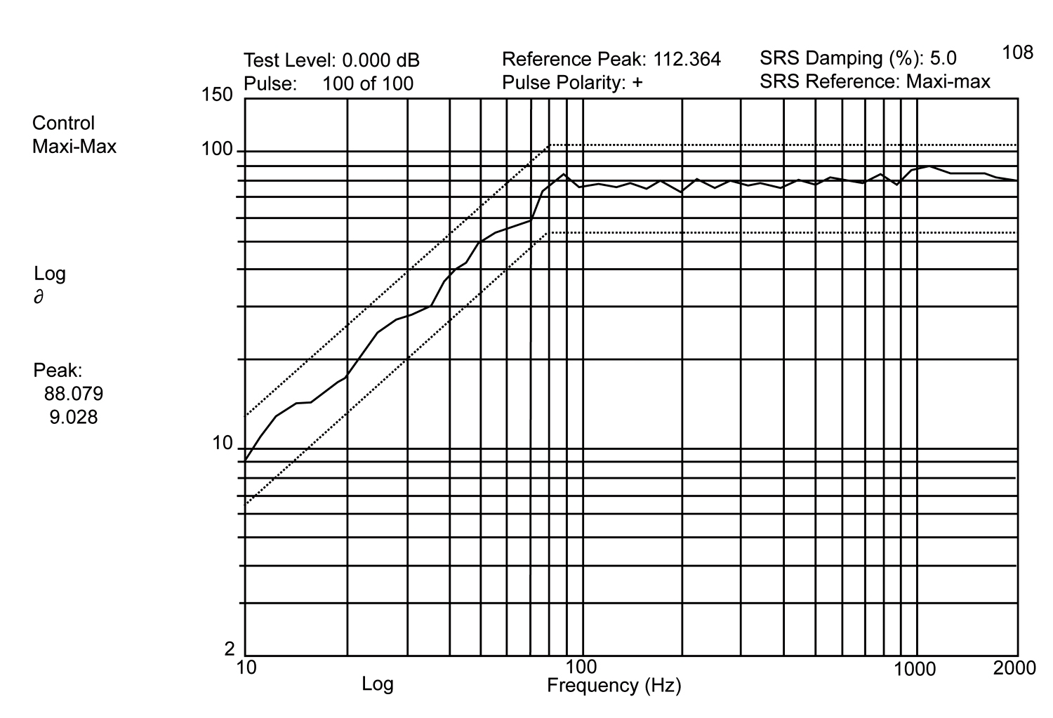
Figure 5: Test Level 1.4 Power Spectrum Density Graph

Mechanical Shock Test 1-Test Results
A total of 12 test vehicles were tested in Mechanical Shock Test 1 by ACI. The Anatech event detector was reset after every change of shock axis and after every level of shock applied.

ACI found no failures from any of the tin lead (SnPb) and SnAgCu soldered hardware. (two vehicles each). However, three (3) TQFP-208 components and one (1) TSOP-50, either initially soldered or re-worked with SACB, indicated failures in Mechanical Shock Test 1. Indicated failures occurred during test step levels 1.1 and 1.2, as per Figure 6. The three TQFP-208 devices exhibited intermitent electrical contacts at Level 1.4 in the Y-axis. All failures indicated are 25% of a total of 4 such devices, two from vehicles originally manufactured using SACB solder and two that had been initially manufactured with tin lead (SnPb) solder, but reworked using SACB solder wire. Therefore all three of the indicated failures from Test 1 are at the U3 location for the TQFP-208 devices, on the vehicles soldered or reworked with SACB only. This (U3) position on the test vehicle board was prone to failure in many of the other tests in the program (such as thermal cycle at Rockwell Collins and vibration at Boeing), and appear to be a universal artifact of the test vehicle, unrelated to the solder joint for these components.
The one failure (25% of four components) of the single TSOP-50 that indicated failure on a single SACB soldered board, was once again an artifact, as can be seen from the cross sections of the failure in Figure 11, where the broken lead and excessively large solder joint volume indicate poor workmanship rather than any solder joint property as the root cause of the indicated failure.

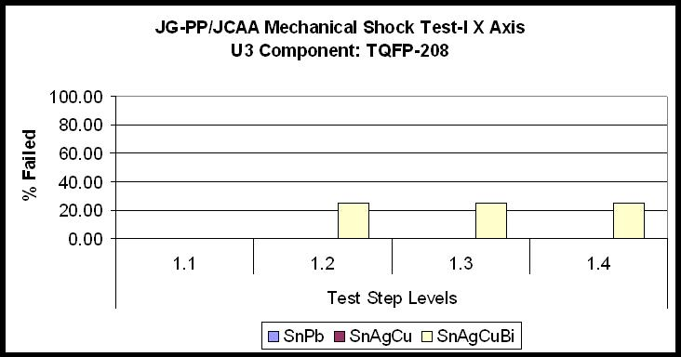 | 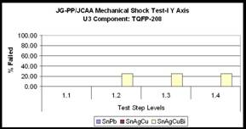
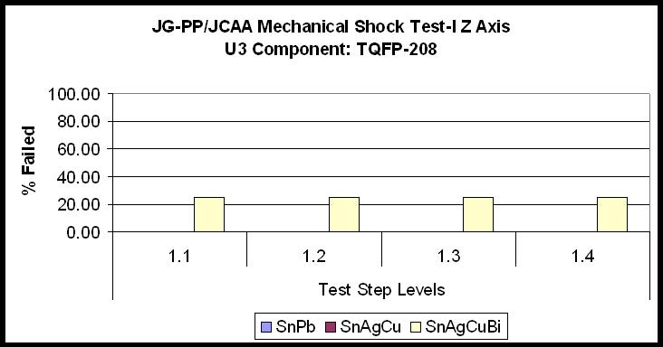 | 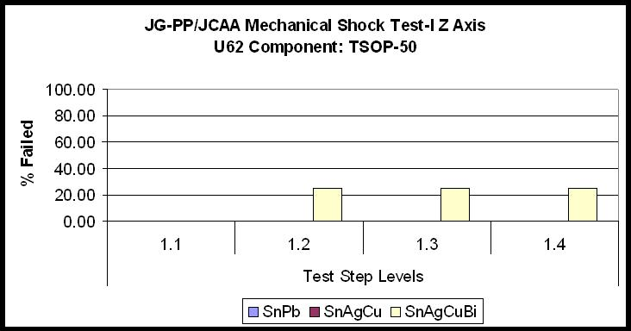

Figure 6: Mechanical Shock Test 1 Test Results. Failures indicated are from a total of four (4) components in each case.

Mechanical Shock Test 1-Failure Analysis

Visual inspection was conducted on all four Level 1 failures, as per Table 2. Continuity tests were performed on all components to determine continuity through the component without the effects of possible board or connector failures.
Table 2. Mechanical Shock Test-I Component Failures
Board | Location | Component | Solder | Component Finish
134 | U3 | TQFP-208 | SACB | NiPdAu
135 | U3 | TQFP-208 | SACB | NiPdAu
135 | U62 | TSOP-50 | SACB | SnPb
197 | U3 | TQFP-208 | SACB (After Rework) | NiPdAu

Each of the TQFPs indicating failure in Mechanical Shock Test 1 showed electrical continuity. A photograph of such a TQFP device is shown in Figure 7. These components had sufficient solder joints and toe and heel fillets as shown in Figure 8. The three (3) TQFP-208 components indicating failure somewhere in the daisy-chain circuit with the test vehicle board all passed continuity testing on the substrate side, so it is suspected that the solder joints all survived the test, and some aspect of the test vehicle board might have caused the electrical discontinuity that falsely indicated the failure. The root cause of failure has not been identified, but is suspected to be related to the Component U3 location on the test vehicle board, since components at the U3 location unexpectedly failed other environmental stress screening tests performed by the program at other program participant locations. .

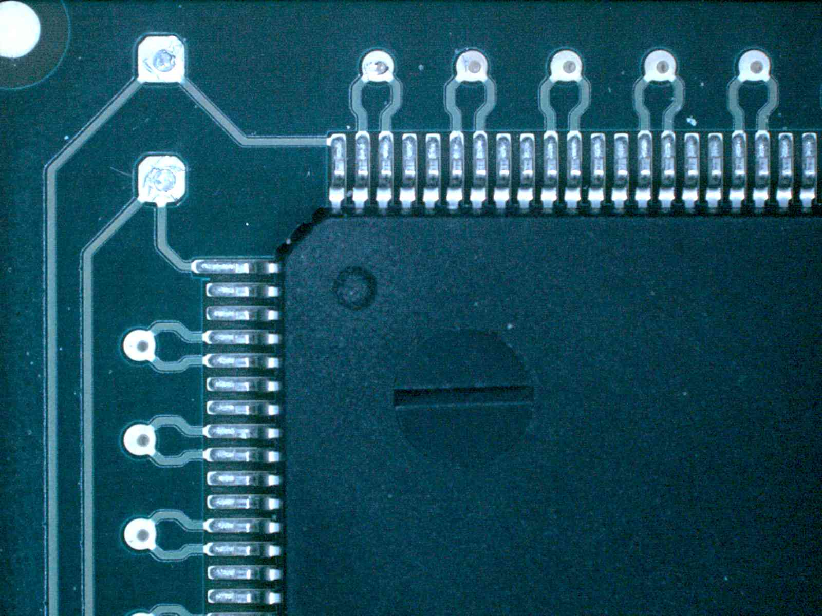
Figure 7. Board 135, U3, TQFP-208 has continuity around the component, both top and bottom side

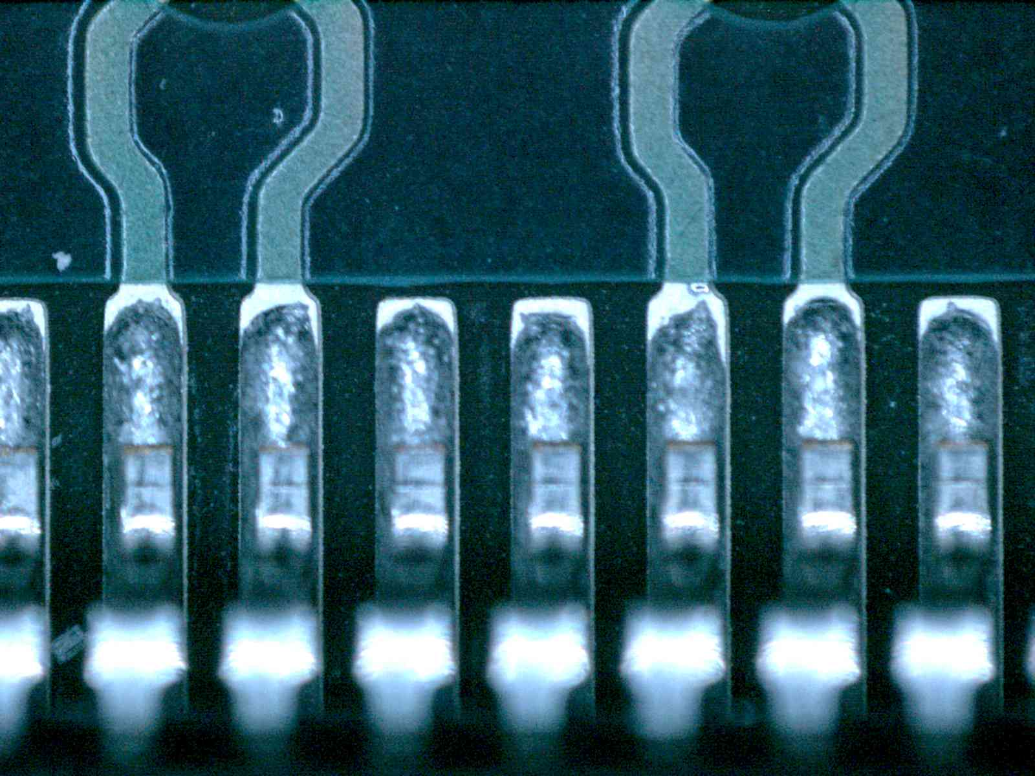 | 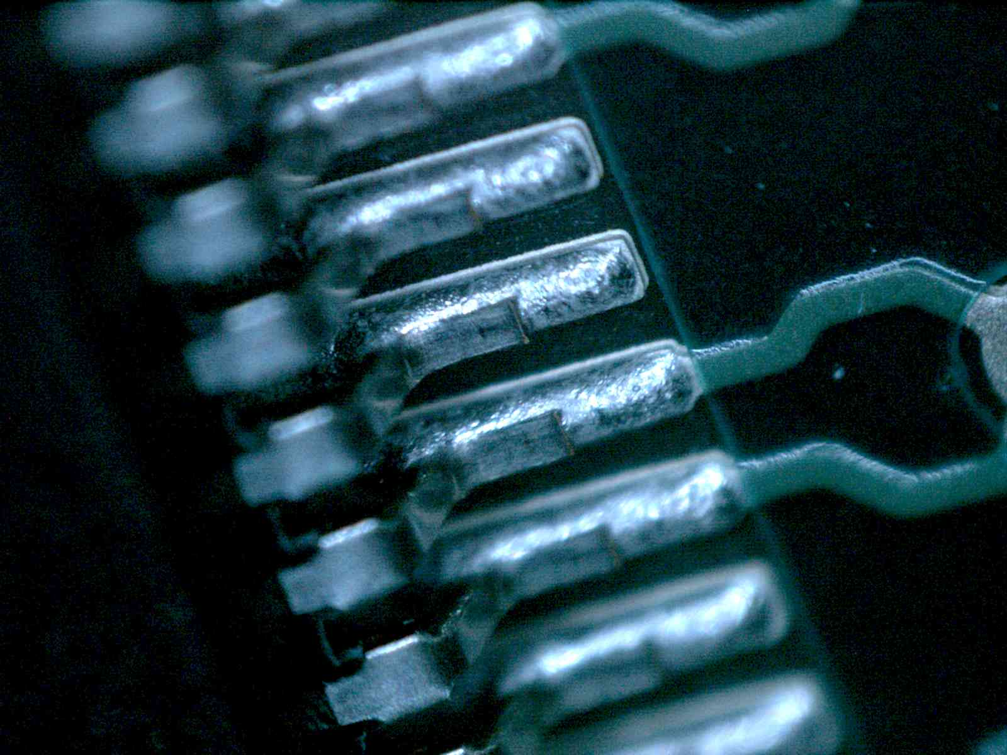
Figure 8. Board 135, U3, TQFP-208 has sufficient toe solder and heel solder and typical solder joints.

The TSOP-50 component did not have electrical continuity from adjacent rows of the TSOP connections. From the top side of the component, Figure 9, only one test point is available, as it is underneath the component. From the bottom side of the component. The discontinuity still exists between rows of TSOP pins. Within each row and its test point, however, electrical continuity is present. X-Ray analysis did not find any internal defects, as shown in Figure 10. Microsectioning discovered separation of the end gull wing lead from its solder joint. The solder wetted past the toe – heel fillet, almost to the lead’s knee, as depicted in Figure 11 and Figure 12. This indicates excessive solder was applied to the lead. This component was reworked with SACB solder in production. SEM analysis showed a lack of intermetallic growth within the solder joint, as shown in Figure 13.

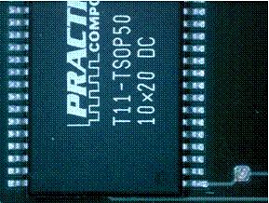 | 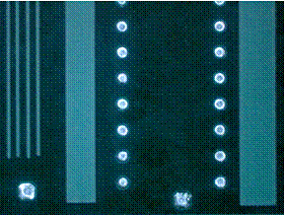
Figure 9. Board 135, U62, TSOP-50 rings out from test point to adjacent pins, but not to opposite pins (top), out from adjacent test point to adjacent pins but not from row to row (bottom).

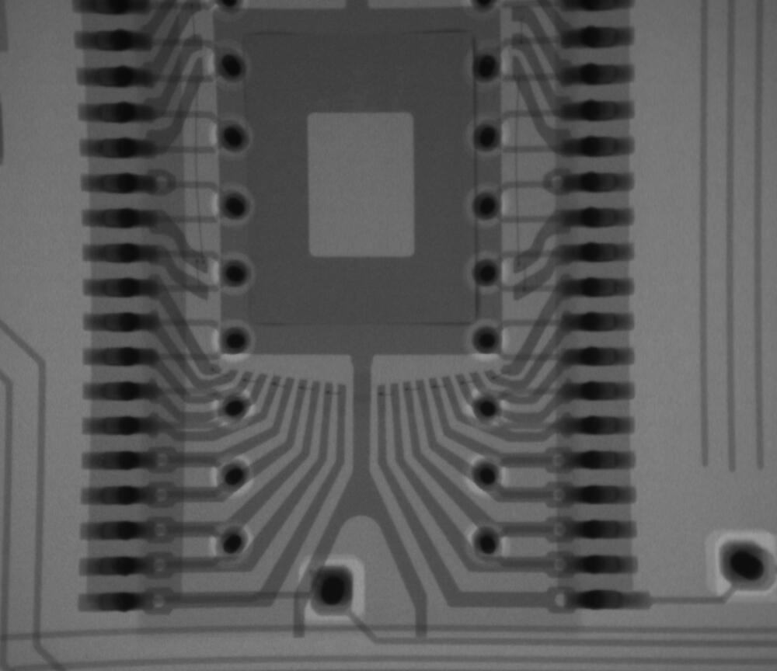 | 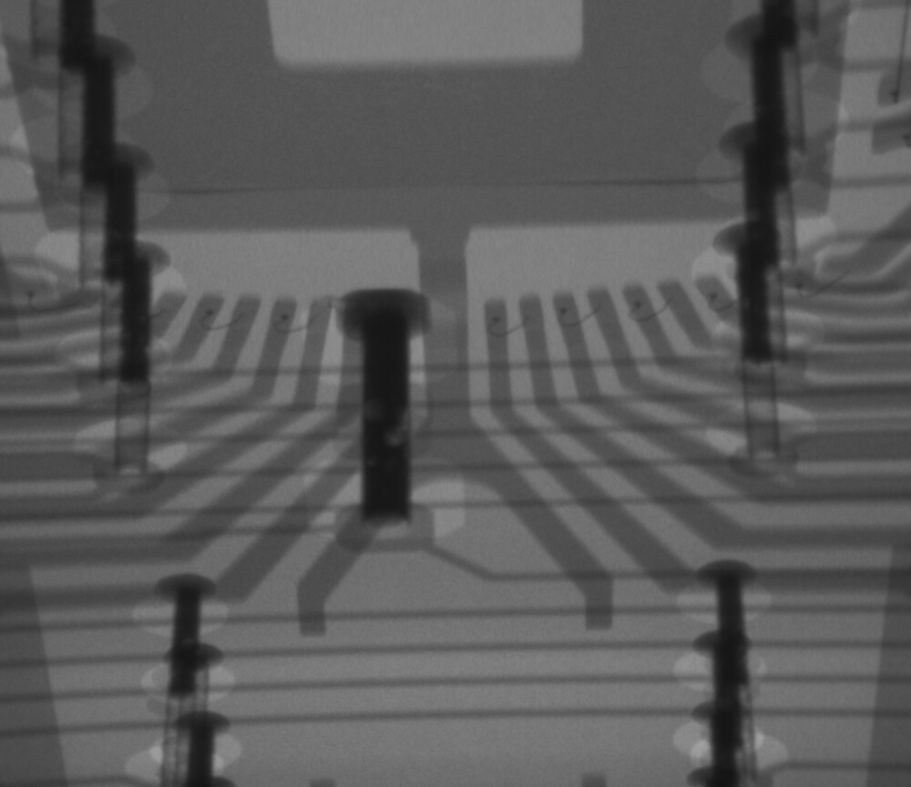
Figure 10. X-ray inspection did not show any internal defects
in the chip bonds (Board 135, U62, TSOP-50)

 | 
Figure 11. Pseudo-microsection showing separation on end gull wing lead
left, and opposite solder joint (Board 135, U62, TSOP-50). This is a simple workmanship defect.

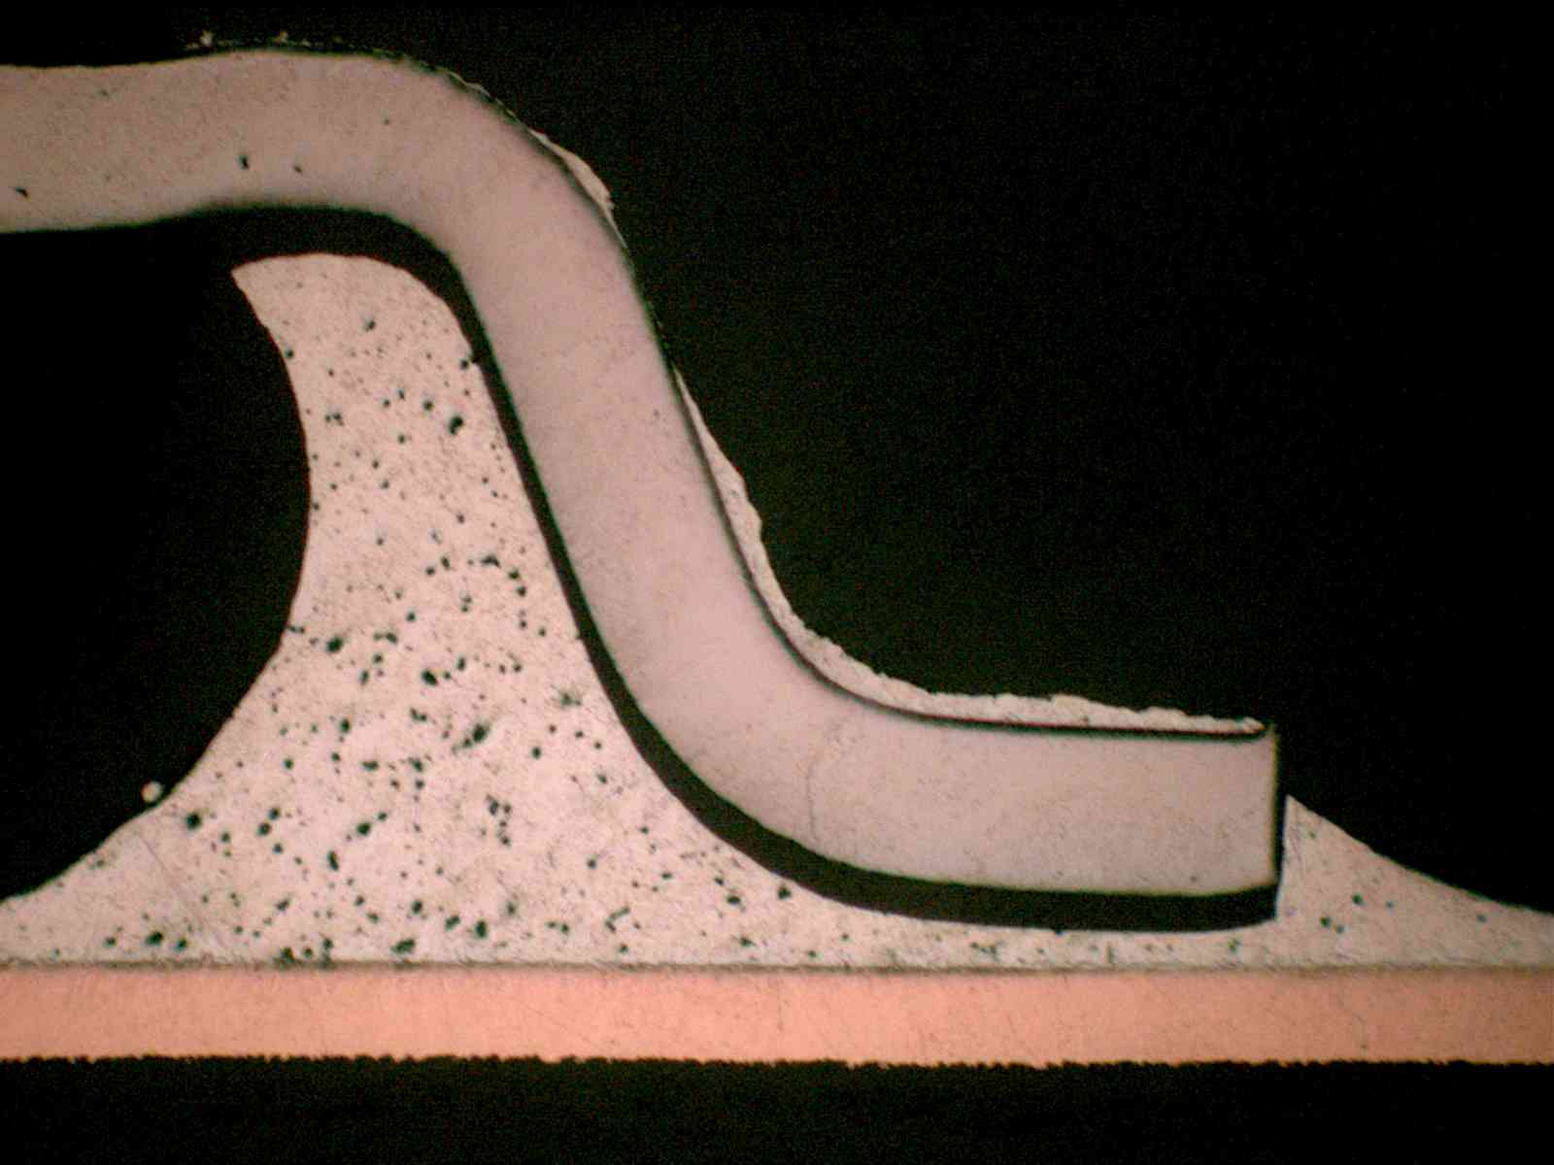 | 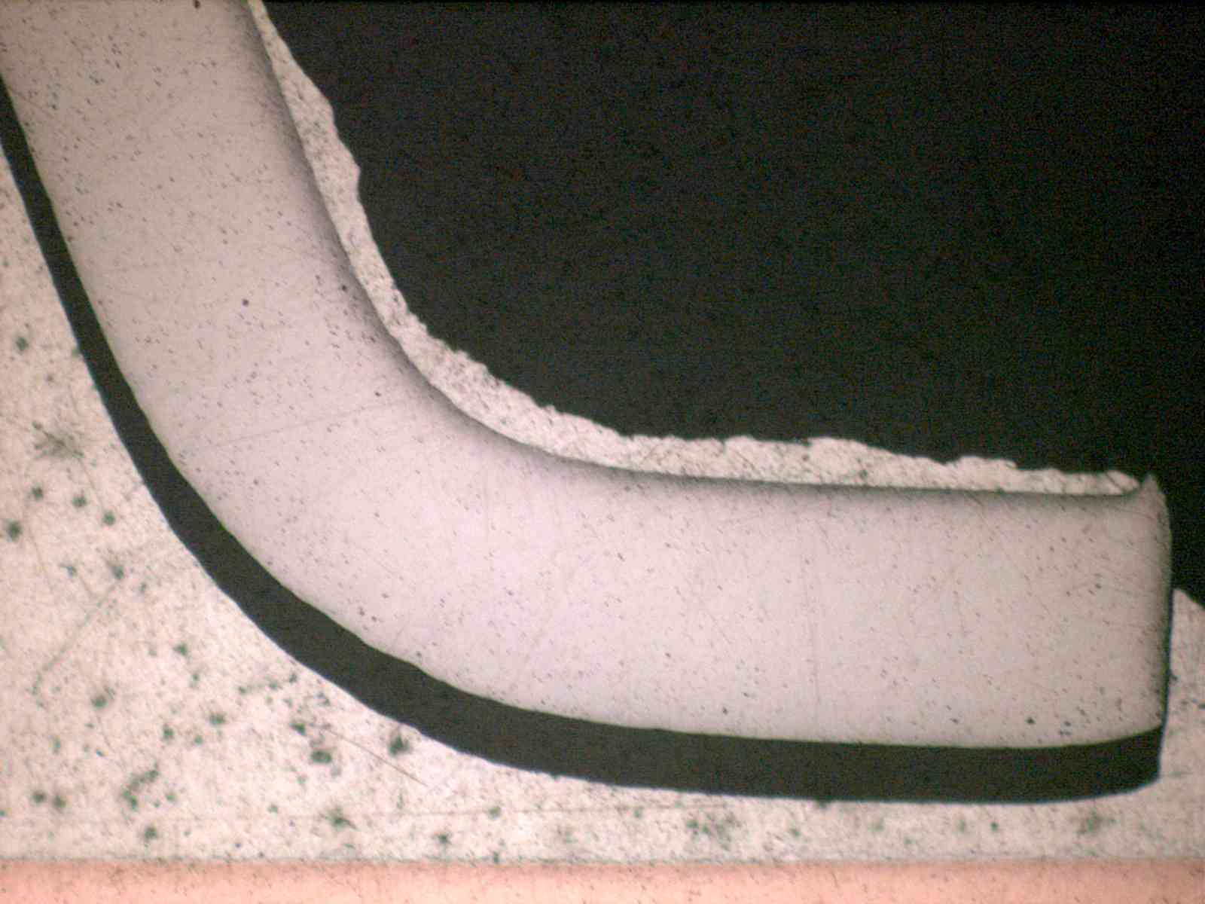

Figure 12. Microsection showing complete separation of solder joint, confirming

the continuity testing measurements (Board 135, U62, TSOP-50).

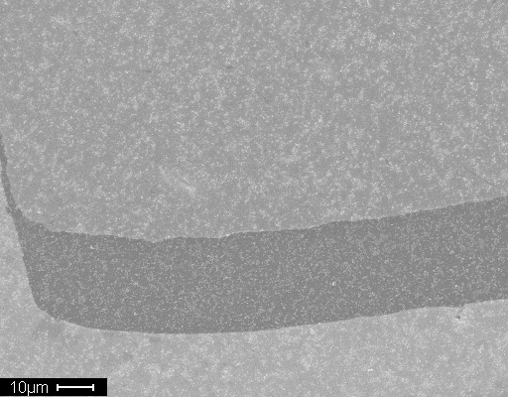 | 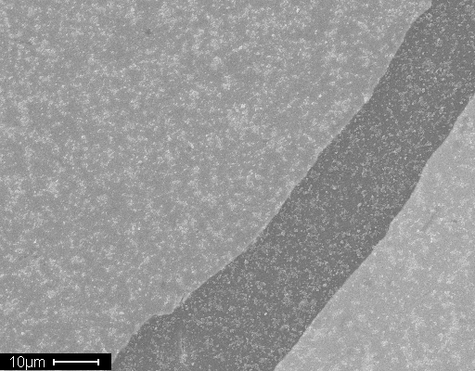
Figure 13. SEM Micrograph does not show distinct intermetallic growth.

Lack of intermetallic growth can be an indication of insufficient heat during soldering and perhaps incomplete wetting of the solder that could accompany this lack of intermetallic formation. All of these effects indicate the strong possibility that this one indicated failure may have been a workmanship issue rather than any indication of bulk solder fatigue or impact properties.

Mechanical Shock Test 2

Test Procedure

ACI performed the Mechanical Shock Tests in the Z axis only as agreed by the entire JG-PP team. A total of twelve (12) test vehicle boards were tested. Table 3 illustrates the testing levels performed at each step.
Table 3: Mechanical Shock II Testing Levels
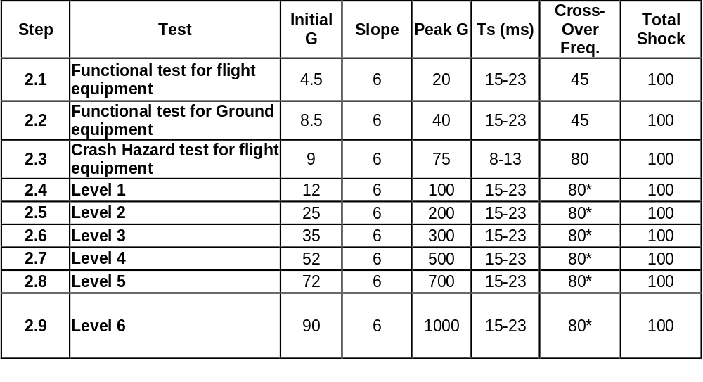
The following are examples of the Mechanical Shock Test-II Power Spectrum Density graphs for Test Steps 2.1 through 2.7, as illustrated in Figure 14 through Figure 20. All testing was performed in the Z-Axis only as agreed by all team members. The Mechanical Shock Test 2 Power Spectrum Density Graphs and Frequency Response Graphs for all three axes are located in Appendix B.
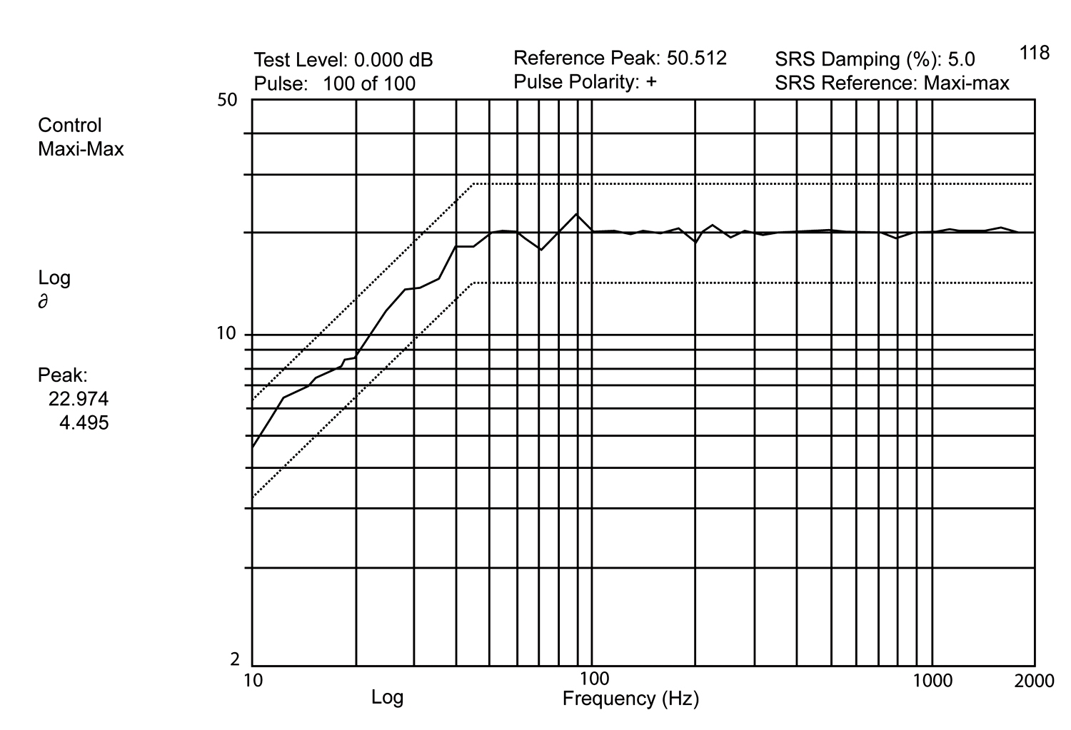
Figure 14: Test Level 2.1 Power Spectrum Density Graph
Figure 15: Test Level 2.2 Power Spectrum Density Graph
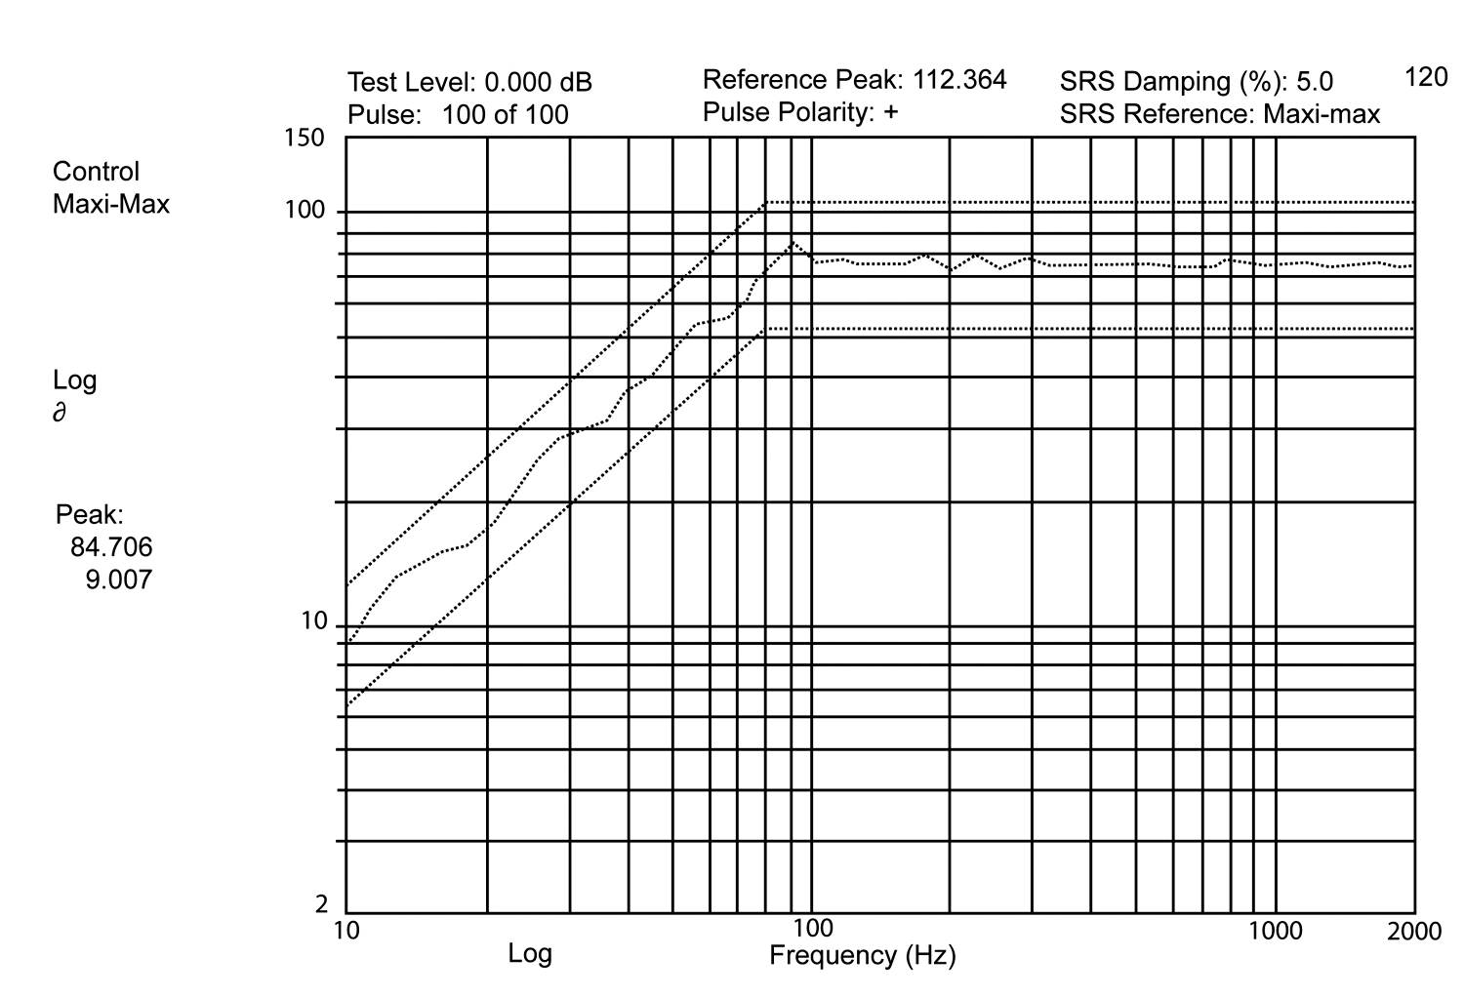
Figure 16: Test Level 2.3 Power Spectrum Density Graph

Power Spectrum Density Graph
Figure 17: Test Level 2.4
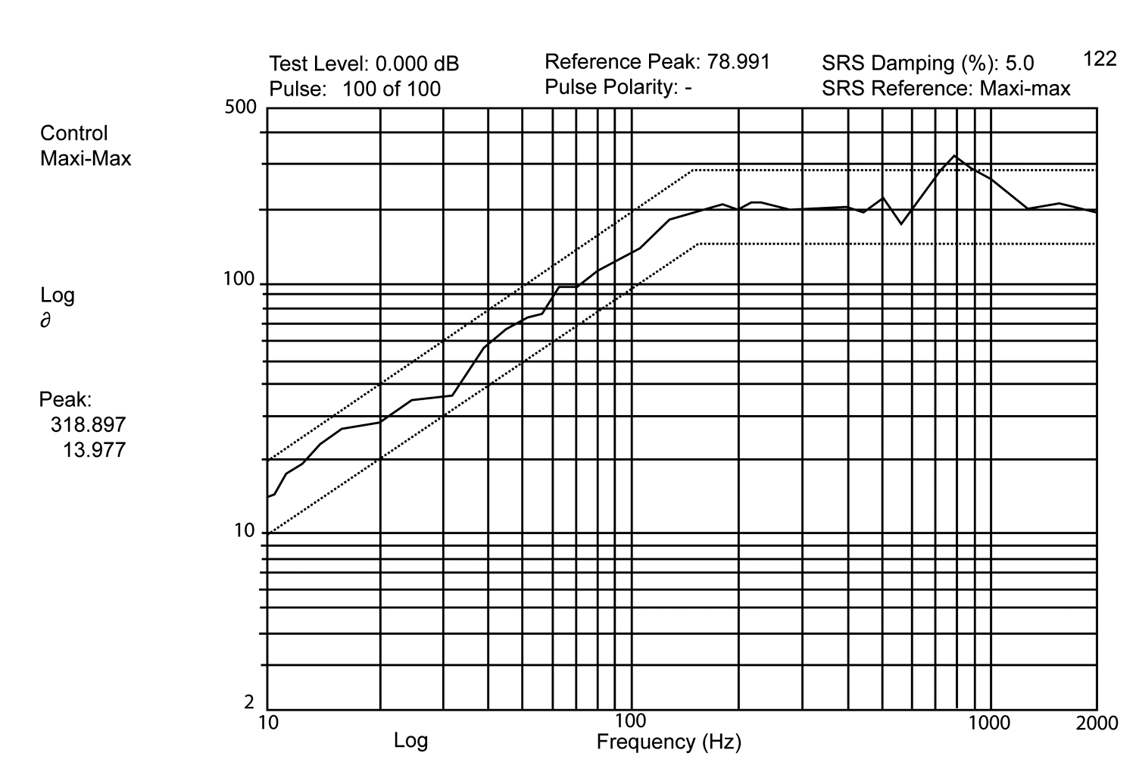
Figure 18: Test Level 2.5 Power Spectrum Density Graph
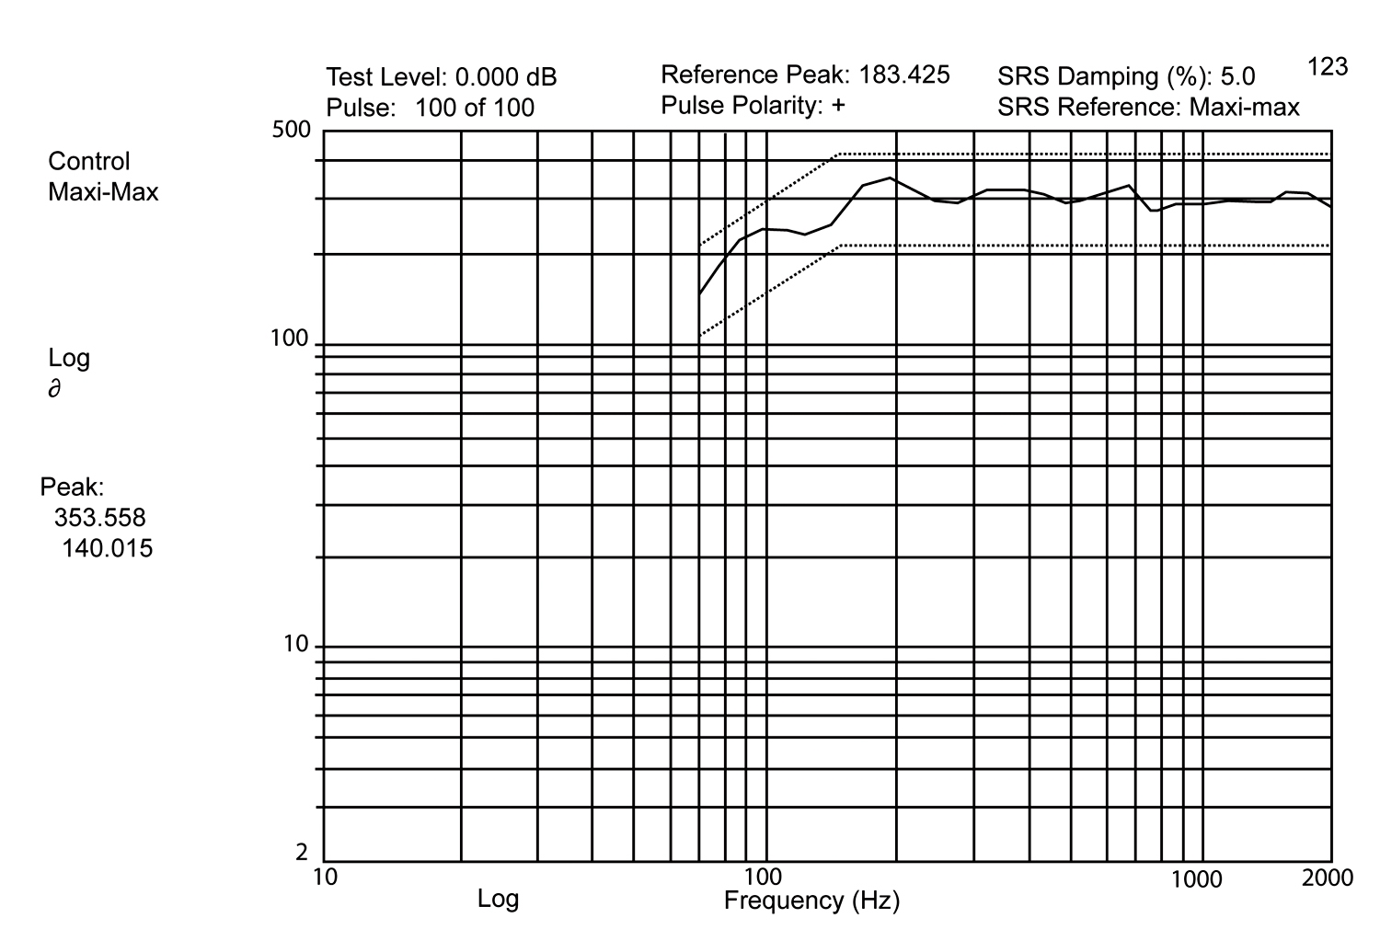
Figure 19: Test Level 2.6 Power Spectrum Density Graph
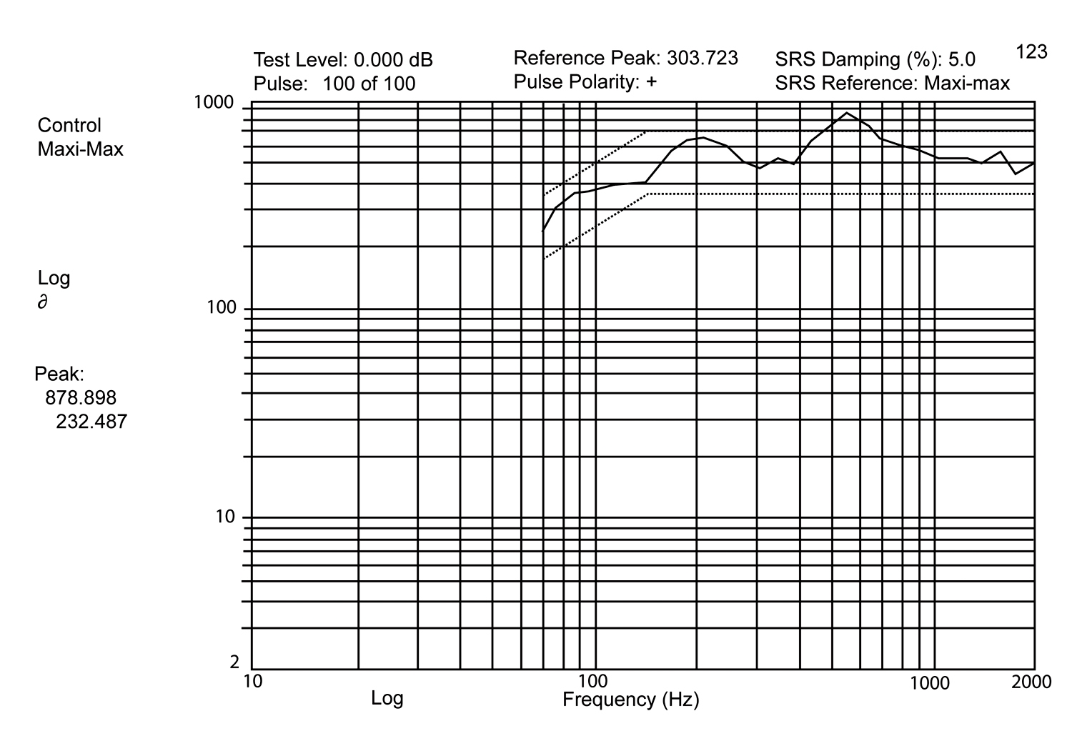
Figure 20: Test Level 2.7 Power Spectrum Density Graph

Mechanical Shock Test 2 -Test Results

At mechanical shock Test Level 2.1 (20 G Peak) through Test Level 2.3 (75 G Peak) there were random failures recorded by the test setup. The Anatech event detector was reset after every shock level. Test Levels 2.1 thru 2.3 are equivalent to the Functional Test for Flight Equipment, the Functional Test for Ground Equipment, and the Crash Hazard Test for Flight Equipment. One hundred (100) shocks were imparted at each level in the Z-axis only, as agreed with the JG-PP team members. This was a more severe test than Mechanical Shock Test 1, where a total of 9 shocks were imparted at each level, consisting of three (3) shocks imparted in each axis.

At the higher Mechanical Shock Test 2 test levels, from Test Level 2.4 (100 G Peak) through Test Level 2.7 (500 G Peak), the test set-up recorded numerous simultaneous failures of multiple devices with intermittent contact. At Level 2.4 (> 100 G Peak) and above, failure event data again indicated numerous simultaneous failures that were intermittent in nature. These intermittent failures, could be failures of the multilayer interconnection board traces (some examples of which are recorded in Failure Analysis section of this report) and/or the electrical connectors in the circuit, and not the solder joint failures intended to be detected, and so confound the test data and do not allow clean interpretation of the test results for Test Procedure 2 shocks. An intermittent contact/open appearing in these data may be the result of several possibilities such as:

- Shock failed solder/interconnect joints breaking and remaking electrical contact.
- Failures not at the device level but somewhere else within the board interconnect chain, such as board traces fracturing. .
- Failures within the component (i.e. wire bonds) but not within the solder/interconnect joint.
- Failures at the mechanical connector.
The post-test data analysis indicated that the failures, which were recorded past the level 2.3, contain, in addition to possible actual solder joint failures, possible board level interconnect failures and test set-up related failures such as connector failures. Since it was determined that the data beyond test level 2.3 is confounded with failures other than the DUT (Device Under Test), and since any shocks over 50 g peak are above the maximum acceleration for the connector used on the test vehicle, results of all shock tests in Test Procedure 2 are compromised by board and/or connector failures. Appendix B shows the entire test data in a raw format, which includes all indicated failures (not necessarily DUT failures), experienced thru level 2.1 to 2.7. It can be concluded from the numerous simultaneous intermittent failures that the Test Procedure 2 data is compromised. This conclusion is supported by the connector data sheet and the failure analysis showing board copper trace failures

Mechanical Shock Test Failure Mode Analysis

Limited scale failure mode analysis of failed solder joints was conducted on the components/boards that had failed in mechanical shock procedure 2 testing. The investigation included visual examination of solder joints at 10-90X, followed by manual electrical continuity testing of each daisy-chain net on each circuit board. Subsequently, boards were subjected to X-ray inspection, and die penetrant testing followed by micro sectioning and SEM examination of the failed interconnect sites. Pinpointing a component level failure in the shock tested boards presents a challenge, since the electrical probe testing, does not lead to open circuit location. In our failure analysis, we analyzed one board from each solder type and only BGA device failures were evaluated.

Mechanical Shock Test – Procedure

Three boards from the lot of 12 boards in the level 2 mechanical shock test were visually inspected for solder joint cracks after the mechanical shock testing. One board from each solder type was selected as described below:
Board # 29 - SnPb manufactured,
Board # 97 - SnAgCu/SnAgCu, and
Board # 137- SnAgCuBi/SnCu.

No failures were visually identified at 10 – 90X magnification, at this stage. Then the boards were manually checked for electrical continuity and failure locations were noted for the SnAgCu, SnAgCuBi and SnPb boards. Electrical opens were identified and were tabulated. The majority of the failures were located at the BGA devices in the SnAgCu followed by the SnPb and the least number of failures were logged on the SnAgCuBi board.
Subsequently, Board # 29 (SnPb) and board # 97 (SnAgCu/SnAgCu) were soaked in a dye penetrant solution, using vacuum to work the dye into any cracks. After baking the boards, a second visual inspection was performed to see if the dye had highlighted any solder joints cracks. Visual inspection showed highlighted cracks in the solder joints only at the board connectors. Some of these cracks appear to be superficial and may be acceptable to IPC specifications. Further investigation, which should include cross sectioning and SEM inspection, is needed to verify if these surface cracks penetrate the entire solder joint. Most of the solder joints, with the visual cracks, do not test electrically open. Since cracks caused by the mechanical shock are often very narrow and the spring tension on the connector leads electrically closes the circuit.

An additional three boards were temperature cycled from -55°C to 125°C, for 10 cycles to attempt to permanently open intermittent electrical failures on the boards. The cycle included 10-minute soak after reaching each temperature. All three boards were continuously electrically monitored to log any intermittent electrical failures, during the temperature cycling. No additional or intermittent electrical failures were recorded during or after temperature cycling on any of the boards.

Failure Analysis

The failures underneath the BGA devices are not visible in the microscopic examination. To assess the damage caused by the shock testing, initially some of BGAs were pried from the boards to see if the dye penetrate had highlighted the failure areas. After prying a BGA device, the solder side of the BGA and the PCB solder areas were inspected for the dried out dye in the failure areas. None of the BGA solder ball failures or PCB failures, indicated the presence of the dye penetrant. The only indications of failures were on the corner BGA balls, where the metal lands had lifted without pulling up the connecting conductor trace. At higher magnification, copper oxide was noted on the edges, where the connecting conductor had separated. See Figure 21 and Figure 22 for general indications of failures. Further investigation correlated failures with electrical opens from the electrical continuity test.
One additional BGA device was separated from both the SnPb and the SnAgCu boards for cross sectioning. The devices were cross-sectioned, lapped and polished to reveal the interconnecting solder balls at the previously identified electrical continuity failure areas.
Electrical opens can be seen at high magnification, at the printed circuit board land to connecting conductor trace. Failures were identical in both the SnPb boards, as illustrated in Figure 24 and SnAgCu boards – Figure and Figure 26.
As can be seen in Figure 26 and Figure 27, some of these copper trace opens will be intermittent failures during shock testing, since the conductor is still in intimate contact with the land pad between shocks.
Some of the adjacent BGA balls exhibit partial cracking in the solder joints as shown in Figure23 (SnPb) and Figure 28 (SnAgCu). However, no complete solder joint crack failures were observed in any of the cross-sections.

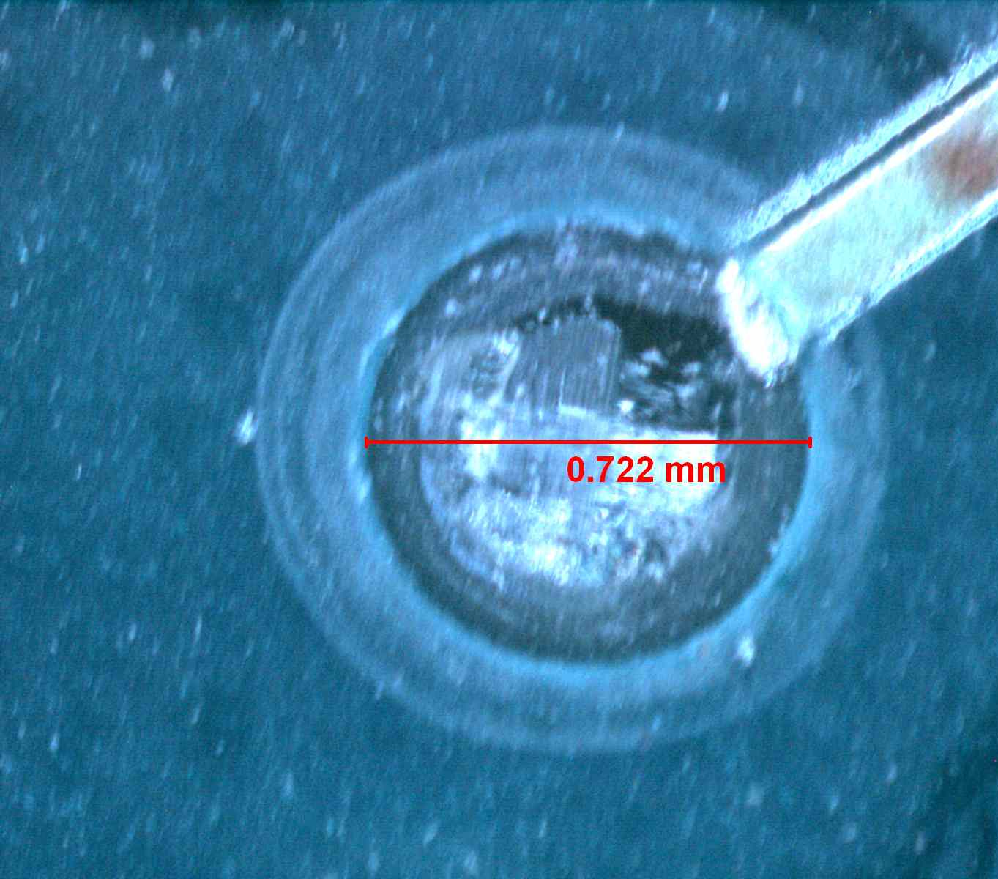

Figure 21: Dye-N-Pry Process: Board 97, SnAgCu/SnAgCu, BGA U6, PCB trace failure at BGA Ball 15R. Land Pads lifted cleanly, separating at the conductor to land pad interface indicating a cracked conductor. The area of separation was also oxidized.

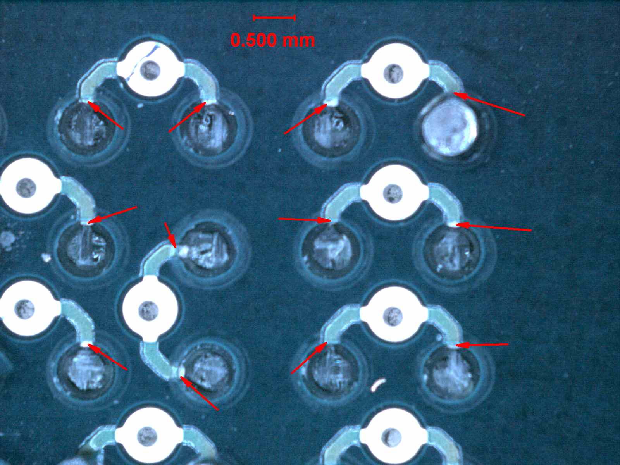

Figure 22: Dye-N-Pry Process: Board 97, SnAgCu/Sn/AgCu, BGA U6, PCB trace failures in the corner of the BGA. Land Pads lifted cleanly, separating at the conductor to land pad interfaces indicating a cracked conductors. The area of separation was also oxidized

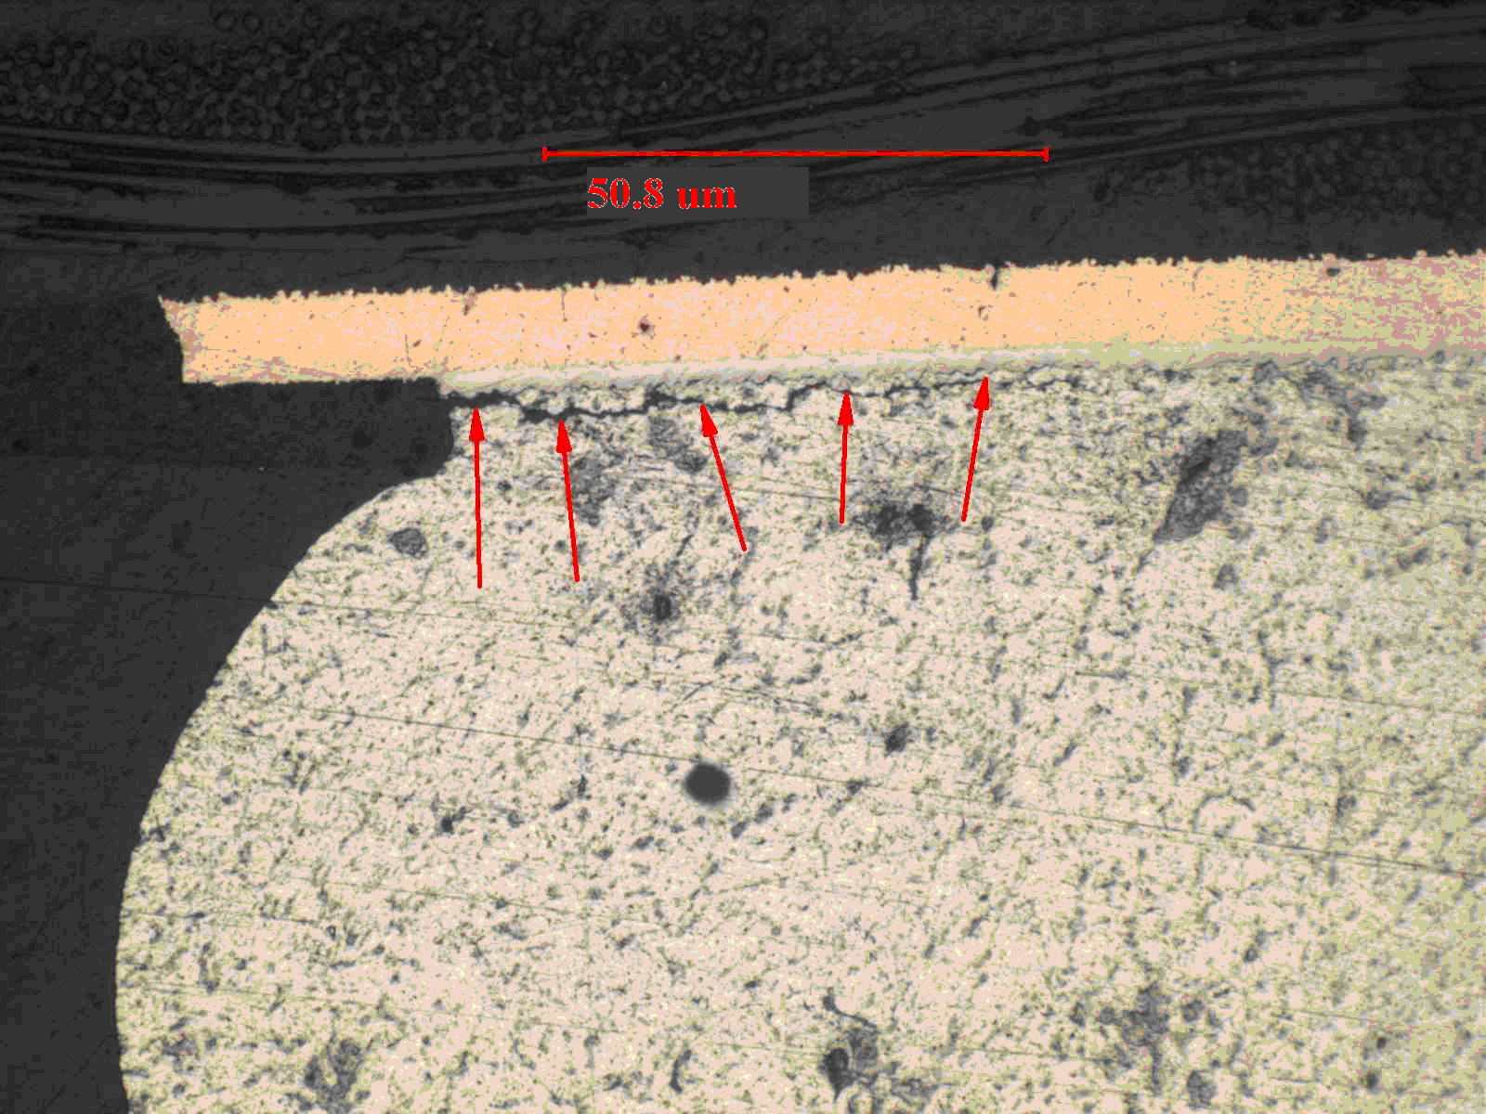

Figure 23: Board 29, SnPb MANUFACTURED, BGA U44, Solder Ball crack on the Component side, No failures of this type found but small amount of cracking seen.

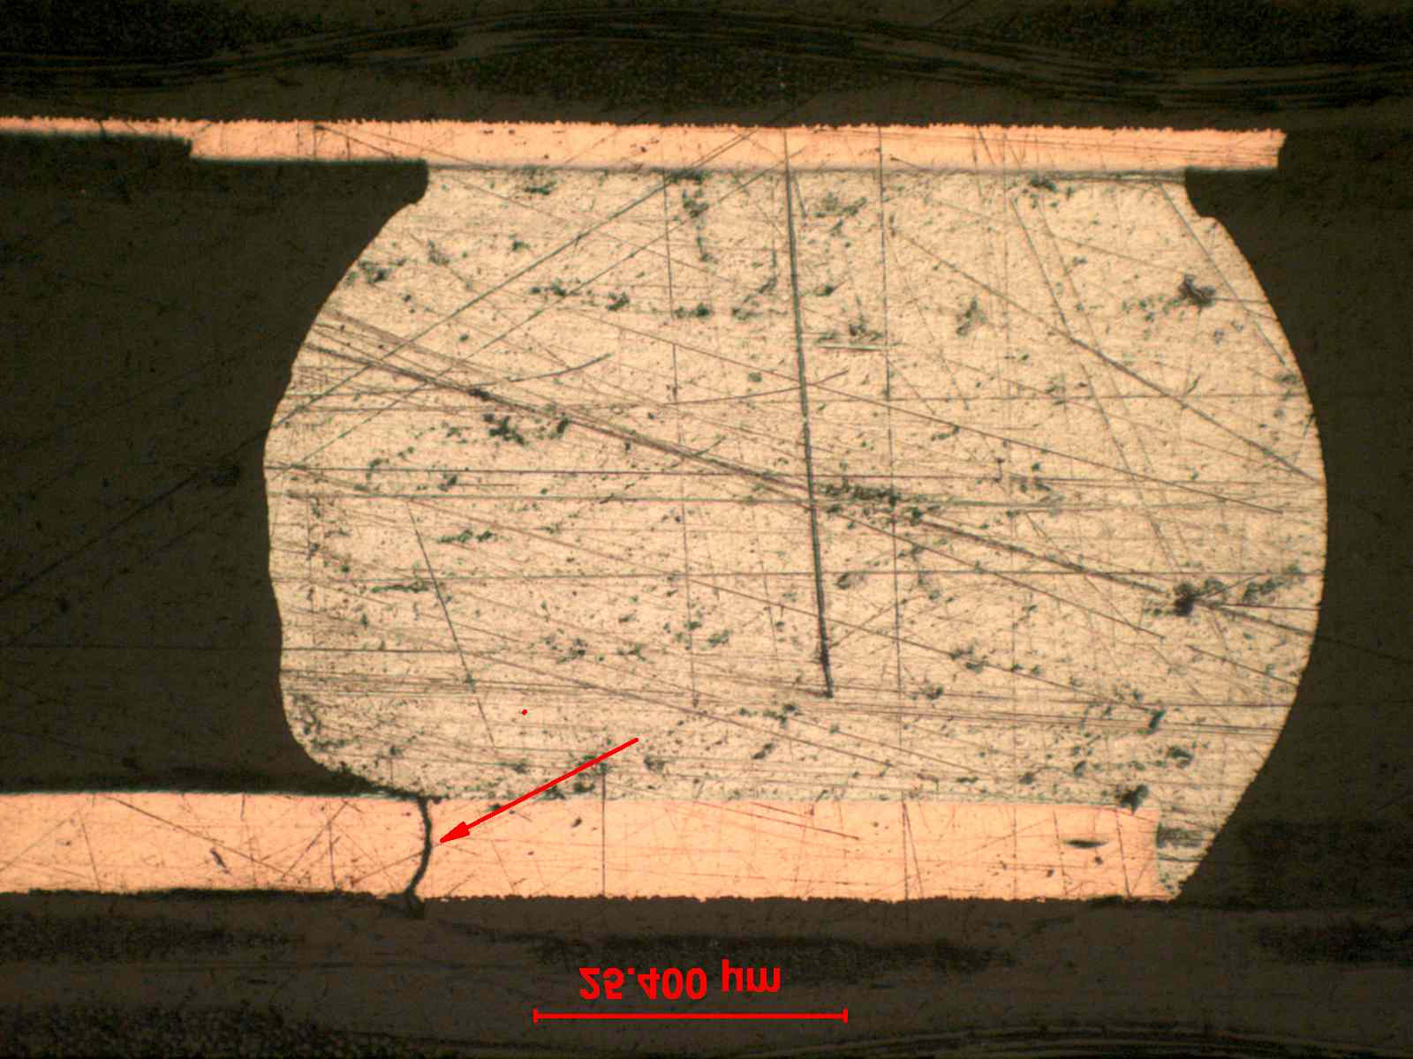

Figure 24: Broad 29, SnPb MANUFACTURED, BGA U44, PCB trace failure at BGA Ball 1R.

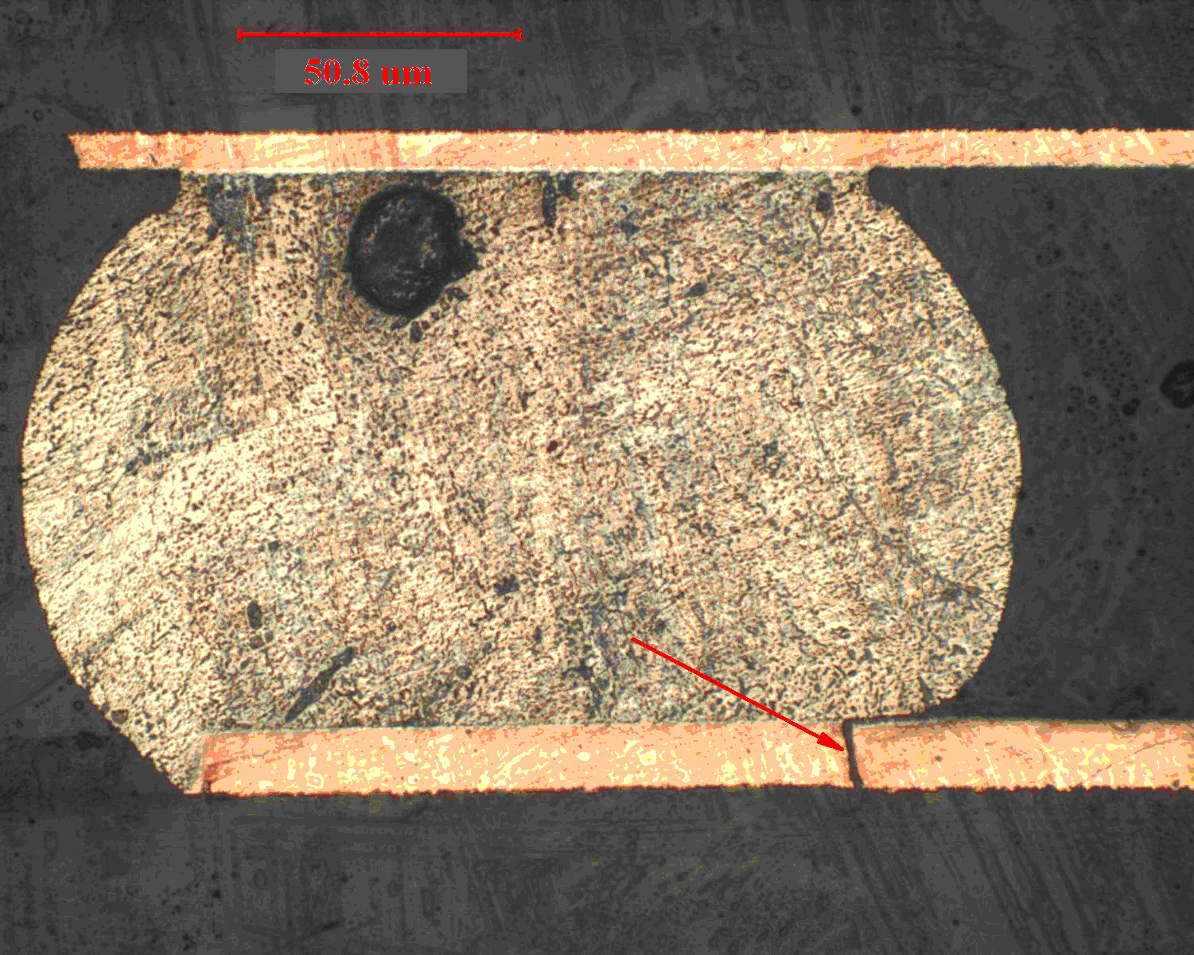

Figure 25: Board 97, SnAgCu/SnAgCu, BGA U44, PCB trace failure at BGA Ball 1R

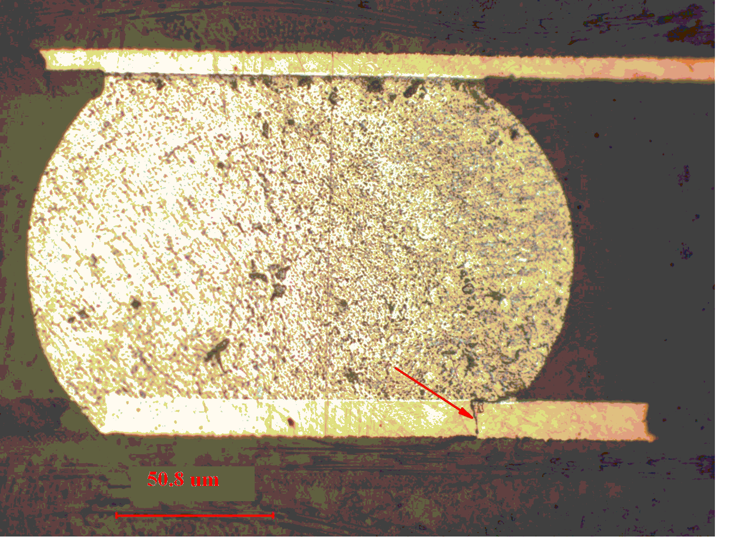
Figure 26 : Board 97, SnAgCu/SnAgCu, BGA U44, PCB trace failure at BGA Ball 2R. As can be seen this failure could cause intermittent electrical failures.

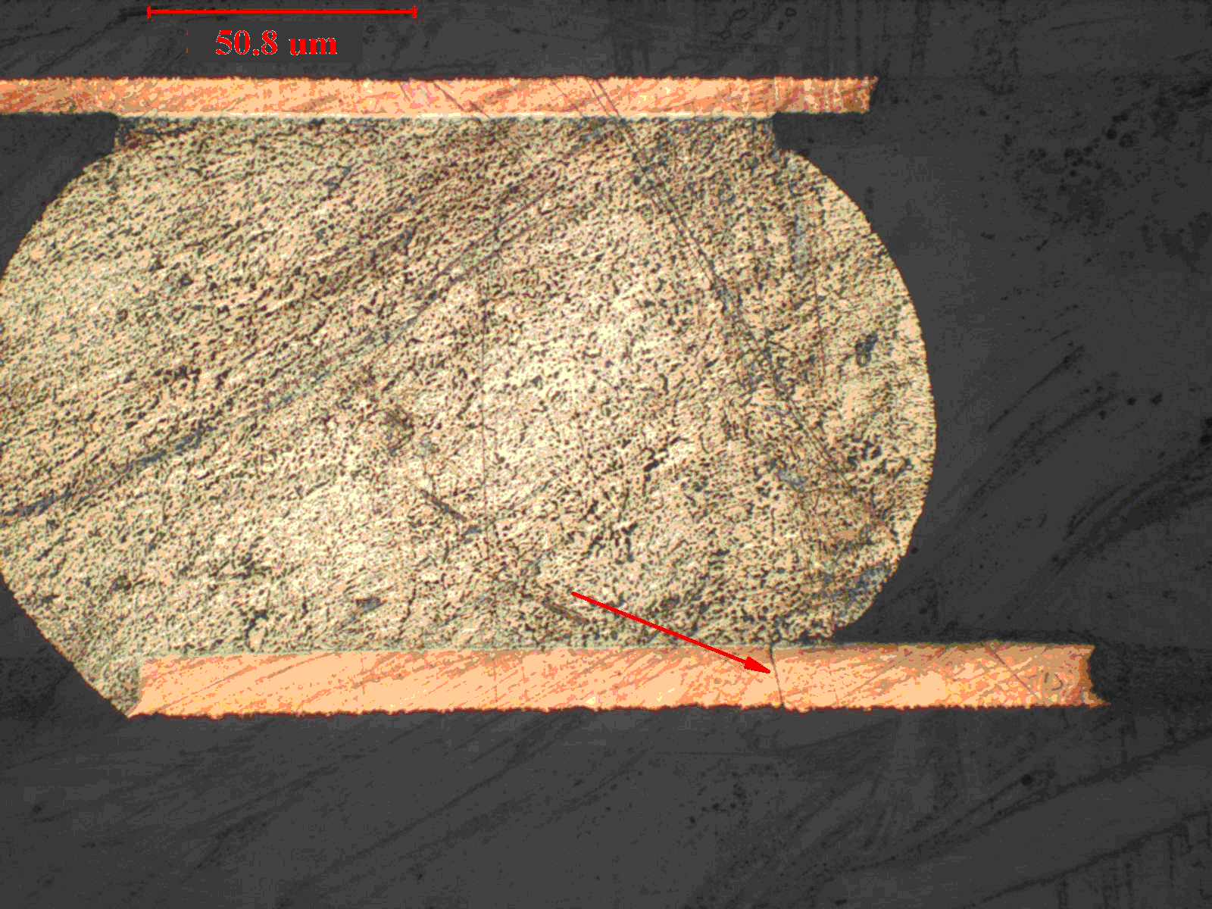

Figure 27: Board 97, SnAgCu/SnAgCu, BGA U44, PCB trace failure at BGA Ball 1B. As can be seen this failure could cause intermittent electrical failures

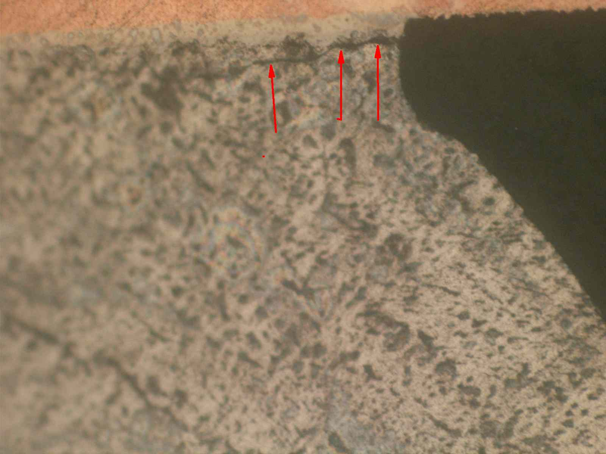

Figure 28: Board 97, SnAgCu/SnAgCu, BGA U44, Solder ball crack on component side, no failures found but small amount of cracking seen.

Figure 21
Figure 22

Test Procedure Critical Review
ACI performed an analysis of the Mechanical Shock Test-II Procedure to determine the root cause of intermittent and inconsistent recorded component failures. We evaluate 3 critical test areas which may have contributed to the intermittent behaviour observed during the testing.

Connector Selection: Did the connector used in the test contribute to false failures?

The following are the operating environmental specifications which the connector is rated:

Operating Temperature: -55°C to +125°C
Shock: 50G peak per MIL-STD-202, Method 213, Condition G
Vibration: 12 cycles in three perpendicular directions @ 10-2000 Hz, per MIL-STD-202, Method 204, Condition D
Moisture Resistance: 90-95% relative humidity @ 40°C for 96 hours per MIL-STD-202, Method 103

The Mechanical Shock Test-II has the following peak shocks shown in Table 4

Table 4: Shock Test Level Parameters
Test | Test Shock Response Spectra | Initial G | Slope | Peak G | Ts  (ms) | Cross-Over  Frequency | Z-Axis
2.1 | Functional Test for Flight Equipment | 4.5 | 6 | 20 | 15-23 | 45 | 100
2.2 | Functional Test for Ground Equipment | 8.5 | 6 | 40 | 15-23 | 45 | 100
2.3 | Crash Hazard for Ground Equipment | 9 | 6 | 75 | 8-13 | 80 | 100
2.4 | Level 1 | 12 | 6 | 100 | 15-23 | 80 | 100
2.5 | Level 2 | 25 | 6 | 200 | 15-23 | 80 | 100
2.6 | Level 3 | 35 | 6 | 300 | 15-23 | 80 | 100
2,7 | Level 4 | 52 | 6 | 500 | 15-23 | 80 | 100
2.8 | Level 5 | 72 | 6 | 700 | 15-23 | 80 | 100
2.9 | Level 6 | 90 | 6 | 1000 | 15-23 | 80 | 100

Based on the connector specifications, we assessed that the connectors survived the first three (3) tests levels. This is verified from the data, where components in Mechanical Shock Test-I solder joints passed the shock test. In Mechanical Shock Test-II, when the shock levels constantly exceeded the 50G level, the connector contact failure probably contributed to the intermittent contacts failures indicated during the test.

Lesson Learned: All data collection wires should be soldered directly into the test vehicle for the shock testing. Connectors should not be used unless rated above the shock test levels.

Wiring Selection: Did the wire harness assembly used in the test contribute to false failures?

The following are the operating environmental specifications which the wiring is rated:

Operating Temperature: -60ºC to 200ºC
Voltage Rating: 600 V
Conductor: Solid Silver Plated Copper
Insulation: Extruded TFE Teflon

The wires used in the test were not shielded to prevent the potential effects from Electromagnetic Interference (EMI). However, the test contractor BAE Systems was unaware of any power line disturbances or radiated EMI at that time. Their laboratory was equipped with power line disturbance detection. No data was captured indicating that their hardware operated outside of specifications.

Lesson Learned: As a precaution, all wires and cables connected to the test vehicle should be shielded to prevent any false readings caused by EMI.

Equipment Grounding: Was the test equipment fully grounded to prevent potential Electrostatic Discharge (ESD) and EMI effects?

Prior to the test, ACI grounded the Anatech equipment at ACI’s facilities and at BAE Systems. The ground used was a system (electrical) ground. The equipment was operating normally at both locations in set-up trials prior to actual testing.

Lesson Learned: As a precaution, all hardware should be properly grounded prior to performing test. It is recommended that earth ground be used to ground the test equipment.

Test Observations

The failures between Mechanical Shock Level 2.1 and Mechanical Shock Level 2.3 are consistent between both Mechanical Shock Test Procedure 1 and Mechanical Shock Test Procedure 2. It was expected that Mechanical Shock Test Procedure 2 would have more failures than the first test since the test had inflicted more shocks in the Z-Axis.

Most of the failures (> 90%) recorded during the Mechanical Shock Procedure 2 occurred after Mechanical Shock Level 2.3.test. Beyond Mechanical Shock test Level 2.3, the recorded open circuits and intermittent failures can be attributed to one or more of multiple factors listed below.

- Connector Failures
- Wiring Failures
- Internal Component Damage
- Board (Copper Trace) Damage

Therefore, rating the performance of the solder alloys tested beyond Mechanical Shock Level 2.3 is not feasible.

Chemical Analysis of Solder Alloys
To assess the compositional make-up of the repaired solder joints, chemical analysis of repaired soldered assemblies was conducted. The method used for analysis was Inductive Coupled Plasma method, which provides a more accurate analysis of the solder composition.

Test Methods:
One JGPP fully populated and soldered assemblie was submitted for analysis (Board 168) Samples of the solder were extracted with Pace de-soldering station using new collection tubes and extraction tips (Model number 1121-0625-P5). Approximately ½ gram of solder was removed from the following location:

- SAC Rework Board 168 Component U18 BGA 225

Solder samples were analyzed using Energy Dispersive X-Ray (EDX) and X-Ray Fluorescence (XRF) elemental analysis methods. The results are shown in Error: Reference source not found.

Results:
The results are shown in Table 11.

Table 11 EDAX Chemical analysis of solder joints of repaired Test Vehicle Component shock tested.

TV  Board No. | Part  Type | Initial Board Finish | Initial Comp.  Finish | Solder  Used  for  Repair | Finish of  Repaired  Component | Tin  (wt. %) | Ag  (wt. %) | Cu  (wt. %) | Bi  (wt. %) | Pb  (wt. %)
168 | U18  BGA 225 | HASL  SnPb | SnPb | Flux | SAC 405 | 94.34 | 4.11 | 0.38 | 0.00 | 1.17

These EDAX results were validated independently using X-Ray Fluorescence (XRF).

Discussion

At the mechanical shock Test Level 2.1 (20 G Peak) through Test Level 2.3 (75 G Peak) only few devices failed. Combined device failure data is insufficient for all solder types, to draw any definitive conclusions about relative performance of the solder types. Levels 2.1 to 2.3 are consistent with the Functional Test for Flight Equipment levels, the Functional Test for Ground Equipment levels, and the Crash Hazard Test for Flight Equipment levels. 100 shocks were given at each level in the Z-axis only. This was a more severe test than Mechanical Shock Test Procedure 1, where only three (3) shocks were provided in each axis. Based on this information, we can conclude that Lead-Free hardware performed as well as tin-lead hardware, upto 75 G shock which is an upper limit of the Crash Hazard Test for flight equipment. Even though the connector is rated for use only up to 50 g, it apparently survived through a few shocks at 75 g to allow these results.

At the higher Mechanical Shock Test Procedure 2 test levels, from Test Level 2.4 (100 G Peak) through Test Level 2.7 (500 G Peak), the test set-up recorded numerous simultaneous failures of multiple devices with intermittent contacts. Post test analysis revealed that the failures were within the test vehicle board and/or the connector/cable interconnect chain, but the failures were not necessarily at solder joints. Discontinuities within the electronic package and the hardware instrumentation yielded the indicated failures, which could not be distinguished from real solder joint failures. Failures in these cases could be attributed to:

- Electrical Interference
- Board Level Failures
  - Solder Joint Interconnect Failures
  - Board Level Copper Wiring Failures
  - Component Failures
- Failures Associated With The Wiring Harness
- Connector Failures

Electrical Interference: In conducting a review with BAE Systems, there were no detected power line disturbances or radiated EMI at that time of the test. BAE Systems have not experienced these types of failures since then. Therefore, this potential root cause of failure was eliminated.

Real failures associated with the board level interconnect chain such as solder joints or PWB level copper wiring. For example board Damage would have resulted in a complete open or an intermittent failure within the daisy chain circuit. Similarly broken solder joint caused by a shock pulse, will show complete open or an intermitant contact.

Internal Component Damage: This would have resulted in a complete open failure of the daisy chain circuit. X-Ray analysis on specific failed components did not yield any evidence of failures. Therefore, this potential root cause of failure was eliminated.

Wiring Failures (external to PWB): At the higher test levels, wiring failures would account for open circuits detected, but not for intermittent failures. Therefore, this potential root cause of failure was eliminated.

Connector Failures: In reviewing the connector’s product data sheet, the connectors were rated for 50G peak per MIL-STD-202, Method 213; Condition G. This is below the 100G level at Test Level 2.4. It is speculated that an instantaneous open in the connector contact at the barrel contributed to the intermittent failures recorded during the higher shock level testing.

As a result, the majority of failures, recorded during the test level 2.4 to 2.7 are attributed to the high likelihood of mechanical connector and/or board level failures. Some of the board copper trace failures were confirmed during failure mode analysis. The mechanical connector used on the board, connecting the board level circuitry to the test gathering equipment is confirmed by its vendor data sheet to be usuitable for mechanical shocks over 50g. The shocks administered in steps 2.3 to 2.9 were much more severe than that. It is speculated that Tin lead (SnPb) and Lead Free solder joints survived the stress levels higher than 75G. So far, real board level failures have been observed only for BGA devices.

ACI performed a limited Failure Mode Analysis (FMA) on BGA components. Solder joint cross sections found several BGA solder balls had partially traversed cracks, but no complete solder joint failure.

Intermittent test failures were a serious cause of concern. However, it was felt that these intermittent failures were caused by two main causes:

- Failure at the mechanical connector contact point and

- Real board level failures. The spring tension on the solder joint leads and making and breaking of contacts in each pulse. As a result, we felt that the failures were coming from the solder joints instead of extraneous sources. Therefore, the test was continued until the test level 2.7.

Based on very limited FMA, we have determined that the BGA devices did not fail in the solder joints. All the noted failures were determined to be test vehicle board copper trace failures, at the trace-BGA land neck area. It is speculated that the shape of the BGA ball and the geometry of the BGA land, contribute to a significant stress concentration at the copper trace-BGA land neck area. During Z direction impact loading, the resulting shock wave causes an overstress, consequentially shearing the copper trace, as illustrated in Figure through Figure .
The solder joint cross-sections also indicate that a parallel failure mode was also progressing. This parallel mode is solder joint fatigue. As evidenced in Figure , Figure , and Figure , a crack within solder joint was progressing simultaneously. We have not observed any BGA solder joint with complete propagation of the crack, but after several more shock cycles/pulses, the solder joint fatigue crack could become a dominant failure mode. At this point the distinction between solder types could have become more apparent.

Figure 29: Board 29, SnPb MANUFACTURED, BGA U44, PCB trace failure at BGA Ball 1R, illustrating a complete failure

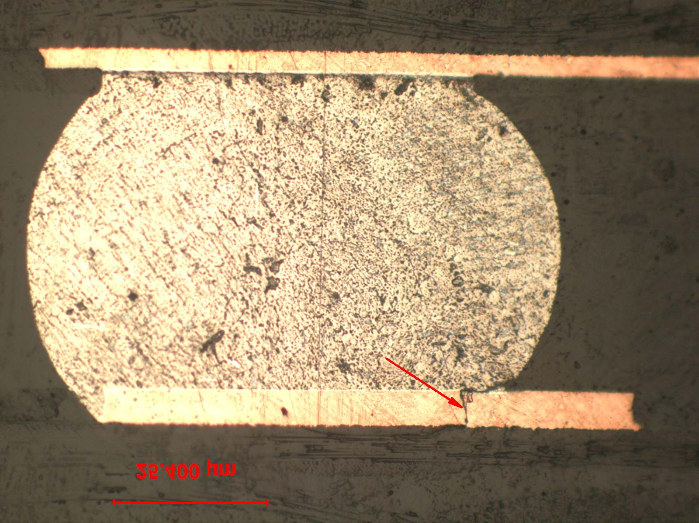

Figure 30: Board 97, SnAgCu/SnAgCu, BGA U44, PCB trace failure at BGA Ball 1B. As can be seen this failure could cause intermittent electrical failures.
Figure 31: Example of PCB Trace failures in the corner of the BGA. Land Pads lifted cleanly, separating at the conductor to land pad interfaces indicating a cracked conductors. The area of separation was oxidized

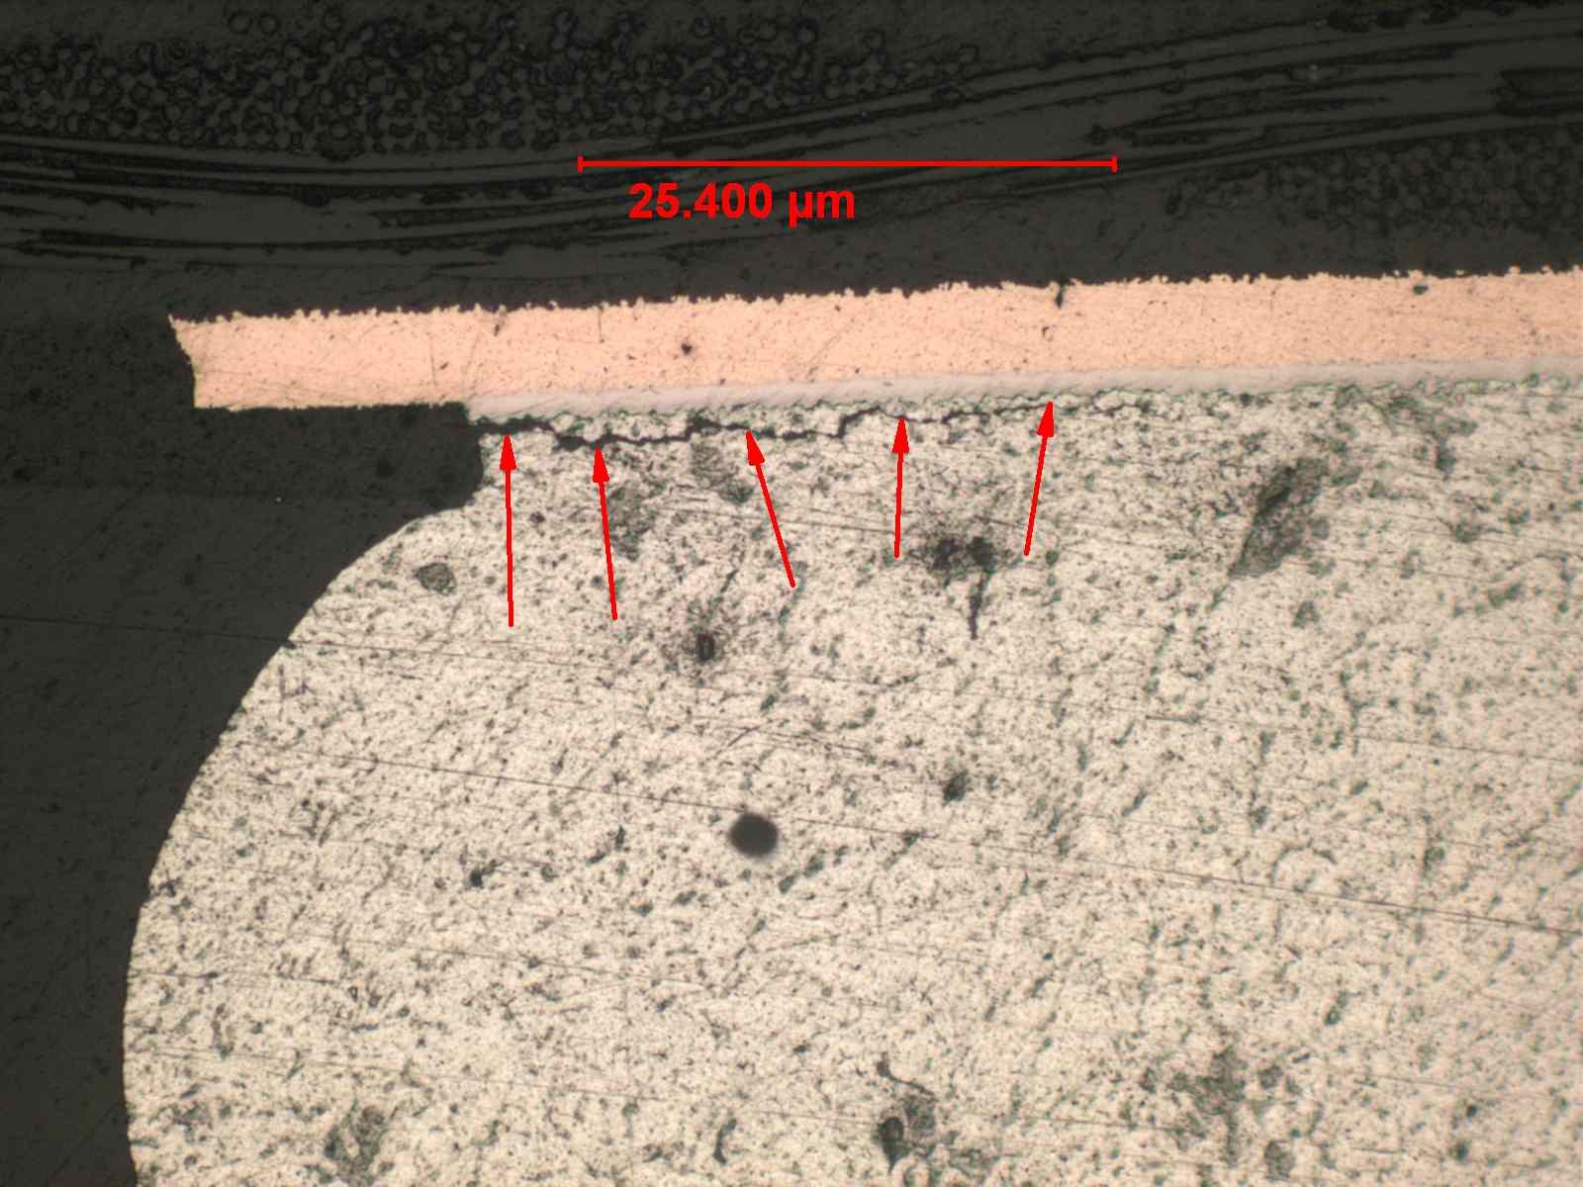

Figure 32: Example of Solder Ball cracked on the component side. No failures of this type found but small amount of cracking seen

A series of Lessons Learned were developed for future Mechanical Shock tests at High G levels:

- All data collection wires should be soldered directly into the test vehicle. Connectors should not be used unless rated above the shock test levels.

- All wires and cables connected to the test vehicle should be shielded to prevent any potential effects from Electromagnetic Interference.

- Hardware and data recording equipment should be grounded to earth ground, or a clean electrical system ground.

- A thorough FMA of all failed assemblies is recommended to verify the solder performance at Hi-G levels of mechanical shock

Conclusions

Mechanical shock testing imposes a different stress mode and stress level on the solder joints. Although these stresses are not common in commercial electronics assemblies, most aviation electronics hardware and some of the high performance military electronics parts need to survive these Hi-G forces.

Mechanical Shock Test-Procedure 1

The test results indicate that, at the normal crash test qualification level (Test Level 1), there is minimal difference in the SnPb and the two lead-free solder alloys used in this study; all three alloys meet the test requirements. All alloys passed the Mechanical Shock Test-Procedure 1, per the environmental stress screening testing described in MIL-STD 810F; Method 516.5; Procedure 1. The tin lead (SnPb) and tin silver copper (SnAgCu - SAC) soldered assemblies did not have any failures. The tin silver copper bismuth (SnAgCuBi - SACB) soldered assemblies had three (3) TQFP-208 components and one (1) TSOP-50 component which failed. The TSOP-50 component failure can be attributed to the solder extending past the heel fillet to the component’s knee. The three (3) TQFP-208 components passed continuity testing directly at the site on the test vehicle board, bypassing (and so eliminating the effects of) cables, connectors, and the long board copper traces. In each case, the TQFP-20 was located at the U4 site of the test vehicle board. Other JG-PP team members, performing other tests, have recorded questionable indicated failures for that same U4 site. So it is suspected that the solder joints for all three of the U4 designated TQFP-20 components survived the test, since they were electrically continuous after the test was over, but whatever the test vehicle “issue” was at the site of U4 that caused indicated but probably not real failures in the temp. cycle and vibration tests, also gave false failure indications in this mechanical shock test.

Mechanical Shock Test-Procedure 2

At the higher shock levels, the failures were within interconnect chain, but the failures were not necessarily at solder joints. Discontinuities within the electronic package and the hardware instrumentation yielded failures, which could not be distinguished from the real solder joints failures. As a result the test data above 75 G shock is considered confounded data. For these reasons we cannot draw definitive conclusion about solder performance and the distinction between different solder alloys is not very clear cut. As pointed out previously, thorough failure analysis is required to pinpoint the failure modes.
Unlike other environmental tests, the mechanical shock testing imposes stresses on all parts of the electrical continuity chain through the board, connectors and cables that run back to the data logger, and not just the solder joints. As a result the failures are not necessarily located at the device-to-board solder joint connection. The shock pulse stresses interconnections within the device package, within the silicon device, board level wiring, board to mechanical connector connection, the male-female connector connection and the external wiring harness connection.
Based on very limited FMA conducted at the ACI, we have determined that the BGA devices from Mechanical Shock Test-Procedure 2 did not fail in the solder joints. All the noted failures were determined to be the copper trace failures, at the trace-BGA land neck area. It is speculated that the shape of the BGA ball and the geometry of the BGA land, contribute to a significant stress concentration, at the copper trace-BGA land neck area. During Z direction impact loading, the resulting shock wave causes an overstress, consequentially shearing the copper trace, as observed in Failure Mode Analysis at ACI.
The solder joint cross-sections also indicate that a parallel failure mode was also progressing. This parallel mode is solder joint fatigue during the 100 cycle duration of the tests. As evidenced in Figure , Figure , and Figure , a crack within the solder joint was progressing. We have not observed any BGA solder joint with complete propagation of the crack, but after several more shock cycles/pulses, the solder joint fatigue crack could become a dominant failure mode. At this point (more than 100 cycles) the distinction between solder types could have become more apparent.
A series of Lessons Learned were developed for future Mechanical Shock tests at high G levels:
- All data collection wires should be soldered directly into the test vehicle. Connectors should not be used unless rated above the shock test levels.
- All wires and cables connected to the test vehicle should be shielded to prevent any potential effects from Electromagnetic Interference.
- Hardware and data recording equipment should be grounded to earth ground, or a clean electrical system ground.
- A thorough FMA of all failed assemblies is recommended to verify the solder performance at Hi-G levels of mechanical shock.
Preliminary Failure Mode Analysis indicated that several copper traces failed at the land-trace interface area. Failures within the electronic package and the hardware instrumentation can also yield failures indications, which need to be distinguished from the solder joint failures to complete the relative solder performance evaluation. BGA solder joint cross sections revealed that several BGA solder balls had partially traversed cracks, but no complete failure.

.

Acknowledgements

The authors would like to acknowledge the contributions of the following individuals who participated in these tests:
L. Whiteman, American Competitiveness Institute
R. Macapagal, American Competitiveness Institute
R. Pappan, American Competitiveness Institute / Widener University
B. Partee, American Competitiveness Institute
S. Pepe, American Competitiveness Institute
A. Vigliotti, American Competitiveness Institute
J. Gilbert, American Competitiveness Institute
J. Bracco, BAE Systems
L. Martin, BAE Systems

Appendices
Appendix A: Mechanical Shock Testing Procedure

Appendix A: Mechanical Shock Testing Procedure

TEST VEHICLE:
There are 24 test boards available, documented by part number and serial number. Test Boards are prepared with eutectic tin-lead solder and lead-free solder alloys.
TEST FACILITY:
BAE Systems
Product Testing Lab
305 Richardson Road
Lansdale, PA 19446

TEST EQUIPMENT
Equipment | Manufacturer | Model | Serial # | Calibration Due Date
Vibration/Shaker Table ** | MB Electronics | C-50 | 9944 | N/A
Fixture | ACI | - | - | N/A
Test Cables
Accelerometer ** | Bruel & Kjaer | 4382 | 17657 | N/A
Vibration Control System ** | Spectral Dynamics | 2552B | 20348 | N/A
Charge Amplifier ** | Unholtz-Dickie | D22 | 12538 | N/A
Event Detector * | Anatech Event Detectors | 128 / STD  256 / STD | 880916  TBD | TBD
** Shock Test equipment will be as described above or equivalent
- Requires personal computer to support the program
TEST PROCESS
The Test Vehicles (TV) shall consisted of JG-PP test boards, documented by part number and serial number. Twenty-four (24) test vehicles underwent mechanical shock testing, test set one of 12 boards were tested according to table 1 and test set two of 12 boards were tested according to table 2. During the test the electrical continuity of the solder joints was continuously monitored.
The mechanical shock test was performed in two test sets as follows:
Test Set One: 12 Boards
4 Sn/Pb: Sn/Pb,
4 Sn/Ag/Cu: Sn/Ag/Cu
4 Sn/Ag/Cu/Bi: Sn/Ag/Cu/Bi
Apply shocks according to Table 1.

Test Set Two: 12 Boards
4 Sn/Pb: Sn/Pb
4 Sn/Ag/Cu: Sn/Ag/Cu,
4 Sn/Ag/Cu/Bi: Sn/Ag/Cu/Bi
Apply shocks according to Table 2.

NOTE: Boards within each test set were defined by the JG-PP Program
Step | Test | Initial G | Slope | Peak G | Ts (ms) | Cross-Over Freq. | Z-axis  (thru-thickness) | X-axis | Y-axis | Total Shock
1.1 | Functional test for flight equipment | 4.5 | 6 | 20 | 15-23 | 45 | 3 | 3 | 3 | 9
1.2 | Functional test for ground equipment | 8.5 | 6 | 40 | 15-23 | 45 | 3 | 3 | 3 | 9
1.3 | Crash Hazard test for flight equipment | 9 | 6 | 75 | 8-13 | 80 | 3 | 3 | 3 | 9
1.4 | Crash Hazard test for flight equipment | 9 | 6 | 75 | 8-13 | 80 | 100 | 100 | 100 | 300
Table 1 Shock test for Test Set One, According to MIL-STD-810F, Method 516.5, Table 516.5-I

Step | Test | Initial G | Slope | Peak G | Ts (ms) | Cross-Over Freq. | Z-axis  (thickness) | X & Y | Reason | Total Shock
2.1 | Functional test for flight equipment | 4.5 | 6 | 20 | 15-23 | 45 | 100 | NA | Fatigue in Z-axis only | 100
2.2 | Functional test for Ground equipment | 8.5 | 6 | 40 | 15-23 | 45 | 100 | NA | Fatigue in Z-axis only | 100
2.3 | Crash Hazard test for flight equipment | 9 | 6 | 75 | 8-13 | 80 | 100 | N/A | Fatigue in Z-axis only | 100
2.4 | Level 1 | 12 | 6 | 100 | 15-23 | 80* | 100 | NA | Fatigue in Z-axis only | 100
2.5 | Level 2 | 25 | 6 | 200 | 15-23 | 80* | 100 | NA | Fatigue in Z-axis only | 100
2.6 | Level 3 | 35 | 6 | 300 | 15-23 | 80* | 100 | NA | Fatigue in Z-axis only | 100
2.7 | Level 4 | 52 | 6 | 500 | 15-23 | 80* | 100 | NA | Fatigue in Z-axis only | 100
2.8 | Level 5 | 72 | 6 | 700 | 15-23 | 80* | 100 | NA | Fatigue in Z-axis only | 100
2.9 | Level 6 | 90 | 6 | 1000 | 15-23 | 80* | 100 or more till majority failure | NA | Fatigue in Z-axis only | 100
Table 2 Shock test for Test 2

TEST CONDITIONS
Each TV shall be connected to the event detector through cables; either by hardwiring or by using connectors; the site test coordinator shall determine the method.
Test will be performed at ambient temperature

Four boards will be mounted on the fixture; So 4 boards will be tested simultaneously. See Table 3 below for test board allocation.
The Event Detector equipment test parameters shall be as follows:
Continuously monitor the electrical continuity of the solder joints, periodic monitoring is not
acceptable
Detect an electrical interruption lasting greater than 0.2 μsec.
Detect a continuity interruption > 300 Ω
Record electrical events every 30 seconds minimum

Test Set | Test Description | Total Board | Manufactured with Sn/Pb solder  Reworked with Sn/Pb solder. | Manufactured with SnPb soder:  Reworked with  Sn/Ag/Cu solder wire for the PTH components amd flux only for the BGAs | Manufactured with SnPb solder:  Reworked with  Sn/Ag/Cu/Bi  solder wire for the PTH components and flux only for the BGAs
Set 1 | According to Table 1 | 12 | 4 | 4 | 4
Set 2 | According to Table 2 | 12 | 4 | 4 | 4

Table 3, Test Boards allocation
TEST FIXTURE
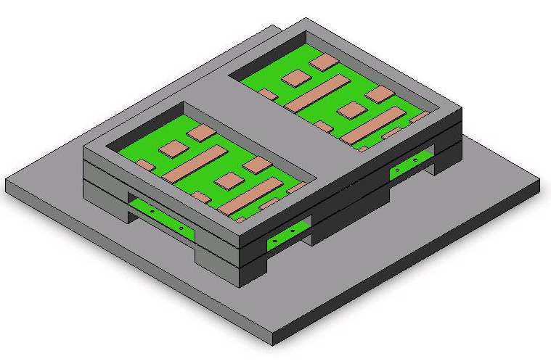
Test Board
(Top & Bottom)
Test Fixture
Test Board
(Top & Bottom)
+X
+Z
+Y
Figure 33: Test Fixture
PRETEST
The 64 net resistances of each test vehicle shall be measured and recorded in the Test Log data sheet prior to the start of testing:
63 components on main TV (test vehicle)
1 plated through-hole loop on TV (test vehicle)

X-ray inspection of solder joints on each TV shall be documented prior to test. Documentation of all anomalies found and the ‘as assembled’ condition shall be part of the Test Log.
Visual/electrical examination may be used to supplement the X-ray documentation of the anomalies/as-assembled solder joint conditions. Visual criteria per J-STD-001, Class 3. X-ray criteria (shorts, uniformity, and missing solder) per J-STD-001, Class 3.
Visual inspection of each TV shall be performed before and after the test. Any damage or manufacturing condition that is out-of-specification shall be documented in the Test Log.
DURING TEST
Continuously monitor the electrical continuity of the solder joints, periodic monitoring is not acceptable. Detect an electrical interruption lasting greater than 0.2 μsec.
Detect a continuity interruption > 300 Ω up to 1000 Ω
Record electrical events every 30 seconds minimum
POST TEST
Test Log shall be completed during the performance of this test procedure
The Test Log shall have the following sections:
Test Data Sheets
Thermal Profile Documentation
Inspection Documentation
Data Analysis
All Failure shall be documented on the test log and event detector report. Inspection defects shall be noted on the test log.

TEST STEPS
Step | Description
1 | Measure Resistance of all 24 test boards & record data
2 | X-ray inspect solder joints of all 24 boards & record data
3 | Visually examine all boards for any damage & record data
4 | Program Shock controller
5 | Test the Shock profile without fixture mounted on table to conform the profile

Test Set One: Test according to Table 1
12 Boards, 4 Sn/Pb: Sn/Pb, 4 Sn/Ag/Cu: Sn/Ag/Cu, 4 Sn/Ag/Cu/Bi: Sn/Ag/Cu/Bi
6 | Mount (4) Sn/Pb:Sn/Pb boards on the fixture
7 | Set the Shaker table for shock on Z direction
8 | Apply 3 shock on Positive Z Direction according to step 1.1 (table 1)
9 | Rotate fixture on table for X direction Shock
10 | Apply 3 shock on Positive X Direction according to step 1.1
11 | Change Shaker settings for Shock on Y direction
12 | Apply 3 shock on Positive Y Direction according to step 1.1
13 | Set the Shaker setting for shock on Z direction
14 | Apply 3 shock on Positive Z Direction according to step 1.2 (table 1)
15 | Rotate fixture on table for X direction Shock
16 | Apply 3 shock on Positive X Direction according to step 1.2
17 | Change Shaker settings for Shock on Y direction
18 | Apply 3 shock on Positive Y Direction according to step 1.2
19 | Set the Shaker table for shock on Z direction
20 | Apply 3 shock on Positive Z Direction according to step 1.3 (table 1)
21 | Rotate fixture on table for X direction Shock
22 | Apply 3 shock on Positive X Direction according to step 1.3
23 | Change Shaker settings for Shock on Y direction
24 | Apply 3 shock on Positive Y Direction according to step 1.3
25 | Set the Shaker table for shock on Z direction
26 | Apply 3 shock on Positive Z Direction according to step 1.4 (table 1)
27 | Rotate fixture on table for X direction Shock
28 | Apply 3 shock on Positive X Direction according to step 1.4
29 | Change Shaker settings for Shock on Y direction
30 | Apply 3 shock on Positive Y Direction according to step 1.4
31 | Disconnect data logger & event detector to all four board & stop collecting data
32 | Remove boards from fixture & Mount next (4) Sn/Ag/Cu:Sn/Ag/Cu Boards on Fixture
33 | Set Shaker table for Shock on Z direction
34 | Apply 3 shock on Positive Z Direction according to step 1.1 (table 1)
35 | Rotate fixture on table for X direction Shock
36 | Apply 3 shock on Positive X Direction according to step 1.1
37 | Change Shaker settings for Shock on Y direction
38 | Apply 3 shock on Positive Y Direction according to step 1.1
39 | Set the Shaker setting for shock on Z direction
40 | Apply 3 shock on Positive Z Direction according to step 1.2 (table 1)
41 | Rotate fixture on table for X direction Shock
42 | Apply 3 shock on Positive X Direction according to step 1.2
43 | Change Shaker settings for Shock on Y direction
44 | Apply 3 shock on Positive Y Direction according to step 1.2
45 | Set the Shaker table for shock on Z direction
46 | Apply 3 shock on Positive Z Direction according to step 1.3 (table 1)
47 | Rotate fixture on table for X direction Shock
48 | Apply 3 shock on Positive X Direction according to step 1.3
49 | Change Shaker settings for Shock on Y direction
50 | Apply 3 shock on Positive Y Direction according to step 1.3
51 | Set the Shaker table for shock on Z direction
52 | Apply 3 shock on Positive Z Direction according to step 1.4 (table 1)
53 | Rotate fixture on table for X direction Shock
54 | Apply 3 shock on Positive X Direction according to step 1.4
55 | Change Shaker settings for Shock on Y direction
56 | Apply 3 shock on Positive Y Direction according to step 1.4
57 | Disconnect data logger & event detector to all four board & stop collecting data
58 | Remove boards from fixture & Mount next (4) Sn/Ag/Cu/Bi:Sn/Ag/Cu/Bi Boards on Fixture
59 | Set the shaker table for shock on Z direction
60 | Apply 3 shock on Positive Z Direction according to step 1.1 (table 1)
61 | Rotate fixture on table for X direction Shock
62 | Apply 3 shock on Positive X Direction according to step 1.1
63 | Change Shaker settings for Shock on Y direction
64 | Apply 3 shock on Positive Y Direction according to step 1.1
65 | Set the Shaker setting for shock on Z direction
66 | Apply 3 shock on Positive Z Direction according to step 1.2 (table 1)
67 | Rotate fixture on table for X direction Shock
68 | Apply 3 shock on Positive X Direction according to step 1.2
69 | Change Shaker settings for Shock on Y direction
70 | Apply 3 shock on Positive Y Direction according to step 1.2
71 | Set the Shaker table for shock on Z direction
72 | Apply 3 shock on Positive Z Direction according to step 1.3 (table 1)
73 | Rotate fixture on table for X direction Shock
74 | Apply 3 shock on Positive X Direction according to step 1.3
75 | Change Shaker settings for Shock on Y direction
76 | Apply 3 shock on Positive Y Direction according to step 1.3
77 | Set the Shaker table for shock on Z direction
78 | Apply 3 shock on Positive Z Direction according to step 1.4 (table 1)
79 | Rotate fixture on table for X direction Shock
80 | Apply 3 shock on Positive X Direction according to step 1.4
81 | Change Shaker settings for Shock on Y direction
82 | Apply 3 shock on Positive Y Direction according to step 1.4
83 | Disconnect data logger & event detector to all four board & stop collecting data
84 | Remove boards from fixture
85 | Visually examine boards for any damage & record data

Test Set Two: Test according to Table 2
12 Boards: 4 Sn/Pb: Sn/Pb, 4 Sn/Ag/Cu: Sn/Ag/Cu, 4 Sn/Ag/Cu/Bi: Sn/Ag/Cu/Bi)
86 | Mount (4) Sn/Pb:Sn/Pb Boards on the fixture
87 | Connect data logger & event detector to all four boards & Start collecting data
88 | Set Shaker for Shock on Z Direction
89 | Mount Fixture on the Shaker Table
90 | Apply 100 Shocks in Z direction according to step 2.1 (Table 2)
91 | Apply 100 Shocks in Z direction according to step 2.2 (Table 2)
92 | Apply 100 Shocks in Z direction according to step 2.3 (Table 2)
93 | Apply 100 Shocks in Z direction according to step 2.4 (Table 2)
94 | Apply 100 Shocks in Z direction according to step 2.5 (Table 2)
95 | Apply 100 Shocks in Z direction according to step 2.6 (Table 2)
96 | Apply 100 Shocks in Z direction according to step 2.7 (Table 2)
97 | Apply 100 Shocks in Z direction according to step 2.8 (Table 2)
98 | Apply 100 or more Shocks in Z direction till majority component fail, according to step 2.9 (Table 2)
99 | Disconnect data logger & event detector and stop collecting data
100 | Remove boards from the fixture & visually examine the boards – record results
101 | Mount next 4 Sn/Ag/Cu:Sn/Ag/Cu Boards on Fixture
102 | Connect data logger & event detector to all four boards & Start collecting data
103 | Set Shaker for Shock on Z Direction
104 | Mount Fixture on the Shaker Table
105 | Apply 100 Shocks in Z direction according to step 2.1 (Table 2)
106 | Apply 100 Shocks in Z direction according to step 2.2 (Table 2)
107 | Apply 100 Shocks in Z direction according to step 2.3 (Table 2)
108 | Apply 100 Shocks in Z direction according to step 2.4 (Table 2)
109 | Apply 100 Shocks in Z direction according to step 2.5 (Table 2)
110 | Apply 100 Shocks in Z direction according to step 2.6 (Table 2)
111 | Apply 100 Shocks in Z direction according to step 2.7 (Table 2)
112 | Apply 100 Shocks in Z direction according to step 2.8 (Table 2)
113 | Apply 100 or more Shocks in Z direction till majority component fail, according to step 2.9 (Table 2)
114 | Disconnect data logger & event detector and stop collecting data
115 | Remove boards from the fixture & visually examine the boards – record results
116 | Mount next 4 Sn/Ag/Cu/Bi:Sn/Ag/Cu/Bi Boards on Fixture
117 | Connect data logger & event detector to all four boards & Start collecting data
118 | Set Shaker for Shock on Z Direction
119 | Mount Fixture on the Shaker Table
120 | Apply 100 Shocks in Z direction according to step 2.1 (Table 2)
121 | Apply 100 Shocks in Z direction according to step 2.2 (Table 2)
122 | Apply 100 Shocks in Z direction according to step 2.3 (Table 2)
123 | Apply 100 Shocks in Z direction according to step 2.4 (Table 2)
124 | Apply 100 Shocks in Z direction according to step 2.5 (Table 2)
125 | Apply 100 Shocks in Z direction according to step 2.6 (Table 2)
126 | Apply 100 Shocks in Z direction according to step 2.7 (Table 2)
127 | Apply 100 Shocks in Z direction according to step 2.8 (Table 2)
128 | Apply 100 or more Shocks in Z direction till majority component fail, according to step 2.9 (Table 2)
129 | Disconnect data logger & event detector and stop collecting data
130 | Remove boards from the fixture & visually examine the boards – record results
131 | End test

Each TV shall be connected to the event detector through cables, either by hardwiring or by using connectors; the site test coordinator shall determine the method.
The Event Detector equipment test parameters shall be as follows:
Continuously monitor the electrical continuity of the solder joints, periodic monitoring is not acceptable
Detect an electrical interruption lasting greater than 0.2 μsec.
Detect a continuity interruption > 300 Ω up to 1000 Ω
Record electrical events every 30 seconds minimum

