PROCESSING MATERIALS, DEVICES AND DIAGNOSTICS FOR THIN FILM PHOTOVOLTAICS:
FUNDAMENTAL AND MANUFACTURABILITY ISSUES

Annual Report
to
National Renewable Energy Laboratory
under
Subcontract No. ADJ-1-30630-12
9/05/04 to 9/04/05


Institute of Energy Conversion
United States Department of Energy
University Center of Excellence

For Photovoltaic Research and Education

Annual Report
to
National Renewable Energy Laboratory
under
Subcontract No. ADJ-1-30630-12
9/05/04-9/04/05

R. W. Birkmire, W. N. Shafarman, E. Eser,
S. S. Hegedus, B. E. McCandless, R. Aparicio, K. D. Dobson

Institute of Energy Conversion
University of Delaware

United States Department of Energy
University Center of Excellence
For Photovoltaic Research and Education
(National Renewable Energy Laboratory)

Newark, Delaware 19716-3820
SUMMARY

CdTe-based Solar Cells

Research on CdTe-based solar cells includes five tasks: (1) High Throughput CdTe Processing; (2) Back Contact Processing Options; (3) ZnTe:Cu Semi-Transparent Contacts for Bifacial Device Analysis; (4)Understanding and Improving V_{oc}; and (5) Accelerated Stressing.

Processing options, which address a number of critical issues relating to processing of thin-film CdTe/CdS devices have been addressed. The window layer properties, including configuration, composition and thickness have been shown to have a significant effect on final device performance. We have selected Ga₂O₃ as the best high resistance interface layer for our process. Engineering and thermo-chemical aspects of the post-deposition CdCl₂ treatment of CdTe were investigated. Annealing CdTe films in the presence of CdCl₂ and O₂ promotes CdS diffusion into CdTe and also shifts the chemical equilibrium of the film surface, which may influence the bulk electrical properties of the CdTe. Comparisons of wet and vapor CdCl₂ treatment were discussed including the development of a packed bed reactor for vapor CdCl₂ treatments. High efficiency with good spatial uniformity was achieved with vapor CdCl₂ treatment. Careful control of the O₂ and humidity in the anneal atmosphere is required to avoid the formation of deleterious oxides, which will affect the Cd-vacancy concentration within the CdTe film, leading to poor device performance. High throughput was evaluated by increasing the CdTe deposition rate to 9 µm/min, reducing the CdCl₂ treatment time while increasing the treatment temperature, and reducing the CdTe thickness. VT devices with 5-7 µm thick CdTe deposited on moving substrates at 9 µm/min using a 20 min vapor CdCl₂ treatment at 415ºC achieved V_{oc} up to 840 mV and efficiency > 13%. Devices with efficiency of 11% were obtained with 2 min CdCl₂ treatments at 465ºC. For cells with CdTe thickness ~1.5 µm, efficiency >10% was obtained . V_{oc} and FF decreased for cells with CdTe deposited at >80 µm/min and for cells with CdTe thinner than 1.5 µm.

A number of steps are required for successful processing of back contacts to CdTe; removal of any oxides, the formation of a Te-rich surface, application of a Cu source, contact annealing and deposition of a secondary contact. A number of methods can be used for each of these steps. Consideration of different processes should include simplicity and ease of industrial scale up. The nature of each process may also be critical for contact and device stability. A thorough knowledge of etching mechanics will allow the development of alternate or modified etches that may be more efficient and faster, perhaps through the use of catalysts, and safer to use, all of which will assist possible industrial scale-up of CdTe technology. The results obtained from monitoring the etching processes have also highlighted the usefulness of VASE and GIXRD as diagnostic tools for monitoring the quality of material surfaces during processing.

The Te rich surface can be formed by wet chemical etching or by ‘dry’ deposition of Te, however, application of Cu should be carried out immediately, to prevent atmospheric oxidation of the Te-rich surface. A number of simple methods of Cu application have been studied including Cu metal, CuCl doped graphite, dipping in CuCl, and Cu-doped ZnTe. Contact annealing should be carried out in an inert atmosphere to avoid oxidizing the back contact. A full understanding of the role of Cu and other possible contact metals in the back contact chemistry and their behavior within the CdTe/CdS structure is required before optimization of device performance and stability can be obtained.

The use of an aniline-based treatment for back contact processing of CdTe/CdS devices was investigated. The treatment was found to form reproducible Te-rich CdTe surfaces, similar to oxidizing etches, which would be expected to allow processing of improved Cu-based back contacts. Analysis of bath conditions highlights that the presence of aniline, Cl⁻ ions, dissolved O₂, consistent illumination and control of pH are critical for successful treatments. A photocatalytic mechanism is proposed, involving the reduction of dissolved O₂ by conduction band electrons to produce H₂O₂ or similar, which etches the CdTe. The reduction is complemented by the oxidation of aniline by valance band holes. Best device results, with efficiencies ∼12%, have been obtained for treatment times as short as 30 min. At longer treatment times, device performance decreases, though the effect is not as severe as has been observed with over-treatment of CdTe in oxidizing etches. Criteria for possible substitutes for the toxic aniline are presented. Results of potential substitutes are discussed. A crucial advantage of aniline is that it is compatible with thinner CdTe films. Unlike more aggressive etches like BDH or NP, aniline etching gives a high yield and negligible shunting with CdTe devices < 3 µm thick.

Cu-doped ZnTe films grown by galvanic deposition were developed to provide transparent ohmic contacts to CdTe solar cells. Control of the Cu doping with triethanolamine was critical to limit the free Cu in order to achieve high transparency (>60% in the visible) and to minimize shunting. Devices with ZnTe:Cu contacts had comparable performance to devices with Cu/Au or Cu/Ni contacts, achieving V_{oc} of 0.82 V and fill factor (FF) of 68% for standard front illumination. The ability to form a low barrier, Ohmic contact with ZnTe:Cu depends on the CdTe surface treatment. Typically, devices with BDH or anilene treatments had better forward bias behavior and do not exhibit roll-over beyond V_{oc}, indicating an ohmic low barrier contact has been formed. Devices with Br-methanol had lower FF and exhibited rollover. Bifacial spectral response (SR) measurements, through front and back contacts, were analyzed and yielded a diffusion length (L) of 0.8 µm and depletion width (W) of 2.5 µm for 5 µm thick CdTe cells. Backwall SR measurements made through the transparent ZnTe contact are much more sensitive to L and W than are measurements for standard front illumination. ZnTe:Cu is a promising material for bifacial characterization as well as tandem cell interconnects and more stable Cu-doped contacts. characterization of devices with CdTe layer thickness from 1.5 to 10 µm is in progress. Accelerated stress testing on devices with ZnTe:Cu contacts with different concentrations of Cu is planned.

Changing the bias voltage, light intensity and temperature during stress can induce transient degradation or recovery in V_{oc} of CdTe solar cells. Simulated day/night cycles leads to daily degradation in the light and recovery in the dark. Greater recovery in the dark and less bias dependence is correlated with better overall stability. These transients complicate the correlation between cell (indoor) and module (outdoor) performance. Results are consistent with changes in electronic states and recombination. No single stress protocol is likely to identify all instability mechanisms.

Increasing V_{oc} in VT CdTe/CdS cells to >900 mV and maintaining it in cells with sub-micron thick CdTe layers requires an understanding of existing cells, determination of the recombination sources in the cell, quantifying the influence of back contact on V_{oc}, especially in thin devices, and assessing changes induced by depositing onto a moving substrate at elevated rate (>10 μm/min). The problem has two parts: 1) defining limits to V_{oc} in CdTe solar cells in general and 2) defining the influence of VT processing, especially in thinner cells.

We have found that the following empirical factors affect V_{oc} in present-generation VT CdTe devices. When initial d_{CdS} < 80 nm or final d_{CdS} < 40 nm, a buffer layer is needed to maintain V_{oc}. The highest V_{oc} is obtained for CdTe deposition >500ºC. V_{oc} decreases as CdTe thickness decreases to d_{CdTe} < 1.5 μm. Thinner CdTe requires re-optimization of the CdCl₂ temperature time cycle and a less penetrating surface etch, such as anilene instead of BDH. The CdCl₂ surface is critical to device performance with aging reducing the effectiveness of the CdCl₂ treatment, including reduction in V_{oc} and yield. High V_{oc} requires an O₂ partial pressure during VT growth. Cu in the contact does not appear to be necessary for V_{oc} ~ 0.78V but Cu + HT is necessary for V_{oc}>0.80V. We have determined that a back contact barrier has no effect on V_{oc}, at least for devices with 3-4 µm CdTe, consistent with recontacting studies from several years ago. Eliminating voltage dependent collection has little effect on improving V_{oc} on devices with FF>65% but can have significant improvement on cells with FF<60%. The upper limit to V_{oc} obtained at low temperature is around 1 V, suggesting this is the built-in potential. The highest V_{oc} at 28°C obtained this year was 0.84V.

Collaboration/Teaming

Support of the National CdTe R&D team continued through sub-team leadership (Brian McCandless), bifacial and stress analyses, and film/cell supply to other team members. Unprocessed and CdCl₂ treated PVD and VT CdTe/CdS stacks were sent to Caroline Corwine (Colorado State University) for photoluminescence investigations of defects. Completed devices were sent to Fred Seymour (Colorado School of Mines) for investigation of defect levels by admittance spectroscopy. The cell fabrication matrix evaluated was: with/without CdCl₂ treatment, with/without Cu, and with less and more intrusive etching prior to metallization. Preliminary results of these studies were presented at the Team meeting held in May 5-6, 2005. Steve Hegedus and Brian McCandless made presentations at the team meeting: “Bifacial CdS/CdTe/ZnTe Device Characterization”, “Effect of Applied Bias during Stress”, “Sensitivity of CdTe/CdS Device Operation to Processing Variations”. IEC provided extensive analysis of Cu_{x}Te back contacts developed by Ilvydas Mathoulis (Ceramem Corporation) using nanoparticle precursors. On-going collaboration with the University of Toledo continued on the fundamental surface chemistry associated with aniline treatments. IEC also conducted bias-dependent tensile pull tests of as-deposited and stressed UT cells to elucidate changes induced by processing and stress variations. In these cells, the adhesion of all layers was sufficiently high that failure occurred either at the epoxy-cell interface or via glass cracking, which is a tacit demonstration that cells with metallized contacts can exhibit high mechanical durability. Other activities included providing VT samples to Ken Kormanyos (McMaster Energy Enterprises, aka Solar Fields) for start-up development of post deposition processing, providing Tim Gessert (NREL) with technical details of the IEC VT system, and teaching the chemical surface deposition (CSD) technique to several groups.

Cu(InGa)Se₂ Based Solar Cells

Research on CuInSe₂-based solar cells includes four different tasks: (1) In-Line Evaporation; (2) Wide Bandgap Materials; (3) Cu(InGa)(SeS)₂ Formation by H₂Se/H₂S Reaction; and (4) Fundamental Materials and Interface Characterization. In each case, significant progress has been made, as documented in this report.

The development of the process of in-line deposition of Cu(InGa)Se₂ on polymer substrates focused on the linear metal evaporation sources and on the preliminary investigation on the understanding of the role of oxygen in Mo back contact in preventing film cracking. The insulation of the 6" metal sources that are presently in use has been entirely modified, switching over to rigid alumina boards. In parallel with this change, all the carbon/graphite-based components in the source have been replaced to eliminate reaction with metallic parts, such as thermocouples and Ta shields. These changes enabled operation of the sources at lower temperatures. The problem of metal vapors leaking between the lid and the source body was also addressed. A sealed source was designed and fabricated. This new source will be tested in the near future. The instability of the Cu source power control at high temperature was finally traced to the multi-channel thermocouple interface module which generated a noisy signal for C-type thermocouple when the signal gets to be higher than 20mV and that there are other thermocouples connected to other channels. The temporary solution, connecting the Cu source thermocouple to its own interface module, allowed system operation without any control problem. In addition, issues associated with the sources in scaling-up the in-line deposition to 13" web were investigated. A bell-jar system with a single source was set-up to determine and analyze the temperature distribution on the present 6" source. Further, simulation of the temperature distribution on a 13" system was performed. The comparison showed that simple scale-up of present sources, which give adequate film uniformity, would result unacceptable non-uniformities over the 13" wide web. Consequently, a number of design options to overcome this problem were evaluated. The issues related to source depletion over long runs, resulting in thermal characteristics leading to drifts in the effusion rates, were also examined. As to the role of oxygen in preventing the Mo back contact film cracking, the Auger depth profiling analysis shed more light to the problem. Comparison of the profiles before and after the Cu(InGa)Se₂ deposition showed that there is a diffusional rearrangement of oxygen in the Mo layer, resulting in a uniform distribution, irrespective of the initial oxygen distribution in the Mo film. This point will be further pursued in the coming year.

Work on wide bandgap materials remained focused on Cu(InAl)Se₂ films deposited by multisource elemental co-evaporation. The primary problems being addressed are poor reproducibility, partly caused by poor adhesion at the Mo/Cu(InAl)Se₂ interface, and poor performance with low V_{oc} as the bandgap is increased. Progress is reported in this report on developing alternative evaporation sequences, characterizing the back contact, and gaining a more complete understanding of the basic material properties. A simplified continuous version of a three-stage evaporation process was developed and end-point detection of the substrate temperature was used to control the film composition. Films were grown with different relative Al contents material. As Al content increased, the grain size decreased, adhesion worsened, and device performance got much worse. The variation in material and device properties as a function of Cu off-stoichiometry was also studied. Formation of an ordered vacancy chalcopyrite structure with low Cu content was verified. Devices with this compound had poor device performance and an ~ 0.2 eV shift in the long-wavelength QE, indicating a shift in bandgap.

Critical issues for the formation of Cu(InGa)(SeS)₂ films by the selenization or sulfization reactions of Cu-Ga-In precursor films have been investigated. A complete understanding of the reaction process requires characterizing phases in the as-deposited precursor films, and after annealing with different time-temperature-gas concentration profiles used to control the reaction pathway. Metal precursor films were deposited by sputtering a Cu-Ga layer from a Cu_{0.8}Ga_{0.2} alloy target, followed by an In layer. The phases present in the sputtered metal precursors after annealing at 450°C were Cu, In, CuIn and Cu₉(In_{1-x}Ga_{x})₄. Films reacted in hydrogen selenide (H₂Se) or hydrogen sulfide (H₂S) were characterized and unreacted intermetallic Cu-Ga or Cu-In phases respectively were identified at the back of the films. This indicates a reaction preference of Se with In, and S with Ga. Homogenization of the Ga using a two-step selenization/sulfization process that takes advantage of this reaction preference was confirmed, and different time-temperature profiles were compared. Devices with V_{oc} > 0.64 V and eff. > 13% were demonstrated. With a better understanding of the reaction pathway, work will be focused on optimization of the time-temperature sequence of the two-step reaction to better understand the mechanism for Ga mobility to control the S composition at the front of the film, and ultimately, to improve device performance.

Fundamental characterization of materials and interfaces has largely focused on a detailed characterization of the optical properties of Cu(InGa)Se₂ thin films as a function of changes in composition, including variations in the relative gallium and copper concentrations. The characterization was done using variable angle spectroscopic ellipsometry with a novel technique developed previously at IEC, in which the Cu(InGa)Se₂ is lifted off the glass/Mo substrate to provide access to a smooth surface for optical characterization. The complex optical constants and critical transition energies of Cu(InGa)Se₂ were previously determined for films varying in relative gallium content spanning from CuInSe₂ to CuGaSe₂. Since all Cu(InGa)Se₂ solar cells are made using Cu-deficient films, it is valuable to relate the optical properties to the degree of Cu off-stoichiometry. A method has been developed to determine the optical constants of films with decreasing Cu content in the Cu-deficient two-phase region as a mixture of the optical properties of the single-phase endpoints with high and low Cu concentrations. The decrease in Cu is characterized by an increase in the fundamental bandgap and broadening of critical point features in the optical constants suggesting degradation of the crystalline quality of the material. This optical analysis can be used to determine the volume fraction of these two phases, which directly determines the film composition.

An aqueous Br-etch has been used for smoothing Cu(InGa)Se₂ films to obtain a specular surface for optical modeling and interface characterization. The etch also controllably reduces the Cu(InGa)Se₂ thickness to study device behavior with thin absorbers and enable characterization of the Mo/Cu(InGa)Se₂ interface. The etch procedure was optimized to give the smoothest surface and controllable etch rates. Determination of Cu(InGa)Se₂ optical constants using the etch surface or the smooth surface obtained by peeling the films from the Mo contact gave comparable results so the etch does not seem not change the bulk Cu(InGa)Se₂. Devices fabricated after etching for different times had lower J_{sc} due to increased reflectivity with the specular surface and a lower V_{oc} that is not understood. Further efforts will be used to characterize the effects of Cu(InGa)Se₂ thickness and the back contact.

Research has also focused on the Cu(InGa)Se₂/CdS interface. High utilization chemical surface deposition was compared to chemical bath deposition, and it was shown that, under well controlled conditions, the same average device performance could be obtained. Also, optical constants of the CdS grown by chemical bath deposition were measured directly on Cu(InGa)Se₂, using ellipsometry and showed broad optical transition consistent with poor crystallinity.

Collaboration and Team Activities
IEC activities in support of the CuInSe₂ National Team and other research groups working on Cu(InGa)Se₂ development have included the following:

Thin Film Partnership - CuInSe₂ National Team
Bill Shafarman attended the CuInSe₂ National Team meeting on March 8, 2005 and gave a presentation titled “Cu(InGa)Se₂ processing research at IEC: Composition control during selenization.”

IEC also continued its ongoing collaboration with team members in the characterization of Cu(InGa)Se₂ films and devices from different groups. This work has resulted in the paper: “Comparison of device performance and measured transport parameters in widely-varying Cu(In,Ga)(Se,S)₂ solar cells” by I. L. Repins, B. J. Stanbery, D. L. Young, S. S. Li, W. K. Metzger, C. L. Perkins, W. N. Shafarman, M. E. Beck, L. Chen, V. K. Kapur, D. Tarrant, M. D. Gonzalez, D. G. Jensen, T. J. Anderson, X. Wang, L. L. Kerr, B. Keyes, S. Asher, A. Delahoy, B. Von Roedern, to be published in Progress in Photovoltaics.

Energy Photovoltaics
IEC has collaborated with EPV on alternative back contacts. In particular, IEC has fabricated and characterized devices using alternative back contacts deposited by EPV, which should provide improved reflectivity for devices with thin Cu(InGa)Se₂ absorbers. In addition, IEC has collaborated with EPV on evaporation source design and provided a design for a laboratory scale Cu evaporation source.

ISET
IEC has assisted ISET in the characterization of series resistance in devices and the design of collection grids for solar cells. In addition, IEC provided Mo-coated polyamide substrates for fabrication of flexible Cu(InGa)Se₂ solar cells.

University of Illinois
IEC has provided samples for novel characterization at University of Illinois This includes structural characterization using high resolution TEM techniques and Near Field Scanning Optical Microscopy (NSOM) measurements. This work has resulted in a paper “Application of Advanced Microstructural and Microchemical Microscopy Techniques to Chalcopyrite Solar Cells,” C. Lei, C.M. Li, A. Rockett, I.M. Robertson and W.N. Shafarman, Mat. Res. Soc. Symp. Proc., (2005) In press.

University of Oregon
IEC has continued its ongoing collaboration with the U. of Oregon to characterize electronic properties of Cu(InGa)Se₂ solar cells. In the past year this has resulted in two publications: “Detailed study of metastable effects in the Cu(InGa)Se₂ alloys: Test of defect creation models,” J.W. Lee, J.T. Heath, J.D. Cohen and W.N. Shafarman, Mat. Res. Soc. Symp. Proc. 865, 373 (2005), and “Defect Studies Using Photocapacitance Spectroscopy in the Copper Indium Diselenide Alloys,” J.D. Cohen, J.T. Heath and W.N. Shafarman, Chapter 13 in Wide Gap Chalcopyrites, ed. by U. Rau S. Siebentritt (Springer Scientific, 2005) In press.

Si Based Solar Cells

Aluminum-induced crystallization (AIC) of Si thin films on glass substrates was investigated as potential techniques leading to continuous large grain Si films. Silicon films were deposited by Hot-Wire Chemical Vapor Deposition (HW-CVD), Plasma Enhanced Chemical Vapor Deposition (PE-CVD) and Electron beam deposition (E-beam) onto Al coated Corning 7059 glass substrates and the annealing of the samples was performed at temperatures below the eutectic temperature of Si-Al binary system (577ºC). Both in-situ and ex-situ AIC was evaluated. The grain structure of the polycrystalline silicon (poly-Si) films formed on glass substrates and Al-Si interface were studied by various analytical techniques. Continuous poly-Si films were obtained using Al layers with a thickness of 500 nm or less, and with a Si/Al thickness ratio of at least 1. The average grain size of poly-Si films was affected by the a-Si deposition technique. E-beam deposited a-Si films resulted in 10-15 μm average grain size while PECVD and HWCVD deposited a-Si films resulted in slightly smaller grain sizes. The nature and morphology of the interface oxide layer between Al and Si layers was studied by XPS and were found to be crucial for layer exchange process. The length of time that the Al layer was exposed to air was used to vary the oxide thickness. The effective activation energy for the ex-situ crystallization and layer exchange process was determined to be 0.9 eV.

Continuous poly-Si films on glass substrates were obtained using an in-situ aluminum-induced crystallization technique at 430ºC. The 0.5 µm Al film was deposited by e-beam and the 0.6 µm Si deposited by HWCVD. Poly-Si films had an average grain size of 10-13 μm, corresponding to a grain size/thickness ratio greater than 20 and similar to poly-Si films prepared by conventional AIC. A unique etching procedure was developed involving repeated cycles of alternately etching the Al then the Si to reveal the continuous Si layer below. Poly-Si layers prepared by either an in-situ or conventional AIC process can be used as seed layers for epitaxial Si growth or for back contact formation in c-Si solar cell fabrication at temperature below 500ºC. As an alternative to conventional AIC, the in-situ AIC process eliminates an additional annealing step, which saves considerable time during processing.

In-line Diagnostics and Process Control

A wide range of thin film analyses using GIXRD were surveyed for implementation into thin film PV device fabrication as a diagnostic and monitoring tool. Construction of a hot stage allowed in-situ detection of CdTe surface oxidation and CdTe-CdS interdiffusion. The oxidation studies were complimented by compositional depth profiling by XPS using the system installed in 2005. Te film thickness on etched CdTe was determined by regression of a layer model with measured data at different incident beam angles. A unique solution is facilitated by considering primary beam attenuation in the Te film. Dual-axis GIXRD measurements of multiple (hkl) reflections allowed determination of depth-distribution of residual stress in sputtered Mo films. For ultra-thin CdS films with nanometer size particulates, the particulate size was determined by fitting the GIXRD line profile and evaluating the integral line breadth. Alloy distribution in CuIn_{1-x}Ga_{x}Se₂ films was determined by modeling GIXRD patterns obtained at different incident beam angles and verified by measuring a CuIn_{1-x}Ga_{x}Se₂ film from both sides. This methodology is being used to investigate reaction pathways for obtaining films with uniform composition and could be used as a product sensor in a developed process.

LIST OF CONTRIBUTORS- 9/05/2004 – 9/04/2005

PRINCIPAL INVESTIGATORS
Roger Aparicio
Robert Birkmire
Stuart Bowden
Kevin Dobson
Erten Eser
Steven Hegedus
Brian McCandless
William Shafarman

RESEARCHERS
Wayne Buchanan
Shannon Fields

POST-DOCTORAL FELLOWS/
LIMITED TERM RESEARCHER
Estela Calixto
Ujjwal Das
Moses Haimbodi
Gregory Hanket
Shiro Nishiwaki
Puthar Devassey Paulson
Sergey Rykov
Nicholas Smith
Alex Stavrides

FULBRIGHT SCHOLAR
Cheik Sene

TECHNICAL SUPPORT
Joshua Cadoret
Vicky DiNetta
Ronald Dozier
Kevin Hart

GRADUATE STUDENTS
Michael Burrows
Darshini Desai
Ozgenc Ebil
Jonathan Frey
Kapil Mukati
Sarah Rickman
Scott Stephens
Jochen Titus

STUDENTS
Michael Angelo
Derek Birkmire
William Crandley
Stephanie Einstein
Jennifer Griffith
Sonam Gupta
Mary Kondos
Daniel Ryan
Christopher Thompson
Peter Wang
James Wilson
Chati Zony

DOCUMENT PREPARATION
Steven Hegedus
Elaine Koronik

TABLE OF CONTENTS
Summary………………………………………………………………………………………. iii
CdTe-based Solar Cells……………………………………………………………………. iii
Cu(InGa)Se₂-based Solar Cells……………………………………………………………. vi
Si-based Solar Cells………………………………………………………………………. ix
In-line Diagnostics and Process Control………………………………………………….. x
List of Contributors xi
Table of Contents xiii
List of Figures xiv
List of Tables xx
1 Introduction
1.1 CdTe-based Solar Cells …………………………………………………………………1
1.2 CuInSe₂-based Solar Cells ………………………………………………………………1
1.3 Si-based Solar Cells 2
1.4 In-line Diagnostics 3
1.5 Training and Education 3
1.6 Publications 3
1.7 Organization of the Report 3
2 CdTe Based Solar Cells………………………………………………………………………. 4
2.1 High Throughput Processing……………………………………………………………. 4
2.2 Back Contact Processing Options…………………………………………………………27
2.3 Bifacial Analysis of Devices with Transparent ZnTe:Cu Back Contacts……………… 46
2.4 Stability of Vapor Transport CdTe……………………………………………………... 57
2.5 Understanding and Improving V_{oc} in Vapor Transport CdTe Solar Cells…………….. 70
3 CIS Based Solar Cells……………………………………………………………………….. 77
3.1 Inline CIGS System……………………………………………………………………. 77
3.2 Wide Bandgap Materials: Cu(InAl)Se₂………………………………………………… 94
4 Si-based Solar Cells………………………………………………………………………….131
4.1 Aluminum-induced Crystallization (AIC) Below the Eutectic Point: ex-situ AIC…… 131
4.2 In-situ AIC below the eutectic point leading to 10 μm grains………………………….142
5 Diagnostics………………………………………………………………………………… 149
5.1 GIXRD………………………………………………………………………………….149
5.2 Diagnostics: Process Control for Co-evaporative PVD Process………………………..162
6 Abstract………………………………………………………………………………………166
7 References……………………………………………………………………………………167

LIST OF FIGURES

Figure 1. V_{oc} versus final CdS film thickness for PVD CdTe/CdS and CdTe_{1-x}S/CdS cells without buffer layers (solid) and with buffer layers (open). 6
Figure 2. GIXRD pattern of CSD CdS as deposited (As Dep), after anneal at 550ºC for 5 min (HTA) and after vapor CdCl₂ treatment at 430°C for 10 min (CdCl₂). CdS peaks at 2θ = 20º, 26.5º,28.2º, 44º, 52º and 53º; remaining peaks due to ITO. 8
Figure 3. Atomic force micrographs of CSD CdS film: as-deposited at 65°C (left) and after vapor CdCl₂ HT at 430°C (right). 9
Figure 4. Normalized optical transmission, T/(1-R), of window layer used in VT cells. 9
Figure 5. AFM images of 5 μm thick CdTe films deposited by vapor transport on moving substrates in He+O₂ at 500°C (left) and 570°C (right). 13
Figure 6. AFM images of 1 μm (left) and 23 μm thick (right) CdTe films deposited by vapor transport on moving substrates in He+O₂ at 550°C. 14
Figure 7. AFM images of 6 μm thick CdTe films deposited by vapor transport on moving substrates in He+O₂ at 8 μm/min (left) and 81 μm/min (right) at 550°C. 14
Figure 8. Schematic depiction of carrier gas passing through a packed bed of CdCl₂. 15
Figure 9. GIXRD patterns of VT CdTe in as-deposited and CdCl₂ treated conditions, showing the contrast between wet and vapor treatments. 16
Figure 10. Light (AM1.5, 28ºC) and dark J-V behavior for 13.3% efficient baseline VT cell. 17
Figure 11. Normalized spectral response (0V, light bias) for 13.3% efficient baseline VT cell. 17
Figure 12. GIXRD apparatus with ambient control shroud removed, showing the hot stage for heating samples from RT to 600ºC. 20
Figure 13. Time-progressive GIXRD scans of oxidation of CdTe in dry and humid ambient at 500ºC. 21
Figure 14. Time-progressive development of oxide thickness for CdTe treated at 500ºC at different ambient humidity. 22
Figure 15. XPS survey scans of the oxidized CdTe films of Figure 13 before and after sputter etching. 23
Figure 16. Time-progressive XPS scans of the oxidized CdTe films of Figure 13 during the sputter-etch process. 23
Figure 17. Light JV curves for the devices of Table VI. 25
Figure 18. VASE ε₂ spectra of (a) an unetched CdTe film and CdTe films following etching in (b) NP1 for 25 sec and in (c) 0.1% BM for 10 sec. 30
Figure 19. Time-progressive GIXRD patterns of Te (101) reflection, for a CdTe film immediately following a 25 sec NP1 etch. Incident angle was 2° and each scan cycle is ∼3 min apart. 31
Figure 20. Time profiles of ε₂ from (a) 25 sec NP1 and (b) 60 sec 0.1% BM etched CdTe films. ε₂ values were obtained at 2.1 eV and 3.3 eV, respectively. 33
Figure 21. Light and dark JV curves for CdTe/CdS devices processed with methanol solutions containing CuCl (solid) and CuCl₂ (dotted). 36
Figure 22. GIXRD plot, at 2° incidence, of a 60s NP etched CdTe film obtained following removal of a Cu powder/graphite paste contact. 38
Figure 23. (a) Structure of aniline, and (b) VASE and (c) GIXRD plots of CdTe following treatment in standard aniline-based baths for 1 hr and 5.5 hr with illumination on the glass. The VASE spectrum of non-treated CdTe/CdS is shown for comparison. 42
Figure 24. VASE spectra of non-CdCl₂ treated CdTe recorded at various times during etching in standard aniline-base solution with illumination on the glass. 44
Figure 25. Schematic of proposed mechanism for illuminated aqueous aniline treatment of CdTe. 44
Figure 26. Structures of (a) 1-naphthylamine and (b) 8-hydroxyquinoline 45
Figure 27. Plots of J-V parameters vs. treatment time for devices processed with the aqueous aniline treatment with illumination either directly on the CdTe ( and ) or on the sample glass (). Results of devices processed with 10 sec etching in 0.05% BM () are shown for comparison. All devices were completed with Cu-containing back contacts. 46
Figure 28. Galvanic deposition setup used for growing ZnTe: Cu films 47
Figure 29. Optical transmission of glass/SnO₂/ZnTe:Cu layers as a function of TEA concentration. 48
Figure 30. Initial J(V) curves for devices from Table VII with ZnTe:Cu contacts for illumination through CdS (front), ZnTe:Cu (back) and dark. Three different CdTe surface treatments were used. Also shown (lower right) is J(V) from VT154-4 after stress showing similar differences between front and back illumination at forward bias as seen on VT178-2-1. 50
Figure 31. Measured and calculated SR (fit with W=2.5 and L=0.8 µm). 51
Figure 32. Calculated SR for L=0.5, 1.0, 1.5 µm with W=2.5 and t=5.0 µm. 51
Figure 33. Backwall SR for VT145-1 at 3 voltage biases. Measured data and fit with L, W values indicated are shown. 52
Figure 34. Depletion width from C-V and from fitting backwall SR(V) measurements for devices with CdTe thickness of 5 (left) and 10 (right) µm 53
Figure 35. (left) V_{oc} as a function of temperature for front and back illumination at 100 and 10% intensity. 54
Figure 36. (right) J_{sc} as a function of temperature for front and back illumination at 100 and 10% intensity. Note the log scale. 54
Figure 37. (left) QE as calculated from J_{sc} measured using filters for front illumination. 55
Figure 38. (Right) QE as calculated from J_{sc} measured using filters for back illumination. 55
Figure 39. J(V) curves for VT154.4-2 before and after stress for light from the front (CdS side), rear (ZnTe side) or in the dark. 56
Figure 40. V_{oc} at 85°C during 14 days stress for devices with Cu/Ni or Ni contact at different bias conditions. 59
Figure 41. (a) left and (b) right. Light and dark JV curves of VT128.5 and 128.6 before (a) and after (b) stress at 85°C for 15 days at OC bias in light. 60
Figure 42. (left) Relative change in efficiency with bias during stress for devices from VT154 with different contacts. 62
Figure 43. (right) V_{oc}@100°C during stress for devices from VT154 with different contacts stressed at OC. 62
Figure 44. V_{oc} at 100°C vs. time at stress (type A/IEC). Bias switched from SC to OC after 24 day (cell 1), and from OC to SC after 1 day (cell 2) or 24 days (cell 3). Insert shows V_{oc} for cell 2 on log scale. 64
Figure 45. V_{oc} at 85°C vs. time at stress (cell type VT-Ni/Cu). Cells were at continuous SC or OC bias or switched from OC to 1.3 V_{oc} to SC to OC every 4 days. 65
Figure 46. V_{oc} vs. time for A1 and A2 devices stressed in cycle 1, biased at OC or 0.5xOC. 66
Figure 47. V_{oc} vs. time for type A1 and A2 devices from Figure 3 biases at OC in cycle 4 showing data at 9 am (16 hours dark) and at 5 pm (8 hrs light) on same device. 67
Figure 48. V_{oc} vs. time at stress for type B cells stressed at OC with cycle 1 (triangles) and 0.5OC with cycle 4 (9 am and 5 pm). 68
Figure 49. The Eff, V_{oc}, FF and yield versus the sequence in CdCl₂ processing. Both best cell and averaged values are shown. Yield is defined in text. 73
Figure 50. Measured and calculated V_{oc} for 17 devices. Calculated V_{oc}=AkT/q ln (J_{sc}/J_{o}). 74
Figure 51. Power curves for device with correction for R_{S} and J_{L}(V). Note there is little increase in V_{oc}. 75
Figure 52. Auger depth profiling of the as-received Mo-on-UpilexS. 80
Figure 53. Auger depth profiling of the Cu(InGa)Se₂ on Mo coated Upilex S. 80
Figure 54. Asymmetric heater assembly. 82
Figure 55. Temperature gradient in the graphite heater: (a) 2D distribution, (b) along the lower branch. 82
Figure 56. Melt level reduction with time (simulation). 83
Figure 57. Experimental set-up. 84
Figure 58. Thermocouple placement inside the source-boat. 84
Figure 59. Temperature dynamics 85
Figure 60. Temperature dynamics 85
Figure 61. Thickness profile (Run 1) 85
Figure 62. Thickness profile (Run 2) 85
Figure 63. Temperature profiles 86
Figure 64. Film thickness profile 86
Figure 65. Variation of film thickness non-uniformity with melt-temperature difference under the two nozzles. 88
Figure 66. Nozzle-flow-rate difference due to temperature gradient. 88
Figure 67. Symmetric heater assembly (Design 1). 89
Figure 68. Temperature gradient in a symmetric heater in Design 1: (a) 2D distribution, (b) along a lower branch. 91
Figure 69. Cylindrical boat with tilted nozzles. 92
Figure 70. Linear boat with central opening 92
Figure 71. Linear boat with tilted nozzles (Design 4) 92
Figure 72. Comparison of designs 1, 2 and 4. 92
Figure 73. Effect of source-to-substrate distance, H, on material utilization efficiency and film thickness non-uniformity. 93
Figure 74. Source temperatures and substrate heater power during the deposition. 95
Figure 75. Typical substrate temperature profile and its first derivative. 95
Figure 76. 112 XRD peaks from films with various Al content. 96
Figure 77. Surface morphologies of (a) low Al ([Al]/[In+Al])=0.17) and (b) high Al([Al]/[In+Al])=0.58) content films. 96
Figure 78. J-V curves with (a) [Al]/[In+Al]=0.25, (b) [Al]/[In+Al]=0.33, and (c) [Al]/[In+Al]=0.52. 97
Figure 79. Source temperatures and substrate heater power during the deposition. 98
Figure 80. Substrate temperature profile during a Cu(InAl)Se₂ deposition using the profile in Figure 65. 98
Figure 81. XRD pattern of a film with composition Cu(In_{0.85},Al_{0.15})_{2.9}Se_{5.0}. Peaks characteristic of the OVC structure are indicated. 99
Figure 82. Cu(InAl)Se₂ solar cell J-V curves with different Cu content. 100
Figure 83. QE curves of Cu-In-Al-Se samples (a) 50607, (b) 50608, and (c) 50610 with compositions indicated in Table XV. 101
Figure 84. CuKα₁ XRD spectra of Cu-Ga-In precursors. Phases: 1 – In; 2 – CuIn ; 3 – Cu₃Ga; 4 – Cu; 5 – Cu₉In_{2.6}Ga_{1.4} (γ1); 6 – Mo; 7 – In₂O₃. 103
Figure 85. SEM micrographs of precursors selenized for 10, 30, and 90 minutes at 104
Figure 86. CuKα₁ broad scans of selenized films, indicating very little Ga incorporation into the chalcopyrite lattice. Peaks designated “+” and “*” are Cu₉(Ga_{0.8}In_{0.2})₄ and CuGa₂, respectively. 105
Figure 87. Backsides of peeled selenized films. 106
Figure 88. Residual intermetallics on Mo back contact after peeling of Cu(InGa)Se₂ films. 107
Figure 89. XRD spectra of exposed Mo back contacts. The γ1 411 peak is shifted from that shown in Figure 75 due to the absence of alloyed In. 108
Figure 90. SEM micrographs of precursors sulfized for 10, 30, and 90 minutes at 450ºC in 0.35% H₂S:0.0035% O₂:balance Ar. 109
Figure 91. In-rich nodules on surface of sulfized films. 110
Figure 92. CuKα₁ spectra of sulfized films. The peak labeled Cu_{x}In_{y} is exhibited by multiple Cu-In alloys, but is likely Cu₁₆In₉ based on the EDS data. 111
Figure 93. CrKα 112 line profiles of sulfized films. 111
Figure 94. Backside SEM micrographs of films sulfized for 10, 30, and 90 minutes. 112
Figure 95. XRD spectrum of Cu(InGa)(SeS)₂ from process 4. (1 = Cu(InGa)(SeS)₂; 2 = Mo; * = unknown). 114
Figure 96. Compositional depth profile of Cu(InGa)(SeS)₂ formed by two-step reaction in H₂Se and H₂S process 4. 115
Figure 97. Cu₂Se-In₂Se₃ quasibinary phase diagram from Reference 84. Triangles indicate the compositions of CIGS films characterized in this work. 116
Figure 98. Optical model used for SE analysis. 118
Figure 99. Optical constants of α-CIGS and δ_{R}-CIGS films with y = 0.3. 120
Figure 100. Comparison of optical constants obtained using an oscillator model and EMA model for films in the α + δ_{R} mixed phase region. The film on the left has 22.0 % Cu and the film on the right has 18.6 % Cu. 120
Figure 101. Optical constants of CIGS films with y = 0.3 determined by EMA analysis. Arrows indicate increasing Cu in sequence 23.6, 22.0, 20.7, 18.6, 15.4, 11.6 %. 122
Figure 102. Extinction coefficient and index of refraction for Cu(InGa)Se₂ samples from a single run with smooth surfaces created by peeling and etching. 123
Figure 103. J-V characteristics with Br-etched Cu(InGa)Se₂ and subsequent KCN-etch and heat treatments to remove surface Se. 124
Figure 104. Optical reflection of as-deposited and Br-etched Cu(InGa)Se₂ films and the thicknesses obtained from the interference fringes. 125
Figure 105. Change in thickness for different Br-etch times. 126
Figure 106. Optical constants of CBD CdS layers deposited on different substrates. The layer on ITO was annealed during CdTe device processing. 128
Figure 107. Optical microscopy images of partially crystallized samples with a-Si layers deposited by (a) PECVD, and (b) e-beam. PECVD deposited sample has higher nucleation density yielding smaller grains due to hydrogen in a-Si layers. 133
Figure 108. SEM surface image of a crystallized sample (with an initial Si/Al ratio of 2) after removing exposed Al on the surface. Excess Si accumulated on top covers large poly-Si grains formed on top of the substrate; however, some Si grains are visible. 134
Figure 109. The change in the thickness of Al oxide layer with time under ambient conditions. The calculated thickness (solid line) is in good agreement with cross-sectional TEM studies (squares). A sudden increase in the thickness of the oxide layer after 9 days is related to changes in atmospheric conditions. 135
Figure 110. Optical microscopy images of partially crystallized samples with a-Si layers deposited by (a) HWCVD, and (b) PECVD. The higher nucleation density and smaller grain size of HWCVD deposited sample is related to etching of interfacial oxide layer by atomic hydrogen in the deposition environment. 136
Figure 111. Optical microscopy pictures of partially crystallized samples taken through the glass substrate. Al layers were exposed to air before Si deposition (a) for 24 hr, (b) for 48 hrs, and (c) for 80 days. 137
Figure 112. XPS depth profile for Al 2p region of 100 nm thick Al film on glass. The binding energy for Al-Al and Al-O are 73 eV and 75.6 eV, respectively. The shift to a higher energy in the oxidation state is noticeable. Sputtering cycles are marked on the right axis. 138
Figure 113. XPS depth profile for O 1s region of 100 nm thick Al film on glass showing a shift to a lower energy as the sputtering depth increases. Red line corresponds to surface. 139
Figure 114. Cross-sectional TEM image the sample with a layer sequence of glass/500 nm Al/600 nm Si. The interfacial oxide layer with a thickness of 10-15 Å was also identified. 140
Figure 115. Another cross-sectional TEM image the sample shown in Figure 114. The interface is not atomically sharp and has discontinuities. 140
Figure 116. Cross-section TEM image of a crystallized sample. The area investigated lacks an interfacial oxide layer, which might be related to the etching effect of atomic hydrogen in HWCVD system. 141
Figure 117. Arrhenius plot of the temperature dependence of time for crystallization. Samples had 500 nm a-Si layers deposited on 400 nm Al. Overall activation energy for crystallization and layer exchange process was calculated to be 0.9 eV. 142
Figure 118. Schematic illustration of crystallization of Si during deposition. Si first diffuses into Al layer where it nucleates. Growing Si crystals replace Al until a continuous poly-Si layer is formed. After crystallization process, Al and excess Si accumulate on top of newly formed poly-Si film. 143
Figure 119. SEM image of a sample after Si deposition in HWCVD system. A 600 nm thick Si layer was deposited on 500 nm Al coated glass substrate. The surface of the sample contains mostly Al and some excess Si. 144
Figure 120. SEM image of the sample after partial etching. The darker areas are Si grains while the lighter areas are mixtures of amorphous and nanocrystalline Si not etched yet. Grains of 10-15 nm are visible. 145
Figure 121. A close up SEM image of the same area shown in Figure 112, showing excess Si on top of continuous Si grains after etching. Two-grain boundaries are visible on the left hand side of the image. Average grain size was estimated around 10-13 μm. 146
Figure 122. Raman spectra of exposed poly-Si layer after etching and c-Si for comparison. The peak is symmetric and position matches with c-Si, indicating high quality crystalline- phase. 146
Figure 123. Optical microscopy images of 4 different samples taken through the substrates. The Si/Al ratios and Al layer thicknesses were: (a) 0.5 and 1000 nm, (b) 1.0 and 1000 nm, (c) 1.0 and 500 nm, and (d) 1.2 and 500 nm, where a continuous poly-Si film was obtained on the substrate. 147
Figure 124. Symmetric and asymmetric diffraction from a polycrystalline aggregate. 150
Figure 125. Coordinate system and two-circle diffractometer configuration used for GIXRD thin film measurement. 150
Figure 126. GIXRD diffraction volume in planar specimen. 151
Figure 127. Comparison of CdTe (111) peak position versus z displacement for Cu Kα diffraction using Bragg-Brentano (circles) and parallel beam 5 deg incidence GIXRD (squares) measurement geometries. 151
Figure 128. Beam paths for visible light and x-rays in planar specimen. 152
Figure 129. AFM images at 1 μm x 1 μm of as-deposited and treated CdS films. 157
Figure 130. GIXRD of CdS/ITO/7059 samples at 1 deg incidence for samples of Figure 120. 157
Figure 131. Measured and modeled CuIn_{1-x}Ga_{x}Se₂ (112) GIXRD line profiles for measurement through as-deposited surface (left) and exposed surface after peeling (right). 158
Figure 132. in-situ GIXRD patterns at 1 deg incidence of PVD CdTe heat treated at 500ºC in dry (left) and humid ambient (right). 159
Figure 133. in-situ GIXRD patterns of CdCl₂ treated VT CdTe/CdS/SnO₂ at 5 deg incidence. 159
Figure 134. GIXRD at different incident beam angles of NP etched PVD CdTe. 159
Figure 135. (Left) Modeled CdTe (111) and Te (110) peak intensities versus incident beam angle for a 25 nm Te layer on 4 μm thick CdTe film and (Right) measured and modeled Te(101)/CdTe (111) peak intensity ratios versus incident beam angle for NP etched CdTe. 160
Figure 136. In-plane Mo stress versus sampling depth for films sputtered at 2 mTorr onto 7059 (left) and SL glass (right). Different points at each depth are for different (hkl). 161
Figure 137. Effect of tuning parameters on controller performance attributes. The arrows indicate the direction of increasing parameter values. 163

LIST OF TABLES

Table I. Nomenclature List 5
Table II. AM1.5 JV results (28°C) for PVD CdTe devices with 7059/ITO, 7059/ITO/buffer/CdS, 7059/SnO₂/buffer/CdS, and 7059/ITO/50nm Cd_{0.95}Zn_{0.05}S window layers. All cells were processed with 580°C, 5 min pre-anneal and 420°C, 15 min vapor CdCl₂ post-deposition treatments. 7
Table III. Static equivalent growth rate and utilization of VT CdTe. 13
Table IV. Best cell AM1.5 J-V results for devices fabricated with CSD CdS, baseline VT CdTe and vapor CdCl₂ treatment. 16
Table V. Best cell AM1.5 J-V results for devices fabricated with baseline vapor CdCl₂ treatment (except *) and with different CdS thickness and CdTe deposition conditions. 18
Table VI. Conditions prior to CdCl₂ treatment and device results for cells with VT CdTe. 24
Table VII.JV results for VT devices fabricated with and without intentional Cu and under different ambient conditions during vapor CdCl₂ treatment. 26
Table VIII. JV results for VT devices fabricated with different Cu thickness and with ZnCl₂ treatment. 27
Table IX. J-V characteristics for CdTe/CdS devices contacted with graphite paste back contacts containing the listed Cu additives. The strength of the effects are indicated by Y = yes, W = weak and N = no. 35
Table X. Device results for devices from 2 VT runs made with ZnTe:Cu contact for frontwall or backwall light with BDH, anilene, or Br-Methanol surface treatment. Results with standard opaque contact also shown in italics for VT149. 49
Table XI. Initial JV values and relative change (%) after stress for devices with Ni (VT128.5) or Cu/Ni (VT128.6) contacts. The device with Cu/Ni stressed at SC in D became shunted. 58
Table XII. JV results and relative change after stressing for 10 days at 100°C in dry air in the light at OC. 61
Table XIII. Typical initial performance for devices studied here. A1, A2 and B were processed entirely at outside manufacturers. 63
Table XIV. Simulated daily light/dark and temperature cycles. 65
Table XV. Efficiency (%) of A1, A2 and B cells before and after 30 days of 4 different stress cycles at OC and after 9 days dark storage. 69
Table XVI. System calibration runs giving Cu(InGa)Se₂ composition and the best device characteristics. 79
Table XVII. Scaled-up process. 87
Table XVIII. Chemical composition of Cu(InAl)Se₂ films determined by EDS analyses. 99
Table XIX. Cu(InAl)Se₂ solar cell properties with different Cu content (J-V curves and Cu content shown in Figure 82). 100
Table XX. Compositions by EDS of selenized films. 105
Table XXI. Composition by EDS of residual intermetallic compounds on Mo back contact. 107
Table XXII. Composition of sulfized films shown in Figure 90. 110
Table XXIII. Composition by EDS of sulfized film backsides. 112
Table XXIV. Composition of intermetallics on sulfized film backsides. 113
Table XXV. Summary of investigated time-temperature profiles for two-step reaction of metallic precursors. 113
Table XXVI. Compositions of CIGS films and volume fractions of α and δ_{R} phases obtained from Bruggeman EMA analysis. Samples in italics are single phase films fit with an oscillator model. 122
Table XXVII. Cell performance with different Cu(InGa)Se₂ etches and heat treatment. Samples marked with * indicate results shown are after a 2 min heat-treat of the completed device at 200°C in air. Other samples did not improve with this treatment. 124
Table XXVIII. Cu(InGa)Se₂ thickness and device J-V parameters as a function of Br-etch time of the Cu(InGa)Se₂ absorber layer. 126
Table XXIX. Comparison of Cu(InGa)Se₂ devices with CBD and CdS emitter layers based on 30 devices of each type. 127
Table XXX. Characteristics of evaporated back contacts for Cu(InGa)Se₂ and device performance. The J-V results with the W and Ta contacts are after a 2 min heat treat in air at 200°C which improved performance. 129
Table XXXI. Cu(InGa)Se₂ device performance with an oxygenated Mo back contact. 129
Table XXXII. Optical properties of selected materials for Cu Kα: λ = 0.15405 nm, hν = 0.008 MeV. 153
Table XXXIII. Mo sputter deposition conditions and lattice parameter results of in-plane stress analysis. Lattice parameter of Mo is: a₀ = 0.3147 nm. 161

1 INTRODUCTION

The primary objectives of this Institute of Energy Conversion (IEC) research are specific to the 3 types of thin film solar cells currently under commercial interest. In addition, generic process diagnostic and control tools will be developed.

1.1 CdTe-based Solar Cells

The CdTe effort will address increased voltage and stability, the development of an in-line CdTe process to implement high rate and high throughput deposition on a moving substrate, and fundamental studies of CdTe surface chemistry. To meet these objectives, IEC will:

- Separate and quantify the effect on V_{oc} of high resistance (HR) buffer layers such as Ga₂O₃ and In₂O₃ and widening the CdS window layer bandgap with Zn.

- Develop and apply a transparent back contact to CdTe to probe back contact junction formation and degradation.

- Evaluate methods for increasing V_{oc} by reducing space charge recombination.

- Improve the stability of CdTe devices by developing alternative processing steps to ‘stabilize’ the junction and contact; and to compare the effects of well-controlled stress conditions on CdTe solar cells by performing detailed device analysis and relating results to differences in fabrication.

- Develop the fundamental understanding needed for high throughput CdTe module fabrication by controlling high rate delivery of Cd and Te species to the moving substrate surface.

- Develop rapid and reproducible post-deposition processing alternatives to the current CdCl₂ vapor treatment.

- Determine fundamental understanding of etching and wet processing steps on CdTe surfaces

- Determine relation between the contact processing and CdTe surface chemistry, and the device performance and stability.

1.2 CuInSe₂-based Solar Cells

The CuInSe₂-based effort will characterize fundamental properties of interfaces in CuInSe₂-based solar cells, develop approaches to improving V_{oc} including alloying with S and Al, and will also include the development of an in-line process for deposition on a moving substrate. To meet these objectives, IEC will:

- Develop the in-line deposition of Cu(InGa)Se₂ films from stationary elemental evaporation sources onto moving rigid (Mo coated glass) and flexible (Mo coated polyamide) substrates at rates commensurate with commercial manufacturing.

- Determine the relationship of the film properties, both compositional and structural, to the solar cell performance with particular emphasis on the effect of complex band-gap profiles due to the depth distribution of Ga and In and incorporation of Na.

- Increase the operating voltage by increasing the bandgap, E_{g}, in the absorber layer or in the space charge region using Cu(InAl)Se₂ alloys.

- Investigate the feasibility of controlled p–type doping of the Cu(InGa)Se₂ or Cu(InAl)Se₂ absorber layers to increase V_{oc}.

- Provide a fundamental understanding of surface reactions and interface chemistry in the fabrication of CIGS devices using atomic level surface characterization techniques to study the Mo surface, Mo/ Cu(InGa)Se₂ interface, the free Cu(InGa)Se₂ surface and Cu(InGa)Se₂/CdS interface.

- Determine reaction pathways for the formation of Cu(InGa)Se₂ and Cu(InGa)(SeS)₂ on H₂Se/H₂S time-temperature-gas concentration profiles using sputtered Cu/Ga/In precursors.

- Fabricate devices with CdS, ZnS, and CdZnS buffer layers and CuInSe₂ with Ga, S, and/or Al alloy absorber layers in order to characterize the effect buffer layers have on device behavior and fundamental interface properties.

1.3 Si-based Solar Cells

The Si-based effort will focus on developing a process for fabricating polycrystalline Si solar cells and materials at low temperatures on low cost substrates as well as the use of microcrystalline Si layers in solar cells. To meet these objectives, IEC will:

- Develop in-situ and/or post-deposition methods such as metal induced crystallization (MIC) to produce HWCVD deposited Si films and devices with grains in the micrometer range.

- Investigate various forms of Eutectic Promoted Deposition (EPD) where very thin metal layers deposited on glass substrates are briefly heated above the metal-Si eutectic as the HWCVD Si deposition proceeds leading to precipitation of Si from the supersaturated liquid solution.

- Develop all HWCVD p n junction devices by developing HWCVD emitter layers on large grain HWCVD absorbers.

1.4 In-line Diagnostics

The in-line process diagnostic effort will develop diagnostic tools needed for process control and the associated quantitative models that link sensor outputs to process variables and material properties. To meet these objectives, IEC will:

- Understand the fundamentals of thin film growth and identification of critical properties that lead to efficient solar cells, i.e., product specifications.

- Identify process parameters to which film properties are sensitive, i.e., process determinants.

- Develop robust, reliable and fast-response sensor equipment for in-situ applications in deposition reactors.

- Develop quantitative models that relate sensor output to process determinants and film properties for use in model based process control, i.e., intelligent process control.

1.5 Training and Education

During the period of this subcontract (September 5, 2004 to September 4, 2005), IEC provided training and education for the following: nine post-doctoral fellows; eight graduate students; and twelve undergraduate students. Names are given in the list of contributors.

1.6 Publications

As a result of research performed under this contract, IEC published 15 papers.

1.7 Organization of the Report

This report is organized into four technical sections: CdTe-based solar cells, CuInSe₂-based solar cells, Si-based solar cells, and diagnostics. Each section describes the progress made at IEC in addressing the critical issues discussed above during the 12-months period of this contract.

2 CdTe Based Solar Cells

2.1 High Throughput Processing

The following section was recently published in a special issue of Solar Energy (vol. 77 (2004) p. 839).

Introduction

Thin-film solar cells based on CdTe continue to show promise for terrestrial photovoltaic power generation. The optoelectronic properties of CdTe provide an ideal match to the solar spectrum for high conversion efficiency thin film devices. Thin-film polycrystalline CdTe/CdS solar cell efficiencies have exceeded 15%, which is 65% of their theoretical values, and module efficiencies greater than 10% have been demonstrated for widely differing CdTe deposition technologies. CdTe offers flexibility in device design in that it forms isostructural and isoelectronic alloys with other group II-VI compounds such as HgTe and ZnTe, thereby allowing the absorber layer bandgap to be narrowed or widened for tandem cell and optical detector applications. The chemical stability of CdTe and its deployment in thin film modules for electrical energy production provides a mechanism to safely contain the cadmium byproducts that originate in copper ore refining.

While laboratory-scale research groups seek the CdTe performance and stability limits, manufacturing groups must also contend with the challenge of scaling-up the laboratory fabrication processes and finding ways to close the gap between small-area cell performance and module performance. For laboratory-scale research, the key issues with respect to cell performance are increasing the open circuit voltage (V_{oc}) beyond 850 mV, achieving short circuit current (J_{sc}) approaching 30 mA/cm², reducing V_{oc} sensitivity to the window layer configuration, and forming low resistance contacts to CdTe. Performance and stability cannot be treated exclusively, because viable processing schemes that give excellent short-term performance are not necessarily those which yield stable behavior over longer time under continuous or cyclic operation. Adapting research-scale fabrication processes to the manufacturing scale requires a detailed understanding of the function of each processing step, its dependence on up-stream processing variations, its influence on down-stream processing needs, and controlling these steps over large area. As this understanding matures, simple and robust processing alternatives can be developed that retain the salient features required for high performance and good stability.

This section presents processing options for superstrate thin-film CdTe solar cells, with emphasis on critical processing steps: window/buffer layer fabrication; absorber layer processing and junction formation; and back contact formation. Specific techniques for depositing CdTe are not addressed, as these are covered extensively in published literature.Error: Reference source not found Results will be shown for laboratory-scale devices with CdTe films by physical vapor deposition (PVD) and vapor transport deposition (VTD). Also, the discussion will be restricted to superstrate cells since these have demonstrated the highest performance and are presently under development by manufacturing groups, including First Solar , Canrom (both USA) and Antec (Germany). Cells made in the inverted configuration, with CdTe deposited onto a suitable substrate, have been fabricated by several groups and suffer from the same generic problems; low V_{oc} and FF, with poor electrical contact between the CdTe and the substrate. Table I lists the nomenclature used in the mathematical expressions presented in this section.

Table I. Nomenclature List

Symbol | Name | Units
J_{sc} | short circuit current density | mA/cm²
V_{oc} | open circuit voltage | mV
d_{f}CdS | final thickness | nm
J_{o} | recombination current | mA/cm²
FF | fill factor | %
Eff | conversion efficiency | %
D_{AB} | mass diffusivity of gas A in gas B | cm²/s
α | thermal diffusivity | cm²/s
τ_{m} | characteristic time for mass diffusion | s
t_{T} | characteristic time for thermal diffusion | s
p | pressure | mTorr
p_{sat} | saturation pressure | Torr
1/T | inverse temperature | 1/K
T | temperature | °C or K
E_{g} | optical band gap | eV
ΔG_{rxn} | heat of reaction | kJ/mol
R_{oc} | slope of power curve near open circuit | mS/cm²
Ω | incident beam angle for GIXRD | degrees
λ | Wavelength | nm

Window Layer

For superstrate thin film CdTe solar cells, the window layer is broadly defined as all the layers through which light passes before being absorbed in the CdTe, and the glass superstrate. The best junction performance, indicated by V_{oc} ~ 850 mV and FF ~ 75%, is obtained using CdS as the heterojunction partner, with a band gap of 2.4 eV. It has been widely shown that the CdS layer in a superstrate CdTe/CdS cell contributes negligible photocurrent and therefore constitutes a photocurrent loss for the wavelength range from 300 nm to ~520 nm; despite the high absorption coefficient in CdS over this wavelength range, >10⁵ cm⁻¹, the poor photoresponse is attributed in part to low hole lifetime and high recombination. Thus, parasitic optical absorption in the CdS layer is the predominant photocurrent loss, making it necessary to minimize the CdS film thickness in the device. Maintaining junction quality in superstrate structures with d_{CdS} < 100 nm depends on maintaining a uniform interface throughout processing to avoid formation of parallel junctions between CdTe and the transparent conductive oxide (TCO), which have a much higher recombination current, J_{o}, than CdTe/CdS. In practice, however, the occurrence of spatially non-uniform microscopic discontinuities in the CdS film increases with diminishing CdS film thickness, resulting in a decrease in V_{oc} with diminishing CdS thickness. This is shown in Figure 1 for devices with PVD CdTe and CdTe_{1-x}S_{x} absorber layers and CdS/ITO window layers (solid markers). Controlling the CdS thickness uniformity at the manufacturing scale requires control over the CdS deposition and CdS-CdTe interdiffusion during post-deposition processing. Deposition methods showing promise for controlling CdS film thickness < 100nm are chemical bath deposition (CBD) and chemical surface deposition (CSD), with the latter method giving very high chemical utilization of dissolved Cd species. The CdTe-CdS interdiffusion which occurs during the post-deposition CdCl₂ treatment of devices has been shown to primarily consist of CdS diffusion into CdTe; and the rate of CdS consumption depends greatly on the CdTe film grain size and the chemical ambient conditions. For CdTe/CdS couples treated in CdCl₂ vapor at 420°C, the bulk diffusion coefficient was found to be ~1 x 10⁻¹³ cm²/s and the grain boundary diffusion coefficient depended on the grain size, with typical values for PVD CdTe to be ~ 1 micron. This resulted in grain boundary diffusion coefficient ~1 x 10⁻⁸ cm²/s, resulting in a net CdS consumption rate of < 2 x 10⁻¹⁰ gmol/cm²-s, corresponding to an equivalent CdS thickness loss rate of < 0.05 nm/s. For CdTe films with 4 micron diameter grains, deposited by either PVD or VTD, typical CdS thickness loss rates less than 0.01 nm/s were measured. Such low rates can also be obtained in small-grain CdTe films by forming the native oxide CdTeO₃ in the CdTe film prior to the CdCl₂ treatment.

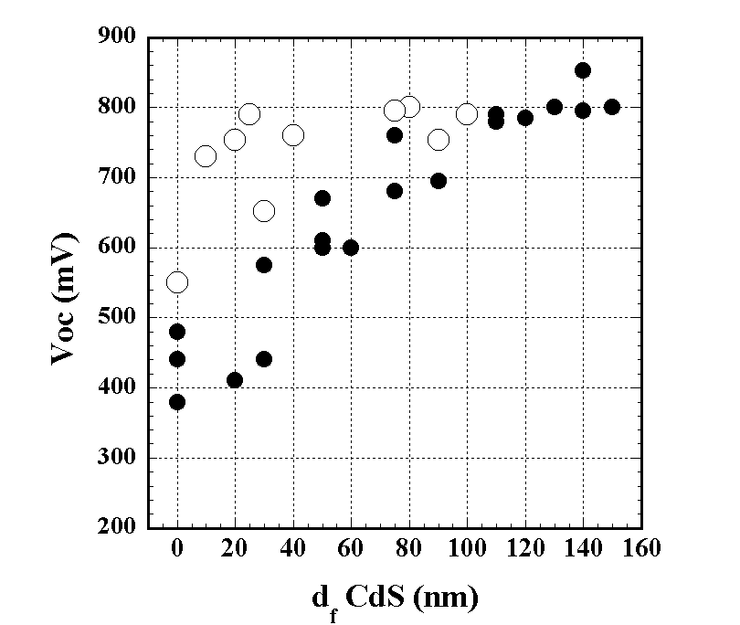

Figure 1. V_{oc} versus final CdS film thickness for PVD CdTe/CdS and CdTe_{1-x}S/CdS cells without buffer layers (solid) and with buffer layers (open).

Two options exist for maximizing photocurrent while retaining high junction quality: 1) employing a high resistance buffer layer between CdS and TCO to raise J_{o} in the CdTe/TCO junction and 2) using Cd_{1-x}Zn_{x}S alloy films to widen the band gap and relax the thickness constraint. Table II lists AM 1.5 current-voltage (JV) device results for CdTe/CdS cells with CdTe deposited by PVD and high resistance oxide buffer layers between the TCO and CdS film. The buffer layers evaluated were SnO₂, In₂O₃ and Ga₂O₃. In all three cases, the buffer layers were fabricated by oxidation of thin films of Sn, In, or Ga deposited on TCO/glass. The cell results in Table II and the V_{oc} plot in Figure 1 (open markers) demonstrate high J_{sc} and retention of junction quality for devices with CdS < 100 nm. Incorporating a high resistance SnO₂ buffer layer on SnO₂/7059 has resulted in devices with conversion efficiencies >13% for evaporated CdTe.

Table II. AM1.5 JV results (28°C) for PVD CdTe devices with 7059/ITO, 7059/ITO/buffer/CdS, 7059/SnO₂/buffer/CdS, and 7059/ITO/50nm Cd_{0.95}Zn_{0.05}S window layers. All cells were processed with 580°C, 5 min pre-anneal and 420°C, 15 min vapor CdCl₂ post-deposition treatments.

TCO | Buffer  nm/  type | d_{f}(CdS)  nm | V_{oc}  mV | J_{sc}  mA/cm² | FF  % | Eff  %
ITO | None | 0 | 440 | 25.0 | 47 | 5.0
ITO | None | 50 | 590 | 23.9 | 47 | 6.6
ITO | None | 110 | 790 | 20.3 | 70 | 11.3
ITO | 20 In₂O₃ | 30 | 652 | 23.9 | 52 | 8.1
ITO | 50 In₂O₃ | < 20 | 754 | 26.2 | 60 | 11.9
ITO | 50 In₂O₃ | 100 | 790 | 21.8 | 70 | 12.0
ITO | 50 Ga₂O₃ | 40 | 760 | 24.0 | 62 | 11.4
SnO₂ | None | 0 | 440 | 18.0 | 46 | 3.5
SnO₂ | None | 90 | 753 | 22.8 | 63 | 10.8
SnO₂ | 50 SnO₂ | < 20 | 790 | 26.0 | 68 | 13.8
ITO | None | 30 Cd_{0.95}Zn_{0.05}S | 750 | 23.2 | 62 | 10.8

Another approach to maximizing transparency in the window layer is replacing pure CdS with Cd_{1-x}Zn_{x}S, as reported in reference. Calculations suggest that addition of Zn to the interface can reduce valence band offsets which may translate to higher V_{oc}. We fabricated devices with no buffer layer but with Cd_{1-x}Zn_{x}S having low Zn content, x ~ 0.05, and obtained higher V_{oc} than for devices fabricated with, non-alloyed CdS (Table II).

High efficiency CdTe/CdS devices require uniform, ultra-thin, pinhole-free CdS films to serve as the heterojunction window layer. Although several methods exist to deposit CdS films with d < 100 nm, chemical surface deposition (CSD) offers high quality conformal films with high growth rate and utilization of dissolved Cd. CSD offers several advantages over chemical bath deposition (CBD), by allowing the heated substrate to selectively provide the heat for reaction at the substrate surface, thereby enhancing heterogeneous nucleation on the substrate and reducing homogeneous nucleation in the bath, which increases the utilization of solvated Cd species. In practice, CSD can be accomplished by flow-on, spray, or other methods. For use in cells with VT CdTe, CSD CdS films were deposited on 10 cm x 10 cm Ga₂O₃/SnO₂-coated glass (L.O.F. TEC15) from a solution containing 1.5 mM CdSO₄, 0.15 M CS(NH₂)₂, and 1.8 M NH₄OH. A 4 min. deposition carried out at 55-60ºC produces 40-50 nm thick films (rate = 0.2 nm/sec), and the Cd species utilization is >80%. Glancing incidence x-ray diffraction (GIXRD) analysis of as-deposited films indicates increasing crystallinity with deposition temperature, with wurtzite structure and microcrystalline order ~ 20 nm for 60ºC deposition (Figure 2). Heat treatment of the films in argon ambient at 550ºC for 5 minutes (HTA) or CdCl₂:O₂:Ar vapor at 430ºC for 5-10 minutes induces primary recrystallization, producing sharp reflections of the wurtzite phase. HTA preserves (001) film orientation while vapor CdCl₂ treatment induces randomization and secondary recrystallization (Figure 3). Vapor CdCl₂ treatment is used for cell processing, sharpens the optical transmission edge and increases transparency (Figure 4).
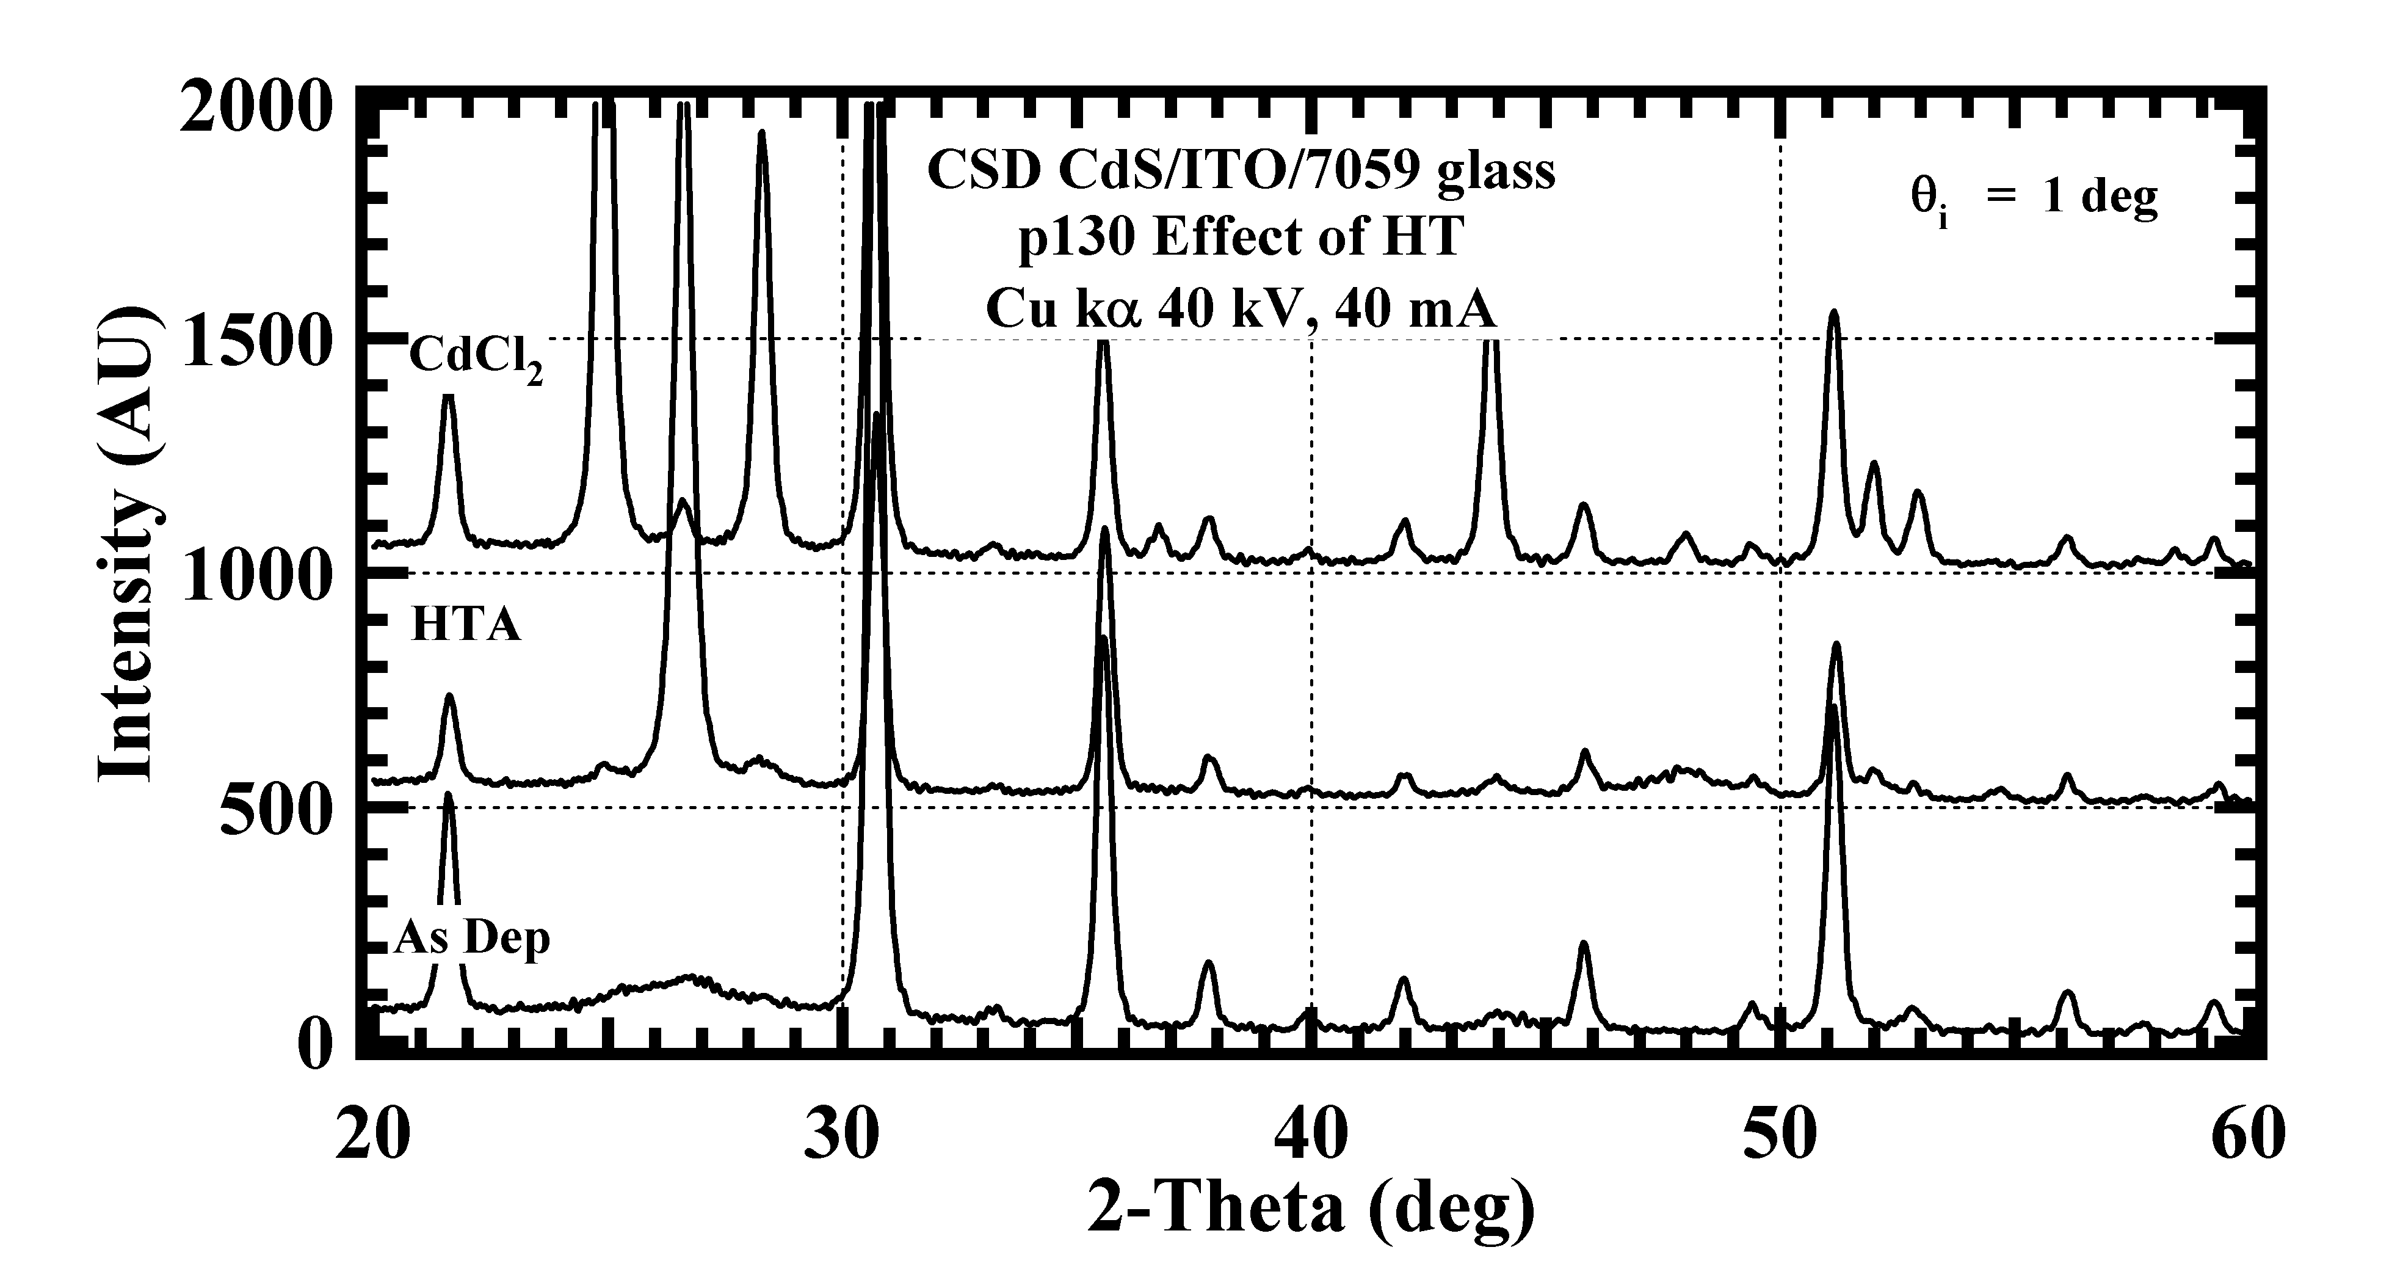
Figure 2. GIXRD pattern of CSD CdS as deposited (As Dep), after anneal at 550ºC for 5 min (HTA) and after vapor CdCl₂ treatment at 430°C for 10 min (CdCl₂). CdS peaks at 2θ = 20º, 26.5º,28.2º, 44º, 52º and 53º; remaining peaks due to ITO.

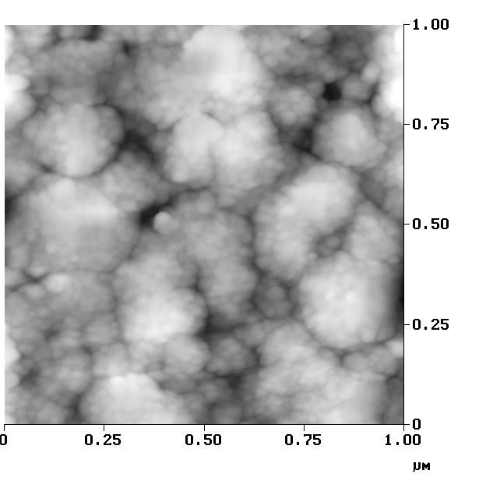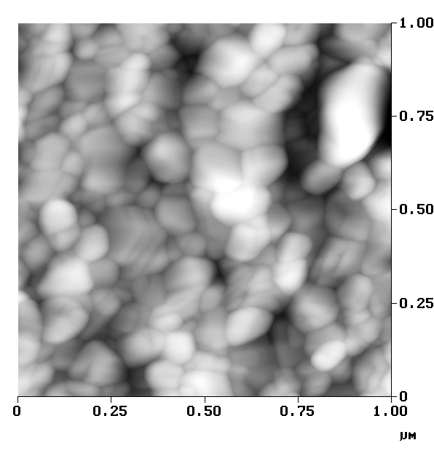

Figure 3. Atomic force micrographs of CSD CdS film: as-deposited at 65°C (left) and after vapor CdCl₂ HT at 430°C (right).

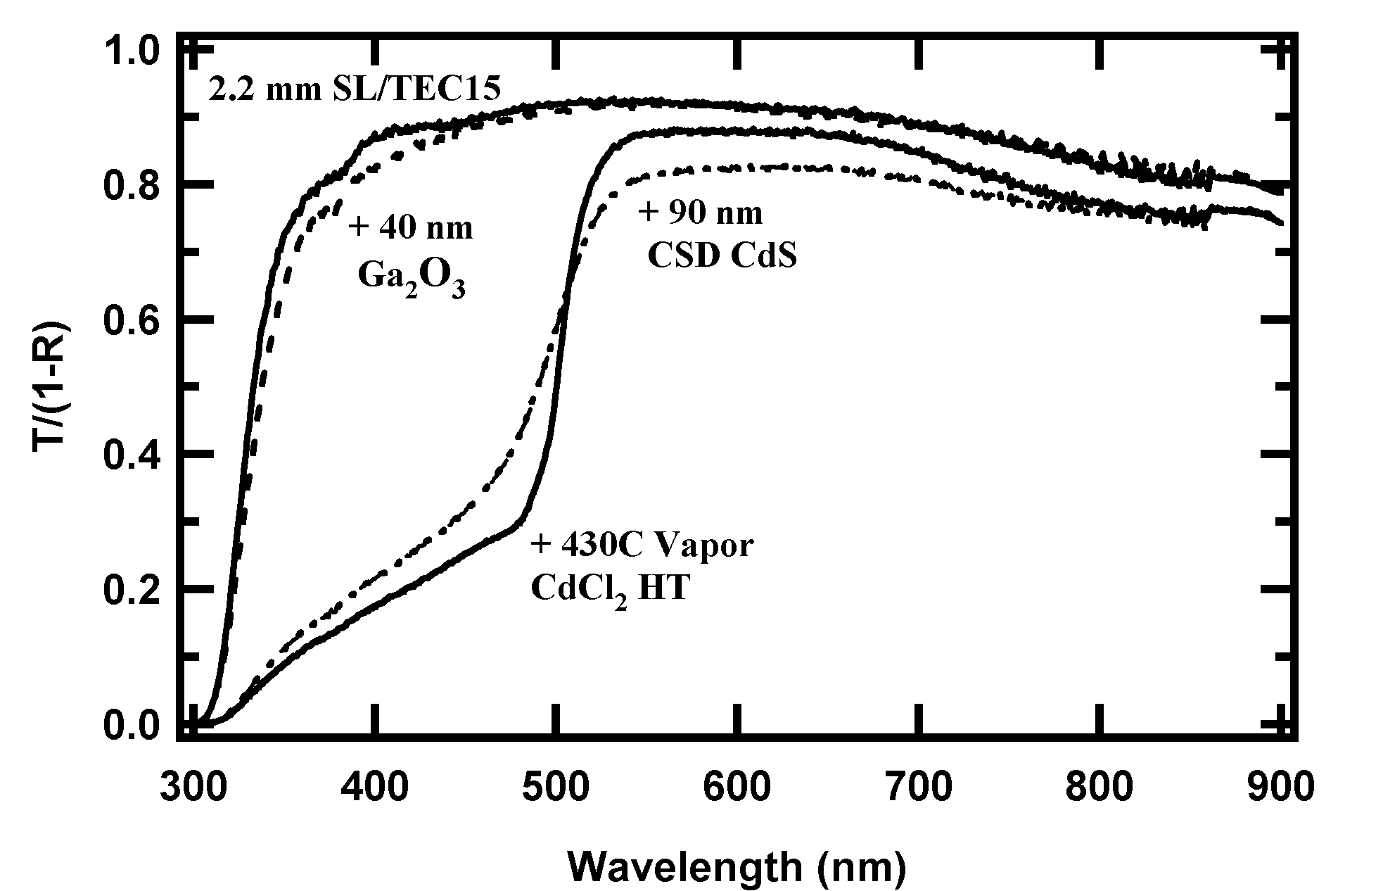

Figure 4. Normalized optical transmission, T/(1-R), of window layer used in VT cells.

Influence of Chemical and Structural Properties on Devices

Post-deposition treatments at elevated temperatures in reactive chemical environments such as O₂ and CdCl₂ shift the chemical state of the films considerably compared to the as-deposited condition and improves device performance. This section summarizes the basis for this and the effect on device operation.

Over the past decade, detailed analysis of the interfacial region in moderate and high efficiency CdTe/CdS cells by x-ray diffraction (XRD), transmission electron microscopy (TEM) with microprobe (EDS), secondary ion mass spectroscopy (SIMS) and opto-electronic measurements have shown that the CdTe-CdS interface in a working device consists of CdTe_{1-x}S_{x}/CdS_{1-y}Te_{y} alloys.Error: Reference source not found The interfacial values of x and y correspond to the solubility limits in the CdTe-CdS system at the device processing temperature. The CdTe_{1-x}S_{x} and CdS_{1-y}Te_{y} alloys form via diffusion across the interface during CdTe deposition and post-deposition treatments and affect photocurrent and junction behavior. For the CdTe-CdS system, with CdTe_{1-x}S_{x} and CdS_{1-y} Te_{y} phases, the thermal dependence of the miscibility gap is well approximated by a cubic fit:

(7a)

(7b)

The stable crystallographic forms of the solid alloys are zincblende (F-43m) structure for Te-rich CdTe_{1-x}S_{x} and wurtzite (P6₃mc) structure for S-rich CdS_{1-y}Te_{y}. The zincblende-wurtzite transition in metastable films occurs at x = 0.3, and the lattice parameter within each structure type follows Vegard’s rule. Metastable and equilibrated CdTe_{1-x}S_{x} alloy films exhibit the same composition dependence of optical bandgap (E_{g}), with minimum E_{g}= 1.39 eV at the zincblende-wurtzite transition. The compositional dependence of the CdTe_{1-x}S_{x} bandgap is described by:Error: Reference source not found

E_{g}(x) = 2.40x + 1.51(1-x) – bx(1-x) (8)

where the bowing parameter, b = 1.8. Thus, for cells processed at ~500°C, the CdTe_{1-x}S_{x} composition is x ~ 0.09, and the corresponding absorber layer optical bandgap is E_{g} ~ 1.44 eV. In correlating measurable properties in CdTe/CdS solar cells and diagnostic structures, it is helpful to recognize that alloy formation results in a lattice parameter distribution, detectable by XRD, that corresponds to a distribution in opto-electronic properties, which are detectable in films by variable angle spectroscopic ellipsometry (VASE) and in devices by quantum efficiency (QE). For compositionally graded alloys formed by diffusion from CdS into the CdTe film, we expect the maximum bandgap variation in the materials to occur at the CdTe-CdS interface and possibly in grain boundary regions near the interface, due to enhanced diffusion in the grain boundaries. In devices, the long-wavelength quantum efficiency edge is generally found to correlate with compositionally-broadened diffraction line profiles of prominent (hkl) reflections in alloyed films.

Formation of the CdS_{1-y}Te_{y} alloy on the S-rich side of the junction reduces the bandgap and increases absorption, which reduces photocurrent in the 500 to 600 nm range. This effect is suppressed by annealing the CdS film prior to CdTe deposition to reduce crystallographic defects in CdS. Formation of the CdTe_{1-x}S_{x} alloy on the Te-rich side of the junction reduces the absorber layer bandgap, due to the relatively large optical bowing parameter of the CdTe-CdS alloy system. Overall, this has little effect on efficiency since the increase in long wavelength QE typically increases photocurrent by ~ 0.5 mA/cm², which is nearly offset by small reduction in V_{oc} ~ 25 mV.

Other significant effects of alloy formation include spatially non-uniform consumption of the CdS layer, penetration of CdS into the CdTe film grain boundaries, and relaxation of lattice strain between CdTe and CdS. The rate of CdS consumption has been quantitatively determined in terms of bulk and grain boundary diffusion. For treatment at 420°C in 10 mTorr CdCl₂ and 150 Torr O₂, similar diffusion coefficients for bulk (D_{b}) and grain boundary (D_{gb}) have been determined for CdS diffusion into CdTe deposited by electrodeposition, PVD, and CSS: D_{b} = 1.25 x 10⁻¹³ cm²/s and D_{gb} = 1.5 x 10⁻⁸ cm²/s. For PVD films with ~1 μm diameter grains and 3-4 μm film thickness, the typical CdCl₂ treatment at 420°C for 20 minutes consumes CdS at an equivalent thickness rate of ~0.05 nm/s. Spatially non-uniform consumption of CdS leads to parallel junctions between CdTe_{1-x}S_{x}/CdS_{1-y}Te_{y} and CdTe_{1-x}S_{x}/ITO (or SnO₂); since the CdTe_{1-x}S_{x}/TCO junctions have higher J_{o}, the net result is an increase in total J_{o}, which reduces V_{oc}. For two predominant types of diode A and B and assuming comparable diode prefactors (β =q/AkT), the overall diode current can be described in terms of the usual diode equation and the fractional area of the two diode types:

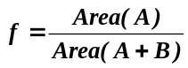 (9)

(10)

Solving for the open circuit voltage (J = 0) gives:

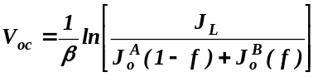 (11)

Characterization of actual CdTe/CdS/ITO (A) and CdTe/ITO (B) cells shows comparable diode A-factors ~ 1.7 but diode currents of 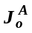= 8 x 10⁻⁸ mA/cm² and 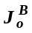= 1 x 10⁻⁴ mA/cm², respectively. For 1% fractional area of holes in the CdS film, the V_{oc} would thus be reduced by 300 mV. Modeling of thin-film device structures with a random distribution of different quality diodes in-parallel is more extensively covered in other recent work. Penetration of S-rich species into the CdTe grain boundaries can produce a three-dimensional junction, which increases the actual junction area, also limiting V_{oc}. This grain boundary penetration of CdS in CdTe is accelerated by CdCl₂ and O₂ chemical activity during the post-deposition treatment and is extremely sensitive to the physical and chemical state of the CdTe film prior to the treatment.Error: Reference source not found

The exposed (back) surface of the CdTe film is subjected to a wide range of ambient conditions during processing, which shift the surface state; shifts in equilibrium are expected to influence bulk properties if the processing is carried out at sufficient temperature to allow re-distribution of excess species. Thus, it is also important to consider the CdTe-O₂-CdCl₂ chemical system. For CdTe-CdCl₂, the occurrence of a eutectic at ~490°C suggests that enhanced surface mobility can be expected for T > 450°C and high CdCl₂ concentration due to liquid Cd(TeCl). Note that the solubility limit for CdCl₂ in CdTe is < 0.1 wt% at 490°C. At lower temperatures and low CdCl₂ concentration in the presence of O₂, chemical reaction at the surface and in grain boundary between CdCl₂, O₂, CdTe and CdS is expected. For treatments where solid CdCl₂ is in physical contact with CdTe in air ambient, the solid phase reaction is:

1) CdCl₂ (s) + O₂ (g) + CdTe (s) ↔ TeCl₂ (g) + 2CdO (s), ΔG_{rxn}(400°C) = -137.6 kJ/mol.

For vapor CdCl₂:O₂:Ar treatments, in which CdCl₂ condensation is prevented by maintaining the CdTe/CdS at a higher temperature than the CdCl₂ source, the reaction between gas phase CdCl₂ and O₂ and solid CdTe is:

2) CdCl₂ (g) + O₂ (g) + CdTe (s) ↔ TeCl₂ (g) + 2CdO (s), ΔG_{rxn} (400°C) = -206.2 kJ/mol.

Both cases are thermodynamically favored but the extent of reaction depends on the activity coefficient of the reactive species, and a large difference is expected between the solid-solid contact case (CdCl₂ activity coefficient = 1) and the solid-vapor case (activity coefficient ~ 10⁻⁸ atm). In fact, for vapor treatments, the CdCl₂ partial pressure can be varied over a wide range by controlling the source temperature. Analogous reactions exist for CdS-CdCl₂-O₂.

In these overall reactions, volatile VIB-VIIA species is generated and solid CdO phase is produced. We have verified this reaction scenario experimentally for treatments of both CdTe and CdS powders and films. The formation of volatile VIB-VIIA species provides a mechanism for enhanced atomic mobility within grain boundaries and may be the key to understanding enhanced diffusivity.

At the back surface of CdTe, the oxide is an undesired byproduct. CdO has halite (Fm3m) structure, is thermally stable up to 900°C, has the highest ionicity value in the Cd-VIB system (0.78), is insulating, and therefore poses an obstacle for back contact formation.

For reaction in the presence of O₂ alone, CdTe forms a native oxide CdTeO₃, which lies on the TeO₂-CdO pseudobinary tie-line and is the equilibrium native oxide of CdTe, has cubic structure and is electrically insulating. We have verified this phase in films experimentally by GIXRD measurements of CdTe films treated at 450°C to 600°C in dry air.Error: Reference source not found For treatments in air containing a partial pressure of water, we have found that a different oxide, CdTe₂O₅ is consistently formed. The deviations from stoichiometry caused by oxide formation should have a profound effect on the near-surface Cd-vacancy concentration, impacting the ability to control both bulk and surface acceptor concentration.

Vapor Transport CdTe Deposition

The VT deposition system previously describedError: Reference source not found, was used to deposit CdTe films down onto moving 10 cm x 10 cm TEC-15 plates coated with CSD CdS films. In VT deposition, He or N₂ carrier gas is saturated with Cd and Te₂ vapor and then de-saturated at the cooler substrate. The substrate rests on a graphite susceptor, which translates at an adjustable rate over an array of quartz halogen lamps. Baseline deposition conditions were established to provide a benchmark for analyzing processing variations. For routine batch operation, the system pressure is maintained at 100 Torr while the CdTe source manifold is heated, then is reduced to 20 Torr as substrate translation at 3 cm/min begins for deposition, and is finally increased after deposition to >100 Torr to suppress re-evaporation from the substrate. Baseline deposition is carried out at a He carrier gas flow rate of 20 sccm and source temperature of 800ºC, with a 3 mm wide exit slit located 1.5 cm above the substrate, producing a CdTe delivery rate of 5 x 10⁻⁶ mol/s and a uniform deposition zone 1-1.5 cm wide. CdTe crystals with 6N purity from Alfa/Aesar were used for all depositions. The growth rate was found to be invariant with substrate temperature over the range studied, from 500ºC to 570ºC. The static equivalent growth rates and utilization of transported CdTe vapor obtained for different source temperatures and carrier gas flow rates are listed in Table III. High deposition rates, up to nearly 100 μm/min, were achieved, and utilization remained constant ~50% except at the highest deposition rate. Scaling this process up is achievable by increasing the deposition zone area, by matching the source slit length to the substrate width and increasing the exit slit width.

Table III. Static equivalent growth rate and utilization of VT CdTe.

T source (C) | Flow (sccm) | Rate  (μm/min) | Utilization  (%)
780 | 20 | 6 | 50
800 | 20 | 8 | 56
820 | 20 | 12 | 53
840 | 20 | 18 | 52
780 | 20 | 6 | 50
780 | 40 | 8 | 49
840 | 20 | 18 | 52
840 | 40 | 35 | 47
860 | 40 | 81 | 7

The effect of deposition conditions on CdTe film morphology and grain size is illustrated in the following series of 20 μm x 20 μm AFM images. As reported previously, O₂ partial pressure, <0.1 Torr, improves lateral grain packing and nearly eliminates pinholes. All samples were deposited in He ambient containing ~50 mTorr O₂ partial pressure. Figure 5 shows increasing grain size with increasing substrate temperature for 5 micron thick films. Figure 6 shows increasing grain size with increasing film thickness for 550ºC substrate temperature. Figure 7 shows decreasing grain size with increasing deposition rate. The appreciable differences measured have a direct bearing on the effects of post-deposition processing, since diffusion in grain boundaries significantly enhances overall CdS-CdTe diffusion during CdCl₂ treatment.Error: Reference source not found In this series, the image in Figure 7-left corresponds to the baseline deposition.

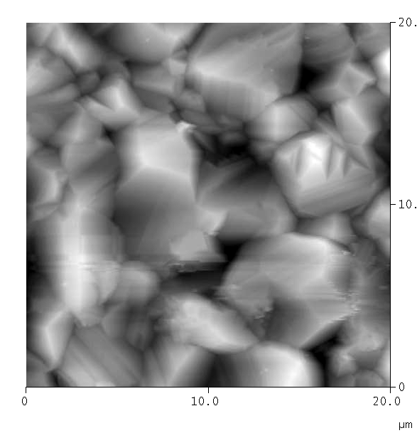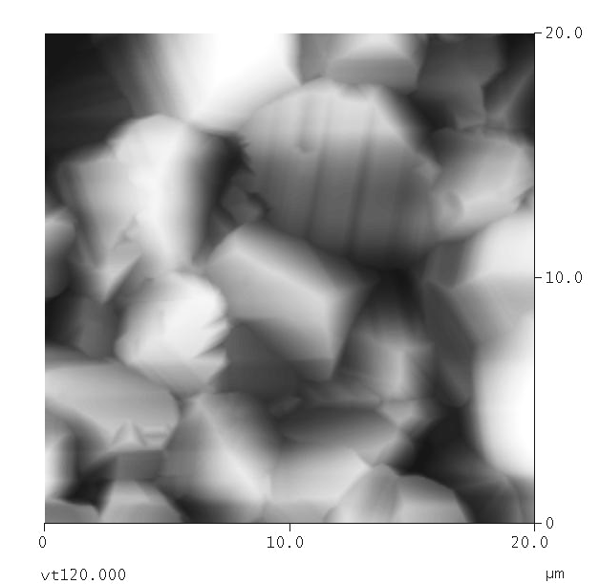
Figure 5. AFM images of 5 μm thick CdTe films deposited by vapor transport on moving substrates in He+O₂ at 500°C (left) and 570°C (right).

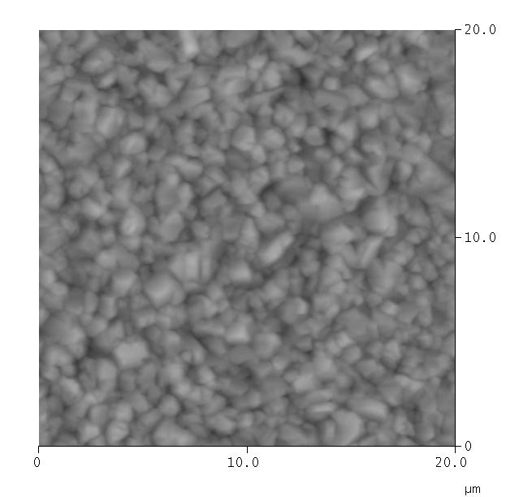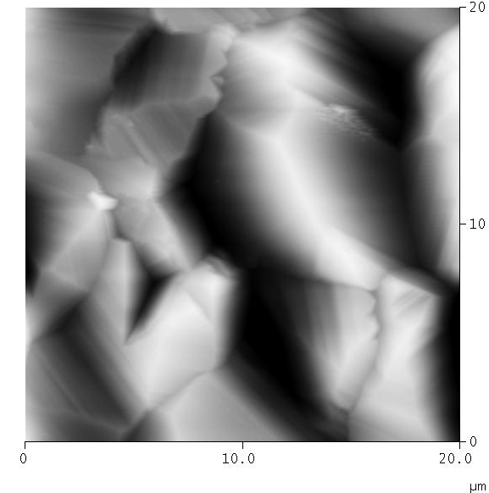
Figure 6. AFM images of 1 μm (left) and 23 μm thick (right) CdTe films deposited by vapor transport on moving substrates in He+O₂ at 550°C.

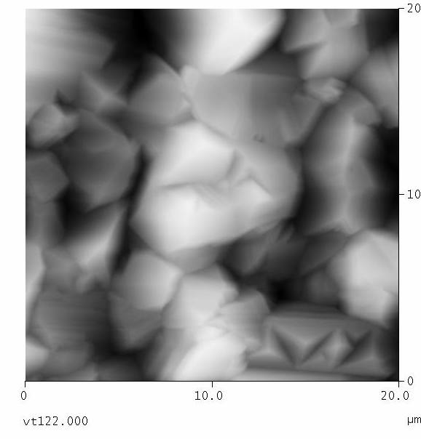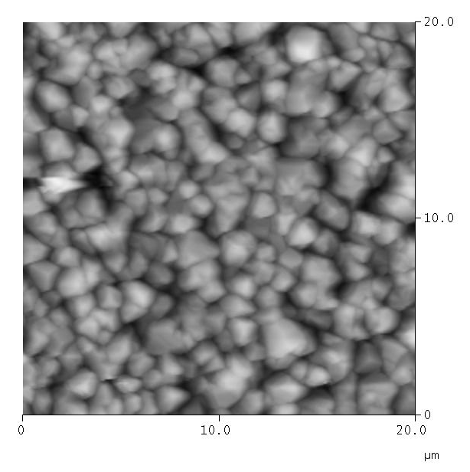
Figure 7. AFM images of 6 μm thick CdTe films deposited by vapor transport on moving substrates in He+O₂ at 8 μm/min (left) and 81 μm/min (right) at 550°C.

Vapor CdCl₂ Treatment

Vapor CdCl₂ treatment yields low surface residue and uniform device performance, making it an attractive alternative for large-scale processing., Vapor CdCl₂ treatment also offers a pathway for rapid post-deposition treatment by allowing the treatment temperature and CdCl₂ concentration to be independently controlled and by producing surfaces, which are free of oxide contamination, reducing the need for etching. For treatments in which CdCl₂ is coated on the CdTe, raising the treatment temperature would simultaneously sublime CdCl₂ from the surface and increase diffusion into the CdTe film. The chemical activity for the diffusion would be ~unity until all CdCl₂ had sublimed away. With vapor processing, the chemical activity is controlled by CdCl₂ partial pressure in the ambient, and shorter treatment times are achievable by raising the treatment temperature and reducing the CdCl₂ concentration. A treatment system for processing 5 cm x 5 cm samples, consisting of a packed-bed CdCl₂ vapor generator with N₂ carrier gas and quartz halogen sample heater, has been developed and is shown in Figure 8.

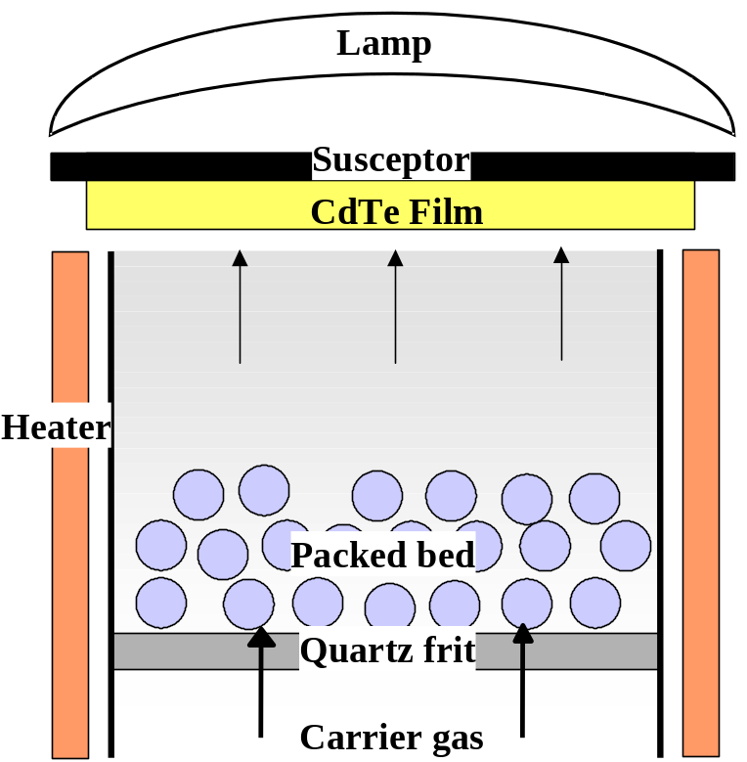

Figure 8. Schematic depiction of carrier gas passing through a packed bed of CdCl₂.

Figure 9 shows GIXRD patterns of the surface of VT CdTe: 1) as-deposited; 2) vapor CdCl₂ treated; and 3) treated with solution-applied CdCl₂ (wet). Baseline CdCl₂ treatments were carried out at 415°C for 25 minutes. For the vapor treatments, the CdCl₂ sources were maintained at 400°C, which produces a CdCl₂ partial pressure of 3.5 mTorr. The GIXRD scan of the as-deposited CdTe shows the usual CdTe reflections (111), (220), (311) and (400). The vapor treated sample exhibits a similar pattern. The wet-treated sample, on the other hand, taken after a water rinse to remove CdCl₂, contains reflections from non-soluble phases, indexed as CdO (2θ = 33°) and a different crystal form of CdTeO₃. No grain growth was observed on baseline deposited VT CdTe, having large as-deposited grains.

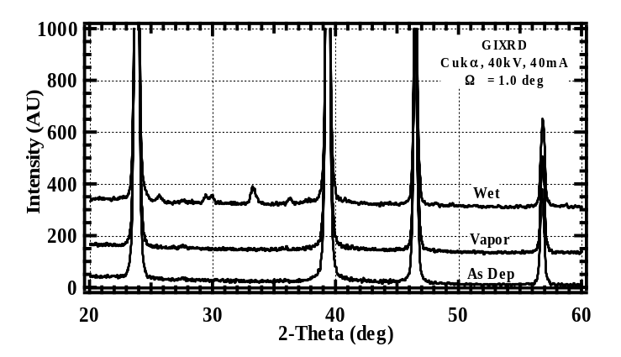
Figure 9. GIXRD patterns of VT CdTe in as-deposited and CdCl₂ treated conditions, showing the contrast between wet and vapor treatments.

Devices

Baseline VT devices were fabricated by first performing a post-deposition vapor CdCl₂ treatment at 415ºC for 20 minutes in Ar/O₂ ambient. The CdTe surface was then etched in a three-step “BDH” process to form a Te layer. Primary electrical contact to CdTe is facilitated by formation of Cu₂Te. This is accomplished by sequential evaporation of Cu followed by application of the current carrying conductor and treatment in argon at 180ºC for 30 minutes. Table IV lists AM1.5 J-V parameters obtained for the baseline deposition process and for different deposition conditions and contacts. The J-V and spectral response behavior of the cell with 13.3% efficiency are shown in Figures 10 and 11, respectively.

Table IV. Best cell AM1.5 J-V results for devices fabricated with CSD CdS, baseline VT CdTe and vapor CdCl₂ treatment.

Vapor CdCl₂  Temp/time  (C/min) | Contact | V_{oc}  (mV) | J_{sc}  (mA/cm²) | FF  (%) | Eff  (%)
None | Au | 570 | 15.9 | 46.9 | 4.2
415/25 | Au | 801 | 23.0 | 71.7 | 13.2
415/25 | Ni | 810 | 23.7 | 70.8 | 13.6
415/25 | Cr | 814 | 23.0 | 62.5 | 11.7
410/20 | Au | 808 | 23.8 | 69.2 | 13.3
440/2 | Au | 634 | 20.4 | 60.2 | 7.8
465/2 | Au | 755 | 24.2 | 60.2 | 11.0

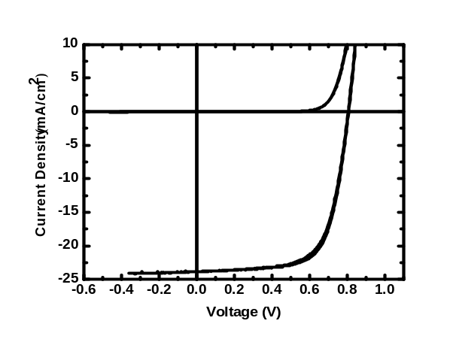
Figure 10. Light (AM1.5, 28ºC) and dark J-V behavior for 13.3% efficient baseline VT cell.

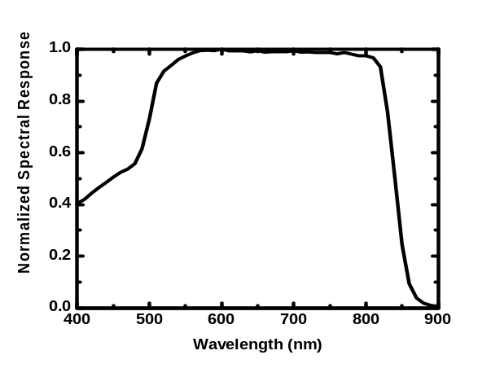
Figure 11. Normalized spectral response (0V, light bias) for 13.3% efficient baseline VT cell.

In Table IV, the cell processed with no CdCl₂ treatment suffers from a poor junction and low current, with 4% efficiency. For cells with CdCl₂ treatment at 410-415ºC, comparable cell performance is demonstrated with Au, Ni and Cr contacts, with best cells having >13% efficiency. The last two rows in Table IV demonstrate that reduced CdCl₂ treatment time can be employed but must be offset with increased treatment temperature to maintain performance at 11% efficiency. Comparing the short wavelength QE in Figure 11 with the optical transmission of the CdS in Figure 4, we estimate that the CdS thickness was reduced during processing by ~20 nm. Not shown are data for cells made with no intentional Cu, which gave V_{oc} from 740 to 790 mV but FF < 60%, with severe rollover in forward bias, attributed to a barrier at the back contact.

The performance of cells with different CdS thickness and CdTe deposition conditions but fixed CdCl₂ treatment and contact are listed in Table V. Each row corresponds to a separate deposition. Note that trials without CdS or Ga₂O₃ buffer layers exhibited poor adhesion after post-deposition processing and cells were not completed. The initial CdS thicknesses are listed in the table. The first three samples show relatively constant V_{oc} ~ 800 mV for 5-7 μm thick CdTe with initial CdS thickness of 80 nm, indicating uniform junction quality. Note that the cell with 7 μm thick CdTe and 80 nm CdS exhibited the highest V_{oc} obtained with the VT baseline process. Doubling the CdS thickness had no beneficial impact on the junction behavior but reduced J_{sc}, which indicates that the baseline CdS coating is sufficiently thick to obtain a high quality junction. The CdS film thickness is reduced in baseline processed cells by ~20 nm due to interdiffusion at the interface, producing a negligible shift in long wavelength spectral response.

The lower three rows in Table V show that very high CdTe growth rate reduces junction quality. For the 6 μm thick sample deposited at 81 μm/min, this can be understood in terms of Figure 7-right, which shows that this sample had very small as-deposited grain structure, similar to 4 μm thick PVD CdTe films deposited at 0.2 μm/min at ~300ºC. In such cases, the additional grain boundary volume enhances CdS diffusion into CdTe, allowing more blue light penetration into the absorber layer, raising J_{sc}, but also creating discontinuities in the CdS film, lowering V_{oc} by formation of parallel diodes having higher recombination current. This sample exhibited secondary recrystallization, or grain growth, after the vapor CdCl₂ treatment, which is additional evidence for high atomic mobility, since grain coalescence involves breaking and re-forming bonds along the moving grain boundary front. Direct evidence for this was shown by time-progressive AFM images of the CdTe surface after CdCl₂ treatments in a 1 minute time frame.

The last two rows in Table V show device results for cells with ~1 μm thick CdTe films deposited at 9 and 18 μm/min, obtained by translating the sample stage at higher speeds compared to the baseline speed of 1.25 cm/min. The films had small as-deposited grains (Figure 5-left), and the CdCl₂ treatment temperature was reduced to 390ºC for 15 min; these conditions were based on earlier results obtained for PVD cells with 1.3 μm thick CdTe. In addition, the aggressive BDH process for treating the back surface could not be employed, since it consistently produced cells with severe shunt characteristics. Aniline was used to etch the surfaces prior to application of the Cu/Ni contact. For the 1.4 μm thick VT film deposited at 9 μm/min, the junction operation is similar to that obtained with baseline CdTe thickness, resulting in >10% efficiency. For a cell with 1 μm CdTe deposited at higher growth rate, lower junction quality is obtained and cannot be attributed to a loss of CdS. Note that the J_{sc} is similar to baseline cells, indicating sufficient CdTe thickness for high current generation.

Table V. Best cell AM1.5 J-V results for devices fabricated with baseline vapor CdCl₂ treatment (except *) and with different CdS thickness and CdTe deposition conditions.
Window | CdTe  thk/rate  (μm/μm/min) | V_{oc}  (mV) | J_{sc}  (mA/cm²) | FF  (%) | Eff  (%)
80 nm CdS | 5/7 | 792 | 23.4 | 66.6 | 12.3
80 nm CdS | 6/8 | 808 | 23.8 | 69.2 | 13.3
80 nm CdS | 7/10 | 845 | 24.1 | 64.0 | 13.0
160 nm CdS | 7/10 | 800 | 21.2 | 63.6 | 10.8
80 nm CdS | 6/81 | 736 | 24.8 | 53.4 | 9.7
*80 nm CdS | 1.4/9 | 807 | 23.0 | 57.0 | 10.5
*80 nm CdS | 1/18 | 650 | 23.2 | 54.1 | 8.2
To summarize the results of this section, CSD delivers high CdS growth rate and Cd utilization and yields high quality CdTe/CdS junctions. For CSD CdS, uniform films deposited with >80% utilization of dissolved Cd demonstrated good junction quality in baseline VT CdTe devices, yielding 13% conversion efficiency and V_{oc} > 840 mV. For VT CdTe, unbaffled batch deposition yields 50% utilization at static equivalent growth rates up 40 μm/min. Much higher utilization would be expected for continuous deposition since much of the non-utilized CdTe is lost during the heat-up and substrate translation delay time, and the chamber would be continuously at steady state. For 100% utilization, achievable by adding baffles, a source T = 840ºC would yield >100 μm/min growth rate and a 1 μm film could be deposited over a 1 m length (module size) in 1 min.

Vapor CdCl₂ treatment offers control of CdCl₂ concentration, temperature and time and yields a clean CdTe surface. The performance of cells deposited on commercial SnO₂/glass substrates with a Ga₂O₃ buffer layer, translating at 3 cm/min at 550ºC, demonstrates that high efficiency can be achieved with a simple, robust process. A post-deposition CdCl₂ treatment time as low as 2 minutes was used to fabricate cells with 11% efficiency. Promising cell results were obtained for cells deposited at very high growth rates, yielding ~10% efficiency. Finally, VT deposition offers a path for development of cells with thin CdTe layers, ~1 μm thick, by adjusting the CdCl₂ treatment conditions. This has yielded cells with >10% efficiency for 1.4 μm thick CdTe and >8% efficiency for 1 μm thick CdTe.

Effect of humidity and oxidation during post-processing

CdTe oxidation at the back surface impedes contact formation. Oxidation along grain boundaries can influence junction operation and cell stability. The chemistry of oxide formation depends on the ambient composition and film structure: XPS, GIXRD and surface energy measurements have shown the primary oxides to be CdO and CdTeO₃, while CdTe₂O₅ has been found in samples treated or stored in humid ambient. The specific oxides formed affect film defect chemistry and grain boundary composition.

Based on GIXRD of CdTe films and XRD of CdTe powder, the crystalline phase residues show that the reaction to form CdO requires O₂ and CdCl₂ together. At 400ºC, the TeCl₂ is volatile, leaving the powder container and condensing at the cold ends of the reaction vessel. Without CdCl₂, i.e., for ambient containing O₂, the chemical reaction forms CdO and TeO₂, which spontaneously reacts to form CdTeO₃, which is the native oxide of CdTe. For reaction in humid ambient, CdTe₂O₅ residue is detected, which is evidence for preferential removal of Te in the presence of H₂O vapor. In such cases, further treatment time produces CdTeO₃ as excess Cd is forced to oxidize and react to satisfy chemical equilibrium.

The sensitivity of oxidation rate and products to temperature and ambient composition were investigated by in-situ treatment during GIXRD analysis of the surface. Experiments were conducted with PVD CdTe films at RH = 0, 20, 40% and T = 400ºC, 500ºC, 550ºC (9 samples) and VT CdTe films at RH = 40% and T = 500ºC (1 sample). The different humidity conditions were achieved by using bottled dry air for RH = 0%, a bubbler for RH ~ 20% and room air for RH ~ 40%. The GIXRD apparatus with hot stage installed and with ambient control shroud removed is shown in Figure 12. The scans were acquired with Cu ka x-rays over the 2θ angular range from 20 to30 degrees, which spans the predominant peaks of CdTe and its oxides, in 10 minute cycles at an incident beam angle of 1 degree, which attenuates the beam at a depth of 116 nm in CdTe and 112 nm in CdTeO₃.

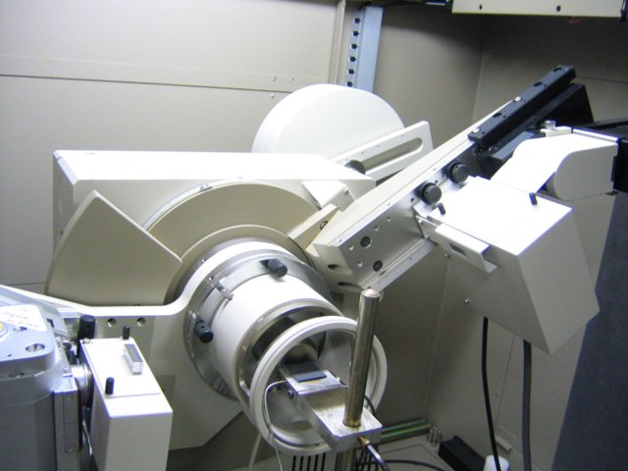
Figure 12. GIXRD apparatus with ambient control shroud removed, showing the hot stage for heating samples from RT to 600ºC.

The time-progressive GIXRD data are shown for PVD films treated at 500ºC in dry and humid ambient in Figure 13. For treatment in dry ambient, the monoclinic crystalline phase α-CdTeO₃ is detected after 10 minutes of treatment and increases monotonically with time to 100 minutes. The CdTe (111) peak is reduced in intensity over this period due to attenuation from the developing oxide. In humid air, the tetragonal oxide TeO₂ is detected in the first 10 minutes, followed by the development of α-CdTeO₃ and conversion to β-CdTeO₃.
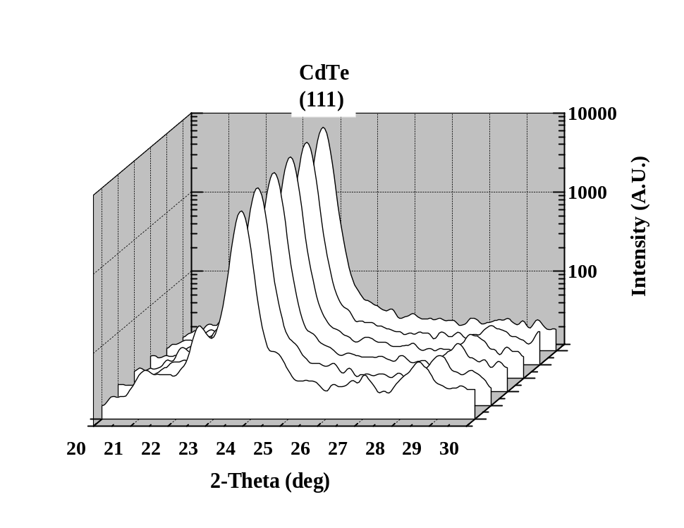
10 min

50 min
100 min
Dry Air: (RH = 0%, <0.001 g/L H₂O)
α-CdTeO₃
α-CdTeO₃
500ºC
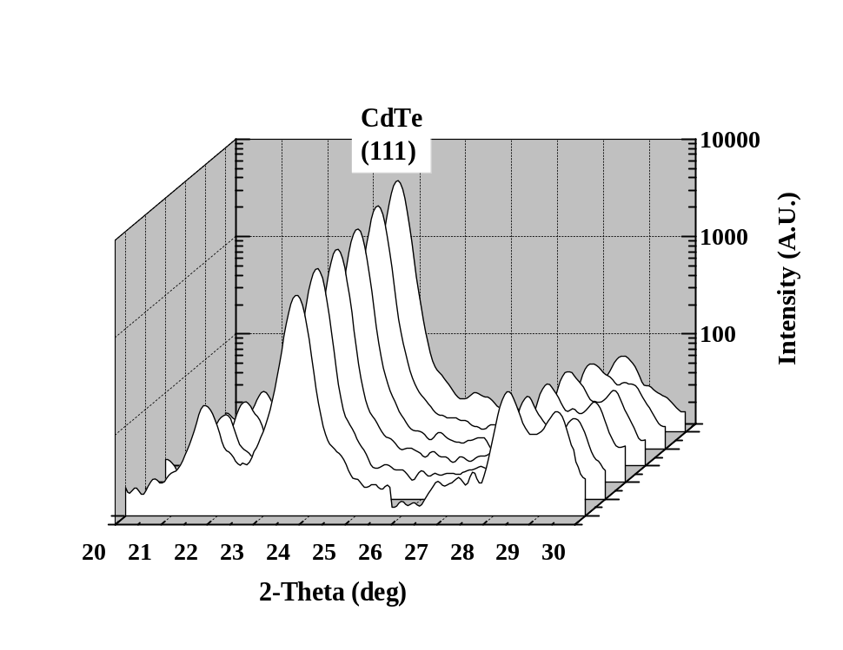
10 min

50 min
100 min
β-CdTeO₃
β-CdTeO₃
α-CdTeO₃
500ºC
TeO₂
Humid Air: (RH ~ 40%, ~ 0.1 g/L H₂O)

Figure 13. Time-progressive GIXRD scans of oxidation of CdTe in dry and humid ambient at 500ºC.

The thickness of the overlying oxides can be easily determined from the reduction of the CdTe peak intensity [see section 5 of this report], since the CdTe film does not undergo any detectable re-orientation during air anneals at 300-500ºC. Figure 14 shows the time-progressive development of oxide thickness for CdTe treated at 500ºC at RH = 0, 20 and 40%. Whereas at RH = 0, the oxide develops very slowly and formed ~20 nm oxide, at RH = 20 and 40%, there is a very rapid initial oxidation rate, followed by a slower, probably diffusion-limiting, formation rate, producing oxide layers of 50-100 nm thick.

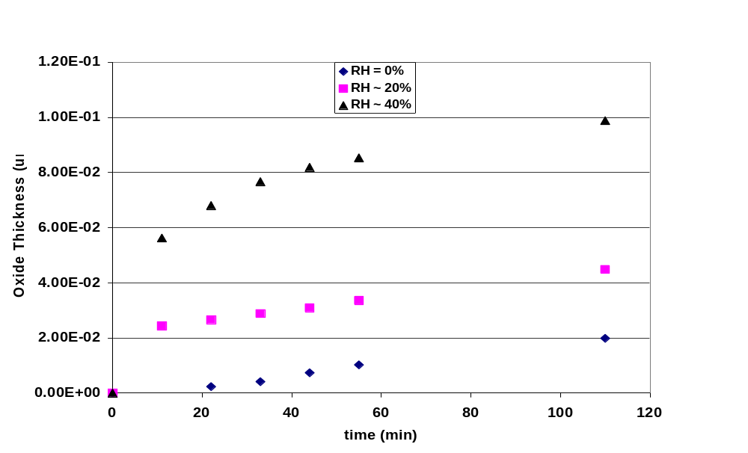
Figure 14. Time-progressive development of oxide thickness for CdTe treated at 500ºC at different ambient humidity.

XPS survey analysis of the films after the 100 minute treatments (Figure 15-top) shows only Cd, Te and O peaks at the exposed surface, and yields concentrations consistent with CdTeO₃: 20 wt% Cd, 20 wt% Te, 60 wt% O, irrespective of ambient humidity. Sputter etching (Ar⁺, 2kV, 25 mA) showed that for the film oxidized in dry air, the oxide was removed after 180 minutes (Figure 15-bottom, left). For the film oxidized in humid ambient, oxygen was still present after etching for 260 minutes (Figure 15-bottom, right). The transition from Te-O bonding to Te-Cd bonding is seen in Figure 16 for 10 sputter etch cycles (each ~ 18 minutes duration) of both samples. The saturation of Cd-Te bonds is reached in the dry treatment case after ~ 150 minutes, while it is never reached for the humid treatment case. This experiment, carried out on smooth CdTe films deposited by PVD, is being repeated on CdTe films deposited by VT.

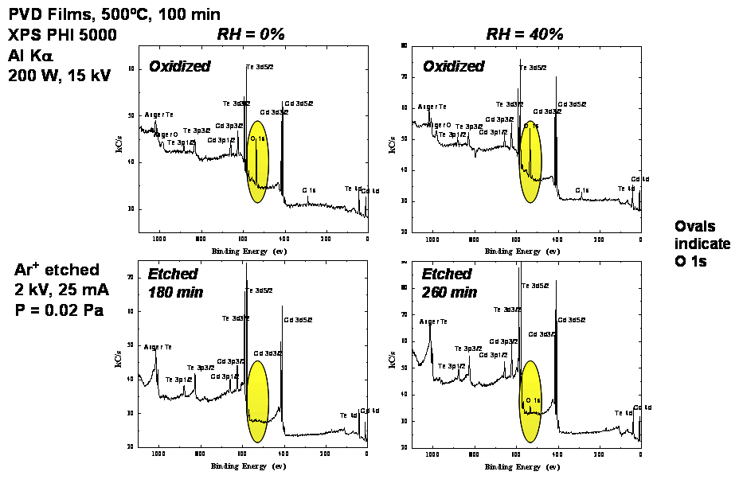
Figure 15. XPS survey scans of the oxidized CdTe films of Figure 13 before and after sputter etching.

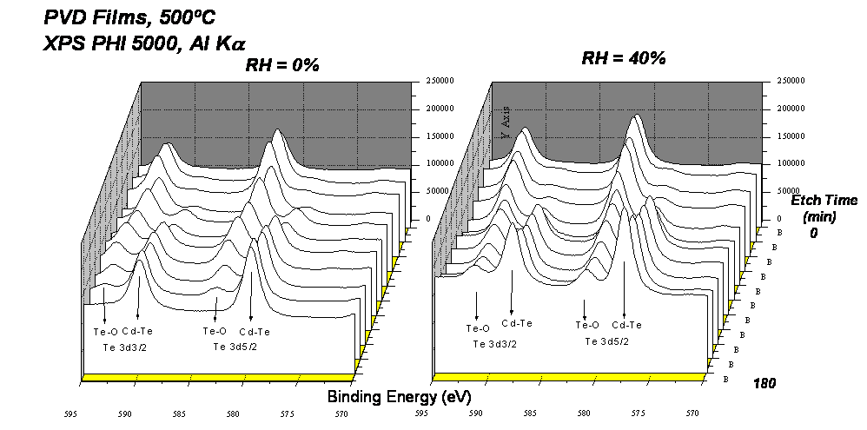

Figure 16. Time-progressive XPS scans of the oxidized CdTe films of Figure 13 during the sputter-etch process.

The effect on device operation of CdTe oxidation prior to CdCl₂ treatment is alteration of the film stoichiometry at chemical levels, which can affect doping and defect concentrations in the CdTe film. VT devices were fabricated with samples cut from adjacent locations on VT plate 161, with 6 μm thick CdTe and subjected to different processing prior to the CdCl₂ treatment. Otherwise, all three samples received the same fabrication and post-deposition processing. The JV parameters for the three pieces are listed in Table VI and the JV curves are shown in Figure 17. The control sample was stored in vacuum for 1 week after CdTe deposition and yielded 12% efficiency. The sample stored in humid ambient at 40ºC for 16 hours prior to CdCl₂ treatment exhibited lower V_{oc} and FF, with 9.5% efficiency. The sample treated in humid air at 400ºC for 5 minutes prior to CdCl₂ treatment also exhibited lower V_{oc} and FF, with the FF being the predominant loss. Another signature of cells exposed to humidity prior to CdCl₂ treatment is pronounced hysteresis between forward and reverse J-V scans, suggesting the existence of metastable states in the CdTe film or at the contacts. Since all samples were etched with the aggressive BDH process and had identical contacts, the origin of the metastability is likely in the CdTe film. The JV data clearly shows that exposure to humidity prior to CdCl₂ treatment is detrimental to device operation. It is suspected that stoichiometric change brought about by the reaction with humid air, which initially preferentially removes Te to form TeO₂, shifts the internal film stoichiometry sufficiently to limit the ability to form V_{Cd} needed for p-type conductivity. In these cases, the subsequent CdCl₂ treatment doesn’t “heal” the film and a poor diode, dominated by low FF, is obtained.

Table VI. Conditions prior to CdCl₂ treatment and device results for cells with VT CdTe.

Piece | Condition  prior to vapor CdCl2 | V_{oc}  (mV) | J_{sc}  (mA/cm2) | FF  (%) | Eff  (%)
161.2 | Vacuum Stored  25ºC, 1 week | 812 | 23 | 64 | 12.0
161.1 | Stored in air 40ºC, 16H  (~0.1 g/L) | 764 | 22.5 | 56 | 9.5
161.4 | HT in air 400ºC, 5 min  (5 g/L) | 778 | 22 | 45 | 7.5

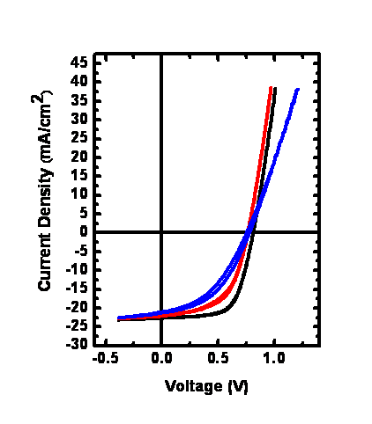
Figure 17. Light JV curves for the devices of Table VI.

The fabrication of CdTe thin film cells relies on the delivery of CdCl₂, O and Cu at various stages of the post deposition processing. We have shown that for VT CdTe, the optimized process can be disrupted by the condition of the films prior to CdCl₂ treatment. In order to further elucidate the role of oxygen in the post-deposition process and to separate the O effects from Cu effects on junction operation, a matrix of cells was fabricated with and without intentional Cu added at the back contact and with different ambient conditions during the CdCl₂ treatment (Table VII). The samples were all cut from the same VT plate, stored in vacuum until use and received Ni contacts at the same time. The post-deposition treatments were: 1) no CdCl₂ treatment; 2) vapor CdCl₂ treatment for 25 minutes in Ar ambient; 3) vapor CdCl₂ treatment for 30 seconds in Ar + O₂ ambient followed by 24.5 minutes in Ar ambient; and 4) vapor CdCl₂ treatment for 25 minutes in Ar + O₂ ambient (baseline conditions). Cells with no CdCl₂ treatment had similar poor performance, dominated by low J_{sc}, independent of the presence of Cu in the contact. Cells with vapor CdCl₂ treatment in Ar ambient with no Cu exhibited low V_{oc}, high FF, light-dark crossover and rollover. High V_{oc} with no JV anomalies were obtained with the addition of Cu to the back contact. Cells with vapor CdCl₂ treatment in ambient with oxygen present for a short period at the start of the treatment exhibited comparable results, with some hysteresis found for the sample without Cu at the contact. Cells with baseline processing, i.e., with oxygen present throughout the vapor CdCl₂ treatment, yielded the highest V_{oc} but not the highest FF. A detailed diode analysis is needed to further quantify and separate out the actions of the different treatments on the electronic constituents of these devices. Similar results were obtained but not published in an identical experiment with PVD devices conducted at this lab in the mid-1990’s.

Table VII.JV results for VT devices fabricated with and without intentional Cu and under different ambient conditions during vapor CdCl₂ treatment.

Piece | CdCl2  temp, time | Ambient | Cu  Thk  (nm) | Voc  (mV) | Jsc  (mA/cm2) | FF  (%) | Eff  (%) | Comment
125.41 | None | - | 0 | 584 | 11.5 | 45 | 3.0 | LDX, Roll
125.42 | None | - | 15 | 606 | 10.5 | 55 | 3.5 | LDX
125.61 | 415ºC, 25 min | Ar | 0 | 603 | 23 | 63 | 8.7 | LDX, Roll
125.62 | 415ºC, 25 min | Ar | 15 | 773 | 23 | 61 | 10.8
125.11 | 415ºC, 25 min | 20% O₂30 s | 0 | 704 | 22.5 | 65 | 10.3 | Hyst
125.12 | 415ºC, 25 min | 20% O₂30 s | 15 | 755 | 23 | 65 | 11.3
125.51 | 415ºC, 25 min | 20% O₂ | 0 | 795 | 23 | 61 | 11.1 | Hyst, LDX
125.52 | 415ºC, 25 min | 20% O₂ | 15 | 788 | 23 | 59 | 10.7
LDX = light-dark crossover on JV plot
Roll = “rollover” in JV characteristic at V > Voc
Hyst = hysteresis between forward and reverse JV sweeps

The implication of Cu in some degradation modes of CdTe cells provides a motivation for investigation of Cu-free contacts. The potential hazards of working with CdCl₂ provide a motivation for finding alternative, safer, treatment agents to activate the junction in CdTe/CdS cells. An experiment was conducted to examine the effect of Cu thickness in the Cu/Ni contact and the utility of ZnCl₂ treatment to activate the junction (Table VI). All cells were treated with 20% oxygen in the treatment ambient. As found with the previous experiment (Table V), efficiency > 10% was achieved without Cu in the back contact, but the cells exhibit light-dark crossover and roll-over in the forward bias characteristic. However, Cu in the contact raises V_{oc} and FF, with 13% efficiency obtained for vapor CdCl₂ treatment at pCdCl₂ = 3 mTorr. Using a vapor ZnCl₂ treatment, with pZnCl₂ = 3 mTorr and using the optimized Cu/Ni contact yielded similar cell performance as obtained with vapor CdCl₂ treatment with Ni only. It is believed that re-optimization of the Cu/Ni contact process may lead to higher performance using vapor ZnCl₂ treatment.

Table VIII. JV results for VT devices fabricated with different Cu thickness and with ZnCl₂ treatment.

Piece | Halide  Vapor | Ambient | Cu  Thk  (nm) | Voc  (mV) | Jsc  (mA/cm2) | FF  (%) | Eff  (%) | Comment
127.6 | 5 mTorr CdCl2 | 20% O2 | 0 | 749 | 23 | 62 | 10.5 | LDX, Roll
127.4 | 5 mTorr CdCl2 | 20% O2 | 10 | 791 | 23 | 68 | 12.5
127.5 | 5 mTorr CdCl2 | 20% O2 | 15 | 801 | 23 | 71 | 13.0
127.2 | 5 mTorr ZnCl2 | 20% O2 | 15 | 746 | 23 | 62 | 10.5

2.2 Back Contact Processing Options

The following section was recently published in a special issue of Solar Energy (vol. 77 (2004) p. 839).

Introduction

Due to the high work function of CdTe, ohmic contact formation is not possible with metal films. Pseudo-ohmic contacts are, therefore, produced by making the CdTe back surface more p-type. Thus, while increasing the barrier height for electron flow at the back contact interface, the resultant narrowing of the barrier allows electron tunneling. Formation of a pseudo-ohmic contact is usually obtained by the introduction of impurity metals at the back contact interface. Though a number of metals have been used to produce CdTe back contacts, including Au, Pb, Ni, Hg and Ag, Cu is almost ubiquitously employed. CdTe itself is difficult to dope with impurity atoms, therefore, to produce a p+-surface, a Te-rich surface is nearly always produced during back contact processing to improve the efficiency and extent of the impurity doping or reaction at the back contact interface. However, this observation and the high Cu concentrations generally used, suggest that a chemical reaction takes place at the back contact to produce a bulk phase contact material as opposed to the concept of a ‘doped’ CdTe back surface.

A number of steps are required for the successful formation of back contacts to CdTe/CdS devices; and nearly every research group applies their own contacting method, via different and varied empirically derived approaches. Often the steps employed have a historical basis, may not be necessary for successful back contact processing and may only complicate possible industrial scale up. The procedures employed for back contact processing of CdTe/CdS devices by most laboratories generally incorporate the following steps; i) removal of residual surface oxides and other contaminants on the CdTe surface, ii) formation of a Te-rich surface to improve CdTe reactivity for contacting, iii) application of Cu or other impurity metals, iv) formation of the back contact, generally via annealing, and v) application of secondary contact and device completion. Many different contacting procedures have evolved empirically. Some may incorporate single treatments, which accomplish more than one of the above steps or some steps may not be required; for example, uninterrupted in vacuo CdTe processing is unlikely to require the removal of surface oxides, but the basic process sequence generally remains constant. Our approach is to begin to understand the fundamental materials chemistry of each of the common processing steps. With this, the goal is to develop a simple and universally applicable process that offers good quality and stable back contacts for CdTe/CdS for devices, irrespective of CdTe history and properties. In this section, each of the above processing points will be discussed, including briefly reviewing recent experiments at IEC and some of the recent literature.

Etching of CdTe

Prior to contacting, the CdTe back surface generally must be modified, as described above, to remove residual oxides and to form a Te-rich CdTe surface. Most research groups generally employ a wet chemical etch step to achieve either or both of these modifications. At an industrial scale, due to the corrosive nature of most etchants, ‘dry’ techniques are being sought. However, wet chemical etching is used in a number of electronic technologies to achieve contaminant-free materials surfaces. For CdTe back contact processing, wet etches allow fast treatment times and are generally easy to use in the laboratory, requiring only small volumes and often no heating of the solution. CdTe etchant chemicals, however, tend to be toxic, corrosive and reactive. Common etchants include Br₂/methanol solutions (BM) and aqueous nitric acid/phosphoric acid mixtures (NP). Other CdTe etchants have included, H₂O₂, hydrazine, thiosulfate, acidified dichromate, citric acid, ammonia and alkali metal hydroxides. One treatment that has had very good success at IEC, but also highlights the hazardous nature of these treatments, is the Br₂-Dichrol-Hydrazine (BDH) etch.Error: Reference source not found This treatment consists of three steps; a short etch in dilute BM to remove residual surface oxides, immediately followed by a dip in acidified dichromate (commercial dichrol solution) to produce a mixed Te/TeO₂ surface, and finally immersion in potentially explosive hydrazine at ∼55°C to reduce surface TeO₂ to Te. This treatment generates a good quality, 50 nm crystalline-Te (c-Te) surface layer on CdTe. At an industrial level, where the use corrosive chemicals may need to be avoided, pre-contact surface treatments may be ignored or less corrosive chemicals sought. For example, organic multi-dentate ligands, including diaminoethane and ethylendiaminetetreaacetic acid, EDTA, has had some success in an industrial process. The action of such etches is thought to progress by solubilizing the Cd²⁺ ions from the CdTe surface by complexation, and leaving a Te-rich surface layer.

A number of factors regarding wet etching during contact processing are, however, of concern. These include; i) the behavior of residual etchant within the grain boundaries, which is not understood in relation to device chemistry and performance, ii) the effects of the atmosphere on the freshly etched CdTe surface prior to application of Cu, iii) effects of the significant changes to film and GB morphology following etching on device performance, and iv) the irreproducibility of wet etches, due to subtle differences in solution and substrate conditions, which may produce inconsistent surface products and morphological effects. Considering these points, and also the ease of industrial scale-up, considering the safety and disposal issues, of the contacting process, ‘dry’ or vacuum processes to form Te-rich CdTe surfaces have also been used.

Despite their widespread and historical use, the mechanism and dynamics of these etches on CdTe are not well understood. A knowledge of etchant behavior and the nature of the CdTe surface throughout the reaction, including its reactivity towards the atmosphere and back contact metals, will assist optimization of wet chemical treatments and contact processing to achieve the development of stable back contacts to CdTe/CdS devices. The development of a universal and safe wet etchant that can be easily applied to CdTe films, independent of thickness and history, would be advantageous for scale-up of the CdTe device processing.

As discussed in a previous section, CdCl₂ treatments of CdTe can, depending on treatment conditions, produce a range of Cd and Te surface oxides. The presence of significant oxide on the CdTe can produce an insulating and unreactive surface, and thus prevent the formation of a favorable back contact. If a wet chemical etch is used to produce the Te-rich surface for contacting, then the single treatment can suffice for both oxide removal and Te generation. However, for ‘dry’ depositions of Te for contacting or in order to carry out measurements or experiments directly on the CdTe surface, removal of the residual oxides is required. For this, short etches in weak BM solutions, ca. 5s in ∼0.01% BM, successfully removes the oxides without significant etching of the CdTe itself. Following etching, samples should be removed from the atmosphere, or immediately continued to the next processing step to minimize atmospheric oxidation of the surface.

The chemical treatments required for the formation of a Te-rich CdTe back surface for contacting, commonly involve an oxidation step, e.g. Br₂ and nitric acid, of BM and NP, respectively, are oxidizing agents. These treatments oxidize surface telluride ions, Te²⁻, to elemental tellurium, Te⁰, and dissolve Cd²⁺ ions, which are unable to remain in a tellurium environment, from the film. Reducing and complexing treatments have also been applied to CdTe devices. For successful back contacting, generally treatments of 5-20s in 0.1 - 1% BM or a ∼60s in aqueous ∼1% HNO₃:∼70% H₃PO₄ mixture (NP)Error: Reference source not found,, are used. As NP etching progresses, the formation of bubbles on the Te surface is generally observed after ∼20s immersion. These bubbles are due to the formation of gaseous NO or NO₂ products. The time for bubbles to appear can vary, dependent on temperature, solution concentration and the presence of surface oxides. The acidity of the NP etch is expected to remove any tellurium oxides formed during treatment.Error: Reference source not found Following etching, the CdTe surface is silvery-gray and roughened, due to GB etching, with a ∼50 – 100 nm surface Te layer. Error: Reference source not found,Error: Reference source not found,Error: Reference source not found Because of the aggressive nature of the NP etch, this treatment can generally only be used for etching thicker, >∼5 μm, CdTe layers. BM etching produces a polished CdTe surface, generally consisting of ~7-8 Å Te surface layer without significant GB etching.Error: Reference source not found,Error: Reference source not found

Understanding the nature of the CdTe surface prior to, during and following etching is critical importance to the successful optimization and outcome of the back contacting process. We have recently reported the use of the surface sensitive techniques VASE and GIXRD to monitor effects of etching the CdTe surface, to clarify etch chemistry and the nature of the CdTe surface both during and following treatment.Error: Reference source not found Figure 18 shows the 1.5 to 4.6 eV range of the ε₂ vs. photon energy spectra, obtained from VASE, of 5μm CdTe/ITO/7059 films prior to and following etching in NP and BM. ε₂ is the imaginary part of the complex dielectric constant and is proportional to the absorption coefficient of the material. Therefore, with knowledge of the electronic transitions of different materials, peaks in the ε₂ spectra can be directly related to materials present within the sample.Error: Reference source not found The ε₂ spectrum of unetched CdTe (curve a) contains two peaks at 3.3 and 3.9 eV. These peaks are due to the E₁ and E₁+Δ₁ transitions of CdTe, respectively. The CdTe peak intensity, with respect to the 3.3 eV transition, depends on the presence of native oxides, highlighting the use of the non-destructive VASE technique as a research and industrial processing diagnostic tool for fast analysis of the CdTe surface. Following 25s NP etch, the ε₂ spectrum now contains a single broad peak at 2.1 eV, due to Te (curve b). The CdTe peaks are barely detectable, indicating a high degree of Te on the CdTe surface. Within a few minutes of etching, the Te peak was observed to grow and sharpen in subsequent VASE scans, before finally reaching a maximum intensity, due to crystallization of surface Te, which was confirmed with rapid GIXRD measurements. Figure 19 shows the sequential GIXRD scans, ∼3 mins apart, of a CdTe sample immediately following a 25s NP etch. The Te (101) reflection at 27.6° is observed to grow, completing crystallization after ~10 min following etching.

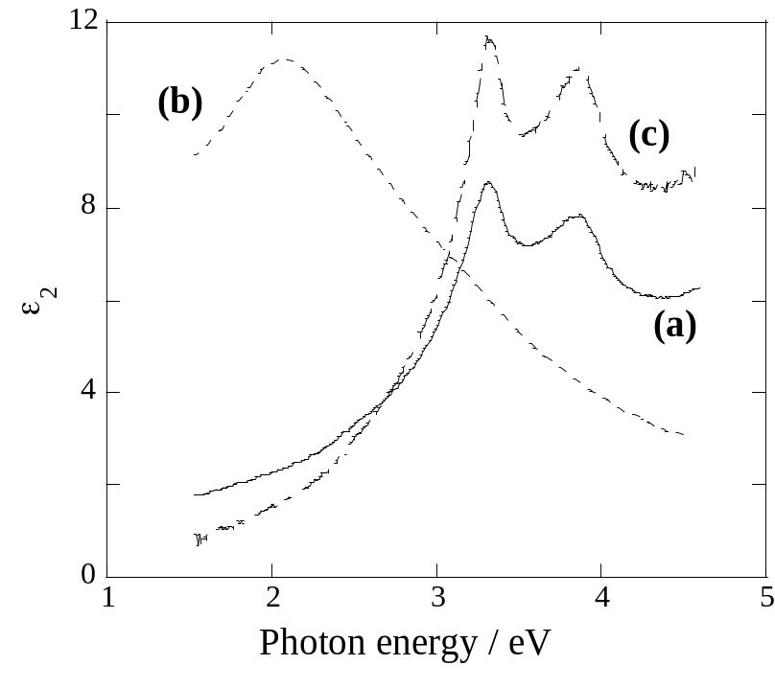
Figure 18. VASE ε₂ spectra of (a) an unetched CdTe film and CdTe films following etching in (b) NP1 for 25 sec and in (c) 0.1% BM for 10 sec.

TABLE

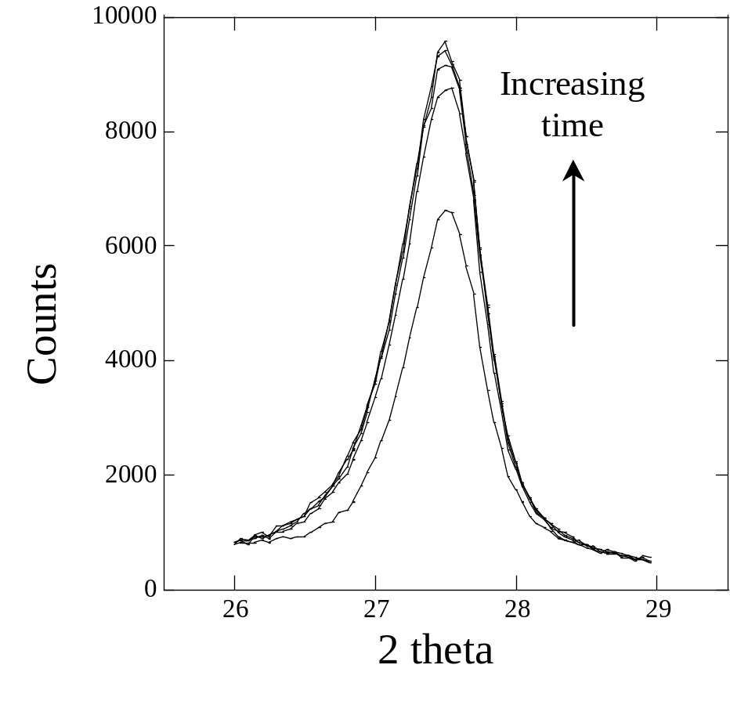
Figure 19. Time-progressive GIXRD patterns of Te (101) reflection, for a CdTe film immediately following a 25 sec NP1 etch. Incident angle was 2° and each scan cycle is ∼3 min apart.

NP Etching for <35s results in amorphous-Te (a-Te) films that spontaneously crystallize following removal from solution. Crystallization time increases for shorter etches, e.g. less than 5 min for a 35 sec etch to over 1 hr for a 15 sec etch. a-Te is known to be unstable at room temperatureError: Reference source not found and spontaneously crystallizes. The slower crystallization with shorter etches can be attributed to the lesser amounts of generated a-Te requiring a longer time to complete molecular rearrangements. It was found that for NP etches >40s, crystallization occurs during etching and a c-Te film is observed.

In contrast to NP, curve c in Figure 18 shows that, following BM etching, only an increase the CdTe VASE ε₂ intensity is observed. This is due to smoothing of the surface, which produces a greater surface sampling area and reduces scattering. Only very thin Te films are expected, and hence, no Te peak is observed with VASE or GIXRD. Modeling of the VASE data has indicated a 7-8 Å Te surface layer is formed, which is consistent with literature data. From VASE measurements, BM etching has been found to be reproducible, giving very similar surfaces on CdTe films of differing microstructure and surface oxide amounts. This very important result allows confidence in the nature of the surface following BM etching.

IEC has also developed ‘dry Te’ or all-vapor processes for back contact processing.Error: Reference source not found,Error: Reference source not found A Te layer of only a few nm thickness can be deposited by vapor deposition or evaporation before application of a Cu layer and other back contact components. These dry processes completely avoid difficulties in handling corrosive chemicals and contamination of the device structure. Smooth crystalline Te films are deposited with good reproducibility and control of film thickness. Devices with 12% efficiency have been processed using dry Te contacting process.Error: Reference source not found However, preparation for dry and/or high vacuum techniques can take significant time, prevention of atmospheric oxidation of deposited layers is critical, and the scale up of such processes may involve far greater start-up costs and difficulties. We note, however, that a wet etch may still be required to remove residual oxides formed during optimized CdCl₂ treatment.

Atmospheric Oxidation of Te on Etched CdTe

Delays in contacting the devices following Te formation, and exposure to atmosphere allows the formation of oxides on the CdTe surface. These will affect reactivity of the Te layer and, hence, affect back contact formation, performance and reproducibility. VASE has been used to monitor the stability of freshly etched CdTe surfaces towards atmospheric oxidation.Error: Reference source not found Figure 20 shows the amplitudes of the 2.1 eV and 3.3 eV photon energies obtained from ε₂ spectra of 25s NP and 60s 0.01% BM etched CdTe films, respectively, over the first 100 min following etching. These energies coincide with the Te peak and CdTe E₁ peaks for NP and BM etched pieces, respectively, of the Figure 20 ε₂ spectra. As Te cannot be detected following BM etching, the CdTe E₁ peak is profiled as oxidation of the surface will result in a decrease in dielectric response and, hence, spectral intensity. A decrease in the CdTe E₁ peak is used as a signature for the formation of a surface layer, resulting in a loss of CdTe sampling depth, and, therefore, a loss in intensity.

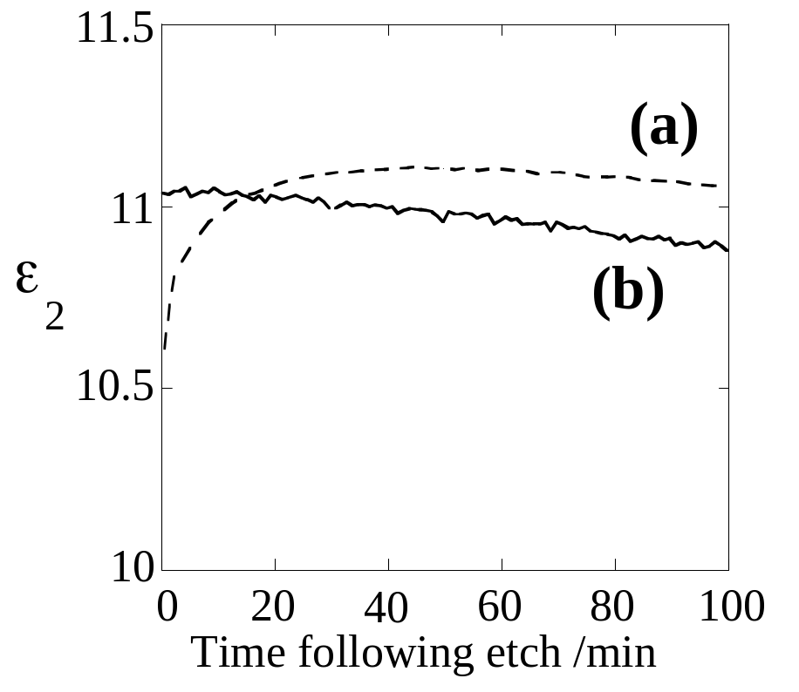

Figure 20. Time profiles of ε₂ from (a) 25 sec NP1 and (b) 60 sec 0.1% BM etched CdTe films. ε₂ values were obtained at 2.1 eV and 3.3 eV, respectively.

Following NP etching, a rapid increase in intensity is observed due to Te crystallization. Following completion of crystallization, no changes are observed until ∼60 mins after etch, when the intensity begins to decrease as a result of atmospheric oxidation. This oxidation continues till around 7-8 hrs after etching. No oxidation was apparent on NP etched CdTe films that were stored in vacuum or dry air immediately following etching, suggesting humidity plays a significant role in atmospheric oxidation of Te. Following BM etching, oxidation of the Te begins almost immediately and continues for 3-6 hours. The fast oxidation of the BM etched surface can be attributed to the Te film being very thin and amorphous. These observations highlight the need for cells to be contacted immediately following Te formation to minimize oxidation of the surface.

Application of Cu

There are several methods to apply Cu to the CdTe back surface, including evaporation of thin Cu films onto the CdTe surface, application of graphite paste containing Cu powder, Cu salts or compounds or Cu-doped alloys, and dipping or spraying the surface with Cu salt solutions. An anneal step is generally required following contacting to force the chemical reaction between Cu and Te to completion, to form the desired copper telluride, Cu_{2-x}Te, phaseError: Reference source not found and distribute Cu into the CdTe film. The application of a secondary contact, to provide for lateral current conduction, is also generally required to complete the back contact. The order of these steps is not always critical, being dependent on the nature of Cu deposition and simplification of the process. Sometimes following annealing and deposition of a metal film secondary contact, a short BM etch, which freely penetrates most metal films, is applied to remove excess Cu from the CdTe surface and GBs.Error: Reference source not found The presence of excess Cu at the junction and/or in the CdS layer, distributed by GB diffusion, has been suspected as a possible component of the instability exhibited by some CdTe/CdS devices.Error: Reference source not found

Vacuum evaporation of high purity Cu for back contact formation of CdTe devices offers good control of deposited metal layer thickness, which allows for careful tuning of the amount of applied Cu to give stoichiometric Cu_{2-x}Te back contacts. The Te layer and metal secondary contact can also be sequentially deposited during the same vacuum process. Annealing of the back contact can also be carried out under vacuum immediately following contact deposition, thus avoiding any deleterious contact with the atmosphere. However, despite the control of deposited Cu, this method delivers an amount of Cu in excess of that required for successful contacting. High-vacuum techniques also require significant purging and pump down times and generally only a limited number of pieces may be processed at any given time in a laboratory setting.

The use of graphite pastes containing a Cu source allows fast and vacuum-free processing of back contacts, and has received much use at a research level. The paste, containing a suitable impurity additive, is merely applied or painted through a mask to a freshly etched CdTe surface and the device is annealed following drying. The graphite paste also acts as the current carrying secondary contact, but can also be coated with metal paste to improve conductivity. Acheson electrodag (#505-SS) is generally the graphite paste used, and often contains resins to improve adhesion and strength of the baked graphite layer. A number of Cu-source additives can be used, including elemental Cu powder, simple Cu salts and compounds, and Cu-doped alloys, e.g. Cu:HgTe and Cu: ZnTe. Care must be taken to ensure homogeneous mixing of the paste and additives.

Methyl ethyl ketone or similar is commonly used as the paste solvent. We have compared a range of Cu-based additives of elemental Cu powder, simple Cu⁺ and Cu²⁺ salts, and Cu²⁺ complexes with simple chelate ligands. Table IX lists the JV characteristics of CdTe/CdS devices contacted with graphite pastes containing these additives. An indicator for series resistance in JV behavior is the slope, dV/dJ at V_{oc}, which is represented as R_{oc}. For high performance devices, R_{oc} is typically less than 2 mS/cm², and devices having poor contact behavior or high contact resistance exhibit R_{oc} in excess of 10 mS/cm². In Table IX, we list R_{oc} and qualitative JV curve characteristics, including forward bias curvature (rollover), crossover between the light and dark curves (crossover), and forward-reverse JV retrace hysteresis. Rollover is a manifestation of a back-contact barrier as demonstrated in other work.Error: Reference source not found Crossover between light and dark curves, or loss of superposition, is commonly attributed to photoconductivity in the device. The occurrence of low-frequency (0.01-1 Hz) hysteresis can be due to either deep traps states in CdTe or additional capacitance from an insulating surface layer. GIXRD measurements have shown residual oxide phases present at the back surface on devices that exhibit significant retrace hysteresis. In Table IX, pastes containing Cu powder, Cu⁰, or Cu⁺ salt additives produce the best devices with the lowest R_{oc} and the least amount of crossover or hysteresis. Simple dehydrated Cu²⁺ salts can produce reasonable back contacts, but tend to yield lower performance than Cu⁺ salts. Cu²⁺ chelate complexes do not produce good contacts due to the stability of these molecules preventing reaction of Cu ions with Te.

Table IX. J-V characteristics for CdTe/CdS devices contacted with graphite paste back contacts containing the listed Cu additives. The strength of the effects are indicated by Y = yes, W = weak and N = no.
Cu source |  | Cu State | R_{oc}  (mS/cm²) | Roll-  over | Cross-  over | Hysteresis
none |  | - | 34.8 | W | Y | W
Cu salts | Cu powder | 0 | 13.6 | N | Y | N
 | CuCl | 1 | 13.1 | N | W | N
 | CuI | 1 | 11.2 | N | W | N
 | CuSCN | 1 | 17.7 | N | Y | N
 | CuCN | 1 | 30.1 | Y | Y | W
 | Cu(acetate) | 2 | 24.1 | N | Y | N
Cu complexes | Cu(oxalate) | 2 | 21.4 | N | Y | W
 | Cu(maleate) | 2 | 63.7 | N | N | N
 | Cu(succinate) | 2 | 25.2 | N | Y | N
 | Cu(phthalate) | 2 | 35.2 | N | Y | N
 | Cu(8-quinolinol) | 2 | 34.8 | N | Y | N
 | Cu(EDTA) | 2 | 85.8 | N | Y | N

While the concentration of Cu in the paste can be well controlled, an excess of Cu must be delivered to the device to ensure surface reaction and to dope the CdTe p-type, though only a limited amount of Cu will initially react with the Te-rich CdTe surface. Thermal treatment, such as experienced during contact annealing and accelerated life testing, of completed CdTe devices is likely to diffuse excess Cu from the paste into the CdTe.Error: Reference source not found Scale-up to industry may be difficult, though screen-printing, spin coating, spray or simple painting approaches have been demonstrated. A similar approach has been reported at an industrial scale, where a clay-based dielectric paste containing Cu salt additivesError: Reference source not found is applied to the Te-rich CdTe surfaces for contacting. To complete devices, however, the paste had to be removed and conducting contacts applied.

Another method to deliver Cu species is via application of Cu salt solutions, by dipping or spraying onto the CdTe surface, or by evaporation.Error: Reference source not found Dipping allows a small amount of Cu to become incorporated in the device, however, and similar to the solution CdCl₂ treatments, complete and uniform coverage of the surface cannot be guaranteed as the sample dries, resulting in a loss of control of the amount of Cu applied. Spray or evaporation methods allow more uniform delivery of precise quantities of Cu species to an area of substrate. Based on the work with Cu-Te metal contacts, devices with Cu₂Te, with Cu in the +1 valence state, Cu⁺, yield the highest efficiency. This also seems to extend to the optimal valence state for Cu salts, as shown in Figure 21. In the figure, devices were fabricated by spraying identical quantities of methanol solutions of CuCl and CuCl₂ onto dry etched CdTe, heating at 200°C for 20 minutes, then applying graphite contacts. Devices prepared with Cu⁺ salt exhibit 50 mV higher V_{oc} and higher FF than devices prepared with Cu²⁺ salt. Furthermore, no crossover was found between light and dark curves for devices prepared with Cu⁺, indicating superposition of the dark diode characteristic. GIXRD analysis of the samples of Figure 21 show Cu₂Te phase for the sample prepared with CuCl, Cu⁺, and CuTe phase for the sample prepared with CuCl₂, Cu²⁺. Thus, solutions of Cu⁺ salts seem preferable, though solutions containing simple dehydrated Cu²⁺ salts can produce reasonable devices. For application of Cu⁺ salts, dry non-aqueous solvents must be used as Cu⁺ ions are generally unstable in aqueous conditions. After delivery of the Cu salt, the samples require annealing to promote reaction with Te, which can be carried out before or after application of the secondary contact.

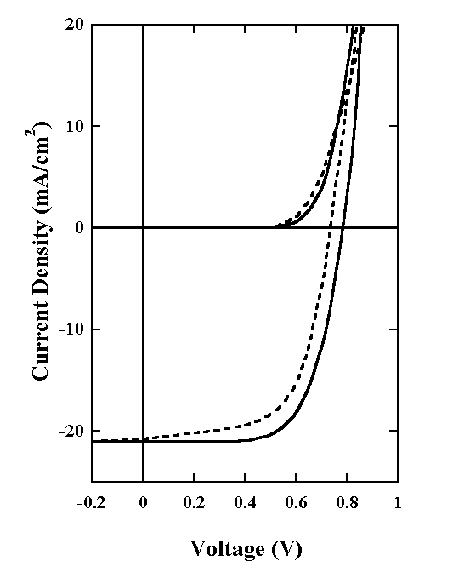
Figure 21. Light and dark JV curves for CdTe/CdS devices processed with methanol solutions containing CuCl (solid) and CuCl₂ (dotted).
Other Back Contacts

A number of other, “Cu-free”, back contact materials, deposited by various methods, have been evaluated for CdTe devices e.g. including vacuum evaporated ZnTe and Sb₂Te₃, and solution deposited metals and NiTe2.Error: Reference source not found Generally, these contacts have not been superior to Cu-based contacts, or not as simple to process as some of the Cu-based options. The unexpected Cu contamination in some “Cu-free” cell processes may also have led to reported high device efficiencies. The success of Cu-based contacts, the simplicity of Cu application, and the difficulty in avoiding copper contamination in CdTe, CdS and back contacts, indicate that Cu containing contacts are yet a worthwhile R&D challenge for future successful device and module processing. However, this will require thorough understanding and control of the chemistry of Cu throughout the device structure, both during processing and post-fabrication, operational stresses.

Back Contact Anneal

Annealing of devices following Cu application is almost always required to produce the desired Cu_{2-x}Te back contact.Error: Reference source not found Most back contact anneals are carried out at 150 – 250°C for times of ∼20-60 mins. Annealing should always be carried out in a dry, inert atmosphere or under vacuum to avoid oxidation. Thin Cu films, Cu⁺ ions and Te are susceptible to reaction with O₂ and water vapor, producing stable and insulating oxides.

The reaction between Cu metal and elemental Te is spontaneous, but heating is required to ensure this reaction goes to completion, or to force the reaction of Cu ions/salts with Te. Previously we showed the formation of Cu_{2-x}Te on devices with back contacts formed by deposition and annealing of stoichiometric Cu and Te layers on CdTe.Error: Reference source not found Interestingly, the transformation of Cu_{2-x}Te to CuTe with device stressing has been observed, linking chemical changes in the back contact with device degradation.Error: Reference source not found Literature on the electrical properties of the Cu-Te compounds is sparse; and we speculate that the difference in electrical properties of CuTe and Cu_{2-x}Te account for the increased R_{oc} and forward bias rollover observed for stressed devices. In comparative studies we have found that the CuTe phase dominates contacts formed by application of Cu powder/graphite pastes to NP and BM etched CdTe surfaces (Figure 22). The difference in phases observed between the paste contact and stoichiometrically deposited metallic films is accounted for by excess surface Te and slow Cu delivery from the graphite paste. This observation highlights that CuTe may be a reasonable back contact, though likely poorer than Cu_{2-x}Te.

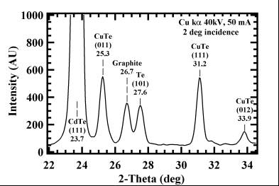

Figure 22. GIXRD plot, at 2° incidence, of a 60s NP etched CdTe film obtained following removal of a Cu powder/graphite paste contact.

Significant diffusion of Cu throughout the cell structure occurs during the back contact anneal, which leads to an increase in accumulated Cu at the junction/CdS region of the device.Error: Reference source not found In addition, untreated CdTe/CdS structures, without purposefully added Cu, already contain significant Cu levels in the CdTe and CdS layers.Error: Reference source not found With contacting and subsequent thermal stressing, the level of Cu increases in both CdTe and CdS layers, which reduces junction quality, manifested by a loss in V_{oc} and FF. We have carried out controlled experiments in which Cu was introduced to the device structure as a thin metal film between the CdS and CdTe and also between the CdS and the TCO. These devices exhibited markedly lower V_{oc} and FF than control devices, with the CdS exhibiting photoconductivity which was evident in short wavelength QE.

Secondary Contacts and Device Completion

The secondary contact is the robust current-carrying contact. The most common secondary contacts are metal films or graphite paste. For back contacts produced from Cu-containing pastes, the graphite layer acts as both the Cu source and secondary contact. The secondary contact also protects the back contact from mechanical abrasion and from the atmosphere. Graphite paste, for example, will immediately seal the surface, preventing contact with the atmosphere, and should be applied immediately following etching or application of Cu. Following annealing, the dried graphite paste will be somewhat permeable to the atmosphere, however, both the thickness (~ 100 μm) and the gettering properties of the graphite may indeed provide some additional protection to the back contact from O₂ and water vapor over contacts made with thin metal films. The secondary contacts have been shown to influence device performance and stability.

Completion of devices requires isolation of the cells by scribing and metallization of the front contact. The secondary contacts should be isolated, by scribing, to prevent current collection outside the back contact area. The front contact is generally completed by application of In or other metal solders or metal pastes/paints to exposed CdS or TCO.

Contact Stability

Thermal stressing in air of devices contacted with Cu-doped graphite has shown increased performance degradation compared to devices thermally stressed in dry inert atmospheres, though no difference in the rate of Cu diffusion through the devices was observed. This reinforces the concept that chemistry changes in the back contact region primarily dominate device stability and that it is critical to protect the back contact from the atmosphere during processing and stress. While modules in the field will be encapsulated from the atmosphere, effects of exposure to the atmosphere during processing or effects on device performance if encapsulation failure occurs, need to be understood.

We have recently shown Cu-based contacts that are less susceptible to atmospheric effects. A series of devices processed at IEC and other sources were stressed for an extensive period of time in the dark at 80°C in atmospheres of varying humidity levels. Devices contacted with Cu/Au films deposited on a thick, ∼100 nm, Te film, produced by a BDH etching followed by Te evaporation, showed significant chemistry occurring during stress, e.g. formation of TeO₂ at low humidity and hydroxides/hydrated oxide phases at high humidity. However, very little change in device performance was noted. Other devices, processed with very thin Te layers, while exhibiting good initial performance (>10%), showed significant degradation after 80°C thermal stress. These results suggest that thick Te may make back contacts more robust towards chemical changes and atmospheric oxidation. Due to the chemical affinity of Te for Cu, a thick Te film is also expected to attenuate Cu diffusion through the device by gettering Cu at the back of the device and thus maintaining the favorable back contact for a longer period. This was also confirmed by stress testing of devices with varying back contact Te thicknesses, processed by NP etches of different times and completed with graphite paste containing 6% Cu powder. Initial efficiencies of all devices were similar, however, after stressing for ∼50 days at 80°C in the dark, the devices with thinner Te, or shorter etch times, exhibited back contact degradation as evidenced increased R_{oc}, while the devices with thicker Te contacts showed almost no loss of performance. Thick Te-based contacts contribute to device robustness and may lengthen device lifetime.

Surface Chemistry of Aniline-based Etching

The following section was published in the proceedings of the Spring MRS Meeting, San Francisco, CA, March 2005.

Introduction

Surface preparation of CdTe remains a critical aspect of CdTe/CdS photovoltaic device processing. It is generally accepted that treatment of the surface prior to back contacting is carried out to remove contaminants and to produce a Te-rich layer to allow easier reaction with metal impurities, generally Cu, added to improve back contact properties.Error: Reference source not found, CdTe treatments generally involve oxidizing wet chemical etches, for example Br₂/methanol (BM) and HNO₃/H₃PO₄ (NP), but these often tend to be reactive, corrosive and toxic, and care is required to prevent over-etching of the CdTe surface. Recently, a new surface treatment was reported by Roussillon et al., where CdTe/CdS structures where treated under illumination in red wine and in aqueous solutions based on aniline (see Figure 14a for structure). Following contacting, devices treated with these solutions showed significant improvements in performance, exceeding 11% conversion efficiency, compared to devices that had not received treatment. It was proposed that the observed improvements in initial device performance were due to clogging of pinholes and neutralization of electrical micro-nonuniformities through the adsorption of charged colloids. In the case of the aniline-based treatment, the formation of charged polyaniline colloids was expected via electropolymerization of aniline on the illuminated CdTe surface.

In this section, the chemistry of aniline-based treatments of CdTe is investigated. Particular emphasis is placed on evaluating the nature of the treated surface, identifying and understanding the chemical mechanisms involved and optimizing the treatment conditions for device processing. Device results highlight this treatment to be very promising for processing of good quality CdTe/CdS devices. The toxicity of aniline, however, is a concern and, with understanding of the chemical mechanisms involved, possible substitutes are being sought.

Experimental Details

Standard aqueous aniline baths are based on those of Roussillon et al.,Error: Reference source not found containing 0.1 M aniline, 0.01 M p-toluenesulfonic acid (p-TSA) and 1 M NaCl electrolyte at pH∼6.2. All baths were freshly prepared unless otherwise stated. Samples consisted of ∼5 μm thick CdTe films vapor transport deposited on SnO₂/glass coated with ∼50 nm chemical solution deposited CdS films. Some CdTe films received vapor-CdCl₂ treatment at ∼410°C for 20 min. Aniline-treatments were carried out by illuminating CdTe/CdS samples immersed in the aniline bath in a Pyrex beaker with a 100 W light bulb. The samples were illuminated either through the glass side of the pieces or directly on the CdTe. Devices were processed, following aniline treatment, by applying a Cu-based back contact, completing with a graphite paste secondary contact and annealing for 15 min at 200°C.

Variable angle scanning ellipsometry (VASE) measurements were carried out using a J.A. Woollam rotating analyzer ellipsometer equipped with an auto-retarder. Spectra were recorded at 75° incident angles. For discussion of the theory of this measurement, see reference Error: Reference source not found. Glancing incidence x-ray diffraction (GIXRD) measurements were carried out using a Rigaku D/Max 2100 x-ray diffractometer in asymmetric mode with parallel beam geometry at 40 kV CuK_{α}. Measurements were obtained at 1° incidence angle. Atomic force microscopy (AFM) was carried out using a Digital Instruments Dimension 3100 microscope in tapping mode. Current Voltage (J-V) curves were measured using an Oriel Xenon solar simulator at AM1.5 and 25°C.

Results and Discussion

As observed by Roussillon et al.,Error: Reference source not found following a successful treatment, the CdTe surface changes to a light gray color. Sometimes, following certain treatment conditions, an organic film can be observed on the CdTe surface. The nature of the surface of the treated samples was investigated using VASE and GIXRD. Figures 23b and 23c show the VASE ε₂ vs. photon energy plots and GIXRD patterns, respectively, of CdTe/CdS samples following 1 hr and 5.5 hr treatments in standard aniline baths with illumination on the glass. The VASE spectrum of an untreated sample is also presented, which exhibits the two characteristics CdTe E₁ and E₁+Δ₁ transition peaks at 3.3 and 3.9 eV, respectively.Error: Reference source not found Following treatment, the VASE spectra now contain only a single broad peak at ∼2 eV, similar to those obtained following NP etching of CdTe,Error: Reference source not found that produces a crystalline Te-rich surface. The formation of crystalline Te was confirmed by GIXRD, which shows peak at 27.6°, assigned to the Te (101) reflection. The CdS reflection in Figure 23c originates from areas exposed at the edge of the piece. These data confirm that the aniline-based treatments produce a crystalline Te surface, similar to some oxidizing etches. GIXRD peak analysis indicates that a ∼4.5x increase in generated Te between the 5.5 hr and 1 hr treated samples, suggesting the rate of Te formation is linear with time. Modeling of the GIXRD data indicated a ∼10 nm surface Te film is formed during the 5.5 hr treatment. The presence of a Te-rich surface will improve back contact properties, allowing an easier formation of the Cu_{2-x}Te during contact processing, and accounts for the differences observed between treated and non-treated devices.Error: Reference source not found The GIXRD pattern of a CdTe sample that had received a 5.5 hr treatment shows that more Te has been generated on the CdTe surface compared to the 1 hr treatments. The VASE spectrum of this piece shows a similar intensity to the 1 hr treated piece, despite a greater amount of Te being generated. A dark organic film, most likely polyaniline, was also visible on the surface of the 5.5 hr treated piece. While a stronger Te peak is expected the VASE spectral intensity is decreased through light scattering by the organic film. AFM measurements showed significant changes to the film surface following treatment, with formation of smaller grained Te on the surface of successfully treated films. Organic species were also often detected by AFM on the surface of treated CdTe.
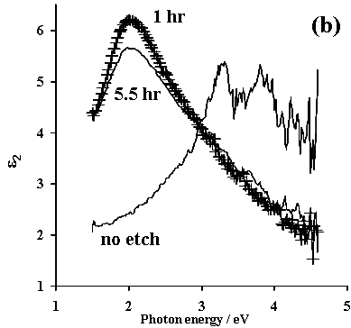
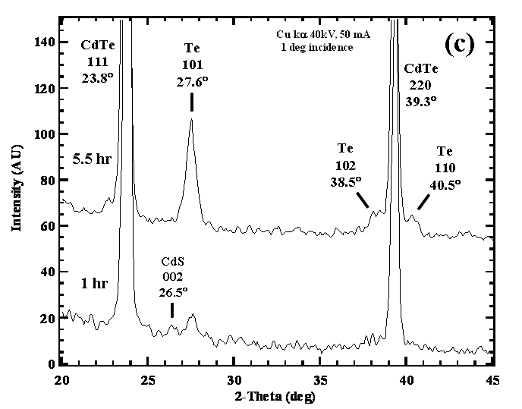
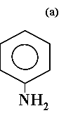
Figure 23. (a) Structure of aniline, and (b) VASE and (c) GIXRD plots of CdTe following treatment in standard aniline-based baths for 1 hr and 5.5 hr with illumination on the glass. The VASE spectrum of non-treated CdTe/CdS is shown for comparison.

To understand the chemical mechanism involved, the effects of varying bath composition and treatment conditions were monitored. The presence of aniline, p-TSA and NaCl, with illumination, was found to be necessary for the etching of CdTe to occur. Increasing aniline concentration had no effect on the rate of the surface reaction, though halving the aniline concentration stopped the reaction. Increasing the concentration of p-TSA also prevented the surface reaction from occurring, suggesting the protonated form of aniline is unreactive to CdTe. This was confirmed by preparing baths based on aniline hydrochloride, which had no effect on CdTe when treated under illumination. The protonated form of aniline is known to be more difficult to oxidize or polymerize. The p-TSA is, therefore, likely only required to improve aniline solubility and was successfully substituted with a range of other organic acids, indicating the species itself is not critical to the surface reaction. Increasing the NaCl concentration enhanced the rate of reaction and resulted in the formation of adsorbed polymer on the sample surface, while no reaction occurred in the absence of the electrolyte. Adding KCl showed similar behavior to NaCl; however, adding NaBr or NaI electrolytes significantly attenuated the reaction. Removing O₂ from the bath, by Ar(g) purge, and from the CdTe surface, by a short anneal in Ar(g), resulted in no surface reaction. Treatments with the same solution following an O₂(g) purge resulted in significant reaction of the CdTe, including the visible adsorption of an organic film.

CdTe/CdS structures that had not received CdCl₂ treatments reacted similarly with the aniline-based bath, though the reaction proceeded at a slightly slower rate. Similar Te levels were obtained following ∼90 min treatment for non-CdCl₂ treated pieces. The differences compared to the CdCl₂-treated samples may be due to morphological effects or lower conductivity of the non-treated films. Different substrates; CdTe/SnO₂/glass (no CdS) and CdTe/glass (no CdS or TCO), were also tested. In each case, a crystalline Te surface was produced, indicating that only the CdTe layer of the structures is involved in the bath reaction. Treatment of glass slides in aniline baths with illumination resulted in the adsorption of an organic film on the glass surface, suggesting that aniline can degrade in light and that polymerization of aniline is not necessarily involved in the CdTe surface reaction.

Treatments carried out in the dark resulted in no surface reaction and no change to the VASE spectra. However, VASE measurements of samples treated under ambient laboratory lighting indicated subtle changes to the CdTe surface, similar to the initial plots in Figure 24, with a decrease in the intensity of the CdTe 3.9 eV peak. This may be related to adsorption of aniline on the CdTe surface, as similar VASE features could be modeled for a system with a thin organic film on CdTe. The absence of this effect with dark treatments suggests that the adsorption of aniline to CdTe is photo-initiated. Orientation of illumination affected the reaction, with direct illumination of the CdTe producing slightly faster rate of treatment compared to illumination on the glass. Areas where the illuminated surface is shadowed, for example from the clip holding the sample in solution, no reaction occurs. This was confirmed by carrying out a treatment with a substrate, which had a small cross pattern of tape placed on the glass. Following treatment with illumination on the glass, a pattern of unreacted CdTe in the shape of the taped pattern was observed on the film surface. VASE confirmed that Te was generated on the CdTe only over areas outside the taped pattern. Ensuring consistent illumination of the sample is required to obtain uniform treatment of the whole CdTe surface. Treatments carried out in the dark at 50°C showed no reaction, indicating that warming of the bath by the illuminating bulb does not affect the treatment.

Figure 24 shows VASE spectra of non-CdCl₂ treated CdTe obtained at various times during aniline etching with illumination on the glass. During the initial stages, effects of aniline adsorption are observed. After ∼60-90 min, the Te peak is clearly forming, and continues to increase in intensity reaching a maximum level after >400 min. At longer times VASE showed little change to the surface, though GIXRD measurements indicate that Te continues to be generated over a number of hours. These observations indicate that Te is non-reactive towards the bath, which was confirmed by treatment of evaporated Te films. In contrast, oxidizing etches rapidly react with the freshly generated Te and, hence, these treatments are often non-reproducible.Error: Reference source not found While the aniline treatment may be slower compared to other etches, stability of the generated Te will help to avoid over-treatment of the CdTe surface and produces consistent and reproducible surfaces. From this list of observations, the requirements for successful treatment include the presence of aniline, Cl⁻ ions, acid, dissolved O₂ and consistent illumination. The nature of the CdTe film and substrate structure are, however, not critical to the reaction. Therefore, the substrate may be considered as an immobilized colloidal solution, where, with illumination, generated carriers will be available at the grain surface for reaction. The proposed mechanism for aniline treatment of CdTe, shown as a schematic in Figure 25, is similar to that of the photocatalytic degradation of organic species in aqueous semiconductor colloid solutions, most commonly TiO₂. Initially, photo-assisted adsorption of aniline on the CdTe surface occurs. With time, the adsorbed aniline is oxidized by the generated holes to polyaniline or to complete mineralization to form CO₂(g). The presence of certain anions is known to affect the oxidation of aniline and similar molecules. For example, the presence of Cl⁻ salts has been shown to decrease the oxidation potential of aniline, therefore, making it easier to oxidize,Error: Reference source not found and would allow the etch reaction to occur at a faster rate. This effect may be due to destabilization of the aniline structure by complexation with the Cl⁻ ions, and increasing the reactivity of aniline. Complementing the oxidation step is the reduction of dissolved O₂ by conduction band electrons. H₂O₂, O₂⁻ or hydroxyl radicals have been proposed as products of O₂ reduction with illumination of TiO₂ suspensions,Error: Reference source not found and are the likely active agents for the removal of organics during photocatalytic treatment of wastewater with colloidal TiO₂. We propose that in this system, these species oxidize the CdTe surface to form the observed crystalline Te. As the surface becomes saturated with Te, the reaction ceases.
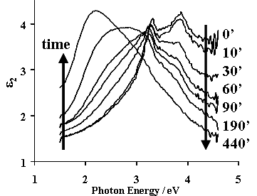

Figure 24. VASE spectra of non-CdCl₂ treated CdTe recorded at various times during etching in standard aniline-base solution with illumination on the glass.

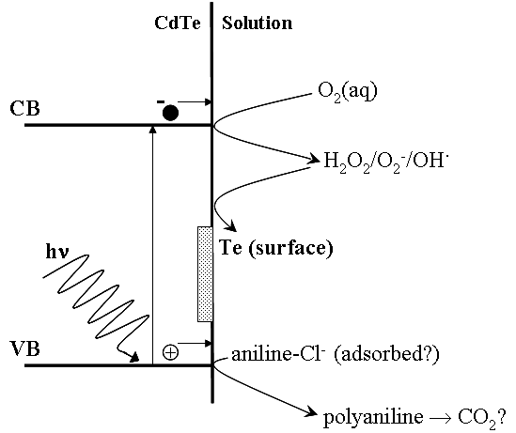

Figure 25. Schematic of proposed mechanism for illuminated aqueous aniline treatment of CdTe.

The toxicity of aniline is a serious concern for the widespread application of this treatment. Understanding of the chemical mechanism involved will assist with the search for a less toxic substitute. Possible alternatives require a number of criteria to be met, including; low toxicity, safe and easy handling, be reasonably soluble in water, have an oxidation potential similar to aniline, and oxidation products must be non-reactive towards CdTe and Te. The use of aniline to treat CdTe is successful as its oxidation results in the formation of either unreactive polyaniline or complete mineralization to CO₂. The less toxic potassium ferrocyanide, K₄Fe(CN)₆, which meets most of the above criteria, was tested as a possible substitute and was found to exhibit activity towards CdTe under illumination. As with aniline, no reaction was observed in the dark. However, the product of oxidation, Fe(CN)₆³⁻(aq), reacts with CdTe and Te to produce surface oxides of these species, which are deleterious to back contact formation and performance. Recently, two other possible substitutes of aniline had exhibited promising behavior during photo-treatment of CdTe. Treatments in solutions of 1-napthylamine and 8-hydroxyquinoline (Figure 26a and b, respectively) under illumination resulted in uniform and consistent etching of CdTe, However, it was found that during treatment, the temperature of the solution was rising higher than expected, to ∼45°C. At this temperature, solutions of just p-TSA and NaCl also successfully etch CdTe. Controlling solution temperature to ∼20°C by carrying out the reaction in a jacketed beaker resulted in no etching of CdTe by NaCl + p-TSA, 1-napthylamine or 8-hydroxyquinoline solutions, confirming the observed action on CdTe was due to the acid and salt mixture at elevated temperature. Temperature-controlled aniline solutions still successfully etch CdTe as expected.

OH
N
(b)
NH₂
(a)

Figure 26. Structures of (a) 1-naphthylamine and (b) 8-hydroxyquinoline

Figure 27 shows plots of the J-V parameters of devices, which received aniline treatments over various times with illumination directly on the CdTe layer. Plotted for comparison are the J-V data for cells processed with a 60 min aniline treatment with illumination on the glass and 10 sec etching in 0.05% BM. The data indicate that very good device performance can be obtained with the aniline etch, with the best devices receiving 30 and 60 min treatments with light on the CdTe and glass, respectively. These devices exhibit V_{oc}∼800 mV, J_{sc}∼23 mA/cm⁻², FF>65% and eff∼12%. The similarity of these two devices suggests that similar surfaces are obtained with these two treatments. At longer treatment times, device performance decreases due to increasing series resistance. After the 5 hr treatment, a decrease of V_{oc} to 770 mV was also observed. In comparison the BM etched sample showed comparable performance, but exhibited higher series resistance compared to the best aniline etched devices. Despite the slow reaction of the aniline treatment and stability of the generated Te, the best devices are obtained after only relatively short treatment times. This indicates that the treatment may also affect the CdTe grain boundaries, though the effects are not as harsh or as rapid as can occur during over-treatment with oxidizing etches.Error: Reference source not found

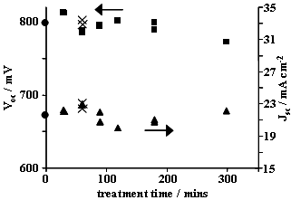
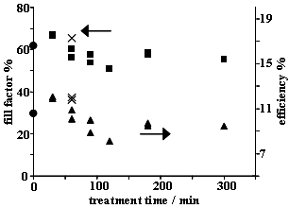

Figure 27. Plots of J-V parameters vs. treatment time for devices processed with the aqueous aniline treatment with illumination either directly on the CdTe ( and ) or on the sample glass (). Results of devices processed with 10 sec etching in 0.05% BM () are shown for comparison. All devices were completed with Cu-containing back contacts.

2.3 Bifacial Analysis of Devices with Transparent ZnTe:Cu Back Contacts

ZnTe:Cu Deposition and Bifacial Device Performance

We have developed a semi-transparent back contact using Cu-doped ZnTe. Development of ZnTe: Cu contacts, has been motivated by the high p-type conductivity of the ZnTe and its use as a source of Cu, leading to high FF. This type of contact has four potential applications: as a more ohmic and stable contact to CdTe; as an alternative controlled source for copper doping of CdTe; as a tool allowing bifacial characterization of transport and junction behavior; and as a transparent interconnect layer for the tandem polycrystalline solar cell.

With a transparent back contact, junction and transport properties can be determined by applying bifacial characterization techniques. For front illumination, most of the light is absorbed in the depletion region and back junction is in dark. In contrast, for back illumination, most of the light is absorbed in the field free region and minority carriers must travel a much greater distance to be collected at the front junction. A bifacial device provides a tool to study photocurrent collection behavior previously unavailable with front illumination. A preliminary report of this work has been presented elsewhere.

Semi-transparent Cu-doped ZnTe films were made by galvanic deposition on CdTe and SnO₂ coated glass substrates.Error: Reference source not found This method offers excellent control over thin film properties. Process conditions that were investigated included temperature, chemical concentration of compounds, pH and deposition time. The anode was Zn foil and the cathode was either SnO₂ coated glass or a glass/SnO₂/CdS/CdTe substrate. Figure 28 shows the cathodic deposition setup.
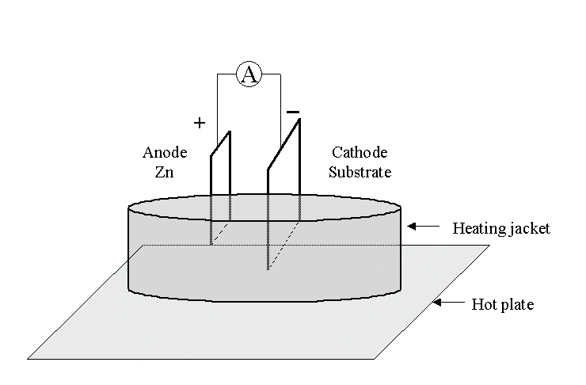

Figure 28. Galvanic deposition setup used for growing ZnTe: Cu films

Two chemical pathways were pursued in this study. The electrolytes evaluated as the source of Zn and Cu were either chloride (ZnCl₂, CuCl₂) or sulphate (ZnSO₄, CuSO₄) based. The sulphate-based films had better transparency and resulted in devices with more repeatable JV curves and lower retrace hysteresis. Hence, all the films reported here were made using ZnSO₄ and CuSO₄ as primary sources for Zn and Cu. Te was obtained from TeO₂. The depositions were done at T=68°C with solution pH=3 and source concentrations of 0.1M ZnSO₄, 0.001M, TeO₂ and 0.0001M CuSO₄. The chemical reaction involved in formation of this film can be described as
Anode Reaction:
Zn ⇒ Zn⁺²+ 2e⁻

Cathode Reaction:
Zn⁺²+ 2e⁻ ⇒Zn⁰
HTeO₂⁺ +3H⁺ +4e⁻ ⇒Te⁰ + 2H₂O

Zn ⁰ + Te⁰ ⇒ ZnTe

A cathodic current of 2.6 mA was measured during film deposition, allowing determination of the film thickness, since there are 6 electrons per mole of ZnTe. We estimate these ZnTe films to be 450 Å for deposition time of 1.5 minutes. Films were evaluated using x-ray diffraction. The primary difficulty encountered during these measurements was the extreme thinness of the film and the roughness of the CdTe substrate. On the SnO₂ coated glass, substrates correlation between deposition time and thickness was observed, and the peak intensity was proportional to film thickness. The thicker films indicated the presence of cubic phase (111) ZnTe:Cu. A trace of CuTe was observed in films with the highest Cu concentration.

Copper is commonly used to provide an ohmic CdTe contact as well as a CdTe dopant source even though it has been implicated in device degradation. In these films, the free Cu concentration was controlled using triethanolamine (TEA), which acts as a complexing agent. TEA reduces the level of free Cu in solution, which reduces the amount of deposited Cu in the film, which increases the film transparency. Figure 29 shows the normalized transmission obtained using different TEA concentration ranging from none to 20 drops, which corresponds to ~1 cc and gives a Cu⁺² activity of 10⁻⁸ M based on half-cell measurements. Films without TEA had very low transmission. There was significant improvement in transmission with 5 drops, but little difference between 10 and 20 drops of TEA. Thus, the addition of TEA increased the transmission at 800 nm from 60% to 85%.
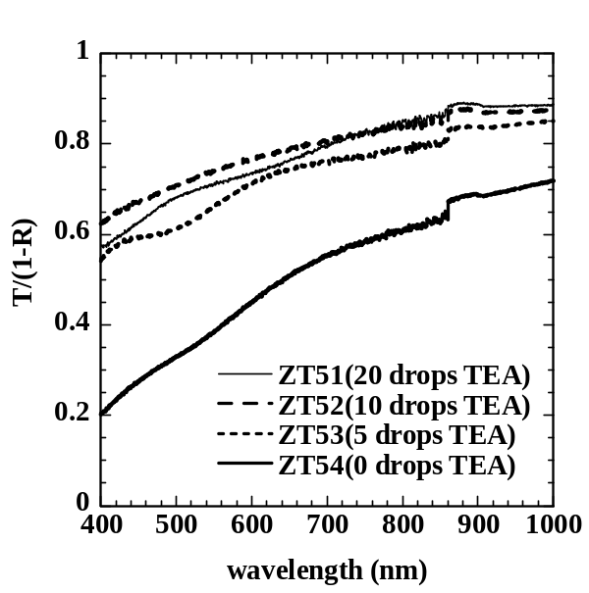

Figure 29. Optical transmission of glass/SnO₂/ZnTe:Cu layers as a function of TEA concentration.

ZnTe:Cu films were grown on glass/SnO₂/CdS/CdTe substrates. The CdTe was 5 µm thick and was deposited at 550°C by vapor transport (VT) at the IEC. The CdTe surface was first treated by one of three processes to remove any oxide present and create a Te rich surface. The 3 wet chemical surface treatments include: the 3 step BDH process (Bromine-methanol, then Dichromate, then Hydrazine); anilene; or Br-methanol. For the devices whose results are presented here, the ZnTe:Cu films were grown for 1.5 minutes with 20 drops of TEA in the solution. Devices without TEA had significant JV hysteresis and retrace instability consistent with too much Cu. Sputtered ITO and evaporated Ni/Al grids were used as secondary back contacts.

Table X lists the device parameters for different CdTe surface treatments for devices from VT149 and VT178. The J_{sc} and V_{oc} are much lower for back illumination due to reduced carrier collection. In general, ZnTe:Cu contacts typically produce devices with similar or better frontwall performance as compared to standard metal contacts as shown for VT149 pieces, indicating that ZnTe:Cu has equivalent properties in terms of forming the Cu₂Te layer for a low resistance back contact and doping the bulk CdTe for high V_{oc}.

Table X. Device results for devices from 2 VT runs made with ZnTe:Cu contact for frontwall or backwall light with BDH, anilene, or Br-Methanol surface treatment. Results with standard opaque contact also shown in italics for VT149.

Contact (Sample#) | CdTe  Surface  treatment | Light  direction | V_{oc}  (mV) | J_{sc}  (mA/cm²) | FF  (%) | Eff  (%)
ZnTe (VT149.4) | BDH | Front  Back | 822  661 | 23.1  0.6 | 68  66 | 13.0  0.26
Cu/Ni (VT149.2) | BDH | Front | 842 | 24.5 | 66 | 13.6
ZnTe (VT 178.5) | Anilene | Front  Back | 814  677 | 22.2  1.2 | 68  70 | 12.3  0.5
ZnTe (VT178.2) | Br-Meth | Front  Back | 804  672 | 22.4  1.48 | 67  67 | 12.1  0.7

The J(V) curves for CdTe devices often show light-to-dark crossover at forward bias attributed to Cu-doped photoconductive CdS or they show rollover (curvature) attributed to blocking contacts. Devices with ZnTe:Cu can show either type of behavior as well. Figure 30 shows the J(V) curves for the three devices from Table X. They are typical of a larger number of pieces we have processed. Namely, devices receiving a BDH or anilene treatment prior to ZnTe:Cu growth typically have no rollover and either no or slight LDXO. Devices receiving BR-methanol typically have rollover, indicating a higher barrier. Yet the J(V) results are not strongly affected. The penetrating nature of the BDH treatment results in shorted devices when the CdTe is less than 5 µm. Bifacial characterization of devices having CdTe from 1 to 10 µm is planned to fully understand the operation and stability of CdTe solar cells. Therefore, subsequent processing of these cells with ZnTe:Cu will use the anilene treatment since it results in ohmic contacts and high yields in thin devices. Another factor requiring optimization is the post-contact heat treatment, typically at 180°C for 20 minutes but some devices do not improve at all, others benefit from slightly higher temperature.

A crucial new result is shown in the Figure 30 for VT178-2. There is rollover in forward bias for light through the front or in the dark but not for light through the ZnTe:Cu. We have observed this on several other pieces from other CdTe runs and with different ZnTe:Cu runs and after stress (i.e. VT154-4 in Figure 30). The J(V) curve for front illumination for devices VT178-2 and VT154-4 in Figure 30 show rollover (curvature) and high resistance attributed to blocking rear contact. Due to the high absorption of CdTe, the back contact is in the dark for front illumination. However, the JV curve for the back illumination rises without curvature and has lower resistance. This shows that the back barrier is photosensitive; i.e. either the ZnTe:Cu or the contact/junction region are photoconductive and create a blocking contact unless illuminated with light above 1.4 eV. It is consistent with recontacting studies reportedError: Reference source not found where replacing the graphite back contact eliminated the roll-over, which developed after stressing.

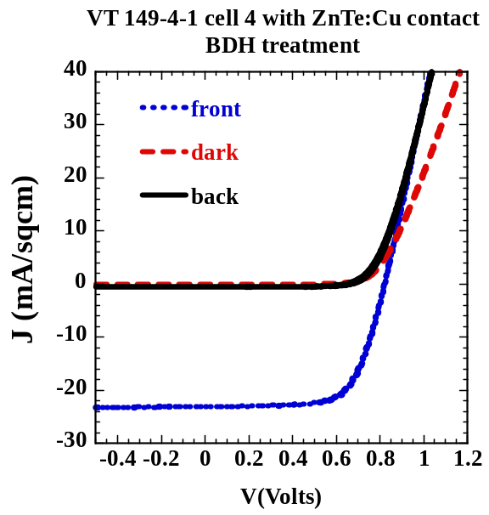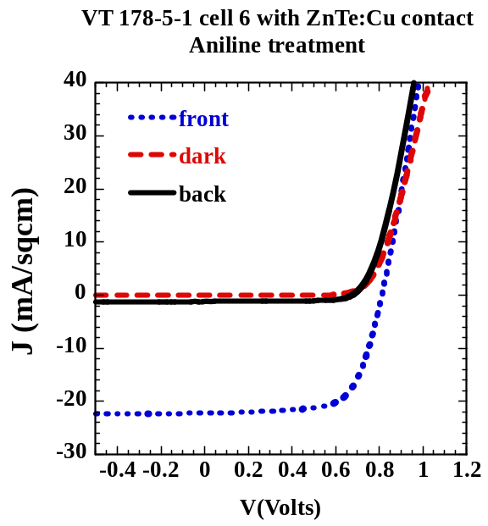
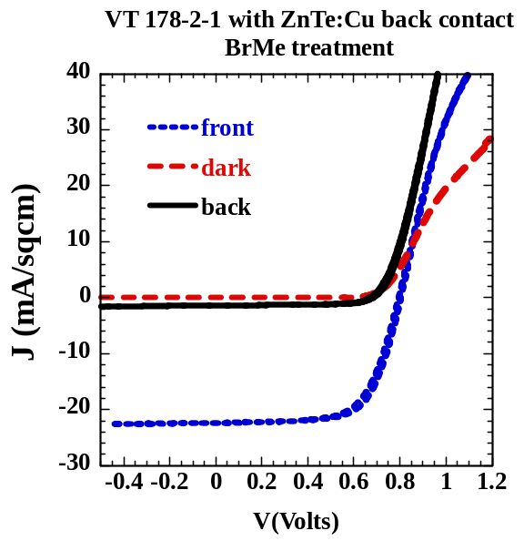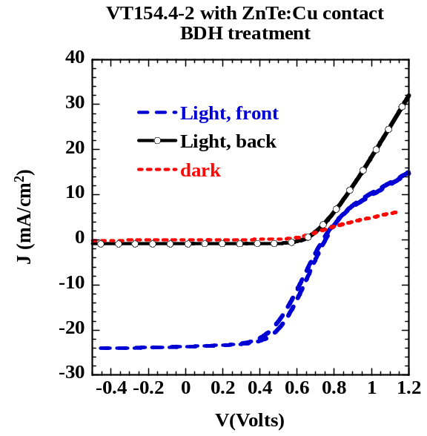

Figure 30. Initial J(V) curves for devices from Table VII with ZnTe:Cu contacts for illumination through CdS (front), ZnTe:Cu (back) and dark. Three different CdTe surface treatments were used. Also shown (lower right) is J(V) from VT154-4 after stress showing similar differences between front and back illumination at forward bias as seen on VT178-2-1.

Bifacial Spectral Response Characterization and Modeling

Bifacial SR measurements are a powerful tool to analyze the transport properties and to isolate the effect of the front and back junction. A model had been developed previously for bifacial spectral analysis of transparent contact for CIS based photovoltaic devices.Error: Reference source not found This model evaluates the spectral response as a function of absorber thickness (t), depletion width (W) and diffusion length (L). Figure 31 shows the front wall and back wall measured and simulated SR. The SnO₂/CdS and ZnTe:Cu absorption is accounted for in the analysis for the front wall and back response, respectively. The measured CdTe absorption coefficient was adjusted slightly to give a good fit to the falling edge of the front wall data. L and W were then fit to the measured back wall response with L=0.8 and W=2.5 µm. There is good agreement between the measured and fitted data.

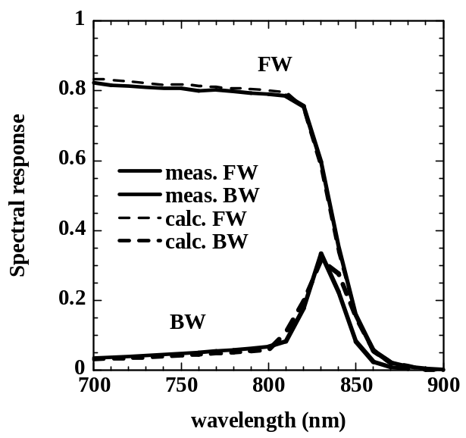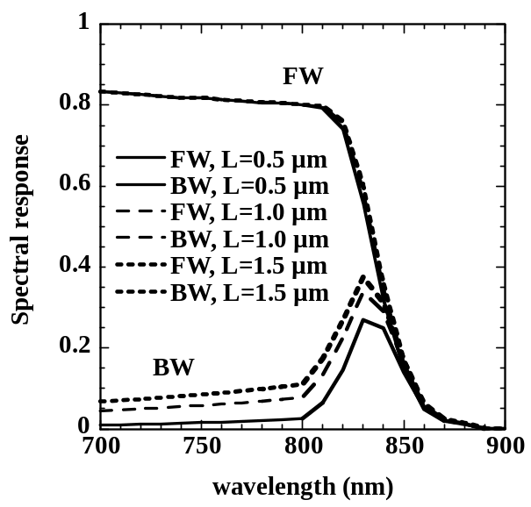

.  Figure 31. Measured and calculated SR (fit with W=2.5 and L=0.8 µm). | Figure 32. Calculated SR for L=0.5, 1.0, 1.5 µm with W=2.5 and t=5.0 µm.

Due to the extremely high CdTe absorption coefficient and steep absorption edge, over 90% of the photocurrent is generated within the first micron for either illumination direction. For standard front wall measurements, the light is absorbed in the high field depletion regions leading to very high collection probability independent of t, W or L providing t and W exceed ~1.5 µm. For back wall measurements, most of the electrons generated in the CdTe bulk must diffuse to the CdS junction depletion region. This is represented by the increasing tail from 400 to 800 nm Carriers generated in the depletion region by weakly absorbed near-bandgap light (800-860 nm) are collected with high probability. This is represented by the peak from 800-860 nm. Typically, we observed very little increase in front wall QE from zero to –1V bias, indicating good collection and consistent with the strong absorption in the depletion region. The depletion width of 2.5μm is very consistent with values obtained by capacitance on these devices, providing independent confirmation of the fitted value. Figure 32 shows the calculated response as function of diffusion length for W=2.5μm and t=5 µm. The front wall response is insensitive to changes in L, but the backwall response shows increased collection at all wavelengths with increasing L. Increasing W primarily increases the collection from 800-860 nm. The back wall spectral response measurements are much more sensitive to transport parameters (L) and depletion collection (W) than front wall spectral response.

Front wall SR is relatively insensitive to reverse bias on a good cell due to the high fraction of photocurrent collected at 0V. However, back wall is sensitive to both W and L since the distance the carriers must diffuse is (t-W) which is 2-3 µm at 0V for t=5µm. This is much larger than L. So W can be determined more accurately from back wall measurements. We have measured SR as a function of forward and reverse bias voltages on several devices with different values of t. Figure 33 shows the SR measured at –0.8V, 0V and +0.5V on VT178. The fitted value is also shown along with values of W and L. The depletion width was also determined independently from C(V) measurements at a range of frequencies. Figure 34 shows W as a function of V from SR fitting and C(V) measurements for devices wit h5 and 10 µm CdTe. There is relatively good agreement at reverse bias. The poorer agreement at forward bias is to be expected since the C(V) has greater frequency dependence and the SR has greater possibility of photoconductive effects influencing the measurements. But clearly they both indicate that the W is likely around a micron at forward bias. This is the comparable to the absorption depth of AM1.5 light incident on the front of the cell. This explains why there is so little dependence on diffusion length for front wall light even in forward bias.

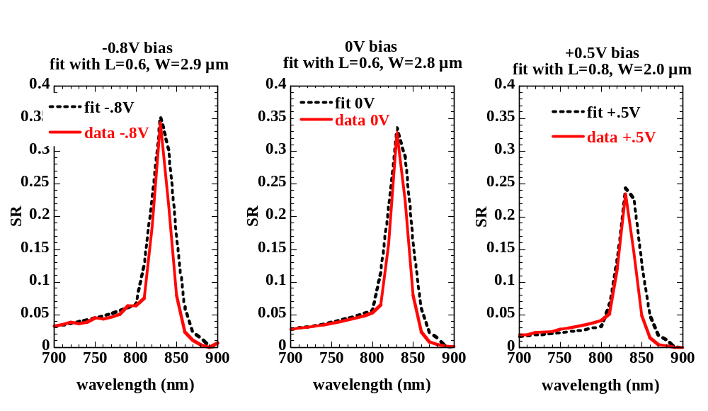
Figure 33. Backwall SR for VT145-1 at 3 voltage biases. Measured data and fit with L, W values indicated are shown.

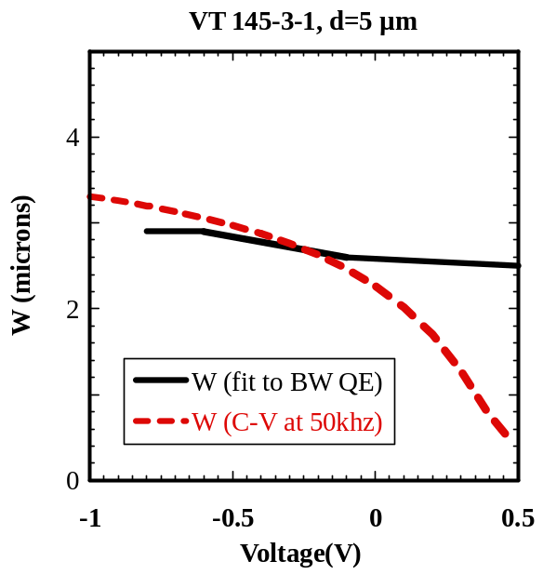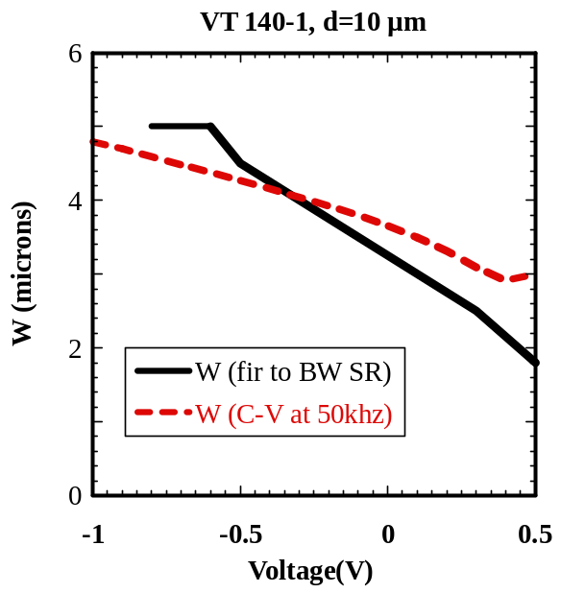

Figure 34. Depletion width from C-V and from fitting backwall SR(V) measurements for devices with CdTe thickness of 5 (left) and 10 (right) µm

Temperature Dependent Bifacial Spectral Response
We have investigated the properties of CdS/CdTe junctions at low temperature using bifacial V_{oc}-T, J_{sc}-T and “effective” QE. V_{oc} and J_{sc} were measured at different white light intensities in the temperature range of 100-300K for front and back illumination. The effective QE was determined using narrow band-pass spectral filters. We have characterized several devices and are still trying to understand the implications of the data. Here we briefly present results from VT149-4 whose J(V) data was presented above in this section.

The temperature dependence of V_{oc} at 100 and 10% light is shown in Figure 35. As T decreases, for front light increases nearly linearly as predicted to around 200K then begins to saturate and become independent of temperature and intensity. V_{oc} for back light has the opposite behavior, remaining low and relatively constant above 200K then increasing sharply. On some devices, V_{oc} for back light has exceeded that for front light at 120K. A common feature of over 30 devices (about 20 with standard contacts including some from First Solar or BP Solar and 10 with ZnTe:Cu contact) characterized so far is that V_{oc} for front light saturates around 0.95-1 V at low temperature, and becomes independent of intensity. We speculate that this is the built-in voltage or maximum achievable V_{oc} resulting from an absence of recombination, which is frozen out. The quasi-fermi levels are pinned by the front and back contact. This is supported by the following qualitative analysis. The bandgap of CdTe at low temperature is reported to be 1.6 eV, the electron Fermi level at the SnO₂ is reported to be 0.3 eV below E_{c}, and the hole Fermi level is pinned by the Cu defect at 0.3 eV above eV. This leads to a potential difference of 1 eV for the maximum quasi-fermi level splitting in the CdTe.

Figure 36 shows the J_{sc} measured at the same time as V_{oc} for two different light intensities for illumination through front and back contact. J_{sc} for front illumination is relatively constant within temperature range 200-300K and then rapidly decreases below 200K. Opposite behavior is observed for back illumination; i.e. J_{sc} increases below 200K. CdTe cells have a large depletion region, even at room temperature, which ensures efficient carrier collection. The J_{sc} for front and back illumination shows opposite temperature dependence. This cannot be explained by reduction in mobility unless the minority carrier switches from electrons to holes and the holes would have to have a much higher mobility at lower temperature. We did spectrally dependent J(V) bifacial measurements to identify carrier transport limitations.

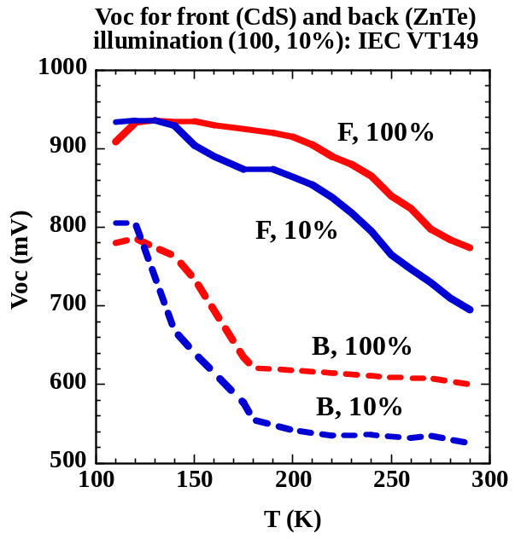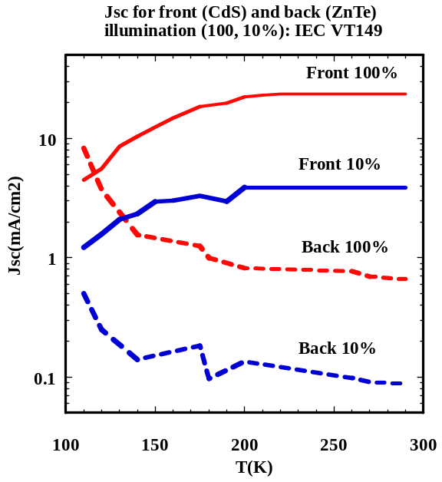

Figure 35. (left) V_{oc} as a function of temperature for front and back illumination at 100 and 10% intensity.

Figure 36. (right) J_{sc} as a function of temperature for front and back illumination at 100 and 10% intensity. Note the log scale.

The J_{sc} for these cells was measured as a function of temperature using narrow band pass filters having FWHM~25 nm. The correction factors for filter transmission and the ELH lamp spectrum were determined using the QE, as measured on our standard monochromator based chopped light QE system at 300K, as a reference. The QE as a function of temperature was then calculated from the J_{sc} values. Figures 37 and 38 show the QE calculated for the front and back illumination for different temperatures.

Due to the high absorption coefficient, most of the carriers generated for front illumination are efficiently collected in the high field region located near CdS/CdTe interface. The depletion width is >2 µm, so all nearly carriers are collected. For the back illumination, the carrier collection is limited by diffusion length of the carriers to that front junction as discussed above. Only the carriers generated close enough to diffuse to the collecting junction can contribute to the photocurrent. Applying this model would suggest that the diffusion length and depletion region increase with decreasing temperature for carriers collected from the back but decreases for carriers collected from front light.

There are several complications, which may influence interpretation of these results such as formation of blocking contacts and long time constants causing slow transients at low temperatures. The interpretation of constant V_{oc} while J_{sc} is decreasing is also problematic. Clearly bifacial device characterization as a function of temperature is a rich area for exploring the operation of CdTe devices, and more work remains.

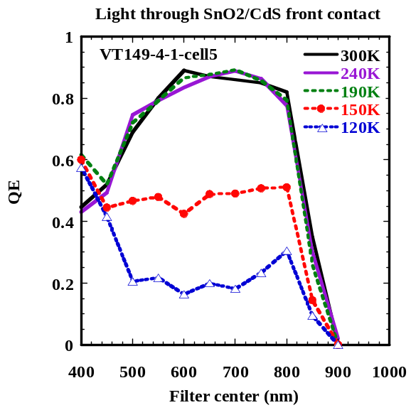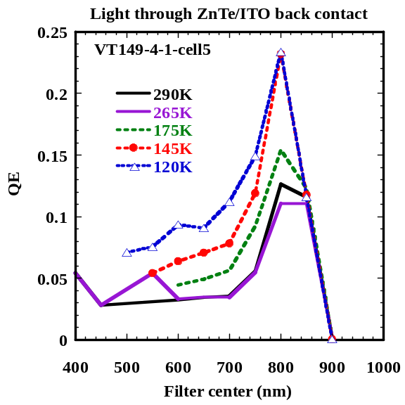

Figure 37. (left) QE as calculated from J_{sc} measured using filters for front illumination.

Figure 38. (Right) QE as calculated from J_{sc} measured using filters for back illumination.

Characterization of Stability Using Bifacial J(V) Measurements

CdTe devices with ZnTe:Cu contacts have been reported to be relatively stable. Samples from VT154 received several different contacts and were stressed at 10 days in the light at 100°C in dry air at 4 different bias conditions. Results comparing the different contacts are shown in Section 2.4. Here, we use bifacial J(V) measurements to provide new insight into contact degradation using the piece with transparent ZnTe:Cu contact.

Figure 39 shows the J(V) curves for light incident from the front (glass), from the back (ZnTe:Cu) and in the dark before and after stress. All of the devices from this particular run had low FF (Table IX) but that does not influence the interpretation of results here since we are focusing on the behavior of the J(V) curve beyond V_{oc} where the back contact injection can be limited by a blocking barrier. After stress, the J(V) curves for illumination from the front or in the dark show curvature in forward bias, classic evidence of a blocking contact. In fact, for this device, there was little change in V_{oc} or FF with stress for front illumination. The largest effect was in forward bias. For back illumination (lower left figure) there is essentially no change in forward bias. This is a new result providing direct evidence that the blocking contact formed after stress is at the back contact and it is light activated. Either photocarriers increase the conductivity of the CdTe or ZnTe or the depletion region formed by the increased barrier collapses. Either of these would restore high injection from the ITO back contact. Further work will include varying the spectrum of the light to see if the effect only occurs with light above the ZnTe bandgap.

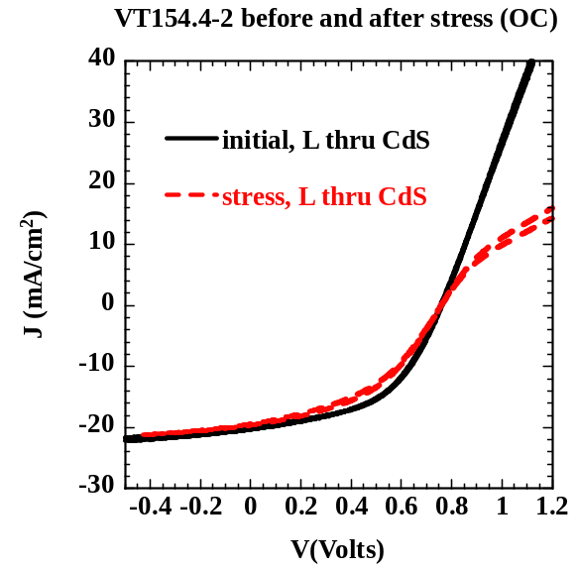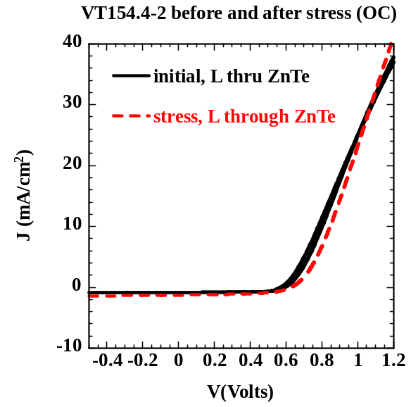

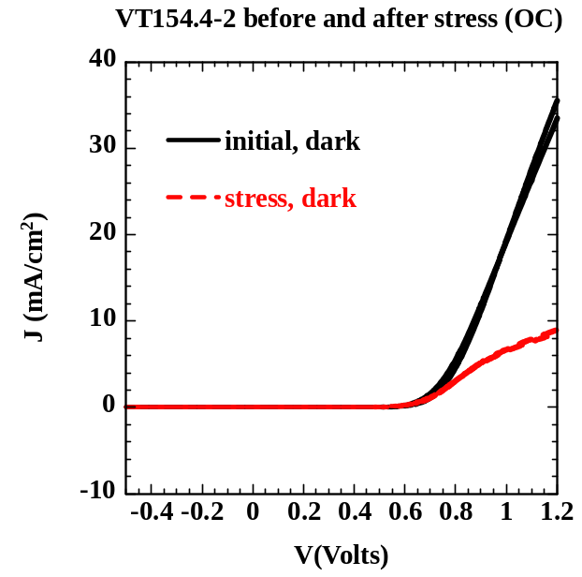

Figure 39. J(V) curves for VT154.4-2 before and after stress for light from the front (CdS side), rear (ZnTe side) or in the dark.
2.4 Stability of Vapor Transport CdTe

Effect of Contacts on Stability

It is well established that stability of CdTe devices depends partially on the contact processing. In a recently published study by our group, it was found that there was little difference in degradation between devices that had a wet-etched CdTe surface or a dry-deposited Te layer, if they had Cu in their contact. However, there was a significant difference between devices with or without Cu in the contact layer, and significant differences between wet or dry processing for devices without Cu in the contact. That work was performed using devices from First Solar. During this year, we have initiated stability studies on devices from IEC’s VT system.

Devices from run VT128 were processed with evaporated Cu/Ni and Ni contacts. The Cu was 15 nm and Ni was 50 nm. The CdTe surface received the wet BDH treatment. Pieces were stressed for 14 days in continuous light (L) or dark (D) at 85°C in dry air. Bias was either open circuit (OC) or short circuit (SC). Other pieces were stressed with time-varying bias cycles and are discussed in the next section.

Table XI lists the relative change in JV performance for the two types of contacts after stress at SC in L and D or OC in L. Initial JV values of typical device also listed. The device without Cu stressed at SC, D is interesting since the junction is at equilibrium with no recombination, it has no Cu in the contact, and has no current flow during stress. Its degradation of 7% is considered somewhat intrinsic to the CdS/CdTe device structure. In the light, degradation increases at either OC or SC bias. Degradation was greater at OC than SC for the device with Cu in the contact. This is consistent with many previous studies here using First Solar (FS) and BP Solar (BPS) devices. However, the opposite trend was seen in the device without Cu. Figure 25 shows the V_{oc} at 85°C during stress for three devices. For stress in the light, the decrease in V_{oc} is comparable for devices with or without Cu in the contact, in agreement with JV results at 25°C in Table XI. This contradicts our earlier results using FS devices. The device without Cu stressed in the dark at OC has a different rate of degradation suggesting a different mechanism.

Table XI. Initial JV values and relative change (%) after stress for devices with Ni (VT128.5) or Cu/Ni (VT128.6) contacts. The device with Cu/Ni stressed at SC in D became shunted.

Contact  (piece) | Stress  Condition | V_{oc}  (V)  or Change | J_{sc}  (mA/cm²)  or Change | FF  (%)  or Change | Eff  (%)  or Change
Ni  (VT128.5) | Initial | 0.77 | 20.1 | 58.2 | 9.0
 | SC, D | -5% | -1% | -2% | -7%
 | SC, L | -9% | -1% | -12% | -21%
 | OC, L | -8% | -5% | -1% | -13%
Cu/Ni  (VT128.6) | Initial | 0.81 | 20.7 | 69.5 | 11.6
 | SC, L | -5% | -2% | -14% | -21%
 | OC, L | -10% | -5% | -18% | -30%

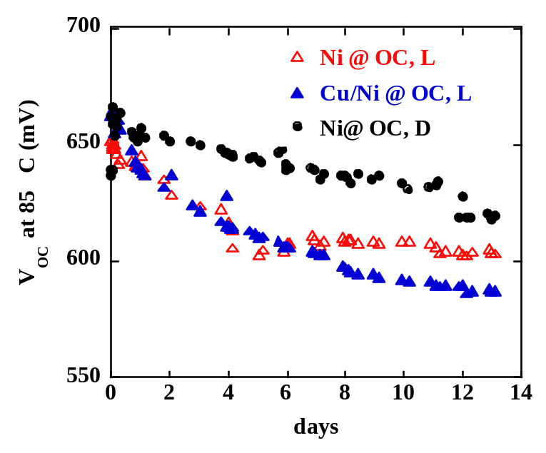

Figure 40. V_{oc} at 85°C during 14 days stress for devices with Cu/Ni or Ni contact at different bias conditions.

Figure 41 shows the light and dark JV for the devices stressed at OC, L having Ni and Cu/Ni contacts. Before stress (Fig.41a), the device with the Cu/Ni contact has no light-dark crossover, while the device with Ni contact has both rollover in forward bias and LDXO, as commonly seen in devices without Cu contact. This is generally attributed to the blocking back contact. JV results for same two devices after stress is in Figure 41. In distinct contrast to the initial JV behavior, after stress, the light and dark curves of both devices are remarkably similar. The light curve for the device without Cu has straightened out in forward bias while the dark curve for the device with Cu has become very resistive. The only difference is slightly lower FF for the device without Cu. The similarity after stress contradicts past resultsError: Reference source not found where devices with Cu develop blocking contacts after stress while devices without Cu maintain their blocking contact after stress. These differences suggest that our present VT devices have different degradation processes than previously studied devices.

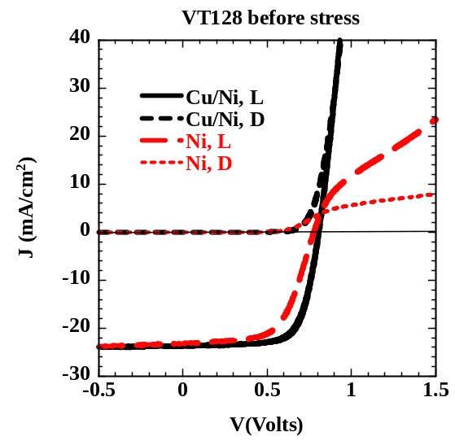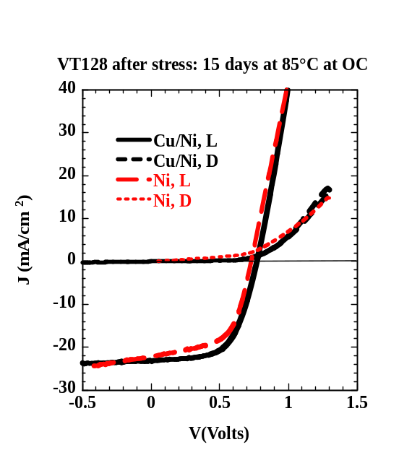
(a) (b)

Figure 41. (a) left and (b) right. Light and dark JV curves of VT128.5 and 128.6 before (a) and after (b) stress at 85°C for 15 days at OC bias in light.

We have a substantial data base of stressing devices from FS or BPS at 100°C for 10 days at 4 biases: -0.5V, SC, MP, and OC. We fabricated devices from standard run VT154 having 4 different contacts – Cu/Ni, CuI/Ni, Ni, and ZnTe:Cu/ITO. This allows us to compare 3 different sources of providing Cu to the contact and the CdTe. Devices were stressed for 10 days at 100°C in dry air in the light at the above 4 biases. Table XII lists results for the device stressed at OC.

Table XII. JV results and relative change after stressing for 10 days at 100°C in dry air in the light at OC.

Contact  (piece) | Stress  condition | V_{oc}  (V)  or Change | J_{sc}  (mA/cm²)  or Change | FF  (%)  or Change | Eff  (%)  or Change
Ni  (VT154.6) | Initial | 0.79 | 25.0 | 56.5 | 11.3
 | change | -19% | -4% | -17% | -36%
Cu/Ni  (VT154.1) | Initial | 0.80 | 24.4 | 60.1 | 11.8
 | change | -5% | -6% | -18% | -27%
CuI/Ni  (VT154.2) | Initial | 0.81 | 24.3 | 63.4 | 12.5
 | change | -9% | -3% | -10 | -21%
ZnTe:Cu/ITO  (VT154.4) | Initial | 0.77 | 23.2 | 53.9 | 9.7
 | change | -2% | -15% | -16 | -30%

Comparing Tables XI and XII for devices with Ni or Cu/Ni contacts shows that the VT154 pieces in Table XII had lower initial FF despite nominally identical processing. Yet the V_{oc} values are comparable. Degradation of all pieces in Table XII was significant, indicating that to first order, how the Cu is incorporated or even the presence of Cu in the contact does not dramatically influence the degradation for cells stressed at OC. Figure 42 shows the relative change in efficiency for these devices as a function of the stress bias. The devices with CuI and ZnTe:Cu behave similar to each other, yet quite different from what we often typically observed; specifically, the decrease in efficiency for stress at MP followed an increase for stress at OC. The devices with Cu/Ni or Ni behave as expected with the caveat that the degradation is larger than typically seen. Figure 43 shows the V_{oc} vs. time. Most degradation occurred in the first 4 days. The V_{oc} for VT154.4 with ZnTe:Cu shows negligible change consistent with Table IX. Given the poor initial performance of the control devices and unusual behavior for MP bias, it is not clear how much can be conclusively drawn from these results of Tables XI and XII, other than the observation that the VT devices show significant degradation despite differences in their contact materials. Critical insights about the formation and nature of the blocking contact has been discussed in Section 2.3, using bifacial measurements on the devices with ZnTe contacts.

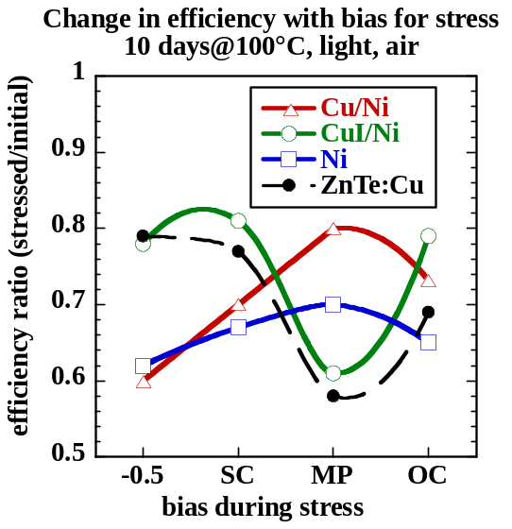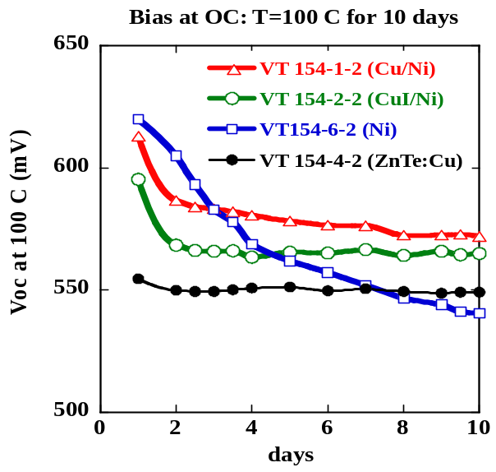

Figure 42. (left) Relative change in efficiency with bias during stress for devices from VT154 with different contacts.

Figure 43. (right) V_{oc}@100°C during stress for devices from VT154 with different contacts stressed at OC.

Transient Degradation and Recovery

Indoor stress experiments typically have continuously applied light, temperature, and bias.Error: Reference source not found,,,, In contrast, modules operate at maximum power MP~ 0.75x V_{oc} and experience daily cycles of light and temperature. Outdoor module performance has been reported to be relatively more stable, than devices experiencing indoor stressing.

This section describes CdTe solar cell transient degradation and recovery, showing complex behavior on differently fabricated devices. Recovery in CdTe devices in the dark and with applied bias during and after stressing has not been reported previously. Much of the results in this section were recently presented.

The focus of this work is on V_{oc} measured in-situ during stress. V_{oc} degrades during stress due to increased recombination,Error: Reference source not found,Error: Reference source not found and thus, is a sensitive and easily measured parameter to monitor the electronic properties of the junction. FF also degrades but is complicated by recombination, contact and series resistance effects.Error: Reference source not found,Error: Reference source not found,Error: Reference source not found

Experimental

Devices were obtained from several sources. Some cells were cut from production modules from two commercial sources (A and B). The CdTe for type A cells was made by VT and was 3-4 µm. Manufacturer A provided cells from two nominally identically processed modules (A1 and A2), fabricated within a short period of each other, yet having different performance and stability. Some devices were hybrids where IEC deposited a C/Cu contact on CdS/CdTe substrates from manufacturer A, referred to as A/IEC. Type B cells were made by electrodeposition and were <2 µm thick. Devices were made with CdTe deposited by VT at IEC that was ~6 µm and had Ni/Cu contacts referred to as VT. Table XIII lists typical initial solar cell performance. Differences in J_{sc} are due to SnO₂ and CdS absorption and are not important for this paper.

Devices were stressed at IEC in a system allowing exposure to controlled ambient, bias, light, and temperature (60 to 100°C), while monitoring performance in-situ.Error: Reference source not found The chambers were pumped out to ~50 mT and purged with Ar several times before stress to remove moisture. Stressing was done with dry bottled air unless stated otherwise. Light during stress was at ~ 1 sun from halogen flood lamps.

Table XIII. Typical initial performance for devices studied here. A1, A2 and B were processed entirely at outside manufacturers.

Cell Type | V_{oc}  (V) | J_{sc}  mA/cm² | FF  (%) | Eff.  (%)
A1 | 0.82 | 21 | 68 | 11
A2 | 0.74 | 20 | 64 | 9.5
B | 0.81 | 18 | 69 | 10
A/IEC | 0.81 | 20 | 69 | 11
VT | 0.80 | 23 | 70 | 13

Results

Voltage Bias-Induced Transients

Three A/IEC cells were stressed at 100°C in dry air for 38 days in the light. The bias was switched during stress between OC or SC. Figure 44 shows the V_{oc} measured in-situ at 100°C. Cell 1 was at SC for 24 days, then switched to OC; cells 2 and 3 were at OC for 1 or 24 days before switching to SC, respectively. The insert shows cell 2 on a log scale.

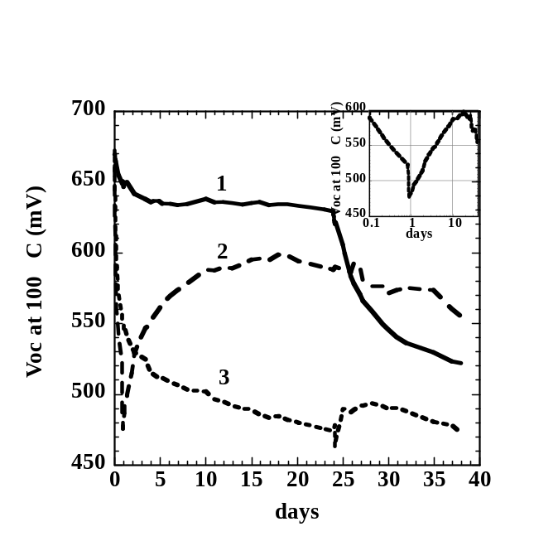
Figure 44. V_{oc} at 100°C vs. time at stress (type A/IEC). Bias switched from SC to OC after 24 day (cell 1), and from OC to SC after 1 day (cell 2) or 24 days (cell 3). Insert shows V_{oc} for cell 2 on log scale.

V_{oc} for cell 1 at SC decreased 40 mV in the first 5 days, then remained constant until switched to OC causing V_{oc} to decrease 100 mV in the next 14 days. Cells at OC showed immediate degradation. V_{oc} decreased 120 mV in the first day. V_{oc} on cells 2 and 3 had common general behavior: it decreases while at OC; when switched to SC there is a rapid drop followed by a slow recovery, which peaks, then continues to degrade. For example, cell 2 at OC decreases ~120 mV (from 650 to 530 mV) in 1 day until switched to SC. At that point, V_{oc} plummets another 50 mV in a few hours (see insert), then begins a slow recovery, reaching a maximum after 15 days. V_{oc} recovery was 20 times slower than degradation at this temperature. Cell 3 behaved similarly but its recovery was minimal. Thus, with increasing time at OC before switching to SC, the maximum value to which V_{oc} can be restored decreases. Identical behavior was observed for devices stressed in H₂/Ar so we conclude that these effects are not due to ambient or random damage to a given cell. Cells stressed at MP degraded and recovered the same as those at OC, indicating that the threshold for major degradation is between SC and MP for these devices.

VT devices from IEC were also stressed with varying bias conditions. Figure 45 shows V_{oc} vs. time for 3 devices on the same substrate. In contrast to the A/IEC device of Figure 44, degradation was very similar between SC or OC, decreasing only 40-60 mV and nearly leveling off after only 4 days. A third cell was at OC for 4 days, then at 1.3xOC (corresponding to forward bias current of ~2xJ_{sc}) for 4 days, resulting in accelerated degradation. When switched to SC, V_{oc} plummeted ~80 mV in a few hours but then continued to decrease slowly for 4 days. V_{oc} recovered just as rapidly when switched to OC. This represents nearly opposite bias dependence from A/IEC devices in Figure 44. The V_{oc} vs. time for a companion piece processed without Cu in the contact looked very similar to Figure 45, including the rapid decrease and recovery with SC or OC. Thus, the bias dependent behavior cannot be explained solely by Cu ion drift changing with field polarity.

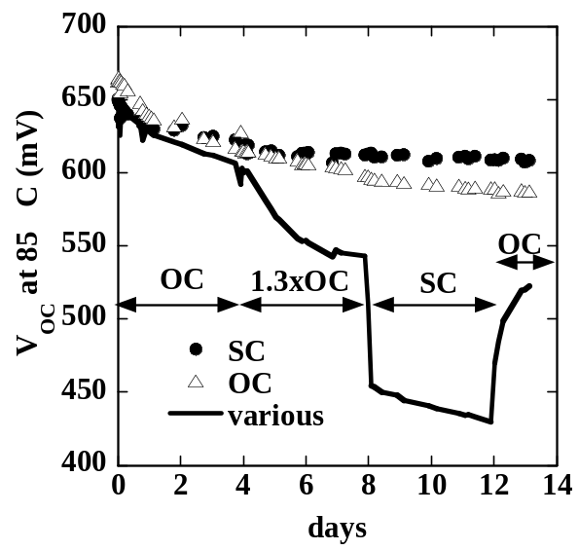

Figure 45. V_{oc} at 85°C vs. time at stress (cell type VT-Ni/Cu). Cells were at continuous SC or OC bias or switched from OC to 1.3 V_{oc} to SC to OC every 4 days.

Simulated Day/Night Cycles

A key difference between laboratory stressing and outdoor module performance is that lab cells are typically stressed at constant illumination and temperature for weeks, while outdoor modules see daily cycles. Table XIV lists stress conditions designed to simulate daily light/dark and high/low temperature cycles experienced by modules outdoors.

Table XIV. Simulated daily light/dark and temperature cycles.
Cycle | Hours light/temp | Hours dark/temp | Comments
1 | 24 hrs @ 65°C | None | Continuous;  std lab stress
2 | 16 hrs @ 65°C | 8 hrs @ 20°C | 8 hrs dark,  low T recovery
3 | 8 hrs @ 65°C | 16 hrs @ 20°C | 16 hrs dark,  low T recovery
4 | 8 hrs @ 65°C | 16 hrs @ 65°C | 16 hrs dark, high T recovery

Table XV shows the efficiency for A1, A2 and B cells before and after 30 days at each of the 4 stress cycles at OC. Cells at 0.5xOC had negligible changes during any of the cycles. Figure 46 shows V_{oc} vs. time for A1 and A2 cells stressed at OC and 0.5xOC for cycle 1 where the cells were constantly at 65°C in the light. V_{oc} for either type of cell was nearly unchanged at 0.5xOC. Those at OC stress degraded rapidly then more slowly after 15 days. However, after 15 days of stress at 65°C, A2 cells have ~50 mV higher V_{oc} than A1 cells, despite starting with 70 mV lower V_{oc} (Table X). A1 cells degraded ~120 mV more than A2 cells, consistent with their much greater decrease in efficiency (Table XV).

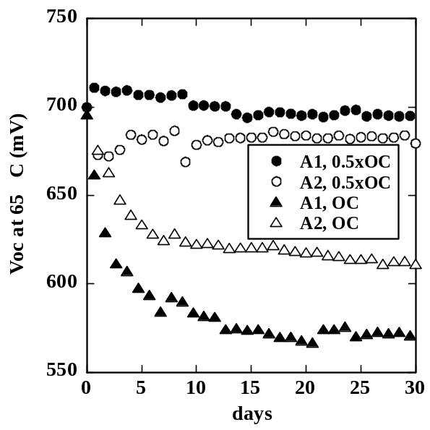
Figure 46. V_{oc} vs. time for A1 and A2 devices stressed in cycle 1, biased at OC or 0.5xOC.

Part of the explanation may be found in results from cycle 4. Figure 47 shows V_{oc} measured daily for 9 am, after 16 hours of darkness at 65°C, and at 5 pm after 8 hours of light at 65°C. A1 cells had negligible recovery in the dark. A2 cells show substantial recovery every night cycle. Thus, every night after 16 hours in the dark at 65°C, the V_{oc} increased, initially by 30 mV and increasing to 50 mV. This is consistent with a change in the recombination due to a nightly relaxation of traps with a response time of a few hours.

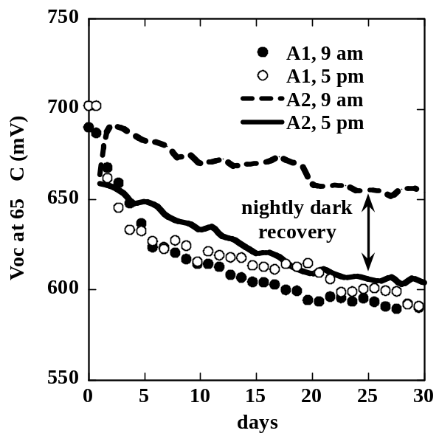
Figure 47. V_{oc} vs. time for type A1 and A2 devices from Figure 3 biases at OC in cycle 4 showing data at 9 am (16 hours dark) and at 5 pm (8 hrs light) on same device.

Figure 48 shows similar V_{oc} data for 2 type B cells during cycle 1 and 4 stress. One cell was under constant illumination at OC in cycle 1. After an initial loss of ~50 mV in the first 3 days, it shows a slow steady increase. The other cell has an initial degradation of ~30 mV and the similar steady increase over the next 27 days but also exhibits nightly recovery of ~30mV. So there is both a daily recovery/degradation cycle (30 mV/day) as well as a slower monotonic recovery (30 mV/27days). Every day V_{oc} decreased during stress in the light and increased the same amount during the dark 65°C. Degradation in type B was essentially independent of voltage bias, in strong contrast to A/IEC, A1 or A2 cells. Cycle 3 caused very little degradation for type B cells at either OC or 0.5xOC (Table XV).

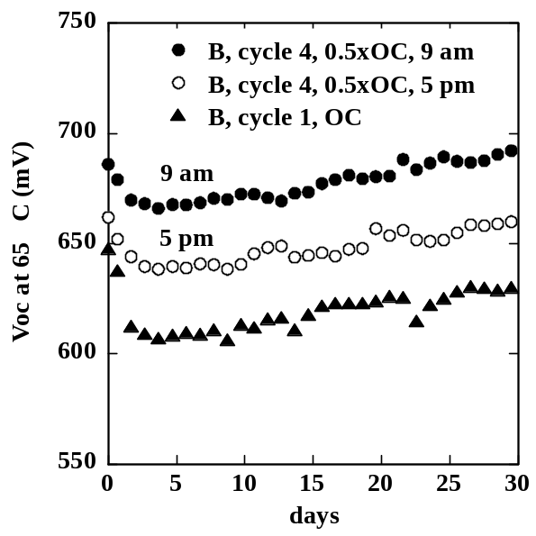

Figure 48. V_{oc} vs. time at stress for type B cells stressed at OC with cycle 1 (triangles) and 0.5OC with cycle 4 (9 am and 5 pm).

Outdoor array data from manufacturer B was analyzed to compare performance in the morning and late afternoon when the irradiance was approximately ~750 W/m². After correcting for higher afternoon temperatures, it was found that module output decreased during the day by an amount consistent with our findings, confirming that the night time recovery and daily degradation occurred in real outdoor exposure.

Recovery in Dark at Room Temperature

A1 and B cells were retested after 9 days in dark at room temperature following the cyclic stressing. Results are in Table XV. Type A1 showed no change, consistent with their lack of day/night recovery. Type B cells show significant recovery. Nearly all degradation is restored within 9 days. Degradation in type B cells is due mostly to V_{oc}, and recovery of V_{oc} is nearly complete within 9 days, independent of the bias during stress.

Table XV. Efficiency (%) of A1, A2 and B cells before and after 30 days of 4 different stress cycles at OC and after 9 days dark storage.

Stress | 1 | 2 | 3 | 4

A1
Before | 11.8 | 11.4 | 11.5 | 11.9
After | 7.4 | 7.5 | 7.6 | 8.1
9 days | 7.5 | 7.6 | 7.5 | 8.3
A2
After | 9.3 | 9.5 | 9.7 | 9.2
Before | 8.0 | 7.7 | 8.6 | 7.9
B
Before | 9.9 | 10.1 | 9.8 | 10.2
After | 8.8 | 9.4 | 9.6 | 9.0
9 days | 9.6 | 9.8 | 9.6 | 9.9

Discussion and Conclusions

In general, degradation increases with forward bias but the threshold for significant degradation varies; i.e. between SC and MP on A/IEC devices; between 0.5xOC and OC on type A1, A2, and B devices; and between OC and 1.3xOC on IEC’s VT devices. The bias for recovery differs as well: A/IEC devices recover with SC while VT devices recover with OC.

Degradation and recovery is shown here at 65, 85 and 100°C. We have not seen qualitative differences in device behavior between temperatures in this range. Bias and light have a much stronger influence than temperature. Stress at only a single bias or in continuous light would not have identified the various recovery modes. Since performance is typically measured within 24 hours after the end of the stress, significant recovery may have already occurred by the time they are measured, while further recovery may occur in the days and weeks following.

The identification of recovery modes in CdTe solar cells with time constants of hours is very important. Previously, degradation has been viewed as an irreversible process, suggesting mechanisms like chemical decomposition or diffusion. Recovery due to changing bias, either applied directly or though light bias at OC, suggests other mechanisms such as defect conversion via capture or emission which changes recombination in the junction region. Thermal and field enhanced drift of species may create defects, which trap charge in the presence of light or forward bias injection. In the absence of generation (i.e. dark, low temperature, SC), the defects may slowly capture or emit trapped charges and become neutral again. Changing the band bending can also change the trap occupancy. Figures 46-48 and Table XV show that dark recovery is correlated with more stable devices. Stability improves from A1 to A2 to B, as does the degree dark recovery of V_{oc}. Type B cells have less degradation for any cycle condition than A1 or A2, which correlates with their greater recovery in V_{oc} during and after stress. It is not known if this is related to differences in CdTe film properties or in other processing steps. The nominally identical A1 and A2 devices differ in their stability and in their tendency for nightly recovery. This suggests that the two mechanisms may be correlated.

The presence of Cu is a critical variable and needs to be studied further. IEC has stressed several devices without any intentional Cu and found them to degrade less than those with intentional Cu but they were not completely stable.

  - Understanding and Improving V_{oc} in Vapor Transport CdTe Solar Cells

Increasing V_{oc} in VT CdTe/CdS cells to >900 mV and maintaining it in cells with sub-micron thick CdTe layers requires an understanding of existing cells, determination of the recombination sources in the cell, quantifying the influence of back contact on V_{oc}, especially in thin devices, and assessing changes induced by depositing onto a moving substrate at elevated rate (>10 μm/min). The problem has two parts: 1) defining limits to V_{oc} in CdTe solar cells in general and 2) defining the influence of VT processing especially in thinner cells.

The highest open circuit voltage ever achieved with a p-type CdTe absorber is V_{oc} = 892 mV, for single crystal CdTe with an ITO window layer, i.e., no CdS. The highest efficiency CdTe/CdS solar cell (η = 16.4%) has V_{oc} = 845 mV and has superstrate structure with 10 μm CSS CdTe/60 nm CBD CdS/i-SnO₂ (the i-SnO₂ is a buffer layer on more conductive SnO₂). The highest V_{oc} achieved at IEC is 853 mV, for 4 μm PVD CdTe and 843 mV, for 7 μm VT CdTe. The PVD cell used 200 nm thick CdS and no buffer layer, while the VT cell used 60 nm thick CdS with an intrinsic Ga₂O₃ buffer. The buffer layer allows V_{oc} to be maintained as the CdS thickness is reduced to maximize J_{sc}. Typically, devices without CdS yield V_{oc} < 300 mV for CdTe/ITO and CdTe/SnO₂ without a buffer layer and V_{oc} > 400 mV with In₂O₃, Ga₂O₃, for i-SnO₂ buffer layers. The collective results of CdTe research groups demonstrate that V_{oc} > 800 mV is achievable in cells with CdTe films with thickness from 1.5 to >10 μm and grain size from 300 nm to 10 μm, suggesting a passive role for grain boundaries in operation of devices with high V_{oc}.

Analysis of superstrate CdTe cells leads to a working model for V_{oc} in thin film CdTe/CdS devices. The forward diode current is primarily limited by SRH recombination in the CdTe layer. Sources of recombination include defect states within CdTe caused by intrinsic and foreign impurities as well as crystallographic defects. No evidence exists to show that the CdS film contributes a significant amount to J_{L} or to built-in voltage. Hence, reducing its thickness increases J_{L} by reduction of parasitic optical loss, while increasing its bandgap by alloying with ZnS has no demonstrable effect on V_{oc} or built-in voltage. The CdS functions at the grain-by-grain level to create the CdTe inversion layer needed to separate excess charge. The forward current is the result of band-to-band recombination in this region and is controlled by the quasi Fermi level separation and extent of the space-charge width. A detailed band model is difficult to assemble, since CdTe is highly compensated and the net space-charge density is the difference of two large numbers, N_{a}-N_{d}.

The defect levels originate from native (stoichiometric) defects, foreign impurities and complexes. The concentration of native defects, such as V_{Cd} and introduced impurities, such as Cu and Cl, can far exceed measured carrier densities, which is consistent with relatively low doping efficiency. The species needed to produce electrically active carriers are therefore present in excess in typical devices. Acceptor doping in CdTe is attributed to V_{Cd} and to complexing with Cu_{i}, which is easily ionized (E_{A} = 0.17 eV). During the CdCl₂ treatment, which is typically carried out in air, oxidation at the surface shifts the stoichiometry beneath the surface, resulting in preferential formation of CdO: ΔG_{f} (CdO) = -54 kcal/mol and ΔG_{f} (TeO₂) = -15 kcal/mol. This disproportionate oxidation of Cd increases V_{Cd}, despite excessive Cd at the surface in the form of CdCl₂. The overall reaction between CdTe and CdCl₂ in air to form CdO is further supported by the formation of TeCl₂ via: CdTe + CdCl₂ + O₂ ↔ 2CdO + TeCl₂, ΔG_{rxn} (400ºC) = -49 kcal/mol. Note that excess CdO and TeO₂ at the CdTe surface will react to form CdTeO₃: CdO + TeO₂ ↔ CdTeO₃, ΔG_{rxn} (400ºC) = -5 kcal/mol. The V_{Cd} concentration near the CdTe surface can be estimated from the volume of CdO produced and from Frenkel disorder formation kinetics, resulting in ~ 10¹⁸ cm⁻³. These defects are expected to easily distribute throughout the film during the course of a 30 minute treatment at 400ºC. With respect to Cu concentration, a 1 nm Cu layer distributed evenly through a 4 μm CdTe film would yield an atomic density of 1 x 10¹⁸ cm⁻³. Capacitance measurements of carrier concentrations, ~10¹⁴ cm⁻³ are far below the physical concentrations, and more fundamental work is needed to understand the mechanisms affecting the doping efficiency.

The CdCl₂ step is sensitive to ambient and the source itself can evolve over time, reducing cell performance by reduction in junction quality. For the baseline treatment used at IEC, the CdS/CdTe structures are exposed to CdCl₂ in a reactor configured in close-space sublimation mode, in which the CdCl₂ source powder is pressed into a graphite susceptor parallel to the CdTe specimen, which is held on a mica spacer ~ 1 mm from the CdCl₂ surface.. Both the substrates and the CdCl₂ are radiatively heated by quartz FCM type lamps. Typically isothermal reactions are carried out, with both substrate and CdCl₂ temperature equal to 420°C. The system is maintained under flowing argon and is operated with a bake at 200ºC under vacuum before each sample is treated. These steps are crucial in spring and summer, when ambient humidity is high. In a previous report, we showed how the chemical composition of the CdCl₂ powder changes with exposure to humid ambient, resulting in the formation of cadmium chlorates. Without properly desiccating the source and sample before each treatment, the close-space treatment configuration entraps the liberated water, whereupon it becomes a reactive species in the vapor ambient.

During this year, some serially-processed devices exhibited performance, suggesting insufficient CdCl₂ exposure despite identical CdCl₂ treatments. Visual inspection of the CdCl₂ bed after removing from the susceptor indicated that the CdCl₂ powder had fused into mm-size platelets at the CdCl₂-susceptor interface. Also, a faint grey discoloration was observed on the source surface which powder XRD measurement showed to be CdO. These changes would reduce the total exposed CdCl₂ surface area and reduce the heat transfer from the susceptor, both of which would significantly reduce the CdCl₂ evaporation rate. This was verified by performing CdCl₂ depositions onto glass substrates, resulting in significantly thinner deposits than obtained with a fresh source. A fresh CdCl₂ source bed was prepared, and pieces from four identically deposited CdCl₂ “baseline” runs were treated (VT170, 172, 173, 174). The pieces came from the same location of the CdS/CdTe plate to eliminate possible spatial variations in the VT reactor. They were given the CdCl₂ treatment (20 minutes in Ar/O₂ at 420°C) in a random order to eliminate any sequential degradation in the VT system. After CdCl₂ treatment, they were all processed identically, receiving BDH etching and 15 nm Cu/ 50 nm Ni contacts in the same evaporator run. There were 8 cells per piece with 0.36 cm² area.

The device results are shown in Figure 49. The x-axis is their sequence in the CdCl₂ process after replacing the source. Data is shown for both best cell per piece and average, after eliminating obviously shunted devices (FF<40% or G_{sc}>15 mS/cm²). The best device was VT174.1-3, the first piece to receive CdCl₂ treatment, and had V_{oc}=0.793V, J_{sc}=23.4 mA/cm², FF=69.9% and efficiency=12.9%, consistent with our typical best cell performance. However, the average values and the best single cell values degrade significantly after 1 or 2 CdCl₂ treatments. The average V_{oc} decreased 0.1V and the average FF by 10 points. The yield is also shown in the bottom graph of Figure 49. Looking from the first to the fourth piece in the sequence, average efficiency decreased from 11.0 to 7.0% and the yield decreased from 87 to 50%. The hysteresis, determined from difference in maximum power between the up and down J-V traces also increased significantly from the first to fourth piece. Thus, all measurable device parameters degraded with subsequent processing with the same CdCl₂ source. Re-compacting the source into the susceptor base restores CdCl₂ delivery as shown by depositions onto glass, resulting in recovery of cell performance. However, re-packing the bed or otherwise preparing a fresh CdCl₂ source bed for each treatment is impractical and unreliable, and new methods are being developed for reproducibly delivering both CdCl₂ vapor and O₂ to the CdTe surface. Results will be presented in the next report.

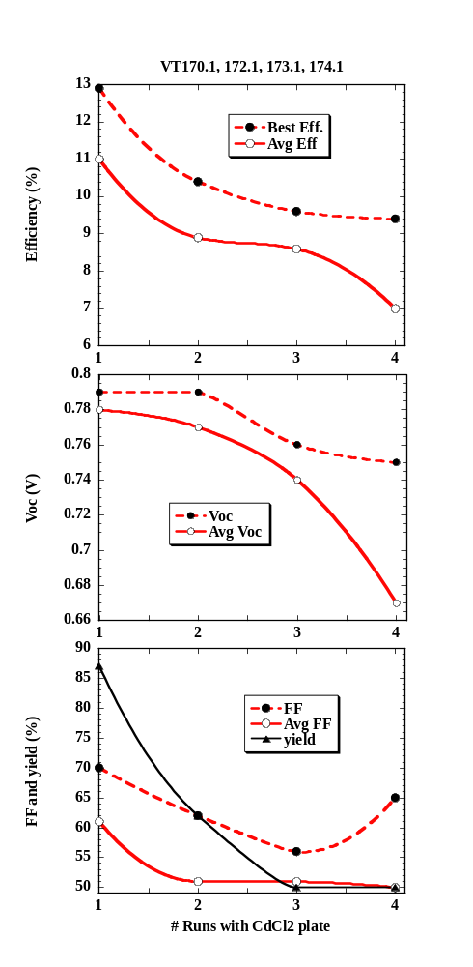
Figure 49. The Eff, V_{oc}, FF and yield versus the sequence in CdCl₂ processing. Both best cell and averaged values are shown. Yield is defined in text.

For SRH recombination, the built-in barrier is coupled to the absorber layer band gap, which can be reduced by alloying with CdS. We have found that the V_{oc} saturates at 0.95-1V below -180ºC and is independent of intensity for many types of CdTe/CdS cells (electrodeposited, PVD, VT), which suggests pinning of the quasi-Fermi levels by states near the band edges. This upper limit suggests a built-in voltage of ~1V. Clearly increasing V_{oc} beyond 900 mV will require a reduction in band tail states and/or an decrease in band misalignment at the interfaces.

A statistical survey was made of devices processed, since the most recent VT reactor modification (VT114-174). The sample population was determined in various ways. In general, it was always found that efficiency was correlated with FF, not V_{oc} or J_{sc}. The V_{oc} was not correlated with J_{sc}, as would be expected if random variations in CdS thickness resulted in higher blue response but greater shunting. The dark JV curves of devices on 17 pieces were analyzed to determine J_{o} and A. Figure 50 compares the V_{oc} calculated from the standard relationship assuming superposition with the measured V_{oc}. There is very poor correlation. The FF was similarly uncorrelated with dark A or J_{o} and V_{oc} was not correlated with FF. This indicates that neither FF nor V_{oc} are governed by the dark JV curve, as would be expected according to the standard superposition model. Instead, we have shown that the voltage dependent collection J_{L}(V) is a major loss governing the FF. We have calculated the efficiency that would result after correction for series resistance and J_{L}(V) losses. Figure 51 shows the power curve for a device VT174.1 that was in Figure 40 as the first plate in the CdCl₂ processing sequence. The as-measured efficiency was 12.0%. After correction for R_{s}, then R_{s} plus J_{L}(V), it increased to 13.0 then 13.9%. There was little increase in V_{oc} with correction for J_{L}(V). Eliminating R_{s} and JL(V) losses leaves primarily junction recombination losses. For our present devices, that would limit us to around 14%.

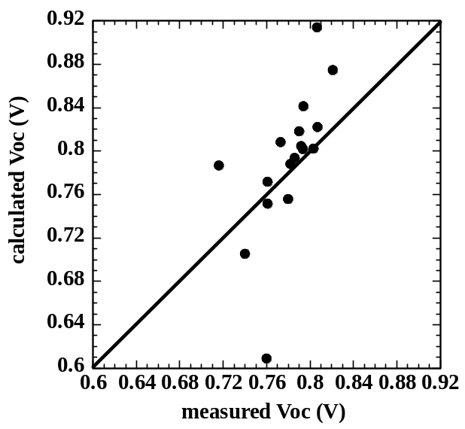

Figure 50. Measured and calculated V_{oc} for 17 devices. Calculated V_{oc}=AkT/q ln (J_{sc}/J_{o}).

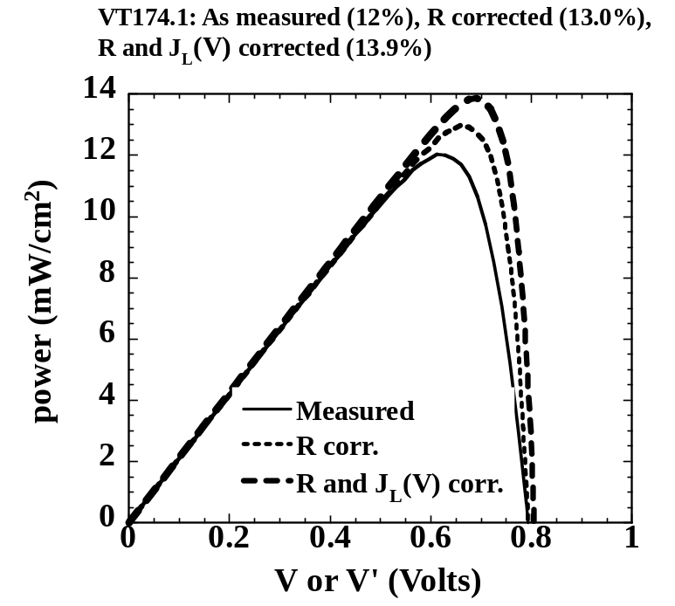

Figure 51. Power curves for device with correction for R_{S} and J_{L}(V). Note there is little increase in V_{oc}.

The grain surfaces and boundary regions can influence forward current by providing or limiting lateral current paths. Likewise, grain boundaries may be active, i.e., conductive, and contribute to shunt conductance, or they may be passive, i.e., oxidized. The presence of the blocking barrier at the back contact is not to first order a loss in V_{oc}. Figure 41a showed two cells with very different back contact behavior. The device with normal forward bias curve was Cu-doped, while the one with blocking behavior had no Cu in the contact, yet their V_{oc}’s differed by only 30 mV. Likewise, Table XV showed data for 4 different types of back contact layers where the Cu-containing layer was the major variable, including one with no Cu. Yet, they all have comparable V_{oc}. Clearly the back contact barrier and Cu availability are not first order influences on V_{oc}. This suggests that front junction V_{oc} is decoupled from any band bending at the rear, and that the rear contact is not phtovoltaically active, hence, not limiting V_{oc} at present.

In summary, the empirical factors found to affect V_{oc} in present-generation VT cells are as follows:

1. CdS thickness
When d_{CdS} < 80 nm, buffer layer used to maintain V_{oc}
V_{oc} decreases for final d_{CdS} < 40 nm

2. T_{sub} during CdTe VT growth
Highest V_{oc} obtained for deposition >500ºC

3. CdTe thickness
Highest V_{oc} for d_{CdTe} > 2 μm
V_{oc} decreases for d_{CdTe} < 1.5 μm

4. Ambient composition during VT growth
Require O₂ partial pressure

5. Cu + HT needed to push V_{oc} from 600 mV range to > 750 mV
Highest V_{oc} for Cu driven from back surface
Single crystal device had no Cu

- CIS BASED SOLAR CELLS

3.1 Inline CIGS System

Introduction
During the past year, research on the roll-to-roll deposition of Cu(InGa)Se₂ on polymer substrates concentrated on process improvements in the in-line system and on investigating the scale-up issues relating to the linear evaporation sources. The latter work is being performed in an independent bell-jar system where the operation of a linear source is being characterized.

The work in the roll-to-roll system uses 50 µm Upilex S web substrates coated on both sides by Mo having thicknesses of 2000Å and 200Å respectively. In some cases, 1000Å Mo back contact was also investigated. The back contact Mo film sputter deposited and contained 5-to-10 at% oxygen on the top half of its thickness to suppress cracking during the Cu(InGa)Se₂ deposition. In order to better understand the effect of oxygen in the films, they were characterized in terms of the oxygen distribution through the thickness.

The substrates in the form of 6" rolls were prepared by Techni-Met, Inc. of Windsor, Connecticut according to specifications and parameters provided by IEC. While these "oxygenated" substrates have consistently been crack free after Cu(InGa)Se₂ depositions, in one lot, crack formation has been observed. However, this problem was traced back to an operational mistake at the supplier and has been corrected.

In all cases prior to the Cu(InGa)Se₂ layer, an adhesion promoting a layer of 100Å to 300Å β-(Ga_{1-x}In_{x})₂Se₃ has been deposited on the Mo film.

Roll-to-roll Process Improvements:

Sources
In order to accommodate higher temperatures required for higher rates, the insulation of the Cu source has been re-designed. Multilayer graphelt/Ta/grafoil parts have been replaced with rigid alumina and Ta foils. Such a rigid insulation system would be reproducible and would have predictable thermal characteristics. Operationally, it also showed a better insulation characteristic in that the source was found to operate at lower temperatures to give Cu(InGa)Se₂ films of similar thickness. Other graphite parts in the source were also changed and replaced with boron nitride so as to eliminate the reaction with alumina insulation. Presently the only graphite part left in the source is the heater.

After several months of operation in the Cu source, the new insulation has been implemented into the Ga and In sources as well.

Another issue that is of concern for high temperature operation of the sources is the vapor leakage through the joint between the lid and the body of the source. Presently, a small amount of leak is observed but it does not result in any operational problem. However, at high rates of effusion, such a leak will reach unacceptable levels. As a result, a sealed source has been designed and fabricated and will be tested at the earliest opportunity.

A new Se source was also found to be necessary because the old design was found to be leaking as the temperature was increased. As a result, the Se was effusing not only through the manifold but also through the grafoil seal between the cap and the body of the source. The new source is made out of graphite and is sealed. It is controlled with an inconel sheathed thermocouple immersed into Se. The source also incorporates water cooling capability. At the end of a run, the Se heater is turned off and water cooling is turned on. At that point, the source cools more rapidly than the manifold and acts like a Se pump, avoiding condensation of Se in the manifold or elsewhere in the Se distribution system.

As far as the new Na source is concerned, the decision was made to use the design of the present metal sources. This would be the most expedient approach since there would be no need to design and test a totally new source. Furthermore, software to control the source would also be the same. In fact, the Na source control component has already been added to the present software program running the system. The Na source will be supplied by a DC power supply that would give more flexibility in monitoring both voltage and current and thus provide additional system monitoring capability. As this DC power supply's operational characteristics is better known, similar powers supplies may be used for the other metal sources replacing presently used transformers.

Cu Source Control

Severe control problem with the Cu source have re-surfaced again during the deposition of Cu(InGa)Se₂ films. The problem, which is in the form of highly unstable behavior in both temperature readings and power outputs, was the same one observed during the previous years and was thought to have been resolved. It took more than a month to resolve the issue that was traced to a design fault in the National Instrument's Field Point Thermocouple Module (FP-TC-120). The module generates unstable temperature reading if the C-type thermocouple, used for the evaporation sources, generates a voltage more than 20mV and there are more than one thermocouple attached to the module. When this behavior was discovered, Cu control thermocouple was connected to an independent FP-TC-120 module all by itself. The other seven input ports were shorted. In this way, control instabilities were totally removed and the system became fully operational.

After these changes, a number of depositions were performed on Mo-on-UpilexS substrates to recalibrate the system in terms of the Cu(InGa)Se₂ composition and device performance level using two different Mo coatings thickness, 2000Å and 1000Å. Table XVI gives the results obtained at the end of this recalibration process.

Table XVI. System calibration runs giving Cu(InGa)Se₂ composition and the best device characteristics.

 |  |  |  |  | Best Device
Run | Mo Thck |  | At % | Ratio | V_{oc} | J_{sc} | FF | Eff
 | (Å) |  |  | (M/III) | (V) | (mA/cm²) | (%) | (%)
70321 | 2000 | Cu | 24.2 | 0.90 | 0.554 | 31.3 | 57.1 | 9.9
 |  | Ga | 9.3
 |  | Se | 49.1
 |  | In | 17.5
70322 | 2000 | Cu | 24.2 | 0.92 | 0.539 | 33.5 | 54.9 | 9.9
 |  | Ga | 10.7 | 0.41
 |  | Se | 49.5
 |  | In | 15.6
70324 | 1000 | Cu | 25.5 | 0.99 | 0.546 | 31.6 | 47.2 | 8.2
 |  | Ga | 10.5 | 0.41
 |  | Se | 48.7
 |  | In | 15.3

The lower device performance on 1000Å Mo may be due to the difficulty in making a back contact for probing without damaging the Mo layer. This point is presently under investigation. Nevertheless, the data show that the system with the new source insulation and control scheme can give reproducible compositions and acceptable device performance.

Analysis of Oxygenated Mo Films

In order to better understand the process by which oxygen suppresses the film cracking during Cu(InGa)Se₂ deposition, Auger depth profiling data was obtained for Mo films both before and after Cu(InGa)Se₂ deposition. Figure 52 gives the profile of the typical 2000Å as-received Mo film on Upilex S. The figure reflects the configuration of Techni-Met's sputtering system as well as the way oxygen is introduced into the system. Sputtering system has two targets separated by some distance. The web stretched over a cooling drum travels over the targets. The sputtering gas is directed over each target through two gas inlets. The Mo film profiled in Figure 52 had oxygen mixed with argon gas directed onto the second target. The flow rate of oxygen was set at 5% of the Ar flow rate. The sputtering gas directed onto the first target was pure Ar. The two dips in the oxygen signal correspond respectively to the concentrations of oxygen in the top and bottom half of the Mo film. The oxygen peak in the middle, on the other hand, represents the oxygen adsorbed by the Mo film deposited by the first target during the transit of the web between the two targets.

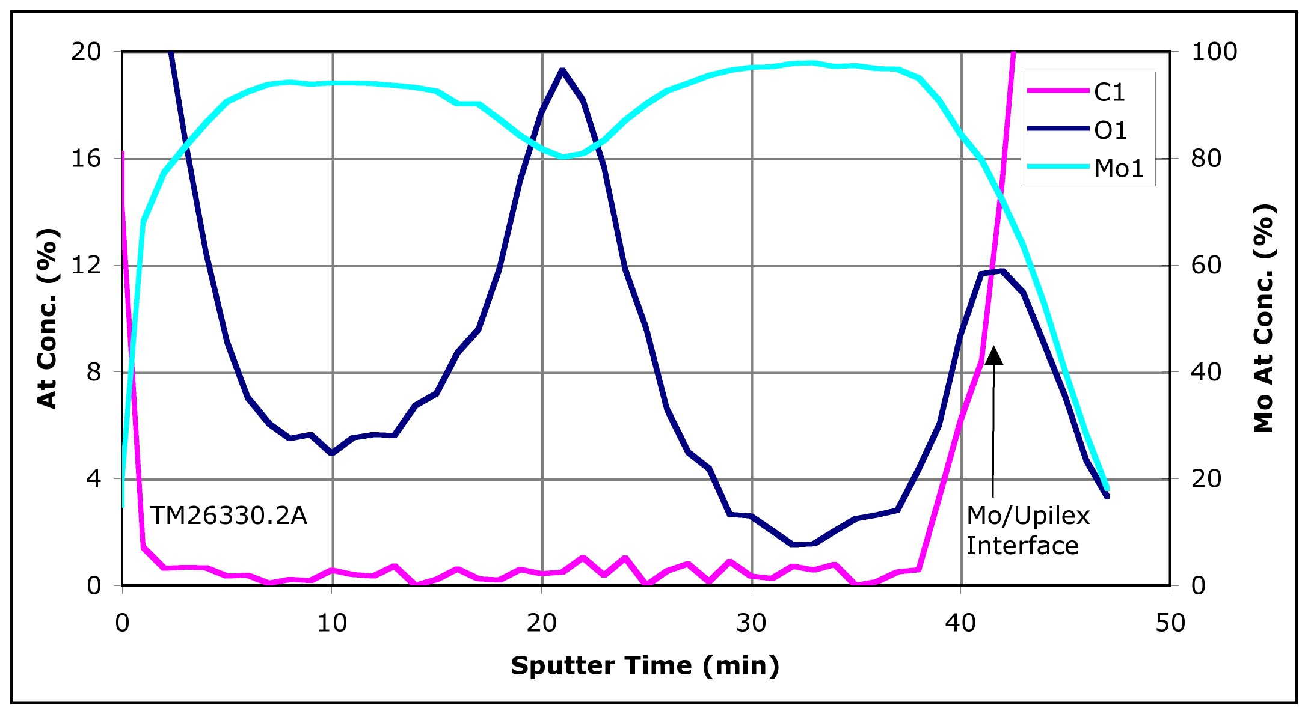
Figure 52. Auger depth profiling of the as-received Mo-on-UpilexS.

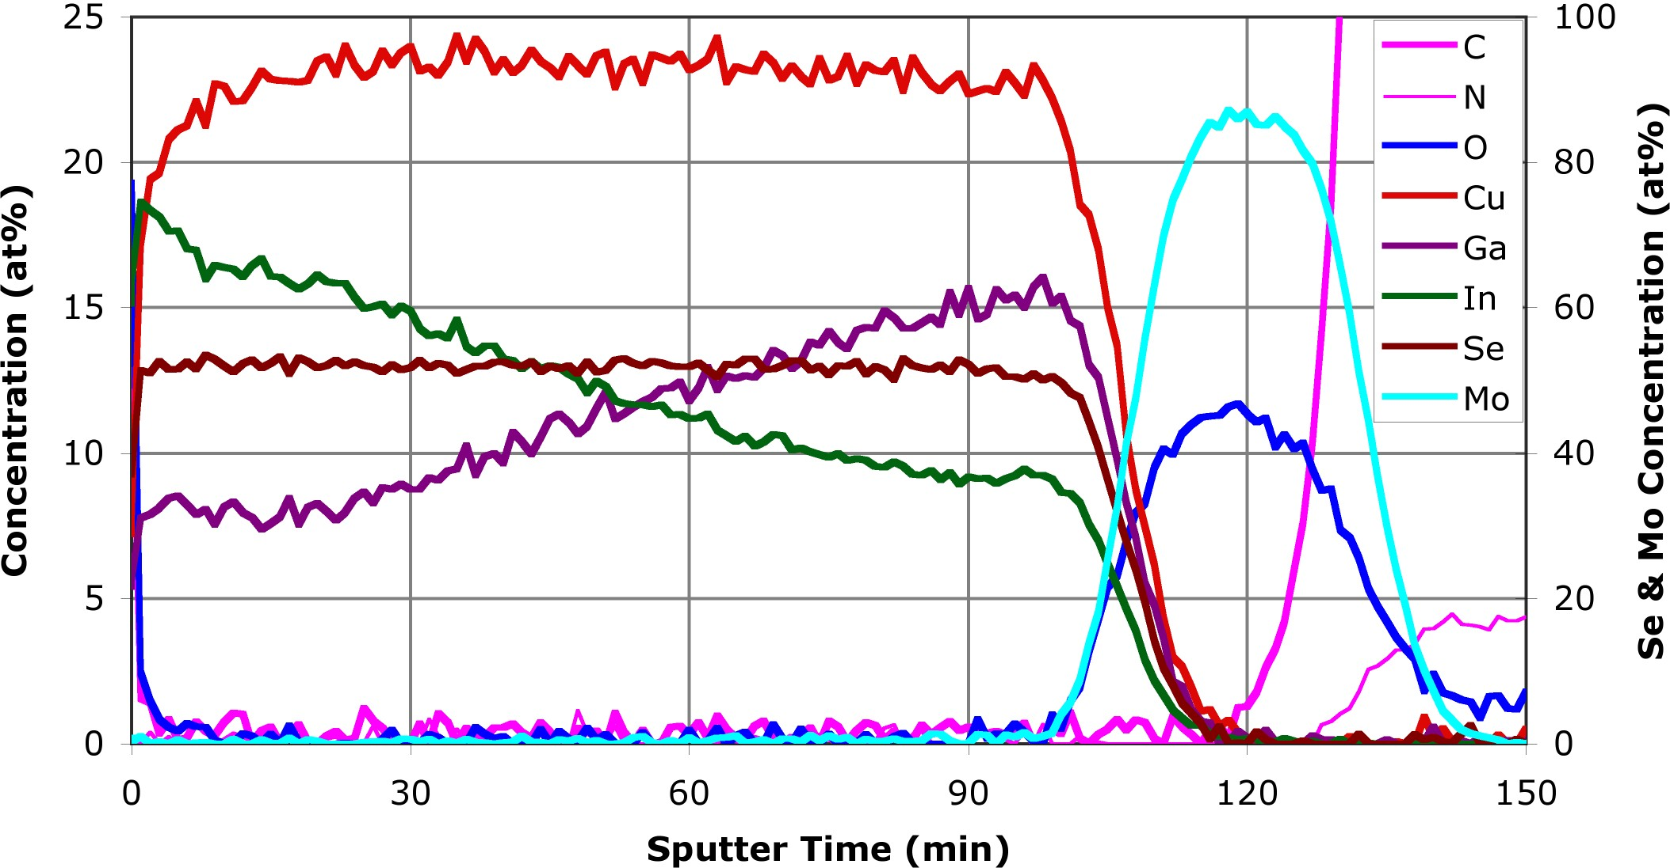
Figure 53. Auger depth profiling of the Cu(InGa)Se₂ on Mo coated Upilex S.

Auger depth profiling of the films following the deposition of the Cu(InGa)Se₂ film on the Mo profiled in Figure 52 is shown in Figure 53. The difference in the oxygen distribution in the Mo film is dramatic. It illustrates the large scale diffusional transport of oxygen in the Mo resulting in a uniform composition of around 9 at%. Furthermore, this level of oxygen also implies that the adsorbed oxygen contributes to the overall oxygen content in the Mo film. Clearly more work is needed in this area.

Scale-up Issues in Linear Evaporative Sources:

The key quality variables that influence final solar cell efficiency are film thickness and composition, and their uniformity across the substrate width. The overall operational objective for a successful commercial process is robust and tight control of the mean values of film thickness and composition as well as their uniformity across large-area substrate, for long deposition times. The film thickness variation (or non-uniformity) is given by:

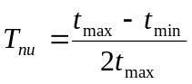 (12)

where, 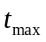and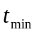are the maximum and minimum film thicknesses respectively (thickness variation of more than ±10% around the mean value is unacceptable).

Successful scale-up involves problems in both design and control that must be considered simultaneously; and unless the process is designed with explicit due consideration for the desired final film quality specifications, successful scale-up to achieve desired control and overall process performance will be difficult.

It has been customary to regard the scale-up of physical vapor deposition (PVD) processes strictly as a problem that can be handled exclusively by control, ignoring the possibility that pilot-scale process design assumptions, such as equal nozzle-effusion-rates in a multi-nozzle source boat, may no longer apply at the commercial scale. For the specific system under study, we have identified two primary issues (relatively insignificant for a pilot-scale process) that must be resolved for a successful commercial-scale development: (i) melt-temperature gradients, and (ii) the reduction of melt-level with time.

Melt Temperature Gradient
For the specific system under study, linear thermal boats with two nozzles each are used as sources for copper, gallium and indium. The heater assembly in the source-boat is asymmetric (see Figure 54); the resulting melt-temperature profile will therefore be asymmetric because of the temperature gradient in the graphite heater, conductive heat loss through the current leads, and direct radiative heat loss through the holes drilled in the insulation (to accommodate the current leads). Since nozzle effusion rate essentially depends upon the melt-surface temperature directly underneath the nozzle, an asymmetric melt-temperature profile will result in a mismatch in the vapor flow rates through the two nozzles, and hence, lead to film thickness non-uniformity.
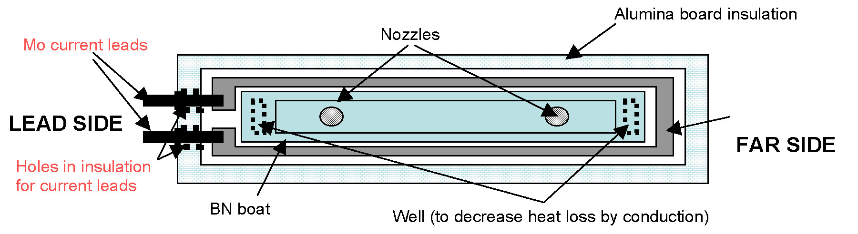
Figure 54. Asymmetric heater assembly.

(a) | 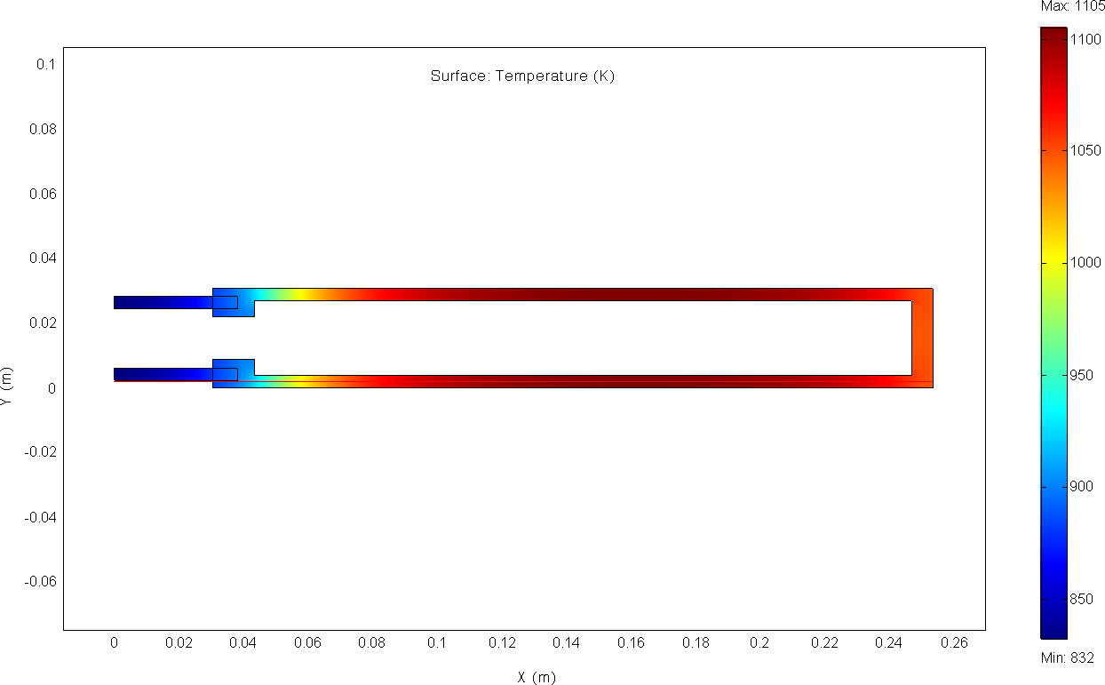
(b) | 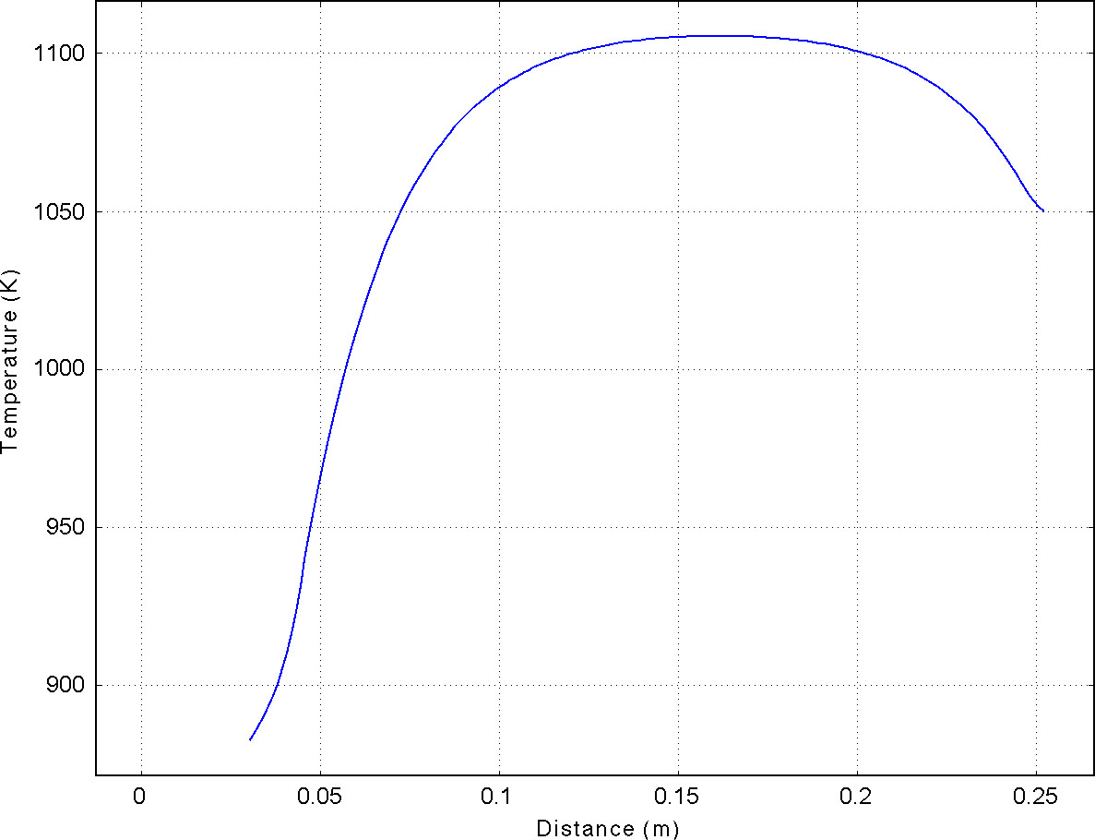

Figure 55. Temperature gradient in the graphite heater: (a) 2D distribution, (b) along the lower branch.

Figure 55 shows the result of the simulation performed in Femlab software to determine expected temperature gradient in the graphite heater. It is assumed that the heater is placed in a vacuum chamber and is radiating heat to the surroundings at 300K; the current flowing through the heater is assumed to be 100 Amps. Note the appreciable temperature gradient between the lead side and far side of the heater.

Melt Level Reduction With Time

The melt level inside a source-boat will drop with time due to mass loss through the nozzles. For relatively small deposition times (< 2 hours) or lower flow rates, melt level reduction may be neglected (Figure 56). However, in a high-throughput commercial-scale process, in addition to higher vapor flow rates, deposition run-times are longer (>8 hours). Consequently, significant reduction in the melt-level occurs, affecting the melt-surface temperature as well as the nozzle flow rates and hence, the film thickness. Since it is difficult to prevent melt-level reduction by source-boat design modification (though designs with low melt cross-section area to melt-height ratio will have more pronounced melt-level drop than the others), the disturbance introduced in the process variables by the slow decrease in the melt-height should be rejected by process control. The development of a coupled heat and mass transfer model to describe how reduction in the melt level affects the vapor flow rates will be the topic of future study.

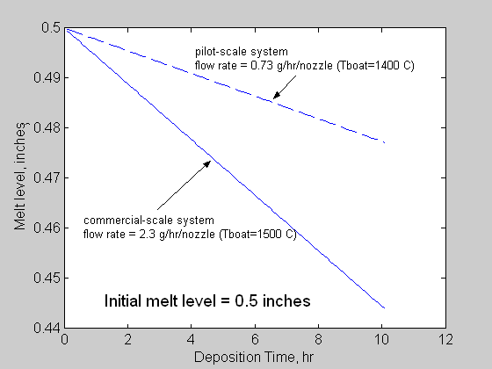

Figure 56. Melt level reduction with time (simulation).

Considering how these issues arise from elemental source design, and considering their impact on process controllability, we divide the scale-up issues into the following two components: (i) The design issue – where an elemental source is designed such that melt-temperature gradients are minimized, thereby reducing product quality variations, and (ii) The control issue – where the mean values of the final film quality variables are robustly controlled such that the desired set-points are achieved while simultaneously rejecting the disturbances introduced by the melt-level reduction.

Experimental Results
An independent vacuum bell-jar system was assembled to quantify temperature gradients within the source-boat, so that the normal operation of the pilot-scale inline process is not interrupted. Figure 57 shows a schematic representation of the experimental system. A source-boat similar to the one currently in use in the pilot-scale system is placed inside the bell-jar. A 10-inch-by-1-inch glass substrate is located 9 inches directly above the source boat for copper film deposition to obtain the thickness profile along the substrate width. Since it is not possible to measure the temperature of the melt directly, thermocouples are placed as shown in Figure 58 to measure the boat-end temperatures, thereby providing an indirect indication of the melt temperature gradient. The source-boat bottom temperature is controlled using a digital PID controller implemented using the LabVIEW package.

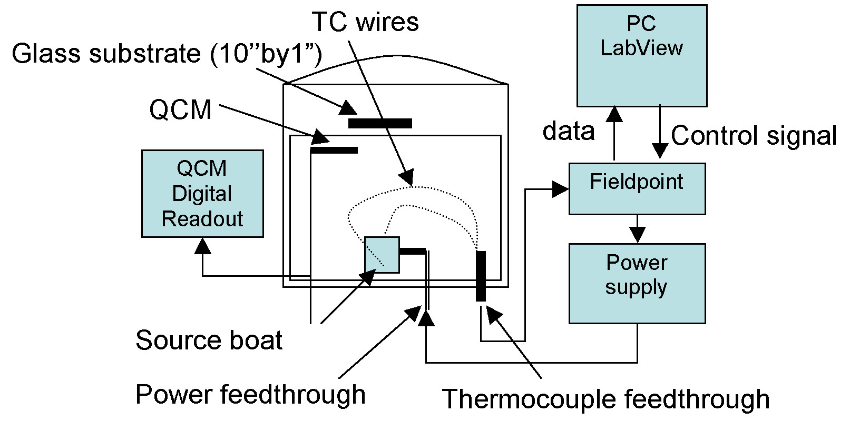

Figure 57. Experimental set-up.

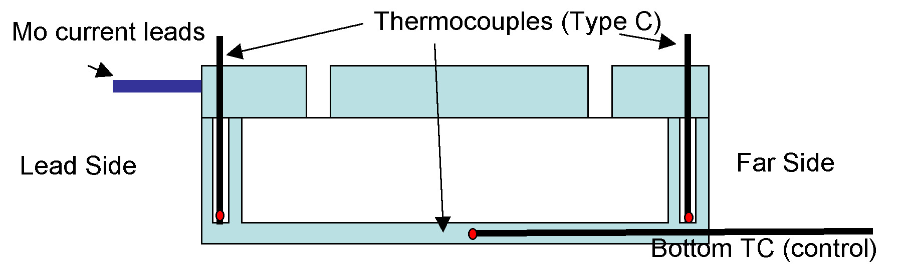

Figure 58. Thermocouple placement inside the source-boat.
Figures 59 and 60 show the experimental results for temperature dynamics at the boat-ends for two separate runs (Run 1 and Run 2), while Figures 61 and 62 show the respective film thickness profiles (negative co-ordinates are on the “Lead Side”: see Figure 58). As expected, the lead-side of the source-boat is cooler than the far-side. Observer that for Run 1, the lead side temperature continues to drop even when the boat-bottom temperature has reached steady-state; this is probably due to the direct heat loss through the insulation holes (the slight increase in the far side temperature may be due to interference from the ground loops). In Run 2, the clearance between the current leads and the insulation holes is removed by essentially screwing the leads through the insulation; the lead side temperature drop is reduced significantly.

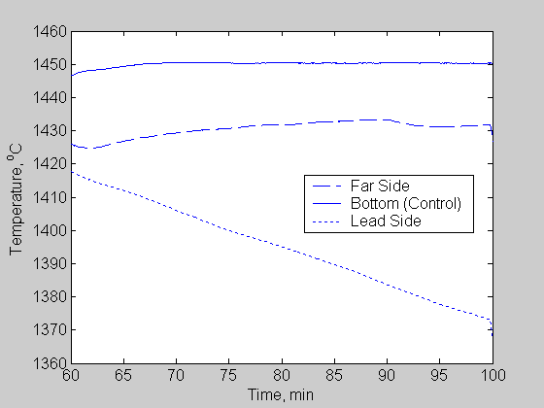  Figure 59. Temperature dynamics  (Run 1) | 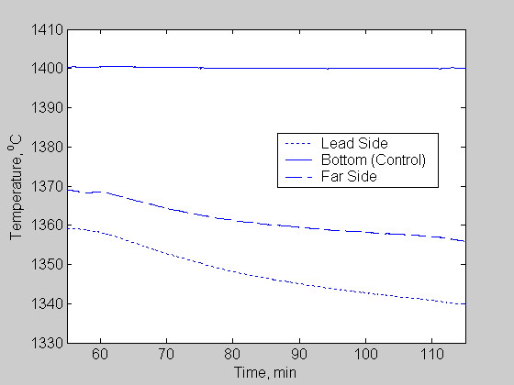  Figure 60. Temperature dynamics  (Run 2)
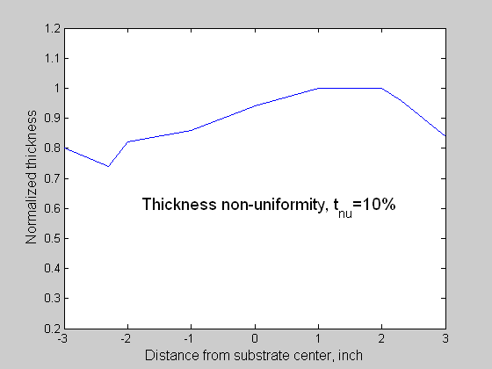  Figure 61. Thickness profile (Run 1) | 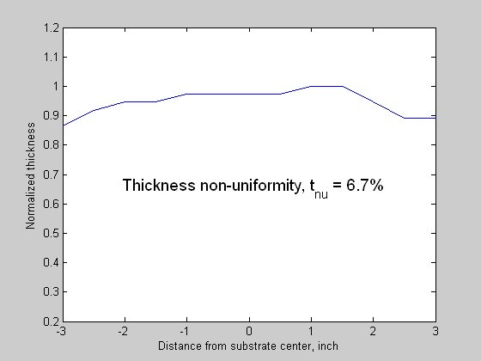  Figure 62. Thickness profile (Run 2)

Variation in the temperature dynamics for different experimental runs is also observed, attributable to the changes in insulation properties (due to wear and tear, and deposited material). The temperature difference between the two ends of the boat (ΔT=T_{FS}-T_{LS}) was observed to be between 20 °C to 50 °C. However, for relatively small 6”-wide substrates, this difference is not substantial enough to cause serious film thickness non-uniformity (the thickness uniformity for both Run 1 and Run 2 is less than 10%).

The following simple qualitative modeling of the heat fluxes at the boat-ends is sufficient to explain the observed temperature difference. The total heat loss at the lead side of the boat is given by:

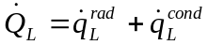 (13)

where 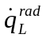is the heat loss term due to radiation to the surroundings and 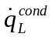is the conductive heat loss through the power leads. The total heat loss at the far side of the boat is given by:

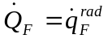 (14)

where, 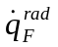is the radiative heat loss at the far side. Also, > due to the presence of holes in the insulation (for the power leads) allowing direct radiative heat loss from the boat that is at a very high temperature. Clearly, 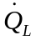 is higher than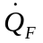. Together with the fact that the graphite-heater temperature is lower at the lead side, this mismatch of heat losses at the boat ends is responsible for the temperature gradient in the source-boat.

An appropriate amount of extra insulation on the lead side may approximately balance and. However, conductive-loss through the current leads and the temperature gradient in the heater itself cannot be removed completely. Moreover, insulation property changes due to material deposition and wear and tear, will make this a non-robust design. The results of one such attempt (Run 3) are shown in Figures 63 and 64. The lead side temperature in this case is observed to be higher than the far side temperature, suggesting over-use of the insulation at the lead-side. However, the film thickness non-uniformity is, again, within the desired limits. Also note that there is a delay between the time when the controlled boat-bottom temperature reaches steady state and when the boat-end temperatures attain steady state.

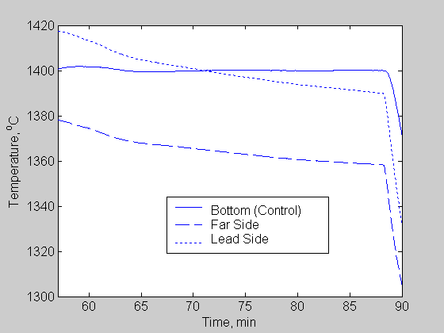  Figure 63. Temperature profiles  (Run 3). | 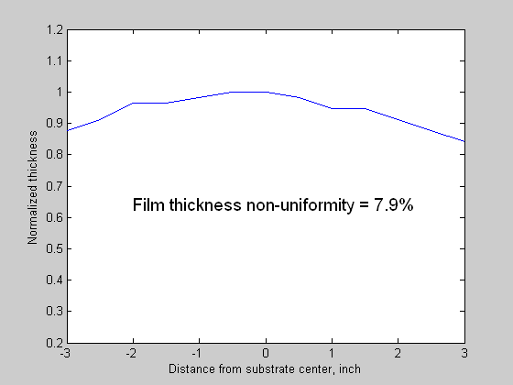  Figure 64. Film thickness profile  (Run 3).

Melt Temperature Gradient In Scaled-Up Process

For the pilot-scale (6”-wide substrate) system, the presence of an asymmetric melt-surface temperature profile was found to have no serious effect on the film thickness uniformity. In this section, we investigate via simulation whether this observation is valid in a scaled-up process. For co-evaporative inline PVD processes, the scale-up entails determination of optimum nozzle-to-nozzle distance, nozzle-to-substrate distance, and boat-to-boat distance such that the material utilization efficiency is maximized for a given substrate-width, and a film thickness non-uniformity constraint. In addition to the above mentioned parameters, there are several other design parameters that have to be fixed (such as length of the deposition zone, number of nozzles in the source boat, maximum tolerable substrate temperature, web speed). For a scaled-up process with 13”-wide substrate, a two-nozzle boat and a film thickness non-uniformity constraint of 10%, the optimum design parameters are listed in Table XVII. The other design parameters are assumed to be same as currently used in the pilot scale-system (deposition zone = 15 in., web speed = 1 in/min). The material utilization efficiency, assuming the source-boat is placed at the center of the deposition zone, is 57%.

Table XVII. Scaled-up process.

Design Parameter | Parameter Value (inch)
Substrate width | 13
Nozzle-to-nozzle distance | 9.2
Nozzle-to-substrate distance | 8
Boat-to-boat distance | 3.5

Results of simulations conducted to determine how the film thickness non-uniformity increases with melt-temperature difference underneath the nozzles are shown in Figure 65. It can be observed that a temperature difference as low as 5 °C is enough to cause film thickness non-uniformity to exceed the acceptable limit of 10%. From the experimental results, we have observed that a temperature difference as high as 50°C is present between the source-boat ends depending upon the insulation degradation. The temperature difference is relatively lower between the melt-surfaces under the nozzles, but greater than 5°C. Thus, to achieve the desired film thickness uniformity, a change in the elemental source-boat design is essential.

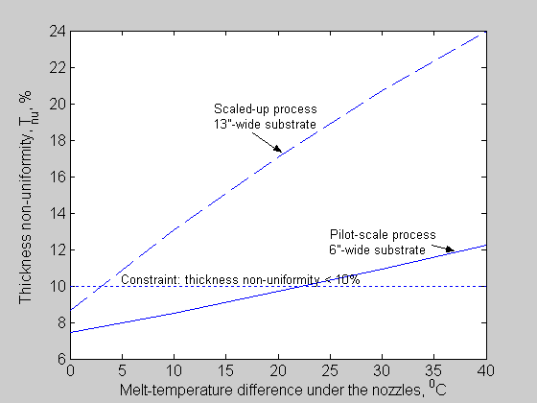

Figure 65. Variation of film thickness non-uniformity with melt-temperature difference under the two nozzles.

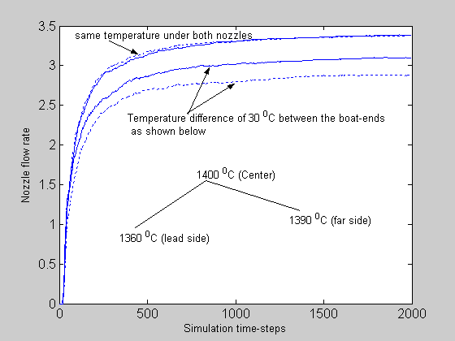

Figure 66. Nozzle-flow-rate difference due to temperature gradient.

Figure 66 shows the results of two-dimensional Direct Simulation Monte Carlo (DSMC) simulations performed for a source-boat with a 30°C melt-temperature difference under the two nozzles. There is significant difference between the two nozzle-flow-rates. (The values of the flow rates are not realistic since it is a 2D simulation; however, the difference is real); this flow-rate difference is enough to exceed the film thickness non-uniformity of 11.2% (acceptable limit being 10%).

Maintaining film thickness within desired limits is not realizable unless equal vapor flow rates through the two nozzles are maintained. This can be accomplished by the following alternative design approaches:

- A design that produces a symmetric temperature profile inside the boat so that the melt-surface temperatures under each nozzle are equal, and

- A design in which nozzles are supplied from a common area on the melt surface.

● Symmetric Melt Temperature:

A simple way to obtain symmetric melt temperature profile is to use a symmetric heater assembly (as shown in Figure 58), thereby providing equal thermal energy to the two nozzles and also balancing the heat losses at the boat ends. This design modification

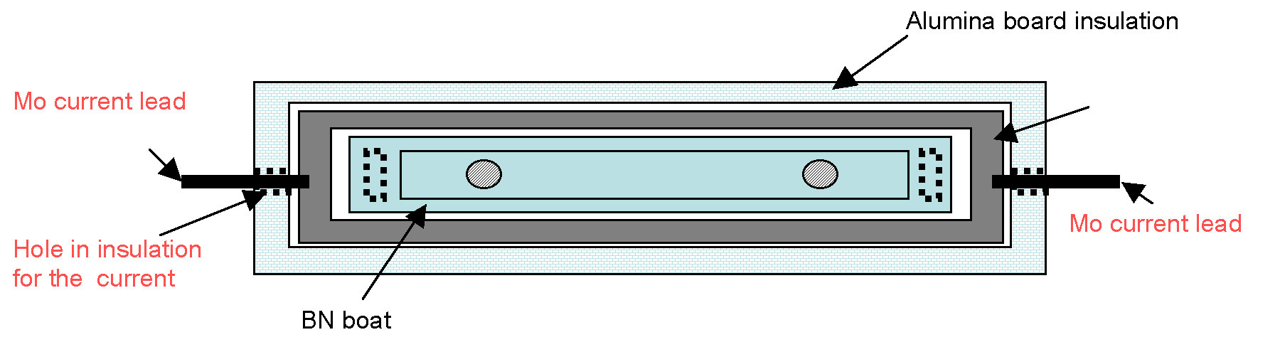
Figure 67. Symmetric heater assembly (Design 1).

(Design 1) achieves the desired equality of the nozzle flow rates since the melt temperature under each nozzle is equal (see Figure 68). Note that the melt-temperature profile is symmetric, but not uniform; hence, introduction of a third center nozzle will entail either reduction in the nozzle-diameter or decrease in resistive heating in the central part of the heater.

● Supply From A Common Melt Surface:

There are three other potential ways, as shown in Figures 69, 70, and 71 by which flow through the nozzles can be made to originate from the same point on the melt surface thus giving equal effusion rates.

- Design 2: a cylindrical source-boat with tilted nozzles (Figure 60) such that the melt-side nozzle openings are close to each other “seeing” the same melt-surface;

- Design 3: a linear boat with a mixing chamber (Figure 61) with a single central opening to the melt volume;

- Design 4: a linear boat with tilted nozzles (Figure 62) placed near the center of the boat again “seeing” the same melt-surface.

(a) | 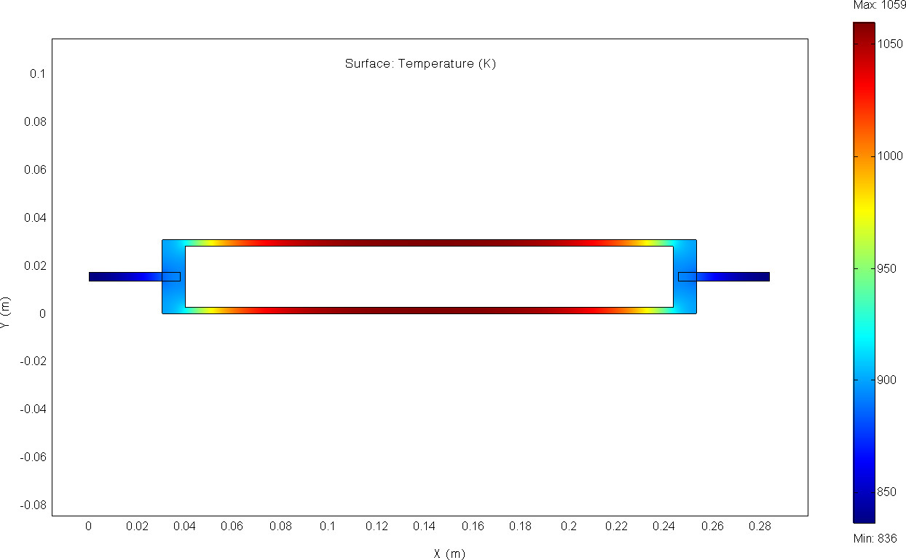
(b) | 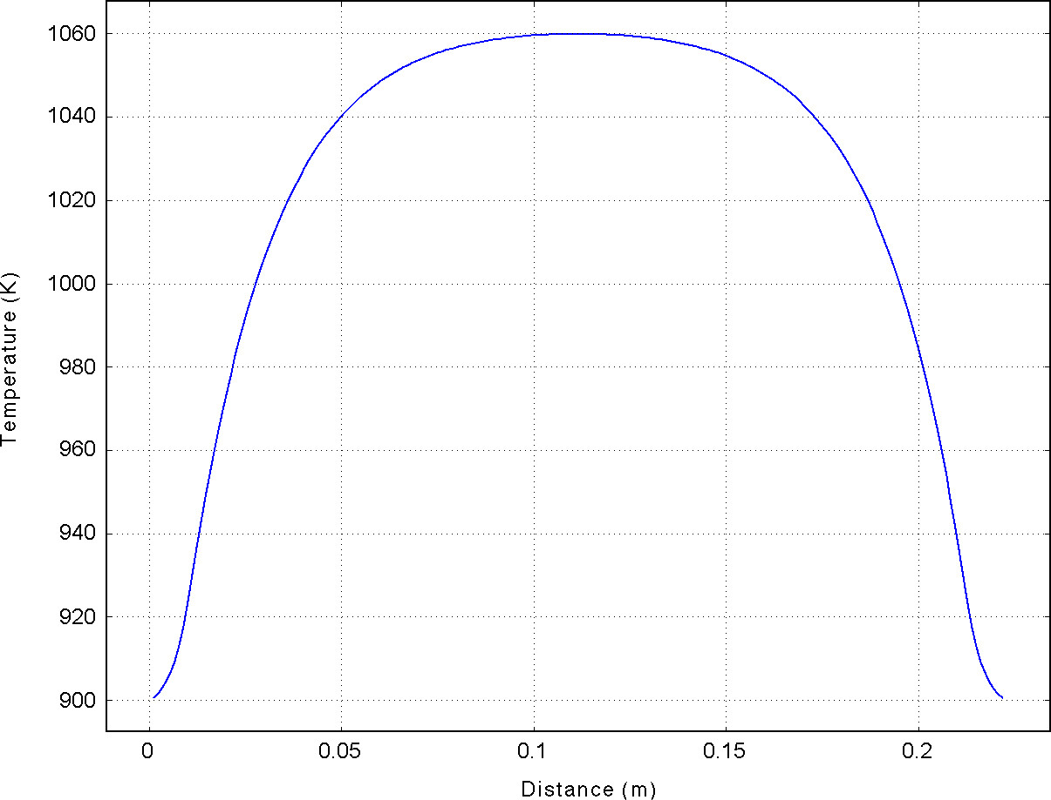

Figure 68. Temperature gradient in a symmetric heater in Design 1: (a) 2D distribution, (b) along a lower branch.

The proposed designs lead to equal nozzle effusion rates and hence desired film thickness uniformity, provided other design parameters (such as nozzle-to-substrate ratio and nozzle-to-nozzle distance) are chosen appropriately. Design 1, where only a symmetric heater assembly is required, is the simplest and involves minimum change in the system. Designs 1 and 3 are identical in terms of film thickness uniformity and material utilization efficiency; however, Design 3 will have lower nozzle effusion rate than that of Design 1 because the vapor flow is restricted by the central opening.

cartoon  α  Figure 69. Cylindrical boat with tilted nozzles.  (Design 2) | Melt  Distribution chamber  Central opening  Figure 70. Linear boat with central opening  (Design 3)
Melt
Figure 71. Linear boat with tilted nozzles (Design 4)

Figure 72 shows a comparison of Design 1, Design 2, and Design 4 in terms of thickness non-uniformity (t_{nu}) and material utilization efficiency (m_{eff}). Note that for a boat with tilted nozzles, both t_{nu} and m_{eff} are strong functions of the nozzle tilt angle.

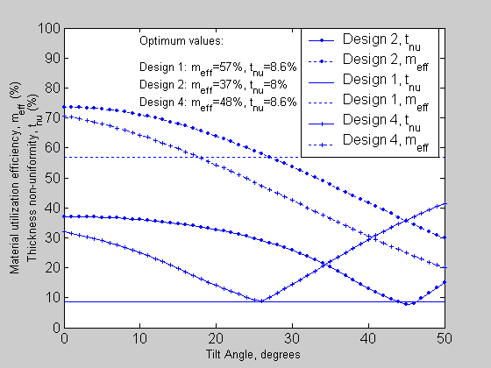
Figure 72. Comparison of designs 1, 2 and 4.

Also, note that m_{eff} of Design 2 is significantly lower than that of Design 1. Material utilization efficiency can be improved for Design 2 by increasing the beam collimation parameter (n) from a value of 3 to 5; however, from the DSMC calculation results, it was not possible to increase the value of n (by increasing nozzle length-to-diameter ratio) since the vapor flow is in transitional regime. Design 4 with tilted nozzles separated by 4 inches provides improved m_{eff} compared to Design 2; however, it is still less compared to that of Design 1.

From these arguments, it is clear that Design 1 is the better option both in terms of ease of implementation and material utilization efficiency. However, for source-boats with 3 nozzles, Design 4 has the advantage that the nozzle flow rates are guaranteed to be equal. Future work involves conducting experiments with the modified source-boat to evaluate improvements in film thickness uniformity for wider substrates.

It should also be pointed out that source-to-substrate distance, H, affects the source design as well. For example, as shown in Figure 73 for a 13”-wide substrate, film thickness non-uniformity of 10% or lower cannot be obtained with a two-nozzle source-boat if nozzle-to-substrate distance is less than 7 inches; a three nozzle boat has to be used.

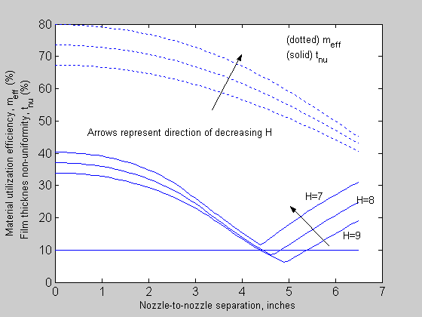

Figure 73. Effect of source-to-substrate distance, H, on material utilization efficiency and film thickness non-uniformity.
3.2 Wide Bandgap Materials: Cu(InAl)Se₂

Cu(InAl)Se₂ based solar cells have demonstrated comparable efficiencies to Cu(InGa)Se₂ for bandgap 1.1 – 1.2 eV; but, with higher bandgap V_{oc} with Cu(InAl)Se₂ is lower than with Cu(InGa)Se_{2.} In addition, poor adhesion at the Mo/Cu(InAl)Se₂ interface was identified as a critical issue and was substantially improved by incorporating a thin, ~ 5 nm, Ga layer sputtered onto the Mo film prior to the Cu(InAl)Se₂ deposition.Error: Reference source not found The improved adhesion enabled films to be deposited at high substrate temperature T_{SS} = 530°C resulting in higher efficiency cells. Most notably, with Al/(In+Al) = 0.13 and E_{g} = 1.16 eV, a cell with 16.9% efficiency was demonstrated after application of an anti-reflection layer. However, efforts to study devices with increasing bandgap or to implement different deposition processes were still severely hampered by poor Mo/Cu(InAl)Se₂ adhesion, resulting in many films delaminating during device processing or characterization. An inverse relation between the Al content at the back of the Cu(InAl)Se₂ film and adhesion was observed. Consequently, efforts on Cu(InAl)Se₂ were partly focused during this period on obtaining a more fundamental understanding of the Mo/CuInSe₂-alloy interface, and this is discussed in the section, “Fundamental Materials and Interface Characterization,” below.

Cu(InAl)Se₂ films have been deposited by multisource elemental co-evaporation onto Mo-coated soda lime glass substrates. In addition to characterization of the back contact, efforts on Cu(InAl)Se₂ have focused on developing alternative evaporation sequences and a more complete understanding of the material.

Cu(InAl)Se₂ films have been deposited using a 3-stage evaporation process, incorporating end-point detection of the substrate temperature (T_{SS}) to control the final composition. A description of the process and characterization of the films follows. Figure 74 shows the time-temperature profile of the elemental sources and the substrate heater power during a typical deposition. Figure 66 shows the measured T_{SS} profile during a typical deposition. The 3-stage process is characterized by sequential deposition and reaction of 3 layers. In the first stage, In, Al, and Se are deposited on the Mo coated soda-lime glass at relatively low T_{SS}. Subsequently, Cu and Se are deposited onto the film to form the chalcopyrite phase at higher T_{SS} and then continued to form a Cu-Se phase on the film surface. Finally, In, Al, and Se are deposited to make the film slightly Cu poor, so it is suitable for devices. The typical final composition gives [Cu]/[In+Al] = 0.8-0.9. Figure 75 shows that at time A during the second stage, a sudden drop in T_{SS} can be measured. This corresponds to the formation of the Cu-Se phase on the film, which changes the emissivity. T_{SS} later increases when the Cu-Se phase is consumed in the third stage. The reproducibility of the 3-stage process owes to the temperature drop at time A, since it enables the operator to carefully monitor the subsequent film growth.

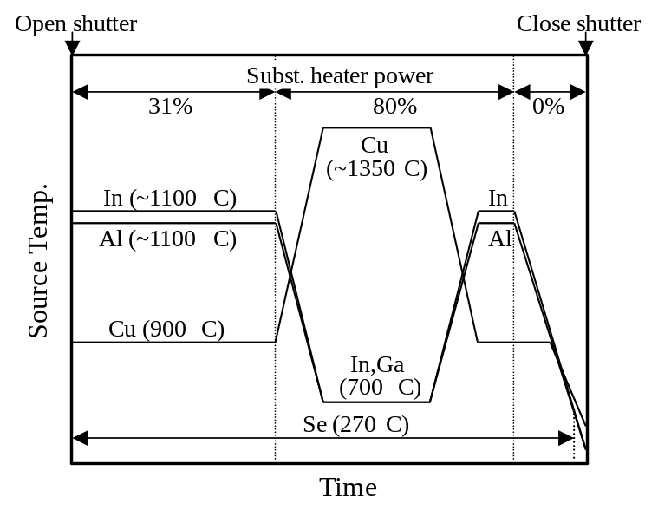
Figure 74. Source temperatures and substrate heater power during the deposition.

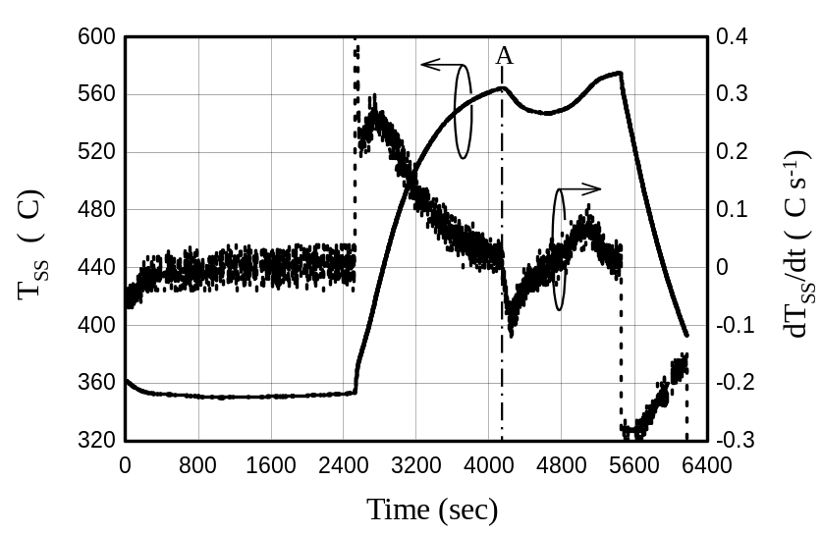
Figure 75. Typical substrate temperature profile and its first derivative.

Films were grown with different relative Al contents and the (112) XRD peaks are shown in Figure 76. Clear shifts to high angle and broadening of the peak with increasing Al content ([Al]/[In+Al]) can be seen. In Figure 77, the surface morphology of low ([Al]/[In+Al]=0.17) and high ([Al]/[In+Al]=0.58) Al content films are shown by SEM micrographs. The low Al film contains 1-2 μm grains, while the high Al film has submicron grains.

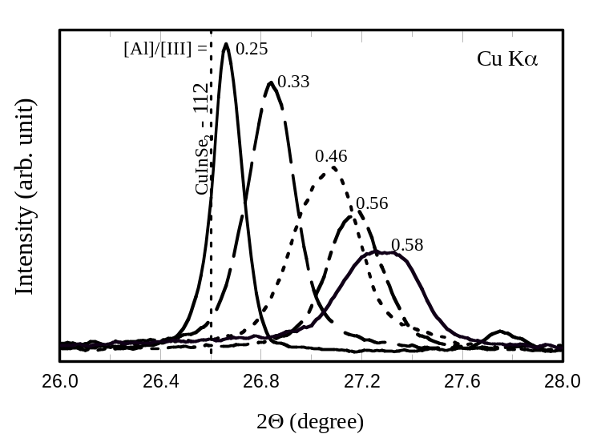
Figure 76. 112 XRD peaks from films with various Al content.

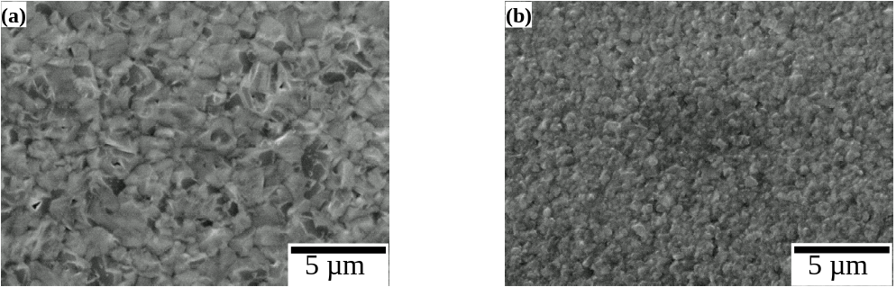

Figure 77. Surface morphologies of (a) low Al ([Al]/[In+Al])=0.17) and (b) high Al([Al]/[In+Al])=0.58) content films.

Solar cells were fabricated using the standard device structure with CdS/ZnO/ITO window layers. Figure 78 shows J-V curves of the best solar cells with different Al content. Devices with [Al]/[In+Al]~0.2 show a reproducible efficiency > 12%. So far, the best performance obtained is an efficiency of 13.6%, with V_{oc} = 0.546V, J_{SC} = 32.8 mA/cm⁻², FF = 75.9 % so no improvement with the 3-stage process has been achieved. As previously reported, higher [Al]/[In+Al] samples generally peel off during CdS buffer layer deposition. The exception is with stoichiometric or Cu-rich films with [Cu]/[In+Al] ≥ 1.0 which have better adhesion. Devices in this case, as with [Al]/[In+Al] = 0.52 in Figure 78, are fabricated after a KCN etch.

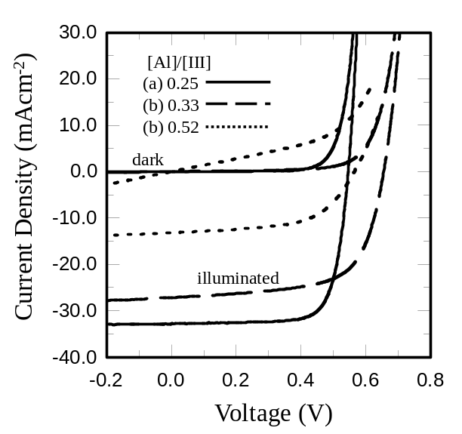
Figure 78. J-V curves with (a) [Al]/[In+Al]=0.25, (b) [Al]/[In+Al]=0.33, and (c) [Al]/[In+Al]=0.52.

Evaporation of Cu(InAl)Se₂ using the 3-stage process is complicated in the baseline IEC evaporators by the relatively slow thermal response times of the insulated Knudsen-type sources. Thus, a simplified version of this process was also developed. In Figure 78, schematic temperature profile of the metal sources during this process is shown. The In and Al source temperatures are kept constant and determine the relative Al content. Once the shutter is opened, the Cu source temperature is ramped from 1100°C to a designated temperature (e.g. 1350°C in the case show) with a ramp rate of 10°C/min. Then T(Cu) is held constant. The final Cu temperature is determined so that the impingement rate of Cu is higher than the sum of In and Al ([Cu]/[In+Al] >1), and the film composition changes from Cu poor to Cu rich. Figure 79 shows a typical substrate temperature profile during the deposition. Similar to the 3-stage process, the temperature changes under constant substrate heater power. Due to the formation and then consumption of Cu-Se phases, these changes can be measured and used for composition control. After the film becomes Cu-rich, the Cu source is turned off; and when the film becomes sufficiently Cu-poor again, the In and Al sources are turned off.

Cu(InAl)Se₂ films deposited with this process have similar morphology to those deposited with the standard 3-stage process. This process can be easily modified to start the deposition with different relative Cu-contents, as long as [Cu]/[In+Al] <1 at the start.

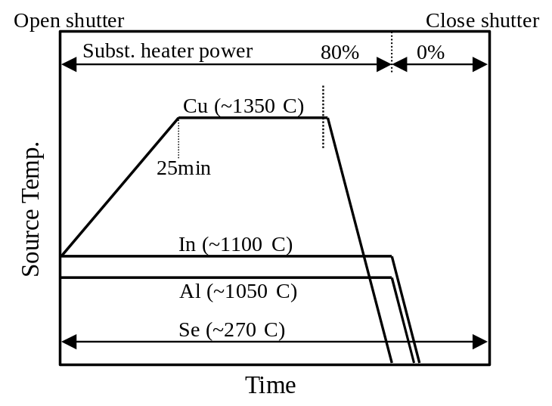

Figure 79. Source temperatures and substrate heater power during the deposition.

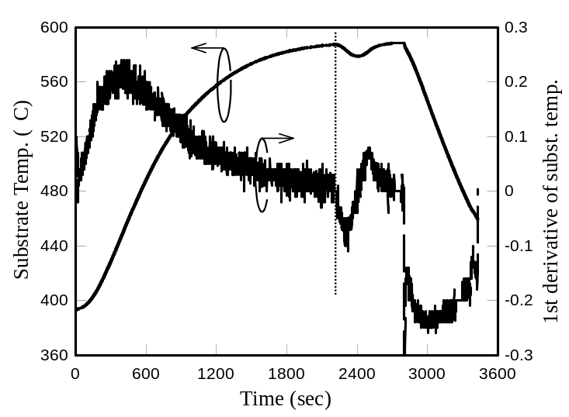

Figure 80. Substrate temperature profile during a Cu(InAl)Se₂ deposition using the profile in Figure 65.

The simplified 3-stage process has been used to study the effect of initial Cu concentration on devices behavior. One of the fundamental questions regarding Cu(InAl)Se₂ films is whether they form an ordered vacancy compound (OVC) in analogy to Cu(InGa)Se₂. Cu-In-Al-Se films were deposited using the modified 3-stage process described in the May 2005 report under this subcontract and with different relative Cu/(In+Al) contents. The film compositions from EDS analyses are listed in Table XVIII. Sample 50607 with 23 at.% Cu has the reference composition of the chalcopyrite crystal structure. The composition formulas of samples 50608 and 50610 are Cu(In_{0.85},Al_{0.15})_{2.2}Se_{3.8} and Cu(In_{0.85},Al_{0.15})_{2.9}Se_{5.0}, respectively. An XRD profile of sample 50610 is shown in Figure 81 where characteristic peaks of the OVC type structure against the chalcopyrite structure are indicated. A similar XRD profile was obtained for sample 50608.

Table XVIII. Chemical composition of Cu(InAl)Se₂ films determined by EDS analyses.

Sample | Cu  (at.%) | In  (at.%) | Al  (at.%) | Se  (at.%) | Composition formula
50607 | 23 | 23 | 3 | 51 | Cu(In_{0.88},Al_{0.12})_{1.1}Se_{2.3}
50608 | 14 | 27 | 5 | 54 | Cu(In_{0.85},Al_{0.15})_{2.2}Se_{3.8}
50610 | 11 | 28 | 5 | 56 | Cu(In_{0.85},Al_{0.15})_{2.9}Se_{5.0}

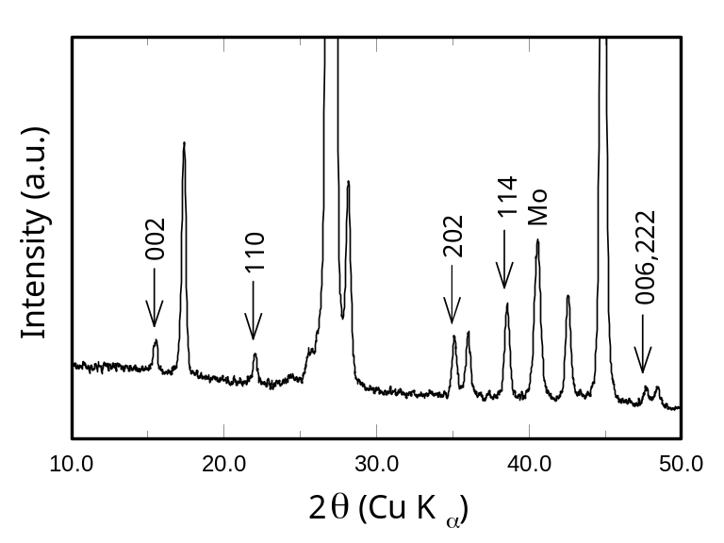

Figure 81. XRD pattern of a film with composition Cu(In_{0.85},Al_{0.15})_{2.9}Se_{5.0}. Peaks characteristic of the OVC structure are indicated.

Solar cell performance decreases dramatically with the lower Cu concentrations as shown by the J-V curves in Figure 82 and in Table XIX. QE curves in the dark and under illumination are shown in Figure 83. As shown, a rough estimation of E_{g} can be made from the long wavelength edge of the dark QE. This indicates a widening of E_{g} with changing the structure type from the chalcopyrite to OVC, similar to the system of Cu-(In,Ga)-Se. Sample 50607 of the chalcopyrite type has E_{g} ≈ 1.14 eV, as shown in Figure 74(a), coinciding with E_{g} calculated from the film composition. Sample 50608 has a wavelength tail that could be related to a mixture of the chalcopyrite and OVC phases. From the QE of sample 50610, E_{g} ≈ 1.32 eV can be estimated. With the 2 lower Cu content films in Figures 83(b) and 83(c), distinct difference in the QE curves in the dark and under illumination are seen corresponding to the poor device J-V performance.

Table XIX. Cu(InAl)Se₂ solar cell properties with different Cu content (J-V curves and Cu content shown in Figure 82).

Sample | Eff.  (%) | V_{oc}  (V) | J_{SC}  (mA/cm²) | FF  (%)
50607 | 11.5 | 0.577 | 28.8 | 0.692
50608 | 3.8 | 0.385 | 21.2 | 0.483
50610 | 0.7 | 0.231 | 9.9 | 0.291

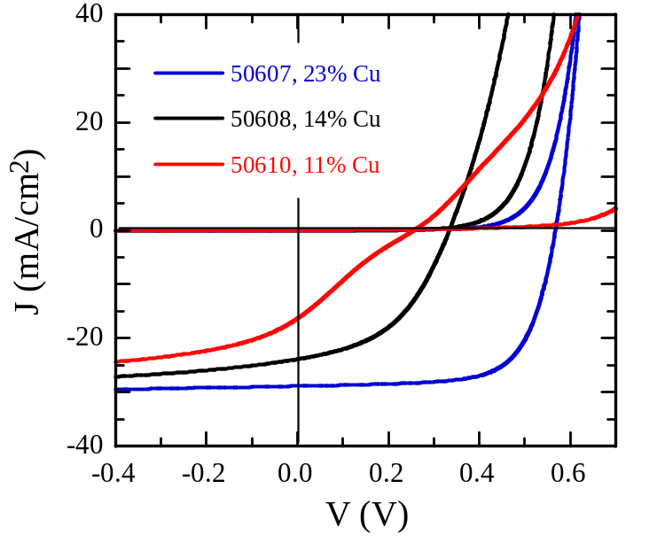
Figure 82. Cu(InAl)Se₂ solar cell J-V curves with different Cu content.

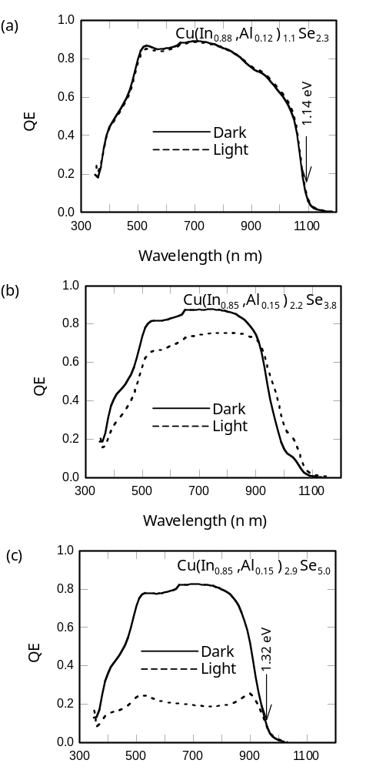

Figure 83. QE curves of Cu-In-Al-Se samples (a) 50607, (b) 50608, and (c) 50610 with compositions indicated in Table XV.

Cu(InGa)(SeS)₂ Formation by H₂Se/H₂S Reaction

The manufacture of Cu(InGa)(SeS)₂ films by selenization/sulfization of metallic precursors is a scalable process that has been used to produce modules with photovoltaic conversion efficiencies in excess of 13%., Despite the successful demonstration of various selenization/sulfization processes at the laboratory and module scales,, some fundamental questions still remain regarding the reaction pathways and development of various elemental concentration profiles during growth. It is anticipated that more detailed studies of this process will ultimately lead to improvements in the process itself, and to a better understanding of the Cu(InGa)(SeS)₂ system in general.

The accumulation of Ga at the back contact during selenization of metallic precursors was initially reported by Jensen et al. but the driving force for Ga movement towards the back contact is still not entirely clear. Two methods have been demonstrated to homogenize the Ga in selenized films: 1) annealing at >500ºC in an inert atmosphere (no Se); and 2) sulfization at >500ºC of partially selenized films.Error: Reference source not found Ga accumulation and homogenization may both be significant mechanisms for influencing device performance.

The selenization/sulfization process as performed at IEC utilizes an atmospheric pressure quartz tube reactor heated by an external heating jacket. The process is performed under flowing Ar, with 0.35% H₂Se or H₂S as appropriate, and O₂, if desired, at a concentration of 0.0035%. Selenizations are typically performed at 400 – 450ºC, while sulfizations are performed at 500 – 550ºC.

Characterization of Metallic Precursor Layers

Precursors were deposited by sequentially sputtering a Cu-Ga alloy film from a Cu_{0.8}Ga_{0.2} target followed by an elemental In layer onto a Mo-coated soda lime glass substrate. The thicknesses of the films were 349 nm for the Cu-Ga film and 489 nm for the In film to give an overall composition of Cu/(In+Ga) = 0.9 and Ga/(In+Ga) = 0.22.

To approximate the Cu-Ga-In phase equilibrium at typical selenization conditions, samples were heat treated at 450ºC for 10 minutes in the absence of hydride, with and without O₂. Figure 84 shows the CuKα₁ x-ray diffraction (XRD) spectrum of one of these samples. The detected phases include In and a Cu₉In₄-Cu₉Ga₄ (γ1) alloy with composition Cu₉(Ga_{0.36}In_{0.64})₄ estimated from the peak position by assuming Vegard’s law applies. In₂O₃ is observed in the sampled annealed in 0.0035% O₂, but not observed in the sample annealed in Ar only. The as-sputtered precursor, shown for comparison, is comprised of In, CuIn, and Cu₃Ga.

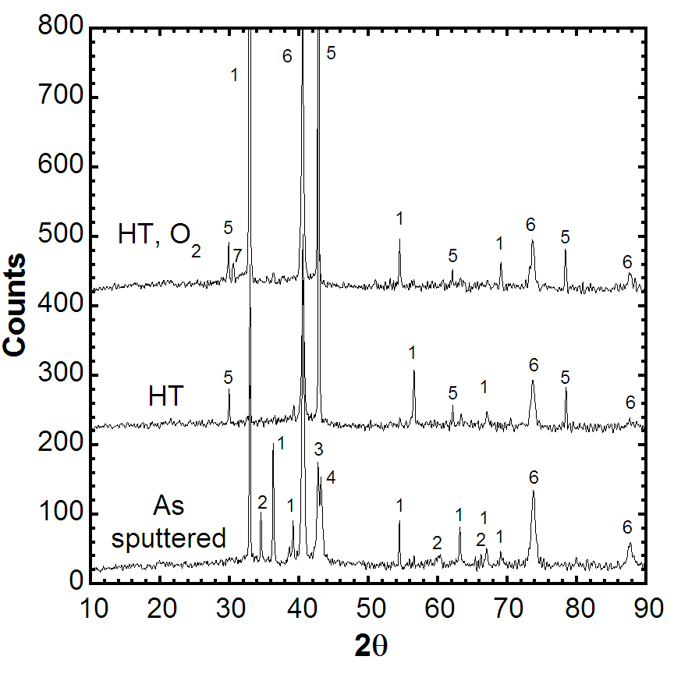
Figure 84. CuKα₁ XRD spectra of Cu-Ga-In precursors. Phases: 1 – In; 2 – CuIn ; 3 – Cu₃Ga; 4 – Cu; 5 – Cu₉In_{2.6}Ga_{1.4} (γ1); 6 – Mo; 7 – In₂O₃.

Cu(InGa)Se₂ Formation by reaction of H₂Se with Cu-Ga-In precursors

Cu-Ga-In precursors were selenized at 450ºC in 0.0035% O₂ for 10, 30, and 90 minutes. Samples were analyzed as-reacted, and also peeled from the Mo back contact for interface analysis.

The surface morphology of the selenized films, shown in Figure 85, does not show a significant change with increasing reaction time. Composition of the films measured by EDS is shown in Table III with Ga/(In+Ga) ≤ 0.03. XRD analysis (Figure 86), which indicates a chalcopyrite structure with Ga/(Ga+In) content of <5% by Vegard analysis, is consistent with the EDS measurements. This is different than previously reported results where a small peak due to CuGaSe₂ was also identified.Error: Reference source not found The 10-minute XRD spectrum additionally indicates the presence of a Cu₉(Ga_{0.8}In_{0.2})₄ intermetallic, and what is believed to be the CuGa₂ phase. CuGa₂ has been observed previously under varying conditions by Dittrich, Lindahl, and Marudachalam.

The backside morphologies of the peeled films, shown in Figure 87, exhibit significant voiding at all reaction times. EDS measurements of the backsides, also listed in Table XX, indicate higher Cu and Ga content than the front.

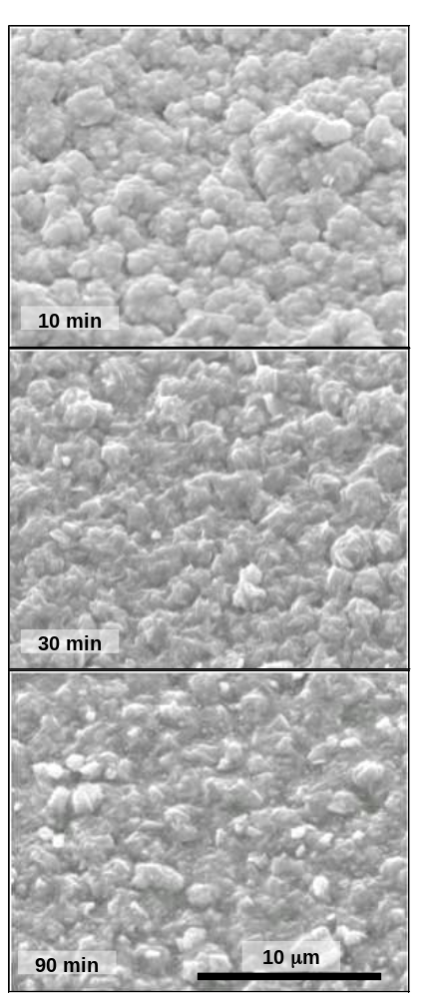

Figure 85. SEM micrographs of precursors selenized for 10, 30, and 90 minutes at
450ºC in 0.35% H₂Se:0.0035% O₂:balance Ar.

Table XX. Compositions by EDS of selenized films.

H₂Se time  (min) | Front side |  |  | Backside
H₂Se time  (min) | 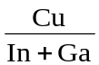 | 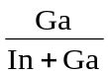 | Se  (at. %) |  |  | Se  (at. %)
10 | 0.96 | 0.03 | 46.5 | 0.53 | 0.16 | 44.2
30 | 1.00 | 0.02 | 46.2 | 0.71 | 0.42 | 47.9
90 | 1.01 | 0.02 | 46.4 | 0.81 | 0.48 | 47.3

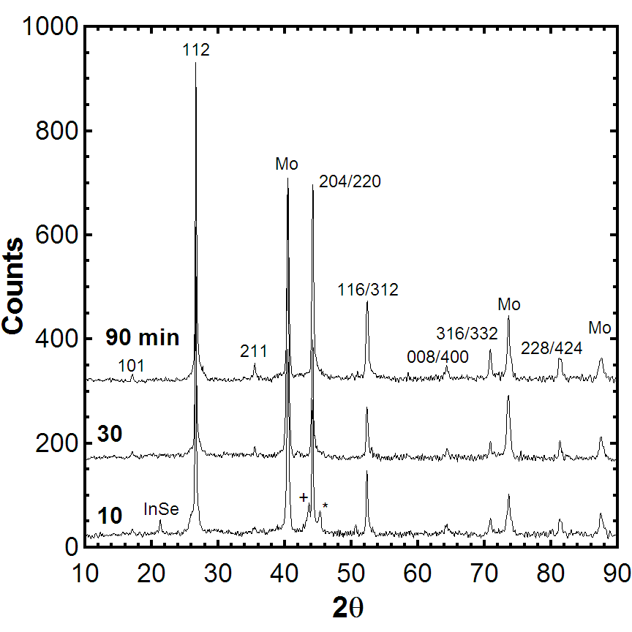
Figure 86. CuKα₁ broad scans of selenized films, indicating very little Ga incorporation into the chalcopyrite lattice. Peaks designated “+” and “*” are Cu₉(Ga_{0.8}In_{0.2})₄ and CuGa₂, respectively.

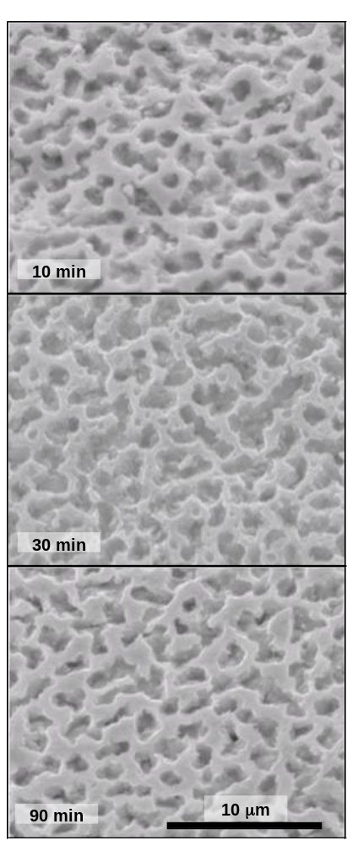

Figure 87. Backsides of peeled selenized films.

Inspection of the Mo back contact after Cu(InGa)Se₂ peel-off reveals residual nodules shown in Figure 88. EDS measurements shown in Table XXI indicate that the nodules contain negligible Se. The measurements at all three reaction times indicate a Cu/(Ga+In) ratio of approximately 1.85. The intermetallic phase at 10 min has a small amount of In, while those at 30 and 90 min are comprised solely of Cu and Ga. The identification of these nodules as intermetallics is further confirmed by XRD analysis as shown in Figure 89.

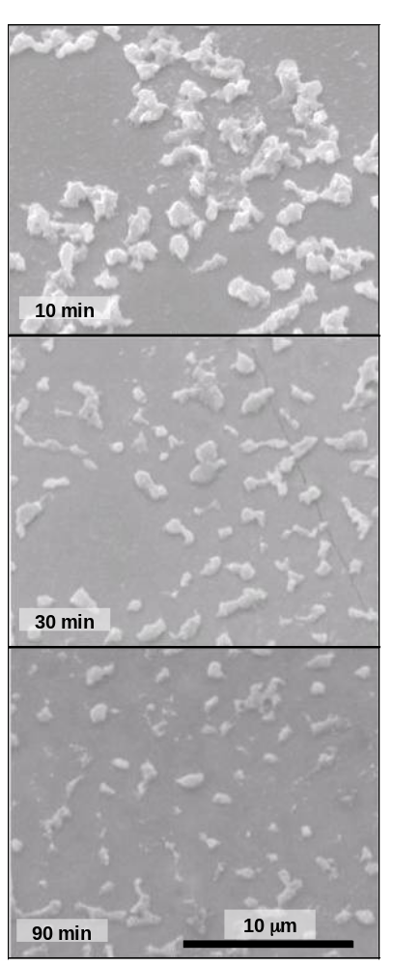

Figure 88. Residual intermetallics on Mo back contact after peeling of Cu(InGa)Se₂ films.

Table XXI. Composition by EDS of residual intermetallic compounds on Mo back contact.

Se time  (min) | Cu  at% | In  at% | Ga  at% | Se  at%
10 | 52.8 | 6.5 | 21.4 | 3.2 | 1.89 | 0.77
30 | 52.1 | 0.0 | 27.5 | 0.8 | 1.90 | 1.00
90 | 42.9 | 0.05 | 24.4 | 1.2 | 1.76 | 1.00

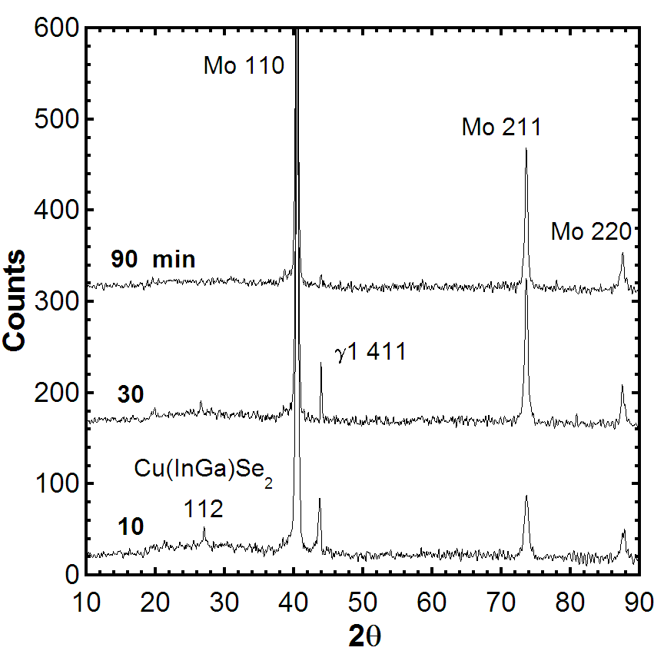
Figure 89. XRD spectra of exposed Mo back contacts. The γ1 411 peak is shifted from that shown in Figure 75 due to the absence of alloyed In.

These results demonstrate the incongruent reaction of Cu-Ga-In intermetallics in H₂Se, with the extraction of In being favored over that of Ga. Qualitatively, the slow depletion of the Cu-Ga intermetallic phase correlates with the slow incorporation of Cu and Ga into the backside of the Cu(InGa)Se₂ film. The segregation caused by the preferred reaction of In may be a contributing mechanism to the migration of Ga to the backside of selenized Cu-Ga-In precursor films.

Cu(InGa)S₂ Formation by Reaction of H₂S with Cu-Ga-In Precursors

Cu-Ga-In precursors were also reacted in H₂S under identical conditions. Unlike the selenization experiments, excessive In agglomeration is observed on the surface, resulting in spherical In nodules approximately 50 μm in diameter. Micrographs of the films and nodules are shown in Figures 90 and 91, respectively. The compositions of the films are shown in Table XXI.

XRD analysis of the sulfized films indicates a very complicated phase structure. At least three distinct Cu(GaIn)S₂ compositions are apparently present, with the possibility of graded chalcopyrite compositions also existing. Broad scans are shown in Figure 92, with (112) line profiles shown in Figure 93. The 10- and 30-minute broad scans exhibit a Cu-In intermetallic peak that is exhibited by multiple Cu_{x}In_{y} phases. EDS data indicates that the composition of these phases corresponds to the Cu₁₆In₉ phase, consistent with the observed XRD peak. The line profiles of Figure 93 clearly indicate a slow incorporation of In into the chalcopyrite – the opposite observation of selenized films.

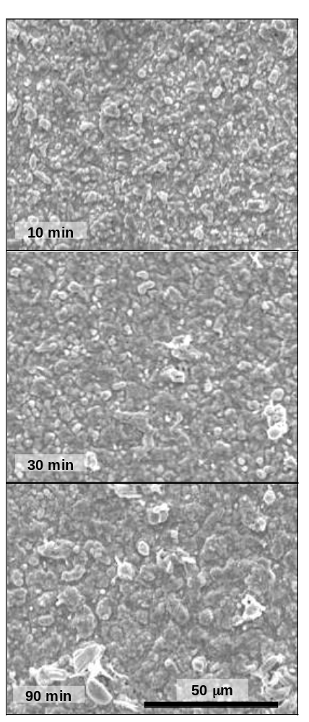

Figure 90. SEM micrographs of precursors sulfized for 10, 30, and 90 minutes at 450ºC in 0.35% H₂S:0.0035% O₂:balance Ar.

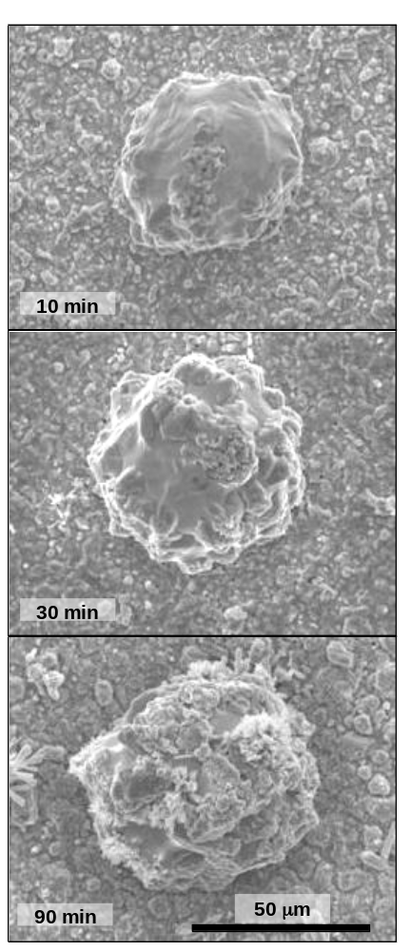

Figure 91. In-rich nodules on surface of sulfized films.

Table XXII. Composition of sulfized films shown in Figure 90.

S time  (min) | Cu  at% | In  at% | Ga  at% | S  at%
10 | 24.3 | 15.2 | 9.6 | 50.9 | 0.98 | 0.39
30 | 25.2 | 17.2 | 8.1 | 49.5 | 1.00 | 0.32
90 | 25.6 | 21.4 | 4.1 | 47.2 | 1.01 | 0.16

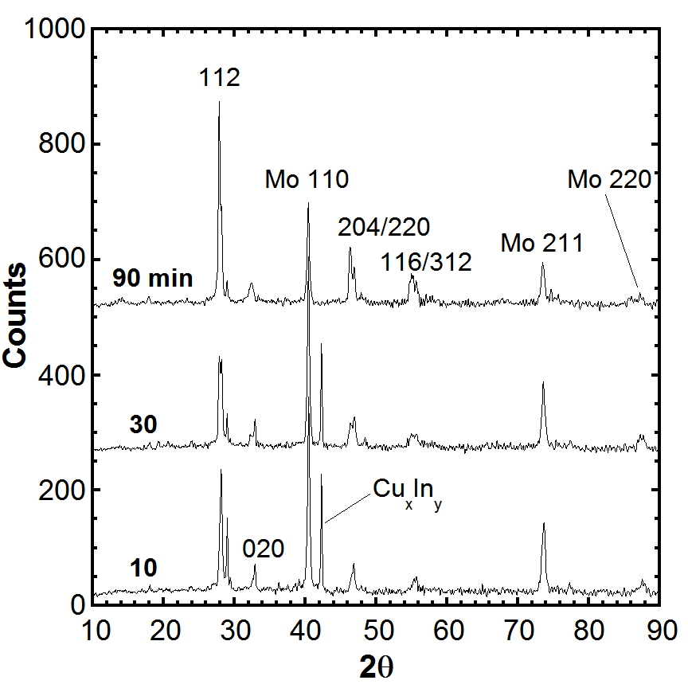
Figure 92. CuKα₁ spectra of sulfized films. The peak labeled Cu_{x}In_{y} is exhibited by multiple Cu-In alloys, but is likely Cu₁₆In₉ based on the EDS data.

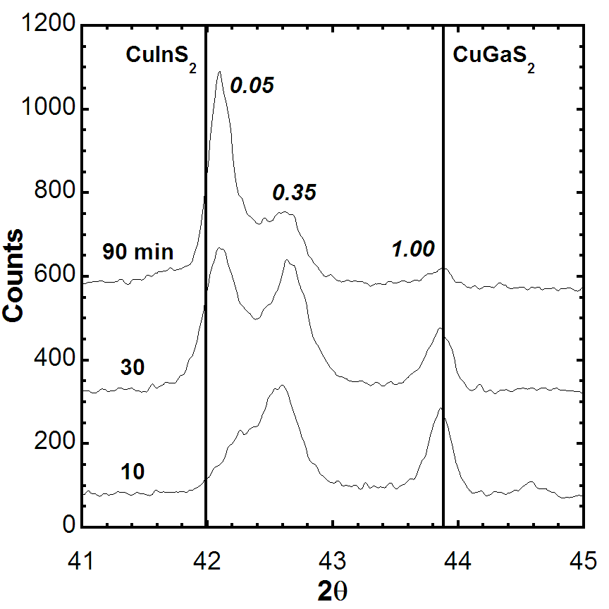

Figure 93. CrKα 112 line profiles of sulfized films.

The sulfized films were also peeled from the Mo back contacts for backside analysis. Unlike the selenized films, the sulfized films left no appreciable residue on the Mo back contact after peeling. Backsides of the sulfized films are shown in Figure 94, with the corresponding EDS data shown in Table XXIII. The distinct, monochromatically colored light regions are Cu-In intermetallics, as indicated by the EDS data in Table XXIII.

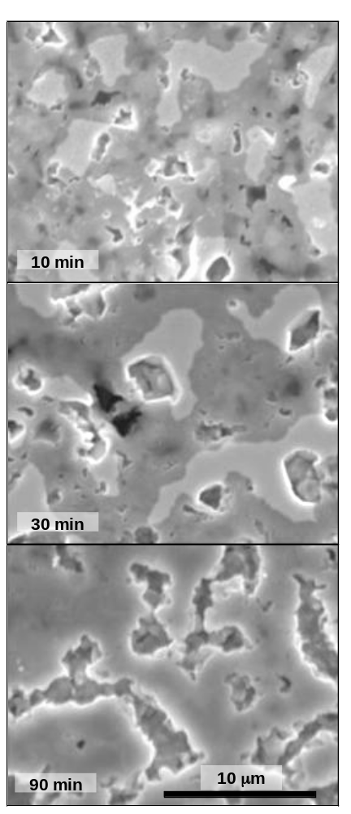

Figure 94. Backside SEM micrographs of films sulfized for 10, 30, and 90 minutes.

Table XXIII. Composition by EDS of sulfized film backsides.

S time  (min) | Cu  at% | In  at% | Ga  at% | S  at%
10 | 29.75 | 20.79 | 9.21 | 40.26 | 0.99 | 0.31
30 | 29.74 | 19.26 | 8.63 | 42.37 | 1.07 | 0.31
90 | 24.97 | 17.20 | 8.25 | 49.58 | 0.98 | 0.32

Table XXIV. Composition of intermetallics on sulfized film backsides.

S time  (min) | Cu  at% | In  at% | Ga  at% | S  at%
10 | 60.38 | 34.44 | 1.50 | 3.68 | 1.68 | 0.04
30 | 62.08 | 35.94 | 0.96 | 1.02 | 1.68 | 0.03

Cu(InGa)(SeS)₂ Formation by H₂Se/H₂S Reaction

A process to form Cu(InGa)(SeS)₂ by a two step reaction in H₂Se at 400 – 450°C followed by reaction in H₂S at higher temperature has been shown to produce a uniform Ga distribution.Error: Reference source not found,Error: Reference source not found The key process variables to control the film composition are the gas concentrations and the temperatures and durations of the two reaction steps.

Cu(InGa)(SSe)₂ films were formed by the reaction of precursor structures with H₂Se at either 400 or 450ºC followed by H₂S at 500 or 550ºC. Four time-temperature profiles were investigated and are summarized in Table XXV. Processes 1 and 2, using a 400ºC H₂Se reaction, were both found to be incompletely reacted after the 500ºC H₂S reaction, and intermetallic phases were detected by XRD. Process 3, utilizing a 30 min H₂Se reaction at 450ºC, gave Ga/(In+Ga) = 0.08 by EDS, less than the value of 0.2 in the precursor. It is suspected that the H₂Se reaction was carried too far, so that there was insufficient Cu₉Ga₄ for Ga homogenization. Process 4, with a 15 min H₂Se reaction at 450ºC followed by a 30 min 550ºC H₂S reaction, produced the high performance Cu(InGa)(SeS)₂ film characterized below.

Table XXV. Summary of investigated time-temperature profiles for two-step reaction of metallic precursors.

Process | H₂Se  reaction | H₂S  reaction | Ga/(Ga+In) | S/(S+Se) | Comments
1 | 400ºC  30 min | 500ºC  15 min | 0.21 | 0.47 | Residual intermetallics  Shorted devices
2 | 400ºC  45 min | 500ºC  15 min | 0.16 | 0.46 | Residual intermetallics,  Shorted devices
3 | 450ºC  30 min | 550ºC  15 min | 0.08 | 0.25 | Ga not homogenized,  Flaking in CdS bath
4 | 450ºC  15 min | 550ºC  30 min | 0.17 | 0.28 | Ga homogeneous  Device: V_{OC} =0.64 V, 13.2% efficiency

The composition of the reacted film from process 4 measured by EDS is Cu/(In+Ga) = 0.90, Ga/(In+Ga) = 0.17, and S/(Se+S) = 0.28. The relative Cu, Ga, and In compositions match the precursor. The XRD spectrum, shown in Figure 95, indicates a high degree of compositional uniformity within the Cu(InGa)(SeS)₂ phase, as evidenced by the narrow peak width. All peaks index to Mo or Cu(InGa)(SeS)₂ except a small peak at 21.8º, which might indicate residual In(SSe) within the film. Compositional depth profiles measured by Auger electron spectroscopy (measured by Craig Perkins at NREL) are shown in Figure 96. These indicate a uniform through-film Ga/(In+Ga) profile but a steep S gradient near the surface.

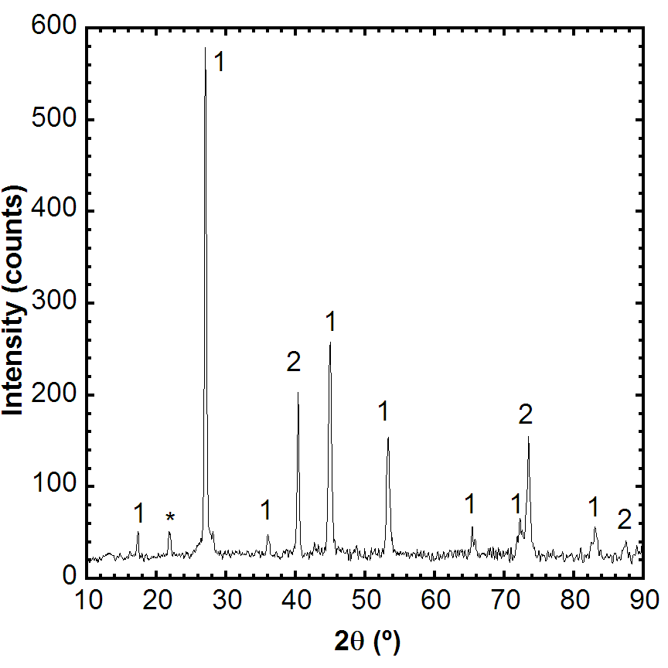
Figure 95. XRD spectrum of Cu(InGa)(SeS)₂ from process 4. (1 = Cu(InGa)(SeS)₂;
2 = Mo; * = unknown).

Devices were fabricated using a SL/Mo/Cu(InGa)(SeS)₂/CdS/ZnO/ITO/Ni-Al grid structure. The best device had efficiency = 13.2 % with V_{oc} = 0.641 V, J_{sc} = 31.6 mA/cm², and FF =
65.1 %. The relatively poor FF may be due to a barrier-to-collection of electrons caused by the steep S gradient.

(a) 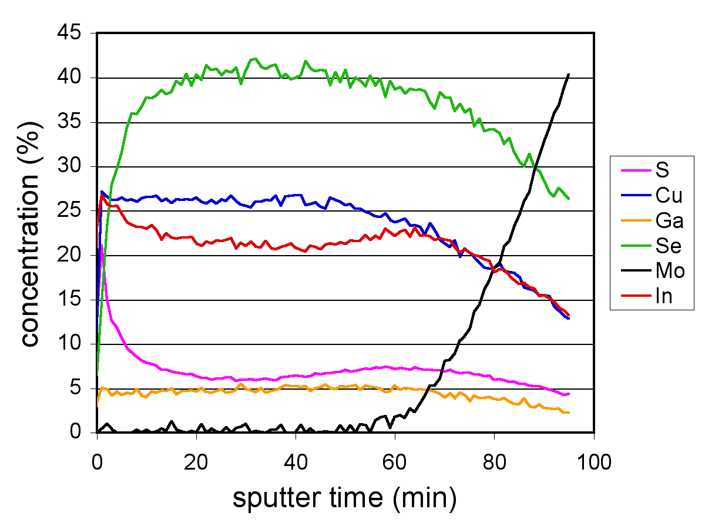

(b) 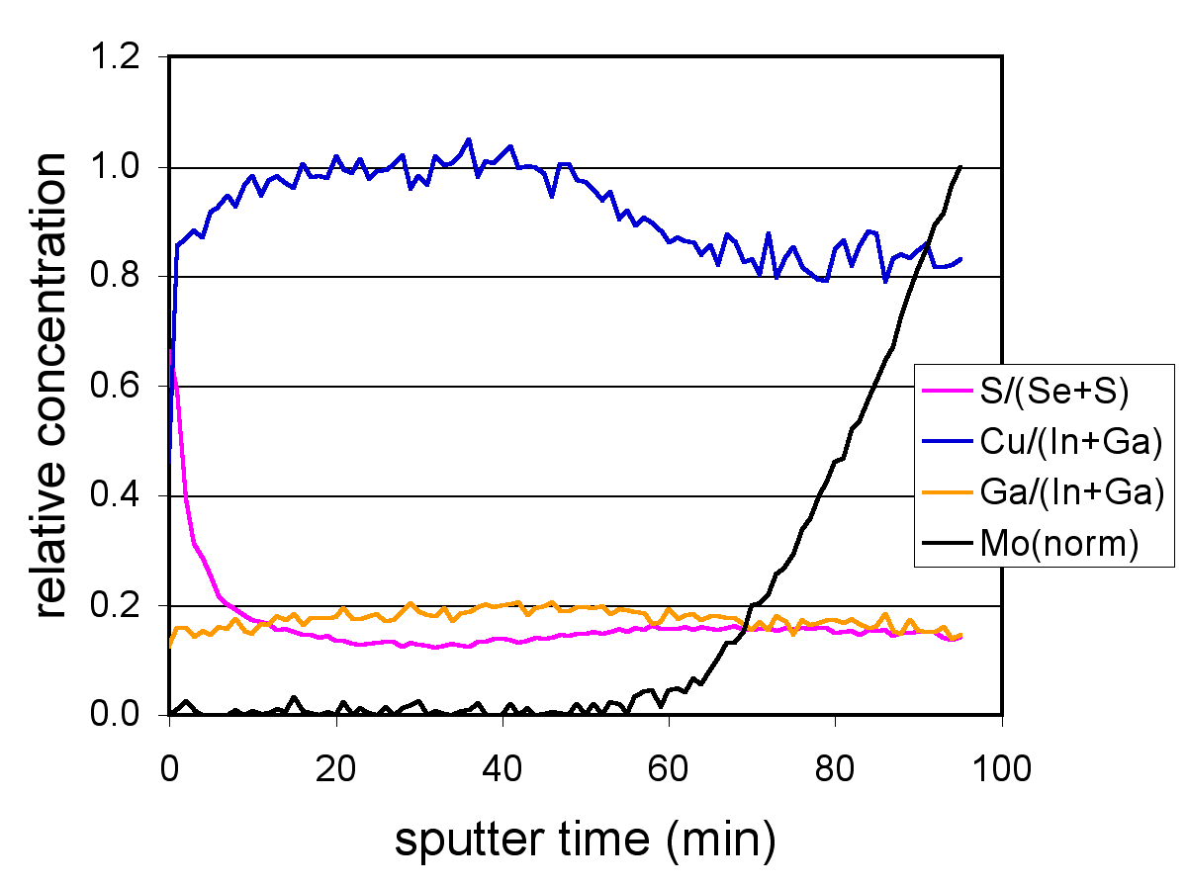

Figure 96. Compositional depth profile of Cu(InGa)(SeS)₂ formed by two-step reaction in H₂Se and H₂S process 4.

The above results demonstrate the difficulties with the exclusive reaction of either selenium or sulfur, and indicate the benefit, if not necessity, of a 2-step reaction: Se to incorporate In into the chalcopyrite lattice, and S to incorporate the Ga. The selenization and sulfization data lend significant insight into the mechanisms of 2-step selenization/sulfization processes. Indium is preferentially reacted during the selenization step, while the sulfization step reacts the remaining Cu-Ga intermetallic. The 2-step process appears to encompass two issues: 1) the quantity of Cu₉Ga₄ remaining after the selenization step, and 2) the transport mechanism of Ga resulting in a homogenous Ga profile. The quantity of Cu₉Ga₄ present after the selenization step is determined by temperature and reaction time. The Ga transport mechanism is still unknown.
Fundamental Materials and Interface Characterization

Cu(InGa)Se₂ Optical Characterization

One of the properties of Cu(InGa)Se₂ that make it uniquely promising for thin film solar cells is its tolerance to deviations in stoichiometry and composition. High efficiency solar cells have been demonstrated using Cu(InGa)Se₂ films with the Cu atomic concentration from 21 to 25 % and the effect of varying y ≡ Ga/(In+Ga) from CuInSe₂ to CuGaSe₂ has been studied extensively. The compositions of Cu-In-Se thin films tend to fall along the quasibinary tie-line between Cu₂Se and In₂Se₃. Thus, the CuInSe₂ film composition can be written as (Cu₂Se)_{x}(In₂Se₃)_{1-x}. A section of the Cu₂Se–In₂Se₃ tie-line taken from the comprehensive Cu-In-Se phase diagram of Gödecke et al. is shown in Figure 97. The composition in most solar cells falls in the single phase α region or the mixed phase α + δ_{R} region where α includes stoichiometric CuInSe₂ with x = 0.5 and δ_{R} includes CuIn₃Se₅ with x = 0.25. The δ_{R}-CIS phase is commonly referred to as an ordered defect compound, since it maintains the chalcopyrite structure of the α phase with a crystallographic ordering of defects. In addition, the In₂Se₃ end-point of the tie-line can be alloyed with Ga to form (In_{1-y}Ga_{y})₂Se₃ and measured film compositions still fall along the tie line. Therefore, CIGS is used as shorthand for the composition described by (Cu₂Se)_{x}[(In_{1-y}Ga_{y})₂Se₃]_{1-x}. The CIGS phase diagram is assumed to follow an analogous phase diagram in the region of Figure 97, although the range of the α-CIGS phase may be expanded with the inclusion of Ga. Similarly, the addition of Na in most thin films extends the range of α-CIGS.Error: Reference source not found
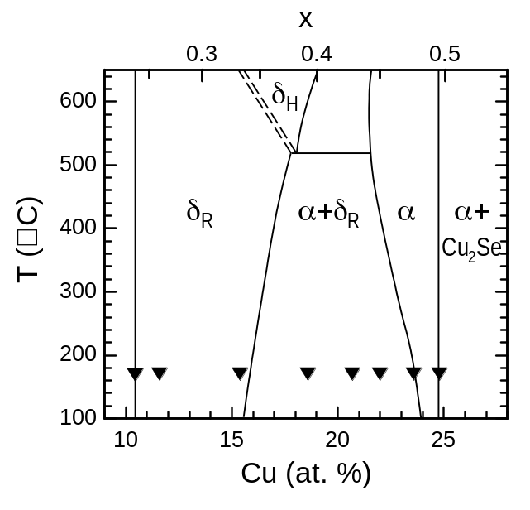
Figure 97. Cu₂Se-In₂Se₃ quasibinary phase diagram from Reference Error: Reference source not found. Triangles indicate the compositions of CIGS films characterized in this work.

Complete characterization of the optical properties of CIGS must address the variations in composition and stoichiometry. In particular, the optical constants must be specified as a function of relative Ga concentration over the complete range 0 ≤ y ≤ 1 and of Cu off-stoichiometry over the region 0.25 ≤ x ≤ 0.5 which includes the α and δ_{R} phases in films used for solar cells. The α-CIS range is relatively narrow at room temperature but the δ_{R}-CIS range is very broad, extending roughly from 10 ≤ Cu ≤ 15 % or 0.25 ≤ x ≤ 0.33. The behavior of the optical constants in the mixed phase α + δ_{R} region will depend on the volume fraction of the phases and, in general, on how the phases are mixed. XPS studies of these films revealed a Cu deficient surface layer on CIGS films with composition similar to CuIn₃Se₅. However, it is not clear that there is a distinct surface layer of this compound.

Optical characterization involves determining the dielectric response or dipole moment per unit volume of the material. In this work, variable angle spectroscopic ellipsometry (SE) has been used to determine the dielectric response of CIGS thin films as a function of relative Ga content and to study the effects of Cu off-stoichiometry. We have previously developed a method to characterize CIGS films despite their surface roughness, which can make the films unsuitable for SE analysis. Accurate values of the refractive index (n) and extinction coefficient (k) were obtained and the effects of varying Ga concentration on the electronic transitions determined. By comparison to single crystal results, it was shown that the polycrystalline nature of the films did not affect the optical constants indicating that the change in the path length as a result of grain boundary reflection is not significant.Error: Reference source not found It was further shown that the presence of Na did not affect the optical properties.

The dielectric response of a polycrystalline or amorphous material can be used to determine the volume fraction of the materials in a mixed phase by combining the individual dielectric responses of the constituent phases using models incorporating an effective medium approximation (EMA). The quasibinary phase diagram in Figure 65 does not contain any eutectic points so a precipitation of secondary phases is expected rather than a homogeneous mixture of phases. This may lead to the formation of grains of dominant phases decorated with precipitate from the secondary phase, a case approximated by the Maxwell Garnett EMA. However for compositions for which the two phases are equally present it may not be appropriate to define a dominant phase and a Bruggeman EMA may be more appropriate.Error: Reference source not found

In this work, we first present SE characterization of single phase α and δ_{R} CIGS films and review the effect of Ga concentration in α-CIGS. Then extensive ellipsometric measurements on CIGS films with y ≈ 0.3 and x varying from ~ 0.25 to 0.5 to include the δ_{R} and α phases are presented. These mixed phase samples are analyzed using both EMA models to determine the volume fraction of the two phases.

Optical Characterization: Experimental Details

CIGS films were deposited by elemental evaporation from Cu, In, Ga, and Se sources with 550°C substrate temperature and constant elemental fluxes through the deposition to form films with uniform through-film composition. All films were deposited on Mo-coated soda lime glass substrates so they contained Na due to diffusion from the glass. Baseline characterization of the films included energy dispersive x-ray spectroscopy at 20kV to determine elemental composition. The Cu concentrations of the CIGS films characterized in this report are shown in Figure 87 relative to the phase diagram, although it must be re-iterated that the phase diagram may differ with the addition of Ga. All films had y = 0.3.

SE measurements were made with a J.A. Woollam Variable Angle Spectroscopic Ellipsometer over the energy range of 0.75–4.6 eV using the procedure described previously.Error: Reference source not found Mo was deposited on the exposed surface of the CIGS and then the films were peeled to expose the CIGS back surface, providing a smooth surface for characterization. Measurements were carried out at room temperature keeping the sample under argon flow to minimize the surface contamination or oxidation. Optical modeling was carried out using the WVASE® software from J. A. Woollam.

The SE measurements determine ψ and Δ, the changes in phase and amplitude of the reflected light. Determination of the optical constants from ψ and Δ requires the construction of an optical model for the peeled CIGS samples as shown in Figure 98. The top layer in the model is a surface roughness layer, which is modeled as a Bruggeman EMA layer containing CIGS and a void fraction. Below this is the CIGS layer. Single phase CIGS layers are modeled using a linear summation of Kramers-Kronig consistent oscillators.Error: Reference source not found Mixed phase CIGS films were modeled with an EMA layer containing α and δ_{R} phases. The Bruggeman EMA model assumes that the grains in the binary phases material are spherical in shape. The Maxwell Garnett EMA model, assumes that the majority phase has spherical shape and the minority phase is a coating over the sphere. Both EMA models assume that the particle size is less than 1/10 of the wavelength of the probing light. The ellipsometry scans are carried out over the range 275 to 1700 nm so accurate analysis requires the grain size to be less than 100 nm for the central wavelength of this range. However, these models have been successfully used for feature size comparable to the probing light. The optical model is completed by an interface layer modeled by an EMA mixture of Mo and the CIGS, although the fit is largely insensitive to this layer, and the Mo film.

Surface roughness
CIGS
Interface layer
Mo

Figure 98. Optical model used for SE analysis.

Optical Characterization: Single-phase Modeling

The optical constants of α-CIGS alloy films with varying Ga concentrations have been determined using multilayer optical modeling with an oscillator model for the absorber layer.Error: Reference source not found For the CIGS alloy system, the valance band maximum at the Brillouin zone center is triply degenerate. These states are split due to the tetragonal crystal field perturbation that results from the change in symmetry from zincblende to chalcopyrite structure and to the spin-orbit interaction. Experimentally, the critical point energies resulting from these and higher energy transitions are obtained from the minima of the second derivative of the imaginary part of the complex dielectric response, ε₂. The energies E₀(A), E₀(B) and E₀(C) corresponding to these triply degenerate fundamental transitions for varying Ga concentration can be fit to a 2nd degree polynomial as shown below.Error: Reference source not found

E₀(A) = 1.035 + 0.389y + 0.264y² (15)
E₀(B) = 1.037 + 0.626y + 0.104y² (16)
E₀(C) = 1.276 + 0.664y + 0.057y² (17)

Equation 15 for the lowest energy transition E₀(A) determines the bandgap and gives a value of 0.26 for the optical bowing parameter. This is comparable to the optical bowing parameters reported from experiments, 0.24, and theoretical calculation, 0.21. It is worth noting that the triple degeneracy of the valence band maximum means that the optical absorption coefficient α(E) does not follow a simple relationship with αE² ∝ (E-Eg) as is often assumed for direct bandgap materials.

Optical constants of single phase δ_{R}-CIGS with x = 0.23 and y = 0.31 have also been determined using a multilayer optical model as in Figure 98 with an oscillator model for the δ_{R}-CIGS. The optical constants thus obtained are shown in Figure 99 along with the those of α-CIGS films. Two features are apparent. First, the fundamental bandgaps are shifted to higher energies with decreasing Cu concentration, in this case from 1.18 to 1.38 eV. This bandgap increase with decreasing Cu concentration is consistent with reduced repulsive coupling of the Cu 3d and Se 4p orbitals resulting in lowering of the valance band maxima. However, higher energy transitions are not noticeably shifted. Second, the critical point features at fundamental bandgap energy as well as at higher energies become broader as the Cu concentration decreases indicating degradation in crystalline quality. As a result, the crystal field splitting becomes less visible for Cu poor samples.

Optical Characterization: Two-phase films

Optical constants of the mixed phase films are obtained from the EMA models using the optical properties of α-CIGS and δ_{R}-CIGS shown in Figure 99. There is no significant difference between the Bruggeman and Maxwell Garnett EMA’s in the quality of the fit, determined by the root mean square error (MSE), or in the resulting volume fractions obtained. The EMA results for two films are compared in Figure 99 to results obtained by treating the materials as single phase and using an oscillator model. The volume fractions of the α and δ_{R} phases used for the EMA fits are indicated in the Figure. The EMA model can successfully be used to model the mixed phase films and determine the relative volume fractions or Cu concentration. There is good agreement in the transition energies determined by the oscillator and EMA models and low values of the MSE are achieved with both. This analysis cannot distinguish whether the films are really comprised of two separate phases or a homogeneous metastable phase. A detailed and comprehensive analysis of x-ray diffraction spectra may be able to answer this question.

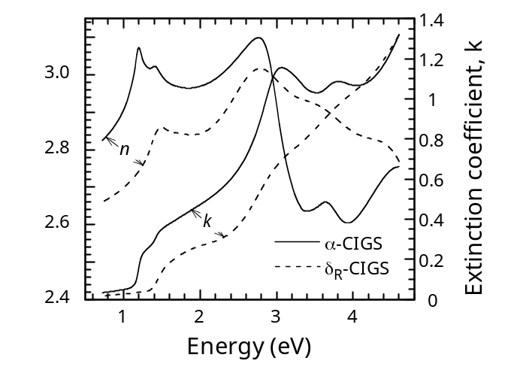
Figure 99. Optical constants of α-CIGS and δ_{R}-CIGS films with y = 0.3.

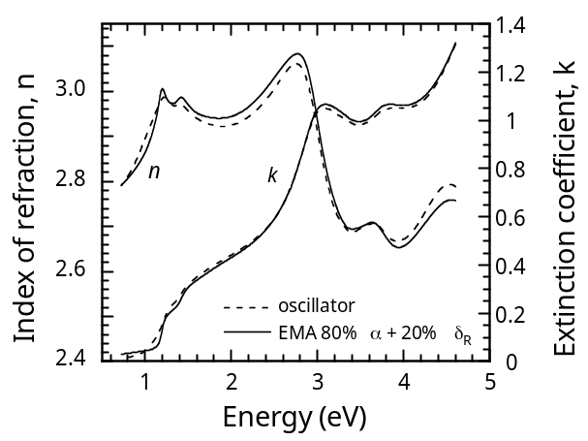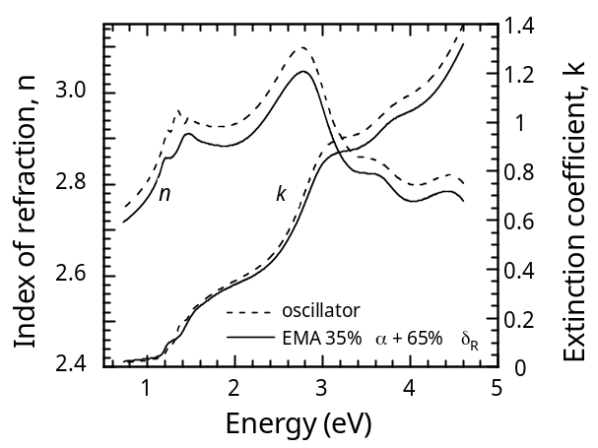

Figure 100. Comparison of optical constants obtained using an oscillator model and EMA model for films in the α + δ_{R} mixed phase region. The film on the left has 22.0 % Cu and the film on the right has 18.6 % Cu.

Table XXVI lists the volume fractions obtained from the EMA analysis for the CIGS films in the mixed phase region and the values of x determined from these volume fractions by
assuming they are a mixture of x = 0.5 and x = 0.25. These agree well with x determined from the EDS composition data. Figure 101 shows n and k from the EMA model for these films. As noted above, there is a bandgap increase and broadening in the critical point features with decreasing Cu concentration. The volume fractions show a phase boundary for α and δ_{R} phases at Cu concentrations between 23.6 and 22.0 % Cu. While the discrepancy with the phase boundary in Figure 97 may just be due to the uncertainty in the composition measurements, it is also consistent with a broadening of the α-phase region due to Ga and Na in the film.Error: Reference source not found Three compositions of films fall within the wide δ_{R}-phase region. However, the optical constants of these films vary with the Cu concentration with no phase boundary indicated near 15 % Cu, as expected from the phase diagram. The EMA analysis was done using the film with the lowest Cu which gave composition close to Cu(In_{0.7}Ga_{0.3})₃Se₅ or x = 0.25 This discrepancy with the phase diagram may result from the assumptions used for the modeling or from differences in phase behavior CIGS and CIS. A similar set of CIS films is currently being characterized to enable better comparison with the phase diagram and remove uncertainties due to variations in relative Ga concentration.

Cu(InGa)Se₂ Etching

An aqueous Br-etch has been previously developed for smoothing Cu(InGa)Se₂ films and reducing their thickness. This etch has been further characterized for two purposes. First, the etch to obtain a smooth surface for precise optical characterization by spectroscopic ellipsometry without peeling the Cu(InGa)Se₂ film as has been used previously.Error: Reference source not found The etch will leave the back contact intact and enable devices to be fabricated and the optical characterization of surface treatments and emitter layers deposited on the Cu(InGa)Se₂ to be directly compared with devices. Second, the etch can provide a means to controllably reduce the Cu(InGa)Se₂ thickness for characterizing the effect of absorber layer thickness on devices.

Table XXVI. Compositions of CIGS films and volume fractions of α and δ_{R} phases obtained from Bruggeman EMA analysis. Samples in italics are single phase films fit with an oscillator model.

Composition determined by EDS |  |  |  |  |  | EMA analysis
Cu  (%) | In  (%) | Ga  (%) | Se  (%) | x | y | α  (%) | δ_{R}  (%) | x
24.8 | 18.3 | 8.3 | 48.7 | 0.48 |  | NA
23.6 | 19.9 | 7.3 | 49.2 | 0.46 | 0.31 | 100 | 0 | 0.50
22.0 | 19.8 | 8.2 | 50.0 | 0.44 | 0.27 | 80 | 20 | 0.45
20.7 | 19.6 | 9.4 | 50.3 | 0.42 | 0.29 | 52 | 48 | 0.38
18.6 | 19.6 | 10.3 | 51.5 | 0.38 | 0.32 | 35 | 65 | 0.34
15.4 | 22.4 | 9.7 | 52.6 | 0.32 | 0.34 | 32 | 68 | 0.33
11.6 | 23.6 | 9.9 | 54.9 | 0.26 | 0.30 | 13 | 87 | 0.28
10.4 | 24.2 | 11.0 | 54.4 | 0.23 | 0.30 | NA

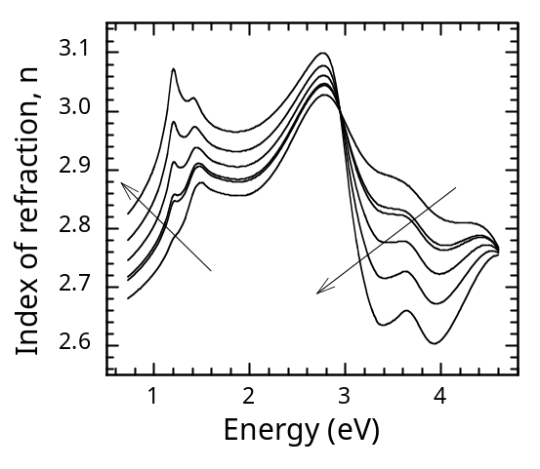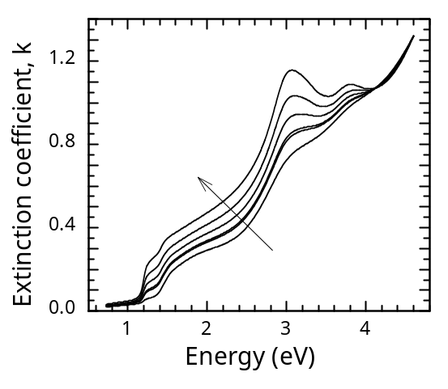
Figure 101. Optical constants of CIGS films with y = 0.3 determined by EMA analysis. Arrows indicate increasing Cu in sequence 23.6, 22.0, 20.7, 18.6, 15.4, 11.6 %.

This can be further used to characterize the optical properties of the Mo/Cu(InGa)Se₂ interface, where a MoSe₂ interlayer is expected to form, and to enable better structural characterization of the interface by increasing sensitivity of XRD measurements through a thinner Cu(InGa)Se₂ film.

The Br-etch of evaporated Cu(InGa)Se₂ films have been optimized as a function of concentration and time to produce the smoothest surface and best control. A Br concentration of 0.06 M Br₂ was found to produce the smallest rms surface roughness and z-range (maximum peak to valley height) as measured by AFM. The RMS surface roughness and Z-range values were reduced from 60 ± 10 nm and 550 ± 50 nm to 11 ± 3 nm and 100 ± 20 nm respectively with a one minute etch. By measuring the change in mass of the samples, the etch rate was calculated at 0.6 ± 1 µm/min.

SE data was measured on peeled and etched films from the same run and modeled as previously to determine optical constants over the range 0.6 ≤ E ≤ 4.6 eV. These are compared in Figure 102, showing good agreement. In particular, the critical optical transitions, which can be defined by inflection points in the optical constants, agree well. Small differences in magnitude might be due to different surface contamination in the two cases, with oxidation of the peeled surface and excess Se on the etched sample. as discussed below, or simply the result of sample to sample variation.

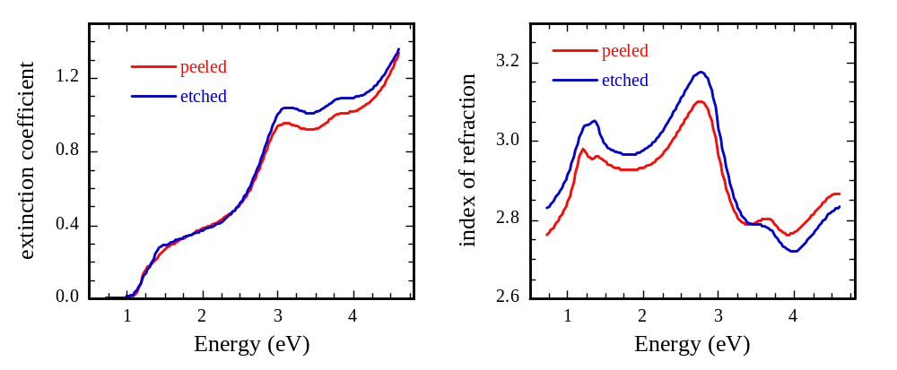
Figure 102. Extinction coefficient and index of refraction for Cu(InGa)Se₂ samples from a single run with smooth surfaces created by peeling and etching.

To verify that the Br-etch does not critically affect the properties of the Cu(InGa)Se₂ film, devices were fabricated after etching. However, it has been reported that XPS characterization reveals excess free Se on the surface after a similar etch. It was further shown that this could be removed with a KCN etch. Therefore, samples from a single Cu(InGa)Se₂ run were smoothed with the Br-etch as described above. One was further etched in KCN and a second was given a vacuum heat treatment at 250°C for 30 min to remove surface Se. J-V curves for the best cells from these samples are shown in Figure 103 along with the control device with as-deposited Cu(InGa)Se₂ and the J-V parameters are listed in Table XXVII. Also listed in the table are additional control samples, which received the KCN-etch and vacuum heat treatments on the as-deposited Cu(InGa)Se₂.

Clearly, the Br-etch severely degrades the device performance but it is mostly recovered by removing surface Se, with the vacuum anneal more effective in this case than the KCN etch. In both cases, a reduction in current may have been caused by greater optical reflection from the smoothed surface. The cause for the lower V_{OC} is not known but it seems to be related to the Cu(InGa)Se₂ surface treatments since both the KCN-etch and HT reduces V_{oc} even without the smoothing Br-etch. It should be noted that cells originally fabricated after the aqueous Br etch used an evaporated emitter layer deposited at 200°CError: Reference source not found so, if there was excess Se on the surface, it would have evaporated during heat up.

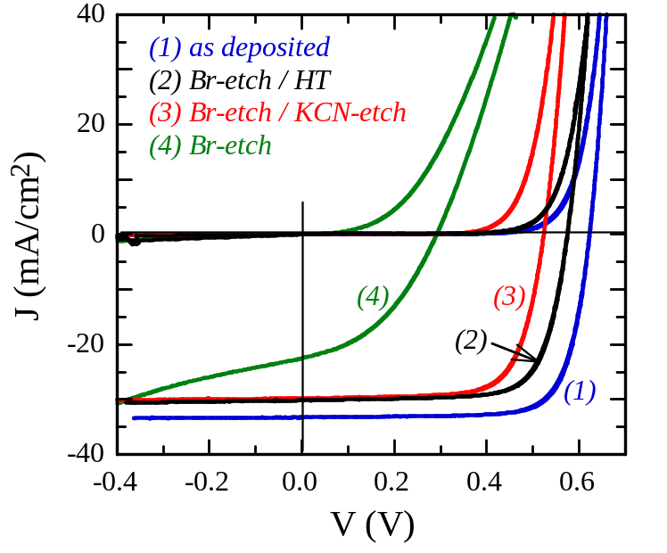
Figure 103. J-V characteristics with Br-etched Cu(InGa)Se₂ and subsequent KCN-etch and heat treatments to remove surface Se.

Table XXVII. Cell performance with different Cu(InGa)Se₂ etches and heat treatment. Samples marked with * indicate results shown are after a 2 min heat-treat of the completed device at 200°C in air. Other samples did not improve with this treatment.

Sample | Treatment | Eff  (%) | V_{oc}  (Volts) | J_{sc}  (mA/cm²) | FF  (%)
33888.22 | As-deposited | 15.8 | 0.623 | 33.2 | 76.3
33888.32 * | Br-etch | 3.2 | 0.470 | 23.3 | 43.1
33888.33 * | Br-etch / KCN etch | 11.2 | 0.524 | 29.8 | 72.1
33888.23 | Br-etch / HT | 12.8 | 0.575 | 30.1 | 73.9
33888.31 | KCN-etch | 12.7 | 0.537 | 32.7 | 72.7
33888.12 * | HT | 13.6 | 0.569 | 32.1 | 74.2

Experiments have been done to explore the use of the Br-etch to vary thickness in a well controlled manner, enabling more fundamental study of the effects of reducing Cu(InGa)Se₂ thickness (d) and characterization of optical reflection at the Mo/Cu(InGa)Se₂ contact. One issue for characterizing the etched films is the precise determination of the Cu(InGa)Se₂ thickness. Several possible methods have been evaluated including measuring the change in mass of the film, cross-sectional SEM images, and extinction of the Mo peak in the EDS spectrum. A simple, non-destructive method is to measure the optical reflection (R) and determine thickness from the optical interference fringes in the transparent region at energies below the bandgap using a procedure reported by Swanepoel. This requires knowing the refractive index as a function of wavelength which we have determined using SE.Error: Reference source not found Figure 104 shows the total reflection for an as-deposited Cu(InGa)Se₂ film with Ga/(In+Ga) = 0.3 and films after 2 and 4 min Br etches in an aqueous 0.03M Br solution at room temperature. The as-deposited film has lower R in the absorbing region λ < 1000 nm and smaller amplitude of the interference fringes in the transparent region at higher λ. This is attributed to the scattering due to the rough surface of the as-deposited film. The spacing of the maxima or minima in the spectra increases with increasing etch time as the films become thinner and were used to determine the thicknesses listed. The change in thickness determined with this method is shown in Figure 105 for etch times up to 4 min and the slope gives an etch rate of 0.2 µm min¹.

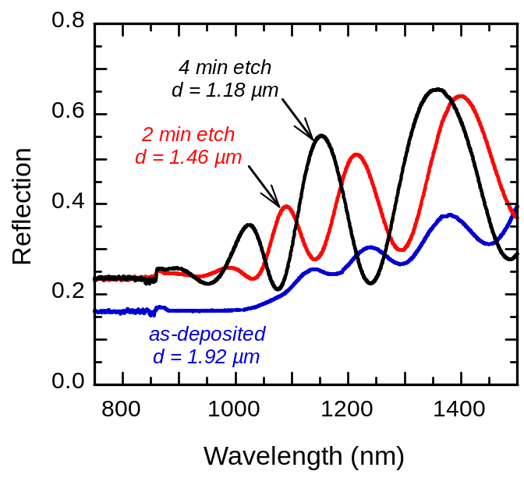

Figure 104. Optical reflection of as-deposited and Br-etched Cu(InGa)Se₂ films and the thicknesses obtained from the interference fringes.

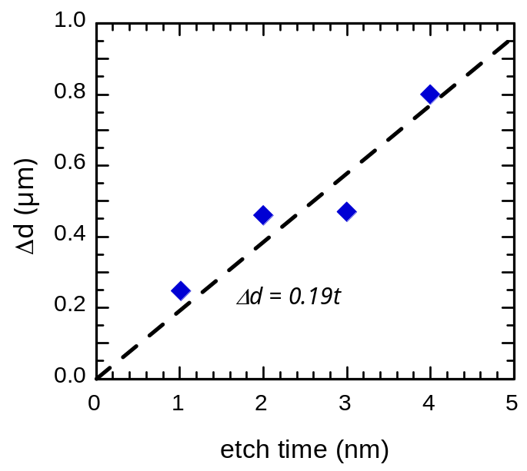
Figure 105. Change in thickness for different Br-etch times.

Samples from a single Cu(InGa)Se₂ run were etched for 1, 2, 3, and 4 min and, after R was measured, devices were fabricated. The resulting thickness and device parameters are listed in Table XXVIII. All the etched films had slightly lower J_{SC} than the un-etched sample, which can be attributed to higher reflection losses with the secular etched films. V_{OC} was also slightly lower but the reason is not known.

Table XXVIII. Cu(InGa)Se₂ thickness and device J-V parameters as a function of Br-etch time of the Cu(InGa)Se₂ absorber layer.

Sample # | etch time  (min) | Cu(InGa)Se₂  d (µm) | η  (%) | V_{oc}  (V) | J_{sc}  (mA/cm²) | FF  (%)
33930.22 | as-dep | 1.92 | 14.5 | 0.621 | 31.1 | 75.0
33930.12 | 1 | 1.67 | 11.8 | 0.582 | 28.1 | 72.1
33930.13 | 2 | 1.46 | 12.7 | 0.593 | 28.6 | 74.7
33930.21 | 3 | 1.33 | 13.8 | 0.602 | 30.5 | 75.4
33930.23 | 4 | 1.18 | 12.1 | 0.583 | 28.7 | 72.5

CdS Deposition and Characterization

Chemical surface deposition (CSD) of CdS has significant potential advantages over conventional chemical bath deposition. This includes very high utilization of Cd with the CSD process and the potential for simpler incorporation into an in-line process.

We have previously compared Cu(InGa)Se₂ devices with CdS deposited by CBD CSD and found similar performance but with evidence of slightly higher V_{oc} using the CBD process. To further determine whether there is any difference in devices, a more extensive set of samples was processed. A total of 10 Cu(InGa)Se₂ samples from 2 different, but nominally identical runs, were processed using 5 with each CdS process. This gave a total of 30 devices with each type. Results are summarized in Table XXIX, which lists the best device of each type and the average and standard deviation. While the best cell with CBD CdS was slightly better, the averages were the same indicating no difference in device performance. The variability in device performance which yields 12.9% overall average efficiency compared to 14.8 – 15.4 % for the best cells is due to variation in the shunt conductance. Causes for this are being investigated.

Table XXIX. Comparison of Cu(InGa)Se₂ devices with CBD and CdS emitter layers based on 30 devices of each type.

CdS dep. |  | Eff  (%) | V_{OC}  (V) | J_{SC}  (mA/cm²) | FF  (%) | R_{OC}  (Ω-cm²) | G_{SC}  (mS/cm²)
CBD | Best cell | 15.4 | 0.633 | 31.7 | 76.6 | 1.4 | 1
CBD | Average | 12.9 | 0.604 | 30.6 | 69.0 | 2.2 | 5
CBD | Std. Dev. | 1.7 | 0.019 | 0.8 | 8.7 | 1.0 | 8
CSD | Best cell | 14.8 | 0.621 | 31.4 | 76.0 | 1.4 | 2
CSD | Average | 12.8 | 0.605 | 30.6 | 68.8 | 1.9 | 4
CSD | Std. Dev. | 1.2 | 0.013 | 0.5 | 5.1 | 0.4 | 2

The optical constants of CdS layers have been characterized by spectroscopic ellipsometry to determine if the CdS properties are affected by the Cu(InGa)Se₂ surface or with different CdS deposition processes. For characterization of films deposited on Cu(InGa)Se₂, a smooth surface must be used. This is formed by a smoothing Br-etch followed by a KCN etch to remove excess Se on the surface, as shown above.

The refractive index (n) and extinction coefficient (k) of CdS films formed by CBD on Mo and on smoothed Cu(InGa)Se₂ are compared in Figure 106. Prior to CdS deposition, the precise optical constants of the Mo and Cu(InGa)Se₂ were determined. The optical model used to determine n and k of the CdS includes the bulk Mo or Cu(InGa)Se₂, then a thin interface/roughness layer fit using an effective medium approximation (EMA), then the bulk CdS film, and finally, a surface roughness EMA layer. A harmonic oscillator model is used for the CdS layer. The CdS films were ~ 50 nm thick. The results in Figure 106 are also compared to n and k determined for a thicker CdS film deposited on crystallized ITO in a CdTe device. In that case, the SE measurements were done after the CdTe was peeled off and the CdS had been annealed in the presence of CdCl₂ during device processing. The CdS on Mo or Cu(InGa)Se₂ has a much broader fundamental transition at 2.4 eV, while the CdS in the CdTe more closely matches published properties of crystalline CdS. These differ also in the high-energy range > 3.5 eV. The reasons for these differences in optical behavior are being further investigated. Possible reasons include: different crystallinity of the annealed CdS in the CdTe device, differences in the CdS/Cu(InGa)Se₂ and CdS/Mo interfaces, and thickness effects in the CdS or in the optical fitting.

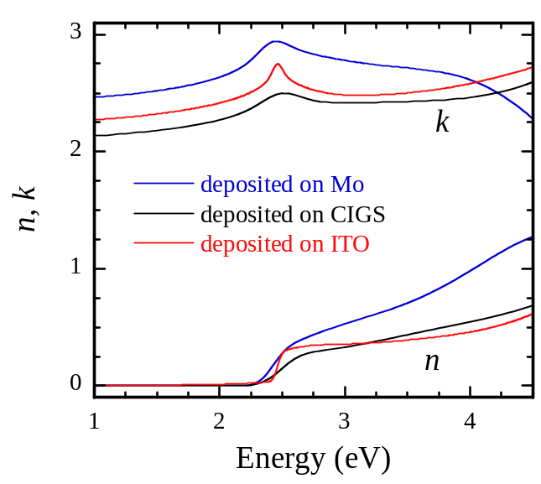

Figure 106. Optical constants of CBD CdS layers deposited on different substrates. The layer on ITO was annealed during CdTe device processing.

Mo/CuInSe₂ Interface Characterization

Alternative back contacts are being evaluated to determine if they might provide improved adhesion at the interface with the CuInSe₂-alloy absorber. Poor adhesion, for example with wide bandgap Cu(InAl)Se₂ is believed caused by the formation of a MoSe₂ interlayer. Initial experiments were done to evaluate Cu(InGa)Se₂ devices formed on W, Ta, and Ti back contacts which all gave good device performance in a recent study by Orgassa et al. In addition, these metals have higher reflection than Mo and may therefore be advantageous in devices with thin absorber layers where losses in current occur due to optical absorption at the back contact.

W, Ta, Ti, and Mo layers were deposited by electron beam evaporation on soda lime glass substrates. The evaporated Mo was included as a control for comparing an evaporated contact to the baseline Mo deposited by dc sputtering. The thicknesses and sheet resistances are listed in Table XXX. The Ti films did not adhere to the glass substrate after Cu(InGa)Se₂ deposition so no results were obtained. These refractory metals are difficult to evaporate so the thicknesses, and hence sheet resistances, were limited.

Results of J-V measurements for the best device with each contact are listed in Table XXX. The sputtered Mo contact gave the best performance and the evaporated Mo gave comparable V_{OC} but lower fill factor. The latter is at least partly due to greater series resistance as indicated by R_{OC} ≡ dV/dJ at J = 0 which is equal to the series resistance plus a diode term if the J-V results are described by a standard diode equation. The Ta and W contacts also had lower V_{oc} than the Mo contacts. Possible explanations for the reduced V_{oc} with the Ta and W contacts include blocking of beneficial Na from the soda lime glass or introduction of impurities into the Cu(InGa)Se₂ layer.

Table XXX. Characteristics of evaporated back contacts for Cu(InGa)Se₂ and device performance. The J-V results with the W and Ta contacts are after a 2 min heat treat in air at 200°C which improved performance.

Sample # | Back Contact |  |  | Best Device Performance
Sample # | Material | Thickness  (µm) | R_{sh}  (Ω/sq) | Eff  (%) | V_{oc}  (Volts) | J_{sc}  (mA/cm²) | FF  (%) | R_{OC}  (Ω-cm²)
33882.21 | Mo sputt. | 0.7 | 0.2 | 15.0 | 0.607 | 33.4 | 73.7 | 1.6
33882.32 | Mo evap. | 0.1 | 23 | 12.0 | 0.610 | 32.1 | 61.4 | 4.2
33882.23 | W | 0.1 | 35 | 10.9 | 0.577 | 31.9 | 59.2 | 4.5
33882.12 | Ta | 0.2 | 26 | 9.4 | 0.526 | 29.3 | 60.7 | 4.3

Another option for the back contact is oxygenated Mo which can minimize reaction of the Mo with Se since Mo oxides are more stable than the selenides. Mo films were prepared containing around 8 at% oxygen by sputtering in a mixed Ar/O₂ atmosphere. Cell results comparing the oxygenated Mo contact to the baseline Mo contact sputtered in pure Ar are shown in Table XXXI. With the oxygenated Mo the fill factor is a little lower for unknown reason but other cell parameters are the same within error. In the next quarter, Cu(InAl)Se₂ films with different relative Al content will be deposited on different back contacts and evaluated for improved adhesion as well as device behavior.

Table XXXI. Cu(InGa)Se₂ device performance with an oxygenated Mo back contact.

Sample # | Back  contact | Eff  (%) | V_{oc}  (Volts) | J_{sc}  (mA/cm²) | FF  (%) | R_{OC}  (Ω-cm²)
33871.13 | Mo. | 14.9 | 0.611 | 31.5 | 77.1 | 1.3
33871.32 | Mo-O | 14.0 | 0.609 | 32.1 | 71.7 | 1.9

Cu(InGa)Se₂ Summary

Two-step H₂Se/H₂S process

The incongruent reaction of Cu-Ga-In intermetallics with either H₂Se or H₂S offers significant insight into the 2-reaction selenization/sulfization of Cu-Ga-In precursors. With a better understanding of the reaction pathway, work will now be focused on optimizing the time-temperature sequence of the 2-step reaction, as well as better understanding the Ga mobility mechanism.

Optimization of the 2-reaction process introduces additional issues, an example being the steep S gradient observed at the surface of the champion Cu(InGa)(SeS)₂ film in this study. This introduces the S profile as another dependent variable in addition to the Ga profile. Fortunately, by developing a better understanding of the reaction pathway, it may be possible to decouple these variables by considering the Ga profile to be primarily dependent on the degree of selenization, and the surface S profile likely being dependent on duration of sulfization. Ideally, optimum selenization and sulfization conditions and times can be identified that yield uniform Ga with only a modest sulfur gradient at the Cu(InGa)(SeS)₂ surface.

Optical Characterization

Multilayer optical modeling of variable angle spectroscopic ellipsometry measurements has been used to determine the optical constants and electronic transitions of CIGS thin films with varying Cu and Ga concentrations. Mixed phase films were effectively modeled using EMA models with comparable results using Bruggeman and Maxwell Garnett models. This analysis shows that the changes in the optical constants as a function of Cu off-stoichiometry can be used to determine the relative volume fractions of α and δ_{R} phases in the CIGS. The decrease in Cu is characterized by an increase in the fundamental bandgap and broadening of critical point features in the optical constant suggesting degradation of the crystalline quality of the material.

4 Si-based Solar Cells
4.1 Aluminum-induced Crystallization (AIC) Below the Eutectic Point:
ex-situ AIC

Introduction to AIC
Thin-film poly-Si is potentially a good alternative to a-Si and crystalline silicon (c-Si) based photovoltaic devices because of its unique properties. Poly-Si offers large area manufacturability at temperatures below 600ºC, and device efficiencies, in theory, comparable to c-Si based devices. One of the most critical issues with poly-Si thin-film photovoltaic devices is the minority carrier life time, which is limited by the nanocrystalline grain structure of poly-Si. Nanocrystalline grain structure is usually associated with low temperature deposition processes required to reduce thermal budget of the production by using low cost substrates such as glass. AIC process is one of the many techniques used to prepare poly-Si thin-films with grain sizes comparable to the film thickness at temperatures below 600ºC. Although the crystallization of a-Si when in contact with certain metals at low temperatures was known for several decades, the use of this technique to produce poly-Si films for device applications is relatively new. There are many studies on metal-induced crystallization (MIC) of a-Si films, most of those studies are focused on the characterization of poly-Si films formed after crystallization.,,,,,, The kinetics of MIC process is still not well understood. One of the least studied, if any, is the interface oxide layer separating the metal and a-Si layers. In this study, the effects of a-Si deposition technique and aluminum oxide interface layer on the crystallization process are reported. Much of this work has been submitted to Progress in Photovoltaics in a paper entitled “Effects of silicon deposition and interface oxide on aluminum-induced crystallization of amorphous silicon thin-films.”

Experimental
Aluminum films with 100, 250, 500, and 1,000 nm thicknesses were deposited on Corning 7059 type glass substrates by electron beam evaporation at a fixed deposition rate of 4 Å/s. The thicknesses of the Al layers were confirmed by profilometer measurements. All Al coated glass substrates were exposed to air from 24 hours to several months prior to Si deposition. Amorphous silicon films with 100, 250, 500, and 1,000 nm thicknesses were deposited using HWCVD, PECVD and electron-beam systems.

Before the deposition of a-Si films, the background pressure in HWCVD system was always kept below 5x10⁻⁷ Torr. The deposition of a-Si films was performed at a fixed filament temperature of 1850ºC and a reactor pressure of 25 mTorr. The deposition was started at room temperature, and the substrate heater was off during the deposition. Growth rate was always greater than 10 μm/hr to reduce the deposition time; therefore, keeping the substrate temperature as low as possible. Due to the radiation from the filament, the substrate temperature reached to a maximum of 110ºC at the end of the deposition. After the deposition, the filament was immediately turned off, and samples were removed as soon as the substrate temperature dropped to 50ºC.

Amorphous Si films were also deposited in a single chamber PECVD system (13.5 Mhz) with two load-locks. The reactor base pressure was always kept below 5x10⁻⁷ Torr. All a-Si depositions in PECVD system were performed at a substrate temperature of 175ºC and a deposition pressure of 200 mTorr. Silane diluted with hydrogen was used for source gas.

Deposition of a-Si films in e-beam system was performed at a growth rate 8 Å/sec (~ 3 μm/hr). The substrate temperature did not exceed 75ºC at any time during the deposition of a-Si.

The thermal annealing of the samples was performed in high temperature furnace. Samples were placed onto a high temperature glass holder sitting inside a quartz tube. Argon gas was used to flush the tube for 20 minutes at a 200 sccm flow rate before introducing the tube into the furnace. Samples were annealed at 430ºC, 475ºC, and 540ºC from 15 minutes to 10 hours under an argon flow of 30 sccm. Three different samples including e-beam, PECVD and HWCVD deposited a-Si layers were annealed together to prevent any differences in thermal histories.

Effect of a-Si Deposition Method

Optical microscopy images taken through the glass substrates in reflection mode were used to calculate the nucleation density of Si crystals and the average grain size for partially crystallized Si samples in order to evaluate the effect of a-Si on AIC process. The differences seen in the grain structure of poly-Si layers formed after AIC process are directly related to the nature of a-Si layer. Although Si films before the annealing were all amorphous, Si films deposited by different techniques had different hydrogen contents due to different deposition chemistries. E-beam deposited samples contain no hydrogen since the e-beam deposition does not involve any component other than the pure source material. On the other hand, PECVD deposited a-Si films contain hydrogen, since the gas phase chemistry in PECVD consists of mostly Si radicals, not elemental Si. The deposition temperature in PECVD system was fixed at 175ºC,; therefore, films contain up to 10% hydrogen, which was confirmed by SIMS and FTIR. Figure 107 shows the optical microscopy images of annealed samples taken through the glass substrate. Darker Si crystals growing on the glass surface are clearly seen on highly reflective Al. Compared to sample containing PECVD deposited a-Si (Figure 107a), sample with e-beam deposited a-Si (Figure 107b) has slightly larger grains. It should be noted that the crystallization process is not complete yet; however, the differences in the average grain size after AIC process is complete will be similar. It seems that the hydrogen in a-Si layer has a negative effect on the AIC process. This is expected since hydrogen passivates some of the dangling bonds in a-Si and reduces the excess energy, which is the main driving force for the crystallization process. Amorphous Si layer deposited by HWCVD will be discussed later since additional parameters affect the crystallization process.

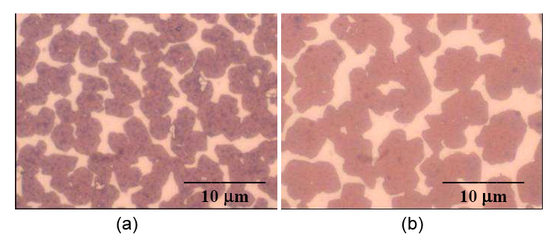
Figure 107. Optical microscopy images of partially crystallized samples with a-Si layers deposited by (a) PECVD, and (b) e-beam. PECVD deposited sample has higher nucleation density yielding smaller grains due to hydrogen in a-Si layers.

Effect of Si/Al Ratio and a-Si Deposition Rate

It has been shown that the thickness of the poly-Si layer formed after layer exchange process in AIC is determined by the initial thickness of the metal layer. This phenomena was also observed in crystallization of Si during deposition onto Al coated glass substrates. When Si layer thickness is smaller than Al layer thickness, crystallization of a-Si films still occurs; however, poly-Si film formed is not continuous. Continuous poly-Si films by AIC process on glass can only be obtained when Si/Al thickness ratio is equal or greater than unity. Increasing the Si/Al thickness ratio does not improve the quality or the thickness of the poly-Si layer formed on the glass substrate. Excess Si is accumulated on top of poly-Si layer and is mixed with aluminum replaced by the growing Si crystals. Figure 108 shows the SEM surface image of a crystallized sample with an initial Si/Al ratio of 2 after removing the exposed Al by etching. Excess Si is seen on top of poly-Si layer formed on the glass substrate, and it is mixed with Al replaced by poly-Si film. If a poly-Si layer is to be used as a seed layer for subsequent epitaxial Si growth, excess Si and aluminum on top of poly-Si layer must be removed by etching. Therefore, having a very thick Si layer is not practical. A Si/Al thickness ratio of slightly greater than unity ensures a continuous poly-Si layer will be formed and excess Si, and Al on top to be etched will have a minimal thickness.

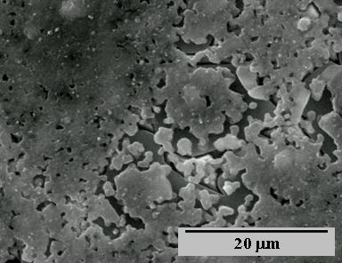

Figure 108. SEM surface image of a crystallized sample (with an initial Si/Al ratio of 2) after removing exposed Al on the surface. Excess Si accumulated on top covers large poly-Si grains formed on top of the substrate; however, some Si grains are visible.

In order to determine the effect of the deposition rate of a-Si on the AIC process, a-Si layers were deposited at 1 μm/hr and 10 μm/hr in HWCVD system. The amorphous nature of the films were confirmed by XRD before annealing since HWCVD films tend to be nano-crystalline at low growth rates. No differences in the nucleation density and average grain size were observed. Provided that the Si films are amorphous before the annealing, there seems to be no effect of the deposition rate of a-Si on the AIC process.

Effect of Oxide at the Al-Si Interface
Depending on the layer sequence, a naturally formed Al or Si oxide layer separates two layers provided that the vacuum is broken between depositions. In this study, the analysis of aluminum oxide layer is of interest since the layer structure is glass/Al/a-Si. Variable Angle Spectroscopic Ellipsometry (VASE) measurements were performed to analyze the increase of the thickness of the natural Al oxide layer. Figure 109 shows the calculated thickness of the oxide layer of a 500 nm Al film on 7059 glass substrate when exposed to air in laboratory environment. VASE measurements were started as soon as Al deposition is done and performed under nitrogen flow. The thickness of the oxide layer increased by about 10 Å in the first 48 hours as seen in Figure 109.

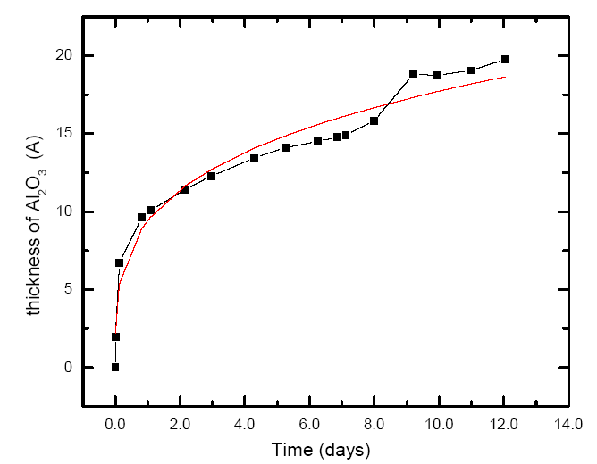
Figure 109. The change in the thickness of Al oxide layer with time under ambient conditions. The calculated thickness (solid line) is in good agreement with cross-sectional TEM studies (squares). A sudden increase in the thickness of the oxide layer after 9 days is related to changes in atmospheric conditions.

In the following 12 days, the thickness increases gradually to 20 Å. It should be noted that extended exposure time might also increase possible contamination of the sample, and also the changes in the humidity in the environment might change the growth rate of the oxide layer. The observed changes in the thickness might also be related to restructuring of the oxide layer. In the previous section, the effect of a-Si layer and hydrogen content on AIC process was discussed by comparing e-beam and PECVD deposited a-Si layers. In case of HWCVD deposited a-Si films, the situation is a little different. In order to evaluate the effect of the hydrogen and interface oxide on AIC process where HWCVD deposited a-Si layer is used, two different aspects must be taken into account; first, the hydrogen content in the a-Si layer, and second, the atomic hydrogen in the gas phase during deposition and its effect on the native oxide layer which was shown to be crucial for layer exchange process. By comparing e-beam and PECVD deposited a-Si layers in the AIC process, it is reasonable to suggest that the hydrogen in the a-Si layer has a slightly detrimental effect. The gas phase in HWCVD system is very rich in hydrogen and a-Si layers have significant hydrogen content since the deposition temperature for a-Si was lower than 110ºC and depositions rate was greater than 10 μm/hr. It is also suggested that very reactive atomic hydrogen supplied by the filament might reduce any oxide layer formed on the aluminum surface. A quick thermodynamic analysis for the reaction at temperatures below 500ºC suggest that the reduction of Al₂O₃ is favorable (ΔG_{rx} = -283 kJ/mol). Unfortunately, there is no way to check the effect of atomic hydrogen on the native oxide in the reactor, and an oxide layer is formed immediately when samples are removed from the reactor. Based on the above thermodynamic analysis, it is expected that the atomic hydrogen interacts and reduces the thickness of the native oxide layer. If the process is fast enough, atomic hydrogen should remove the whole oxide layer, and the layer exchange process should not occur. However, if the reduction of the oxide layer is not fast enough, it should only increase the nucleation density of Si crystals, because the thinner oxide layer will result in faster diffusion of Si and Al. Optical microscopy images of partially crystallized a-Si layer deposited by HWCVD shows a slightly increased nucleation density compared to PECVD deposited a-Si layers as seen in Figure 110, and increased nucleation density translates into smaller grain size. The layer exchange process was also observed in fully crystallized samples, indicating that the etching effect of atomic hydrogen on the native oxide layer is not very significant since the layer exchange process only occurs in the presence of an interfacial oxide layer. The smaller average grain size of HWCVD deposited samples can also be related to the amount of hydrogen in the a-Si layer rather than interface oxide.
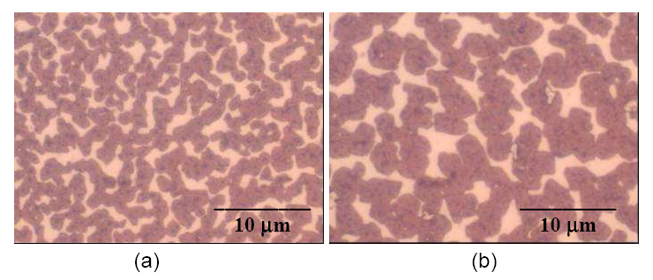
Figure 110. Optical microscopy images of partially crystallized samples with a-Si layers deposited by (a) HWCVD, and (b) PECVD. The higher nucleation density and smaller grain size of HWCVD deposited sample is related to etching of interfacial oxide layer by atomic hydrogen in the deposition environment.

At this point, it is reasonable to suggest that the differences in the average grain size of AIC crystallized a-Si layer are related only to the amount of hydrogen in a-Si layers, and hydrogen seems to be increasing the nucleation density of Si crystals. The driving force for crystallization process is expected to be greater for a-Si films without any hydrogen, since hydrogen helps to reduce the excess energy by passivating some of the dangling bonds in a-Si. Figure 111 shows OM images of 3 partially crystallized samples prepared under identical conditions and annealed at 475ºC for 15 minutes. All samples had 500 nm Al and a-Si deposited by HWCVD. The samples were exposed to air for 24 hours (a), 48 hours (b), and 80 days (c) prior the deposition of a-Si. The exposure time is directly related to the thickness of oxide layer. Thicker oxide layer in Figure 111c results in slower diffusion process and lower nucleation density, which yields larger Si grains when the crystallization process is complete. Only 10% of the substrate surface is covered with Si crystals. The thinner oxide layer in Figure 111a results in higher nucleation density, which also yields smaller grain size compared to Figure 111c when the crystallization process is complete. However, the thinner oxide layer also enhances the diffusion process; more than 90% of the substrate surface is covered with Si crystals (Figure 111a).

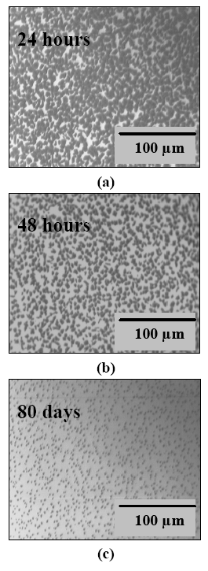
Figure 111. Optical microscopy pictures of partially crystallized samples taken through the glass substrate. Al layers were exposed to air before Si deposition (a) for 24 hr, (b) for 48 hrs, and (c) for 80 days.

The nature of the oxide layer was also investigated using X-Ray Photoelectron Spectroscopy (XPS). Aluminum layers with different thicknesses were deposited on 7059 glass substrates by e-beam deposition. The analysis was focused on Al 2p and O 1s core levels. Figure 112 shows XPS depth profile of Al 2p regions for 100 nm thick Al film on glass. A total of 6 levels are shown, each taken after sequential etching for 30 seconds. The binding energies for Al-Al and Al-O bonds are 73 eV and 75.6 eV, respectively, and each profile is normalized with respect to Al-O peak. The intensity of bulk Al 2p peak increases (at 73 eV) as the sputtering depth increases indicating a decrease in the oxidation state.

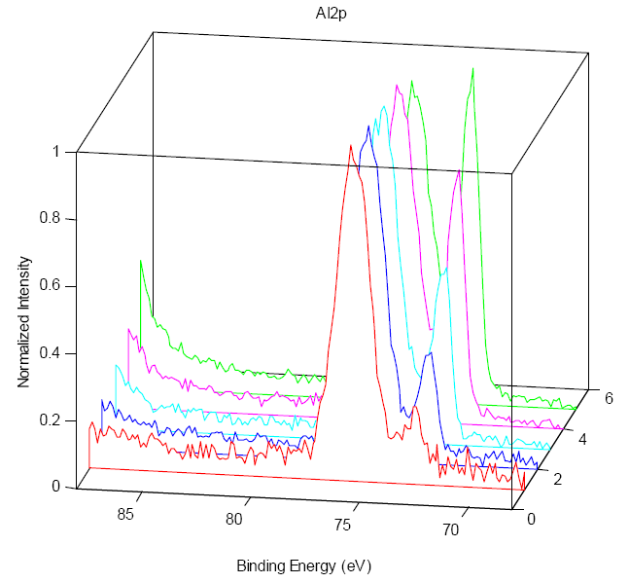
Figure 112. XPS depth profile for Al 2p region of 100 nm thick Al film on glass. The binding energy for Al-Al and Al-O are 73 eV and 75.6 eV, respectively. The shift to a higher energy in the oxidation state is noticeable. Sputtering cycles are marked on the right axis.

Figure 113 shows the depth profile for O 1s where the binding energy is 533.8 eV at the surface and 532.5 eV after 6 sputtering cycles supporting the presence of an oxide on the surface. A detailed analysis of XPS depth profiles suggests that the oxide layer actually a bilayer structure; Al(OH)₃ on top of Al₂O₃ layer. The changes in the optical properties of the aluminum surface observed by ellipsometry might be related to the restructuring of the hydroxide and oxide layers. It should be noted that the interfacial oxide layer remains intact throughout the entire crystallization process. XPS studies performed on samples with glass/Al/a-Si initial layer sequence before and after the crystallization process below eutectic temperature indicates that the initial position of the oxide layer does not change. The diffusion of metal and Si atoms occur through the oxide layer, while the layer itself stays intact. The findings on the effect of the thickness of the oxide layer and XPS studies suggest that the interfacial oxide layer should be thin or inhomogeneous enough to allow the material transport but stable enough to stay intact throughout the process.

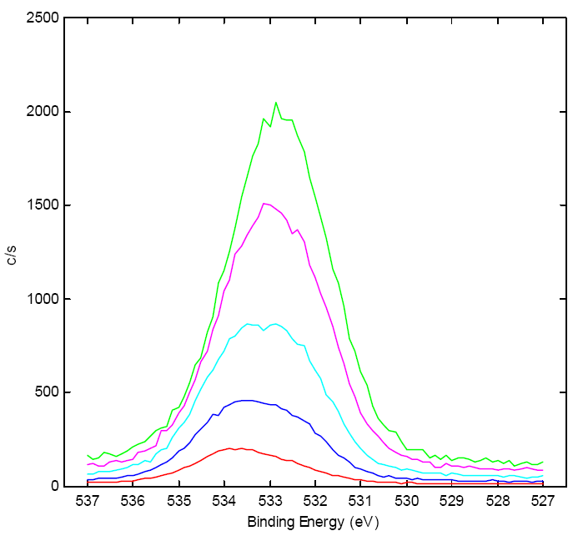
Figure 113. XPS depth profile for O 1s region of 100 nm thick Al film on glass showing a shift to a lower energy as the sputtering depth increases. Red line corresponds to surface.

Figure 114 and Figure 115 show cross-section TEM images of a-Si/Al interface of a sample. This particular sample has 600 nm a-Si layer deposited by e-beam onto a 500 nm thick Al layer on 7059 glass substrate. Figure 114 shows that a-Si/Al interface is not atomically sharp. There is a thin transitional layer. This thickness is in well agreement with calculated thickness of the interfacial oxide layer from the ellipsometry measurements. Figure 115 shows a different cross sectional area on the same sample. In this case, the layer between Si and Al is not visible. Figure 116 shows cross-sectional TEM image of a sample prepared by AIC. The sample had a Si/al ratio of 1.1 with an initial Al layer thickness of 1 μm. The examined area of this particular sample does not have any transition region or interfacial layer. Amorphous Si mixed with Al lies on top of a Si grain in which several defects are clearly visible. The absence of a separating layer between Si and Al might be related to either the discontinuity of native oxide layer due to the surface roughness of initial Al layer or the etching effect of atomic hydrogen mentioned above. TEM images indicate that the structure of the interfacial oxide layer is not uniform; there are discontinuities and thickness variations.

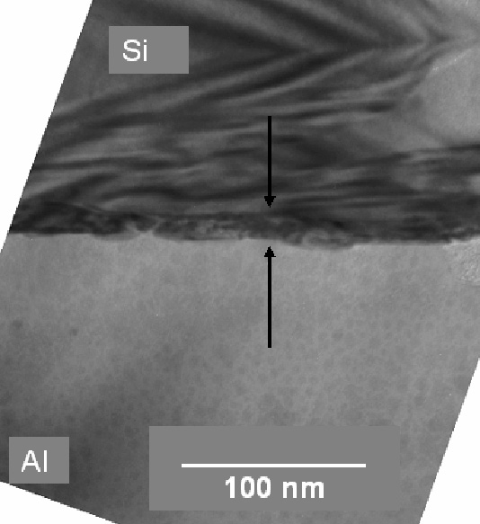
Figure 114. Cross-sectional TEM image the sample with a layer sequence of glass/500 nm Al/600 nm Si. The interfacial oxide layer with a thickness of 10-15 Å was also identified.

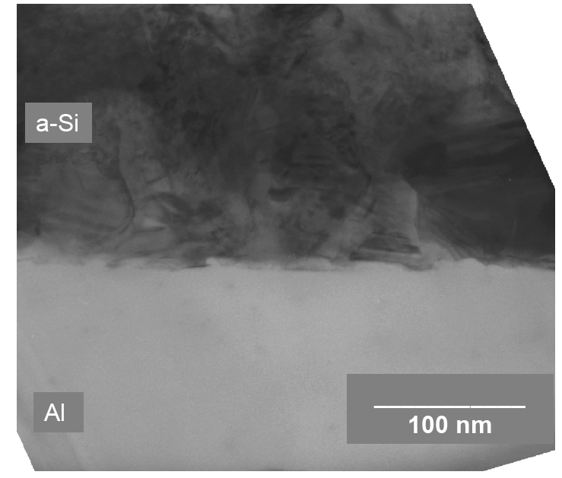

Figure 115. Another cross-sectional TEM image the sample shown in Figure 114. The interface is not atomically sharp and has discontinuities.

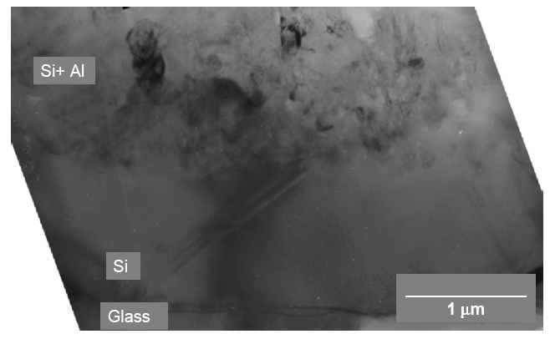

Figure 116. Cross-section TEM image of a crystallized sample. The area investigated lacks an interfacial oxide layer, which might be related to the etching effect of atomic hydrogen in HWCVD system.

It is clear that the layer exchange process which is usually associated with conventional metal-induced crystallization occurs only in the presence of an interfacial oxide layer. This interfacial oxide layer, however, is not required for the crystallization process. This also indicates that the role of interface oxide might be limited to acting as a physical barrier to prevent Si crystals growing into the a-Si layers and facilitate lateral growth on the substrate surface. The oxide layer also controls the diffusion process and determines the speed of crystallization. A thinner oxide layer results in enhanced diffusion but small grain size due to higher nucleation density. A thicker oxide layer slows the crystallization process but yields larger grains. Depending on the structure of the aluminum layer used and process conditions such as annealing time and temperature, there has to be an optimum oxide layer thickness which will yield the desired grain size in a reasonable amount of time.

The effective activation energy for the crystallization and layer exchange process was also calculated using OM images of partially crystallized samples annealed at 430ºC, 475ºC, and 540ºC. Figure 117 shows the plot of temperature dependence of the time needed for 50% surface coverage. From the slope of the line, the effective activation energy for AIC process was determined to be 0.9 eV. The calculated activation energy is lower than reported value of 1.2 eV in literature.Error: Reference source not found, On the other hand, Widenborg reported a lower activation energy of 0.5-0.65 eV for a modified MIC process based on an aluminum hydroxide interfacial layer. Considering the characterization of interfacial oxide layer and the existence of aluminum hydroxide as well as aluminum oxide at the interface, the activation energy of 0.9 eV reported in this study seems to be in good agreement with Widenborg's results. It seems that the limiting factor in the AIC process is not the diffusion of Si into Al, but rather the material transport through the interfacial oxide layer.
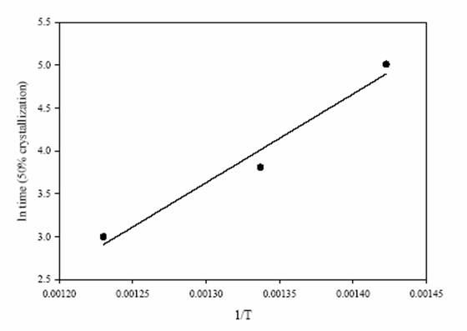
Figure 117. Arrhenius plot of the temperature dependence of time for crystallization. Samples had 500 nm a-Si layers deposited on 400 nm Al. Overall activation energy for crystallization and layer exchange process was calculated to be 0.9 eV.

Summary

It has been shown that the grain size of poly-Si film formed after the crystallization and layer exchange process is determined by three factors; the grain structure of Al layer, the nature of the interfacial oxide, and crystallization temperature. The interface oxide is crucial for layer exchange process but not required for crystallization. The oxide layer formed on Al films has a bilayer structure containing Al₂O₃ and Al(OH)₃, and the structure of the oxide layer determines the material transport during layer exchange process. The overall activation energy for crystallization and layer exchange process was determined to be 0.9 eV. The limiting factor is the material transport through the interfacial oxide layer. The gas phase chemistry during deposition of a-Si layers is important. Hydrogen in a-Si layers seems to have a detrimental effect on crystallization process by reducing the overall driving force for crystallization.

4.2 In-situ AIC below the eutectic point leading to 10 µm grains

Most AIC studies reported in the literature perform the crystallization thermal step ex-situ, after the low-temperature deposition of both Si and Al layers as described in Section 4.1 above. However, attempts to obtain continuous large grain poly-Si films using ex-situ AIC have generally not been successful at IEC or elsewhere. Here, an in-situ AIC crystallization process where Si is deposited by HWCVD on Al coated glass substrates at 430ºC leading to grains >10 µm is discussed.

The glass substrates (Corning 7059 type) were cleaned using a mild soap solution and DI water rinse. Aluminum films with 500 nm and 1000 nm thicknesses were deposited on substrates by electron beam evaporation at a fixed deposition rate of 4 nm/s. All Al coated glass substrates were exposed to air, at least 24 hours prior to Si deposition to ensure the formation of an oxide layer as discussed above.

In-situ AIC experiments were performed using the HWCVD system. The background pressure in the HWCVD system was always kept below 5x10⁻⁷ Torr. Silane gas was used as the source gas without hydrogen dilution. Silicon films with 500, 600 and 1000 nm thicknesses were deposited at fixed substrate and filament temperatures of 430ºC and 1850ºC, respectively, and a pressure of 25 mTorr. The deposition rate of Si was either 1 or 5 μm/hour.

In a conventional AIC process where a-Si and Al layers are annealed at temperatures below 500ºC, the poly-Si film is formed on the glass substrate, replacing the initial Al layer. Al is accumulated on top of the newly formed poly-Si layer. If the thickness of the a-Si layer is greater than the thickness of the initial Al layer, the excess Si is accumulated on top of the newly formed poly-Si layer. The newly formed poly-Si layer is covered with a surface layer of mixed Si and Al. This mixture must be removed before the poly-Si can be used as a seed layer. The schematic illustration of the crystallization process is shown in Figure 118.
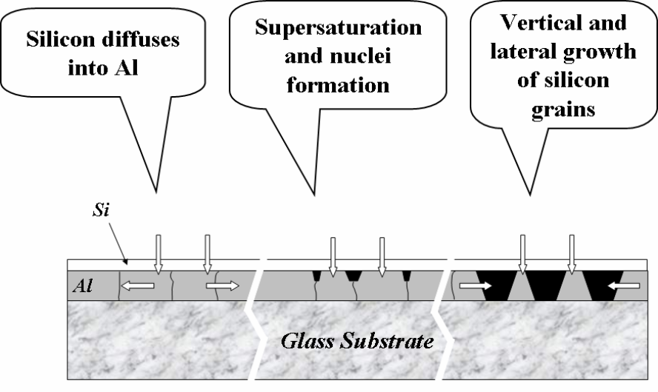

Increasing deposition or annealing time ⇒

Figure 118. Schematic illustration of crystallization of Si during deposition. Si first diffuses into Al layer where it nucleates. Growing Si crystals replace Al until a continuous poly-Si layer is formed. After crystallization process, Al and excess Si accumulate on top of newly formed poly-Si film.

The crystallization process can be divided into 3 steps: First, Si diffuses into Al layer. Depending on the flux of Si atoms, a thin Si film might be formed on top of the Al layer. Next, the Al layer is supersaturated with Si and dissolved Si crystallizes at Al grain boundaries. The grain boundaries are preferential nucleation sites because supersaturation can be achieved locally, although Al grains are not supersaturated. Finally, Si grains grow both laterally and vertically until they reach the glass substrates. After that, only lateral growth is possible, since the oxide layer at the a-Si/Al interface acts as a physical barrier.

Si grains grow laterally, replacing the initial Al layer. Al diffuses through the interface and accumulates on top of the newly formed poly-Si layer. The thickness of the poly-Si layer is determined by the thickness of the initial Al layer. Figure 119 shows the SEM surface image of a sample after Si deposition. The substrate was 500 nm Al coated glass substrate, and the thickness of the Si layer deposited was 600 nm. Deposition and crystallization of Si occurred at the same time. EDS analysis of the sample revealed the presence of Al and Si on the surface, indicating that the initial Al layer was replaced by poly-Si film. Depending on the thicknesses of Si and Al layers and the deposition rate of Si, samples showed a variety of different surface morphologies.

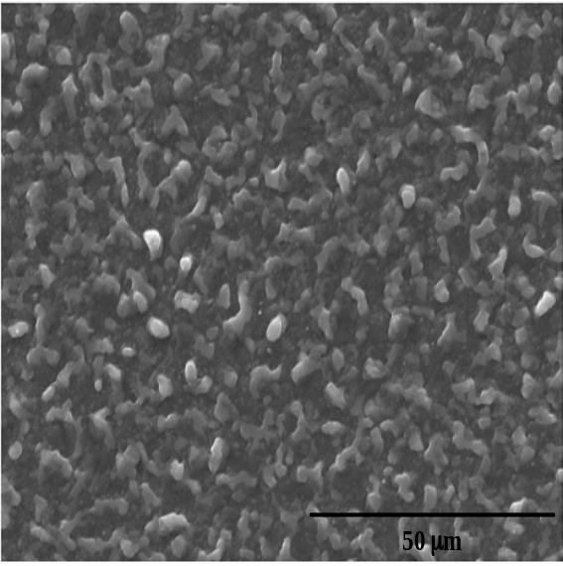

Figure 119. SEM image of a sample after Si deposition in HWCVD system. A 600 nm thick Si layer was deposited on 500 nm Al coated glass substrate. The surface of the sample contains mostly Al and some excess Si.

In the literature, the poly-Si layer is commonly exposed, by using a standard Al etching solution. This solution consists of 80 parts of phosphoric acid, 5 parts of nitric acid, 5 parts of acetic acid, and 10 parts of deionized water, and is applied at temperatures of 50ºC - 55ºC. However, this solution removes only the exposed Al on the surface, not the Al clusters surrounded by excess Si.

In order to reveal the grain structure of poly-Si hidden by the excess Si and Al, a new etching procedure was developed. This etching recipe involves the use of a standard Al etching solution mentioned above as well as the use of XeF₂ gas. XeF₂ gas etches a-Si and nano-Si rapidly compared to the etching rate for the crystalline phase. The new etching procedure involves sequential etching using XeF₂ and standard Al etching solution for different times, depending on the thickness of the initial Al layer and Si film deposited.

Figure 120 shows the SEM image of a sample with an initial layer structure of glass/500 nm Al/ 600 nm a-Si after partial etching, using the new etching process. The sequential etching removes excess Si as well as the exposed and unexposed Al trapped in the Si matrix, resulting in almost planar etching. Since the etching is not complete, some excess Si is still visible (lighter areas) on top of Si grains (darker areas).

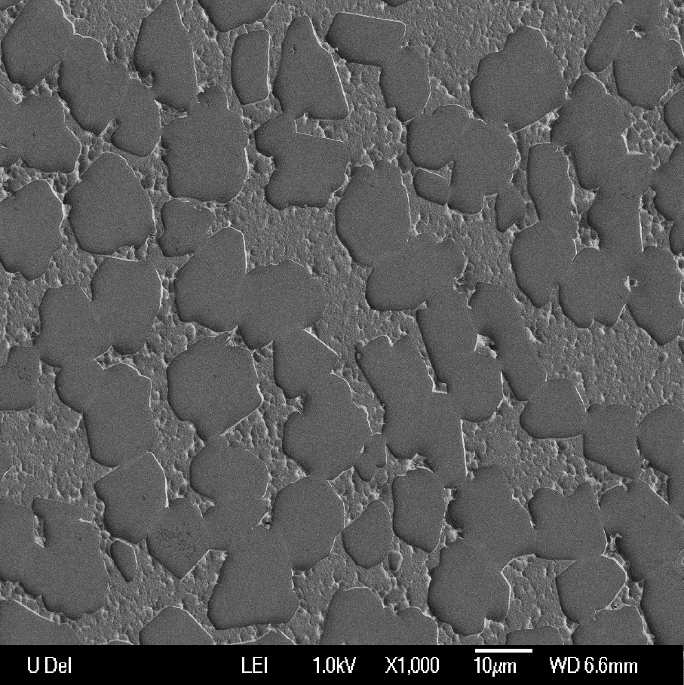

Figure 120. SEM image of the sample after partial etching. The darker areas are Si grains while the lighter areas are mixtures of amorphous and nanocrystalline Si not etched yet. Grains of 10-15 nm are visible.

Figure 121 shows the SEM image of the same sample at higher magnification. Three individual Si grains and two-grain boundaries between them are clearly visible on the left hand side of the image. The average grain size was estimated to be 10 to 13 μm after complete etching of the excess Si from the surface.

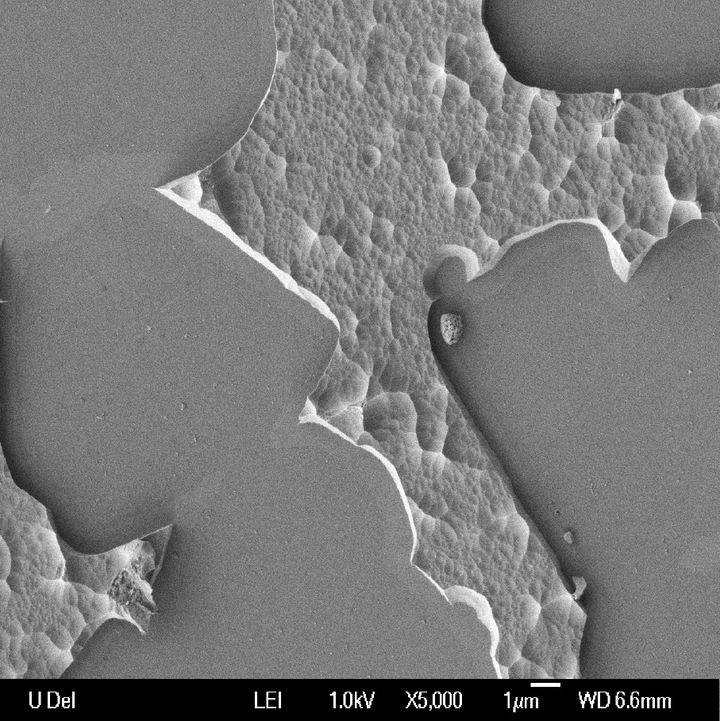

Figure 121. A close up SEM image of the same area shown in Figure 112, showing excess Si on top of continuous Si grains after etching. Two-grain boundaries are visible on the left hand side of the image. Average grain size was estimated around 10-13 μm.

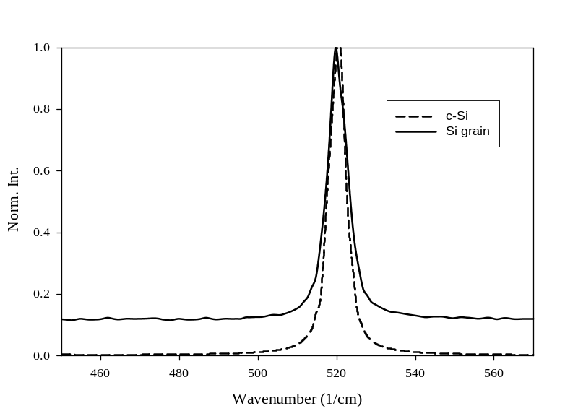

Figure 122. Raman spectra of exposed poly-Si layer after etching and c-Si for comparison. The peak is symmetric and position matches with c-Si, indicating high quality crystalline- phase.

Figure 122 shows the Raman spectrum taken from the Si grain on the left hand side in Figure 121. For comparison, the Raman profile of c-Si is also shown. The Raman profile reveals a high quality Si crystal without any amorphous or nano-crystalline phase, which would be seen at 480 and 504 cm⁻¹, respectively. The crystalline Si peak is symmetric, and the peak position matches with c-Si at 519 cm⁻¹, indicating a high quality Si film with little or no stress.

The effects of Si and Al layer thicknesses on the nucleation density and the surface coverage of Si grains was evaluated using optical microscopy. In reflection mode, Si crystals reaching to the glass substrate are seen as dark spots, compared to a highly reflective Al layer. Figure 123 shows OM images of 4 samples taken through the glass substrates, each representing a different level of crystallization. The Si/Al thickness ratios and Al layer thicknesses were; (a) 0.5 and 1000 nm, (b) 1.0 and 1000 nm, (c) 1.0 and 500 nm, and (d) 1.2 and 500 nm.

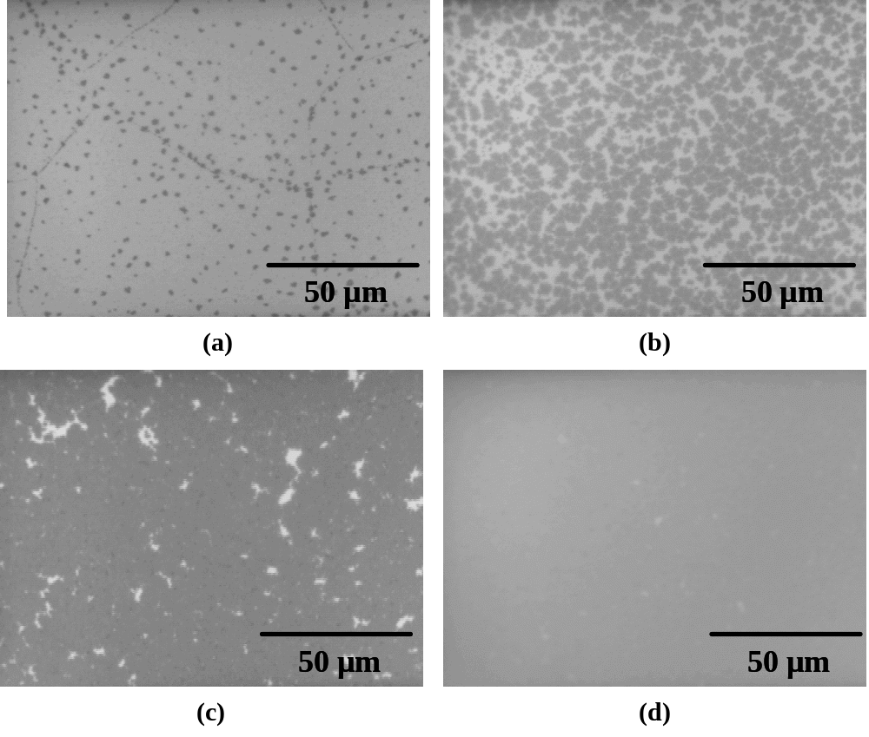
Figure 123. Optical microscopy images of 4 different samples taken through the substrates. The Si/Al ratios and Al layer thicknesses were: (a) 0.5 and 1000 nm, (b) 1.0 and 1000 nm, (c) 1.0 and 500 nm, and (d) 1.2 and 500 nm, where a continuous poly-Si film was obtained on the substrate.

Although the Si layer thicknesses were different, the deposition/crystallization times were comparable. Increasing the amount of Si available for crystallization increases the surface coverage of Si crystals from 5% in Figure 123a to 50% in Figure 123b, but does not change the nucleation density. When the Al layer thickness was reduced to 500 nm in Figure 123c, the surface coverage of the Si crystals increased to over 90%.

It was first thought that aluminum clusters that were stuck between growing poly-Si grains prevented formation of a continuous poly-Si film. However, when the Si/Al ratio was increased from 1.0 to 1.2 to provide enough Si for crystallization, a continuous poly-Si film (Figure 123d) was obtained. A few, very small Al clusters can still be seen between the poly-Si grains for the sample in Figure 123d. However, no Al clusters were observed in similar samples with a maximum Al layer thickness of 500 nm. Actually, the sample shown in Figure 123d is the same sample shown in Figure 119. Using an Al layer thickness greater than 500 nm resulted in non-continuous poly-Si films with Al clusters between Si grains. This is the result of Si grains coalescing and forming a diffusion barrier for Al atoms, as the Si grains grow faster along Si/Al interface than on the glass surface.

In order to prevent Al clusters on the glass surface after crystallization, the initial layer of the Al layer must be equal or less than 500 nm when the deposition conditions mentioned above are used. When thicker Al layers were used, the formation of a continuous poly-Si layer along Si/Al interface prevented diffusion of Al, resulting in an incomplete crystallization process with some of the Al trapped between glass and continuous poly-Si layer at the Si/Al interface.

Increasing the Si/Al ratio further does not improve either the quality or the thickness of the poly-Si film. Increasing the Si layer thickness results in a continuous poly-Si film with a thickness equal to the thickness of the initial layer of Al, and on top of that layer, a mixture of excess Si and Al. XRD analysis of the poly-Si layer revealed preferential (400) or (422) orientations. The major limitation of poly-Si layers prepared by in-situ or conventional ex-situ AIC process is Al contamination.

In previous reports, Al concentrations in the order of 10¹⁹ Atoms/cm³ have been measured in poly-Si layers prepared by conventional AIC. Although AIC poly-Si layers with this level of Al are inadequate as a solar cell absorber, they can be used as potential seed layers for epitaxial growth of bulk Si.

In summary, continuous poly-Si films on glass substrates were obtained using an in-situ aluminum-induced crystallization technique at 430ºC. The Al film deposited by e-beam was 0.5 µm and the Si deposited by HWCVD was 0.6 µm. Poly-Si films had an average grain size of 10-13 μm, corresponding to a grain size/thickness ratio greater than 20 and similar to poly-Si films prepared by conventional metal-induced crystallization. Poly-Si layers prepared by either an in-situ or conventional AIC process can be used as seed layers for epitaxial Si growth or for back contact formation in c-Si solar cell fabrication at temperature below 500ºC. As an alternative to conventional AIC, the in-situ AIC process eliminates an additional annealing step, which saves considerable time during processing.

5 DIAGNOSTICS

5.1 GIXRD

Introduction

The development of thin film materials for photovoltaics is facilitated by non-destructive analytical methods which can provide quantitative information on the physical and chemical state of the constituent layers, their interfaces and surfaces. Glancing incidence x-ray diffraction (GIXRD) is a powerful diagnostic tool for non-destructive analysis of thin film materials and structures which provides this capability by decoupling incident and diffracted beam paths, allowing depth-specific quantification of phase distribution, alloy formation, residual stress, and particle size. The addition of a heater and means for ambient control allows real-time in situ investigation of chemical reactions between thin film specimens and ambient and between different layers within the thin film structure.

GIXRD Fundamentals

The symmetric diffraction condition, in which the incident and diffracted beam angles are identical, produces a diffraction signal only for sets of crystal planes whose normal bisects the incident and diffracted beam direction (shaded circles in Figure 124, left). In its most common application, powder diffractometry, the diffraction pattern is measured over a wide angular range for a powder bed containing randomly oriented particles with size >100 μm, using the Bragg-Brentano (B-B) parafocusing optical configuration. The B-B method permits accurate intensity measurement for lattice planes lying parallel to the focusing plane, allowing quantitative assessment of phase mixtures to be reliably determined to ±1 weight percent. By substituting a thin film for the powder in the focal plane, randomness is not guaranteed and the crystallographic texture of the specimen with respect to the substrate can be assessed. Whereas powder line profiles in B-B mode are primarily sensitive to instrumental effects, those of thin films are sensitive to both sample and instrumental effects: asymmetrical broadening by beam divergence; broadening by specimen planarity; non-uniform stress and small domain volumes; and angular shifting by specimen displacement from focusing circle and uniform stress. Parallel beam geometry reduces some of these effects significantly. Furthermore, since the incident beam angle changes as the intensity pattern is acquired; greater incident beam penetration is obtained at higher diffraction angles. For example, the sampling depth for Cu Kα x-rays in CuIn_{0.7}Ga_{0.3}Se₂ is 3.3 μm for (112) and 6.3 μm for the (312)/(116) doublet. Thus, peaks obtained at different diffraction angles arise from different depths in the specimen, known as the diffraction volume, and the utility of the symmetric diffraction mode for quantitative analysis of thin film specimens is limited by the inability to differentiate between phase mixtures and layers.

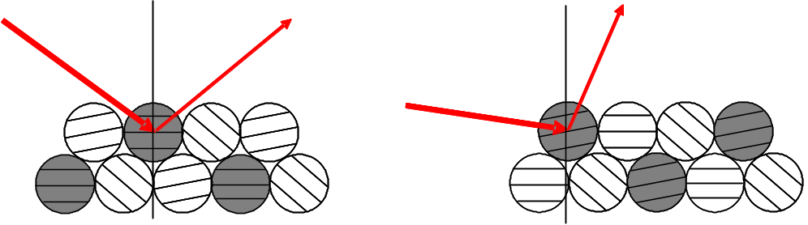

Figure 124. Symmetric and asymmetric diffraction from a polycrystalline aggregate.

The asymmetric diffraction condition is defined by decoupling of the incident and diffracted beams. For a fixed incident beam angle, only lattice planes located at the Bragg angle for that incident beam angle give diffraction intensity (shaded circles in Figure 124, right). Fixing the incident beam at different, low angles allows measurement of diffraction patterns over a fixed sampling depth, in a constant diffraction volume. Diffraction patterns obtained at very shallow, or glancing, incident angles contain information relating to the film surface, since mass absorption of the x-rays by the specimen attenuate the incident beam intensity in the surface region. Diffraction patterns obtained at higher incident beam angles contain information averaged over a greater fraction of the film depth, and analysis of diffraction patterns acquired at varying incident beam angles permits quantitative determination of film thickness, compositional distribution, and residual stress distribution. Figure 125 shows the coordinate system and configuration employed for GIXRD in this work.

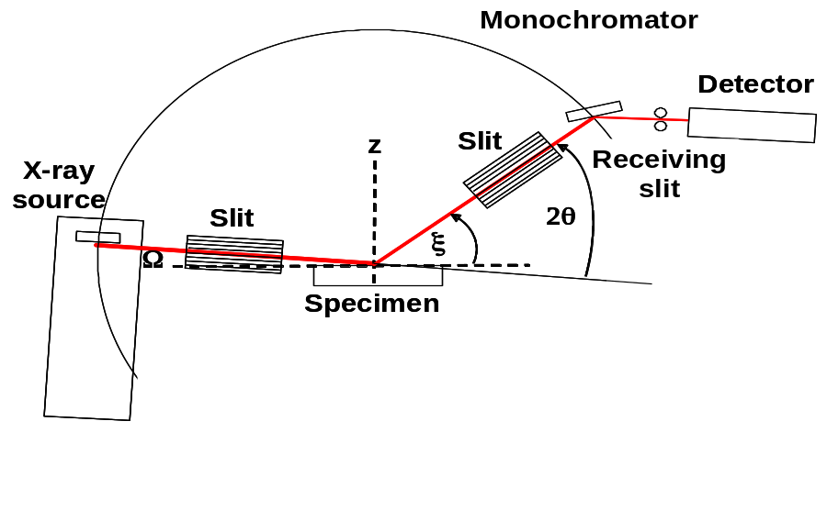
Figure 125. Coordinate system and two-circle diffractometer configuration used for GIXRD thin film measurement.

The GIXRD geometry with parallel beam optics is shown in Figure 126. The Bragg condition for diffraction in a refractive index matched (air-specimen) system is 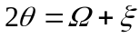.
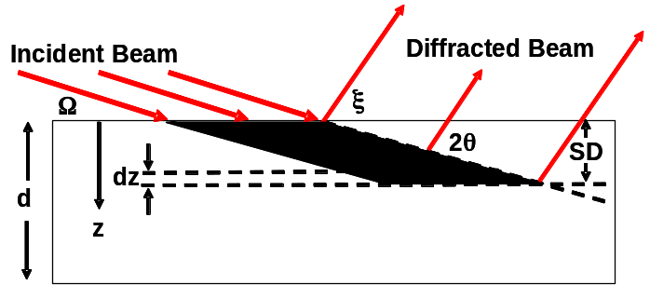

Figure 126. GIXRD diffraction volume in planar specimen.

Parallel beam optics offer advantages over parafocusing methods, such as higher beam intensity and reduced angular sensitivity to specimen displacement offsets in the z-direction, in and out of the calibration plane. However, the angular resolution is typically lower. The measured 2θ peak positions of the CdTe (111) peak in B-B parafocusing and parallel beam configurations are shown in Figure 127 for displacement above and below the calibration plane (focal plane of the B-B geometry). The results show that for B-B geometry, a total offset range of 2.2 mm causes a 2θ variation of 1.6 deg. For parallel beam geometry, the displacement does not measurably change the 2θ position and only affects the intensity due to irradiated area differences.

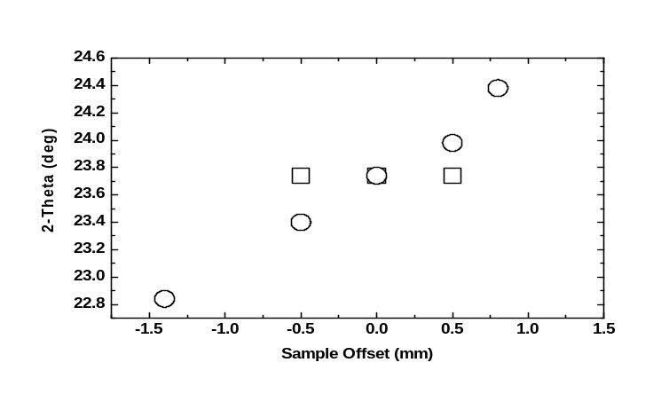
Figure 127. Comparison of CdTe (111) peak position versus z displacement for Cu Kα diffraction using Bragg-Brentano (circles) and parallel beam 5 deg incidence GIXRD (squares) measurement geometries.

The path of light incident from air to a planar medium changes by the differing refractive indices. Figure 128 shows this effect for light at ~600 nm and 0.154 nm. For depth profiling and lattice parameter calculation, the incident beam angle must thus be corrected for refraction:

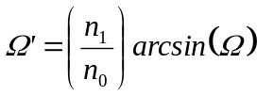 (18)

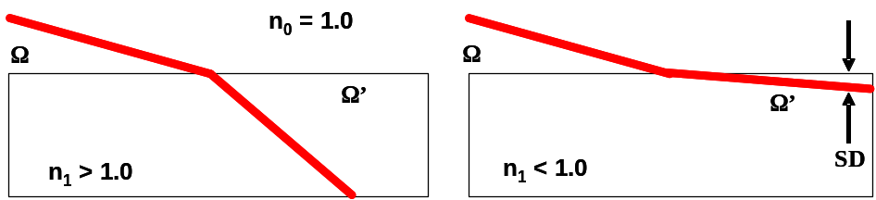

Figure 128. Beam paths for visible light and x-rays in planar specimen.

The refractive index (n) is a complex quantity and is fully expressed as

n = 1 - δ - iβ, where (19)

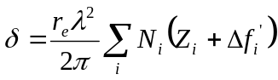 and 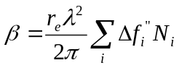 (20)

where r_{e} is the electron radius = 2.82 x 10⁻¹⁵ m, λ is the x-ray wavelength, Z_{i} is the atomic number of the i^{th} atom, N_{i} is the number of i^{th} atoms per unit volume, and Δf’ and Δf” are the elemental dispersion corrections. The index determines the critical angle, θ_{c}, at which total reflection occurs, below which diffracted intensity tends to zero. The imaginary part of the refractive index (β) is related to the specimen mass absorption coefficient by:

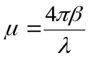 (21)

The sampling depth (SD) depends on the mass absorption of the specimen and the incident angle, which determine the penetration depth (PD):

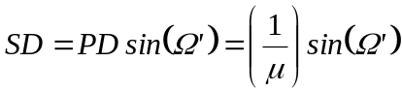 (22)

For mixtures or compounds, the linear mass absorption coefficient (μ_{m}) is calculated using:

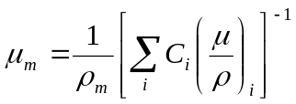 (23)

where ρ_{m} is the net specimen density, C_{i} is the weight fraction of the i^{th} elemental component, and (μ/ρ)_{i} is the corresponding elemental mass absorption coefficient. The absorption length (1/μ) is the length at which the incident beam is attenuated to 1/e of the incident intensity. Table XXXII lists the optical constants for selected elemental and compound materials encountered in thin film photovoltaic research, calculated using the equations above. The sampling depth, SD, is calculated for incident beam angle, Ω = 1 deg, corrected for refraction.

Table XXXII. Optical properties of selected materials for Cu Kα: λ = 0.15405 nm, hν = 0.008 MeV.

Material | 1/μ  (μm) | δ  (x 10⁻⁵) | β  (x 10⁻⁷) | n | θ_{c}  (deg) | SD @ 1º  (nm)
Al | 76.15 | 0.847 | 1.93 | 0.999992 | 0.24 | 1325
Cr | 17.40 | 2.12 | 23.1 | 0.999981 | 0.37 | 303
Ni | 14.98 | 3.11 | 7.49 | 0.999970 | 0.45 | 261
Mo | 6.05 | 2.83 | 20.4 | 0.999974 | 0.43 | 106
WC | 3.20 | 4.68 | 37.9 | 0.999957 | 0.55 | 55
Se | 22.8 | 1.29 | 5.08 | 0.999988 | 0.29 | 396
Te | 5.46 | 1.67 | 21.9 | 0.999985 | 0.33 | 95
Si | 70.82 | 0.755 | 2.13 | 0.999993 | 0.22 | 1236
Ge | 24.82 | 1.44 | 5.18 | 0.999986 | 0.31 | 433
α-CdS | 10.44 | 1.36 | 11.9 | 0.999988 | 0.30 | 182
CdSe | 9.94 | 1.56 | 12.2 | 0.999986 | 0.32 | 174
CdTe | 6.68 | 1.53 | 18.1 | 0.999987 | 0.32 | 117
β−ZnS | 34.96 | 1.20 | 3.78 | 0.999988 | 0.28 | 610
ZnSe | 23.86 | 1.48 | 5.06 | 0.999986 | 0.31 | 416
ZnTe | 8.48 | 1.50 | 14.2 | 0.999986 | 0.31 | 148
HgS | 6.22 | 2.04 | 21.4 | 0.999982 | 0.37 | 109
HgSe | 6.69 | 2.05 | 19.5 | 0.999981 | 0.37 | 117
HgTe | 5.11 | 2.00 | 24.8 | 0.999983 | 0.36 | 89
CuAlS₂ | 42.66 | 1.05 | 3.18 | 0.999990 | 0.26 | 745
CuAlSe₂ | 27.20 | 1.31 | 4.44 | 0.999987 | 0.29 | 475
CuGaS₂ | 32.71 | 1.26 | 3.97 | 0.999988 | 0.29 | 571
CuGaSe₂ | 23.20 | 1.50 | 5.15 | 0.999986 | 0.31 | 405
CuInS₂ | 13.81 | 1.36 | 9.17 | 0.999987 | 0.30 | 241
CuInSe₂ | 12.80 | 1.55 | 9.54 | 0.999985 | 0.32 | 223
SiO₂ | 132.54 | 0.706 | 0.935 | 0.999930 | 0.22 | 2313
CdO | 6.03 | 2.25 | 20.3 | 0.999979 | 0.38 | 105
ZnO | 35.22 | 1.60 | 3.53 | 0.999984 | 0.32 | 615
In₂O₃ | 6.86 | 2.00 | 17.9 | 0.999982 | 0.36 | 120
CdTeO₃ | 7.69 | 1.63 | 15.6 | 0.999985 | 0.33 | 134

In a polycrystalline assemblage such as a powder, sintered pellet, or film, each grain can have a unique crystallographic orientation, size, stress, and composition compared to its neighbors. The extent of texture, or preferred orientation, with respect to the sample surface is closely tied to the thermo-chemical history of the film and can only be completely determined by pole figure measurements, where diffraction intensities are collected for a fixed Bragg angle but at different positions of φ (about z-axis) and Ψ (away from Ω−ξ plane). Single-axis texture coefficients (TC_{hkl}) can be determined from B-B measurements by normalizing peak intensities:

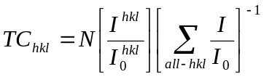 (24)

where N = the number of peaks considered, and I/I₀ is the measured intensity rank of each peak, normalized to the powder standard. Similar TC is obtained with GIXRD and B-B methods for films with random and slight low-order orientation, e.g., for CdTe films with TC₁₁₁ < 5.

The measured diffraction intensity is the convolution of the pure material intensity function with the effects of the polycrystalline assemblage and the diffractometer instrument function. The resulting line profile can be mathematically represented by the Pearson VII function:
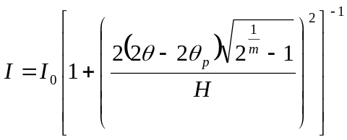 (25)

where 2θ_{p} is the centrum, H is the peak half-breadth and m is the shape parameter. The peak width, representing a lattice parameter distribution, is affected by many factors, most significantly non-uniform stress, particle size and alloying. Precise uncoupling of these effects with two-circle diffraction is not possible without additional specimen-specific information, such as a compositional depth profile or microscopic imaging to assess grain size. However, in II-VI and I-II-VI₂ films, the angular distortions can be ranked in terms of their magnitude. For films with large crystallites, alloying exerts the greatest effect. The integral line breadth, B = ratio of peak area to peak maximum, of a given (hkl) reflection, is inversely related to the number of planes contributing to the diffraction intensity. Different treatments of the problem have led to the same result:,

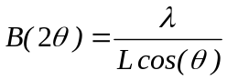 (26)

where the parameter L is a volume average of the crystal dimension normal to the reflecting planes. For spherical particles with diameter, D, the parameter L ~ D. For fibrous grains with width, D’, the parameter L ~ 1.1D’. In a polycrystalline film, both shape and width of the line profile are affected, depending on the distribution of particle sizes; therefore some a priori assessment of grain size distribution is invaluable before attributing broadening to compositional or stress related effects. The Cu Kα particle size broadening effect at 2θ = 25° is B = 9 for D = 1 nm and B = 0.09 deg for D = 100 nm.

Uniform stress (σ) from a given direction (Ψ) results in uniform lattice strain (ε_{Ψ}), which causes angular peak displacement, while non-uniform stress distorts peak shape. The measured strain is related to the applied stress by the elastic compliance coefficients. The in-plane strain-stress relationship for f.c.c. materials is:

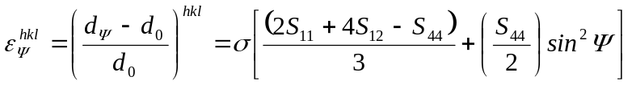 (27)

where S_{ab} are the compliance coefficients and d_{Ψ} is the d-spacing of (hkl) planes with their normals subtending the angle Ψ to the substrate normal. In B-B geometry, Ψ is always zero, while in GIXRD, Ψ equals the Bragg angle (2θ/2) minus the incident beam angle (Ω). By convention, tensile in-plane stress is positive, while compressive is negative.

Multi-layer film structures in which the layers are thinner than the absorption length can be analyzed by GIXRD for layer thickness, alloy formation via interdiffusion, and other chemical changes incurred during processing. Assuming planar geometry, the relation between thickness and peak intensity of the n^{th} film layer in a multi-layer stack is:

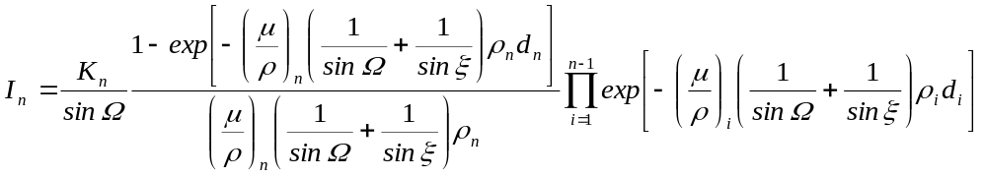 (28)

where K is the intensity scaling factor at incident beam angle. The peak intensity of an underlying substrate (s) is calculated using:

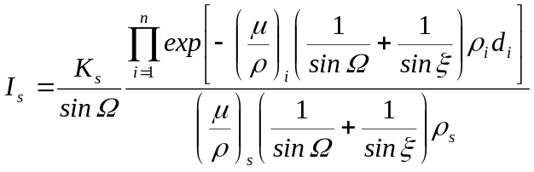 (29)

Measurement and Film Preparation

GIXRD measurements were made on a Rigaku D/Max 2100 diffractometer with an 18.5 cm radius two-circle goniometer using Cu Kα radiation with stationary anode, at 40 kV and 40 mA. Parallel beam optical geometry was employed for the measurements using narrow Soller slit assemblies in incident and diffracted beam paths, with incident beam area of 10 mm x 15 mm. Wide angle scans were made at a step size of 0.05 deg and a step rate of 1 deg/min. For higher precision needed for lattice parameter determination and line profiles, scans were acquired at a step size of 0.02 deg. Raw data was smoothed using 5 point binomial smoothing and stripped of Kα₂ component with the Rachinger correction. B-B measurements were made with a Philips/Norelco powder diffractometer using Cu Kα radiation at 35 kV and 20 mA. GIXRD line profiles of CdTe and CuInSe₂ films deposited at high temperatures having grain size > 1 μm exhibit Pearson VII distributions with shape parameter 3 < m < 10 and full width at half maximum (FWHM) of 0.35 deg. The B-B line profiles of the same CdTe and CuInSe₂ films exhibit Pearson VII distributions with shape parameter m = 3 and FWHM of 0.12 deg.

Films were also analyzed by atomic force microscopy (AFM) with a digital Instruments Dimension 3100 system in tapping mode. Scanning electron microscopy with an Amray 1810T system was used to assess surface morphology in conjunction with energy dispersive x-ray spectroscopy (EDS) by Oxford Instruments for composition. EDS was carried out at 20 kV, which provides average composition over a depth of ~1 μm, for films with ρ = 6 g/cm³.

CdS films were deposited by chemical surface deposition from an aqueous bath containing CdSO₄, thiourea and ammonia onto In₂O₃:SnO (ITO) coated Corning 7059 glass substrates at 40ºC.Error: Reference source not found CuIn_{1-x}Ga_{x}Se₂ films were fabricated by reaction of sputtered metal precursor films with H₂Se gas at 450ºC. CdTe films were deposited physical vapor deposition (PVD) at 0.1 μm/min onto stationary substrates at 325ºC and by vapor transport deposition (VT) at 10 μm/min onto substrates translating at 10 cm/min at 550ºC. Films were subjected to in situ oxidation in dry and humid ambient, in situ CdCl₂ treatment, and ex situ etching in 1:70 nitric:phosphoric (NP) acid. Mo films were deposited onto Corning 7059 and Glaverbel soda lime glass by DC sputtering onto stationary substrates at 700W in argon at pressures of 2, 3 and 5 mTorr.

GIXRD Applications

Recrystallization of chemical surface deposited CdS

Chemical surface deposited CdS films are used as window layers for thin film CdTe and CuInSe₂ based solar cells. Figures 129 and 130 show AFM images and GIXRD patterns of 40 nm thick CdS films deposited at 40ºC onto ITO/7059 substrates and heat treated. Two heat treatments were used: 550ºC in argon for 10 min (HTA) and 400ºC for 20 min in 9 mTorr CdCl₂ vapor in air (CdCl₂). As-deposited films are dense, conformal and free of surface residues but exhibit very small particulate size. The as-deposited GIXRD pattern shows numerous In₂O₃ peaks of the ITO substrate and a low broad peak at the position expected for CdS (100) and (002). Analysis of the peak shape using equations 8 and 9 above yield as-deposited average particulate size of 10 nm, consistent with the small features in the AFM image. HTA treatment promoted secondary recystallization, with (002) orientation and narrow grain size distribution. CdCl₂ treatment promoted primary and secondary recrystallization, with random orientation and a broader range of crystallite size.
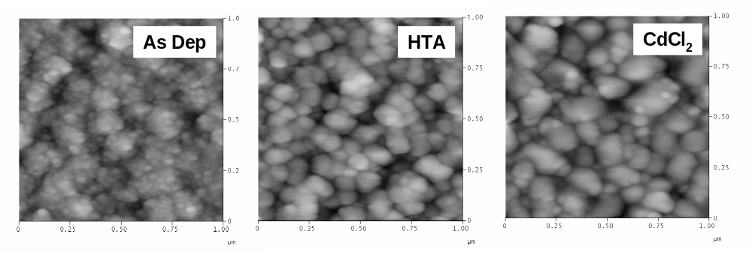
Figure 129. AFM images at 1 μm x 1 μm of as-deposited and treated CdS films.

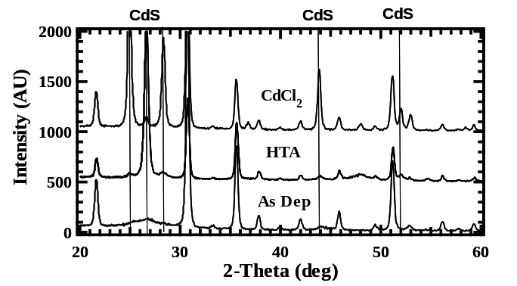
Figure 130. GIXRD of CdS/ITO/7059 samples at 1 deg incidence for samples of Figure 120.

Composition Profile in Selenized CuIn_{1-x}Ga_{x}Se₂

A promising approach for fabricating CuIn_{1-x}Ga_{x}Se₂ films at the commercial scale is by reaction of sputtered metal precursor films in H₂Se ambient, known as “selenization”, and the critical issue is controlling Ga distribution through the film. Selenization of a SL/Mo/Cu_{0.8}Ga_{0.2}/In bilayer precursor was carried out at 450ºC for 30 min in 0.35vol% H₂Se in Ar:O₂ (O₂:H₂Se = 0.01). The resulting film was characterized by EDS and multi-incidence GIXRD to survey the through-film composition. The film was then bonded to a glass substrate, peeled from the Mo substrate and re-measured. Broad GIXRD patterns showed that all reflections had the same shape dependence on incident beam angle. Figure 131 shows four sets of diffraction patterns of the (112) peak and EDS results; the upper row shows measured data for the as-deposited (left) and exposed (right) surfaces. The film is found to contain higher Ga at the Mo interface than at the surface. The line profiles for the two cases were modeled for an exponentially varying Ga composition from the Mo interface towards the film surface (inset). Modeling the GIXRD patterns from both sides supports the effort to quickly diagnose uniformity by a single measurement from the as-deposited surface.
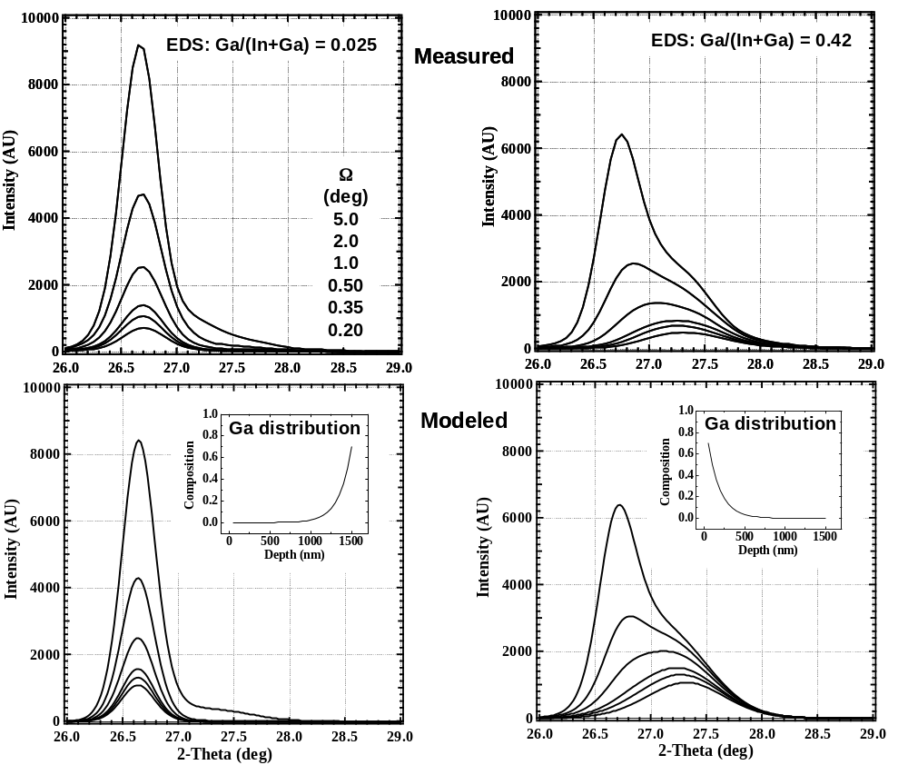

Figure 131. Measured and modeled CuIn_{1-x}Ga_{x}Se₂ (112) GIXRD line profiles for measurement through as-deposited surface (left) and exposed surface after peeling (right).

CdTe/CdS Treatments

Post-deposition treatments needed to fabricate high efficiency thin film CdTe/CdS cells produce multiple effects such as surface oxidation and reduction and interdiffusion. GIXRD with in situ heating and ambient control was used to directly investigate oxide formation and interdiffusion. Figure 132 shows time-progressive patterns for PVD CdTe films annealed in dry and humid air (~0.1 g/L) at 500ºC. In dry air, α-CdTeO₃ formed after 20 min, decreasing the (111) peak intensity. The oxide thickness followed a parabolic time dependence, indicating diffusion limited formation rate. Humidity enhanced the oxidation rate, with α-CdTeO₃ peaks forming within the first 10 min then transforming to β-CdTeO₃. Figure 133 shows time-progressive patterns obtained for 400ºC CdCl₂ treatment of a VT CdTe cell with 1 μm CdTe and 80 nm CdS on L.O.F. TEC-15 SnO₂/soda-lime glass; the AM1.5 conversion efficiency of the completed cell treated for 20 minutes was 11%. In the figure, note that the SnO₂ (110) peak position was unchanged by the treatment, but interdiffusion between CdTe and CdS shifted the CdTe (111) and CdS (002) peak positions to those of CdTe_{0.95}S_{0.05} and CdS_{0.95}Te_{0.05}.
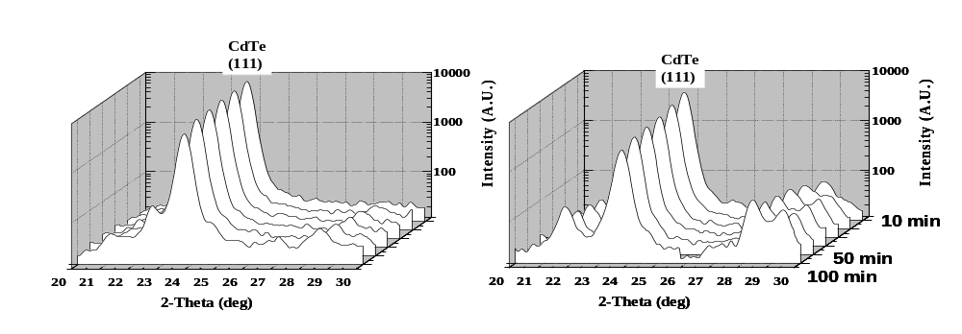
Figure 132. in-situ GIXRD patterns at 1 deg incidence of PVD CdTe heat treated at 500ºC in dry (left) and humid ambient (right).

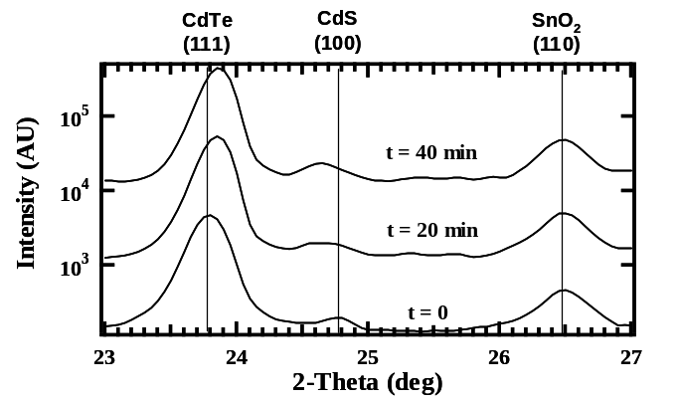
Figure 133. in-situ GIXRD patterns of CdCl₂ treated VT CdTe/CdS/SnO₂ at 5 deg incidence.

Figure 134 shows the GIXRD pattern of a Te layer formed after etching CdTe in NP acid mixture for 60 s. The CdTe (111) and Te (101) peak intensities and ratios versus Ω were modeled using equations 11 and 12 above and intensity factors from film standards. The modeled CdTe and Te peak intensities and intensity ratios are shown in Figure 135.

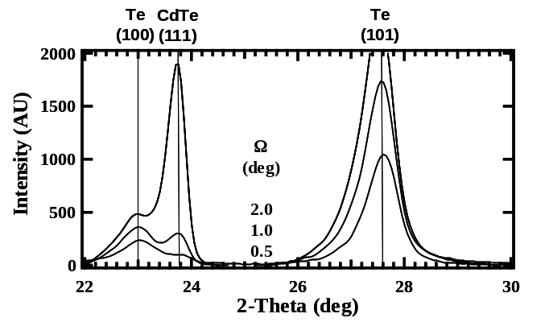

Figure 134. GIXRD at different incident beam angles of NP etched PVD CdTe.
Pearson VII peak fitting was used to separate the CdTe (111) peak from the Te (100) in the measured data. Iterative solutions were calculated by changing only the Te thickness to minimize the difference between measured and modeled Te/CdTe intensity ratio, yielding 25 nm.

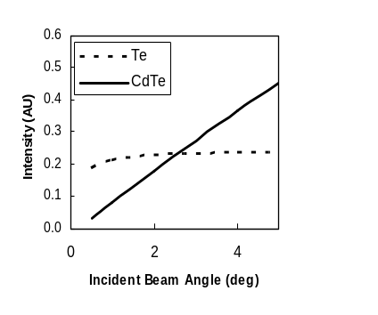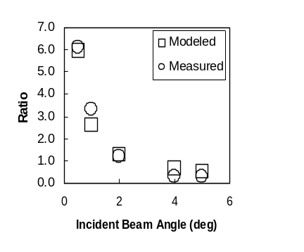

Figure 135. (Left) Modeled CdTe (111) and Te (110) peak intensities versus incident beam angle for a 25 nm Te layer on 4 μm thick CdTe film and (Right) measured and modeled Te(101)/CdTe (111) peak intensity ratios versus incident beam angle for NP etched CdTe.

Stress in Sputtered Mo Films

Sputter deposition of metals can lead to incorporated stress, depending on deposition pressure. Residual stress in Mo films used as substrates for CuInSe₂ based solar cells can affect Mo reactivity, adhesion and crack formation in both Mo and CuInSe₂ layers. The depth variation of stress was investigated with multi-incidence GIXRD of different (hkl) peaks in films deposited at 2, 3 and 5 mTorr on Glaverbel soda-lime glass and Corning 7059 glass. In-plane stress was calculated using equation 10 above and plotted versus sample depth (Figure 136). Lattice parameter results are compared to those obtained by Nelson-Riley-Sinclair-Taylor reduction of symmetric XRD patterns. Table XXXIII lists the lattice parameter, texture coefficient and bulk stress values obtained. In all cases, the surface stress was positive, indicating in-plane tension in the top 100 nm. The XRD and GIXRD bulk lattice parameters were in good agreement, and bulk stress was negative at 2 mTorr, indicating compression. Higher pressures resulted in essentially unstressed bulk. Orientation was random for 3 mTorr and slightly preferred (110) for 2 and 5 mTorr. The results also show that films deposited on soda lime glass are slightly less stressed than those on 7059.

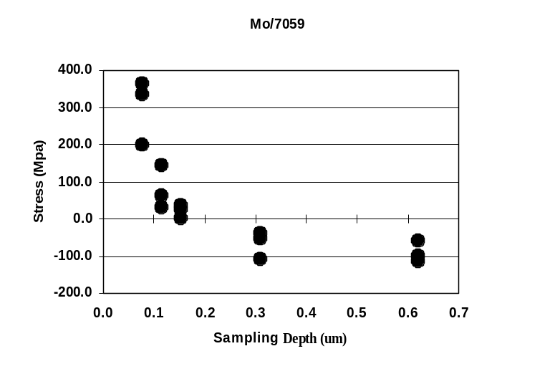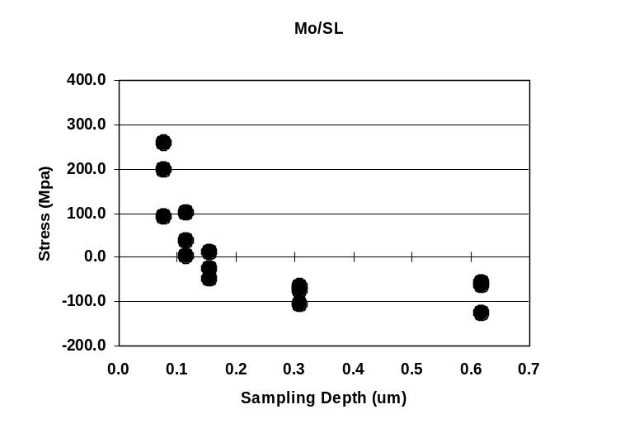
Figure 136. In-plane Mo stress versus sampling depth for films sputtered at 2 mTorr onto 7059 (left) and SL glass (right). Different points at each depth are for different (hkl).

Table XXXIII. Mo sputter deposition conditions and lattice parameter results of in-plane stress analysis. Lattice parameter of Mo is: a₀ = 0.3147 nm.

Sputter  Pressure  (mTorr) | Substrate | a₀  (±0.0001 nm)  B-B GIXRD | B-B  TC₁₁₀ | Bulk  Stress  (±25 MPa) | Surface  Stress  (±25 MPa)
2 | 7059 | 0.3152 0.3150 | 2.8 | -100 | +350
2 | SL | 0.3154 0.3150 | 2.9 | -100 | +225
3 | 7059 | 0.3145 0.3146 | 1.1 | +25 | +300
3 | SL | 0.3146 0.3145 | 0.7 | 0 | +250
5 | 7059 | 0.3144 0.3146 | 2.4 | +25 | +200
5 | SL | 0.3147 0.3142 | 1.6 | 0 | +150

Summary

GIXRD provides a means for non-destructive diagnostic analysis of polycrystalline thin films. Beyond providing overall crystalline phases, GIXRD can be used to quantify film thickness, orientation, composition, and stress in the constituent layers. For ultra-thin CdS films with nanometer size particulates, the particulate size was determined by fitting the line profile and evaluating the integral line breadth. Alloy distribution was determined by modeling GIXRD patterns obtained at different incident beam angles and verified by measuring a CuIn_{1-x}Ga_{x}Se₂ film from both sides. This methodology is being used to investigate reaction pathways for obtaining films with uniform composition and could be used as a product sensor in a developed process. CdTe oxidation and CdTe-CdS interdiffusion in solar cells were investigated by in situ heating and reaction. Te film thickness on etched CdTe was determined by regression of a layer model with measured data at different incident beam angles. A unique solution is facilitated by considering primary beam attenuation in the Te film. In-plane stress profiles were determined for sputtered Mo films on different types of glass and offers a means for routine quality assessment.

5.2 Diagnostics: Process Control for Co-evaporative PVD Process

The performance of a well-designed co-evaporative physical vapor deposition process for CIGS thin-film growth depends mainly on the ease of controlling individual elemental vapor fluxes. This is done essentially by manipulating the individual source-boat temperature set-points provided by a model predictive controller to achieve the desired film thickness and composition. In such a cascaded control structure, fast and accurate inner-loop controllers are essential. The popular PID controllers are usually employed to control the inner temperature loops.

Even though employed widely in industrial practice, the popular PID controller has weaknesses that limit its achievable performance, and an intrinsic structure that makes tuning not only more complex than necessary, but also less transparent with respect to the key attributes of the overall controller performance, namely: robustness, set-point tracking, and disturbance rejection. We have proposed an alternative control scheme that combines the simplicity of the PID controller with the versatility of model predictive control (MPC) while avoiding the tuning problems associated with both. The tuning parameters of the proposed control scheme are related directly to the controller performance attributes; they are normalized to lie between 0 and 1; and they arise naturally from the formulation in a manner that makes it possible to tune the controller directly for each performance attribute independently. The result is a controller that can be designed and implemented much more directly and transparently, and one that outperforms the classical PID controller both in set-point tracking and disturbance rejection while using precisely the same process reaction curve information required to tune PID controllers. Figure 137 shows how the four tuning parameters directly influence the controller performance attributes of set-point tracking, robustness, disturbance rejection and overall controller aggressiveness.

Placement of thermocouples for source-boat temperature measurement is another important issue directly affecting the performance of temperature controllers. Presently, thermocouples are placed at the bottom-center of the source-boats. Since the heater is placed near the top of an effusion source, any change in the heater-power will immediately affect the melt-surface-temperature thereby changing the vapor flow rate; the corresponding change in the boat bottom-center temperature is relatively gradual. Hence, it is important to place the temperature sensor in the top-lid for faster response. The issue of thermocouple placement becomes even more problematic if a linear source-boat with three or more nozzles is used because the temperature at the source-center is higher than that of boat-ends. A two-dimensional and, if possible, three-dimensional thermal modeling is necessary to estimate the melt temperature profile. This will allow us not only to infer melt-temperatures under all the nozzles by a single temperature measurement at the top-lid center (and, hence, to use a simple single-input-single-output controller), but also to determine the nozzle diameters such that equal effusion rates are obtained from multiple nozzles for a given source temperature set-point.

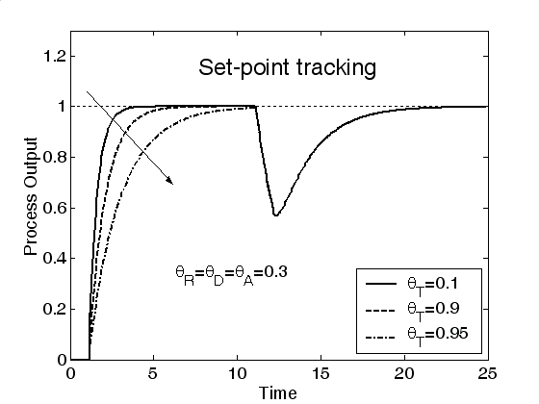 | 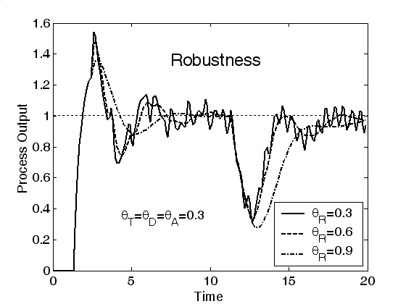
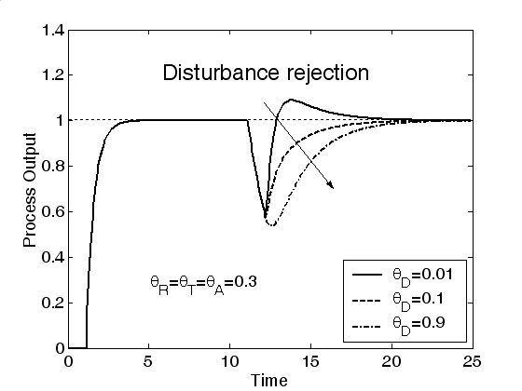 | 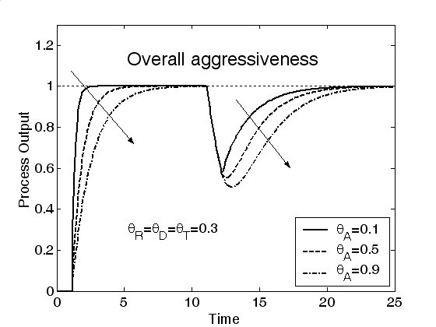

Figure 137. Effect of tuning parameters on controller performance attributes. The arrows indicate the direction of increasing parameter values.

6 ABSTRACT

This report describes results achieved during phase IV of a V-phase subcontract to develop and understand thin film solar cell technology associated to CuInSe₂ and related alloys, a-Si and its alloys and CdTe. Modules based on all these thin films are promising candidates to meet DOE long-range efficiency, reliability and manufacturing cost goals. The critical issues being addressed under this program are intended to provide the science and engineering basis for the development of viable commercial processes and to improve module performance. The generic research issues addressed are: 1) quantitative analysis of processing steps to provide information for efficient commercial scale equipment design and operation; 2) device characterization relating the device performance to materials properties and process conditions; 3) development of alloy materials with different bandgaps to allow improved device structures for stability and compatibility with module design; 4) development of improved window/heterojunction layers and contacts to improve device performance and reliability; and 5) evaluation of cell stability with respect to illumination, temperature and ambient and with respect to device structure and module encapsulation.
7 REFERENCES

1J. Loferski, J. Appl. Phys. 27, 777 (1956).
2 B. E. McCandless and J. R. Sites, Cadmium Telluride Solar Cells, Chapter 14 in Handbook of Photovoltaic Science and Engineering (A. Luque and S. S. Hegedus, Eds), John Wiley & Sons, Chichester, 617 (2003).
3 P. Capper, (Ed), Properties of Narrow Gap Cadmium-based Compounds, EMIS Data Reviews Series No. 10, INPSEC, Exeter, (1994).
4 V. Fthenakis and K. Zweibel, CdTe PV: Real and Perceived EHS Risks, Presented at NCPV Review Meeting, Denver, (2003). Available at: http://www. www.nrel.gov/cdte/ref_res.html.
5 R. W. Birkmire, L. C. DiNetta, S. C. Jackson, P. G. Lasswell, B. E. McCandless, J. D. Meakin and J. E. Phillips, Proc. 18th IEEE PVSC, 419 (1985).
6 B. E. McCandless and W. N. Shafarman, United States Patent 6,537,845, (2003).
7 B. E. McCandless, Proc. Mat. Res. Soc. Symp. Proc. 668, H1.6.1 (2001).
8 B. E. McCandless, S. S. Hegedus, R. W. Birkmire and D. Cunningham, Thin Solid Films 431-432, 249 (2003).
9 B. E. McCandless and R. W. Birkmire, Proc. 28th IEEE PVSC, 491 (2000).
10 S.-H. Wei, S. B. Zhang and A. Zunger, J. Appl. Phys. 87, 1304 (2000).
B. E. McCandless and W. N. Shafarman, Proc. PVSEC-3, 562 (2003).
B. E. McCandless and W. N. Shafarman, United States Patent 6,537,845, March 25, 2003.
13 B . E. McCandless, G. M. Hanket, D. G. Jensen and R. W. Birkmire, J. Vac. Soc. Technol. A, 20, 1462 (2002).
B. E. McCandless, M. G. Engelmann, R. W. Birkmire, J. Appl. Phys. 89 (2), 988 (2001).
15 V. G. Karpov, A. D. Compaan and D. Shvydka, Phys. Rev. B 69, 435 (2004).
16 Y. Marfaing, Thin Solid Films 387, 123 (2001).
B. E. McCandless, R. W. Birkmire, W. A. Buchanan, S. Fields, G. M. Hanket, Proc. 29th IEEE PVSC, 547 (2002).
B. E. McCandless, H. Hichri, G. Hanket, R. W. Birkmire, Proc. 25th IEEE PVSC, 784 (1996).
B. E. McCandless, United States Patent, 6,251,701, June 26, 2001.
B. E. McCandless and K. D. Dobson, Int’l Journal of Solar Energy (2004) in press.
L. Szabo and W. Biter, United States Patent 4,735,662 (1988).
IEC Annual Report to NREL, Contract DE-AC36-98-GO10337, pp.57-59 (2000).
B. E. McCandless and R. W. Birkmire, Proc. 28th IEEE PVSC, 491 (2003).
24 K. Durose, P. R. Edwards and D. P. Halliday, J. Cryst. Growth 197, 733 (1999).
25 K. D. Dobson, I. Visoly-Fisher, G. Hodes and D. Cahen, Sol. Energy Mater. Sol. Cells 62, 295 (2000).
26 B. E. McCandless, J. E., Phillips and J. Titus, Proc. 2nd World PV Conf., 448 (1998).
27 K. D. Dobson, P., Paulson, B. E. McCandless and R. W. Birkmire, Proc. Mater. Res. Soc. Symp., 107 (2003).
28 D. R. Johnson, S. Oktik, M. E. Ozsan and M. H. Patterson, European Patent EP 0541382B1 (2001).
29 S. S. Hegedus, B. E., McCandless and R. W., Birkmire, Proc. 28th IEEE PVSC, 535 (2000).
30 D. L. Batzner, R. Wendt, A., Romeo, H., Zogg and A. N. Tiwari, Thin Solid Films 361, 463 (2000).
31 J. Sarlund, M. Ritala, M. Leskela, E. Siponmaa and R. Zilliacus, Sol. Energy Mater. Sol. Cells, 44, 177 (1996).
32 X. Li, D. W. Niles, F. S. Hasoon, R. F. Matson and P. Sheldon, J. Vac. Sci. Technol. A.17, 805 (1999).
33 D. E. Aspnes and H. Arwin, J. Vac. Sci. Technol. A 2,1309 (1984).
34 K. Durose, M. A. Cousins, D. S. Boyle, J. Beier and D. Bonnet, Thin Solid Films 403, 396 (2002).
35 S. E. Asher, F. S. Hasoon, T. A. Gessert, M. R. Young, P. Sheldon, J. Hiltner and J. Sites, Proc. 28th IEEE PVSC, 479 (2000).
36 S. S. Hegedus, D. Ryan, K. D. Dobson, B. E. McCandless and D. Desai, Proc. Mater. Res. Soc. Symp., 447 (2003).
37 S. S. Hegedus, B. E. McCandless and R. W. Birkmire, Proc. NCPV Prog. Rev. Meeting, AIP Press, 119 (2001).
38 I. Visoly-Fisher, K. D. Dobson, J. Nair, E. Bezalel, G. Hodes and D. Cahen, Adv. Funct. Mater. 13, 289 (2003).
39 B. E. McCandless and K. D. Dobson, Sol. Energy 77, 839 (2004).
40 Y. Roussillon, D. M. Giolando, D. Shvydka, A. D. Compaan, and V. G. Karpov, Appl. Phys. Lett. 84, 616 (2004).
41 S. Mu and J. Kan, Synth. Met. 92, 149 (1998).
42 M. R. Hoffman, S. T. Martin, W. Choi, and D. W. Bahneman, Chem. Rev. 95, 69 (1995).
43 B. H. Erne, F. Leferve, D. Lorans, D. Ballutaud, C. Dibiemme-Chouvy, J. Vigneron and A. Etcheberry, Appl. Surf. Sci. 175, 579 (2001).
T. Gessert, A. Duda, S. Asher, C. Narayanswamy, D. Rose, Proc. 28th IEEE Photovoltaic Spec. Conf., 654 (2000).
P. Mahawala, S. Vakkalanka, S. Jeedugunta, C. S. Ferekides, Proc. 31st IEEE PVSC (2005).
J. Phillips, Proc. 21th IEEE PVSC, 782 (1990).
A. Mondal, B. McCandless, R. Birkmire, Solar Energy Mat. Solar Cells 26, 181 (1992).
B. McCandless, J. Sites, Chapter 14 in Handbook of Photovoltaic Science and Engineering, eds. A. Luque and S. Hegedus, J. Wiley and Sons (2003).
K. Dobson, I. Visoly-Fisher, G. Hodes, D. Cahen, Solar Energy Mat. Solar Cells 62, 295 (2000).
B. McCandless, W. Buchanan, R. Birkmire, Proc. 31st IEEE PVSC, 295 (2005).
B. McCandless, S. Hegedus, R. Birkmire, D. Cunningham, Thin Solid Films 431-432, 248 (2003).
S. Hegedus, D. Ryan, K. Dobson, B. McCandless, D. Desai, Proc. MRS Symp. Proc. 763, 447 (2003).
S. Hegedus, B. McCandless, R. Birkmire, Proc. 28th IEEE PVSC, 535 (2000).
T. Gessert, et al., Proc. 26th IEEE PVSC, 419 (1997).
S. Hegedus, B. McCandless, Solar Energy Mat. and Solar Cells 88, 75 (2005).
R. Powell, R. Sasala, G. Rich, M. Steele, K. Bihn, N. Reitner, S. Cox, G. Dorer, Proc. 25th IEEE PVSC, 785 (1996).
C. Corwine, A. Pudov, M. Gloeckler, S. Demstsu, J. Sites, SEMSC 82, 481 (2004).
S. Hegedus, B. McCandless, R. Birkmire, Proc. 28th IEEE PVSC, 535 (2000).
P. Meyers, J. Phillips, Proc. 25th IEEE PVSC, 789 (1996).
R. Sasala, R. Powell, G. Dorer and N. Reiter, AIP Conf. Proc. 394, 171 (1997).
D. Cunningham, M. Rubcich, D. Skinner, Prog. In Photovoltaics 10, 159 (2002).
Steven Hegedus, Darshini Desai, Dan Ryan and Brian McCandless, Proc. 31st IEEE PVSC 319 (2005).
B. McCandless, W. Buchanan, R. Birkmire, Proc. 31st IEEE PVSC, 295 (2005).
D. Cunningham, personal communication, (2002).
65 T. Nakazawa, K. Takamizawa, K. Ito, Appl. Phys. Lett. 50, 279 (1987).
66 X. Wu, et al., J. Appl. Phys. 89, 4564 (2001).
67 B. McCandless, I. Youm, R. Birkmire, Prog. In Photovolt. Res. Appl. 7, 21 (1999).
68 J. Phillips, R. Birkmire, B. McCandless, P. Meyers, W. Shafarman, Phys. Stat. Sol. (b) 194, 31 (1996).
69 A. Fahrenbruch, 2005 CdTe Team Meeting minutes.
70 IEC Monthly Report to NREL for Phase 2 of this contract, Aug 2003.
71 S. Hegedus, May 2005 CdTe Team Meeting minutes; also IEC Annual report 2004.
S. Marsillac, P.D. Paulson, M.W. Haimbodi, R.W. Birkmire and W.N. Shafarman, Appl. Phys. Lett. 81(7), 1350 (2002).
W.N. Shafarman, S. Marsillac, P.D. Paulson, M.W. Haimbodi, T. Minemoto and R.W. Birkmire, Proc. 29th IEEE PVSC, 519 (2002).
K. Kushiya, Solar Energy 77, 717 (2004).
J. Palm, J., V. Probst, W. Stetter, R. Toelle, S. Visbeck, H. Calwer, T. Niesen, H. Vogt, O. Hernández, M. Wendl, and F.H. Karg, Thin Solid Films 451-452, 544 (2004).
K. Kushiya, et al., Sol. Energy Mat. Sol. Cells 49, 277 (1997).
V. Alberts, J. Titus, and R.W. Birkmire, Thin Solid Films 451 – 452, 207 (2004).
C. Jensen, D. Tarrant, J. Ermer, and G. Pollock, Proc. 23rd IEEE PVSC, 577 (1993).
M. Marudachalam, H. Hichri, R. Klenk, R.W. Birkmire, W.N. Shafarman and J.M. Schultz, Appl. Phys. Lett. 67, 3978 (1995).
H. Dittrich, U. Prinz, J. Szot, and H.W. Schock, Proc. 9th EC PVSEC, 163-166.
K. Lindahl, D. Olson, J. Moore, A. Swartzlander, and R. Noufi, Proc. 25th IEEE PVSC, 949 (1996).
M. Marudachalam, R. Birkmire, H. Hichri, J. Schultz, A. Swartzlander, and M. Al-Jassim, J. Appl. Phys. 82 (6), 2896 (1997).
W.N. Shafarman and L. Stolt in Handbook of Photovoltaic Science and Engineering, edited by A. Luque and S Hegedus (Wiley and Sons, Chichester UK, 2003) 567 (2003).
T. Gödecke, T. Haalboom and F. Ernst, Z. Metallkd. 91, 622 (2000).
R. Herberholz, U. Rau1, H.W. Schock, T. Haalboom, T. Gödecke, F. Ernst, C. Beilharz, K.W. Benz, and D. Cahen, Eur. Phys. J. Appl. Phys. 6, 131 (1999).
D. Schmid, M. Ruckh, F. Grunwald, H. Schock, J. Appl. Phys. 73, 2902 (1993).
P.D. Paulson, R.W. Birkmire, W.N. Shafarman, J. Appl. Phys. 94, 879 (2003).
M.I. Alonso, M. Garriga, C.A. Durante Rincón, E. Hernández and M. León, Appl. Phys. A 74, 659 (2002).
D.E. Aspnes, Thin Sol. Films 89, 249 (1982).
D.S. Albin, J.J Carapella, J.R. Tuttle and R. Noufi, Mater. Res. Soc. Symp. Proc. 228, 267 (1991).
S.-H. Wei and A. Zunger, J. Appl. Phys. 78, 3846 (1995).
R.W. Birkmire, B.E. McCandless, Appl. Phys. Lett. 53, 140 (1988).
B. Canava, J.F. Guillemoles, J. Vigneron, D. Lincot, and A. Etcheberry, J. Phys. Chem. Sol. 64, 1791 (2003).
R. Swanepoel, J. Phys. E 16, 1214 (1983).
B. E. McCandless and W. N. Shafarman, United States Patent 6,537,845, March 25, 2003.
B.E. McCandless and W.N. Shafarman, Proc. PVSEC-3, 562 (2003).
K. Orgassa, H.W. Schock, and J.H. Werner, Thin Solid Films 431-2, 387 (2003).
G. Radnoczi, A. Robertson, H. T. G. Hentzell, S. F. Gong, and M. A. Hasan. J. Appl. Phys. 69(9), 6394 (1991).
M. S. Haque, H. A. Naseem, and W. D. Brown. J. Appl. Phys. 79(10), 7529 (1996).
O. Nast, T. Puzzer, L. M. Koschier, A. B. Sproul, and S. R. Wenham. Appl. Phys. Lett. 73(22), 3214 (1998).
Z. Jin, G. A. Bhat, M. Yeung, H. S. Lwok, and M. Wong. J. Appl. Phys. 84(1), 194 (1998).
B. Bian, J. Yie, B. Li, and Z. Wu. J. Appl. Phys. 73, 7402 (1993).
T. J. Konno and R. Sinclair. Philosophical Magazine B 66, 749 (1992).
T. J. Konno and R. Sinclair. Mater. Sci. Engin., A179/A180, 426 (1994).
O. Nast and A. J. Hartmann, J. Appl. Phys. 88(2), 716 (2000).
O. Ebil, R. Aparicio and R. W. Birkmire, Prog. in Photovoltaics, submitted July 2005.
Oliver Nast, PhD thesis, Philipps-Universitt Marburg, (2000).
P. I. Widenborg and A. G. Aberle. In Proc. 14th International Photovoltaic Science and Engineering Conf., 281 (2004).
H. P. Klug and L. E. Alexander, X-ray Diffraction Procedures, J. Wiley and Sons, New York (1974).
International Tables for X-Ray Crystallography, Vol. III. (1962).
R. W. James, The Optical Principles of the Diffraction of X-Rays, Oxbow Press, Connecticut (1962).
See treatments of Scherrer and Stokes and Wilson in: B. E. Warren, X-Ray Diffraction, Dover, New York (1968).
A. Gavini and M. Cardona, Phys. Rev. B1, 672 (1970).
G.A. Battiston and R. Geerbasi, Thin Film Characterization by Advanced X-Ray Diffraction Techniques, Laboratori Nazionali Di Frascati, 225 (1996).
115 M. Marudachalam, H. Hichri, R. Klenk, R. W. Birkmire, W. N. Shafarman, J. M. Schultz, Appl. Phys. Lett. 67, 3978 (1995).
B. E. McCandless, W. A. Buchanan, R. W. Birkmire, Proc. 21st IEEE PVSC, 295 (2005).
B. E. McCandless and J. R. Sites, Chapter 14 in: A. Luque and S. Hegedus, Ed., Handbook of Photovoltaic Science and Engineering, J. Wiley and Sons, Chichester, 617 (2003).
B. A. Ogunnaike and K. Mukati, An alternative structure for next generation regulatory controllers. Part I: Basic theory for design, development and implementation, Journal of Process Control, In Press, (2005).

