TES Bolometer Arrays for CMB Polarization
and SZ Measurements

Helmuth Spieler
Lawrence Berkeley National Laboratory

Berkeley, CA 94720

Presentation to Interagency CMB Task Force July 29, 2004
Participants

Senior Staff
J. Clarke (UCB)
W. Holzapfel (UCB)
A.T. Lee (UCB)
P.L. Richards (UCB)
H. Spieler (LBNL)

Postdocs
H.M. (Sherry) Cho (UCB)
Matt Dobbs (LBNL)
Nils Halverson (UCB)
Huan Tran (UCB)

Engineers
John Joseph (LBNL)
Greg Engargiola (UCB RAL)
Chinh Vu (LBNL)

Students
M. Fogel (undergrad)
Z. Kermish
T. Lanting
M. Lueker

J. Mehl
M. Moore
M. Myers
R. O’Brient
M. Scherzer
D. Schwan

Detector development driven by 3 experiments

1. APEX-SZ
Galaxy cluster search using Sunyaev-Zel’dovich Effect
UC Berkeley, LBNL, and MPIfR Bonn
12m telescope on Atacama Plateau
320 bolometer array

2. South Pole Telescope
Univ. Chicago, UC Berkeley, Case Western, Harvard CfA, Univ. Illinois, LBNL
10m telescope at South Pole
1000 bolometer array

3. PolarBear
UC Berkeley, LBNL, UC San Diego
3m telescope on White Mountain, CA
Specifically designed for CMB polarization
Test bed for new technologies
“Multi-color” pixels with dual polarization
Phase 1: 320 detectors
Phase 2: 1200 detectors
Key technologies

Wafer-scale bolometer arrays using photolithographic techniques

Voltage-biased superconducting transition edge sensors (TES)
stable operating point
controlled responsivity

Antenna-coupled devices

Integrated dual-polarization arrays with bandpass filtering

Future: wideband antennas with multiple frequency bands

Frequency-domain multiplexing

Two wires per multiplexed bolometer set

One SQUID per multiplexed bolometer set

Utilize experience from large HEP detectors
Focal Plane Design for APEX-SZ and SPT
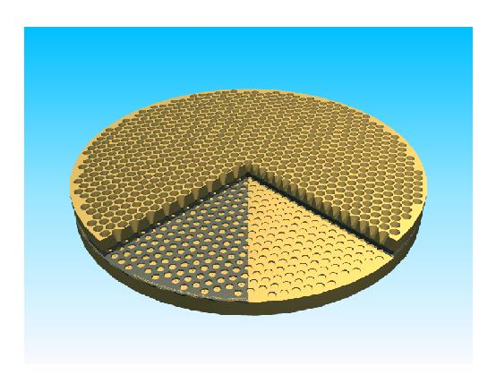

Each pixel:

Spiderweb absorber and TES

Coupled to optics by array of smooth horns

APEX: Six 55-element wedges
from 4” wafers

SPT: Six 172-element wedges
from 6” wafers
TES Spiderweb Arrays (APEX-SZ, SPT)

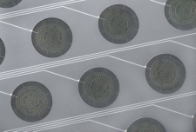

fabricated 55-bolometer array
(Jared Mehl)
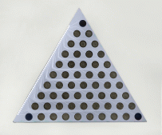
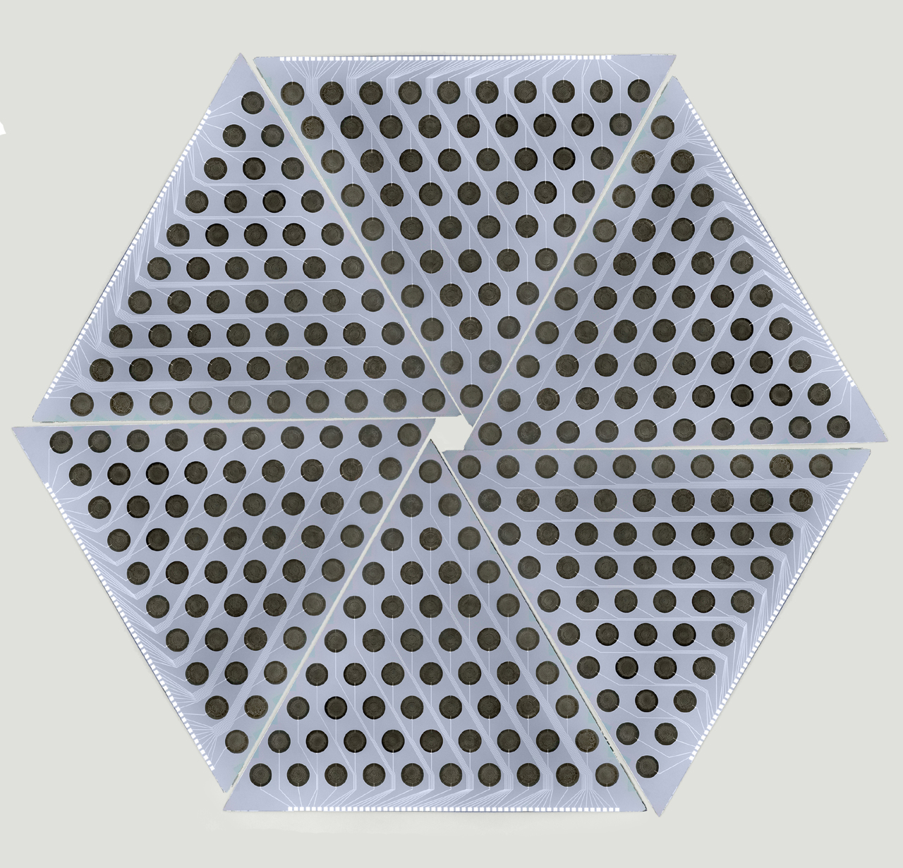

5”

photomontage
of focal plane:

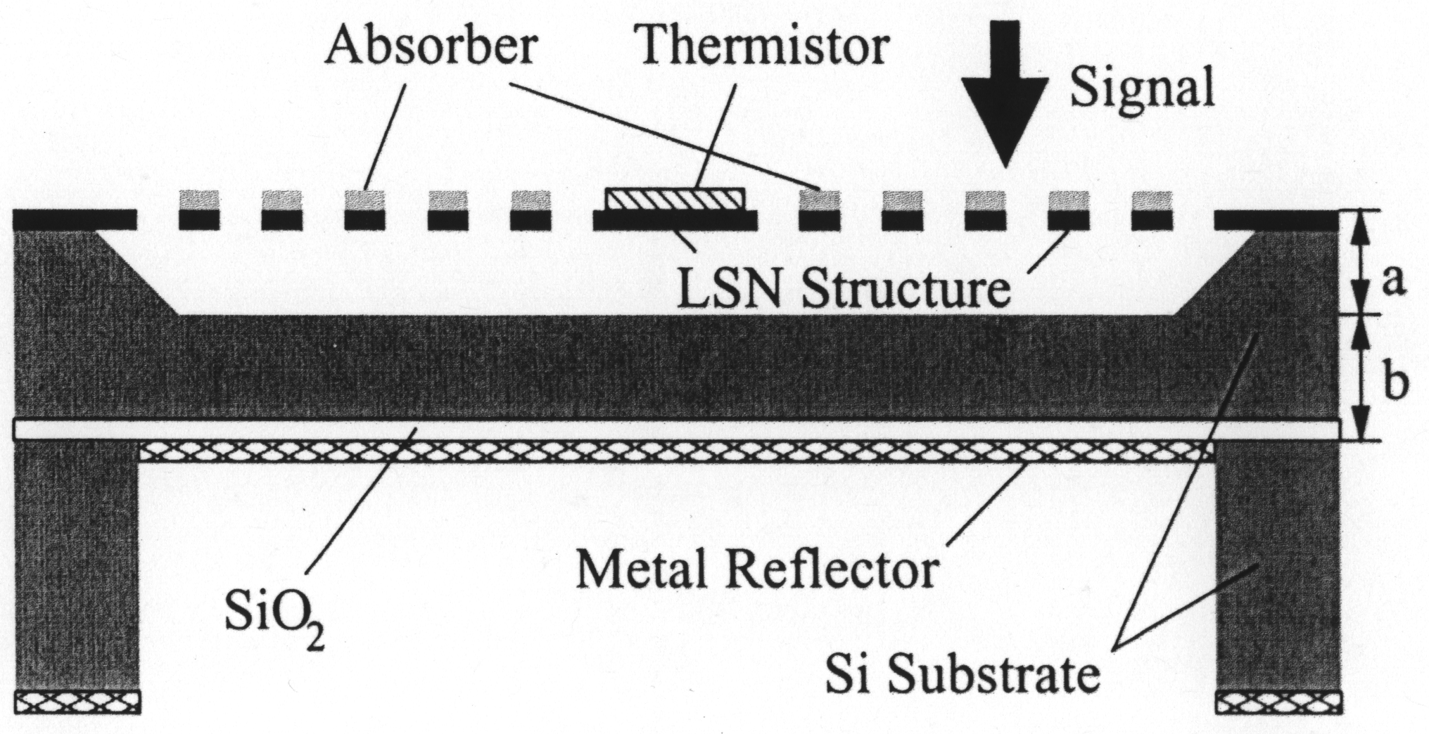
Cross-Section of a Pixel

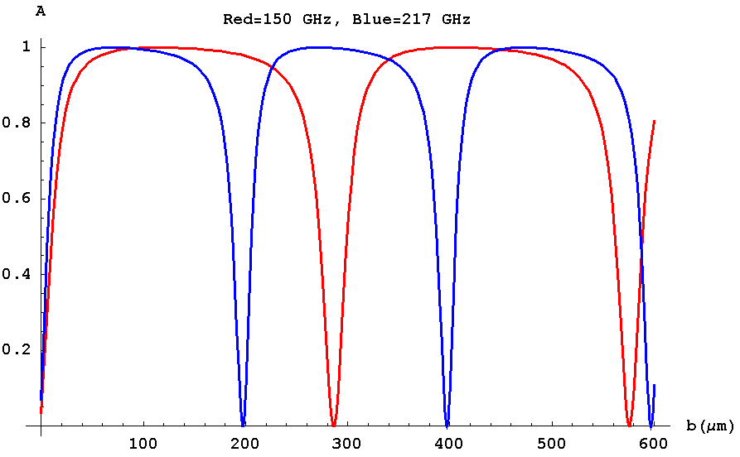

Calculated efficiency vs.
backshort spacing

Backshort at a+b= 150 μm
gives good efficiency
at 150 and 217 GHz.

Bolometer Design Parameters for SPT

- Geometry: Spider Absorber with TES sensor
- Frequencies: 150 GHz, 217 GHz
- Absorber Diameter: 3 mm
- Suspension: (8) 1 mm thick, 0.5mm long legs
- Thermal Conductance: G = 2 x 10⁻¹⁰ W/K
P_{sat} ~ 40 pW
- Expected Loading ~ 11 pW (from ACBAR)
- Sheet resistance of absorber: ~ 400 ohms/square
90 and 270 GHz bands considered: different arrays

Antenna-Coupled Arrays

Highly integrated design

- Antenna defines beam
- On chip filters define band
- Microstrip transmission lines to load resistor coupled to bolometer
- Dual polarization in same pixel
- Multiple frequencies possible

TES multiplexable

Extensible to wideband polarization-sensitive antennas
with multiband readout

Antenna-Coupled Prototype Pixels (Mike Myers)

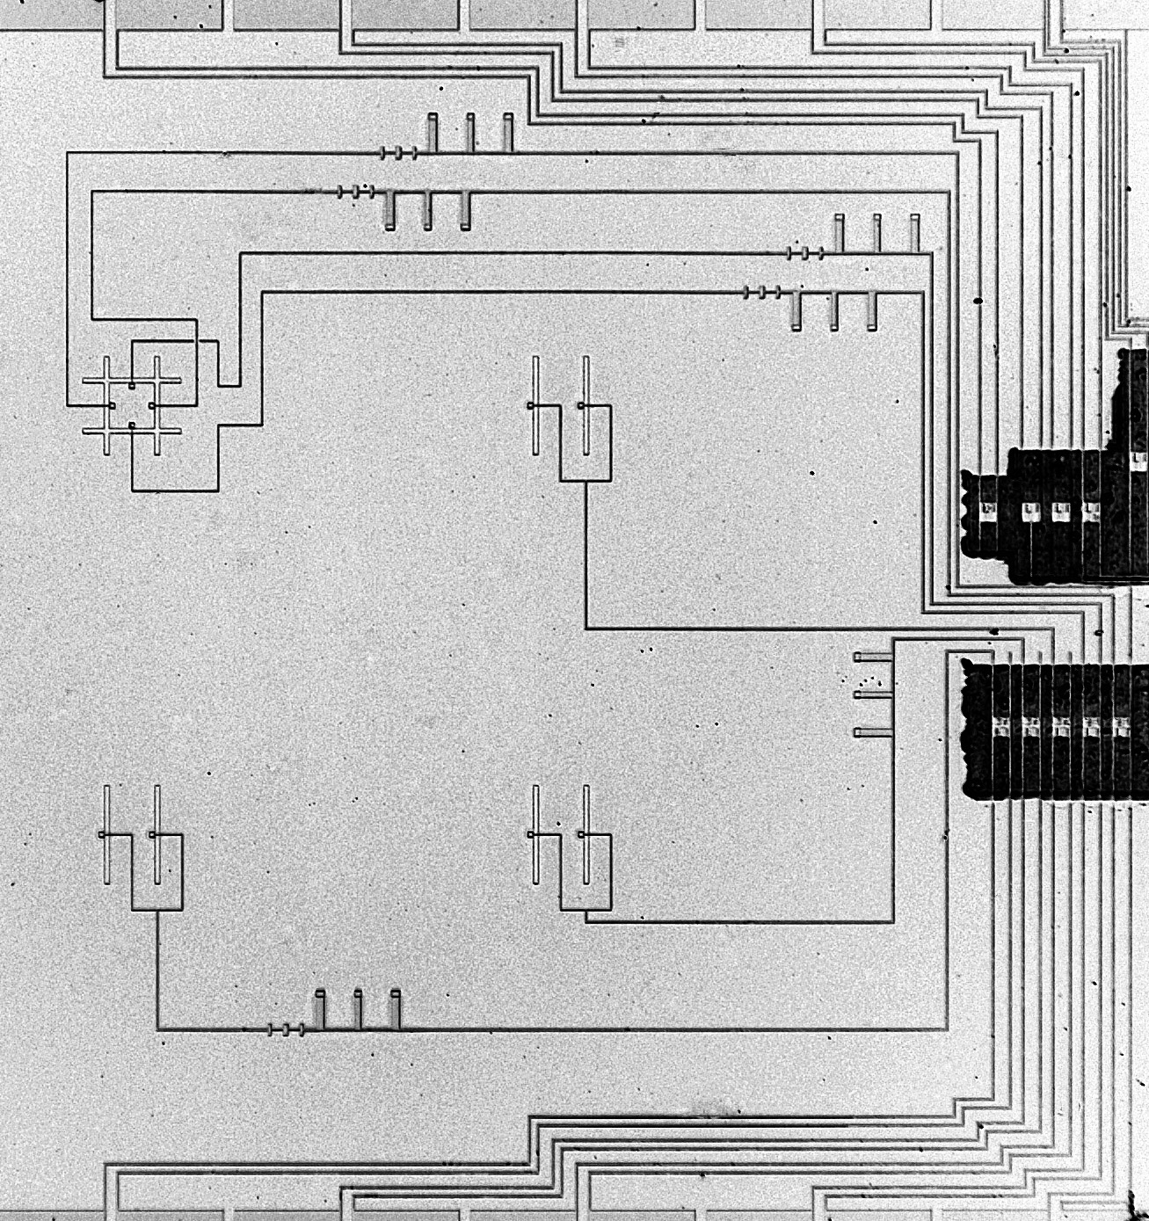
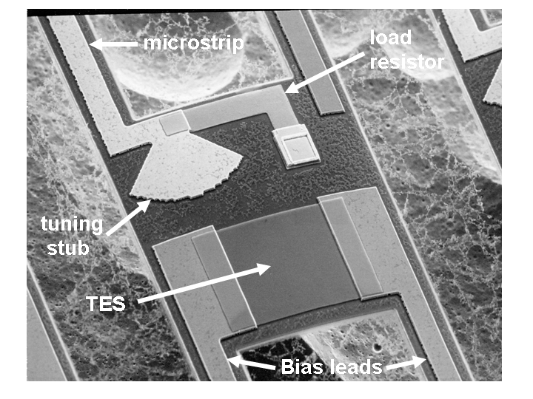

Microstrip fed double slot dipole antenna

Bandpass filter at 217GHz, 40% BW

Lowpass filter to remove spurious passbands

Microstrip terminated on a nitride suspension, power measured with TES

Dual pol. antenna at upper left (after Chattopadhyay and Zmuidzinas)
Antenna coupling to optics by dielectric lenses

Antenna
substrate
Extended Hemispherical lens

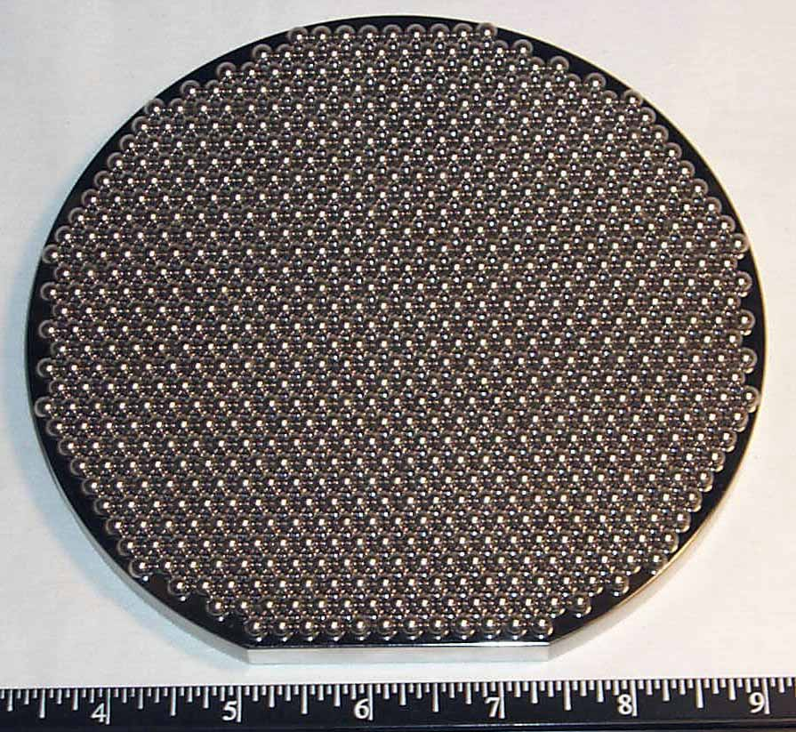

- Well developed (SIS mixers, etc.)
- High antenna gain, symmetric beam
- Forward radiation pattern
- Efficient coupling to telescope (Similar to scalar horn)

Test Apparatus (M. Myers)
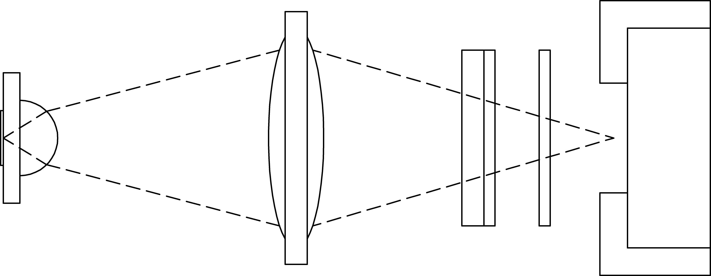
300mK
1.5K
77K
300K
Bolometer
test chip
Silicon hemispherical lens and spacer
TPX lens
1.3% NDF, alkali halide filter
Metal mesh filter
Vacuum window
Test Apparatus (Mike Myers, Dan Schwan)
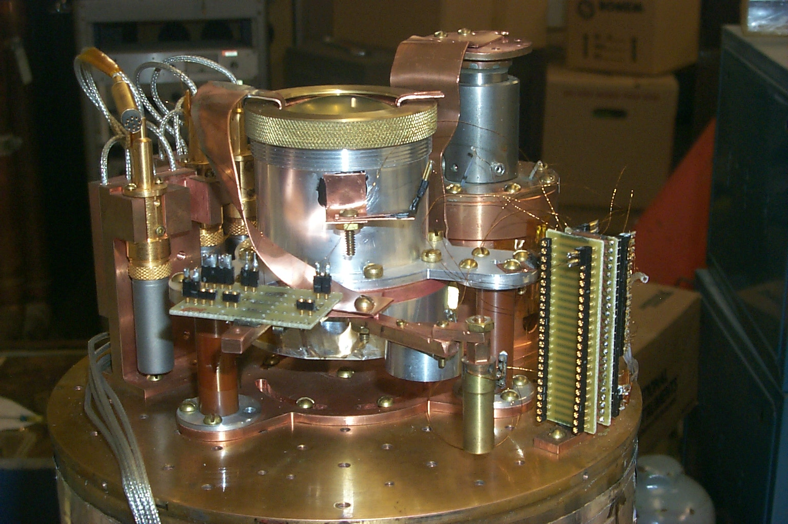
reimaging lens

SQUIDs
bias circuit
detector
enclosure

Typical parameters:
- G ~ 9x10⁻¹⁰ W/K
- Expected white noise from < 1 Hz to 100 Hz (thermal fluctuation limit)
- T_{C} ~ 450mK
- τ ~ 0.2 - 0.3 ms
- R_{load} ~ 25 W (10 W design value)

Preliminary results
- Polarization sensitivity

Chopped LN load and wire grid polarizer
Cross polarization 3% upper limit
- Rough beam map
~ 4° symmetric beam, matches expectation
Frequency Response (optical transmission)
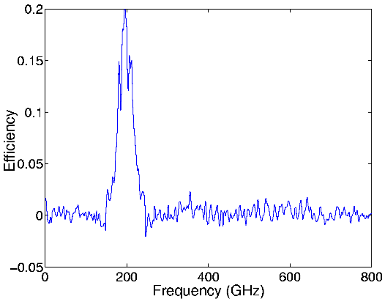

Performance adequate, but not optimized

x2 improvement expected (no anti-reflective coating yet)
(for comparison: Planck spec is 30% efficiency)
Readout

Heat leaks through connecting wires from 0.25K bolometer stage to 4K SQUID stage is prohibitive for large arrays

Solution: Multiplexing

constraints:
low impedance required to maintain constant voltage bias
power budget at 0.25K stage <1 μW

Two options:

time domain multiplexing (K. Irwin et al.)
1 SQUID per bolometer

frequency domain multiplexing
LBNL design: 1 SQUID reads out ~30 bolometers

More bolometers possible: discussion later

Principle of Time-Domain Multiplexing

1. AC bias bolometers (~100 kHz – 1 MHz)

each bolometer biased at different frequency

2. signals change sensor resistance

⇒ modulate current

⇒ transfer signal spectrum to sidebands adjacent to bias frequency

⇒ each sensor signal translated to unique frequency band

3. combine all signals in common readout line

4. retrieve individual signals in bank of frequency-selective demodulators

MUX circuit on cold stage
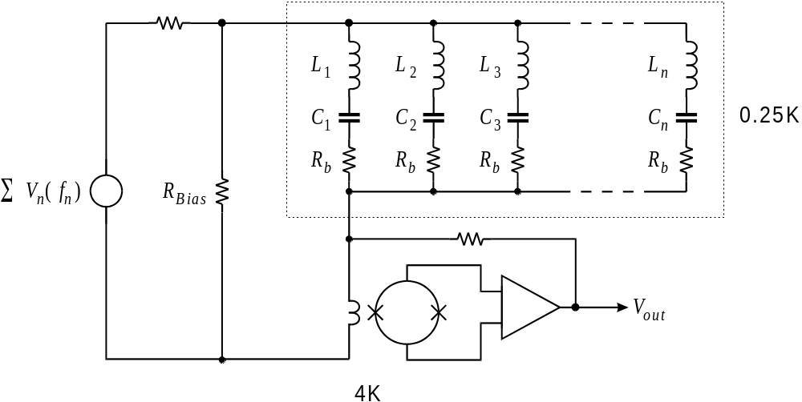
“Comb” of all bias frequencies fed through single wire
Tuned circuits “steer” appropriate frequencies to bolometers
Current return through shunt-fedback SQUID amplifier (low input impedance)
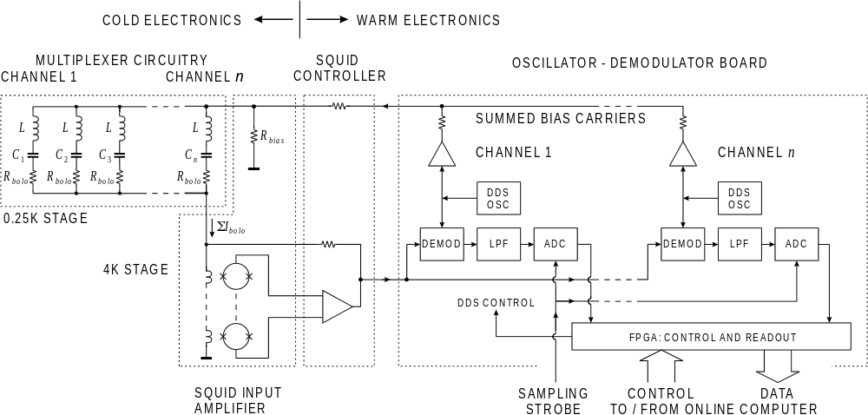
System Block Diagram

Intermodulation
SQUID output voltage approx. sinusoidal function of flux ⇒ non-linear: 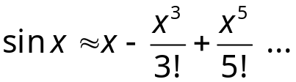
Non-linear terms lead to mixing products.

For two input frequencies f₁ and f₂ : 3rd order distortion ⇒ 3 f₁

3 f₂

2 f₁ ± f₂

2 f₂ ± f₁

What levels are of concern? Bolometer noise current: 10 pA/Hz^{1/2}
Bandwidth: 1 kHz
Total noise current: 320 pA

Bolometer bias current: 10 μA

i_{noise} / i_{bias} = 3.2 ⋅10⁻⁵ ( -90 dBC )

Depends on ratio of signal to max optical loading

System must be designed for very low distortion – choose appropriate technology

Similar constraint applies to all frequency multiplexing schemes

Carrier Nulling

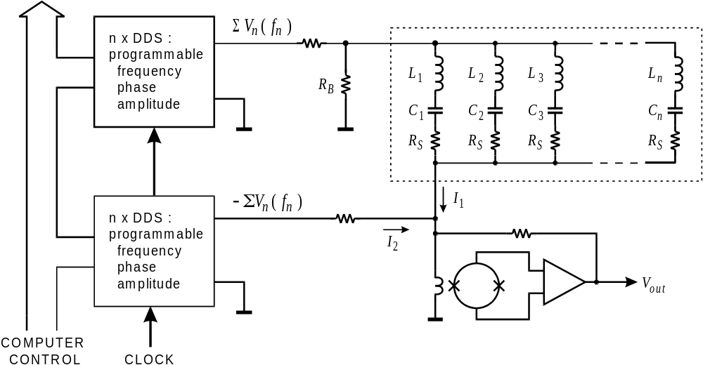
All of the information is in the sidebands, so the carrier can be suppressed to reduce dynamic range requirements.
How many bolometers can be MUXed?

1. Frequency spacing of bias carriers depends on selectivity of tuned circuits.

2. Minimum LC bandwidth (Q) set by bolometer time constant.

3. Channel spacing set by allowable cross-talk and noise leakage from other channels.

4. Minimum frequency set by bolometer thermal time constant
(typ. min. 100 kHz)

5. Maximum frequency set by large-signal bandwidth of SQUID feedback loop.

Loop gain-bandwidth product: set by a) required dynamic range
b) distortion in SQUID

limited by total wiring length of feedback loop

Example: round trip wiring length of 20 cm limits loop gain-bandwidth product
to ~100 MHz (at 1 MHz extend dynamic range x100)

H. Spieler, Frequency Domain Multiplexing for Large-Scale Bolometer Arrays, in Proceedings Far-IR, Sub-mm & mm Detector Technology Workshop, Wolf J., Farhoomand J. and McCreight C.R. (eds.), NASA/CP-211408, 2002 and LBNL-49993, www-physics.LBL.gov/~spieler.
Solutions

1. Maximize dynamic range of SQUID

SQUID is limited by flux, so reducing the mutual input inductance allows larger input current.

Smaller input mutual inductance
increases input noise current
reduces SQUID transresistance (gain)

Limited by bolometer noise and noise of warm amplifier

⇒ SQUID arrays (many SQUIDs connected in series)

We use 100-SQUID arrays from NIST

2. Cold feedback loop

Use cryogenic Si MOSFET or GaAs MESFET amplifier at 4K
Reduced wire length increases maximum frequency.

With SQUID array and cold/warm feedback loop ~30 channels per readout line practical.
Hardware

1st generation prototypes tested end-to-end with bolometers

Now fabricating production prototypes
(APEX-SZ, SPT, PolarBear use similar designs)

Layout of flex interconnect
Focal Plane Assembly from bolometer array to wiring harness to SQUIDs

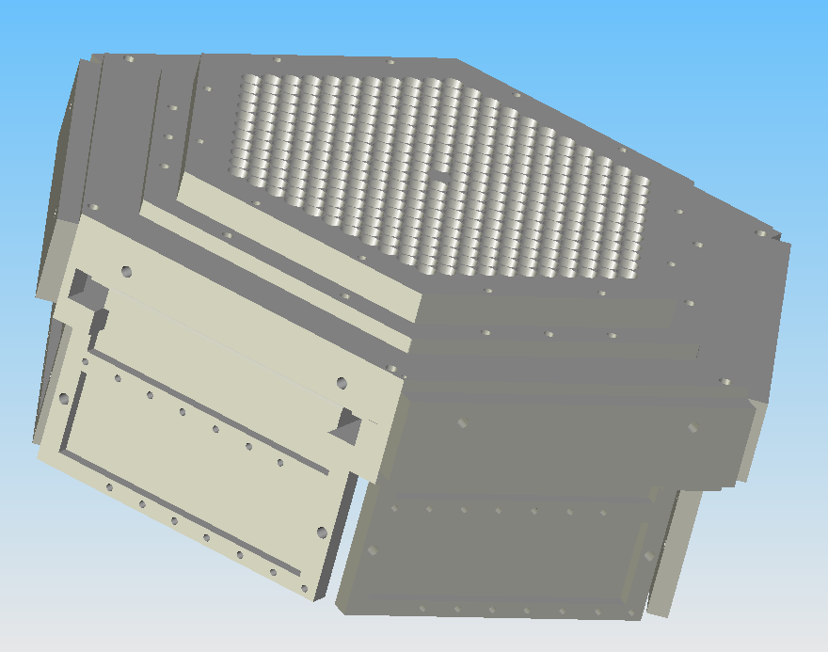
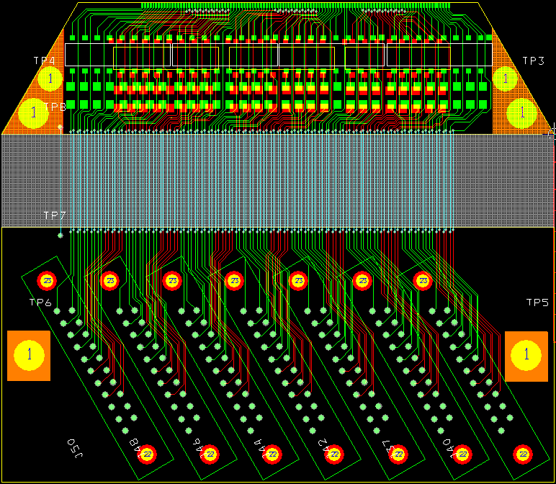
(Z. Kermish) G10

Kapton flex

G10

(Z. Kermish)

MUX chip (0.25K stage)

Superconducting spiral inductors

integrated on a chip
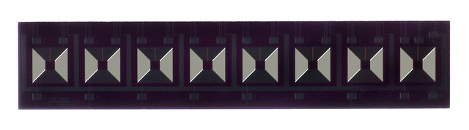

(fabbed by Northrop-Grumman)
______

5 mm
_______

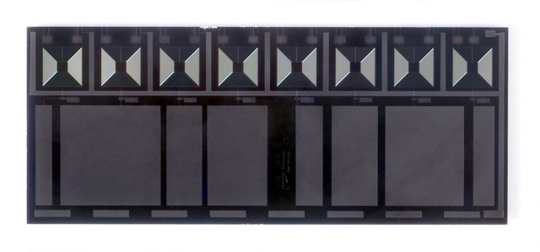

Capacitors can be integrated

with inductors,
but external chip capacitors
require less space.

NP0 chip capacitors perform well.

SQUIDs mounted as arrays of eight in magnetic shield (4K stage)
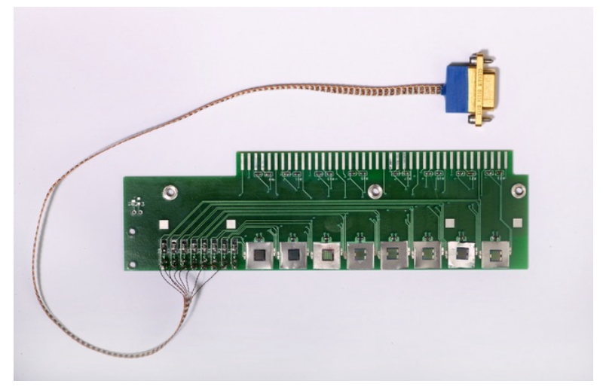

SQUID mounting board

SQUIDs mounted on Nb pads
to pin magnetic flux

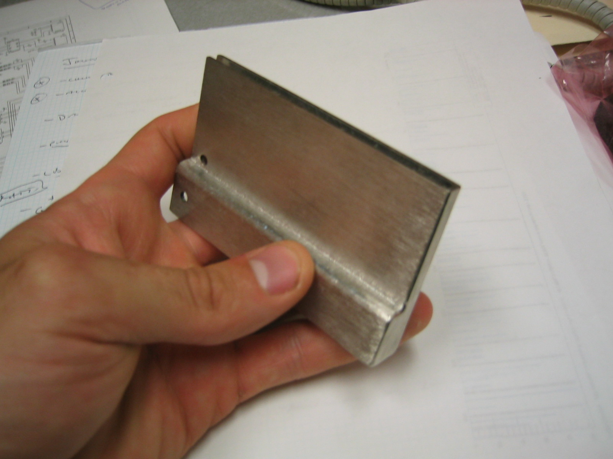

Magnetic Shield

8-channel SQUID Controller
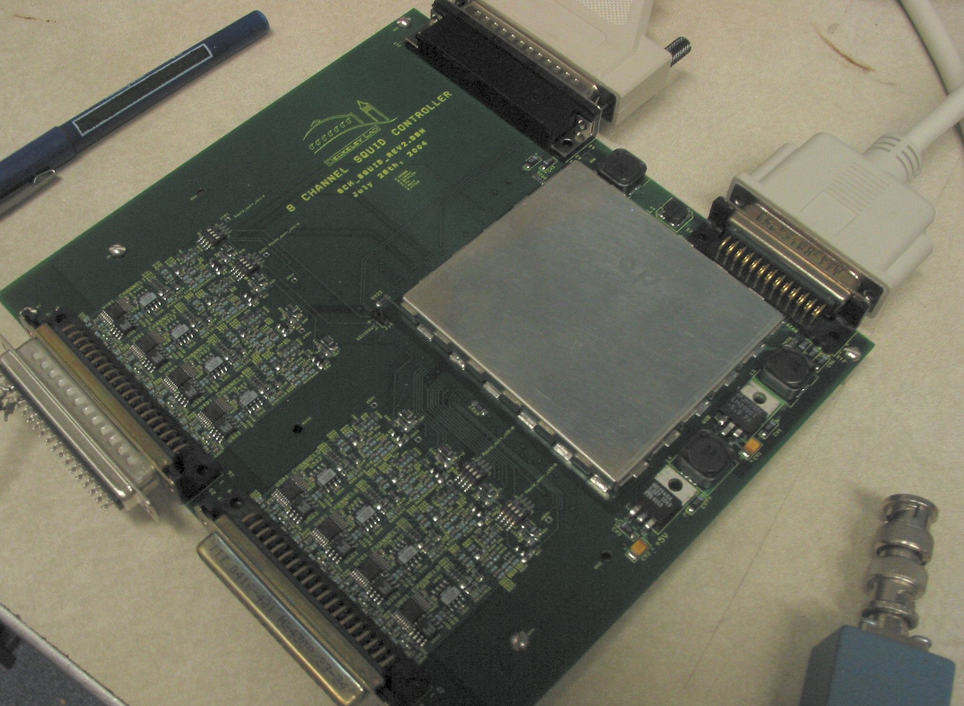
Computer-controlled
SQUID diagnostics
Open/closed loop
Switchable gain

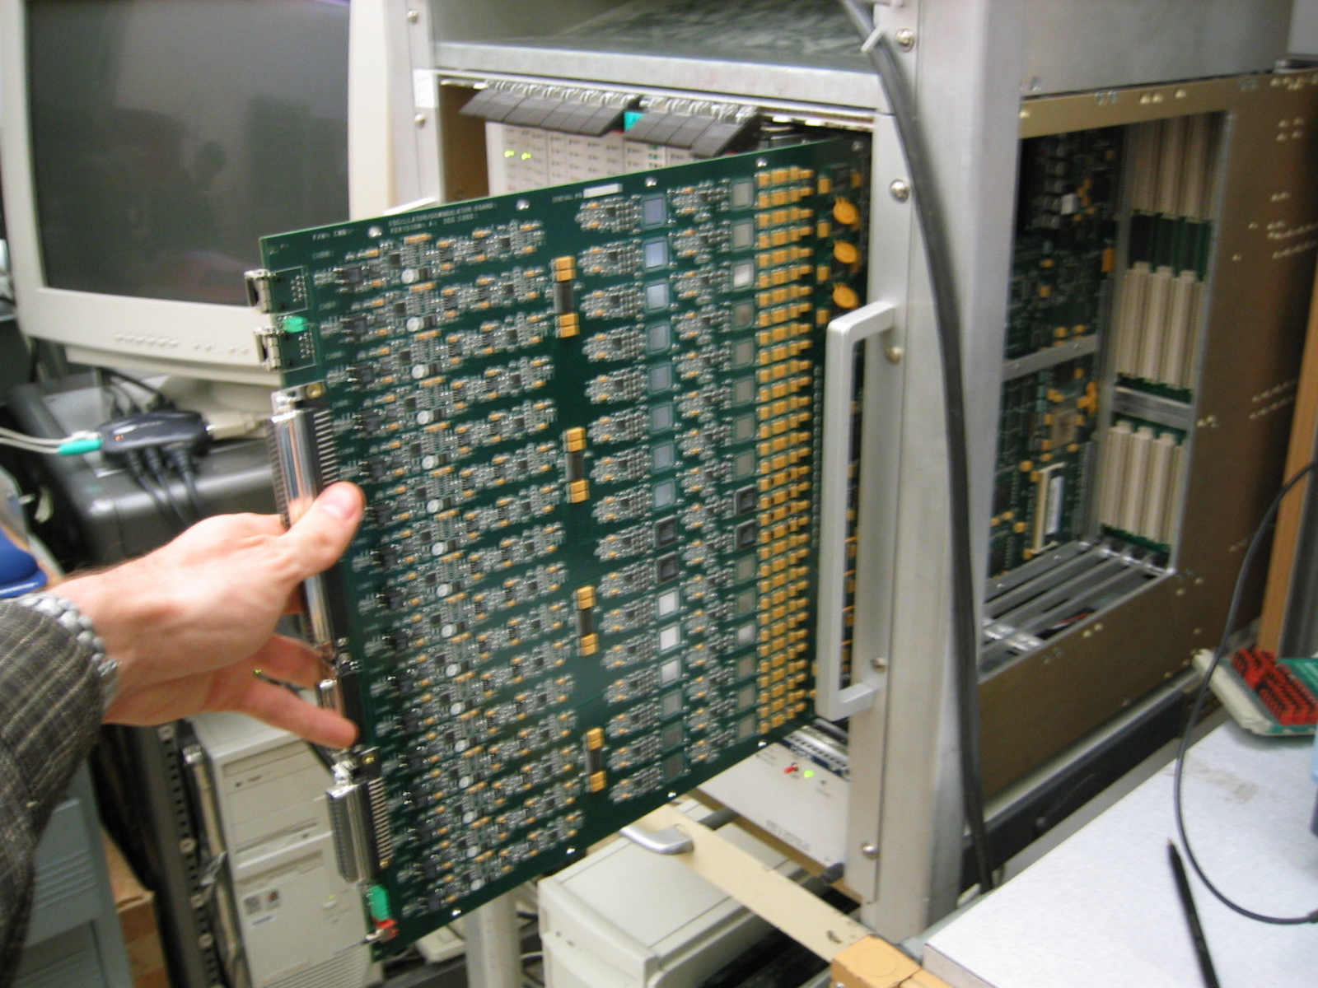

16-channel Demodulator Board

16 individual demodulator channels
2 DDS freq. generators per channel
on-board A/D
opto-isolated computer interface

(M. Dobbs, J. Joseph, M. Lueker, C. Vu)

MUX measurements using 1st generation boards
(T. Lanting)

Bias comb sent to SQUID (top) and measured at SQUID output (bottom)

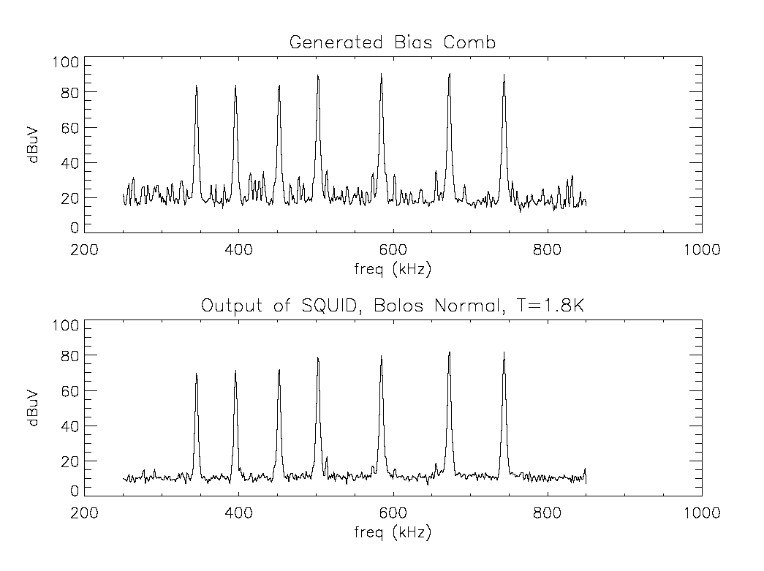

8-channel MUX

7 bolometers

+ one dummy resistor
Measured noise agrees with theory
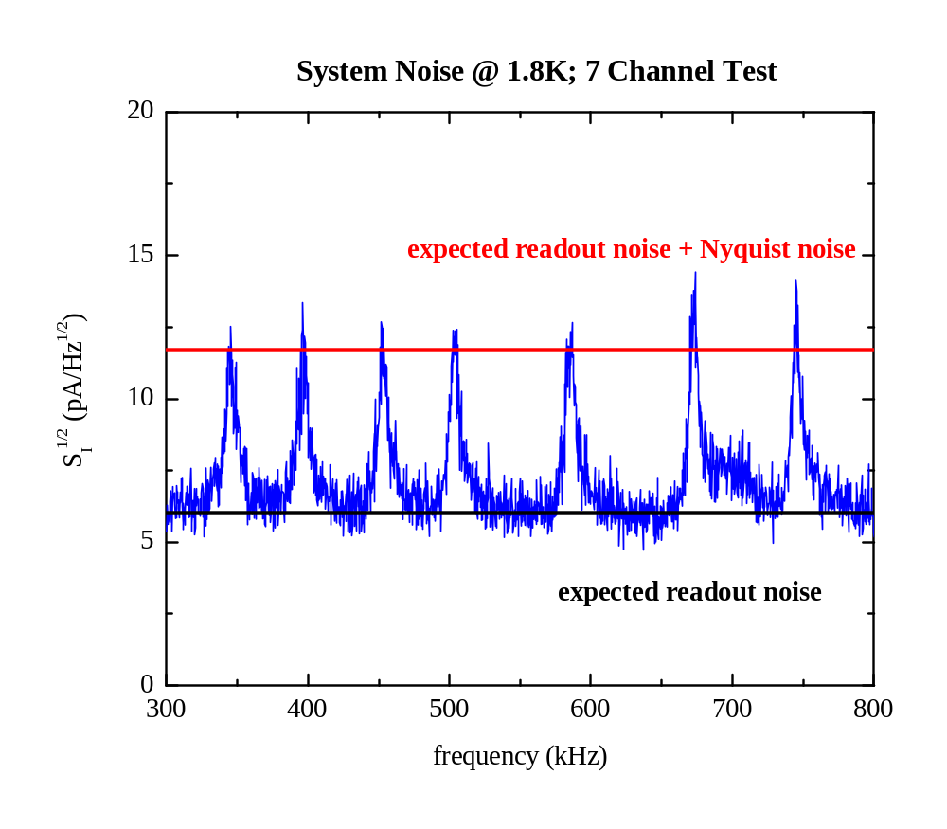
Cross-Talk <0.8% (in agreement with design simulation)

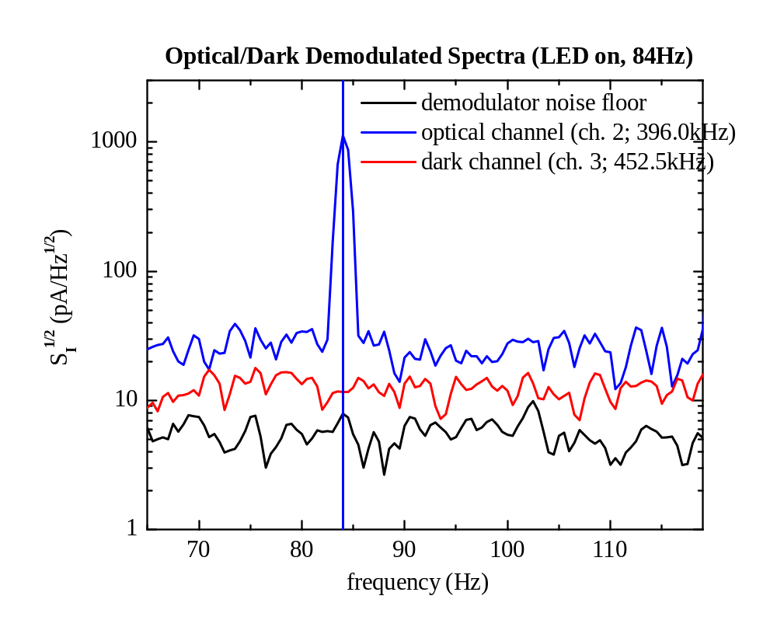
One bolometer illuminated by modulated LED
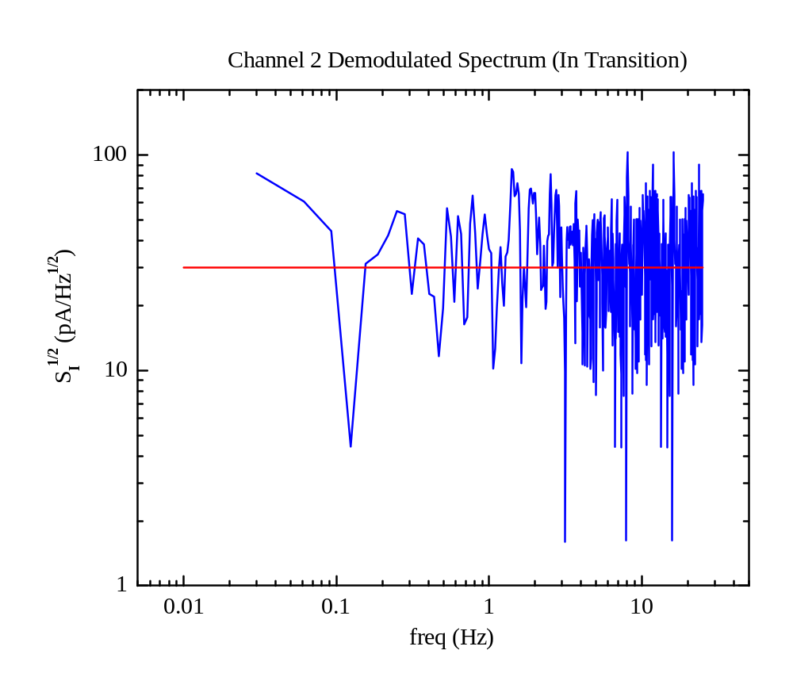
Measured Noise Spectrum (preliminary measurement valid >0.1Hz)
Summary

Exciting times in cosmology – New technologies: large leap in sensitivity

Testable theoretical predictions

Many interesting ideas in the community for next generation CMB detectors

Concepts must be evaluated as complete system, incl. wiring, readout, ...

Full system design and operation in experiment is crucial to
assess technology
Example: PolarBear is designed as forefront experiment, but site is
readily accessible for tests and upgrades.

Large array technology requires

Process control

Thorough engineering

Wide range of experience

Sustained funding to bridge “proof-of-principle” to working experiment

Significant costs for professional engineering, infrastructure

Intellectual and technical contributions from different groups

Complementary strengths of University and National Lab.

