Interference Rejection Thresholds
of Consumer Digital Television Receivers
Available in 2005 and 2006

March 30, 2007

Technical Research Branch
Laboratory Division
Office of Engineering and Technology
Federal Communications Commission

OET Report Prepared by:
FCC/OET 07-TR-1003 Stephen R. Martin

ACKNOWLEDGEMENTS

The author gratefully acknowledges the following contributions to this work. Mark Hryszko of the Digital Television group of Advanced Micro Devices provided the “Muddy Waters” RF vector file (mathematically derived from an MPEG2 transport stream) that was used with the Wavetech WS2100 RF player to provide a “desired signal” for the final few tests performed for this report. John Gabrysch of the Commission’s Media Bureau set up and evaluated the performance of the Rohde and Schwarz SFU DTV signal generator and developed channel assignment files for the instrument. The work of Charles Rhodes on third-order intermodulation inspired the paired-signal tests in this project. Gary Sgrignoli of MSW provided a fast-track DTV education to prepare the author for the prequel to this project. The author thanks the following Commission employees for reviewing drafts of this document: Alan Stillwell, Rashmi Doshi, and William Hurst (Office of Engineering and Technology); Doug Miller, John Raymond, and Steve DeSena (Enforcement Bureau); Richard Engelman and Sankar Persaud (International Bureau). The author also acknowledges the support of wife, Dr. Bonnie Dorr, through many long hours spent completing this work.

TABLE OF CONTENTS

EXECUTIVE SUMMARY viii
Tuner Type Tests viii
Interference Rejection Tests ix
Interference From One Undesired Signal ix
Interference From IM3-Generating Pairs of Undesired Signals xi
CHAPTER 1 INTRODUCTION 1
Background 1
Objectives 2
Measurement Program 3
Overview 5
CHAPTER 2 SCOPE AND APPROACH 2-1
Scope of Testing 2-1
Interference Rejection Testing Approach 2-4
Presentation of Results 2-6
Test Summary 2-8
CHAPTER 3 TUNER TYPE TESTS 3-1
Tuner Topologies 3-1
LO Measurement For Tuner Type Identification 3-2
Interference Rejection Tests For Tuner Type Identification 3-3
Summary 3-4
CHAPTER 4 INTERFERENCE REJECTION REFERENCE LEVELS AND TEST METHODOLOGY 4-1
Reference Levels for Interference Rejection Performance 4-1
Test Setup Requirements 4-3
Test Setup 4-4
Test Setup Performance 4-5
Test Setup Configurations 4-7
CHAPTER 5 REJECTION RESULTS ON CHANNEL 30 FOR SINGLE INTERFERERS WITH FULL CHANNEL WIDTH 5-1
Tests at ATSC-Specified Desired Signal Levels 5-1
Selection of a Weaker Desired Signal for Tests 5-3
Effect of Desired Signal Source 5-5
Tests with Desired Signal at D_{MIN} + 3 dB 5-7
Summary of Fifth-Generation Receiver Results 5-8
Earlier-Generation Receivers 5-9
Taboo Effects and Other Observations 5-9
CHAPTER 6 REJECTION RESULTS ON CHANNEL 51 FOR SINGLE 8-VSB INTERFERERS 6-1
Tests at ATSC-Specified Desired Signal Levels 6-1
Comparison to Channel-30 Results 6-2
CHAPTER 7 TESTS WITH DIFFERENT SIGNAL TYPES AND SOURCES 7-1
1-MHz Bandwidth Undesired Signal 7-3
Desired Signal Source: SFU Versus ATSC997 7-3
Repeat Baseline Test 7-5
Undesired Signal Type: 8-VSB Versus Bandlimited Gaussian Noise 7-6
Undesired Signal Type: DVB-H OFDM Versus Bandlimited Gaussian Noise 7-7
CHAPTER 8 THEORETICAL FRAMEWORK FOR OUT-OF-CHANNEL INTERFERENCE 8-1
Interference Mechanisms and Order 8-1
Threshold of Visibility of Picture Degradation Due to Interference 8-2
Slopes of Log-Log Plots of D, U, and D/U 8-3
Effect of AGC 8-3
Weak Signals 8-4
IM3 With Paired Signals 8-5
CHAPTER 9 THIRD-ORDER INTERMODULATION WITH PAIRED EQUAL-POWER INTERFERERS 9-1
Spectra of Third-Order Intermodulation Distortion 9-1
Channel-30 Results at Three Desired Signal Levels 9-3
Channel-51 Results at Three Desired Signal Levels 9-6
Estimating 3rd Order Intercept Point (IP3) 9-8
Summary Data 9-12
CHAPTER 10 IM3 WITH PAIRED SIGNALS OF UNEQUAL AMPLITUDES 10-1
Measurements on Two Receivers 10-1
Modeling and Extrapolation 10-2
CHAPTER 11 SINGLE AND PAIRED REJECTION RATIOS VERSUS DESIRED SIGNAL LEVEL—A DETAILED EXAMPLE 11-1
General Observations 11-2
IM3 With Paired Undesired Signals 11-3
Single Undesired Signals 11-6
Summary 11-9
CHAPTER 12 EXTENDING THE RESULTS TO LOWER SIGNAL LEVELS 12-1
Order of Interference Processes and Effect of AGC 12-1
Extrapolation to D = D_{MIN} + 1 dB 12-2
CHAPTER 13 COMBINING MEASURED AND EXTRAPOLATED RESULTS 13-1
CHAPTER 14 VERIFICATION TESTS USING ALTERNATIVE METHODS 14-1
Alternative Test Setup With Bandpass Filter on Undesired Signal 14-1
Broadband Notched Noise 14-2
Screen-Room Test 14-5
Summary 14-5
CHAPTER 15 SUMMARY AND CONCLUSIONS 15-1
DTV Tuner Type 15-2
Effect of Undesired Signal Type 15-2
Cliff Effect 15-2
Interference from a Single Undesired Signal 15-3
Interference From IM3-Generating Pairs of Undesired Signals 15-4
APPENDIX A TABULATED REJECTION PERFORMANCE RESULTS A-1
Threshold D/U Statistics for 8 Fifth-Generation DTV Receivers A-2
Threshold U Statistics for 8 Fifth-Generation DTV Receivers A-7
APPENDIX B THEORETICAL BASIS FOR OUT-OF-CHANNEL INTERFERENCE B-1
Single Interferer B-2
IM3 With Paired Signals B-9
Summary B-12
BIBLIOGRAPHY

ILLUSTRATIONS

Figure 2-1. Spectra of the Four Undesired Signal Sources 2-11
Figure 2-2. Spectra of the Four Undesired Signal Sources—Expanded Scale 2-11
Figure 2-3. Relationship Between Signal Excess and Coverage Area 2-12
Figure 3-1. Single-Conversion DTV Tuner Block Diagram Example 3-4
Figure 3-2. Double-Conversion DTV Tuner Block Diagram Example 3-4
Figure 3-3. Rejection Performance of Receivers with Undetected LO’s 3-5
Figure 4-1. Block Diagram of Interference Rejection Test Setup 4-9
Figure 4-2. Leakage of U at N+2 into Channel N (30) 4-10
Figure 4-3. Leakage of U pair at N-2/N-4 into Channel N (30) 4-10
Figure 4-4. Leakage of U pair at N+1/N+2 into Channel N (30) 4-11
Figure 5-1. D/U of 8 Receivers at D = -68 dBm on Channel 30 5-12
Figure 5-2. D/U Statistics at D = -68 dBm on Channel 30 5-12
Figure 5-3. D/U of 8 receivers at D = -53 dBm on Channel 30 5-13
Figure 5-4. D/U Statistics at D = -53 dBm on Channel 30 5-13
Figure 5-5. D/U of 8 receivers at D = -28 dBm on Channel 30 5-14
Figure 5-6. D/U Statistics at D = -28 dBm on Channel 30 5-14
Figure 5-7. Spectra of Two Desired Signal Sources 5-15
Figure 5-8. Spectra of Two Desired Signal Sources on Expanded Scale 5-15
Figure 5-9. D/U of 8 receivers at D = D_{MIN} + 3 dB on Channel 30 5-16
Figure 5-10. D/U Statistics at D = D_{MIN} + 3 dB on Channel 30 5-16
Figure 5-11. Median D/U of 8 receivers at Four Signal Levels on Channel 30 5-17
Figure 5-12. Median Threshold U of 8 receivers at Four Signal Levels on Channel 30 5-17
Figure 5-13. 2nd Worst D/U of 8 receivers at Four Signal Levels on Channel 30 5-18
Figure 5-14. 2nd Worst Threshold U of 8 receivers at Four Signal Levels on Channel 30 5-18
Figure 5-15. Worst D/U of 8 receivers at Four Signal Levels on Channel 30 5-19
Figure 5-16. Worst Threshold U of 8 receivers at Four Signal Levels on Channel 30 5-19
Figure 5-17. D/U of Two Earlier-Generation Receivers at D = -68 dBm Relative to Fifth-Generation Results 5-20
Figure 6-1. D/U of 7 Receivers at D = -68 dBm on Channel 51 6-3
Figure 6-2. D/U Statistics at D = -68 dBm on Channel 51 6-3
Figure 6-3. D/U of 7 Receivers at D = -53 dBm on Channel 51 6-4
Figure 6-4. D/U Statistics at D = -53 dBm on Channel 51 6-4
Figure 6-5. D/U of 7 Receivers at D = -28 dBm on Channel 51 6-5
Figure 6-6. D/U Statistics at D = -28 dBm on Channel 51 6-5
Figure 6-7. Comparison of Median D/U for 7 Receivers on Channels 30 and 51 at D = -68 dBm 6-6
Figure 6-8. Comparison of Median D/U for 7 Receivers on Channels 30 and 51 at D = -53 dBm 6-6
Figure 7-1. D/U With 1-MHz Undesired Signal Bandwidth 7-8
Figure 8-1. Deviation of Log-U Versus Log-D From Straight Line For Linear Interference 8-7
Figure 8-2. Deviation of Log-U Versus Log-D From Straight Line For 2nd-Order Interference 8-7
Figure 8-3. Deviation of Log-U Versus Log-D From Straight Line For 3rd-Order Interference 8-8
Figure 8-4. Deviation of Log-U Versus Log-D From Straight Line For Cross-Modulation 8-8
Figure 9-1. Third-Order Intermodulation Distortion Spectra of Single and Paired Signals 9-15
Figure 9-2. Third-Order Intermodulation Distortion Spectra of Paired Signals Versus Amplitude 9-16
Figure 9-3. Paired-Signal D/U of 8 receivers at D = -68 dBm on Channel 30 9-17
Figure 9-4. Paired-Signal D/U Statistics of 8 receivers at D = -68 dBm on Channel 30 9-17
Figure 9-5. Paired-Signal D/U of 8 receivers at D = -53 dBm on Channel 30 9-18
Figure 9-6. Paired-Signal D/U Statistics of 8 receivers at D = -53 dBm on Channel 30 9-18
Figure 9-7. Paired-Signal D/U of 8 receivers at D = -28 dBm on Channel 30—1st-Adjacent Only 9-19
Figure 9-8. Paired-Signal D/U of 8 receivers at D = -28 dBm on Channel 30—1st-Adjacent Only 9-19
Figure 9-9. Paired-Signal D/U of Receiver A3 on Channel 30 with Summed D/U’s as Reference 9-20
Figure 9-10. Paired-Signal D/U of Receiver D3 on Channel 30 with Summed D/U’s as Reference 9-20
Figure 9-11. Paired-Signal D/U of Receiver I1 on Channel 30 with Summed D/U’s as Reference 9-21
Figure 9-12. Paired-Signal D/U of Receiver J1 on Channel 30 with Summed D/U’s as Reference 9-21
Figure 9-13. Paired-Signal D/U of Receiver M1 on Channel 30 with Summed D/U’s as Reference 9-22
Figure 9-14. Paired-Signal D/U of Receiver N1 on Channel 30 with Summed D/U’s as Reference 9-22
Figure 9-15. Paired-Signal D/U of Receiver O1 on Channel 30 with Summed D/U’s as Reference 9-23
Figure 9-16. Paired-Signal D/U of Receiver G4 on Channel 30 with Summed D/U’s as Reference 9-23
Figure 9-17. Paired-Signal D/U of 7 receivers at D = -68 dBm on Channel 51 9-24
Figure 9-18. Paired-Signal D/U Statistics of 7 receivers at D = -68 dBm on Channel 51 9-24
Figure 9-19. Paired-Signal D/U of 7 receivers at D = -53 dBm on Channel 51 9-25
Figure 9-20. Paired-Signal D/U Statistics of 6 receivers at D = -53 dBm on Channel 51 9-25
Figure 9-21. Paired-Signal D/U of 7 receivers at D = -28 dBm on Channel 51 9-26
Figure 9-22. Paired-Signal D/U Statistics of 6 receivers at D = -28 dBm on Channel 51 9-26
Figure 9-23. Paired-Signal D/U of Receiver A3 on Channel 51 with Summed D/U’s as Reference 9-27
Figure 9-24. Paired-Signal D/U of Receiver D3 on Channel 51 with Summed D/U’s as Reference 9-27
Figure 9-25. Paired-Signal D/U of Receiver I1 on Channel 51 with Summed D/U’s as Reference 9-28
Figure 9-26. Paired-Signal D/U of Receiver J1 on Channel 51 with Summed D/U’s as Reference 9-28
Figure 9-27. Paired-Signal D/U of Receiver M1 on Channel 51 with Summed D/U’s as Reference 9-29
Figure 9-28. Paired-Signal D/U of Receiver N1 on Channel 51 with Summed D/U’s as Reference 9-29
Figure 9-29. Paired-Signal D/U of Receiver O1 on Channel 51 with Summed D/U’s as Reference 9-30
Figure 9-30. Third-Order Intercept Point Parameter with Desired Signal = -68 dBm on Channel 30 9-31
Figure 9-31. Third-Order Intercept Point Parameter with Desired Signal = -53 dBm on Channel 30 9-31
Figure 9-32. Third-Order Intercept Point Parameter with Desired Signal = -68 dBm on Channel 51 9-32
Figure 9-33. Third-Order Intercept Point Parameter with Desired Signal = -53 dBm on Channel 51 9-32
Figure 9-34. Third-Order Intercept Point Parameter—Channel 30/51 Comparison 9-33
Figure 10-1. Threshold U for Paired, Unequal Undesired Signals on Receiver G4 10-6
Figure 10-2. Threshold U for Paired, Unequal Undesired Signals on Receiver M1 10-6
Figure 10-3. Threshold U for Paired, Unequal Undesired Signals on Receiver M1 at D = -68 dBm 10-7
Figure 10-4. Modeled Thresholds for N-5/N-10 with D = -68 dBm 10-7
Figure 10-5. Modeled Thresholds for N-4/N-8 with D = -68 dBm 10-8
Figure 10-6. Modeled Thresholds for N-3/N-6 with D = -68 dBm 10-8
Figure 10-7. Modeled Thresholds for N+2/N+4 with D = -68 dBm 10-9
Figure 10-8. Modeled Thresholds for N+3/N+6 with D = -68 dBm 10-9
Figure 10-9. Modeled Thresholds for N+4/N+8 with D = -68 dBm 10-10
Figure 10-10. Modeled Thresholds for N+5/N+10 with D = -68 dBm 10-10
Figure 10-11. Modeled Thresholds for N-5/N-10 with D = D_{MIN} + 3 dB 10-11
Figure 10-12. Modeled Thresholds for N-4/N-8 with D = D_{MIN} + 3 dB 10-11
Figure 10-13. Modeled Thresholds for N-3/N-6 with D = D_{MIN} + 3 dB 10-12
Figure 10-14. Modeled Thresholds for N+2/N+4 with D = D_{MIN} + 3 dB 10-12
Figure 10-15. Modeled Thresholds for N+3/N+6 with D = D_{MIN} + 3 dB 10-13
Figure 10-16. Modeled Thresholds for N+4/N+8 with D = D_{MIN} + 3 dB 10-13
Figure 10-17. Modeled Thresholds for N+5/N+10 with D = D_{MIN} + 3 dB 10-14
Figure 11-1. D/U Versus D for Receiver D3 (Desired Signal on Channel 51) 11-10
Figure 11-2. Threshold U Versus D for Receiver D3 (Desired Signal on Channel 51) 11-10
Figure 11-3. Slope of Log-D versus Log-U for Receiver D3 (Desired Signal on Channel 51) 11-11
Figure 11-4. Slope of Log-U versus Log-D for Receiver D3 (Desired Signal on Channel 51) 11-11
Figure 11-5. D/U Versus D for Receiver D3—Paired Signals And Their Constituents 11-12
Figure 11-6. D/U Versus D for Receiver D3—Single Undesired Signals 11-12
Figure 11-7. Threshold U Versus D for Receiver D3—Single Undesired Signals 11-13
Figure 11-8. Linear Undesired Power Versus Log-Desired Signal Power for N+6 11-13
Figure 12-1. Slope of Threshold U Versus D from D = -68 dBm to -53 dBm 12-6
Figure 12-2. Slope of Threshold U Versus D from D =D_{MIN}+3dB to -68 dBm 12-6
Figure 12-3. Slope of Threshold D Versus U from D =D_{MIN}+3dB to -68 dBm 12-7
Figure 12-4. D/U of 8 Receivers at D = D_{MIN} + 1 dB on Channel 30 (Extrapolation) 12-7
Figure 13-1. D/U of Receiver A3 at Five Desired Signal Levels on Channel 30 13-3
Figure 13-2. Threshold U of Receiver A3 at Five Desired Signal Levels on Channel 30 13-3
Figure 13-3. D/U of Receiver D3 at Five Desired Signal Levels on Channel 30 13-4
Figure 13-4. Threshold U of Receiver D3 at Five Desired Signal Levels on Channel 30 13-4
Figure 13-5. D/U of Receiver I1 at Five Desired Signal Levels on Channel 30 13-5
Figure 13-6. Threshold U of Receiver I1 at Five Desired Signal Levels on Channel 30 13-5
Figure 13-7. D/U of Receiver J1 at Five Desired Signal Levels on Channel 30 13-6
Figure 13-8. Threshold U of Receiver J1 at Five Desired Signal Levels on Channel 30 13-6
Figure 13-9. D/U of Receiver M1 at Five Desired Signal Levels on Channel 30 13-7
Figure 13-10. Threshold U of Receiver M1 at Five Desired Signal Levels on Channel 30 13-7
Figure 13-11. D/U of Receiver N1 at Five Desired Signal Levels on Channel 30 13-8
Figure 13-12. Threshold U of Receiver N1 at Five Desired Signal Levels on Channel 30 13-8
Figure 13-13. D/U of Receiver O1 at Five Desired Signal Levels on Channel 30 13-9
Figure 13-14. Threshold U of Receiver O1 at Five Desired Signal Levels on Channel 30 13-9
Figure 13-15. D/U of Receiver G4 at Five Desired Signal Levels on Channel 30 13-10
Figure 13-16. Threshold U of Receiver G4 at Five Desired Signal Levels on Channel 30 13-10
Figure 14-1. Frequency Response of Channel-29 Bandpass Filter 14-6
Figure 14-2. Alternative Test Configuration With Bandpass Filter on Undesired Signal 14-6
Figure 14-3. D/U Measurements on Receiver J1 with Primary Versus Alternative Test Setup 14-7
Figure 14-4. Spectrum of Undesired Signal for Broadband Notched Noise Test 14-7
Figure 14-5. Model Plot for “Plateau IM3” On Receiver G4 at D = -68 dBm with N-5/N-10 14-8
Figure 14-6. Model Plot for “Plateau IM3” On Receiver D3 at D = -68 dBm with N+2/N+4 14-8
Figure 14-7. Model Plot for “Plateau IM3” On Receiver G4 at D = D_{MIN}+3dB with N+4/N+8 14-9
Figure 14-8. Model Plot for “Plateau IM3” On Receiver G4 at D =-68 dBm with N-3/N-6 14-9
Figure 15-1. Median D/U of 8 Receivers at Five Signal Levels on Channel 30 15-8
Figure 15-2. Median Threshold U of 8 Receivers at Five Signal Levels on Channel 30 15-8
Figure 15-3. 2nd Worst D/U of 8 Receivers at Five Signal Levels on Channel 30 15-9
Figure 15-4. 2nd Worst Threshold U of 8 Receivers at Five Signal Levels on Channel 30 15-9
Figure 15-5. Worst D/U of 8 Receivers at Five Signal Levels on Channel 30 15-10
Figure 15-6. Worst Threshold U of 8 Receivers at Five Signal Levels on Channel 30 15-10
Figure 15-7. Median D/U of 8 Receivers at D = -68 dBm With IM3 Signal Pairs 15-11
Figure 15-8. Median Threshold U of 8 Receivers at D = -68 dBm With IM3 Signal Pairs 15-11
Figure 15-9. 2nd Worst D/U of 8 Receivers at D = -68 dBm With IM3 Signal Pairs 15-12
Figure 15-10. 2nd Worst Threshold U of 8 Receivers at D = -68 dBm With IM3 Signal Pairs 15-12
Figure 15-11. Worst D/U of 8 Receivers at D = -68 dBm With IM3 Signal Pairs 15-13
Figure 15-12. Worst Threshold U of 8 Receivers at D = -68 dBm With IM3 Signal Pairs 15-13
Figure 15-13. Median D/U of 8 Receivers at D = D_{MIN}+3dB With IM3 Signal Pairs 15-14
Figure 15-14. Median Threshold U of 8 Receivers at D = D_{MIN}+3dB With IM3 Signal Pairs 15-14
Figure 15-15. 2nd Worst D/U of 8 Receivers at D = D_{MIN}+3dB With IM3 Signal Pairs 15-15
Figure 15-16. 2nd Worst Threshold U of 8 Receivers at D = D_{MIN}+3dB With IM3 Signal Pairs 15-15
Figure 15-17. Worst D/U of 8 Receivers at D = D_{MIN}+3dB With IM3 Signal Pairs 15-16
Figure 15-18. Worst Threshold U of 8 Receivers at D = D_{MIN}+3dB With IM3 Signal Pairs 15-16
Figure 15-19. Median D/U of 8 Receivers at D = D_{MIN}+1dB With IM3 Signal Pairs 15-17
Figure 15-20. Median Threshold U of 8 Receivers at D = D_{MIN}+1dB With IM3 Signal Pairs 15-17
Figure 15-21. 2nd Worst D/U of 8 Receivers at D = D_{MIN}+1dB With IM3 Signal Pairs 15-18
Figure 15-22. 2nd Worst Threshold U of 8 Receivers at D = D_{MIN}+1dB With IM3 Signal Pairs 15-18
Figure 15-23. Worst D/U of 8 Receivers at D = D_{MIN}+1dB With IM3 Signal Pairs 15-19
Figure 15-24. Worst Threshold U of 8 Receivers at D = D_{MIN}+1dB With IM3 Signal Pairs 15-19

TABLES

Table 2-1. Measured Bandwidths of Undesired Signal Sources 2-2
Table 2-2. Relationship Between Excess Signal and Coverage Area 2-3
Table 2-3. DTV Receiver Samples 2-4
Table 2-4. UHF Reception Examples 2-7
Table 2-5. Summary of Tests 2-9
Table 4-1. Grand Alliance Receiver Interference Rejection Performance 4-1
Table 4-2. OET-69 DTV-Into-DTV Interference Protection Criteria 4-1
Table 4-3. ATSC A/74 Recommended Thresholds for Receiver Interference Rejection 4-2
Table 4-4. Measurement Limitations of the Test Setup 4-7
Table 4-5. Test Setup Configurations and Settings 4-8
Table 5-1. Receiver Minimum Signal Level at TOV Versus Desired Signal Source 5-6
Table 5-2. Signal Quality Measurements on 8-VSB Sources 5-6
Table 7-1. Comparative Signal Test Summary 7-2
Table 7-2. D/U Ratio With SFU as Desired Signal Source Relative to That With Baseline Generator (ATSC997) 7-4
Table 7-3. D/U Ratio for Repeat of Baseline Test Relative to Baseline 7-5
Table 7-4. D/U Ratio With 8-VSB as Undesired Signal Relative to That with Bandlimited Gaussian Noise 7-6
Table 7-5. D/U Ratio With DVB-H as Undesired Signal Relative to That with Bandlimited Gaussian Noise 7-7
Table 8-1. Slopes of Log-Log Plots of D, U, and D/U for Various Interference Mechanisms 8-3
Table 8-2. Deviation in Threshold U from Straight-Line Projection as D approaches D_{MIN} 8-5
Table 9-1. Parameters for Paired-Interferer Tests (N+K/N+2K) 9-2
Table 9-2. Statistics of Paired-Signal D/U’s Relative to Summed D/U’s for 8 Receivers on Channel 30 9-7
Table 9-3. IP3/SNR_{R}^{1/2} Based on Paired-Signal Rejection Measurements at Channel-30 9-10
Table 9-4. IP3/SNR_{R}^{1/2} Based on Paired-Signal Rejection Measurements at Channel-51 9-11
Table 9-5. IP3/SNR_{R}^{1/2} Statistics 9-12
Table 9-6. Computed Threshold U Due to IM3 for Equal Paired Signals 9-13
Table 9-7. Computed Threshold D/U Due to IM3 for Equal Paired Signals 9-14
Table 10-1. Range of Impact of IM3 from Pairs of Undesired Signals When D = -68 dBm 10-4
Table 10-2. Range of Impact of IM3 from Pairs of Undesired Signals When D =D_{MIN} + 3 dB 10-5
Table 12-1. Characteristics of Log-Log Plots of Undesired Versus Desired Signal Power At TOV 12-1
Table 12-2. Process for Extrapolation from D = D_{MIN}+3dB to D_{MIN}+1dB 12-4
Table 12-3. Error Test for Extrapolation From D = D_{MIN} + 3 dB to D_{MIN} + 1 dB 12-5
Table 14-1. Broadband Notched Noise D/U Ratios at Threshold 14-3

Table A-1. Statistics of D_{MIN} for 8 Receivers on Channel 30 A-1
Table A-2. D/U Statistics for 8 Receivers at D = D_{MIN} + 1 dB on Channel 30 A-2
Table A-3. D/U Statistics for 8 Receivers at D = D_{MIN} + 3 dB on Channel 30 A-3
Table A-4. D/U Statistics for 8 Receivers at D = -68 dBm on Channel 30 A-4
Table A-5. D/U Statistics for 8 Receivers at D = -53 dBm on Channel 30 A-5
Table A-6. D/U Statistics for 8 Receivers at D = -28 dBm on Channel 30 A-6
Table A-7. Threshold U Statistics for 8 Receivers at D = D_{MIN} + 1 dB on Channel 30 A-7
Table A-8. Threshold U Statistics for 8 Receivers at D = D_{MIN} + 3 dB on Channel 30 A-8
Table A-9. Threshold U Statistics for 8 Receivers at D = -68 dBm on Channel 30 A-9
Table A-10. Threshold U Statistics for 8 Receivers at D = -53 dBm on Channel 30 A-10
Table A-11. Threshold U Statistics for 8 Receivers at D = -28 dBm on Channel 30 A-11
Table B-1. Slopes of Log-Log Plots of D, U, and D/U for Various Interference Mechanisms B-4
Table B-2. Deviation in Threshold U from Straight-Line Projection as D Approaches D_{MIN} B-5
Table B-3. Slopes of Log-Log Plots of D, U, and D/U for Various Interference Mechanisms B-13
Table B-4. Deviation in Threshold U from Straight-Line Projection as D approaches D_{MIN} B-14

EXECUTIVE SUMMARY
This report presents the results of two categories of tests performed on consumer digital television receivers to assess their vulnerability to out-of-channel interference:
Tests of tuner type; and
Interference rejection threshold tests.

The first category of test identifies the type of tuner (e.g., single-conversion versus double-conversion) in consumer DTV receivers. A knowledge of tuner type aids in identifying the channel offsets at which a TV receiver is likely to be susceptible to interference. The second type of test measures the ability of DTV receivers to reject interference from signals in TV channels other than the one to which the TV is tuned.

The test results are intended to support assessments of interference to DTV reception from:
non-TV use of locally-unused spectrum within the TV broadcast spectrum, which is also often termed “white-space” use;
non-TV use of spectrum adjacent to or near TV broadcast spectrum (e.g., the TV channel 52 to 67 spectrum that will be auctioned for other uses); and,
other DTV stations.

The results also enable evaluation of the degree to which consumer DTV receivers comply with the voluntary standards contained in the receiver standards document, “ATSC Recommended Practice: Receiver Performance Guidelines”

It should be noted that this study characterizes susceptibility of consumer DTVs to interference in terms of signal and interference levels appearing at the antenna input terminal of the receiver. Assessments of potential for interference to DTV reception will require additional analysis involving specific protection scenarios, propagation modeling, and antenna modeling, which are beyond the scope of the study.

Tuner Type Tests
Measurements on the “Grand Alliance” prototype DTV receiver provided the basis for establishing interference protection criteria for the DTV channel allotment process. That receiver used a double-conversion tuner. Consumer DTV receivers often use single-conversion tuners, which can be more susceptible to interference at certain channel spacings than a double-conversion tuner. Most of the analog TV taboos that limited allotments of channels at certain spacings in a given local area were the result of interference vulnerabilities associated with single-conversion tuners.

Tests were performed on thirty consumer DTV receivers to determine their tuner types. All were found to have single-conversion tuners. While the use of single-conversion tuners implies the possibility of interference susceptibilities at the same frequency offsets as those experienced by analog TV, it should be noted that such interference vulnerabilities are lower for digital TV than for analog TV because the ATSC DTV system is inherently more resistant to interference than the NTSC analog system.

Interference Rejection Tests
The out-of-channel interference rejection threshold of consumer digital television (DTV) receivers was measured by supplying an ATSC 8-VSB signal (the desired signal), along with one or two undesired signals, to the antenna terminal of a DTV receiver and then adjusting the level of the undesired signal(s) to the point at which picture degradation begins to be observed—a point known as the threshold of visibility (TOV) of degradation. In such testing, the DTV receiver is tuned to the channel number of the desired signal. The undesired signal (the potential interferer) is placed on another channel, either above or below the desired channel.

We refer to the desired signal power at the input to the DTV receiver as D and the undesired power when adjusted to the threshold (TOV) as U. It is traditional to express interference rejection performance in terms of the ratio D/U. When D/U is expressed in decibels (dB), it is typically a negative number for out-of-channel interference; that is, the undesired signal level is greater than the desired signal at TOV. Low values (i.e., large negative numbers) represent good rejection performance; high values (small negative numbers) represent high susceptibility to interference. D/U ratios measured for this report ranged from below -74 dB to -20 dB. Results in this report are presented both as D/U ratios and as threshold values of the undesired signal power U in order to meet the needs or preferences of different analysts.

Most of the interference rejection tests were performed on eight consumer DTV receivers that were on the market in 2005 and 2006. The eight receivers were identified as having fifth-generation multipath-handling capability. Limited tests were also performed on two earlier-generation receivers.

It should be noted that the out-of-channel interference tests for this report were performed using a test setup that suppressed leakage of the undesired signal into the desired channel to a sufficient degree to make spectral leakage effects negligible. Thus, the first-adjacent channel tests do not include the effects of spectral splatter representative of a DTV transmitter—an effect which drives the first-adjacent channel protection ratios used for DTV channel allotments.

Interference From One Undesired Signal

Channel Selection
All tests for this report were performed in the UHF TV band. For the bulk of the testing, the TV was tuned to a desired signal on channel 30 (designated as channel “N”), and the undesired signal was sequenced through channels N-1 through N-16 and N+1 through N+16. The earliest testing in the program was performed with the desired signal on channel 51 and the undesired signal placed on channels N+1 through N+16.

The measurements on channel 51 generally matched those on channel 30 within about 4 dB—and in most instances much closer than that.

Undesired Signals
All tests were performed using undesired signals that were continuous, as opposed to occurring in bursts (as might be typical for packet-based communications).

Signal Type
For most tests the undesired signal was either an 8-VSB DTV signal or a white Gaussian noise signal that had been bandlimited to match the 3-dB width of the 8-VSB signal. The selection between these two signal types was driven by equipment availability and spectrum shape requirements.

A smaller number of tests were performed to compare the interference effects of three signal types:
The 8-VSB DTV signal;
The Gaussian noise signal bandlimited to match the 8-VSB signal width (at the 3-dB points);
An OFDM signal (DVB-H) that was about 5-MHz wide.

The results show that the DTV receivers are more vulnerable to out-of-channel interference from the Gaussian noise and OFDM signals than from the 8-VSB DTV signal by an amount just over 1 dB.

Signal Bandwidth
For most tests, the undesired signal filled most of the 6-MHz width of a TV channel. Tests were also performed on one TV using a narrower signal—Gaussian noise bandlimited to a 3-dB bandwidth of 1 MHz. D/U ratios with this reduced-bandwidth signal were comparable to those for the wider undesired signals except in channel offsets where significant narrowband interference effects occurred. One prominent such effect occurred with the interference on channel N+7, where an interference susceptibility peak was observable on 7 of the 8 DTV receivers that were tested with the broader signals. Tests with the narrow signal showed that the N+7 interference effect is narrowly centered at the local oscillator frequency of the receiver (44 MHz above the center of the tuned channel).

Signal Levels
If D/U ratios were constant with changes in desired signal level, measurements at a single desired signal level would be sufficient to characterize the interference susceptibility of a TV receiver at a given channel offset; however, the tests showed that threshold D/U ratios vary with signal level, and do so in ways that vary among the different channel offsets on different TVs. The nature of the variation also changes with signal level. As a result, tests were performed at three desired signal levels specified by the ATSC (-28, -53, and -68 dBm) as well as one additional signal level, D_{MIN} + 3 dB, where D_{MIN} refers to the receiver-specific desired signal level at TOV in the absence of interference (essentially, the minimum signal level at which a given DTV receiver can operate). In addition, modeling was performed to extend the results down to D_{MIN} + 1 dB.

Cliff Effect
The digital television broadcast system can achieve flawless picture reception under interference conditions (D/U ratios) that would produce an unusable picture for analog broadcast TV; however, once an undesired signal reaches a level at which picture impairments become visible on a DTV receiver, the picture degrades extremely rapidly with further increases in undesired signal level. This characteristic of DTV receiver performance is known as the “cliff effect”. The interference rejection thresholds of the tested receivers exhibited a strong “cliff effect”. In most cases, increasing interference level about 1 dB above the TOV level, at which picture impairments are first observed, caused complete loss of the TV picture.

Rejection Performance
No receiver appeared to fully achieve the ATSC recommended guidelines for interference rejection performance—guidelines that are less stringent than the receiver performance assumptions on which current DTV interference protection criteria are based. After taking into account differences between the Gaussian-noise interferer used for most of the tests and the 8-VSB interferer specified by the ATSC, the best-performing receiver appears to fail the guidelines at only one channel offset, and there by only 1 dB. A second receiver failed to meet the voluntary guidelines by 1 to 2 dB at two channel offsets. The remaining five receivers failed to meet the guidelines at two to 16 channel offsets; the worst failure for each of those receivers ranged from about 8 to 24 dB.

The rejection performance of the receivers is summarized by plots in the final chapter of this report. The following observations apply to the results.
In terms of absolute signal levels that can cause interference, the DTV receivers are at their most vulnerable when operating at low desired signal levels.
At low desired signal levels the DTV receivers are as susceptible to interference from the second-adjacent channels (N-2 and N+2) as from first-adjacent channels (N-1 and N+1). In terms of worst and second-worst performance, the receivers are actually more susceptible to interference from second-adjacent channels than from first-adjacent channels. (This contradicts the assumptions of OET-69 and the ATSC Receiver Guidelines.)
The receivers tend to be more susceptible to interference from N+2, N+1, N-1, N-2, N-3, N-4, and sometimes N-6 than from the mixer image channel offsets of N+14 and N+15.
At moderate desired signal levels, the receivers exhibit relatively high susceptibility to interference from channel N+7. This interference threshold is nearly constant in terms of absolute power of the undesired signal necessary to cause interference at different levels of desired signals. At lower desired signal levels, other channel offsets become more vulnerable.

Interference From IM3-Generating Pairs of Undesired Signals
Pairs of undesired signals placed on channels N+K and N+2K, where K is a positive or negative integer, create an opportunity for third-order intermodulation (IM3) occurring in the DTV tuner to create spectral products that fall in the desired channel N. These spectral products can interfere with TV reception. Though the D/U ratios associated with paired-signal IM3 effects tend to decrease as the desired signal decreases, the test results show that IM3 can constitute a dominant interference mechanism even at desired signal levels very near the minimum signal threshold for the TV (D_{MIN}).

Measurements of interference thresholds were performed with equal-powered undesired signals on N+K/N+2K combinations for eight TVs on channel 30 and seven TVs on channel 51. Tests were performed for K = -5 to 5 when N was 30 and for K = 1 to 8 when N was 51. In both sets of tests, the desired signal levels were -68 dBm and -53 dBm. Not all measured cases produced interference effects that were sufficiently higher than the single-channel effects to allow isolation of the IM3 effects. For those that did, a third-order intercept point (IP3) was computed.

The IP3 data was used to predict paired-signal IM3 interference effects at lower desired signal levels than the measurements and at unequal undesired signal levels—predictions that were tested by measuring two receivers using unequal undesired signals. The results show that when such signal pairs occur, they represent the dominant interference mechanism for channel offsets from about N+4 to N+16 (with the exception of the mixer image at N+14 and N+15) and from about N-5 to N-10. For spacings close to channel N (e.g., N+/-1 and N+/-2), the paired-signal effects appear less likely to dominate—at least if the pair has equal power levels. No paired signal measurements were performed beyond N+16 and N-10, so it is not know how far out the effect continues; however, the effect is seen to diminish with increasing channel offset from the desired channel.

Paired signals at IM3-generating spacings have the potential to create even greater interference susceptibilities if an existing undesired signal on one of the IM3-generating channels (e.g., a nearby DTV broadcast station when the receiver is tuned to a more distant station) exceeds the measured equal-power-level threshold for paired signals. In such a case, the presence of that signal can greatly increase susceptibility to interference on the other channel of the IM3-generating pair. This situation generally creates the greatest vulnerabilities when the stronger undesired signal is on channel N+K and it exceeds the equal-power paired-signal threshold; in that case, the receiver susceptibility to interference on the N+2K channel increases by twice the N+K signal excess above the equal-power threshold (in dB).

The ATSC Receiver Guidelines document (A/74) provides no recommended performance levels for rejection of paired-signal interference.

INTRODUCTION
This report presents the results of laboratory tests of consumer digital television (DTV) receivers to determine:
Tuner type (e.g., single conversion); and
UHF out-of-channel interference rejection thresholds at the antenna input terminal of the receiver.

The term, “out-of-channel” interference, as used in this report, includes any interference occurring outside of the 6-MHz width of the TV channel to which the receiver is tuned. Thus, it includes: first-adjacent channels; “taboo” channels associated with analog TV (i.e., TV channels more than one channel away from the desired channel at specific channel spacings associated with interference vulnerabilities of analog TV); other TV channels; and interference from sources outside of spectrum allocated to broadcast TV.

The tuner type tests were performed on 30 consumer DTV receivers—29 of which were on the market in mid-to-late 2005 and the other of which was procured in 2006. 28 of the receivers had been subjected to other terrestrial reception performance testing during an earlier program conducted as part of the Commission’s compliance with the Satellite Home Viewer Extension and Reauthorization Act of 2004 (SHVERA).

Extensive interference rejection tests were performed on eight of the receivers. Limited interference rejection testing was performed on two other receivers as part of the tuner type tests.

Background
The ability of television receivers to operate in the presence of interference is an important factor in determining whether consumers can receive TV broadcast service. It is generally recognized that the ATSC DTV system (also known as 8-VSB) used for terrestrial broadcast digital TV in the United States is less susceptible to interference than the NTSC analog TV system that it is replacing. This increased robustness has enabled a relaxation of the “taboo” rules that govern channel spacings of broadcast television stations in a local area—allowing part of the spectrum formerly assigned for broadcast TV use (UHF channels 52 through 69) to be made available for other uses after the completion of the DTV transition.

The Federal Communications Commission’s (FCC) rules that are intended to prevent interference to broadcast DTV reception are based on the interference rejection performance of the so-called “Grand Alliance” DTV prototype receiver. These rules define the interference protection afforded to broadcast TV stations, and receiver manufacturers are expected to consider the signal protection ratios in the rules when designing their TV receiver products. While the prototype DTV receiver used a double-conversion tuner configuration, some authors have surmised that many modern consumer DTVs employ single-conversion tuners that may be more susceptible to out-of-channel interference at some frequencies than a double-conversion tuner. In addition, other design differences between the “Grand Alliance” prototype DTV receiver and today’s consumer receivers could potentially affect the degree of a receiver’s ability to reject out-of-channel interference.

Interference can be broadly divided into two categories:
Co-channel interference; and,
Out-of-channel interference.

Co-channel interference results from undesired emissions at frequencies within the channel that a television receiver is currently attempting to receive. Out-of-channel interference results from emissions occurring in a frequency range outside that of the TV channel to which the receiver is tuned. Out-of-channel emissions may come from another TV broadcast or a non-TV source.

Co-Channel Interference Rejection
Tests conducted by the FCC Laboratory in 2005 on 28 consumer DTV receivers demonstrated that the receivers differ very little in their immunity to broadband co-channel interference. In those tests, receivers were found to produce pictures that were free of visual errors when the TV signal power exceeded broadband interference power within the same TV channel by a threshold ranging from 14.9 to 15.8 dB, with the median threshold being 15.3 dB. These results closely match the 15.2 dB threshold of the Grand Alliance receiver.

The small variation of co-channel interference rejection performance among the receivers and the close match to the older Grand Alliance results are in line with the expectation that co-channel interference rejection threshold is determined primarily by the structure of the ATSC DTV signal format adopted by the FCC.

Out-of-Channel Interference Rejection
Unlike co-channel interference rejection, out-of-channel interference rejection of a DTV receiver is expected to depend heavily on receiver characteristics, such as tuner selectivity, tuner image performance, automatic gain control (AGC) implementation, and tuner overload characteristics.

Because of this dependence on receiver characteristics and because modern consumer DTV receivers may differ substantially in design from the Grand Alliance receiver, new measurements are required to characterize out-of-channel interference rejection of today’s DTV receivers.

Objectives
The DTV receiver measurements described in this report are intended to support assessments of interference to DTV reception from:
non-TV use of locally-unused spectrum within the TV broadcast spectrum, which is also often termed “white-space” use;
non-TV use of spectrum adjacent to or near TV broadcast spectrum (e.g., the TV channel 52 to 67 spectrum that will be auctioned for other uses); and,
other DTV stations.

The results also enable evaluation of the degree to which consumer DTV receivers comply with the voluntary standards contained in the receiver standards document, “ATSC Recommended Practice: Receiver Performance Guidelines”

A device that transmits radio energy on an otherwise unused TV channel (or in spectrum adjacent to a TV band) can interfere with DTV reception in one of two ways, or in a combination of the two:
(1) The radio energy it creates in its intended band of operation may impact the DTV receiver through various receiver vulnerabilities caused by nonlinearities in the receiver, mixer images, or other mechanisms;
(2) The device may unintentionally “splatter” enough energy into the channel to which the DTV receiver is tuned to interfere with TV operation.
The first of these ways is true out-of-channel interference; the second is a form of co-channel interference. Given that either of these factors—or a combination thereof—could determine interference rejection performance, one way to test DTV receivers would be to subject them to simulated interferers that contain both an intended emission on a channel outside of the desired channel and spectral splatter into the desired channel. The resulting interference performance measurements would reflect the combination of the two interference effects. However, given that there is debate within the technical community regarding both the intended emissions and the out-of-band (e.g., spurious) emissions for devices operating in the “white spaces”, we believe it is appropriate to deal with these two types of interference separately. As was stated in the previous section, co-channel interference is relatively well understood and relatively constant among ATSC DTV receivers compared to out-of-channel interference; consequently, we chose to measure only true out-of-channel interference in this study. As such, we applied filtering to the outputs of out-of-channel signal sources used in the tests in order to reduce their spectral splatter into the desired channel to negligible levels.

It should be noted that this study characterizes susceptibility of consumer DTVs to interference in terms of signal and interference levels appearing at the antenna input terminal of the receiver. Assessments of potential for interference to DTV reception will require additional analysis involving specific protection scenarios, propagation modeling, and antenna modeling, which are beyond the scope of the study.

Measurement Program
The tests were performed on subsets of the 28 DTV receivers that had been tested in 2005 in support of the Satellite Home Viewer Extension and Reauthorization Act of 2004 (SHVERA). An additional receiver that was received too late for inclusion in that study, as well as one that was purchased in 2006, were also tested, bringing the total to 30 receivers. Five of the 30 receivers were set top DTV tuners. The remaining 25 were DTVs with integrated digital tuners.

The measurement program described here consisted broadly of two parts: (1) tuner type characterization; (2) interference rejection threshold tests.

Tuner type characterization was intended to identify tuner topology used in consumer DTV receivers. The first phase of these tests involved searching for a local oscillator (LO) signal at the antenna inputs of each of the 30 DTV receivers while switching between two channels. The tests demonstrated that at least 28 of the 30 receivers use single-conversion tuners with an intermediate frequency (IF) of 44 MHz. For the two receivers that produced inconclusive results in the LO tests, interference rejection tests were used to identify any interference susceptibilities that would be a “signature” of single-conversion receivers with 44-MHz IF. Those two receivers were also determined to use single-conversion tuners.

Interference rejection threshold testing consists of measuring the maximum signal level at which an undesired (i.e., interfering) signal can be injected into the TV receiver’s antenna input without adversely affecting TV reception of a “desired” signal. The behavior of DTV signal reception in this regard differs considerably from that of analog TV reception. The DTV broadcast system can achieve flawless picture reception under interference conditions that would produce an unusable picture for analog broadcast TV; however, once an undesired signal reaches a level at which picture impairments become visible on a DTV receiver, the picture degrades extremely rapidly with further increases in undesired signal level—typically going from barely perceptible picture impairments to complete loss of picture with a span of about 1 dB. Similar degradation of analog reception occurs over a span as large as 30 dB, a difference that emphasizes the importance of these measurements for DTV.

Because of the number of variables involved in interference rejection testing, measurements were performed on only ten DTV receivers. Seven of these included one of each brand selected from among receivers exhibiting “fifth-generation” DTV demodulator performance in the SHVERA Study. An eighth TV was procured in 2006. The remaining two, on which only limited interference rejection testing was performed, were the two receivers for which the LO tests were inconclusive.

Initial focus of the work reported herein was on the immunity of the receivers to interference from future radio services that will operate in the channel 52 to 67 spectrum after completion of the DTV transition. Consequently, the initial tests were performed with the receivers tuned to channel 51 and interference placed on channels 52 through 67. Subsequent measurements, focused on the white-space use of the TV spectrum, were performed with the receivers tuned to channel 30—near the center of the UHF core TV spectrum—with interferers placed both above and below channel 30.

Interfering sources used for most of the testing included an ATSC 8-VSB DTV signal and a pseudo-random Gaussian noise signal bandlimited to the same spectral width as a DTV signal (5.38 MHz, 3-dB width). Except for the small pilot tone of the DTV signal, both signals exhibit noise-like signal characteristics and relatively flat spectra similar to those of most modern communication systems using digital modulation. A few tests were performed using an OFDM signal and using a narrower width Gaussian noise signal, for comparison.

In accordance with standard industry practice, the interference rejection threshold of the receiver is expressed as the ratio of desired signal power to undesired signal power (D/U ratio) at the threshold of visibility (TOV) of degradation of the TV picture. For a few interference mechanisms, the threshold D/U ratio remains constant as the desired signal level is varied except at low signal levels, but many other mechanisms are non-linear, resulting in variable D/U ratios that are further affected by the receiver’s automatic gain control (AGC) in a way that is not predictable without a detailed knowledge of the design of the each receiver; consequently, measurements were performed at multiple desired signal power levels.

Interference rejection thresholds are also a function of the frequency spacing between the desired TV signal and the undesired interfering signal. Single-conversion TV receivers are known to exhibit interference susceptibilities up to 90 MHz (15 TV channel widths) from the desired TV channel; consequently, measurements with single interferers were performed at various frequency spacings within, and just beyond, this range.

In addition, pairs of interfering signals at particular spacings can be expected to create interference through non-linear effects in a TV tuner; consequently, some tests were performed using pairs of interferers spaced at intervals that could cause third-order intermodulation distortion to fall in the desired channel.

Overview
Chapter 2 of this report describes the scope of the test program and the general testing approach.

Chapter 3 describes the tests performed to determine DTV tuner type (single conversion versus double conversion or other types) and the results of those tests.

All remaining chapters deal with interference rejection performance of the DTV receivers, as described below.

Chapter 4 describes the test methodology employed for interference testing, the performance of the test setup, and some reference values for rejection performance from other documents.

Chapter 5 presents the results of rejection performance measurements on eight DTV receivers tuned to channel 30 (N=30) for a single undesired signal placed on each of the channels from N-1 to N-16 and N+1 to N+16 The undesired signal was an 8-VSB signal for channels N-1 and N+1 and a white Gaussian noise signal bandlimited to match the 3-dB width of an 8-VSB signal for all other channels. The desired signal power levels for these tests were -28 dBm, -53 dBm, -68 dBm, and D_{MIN} +3 dB, where D_{MIN} refers to the individually measured threshold for each receiver when operated without interference.

Chapter 6 presents results of rejection performance measurements on seven DTV receivers (a subset of the eight) tuned to channel 51 (N=51) for a single undesired 8-VSB signal placed on each of the channels from N+1 to N+16. The desired signal power levels for these tests were -28 dBm, -53 dBm, and -68 dBm.

Chapter 7 presents the results of measurements of the differences in interference effects of four undesired signal types:
White Gaussian noise bandlimited to the 3-dB width of an 8-VSB source;
8-VSB;
DVB-H—an orthogonal frequency division multiplexing (OFDM) signal—set for a 5-MHz channel width; and
White Gaussian noise bandlimited to a 3-dB width of 1 MHz.
The chapter also presents the effects of signal quality differences of two different 8-VSB signal generators that served as the desired source.

Chapter 8 presents a theoretical framework that aids in interpreting and extending the out-of-channel interference measurements.

Chapter 9 presents the results of interference rejection measurements performed using equal-power pairs of undesired signals spaced so as to place third-order intermodulation (IM3) products in the desired channel. The tests were performed on eight DTV receivers tuned to channel 30 and seven DTVs tuned to channel 51. Undesired signals were placed at channel pairs N+K/N+2K for K = -1 through -5 and +1 through +5 for channel 30 and K = 1 through 8 for channel 51. The undesired sources were the same as those described for Chapters 5 and 6. Values of a third-order intercept parameter (IP3) were estimated based on some of the measurements.

Chapter 10 presents interference rejection measurements on two receivers (one N+K/N+2K channel offset pair for each) using a pair of undesired signals of unequal amplitudes. It also presents a model that is then used to make predictions regarding interference rejection performance of the other tested DTV receivers for unequal, paired undesired signals. The model makes use of measurements from Chapters 5 and 9.

Chapter 11 presents measurements of rejection performance for one DTV receiver over a wide, finely-stepped desired-signal amplitude range. The tests included single interferers, as well as paired interferers spaced to place IM3 products in the desired signal channel. The measurements provide insight into the behavior of interference susceptibilities including their nonlinearities and the effects of receiver AGC.

Chapter 12 extrapolates the channel-30, single-channel interference rejection measurements from Chapter 5 of this report to a lower desired signal level, D_{MIN} + 1 dB. It also employs measured data from Chapter 11 to evaluate the extrapolation method.

Chapter 13 combines the single-channel rejection performance measurements of the eight DTV receivers on channel 30 from Chapter 5 (at D = -28 dBm, -53 dBm, -68 dBm, and D_{MIN} + 3 dB) with the extrapolations of Chapter 12 (to D = D_{MIN} + 1 dB) to present combined results.

Chapter 14 presents the results of tests and analyses performed to validate the test methodology and test setup used for the measurements in this report. (Direct measurements of test setup performance are shown in Chapter 4.)

Chapter 15 presents the summary and conclusions. It also includes new graphs that integrate the results of some of the other chapters in terms of median, 2nd worst, and worst performance among the eight receivers.

SCOPE AND APPROACH

Scope of Testing
Two types of tests were performed on DTV receivers in the measurement program reported herein: (1) frequency measurements of tuner local oscillator (LO) signals leaking out of the TV receiver antenna terminal; (2) signal levels of desired and undesired signals at the TV receiver antenna port with the undesired signal set to the threshold of visibility (TOV) of degradation of the received TV picture.

Measurements of the LO, where possible, serve to characterize the type of receiver (single or double conversion) and intermediate frequency (IF) for single conversion receivers.

The signal level measurements at TOV quantify the immunity of the receiver to out-of-channel interference and also can be used to aid in characterizing receiver type when LO leakage is not measurable. These results are expressed as interference rejection ratio threshold—the ratio of desired signal power to undesired (interfering) signal power (D/U ratio) at TOV.

Interfering Signal Types
The objectives of the testing were to generate data that could be used to assess potential interference to DTV by future devices operating in TV white spaces, future services operating in channels 52 through 67 after the completion of the DTV transition, and other DTV signals. Ideally, measurements would have been performed using each potential type of interfering signal; however, white-space devices and signals to be transmitted in channels 52 through 67 are not fully defined, and, even if representative devices had been available, the number of tests would have been prohibitive.

Most modern digital communications systems produce signals that are somewhat noise-like. The spectra are often flat over most of their channel width; they have relatively high peak-to-average ratios and peak levels that are random, rather than fixed—as in the case of most analog transmissions. A growing number of digital systems are using orthogonal-frequency-division-multiplexing (OFDM) signals. Both the 8-VSB DTV signal used for broadcast DTV in the United States and OFDM signals share these noise-like, flat-spectrum characteristics (except for the 8-VSB pilot).

We initially expected that bandlimited white noise, 8-VSB DTV signals, and OFDM signals of equal bandwidths would be likely to exhibit similar interference effects on DTV reception. (Later, testing described in Chapter 7 caused a small adjustment to this expectation.) Initial single-interferer testing was performed using an 8-VSB DTV signal as the interferer and TV receivers tuned to channel 51. For tests with pairs of interferers to create intermodulation distortion within the TV receivers, a Gaussian noise generator—bandlimited to the same 3-dB width as an 8-VSB signal—was used as the second interferer because an additional 8-VSB source was not available. The measurements on channel 51 were terminated after failure of the 8-VSB source that had been used as an interferer.

All further tests were performed with the TV receivers tuned to channel 30 because of the change in focus of the project from interference effects of services in channel 52 through 69 to interference effects of white-space devices, which would be limited to VHF and core UHF channels. Channel 30 was selected for testing because it is a locally-unused channel near the center of the core UHF band.

The testing with TV receivers tuned to channel 30 was initiated using a Gaussian noise generator—bandlimited to the 3-dB width of an 8-VSB signal—as the interferer, because the only available 8-VSB source was being used to generate the desired signal. For intermodulation tests, two such signal sources were used as interferers. The bandlimited Gaussian noise sources did not exhibit a band-edge rolloff steep enough to support tests of interference on first-adjacent-channels (i.e., N-1 or N+1 when the TV is tuned to channel N); consequently, first adjacent channel tests were postponed until a new 8-VSB DTV signal source was procured. That source, which arrived late in the test program, was then used for all tests on first-adjacent channels for N=30.

A limited number of tests were performed to compare the interference results of four interferer types:
(1) 8-VSB DTV signal;
(2) Gaussian noise bandlimited to match the 3-dB width of an 8-VSB signal;
(3) an OFDM DVB-H signal; and
(4) Gaussian noise bandlimited to a 3-dB width of 1 MHz.
The OFDM DVB-H signal was generated using a commercial software package for a vector signal generator with parameters set for a 2k OFDM signal with 5-MHz channel width and 64 QAM modulation.

Figures 2-1 and 2-2 show measured spectra of the four interferers at equal total power levels. Table 2-1 shows bandwidths of each signal.

Table 2-1. Measured Bandwidths of Undesired Signal Sources
Signal | 3-dB Bandwidth (MHz) | 20-dB Bandwidth (MHz)
8-VSB (Bandwidths, neglecting pilot) | 5.38 | 5.90
Gaussian noise (8-VSB width) | 5.38 | 6.32
Gaussian noise (1-MHz width) | 1.00 | 1.18
OFDM DVB-H | 4.76 | 4.80

Desired Signal Levels
The ATSC specifies guidelines for interference rejection performance of DTV receivers at three desired signal levels: -68 dBm, -53 dBm, and -28 dBm, which they designate as “weak”, “moderate”, and “strong”, respectively. Our initial intent was to test only at these three signal levels; however, after tests demonstrated that D/U rejection ratios are by no means constant as a function of desired signal power, a decision was made to extend the measurements to a lower level that was receiver dependent.

The motivation for the tests at lower desired signal levels, near D_{MIN}, can be seen in Figure 2-3 and Table 2-2, both of which show the relationship of desired signal levels to broadcast coverage area with flat terrain. The computations are based on the Egli propagation model, which has propagation loss proportional to the fourth power of distance. If we view the outer boundary of a broadcast station’s coverage area to be determined by the point at which consistent reception is just barely possible with a given receiver and antenna system (i.e., no signal margin remains after normal amplitude variations of the signal due to fading), then the signal margin will be less than 1 dB in the outer 11 percent of the coverage area. Similarly, the outer 29 percent of the coverage area has less than 3 dB of margin, and fully 84 percent of the coverage area would experience lower signal levels than the ATSC-designated “weak” signal level of -68 dBm (where the excess signal is nominally 16 dB).

Given the above analysis and the increased vulnerability to interference when the desired signal levels are low, a decision was made to extend the results—through both measurement and extrapolation—to signal levels close to the DTV receiver thresholds. Specifically, the desired signal threshold (D_{MIN}) for each TV was measured in the absence of interference. Interference rejection tests were then conducted at a desired signal level 3 dB higher than this threshold—i.e., at D = D_{MIN} + 3 dB. In addition, analytical work was performed to extrapolate the test results down to a desired signal level of D_{MIN} + 1 dB.

Table 2-2. Relationship Between Excess Signal and Coverage Area
Excess Signal (dB) | R/R_{MAX} | Percentage of Coverage Area Having Less Excess Signal Than That Shown
0 | 1 | 0%
1 | 0.94 | 11%
3 | 0.84 | 29%
10 | 0.56 | 68%
16 | 0.40 | 84%
R = range from the broadcast antenna to the TV reception antenna;
R_{MAX} = R at the edge of coverage

TV Receiver Samples
A total of 30 receivers were available for this test program. One TV was procured in 2006 and 29 were provided by the manufacturers for the Congressionally-mandated 2005 SHVERA Study (though only 28 had arrived in time to be included in that study). The 29 receivers from the SHVERA Study had been selected to be representative of consumer DTV receivers that were on the market in the summer of 2005. Five of the receivers were set top boxes and 25, including the one procured in 2006, were DTVs with built-in digital ATSC tuners. The DTV receivers comprise 16 brand names and a wide range of prices, sizes, and display technologies, as shown in Table 2-3.

All 30 receivers were tested to determine tuner type. Local oscillator sensing was sufficient to identify all but two of the receivers as having single-conversion tuners with 44-MHz IF. The remaining two were subjected to limited interference rejection performance tests to look for signatures of single-conversion tuners. Such signatures were found in both receivers.

Because of the complexity of interference testing, only eight of the receivers were selected for interference rejection tests (beyond the limited testing on two receivers mentioned in the preceding paragraph). The selection process was as follows. Of the 28 receivers that had been tested in the SHVERA Study, only ten had been found to exhibit “upper tier” (or “fifth generation”) multipath performance. Those ten, which were among the more recently introduced receivers used for the SHVERA Study, along with the receiver procured in 2006 (which also exhibited “upper tier” multipath performance), were taken to be representative of the new generation receiver technology. The eleven comprised eight brands of receivers. All were DTVs (i.e., none were set top boxes). One receiver of each brand from among the eleven—a total of eight receivers—was selected for interference rejection testing. The eight included receivers from all price ranges.

Specific receivers are identified in both this report and the SHVERA Study by two-character codes—a letter followed by a number—in order to avoid revealing specific brands or models. Additional information regarding the samples can be found in the SHVERA Study.

Table 2-3. DTV Receiver Samples
Sample Type | Number of Samples |  | Display Size | Display Aspect Ratio | Display Technology^{A}
Sample Type | LO Tests | Rejection Tests | Display Size | Display Aspect Ratio | Display Technology^{A}
Set-Top Box (STB) | 5 | 0 | N/A | N/A | N/A
DTV with Integrated ATSC Digital Tuner^{B}:
$370 - $1000 | 7 | 2 | 26” – 36” | 4:3 or 16:9 | Direct-View CRT
$1001 - $2000 | 8 | 2+1^{C} | 26” – 52” | 16:9 | Direct-View LCD,  Plasma,  CRT Rear Projection,  DLP Rear Projection,  LCD Rear Projection
$2001 - $4200 | 10 | 4+1^{C} | 32” – 62” | 16:9 | Direct-View LCD,  Plasma,  DLP Rear Projection,  LCD Rear Projection
TOTAL | 30 | 8+2^{C}
Note:
A – Display Technologies
CRT = cathode ray tube (conventional picture tube)
DLP = digital light processing
LCD = liquid crystal display
B -- Prices shown are market prices in August or September 2005.
C – 1st number represents receivers selected for test based on having “upper-tier” DTV demodulator performance; 2nd number represents receivers tested to characterize receiver type where LO tests were inconclusive.

Interference Rejection Testing Approach

TV Channel Selection
Initial tests were performed with TV receivers tuned to channel 51 and interferers placed on channels 52 through 67 in order to provide data on the receivers’ ability to reject interference from services that may operate in the spectrum of channels 52 through 67 after the DTV transition is complete.

Subsequent testing was performed with TVs tuned to channel 30, to represent performance near the middle of the UHF core band.

In order to provide comparative data using a different test method, one set of tests was performed with the interfering source fixed at channel 29 and the TV receiver tuned to various channels from 14 to 37.

Filtering of Undesired Signals
DTV interference rejection testing requires extremely high suppression of out-of-band emissions from the undesired signal that might otherwise spill into the desired channel. Available signal generators do not provide sufficient suppression.

The conventional approach to dealing with this issue is to place a bandpass filter around the undesired signal. In that approach the undesired signal is typically placed on a fixed channel so that a fixed filter can be used. The desired signal and the TV tuner are then switched to various channels to achieve the channel-spacings to be tested.

For this report a different approach was taken to the problem. The desired channel was fixed and the undesired channel was varied. A fixed band-reject filter was used to suppress the out-of-band emissions of the undesired signal that fell within the desired channel. The details of the technique are provided in Chapter 4. Tests using the conventional approach are reported in Chapter 14 for comparison.

Operation and Connection of Samples
For receivers having multiple antenna inputs that could handle ATSC signals, only the input labeled “antenna A” or “antenna 1” was tested. For receivers having a radio frequency (RF) output associated with the selected antenna input, the output was externally terminated in 75 ohms.

Only one TV was turned on during any given test in order to avoid possible interference from emissions of other TV receivers.

Identifying Interference Rejection Thresholds
In determining interference thresholds, we are interested in picture degradation that is visible to the TV viewer. With digital television, some data transmission errors are fully corrected by error correction algorithms—resulting in no errors in the video transport stream data. Other transmission errors that cannot be corrected may, in some cases, be effectively masked by error concealment techniques used in the receiver’s video processor. We are only interested in picture errors that will be perceived by the viewer. The subjectivity of visual error detection could be eliminated through relationships that have been established between visible TOV and bit-error-rate (BER); however, such techniques cannot be applied in testing of consumer DTV receivers that do not provide access to bit streams; consequently, thresholds for this report were determined by visual observation of DTV pictures.

In all interference rejection tests, the level of the desired signal D was adjusted as closely as possible to the intended value by using a step attenuator operating in 0.1-dB steps. The level of the undesired (interfering) signal was then adjusted upward until picture errors were easily observed within a few seconds. That level was then backed off and readjusted in 0.1-dB steps to determine the minimum undesired signal level at which one or more visible picture errors occurred in two consecutive 30-second intervals. The power level of the undesired signal was then measured and this level was identified as the undesired power level U at TOV—except in rare cases as described below.

The thresholds exhibited a strong “cliff effect”. In most cases, the increasing interference level about 1 dB above the TOV level identified by the method above caused complete loss of picture. In some cases, picture loss did not occur until the undesired signal level rose as much as much as 3 dB and in one case, 5 dB. In a few cases, picture loss occurred concurrently with the appearance of errors or with only an additional 0.1 dB increase in interference—an extremely abrupt cliff!

When the picture was lost due to high interference levels, it was recovered in most cases by reducing the undesired signal level back to the TOV level that was identified by the procedure described above, though in some cases that recovery took 20-seconds or more. In a few cases, it was observed that—after loss of picture due to either high interference levels or a channel change—the TV was unable to re-establish a picture without reducing the undesired signal level a few tenths of a dB below the apparent TOV point. In such cases, the threshold was rerecorded as one 0.1-dB step above the level necessary to permit picture recovery. (i.e., inability to recover the picture was treated as an error.)

D/U ratios were computed based on the actual measured value of the desired signal D rather than on the intended setting of D (though the difference was generally less than 0.05 dB).

Signal Power Measurements
All measurements of desired and undesired power levels were made by means of the band power integration function of a spectrum analyzer that was set to perform an RMS average of spectrum traces. The number of points in the spectrum sweep was set so that bin spacing matched the 30 kHz resolution bandwidth used for the measurements. The spectrum analyzer’s internal preamp was used to ensure a sufficiently low instrumentation noise level (approximately -98 dBm in 6-MHz bandwidth + analyzer attenuation). The analyzer was used in the automatic attenuation mode with the reference level set to the lowest multiple of 5 dBm that was at least 1 dB above the total signal power. In cases where power levels below -70 dB were to be measured, the analyzer attenuation was manually set to 0 dB. For measurements below -78 dBm (measurements of desired signal level at or near the receiver threshold), analyzer noise was measured separately and subtracted—in linear power units—from the measured values.

Presentation of Results
Interference rejection performance measurements on TV receivers are typically presented in terms of the ratio of desired to undesired signal powers (D/U) at TOV. Protection criteria designed to prevent interference are sometimes specified in terms of D/U ratios and at other times specified as absolute signal levels (e.g., of transmit power or field strength) permitted in a band.

D/U rejection ratios would provide a particularly useful characterization of interference rejection performance of a receiver if those rejection ratios remained constant as signal levels were varied. Unfortunately, we found this not to be the case for DTV receivers. Interference at many channel offsets is driven by nonlinear mechanisms that cause D/U to increase with increasing signal levels; such variability is particularly common at low desired signal levels where a TV is most susceptible to interference. Even for linear interference mechanisms, D/U increases as the desired signal level approaches D_{MIN} for a receiver.

Since D/U rejection ratios of DTV receivers are not constant, interference assessment requires knowledge of the absolute levels of desired and undesired signals at the input to the receiver rather than just a knowledge of the ratio of the signal powers. But, the absolute signal levels at the input to a DTV receiver can vary widely depending on the gain, height, or indoor-versus-outdoor placement of the antenna to which it is attached. Table 2-4 shows UHF reception examples for three different antenna systems:
An outdoor antenna system with a mast-mounted preamp sufficient to overcome downlead loss;
An outdoor antenna system according to OET-69 planning factors;
A low-gain, indoor antenna.
The table shows that the signal level at the TV’s RF input can easily vary over a 26-dB range simply by changing from an indoor antenna to an outdoor, mast-mounted antenna. The span can be even wider (30-dB or more) if a mast-mounted preamp is used to minimize the effect of downlead attenuation.

Knowledge of the receive antenna system and deployment (e.g., indoor versus outdoor) used by a given TV receiver is not generally available to an outside entity, whether that entity is a smart-radio device transmitting in locally unused TV spectrum or an analyst assessing potential for interference between two DTV broadcast stations. Even if a potential interferer to DTV reception had access to complete, accurate information regarding desired and undesired signal field strengths in a given DTV reception area, there would be no way to know where within a 30-dB signal level span that a given DTV receiver is operating without knowing the gain, height, or indoor-versus-outdoor placement of its antenna. Thus, for example, a given receiver could be operating with a 1-dB signal margin (at D = D_{MIN} + 1 dB, or about -83 dBm) or at the ATSC “moderate” signal level (D = -53 dBm), based only on changes in the antenna system.

Table 2-4. UHF Reception Examples
 | Outdoor Reception w/Mast-Mounted Preamp¹ | Outdoor Reception (OET-69) | Indoor Reception (Low Gain Antenna)²
Antenna gain (dBd) | 10 | 10 | 0.0
Downlead loss (dB) | 0 | 4 | 0.6
Antenna height (m) | 10 | 10 | 2.0
Relative field strength due to height difference (dB)³ | 0 | 0 | -14.0
Building loss (dB)⁴ | 0 | 0 | 5.0
Relative signal level at input to TV (dB) | 10 | 6 | -19.6
Notes
¹ Mast-mounted preamp is assumed to have gain sufficient to overcome downlead loss.
² Downlead loss for indoor antenna is based on 2 meters of RG-59 at 573 MHz (geometric mean frequency between channel 14 and channel 51).
³ Signal-strength dependence on height is based on the Egli propagation model, in which received signal power is proportional to the square of antenna height (Egli, J., “Radiowave propagation above 40 Mc over irregular terrain”, Proceedings of the IRE, Vol. 45, Oct. 1957, pp.1383-1391)
⁴ Building loss attenuation shown is intended only as an example—not as an endorsement of a particular value

Despite the variation of D/U rejection ratios of TV receivers with absolute signal amplitudes, the D/U ratio formulation is convenient to use in applications like DTV-into-DTV interference assessment because estimation of D/U ratios may be easier and more accurate than estimation of absolute levels where long-distance propagation is involved—especially if the broadcast stations are co-sited. In such applications a change in antenna gain, height, or indoor-versus-outdoor placement are likely to affect the desired and undesired signal levels in the same way, so that the D/U ratio to which the TV is exposed remains constant with antenna changes (assuming that the undesired and desired signal sources both fall within the main response of the TV directional pattern). The lack of knowledge of the reception antenna means that interference assessment might have to consider a range of rejection ratios that are possible for the receiver given the range of signal levels that could reach the TV RF input from the range of likely antenna systems to which the potential victim TV receiver might be attached.

On the other hand, some may find absolute undesired signal level thresholds to be more useful for assessing shorter distance interference from low-power devices because the effects of TV antenna height and placement on the undesired signal are likely to be different from their effects on the desired signal. In such cases, it may be useful to assess interference by determining the absolute level of an undesired signal that could cause picture degradation under the assumption that the TV could be operating at a low signal margin.

Because of these differences in approach, this report presents the interference rejection performance measurements in two ways: as D/U ratios and as threshold values for the undesired signal level U.

Test Summary
Table 2-5 summarizes the tests performed for this report, including local-oscillator sensing and over 2000 measurements of D/U ratio.
Table 2-5. Summary of Tests
Test | Chap-ter | # of TV Receivers Tested | TV  Tuned Chan (N) | Interference Channel | Interferer Type | Desired Signal Levels | # of D/U Measure-ments
Tuner Type Tests (e.g., Single/Double Conversion)
Local-oscillator (LO) sensing | 3 | 30  (11,5th-G) | 51 & 53 | N/A | N/A | N/A
Interference rejection when not resolved by LO sensing | 3 | 2 (4th G or earlier) | 30 | N+2 to N+16 | WGN* | N/A | 30
Interference Rejection—Single Interferer
Channel 30 tests | 5 | 8 (5th G) | 30 | N-16 to N-1,  N+1 to N+16 | 8-VSB: N±1.  WGN¹: N±2 to N±16 | D_{MIN}+3 dB, -68, -53, -28 dBm | 1024
Channel-51 tests | 6 | 7 (5th G) | 51 | N+1 to N+16 | 8-VSB | -68, -53,  -28 dBm² | 225
Channel-51 detailed tests of one TV | 11 | 1 (5th G) | 51 | N+1 to N+7, N+14, N+15 | 8-VSB | D_{MIN}+1 dB,  D_{MIN}+3 dB,  -78 to -8 dBm in 5-dB steps | 98
Interference Rejection for Paired Signals (3rd-Order Intermodulation in TV Receiver)
Channel-30 tests | 9 | 8 (5th G) | 30 | N-5/N-10 to N-1/N-2 and N+1/N+2 to N+5/N+10 | 8-VSB for N±1; WGN¹ for all others | -68, -53, -28 dBm³ | 176
Channel-51 tests | 9 | 7 (5th G) | 51 | N+1/N+2 to N+8/N+16 | 8-VSB for N+K; WGN¹ for N+2K | -68, -53, -28 dBm² | 162
Channel-51 detailed tests of one TV | 11 | 1 (5th G) | 51 | N+1/N+2 to  N+4/N+8 | 8-VSB for N+1; WGN¹ for all others | D_{MIN}+1 dB, D_{MIN}+3 dB, -78 to -8 dBm in 5-dB steps | 57
Interference Rejection—Comparison Tests with Different Sources
Repeat test for consistency | 7 | 8 (5th G) | 30 | N-6, N-4, N-3, N-2, N+2 | WGN¹ | -68 dBm | 40
OFDM Interference | 7 | 8 (5th G) | 30 | N-6, N-4, N-3, N-2, N+2 | DVB-H (5-MHz width) | -68 dBm | 40
8-VSB Interference | 7 | 8 (5th G) | 30 | N-6, N-4, N-3, N-2, N+2 | 8-VSB | -68 dBm | 40
1-MHz wide Interferer | 7 | 1 (5th G) | 30 | N-15 to N-1,  N+1 to N+15 | Gaussian noise (1 MHz) | -68 dBm | 88
Higher quality desired signal | 7 | 8 (5th G) | 30 | N-6, N-4, N-3, N-2, N+2 | WGN¹ | -68 dBm | 40
Interference Rejection—To Evaluate Test Method
Alternative test setup w/bandpass filter | 14 | 1 (5th G) | 14, 15, 21 to 37 | Channel 29 (N-8 to N-1,  N+1 to N+8, N+14, N+15) | 8-VSB | -68 dBm | 18
Broadband Notched Noise | 14 | 8 (5th G) | 30 | Chan 2 -69 w/notch for chan 29-31 | Gaussian noise + band-reject filter | -68, -53 dBm | 16
Screen-Room | 14 | 1 (5th G) | 30 | N+7 | WGN¹ | -68 dBm | 1
TOTAL |  |  |  |  |  |  | 2055
Notes (see next page):
Notes from Table 2-5:
5th G” refers to receivers having multipath performance equivalent to that of 5th-generation Zenith demodulators; all others tested as having earlier-generation demodulators.
D_{MIN} is the desired signal level corresponding to the threshold of visibility (TOV) of picture degradation in the absence of interference.
¹ WGN = white Gaussian noise bandlimited to 5.38-MHz 3-dB width.
² Tests of one of the seven receivers tested channel 51 were incomplete. For that receiver: all tests at D = -68 dBm were completed; at D = -53 dBm, the single-interferer tests were completed, but the paired-interferer tests were performed only for N+1/N+2; at D= -28 dBm, the only tests performed were N+1 and N+1/N+2.
³ Channel-30 paired-signal tests at D = -28 dBm were limited to N+1/N+2 and N-1/N-2.

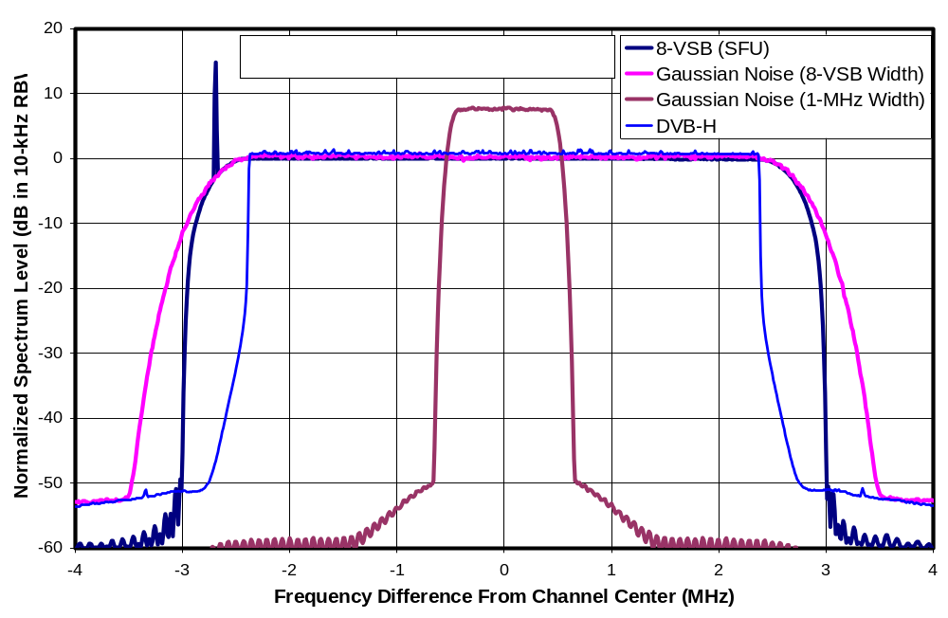
Figure 2-1. Spectra of the Four Undesired Signal Sources
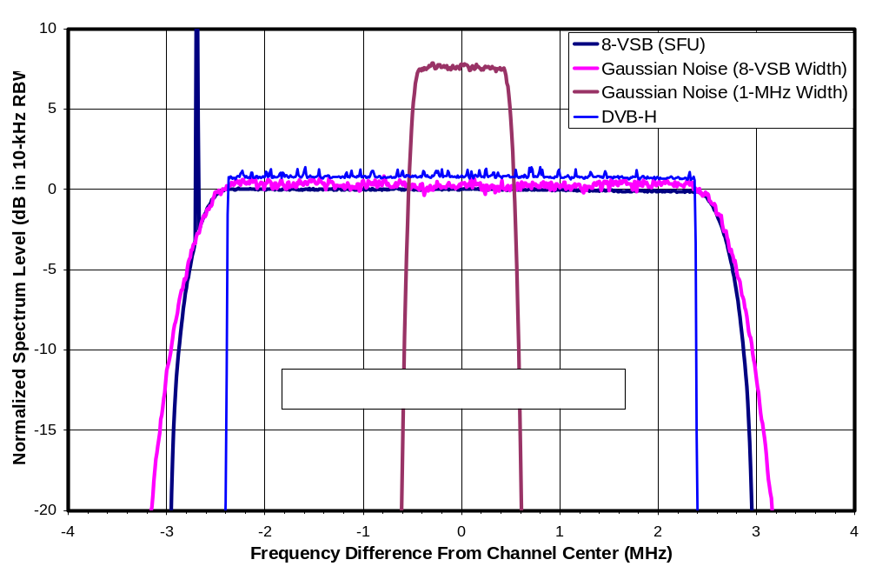
Figure 2-2. Spectra of the Four Undesired Signal Sources—Expanded Scale

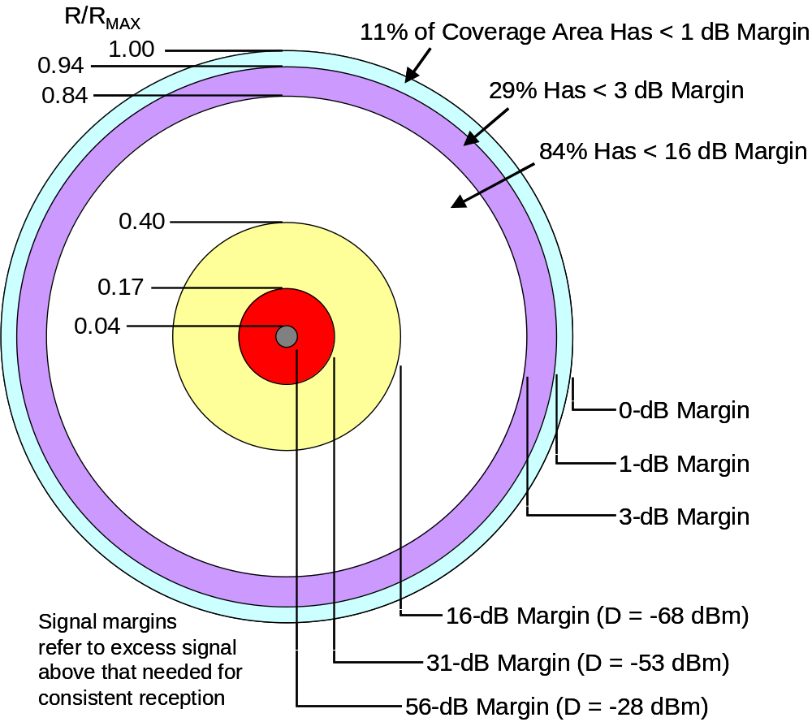
R = range from the broadcast antenna to the TV reception antenna;
R_{MAX} = R at the edge of coverage

Figure 2-3. Relationship Between Signal Excess and Coverage Area

TUNER TYPE TESTS
This chapter presents the results of tests of 30 DTV receivers to determine their tuner topologies.

Tuner Topologies
Two tuner topologies are known to have been used in ATSC DTV receivers: single-conversion tuners and double conversion tuners.

Both types of tuners are designed to shift a desired, 6-MHz wide TV signal from its original frequency (centered between 57 MHz for channel 2 and 803 MHz for channel 69) to a lower, fixed frequency range where it is feasible to implement a filter that passes the desired channel without significant distortion of its spectral shape while providing a high degree of rejection of adjacent-channel signals. Typically such a filter is implemented at a center frequency of 44 MHz and passes frequencies from 41 to 47 MHz. A single-conversion tuner performs the frequency shift in one operation. A double-conversion tuner performs it in two steps.

Single-Conversion Tuners
Figure 3-1 shows a simplified block diagram of single-conversion tuner. The input filter may be broad enough to pass an entire TV band, such as the UHF band containing channels 14 through 69. A “tracking filter” in the RF section adjusts with the TV channel selection and passes the desired TV channel and perhaps several channels on either side. A local oscillator (LO) at a frequency 44 MHz above the center of the desired TV channel (e.g., 739 MHz when the receiver is tuned to channel 51) is then non-linearly mixed with the amplified and filtered RF signal. This mixing down-converts the desired TV channel from its original frequency (e.g., 695 MHz +/- 3 MHz, for channel 51) to 44 MHz +/-3 MHz, which can pass through the fixed-frequency IF filter that serves to perform the primary channel selection function.

In addition to the desired TV channel—centered 44 MHz below the LO frequency—incoming signals that are located 44 MHz +/- 3 MHz above the LO are also down-converted into the IF filter band. For UHF channels, which occupy contiguous 6-MHz spectrum assignments, this corresponds to parts of the energy in TV channel numbers N+14 and N+15, where N is the desired channel number. The presence of these image signals can interfere with reception of the desired signal. One of the purposes of the tracking filter in a single-conversion TV tuner is to attenuate signals at the image frequencies before they reach the mixer in order to mitigate the interference potential.

Certain other signal interactions in a single-conversion tuner can create interference sensitivities at other channel spacings. These will be discussed later in this report.

Double-Conversion Tuners
Figure 3-2 shows a simplified block diagram of a double-conversion tuner—as implemented in the Grand Alliance receiver. This tuner configuration does not use a tracking filter. Rather, the entire TV spectrum is up-converted in such a way as to center the desired TV signal at 920 MHz. After filtering, the resulting signal is then down-converted by the second mixer so that the desired signal is centered at 44 MHz.

Comparisons
The double-conversion design results in image frequencies that are further separated from desired signal as compared to a single-conversion design. This separation makes it easier to filter out those undesired signal components. A double-conversion receiver is therefore less likely to have detectable image responses.

On the other hand, the lack of a tracking filter in double-conversion designs means that the first mixer must process all received TV signals rather than just the few channels surrounding the desired signal. Non-linear interactions between these various signals can create other interference issues. Additionally, achieving low noise figure and phase noise is more difficult in double-conversion than single-conversion receivers.

LO Measurement For Tuner Type Identification
In a single-conversion tuner, the LO frequency is located within the TV bands except when tuning the upper channels of a band. A small amount of the LO signal can leak out through the antenna port of the TV receiver. If the LO is detectable at the antenna port, its presence and frequency can be used to identify the tuner as single conversion and to confirm the IF frequency.

With double-conversion tuners, the LO is located above the UHF TV bands and is thus more easily filtered out and less likely to be detectable at the antenna port.

LO Frequency Test Methodology
The antenna port of each of the 30 DTV receivers discussed in Chapter 2 was observed using a spectrum analyzer in search of LO emissions. (For receivers having multiple antenna inputs that could handle ATSC signals, only the input labeled “antenna A” or “antenna 1” was tested.) During these tests, no signal was supplied to the antenna port; however, prior to these tests, a channel scan was performed on each TV while simultaneously applying ATSC signals on UHF channels 51 and 53. This step was necessary because many DTVs prevent selection of a given TV channel unless a valid signal was observed on that channel in a previous channel scan.

To improve the detectability of very weak LO emissions, the spectrum analyzer was operated with 0 dB input attenuation, the internal preamp turned on, resolution bandwidth set to 10 kHz, and trace averaging enabled. The analyzer was set to sweep a 20 MHz span that included the frequencies of interest. Use of a 2001-point sweep enabled a 0.01-MHz bin-to-bin spacing. Each TV was initially tuned to channel 51 and the spectrum was observed for the presence of a line at 739 MHz—the LO frequency expected for a single-conversion tuner with a 44-MHz IF when tuned to channel 51. The TV was then changed to channel 53, the spectrum averaging was restarted, and the spectrum was observed to determine whether the line shifted upward by 12 MHz to the LO frequency expected for channel 53.

LO Test Results
For 28 of the tested 30 DTV receivers, LO signals were detected at frequencies consistent with a single-conversion receiver with an IF frequency of approximately 44 MHz. For 25 of those, each observed LO-associated line was within 0.02 MHz of the value expected (44 MHz above the center frequency of the tuned channel) for each tested channel. One of the receivers (designated O1 in the SHVERA Study) exhibited LO-associated lines that were 0.18 MHz above the expected frequencies. The LO-associated emissions from two other receivers (designated D2 and D3) exhibited a hunting behavior around the expected frequency—extending as far as 0.25 or 0.26 MHz from the expected frequency.

These results provide clear evidence that at least 28 of the 30 consumer DTV receivers that were tested have single-conversion tuners with an IF frequency at, or very near, 44 MHz.

For two of the receivers (designated G3 and P1), no LO signal was observed in the expected frequency range. Based only on these results, each of these two receivers could have had a different tuner topology, such as a double conversion tuner, or they could have had single-conversion tuners but either with a different IF frequency than was expected or with better control of LO leakage to the antenna port than the other receivers; consequently, a conclusion regarding topology of these two receivers required additional tests.

Interference Rejection Tests For Tuner Type Identification
Interference rejection tests were performed for the receivers G3 and P1, the two receivers for which LO sensing was inconclusive. These two DTVs would be classified as fourth-generation or earlier based on their multipath performance, which was tested as part of the SHVERA Study. Both were on the market in 2005, though P1 was actually introduced to the market in 2004.

The measurements were performed using techniques to be described in the next chapter. A desired signal of -68 dBm was applied to the receivers on channel 30 along with a white noise signal bandlimited to a 3-dB width of 5.38 MHz on another channel. The undesired signal level was adjusted to the TOV of degradation of the television picture. The resulting D/U ratios are plotted in Figure 3.3.

Both receivers exhibit a peak in sensitivity to interference at N+7. This channel contains the LO frequency of a single-conversion tuner with 44-MHz IF. Such a peak can be observed in D/U plots presented in a later chapter of this report for seven of the other eight single-conversion receivers tested.

In addition, receiver P1 exhibits elevated sensitivity to interference at N+14 and N+15. This corresponds to the mixer image for a single-conversion tuner with 44-MHz IF. Mixer image peaks are seen in D/U plots presented later in this report for seven of the eight single-conversion receivers tested.

Based on these observations, receivers G3 and P1 are judged to have single-conversion tuners with 44-MHz IF. No further testing was performed on these two receivers.

Summary
All 30 tested receivers were judged to have single-conversion topologies with 44-MHz IF.

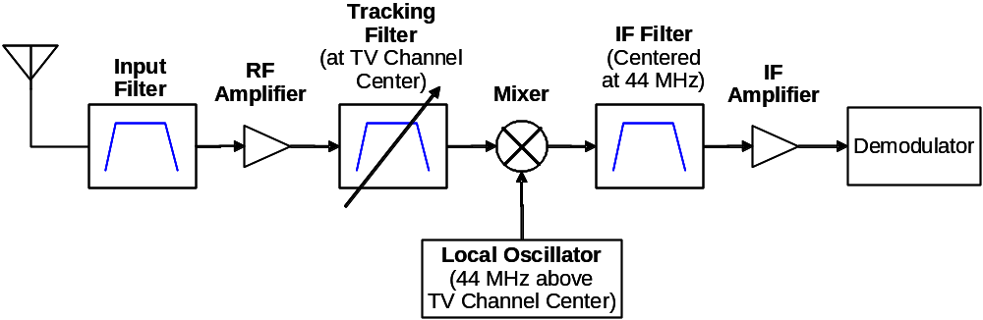
Figure 3-4. Single-Conversion DTV Tuner Block Diagram Example

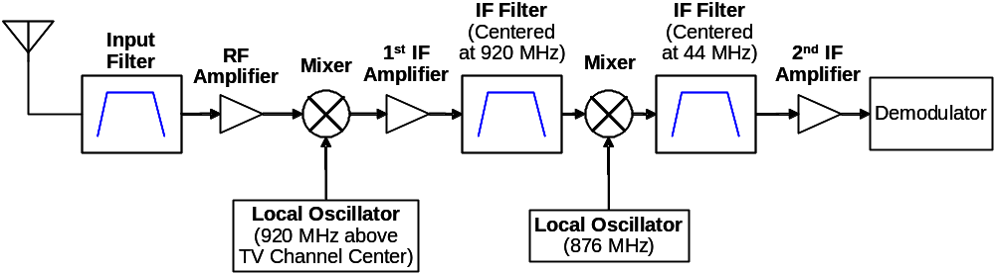
Figure 3-5. Double-Conversion DTV Tuner Block Diagram Example

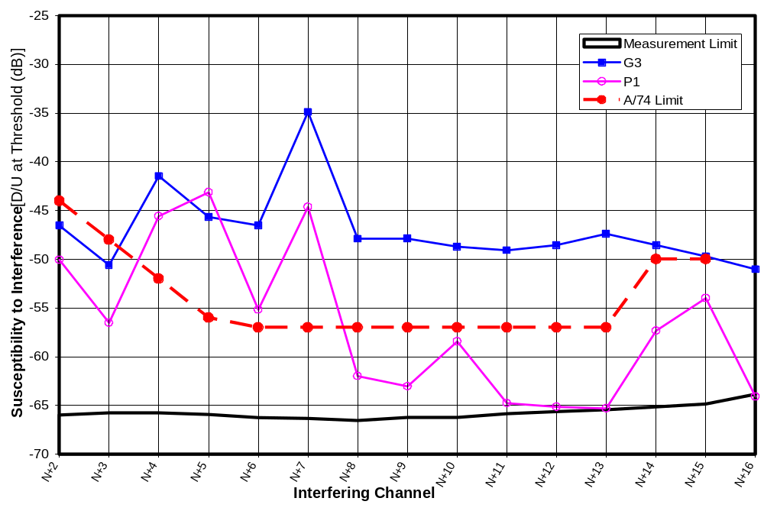
Figure 3-6. Rejection Performance of Receivers with Undetected LO’s

INTERFERENCE REJECTION REFERENCE LEVELS AND TEST METHODOLOGY
This chapter describes the test methodology employed for interference testing, the performance of the test setup, and some reference values for rejection performance from other documents.

Channel-to-channel signal level differences required for out-of-channel interference rejection testing present some challenges that require the use of specialized filters. The amount of filtering depends on the threshold desired-to-undesired (D/U) power ratios that are to be measured.

Reference Levels for Interference Rejection Performance
Interference rejection performance is defined in terms of the ratio of desired signal power (D) to undesired signal power (U) at the point at which visible degradation begins to occur in the television picture.

Grand Alliance Receiver Performance
The interference rejection capability achieved by the Grand Alliance prototype DTV receiver for a DTV interferer is shown in Table 4-1.

Table 4-6. Grand Alliance Receiver Interference Rejection Performance
K | D/U Ratio (dB)
K | N – K | N + K
1 | -41.98 | -43.17
2 | -60.52 | -59.13
3 | -60.61 | -61.53
4 to 15 | Not measurable | Not measurable

It can be seen that, for DTV interference, the receiver achieved rejection ratios of about -42 and -43 dB for the two first-adjacent channels (N+1 and N-1) and rejection ratios of about -60 dB or better at all other tested channel spacings.

OET-69 Guidance for Evaluating TV Service Coverage and Interference
OET Bulletin No. 69, “Longley-Rice Methodology for Evaluating TV Coverage and Interference”, defines the FCC methodology for evaluating TV service coverage and interference protection. Though it does not directly define TV receiver characteristics or requirements, it does define D/U ratios that are to serve as protection criteria to avoid DTV-to-DTV interference. Those protection criteria are shown in Table 4-2.

Table 4-7. OET-69 DTV-Into-DTV Interference Protection Criteria
Interfering  Channel | D/U Ratio (dB)  for DTV-into-DTV Interference
N-1 | -28
N+1 | -26

For other channel offsets, OET-69 states the following.

“The evaluation of service and interference in Appendix B of the Sixth Report and Order considered taboo channel relationships for interference into DTV. However, the D/U ratios (approximately -60 dB) were such that they rarely if ever had an effect on the results, and the FCC rules adopted in the
Sixth Report and Order do not require attention to UHF taboo interference to DTV stations.”

Thus, the interference rejection threshold of -60 dB assumed for DTV receivers was considered adequate to protect against DTV-into-DTV interference for channel spacings beyond N+1 and N-1 based on the allotment scenarios that were evaluated.

ATSC Recommended Performance
The ATSC Receiver Guidelines recommend that DTV receivers achieve the interference rejection capabilities shown in Table 4-3. The performance thresholds are specified at three different desired signal levels, which the ATSC designates as “weak”, “moderate”, and “strong”.

Table 4-8. ATSC A/74 Recommended Thresholds for Receiver Interference Rejection
Interfering Channel Number | Threshold D/U for Specified Desired Signal Level (dB)
Interfering Channel Number | Weak  (-68 dBm) | Moderate  (-53 dBm) | Strong  (-28 dBm)
N+/-1 | -33 | -33 | -20
N+/-2 | -44 | -40 | -20
N+/-3 | -48 | -40 | -20
N+/-4 | -52 | -40 | -20
N+/-5 | -56 | -42 | -20
N+/-6 to N+/-13 | -57 | -45 | -20
N+/-14 to N+/-15 | -50 | -45 | -20
Notes
Channel “N” is the channel number of the “desired” signal—to which the DTV receiver is tuned.
Bold Italics denote D/U thresholds that correspond to an undesired signal level of -8 dBm.

It should be noted that the ATSC-designated “weak” and “strong” levels do not bound the range of expected signal levels. The document recommends that receivers be able to operate with DTV signals ranging from -83 dBm to -8 dBm in level.

The ATSC document explains the basis for the -33 dB rejection ratio for first-adjacent channel interference in Table 4-3. It points out that the OET-69 protection criteria for allotting DTV stations permits a D/U ratio as low as -26 and -28 dB for first-adjacent channel interference. The recommended -33 dB receiver threshold was obtained by subtracting 6 dB from the mean of these values. Since the criteria in OET-69 are derived from receiver susceptibility to transmitter splatter into the first adjacent channel (based on the DTV emission mask), a receiver threshold of -33 dB, measured without splatter, ensures that the factor determining adjacent channel interference will be transmitter splatter rather than receiver performance.

The ATSC document does not explain the basis of the other D/U values it recommends; however, those identified by red italics in the above table correspond to interference at the maximum expected DTV signal level of -8 dBm. We understand the other values to be a result of negotiations that considered the performance levels that would likely be achievable by consumer-grade TV receivers.

Test Setup Requirements

Measurement Requirements
Goals for performance of the test setup were established based on the above reference levels. For first-adjacent channels (N+1 and N-1), our goal was to able to measure threshold D/U ratios at least as low as the -33 dB level recommended by the ATSC Receiver Guidelines. For all other channel spacings, or goal was to be able to measure down to a D/U ratio of -60 dB.

We also wished to be able to supply desired and undesired signals at levels up to -8 dBm.

The Challenge
Consider the case of a D/U ratio of -60 dB—meaning that the desired TV signal power is 60 dB below the power of the interferer. The SHVERA Study demonstrated that the median DTV receiver requires that the desired signal be at least 15.3 dB above any co-channel noise in order for successful reception to occur. For testing at a D/U ratio of -60 dB, this means that the co-channel noise created by the test setup must be at least 60 + 15.3 dB below the power of the interferer; otherwise, the test setup itself will prevent successful DTV reception. In fact, in order to make test setup noise relatively insignificant at a D/U ratio of -60 dB, we want an additional 10 dB margin—meaning that co-channel noise created by the test setup must be at least 85.3 dB below the power of the undesired signal when that signal is placed on any channel other than a first-adjacent one.

No available signal sources met this requirement. The source used to generate the “undesired” signal for the testing on channel 51 achieved only a 49-dB spread between signal power and power splattered into the second-adjacent channel (i.e., power splattered into channel N when the undesired source was placed at channel N+2). The source used for most of the testing on channel 30 was somewhat better but still achieved only a 56 dB spread between signal power and splatter into the second-adjacent channel.

The -33 dB D/U specification placed on first-adjacent channel interference requires a less formidable sounding dynamic range. For that measurement, any noise created by the test setup must be at least 33 + 15.3 + 10 dB = 58.3 dB below the power of the interferer. This specification was not met in the first adjacent channel of any source available during most of the testing.

To achieve the required test setup performance levels, a filter is needed to further reduce the out-of-band components of the undesired signal source.

Solutions
A typical solution to this filtering problem is to bandpass filter the undesired signal to reduce energy leakage into the desired channel. Because variable filters tend to have poorer shape factors than high-quality fixed filters, one approach would be to select a fixed interfering channel for the tests and to procure a fixed filter to shape the undesired signal on that channel. Testing at various channel spacings between the desired and undesired signals could be accomplished by switching the desired channel number over some required range.

While this approach would work well for tests with a single interferer, it creates a problem for testing against a pair of interferers. Intermodulation effects in the DTV receiver are expected to be most prominent for specific pairs of interfering signal channels, such as N+1 and N+2, N+2 and N+4, or N+3 and N+6. For tests of those effects, one interferer could operate on a fixed channel, but the other would have to be movable.

To deal with this problem, the desired channel was fixed and the undesired channels were allowed to change. The undesired signals were then subjected to a band-reject filter at the desired channel frequency. This fixed band-reject filter served to reduce leakage of the undesired signals into the desired TV channel.

In actuality, for a given desired channel, two custom filters were procured: one for adjacent-channel tests and the other for interferers located beyond the first-adjacent channel. Of the two filters, the filter for non-adjacent tests has greater rejection in the desired channel, but would cause unacceptable spectral distortion of an undesired signal on the adjacent channel (N+1). The filter for adjacent tests avoids excessive distortion to a first-adjacent undesired signal; it has less rejection in the desired channel than the other filter, but the rejection is sufficient for measurements at the more modest D/U ratios required for the first-adjacent channel.

In addition, the more conventional bandpass filter approach was implemented for one set of tests for comparison.

Test Setup
Figure 4-1 shows an overall block diagram of the test setup used for interference rejection tests.

The top left portion of the diagram shows the desired DTV signal source and associated amplifiers, along with a step attenuator allowing signal level to be adjusted in 0.1-dB steps over an 81-dB range. A Sencore ATSC997 8-VSB generator playing a built-in high-definition video stream of a football game was used for most of the testing. A Rohde and Schwarz SFU generator, acquired relatively late in the test program, was used for tests at a low desired signal level (D_{MIN} + 3 dB) and for some comparative tests; a built-in high-definition video stream of a shark tank served as the video content for those tests. In the final two weeks before the due date of this report, some adjacent-channel testing was performed using a newly acquired Wavetech WS2100 RF Player, combined with an external upconverter and a file containing an 8-VSB signal mathematically derived from an MPEG2 transport stream, to create a higher quality desired signal source than the Sencore ATSC997, while freeing the SFU to act as undesired signal on the adjacent channel.

Up to two generators were used at any given time to create the undesired (i.e., interfering) signals. The generators included a Sencore RFP910 RF Player playing a supplied recording (“Hawaii Reference A”), the Rohde and Schwarz SFU mentioned above, two Agilent E4437B vector signal generators used to generate band-limited white Gaussian noise, and an Agilent 4438C vector signal generator equipped with Signal Studio for DVB software to generate an OFDM DVB-H signal. The Sencore RF Player failed near the end of the planned tests at channel 51 and was unrepairable. The Rohde and Schwarz SFU was procured later in the testing period.

The two undesired signals are combined and amplified by a 5-watt power amplifier which is operated at an output power of only 0.07 watts in order to limit third-order intermodulation distortion products, which would fall within the desired signal channel. A step-attenuator (Atten-C) is used to adjust the input level of the amplifier.

The amplified, undesired signal pair is then passed through one of four band-reject filters to reduce out-of-band splatter into the desired channel to which the TV is tuned. The filter is followed by a fixed attenuator and a step attenuator that allows the undesired signal level to be adjusted in 0.1-dB steps over an 81-dB range. No active devices (e.g., amplifiers) are included in the test setup beyond the filter output in order to avoid creation of intermodulation products.

The desired signal is then combined with the filtered undesired signal pair. The combined signals are split into two paths—one feeding the DTV receiver under test through an impedance-matching pad and the other feeding a spectrum analyzer used for all power measurements. A total of about 9-dB of attenuation is provided in each splitter output path in order to reduce the impact of any reflections caused by impedance mismatches at the DTV receiver input. The attenuators following the splitter were selected to provide a signal level match between the TV port and the measurement port to within 0.1 dB across all TV channels.

Double-shielded cables were used throughout the test setup because of the wide range of signal levels present simultaneously. A 50-ohm impedance was maintained throughout the setup, except at two 8-VSB sources and the consumer TV inputs, which were each specified to be nominally 75 ohms. The 75-ohm devices were matched to the rest of the test setup through impedance-matching pads or—in the case of one of the 8-VSB sources—an impedance-matching transformer. In addition to the impedance-matching pads, 50-ohm attenuator pads were used at various places throughout the test setups to reduce the effects of any impedance mismatches at places where such mismatches were considered likely or would be expected to have a significant impact, as well as to reduce third-order intermodulation in amplifiers A1 and A2.

The test setup is capable of delivering undesired signals to the TV receiver at a maximum level ranging from -7 to -1 dBm per interferer.

Test Setup Performance
As was described in the Test Setup Requirements section, the test setup was required to suppress splatter from the undesired signals into the desired channel by as much as 85.3 dB. No available spectrum analyzer had sufficient dynamic range to measure this degree of suppression. Instead, the spectrum of the output of the test setup was first measured with the filter bypassed. These measurements were performed with no desired signal present and for several different channel selections for the undesired signal with undesired signal set to a high level. Separately, the frequency response of the test setup was then measured both with the filter in place and with the filter bypassed; the difference between these measurements represents the in-situ filter frequency response. The filter frequency response was then applied to the spectrum measurements made with the filter bypassed—resulting in a computed value for the net output spectrum.

Figure 4-2 shows the output spectrum of the test setup with channel 30 as the desired channel and a bandlimited white Gaussian undesired signal at channel N+2. Integration of the blue—undesired-signal-only curve shows that the power splattered by test setup into channel N is 99.3 dB below the total undesired signal power. About 56 dB of this suppression is due to the performance of the undesired signal generator—degraded slightly by the amplifier that follows it. The remaining 43 dB of suppression comes from the band-reject filter.

In the figure, the spectrum of a desired DTV signal is plotted at a total power level 60 dB below the power of the undesired signal, i.e., at a D/U ratio of -60 dB. Since a typical DTV requires that D be 15.3 dB above any co-channel noise, the test setup noise is 24 dB below the point at which DTV operation would fail. This significantly exceeds the 10-dB margin that was considered essential for meaningful D/U measurements.

Figure 4-3 shows another example of the output spectrum of the test setup—again with channel 30 as the desired channel, but this time with a pair of interfering signals spaced to create intermodulation distortion in channel N. In this case the unintended power leaked into the desired channel is 98.2 dB below the undesired signal power.

Figure 4-4 shows an adjacent-channel example. A pair of interferers is placed at N+1/N+2. The interferer at N+1 (U₁) is an 8-VSB source; some rounding of the left side of the 8-VSB signal by the band-reject filter can be seen. The interferer at N+2 (U₂) is a white-Gaussian-noise source bandlimited to match the 3-dB width of an 8-VSB signal. Two different interferer types had to be used for this test: though two bandlimited noise generators were available, their spectrum rolloff is not steep enough for use as an adjacent channel (N+1) source because too much power would be spilled into the desired channel; and, only one 8-VSB source (besides the one used as a desired signal) was available.

In the case of N+1/N+2 interference, there is no need to measure D/U ratios as low as -60 dB. In this case, the desired signal is shown at a D/U ratio of -33 dB—the ATSC-recommended rejection performance for first-adjacent-channel interference. Based on integration of the signal spectra, the total noise power leaked into the desired channel is 70.2 dB below the undesired signal power. This provides a 21.9 dB margin to the point of reception failure caused by the test setup. (Actual margin is likely higher than this because, as can be seen from the plot, much of the undesired power that leaks into the desired channel N is at the band edges where filtering within the DTV receiver will reduce its effect.) With 10 dB being considered the minimum acceptable margin, receiver measurements could be made with this signal configuration down to a D/U ratio of about -45 dB per undesired signal.

Table 4-4 summarizes the minimum D/U ratios that can be measured by the various test setup configurations used in this report based on the undesired signal leakage into the desired channel. Two limitations are listed for adjacent-channel test configurations: a limit based on total power leaked into the desired channel and a limit that includes the effect of a DTV receiver’s raised-cosine filter response on spectrum leakage at the edges of the desired channel. The former limit (“worst case limit”) is displayed on plots as the “Measurement Limit” for measurements on channel 30. The latter limit is used as a measurement limit for measurements at channel 51 to avoid unnecessarily excluding measurement results from further analysis. (This decision was made because the channel-51 test setup had poorer performance than that for channel 30, in that it spilled more energy from the undesired signal into the edge of the desired channel.)

In addition, minimum D/U ratio is limited by the maximum undesired signal level that the test setup can produce. The maximum undesired signal level ranges from about -7 dBm to -1 dBm depending on the test setup configuration and channel spacing being tested. Typically, at a desired signal level of -68 dBm the D/U measurement range is limited by leakage of undesired signal into the desired channel for measurements at N+1 or N-1 and by maximum undesired signal that the test setup can generate for all other channel spacings.

Test Setup Configurations
Table 4-5 summarizes the equipment configurations used for the various tests of interference rejection performance.

Table 4-9. Measurement Limitations of the Test Setup
Desired Channel N | Filter | Undesired Source 1 | Undesired Source 2 | Applicable Interference Channels | Cases examined | Worst-Case Limit on D/U  (dB) | D/U Limit If the DTV’s Raised Cosine Filter Is Assumed in TV  (dB)
30 | 30N | 8-VSB (Rohde SFU) | None | N+1, N-1 | Both | -48.3 | -59.4
30 | 30W | WGN | None | N+2 to N+16 and  N-2 to N-16 | N-16, N-8, N-2, N+2, N+8, N+16 | -74.0
30 | 30N | 8-VSB (Rohde SFU) | WGN | Pairs: N+1/N+2 and  N-1/N-2 | Both | -44.9 | -52.5
30 | 30W | WGN | WGN | Pairs:  N+2/N+4 to N+8/N+16;  N-2/N-4 to  N-8/N-16 | Pairs: N-8/N-16, N-4/N-8, N-2/N-4, N+2/N+4, N+4/N+8, N+8/N+16 | -71.7
51 | P52-53 | 8-VSB (Sencore RFP) | None | N+1 | N+1 | -37.6 | -43.9
51 | P52-53 | 8-VSB (Sencore RFP) | WGN | N+1/N+2 | N+1/N+2 | -36.7 | -42.6
51 | P53-56 | 8-VSB (Sencore RFP) | WGN | N+2 to N+16 and pairs: N+2/N+4 to N+8/N+16 | All pairs and N+9 to N+16 | -71.0
Note: WGN refers to bandlimited white Gaussian noise from an Agilent E4437B vector signal generator

Table 4-10. Test Setup Configurations and Settings
N | Interferer(s) | Test Setup | Desired Signal Source | Undesired Source 1 | Undesired Source 2 | Step Atten-C (dB)
Interference Rejection—Single Interferer
30 | Single adjacent | Primary | 8-VSB Src A @ 38dBmV | 8-VSB Src C @ +2 dBm |  | 5
30 | Single adjacent w/D at D_{MIN}+3 dB | Primary | 8-VSB Src D | 8-VSB Src C @ +2 dBm |  | 5
30 | Single non-adjacent | Primary | 8-VSB Src A @ 38dBmV | WGN Src A @ -7 dBm |  | 2
30 | Single non-adjacent w/D at D_{MIN}+3 dB | Primary | 8-VSB Src C @+2dBm | WGN Src A @ -7 dBm |  | 2
51 | Single | Primary | 8-VSB Src A @ 38dBmV | 8-VSB Src B @ -30 dBm |  | 2
Interference Rejection for Paired Signals
30 | Paired adjacent  (e.g., N+1/N+2) | Primary | 8-VSB Src A @ 38dBmV | 8-VSB Src C @ +2 dBm | WGN Src A @ variable level | 5
30 | Paired non-adjacent | Primary | 8-VSB Src C @+2dBm | WGN Src B @ -7 dBm | WGN Src A @ variable level | 8
51 | Paired | Primary | 8-VSB Src A @ 38dBmV | 8-VSB Src B @ -30 dBm | WGN Src A @ variable level | 2
Interference Rejection—Comparison Tests With Different Sources
30 | Single non-adjacent DTV interferer | Primary | 8-VSB Src A @ 38dBmV | 8-VSB Src C @ +2 dBm |  | 2
30 | Single non-adjacent OFDM interferer | Primary | 8-VSB Src A @ 38dBmV | OFDM Src A @ -6.9 dBm |  | 2
Interference Rejection—To Evaluate Test Method
Variable (U at 29) | Single adjacent & nonadjacent using Simplified Test Setup w/BPF on U | Alt | 8-VSB Src A @ variable output level | 8-VSB Src C @ variable output level |  | NA
Test Setups
Primary: Figure 4-1
Alt.: Figure 14-2
Signal sources
8-VSB Source A: Sencore ATSC997 ATSC Source
8-VSB Source B: Sencore RFP910 RF Player (“Hawaii_ReferenceA” file)
8-VSB Source C: Rohde & Schwarz SFU 8-VSB Generator
8-VSB Source D: Wavetech WS-2100 RF Player (“Muddy Waters” file) + Drake DUC860 Upconverter
AWGN Source A: Agilent E4437B Vector Signal Generator in AWGN mode
AWGN Source B: Agilent E4437B Vector Signal Generator in AWGN mode
OFDM Source A: Agilent E4438C Vector Signal Generator + Agilent Signal Studio for DVB software
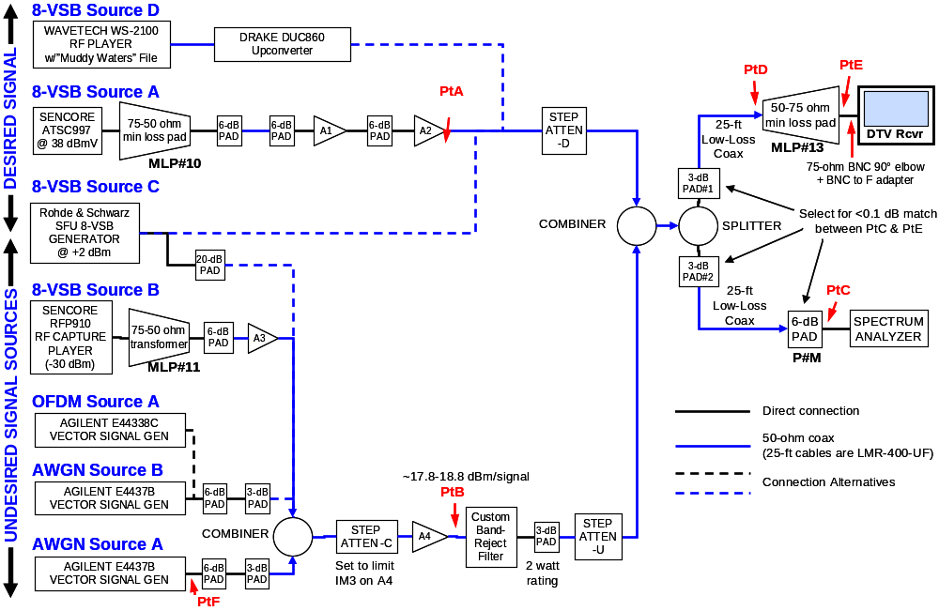
Amplifiers
A1 = MiniCircuits ZFL-1000H (28 dB minimum gain; 20 dBm 1-dB compression)
A2 = MiniCircuits ZFL-1000VH (20 dB minimum gain; 25 dBm 1-dB compression)
A3 = HP8447B (22 dB gain; 400-1300 MHz)
A4 = Amplifier Research 5W1000 (37 dB gain; 500 kHz – 1000 MHz; 5 watts output)
Attenuators
Attenuators preceding A1 and A2 are selected to reduce IM3 to acceptable levels
Step Attenuator-C set to reduce IM3 of A4 to acceptable levels
Step Attenuators D & U: Alan Industries models 50V70 N, 50V10 N, and 50V1 N cascaded to provide 0 - 81 dB in 0.1-dB steps (0.5W max power)
Combiners & Splitter: MiniCircuits ZAPD-900-5W (100-900 MHz)
Custom Band-Reject Filters
“30N” = Tin Lee CE7-569(4.8)N50
“30W” = Microwave Filter Company model 16195
“P52-53” = Tin Lee CE7-692/697.4(20) N50
“P53-56” = Tin Lee CE7-692/698 N50
Impedance Matching
Minimum Loss Pads = Trilithic ZM-57
75-50 ohm transformer = Trilithic ZMT-57
25-ft coax = Times Microwave LMR-400-UF
Equipment settings
Agilent E4437B settings for bandlimited white Gaussian noise
AWGN mode w/length 1048576
Bandwidth setting = 4.686 MHz for 5.38-MHz 3-dB width
Bandwidth setting = 875 kHz for 1-MHz 3-dB width
Output setting = -7 dBm. (Higher could damage Step-Atten-U & raise IM3 of E4437B output)
Agilent E4438C vector signal generator using Agilent Signal Studio for DVB software
Signal Type: DVB-H
Waveform parameters: Size=2k; Modulation=64 QAM; Chan. width=5 MHz; Guard interval=1/8
Output setting = -6.9 dBm
Figure 4-7. Block Diagram of Interference Rejection Test Setup

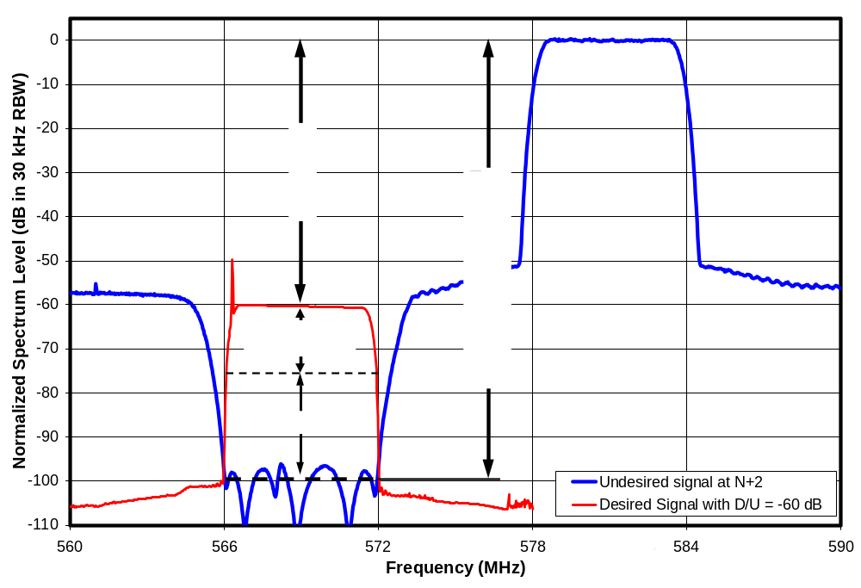
Figure 4-8. Leakage of U at N+2 into Channel N (30)
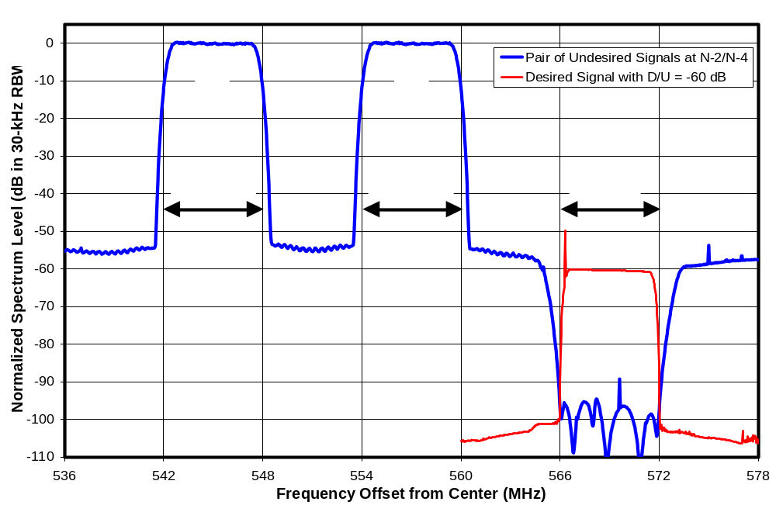
Figure 4-9. Leakage of U pair at N-2/N-4 into Channel N (30)
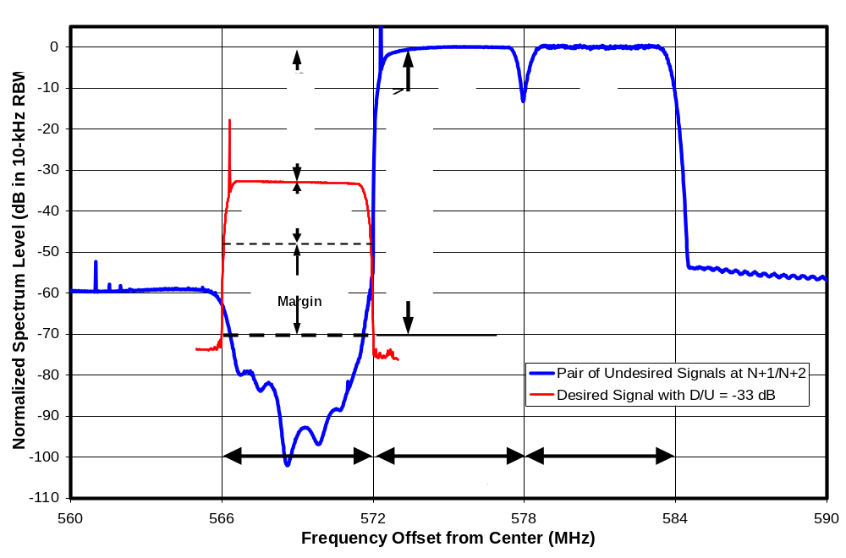
Figure 4-10. Leakage of U pair at N+1/N+2 into Channel N (30)

REJECTION RESULTS ON CHANNEL 30 FOR SINGLE INTERFERERS WITH FULL CHANNEL WIDTH
This chapter presents the results of interference rejection tests of eight “fifth-generation” DTV receivers tuned to channel 30. The interferer for these tests was:
For channels N+1 and N-1, an 8-VSB signal;
For channels N+2 through N+16 and N-2 through N-16, a white Gaussian noise signal bandlimited to match the 3-dB width of an 8-VSB signal.
Spectra of the sources were shown in Figures 2-1 and 2-2.

A limited set of interference rejection tests was also performed on two earlier-generation receivers, designated G3 and P1, for purposes of identifying tuner type as described in Chapter 3. This data was plotted in Figure 3-3, but it is repeated near the end of this chapter with an overlay showing the range of values measured for the fifth-generation receivers for comparison.

The primary focus of these tests was to investigate the interference susceptibility of DTV receivers operating in the UHF band to interference from other occupants of the UHF TV spectrum, including other TV broadcasts as well as non-TV use of the “white spaces”. As such, the desired channel (30) was selected as a locally unused channel near the center of the UHF core spectrum.

Test results are presented in this chapter either as D/U ratios, in which case better performance corresponds to lower points on the graph, or as threshold values of the undesired signal level U, in which case better performance corresponds to points nearer the top of the graph.

Tests at ATSC-Specified Desired Signal Levels

“Weak” Desired Signal (D = -68 dBm)
Figure 5-1 shows measured values of D/U ratios at TOV for the eight DTV receivers for undesired signal channels ranging from N-16 to N+16. (The case of co-channel interference, i.e., interference on channel N, is omitted.) The desired signal power was set to -68 dBm, a signal level that the ATSC chose to designate as “weak”, although DTVs are assumed to operate down to a signal level of -84 dBm.

The shaded area at the bottom of the plot represents the measurement limitations imposed by the test setup—as described in Chapter 4. Measurements falling in—or at the border of—this region are not valid; the actual performance of a receiver at these points is better (i.e., lower on the graph) than the plotted point indicates. For N-1 and N+1 with D = -68 dBm, the limit is based on leakage from the undesired source into the desired channel. For other offsets and higher desired signal levels, the measurements are limited by the maximum undesired signal power the test setup could inject into the DTV receiver.

The ATSC-recommended DTV-into-DTV interference rejection thresholds are shown on the plot as a reference. Those limits are defined for channels ranging from N-15 and N+15. Compliance with those voluntary limits would be indicated by all points on a measurement curve falling on or below the ATSC line. It should be recognized, however, that the ATSC recommendations apply when the undesired signal is an 8-VSB DTV signal, which was the case only for the N-1 and N+1 points on each curve. It can be seen that all eight receivers comply with the ATSC recommendation at N-1 and N+1.

At the other channel offsets, N-2 through N-15 and N+2 through N+15, no receiver appears to fully comply with the recommended performance limit. The best-performing receiver, designated G4, complied everywhere except at N+5 and N+6, where its performance failed to meet the limits by about 2 dB and 1 dB, respectively. On average, the receivers failed to meet the recommended performance on at about seven of the 30 channel offsets, with one receiver (D3) failing at twelve points. The worst failure for each receiver ranged from about 2 dB to 25 dB.

The above results cannot be viewed as definite failures to meet the performance guidelines because the tests (other than at N-1 and N+1) were performed using a bandlimited white noise source as the interferer, rather than an 8-VSB signal. (An 8-VSB source was not available for most of the test period.) Limited tests presented in Chapter 7 show an average performance improvement of 1.1 dB when the interference comes from an 8-VSB signal rather than from the white Gaussian noise source of the same 3-dB bandwidth. However, even taking this difference into account, it is unlikely that any of the receivers would fully comply with the ATSC guidelines at every channel offset, though one or two would probably come close.

Figure 5-2 summarizes the measurements that were shown in Figure 5-1. The blue curve shows the median performance of the eight receivers. Error bars show the best and worst performance among the receivers at each channel offset. A dashed curve shows the performance of the second worst performing receiver at each channel offset. On a median basis, the offsets that break the recommended limits by the largest amounts are N-4, N-6, and N+7.

“Moderate” Desired Signal (D = -53 dBm)
Figure 5-3 shows measured values of D/U ratios at TOV for the same eight DTV receivers with the desired signal power set to -53 dBm, a signal level that the ATSC designates as “moderate”. Again, all eight receivers comply with the ATSC recommended performance on the first-adjacent channels (N+1 or N-1). At the other channel offsets, only one receiver (G4) appears to fully comply with the recommended performance limit. A second receiver (I1) appears to fail only at N-2 by 1 dB and at N-4 by a negligible amount. Other receivers fail at from one to 16 points with worst-case failures ranging from three to 18 dB. The worst performing receiver was D3. Again, these results cannot be viewed as definite failures to meet the guidelines because the tests were performed using a bandlimited white noise source as the interferer, rather than an 8-VSB signal. Based on the differences in interference effect of the 8-VSB and Gaussian signals, it is likely that a second receiver would have complied with the guidelines at this desired signal level if an 8-VSB signal had been used as the interferer.

Figure 5-4 shows the best, median, second worst, and worst performance at each channel offset. On a median basis the only failure to satisfy the ATSC recommended performance is at N+7.

“Strong” Desired Signal (D = -28 dBm)
Figure 5-5 shows that, with the desired signal set to the level that the ATSC designates as “strong”, every receiver complied with the ATSC Recommended Guidelines at every point, with the exception of one receiver (G4) that appeared to fail by only 0.2 dB at N+1. In most cases the test setup was not capable of generating strong enough undesired signals to cause visible degradation of the TV picture; consequently, most data points are plotted on the measurement limit line. Figure 5-6 shows the best, median, second worst, and worst performance at each channel offset.

Selection of a Weaker Desired Signal for Tests

Motivation
The data in this chapter and later chapters of this report show that, as desired signal power at the input to a TV decreases, the amount of undesired power that the TV can tolerate on another channel also decreases. This means that a TV is most vulnerable to interference when operating at a low desired signal level—not a surprising result.

One might also hypothesize that, as the desired signal power D at the input to the TV decreases, the undesired signal power U necessary to cause picture degradation would decrease at the same rate. If this were true, the D/U ratio would remain constant, and interference rejection measurements would only need to be performed at a single power level to gain an understanding of the TV’s rejection performance. From the test results in this report, it is clear that this hypothesis is false. In fact, the rate of change of threshold undesired signal with desired signal differs with channel offset between the desired and undesired channel and also varies with desired signal amplitude.

The variation of D/U ratio with signal amplitude—often in unexpected ways—suggests the need for rejection performance measurements at a variety of amplitudes. In Chapter 11, we subject a single TV to D/U measurements over a wide amplitude range to gain some insight into interference behavior. However, given that TV’s are most susceptible to interference at low desired signal levels, we focus here on weak signals.

The range of desired signal levels that a DTV receiver can or should accommodate extends from:
D_{MIN} (nominally -84 dBm)
— the desired signal level at which a DTV receiver begins to experience visible picture degradation; -84 dBm is the threshold assumed by OET-69 for edge-of-coverage UHF reception and also the median channel-30 threshold of 28 consumer DTV receivers measured under the SHVERA Study; to,
-8 dBm — the maximum DTV signal level anticipated by the ATSC Receiver Guidelines.

In between are the three levels at which ATSC A/74 defines interference rejection performance guidelines for DTV receivers:
-68 dBm -- “weak”
-53 dBm -- “moderate”
-28 dBm -- “strong”
The measurements of rejection performance presented thus far in this chapter were performed at these three levels.

Note that the -68 dBm signal level designated by the ATSC as “weak” is 16 dB above the -84 dBm minimum signal level at which a typical DTV receiver can operate; that minimum signal level of -84 dBm is also the signal level assumed by OET-69 (FCC’s document for predicting coverage of a TV station) to be available to a DTV receiver at the edge of coverage of a TV broadcast station. Table 2-2 and Figure 2-3 of Chapter 2 showed that fully 84 percent of the coverage area of a broadcast station may experience desired signal levels weaker than -68 dBm, assuming that the same type of antenna system is used at all locations in the viewing area. This suggests a need to test at lower signal levels.

Signal Level Selection
Selecting a signal level for interference tests that represent a near edge-of-coverage condition is not straight-forward. Only about half of the 28 receivers tested for the SHVERA Study could produce an error-free picture with a channel-30 desired signal level matching the -84 dBm edge-of-coverage signal level assumed by OET-69, even without adding any interference, and a few TVs would produce no picture at all at this signal level. Among those receivers, the TV with the least UHF sensitivity required an input signal level about 2.6 dB larger than the -84 dBm level, while the most sensitive TV could operate at a signal level 1.3 dB weaker than -84 dBm. The spread between the most-sensitive and least-sensitive receivers was larger in the VHF band—as high as 15 dB.

If, in order to accommodate relatively insensitive receivers, a relatively high desired signal level is chosen as the measurement basis for rules to prevent interference to television, the resulting rules for a new service might permit interference levels that would limit the operation of the better receivers that can operate on weaker signals. Hence a decision was made to also test at a receiver-dependent desired signal level near the threshold of visible picture degradation (TOV) that occurs in the absence of interference, a level we have designated as D_{MIN}.

Table 2-2 and Figure 2-3 of Chapter 2 showed that a TV located beyond 84 percent of the maximum reception range (R_{MAX}) of the broadcast station (for a given antenna system) will receive signal levels at less than 3 dB of signal margin (i.e., signal level relative to that needed for consistent, clear reception of the broadcast signal). 29 percent of the coverage area falls in this region of less than 3 dB signal excess. Similarly, and 11 percent of the coverage area will exhibit a signal excess of less than 1 dB.

The assumptions regarding coverage area are typically based on use of a high-gain outdoor antenna on a 10-meter mast. The percentages discussed above apply to such coverage area as long as the receiving system (including antenna gain and mast height) remains constant as one moves in to closer distances from the broadcast location. Thus, for example, 29 percent of the receiving coverage area would operate with less than 3-dB signal excess for customers with that receiving system. If, however, closer-in customers choose a lower-gain antenna, a lower mast height, or an indoor antenna location, those customers will operate with a shorter maximum possible range for consistent reception (R_{MAX}). Such customers would also operate with less than 3-dB excess signal whenever they are beyond 84% of the maximum reception range possible with that antenna system. In essence, the region with less than 3-dB excess signal repeats itself as 29 percent of the area of a smaller coverage circle corresponding to use of the lesser antenna system. Hence, the area where excess signal is less than 1 or 3 dB will be larger than the 11 and 29 percent values discussed here if closer-in customers choose lower-gain antennas or place those antennas at less optimal locations such as on a shorter outdoor mast or indoors. (We note that, while the simple model used in the above analysis is useful for estimating the relative importance of various values for signal excess, terrain and man-made structures in real-world locations will cause the numbers to vary from those shown here.)

Given that rejection performance tests are time consuming, a decision was made to make measurements at only one additional signal level beyond the three ATSC-specified levels. We chose to make this level dependent on the threshold reception performance of the individual receivers. Thus, we measured the desired signal level D_{MIN} at which TOV occurs for each receiver in the absence of interference. Interference rejection tests were then performed at a desired signal level 3 dB above this threshold. The desired signal level for these tests is designated as D_{MIN} + 3 dB. In addition, we extrapolated the measurements to a desired signal power of D_{MIN} + 1 dB in Chapter 12 by means of a modeling approach developed from a theoretical framework presented in Chapter 8.

Effect of Desired Signal Source
In preparing for the D_{MIN}-referenced measurements, D_{MIN} was measured for three receivers that been tested for the SHVERA Study, but the new measurements were found to be about 1 dB higher than the earlier SHVERA measurements. While these differences could have been considered to be within measurement error, there was uncertainty about whether the difference could be attributed to differences between the SHVERA test setup and the current test setup or the use of different desired signal sources in the two test programs.

The signal source used in the SHVERA Study had failed irreparably while being used as an undesired signal source for channel-51 tests in the current program; however, a new signal source (Rohde and Schwarz SFU) had been procured late in the current test program. To evaluate the cause of 1-dB difference, the new SFU generator was substituted for the Sencore ATSC997 source that was used as the desired source for most of the testing described in this report. The result of the switch was a 1-dB improvement in measured sensitivity of the receivers—to results that matched the SHVERA test results.

Table 5-1 shows the observed differences in receiver threshold for various desired-signal configurations, with the SFU-based measurements as the reference. In all cases, the measurements were made at the output of the test configuration that was shown in Figure 4-1. The first measurement column shows the differences in measured D_{MIN} using the ATSC997 in the test setup as shown in Figure 4-1 (including amplifiers A1 and A2, as well as three 6-dB pads) instead of the SFU. On average the ATSC997 in the “normal” test-setup configuration widely used in this report resulted in a receiver threshold about 0.9 dB higher than that when the SFU was used. The second column represents measurements to determine whether the difference was due to the ATSC997 itself, or the amplifiers that followed it. The third is a comparison to the SHVERA measurements.

In general, all three tested TVs appeared to require an input DTV signal level about 0.9 dB higher when the signal was supplied by the Sencore ATSC997 than when it was supplied by either the Rohde and Schwarz SFU or, based on the SHVERA test results, the Sencore RF Player (playing the “Hawaii_ReferenceA” file). This fact suggested that the signal quality of the ATSC997 was inferior to that of the other sources in a way that affected TV performance in a small, but measurable way. While a 0.9-dB discrepancy in TV receiver threshold may seem small, there was concern that it might be relevant when performing interference testing at levels only 3-dB above the receiver threshold.

Measurements were performed on the desired signal at the output of the test setup in an attempt to determine the cause of the generator-dependence of receiver thresholds.

Figures 5-7 and 5-8 show the spectra of the desired signal at the output of the test setup using each of the two remaining 8-VSB sources. Figure 5-7 illustrates the higher noise floor of the ATSC997 relative to the SFU. If the ATSC997’s noise floor extended through the desired signal band at a level roughly 40 dB below the desired signal, it would add to the TV receiver noise, which is generally expected to be about

Table 5-11. Receiver Minimum Signal Level at TOV Versus Desired Signal Source
TV Receiver | D_{MIN} Measured Using Signal Source Shown  Relative to D_{MIN} Measured Using Rohde & Schwarz SFU (dB)
TV Receiver | Sencore ATSC997 (with amplifiers A1 & A2 as shown in Figure 4-1) | Sencore ATSC997 (bypassing external amplifiers) | SHVERA Result (Sencore RF Player in a Different Test Setup)
I1 | 0.77 | 0.87 | -0.16
M1 | 1.06 | 1.24 | 0.05
N1 | 0.80 | 0.74 | 0.26
Mean | 0.87 | 0.95 | 0.05

15 dB below the desired signal level at threshold. This would cause the total noise seen by the receiver to rise, relative to receiver-noise-only, by 10 Log(1 + 10^{-(40-15)/10}) = 0.014 dB. Clearly this is not the cause of the 0.9-dB change in receiver threshold.

The “flat top” of the ATSC997 signal exhibits a downward slope (visible in Figure 5-8) that projects to 0.7 dB across a 6-MHz channel width—far greater than the slope of the SFU spectrum, which projects to 0.04 dB across 6-MHz. We are unaware of a way to predict the impact of the spectral slope.

The pilot peak of the ATSC997 spectrum is 0.4 dB higher than that of the SFU—probably owing in part to the spectral slope.

Table 5-2 shows some additional measurements that were made on the desired signal at the output of the test setup for each desired signal source using an Agilent 89441A vector signal generator. Each measurement was an average of at least four successive readings that were obtained using the default settings of a control software package designed for DTV measurements.

Table 5-12. Signal Quality Measurements on 8-VSB Sources
Desired Signal Source--> | ATSC997 |  | SFU
Vector Signal Analyzer Equalizer Setting--> | OFF | ON | OFF | ON
Modulation Error Ratio (MER) (dB) | 29.88 | 32.50 | 39.10 | 40.86
Phase Error (deg) | 2.43 | 1.51 | 1.01 | 0.92
Pilot Level (dB) | 0.59 | 0.30 | 0.04 | 0.08

The modulation error ratios (MER) were examined to determine whether MER differences could account for the observed receiver performance differences. MER is definitely poorer for the ATSC997 source than for the SFU; however, even with the vector signal analyzer’s equalizer turned off, the MER of the ATSC997 is still quite respectable. The ATSC states that the MER of a DTV transmitter should be greater than 27 dB in order to limit the impact on receiver threshold to about 0.25 dB. The even higher 29.9 dB MER measured from the test setup using the ATSC997 source suggests that the impact on the receiver should be well under 0.25 dB.

Eilers and Sgrignoli state that an MER of 27 dB will cause an increase in receiver threshold of 0.28 dB and explain that the increase can be computed “by converting the 27-dB transmitter figure of merit value and the 15-dB receiver threshold value to equivalent linear relative powers, adding them together, and converting back to a logarithmic value resulting in 0.28 dB (= 0.3 dB) of increased noise.” Applying this technique to an MER of 29.88 dB, yields a 0.14-dB predicted increase in receiver threshold—nowhere near the observed 0.9-dB increase.

The cause of the roughly 1-dB degradation in receiver threshold when the ATSC997 supplies the desired signal remains unresolved. Similar results were obtained on repetition of the measurements—again swapping signal sources but changing nothing else in the test setup; this suggests that the difference was real rather than a result of measurement error.

Selection of a Desired Signal Source for Tests at D_{MIN} + 3 dB
Due to concern over possible impacts on interference rejection measurements to be made only 3-dB above the receiver threshold, a decision was made to make the “D_{MIN}+3 dB” measurements using the SFU as the desired signal source. The use of the SFU as the desired signal source for these measurements precluded testing on first-adjacent channel (N+1 and N-1) because neither the ATSC997 nor the bandlimited white noise source had adequate out-of-band spectral characteristics to support such testing. Hence, these measurements were performed (initially) only for an undesired signal (white Gaussian noise source bandlimited to match the 3-dB width of an 8-VSB signal) on channels N-2 through N-16 and N+2 through N+16.

Receipt of a Wavetech WS2100 RF Player shortly before the delivery deadline for this report enabled first-adjacent channel testing with a high-quality desired signal source at D_{MIN}+3 dB. The primary purpose of this player is playback of digitally-recorded RF captures of broadcast DTV signals received on TV antennas for evaluation of the multipath performance of DTV demodulators; however, the system is capable of performing as an unimpaired 8-VSB signal source if equipped with a recording of a high quality DTV signal. The Digital Television group of Advanced Micro Devices (AMD) created such a “recording” by mathematically deriving an 8-VSB signal from an MPEG2 transport stream. They provided this recording to us through Wavetech in the form of a file called “Muddy Waters”. The WS2100, equipped with this file, was combined with an external upconverter to act as a desired signal source at a level of D_{MIN} + 3 dB for tests with the SFU as an undesired signal source on channels N-1 and N+1; those results are presented in the next section of this chapter.

In tests of the three receivers indicated in Table 5-1 using the Wavetech and the SFU, alternately, as desired signal sources, D_{MIN} values obtained with the two sources matched within 0.1 dB for each TV, with an average difference of 0.0 dB. Thus, the TV receivers were unable to distinguish the signal quality of the Wavetech source from that of the SFU.

Tests with Desired Signal at D_{MIN} + 3 dB
The results of the interference rejection measurements with the desired signal at D_{MIN} + 3 dB are shown in Figures 5-9 and 5-10. Though the ATSC provides no performance guidelines for interference rejection with D = D_{MIN} + 3 dB, the performance guideline for D = -68 dBm is included on the plots as a reference. Note that the vertical scale of the plots was extended 5 dB lower than the earlier D/U plots, because the measurement limit of the test setup extends lower at D_{MIN} + 3 dB. The measurement limitations at D = D_{MIN} + 3 dB are based on leakage from the undesired source into the desired channel.

Qualitatively, the interference behavior at the lower desired signal level is similar to that at -68 dBm, with at least one notable exception; the N+7 interference susceptibility that appeared so significant at -68 dBm is quite low at D_{MIN} + 3 dB.

We also note that there was another of several discrepancies involving measurements of receiver G4. When D_{MIN} was measured for the N-1 and N+1 tests, the result was 5.5 dB higher than the two measurements performed three months earlier for the N+2 through N+16 and N-2 through N-16 tests. A repeat of the tests the next morning produced a match to the older results. Though receiver G8 was the best performing receiver among the eight in terms of interference rejection performance, measurements involving G8 were consistently inconsistent (a topic discussed further in Chapter 7).

Summary of Fifth-Generation Receiver Results
Figure 5-11 combines the measurements for each of the four desired signal levels—showing the median D/U ratio across the eight receivers at each channel offset and signal level. The three upper solid black lines correspond to the measurement limits applicable to the three upper curves on the plot—for D = -28 dBm, -53 dBm, and -68 dBm. Points falling on the respective black curves are at the measurement limit. The black line at the top of the shaded region is the measurement limit corresponding the measurements at D = D_{MIN} + 3 dB; it is based on leakage from the undesired source into the desired channel.

Figure 5-12 is similar to Figure 5-11, except the plot is in terms of undesired signal level (U) at the threshold. This portrayal differs in two significant ways from the D/U plots:
(1) Better performance is indicated by higher points on the plot rather than by lower ones;
(2) It makes clear that the greatest susceptibility to interference occurs at low desired signal levels—even though D/U ratio is often lowest (i.e., best) at low desired signal levels.

We note that the measurement limitation shown in Figure 5-12 is the maximum undesired signal power that the test setup could inject into the receiver. The N-1 and N+1 offsets for D = -68 dBm and all of the offsets for D = D_{MIN} + 3 dB are subject to an additional limitation, shown only in the D/U plots, based on leakage of the undesired signal into the desired channel.

Based on the D/U plots one might conclude that interference at N+7 is a problem area; however, in terms of absolute levels of undesired signals that can cause interference there are 14 other channel spacings that are more vulnerable (N-7 through N+5, N+14, and N+15) to interference.

Figures 5-13 and 5-14 are repeats of the previous two plots except that they show the second-worst performance among the eight receivers, rather than the median. Figure 5-15 and 5-16 show the worst performance among the eight receivers.

Chapter 13 includes plots of these measurement results for the individual receivers along with extrapolations to D = D_{MIN} + 1 dB. Chapter 15 presents plots of the measurements and extrapolations for median, second-worst, and worst performance among the receivers. Appendix A includes tabulations of some of the data.

Earlier-Generation Receivers
A limited set of interference rejection tests was also performed on two earlier-generation receivers for purposes of identifying tuner type, as described in Chapter 3. The receivers are designated G3 and P1. These two DTVs would be classified as fourth-generation or earlier based on their multipath performance, which was tested as part of the SHVERA Study. Both were on the market in 2005, though P1 was actually introduced to the market in 2004.

Data from those measurements was plotted in Figure 3-7, but Figure 5-17 shows the same measurements overlaid with the median and range of measurements of the eight fifth-generation receivers, for comparison. All measurements were made with a desired signal power of -68 dBm; the third/fourth generation measurements were limited to channel offsets of N+2 through N+16.

It can be seen that the measurements on receiver P1 fall within the range of performance for the fifth-generation receivers except at two points: N+2, where the results for P1 are slightly better than any of the fifth-generation results, and N+10, where the results for P1 are worse than the fifth-generation results but are still within the ATSC A/74 guidelines.

On the other hand, most of the measurements on receiver G3 correspond to worse performance than any of the tested fifth-generation receivers, and most fall well outside of the ATSC A/74 guidelines. Given the small number of receivers tested, it is impossible to say whether similarly poor performance is common among earlier-generation receivers.

Taboo Effects and Other Observations
Some of the interference susceptibilities that can be seen in the plots were expected based on previous knowledge of the analog UHF taboos. For example, in Figures 5-1 and 5-9, an increased susceptibility to interference can be seen at channels N+14 and N+15 in seven of the eight fifth-generation receivers; a similar peak is seen for one of the two earlier generation receivers in Figure 5-17. The mixer image frequency band, which is centered 88 MHz (14 ²/₃ channels) above the center of the desired channel, straddles channels N+14 and N+15—causing the increased susceptibility to interference from undesired signals on those channels.

Similarly, a peak in susceptibility can be seen at N+7 in nine of the ten receivers. The analog taboo at N+7 exists primarily because of the possibility that unintentional local oscillator radiation from one TV receiver might interfere with reception on another TV tuned seven channels higher. Since all tests for this report were performed with only one TV turned on at a time, local oscillator radiation was not a factor.

Another potential explanation for the N+7 peak was the possibility that an undesired signal on channel N+7 could beat with the desired signal—creating interference that could pass through the IF filter of the receiver. This “IF beat” effect has previously been recognized with analog TV receivers and was initially thought to be the explanation of the N+7 peak observed here—both because of its location (at N+7) and the fact that the susceptibility threshold exhibits more of a constant undesired signal level rather than a constant D/U ratio (see, for example, Figures 5-11 and 5-12). The mixing product between the desired signal and an undesired signal would be expected to have a power level that is directly proportional to both the desired signal power and the undesired signal power. The resulting interference passing through the receiver’s IF filter would thus increase in direct proportion to the desired signal power, so that once the undesired signal reaches a sufficient level to result in the interference coming within about 15 dB of the desired signal power, reception would no longer be possible; attempts to re-establish reception by increasing the desired signal power would result in corresponding increases in the interference power.

Tests results presented in Chapter 7 contradict the IF-beat explanation for the N+7 peak—suggesting instead some sort of direct interaction between the TV’s local oscillator and the undesired signal. The absence of an N-7 peak also runs counter to the IF-beat explanation.

Another analog taboo is associated with the “half IF” beat response. This is the result of the second harmonic of an undesired signal, spaced above the desired channel by half the IF frequency, beating with the second harmonic of the TV’s local oscillator. The result is an increased susceptibility to interference spaced 22 MHz (3 ²/₃ channels) above the center of the desired channel. The susceptibility peak from this effect would be expected to be seen primarily at channel N+4. Peaks at N+4 were observed on only two receivers: A3 (Figure 5-3) and G3 (Figure 5-17).

An unexpected sensitivity occurred at N-6 on some receivers. Receiver J1 exhibits a large peak at N-6, as seen in Figure 5-1. A smaller peak can be seen for receiver N1 in the same graph, and a third receiver (A3) exhibits a slight susceptibility peak in Figure 5-3. The cause of this sensitivity is not known.

Also unexpected is that two of the receivers (J1 and N1) are significantly more susceptible to interference on the second-adjacent channels (N-2 and N+2) than on the first-adjacent ones (N-1 and N+1), and one more receiver (O1) exhibits such behavior on the positive side (i.e., N+2 only). (See Figure 5-1, for example.) In fact, at low signal levels (D_{MIN} + 3 dB), the second adjacent channels are as susceptible to interference as the first adjacent channels even when viewed on a median basis across all eight TVs. (See the lower curve on Figure 5-12, for example.)

Some broader band effects can also been seen. For example, in Figure 5-3, the susceptibility of receiver D3 to interference is seen to smoothly decrease from N-4 to N-16. The absence of peaks at specific channels suggests that this is a cross-modulation effect. Cross-modulation creates an interference power that is directly proportional to the desired signal power. As a result, it is expected to exhibit a fixed undesired signal level threshold that does not change as the desired signal decreases (until desired signal approaches D_{MIN}). In Chapter 13 (Figure 13-4), we see that this is indeed the case at desired signal levels of -53 dBm and below. The smooth decrease in the cross-modulation effect as the desired signal moves from N-4 to N-16 is likely to be a result of rolloff caused by the RF tracking filter in the receiver.

This apparent cross-modulation effect on receiver D3 exhibits some rather unexpected behavior as the undesired signal moves from channel N-4 to N-3. With a desired signal power of -53 dBm, the interference susceptibility, which had been rising smoothly as the undesired signal was moved closer to the desired channel, suddenly drops precipitously at channel N-3 by 20 dB or more and remains lower at channels N-2, N-1, N+1, and N+2 than it had been at N-4. We believe that the reduction in susceptibility is due to the influence of the undesired signal on the receiver’s automatic gain control (AGC)—a topic that will be discussed further in Chapters 8 and 11.

Though the “hardness” of the thresholds was not one of the measurement parameters for this study, we noted a strong “cliff effect” in most of the threshold measurements. For example, in most cases, increasing interference level about 1 dB above the threshold of visibility (TOV)—the point at which picture degradation becomes perceptible—caused complete loss of picture. In some cases picture loss didn’t occur until the undesired signal level rose as much as much as 3 dB and in one case, 5 dB (though picture errors occurred continuously in that case after only a 1.5 dB increase). In a few cases, picture loss occurred concurrently with appearance of errors or with only an additional 0.1 dB increase in interference—an extremely abrupt cliff!
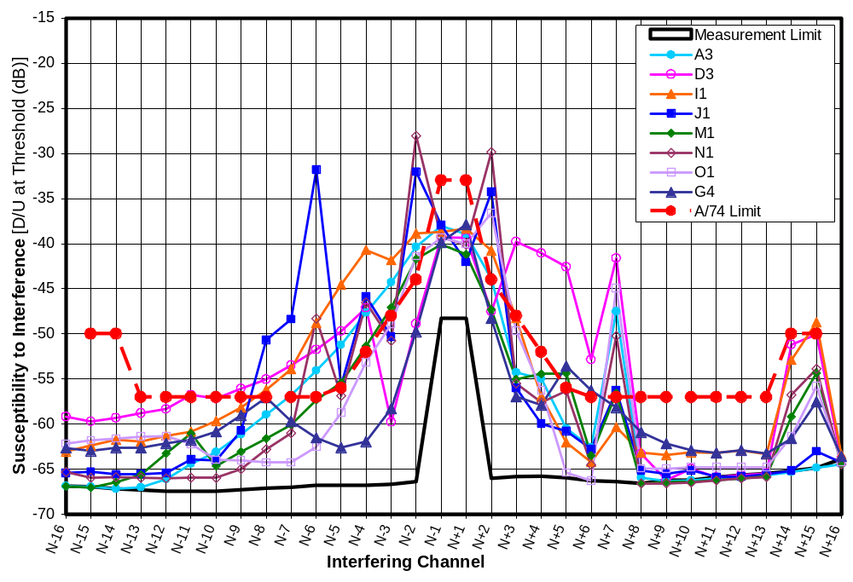
Figure 5-11. D/U of 8 Receivers at D = -68 dBm on Channel 30
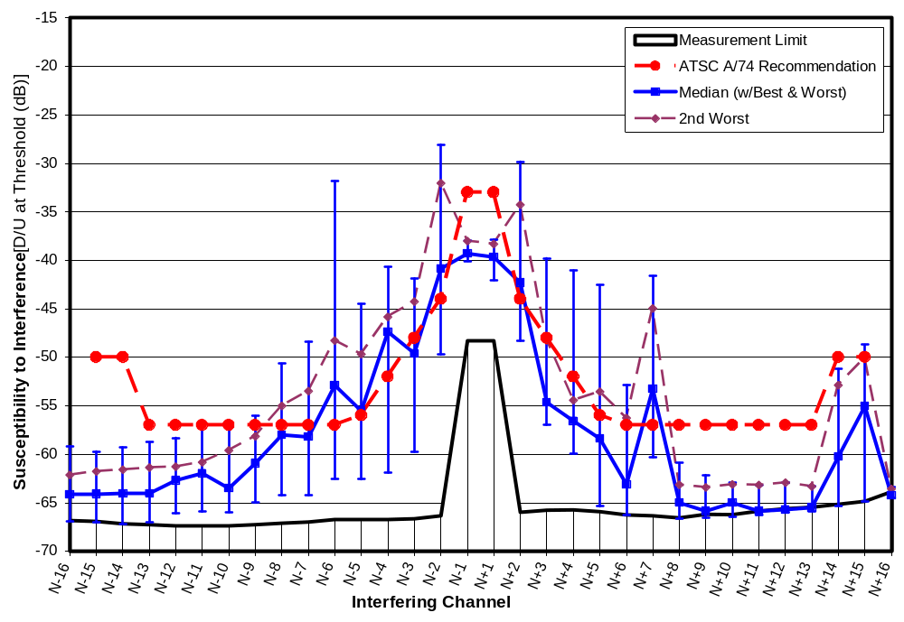
Figure 5-12. D/U Statistics at D = -68 dBm on Channel 30
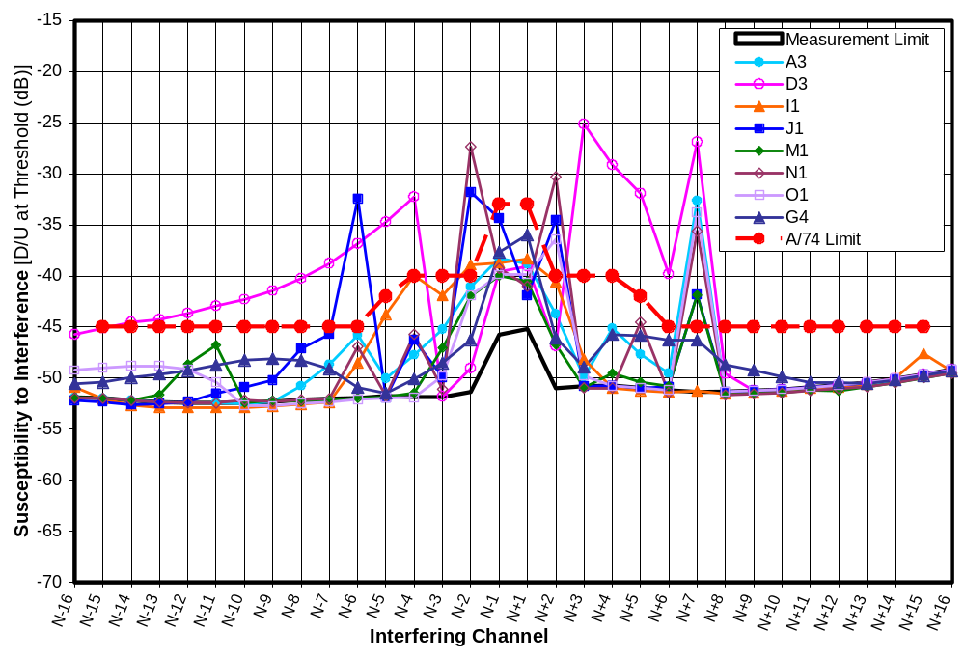
Figure 5-13. D/U of 8 receivers at D = -53 dBm on Channel 30
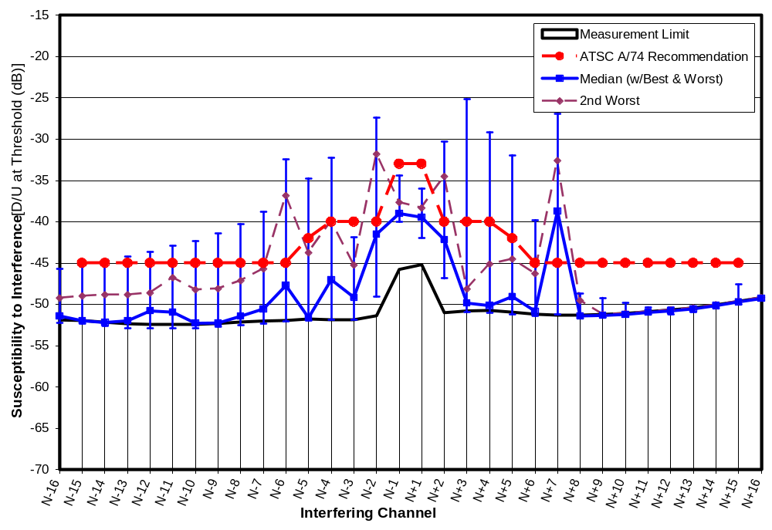
Figure 5-14. D/U Statistics at D = -53 dBm on Channel 30
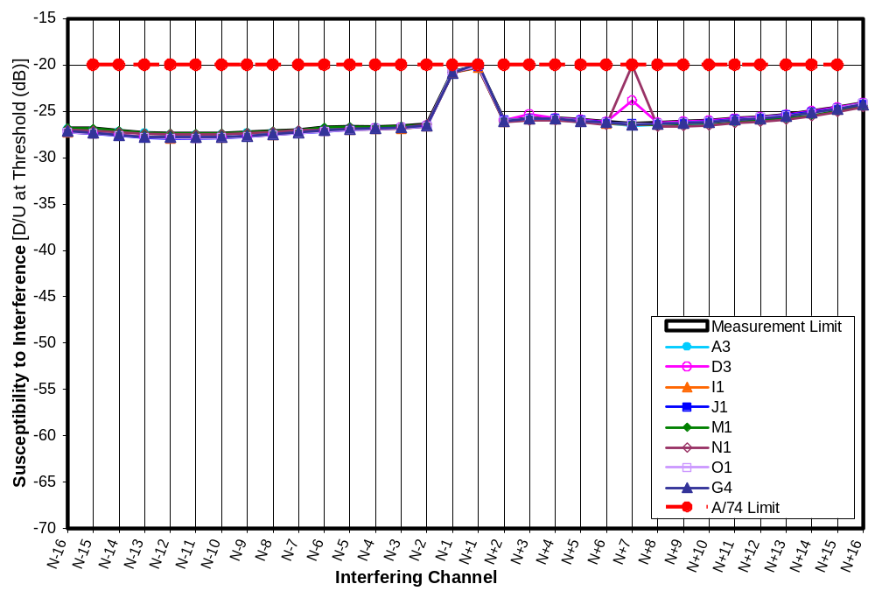
Figure 5-15. D/U of 8 receivers at D = -28 dBm on Channel 30
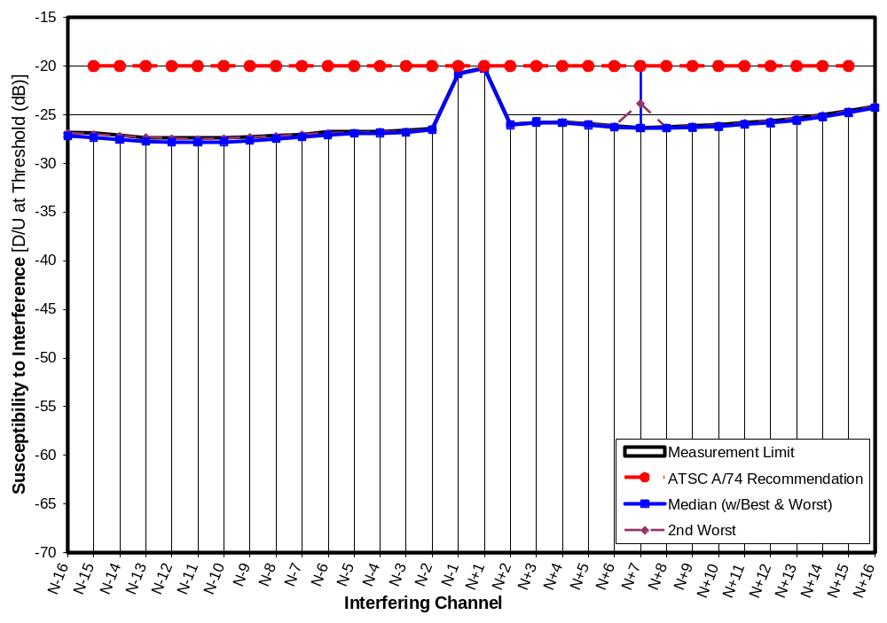
Figure 5-16. D/U Statistics at D = -28 dBm on Channel 30
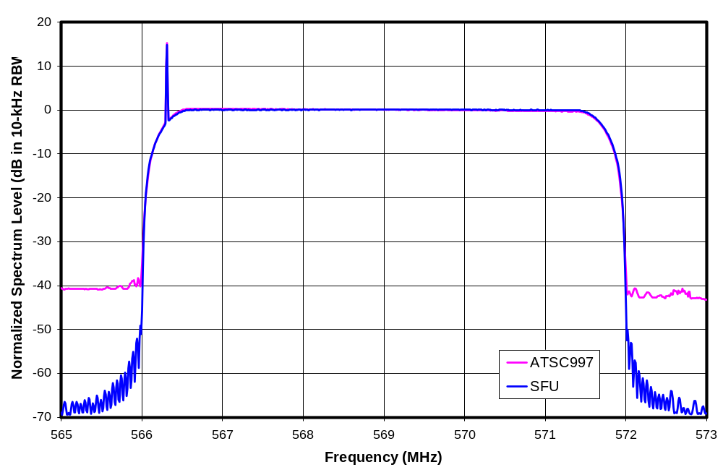
Figure 5-17. Spectra of Two Desired Signal Sources
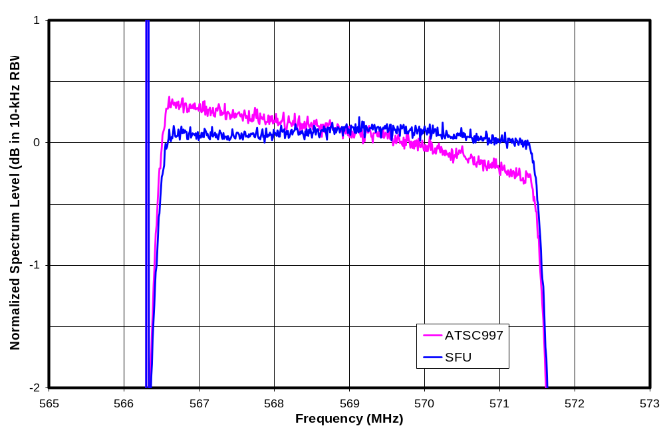
Figure 5-18. Spectra of Two Desired Signal Sources on Expanded Scale
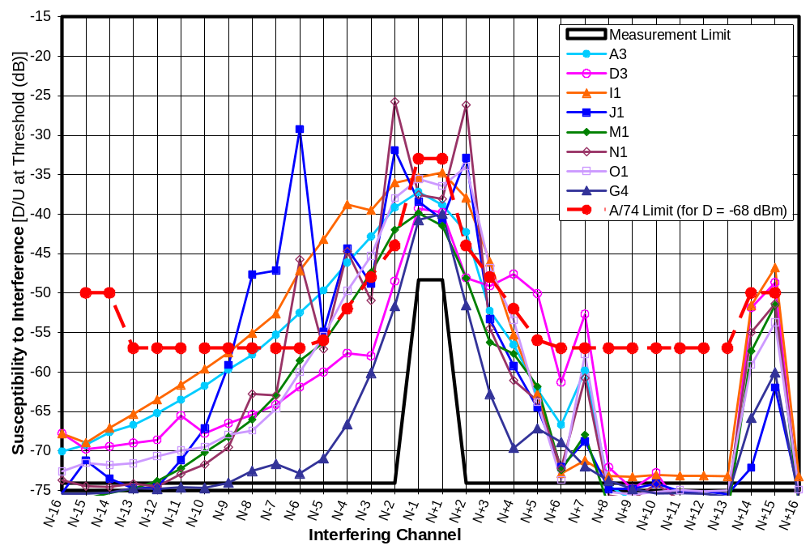
Figure 5-19. D/U of 8 receivers at D = D_{MIN} + 3 dB on Channel 30
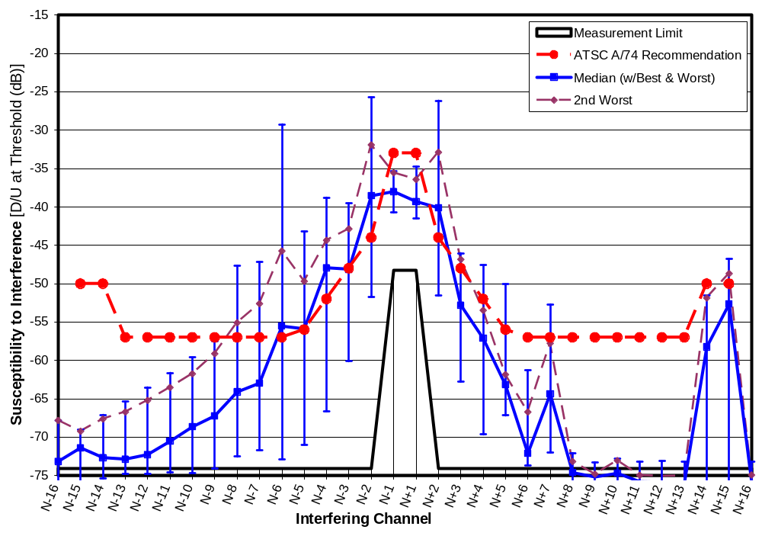
Figure 5-20. D/U Statistics at D = D_{MIN} + 3 dB on Channel 30

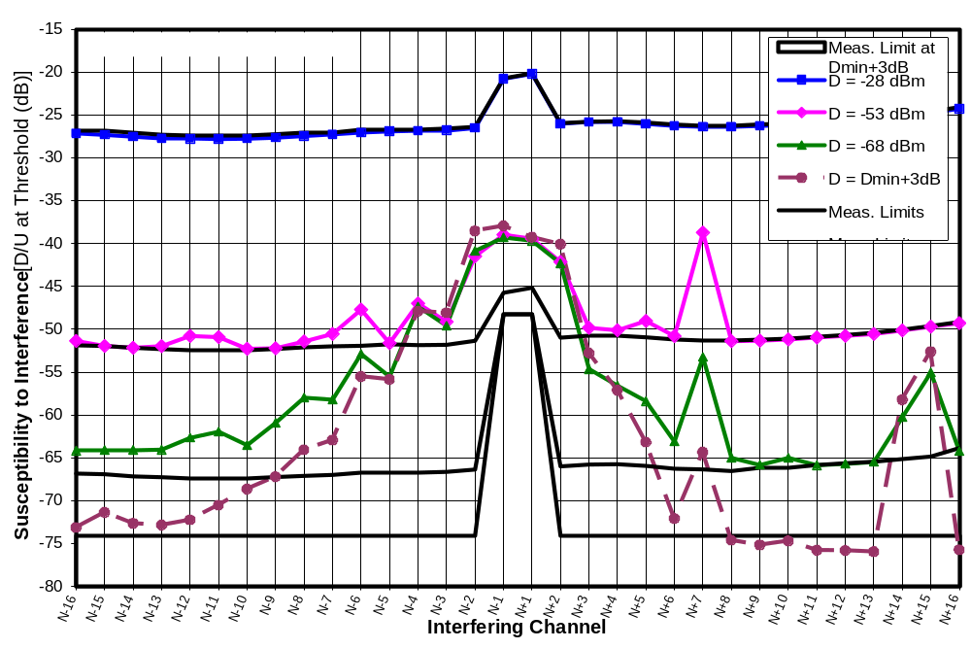
Figure 5-21. Median D/U of 8 receivers at Four Signal Levels on Channel 30
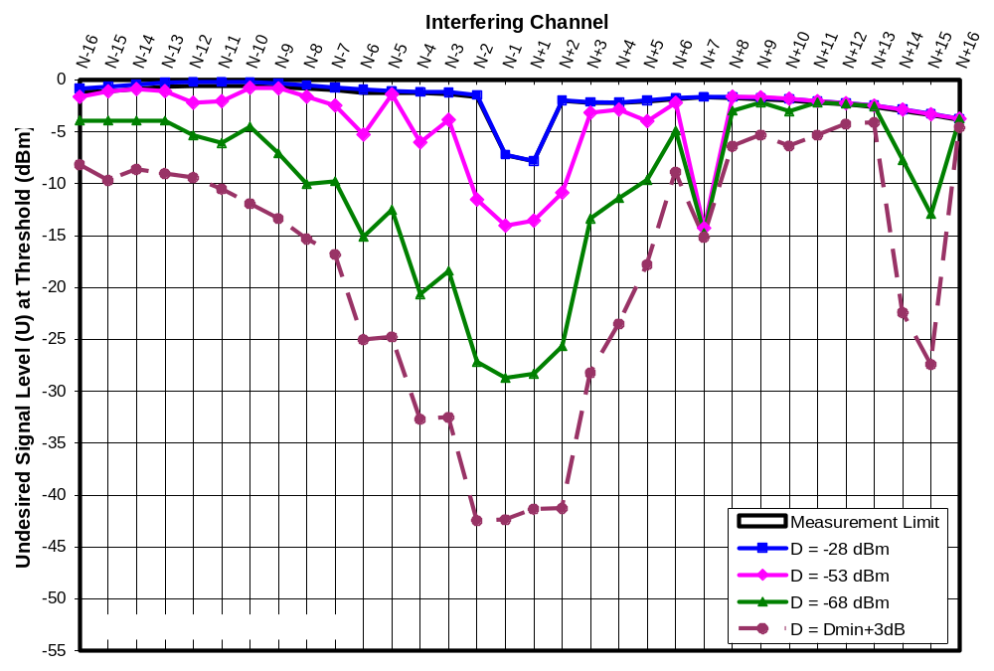
Figure 5-22. Median Threshold U of 8 receivers at Four Signal Levels on Channel 30
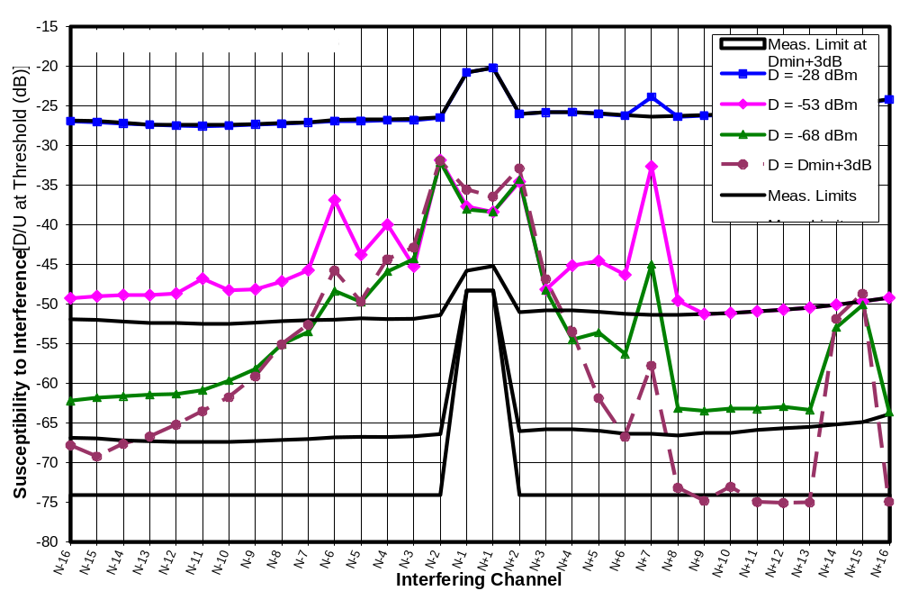
Figure 5-23. 2nd Worst D/U of 8 receivers at Four Signal Levels on Channel 30
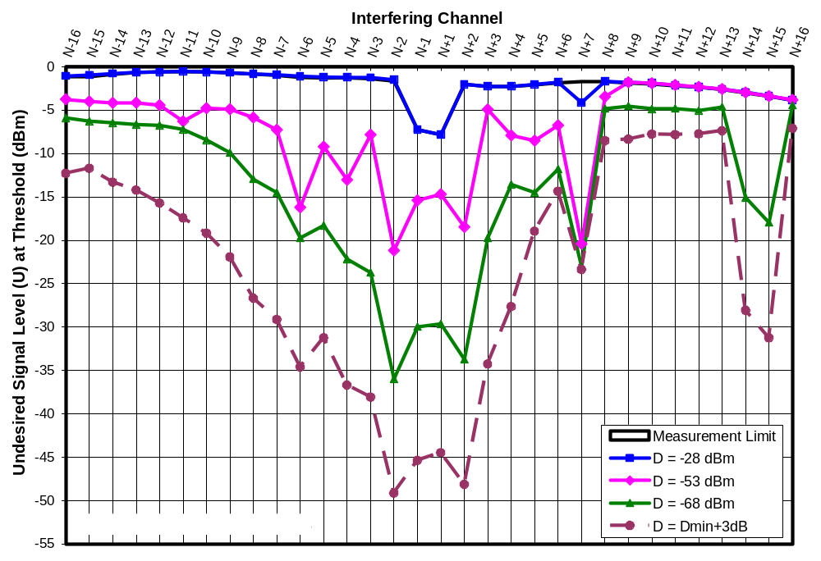
Figure 5-24. 2nd Worst Threshold U of 8 receivers at Four Signal Levels on Channel 30
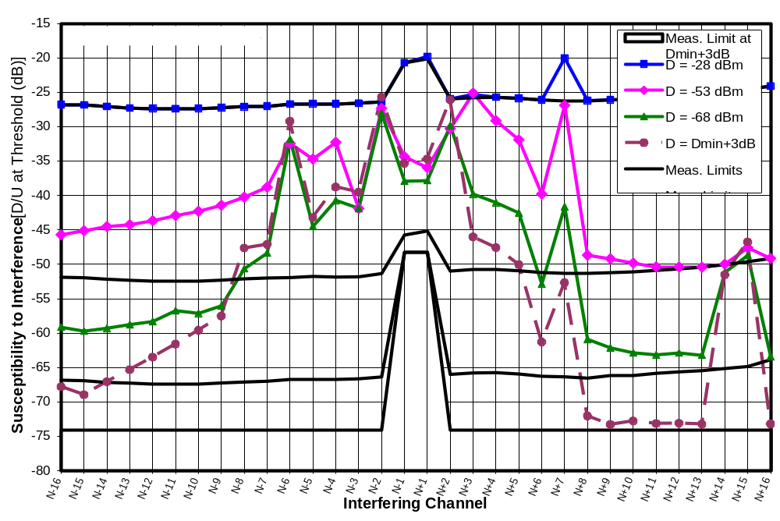
Figure 5-25. Worst D/U of 8 receivers at Four Signal Levels on Channel 30
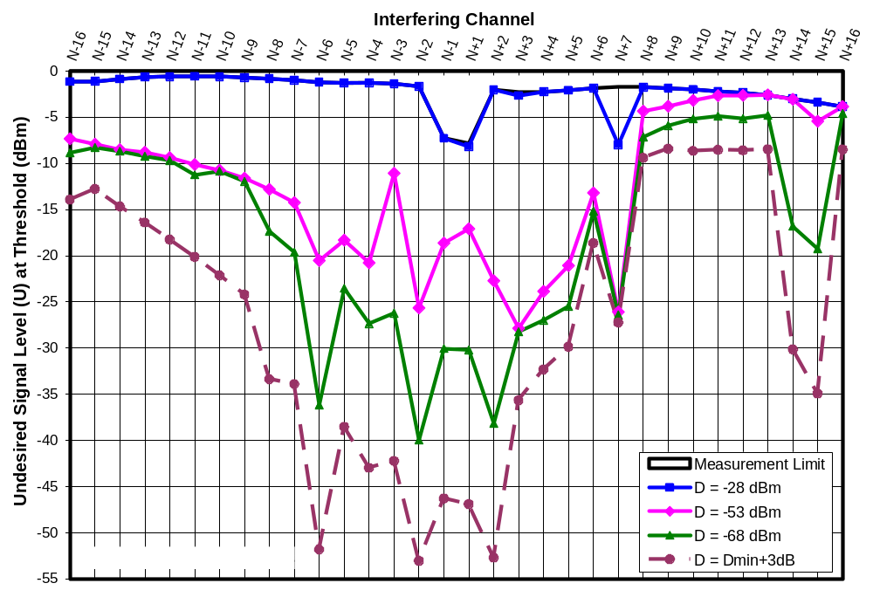
Figure 5-26. Worst Threshold U of 8 receivers at Four Signal Levels on Channel 30
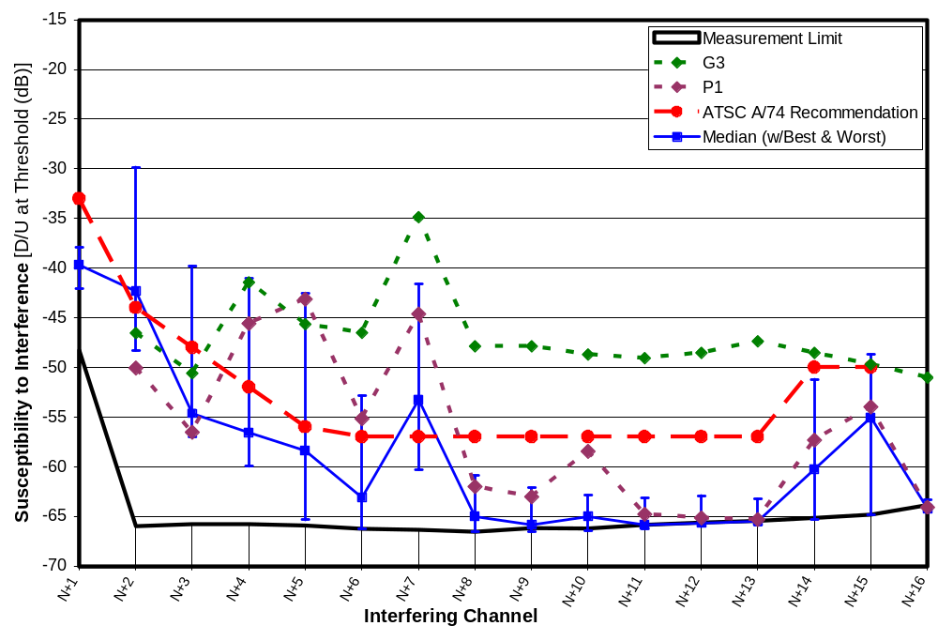
Figure 5-27. D/U of Two Earlier-Generation Receivers at D = -68 dBm Relative to Fifth-Generation Results

REJECTION RESULTS ON CHANNEL 51 FOR SINGLE 8-VSB INTERFERERS
This chapter presents the results of interference rejection tests of seven DTV receivers tuned to channel 51. The interferer for these tests was an 8-VSB signal placed sequentially on channels N+1 through N+16. The tested receivers comprise seven of the eight receivers that were tested for Chapter 5. Tests on one of the seven receivers were not completed due to equipment failure. (Note that presentation of detailed test results showing the variation of D/U with desired signal level for one TV receiver at channel 51 are postponed until Chapter 11.)

The channel-51 tests for this chapter occurred chronologically before those on channel-30, described in Chapter 5. The primary focus of these tests was to investigate interference susceptibility of DTV receivers operating in the upper UHF core channels to interference from future services to be offered in spectrum currently assigned to television channels 52 through 67. Because of this focus, tests were limited to undesired signals above the desired channel.

Notwithstanding the above focus, an 8-VSB source was used as the undesired signal for all of these tests (unlike the tests in Chapter 5, which used an 8-VSB source only at N-1 and N+1 and used a bandlimited Gaussian noise source at all other channel offsets). That choice was based on the steep rolloff of the 8-VSB source at its channel edges and the lack of availability of surrogate devices representative of signals planned for use in channels 52 through 67.

Tests at ATSC-Specified Desired Signal Levels

“Weak” Desired Signal (D = -68 dBm)
Figure 6-1 shows measured values of D/U ratios at TOV for seven DTV receivers for undesired signal channels ranging from N+1 to N+16 with the desired signal power set to -68 dBm, the signal level that the ATSC designates as “weak”. The configuration of the plots is similar to those in Chapter 5, except for the single-sided range of channel offsets, so the reader is referred to the corresponding section of that chapter for further explanation of the format.

The ATSC-recommended DTV-into-DTV interference rejection thresholds are shown on the plot as a reference. Compliance with those voluntary limits would be indicated by all points on each measurement curve falling on or below the ATSC line. For the desired signal level of -68 dBm, only one of the receivers (M1) fully complies with the guidelines. Receiver D3 fails to comply at seven of the sixteen tested channel offsets. The other receivers fail to comply at from one to three of the channel offsets. The N+7 channel offset seems to offer the most challenge in that five of the receivers failed to comply with the guidelines at that offset. We note that these measurements are directly comparable to the ATSC performance guidelines since they were made with an 8-VSB signal as the undesired signal.

The measurements on the seven receivers for the first adjacent channel (N+1) are closely clustered, and all satisfy the ATSC guidelines. The second-adjacent channel results (N+2) are much more scattered—with three of the receivers failing to meet the ATSC guidelines and actually exhibiting more susceptibility to interference at N+2 than at N+1.

Figure 6-2 shows the best, median, second worst, and worst performance at each channel offset. On a median basis the only failure to satisfy the ATSC recommended performance is at N+7.

“Moderate” Desired Signal (D = -53 dBm)
Figure 6-3 shows measured values of D/U ratios at TOV for the same seven DTV receivers with the desired signal power set to -53 dBm, the signal level that the ATSC designates as “moderate”. None of the receivers comply with the performance guidelines at all channel offsets. Again, N+7 appears to be the most challenging channel offset in that six of the seven receivers failed to comply at that offset. Receiver D3 was, again, the poorest performer—failing to comply with the guidelines at five of the sixteen tested channel offsets. The other receivers failed to comply at one or two channel offsets.

Figure 6-4 shows the best, median, second worst, and worst performance at each channel offset. On a median basis the only failure to satisfy the ATSC recommended performance is at N+7.

“Strong” Desired Signal (D = -28 dBm)
Figure 6-5 shows that, with the desired signal set to the level that the ATSC designates as “strong”, every receiver complied with the ATSC guidelines. Since the measurement limit was close to the ATSC guidelines, almost all of the measurements fell at the measurement limit (i.e., the test setup was not capable of generating a strong enough undesired signal to cause interference.)

Figure 6-6 shows the corresponding statistical data.

Comparison to Channel-30 Results
Figures 6-7 and 6-8 compare the median D/U measurements on channel 30 with those on channel 51 for desired signal levels of -68 dBm and -53 dBm, respectively, for the seven DTV receivers that were tested on channel 51. (Note that the medians for channel 30 shown in these two charts are for only seven receivers—in order to match the channel-51 test group. The channel-30 data in Chapter 5 includes an eight receiver.) The largest differences among points that were measurable were 5 dB at N+15 (mixer image frequency) and 4 dB at N+2; both of those measurements indicate better performance at channel 51 than at channel 30 (perhaps surprisingly). For all other measurements, the match between channels was within about 2 dB or less.

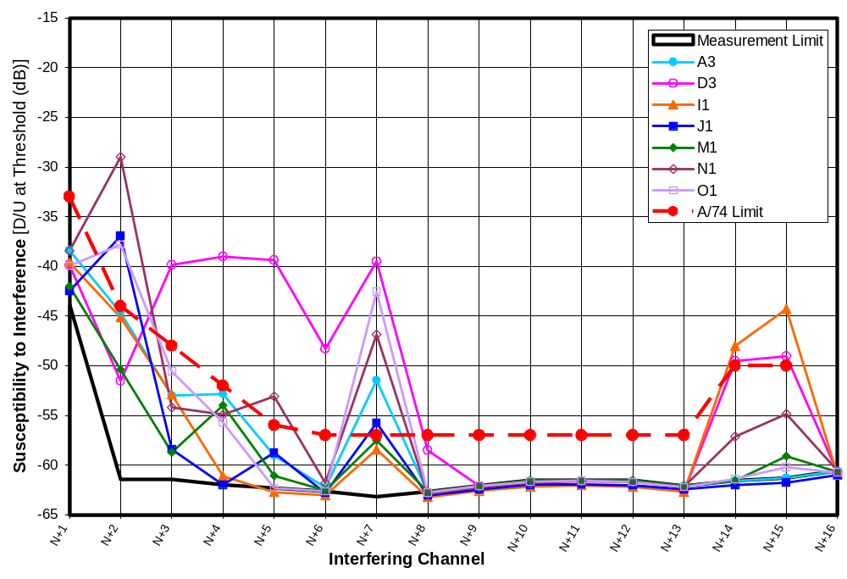
Figure 6-28. D/U of 7 Receivers at D = -68 dBm on Channel 51
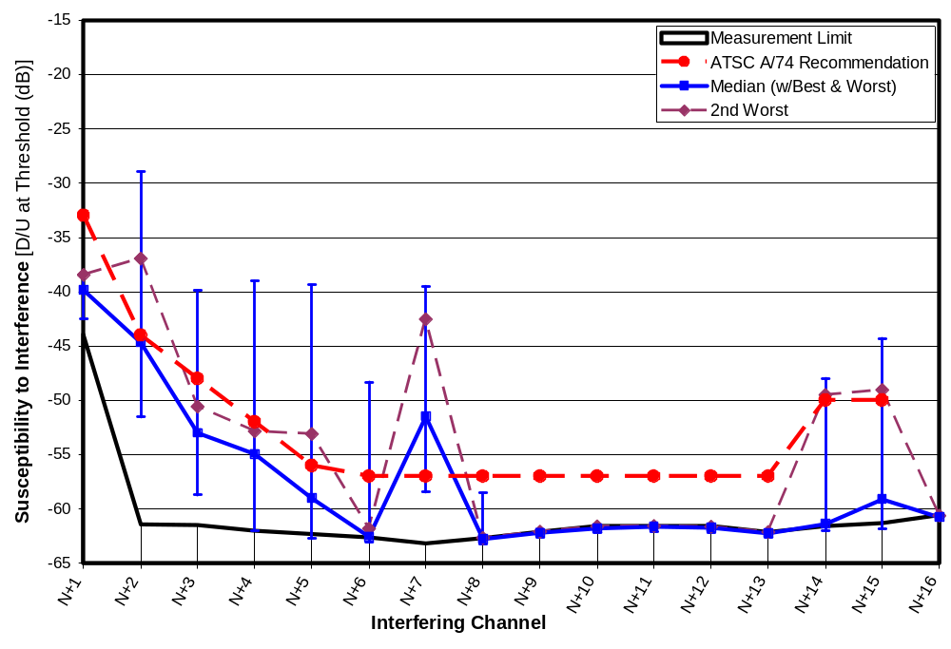
Figure 6-29. D/U Statistics at D = -68 dBm on Channel 51
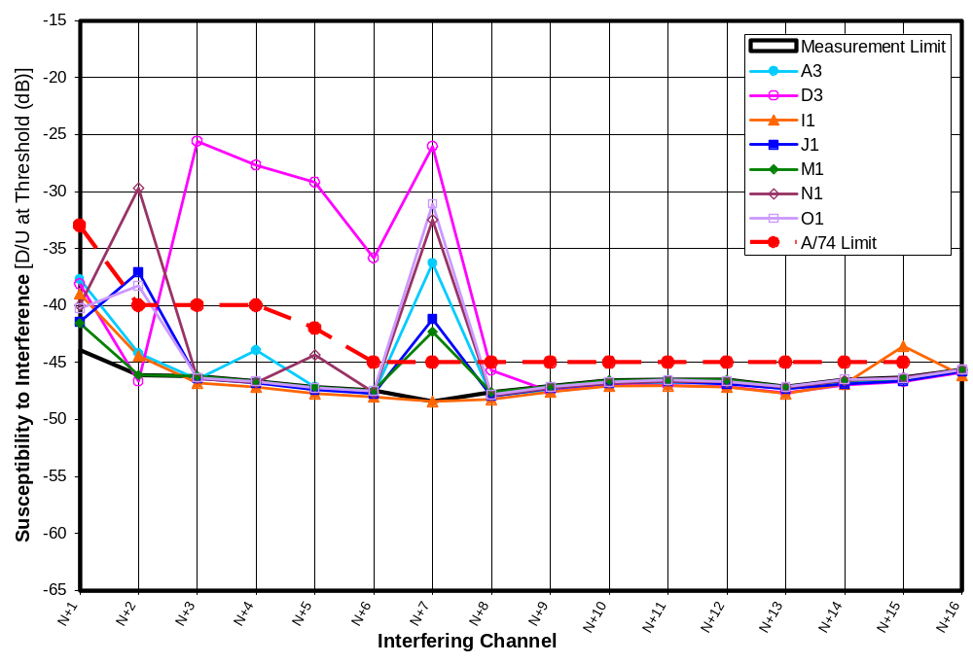
Figure 6-30. D/U of 7 Receivers at D = -53 dBm on Channel 51
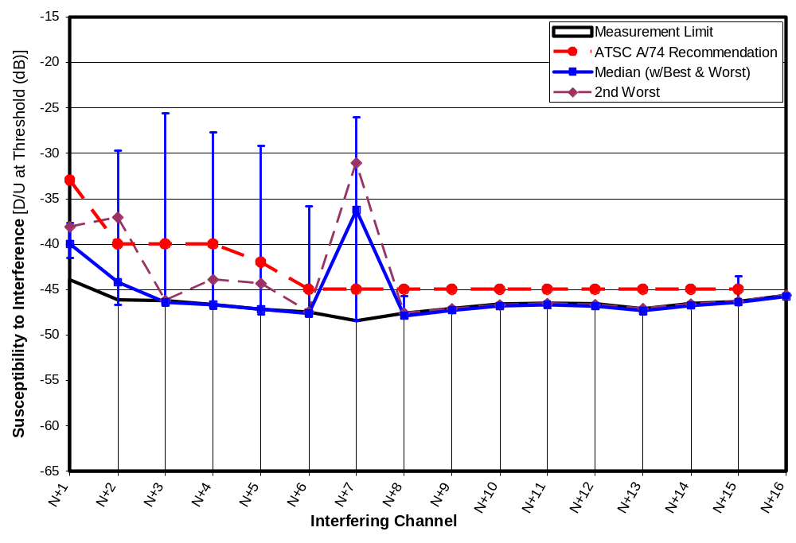
Figure 6-31. D/U Statistics at D = -53 dBm on Channel 51
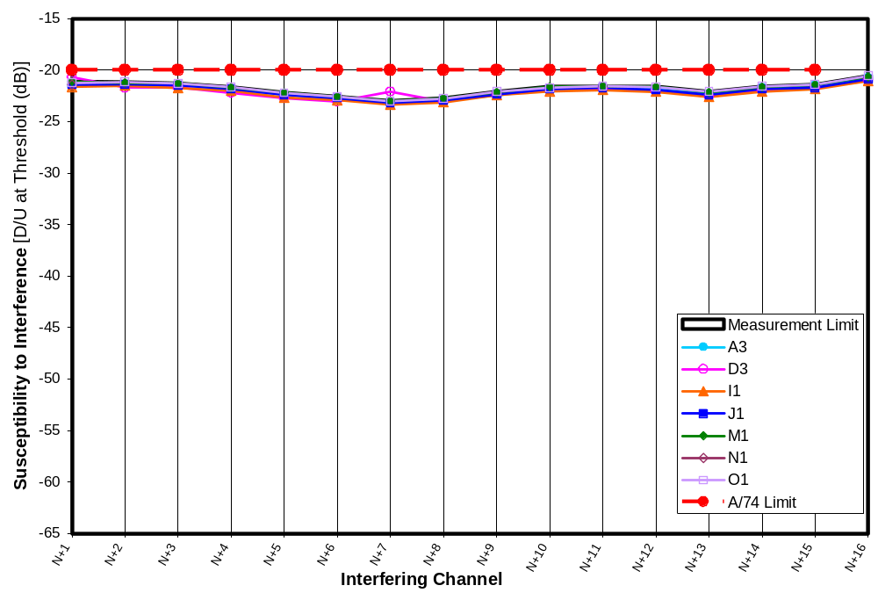
Figure 6-32. D/U of 7 Receivers at D = -28 dBm on Channel 51
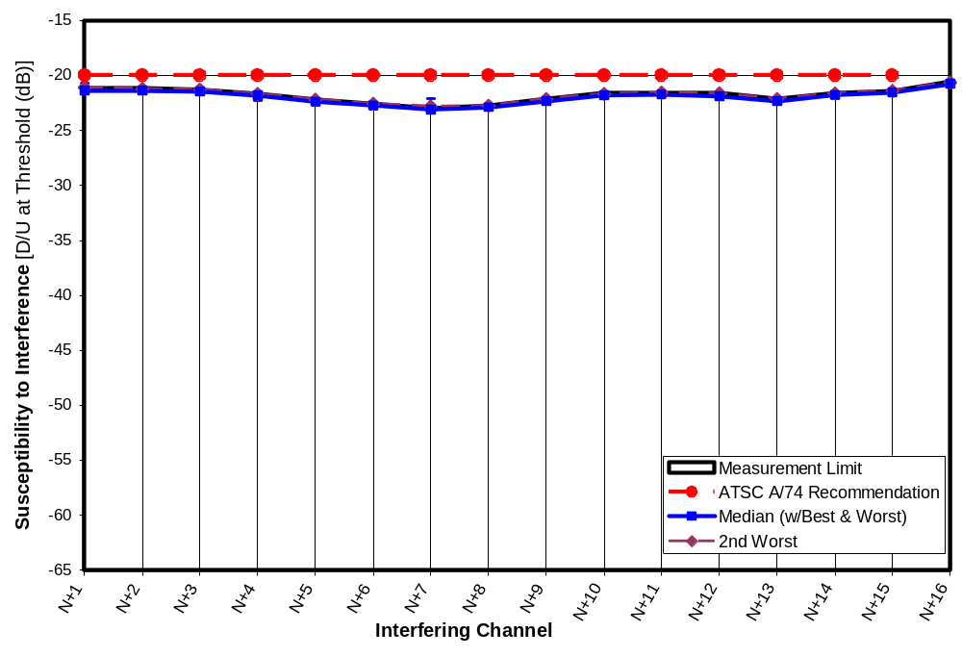
Figure 6-33. D/U Statistics at D = -28 dBm on Channel 51
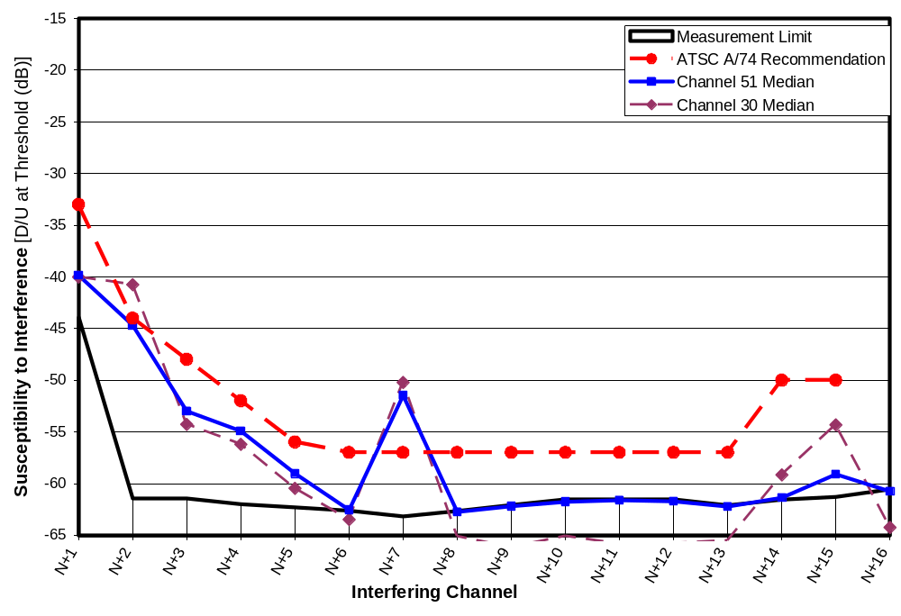
Figure 6-34. Comparison of Median D/U for 7 Receivers on Channels 30 and 51 at D = -68 dBm
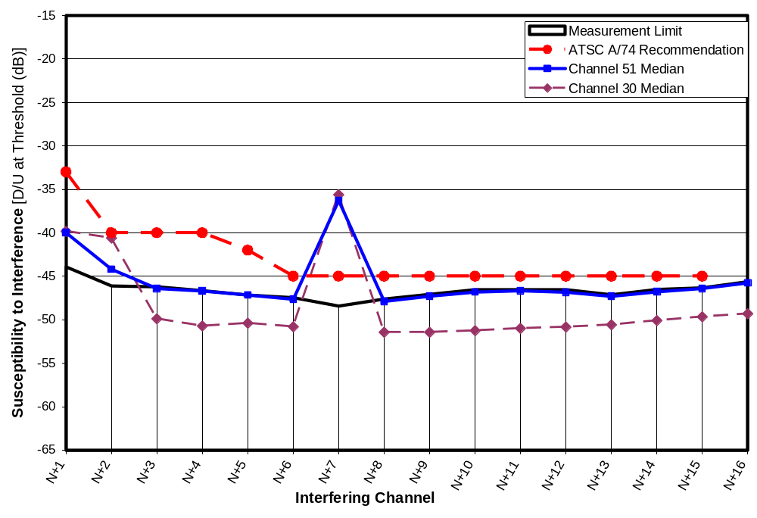
Figure 6-35. Comparison of Median D/U for 7 Receivers on Channels 30 and 51 at D = -53 dBm

TESTS WITH DIFFERENT SIGNAL TYPES AND SOURCES
This chapter presents the results of tests performed to determine the influence of test signal sources and signal types on the interference rejection performance of DTV receivers. Specifically, the tests compare the following:
Effect of two different 8-VSB signal generators as the desired signal;
Effect of several types of undesired signals, including
White Gaussian noise bandlimited to the 3-dB width of an 8-VSB source;
8-VSB;
DVB-H—an orthogonal frequency division multiplexing (OFDM) signal—set for a 5-MHz channel width; and
White Gaussian noise bandlimited to a 3-dB width of 1 MHz.
In addition, the tests include a repeat of the baseline test conditions (described below) to determine the amount of variation that may have been due to repeatability or equipment changes (spectrum analyzer). All of the tests discussed in this section were performed with the desired signal on channel 30 and set to a level of -68 dBm.

Spectra and bandwidths of the various sources can be found in Chapters 2 and 5. Figures 2-1 and 2-2 show spectra of the four undesired signals; bandwidths characteristics are shown in Table 2-1. Figures 5-7 and 5-8 show spectra of the two desired signal sources.

The baseline for comparison is:
Desired signal source—Sencore ATSC997;
Undesired signal type—white Gaussian noise (from an Agilent E4437B vector signal generator) bandlimited to match the 3-dB width of an 8-VSB signal.

The 1-MHz bandwidth tests were performed on one DTV receiver (N1) for channel offsets from N-16 to N+16. All other tests were performed on all eight DTV receivers, but were limited to the five non-adjacent channel offsets that exhibited the most interference potential among the receivers at low signal levels (Figure 5-16): N+2, N-2, N-3, N-4, and N-6. (Note that channels N-1 and N+1 were not tested because the Gaussian source did not have adequate band-edge rolloff to permit testing on first-adjacent channels.)

The baseline tests, a subset of the measurements presented in Chapter 5, were performed between August 30 and October 23, 2006. The comparative tests presented here, including the “repeat baseline” test, were performed between January 31 and February 6, 2007.

The results for all tests except the 1-MHz bandwidth tests are summarized in Table 7-1. Individual results are presented in each section. Results for the 1 MHz tests are in the next section of this chapter.

Table 7-1 shows the means and standard deviations for the differences in D/U measurements between a “comparative test” configuration and the baseline configuration. The statistics are based on 35 measured values (7 receivers X 5 channel offsets), except in the case of the DVB-H signal, where 34 measurements were used for reasons explained in the DVB-H section below. The standard deviations shown are for the individual differences; standard deviation of the mean would be reduced from this by a factor of square-root of 34 or 35 (5.8 or 5.9) if the individual differences can be considered independent. Results are shown in hundredths of a dB to reduce round-off error, although D/U measurement resolution was 0.1 dB since the measurements were made by stepping the undesired signal in increments of 0.1 dB to locate the receiver’s TOV.

Table 7-13. Comparative Signal Test Summary
 |  | Signals |  | D/U Ratio Relative to Baseline (dB)
Test Case | Test Dates | Desired Signal Source | Undesired Signal | Mean | Standard Deviation
Baseline | 8/30/2006 – 10/23/2006 | ATSC997 | WGN | 0 | N/A
Repeat Baseline | 2/02/2007 – 2/05/2007 | ATSC997 | WGN | -0.12 | 0.33
SFU as D | 1/31/2007 – 2/1/2007 | SFU | WGN | -1.14 | 0.40
8-VSB as U | 2/06/2007 – 2/07/2007 | ATSC997 | 8-VSB | -1.28 | 0.68
DVB-H OFDM as U | 2/05/2007 – 2/06/2007 | ATSC997 | DVB-H | -0.40  (-0.25*) | 1.09  (0.66*)
Notes:
WGN = White Gaussian noise bandlimited to 5.38 MHz 3-dB width.
The means and standard deviations were across five channel offsets and seven receivers—a total of 35 measurements, except results marked “*” are for 34 measurements. Measurement results for receiver G4 were not included in these statistics for reasons discussed in the section of this chapter entitled, “Desired Signal Source: SFU Versus ATSC997”

The “repeat baseline” test results differed from the baseline test results by an average of only 0.12 dB—a reassuringly small difference given the four-month delay and spectrum analyzer change between the baseline and “repeat baseline”. Though the results in the table are presented relative to the original baseline tests, we can use the newer “repeat baseline” as the point of reference by subtracting -0.12 dB from the means. Doing so, we find the following.
Use of the SFU as the desired signal source resulted in D/U ratios that were 1.0 dB lower (better) than were achieved with the ATSC997 (the source used for most of the tests presented in this report). Thus the DTV receivers could tolerate about 1.0 dB more interference when the SFU was the desired signal source. This suggests that the ATSC997 may have had a slightly degraded performance that affected the results, at topic that was discussed in Chapter 5.
An 8-VSB interferer results in D/U ratios that are 1.2 dB lower than those measured with a bandlimited white Gaussian noise interferer. Thus, the TV’s are 1.2 dB less susceptible to out-of-band interference from an 8-VSB DTV signal than from a Gaussian-noise signal of comparable bandwidth.
The OFDM DVB-H signal causes an interference effect comparable to that of bandlimited Gaussian noise based on the mean listed in parentheses in the table; this mean omits one measurement (in addition to those of receiver G4) for reasons discussed in the DVB-H section of this chapter.

The results of tests with the reduced-bandwidth interferer are presented in the next section followed by detailed results of the tests described above.

1-MHz Bandwidth Undesired Signal
Most tests performed for this report involved undesired signals that filled, or nearly filled, a 6-MHz wide TV channel. Interference rejection tests were also performed on one DTV receiver (receiver N1) using a reduced-bandwidth source to determine the effect of a narrower undesired signal spectrum. Specifically, a Gaussian noise signal with a 1-MHz 3-dB width was created using the same vector signal generator that was used to generate 5.38-MHz wide Gaussian noise signal. Spectral plots were shown in Figures 2-1 and 2-2.

The interference rejection measurements were performed with the 1-MHz bandwidth undesired signal centered on each channel from N-16 to N+16, except for channel N. In addition, where the 8-VSB-width source had identified interference vulnerabilities, tests were performed with the 1-MHz wide source stepped in 1-MHz or 2-MHz steps to look for finer frequency dependence of the vulnerability. The desired signal was set to -68 dBm.

Figure 7-1 shows the threshold D/U ratio measurements for the 1-MHz wide Gaussian noise source along with the results (from Chapter 5) for the 5.38-MHz-wide baseline source. (The baseline source was a Gaussian noise source bandlimited to match the 3-dB width of an 8-VSB signal, except that for N-1 and N+1, an actual 8-VSB source was used in order to achieve band-edge characteristics adequate for adjacent channel testing.) Though measurements were made from N-16 to N+16, the plot is limited to a range over which the 1-MHz width tests yielded D/U ratios that were above the measurement limit; consequently, the plot extends from channel N-9 through the center point of channel N+16. Vertical gridlines correspond to the boundaries between TV channels.

N+7 Interference
In general the two plots in Figure 7-1 track each other reasonably well except where narrowband vulnerabilities are apparent. One point of interest is the interference susceptibility peak at N+7. The 1-MHz data shows high susceptibility when the undesired signal is centered at 44 MHz, but no measurable interference susceptibility at 43 or 45 MHz (or elsewhere within channel N+7). Based on the bandwidth ratio of the two signal sources (5.38 MHz / 1 MHz), one would expect the 1-MHz wide signal to have a 7.3 dB greater power spectral density than the 5.38 MHz wide signal used for the baseline tests when the power levels are the same. This closely matches the 6.7 dB difference in D/U peaks in N+7 for the two signal bandwidths.

It appears that N+7 interference is seen only when the undesired signal overlaps the receiver’s local-oscillator frequency, 44 MHz above the center of the channel to which the DTV receiver is tuned. Our initial hypothesis for the cause of the N+7 peak in the previous D/U plots was that the undesired signal was acting as a noise-like local oscillator—beating with the desired signal and creating a mixer product that falls within the IF frequency of the TV. Such a mechanism would not result in the narrow sensitivity spike observed here. Rather, the interference mechanism apparently involves interaction between the DTV receiver’s local oscillator and the incoming undesired signal when the spectrum of the incoming signal overlaps the local oscillator frequency.

Desired Signal Source: SFU Versus ATSC997
Test results described in Chapter 5, in the section entitled “Effect of Desired Signal Source”, demonstrate that, with no undesired signals present, DTV receivers could operate at a lower desired signal level when the desired signal was supplied by a newer, higher-quality 8-VSB signal source (the Rohde and Schwarz SFU acquired by the FCC late in this measurement program) than when it was supplied by the Sencore ATSC997, the source that supplied the desired signal for most of the measurements presented in this report (and the only 8-VSB signal source available at the Laboratory during most of the channel-30 test period). That section of Chapter 5 also presents the results of signal quality tests, such as modulation error ratio, on each of the two sources.

The tests presented here look at the effect of the desired signal source on susceptibility to interference. Specifically, interference rejection measurements were performed with a desired signal level of -68 dBm on channel 30 supplied by each of the two signal generators.

Table 7-2 shows the D/U ratios measured with the SFU as the desired signal source relative to the baseline measurements made with the ATSC997 as the source. The table also includes means and standard deviations calculated across channel offsets (statistics computed on five measurements) for each DTV receiver, across DTV receivers except for receiver G5 (statistics computed on seven measurements), and across both the channel offsets and receivers (statistics computed on 35 measurements).

Table 7-14. D/U Ratio With SFU as Desired Signal Source Relative to That With Baseline Generator (ATSC997)
Channel Offset | D/U Ratio Relative to Baseline (dB) |  |  |  |  |  |  |  | Mean (dB) (Excluding G4) | Standard Deviation (dB) (Excluding G4)
Channel Offset | A3 | D3 | I1 | J1 | M1 | N1 | O1 | G4 | Mean (dB) (Excluding G4) | Standard Deviation (dB) (Excluding G4)
N-6 | -1.37 | -0.01 | -1.54 | -1.42 | -1.39 | -1.96 | -1.29 | -6.29 | -1.28 | 0.60
N-4 | -1.15 | -0.11 | -1.00 | -1.44 | -1.16 | -1.51 | -1.03 | -5.16 | -1.06 | 0.46
N-3 | -1.03 | -0.88 | -0.98 | -0.57 | -1.10 | -1.50 | -1.06 | -5.70 | -1.02 | 0.28
N-2 | -1.21 | -0.56 | -0.96 | -1.63 | -1.14 | -1.42 | -0.90 | -4.82 | -1.12 | 0.35
N+2 | -1.28 | -1.50 | -1.27 | -1.44 | -0.75 | -1.30 | -1.12 | -4.49 | -1.24 | 0.25
Mean | -1.21 | -0.61 | -1.15 | -1.30 | -1.11 | -1.54 | -1.08 | -5.29 | -1.14
Std Dev | 0.13 | 0.61 | 0.25 | 0.42 | 0.23 | 0.25 | 0.14 | 0.72 |  | 0.40
Note:
The overall means and standard deviations (lower right corner of the chart) omitted data for receiver G4 for reasons discussed in the text.

Overall, the SFU measurements differed from the baseline measurements by an average of about -1.1 dB (excluding receiver G4), indicating that the receivers were slightly less susceptible to out-of-channel interference when looking at a desired signal from the SFU as opposed to the ATSC997. This difference reduces to -1.0 dB if the newer “repeat baseline” mean is subtracted. A difference of 1 dB in an individual measurement having a 0.4 dB standard deviation is large enough to suggest a statistically significant difference. If the measurement differences were deemed independent of one another, the standard deviation of the mean would be reduced by a factor of square-root of 35 (i.e., 5.9) to less than 0.1 dB. The size of the 1-dB mean difference relative to this computed standard deviation provides strong evidence that this is a real difference rather than a statistical artifact. Other measurements, presented in Chapter 5, support the notion that there is a real difference between the signal sources that influences the performance of DTV receivers.

Except for the tests with receiver G4, there appears to be no major trend across the receivers or the channel offsets.

The measurements for receiver G4 were dramatically different from those for the other receivers. The change in signal sources appeared to have a 5 dB effect on D/U ratios for that receiver; however, when the “repeat baseline tests” were performed (the next section of this chapter), the measurements on receiver G4 were performed twice with results differing by as much as 6 dB for one of the channel offsets. Furthermore, when receiver threshold without interference (D_{MIN}) had been measured as part of the D_{MIN}+3 dB measurements presented in Chapter 5, D_{MIN} measurements on consecutive days yielded results differing by 5.4 dB. Later, in measuring intermodulation effects with pairs of undesired signals of unequal power, another discrepancy of about 6 dB arose for that receiver. No other receiver exhibited such variations. Although receiver G4 is the best-performing receiver tested (in terms of interference rejection capabilities), there appears to be something intermittent or variable in its performance. Consequently, results for G4 were omitted from the overall mean and standard deviation data presented in this chapter.

The results suggest that degraded signal quality from the ATSC997 reduces the receiver’s available margin to handle interference. Signal quality measurements presented in Chapter 5 did show that the signal from the ATSC997 is inferior to that from the ATSC997, but we are unable to identify a signal quality measurement low enough to explain the performance differences of the TV receivers.

Repeat Baseline Test
We wanted to determine whether the 1-dB change in D/U ratio discussed in the previous section was actually related to the change in signal sources or whether it might have been caused by some aspect of the test setup. A different spectrum analyzer was used for the comparative tests than for the baseline tests. Also, the baseline tests had been performed about four months earlier than the comparative tests, so it was plausible that some other unintended change in the equipment setup or performance might have contributed to the observed change.

To rule out such equipment and test-setup issues the baseline tests were repeated. Table 7-3 shows the results. The repeat test produced results that, on average, differed from the original measurements by only about 0.1 dB. The standard deviation of those differences was 0.33 dB. This agreement between the four-month old baseline data and new measurements is considered quite good.

Table 7-15. D/U Ratio for Repeat of Baseline Test Relative to Baseline
Channel Offset | D/U Ratio Relative to Baseline (dB) |  |  |  |  |  |  |  |  | Mean (dB) (Excluding G4) | Standard Deviation (dB) (Excluding G4)
Channel Offset | A3 | D3 | I1 | J1 | M1 | N1 | O1 | G4 | G4 again | Mean (dB) (Excluding G4) | Standard Deviation (dB) (Excluding G4)
N-6 | -0.73 | 0.01 | 0.00 | 0.02 | -0.48 | -0.27 | -0.11 | -6.23 | -0.23 | -0.22 | 0.29
N-4 | -0.69 | 0.11 | 0.50 | 0.13 | -0.36 | -0.22 | -0.01 | -3.37 | -0.09 | -0.08 | 0.39
N-3 | -0.47 | -0.68 | 0.15 | 0.06 | -0.26 | -0.44 | 0.10 | 0.14 | 0.63 | -0.22 | 0.33
N-2 | -0.31 | -0.21 | 0.33 | 0.00 | -0.04 | -0.15 | 0.12 | 0.68 | 0.19 | -0.04 | 0.22
N+2 | 0.06 | -0.90 | -0.03 | 0.15 | 0.44 | -0.01 | 0.13 | -0.28 | 0.36 | -0.02 | 0.42
Mean | -0.43 | -0.33 | 0.19 | 0.07 | -0.14 | -0.22 | 0.05 | -1.81 | 0.17 | -0.12
Std Dev | 0.32 | 0.44 | 0.22 | 0.07 | 0.36 | 0.16 | 0.10 | 2.93 | 0.34 |  | 0.33
Note:
The overall means and standard deviations (lower right corner of the chart) omitted data for receiver G4 for reasons discussed in the section of this chapter entitled, “Desired Signal Source: SFU Versus ATSC997”.

Results for receiver G4 were omitted from the statistics presented in the previous paragraph for reasons described in the previous section. The measurements shown in the “G4” column were made on a Friday. G4 was measured again (“G4 again” column) on the following Monday with significantly different results.

Undesired Signal Type: 8-VSB Versus Bandlimited Gaussian Noise
Table 7-4 shows the effect of using an 8-VSB signal instead of bandlimited white Gaussian noise as the undesired signal. On average, the TVs are 1.3 dB less susceptible to interference from a DTV 8-VSB signal than from white Gaussian noise bandlimited to the same 3-dB bandwidth. The difference reduces to 1.2 dB when the newer baseline measurements are used as the reference. Given that the standard deviation of the mean is expected to be much less than the 0.68 dB value for individual measurements (by a factor of 5.9, if individual differences were statistically independent), the observed difference appears to be real, rather than a statistical artifact.

The reason for the difference could be related to the amplitude statistics of the respective waveforms. An 8-VSB waveform is likely to exhibit fewer and smaller amplitude extremes (i.e., less time spent at levels far above the average power) than a Gaussian noise signal. For linear interference mechanisms, the interference signal (within the TV) is linearly related to the incoming undesired signal, and the interference power (within the TV) is related to the mean-square of that signal (i.e., the second-order moment). For a third-order interference mechanism on the other hand, the interference signal in the TV is related to the cube of the incoming undesired signal, and the interference power in the TV is related to the 6th-order moment of the undesired signal. We consider it likely that the high order moments of an 8-VSB signal are lower than those for a Gaussian noise signal (or for an OFDM signal) of the same power.

Table 7-16. D/U Ratio With 8-VSB as Undesired Signal Relative to That with Bandlimited Gaussian Noise
Channel Offset | D/U Ratio Relative to Baseline (dB) |  |  |  |  |  |  |  | Mean (dB) (Excluding G4) | Standard Deviation (dB) (Excluding G4)
Channel Offset | A3 | D3 | I1 | J1 | M1 | N1 | O1 | G4 | Mean (dB) (Excluding G4) | Standard Deviation (dB) (Excluding G4)
N-6 | -1.32 | -1.25 | -1.61 | -0.73 | -1.85 | -0.87 | -1.76 | -3.72 | -1.34 | 0.43
N-4 | -1.31 | -1.43 | -0.92 | -1.07 | -1.66 | -1.07 | -0.87 | -1.94 | -1.19 | 0.29
N-3 | -0.79 | -1.85 | -2.23 | -1.73 | -1.50 | -2.38 | -1.47 | -0.26 | -1.71 | 0.53
N-2 | -0.76 | -1.94 | -2.31 | -0.53 | -1.31 | -0.91 | -0.71 | -0.89 | -1.21 | 0.68
N+2 | 0.02 | -2.99 | -1.94 | -0.48 | -0.04 | -0.67 | -0.40 | 0.50 | -0.93 | 1.12
Mean | -0.83 | -1.89 | -1.80 | -0.91 | -1.27 | -1.18 | -1.04 | -1.26 | -1.28
Std Dev | 0.55 | 0.68 | 0.56 | 0.51 | 0.72 | 0.69 | 0.56 | 1.64 |  | 0.68
Note:
The overall means and standard deviations (lower right corner of the chart) omitted data for receiver G4 for reasons discussed in the section of this chapter entitled, “Desired Signal Source: SFU Versus ATSC997”.

The variability among these measured differences in D/U ratios for the change in undesired signal type is somewhat larger than that associated with the change in the desired signal source. There may be patterns in the data. For example, the undesired signal type appears to have a greater effect at N-3 than at N+2. Whether these differences are associated with the order of the associated interference mechanisms-in conjunction with moments of the undesired signals (as discussed in the previous paragraph) is uncertain because the order of the interference mechanisms is often masked by AGC operation—a topic to be addressed in subsequent chapters.

Undesired Signal Type: DVB-H OFDM Versus Bandlimited Gaussian Noise
Tests were performed with an OFDM undesired signal and compared to the tests with bandlimited Gaussian noise. The OFDM signal was produced by an Agilent E4438C vector signal generator using Agilent Signal Studio for DVB software. The signal type was selected as DVB-H, an OFDM signal format designed for mobile video application. The waveform parameters were as follows:
Size 2k
Modulation 64 QAM
Channel width 5 MHz
Guard interval 1/8

Plots of the signal spectrum were shown in Figures 2-1 and 2-2. The bandwidth measurements were shown in Table 2-1.

Table 7-5 shows the D/U ratio measurements made with the DVB-H source as the undesired signal relative to those for the bandlimited Gaussian noise baseline. The table includes one point that is greatly inconsistent with the others (by about 5 dB). That measurement, for receiver N1 with the undesired signal on channel N-3, indicates that the receiver was significantly less susceptible to the DVB-H interference than to the bandlimited Gaussian noise signal.

Table 7-17. D/U Ratio With DVB-H as Undesired Signal Relative to That with Bandlimited Gaussian Noise
Channel Offset | D/U Ratio Relative to Baseline (dB) |  |  |  |  |  |  |  | Mean (dB) (Excluding G4) | Standard Deviation (dB) (Excluding G4)
Channel Offset | A3 | D3 | I1 | J1 | M1 | N1 | O1 | G4 | Mean (dB) (Excluding G4) | Standard Deviation (dB) (Excluding G4)
N-6 | -0.87 | -0.08 | 0.24 | 0.17 | -0.78 | -0.23 | -0.54 | -1.47 | -0.30 | 0.44
N-4 | -0.94 | -0.1 | 1.92 | 0.04 | -0.74 | -0.43 | -0.54 | -0.87 | -0.11 | 0.96
N-3 | -0.53 | -0.53 | 0.09 | -1.13 | -0.52 | -5.44 | -0.53 | 0.49 | -1.23 | 1.89
N-2 | -0.54 | -0.15 | 0.2 | -0.09 | -0.05 | -0.08 | 0.00 | -0.08 | -0.10 | 0.22
N+2 | 0.12 | -2.37 | -0.57 | 0.26 | 0.43 | 0.11 | 0.24 | -1.53 | -0.25 | 0.99
Mean | -0.55 | -0.65 | 0.38 | -0.15 | -0.33 | -1.21 | -0.27 | -0.69 | -0.40 (-0.25)
Std Dev | 0.42 | 0.98 | 0.92 | 0.56 | 0.52 | 2.37 | 0.37 | 0.88 |  | 1.09 (0.66)
Note:
The overall means and standard deviations (lower right corner of the chart) exclude data for receiver G4 for reasons discussed in the section of this chapter entitled, “Desired Signal Source: SFU Versus ATSC997”. The means and standard deviations shown in parentheses also exclude the value associated with receiver N1 at N-3 boxed bold italics for reasons discussed below.

Since the 4.8 MHz width of the DVB-H waveform, combined with its extremely steep spectrum rolloff on each side, left a gap of about 0.6 MHz between each side of the waveform’s spectrum and the channel edges, we wondered whether receiver N1 might have a narrowband interference susceptibility within channel N-4 that falls outside of the DVB-H waveform bandwidth. To test this theory, the measurement was repeated twice, once with the waveform shifted 0.5 MHz downward and once with the waveform shifted 0.5 MHz upward. The measured D/U ratios relative to the baseline were as follows:

Frequency shift = -0.5 MHz D/U relative to baseline = -5.97 dB
Frequency shift = +0.5 MHz D/U relative to baseline = +1.95 dB

The results suggest that this receiver had a narrowband susceptibility between the upper edge of the DVB-H waveform, when it was centered on the channel, and the upper edge of the channel. The tests conducted with a 1-MHz wide interferer (Figure 7-1) happen to have been performed with the same receiver. Those tests do reveal a rapidly increasing susceptibility to interference as the undesired signal approaches the upper band edge for channel N-3.

The mean and standard deviation shown in the table were computed in the same manner those for the other comparison tests in this chapter. In addition, a second computation was performed omitting the measurement associated with N-4 for receiver N1 because the reduced width of the OFDM signal had apparently caused a narrowband susceptibility to be missed.

Except for the one aberrant point caused by placement of the DVB-H waveform spectrum, there is no obvious trend in the data.

Using the parenthetical value of mean from the table (-0.25 dB) and subtracting the mean for the “repeat baseline” test shows a mean difference of -0.1 dB between the OFDM results and the Gaussian results. The interference effect of the DVB-H waveform appears to be essentially identical to that of bandlimited Gaussian noise.

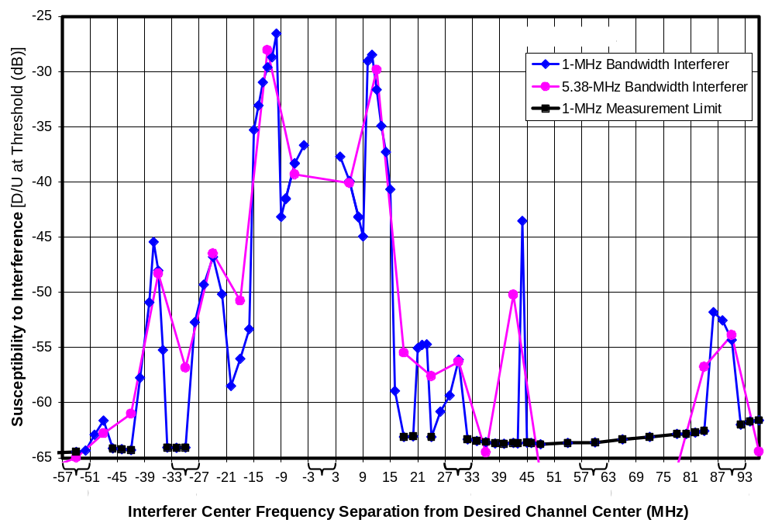
Figure 7-36. D/U With 1-MHz Undesired Signal Bandwidth

THEORETICAL FRAMEWORK FOR OUT-OF-CHANNEL INTERFERENCE
Before presenting more measurement results, we devote a chapter to establishing a theoretical framework that will be used for interpreting or extending the measurement results in most of the remaining chapters. We apply this theoretical basis to some of the common interference mechanisms that apply to TV reception. A more detailed derivation is included in Appendix B.

When a DTV receiver operates in the presence of white Gaussian co-channel interference, the threshold of visibility (TOV) of picture degradation occurs when the desired signal power D exceeds the co-channel interference by about 15 dB. This number may vary somewhat for noise having other statistical properties, and may be much lower if the noise is heavily concentrated at a band edge where filtering in the DTV provides additional rejection; nonetheless, one expects that, as signal power D varies, the undesired signal power at threshold will vary linearly with it—resulting a constant D/U ratio as D or U are varied. This relationship holds whenever the co-channel interference is high enough that the effect of internal noise in the receiver becomes insignificant.

For most out-of-channel interference mechanisms, the DTV receiver unintentionally converts a small portion of the out-of-channel power into co-channel power. If one knows the amount of conversion into co-channel interference, one can treat the problem as a co-channel interference problem, which is relatively well understood, as described above. In this formulation of the problem, measuring the desired signal power D at the TOV provides an indirect method of measuring the co-channel power created internal to the receiver, since we know that the co-channel power will be about 15 dB below the measured value of D.

The conversion process by the DTV receiver from out-of-channel interference to co-channel interference may be linear or nonlinear. If it is linear, then the internally-created co-channel interference will vary linearly with the out-of-channel interference power U causing the value of the desired signal power D at threshold to vary linearly with U. The result will be that threshold D/U ratio will be constant as D or U is varied. If the conversion process is nonlinear, then the relationship between D and U will be nonlinear and the D/U ratio will vary with D and U.

Interference Mechanisms and Order
We will assume that the co-channel interference power created by the DTV receiver in response to an out-of-channel undesired signal power U will be proportional to D^{L}U^{M}, where L and M are integer constants that define the order of the interference mechanism. For most interference mechanisms, L will be zero, so only the U^{M} term exists. The following are among the interference mechanisms that can be modeled by this formulation.
Linear interference: L=0, M=1. Creates co-channel interference proportional to U.
Example: mixer image. The mixer in a TV receiver converts the spectrum of the intended channel of the received signal to an intermediate frequency (IF) where it can be filtered more precisely to pass the desired channel while rejecting the undesired frequencies. Unfortunately, in single-conversion tuners a second a 6-MHz wide portion of the input spectrum centered 88 MHz above the desired channel is also converted to that same IF. Filtering prior to the mixer strongly diminishes—but doesn’t fully extinguish—this unintended signal.
Example: leakage of the adjacent channel signal through the channel selection filter of the DTV receiver would also constitute a linear interference mechanism.
Second-order interference: L=0, M=2. Creates co-channel interference proportional to U².
Example: “half-IF” taboo. The second harmonic of an undesired signal 22 MHz above the desired signal beats with the second harmonic of the receiver’s local oscillator, creating a difference frequency that falls within the IF band of the receiver.
Third-order interference: L=0, M=3. Creates co-channel interference proportional to U³.
Example: third-order intermodulation (IM3) of a single, adjacent-channel undesired signal. IM3 creates spectral components that spill into each adjacent channel.
Example: third-order intermodulation (IM3) of a pair of undesired channels placed at channels N+K and N+2K where N is the desired channel. In this case, the interference power created in channel N is proportional to U_{N+K}²U_{N+2K}. The result is a process that is second-order in terms of U_{N+K} and linear in terms of U_{N+2K}; however, if the two undesired signals are set to equal powers and varied in amplitude together, the resulting interference is third order.
Cross-modulation: L=1, M=2. Creates co-channel interference proportional to DU².
Cross-modulation is essentially a third-order effect, but the co-channel interference created is proportional to D and to U². As a result, increasing the desired signal power does not improve the signal-to-interference ratio.

Threshold of Visibility of Picture Degradation Due to Interference
As stated earlier, the TOV for a DTV receiver occurs when the ratio of the desired signal to the co-channel interference-plus-noise exceeds the required signal-to-noise ratio SNR_{R} for the DTV receiver. We will assume that the co-channel interference-plus-noise power includes two components: receiver noise power N_{R} and the co-channel interference that was created by linear or nonlinear interference mechanisms operating on the out-of-channel undesired signal (c D^{L}U^{M}, where c is a constant). Note that the both the co-channel receiver noise and the co-channel interference power are generated within the DTV receiver. The levels we refer to here are expressed in terms of equivalent input power levels to the TV.

Thus we can say

D / (c D^{L}U^{M} + N_{R}) = SNR_{R}

For 8-VSB DTV receivers the SNR_{R} is about 33.9 (i.e., 15.3 dB converted to a linear power ratio) if the noise and interference have white spectra and Gaussian statistics. Note that, while the receiver noise is likely to be white and Gaussian, the interference may not be—in which case a different SNR would apply to it, but we will neglect that difference for the discussion here.

We note that the threshold desired signal power in the absence of interference (D_{MIN}) is given by

D_{MIN} = SNR_{R} N_{R}

Thus we can write,

D = SNR_{R} c D^{L}U^{M} + D_{MIN}

Slopes of Log-Log Plots of D, U, and D/U
We first consider the case in which the desired signal at threshold is much larger than D_{MIN}. We can then write,

D ≈ SNR_{R} c D^{L}U^{M}

Depending on the values of L and M, a plot of D versus U (in power units, such as microwatts) may be linear or nonlinear; however, a plot of log(D) versus log(U) will always be linear. Thus, plots of D versus U in units of dBm will be straight lines, since decibels are a logarithmic unit. The slope of such a log-log plot indicates the order of the interference mechanism. For example, for a third-order interference mechanism (L=0, M=3), the slope of log-D versus log-U will be 3 dB/dB and the log-U versus log-D will be 0.333 dB/dB; similarly, a plot of D/U versus D on a log-log scale will have a slope of 0.667 dB/dB. The expected slopes of log-log plots for various interference mechanisms are summarized in Table 8-1. The final row of the table will be explained in the next section.

Table 8-18. Slopes of Log-Log Plots of D, U, and D/U for Various Interference Mechanisms
Interference Mechanism | Slope of  Log (D) Versus  Log (U)  in dB/dB | Slope of  Log (U) Versus  Log (D)  in dB/dB | Slope of  Log (D/U) Versus  Log (D)  in dB/dB | Characterization
Linear (M = 1) | 1 | 1 | 0 | Constant D/U
Second order (M = 2) | 2 | 0.5 | 0.5
Third order (including third-order intermodulation of a pair of equal-power interferers) (M = 3) | 3 | 0.333 | 0.667
Cross modulation (M = 2, L = 1) | Infinite | 0 | 1 | Constant U
AGC-Stabilized Nonlinear¹ | 1 | 1 | 0 | Constant D/U
Notes:
¹ See next section (“Effect of AGC”)

Effect of AGC
Television receivers incorporate an automatic gain control (AGC) function that adjusts the gain of one or more stages in the tuner in order to maintain acceptable signal levels. The gain may be constant (at its maximum) when signal levels are low. As signal levels rise, a point is reached at which the AGC begins to reduce the gain to avoid overdriving the tuner circuitry. The AGC control function may be based on the level of the desired signal, or on the combined power of the desired and undesired signals at some point in the tuner (typically the mixer), or both. Typically, the AGC will act to reduce the gain of both RF and IF amplifier stages, but not necessarily at the same signal levels. As input signal levels increase, the AGC may act to reduce IF gain first—waiting for higher signal levels before reducing RF amplifier gain (delayed AGC).

If we consider an interference mechanism that is caused by a nonlinearity at a given point in the tuner, the expected nonlinear behavior described in the previous section will exist only for signal levels up to the point at which AGC begins to reduce gain prior to the point of the nonlinearity. For example, if a given interference mechanism is caused by nonlinearity in the receiver’s mixer, AGC gain reductions in the IF amplifier will not affect it, but gain reductions in the RF amplifier will.

Under the assumption that AGC operation tends to adjust gain so as to maintain either the desired signal or the undesired signal at a constant level at the point of nonlinearity, then the interference begins to behave as if it were linear (with the possible exception of cross-modulation when AGC operates on undesired signal power). That is, further increases in D result in corresponding increases in threshold U, so D/U remains constant. This occurs because the amplitudes at the nonlinearity remain constant in spite of further increases in input signal levels at the receiver’s antenna input terminal. The results are derived in Appendix B.

This suggests that we may see interference that behaves like third-order interference, for example, at low signal levels, but switches to linear behavior when a certain signal threshold associated with the AGC is exceeded. The last row of Table 8-1 refers this effect.

Weak Signals
As stated above, both the linear and the nonlinear interference mechanisms will plot as straight lines on a log-log plot (e.g., plotting U, D, and D/U in decibels). However, this relationship is true only at desired input signal levels high enough to make the receiver’s own internal noise an insignificant contributor to performance.

As signal level approaches the threshold for the receiver in absence of interference, the receiver becomes increasingly more susceptible to interference than such straight-line projections would predict.

Referring to the earlier equation defining the interference threshold, we had

D = SNR_{R} c D^{L}U^{M} + D_{MIN}

The presence of the quantity D_{MIN} causes the log-log plots to deviate from straight-line behavior as D approaches D_{MIN}. Figures 8-1 through 8-4 depict the deviation of threshold U versus D from a straight line on a log-log plot for linear, second-order, third-order, and cross-modulation interference, respectively. It can be seen that for the first three cases, the distance in the D direction from the straight line projection is 3 dB and 6.9 dB when D = D_{MIN} + 3 dB and D_{MIN} + 1 dB, respectively. Distances in the U direction vary with slope of the line as shown in the illustrations and in Table 8-2. Thus, for example, when desired signal level drops to a point 1 dB above the receiver’s threshold (D_{MIN}), the DTV receiver will be sensitive to interference from undesired signals that are lower than a straight-line projection would predict, by amounts ranging from 2.3 to 6.9 dB, depending on the order of the interference mechanism.

In terms of deviation from the straight-line projection, the effect of AGC varies according to whether the AGC is driven primarily by desired signal power or by undesired signal power. In the former case, the deviation from a straight-line projection matches that of the underlying interference mechanism. In the latter, the deviation matches that of a linear process.

Table 8-19. Deviation in Threshold U from Straight-Line Projection as D approaches D_{MIN}
Deviation in Threshold U
from Straight-Line Projection (dB)
Interference Mechanism | D/D_{MIN}¹  = 16 dBm | D/D_{MIN}  = 3 dB | D/D_{MIN}  = 1 dB | D/D_{MIN}  = 0 dB
Linear (M = 1) | -0.1 | -3.0 | -6.9 | Infinite
Second order (M = 2) |  | -1.5 | -3.4 | Infinite
Third order (including third-order intermodulation of a pair of equal-power interferers) (M = 3) |  | -1.0 | -2.3 | Infinite
Cross modulation (M = 2, L = 1) |  | -1.5 | -3.4 | Infinite
AGC-Stabilized Nonlinear w/U driving AGC² | -0.1 | -3.0 | -6.9 | Infinite
Note:
¹ For the nominal D_{MIN} value of -84 dBm, D/D_{MIN} = 16 dB when D = -68 dBm
² With desired signal driving AGC, deviation from straight-line projection matches that of the original nonlinear process, except in the case of cross-modulation, which was not completely solved.

IM3 With Paired Signals
When the interference is caused by a pair of signals located at channels N+K and N+2K, the receiver creates third-order intermodulation (IM3) products in the desired channel N.

In this case, Appendix B shows that the interference equation becomes:

D = (SNR_{R} / IP3²) U_{N+K}²U_{N+2K} + D_{MIN}.

We will use the term IP3 / SNR_{R}^{1/2} to quantify the IM3 properties of the receiver by computing it from measurements of D and U at threshold with D >> D_{MIN} and U = U_{N+K} = U_{N+2K}.

IP3 / SNR_{R}^{1/2} = (U³ / D)^{1/2}

or, in decibel units

(IP3 / SNR_{R}^{1/2})|_{dB} = 1.5 U|_{dB} - 0.5 D|_{dB}

where |_{dB} means conversion to decibels:

X|_{dB} = 10 log(X)

To compute interference susceptibilities knowing (IP3 / SNR_{R}^{1/2})|_{dB}, we will use the following.

U_{N+K}|_{dB} = (IP3 / SNR_{R}^{1/2})|_{dB} + (D|_{dB} - U_{N+2K}|_{dB})/2

or,

U_{N+2K}|_{dB} = 2(IP3 / SNR_{R}^{1/2})|_{dB} + D|_{dB} - 2 U_{N+K}|_{dB}]

See Appendix B for details the derivation.
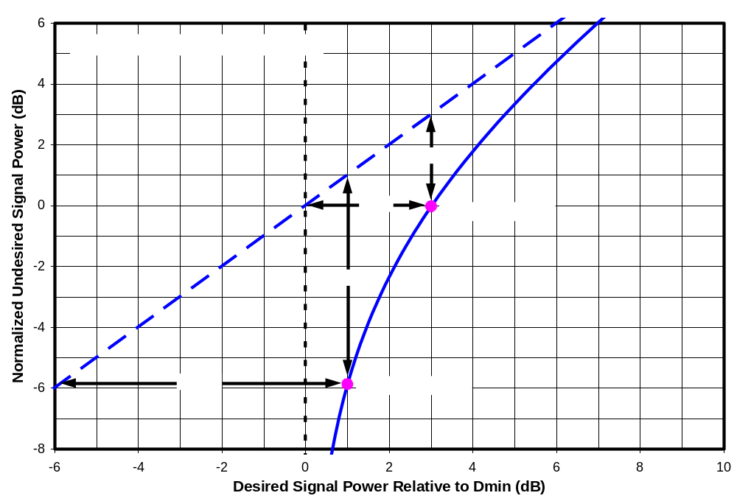
Figure 8-37. Deviation of Log-U Versus Log-D From Straight Line For Linear Interference
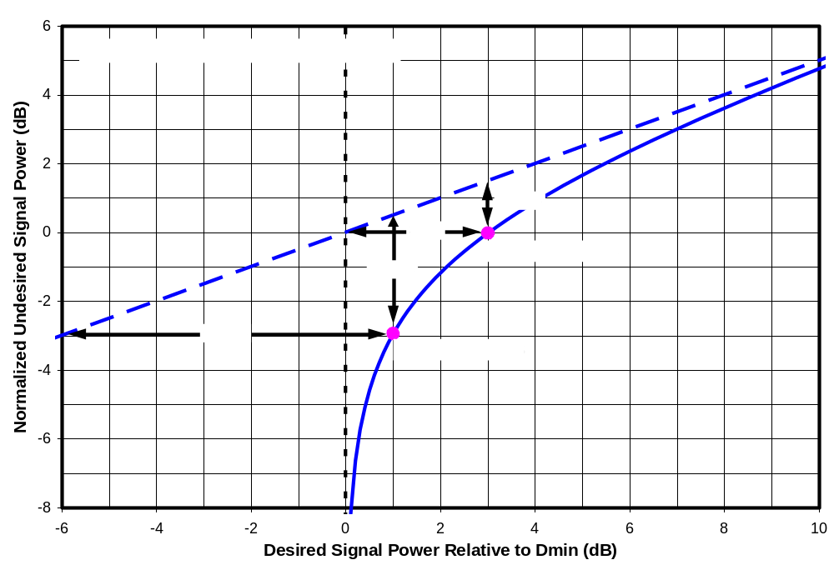
Figure 8-38. Deviation of Log-U Versus Log-D From Straight Line For 2nd-Order Interference
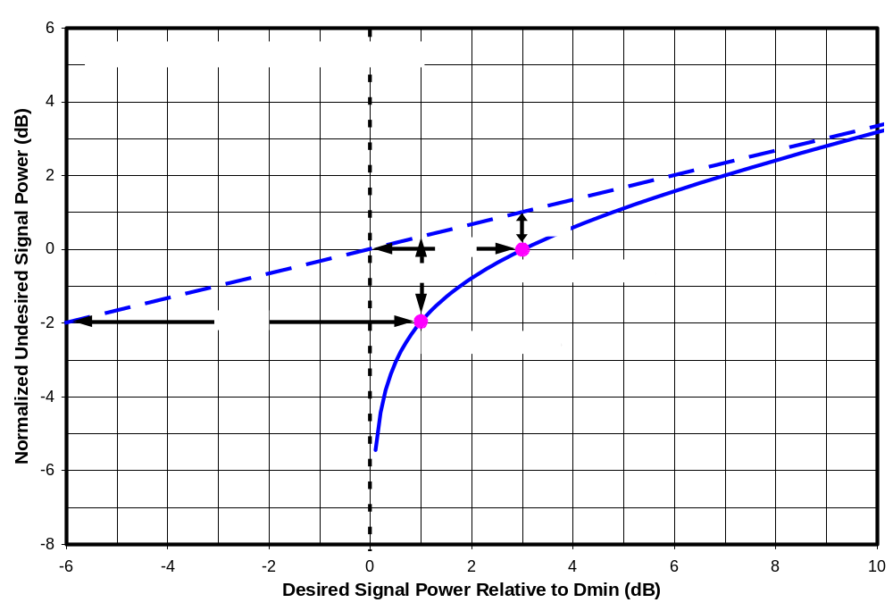
Figure 8-39. Deviation of Log-U Versus Log-D From Straight Line For 3rd-Order Interference
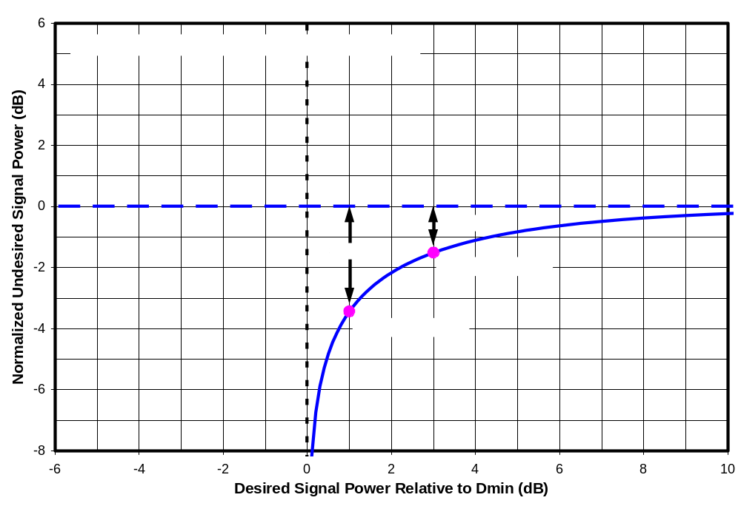
Figure 8-40. Deviation of Log-U Versus Log-D From Straight Line For Cross-Modulation

THIRD-ORDER INTERMODULATION WITH PAIRED EQUAL-POWER INTERFERERS
Rhodes and Sgrignoli have raised the issue of third-order intermodulation (IM3) distortion occurring within a TV receiver between pairs of undesired input signals as a potentially significant interference mechanism for DTV reception. This chapter presents the results of interference rejection measurements performed using pairs of undesired signals spaced so as to place IM3 products into the desired channel. Thus, signal pairs were placed on channels N+K and N+2K, where K is a positive or negative integer. For this chapter the two undesired sources were maintained at equal power levels. Additional test results with paired signals are contained in Chapters 10 (unequal sources) and 11 (detailed measurements on one TV).

In all tests, the undesired signal placed farthest from the desired channel (i.e., at N+2K) was a white Gaussian noise signal bandlimited to match the 3-dB width of an 8-VSB signal. For tests with the desired channel N = 51, the closer undesired signal (at N+K) to the desired channel N was an 8-VSB signal. For tests with the desired channel N = 30, the closer undesired signal was 8-VSB only if it was on a first-adjacent channel (N-1 or N+1); otherwise, the bandlimited Gaussian noise signal was used as the closer undesired signal source. The reason for the use of bandlimited Gaussian noise instead of 8-VSB was that, throughout most of the test period, only one 8-VSB source was available and it was needed as a desired signal source. Tests involving first adjacent channels were postponed until the procurement of another 8-VSB generator because the edge-of-band rolloff of the Gaussian source was not sufficient to support rejection tests on first adjacent channels.

Table 9-1 summarizes the test parameters. Only the test results from the first three rows of the chart are presented in this chapter. The fourth row describes tests at unequal undesired signal levels, which are presented in Chapter 10. The last row of the table identifies very detailed tests of the variation of D/U with desired signal level, which are presented in Chapter 11.

The purpose of these tests was to determine the extent to which pairs of undesired signals create an interference effect—through IM3 occurring within a TV receiver—that exceeds the effects of the individual signals.

Spectra of Third-Order Intermodulation Distortion
IM3 creates signal components at frequencies that were not present in the input spectrum, but are in the same general frequency range as the input signals. The IM3 of interest in this chapter is created within the tuners of consumer DTV receivers. Since test points are not available within consumer receivers to show the actual signal effects that occur, spectra of IM3 components created by a laboratory instrumentation amplifier were measured to illustrate the concepts.

Table 9-20. Parameters for Paired-Interferer Tests (N+K/N+2K)
Chapter | Desired Channel N | Desired Signal Power | K | Undesired Signal at N+K | Undesired Signal at N+2K | Relative Power of U_{N+K} and U_{N+2K} | Number of DTV Receivers Tested
9 | 30 | -68 dBm, -53 dBm, -28 dBm | 1, -1 | 8-VSB | WGN¹ | Equal | 8
9 | 30 | -68 dBm, -53 dBm | 2 through 5  and  -2 through -5 | WGN¹ | WGN¹ | Equal | 8
9 | 51 | -68 dBm, -53 dBm, -28 dBm | 1 through 8 | 8-VSB | WGN¹ | Equal | 7²
10 | 30 | D_{MIN}+3 dB,  -68 dBm,  -53 dBm | 2 or 3 | WGN¹ | WGN¹ | Variable | 2
11 | 51 | D_{MIN}+1 dB, D_{MIN}+3 dB, -78 to -8 dBm in 5-dB steps | 1 through 4 | 8-VSB | WGN¹ | Equal | 1
Notes:
¹ WGN = white Gaussian noise signal bandlimited to match the 3-dB width of an 8-VSB signal.
² For one of the seven TVs tested at channel 51, the complete set of measurements was performed only for D = -68 dBm; for the other two levels, only N+1/N+2 tests were performed.

Figure 9-1(a) shows the spectrum of an 8-VSB signal on channel 34 after passing through the amplifier at a level 12 dB below the maximum rated output power of the amplifier. The “shoulders” that can be seen emerging from the sides of the 8-VSB spectrum about 33-dB below the main signal spectrum level are IM3 products. It can be seen that they extend through most of the width of each adjacent channel (channels 33 and 35), but not beyond. Thus, IM3 generated with a DTV tuner in response to an undesired signal on a single TV channel could influence reception of a desired signal on a first-adjacent channel. Put another way, if the TV is tuned to channel N, its reception there could be adversely impacted by IM3 caused by an undesired signal on channel N-1 or on channel N+1.

Figure 9-1(b) shows the effect of adding a signal of equal power on a second channel—in this case channel 38. The addition of the second signal causes the shoulders around the first signal to increase. A similar pair of shoulders is also created around the second signal. The spectral shoulders occupy channels 33, 35, 37, and 39—the channels adjacent to each of the input signals. In addition to the shoulders around each input signal, the presence of the second signal causes two other bumps in the spectrum to occur. One is centered on channel 30 and the other on channel 42, but they also spill over into the channels adjacent to those two channels. Thus, intermodulation products can now be found in channels 29, 30, 31, 33, 35, 37, 39, 41, 42, and 43.

If one imagines that a TV is attempting to receive a signal on channel 30 in the presence of the two undesired signals creating (within the TV tuner) intermodulation distortion shown in Figure 9-1(b), we would have the case of interference to channel N from an undesired signal pair, N+4/N+8. This is one of the cases examined in this chapter, as is the case of N-4/N-8, which would occur if the receiver were tuned to channel 42. (In test results shown in this chapter, the TV was always tuned to either channel 30 or channel 51, and the undesired signal channels were shifted appropriately.)

Figure 9-2(a) shows the effect of changing the amplitudes of both signals by 5 dB. The IM3 products change by 15 dB, as is expected since this is a third order process. From this we can conclude that if the undesired signal levels should rise, the interference effects created within the TV will rise even faster—at three times the rate of the rise in input signal level.

If only one of the two signals changes in amplitude, the results are somewhat more complex. Figure 9-2(b) shows the effect of a 5-dB change in amplitude of the signal at channel 34, while the one at channel 38 remains constant. The result is a 10-dB change in the amplitude of the IM3 bump closest the changed signal (i.e., the bump at channel 30) and a 5-dB change in amplitude of the IM3 bump closest to the unchanged signal (i.e., the bump at channel 42).

The tests in this chapter are configured so that undesired signals are placed on channels N+K and N+2K and the TV is tuned to channel N. Thus, channel N is centered on one of the outer spectral bumps. Figure 9-2(b) confirms the prediction shown in Chapter 8 that the interference power created at channel N is proportional to U_{N+K}² U_{N+2K}, where U_{N+K} and U_{N+2K} represent the respective power levels of the undesired signals. Thus, the interference created at channel N is a second order function of U_{N+K} and a linear function of U_{N+2K}.

Channel-30 Results at Three Desired Signal Levels

“Weak” Desired Signal (D = -68 dBm)
Figure 9-3 shows measured D/U ratios at TOV for eight DTV receivers for pairs of equal-level undesired signals on channel pairs N+K/N+2K for K = -5, -4, -3, -2, -1, 1, 2, 3, 4, and 5 and a desired signal power of -68 dBm. The measurements were made with the TVs tuned to channel 30 as the desired channel N. The desired signal power was set to -68 dBm. In computing the D/U ratio, U was taken as the power of each signal in the signal pair rather than the combined power of the two signals; thus,

U = U_{N+K} = U_{N+2K}

The shaded area at the bottom of the plot represents the measurement limitations imposed by the test setup—as described in Chapter 4. None of these measurements were limited by the measurement system.

Though the ATSC A/74 has no recommended performance limits related to interference by a pair of signals, the red dashed curve labeled “A/74 Max of Pair” is provided as a reference based on single-channel ATSC interference rejection guidelines. For each point, N+K/N+2K, the value is equal to the higher (least restrictive) of the ATSC-recommended DTV-into-DTV interference rejection thresholds for single-channel DTV interferers. All of the TVs exhibited higher D/U ratios (poorer performance) at most points than is indicated by this A/74-based curve.

Figure 9-4 summarizes the measurements that were shown in Figure 9-3. The solid curve shows the median performance of the eight receivers. Error bars show the best and worst performance among the receivers at each channel offset. A dashed curve shows the performance of the second worst performing receiver at each channel offset.

Since the IF filter in a receiver is expected to greatly reduce signal levels available for creation of intermodulation products after the filter, one would expect that intermodulation between pairs of out-of-channel interferers would occur prior to the IF filter—probably in the mixer. Prior to the mixer, a typical single-conversion TV receiver would include a “tracking filter” that passes the desired channel but provides a gradually increasing attenuation to signals in other channels based on separation from the desired channel. The filter is expected to provide substantial attenuation at N+14 and N+15 in order to reduce the mixer image response. One would expect that such a tracking filter—if placed before the point of nonlinearity that created the intermodulation products—would cause interference effects of a N+K/N+2K signal pair to diminish as |K| increases. Such a trend is evident in some, but not all of the receivers, based on the measured data, which extends to |K| = 5.

“Moderate” Desired Signal (D = -53 dBm)
Figure 9-5 shows D/U-ratio measurements at TOV for the same eight receivers at a higher desired signal level of -53 dBm. Figure 9-6 shows the median and range of the measurements, as well as the second worst performance among the eight receivers.

The expected rolloff with increasing |K| is even less evident than in the signal measurements that were made with a desired signal power of -68 dBm. In some cases, the influence of AGC operation on the N+1/N+2 and N-1/N-2 data may be partly responsible for the lack of increase at low absolute values of K. This topic is discussed more in Chapter 11.

“Strong” Desired Signal (D = -28 dBm)
Figure 9-7 shows the D/U measurements for a desired signal level of -28 dBm. At this signal level, the measurements were performed for only two channel pairs—N-1/N-2 and N+1/N+2. The maximum signal levels that could be generated by the test setup (about -7 dBm for each channel for adjacent-channel tests) were not high enough to create picture errors for most of the receivers. As a result, threshold measurements were possible on only three of the receivers for N-1/N-2 and only two of the receivers for N+1/N+2. The other measured points are shown at the measurement-limit line.

Figure 9-8 presents information regarding the best, median, second worst, and worst performance for each of the two channel pairs measured. Since there were only two points per curve, the data is presented in tabular form. The table shows the threshold values for the worst and second worst performers. The median and best performing values are shown only as “< [value]” because most of the data points were beyond the measurement limit of the test setup.

Combined Results With Single-Channel Reference Values
The plots shown in the previous three subsections provide no indication of whether the DTV picture errors are caused by IM3 interactions between the pair of undesired signals or whether they are caused by each signal independently.

To determine whether IM3 is the cause, it would be useful to show the interference thresholds for the individual undesired signals as well. Thus, we could plot the interference threshold for N+K/N+2K as well as the interference threshold for N+K alone and that for N+2K alone. An even better reference would be one that combined the effects of N+K interference and N+2K interference under the assumption that the interference mechanisms are independent and not the result of intermodulation. We attempt to take the latter approach—partly to reduce the number of curves that must be plotted so that results can be combined into a manageable number of graphs for this report.

The approach taken is to recognize that the observed interference phenomena are the result of mechanisms at work within the TV that convert out-of-channel undesired signals into co-channel interference at some point within the TV. The desired signal at threshold is then—in essence—a measure of the power level of that internal co-channel interference level, since the desired signal at threshold is expected to be about 15 dB above the co-channel interference. This concept was discussed in Chapter 8.

We will define D_{N+K} as the desired signal at threshold resulting from interferer U_{N+K}, and D_{N+2K} as the desired signal at threshold resulting from interferer U_{N+2K}. If we were to take measurements of D_{N+K} and D_{N+2K} at equal undesired signal levels (U_{N+K}=U_{N+2K}=U), then D_{N+K} + D_{N+2K} would be the expected desired signal level threshold if both undesired signals were applied simultaneously and there were no interaction between them. (Summing D_{N+K} and D_{N+2K} is equivalent to summing the co-channel interference powers created within the receiver from each of the two undesired signals individually.) If the undesired signal powers are equal, this is equivalent to summing the D/U ratios:

(D/U)|_{N+K/N+2K} = (D_{N+K}+D_{N+2K})/U = (D/U)|_{N+K} + (D/U)|_{N+2K} , if there is no interaction between the two undesired signals.

This provides a reference point for determining whether the paired-signal D/U is caused by the combined individual effects of the two undesired signals or a by nonlinear interaction between them (i.e., IM3). Summing the D/U ratios to provide this reference point is strictly valid only if the measurements were performed at equal undesired signal levels (and if the AGC state of the tuner is the same for each measurement). Our measurements were performed with equal D values rather than equal U values; however, it would still be valid to apply this technique if D/U for the individual interferers were constant with variations in D. This is true of some cases but not for others. Even when it is not true, very little error is made in summing the D/U ratios if the interference effect (D/U ratio) for one interferer is much higher for the other, since, in that case the sum is approximately equal the D/U of the dominant interferer.

Based on the above we will plot the summed D/U ratio of the individual interferers along with the measured D/U ratio for the pair of interferers to provide an indication of whether IM3 effects are at work. (Note that the summing is performed on the direct power ratios, not on their values in decibels.)

Figures 9-9 through 9-16 show the measured D/U ratios for the paired interferers along with the summed D/U ratios for the corresponding individual interferers. Each graph presents the measurements for one DTV receiver. The two solid lines on each graph show the paired-signal D/U ratios measured at desired signal levels of -68 dBm and -53 dBm. The dashed lines show the summed D/U’s for those signal levels. Note that if one or both of the individual D/U’s was beyond the measurement limit of the test setup, then the sum was computed using the measurement limit; this fact may cause a summed D/U to exceed the paired-signal D/U if one element of the sum was at the measurement limit and the other was near the limit.

Where the solid lines are closely matched by the dashed summed-D/U lines, the interference effect of the pair of equal-powered undesired signals is primarily due to one of the individual signals—or to the combined effect of both—rather than to an IM3 interaction between the two interferers. Where a solid line is significantly higher than a dashed line, there is a significant IM3 effect from the pair of signals.

Notably, most of the receivers exhibit very little evidence of IM3 interaction from the N-1/N-2 and N+1/N+2 pairs. For a desired signal level of -68 dBm, the paired-signal D/U’s exceed the summed signal D/U’s by no more than 1.2 dB (and in most cases less than 0.5 dB) with one exception. For receiver G4 the difference is 4 dB at N-1/N-2. This indicates that, for equal-power paired undesired signals, any IM3 effects resulting from a signal pair on the first-adjacent channels (N-1/N-2 and N+1/N+2) of most receivers are insignificant relative to the interference sensitivities associated with the individual channels, at least for a desired signal power of -68 dBm. The one exception to this—one case out of 16 (8 receivers, upper and lower channel pairs)—yields a 4-dB increase in susceptibility as a result of IM3. At a desired signal power of -53 dBm, three of the 16 combinations exhibit an IM3 effect that is about 2 dB above the summed D/U’s and one exceeds the summed D/U’s by 3.6 dB.

Even at N-2/N-4 and N+2/N+4 about half of the receivers exhibit little or no evidence of an IM3 effect for paired equal-power undesired signals. Among the other half, some exhibit very pronounced IM3 effects up to 11 dB above the summed D/U’s.

At larger channel spacings, there is evidence of IM3 from the signal pairs significantly exceeding the interference effect of the individual interferers—by amounts up to at least 17 dB. (In cases where summed D/U’s are computed from measurements that were at the limit of the measurement setup, the actual summed D/U’s are lower than those shown, so the true amount of the excess is greater than that shown.)

An unexpected and seemingly impossible behavior can be seen for receiver D3 (Figure 9-10) at N-2/N-4 for a desired signal level D = -53 dBm. The D/U for the pair of interferers operating together is actually significantly lower than the summed D/U’s for the individual interferers. Examination of the single-channel data shows that the receiver is far more sensitive to interference at N-4 (D/U = -32.3) than at N-2 (D/U = -49.0 dB); however, the D/U ratio for the pair of signals (with U referring to the undesired power on each of the two channels) is only -38.8 dB, 6.5 dB less than the D/U for N-4 alone. Put another way, an undesired signal level of -20.8 dBm on channel N-4 causes picture errors on the TV, but if a second undesired signal is placed on channel N-2, the TV can tolerate a higher interference level of -14.3 dBm on each of the channels simultaneously!

This result is highly counter-intuitive until one examines detailed test results for that TV—presented in the Chapter 11. Though those measurements are limited to cases with interferers on higher channel numbers than the desired signal (N+K/N+2K with positive values of K), the data suggests that the presence of an undesired signal on channel N+2 any higher than approximately -35 dBm causes the DTV receiver’s AGC to reduce the RF gain, whereas an undesired signal at N+4 causes no such gain reduction (or, if it does, the reduction occurs at a higher signal level). In the case described above, the TV is very susceptible to interference from an undesired signal placed at N-4, probably due to a nonlinearity in the tuner; but, adding in an undesired signal at N-2 probably causes the AGC to reduce the RF gain of the tuner (as was the case at N+2), which reduces the signal levels at the point of the nonlinearity. A theoretical basis for understanding the effect of AGC on interference phenomena was presented in Chapter 8 (with more details in Appendix B). More discussion about the effect of AGC will be presented in Chapter 11 on the basis of detailed measurement data for Receiver D3.

Table 9-2 shows statistics for the difference (in dB) between the paired-signal D/U’s and the summed D/U’s for the eight TV receivers that were tested. Looking across all of the data, we see that a pair of appropriately-spaced equal-power undesired signals can create an intermodulation effect that enhances the interference potential of the signals. The combined signals can cause TV picture degradation (or loss) at signal levels at least as much as 17 dB lower than the levels that would be required to cause picture degradation based on the combined individual effects of each signal, i.e., without intermodulation between the pair. (The actual difference may have been much larger. See the note in table.) At the other extreme, paired signals applied to some TV receivers on some N+K/N+2K channel pairs cause no increase in interference effect above the summed effects of the individual signals, and in one case (discussed in the preceding paragraph), AGC action causes the paired signal combination to have less of an interference effect than that of one of the individual signals.

Channel-51 Results at Three Desired Signal Levels
In this section we present the results of paired-signal rejection measurements made with the TVs tuned to channel 51 as the desired channel N. The two undesired signals were placed on N+K and N+2K for K = 1 through 8. The reason for limiting these tests to positive values of K is that the focus was on potential for interference to upper UHF channels from other radio services that are expected to operate in channels 52 through 69 after completion of the DTV transition.

For these tests, the undesired signal on channel N+K was an 8-VSB DTV signal. The undesired signal on channel N+2K was a white Gaussian noise source bandlimited to match the 3-dB width of an 8-VSB DTV signal.

Table 9-21. Statistics of Paired-Signal D/U’s Relative to Summed D/U’s for 8 Receivers on Channel 30
Undesired Channel Pair | Excess of Paired-Signal D/U Above Summed D/U’s (dB)
Undesired Channel Pair | D = -68 dBm |  |  |  | D = -53 dBm
Undesired Channel Pair | Min | Mean | Median | Max | Min | Lower Bound on Mean¹ | Lower Bound on Median¹ | Lower Bound on  Max¹
N-5/N-10 | 1.8 | 9.8 | 9.8 | 15.7 | 3.4 | 11.7 | 11.7 | 16.9
N-4/N-8 | 0.4 | 5.7 | 5.1 | 12.2 | 3.4 | 9.5 | 9.8 | 16.3
N-3/N-6 | -1.2 | 5.2 | 3.1 | 15.1 | -0.2 | 5.9 | 6.4 | 11.3
N-2/N-4 | -1.9 | -0.2 | -0.6 | 3.0 | -6.6 | 0.5 | 0.2 | 5.6
N-1/N-2 | -0.3 | 0.7 | 0.2 | 4.0 | -0.3 | 0.7 | 0.1 | 3.6
N+1/N+2 | -1.5 | 0.0 | 0.3 | 0.6 | -1.3 | 0.6 | 0.5 | 2.3
N+2/N+4 | -1.5 | 2.7 | 0.1 | 11.3 | -1.2 | 4.0 | 3.9 | 11.4
N+3/N+6 | -0.2 | 7.2 | 6.8 | 14.1 | 2.1 | 9.8 | 9.9 | 14.7
N+4/N+8 | 1.5 | 8.2 | 7.0 | 16.4 | 0.7 | 8.7 | 8.9 | 13.8
N+5/N+10 | 0.0 | 7.9 | 9.1 | 12.8 | -0.3 | 7.1 | 7.3 | 13.7
 | -1.9 | 4.7 | 4.1 | 16.4 | -6.6 | 5.9 | 6.8 | 16.9
Note
¹ For D = -53 dBm, the actual means, medians, and maxima for channels N+3/N+6 and beyond on the positive side and N-4/N-8 and beyond on the negative side are underestimated because most of the individual measurements on which the summed D/U’s are based were for measurement conditions in which TOV for the receivers was not reached due to limitations on maximum signal that the test setup could generate; consequently, the values shown in red italics should be viewed as lower bounds on the actual values.

“Weak” Desired Signal (D = -68 dBm)
Figure 9-17 shows measured values of D/U ratios at TOV for seven DTV receivers for pairs of equal-level undesired signals with the desired signal power was set to -68 dBm. The seven receivers are a subset of the eight that were tested for the previous major section of this chapter. The reader is referred to the channel-30 section of this chapter for more information on the plot format.

Figure 9-18 summarizes the measurements that were shown in Figure 9-17. The solid curve shows the median performance of the eight receivers. Error bars show the best and worst performance among the receivers at each channel offset. A dashed curve shows the performance of the second worst performing receiver at each channel offset.

For the most part the D/U ratios exhibit an expected drop (indicating less susceptibility to interference) as the channel spacing from the desired channel increases. There are some exceptions. The increase in D/U for receiver D3 as the undesired signal pair is moved from N+1/N+2 to N+2/N+4 is believed to be the result of an AGC gain reduction occurring when the undesired signal is placed on N+1. This will be discussed further in Chapter 11. The peak exhibited by some TVs at N+7/N+14 is the result of single-channel effects at N+7 (the local oscillator frequency) or N+14 (mixer image frequency).

“Moderate” Desired Signal (D = -53 dBm)
Figure 9-19 shows D/U-ratio measurements at TOV for the same seven receivers at a higher desired signal level of -53 dBm. We note that only one measurement was performed on receiver N1 at this desired signal level—at N+1/N+2. Figure 9-20 shows the median and range of the measurements, as well as the second worst performance among the receivers; except for N+1/N+2, the data are for only six of the receivers.

The expected rolloff with increasing |K| is less evident than in the “weak”-signal measurements. In some cases, the influence of AGC operation on the N+1/N+2 and N-1/N-2 data may be partly responsible.

“Strong” Desired Signal (D = -28 dBm)
Figure 9-21 and 9-22 show corresponding plots of D/U measurements of seven receivers for a desired signal level of -28 dBm. As in the case of -53 dBm, one of the receivers was measured only at N+1/N+2. Most of the D/U ratios fall outside the measurement range of the test setup.

Combined Results With Single-Channel Reference Values
Figures 9-23 through 9-29 show the measured D/U ratios for the paired interferers along with the summed D/U ratios for the corresponding individual interferers. Each graph presents the measurements for one DTV receiver. The solid colored lines on each graph show the paired-signal D/U ratios measured at desired signal levels of -68 dBm, -53 dBm, and -28 dBm.

The dashed lines on each graph show the summed D/U’s for each of the three desired signal levels. The summed D/U’s represent the summed interference effects of the two undesired signals in the absence of any intermodulation products generated by nonlinear interactions of one signal with the other. Note that if one or both of the individual D/U’s was beyond the measurement limit of the test setup, then the sum was computed using the measurement limit. This occurred for many of the summed D/U values for D = -68 dBm and most of those for D = -53 dBm and D = -28 dBm. Where it occurred, the actual TOV levels for the individual undesired signals are unknown, and the actual differences between the paired-signal D/U’s and the summed D/U’s are greater than those shown in the charts. Because of the number of data points affected by this limitation, the channel-51 data were not tabulated as the channel-30 data were. We also note that the use of measurement limit values sometimes caused a summed D/U value on the plots to artificially exceed the paired-signal D/U when one element of the sum was at the measurement limit and the other was near the limit—a condition that occurred for most of the measurements for D = -28 dBm.

Where the solid lines are closely matched by the dashed “summed D/U” lines, the interference effect of the pair of interferers is primarily due to one of the individual interferers—or the combined effect of both—rather than an IM3 interaction between the two interferers. Where the solid lines significantly exceed the dashed lines, there is a significant IM3 effect from the pair of signals.

Estimating 3rd Order Intercept Point (IP3)
The measurements presented in this chapter can be used to determine the DTV receiver’s third-order intercept point (IP3)—a property that quantifies the nonlinearity of the receiver and allows computation of IM3 interference effects from undesired signal amplitudes that differ from the levels actually tested. Our use of the term IP3 here, while similar to its traditional use in characterizing amplifiers, differs from the traditionally defined IP3 in two ways:
The measurements here were made with broadband, noise or noise-like signals rather than with the CW (continuous wave) sinusoids usually used for IP3 measurements; since the process is a third-order one, one would expect the effective interference power to be related to the sixth-order moments of the input signals; those moments are expected to be higher for the noise-like waveforms than for a sinusoid of the same input power;
As Figure 9-2 showed, the IM3 power in each side “bump” of the spectrum is split across three TV channels, of which only the center one (where most of the power is concentrated) is “measured” by the TV in our tests; thus, a portion of the IM3 power is excluded from the measurement.

There are three limitations on such IP3-based assessment of DTV interference:
(1) IP3 can be quantified from the paired-signal measurements only if the observed interference is primarily due to IM3 between the signal pair;
(2) While IP3 is usually treated as a constant for a given amplifier, it will, in fact, vary with AGC operation; and,
(3) IP3 computation depends on a knowledge of the signal-to-noise ratio necessary for the receiver to reach TOV because we are not measuring IM3 effects directly, but rather are inferring them from measurements of U and D at TOV.

Regarding the first limitation, we will compute IP3 only when the D/U ratio for the pair of signals exceeds the summed D/U ratios of the individual signals (plotted as reference curves in Figures 9-9 through 9-16 and 9-23 to 9-29) by at least 4 dB.

Regarding the second limitation, we will recognize that IP3 will be constant only when desired and undesired signal levels are low enough not to cause AGC gain reductions prior to the point of the nonlinearity that causes the IM3. We will attempt to use changes in measured IP3 to determine whether or not the AGC is active in the vicinity of a paired-signal measurement.

Regarding the third limitation, we could choose to substitute a value such as 33.9 (i.e., 15.3 dB converted to a linear power ratio) for the required signal-to-noise ratio (SNR_{R}) since all of the receivers have required signal-to-noise ratios close to this value (according to measurements presented in the SHVERA Study); however, that value was measured using white Gaussian noise as the interferer, and, strictly speaking, the SNR required to overcome IM3 interference may differ from that of white Gaussian noise due to differing spectral shape or perhaps statistical properties. Consequently, we choose to incorporate the SNR_{R} term into the quantity calculated to quantify the receiver’s nonlinearity.

Thus, instead of computing IP3, we choose to compute the quantity, IP3 / SNR_{R}^{1/2}, which was shown in Chapter 8 to be related to desired and undesired signal powers at threshold for paired-signal IM3 interference. In linear power units, the quantity can be computed by

IP3 / SNR_{R}^{1/2} = (U³ / D)^{1/2}

In decibel units, it is given by

(IP3 / SNR_{R}^{1/2})|_{dB} = 1.5 U|_{dB} - 0.5 D|_{dB}

The values of IP3 / SNR_{R}^{1/2} computed here will be applied to the case of unequal undesired signal levels in the next chapter.

Channel 30
Table 9-3 and Figures 9-30 and 9-31 present computed values of IP3 / SNR_{R}^{1/2} (in dB) based on the channel-30 measurements of rejection ratios for paired signals. Values were computed only when the paired-signal D/U ratio exceeded the summed single-signal D/U ratios by at least 4 dB, as stated above. The blank cells represent measurements that did not meet this condition. See the note at the bottom of the table for conversion to IP3.

Table 9-22. IP3/SNR_{R}^{1/2} Based on Paired-Signal Rejection Measurements at Channel-30
 |  | IP3 / SNR_{R}^{1/2} (dB)
 | K→ | -5 | -4 | -3 | -2 | -1 | 1 | 2 | 3 | 4 | 5
Receiver | D (dBm) | N-5/ N-10 | N-4/ N-8 | N-3/ N-6 | N-2/ N-4 | N-1/ N-2 | N+1/ N+2 | N+2/ N+4 | N+3/ N+6 | N+4/ N+8 | N+5/ N+10
A3 | -68 |  |  |  |  |  |  |  | 0.7 | 3.9 | 6.8
D3 | -68 | -5.5 | -9.4 | -13.9 |  |  |  | -24.7 | -17.1
G4 | -68 | -1.3 | -0.1 | -3.4 |  |  |  | -10.4 | -7.1 | -4.8 | -1.3
I1 | -68 | -12.2 |  |  |  |  |  |  |  | 5.2 | 3.7
J1 | -68 | -3.9 |  |  |  |  |  |  | -6.4 | -4.3 | 2.0
M1 | -68 | -5.4 | -5.0 | -5.5 |  |  |  | -5.2 | -6.1 | 0.6 | 5.1
N1 | -68 | 6.7 |  |  |  |  |  |  |  | 7.6
O1 | -68 | -5.2 | -7.1 | -5.4 |  |  |  |  |  | 8.2 | 7.7
A3 | -53 | 5.4 | 2.2 | -2.8 | 0.5 |  |  | -0.8 | -0.5 | 2.7 | 5.6
D3 | -53 |  |  | -14.9 |  |  |  | -21.7
G4 | -53 | 1.8 | -0.7 | 7.6 | 5.7 |  |  | -5.8 | -8.2 | -1.7 | 3.2
I1 | -53 | -4.3 | 0.4 |  |  |  |  |  | 6.0 | 5.4 | 3.8
J1 | -53 | -1.4 | -3.3 |  |  |  |  |  | -3.1 | -1.3 | -1.5
M1 | -53 | -4.7 | -4.3 | 0.9 |  |  |  | 1.9 | -3.2 | -2.5 | 4.7
N1 | -53 | 1.5 | 4.7 | 5.2 |  |  |  |  | 7.0 | 6.8
O1 | -53 | -3.9 | -1.6 | 12.4 |  |  |  |  | 9.3 | 8.8 | 7.8
Notes:
Outlines represent receivers and channel offsets subjected to further measurement in the next chapter.
IP3 can be estimated by adding SNR_{R}|_{dB}/2 (nominally 15.3 / 2 = 7.6 dB) to the values of (IP3 / SNR_{R}^{1/2})|_{dB} shown.

In the table, bold italics with shading indicates values that are believed to correspond to full gain operation of the receiver through the mixer (i.e., no RF AGC operation); this judgment was made on the basis of the change in computed IP3 as desired signal level changed from -68 dBm to -53 dBm. (Note the lack of shading does not necessarily indicate that AGC did operate in a given region; rather, it may indicate that the measurements were insufficient to make a judgment.) If the AGC was inactive throughout the range, one would expect a constant IP3 value. If the AGC operated throughout the range to maintain constant signal levels at the point of nonlinearity, one would expect IP3 to increase by 15 dB (same change as D). The observed IP3 changes from D = -68 dBm to D = -53 dBm within the same receiver ranged from -5 to +18 dB. AGC was judged to have operated throughout the range if the IP3 change was greater than 10 dB; in that case, corresponding cells for both -68 dBm and -53 dBm are marked as having been influenced by AGC. Pairs with lower IP3 changes were judged to have had AGC operation through no more than part of the range, so the low end of the range (D = -68 dBm) was judged not to have been influenced by AGC. Where IP3 change was less than 3.5 dB, we judged that both ends of the range were free of AGC operation.

Measurable IM3 effects were not observed on the first-adjacent channel cases (N+1/N+2 and N-1/N-2) and many of the second-adjacent channel cases (N+2/N+4 and N-2/N-4). This is believed to be a result of two factors: (1) AGC-induced gain reductions in each receiver’s front end reduced the amplitudes of IM3 effects for those channel offsets; and (2) those channel offsets exhibited higher single-channel interference effects that would have tended to mask the IM3 effects.

In Figure 9-30, which presents IP3 / SNR_{R}^{1/2} values for D = -68 dBm, the expected increase in IP3 with increasing offset from channel N due to filtering in the receiver front end is clearly evident for most receivers on the right half of the graph where there are more data points. Such a tendency is seen at D = -53 dBm (Figure 9-31) for fewer receivers.

Channel 51
Table 9-4 and Figures 9-32 and 9-33 present computed values of IP3 / SNR_{R}^{1/2} (in dB) based on the channel-51 measurements of rejection ratios for paired signals. As with the channel-30 measurements, values were computed only when the paired-signal D/U ratio exceeded the summed single-signal D/U ratios by at least 4 dB. The blank cells represent measurements that did not meet this condition. The reader is referred to the discussion in the previous section (for channel 30) for information regarding the shading in the table. See the note at the bottom of the table for conversion to IP3.

For D = -68 dBm (Figure 9-32) most receivers exhibit an increase in IP3 with increased spacing between the undesired channels and the desired channel. Such a trend is not clear for D = -53 dBm (Figure 9-33); in fact, receiver I1 exhibits a very flat IP3.

Table 9-23. IP3/SNR_{R}^{1/2} Based on Paired-Signal Rejection Measurements at Channel-51
 |  | IP3 / SNR_{R}^{1/2} (dB)
 | K→ | 1 | 2 | 3 | 4 | 5 | 6 | 7 | 8
Receiver | D (dBm) | N+1/ N+2 | N+2/ N+4 | N+3/ N+6 | N+4/ N+8 | N+5/ N+10 | N+6/ N+12 | N+7 /N+14 | N+8/ N+16
A3 | -68 |  |  | -2.5 | 1.7 | 5.3 | 8.8
D3 | -68 |  | -25.6 | -17.8
I1 | -68 |  |  |  | 4.8 | 4.7 | 4.0 |  | 4.1
J1 | -68 |  |  | -3.6 | -3.5 | 2.7 | 6.1 | 7.9 | 9.2
M1 | -68 |  | -3.4 | -2.0 | 3.0 | 8.2 | 13.4
N1 | -68 |  |  | 4.9 | 0.2 | 0.4 | 3.1 |  | 5.0
O1 | -68 |  |  |  |  | 8.7 | 7.9 |  | 7.8
A3 | -53 |  | 1.1 | -2.5 | 1.8 | 5.3
D3 | -53 |  | -18.7
I1 | -53 |  |  | 5.8 | 5.4 | 4.8 | 4.6 | 4.3 | 5.3
J1 | -53 |  |  | 4.5 | -1.1 | 0.2 | 3.6
M1 | -53 |  | 1.0 | 0.2 | 2.8
N1 | -53 |  | NM | NM | NM | NM | NM | NM | NM
O1 | -53
Notes:
Bold italics with shading indicates probable operation at signal level low enough to avoid AGC operation; that assessment is based on the observed change in IP3 / SNR_{R}^{1/2} as desired signal level changes from -68 dBm to -53 dBm. (See text for details.)
NM (for receiver N1) indicates that no measurements of paired-signal D/U ratio were made due to equipment failure. The lack of measurements for receiver N1 at D = -53 dBm precluded the opportunity to estimate AGC operation; consequently, none of the N1 measurements at D = -68 dBm could be judged to be free of AGC gain changes.
IP3 can be estimated by adding SNR_{R}|_{dB}/2 (nominally 15.3 / 2 = 7.6 dB) to the values of (IP3 / SNR_{R}^{1/2})|_{dB} shown.

Comparison of Channels 30 and 51
Figure 9-34 combines the IP3 / SNR_{R}^{1/2} data measured on channels 30 and 51 for a desired signal power of -68 dBm. The measurements include up to four channel pairs in common. For most of the TV receivers, there is a close match between the measurements in the overlap region.

Summary Data
The IP3 data tables are incompletely filled because of our restriction that we computed the IP3 parameter only when the paired-signal D/U ratio exceeded the summed single-signal D/U ratios by at least 4 dB. Thus, data could be missing because the IM3 effects are small, because the interference effects of the corresponding single-channel undesired signals are high, or because some single-channel measurements on which the summed D/U’s are based are at the measurement limit of the test setup. This makes it harder (and in many cases, impossible) to determine worst-case, second-worst, and median values from the existing measurements without introducing biases.

We carefully examined both the paired-signal D/U measurements and the corresponding single-channel D/U measurements including combinations in which IP3 is not reported due to the paired-signal D/U ratio not meeting the threshold requirement described above. This evaluation was used to determine, where possible, the values for median, second-worst, and worst (lowest) IP3 values among the channel pairs. The results are shown in Table 9-5 for both channels 30 and 51. The final three columns combine the data from the two desired channels—by averaging when measurements exist on both channels—to provide a larger view of the IP3 variation with channel-pair spacing.

Table 9-24. IP3/SNR_{R}^{1/2} Statistics
 | IP3 / SNR_{R}^{1/2} (dB)
 | Channel 30 |  |  | Channel 51 |  |  | Combined
 | Worst | 2nd Worst | Median | Worst | 2nd Worst | Median | Worst | 2nd Worst | Median
N-5/N-10 | -12.2 | -5.5 | -4.5 |  |  |  | -12.2 | -5.5 | -4.5
N-4/N-8 | -9.4 | -7.1 | -5.0 |  |  |  | -9.4 | -7.1 | -5.0
N-3/N-6
N-2/N-4
N-1/N-2
N+1/N+2
N+2/N+4
N+3/N+6 | -17.1 | -7.1 | -2.7 | -17.8 | -3.6 | -2.0 | -17.5 | -5.3 | -2.4
N+4/N+8 | -4.8 | -4.3 | 2.2 |  |  | 1.7 | -4.8 | -4.3 | 1.9
N+5/N+10 | -1.3 | 2.0 | 4.4 | 0.4 | 2.7 | 4.7 | -0.5 | 2.3 | 4.5
N+6/N+12 |  |  |  | 3.1 | 4.0 | 6.1 | 3.1 | 4.0 | 6.1
N+7/N+14
N+8/N+16 |  |  |  | 4.1 | 5.0 | 9.2 | 4.1 | 5.0 | 9.2

The results can be used to compute threshold values of undesired signal power U and D/U ratio when the two undesired signals have equal power:

U|_{dB} = (1/3) [2 (IP3 / SNR_{R}^{1/2})|_{dB} + (D – D_{MIN})|_{dB}]

where (D – D_{MIN})|_{dB} is computed by converting the desired power levels to linear power units (e.g., mW), performing the subtraction, and then converting back to dB.

The calculation has been performed for desired signal levels of -68 dBm and D_{MIN} + 3 dB, under the assumption that D_{MIN} = -84 dBm. The results are shown in Tables 9-6 and 9-7.

We note that the absence of data for channel pairs N-3/N-6, N-2/N-4, N+2/N+4 and N+7/N+14 in these tables does not indicate that IM3 was immeasurable on all of the receivers. It means, rather, that conclusions regarding the worst, second-worst, and median values could not be reached from the receivers that were measurable. On the other hand, the absence of data in the tables for the first-adjacent pairs (N-1/N-2 and N+1/N+2) was due to the fact that IM3 effects did not exceed single-channel effects on any of the receivers by a sufficient amount to support measurement of IM3 effects.

Table 9-25. Computed Threshold U Due to IM3 for Equal Paired Signals
 | Threshold U for Paired Signals With U_{N+K} = U_{N+2K} = U (dB)
 | D = -68 dBm |  |  | D = D_{MIN} + 3 dB |  |  | D = D_{MIN} + 1 dB
 | Worst | 2nd Worst | Median | Worst | 2nd Worst | Median | Worst | 2nd Worst | Median
N-5/N-10 | -30.8 | -26.3 | -25.7 | -36.1 | -31.7 | -31.0 | -38.1 | -33.6 | -33.0
N-4/N-8 | -29.0 | -27.4 | -26.0 | -34.3 | -32.7 | -31.4 | -36.2 | -34.7 | -33.3
N-3/N-6
N-2/N-4
N-1/N-2
N+1/N+2
N+2/N+4
N+3/N+6 | -34.3 | -26.2 | -24.3 | -39.6 | -31.6 | -29.6 | -41.6 | -33.5 | -31.5
N+4/N+8 | -25.9 | -25.6 | -21.4 | -31.2 | -30.9 | -26.7 | -33.1 | -32.8 | -28.7
N+5/N+10 | -23.0 | -21.1 | -19.6 | -28.3 | -26.4 | -25.0 | -30.3 | -28.4 | -26.9
N+6/N+12 | -20.6 | -20.0 | -18.6 | -25.9 | -25.3 | -23.9 | -27.9 | -27.3 | -25.9
N+7/N+14
N+8/N+16 | -20.0 | -19.3 | -16.6 | -25.3 | -24.7 | -21.9 | -27.2 | -26.6 | -23.8
Computation assumes D_{MIN} = -84 dBm

Table 9-26. Computed Threshold D/U Due to IM3 for Equal Paired Signals
 | Paired-Signal D/U for U_{N+K} = U_{N+2K} = U (dB)
 | D = -68 dBm |  |  | D = D_{MIN} + 3 dB |  |  | D = D_{MIN} + 1 dB
 | Worst | 2nd Worst | Median | Worst | 2nd Worst | Median | Worst | 2nd Worst | Median
N-5/N-10 | -37.2 | -41.7 | -42.3 | -44.9 | -49.3 | -50.0 | -44.9 | -49.4 | -50.0
N-4/N-8 | -39.1 | -40.6 | -42.0 | -46.7 | -48.3 | -49.6 | -46.8 | -48.3 | -49.7
N-3/N-6
N-2/N-4
N-1/N-2
N+1/N+2
N+2/N+4
N+3/N+6 | -33.7 | -41.8 | -43.7 | -41.4 | -49.4 | -51.4 | -41.4 | -49.5 | -51.5
N+4/N+8 | -42.1 | -42.4 | -46.6 | -49.8 | -50.1 | -54.3 | -49.9 | -50.2 | -54.3
N+5/N+10 | -45.0 | -46.9 | -48.4 | -52.7 | -54.6 | -56.0 | -52.7 | -54.6 | -56.1
N+6/N+12 | -47.4 | -48.0 | -49.4 | -55.1 | -55.7 | -57.1 | -55.1 | -55.7 | -57.1
N+7/N+14
N+8/N+16 | -48.1 | -48.7 | -51.4 | -55.7 | -56.3 | -59.1 | -55.8 | -56.4 | -59.2
Computation assumes D_{MIN} = -84 dBm

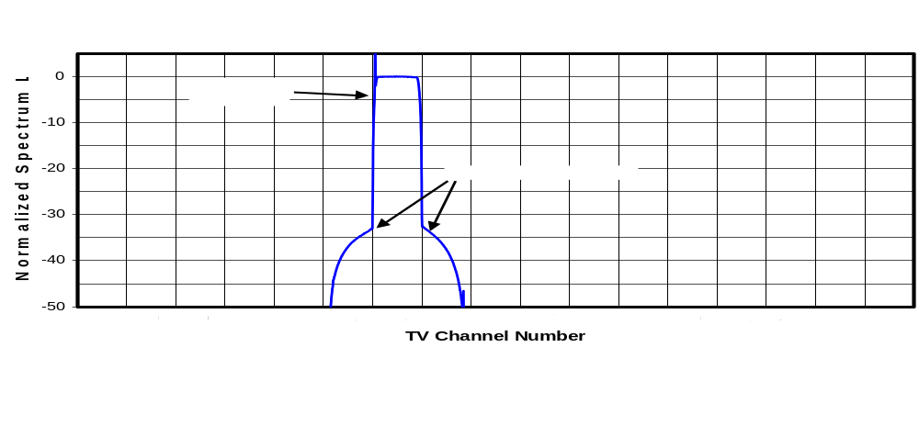
(a) Single 8-VSB Signal

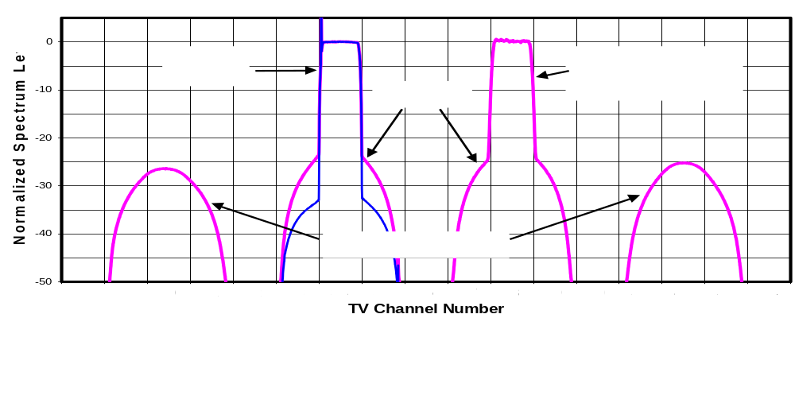
(b) Pair of Equal-Amplitude Signals

Figure 9-41. Third-Order Intermodulation Distortion Spectra of Single and Paired Signals
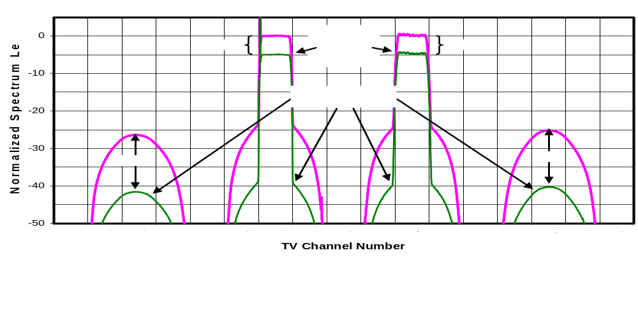
(a) Effect of Changing Amplitude of Both Signals

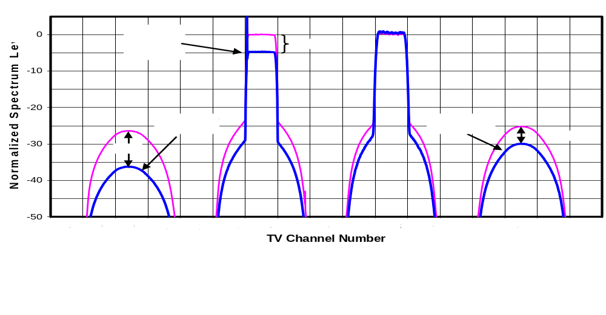
(b) Effect of Changing Amplitude of One Signal

Figure 9-42. Third-Order Intermodulation Distortion Spectra of Paired Signals Versus Amplitude
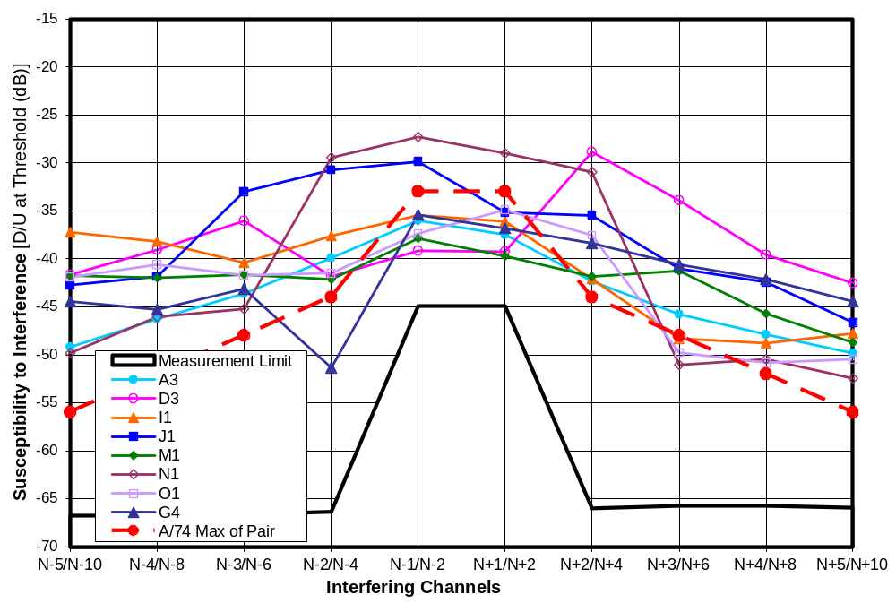
Figure 9-43. Paired-Signal D/U of 8 receivers at D = -68 dBm on Channel 30
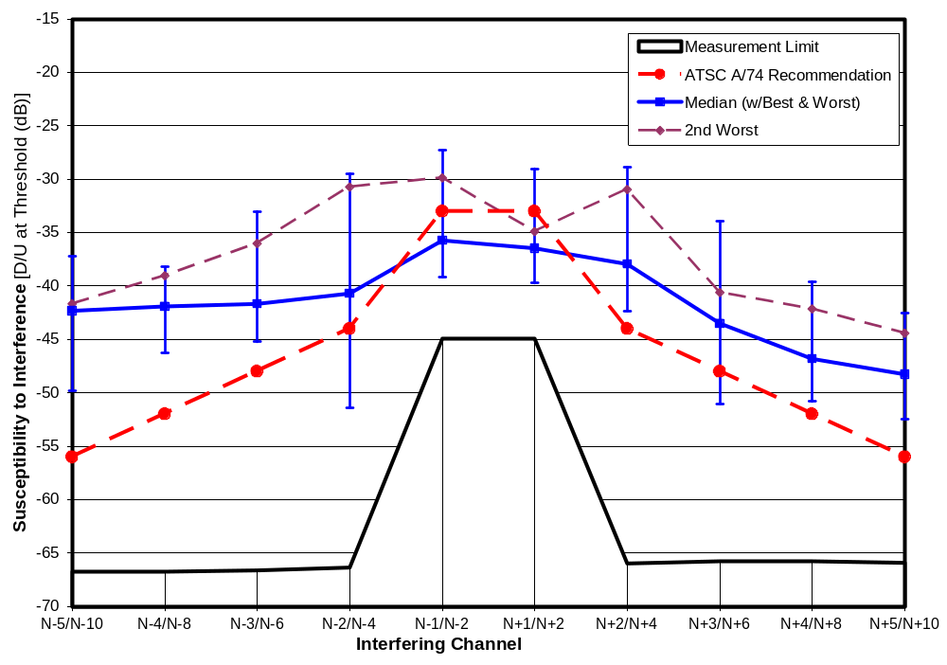
Figure 9-44. Paired-Signal D/U Statistics of 8 receivers at D = -68 dBm on Channel 30
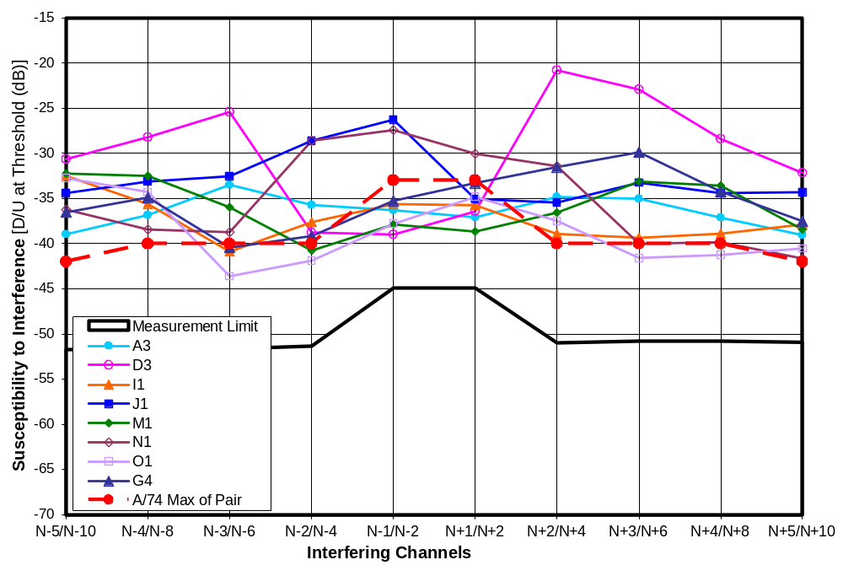
Figure 9-45. Paired-Signal D/U of 8 receivers at D = -53 dBm on Channel 30
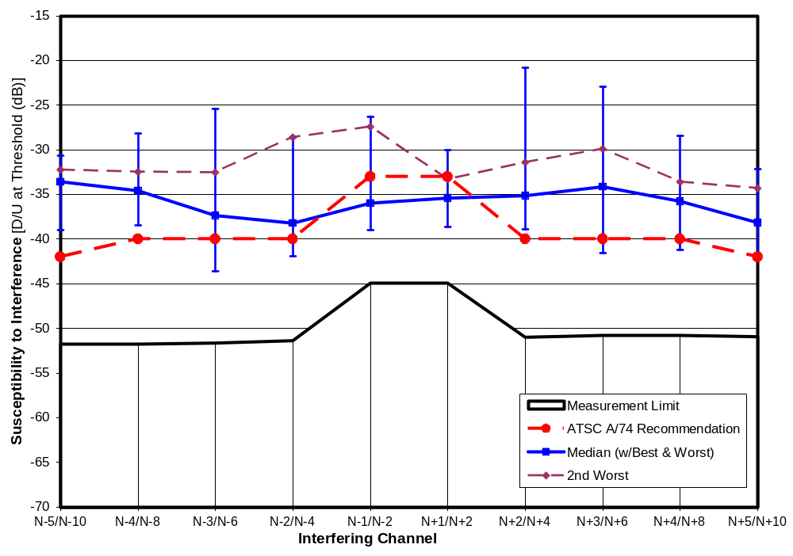
Figure 9-46. Paired-Signal D/U Statistics of 8 receivers at D = -53 dBm on Channel 30
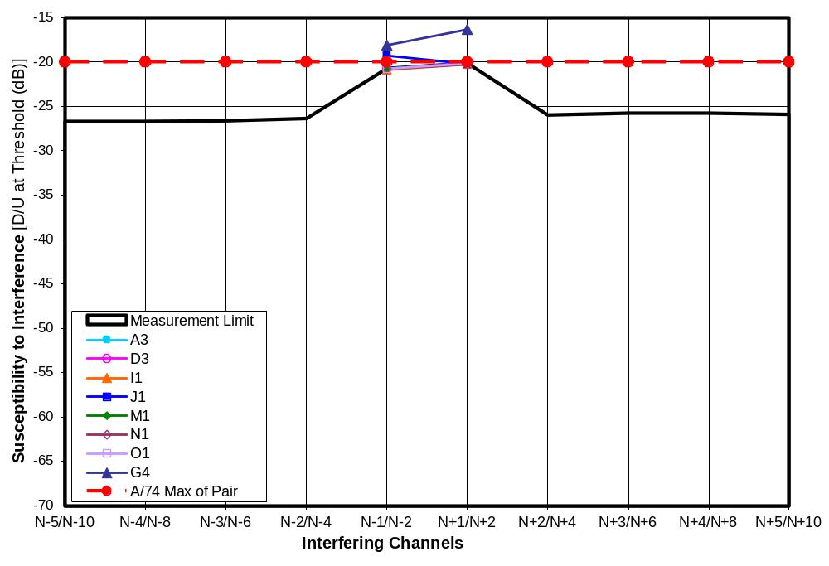
Figure 9-47. Paired-Signal D/U of 8 receivers at D = -28 dBm on Channel 30—1st-Adjacent Only

 | Susceptibility to Interference (D/U at Threshold [dB)]
 | N-1/N-2 | N+1/N+2
Worst | -18.1 | -16.4
2nd Worst | -19.3 | -20.1
Median | < -20.7 | < -20.2
Best | < -20.7 | < -20.2

Figure 9-48. Paired-Signal D/U of 8 receivers at D = -28 dBm on Channel 30—1st-Adjacent Only

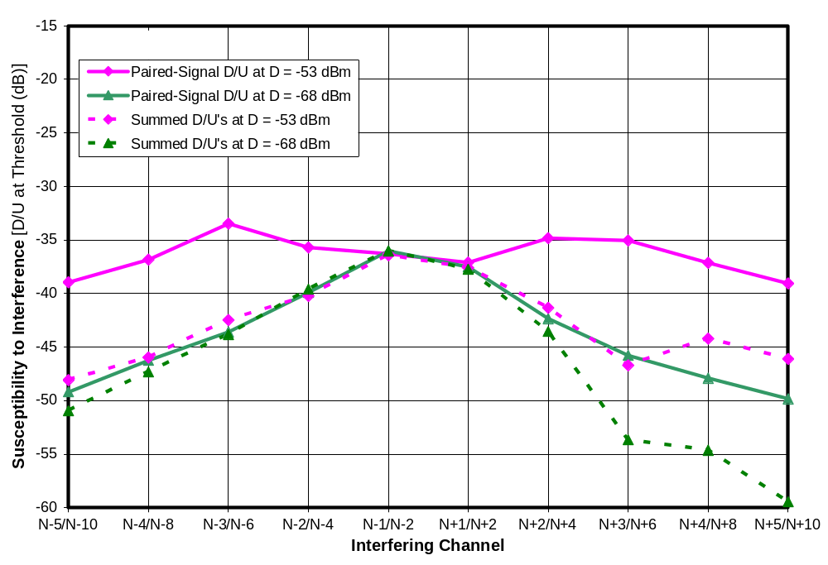
Figure 9-49. Paired-Signal D/U of Receiver A3 on Channel 30 with Summed D/U’s as Reference
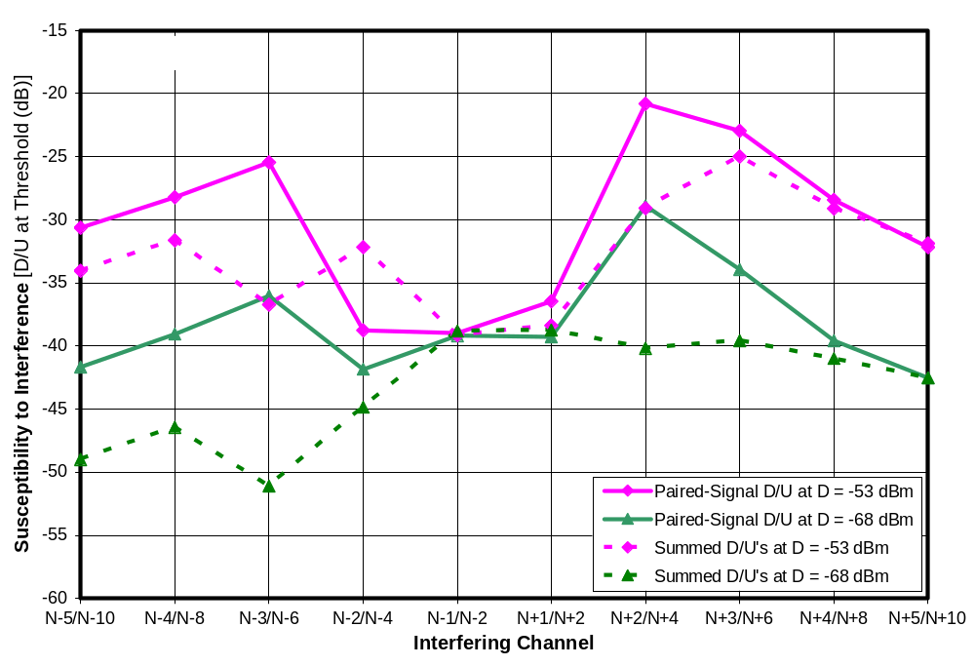
Figure 9-50. Paired-Signal D/U of Receiver D3 on Channel 30 with Summed D/U’s as Reference
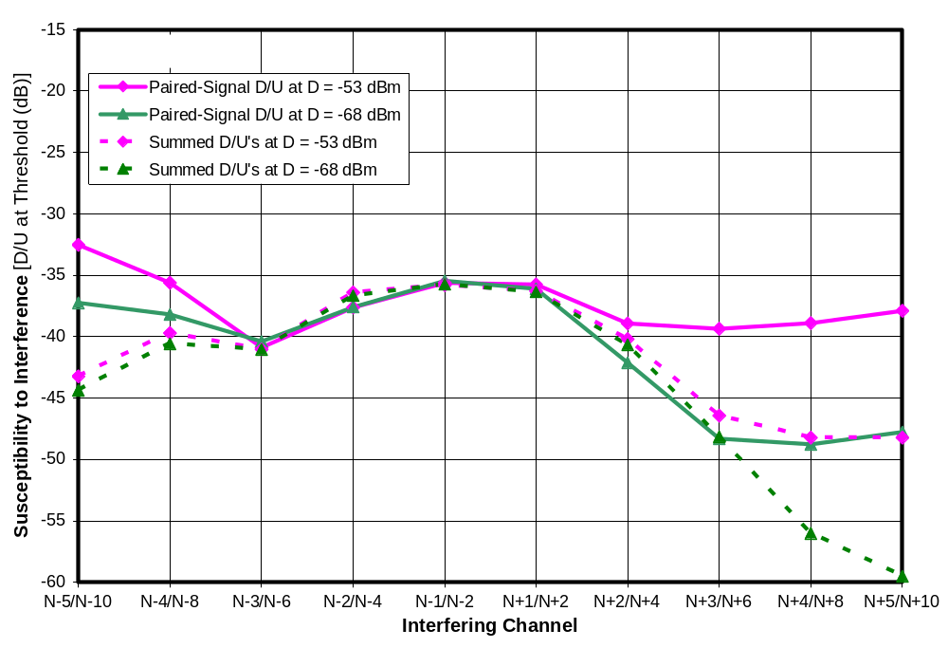
Figure 9-51. Paired-Signal D/U of Receiver I1 on Channel 30 with Summed D/U’s as Reference
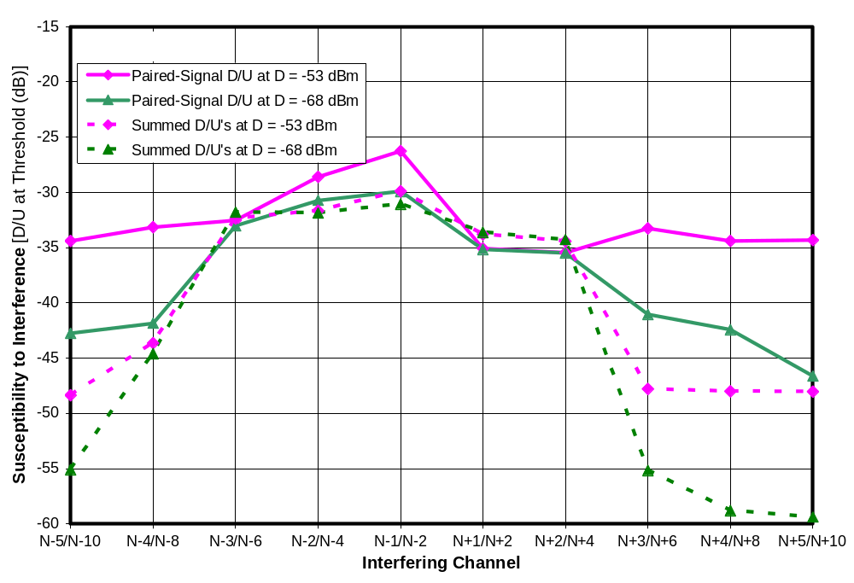
Figure 9-52. Paired-Signal D/U of Receiver J1 on Channel 30 with Summed D/U’s as Reference
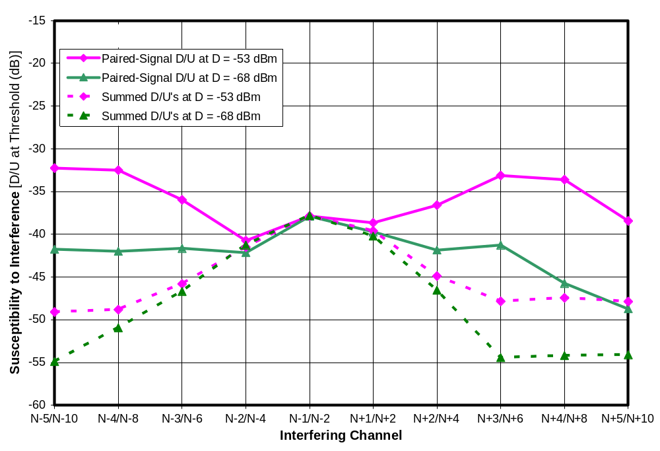
Figure 9-53. Paired-Signal D/U of Receiver M1 on Channel 30 with Summed D/U’s as Reference
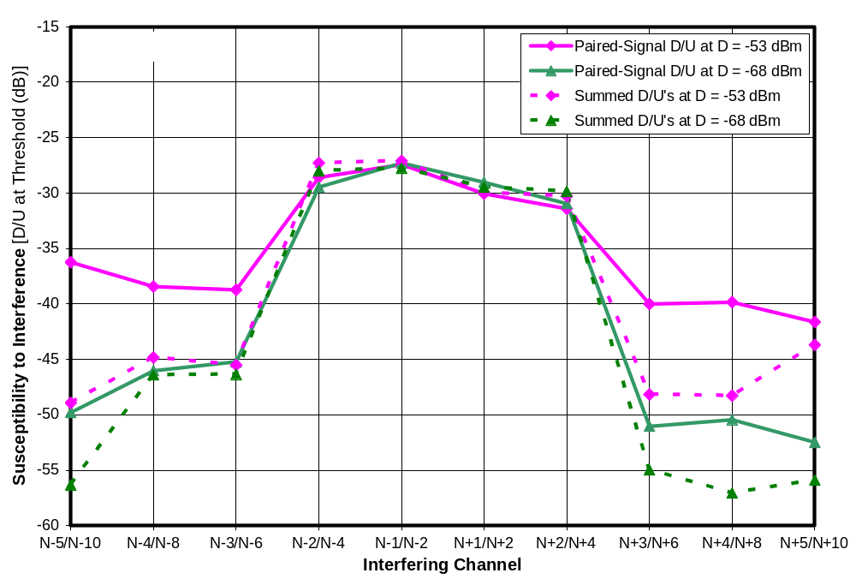
Figure 9-54. Paired-Signal D/U of Receiver N1 on Channel 30 with Summed D/U’s as Reference
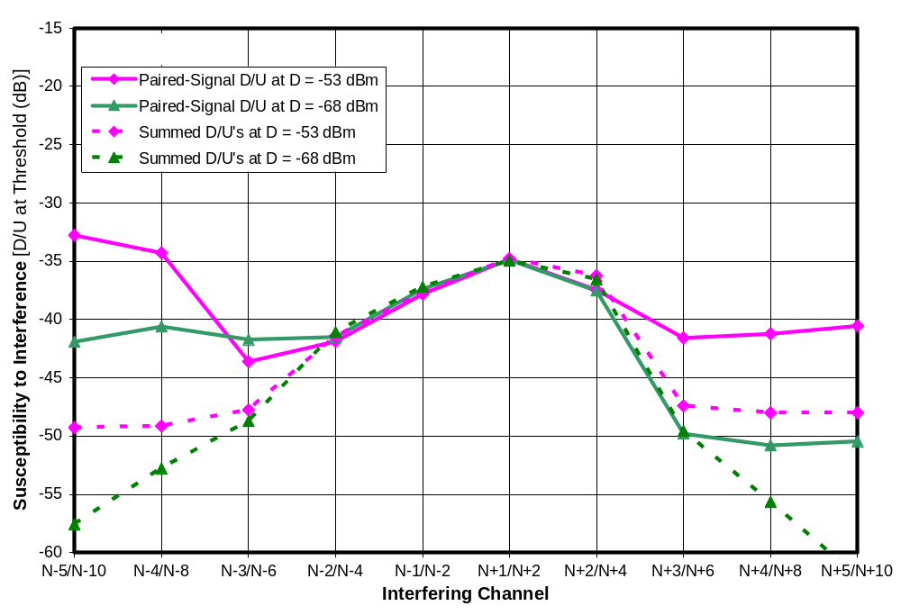
Figure 9-55. Paired-Signal D/U of Receiver O1 on Channel 30 with Summed D/U’s as Reference
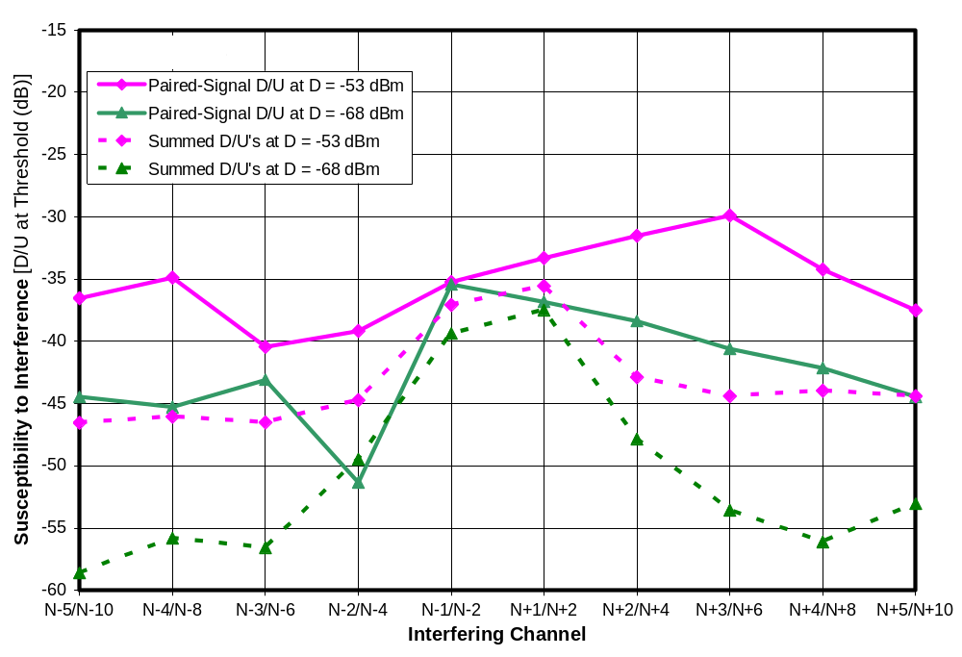
Figure 9-56. Paired-Signal D/U of Receiver G4 on Channel 30 with Summed D/U’s as Reference
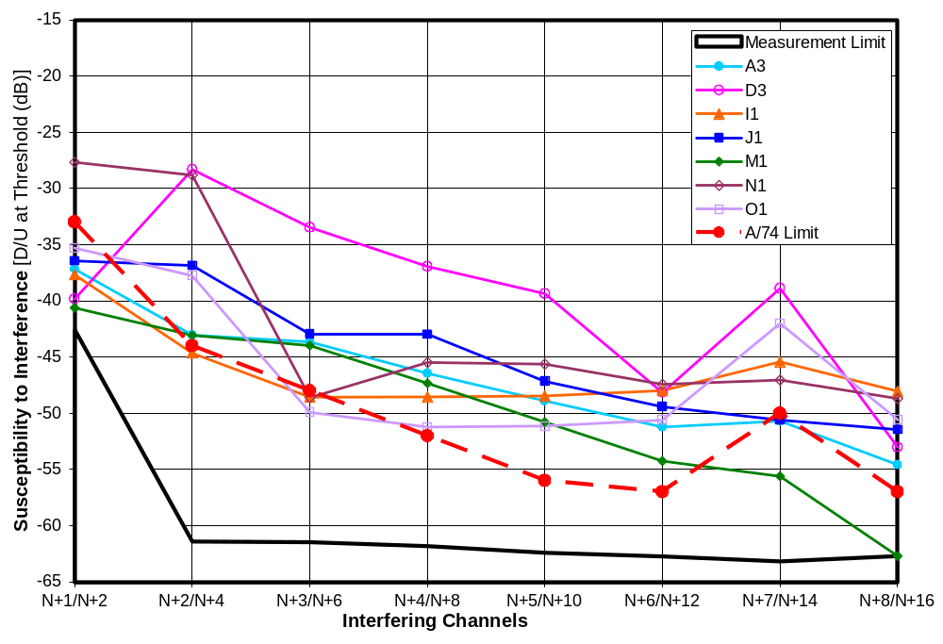
Figure 9-57. Paired-Signal D/U of 7 receivers at D = -68 dBm on Channel 51
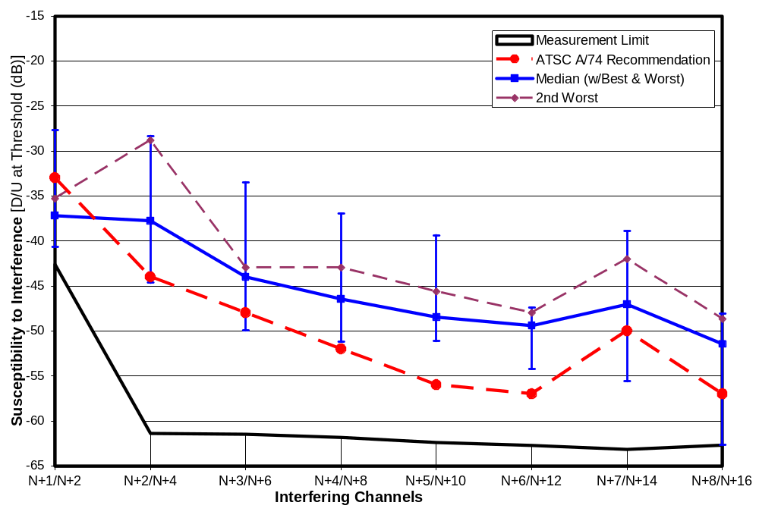
Figure 9-58. Paired-Signal D/U Statistics of 7 receivers at D = -68 dBm on Channel 51
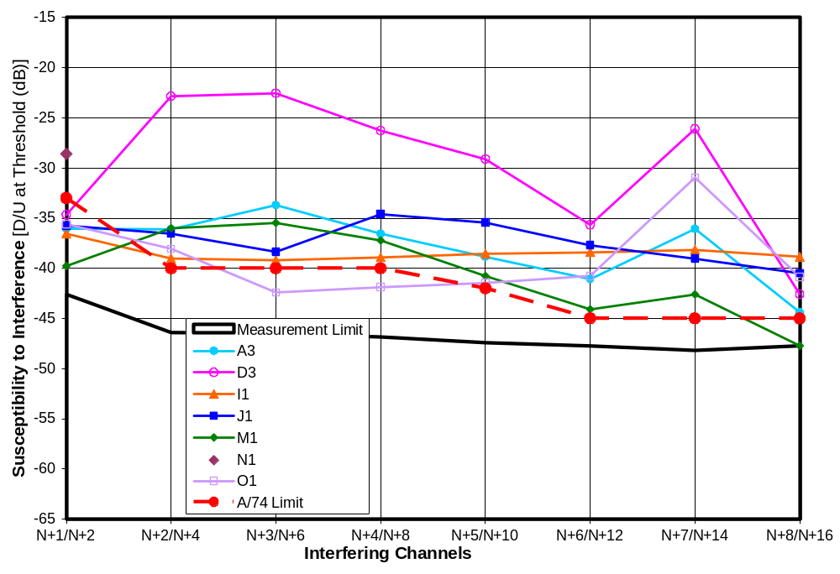
Figure 9-59. Paired-Signal D/U of 7 receivers at D = -53 dBm on Channel 51
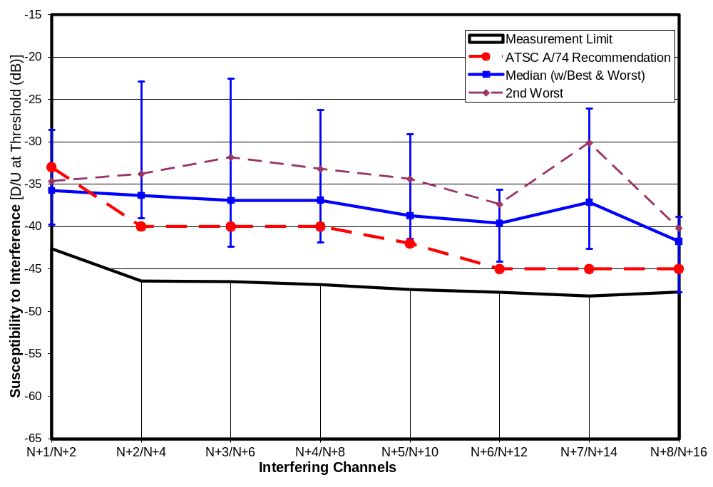
Figure 9-60. Paired-Signal D/U Statistics of 6 receivers at D = -53 dBm on Channel 51
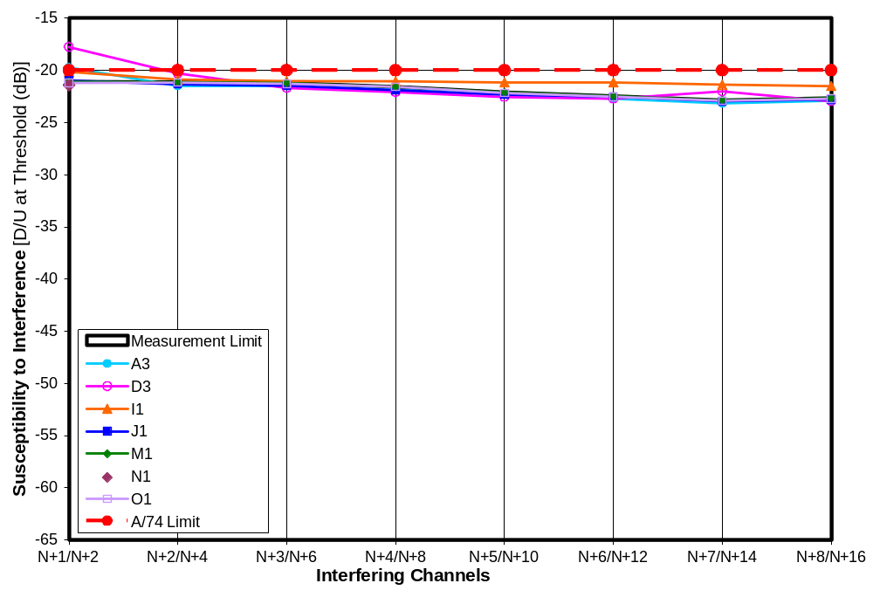
Figure 9-61. Paired-Signal D/U of 7 receivers at D = -28 dBm on Channel 51
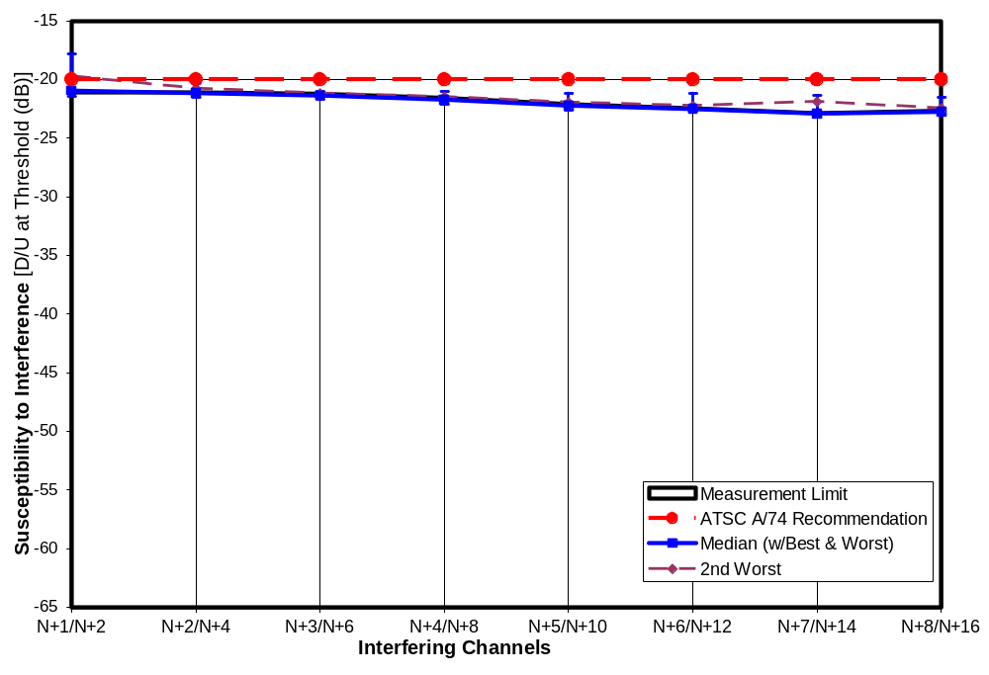
Figure 9-62. Paired-Signal D/U Statistics of 6 receivers at D = -28 dBm on Channel 51
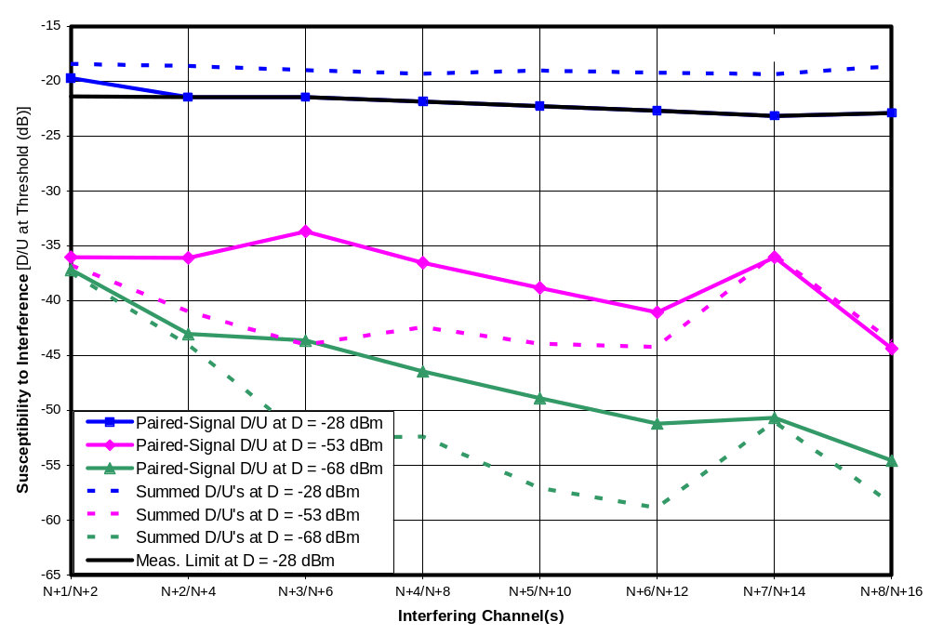
Figure 9-63. Paired-Signal D/U of Receiver A3 on Channel 51 with Summed D/U’s as Reference
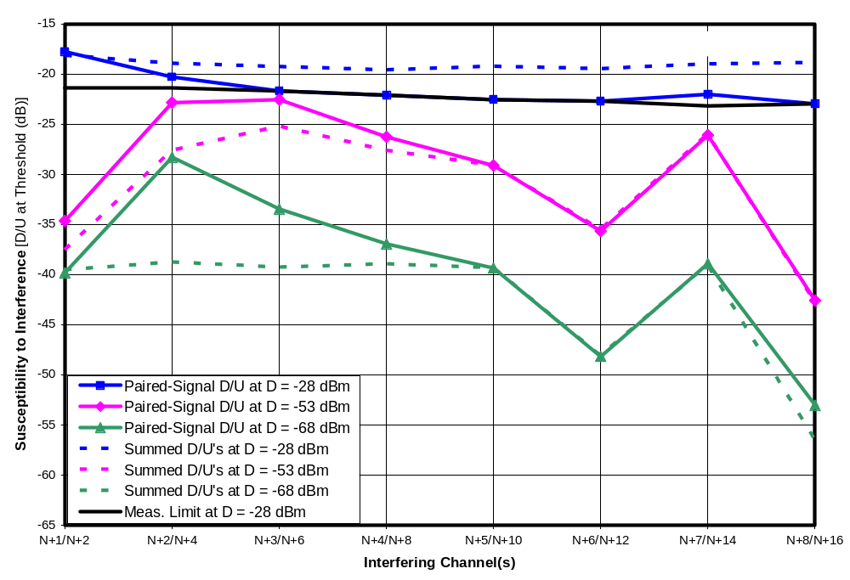
Figure 9-64. Paired-Signal D/U of Receiver D3 on Channel 51 with Summed D/U’s as Reference
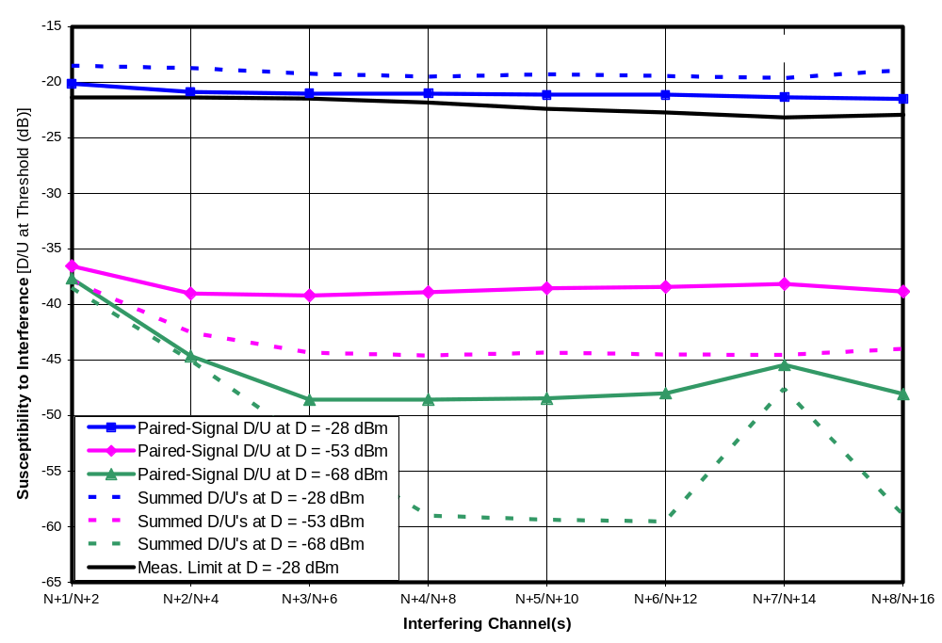
Figure 9-65. Paired-Signal D/U of Receiver I1 on Channel 51 with Summed D/U’s as Reference
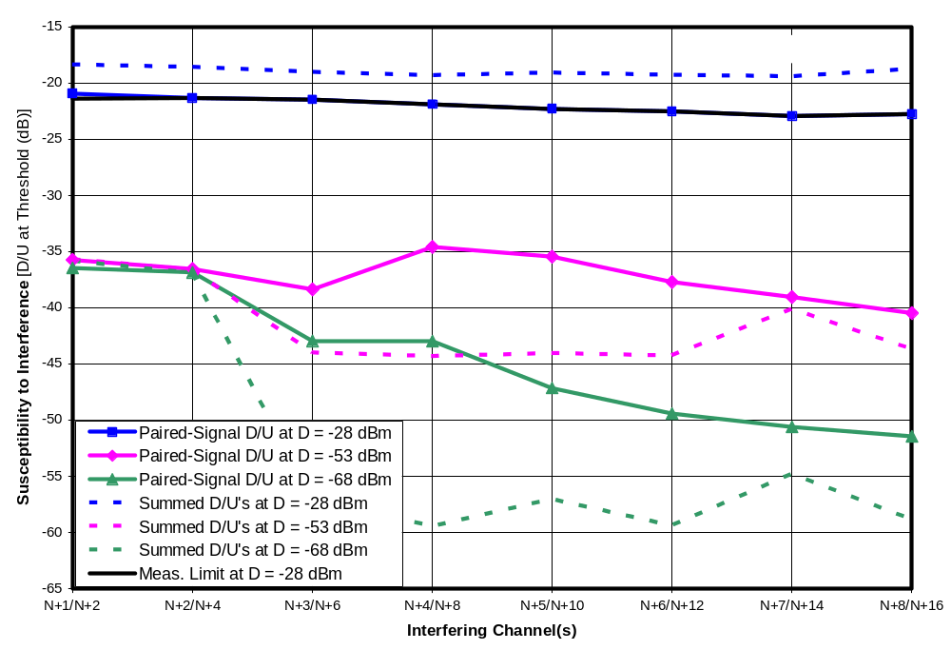
Figure 9-66. Paired-Signal D/U of Receiver J1 on Channel 51 with Summed D/U’s as Reference
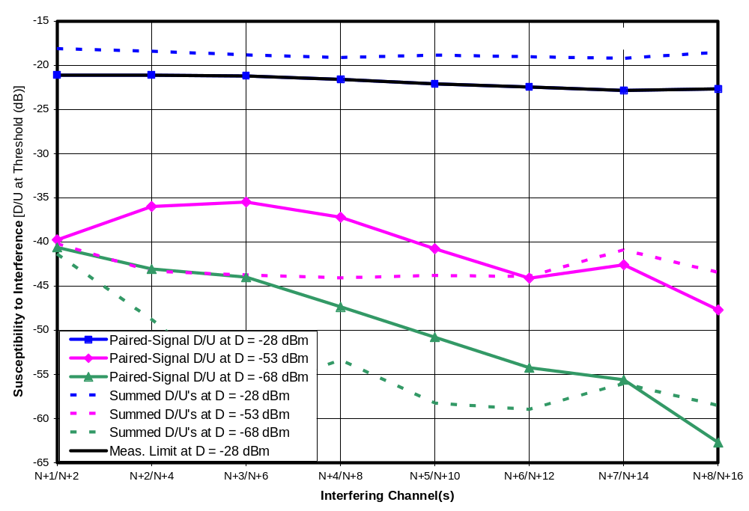
Figure 9-67. Paired-Signal D/U of Receiver M1 on Channel 51 with Summed D/U’s as Reference
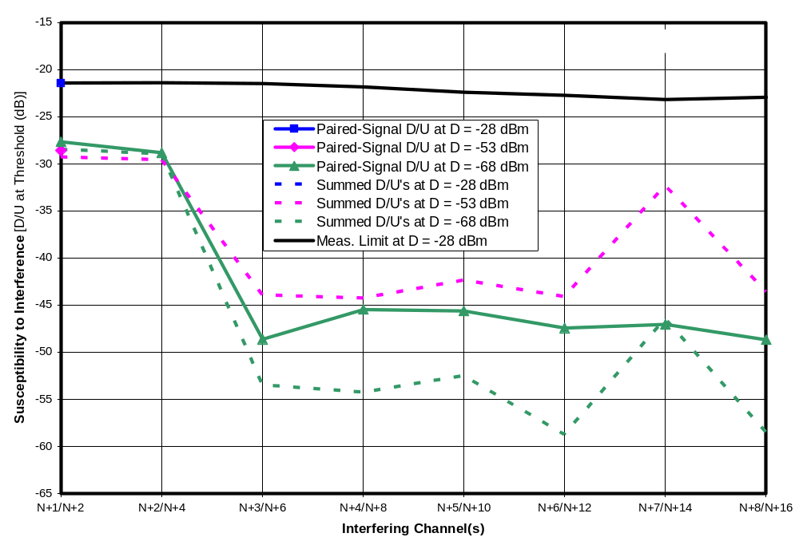
Figure 9-68. Paired-Signal D/U of Receiver N1 on Channel 51 with Summed D/U’s as Reference
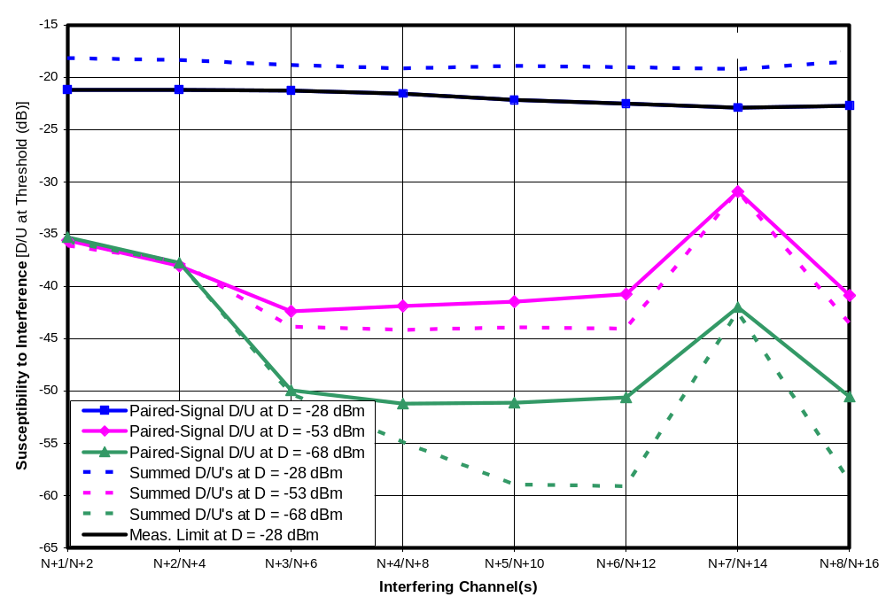
Figure 9-69. Paired-Signal D/U of Receiver O1 on Channel 51 with Summed D/U’s as Reference
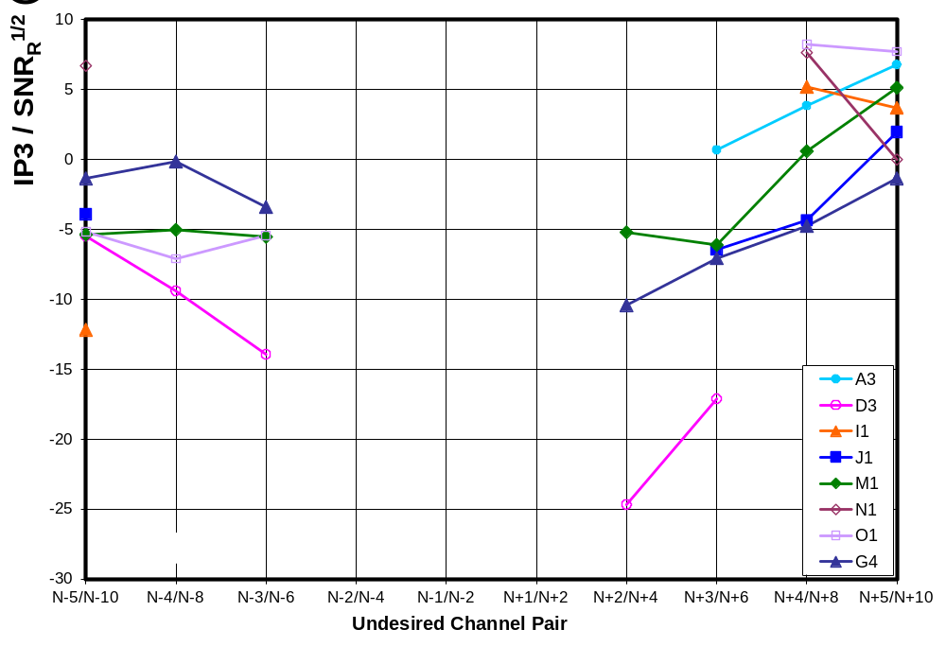
Figure 9-70. Third-Order Intercept Point Parameter with Desired Signal = -68 dBm on Channel 30
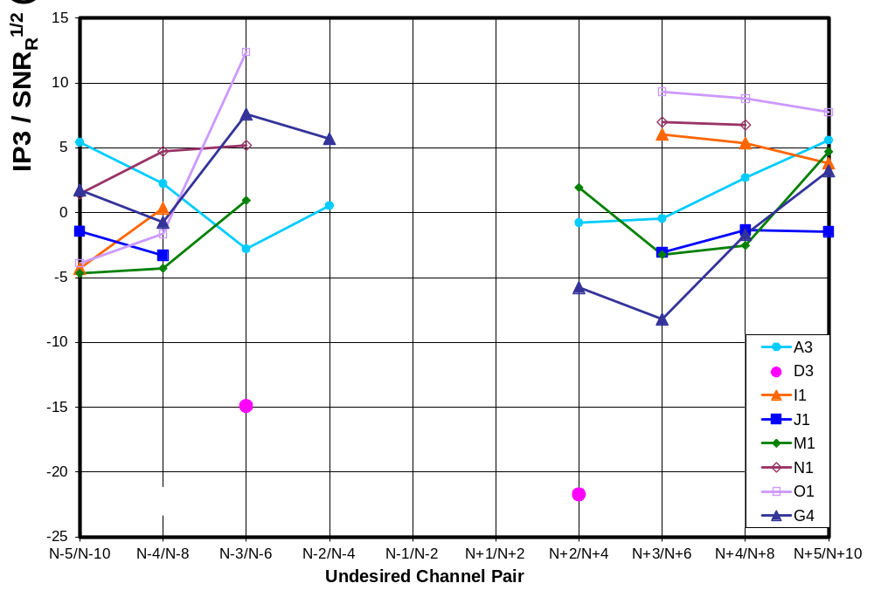
Figure 9-71. Third-Order Intercept Point Parameter with Desired Signal = -53 dBm on Channel 30
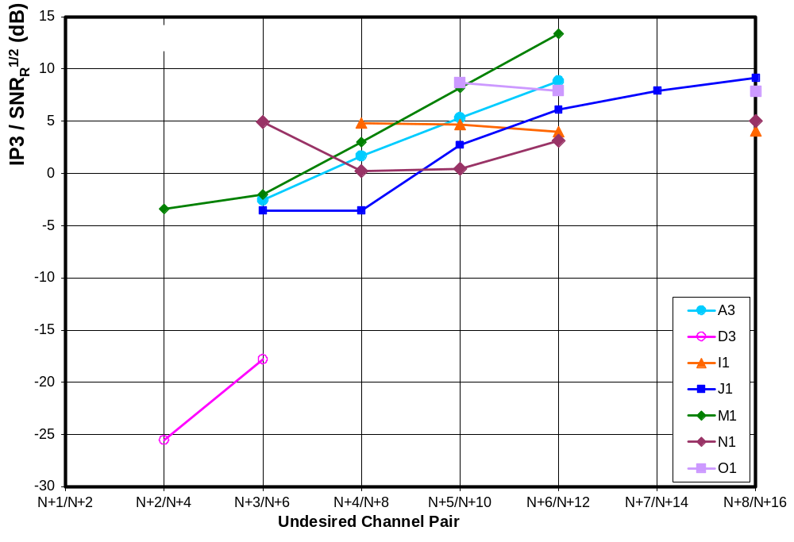
Figure 9-72. Third-Order Intercept Point Parameter with Desired Signal = -68 dBm on Channel 51
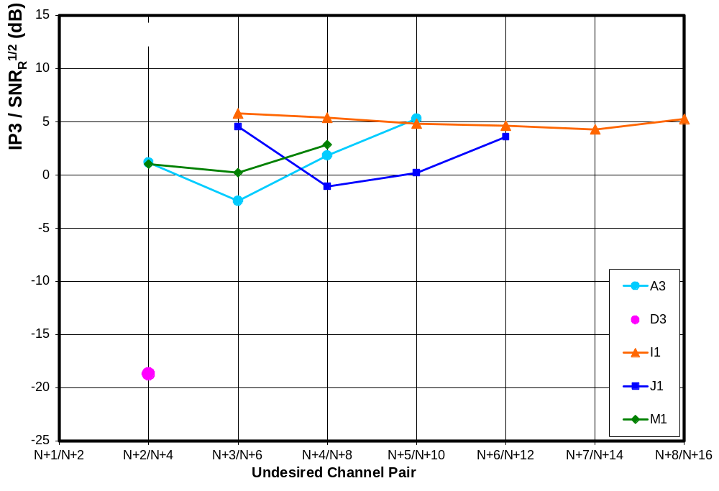
Figure 9-73. Third-Order Intercept Point Parameter with Desired Signal = -53 dBm on Channel 51
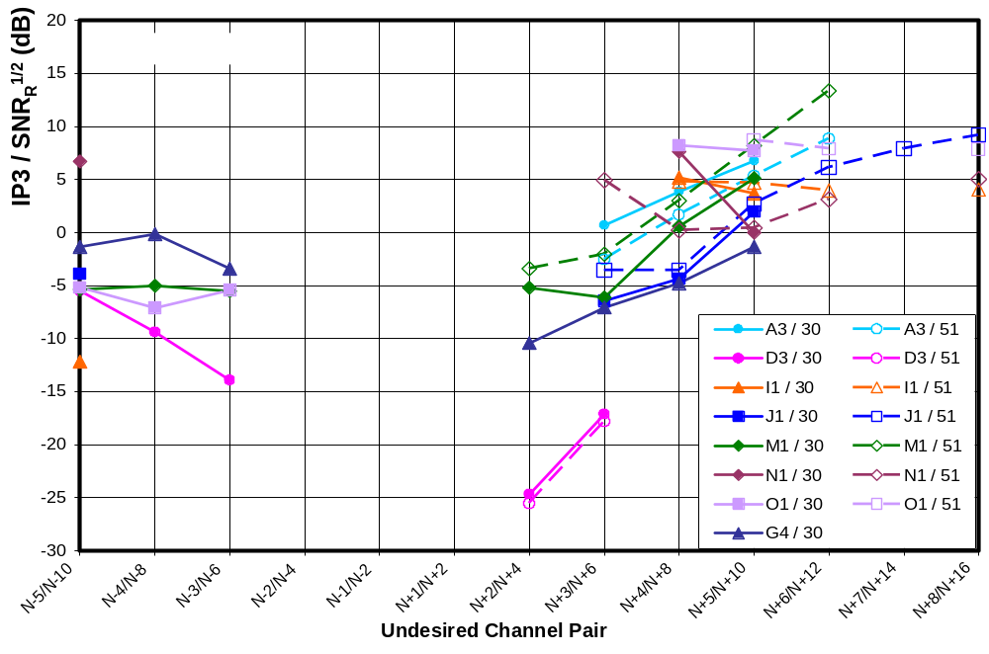
Figure 9-74. Third-Order Intercept Point Parameter—Channel 30/51 Comparison

IM3 WITH PAIRED SIGNALS OF UNEQUAL AMPLITUDES
The previous chapter showed the results of D/U measurements on eight receivers for pairs of undesired signals that were equal in power. In this chapter, we select two receivers and one channel offset pair for each for additional measurements with unequal undesired input signals. A model of the results is presented to allow measurements from the previous chapter to be to be extended to unequal signal levels on the other receivers. It will be seen that the model performs best at low desired signal levels.

Measurements on Two Receivers
The tests for this chapter were performed on receiver G4 with an undesired signal pair at N+2/N+4 and receiver M1 with an undesired signal pair at N+3/N+6. The selections of these receivers and channel offsets were based on their relatively high (though not the highest) differences between paired-signal D/U and summed D/U measurements, as presented in Chapter 9. This selection criterion ensured that the tests would be performed on receivers that exhibited easily measurable IM3 effects—at least for paired signals of equal levels. Plots of paired-signal D/U’s and summed D/U’s for these receivers were shown in Figures 9-16 and 9-13, respectively, in Chapter 9.

Figure 10-1 shows measurements of threshold signal levels for a pair of undesired signals on N+2 and N+4 for receiver G4. The three curves correspond to three desired signal levels: -53 dBm, -68 dBm, and D_{MIN} + 3 dB. The measurements were performed by attenuating one undesired signal with respect to the other, and then adjusting an attenuator that affected both undesired signal levels until TOV for the DTV receiver was found. The X-axis shows the signal level of the undesired signal on channel N+2. The Y-axis shows the level of the undesired signal on channel N+4. The dashed lines represent a model, to be discussed in the next section.

If one moves down the chart toward very low signal levels on N+4, each curve asymptotically approaches the respective threshold level for N+2 alone. Similarly, moving leftward on the chart toward very low levels on N+2 causes at least one curve (that for D_{MIN} + 3 dB) to asymptotically approach the threshold value for N+4 alone. In between these two conditions is the region where IM3 between the pair of signals is the dominant interference mechanism.

Figure 10-2 shows the same type of measurement performed on receiver M1. This receiver exhibited very odd behavior when the undesired signal power on N+3 (U_{N+3}) was between -27 and -21 dBm. As U_{N+3} is increased in this range, the upper two curves exhibit first a dip in U_{N+6} relative to the previous trajectory, then a sharp increase, and finally a return back down to the previous trajectory. The lower curve exhibits the dip, but the threshold value of U_{N+3} is reached before subsequent behavior had an opportunity to occur.

Figure 10-3 isolates the curve corresponding to a desired signal power of -68 dBm and adds a shading effect to illustrate the bizarreness of the behavior. Consider moving along the solid diagonal line, representing equal values of undesired signals, while the desired signal level remains at -68 dBm. Beginning at the lower left and moving rightward, DTV reception is visually flawless. When each of the undesired signals reaches a level of -26.6 dBm, the TV picture begins to exhibit visual errors. As the level of the undesired signal pair increases about another dB, the picture is lost entirely. However, a further increase causes the picture to come back, and, with a little additional increase, to again become error free. But the new error-free condition exists only over a very narrow range of undesired signal levels before picture errors—followed by complete picture failure—occur again as the undesired signal levels rise further.

This behavior—of first losing the picture, then regaining it, and then losing it again with increases in undesired signal levels—was observed at D = -68 dBm for increases in both undesired signals at equal levels, as well as for both D = -68 dBm and D = -53 dBm when U_{N+6} was fixed in power (at an appropriate level) and U_{N+3} was varied. We have no explanation for the observed behavior, but we suspect that AGC operation—driven by the signal level on N+3—is involved.

Modeling and Extrapolation
Appendix B demonstrated that a pair of undesired signals at N+K and N+2K can create an IM3-based interference effect that is proportional to U_{N+K}² and to U_{N+2K}. The resulting relationship between the threshold values of D, U_{N+K}, and U_{N+2K} is given in Chapter 8 as

D = (SNR_{R} / IP3²) U_{N+K}²U_{N+2K} + D_{MIN}.

where SNR_{R} / IP3² quantifies the IM3 characteristics of the receiver for the specified channel offsets (N+K and N+2K) and AGC gain state. It is clear from the equation that, for a fixed desired signal power, increasing the power of one of the undesired signals must result in a reduction of threshold power of the other if AGC gain remains constant with the variations. Furthermore, because the U_{N+K} term is squared and the U_{N+2K} term is not, a change in U_{N+K} must be countered with a larger, but opposite, change in U_{N+2K}, in order to remain at threshold. For example, a 3 dB increase in U_{N+K} results in the threshold value of U_{N+2K} dropping by 6 dB.

Chapter 8 shows that one can compute the threshold of one undesired signal given the level of the other by means of the following equations:

U_{N+K}|_{dB} = (IP3 / SNR_{R}^{1/2})|_{dB} + (D|_{dB} - U_{N+2K}|_{dB})/2

U_{N+2K}|_{dB} = 2(IP3 / SNR_{R}^{1/2})|_{dB} + D|_{dB} - 2 U_{N+K}|_{dB}

If there are no AGC-induced changes in tuner gain prior to the point of the nonlinearity that causes IM3 in a given situation, then the value of (IP3 / SNR_{R}^{1/2})|_{dB} is a constant, which can be computed from a measurement of threshold made with equal levels of undesired signals on the two channels (i.e., U = U_{N+K} = U_{N+2K}).

(IP3 / SNR_{R}^{1/2})|_{dB} = (3 U|_{dB} - D|_{dB} )/2

Values of IP3 / SNR_{R}^{1/2} computed in this way for eight receivers were shown in Tables 9-3 through 9-5 and Figures 9-30 through 9-34 of Chapter 9. (Note that for values of D approaching D_{MIN}, the quantity D|_{dB} should be replaced by (D – D_{MIN})|_{dB} where the subtraction is performed in linear power units, before conversion to dB.)

Figures 10-1 and 10-2 included dashed line representing modeled performance in three regions:
A horizontal line represents the threshold value of U_{N+2K} in the absence of an undesired signal at N+K; this portion of the model is based on direct measurement of the threshold under that condition;
A vertical line represents the threshold value of U_{N+K} in the absence of an undesired signal at N+2K; this portion of the model is based on direct measurement of the threshold under that condition;
A diagonal line with a slope of -2 dB/dB represents the IM3 contribution to interference based on the formulas above; the required value of IP3 / SNR_{R}^{1/2} was computed by measurement of threshold with U_{N+K} = U_{N+2K}.

Thus, three measurements (indicated by the black circles) were required to create each modeled performance curve. Given that those same three measurements exist for each of the eight receivers at various channel offsets, we can apply the modeling technique to the other receivers and other channel offsets. We choose to do this only at the lower signal levels (D = -68 dBm and below) since the model appears to be a better fit to measurements at such levels. (At higher levels, AGC is more likely to influence the results.)

We note that, even if the AGC did not engage to reduce gain prior to the IM3-generating nonlinearity during measurement of the threshold for equal-powered undesired signals, it is still possible that it might engage under some non-equal undesired signal conditions. This is more likely to occur on the basis of U_{N+K}, since it is likely to be subjected to less attenuation by the tuner’s tracking filter than is U_{N+2K}. If the AGC does engage on U_{N+K}, the IM3 segment of the model curve will switch at that point from being a diagonal line to a horizontal line extending rightward from the AGC engagement point (per Appendix B). Since we haven’t attempted to determine AGC thresholds for each case, the reader should recognize that the curves shown in the models presented in this chapter will be invalid to the right of such an AGC engagement point, if one occurs. In Chapter 14, we identify one such case.

Models for D = -68 dBm
Figures 10-4 through 10-10 show paired-signal IM3 models for the eight DTV receivers at a desired signal level of -68 dBm. Each graph represents one channel-offset pair—e.g., N-5/N-10 for the first. Each graph contains one curve for each DTV receiver for which an IP3 / SNR_{R}^{1/2} was determined in Table 9-3.

No plots are shown for the first-adjacent channel cases (N-1/N-2 and N+1/N+2) because measurements presented in Chapter 9 were not adequate to ensure that a paired-signal IM3 effect was measured for those channels (as opposed to individual-channel effects). Chapter 11 will show, in detail, that the paired-signal IM3 on N+1/N+2 is limited to certain regions of the amplitude range for receiver D3 (at least for equal amplitude undesired signals).

Each curve shows that the presence of one undesired signal can affect the TV receiver’s susceptibility to the other. As an example, we examine the curve corresponding to receiver D3 in Figure 10-5, where K is -4 (i.e., the channel pair is N-4/N-8). Starting at the top left end of that curve, we see that the TV is susceptible to interference from an undesired signal at -13 dBm on channel N+2K (y-axis). Moving to the right, we see that, if an undesired signal is also present on channel N+K at a level exceeding -37 dBm, the susceptibility of the receiver to interference on channel N+2K will increase (i.e., the receiver will be affected by smaller undesired signals on that channel). As the level of the undesired signal on channel N+K increases, the signal level on channel N+2K necessary to cause interference drops by 2 dB for each 1-dB increase in power on channel N+K—eventually reaching -45 dBm when the undesired signal on channel N+K reaches -21 dB. Similarly, we can view the undesired signal on channel N+2K as causing the TV to be more susceptible to interference from channel N+K.

This example could be applied to the case in which a desired signal—broadcast from a DTV station on channel N—is received at a level of -68 dBm at the input to a DTV receiver and another DTV broadcast on channel N-4 is the first undesired signal. The analysis described above could be used to predict the vulnerability of the DTV receiver to emissions from a white-space device or another DTV station operating on channel N-8, as a function of the undesired signal level on channel N-4 at the input to the receiver.

Table 10-1 summarizes the information in the model plots. Note that the statistics provided here apply to the subset of combinations of channel offsets and TVs for which a measurement of IP3 / SNR_{R}^{1/2} was obtained. In general, the greatest susceptibility to interference is predicted to be on channel N+2K when a large signal is present on N+K. If no undesired signal is present on channel N+K, the receivers can tolerate undesired signal levels as high as -27 to -1 dBm on N+2K. With an undesired signal on N+2K, the receivers are predicted to be susceptible to undesired signal powers as low as -79 to -28 dBm—an increase in susceptibility ranging from 23 to 63 dBm. The signal level on N+K necessary to cause such an increase in interference susceptibility can range from -28 to -3 dBm, but the susceptibility increase begins at levels of -45 to -24 dBm on channel N+2K.

If one were interested in determining what undesired signal level could cause interference to DTV reception, one might consider two different approaches with respect to IM3 from paired signals:
(1) Identify a level that could cause interference if a similar signal level happens to occur at another channel offset that would place IM3 products in the desired channel;
(2) Identify levels that will cause interference given a specific knowledge of signal levels that already exist on other channels that might combine with the signal of interest to cause IM3.

In case (1) analysis could be performed based on the equal-power paired-signal test results from Chapter 9 (or summary charts presented in Chapter 15 of this report). In case (2), the modeled results in this chapter could provide a basis for analysis.

Table 10-27. Range of Impact of IM3 from Pairs of Undesired Signals When D = -68 dBm
 | Statistics of Undesired Signal Levels (dBm)
 | Min. | Median | Mean | Max. | Standard Deviation
Susceptibility increase on N+K due to N+2K:
Susceptibility to N+K begins increasing at U_{N+2K}= | -79.4 | -46.6 | -47.7 | -28.0 | 11.9
Susceptibility to N+K reaches max. at U_{N+2K}= | -27.0 | -5.2 | -6.9 | -1.4 | 5.4
U_{N+K} threshold before increase in susceptibility | -28.2 | -12.5 | -13.3 | -2.6 | 5.7
U_{N+K} threshold after increase in susceptibility | -45.2 | -34.2 | -33.7 | -24.2 | 5.4
Net increase in susceptibility caused by U_{N+2K} | 11.7 | 19.4 | 20.4 | 31.6 | 5.1
Susceptibility increase on N+2K due to N+K:
Susceptibility to N+2K begins increasing at U_{N+K}= | -45.2 | -34.2 | -33.7 | -24.2 | 5.4
Susceptibility to N+2K reaches max. at U_{N+K}= | -28.2 | -12.5 | -13.3 | -2.6 | 5.7
U_{N+2K} threshold before increase in susceptibility | -27.0 | -5.2 | -6.9 | -1.4 | 5.4
U_{N+2K} threshold after increase in susceptibility | -79.4 | -46.6 | -47.7 | -28.0 | 11.9
Net increase in susceptibility caused by U_{N+K} | 23.5 | 38.8 | 40.8 | 63.1 | 10.1

Models for D = D_{MIN} + 3 dB
Figures 10-11 through 10-17 show plots of models corresponding to a desired signal level that is 3 dB above the D_{MIN} value that was measured for each receiver. Since we made no measurement of paired-signal thresholds at D_{MIN} + 3 dB (except for those shown in Figures 10-1 and 10-2, which were not used in Figures 10-11 through 10-17), the plots are based on an assumption that IP3 / SNR_{R}^{1/2} is the same at this low desired signal level as it was at D = -68 dBm. To help ensure the validity of this assumption, models are shown only for DTVs and channel offsets for which Table 9-3 indicates that -68 dBm was likely to be low enough to avoid AGC operation (based on the change in IP3 / SNR_{R}^{1/2} as desired the signal decreased from -53 dBm to -68 dBm). Nonetheless, this extrapolation to lower signal levels constitutes an additional potential source of error in these plots that was not present in the Figures 10-4 to 10-10.

Comparing the modeled curve for receiver M1 in Figure 10-15 to the measurements for that receiver at D = D_{MIN} + 3 dB in Figure 10-2, we see that the modeled threshold along the equal-power line is about -32 dBm, whereas the measured threshold is about -30 dBm. This 2 dB error can be attributed to the anomalous behavior of the receiver for D = -68 dBm in the vicinity of the equal power line (Figure 10-2). In fact, if the model had been computed from the IP3 / SNR_{R}^{1/2} value for D = -53 dBm, it would match the measurement within 0.3 dB.

Table 10-2 summarizes the information in the model plots. Note that the statistics provided here apply to the subset of combinations of channel offsets and TVs for which a measurement of IP3 / SNR_{R}^{1/2} was obtained and for which AGC was judged to be inactive at -68 dBm (for tuner stages prior to the nonlinearity that causes the observed IM3) so that IP3 could be assumed constant below that level. In most cases, the greatest susceptibility to interference is predicted to occur on channel N+2K, where the susceptibility may increase by amounts ranging from 6 to 59 dB when a large signal is present on N+K.

Table 10-28. Range of Impact of IM3 from Pairs of Undesired Signals When D =D_{MIN} + 3 dB
 | Statistics of Undesired Signal Levels (dBm)
 | Min. | Median | Mean | Max. | Standard Deviation
Susceptibility increase on N+K due to N+2K:
Susceptibility to N+K begins increasing at U_{N+2K}= | -68.7 | -39.5 | -41.3 | -12.4 | 14.4
Susceptibility to N+K reaches max. at U_{N+2K}= | -32.3 | -9.0 | -11.1 | -2.9 | 6.7
U_{N+K} threshold before increase in susceptibility | -38.5 | -23.9 | -23.7 | -12.3 | 6.4
U_{N+K} threshold after increase in susceptibility | -50.0 | -39.4 | -38.9 | -30.7 | 5.2
Net increase in susceptibility caused by U_{N+2K} | 3.2 | 15.4 | 15.1 | 29.6 | 7.2
Susceptibility increase on N+2K due to N+K:
Susceptibility to N+2K begins increasing at U_{N+K}= | -50.0 | -39.4 | -38.9 | -30.7 | 5.2
Susceptibility to N+2K reaches max. at U_{N+K}= | -38.5 | -23.9 | -23.7 | -12.3 | 6.4
U_{N+2K} threshold before increase in susceptibility | -32.3 | -9.0 | -11.1 | -2.9 | 6.7
U_{N+2K} threshold after increase in susceptibility | -68.7 | -39.5 | -41.3 | -12.4 | 14.4
Net increase in susceptibility caused by U_{N+K} | 6.4 | 30.8 | 30.2 | 59.3 | 14.3

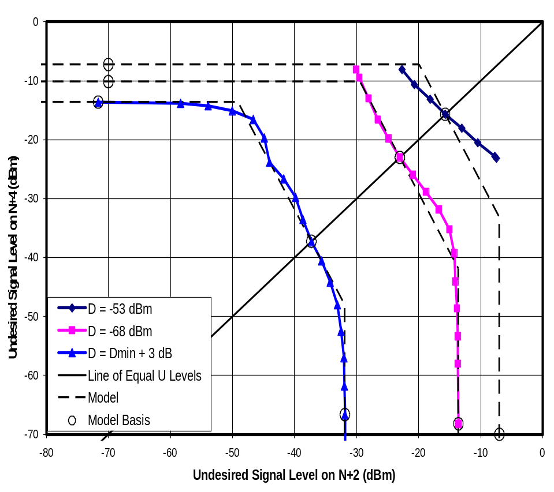
Figure 10-75. Threshold U for Paired, Unequal Undesired Signals on Receiver G4
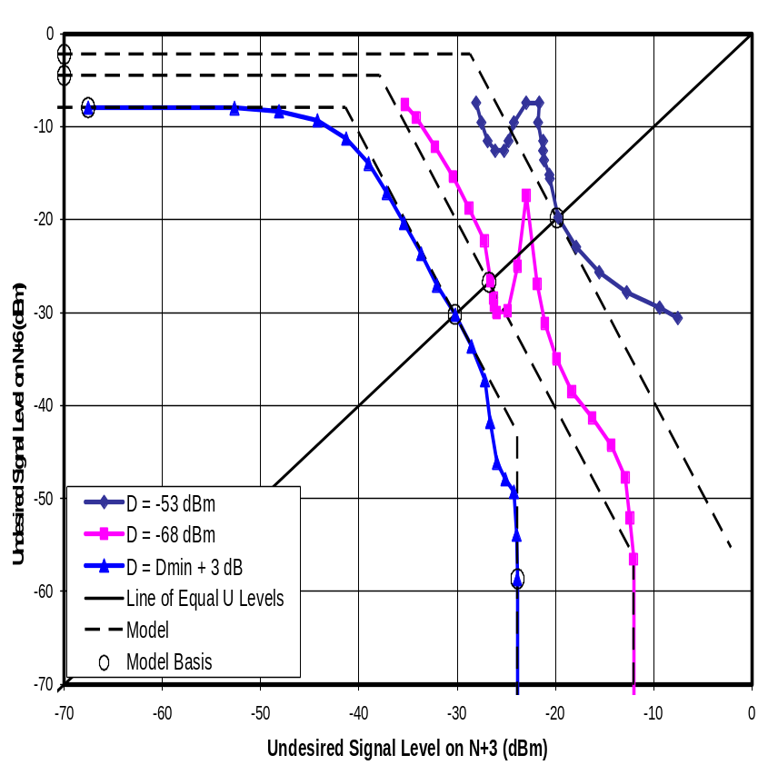
Figure 10-76. Threshold U for Paired, Unequal Undesired Signals on Receiver M1
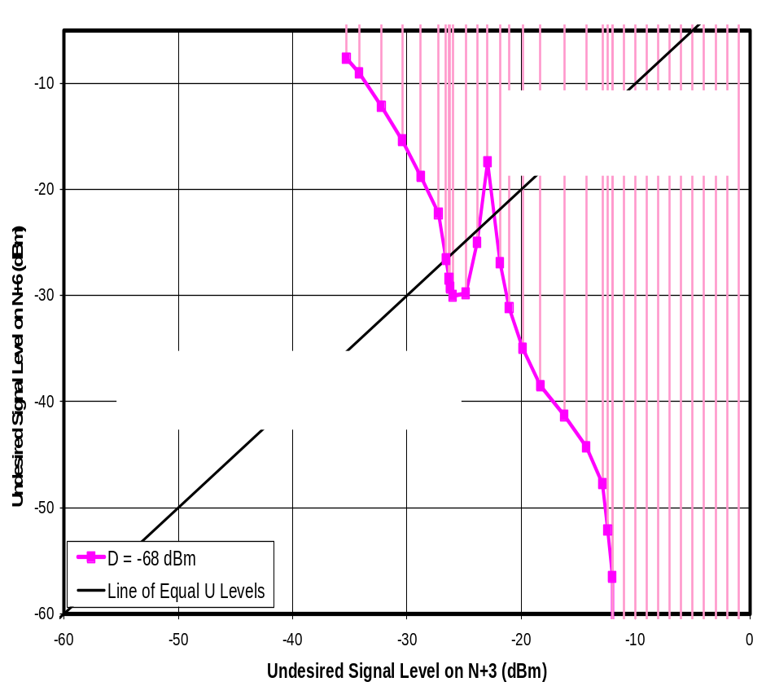
Figure 10-77. Threshold U for Paired, Unequal Undesired Signals on Receiver M1 at D = -68 dBm
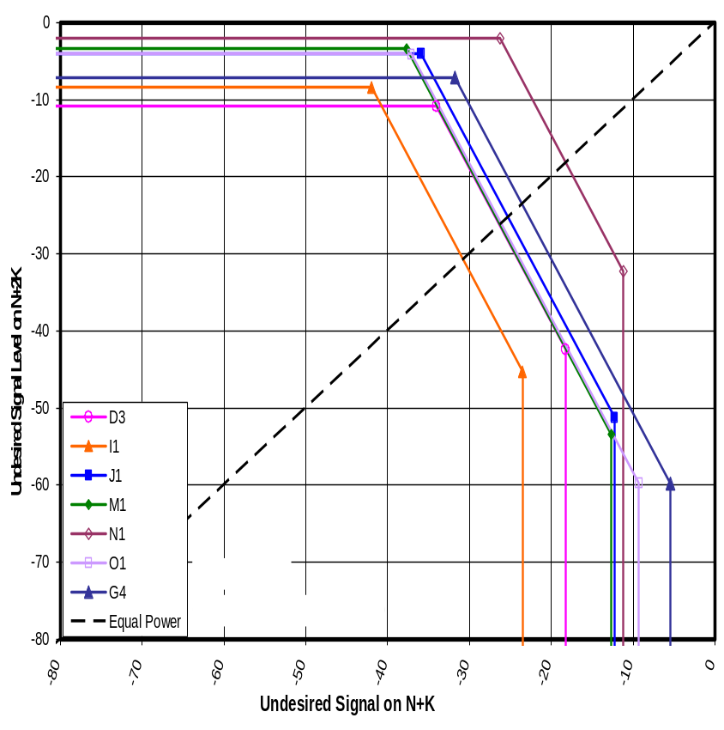
Figure 10-78. Modeled Thresholds for N-5/N-10 with D = -68 dBm
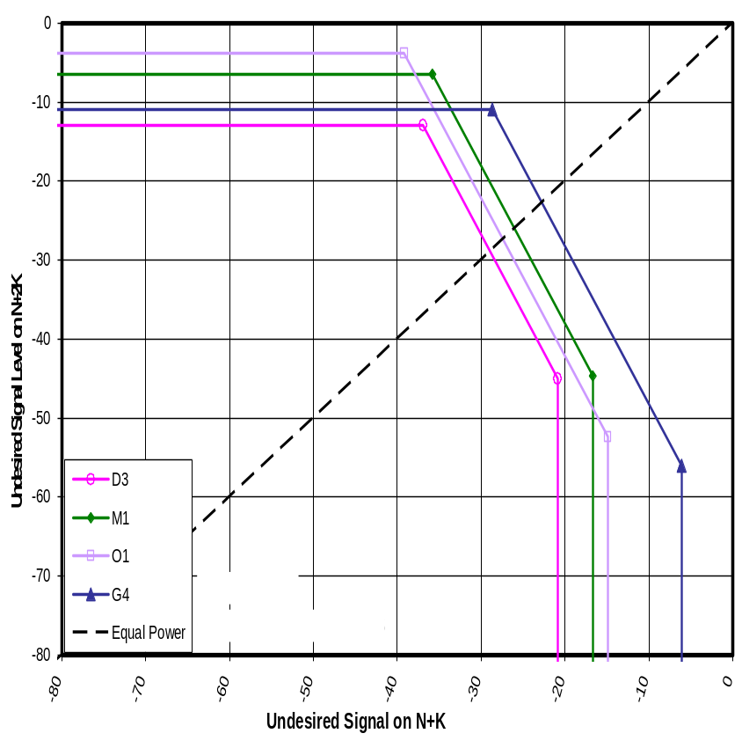
Figure 10-79. Modeled Thresholds for N-4/N-8 with D = -68 dBm
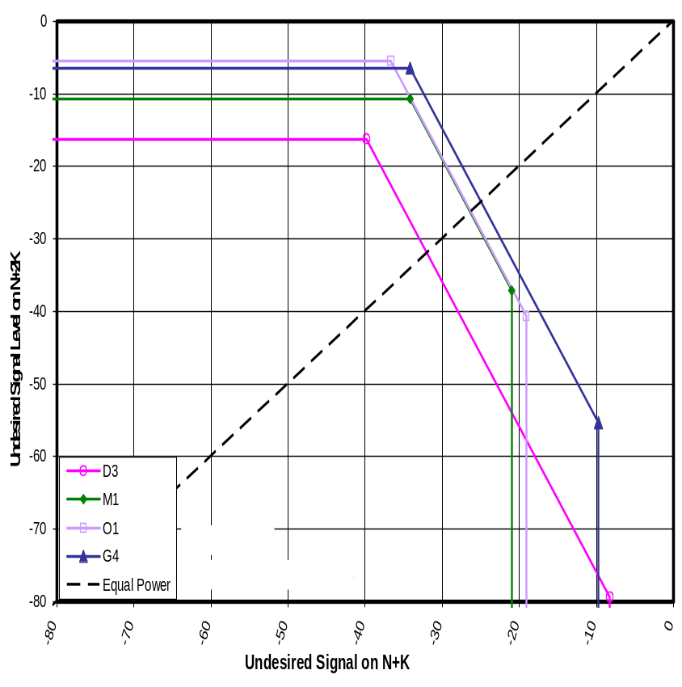
Figure 10-80. Modeled Thresholds for N-3/N-6 with D = -68 dBm
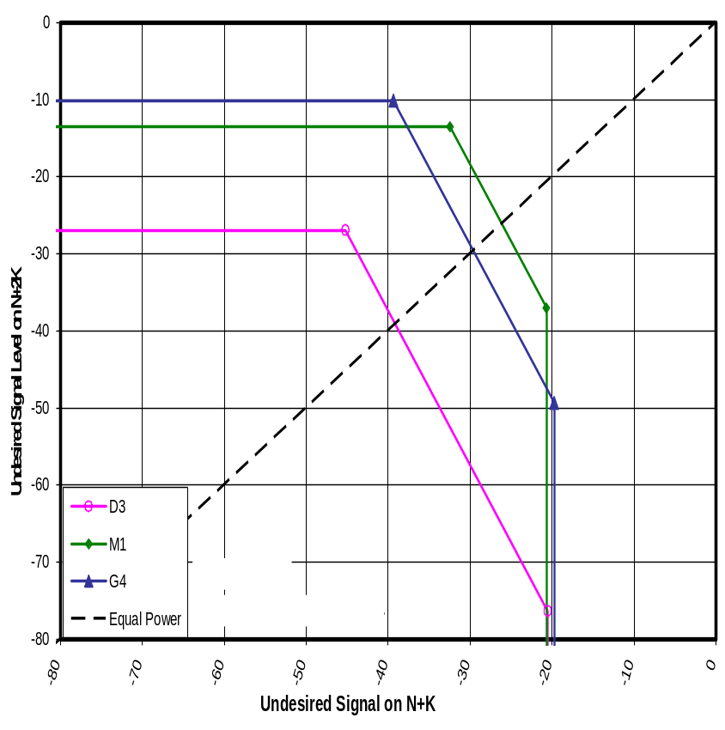
Figure 10-81. Modeled Thresholds for N+2/N+4 with D = -68 dBm
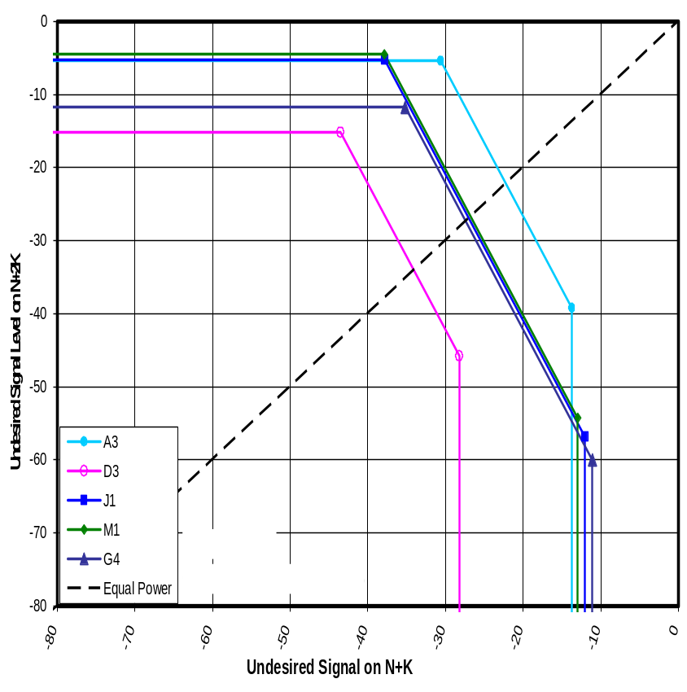
Figure 10-82. Modeled Thresholds for N+3/N+6 with D = -68 dBm
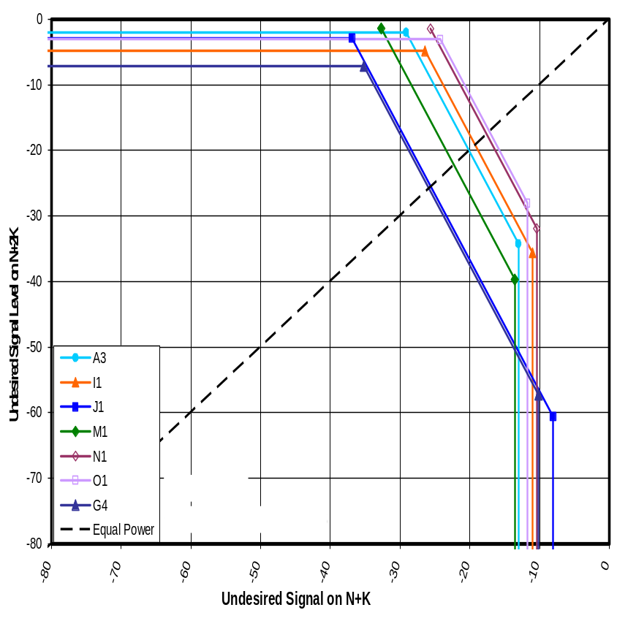
Figure 10-83. Modeled Thresholds for N+4/N+8 with D = -68 dBm
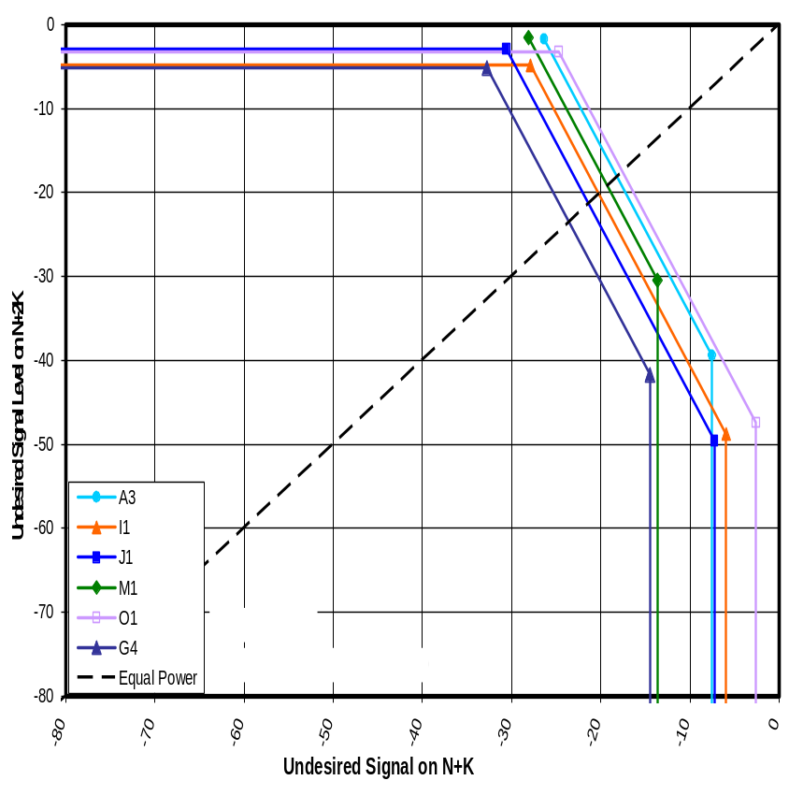
Figure 10-84. Modeled Thresholds for N+5/N+10 with D = -68 dBm
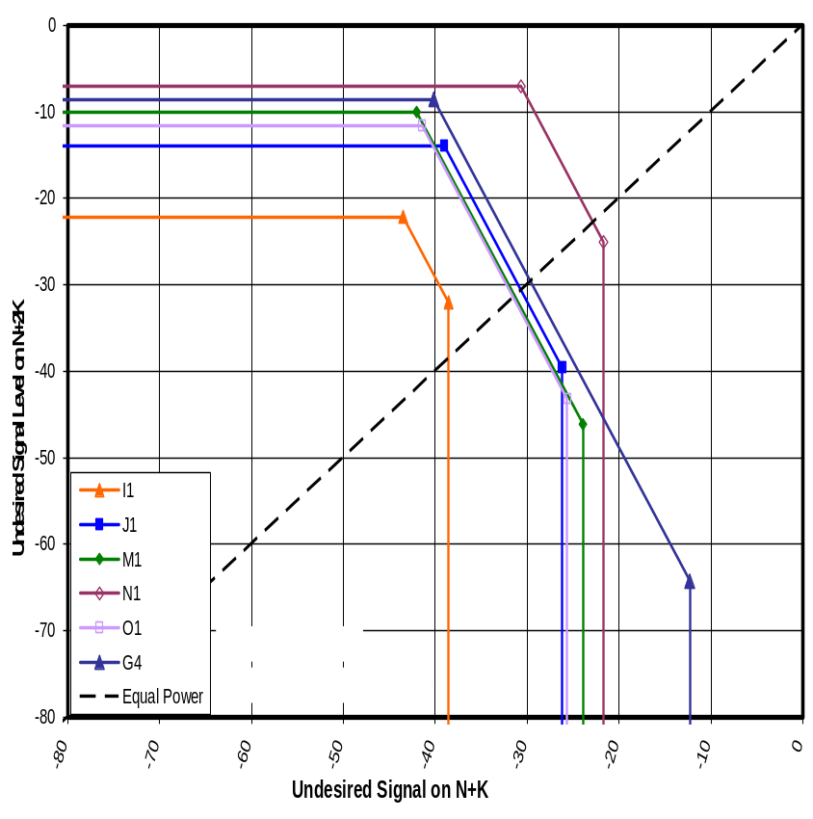
Figure 10-85. Modeled Thresholds for N-5/N-10 with D = D_{MIN} + 3 dB
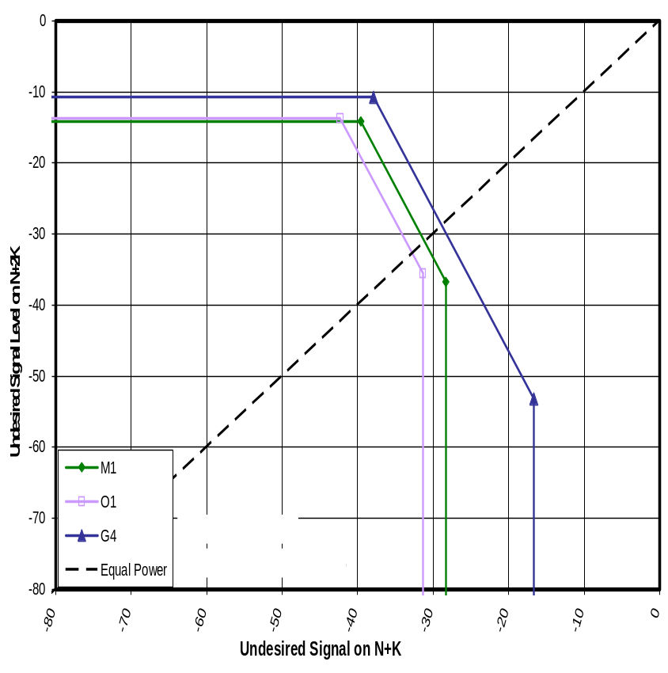
Figure 10-86. Modeled Thresholds for N-4/N-8 with D = D_{MIN} + 3 dB
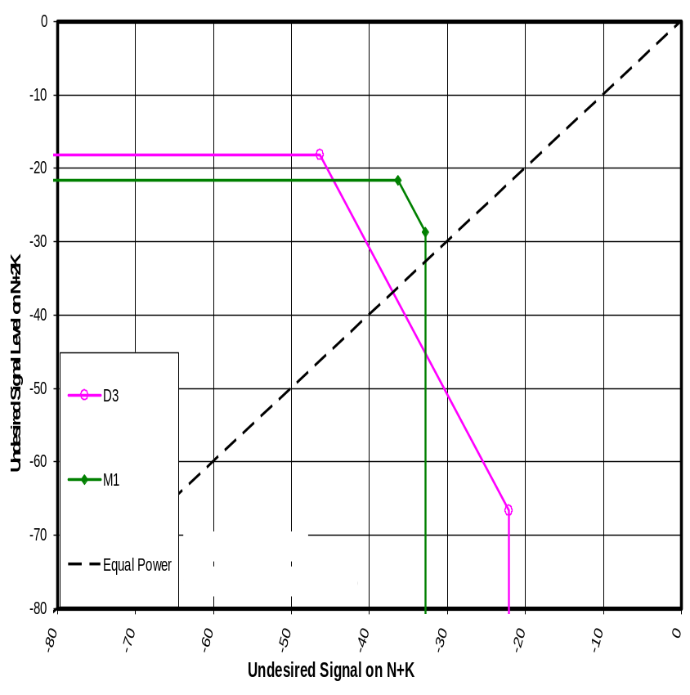
Figure 10-87. Modeled Thresholds for N-3/N-6 with D = D_{MIN} + 3 dB
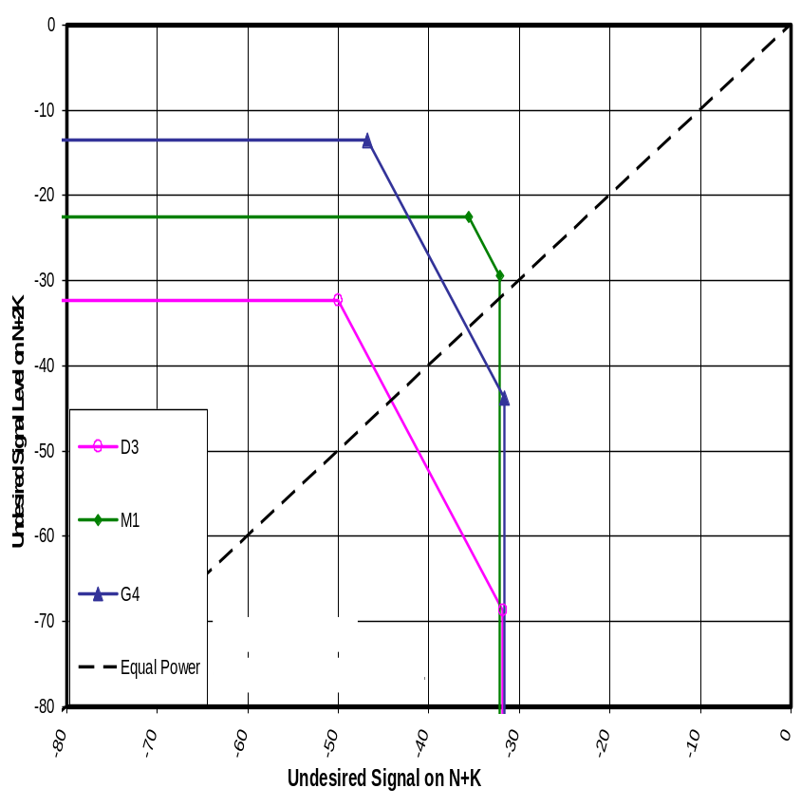
Figure 10-88. Modeled Thresholds for N+2/N+4 with D = D_{MIN} + 3 dB
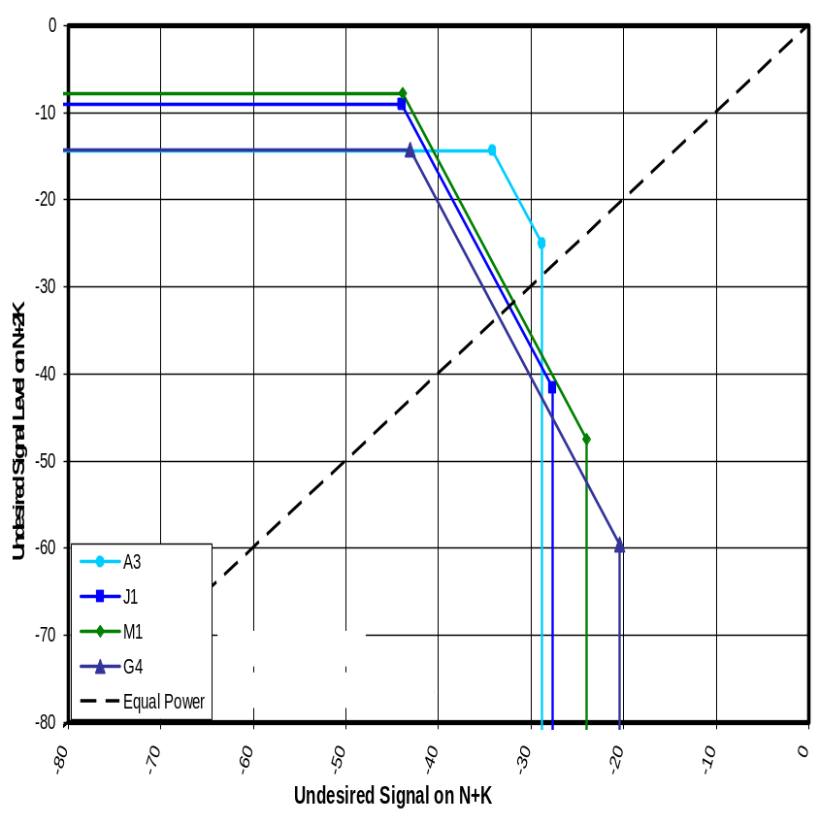
Figure 10-89. Modeled Thresholds for N+3/N+6 with D = D_{MIN} + 3 dB
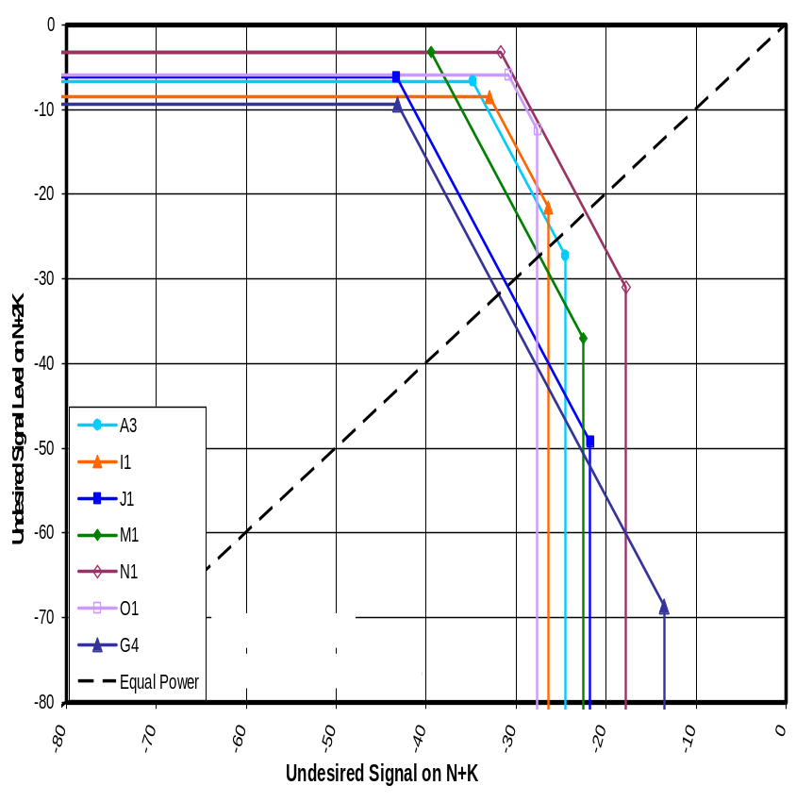
Figure 10-90. Modeled Thresholds for N+4/N+8 with D = D_{MIN} + 3 dB
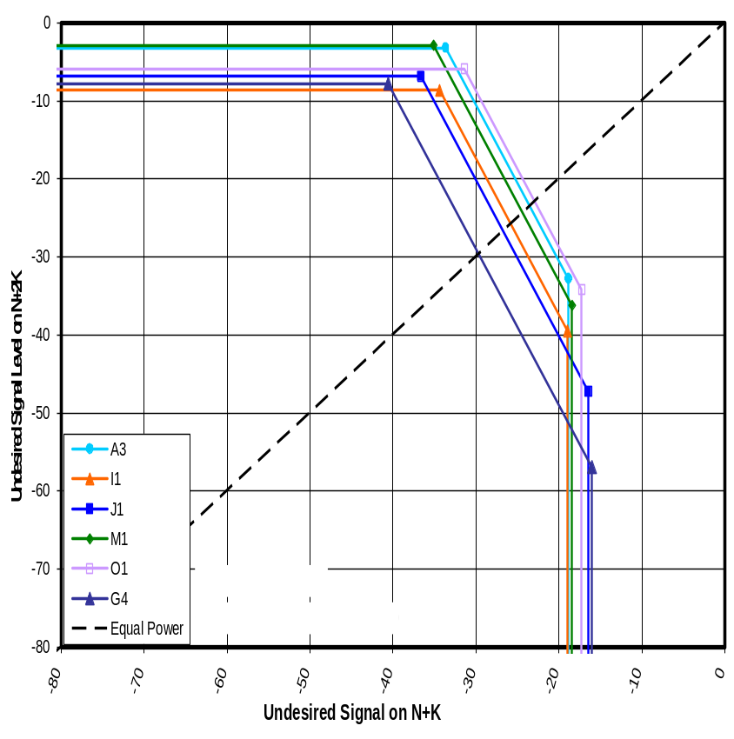
Figure 10-91. Modeled Thresholds for N+5/N+10 with D = D_{MIN} + 3 dB

SINGLE AND PAIRED REJECTION RATIOS VERSUS DESIRED SIGNAL LEVEL—A DETAILED EXAMPLE
This chapter presents measurements of D/U ratio and of U at threshold as functions of desired signal level D based on a detailed set of measurements for one DTV receiver, D3. The tests included single interferers as well as paired interferers spaced to place IM3 products in the desired signal channel. The amount of effort involved in making these measurements precluded such an evaluation of other receivers; however, the results from this one set of measurements provide some insight into the behavior of interference susceptibilities that will aid in developing an understanding of test results for other DTV receivers.

Figure 11-1 shows measurements of D/U versus D for receiver D3—measured for the desired channel N = 51. Chronologically, this was the first rejection performance work done under this test program apart from a crude set of measurements used to select the TV for this test. The test was performed to provide some insight into the variation of certain interference effects with desired signal level prior to testing at fixed desired signal levels.

The dashed curves on the plot represent measurements using pairs of equal-level undesired signals at N+1/N+2, N+2/N+4, N+3/N+6, and N+4/N+8. The solid lines represent measurements with single undesired signals on channels N+1 through N+7, N+14, and N+15. Curves labeled “N+1 (No Filter)” and “N+1/N+2 (No Filter)” are measurements performed with the filter removed from the test setup; this allowed the test setup to create higher interfering signal levels.

Though the number of curves on each plot makes it difficult to identify individual results, the curves are all combined on one graph to illustrate both the diversity and the commonality in the behavior of the various interference phenomena. The data will be dissected into separate charts later in the chapter.

The first point on each curve is a measurement with the desired signal at approximately 1 dB above the minimum signal D_{MIN} for the TV. (D_{MIN} is the desired signal level corresponding to the threshold of visibility (TOV) of picture degradation in the absence of interference.) The second point is 3 dB above D_{MIN}. The third point is at D_{MIN} + 5 dB, and all subsequent points are at 5-dB intervals.

Note the following reference levels on the graph.
Diamonds () on the X-axis mark the following desired signal levels.
-84 dBm is the received level of a DTV signal at the edge of coverage of a broadcast station (per OET-69); this is also marked by a black vertical dashed line.
-68 dBm, -53 dBm, and -28 dBm are the desired signal levels that the ATSC designated as “weak”, “moderate”, and “strong”, respectively; most D/U measurements shown elsewhere in this report were made at these three levels.
Not shown (off scale to the right) is -8 dBm, the largest expected DTV signal.
A diagonal dashed line corresponds to an undesired signal level of -8 dBm—equal to the maximum DTV signal that is expected at the input to a TV receiver.

Figure 11-2 shows the same measurement data as Figure 11-1, but it is presented as undesired signal level at threshold rather than as D/U ratios. Thus, in Figure 11-2, high points on the graph represent high rejection performance rather than high susceptibility to interference.

Figures 11-3 and 11-4 are plots of slope of log-D versus log-U and of log-U versus log-D, respectively. The slope information will aid in evaluating order of the interference mechanisms represented by the curves. The slope of log-D versus log-U directly indicates order of the interference mechanism (except where AGC affects the results and at desired signal levels near D_{MIN}); thus, an interference mechanism that is third-order in terms of the undesired signal level should have a slope of 3 in Figure 11-3. Figure 11-4 is included because the interference effect of certain interference mechanisms such as cross-modulation is directly proportional to desired signal as well as being dependent on the undesired signal level; the result is predicted to be an infinite slope in Figure 11-3 or a zero slope in Figure 11-4. Slopes were computed from adjacent pairs of measurement points from Figures 11-1 and 11-2 and are plotted at the midpoint of the pair. Thus, for example, the slope that was computed based on measurements at desired signal levels of -68 dBm and -63-dBm was plotted at -65.5 dBm.

General Observations
Returning to Figure 11-1, we make some general observations regarding the interference rejection results.

First, in examining the left portion of the graph—for desired signals less than about -60 dBm—we note the following.
Some of the curves are—for the most part—horizontal lines, indicating constant D/U ratio as desired signal is varied. This result is true for interference at N+14 and N+15 because interference effects on these channels result from the receiver’s mixer image—a linear interference mechanism. Less expected is that the curves for N+1 and N+2 are flat, a topic that will be discussed later. Totally unexpected is the fact that interference from a pair of undesired signals at N+1/N+2 also exhibits a flat D/U and that the D/U is nearly identical to that for N+1 alone, over part of the curve. N+1/N+2 is expected to generate IM3—a third order nonlinear process (third order when the amplitudes of both undesired signals are adjusted together).
Some of the curves exhibit upward slopes of log(D/U) versus log-D. Many of the slopes appear to be identical, but others—such as those for N+3 and for N+7—are steeper.
While most of the curves appear to be nearly straight lines, all bend upward at their left-hand ends, where the desired signal level approaches D_{MIN}.

Next, looking at the middle to right hand portions of the graph, we note the following.
Most of the curves that are upward-sloped on the left exhibit an abrupt bend—becoming approximately horizontal. The D/U’s, which were increasing as straight lines (on the dB versus dB scale), dip down gradually after the bend, but then eventually begin to increase again. The bend is believed to be associated with AGC action in the receiver for reasons discussed in Chapter 8.
The abrupt bend in most of the curves occurs at the same desired signal level of approximately -53 dBm. We believe that the receiver AGC begins reducing RF gain at this desired signal level.
One curve, that for interference at N+2/N+4, exhibits its bend at a lower desired signal level—approximately -58 dBm. In this case, it is considered likely that AGC action is initiated—not based on the desired signal level alone, but rather based on the total power reaching an AGC sensing point in the receiver. In this case, the approximately -37 dBm undesired power on channel N+2 (see Figure 11-2) is sufficient that—after filtering within the tuner—it combines with the desired signal power to engage the AGC.
The curves for N+1 and for the N+1/N+2 pair gradually shift from their horizontal slope on the left of the graph to upward slopes on the right half of the plot. The flat portions at the left side of both curves is believed to be due to AGC action similar to that discussed in the previous bullet; in this case, AGC action based on the level of the undesired signal at N+1 exceeding a threshold on the order of -40 dB or lower results in the curves being flat in the left hand region. In the upward-sloped region, the D/U of the N+1/N+2 curve tracks that of the N+1 curve, but at a D/U ratio that is about 3-dB higher than that for N+1. This portion of both of the curves is likely to be the result of IM3 occurring either at an early RF amplifier stage that is not controlled by the AGC, or at the same point as the other IM3 examples (probably the mixer), but after the AGC’s gain reduction capability for those stages has reached its limit.

IM3 With Paired Undesired Signals
We start by assessing the paired-signal results, because those results enable us to understand the N+1 results. To provide a simpler view, Figure 11-5 was created to show D/U for the four tested pairs (the dashed lines) and for the single interferers associated with them (solid lines). All other data has been removed from the plot.

N+2/N+4, N+3/N+6, and N+4/N+8
We first examine the paired signal test results that did not involve the first adjacent channel. We note that the D/U curves for N+2/N+4, N+3/N+6, and N+4/N+8 (Figure 11-5) have two distinctive regions: an up-sloped region on the left and more horizontal, but dish-shaped region to the right. The dish-shaped region slopes downward initially, but then begins to trend upward (on two of the three curves) on the far right. The two regions are separated by an abrupt bend in each curve, occurring at a desired signal level of either -53 dBm or -58 dBm.

Looking at the sloped portions of the curves to the left of D = -58 dBm, we see that the D/U ratios (and thus the interference effects) of the paired signals (dashed curves) are higher than those of the corresponding single signals. For example, the D/U ratios for N+2/N+4 (the top curve) are significantly higher than those for N+2 and N+4 individually. This implies that the pair of undesired signals combines synergistically so as to create an interference effect larger than the sum of the interference effects of the individual signals. This synergism is the result of third-order intermodulation (IM3) distortion occurring somewhere in the DTV receiver—most likely in the mixer.

Looking at the slope of log-D versus log-U (Figure 11-3), we see that the slope measurements of the paired signal curves in this region fall between 3 and 4 dB/dB. The expected slope for an IM3 process with both undesired signals varied in amplitude together is 3 dB/dB. We take this as further confirmation of IM3 as the primary cause of the paired signal interference.

While we had expected the paired-signal IM3 to be significant only at high signal levels, it is interesting to note in Figure 11-1 that IM3 for the N+2/N+4 pair causes higher interference susceptibility than any single-channel interferer—including the first-adjacent channel—all the way down to a desired signal level only 1 dB above the lowest signal level at which the receiver can operate (D_{MIN}). Similarly, susceptibility to interference from an undesired signal pair at N+3/N+6 is greater—even at signal levels down to D_{MIN} + 1 dB—than from any single channel except the first adjacent channel, and it exceeds even that except when the desired signal drops to D_{MIN} + 3 dB or below. Even on N+4/N+8, interference susceptibility exceeds that of any single channel, except the first adjacent one, down to 2 dB above D_{MIN}; mixer image interference at N+15 barely surpasses N+4/N+8 interference effects only at D_{MIN} + 1 dB.

We also note in Figure 11-5 that D/U ratios of the N+K/N+2K pairs fall gradually as K increases. The fact that IM3 is observed even for N+4/N+8 suggests that it occurs at a place in tuner at which undesired signals all the way out to N+8 (for the N+4/N+8 pair) are still present. The gradual fall with increasing K suggests that the nonlinearity causing these IM3 effects is after the tracking filter in the RF section. We surmise that the IM3 effects observed on this part of each of the three paired-signal curves being discussed in this section is caused by nonlinearity at the mixer.

We now note the abrupt bend in each of the three curves (for N+2/N+4, N+3/N+6, and N+4/N+8), representing a change in character of the interference effect. Based on discussions in the Chapter 8, we attribute that bend and subsequent leveling of the D/U plots to AGC action in the tuner. Specifically, we conclude that, beginning at this bend, the AGC adjusts gain downward with further increases in signal level and that this gain adjustment occurs in the RF amplifier stage since the nonlinearity that is affected is probably at the mixer.

We further note that the curves for N+3/N+6 and N+4/N+8 exhibit this AGC bend at identical levels of desired signal, D = -53 dBm. Four of the single-interferer curves in Figure 11-1 exhibit this same bend point. We conclude that the RF AGC engages whenever the desired signal exceeds -53 dBm.

N+2/N+4—A Different AGC Point
On the other hand, the N+2/N+4 curve exhibits its AGC bend when D = -58 dBm. This suggests an AGC action that is influenced by the undesired signal level. The bend occurs when the undesired signal level applied to both N+2 and N+4 reaches -36.5 dBm (Figure 11-2). The desired-signal-driven AGC thresholds for the other curves occur when undesired signals on channel N+3 or beyond are at signal levels ranging from -31 to -17 dBm (Figure 11-2); these levels apparently do not result in AGC action since all bends occurred at the same desired signal level. In particular, the bend in the N+4 curve at D = -53 dBm and U = -25 dBm suggests that the early bend in the N+2/N+4 curve is entirely due to N+2 as opposed to N+4.

Hence, it is clear that the RF gain reduction in at least this one case—and maybe in all—is triggered by total signal level (desired plus undesired) at a point in the tuner where total power from each channel is influenced by filtering. Assuming both AGC mechanisms are the same, the fact that AGC action begins at a desired signal level of -53 dBm for most cases, but begins at a desired signal of -58 dBm in the case at hand implies that the undesired signal is making up the difference—at total of about -54.7 dBm referred to the input to get to the apparent AGC threshold of -53 dBm referred to the input. (This suggests that, had the desired signal level been much smaller, the threshold at which N+2 would engage the AGC would be 1.7 dB higher than that observed—i.e., at U = -36.5 dBm + 1.7 dB = -34.8 dBm). Since the undesired input level on channel N+2 at the point of RF AGC action occurred at an input level of -36.5 dBm, it appears that the total power in the N+2 channel is attenuated by filtering by about 18.2 dB (i.e., -36.5 dBm - [-54.7 dBm]) relative to the desired channel.

We examine the N+2 curve (Figure 11-2) to see whether it exhibits evidence of RF AGC action beginning at an undesired signal level in the region of -34.8 to -36.5 dBm. There are no obvious AGC bends in the curve; however, the undesired signal level for points on the curve ranges from -34.1 to -11.7 dBm. Thus it is likely that the AGC reductions of RF gain began just prior to the left-most point on the N+2 curve and continued throughout the curve.

Deviation From Straight Line Near Receiver Threshold
The portion of each of the three D/U curves (N+2/N+4, N+3/N+6, and N+4/N+8 in Figure 11-5) to the left of the AGC bend exhibits a primarily straight-line appearance with a slope consistent with a third-order interference process; however, there is an upward deviation from the straight line at the left end of each curve. Chapter 8 predicted that such deviations will occur as the desired signal level approaches D_{MIN} for the receiver. Specifically, Table 11-2 predicts that, for a third-order interference process, the undesired signal at threshold will deviate from a straight-line projection by 1.0 dB when D = D_{MIN} + 3 dB and by 2.3 dB when D = D_{MIN} + 1 dB.

By using these predicted deviations together with the theoretical slope for a third-order process (Table 11-1) and a single measurement at D = -68 dBm (15 dB above D_{MIN}), one can predict the actual measured threshold values of undesired signal at D_{MIN} + 3 dB and D_{MIN} + 1 dB with errors not exceeding 0.6 dB for the former prediction and 1.2 dB for the latter in this particular case.

N+1/N+2
Following the trend that was observed in the sub-section titled, “N+2/N+4, N+3/N+6, and N+4/N+8”, one might expect that the curve for N+1/N+2 would look just like those for the other three paired signals except that it would be positioned above those curves on the D/U chart (Figure 11-5)—indicating that the TV is more susceptible to interference from the adjacent-channel pair than from the pairs that are further away from the desired channel. The measurements dash this expectation. Not only is the N+1/N+2 curve below the other three for most of its trajectory, but its shape is completely different—flat where the others are sloped and sloped where the others are essentially flat.

Also unexpected is that the N+1 curve overlays the N+1/N+2 curve for desired signals ranging from -73 dBm to -68 dBm. Apparently in this region, adding an undesired signal at N+2 to an existing one at N+1 causes no additional interference effect. Clearly, in this region, the IM3 contribution from the pair is negligible compared to the interference effect of N+1 alone, and the overall interference effect is less than that of the other pairs.

We can take a clue as to the reason for the unexpected behavior from the observations about AGC in the previous section. We note that a signal level exceeding -34.8 dBm on channel N+2 is able to cause the AGC to reduce the RF amplifier. (The observed threshold of -36.5 dBm was slightly less because the desired signal was also contributing to the energy seen by the AGC sampling point.) Given that RF AGC operation begins at a level of -53 dBm on channel N, at -34.8 dBm on channel N+2, and a higher, but unknown level on channels N+3 and beyond, we would expect that an undesired signal on channel N+1 would activate the RF AGC at a level somewhere between the channel N and channel N+1 values—i.e., between -53 and -34.8 dBm. Furthermore, a typical bandpass filter at channel N would take a much bigger bite out of a signal at N+2 than out of a signal at N+1, so we might expect the AGC threshold for N+1 to be closer to that at N than to that at N+2. This suggests that the AGC threshold for N+2 is somewhere between that for N and the midpoint between those for N and N+2; hence, we would expect a threshold between -44 and -53 dBm. Looking at the U versus D plot in Figure 11-2, we see that only the left-most point on the N+1/N+2 curve has a U value within this range; all other points are above the range—suggesting that the RF AGC is active throughout the plotted curve, with the possible exception of the left-most point.

RF AGC operation throughout the curve provides a reason for the different behavior of N+1/N+2 interference relative to the other pairs. At all measured threshold points for N+1/N+2 (except possibly D_{MIN} + 1 dB) the RF gain is reduced, reducing the IM3 at the mixer—apparently to a level below the N+1 interference mechanism that is at work.

The N+1/N+2 D/U ratio matches that for N+1 virtually exactly for desired signal levels of -73 to -68 dBm or so. Outside of this range, the paired signal shows more interference effect than N+1 alone. Since N+2 has a relatively low D/U ratio, the fact that interference susceptibility for the pair significantly exceeds that of N+1 indicates that the IM3 of the pair becomes significant outside of this narrow range. Why?

Desired Signal Levels Above -58 dBm
At desired signal levels above -58 dBm, both the N+1/N+2 and N+1 plots of D/U (Figure 11-5) become upward sloped. In this region it is assumed that the interference mechanism for both single adjacent-channel case (N+1) and the paired signal case (N+1/N+2) is IM3. (Recall that IM3 creates shoulders around a single undesired signal that spill into the adjacent channel. Thus, for the first-adjacent-channel case, a pair of signals is not needed to create IM3 in the desired channel.) The slope of log-D versus log-U (Figure 11-3) goes to about three—consistent with IM3. The D/U of N+1/N+2 exceeds that of N+1 alone by about 3 dB—consistent with the expectation that more IM3 will be generated in the paired-signal case than in the single-signal case.

The fact that more IM3 occurs with N+1/N+2 than with N+1 in the right-hand part of the curves suggests that the interference is being generated by a nonlinearity occurring before the IF filter; so, again, it appears that the relevant nonlinearity is likely to be at the mixer or an earlier point in the tuner. The upturn of the D/U curves at a desired signal level around -63 dBm indicates that either the interference is being generated by a nonlinearity at an RF amplifier stage that is not controlled by the AGC or the interference is being generated by nonlinearity at the mixer and the AGC range for the RF amplifier has run out—i.e., the RF amplifier is at its minimum gain. As a result, the D/U ratio rises with further increases in signal level. In Figure 11-5 the beginnings of a similar trend can be seen at the right-hand end of the curve for N+2/N+4, where D/U begins rising, but does so at a level below the D/U of N+1/N+2, indicating that N+2/N+4 generates less IM3 than does N+1/N+2 due to rolloff of the tracking filter in the RF stage.

Desired Signal Levels Below -73 dBm
The upturn of D/U for N+1/N+2 relative to N+1 below -73 dBm was unexpected. Measurements were repeated to confirm the behavior; the result was the same.

In general all of the D/U curves exhibit an upturn from their straight-line projections as one moves leftward on the plot—toward D_{MIN}. Such an upturn is predicted in Chapter 8 (Table 8-2). The increase in D/U for N+1/N+2 above that of N+1, while D/U for N+2 remains low, suggests that IM3 for the signal pair becomes dominant again at low signal levels near the receiver’s threshold. In fact, by the time desired signal drops to -82 dBm, D/U at N+1/N+2 has returned to its “rightful place” above the D/U for the other signal pairs. Thus, the adjacent undesired signal pair (N+1/N+2) finally exhibits a greater interference effect than that of the more distant signal pairs, an expectation which was foiled by AGC gain reductions in the RF stage at most other points along the curve. Apparently, the AGC-induced RF-gain reductions are gone or nearly gone by this point on the graph.

Single Undesired Signals
To facilitate the discussions below, Figure 11-6 and 11-7 were created to show the D/U ratio and threshold U, respectively, for single undesired signals (excluding the paired signal data that are included in Figures 11-1 and 11-2). For the most part the plots exhibit a near-straight-line character (in the log-log plots due to units of dB) in a region from about D = -78 dBm to D = -58 or -53 dBm.

To the left of this region, all D/U curves exhibit upturns from their straight line projections. Those upturns are attributed to the effect of receiver noise as the minimum signal threshold for the DTV receiver is approached.

Moving to the right, five of the plots (like three of the paired-signal plots) exhibit an abrupt downward bend in D/U to a relatively constant D/U ratio beginning at what we have termed the “AGC bend” at D = -53 dBm. The bend is caused by a stabilization of nonlinear interference mechanisms by AGC operation.

N+1
The case of N+1 interference is discussed extensively in the previous section. The observed behavior differs among three regions of the curve.

In the middle section, from D = -78 dBm to D = -58 dBm, the D/U is constant, as would be expected for a linear interference process. However, we showed, in the “N+1/N+2” section of this chapter, that the AGC is actively adjusting RF gain throughout this section, so the constant D/U could be due to a linear interference mechanism or a non-linear one whose effect has been stabilized by the AGC. The “N+1/N+2” section also argued that the interference in this region occurs at a point beyond the first IF filter stage. It could be due to a nonlinearity in an IF amplifier stage or due to a linear process, such as inadequate IF selectivity allowing the edge of the N+1 signal to leak into the demodulator.

In the right-hand section, beyond D = -53 dBm, interference was shown to be the likely result of IM3 in the mixer after the AGC has reached the limit of its ability to reduce gain of the RF amplifier.

In the left-hand section, to the left of D = -73 dBm, there is a rise in the left-most two points on the curve that is attributable to the influence of receiver noise as the receiver threshold is approached. The fact that the rise is somewhat smaller than expected, coupled with a possible slight dip in D/U to the left of D = -73 dBm may suggest a diminishment of the interference mechanism that was dominant in the middle section of the curve. Such a diminishment could occur if that interference mechanism were nonlinear and if the AGC action ends as one moves leftward on the curve through that region. An alternative hypothesis is that the AGC-induced gain reductions might have increased the noise figure of the tuner and that the additional noise diminishes as one moves to the left on the curve and the AGC causes the RF gain to increase. (Cowley and Hanrahan state that noise figure “increases at 1 dB per dB of gain backoff…with some AGC architectures.”)

N+2
The D/U ratio for N+2 is shown in the bottom-most horizontal curve in Figure 11-6.

In the “N+2/N+4” section of this chapter, we showed that the AGC begins to reduce RF gain when the undesired signal level on N+2 exceeds a threshold of -34.8 dBm (or lower if the desired signal level approaches -53 dBm). Figure 11-7 shows that the undesired signal level throughout the N+2 curve exceeds this AGC threshold; thus, it appears that the AGC was controlling the RF gain throughout this curve.

The constant D/U ratio versus D throughout most of the plot is consistent with either a linear interference mechanism or an AGC-stabilized nonlinear one. The upturn at the left of the D/U plot (Figure 11-6) as D approaches D_{MIN} is caused by the effect of receiver noise.

N+3
The D/U curve for N+3 exhibits a steeper slope than the IM3-driven curves (Figure 1-1). On the plot of threshold U versus D, one can see that, for desired signal levels between -73 dBm and -53 dBm, the threshold U is almost constant—increasing only by only 1.1 dB in a span of 20 dB change in desired signal level. A constant value of U would be expected for interference caused by a cross-modulation mechanism. The slope of log-U versus log-D for such a mechanism would be nominally zero, a value approached in this case, as can be seen in Figure 11-4.

We suspect cross modulation in the mixer (a likely candidate for N+2 interference as well). We attribute the abrupt bend in U (downward bend in D/U) toward a more constant D/U ratio at D = -53 dBm to AGC gain reductions in the RF amplifier driven by the desired signal level.

N+4
For desired signal levels below D = -63 dBm, the log-D versus log-U curve for N+4 approaches 3—consistent with third-order interference mechanism (Figure 11-3). We are unable to propose such a mechanism in this case. The so-called the “half IF” taboo channel for analog TV was based on the second harmonic of an undesired signal beating with the second harmonic of the local oscillator frequency. Such an effect would create a susceptibility to interference that is centered 22 MHz (3 ²/₃ channels) above the desired channel—placing it predominantly at N+4. However, we anticipate that such an effect would be second-order in terms of the undesired signal level, and thus would exhibit a log-D versus log-U slope of two.

Between D = -63 dBm and D = -53 dBm, the slope increases significantly—possibly indicating a shift toward cross-modulation as the dominant interference mechanism.

As with many of the other curves, the D/U for N+4 flattens when D exceeds -53 dBm, due to AGC action in the RF amplifier.

N+5
The slope of the N+5 curve to the left of the AGC bend at D = -53 dBm appears to be consistent with a third-order process. We are unable to propose a likely mechanism.

N+6
Oddly, the slope of log-D versus log-U for N+6 appears to linearly increase with desired signal level until the AGC bend point, as can be seen in Figure 11-3. Mathematically, this would suggest that log-D is linearly related to U. Indeed, when desired signal level in dB is plotted against the threshold undesired signal level in linear power units (Figure 11-8), the result is strikingly linear to the left of the AGC bend. Whether there is a physical reason for this behavior or it is just a fluke is not known; however, we note that N+6 is one of the smaller interference vulnerabilities for this receiver, so no additional assessment has been performed.

N+7
As was noted in Chapter 5 of this report, most of the DTV receivers tested for this program exhibited an increased susceptibility to interference at N+7 relative to the surrounding channels. The interference threshold at N+7 was found to be nearly constant in terms of undesired signal level as desired signal level was varied over a wide range up to -53 dBm. (See for example even numbered Figures 5-12 through 5-16.) The behavior can be seen here in Figure 11-7.

Initially, we attributed the interference phenomenon to the “IF beat” mechanism, which was one reason for the N+7 analog taboo. “IF beat” interference is caused by an undesired signal on channel N+7 or N-7 beating with the desired signal—creating interference that can pass through the IF filter of the receiver. The lack of a corresponding susceptibility at N-7 (based on tests presented in Chapter 5) suggests that another mechanism may be at work. Furthermore, tests with a narrower-bandwidth interferer, presented in Chapter 7, suggest that the interference occurs only when the undesired signal spectrum overlaps the local oscillator frequency of the receiver. (Located 44 MHz above the center of the desired channel, the local oscillator falls within channel N+7.) This suggests some sort of direct interaction between the undesired signal and the local oscillator, although we have not identified a specific mechanism.

N+14 and N+15
The mixer image band for a single-conversion TV tuner with a 44 MHz IF overlaps parts of channels N+14 and N+15. In Figure 11-6, the D/U ratio on these channels is seen to be essentially constant except when D approaches D_{MIN}. This is consistent with the fact that the mixer image interference mechanism is linear.

Summary
The detailed assessment of one receiver’s out-of-channel interference rejection performance provides a basis for understanding the less detailed measurements for the other receivers. In particular, we note the following.

Paired-signal IM3 can be one of the more dominant interference mechanisms, even at low signal levels.
The expected increase in D/U ratio with increasing signal levels for nonlinear interference mechanisms is flattened above levels at which the AGC engages to stabilize the nonlinearity.
AGC flattening of D/U ratios may begin at lower signal levels for close-in interference (e.g., N+1) than for interferers spaced further from the desired channel. This can cause the unexpected result that, at some signal levels, a TV may be more tolerant of interference on the first-adjacent channels than on some other channels.
As signal levels continue to increase, the flatting of D/U ratios by AGC may end, allowing D/U ratios to, again, increase with increasing signal levels.

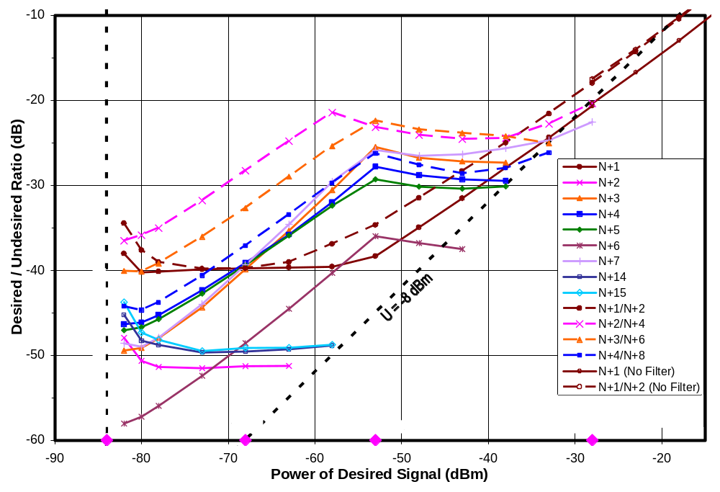
Figure 11-92. D/U Versus D for Receiver D3 (Desired Signal on Channel 51)
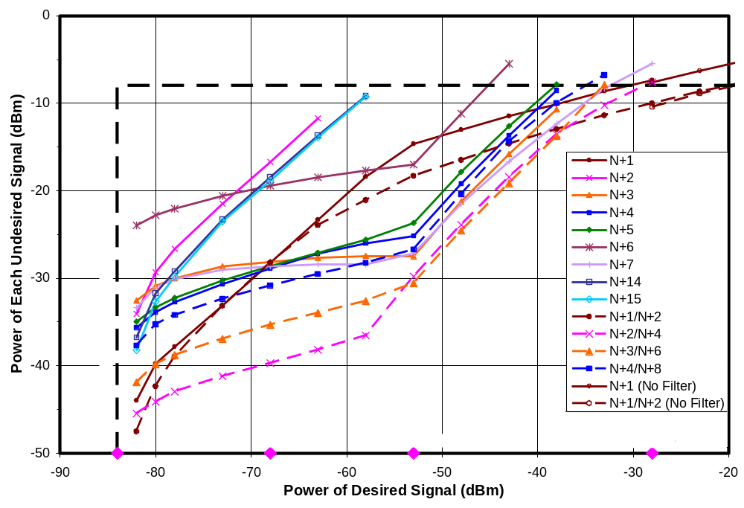
Figure 11-93. Threshold U Versus D for Receiver D3 (Desired Signal on Channel 51)
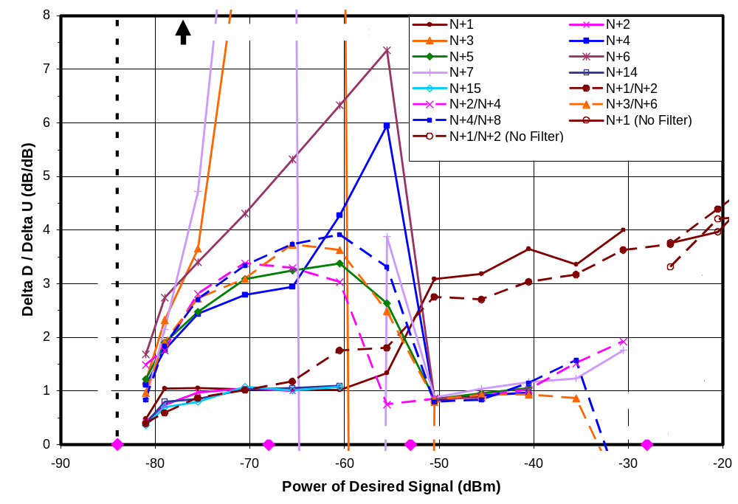
Figure 11-94. Slope of Log-D versus Log-U for Receiver D3 (Desired Signal on Channel 51)
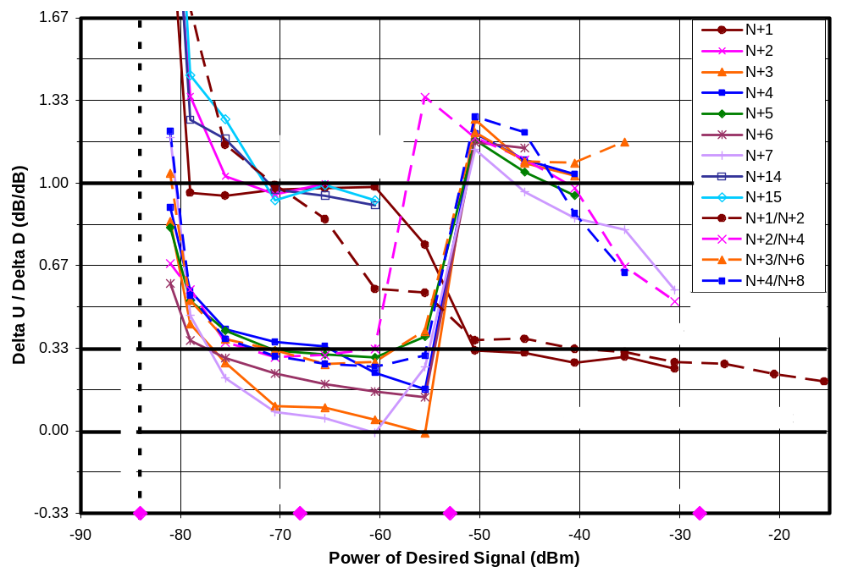
Figure 11-95. Slope of Log-U versus Log-D for Receiver D3 (Desired Signal on Channel 51)
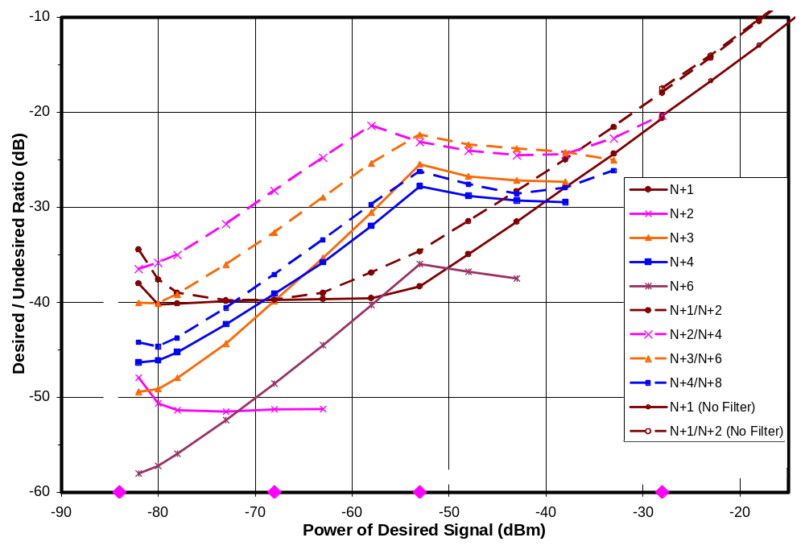
Figure 11-96. D/U Versus D for Receiver D3—Paired Signals And Their Constituents
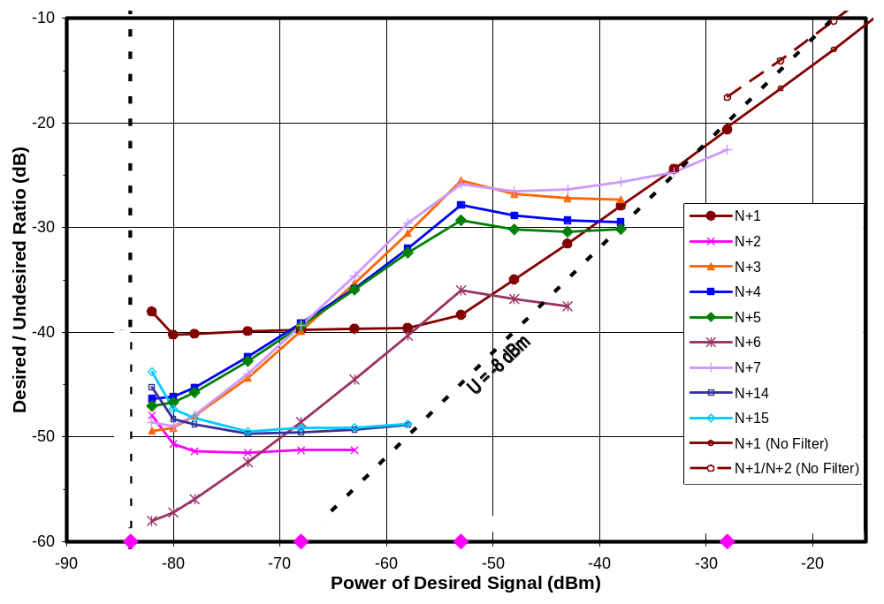
Figure 11-97. D/U Versus D for Receiver D3—Single Undesired Signals
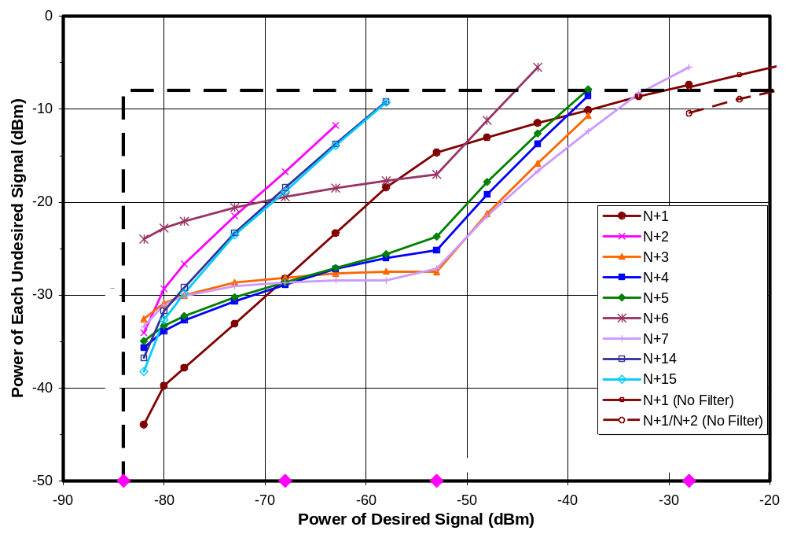
Figure 11-98. Threshold U Versus D for Receiver D3—Single Undesired Signals
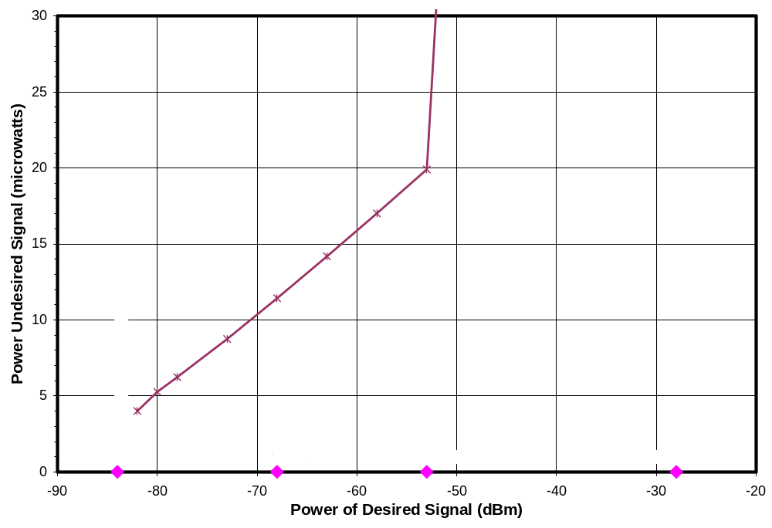
Figure 11-99. Linear Undesired Power Versus Log-Desired Signal Power for N+6

EXTENDING THE RESULTS TO LOWER SIGNAL LEVELS

This chapter extrapolates the channel-30, single-channel interference rejection measurements from Chapter 5 of this report to a lower desired signal level, D_{MIN} + 1 dB. It also employs measured data from Chapter 11 to evaluate the extrapolation method. The motivation for the extrapolation was explained in Chapter 2.

Order of Interference Processes and Effect of AGC
Chapter 8 presented a theoretical framework for understanding DTV interference susceptibilities. Table 12-1 summarizes the effects of the order of an interference mechanism and the state of the tuner’s AGC on plots of threshold undesired versus desired signal power at the input to a TV according to that framework.

Table 12-29. Characteristics of Log-Log Plots of Undesired Versus Desired Signal Power At TOV
 | Characteristics of Log-Log Plot of U Versus D
Tuner AGC State→  and  Input Condition↓ | Fixed gain (or AGC operating to adjust gain of a tuner stage after the relevant nonlinearity¹) | AGC operating to adjust gain of a tuner stage prior to relevant nonlinearity¹
D >> D_{MIN} | Straight line with slope determined by the order of the interference mechanism. Slope is unity for linear interference. | Straight line with unity slope—matching that of a linear interference mechanism
D approaching D_{MIN} | Deviation from straight-line determined by order of interference mechanism | Deviation from straight-line:  matches linear process if AGC is driven by U;  determined by order of interference mechanism if AGC is driven by D
¹ Relevant nonlinearity refers to the nonlinearity responsible for a given observed interference effect.
Slopes are listed in Table 8-1 and deviations from straight line are listed in Table 8-2 of Chapter 8.

Behavior for Desired Signal Levels From -68 dBm to -53 dBm
Over the desired signal range from -68 dBm to -53 dBm, the desired signal power is far enough above D_{MIN} that the model predicts essentially straight-line behavior for log-U versus log-D, assuming that the interference mechanisms and AGC state remain the same throughout the region.

Figure 12-1 shows the slopes of threshold U vs D in dB units over this signal range for each of the receivers and channel offsets for which threshold measurements were successful (i.e., the rejection performance was not beyond the measurement limit imposed by the test setup) at N = channel 30. The graph also includes horizontal reference lines corresponding to the slopes for the various interference mechanisms discussed in this report.

We note that some points clearly fit the expectations for a category of interference. For example, most of the receivers exhibit linear-like interference behavior when the undesired signal is on channels N-4 through N+2. It is considered likely that the actual interference mechanisms in those cases are nonlinear and that the linear-like behavior is caused by AGC operation. Interference to receiver D3 from undesired signals on channels N-15 through N-4 clearly fits the pattern of cross-modulation—a fact that was also discussed in Chapter 5 in the section entitled, “Taboo Effects and Other Observations”, based on other evidence. The susceptibility of most receivers at N+7 also matches the slope expected for cross-modulation, although we suspect that the actual mechanism is different from those that have been postulated here based on the discussion in Chapter 7.

Some of the points fall in-between categories, possibly as a result of changes in the dominant interference mechanisms over the 15 dB range of desired signal amplitudes, or due to changes in AGC operation over that range.

Behavior for Desired Signal Levels From D_{MIN} + 3 dB to -68 dBm
As the desired signal drops to a point 3-dB above D_{MIN}, the deviation from straight-line behavior is expected to become significant—ranging from 1 to 3 dB (Table 8-2 of Chapter 8).

Because of this deviation, we have chosen to estimate the slope of the straight-line portion of the log-undesired versus log-desired signal curves in the region between D_{MIN} + 3 dB and -68 dBm by what we will call the adjusted slope. The slope will be estimated by first shifting the left-hand point of the range (D = D_{MIN} + 3 dB) by 3 dB to the left (to D = D_{MIN}). Figures 8-1 through 8-4 (Chapter 8) showed that, in cases that are not stabilized by AGC operation, such a shift returns that point to the straight-line whose slope we are trying to predict, in all cases except the cross-modulation case. With AGC operation driven by the undesired signal level, the same will be true. Slope estimated in this way will deviate from that of the straight-line portion we would like to estimate in cases involving cross-modulation or involving AGC operation driven by the desired signal level. Neglecting these cases, the expected slopes of log-U versus log-D for linear (or AGC-stabilized nonlinear), second order, and third order interference processes are 1, 1/2, and 1/3 dB/dB, respectively, and the expected slopes of log-D versus log-U are 1, 2, and 3 dB/dB.

For the cross-modulation case, Figure 8-4 showed that the straight-line projection should have a slope of zero for log-U versus log-D or an infinite slope for log-D versus log-U. The shift of the left hand point of the range by 3 dB (for a log-U versus log-D plot) does not return that point to the straight line in this case. Rather, in the nominal case, where D_{MIN} = -84 dBm, we are measuring the slope of a line connecting the points (D = -68 dBm, U = U_{T}) and (D = -84 dBm, U = U_{T} - 1.5 dB), where U_{T} is the constant threshold value of U along the straight line. The expected slope, then, is 0.09 for log-U versus log-D or 10.7 for log-D versus log-U, though small measurement errors could cause the latter number to vary widely.

Similarly, for the case of nonlinear interference stabilized by AGC operation driven by desired signal level, the adjusted slope of log-U versus log-D will be somewhat less than the unity slope of the straight-line portion of the curve, and the slope of the log-D versus log-U curve will exceed unity.

Figure 12-2 shows the “adjusted slope” of log-log curves of U versus D computed by the above method for D from D_{MIN} + 3 dB to -68 dBm. Figure 12-3 shows the adjusted slope of log-log curves of D versus U—the reciprocal of the slopes shown in Figure 12-2. For reasons discussed above, the slopes of the cross-modulation case generally fall above zero on the first plot and below infinity for the second. Similarly, some of the AGC-stabilized cases fall below unity slope of the first plot and above unity on the second.

Extrapolation to D = D_{MIN} + 1 dB
The extrapolations to D = D_{MIN} + 1 dB will be based on measurements at D = D_{MIN} + 3 dB—an extrapolation distance (in terms of desired signal level) of only 2 dB. Though the extrapolation distance is short, it should be recognized that threshold undesired signal levels are expected to change rapidly as D_{MIN} is approached, as was illustrated in Figures 8-1 through 8-4. Consequently, both measurements and extrapolations can be subject to greater errors as D approaches D_{MIN}, due to high sensitivity to the D/D_{MIN} ratio. As an example, when D/D_{MIN} is expected to be 1 dB, misjudging the D/D_{MIN} ratio by 0.25 dB could cause the threshold undesired signal level to change by amounts ranging from 0.3 to 1.1 dB, depending on the direction of the error and the order of the interference process.

The extrapolation will consist of two parts:
a straight-line projection part based on the slopes identified in Table 8-1 for each of the interference categories;
an estimate of the deviation from straight-line projection based on the deviations listed in Table 8-2; more specifically, we will use the difference between the straight line deviation for D/D_{MIN} = 1 dB and that for D/D_{MIN} = 3 dB.

The first part will require that we categorize each interference case (each channel offset for each receiver) into one of four categories: (1) linear or AGC-stabilized; (2) second order; (3) third order; (4) cross-modulation. The second part will require additional categorization within the linear or AGC-stabilized category.

The category of each interference process will be estimated from the adjusted slope of the log-D versus log-U data from D = -68 dBm to D = D_{MIN} + 3 dB, computed as described in the previous section. The boundary between third-order interference and cross-modulation will be set at an adjusted slope of 5. The categories will serve as the basis for defining the slope of the straight-line portion of the extrapolation (Table 8-1), as well as for estimating the deviation from the straight-line projection. The measurement data at D = D_{MIN} + 3 dB will serve as the anchor point for the extrapolation.

The deviation from straight-line behavior will create a need to adjust the threshold undesired signal downward from the straight-line projection by an amount equal to the difference between the deviation for D_{MIN} + 1 dB and that for D_{MIN} + 3 dB, as determined by Table 8-2 (Chapter 8). Those differences range from -1.3 to -3.8 dB—a span of 2.5 dB.

But selection of the correct values from Table 8-2 will, in some cases, require more knowledge than we have. For cases that appear to be nonlinear (order higher than 1) based on the above, the appropriate values from Table 8-2 can be used directly; however, for channel offsets that appear to exhibit linear behavior based on the above, Table 8-2 shows that the expected offset depends on whether the underlying interference mechanism was truly linear or was made to appear linear by AGC action. We will assume that the underlying mechanism is linear only for N+14 and N+15, the mixer image frequencies. For the other cases, the correction depends both on the order of the nonlinearity and on whether the AGC action was driven primarily by desired signal level or primarily by the undesired signal level. In the former case the deviation matches that for the underlying nonlinear process, which we don’t know; in the latter, the deviation will be the same as for a linear process.

Though we have enough information to resolve some of these questions for receiver D3, on which detailed tests were performed, the limited measurements performed on the other receivers are inadequate for such resolution. Consequently, we take the following approach to computing the deviation from a straight-line projection for all receivers:
If the interference behavior appears nonlinear, use the values from Table 8-2 for the estimated order of the interference;
For N+14 and N+15, use the values from Table 8-2 for linear processes;
For all other cases that appear linear, select a deviation from straight line behavior as the midpoint between the two extremes that could be occur—i.e., nonlinear with U driving the AGC (-3.8 dB adjustment) and third-order with D driving the AGC (-1.3 dB); we will accept the error of up to 1.3 dB in either direction that could result from adjustments based on the midpoint (-2.6 dB).

Table 12-2 summarizes the entire extrapolation process.

Table 12-30. Process for Extrapolation from D = D_{MIN}+3dB to D_{MIN}+1dB
Undesired Channel | Adjusted Slope of  Log-D Versus Log-U  (dB/dB) | Assumed Interference Mechanism | Extrapolation of Threshold U From  D = D_{MIN}+3dB to D_{MIN}+1dB (dB)
Undesired Channel | Adjusted Slope of  Log-D Versus Log-U  (dB/dB) | Assumed Interference Mechanism | Straight-Line Projection | Deviation From Straight Line | Total
N+14 or N+15 |  | Linear | -2.0 | -3.8 | -5.8
All others | < 1.5 | AGC Stabilized Nonlinear | -2.0 | -2.6 | -4.6
All others | 1.5 to 2.5 | 2nd Order | -1.0 | -1.9 | -2.9
All others | 2.5 to 5 | 3rd Order | -0.7 | -1.3 | -1.9
All others | Magnitude >5 | Cross Modulation | 0 | -1.9 | -1.9

Extrapolation Test
In Table 12-3 we have applied this extrapolation process to data from the detailed measurements that were made on receiver D3 on channel 51 (Chapter 11). Values of threshold U at D = D_{MIN} + 1 dB extrapolated from measurements at D = D_{MIN} + 3 dB and -68 dBm are compared to measurements at D = D_{MIN} + 1 dB. The extrapolation errors were less than 1 dB in each case.

Extrapolation of Channel-30 Measurements on All Eight Receivers
Extrapolations of threshold undesired signal level to a desired signal level of D_{MIN} + 1 dB were performed for all channel-30 measurements of single-channel rejection performance for the eight fifth-generation DTV receivers.

Figure 12-4 shows D/U ratios for the eight receivers based on the extrapolation. Note that the plot includes data for a given receiver at a given channel offset only if a valid measurement was obtained at D_{MIN} + 3 dB, from which to extrapolate, and if the slope could be estimated. Slope estimation requires a valid measurement at D = -68 dBm, except in the cases of N+14 and N+15, where the interference process was assumed to be linear.

The plot also includes the ATSC performance guidelines corresponding to a desired signal level of -68 dBm. (ATSC does not specify rejection performance at a lower desired signal level.)

The extrapolated data are combined with measured data in graphs in Chapter 13 and tabulations in Appendix A.

Table 12-31. Error Test for Extrapolation From D = D_{MIN} + 3 dB to D_{MIN} + 1 dB
 | Adjusted Slope of Log-D Versus Log-U (dB/dB) | Modeled Interference Mechanism | Change in U as D goes from D_{MIN}+3dB to D_{MIN}+1dB (dB) |  |  |  | Extrapolation Error  (dB)
 | Adjusted Slope of Log-D Versus Log-U (dB/dB) | Modeled Interference Mechanism | Extrapolated Change In U |  |  | Measured Change in U | Extrapolation Error  (dB)
 | Adjusted Slope of Log-D Versus Log-U (dB/dB) | Modeled Interference Mechanism | Straight-Line Portion of Projection | Deviation From Straight Line | Total | Measured Change in U | Extrapolation Error  (dB)
N+1 | 1.3 | AGC-Stabilized Nonlinear | -2.0 | -2.6 | -4.6 | -4.2 | 0.4
N+2 | 1.2 | AGC-Stabilized Nonlinear | -2.0 | -2.6 | -4.6 | -4.7 | -0.2
N+3 | 5.5 | Cross-Modulation | 0.0 | -1.9 | -1.9 | -1.7 | 0.2
N+4 | 3.0 | 3rd Order | -0.7 | -1.3 | -1.9 | -1.8 | 0.1
N+5 | 3.2 | 3rd Order | -0.7 | -1.3 | -1.9 | -1.6 | 0.3
N+6 | 4.5 | 3rd Order | -0.7 | -1.3 | -1.9 | -1.2 | 0.8
N+7 | 6.3 | Cross-Modulation | 0.0 | -1.9 | -1.9 | -2.4 | -0.4
N+14 | 1.1 | Linear | -2.0 | -3.8 | -5.8 | -5.0 | 0.8
N+15 | 1.1 | Linear | -2.0 | -3.8 | -5.8 | -5.6 | 0.3
N+1/ N+2 | 1.1 | AGC-Stabilized Nonlinear | -2.0 | -2.6 | -4.6 | -5.2 | -0.6
N+2/ N+4 | 3.4 | 3rd Order | -0.7 | -1.3 | -1.9 | -1.4 | 0.6
N+3/ N+6 | 3.3 | 3rd Order | -0.7 | -1.3 | -1.9 | -2.1 | -0.1
N+4/ N+8 | 3.4 | 3rd Order | -0.7 | -1.3 | -1.9 | -2.4 | -0.5
Notes
¹ For cases shown in bold italics, the apparent linearity is assumed to be a possible result of AGC action and deviation from straight line is calculated as described in text.
Rounding to 0.1 dB after calculations are performed may cause some apparent discrepancies of up to 0.1 dB.

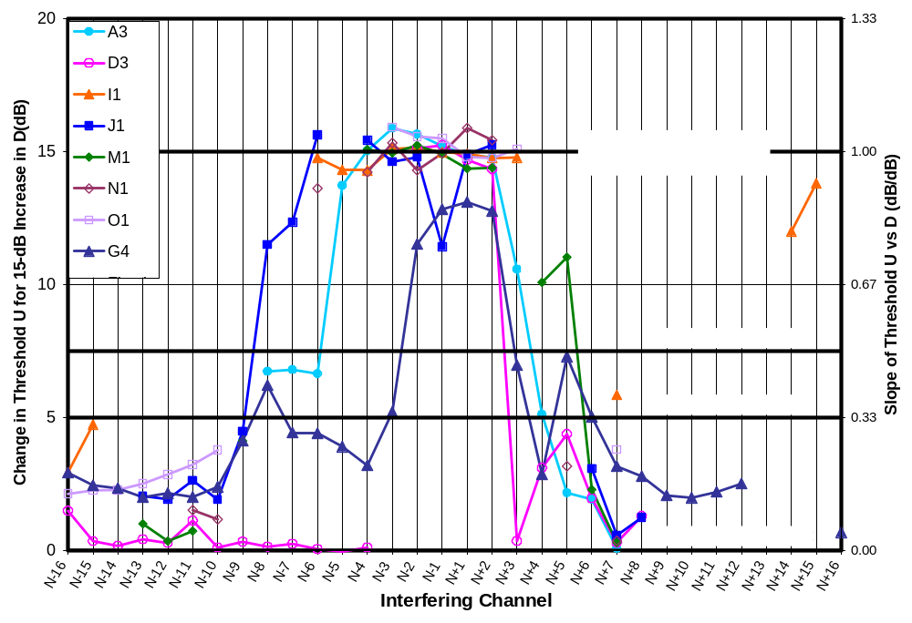
Figure 12-100. Slope of Threshold U Versus D from D = -68 dBm to -53 dBm
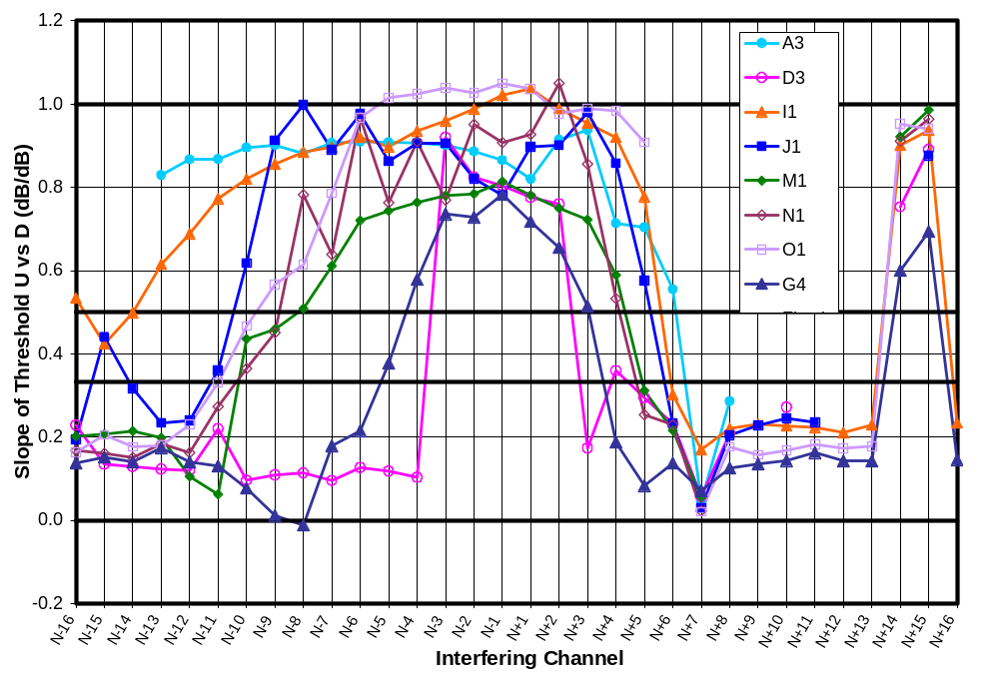
Figure 12-101. Slope of Threshold U Versus D from D =D_{MIN}+3dB to -68 dBm
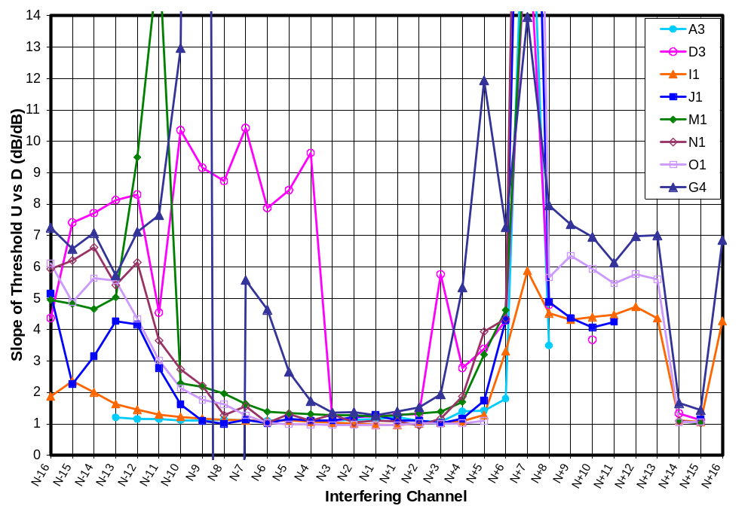
Figure 12-102. Slope of Threshold D Versus U from D =D_{MIN}+3dB to -68 dBm
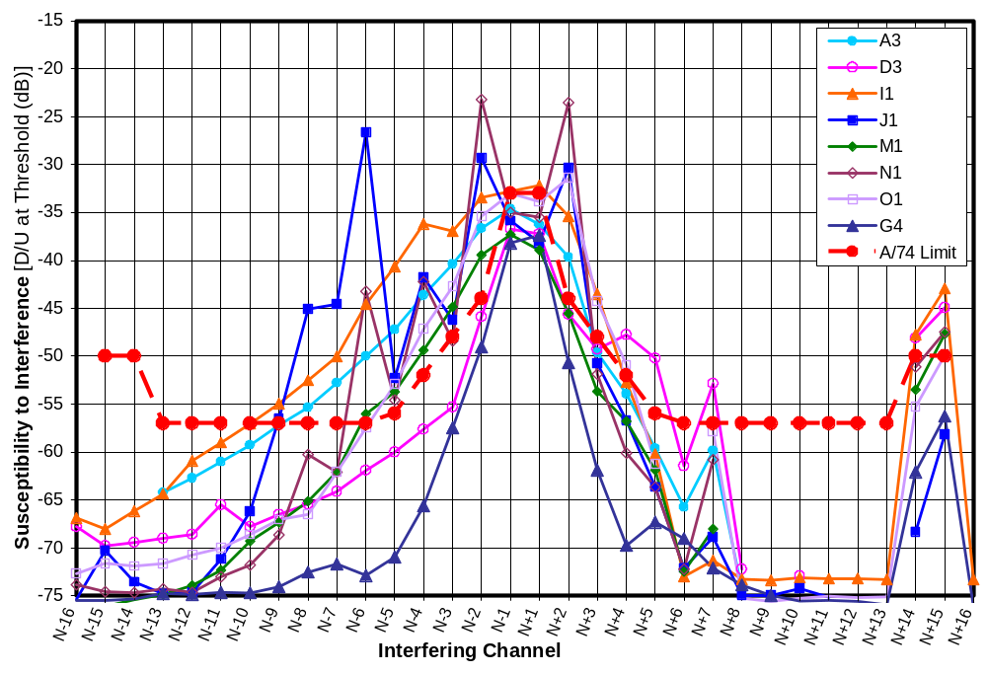
Figure 12-103. D/U of 8 Receivers at D = D_{MIN} + 1 dB on Channel 30 (Extrapolation)

COMBINING MEASURED AND EXTRAPOLATED RESULTS
This chapter shows single-channel rejection performance for eight DTV receivers for a desired signal on channel 30. The results shown combine the measurements of Chapter 5 (D = -28 dBm, -53 dBm, -68 dBm, and D_{MIN} + 3 dB) with the extrapolations of Chapter 12 (D = D_{MIN} + 1 dB).

Figure 13-1 shows D/U ratios for receiver A3. Figure 13-2 shows the same information as Figure 13-1, but shows it as the threshold value for undesired signal power. The first graph will be useful for those who prefer to work in terms of D/U ratios and for identifying channel offsets that behave in a linear manner (constant D/U ratio as D changes) either because the interference mechanism is linear (N+14 and N+15) or due to AGC action. The second is useful for identifying the absolute signal levels that cause interference effects and for identifying channel offsets where thresholds tend to be constant in terms of absolute power of the undesired signal (e.g., N+7).

Figures 13-3 to 13-16 are the same pair of plot formats for each of the remaining seven receivers.

We note that the D/U plots (odd-numbered Figures 13-1 through 13-15) show four measurement limit curves. From top to bottom, these correspond to limits at D = -28 dBm, -53 dBm, -68 dBm, and D_{MIN} + 3 dB, respectively. In the top two curves, all points are determined by the maximum undesired signal power that the test setup could deliver to the input of a TV receiver. The third curve, for D = -68 dBm, has two sources of measurement limits: at N-1 and N+1, the measurement limitation is based on leakage of the undesired signal into the desired channel; at all other channel offsets, the measurements are limited by maximum undesired signal level. For D = D_{MIN} + 3 dB, the measurement limitation (shown by the bottom, shaded region of the graph) is caused by leakage of the undesired signal into the desired channel; since this is a soft limit, values below the limit are shown, but their accuracies are influenced by the leakage. In the case of data extrapolated to D_{MIN} + 1 dB, data points are shown only if the measurements on which they were based were not subject to measurement limits.

The undesired signal threshold plots (even-numbered Figures 13-2 through 13-16) show only one measurement limit curve—the curve associated with the maximum undesired signal power that the test setup could inject into the receiver. The N-1 and N+1 offsets for D = -68 dBm and all of the offsets for D = D_{MIN} + 3 dB are subject to an additional limitation, shown only in the D/U plots, based on leakage of the undesired signal into the desired channel.

We note in particular the case of receiver D3 in Figures 13-3 and 13-4. In Chapter 5 we stated that the smooth rise in D/U (or corresponding smooth fall in threshold U) as one moves from N-15 to N-4 is suggestive of a particular broadband interference mechanism—cross-modulation. Chapter 8 showed that cross-modulation is expected to exhibit a constant threshold U with changes in desired signal level except as the desired signal level approaches D_{MIN} or if the AGC begins to reduce gain prior to the tuner nonlinearity at which the cross-modulation is occurring. We see in Figure 13-4 that the curves corresponding to D = -53 dBm and D = -68 dBm are essentially identical from N-15 to N-4 (except for a small bump associated with a single-channel interference susceptibility at N-11. Interference susceptibility increases by a few dB as one moves past the curve for D = D_{MIN} + 3 dB to the curve corresponding to D = D_{MIN} + 1 dB; the increased susceptibility is an expected result of receiver noise becoming significant at lower signal levels. All four of the curves appear to be the result of cross-modulation.

At N-3 things change. The D/U ratio, which had been smoothly increasing as the undesired channel moved toward the desired channel, takes an abrupt drop—indicating that the receiver’s AGC has acted to decrease the RF gain prior to the mixer—the likely point of the nonlinearity that caused the cross-modulation. Since each curve corresponds to fixed desired signal level, it is clear that the AGC must have been engaged by the undesired signal, which is likely to be larger in amplitude at the AGC sampling point when the undesired signal is on N-3 than when it was on N-4 and beyond because of the tuner’s RF tracking filter response. The smaller change in the D_{MIN} + 3 dB curve as compared to the -68 dBm curve suggests that the AGC gain reduction was relatively small in the former case (where U is about -22 dBm). Thus, it is clear that the AGC engages on an undesired signal level somewhat lower than -22 dBm on N+3—a factor that will become important in some analysis in the next chapter.

Chapter 15 includes composite charts for median, second-worst, and worst performance among the receivers.
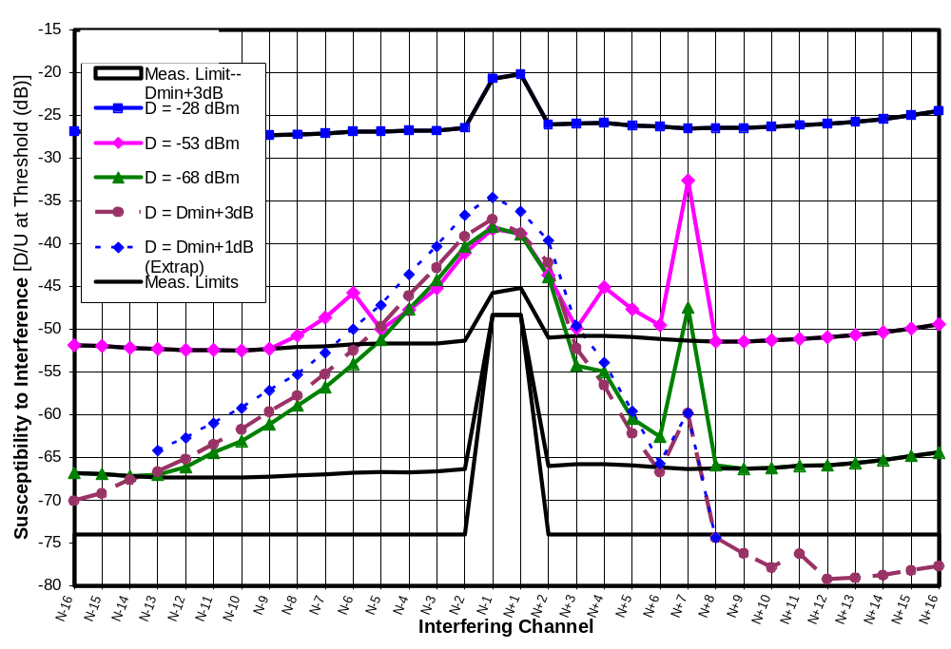
Figure 13-104. D/U of Receiver A3 at Five Desired Signal Levels on Channel 30
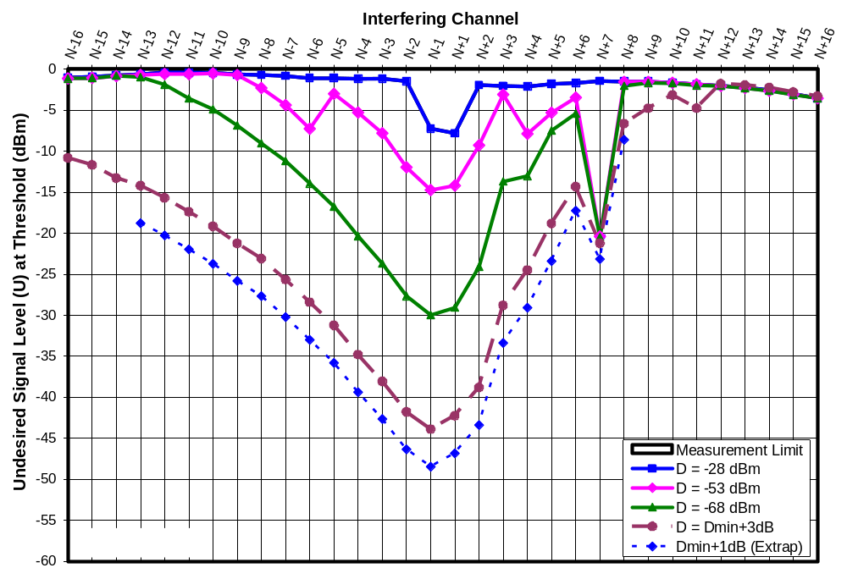
Figure 13-105. Threshold U of Receiver A3 at Five Desired Signal Levels on Channel 30
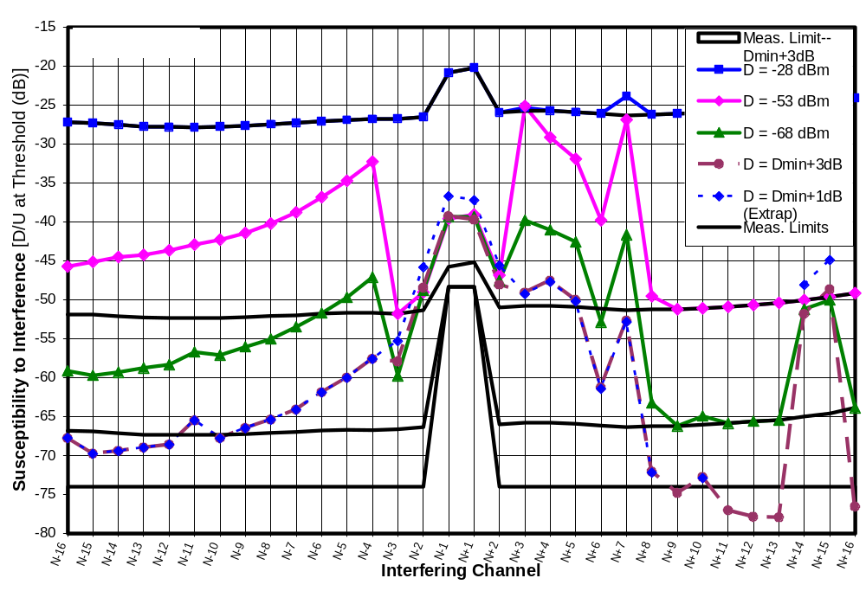
Figure 13-106. D/U of Receiver D3 at Five Desired Signal Levels on Channel 30
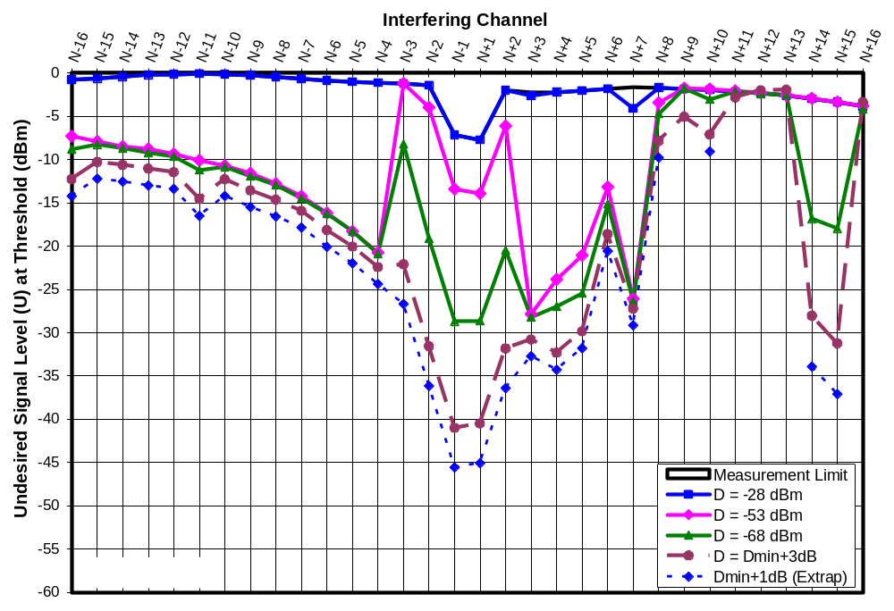
Figure 13-107. Threshold U of Receiver D3 at Five Desired Signal Levels on Channel 30
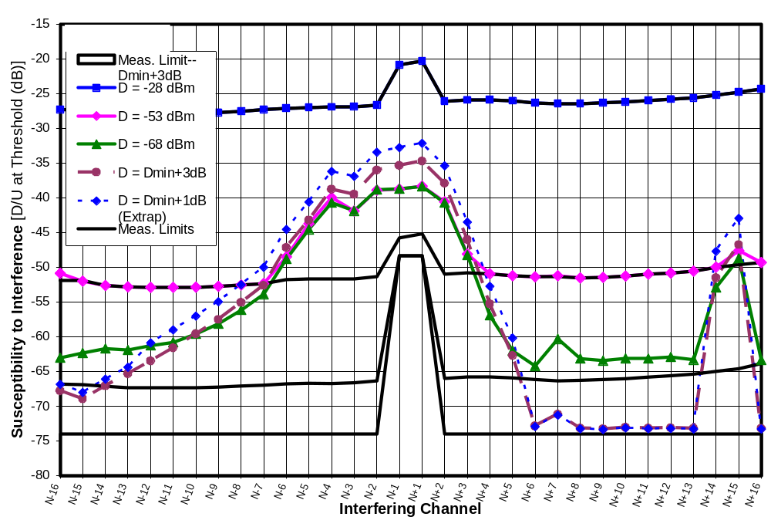
Figure 13-108. D/U of Receiver I1 at Five Desired Signal Levels on Channel 30
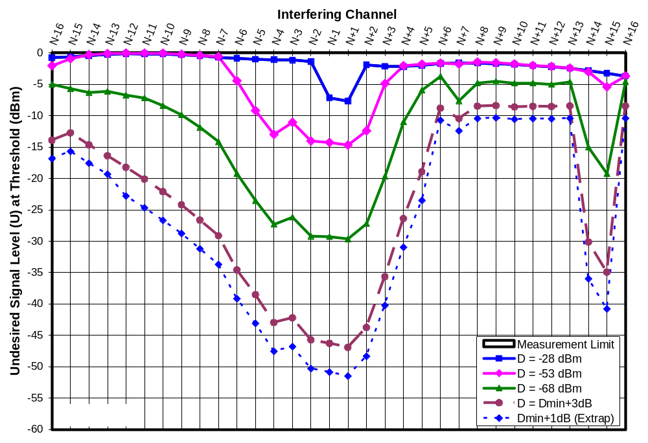
Figure 13-109. Threshold U of Receiver I1 at Five Desired Signal Levels on Channel 30
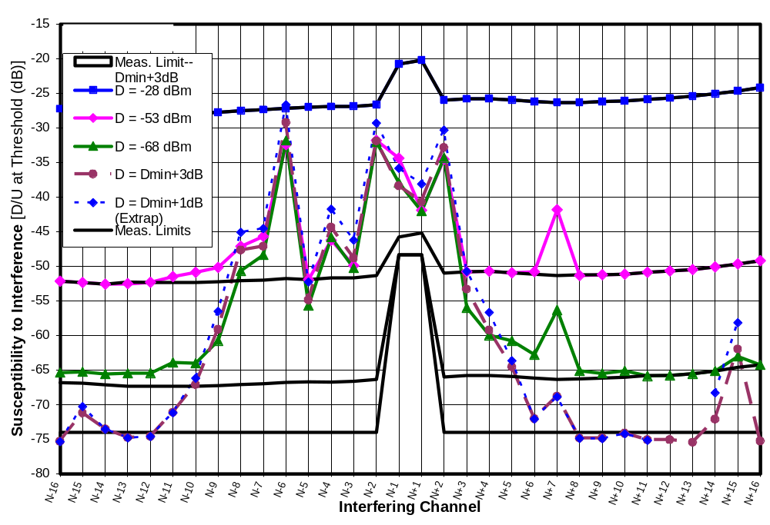
Figure 13-110. D/U of Receiver J1 at Five Desired Signal Levels on Channel 30
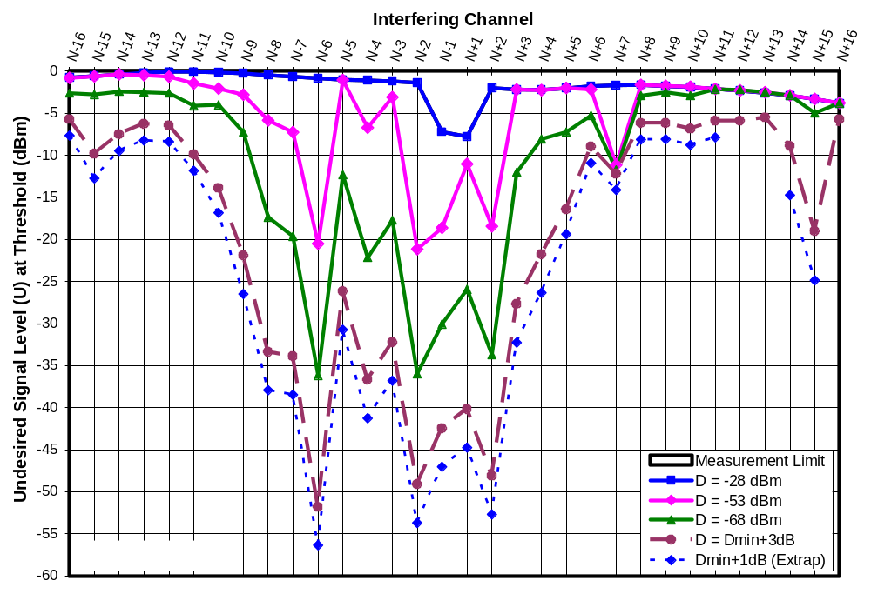
Figure 13-111. Threshold U of Receiver J1 at Five Desired Signal Levels on Channel 30
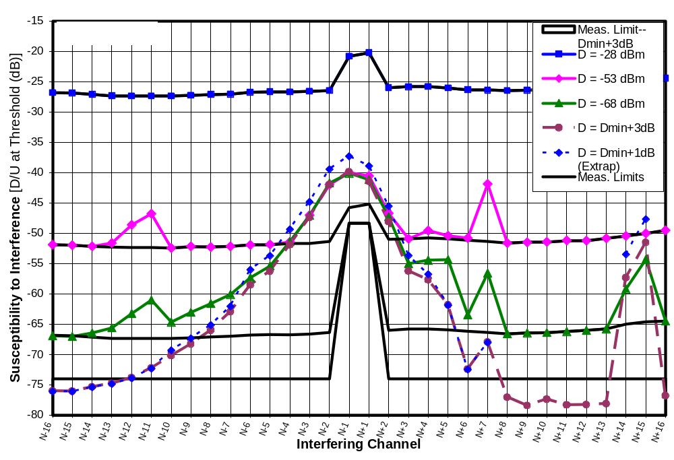
Figure 13-112. D/U of Receiver M1 at Five Desired Signal Levels on Channel 30
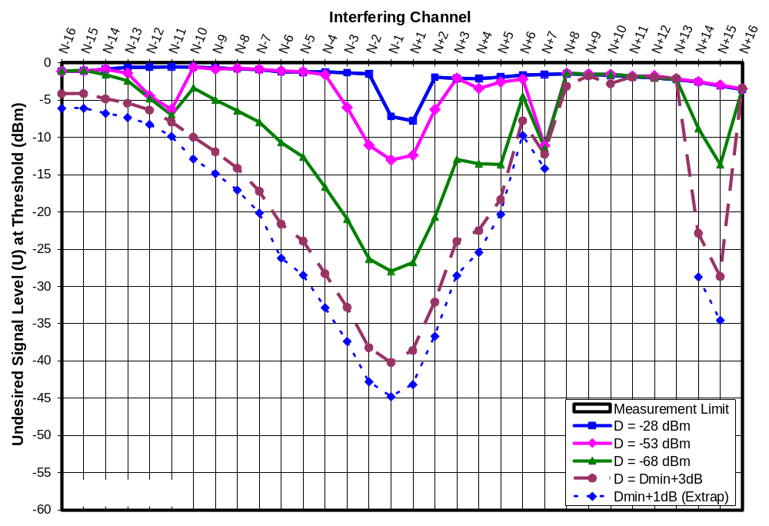
Figure 13-113. Threshold U of Receiver M1 at Five Desired Signal Levels on Channel 30
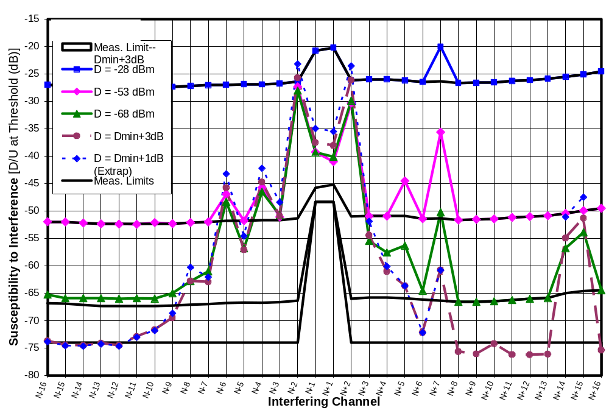
Figure 13-114. D/U of Receiver N1 at Five Desired Signal Levels on Channel 30
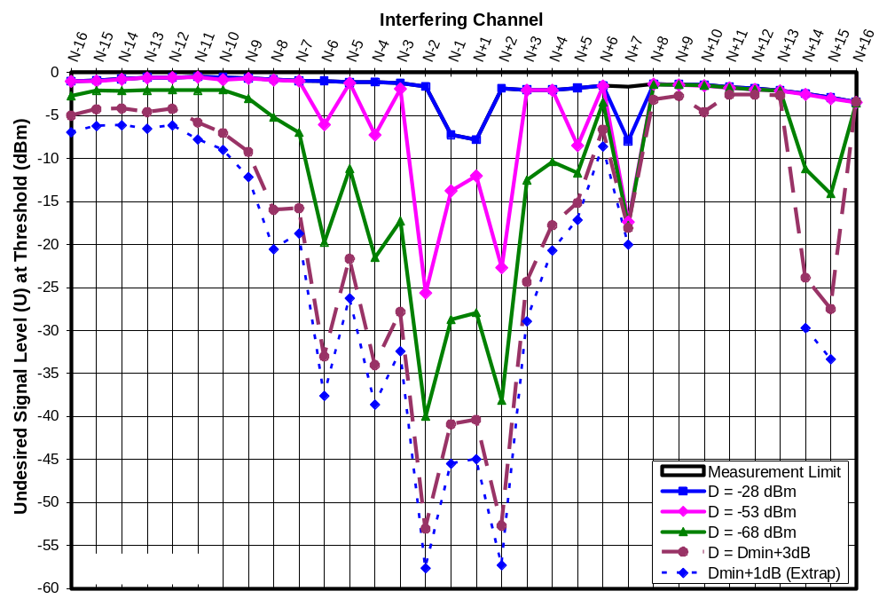
Figure 13-115. Threshold U of Receiver N1 at Five Desired Signal Levels on Channel 30
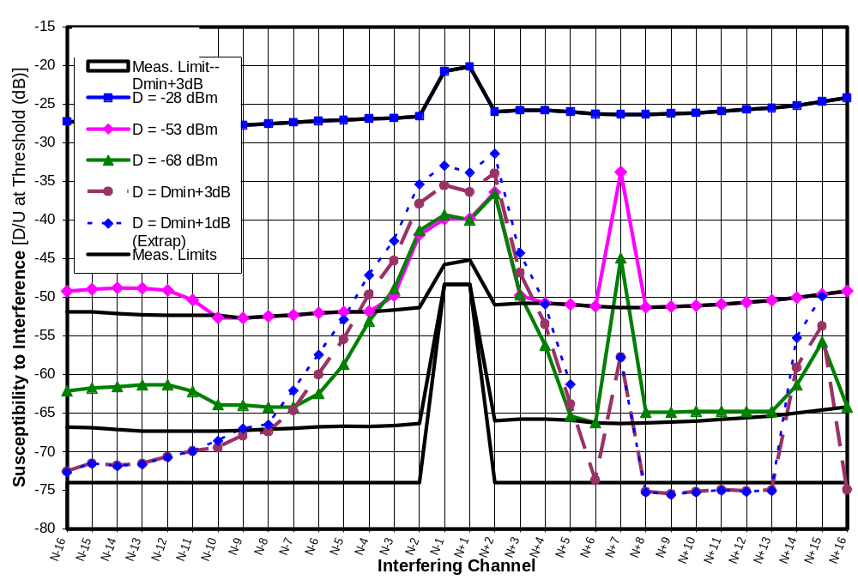
Figure 13-116. D/U of Receiver O1 at Five Desired Signal Levels on Channel 30
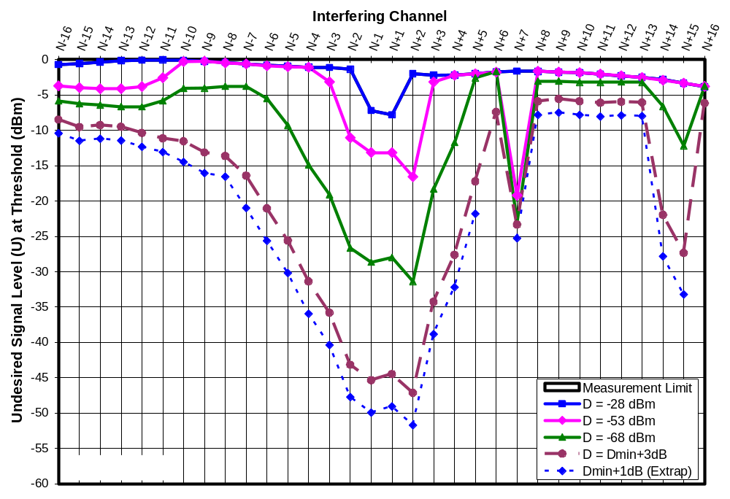
Figure 13-117. Threshold U of Receiver O1 at Five Desired Signal Levels on Channel 30
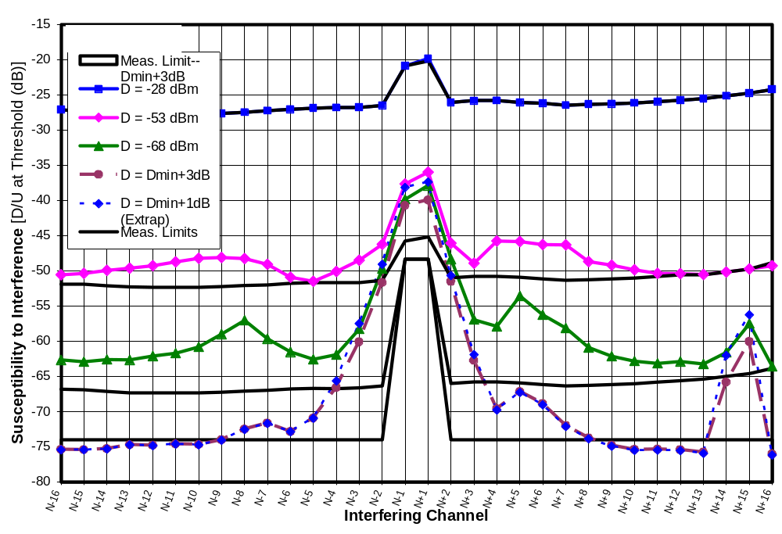
Figure 13-118. D/U of Receiver G4 at Five Desired Signal Levels on Channel 30
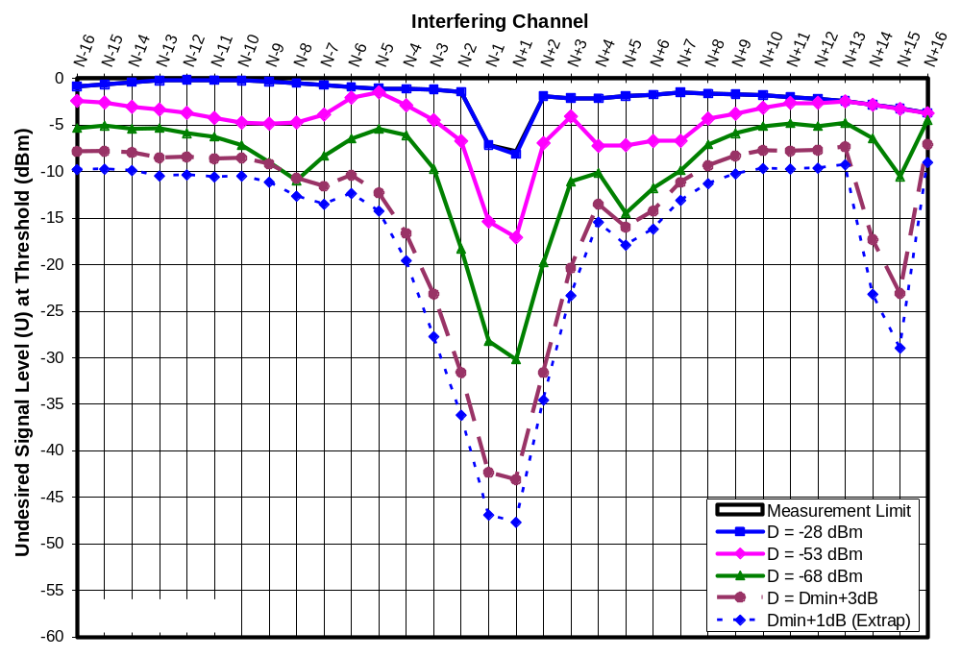
Figure 13-119. Threshold U of Receiver G4 at Five Desired Signal Levels on Channel 30

VERIFICATION TESTS USING ALTERNATIVE METHODS
This chapter presents the results of tests and analyses performed to validate the test methodology and test setup used for the measurements in this report. Readers primarily interested in DTV receiver test results may prefer to skip ahead to Chapter 15 or to the “Summary” section of this chapter.

Most of tests described in this section of the report were intended to eliminate various artifacts that might be associated with the primary test setup used for measurements throughout this report, and then to retest a TV to see whether the interference rejection results change. One test was designed to directly measure the effect of one such artifact—the noise plateau around the desired channel caused by using a band-reject filter to “clean up” the output spectrum of the undesired signal.

The other reason for the validation tests was to confirm unexpected results of the interference rejection tests—most notably, the peak in interference susceptibility that was observed to varying degrees at channel N+7 for nine out of ten receivers that was tested.

The verification tests were performed only for channel 30.

Alternative Test Setup With Bandpass Filter on Undesired Signal
The primary test setup for measurements presented in this report used a band-reject filter to limit leakage of the undesired signal into the desired channel, as described in Chapter 4. This differs from the more conventional approach of placing a band-pass filter around the undesired signal (or signals). The band-reject approach leaves a plateau in the out-of-band spectrum of the undesired signals—a plateau which is filtered out only in the desired channel and its immediate vicinity. (See, for example, Figures 4-1 and 4-2 of Chapter 4.)

For the measurements described in this section of the report, the test approach was changed to a more conventional one. Instead of subjecting the undesired signal to a band-reject filter designed to limit leakage into the desired channel (channel 30), a bandpass filter was employed to limit leakage into any channel outside of the undesired channel. The bandpass filter used for this test was an existing seven-section cavity filter (Micro Communications, Inc, Type "N" IDBP Filter, Part # 220035 C/N) for TV broadcast channel 29. Filter response was down 0.7 to 0.8 dB at the channel-29 band edges (0.4 dB at the DTV pilot frequency) and more than 73 dB beyond the first-adjacent channels. Measured frequency response is shown in Figure 14-1.

The use of the fixed bandpass filter for the undesired signal as opposed to a band-reject filter at the desired channel required a change in test approach. The undesired signal was fixed at channel 29 and the desired channel, along with the TV tuner, were switched among channels 14, 15, 21 to 28, and 30 to 37—creating test cases corresponding to N+15, N+14, N+8 through N+1, and N-1 through N-8. (Note that we were changing N rather than the undesired channel to achieve these offsets.)

Though the main purpose of testing in this way was to eliminate the noise shoulders that appeared around the desired channel in the primary test setup, several other changes were made in the test setup in order to rule out the influence of other possible artifacts. Specifically, the test setup (Figure 4-1 of Chapter 4) was modified as described below and as shown in Figure 14-2.
The Rohde and Schwarz SFU 8-VSB signal generator was used as the undesired signal source for all of these measurements. This was intended to eliminate the effects of any generator-specific artifacts that might be produced by the Agilent E4437B signal generator that was configured to produce bandlimited Gaussian noise as the undesired signal source for much of the testing described in this report.
All amplifiers and step attenuators, as well as some fixed attenuator pads, were eliminated to simplify the test setup and to reduce the maximum signal levels that existed within the test setup in order to reduce the possibility of unintended coupling of signals (e.g., by radiation).

Rejection ratio measurements were performed on one DTV (receiver J1) using the alternative test setup. Figure 14-3 compares the results with the previous measurements using the primary test setup. All measurements matched within 1.5 dB. The measurements differed on N-1 and N+1 by only 0.4 and 0.8 dB, respectively. On the other channels, the D/U ratios with the alternative test setup averaged 0.7 dB lower than those with the primary test setup. Since the alternative test setup used an 8-VSB signal rather than bandlimited Gaussian noise as the interferer, the alternative test setup was expected to exhibit lower D/U ratios than the primary one by about 1.2 dB based on the difference in signal type (Chapter 7).

The match between test results is quite close, especially given that the different test approaches forced testing to be performed on different TV channels (mostly channels 21 through 37 for the alternative test setup and channel 30 for the primary one).

Broadband Notched Noise
Since the primary test setup left a plateau of noise surrounding the desired channel, a decision was made to test each TV receiver to determine the effect of that plateau by itself (i.e., without the undesired signal). The signal generator used as an undesired signal source for non-adjacent tests on channel 30 had a noise floor that was 56 to 59 dB below the undesired signal power when measured in a 6-MHz bandwidth beyond the first adjacent channels. The primary test setup subjected the undesired signal to a band-reject filter that further attenuated this noise floor within the desired channel. The result was a signal spectrum that included the main undesired signal spectrum, plus a noise plateau 56 to 59 dB below it, but with a valley cut into the noise plateau at channel N, as shown in Figure 4-2.

Measurements
The “broadband notched noise” tests were performed by replacing the undesired signal source with a white Gaussian noise generator having a spectrum that extended from about 40 to 850 MHz—i.e., covering the entire broadcast television spectrum and beyond. The noise signal spectrum was “notched” by the same band-reject filter that had been used to filter the undesired signal in all of the non-adjacent tests at channel 30 (i.e., all tests except at N-1 and N+1). Figure 14-4 shows a portion of the resulting spectrum. Essentially, the undesired signal for these tests consisted of white noise filling the entire TV spectrum and beyond, but with a 43-dB deep hole cut in it at channel 30 (N), and with some filter rolloff through the first-adjacent channels.

The interference rejection performance of the eight DTV receivers were then measured using this broadband notched noise source. Tests were performed for desired signal levels of -68 and -53 dBm. D/U ratios were computed with U being the undesired power per TV channel averaged across channels N-4 through N-2 and N+2 through N+4.

The results are shown in the first two data columns of Table 14-1. At a desired signal power of -68 dBm, the interference thresholds occurred at a D/U ratio ranging from -27.1 to -23.0 dB, where U is measured on a per TV channel basis, as described above. The corresponding D/U range when D = -53 dBm was slightly higher at -25.9 to -20.6 dB.

Table 14-32. Broadband Notched Noise D/U Ratios at Threshold
 | D/(U/channel) For Notched Noise Only (dB) |  | D/U Caused by Noise Plateau If Single-Channel U Were 56 dB Above the Noise Plateau (dB)
Receiver | D = -68 dBm | D = -53 dBm | D = -68 dBm | D = -53 dBm
A3 | -26.9 | -25.9 | -82.9 | -81.9
D3 | -25.5 | -22.9 | -81.5 | -78.9
I1 | -25.4 | -23.6 | -81.4 | -79.6
J1 | -23.0 | -20.6 | -79.0 | -76.6
M1 | -27.1 | -25.6 | -83.1 | -81.6
M2 | -23.1 | -22.0 | -79.1 | -78.0
N1 | -26.1 | -22.2 | -82.1 | -78.2
G4 | -23.4 | -23.7 | -79.4 | -79.7
Max | -23.0 | -20.6 | -79.0 | -76.6
Min | -27.1 | -25.9 | -83.1 | -81.9

Thus, all of the TVs could operate with the noise plateau 23 dB or more above the desired channel, on a noise-power-per-channel basis when D = -68 dBm and 20.6 dB or more above the desired channel when D = -53 dBm. Since the actual undesired noise source power used in the tests was 56 dB above its noise plateau, one would expect that the effect of the noise plateau by itself would limit D/U measurements to about -79 dB at D = -68 dBm and about -77 dB at D = -53 dBm. If we want to maintain at least 10 dB margin between measured D/U’s and the failure point due to the plateau, these numbers increase to -69 and -67 dB, respectively.

In reality, D/U ratio measurements were limited by the maximum undesired signal level that the test setup could generate to values of about -52 dB at D = -53 dBm and -66 dB at D = -68 dBm; consequently, plateau noise alone would not have affected the measurements, even for the most vulnerable TV.

IM3 Analysis
We saw in Chapter 10 that a high level signal on a channel N+K can cause a receiver to be susceptible to interference from very low level signals on channel N+2K. We could consider the intended undesired signal to be on N+K and the plateau noise to contain a signal at N+2K at a level 56 dB below the intended undesired signal. (Note that, for N+/-2 and beyond, the plateau noise ranges from 56 to 59 dB below the undesired signal power, so this is a worst-case assumption.) The same could be considered with the roles of N+K and N+2K reversed.

To test whether IM3 between the undesired signal and the plateau could have been responsible for any of the measured single-channel D/U ratios, lines corresponding to the cases of U_{N+K}/U_{N+2K} = 56 dB U_{N+K}/U_{N+2K} = -56 dB were overlaid on the modeled IM3 charts from Figures 10-4 to 10-17. The intersections of those overlaid lines with the modeled curve for each channel offset, each TV, and each of two desired signal levels (-68 dBm and D_{MIN} + 3 dB) were then examined.

In all of the 67 cases available on the plots, the U_{N+K}/U_{N+2K} = -56 dB line crossed the horizontal segment of the model plot, indicating that the measured U_{N+2K} threshold was reached before the plateau-based IM3 threshold would have been reached. In 63 out of the 67 cases available on the plots, the U_{N+K}/U_{N+2K} = 56 dB line crossed the vertical segment of the model plot, indicating that the measured U_{N+K} threshold was reached before the plateau-based IM3 threshold would have been reached. These results indicate that IM3 between the undesired signal and the plateau was not a factor in these cases.

In three cases, the U_{N+K}/U_{N+2K} = 56 dB line crossed model plot near the intersection of the vertical segment and the diagonal IM3 segment. This suggests that, in those cases, the “single-channel” threshold that was measured and reported in Chapter 5 may have actually been caused by IM3 between the undesired signal and the plateau. The model plots for those cases are shown in Figures 14-5 to 14-7. The three cases are summarized in the following bullets.
Receiver D3 at D = -68 dBm, N+2 threshold occurred at U = -20.5 dBm, D/U = -47.5 dB.
Receiver G4 at D = -68 dBm, N-5 threshold occurred at U = -5.4 dBm, D/U = -62.7 dB;
Receiver G4 at D = D_{MIN} + 3 dB, N+4 threshold occurred at , D/U = -13.5 dB,U = -69.6 dBm;
The two cases involving receiver G4 correspond to D/U ratios below (more negative than) -60 dB. If IM3 between the undesired signal and the plateau caused measurement limitations at those levels, the measurement limitations occurred beyond the planned measurement range of the test setup and in a region that represents very good rejection performance by the DTV receivers; consequently, the cases are not considered important. The remaining case, involving receiver D3, corresponds to the second best rejection ratio among the eight receivers at N+2 for a desired signal level of -68 dBm. If the results were influenced by IM3, it would mean that the actual performance was even better and falls only 0.8 dB short of the best performance among the eight receivers.

In one other case (Figure 14-8), the U_{N+K}/U_{N+2K} = 56 dB line crossed a model plot on the diagonal IM3 segment at a U_{N+K} value about 5 dB below the single-channel threshold that had been measured for that case (receiver D3 at D = -68 dBm, N-3 threshold occurring at U = -8.2 dBm, D/U = -59.8 dB). This is expected to be an impossible situation in that the IM3 effect is predicted to occur at a lower desired signal level than the actual -8.2 dBm threshold that was measured for the single-channel interferer. Theoretically, IM3 should have caused an artificially low reading of about -13 dBm at threshold.

Our use of worst-case assumptions regarding the undesired signal-to-plateau ratio (56 dB, whereas the range was 56 to 59 dB) is not enough to account for the difference; however, Figures 13-3 and 13-4 and the related discussion in Chapter 13 offer some insight into what is happening. The text in Chapter 13 argues that the receiver’s AGC activates to reduce the tuner gain prior to the mixer when the undesired signal level on channel N-3 exceeds a level somewhat below -22 dBm. Referring to Figure 14-8, we see that the AGC would engage beginning at a point above and to the left of U_{N+K} = -22 dBm and U_{N+2K} = -52 dB. The Appendix B shows that, when AGC engages on U_{N+K}, the threshold value of U_{N+2K} becomes constant with further increases in U_{N+K}. This means that the sloped IM3 portion of the model for receiver D3 in Figure 14-8 should end its downward trajectory and switch to a horizontal trajectory when the AGC engages. The horizontal trajectory would continue until the curve intersects the vertical segment corresponding to the measured single-channel threshold for U_{N+K}. An examination of the plot shows that, with this new trajectory, the dashed line representing U_{N+K}/U_{N+2K} = 56 dB would not intersect the IM3 segment of the line. The apparent contradiction was actually caused by a failure to show the AGC engagement effect in the model for that receiver. Chapter 10, the origin of the modeled results cautions that the model becomes invalid beyond the signal levels at which the AGC engages to reduce gain prior to the nonlinearity that causes the IM3 (usually the mixer).

Thus we conclude that the only cases in which we have identified a potential for IM3 between the undesired signal and the plateau to have influenced the test results are cases in which measured rejection performance of a receiver was very good. If the unintended IM3 did actually influence those measurements, then the actual receiver performance was even better than the measurement indicated—a result that would not change any conclusions of this report.

Screen-Room Test
We are unaware of other reports of DTV receivers exhibiting an N+7 interference vulnerability, such as was observed on nine of ten receivers tested for this report. In an effort to rule out test environment anomalies as the cause, receiver D3 was placed in a closed screen room. No equipment inside the screen room, other than the TV, was powered on. The rejection performance test equipment was placed outside of the screen room about 18 feet from the TV. Rejection performance was measured with a desired signal of -68 dBm on channel 30 and the white Gaussian noise source (bandlimited to match the 3-dB width of an 8-VSB signal) was placed on channel N+7 and was adjusted to determine TOV. The resulting D/U ratio was -42.1 dB. The measurement one month earlier using the primary test setup without the screen room was -41.6 dB. The difference of only 0.5 dB provides further evidence that the observed N+7 sensitivity is not an anomaly of the test environment.

Summary
A single screen-room measurement confirmed that the N+7 susceptibility is not caused by direct pickup involving the TV receiver.

The noise plateau discussed in this report was about 56 dB or more below the undesired signal power when measured on a per-channel basis. Tests were performed using an alternative test setup that (1) employed a bandpass filter approach to attenuate the noise plateau globally rather than just within the desired channel and (2) eliminated amplifiers and attenuators to create a simpler (and more limited) configuration that maintained lower signal levels in the test setup to minimize potential for unintended signal coupling. The test results closely matched those obtained with the primary test setup used in this report.

Tests of each of the eight receivers against notched plateau noise demonstrated that the rejection performance tests were not influenced by the presence of the noise plateau by itself.

Analysis was performed to determine whether IM3 effects between the undesired signal and a portion of the undesired signal plateau 56 or more dB lower could have affected the measured results for single-channel rejection performance. Since IM3 properties vary among the individual receivers as well as with channel offset and desired signal amplitude, a global answer is not feasible. Measurements of IM3 effects performed with equal-powered paired signals (Chapter 9) were used to develop models for paired-signal IM3 for 67 combinations of TV receivers, channel offsets, and desired power levels (Chapter 10). Each of these 67 was examined to determine whether IM3 could have influenced the single channel measurements in either of two cases (undesired signal at N+K and undesired signal at N+2K)—a total of 134 cases of single-channel rejection measurements. The evaluation suggested that three of the 134 measurements might have been affected by IM3 with the noise plateau. All three involved very good rejection performance (two with D/U’s beyond -60 dB and one only -48 dB, but the second best performance among eight receivers); if IM3 influenced the measurements, the actual rejection performance was even better than that measured—a result that would not change any conclusions of this report.
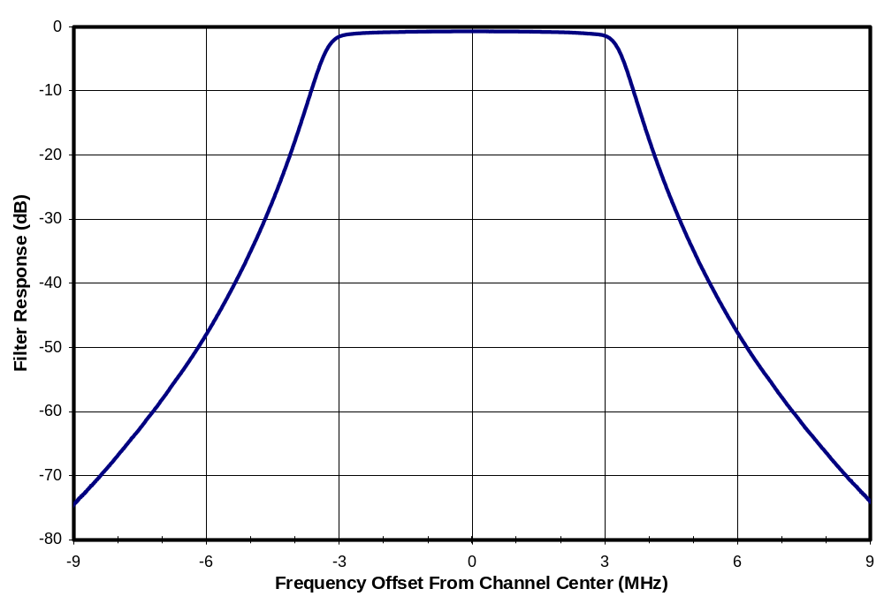
Figure 14-120. Frequency Response of Channel-29 Bandpass Filter

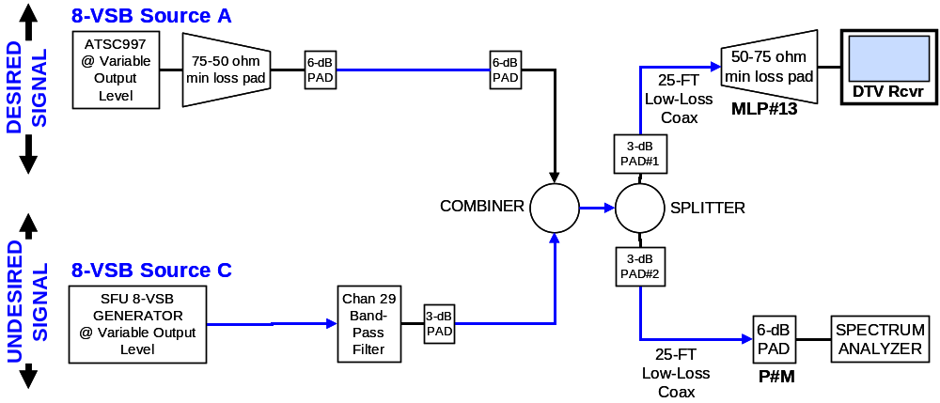
Figure 14-121. Alternative Test Configuration With Bandpass Filter on Undesired Signal
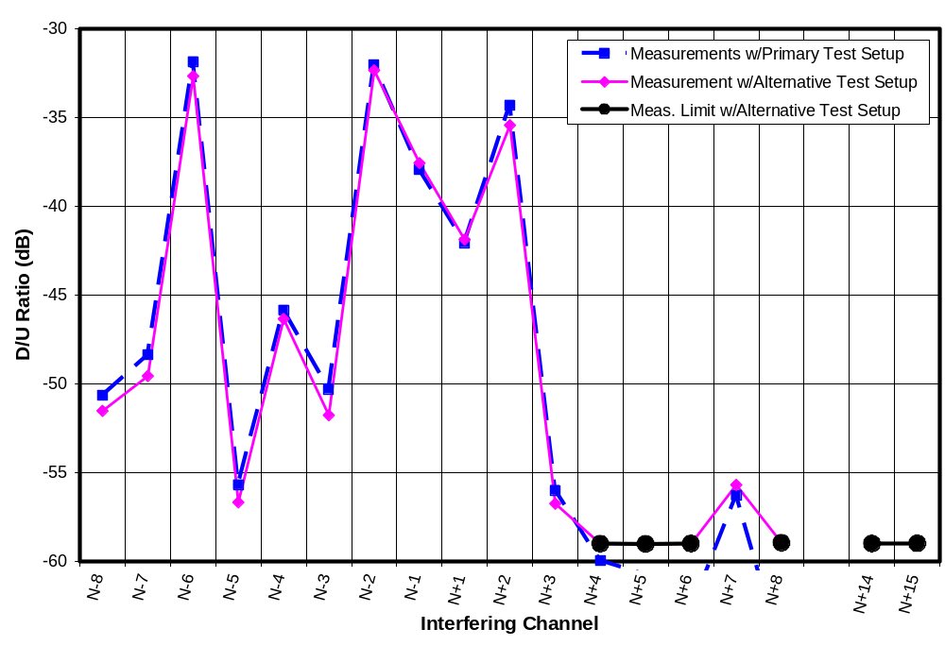
Figure 14-122. D/U Measurements on Receiver J1 with Primary Versus Alternative Test Setup
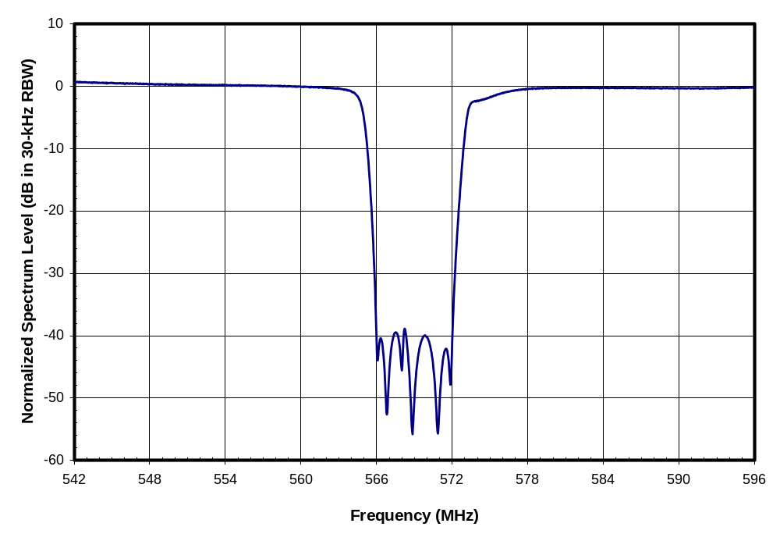
Figure 14-123. Spectrum of Undesired Signal for Broadband Notched Noise Test
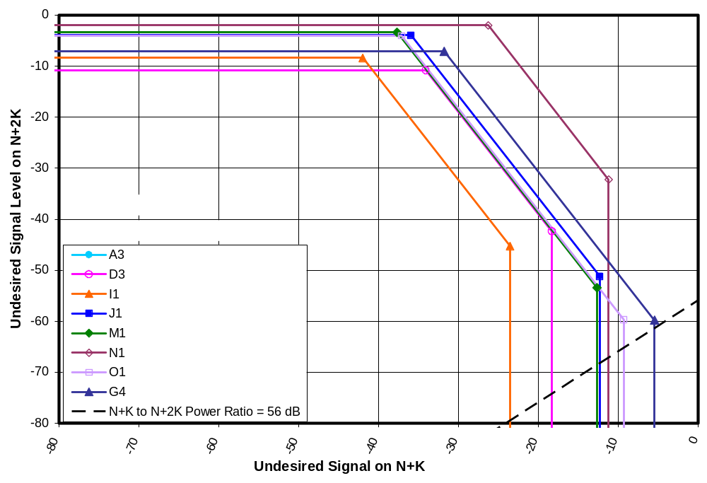
Figure 14-124. Model Plot for “Plateau IM3” On Receiver G4 at D = -68 dBm with N-5/N-10
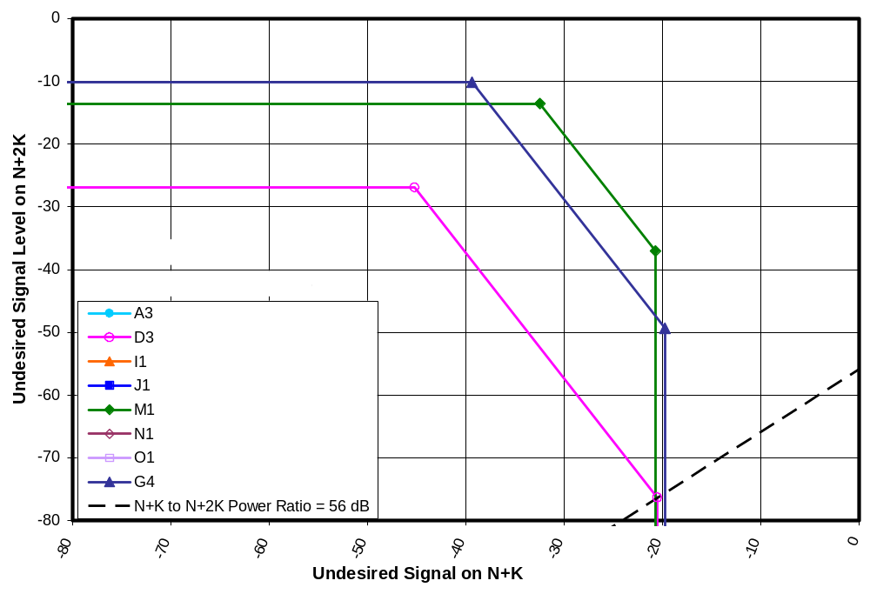
Figure 14-125. Model Plot for “Plateau IM3” On Receiver D3 at D = -68 dBm with N+2/N+4
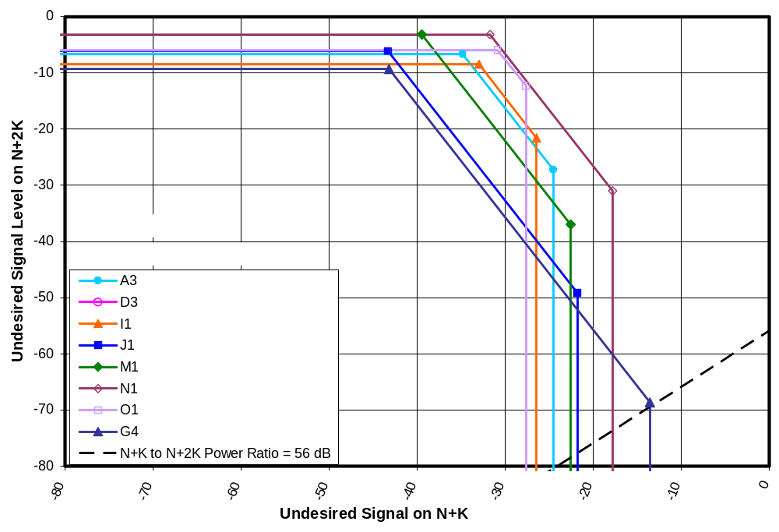
Figure 14-126. Model Plot for “Plateau IM3” On Receiver G4 at D = D_{MIN}+3dB with N+4/N+8
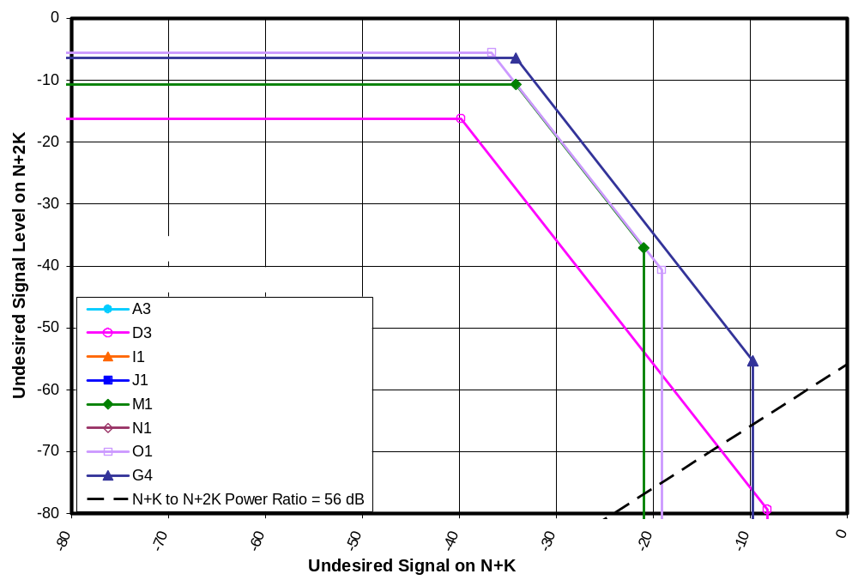
Figure 14-127. Model Plot for “Plateau IM3” On Receiver G4 at D =-68 dBm with N-3/N-6

SUMMARY AND CONCLUSIONS
We now summarize the main findings of the measurement program.

This report presented the following:
Tests of 30 consumer DTV receivers to determine tuner type (e.g., single conversion or double conversion);
Measurements of out-of-channel interference rejection performance of eight DTV receivers tuned to channel 30;
Measurements of out-of-channel interference rejection performance of seven DTV receivers (a subset of the eight) tuned to channel 51;
A theoretical framework for understanding the results;
Extrapolation of the measurement results to a desired signal level 1 dB above the minimum signal threshold for each receiver.

The out-of-channel interference tests included single-channel interferers and pairs of interferers at channel spacings that could place third-order intermodulation distortion products in the desired TV channel. Most of the tests used undesired (i.e., interfering) signals that occupied most of the 6-MHz width of a DTV channel assignment. An 8-VSB DTV signal was used as the undesired signal for all tests on first-adjacent channels. For other channel spacings, the source was either an 8-VSB source (for the channel-51 tests) or a Gaussian noise source bandlimited to match the 3-dB width of an 8-VSB signal (for the channel-30 tests). For paired-signal tests, the second undesired signal was always a Gaussian source. A limited number of tests were performed to measure the relative interference effects of 8-VSB, Gaussian noise, and OFDM signals. One TV was tested to determine the effects of a narrower-band undesired signal—a Gaussian noise source bandlimited to a 3-dB width of 1 MHz.

The out-of-channel interference rejection performance measurements are presented in this report in terms of desired and undesired signal power levels at the RF input (i.e., antenna terminal) of each DTV receiver. While the test results are intended to be useful in assessing interference potential and developing protection criteria to prevent interference, the results do not translate directly into such criteria. Assessing existing protection criteria or developing new criteria will require steps that are beyond the scope of this report, such as definition of the scenarios on which protection is to be based, modeling of propagation from the undesired signal source to the DTV antenna, modeling of antenna gain and of losses from the TV antenna to the DTV receiver, and policy decisions regarding the DTV receiver performance and signal margins to be assumed in developing the protection criteria.

We have attempted to provide receiver interference rejection performance data over a parameter range sufficient to support the broad needs of the Commission and the technical community. While we note that the rejection performance measurements in this report were performed on only a small sample of consumer DTV receivers and thus do not provide a robust statistical basis for identifying the overall range of performance of consumer DTV receivers, they do provide a more representative sample of the performance of currently available products than did the earlier tests of the prototype receiver.

In forming conclusions from the measurements, we focus primarily on the measurement results at channel 30, since that channel is more central to the UHF band and thus is likely to be more representative of performance across the band. Results from channel 51 are used for comparative purposes, and to fill in gaps in the measurements at channel 30.

DTV Tuner Type
Tuner type is of significance because the “taboos” that limited local analog TV channel allotments at certain channel spacings were based primarily on interference susceptibilities that were unique to single-conversion tuners having a 44-MHz intermediate frequency (IF). The reduced vulnerability of the prototype ATSC DTV receiver—relative to analog TV—was achieved by a combination of the more robust ATSC digital transmission system that is inherently less susceptible to noise and interference than the NTSC analog system and the use of a double-conversion tuner in the prototype receiver.

Tests of 30 consumer DTV receivers demonstrated that all 30 have single-conversion tuners with 44-MHz IF. (28 were identified as single conversion by means of a small but detectable leakage of the tuner’s local oscillator frequency from its antenna port. The remaining two were identified by means of interference vulnerabilities that we expect to be unique to single-conversion tuners with 44-MHz IF.)

Effect of Undesired Signal Type
Tests were performed to determine the relative interference effects of the following types of signals:
White Gaussian noise bandlimited to the 3-dB width of an 8-VSB signals;
8-VSB DTV signal;
DVB-H—an orthogonal frequency division multiplexing (OFDM) signal—set for a 5-MHz channel width; and
White Gaussian noise bandlimited to a 3-dB width of 1 MHz.

The first three signal types were tested on eight DTV receivers at the five non-first-adjacent channel offsets that exhibited the most interference potential among the receivers at low signal levels (N+2, N-2, N-3, N-4, and N-6). (Channels N-1 and N+1 were not tested because the Gaussian source did not have adequate band-edge rolloff to permit testing on first-adjacent channels.)

The interference effects of the OFDM signal and of the Gaussian noise signal averaged 1.0 and 1.2 dB, respectively, greater than the interference effects of the 8-VSB signal. That is, the signal level of an OFDM signal or of a Gaussian noise signal that is required to interfere with DTV reception is about 1 dB lower than the level of an 8-VSB signal that would cause interference at the same channel offset.

Tests with the reduced-bandwidth interferer (1 MHz wide) were performed on only one receiver. The results generally tracked those of the wider Gaussian noise interferer except where narrowband interference susceptibilities existed, such as at N+7, where reception was susceptible to interference when the undesired signal spectrum overlapped the TV’s local oscillator frequency.

Cliff Effect
The ATSC digital television broadcast system can achieve flawless picture reception under interference conditions that would produce an unusable picture for analog broadcast TV; however, once an undesired signal reaches a level at which picture impairments become visible on a DTV receiver, the picture degrades extremely rapidly with further increases in undesired signal level. The rapid degradation from flawless picture to no picture at all is known as the cliff effect.

The interference rejection test results in this report are presented as signal levels at the threshold of visibility (TOV) of picture degradation—i.e., the point at which picture degradation (in the form of pixilation, image freezes, or dropouts) becomes visible. Increases in interfering signal level above this point result in further degradation—and ultimately complete loss—of the TV picture.

Though the “hardness” of the thresholds was not one of the measurement parameters for this study, a strong “cliff effect” was observed during the tests. For example, in most cases, increasing interference level about 1 dB above TOV caused complete loss of picture. In some cases picture loss didn’t occur until the undesired signal level rose as much as much as 3 dB and in one case, 5 dB (though picture errors occurred continuously in that case after only a 1.5 dB increase). In a few cases picture loss occurred concurrently with appearance of errors or with only an additional 0.1 dB increase in interference—an extremely abrupt cliff! By contrast, interference to analog TV occurs much more gradually. An 8-dB increase in signal level of an interferer from the TOV level for analog TV may cause the interference effect to grow to the “slightly-annoying” level, from the TV viewer’s point of view. A total increase of 20 to 30 dB may be required to make the analog picture unusable.

Interference from a Single Undesired Signal
The interference tests with a desired signal on channel 30 were performed using an 8-VSB undesired signal for first-adjacent channels (N-1 and N+1) and a white Gaussian noise signal bandlimited to match the 3-dB width of an 8-VSB signal for all other channels.

Measurements of interference rejection performance are specified in terms of desired signal power D and undesired (i.e., interfering) signal power U at the RF input of the DTV receiver. We have chosen to present the interference rejection performance measurements in two ways: as D/U ratios and as threshold values for the undesired signal level U. Each has its own application. D/U ratios might be preferable for all analytical work if they were constant with desired signal power; however, nonlinearity of interference mechanisms and the effects of receiver noise at low desired signal levels cause D/U ratios to be variable. Nonetheless, D/U ratios can be convenient to use in applications like DTV-into-DTV interference assessment because estimation of D/U ratios may be easier and more accurate that estimation of absolute levels where long-distance propagation is involved—especially if the broadcast stations are co-sited. Use of absolute signal level thresholds may be more appropriate for assessing shorter distance interference from low-power devices because the effects of TV antenna height and placement on the undesired signal are likely to be very different from their effects on the desired signal.

No receiver appeared to fully achieve the ATSC recommended guidelines for interference rejection performance. After taking into account differences between the Gaussian-noise interferer used for most of the tests and the 8-VSB interferer specified by the ATSC, the best-performing receiver appears to fail the guidelines at only one channel offset, and there by only 1 dB. A second receiver failed to meet the voluntary guidelines by 1 to 2 dB at two channel offsets. The remaining five receivers failed to meet the guidelines at two to 16 channel offsets; the worst failure for each of those receivers ranged from 8 to 24 dB.

The single-channel rejection performance measurements performed for this report are best summarized by Figures 15-1 through 15-6. The first graph presents the rejection performance in terms of D/U ratios and the second in terms of the undesired signal power at TOV. The first pair of graphs presents the median rejection performance across the eight DTV receivers at each of the tested channel offsets (from N-16 to N+16—omitting the co-channel case). The second pair presents the second-worst performance across the eight receivers. The third pair presents the worst performance.

Each graph shows the interference thresholds at five desired signal levels: -28 dBm, -53 dBm, -68 dBm, D_{MIN} + 3 dB, and D_{MIN} + 1 dB, where D_{MIN} is the desired signal level corresponding to the TOV for the receiver in the absence of interference. For measurements at D_{MIN} + 3 dB, each TV was tested by first measuring its minimum signal threshold D_{MIN}, then setting the desired signal power 3 dB higher that threshold for the interference rejection tests. Thus the desired signal level was different for each DTV receiver. The results at D_{MIN} + 1 dB were extrapolated from the measured values at D_{MIN} + 3 dB by means of a model developed in Chapters 8 and 12.

Each graph shows measurement limitations imposed by the test setup—in the form of solid black lines and a shaded region. The D/U plots (Figures 15-1, 15-3, and 15-5) show four measurement limit curves that correspond, from top to bottom, to limits at D = -28 dBm, -53 dBm, -68 dBm, and D_{MIN} + 3 dB, respectively. In the case of data extrapolated to D_{MIN} + 1 dB, data points are shown only if the measurements on which they were based were not subject to measurement limits. The undesired signal threshold plots (even-numbered Figures 15-2, 15-4, and 15-6) show only one measurement limit curve—the curve associated with the maximum undesired signal power that the test setup could inject into the receiver; the N-1 and N+1 offsets for D = -68 dBm and all of the offsets for D = D_{MIN} + 3 dB are subject to an additional limitation—shown only in the D/U plots—that is caused by leakage of the undesired signal into the desired channel.

We make the following observations regarding the results.
In terms of absolute signal levels that can cause interference, the TVs are at their most vulnerable when operating at low desired signal levels.
At low desired signal levels the TV receivers are as susceptible to interference from the second-adjacent channels (N-2 and N+2) as from first-adjacent channels (N-1 and N+1) in terms of median performance of the receivers. In terms of worst and second-worst performance, the receivers are more susceptible to interference from second-adjacent channels than from first-adjacent channels. (This contradicts the assumptions of OET-69 and the receiver performance guidelines of ATSC Document A/74.)
The receivers tend to be more susceptible to interference from N+2, N+1, N-1, N-2, N-3, N-4, and sometimes N-6 than from the mixer image channel offsets of N+14 and N+15.
At moderate desired signal levels, the receivers exhibit relatively high susceptibility to interference from channel N+7. This interference threshold is nearly constant in terms of absolute power of the undesired signal necessary to cause interference at different levels of desired signals. At lower desired signal levels, other channel offsets become more vulnerable.

Interference From IM3-Generating Pairs of Undesired Signals
Pairs of undesired signals placed on channels N+K and N+2K, where K is a positive or negative integer, create an opportunity for third-order intermodulation (IM3) occurring in the DTV tuner to create spectral products that fall in the desired channel N. We had anticipated paired-signal IM3 effects would be significant only at high signal levels; however, detailed measurements on one DTV receiver (Chapter 11) demonstrated that such effects can constitute a dominant interference susceptibility even at desired signal levels very near the minimum signal threshold for the TV, when such signal pairs exist.

Measurements of interference thresholds were performed with equal-powered undesired signals on N+K/N+2K combinations for eight DTVs on channel 30 and seven of those DTVs on channel 51. Tests were performed for K = -5 to 5 when N was 30 and for K = 1 to 8 when N was 51. In both cases, desired signal levels were set to -68 dBm and -53 dBm. Not all measured cases produced interference effects that were sufficiently higher than the single-channel interference effects to allow measurement of the IM3 effects. For those that were, a third-order intercept point (IP3) was computed.

The data was carefully examined to identify cases for which median, second-worst, and worst IP3 across the eight receivers could be determined. In cases in which corresponding values (e.g., “second-worst”) were obtained from both the channel 30 measurements and the channel 51 measurements, the results were averaged across the two channels; in cases where only one channel yielded a value, that value was used. IP3’s computed from that data were used to extend the results, by calculation, to desired power levels of D_{MIN} + 3 dB and D_{MIN} + 1 dB. For simplicity, that calculation assumed that D_{MIN} = -84 dBm for each receiver.

Figure 15-7 shows the median D/U ratios across the eight tested receivers for a desired signal level of -68 dBm. The “Single Signal” curve is a duplicate of the corresponding curve from Figure 15-1. Paired signal combinations for which IM3 effects were measurable across a sufficient set of receivers to allow the median IP3 to be computed are shown as pairs of large red dots connected by straight lines. The horizontal pairs represent rejection thresholds for equal-level undesired signals. For example, the connected pair of dots at N+3 and N+6 indicates that the median D/U ratio for a signal pair at N+3 and N+6 is –43.7 dB when the desired signal level is -68 dBm. (For equal-powered undesired signals, the “U” in the D/U ratio is U = U_{N+K} = U_{N+2K}.)

The right-most signal pair (N+8/N+16) was plotted in three ways—as an equal-power signal pair (horizontal line) and as two sets of unequal pairs. Unequal pairs were created by raising and lowering the N+8 point by 10 dB, which results in a +/-20 dB change in the threshold for N+16. The example illustrates behavior that would be exhibited by any of the signal pairs for unequal signals with such a signal level deviation. That is, if U_{N+K} were to change by X dB from the equal-level threshold value, the U_{N+2K} threshold would change by -2X dB. Thus, the presence of a signal stronger than the equal-power threshold on one channel in a pair, makes the other channel susceptible to weaker undesired signals. In the example, increasing the undesired signal power at channel N+8 by 10 dB from the equal-power threshold (resulting in a 10 dB decrease in D/U at N+8) causes the threshold D/U ratio at N+16 to increase from its equal power value of -51.4 dB to -31.4 dBm. The result is that the susceptibility of the TV to interference on channel N+16 is now greater than its susceptibility to interference on the first adjacent channels (N-1 or N+1). Charts and tables in Chapter 10 illustrate the range of thresholds that can result.

We note that the behavior of unequal signal pairs as described in the previous paragraph and quantified in the charts and tables of Chapter 10 is valid only over signal level regions for which the receiver’s automatic gain control (AGC) does not act to reduce tuner gain prior to the nonlinearity that causes the IM3 effects (usually in the mixer). In some cases (including one identified in Chapter 14), a large increase in U_{N+K} for small K values may cause such AGC gain reductions. When that happens, the model predicts that the sensitivity of the receiver to interference on N+2K will freeze—exhibiting no further increases in interference susceptibility with further increases in U_{N+K}.

Regarding signal pairs that are missing from Figure 15-7 (and from the subsequent plots that will be introduced), we note the following.
In the case of the first-adjacent pairs (N-1/N-2 and N+1/N+2) the values are missing because the measurements of paired-signal thresholds for those channel pairs did not exceed single-channel effects on any of the receivers by a sufficient amount to support measurement of IM3 effects. (We note that equal undesired signal powers levels are not necessarily optimal for detecting IP3 effects, so it is not known whether IM3 estimates could have been obtained from measurements at unequal levels.)
In the case of channel pairs N-3/N-6, N-2/N-4, N+2/N+4 and N+7/N+14, IM3 effects were successfully measured for some of the receivers, but the receivers that did not support such measurement created uncertainty in trying to determine worst, second-worst, and median values of the IP3 parameter; consequently, those values are missing from the graphs.
No signal pair measurements were performed beyond N-5/N-10 in on the left side of the plots.

It can be seen on the right side of the plot, where measurements are more plentiful, that the paired-signal interference effects gradually decrease with separation from the desired channel.

If one were interested in determining general undesired signal levels at which IM3 can interfere with TV reception, the “Equal Signal Pairs” plots in Figure 15-7 (and in subsequent charts to be described next) could be used to identify a level that could cause interference if a similar signal level happens to occur at another channel offset that would place IM3 products in the desired channel. If, on the other hand, one wanted to determine case-specific interference vulnerabilities that take into account existing undesired sources (e.g., a nearby DTV broadcast station when the receiver is tuned to a more distant station), one could use the data from Chapter 10 to determine the signal level associated, for example, with a new non-TV service that would cause interference under specific reception conditions. Such analysis using signal levels from existing channel allotments could reveal greater interference susceptibilities than those based on equal signal pairs.

Figure 15-8 presents the same data as Figure 15-7, but shows it as the threshold value of undesired signal power U rather than as a D/U ratio.

The previous two plots corresponded to median receiver performance with a desired signal level of -68 dBm. The subsequent two pairs of charts show similar data for the second-worst and worst performing receivers. That six-chart sequence is followed by six charts corresponding to a desired signal level of D_{MIN} + 3 dB and six more charts corresponding to a desired signal of D_{MIN} + 1 dB.

The plots show that IM3 between paired signals can be the dominant source of interference at many channel offsets, when undesired signals exist at IM3-generating spacings (N+K/N+2K). IM3 interference effects from paired signals on the first-adjacent channel pair (N+1/N+2 or N-1/N-2) appear to be less important than the single-channel interference effects for first adjacent channels; the same is sometimes, but not always, true for the second adjacent pair (N+2/N+4 or N-2/N-4). At other channel spacings the paired signal IM3 effects dominate when the desired signal level is -68 dBm.

As desired signal level drops, IM3 effects diminish more rapidly than first- and second-adjacent single-channel interference effects. This can be seen by comparing, for example, Figures 15-7 and 15-19. Nonetheless, paired-signal IM3 appears to be the dominant interference vulnerability for channel offsets from about N+4 to N+16 (with the exception of the mixer image at N+14 and N+15) and from about N-5 to N-10, even at desired signal levels near D_{MIN} and even if the paired signals are assumed to be equal in level. No paired signal measurements were performed beyond N+16 and N-10, so it is not know how far out the effect continues; however, the effect is seen to diminish with increasing channel offset from the desired channel.

Paired signals at IM3-generating spacings have the potential to create even greater interference susceptibilities if an existing undesired signal on one of the IM3-generating channels (e.g., a nearby DTV broadcast station when the receiver is tuned to a more distant station) exceeds the measured equal-power-level threshold for paired signals. In such a case, the presence of that signal can greatly increase susceptibility to interference on the other channel of the IM3-generating pair. This situation generally creates the greatest vulnerabilities when the stronger undesired signal is on channel N+K and it exceeds the equal-power paired-signal threshold; in that case, the receiver susceptibility to interference on the N+2K channel increases by twice the N+K signal excess above the equal power threshold.

The ATSC Receiver Guidelines document (A/74) provides no recommended performance levels for rejection of paired-signal interference.
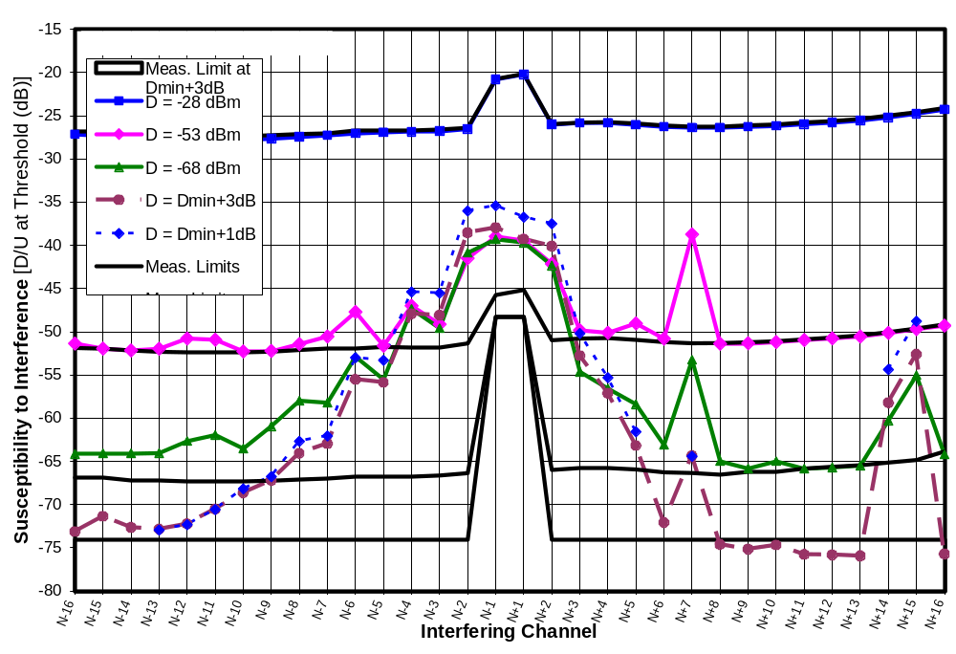
Figure 15-128. Median D/U of 8 Receivers at Five Signal Levels on Channel 30
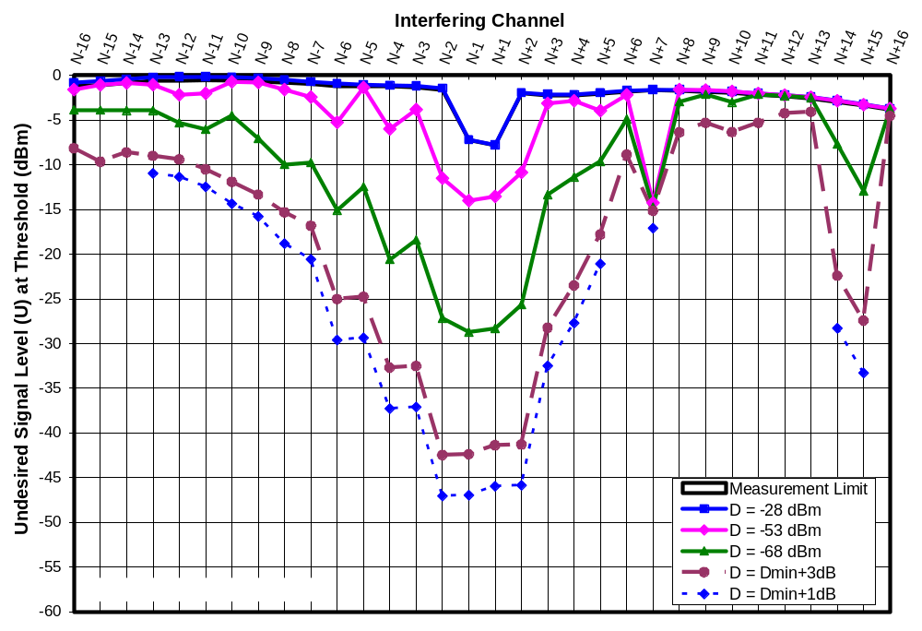
Figure 15-129. Median Threshold U of 8 Receivers at Five Signal Levels on Channel 30
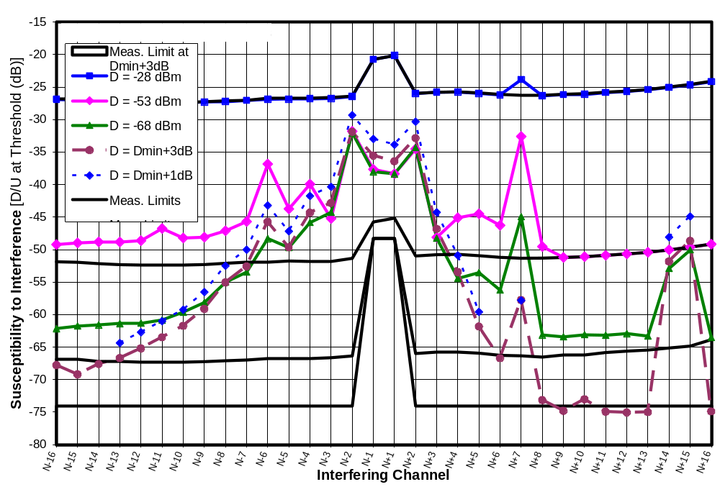
Figure 15-130. 2nd Worst D/U of 8 Receivers at Five Signal Levels on Channel 30
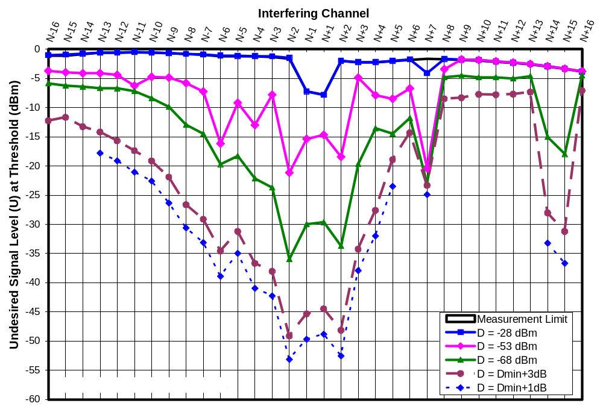
Figure 15-131. 2nd Worst Threshold U of 8 Receivers at Five Signal Levels on Channel 30
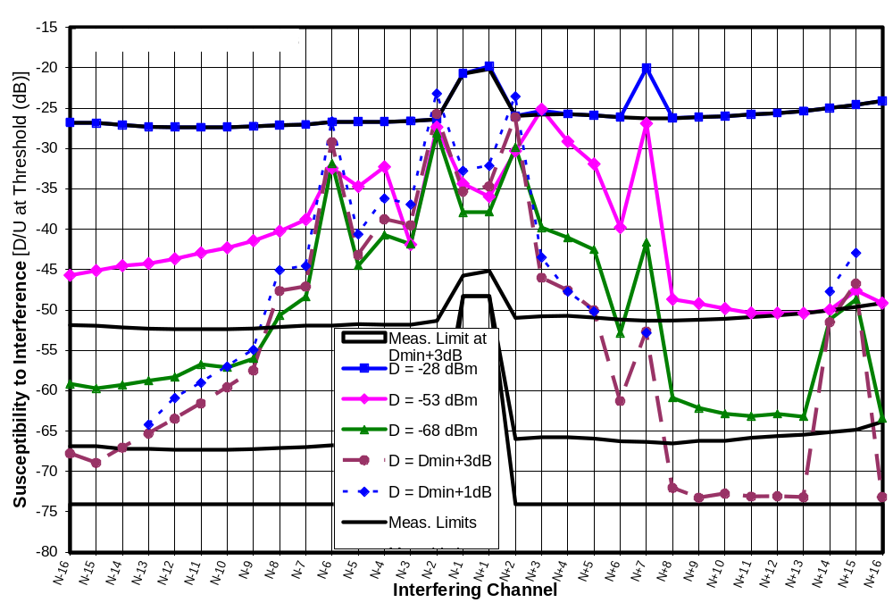
Figure 15-132. Worst D/U of 8 Receivers at Five Signal Levels on Channel 30
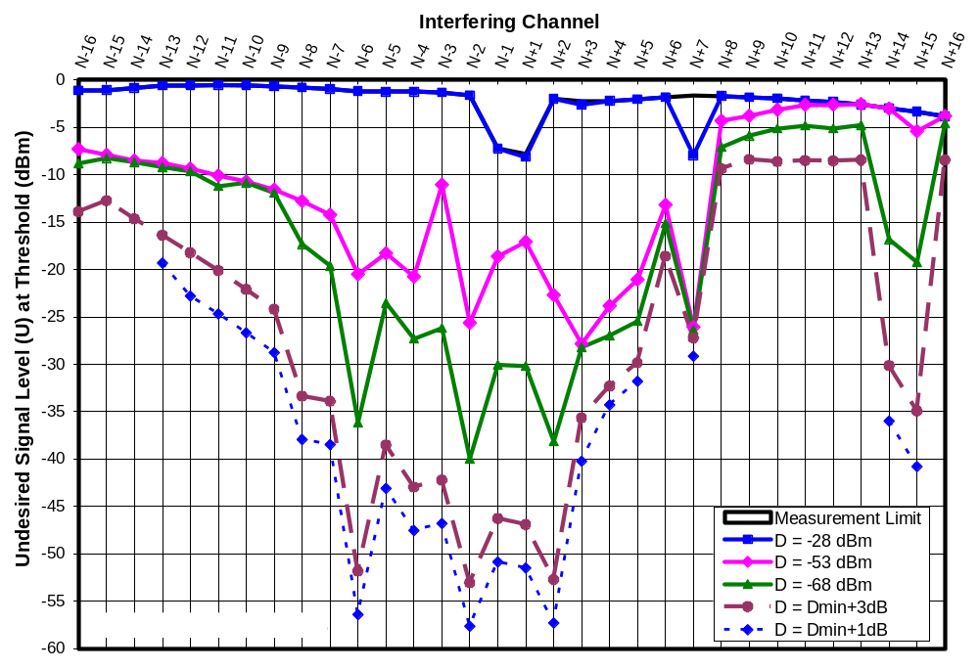
Figure 15-133. Worst Threshold U of 8 Receivers at Five Signal Levels on Channel 30
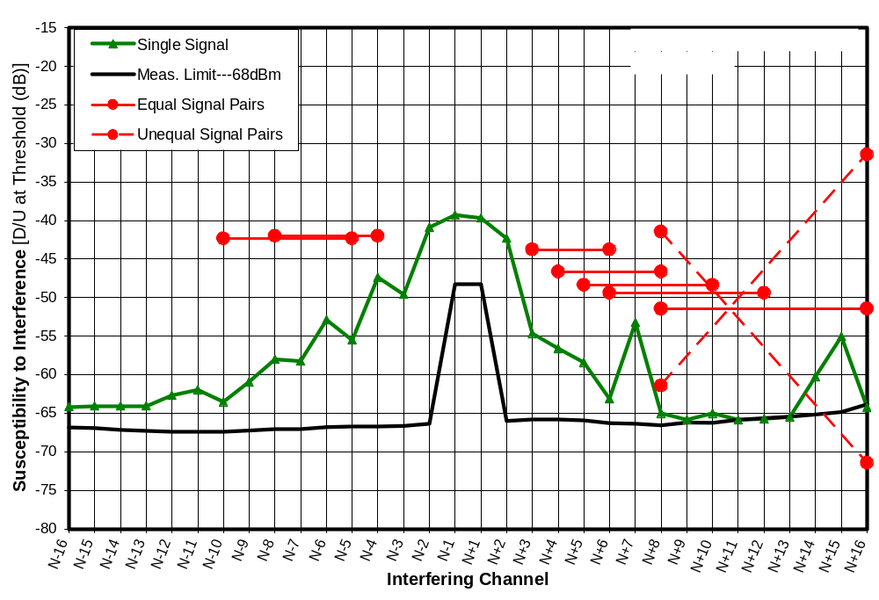
Figure 15-134. Median D/U of 8 Receivers at D = -68 dBm With IM3 Signal Pairs
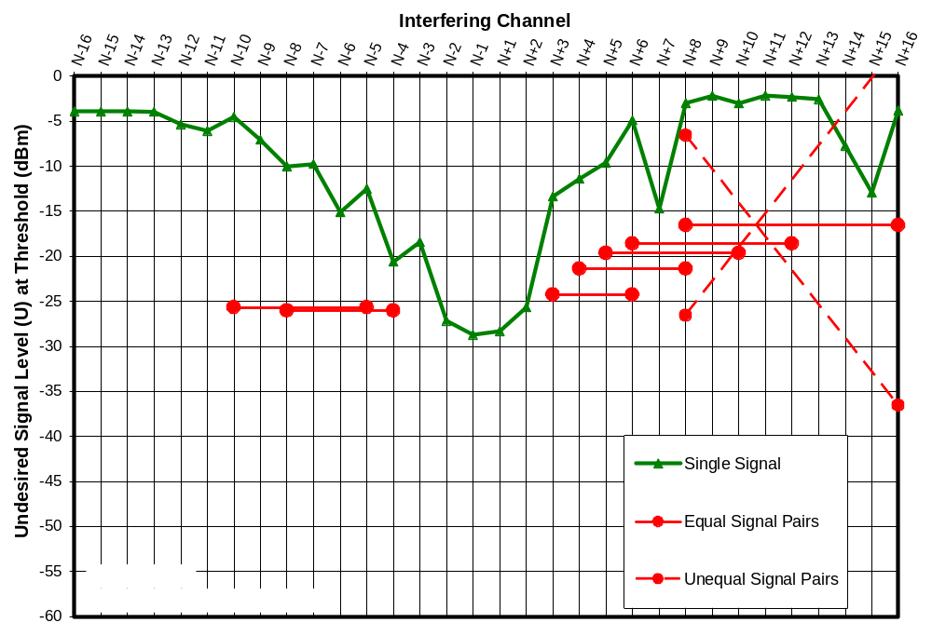
Figure 15-135. Median Threshold U of 8 Receivers at D = -68 dBm With IM3 Signal Pairs
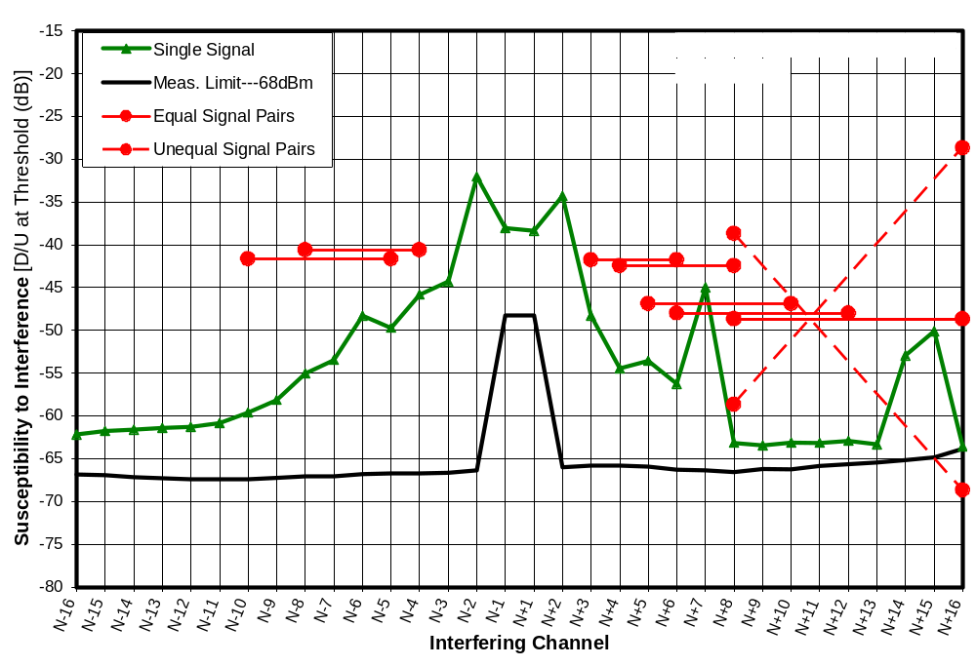
Figure 15-136. 2nd Worst D/U of 8 Receivers at D = -68 dBm With IM3 Signal Pairs
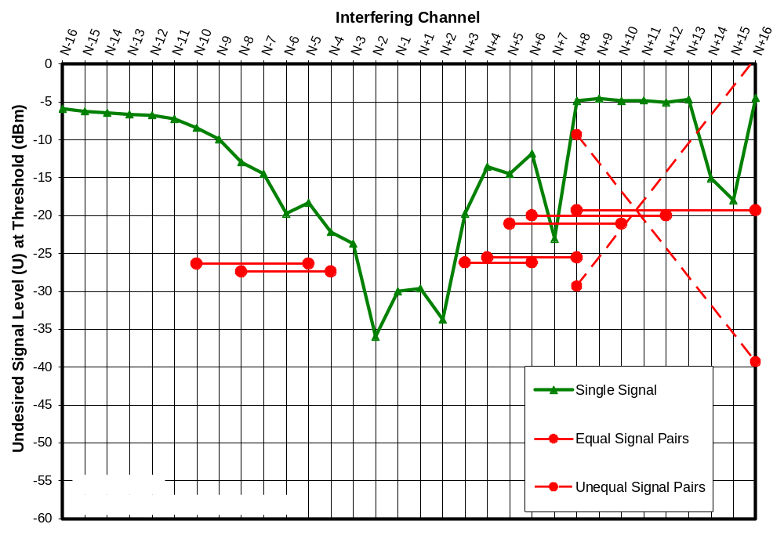
Figure 15-137. 2nd Worst Threshold U of 8 Receivers at D = -68 dBm With IM3 Signal Pairs
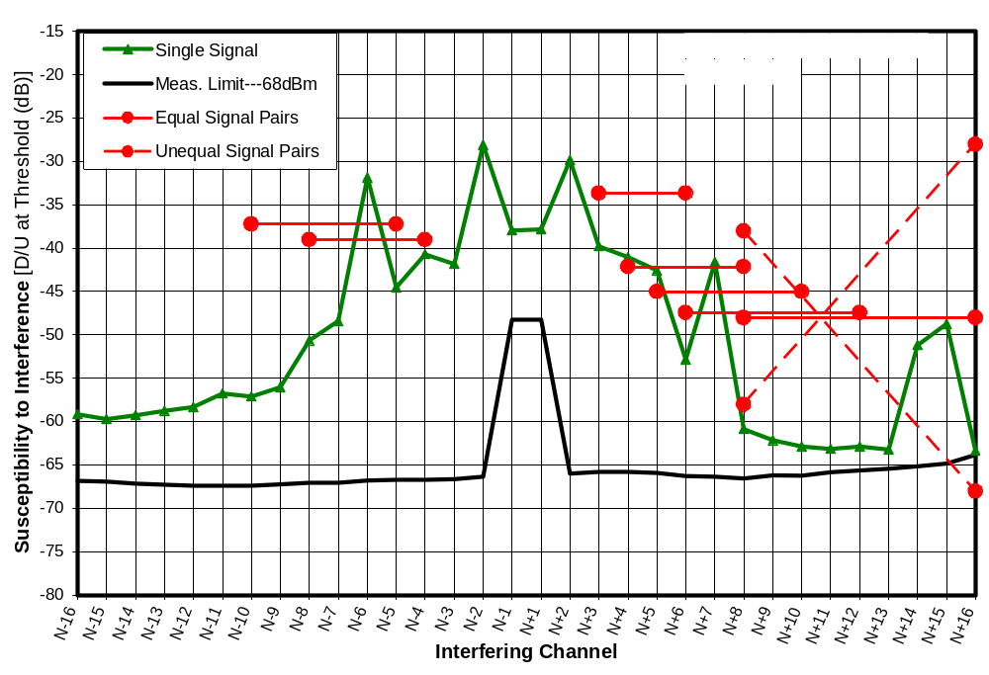
Figure 15-138. Worst D/U of 8 Receivers at D = -68 dBm With IM3 Signal Pairs
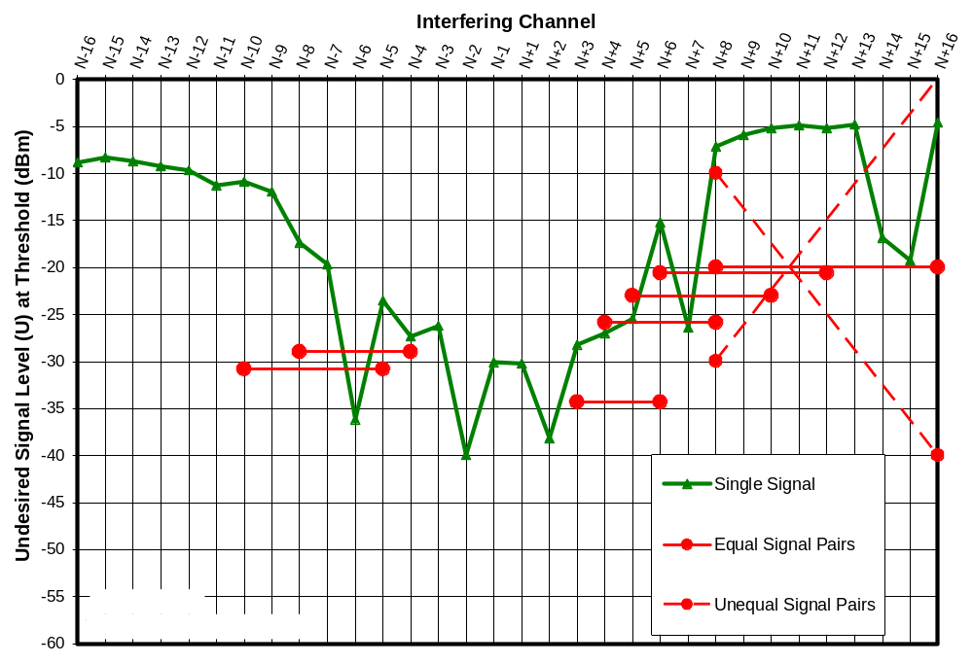
Figure 15-139. Worst Threshold U of 8 Receivers at D = -68 dBm With IM3 Signal Pairs
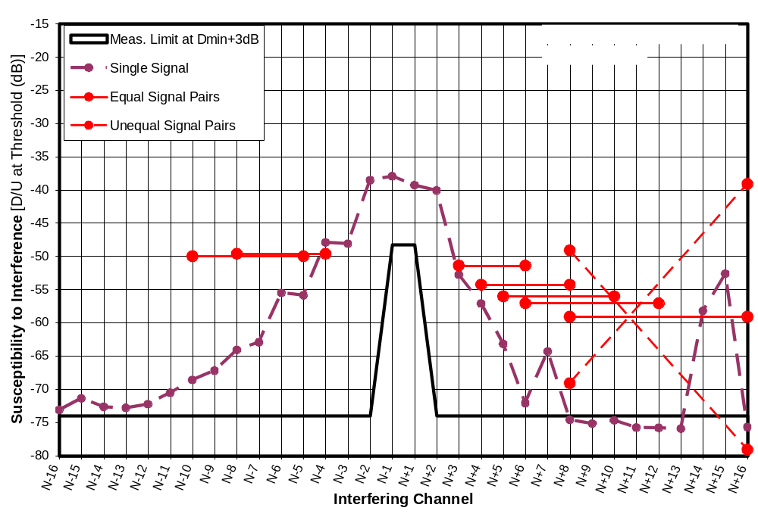
Figure 15-140. Median D/U of 8 Receivers at D = D_{MIN}+3dB With IM3 Signal Pairs
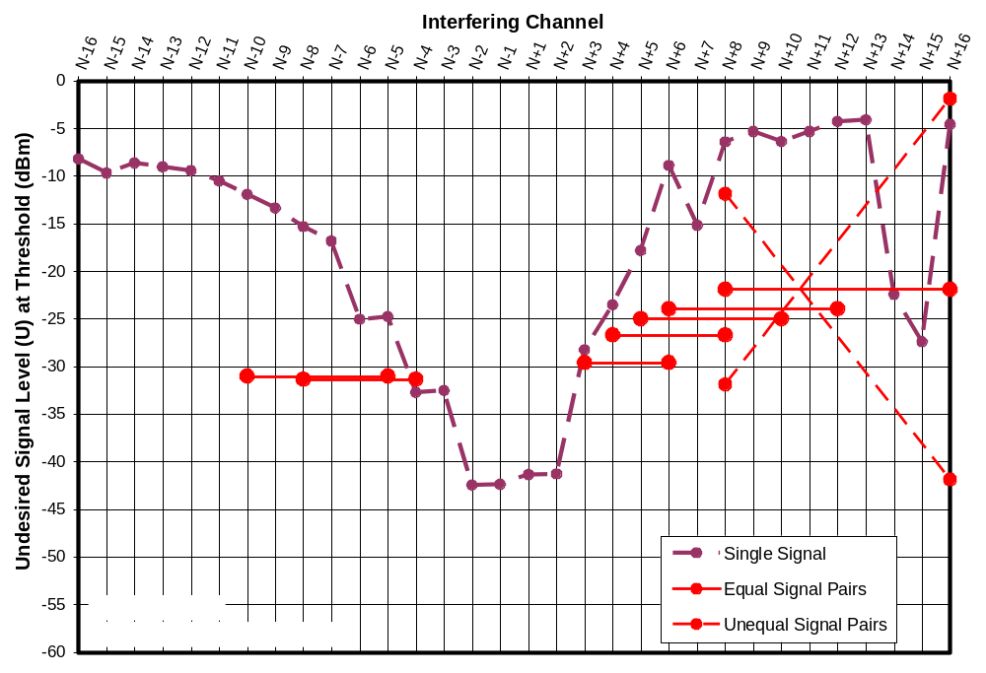
Figure 15-141. Median Threshold U of 8 Receivers at D = D_{MIN}+3dB With IM3 Signal Pairs
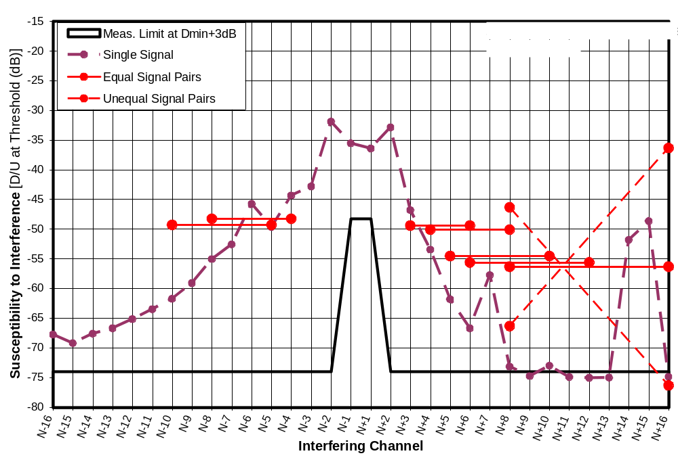
Figure 15-142. 2nd Worst D/U of 8 Receivers at D = D_{MIN}+3dB With IM3 Signal Pairs
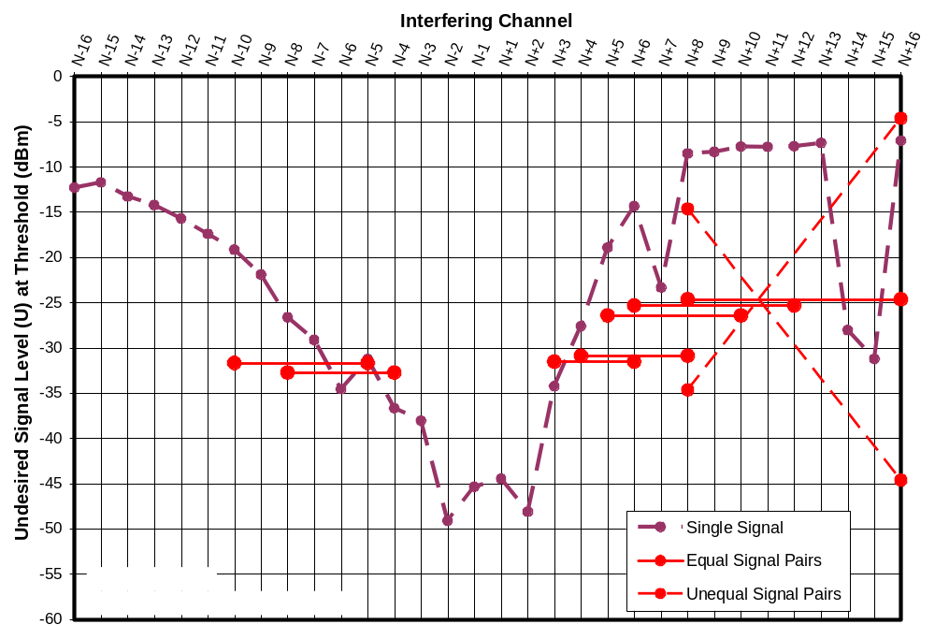
Figure 15-143. 2nd Worst Threshold U of 8 Receivers at D = D_{MIN}+3dB With IM3 Signal Pairs
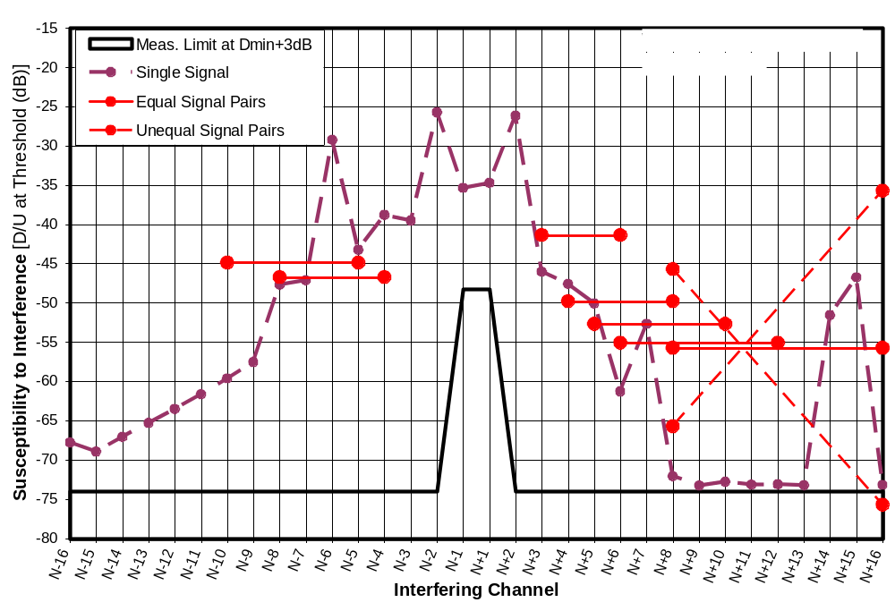
Figure 15-144. Worst D/U of 8 Receivers at D = D_{MIN}+3dB With IM3 Signal Pairs
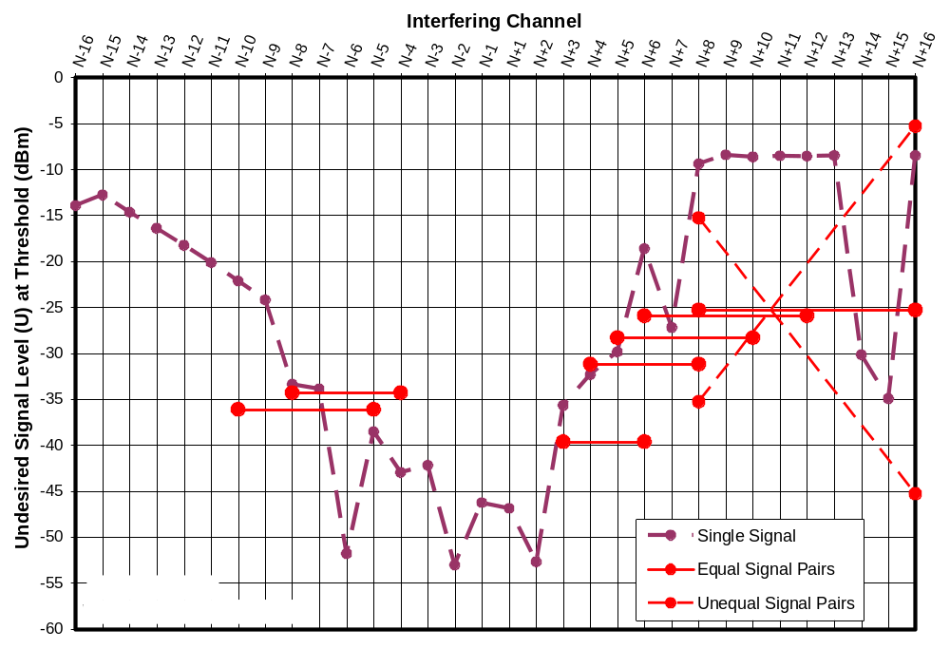
Figure 15-145. Worst Threshold U of 8 Receivers at D = D_{MIN}+3dB With IM3 Signal Pairs
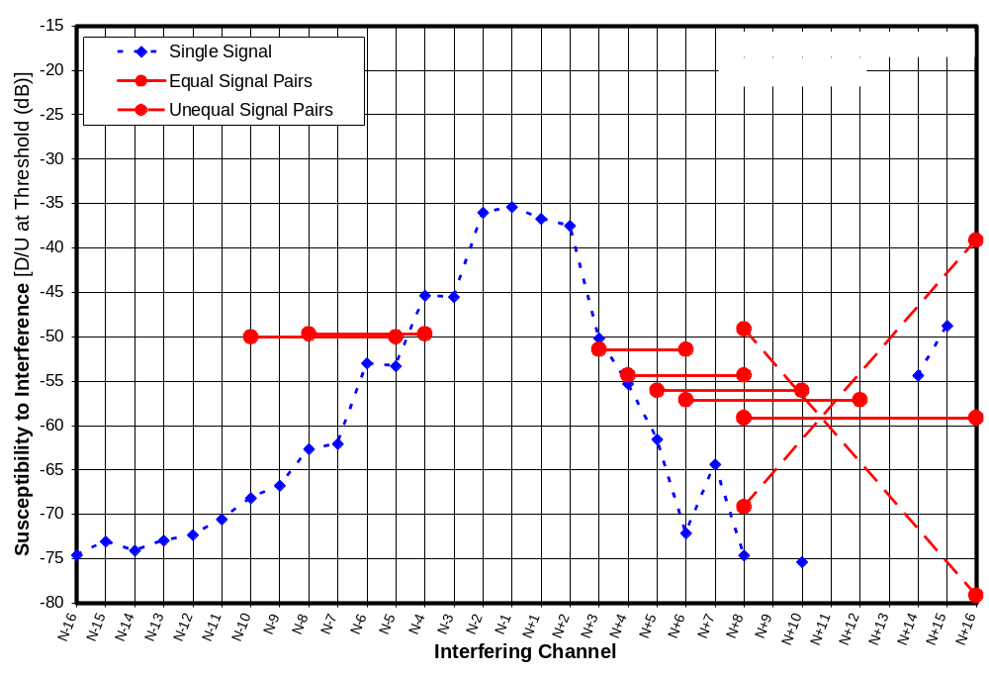
Figure 15-146. Median D/U of 8 Receivers at D = D_{MIN}+1dB With IM3 Signal Pairs
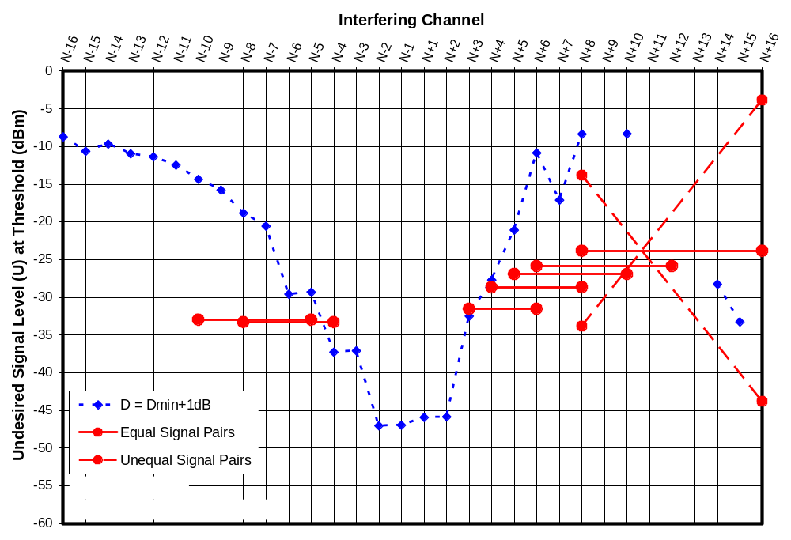
Figure 15-147. Median Threshold U of 8 Receivers at D = D_{MIN}+1dB With IM3 Signal Pairs
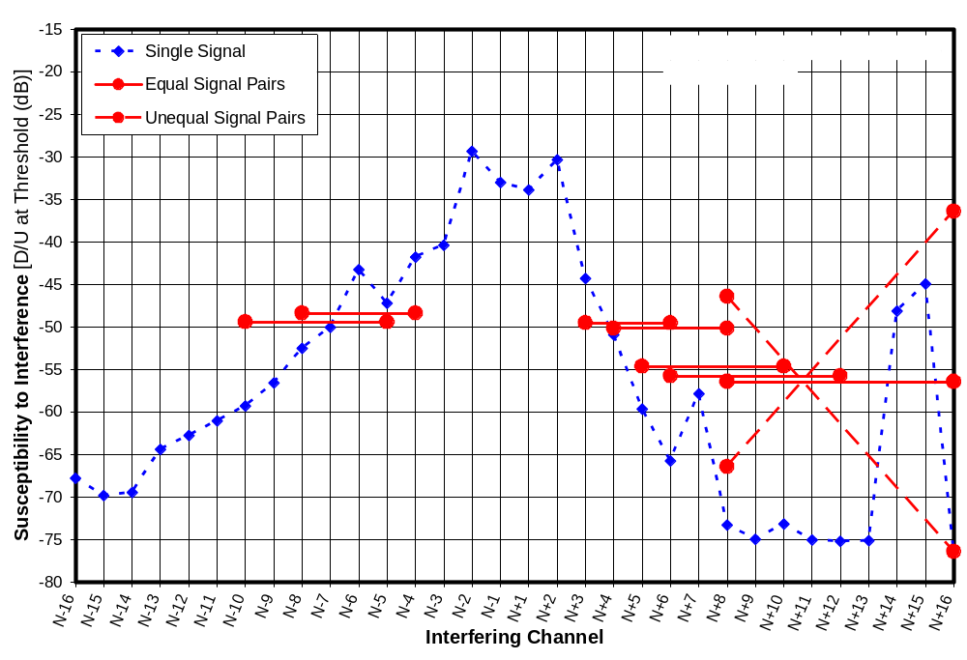
Figure 15-148. 2nd Worst D/U of 8 Receivers at D = D_{MIN}+1dB With IM3 Signal Pairs
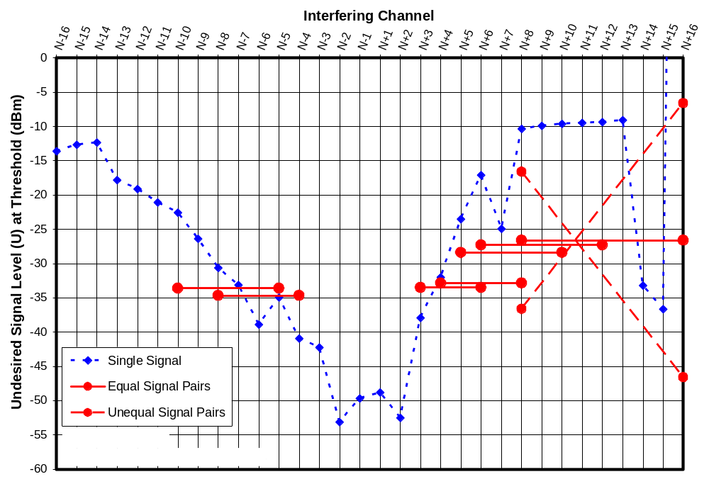
Figure 15-149. 2nd Worst Threshold U of 8 Receivers at D = D_{MIN}+1dB With IM3 Signal Pairs
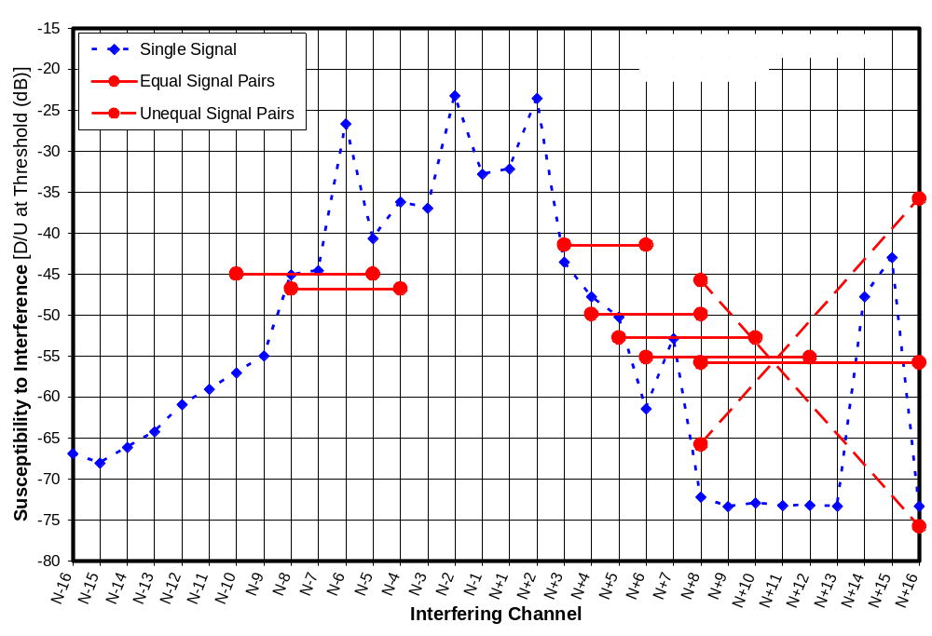
Figure 15-150. Worst D/U of 8 Receivers at D = D_{MIN}+1dB With IM3 Signal Pairs
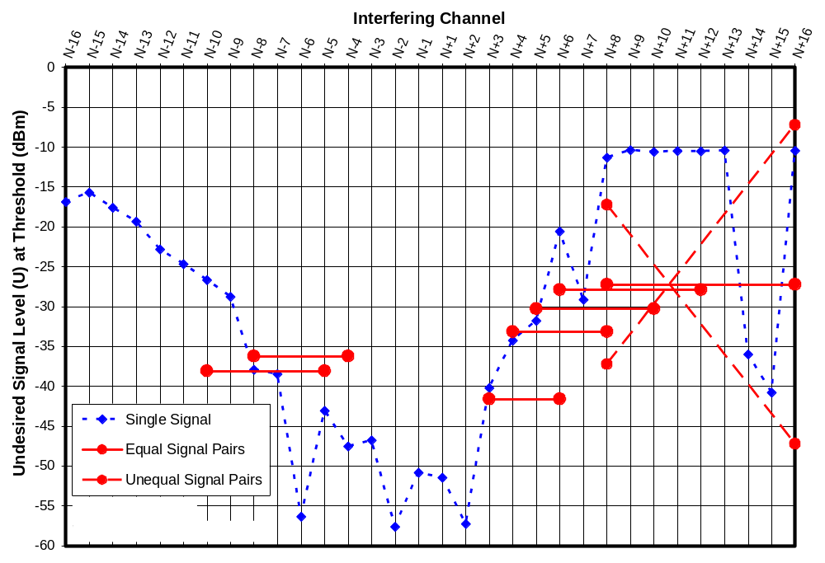
Figure 15-151. Worst Threshold U of 8 Receivers at D = D_{MIN}+1dB With IM3 Signal Pairs

TABULATED REJECTION PERFORMANCE RESULTS
This appendix includes tabulations of statistical data from the interference rejection performance measurements of eight DTV receivers on tuned to channel 30. The data are presented as D/U ratios and as threshold levels of the undesired signal U in separate major sections of this appendix.

Within each major section, a separate table is provided for rejection performance data at each of five desired signal levels:
D_{MIN} + 1 dB
D_{MIN} + 3 dB
-68 dBm
-53 dBm
-28 dBm

The rejection performance results for the four higher levels were obtained by direct measurement. For that data, “>” or “<” symbols appear when the statistical parameter shown depends on a value that was at the measurement limit of the test setup. For example, if the “Best U” value is listed as >-6.6 dBm, that means that a valid measurement of rejection performance of the best performing receiver was not obtained due to measurement system limitations. Specifically, at that channel offset, the maximum undesired signal power that the test setup was capable of supplying to the DTV input was -6.6 dBm and the TV picture was still flawless at that level; thus we know only that the threshold undesired signal power of the best receiver was greater than -6.6 dBm. If only the best receiver measurement was so limited, values will be listed for the median, 2nd worst, and worst performance, but not for the mean or standard deviation, because those values can be computed only if all of the measurement values were valid.

The rejection results for D_{MIN} + 1 dB were extrapolated from measurements at D = -68 dBm and D = D_{MIN} + 3 dB, but only if valid measurements were available at both of those levels. Otherwise the corresponding cell in the table is left blank.

In the case of the measurements at D = D_{MIN} + 3 dB or extrapolations for D = D_{MIN} + 3 dB, the desired signal level was different for each receiver, based on separately measured D_{MIN} values for the receivers. Table A-1 shows statistics for the D_{MIN} values.

Table A-1. Statistics of D_{MIN} for 8 Receivers on Channel 30
 | D_{MIN} | D_{MIN}+3dB
Minimum (dBm) | -86.2 | -83.2
Median (dBm) | -84.0 | -81.0
Mean (dBm) | -83.9 | -80.9
Maximum (dBm) | -81.8 | -78.8
Standard Deviation (dB) | 1.3 | 1.3

Threshold D/U Statistics for 8 Fifth-Generation DTV Receivers

Desired Signal = DMIN + 1 dB (Extrapolated from Measurements at DMIN + 3 dB)

Table A-2. D/U Statistics for 8 Receivers at D = D_{MIN} + 1 dB on Channel 30
Undesired Channel | Best D/U (dB) | Median D/U (dB) | Mean D/U (dB) | 2nd Worst D/U (dB) | Worst D/U (dB) | Standard Deviation (dB)
N-16
N-15
N-14
N-13 |  | -73.0 |  | -64.4 | -64.2
N-12 |  | -72.3 |  | -62.7 | -60.9
N-11 |  | -70.6 |  | -61.0 | -59.0
N-10 |  | -68.2 |  | -59.3 | -57.0
N-9 |  | -66.8 |  | -56.5 | -55.0
N-8 | -72.6 | -62.7 | -60.3 | -52.5 | -45.1 | 8.9
N-7 | -71.7 | -62.1 | -58.7 | -50.0 | -44.6 | 8.8
N-6 | -72.9 | -53.0 | -51.6 | -43.2 | -26.6 | 13.9
N-5 | -71.0 | -53.3 | -54.0 | -47.2 | -40.6 | 8.9
N-4 | -65.6 | -45.4 | -47.9 | -41.8 | -36.2 | 9.5
N-3 | -57.5 | -45.5 | -46.5 | -40.4 | -36.9 | 7.1
N-2 | -49.1 | -36.0 | -36.5 | -29.3 | -23.2 | 8.4
N-1 | -38.2 | -35.4 | -35.4 | -33.0 | -32.8 | 2.0
N+1 | -38.9 | -36.7 | -36.2 | -33.9 | -32.2 | 2.3
N+2 | -50.7 | -37.5 | -37.8 | -30.3 | -23.5 | 9.2
N+3 | -61.9 | -50.2 | -50.6 | -44.3 | -43.5 | 5.8
N+4 | -69.8 | -55.3 | -56.1 | -50.9 | -47.7 | 6.7
N+5 | -67.3 | -61.6 | -61.0 | -59.6 | -50.2 | 5.0
N+6
N+7 | -72.1 | -64.4 | -64.0 | -57.8 | -52.8 | 7.1
N+8
N+9
N+10
N+11
N+12
N+13
N+14 |  | -54.4 |  | -48.1 | -47.7
N+15 |  | -48.8 |  | -44.9 | -42.9
N+16

Desired Signal = D_{MIN} + 3 dB

Table A-3. D/U Statistics for 8 Receivers at D = D_{MIN} + 3 dB on Channel 30
Undesired Channel | Best D/U (dB) | Median D/U (dB) | Mean D/U (dB) | 2nd Worst D/U (dB) | Worst D/U (dB) | Standard Deviation (dB)
N-16 | < -76.0 | -73.2 | < -72.3 | -67.8 | -67.8 | > 3.4
N-15 | < -76.0 | -71.4 | < -72.1 | -69.2 | -69.0 | > 2.8
N-14 | < -75.3 | -72.7 | < -71.8 | -67.6 | -67.1 | > 3.4
N-13 | < -74.8 | -72.9 | < -71.4 | -66.7 | -65.3 | > 3.9
N-12 | < -74.8 | -72.3 | < -70.7 | -65.2 | -63.5 | > 4.5
N-11 | < -74.6 | -70.5 | < -68.9 | -63.5 | -61.6 | > 4.8
N-10 | < -74.7 | -68.7 | < -67.8 | -61.8 | -59.6 | > 5.0
N-9 | < -74.1 | -67.2 | < -65.3 | -59.1 | -57.5 | > 5.9
N-8 | -72.5 | -64.1 | -61.8 | -55.1 | -47.7 | 7.9
N-7 | -71.7 | -63.0 | -60.2 | -52.6 | -47.1 | 7.9
N-6 | -72.9 | -55.5 | -53.5 | -45.7 | -29.2 | 13.1
N-5 | -71.0 | -55.9 | -56.0 | -49.7 | -43.2 | 8.0
N-4 | -66.6 | -47.9 | -50.0 | -44.3 | -38.8 | 8.8
N-3 | -60.1 | -48.1 | -49.1 | -42.9 | -39.5 | 7.1
N-2 | -51.7 | -38.5 | -39.1 | -31.9 | -25.7 | 8.4
N-1 | -40.7 | -38.0 | -38.0 | -35.6 | -35.3 | 2.0
N+1 | -41.5 | -39.3 | -38.7 | -36.4 | -34.7 | 2.3
N+2 | -51.5 | -40.1 | -40.1 | -32.9 | -26.1 | 8.9
N+3 | -62.8 | -52.8 | -52.6 | -46.8 | -46.0 | 5.5
N+4 | -69.6 | -57.1 | -57.6 | -53.5 | -47.6 | 6.4
N+5 | -67.2 | -63.2 | -62.0 | -61.8 | -50.1 | 5.1
N+6 | -73.7 | -72.1 | -70.0 | -66.7 | -61.3 | 4.2
N+7 | -72.0 | -64.4 | -63.9 | -57.8 | -52.7 | 7.1
N+8 | < -77.1 | <-74.6 | < -74.5 | -73.2 | -72.1 | > 1.5
N+9 | < -78.4 | <-75.2 | < -75.5 | <-74.8 | -73.3 | > 1.5
N+10 | < -77.9 | <-74.7 | < -75.0 | -73.1 | -72.8 | > 1.9
N+11 | < -78.3 | <-75.8 | < -75.8 | <-75.0 | -73.2 | > 1.5
N+12 | < -79.3 | <-75.8 | < -76.3 | <-75.1 | -73.1 | > 2.0
N+13 | < -79.1 | <-76.0 | < -76.4 | <-75.0 | -73.2 | > 1.9
N+14 | < -78.8 | -58.2 | < -61.5 | -51.9 | -51.6 | > 9.9
N+15 | < -78.3 | -52.6 | < -56.5 | -48.7 | -46.8 | > 10.2
N+16 | < -77.7 | <-75.7 | < -75.8 | <-74.9 | -73.2 | > 1.4

Desired Signal = -68 dBm
Table A-4. D/U Statistics for 8 Receivers at D = -68 dBm on Channel 30
Undesired Channel | Best D/U (dB) | Median D/U (dB) | Mean D/U (dB) | 2nd Worst D/U (dB) | Worst D/U (dB) | Standard Deviation (dB) | ATSC Performance Guideline (dB)
N-16 | < -66.9 | -64.2 | < -63.9 | -62.2 | -59.2 | > 2.7
N-15 | < -67.0 | -64.1 | < -64.0 | -61.8 | -59.7 | > 2.7 | -50.0
N-14 | < -67.2 | -64.1 | < -63.8 | -61.6 | -59.3 | > 2.8 | -50.0
N-13 | -67.0 | -64.1 | -63.6 | -61.4 | -58.8 | 2.8 | -57.0
N-12 | -66.1 | -62.7 | -63.0 | -61.3 | -58.3 | 2.7 | -57.0
N-11 | -65.9 | -62.0 | -62.1 | -60.8 | -56.7 | 2.8 | -57.0
N-10 | -66.0 | -63.5 | -62.4 | -59.6 | -57.1 | 3.0 | -57.0
N-9 | -65.0 | -60.9 | -60.9 | -58.1 | -56.0 | 3.1 | -57.0
N-8 | -64.2 | -58.0 | -58.3 | -55.0 | -50.7 | 4.5 | -57.0
N-7 | -64.2 | -58.2 | -57.2 | -53.5 | -48.4 | 5.1 | -57.0
N-6 | -62.5 | -52.9 | -52.0 | -48.3 | -31.8 | 9.7 | -57.0
N-5 | -62.6 | -55.5 | -54.3 | -49.7 | -44.5 | 5.7 | -56.0
N-4 | -61.9 | -47.4 | -49.3 | -45.8 | -40.7 | 6.3 | -52.0
N-3 | -59.8 | -49.6 | -50.1 | -44.3 | -41.9 | 6.2 | -48.0
N-2 | -49.7 | -40.9 | -40.1 | -32.0 | -28.1 | 7.4 | -44.0
N-1 | -40.1 | -39.3 | -39.1 | -38.0 | -37.9 | 0.8 | -33.0
N+1 | -42.1 | -39.7 | -39.7 | -38.3 | -37.9 | 1.4 | -33.0
N+2 | -48.3 | -42.3 | -41.1 | -34.3 | -29.8 | 6.9 | -44.0
N+3 | -57.0 | -54.6 | -51.9 | -48.3 | -39.8 | 5.8 | -48.0
N+4 | -60.0 | -56.6 | -54.9 | -54.4 | -41.1 | 5.9 | -52.0
N+5 | -65.4 | -58.4 | -56.9 | -53.6 | -42.6 | 7.1 | -56.0
N+6 | < -66.3 | -63.1 | < -61.6 | -56.3 | -52.9 | > 4.6 | -57.0
N+7 | -60.3 | -53.3 | -51.9 | -45.0 | -41.6 | 6.8 | -57.0
N+8 | < -66.6 | -65.0 | < -64.5 | -63.1 | -60.9 | > 2.0 | -57.0
N+9 | < -66.6 | -65.9 | < -65.2 | -63.4 | -62.1 | > 1.6 | -57.0
N+10 | < -66.5 | -65.0 | < -65.0 | -63.1 | -62.9 | > 1.4 | -57.0
N+11 | < -66.2 | <-65.9 | < -65.2 | -63.2 | -63.2 | > 1.3 | -57.0
N+12 | < -66.0 | <-65.7 | < -65.0 | -62.9 | -62.9 | > 1.3 | -57.0
N+13 | < -65.9 | <-65.5 | < -64.9 | -63.3 | -63.2 | > 1.1 | -57.0
N+14 | < -65.3 | -60.3 | < -59.2 | -52.9 | -51.2 | > 5.3 | -50.0
N+15 | < -64.8 | -55.0 | < -56.0 | -50.1 | -48.7 | > 5.7 | -50.0
N+16 | < -64.5 | <-64.2 | < -64.1 | -63.6 | -63.4 | > 0.4
N-5/N-10 | -49.8 | -42.3 | -43.6 | -41.7 | -37.2 | 4.2
N-4/N-8 | -46.3 | -41.9 | -42.4 | -39.1 | -38.2 | 3.1
N-3/N-6 | -45.2 | -41.7 | -40.6 | -36.0 | -33.0 | 4.1
N-2/N-4 | -51.4 | -40.7 | -39.3 | -30.7 | -29.5 | 7.0
N-1/N-2 | -39.2 | -35.7 | -34.8 | -29.9 | -27.3 | 4.1
N+1/N+2 | -39.7 | -36.5 | -36.1 | -34.9 | -29.0 | 3.3
N+2/N+4 | -42.3 | -38.0 | -37.2 | -31.0 | -28.9 | 5.1
N+3/N+6 | -51.1 | -43.5 | -44.0 | -40.6 | -33.9 | 5.8
N+4/N+8 | -50.8 | -46.8 | -46.0 | -42.1 | -39.6 | 4.2
N+5/N+10 | -52.5 | -48.3 | -47.9 | -44.4 | -42.5 | 3.3

Desired Signal = -53 dBm

Table A-5. D/U Statistics for 8 Receivers at D = -53 dBm on Channel 30
Undesired Channel | Best D/U (dB) | Median D/U (dB) | Mean D/U (dB) | 2nd Worst D/U (dB) | Worst D/U (dB) | Standard Deviation (dB) | ATSC Performance Guideline (dB)
N-16 | < -52.2 | -51.4 | < -50.5 | -49.2 | -45.7 | > 2.2
N-15 | < -52.4 | <-52.0 | < -50.6 | -49.0 | -45.1 | > 2.5 | -45.0
N-14 | < -52.6 | <-52.2 | < -50.6 | -48.8 | -44.5 | > 2.8 | -45.0
N-13 | < -52.8 | -52.0 | < -50.5 | -48.8 | -44.3 | > 2.9 | -45.0
N-12 | < -52.9 | -50.8 | < -50.1 | -48.6 | -43.7 | > 3.1 | -45.0
N-11 | < -52.9 | -50.9 | < -49.8 | -46.8 | -42.9 | > 3.5 | -45.0
N-10 | < -52.9 | -52.3 | < -50.5 | -48.2 | -42.3 | > 3.6 | -45.0
N-9 | < -52.7 | -52.2 | < -50.2 | -48.1 | -41.4 | > 3.9 | -45.0
N-8 | < -52.6 | -51.4 | < -49.5 | -47.1 | -40.2 | > 4.3 | -45.0
N-7 | < -52.3 | -50.5 | < -48.9 | -45.7 | -38.8 | > 4.7 | -45.0
N-6 | < -52.1 | -47.7 | < -45.7 | -36.9 | -32.4 | > 7.3 | -45.0
N-5 | < -51.9 | -51.6 | < -48.4 | -43.8 | -34.7 | > 6.2 | -42.0
N-4 | < -51.9 | -47.0 | < -45.7 | -39.9 | -32.3 | > 6.6 | -40.0
N-3 | < -51.8 | -49.1 | < -48.2 | -45.2 | -41.9 | > 3.3 | -40.0
N-2 | -49.0 | -41.5 | -39.8 | -31.8 | -27.4 | 7.1 | -40.0
N-1 | -40.0 | -39.0 | -38.5 | -37.7 | -34.4 | 1.8 | -33.0
N+1 | -41.9 | -39.4 | -39.4 | -38.3 | -36.0 | 1.8 | -33.0
N+2 | -46.8 | -42.2 | -40.6 | -34.5 | -30.3 | 6.3 | -40.0
N+3 | < -50.9 | -49.8 | < -46.8 | -48.1 | -25.1 | > 8.8 | -40.0
N+4 | < -51.0 | -50.1 | < -46.6 | -45.1 | -29.1 | > 7.5 | -40.0
N+5 | < -51.2 | -49.0 | < -46.7 | -44.5 | -31.9 | > 6.5 | -42.0
N+6 | < -51.4 | -50.8 | < -48.9 | -46.3 | -39.8 | > 4.1 | -45.0
N+7 | -51.2 | -38.7 | -38.8 | -32.6 | -26.9 | 8.0 | -45.0
N+8 | < -51.7 | <-51.4 | < -50.9 | -49.6 | -48.7 | > 1.1 | -45.0
N+9 | < -51.6 | <-51.3 | < -51.1 | <-51.2 | -49.2 | > 0.8 | -45.0
N+10 | < -51.5 | <-51.2 | < -51.1 | <-51.1 | -49.8 | > 0.5 | -45.0
N+11 | < -51.2 | <-51.0 | < -51.0 | <-50.9 | -50.4 | > 0.3 | -45.0
N+12 | < -51.2 | <-50.8 | < -50.8 | <-50.7 | -50.4 | > 0.3 | -45.0
N+13 | < -50.9 | <-50.6 | < -50.6 | <-50.4 | <-50.4 | > 0.2 | -45.0
N+14 | < -50.5 | <-50.1 | < -50.2 | <-50.0 | -50.0 | > 0.2 | -45.0
N+15 | < -50.0 | <-49.7 | < -49.5 | <-49.6 | -47.6 | > 0.8 | -45.0
N+16 | < -49.5 | <-49.3 | < -49.3 | <-49.2 | <-49.2 | > 0.1
N-5/N-10 | -39.0 | -33.6 | -34.3 | -32.2 | -30.6 | 2.8
N-4/N-8 | -38.4 | -34.6 | -34.2 | -32.5 | -28.2 | 3.1
N-3/N-6 | -43.6 | -37.4 | -36.4 | -32.5 | -25.4 | 5.8
N-2/N-4 | -41.9 | -38.2 | -36.4 | -28.6 | -28.6 | 5.2
N-1/N-2 | -39.0 | -36.0 | -34.4 | -27.4 | -26.3 | 4.9
N+1/N+2 | -38.7 | -35.4 | -35.2 | -33.3 | -30.1 | 2.6
N+2/N+4 | -38.9 | -35.1 | -33.4 | -31.4 | -20.8 | 5.7
N+3/N+6 | -41.6 | -34.1 | -34.4 | -29.9 | -22.9 | 6.1
N+4/N+8 | -41.2 | -35.8 | -36.0 | -33.6 | -28.4 | 4.2
N+5/N+10 | -41.6 | -38.2 | -37.7 | -34.3 | -32.2 | 3.1

Desired Signal = -28 dBm

Table A-6. D/U Statistics for 8 Receivers at D = -28 dBm on Channel 30
Undesired Channel | Best D/U (dB) | Median D/U (dB) | Mean D/U (dB) | 2nd Worst D/U (dB) | Worst D/U (dB) | Standard Deviation (dB) | ATSC Performance Guideline (dB)
N-16 | < -27.3 | <-27.2 | < -27.1 | <-26.9 | <-26.8 | > 0.2
N-15 | < -27.4 | <-27.3 | < -27.2 | <-27.0 | <-26.9 | > 0.2 | -20.0
N-14 | < -27.6 | <-27.5 | < -27.4 | <-27.2 | <-27.1 | > 0.2 | -20.0
N-13 | < -27.8 | <-27.7 | < -27.6 | <-27.3 | <-27.3 | > 0.2 | -20.0
N-12 | < -27.9 | <-27.8 | < -27.7 | <-27.5 | <-27.4 | > 0.2 | -20.0
N-11 | < -28.0 | <-27.8 | < -27.7 | <-27.5 | <-27.4 | > 0.2 | -20.0
N-10 | < -27.9 | <-27.8 | < -27.7 | <-27.5 | <-27.4 | > 0.2 | -20.0
N-9 | < -27.8 | <-27.7 | < -27.6 | <-27.3 | <-27.3 | > 0.2 | -20.0
N-8 | < -27.6 | <-27.5 | < -27.4 | <-27.2 | <-27.1 | > 0.2 | -20.0
N-7 | < -27.4 | <-27.3 | < -27.2 | <-27.1 | <-27.0 | > 0.1 | -20.0
N-6 | < -27.2 | <-27.1 | < -27.0 | <-26.9 | <-26.7 | > 0.2 | -20.0
N-5 | < -27.0 | <-26.9 | < -26.9 | <-26.9 | <-26.7 | > 0.1 | -20.0
N-4 | < -26.9 | <-26.9 | < -26.9 | <-26.8 | <-26.7 | > 0.1 | -20.0
N-3 | < -26.9 | <-26.8 | < -26.8 | <-26.7 | <-26.6 | > 0.1 | -20.0
N-2 | < -26.6 | <-26.5 | < -26.5 | <-26.5 | <-26.4 | > 0.1 | -20.0
N-1 | < -20.9 | <-20.8 | < -20.8 | <-20.7 | -20.7 | > 0.1 | -20.0
N+1 | < -20.3 | <-20.2 | < -20.2 | <-20.2 | -19.8 | > 0.1 | -20.0
N+2 | < -26.2 | <-26.0 | < -26.0 | <-26.0 | <-26.0 | > 0.1 | -20.0
N+3 | < -26.0 | <-25.8 | < -25.8 | <-25.8 | -25.3 | > 0.2 | -20.0
N+4 | < -26.0 | <-25.8 | < -25.8 | <-25.8 | <-25.7 | > 0.1 | -20.0
N+5 | < -26.2 | <-26.0 | < -26.0 | <-26.0 | <-25.9 | > 0.1 | -20.0
N+6 | < -26.5 | <-26.3 | < -26.3 | <-26.2 | <-26.1 | > 0.1 | -20.0
N+7 | < -26.6 | <-26.4 | < -25.3 | -23.9 | -20.0 | > 2.3 | -20.0
N+8 | < -26.7 | <-26.4 | < -26.4 | <-26.3 | <-26.2 | > 0.1 | -20.0
N+9 | < -26.6 | <-26.3 | < -26.3 | <-26.2 | <-26.1 | > 0.2 | -20.0
N+10 | < -26.5 | <-26.2 | < -26.2 | <-26.1 | <-26.0 | > 0.2 | -20.0
N+11 | < -26.3 | <-26.0 | < -26.0 | <-25.9 | <-25.8 | > 0.2 | -20.0
N+12 | < -26.1 | <-25.8 | < -25.8 | <-25.7 | <-25.6 | > 0.2 | -20.0
N+13 | < -25.9 | <-25.6 | < -25.6 | <-25.4 | <-25.4 | > 0.2 | -20.0
N+14 | < -25.5 | <-25.2 | < -25.2 | <-25.1 | <-25.0 | > 0.2 | -20.0
N+15 | < -25.1 | <-24.8 | < -24.8 | <-24.7 | <-24.6 | > 0.2 | -20.0
N+16 | < -24.5 | <-24.3 | < -24.3 | <-24.2 | <-24.1 | > 0.2
N-5/N-10 | NA | NA | NA | NA | NA | NA
N-4/N-8 | NA | NA | NA | NA | NA | NA
N-3/N-6 | NA | NA | NA | NA | NA | NA
N-2/N-4 | NA | NA | NA | NA | NA | NA
N-1/N-2 | < -20.9 | <-20.8 | < -20.3 | -19.3 | -18.1 | > 1.0
N+1/N+2 | < -20.3 | <-20.2 | < -19.7 | -20.1 | -16.4 | > 1.4
N+2/N+4 | NA | NA | NA | NA | NA | NA
N+3/N+6 | NA | NA | NA | NA | NA | NA
N+4/N+8 | NA | NA | NA | NA | NA | NA
N+5/N+10 | NA | NA | NA | NA | NA | NA

Threshold U Statistics for 8 Fifth-Generation DTV Receivers

Desired Signal = D_{MIN} + 1 dB (Extrapolated from Measurements at D_{MIN} + 3 dB)

Table A-7. Threshold U Statistics for 8 Receivers at D = D_{MIN} + 1 dB on Channel 30
Undesired Channel | Best U (dBm) | Median U (dBm) | Mean U (dBm) | 2nd Worst U (dBm) | Worst U (dBm) | Standard Deviation (dB)
N-16
N-15
N-14
N-13 |  | -11.0 |  | -18.8 | -19.3
N-12 |  | -11.4 |  | -20.3 | -22.8
N-11 |  | -12.5 |  | -22.0 | -24.7
N-10 |  | -14.4 |  | -23.7 | -26.7
N-9 |  | -15.8 |  | -26.5 | -28.8
N-8 | -12.7 | -18.8 | -22.5 | -31.2 | -37.9 | 8.8
N-7 | -13.5 | -20.6 | -24.2 | -33.7 | -38.5 | 8.8
N-6 | -12.4 | -29.6 | -31.3 | -39.2 | -56.4 | 13.5
N-5 | -14.3 | -29.4 | -28.9 | -35.8 | -43.1 | 8.6
N-4 | -19.6 | -37.3 | -34.9 | -41.3 | -47.5 | 9.1
N-3 | -26.7 | -37.1 | -36.4 | -42.6 | -46.8 | 7.1
N-2 | -36.2 | -47.0 | -46.4 | -53.7 | -57.6 | 7.7
N-1 | -44.8 | -47.0 | -47.4 | -49.9 | -50.9 | 2.2
N+1 | -43.2 | -46.0 | -46.6 | -49.1 | -51.5 | 2.7
N+2 | -34.6 | -45.9 | -45.1 | -52.7 | -57.3 | 8.6
N+3 | -23.3 | -32.5 | -32.3 | -38.8 | -40.2 | 5.5
N+4 | -15.5 | -27.7 | -26.8 | -32.2 | -34.3 | 6.3
N+5 | -17.2 | -21.1 | -21.9 | -23.5 | -31.8 | 4.6
N+6
N+7 | -12.4 | -17.1 | -18.9 | -25.3 | -29.2 | 6.4
N+8
N+9
N+10
N+11
N+12
N+13
N+14 |  |  | 28.3 | 33.9 | 36.0
N+15 |  |  | 33.3 | 37.1 | 40.8
N+16

Desired Signal = D_{MIN} + 3 dB

Table A-8. Threshold U Statistics for 8 Receivers at D = D_{MIN} + 3 dB on Channel 30
Undesired Channel | Best U (dBm) | Median U (dBm) | Mean U (dBm) | 2nd Worst U (dBm) | Worst U (dBm) | Standard Deviation (dB)
N-16 | > -4.2 | -8.2 | > -8.6 | -12.3 | -13.9 | > 3.5
N-15 | > -4.2 | -9.7 | > -8.8 | -11.7 | -12.8 | > 3.2
N-14 | > -4.2 | -8.6 | > -9.1 | -13.3 | -14.7 | > 3.7
N-13 | > -4.6 | -9.1 | > -9.5 | -14.2 | -16.4 | > 4.2
N-12 | > -4.3 | -9.4 | > -10.2 | -15.7 | -18.3 | > 4.8
N-11 | > -5.9 | -10.5 | > -12.0 | -17.4 | -20.1 | > 5.0
N-10 | -7.1 | -11.9 | > -13.1 | -19.2 | -22.1 | > 5.2
N-9 | -9.2 | -13.4 | > -15.6 | -21.9 | -24.2 | > 6.0
N-8 | -10.8 | -15.3 | -19.1 | -26.7 | -33.4 | 7.8
N-7 | -11.6 | -16.8 | -20.7 | -29.1 | -33.9 | 7.8
N-6 | -10.4 | -25.0 | -27.4 | -34.6 | -51.8 | 12.7
N-5 | -12.3 | -24.8 | -25.0 | -31.3 | -38.5 | 7.8
N-4 | -16.7 | -32.7 | -30.9 | -36.7 | -43.0 | 8.3
N-3 | -22.1 | -32.5 | -31.8 | -38.1 | -42.2 | 7.1
N-2 | -31.6 | -42.5 | -41.8 | -49.1 | -53.1 | 7.7
N-1 | -40.2 | -42.4 | -42.8 | -45.4 | -46.3 | 2.2
N+1 | -38.6 | -41.4 | -42.1 | -44.5 | -46.9 | 2.7
N+2 | -31.6 | -41.3 | -40.8 | -48.1 | -52.7 | 8.4
N+3 | -20.4 | -28.3 | -28.3 | -34.3 | -35.7 | 5.3
N+4 | -13.5 | -23.5 | -23.3 | -27.6 | -32.3 | 5.9
N+5 | -15.2 | -17.8 | -18.9 | -19.0 | -29.9 | 4.6
N+6 | > -6.7 | -8.9 | -10.9 | -14.4 | -18.6 | 4.3
N+7 | -10.5 | -15.2 | -17.0 | -23.4 | -27.2 | 6.4
N+8 | > -3.2 | >-6.4 | > -6.4 | -8.5 | -9.4 | > 2.3
N+9 | > -1.8 | >-5.3 | > -5.4 | -8.4 | -8.4 | > 2.4
N+10 | > -2.9 | >-6.4 | > -5.9 | -7.8 | -8.7 | > 2.1
N+11 | > -1.9 | >-5.4 | > -5.1 | -7.8 | -8.5 | > 2.5
N+12 | > -1.8 | >-4.3 | > -4.6 | -7.7 | -8.6 | > 2.8
N+13 | > -2.0 | >-4.1 | > -4.5 | -7.4 | -8.5 | > 2.7
N+14 | > -2.3 | -22.4 | > -19.4 | -28.1 | -30.2 | > 9.5
N+15 | > -2.8 | -27.4 | > -24.3 | -31.3 | -34.9 | > 9.9
N+16 | > -3.3 | >-4.6 | > -5.1 | -7.1 | -8.5 | > 2.0

Desired Signal = -68 dBm
Table A-9. Threshold U Statistics for 8 Receivers at D = -68 dBm on Channel 30
Undesired Channel | Best U (dBm) | Median U (dBm) | Mean U (dBm) | 2nd Worst U (dBm) | Worst U (dBm) | Standard Deviation (dB)
N-16 | > -1.1 | -3.9 | > -4.1 | -5.9 | -8.8 | > 2.7
N-15 | > -1.0 | -3.9 | > -4.0 | -6.3 | -8.3 | > 2.7
N-14 | > -0.8 | -3.9 | > -4.2 | -6.4 | -8.7 | > 2.8
N-13 | -1.0 | -3.9 | -4.4 | -6.7 | -9.2 | 2.8
N-12 | -1.9 | -5.3 | -5.0 | -6.7 | -9.7 | 2.7
N-11 | -2.1 | -6.1 | -5.9 | -7.2 | -11.2 | 2.8
N-10 | -2.1 | -4.5 | -5.6 | -8.4 | -10.9 | 2.9
N-9 | -3.1 | -7.1 | -7.1 | -9.9 | -11.9 | 3.1
N-8 | -3.8 | -10.0 | -9.7 | -13.0 | -17.4 | 4.5
N-7 | -3.8 | -9.8 | -10.8 | -14.5 | -19.6 | 5.1
N-6 | -5.5 | -15.1 | -16.0 | -19.7 | -36.2 | 9.7
N-5 | -5.4 | -12.5 | -13.7 | -18.3 | -23.5 | 5.7
N-4 | -6.1 | -20.6 | -18.7 | -22.2 | -27.3 | 6.3
N-3 | -8.2 | -18.4 | -17.9 | -23.7 | -26.2 | 6.3
N-2 | -18.3 | -27.2 | -27.9 | -36.0 | -40.0 | 7.4
N-1 | -28.0 | -28.7 | -28.9 | -30.0 | -30.1 | 0.8
N+1 | -25.9 | -28.3 | -28.3 | -29.6 | -30.2 | 1.4
N+2 | -19.7 | -25.7 | -26.9 | -33.7 | -38.2 | 6.9
N+3 | -11.1 | -13.3 | -16.1 | -19.7 | -28.2 | 5.8
N+4 | -8.1 | -11.4 | -13.1 | -13.6 | -27.0 | 5.9
N+5 | -2.6 | -9.6 | -11.1 | -14.5 | -25.5 | 7.1
N+6 | > -1.7 | -4.9 | > -6.4 | -11.8 | -15.2 | > 4.6
N+7 | -7.7 | -14.8 | -16.0 | -23.0 | -26.4 | 6.8
N+8 | > -1.4 | -3.0 | > -3.4 | -4.8 | -7.1 | > 2.0
N+9 | > -1.4 | -2.2 | > -2.8 | -4.5 | -5.9 | > 1.6
N+10 | > -1.5 | -3.0 | > -3.0 | -4.9 | -5.2 | > 1.4
N+11 | > -1.8 | >-2.2 | > -2.8 | -4.8 | -4.9 | > 1.3
N+12 | > -2.0 | >-2.3 | > -3.0 | -5.0 | -5.1 | > 1.3
N+13 | > -2.1 | >-2.5 | > -3.0 | -4.6 | -4.8 | > 1.1
N+14 | > -2.7 | -7.7 | > -8.8 | -15.1 | -16.8 | > 5.2
N+15 | > -3.1 | -12.9 | > -12.0 | -18.0 | -19.3 | > 5.7
N+16 | > -3.5 | >-3.8 | > -3.9 | -4.5 | -4.6 | > 0.4
N-5/N-10 | -18.2 | -25.7 | -24.4 | -26.3 | -30.8 | 4.2
N-4/N-8 | -21.7 | -26.1 | -25.6 | -28.9 | -29.8 | 3.1
N-3/N-6 | -22.8 | -26.3 | -27.4 | -32.0 | -35.0 | 4.1
N-2/N-4 | -16.7 | -27.3 | -28.7 | -37.3 | -38.5 | 6.9
N-1/N-2 | -28.8 | -32.3 | -33.2 | -38.1 | -40.7 | 4.1
N+1/N+2 | -28.3 | -31.5 | -31.9 | -33.1 | -39.0 | 3.4
N+2/N+4 | -25.7 | -30.0 | -30.8 | -37.1 | -39.1 | 5.1
N+3/N+6 | -17.0 | -24.5 | -24.0 | -27.4 | -34.1 | 5.8
N+4/N+8 | -17.2 | -21.2 | -22.0 | -25.8 | -28.4 | 4.2
N+5/N+10 | -15.6 | -19.7 | -20.1 | -23.6 | -25.5 | 3.2

Desired Signal = -53 dBm
Table A-10. Threshold U Statistics for 8 Receivers at D = -53 dBm on Channel 30
Undesired Channel | Best U (dBm) | Median U (dBm) | Mean U (dBm) | 2nd Worst U (dBm) | Worst U (dBm) | Standard Deviation (dB)
N-16 | > -0.8 | -1.6 | > -2.5 | -3.7 | -7.3 | > 2.2
N-15 | > -0.6 | >-1.1 | > -2.4 | -4.0 | -7.9 | > 2.5
N-14 | > -0.3 | >-0.9 | > -2.4 | -4.2 | -8.5 | > 2.8
N-13 | > -0.1 | -1.1 | > -2.5 | -4.1 | -8.8 | > 2.9
N-12 | > -0.1 | -2.2 | > -2.9 | -4.4 | -9.4 | > 3.1
N-11 | > -0.1 | -2.0 | > -3.2 | -6.3 | -10.1 | > 3.5
N-10 | > -0.1 | -0.7 | > -2.5 | -4.8 | -10.7 | > 3.7
N-9 | > -0.2 | -0.8 | > -2.8 | -4.9 | -11.6 | > 3.9
N-8 | > -0.4 | -1.6 | > -3.5 | -5.8 | -12.8 | > 4.3
N-7 | > -0.6 | -2.5 | > -4.1 | -7.3 | -14.2 | > 4.7
N-6 | > -0.9 | -5.3 | > -7.3 | -16.2 | -20.5 | > 7.3
N-5 | > -1.0 | -1.4 | > -4.6 | -9.2 | -18.3 | > 6.2
N-4 | > -1.1 | -6.0 | > -7.3 | -13.0 | -20.8 | > 6.6
N-3 | > -1.2 | -3.8 | > -4.9 | -7.8 | -11.1 | > 3.3
N-2 | -4.0 | -11.5 | -13.2 | -21.2 | -25.7 | 7.1
N-1 | -13.1 | -14.0 | -14.6 | -15.4 | -18.6 | 1.8
N+1 | -11.0 | -13.6 | -13.6 | -14.7 | -17.1 | 1.9
N+2 | -6.2 | -10.9 | -12.4 | -18.5 | -22.7 | 6.3
N+3 | > -2.1 | -3.2 | > -6.2 | -4.9 | -27.9 | > 8.8
N+4 | > -2.1 | -2.9 | > -6.4 | -7.9 | -23.9 | > 7.4
N+5 | > -1.8 | -4.0 | > -6.3 | -8.5 | -21.1 | > 6.5
N+6 | > -1.6 | -2.2 | > -4.1 | -6.7 | -13.2 | > 4.1
N+7 | -1.8 | -14.3 | -14.2 | -20.4 | -26.1 | 8.0
N+8 | > -1.4 | >-1.6 | > -2.1 | -3.4 | -4.3 | > 1.1
N+9 | > -1.5 | >-1.7 | > -1.9 | >-1.8 | -3.8 | > 0.8
N+10 | > -1.6 | >-1.8 | > -1.9 | >-1.9 | -3.2 | > 0.5
N+11 | > -1.8 | >-2.0 | > -2.1 | >-2.1 | -2.7 | > 0.3
N+12 | > -1.8 | >-2.2 | > -2.2 | >-2.3 | -2.6 | > 0.3
N+13 | > -2.2 | >-2.5 | > -2.4 | >-2.6 | >-2.6 | > 0.2
N+14 | > -2.6 | >-2.9 | > -2.8 | >-3.0 | -3.1 | > 0.2
N+15 | > -3.0 | >-3.3 | > -3.5 | >-3.4 | -5.4 | > 0.8
N+16 | > -3.5 | >-3.7 | > -3.7 | >-3.8 | >-3.8 | > 0.1
N-5/N-10 | -14.1 | -19.4 | -18.7 | -20.8 | -22.4 | 2.8
N-4/N-8 | -14.5 | -18.5 | -18.8 | -20.5 | -24.8 | 3.1
N-3/N-6 | -9.4 | -15.6 | -16.6 | -20.5 | -27.6 | 5.8
N-2/N-4 | -11.1 | -14.8 | -16.6 | -24.4 | -24.4 | 5.1
N-1/N-2 | -14.0 | -17.1 | -18.6 | -25.6 | -26.7 | 4.9
N+1/N+2 | -14.3 | -17.6 | -17.9 | -19.7 | -23.0 | 2.6
N+2/N+4 | -14.1 | -17.8 | -19.6 | -21.6 | -32.2 | 5.7
N+3/N+6 | -11.5 | -18.8 | -18.6 | -23.1 | -30.0 | 6.1
N+4/N+8 | -11.8 | -17.2 | -17.0 | -19.4 | -24.5 | 4.1
N+5/N+10 | -11.4 | -14.8 | -15.3 | -18.7 | -20.8 | 3.1

Desired Signal = -28 dBm
Table A-11. Threshold U Statistics for 8 Receivers at D = -28 dBm on Channel 30
Undesired Channel | Best U (dBm) | Median U (dBm) | Mean U (dBm) | 2nd Worst U (dBm) | Worst U (dBm) | Standard Deviation (dB)
N-16 | > -0.7 | >-0.8 | > -0.9 | >-1.1 | >-1.2 | > 0.2
N-15 | > -0.6 | >-0.7 | > -0.8 | >-1.0 | >-1.1 | > 0.2
N-14 | > -0.4 | >-0.5 | > -0.6 | >-0.8 | >-0.9 | > 0.2
N-13 | > -0.2 | >-0.2 | > -0.4 | >-0.6 | >-0.6 | > 0.2
N-12 | > -0.1 | >-0.2 | > -0.3 | >-0.6 | >-0.6 | > 0.2
N-11 | > -0.1 | >-0.2 | > -0.3 | >-0.5 | >-0.6 | > 0.2
N-10 | > -0.1 | >-0.2 | > -0.3 | >-0.6 | >-0.6 | > 0.2
N-9 | > -0.3 | >-0.3 | > -0.4 | >-0.7 | >-0.7 | > 0.2
N-8 | > -0.4 | >-0.5 | > -0.6 | >-0.8 | >-0.8 | > 0.2
N-7 | > -0.6 | >-0.7 | > -0.8 | >-0.9 | >-1.0 | > 0.1
N-6 | > -0.8 | >-0.9 | > -1.0 | >-1.1 | >-1.2 | > 0.1
N-5 | > -0.9 | >-1.1 | > -1.1 | >-1.2 | >-1.3 | > 0.1
N-4 | > -1.1 | >-1.1 | > -1.1 | >-1.2 | >-1.3 | > 0.1
N-3 | > -1.2 | >-1.2 | > -1.2 | >-1.3 | >-1.4 | > 0.1
N-2 | > -1.4 | >-1.5 | > -1.5 | >-1.5 | >-1.6 | > 0.1
N-1 | > -7.2 | >-7.2 | > -7.2 | >-7.3 | -7.3 | > 0.0
N+1 | > -7.7 | >-7.8 | > -7.8 | >-7.8 | -8.2 | > 0.1
N+2 | > -1.9 | >-2.0 | > -2.0 | >-2.0 | >-2.0 | > 0.1
N+3 | > -2.0 | >-2.1 | > -2.2 | >-2.2 | -2.7 | > 0.2
N+4 | > -2.0 | >-2.2 | > -2.2 | >-2.2 | >-2.2 | > 0.1
N+5 | > -1.8 | >-2.0 | > -2.0 | >-2.0 | >-2.1 | > 0.1
N+6 | > -1.5 | >-1.7 | > -1.7 | >-1.8 | >-1.8 | > 0.1
N+7 | > -1.5 | >-1.6 | > -2.7 | -4.1 | -8.0 | > 2.3
N+8 | > -1.4 | >-1.6 | > -1.6 | >-1.7 | >-1.7 | > 0.1
N+9 | > -1.4 | >-1.7 | > -1.7 | >-1.8 | >-1.9 | > 0.2
N+10 | > -1.5 | >-1.8 | > -1.8 | >-1.9 | >-2.0 | > 0.2
N+11 | > -1.7 | >-2.1 | > -2.0 | >-2.1 | >-2.2 | > 0.2
N+12 | > -1.9 | >-2.2 | > -2.2 | >-2.3 | >-2.4 | > 0.2
N+13 | > -2.1 | >-2.5 | > -2.4 | >-2.6 | >-2.6 | > 0.2
N+14 | > -2.5 | >-2.8 | > -2.8 | >-2.9 | >-3.0 | > 0.2
N+15 | > -2.9 | >-3.3 | > -3.2 | >-3.4 | >-3.4 | > 0.2
N+16 | > -3.5 | >-3.7 | > -3.7 | >-3.9 | >-3.9 | > 0.1
N-5/N-10 | NA | NA | NA | NA | NA | NA
N-4/N-8 | NA | NA | NA | NA | NA | NA
N-3/N-6 | NA | NA | NA | NA | NA | NA
N-2/N-4 | NA | NA | NA | NA | NA | NA
N-1/N-2 | > -7.1 | >-7.2 | > -7.7 | -8.7 | -9.9 | > 1.0
N+1/N+2 | > -7.7 | >-7.8 | > -8.3 | -7.9 | -11.7 | > 1.4
N+2/N+4 | NA | NA | NA | NA | NA | NA
N+3/N+6 | NA | NA | NA | NA | NA | NA
N+4/N+8 | NA | NA | NA | NA | NA | NA
N+5/N+10 | NA | NA | NA | NA | NA | NA

THEORETICAL BASIS FOR OUT-OF-CHANNEL INTERFERENCE
When a DTV receiver operates in the presence of white Gaussian co-channel interference, the threshold of visibility (TOV) of picture degradation occurs when the desired signal power D exceeds the co-channel interference by about 15 dB. This number may vary somewhat for noise having other statistical properties, and may be much lower if the noise is heavily concentrated at a band edge where filtering in the DTV provides additional rejection; nonetheless, one expects that, as signal power D varies, the undesired signal power at threshold will vary linearly with it—resulting a constant D/U ratio as D or U are varied. This relationship holds whenever the co-channel interference is high enough that the effect of internal noise in the receiver becomes insignificant.

For most out-of-channel interference mechanisms, the DTV receiver unintentionally converts a small portion of the out-of-channel power into co-channel power. If one knows the amount of conversion into co-channel interference, one can treat the problem as a co-channel interference problem, which is relatively well understood, as described above. In this formulation of the problem, measuring the desired signal power D at the TOV provides an indirect method of measuring the co-channel power created internal to the receiver, since we know that the co-channel power will be about 15 dB below the measured value of D.

The conversion process by the DTV from out-of-channel interference to co-channel interference may be linear or nonlinear. If it is linear, then the internally-created co-channel interference will vary linearly with the out-of-channel interference power U causing the value of the desired signal power D at threshold to vary linearly with U. The result will be that threshold D/U ratio will be constant as D or U is varied. If the conversion process is nonlinear, then the relationship between D and U will be nonlinear and the D/U ratio will vary with D and U.

We will assume that the co-channel interference power created by the DTV receiver in response to an out-of-channel undesired signal power U will be proportional to D^{L}U^{M}, where L and M are integer constants that define the order of the interference mechanism. For most interference mechanisms, L will be zero, so only the U^{M} term exists. The following are among the interference mechanisms that can be modeled by this formulation.
Linear interference: L=0, M=1. Creates co-channel interference proportional to U.
Example: mixer image. The mixer in a TV receiver converts the spectrum of the intended channel of the received signal to an intermediate frequency (IF) where it can be filtered more precisely to pass the desired channel while rejecting the undesired frequencies. Unfortunately, in single-conversion tuners a second a 6-MHz wide portion of the input spectrum centered 88 MHz above the desired channel is also converted to that same IF. Filtering prior to the mixer strongly diminishes—but doesn’t fully extinguish—this unintended signal.
Example: leakage of the adjacent channel signal through the channel selection filter of the DTV would also constitute a linear interference mechanism.
Second-order interference: L=0, M=2. Creates co-channel interference proportional to U².
Example: “half-IF” taboo. The second harmonic of an undesired signal 22 MHz above the desired signal beats with the second harmonic of the receiver’s local oscillator, creating a difference frequency that falls within the IF band of the receiver.
Third-order interference: L=0, M=3. Creates co-channel interference proportional to U³.
Example: third-order intermodulation (IM3) of a single, adjacent-channel undesired signal. IM3 creates spectral components that spill into each adjacent channel.
Example: third-order intermodulation (IM3) of a pair of undesired channels placed at channels N+K and N+2K where N is the desired channel. In this case, the interference power created in channel N is proportional to U_{N+K}²U_{N+2K}. The result is a process that is second-order in terms of U_{N+K} and linear in terms of U_{N+2K}; however, if the two undesired signals are set to equal powers and varied in amplitude together, the resulting interference is third order.
Cross-modulation: L=1, M=2. Creates co-channel interference proportional to DU².
Cross-modulation is essentially a third-order effect, but the co-channel interference created is proportional to D and to U². As a result, increasing the desired signal power does not improve the signal-to-interference ratio.

We define the following:
D = Power of desired signal on channel N at input to TV
U_{N+K} = Power of interferer on channel N+K at input to TV
U_{N+2K} = Power of interferer on channel N+2K at input to TV
where D, U_{N+K}, and U_{N+2K} refer to signal level combinations that place the TV at TOV

R = Required SNR of the TV receiver at TOV
D_{MIN} = D at TOV in absence of interference or external noise
N_{R} = Receiver noise referred to the input of the TV

Thus,
R = D_{MIN}/N_{R}
N_{R} = D_{MIN}/R

Consequently, N_{R} can be inferred from measurements of D_{MIN} and R

Let

P_{CC} = Total power of co-channel noise and interference affecting the demodulation of the DTV signal by the TV, referenced to the input. P_{CC} includes co-channel interference created by non-linear effects in the TV.

We will consider two cases. That of a single interferer with power U, where

P_{CC} = N_{R} + c U^{M} D^{L}

And that of third-order intermodulation (IM) between a pair of signals U_{N+K}, and U_{N+2K}

P_{CC} = N_{R} + c_{IM3} U_{K}² U_{2K}

The “c” terms are constants related to the nonlinear process in the receiver. The 1st term in each equation is receiver noise. The second is the interference term created by distortion in the TV tuner. The terms M and L define the order of the nonlinear interference process with respect to the undesired and desired signals, respectively.

We start with the case of a single interferer.

Single Interferer
We have

P_{CC} = N_{R} + c U^{M} D^{L}

We will generally be interested in three cases:
Linear interference mechanisms: M = 1; L = 0
2nd-order interference mechanisms: M = 2; L = 0
3rd-order interference mechanisms: M = 3; L = 0
Cross-modulation: M = 2; L = 1

At TOV the desired signal must exceed P_{CC} by a factor equal to the required signal-to-noise ratio R. (We assume that the same value of R applies for both receiver noise and noise created by an undesired signal.) Thus

D/P_{CC} = R, or, equivalently,

D = R P_{CC}

Substituting, we have

D = R (N_{R} + c U^{M} D^{L})

Substituting N_{R} = D_{MIN}/R, we have

D = R c D^{L}U^{M} + D_{MIN}

U^{M} = (D - D_{MIN}) / (R c D^{L})

And, finally,

U = [(D - D_{MIN}) / (R c D^{L})]^{1/M}

We will also find it useful to write this as

U = D^{(1-L)/M} [(1 - D_{MIN}/D) / (R c)]^{1/M}

High Signal Levels (D >> DMIN)
When D >> D_{MIN}, the equation simplifies to

U ≈ [D^{1-L} / (R c)]^{1/M}

U ≈ D^{(1-L) / M} / (R c)^{1/M}

Similarly, D/U at threshold is given by

D/U ≈ D/[ D^{(1-L) / M} / (R c)^{1/M}]

D/U ≈ (R c)^{1/M} D^{(M – 1 + L)/M}

Now we wish to view U and D in log-based units, such as decibels.

log(U) ≈ log[D^{(1-L) / M} / (R c)^{1/M}] = [(1 – L)/M] log(D) – (1/M) log(R c)

log(D/U) ≈ log[(R c)^{1/M} D^{(M – 1 + L)/M}] = [(M – 1 + L)/M] log(D) + (1/M) log(R c)

Thus a log-log plot of U versus D will be a straight line, with slope (1 – L) / M. Similarly, the slope of log-D versus log-U will be M / (1 – L), and the slope of log(D/U) versus log-D is given by
[(M – 1 + L)/M].

Table A-1 summarizes this slope information for the interference mechanisms of interest.

Table B-12. Slopes of Log-Log Plots of D, U, and D/U for Various Interference Mechanisms
Interference Mechanism | Slope of  Log (D) Versus  Log (U)  in dB/dB | Slope of  Log (U) Versus  Log (D)  in dB/dB | Slope of  Log (D/U) Versus  Log (D)  in dB/dB
Linear (M = 1, L = 0) | 1 | 1 | 0
Second order (M = 2, L = 0) | 2 | 0.5 | 0.5
Third order (including third-order intermodulation of a pair of equal-power interferers) (M = 3, L = 0) | 3 | 0.333 | 0.667
Cross modulation (M = 2, L = 1) | Infinite | 0 | 1

Low Signal Levels
The interference mechanisms described above are expected to result in linear relationships between log-U and log-D at threshold when the desired signal level is high enough that receiver noise is insignificant. Now we consider the case of smaller signal levels. Recall that

U = [(D - D_{MIN}) / (R c D^{L})]^{1/M}

Note that the presence of receiver noise (causing D_{MIN} to be non-zero and the log-U versus log-D relationship to deviate from a straight line) results in U changing by a factor of

[(D - D_{MIN}) / D]^{1/M}

Consider the case where D is X dB above D_{MIN}. Then U is Y dB above the value it would have had based on a straight-line log-log projection from the results at a high desired signal level.

X = 10 log(D / D_{MIN})

Y = 10 log{(D - D_{MIN}) / D]^{1/M} }

Y = (1/M) 10 log[1 – 10^{-X/10}] dB

Table B-2 summarizes these results for three values of X.

Table B-13. Deviation in Threshold U from Straight-Line Projection as D Approaches D_{MIN}
Deviation in Threshold U
from Straight-Line Projection (dB)
Interference Mechanism | D/D_{MIN}¹  = 16 dBm | D/D_{MIN}  = 3 dB | D/D_{MIN}  = 1 dB | D/D_{MIN}  = 0 dB
Linear (M = 1) | -0.11 | -3.02 | -6.87 | Infinite
Second order (M = 2) | -0.06 | -1.51 | -3.43 | Infinite
Third order (including third-order intermodulation of a pair of equal-power interferers) (M = 3) | -0.04 | -1.01 | -2.29 | Infinite
Cross modulation (M = 2, L = 1) | -0.06 | -1.51 | -3.43 | Infinite
Note:
¹ For the nominal D_{MIN} value of -84 dBm, D/D_{MIN} = 16 dB when D = -68 dBm

Effect of AGC
The above relationships are expected to hold when automatic-gain-control (AGC) does not cause changes in gain between the TV antenna port and the point in the TV tuner at which the relevant nonlinearity occurs (i.e., the location of the nonlinearity that causes the observed interference, assuming it is caused by a nonlinearity).

When either the desired signal power (D) or an undesired signal (U) rises sufficiently that AGC causes gain reductions prior to the point of a relevant nonlinearity, the relationships change.

We define the following terms:

G = power gain from the antenna input terminal of the TV to the point of a relevant nonlinearity;
G_{MAX} = the value of G when both D and U are low enough that AGC does not reduce the gain of any tuner stages prior to the nonlinearity;

In a television, AGC operation may be invoked based on increasing levels of either the desired signal D on channel N or of some filtered combination of desired and undesired signals. In modeling AGC, we will assume that, if the AGC reduces gain of a tuner stage prior to the point of the relevant nonlinearity, it will do so in such a way as to achieve a constant power level with changes input signal level. Specifically, the power which is maintained constant by AGC action will be either the desired signal or the total power of some filtered combination of desired and undesired signals (as in the case of “broadband AGC”). We will consider two bounding cases:
AGC driven by D. AGC adjusts gain in such a way that the level of the desired signal at the point of the nonlinearity remains constant;
AGC driven by U_{N+K}. AGC is controlled by a filtered combination of desired and undesired signals, but with undesired signal at the AGC sensing point being much larger than the desired signal, so that the AGC adjusts gain to, in effect, maintain a constant undesired signal power at the point of the relevant nonlinearity.

For each of these two cases, we define a signal level threshold above which the AGC reduces the gain of tuner stages prior to the point of the relevant nonlinearity:
D_{AGCthresh} = the desired signal power at the TV input, above which AGC begins reducing G;
U_{N-K,AGCthresh} = the undesired signal power on channel N+K, above which AGC begins reducing G.

Thus, in the first case, we will assume that the AGC reduces gain by 1 dB for each 1-dB increase in D above D_{AGCthresh}. In the second case we assume that AGC reduces gain by 1 dB for each 1-dB increase in U beyond U_{N-K,AGCthresh}.

In the single-interferer case, recall that the total co-channel noise plus interference that seen by the receiver, referenced to input levels, is

P_{CC} = N_{R} + c U_{N+K}^{M} D^{L}

We note that this formula applies when gain prior to the relevant point of nonlinearity is at its maximum (G = G_{MAX})—i.e., the AGC hasn’t caused any gain reductions. Thus, the formula is valid only when D < D_{AGCthresh} and U_{K} < U_{K-AGCthresh}. If either AGC threshold is exceed, G is reduced and the formula is no longer valid. We include the N+K subscript on U to emphasize that the AGC threshold will be different for different channel offsets because of filtering in the receiver.

It should be recognized that the terms U_{N+K}^{M} and D^{L} describe nonlinear behavior at some point in the TV tuner—perhaps at the mixer, or at the output of the IF amplifier. Thus, we could more correctly describe the nonlinearity in terms of signal levels at this point in the TV tuner. If we use bold italicized terms to represent desired signal power, undesired signal power, and receiver noise referred to the point of nonlinearity in the tuner, we can rewrite the equation as follows:

P_{CC} = N_{R} + c₁ U_{N+K}^{M} D^{L} when G = G_{MAX}

where
P_{CC} = G P_{CC}
N_{R} = G N_{R}
c₁ = a new constant describing the nonlinearity in terms of levels at the point of nonlinearity, instead of at referenced to the input
U_{N+K} = G U_{N+K}
D = G D

Performing substitutions, we have

G P_{CC} = G N_{R} + c₁ (G U_{N+K})^{M} (G D)^{L}

G P_{CC} = G N_{R} + c₁ G^{M+L} U_{N+K}^{M} D^{L}

P_{CC} = N_{R} + c₁ G^{M+L-1} U_{N+K}^{M} D^{L}

P_{CC} = N_{R} + c₁ G_{MAX}^{M+L-1} (G/G_{MAX})^{M+L-1} U_{N+K}^{M} D^{L}

When G = G_{MAX}, this formula must be equivalent to the previous version:

P_{CC} = N_{R} + c U_{N+K}^{M} D^{L} when G = G_{MAX}

Thus, it is clear that the relationship between the nonlinearity constant defined referenced to the input and that defined referenced to the point of the nonlinearity is

c = c₁ G_{MAX}^{M+L-1}

Consequently, we will rewrite the new formula as follows:

P_{CC} = N_{R} + c (G/G_{MAX})^{M+L-1} U_{N+K}^{M} D^{L}

At threshold, P_{CC} = D/R; also R N_{R} = D_{MIN}. So we have

D = R [N_{R} + c (G/G_{MAX})^{M+L-1} U_{N+K}^{M} D^{L}

D = D_{MIN} + R c (G/G_{MAX})^{M+L-1} U_{N+K}^{M} D^{L}

AGC Driven By D
We first consider the case in which the desired signal reaches a sufficient level to cause AGC gain reductions before the point of the relevant nonlinearity. We assume that

G/G_{MAX} = 1, when D ≤ D_{AGCthresh}, and
= D_{AGCthresh}/D, when D > D_{AGCthresh}

Thus, for the case of D > D_{AGCthresh}, we have

D = D_{MIN} + R c (D_{AGCthresh}/D)^{M+L-1} U^{M} D^{L}]

D - D_{MIN} = R c D_{AGCthresh}^{M+L-1} U^{M} D^{-M+1}]

U^{M} = (D - D_{MIN}) D^{M-1} /(R c D_{AGCthresh}^{M+L-1})

U = [(D - D_{MIN}) D^{M-1} /(R c D_{AGCthresh}^{M+L-1})]^{1/M}

U = [(D - D_{MIN}) D^{M} /(R c D D_{AGCthresh}^{M+L-1})]^{1/M}

U = D [(D - D_{MIN}) /(R c D D_{AGCthresh}^{M+L-1})]^{1/M}

U = D [(1 - D_{MIN}/D) /(R c D_{AGCthresh}^{M+L-1})]^{1/M}

We recall and rearrange the original formula that applies when there are no AGC gain reductions,

U = [(D - D_{MIN}) / (R c D^{L})]^{1/M}

U = D^{(1-L)/M} [(1 - D_{MIN}/D) / (R c)]^{1/M}

We now combine this with the case of no AGC gain changes.

With AGC operation driven by desired signal level,

U = D [(1 - D_{MIN}/D) /(R c D_{AGCthresh}^{M+L-1})]^{1/M}, when D > D_{AGCthresh} (i.e., AGC operating)

D^{(1-L)/M} [(1 - D_{MIN}/D] / (R c)]^{1/M}, when D ≤ D_{AGCthresh} (i.e., no AGC operation)

Consider the case when D >> D_{MIN}. The formula becomes,

U ≈ D [1 / (R c D_{AGCthresh}^{M+L-1})]^{1/M}, when D > D_{AGCthresh} (i.e., AGC operating)

D^{(1-L)/M} / (R c)^{1/M}, when D ≤ D_{AGCthresh} (i.e., no AGC operation)

Notice that the first formula (for use when the AGC is operating) is linear in D. I.e., the threshold undesired signal is directly proportional to the desired signal level. This means that, at signal levels D >> D_{MIN}, the interference behaves as if it is linear, even though the underlying mechanism is nonlinear. For D >> D_{MIN}, once D exceeds the AGC threshold for gain adjustments prior to the point of the relevant nonlinearity, D/U ratio remains constant with further increases in D. Beyond this AGC threshold, the interference behaves as if it derives from a linear mechanism, even though the actual interference mechanism may be nonlinear.

The above statement applies to D >> D_{MIN}. We now examine further the case of small signal levels.

U = D [(1 - D_{MIN}/D) /(R c D_{AGCthresh}^{M+L-1})]^{1/M}, when D > D_{AGCthresh} (i.e., AGC operating)

Or

U = D (1 - D_{MIN}/D)^{1/M} / (R c D_{AGCthresh}^{M+L-1})^{1/M}, when D > D_{AGCthresh} (i.e., AGC operating)

We can see that the presence of receiver noise (causing non-zero D_{MIN}) causes the undesired signal threshold U to change by a factor of

(1 - D_{MIN}/D)^{1/M}, when D > D_{AGCthresh} (i.e., AGC operating)

The effect of receiver noise on threshold U is the same result that was obtained when D was below the AGC threshold.

AGC Driven by U

Now consider the case in which the undesired signal reaches a sufficient level to cause AGC gain reductions before the point of the relevant nonlinearity. We assume that

G/G_{MAX} = 1, when U_{N+K} ≤ U_{N+K-AGCthresh}, and
= U_{N+K,AGCthresh}/U_{N+K}, when U_{N+K} > U_{N+K-AGCthresh}

Thus, for the case U_{N+K} > U_{N+K,AGCthresh}, we have

D = D_{MIN} + R c (G/G_{MAX})^{M+L-1} U_{N+K}^{M} D^{L}

Substituting for G/G_{MAX},

D = D_{MIN} + R c (U_{N+K,AGCthresh}/U_{N+K})^{M+L-1} U_{N+K}^{M} D^{L}

Rearranging,

D - D_{MIN} = R c U_{N+K,AGCthresh}^{M+L-1} U_{N+K}^{1-L} D^{L}

U_{N+K}^{1-L} = (D - D_{MIN}) / [R c U_{N+K,AGCthresh}^{M+L-1} D^{L}]

There is no solution when L = 1, the cross-modulation case. For other cases, where L = 0,

U_{N+K} = (D - D_{MIN}) / [R c U_{N+K,AGCthresh}^{M-1}]

We now combine this with the case of no AGC gain changes.

With AGC operation driven by the undesired signal level,

U_{N+K} = (D - D_{MIN}) / (R c U_{N+K,AGCthresh}^{M-1}), when U_{N+K} > U_{N+K,AGCthresh}, (i.e., AGC operating), L = 0;

D^{(1-L)/M} [(1 - D_{MIN}/D] / (R c)]^{1/M}, when U_{N+K} ≤ U_{N+K,AGCthresh} (i.e., no AGC operation)

By requiring that L = 0, we are excluding the case of cross-modulation from the solution when the AGC is operating on undesired signal level. Recall that, for large desired signal levels well above D_{MIN}, the solution to the no-AGC cross-modulation case is a fixed value of U, independent of D, because the co-channel interference power created by the TV tuner is directly proportional to D; a 1-dB increase in D causes a 1-dB increase in co-channel interference power, so changing D doesn’t get you closer to, or take you further from, the TOV. If we consider the case with AGC driven by undesired signal, our hypothesis is that the AGC acts to keep the power of the undesired signal at a fixed level at the point of the nonlinearity by driving down the gain as the undesired signal at the input increases. The net effect, then, of a 1-dB increase in undesired signal at the input will be that the undesired signal power at the point of nonlinearity remains constant, but the power of the desired signal at that point decreases. As we described above, such a change does not move the operating point either closer to, or further from, the TOV. Rather, whether the TV operates error free will depend only on whether the AGC threshold is above or below the TOV threshold for U that results from the cross-modulation process.

Note that, in the formula that applies when AGC is operating, we find that U is directly proportional to D if D >> D_{MIN}. Thus, the AGC operation causes the interference to act as if it were linear, even if the underlying mechanism is nonlinear.

At low signal levels, the effect of receiver noise is identical to that for a linear process.

Except in the case of cross-modulation, AGC operation that is driven by undesired signal level causes the interference to behave as if it were created by a linear process. This conclusion applies both to the slope of log-U versus log-D at high signal levels, and to the deviation from that straight-line log-log curve at low signal levels.

IM3 With Paired Signals
When a pair of undesired signals placed on channels N+K and N+2K, nonlinearities in the receiver can create third-order intermodulation products in the desired channel N.

If the undesired signals are set to equal amplitudes (U = U_{N+K} = U_{N+2K}), then the results are identical to the third-order interference case described above. More generally, we substitute U_{N+K}² U_{N+2K} for U³ in those formulas.

D = R (N_{R} + c U_{N+K}² U_{N+2K})

D = D_{MIN} + R c U_{N+K}² U_{N+2K}

If the two undesired signals have equal power (U = U_{N+K} = U_{N+2K}) and D >> D_{MIN} so that receiver noise is insignificant, the equation simplifies to

D = R c U³

Or,

D/R = c U³ = IM3 power referred to the input of the TV receiver.

Rhodes and Sgrignoli point out that IM3 is often computed in terms of the third-order intercept power (IP3) for an amplifier or receiver. In decibel units, this is written as

IM3|_{dB} = 3 U|_{dB} – 2 IP3|_{dB}

In linear power units, the equation can be rewritten as

IM3 = U³ / IP3²

Using this in our equation,

D/R = c U³ = IM3 = U³ / IP3²

In this form we see that our constant c is equal to 1/ IP3² and our original equation (when receiver noise is insignificant) becomes

D = (R / IP3²) U_{N+K}² U_{N+2K}

Given measurements at threshold for D and U, along with knowledge of the required SNR of the DTV receiver (R), we could compute IP3 as follows (when the two undesired signals are equal):

IP3 = (R U³ / D)^{1/2}

Rather than do this, we will group the IP3 and R terms.

IP3 / R^{1/2} = (U³ / D)^{1/2}

IP3 / R^{1/2} = (U³ / D)^{1/2}

or, in decibel units,

(IP3 / R^{1/2})|_{dB} = 1.5 U|_{dB} - 0.5 D|_{dB}

Once we know IP3 / R^{1/2}, we can use it in our original, more general equation.

D = D_{MIN} + R c U_{N+K}² U_{N+2K}

D = D_{MIN} + U_{N+K}² U_{N+2K} / (IP3 / R^{1/2})²

If we know one of the two undesired signals, we can determine the threshold value of the other from:

U_{N+K}² U_{N+2K} = (IP3 / R^{1/2})² (D - D_{MIN})

U_{N+K} = (IP3 / R^{1/2}) (D - D_{MIN})^{1/2} / U_{N+2K}^{1/2}

U_{N+2K} = (IP3 / R^{1/2})² (D - D_{MIN}) / U_{N+K}²

If D >> D_{MIN}, then the equations can be converted to dB as follows:

U_{N+K}|_{dB} = (IP3 / R^{1/2})|_{dB} + (D|_{dB} - U_{N+2K}|_{dB}) / 2

U_{N+2K}|_{dB} = 2 (IP3 / R^{1/2})|_{dB} + D|_{dB} - 2 U_{N+K}|_{dB}

AGC With Paired-Signal IM3
We consider the case of AGC operating in such a way as to maintain one of the two undesired signals at a constant power level at the point of the nonlinearity that causes the observed IP3.

We begin with AGC operation based on the power of the first of the two undesired signals. We assume that

G/G_{MAX} = 1, when U_{N+K} ≤ U_{N+K-AGCthresh}, and
= U_{N+K,AGCthresh}/U_{N+K}, when U_{N+K} > U_{N+K-AGCthresh}

Thus, for the case U_{N+K} > U_{N+K,AGCthresh}, we have

D = D_{MIN} + (G/G_{MAX})² U_{N+K}² U_{N+2K} / (IP3 / R^{1/2})²

Substituting for G/G_{MAX},

D = D_{MIN} + (U_{N+K,AGCthresh}/U_{N+K})² U_{N+K}² U_{N+2K} / (IP3 / R^{1/2})²

Rearranging,

D - D_{MIN} = (U_{N+K,AGCthresh})² U_{N+2K} / (IP3 / R^{1/2})²

Thus when the AGC is driven by the power of U_{N+K}, the desired signal power at threshold is linearly related to the power of the second undesired signal U_{N+2K} and independent of the power of first undesired signal power U_{N+K}. At a constant desired signal power, the threshold of U_{N+2K} is constant—independent of U_{N+K}.

Now we consider the case of AGC operation based on the power of the second undesired signal. We assume that

G/G_{MAX} = 1, when U_{N+2K} ≤ U_{N+2K-AGCthresh}, and
= U_{N+2K,AGCthresh}/U_{N+2K}, when U_{N+2K} > U_{N+2K-AGCthresh}

Thus, for the case U_{N+2K} > U_{N+2K,AGCthresh}, we have

D = D_{MIN} + (G/G_{MAX})² U_{N+K}² U_{N+2K} / (IP3 / R^{1/2})²

Substituting for G/G_{MAX},

D = D_{MIN} + (U_{N+2K,AGCthresh}/U_{N+2K})² U_{N+K}² U_{N+2K} / (IP3 / R^{1/2})²

Rearranging,

D - D_{MIN} = (U_{N+2K,AGCthresh})² (U_{N+K}² / U_{N+2K}) / (IP3 / R^{1/2})²

Recall that, for values below the AGC threshold, each 1-dB increase in the power of U_{N+2K} causes a 0.5 dB decrease in the undesired signal power that can be tolerated on U_{N+K} for a given desired signal power. When the AGC is driven by the power of U_{N+2K}, this trend reverses above the AGC threshold. At constant a desired signal power, each 1 dB increase in U_{N+2K} above the AGC threshold causes a 0.5-dB increase in the undesired signal power that can be tolerated on channel N+K.

Summary

Single Undesired Signals
Interference creating by linear or non-linear effects within a TV receiver acting on incoming signals has been modeled as a conversion of the incoming signals into co-channel interference with a power proportional to D^{L} U^{M}, where D and U represent the desired and undesired signal powers, respectively, at the input to the TV receiver. The model has been developed for the following types of interference mechanisms:
Linear (M = 1; L = 0)
Second-order (M = 2; L = 0)
Third-order (M = 3; L = 0)
Cross-modulation (M = 2; L = 1)

The model includes the effects of receiver noise at low signal levels.

The basic model applies to the case in which no AGC-induced gain changes occur between the input of the receiver and the point in the tuner at which the interference mechanism is created (usually a nonlinearity). The model is then extended to include the changed behavior that occurs when AGC acts to reduce gain prior to the point at which the interference is created. The AGC model assumes that, for signal levels above a certain threshold, the gain will be adjusted in such a way as to maintain a constant signal level at the point at which the interference is created. In practice, that constant signal level assumption may apply to the desired signal power D or to a filtered sum of desired and undesired signal powers. The AGC model considers two bounding cases of such operation:
AGC driven by desired signal power. AGC adjusts gain in such a way that the level of the desired signal at the point of the nonlinearity remains constant;
AGC driven by undesired signal power. Here we assumed that the AGC is controlled by a filtered combination of desired and undesired signals, but with undesired signal at the AGC-sensing point being much larger than the desired signal, so that the AGC adjusts gain to, in effect, maintain a constant undesired signal power at the point of the relevant nonlinearity.

Relevant formulas for undesired signal power at TOV are:

U_{N+K} = D^{(1-L)/M} [(1 - D_{MIN}/D) / (R c)]^{1/M}, when D ≤ D_{AGCthresh} and U_{N+K} ≤ U_{N+K,AGCthresh} (i.e., no AGC operation)

U_{N+K} = D [(1 - D_{MIN}/D) /(R c D_{AGCthresh}^{M+L-1})]^{1/M}, when D > D_{AGCthresh} (i.e., AGC operating to keep desired signal constant at the point in the receiver at which the interference is created)

U_{N+K} = (D - D_{MIN}) / (R c U_{N+K,AGCthresh}^{M-1}), when U_{N+K} > U_{N+K,AGCthresh} (i.e., AGC operating to keep the undesired signal power constant at the point in the receiver at which the interference is created) and L = 0 (i.e., the formula does not apply to cross-modulation).

where,

D = Power of desired signal on channel N at input to TV
U = Power of the undesired, out-of-channel signal at channel N+K at input to TV
(D and U refer to signal level combinations that place the TV at TOV)
R = Required SNR by TV at TOV
D_{MIN} = Desired signal at TOV in absence of interference or external noise
c = a constant describing the interference mechanism

When operating well above the minimum desired signal level that a TV can demodulate (in the absence of interference), the interference model predicts that a log-log plot of undesired signal power (U) versus desired signal power (D) or a log-log plot of D/U ratio versus desired signal power (D) (i.e., plots in units of decibels) will be linear, with a slope determined by the interference mechanism and the AGC operation. The slopes are summarized in Table B-4.

Table B-14. Slopes of Log-Log Plots of D, U, and D/U for Various Interference Mechanisms
Interference Mechanism | Slope of  Log (D)  Versus  Log (U)  in dB/dB | Slope of  Log (U) Versus  Log (D)  in dB/dB | Slope of  Log (D/U) Versus  Log (D)  in dB/dB | Characterization
Linear (M = 1) | 1 | 1 | 0 | Constant D/U
Second order (M = 2) | 2 | 0.5 | 0.5
Third order (including third-order intermodulation of a pair of equal-power interferers) (M = 3) | 3 | 0.333 | 0.667
Cross modulation (M = 2, L = 1) | Infinite | 0 | 1 | Constant U
AGC-Stabilized Nonlinear | 1 | 1 | 0 | Constant D/U

As desired signal power approaches D_{MIN}, the threshold of the receiver in the absence of interference, the undesired signal deviates from the log-log straight line by amounts shown in Table B-4.

Table B-15. Deviation in Threshold U from Straight-Line Projection as D approaches D_{MIN}
Deviation in Threshold U
from Straight-Line Projection (dB)
Interference Mechanism | D/D_{MIN}¹  = 16 dBm | D/D_{MIN}  = 3 dB | D/D_{MIN}  = 1 dB | D/D_{MIN}  = 0 dB
Linear (M = 1) | -0.1 | -3.0 | -6.9 | Infinite
Second order (M = 2) |  | -1.5 | -3.4 | Infinite
Third order (including third-order intermodulation of a pair of equal-power interferers) (M = 3) |  | -1.0 | -2.3 | Infinite
Cross modulation (M = 2, L = 1) |  | -1.5 | -3.4 | Infinite
AGC-Stabilized Nonlinear w/U driving AGC² | -0.1 | -3.0 | -6.9 | Infinite
Note:
¹ For the nominal D_{MIN} value of -84 dBm, D/D_{MIN} = 16 dB when D = -68 dBm
² With desired signal driving AGC, deviation from straight-line projection matches that of the original nonlinear process, except in the case of cross-modulation, which is not addressed.

Third-Order Intermodulation With Paired Signals at N+K and N+2K
Third-order intermodulation between paired signals at N+K and N+2K was modeled as follows.

D = Power of desired signal on channel N at input to TV
U_{N+K} = Power of interferer on channel N+K at input to TV
U_{N+2K} = Power of interferer on channel N+2K at input to TV

where D, U_{N+K}, and U_{N+2K} refer to signal level combinations that place the TV at TOV.

R = Required SNR of TV at TOV
D_{MIN} = Desired signal at TOV in absence of interference or external noise
IP3 = Third-order intercept point of the receiver under the current AGC conditions

We define the interference performance in terms of a parameter that combines IP3 with the required SNR of the DTV receiver (nominally 15.3 dB, or 33.9). The parameter is computed from measurements of threshold values of undesired and desired signals when the two undesired signals have equal power (U = U_{N+K} = U_{N+2K}).

IP3 / R^{1/2} = (U³ / D)^{1/2}

or, in decibel units,

(IP3 / R^{1/2})|_{dB} = 1.5 U|_{dB} - 0.5 D|_{dB}

Once we know IP3 / R^{1/2}, we can use it in one of the following equations to determine the threshold for one undesired signal in terms of the other undesired signal power.

U_{N+K} = (IP3 / R^{1/2}) (D - D_{MIN})^{1/2} / U_{N+2K}^{1/2}

U_{N+2K} = (IP3 / R^{1/2})² (D - D_{MIN}) / U_{N+K}²

If D >> D_{MIN}, then the equations can be converted to dB as follows:

U_{N+K}|_{dB} = (IP3 / R^{1/2})|_{dB} + (D|_{dB} - U_{N+2K}|_{dB}) / 2

U_{N+2K}|_{dB} = 2 (IP3 / R^{1/2})|_{dB} + D|_{dB} - 2 U_{N+K}|_{dB}

AGC With Paired-Signal IM3
When gain is constant, each 1-dB increase in the power of U_{N+K} causes a 2-dB decrease in the undesired signal power that can be tolerated on U_{N+2K} at a constant desired signal power. Conversely, each 1-dB increase in the power of U_{N+2K} causes a 0.5-dB decrease in the undesired signal power that can be tolerated on U_{N+K}.

If the AGC acts to keep the power of U_{N+K} constant at the point of the nonlinearity that creates the observed IM3, the threshold of U_{N+2K} becomes a linear function of desired signal power and is independent of U_{N+K}.

If the AGC acts to keep the power of U_{N+2K} constant at the point of the nonlinearity that creates the observed IM3, the fixed-gain trend reverses. At constant a desired signal power, each 1 dB increase in U_{N+2K} above the AGC threshold causes a 0.5-dB increase in the undesired signal power that can be tolerated on channel N+K.

BIBLIOGRAPHY

____, Code of Federal Regulations (CFR) Title 47, Telecommunications, Section 73.
____, “Longley-Rice Methodology for Evaluating TV Coverage and Interference”, Office of Engineering and Technology (OET) Bulletin No. 69, <OET-69>, Federal Communications Commission, 6 February 2004.
Advanced Television Systems Committee (ATSC), “ATSC Recommended Practice: Receiver Performance Guidelines”, <ATSC Receiver Guidelines>, ATSC Doc. A/74, 17 June 2004.
Advanced Television Systems Committee (ATSC), “ATSC Standard: Digital Television Standard (A/53), Revision C Including Amendment No. 1”, Doc. A/53C, 13 July 2004.
Advanced Television Systems Committee, “Recommended Practice: Guide to the Use of the ATSC Digital Television Standard”, ATSC Doc. A/54A, 4 December 2003.
Advanced Television Systems Committee, “Transmission Measurement and Compliance for Digital Television”, ATSC Standard Doc. A/64 Rev A, 30 May 2000.
Bendov, Oded and C. B. Patel, “Television Receiver Optimization in the Presence of Adjacent Channel Interference”, IEEE Transactions On Broadcasting, Vol. 51, No. 1, March 2005, p.38-39.
Bendov, Oded and others, “Planning Factors for Fixed and Portable DTTV Reception”, IEEE Transactions On Broadcasting, Vol. 50, No. 3, September 2004.
Bretl, Wayne and Gary Sgrignoli, “Summary of the Grand Alliance VSB Transmission System Laboratory Tests”, IEEE Transactions on Consumer Electronics, Vol 42, No. 3, June 1996.
Bretl, Wayne and others, “VSB Modem Subsystem Design for Grand Alliance Digital Television Receivers”, IEEE Transactions on Consumer Electronics. Vol. 41, No. 3, August 1995, p.773.
Chong, Young-Jun and others, “The Design And Implementation Of TV Tuner For Digital Terrestrial Broadcasting”, International Conference on Consumer Electronics (ICCE), 2000 Digest of Technical Papers, 13-15 June 2000, p40 – 41.
Cowley, Wayne and Robert Hanrahan, “ATSC Compliance and Tuner Design Implications”, Electronic Engineering Times, May 1, 2006. (http://www.eetasia.com/ART_8800416208_480700_f6d4765f200605.HTM)
Egli, J., “Radiowave propagation above 40 Mc over irregular terrain”, Proceedings of the IRE, Vol. 45, Oct. 1957, pp.1383-1391.
Eilers, Carl and Gary Sgrignoli, “Digital Television Transmission Parameters—Analysis and Discussion”, IEEE Transactions on Broadcasting, Vol. 45, No. 4, Dec 1999, p.368.
Federal Communications Commission Advisory Committee on Advanced Television Service, “Final Technical Report”, Oct 31, 1995, p.19.
Henderson, John and others, “ATSC DTV Receiver Implementation”, Proceedings of the IEEE, Vol. 94, No. 1, January 2006, p.125.
Martin, Stephen R., “Tests of ATSC 8-VSB Reception Performance of Consumer Digital Television Receivers Available in 2005”, Report FCC/OET TR 05-1017, <SHVERA Study>, November 2, 2005. (www.fcc.gov/oet/info/documents/reports/TR-05-1017-ATSC-reception-testing.pdf)
Rhodes, Charles W. and Gary J. Sgrignoli, “Interference Mitigation for Improved DTV Reception”, IEEE Transactions on Consumer Electronics, Vol. 51, No. 2, May 2005, p. 463-470.
Rhodes, Charles W., “DTV interference could be mitigated by receivers,” TV Technology Magazine, Vol. 22, No. 17, p.21-23, Aug. 18, 2004.
Rhodes, Charles W., “Interference Between Television Signals due to Intermodulation in Receiver Front-Ends”, IEEE Transactions On Broadcasting, Vol. 51, No. 1, March 2005, p.36.
Rhodes, Charles W., “The Challenge of Channel Election, TV Technology.com, January 19, 2005. (http://www.tvtechnology.com/features/digital_tv/Features_Rhodes-01.19.05.shtml)
Scheinberg, N. and others, “A GaAs Up Converter Integrated Circuit for a Double Conversion Cable TV ‘Set-Top’ Tuner”, IEEE Journal of Solid-State Circuits, Vol. 29, No. 6, June 1994, p.688.
Wu, Yiyan, “Performance Comparison of ATSC 8-VSB and DVB-T COFDM Transmission Systems for Digital Television Terrestrial Broadcasting”, IEEE Transactions on Consumer Electronics, Vol. 45, No.3, August 1999, p. 922.

Advanced Television Systems Committee, “ATSC Recommended Practice: Receiver Performance Guidelines”, <ATSC Receiver Guidelines>, ATSC Doc. A/74, 17 June 2004.
In this context, a protection scenario refers to a set of conditions that may be part of the analytic process of setting protection limits. The conditions might include such factors as the distance from the interfering device to the antenna of the DTV receiver and the attenuation of any intervening walls.
8-level Vestigial Side Band (8-VSB) is the over-the-air digital television (DTV) transmission format specified by the Advanced Television Systems Committee’s (ATSC) Digital Television Standard (A/53) and adopted by the FCC as the U.S. standard for terrestrial DTV broadcasting.
An 8-VSB signal was used for the first tests performed under this program (those on channel 51) because it nearly filled the 6-MHz width of a TV channel and it exhibited steep rolloff at the band edges—an essential characteristic for adjacent-channel interference tests. After failure of that 8-VSB source, tests (on channel 30) were performed using the bandlimited Gaussian noise source. Because the band-edge rolloff of that signal was not sufficiently steep to permit interference measurements on first-adjacent channels, those tests were postponed until procurement of a new 8-VSB signal source (after repair of the previous source was found to be impossible). All tests involving two interferers made use of bandlimited Gaussian noise as the second source.
The ATSC provides recommended guidelines for DTV receiver performance in its document, “ATSC Recommended Practice: Receiver Performance Guidelines”, ATSC Doc. A/74, 17 June 2004.
“Longley-Rice Methodology for Evaluating TV Coverage and Interference”, Office of Engineering and Technology (OET) Bulletin No. 69, <OET-69>, Federal Communications Commission, 6 February 2004.
Stephen R. Martin, “Tests of ATSC 8-VSB Reception Performance of Consumer Digital Television Receivers Available in 2005”, Report FCC/OET TR 05-1017, <SHVERA Study>, November 2, 2005. (www.fcc.gov/oet/info/documents/reports/TR-05-1017-ATSC-reception-testing.pdf)
8-level Vestigial Side Band (8-VSB) is the over-the-air digital television (DTV) transmission format specified by the Advanced Television Systems Committee’s (ATSC) Digital Television Standard (A/53) and adopted by the FCC as the U.S. standard for terrestrial DTV broadcasting.
See 47 C.F.R. section 73.623(d)
Charles W. Rhodes, “The Challenge of Channel Election, TV Technology.com, January 19, 2005. (http://www.tvtechnology.com/features/digital_tv/Features_Rhodes-01.19.05.shtml)
Oded Bendov and others, “Planning Factors for Fixed and Portable DTTV Reception”, IEEE Transactions On Broadcasting, Vol. 50, No. 3, September 2004.
Martin, <SHVERA Study>, 2005, chapter 3.
Federal Communications Commission Advisory Committee on Advanced Television Service, “Final Technical Report”, Oct 31, 1995, p.19.
Advanced Television Systems Committee, “ATSC Recommended Practice: Receiver Performance Guidelines”, <ATSC Receiver Guidelines>, ATSC Doc. A/74, 17 June 2004.
In this context, a protection scenario refers to a set of conditions that may be part of the analytic process of setting protection limits. The conditions might include such factors as the distance from the interfering device to the antenna of the DTV receiver and the attenuation of any intervening walls.
Martin, <SHVERA Study>, 2005.
The mixer image for a single-conversion TV tuner is centered 88 MHz above the center frequency of the desired channel. It occupies portions of channels N+14 and N+15, where N is the desired channel.
The actual pattern of TV desired signals can differ significantly from the flat terrain model due to the variability in terrain and other geographic features that are present in a local area; consequently, terrain-dependent models are normally used for coverage area calculations. The simpler model used here is intended only to provide some insight regarding signal excess.
J. Egli, “Radiowave propagation above 40 Mc over irregular terrain”, Proceedings of the IRE, Vol. 45, Oct. 1957, pp.1383-1391.
We note that these percentages assume that the same TV antenna system (e.g., a high gain antenna on a 10-meter mast and a downlead having a given loss) is used throughout the coverage area. If closer-in TV viewers choose less extensive antenna systems (lower gain, shorter mast, or indoor location), those customers may experience low signal excess even if far inside the maximum coverage range.
Martin, <SHVERA Study>, 2005, chapter 6.
The absence of a set top box among the receivers is consistent with the fact that all set top boxes that were identified for inclusion in the SHVERA Study had been introduced to the market in or before November 2004—a date that was probably too early to have included “fifth generation” DTV reception technology.
Martin, <SHVERA Study>, 2005.
We show later in this report that a tuner’s automatic gain control (AGC) can “stabilize” the effects of nonlinear interference mechanisms resulting in a more constant value of D/U at higher signal levels.
This data was based on a simple, flat-terrain propagation model. The results are intended only to illustrate that signal level at the input to a TV receiver can vary substantially with changes in antenna type and placement.
This is more than just a convenience. For fixed desired signal levels, one can easily translate data between threshold U values and D/U ratios; however, for desired signals levels that are receiver dependent (e.g., D_{MIN}+3db), the desired signal power necessary to convert between the two formats may be lost to the user for results that are presented as, for example, median across eight receivers or second-worst of eight receivers.
The down-conversion also reverses the direction of the frequency spectrum because the local oscillator frequency is above the frequency of the incoming signal.
The diagram omits automatic gain control elements and lumps the first IF filter into a single filter located after the first IF amplifier; the actual implementation included filters before and after the first IF amplifier. A more detailed block diagram is available in the following reference: Advanced Television Systems Committee, “Recommended Practice: Guide to the Use of the ATSC Digital Television Standard”, ATSC Doc. A/54A, 4 December 2003, Figure 9.2, p.86.
N. Scheinberg and others, “A GaAs Up Converter Integrated Circuit for a Double Conversion Cable TV ‘Set-Top’ Tuner”, IEEE Journal of Solid-State Circuits, Vol. 29, No. 6, June 1994, p.688
Wayne Bretl and others, “VSB Modem Subsystem Design for Grand Alliance Digital Television Receivers”, IEEE Transactions on Consumer Electronics. Vol. 41, No. 3, August 1995, p.773.
Scheinberg and others, 1994, p.688
Nick Cowley and Robert Hanrahan, “ATSC Compliance and Tuner Design Implications”, Electronic Engineering Times, May 1, 2006. (http://www.eetasia.com/ART_8800416208_480700_f6d4765f200605.HTM)
Yiyan Wu, “Performance Comparison of ATSC 8-VSB and DVB-T COFDM Transmission Systems for Digital Television Terrestrial Broadcasting”, IEEE Transactions on Consumer Electronics, Vol. 45, No.3, August 1999, p. 922.
Charles W. Rhodes, “Interference Between Television Signals due to Intermodulation in Receiver Front-Ends”, IEEE Transactions On Broadcasting, Vol. 51, No. 1, March 2005, p.36.
John Henderson and others, “ATSC DTV Receiver Implementation”, Proceedings of the IEEE, Vol. 94, No. 1, January 2006, p.125.
Wayne Bretl and others, 1995, p.773.
The term “fifth generation” in this report refers to DTV receivers that exhibit multipath performance equivalent to that of Zenith fifth-generation demodulators. These two TVs exhibited multipath performance well below that level.
“Longley-Rice Methodology for Evaluating TV Coverage and Interference”, Office of Engineering and Technology (OET) Bulletin No. 69, <OET-69>, Federal Communications Commission, 6 February 2004, p.8.
<ATSC Receiver Guidelines>, ATSC Doc. A/74, p.13-14.
Martin, <SHVERA Study>, 2005, chapter 3.
The file was provided by Mark Hryszko of the Digital Television group of Advanced Micro Devices.
The indirect measurement method used in generating the spectrum—measuring it without the filter, then adding in an in-situ measurement of filter response—would not identify any energy coupled by radiation into the test setup at a point after the filter or any spectral components created by intermodulation distortion occurring after the filter; however, the use of double-shielded cables throughout the test setup and the avoidance of using any active devices after the filter are expected to preclude significant degradation in test setup performance due to these factors.
DTV allotment planning factors assume that a DTV receiver can operate at an input level of -84 dBm on UHF channels. The ATSC Receiver Guidelines document recommends that receivers be able to operate with signal levels at least as low as -83 dBm. Measurements on 28 DTV consumer receivers in the SHVERA Study showed a median capability of -83.9 dBm at channel 30.
Section 73.622E of the rules (CFR 47) establishes 41 dBuV/m as the UHF DTV field strength at the noise-limited edge-of-coverage contour. This field strength is derived from a planning model in which a -84 dBm signal is delivered to the DTV input at the edge-of-coverage in order to enable at TV with a 7-dB noise figure and a 15-dB required signal-to-noise ratio to operate.
The repeated use of the number 84 is not a typographical error. This number appears in three contexts in this discussion: D_{MIN} is typically -84 dBm (a value also assumed in the rules); signal excess diminishes to 3 dB at 84 percent of the maximum reception range; and, 84 percent of the coverage area that can be achieved by a nominal receiver (i.e. with D_{MIN} of -84 dBm) will exhibit signal levels at the TV input that are below the ATSC-specified “weak” signal level.
These percentages refer to fractions of the coverage area possible for a given TV receiver with a given antenna system and with flat local terrain.
The decision to measure at D_{MIN} + 3 dB and extrapolate to D_{MIN} + 1 dB, rather than the other way around, was made because measurements become more sensitive to measurement error of the desired signal level and of D_{MIN} as the desired signal level approaches D_{MIN}.
Martin, <SHVERA Study>, 2005, Chapter 4.
"Control Software for the HP89400 Vector Signal Analyzer for Measuring DTV and NTSC Signals", VSA5.BAS, Version 5.02, by Gary Sgrignoli. Note that it was necessary to exit the control software to turn the instrument’s equalizer ON and OFF.
Advanced Television Systems Committee, “Transmission Measurement and Compliance for Digital Television”, ATSC Standard Doc. A/64 Rev A, 30 May 2000, p.5.
Carl Eilers and Gary Sgrignoli, “Digital Television Transmission Parameters—Analysis and Discussion”, IEEE Transactions on Broadcasting, Vol. 45, No. 4, Dec 1999, p.368.
Both the Wavetech and SFU results were an average of 0.2 dB higher than the four-months-earlier SFU results from Table 5-1.
Taboos are channel spacings at which analog TV reception is vulnerable to interference. The taboos limited the allotment of local analog channel assignments.
Mixer image for a single-conversion tuner occurs at a separation of twice the intermediate frequency (IF) above the center of the desired channel. The IF for single-conversion TV receivers is 44 MHz.
Young-Jun Chong, and others, “The design and implementation of TV tuner for digital terrestrial broadcasting.” Consumer Electronics, 2000. ICCE. 2000 Digest of Technical Papers. International Conference on Consumer Electronics (ICCE), 2000 Digest of Technical Papers, 13-15 June 2000, p. 40 – 41.
The susceptibility drops below the measurement floor of the test setup.
Failure of the 8-VSB source that had served as the undesired signal for these tests forced the use of the bandlimited Gaussian noise source for subsequent tests on channel 30.
Dates are presented to address issues of whether observed differences were caused by possible changes in test setup performance or equipment. (A different spectrum analyzer was used for the comparative signal tests than for the baseline tests.) Though the baseline tests were performed about four months before the comparative tests, the “repeat baseline” test was performed as part of the comparative tests and was performed after the “SFU as D” test.
The ATSC997 was the desired signal source for all tests except as follows. The SFU was a desired source for: (1) some tests to identify effect of the desired signal source (here and in Chapter 5, “Effect of Desired Signal Source”), and (2) tests with D = D_{MIN} + 3 dB with non-adjacent interference. The Wavetech WS-2100 with an external Drake upconverter served as the desired signal source for tests with D = D_{MIN} + 3 dB with the undesired signal at N-1 or N+1.
The SHVERA Study test results on 28 receivers showed that D must exceed U by amounts ranging from 14.9 to 15.8 dB, with a median value of 15.3 dB.
O. Bendov and C. B. Patel, “Television Receiver Optimization in the Presence of Adjacent Channel Interference”, IEEE Transactions On Broadcasting, Vol. 51, No. 1, March 2005, p.38-39.
AGC will generally act on the basis of either desired signal power or total power at a point in the tuner. Broadband AGC is an example of the latter. If operating on the basis of total power, the relative contributions of the desired and undesired signals at the AGC control point may differ from their relative levels at the receiver input due to filtering within the receiver. In the case of AGC operation based on total power, the two bounding cases—desired signal being dominant and undesired signal being dominant—were considered in the analysis.
For the case in which the AGC acts to maintain the desired signal at a constant power at the point of tuner nonlinearity that is responsible for the dominant interference, Appendix B shows the math behind the transition to linear behavior for each of the four types of interference discussed in this chapter. For the case in which the AGC acts to maintain the undesired signal at a constant level, Appendix B shows the math only for three of the four interference categories. The case of cross-modulation with AGC acting on undesired signal was not completely solved. When desired signal power is much greater than D_{MIN}, cross-modulation causes TOV to occur at a fixed threshold undesired signal power (U), independent of the desired signal power, for cases in which gain is constant. If the undesired signal rises to a point at which the AGC begins reducing gain prior to the point of nonlinearity, the model suggests the following: (1) if that AGC threshold occurs before the TOV is reached, then the subsequent gain reductions will prevent TOV from being reached as U increases further (until the range of gain reduction for the AGC is exceeded or another nonlinearity becomes significant); (2) if the AGC threshold occurs after TOV is reached, then the TV will remain in a degraded picture state with further increases in undesired signal power.
Charles W. Rhodes, “Interference Between Television Signals due to Intermodulation in Receiver Front-Ends”, IEEE Transactions On Broadcasting, Vol. 51, No. 1, March 2005, p.31-37.
Charles W. Rhodes, and Gary J. Sgrignoli, “Interference Mitigation for Improved DTV Reception”, IEEE Transactions on Consumer Electronics, Vol. 51, No. 2, May 2005, p. 463-470.
Charles W. Rhodes, “DTV interference could be mitigated by receivers,” TV Technology Magazine, vol. 22, no. 17, p.21-23, Aug. 18, 2004.
An HP8447E amplifier rated for 0.1 watts (20 dBm) output served as the IM3 producer. For the first illustration it was driven with a signal sufficient to create an output level of 8.1 dBm on each of one or two TV channels.
This test series was terminated by equipment failure, followed by a change in focus of the test program.
Martin, <SHVERA Study>, 2005, chapter 3.
Referring to the block diagram in Figure 4-1, the output level of one of the two “AWGN” sources was lowered with respect to the other. Step Attenuator-U, which operates on the sum of the two sources, was then adjusted to find the TOV point.
We note that this is the receiver that exhibited intermittent changes in performance of up to 6 dB, as noted in Chapter 7. Consequently, there is approximately a 6-dB mismatch between three of the threshold shown here and equivalent measurements presented elsewhere in this report.
Our expectation at the onset of this project was that the primary vulnerabilities that would need to be investigated would be the first-adjacent channel response, the mixer image response, and possibly the effects of third-order intermodulation (IM3) distortion for signal pairs. In order to gain an understanding of the nature of these interference vulnerabilities, we decided to conduct detailed measurements on a TV receiver that exhibited high enough interference susceptibilities for those cases to permit measurement over a wide range of signal levels. Prior to procurement of custom filters for this project, measurements on first-adjacent channels were not feasible with the signal generators available at the FCC Laboratory; however, crude measurements could be made at other channel spacings. Such measurements were performed on eight TVs (including three that were used in tests reported in this document) with the goal of identifying a TV that exhibited relatively high mixer image and third-order intermodulation (IM3) effects. The mixer image measurements were performed using a single undesired signal at N+15 and a desired signal level of -68 dBm; IM3 measurements were performed for undesired signal pairs at N+1/N+2 and at N+2/N+4 with each undesired signal set for -14 dBm. (It was thought, incorrectly, that such high signal levels might be necessary to enable observation of IM3 effects.) The selected receiver (D3) had the highest IM3 effects and the second highest mixer image response among the three tested receivers at these levels.
Removal of the filter was possible because the high D/U ratios (above -20 dB) for those few measurements reduced the otherwise stringent requirement on splatter of the undesired signal into the desired channel.
Note that linear appearance on a log-log plot (such as these plots in decibels) does not necessarily indicate a linear function but rather a fixed-order function such as X^{M} where M is a fixed exponent. The slope of the plot of D versus U on a log-log scale provides the value of the exponent that describes the order of the interference mechanism. A linear process (M=1) will have a slope of one on a log-log plot.
Measurements of D/U for N+8 were not performed in this test; however, measurements presented in Chapter 6 show that D/U for N+8 is quite small.
This value was obtained by converting -53 dBm and -58 dBm to milliwatts, subtracting the two, and then converting back to dBm.
Cowley and Hanrahan, 2006.
The other reason was the potential for direct radiation of one TV’s local oscillator to cause interference to another nearby receiver tuned seven channels higher.
The differences of the rounded numbers is the table, -6.9 - (-3.0) is -3.9, however, if the calculation is performed before rounding, and the answer is then rounded, the result is -3.8 dB.
The undesired signal for all channel offsets except N-1 and N+1 was Gaussian noise in measurements made with the primary test setup.
Total noise power in channel N was 42.8 dB below the average power per channel on channels N-4, N-3, N-2, N+2, N+3, and N+4.
The co-channel D/U ratio for DTV into DTV interference is 15.3 dB. Analog TV reaches the point of unusability at a D/U ratio of 16.1 dB for interference from DTV and requires a significantly higher D/U ratio to achieve a high quality picture. Results are from: Wayne Bretl and Gary Sgrignoli, “Summary of the Grand Alliance VSB Transmission System Laboratory Tests”, IEEE Transactions on Consumer Electronics, Vol 42, No. 3, June 1996, sections 3.7.1 and 3.8.1.
Tests of interference rejection thresholds for DTV into analog NTSC TV for 8 taboo channels show that D/U ratios differed by an average of 8.1 dB between TOV and CCIR Grade 3 (“Slightly Annoying”) at a weak signal level. These results were obtained by averaging data from table in Bretl and Sgrignoli, 1996, section 3.8.3.
Tests of lower-adjacent interference rejection thresholds for DTV into analog NTSC TV showed a difference of 20.2 dB between D/U ratio at TOV and D/U ratio at the point of unusability at a weak signal level. Similar tests for co-channel interference showed a difference of 32 dB between TOV and the point of unusability (Bretl and Sgrignoli, 1996, sections 3.8.1 and 3.8.2.1).
SHVERA Study results on 28 receivers showed that D must exceed U by amounts ranging from 14.9 to 15.8 dB, with a median value of 15.3 dB.
Bendov and Patel, 2005, p.38-39.
For example, see Rhodes and Sgrignoli, 2005, p. 464.
We note that IP3 is typically defined in this way for narrowband signals. Here we use a definition that, while similar to the narrowband case, is not the same because: (1) we are using to model IM3 with broadband signals rather than sinusoids, and (2) we are interested only in the IM3 power than falls in TV channel N although the IM3 signal also extends into channels N-1 and N+1.

