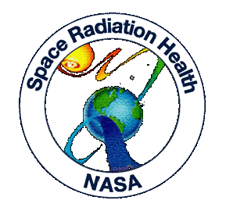



NSRL-07C RUN

September - October 2007

FINAL REPORT

Kelly Guiffreda Peter Guida Michael Sivertz
RHIC & AGS Users Center Medical Dept. Collider-Accelerator Dept.
BNL BNL/NASA BNL/NASA

http://www.bnl.gov/medical/NASA

TABLE OF CONTENTS

EXECUTIVE SUMMARY 3
Projects Reviewed by the BNL Scientific Advisory Committee in Radiobiology 4
PARTICIPANTS (Principal Investigators are highlighted) 6
Participant Institutions 12
RESEARCH PROJECT SPONSORS 13
INSTITUTION STATISTICS 13
TOTAL RUN-TIME STATISTICS 14
SCIENCE STUDIES STATISTICS 14
ION SPECIES AND ENERGY (MeV/n) DISTRIBUTION 15
RUN TIME DESCRIPTION (hours) 16
BEAM CHARACTERISTICS 18
DOSIMETRY AND BEAM DEVELOPMENTS 20
RUN DATES 21
EXPERIMENTERS AND RUN STATISTICS 22

EXECUTIVE SUMMARY
During the fall of 2007, a series of radiobiological and physics experiments were performed using the proton and heavy ion beams available at the NASA Space Radiation Laboratory (NSRL). These experiments were part of the fourteenth NSRL scientific run (NSRL-07C) sponsored by NASA’s Space Radiation Health Program (SRHP) heavy ion radiobiology research program at BNL.

A total of forty-one proposals were approved for participation in the NSRL-07C run in which one did not participate. One hundred and sixty seven users from thirty-two institutions were represented, all from the United States. There was no foreign representation this run. More than 4600 biological samples were exposed at the NSRL beam line, employing 263:03 hours of beam time (72:41 hours for in vivo studies, 148:20 hours for in vitro studies, and 42:02 hours for physics experiments) delivered in a six week period. In addition, 24:36 hours were used for dosimetry and beam development. Machine set-up took a total of 108:51 hours, and 20:30 hours for wrap-up of the beam. Accelerator problems with the NSRL beam accounted for 62:47 hours lost. This gave a total NSRL usage time of 479:47 hours. Since we were not running concurrently with RHIC, there was no time lost while due to RHIC. As a byproduct of this, all accelerator down-time counted towards the NSRL total.

During NSRL-07C, Booster provided protons (100, 150, 200, 250, 500, and 1000 MeV), oxygen (300 and 1000 MeV/n), silicon (300, 600, and 1000 MeV/n), iron (150, 300, 600, and 1000 MeV/n) and sequential fields of protons and iron (1000 MeV/n) beams for biology and physics experiments. Experimenters are becoming more interested in studying the effects of low doses and low dose rates. For this reason, our attention has been on developing stable low fluence beams with the same dosimetry capability of the higher intensity beam. The maximum dose rates used for biology experiments were as high as 7.5 Gray/min (Fe 1000 MeV/n). The general spill rate employed was 15 spills per minute with durations of 300 msec/spill. The spill fluence range was (particles/spill) from 1.5 x 10¹¹ (max) and 2 x 10² (min). Square beam spots as big as 20 x 20 cm² and as small as 1 x 1 cm² were employed for biology and physics experiments.

Tandem-Booster set-up started on 31 August 2007 with the transport and circulation of Silicon beams at the NSRL complex. Beam was tuned into the target cave on 5 September 2007 and 300 MeV/n Si beams were available for tuning at 7:00 AM 5 September 2007. NSRL-07C officially ended at 1:58 PM 26 October 2007.

Projects Reviewed by the BNL Scientific Advisory Committee in Radiobiology
Proposal | PI | Sponsor | NSRL-07C Participation
B-7 | RABIN, BERNARD | NASA | Yes
B-10 | CHANG, POLLY | NASA | Yes
B-52 | SUTHERLAND/GEWIRTZ… | NSBRI | Yes
N-88 | SUTHERLAND, BETSY | NASA | Yes
N-89 | HELD, KATHY | NASA | Yes
N-90 | BAILEY, SUSAN | NASA | Yes
N-97 | KRONENBERG, AMY | NASA | Yes
N-102 | HALL, ERIC | NASA | Yes
N-103 | BARCELLOS-HOFF, MARY HELEN | NASA-NSCOR | Yes
N-104 | ULLRICH, ROBERT | NASA | Yes
N-108 | OBENAUS, ANDRE | NASA | Yes
N-129 | LIMOLI, CHARLES | NASA | Yes
N-134 | CHEN, DAVID | NASA | Yes
N-146 | WU, HONGLU | NASA | Yes
N-153 | MINNA, JOHN | NASA-DOE | Yes
N-154 | MAURER, RICHARD HORNSBY | NASA/NSBRI | Yes
N-155 | RABER, JACOB | NASA | Yes
N-157 | SCHIESTL, ROBERT | NASA | Yes
N-159 | HALL, ERIC | NASA | Yes
N-160 | SPENCE, HARLAN | NASA-ESMD | Yes
N-163 | WIESE, CLAUDIA | NASA | Yes
N-167 | BURMA, SANDEEP | NASA | Yes
N-171 | DYNLACHT, JOSEPH | NASA | Yes
N-172 | BERKOWITZ, DAN | NASA | Yes
N-175 | FIKE, JEFFREY | DOE NASA-NSCOR | Yes
N-177 | MORGAN | NASA | No
N-180 | CARSON, WILLIAM | NASA | Yes
N-181 | OBENAUS, ANDRE | NASA | Yes
N-185 | SUTHERLAND, BETSY | NASA-DOE | Yes
N-186 | SHAY, JERRY | NASA | Yes
N-187 | REDPATH, JOHN | NASA | Yes
N-188 | GREENLORA | NASA | Yes
N-190 | IANZINI, FIORENZA | NASA | Yes
N-193 | O'BANION, MICHAEL | NASA-DOE | Yes
N-194 | KUCIK, DENNIS | NASA | Yes
N-196 | AZZAM, EDOUARD | NASA | Yes
N-197 | FORNACE, AL | NASA | Yes
N-198 | GLOBUS, RUTH | NASA | Yes
N-200 | HLATKY, LYNN | NASA | Yes
N-203 | BRITTEN, RICHARD | NASA | Yes
N-204 | AMUNDSON, SALLY | NASA-DOE | Yes
N-205 | KLEIMAN, NORMAN | NASA-DOE | Yes

†Not Present During Actual Run

PARTICIPANTS (Principal Investigators are highlighted)
Exp. | Name | Guest Title | Employer
B-7 | Rabin, Bernard | Ph.D, Principal Investigator | University of Maryland
 | Carrihill, Kirsty Lee | Guest Research Associate | University of Maryland
 | Cheng, Vivian | Guest Jr Research Associate | University of Maryland
 | Shukitt-Hale, Barbara | Guest Scientist | Tufts University
B-10 | Chang, Polly Yee | Ph.D, Principal Investigator | SRI International
 | Bakke, James | Guest Scientific Associate | SRI International
 | Hutson, Christopher | Guest Jr Research Associate | SRI International
B-52 | SUTHERLAND/GEWIRTZ | Ph.D, Principal Investigators | BNL, Biology Dept./Univ. of Pennsylvania
 | BENNETT | M.S., Co-Worker | BNL, Biology Dept., Upton, NY
 | NAIDU | PhD., Co-Worker | BNL, Biology Dept., Upton, NY
 | J. SUTHERLAND | PhD., Co-Worker | BNL, Biology Dept., Upton, NY
 | MONTELEONE | B.S., Co-Worker | BNL, Biology Dept., Upton, NY
 | TRUNK | PhD., Co-Worker | BNL, Biology Dept., Upton, NY
N-88 | Sutherland, Betsy | Ph.D, Principal Investigator | BNL, Biology Dept.
 | Vercoutere, Wenonah A. | Guest Scientist | National Aeronautics and Space Admin. (NASA)
N-89 | Held, Kathryn | Ph.D, Principal Investigator | Massachusetts General Hospital
 | Han, Wei | Guest Jr Research Associate | Massachusetts General Hospital
 | Kumaraswamy, Deepak | Guest Scientific Associate | Massachusetts General Hospital
 | Magpayo, Nicole | Guest Scientific Associate | Massachusetts General Hospital
 | Yang, Hongying | Guest Scientist | Massachusetts General Hospital
N-90 | Bailey, Susan | Ph.D, Principal Investigator | Colorado State University
N-97 | Kronenberg, Amy | Ph.D, Principal Investigator | Lawrence Berkeley National Laboratory
 | Gauny, Stacey | Guest Scientific Associate | Lawrence Berkeley National Laboratory
 | Kwoh, Ely | Guest Scientific Associate | Lawrence Berkeley National Laboratory
N-102 | Hall, Eric J | Ph.D, Principal Investigator | Columbia University
 | David, Janice | Guest Scientific Associate | Columbia University
 | Maerki, Jennifer | Guest Research Assistant | Columbia University
 | Meador, Jarah | Guest Research Associate | Columbia University
 | Smilenov, Lubomir B. | Guest Scientist | Columbia University, Nevis Laboratories
N-103 | Barcellos-Hoff, Mary Helen | Ph.D, Principal Investigator | Lawrence Berkeley National Laboratory
 | Costes, Sylvain Vincent | Guest Scientist | Lawrence Berkeley National Laboratory
 | Deheuninck, Julien | Guest Research Associate | Lawrence Berkeley National Laboratory
 | Groesser, Torsten | Guest Research Associate | Lawrence Berkeley National Laboratory
 | Kronenberg, Amy | Guest Scientist | Lawrence Berkeley National Laboratory
 | Mukhopadhyay, Rituparna | Guest Research Associate | Lawrence Berkeley National Laboratory
 | Rydberg, Bjorn E. | Guest Scientist | Lawrence Berkeley National Laboratory
N-104 | Weil, Michael | Ph.D, Principal Investigator | Colorado State University
 | Fallgren, Christina Marie | Guest Scientific Associate | Colorado State University
 | Genik, Paula Constance | Guest Scientist | Colorado State University
 | Peng, Yuanlin | Guest Scientist | Colorado State University
 | Ray, Frank Andrew | Guest Scientist | Colorado State University
N-108 | Obenaus, Andre | Ph.D, Principal Investigator | NASA - Loma Linda University Medical School
 | Jones, Tamako | Guest Scientific Associate | NASA - Loma Linda University Medical School
N-187 | Redpath, John Leslie | Ph.D, Principal Investigator | University of California @ Irvine
 | Elmore, Eugene Lawrence | Guest Scientist | University of California @ Irvine
N-129 | Limoli, Charles | Ph.D, Principal Investigator | University of California @ Irvine
 | Giedzinski, Erich | Guest Scientific Associate | University of California @ Irvine
 | Suarez, Vannina | Guest Scientific Associate | University of California @ Irvine
N-134 | Chen, David | Ph.D, Principal Investigator | University of Texas Southwestern
 | Aroumougame, Asaithamby | Guest Scientist | University of Texas Southwestern
 | Gonzalez, Oscar Ruben | Guest Research Assistant | University of Texas Southwestern
N-145 | O'Banion, Michael | Ph.D, Principal Investigator | University of Rochester
 | Hurley, Sean David | Guest Scientist | University of Rochester
 | Trojanczyk, Lee Ann | Guest Scientific Associate | University of Rochester
 | Williams, Jacqueline Patricia | Guest Scientist | University of Rochester
N-146 | Wu, Honglu | Ph.D, Principal Investigator | NASA - Johnson Space Center
 | Meador, Jarah | Guest Research Associate | Columbia University
N-153 | Story, Michael/Minna | Ph.D, Principal Investigator | University of Texas Southwestern
 | Delgado, Oliver | Guest Jr Research Associate | University of Texas Southwestern
 | Park, Seongmi | Guest Research Associate | University of Texas Southwestern
 | Peyton, Michael Jess | Guest Scientist | University of Texas Southwestern
N-154 | Maurer, Richard Hornsby | Ph.D, Principal Investigator | Johns Hopkins University
 | Goldsten, John | Guest Research Assistant | Johns Hopkins University
 | Grey, Matthew | Guest Research Assistant | Johns Hopkins University
 | Roth, David Richard | Guest Scientist | Johns Hopkins University
 | Zeitlin, Cary | Guest Scientist | Lawrence Berkeley National Laboratory
N-155 | Raber, Jacob | Ph.D, Principal Investigator | Oregon Health & Science University
 | Villasana, Laura | Guest Jr Research Associate | Oregon Health & Science University
N-157 | Schiestl, Robert | Ph.D, Principal Investigator | University of California @ Los Angeles
 | Hacke, Katrin | Guest Research Associate | University of California @ Los Angeles
 | Hafer, Kurt | Guest Jr Research Associate | University of California @ Los Angeles
 | Yamamoto, Mitsuko Lynn | Guest Jr Research Associate | University of California @ Los Angeles
N-159 | Hall, Eric J | Ph.D, Principal Investigator | Columbia University
 | Maerki, Jennifer | Guest Research Assistant | Columbia University
 | Meador, Jarah | Guest Research Associate | Columbia University
 | Smilenov, Lubomir B. | Guest Scientist | Columbia University, Nevis Laboratories
 | David, Janice | Guest Scientific Associate | Columbia University
N-160 | Spence, Harlan E. | Ph.D, Principal Investigator | Boston University
 | Foster, Richard F | Guest Scientific Associate | Massachusetts Institute of Technology
 | Golightly, Michael Joseph | Guest Scientific Associate | Boston University
 | Larsen, Brian | Guest Scientist | Boston University
N-163 | Wiese, Claudia | Ph.D, Principal Investigator | Lawrence Berkeley National Laboratory
 | Zafar, Faria | Guest Jr Research Associate | Lawrence Berkeley National Laboratory
N-167 | Burma, Sandeep | Ph.D, Principal Investigator | University of Texas Southwestern
 | McEllin, Brian | Guest Jr Research Associate | University of Texas Southwestern
N-171 | Dynlacht, Joseph | Ph.D, Principal Investigator | Indiana University @ Indianapolis
 | Caperell-Grant, Andrea | Guest Scientific Associate | Indiana University @ Indianapolis
 | Garrett, Joy | Guest Research Assistant | Indiana University @ Indianapolis
N-172 | Berkowitz, Dan | Ph.D, Principal Investigator | Johns Hopkins University
 | Bugaj, Lukasz | Guest Jr Research Associate | Johns Hopkins University
 | Soucy, Kevin Gilbert | Guest Jr Research Associate | Johns Hopkins University
N-175 | Fike, Jeffrey | Ph.D, Principal Investigator | Loma Linda University
 | Smith, Anna Lucille | Guest Scientific Associate | Loma Linda University
N-180 | Carson, William | Ph.D, Principal Investigator | NASA - Johnson Space Center
 | Dungan, Larry Kenneth | Guest Scientific Associate | NASA - Johnson Space Center
 | Klyachko, Alexander | Guest Scientist | Indiana University @ Bloomington
 | Rojdev, Kristina | Guest Scientific Associate | NASA - Johnson Space Center
 | Wheeler, Scott | Guest Scientific Associate | NASA - Johnson Space Center
N-181 | Obenaus, Andre | Ph.D, Principal Investigator | Loma Linda University
 | Smith, Anna Lucille | Guest Scientific Associate | Loma Linda University
 | Jones, Tamako | Guest Scientific Associate | NASA - Loma Linda University Medical School
N-185 | Sutherland, Betsy | Ph.D, Principal Investigator | BNL, Biology Dept.
N-186 | Shay, Jerry | Ph.D, Principal Investigator | University of Texas Southwestern
 | Roig, Andres | Guest Jr Research Associate | University of Texas Southwestern
N-187 | Redpath, John | Guest Scientist | University of California @ Irvine
 | Elmore, Eugene | Guest Scientist | University of California @ Irvine
N-188 | Green, Lora Murray | Ph.D, Principal Investigator | Loma Linda University Medical Center
 | Bianski, Brandon | Guest Scientific Associate | Loma Linda University
 | Sanchez, Martha Celia | Guest Research Assistant | Loma Linda University
N-190 | Ianzini, Fiorenza | Ph.D, Principal Investigator | University of Iowa
 | Kosmacek, Elizabeth Anne | Guest Research Assistant | University of Iowa
N-193 | O'Banion, Kerry | Ph.D, Principal Investigator | University of Rochester
N-194 | Kucik, Dennis F | Ph.D, Principal Investigator | University of Alabama
 | Gupta, Kiran B | Guest Jr Research Associate | University of Alabama
 | Khaled, Saman Fatima | Guest Jr Research Associate | University of Alabama
 | Yu, Tao | Guest Jr Research Associate | University of Alabama
N-196 | Azzam, Edouard Iskandar | Ph.D, Principal Investigator | University of Medicine and Dentistry of NJ
 | Autsavapromporn, Narongchai | Guest Jr Research Associate | University of Medicine and Dentistry of NJ
 | Buonanno, Manuela | Guest Research Assistant | University of Medicine and Dentistry of NJ
 | de Toledo, Sonia Maria | Guest Scientist | University of Medicine and Dentistry of NJ
 | Yang, Zhi | Guest Research Associate | University of Medicine and Dentistry of NJ
N-197 | Fornace, Jr, Albert | Ph.D, Principal Investigator | Georgetown University
 | Datta, Kamal | Guest Research Associate | Georgetown University
 | Doiron, Kathyrn E | Guest Scientific Associate | Georgetown University
 | Li, Henghong | Guest Scientist | Georgetown University
N-198 | Globus, Ruth | Ph.D, Principal Investigator | NASA - Ames Research Center
 | Mojarrab, Rose | Guest Scientific Associate | NASA - Ames Research Center
 | Searby, Nancy | Guest Scientist | NASA Headquarters
 | Vercoutere, Wenonah A. | Guest Scientist | National Aeronautics and Space Admin. (NASA)
 | Yumoto, Kenji | Guest Jr Research Associate | NASA - Ames Research Center
N-200 | Hlatky, Lynn | Ph.D, Principal Investigator | Tufts University
 | Beheshti, Afshin | Guest Scientist | Tufts University
 | Enderling, Heiko | Guest Scientist | Tufts University
 | Girdhani, Swati | Guest Scientist | Tufts University
 | Hahnfeldt, Philip | Guest Scientist | Tufts University
 | Lamont, Clare | Guest Scientific Associate | Tufts University
N-203 | Britten, Richard | Ph.D, Principal Investigator | Eastern Virginia Medical School
 | Johnson, Angela | Guest Scientific Associate | Eastern Virginia Medical School
 | Mitchell, Shamina | Guest Jr Research Associate | Eastern Virginia Medical School
 | Singletary, Sylvia J | Guest Scientist | Eastern Virginia Medical School
N-204 | Amundson, Sally A. | Ph.D, Principal Investigator | Columbia University
 | Mezentsev, Alexandre | Guest Scientist | Columbia University
N-205 | Kleiman, Norman | Ph.D, Principal Investigator | Columbia University
NSRL(NASA) | Sulzman, Frank Michael | Guest Scientist | NASA – Johnson Space Center
NSRL | Guida Peter‡ | Scientist | Scientist
NSRL | Tafrov, Stefan ‡ | Associate Scientist | Associate Scientist
NSRL | Keszenman, Deborah‡ | Associate Scientist | Associate Scientist
NSRL | Pyatt, Beatrice ‡ | Medical Associate | Medical Associate
NSRL | Abele, William ‡ | Associate Scientist | Brookhaven National Laboratory
NSRL | Sutherland, John ‡ | Senior Scientist | Brookhaven National Laboratory
NSRL | Bennett, Paula ‡ | Biology Associate I | Brookhaven National Laboratory
NSRL | Trunk, John ‡ | Senior Technical Associate | Brookhaven National Laboratory
NSRL | Hein, Patricia ‡ | Senior Administrative Assistant | Brookhaven National Laboratory
NSRL | Kershaw, Maryann‡ | BLAF Manager | Brookhaven National Laboratory
NSRL | Jardine, James ‡ | Laboratory Specialist | Brookhaven National Laboratory
NSRL | Sivertz, Michael‡ | Scientist | Brookhaven National Laboratory
NSRL | Naidu, Mamta ‡ | Associate Scientist | Brookhaven National Laboratory
NSRL | Kim, Angela ‡ | Medical Associate | Brookhaven National Laboratory
NSRL | Billups, Adele‡ | Medical Associate | Brookhaven National Laboratory
NSRL | Thompson, Laura‡ | Medical Associate | Brookhaven National Laboratory
NSRL | Forrette, Elise‡ | Administrative Assistant | Brookhaven National Laboratory
NSRL | Bonti, Kerry‡ | BLAF Staff | Brookhaven National Laboratory
NSRL | Snyder, Deborah‡ | BLAF Staff | Brookhaven National Laboratory
NSRL | Reiszel, Corrine‡ | BLAF Staff | Brookhaven National Laboratory
NSRL | Rusek, Adam‡‡ | Scientist | Brookhaven National Laboratory

† Not present during actual run.
‡ BNL Personnel who participated in many different experiments throughout the run.

Participant Institutions
Universities (22) |  | National Laboratories/Institutions (2)
Boston University |  | Brookhaven National Laboratory
Colorado State University |  | Lawrence Berkeley National Laboratory
Columbia University
Columbia University, Nevis Laboratories
Eastern Virginia Medical School |  | NASA Related Centers/institutions (5)
Georgetown University |  | NASA - Ames Research Center
Indiana University @ Bloomington |  | NASA - Johnson Space Center
Indiana University @ Indianapolis |  | NASA - Loma Linda University Medical School
Johns Hopkins University |  | National Aeronautics and Space Admin. (NASA)
Loma Linda University |  | NASA Headquarters
Loma Linda University Medical Center
Oregon Health & Science University
Massachusetts Institute of Technology |  | Private Institutions(1)
Tufts University |  | Massachusetts General Hospital
University of Alabama
University of California @ Irvine
University of California @ Los Angeles |  | Government (1)
University of Iowa |  | SRI International
University of Maryland
University of Medicine and Dentistry of NJ
University of Rochester
University of Texas Southwestern

RESEARCH PROJECT SPONSORS
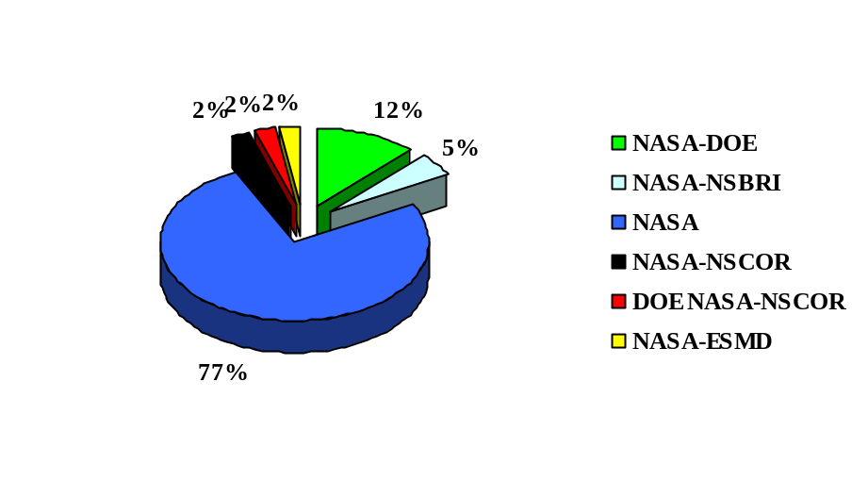

INSTITUTION STATISTICS

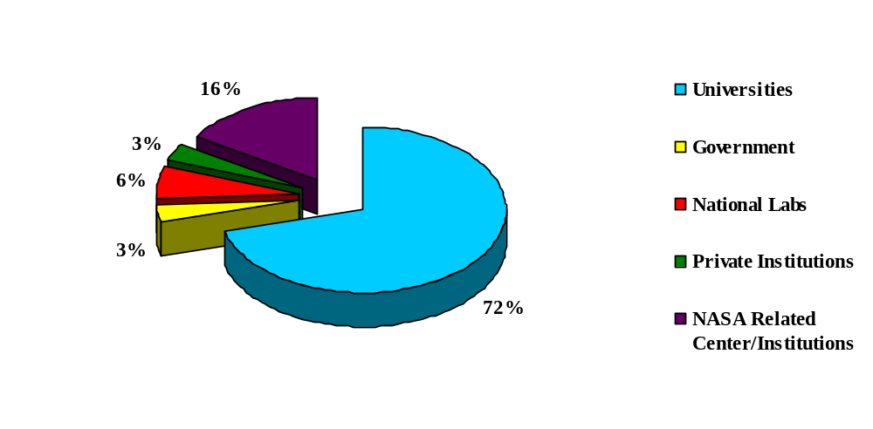

TOTAL RUN-TIME STATISTICS
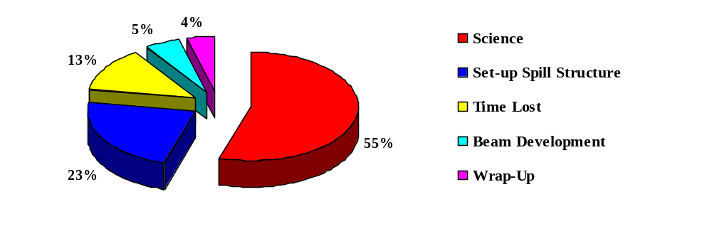

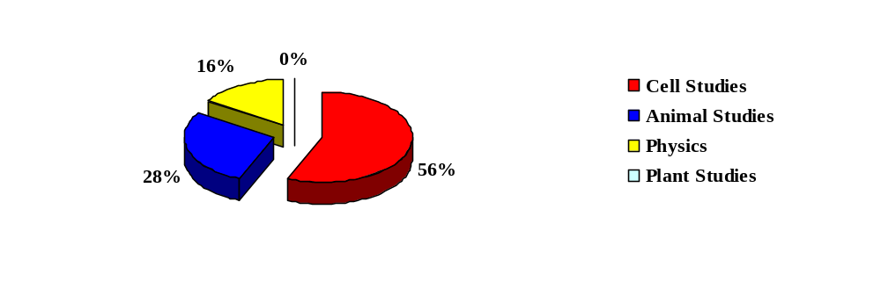SCIENCE STUDIES STATISTICS

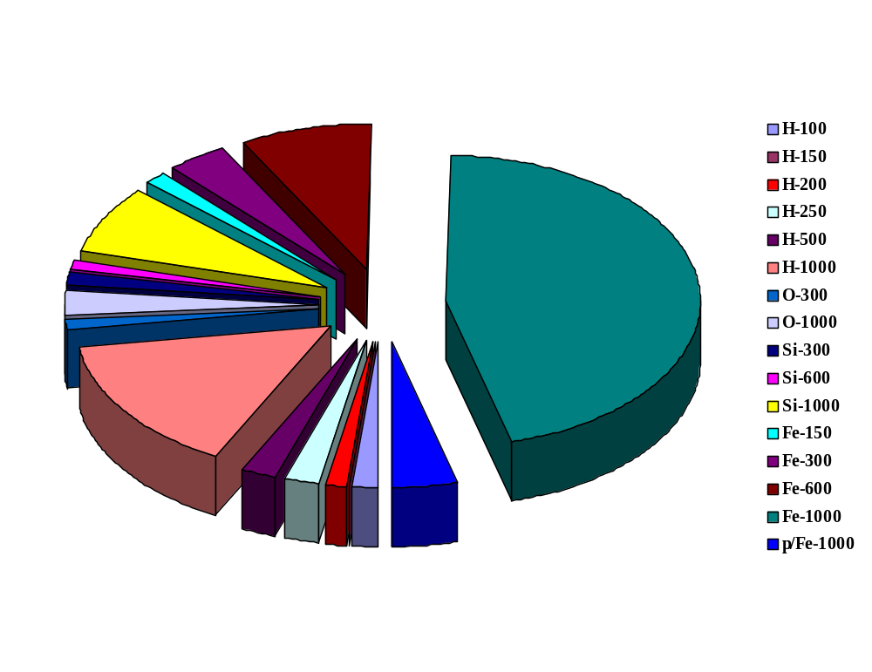ION SPECIES AND ENERGY (MeV/n) DISTRIBUTION

RUN TIME DESCRIPTION (hours)
NSRL-07C | ION SPECIES AND ENERGIES (MeV/nucleon)
 | H |  |  |  |  |  | O |  | Si
 | 100 | 150 | 200 | 250 | 500 | 1000 | 300 | 1000 | 300 | 600 | 1000
Machine Set-Up | 2:00:00 | 2:00:00 | 2:00:00 | 2:00:00 | 2:00:00 | 16:00:00 | 2:00:00 | 4:00:00 | 2:00:00 | 2:00:00 | 4:00:00
Wrap-Up | 0:00:00 | 0:30:00 | 0:30:00 | 0:00:00 | 1:00:00 | 2:30:00 | 0:00:00 | 1:00:00 | 0:00:00 | 0:00:00 | 1:30:00
Development | 0:00:00 | 0:00:00 | 0:00:00 | 0:00:00 | 0:00:00 | 0:00:00 | 0:00:00 | 0:00:00 | 0:00:00 | 0:00:00 | 0:00:00
Science
In Vitro | 1:29:58 | 0:00:00 | 0:00:00 | 7:59:57 | 6:26:45 | 30:59:48 | 1:24:08 | 3:20:43 | 1:14:38 | 2:48:50 | 2:29:16
In Vivo | 0:00:00 | 5:58:29 | 3:34:34 | 0:00:00 | 0:00:00 | 6:57:48 | 0:00:00 | 3:14:33 | 0:00:00 | 0:00:00 | 0:00:00
Others | 0:00:00 | 0:00:00 | 0:00:00 | 0:00:00 | 0:00:00 | 0:00:00 | 0:00:00 | 0:00:00 | 0:00:00 | 0:00:00 | 0:00:00
Physics | 0:00:00 | 0:00:00 | 0:00:00 | 0:00:00 | 0:00:00 | 0:00:00 | 0:00:00 | 0:00:00 | 0:00:00 | 0:00:00 | 22:12:34
NSRL Time Lost | 4:15:00 | 1:45:00 | 0:00:00 | 0:30:00 | 1:25:00 | 15:30:00 | 2:00:00 | 1:25:00 | 3:00:00 | 0:00:00 | 4:55:00
Totals | 7:45 | 10:13 | 6:05 | 10:30 | 10:52 | 71:58 | 5:24 | 13:00 | 6:15 | 4:49 | 35:07

(continued next page)

NSRL-07C | ION SPECIES AND ENERGIES (MeV/nucleon)
 | p/Fe |  |  | Fe |  | Total
 | 1000 | 150 | 300 | 600 | 1000
Machine Set-Up | 4:00:00 | 4:00:00 | 6:00:00 | 8:00:00 | 46:51:00 | 108:51
Wrap-Up | 0:30:00 | 0:00:00 | 0:30:00 | 2:30:00 | 10:00:00 | 20:30
Non-Science Sub-Total: |  |  |  |  |  | 129:21
Development | 0:00:00 | 0:00:00 | 2:35:00 | 0:00:00 | 22:00:45 | 24:36
Science
In Vitro | 10:19:00 | 3:00:00 | 4:06:49 | 1:28:00 | 71:11:42 | 148:20
In Vivo | 0:00:00 | 0:00:00 | 3:15:51 | 22:20:27 | 27:19:43 | 72:41
Others | 0:00:00 | 0:00:00 | 0:00:00 | 0:00:00 | 0:00:00 | 0:00
Physics | 0:00:00 | 0:00:00 | 0:00:00 | 0:00:00 | 19:49:19 | 42:02
Science Sub Total: |  |  |  |  |  | 263:03
NSRL Time Lost | 4:45:00 | 0:00:00 | 2:12:00 | 4:40:00 | 16:25:00 | 62:47
Totals | 19:34 | 7:00 | 18:40 | 38:58 | 213:37 | 479:47

BEAM CHARACTERISTICS
Ion | H |  |  |  |  |  | O
Energy (MeV/n)
Planned | 100 | 150 | 200 | 250 | 500 | 1000 | 300 | 1000
Extracted | 103.1 | 150 | 200 | 250 | 500 | 1000 | 300 | 1000
On Target | 103.1 | 150* | 200* | 250* | 500* | 1000* | 300* | 1000*
Fluence (particles/cm²/sec)
Maximum on target | 8.3E+5 | 1.3E+7 | 3.5E+7 | 9.1E+6 | 4.3E+7 | 4.3E+7 | 1.6E+5 | 5.0E+5
Minimum on target | 4.1E+5 | 0.4E+7 | 0.9E+6 | 2.2E+5 | 200 | 200 | 0.5E+6 | 0.6E+4
Spill Period (sec) | 4 | 4 | 4 | 4 | 4 | 4 | 4 | 4
Spill rate (spills/min) | 15 | 15 | 15 | 15 | 15 | 15 | 15 | 15
Spill length (msec) | 300 | 300 | 300 | 300 | 300 | 300 | 300 | 300
Particles/spill
Maximum | 3.3E+6 | 5.2E+7 | 1.4E+8 | 3.6E+7 | 1.7E+8 | 1.7E+8 | 6.3E+5 | 2.0E+6
Minimum | 200 | 200 | 0.3E+8 | 1.0E+6 | 8.0E+5 | 8.0E+5 | 2.1E+5 | 0.3E+5
Beam Cut Off Accuracy | 0.50% | 0.50% | 0.50% | 0.50% | 0.50% | 0.50% | 0.50% | 0.50%
Actual LET on Target (keV/µm) | 0.715 | 0.546* | 0.405* | 0.392* | 0.275* | 0.222* | 22.6* | 14.2*
Max. Dose Rate (Gy/min)
20 cm x 20 cm | 0.05 | 0.6 | 1.2 | 0.3 | 1 | 0.8 | 0.3 | 0.6
Total Dose (Gy)
Maximum | 0.2 | 3 | 2 | 4 | 50 | 8 | 3 | 3
Minimum | 0.1 | 1 | 0.5 | 0.1 | 0.00001 | 0.00001 | 1 | 0.05

* No Bragg results are available for H running at 500 or 1000 MeV, or Fe at 300 MeV/nucleon. Only calculated LET is quoted.

(continued next page)

Ion | Si |  |  | p/FeH | Fe
Energy (MeV/n)
Planned | 300 | 600 | 1000 | 1000 | 150 | 300 | 600 | 1000
Extracted | 300 | 600 | 1000 | 1000 | 151.1 | 296.8 | 591.5 | 964.9
On Target | 308.9 | 591.9 | 1000* | 1000* | 151.1 | 296.8 | 591.5 | 964.9
Fluence (particles/cm²/sec)
Maximum on target | 6.8E+5 | 3.1E+5 | 2.7E+6 | N/A | 6.4E+4 | 5.0E+4 | 1.4E+5 | 3.1E+5
Minimum on target | 6.8E+3 | 3.1E+3 | 0.7E+4 | N/A | 6.4E+4 | 200 | 1.6E+3 | 200
Spill Period (sec) | 4 | 4 | 4 | 4 | 4 | 4 | 4 | 4
Spill rate (spills/min) | 15 | 15 | 15 | 15 | 15 | 15 | 15 | 15
Spill length (msec) | 300 | 300 | 300 | 300 | 300 | 300 | 300 | 300
Particles/spill
Maximum | 2.7E+6 | 1.2E+6 | 1.1E+7 | N/A | 2.6E+5 | 2.0E+5 | 5.4E+5 | 1.3E+6
Minimum | 2.7E+4 | 1.2E+4 | 0.3E+5 | N/A | 2.6E+5 | 200 | 6.0E+3 | 8.0E+5
Beam Cut Off Accuracy | 0.50% | 0.50% | 0.50% | 0.50% | 0.50% | 0.50% | 0.50% | 0.50%
Actual LET on Target (keV/µm) | 69.3 | 50.3 | 43.6 | 0.222*/151 | 368 | 239* | 174 | 151
Max. Dose Rate (Gy/min)
20 cm x 20 cm | 4 | 1.3 | 10 | 0.2 | 2 | 1 | 2 | 4
Total Dose (Gy)
Maximum | 50 | 50 | 100 | 1.5 | 1 | 1 | 4 | 7.5
Minimum | 0.5 | 0.5 | 0.25 | 0.00001 | 1 | 0.00001 | 0.05 | 0.00001

* No Bragg results are available for H running at 500 or 1000 MeV, or Fe at 300 MeV/nucleon. Only calculated LET is quoted.

DOSIMETRY AND BEAM DEVELOPMENTS

New Beams:
During NSRL 07C the flowing beams were developed and used for the first time:
Protons at 100, and 150 MeV,
Oxygen at 300 MeV/n and
Iron at 150 MeV/n.

RUN DATES
Ion | Energy | Scheduled Start | Scheduled End | Actual Start | Actual End
Silicon | 300-1000 | 9/05/07 7:00 | 9/05/07 17:30 | 9/05/07 7:00 | 9/05/07 17:17
Oxygen | 300-1000 | 9/08/07 7:00 | 9/10/07 19:00 | 9/08/07 7:00 | 9/10/07 14:59
Iron | 150-1000 | 9/11/07 7:00 | 9/21/07 16:00 | 9/11/07 5:15 | 9/21/07 12:20
p/Fe | 1000 | 9/24/07 7:00 | 9/26/07 20:00 | 9/24/07 7:00 | 9/26/07 20:34
Iron | 150-1000 | 9/27/07 7:00 | 10/01/07 20:00 | 9/27/07 7:00 | 10/01/07 19:02
Protons | 100-1000 | 10/02/07 7:00 | 10/02/07 21:30 | 10/02/07 7:00 | 10/02/07 20:37
Iron | 150-1000 | 10/03/07 7:00 | 10/03/07 16:00 | 10/03/07 7:00 | 10/03/07 15:45
Protons | 100-1000 | 10/4/07 7:00 | 10/04/07 20:30 | 10/04/07 7:00 | 10/04/07 18:28
Iron | 150-1000 | 10/05/07 7:00 | 10/05/07 17:00 | 10/05/07 7:00 | 10/05/07 15:00
Protons | 100-1000 | 10/06/07 7:00 | 10/12/07 19:30 | 10/06/07 7:00 | 10/12/07 15:38
Iron | 150-1000 | 10/15/07 7:00 | 10/26/07 18:30 | 10/15/07 7:00 | 10/26/07 14:28

EXPERIMENTERS AND RUN STATISTICS

Proposal | Principle Investigator | Ion | Energy | Beam Time Approved | Beam Time Used | Dose Rate | Dose Range | Number of Samples
B-7 | Rabin, Bernard | Iron | 600 | 6:30 | 4:59:25 | 10-200 | 10-350 | 65
B-7 | Rabin, Bernard | Oxygen | 1000 | 5:00 | 4:39:33 | 60 | 5-200 | 80
B-10 | Chang, Polly | Protons | 1000 | 16:00 | 6:57:50 | 20-35 | 10-500 | 113
B-52 | Gewirtz, Alan | p/Fe | 1000 | 4:00 | 4:38:47 | 20 | 0-20 | 40
B-185 | Sutherland,Betsy | Iron | 1000 | 4:15 | 5:44:04 | 20 | 10-100 | 141
B-185 | Sutherland,Betsy | Protons | 1000 | 4:15 | 10:07:18 | 20 | 10-100 | 8
N-88 | Sutherland, Betsy | Iron | 300 | 2:00 | 0:42:00 | 20 | 10-30 | 6
N-88 | Sutherland, Betsy | Iron | 600 | 0:00 | 0:33:00 | 20 | 10-30 | 6
N-88 | Sutherland, Betsy | Iron | 1000 | 2:30 | 0:45:00 | 20 | 10-30 | 6
N-88 | Sutherland,Betsy | Protons | 100 | 1:30 | 1:29:58 | 5 | 10-20 | 4
N-88 | Sutherland,Betsy | Protons | 250 | 2:00 | 3:49:14 | 20 | 10-30 | 12
N-88 | Sutherland,Betsy | Protons | 500 | 2:30 | 3:19:27 | .000001-20 | 10-30 | 14
N-88 | Sutherland,Betsy | Protons | 1000 | 2:00 | 1:52:59 | 20 | 10-30 | 12
N-88 | Sutherland, Betsy | Silicon | 600 | 2:00 | 2:48:50 | 20 | 20 | 12
N-89 | Held, Kathy | Iron | 1000 | 7:00 | 5:17:57 | .00001-200 |  | 1
N-89 | Held, Kathy | p/Fe | 1000 | 6:24 | 6:25:13 | 1 | 150 | 1
N-89 | Held, Kathy | Protons | 1000 | 6:12 | 7:00:00 | .000001-20 | .0000001 - 20 | 606
N-90 | Bailey, Susan | Iron | 1000 | 2:00 | 0:42:20 | 100 | 100-200 | 16
N-97 | Kronenberg, Amy | Iron | 1000 | 9:00 | 7:07:33 | 100 | 50-300 | 24
N-97 | Kronenberg, Amy | Protons | 1000 | 9:00 | 10:57:30 | 80 | 50-530 | 48
N-102 | Hall, Eric | Iron | 1000 | 4:24 | 0:44:49 | 100 | 20-300 | 24
N-103 | Barcellos-Hoff, Mary Helen | Iron | 150 | 3:00 | 3:00:00 | 100-200 | 100 | 21
N-103 | Barcellos-Hoff, Mary Helen | Iron | 1000 | 9:00 | 9:39:17 | 10-100 | 10-200 | 180
N-104 | Weil, Michael | Protons | 150 | 5:30 | 7:43:31 | 60 | 100-300 | 224
N-108 | Obenaus, Andre | Iron | 600 | 3:00 | 6:05:32 | 100 | 100-400 | 160
N-129 | Limoli, Charles | Iron | 1000 | 7:00 | 6:36:46 | 20-200 | 10-750 | 113
N-134 | Chen, David | Oxygen | 1000 | 1:00 | 2:07:24 | 50-60 | 100 | 32
N-134 | Chen, David | Silicon | 300 | 1:00 | 4:14:38 | 100 | 100 | 10
N-134 | Chen, David | Silicon | 1000 | 1:00 | 0:48:46 | 100 | 100 | 32
N-146 | Wu, Honglu | Iron | 600 | 3:00 | 0:55:00 | 90 | 25-100 | 7
N-153 | Story, Michael | Iron | 300 | 3:00 | 3:45:59 | 100 | 20-100 | 76
N-153 | Story, Michael | Iron | 1000 | 10:00 | 10:41:12 | 20-100 | 20-100 | 269
N-153 | Story, Michael | Oxygen | 300 | 3:00 | 3:24:08 | 30 | 100-300 | 18
N-153 | Story, Michael | Oxygen | 1000 | 0:30 | 1:13:19 | 30 | 100-300 | 18
N-153 | Story, Michael | Silicon | 1000 | 1:00 | 1:40:30 | 100 | 25-100 | 40
N-154 | Maurer, Richard | Iron | 1000 | 8:00 | 8:32:25 | .000001 | .000001 | 1
N-154 | Maurer, Richard | Silicon | 1000 | 16:00 | 17:29:58 | .000001 | .000001 | 3
N-157 | Schiestl, Robert | Iron | 1000 | 3:00 | 2:29:16 | 100 | 100-200 | 123
N-159 | Hall, Eric | Iron | 600 | 11:00 | 2:21:02 | 50 | 25 | 40
N-160 | Spence, Harlan | Iron | 1000 | 4:42 | 5:26:36 | low | low | 1
N-160 | Spence, Harlan | Silicon | 1000 | 4:42 | 4:42:36 | low | low | 1
N-163 | Wiese, Claudia | Iron | 1000 | 7:00 | 4:08:42 | 50-200 | 25-300 | 115
N-167 | Burma, Sandeep | Iron | 1000 | 2:00 | 1:19:36 | 100-400 | 100-400 | 1
N-171 | Dynlacht, Joseph | Iron | 600 | 5:48 | 4:52:02 | 15-100 | 100-400 | 123
N-172 | Berkowitz, Dan | Iron | 1000 | 2:30 | 1:40:00 | 50 | 100 | 22
N-180 | Carson, William | Iron | 1000 | 18:00 | 5:50:18 | low |  | 1
N-186 | Shay, Jerry | Iron | 1000 | 2:00 | 0:33:24 | 100 | 50-150 | 12
N-186 | Shay, Jerry | Protons | 1000 | 2:00 | 1:27:42 | 20 | 100-300 | 16
N-187 | Redpath, Les | Iron | 1000 | 1:00 | 1:46:44 | 20 | 20 | 40
N-187 | Redpath, Les | Protons | 1000 | 1:00 | 1:05:38 | 20 | 20 | 48
N-188 | Green, Lora | Iron | 1000 | 9:00 | 7:47:05 | 50-200 | 10-200 | 130
N-190 | Ianzini, Fiorenza | Iron | 1000 | 15:00 | 5:13:25 | 80-100 | 50-200 | 160
N-193 | Obanion, M. Kerry | Iron | 1000 | 9:45 | 5:51:46 | 3-100 | 1-600 | 256
N-194 | Kucik, Dennis | Protons | 200 | 1:00 | 3:34:34 | 120 | 50-200 | 40
N-194 | Kucik, Dennis | Protons | 250 | 1:00 | 4:10:43 | 30 | 100-400 | 100
N-196 | Azzam, Edouard | Iron | 1000 | 7:12 | 7:59:51 | 100 | 10-200 | 84
N-197 | Fornace, Al | Iron | 1000 | 3:18 | 3:41:15 | 100 | 60-700 | 66
N-197 | Fornace, Al | Protons | 1000 | 3:18 | 3:23:45 | 20 | 100-800 | 28
N-198 | Globus, Ruth | Iron | 1000 | 7:00 | 3:02:28 | 10-200 | 10-750 | 97
N-200 | Hlatky, Lynn | Iron | 1000 | 12:30 | 12:00:35 | 10-100 | 10-100 | 378
N-200 | Hlatky, Lynn | Protons | 1000 | 3:24 | 3:42:12 | 30 | 100-400 | 140
N-203 | Britten, Richard | Iron | 1000 | 2:00 | 3:03:20 | 100 | 130-300 | 76
N-204 | Amudson, Sally | Iron | 300 | 3:00 | 2:54:41 | 0.000001 | 0.0000001 | 16
N-205 | Kleiman, Norman | Iron | 600 | 4:00 | 4:42:26 | 100 | 50 | 85

Total approved hours of science (not including those proposals that chose not to run in 07C is 319:39.
Total number of hours of science that ran in Run 07C is 263:03.

