2.3 Spectrographs

Introduction

The SNAP visible and IR spectrograph must produce confirmation spectra and redshifts of candidate SNe events and host galaxies quickly and accurately. This requires high throughput and broad wavelength coverage. In addition, the capability to measure simultaneously the spectra of the SNe and of the host galaxy would significantly boost the observatory performance. These lead to the baseline specifications outlined in Table 1.

To meet these goals, we are proposing an integral field spectrograph based on an image slicer. Integral field spectroscopy is now a mature technique and has been used in many ground based instruments, with the latest generation being developed for 8-meter telescopes like Gemini and VLT (see e.g. Bacon et al., 1999; Le Fèvre et al., 2000; Davies et al., 1998). The principle is simple: take spectra of each resolution element in a contiguous sky area. In this way it is possible to measure at the same time the spectrum of the SNe candidate and that of the host galaxy, without slit losses and without strong requirements on the pointing capabilities of the spacecraft.
The heart of the proposed system is an image slicer of the same type as we have studied in the context of the NGST near-IR spectrograph (Allington-Smith et al., 1999; Le Fèvre et al., 1999). This technology has been ranked at a NASA readiness level already of 5 on a scale of 7 (6 being required to be "space qualified") by a panel of NASA experts in the context of the concept appraisal of pre-phase A NGST studies. Continuous prototyping activities are on-going at Laboratoire d’Astrophysique de Marseille (LAM) and in collaboration with other European institutes to validate this technology both for large ground-based telescopes and for space applications, under funding with various agencies including ESA, CNRS and CNES. The R&D effort necessary to adapt this concept to the SNAP requirements therefore meshes in nicely with on-going activities.
baseline design

The proposed technical solution for the spectrograph is an integral field spectrograph based on a slicer unit (e.g. NGST IFMOS study, Le Fèvre et al., 1999, ASP conference series, Volume 207, 313). The basic principle is identified in Figure 1: the 2-D field of interest is "sliced" in several strips, with the slices rearranged to enter the spectrograph as the equivalent of one single long slit. This concept has several major advantages compared to a long slit spectrograph: all resolved spatial elements of a contiguous area on the sky have spectra taken, there are no slit losses, and the telescope pointing is relaxed to a fraction of the observed field, rather than being constrained to a fraction of a slit width, allowing for quick acquisition.

Figure 1: Image slicer principle (courtesy J. Allington-Smith, Durham U.)

The main requirements for the visible and IR spectrograph are listed in Table 1. The visible and infrared spectrographs are similar. We present below the baseline for the infrared spectrograph.

Table 1: spectrograph main characteristics

Item | Visible | IR | Spec
Wavelength coverage μm | 0.35-1 | 0.6-1.7 | 0.35-1.7
Field of view | 2.03" x 2.03" | 2.03" x 2.03" | 2"x2"
Spatial resolution element (arc-sec) | 0.07 | 0.12 | 0.07-0.12
Number of slices | 29 | 17 | -
Spectral resolution, A | 15/30 | 30/50 | 15-30-50
Throughput w/o slicer | 75% | 75% | As high as possible
Throughput w/ slicer | 65-71% | 65-71% | As high as possible

High level requirements will be iterated in subsequent phases, based on the science specifications. The detailed technical specifications and the instrument configuration will then be established, including the field-of-view, spatial resolution, spectral resolution, channel count, etc. The concept discussed below represents a first step in this process.

There are several main components for this instrument:

Front Optics

This unit is the interface between the telescope beam and the instrument. The optical solution is highly dependent on the implementation of the instrument. The definition of this optical system requires the knowledge of the spectrograph position with respect to the telescope focal plane. The beam can be picked off wherever it’s most convenient for the overall instrument. It will be beneficial to correct some telescope aberrations (ex: astigmatism) within this optical system. A 2- or 3-mirror configuration should be sufficient to satisfy requirements, as has been designed during the IFMOS study for NGST.

Slicer Unit

The slicer unit acts as a field reformator. The principle is to slice a 2-D field of view in long strips and optically align all the strips to a long spectrograph entrance slit.
The slicing mirror comprises a stack of slicers. Each slicer has an optically active surface on one edge (see Figure 2, the active spherical surface is the first edge).
A line of «pupil» mirrors does the reformatting. Each mirror sends the beam to a slit mirror, which does the pupil adaptation to the entrance of the spectrograph.
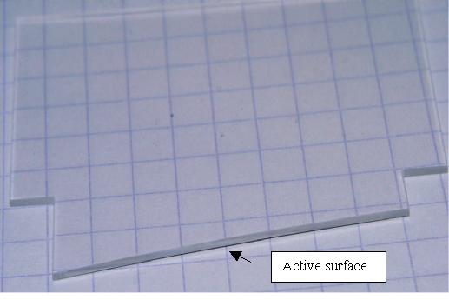
Figure 2: picture of one silica individual slice (dim: 400mm x 0.9mm)
The long, thin, active surface of each individual slicer will produce a large diffraction effect.
In order to minimize flux loses to a few percent, the spectrograph entrance pupil has to be oversized. A combined theoretical and experimental approach is underway at LAM to define the optimum entrance pupil (in the infrared bands 1-5µm).
The baseline requirements on the slicer unit are λ/10 rms on the optical surfaces and 5nm rms for the surface roughness (existing prototypes are fully compliant with these numbers).

Spectrograph options

Thanks to the low beam aperture and field-of-view, the spectrograph will be very simple. Some possibilities are:

Classical spectrograph (baseline): a classical spectrograph with one collimator mirror, plus one grating, plus one camera mirror, should work well. Using spherical shape for all the mirrors will provide sharp enough image quality, but having aspherical mirrors will make possible to a very compact spectrograph.
Spectrograph with a spherical grating. The sphere will “image” the long slit on the detector and the grating groove on it will disperse the light. First simulations show that this option is possible, but will require more volume.

Spectrograph with a flat grating or a prism or a grism plus a mirror. This option would give good image quality for lower dispersion. For the required dispersion of 30/50Å, it is difficult to reach a satisfactory image quality. At this stage we have developed a complete design for the infrared spectrograph. This is the more demanding because of the diffraction effects at the higher wavelength. A visible spectrograph will be in all respects similar to the IR spectrograph, although it will need to be larger to accommodate more slices (see Table 1).

Figure 3 shows the classical spectrograph configuration. In this configuration, a dichroic is placed in order to cover two bands simultaneously (e.g. 0.6-1.1 μm, 1.1-1.7 μm) with a small overlap around 1.1µm. This arrangement can cover the two requested octaves. The resolution will be changed with a grating exchange unit. A complete analysis of wavelength-coverage possibilities and spectral resolution will be carried out during the conceptual phase.
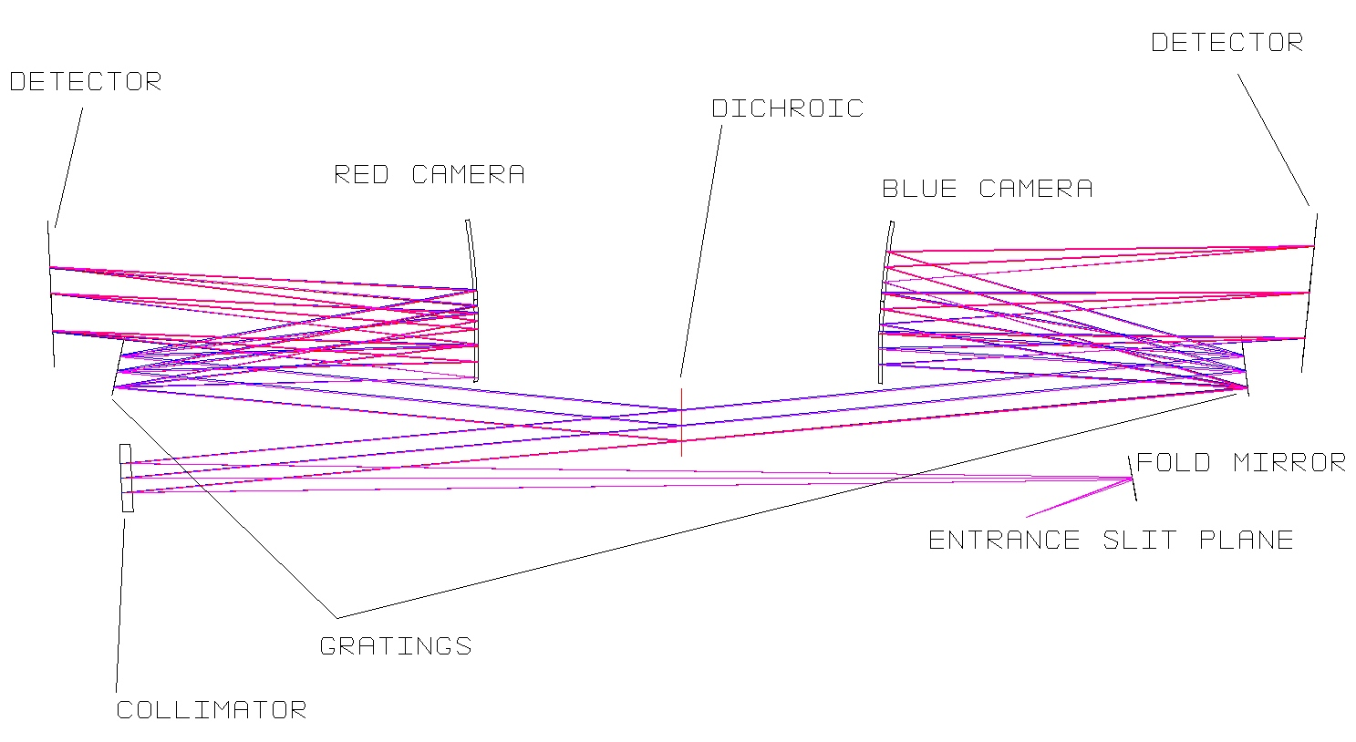
Figure 3: The infrared Spectrograph
The pupil has been oversized in order to catch >95% of the flux at 0.6µm, and at worst 85% of the flux at 1.7µm. The optimization will be performed during the conceptual phase.

Detectors

In the visible, thinned back-side illuminated low noise CCDs of at least 1024x1024 pixels will be the baseline detectors. Explain why thinned CCDs rather than LBNL CCDs.

We have been considering a 1024x1024, 18.5-μm pixel HgCdTe array from Rockwell for these first designs. Other detectors like the InSb Raytheon arrays will be investigated.

The baseline spectrograph design provides spectra about 400 pixels long, which could even fit on a 512x512 array. This will be investigated further.

We are planning to coordinate our visible and IR detectors needs with the work of the teams involved in the visible and IR cameras.

Overall instrument layout

Figure 4 presents the complete instrument.
Figure 4: The Infra-Red Integral Field Spectrograph optical design (scale ~1)

During subsequent phases, we will conduct an in-depth analysis of these designs and will explore alternatives. A trade-off analysis will be performed, balancing performance and budget, in order to select the best possible design.
Development plan:

R&D activities

The R&D activities related to the SNAP spectrograph fit in a logical way within the on-going R&D activities of our team (VLT-VIRMOS, NGST-NIRSPEC, NGST-IFMOS, and VLT- second generation instruments). Specifically, we have an on-going program to qualify image slicers for space instrumentation, the core component of any integral field spectrograph.

Slicer R&D

The main R&D activity identified is the image slicer unit development. We are now in the process of developing a realistic prototype for a space-qualified unit, based on silica-glass slices. Several slices have been successfully manufactured to specifications (Figure 2). This prototype will adequately represent the SNAP case. The main goals of the R&D are:

- Demonstrate a reliable optical surface quality on slices, within the image quality required specification
- Demonstrate that the stacking of slices is possible within the overall unit tolerances
- Qualify a test unit under simulated space environment conditions

Development planning for the image slicer R&D:
- Fabrication process of each individual slice (silica): proven
- Fabrication of 15 slices: on-going
- Assembly of a 15-slice prototype: completed by February 2001
- Testing of prototype on cold chamber: by end 2001
- Vibration testing of prototype: by end 2001
- Full space-qualified prototype: ready by the end of 2002

This activity will continue until the end of 2002. We are planning to finish all R&D activities for the SNAP spectrograph prior to the CDR.

While we are engaged in the first phases of a prototype based on ESA-NGST IFMOS pre-phase A studies funds, we expect ESA to fund a study dedicated to the manufacture a slicer prototype in 2001 in the context of NGST instrumentation.

Performance analysis and trade-off

The ultimate performance of the spectrograph depends on
- The detector performance, including readout noise and dark current. The cutoff wavelength of the array needs to be as close as possible to 1.7 μm, while keep noise figures low. The operating temperature will have an impact on the systems engineering.
- The overall telescope and spectrograph operating temperature: the thermal background at 1.7 μm should be negligible
- The ability to perform accurate spectrophotometry to better than 1%

We will address these issues with a full simulation including all effects, and packaged into an exposure-time calculator. The output of this activity will be a recommendation for the detector specifications and spectrograph operating temperature.

Analysis shows that no other component of the spectrograph requires R&D activity.

R&D Deliverables

The table below lists deliverables generated during the R&D effort.

Deliverable | Completion Date
Science and Technical trade study | 1-Jul-2001
Requirements document | 1-Jul-2001
System conceptual design | 1-Sep-2001
Slicer Prototype report | 1-Oct-2002
Construction cost and schedule | 2-Oct-2002

Risk Assessment

Manpower:

The instrument development will be carried out under the responsibility of the Laboratoire d'Astrophysique de Marseille (resp. Olivier Le Fèvre). The LAM has experience in large space and ground projects directly applicable to the SNAP spectrograph. Laboratory facilities include optical benches and metrology, large cold vacuum chambers, launch load tests. The LAM will coordinate a team of institutes belonging to INSU and IN2P3, the astronomy and particle physics branches of the CNRS (National Research Council).

Table 2 shows the manpower estimate that have been derived from the upper planning

Table 2
 | 2001  Manpower Estimate |  |  | 2002 Manpower Estimate
 | FTE |  | FTE
Project Scientist | Olivier Le Fèvre | 0.1 | 0.1
Science team | See below | 0.3 | 0.3
Project Manager | Eric Prieto | 0.3 | 0.3
Slicer Specialist | Christophe Bonneville | 0.2 | 0.2
Optical Designer | Eric Prieto | 0.3 | 0.3
Mechanical Designer | Serge List | 0.4 | 0.6
Thermal Designer | Christelle Rossin | 0.1 | 0.1
Electronics Designer | Patrick Levacher | 0.1 | 0.2
Control Hardware | Patrick Levacher | 0.1 | 0.2
Detector specialist | R. Barbier | 0.2 | 0.5
Software | In discussion | 0.1 | 0.1
Performance analysis | E. Pécontal | 0.1 | 0.1
Project Assistant | In discussion | 0.2 | 0.3
Quality Engineer | In discussion | 0.1 | 0.1
total |  | 2.6 | 3.4

People listed besides scientists are experimented engineers in the field of space optical instrument who have worked for different space and ground based instruments (Rosetta, COROT, FIRST, NGST, VIRMOS…). Christophe Bonneville is a Ph.D. student focused on slicer development. In addition, we have a team of astronomers available to define and review specifications and design (Giraud, Le Fèvre, Malina, Tresse, Treyer).

Schedule Summary

The first milestone is the CDR (end of 2002) at the end of phase A. The planning for the next two years has been phased with this milestone.

Figure 5 shows the development planning to go to the CDR.

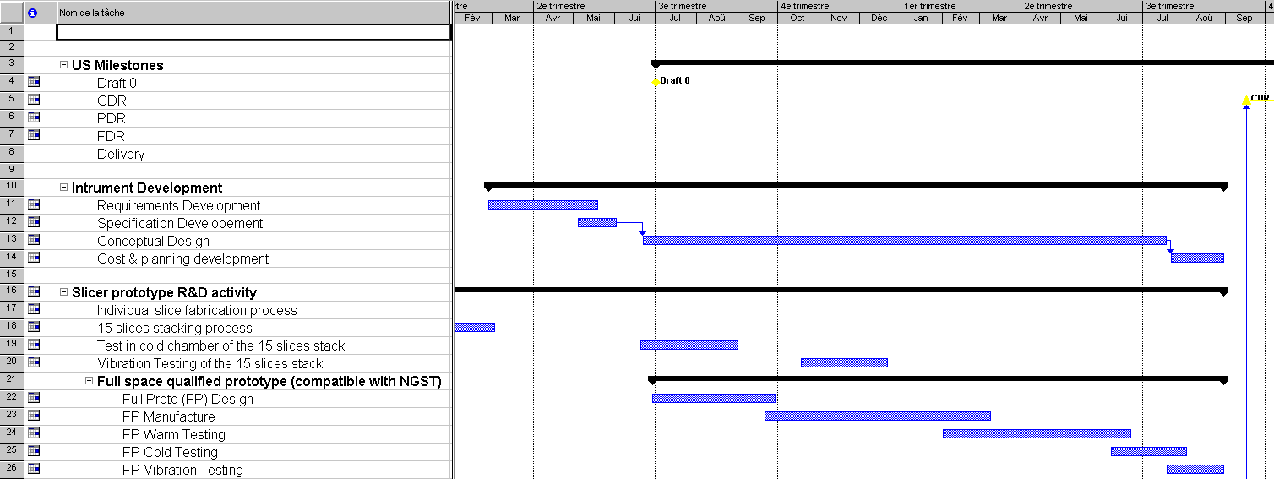
Figure 5: Development planning

