Run IIb Meeting, 03/15/02

Vladimir Shiltsev

6 Months Progress with TEL-1

and Plans

6 months ago: max dQ=0.007, lifetime 6-24 hours, poor diagnostics → poor understanding

Mar ’02: max dQ=0.009, lifetime 6-20hours, significant technical progress, better understanding, TEL as abort gap cleaner

Future: continue studies, improve electron beam and lifetime, decide on TEL-2 fabrication

Technical progress:

- Fast FID pulser – high power problems
- Trigger jitter improved
- Back to RF tube modulator
- Problems with current stability
- Position jitter “measured”, “improved”
- Hysteresis and e-position
- BPM improvements

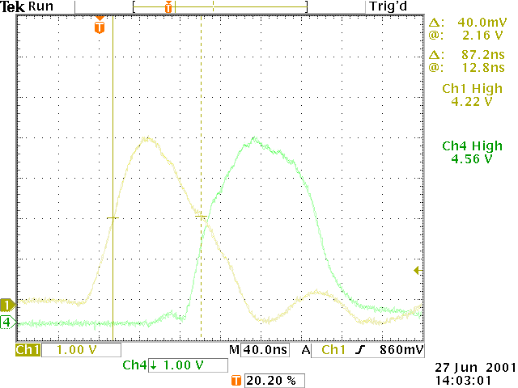

The FID pulser produced 100ns pulses with up to 18 kV amplitude (4.5A of peak current → SC lengthening), had no flat top, burnt anode cables → so we operated below 10kV that is not much better than with RF tube.

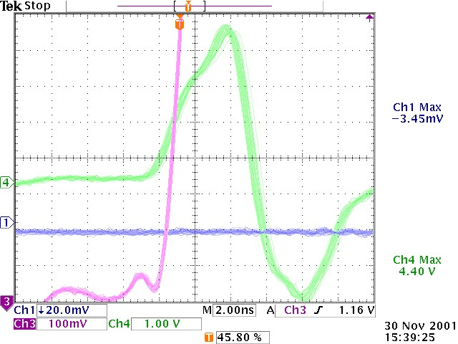
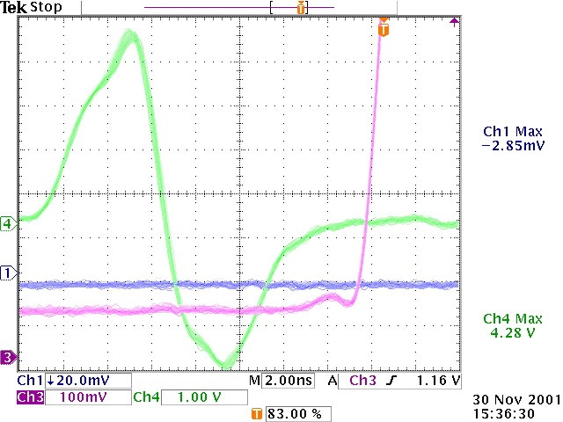

C479 time 0.7ns jitter was discovered (left) and reduced to 0.3ns by synchronization with 53 MHz from MI-60. Even 0.3 ns result in some 0.4% peak-to-peak effective current fluctuations with “triangular” pulse from the FID. (Theoretical tolerance dJ/J<0.05% p-p). So, we had not seen a good lifetime with the FID pulser. Attempts to flatten the top failed while the FID is the tunnel. FID was replaced with the RF tube modulator and now its PFL is under modification by Dave Wildman.

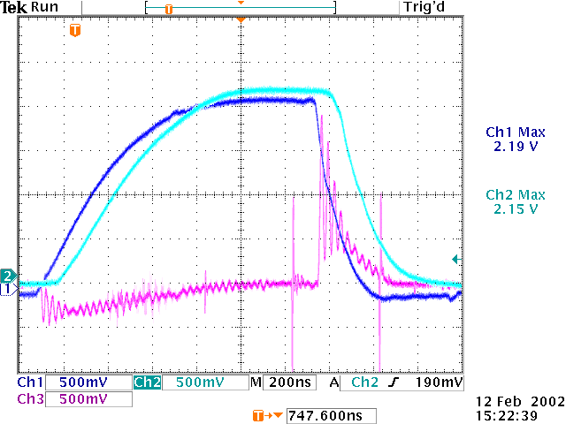
RF tube modulator pulse has flat top but it is longer. Now with 1.5kOhm resistor – about 1.4 us to have good flat top. We see 1-3% 30 MHz structure in current pulse. Fig: blue, cyan – cathode, collector currents, pink – sum-BPM signal for e, pbars.
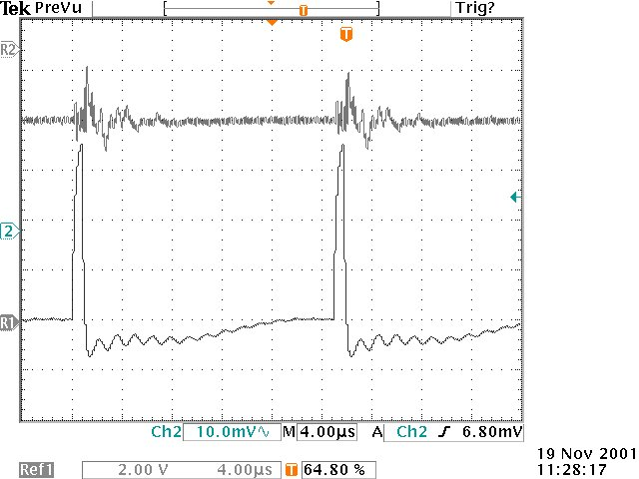
Anode pulse (right Fig):
Max “+”amplitude 7kV (to get some 2.5A of e-current, negative 1.5kV → we plan to improve pulse width, shape and get rid of the 30 MHz

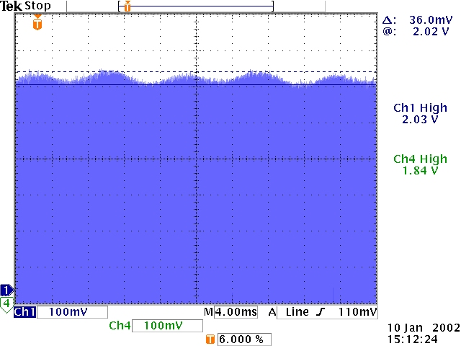
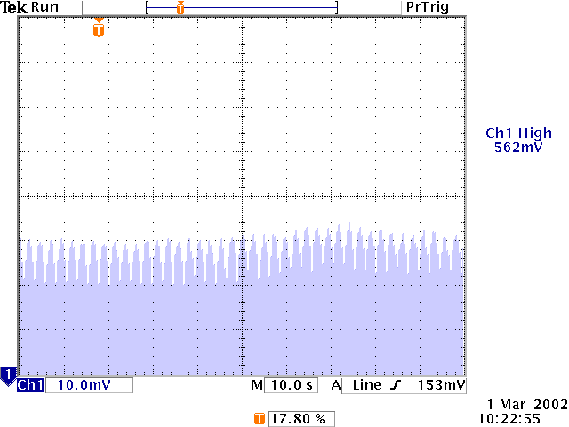

Something changed after November shutdown – we had very stable electron current - dJ/J at low freq was under 0.02% peak-to-peak. Now we have total of 1-3% in dJ/J at all sort of frequencies: 120 Hz (left plot – 36mA/2A=1.8%), 60 Hz (less), 15 Hz (was few % back in January), 2 seconds (left Fig – 10mA/562mA=2%). We compensate some frequencies e.g. 60 or 120 Hz down to 0.5-1% but it is still much worse than before. We plan to replace filament PS with DC supply in May. (not sure how much it will help).

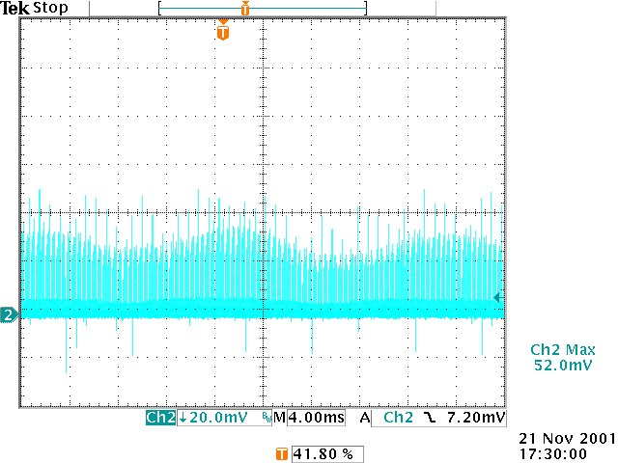
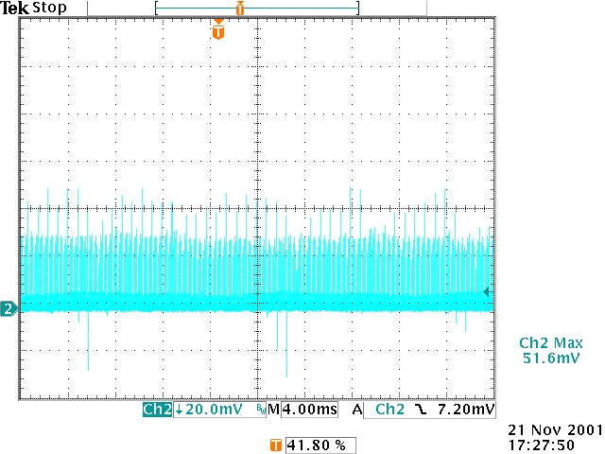

We have very tight tolerances on alignment of e-beam w.r.t. proton beam: <100 micron DC, <1 micron turn-to-turn and some 10-50 micron AC. Right Fig. shows some 20 micron 60 Hz p-p variation in hor beam position (thought to be due to gun solenoid field ripple) and how it was reduced by factor of 2-3 with use of dipole correctors in the solenoid.
The stabilization is still not routine. We believe that vertical stability is not better. New 14bit 120k-word system is coming for position fluctuation measurements (Alexei Semenov). P(pbar) beam should be equally stable.

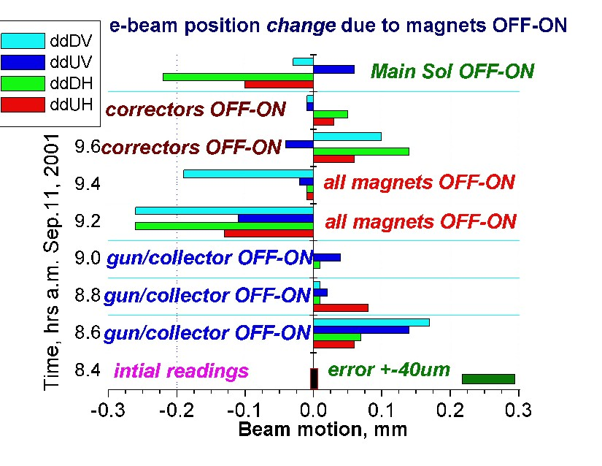
Our magnets have iron so beam position was found to be dependent not only on currents in all 9 magnets but also on history. The scale of the effect is 0.2-0.3 mm – see Figure above.

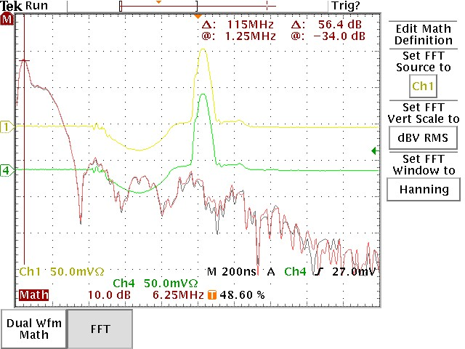
BPMs should have 0.1 mm accuracy in e/p/pabr position measurements . That is <0.02dB per channel A or B (0.3%). What we found is 2-5 dB at high frequencies (see Fig) and scope channels are different by upto 5% (about 1-1.5 mm). →New 15k$ scope – 2%! (but much faster). We now filter signals in 0-5 MHz and use a single scope channel for all measurements. E-p accuracy is about 0.4-0.5 mm (we need 0.1-0.2 and working on that). Relative accuracy is&was 10μm.

TEL as Tevatron abort gap cleaner and beam removal tool

- E-beam SC force drives 7th order resonance → losses
- TEL is equivalent to 1MW “tickler” (vs 50W in Q-mtr)
- E-current is fired every 7th turn in 3 Tevatron gaps
- E-beam placed to edge the p-orbit helix
- TEL reduces DC beam intensity and eliminates spikes
In the CDF losses
- Some good for BBCompensation – found afterpulse

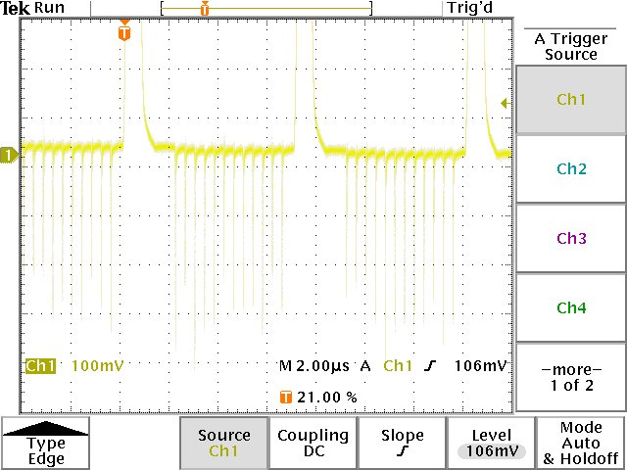

TEL pulses cover some 1 microsec in abort gaps. J_peak≈0.5A.

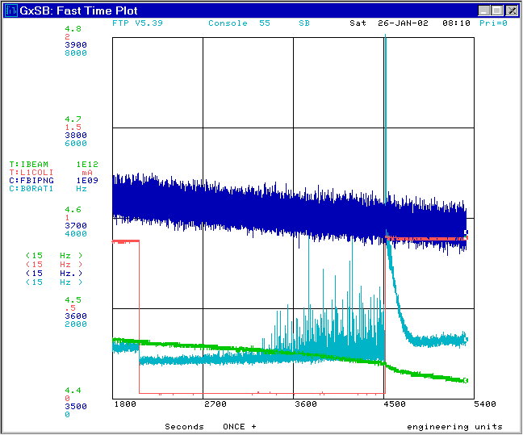

Without the TEL, DC beam acculates in 10-15 minutes and spikes appear in the CDF background.

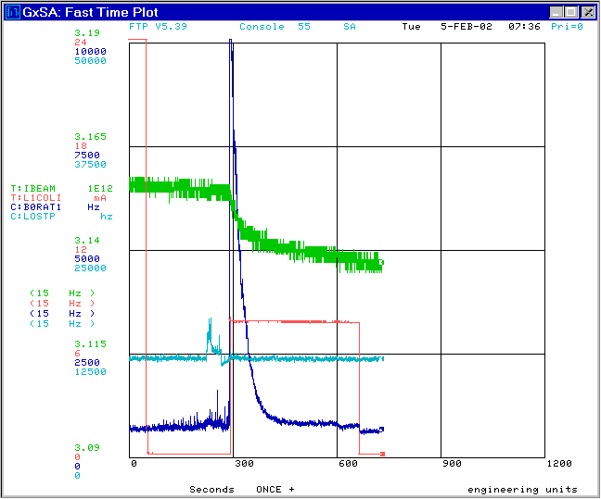

TEL kills a good portion of the DC beam in about 90 seconds (see above – optimized position and 1 A current). Kink in IBEAM corresponds to the DC beam intensity.

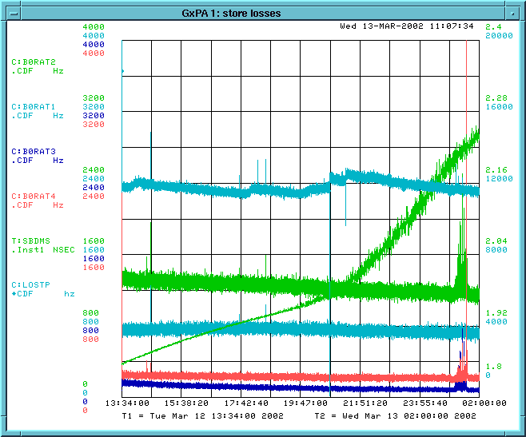
So TEL is used as a diagnostic tool: now it is turned ON early into each store, then OFF for ½ hour at the end of each store and then ON again to see the DC beam – see store #1070 losses.
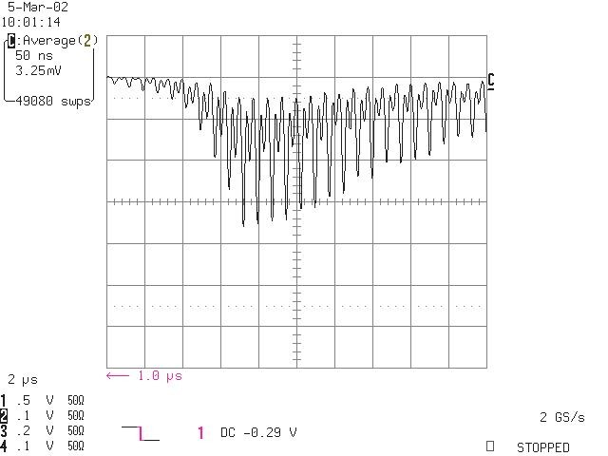

CDF losses in the abort gap with the TEL ON show 20 ns and 10 ns structure (TEL drives “DC-” and “DC+” beams).
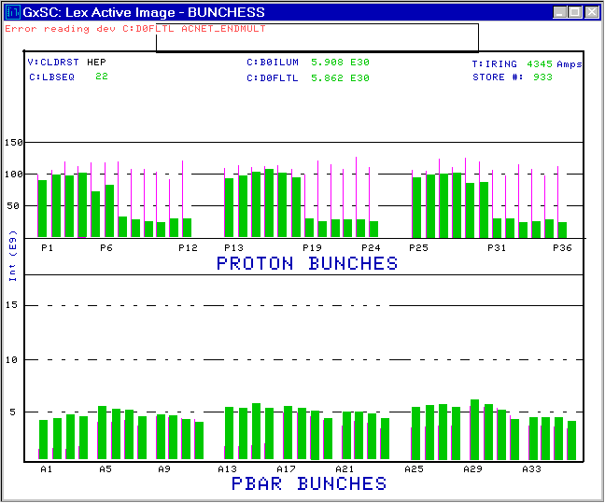
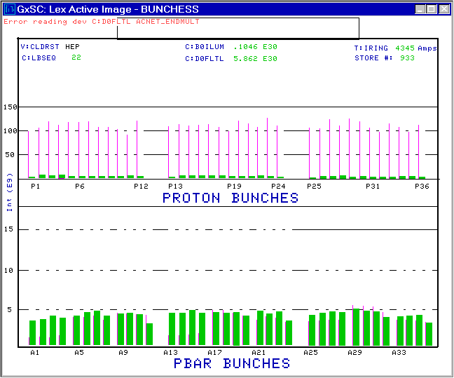
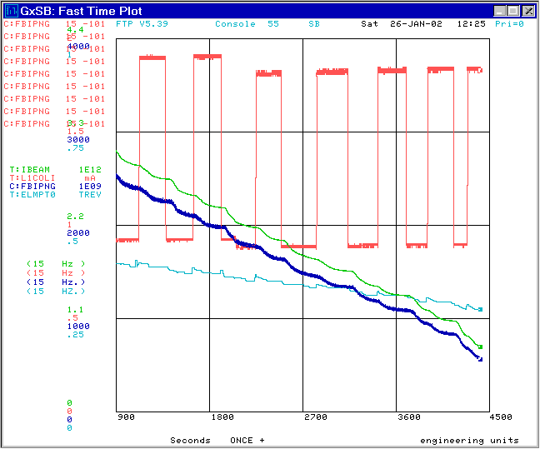
TEL can be used for p/pbar
Removal. For that e-current to be timed consequently on all bunches - see Figs. Process is slow (1 ½ hour)
But helped us to avoid quenches in Jan-Feb’02.

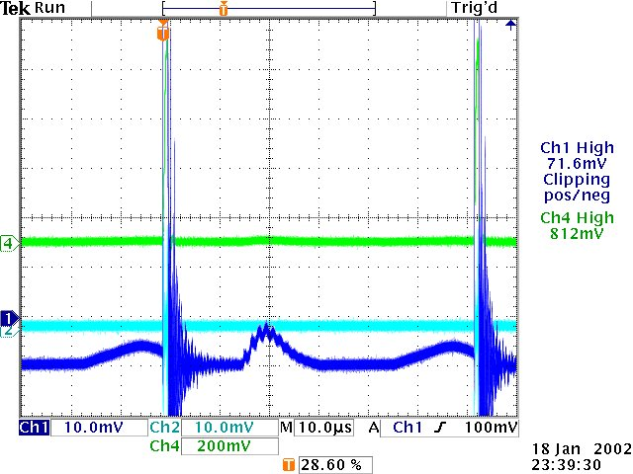
TEL is now operational, but there is some good for the BBCompensation project – e.g. we have revealed 2-4% “afterpulses” (see Fig) and eliminated them. There is some useful info on how stable TEL current has to be for the BBC.

Beam physics studies for the Beam-Beam Compensation:

- Since Sep’01 there were total 8 beam studies shifts with 980 GeV protons and 1 shift with antiprotons. Currently the rate is 3 shifts/month.
- Until recent 3 shifts p-lifetime was very poor (few hours) – probably due to inaccurate alignment
- With improved alignment we have got record tuneshift dQ=0.009 with 2.5A e-current, and exceeded 12 hour lifetime at the usual Tev WP 0.585/0.575 (also a record)
- New diagnostics resulted in better physics understanding
- TEL often works as a “soft collimator”

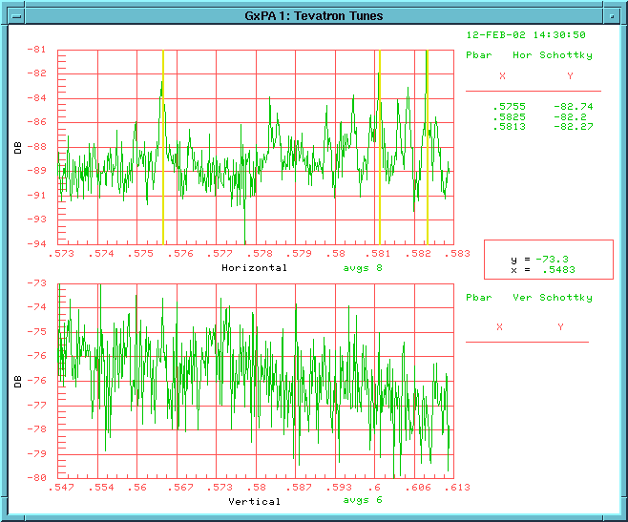
Schottky spectra for 3 pbar bunches in the Tev, about 8e9 each. One is shifted by the TEL down dQ_x=- 0.007. Width of the shifted beam line is not much different from unshifted. Operation of the TEL on pbars was found not very different from operation from protons, so we’ll take no pbar shifts until all the problems solved with protons.

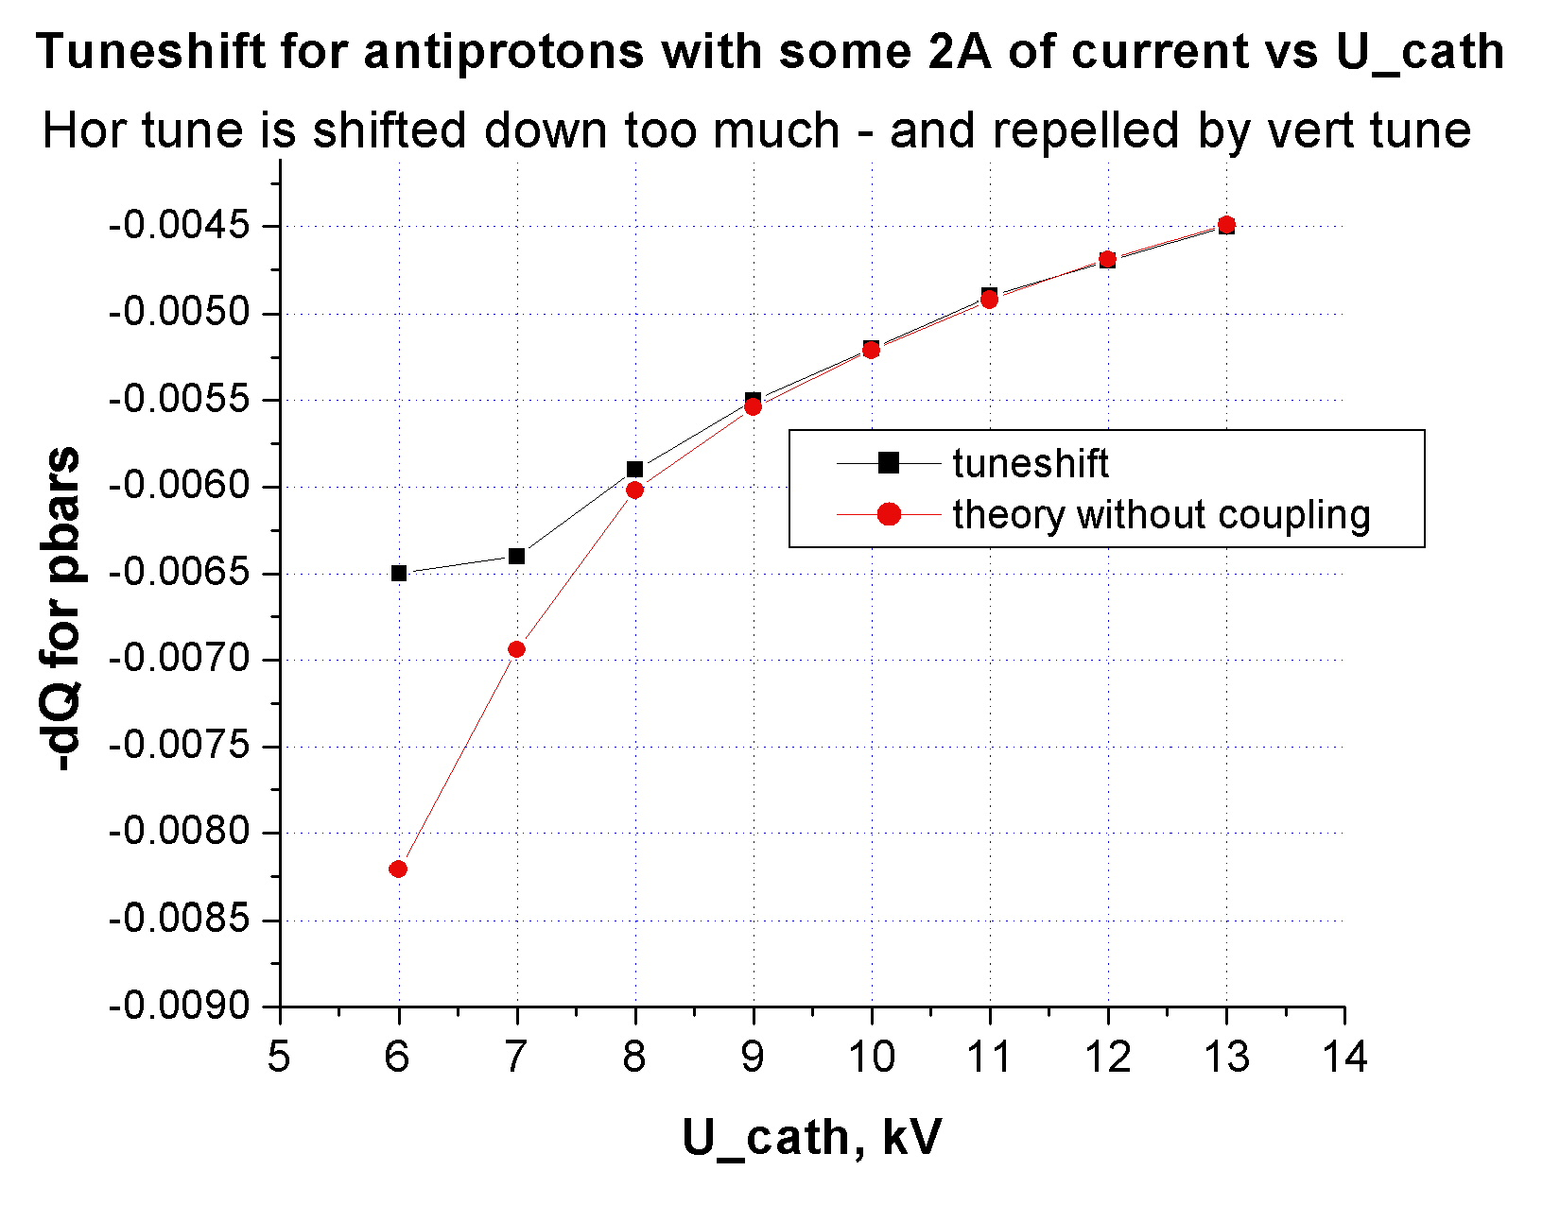
We understand tuneshift phenomena quite well – see e.g. theory vs experimental data on dQ vs the cathode potential.

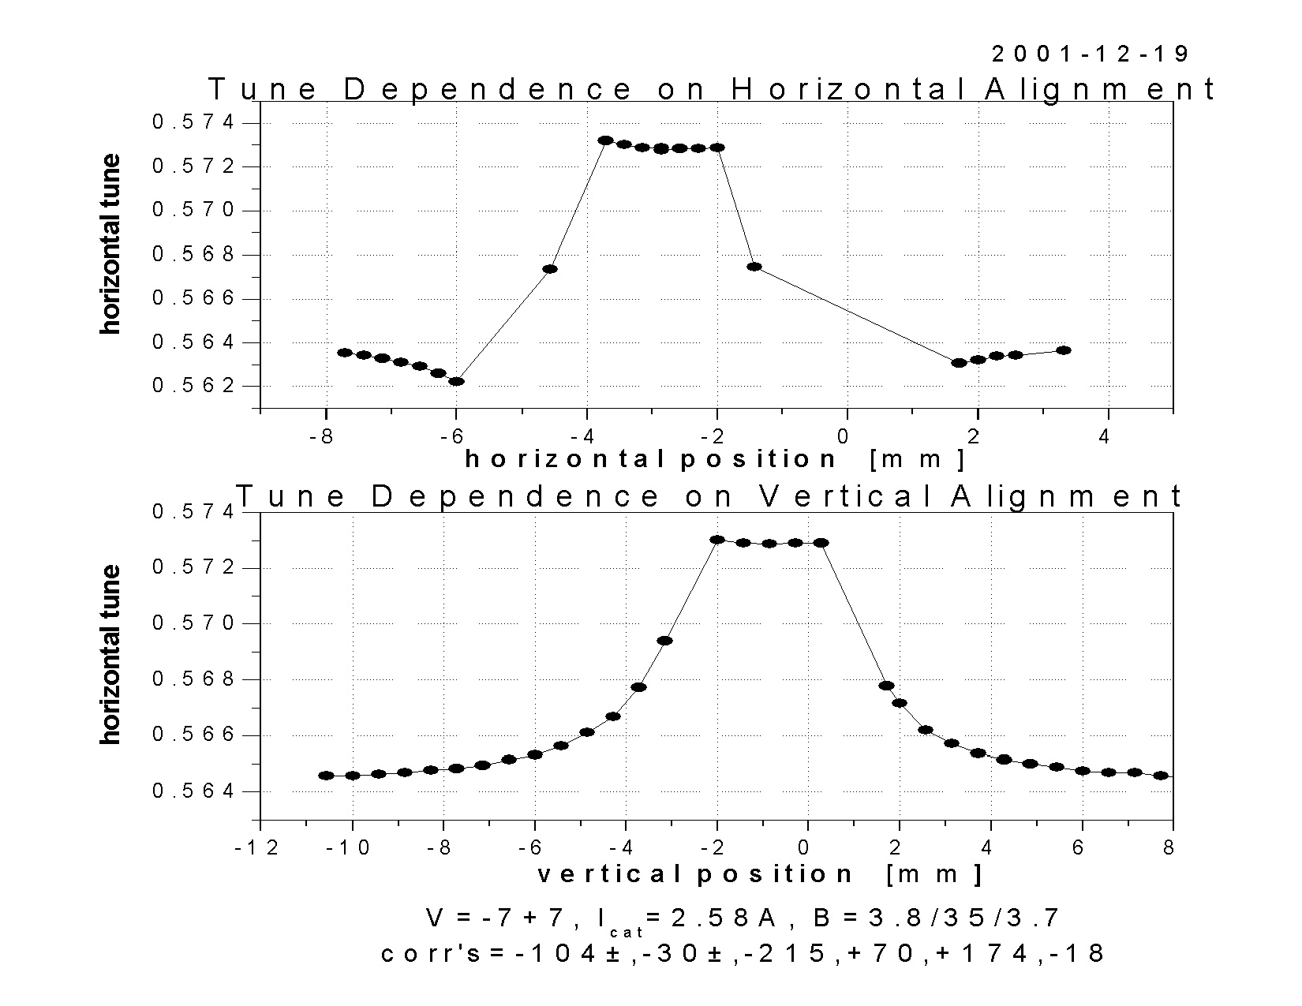

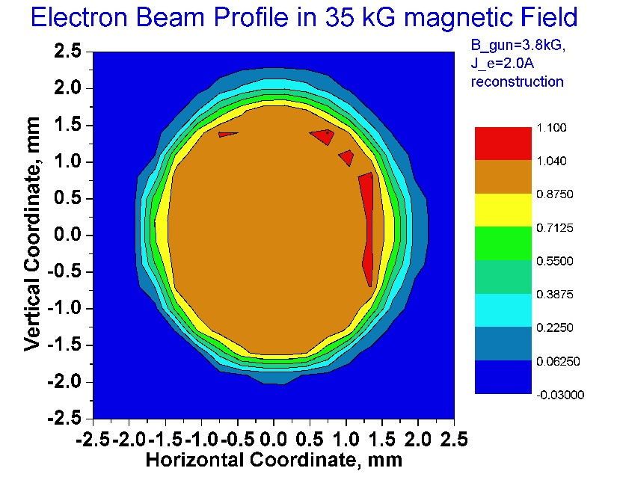
Recently, due to better e-alignment, we were able to reveal another effect: sign of the hole in the e-beam. (see right Fig). That was expected from e-beam profile measurements (see below). This is a terrible thing for p-beam dynamics at the e-edge.

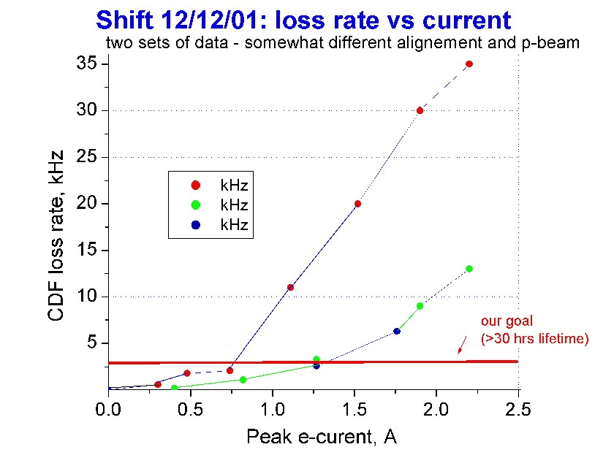

There are two competing theories of the lifetime degradation: a) nonlinearities kill the beam (e.g., if TEL alignment is poor), b) TEL noises blow up p(pbar) beam and lead to particle loss. Fig above shows the CDF los rate vs J_e under “not the best” aligment conditions. Quadratic behaviour is also consistent with noise hypothesis.
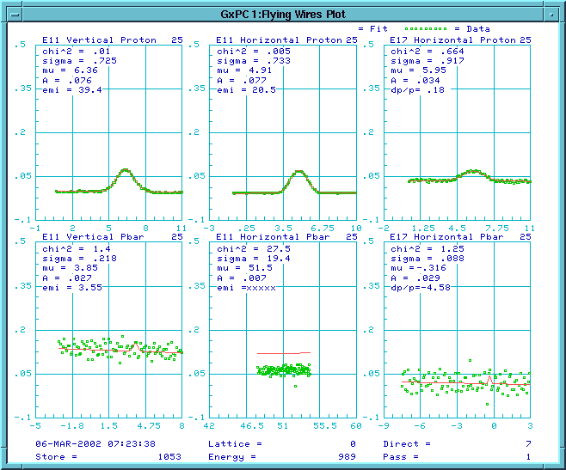
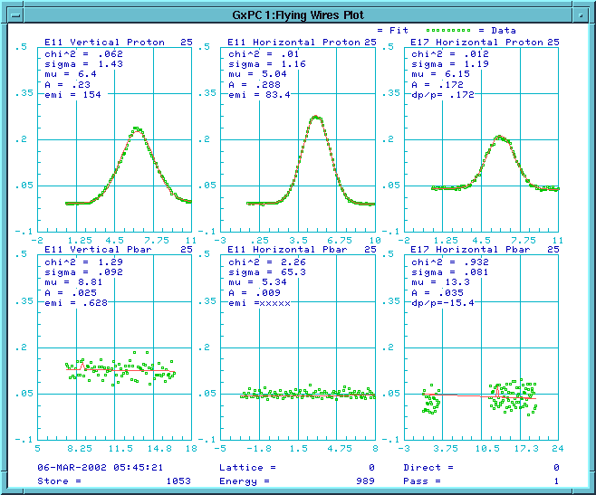
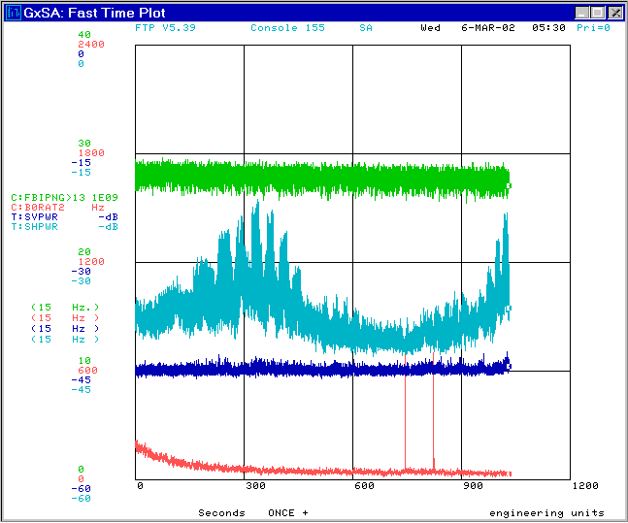
TEL works as a pipe collimator --
cuts everything outside aperture, but
what’s left lives well (see Figs – bunch 25 is blown up, collimated by TEL and has some 10 hour lifetime.

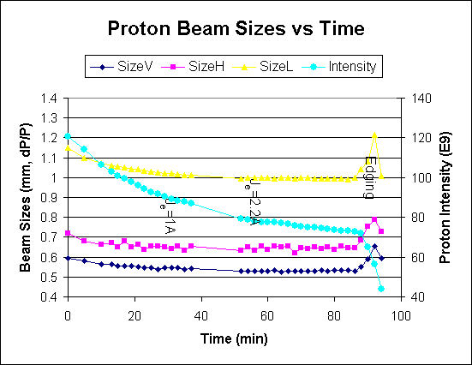

Data from another store – after any e-beam position adjustment, the p-beam size blows up (at 0 min and 86 min), then stabilized.

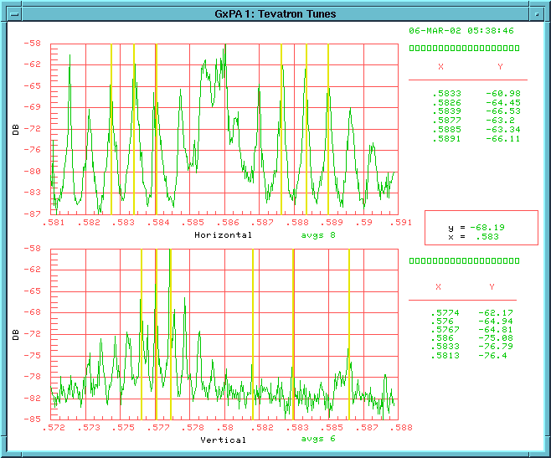
TEL noises? – Fig presents Schottky spectra with two bunches in the Tevatron . P25 has 169e9 protons and stays at the nominal TeV working point (left set of SB lines), P13 has 28e9 and shifted by TEL up 0.0065. Width of the SB-lines is about the same for P25 and P13 – so TEL alignment is probably good for P13. Amplitude of P25 peaks is only 2dB larger than P13 peaks A_sb=Q x X→ for 5 times different intensities Q it means that noise amplitude X is some factor of 4 larger in P13. [P25 lifetiem is about 200 hours, for 4 times larger noise amplitude it should drop 4^2=16 times to 12 hours – close to what we observe]

Our plans:

- Continue beam studies (including: measurements of e-beam noises, p-orbit motion msmnts, e-stabilization, etc)
- Make e-beam “smoother” → May shutdown: install new e-gun which will produce “smooth edge” electron beam; fix 120 Hz and 30 MHz ripple in e-current
- Make e-beam wider → fabricate new bending sections for TEL-1 and install them during August shutdown
- Modify FID pulser PFLs to get 10 kV pulse with >40ns flat top
- Personell problems → find a good RA

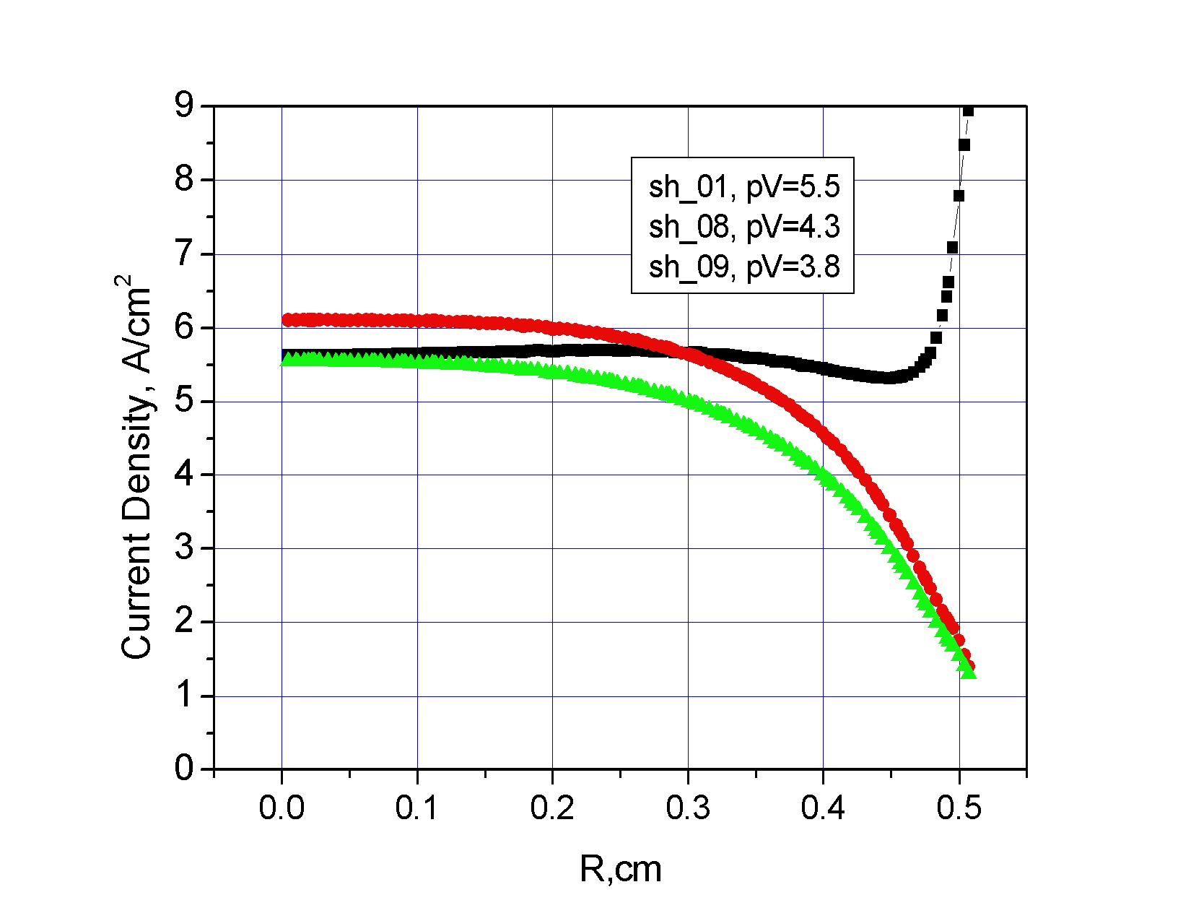
Calculated distribution of electron current density vs radius with original (black) and modified geometry of the gun electrodes (green and red)

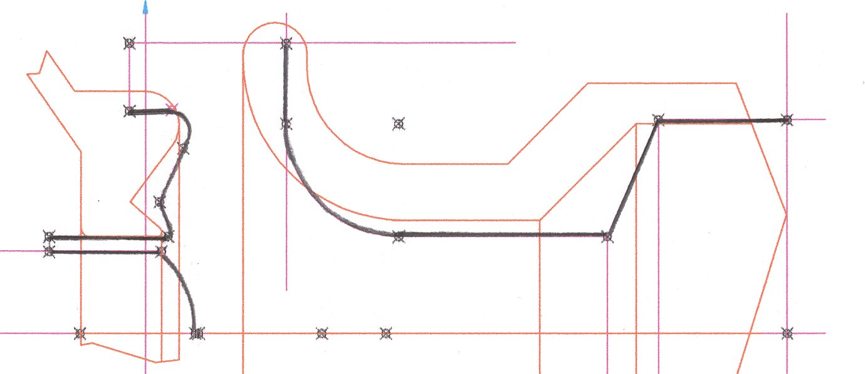
Shapes of electron gun electrodes (anode, cathode and near-cathode electrode)for bell-shape profile (black) and for flat-top electron current profile (red line).

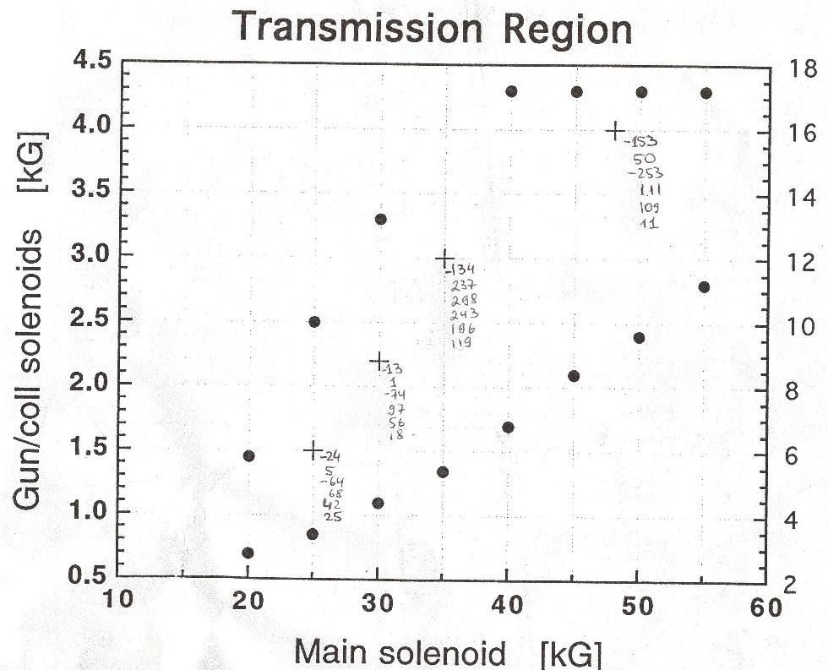
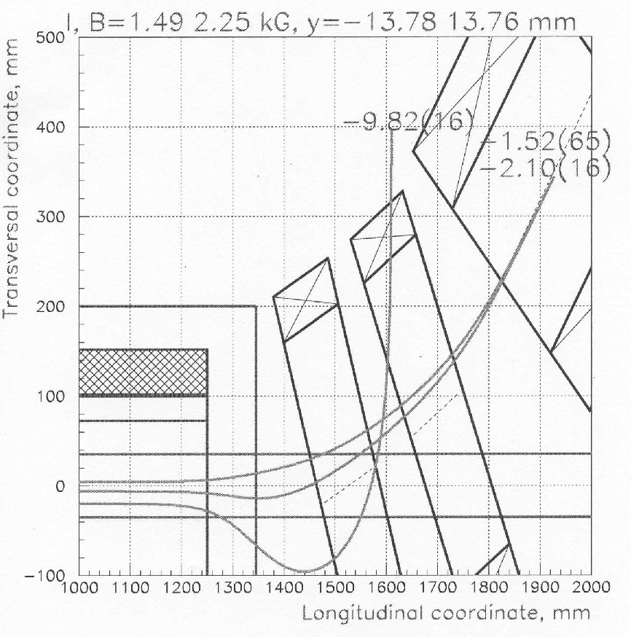

Transmission region of the TEL-1 (measured) and magnetic field simulations for the TEL-1M which will allow 60% larger e-beam size variation.

