Dermatologic and Ophthalmic Drugs Advisory Committee
and
Drugs Safety and Risk Management Advisory Committee

July 12, 2004

Statement of Tyrone Gorre

My name is Tyrone Gorre and I am a professional fishing guide and ranch hand from Newcastle, California, which is about a forty-minute drive northeast of Sacramento. I am 45 years old, single, and have two great daughters.

I want to say thanks to the National Psoriasis Foundation for making it possible for me to be here today to share my story.

And I have to say for the record that I do not have a financial interest in the company that makes oral tazarotene.

I have had psoriasis for almost all my life. I have tried many different treatments over the years, including UVB light, PUVA, topical steroids, Dovonex, Tegison, and methotrexate.

My psoriasis really started getting bad when I was about 25 or so. I had it a long time before that, but that’s when it became much more widespread and visible on my face and all over my body. At the time I was married and raising young children.

Psoriasis changed my life. I used to be a life guard and wear shorts all the time. I gradually changed until most of my shirts were long-sleeved. I covered myself up because I was embarrassed. At that point I had psoriasis on about 40% of my body.

My daughter told me recently that her mother said one of the reasons we divorced was because I did not have psoriasis before we married but I did afterwards. She said this was a big factor in our divorce. I believe it.

I tried Tegison to control the psoriasis. But I had to stop taking it because it did not work that well for me and because of the side effects. Then I tried methotrexate. This worked OK for a little while, but then I had to stop it too because it affected my liver and blood. Then I tried PUVA light treatments for a while. They helped a little bit but certainly did not clear my skin entirely.

Then there was a period of a few years when I simply played “cover up” because I did not have regular access to health care or health insurance.

(over)
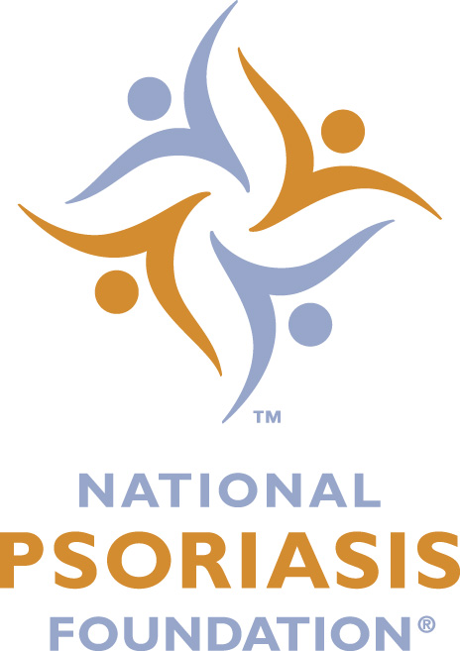

DODAC/DSRMAC, July 12, 2004
Statement of Tyrone Gorre
Page 2

Since I had bad psoriasis for a long time and had known a dermatologist that helped with research studies, he asked me if I wanted to participate in a study of this new drug oral tazarotene.

I thought about it seriously. At the time, I had a nephew who was beginning to show signs of psoriasis. He was about the same age I was when my psoriasis started getting bad. This was the extra motivation I needed to join the study. I was willing to do it because I wanted to answer questions about psoriasis for myself, for my family, and for other families too.

During the first part of the study I am 99% sure I received a placebo. There was zero effect. During the second part of the study, I received the drug. The only side effect I noticed was peeling skin. After about week six, I noticed the thickness of the plaques shrinking dramatically. I certainly did not notice any depression. I was excited!

Within about four months I was 95% clear and just had tiny little areas of affected skin. The research clinic said I went from having 25% of my body affected to 4%. That was a pretty good improvement, and it felt like more than that.

At the point the study ended, I had only a few patches of red skin here and there, smaller than the size of a quarter. For the first time in my life, I was virtually clear of psoriasis. It was amazing!

I was wearing sandles and open-toed shoes. I was even wearing a black suit, which is amazing! A while ago, for the first time in 28 years, I wore a tuxedo with a silk collar, with confidence. For the first time in my life, I went to Calistoga hot springs with confidence. At my health club, I go to the shower and do not worry about it at all.

I used to feel bad. The amount of mental pressure that this has released is just huge. The confidence that not having psoriasis brings is amazing. It is so rewarding to not have to worry so much.

There are three huge things this study changed for me: One, with psoriasis you can’t sleep because of the itching. I can sleep all night now. Two, you are so self-conscious and the psoriasis eats at your confidence all the time. All that changed too. Three, the constant pain and stinging of psoriasis are incredible. It just consumes a huge part of your life. That was gone too.

I will live with psoriasis for the rest of my life. I am really glad I got involved in the study because it gave me hope and it should give other people with psoriasis hope too. After more than 20 years struggling with psoriasis, I feel like a new man using this drug. This medication has not only improved my physical health, it has given me back my self-confidence.

One thing I hope is that this committee will do what it can to make this drug available to patients who need it. This was definitely the least threatening oral medicine I have tried for psoriasis. It has worked for me. I did it for myself and for my family and for the thousands of people just like me.

Thank you very much.

