 | Module 14  Blood Collection  and Handling –  Dried Blood Spot (DBS)

Purpose | To provide you with the skills to collect and handle dried blood spots (DBS) for EQA purposes.
Pre-requisite  Modules | Module 6: Safety at HIV Rapid Testing Site  Module 8: Blood Collection – Fingerprick  Module 13: EQA
Learning Objectives | At the end of this module, you will be able to:  - Collect dried blood spots (DBS)  - Package and store DBS in a way to maintain specimen integrity  - Maintain DBS records  - Distinguish between valid and invalid DBS
Content Outline | Required supplies  How to collect and dry DBS  How to package and store DBS  Valid and invalid DBS  Hands-on practice
Handout | Example Specimen Transfer Log for Re-Testing

Notes on Customization

What Is a Dried Blood Spot (DBS)? | Dried Blood Spots (DBS) are whole blood collected on filter paper and dried. They are made directly from the client’s whole blood.  DBS are used for re-testing at a reference laboratory, which may be part of your country’s External Quality Assessment plan. Testing site results are compared to reference laboratory results. DBS samples are useful for re-testing as they are easy to collect, store, and transport.
EQA Re-testing | Remember…Two types of specimens may be collected at the site for referral to a reference lab for re-testing: serum/plasma or dried blood spots (DBS).
What Are Your Responsibilities? | Your EQA responsibilities include:  - Collecting valid specimens  - Labeling and store appropriately until transported for re-testing  - Ensuring records are properly maintained  - Avoiding transcription errors  A test result is only as good as the specimen collected.
EQA Specimen Transfer Log | An example EQA specimen transfer log is provided for your reference at the end of this module.
Data recorded on transfer logs must be accurate. Care should be taken in transferring information from test records to EQA transfer log. Errors that are typically made include:
- Specimen ID on transfer log sheet doesn’t match specimen ID filter paper
- Final result at testing site incorrectly transcribed from test records
Required Supplies for DBS | When collecting DBS, you need the following items:  - Blood collection card (filter paper)  - Glycine weighing paper  - Sealable plastic bags  - Humidity cards  - Desiccant packs |  |  | 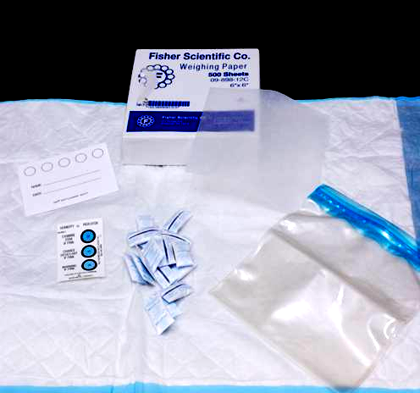
 | Other supplies include safety supplies such as discard bins and supplies for performing a fingerprick. While the collection card may include 5 circles, only one patient/client’s blood may be collected on one card.
How to Collect DBS | Always use Universal Safety Precautions. This includes:  - Treat all blood samples as though they are infectious  - Wash hands  - Wear gloves and apron/lab coat  - Take precaution to avoid needle injury  - Dispose of contaminated sharps and waste appropriately |  |  |  |  | 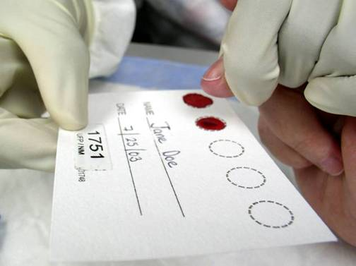  It is critical that entire circle be uniformly saturated.
 | Clearly label each card with appropriate identification number – It is unacceptable to submit a blood card for testing that has not been properly labeled.
Follow the fingerprick procedure and the additional steps below:
- Apply gentle pressure to the finger and allow a large drop of free flowing blood to collect at the puncture site.
- Working quickly, hold the filter paper by the edges and touch the filter paper gently against the large drop of blood and in one step allow a sufficient quantity of blood to soak through and completely fill or saturate a circle. A completed saturated spot will contain 100 µl of blood.
- Repeat, until you have collected enough blood to fill at least 3 circles on the blood collection card.
- Completing filling the circle is important because the laboratory will need to use a hole puncher to punch a section of the circle of blood for testing
- If collecting spots using a pipette, collect 100 µl of blood and gently apply to filter paper.
Additional tips:
- DO NOT press the filter paper against the puncture site.
- Apply blood to only one side of the filter paper.
- Do not layer successive drops of blood or apply blood more than once in the same collection circle.
- Do not “milk” the finger as excessive milking or squeezing the puncture site might cause hemolysis of the specimen or result in collection of tissue fluids with the specimen, which might adversely affect the test result. (NOTE: “hemo-” means red cells, “-lysis” means destruction, “hemolysis” means destruction of red cells.)
NOTE: Two complete circles are better than five incomplete ones! While the collection card may include 5 circles, only one patient/client’s blood may be collected on one card.

How to Dry DBS | Important tips for drying DBS:  - Avoid touching or smearing the blood spots  - Allow the specimen to fully air dry horizontally (at least 3 hours) at room temperature  - Keep away from direct sunlight - Care should be taken to avoid exposing DBS to environmental conditions that may compromise the integrity of the specimen. DBS should not be dried near an open window as sunlight, dust and in some cases flying insects may come in contact with the DBS during the drying procedure.  - Do not heat, stack or allow DBS to touch other surfaces during the drying process
Dry Completely Before Packaging | There are several ways in which you can effectively dry DBS  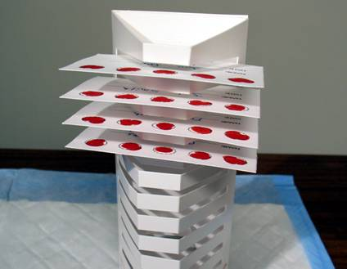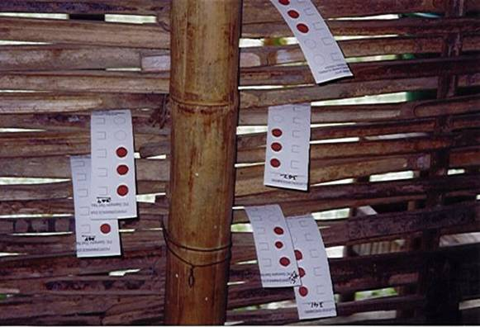
The image on the left is one that was taken in India. DBS are dried horizontally between bamboo.
The image on the right can be obtained from Schleicher & Schuell Bioscience, Inc. (Manufacturer of DBS collection cards)
DBS change from bright red to dark red as they dry.

How to Package DBS for storage: An overview | Follow these steps:  - Appropriately stack DBS  - Insert into sealable plastic bag  - Add desiccant packets  - Add humidity cards  - Label contents of bag and seal.
Step 1 - Stack DBS | Place weighing or glycine paper between DBS cards before transport to prevent cross-contamination.
 | 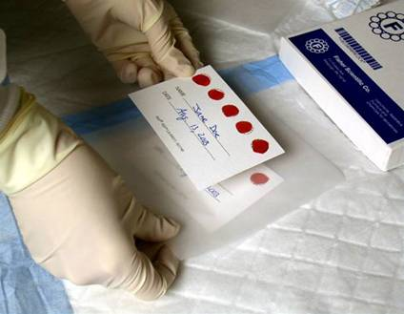 |  |  |  | 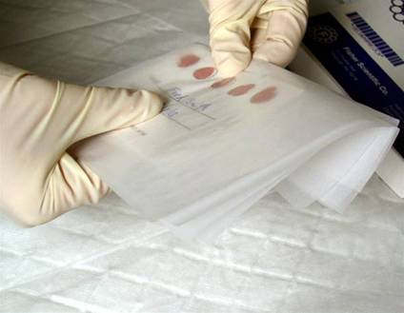
 | Place filter paper between sheets of weighing paper |  |  |  | Fold weigh ends of weighing paper
Step 2 - Insert Into Sealable Plastic Bag | You can typically place up to 15 DBS cards in each plastic bag. The bag should be just the right size to hold the cards. Avoid using bags that are too big as the cards will shuffle inside the bag. |  | 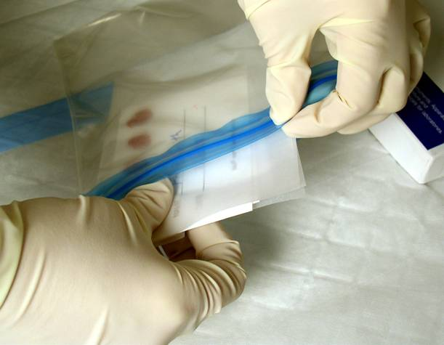
 | Sandwich bags will not work as many of these are of the type where you fold the top. The bag should be a sealable heavy duty plastic bag, one that will prevent moisture from entering.
Step 3 - Add Desiccant Packets | 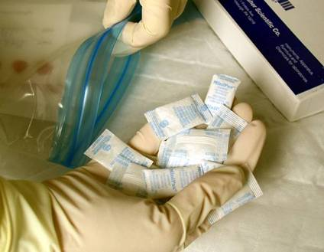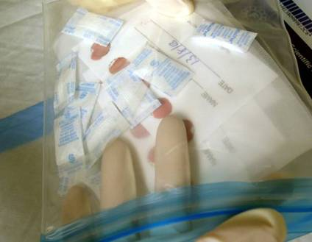  Desiccant packets serve as a drying agent. At least 5 desiccant packs should be placed in each bag. Some sites may need more or fewer packets in each bag depending on environmental and storage conditions.  Desiccant packets vary in size. The ones seen here are the smaller ones.
Step 4 - Add Humidity Cards and Seal Bag | Often humidity cards must be recharged before use. If the humidity card is pink at the 30% level, you must:  - Recharge card and desiccant pack by heating at 50-60○C for 3-4 hours in a drying oven.  - Cool 10 minutes.  - IMMEDIATELY RETURN card and desiccant pack to sealable plastic bag. |  |  |  | 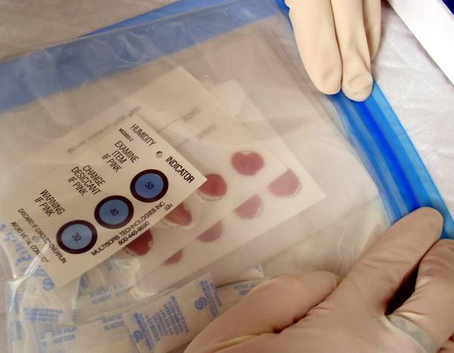  Note: If a drying oven is not available, place cards and excessive number of desiccant packets in a sealable bag or envelope
Step 5 - Label Outside of Plastic Bag with Contents | A permanent marker should be used to clearly label the contents on the bag. | 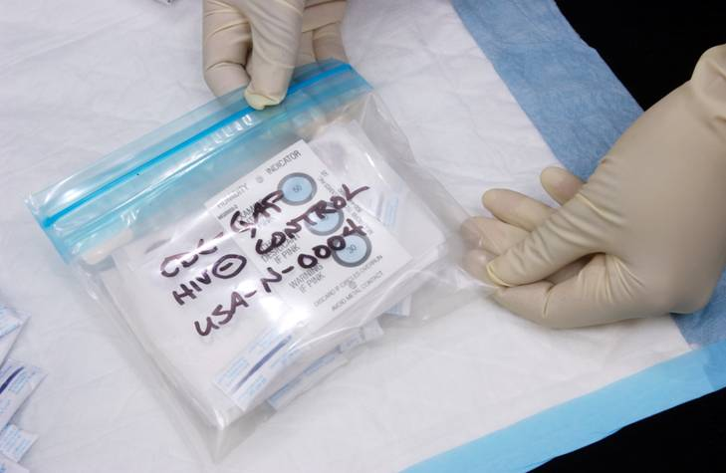
How to Store DBS | Keep packaged DBS (in sealable plastic bags) cool and dry until transported to reference laboratory. It is also acceptable to store DBS in a Styrofoam box.  Avoid leaving it in a vehicle, as sun and heat will deteriorate DBS  Avoid placing spots in an malfunctioning refrigerator where water may drip on or soak the spots
How to Package DBS for Shipping | 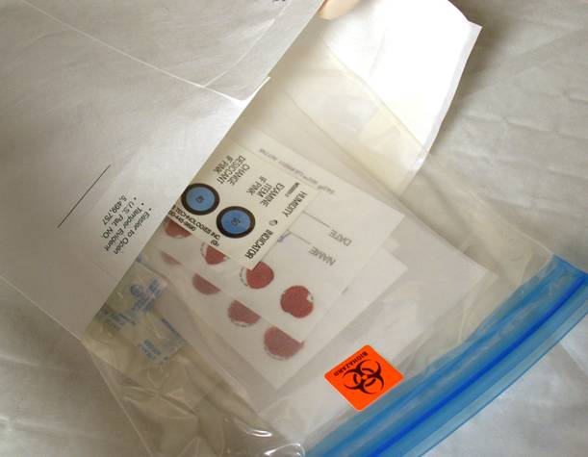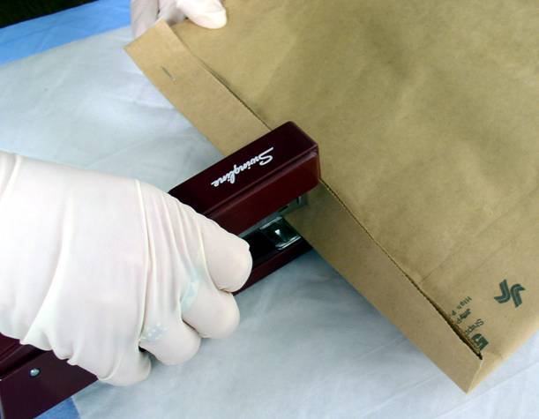
Follow these steps:
- Insert bundled DBS into rip-resistant envelope. The sealable plastic bag has a label on the outside indicating bio-hazardous contents.
- Include appropriate documentation (such as EQA Specimen Transfer Log) with the shipment
- Insert both into brown envelop and seal for shipment.

Valid DBS Specimen | This specimen is valid because:  - 100 µl of blood has been collected in each circle completely saturating or filling the circle  - The filter paper card has been labeled with appropriate identification.  - Blood is soaked through to the other side of the card. |  |  |  |  | 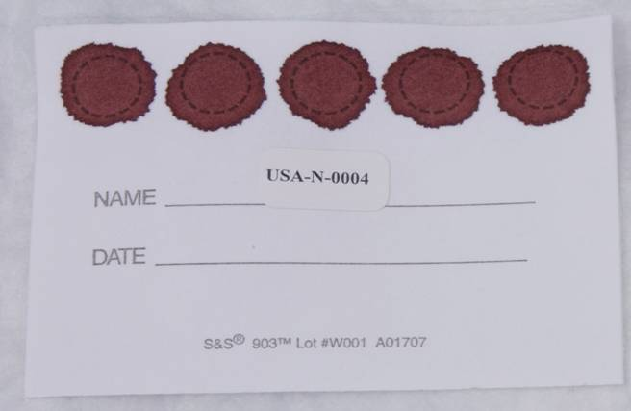
Valid DBS Specimen | On the card with MB/KP/120, the blood is spreading from one circle to another due to the anemia (anemic blood is more fluid). This is still considered a valid specimen. Blood has completely filled the circle. Notice that the third and fifth circles have been punched (hence the white area in the middle). |  |  |  | 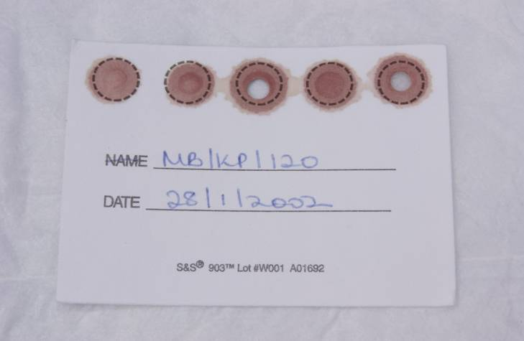
Invalid DBS Specimen | 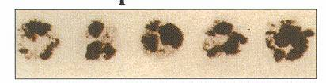
This specimen is invalid because quantity of blood is insufficient for testing. This may have been caused by::
- Removing filter paper before blood has completely filled circle or before blood has soaked through to the other side
- Applying blood to filter paper with a capillary tube
- Filter paper coming in contact with gloved or ungloved hands or substances such as hand lotion or powder, either before or after blood specimen collection

Invalid DBS Specimen | 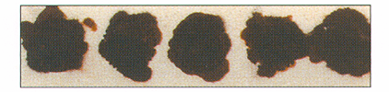
 | This specimen is invalid because it appears scratched or abraded. This may have been caused by applying blood with a capillary tube or other device.
Invalid DBS Specimen | 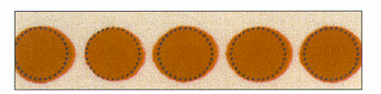
 | This specimen is invalid because the specimen was not dry before mailing. DBS must dry a minimum of 4 hours before packaging and shipping.
Invalid DBS Specimen | 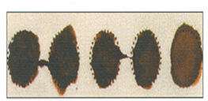
This specimen is invalid because the specimen appears clotted or layered. This may have been caused by:
- Touching the same circle on the filter paper to blood drop several times
- Filling circle on both sides of filter paper
The volume of specimen will not be uniform between spots resulting in errors during the testing process.

Invalid DBS Specimen | 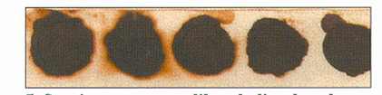
This specimen is invalid because the specimen appears hemolyzed, discolored, or contaminated. This may have been caused by:
- Squeezing or “milking” of area surrounding the puncture site
- Allowing filter paper to come in contact with glove or ungloved hands or substances either before or after blood collection
- Exposing blood spots to direct heat

Invalid DBS Specimen | 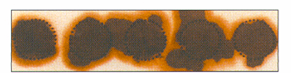
This specimen is invalid because the specimen exhibits serum rings – in other words, serum becomes separate from cells. This may have been caused by:
- Not allowing alcohol to dry at puncture site before making skin puncture
- Allowing filter paper to come in contact with alcohol, hand lotion, etc.
- Squeezing area surrounding puncture site excessively
- Drying specimen improperly
- Applying blood to filter paper with a capillary tube

Invalid DBS Specimen | 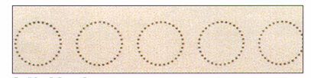
 | This specimen is invalid because no blood was applied to the filter paper.

  Key message | - DBS are used for re-testing at a reference laboratory, which may be part of your country’s External Quality Assessment plan  - Care must be taken to collect, dry, store, and ship dried blood spots used for re-testing.

 | Module Review
Find out how much you have learned by answering these questions.
Describe the procedures for collecting DBS.
______________________________________________________________________________________________________________________________________________________________________________________________________

Describe the procedures for drying DBS. ______________________________________________________________________________________________________________________________________________________________________________________________________

Describe the procedures for packaging DBS for storage. ______________________________________________________________________________________________________________________________________________________________________________________________________

Describe the procedures for storing DBS. __________________________________________________________________
__________________________________________________________________
__________________________________________________________________

 | Module Review
Find out how much you have learned by answering these questions.
Describe the procedures for packaging DBS for shipping. ______________________________________________________________________________________________________________________________________________________________________________________________________

Describe the criteria for valid DBS samples. _______________________________________________________________________________________________________________________________________________________________________________________________________________

- What may have caused a DBS sample to be invalid?
______________________________________________________________________________________________________________________________________________________________________________________________________

Example Specimen Transfer Log for Re-testing

[Insert Name of Referring Testing Site,
Contact Name
Address and Phone Number]

Date: _______________________ Referring Testing Site _________________________________

Specimen Tracking Number | Test Subject  ID* | Final Result (Testing Site) | Date Specimen Collected | Specimen Type  (DBS or Serum) | Collected by | Referral Lab Req† Completed (✓) | Date to referral lab | Date Conf  Result Received | Result of Re-test
*ID = Identification
†Lab Req = Laboratory Requisition

