
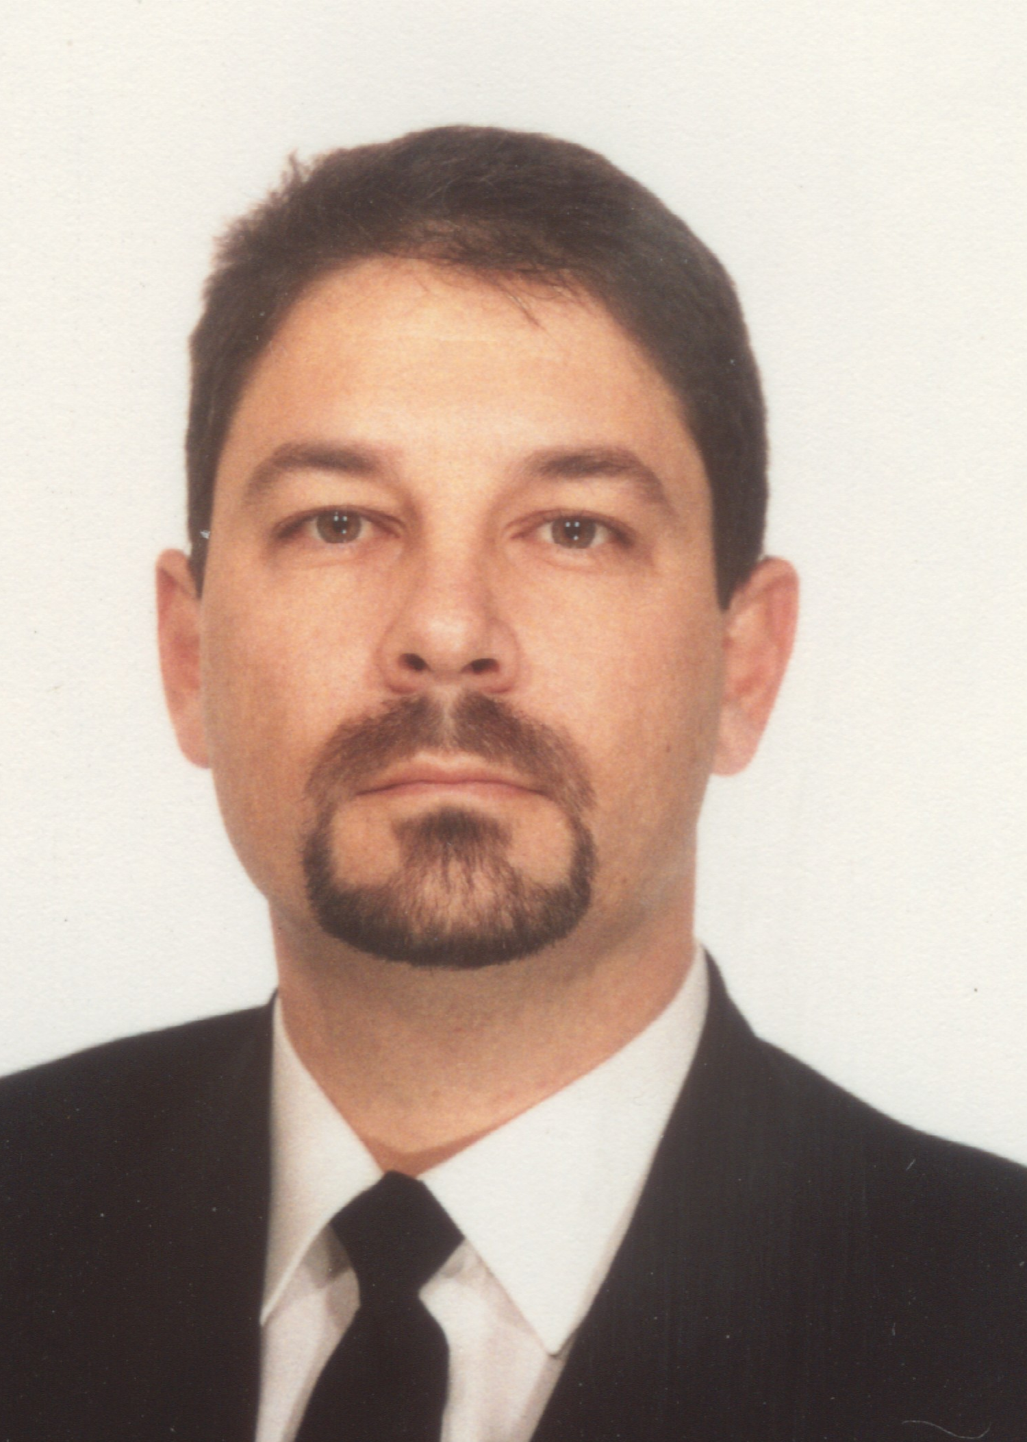

Mr. Enzo Maria Feliziani
Pilot
ENAV S.p.A Flight Inspection Dept.
Hangar 127 Ciampino Airport
00040 Roma
ITALY mail: e.feliziani@tin.it
Mr. Fabrizio Boris Maracich
Pilot
ENAV S.p.A Flight Inspection Dept.
Hangar 127 Ciampino Airport
00040 Roma
ITALY
mail: f.marak@infinito.it

ADVANTAGES IN EMPLOYING AN OPERATIONAL COORDINATOR

DURING FLIGHT INSPECTION ACTIVITIES
June 2002

ABSTRACT

The Paper presents the results of a study conducted by ENAV Radiomisure, in 2001, on the advantages resulting from a tighter collaboration between the Air Traffic Controller unit and the Flight Inspection Crew. This collaboration is obtained experimenting a new figure, called Operational Coordinator, working side by side with air traffic controllers during flight inspection.
With the introduction of the Operational Coordinator the following advantages have been reached:

- A better use of the communication frequency;
- A comfortable Air Traffic Controller because of the support of an expert at his\her side;
- Reduced delays for commercial flights;
- Greater economy for the Flight Inspection Dept.
The paper will provide an overview of the methodology used and the results of the experimentation.
PURPOSE

To make more efficient the FI activity in the most congested traffic environment.

BACKGROUND

It is easy to understand the difficulties of performing FI flights in a very busy environment.
These are the four main problems encountered during day by day operations:

- Delay – commercial traffic;
- Delay - FI activity;
- Air Traffic Controllers providing unnecessary separations between FI aircraft and rest of traffic since FI flight profile are not well known;
- Tendency of Air Traffic Controllers to consider the FI activity as “low priority”, thus putting the FI aircraft in a sort of “last of the line” condition.
As an example, to explain in real world terms the challenge of FI activity in busy areas, we can look at Milan Malpensa airport ILS RWY 17L.
The geographical location of the airport, close to the Alps, (the tallest mountains in Europe) is itself a problem, with SIDs and STARs complicated by other nearby airports: Turin Caselle, Milan Linate, Bergamo, all of them busy international airports. The commissioning of ILS RWY 17L was a serious threat to the delicate ATC mechanism, with severe delays forecasted for commercial traffic.
Flow control was issued to permit FI to take place and the landing rate was reduced from 30/37 movements/hour (duty RWYs 35R & 35L) to 6/8 movements/hour (RWY 17L – VOR DME approaches).
Malpensa is one of the European hubs and such delays can have a severe impact on the whole European ATC system. In our previous experiences as radar ATCOs we realized the difficulties in managing FI activities in the most congested traffic areas, but we realized also that to avoid further complications (every minute of delay assigned to FI aircraft is a one more minute to manage with traffic restrictions) we need to permit FI to take place and to be completed in the shortest time possible.
Nowadays, as FI pilots, we have the whole picture. We are better able to understand the problem from the flight crew’s point of view. Combining this knowledge with our previous experience as air traffic controllers we decided, in collaboration with our staff, to find a solution in order to improve the coordination between the air traffic controller and the flight crew during the FI activity.

SUBJECT

ENAV S.p.A. FI Dept. during the last year has experimented a new professional figure, “The Operational Coordinator.”
The Operational Coordinator is an expert in the FI sector; possibly a FI pilot and even better one with experience as air traffic controller (radar rating clearly an advantage).

The tasks of the Operational Coordinator include:

- To Coordinate all relative ATS Units. First step is to get in touch with the Unit Supervisor and to explain in general the FI activity. A subsequent meeting with FMU supervisor and ARR/DEP supervisor is set to start looking at the details such as the needs to issue flow control or ARR/DEP special procedures. The two supervisors will then instruct their respective teams to take appropriate actions. At this point the ARR/DEP supervisor will introduce the OC to the duty Controller (FI aircraft ready for departure). A workstation is provided for the OC and real time coordination begins. During shift changes in the ATC workstations the OC is the “memory” of the events, thus making the job of the Controller entering service easier.

- To assist the controller on duty, giving him all information regarding the FI aircraft ( mainly speed vs profile and altitude/level vs profile data or lateral position vs profile data) in advance.

- To answer any doubts which a controller may have regarding the present and future flight profile of the aircraft.

CONCEPT VALIDATION

In order to test the validity of the assumption that “the Operational Coordinator improves the overall efficiency of FI”, ENAV S.p.A. issued duty orders to employ the OC during the regular FI checks on very busy airports such as Roma Fiumicino, Milano Malpensa, Milano Linate and Palermo.

METHODOLOGY

To understand the methodology and the advantages better; we will show one of the test flights in detail: the annual ILS Rwy 34C check at LIRF (Roma Fiumicino).

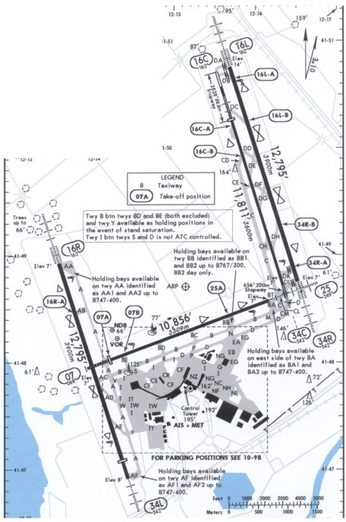
LIRF
AERODROME
CHART

The test flight was held 28th of march 2001.

Scheduled operations were as follows:

12:00 Crew briefing – Pilots, FI system operator, Operational Coordinator (OC)
13:30 The OC moves to the Area Control Center where he briefs the DEP/ARR Coordinator and the Controller on duty, then he takes position beside the controller on duty, with provision of every things he needs to coordinate the activity, including the possibility of monitoring the GAG frequency

LIRF RWY 34C
APPROACHES CHART

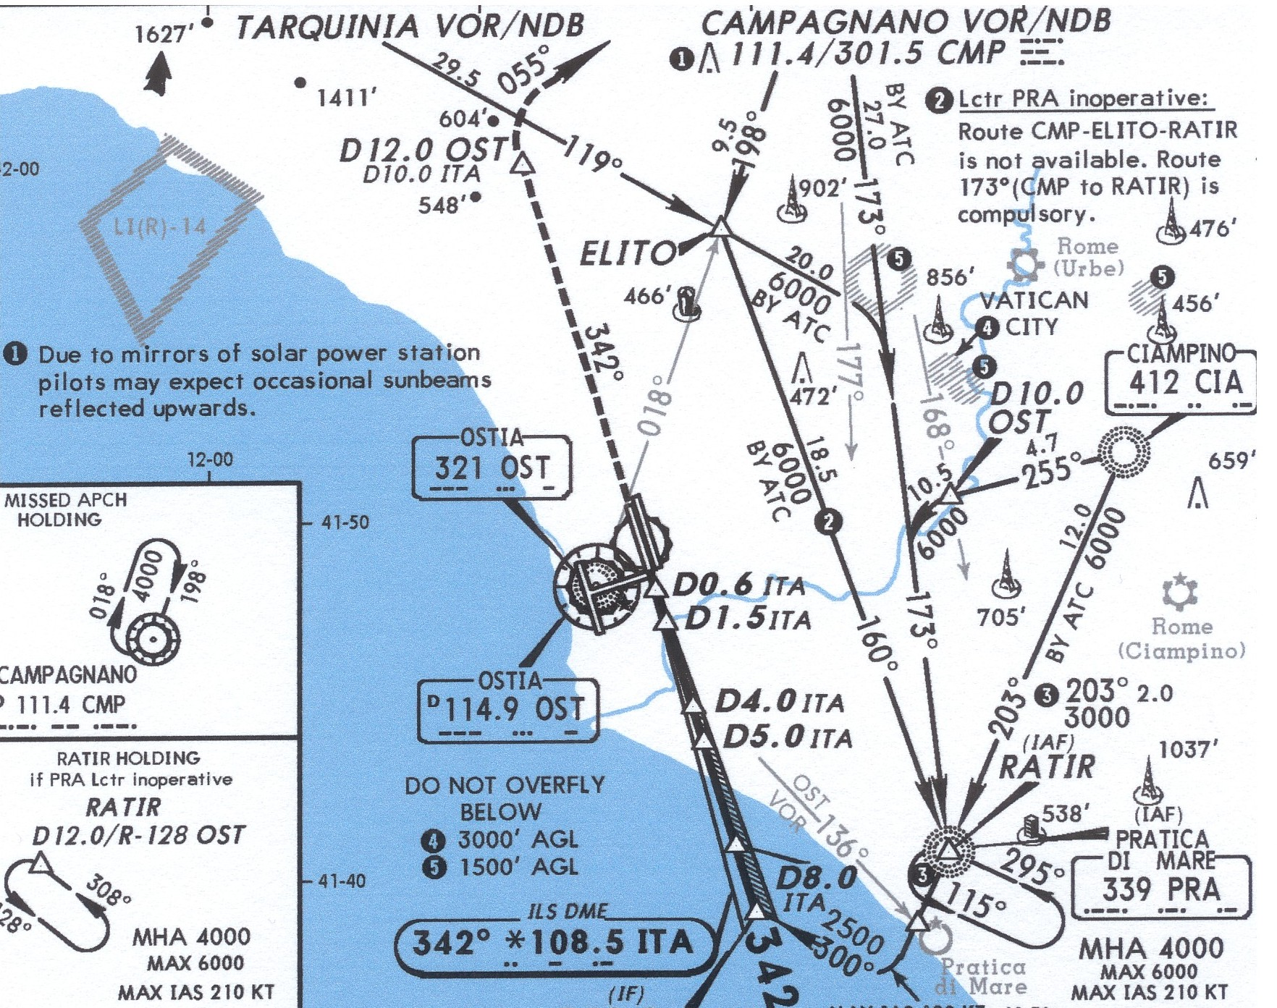

13:50 I-AVRM takes off from Roma Ciampino airport
14:00 FI activity starts
17:50 FI activity ends

- FI flight time: 3 hours, 50 minutes.

- Normal flight time (that means without the OC) for such a control in Fiumicino would range anywhere between 5 and 6 hours (two or three flights).

LIRF traffic environment:

Before FI:

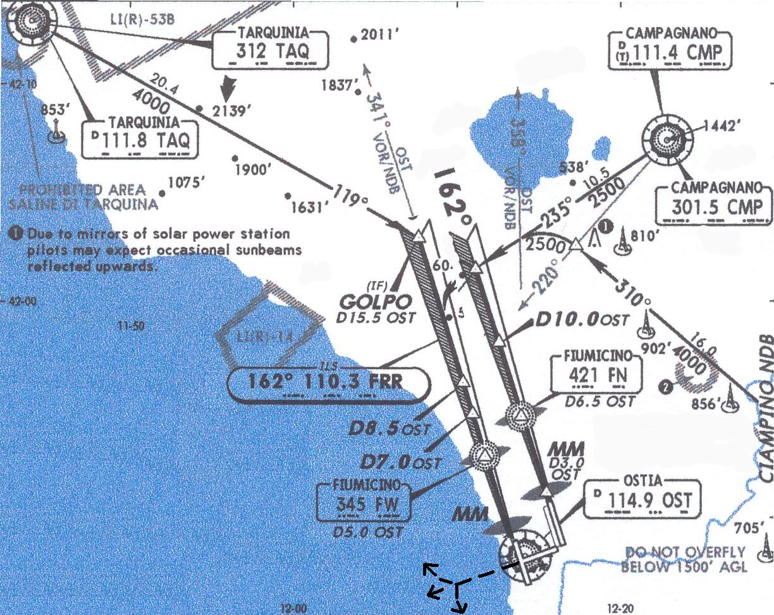
- Departures RWY 25
- Arrivals RWYs 16R e 16L
- Normal Missed Approach Procedures

During FI With OC :

In order to check the ILS of runway 34C the controllers should change the runway in use for the landing of commercial aircraft, to avoid possible traffic conflicts between commercial aircraft and FI inspecting the 34C, and therefore use runway 34L.
That day, at the beginning of the flight check, the wind that was initially coming from the sea unpredictably changed direction and began coming from the south with a speed of approximately 18 Kts. Due to the change in wind direction, the controllers weren’t able to change the runway for the commercial aircrafts.
Usually in this situation the flight check would have been aborted. On this particular day, however, the inspection was made, still using RWY 16R for the commercial aircrafts landings but with special modifications for the M.A. procedure and giving the flight inspection aircraft special restrictions especially
regarding the goaround after the RWY overfly.

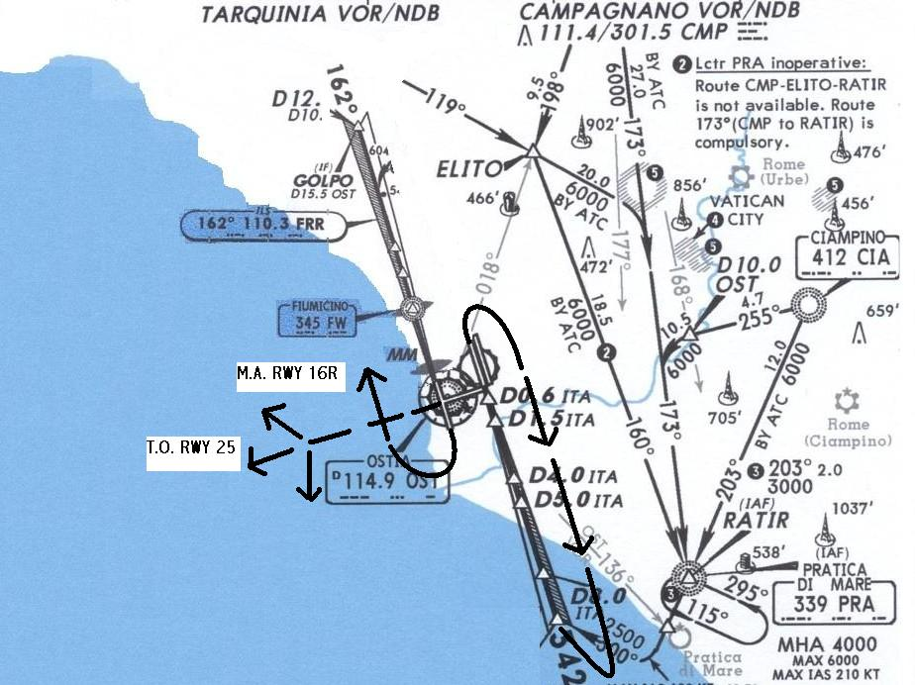
- Departures RWY 25
- Arrivals RWY 16R
- Missed Approach Procedures amended to provide separation between FI aircraft and commercial traffic in case of missed approach (remember: FI aircraft was operating on the opposite RWY).

This modified procedure not only allows for the making of the flight inspection without delay but also allows for the delay of commercial aircraft to be reduced to the minimum.
This solution wasn’t really taken into consideration by ATC, because it was not a common operating procedure, and also because ATC doesn’t usually know exactly what the capabilities of the FI aircraft are or the crews’ possibility of complying with his requests, in order to maintain the correct separation between the FI aircraft and all other traffic.
The presence of the OC has made all of this possible giving the ATCO all relevant information in advance and assuring him of to the aircraft and crew capabilities in complying with his requests.
The OC also functions as a kind of ‘hinge pin’ in connecting and coordinating all ATS units involved ( ACC,APP,TWR )

RESULTS

The experimental phase lasted for three months with checks on ten different ILS on the most busy airports and airspaces in Italy.
The presence of the OC has been instrumental in obtaining such a result (improved relationship between FI crew and ATCO, reduction in FI flight time) for a series of reasons. His/her presence is really useful for:

- Providing the Controller with all information on the current flight, in order to provide safe operations and expedite commercial traffic. This is obtained mainly with:

Precise information on FI aircraft performances and particularly on speeds that the aircraft needs to maintain to perform the intended task;

Precise information about flight profiles (horizontally and vertically) so the controller can forecast the position of the FI aircraft exactly at the end of the intended manoeuvre

Precise information about flight profiles (horizontally and vertically) that the aircraft is able to perform if the need to make an emergency manoeuvre arises

- Drastically reducing the use of the frequency, since all explanations can be obtained from the OC.

- Reducing coordination time between sectors of the same ACC

- “Reassuring“ the controller, thus permitting a more relaxed environment (lower stress level).

Analyses of data highlighted the following points:

- Savings in ILS FI flight time 35%

In the details:

- ILS 1 -40%

The ILS 1 is one of the most complex to manage from the ATCO’s point of view. It implies many crossings of the approach path. Obviously changes of speed or trajectory cannot be asked to commercial flights during the approach to land final phase and careful evaluation of separations is mandatory. Sometime long communications are exchanged between Controllers and FI Pilots to exactly explain the nature of this flight profile. The OC can visually show on the radar display the trajectory of the FI aircraft avoiding communications congestion and misunderstandings. Saving precious time on the frequency is in itself a great advantage in busy sectors of ATC units

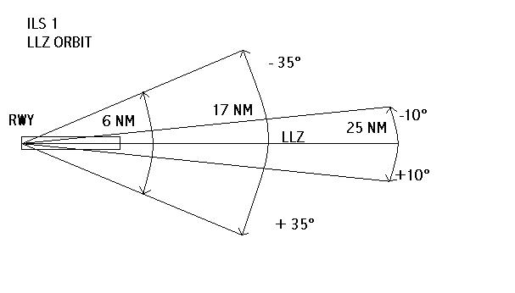

- ILS 2 -30%

The ILS 2 is less demanding but nevertheless difficult to explain on the frequency. Again the presence of the OC is important to prevent misuse of the frequency. Sometimes departures are unnecessarily delayed during ILS 2 check. The OC can explain the profile by pointing out that departures are not restricted by this profile during the inbound track, because the FI a/c will turn when it reaches the OM, thus maintaining the RWY free, and also that due to of the horizontal profile of this pattern some delay can be avoided during the run, because of the easier separation between the FI aircraft and the preceding and following aircrafts.
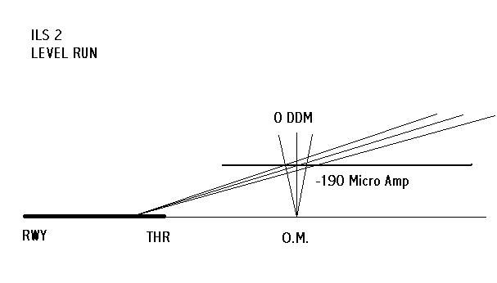
- ILS 3 -25%

During ILS 3 the saving in time is obtained by coordinating exactly the right timing and distance between the preceding aircraft for the approach and the FI aircraft, thus preventing delays and wasted runs due to interfering aircraft ( preceding or departing aircrafts too close especially during LLZ check).
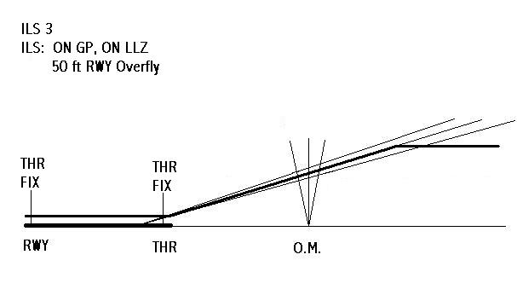
- Reduction of delays imposed on commercial traffic 25%;

- Better working conditions (mainly with regard to stress level) for both the flight crew and the controllers on duty;

- Relationship between OC and ATCO on a repeated basis will make the culture of FI spread among the ATC units, thus facilitating understanding of each others needs and providing an even greater level of safety

THE OPERATIONAL COORDINATOR:
WHO IS HE?

Providing guidelines for a new professional figure in the FI world might not seem an easy task.
Notwithstanding the premise it is quite easy to find qualified people to perform the task. In our FI Unit we are really fortunate since many of us are former Air Traffic controllers: 7 out of 18 pilots have had various degrees of experience as ATCO, with ratings from TWR/APP to RDR/AWY.
Good behavior and a certain level of “diplomatic” ability is required of an OC, since one of the main tasks is to obtain cooperation from ATC Units. Air Traffic Controllers’ professional ability and willingness to provide help must not be threatened. OC must remember at all times that he is a guest of the ATC Unit responsible for the airspace in which FI is taking place.
This situation could be natural in Italy, where the same provider is in charge for both ATC and FI, but this might not be the case in other countries.
What we would like to point out are some general rules, according to our experience, to select or form a good OC.
In the following table, candidates are placed from the most desirable (top left) to the least desirable, but sufficient (bottom right). A different set of considerations could probably lead to different choices, but in our environment this work out very well.

Previous  experience or  current job | ATCO  AREA or APP  RDR | ATCO  Non RDR | Non ATCO
F.I. Pilot | XXXXXXXX | YYYY | ZZZZZZZ
Pilot  ATPL or CPL | YYYYYYYYYYYYYY |  | ZZZZZZZ
Pilot PPL | ZZZZZZZZZZZZZZZZZZZZZZZZZZ
Non pilot | ZZZZZZZZZZ | ????????????????????

Keys to the table
XXXXXX | Little or no training required
YYYYYY | A certain amount of training is required
ZZZZZZZ | Significant training is required
?????????? | Extensive theoretical and OJT required

TRAINING REQUIREMENTS

Perfect knowledge of standard aviation phraseology is necessary. The OC must be able to read, speak and understand English.
At this point let’s consider in detail the previous table.

XXXXXX condition: little self training is required, mainly to keep up with latest changes in documents and/or local procedures or development of new flight profiles.
Time: 2/3 working days.
OJT: No

YYYYYY condition: training is required to cover all the aspects of FI profiles; another part of the training syllabus must be devoted to the coordination procedures in a RDR environment should the candidate be non RDR rated.
Time: 5/10 working days
OJT: 3 FI missions

ZZZZZZ condition: training is required to cover all the aspects of FI profiles and another part of the training syllabus must be devoted to the coordination procedures in a RDR and non RDR environment. General ATC procedures, AIP and MET should be taken into account.
Time: 30 working days
OJT: 10 FI missions

?????? condition: training is required to cover all the aspects of FI profiles and another part of the training syllabus must be devoted to the coordination procedures in a RDR and non RDR environment. General ATC procedures, AIP and MET should be taken into account. General training on aviation matters should be considered (aircraft performance, air navigation, planning, specific aviation laws and rules)
Time: 45 working days
OJT: 15 FI missions.

“Time” means classroom time
OJT refers to duty performed under supervision during real FI missions
CONCLUSIONS

As a conclusion of this paper we would like to point out the most important results of the ENAV S.p.A.’s experimentation.
The O.C. introduction in the F.I. operational environment has been instrumental in the achievement of a better quality of work for both F.I. Crews and Air Traffic Controllers.
As a result of these goals we have obtained a dramatic reduction in a F.I. flght time (about 35%) and a considerable reduction in commercial flight delay too (about 25%).
In our opinion the O.C. and his extensive training may seem costly and time consuming, but compared with the potential savings over time it is well worth the initial effort.
It is our opinion that OC should be found within the FI unit (pilots), since training requirements are minimal.
Team composition should take advantage of the double use of the OC as pilot when needed (on a rotational basis).
From the management point of view this will produce an increased productivity and reduced overall costs (reduced flight time will overcompensate the cost addition of another crew member – the OC). Furthermore, the saved flight hours will create a pool of hours available to be sold to other customers.
Finally, ENAV S.p.A. is regularly using OC when needed with great results.

