

The Asian Pacific American Association wishes to thank the many corporate, organizational, and individual contributions to the scholarship fund for their continued support and encouragement in furthering Dr. Lin’s legacy of developing young talent in an enriched laboratory environment.



APAA Scholarship Committee

Joanne Beebe-Wang
Vatsal Bhatt
Lim-Seok Chang
Joseph Eng
Benny Hooda
Beth Y. Lin
Samantha Lin
Nand Narain
Marie Van Buren
Maria-Gracia Webster
Susan Eng Wong - Chair

NOTE: The cover of this program displays a copy of an original piece of artwork painted by Dr. Mow Shiah Lin of his birthplace, Guilin of Guangxi Zhuang, China.

BERA

Asian Pacific American Association

presents the

2007
Dr. Mow Shiah Lin Scholarship

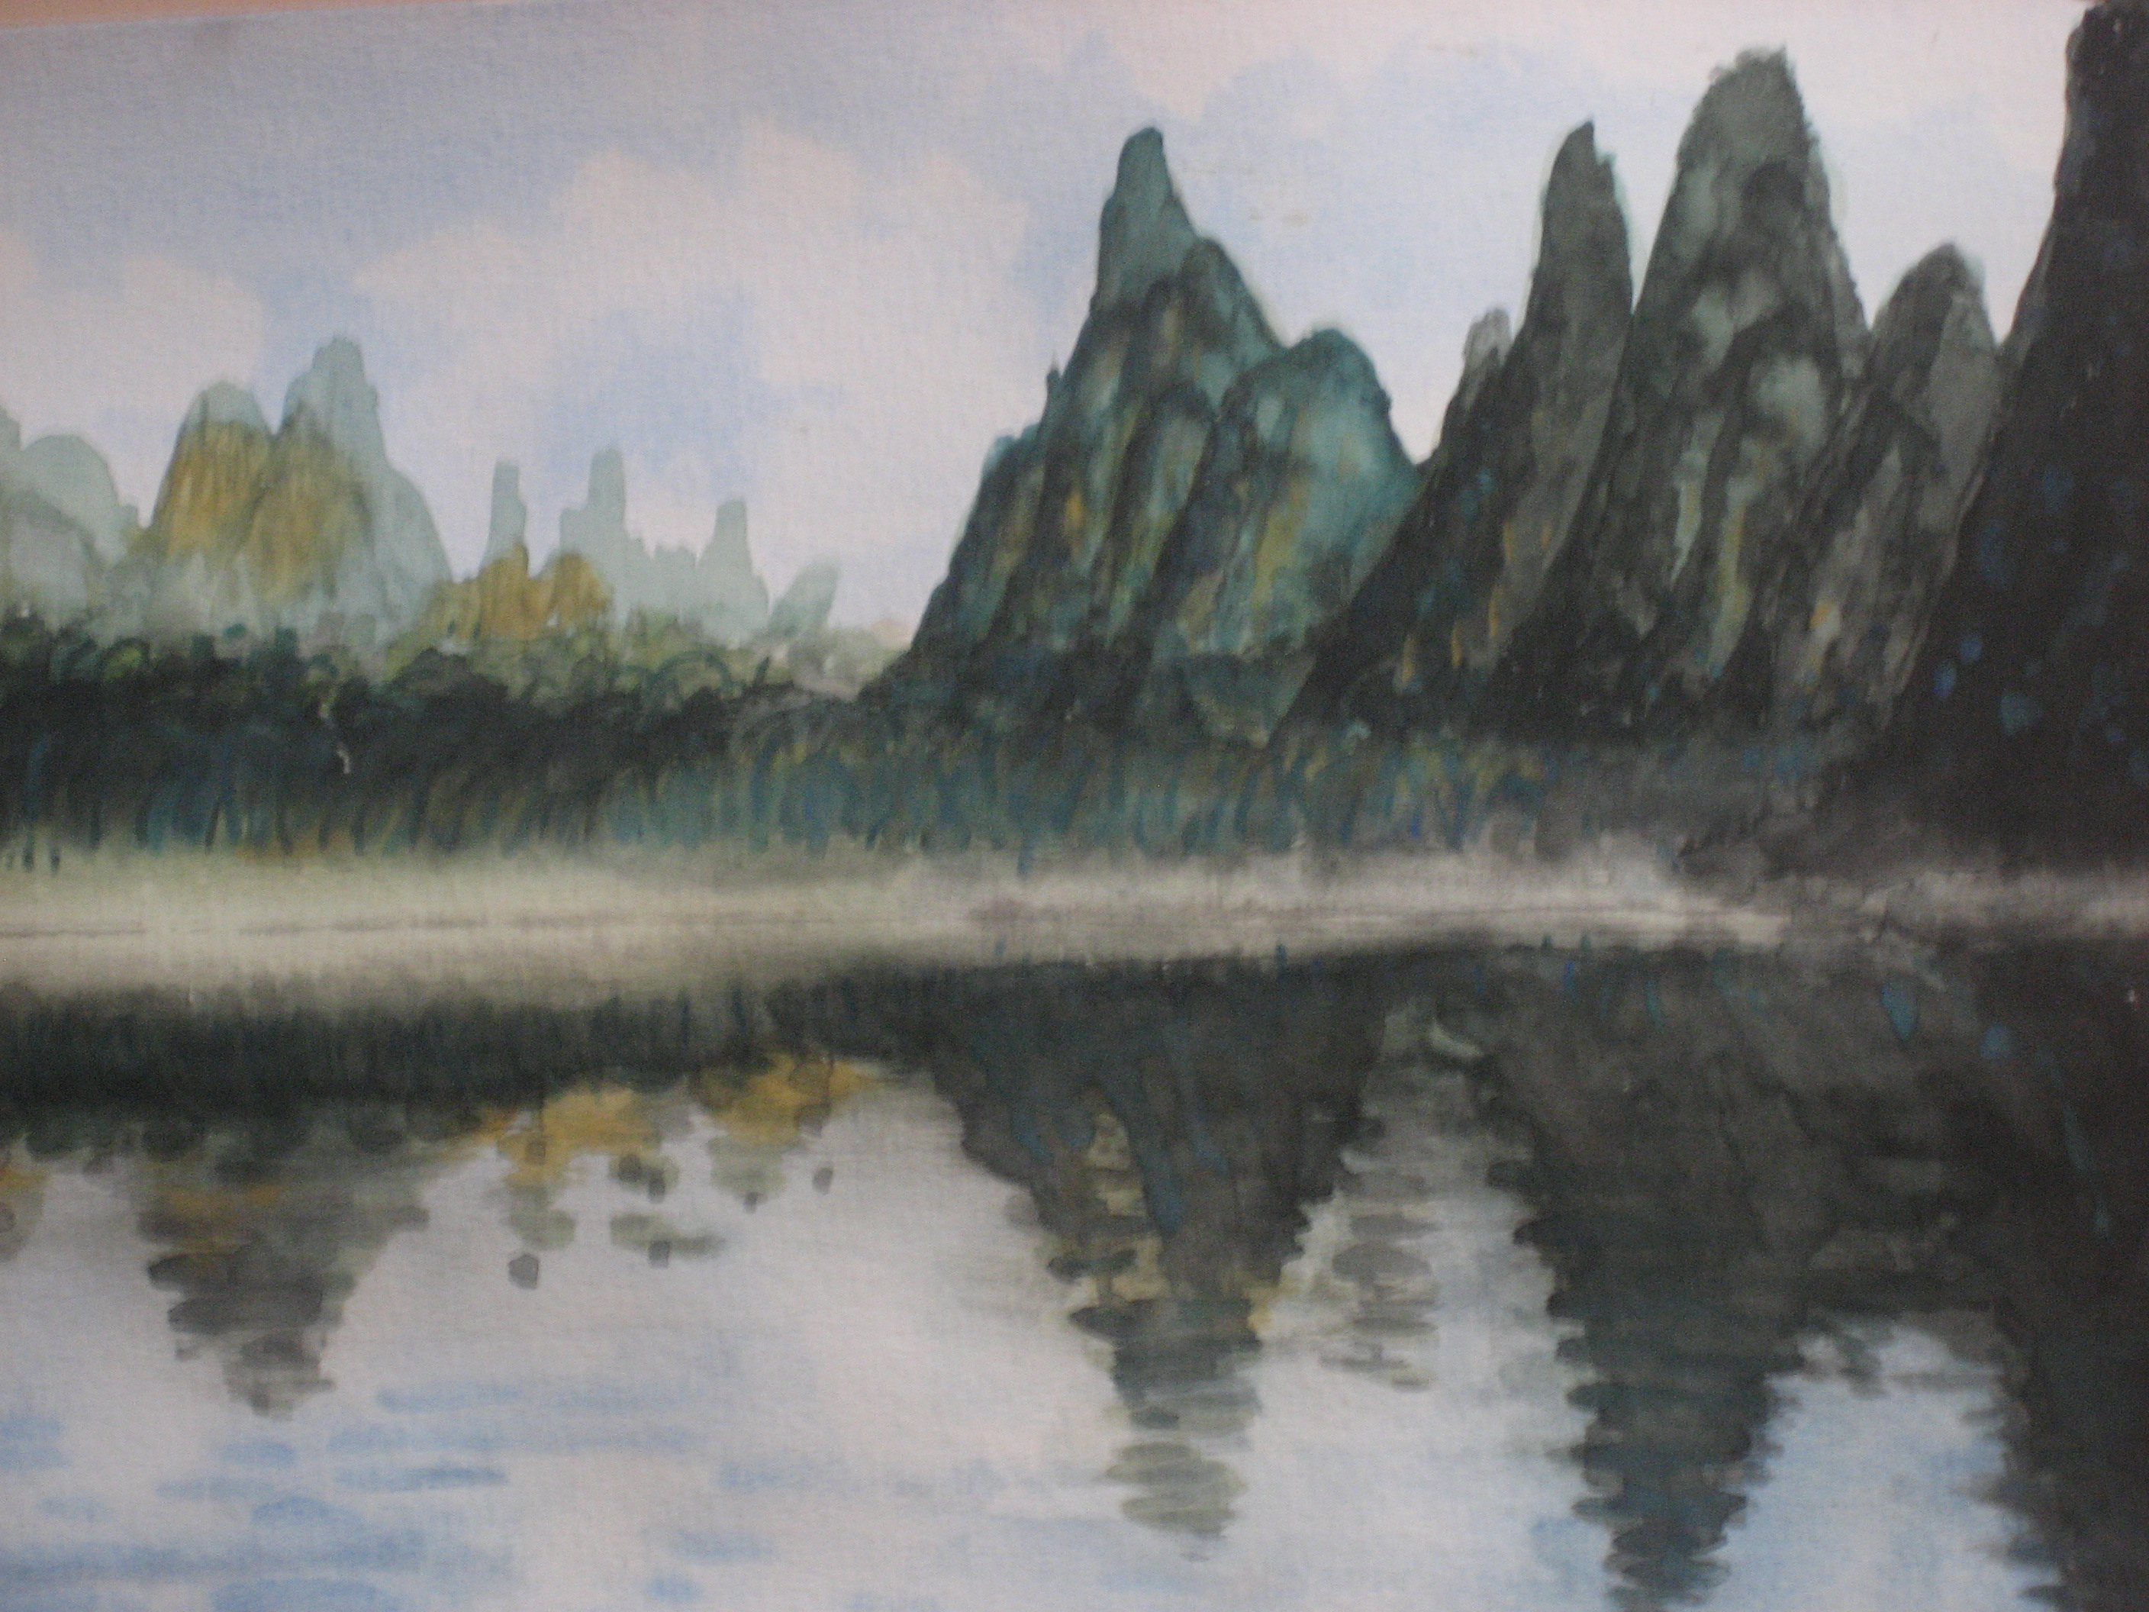

3rd Annual
Award Ceremony and
Reception

Tuesday, October 2, 2007
4:00 p.m.
Hamilton Seminar Room, Bldg. 555

Con
Sponsored by the
BERA Asian Pacific American Association (APAA),
Energy Sciences & Technology Department,
and BNL Diversity Office
Program

Welcome………...................................Susan Eng Wong, APAA

Dr. Miriam Rafailovich
Professor, Dept. of Materials Science & Engineering
Director, Program in Chemical & Molecular Engineering
SUNY Stony Brook

Presentation of Award
Beth Y. Lin
Biology Department
Brookhaven National Laboratory

Yuan Sun

Department of Materials Science and Engineering
Stony Brook University

“Highly Crystalline Rectangular Palladium Nanoparticles: Colloidal Synthesis and Electron Microscopy Studies”

Reception

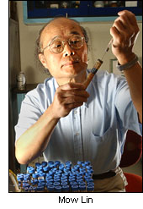

Dr. Lin began his career at Brookhaven in 1975 as a postdoctoral fellow in the Chemistry Department. Over the years, he advanced to Senior Scientist and, ultimately, to Principal Investigator of a BNL team working with a Californian environmental remediation company to use selected bacteria to convert toxic oil wastes, such as oil spills and used motor oil, into useful products. Dr. Lin owned 9 patents, published 85 papers, and won many national awards, including the 2001 R&D 100 award. In 2003, he was posthumously nominated for the Lemelson, MIT life-time award.

His career ended abruptly due to a brain aneurysm in September 2003 while on a flight to China where he was invited to present his research at the National Petroleum Research Institute. Dr. Lin is survived by his wife, Beth Y. Lin, a BNL Biology Associate with the Scanning Transmission Electron Microscope (STEM) group at the Biology Department; three daughters, Samantha, Lucinda, and Sophia; and two grandchildren, Josephine and Lee.

With this scholarship, the Lin family hopes to make a difference for students who come to the United States, like Dr. Lin, in pursuit of higher education with the purpose of making significant contributions to the environment and improving the lives for all humankind.

Brookhaven Employee Recreation
Association (BERA)

Asian Pacific American
Association (APAA)

In celebration of the
Asian Pacific American Heritage Month, May 2002

