

The Asian Pacific American Association wishes to thank the many corporate, organizational, and individual contributions to the scholarship fund for their continued support and encouragement in furthering Dr. Lin’s legacy of developing young talent in an enriched laboratory environment.



APAA Scholarship Committee

Vatsal Bhatt
Joanne Beebe-Wang
Beth Y. Lin
Samantha Lin
Marie Van Buren
Maria-Gracia Webster
Susan Eng Wong - Chair

NOTE: The cover of this program displays a copy of an original piece of artwork painted by the late Dr. Mow Shiah Lin.

BERA

Asian Pacific American Association

presents the

2006
Dr. Mow Shiah Lin Scholarship

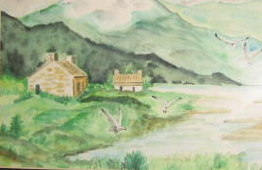

2nd Annual
Award Ceremony and
Reception

Friday, September 29, 2006
4:00 p.m.
Hamilton Seminar Room
Bldg. 555

Con
Sponsored by the
BERA Asian Pacific American Association (APAA), Energy Sciences & Technology Department,
and BNL Diversity Office
Program

Opening Remarks......................Maria-Gracia Webster, APAA

Introduction of Speakers………..…..........Vatsal Bhatt, APAA

Dr. Thomas A. Butcher
Head, Energy Resources Division
Energy Sciences & Technology Department
Brookhaven National Laboratory

Dr. Radoslav Adzic
Electrochemistry Group Leader
Chemistry Department
Brookhaven National Laboratory

Presentation of Award
Beth Y. Lin
Biology Department
Brookhaven National Laboratory

Minhua Shao
Department of Materials Science and Engineering
Stony Brook University

“Electrochemical and Spectroscopic Studies
of Fuel Cell Reactions”

Closing Remarks…..............................Susan Eng Wong, APAA

Reception

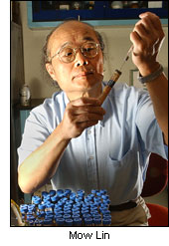

Dr. Lin began his career at Brookhaven in 1975 as a postdoctoral fellow in the Chemistry Department. Over the years, he advanced to Senior Scientist and, ultimately, to Principal Investigator of a BNL team working with a Californian environmental remediation company to use selected bacteria to convert toxic oil wastes, such as oil spills and used motor oil, into useful products. Dr. Lin owned 9 patents, published 85 papers, and won many national awards, including the 2001 R&D 100 award. In 2003, he was posthumously nominated for the Lemelson, MIT life-time award.

His career ended abruptly due to a brain aneurysm in September 2003 while on a flight to China where he was invited to present his research at the National Petroleum Research Institute. Dr. Lin is survived by his wife, Beth Y. Lin, a BNL Biology Associate with the Scanning Transmission Electron Microscope (STEM) group at the Biology Department; three daughters, Samantha, Lucinda, and Sophia; and two grandchildren, Josephine and Lee.

With this scholarship, the Lin family hopes to make a difference for students who come to the United States, like Dr. Lin, in pursuit of higher education with the purpose of making significant contributions to the environment and improving the lives for all humankind.

Brookhaven Employee Recreation
Association (BERA)

Asian Pacific American
Association (APAA)

In celebration of the
Asian Pacific American Heritage Month, May 2002

