Data Layout for GCRM Output
11/19/08 5:15 PM
This document describes the horizontal and vertical grid used by the GCRM, how variables are placed on the grid, the information required to support visualization, and finally a data model for persisted data. The data model is described in terms of its mapping to the netcdf data model, though others are possible. The primary purpose is to document the grid and reach consensus on the data model for the grid. Therefore an emphasis is placed on the grid definition. A secondary purpose is to define document the mapping of internal GCRM data structures to actual output variables. This document is not intended to describe all the actual data variables though examples of the more complex 2d and 3d variables are provided.

GCRM Horizontal Grid
The GCRM uses the geodesic grid. A detailed description of the grid is beyond the scope of this document but can be found at the CSU web site - http://kiwi.atmos.colostate.edu/BUGS/geodesic/.

The grid will be written using a morton ordering scheme (see http://en.wikipedia.org/wiki/Z-order_(curve)). For our purpose, the benefits of this scheme are: it supports large contiguous writes and the data layout is not dependent upon the number of processors used to create it. An example data set that demonstrates this layout can be found at http://climate.pnl.gov/data/.

The number of grid points in a grid is determined by the equation
N=10x2**(2r) + 2
where r is the recursion number. Some characteristics of the grid based on the r value is shown in Figure 1. Target r value is r=11 or higher.

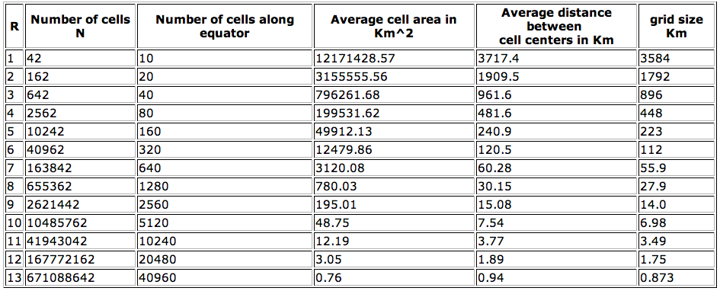
Figure 1. Table of grid characteristics for various values of r.

Though there are 12 pentagons, all relevant arrays are dimensioned to 6 with one of the values repeated in the case of pentagons. Repeated values may occur anywhere within the 6 elements. For example a neighbor list may contain values 2,3,5,5,1900,1901.

GCRM Vertical Dimension
A vertical column is partitioned using vertical coordinate surfaces. The positions of these surfaces are referred to as interfaces. A model layer is sandwiched between two interfaces (see Figure 2). Variables will be defined at both interfaces and layers. For example, eta (the horizontal component of vorticity) is defined at interfaces, and zeta (the vertical component of vorticity) is defined in the layers. There will be 1 more interface than layer in a model column. For example, if we have a model with 4 layers, the values of the interfaces might be:

vertcoor_ifc = {0 km, 10 km, 20 km, 30 km, 40 km}

and the values of the layers would then be:

vertcoor_lyr = {5 km, 15 km, 25 km, 35 km}
Vertical interfaces and layers my either increase or decrease with increasing height. For example, pressure is used as a vertical coordinate, and it decreases with increasing height. The anticipated number of interfaces is 96 for 4 km model runs.
In the initial versions of the GCRM, the grid metrics (areas, lengths etc.) will be the same for all levels. However, in future versions, we will need to account for increasing metrics (stretching) for increasing model layers -- especially for a very deep atmosphere. This document considers only the case of uniform metrics.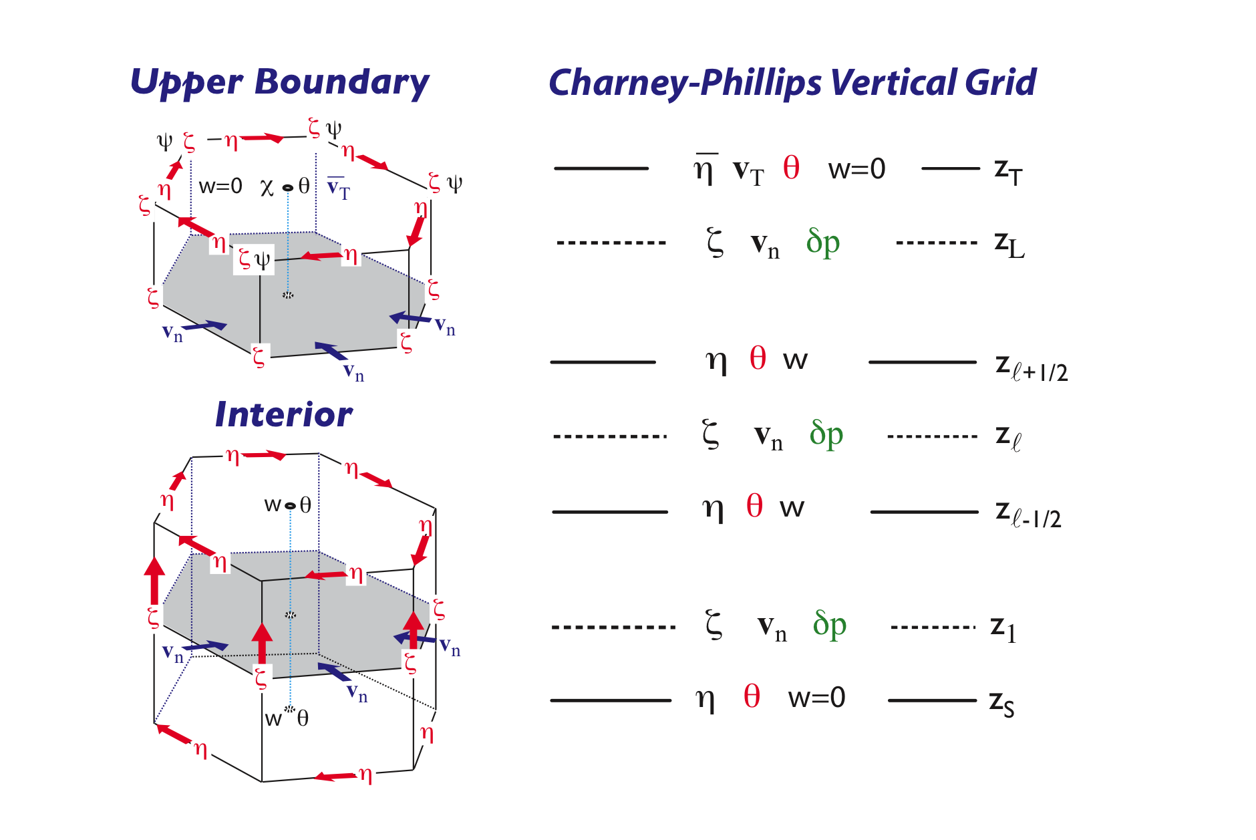
Figure 2. Distribution of discrete variables on the grid.

Variable Location On the Grid
GCRM data can be cell centered, edge centered, or associated with corners as shown in Figure 2. The list below shows some examples of data and their grid location, in the initial GCRM model.
Prognostic variables:
- Horizontal component of vorticity η ( * 3 for edges)
- Potential temperature θ
- 5 species of water
Diagnostic Variables:
- Vertical velocity w
- Horizontal velocity V ( * 3 for edges)
- Vertical component of vorticity ζ ( * 2 for corners)

Edges are defined as the midpoint (on the sphere) of the distance between two cell centers. Corners are defined as the voronoi center of three cell centers. Additionally, variables are defined at both interfaces and layers as described above. The minimum amount of information necessary to construct all needed locations are: cell_neighbors, grid_center_lon, grid_center_lat, interfaces, and layers plus the functions:
midpoint(cell1, cell2)
voronoi_corner(cell1,cell2,cell3)
The number of unique corners and edges on the grid can be determined from the number of cells as shown in figure 2.
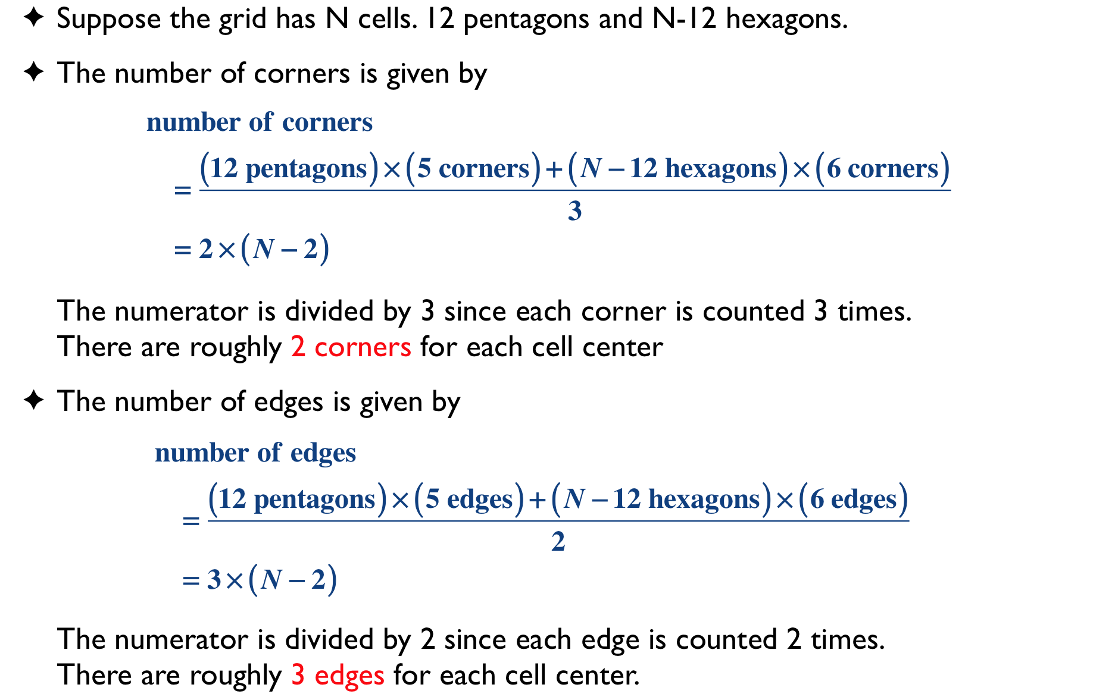

Cell Centered Data
Cell centered data is straight-forward to describe. Internally to the model, 2d and 2d cell centered data will be defined as follows:
real centervar(i,j,j,b)
real centervar(i,j,k,layer,b)
real centervar(i,j,k+1,b)
where i,j are indices of the horizontal grid within a block, k is the vertical component, and b is the block. Externally, data will be persisted with the following structure:
centervar(cells)
centervar(cells,layers)
centervar(cells,interfaces)

Corner Data
Internally to the model, corner data is associated with the unique corners of a cell. As previously described, there are two unique corners per cell. A model data structure may thus be defined as:
real cornervar(2,i,j,k,b)
where the first index is the unique corners per cell and i,j,k, and b are as previously described. Some data, such as wind may have multiple components. For example:
real cornervar(2,2,i,j,k,b)
stores the north/south component of wind in the 1st value of the first index whereas the east/west component of wind is stored in the 2nd value of the first index. The other indices are as described above. When data is persisted, each component of the first index will be written as two variables in the output data files.
More generally, the form of variables is:
real cornervar(index2,index1,i,j,k,b)
Index2 may be 2 in the case of the wind example above or three in the case of vectors. The current plan is to separate all indices at index2 into separate variables but the api will be flexible enough to support different choices for persistence. Index1 will be 2 for corners or 3 for edges (discussed below).
The corner data can be persisted one of three ways:
- All corners per cells: In this approach, corner data is associated with all 6 corners of a given cell. This approach simplifies post processing and analysis at the cost of storing 6 values per cell instead of two. This data duplication creates unnecessary file size bloating and carries a negative impact on bandwidth. Howevver, it should be noted that unlike the other options, no additional grid description data is required. In c index order, a variable would be defined as follows:
float cornervar(cells, layers, 6)
No additional grid data is required.
- Unique corners per cell: This approach follows the design of the gcrm model. It minimizes the data munging required to write the data. Aditional grid data and a small algorithm are required to map the corners to their cells. In c index order, with the I,j values transformed into cell indices, we would have the following data arrays:
float cornervar(cell, layer, 2)
int grid_corner_map(cell, 6)
The algorithm required to convert the value in grid_corner_map to separate cell and unique corner indices is as follows:
unique_corner = corner % 2,
cell = (corner-unique_corner)/2

- Arrays indexed by all unique corners: In this approache, data is associated with a “unique corner” index rather than being associated with individual cells. A mapping between cell corners and corner arry index must be provided. This strategy impacts subsetting in that the when requesting a region, multiple different dimensions and their coordinates must both be stored and considered in the subsetting. In c notation, the following arrays would be required:
float cornervar(corner, layer)
float grid_corner_lat(corner)
float grid_corner_lon(corner)
int grid_corner_map(cell, 6)

For each cell, the corner map contains the index of the 6 corners into the corner dimension. The corner dimension lat/lon are required for completeness and easy subsetting.
Option 3 will be adopted because it is conceptually clear and generally applicable to arbitrary grids.

Edge Data
Storage of edge data has the same three options as corner data. Using the preferred option of storing all edge data as a flat array, the necessary variables are:
float edgevar(edge, layer)
float grid_edge_lat(edge)
float grid_edge_lon(edge)
int grid_edge_map(cell,6)

Visualization
Corner and edge data create special difficulties for visualization. Figure 3 shows considerations for tesselation when visualizating cell, corner, and edge centered data. For corner variables, the algorithm is to iterate over each of the cells and retrieve the list of corners. With this information, the tesselation can be done in a straight forward manner.

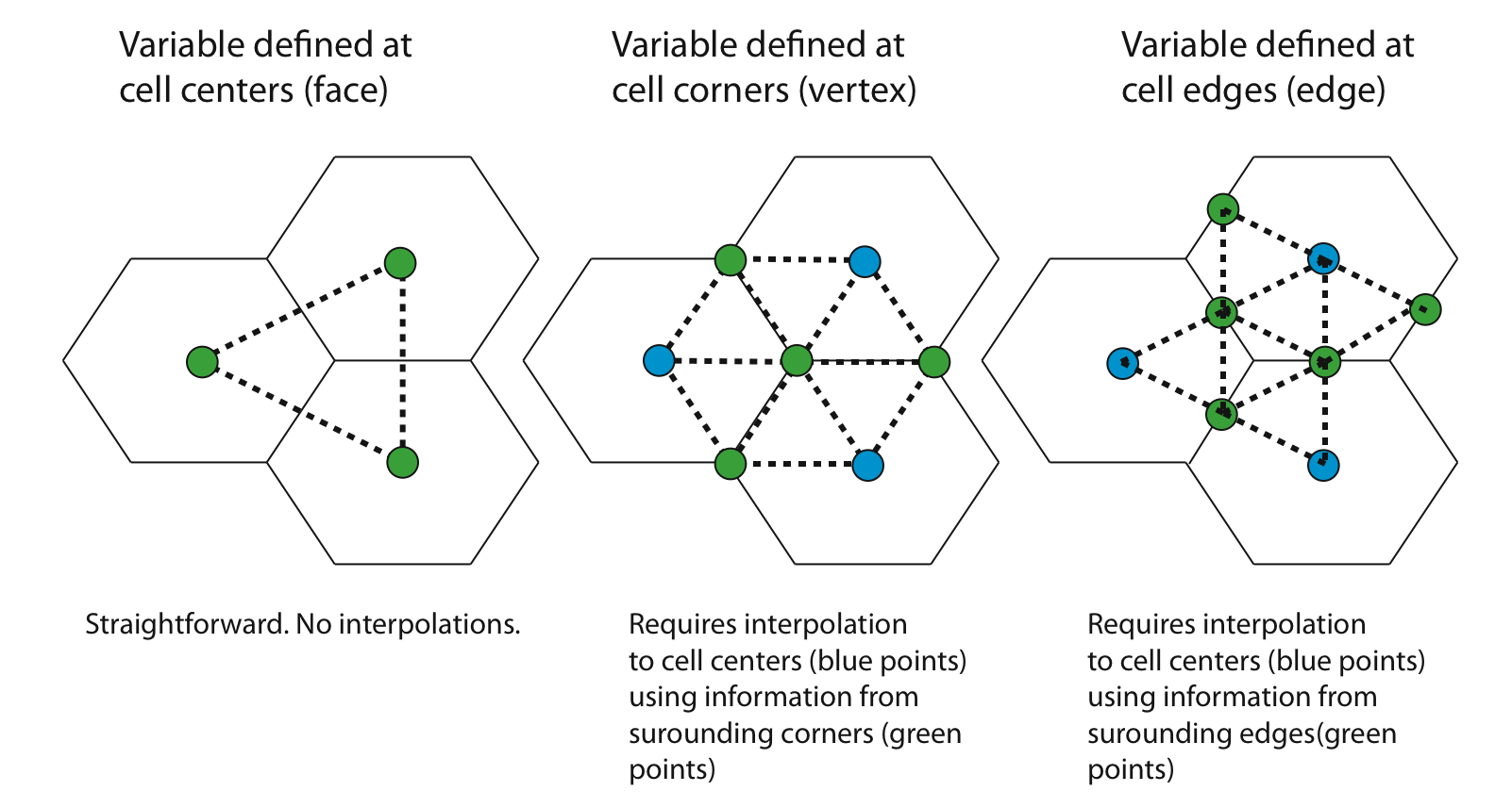
Figure 3. Tesselations for cell, corner, and edge centered data.

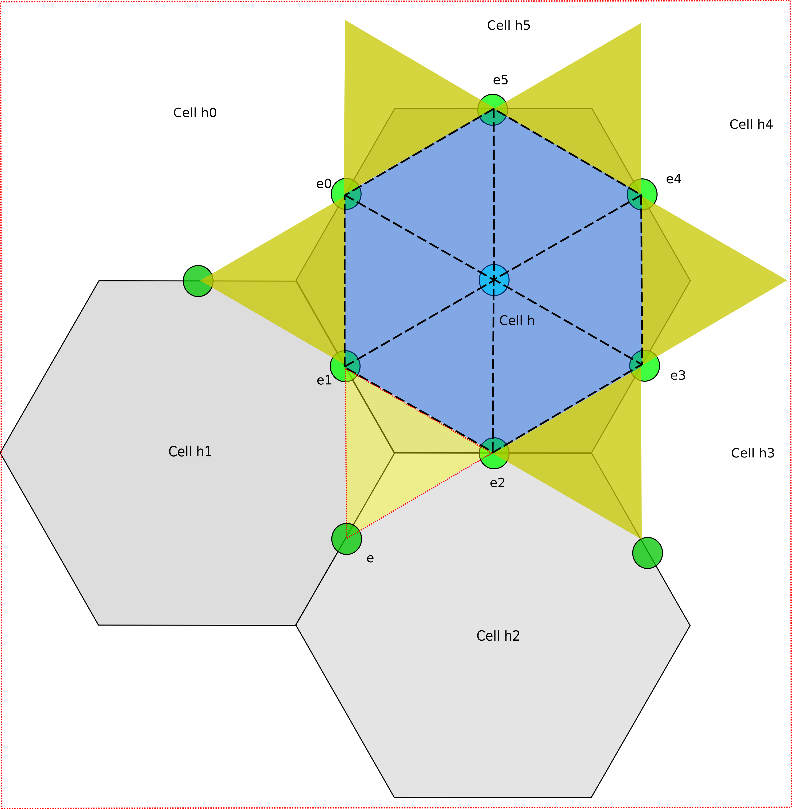
Figure4: Tesselation scheme for edge-centered data.
The tesselation scheme for edge-centered data is slightly more complicated that cell and corner-centered data. Figure4 shows the desired tesselation. We need to create triangles for the inscribed hexagon (in blue) and the yellow “star” triangles.
Creating the inscribed hexagon is easy: For a given cell, we find the position of the center. Then we find the positions of the 6 edge-midpoints. This is sufficient information to create the blue insribed hexagon. We also need to interpolate the edge data to the center of the cell.
Creating the yellow “star” triangles is the tricky part. Refering to Figure4 and taking the light yellow triangle as an example, we know 2 vertices of the triangle (e1 and e2). The question is how do we determine e?
The algorithm for finding e can be described as follows (ref to Figure 4):
Assumptions:
iteration is performed over cells rather than edges
cell center and corner positions provided
cell neighbor list provided
edge positions provided/generated
mapping from edge to cells may be available
mapping of cell to unique corner and edge indices provided/generated
counter –clockwise ordering for cell neighbors (e.g. h = {h0,h1,h2…})
counter –clockwise ordering for edges (e.g. h = {e0, e1, e2…})
Algorithm for finding e, and hence the triangle (e1,e2, e). We are given Cell h and edges e1, e2:
1) Find the relevant neighboring cells h1 & h2
a) First we find all cell_neighbors of h
cell_neighbors(h) = {h0, h1, h2, h3, h4, h5}
- Go through all cell neighbors
- For each cell neighbor, go through all edges till you find e1. Return the cell that contains e1 (Cell h1 in our case).
b) Based on counter-clockwise ordering of cell neighbors, return h2, the cell that immediately follows h1 in the ordering.
2) Obtain the set of counter-clockwise edges E {e2, e, ...} in h2. Return the edge that immediately follows e2 in E. This corresponds to the desired edge “e” in our case.
We need to take care to create the “star” triangles only once, and not three times. This can be done by inserting the triangle only when the current cell index is the minimum of the 3 cells.
Note that if a mapping between an edge and its two cells is also available, this will speed up the algorithm. This would be defined as follows:
int grid_edge_cells(edges,2)
It is also necessary to get the complete description of the cell bounds in order to draw the polygons. This information is provided by an cell dimensioned array that provides coordinates for each cell corner.
The vertical dimension requires being able to look up an elevation value for each level. Currently no scaling or offsetting is planned. A spherical projection is done on the height and will need to take into account whether the z direction is moving up or down. This information must be provided as part of the metadata.

Subsetting
Current subsetting tools are geared toward lat/lon grids. Because of the monotonic nature of the coordinates, dimensions can be readily subsettted by index or value. For the geodesic grid, new software is necessary. For cell centered data, standard names can be used to find the lat/lon variables and use those to subset by coordinate value. However, for this to work for corner and edge data, the data must be indexed using the same scheme or subsetting must be performed as a multi-step process. For example, in option 3 in the corner section above, the cell centered data is subsetted based on cell centers, the corner data is subsetted based on corner coordinates, and edge data is subsetted based on edge coordinates. This allows existing tools that work based on generic dimension processing to work on this data with the caveat that at the edges of the grid region, cells will be missing some edge/corner data. However, to ensure that all corner and edge variables associated with a cell that is within the selection range, the corners and edges should be computed from the selected cells. More significantly, all index arrays will need to have the indices updated.

NetCDF Mapping
Given all the information from the previous sections, we can define a binding to our netcdf. We rely on CF conventions (http://cf-pcmdi.llnl.gov/documents/cf-conventions/1.3/) where appropriate, and extend them as necessary.
In addition, the standard practice of providing dimension variables will be followed and can be leveraged by applications. For example, given the dimension layers, there will also be a variable named layers the provides the values for each layer.
At this time, it is expected that each 3d variable will be stored in its own time series file with the full grid definition. The reasons for this choice at this time include:
- Time series data for individual variables is likely to make data access the most convenient for the majority of operations.
- Size limits imposed by netcdf3 currently restrict the size of variables due to integer offsets
- Many processing tools do not yet support external grids

Long term, our goal, which is supported by our IO API design, is to allow the modeler to aggregate variables together into files in any way they choose which includes control over whether or not a grid variables are written to each file or to one file. This will require conversion to netcdf4 or the upgrade of netcdf3 to handle large arrays. The best guess for the latter is early to mid 2009.
The largest grid size that can be supported with current netcdf libraries is r=11 which represents a resolution of about 3.5 km.
Initially, variables will be written as floats. Support for double precision will be added later if necessary. Similarly, indices will be written as ints initially. Though longs will ultimately be required, PNetCDF does not currently support them nor does netcdf generally support dimensions that are longs.
The following netcdf definition is based on horizontal resolution of r=11. Variables in bold are new additions from original sample files. The exact mapping for corner and cell data is still up for debate. Two options are under consideration. A cell-centric view is show in blue. A unique corner/edge view is shown in purple.
The following table summarizes the extra grid information and the additional size requirements for the alternative grid descriptions. The approximate extra size for the unique corner/edge view is due to the duplication of grid corner lat/lon.
Variable | Formula | Size (floats)
grid_edge_lat | 3 * (cells-2) | .5 GB
grid_edge_lon | 3 * (cells-2) | .5 GB
cell_corners | 6 * cells | 1 GB
cell_edges | 6 * cells | 1 GB
grid_edge_lat2 | 3 * (cells-2) | .5 GB
grid_edge_lon2 | 3 * (cells-2) | .5 GB
grid_corner_lat2 | 2 * (cells-2) | .3 GB
grid_corner_lon2 | 2 * (cells-2) | .3 GB
corner_cells | 3* 2 * (cells-2) | 1.0 GB
edge_cells | 2* 3 * (cells-2) | 1.0 GB
Total |  | 3.0 GB /3.6 GB

Dimensions:
interfaces: 96
layers: 95 # interfaces -1
cells: 41943042
corners: 83886080 # total unique corners in the grid; 2 * (cells – 2)
edges: 125829120 # total unique edges in the grid; 3 * (cells - 2)
cellcorners: 6 # max corners per cell
celledges: 6 # max edges per cell
cellneighbors: 6 # max neighbors per cell

Variables:
float interfaces(interfaces)
interfaces:units = “Pa”;
interfaces:positive = “down”;
interfaces::axis = “Z”;
float layers(layers)
layers:units = “Pa”;
layers:positive = “down”;
layers::axis = “Z”;
float grid_center_lat(cells)
grid_center_lat:long_name = "Latitude of cell center" ;
grid_center_lat:units = "radians" ;
grid_center_lat:standard_name = "latitude" ;
grid_center_lat:bounds = "grid_corner_lat" ;
float grid_corner_lat(cells,cellcorners)

float grid_center_lon(cells)
grid_center_lon:long_name = "Longitude of cell center" ;
grid_center_lon:units = "radians" ;
grid_center_lon:standard_name = "longitude" ;
grid_center_lon:bounds = "grid_corner_lon" ;
float grid_corner_lon(cells, cellcorners)

float area(cells)
grid_area:long_name = "cell area" ;
grid_area:standard_name = "area" ;
grid_area:units = "square radians" ;
int cell_neighbors(cells, cellneighbors)
cell_neighbors:long_name = "Index of cell neighbors" ;
cell_neighbors:traverse = “counter-clockwise” ;

float grid_edge_lat(cells, celledges)
grid_edge_lat:long_name = "Mid-point latitude of edge " ;
grid_edge_lat:standard_name = “latitude” ;
grid_edge_lat:units = "radians" ;

float grid_edge_lon(cells, celledges)
grid_edge_lon:long_name = "Mid-point longitude of edge" ;
grid_edge_lon:standard_name = “latitude” ;
grid_edge_lon:units = "radians" ;

int cell_corners(cells, cellcorners)
cell_corners:traverse = “counter-clockwise“ ;
cell_corners:long_name = “mapping of unique corner indices for each cell”;

int cell_edges(cells, celledges)
cell_edges::traverse = “counterclockwise” ;
cell_edges:long_name = “mapping of unique edge indices for each cell”;

float grid_corner_lat2(corners):
grid_corner_lat2:long_name = “TBD”;
float grid_corner_lon2(corners):
grid_corner_lon2:long_name = “”TBD”;
float grid_edge_lat2(edges):
grid_edge_lat2:long_name = “TBD”;
float grid_edge_lon2(edges):
grid_edge_lon2:long_name = “”TBD”;

int corner_cells(corners, 3):
corner_cells:long_name = “list of cells per unique corner”;

int edge_cells(edges, 2):
edge_cells:long_name = “list of cells per unique edge”;

int grid_global_index(cells): # To reconstruct full globe from regional files IFF global files not used
grid_global_index:long_name = “cells index into global cell array”

Some example variables on this grid

float centervar1(time, cells, layers): # a cell centered variable residing on a layer
centervar1:coordinates = “grid_center_lat grid_center_lon”;

float centervar2(time, cells, interfaces): # a cell centered variable residing on interface
centervar2:coordinates = “grid_center_lat grid_center_lon”;

float cornervar(time, corners, layers)
cornervar:coordinates = “grid_corner_lat grid_corner_lon”;

float edgevar(time, edges, layers)
edgevar:coordinates = “grid_edge_lat grid_edge_lon”;

# global attributes:
:Conventions = "CF-1.3" ;
:institution = "<specifies where the original data was produced>" ;
:title = "<a succint description of what is in the dataset>" ;
:history = "<audit trail>" ;
:source = "<method of production of the original data>" ;
:references = "<published or web-based references that describe the data or methods to produce it>" ;
:grid = "geodesic" ;
:grid_cell_index_origin: = "0" ; # Identifies index of first cell (i.e. origin)

