USDA Foreign Agricultural Service
GAIN Report

Global Agriculture Information Network
Template Version 2.09

Voluntary Report - Public distribution
Date: 12/15/2007
GAIN Report Number: CH7815
CH7815
China, Peoples Republic of
Market Development Reports
Wuhan: An Emerging City Market in Central China
2007

Approved by:
Wayne Batwin
U.S. Consulate
Prepared by:
Xu Min, Katherine Hanson

Report Highlights:
Sitting on the middle reaches of the Yangtze River in the heart of China’s interior, Wuhan is famous for its national transportation hub of waterways, railways, highways and domestic airlines in Central China. With a population of 8.7 million and a GDP growth rate of 14.8%, combined with a rapidly evolving consumer culture, Wuhan reveals considerable potential for U.S. food and agricultural products. The key obstacle to market development continues to be lack of familiarity with imported food among Wuhan’s increasingly affluent consumers. U.S. exporters considering Wuhan as a potential market should be careful to take existing fragmented logistics and distribution into account. ATO Shanghai organized a multilevel promotional event in Wuhan’s HRI and retail sectors this fall.

Includes PSD Changes: No
Includes Trade Matrix: No
Annual Report
Shanghai ATO [CH2]
[CH]

Table of Contents

Introduction: 3
Sector Analysis: Food Processing, Cuisine, HRI and Retail 4
Food Processing 4
Hotel, Restaurant and Institutions 5
Retail 6
Prospects for the Future 8
ATO Marketing Activity 9
Contact Information and Useful Websites 9

Introduction:

Sitting on the middle reaches of the Yangtze River in the heart of Central China, Wuhan has served as a commercial and communication hub for Central China since the mid 19th century. Today, people in Wuhan can reach China’s major cities like Beijing, Shanghai and Guangzhou within 1.5 hours by air. A network of national waterways, railroads, highways, and extensive airline coverage in the city makes it an excellent distribution hub for regional markets. Wuhan claims to offer the best living conditions and quality of life in Central China. The combined strength of maturing industrial zones, state-level scientific and technical institutions, universities and an educated labor pool lead pundits to suggest that Wuhan will continue to lead sustainable economic development in the Central China region.
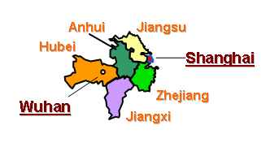

The Yangtze River, the world’s third longest river, and its tributary, the Han River, divide Wuhan, the capital city of Hubei Province, into three parts: Hankou - which local people view as the commercial center; Wuchang, where China’s Optical Valley and a dozen scientific research institutions and universities are based; and Wuhan, where provincial and municipal governmental organizations are located. These parts face each other across the rivers and are linked by bridges, including the very first bridge built across the Yangtze with the assistance of the then Soviet Union in the 1950’s. Because of its hot summer weather, Wuhan is also well known as one of the “Four Furnaces” of China, along with Nanjing, Chongqing and Nanchang. The average temperature in July and August is 37.2 degrees C (99 degrees F), and the maximum often exceeds 40 degrees C (104 degrees F).

With a population of over 8.7 million and land area of 8,494 square kilometers, (3,280 sq. miles) Wuhan has become one of China’s manufacturing platforms to the world. GDP reached RMB 2,590 billion (USD 34.5 billion) in 2006, an increase of 14.8% over 2005. Long a base for heavy industry, Wuhan has developed as an important automobile assembly and parts manufacturing base in central China both for domestic and export markets. Other notable industries are optical fibers, steel, textiles, packaging, paper manufacturing, chemicals and pharmaceuticals. Foreign direct investments in the manufacturing industry, mainly from France and Taiwan, have helped fuel the impressive rate of GDP growth. In the past four years, Wuhan has attracted many foreign investment projects. Among them, 160 projects each reached an investment value of over USD 10 million. The American brand Budweiser, who is very popular among China’s urban beer consumers, has a large operation in Wuhan. FedEx, the world largest express shipment company, is reportedly going to set up its China Business Center in Wuhan for consumer service, accounting and human resource management.
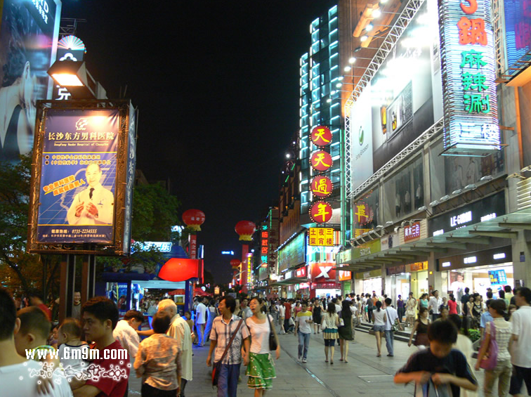

Although the rural income per capita is still low, purchasing power is centered in Wuhan urban residents whose disposable income climbed 14% in 2006 to RMB 12,360 (USD 1,648). Despite its rapid growth, however, Wuhan still remains somewhat underexposed to Western food products, often ignored by food importers and distributors based in China’s coastal cities, and underdeveloped as a market for imported foods. In its current state, Wuhan is a viable emerging market for those committed to building a client base through long-term market development, consumer education, and other training programs.
Wuhan at a Glance (2006)
Population | 8.75 million
GDP | USD $34.5 billion
GDP Growth Rate | 14.8%
GDP/Capita | USD $3,900
Major Industries | Automobile assembly and parts manufacturing, optical fiber and equipment, textile, Iron/Steel, Chemicals and pharmaceuticals,
Food Consumption/per capita expenditure | 38.8%
Major Food Retailers | Zhongbai Cangchu, Wushang Liangfan, Zhongshang Pingjia, Carrefour, Metro, Wal-Mart, New World,
Source Wuhan Commercial Bureau; 1USD=7.5RMB

In the view of Chinese consumers, Wuhan cuisine - a little bit heavy on salt and mild in spice - is a combination of all styles and characteristics from all over the country. Local chefs blend various flavors in their dishes, and thus have left Wuhan cuisine no specific distinguishable style.

Sector Analysis: Food Processing, Cuisine, HRI and Retail

Food Processing
Located in the Dongxi Hu District, Wuhan Food Processing Park is the largest food processing platform in the Central China region. Since beginning its operation, international and local brands like Pepsi, Tongyi from Taiwan, Shuanghui and Jinyuan from Henan, and Ruyi from Xiamen have set up processing plants in the park. Products include yogurt, drinking water, beer, pork, instant noodles, fruits, vegetables, edible oil and animal feed. In addition, China’s state-owned food import and export giant, COFCO, known as China National Cereals, Oils and Foodstuffs Corp., has recently invested USD 100 million in the Jiangxia District of Wuhan for a meat processing plant with a land area of 87 hectares (215 acres). Equipment and technology used in the plant are from EU. The municipality plans to pour a USD $5.3 million investment to build up brands of local agricultural and food products. With the Chinese government undertaking a strong campaign to improve the quality, safety and scale of the domestic food processing industry, food processing parks endorsed by the government are likely to play an increasingly important role both as centers for monitoring food hygiene and as sources of future leadership for the food industry.

Hotel, Restaurant and Institutions

Wuhan is home to several 4 and 5-star hotels including Shangri-La, Oriental, Best Western, Novotel, Ramada, Wuhan Lake View, East Lake and Jinjiang. Hilton will soon open its first hotel in the capital city of Hubei province. Wuhan’s 4-5 star hotels are frequented by local and international business people, government officials, expatriates working for Wuhan’s large international companies, and a small number of students studying abroad. Catering to the increasing numbers of domestic and international travelers visiting Wuhan for business, conferences, and tourism, these high-end hotels reflect Wuhan’s rising importance in Central China. Although many high-end hotels would like to expand their client base to include mid-range customers, high prices relative to local options continue to slow their advance into the middle class market. In an effort to lure more local customers, hotel restaurants strive very hard to get their share of the market from the local consumers by offering a unique dining experience. At the time of ATO’s visit, Shangri-La was offering a dinner table which typically accommodates 10 people for anniversary or wedding parties for only RMB 888 (USD 119), a very competitive price. Just as with the chefs working for restaurant chains, hotel chefs are under a great deal of pressure to create new dishes with new ingredients, which provides opportunities for the USDA marketing cooperators and U.S. food suppliers to introduce their products that are not yet available in the local market.

Western kitchen/cuisine restaurants are the primary end-users of imported food ingredients and condiments. Most of these western restaurants are located in high-end hotels. Future expansion of international luxury hotels implies more opportunities for American food ingredients in Wuhan. However, the current market offers very few imported food items for chefs to choose from even in the hotel restaurants. A recent interview with one of the leading foodservice distributors indicates that imported items available in the market are restricted to salmon from Norway, scallops and mussels from Australia, crab legs from Russia, and poultry offal, frozen potatoes, corn and green beans from U.S. One of the reasons for the limited selection is that restaurants and distributors face significant distribution challenges in Wuhan. For example, distributors often require restaurants to order very large quantities of a single item in order to guarantee supply, but limited restaurant storage space and stocking cost make this difficult. Poor communications channels between hotels and traders have added barriers as well. One executive chef noted that his restaurant in a 5-star hotel had to frequently seek out local suppliers of new-to-market ingredients for developing new recipes because no supplier of new U.S. food products from outside the province has ever approached him. On the other hand, executive chefs and purchasing managers of restaurants prefer to stick with their existing vendors due to concerns about supply consistency, communication and after-sale service.

According to the Wuhan Statistic Bureau, the sales revenue of the Wuhan catering industry reached RMB 17.7 billion (USD 2.36 billion) in 2006, ranking 8th in China. The growth rate is on a rapid rise of 17% in the first half of 2007. Urban food expenditures account for 38.8 % of the total per capita consumption expenses. During the discussions with the local culinary association and restaurant managers, ATO noted that the Wuhan restaurant industry has over 40,000 restaurants with about 170,000 employees. For Wuhan people, the cost of a meal in the restaurant is not much different from the cost of food they prepare at home. The prices of dishes served in the restaurants are much cheaper than those in the first tier cities like Shanghai, Guangzhou and Beijing. “With RMB 400 (USD 53) in Wuhan, you can enjoy such fancy food that you would typically need to pay five times more for in Beijing or Shanghai,” commented the head of the local culinary association.

To meet the demands of different consumer groups, many restaurants offer their customers 3 levels of service prices: in the range of USD 10–13 per person, customers can receive “enough food” service; in the middle range of USD 15-25 per person, customers can host a respectable dinner for their friends, relatives and business contacts; and with USD 28 per person and above, consumers can enjoy luxury dining and wine service. The following example might not be typical, but this is a snapshot of what Wuhan’s high-profile chain restaurants are like. When ATO staff were provided a guided tour of a premium chain restaurant, they were amazed by the luxurious decorations and facilities, from an electronic piano made of crystals, digital golf game to double shower rooms, all within a single dining suite. The cost of a dinner party for 20 guests in the banquet room is minimum RMB 20,000 (USD 2,666), which does not include the cost for beverages. The owner of the restaurant told ATO that this is one of 30 private rooms in the banquet hall, and these private rooms are frequented by customers from local highly profitable enterprises and private sector business people. The same is true with table occupancy in the public area of the restaurant. Table reservations for dinner parties of large scale events like weddings and anniversaries in the restaurant are full throughout the end of the Lunar Year (mid-February in 2008). The crowds seen in high-end chain restaurants can also be found at lower profile restaurants during lunchtime even on working days.

However, the overall restaurant business in Wuhan is still price driven. Very few imported food items are available in the chain restaurants. Chefs at chain restaurants take the prices of incoming material into serious consideration when vendors approach them with new ingredients. But, under the pressure to renew their menus with newly developed dishes on a monthly or weekly basis, chefs are eager to receive information about new ingredients from distributors, which implies there may be opportunities for U.S. food suppliers who are based mainly in first tier cities via the local distributors to bring their products to the market.

Retail

In contrast to most of China’s coastal cities, local retailers like Zhongbei, Zhongshang and Wushang are very strong in Wuhan’s retail business. They are in a better position for store locations, have good product assortment, and thus attract much more consumer traffic and enjoy higher sales revenue when compared to foreign retailers. That is because Wuhan has a hundred-year history of being the economic and transportation hub for Central China, and local businessmen have taken root with a solid foundation in the market. Foreign retailers only started entering the Wuhan market after the year 2000.

Similar to many metropolis cities in China, as the economy has grown and consumers have matured, traditional wet markets are disappearing. Today, consumers shop at supermarkets seeking higher quality, consistency, sanitation and convenience. During
the last few years, Wuhan’s food retail sector has undergone a radical transformation with the rapid rise of supermarkets, hypermarkets, convenience stores and premium stores. These retail formats have extensive dry and frozen goods, fresh and frozen meat and seafood, fruit, vegetables, prepared foods, and food service sections. Many of these outlets are located in mall settings or a shopping destination for the whole family to enjoy with restaurants, movie theatres, fashion boutiques, sporting goods stores, and other specialty shops.
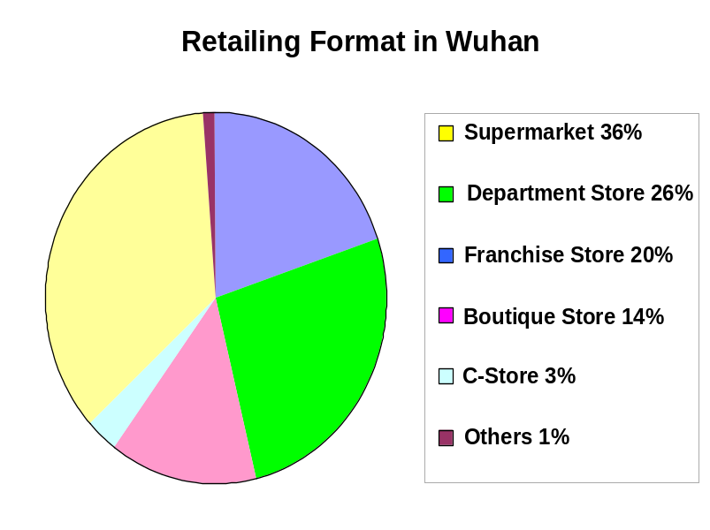
Source:Wuhan Commercial Development Report, 2006
Published by Wuhan Commercial Bureau

In general, the Wuhan market still remains very price sensitive and domestic substitutes for many imported products are available at substantially lower prices. A recent visit to an outlet of a foreign operated retailer found that U.S. food products are restricted to just a few products: frozen potatoes, apples, oranges, nut snacks and three varieties of wine. Other retailers may sell more U.S. products, but the variety of imports clearly falls far short of more developed interior cities such as Chengdu. A merchandising manager for one of the local supermarkets in Wuhan noted that U.S. frozen vegetables, fruits and snack foods might sell well and consumers are often willing to pay a 10-20% premium for U.S. foods during Chinese holidays like mid-Autumn Festival and Lunar New Year, so there appears to be interest among some outlets for more international products. To retain their position in the increasingly competitive market, the leading local retailers are planning to open high profile food stores similar to the SOGO premium food store in the Shanghai Ongoing Department Store. Branded products, particularly imported items, will be their primary choice of assortment.
Major Food Retailers
Name | Format | Number of outlet
Zhongbai Cangchu | Supermarket | 58
Wushang Liangfan | Supermarket | 37
Zhongshang Pingjia | Supermarket | 21
Carrefour | Hypermarket | 4
Lotus | Hypermarket | 3
RT Market | Hypermarket | 2
Wal-Mart | Hypermarket | 2
Metro Cash & Carry | Hypermarket | 2
New World | Department store | 2
Park’n Shop | Hypermarket | 1
Dafuyuan | Supermarket | 1
Source Wuhan Commercial Bureau

Retailers also expressed a willingness to participate in promotions and expand their list of U.S. products. With proper promotion of a product’s premium quality or safety benefits, the all-important consumer price sensitivity of many consumers can be sacrificed.

Prospects for the Future

Under the traditional impression that the interior markets like Wuhan lag behind China’s coastal cities and therefore is immature for imported goods, distributors and USDA cooperators arranging promotional activities in China often overlook Wuhan, focusing on more developed markets. But the market situation in Wuhan is changing rapidly. As the established first tier markets of Beijing, Shanghai and Guangzhou develop stronger linkages with suppliers for increasing quantities of imported food products, U.S. exporters and U.S. food distributors should look into emerging city markets (ECM) for new growth opportunities. China’s inland ECMs are the new frontier and offer great untapped opportunities for American products.
As in most other large Chinese cities, Wuhan is home to a rising group of middle- and upper-income consumers. The municipality is ambitious to bring the disposable income of its urban inhabitants up to RMB 20,000 (USD 2,666) within the next five years. The expatriate community is also expected to grow as international companies build up their operations in Wuhan. The population of domestic business people traveling through and living in Wuhan is already climbing, and massive new upscale housing for Wuhan’s elite are being built in and outside the city center. These high-income domestic and international residents could potentially develop into a sizable market for U.S.-made goods, much like their counterparts in other major cities.

Wuhan: Best Product Prospects
Product | Market | Notes
Baking ingredients, bread bases | Hotel/Premium Retail Stores | Baked goods are an important staple for Western hotels, so demand for baking ingredients should increase as more 5-star hotels and high profile bakery stores open in the city.
Dried fruit and nuts | Hotel/Retail | Common as snacks and as ingredients in Western pastries and other dishes, dried fruit and nuts have excellent potential. Local substitutes are available but usually have a significantly different texture and taste than U.S. products.
Frozen vegetable products | Hotel/Retail | Consumers are using more frozen vegetables like corn, green bean and potato products both at restaurants and supermarkets. U.S. products currently selling well with competitive prices in coastal cities like Shanghai and Hangzhou are limited in variety in Wuhan market.
Seafood | Hotel | Several hotels and traders are already importing fish, including Norwegian salmon. U.S. seafood producers will need to differentiate their products from local and import competitors.
Wine and distilled spirits | Hotel/Retail | Demands for imported wines are growing rapidly at hotels, restaurant chains, wine stores and supermarkets. High value wines and spirits have great potential in 5-star hotels, bar and night clubs.
Condiments & sauces | Hotel | International hotels frequently use imported condiments and sauces to offer international guests a flavor from home, so growth in the hotel sector could benefit U.S. producers of condiments and sauces. Consumers also shop for imported condiments and sauces for house kitchens with retail packages at premium stores.
Meat |  | Logistics remains the primary barrier for these sensitive products. U.S. poultry and pork products are popular throughout China and are likely to do well in Wuhan.

ATO Marketing Activity

From September–October 2007, ATO Shanghai led a multilevel promotional campaign for U.S. food products in Wuhan, in cooperation with the Hubei Culinary Association and Wuhan Wushang Bulksale Chain Co. Ltd. Activities included a seminar, cooking demo, cooking contest, tabletop shows, food tasting receptions, one-on-one meetings with local traders, and in-store promotions for 2 weeks. The event was designed to assist U.S. companies/American food importers/suppliers generate direct trade contacts with local distributors, restaurants and retailers; expose local consumers to a variety of American high-value food products; introduce some new-to-market U.S. food products; launch a positive PR campaign to build consumer confidence in and demand for U.S. food products; and encourage deeper geographic penetration of U.S. food products in Central China. ATO Shanghai will continue its market development efforts in Wuhan in 2008.

Contact Information and Useful Websites

Agricultural Trade Office, Shanghai
Shanghai Center, Suite 331
1376 Nanjing West Road
Shanghai 200040, China
Phone: 86-21-6279 8622
Fax: 86-21-6279-8336
E-mail: ATOShanghai@fas.usda.gov
Website: www.USDAChina.org

