Synthesis of Shoulder Rumble Strip Practices and Policies

EXECUTIVE SUMMARY

This synthesis provides a review of shoulder rumble strip research and the rumble strips’ crash reduction record. A discussion of shoulder rumble strips as perceived by the motorist and the bicyclist is followed by the presentation of results of three nationwide surveys conducted in 2000 of State DOTs regarding shoulder rumble strips. A comparison of policies, practices and alternative designs is utilized as the basis for illustrating the components of a bicycle tolerable shoulder rumble strip policy. Finally, the need for future research is assessed.

TABLE OF CONTENTS

1.0 INTRODUCTION 3
2.0 LITERATURE REVIEW 4
2.1 Previous Research 4
2.2 Ongoing and Future SRS Research 6
3.0 SRS DESIGNS 7
3.1 Milled SRS 7
3.2 Rolled SRS 7
3.3 Dimensions and Offset 8
3.4 Safety Record 9
4.0 EFFECT ON DIFFERENT ROADWAY USERS 10
4.1 The Driver’s Experience 10
4.1.1 The Driver and Motor Vehicle Auditory Stimulus 10
4.1.2 The Driver and Motor Vehicle Vibrational Stimulus 12
4.2 The Bicyclist’s Experience 13
4.2.1 The Bicyclist and Bicycle Auditory and Vibrational Stimulus 13
4.2.2 Other Bicyclist’s Concerns 14
4.3 Motorcycles 15
4.4 Other Vehicles 15
5.0 SUMMARY OF SHOULDER WIDTHS AND POTENTIAL SRS PROBLEMS 16
6.0 SURVEY OF STATES’ POLICIES AND PRACTICES 17
6.1 Minnesota DOT Survey (February 2000) 17
6.2 FHWA Survey (Spring 2000) 17
6.3 FHWA Survey (September 2000) 17
7.0 SRS PRACTICES 19
7.1 Skip Pattern 19
7.2 Transverse Width of SRS 19
7.3 Depth of SRS 19
7.4 SRS Placement 19
8.0 SRS POLICY 22
8.1 Policy Classification 22
8.2 SRS Installation Warrants 23
8.3 Recommended Inclusions into any SRS Policy 24
9.0 PROPOSED RESEARCH 26
9.1 High Priority Research 26
9.2 Medium Priority Research 26
9.3 Low Priority Research 27
Appendix A 29
Decibel Levels 29
Appendix B 31
Mn/DOT Survey 31
FHWA Spring Survey 32
FHWA September 2000 Survey 33
Appendix C 35
Arizona Rumble Strip Policy 35
Appendix D 38
Minnesota Rumble Strip Policy 38
Cited References 50
BIBLIOGRAPHY 53

1.0 INTRODUCTION
The first shoulder rumble strips (SRS) appeared on New Jersey’s Garden State Parkway in 1955 when 25 miles of “singing shoulders” were installed in Middlesex and Monmouth counties. The singing shoulder was a strip of corrugated concrete that produced a sound when driven upon. These early SRS were later resurfaced into smooth shoulders in 1965. A more detailed history of SRS usage is provided by Ligon et al. (1) in “Effects of Shoulder Textured Treatments on Safety.”

From the 1960s on, various States have utilized SRS in a variety of forms. Due to the growing record of documented studies on safety effectiveness of SRS, an increase in installation on many high volume roads has occurred in the past ten years. The popularity of SRS has recently led to their installation on many two-lane rural roadways.
The League of American Bicyclists (LAB) alerted Congressman James L. Oberstar of safety concerns SRS present bicyclists. In an effort to ease bicyclists’ concerns regarding SRS, the Federal Highway Administration (FHWA) met with the LAB and Congressman Oberstar. A product of this meeting was a decision for FHWA to produce a report on current SRS policies, designs, and usage. While it is documented that SRS are an effective means of preventing certain types of crashes, FHWA is concerned about the challenges that SRS present to some roadway users. Due to this concern, FHWA assigned Science Applications International Corporation (SAIC) to perform a synthesis regarding SRS practices and policies.

The following synthesis:

- Identifies current and near-term SRS research,

- Reports on the current status of State Department of Transportation (DOT) practices and policies, and

- Highlights areas where further SRS research is required.

2.0 LITERATURE REVIEW

2.1 Previous Research
Various research and evaluation studies have been performed on SRS since their conception in the mid-1950s. This literature review focuses on work performed since 1984.

Higgins and Barbel (2) performed research in Illinois in 1984 regarding vibration and noise produced by SRS. While it was determined that outside noise did not significantly vary with different types and configurations of SRS, it was determined that SRS produced a low frequency noise that increased the ambient decibel (dB) level an additional 7 dB over noise levels produced by traffic on normal pavement. In general, most measured frequencies were between 50 and 160 Hertz (Hz).

Ligon et al. (1) performed chi-squared analyses on before-and-after accident data for freeways and expressways with SRS in 1985. The research revealed a 19.8 percent decrease in accidents at test sites with SRS as compared to a 9.3 percent increase in accidents at control sites. The researchers concluded that their analyses involving accident rates did not show significant differences when looking at the following variables on roadways with textured treatment: high ADT versus low ADT sites; day versus night reduction in accidents; wide versus narrow shoulder textured treatments; or spaced versus continuous shoulder textured treatments. The authors recommend the placement of textured treatments as close to the edgeline as possible on Interstate shoulder segments as they are resurfaced.

In 1993 Cheng et al. (3) performed a before and after analysis of 1990-1992 crash data on Utah roadways. It was determined that freeways without SRS experienced a higher rate of run-off-road (ROR) crashes (33.4 percent) compared to those with SRS (26.9 percent). Additionally, highway segments with asphalt SRS that were continuous and located near the travel lane experienced lower accident rates than highway segments with concrete SRS that were discontinuous (skip pattern) and offset from travel lane. Also included in the report was an informal survey of 126 cyclists regarding SRS placement, in which 46 percent preferred SRS placement near the edgeline and 35 percent preferred SRS placement near the edge of shoulder.

In 1994 Wood (4) evaluated data from the first five Sonic Nap Alert Pattern (SNAP) projects that were installed on the Pennsylvania Turnpike. The evaluation showed a 70 percent reduction in drift-off-road (DOR) crashes and resulted in milled SRS being installed over the entire length of the Turnpike.

Khan and Bacchus (5) presented economic and safety benefits to bicyclists derived from highway shoulder use in a 1995 study. The authors commented that “it is relevant to note that the addition of SRS improve the benefit-cost ratios considerably because their benefits are much higher than their costs.”

In a follow-up study to the 1994 Wood study, Hickey (6) reviewed the initial results in 1997 and added traffic exposure in order to compare accident rates per vehicle-distance-traveled. Additionally, adjustments were made to account for a decline in all accidents during the study years. The study revised the initially reported 70 percent crash reduction to a 65 percent reduction.

Data collected by the New York State Department of Transportation (NYSDOT) and the New York State Thruway Authority (NYSTA) was utilized by Perrillo (7) in 1998 to perform a before and after analysis. The results of the analysis for both agencies revealed at least a 65 percent reduction in ROR crashes on rural Interstates and parkways due to milled SRS.

In a 1999 study, Griffith (8) extracted data from California and Illinois and estimated the safety effects of continuous rolled SRS on freeways. To perform this study, treatment and downstream freeway sections were initially analyzed for all fatigued/drowsy crashes. It was not possible to identify all fatigued/drowsy crashes in this dataset, therefore, an alternative analysis was performed using alcohol/drug-impaired drivers as a substitute for fatigued drivers. The results from this analysis estimated that continuous SRS reduced single-vehicle ROR crashes on average by 18.3 percent on all freeways (with no regard to urban/rural classification) and 21.1 percent on rural freeways.
 
Moeur (9) tested 28 bicyclists (5 basic, 17 skilled and 6 experienced) in a 2000 Arizona field study by having them ride over various skipped SRS sections to determine acceptable skip patterns. It was determined that 3.7 m (12 ft) skips in ground-in SRS pattern would acceptably permit bicyclists to cross at high speeds (speeds were assumed to be between 37-45 kph, (23 - 28 mph)). Either 12.2 or 18.3 m (40 or 60 ft) cycles for the skip pattern were determined acceptable.

The objective of the Pennsylvania Transportation Institute project performed in 2000 by Elefteriadou et al. (10) was to develop new SRS configurations that decrease the level of vibration experienced by bicyclists while providing an adequate amount of stimulus to alert inattentive or drowsy drivers. Six configurations were tested by 25 intermediate and advanced bicyclists. The researchers recommended the adoption of two new “bicycle-tolerable” rumble patterns, one for non-freeway facilities operating near 88 kph (55 mph) and the other for those operating at 72 kph (45 mph).

Chen (11) performed an analysis of milled, rolled and corrugated SRS in 1994 at 112 differently location on two Interstates in Virginia. A portion of the report is devoted an a theoretical analysis of tire drop, which is used to help determine SRS effectiveness. The analysis showed that tire drop can be up to 50 times greater for milled SRS than rolled SRS at a critical speed of 105 kph (65 mph). Chen concluded that milled SRS were more effective than rolled SRS since they were found to produce 12.5 times more vibrational stimulus and 3.35 times more auditory stimulus. Finally, it was noted in a survey conducted by Chen that an increasing number of jurisdictions believe that “rolled rumble strips have very little effect on trucks.”

In 2001, the California Department of Transportation (Caltrans) (12) performed a study of various SRS designs, as well as five prototypes of incised or pressed rumble strip configurations. This study was based on the work done by Elefteriadou et al. (10). Six test vehicles, ranging from a compact automobile to large commercial vehicles were used to collect auditory and vibrational data while traversing the SRS. Two test drivers were asked to subjectively rate characteristic of the various test patterns, based on the driver’s perspective. Finally, 55 bicyclists of various skill levels and ages volunteered to evaluate the SRS designs. The recommendation of the study was to replace the existing rolled SRS design with a milled SRS design that is 300 mm (1 ft) in transverse width and 8 ± 1.5 mm (5/16 ± 1/16 in) in depth on shoulders that are at least 1.5 m (5 ft) wide. For shoulders less than this width, the installation of raised/inverted profile thermoplastic was recommended.

Outcalt (13) led a research effort in 2001 that compared various styles of SRS in Colorado. The study’s recommendations were based upon the input of 29 bicyclists as well as vibrational and auditory data collected in four different types of vehicles. While data was collected on milled and rolled asphalt SRS and milled concrete SRS, no recommendations were made concerning concrete SRS. Of the ten styles tested, those that provided the most noticeable vibrational and auditory stimuli to the vehicle were rated worst by bicyclists. The milled SRS with a depth of 9.5 ±3 mm (3/8 ± 1.8 in) on 305 mm (12 in) centers in a skip pattern of 14.6 m (48 ft) of SRS followed by 3.7 m (12 ft) of gap was recommended.

2.2 Ongoing and Future SRS Research
Table 1 presents on-going and proposed rumble strip research efforts, as of March , 2001.

Table 1. On-Going and Proposed SRS Research Efforts.
Study Title | Researcher | Status
Rumble Strips along the Center of the Travel Lane | Kansas DOT | On-Going
Cost Effectiveness of Milled Rumble Strips | Georgia DOT | On-Going
Comparison of Accident Experiences | Michigan DOT | On-Going
Analysis of Accident Data and Shoulder Rumble Strips | Virginia DOT | On-Going
Centerline Rumble strips | Colorado, Connecticut, and Maryland DOTs | On-Going
Rumble Strip Directly under the Edgeline | Alaska DOT | On-Going
Location of Roadway Segments with Abnormally High ROR Crashes | Oklahoma DOT | Proposed
Study of the Effectiveness of Shoulder Rumble Strips in Reducing ROR Crashes | Nevada DOT | Proposed

3.0 SRS DESIGNS
Currently, SRS of various types, patterns, and designs are used in almost every State. There are four types of SRS designs: milled, rolled, formed, and raised; the two that are most common are milled and rolled. Since these are the predominate types installed, the remainder of this synthesis will deal with these. The differences between these types of SRS are installation procedure and shape, which affects the amount of noise and vibration produced.

3.1 Milled SRS
Milled SRS can be placed on either new or existing asphalt or Portland cement concrete (PCC). A milled SRS is made with a machine that cuts a smooth groove in the roadway’s shoulder. A SRS pattern results when SRS are repeated at regular intervals, as shown in Figure 1. This type of SRS modifies the pavement surface and provides for a vehicle’s tires to drop, which creates high levels of vibrational and auditory stimuli.
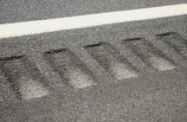
Figure 1. Milled SRS.

3.2 Rolled SRS
Rolled SRS are pressed into freshly laid asphalt pavement, as shown in Figure 2. Depressions in the hot pavement are made with a roller that has steel pipes welded to a drum. Rolled SRS are generally rounded or V-shaped and produce lower levels of auditory and vibrational stimuli than milled SRS.
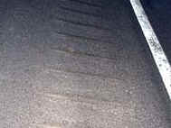
Figure 2. Rolled SRS.

3.3 Dimensions and Offset
The SRS’s transverse and longitudinal widths, spacing and depth can be modified to vary the amount of vibration and auditory stimuli produced. However, Isackson (14) noted in a nationwide survey conducted by the Minnesota DOT (Mn/DOT) that the actual dimension of the SRS varies slightly from State to State. While specific dimensions will be discussed in a following section, Table 2 and Figures 3 and 4 show the layout of a typical SRS:

Table 2. Standard Dimensions of Milled and Rolled SRS.
Dimension | Measurement | Milled (mm) | Rolled (mm)
A | Repeat Pattern | approx. 130 (5.1 in) | approx. 130 (5.1 in)
B | Longitudinal Width | 180 (7.1 in) | 40 (1.6 in)
C | Transverse Width | 400 (15.8 in) | 400 (15.8 in)
D | Tire Drop | 13 (0.5 in) | 0.75 (0.03 in)
E | Depth | 13 (0.5 in) | 32 (1.3 in)

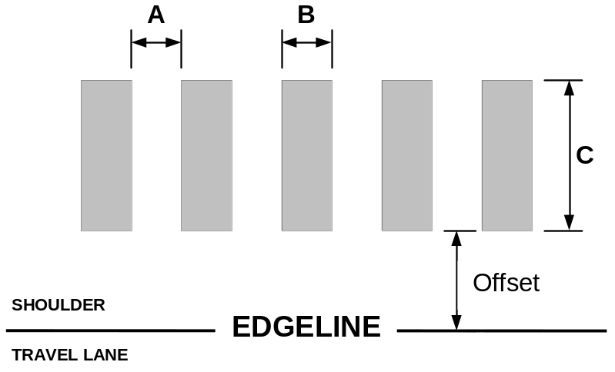

Figure 3. Standard Measurements of SRS.

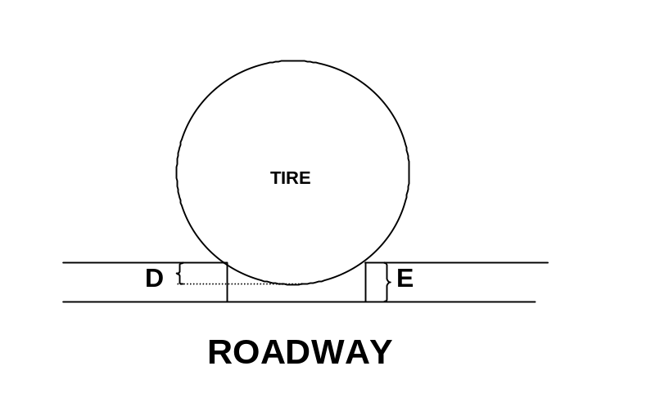
Figure 4. SRS Tire Drop and Depth Illustration.
Isackson also noted that the offset of the SRS (with respect to the edgeline) varies greatly from State to State. While the vast majority of States offset the SRS between 150 – 600 mm (5.9 - 23.6 in) from the edgeline, it is possible to find States that place the strip directly next to or partially under the edgeline or install them as far away as 900 mm (35.4 in). Assuming a SRS with a traverse width of 305 mm (12 in) on a 1830 mm (6 ft) shoulder, the recovery area can range from 1525 - 610 mm (60 - 24 in).

3.4 Safety Record
Even though alternative SRS designs have been used, evaluation studies have demonstrated that SRS are effective in preventing ROR crashes. Table 3, taken from a report by FHWA’s Wyoming Division Office posted on FHWA’s rumble strip website entitled “Shoulder Rumble Strips B Effectiveness and Current Practice” (15), presents additional evaluations conducted since 1985. The success of SRS appears to have led several States to require the incorporation of SRS on 3R projects (reconstruction, rehabilitation or resurfacing) on limited access roadways.

Table 3. SRS Studies and Associated Crash Reductions.
State (date) | Roadway Type | Percent Crash Reduction
Massachusetts (1997) | Turnpike, Rural | 42
New Jersey (1995) | Turnpike, Rural | 34
Washington (1991) | Six Locations | 18
Kansas (1991) | Turnpike, Rural | 34
FHWA (1985) | Five States, Rural | 20
note: The FHWA study included Arizona, California, Mississippi, Nevada and North Carolina.
source: “Shoulder Rumble Strips B Effectiveness and Current Practice” (15)

4.0 EFFECT ON DIFFERENT ROADWAY USERS
Simple auditory and vibrational warnings are known to be an effective means of providing an urgent message to an operator. Auditory stimulus have been used for many years by human factors engineers and motor vehicle design engineers as a warning to alert a driver of an important situation. More recently, vibrational stimulus has been used in motor vehicles to provide a warning.

4.1 The Driver’s Experience
The driver that traverses a SRS typically is doing so as their vehicle unintentionally veers from the travel lane. This driver may be inattentive, fatigued, or under the influence of drugs or alcohol. In any case, the driver experiences both an auditory and vibrational warning when the vehicle’s tires roll over the SRS.

Ideally, when a driver encounters a SRS the desired reaction is to have them regain their attention and steer back onto the travel lane. However, depending on the level of the driver’s inattention, this desired reaction may not happen. For a semi-alert driver (e.g., one changing the radio station) it is believed that the driver will simply refocus their attention and steer the vehicle back onto the travel lane. For a driver that is asleep the possibility exists that the reaction to the SRS could be greatly exaggerated, to the extent of sharply turning the steering wheel and swerving into the adjacent lane or even off the roadway. Unfortunately, the frequency of this hypothesized scenario is unknown; no research has been identified to determine what actions a driver will take when suddenly awakened while driving. What is known is that to determine the amount of stimulus required to alert an inattentive driver is compounded by the fact that different types of vehicles travel the roadway.

4.1.1 The Driver and Motor Vehicle Auditory Stimulus
Table 4 presents common transportation sounds and their associated decibel levels. As can be seen, the sound level of city traffic measured from inside a car is 85 dB and is similar to the sound level measurement of heavy traffic. Perrillo (7) reported that the sound inside an operating passenger vehicle is approximately 60 dB. The sound level of a car traveling on a highway could not be found for this synthesis, but it can be assumed to be comparable to the sound level of freeway traffic, 70 dB (assuming no radio or conversation occurring in the car). Given these decibel levels, the auditory warning generated by the SRS must be able to be heard inside the vehicle. A more detailed discussion of decibel levels can be found in Appendix A.

Table 4. Common Transportation Sounds and Their Associated Decibel Level
DB | Sound |  | dB | Sound
70 | freeway traffic |  | 90 | Truck
85 | heavy traffic |  | 95 - 110 | Motorcycle
85 | city traffic inside car |  | 110 | car horn
source: League for the Hard of Hearing (16)

The auditory warning created as a vehicle passes over a SRS sounds much like a low rumble to the driver. Typically, the sound produced inside the vehicle by the SRS is not much louder that the ambient level already inside the vehicle, and at times may be even less. Therefore, it is important to determine the level of auditory stimulus required to be heard inside the vehicle.

One of the most obvious ways to measure the auditory stimulus produced by a SRS is to measure its loudness. Various researchers have made this measurement both inside and outside of the vehicle. Higgins and Barbel (2) reported that when a vehicle traveled over SRS, an increase in the order of 7 dB over regular road noise was recorded at locations 15 m (49.2 ft) from the SRS. Additionally, it was determined that peak noise levels averaged at 87 dB in a cab of a tractor-trailer while the tests were performed.

In 1988 various SNAP patterns were tested by the Pennsylvania DOT and reported by Wood (4) in 1994. Auditory measurements were taken inside test vehicles as they passed over five different milled rumble strips designs at different speeds. The data revealed that as speed increased, associated decibel level increased. The test vehicles used were a sedan passenger car and a dump truck.

In Chen’s (11) research, which compared various types of SRS, one characteristic of SRS that was measured was the loudness of the auditory stimulus. At speeds of 105 kph (65 mph), milled SRS were measured between 85 – 86 dB and rolled SRS were measured at 74 – 79 dB. The measurements were taken 61 m (200 ft) from the vehicle. It was further noted that a 3 dB difference between the milled and rolled SRS was noticeable to drivers.

More recently, Elefteriadoiu et al. (10) reported sound levels inside the passenger compartment of a minivan when traversing six different milled SRS at speeds of 72 and 88 kph (45 and 55 mph). While at the slower speed, the sound levels increased from an ambient level of 68 dB to approximately 79 dB. Likewise, at the higher speeds, the sound levels increased from an ambient level of 65 dB to approximately 81 dB.

The Caltrans study (12) recorded sound levels inside the cabin of passenger vehicles and heavy trucks with the vehicle’s fan and radio off and all of the windows closed. Testing revealed an increase in average auditory stimulus ranging from 11.0 - 19.9 dB for passenger cars at test speeds of 80 and 100 kph (50 and 62.5 mph). Heavy trucks produced a lower amount of auditory stimulus when measured inside the cabin, ranging from an average of 1.8 dB - 4.7 dB. However, due to a space constraint at the testing facility, heavy trucks were only tested at speeds of 80 kph (50 mph).

Outcalt (13) compared sound levels for vehicles taveling on SRS against those traveling on smooth pavement at speeds of 88 and 105 kph (55 and 65 mph). The author used a generally accepted 6 dB increase in cabin sound level as a “clearly noticeable” sound level increase to alert a motorist. Overall, sound levels were louder for SRS with larger longitudinal widths.

Table 5 summarizes the five described studies, associated decibel levels produced, and the location of the measurement.
Table 5. Decibel Levels Produced by Milled and Rolled SRS.
 | Decibel Level Produced |  | Location of Measurement
 | Milled SRS | Rolled SRS | Location of Measurement
Higgens and Barbel (2) | increase of 7 dB over ambient levels |  | outside vehicle
Wood (4) | 74-80 (auto)  86 (truck) |  | inside vehicle
Chen (11) | 85-86 | 74-79 | outside vehicle
Elefteriadoiu et al. (10) | 75-84 (@ 72 kph)  78-89 (@ 88 kph) |  | inside vehicle
Caltrans (12) | increase of 12 – 21 (@ 80 kph) (auto)  increase of 10 – 19 (@ 100 kph) (auto)  increase of 2 – 5 (@ 80 kph) (heavy vehicle) | 14 (@ 80 kph) (auto)  13 (@ 100 kph) (auto)  5 (@ 80 kph) (heavy vehicle) | inside vehicle
Outcalt (13) | increase of approximately 10 dB over ambient levels |  | inside vehicle

Research performed by Harwood (17) in 1993 determined that by modifying the repeat pattern of the SRS pattern, the noise level produced could be changed. Of the repeat patterns tested, 3048 mm (10 ft) patterns produced the lowest noise levels. When the repeat pattern varied between 1524 mm (5 ft) and 3048 mm (10 ft), the noise levels produced decreased linearly with vehicle speed. Repeat patterns ranging from 305 – 915 mm (1 –3 ft) produced noise levels that varied erratically and were considered undesirable.

Another method to measure the auditory stimulus produced by SRS is to determine the frequency produced. The Higgins and Barbel (2) study was the only research identified that measured the frequency of the sound produced by SRS. While the SRS tested produced frequencies on the low end of the scale (80 Hz – 315 Hz), some high level frequencies in the area of 1000 Hz were measured. While it was shown that speed has some effect on frequency, no research has been identified regarding the effect of SRS dimensions on frequency.

4.1.2 The Driver and Motor Vehicle Vibrational Stimulus
The vibrations produced when a vehicle passes over SRS typically begin at one of the front tires. Vertical and lateral accelerations of the tire are transferred though the vehicle to its steering wheel, seats, and floor in the form of vibrations. These vibrations must be gentle enough so that the driver of a compact car does not lose control but strong enough that the driver of a sport utility vehicle (SUV) or large truck is able to feel them. As assortment of vehicle types may encounter SRS, therefore, most SRS appear to be designed with large trucks as the design vehicle.

Recent advances in technology have made vibrational measurements much easier to obtain. Chen (11) developed a theoretical analysis of the tire drop to establish a measurement of effectiveness of the SRS. It was hypothesized that to generate adequate auditory and vibrational stimuli, the longitudinal width of the strip should be large enough for the tire to drop into the grove. Based on standard SRS dimensions used in Virginia, Chen concluded that milled SRS perform better than rolled SRS since the tires only drop to the bottom of milled SRS. Field tests verified that milled SRS produced greater vibrational and auditory stimuli than rolled SRS. However, as noted by Elefteriadoiu et al. (10), Chen’s theoretical analysis was based on solid wheels, not elastic motor vehicle tires.

The study by Elefteriadoiu et al. (10) compared five proposed bicycle tolerable SRS designs to Pennsylvania’s existing pattern. In this study, a minivan was instrumented to measure vertical acceleration and pitch angular acceleration. When the accelerations of the five proposed designs were compared to accelerations of the existing design, it was determined that the difference was insignificant. No further in-vehicle vibration tests were performed. The depth of the five proposed designs ranged from 6.3 – 13 mm (0.25 – 0.5 in) while the Pennsylvania existing pattern had a depth of 13 mm (0.5 in).

Four accelerometers were mounted to the steering wheel of test vehicles in the Caltrans study (12) to test for vibrational stimulus. A general trend was found in the vibrational stimulus produced, as the depth of the SRS increased, so did the amount of vibrational stimulus. An interesting observation regarding the heavy vehicles at speeds of 80 kph (50 mph) occurred; when the existing rolled SRS was compared to the proposed milled designs, the average vibrational stimulus of the rolled SRS was slightly greater.

Outcalt (13) had a minivan equipped with two accelerometers to measure vibration. One was installed on the floor just behind the driver and the other was installed on the steering wheel. Vibrational measurements were taken at 88 and 105 kph (55 and 65 mph) on both SRS sections and smooth pavement. Results showed that SRS with larger longitudinal widths produced greater vehicle vibrations.

4.2 The Bicyclist’s Experience
Bicyclists nationwide have reported safety problems associated with rumble strips. A combination of this concern and laws enacted by some States have led most bicyclists to ride as far to the right of the travel lane as practicable or on the shoulder.

When traveling on the shoulder, debris covering the shoulder or a narrowing of the shoulder due to an overpass may force the bicyclist onto the travel lane. If the shoulder has SRS placed near the edgeline, then the bicyclist must travel over the SRS to get off of the shoulder. The accepted useable shoulder width required for a bicycle to travel is 1220 mm (4 ft), as stated by the American Association of State Highway and Transportation Officials (AASHTO) (18). In instances when a guardrail or curb may infringe on this width, the generally accepted practice is to increase this with to 1525 m (5 ft), so the bicyclist may ride further away from the guardrail and still have an effective width of 1220 mm (4 ft).

4.2.1 The Bicyclist and Bicycle Auditory and Vibrational Stimulus
When considering the combined weight of a bicycle and bicyclist, the sound a bicycle makes when traveling over a SRS is not loud enough to cause much of a problem. However, the vibration that is produced is of a great concern to a bicyclist.
It has been proposed by Chen (11) that the deeper the vertical drop (depth) of the SRS, the greater the vibrational stimulus provided to the errant driver. It was shown by Moeur (9) that the larger the depth of the SRS the more difficult for the bicyclists to retain control of their bicycle while crossing the strips, even at low speeds. However, Gårder (19) concluded from a test of milled and rolled rumble strips 12 mm (1/2 in.) deep, which he and 20 others traversed on a bicycle, that there is no danger if a bicyclist mistakenly crossed a rumble strip.

In the study by Elefteriadoiu et al. (10), the five proposed bicycle tolerable SRS designs were evaluated by 25 intermediate and advanced bicyclists. Once again, vertical acceleration and pitch angular acceleration were measured, as well as having each participant subjectively rate the proposed designs on comfort and control. Low, intermediate, and high approach speed, as well as three approach angles (0°, 10°, and 45°) were tested. When the acceleration measurements were examined and the subjects’ subjective rankings were tabulated, it was determined that the most tolerable design for bicyclists had a depth of 6.3 mm (0.25 in) and caused the least auditory and vibrational stimulus for motor vehicles.

Fifty-five bicyclists in the Caltrans study (12) were asked to subjectively rate the various test strips on comfort and control level. Participants were allowed to ride over the test strips as many times as necessary, both alone and in groups. Milled SRS that were not as deep were favored by the bicyclists when compared to deeper milled SRS. An additional analysis based upon major demographic variables found three bicyclist variables to be significant: riding in inclement weather, age, and whether a bicyclist has ridden on SRS.

Of the 29 bicyclists surveyed in the Outcalt (13) study, 27 used bicyclists with narrow, high-pressure tires. Bicyclists rated each SRS design for control and comfort. Overall, the survey concluded that while bicyclists can navigate 9.5 mm (3/8 in) deep SRS fairly easily, when grooves are 13 mm (1/2 in) deep or greater, bicyclists may experience control problems.

4.2.2 Other Bicyclist’s Concerns
Many bicyclist believe that SRS near the edgeline force bicycles further from the “sweeping action” of passing vehicles that push debris from the travel lane. Thus, the bicyclist is forced to ride in heavier debris. Harwood (17), Moeur (9), and Gårder (19) have commented that shoulders may at times be covered with debris and have acknowledged a vehicle’s sweeping action; however, no research has been identified to document the width of the sweeping action based upon vehicular speed or volume.

At the current time there are two ways to deal with shoulder debris. The first is to have maintenance crews routinely sweep the shoulders. The second is to place a skip (or gap) in the SRS pattern to allow bicyclists to cross from the shoulder to the travel lane when encountering debris, but this does not ensure that debris will not be in the skip pattern.

In addition to shoulder debris, other dislikes of bicyclists with respect to SRS are listed below:

- SRS are appearing on more and more roads that are frequented by bicyclists,

- SRS often appear without warning,

- SRS that are placed close to an intersection,

- Different States have different standards and designs, and

- “Weaving” SRS (poorly installed SRS that are supposed to be in a straight line) are difficult for bicyclists to ride near.

4.3 Motorcycles
Caltrans has performed a motorcycle SRS evaluation of various SRS designs. In its study, participants rode over a series of various SRS at either 88 or 105 kph (55 or 65 mph) or another speed they were comfortable with and then asked to rate their comfort and control for each of the SRS traversed. It has also been reported Kansas and Massachusetts have tested motorcycles traversing rumble strips. While the composition of the Kansas test group was unknown, the Massachusetts test group was comprised of the police motorcycle squad. Both test groups reported noticing the rumble strips, however, they did not feel out of control.

4.4 Other Vehicles
Little information was identified regarding SRS and maintenance vehicles, such as those used for snowplows operation. It was commented in telephone conversations with some State DOTs that when travel lanes are first plowed, snowplow operators may use SRS to help them maintain their course. However, when plowing the shoulder, drivers have commented negatively regarding the vibrations caused by the SRS.

It has been suggested that maintenance trucks equipped with snowplows, wide loads tractor-trailers and other vehicles that typically ride over SRS may want to have dampening devices installed on the vehicle to lessen the effect of the SRS. However, at this time no dampening device in known to exist.

5.0 SUMMARY OF SHOULDER WIDTHS AND POTENTIAL SRS PROBLEMS
To summarize the current problem, when the various shoulder widths were classified into groups, it is apparent that problems appear only under certain conditions. Table 6 is used to illustrate the various shoulder widths and potential problems that may exist between bicyclists and SRS.

Even though shoulders that are less than 1219 mm (3.9 ft) do not have the minimum usable width recommended by AASHTO (18) for bicycle travel, bicyclists may choose to ride on these shoulders in order to maintain a maximum distance from passing motor vehicles. Shoulders that are between 1220 – 1829 mm (4 – 5.9 ft) have both bicyclists and SRS competing for the same area. It is not surprising that these shoulders tend to be where bicyclists have greatest concern. Shoulders over 1830 mm (6 ft) typically have enough room for both the SRS and bicyclist to maneuver around most existing debris.

Table 6. Shoulder Width and Potential SRS Problems.
Shoulder Width (mm) | Problem | Reasoning
0 – 609 (0 - 1.9 ft) | No | Shoulder too narrow for SRS or bicyclist.
610 – 1219 (2 – 3.94 ft) | Yes | Shoulder may be wide enough for SRS or bicyclist.
1220 – 1829 (4 – 5.9 ft) | Yes | Shoulder might be wide enough for both SRS and bicyclist.
1830 + (6 ft+) | No | Shoulder wide enough for SRS and bicyclist.

6.0 SURVEY OF STATES’ POLICIES AND PRACTICES
During 2000, three SRS surveys were distributed to every State DOT, two by FHWA and one by Mn/DOT. A copy of the three surveys can be found in Appendix B.

While none of the surveys achieved a response rate of 100 percent, every jurisdiction responded to at least one survey. Table 2A in Appendix B relates the surveys a jurisdiction responded to. When viewed alone, the surveys convey a sampling of SRS practices; when combined, the surveys provide a complete synthesis of SRS practices and policies.

6.1 Minnesota DOT Survey (February 2000)
In the process of reviewing their SRS policy, Mn/DOT’s Design Standards Unit conducted an informal survey of State DOTs in order to gain a perspective on the use of continuous milled SRS. State and FHWA officials were contacted via e-mail and asked six questions of specific interest to Mn/DOT regarding their State’s SRS policy.

Since the intent was to collect this information in a short (i.e., two week) time period, follow-up questions were not pursued. The document compiled by Isackson (14) should be considered a general summary of milled SRS dimensions and policies nationwide.

Thirty-nine responses (78 percent) were received out of a possible 50. As previously reported, there is a great deal of consistency regarding the dimensions of SRS, except for the offset, which varied greatly. According to the survey, approximately 70 percent of the States use milled SRS. Twenty-one of the 39 surveyed States have some type of SRS restriction based upon shoulder width. Fourteen States responded that they have some type of SRS restriction based upon bicycle history.

6.2 FHWA Survey (Spring 2000)
An attempt to identify proposed SRS research/effectiveness studies was addressed with a survey sent to the FHWA Division Offices in each State and Washington, D.C. The surveys were either completed by the FHWA Division Offices or forwarded to the State DOT. Attached to the survey were summaries of research/evaluation studies (either completed, on-going, or proposed) that were conducted by eight States.

Twenty-one responses out of a possible 51 were received (41 percent). Thirteen States reported SRS research either underway or recently completed in their State. While few States commented on the attached summaries, many States suggested future paths for SRS research and evaluation. These responses ranged from long term effects on pavement to human factors and bicycle studies for optimal SRS dimensions.

6.3 FHWA Survey (September 2000)
In order to complete this synthesis, an additional survey was sent to FHWA Division Offices in each State and Washington, D.C. Once again, the surveys were either completed by the FHWA Division Offices or forwarded to the State DOT.
Forty-two responses were received out of a possible 51 (82 percent). Responses to this survey dealt with bicyclists’ rights to travel on Interstates, controlled access highways, and non-access controlled roads. Bicycle travel on rural Interstates is allowed in a heavy majority of Western States but in very few Eastern States. Nationwide, bicycle travel is allowed on some access control roads while not on others. It was unclear from the survey responses what characteristics made a controlled access highways acceptable for bicycle travel. Finally, each State that responded sent an updated copy of their SRS policy and standards.

7.0 SRS PRACTICES
Numerous SRS designs have been implemented and evaluated by different States. In review of the various standards and specifications, key modifications to the standard SRS are now discussed.

7.1 Skip Pattern
Originally SRS were placed continuously on the shoulder. More recently at least ten States have been identified that install SRS in a skip pattern, such as ten meters with and ten meters without SRS. This design is intended to allow bicyclists to cross from one side of the strip to the other without much difficulty while still maintaining the ability to alert errant drivers.

7.2 Transverse Width of SRS
With the exception of one State, all States identified use 3660 mm (12 in) as a minimum transverse SRS width. Arizona (20) was the only State identified that modifies the width of the SRS, and this modification is based on right shoulder width. If shoulders on an undivided roadway are less than 1220 mm (4 ft) in width and SRS are installed, the policy recommends as a guideline that the right SRS transverse width be 153 mm (6 in) wide. Additionally, by placing the SRS partially under the edgeline, Arizona is providing the safety benefit of the SRS while still providing usable shoulder to the bicyclist.

7.3 Depth of SRS
Work preformed by Elefteriadoiu et al. (10) has highlighted the possibility of using multiple SRS designs in one State. The possibility exists to examine vehicular traffic to determine if a deeper SRS, which has been shown to be effective with large vehicles, is required on a road that does not carry many large vehicles. A shallower rumble strip may provide adequate stimulus to the inattentive driver of a pickup truck and be gentler to bicyclists.

7.4 SRS Placement
As noted by Isackson (14), an inconsistency exists in determining a standard offset for SRS placement. The two main theories are to place the SRS close to the edgeline or close to the edge of shoulder. Most States are following the practice of installing the SRS near the edgeline but some States place SRS near the edge of shoulder.

SRS placed near the edgeline allow the remainder of the shoulder to be utilized by other users, such as bicyclists or pedestrians. This small offset provides a warning to errant drivers as soon as they leave the travel lane and generates the largest amount of recovery area for the errant driver. Furthermore, it also places a warning device between errant motor vehicles and bicyclists. However, this offset forces the bicyclist to decide whether to travel in the travel lane (if legal) or on the right side of the shoulder, which may contain debris.

SRS placed close to the edge of shoulder allow bicyclists to travel freely between the travel lane and the shoulder. Additionally, it also allows for the sweeping action of the motor vehicles to clear a larger section of the bikeable shoulder. The drawback of this large offset is that it reduces the amount of recovery area available for an errant vehicle and lessens the SRS’s potential safety benefit.

Pennsylvania (21) has a variable offset for SRS placement, even though it does not modify the traverse width of their SRS from 406 – 432 mm (16 -17 in). While their recommended offset is 457 mm ± 12 mm (18 in ± ½ in) from the pavement/shoulder joint, for free (non-limited) access highways the designer has the flexibility to adjust the offset from 102 - 457 mm ± 12 mm (4 - 18 in ± ½ in). When the offset is designed to be more than 470 mm (18.5 in), the designer is directed to attach revised details to show selected offset dimensions accordingly.

Table 7 presents bicyclists’ and motor vehicle safety advocates’ perspectives regarding SRS placement. The table emphasizes the fact that the two groups are on opposite sides when it comes to SRS placement.
Table 7. SRS Placement Based on Drivers’ and Bicyclists’ Perspectives.
(for Shoulders 1220 – 2440 mm (4 - 8 ft) Wide)
Perspective |  | SRS Placement
Perspective |  | Near Edgeline | Near Edge of Shoulder
Perspective | Motor Vehicle Safety Advocates | · Large recovery zone  · Earliest warning for errant drivers | · Eliminates the recovery zone  · Diminished early warning for drivers
Perspective | Bicyclists | · Forces bicyclists to cross over the SRS  · Places warning device between cars and bicycles | · Allows bicycles to cross freely into travel way  · Placing bicycle in sweep zone  · Places bicycle closer to vehicles

8.0 SRS POLICY

8.1 Policy Classification
The SRS policies and practices of 41 jurisdictions were collected in the September 2000 Survey. After review of the policies, five subjective categories were created based on the level of detail that the policy gave to bicyclists and their concerns:

No SRS or policy. These jurisdictions do not install SRS. A standard or spec does not exist.

No written policy but SRS spec. These jurisdictions do not have a formal written SRS policy but they do have a standard or spec detailing SRS installation. Typically the standard or spec contains notes regarding installation issues. Some of the jurisdictions in this category were noted as having unwritten SRS policies.

Written policy but does not mention bicycles. The jurisdiction has a formal, written SRS policy but it does not mention bicycles or a bicyclist’s needs.

Written policy but only mentions bicycles. The policy mentions bicycles but it relies almost entirely on engineering judgment regarding SRS installation.

Written policy that deals with bicycles. A formal, written policy that was designed in an attempt to address some of the concerns bicyclists’ have with SRS.

Table 8 presents a distribution of the 41 policies that were available for review, by type of policy.

Table 8. SRS Policies by Type of Policy.
Type of Policy | States
No SRS or policy | 1
No policy (written or unwritten policy) but SRS spec | 14
Written policy but does not mention bicycles | 9
Written policy but only mentions bicycles | 7
Written policy that deals with bicycles | 10

According to the surveys, SRS policies of at least seven States are in the process of being updated. From follow up telephone conversations with some of these States, it was determined that one of three actions are being taken with respect to policy update:

- Awaiting FHWA recommendations,

- Performing their own SRS research/working with the bicycle community, or

- Awaiting FHWA recommendations and the opportunity to view newly revised policies of other States.

Some States that have previously updated their policy, including California and Wyoming, placed a moratorium on SRS installation while their policy was under review.

At least eight States have a SRS policy (either written or unwritten) in which they would install SRS only on roads that prohibit bicycles. While this is one way to ensure that there will not be a conflict between SRS advocates and bicyclists, it also limits the number of roadways where this safety device can be installed.

8.2 SRS Installation Warrants
Upon review of the surveys and policies obtained for this synthesis, it was noted that specific warrants for SRS installation do not exist. However, numerous States had guidelines, criteria, or recommendations regarding when to install or not install SRS. The following seven suggestions were found in at least one State policy.

Minimum Shoulder Width – The suggested minimum shoulder width before installation ranged from 610 mm (2 ft) in Wyoming (22) to 2438 mm (8 ft) in New Mexico (23).

High ROR Crash Location - Numerous policies mention installing SRS in high ROR crash locations, but only Ohio (24) provides a threshold (0.25 crashes per million vehicle miles traveled) to help the engineer identify high ROR crash locations.

Uninterrupted Length – Oklahoma (25) set one of its criteria for SRS installation to be that they can only be used in locations where driving may be uninterrupted for a length as calculated by the follow equation, where length is in miles and design speed is in miles per hour. .

Significant Bicycle Usage - Many policies commented that SRS would not be installed on roadways with significant bicycle usage, however, no State provided a threshold to its engineers.

Minimum Speed Limit – Numerous States have recommended a minimum speed limit of 50 mph on all roads in which SRS are to be installed.

Fully Controlled Roadways or Roads where Bicycles are Prohibited – Many States recommend only installing SRS on roadways where bicycles are prohibited.

Rural Roadways Only – Numerous States recommend to install SRS only in rural areas.

8.3 Recommended Inclusions into any SRS Policy
Of the States that have provided their SRS policies, two policies stood out from the rest as model policies.

Arizona. Utilizes a skip pattern and different SRS widths based on the type of roadway and right shoulder width. (20) See Appendix C.

Minnesota. Has multiple SRS patterns based on roadway type and shoulder width. (26) See Appendix D.

The following provisions have been identified in various SRS policies. They are provided as recommendations for future bicycle tolerable SRS policies. After each recommendation is the name of one State which currently uses the provisions. By combining some of the alternative designs and SRS placement strategies, both SRS and bicyclists can share shoulders.

- Provide multiple SRS dimensions based on shoulder width or roadway type – Arizona (20),

- Provide flexible offset for 1830 – 2440 mm (6 – 8 ft) shoulders to adjust the offset of the SRS to better address bicyclists’ needs – Pennsylvania (21),

- Use SRS in a skip pattern when appreciable bike traffic exists or is anticipated and shoulders are less than 2440 mm (8 ft) – Arizona (20),

- Apply SRS on all roads with a high ROR crash history. (Ohio has set a threshold of 0.25 crashes per million VMT) – Ohio (24),

- Set shoulder width minimum standards greater for those shoulders that have guardrails to ensure an “effective shoulder width” for bicycles – Arizona (20),

- Keep shoulders free of debris on designated bike routes and/or designated high bicycle use areas – Wyoming (22),

- Do not install SRS when pavement analysis determines that installation will result in inadequate shoulder strength – Washington (27),

- Do not install SRS on: bridges, overpasses, or roads with structural re-enforcement – Washington (27),

- Do not install SRS in: front of driveways, intersections, suburban, urban or residential areas - New York (28),

- Do not use SRS when strong consideration is being given to using the shoulder as a peak travel lane or if construction activity within the next year will require the use of the shoulder or if the shoulder will be overlaid or reconstructed – Washington (27),
- Provide advance warning signs or public service announcements to educate the public about SRS use, benefits, and limitations – Wyoming (22),

- Apply SRS 45.7 m (150 ft) upstream on all shoulders approaching a bridge overpass or underpass when the shoulder width is reduced or eliminated – New York (28),

- SRS noise can be offensive to nearby residents. Numerous State DOTs have restricted SRS use in residential areas – Wyoming (22),

- Provide a map/website for bicyclists that shows road with SRS. (Iowa is considering this practice.), and

- Designate bicycle routes throughout the State. It is suggested on these roadways, the shoulders be of adequate width (i.e., 1220 mm (4 ft)), having signing indicating to drivers that the road is a route frequently traveled by bicycles, and attempt to keep the road free of debris. However, in the event that ROR crashes become a problem on a section of the roadway, the possibility exists for the State to install SRS. – AASHTO (18).

9.0 PROPOSED RESEARCH
While much research has been done on the effectiveness of SRS, more research would be useful. In the following section, needed research has been assigned to one of three levels: high, medium, and low priority.

9.1 High Priority Research
High priority research can be classified into two categories: SRS design and driver interaction.

Much research has already been done regarding the longitudinal width and depth of the SRS. Several States, such as California and Pennsylvania have studied various SRS designs in order to determine which are the most favorable to bicyclists while still meeting threshold vibration and auditory requirements set forth by motor vehicles. It is recommended that future research focus on the SRS’s transverse width and offset. Considering that over the last ten years states have begun to experiment with narrower widths and variable offsets on newly installed SRS, it is apparent that the SRS does not require the entire shoulder to remain an effective safety countermeasure.

Since the SRS’s specific intent is to alert errant drivers, research needs to be performed to determine how an inattentive driver reacts to a SRS. Evaluation of the driver’s reaction time and subsequent reaction will provide excellent design data that will be used to help design effective SRS. For example, determining the amount of exposure time a driver will require to make corrective action will lead directly into determining a minimum transverse width of the SRS. Additionally, Watts (29) indicates that a need exists to determine the amount of auditory stimulus required to alert errant drivers, both those that are awake but inattentive and those that are drowsy or not awake.

9.2 Medium Priority Research
Research into skip patterns of SRS needs to be refined to determine its effectiveness relative to continuous SRS patterns in alerting drivers. In order to do this, the skip pattern (and SRS transverse width) must take into account both errant vehicle speed and trajectory as well as the speed of bicyclists. While the Mouer study in Arizona has done work in this area based on the bicyclist’s needs, further research is required regarding the length of the skip and SRS width when using a skip pattern.

Alternative SRS designs and applications should also be further investigated. Thus, textured edgelines and chip and seal shoulders need to be evaluated on both a safety and economic analysis.

Reports from Northern States that experience freeze/thaw cycles have related instances of SRS increasing the degradation of the pavement. These reports need to be evaluated to determine whether installing SRS decreases the expected life of the pavement.

Additionally, a narrow SRS placed in the middle of the travel lane is an option that merits further attention. As previously reported, these SRS originally were dismissed as being potentially dangerous to motorcycles or cause an increase in fatigue to drivers of cars and trucks. However, this dismissal was based on existing SRS designs and patterns. Alternative SRS designs may prove that this option is feasible and will not cause difficulty for motorcyclists.

9.3 Low Priority Research
Low priority SRS research can be viewed as helping to fill-in the gaps in current SRS knowledge.

Further investigations are needed to determine the effectiveness of SRS. Most studies to date have been based on data from Interstates. Now that data are available on full-access roads where bicycles are allowed to travel, research should be conducted on these roads and should include the type of vehicle involved in the crash, time of day, day of week and time of year.

- Substitution of raised pavement markers (RPMs) or Botts Dotts for SRS,

- Maximum vibrational threshold for bicycles,

- Minimum (acceptable) width of shoulder for bicycle travel,

- Angle of ROR crashes to aid in the proper design of transverse width,

- Method to determine prioritization of existing shoulders for SRS retro-fit,

- Width of sweeping action of vehicles,

- Minimum width required for a “weave” maneuver required for a bicyclist to weave around a SRS (assuming a skip pattern),

- Noise pollution created by SRS,

- Cost effectiveness of the skip pattern, and

- As Intelligent Transportation Systems (ITS) technologies advance, further research into the advancement of lane departure warning systems and their economic viability will need to be investigated. Systems such as these would provide the opportunity to replace SRS.

Appendices

Appendix A

Decibel Levels

The loudness of sound is expressed as a ratio comparing the sound to the least audible sound. The range of energy from the lowest sound that can be heard to a sound so loud that it produces pain rather than the sensation of hearing is so large that an exponential scale is used. The lowest possible sound that can be heard is called the threshold of hearing. The sound level at the threshold of hearing is:

I_{o} = 10⁻¹²W/m²

Intensity of sound is measured in Watts per square meter. To calculate the intensity level in decibels, find the ratio of the intensity of sound to the threshold intensity. Since an exponential scale is being used, you will find the logarithm of the ratio. If you stopped at this point the intensity level would be expressed in Bels. This unit was named in recognition of Alexander Graham Bell. To express the intensity level in dB (decibels) multiply the logarithm of the ratio by 10. The resulting equation is:

β = 10∙log(I/I_{o})

Experts agree that continued exposure to noise above 85 dB over time, will cause hearing loss. To know if a sound is loud enough to damage your ears, it is important to know both the decibel level and the length of exposure to the sound. In general, the louder the noise, the less time required before hearing loss will occur. According to the National Institute for Occupational Safety and Health (1998), the maximum exposure time at 85 dB is 8 hours. At 110 dB, the maximum exposure time is one minute and 29 seconds.

Table 1A. Common Sounds and Their Associated Decibel Levels
dB | Sound |  | dB | Sound
0 | Softest sound a person can hear |  | 95-110 | Motorcycle
60 | Normal conversation |  | 110 | Shouting in ear
70 | Freeway traffic |  | 110 | Leafblower
80 | Ringing telephone |  | 110 | Car horn
85 | Heavy traffic |  | 117 | Football game (stadium)
85 | City traffic inside car |  | 130 | Stock car races
90 | Truck |  | 150 | Firecracker
90 | Shouted conversation |  | 170 | Shotgun
90 | Train whistle at 500 ft |  | 194 | Loudest sound that can occur

Taken from:

“Physics Tutorials; Sound; Decibel Levels” Online Posting: http://www.memphis-
schools.k12.tn.us/admin/tlapages/sound_decibel.htm. October 2000.

“Noise Center; Noise Levels in our Environment Fact Sheet” March 1999. Online Posting: http://www.lhh.org/noise/decibel.htm. October 2000.

Appendix B

Mn/DOT Survey

Question 1: What state do you represent?

Question 2: Does your state use continuous milled shoulder rumble strips on: (Urban and/or rural - Freeways, Expressways, and/ or Two-lane Roads)?

Question 3: Do you have any restrictions on usage (Accident Rates, Shoulder Widths, Bicycle Usage)?

Question 4: Has the bicycle community expressed concern about your design or use of rumble strips? If so, how has your design and/or policy changed?

Question 5: What are the dimensions of the milled shoulder rumble strips that you use?

Question 6: Have you ever installed intermittent milled rumble strips on a bituminous shoulder? If so, please explain.

FHWA Spring Survey

Question 1: What comments do you or your State have on the research and evaluation studies identified in the attachment?

Question 2: What other research or evaluation studies are underway or have been completed in your State?

Question 3: What further research or evaluation studies do you believe are needed regarding shoulder rumble strip design and evaluation?

FHWA September 2000 Survey

Question 1: By State law, are bicyclists allowed on any Interstate routes? Please be specific, i.e., all, rural sections only, rural sections with no parallel alternative routes, only where permitted by signs, none, etc. Is this usage restricted to shoulders only, or may bicyclists ride in a travel lane? Are any roadway speed limits (maximum or minimums) regarding when bicyclists are permitted on the shoulders or traffic lane?

Question 2. Same as above for other controlled access highways such as freeway, expressways, and parkways...

Question 3. Same as above for non-access controlled roads and streets...

Question 4. Does your State highway agency have a written policy and/or design for the use of shoulder rumble strips, and particularly that addresses bicyclists’ concerns? If yes, please fax or mail a copy of that policy.

Table 2A. Survey Responses by Survey and State.
State | Mn/DOT | Spring FWHA | Sept. FHWA |  | State | Mn/DOT | Spring FWHA | Sept. FHWA |  | State | Mn/DOT | Spring FWHA | Sept. FHWA
Alabama |  |  |  |  | Kentucky |  |  |  |  | N. Carolina |  |  | 
Alaska |  |  |  |  | Louisiana |  |  |  |  | Ohio |  |  | 
Arizona |  |  |  |  | Maine |  |  |  |  | Oklahoma |  |  | 
Arkansas |  |  |  |  | Maryland |  |  |  |  | Oregon |  |  | 
California |  |  |  |  | Mass. |  |  |  |  | Penna. |  |  | 
Colorado |  |  |  |  | Michigan |  |  |  |  | Rhode Isl. |  |  | 
Connect. |  |  |  |  | Minnesota |  |  |  |  | S. Carolina |  |  | 
Delaware |  |  |  |  | Missouri |  |  |  |  | S. Dakota |  |  | 
D. C.* | n/a |  |  |  | Mississippi |  |  |  |  | Tennessee |  | 
Florida |  |  |  |  | Montana |  |  |  |  | Texas |  |  | 
Georgia |  |  |  |  | Nebraska |  |  |  |  | Utah | 
Hawaii |  |  |  |  | Nevada |  |  |  |  | Vermont |  |  | 
Idaho |  |  |  |  | New Jersey |  |  |  |  | Virginia |  |  | 
Illinois |  |  |  |  | New Mex. |  |  |  |  | Wash. |  |  | 
Indiana |  |  |  |  | N. Hamp. |  |  |  |  | West Virg. |  |  | 
Iowa |  |  |  |  | New York |  |  |  |  | Wisconsin |  |  | 
Kansas |  |  |  |  | N. Dakota |  |  |  |  | Wyoming | 
* The District of Columbia was not contacted in the Mn/DOT survey.

Of the 51 jurisdictions responding to the surveys, only the District of Columbia does not install shoulder rumble strips.

Appendix C

Arizona Rumble Strip Policy
Typical drawings of the Arizona rumble strip can be obtained on the Arizona DOT website by following the link below and then selecting section 480 (Continuous Longitudinal Rumble Strips)

http://www.dot.state.az.us/ROADS/traffic/pgp.htm

480 CONTINUOUS LONGITUDINAL RUMBLE STRIPS

480.1 INTRODUCTION

The purpose of this policy is to define when and where continuous longitudinal rumble strips may be applied on the state highway system.

The purpose of continuous longitudinal rumble strips is to enhance safety by preventing run-off-road (ROR) collisions with fixed object and rollovers due to driver over-correction type crashes. These rumble strips are intended to alert drivers by creating a audible (noise) and tactile (rumble or vibratory) warning sensation that their vehicle is leaving the traveled way (traffic lane) and that a steering correction is required. Before and after accident studies have indicated that ROR type crashes may be reduced significantly by the use of continuous longitudinal rumble strips.

480.2 POLICY

Continuous longitudinal ground-in rumble strips may be applied to the mainline roadway on projects per the recommendations and requirements of this document.

The following table should be used as a guideline in determining the groove width of the rumble strips to be installed:

Type of Roadway | Right Shoulder Width | Groove Width  (both shoulders)
Undivided | less than 4’ | 6”
Undivided | greater than or equal to 4’ | 8”
Divided | less than 6’ | 8”
Divided | greater than or equal to 6’ | 12”

For divided roadways, the groove width for the left shoulder of the roadway should be the same as the width applied to the right shoulder, where possible.

On undivided two lane highway with shoulders four (4) feet and greater in width, longitudinal rumble strips should be applied. The use of longitudinal rumble strips on shoulders less than four (4) feet may be considered on a case by case basis when supported by a written traffic evaluation.

On divided highways, longitudinal rumble strips should be applied on the right (outside) shoulders with a width of four (4) feet or more and on left (median) shoulders which have a width of two (2) feet or more. The use of longitudinal rumble strips on divided highways with narrower shoulders than those noted may be considered on a case by case basis when supported by a written traffic evaluation.

The use of longitudinal rumble strips on all roadway shoulders less that six (6) feet wide with sections of guardrail and/or barrier shall be evaluated. The effective clear width of the shoulder in these areas if a continuous longitudinal rumble strip is installed shall be determined. The effective clear shoulder width is defined as the distance between the outside edge of the proposed rumble strip and the front face of the guardrail or barrier.

The effective clear shoulder width is important for the following reasons:

- Constructibility- To allow for installation equipment, i.e. grinding, a minimum effective clear shoulder width of two (2) feet is needed from the outside edge of the rumble strip groove to the front face of the barrier or guardrail. If the barrier is on a sharp curve additional width may be needed. This constructibility issue applies to all shoulders and all types of highways.

- Bicycle Traffic- If appreciable bicycle traffic exists or is anticipated then a minimum effective clear shoulder width of three-feet and five-inches (3’-5”) should be provided from the outside edge of the rumble strip groove to the front face of the barrier or guardrail. If this clear area cannot maintained then a change of configuration and/or deletion of the rumble strip should be considered.

If these minimum clear shoulder width dimension criteria cannot be maintained, then there are four possible solutions that may be considered. These possible solutions should be considered in the order that they are presented here. The first solution is to reevaluate lane widths; if the lanes are wider than 12 feet it may be permissible to reduce their width. The second solution is to move the location of the rumble strip closer to the traveled way and /or use a narrower strip width (6 inch or 8 inch). If the strip is moved closer to the traveled way it shall not infringe on the actual traffic lane. The third solution is to consider using an alternative rumble strip treatment such as profile pavement markings and/or raised pavement markers; this solution only applies to non-snow removal areas. The fourth solution is to omit the use of the longitudinal rumble strip in the area of the guardrail or barrier.

Details for rumble strip configuraion and placement shall be shown on the plans. Typically the details will be included in conjunction with project striping plans. In addition, the limits of the various type of improvements shall be indicated on the plans.

Where appreciable bicycle traffic exists or is anticipated on non-access-controlled highways with shoulders less than eight (8) feet, the provision of a 10-foot gap for bicyclists to traverse the rumble strip treatment may be provided. For such situations, the rumble strip pattern shall consist of 30-foot long segments of rumble strips at 12-inch centers, with 10-foot segments of no rumble strips, on a 40-foot cycle.

Generally, continuous longitudinal rumble strips should not be applied on the shoulders of roadways within developed and urban areas. In suburban and developing areas, the design team should decide whether rumble strips are appropriate. These types of rumble strips can produce noise that may be objectionable to citizens that reside nearby. The use of continuous longitudinal rumble strips in urban areas should only be considered if there are no other reasonable alternatives and/or it is to mitigate a specific area problem.

480.3 OTHER CONSIDERATIONS

Continuous longidinal rumble strps may be achieved through a number of different techniques and patterns (e.g. formed rumble strip, raised pavement markers like ceramic buttons, or profile pavement markings). This policy is not intended to restrict or prohibit the use of any of these other alternatives. If an alternative technique is shown to offer an advantage over the ground-in rumble strip, then its use may be pursued.

Ground-in rumble strip can be installed in portland cement concrete pavement (PCCP). However, at the writing of this policy it still has not been done in Arizona. Grinding of PCCP requires a diamond tip saw blade grinding drum that is water cooled. The grinding of asphaltic cement pavement (ACP) can be done with a steel grinding drum without water cooling. Thus, doing PCCP ground-in rumble strip would require a significantly different operation and payment structure than what is currently reflected in ADOT’s ACP grinding practice. Careful study needs to be given prior to the application of ground-in rumble strip on PCCP.

The make-up of the new pavement or the thickness, condition, and type of existing pavement needs to be determined prior to the application of ground-in rumble strip. The installation of ground-in rumble strip on pavement that is of questionable thickness, condition, or type (e.g. AC over PCCP) needs to be evaluated to ensure that the installation of the rumble strip will be possible without adverse impact to the pavement or the performance of the strip.

This policy or the rumble strip standard drawings do not account for all possible applications (e.g. rural gore areas). Therefore, it may be necessary for the designer to develop special application plans or details for the application of ground-in or alternative longitudinal rumble strip treatments. All such plans and details shall be submitted to the Traffic Engineering Group for review prior to their use on a project. This includes the use of centerline rumble strip on two-way highways.

480.4 WRITTEN TRAFFIC EVALUATION

The use of continuous longitudinal rumble strips on roadways with shoulders less than four (4) feet shall require a written traffic evaluation approved by the Manager of the HES Section.

Appendix D

Minnesota Rumble Strip Policy


Technical Memorandum

No. 00-08-DS-01

MINNESOTA DEPARTMENT OF TRANSPORTATION
Program Support Group
Technical Memorandum No. 00-08-DS-01
May 9, 2000

TO: Distributions 57, 612, 618, 650
FROM: Patrick C. Hughes
Director, Program Support Group
Assistant Commissioner
SUBJECT: Rumble Strips on Shoulders of Rural Trunk Highways

EXPIRATION

This Technical Memorandum supersedes Technical Memorandum 99-15-DS-01 and Section 4-4.0 of the Road Design Manual. It will be in effect until December 24, 2005,
or until included in the Road Design Manual, which ever comes first.

Implementation

This policy shall be in effect for all projects with a scheduled letting date after July 1, 2000. District personnel should make every effort to implement this policy for projects which have been let prior to July 1, 2000 and on which rumblestrip construction has not yet begun.

Introduction

This Technical Memorandum establishes a policy for placement of rumble strips on shoulders of rural, state-owned highways. Rural is defined as roadway segments that
have minimal residential or commercial development and little or no further development is anticipated in the near future.

Purpose

To provide rumble strips to reduce run-off-the-road (ROR) accidents and to guide motorists during snowy conditions when striping visibility is poor.

Guidelines

Rumble strips shall be placed on all rural highway projects where shoulders are constructed, reconstructed, or overlayed and where the posted speed limit is 50 mph (80 kph) or greater. This applies to both multi-lane and two-lane highways with shoulders 6 feet (1.8 m) or greater in width. They shall also be placed on the left shoulder of multi-lane roads. Districts should also consider placing rumble strips on inplace shoulders at locations with a high ROR accident rate and on which no reconstruction is scheduled in the near future. The District Materials Engineer should make recommendations regarding the structural adequacy of inplace shoulder to receive rumble strips.

Types and applications of rumble strips can be found in Table 1. See Figures 1 and 2 for section and plan views of rumble strips on bituminous shoulders. The intermittent pattern is shown in Plan View B in Figure 2. Figure 3 gives section and plan views of structural rumble strips in concrete pavement that have been modified for safety. Guidelines for appropriate breaks in the rumble strips due to entrances, turn lanes, acceleration lanes, intersections, and deceleration lanes on all roads can be found in Figure 4. Rumble strips in bituminous shoulders should be produced by the milling method. Districts may fog seal rumble strips milled into bituminous pavement.

Shoulder widths of 4 feet (1.2 m) or less with rumble strips will not adequately accommodate bicycles. Therefore, rumble strips should not be placed on these roadway sections unless the District Traffic Engineer has documented a serious ROR accident problem and little or no bicycle traffic is expected. Districts shall contact the State Bicycle Coordinator to determine the amount of bicycle traffic on a roadway.

Because rumble strips will require bicycles to ride farther out from the vehicle induced wind sweep shoulder edge, brooming may be necessary to remove debris to safely accommodate the bicyclist in bike use areas.

Technical Memoradum No.: 00-08-DS-01
May 9, 2000
Page 2

TABLE 1 B Types and Applications of Rumble strips
Applications | Rumble Strip Types
Freeway right shoulders¹ | Type 1A - 1' 4” (400 mm) Continuous  Continuous milled rumble strips used on bituminous shoulders that are 1' 4” (400 mm) wide and located 2’ (600 mm) from  the painted edge-line (see Figures 1 and 2).
Freeway left shoulders¹ | Type 1B - 1' 4” (400 mm) Continuous  Continuous milled rumble strips used on bituminous shoulders that are 1'4” (400 mm) wide and located 4” (100 mm) from the painted edge-line (see Figures 1 and 2).
Two-lane roadway shoulders (left and right) | Type 2 - 1' (300 mm) Intermittent  Intermittent milled rumble strips used on bituminous  shoulders that are 1' (300 mm) wide and located 4” (100 mm) from the edge-line. Intermittent rumble strips shall be milled in a 60’ (18 m) cycle. (48’ (14.4 m) of rumble strip followed  by a 12’ (3.6 m) gap as shown in Figures 1 and 2).
Multi-lane roadway right shoulders
Multi-lane roadway left shoulders | Type 3 - 1' (300 mm) Continuous  Continuous milled rumble strips used on bituminous shoulders that are 1' (300 mm) wide and located 4” (100 mm) from the painted edge-line (see Figures 1 and 2).
Multi-lane and two-lane highways with 27= (8 m) wide concrete pavement (new or existing) in lieu of Type 2. | Type 4 - Modified Structural  Structural rumble strips shall be modified such that they are 3’ (1 m) long and placed on every other concrete panel. They shall be centered at the mid-point of the panel. The right edge of the painted edge-line shall be placed adjacent to the left  edge of the rumble strip (see Figure 3).
¹ Type 4 rumble strips may be used on 27' (8 m) wide concrete pavement on freeways in lieu of Type 1A and Type
1B at the Designer’s discretion.
Technical Memoradum No.: 00-08-DS-01
May 9, 2000
Page 3

Questions

Any questions regarding the content or implementation of this technical memorandum should be referred to Amr Jabr, Design Standards Engineer (651/296-4859).

Any questions regarding the publication or distribution of this technical memorandum should be referred to Amr Jabr, Design Standards Engineer (651/296-4859) or Susan Berndt, Office and Administrative Specialist (651/296-9570).

Attachments:
Figure 1: Shoulder Rumble Strip - Section View (English)
Figure 2: Shoulder Rumble Strip - Plan View (English)
Figure 3: Modified Structural Rumble Strip (English)
Figure 4: Shoulder Rumble Strip - Appropriate Breaks (English)
Figure 1: Shoulder Rumble Strip - Section View (Metric)
Figure 2: Shoulder Rumble Strip - Plan View (Metric)
Figure 3: Modified Structural Rumble Strip (Metric)
Figure 4: Shoulder Rumble Strip - Appropriate Breaks (Metric)

-END-
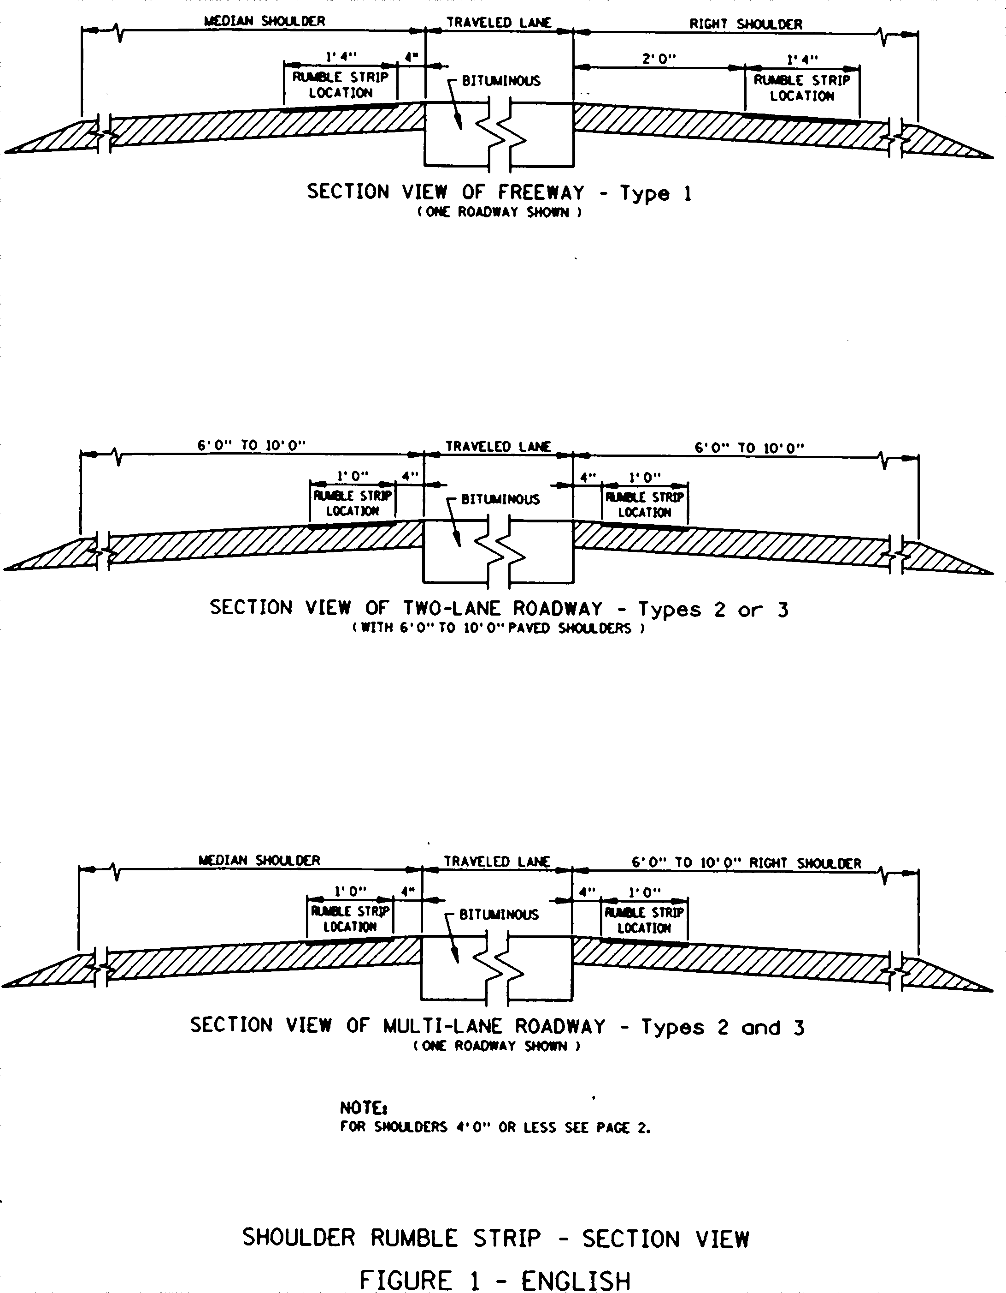
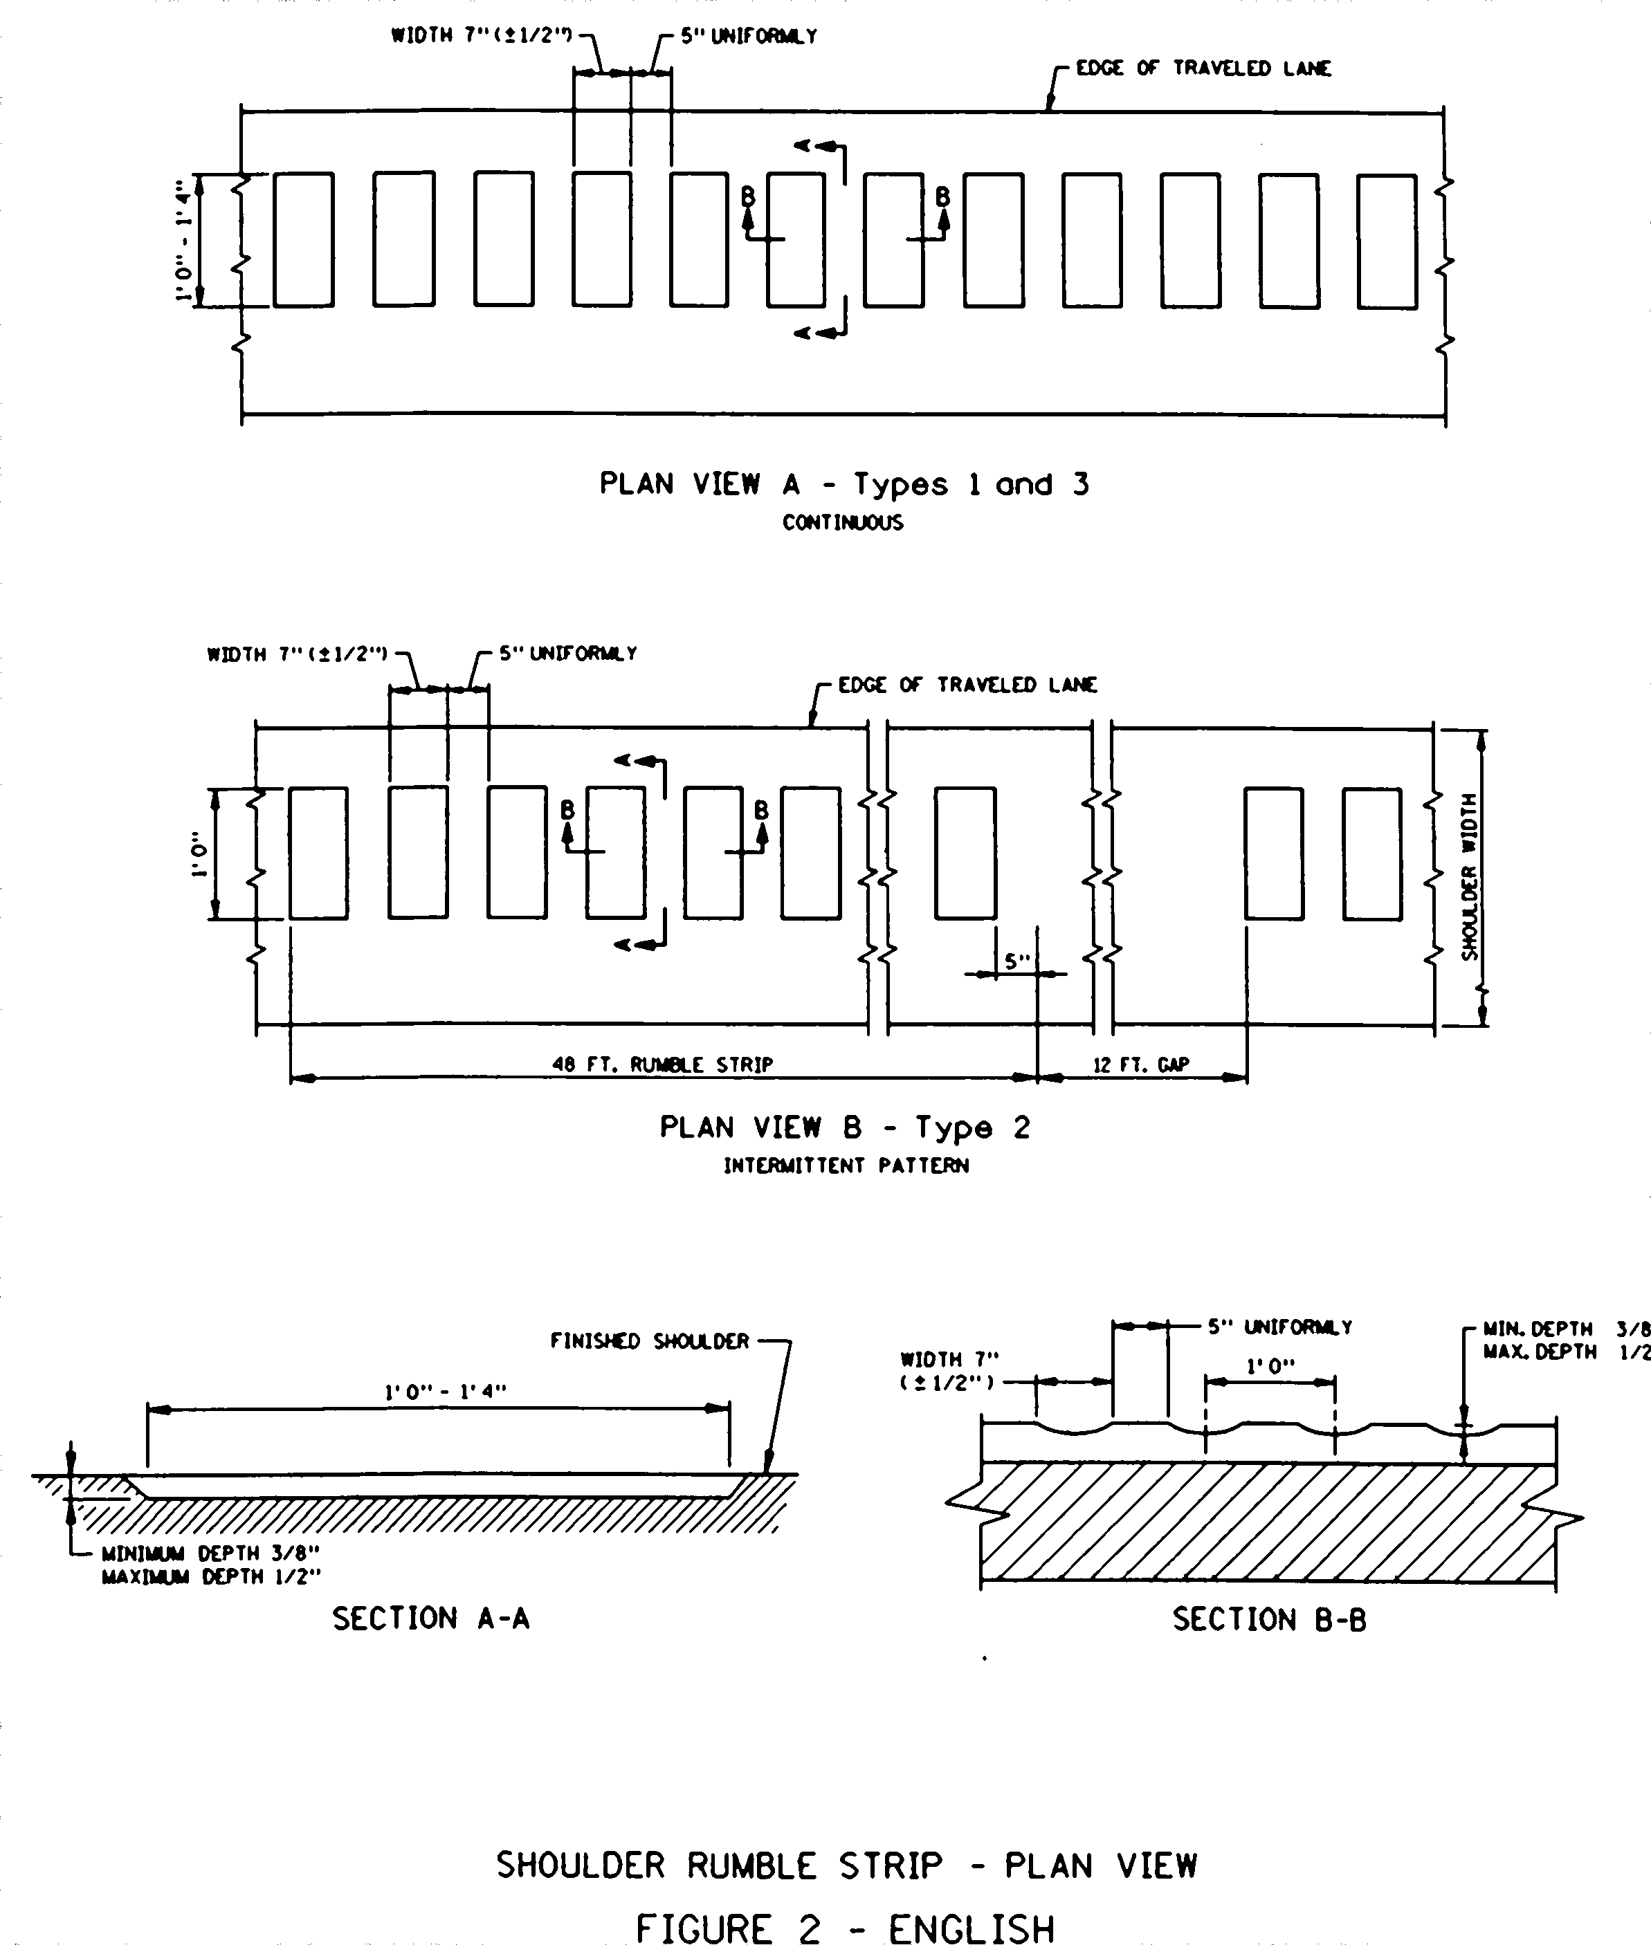
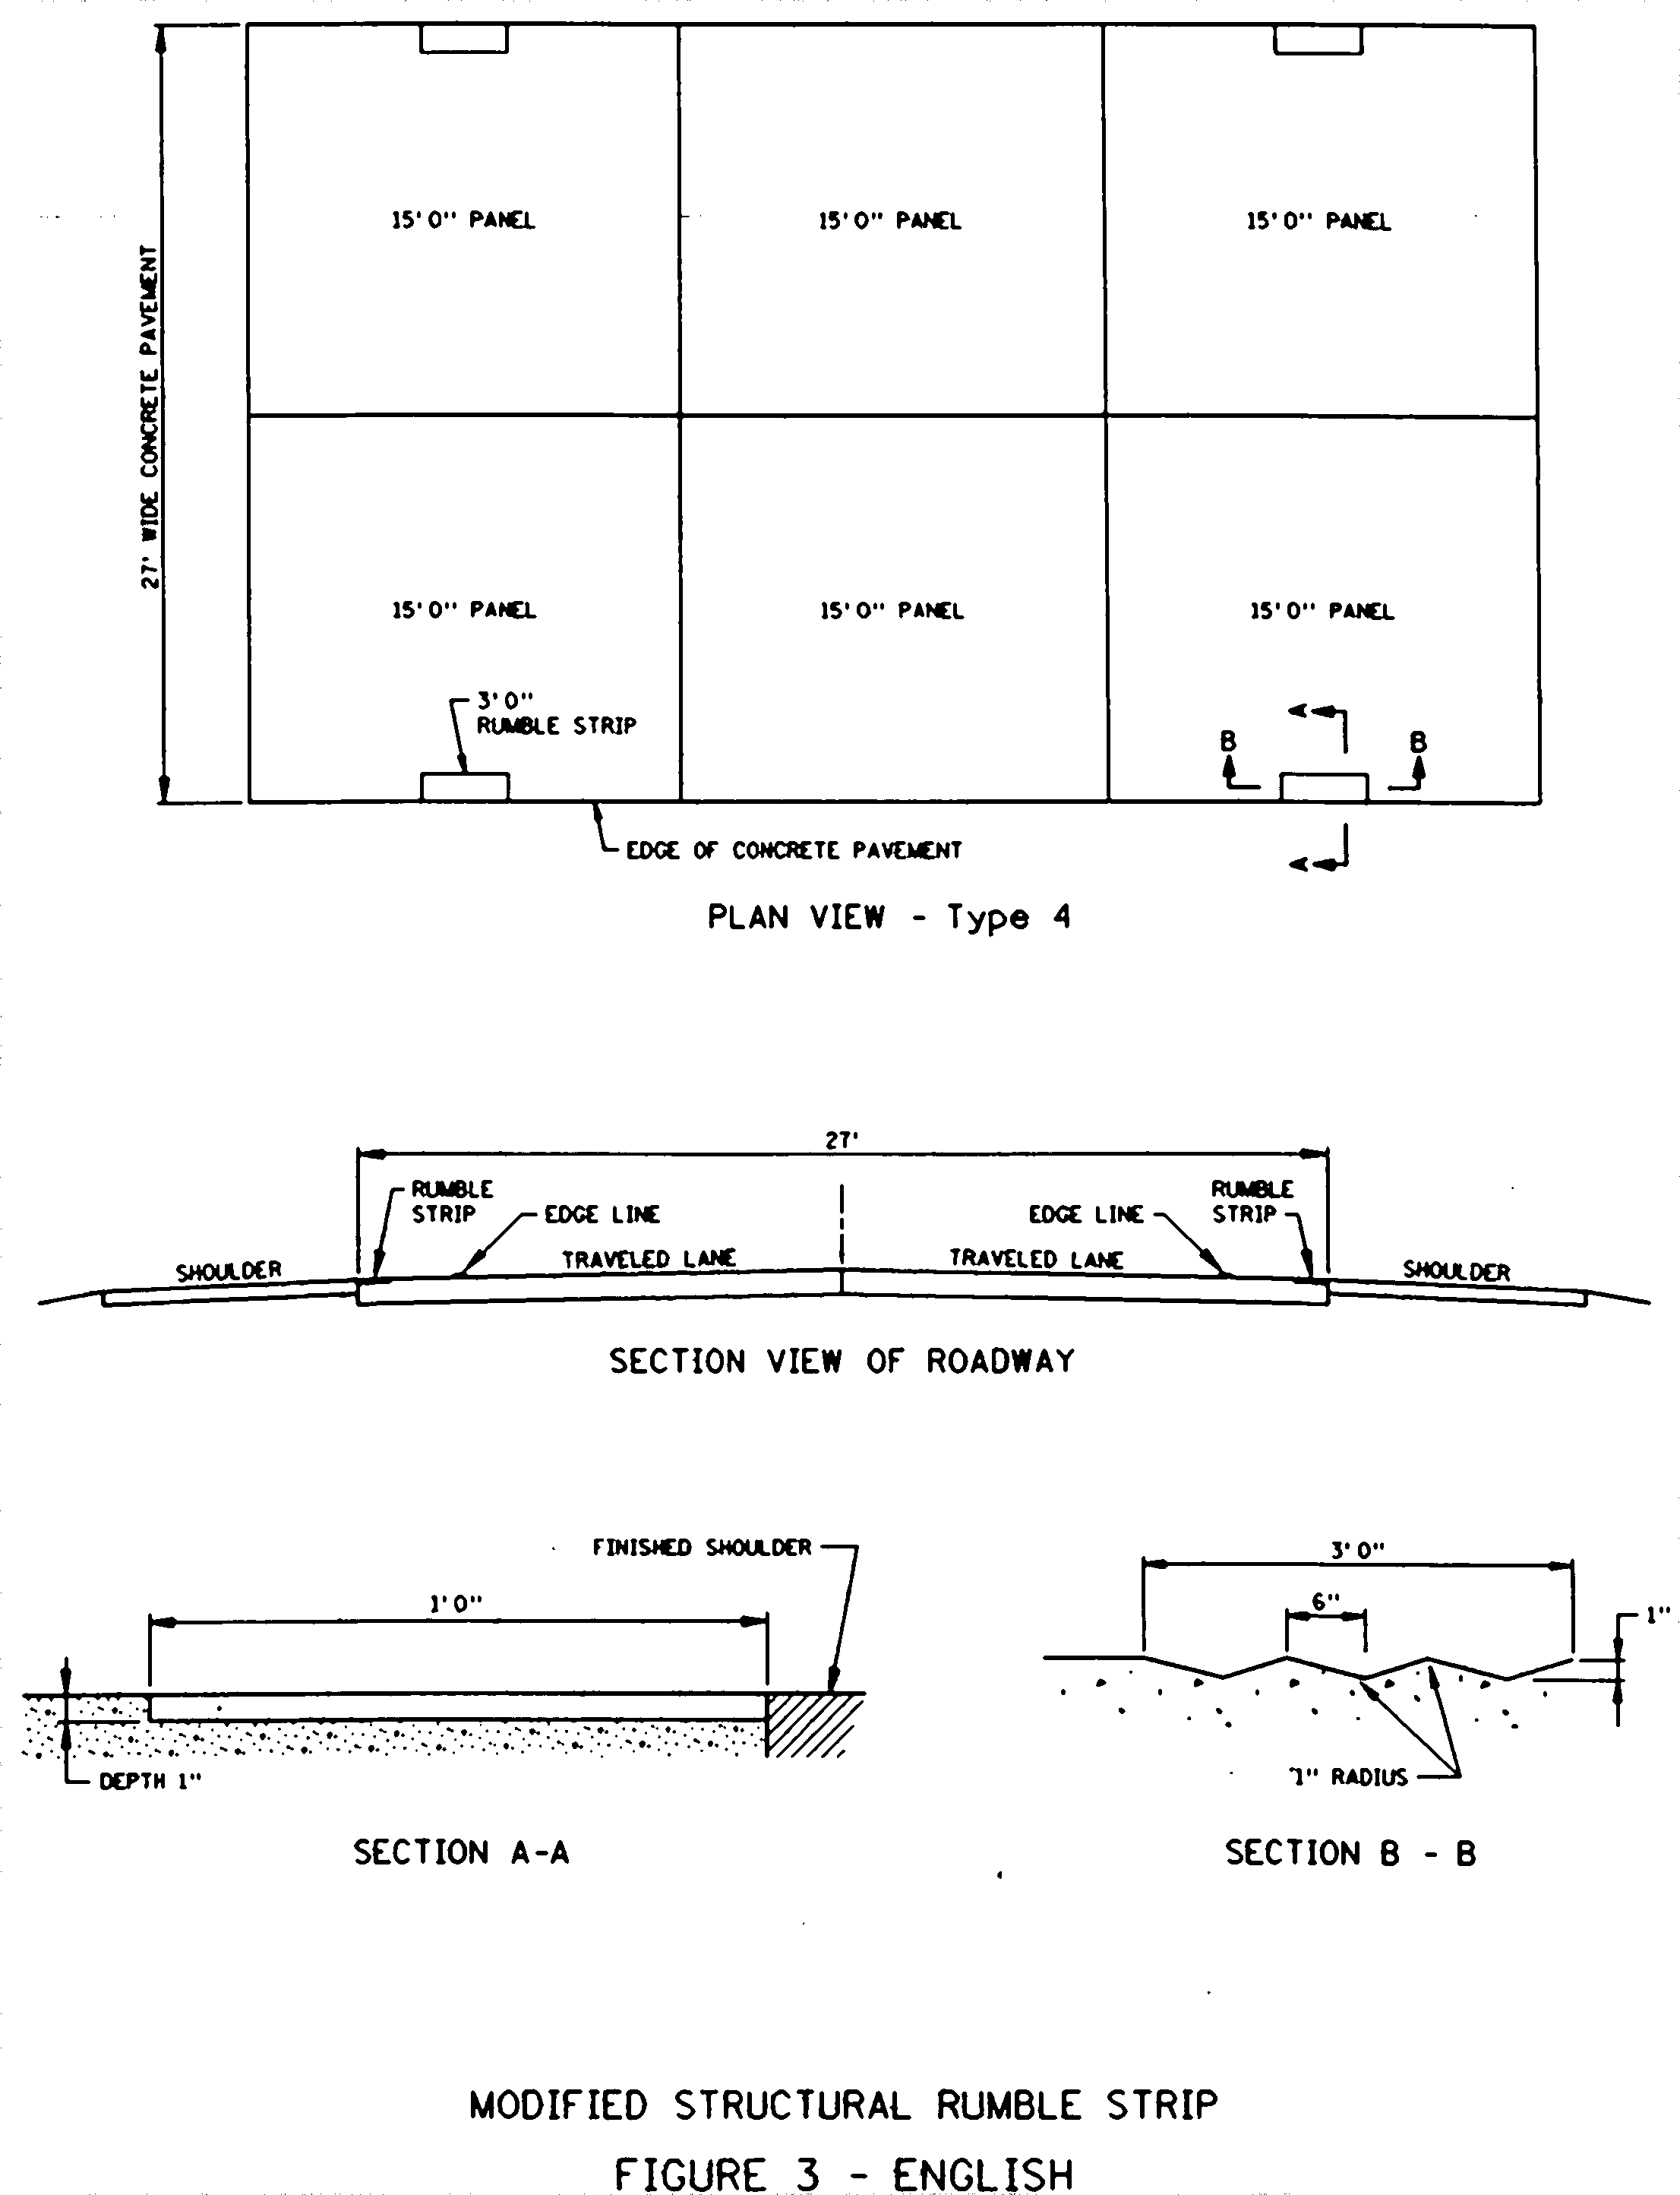
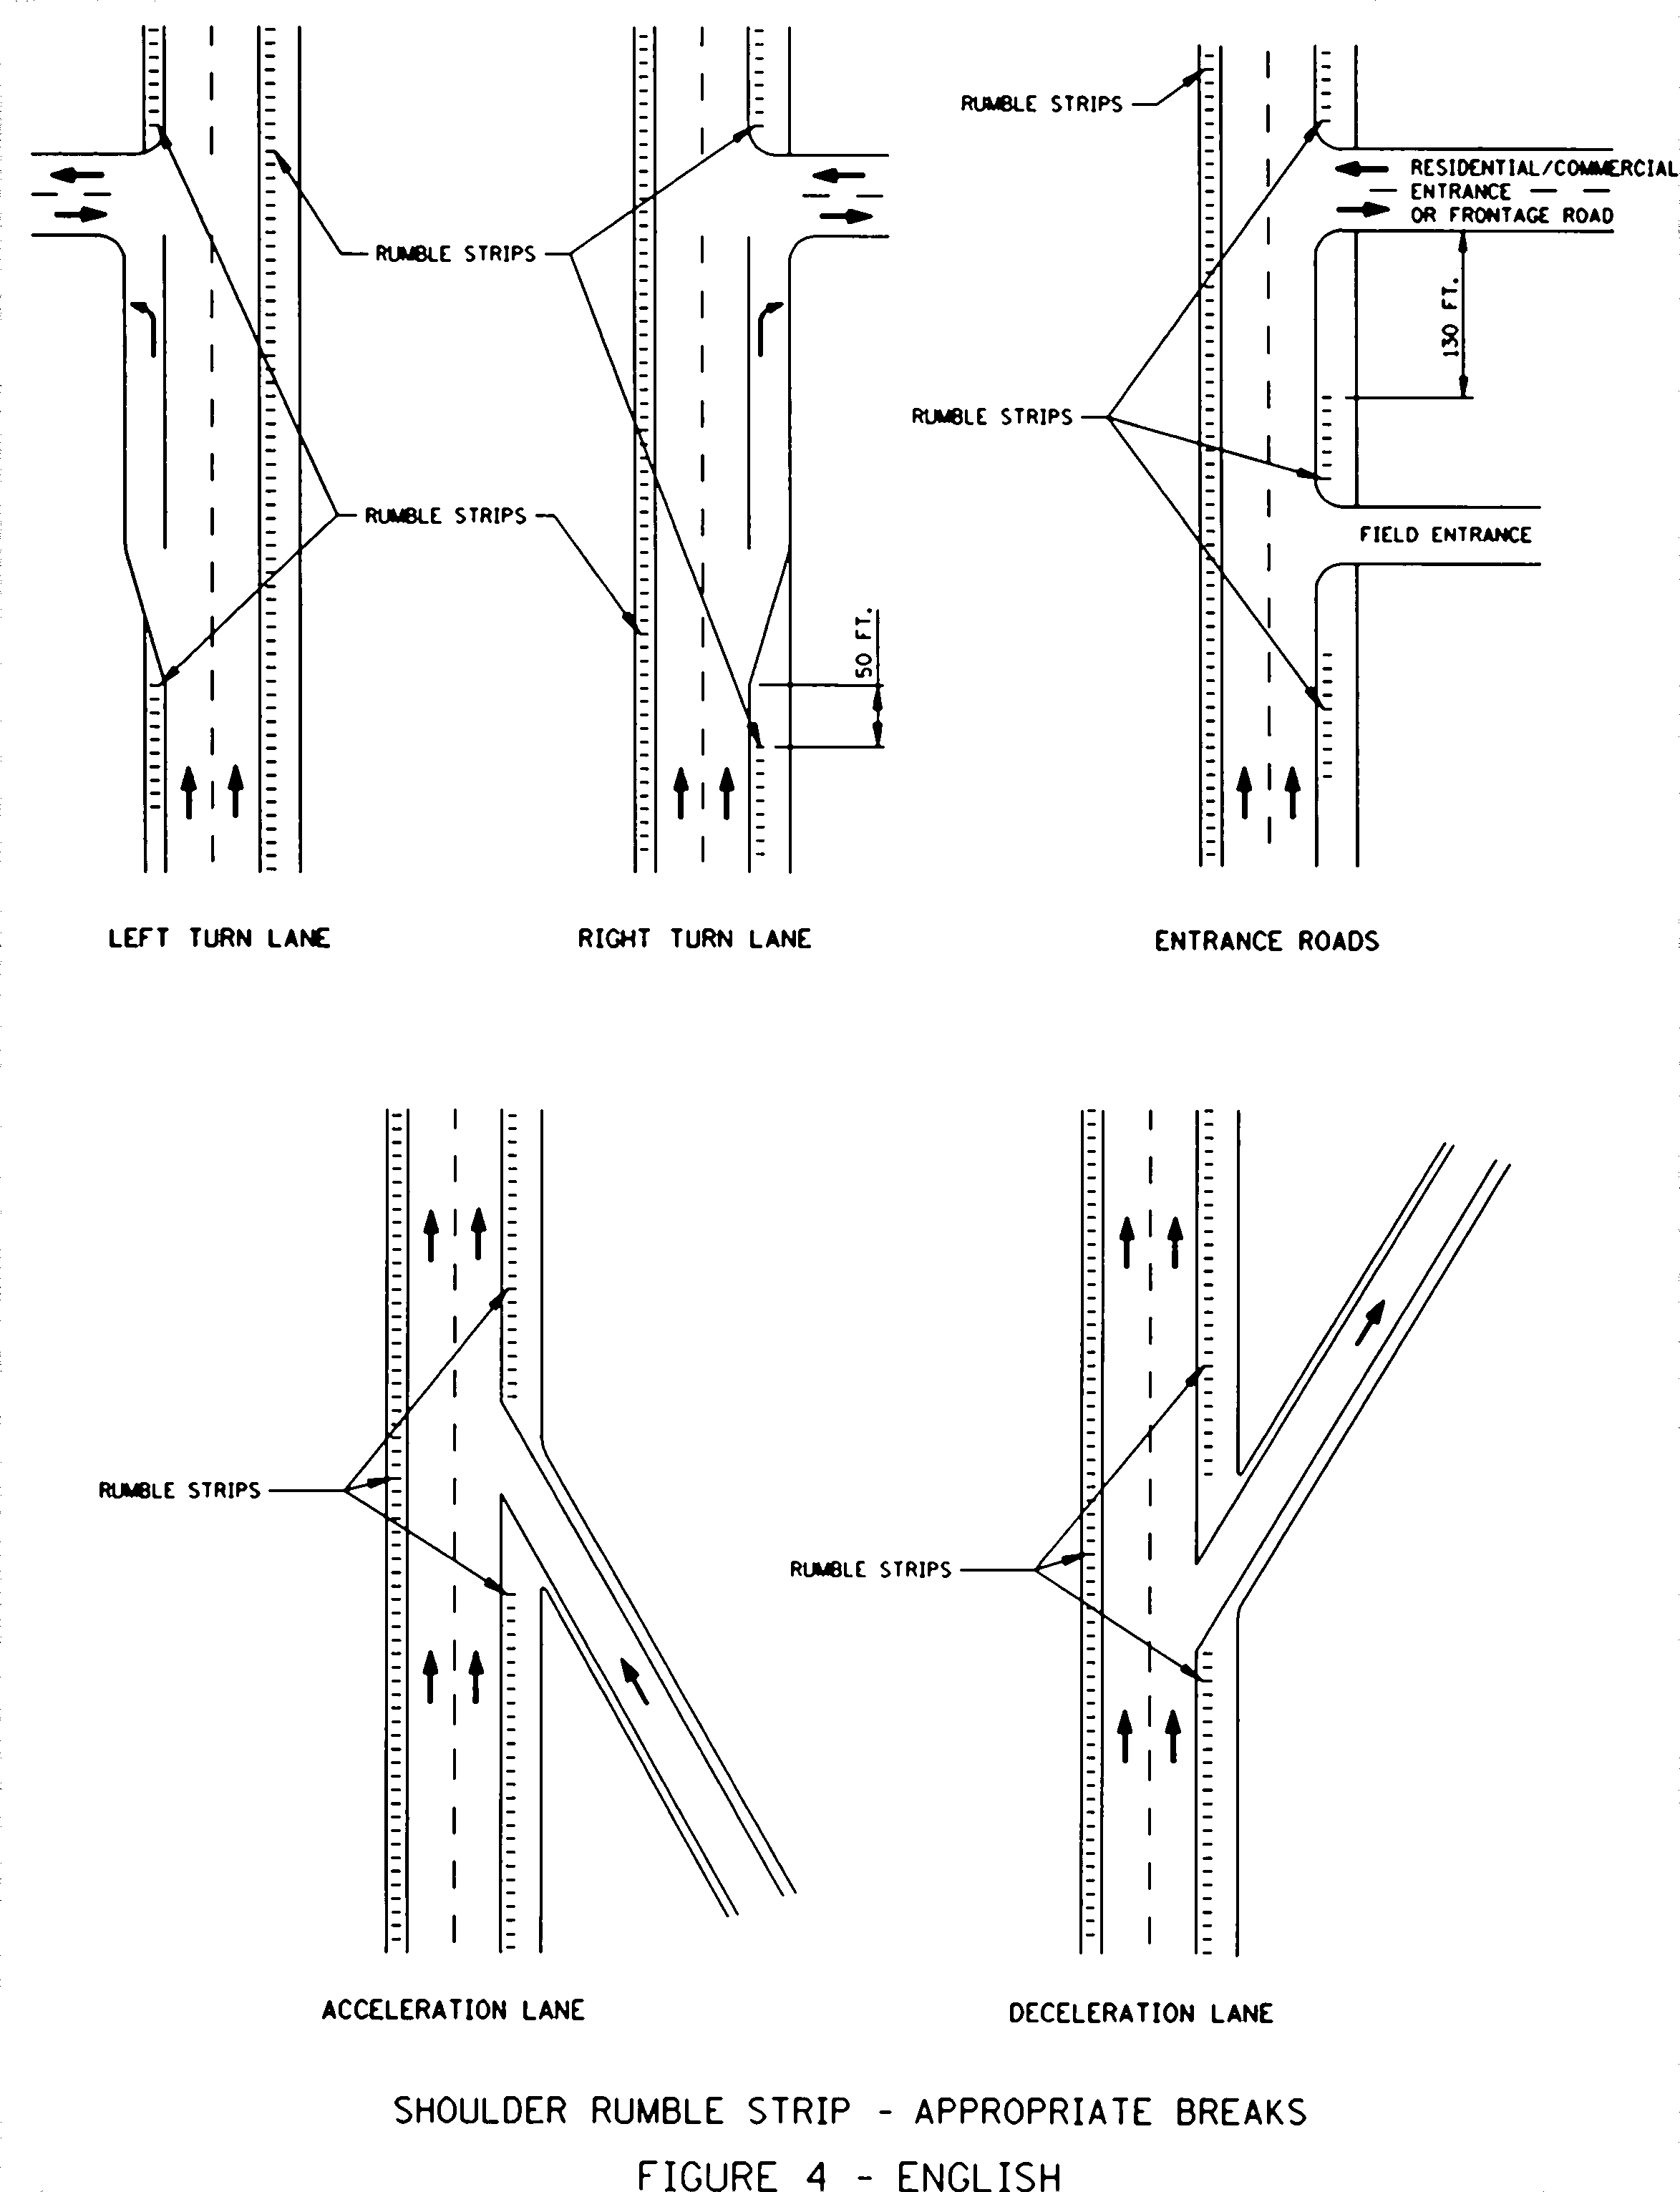
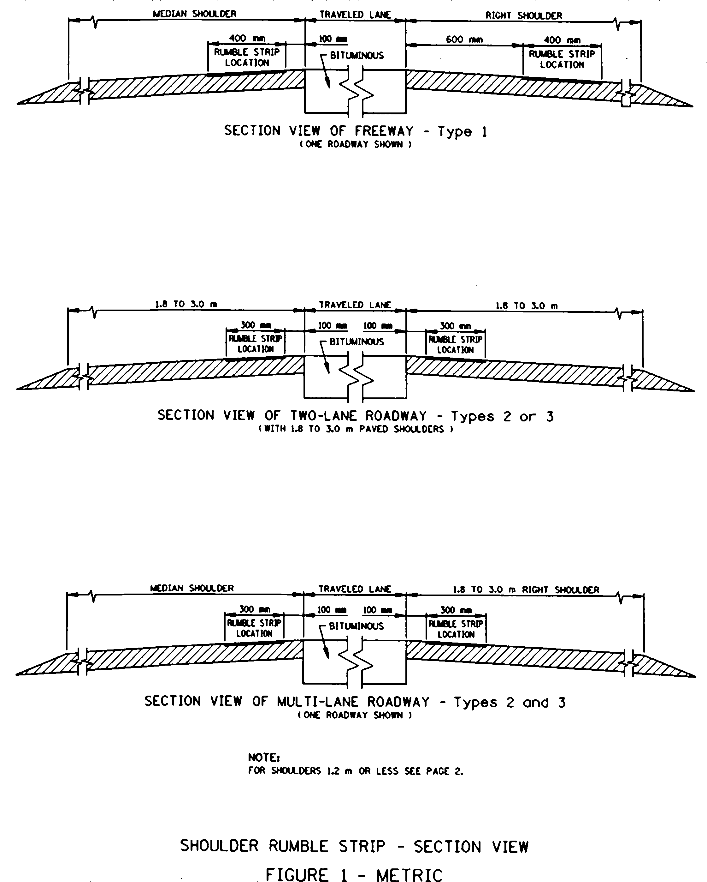
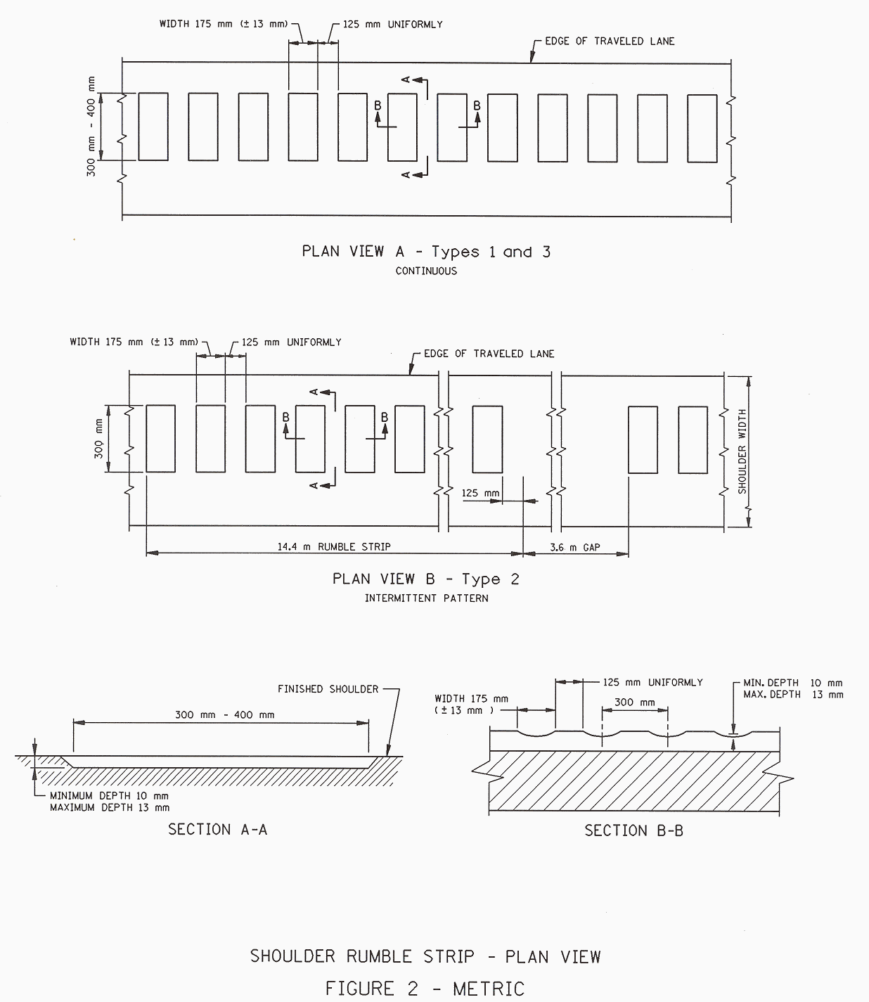
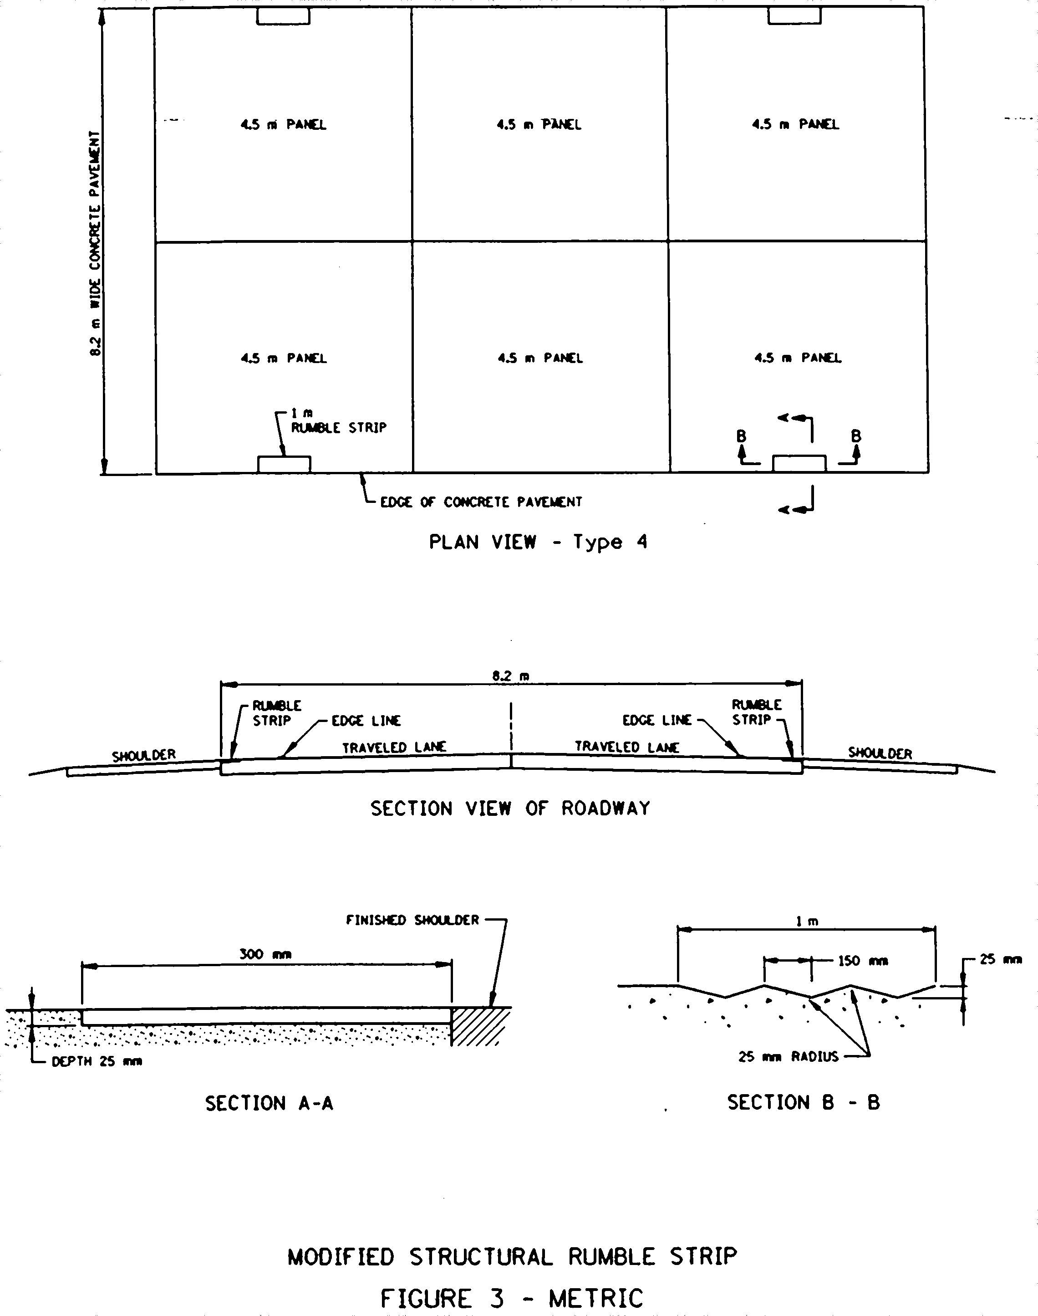
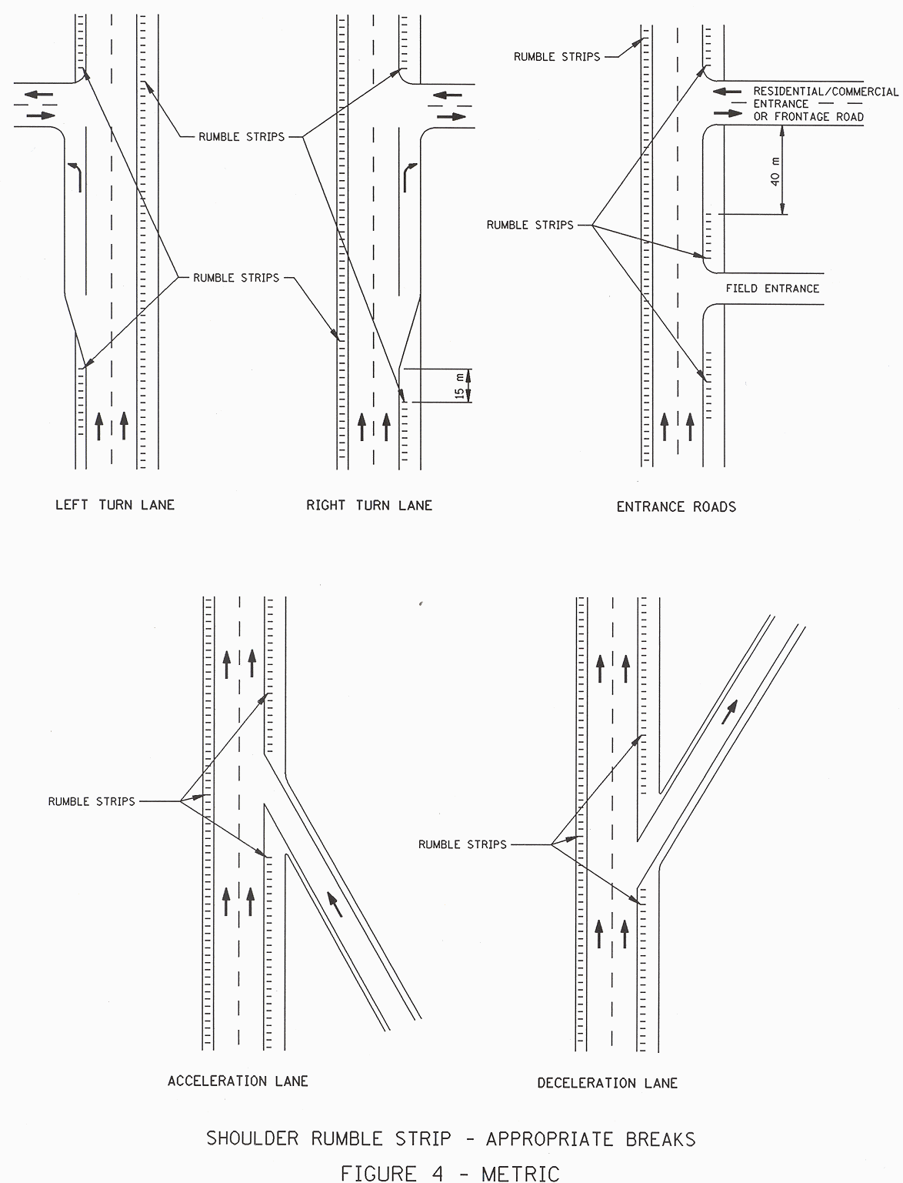

Cited References
1. Ligon, Claude, et al. Effects of Shoulder Textured Treatments on Safety. Federal Highway Administration, FHWA/RD-85/027, 1985.

2. Higgins, J. S. and W. Barbel. Rumble Strip Noise. Transportation Research Record. No. 983, 1984, 27-36.

3. Cheng, Eric, et al. Application and Evaluation of Rumble Strips on Highways. Utah Department of Transportation. Online Posting. http://safety.fhwa.dot.gov/rumblestrips/resources/chengite.htm. August 2000.

- Wood, Neal E. Shoulder Rumble Strips: A Method to Alert “Drifting Drivers. Pennsylvania Turnpike Commission. January 1994. Online Posting. http://safety.fhwa.dot.gov/rumblestrips/resources/snap4pub.htm. August 2000.

5. Khan, A. and A. Bacchus. Economic Feasibility and Related Issues of Highway Shoulder Rumble Strips. Transportation Research Record. No. 1498, 1995, 92-101.

6. Hickey Jr., John. Shoulder Rumble Strips Effectiveness; Drift-Off-Road Accident Reductions on the Pennsylvania Turnpike. Transportation Research Record. No. 1573, 1997, 105-109.

7. Perrillo, Kerry. The Effectiveness and Use of Continuous Rumble Strips. August 1998. Online Posting. http://safety.fhwa.dot.gov/rumblestrips/resources.rumblekp.htm. August 2000.

8. Griffith, Michael. Safety Evaluation of Continuous Shoulder Rumble Strips Installed on Freeways. Transportation Research Record. No. 1665, 1999, 28-34.

9. Moeur, Richard. Analysis of Gap Patterns in Longitudinal Rumble Strips to Accommodate Bicycle Travel. Transportation Research Record. No. 1705, 2000, 93-98.

10. Elefteriadoiu, L. et al. Bicycle Tolerable Shoulder Rumble Strips. Pennsylvania Department of Transportation, 2000.

- Chen. A Study of Effectiveness of Various Shoulder Rumble Strips on Highway Safety. Virginia Department of Transportation, 1994.

- California Department of Transportation. Evaluation of Milled-In Rumble Strips, Rolled-In Rumble Strips and Proprietary Applications. California State. Draft Report. February 2001.

13. Outcalt, William. Bicycle-Friendly Rumble Strips. Report No. CDOT-DTD-R-2001-4. Colorado Department of Transportation, 2001.

14. Isackson, Cassandra. Continuous Milled Shoulder Rumble Strips; Nationwide Survey. Minnesota Department of Transportation, February 2000.

15. Federal Highway Administration, Wyoming Division Office. Shoulder Rumble Strips B Effectiveness and Current Practice. April 1998. Online Posting. http://safety.fhwa.dot.gov/rumblestrips/effectiveness/wy.htm. July 2000.

16. League for the Hard of Hearing. Noise Levels in our Environment Fact Sheet. March 1999. Online Posting. http://www.lhh.org/noise/decibel.htm. October 1999.

17. Harwood, Douglas. Use of Rumble Strips to Enhance Safety. National Cooperative Highway Research Program, Synthesis of Highway Practice 191, 1993.

18. American Association of State Highway and Transportation Officials. Guide for the Development of Bicycle Facilities. Washington, D.C. AASHTO, 1999.

19. Gårder, Per. Rumble Strips or Not Along Wide Shoulders Designated for Bicycle Traffic? Transportation Research Record. No. 1502, 1995, 1-7.

20. Arizona Department of Transportation. Continuous Longitudinal Rumble Strips. ADOT Traffic Engineering Policies, Guidelines, and Procedures. Section 480. 2000.

21. Pennsylvania Department of Transportation. Milled Shoulder Rumble Strips (MSRS); Safety Enhancement. Memo from Michael Ryan, Deputy Secretary to District Engineers. Dated April 21, 1995 with attachments.

22. Wyoming Department of Transportation. Shoulder Rumble Strips. Operating Policy. No. 7-3. 1998.

23. New Mexico State Highway and Transportation Department. Rumble Strip Guidelines. 1992.

24. Ohio Department of Transportation. Rumble Strips. Roadside Safety Devices. Section 605.

25. Oklahoma Department of Transportation. Rumble Strip Policy. 2000.

26. Minnesota Department of Transportation. Rumble Strips on Shoulders of Rural Truck Highways. Minnesota Department of Transportation Technical Memorandum. No. 00-08-DS-01. 2000.

27. Washington Department of Transportation. Rumble Strips. Revised Code of Washington. Section 46.61.160.

28. New York State Department of Transportation. Safety shoulder Rumbles Strips (Safe-Strips) Policy and Revised Installation Details. New York State. Engineering Instruction 97-013. 1997.

29. Watts, G. R. The Development of Rumble Areas as a Driver Alerting Device.” Supplementary Report No. 291. Transport and Road Research Laboratory. (1977).

BIBLIOGRAPHY
American Association of State Highway and Transportation Officials. Guide for the Development of Bicycle Facilities. Washington, D.C. AASHTO, 1999.

Arizona Department of Transportation. Continuous Longitudinal Rumble Strips. ADOT Traffic Engineering Policies, Guidelines, and Procedures. Section 480. 2000.

ASCE Human Powered Transportation Committee. Comments TEA-21, October 30, 1998. Online Posting: http://ourworld.compuserve.com/homepages/kbarrett/tea21.htm. August 2000.

ASCE Human Powered Transportation Committee. Committee Meeting Minutes January 13 and 15, 1997. Online Posting: http://ourworld.compuserve.com/homepages/kbarrett/min_0197.htm. August 2000.

ASCE Human Powered Transportation Committee. Committee Meeting Minutes January 12 and 14, 1998. Online Posting: http://ourworld.compuserve.com/homepages/kbarrett/min_0198.htm. August 2000.

ASCE Human Powered Transportation Committee. Committee Meeting Minutes January 10, 1999. Online Posting: http://ourworld.compuserve.com/homepages/kbarrett/min_0199.htm. August 2000.

ASCE Human Powered Transportation Committee. Update. April 1999. Online Posting: http://ourworld.compuserve.com/homepages/kbarrett/upd_0499.htm. August 2000.

ASCE Human Powered Transportation Committee. Update. August 1996. Online Posting: http://ourworld.compuserve.com/homepages/kbarrett/upd_0896.htm. August 2000.

ASCE Human Powered Transportation Committee. Update. December 1997. Online Posting: http://ourworld.compuserve.com/homepages/kbarrett/upd_1297.htm. August 2000.

ASCE Human Powered Transportation Committee. Update. February 1997. Online Posting: http://ourworld.compuserve.com/homepages/kbarrett/upd_0297.htm. August 2000.

ASCE Human Powered Transportation Committee. Update. February 2000. Online Posting: http://ourworld.compuserve.com/homepages/kbarrett/upd_0200.htm. August 2000.

ASCE Human Powered Transportation Committee. Update. June 2000. Online Posting: http://ourworld.compuserve.com/homepages/kbarrett/upd_0500.htm. August 2000.

ASCE Human Powered Transportation Committee. Update. March 1998. Online Posting: http://ourworld.compuserve.com/homepages/kbarrett/upd_0398.htm. August 2000.

ASCE Human Powered Transportation Committee. Update. September 1997. Online Posting: http://ourworld.compuserve.com/homepages/kbarrett/upd_0997.htm. August 2000.

ASCE Human Powered Transportation Committee. Update. September 1998. Online Posting: http://ourworld.compuserve.com/homepages/kbarrett/upd_0998.htm. August 2000.

ASCE Human Powered Transportation Committee. Update. September 1999. Online Posting: http://ourworld.compuserve.com/homepages/kbarrett/upd_0999.htm. August 2000.

Bennett, R. Clarke. FHWA Notice. N 7560.9. April 1987. Online Posting. http://www.bikeplan.com/rumble1.html. July 2000.

Bicycle Transportation Alliance. Alert, Rumble Strips. Online Posting. http://www.telepoert.com/~bta4bike/act/alert/a-rumble.htm. July 2000.

Bike Plan Source. Comments on the AASHTO Guide for the Development of New Bicycle Facilities. Online Posting. http://www.bikeplan.com/guidedes.htm. July 2000.

California Department of Transportation. Rumble Strips. Caltrans Traffic Manual. Section 6-03.2. 1999.

California Department of Transportation. Evaluation of Milled-In Rumble Strips, Rolled-In Rumble Strips and Proprietary Applications. California State. Draft Report. February 2001.

CH2MHILL. Initial Draft of a Compendium of Strategies. National Cooperative Highway Research Program, Project 17-18(3), September 2000, 4-1 – 4-10.

Cheng, Eric, et al. Application and Evaluation of Rumble Strips on Highways. Utah Department of Transportation. Online Posting. http://safety.fhwa.dot.gov/rumblestrips/resources/chengite.htm. August 2000.

Chung. A Study of Effectiveness of Various Shoulder Rumble Strips on Highway Safety. Virginia Department of Transportation, 1994.

Dorman, Frank. VDOT Installs High Tech ‘Rumble Strips’ on Smart Roads. November 1999. Online Posting. http://www.vdot.state.va.us/info/News/state/1999/nrCO11231999_rumble.htm. July 2000.

Elefteriadoiu, L. et al. Bicycle Tolerable Shoulder Rumble Strips. Pennsylvania Department of Transportation, 2000.

Federal Highway Administration, Wyoming Division Office. Shoulder Rumble Strips B Effectiveness and Current Practice. April 1998. Online Posting. http://safety.fhwa.dot.gov/rumblestrips/effectiveness/wy.htm. July 2000.

Federal Highway Administration. Guidebook on Method to Estimate Non-Motorized Travel. Report No. FHWA-RD-98-166, Federal Highway Administration, 1998.

Federal Highway Administration. Rumble Strip; Survey Summary Results. Online Posting. http://safety.fhwa.dot.gov/rumblestrips/resources/hqsurvey.htm. August 2000.

Federal Highway Administration. Rumble Strips are LOUD!. Online Posting: http://safety.fhwa.dot.gov/fourthlevel/rumble/concern_noise.htm. November 2000.

Federal Highway Administration. Rumble Strips; Bicycles and Things That Go Bump on the Road. Online Posting. http://safety.fhwa.dot.gov/rumblestrips/issues/bikeissues.htm. July 2000.

Federal Highway Administration. Rumble Strips; Discussion Group; Rumble Strips and Bicycles. October 1999. Online Posting. http://safety.fhwa.dot.gov/rumblestrips/communication/threads.cfm. July 2000.

Federal Highway Administration. Rumble Strips; Technical Questions Received from Persons Communicating Via the Rumble Strip Web Site and Responses Given by Jim Growney, FHWA Rumble Strip Expert. February 1999. Online Posting. http://safety.fhwa.dot.gov/rumblestrips/overview/maintenance2.htm. July 2000.

Federal Highway Administration. Rumble Strips; The Four Types of Rumble Strips. Online Posting. http://safety.fhwa.dot.gov/rumblestrips/types.htm. July 2000.

FHWA Transporter. July 2000, 5. Online Posting. http://www.roads.detr.gov.uk/roadnetwork/tirm/tal/traffic/11_93/item1.htm. July 2000.

Forkosh, Alan. Rumble Strips B Act Now! April 1999. Online Posting. http://www.ebbc.org/hypermail/ebbc-talk/1999/htm. Discussion on East Bay Bicycle Coalition Talk. July, 2000.

Gårder, Per. Rumble Strips or Not Along Wide Shoulders Designated for Bicycle Traffic? Transportation Research Record. No. 1502, 1995, 1-7.

Griffith, Michael. Rolled-In Continuous Shoulder Rumble Strips Reduce ROR Crashes.

Griffith, Michael. Safety Evaluation of Continuous Shoulder Rumble Strips Installed on Freeways. Transportation Research Record. No. 1665, 1999, 28-34.

Griffith, Michael. Safety Evaluation of Roll-In Continuous Shoulder Rumble Strips on Freeways. HSIS Report Summary Report FHWA-RD-00-032, December 1999.

Harwood, Douglas. Enhancing Highway Safety with Rumble Strips. TR News. No. 178, May-June 1995, 12-16.

Harwood, Douglas. Use of Rumble Strips to Enhance Safety. National Cooperative Highway Research Program, Synthesis of Highway Practice 191, 1993.

Hickey Jr., John. Shoulder Rumble Strips Effectiveness; Drift-Off-Road Accident Reductions on the Pennsylvania Turnpike. Transportation Research Record. No. 1573, 1997, 105-109.

Higgins, J. S. and W. Barbel. Rumble Strip Noise. Transportation Research Record. No. 983, 1984, 27-36.

Isackson, Cassandra. Continuous Milled Shoulder Rumble Strips; Nationwide Survey. Minnesota Department of Transportation, February 2000.

Khan, A. and A. Bacchus. Economic Feasibility and Related Issues of Highway Shoulder Rumble Strips. Transportation Research Record. No. 1498, 1995, 92-101.

Khan, A. M. and A. Bacchus. Bicycle Use on Highway Shoulders. Transportation Research Record. No. 1502, 1995, 8-21.

Kugler, B. Andrew, et al. Highway Noise; A Design for Prediction and Control. National Cooperative Highway Research Program. Transportation Research Board, Synthesis 174, 1976.

League for the Hard of Hearing. Noise Levels in our Environment Fact Sheet. March 1999. Online Posting. http://www.lhh.org/noise/decibel.htm. October 1999.

Ligon, Claude, et al. Effects of Shoulder Textured Treatments on Safety. Federal Highway Administration, FHWA/RD-85/027, 1985.

Memphis City Schools. Physics Tutorials; Sound; Decibel Levels Online Posting: http://www.memphis-schools.k12.tn.us/admin/tlapages/sound_decibel.htm. October 2000.

Minnesota Coalition of Bicyclists. MCB Position Paper on ‘Run-Off-Road’ Rumble Strips. Online Posting. http://www.winternet.com/~rtandems/mcb/ror1.thml. July 2000.

Minnesota Department of Transportation. Rumble Strips on Shoulders of Rural Truck Highways.
Minnesota Department of Transportation Technical Memorandum. No. 00-08-DS-01. 2000.

Moeur, Richard. Analysis of Gap Patterns in Longitudinal Rumble Strips to Accommodate Bicycle Travel. Transportation Research Record. No. 1705, 2000, 93-98.

Moeur, Richard. What I (and Others) Have to Say About Cycling. October 1999. Online Posting. http://members.aol.com/rcmoeur/opinbike.html. July 2000.

Morgan, Rick and Dan McAuliffe. Effectiveness of Shoulder Rumble Strips: A Survey of Current Practice. Report No. FHWA/NY/SR-97/127. New York State Department of Transportation, 1997.

National Center for Bicycling and Walking. Rumble Strips; Grumblings on Rumble Strips: Perspectives from around the US. Online Posting. http://www.bikefed.org/rumble.htm. August 2000.

National Highway Traffic Safety Administration and National Center on Sleep Disorders Research. A Report to Congress on the Collaboration Between the National Highway Traffic Safety Administration (NHTSA) and the National Center on Sleep Disorders Research (NCSDR). 1999.

New Mexico State Highway and Transportation Department. Rumble Strip Guidelines. 1992.

New York State Department of Transportation. Safety shoulder Rumbles Strips (Safe-Strips) Policy and Revised Installation Details. New York State. Engineering Instruction 97-013. 1997.

O’hanlon, James and Gene Kelley. A Psychophysiological Evaluation of Devices for Preventing Lane Drift and Run-Off-Road Accidents. Technical Report No. 1736-F. California Department of Transportation, 1974.

Ohio Department of Transportation. Rumble Strips. Roadside Safety Devices. Section 605.

Oklahoma Department of Transportation. Rumble Strip Policy. 2000.

Pennsylvania Department of Transportation. Milled Shoulder Rumble Strips (MSRS); Safety Enhancement. Memo from Michael Ryan, Deputy Secretary to District Engineers. Dated April
21, 1995 with attachments.

Perrillo, Kerry. The Effectiveness and Use of Continuous Rumble Strips. August 1998. Online Posting. http://safety.fhwa.dot.gov/rumblestrips/resources.rumblekp.htm. August 2000.

Schimek, Paul. The Dilemmas of Bicycle Planning. Presented at the Association of Collegiate Schools of Planning. July 1996.

Snyder, Richard. Bituminous Shoulder Rumble Strips.” Research Project 90-059, Pennsylvania Department of Transportation. 1994.

Stonecypher, T. Lamar. Rumble Strips; Victory. June 2000. Online Posting. http://www.gate.net/~1stone/rumble.htm. July 2000.

Stutts, James. Sleep Deprivation Countermeasures for Motorist Safety. National Cooperative Highway Research Program. Transportation Research Board, Synthesis 287, 2000.

The Noise Center. Noise Levels in our Environment Fact Sheet. March 1999. Online Posting: http://www.lhh.org/noise/decibel.htm. October 2000.

TranSafety Reporter. Shoulder Rumble Strips Proven Effective on the Pennsylvania Turnpike.” TranSafety Reporter. Vol. 16, No. 8, August 1998, 5-6.

Tye, E. J. Devices to Prevent Run-Off-Road Accidents. Report No. CA-DOT-TR-1269--76-01. California Department of Transportation, Office of Traffic. 1976.

U.S. Roads. Shoulder Rumble Strips Proven Effective on the PA Turnpike. Road Injury Prevention and Litigation Journal. August 1998.

United Kingdom, Department of the Environment, Transport and the Regions. Rumble Devices. Traffic Advisory Leaflets – Traffic Management. June 1998. Online Posting.

Outcalt, William. Bicycle-Friendly Rumble Strips. Report No. CDOT-DTD-R-2001-4. Colorado Department of Transportation, 2001.

Walls, Ann. A Silver Bullet: Shoulder Texture Treatments. Public Roads. Vol. 62, No. 4, January 1999, 9-12.

Washington Department of Transportation. Rumble Strips. Revised Code of Washington. Section 46.61.160.

Watts, G. R. The Development of Rumble Areas as a Driver Alerting Device.” Supplementary Report No. 291. Transport and Road Research Laboratory. (1977).

Williams, John. Rumble Strips: A Growing Threat to America=s Cyclists? Bicycle Forum. Vol. 14, April 1987.

Wisconsin Department of Transportation. Cross-Section Elements for Rural Highways and Freeways. Facilities Development Manual. 2000.

Wood, Neal E. Shoulder Rumble Strips: A Method to Alert “Drifting Drivers. Pennsylvania Turnpike Commission. January 1994. Online Posting. http://safety.fhwa.dot.gov/rumblestrips/resources/snap4pub.htm. August 2000.

Wyoming Department of Transportation. Shoulder Rumble Strips. Operating Policy. No. 7-3. 1998.

