DRAGONFLIES OF ARANSAS / MATAGORDA ISLAND NATIONAL WILDLIFE REFUGE

Welcome to the wonderful world of dragonflies! Dragonflies are as colorful and entertaining as their names suggest: Vivid Dancer, Sparkling Jewelwing, Furtive Forktail, Stygian Shadowdragon, Harlequin Darner, Dragonhunter, Ebony Boghaunter. They offer the naturalist a wide field for exploration, study and observation and an opportunity to experience the intricate web of life of aquatic ecosystems firsthand.

While other species have come and gone, dragonflies have reigned over Earth's swamps, ponds, lakes and rivers for perhaps two hundred million years. Their survival in a wide range of habitats is testimony to the versatility of their form and behavior.

Dragonflies can be found almost anywhere, their life cycle is inextricably linked to aquatic environments and that is the best place to seek them. They can be observed from spring to autumn in any wetland location including rivers, lakes, ponds, woodland pools and streams, bogs, swamps, marshes and even roadside ditches. Because dragonflies are common in virtually all climes, you won't need to go very far from home to begin your study. Choose a warm and sunny day, since most dragonflies are sluggish and less abundant during cool or cloudy weather.

DARNERS:

Darners include our largest dragonflies, carrying abdomens long and slender beyond the base, like darning needles. They are flyers, but perch by hanging vertically. Most are brown or black, striped and spotted with blue, green or yellow while the eyes are large and meet in a seam on top of the head. In many species scars can be seen on the females’ eyes, showing where the males’ epiproct held her during mating. Females have an ovipositor with blades, used in most species to deposit eggs in plant tissues up to the length of the abdomen below the waterline. Each HW bears a rounded anal loop, while the maximum wing pattern among our species is a small brown spot at the base of each wing. Known life cycles are usually 1 year, up to 6 years in the far north.

Common Green Darner Anax junius (Drury): Aeshnidae

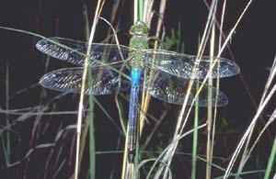
Male, dorsal view © John C. Abbott
This widespread species is found throughout North America, including all 50 U.S. states. It is certainly one of the most common and widespread species in our area. The face is pale green with a distinct black spot on the top of the frons bordered anteriorly by a blue semicircle. Anax amazili has a triangular spot. The thorax is green with brown only lightly represented on the lateral sutures. The wings are hyaline with a yellow costa. The abdomen is mostly blue, with green on segment 1 in males and greenish-brown throughout in females. The brown superior caudal appendages in the male are long, about the length of segments 9-10 combined. Byers (1927b) described and illustrated the larva.

Size: Total length: 68-84 mm; abdomen: 46-60 mm; hindwing: 45-58 mm.

Habitat: Permanent and temporary ponds, lakes, bays and slow-flowing streams with emergent vegetation.

Comet Darner Anax longipes (Hagen): Aeshnidae
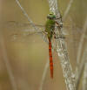
This distinct darner has the typical green thorax of the genus, but the abdomen is brilliant red. The face is yellow-green, but unlike in other Anax species the top of the frons is unmarked. The legs are unusually long and the femora are red except distally where they become black. The wings are hyaline, however, occasionally they may be tinted and have a greenish costa. The male abdomen is bright red beyond the basal green segments. Females are similar, but with greenish-brown spots, and with blue in juveniles on the middle and posterior segments.

Size: Total length: 75-87 mm; abdomen: 50-61 mm; hindwing: 46-56 mm.

Habitat: Primarily fishless temporary and semi-permanent grassy ponds and pools.
Regal Darner Coryphaeschna ingens (Rambur): Aeshnidae
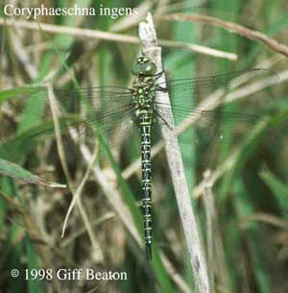
This large coastal species, may be confused with the equally large Epiaeschna heros. The latter however, has a brown pterothorax with green stripes, while C. ingens is green with brown stripes. The eyes are green in juvenile individuals and males, but become deep blue in older females. The wings are hyaline, except in females which change with age as described for the genus. The abdomen is brown with narrow green markings. The basal segments are swollen and there is no noticeable constriction following them. Needham and Westfall (1955) presented larval keys to all but one North American species.
Size: Total length: 82-100 mm; abdomen: 64-78 mm; hindwing: 54-60 mm.

Habitat: Lakes and slow flowing streams with heavy vegetation.
Swamp Darner Epiaeschna heros (Fabricius): Aeshnidae
Male, dorsal view ©John C. Abbott
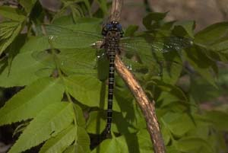
This species is equally large but more widespread than the similar Coryphaeschna ingens. Epiaeschna heros has blue eyes and a brown thorax with two green lateral stripes, while that of C. ingens is green striped with brown. The only other brown and green darner it could be confused with is Nasiaeschna pentacantha, but the latter is smaller and has a fairly uninterrupted green longitudinal stripe laterally on the abdomen. The wings are often heavily tinged, moreso laterally. The abdomen is brown, long and nearly parallel sided posteriorly. The caudal appendages are long in both sexes. The male appendages are complex and distinctly hairy. The female appendages are flattened appearing petiolate. The larva was described and illustrated by Cabot (1881).
Size: Total length: 80-94 mm; abdomen: 63-72 mm; hindwing: 52-60 mm;

Habitat: Heavily wooded ponds, streams and ox-bows including ephemeral pools and ponds.

CUBTAILS

Very distinctive, most species with S7-S9 enlarged and clublike, usually seen perching horizontally and on flat surfaces. Males usually have a larger club than females and commonly raise and display it like a flag. Clubtails generally have a camouflage pattern, usually brown or black marked with yellow in juveniles, the yellow becoming green after a few days. They have separated eyes as in the side of S8 instead of an ovipositor with blades. Males have a forked epiproct, while females of some species have hornlike spines on the top or back of the head. None of our species has bright red markings, blue markings are rare (Blue-Faced Ringtail), and the maximum wing marking is a small brown spot at each wing base (some Sanddragons). Clubtails do not soar, feed in swarms, or lay eggs in tandem. Many species are uncommon, wary, have short flight seasons or restricted ranges, perch mostly in trees, or all of the above. These factors, combined with the similarity of many species, make Clubtails a difficult challenge to locate and identify in the field. Our species perch to mate for 10 minutes or more, and in some (most notably the Dragon hunter), the male abdominal appendages punch holes in the female head, damage that is unexplained.
Some other dragonflies have clubbed abdomens, notably some male Cruisers, male Clubskimmers, and female Baskettails carrying egg balls. Pondhawks commonly perch like Clubtails, but have the eyes in contact on top of the head.
Most Clubtails breed in flowing water, where they are quite susceptible to pollution, particularly because their (known) life cycles are 2-plus years.

Sulphur-tipped Clubtail Gomphus militaris Hagen in Sélys: Gomphidae
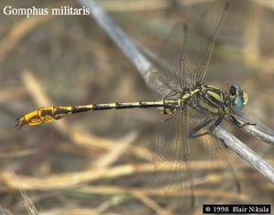
Male doro-lateral view
This is the most widespread Gomphus in our region, although it is conspicuously absent in both Arkansas and Louisiana. It is marked with the most yellow and is the brightest colored of our species. The face is yellow with no evidence of dark stripes. Females have a pair of minute spines present on the vertex. The front of the thorax is distinctly yellower than the darker sides. The brown middorsal stripe is narrow and widens slightly toward the collar. The antehumeral stripe is well separated from the humeral stripe and is free at its upper end. The pale stripe between them is 1/2-2/3 their width at their widest. The humeral stripe narrows at its lower end. The midlateral stripe is thin and always present, but generally interrupted above the spiracle. The third lateral stripe is also thin, but well-developed. The legs have more yellow on them than do those in other species. The otherwise black femora and tibiae both have yellow stripes on their outer surfaces. The black abdomen is conspicuously narrowed medially. The pale yellow middorsal stripe is wide and nearly continuous on the middle segments. Segments 7-9 are expanded laterally, less so in females and segments 8-10 are diffusely yellow with the caudal appendages brownish-yellow. Males are distinctive because of an enlarged, distinctly warty peduncle. Bird (1934) described and illustrated the larva.
Size: Total length: 47-54 mm; abdomen: 34-41 mm; hindwing: 28-35 mm.
Habitat: Ponds, lakes, streams and creeks with muddy bottoms.

Cobra Clubtail Gomphus vastus Walsh: Gomphidae
Male, dorso-lateral view
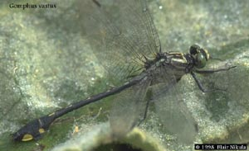
This eastern species is widespread throughout the Austroriparian biotic province, except in Louisiana. It is most similar to the paler G. modestus. The pale green face is broadly striped with black and the humeral and middorsal thoracic stripes are generally confluent at their upper ends, leaving the antehumeral stripe free at its upper end. The thorax is yellowish-green with a thin midlateral stripe often interrupted above the spiracle. The third lateral stripe may be present, but it is usually wanting. The abdomen is black except for a thin interrupted pale yellow middorsal stripe and laterally on the basal segments. Segments 7-9 are broadly expanded with only a small basal yellow spot laterally on 8 and a broad irregular lateral stripe on 9. The larva was first described and illustrated by Cabot (1872) and more recently was compared to G. modestus by Westfall (1974).
Size: Total length: 46-57 mm; abdomen: 33-42 mm; hindwing: 27-35 mm.
Habitat: Medium-sized rivers or lakes with areas of alternating sand and gravel.
Plains Clubtail
Gomphus externus Hagen in Sélys: Gomphidae

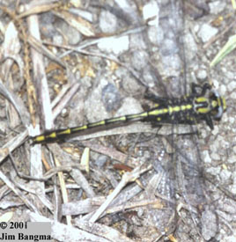
Female, lateral view
This is a central U.S. species widely distributed throughout our area, but not as yet reported from Louisiana. It is a medium-sized robust yellowish species most similar to G. gonzalezi, but generally larger and darker with wider brown thoracic stripes and erect yellow spines at each end of the postocellar ridge in the female. The face is pale yellowish and devoid of any dark marks. The thorax is pale yellowish-green and the dark brown middorsal stripe is widened slightly, to appear nearly parallel. It is thinly divided by the pale middorsal carina. The antehumeral stripe is narrowly confluent with the humeral stripe at its upper end. There is a pale yellowish stripe between the two, no more than 1/2 their width. The mid- and third lateral stripes are present and well-developed, only narrowly confluent at their lower ends. A paler yellow stripe separates the two, but this may become obscured in older individuals. The legs are dark brown or black with a yellow stripe on the outer surface of the tibiae. The wings are hyaline with a brown pterostigma. The abdomen is black with interrupted pale middorsal and lateral stripes. Segments 7-9 are widely expanded with a middorsal stripe appearing as spearheads on segments 7-8. In females, segment 8 generally has only a pale basal spot. Segment 9 has a broad yellow stripe dorsally and segment 10 is yellow. The superior caudal appendages of the male are parallel, not divergent, when viewed dorsally.
Size: Total length: 52-60 mm; abdomen: 36-43 mm; hindwing: 30-35 mm.
Habitat: Large muddy bottomed rivers and streams with moderate flow.

Russet-tipped Clubtail Stylurus plagiatus (Sélys): Gomphidae
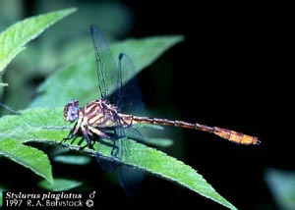
Male, lateral view
This is the most widespread of our three Stylurus species. It is darker than S. laurae, has widely separated humeral and antehumeral stripes, and the posterior 1/2 of the vertex is green, not black. The eyes are brilliant blue in mature adults. The brown middorsal stripe on this dark green species widens anteriorly, becoming confluent at both ends with the antehumeral stripe. The dark humeral and antehumeral stripes are widely separated by an olivaceous green stripe as stated above. The midlateral stripe is thin, 1/2 the width of the humeral stripe and somewhat sinuate or interrupted at its upper end. The third lateral stripe is less well developed and often interrupted in its lower 1/2. The wings are hyaline, but may become amber in older females. The legs are, as in S. laurae, pale basally becoming black on the tibiae and tarsi. The pale abdominal middorsal stripe is nearly obsolete on the tawny brown abdomen. Segments 7-10 are expanded laterally and are orange-brown, as are the caudal appendages. Walker (1928) and Byers (1930) described and illustrated the larva.
Size: Total length: 53-66 mm; abdomen: 38-50 mm; hindwing: 20-41 mm.
Habitat: Weedy rivers, streams and lakes with moderate to little current.
Flag-tailed Spinyleg Dromogomphus spoliatus (Hagen in Sélys): Gomphidae
Male, lateral view
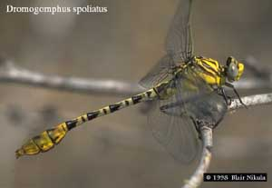
This species is lighter in color than the preceding, D. spinosus, and is more similar to D. armatus, with distinct dark antehumeral and humeral stripes. The face is yellow and never marked with a black cross-stripe. The vertex is dark brown and females lack spines. The thorax is yellowish-green. The middorsal thoracic stripe parallels the anterior collar, so that it nearly contacts the antehumeral stripe at its lower end. The dark antehumeral and humeral stripes are separated by a pale yellowish-green stripe of equal or greater width and the midlateral stripe is more developed than in D. spinosus, but not reaching far beyond the spiracle. The third lateral stripe is hardly wider than the suture itself. The wings are hyaline and the costa is yellow. The abdomen is brownish-green with an interrupted dark dorsolateral stripe on segments 3-6. Segments 7-9 are expanded greatly in males, moreso than in the other two species, and are orange-brown.
Size: Total length: 60-61 mm; abdomen: 43-46 mm; hindwing: 35-38 mm.
Habitat: Small, clear sandy or mud bottomed streams with a regular current.
Stillwater Clubtail Arigomphus lentulus (Needham): Gomphidae

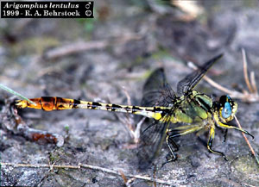
Male, lateral view
This is a smaller pale greenish-gray species with the thorax faintly marked in a similar fashion to that of A. submedianus The humeral and antehumeral stripes are generally subequal, however, in A. lentulus. The middorsal thoracic stripe is completely divided by the pale carina and may be very faint. The brownish humeral and antehumeral stripes are usually subequal in width, as stated above, but with the former generally moredeveloped and always separated from the latter by a thin stripe of greenish-yellow. The lateral thoracic stripes are wanting, only visible at their ends. The abdomen is rufous-brown with a pale middorsal stripe hardly visible. Segments 7 and 8 are black dorsally and 9 is pale brown. Segment 10 and the caudal appendages are yellowish.
Size: Total length: 48-57 mm; abdomen: 34-41 mm; hindwing: 30-37 mm.
Habitat: Semi-permanent and artificial ponds, lakes and slow-areas of streams with muddy bottoms.
Common Sanddragon Progomphus obscurus (Rambur): Gomphidae
Male, dorso-lateral view ©John C. Abbott
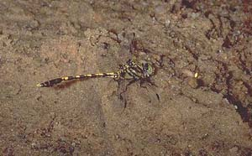
This species is much more widely distributed throughout its range, than the former. It is slightly smaller with a complete midlateral thoracic stripe and a strong patch of brown basally in each wing. The thorax is pale yellow with the dark middorsal stripe widening anteriorly toward the collar and isolated from the antehumeral stripe at its upper end. The humeral and antehumeral stripes are normally confluent at both ends with a thin pale stripe between them. The mid- and third lateral stripes are both present and well developed. The legs are short and darker than in P. borealis. The basal brown spot in each wing extends out generally to the first antenodal crossvein. They can be distinguished from E. designatus, in this respect, by the distinctly yellow superior and black inferior caudal appendages in the male and the general maculation of the abdomen, which is similar to that of P. borealis. Needham (1941) described and illustrated the larva.
Size: Total length: 51-55 mm; abdomen: 39-43 mm; hindwing: 31-35 mm.
Habitat: Shallow streams and lakes with a sandy bottoms.
Eastern Ringtail Erpetogomphus designatus Hagen in Sélys: Gomphidae
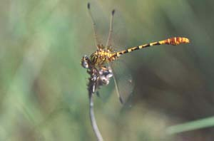
Male, dorso-lateral view ©John C. Abbott
This is the most widely distributed of our species. It can be distinguished from other species by a combination of characters including diffuse yellow or brown in the quadrangles of all wings, a dark brown pterostigma and a medially swollen occiput in both sexes. The face of this yellowish-green species is pale green and the vertex is dark brown. The green occiput is swollen medially in both species. The middorsal thoracic stripe widens anteriorly toward the collar. The brown antehumeral stripe tapers distally and is free at both ends. The brown humeral stripe is complete and well-developed, but not extending considerably posteroventrally. The midlateral stripe is weakly developed and interrupted, often wanting at its upper end. The third lateral stripe is narrow, but complete. The femora are pale green becoming darker distally. The tibiae are dark brown armed with black spines. The wings are hyaline with the above-mentioned distinctive basal wash of yellow. The abdomen is pale green marked with reddish-brown rings and an interrupted dorsolateral stripe on segments 3-6. The remaining segments in males are light yellowish-brown and in females segments 7-8 are darker dorsally. The larva was first described and illustrated by Cabot (1872).
Size: Total length: 49-55 mm; abdomen: 34-37 mm; hindwing: 28-32 mm.
Habitat: Clear streams and rivers of deciduous forests with moderate current.
Narrow-striped Forceptail Aphylla protracta (Hagen in Sélys): Gomphidae
©Greg Lasley
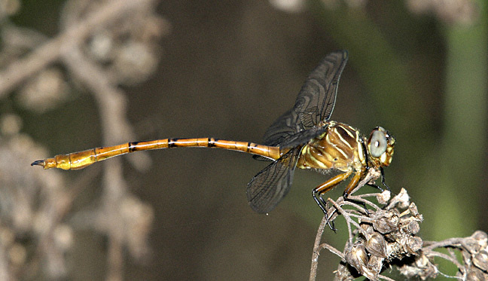
This mexican species is less common than A. angustifolia and has a wider lateral margin on abdominal segment 8. Other characters to separate these species are given under the description of A. angustifolia. The face is greenish-yellow and the thorax is very similar to that of A. angustifolia. The dark third lateral thoracic stripe is generally as broad as the humeral and midlateral stripes. The wings are hyaline and typical of the genus. Segment 10 of the long, slender abdomen is deeply notched dorsally. The male superior caudal appendages lack an overlapping ridge on their mesal margin dorsoapically.
Size: Total length: 64-66 mm; abdomen: 42-50 mm: hindwing: 35-49 mm.

Habitat: Lakes, ponds and pools of intermittent streams with muddy bottoms.
Broad-striped Forceptail Aphylla angustifolia Garrison: Gomphidae
Female, Lateral view ©John C. Abbott
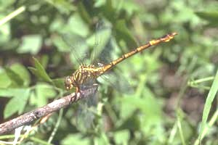
This species occurs within the southern limits of this region may be easily confused with A. protracta. The thoracic stripes of the later are typically all about the same width. In A. angustifolia, the dark third lateral stripe is narrower and the lateral expanse of abdominal segment 8 is not as wide. The thorax is greenish-yellow with dark brown stripes. The middorsal stripes are triangular. The humeral and antehumeral stripes are equally broad. The midlateral thoracic stripe is broader than the humeral and third lateral stripes. The wings are hyaline with a relatively long brown pterostigma. The abdomen is long, slender and brown marked with yellowish stripes. Segment 8 is widely expanded laterally, more so in males than females. The apical mesal margin of the male superior caudal appendages form a ridge overlapping the appendage dorsally. The posterior margin of segment 10 is narrowly emarginate. The larva was first briefly described from an exuviae collected from Williams Lake in Matagorda County, Texas, by Calvert (1914) and then by Needham (1940).
Size: Total length: 62-68 mm; abdomen: 47-50 mm; hindwing: 36-40 mm.

Habitat: Lakes, ponds and pools of intermittent streams with muddy bottoms.
CRUISERS

Medium-to large-size dragonflies, brown or black with yellow markings, that cruise long distances looking for mates and prey on stiff narrow wings built for sustained speed. A yellow belt around the thorax forms a single stripe on each side, and the middle abdominal segments each have only one spot or one pair of spots. The eyes, brilliant green in several species, are in contact on top of the head, and each bears a posterior lateral bump. The face is dark with 2 yellow cross-stripes, while the HW exhibit a rounded anal loop. The legs are very long and bear forked claws. The abdomen is clubbed in males, except for the Royal River Cruiser, but cylindrical in females. Males have ventral rubbery keels on the lower leg of the fore-and hind legs, and of variable length according to the species on the middle leg. Females lack ovipositors, and lay their green eggs by touching the tip of the abdomen to the water surface at high speed, usually near a high or overhanging bank. The female subgenital plate is short and V-notched.

Illinois River Cruiser Macromia illinoiensis (Sélys): Macromiidae
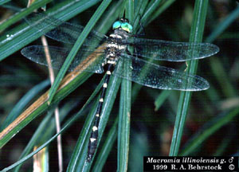
Male, dorsal view
This is perhaps our most widespread and frequently encountered Macromia species. It would only be confused in our region with M. alleghaniensis, but the yellow on abdominal segment 7 does not completely encircle that segment. The top of the frons is dark with two dorsal and two lateral pale spots. The vertex is wholly black. The antehumeral stripes on the dark thorax extend up 1/3 - 1/2 the distance of the front of the thorax. The wings are hyaline, with at most a hint of brown basally in females. The legs are black and long. There is an uninterrupted yellow ring on abdominal segment 2. Segments 3-6 each have a dorsal spot that may be thinly interrupted. Segments 7-8 each have a pale ring interrupted ventrolaterally, broadly so on 7. Cabot (1890) first described the larva. More recently Louton (1982) and Donnelly and Tennessen (1994) have illustrated it.
Size: Total length: 65-79 mm; abdomen: 47-56 mm; hindwing: 40-53 mm.

Habitat: Moderate to large rivers and streams.
Prince Baskettail Epitheca princeps (Hagen): Corduliidae
Male, dorso-lateral view
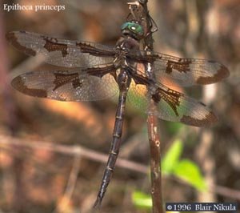
This is our most widespread and probably easiest corduliid to recognize. It is the only Epitheca with brown wing tips. It may be confused with L. pulchella, which has wings similarly patterned, but there are no yellow lateral thoracic stripes in E. princeps. The thorax and abdomen are brown, the latter with an obscured row of pale spots on the sides. The wings are variably marked with brown basally, at the nodus and apically. The larva was described and illustrated by Cabot (1890).
Size: Total length: 58-68 mm; abdomen: 42-49 mm; hindwing: 38-43 mm.

Habitat: Quiet reaches of streams, rivers, ponds and lakes.
Stripe-winged Baskettail Epitheca costalis (Sélys): Corduliidae
Male, Dorsal view ©John C. Abbott
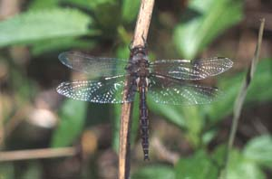
This is a brown dragonfly, typical of the subgenus, with a hairy thorax and a spot of yellow on the side. The abdomen has a lateral yellow stripe. The wings are marked with a basal spot of brown, or in some females there may be a brown stripe across the front edge of the wings. Males have a slender abdomen and long superior caudal appendages (greater than 3.4 mm). These appendages are similar to those of E. cynosura, but lack a ventral keel. The abdomen of the male is often strongly constricted behind segment 3. The female caudal appendages are long, as long as segments 9 and 10 together. Tennessen (1977) described the larva.

Size: Total length: 42-45 mm; abdomen: 28-32 mm; hindwing: 25-28 mm.

Habitat: Lakes, ponds and slow reaches of streams and rivers.

SKIMMERS

Skimmers are by far the most common dragonflies at still waters, and relatively few breed in running water. They are the showiest dragonflies, exhibiting a full spectrum of colors, which, however, are seldom metallic. Many species have a conspicuous wing pattern. Lacking in other North American dragonfly families, but found in some of the Skimmers, are: abdomen flattened from the base; abdomen of a solid color, including red or white; stigmas red, orange, green, or white; white wing spots; dark wing bands; orange or red wing veins; and male hover-guarding. Rare in other families, but more common in Skimmers, are: very small size’ pruinosity; brown wing spots; striped abdomen; and complete mating in midair.
Nearly all Skimmers possess a characteristic foot-shaped anal loop, complete with knee, heel, and toe. This loop helps support the base of the HW, and is particularly large in the widened wings of gliding species. Males lack auricles on S2, as well as the correlated angle at the HW base, so that the shape of the HW is similar in males and females. As in most dragonflies, the eyes of Skimmers are in contact on top of the head, but the posterior bump on each eye present in Emeralds has been lost. In about 10% of our skimmers, the female subgenital plate is developed into a spoutlike ovipositor (Scarlet Skimmer, Filigree Skimmer, 4 Pondhawks, and 4 Dragonlets). In about 25% of our Skimmers, the females have lateral flanges on S8 used to splash eggs onto the bank (Roseate Skimmer, Narrow-Winged Skimmer, and 22 King Skimmers).
Most Skimmers are perchers that cling horizontally to tips of stems or obliquely on sides of stems. Other Skimmers are gliders with widened HW that stay aloft for hours at a time. Many Skimmers lay eggs in tandem, but our only other dragonfly that does this is the Common Green Darner.
Known life cycles is usually 1 year, but vary from 1/3 year in some tropical species to 3 years in some northern species.

Widow Skimmer Libellula luctuosa Burmeister: Libellulidae
Male, Dorsal view ©John C. Abbott
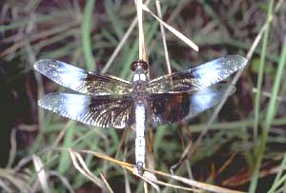
This is certainly a widespread and easily recognized dragonfly. It has large black wing bands in both sexes extending from the base out to the nodus. The face is pale yellow or brown in juveniles and females, but darkens, to black along with top of the head in mature males. The pterothorax is dark brown with a pale yellow middorsal stripe that extends onto the prothorax. This area becomes an obscure brown color in females and black in mature males, ultimately turning powder blue. The sides are pale yellow with a somewhat ill-defined dark stripe on the third lateral suture. This area becomes obscured in females and turns a dark brassy brown in older males. The wings are distinctly marked as above, with occasional darkening of the wing tips, especially in females and more western-distributed individuals Mature males develop a white area beyond the basal dark stripe that extends to the wing apex. The legs are black. The abdomen is only moderately depressed and tapers rearward. It is pale yellow with broad black middorsal and lateral stripes. The yellow is interrupted only by the black carinae. Segment 8 in females is but slightly expanded laterally. The caudal appendages are black. The color of the abdomen darkens in both sexes and becomes a powder pruinose blue in males.
Size: Total length: 38-50 mm; abdomen: 24-32 mm; hindwing: 33-41 mm.

Habitat: Still bodies of water, including marshy ponds, lakes and borrow pits.

Common Whitetail Libellula lydia Drury: Libellulidae
Female, dorsal view ©John C. Abbott
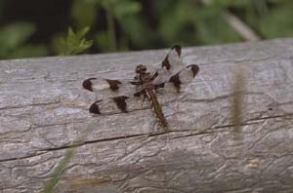
This is another ubiquitous dragonfly, commonly seen at almost any standing body of water during the summer. It is found throughout most of the U.S. and southern Canada. It is a moderate-sized stout species that displays a distinct dimorphism between the sexes. The male has large broad brown or black bands in the outer portion of each wing, while the female's wings are less maculated, with three spots, basally, at the nodus and apically, appearing as a smaller version of L. pulchella. The face is yellowish-brown initially, but becomes noticeably darker in both sexes. The top of the head is a deep brown. The robust thorax is brown, unmarked in the front and with two yellowish lateral stripes giving way to white at their upper ends. The wings in the male are as above with a small white spot below the basal dark area in the hindwing. The legs are brown. The abdomen is quite wide and appears triangular in cross-section as it tapers apically in males. In females the abdomen is strongly depressed. In both sexes the abdomen is brown with an interrupted white line laterally, appearing as individual stripes. In mature males the thorax becomes darker and the lateral stripes obscured. The most noticeable change, however, is the total envelopment of the male abdomen by a white pruinescence. Needham (1901) originally described the larva and Levine (1957) later studied and described it in further detail.
Size: Total length: 38-48 mm; abdomen: 23-29 mm; hindwing: 29-35 mm.

Habitat: Nearly any pool, pond, lake or quiet stream.
Twelve-spotted Skimmer Libellula pulchella Drury: Libellulidae
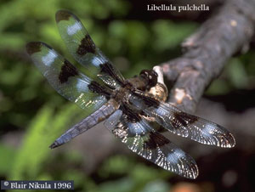
Male, dorsal view
This is a large, handsome, brown skimmer found in all 48 contiguous United States. Its distinct wing pattern of dark brown or black wing spots, basally, at the nodus and at the wing tips, will readily distinguish it from most dragonflies in our region. Individuals of the similar L. forensis lack dark wing tips. Female L. lydia are very similar, but they are smaller and have pale legs. The face of L. pulchella is dull yellowish-brown. The thorax is brown and lacks a middorsal stripe. Each side has a pair of pale yellowish-stripes. The wings are spotted with dark brown or black, as mentioned above. Mature males develop two white spots in each forewing and three in each hindwing, giving them their traditional common name "ten spot." It has more recently been given the name "twelve spot" to represent the more conspicuous brown spots of each wing. The legs are brown at their extreme bases and black beyond for the remainder of their length. The abdomen is brown with a broad pale yellow uninterrupted stripe on each side and a narrower one along the middorsal carina. The caudal appendages are brown, darkening with age. Females have a slight lateral expansion of abdominal segment 8. Musser (1962) described and illustrated the larva.
Size: Total length: 51-58 mm; abdomen: 32-36 mm; hindwing: 42-48 mm.
Habitat: Shallow ponds, lakes, marshes and slow streams.

Golden-winged Skimmer Libellula auripennis Burmeister: Libellulidae
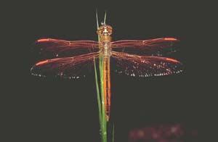
Female, dorsal view ©John C. Abbott
This is a relatively large, beautiful, red species found throughout the eastern portions of our area. It is very similar to the coastal species L. needhami, but it has red veins throughout, whereas L. needhami has black veins over most of its wings. The hind tibiae of L. auripennis are reddish-brown, never bicolored. Teneral individuals of Libellula flavida are also easily confused, but the costa is generally dark out at least to the nodus, the front 1/4 to 1/5 of all wings is heavily tinged with amber or yellow and the thorax is more robust and has a prominent pale middorsal stripe. The face is brown in juvenile and female L. auripennis, becoming bright red in older males. The thorax is brown with 2 diffuse pale stripes laterally. The wings have a yellow pterostigma and the abdomen is yellow with a black middorsal stripe. In mature males the front of the thorax becomes rusty red, and the pterostigma and abdomen become bright red. The wing veins are reddish-orange throughout.
Size: Total length: 45-58 mm; abdomen: 32-40 mm; hindwing: 35-45 mm

Habitat: Ponds, pools, ditches, lakes and occasionally slow flowing streams.

Roseate Skimmer Orthemis ferruginea (Fabricius): Libellulidae
Male, dorso-lateral view ©John C. Abbott
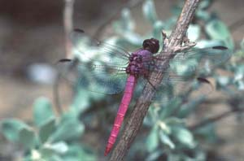
This handsome and widespread, common species is found throughout all parts of our area. It is brown initially in both sexes with pale stripes on the thorax forming an irregular "HII" pattern. The abdomen is uniform brown in juveniles. Mature adults develop a pale bluish thorax and a bright pinkish or purple abdomen. The wings are clear with orangish veins. The lateral flanges of abdominal segment 8 in females are generally pale. Other characteristics and specific differences between O. ferruginea and O. discolor are given under the description of the latter.
Size: Total length: 46-55 mm; abdomen: 33-39 mm; hindwing: 35-44 mm.

Habitat: Temporary and permanent ponds, lakes, ditches and slow streams.
Blue-faced Meadowhawk Sympetrum ambiguum (Rambur): Libellulidae
Male, dorsal view ©J. Laswell
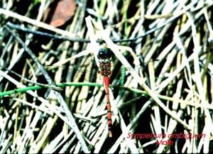
This is our only predominantly eastern distributed species. Its face is white in front and bluish above. The thorax is grayish-brown or olivaceous with the lateral sutures outlined by thin brown stripes. The wings are clear, with only a small spot of flavescence at the extreme base of each wing tip. The costa is yellow and the pterostigma is brown with yellow around its outer edges. The legs are pale brown but darken at the joints. The abdomen is brown with diffuse black rings apically around segments 4-9, in juveniles and females. The abdomen turns red in mature males. Wright (1946d) described and illustrated the larva. This upper part of the face is bluish-green, while the lower part is white. The face along with the pale legs and male genitalia make this species distinct in our region.
Size: Total length: 31-38 mm; abdomen: 22-25 mm; hindwing: 26-28 mm.
Habitat: Partially shaded temporary and permanent ponds, pools, marshes, swamps and sloughs.
Variegated Meadowhawk Sympetrum corruptum (Hagen): Libellulidae
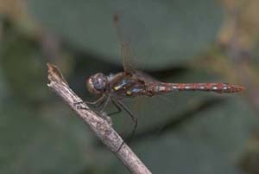
Male, lateral view ©John C. Abbott
This is certainly our most widespread Sympetrum species. It is largely tan or gray. The face is pale or tan in juveniles and females but becomes red in mature males. The thorax has two oblique lateral white stripes, each with a distinct round yellow spot at the lower end. The yellow always remains visible, but the white becomes obscured in mature males. The wings are clear with yellow veins in the costal and subcostal areas and have a tan pterostigma, bordered by yellow and red. The legs are dark brown except on their outer surfaces. The abdomen is grayish with a yellowish orange middorsal stripe and orange rings apically on segments 3-7. There is a row of white spots laterally on segments 2-8 and segment 8 and 9 each have a large black spot dorsally. The orange color of the abdomen turns red in older males. Needham (1901) and more recently Musser (1962) have described and illustrated the larva. Cannings (1982) described differences between the larva of this species and others in the Tarnetrum group.
Size: Total length: 33-43 mm; abdomen: 23-29 mm; hindwing: 27-33 mm.

Habitat: Ponds and slow streams, preferably with sandy or cobble bottoms, but occasionally including brackish waters.
Band-winged Dragonlet Erythrodiplax umbrata (Linnaeus): Libellulidae
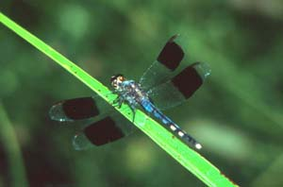
Male, dorso-lateral view ©John C. Abbott
This is a larger species in the genus, second only to the similar E. funerea. Diagnostic differences are given under that species. Other similar species include Pseudoleon superbus, which has wings with much heavier maculation and Erythemis vesiculosa, which may be confused with teneral and female individuals with unmarked wings. Erythemis vesiculosa, however, is a bright green species with the abdomen well marked with black. The face and thorax of E. umbrata are olivaceous or greenish-brown in teneral males and most commonly in females. In these females the wings are clear with only a wash of amber or flavescence through the wing. Males become black with age, as does the uncommon heterochromatic form of the female. Both have a large dark spot that becomes a broad black band in the outer half of each wing. Calvert (1928) described the larva.
Size: Total length: 38-47 mm; abdomen: 23-34 mm; hindwing: 25-34 mm.

Habitat: Permanent and temporary marshy ponds, pools and lakes.
Little Blue Dragonlet Erythrodiplax minuscula (Rambur): Libellulidae

Male, dorsal view ©John C. Abbott
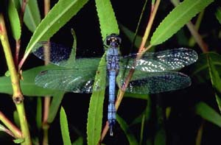
This is a widespread Erythrodiplax species. It is a small species, very similar to its southwestern counterparts, E. connata and E. fusca, once considered a subspecies of the former. It can generally be readily distinguished in the field from either of these by its eastern distribution and the distinctive powder blue pruinose appearance of older individuals. Other specific differences are given under each of the previous two species. Teneral and female individuals are greenish-brown. The front of the thorax is devoid of stripes and darker than the sides. The wings are hyaline or with only a small basal spot in the hindwing. There is a black middorsal and a pair of interrupted lateral stripes on the abdomen. Mature individuals develop a powder blue pruinose appearance that envelopes the body from the thorax posteriorly and terminal abdominal segments anteriorly. Abdominal segments 7-10 become wholly black. The caudal appendages are pale and the female has a short but distinct, triangular, spout-like ovipositor, below segment 9. Needham (1904) described and illustrated the larva.
Size: Total length: 22-27 mm; abdomen: 14-17 mm; hindwing: 15-21 mm.

Habitat: Marshy ponds, pools, lakes and slow moving streams.
Seaside Dragonlet Erythrodiplax berenice (Drury): Libellulidae
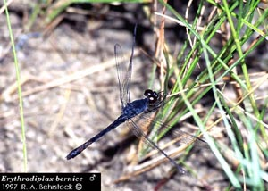
Male, dorso-lateral view
This is a small, common, distinctly coastal species. It is similar to Pachydiplax longipennis, which has an unmarked face and basal wing markings. Juveniles and females have a pale face with broad black stripes. The thorax is pale yellowish, heavily striped with black in the front and sides. These dark stripes are broadly confluent at their lower ends. The face and thorax quickly become entirely dark blue or black in males and nearly so in females. The top of the frons becomes metallic blue. The wings are clear, although there may be hints of amber basally and at the nodus in females. The legs are black. The abdomen is largely black with broad orange or yellow spots dorsally on segments 1-7. These spots quickly become obscured in males and more slowly in females. Females are quite variable during this transition time, in some individuals the thorax becomes black before the abdomen. In others the abdomen turns black before the thorax and there may or may not be an amber spot near the nodus in each wing. The female has a triangular shaped, scooped-out, ovipositor projecting ventrally from segment 9. Calvert (1904) described the larva.
Size: Total length: 28-35 mm; abdomen: 15-23 mm; hindwing: 18-26 mm.
Habitat: Salt marshes, estuaries, bays and occasionally inland lakes high in salinity.
Eastern Amberwing Perithemis tenera (Say): Libellulidae
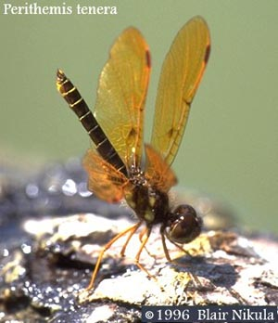
Male, dorso-lateral view
This species is very similar to P. domitia, but it is much more widespread throughout the U.S. and our area. It is a small brown species. Perithemis tenera, males have orange or amber wings that usually develop a brown spot above the triangles in our area. Females have variously shaped brown spots or stripes through the amber areas. Needham (1901) described and illustrated the larva. Differences between this species and P. domitia are given under that species.
Size: Total length: 19-25 mm; abdomen: 12-16 mm; hindwing: 16-21 mm.

Habitat: Open sloughs, ponds, pools, roadside ditches and other still waters.
Blue Dasher Pachydiplax longipennis (Burmeister): Libellulidae
Male, lateral view ©John C. Abbott
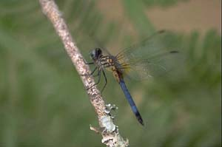
This rather distinctive species is found throughout our area. It has a white face, and the top of the frons is metallic blue in mature individuals of both sexes. The eyes are brilliant blue or green in males and reddish-brown in females. The front of the thorax is brown with a thin pale carina medially and a wider pale stripe on either side. The sides are pale green with three full length brown stripes. The wings are typically clear but may be flavescent and with a dark brown stripe on either side of the midbasal space in males. The legs are black and heavily armed. The abdomen is black with a pair of pale yellow stripes dorsally that are interrupted on segments 3-8 to appear as dashes. Segment 9 and the caudal appendages are black, while 10 is pale. The abdomen is considerably shorter in females. Older males develop a pale pruinose blue color dorsally and more slowly laterally on the thorax and over the entire abdomen. Females become pruinose, but much more slowly than males. The larva was described by Needham (1901) and most recently illustrated by Musser (1962). This species is similar to mature males of Erythemis simplicicollis, which have an unmarked green or blue thorax. Females of Erythrodiplax berenice have a prominent ventrally projecting ovipositor. Species of Micrathyria are similar and characters are given under those species to help separate them.
Size: Total length: 28-45 mm; abdomen: 23-35 mm; hindwing: 30-43 mm.
Habitat: Ponds, lakes, marshes, ditches, slow streams and other quiet bodies of water.
Eastern Pondhawk Erythemis simplicicollis (Say): Libellulidae
Male feeding on sulfur butterfly, lateral view ©John C. Abbott
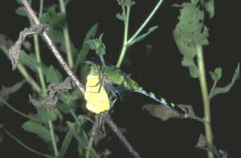
This is one of the most widely distributed species in our region and in all of the eastern U.S. It is very similar to the darker, western E. collocata, with differences emphasized under that species. Other species for which it may be confused are also diagnosed under E. collocata. It is bright green in teneral individuals and females, becoming powder blue in older males, starting basally on the abdomen and on the front of the thorax. The abdomen, before becoming obscured in older males, is black with green dorsolateral spots on abdominal segments 4-6 and yellow or pale superior caudal appendages. Females have the usual ventrally projecting spout-like ovipositor below segment 9. The last instar has been described by various authors (Needham 1901; Calvert 1927; Garman 1927; Byers 1930) and Bick (1941) reared this species from an egg, describing each larval instar in detail.
Size: Total length: 36-48 mm; abdomen: 24-30 mm; hindwing: 30-34 mm.
Habitat: Ponds, lakes, ditches, and slow moving creeks, streams and rivers.

Great Pondhawk Erythemis vesiculosa (Fabricius): Libellulidae
Male, Dorsal view ©John C. Abbott
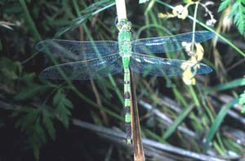
This species is called the Great Pond Hawk because of its large size. It occurs from Kansas south through the central part of our area to Argentina. Its size and the dark wide bands on abdominal segments 4-7 will distinguish it from other species, including the smaller E. simplicicollis and E. collocata, which have interrupted rings or spots on abdominal segments 4-7. The face and thorax are bright green and unmarked. The wings are hyaline with a green pterostigma in juveniles and the abdomen is green, marked as described above, with segments 8-10 black. The caudal appendages are pale yellow. The legs are greenish basally, but black for most of their length, with large prominent femoral and tibial spines. Klots (1932) described and illustrated the larva.
Size: Total length: 55-65 mm; abdomen: 40-48 mm; hindwing: 38-45 mm.

Habitat: Ponds, lakes, ditches, and slow moving creeks, streams and rivers.
Pin-tailed Pondhawk Erythemis plebja (Burmeister): Libellulidae
Male, dorso-lateral view ©John C. Abbott
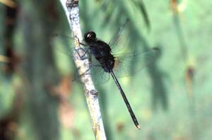
This is our only black pondhawk. It can easily be distinguished from other dragonflies by a combination of its dark color, a small basal black spot in the hindwing and an extremely thin abdomen. The similar Macrodiplax balteata is larger, with more black basally in the hindwing, and the abdomen is not noticeably narrowed. The face and thorax of E. plebeja are brownish in juveniles and females and black in older males. The dark abdomen is swollen basally and then extremely narrowed to the end, with light brown rings on abdominal segments 4-7, that become obscured in older males. The female

Size: Total length: 41-49mm; abdomen: 30-39 mm; hindwing: 30-37.

Habitat: Ponds, lakes, ditches and slow reaches of rivers and streams.

Wandering Glider Pantala flavescens (Fabricius): Libellulidae
Male, dorsal-view ©John C. Abbott
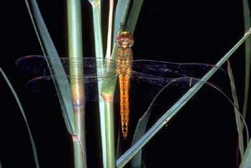
This is probably the most widespread and cosmopolitan of all dragonflies. It is commonly encountered throughout our area. It is distinctive with its predominantly yellow color. The face is pale yellow becoming reddish in older males. The thorax is olivaceous brown and largely unmarked. The wings are clear, with males developing brown apices. The legs are pale basally, becoming black for most of their length. The stout tapered abdomen is yellow with black stripes laterally on the swollen basal segments. The thin dark middorsal stripe widens and becomes noticeably darker on segments 8-10. The pale caudal appendages are more or less bicolored in males, darkening in their outer half. Cabot (1890) first described the larva and more recently Musser (1962) illustrated it. Similar species include P. hymenaea, which has a brown spot basally in the wings and Sympetrum spp. which have normal shaped wings and parallel-sided abdomens. Our species of Tramea all have wide crossbands in the hindwings.
Size: Total length: 44-51 mm; abdomen: 25-34 mm; hindwing: 35-42 mm.

Habitat: Permanent and temporary ponds, pools and other water bodies, including brackish ones.
Spot-winged Glider Pantala hymenaea (Say): Libellulidae
Male, dorsal view
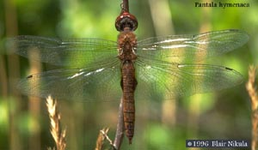
This species is very similar to P. flavescens and equally cosmopolitan in the south-central U.S. The face and thorax are essentially as in that species. Each hindwing, however, has a distinct round dark spot basally. The abdomen is dark and mottled. Kennedy (1923b) and Musser (1962) have described and illustrated the larva. This species can be distinguished from P. flavescens by the presence of the dark basal hindwing spot and darker abdomen. Other species (Tramea) that are similar and with which P. hymenaea may fly either lack the basal wing spot or have this spot differently shaped.
Size: Total length: 43-51 mm; abdomen: 29-35 mm; hindwing: 39-45 mm.

Habitat: Open, temporary and artificial ponds and pools, including brackish waters.
Black Saddlebags Tramea lacerata Hagen: Libellulidae
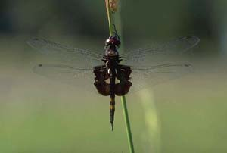
Male, dorsal view ©John C. Abbott
This is our only black Tramea. It is large with a yellowish face in tenerals and females that becomes entirely black in mature males. The top of the head, including the vertex, is deep metallic violet. The thorax is brown with black iridescence on the sides. The wings are clear with a broad black crossband covering the basal 1/4 of the hindwing. There is a large prominent clear spot medially in this area, extending to the inner wing margin. The legs are black. The abdomen is black with a pair of yellowish spots dorsally on the middle segments which becomes obscured except on segment 7. Bick (1951) described the early instar of the larva from New Orleans, Louisiana, and Musser (1962) described the final instar larva.
Size: Total length: 47-55 mm; abdomen: 31-38 mm; hindwing: 40-48 mm.
Habitat: Marshy ponds, lakes, ditches and slow streams.
Red-mantled Saddlebags Tramea onusta Hagen: Libellulidae
Male, dorso-lateral view ©John C. Abbott
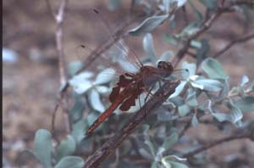
This is another red species that is widely distributed, both across our area and the entire U.S. The face is pale brown initially but turns red in mature males. The thorax is brown and unmarked. The wings have reddish-brown veins anteriorly and the hindwing has a large basal brown crossband that doesn't generally extend beyond the midrib of the anal loop. There is a large central clear spot in this crossband. The legs are pale turning black more distally. The abdomen is yellowish-brown in juveniles and females, but turns red in mature males. Segments 8-10 are black dorsally. Byers (1927b) described the larva. This species is very similar to T. carolina, and they can be very difficult to separate, especially in flight. Distinguishing characteristics are given under the former species.
Size: Total length: 41-48 mm; abdomen: 28-34 mm; hindwing: 37-42 mm.

Habitat: Permanent and temporary ponds, lakes and slow streams.
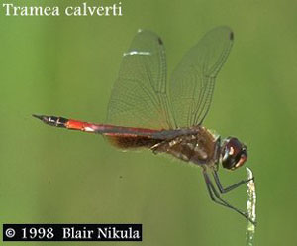
Striped Saddlebags Tramea calverti Muttkowski: Libellulidae
This tropical species has expanded its northern range into Texas and up the eastern seaboard. Its face is pale yellow turning red in mature males and the vertex is metallic violet. The thorax is brown with 2 oblique pale stripes laterally. The wings are clear with a broad basal brown stripe in the hindwing. The legs are pale basally and darker beyond. The abdomen is yellowish in females and red in mature males. Segments 8-10 are black dorsally. This is our only Tramea with a striped thorax. It is most similar to the smaller Miathyria marcella, but it lacks the complete middorsal black stripe of that species.
Size: Total length: 44-49 mm; abdomen: 30-33 mm; hindwing: 37-42 mm.

Habitat: Temporary and permanent ponds and slow streams.
Hyacinth Glider Miathyria marcella (Sélys in Sagra): Libellulidae
Female, dorsal view ©John C. Abbott
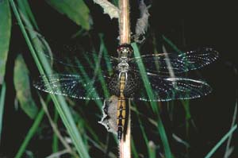
This beautiful brown species is found all along the coastal areas of southern Texas and Louisiana as well as some distance inland. It is similar to members of the genus Tramea, but Tramea are all larger with the black on the abdomen restricted to segments 8-10, and all but T. calverti lack thoracic stripes. The face of M. marcella is pale, with the top of the frons becoming metallic violet in older males. The thorax is tawny brown with a pair of oblique cream-colored lateral stripes. These may become obscured with age in males as the thorax progressively becomes darker violet in color, starting with the front and the area between the wings. The wings themselves are clear with light brown or reddish veins and a dark basal band in each hindwing. There are relatively few antenodal crossveins compared to other dragonflies this size, with 7 and 4 in the fore- and hindwings, respectively. The legs are dark brown with paler bases. The abdomen is orangish-brown with a black middorsal stripe. The larva was described and illustrated by Bick (1953) and Westfall (1953).
Size: Total length: 35-41 mm; abdomen: 21-27 mm; hindwing: 27-34 mm.
Habitat: Marshy ponds and lakes, including brackish waters, with water hyacinth.
Marl Pennant Macrodiplax balteata (Hagen): Libellulidae

Male obilisking
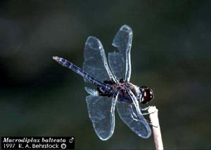
This widely distributed species is recognizable by a large black spot at the base of the hindwing and a much smaller, but similar, spot in the forewing. Mature males are similar to Erythemis plebeja, but they have a larger spot in the hindwing, extending out to the hind margin of the triangle, and they lack the unusually slender abdomen of that species. A few species of Celithemis are similar, but all are much smaller. The face and thorax in juvenile and female individuals are white and gray, respectively. There is no middorsal stripe on the latter, only a darkly outline carina. The lateral sutures on the side of thorax are irregularly outlined by black and connected below, to appear as a "W." The wings are as described above with a narrow brown pterostigma. The legs are pale at their bases and black throughout the rest of their length. The abdomen is pale yellow outlined laterally, middorsally and on the carinae by black. Segments 8-10 are entirely black. The mature male darkens extensively, with the face and entire body turning black. Needham and Fisher (1936) described and illustrated the larva.
Size: Total length: 35-42 mm; abdomen: 25-30 mm; hindwing: 31-35 mm.

Habitat: Large brackish ponds and lakes.
Red-tailed Pennant Brachymesia furcata (Hagen): Libellulidae
Male, dorsal view ©John C. Abbott
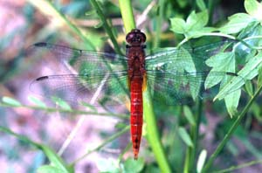
This species is found in the southern portions of Texas and is distinctive from the other two species in this genus because of a relatively short abdomen, distinctly shorter than the wings, that becomes brilliant red in mature individuals. The face is yellow or red and the prothorax is bilobed and covered by a dense fringe of long hairs. The pterothorax is brown, unmarked and densely clothed with short hairs. The wings are hyaline with a hint of yellow basally in the forewing and a larger spot in the hindwing. The legs are brown becoming black distally. The abdomen is swollen basally and strongly compressed, tapering towards the tip. It is bright red in older males and some females, but usually yellowish-brown in the latter. Garcia (1938) described and illustrated the larva.
Size: Total length: 38-46 mm; abdomen: 23-30 mm; hindwing: 30-36 mm.

Habitat: Ponds, lakes and ditches with permanent or semipermanent water including brackish waters.
Four-spotted Pennant Brachymesia gravida (Calvert): Libellulidae
Male, dorsal view ©John C. Abbott
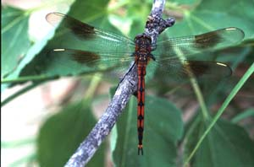
This is the most widespread and commonly encountered member of this genus in our region. It has a much longer abdomen that is parallel-sided, not tapered, as in B. furcata. Young individuals are similar to those of B. herbida, but the latter have a tan pterostigmata and lack the prominent wing spots described below. The face is black and white, becoming wholly black, along with the top of the head, in older individuals. The thorax is brown, becoming dark bluish-black with age, but less so in females. The wings have a distinct white pterostigma. Males and mature females develop a dark brown spot between the nodus and pterostigma in all wings. The legs are black. The abdomen is brown with an interrupted longitudinal dark stripe in tenerals and females, but it becomes wholly black in males. It is swollen basally, and somewhat compressed for a short distance thereafter, but never tapering to the end. The larva was described by Byers (1936) and Needham and Fisher (1936) separately.
Size: Total length: 47-55 mm; abdomen: 30-40 mm; hindwing: 32-42 mm.

Habitat: Ponds, lakes and roadside ditches, including brackish waters.

Halloween Pennant Celithemis eponina (Drury): Libellulidae

Male, lateral view ©John C. Abbott
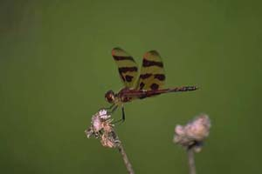
This is our largest, most widely distributed, and perhaps most colorful Celithemis species. Its common name is very descriptive of its distinctive orange and brown or black wings. The face is yellowish or olivaceous, becoming darker with age and red in males. The thorax is yellowish-green with a dark middorsal stripe and narrow lateral stripes on each suture. The midlateral stripe is usually not continuous after the spiracle. This is the only species with completely yellowish-orange wings marked with broad dark brown or black stripes and a red pterostigma. The abdomen is slender with pale yellow dorsal spots that become red, with age, on segments 3-7.
Size: Total length: 30-42 mm; abdomen: 20-30 mm; hindwing: 27-35 mm.

Habitat: Lakes, ponds, borrow pits and marshes with emergent vegetation.
Banded Pennant Celithemis fasciata Kirby: Libellulidae
Male, dorsal view ©John C. Abbott
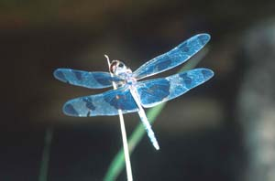
This is another larger member of this group that is easily identified by its dark color and clear wings with large black spots. The face and body of this species are bright yellow, but quickly become black or dark blue in males. The thorax is yellow, striped with black on the humeral, midlateral and third lateral sutures, but becomes wholly black at maturity. The wings are clear with a large basal black spot extending out to the nodus and encompassing an amber area centrally in the hindwing. There is also a dark spot in the outer half of the wing and the wing tips are black. The abdomen is black with pale yellowish dorsal markings on segments 5-7 that quickly become obscured in older individuals. Leonard (1934) described the larva as C. monomelaena.
Size: Total length: 28-38 mm; abdomen: 17-26 mm; hindwing: 24-32 mm.
Habitat: Lakes, ponds and borrow pits with emergent vegetation.
Checkered Setwing Dythemis fugax Hagen: Libellulidae
Female, lateral view ©John C. Abbott
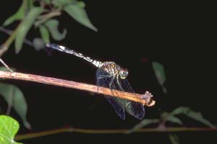
This is a primarily southwestern species that is easily recognized by its dark color and the large basal brown spots that extend out to not quite 1/4 the length of the wings. It is the only dark Dythemis in our region, with strongly spotted wings. The face is olivaceous, but becomes bright red in older males. The brown middorsal and antehumeral stripes are broadly confluent above, exposing only a small isolated pale area. The side of the thorax is bluish-gray or olivaceous with four brown diffuse lateral stripes. The legs are black and the wings are as above with a smaller spot of brown at the nodus and generally with dark wingtips. The abdomen is bluish-gray to yellow basally and dark brown to black for most of its length. There are pale spots laterally on segments 4-9 and middorsally on 4-7, becoming large and most conspicuous on 7. The remaining segments and caudal appendages are dark brown or black. Needham (1904) described and illustrated the larva from Roswell, New Mexico.
Size: Total length: 42-51 mm; abdomen: 30-35 mm; hindwing: 35-40 mm.
Habitat: Ponds and lakes with emergent vegetation.

Swift Setwing Dythemis velox Hagen: Libellulidae
Female, lateral view ©John C. Abbott
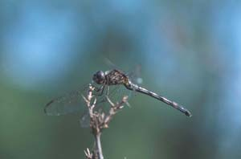
This is another largely clear winged species that is very similar to D. nigrescens, but the top of the frons is dull, never metallic, older males generally lack heavy pruinescence, the wing tips are generally darker and there are usually 3 rows of cells between vein A2 and the hindwing margin. The face is olivaceous in tenerals and females and dark brown in older males. The thorax and abdominal markings are as described for D. nigrescens, but generally with less diffuse pruinosity. The wings become amber in older individuals and have a spot of brown at the extreme base in both wings. The tips are dark brown, more so than in D. nigrescens. The legs are black. Needham (1904) described the larva from the Sand River in San San Marcos, Texas.
Size: Total length: 42-50 mm; abdomen: 25-32 mm; hindwing: 30-36 mm.

Habitat: Lakes, ponds and borrow pits as well as creeks, streams and rivers with moderate current.
Information compiled for Chad Stinson, Refuge Biologist
by Jo Ann Kinsey

Resources:

Dunkle, Sidney W. 2000. Dragonflies through Binoculars A Field Guide to Dragonflies of North America. Oxford University Press

http://www.esb.utexas.edu/jcabbott/ index.html

