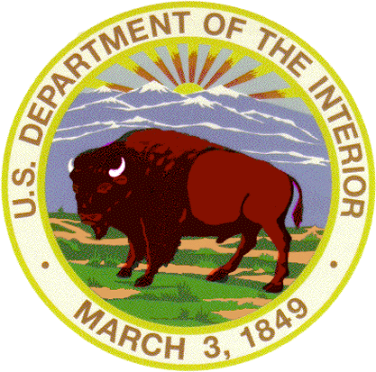 | United States Department of the Interior  NATIONAL PARK SERVICE  BRYCE CANYON NATIONAL PARK  Highway 63, #1 Park Road  PO Box 640201  Bryce Canyon, UT 84764-0201 | 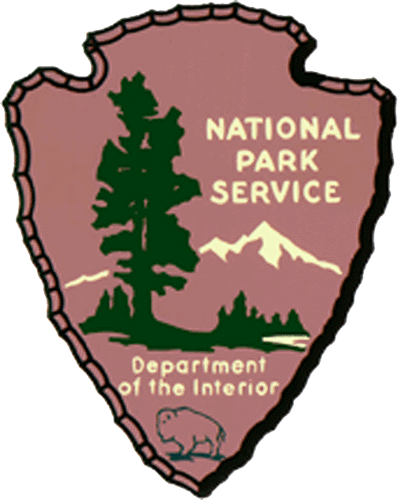

In Reply Refer to:
N-3615-Soundscapes

July 21, 2008

From: Eddie Lopez, Superintendent, Bryce Canyon National Park

To: Federal Aviation Administration

Subject: Notice of Interim Operating Authority Granted to Commercial Air Tour Operators Over National Parks and Tribal Lands Within or Abutting National Parks, Docket No. FAA-2008-0713

The Federal Aviation Administration (FAA) has received a request to accept 5 new entrant applications for overflights of national parks including granting Interim Operating Authority (IOA) to Utah Air Service, Kanab, UT, to overfly Bryce Canyon 120 times per year (two trips per week). Bryce Canyon National Park requests that the FAA not grant IOA to Utah Air Service for reasons outlined below.

According to the National Parks Air Tour Management Act:

3) New entrant air tour operators. -- ``(A) In general.--The Administrator, in cooperation
with the Director, may grant interim operating authority under this paragraph to an air tour operator for a
national park or tribal lands for which that operator is a new entrant air tour operator if the Administrator determines the authority is necessary to ensure competition in the provision of commercial air tour operations over the park or tribal lands. ``(B) Safety limitation.--The Administrator may not grant interim operating authority under subparagraph (A) if the Administrator determines that it would create a safety problem at the park or on the tribal lands, or the Director determines that it would create a noise problem at the park or on the tribal lands.

Currently there are 15 air tour operators with IOA over the park. Adding a 16th air tour operator is not necessary to ensure competition. We are also concerned that adding 120 flights a year would contribute to noise problems over the park.

Intrusive sounds are of concern to the National Park Service (NPS) because they can impede the Service's ability to accomplish its mission. Director’s Order 47 delegates to parks the positive responsibility to preserve natural soundscapes and eliminate or mitigate inappropriate noise sources. Bryce Canyon has made substantial progress in understanding our soundscape by collecting multiple years of sound data, partnering with researchers on noise impact studies including visitor perception of overflights, and working closely with the National Park Service Soundscapes program to analyze data and provide management guidance. During the summer of 2009, Bryce Canyon will assess noise impacts of air tours at peregrine falcon eyries (nesting locations) within the park. Preliminary sociological and environmental data suggests that impacts to the natural soundscape effects visitor experience and wildlife behavior in a negative manner. We are especially concerned with apparent detrimental effects on nesting peregrine falcons within the park. We plan to use information gathered over the past 15 years (incorporating the planned peregrine study in 2009) to develop a Soundscape Management Plan for our park.

Bryce Canyon respects the right of air tour operators to expand their services. However, the mandate of the NPS directs us to protect the resources of the park, including natural soundscapes. Natural sounds are inherent components of "the scenery and the natural and historic objects and the wild life" protected by the NPS Organic Act. They are vital to the natural functioning of Bryce Canyon and may provide valuable indicators of the health of the natural ecosystems within the park. Please help us to accomplish our mission of protecting the natural soundscape by maintaining the current level of air tours with IOA. We appreciate your consideration of our mandate as well as our concerns for the current and future soundscape of Bryce Canyon.

Sincerely,

Eddie Lopez /s/

Superintendent
Bryce Canyon National Park

