Radiation issues In the Fermilab Booster Magnets*
E. Prebys#, Fermilab, Batavia, IL 60510, U.S.A.

Abstract
The demands of the Fermilab neutrino program will require the lab’s 30+ year old 8 GeV Booster to deliver higher intensities than it ever has. Total proton throughput is limited by radiation damage and activation due to beam loss in the Booster tunnel. Of particular concern is the epoxy resin that acts as the insulation in the 96 combined function lattice magnets. This paper describes a simulation study to determine the integrated radiation dose to this epoxy and a discussion of the potential effects.

Introduction
The Fermilab Booster is described in detail elsewhere [1]. It is a rapid cycling synchrotron, which accelerates a proton beam from 400 MeV to 8 GeV at an instantaneous rate of 15 Hz. The lattice consists of 96 combined function magnets arranged with 2 horizontally focusing and 2 horizontally defocusing in each of 24 identical periods. The cross sections of the two types of magnet are shown in Figure 1. The entire magnet body is in vacuum in order to eliminate the need for a beam pipe.

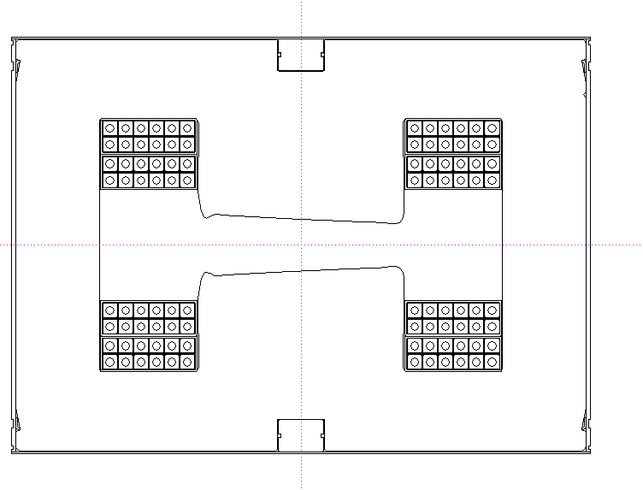
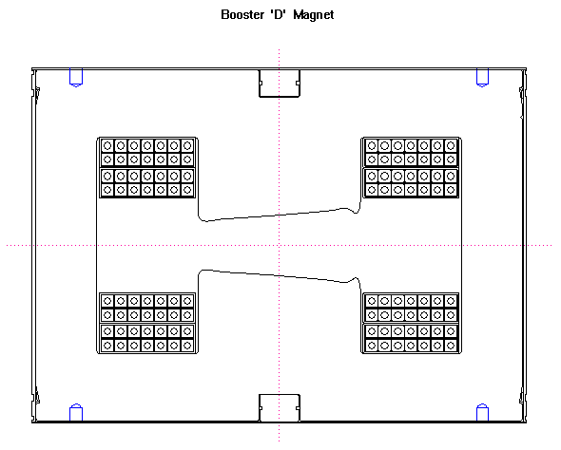
Figure 1: Booster magnet cross sections. Each magnet is approximately 13” high by 18” wide.

The field is produced by 56 coils of water cooled copper conductor. The coils are potted in an epoxy resin which acts as an insulator. Because the magnet is inside the vacuum volume and there has not been a magnet failure in over 30 years, it has not been possible to inspect this insulation for radiation damage directly.

* Work supported by the United States Department of Energy under Contract No. DE-AC02-76CH03000
#prebys@fnal.gov

Booster LOSS Simulation

Interaction Model
This study uses the MARS Monte Carlo program [2] to simulate the interaction of the beam protons with the magnets. A simple model of the magnet has been created which includes the magnetic yoke, the current carrying coils, and the insulating epoxy. An approximate model of the magnetic field is also included as it could affect the shower development. The incident beam is evenly distributed in a swath 4 cm wide and 1 mm high along the top edge of the magnet to simulate a reasonable range of beam motion.

Incident Beam Rate
It is very difficult to accurately determine the amount of beam deposited in the individual magnets of the Booster. We will make an estimate based on the observed beam loss. Figure 2 shows a typical 33 ms Booster acceleration cycle. The overall efficiency is between 80 and 85%, with the majority of the beam lost shortly after injection. A significant amount of this lost beam ends up in the Booster collimator system, so for the sake of this model we will assume beam loss of 10% at 1% at discrete energies of 500 MeV and 5 GeV respectively.
Recently, the Booster has been delivering an average of about $5×{\text{10}}^{\text{16}}$ protons/hr ($1\text{.}4×{\text{10}}^{\text{13}}$ protons/sec) outside of major down times [3]. If we naively assume that the lost beam is evenly distributed over the magnets, this leads to the following rates for incident beam on each magnet
- 500 MeV: $1\text{.}4×{\text{10}}^{\text{10}}$ p/sec
- 5 GeV: $1\text{.}4×{\text{10}}^{9}$ p/sec

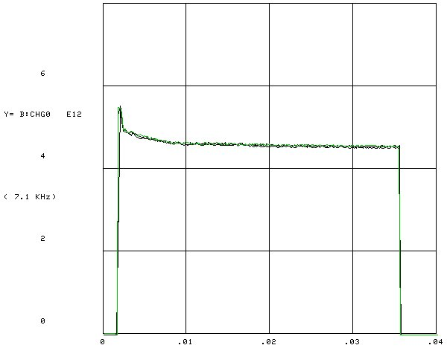

Figure 2: Beam intensity as a fuction of time (in seconds) during a typical Booster acceleration cycle.

In fact, the lost beam is divided between the top and bottom faces, but as we will see, beam loss on either face leads to similar integrated dose on the top and bottom coils, so for the sake of simplicity, we deposit the entire beam loss in the top face in the simulation.

Results

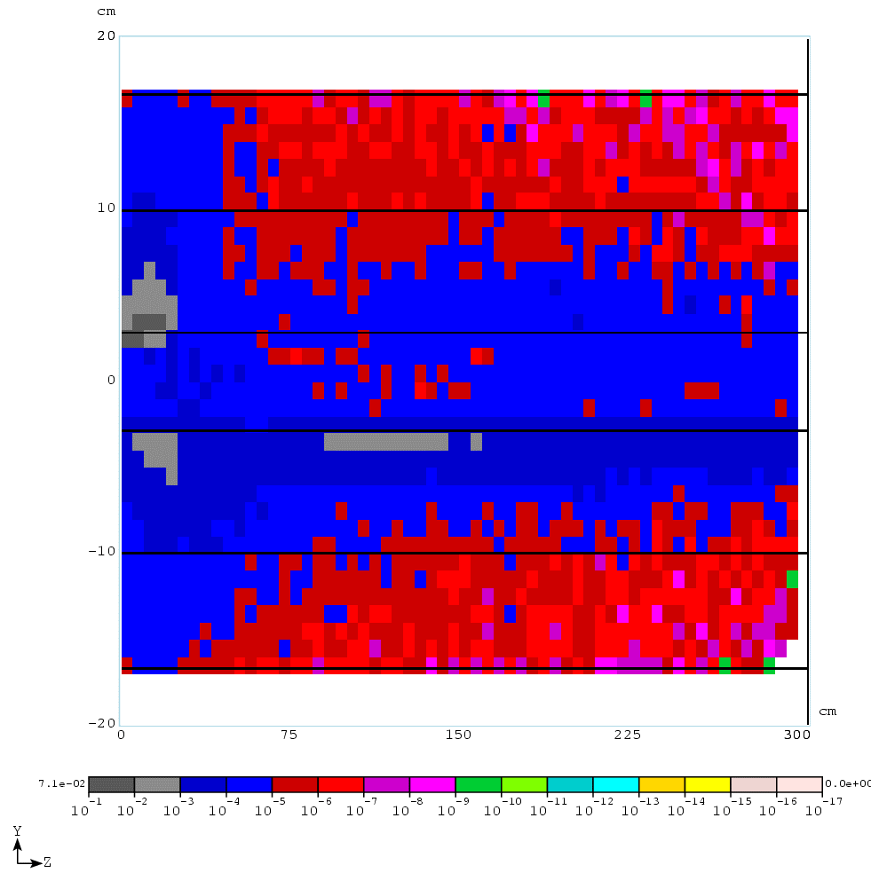
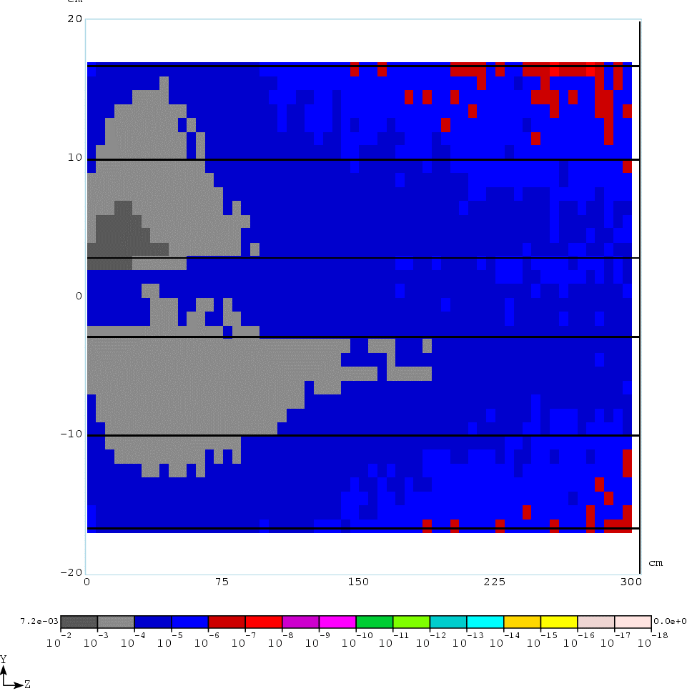
Figure 3: Longitudinal energy deposition in Gy/sec at 500 MeV (top) and 5 GeV (bottom) incident energy.

Instantaneous Energy Deposition
Figure 3 shows the longitudinal profile of the energy deposition at both energies. Based on this, the first 50 cm are taken as the shower maximum and used to determine the peak of the energy deposition in the insulator. Figure 4 shows then rate of energy deposition in this region. We see that both energies result in peak energy losses of about $1\text{.}×{\text{10}}^{−3}$ Gy/sec in the volume of the epoxy resin.
As a cross check of our assumptions, Figure 5 shows the MARS calculation of the residual radiation at the front face after 30 days of operation and 1 day of cool down. This is consistent with surveys done in the Booster.

Total Dose
Recalling the total proton rate that we started with, the instantaneous energy deposition above corresponds to an energy deposition on the order of $1−2×{\text{10}}^{−\text{17}}$ Gy per accelerated proton. The Booster has accelerated about $1×{\text{10}}^{\text{21}}$ protons in its years of operation [5], so this corresponds to roughly 10-20 kGy of total dose. Recalling that Booster was significantly less efficient for most of its life and the fact that beam loss is different in different periods, it is reasonable to assume that some areas of insulation may have received as much as 100-200 kGy.

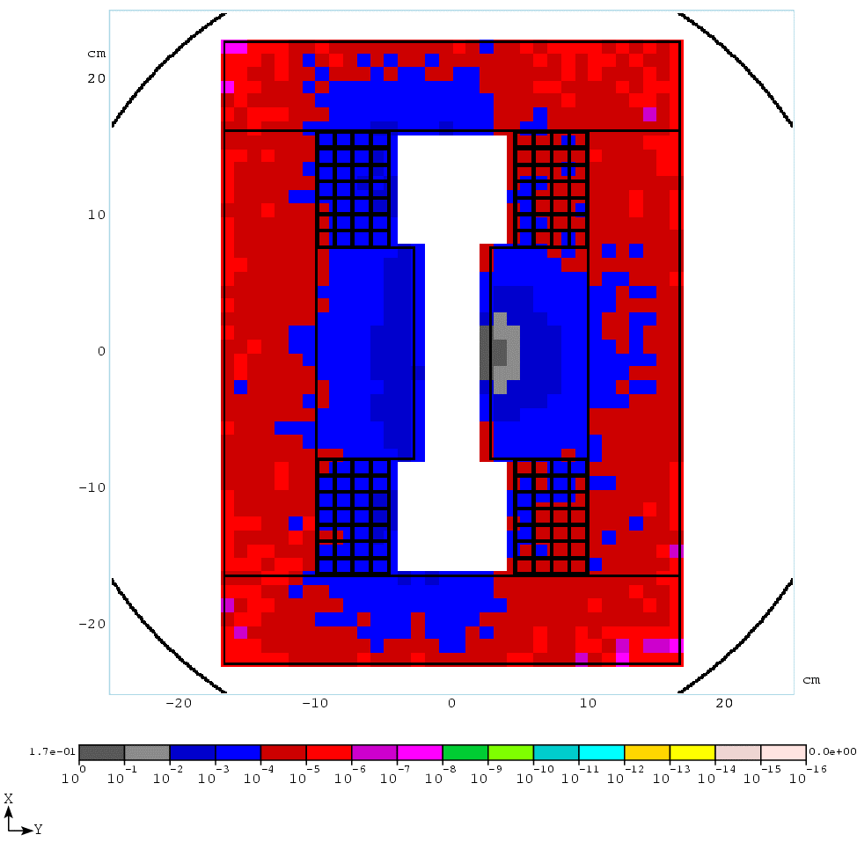
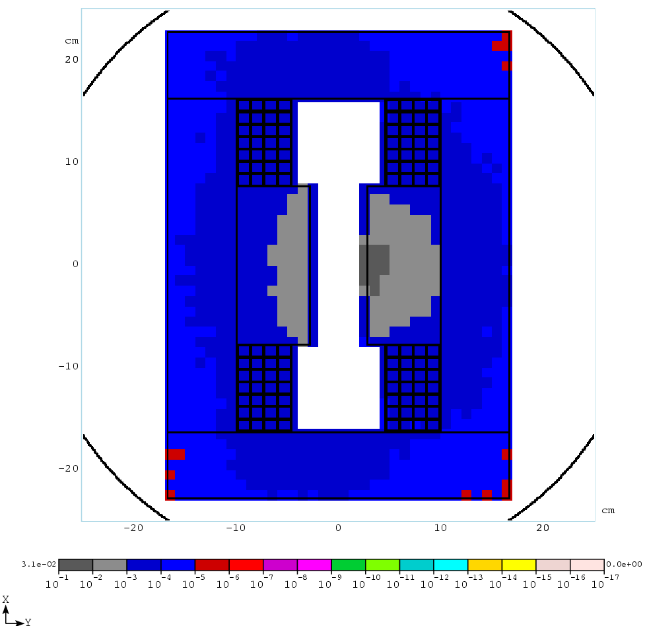
Figure 4: Cross sectional energy distribution, showing the energy deposited in the coil packs at 500 MeV (top) and 5 GeV (bottom) incident energy.

Projected Dose
The Booster is expected to deliver on the order of $5−\text{10}×{\text{10}}^{\text{21}}$ protons over the next 10 years [6]. The ability to deliver these protons will necessarily involve decreasing beam loss, but it is still reasonable to project that this will result in exposures of up to 1 MGy in some areas of the magnet insulation.

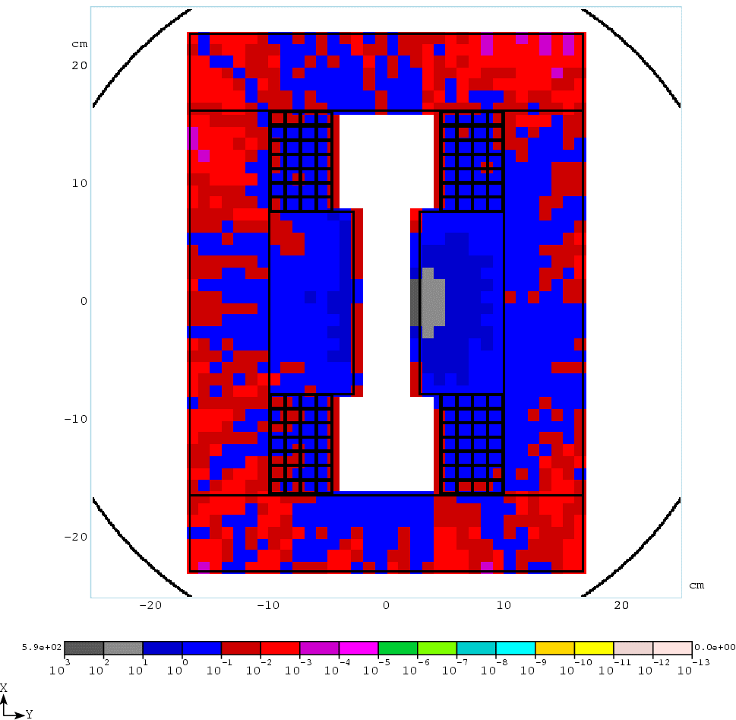
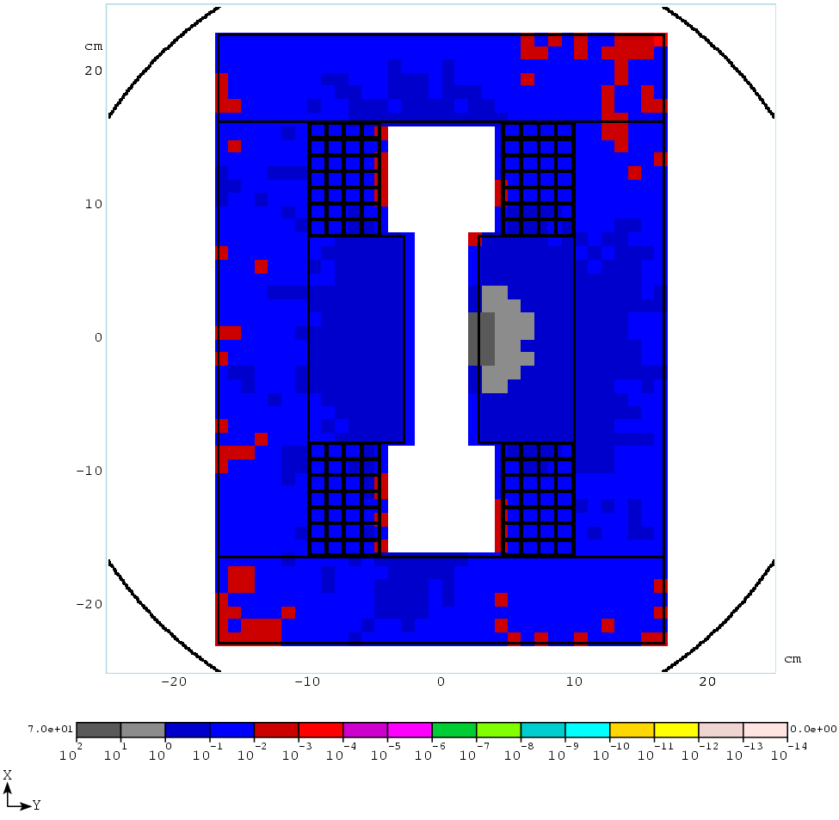
Figure 5: Residual radiation on contact after 30 days of operation and 1 day of cool down for 500 MeV (top) and 5 GeV (bottom) incident beam. These rates are consistent with surveyed activation.

DISCUSSION
Unfortunately, there is little information on the details of the epoxy used in the Booster magnets. In typical epoxy resins of this type, detectable radiation damage begins to occur with exposure at the few hundred kGy level [7,8], but the first symptoms are embrittlement and an increase in moisture absorption. The former should not be a worry unless it becomes extreme. The latter might be a concern in that moisture could affect the conductivity of the resin; however, as the coils are in vacuum, this is not an issue. Epoxy resins in the magnets at the Tristan ring at KEK had exposure as high as 10 MGy and while they were visibly darkened they continued to function properly [9].

Conclusions
Our studies indicate that the epoxy resin used as an insulator in the magnets of the Fermilab Booster may have received integrated radiation doses as high as 100 kGy over the life of the machine. The increased proton flux needed by the neutrino program could mean that some areas will receive as much as 1 MGy over the next ten years.
While these numbers are within the range where epoxy resins have been shown to work in the past, they are definitely at a level which causes some concern, particularly given our lack of details about the exact epoxy used. It is therefore extremely important to keep beam loss at a minimum in the coming years and to try to keep it as uniform as possible to avoid excessive localized dosage.
Further study is warranted, and should a magnet fail for other reasons, it will be important to inspect the condition of the epoxy.

References
[1] E. L. Hubbard, et al, “Booster Synchrotron”, FERMILAB-TM-405 (1973).
[2] http://www-ap.fnal.gov/MARS/
[3] E. Prebys, “Status of the Proton Plan”, talk presented at URA site review, Fermilab BEAMS-DOC-1817 (2005).
[4] N.V. Mokhov, A.I. Drozhdin, P.H. Kasper, J.R. Lackey, E.J. Prebys, R.C. Webber, “Fermilab Booster Beam Collimation and Shielding”, presented at PAC03, FERMILAB-CONF-03-087 (2003).
[5] Dave Finley, private communication.
[6] E. Prebys, B. Baller, W.J. Spalding, “The Proton Plan”, FERMILAB-BEAMS-DOC-1441 (2004).
[7] Lin Fu, R.A. Fouracre, H.M. Banford, “An Investigation of Radiation Damage in a Cured Epoxy Resin System Using Regression Experiment Design”, presented at conference on Electrical Insulation and Dielectric Phenomena, CEIDP.1988.26320 (1988).
[8] R.A. Fouracre, A. Al-Attabi, H.M. Banford, “Effects of Radiation Doses up to 2 MGy on the Thermally Stimulated Discharge Current Spectra for a Cured Epoxy Resin System”, presented at conference on Electrical Insulation and Dielectric Phenomena, CEIDP.1992.283250 (1992).
[9] K. Endo, K. Egawa, Y. Ohsawa, T. Michikawa, “Estimation of Radiation Dose to Epoxy Resin by IR Spectrophotometry”, presentation at EPAC 96, KEK-PREPRINT-96-55 (1996).

