Upcoming Regional Events and Activities
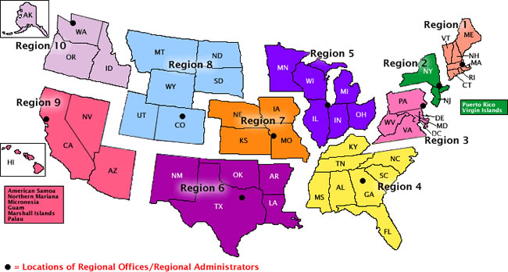

Contact your Regional Healthy Marriage Specialist for additional information http://www.acf.hhs.gov/healthymarriage/about/regionalcontact.htm
Region 1 - Boston
Connecticut, Maine, Massachusetts, New Hampshire, Rhode Island, and Vermont

March 16, 2007 The Boston Father’s and Family Network Boston, MA
Richard Claytor, an ACF grantee, is a national leader in the fatherhood movement. He will give an overview of perspectives on responsible fatherhood and proven strategies for building and enhancing programs. Richard will also address the trend toward public/private partnerships to enhance projects and support marriages and healthy families.

March 21-22, 2007 Exploring What Dads Want and Need Wakefield, Massachusetts

April 2-4, 2007 Exhibitor at New England Regional Minority Health Conference –
Eliminating Racial and Ethnic Health Disparities by 2010: Moral and Economics Imperatives Mashantucket, CT

Region 2 - New York
New Jersey, New York, Puerto Rico, and the Virgin Islands

Region 3 - Philadelphia
Delaware, District of Columbia, Maryland, Pennsylvania, Virginia, and West Virginia

March 6-9, 2007 Virginia Family Strengthening Conference Hampton, VA
June 9, 2007 2007 Philadelphia Fatherhood Festival, A Change in Progress: Fatherhood is the Solution
Region 4 - Atlanta
Alabama, Florida, Georgia, Kentucky, Mississippi, North Carolina, South Carolina, and Tennessee

April 29, 2007 Alabama Healthy Marriage and Fatherhood Forum, Connecting, Educating and Networking Montgomery, Alabama

Region 5 - Chicago
Illinois, Indiana, Michigan, Minnesota, Ohio, and Wisconsin

April 25, 2007 Strengthening Your Family Ministry, Meier's Clinic Foundation, (CALMA/Arusi)
Indiana Community Healthy Marriage and Family Coalition, Lunch-and-Learn Event
April 25-28, 2007 3rd Annual Indiana Community Healthy Marriage and Family Coalition, Indianapolis, IN
Keynote Speaker: Deloris Jordan, mother of Michael Jordan
May 9-13, 2007 Within Our Reach Training, Meier's Clinic Foundation
May 26-28, 2007 "How to Strengthen the Black Family?" Family's Digest "Power of Family Get Together"
Fun-filled, Three-Day Event on Memorial Day Weekend Brings Together Black Families & Couples and the Leading Black Experts on Family, Relationships, Health, and Parenting
September 29, 2007 Meier's Clinic Marriage Conference

Region 6 - Dallas
Arkansas, Louisiana, New Mexico, Oklahoma, and Texas

Greater Houston Healthy Marriage Coalition Newsletter

March 20, 2007 Protecting Your Kids By Protecting Your Marriage Fort Worth, TX

Region 7 - Kansas City
Iowa, Kansas, Missouri, and Nebraska

Region 8 - Denver
Colorado, Montana, North Dakota, South Dakota, Utah, and Wyoming

March 11, 2007 The Fourth Annual Pure By Choice Abstinence Rally Broomfield, CO
Up to 5000 teens, parents, and faith-based and community leaders are expected. Regional Administrator Thomas F. Sullivan sits on the planning committee for the event. ACF staff will provide information on initiatives and key priorities, as well as local resources.

March 16, 2007 Grantee Faith Initiatives of Wyoming will host a Community Marriage
Covenant signing for Natrona County. Faith and lay leaders will sign an agreement to help couples prepare for marriage. The Laramie County Marriage Covenant, signed in November, 2005, has nearly 300 partners.

June 28, 2007 Grantee WAIT Training will host a Colorado Family Strengthening
Workgroup in conjunction with SmartMarriages Denver, CO
This full-day event will bring together state and local human services managers and nonprofit human services providers in a mobilizing effort to develop and expand working relationships and strengthen families across Colorado.

** NEWS
The State of Utah has agreed to allow 1% of TANF funds to be used for marriage education and healthy marriage initiatives. The estimated value of this investment is $750,000. The Director of the Utah Marriage Commission, Melanie Reese, submitted a formal plan for use of the funds which includes research, public awareness, and education services.

Region 9 - San Francisco
Arizona, California, Hawaii, Nevada, American Samoa, Commonwealth of the Northern Mariana Islands, Federated States of Micronesia, Guam, Marshall Islands, and Republic of Palau

March 19-20, 2007 Mobilizing to End Domestic Violence in the African American
Community: A Contract for Change Long Beach, CA

Region 10 - Seattle
Alaska, Idaho, Oregon, and Washington
March 24, 2007 Celebrating Black Marriage Day in Washington Seattle, WA

