National Park Service  U.S. Department of the Interior | Great Sand Dunes National Park and Preserve  Use the complete site name here (e.g. Palo Alto Battlefield Historic Site). |  | 11500 Highway 150  Mosca, Colorado  81146  719-378-6399 phone  719-378-6360 fax
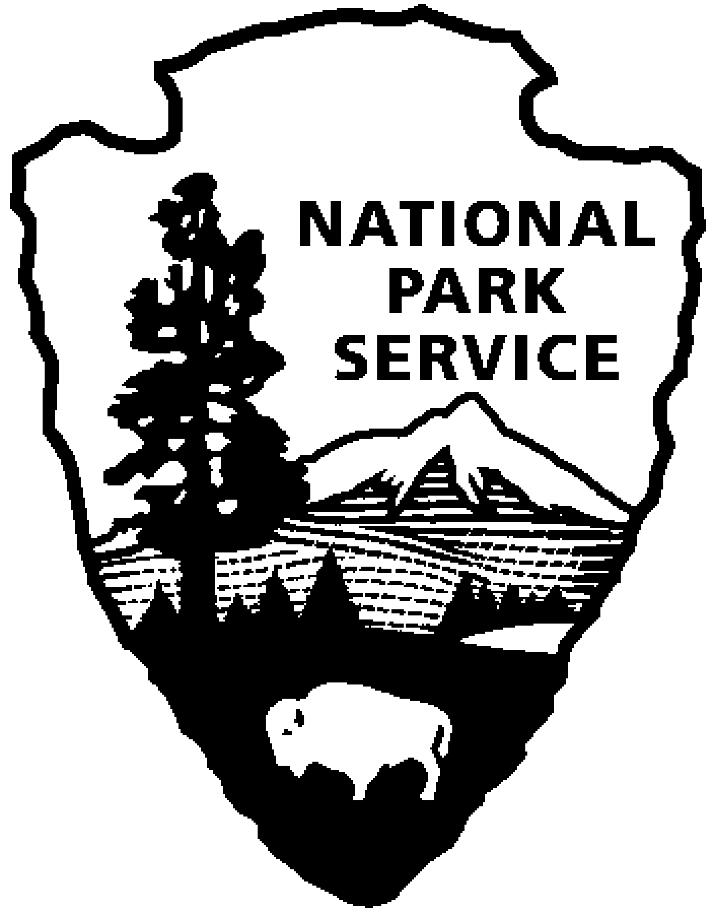
Great Sand Dunes National Park and Preserve
News Release
Use a “short-hand” version of the site name here (e.g. Palo Alto Battlefield not Palo Alto Battlefield National Historical Site).

For Immediate Release—5/29/08

Great Sand Dunes Celebrates Kids on Junior Ranger Day

“The creek is flowing and the sun is shining—we invite everyone to join park rangers, volunteers, friends, and neighbors in a parkwide celebration of kids in national parks!” announced Superintendent Art Hutchinson. On Saturday, June 14th, Great Sand Dunes National Park hosts Junior Ranger Day – a fun-filled day of exploratory activities for kids of all ages. Participants will have the opportunity to earn badges, patches, pins, buttons, and certificates as well as take home their own handcrafted souvenirs.

Ranger-guided activities begin at 10 a.m. and will include nature walks, porch talks, kids programs, and evening programs. Families can also visit the special Junior Ranger Day Nature Stations between 10 a.m. and 3 p.m. to explore tracks, primitive skills, touchable nature objects, storytelling, and craft projects. A scavenger hunt, Junior Ranger booklet, and sand sculpture contest will be available for youngsters wanting to explore the park on their own.

This event is possible only with generous volunteer help from Friends of the Dunes and local community members. If you would like to participate in Junior Ranger Day as a volunteer, please contact the Education Specialist by June 7th. Call 719-378-6344 or email Melanie_Rawlins@nps.gov. Uniform shirts and lunch will be provided.

Entrance to the park is free for kids under 16, $3 per person age 16 or over. No fee or reservations are required for ranger-guided activities or programs. However, parking is limited so carpooling is highly recommended. Consult the park website www.nps.gov/grsa or call the Visitor Center at 719-378-6399 for more detailed program schedules and information.
-NPS-

