June 2008
Federal Acquisition Institute

Program Management

Government Specific Course III

Final Participant Guide



Program Management
Government Specific Course III
Course Agenda

Day 1
Morning | Course Introduction  Professional/Leadership Skills
Afternoon | Professional/Leadership Skills (cont’d.)  Agency Policy and Practices
Day 2
Morning | Basics of Contracting
Afternoon | Pre-solicitation Phase  Perform Source Selection
Day 3
Morning | Perform Source Selection (cont’d.)  Contract Management
Afternoon | Contract Management (cont’d.)  Performance-Based Agreements
Day 4
Morning | Performance-Based Agreements (cont’d.)  LCL Management, Product Support
Afternoon | Business Financial Planning and Management  Course Review

Table of Contents

Course Introduction 1
Program/Project Management References 7
Module 1 – Leadership/Professional Skills 11
Leadership: Roger Bushell 15
10 Principles of Servant Leadership 23
Module 2 – Agency Policies and Practices 42
Program Management Skills 50
Earned Value Management 54
Module 3 – Basics of Contracting 63
Module 4 – Pre-Solicitation Phase 73
Module 5 – Perform Source Selection 81
Risk Analysis Methods 87
Module 6 – Contract Management 95
Module 7 – Performance-Based Agreements 108
Module 8 – LCL Management, Product Support 122
Risks and Mitigation Actions Involving Operational Requirements 130
Risks and Mitigation Actions Involving Technical Approach 131
Risks and Mitigation Actions Involving Business Strategy 137
Module 9 – Perform Source Selection 142
Organizational Maturity Levels 146

Course Introduction

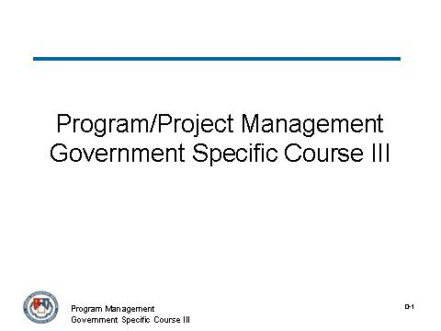
_____________________________________________________________________________
_____________________________________________________________________________
_____________________________________________________________________________
_____________________________________________________________________________
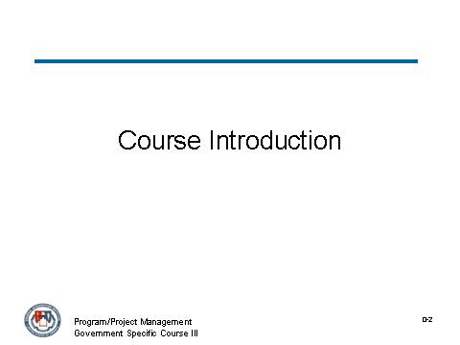
_____________________________________________________________________________
_____________________________________________________________________________
_____________________________________________________________________________
_____________________________________________________________________________

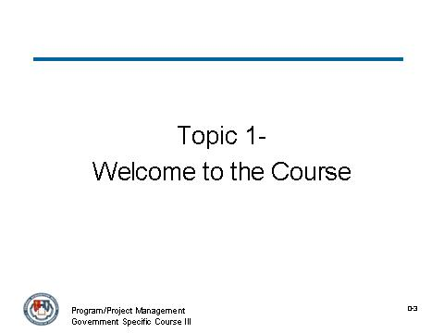
_____________________________________________________________________________
_____________________________________________________________________________
_____________________________________________________________________________
_____________________________________________________________________________
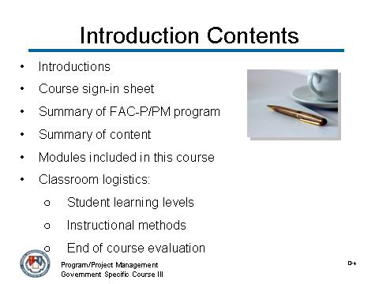
_____________________________________________________________________________
_____________________________________________________________________________
_____________________________________________________________________________
_____________________________________________________________________________

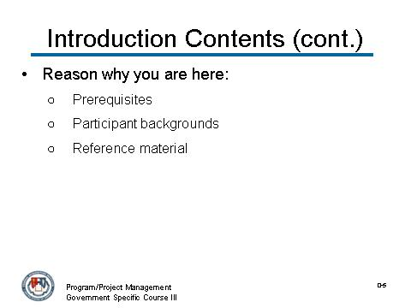
_____________________________________________________________________________
_____________________________________________________________________________
_____________________________________________________________________________
_____________________________________________________________________________
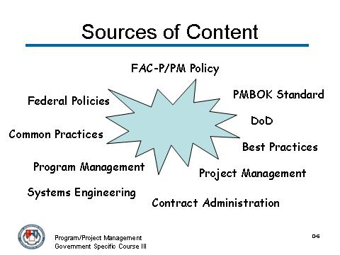
_____________________________________________________________________________
_____________________________________________________________________________
_____________________________________________________________________________
_____________________________________________________________________________

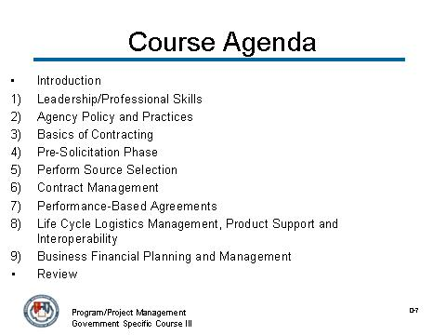
_____________________________________________________________________________
_____________________________________________________________________________
_____________________________________________________________________________
_____________________________________________________________________________
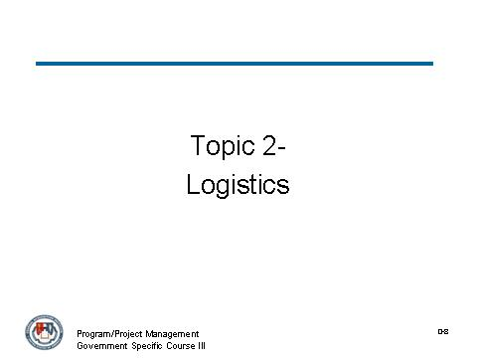
_____________________________________________________________________________
_____________________________________________________________________________
_____________________________________________________________________________
_____________________________________________________________________________

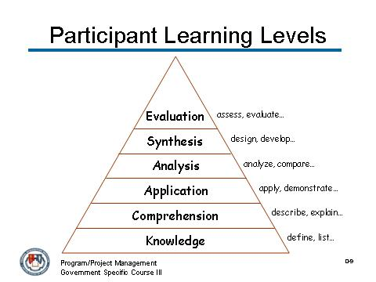
_____________________________________________________________________________
_____________________________________________________________________________
_____________________________________________________________________________
_____________________________________________________________________________
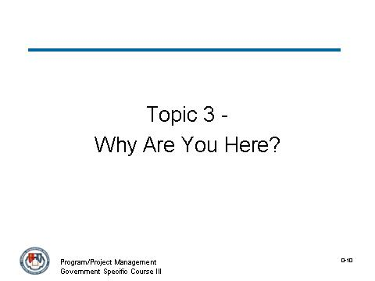
_____________________________________________________________________________
_____________________________________________________________________________
_____________________________________________________________________________
_____________________________________________________________________________

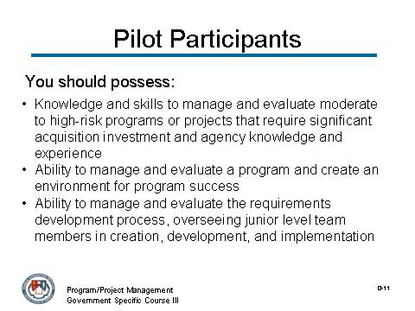
_____________________________________________________________________________
_____________________________________________________________________________
_____________________________________________________________________________
_____________________________________________________________________________
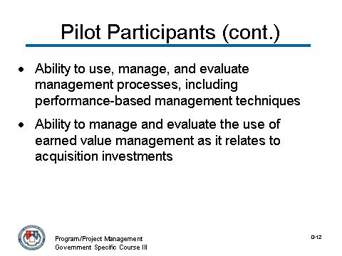
_____________________________________________________________________________
_____________________________________________________________________________
_____________________________________________________________________________
_____________________________________________________________________________

Program/Project Management References

A Leader’s Legacy: Kouzes & Posner
Advancing Organizational Project Management Maturity: Appleby…
Alpha Project Managers: Andy Crowe
Creating An Environment For Successful Projects: Graham and Englund
Death March: Edward Yourdon
Engineering Program Management: Hnas Thamhain
Introduction to IT Project Management: Snyder and Parth
Government Extension to the PMBOK: Project Management Institute
Growing Leaders: Yearout and Miles
Justifying the Value of Project Management: James Pennypacker
Leadership Skills for Project Managers: Pinto and Trailer
Managing Projects In Organizations: J. Davidson Frame
Managing Risk In Organizations: J. Davidson Frame
Middle Managers In Program & Portfolio Management: Bloomquist and Muller
My Life is Failure: Jim Johnson
Power & Politics in Project Management: Jeffrey Pinto
Project Leadership: Pinto, Thomas, Trailer, Palmer, and Govekar
Project Lessons from The Great Escape (Stalag Luft III): Mark Kozak-Holland
Project Management Maturity Model: J. Kent Crawford
Project Management Competence: J. Davidson Frame
Project Management Roles & Responsibilities: J. Kent Crawford
Quantifying the Value of Project Management: Ibbs and Reginato
Servant Leadership: Robert Greenleaf
Shackleton’s Way: Morrell and Capparell
The Advanced Project Management Office: Rad and Levin
The AMA Handbook of Project Management: Paul Dinsmore
The Endurance: Caroline Alexander
Program/Project Management References (continued)

The Project Management Body of Knowledge (PMBOK): Project Management Institute
The Standard for Portfolio Management: Project Management Institute
The Standard for Program Management: Project Management Institute
Visualizing Project Management: Forsberg, Mooz, and Cotterman
What Makes a Good Project Manager: James Pennypacker
Activity

Working in your group, develop answers for the questions below. Base your answers on experience and knowledge, as well as information from selected reference books.

What is the definition of a project?
_____________________________________________________________________________
_____________________________________________________________________________
_____________________________________________________________________________
_____________________________________________________________________________

How do projects where you work differ from the definition?
_____________________________________________________________________________
_____________________________________________________________________________
_____________________________________________________________________________
_____________________________________________________________________________

What is the definition of a program?
_____________________________________________________________________________
_____________________________________________________________________________
_____________________________________________________________________________
_____________________________________________________________________________

Activity (continued)
How do programs where you work differ from the definition?
_____________________________________________________________________________
_____________________________________________________________________________
_____________________________________________________________________________
_____________________________________________________________________________

What are some key similarities between projects and programs?
_____________________________________________________________________________
_____________________________________________________________________________
_____________________________________________________________________________
_____________________________________________________________________________

What are some key differences between projects and programs?
_____________________________________________________________________________
_____________________________________________________________________________
_____________________________________________________________________________
_____________________________________________________________________________

Module 1 – Leadership/Professional Skills

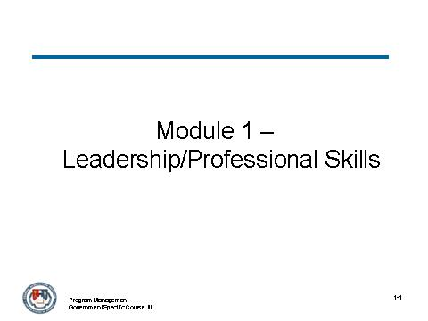
_____________________________________________________________________________
_____________________________________________________________________________
_____________________________________________________________________________
_____________________________________________________________________________
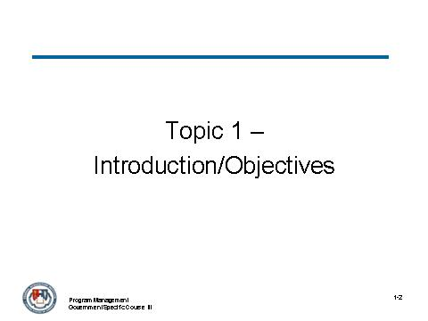
_____________________________________________________________________________
_____________________________________________________________________________
_____________________________________________________________________________
_____________________________________________________________________________

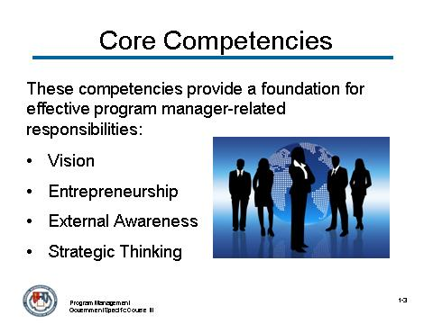
_____________________________________________________________________________
_____________________________________________________________________________
_____________________________________________________________________________
_____________________________________________________________________________
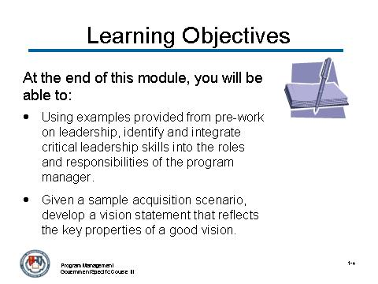
_____________________________________________________________________________
_____________________________________________________________________________
_____________________________________________________________________________
_____________________________________________________________________________

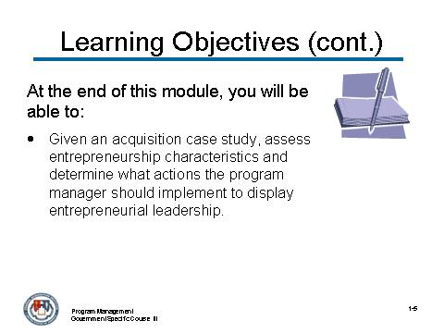
_____________________________________________________________________________
_____________________________________________________________________________
_____________________________________________________________________________
_____________________________________________________________________________
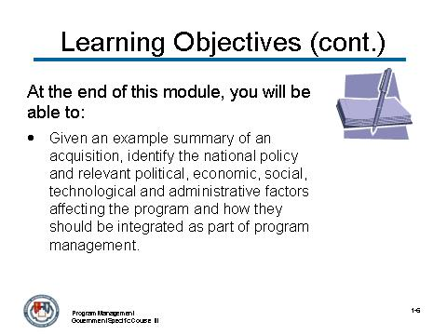
_____________________________________________________________________________
_____________________________________________________________________________
_____________________________________________________________________________
_____________________________________________________________________________

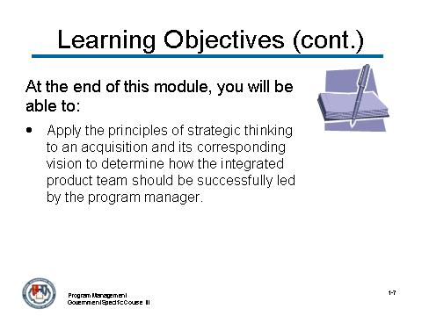
_____________________________________________________________________________
_____________________________________________________________________________
_____________________________________________________________________________
_____________________________________________________________________________

Leadership: Roger Bushell

Let’s look at an example of a modern day leader who exemplified key leadership skills in the areas of vision, entrepreneurship, external awareness and strategic thinking.

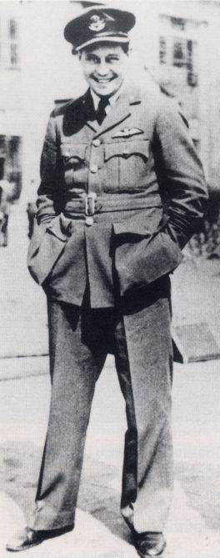  Roger Bushell in his RAF uniform shortly before his capture. | Roger Bushell  Project Leader for the “Great Escape” from Stalag Luft III in 1944 during World War II.  Lead large escape project during WWII under extremely difficult and dangerous conditions.  Plane was shot down and he became a POW who eventually ended up at Stalag Luft III in (then) Sagan, Germany.  Became known as "Big X" of the camp escape committee and was the mastermind behind the mass escape that occurred on the evening of March 24, 1944.  Roger and his partner Bernard Scheidhauer escaped through a tunnel known as “Harry” along with 74 other men.  Of the 76 men who escaped through "Harry", three men succeeded in escaping while the remaining 73 were all recaptured.  Project involved:  - Planning and building multiple tunnels  - Developing and producing hundreds of disguises and false identifications  - Evading discovery and  - Sending escapees on their way to freedom.  Prisoners were isolated deep within Germany in “escape-proof” compound under constant surveillance from highly trained guards.

Roger Bushell’s leadership efforts involved:
- Organizing and managing an escape committee
- Focusing the efforts of hundreds of prisoners
- Dealing with enormous set backs and risks and
- Motivating under deadly circumstances

Vision:
Developed the vision of a project that would provide the prisoners something meaningful to do during their long and uncertain future, something that could serve as an important element in the fight against the Germans.
His vision was bold almost beyond reason. Considering the hardships of capture and incarceration and the harsh conditions of the prison camp, it is almost unimaginable that the POWs could be organized for a project with the goal of having 200 prisoners escape at the same time.

So why would so many prisoners risk their lives attempting to escape from a prison camp built as “escape proof?” And the vision was not just for one tunnel, it was for three tunnels.

The answer is visionary leadership.

Entrepreneurship:
- Bushell’s incredible entrepreneurship was just as bold as his vision for the escape
- Actually able to have a radio receiver built (hidden below a toilet) to listen to the news from the outside world
- Found sources of large quantities of wood to support the tunnel roof and walls (slats from beds)
- Developed undetectable trap doors in the elevated buildings for tunnels access (underneath an operating stove)
- Dispersed the huge quantity of removed sand (POW “penguins” who wore long pockets with drawstrings in their pant legs that were filled with 8 pounds of sand in each leg that would be covertly dispersed while walking outside)
- Produced false documentation (passports, travel papers).
External Awareness:

Key to the success of The Great Escape was the intense effort Roger undertook to become aware of the environmental situation. Located deep within the German borders and cut off from virtually all contact with the outside world Bushell actually built an intelligence gathering organization.

Learned about:
- Sandy soil that would hamper tunneling, about the escape-proof design of the prison camp (elevated barracks, double perimeter fence, buried microphone sensors, watchtowers)
- Ferrets (German Army intelligence troops who intermingled with the prisoners), about the nearby roads and train lines
- Possibilities of exploiting the occasional Red Cross food parcels

Bushell incorporated and used all of these external elements into his escape plan.

Strategic Thinking:

Bushell built and led a well-organized Escape Committee project management team with one dozen departments. His leadership style was to meet regularly with his team to solicit their thoughts and ideas about the project as it progressed.

He was a good listener and gave everyone an opportunity to participate. From these discussions, he would form strategic goals and then challenge his team to do the planning necessary to implement them.

Throughout the project, Bushell did not usually get involved in technical arguments or the day-to-day management; he left that to his department chiefs.

Notes:
_____________________________________________________________________________
_____________________________________________________________________________
_____________________________________________________________________________
_____________________________________________________________________________

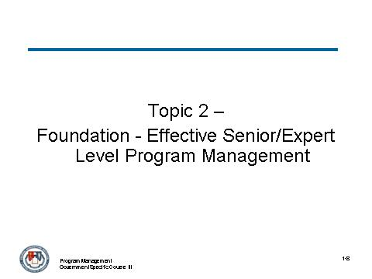
_____________________________________________________________________________
_____________________________________________________________________________
_____________________________________________________________________________
_____________________________________________________________________________
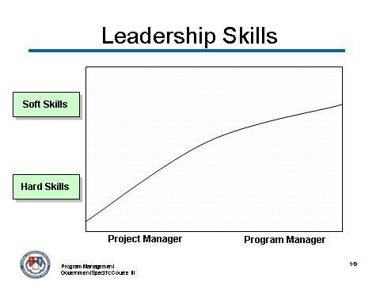
_____________________________________________________________________________
_____________________________________________________________________________
_____________________________________________________________________________
_____________________________________________________________________________

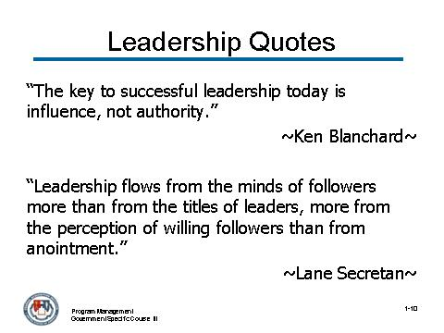
_____________________________________________________________________________
_____________________________________________________________________________
_____________________________________________________________________________
_____________________________________________________________________________
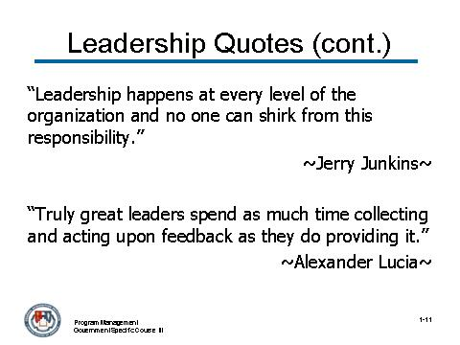
_____________________________________________________________________________
_____________________________________________________________________________
_____________________________________________________________________________
_____________________________________________________________________________

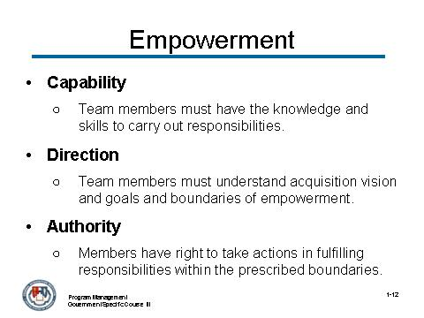
_____________________________________________________________________________
_____________________________________________________________________________
_____________________________________________________________________________
_____________________________________________________________________________
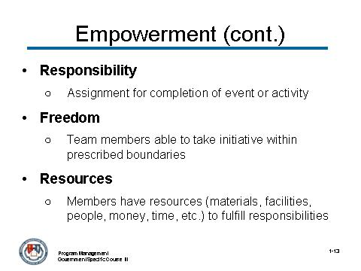
_____________________________________________________________________________
_____________________________________________________________________________
_____________________________________________________________________________
_____________________________________________________________________________

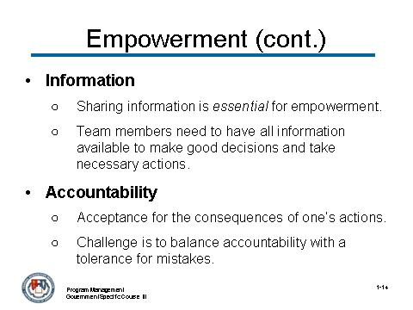
_____________________________________________________________________________
_____________________________________________________________________________
_____________________________________________________________________________
_____________________________________________________________________________
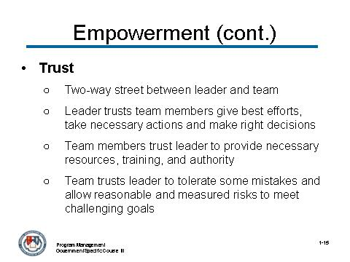
_____________________________________________________________________________
_____________________________________________________________________________
_____________________________________________________________________________
_____________________________________________________________________________

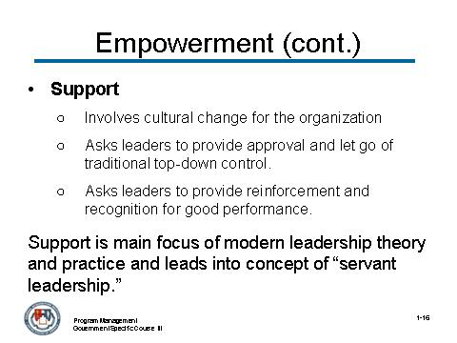
_____________________________________________________________________________
_____________________________________________________________________________
_____________________________________________________________________________
_____________________________________________________________________________
_____________________________________________________________________________
_____________________________________________________________________________
_____________________________________________________________________________
_____________________________________________________________________________
_____________________________________________________________________________
_____________________________________________________________________________
_____________________________________________________________________________
_____________________________________________________________________________
_____________________________________________________________________________
_____________________________________________________________________________
_____________________________________________________________________________
_____________________________________________________________________________

10 Principles of Servant Leadership
(as defined by Larry Spears, CEO of the Greenleaf Center)

1. Listening
Traditionally, leaders have been valued for their communication and decision making skills. Servant-leaders must reinforce these important skills by making a deep commitment to listening intently to others. Servant-leaders seek to identify and clarify the will of a group. They seek to listen receptively to what is being and said (and not said). Listening also encompasses getting in touch with one's inner voice, and seeking to understand what one's body, spirit, and mind are communicating.
2. Empathy
Servant-leaders strive to understand and empathize with others. People need to be accepted and recognized for their special and unique spirit. One must assume the good intentions of coworkers and not reject them as people, even when forced to reject their behavior or performance.
3. Healing
Learning to heal is a powerful force for transformation and integration. One of the great strengths of servant-leadership is the potential for healing one's self and others. In "The Servant as Leader", Greenleaf writes, "There is something subtle communicated to one who is being served and led if, implicit in the compact between the servant-leader and led is the understanding that the search for wholeness is something that they have."
4. Awareness
General awareness, and especially self-awareness, strengthens the servant-leader. Making a commitment to foster awareness can be scary--one never knows that one may discover! As Greenleaf observed, "Awareness is not a giver of solace - it's just the opposite. It disturbed. They are not seekers of solace. They have their own inner security."
5. Persuasion
Servant-leaders seek to convince others, rather than coerce compliance. This particular element offers one of the clearest distinctions between the traditional authoritarian model and that of servant-leadership. The servant-leader is effective at building consensus within groups.
6. Conceptualization
Servant-leaders seek to nurture their abilities to "dream great dreams." The ability to look at a problem (or an organization) from a conceptualizing perspective means that one must think beyond day-to-day realities. Servant-leaders must seek a delicate balance between conceptualization and day-to-day focus.
10 Principles of Servant Leadership (continued)

7. Foresight
Foresight is a characteristic that enables servant-leaders to understand lessons from the past, the realities of the present, and the likely consequence of a decision in the future. It is deeply rooted in the intuitive mind.
8. Stewardship
Robert Greenleaf's view of all institutions was one in which CEO's, staff, directors, and trustees all play significance roles in holding their institutions in trust for the great good of society.
9. Commitment to the Growth of People
Servant-leaders believe that people have an intrinsic value beyond their tangible contributions as workers. As such, Servant-leaders are deeply committed to a personal, professional, and spiritual growth of each and every individual within the organization.
10. Building Community
Servant-leaders are aware that the shift from local communities to large institutions as the primary shaper of human lives has changed our perceptions and caused a send of loss. Servant-leaders seek to identify a means for building community among those who work within a given institution.

Notes:
______________________________________________________________________
______________________________________________________________________
______________________________________________________________________
______________________________________________________________________

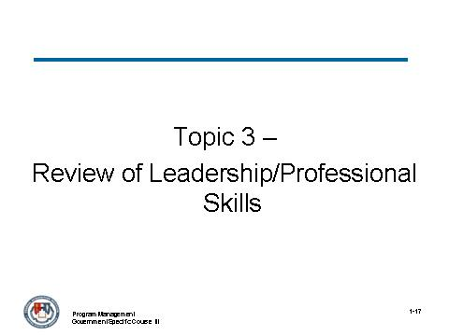
_____________________________________________________________________________
_____________________________________________________________________________
_____________________________________________________________________________
_____________________________________________________________________________
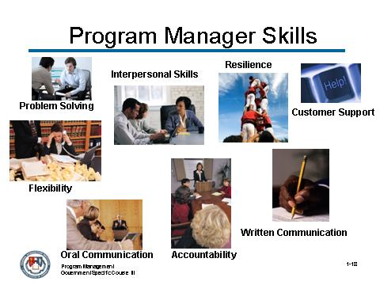
_____________________________________________________________________________
_____________________________________________________________________________
_____________________________________________________________________________
_____________________________________________________________________________

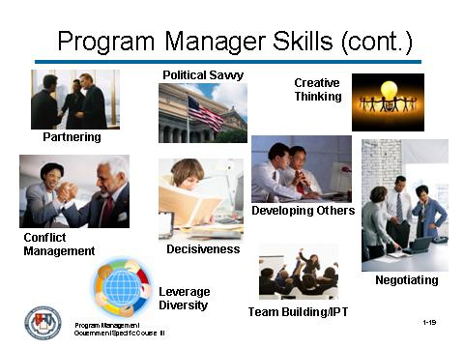
_____________________________________________________________________________
_____________________________________________________________________________
_____________________________________________________________________________
_____________________________________________________________________________
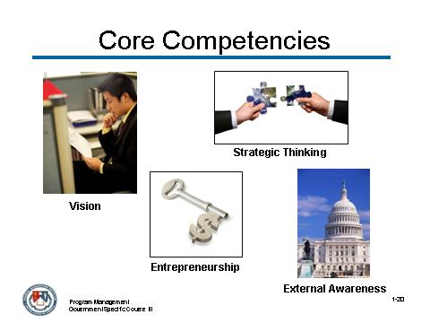
_____________________________________________________________________________
_____________________________________________________________________________
_____________________________________________________________________________
_____________________________________________________________________________

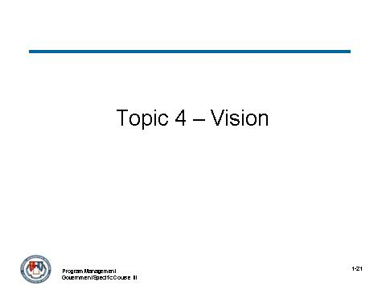
_____________________________________________________________________________
_____________________________________________________________________________
_____________________________________________________________________________
_____________________________________________________________________________
_____________________________________________________________________________
_____________________________________________________________________________
_____________________________________________________________________________
_____________________________________________________________________________
_____________________________________________________________________________
_____________________________________________________________________________
_____________________________________________________________________________
_____________________________________________________________________________
_____________________________________________________________________________
_____________________________________________________________________________
_____________________________________________________________________________
_____________________________________________________________________________

Activity

As part of the pre-work for this class, you were requested to bring the name of a leader that you feel exemplifies valuable leadership skills.

Answer the question below.

How would you describe your leader’s vision?

_____________________________________________________________________________
_____________________________________________________________________________
_____________________________________________________________________________
_____________________________________________________________________________
_____________________________________________________________________________


John F. Kennedy did not live to see the achievement of his vision for National Air and Space Administration (NASA), but he set it in motion when he said, "By the end of the decade, we will put a man on the moon." That night, when the moon came out, Americans could all look out the window and imagine.

When it came time to appropriate the enormous funds necessary to accomplish this vision, Congress did not hesitate. Why? Because this vision spoke powerfully to values Americans held dear: America as a pioneer and America as world leader.

Discussion Notes:
_____________________________________________________________________________
_____________________________________________________________________________
_____________________________________________________________________________
_____________________________________________________________________________
_____________________________________________________________________________
Activity
Read the US West Acquisition Vision Case Study below and create a written vision statement for the IPT they are leading for this program.

US West Acquisition Strategic Thinking Case Study
You are the program manager for the following acquisition of services contract. What would you imagine as the vision for this program, and how would you communicate that vision to your team?
US WEST announced it has been awarded a Metropolitan Area Acquisition (MAA) award from the U.S. General Services Administration's (GSA) Federal Technology Service (FTS) for the cities and surrounding metropolitan area of Minneapolis and St. Paul, Minn. The contract, awarded to US WEST and Winstar Communications, has an estimated value of $160 million.

Under the multi-year contract, US WEST will provide government agencies with standard voice services, including Centrex, Business Line, PBX Access Trunks, Key System Access, Private Line and ISDN services, as well as switched data service and dedicated transmission service offerings at competitive rates to government agencies in Minneapolis and St. Paul. The MAA program is envisioned to be the government's tool for achieving the immediate benefits, such as price reduction and better services, from the emerging competitive local telecommunications market.

US WEST was awarded the contract after a competitive bid based on several criteria of the MAA Program, including its ability to provide the services and its past history of successful deployments. Winning the MAA contract affords US WEST the opportunity to expand its services for GSA to include new, high-speed services as they become available, bid for other GSA contracts and to potentially offer FTS2001 long distance services nationally.

Through the contract, US WEST will offer new local service prices that will result in substantial cost savings for the government, when compared with standard business rates.
Activity (continued)

Vision:
_____________________________________________________________________________
_____________________________________________________________________________
_____________________________________________________________________________
_____________________________________________________________________________
_____________________________________________________________________________
_____________________________________________________________________________
_____________________________________________________________________________
_____________________________________________________________________________
_____________________________________________________________________________
_____________________________________________________________________________
_____________________________________________________________________________
_____________________________________________________________________________
_____________________________________________________________________________
_____________________________________________________________________________
_____________________________________________________________________________
_____________________________________________________________________________
_____________________________________________________________________________
_____________________________________________________________________________
_____________________________________________________________________________
_____________________________________________________________________________

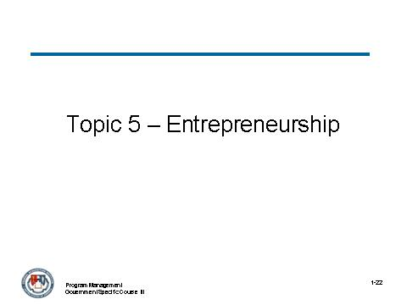
_____________________________________________________________________________
_____________________________________________________________________________
_____________________________________________________________________________
_____________________________________________________________________________

_____________________________________________________________________________
_____________________________________________________________________________
_____________________________________________________________________________
_____________________________________________________________________________
_____________________________________________________________________________
_____________________________________________________________________________
_____________________________________________________________________________
_____________________________________________________________________________
_____________________________________________________________________________
_____________________________________________________________________________
_____________________________________________________________________________
_____________________________________________________________________________
_____________________________________________________________________________
_____________________________________________________________________________
_____________________________________________________________________________

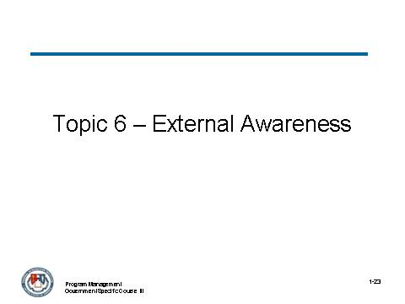
_____________________________________________________________________________
_____________________________________________________________________________
_____________________________________________________________________________
_____________________________________________________________________________
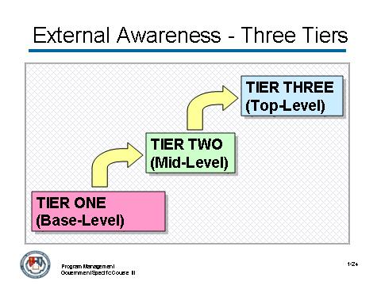
_____________________________________________________________________________
_____________________________________________________________________________
_____________________________________________________________________________
_____________________________________________________________________________

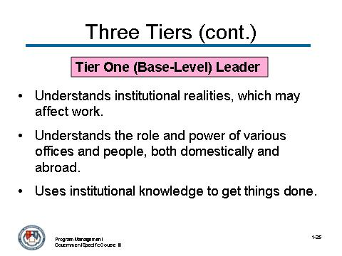
_____________________________________________________________________________
_____________________________________________________________________________
_____________________________________________________________________________
_____________________________________________________________________________
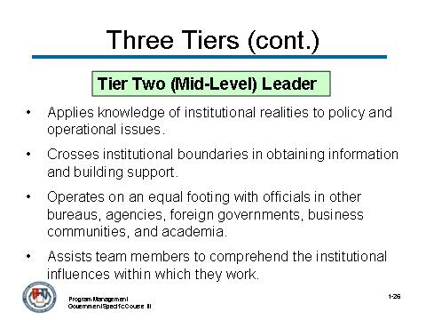
_____________________________________________________________________________
_____________________________________________________________________________
_____________________________________________________________________________
_____________________________________________________________________________

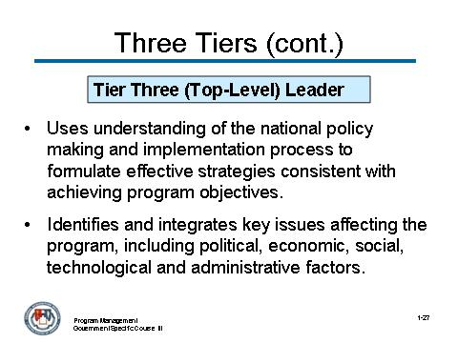
_____________________________________________________________________________
_____________________________________________________________________________
_____________________________________________________________________________
_____________________________________________________________________________
_____________________________________________________________________________
_____________________________________________________________________________
_____________________________________________________________________________
_____________________________________________________________________________
_____________________________________________________________________________
_____________________________________________________________________________
_____________________________________________________________________________
_____________________________________________________________________________
_____________________________________________________________________________
_____________________________________________________________________________
_____________________________________________________________________________
_____________________________________________________________________________
_____________________________________________________________________________
_____________________________________________________________________________
_____________________________________________________________________________

Activity

As part of the pre-work for this class, you were requested to bring to class the name of a leader that you feel exemplifies valuable leadership skills.

How is your leader a good example of someone practicing external awareness?

_____________________________________________________________________________
_____________________________________________________________________________
_____________________________________________________________________________
_____________________________________________________________________________
_____________________________________________________________________________
_____________________________________________________________________________
_____________________________________________________________________________
_____________________________________________________________________________
_____________________________________________________________________________
_____________________________________________________________________________
_____________________________________________________________________________
_____________________________________________________________________________
_____________________________________________________________________________
_____________________________________________________________________________
_____________________________________________________________________________
_____________________________________________________________________________
_____________________________________________________________________________
_____________________________________________________________________________
_____________________________________________________________________________
_____________________________________________________________________________

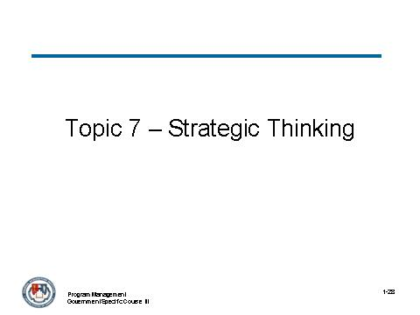
_____________________________________________________________________________
_____________________________________________________________________________
_____________________________________________________________________________
_____________________________________________________________________________
_____________________________________________________________________________
_____________________________________________________________________________
_____________________________________________________________________________
_____________________________________________________________________________
_____________________________________________________________________________
_____________________________________________________________________________
_____________________________________________________________________________
_____________________________________________________________________________
_____________________________________________________________________________
_____________________________________________________________________________
_____________________________________________________________________________
_____________________________________________________________________________
_____________________________________________________________________________
_____________________________________________________________________________
_____________________________________________________________________________

What is the difference between a program manager who uses strategic thinking and a program manager who uses strategic planning? Or is there a difference?

Concept | Strategic Thinking | Strategic Planning
Vision of the Future | Only shape of the future can be predicted. | A future that is predictable and specifiable in detail.
Strategic Formulating and Implementing | These concepts are interactive rather than sequential and discrete. | The roles of these concepts can be neatly divided.
Program Manager Role in Strategy Making | Involves more project managers who have a voice in strategy-making. | Obtain the needed information from project managers, and then use it to create a plan and, disseminate it to project managers for implementation.
Control | Relies on self-reference –that guides choices on a daily basis in a process that is often difficult to measure and monitor. | Asserts control and hopes agency can measure and monitor important variables both accurately and quickly.
Program Manager Role in Implementation | All managers understand the larger system, the connection between their roles and the functioning of that system, and the interdependence between the various roles that comprise the system. | Project managers need to know their role well but usually only defend his or her own turf.

(continued)

Concept | Strategic Thinking | Strategic Planning
Strategy Making | Sees strategy and change as inescapably linked and assumes that finding new strategic options and implementing them successfully is harder and more important than evaluating them. | Challenge of setting strategic direction is primarily analytic.
Process and Outcome | Sees the planning process itself as a critical value-adding element. | Focus is on the creation of the plan as the ultimate objective

Notes:
_____________________________________________________________________________
_____________________________________________________________________________
_____________________________________________________________________________
_____________________________________________________________________________
_____________________________________________________________________________
_____________________________________________________________________________
_____________________________________________________________________________
_____________________________________________________________________________
_____________________________________________________________________________
_____________________________________________________________________________
_____________________________________________________________________________
_____________________________________________________________________________
_____________________________________________________________________________
_____________________________________________________________________________
_____________________________________________________________________________

Activity

Refer to the vision you created as part of Topic 4: Vision during this module.

Read the US West Acquisition Strategic Thinking Case Study below and identify how strategic thinking affects the information contained in the case study. List the impacts on the following page. Identify a solution or action that would likely be taken to mitigate the impact identified.

Imagine you are the program manager for the following acquisition of services contract. How would you envision excellence in this program, and how would you communicate it to your team?

US WEST announced it has been awarded a Metropolitan Area Acquisition (MAA) award from the U.S. General Services Administration's (GSA) Federal Technology Service (FTS) for the cities and surrounding metropolitan area of Minneapolis and St. Paul, Minn. The contract, awarded to US WEST and Winstar Communications, has an estimated value of $160 million.

Under the multi-year contract, US WEST will provide government agencies with standard voice services, including Centrex, Business Line, PBX Access Trunks, Key System Access, Private Line and ISDN services, as well as switched data service and dedicated transmission service offerings at competitive rates to government agencies in Minneapolis and St. Paul.

The MAA program is envisioned to be the government's tool for achieving the immediate benefits, such as price reduction and better services, from the emerging competitive local telecommunications market.
US WEST was awarded the contract after a competitive bid based on several criteria of the MAA Program, including its ability to provide the services and its past history of successful deployments. Winning the MAA contract affords US WEST the opportunity to expand its services for GSA to include new, high-speed services as they become available, bid for other GSA contracts and to potentially offer FTS2001 long distance services nationally.

Through the contract, US WEST will offer new local service prices that will result in substantial cost savings for the government, when compared with standard business rates.
Activity (continued)

List the impacts of strategic thinking on the cast study provided. For each impact, identify a solution or action that would likely be taken.

_____________________________________________________________________________
_____________________________________________________________________________
_____________________________________________________________________________
_____________________________________________________________________________
_____________________________________________________________________________
_____________________________________________________________________________
_____________________________________________________________________________
_____________________________________________________________________________
_____________________________________________________________________________
_____________________________________________________________________________
_____________________________________________________________________________
_____________________________________________________________________________
_____________________________________________________________________________
_____________________________________________________________________________
_____________________________________________________________________________
_____________________________________________________________________________
_____________________________________________________________________________
_____________________________________________________________________________
_____________________________________________________________________________
_____________________________________________________________________________
_____________________________________________________________________________
_____________________________________________________________________________
_____________________________________________________________________________
_____________________________________________________________________________

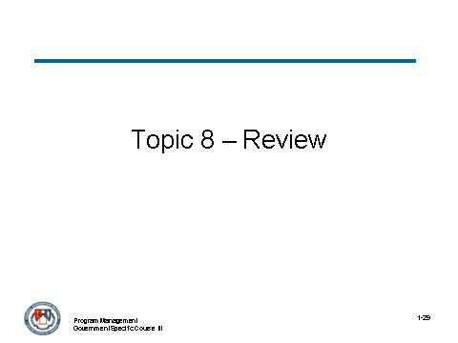
_____________________________________________________________________________
_____________________________________________________________________________
_____________________________________________________________________________
_____________________________________________________________________________
_____________________________________________________________________________
_____________________________________________________________________________
_____________________________________________________________________________
_____________________________________________________________________________
_____________________________________________________________________________
_____________________________________________________________________________
_____________________________________________________________________________
_____________________________________________________________________________
_____________________________________________________________________________
_____________________________________________________________________________
_____________________________________________________________________________
_____________________________________________________________________________
_____________________________________________________________________________
_____________________________________________________________________________
_____________________________________________________________________________

Module 2 – Agency Policies and Practices

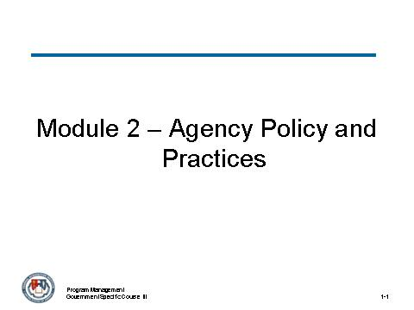
_____________________________________________________________________________
_____________________________________________________________________________
_____________________________________________________________________________
_____________________________________________________________________________
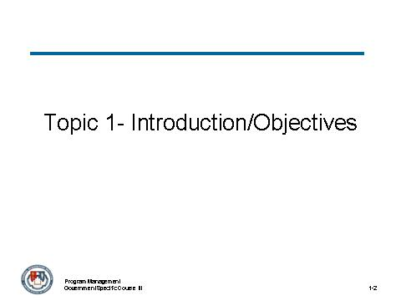
_____________________________________________________________________________
_____________________________________________________________________________
_____________________________________________________________________________
_____________________________________________________________________________

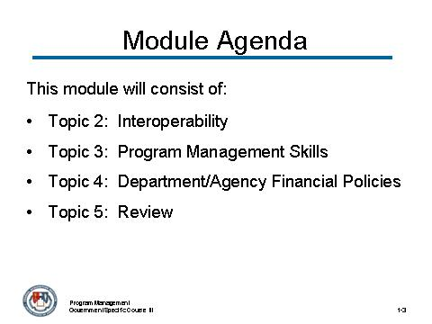
_____________________________________________________________________________
_____________________________________________________________________________
_____________________________________________________________________________
_____________________________________________________________________________
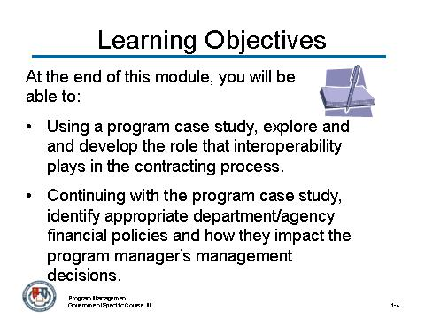
_____________________________________________________________________________
_____________________________________________________________________________
_____________________________________________________________________________
_____________________________________________________________________________

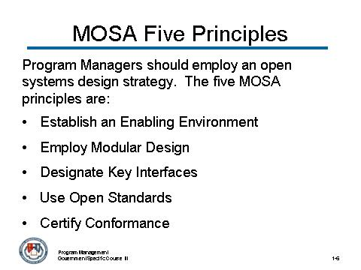
_____________________________________________________________________________
_____________________________________________________________________________
_____________________________________________________________________________
_____________________________________________________________________________
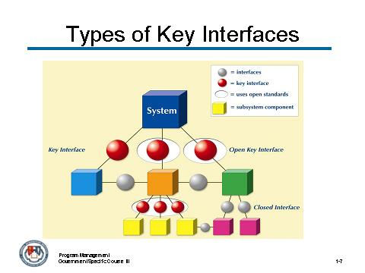
Note: Refer to the larger Types of Key Interfaces diagram on the following page.
_____________________________________________________________________________
_____________________________________________________________________________
_____________________________________________________________________________
_____________________________________________________________________________
Types of Key Interfaces

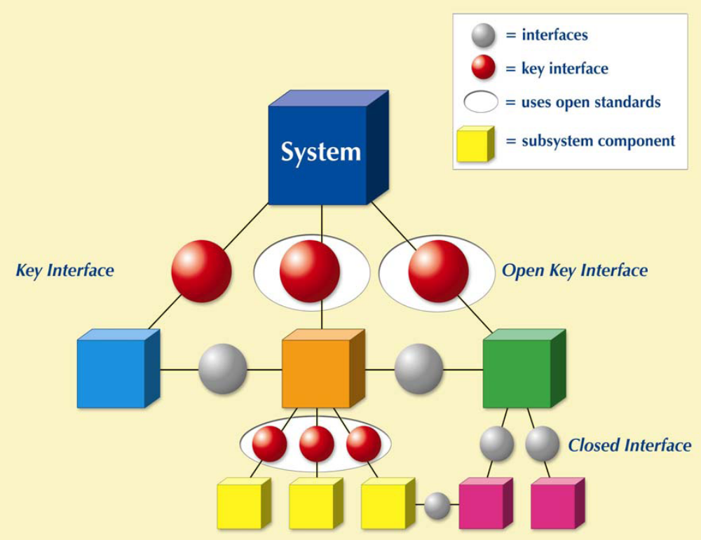
Activity:

Review the following summary of the acquisition strategy for the Virtual Case File (VCF) Acquisition Program Management Business Case Study that will be used throughout this course. Use this summary to determine whether or not the five principles of MOSA have been adhered to as part of the strategy’s development.

As you consider whether or not the principle was applied, highlight the reason(s) for your finding.

MOSA Principles Acquisition Strategy Summary
The Virtual Case File (VCF)
Introduction: FBI Shares the Blame
The VCF was supposed to automate the FBI's paper-based work environment, allow agents and intelligence analysts to share vital investigative information, and replace the obsolete Automated Case Support (ACS) system. Instead, the FBI claims, the VCF's contractor, Science Applications International Corp. (SAIC), delivered 700 000 lines of code so bug-ridden and functionally off target that the bureau had to scrap the $170 million project, including $105 million worth of unusable code. However, various government and independent reports show that the FBI shares the blame for the project's failure.
The Bureau Environment: Lots of Paper
The bureau's 12,400 agents work out of 56 field offices and 400 satellite - or resident agency - offices, as well as 51 Legal Attaché offices scattered across the globe in U.S. embassies and consulates. Field agents interview witnesses, develop informants, conduct surveillance, hunt for clues, and collaborate with local law enforcement to find and arrest criminals. Agents document every step and methodically build case files. They spend a tremendous amount of time processing paperwork, faxing and FedEx-ing standardized memo and requisition forms through the approval chain. Once the appropriate supervisors sign off on the form, it goes back to the agent, who gives it to a clerk to enter into the ACS system. From there, the paper form is filed as part of the official record of the case. This system of forms and approvals stretches back to the 1920s.
MOSA Principles Acquisition Strategy Summary (continued)

July 2000: Trying to Bring Order to Chaos
According to the DOJ's Office of the Inspector General, the FBI had 13,000 computers that could not run modern software. Most of the 400 resident agency offices were connected to the FBI intranet with links about the speed of a 56-kilobit-per-second modem. Many of the bureau's network components were no longer manufactured or supported. And agents could not e-mail U.S. Attorney offices, federal agencies, local law enforcement, or each other; instead, they typically faxed case-related information.
In 2000 the bureau finally began to deal with its outdated IT systems. At the time, under the direction of Louis J. Freeh, the bureau had neither a CIO nor documentation detailing its IT systems, much less a plan for revamping them. The task of creating such a plan fell to former IBM executive Bob E. Dies, who became assistant director in charge of the FBI Information Resources Division on 17 July 2000. He was the first of five officials who, over the next four years, would struggle to lead the FBI's sprawling and antiquated information systems and get the VCF project under way.
In September 2000, Congress approved $379.8 million over three years for what was then called the FBI Information Technology Upgrade Project. Eventually divided into three parts, the program became known as Trilogy. The Information Presentation Component would provide all 56 FBI field offices, some 22,000 agents and support staff, with new Dell Pentium PCs running Microsoft Office, as well as new scanners, printers, and servers. The Transportation Network Component would provide secure local area and wide area networks, allowing agents to share information with their supervisors and each other.
But the User Applications Component, which would ultimately become the VCF, staked out the most ambitious goals. First, it was to make the five most heavily used investigative applications—the Automated Case Support system, IntelPlus, the Criminal Law Enforcement Application, the Integrated Intelligence Information Application, and the Telephone Application—accessible via a point-and-click Web interface. Next, it would rebuild the FBI's intranet. Finally, it was supposed to identify a way to replace the FBI's 40-odd investigative software applications, including ACS.
Spring 2001: Trilogy Contracts Awarded
In May and June 2001, the bureau awarded Trilogy contracts to two major U.S. government contractors: DynCorp, of Reston, Va., for the hardware and network projects, and to SAIC for software. All three Trilogy components were to be delivered by the middle of 2004. The FBI used cost-plus-award fee contracts for the hardware, networks, and software.

Key Findings:
_____________________________________________________________________________
_____________________________________________________________________________
_____________________________________________________________________________
_____________________________________________________________________________
_____________________________________________________________________________
_____________________________________________________________________________
_____________________________________________________________________________
_____________________________________________________________________________
_____________________________________________________________________________
_____________________________________________________________________________
_____________________________________________________________________________
_____________________________________________________________________________
_____________________________________________________________________________
_____________________________________________________________________________
_____________________________________________________________________________
_____________________________________________________________________________
_____________________________________________________________________________
_____________________________________________________________________________
_____________________________________________________________________________
_____________________________________________________________________________
_____________________________________________________________________________
_____________________________________________________________________________
_____________________________________________________________________________
_____________________________________________________________________________

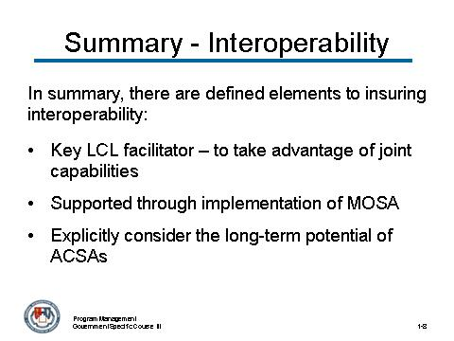
_____________________________________________________________________________
_____________________________________________________________________________
_____________________________________________________________________________
_____________________________________________________________________________
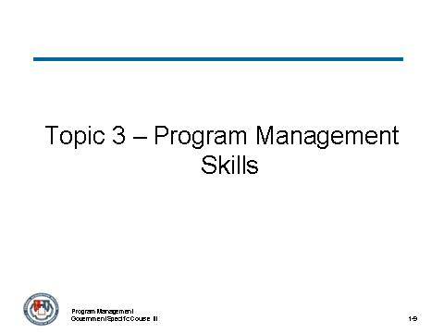
_____________________________________________________________________________
_____________________________________________________________________________
_____________________________________________________________________________
_____________________________________________________________________________

Program Management Skills
Senior program managers possess the skills, knowledge and experience necessary to manage moderate to high-risk programs or projects that require significant acquisition investment and agency knowledge and experience. This includes:
- Ability to run a program and create an environment for program success
- Ability to manage the requirements process, overseeing junior level team members in creation, development, and implementation
- Expert ability to use, manage, and evaluate management processes
- Expert ability to manage and evaluate the use of earned value management (EVM) as it relates to acquisition investments
Accordingly, there are key program management skills that lend themselves to the effective management of an acquisition that is developed using an open strategy.

Program management skills include many elements that are defined by the program being managed and the role and responsibilities the program manager may have for the acquisition. Some key skills (as defined by various agencies) include (but are not limited to):

- Organizing/staffing a team

- Assuring and Sustaining Benefits

- Training

- Planning for an EVM program linked to risk

- Other basic program management practices included as part of each activity

These key skills are essential to a program manager’s ability to succeed at the complex tasks and elements required as part of an agency’s practices relative to a defined acquisition strategy.
Program Management Skills (continued)
Of these skills, one that is common to misunderstanding is Assuring and Sustaining Benefits.

The responsibility for benefits sustainment (product support) to ensure that the customer remains able to use and maintain and that the product continues to deliver the benefits expected by the customer falls outside the traditional project life cycle, but very often within the program life cycle.

While it may follow a structured approach, ongoing product support does not usually define its work with a WBS and control activities such as earned value management are generally not applicable. Program Management of ongoing product support can entail the following activities:

- Monitoring the performance of the product from a reliability and availability-for-use perspective and comparing that performance to that predicted during the development of the product.

- Monitoring the continued suitability of the deployed product to provide the benefits expected by the customers owning and operating it. This can include the continued viability of interface with other products and the continued completeness of the product functionality.

- Monitoring the continued availability of logistics support for the product in light of technology advancements and the willingness of vendors to continue to support older configurations.

- Directly responding to customer inputs on their needs for product support assistance or for improvements in performance or functionality.

- Providing on-demand support for the product either in parts, improved technical information or real-time help desk support.

- Planning for and establishing operational support of the product separate from the program management function without relinquishing the other product support functions.
(continued)
Program Management Skills (continued)
- Initiating new projects to respond to operational issues with the deployed product being supported. Such issues can include the need to improve reliability problems, address software anomalies, update configurations to ensure continued effective interface with other products or to provide additional functionality to meet evolving requirements.

- Initiating new projects to respond to logistics issues with the deployed product being supported. Such issues can include the continued ability to support a physical product or associated support equipment with spare parts that may require engineering retrofit changes to ensure continued supportability.

- Updating technical information concerning the product in response to frequent product support queries.

- Planning the transition of product support from program management to an operations function within the organization.

- Planning the retirement and disposition of the product or the cessation of product support with appropriate guidance to the current customers.

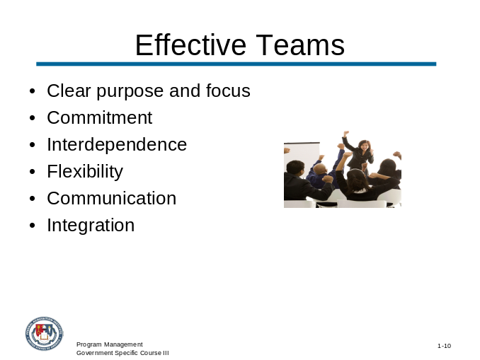
_____________________________________________________________________________
_____________________________________________________________________________
_____________________________________________________________________________
_____________________________________________________________________________
Activity:

Refer to the VCF case study presented and determine when and how teams were used. Consider and identify instances during the acquisition process where the use of a team was or would have been appropriate. Record your findings below.
_____________________________________________________________________________
_____________________________________________________________________________
_____________________________________________________________________________
_____________________________________________________________________________
_____________________________________________________________________________
_____________________________________________________________________________
_____________________________________________________________________________
_____________________________________________________________________________
_____________________________________________________________________________
_____________________________________________________________________________
_____________________________________________________________________________
_____________________________________________________________________________
_____________________________________________________________________________
_____________________________________________________________________________
_____________________________________________________________________________
_____________________________________________________________________________
_____________________________________________________________________________
_____________________________________________________________________________
____________________________________________________________________________
_____________________________________________________________________________
_____________________________________________________________________________
_____________________________________________________________________________
_____________________________________________________________________________
_____________________________________________________________________________

Earned Value Management

Another key program management skill, Earned Value Management (EVM), is a systematic approach to the integration and measurement of cost, schedule, and technical (scope) accomplishments on a project or task.

It provides both the government and contractors the ability to examine detailed schedule information, critical program and technical milestones, and cost data.

EVM is intended to provide data from a contractor’s management system to the government in standard data elements that:

- Relate time-phased budgets to contract tasks

- Integrate cost, schedule, and technical performance

- Indicate work progress objectively

- Are valid, timely and auditable

- Are from the internal system the contractor uses to manage

- Are at a practical level of summarization

By using EVM and implementing an Earned Value Management System (EVMS), the program manager can answer the following questions objectively:

- Where have we been?

- Where are we now?

- Where are we going?

The ability to answer these three basic questions specifically and objectively directly translates into the program manager’s ability to successfully manage an acquisition.

To better understand EVM, let us first take a look at how it compares with traditional management. There is an important and fundamental difference between the data available for analysis in a traditional management environment as compared to an environment using earned value.

In traditional management, there are two data sources, the budget (or planned) expenditures and the actual expenditures. The comparison of budget versus actual expenditures merely indicates what was planned to be spent versus what was actually spent at any given time. But how much has been produced?
With this approach, there is no way to determine the physical amount of work performed. It does not indicate anything about what has actually been produced for the amount of money spent nor whether it is being produced at the rate, or according to the schedule, originally planned. In other words, it does not relate the true cost performance of the project.

In EVM, unlike in traditional management, there are three data sources:

- Budget (or planned) value of work scheduled

- Actual value of work completed

- “Earned Value” of the physical work completed

EVM takes these three data sources and is able to compare the budgeted value of work scheduled and compare it to the “earned value of physical work completed” and the actual value of work completed.

The implication of EVM for the program manager is to understand how earned value fits into the program and project management environment. These implications relate directly to:

- Project management

- Program management

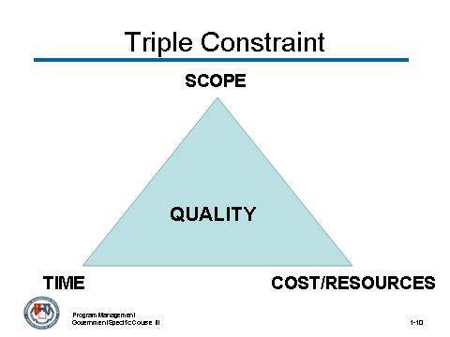
_____________________________________________________________________________
_____________________________________________________________________________
_____________________________________________________________________________
_____________________________________________________________________________
EVM is a technique used to objectively evaluate cost and schedule efficiency, thereby facilitating better management of customer needs and expectations.

It is a subset of program/project management when you consider its implication in the following statements:

- EVM is a component of project management.

- Project management is in turn, a component of program management.

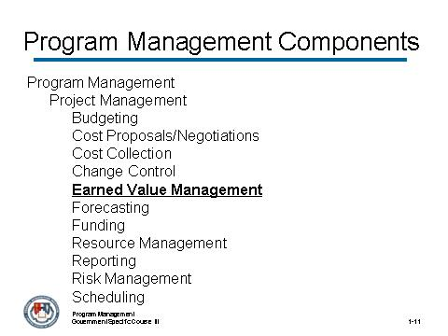
_____________________________________________________________________________
_____________________________________________________________________________
_____________________________________________________________________________
_____________________________________________________________________________

Activity:

Refer to the the Virtual Case File (VCF) acquisition business case and answer the questions below.

During which parts of the business case would you implement teams? What are some of the decisions you might make to organize and staff the teams?
_____________________________________________________________________________
_____________________________________________________________________________
_____________________________________________________________________________
_____________________________________________________________________________

What are some of the team development activities that you would implement for these teams? What would your criteria be for identifying these activities?
_____________________________________________________________________________
_____________________________________________________________________________
_____________________________________________________________________________
_____________________________________________________________________________

What are some of the risk considerations that would affect the EVM program for this acquisition?
_____________________________________________________________________________
_____________________________________________________________________________
_____________________________________________________________________________
_____________________________________________________________________________

Activity (continued):
What are some program management skills that you would consider to be important and relevant for this business case? Why?
_____________________________________________________________________________
_____________________________________________________________________________
_____________________________________________________________________________
_____________________________________________________________________________

Notes:
_____________________________________________________________________________
_____________________________________________________________________________
_____________________________________________________________________________
_____________________________________________________________________________
_____________________________________________________________________________
_____________________________________________________________________________
_____________________________________________________________________________
_____________________________________________________________________________
_____________________________________________________________________________
_____________________________________________________________________________
_____________________________________________________________________________
_____________________________________________________________________________
_____________________________________________________________________________
_____________________________________________________________________________
_____________________________________________________________________________
_____________________________________________________________________________

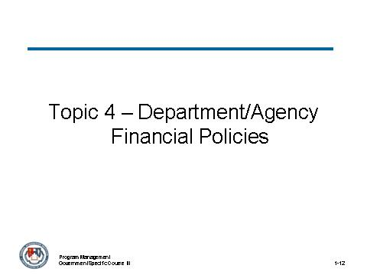
_____________________________________________________________________________
_____________________________________________________________________________
_____________________________________________________________________________
_____________________________________________________________________________
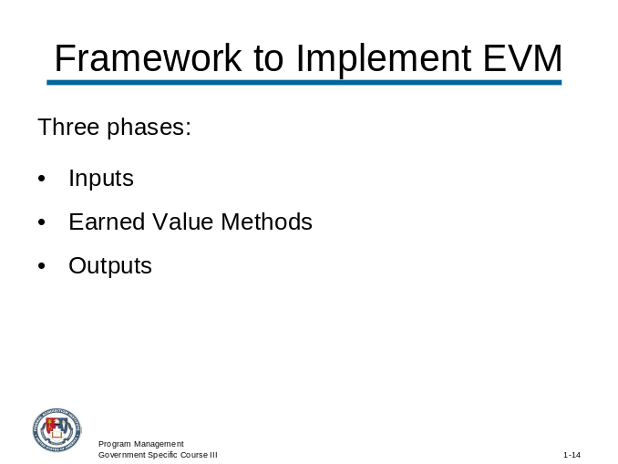
_____________________________________________________________________________
_____________________________________________________________________________
_____________________________________________________________________________
_____________________________________________________________________________

Activity:

Refer to the VCF Acquisition Program Management Business Case and answer the questions below.

What are the financial policies the program manager must consider relative to this acquisition?
_____________________________________________________________________________
_____________________________________________________________________________
_____________________________________________________________________________
_____________________________________________________________________________

How might these financial policies affect the decisions the program manager makes?
_____________________________________________________________________________
_____________________________________________________________________________
_____________________________________________________________________________
_____________________________________________________________________________

What are the challenges these financial policies present relative to the acquisition?
_____________________________________________________________________________
_____________________________________________________________________________
_____________________________________________________________________________
_____________________________________________________________________________

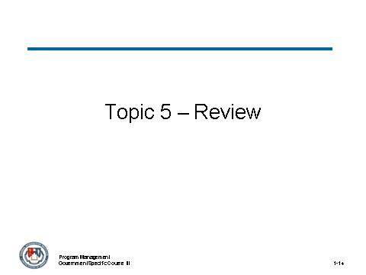
_____________________________________________________________________________
_____________________________________________________________________________
_____________________________________________________________________________
_____________________________________________________________________________

All of the following are valid MOSA principles except:
- Establishing an Enbabling Environment
- Employ Modular Design
- Designate Key Interfaces
- Use Closed Standard
- Certify Conformance
(Circle the correct answer.)

Which of the following best describes the role interoperability plays in the contracting process?
- Allows the program manager to take advantage of joint capabilities in designing and implementing a product support strategy
- Planning, developing, implementation and management of a comprehensive affordable and effective systems support strategy
- Provides interoperability, maintainability, and compatibility when developing the support strategy and follow-on logistics planning for sustainment
- Increases the chance that future changes will be able to be integrated in a cost effective manner
(Circle the correct answer.)

True or False. Project management is a component of program management.
(Circle the correct answer.)

Module 3 – Basics of Contracting

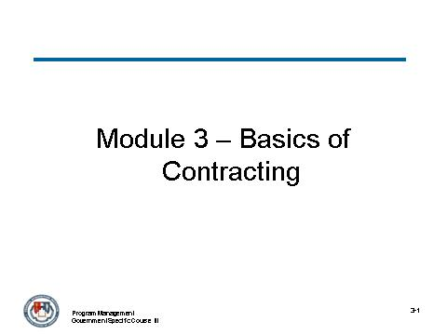
_____________________________________________________________________________
_____________________________________________________________________________
_____________________________________________________________________________
_____________________________________________________________________________
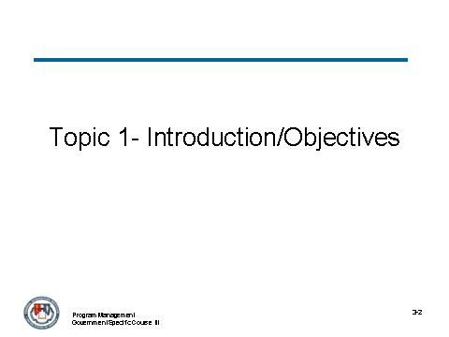
_____________________________________________________________________________
_____________________________________________________________________________
_____________________________________________________________________________
_____________________________________________________________________________

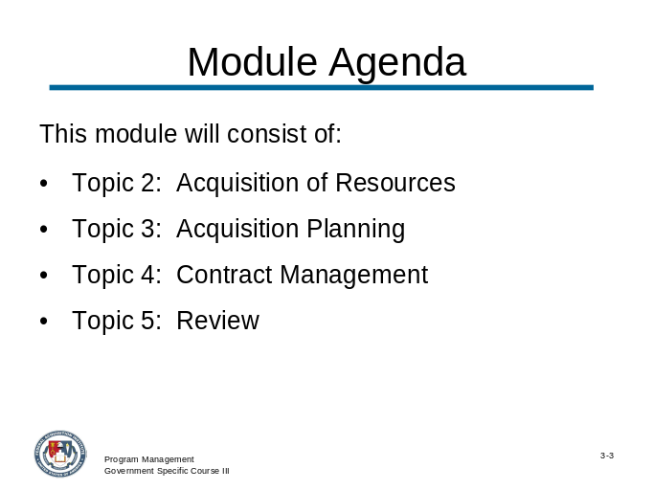
_____________________________________________________________________________
_____________________________________________________________________________
_____________________________________________________________________________
_____________________________________________________________________________
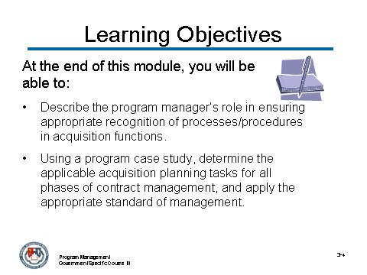
_____________________________________________________________________________
_____________________________________________________________________________
_____________________________________________________________________________
_____________________________________________________________________________

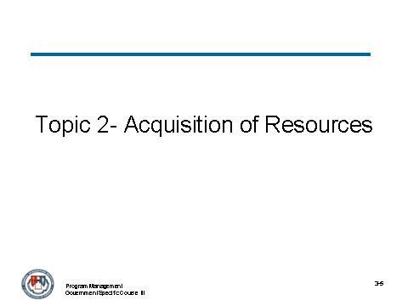
_____________________________________________________________________________
_____________________________________________________________________________
_____________________________________________________________________________
_____________________________________________________________________________
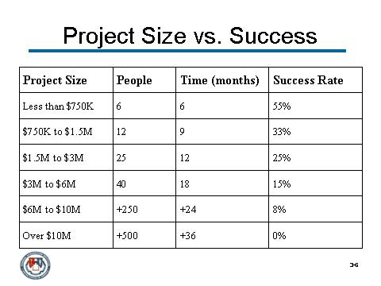
_____________________________________________________________________________
_____________________________________________________________________________
_____________________________________________________________________________
_____________________________________________________________________________

Activity:

Refer to the VCF Business Case Study we are using throughout the course. Identify which acquisition strategy the program manager would utilize by answering the questions below:

Identify whether a single-step or evolutionary program approach is best for this program?
_____________________________________________________________________________
_____________________________________________________________________________
_____________________________________________________________________________
_____________________________________________________________________________

Why (or why not)?

_____________________________________________________________________________
_____________________________________________________________________________
_____________________________________________________________________________
_____________________________________________________________________________
_____________________________________________________________________________
_____________________________________________________________________________
_____________________________________________________________________________
_____________________________________________________________________________
_____________________________________________________________________________
_____________________________________________________________________________
_____________________________________________________________________________
_____________________________________________________________________________

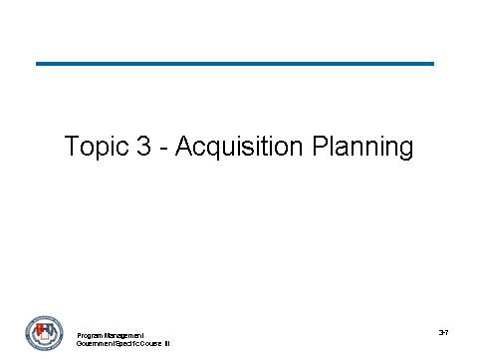
_____________________________________________________________________________
_____________________________________________________________________________
_____________________________________________________________________________
_____________________________________________________________________________

Activity

Refer to the Virtual Case File (VCF) acquisition business case. Answer the following question:

What are the key events and timeline for including in an acquisition plan the program manager could have used to lead to the Spring 2001 award?

ELEMENT | DATE

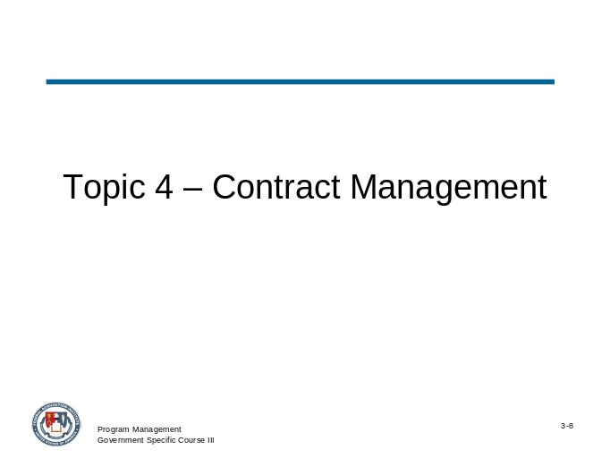
_____________________________________________________________________________
_____________________________________________________________________________
_____________________________________________________________________________
_____________________________________________________________________________
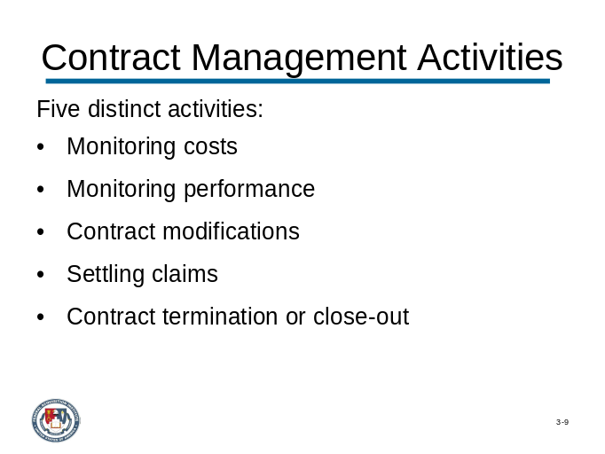
_____________________________________________________________________________
_____________________________________________________________________________
_____________________________________________________________________________
_____________________________________________________________________________

Activity:
Review the VCF Acquisition Program Management Business Case and answer the following questions:
Identify at least one point where each of the five contract administration activities should or could have occurred.
_____________________________________________________________________________
_____________________________________________________________________________
_____________________________________________________________________________
_____________________________________________________________________________
_____________________________________________________________________________
_____________________________________________________________________________
_____________________________________________________________________________
_____________________________________________________________________________

Identify the impact of the administration activity (or failure to perform).
_____________________________________________________________________________
_____________________________________________________________________________
_____________________________________________________________________________
_____________________________________________________________________________
_____________________________________________________________________________
_____________________________________________________________________________
_____________________________________________________________________________

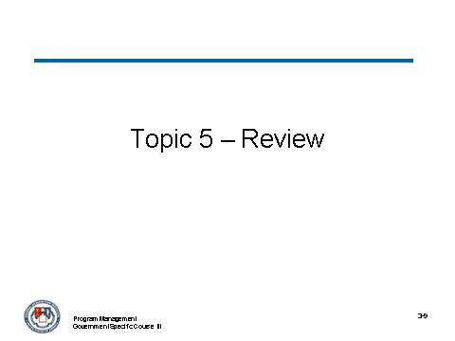
_____________________________________________________________________________
_____________________________________________________________________________
_____________________________________________________________________________
_____________________________________________________________________________

All of the following are valid source design option in an acquisition strategy except: (Select all that apply)

- -Source procurement – government negotiates with only one contractor
- Unilateral award – government pre-selects contractor and does not use a solicitation
- Limited competition – government solicits bids from a prequalified list of firms or invites some limited group of firms to bid on an ad hoc basis
- Diversity competition – government solicits bids exclusively from minority-owned contractors
- Full and open competition – any firm is entitled to a fairly evaluated bid
(Circle all that apply.)

True or False. A pitfall of low bid awards is the contractor use of a “buy in and get well” low bid strategy with initial unrealistic low bid prices and the intention to make financial deficit through post-award contract modifications.
(Circle the correct answer.)

Which of the following provisions apply in the instance of a contract terminated for default? (Select all that apply)
- For a terminated fixed-price contract, the contractor will be paid for all work performed, regardless of acceptability
- If the contractor has received advance payments for undelivered or unacceptable items, those payments must be returned to the agency.
- If the government pays a higher price when it re-procures the items covered under the terminated contract, the contractor must pay the government “excess re-procurement costs.”
- A contract terminated for default will hurt the contractor's past performance ratings on future government work for which it also bids.
(Circle all that apply.)

Module 4 – Pre-Solicitation Phase

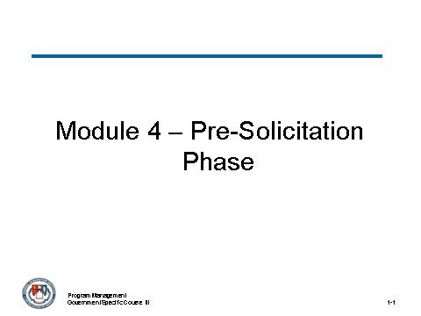
_____________________________________________________________________________
_____________________________________________________________________________
_____________________________________________________________________________
_____________________________________________________________________________
_____________________________________________________________________________
_____________________________________________________________________________
_____________________________________________________________________________
_____________________________________________________________________________

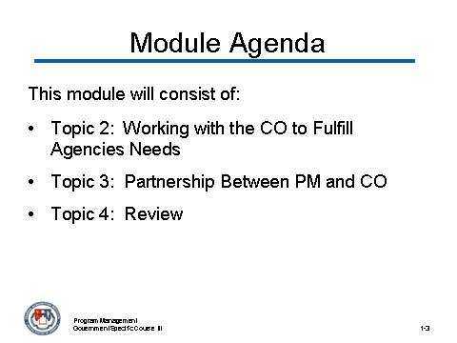
_____________________________________________________________________________
_____________________________________________________________________________
_____________________________________________________________________________
_____________________________________________________________________________
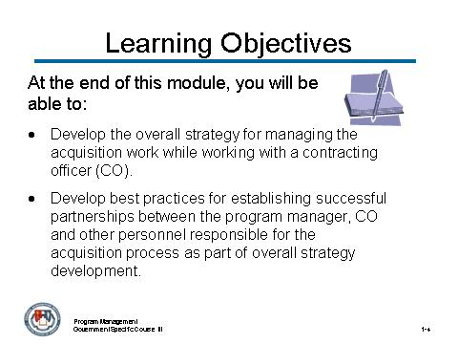
_____________________________________________________________________________
_____________________________________________________________________________
_____________________________________________________________________________
_____________________________________________________________________________

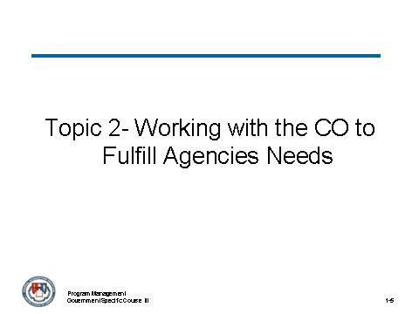
_____________________________________________________________________________
_____________________________________________________________________________
_____________________________________________________________________________
_____________________________________________________________________________
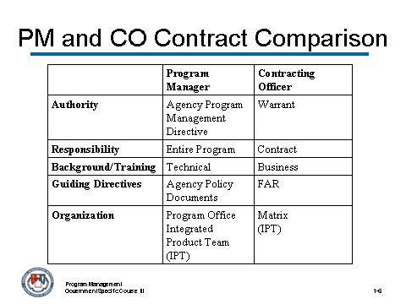
_____________________________________________________________________________
_____________________________________________________________________________
_____________________________________________________________________________
_____________________________________________________________________________

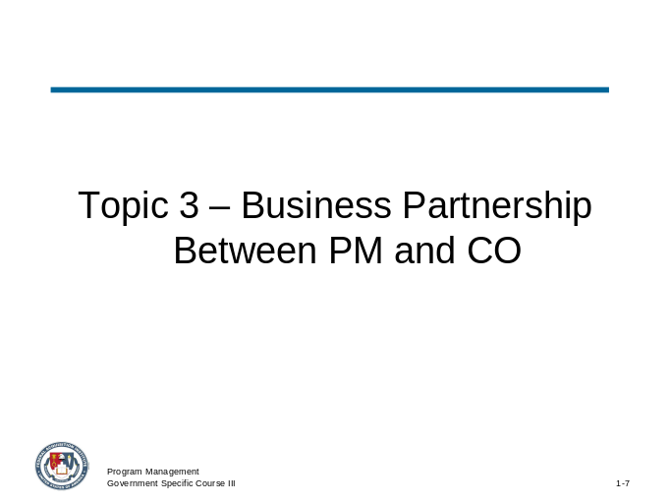
_____________________________________________________________________________
_____________________________________________________________________________
_____________________________________________________________________________
_____________________________________________________________________________

Activity
This module activity continues the business case that will be used throughout this course to apply various concepts and reinforce learning through the use of critical thinking and application skills.
- You will be divided into several discussion groups.
- Use the flip chart that will be provided to you to record your comments.
- You will be given 5 – 10 minutes to review the VCF Business Case Study found in this Participant Guide. Work together to answer the following questions:
What elements of an acquisition strategy must be jointly considered and developed in order to build a successful acquisition strategy leading to program success? Why?
_____________________________________________________________________________
_____________________________________________________________________________
_____________________________________________________________________________
_____________________________________________________________________________
_____________________________________________________________________________

Activity
- You will be divided into table discussion groups.
- In your groups, identify and write down a listing of the barriers to an effective business partnership between the program manager and PCO.
- Pass your list of barriers to the table to the right.
- Have a spokesperson from your group discuss one barrier and the corresponding solution to overcome it.
_____________________________________________________________________________
_____________________________________________________________________________
_____________________________________________________________________________
_____________________________________________________________________________
_____________________________________________________________________________

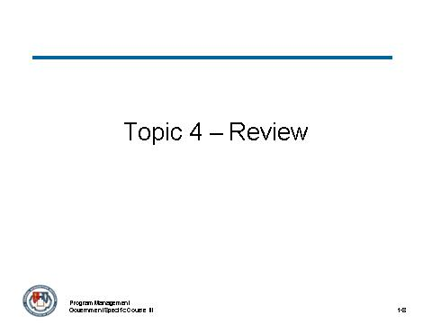
_____________________________________________________________________________
_____________________________________________________________________________
_____________________________________________________________________________
_____________________________________________________________________________

Which of the following best describes the contract responsibilities of the PCO? (Select all that apply)
- Handling the procurement from the pre-solicitation phase through to contract award (including contract signing on the agency’s behalf)
- Overall responsibility for bringing the program in on time and within budget
- Overall responsibility for the contract until it is completed and closed out
- Performing contract administration functions as assigned
(Circle all that apply.)

True or False. In order to initiate the contracting process, a capability need must first be identified by the agency.

(Circle the correct answer.)

All of the following are a business partnership development action between the program manager and the PCO to build a successful acquisition strategy for a successful program except? Select all that apply.
- Identifying interagency needs
- Comprehending procurement policies, contracting regulations, options, procedures and contract administration, performance and management issues
- Structuring terms and conditions
- Formulating the acquisition strategy considering contract types and their applicability as they relate to acquisition strategies, risk and life cycle management of the system
(Circle the correct answer.)

Module 5 – Perform Source Selection

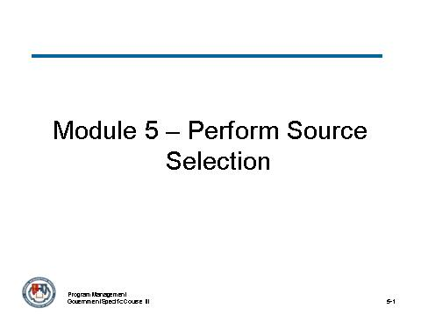
_____________________________________________________________________________
_____________________________________________________________________________
_____________________________________________________________________________
_____________________________________________________________________________
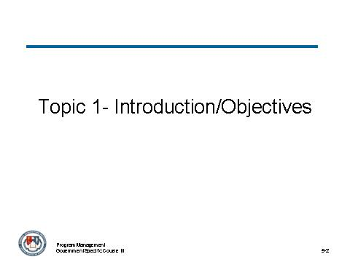
_____________________________________________________________________________
_____________________________________________________________________________
_____________________________________________________________________________
_____________________________________________________________________________

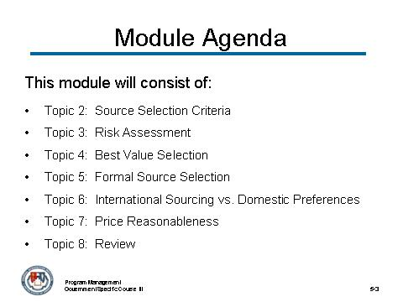
_____________________________________________________________________________
_____________________________________________________________________________
_____________________________________________________________________________
_____________________________________________________________________________
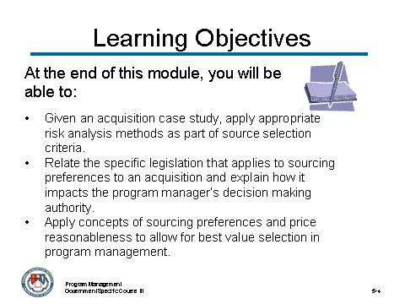
_____________________________________________________________________________
_____________________________________________________________________________
_____________________________________________________________________________
_____________________________________________________________________________

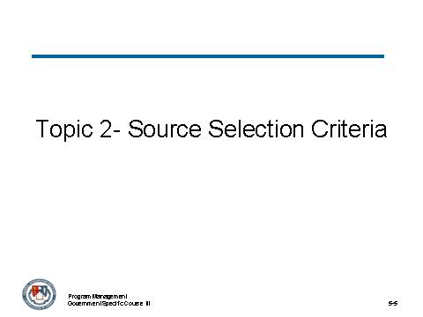
_____________________________________________________________________________
_____________________________________________________________________________
_____________________________________________________________________________
_____________________________________________________________________________

Activity:

Review the VCF Acquisition Program Management Business Case.

What types of source selection criteria should the program manager identify and use for the evaluation of proposals that led to the Spring 2001 award? Provide a rationale using information from the case for each of the criteria?
_____________________________________________________________________________
_____________________________________________________________________________
_____________________________________________________________________________
_____________________________________________________________________________
What are some effective types of source selection factors you have identified for programs/projects you’ve managed in the past?
_____________________________________________________________________________
_____________________________________________________________________________
_____________________________________________________________________________
_____________________________________________________________________________

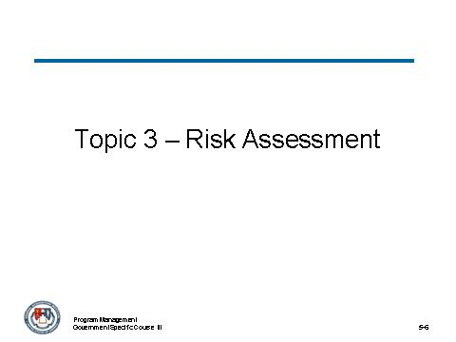
_____________________________________________________________________________
_____________________________________________________________________________
_____________________________________________________________________________
_____________________________________________________________________________
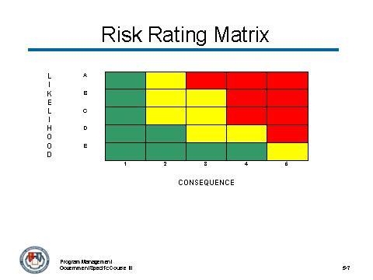
Note: Colors and adjectives are commonly used to symbolize risk; not numbers or letters as used to create the “x” and “y” axis characteristics on the matrix graphic.
_____________________________________________________________________________
_____________________________________________________________________________
_____________________________________________________________________________
_____________________________________________________________________________

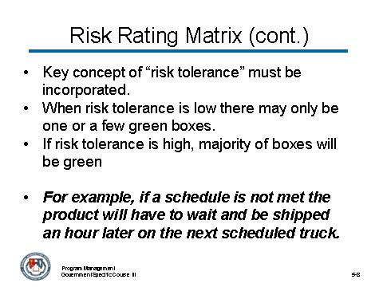
_____________________________________________________________________________
_____________________________________________________________________________
_____________________________________________________________________________
_____________________________________________________________________________
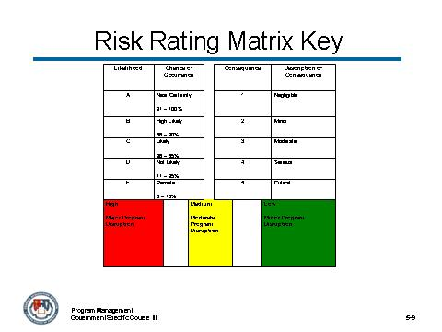
_____________________________________________________________________________
_____________________________________________________________________________
_____________________________________________________________________________
_____________________________________________________________________________

Risk Analysis Methods
The generic process described for risk management and analysis is typically accomplished using any number of standard risk analysis methods that are appropriate for the situation.
In some cases, one or more techniques could be applied simultaneously.
Standard risk analysis methods include:
- Process Risk Assessment
- Program Documentation Evaluation Risk Identification
- Threat and Requirements Risk Assessment
- Product (Work Breakdown Structure {WBS}) Risk Assessment
- Cost Risk Assessment
- Quantified Schedule Risk Assessment
- Expert Interviews
- Analog Comparison/Lesson Learned Studies
- Risk Prioritization and Risk Aggregation

Activity
Review the VCF Acquisition Program Management Business Case.
What would have been an effective risk assessment technique for the program manager to use in the Summer 2002? Provide a rationale using information from the case.
_____________________________________________________________________________
_____________________________________________________________________________
_____________________________________________________________________________
_____________________________________________________________________________
Using the selected technique what risks are identified? Plot the identified risks on a Likelihood/Consequence risk rating matrix.
_____________________________________________________________________________
_____________________________________________________________________________
_____________________________________________________________________________
_____________________________________________________________________________

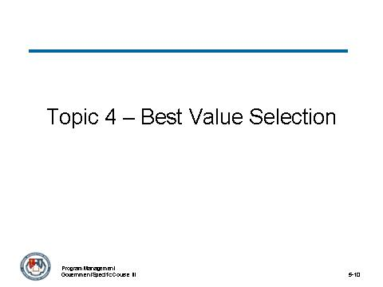
_____________________________________________________________________________
_____________________________________________________________________________
_____________________________________________________________________________
_____________________________________________________________________________

Activity
What are some of the barriers to performing a best-value source selection?
_____________________________________________________________________________
_____________________________________________________________________________
_____________________________________________________________________________
_____________________________________________________________________________

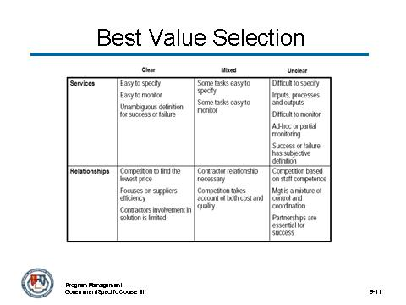
_____________________________________________________________________________
_____________________________________________________________________________
_____________________________________________________________________________
_____________________________________________________________________________
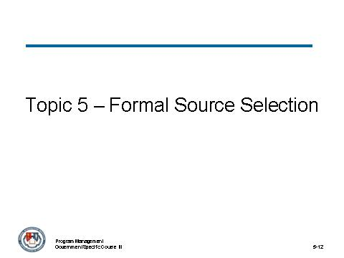
_____________________________________________________________________________
_____________________________________________________________________________
_____________________________________________________________________________
_____________________________________________________________________________

Activity
Review the VCF Acquisition Program Management Business Case.
In your group, formulate a company name and write a proposal using information from the case for submission to the FBI to be evaluated in a best value acquisition leading to a May 2005 award? The proposal is to be legibly written on one side of a single sheet of 8.5x11 paper.
Evaluate all proposals using best value acquisition and select one proposal for negotiation for award. Provide a rational for the selection.

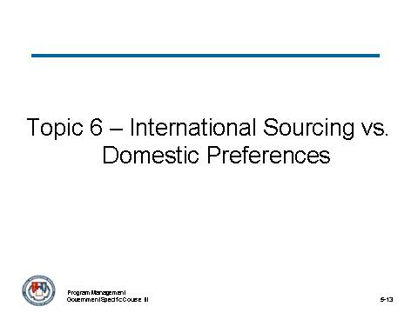
_____________________________________________________________________________
_____________________________________________________________________________
_____________________________________________________________________________
_____________________________________________________________________________
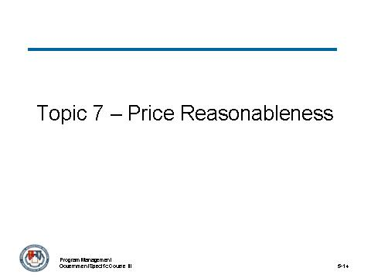
_____________________________________________________________________________
_____________________________________________________________________________
_____________________________________________________________________________
_____________________________________________________________________________

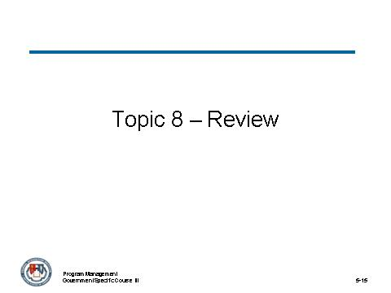
_____________________________________________________________________________
_____________________________________________________________________________
_____________________________________________________________________________
_____________________________________________________________________________

Module 6 – Contract Management

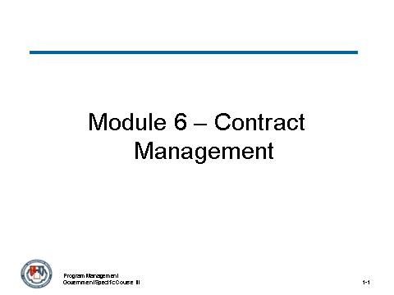
_____________________________________________________________________________
_____________________________________________________________________________
_____________________________________________________________________________
_____________________________________________________________________________
_____________________________________________________________________________
_____________________________________________________________________________
_____________________________________________________________________________
_____________________________________________________________________________

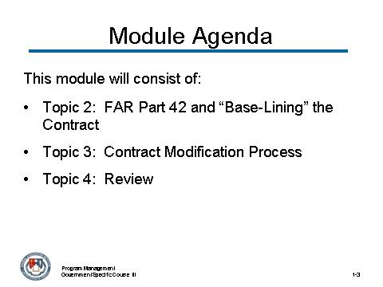
_____________________________________________________________________________
_____________________________________________________________________________
_____________________________________________________________________________
_____________________________________________________________________________
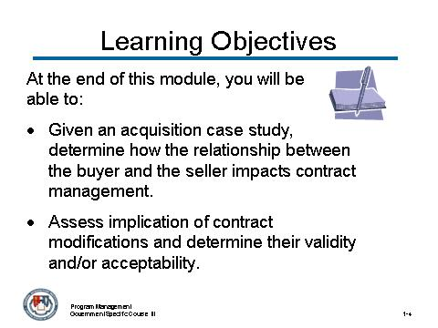
_____________________________________________________________________________
_____________________________________________________________________________
_____________________________________________________________________________
_____________________________________________________________________________

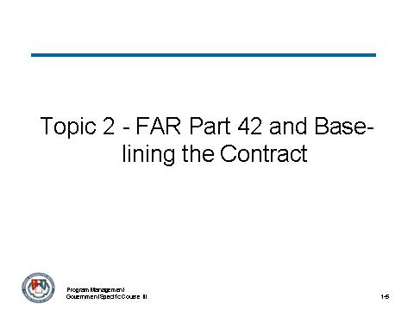
_____________________________________________________________________________
_____________________________________________________________________________
_____________________________________________________________________________
_____________________________________________________________________________
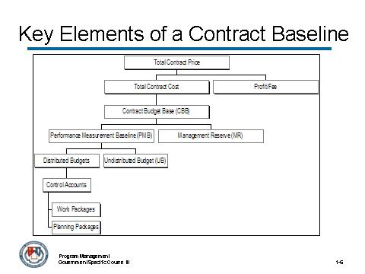
_____________________________________________________________________________
_____________________________________________________________________________
_____________________________________________________________________________
_____________________________________________________________________________

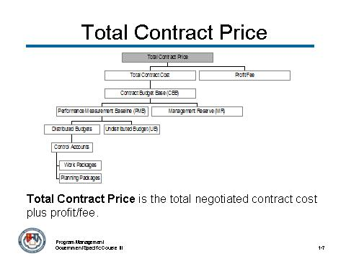
_____________________________________________________________________________
_____________________________________________________________________________
_____________________________________________________________________________
_____________________________________________________________________________
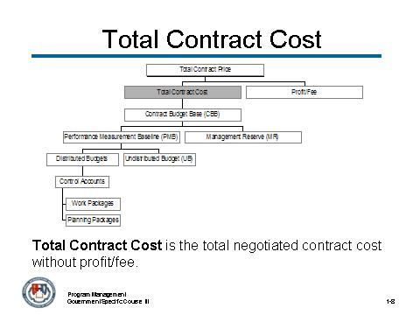
_____________________________________________________________________________
_____________________________________________________________________________
_____________________________________________________________________________
_____________________________________________________________________________

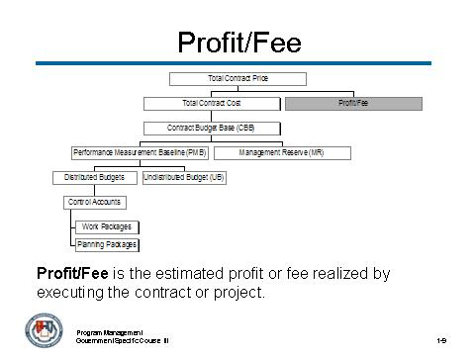
_____________________________________________________________________________
_____________________________________________________________________________
_____________________________________________________________________________
_____________________________________________________________________________
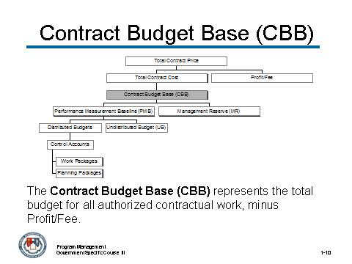
_____________________________________________________________________________
_____________________________________________________________________________
_____________________________________________________________________________
_____________________________________________________________________________

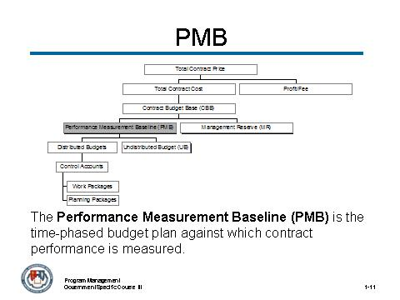
_____________________________________________________________________________
_____________________________________________________________________________
_____________________________________________________________________________
_____________________________________________________________________________
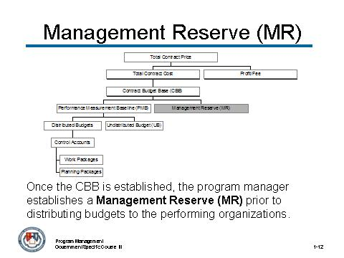
_____________________________________________________________________________
_____________________________________________________________________________
_____________________________________________________________________________
_____________________________________________________________________________

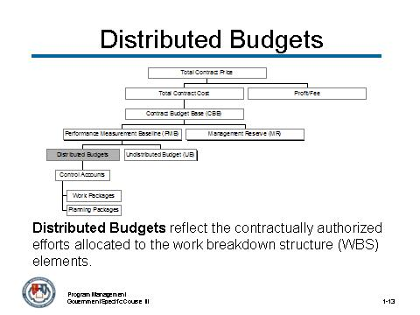
_____________________________________________________________________________
_____________________________________________________________________________
_____________________________________________________________________________
_____________________________________________________________________________
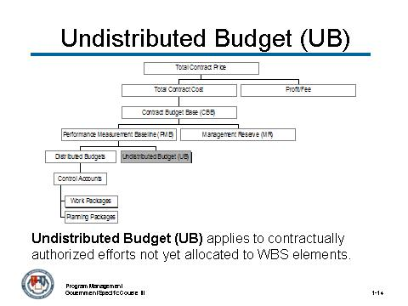
_____________________________________________________________________________
_____________________________________________________________________________
_____________________________________________________________________________
_____________________________________________________________________________

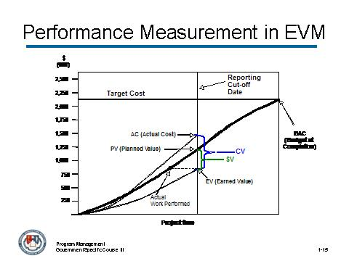
_____________________________________________________________________________
_____________________________________________________________________________
_____________________________________________________________________________
_____________________________________________________________________________
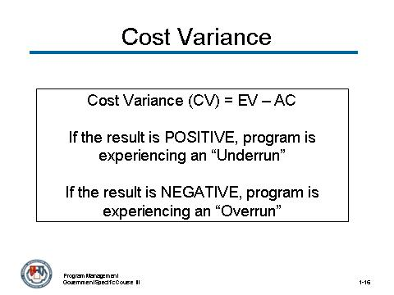
_____________________________________________________________________________
_____________________________________________________________________________
_____________________________________________________________________________
_____________________________________________________________________________

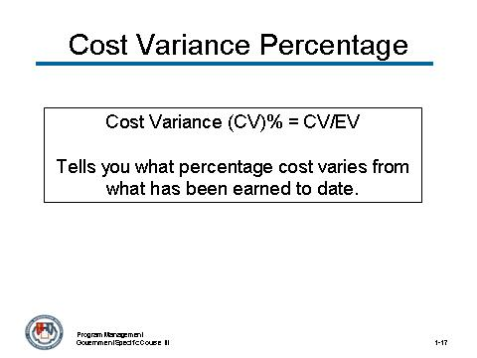
_____________________________________________________________________________
_____________________________________________________________________________
_____________________________________________________________________________
_____________________________________________________________________________
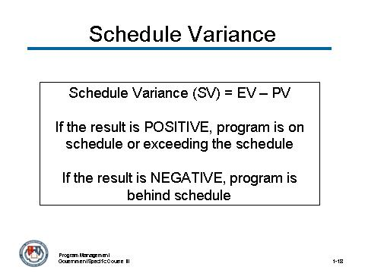
_____________________________________________________________________________
_____________________________________________________________________________
_____________________________________________________________________________
_____________________________________________________________________________

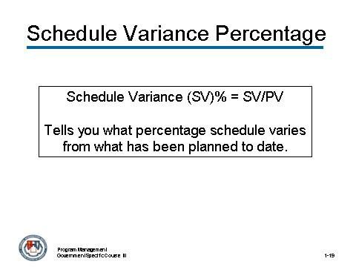
_____________________________________________________________________________
_____________________________________________________________________________
_____________________________________________________________________________
_____________________________________________________________________________
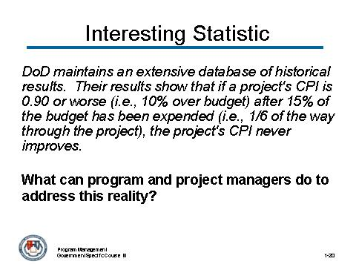
_____________________________________________________________________________
_____________________________________________________________________________
_____________________________________________________________________________
_____________________________________________________________________________

Activity

Your instructor will lead you through this activity.
What risk analysis activities make the most sense given the types of common EV PMB methods might be used?
_____________________________________________________________________________
_____________________________________________________________________________
_____________________________________________________________________________
_____________________________________________________________________________
_____________________________________________________________________________
_____________________________________________________________________________
_____________________________________________________________________________
_____________________________________________________________________________

What implications do these have with regard to the contract pre-solicitation and planning phase for the program manager?
_____________________________________________________________________________
_____________________________________________________________________________
_____________________________________________________________________________
_____________________________________________________________________________
_____________________________________________________________________________
_____________________________________________________________________________
_____________________________________________________________________________
_____________________________________________________________________________

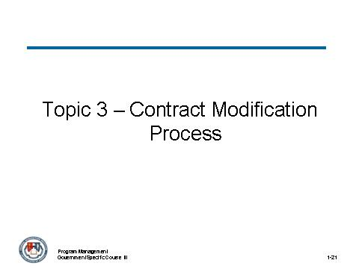
_____________________________________________________________________________
_____________________________________________________________________________
_____________________________________________________________________________
_____________________________________________________________________________
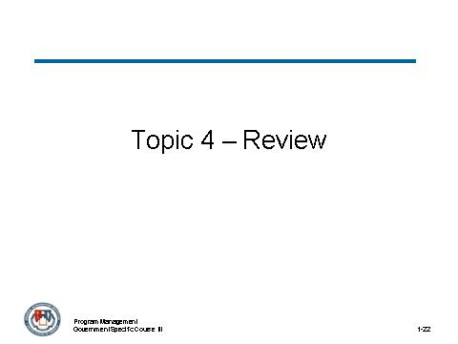
_____________________________________________________________________________
_____________________________________________________________________________
_____________________________________________________________________________
_____________________________________________________________________________

Activity
Review the VCF Acquisition Program Management Business Case and answer the following questions.
During which parts of the business case would you think contract modifications should have occurred that did not? State the purpose of each modification and provide a rational.
_____________________________________________________________________________
_____________________________________________________________________________
_____________________________________________________________________________
_____________________________________________________________________________
_____________________________________________________________________________
_____________________________________________________________________________
_____________________________________________________________________________
_____________________________________________________________________________
Should these modifications be bilateral or unilateral?
_____________________________________________________________________________
_____________________________________________________________________________
_____________________________________________________________________________
_____________________________________________________________________________
What are the risks associated with making and not making each modification?
_____________________________________________________________________________
_____________________________________________________________________________
_____________________________________________________________________________
_____________________________________________________________________________

Module 7 – Performance-Based Agreements

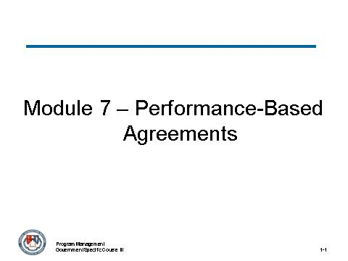
_____________________________________________________________________________
_____________________________________________________________________________
_____________________________________________________________________________
_____________________________________________________________________________
_____________________________________________________________________________
_____________________________________________________________________________
_____________________________________________________________________________
_____________________________________________________________________________

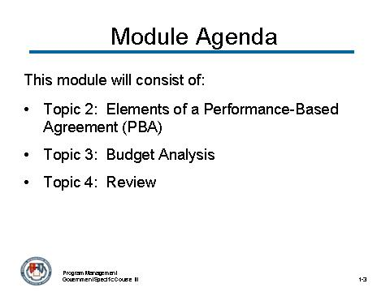
_____________________________________________________________________________
_____________________________________________________________________________
_____________________________________________________________________________
_____________________________________________________________________________
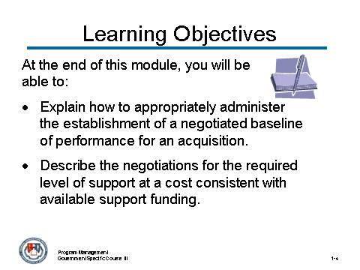
_____________________________________________________________________________
_____________________________________________________________________________
_____________________________________________________________________________
_____________________________________________________________________________

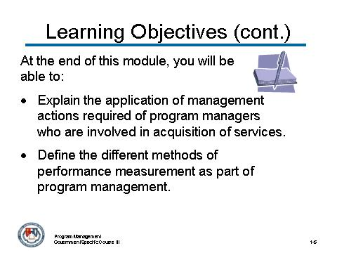
_____________________________________________________________________________
_____________________________________________________________________________
_____________________________________________________________________________
_____________________________________________________________________________
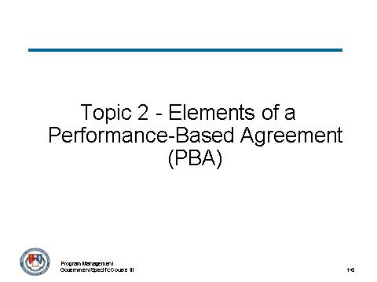
_____________________________________________________________________________
_____________________________________________________________________________
_____________________________________________________________________________
_____________________________________________________________________________

Activity (continued)
You are the program manager for this acquisition. What are some of the decision points you might use to identify remedies and incentives?
_____________________________________________________________________________
_____________________________________________________________________________
_____________________________________________________________________________
_____________________________________________________________________________

How would you utilize your team to develop these remedies and incentives?
_____________________________________________________________________________
_____________________________________________________________________________
_____________________________________________________________________________
_____________________________________________________________________________

What types of methods would you use for determining applicability?
_____________________________________________________________________________
_____________________________________________________________________________
_____________________________________________________________________________
_____________________________________________________________________________

Where do you feel the actual program manager (and/or team) failed with regard to remedies and incentives for this acquisition?
_____________________________________________________________________________
_____________________________________________________________________________
_____________________________________________________________________________
_____________________________________________________________________________

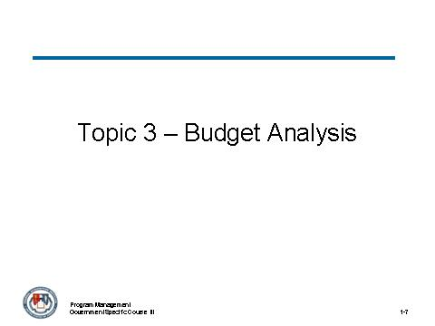
_____________________________________________________________________________
_____________________________________________________________________________
_____________________________________________________________________________
_____________________________________________________________________________

Activity
Use the VCF Acquisition Program Management Business Case to answer the following questions.
Which of the four cost estimating methodologies (analogy, parametric, engineering and actual costs) would make the most sense for the program manager to use at each of the following points? Spring 2001, December 2001, Summer 2002, June 2003, and May 2005?
_____________________________________________________________________________
_____________________________________________________________________________
_____________________________________________________________________________
_____________________________________________________________________________
What information is available to the program manager to perform a cost estimation using the methodology assigned to your sub-group?
_____________________________________________________________________________
_____________________________________________________________________________
_____________________________________________________________________________
_____________________________________________________________________________
What additional information does the program manager need to perform the cost estimation?
_____________________________________________________________________________
_____________________________________________________________________________
_____________________________________________________________________________
_____________________________________________________________________________

Activity (continued)
How can the program manager obtain the needed additional information?
_____________________________________________________________________________
_____________________________________________________________________________
_____________________________________________________________________________
_____________________________________________________________________________

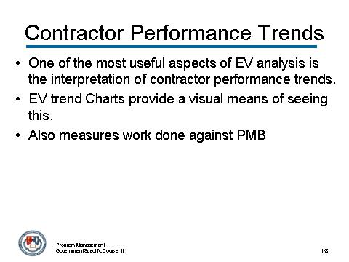
_____________________________________________________________________________
_____________________________________________________________________________
_____________________________________________________________________________
_____________________________________________________________________________

Activity
Review the charts on the following pages and identify how well or how poorly the project is performing. Be prepared to discuss your rationale with the class.
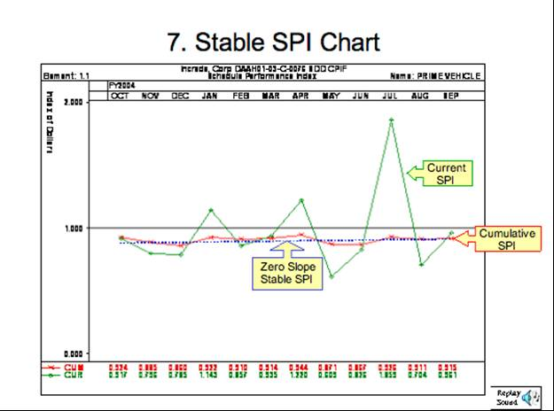
_____________________________________________________________________________
_____________________________________________________________________________
_____________________________________________________________________________
_____________________________________________________________________________
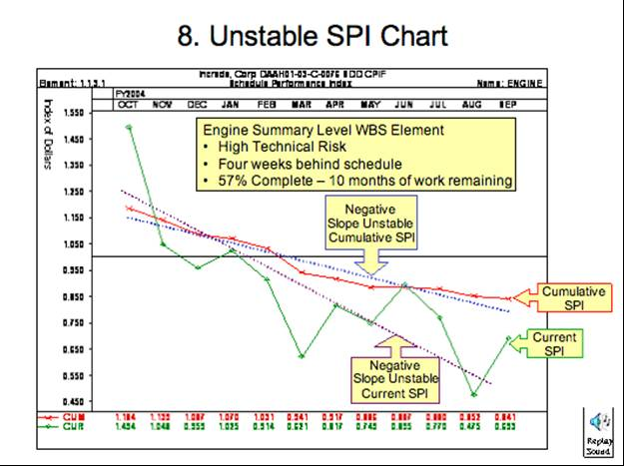
_____________________________________________________________________________
_____________________________________________________________________________
_____________________________________________________________________________
_____________________________________________________________________________
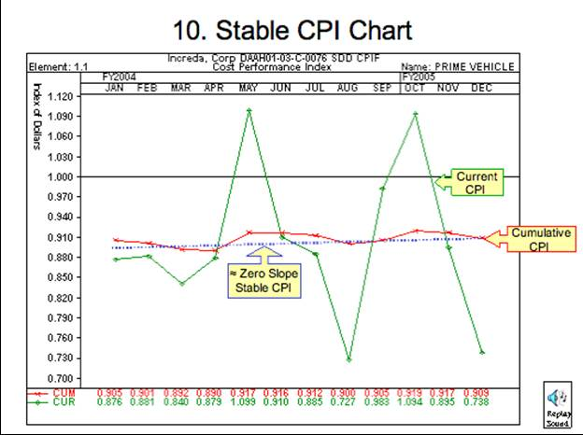
_____________________________________________________________________________
_____________________________________________________________________________
_____________________________________________________________________________
_____________________________________________________________________________
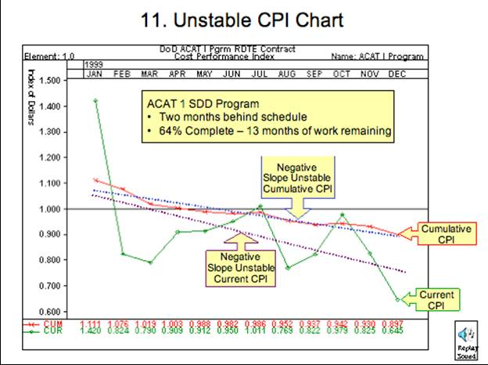
_____________________________________________________________________________
_____________________________________________________________________________
_____________________________________________________________________________
_____________________________________________________________________________
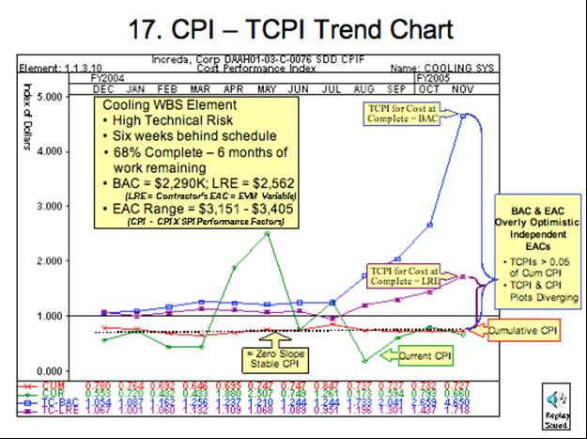
_____________________________________________________________________________
_____________________________________________________________________________
_____________________________________________________________________________
_____________________________________________________________________________

Activity
Review the GAO-07-912 Report Experpts and answer the following questions.
What would your reaction as Sentinal program manager be to the GAO report?
_____________________________________________________________________________
_____________________________________________________________________________
_____________________________________________________________________________
_____________________________________________________________________________
What actions, if any, would you as the Sentinal program manager take as a reuult of the report?
_____________________________________________________________________________
_____________________________________________________________________________
_____________________________________________________________________________
_____________________________________________________________________________

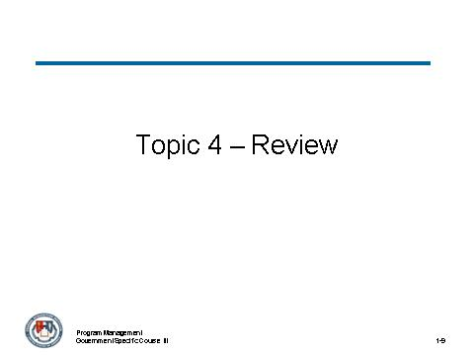
_____________________________________________________________________________
_____________________________________________________________________________
_____________________________________________________________________________
_____________________________________________________________________________

Module 8 – LCL Management, Product Support

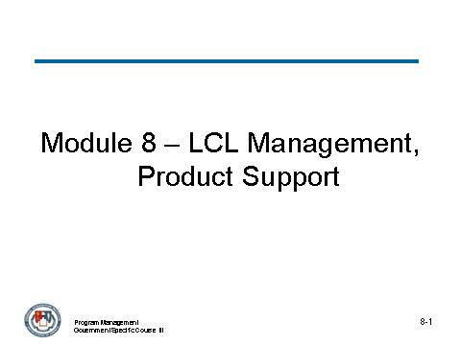
_____________________________________________________________________________
_____________________________________________________________________________
_____________________________________________________________________________
_____________________________________________________________________________
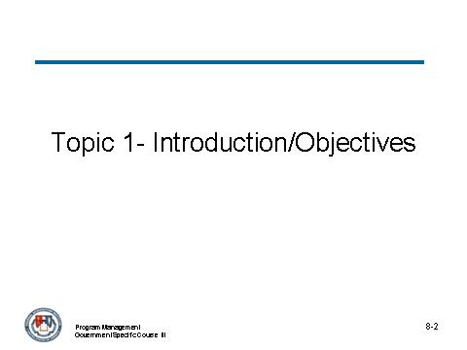
_____________________________________________________________________________
_____________________________________________________________________________
_____________________________________________________________________________
_____________________________________________________________________________

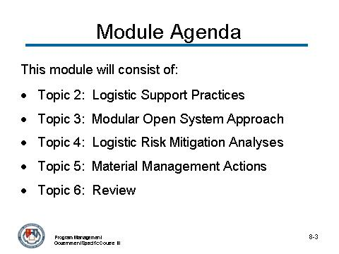
_____________________________________________________________________________
_____________________________________________________________________________
_____________________________________________________________________________
_____________________________________________________________________________
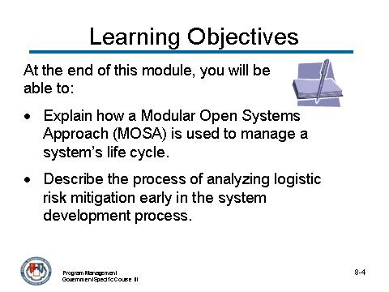
_____________________________________________________________________________
_____________________________________________________________________________
_____________________________________________________________________________
_____________________________________________________________________________

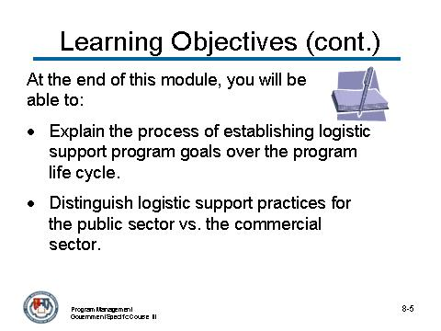
_____________________________________________________________________________
_____________________________________________________________________________
_____________________________________________________________________________
_____________________________________________________________________________
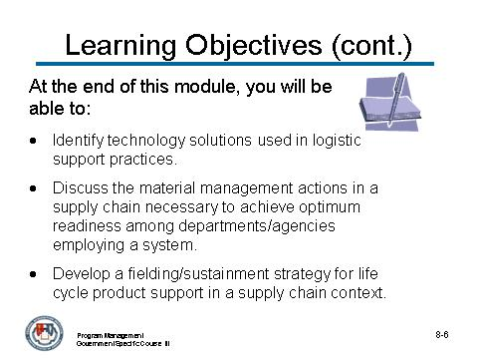
_____________________________________________________________________________
_____________________________________________________________________________
_____________________________________________________________________________
_____________________________________________________________________________

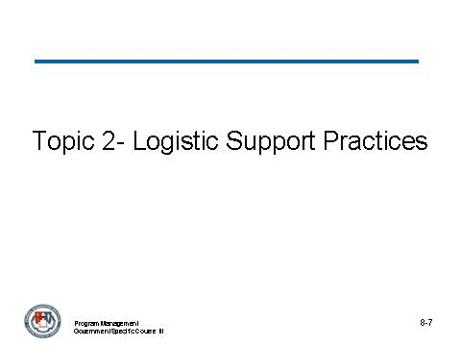
_____________________________________________________________________________
_____________________________________________________________________________
_____________________________________________________________________________
_____________________________________________________________________________

Activity:
Brainstorm and write down as many logistics support practices that you can – excluding those which have been discussed as part of this topic.
_____________________________________________________________________________
_____________________________________________________________________________
_____________________________________________________________________________
_____________________________________________________________________________
_____________________________________________________________________________
_____________________________________________________________________________
_____________________________________________________________________________
_____________________________________________________________________________
_____________________________________________________________________________
_____________________________________________________________________________
_____________________________________________________________________________
_____________________________________________________________________________
_____________________________________________________________________________
_____________________________________________________________________________
_____________________________________________________________________________
_____________________________________________________________________________
_____________________________________________________________________________
_____________________________________________________________________________
_____________________________________________________________________________
_____________________________________________________________________________
_____________________________________________________________________________
_____________________________________________________________________________
_____________________________________________________________________________
_____________________________________________________________________________

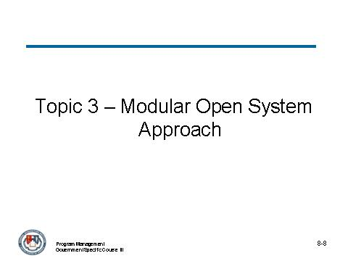
_____________________________________________________________________________
_____________________________________________________________________________
_____________________________________________________________________________
_____________________________________________________________________________

Activity:
Create a three-column page on a blank piece of paper, labeled the same as the three easel pad pages in front of you. Brainstorm the types of strategies, capabilities and performance requirements that you have had experience with and write them in the proper category on your paper.

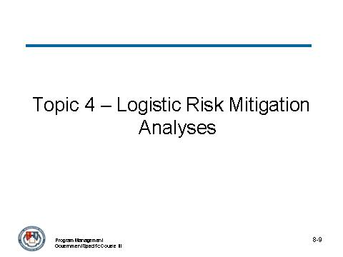
_____________________________________________________________________________
_____________________________________________________________________________
_____________________________________________________________________________
_____________________________________________________________________________

Risks and Mitigation Actions Involving Operational Requirements

For this potential risk… | Consider these mitigation actions…
Availability: Availability of COTS products that meet functional requirements before beginning development are unknown; estimated development cost and schedule are highly uncertain | - Conduct market research  - Solicit industry inputs (e.g., Request for Information, industry day, demonstrations).  - Encourage vendors to change product capabilities and performance to meet requirements only if the change will be incorporated into the commercial product.
Functionality and Performance: Actual functionality and performance of a COTS product are not as advertised; system may not meet its requirements. | - Ask vendors to conduct demonstrations.  - Evaluate through prototyping.  - Consult other users with similar requirements to see what their experiences have been with the product.
Requirements Gap: COTS product does not match current operational requirements or procedures and these can not be changed; COTS product can not be used. | - Re-evaluate user requirements by keeping the user involved in trade-offs between COTS functionality, requirements, and cost and schedule.  - Encourage user to consider changing operational processes to match those embedded in COTS products.  - Maintain an up-to-date Operational Requirements document, especially to avoid failing operational testing.  - Document requirement and operational procedure deviations.  - Consider using a non-COTS solution rather than modify the COTS product so it deviates from the commercial product
Risks and Mitigation Actions Involving Operational Requirements (continued)

For this potential risk… | Consider these mitigation actions…
Security and Safety Issues: If there are stringent security requirements, it may not be possible to certify that the product meets requirements because the COTS product must be tested as a black box without its implementation. | - Analyze the vulnerability of the system due to untrusted COTS components and determine if the system can be designed to reduce the vulnerability to an acceptable level or else use custom software at the key points of vulnerability

Risks and Mitigation Actions Involving Technical Approach

For this potential risk… | Consider these mitigation actions…
Conformance to Program Standards: Conformance to technical standards is not supported by the COTS product; funding may be jeopardized or the COTS product may not be acceptable. | - Make every effort to find candidate COTS products that comply with current, relevant standards.  - Investigate ways to obtain waivers or to add the product to accepted standards.
Conformance to Commercial Standards: Candidate COTS products do not conform to commercial standards; interoperability with other selected COTS products may be difficult, costly, and time consuming or impossible. | - Choose COTS products that have interfaces that conform to well-known, well-defined standards that are widely used.  - Establish and maintain an integration facility to verify conformance.  - Determine if results are available from other verification or operational activities.

Risks and Mitigation Actions Involving Technical Approach (continued)

For this potential risk… | Consider these mitigation actions…
Integration Contractor's Capability: Contractor does not have the technical experience to deliver a COTS-based system; system may not meet requirements, cost, and schedule. | - Specify contractor selection criteria to include demonstrating experience with selecting, integrating, and testing COTS products.  - Ensure contractors are familiar with the specific COTS products they proposed.  - Determine the contractor’s ability to perform COTS-based system engineering (e.g., past performance).  - Ensure that the contract's configuration management capability can track versions of COTS products.
Quality Requirements: Candidate COTS product does not meet quality requirements (e.g., reliability, performance, usability); cost, schedule, and operational capability may be impacted. | - Use market research to determine size and satisfaction of customer base.  - Conduct demonstrations, prototyping before final selection.  - Consult other users with similar requirements.

Risks and Mitigation Actions Involving Technical Approach (continued)

For this potential risk… | Consider these mitigation actions…
Adaptability: Candidate COTS products do not fully support initial and evolving requirements and do not have built-in flexibility; custom code may be needed or the product may be difficult to integrate with other products and may become unsuitable as the system changes. | - Assess ability of COTS products to be adapted, tailored, extended, and integrated.  - Determine how "open" the application programmer interface (API) is for adding capability and integrating with other products.  - Evaluate tools available to tailor a COTS product.  - Do not modify code of COTS products.  - Do continuous market research for alternatives and market trends throughout the system’s life cycle.  - Take a pro-active role in influencing commercial standards so that commercial products will better integrate into program systems.
Portability: Candidate COTS package is not supportable across a variety of hardware and operating system platforms; hardware platform choices over a program lifecycle may be limited. | - Select portable COTS products that can run on a broad-spectrum of platforms or can be easily implemented for new platforms  - Check the vendor's record for moving to new platforms and operating systems.

Risks and Mitigation Actions Involving Technical Approach (continued)

For this potential risk… | Consider these mitigation actions…
Sustainment: Market research is not conducted and new COTS products and technology are not considered; there may be missed opportunities to introduce new technology. | - Use market research to track technology trends, anticipate future products releases, vendors' plans.  - Participate in beta tests of new products and versions in the integration lab.  - Perform cost/benefit analysis for replacement, e.g., impact on licensing, other system software affected, operator interfaces and procedures, training, performance, other sustainment costs.  - Involve users if operational capabilities, operator interfaces, interoperability affected.  - Plan for security recertification.  - Plan capability delivery schedule to coincide with emerging product releases to the extent possible.  - Plan for replacement, upgrades at regular intervals.

Risks and Mitigation Actions Involving Technical Approach (continued)

For this potential risk… | Consider these mitigation actions…
Evolution: New hardware upgrades or replacements are not compatible with current COTS software products; COTS software products may have to be replaced at the same time. | - Coordinate plans for hardware upgrades with software upgrades.  - Evaluate hardware and software upgrades together in the integration lab.  - Determine vendor plans for COTS product compatibility with hardware.  - Do not count on vendor delivery schedules for achieving hardware compatibilities.  - Accept shorter lifespan for COTS. Sometimes, throwaway is a realistic part of evolution.
Source Code: There is no access to source code; it may be difficult to trace integration and testing problems to COTS products. | - Plan to have COTS vendors provide product and debugging support.  - Develop alternative methods and tools for system fault diagnosis.
Upgrades: Upgrades to COTS software increase the size of the programs or the files they produce; size of the hardware memory in the system may be insufficient and may have to be replaced or upgraded. | - Plan for large size growth in COTS software upgrades. Buy large amounts of spare memory initially.  - Make sure hardware and system architecture have a growth path.

Risks and Mitigation Actions Involving Technical Approach (continued)

For this potential risk… | Consider these mitigation actions…
Security: Security requirements are levied; integration of COTS products may introduce security vulnerabilities. | - Select certified products in accordance with the system requirements if such products are available.  - Design the system to encapsulate the non-secure products and limit the vulnerabilities they create.  - Plan for the certification of the integrated products.  - Use custom software or hardware components when the security of COTS products cannot be assured and will make the system unacceptable.

Risks and Mitigation Actions Involving Business Strategy

For this potential risk… | Consider these mitigation actions…
Acquisition Alternatives: Alternative methods of acquiring COTS products are not evaluated; cost may be unnecessarily high. | - Evaluate alternatives for licensing such as third party vendors.  - Seek licensing terms that give the most favorable conditions based on requirements and utilization, e.g., number of users, number of CPUs.  - Choose the appropriate time to buy COTS products in volume to assure latest technology at installation.
Vendor Reliability: Vendor of a candidate COTS product is financially weak or unstable; product may have poor support or become unsupported, potentially leading to unexpected or unplanned cost and schedule slips. | - Assess vendor’s market share and financial status.  - Evaluate vendor’s history of product support.
Cost and Schedule Completeness: Cost and schedule estimates do not consider all the ongoing costs of acquiring a COTS-based system; system may not be adequately funded. | - Consider market research results when developing estimates for initial cost.  - Include cost of integration lab, license renewals, continuing market research, version upgrades, etc. in annual budgets for development as well as support.

Risks and Mitigation Actions Involving Business Strategy (continued)

For this potential risk… | Consider these mitigation actions…
Business Skills: Vendor relationship and business skills of the contractor are weak; system component costs and licensing may be more costly than necessary. | - Assess ability of contractor to establish business relationships with vendors, including product services and licensing.  - Consider contractor's preferred vendor list.
Vendor Support: Vendor stops supporting the maintenance or further distribution of a product or a version of that product, or the vendor goes out of business; lifecycle costs may increase and continued sustainment may not be possible. | - Use continuous market research to identify alternatives and anticipate vendor termination.  - Determine if another organization has assumed maintenance responsibility for the product.  - Consider upgrade to the latest product the vendor supports to avoid loss of vendor maintenance support.  - Negotiate level of vendor support based on system availability requirements and geographic distribution of installations.

Risks and Mitigation Actions Involving Business Strategy (continued)

For this potential risk… | Consider these mitigation actions…
Statement of Work: Tasks in the contractor's Statement of Work are not supportive of acquiring a COTS-based system; appropriate risk mitigation strategies may not be applied, potentially leading to cost and schedule slips. | - Task statements should specify:  - Do early and frequent prototyping  - Do continuous market research  - Maintain integration lab  - Perform system engineering when selecting, adapting, and integrating COTS products with each other and system hardware.
Activity

Review the VCF Acquisition Program Business Case Study. Identify the specific risks and risk mitigation actions as they relate to this business case.
_____________________________________________________________________________
_____________________________________________________________________________
_____________________________________________________________________________
_____________________________________________________________________________
_____________________________________________________________________________
_____________________________________________________________________________
_____________________________________________________________________________
_____________________________________________________________________________
_____________________________________________________________________________
_____________________________________________________________________________
_____________________________________________________________________________
_____________________________________________________________________________
_____________________________________________________________________________
_____________________________________________________________________________
_____________________________________________________________________________
_____________________________________________________________________________
_____________________________________________________________________________
_____________________________________________________________________________
_____________________________________________________________________________
_____________________________________________________________________________
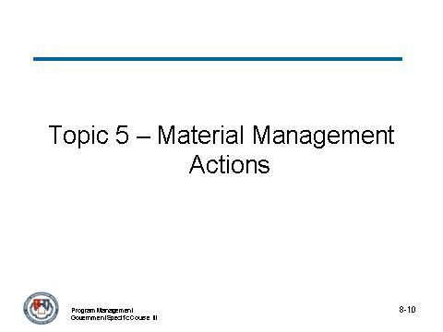
_____________________________________________________________________________
_____________________________________________________________________________
_____________________________________________________________________________
_____________________________________________________________________________
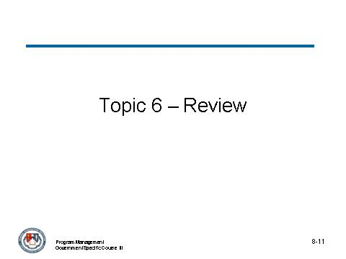
_____________________________________________________________________________
_____________________________________________________________________________
_____________________________________________________________________________
_____________________________________________________________________________

Module 9 – Perform Source Selection

_____________________________________________________________________________
_____________________________________________________________________________
_____________________________________________________________________________
_____________________________________________________________________________
_____________________________________________________________________________
_____________________________________________________________________________
_____________________________________________________________________________
_____________________________________________________________________________

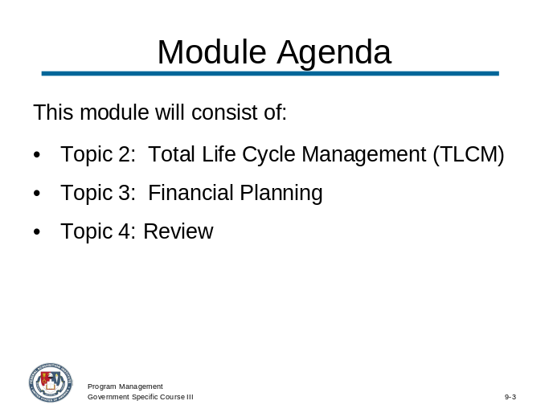
_____________________________________________________________________________
_____________________________________________________________________________
_____________________________________________________________________________
_____________________________________________________________________________
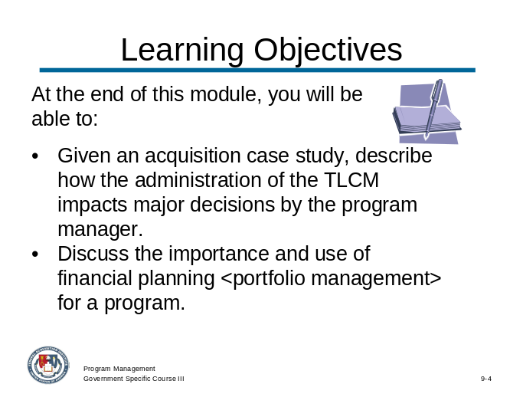
_____________________________________________________________________________
_____________________________________________________________________________
_____________________________________________________________________________
_____________________________________________________________________________

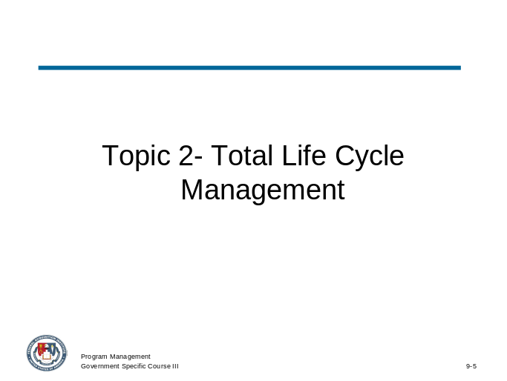
_____________________________________________________________________________
_____________________________________________________________________________
_____________________________________________________________________________
_____________________________________________________________________________
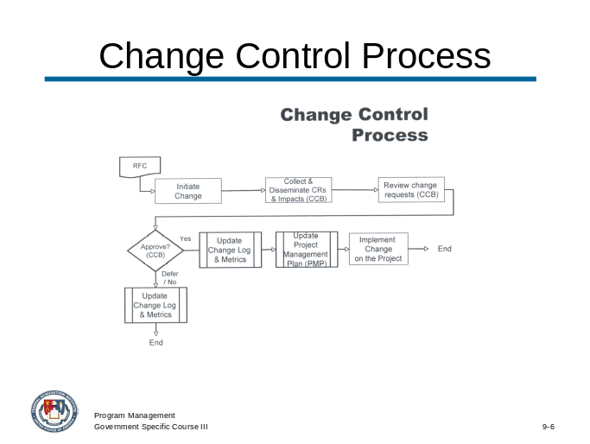
_____________________________________________________________________________
_____________________________________________________________________________
_____________________________________________________________________________
_____________________________________________________________________________

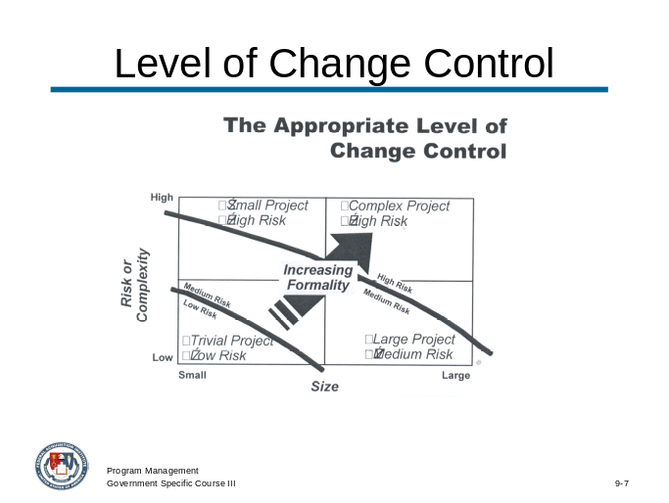
_____________________________________________________________________________
_____________________________________________________________________________
_____________________________________________________________________________
_____________________________________________________________________________

Organizational Maturity Levels

 | Level 1  Performed | Level 2  Managed | Level 3  Established | Level 4  Predictable | Level 5  Optimizing
People | Success depends on individual heroics.  “Fire fighting is a way of life.”  Relationships between disciplines are uncoordinated, perhaps even adversarial. | Success depends on individuals and management system supports.  Commitments are understood and managed.  People are trained. | Project groups work together, perhaps as an integrated product team.  Training is planned and provided according to roles. | A strong sense of teamwork exists within each project. | A strong sense of teamwork exists across the organization.  Everyone is involved in process improvement.
Process | Few stable processes exist or are used. | Documented and stable estimating, planning, and commitment processes are at the project level. | Integrated management and engineering processes are used across the organization. | Processes are quantitatively understood and stabilized. | Processes are continuously and systematically improved.

Organizational Maturity Levels, continued

Technology | The introduction of new technology is risky. | Technology supports established, stable activities. | New technologies are evaluated on a qualitative basis. | New technologies are evaluated on a quantitative basis. | New technologies are proactively pursued and deployed.
Measurement | Data collection and analysis are ad hoc. | Planning and management data is used by individual projects. | Data is collected and used in all defined processes.  Data is systematically shared across projects. | Data definition and collection are standardized across the organization  Data is used to understand the process qualitatively and stabilize it. | Data is used to evaluate and select process improvements.

Activity

Consider a project or program currently under your management or one in which you have managed in the past. Use the four categories (People, Process, Technology and Measurement) to assess your perceived level of organizational maturity for the program. Be prepared to provide specific examples of why or how you feel the program is evaluated at the level you’ve identified.
_____________________________________________________________________________
_____________________________________________________________________________
_____________________________________________________________________________
_____________________________________________________________________________
_____________________________________________________________________________
_____________________________________________________________________________
_____________________________________________________________________________
_____________________________________________________________________________
_____________________________________________________________________________
_____________________________________________________________________________
_____________________________________________________________________________
_____________________________________________________________________________
_____________________________________________________________________________
_____________________________________________________________________________
_____________________________________________________________________________
_____________________________________________________________________________
_____________________________________________________________________________
_____________________________________________________________________________
_____________________________________________________________________________
_____________________________________________________________________________

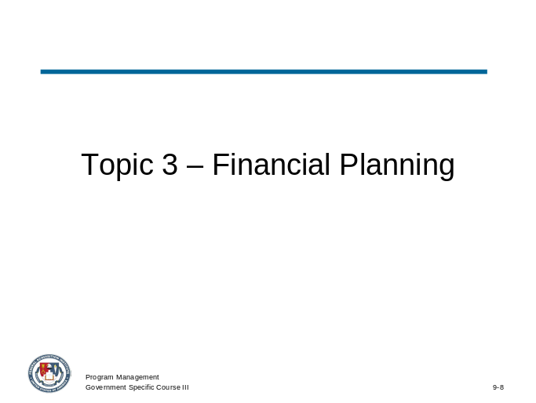
_____________________________________________________________________________
_____________________________________________________________________________
_____________________________________________________________________________
_____________________________________________________________________________
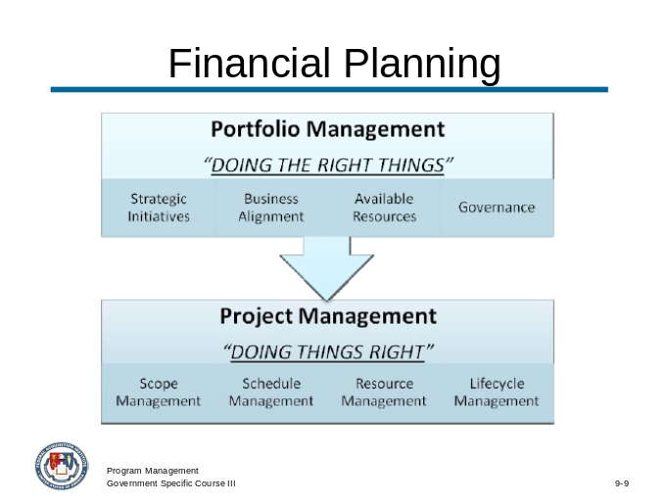
_____________________________________________________________________________
_____________________________________________________________________________
_____________________________________________________________________________
_____________________________________________________________________________

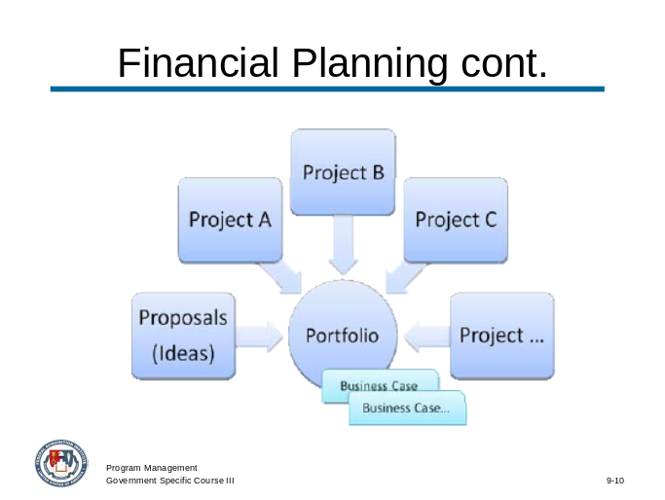
_____________________________________________________________________________
_____________________________________________________________________________
_____________________________________________________________________________
_____________________________________________________________________________
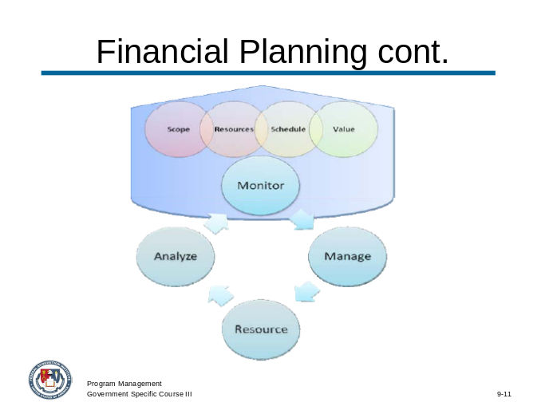
_____________________________________________________________________________
_____________________________________________________________________________
_____________________________________________________________________________
_____________________________________________________________________________

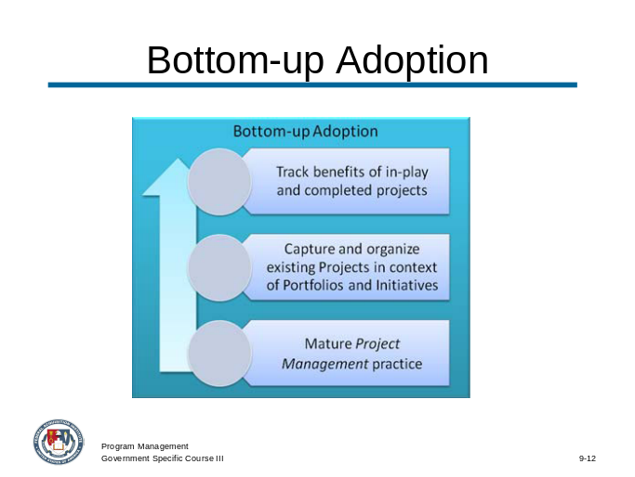
_____________________________________________________________________________
_____________________________________________________________________________
_____________________________________________________________________________
_____________________________________________________________________________

Activity

Review the VCF Acquisition Program Business Case Study. Identify how and where the portfolio management process could have been applied to assist the program manager in keeping the program on track, specifically related to the cost management responsibilities.
_____________________________________________________________________________
_____________________________________________________________________________
_____________________________________________________________________________
_____________________________________________________________________________
_____________________________________________________________________________
_____________________________________________________________________________
_____________________________________________________________________________
_____________________________________________________________________________
_____________________________________________________________________________
_____________________________________________________________________________
_____________________________________________________________________________
_____________________________________________________________________________
_____________________________________________________________________________
_____________________________________________________________________________
_____________________________________________________________________________
_____________________________________________________________________________
_____________________________________________________________________________
_____________________________________________________________________________
_____________________________________________________________________________
_____________________________________________________________________________

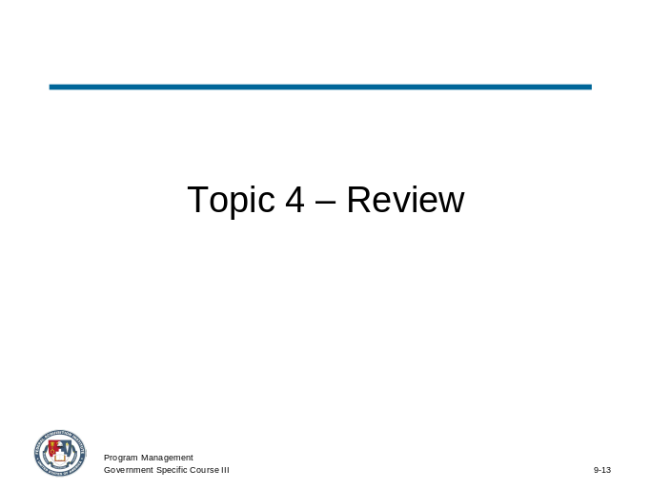
_____________________________________________________________________________
_____________________________________________________________________________
_____________________________________________________________________________
_____________________________________________________________________________

Activity

Review the VCF Acquisition Program Business Case Study. Consider all activities associated with the VCF business case from the following program management perspectives and identify how each affects the program manager’s implementation, management and oversight decisions across its life cycle.
a. Acquisition
b. Development
c. Production
d. Sustainment
_____________________________________________________________________________
_____________________________________________________________________________
_____________________________________________________________________________
_____________________________________________________________________________
_____________________________________________________________________________
_____________________________________________________________________________
_____________________________________________________________________________
_____________________________________________________________________________
_____________________________________________________________________________
_____________________________________________________________________________
_____________________________________________________________________________
_____________________________________________________________________________
_____________________________________________________________________________
_____________________________________________________________________________
_____________________________________________________________________________
_____________________________________________________________________________

