Mar165 CCD Detector
3/17/2005
- Introduction

The Mar165 is a circular CCD detector with a diameter of 165mm. The detector uses a single front-illuminated CCD which is cooled to -70C with a cryogenic cooler. The detector acquires images to be stored on a Linux box, supplied by Mar. The frame rate is around .5Hz, or 2s/frame. The x-rays are converted to visible light with a GdOS phosphor attached to a fiber optic taper of a 2.7:1 demagnification. The detector is connected to a cabinet containing electronics and cryo-chiller with several hoses and cables. None of the hoses or cables between the detector head and chiller cabinet should be disconnected. The detector head is evacuated to about .5Torr. If this pressure rises above 1Torr, the system should be pumped out. Do not cool the detector if pressure is above 1Torr, or ice may freeze on CCD. The Mar detector system includes the following items: CCD Head, Cryo-chiller cabinet, heater, fiber optic cable, Linux computer, cables and gas lines.

The detector is controlled by software, mar165, supplied by the vendor (Mar Research). The control computer runs under the RedHat implementation of Linux. The computer communicates to the Mar with an orange fiber optic cable that can be routed into a hutch, so the PC can be outside the hutch. The PC uses an Ethernet card to connect to the network (device eth0), using DHCP. Some users prefer to set a hard IP address. Some Mar computers have a second Ethernet card, eth1, that is unused.

For more specifications on the detector please go to the Mar website:
http://www.marresearch.com

- Detector and Accessories

As there are two detectors, we include a list of items for each detector. When checking out the detector to a user, give them all of the items on this list, except the toolkit (unless they specifically ask for it).

When giving out the detector, the camera head, and chiller are cabled together with many cables and hoses. DO NOT DISCONNECT ANY OF THESE HOSES OR CABLES. Disconnecting hoses could release flammable cooling gasses. Disconnecting cables could damage the detector, if done when power is on.

It takes 2 people to move the Mar165- One to push the chiller, and another to hold the hoses etc. The computer must be gathered on a second trip.

The following tables are lists of all the equipment associated with the two Mar 165 detectors in the detector pool.

Table 1. Mar165 A
DP00022 | Mar 165 (CCD camera) unit A
DP00023 | Computer (Mar ImagePlate software)(Linux)
DP00024 | ViewSonic 20" LCD Monitor
DP00097 | Mounting stand for Mar165 (DP00022)
DP00104 | Mouse for computer DP00023
DP00119 | Spectral Inst. Inc. line heater for Mar165a
DP00108 | Tools for Mar CCD, unit A
DP00120 | Chiller for Mar165a
 | Orange fiberoptic cable.

Table 2. Mar 165 B
DP00051 | Mar 165 (CCD camera B)
DP00052 | Chiller for Mar165b
DP00053 | Spectral Inst. Inc. lineheater box for Mar165b
DP00055 | Computer for Mar165b
DP00056 | Monitor for Mar165b
DP00101 | Aluminium Base Plate 1 of 2 for Mar165b
DP00102 | Aluminium Base Plate 2 of 2 for Mar165b
DP00054 | Tools for MAR CCD uni B
DP00103 | Keyboard for Mar165b
 | Orange fiberoptic cable

A picture of the whole detector (what needs to be sent to the user) is shown in Fig 0.

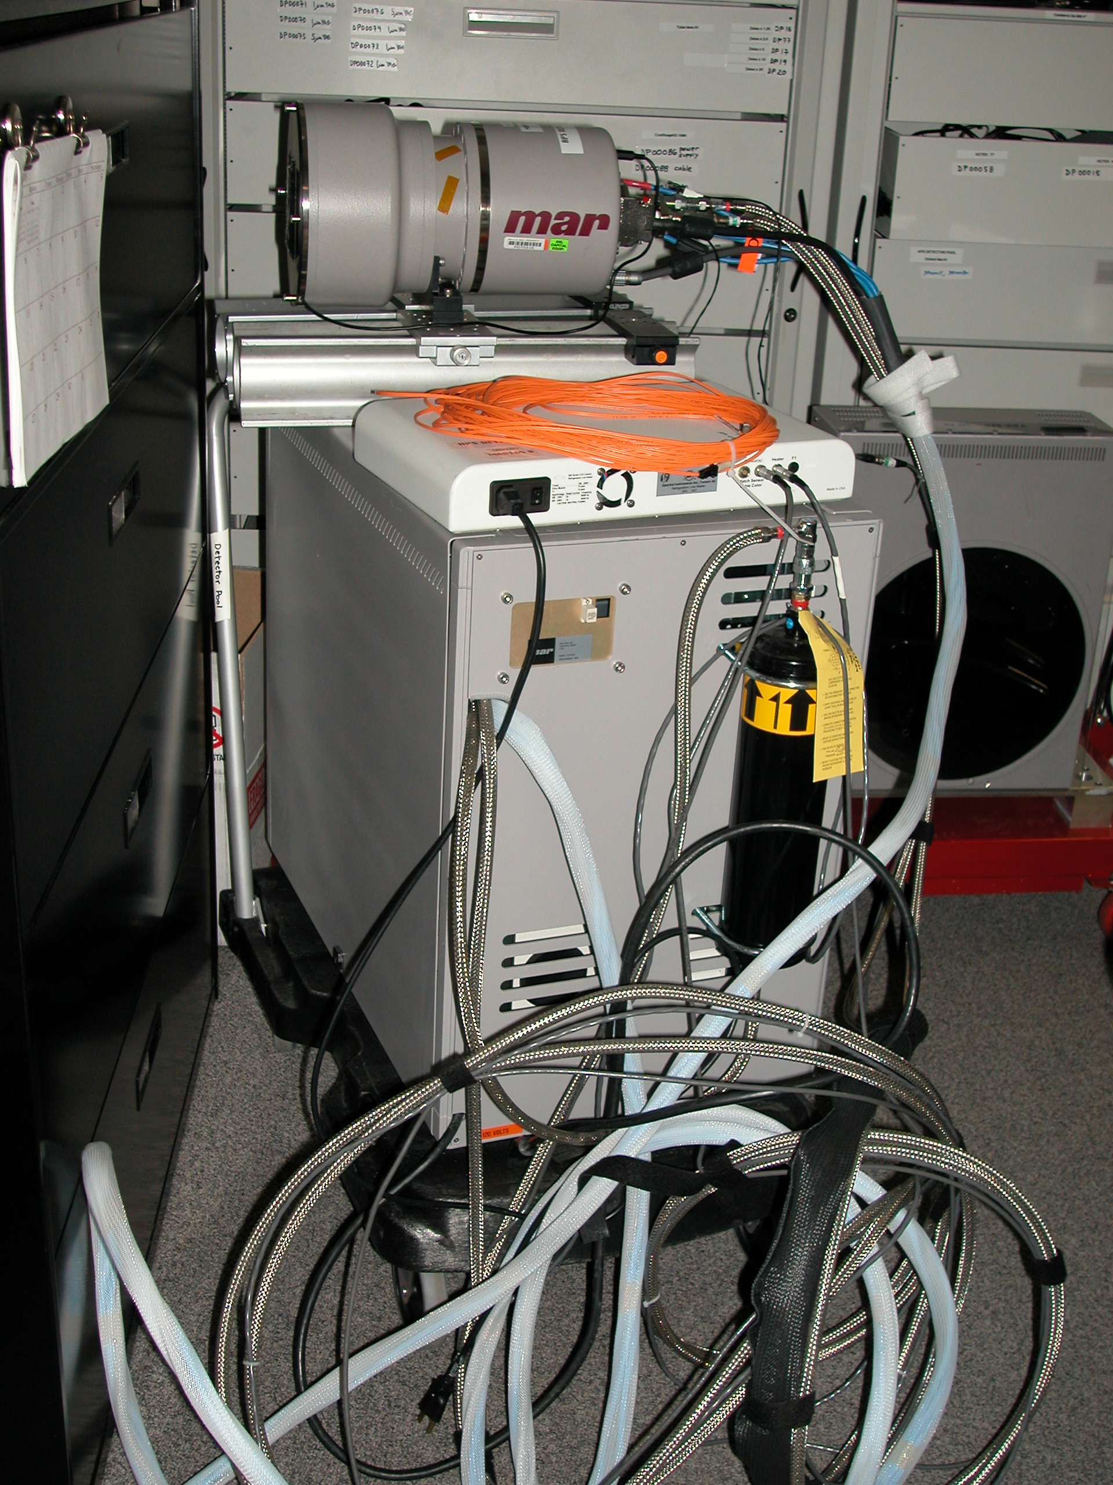
Fig. 0 Mar detector system, including chiller cabinet, CCD head, heating unit, hoses, cabels, orange fiber optic cable. Don’t mess with cables or hoses connected to CCD head. Computer not shown, as they all look the same. When delivering detector, take the cart shown in the picture, and the computer/monitor.

- Physical Connection

  - Secure the detector in the proper location in the experimental setup. The chiller cabinet and CCD go into the hutch. Fish the orange fiber optic cable out of the hutch to the lab floor, where the Linux box resides.
  - Connect orange cable to jack on Linux box, and jack on chiller cabinet. (Fig. 1, 2)
  - Turn on detector, by sticking your finger into hole in metal cabinet. Feel for rocker switch, and flip switch. Note that the rocker switch is on a power strip with 110V outlets. Look in the hole before blindly feeling around. (Fig. 3)
  - Turn on white line heater box. (Fig. 4)
  - Boot computer.

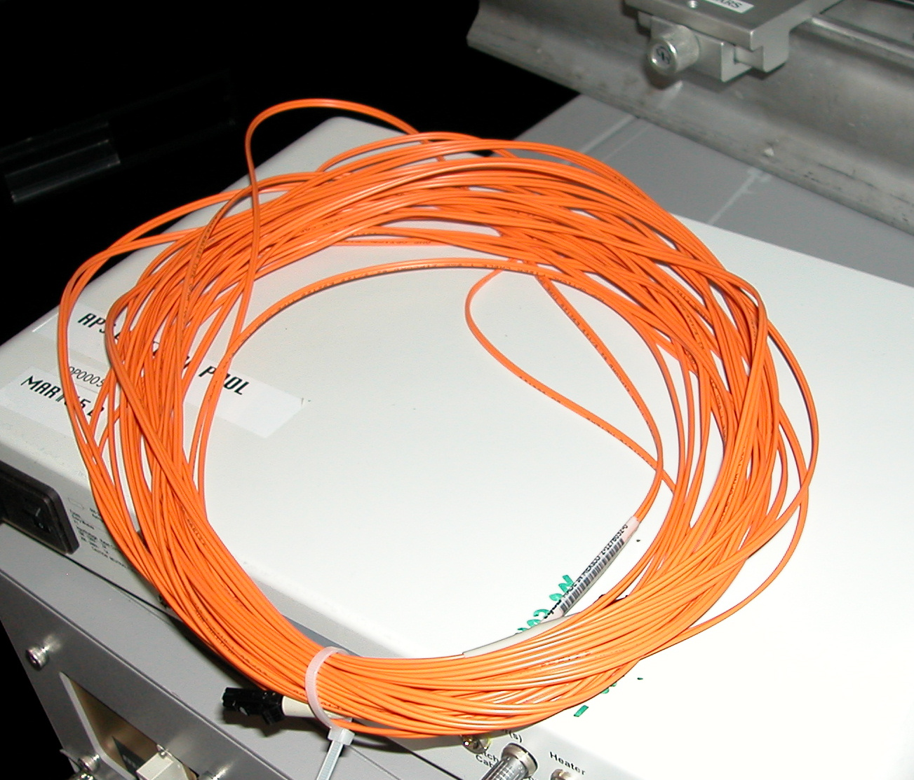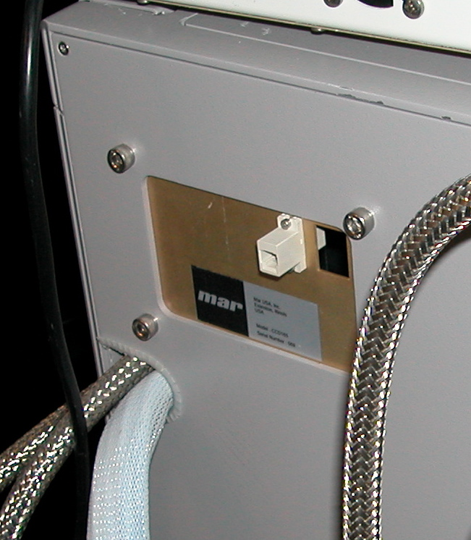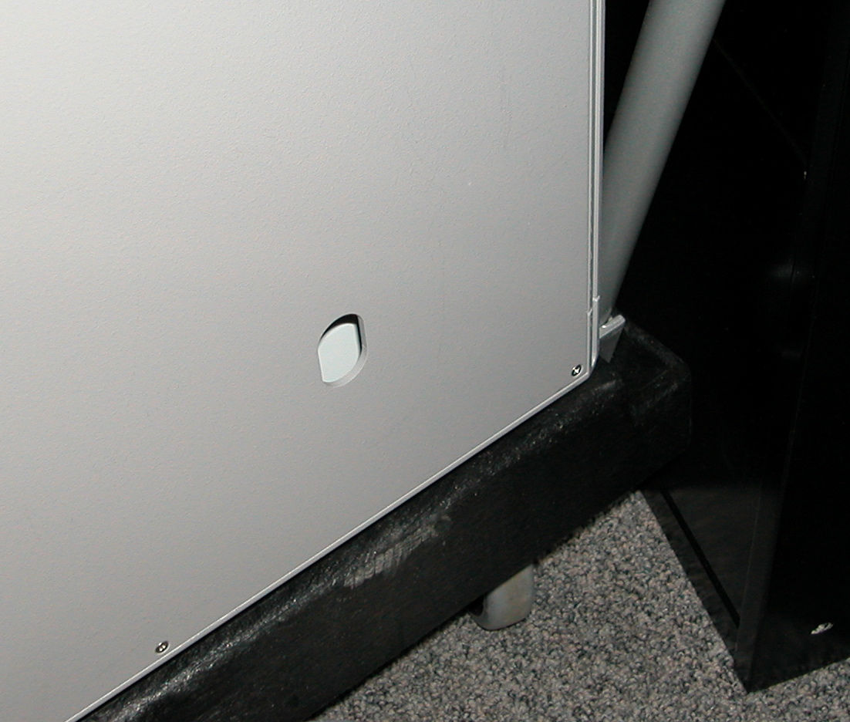
Fig.1 Orange cable. Fig.2 Jack for orange cable. Fig3. In hole is power switch.

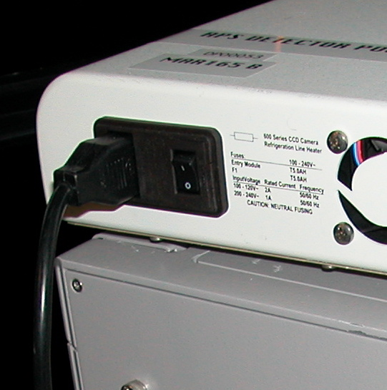
Fig 4. Turn on heater unit.

- Software Start Up (and Shut Down)

  - Log on to computer. Username: marccd, password:marccd.
  - Open new terminal.
  - Type more readme, to see a readme file with useful information.
  - Type marccd to start Mar software. You should get the main GUI for the Mar CCD system.
  - Reboot detector: Select menus: Configure→Detector. A window should appear. At bottom, select REBOOT button. Answer Yes to any redundant questions. Answer Yes to restart cooling.
  - Test Detector: Acquire single frame by selecting menus: Acquire→ Single Frame. Enter exposure time of 1s, and hit START. You should see an image appear on the main window.
  - To shut down detector system: Exit the software on the Linux box. In hutch, turn off the detector by inserting your finger into the hole in the chiller, and switching off the rocker switch. Turn off the white heater box. Shut down the computer. It is easy. Don’t worry about any complicated procedure to warm the CCD. Just turn everything off.
  - To control the cooling: Select menu: Configure→ Detector. This window has a button to turn cooling on and off. Leave it on.
  - Verify pressure. The pressure inside the evacuated CCD camera should be below 1Torr. It is shown on the main software window near the top. If not, DO NOT START THE COOLING. Just shut down the system and page the Detector Pool at 2-9490. At night, call the floor coordinator. The detector needs to be pumped out.
  - Start Remote Control: Select menus Acquire→Remote Control. A window comes up with 4 fields which must be filled in. The proper parameters are default in the Mar 165 A unit, but must be altered for the B unit (this will be fixed later). The readme file has the proper parameters. Hit the Start button to start Remote control. If the parameters are wrong, the mar software can freeze, requiring a restart.
  - Start EPICS. Open a new terminal and type start_epics. This starts a soft IOC, and MEDM. IF the computer is networked properly, the PVs will be served to EPICS.
  - Test EPICS. In the MEDM window, acquire a background image, by selecting “background” and hitting the Start button (middle, low in the MEDM window). Select “normal” and hit Start again. You should see the marccd software take images.

- Troubleshooting (based on problems that always happen)
  - Can’t take picture.
This happens when the detector is off, or needs reboot. The detector is not communicating with the PC. Check fiberoptic cable. If you can take a picture from marccd, but not EPICS, then restart the Mar remote control server, restart the EPICS server. IF that fails there is probably a network problem.
  - What if I have to reboot computer?
You can safely reboot the Linux box without damaging the CCD detector. Just leave the detector on, and reboot the computer. The detector will take care of itself. When restarting marccd, you must reboot the detector as in (3) below.
  - What if I have to turn off and on the detector?
See above instructions (D). Just turn off the detector, turn it on. Reboot the detector from marccd software menu Configure→Detector, REBOOT.
  - Can’t get Spec to control detector.
Detector is not running server, or detector is not on network, or on wrong subnet. Check to see if mar server is running, EPICS is running. Check subnet with ifconfig.
  - EPICS PVs white in MEDM.
This happens when the soft IOC is not working right. Reboot the soft IOC. If that does not fix it then check the network. If the PC is not on the network correctly, the IOC will not serve the PVs properly, even to a local EPICS client. Fix the network.
  - Calibration Files
  - What is wrong with the Network?
Because of ANL’s enhanced computer security, getting the Mar onto the network at a beamline is a headache. The most common problem is that the subnet at the beamline does not recognize the MAC address of the detector PC. Type ifconfig to get the MAC address. Set up the detector for DHCP (it should already be). A Sysadmin person must configure the network to allow the Mar to get onto the subnet. As firewalls are constantly changing, and the detector moves all around the ring, the network always breaks. The best advice is to test the detector in the morning, so computer people can fix the network after lunch.
  - Pressure reads ???
The CCD detector is not communicating with the PC. Restart everything, to try to get the system working again. Go through the aforementioned startup procedure.
  - Detector will not turn on.
This happens when fuses inside the chiller cabinet blow. Call DP staff to replace fuses.

- Whom to call.

Floor coordinators. (24 hours)
DP engineers at 2-9490. (M-F 9-5)

