Natural Resources Conservation Service
6200 Jefferson NE
Albuquerque, New Mexico 87109
Phone: (505) 761-4400 Fax: (505) 761-4462
Web site: www.nm.nrcs.usda.gov
_________________________________________________________________________________________________________

May 25, 2005

New Mexico AGRONOMY TECHNICAL NOTE NO.73

SUBJECT: ECS – HOW TO MONITOR RESIDUE

Purpose: To distribute an Agronomy Technical Note No. 73.

Effective Date: When received.

Filing Instructions: Maintained on web page.

Attached is Agronomy Technical Note 73. This should help when identifying visual estimates of crop residue. Use this to get a mental picture of various levels of small grain reside. Take this with you to your fields to compare your levels of residue with these pictures.

GEORGE CHAVEZ
State Resource Conservationist

Attachment

Picture your residue

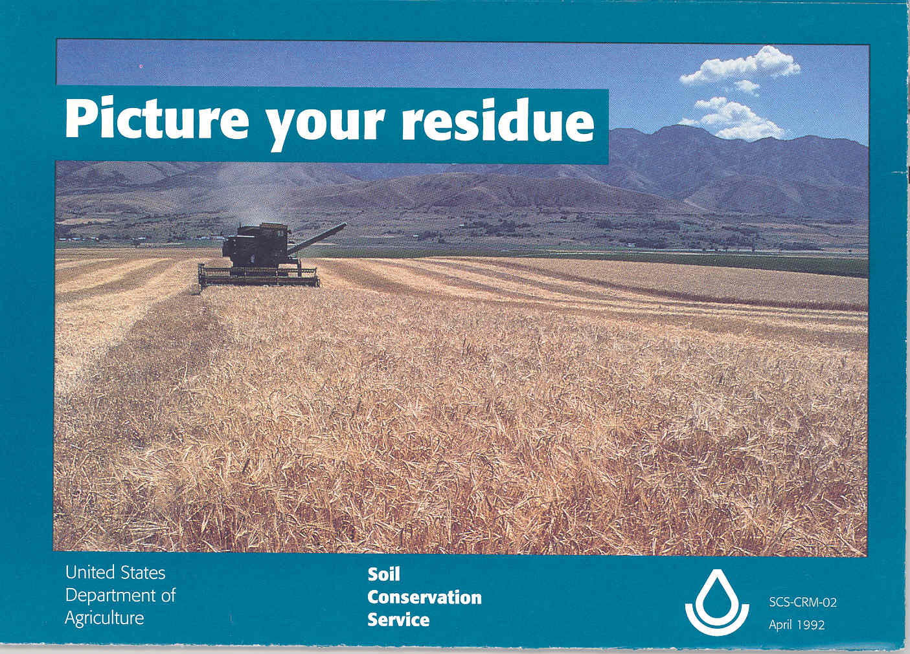

Look down, not out across the field, for an accurate estimate of ground cover

To get an idea of the amount of crop residue on your fields, it can be helpful to make a visual estimate.

Use these photographs to get a mental picture of various levels of small grain residue. Take this with you to your fields to compare your levels of residue with these pictures.

The effectiveness of ground cover depends on both the amount of crop residue and its distribution. Evenly distributed residue provides the best protection.

It’s easy to over-estimate residue levels by looking out across a field. From that perspective, residue appears to cover most of the ground.

For a true picture, look straight down at the field, as was done with these pictures. Ask yourself what percent of the ground is covered with residue.

You’ll develop confidence in your ability to visually estimate residue levels by using these photographs and measuring residues a number of times.

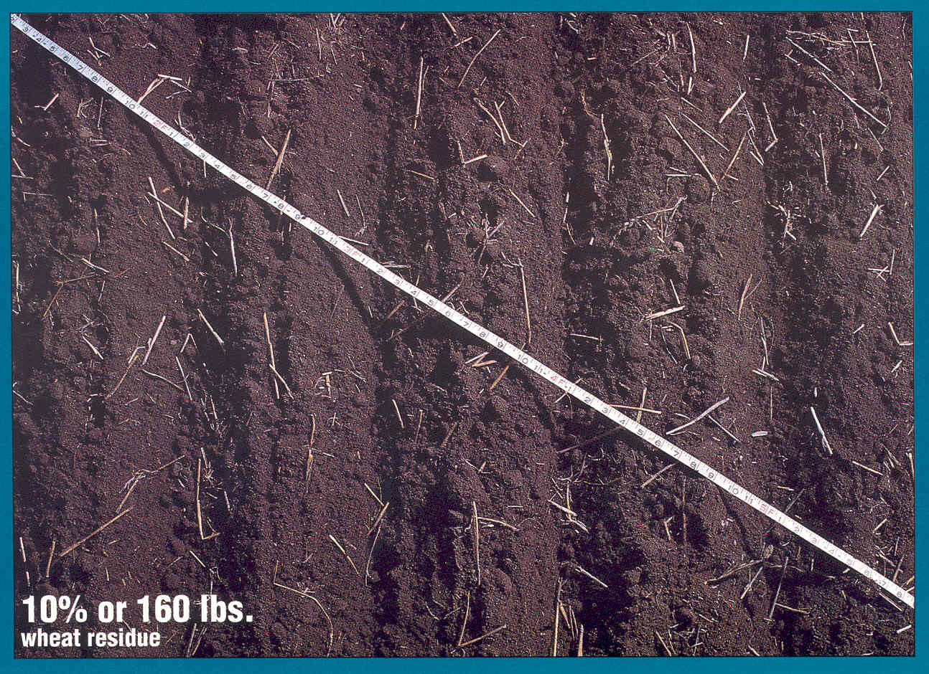

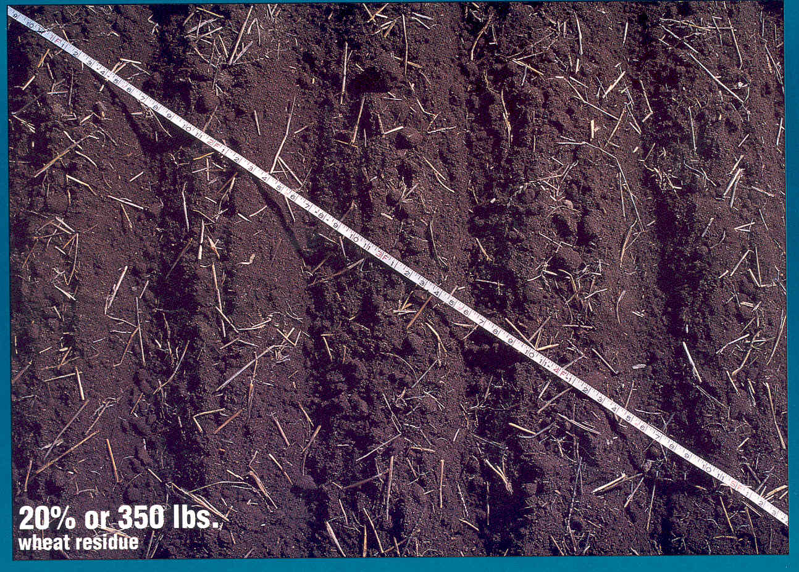

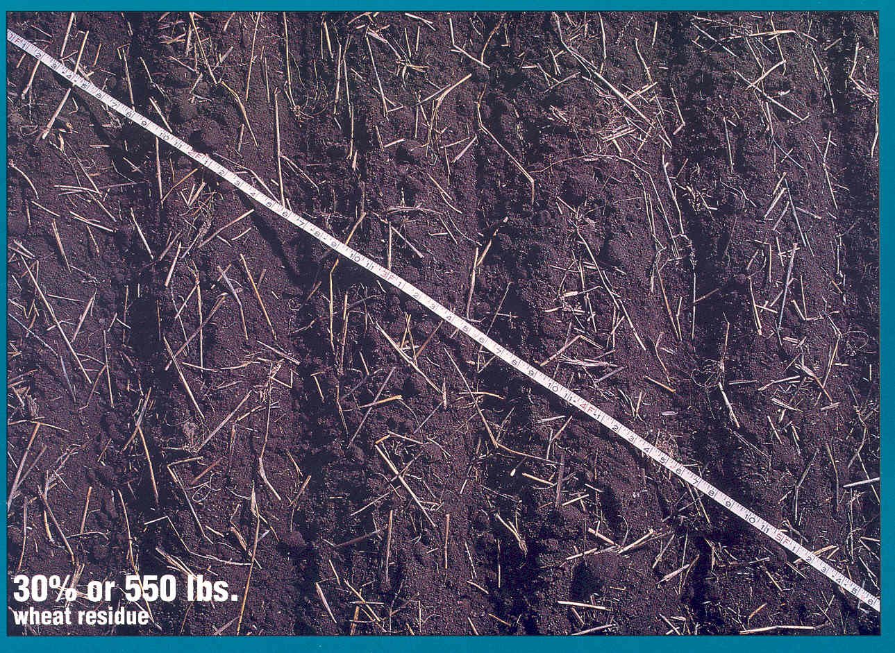

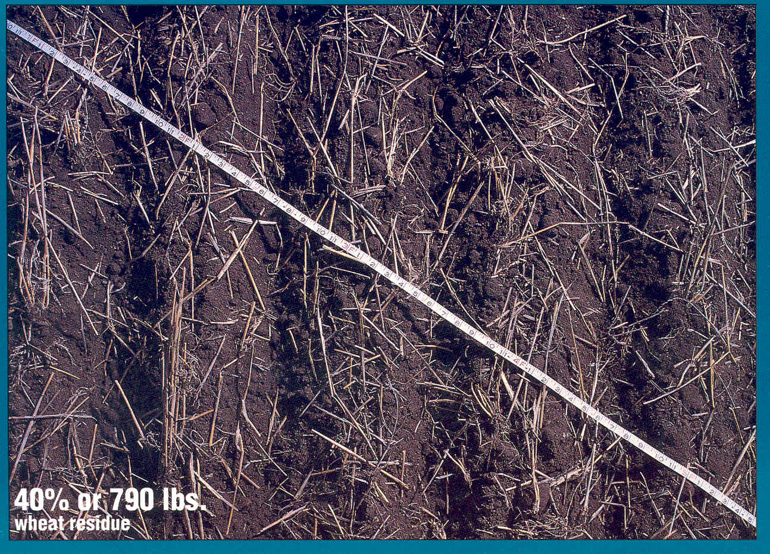

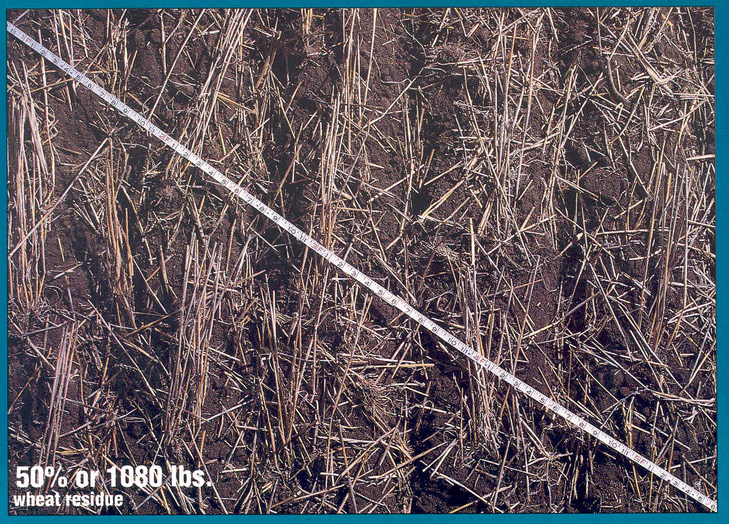

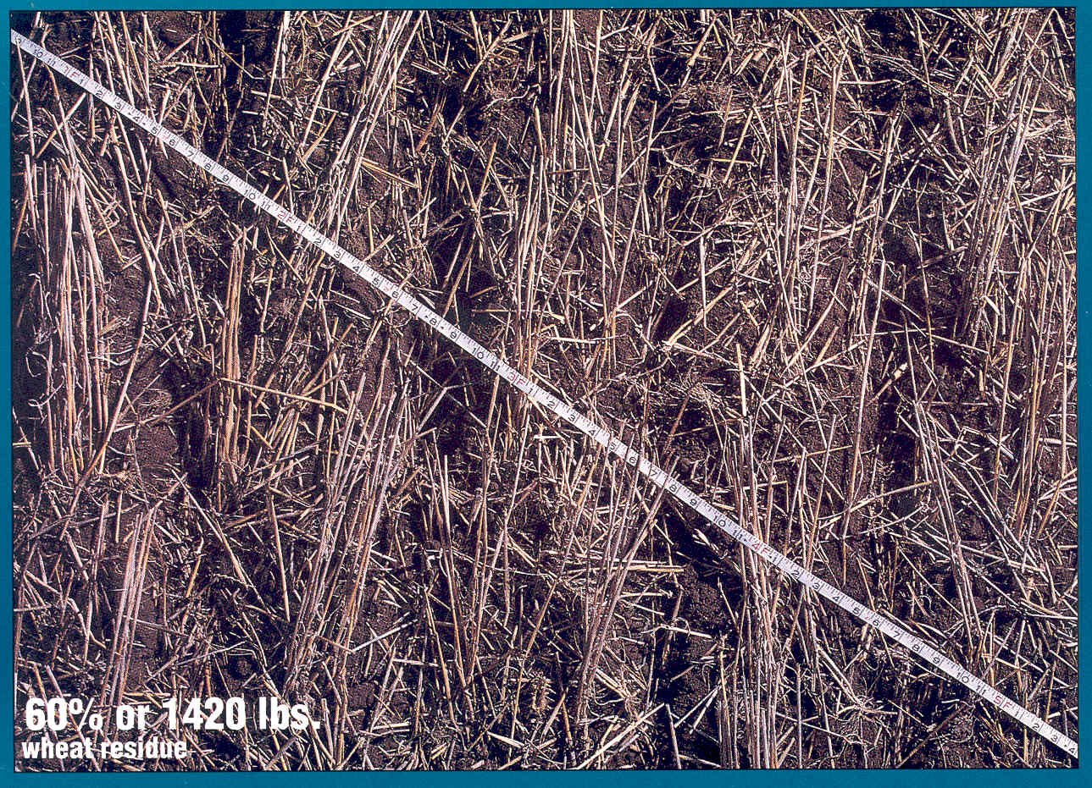

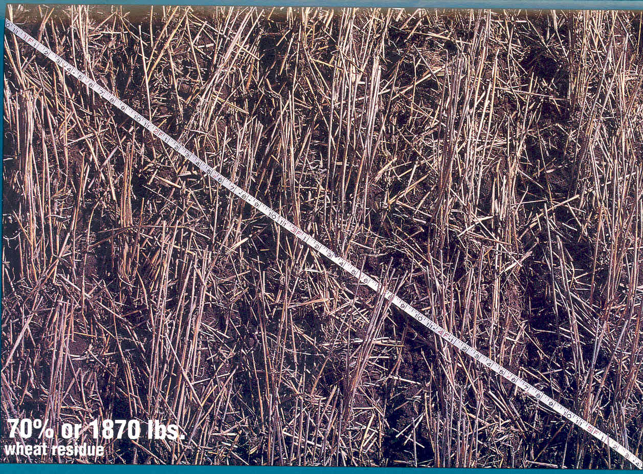

Can you pass the residue test?


Do you know how much crop residue is called for in your conservation plan?

Your conservation plan tells you how much residue you need to maintain. It also tells you when you need that residue cover. Residue is measured before the critical erosion period-the time when there is the greatest potential for erosion to occur.

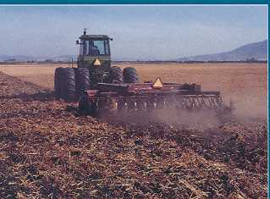

Does your tillage and cropping system allow for leaving that amount of residue?

Points for higher residue levels

The point or blade of a tillage implement can make a big difference in crop residue levels. For example, a shallow chisel plow with sweeps could leave up to 85 percent of the existing residue on the surface while a deep disk chiseling with 4-inch twisted points could leave as little as 30 percent of the residue on the surface.

Consider using the tillage points that bury less residue like those featured on these pages. Use the values under the photos as a guide. Your best guide will come from monitoring residue before and after each tillage pass.

Blades

Blades, often in a V-shape, undercut the residue and disturb very little of the small grain residue on the soil surface. Blades that are 30 or more inches wide will leave about 85-95% of the small grain residue that existed before a pass with a blade.

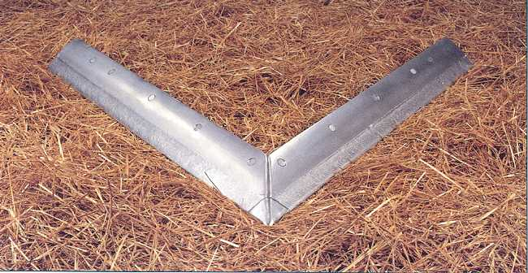

Residue management begins at harvest. This is the starting point for any residue management system; it’s also when you have maximum ground cover.

Write down the sequence of tillage and planting operations you are planning.

Estimate how each operation will affect residue levels. Your local SCS office has charts that will help you make those estimates.

Compare the amount of residue you estimate with the residue target in your conservation plan.

If it is more than the residue level called for in your conservation plan, you’re doing okay. If you fall short of the residue targeted in your conservation plan, try deleting an operation in the sequence and see how it impacts the residue amount.

Your goal here is to follow a tillage sequence that will leave enough residue to meet your conservation and production goals.

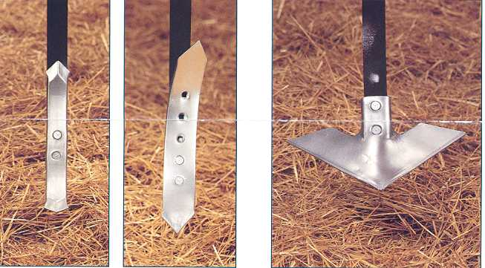

Straight and twisted points
Straight points and twisted points have been used for years on chisel plows. Straight points turn and mix the soil less than twisted points. In small grain residue, straight points leave 60 to 80% of the residue that existed before a pass. Twisted points leave 50 to 70 % of the small grain residue that existed before one pass.

Sweeps
Sweeps can be operated shallow or as deep as 10 inches. Sweeps with low crowns fracture and loosen the soil but turn it very little. In small grain residue, chisel plows with 12-inch sweeps can leave 70 to 85 % of the residue that existed before the pass.

Photos courtesy of Successful Farming

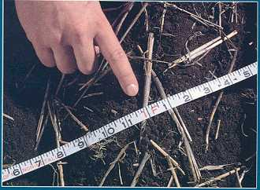

Did you measure that percent ground cover?

Measuring residue cover in the field after an operation is a way to verify that your actual tillage operations are leaving the amount of residue you predicted.

When residues are laying flat and randomly distributed, the line-transect method is one of the easiest field sampling procedures to estimate percent residue on the surface.

This method is not appropriate for standing stubble.

- Use any line that is equally divided into 100 parts. Fifty foot cable transect lines are available for this purpose. Another tool is a 50-foot nylon rope with 100 knots or marks, six inches apart. A 50-foot tape measure using the 6-inch and foot marks also works well.

- Stretch the line diagonally across the field. Walk back along the line and count the number of times a piece of residue lies under one edge of a mark.

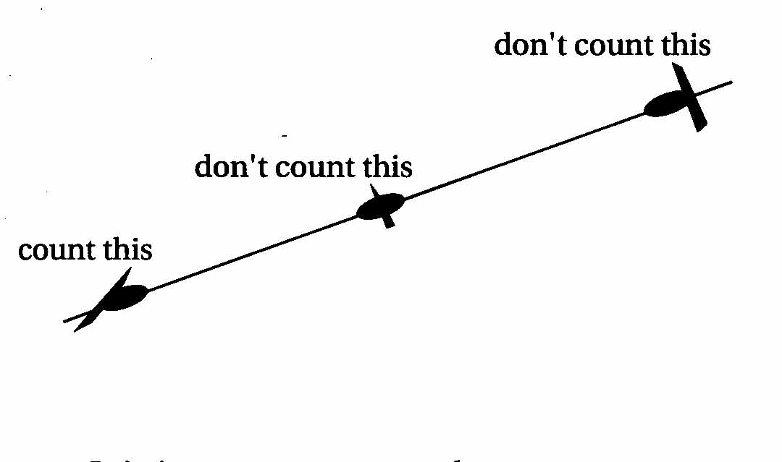

- It is important to use the same point on each mark for accuracy. Don’t count residue smaller than 1/8-inch in diameter.

- Walk the entire length of the string, rope or tape. The total number of marks with residue under them is the percent cover for the field.

Your best estimate of residue cover can be obtained by averaging at least three representative locations in the field. Avoid measuring areas not representative of the whole field, such as end rows, field edges, or areas of tillage overlap.

Leave it standing in the wind

Standing stubble is more effective in controlling wind erosion than residue that is flat on the ground. Standing stubble is also less likely to be buried during tillage operations.

To get the best wind erosion protection from standing stubble:

- Use undercutting type tillage; it disturbs standing stubble the least.

- Minimize tillage passes; wheel traffic will tend to flatten residue.

Percent ground cover to pounds residue
The required crop residue may be expressed in percent ground cover in some plans and in pounds per acre in other plans. This table should be used to make the conversion from percent ground cover to pounds of residue.  Residue weight varies with the variety of small grain grown. Some varieties might convert to more pounds than indicated on the table.  Your SCS office may have a table that better represents the small grain varieties grown in your area | % cover | lbs. per acre | % cover | lbs. per acre
 | 5 | 80 | 55 | 1240
 | 10 | 160 | 60 | 1420
 | 15 | 250 | 65 | 1630
 | 20 | 350 | 70 | 1870
 | 25 | 450 | 75 | 2150
 | 30 | 550 | 80 | 2500
 | 35 | 670 | 85 | 2940
 | 40 | 790 | 90 | 3570
 | 45 | 930 | 95 | 4650
 | 50 | 1080 | 99 | 7140


If you answered “yes”
to these questions
YOU PASS

