Debris Photos

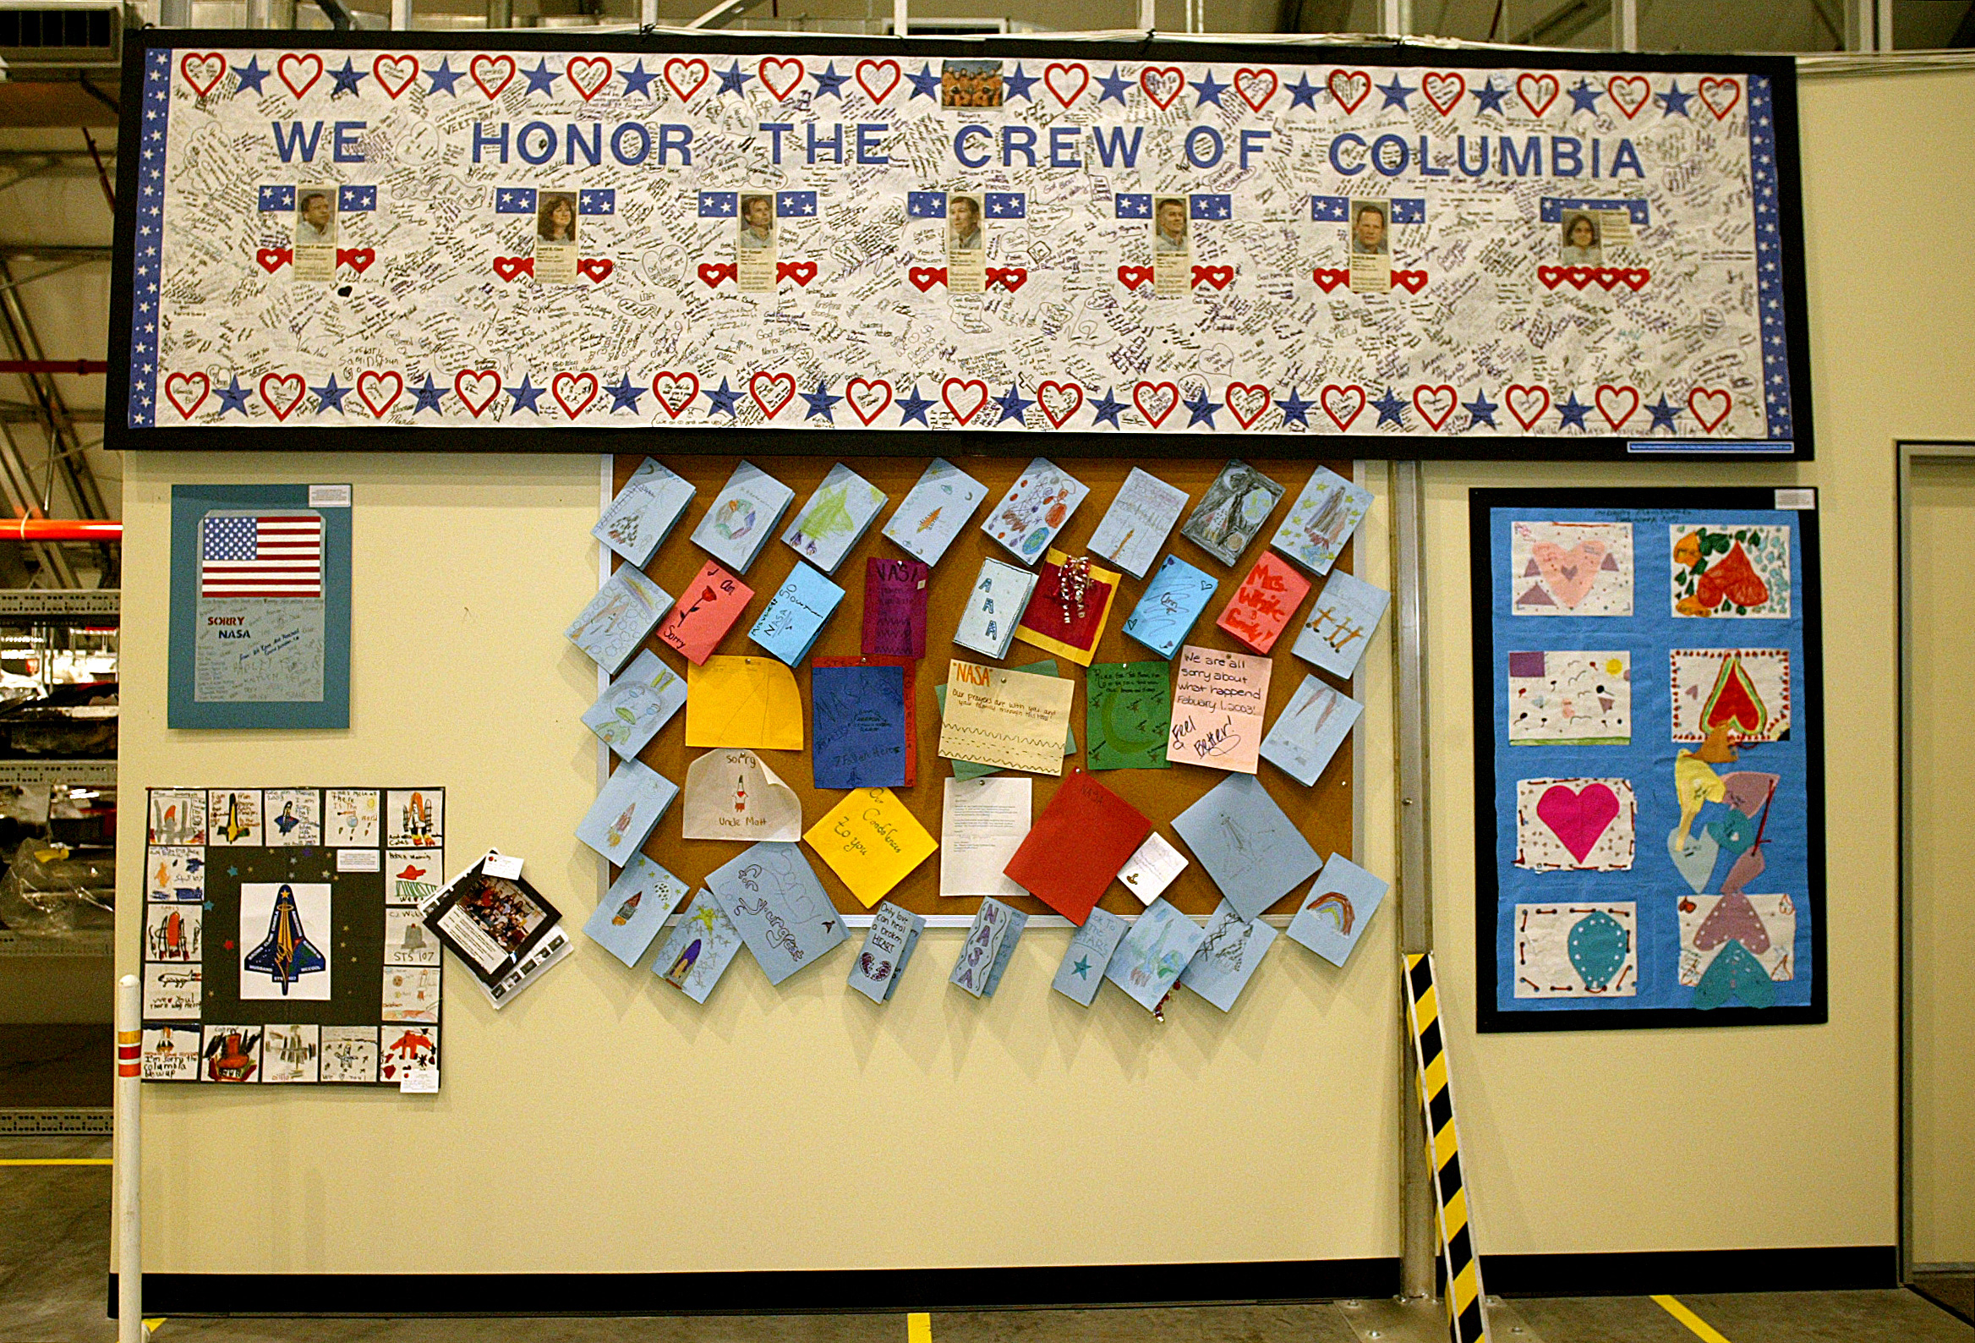
Various cards and letters from children hanging on a wall in the Columbia reconstruction hangar at JSC. Photographed at the Columbia reconstruction hangar at KSC on March 3, 2003. CAIB Photo no photographer listed 2003 < CardsBannersEtc>

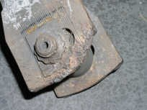
Closeup of a left main landing gear uplock roller from STS-107. Found Feburary 19, 2003 near Chireno, TX. CAIB Photo no photographer listed 2003 < closeuproll>

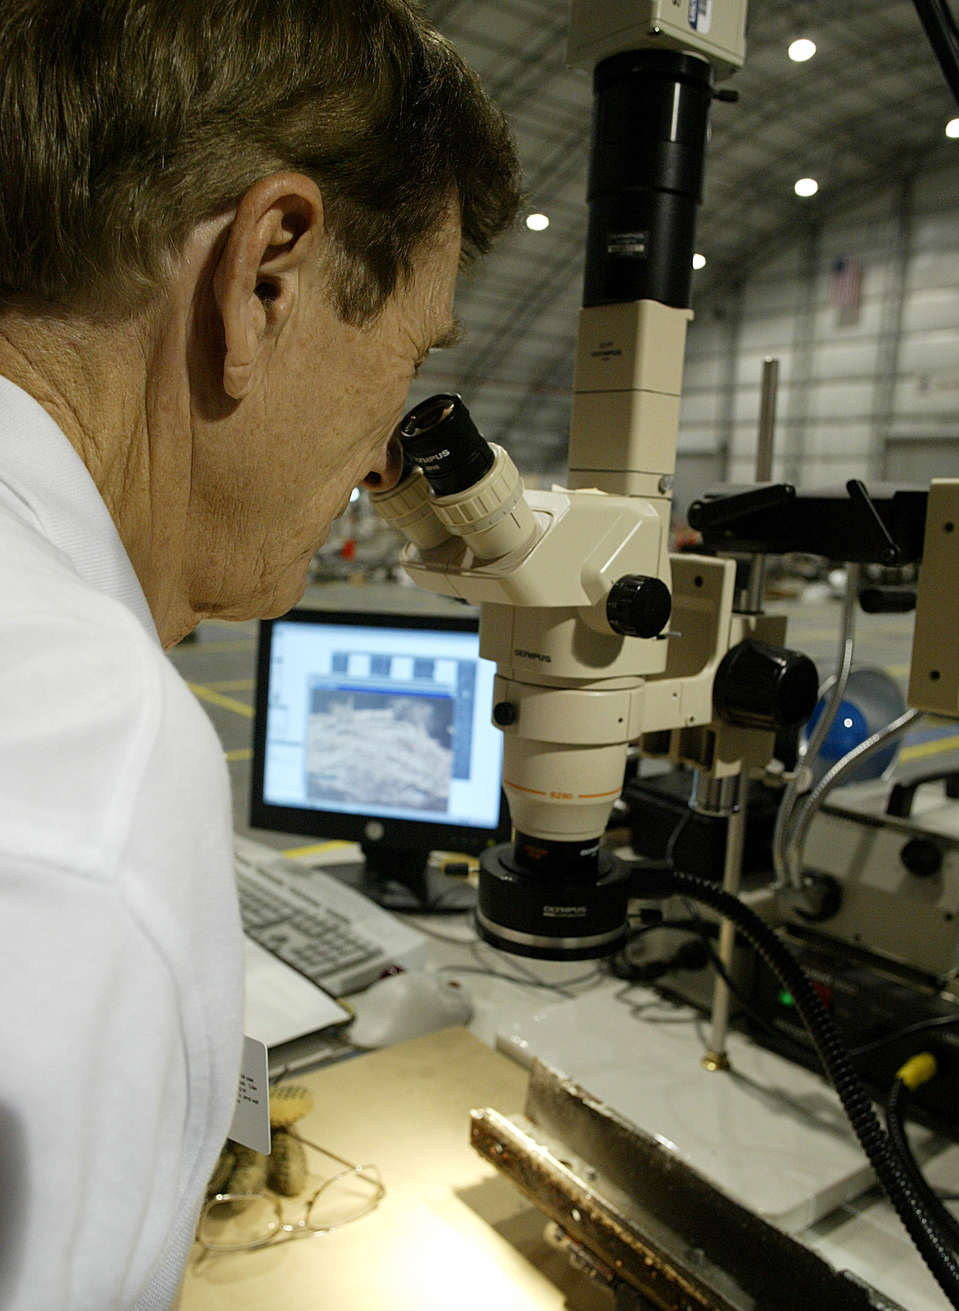
A Reconstruction Team member examines debris with a video-microscope searching for clues that will give investigators a better understanding of the events leading to the cause of the orbiter break-up. CAIB Photo no photographer listed 2003. < Microscope1>

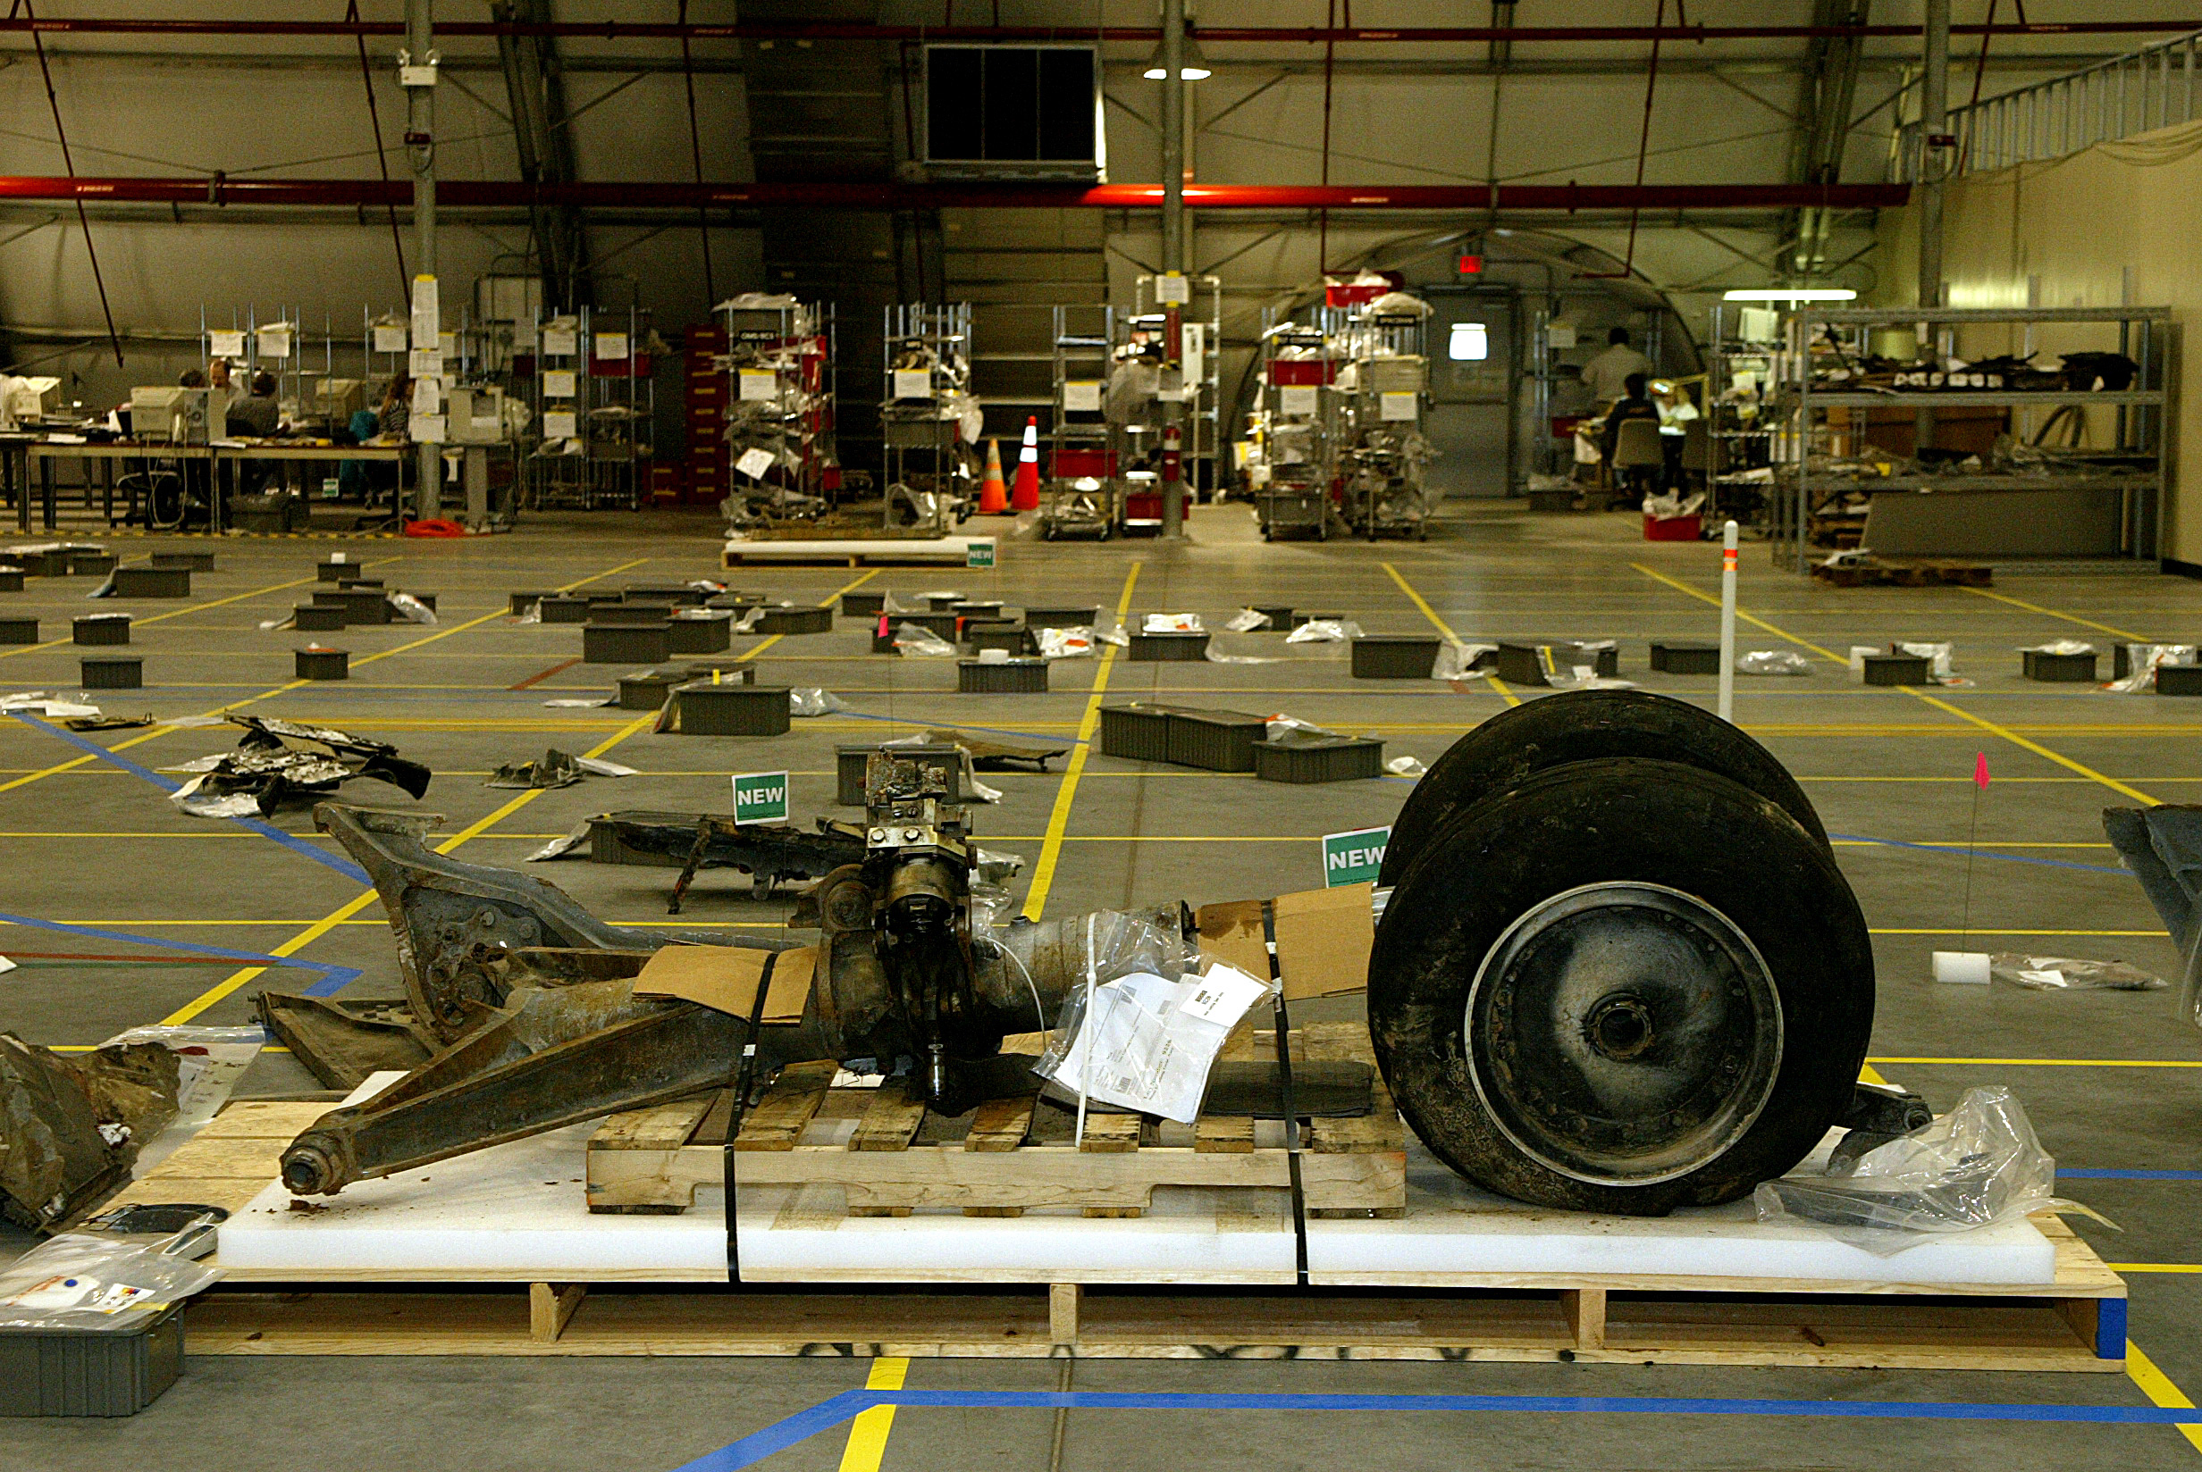
One of the larger pieces of recovered debris is Columbia's nose gear shown here with tires still intact. CAIB Photo no photographer listed 2003 < NoseGear 1>

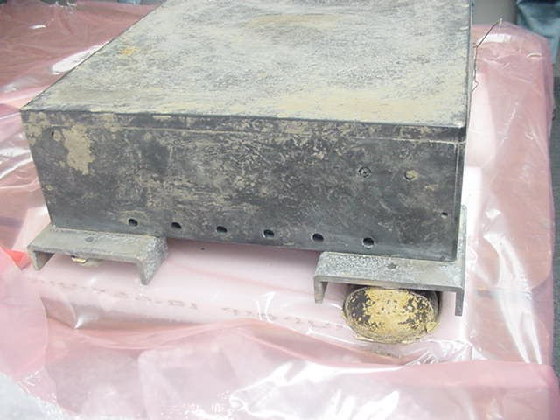
Columbia Data Recorder. CAIB Photo no photographer listed 2003 <OEX1>

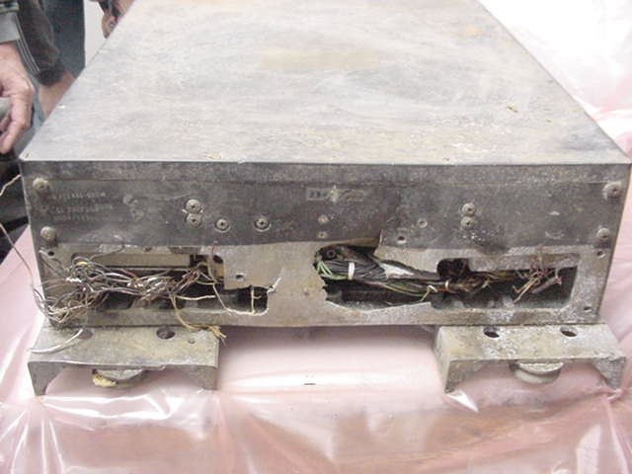
Columbia Data Recorder. CAIB Photo no photographer listed 2003 <OEX3>

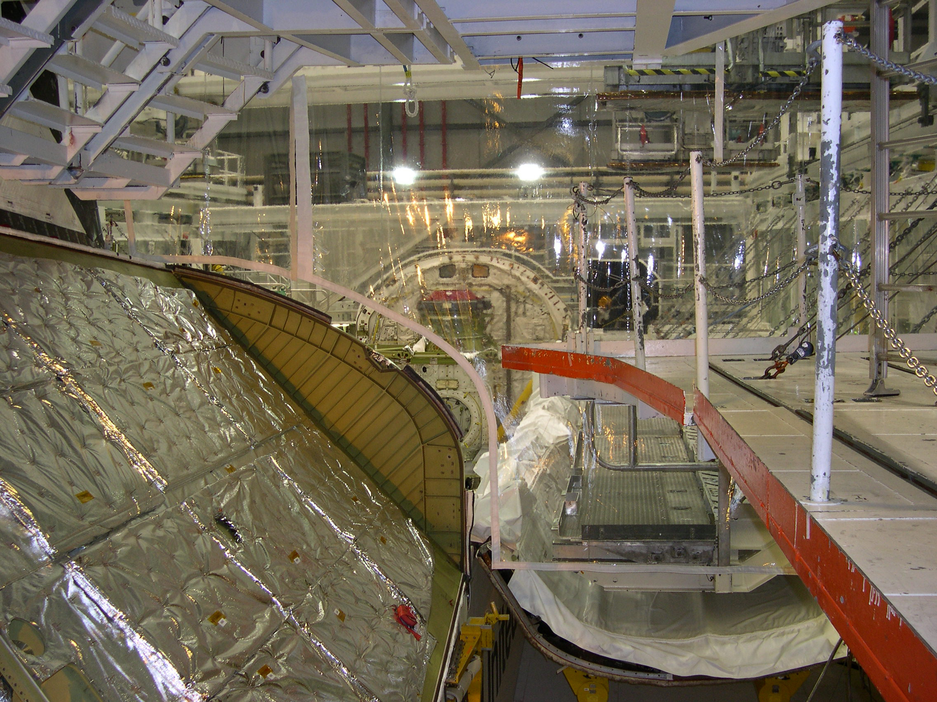
Orbiter Processing Facility. CAIB Photo no photographer listed 2003 < STS-107-DSCN0070>

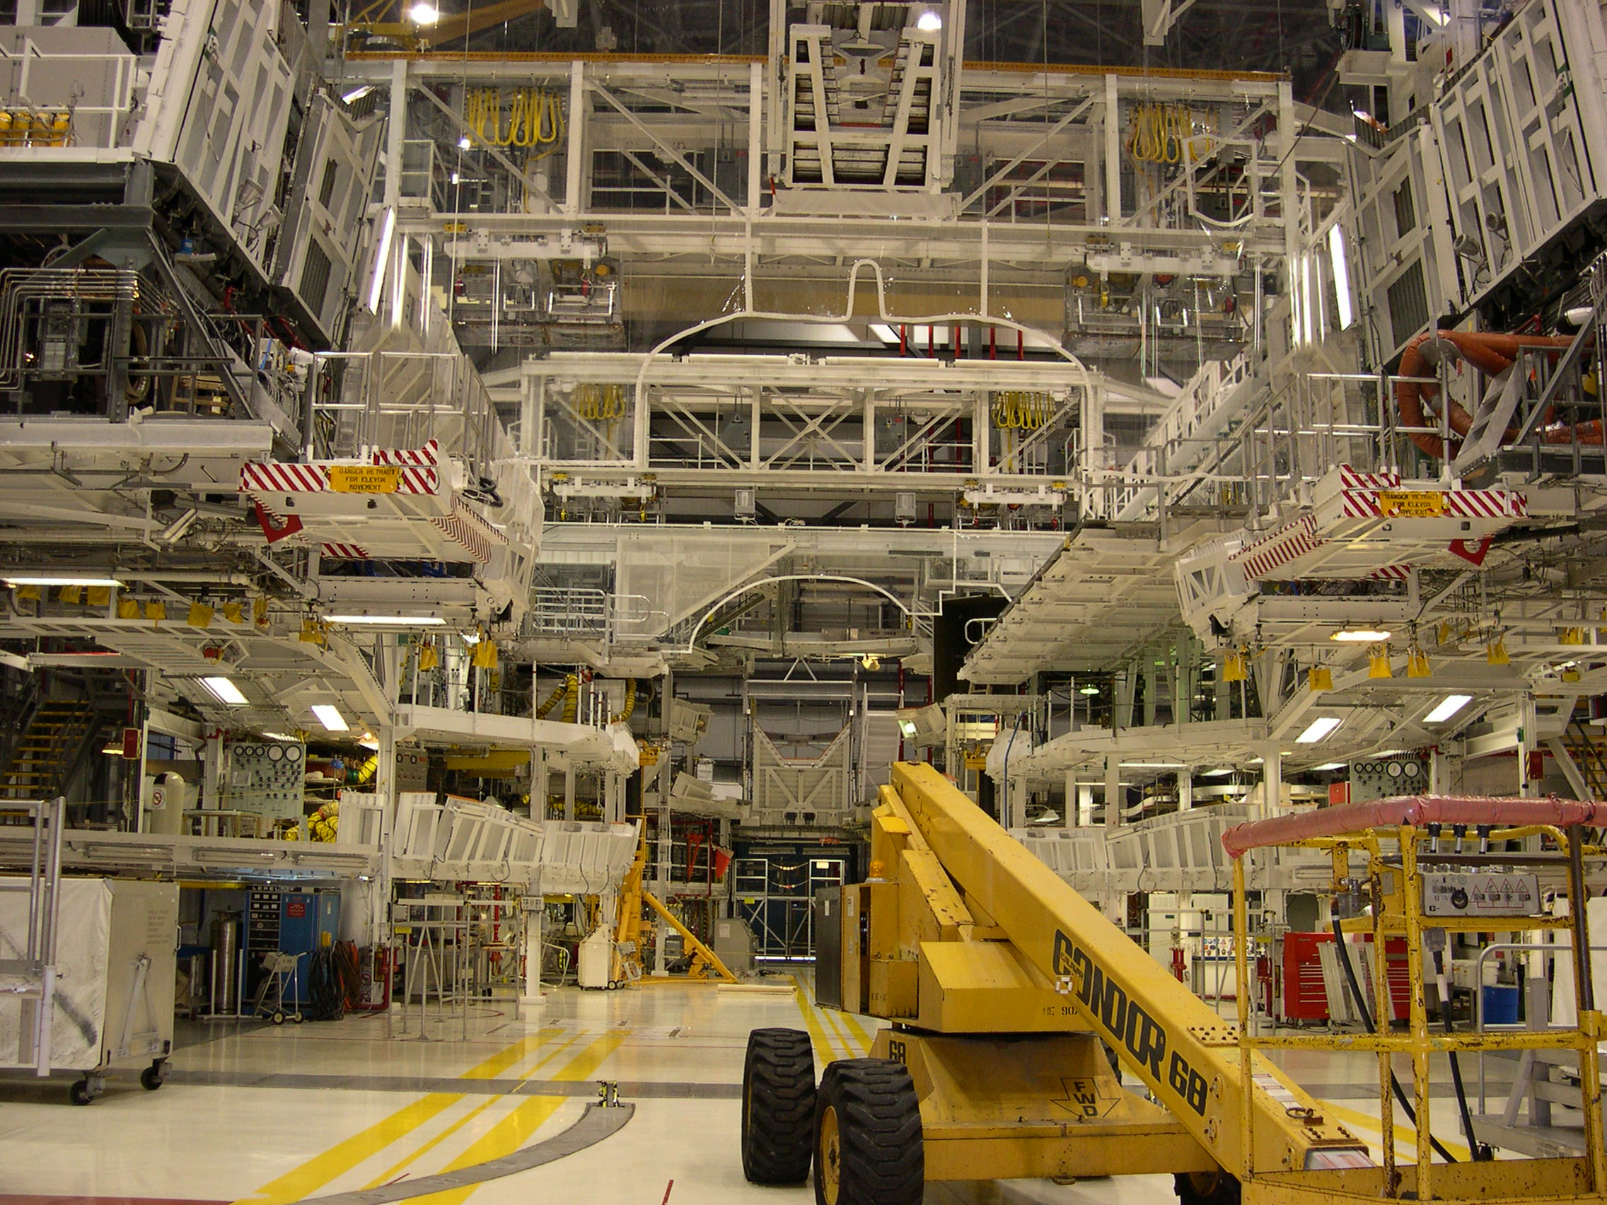
Orbiter Processing Facility. CAIB Photo no photographer listed 2003 < STS-107-DSCN0218>

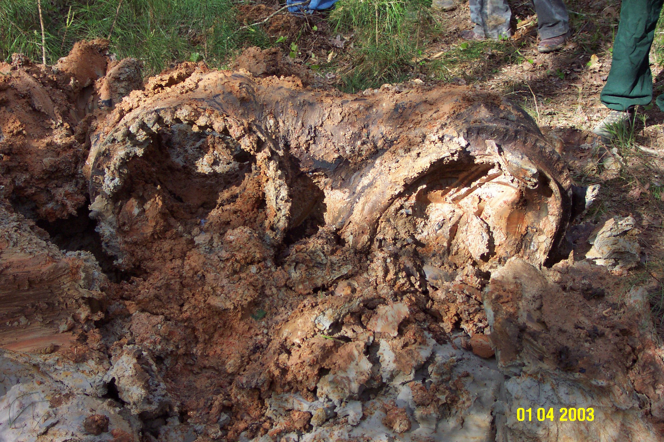
Columbia main engine powerhead recovered from Fort Polk in Louisiana. CAIB Photo no photographer listed 2003 < STS-107-powerhead1>

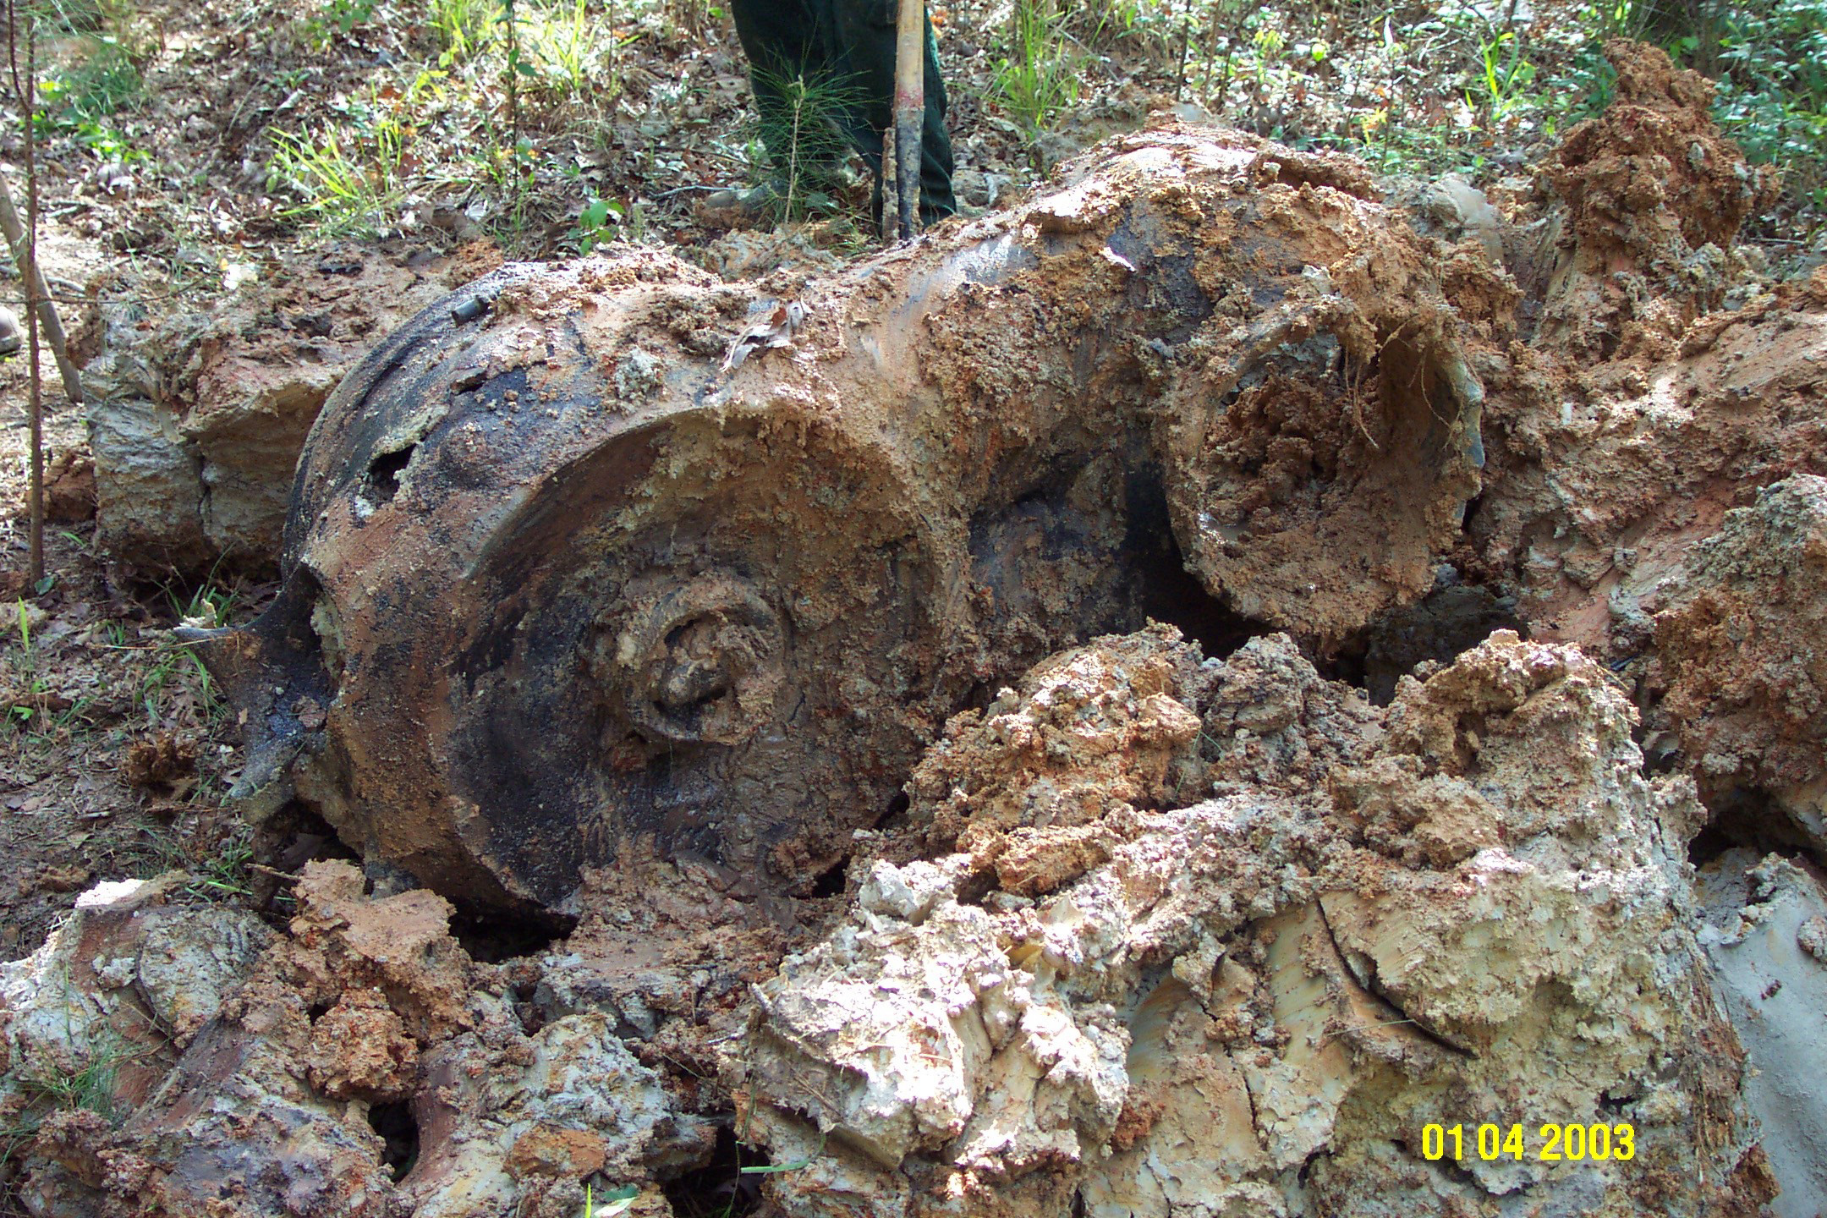
Columbia main engine powerhead recovered from Fort Polk in Louisiana. CAIB Photo no photographer listed 2003 < STS-107-powerhead2>

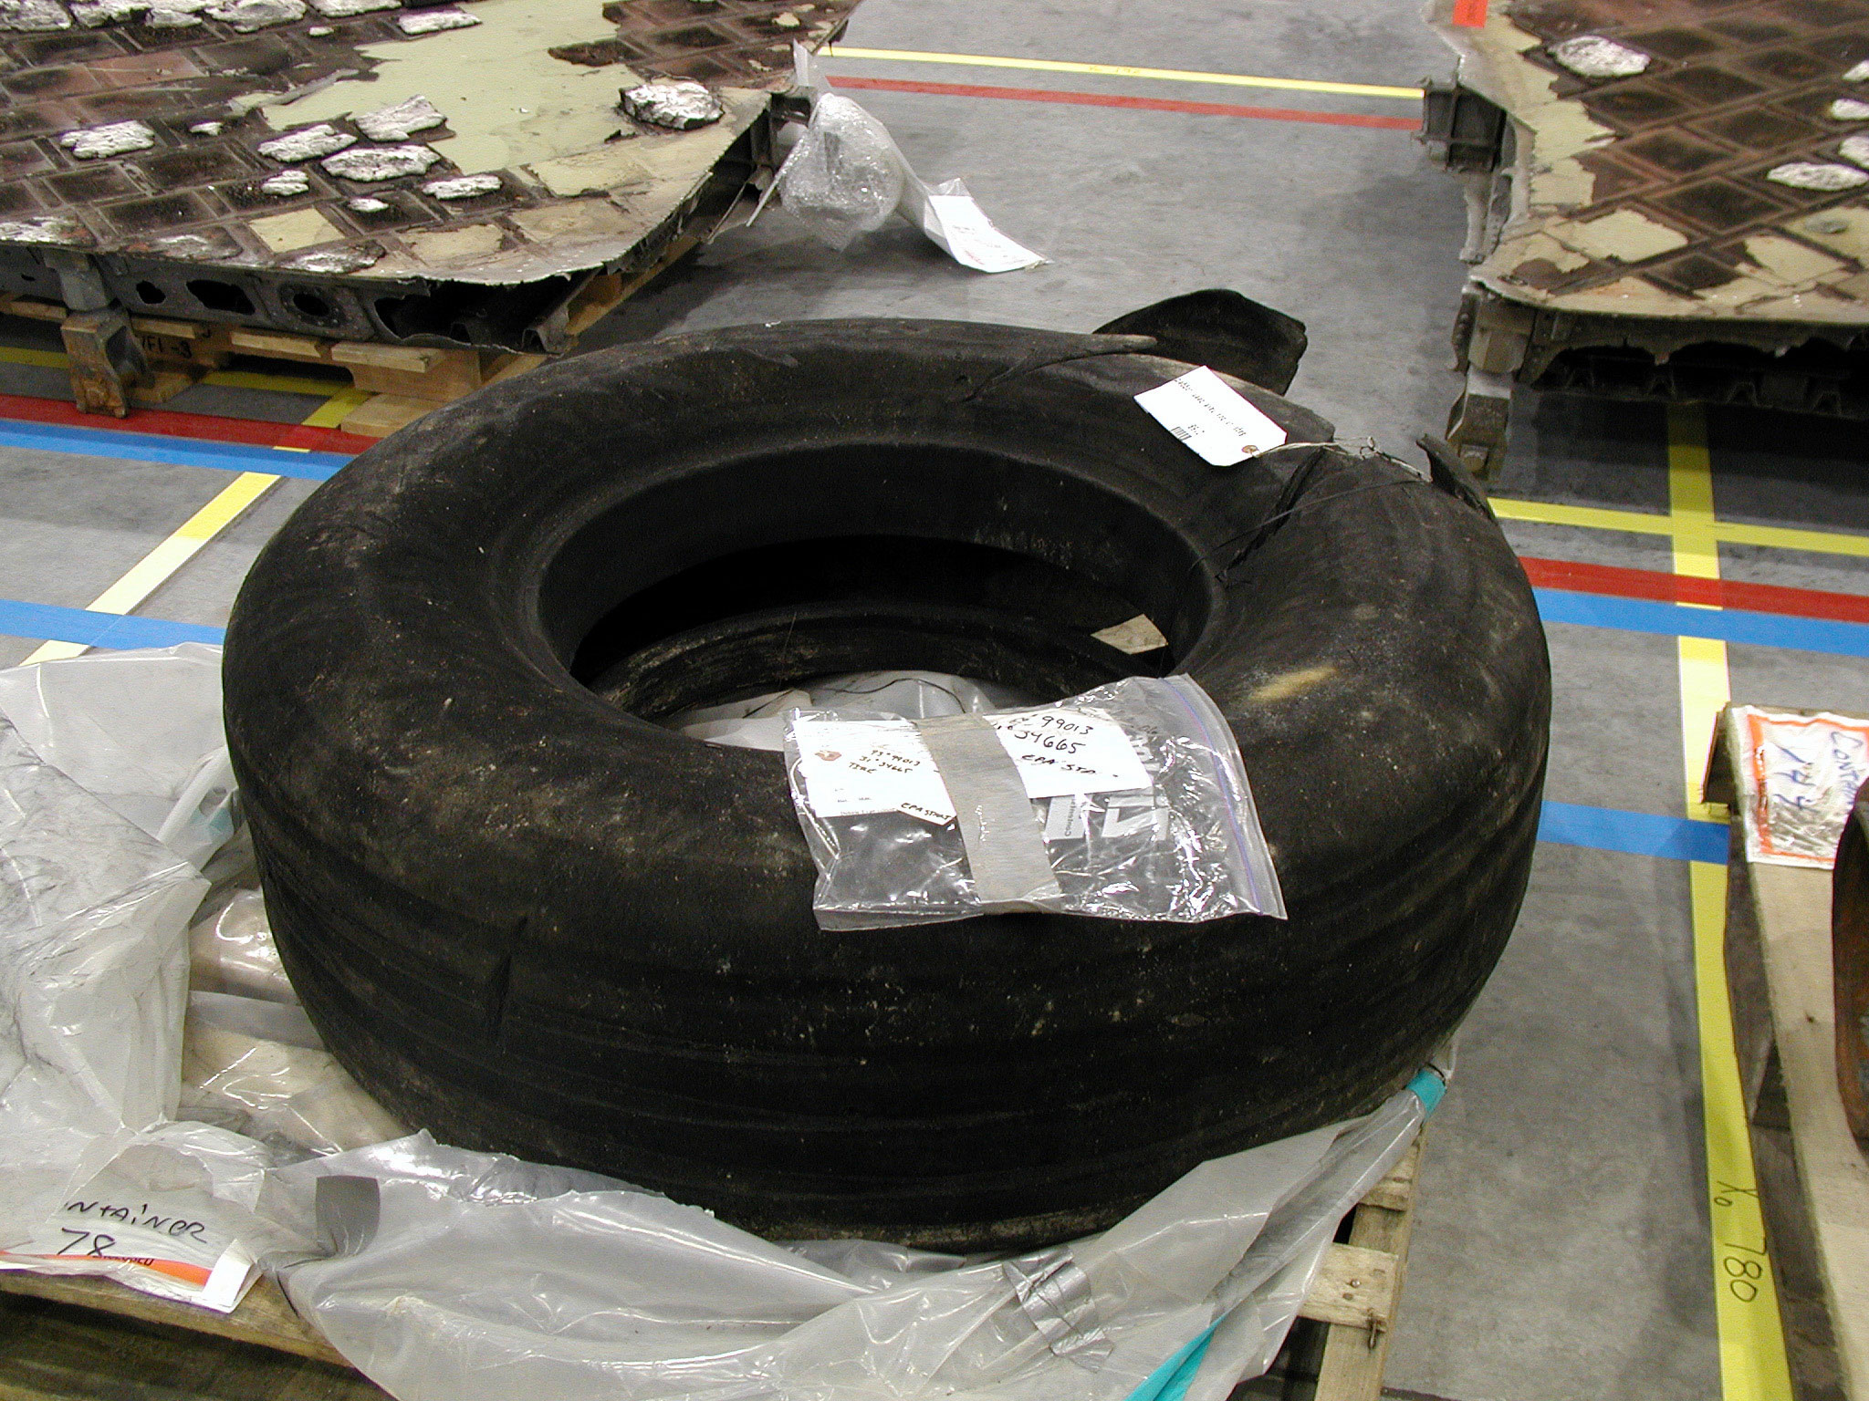
One of the right main landing gear tires from STS-107. CAIB Photo no photographer listed 2003 < STS-107-right_mlg_tire>

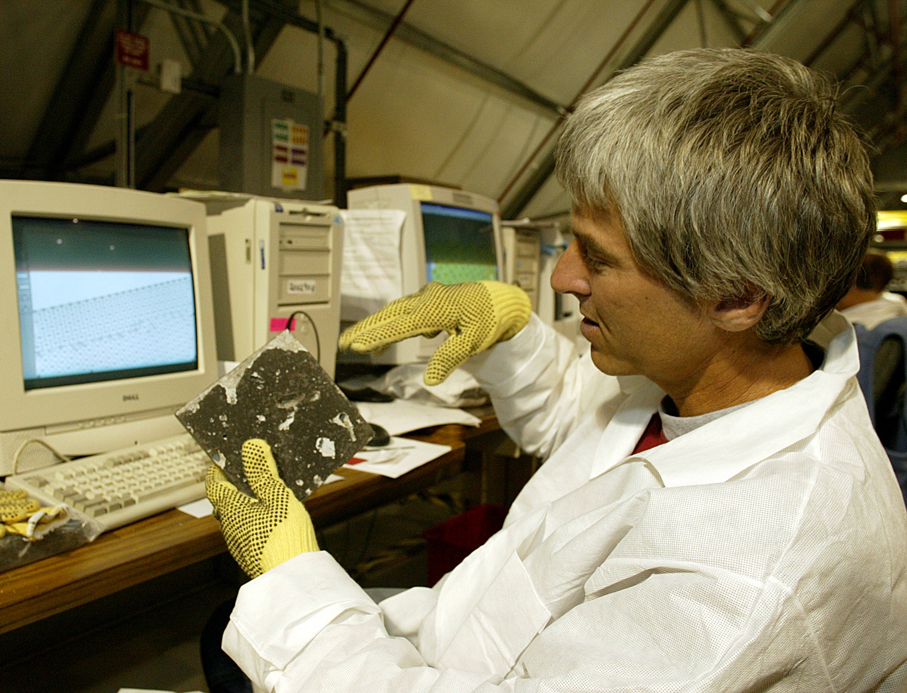
A Reconstruction Team member identifies recovered TPS (Thermal Protection System) Tiles. Columbia had more than 20,000 tiles on its surface. CAIB Photo no photographer listed 2003 < TileID2>

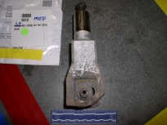
Main landing gear uplock roller from STS-107 (same as above). Found February 19, 2003 near Chireno, TX. CAIB Photo no photographer listed 2003 < uplockroller>

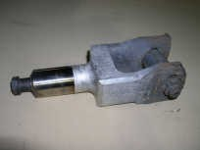
Main landing gear uplock roller from STS-107 (same as above). Found February 19, 2003 near Chireno, TX. CAIB Photo no photographer listed 2003 <uplockroller2>

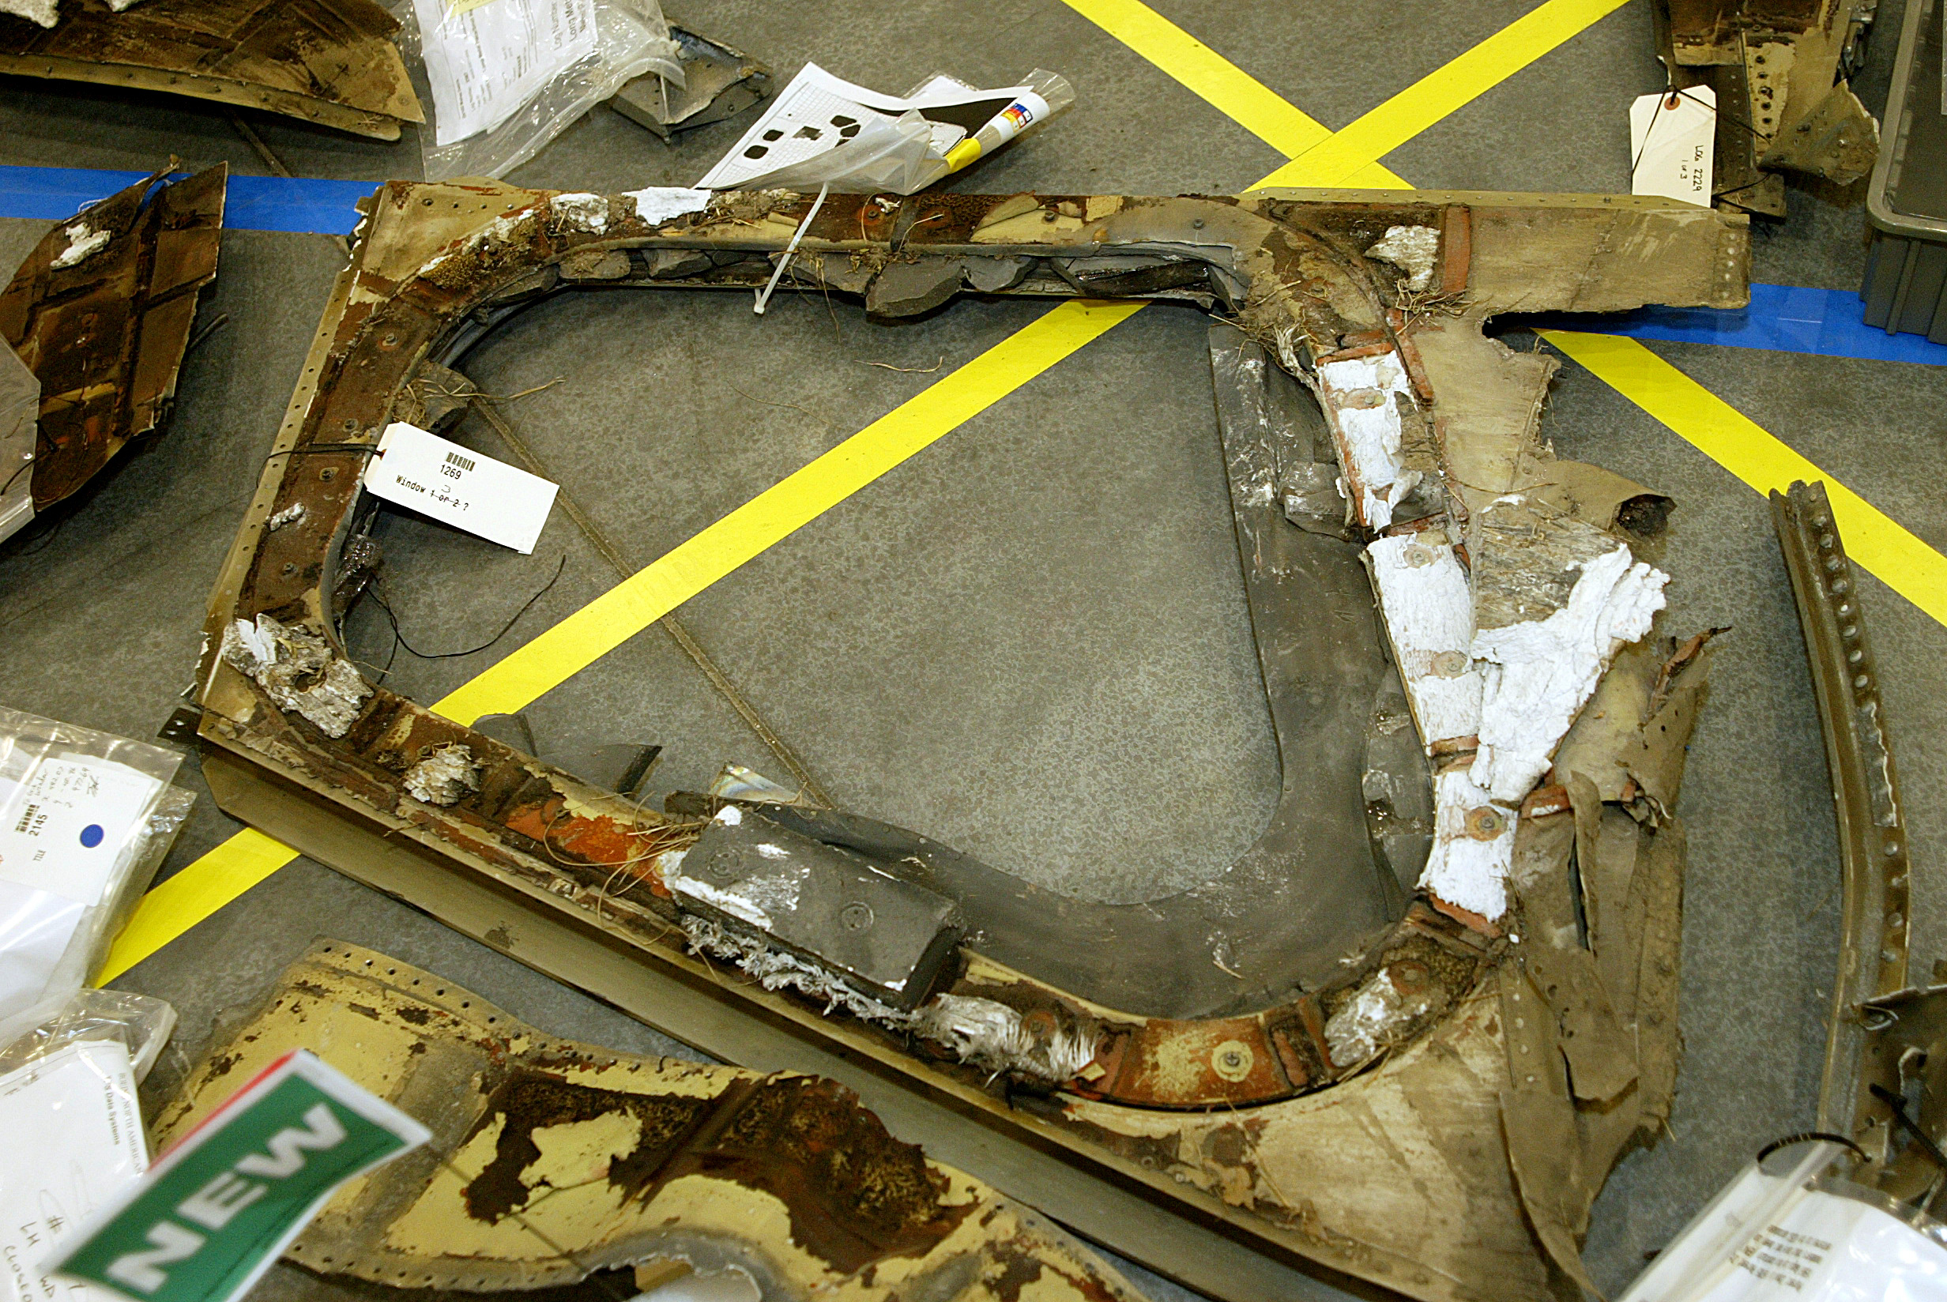
Columbia window lying exterior-side up. Photographed at the Columbia reconstruction hangar at KSC on March 3, 2003. CAIB Photo no photographer listed 2003 < Window>

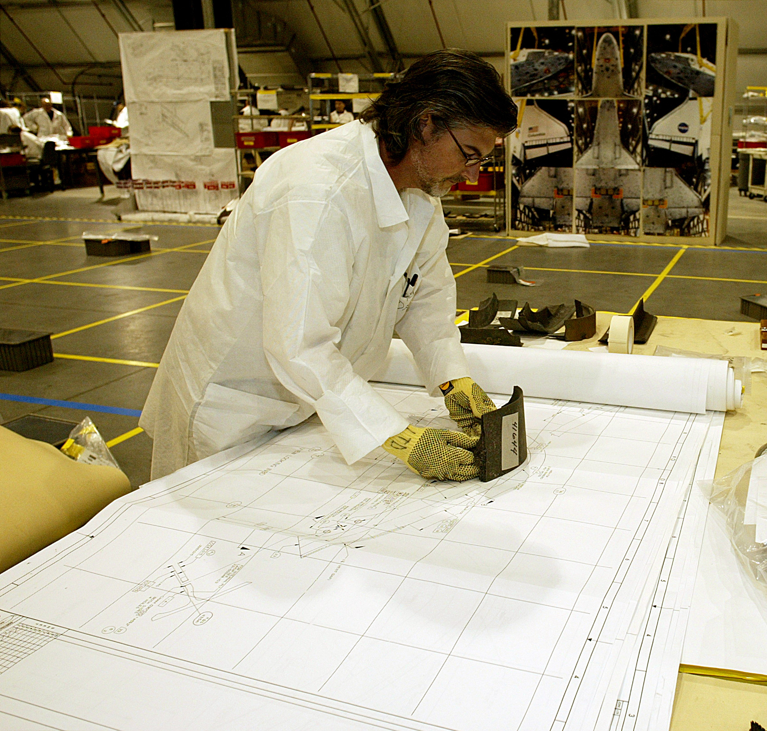
A Reconstruction Team member uses 1:1 engineering drawings as a tool in the process of identifying recovered RCC debris material. CAIB Photo no photographer listed 2003 < Debris-RCC-ID>

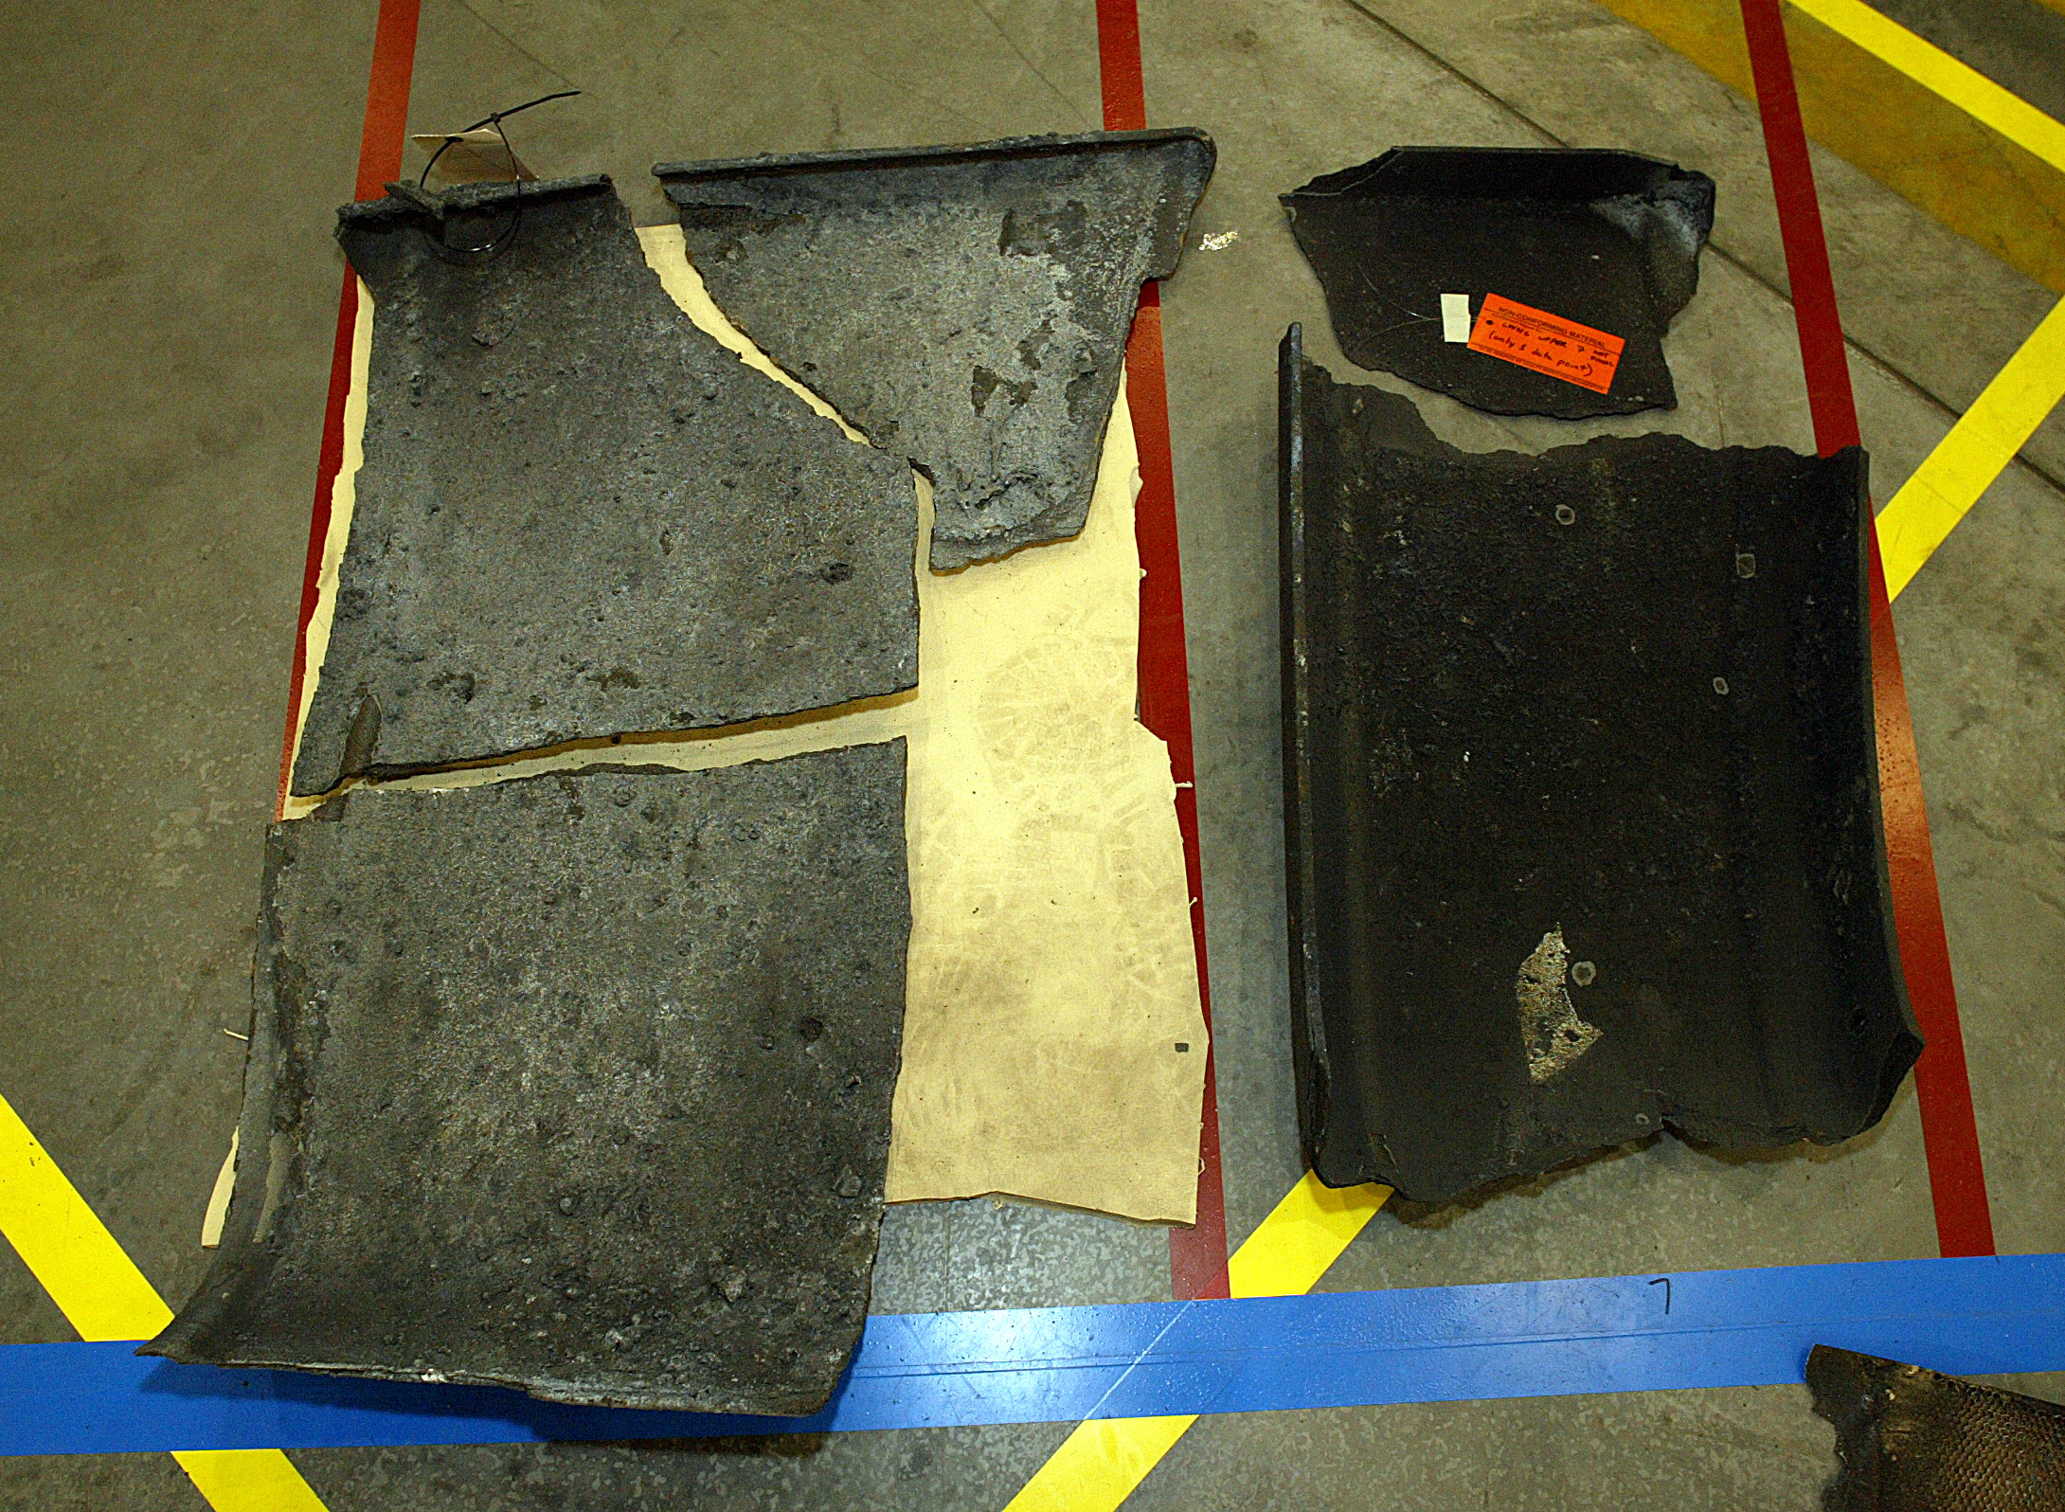
These pieces of RCC (Reinforced Carbon Carbon) illustrate how identified pieces of the debris puzzle are laid-out together on the hangar floor, one piece at a time. CAIB Photo no photographer listed 2003. <Fitted-RCC-Layout1>

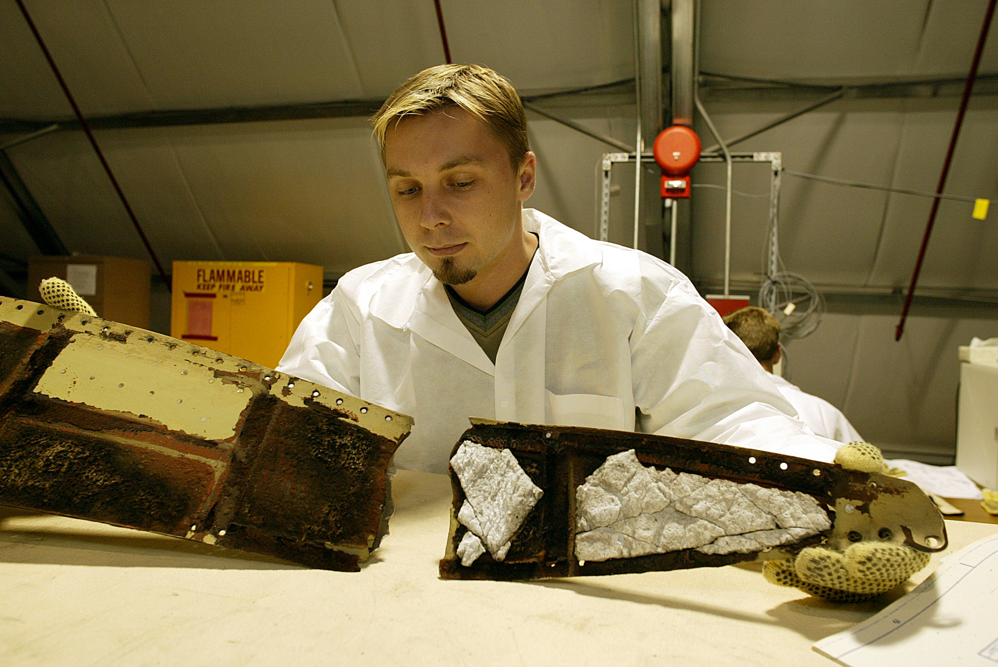
A Reconstruction Team member matches puzzle pieces of debris material. CAIB Photo no photographer listed 2003. < FittingPieces1>

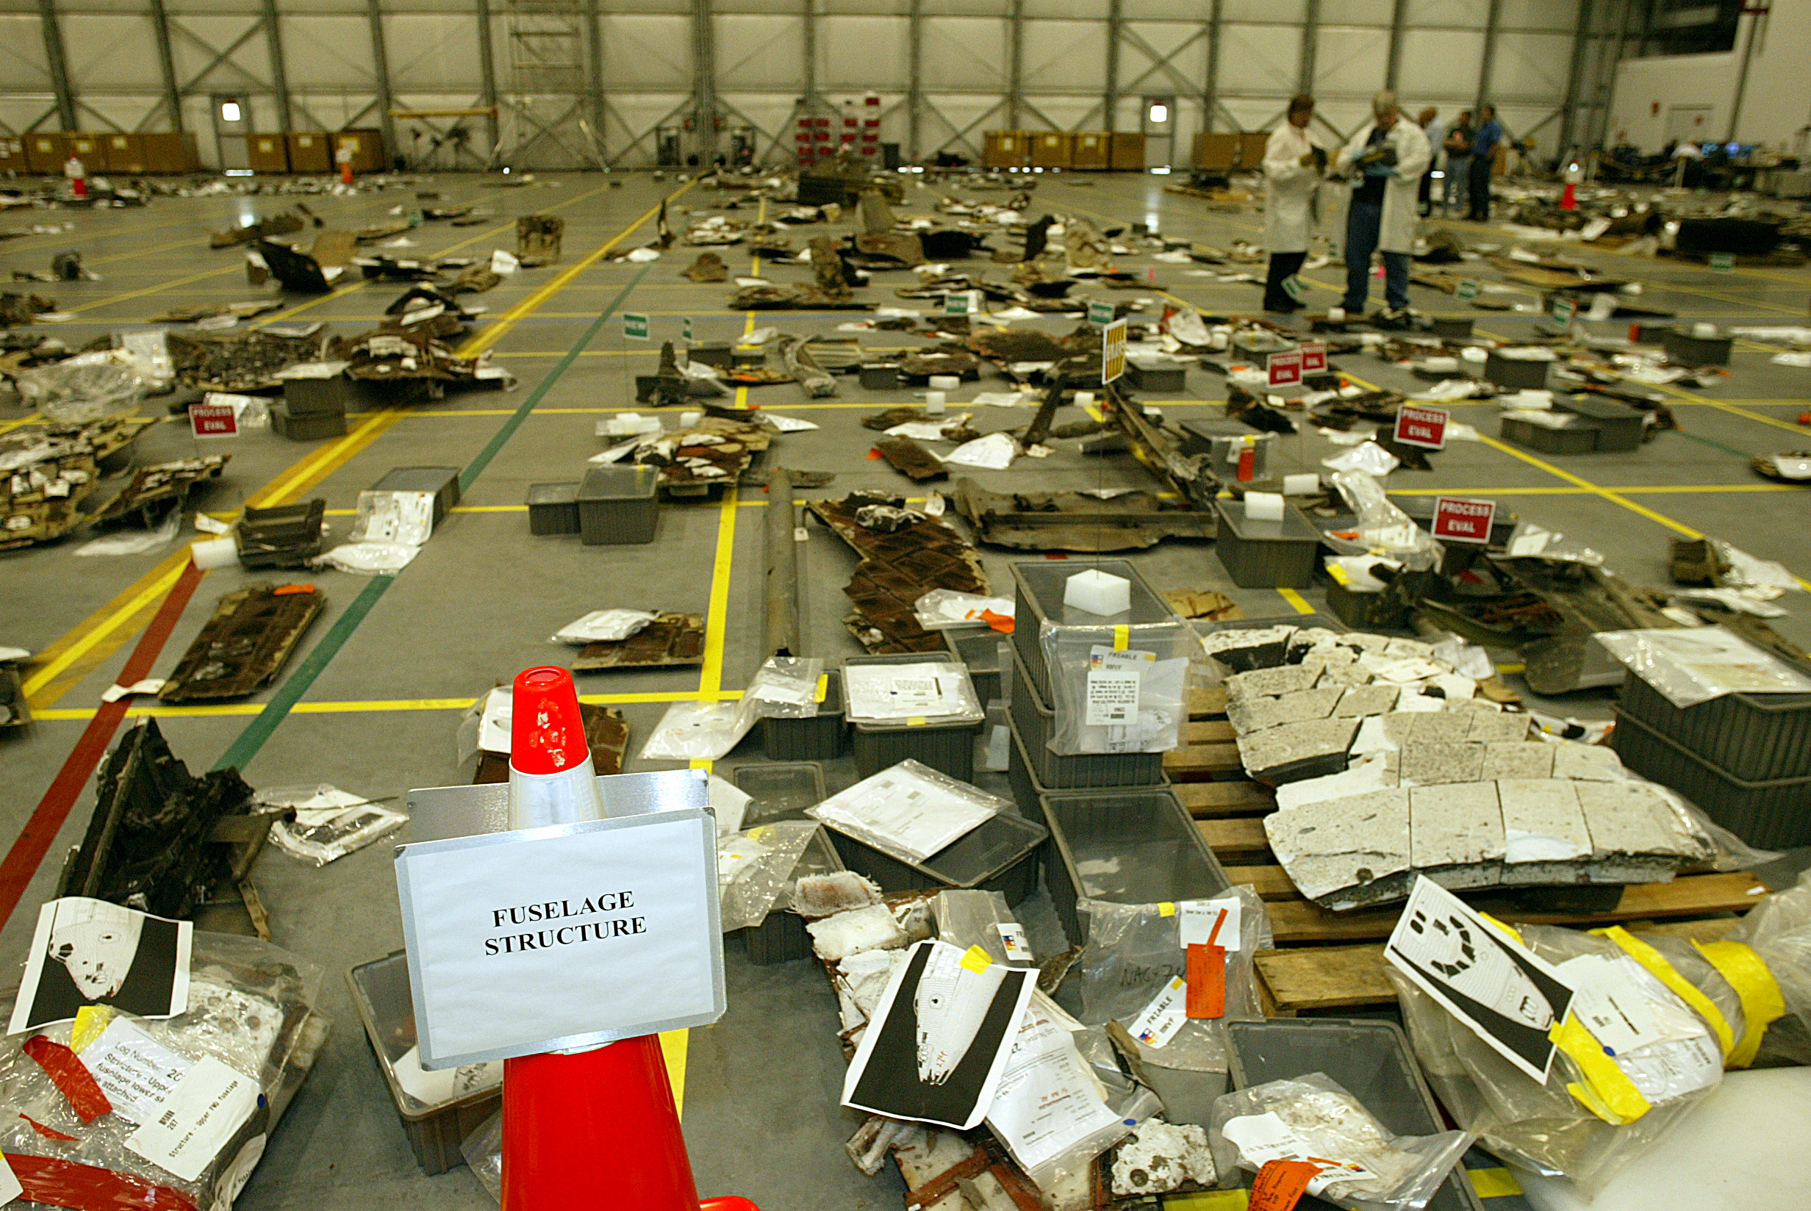
Looking down the line of identified main fuselage debris located on the grid system in the hangar. CAIB Photo no photographer listed 2003 < FuselageStructure1>

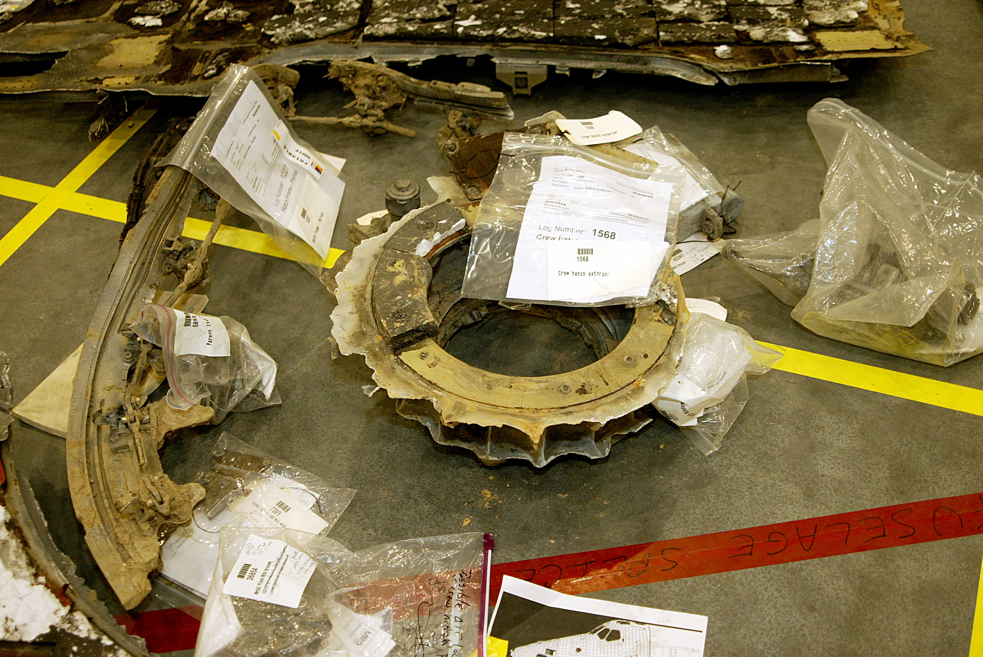
The crew hatch is located in the center of the photo with surrounding latch mechanisms lying nearby. Photographed at the Columbia reconstruction hangar at KSC on March 3, 2003. CAIB Photo no photographer listed 2003 < HatchMain3>

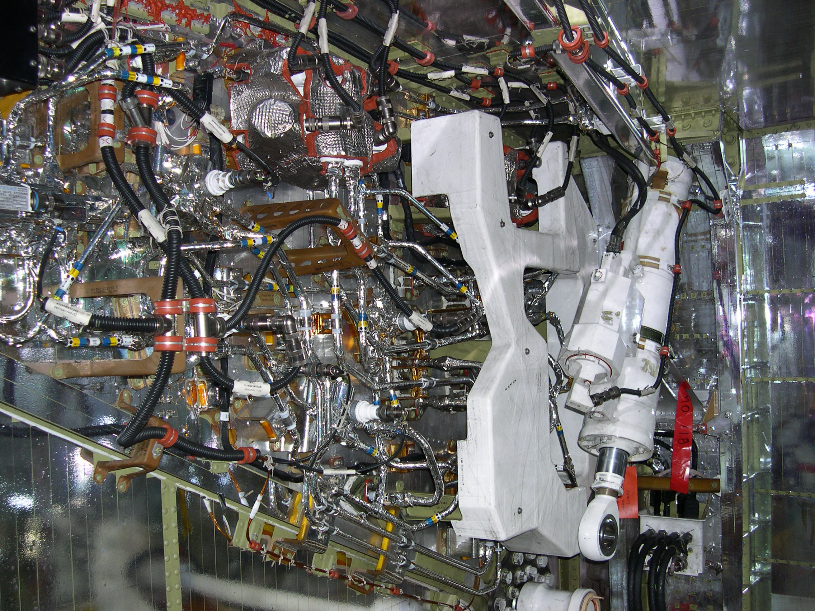
Left Wheel Well. CAIB Photo no photographer listed 2003 < STS-107-DSCN0087>

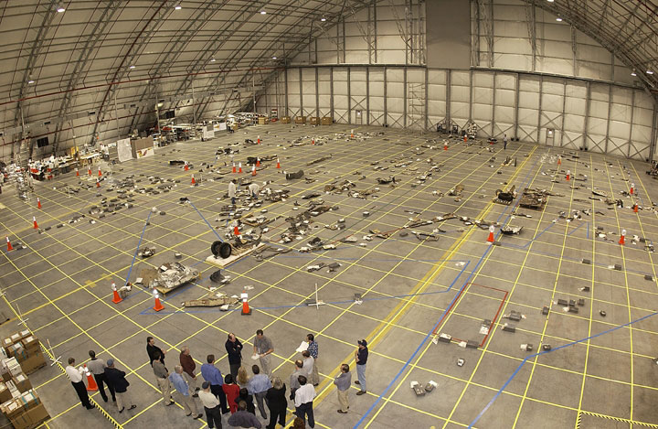
Overhead image of STS-107 debris layout at Kennedy Space Center. CAIB Photo no photographer listed 2003 <STS-107-ksc_debris_layout>

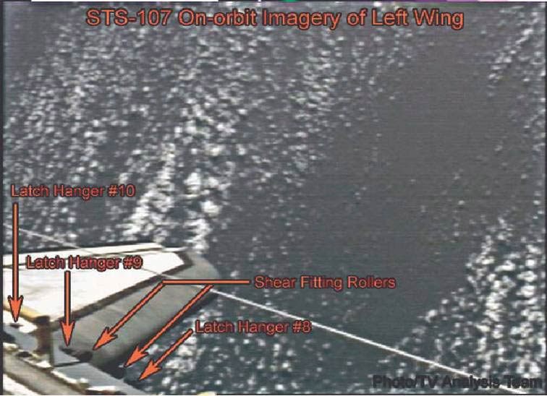
Photo taken Flight Day One, Orbit Five, approximately 6 p.m. CST, of STS-107 left wing on orbit. CAIB Photo no photographer listed 2003 < STS-107-left_wing_in_orbit>

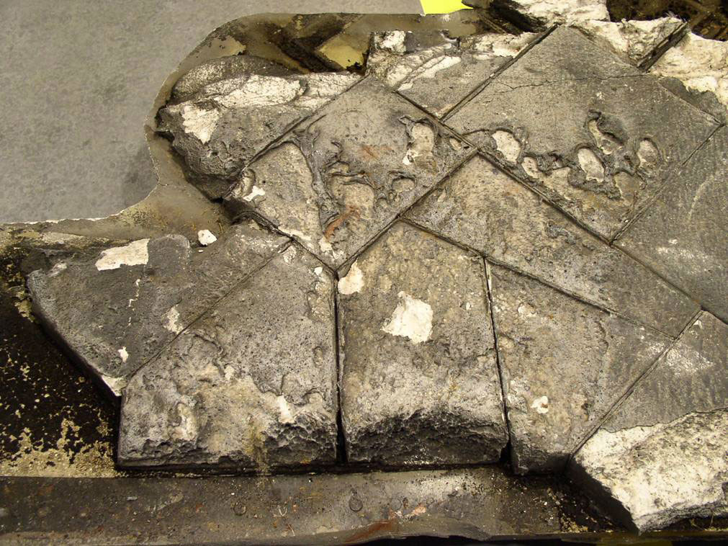
Piece of STS-107 left wing underside, forward and inboard of the corner of the left main landing gear door. Delivered to Barksdale Air Force Base on February 7, 2003. CAIB Photo no photographer listed 2003 < STS-107-left_wing_underside>

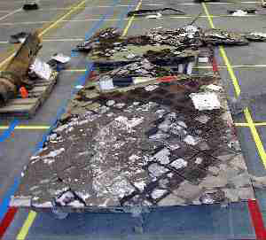
Right main landing gear door from STS-107 in three pieces (front to back). CAIB Photo no photographer listed 2003 < STS-107-right_mlg_door>

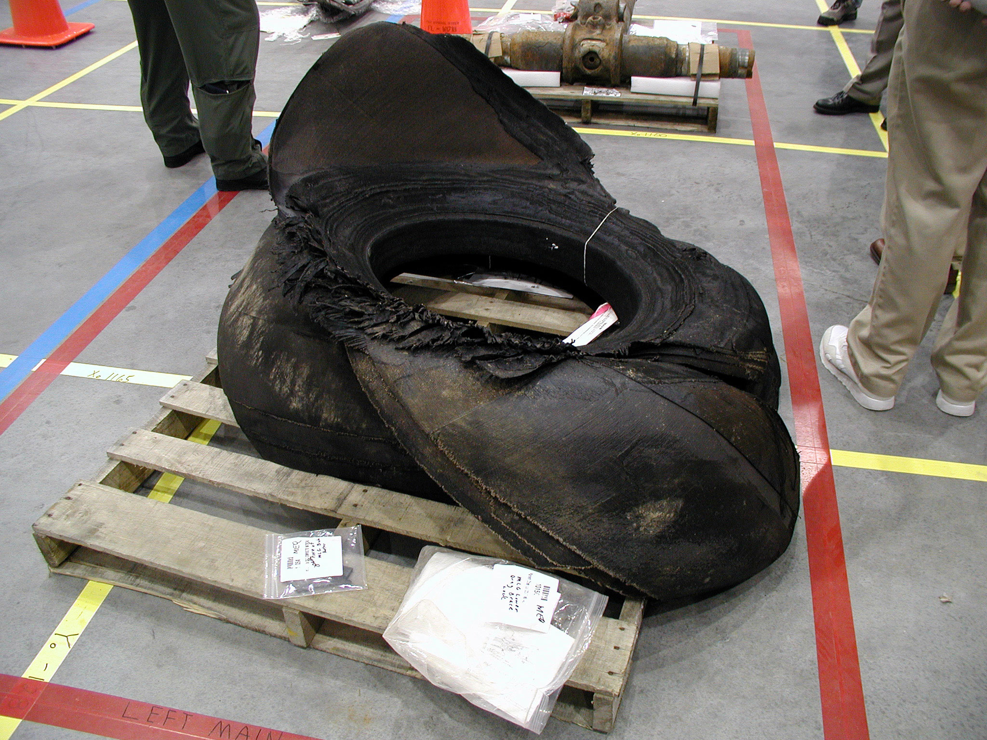
The left inboard main landing gear tire from STS-107. CAIB Photo no photographer listed 2003 < STS-107-left_inboard_tire>

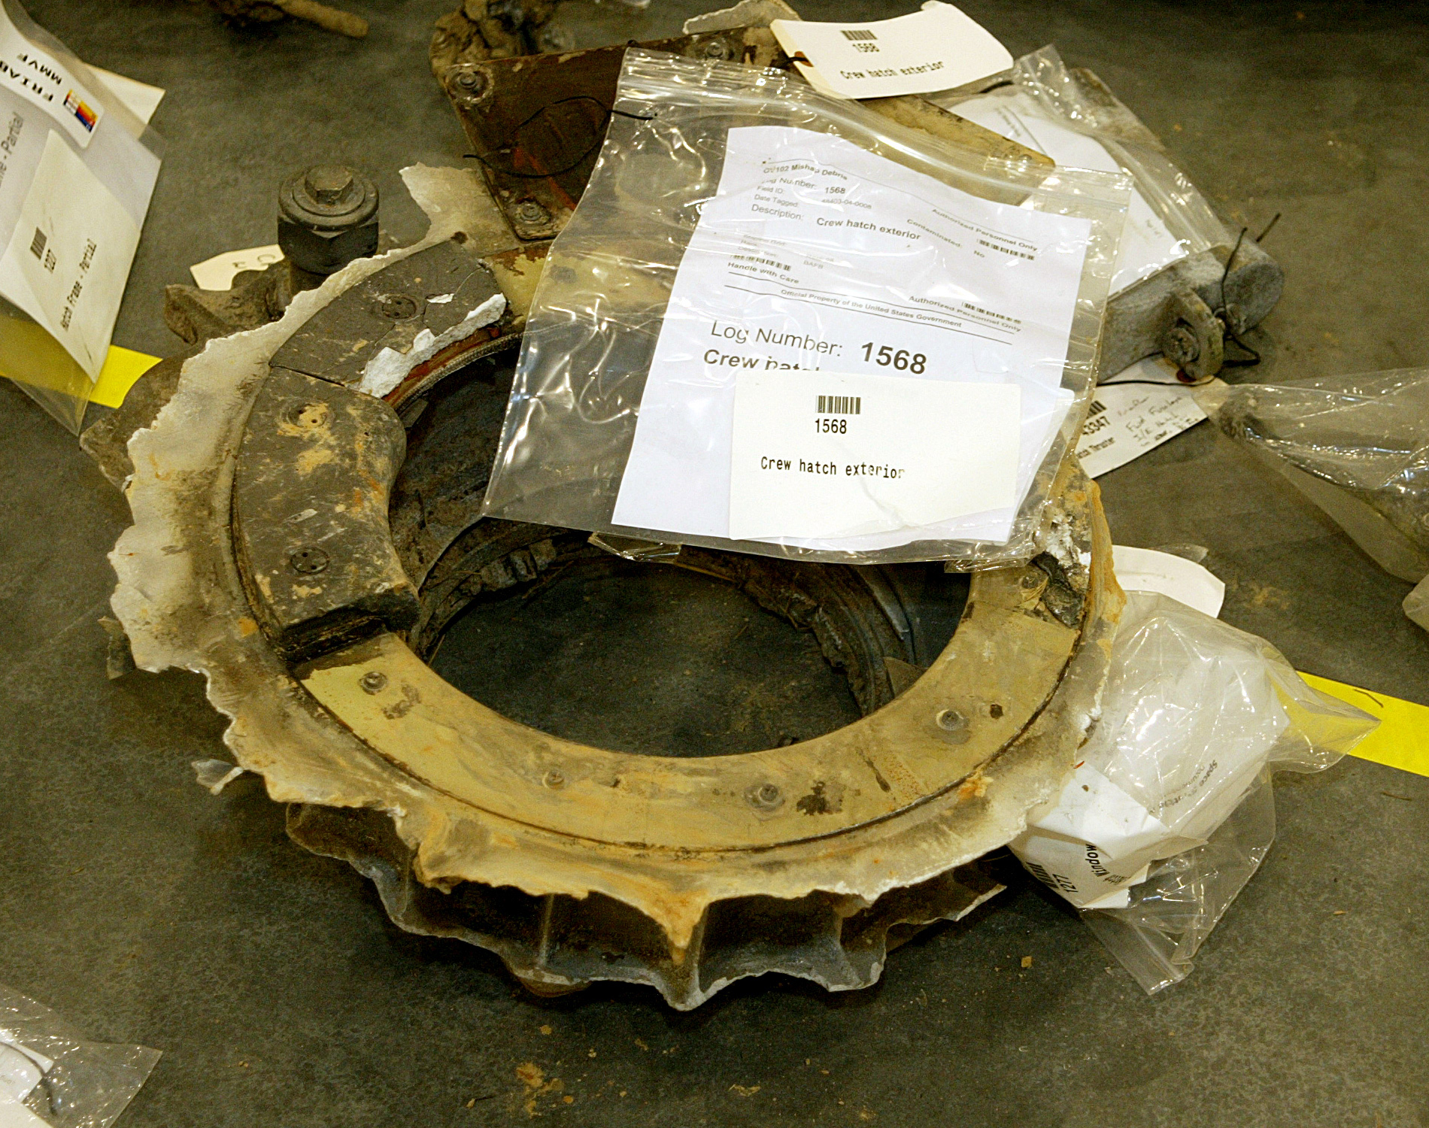
Close up of the Crew Hatch lying exterior-side up. Photographed at the Columbia reconstruction hangar at KSC on March 3, 2003. CAIB Photo no photographer listed 2003 < HatchMain>

