Real Time Mission Monitor
Quick Start User’s Guide

- Introduction

The NASA Real Time Mission Monitor (RTMM) is a situational awareness tool that integrates satellite, airborne and surface data sets; weather information; model and forecast outputs; and vehicle state data (e.g., aircraft navigation, satellite tracks and instrument field-of-views) for field experiment management. RTMM optimizes science and logistic decision-making during field experiments by presenting timely data and graphics to the users to improve real time situational awareness of the experiment's assets. The RTMM is proven in the field as it supported program managers, scientists, and aircraft personnel during the NASA African Monsoon Multidisciplinary Analyses experiment during summer 2006 in Cape Verde, Africa. The integration and delivery of this information is made possible through data acquisition systems, network communication links and network server resources built and managed by collaborators at NASA Dryden Flight Research Center (DFRC) and Marshall Space Flight Center (MSFC). RTMM is evolving towards a more flexible and dynamic combination of sensor ingest, network computing, and decision-making activities through the use of a service oriented architecture based on community standards and protocols.

The Real-Time Mission Monitor (RTMM) as currently implemented uses Google Earth as its visualization engine. The primary RTMM data servers are located at MSFC in Huntsville, Alabama. There will also be a RTMM data server located on the DC-8 aircraft and DFRC. Data and imagery will be transmitted between the DC-8 and the ground using the REVEAL communications system developed by DFRC. REVEAL uses the Iridium satellite telephone transmission links to download/upload the data between the aircraft and the ground data servers. The imagery and data available to the mission participants using the RTMM onboard the DC-8 may be at reduced resolution and scope to accommodate the uplink bandwidth.

The Real Time Mission Monitor web site (http://rtmm.nsstc.nasa.gov) provides information on the current and past missions that RTMM serves. Documentation (including this guide) can be found on line at the RTMM Tutorial page (http://rtmm.nsstc.nasa.gov/tutorial.html) .

- Google Earth Installation

Please use the following procedure to enable RTMM on your computer. You only have to do this once.

  - Download and install Google Earth (GE) on your PC/Mac. The software is easily downloaded and installed from the link at RTMM web site (http://rtmm.nsstc.nasa.gov/current_missions.html). There is a bug in the current version (as of 12 July 2007) of Google Earth, so please download the version that the RTMM web site points you to. Do not run the most recent version of Google Earth, run the version we point you to at the RTMM web site. Also review the FAQ list at the Google Earth web site.

- Starting and Ending a Real Time Mission Monitor Session

  - Once Google Earth is installed, you may start RTMM by connecting to the kml file at the RTMM site (http://rtmm.nsstc.nasa.gov/current_missions.html). This will start a Google Earth session focused on the TC4 region. [Note: on a Mac the kml file will be downloaded to your desktop and you will have to click on the kml file to start the RTMM sequence.] Several banners or popup dialog boxes may be briefly displayed as Google Earth starts and logs into the Google Earth server. You may ignore these, as this is the normal startup sequence. You may be presented with a dialog box asking about the ‘DirectX’ mode, (depending on options selected during Google Earth installation). ‘DirectX’ provide faster graphics presentation. But, ‘DirectX’ does not support a few of the Google Earth features. For the RTMM it is recommended that you operate in `DirectX’ mode, if possible. Click the “Yes” button if asked.

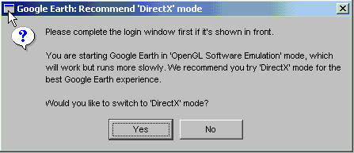
Figure 1. DirectX dialog box that may appear upon first use of Google Earth

- After starting RTMM, you will be presented with a login/password dialog box. Please enter the login and password combination that was provided to all participants.

Important: If your browser (e.g., Internet Explorer, Firefox, Safari) has a check box to “always remember password” please check “yes”. If you do not check “always remember password” there is the possibility that numerous pop-up windows will repeatedly ask you to login.

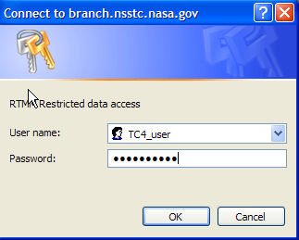
Figure 2. Login / password dialog window

Important: Before describing how to use RTMM, it is important to know how to exit the program. When you close the Google Earth/RTMM window, a pop-up dialog box will appear asking you to Save or Not Save your session. Your answer should always be “No”

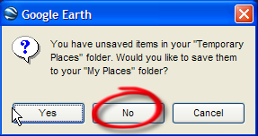
Figure 3. Always answer No when exiting Google Earth

We will now continue with a description of how to use RTMM.

- RTMM automatically defaults to the experiment region. Using the mouse you may zoom in or out, pan left or right, up or down to move around the globe.

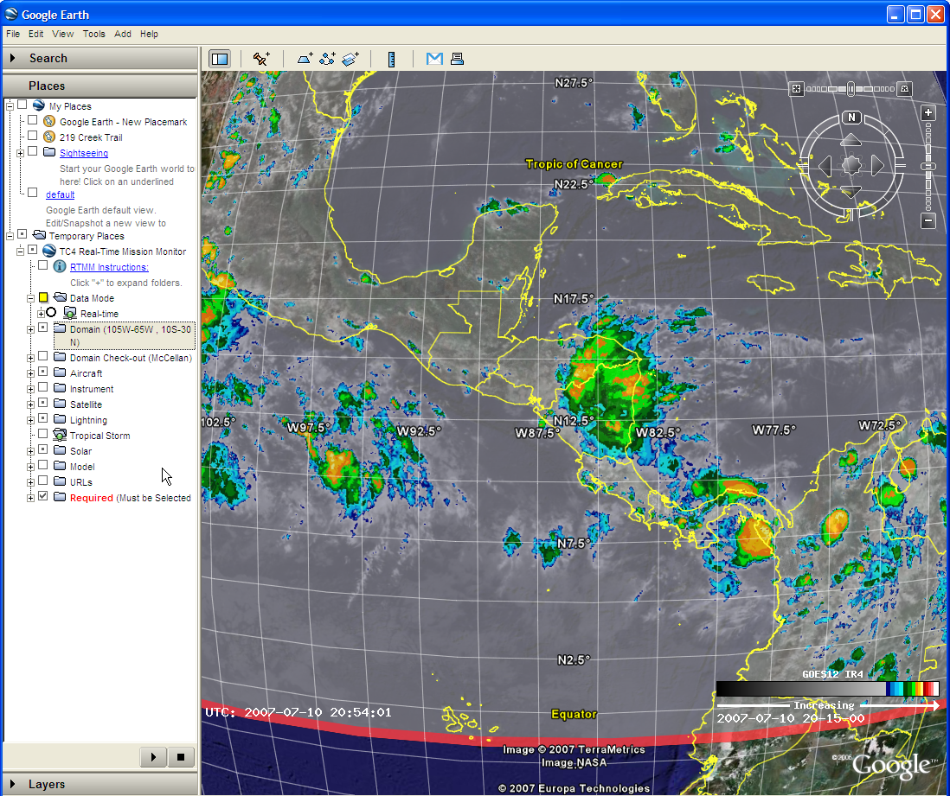
Figure 4. Opening RTMM screen focused on the TC4 domain

- The left side of the RTMM / Google Earth screen contains the data selection menu. RTMM uses a menu tree with radio buttons (i.e., on/off selections). The menu tree can be expanded for each source by clicking on the “+ boxes”. Likewise, the menu tree can be collapsed by clicking on the “– box” for each data source. Yellow filled boxes indicate that you can not click within the box, rather you must expand that portion of the menu tree and make selections a level deeper. Clear boxes indicate a selection can be made by clicking in the box. A dot filled box indicates that a selection has already been made.
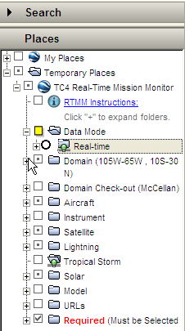
Figure 5. Left side data selection bar which lists data sources in a menu tree

- Data Selection and Manipulation

  - Domain
The “Domain” menu tree allows the user to highlight the projects domain. The TC4 domain is defined by the following latitude and longitude corner boundaries:
northwest corner: 30 N, 105 W and southeast corner: 10 S, 65 W

There are three domain selections: Initial View, Persistent and Show Border

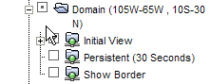
Figure 6. Domain menu tree options

Double clicking on the “Initial View” always returns the view to TC4 domain. “Persistent” returns the view to the TC4 domain every 30 seconds. Finally, “Show Border” put as yellow border around the TC4 domain.

  - Aircraft
The Aircraft menu tree allows the user to select any or all of the three airplanes to track (i.e., aerosonde, ER2, DC8, or WB57). Expanding the menu tree for any of the aircraft reveals a list of tracking ranging from the last 15-minutes of flight to the complete flight track.

The WayPoint menu allows the user to display the planned flight track for any of the aircraft. Waypoints can be selected for the current or past flights.

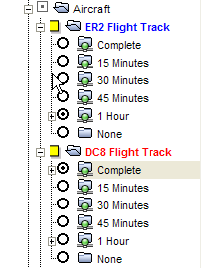
Figure 7. Aircraft track menu depicting the selection of 1-hr of ER2 flight tracks and the complete track of the DC8.

  - Instruments
The Instrument menu tree lists both ground and airborne instruments whose data can be displayed by RTMM. Expanding each sub-menu tree lists the available instruments for that platform type. For example under Radar heading lists the NPOL and SMART-R radars. Likewise the Dropsonde selections list the individual dropsondes per flight. Airborne instruments aboard the ER2 or DC8 that are transmitting to the ground in near real time are listed.

To display Ticosonde (radiosonde) skew-T graphs the procedure is slightly different. The skew-T graphs are displayed in a separate window. To select a particular skew-T time, click on the Skew-T link.

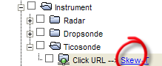 → 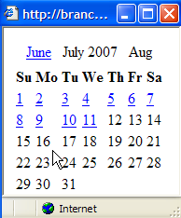 → 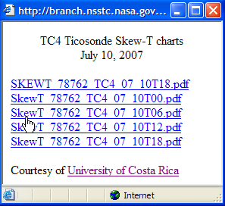
Figure 8. Clicking on the Ticosonde Skew-T link pops up a calendar window for the user to select the particular day and time. Selecting a specific Skew-T pops up a graph from a .pdf file

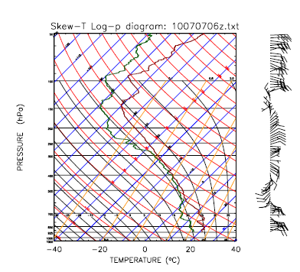
Figure 9. A Skew-T diagram as displayed in a separate window after being selected from the University of Costa Rica Ticosonde web site.

  - Satellite Imagery over TC4 Domain

Upon starting RTMM, the default background satellite image is GOES-12 infrared over the TC4 domain. The user may toggle between visible, water vapor, and infrared channels. Other satellites domains include GOES-12 over the U.S. and the GOES-10 satellite centered over South America. The northern limit of GOES-10 covers the TC4 domain.

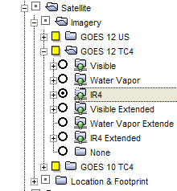
Figure 10. GOES-12 expanded satellite menu with infrared channel selected.

  - Satellite Tracking in Real Time

RTMM has the capability to track in real time the geolocation of satellite instrument nadir point and footprint. A database of polar and low earth orbiting satellite and associated instruments are dynamically retrieved upon request.

The user selects the satellite and instrument to view from a menu tree. The user may select the satellite-instrument swath and/or instrument footprint to view.

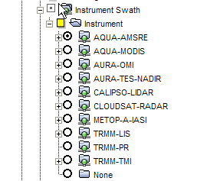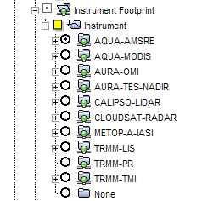
a) b)
Figure 11a and 11b. A depiction of the menu tree for the selection of satellite swath and footprint field of view.

The swath represents the path of the satellite-instrument during an extended field of view (default +/- 5-minutes), where as the footprint represents the satellite-instrument field of view over a much shorter time frame (default +/- 30 seconds). An example of the AMSR-E instrument swath/footprint is depicted below.

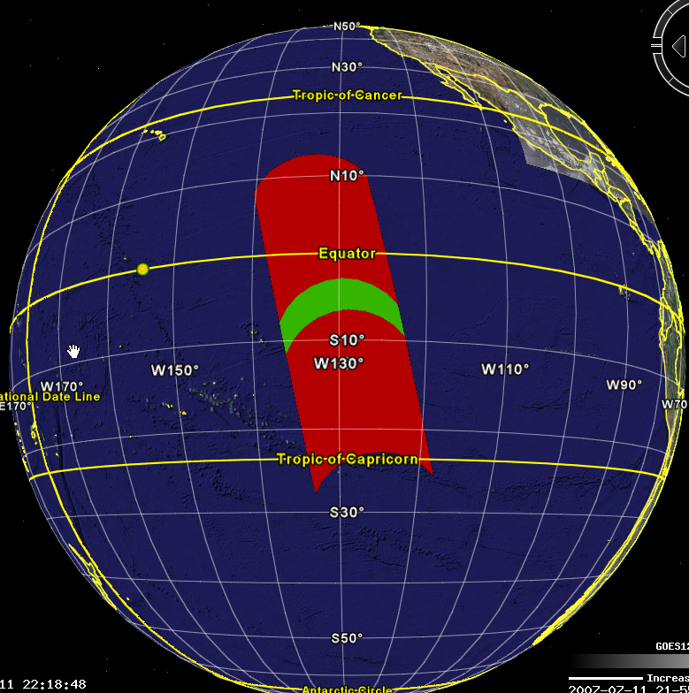

In figure 11c (above), the 10 minute (+/- 5-min) “swath” is depicted in red and the 1-minute (=/- 30-sec) “footprint” is displayed in green. The default swath and footprint lengths can be changed in the Configure Swath and Configure Footprint menu trees. In either the Configure Swath and/or Configure Footprint menu, select an alternate time lag and then right click on the words “Instrument Swath” or “Instrument Footprint” and select “Refresh” (this is a bit complicated to describe here in print but easy to demonstrate).

  - Predictive Tracking of a Satellite

The user can use the Coincidence Search menu to select a future date and determine at what time the specified satellite-instrument will pass through the TC4 region. First the user selects the future date (e.g., 13 July 2007) or uses the Calendar radio button for dates beyond two weeks (fig. 12a). Then the satellite-instrument to be viewed is selected (fig. 12b). In the example below the Aqua-AMSRE instrument has been selected for 13 July 2007. The result is an instrument swath at 8:04:45 UTC as displayed in fig. 12c.

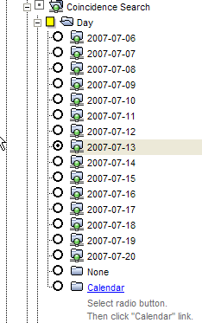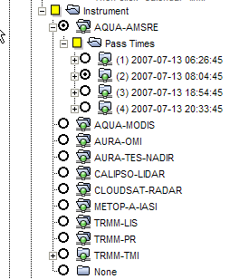
- b)

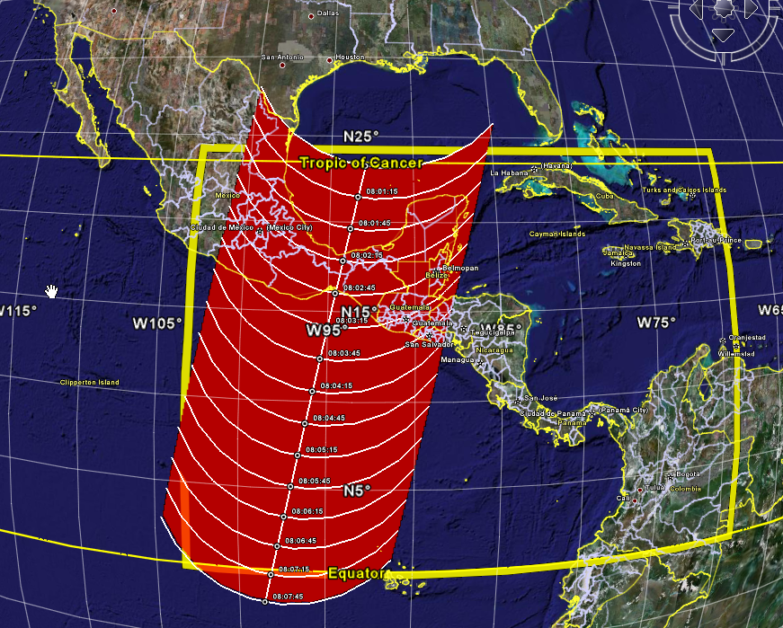
c) AMSR-E predictive swath for 13 July 2007 over the TC4 region

  - Real Time Lightning Display

Real time lightning observations from up to four surface networks are available. Data is continually ingested from the National Lightning Detection Network, the Vaisala Long Range Lightning Network, the World Wide Lightning Location Network, and the Costa Rica Network. Any or all of these sources can be displayed at once. The user selects the time range for observations (from previous 5-min up to the previous hour). Figure 13 depicts the real time lightning over the previous 10 minutes from the Vaisala Long Range Network on 11 July 2007. Selecting all four lightning networks will display comprehensive coverage for the area.

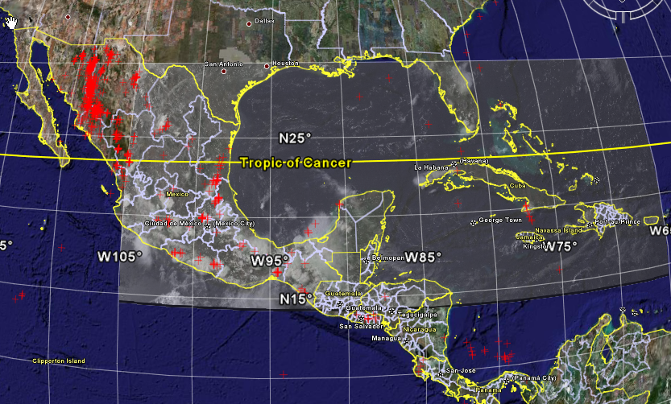
Fig. 13 Lightning observations on 11 July 2007 at 2300 UTC from the Vaisala Network

  - Tropical Storm Tracks

The tropical storm tracks for the current season are dynamically retrieved and displayed. Click on the in the Tropical Storm menu box and the list of storms for the hurricane season is displayed. Then select the storm track(s) of interest.

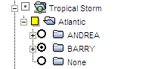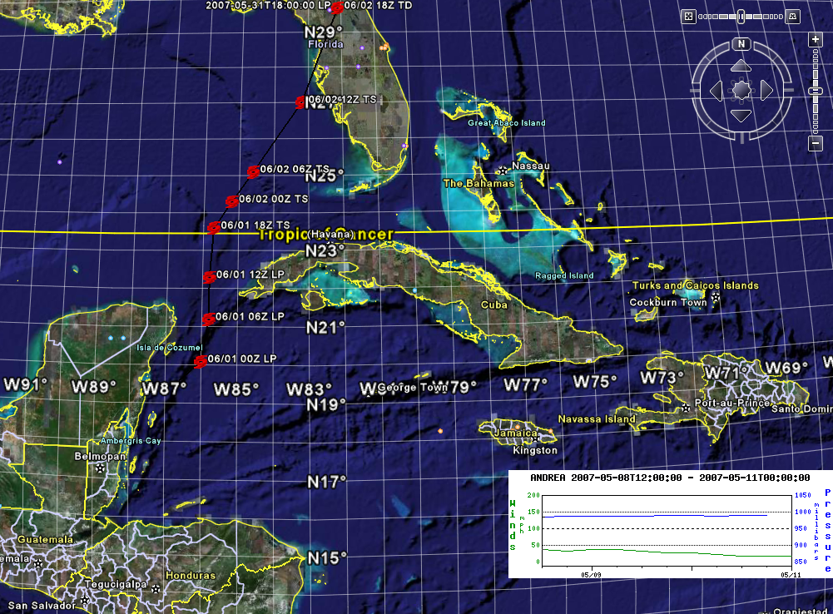
Fig. 14. Expanded Tropical Storm menu tree with two storms listed for the 2007 Atlantic season. To the right is an image with the historical track of TS Barry.

--This is an evolving document and more will be added later

End of Document

