United States Department of Agriculture

CRP Mid-Contract

Management: Strip Spraying


Indiana - August 2008 (ver. 1.0)
Conservation Program Job Sheet

Conservation Reserve Program (CRP) policy requires newly enrolled participants, starting with Signup 26, to do some type of “disturbance” to certain CRP practices during the life of the contract to benefit wildlife. This job sheet describes that guidance in more detail.
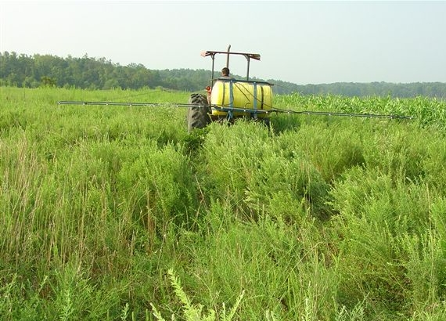
Dave Howell, Quail Unlimited
Normally, mid-contract management activities are conducted between the 4th and 7th year of the contract. However, on land with existing cover, disturbance activities can begin as soon as technically feasible.
STRIP SPRAYING
Once established, grassland fields need to be managed so that grasses do not crowd out the forbs and/or legumes over time. In the absence of disturbance, the composition of grassland communities will change over several years through normal plant succession. The vegetative structure changes as annual forbs and legumes are replaced by perennial forbs, grasses, and eventually, woody plants. Changes also occur structurally, as bare ground declines, litter accumulates, and vegetation density increases. These changes lead to a decline in wildlife benefits.
The purpose of mid-contract management activities is to enhance the wildlife habitat value of the enrolled acres by increasing the amount of bare soil and by encouraging a diverse forb/legume community. Forbs (any broadleaf plant) and legumes in grasslands are beneficial to birds, insects such as butterflies, and other wildlife. Strip spraying is an effective management tool that can be utilized where vegetation has become too thick to benefit the target species.
Spraying is especially helpful for maintaining brood-rearing habitat for bobwhite quail, wild turkey, ring-necked pheasant and other early successional grassland wildlife species. The insects associated with annual weed communities provide critical nutrients, including protein, and essential amino acids for growing nestlings and chicks. Reduced plant residue, along with bare ground, are also critical for young chick mobility in grassland areas. The structural diversity that results from spraying also improves habitat for a variety of grassland songbirds, including dickcissels, bobolinks and savannah sparrows. Many of these species have experienced population declines over the last several decades. Spraying enhances habitat quality because it inhibits woody growth, promotes favored seed producing plants, reduces plant residue, increases bare ground, and increases insect abundance.
The goal of the herbicide application should be to kill approximately 50% of the perennial grasses within the treatment area. Consult with your local dealer, or Cooperative Extension Specialist, for specific herbicides that are recommended for your area. Note that the type of chemical, and spray timing, varies between warm season and cool season grasses.

SPECIFICATIONS
The following are specifications for Strip Spraying on CRP acreage:
- NRCS eFOTG Standard Early Successional Habitat Development/Management (647) will be utilized for this practice.
- Grassland fields must be established for a minimum of three years before initiating strip spraying, and strips will not be sprayed more than once in a two-year period.
- The following chart shows the maximum area that can be disturbed during any year (unless a waiver is received from the Farm Services Agency):
 | CP33 | All other CP practices
Greater than 1.5 acres | 1/3 of the area | 1/3 of the area
1.5 acres or less | ½ of the area | ½ of the area or  the total area
- Strip spraying will be avoided on environmentally sensitive areas including:
- Concentrated flow areas
- Critical areas
- Within the first 20 feet of a practice that borders a water resource to avoid water quality resource concerns
- Other areas where gully erosion is likely
- Environmentally Sensitive Areas will be marked on the plan map to ensure Mid Contract Management activities are avoided on these areas.
- Sprayed fieldstrips will be a maximum of 50 feet wide. Alternate the sprayed strips with unsprayed strips 2-4 times the width of the disturbed areas. Duplicate this pattern across the field.
- Spraying of grassed waterways, riparian forest buffers, or areas planted to trees and/or shrubs is not allowed.
- Spraying operations will not be performed from April 1 through August 1, the primary nesting period for grassland bird species. It is also recommended, but is not required, to delay spraying until after August 15 to reduce the chance of harming fledgling birds and other young wildlife.
- Designated filter strips will be left adjacent to all water bodies to maintain water quality. See NRCS Field Office Technical Guide (FOTG) Standard 393 - Filter Strip for additional guidance.
- Strip spraying operations will be performed along field contours, or across the slope, when practical.
- Erosion from sprayed strips will not exceed tolerable limits.
- Strips will parallel brushy or woody escape cover when feasible.
- All Federal, State and Local guidelines and Manufacturer’s label rates will be followed when applying herbicides.
CONSIDERATIONS
- Strip spraying should be planned for the least erosive parts of fields and not in places where gully formation is a problem. CAUTION: Spraying in the late fall on highly erosive sites may cause erosion to occur over the winter months. Consider drilling ½ bushel of winter wheat per acre, between September 15 and October 30, to reduce erosion potential.
- Consider seeding a mixture of forbs and legumes into areas that have been strip sprayed. See NRCS CRP Job Sheet Mid-Contract Management: Inter-seeding for additional guidance.
- Consider the habitat needs of the target wildlife species. Areas sprayed in late summer or early fall will tend to stimulate the production of hard-seeded plants such as common ragweed. These species provide excellent brood-rearing cover and winter food for quail and pheasants.

CONSIDERATIONS (continued)
- In fields with heavy cover, consider connecting sprayed areas to improve brood movement.
- Spraying in low, wet areas currently dominated by sedges should be avoided because these areas often add additional plant diversity to the site.
- Where the existing vegetation is extremely thick, tall, or rank, consider first using prescribed burns or mowing, on those areas where spraying will be preformed.
- Consider raking the thatch after any mowing operations, and prior to herbicide application, to increase the germination of forbs in the seed bank. NOTE: Thatch will not be removed from the field.
- Landowners should be wary of tile blowholes, groundhog holes, fallen tree limbs, and other hazards that may have developed since they were last in the field.
- After completion of the strip spraying, consider planting wheat at a rate of one (1) bushel per acre. In addition to adding food and habitat structure, wheat may suppress grass growth and increase forbs resulting in longer-term wildlife benefits.
EXAMPLE: 3-Year Rotation
Divide the field into adjacent plots that are 90 to 150 feet wide. Within each plot, mark three strips of land that are 30 to 50 feet wide.
- In fall of the first year of disturbance, within each plot, spray the first strip of land and leave the second and third strip unsprayed.
- In fall of the second year, spray the second strip, leaving the first (sprayed during previous year) and third strip unsprayed.
- In fall of the third year, spray the third strip leaving the first and second strips unsprayed.
- In the fourth year, begin the rotation again, as indicated in the conservation plan.
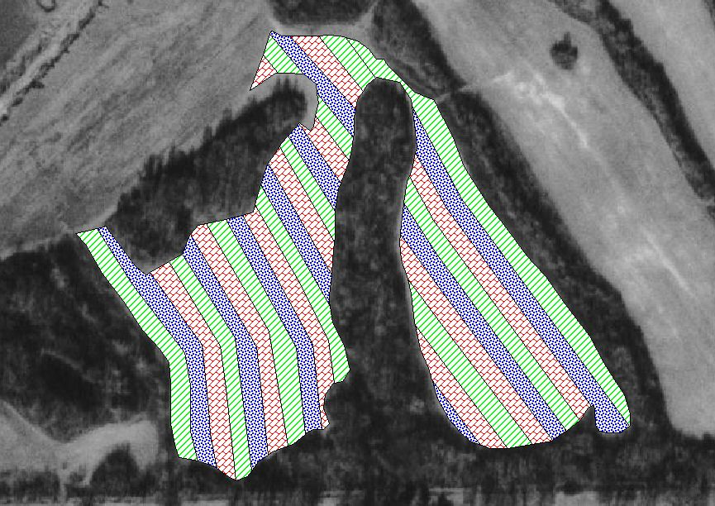

Strip Spraying - Specifications Sheet

Landowner: |  |  |  |  |  |  | County:
Farm: |  | Tract: |  | Field(s): |  | Acres: |  |  | Date:
CONCURRENCE OF IDNR DISTRICT BIOLOGIST (recommended):

Specific Recommendations

Wildlife species to be benefited:

Date range (i.e. spraying window):

Preparations needed before spraying:

Additional Considerations:

Site/Sketch Map
(Include environmentally sensitive areas to be avoided)

Helping People Help the Land
USDA is an equal opportunity provider and employer

