VENTURA TOOLS SHAPEMASTER

DATA MANIPULATION

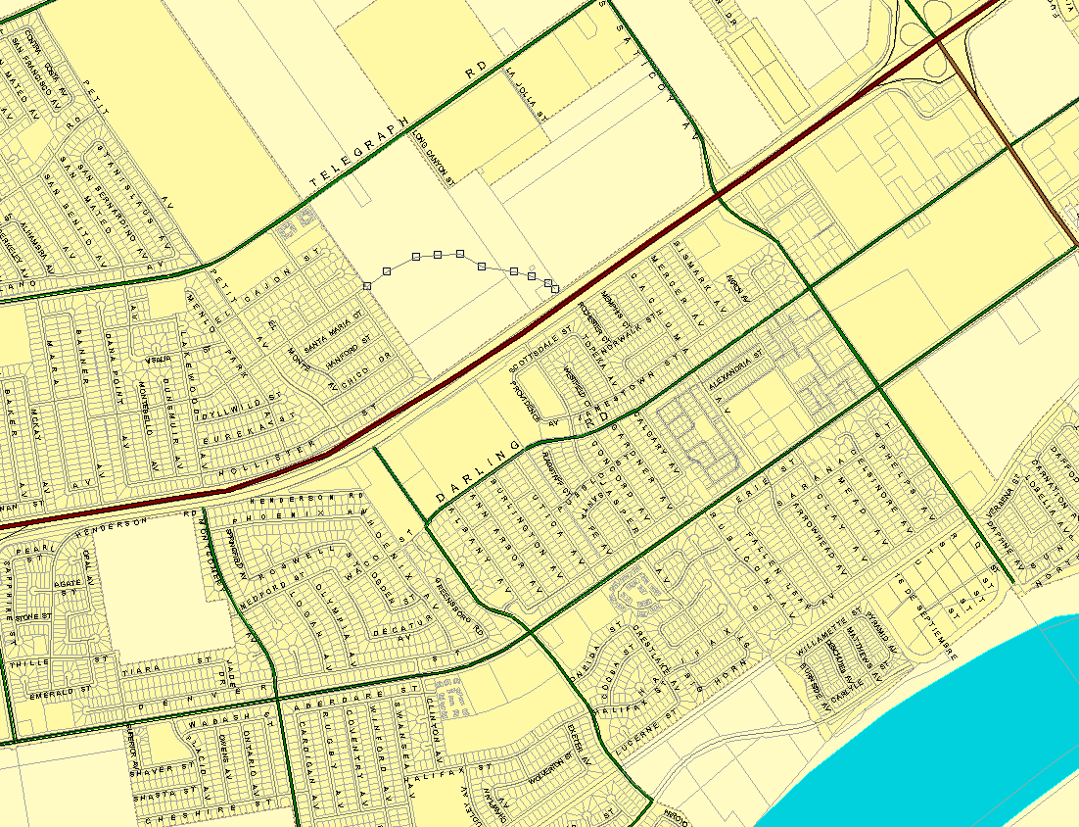

INTRODUCTION

The Ventura Tool ShapeMaster extension is a comprehensive set of GIS tools used for polyline editing. They were developed by the Ventura County Fire Department’s Mapping Services Section in the late 90’s by Jim Kniss and Don Taylor. These tools were originally designed for use as an assistant for the construction and maintenance of the 911 centerline used by the departments computer aided dispatch system.

The ShapeMaster extension allows the GIS Technician to perform a multitude of GIS editing operations not included in the existing ArcView application:
- Show all polyline vertices visible in the view.
- Show polyline direction of a selected arc.
- Lists polyline and polygon length and/or area.
- Advanced polyline editing functions.
- Set view projections for data input.
- Utilities to convert and reproject various GIS data formats.
- Import functions for points, polylines and polygons.

VENTURA TOOLS – SHAPE MASTER EXTENSION

Add the ShapeMaster extension to your project
The “Shape” menu should be added to your toolbar. Click on this menu

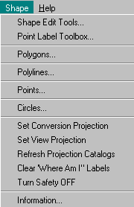
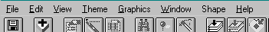

This menu will be expanded to show the first level menu of the :Shape Master” extension.

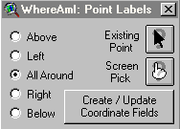
Starts the ”Where AM I” dialog – These tools are used to label Latitude and Longitude text around points.

Pick on either Existing Point or Screen Pick.

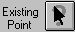Labels existing point feature from a theme in the current view.

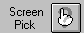 Adds a Latitude and Longitude label at a picked location on the screen.

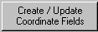 Recalculates the values for the Latitude and Longitude fields based on the current location of each point in user-selected Point theme.
Recalculates Lat/Lon coordinate fields in the theme database. Six different display format are available. Three in a X/Y or Easting/Northing format and three in a Lat/Lon format.

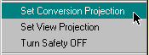
Move to the bottom of this menu to look at setting a few variables that will be used throughout the application.

Pick on “Set Conversion Projection”

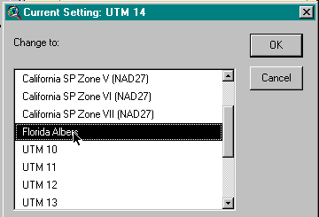
A box will be displayed that at the top shows what conversion projection is currently active. A scroll bar on the right can be moved up or down to locate the projection of the data that this project is in. Pick the appropriate value.

This selection will be used throughout the application for input of Lat/Lon data and display of a lat/Lon location on the screen.

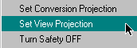

The next item will set the view projection. Use this only if you are using un-projected data (Geographic) and wish to see it displayed in real world coordinates.

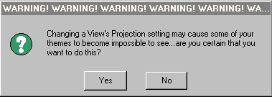

Be Careful, This can cause great havoc …..

The final setting in this area is the Safety selection. The safety controls the various “Are you sure” questions issued during editing.
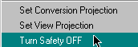
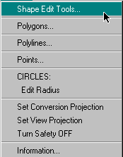
Keep this turned on until you are completely comfortable with this application

Now we can get into the core of the application. The next selection from the “Shape” menu will be “Shape Edit Tools”. This is one of the most valuable parts of the extension and one that you will use in your every day operations.
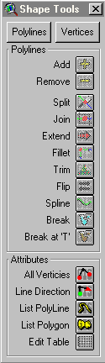
Once you have picked on that box a new menu will appear on the left side of your Computer screen. This menu can then be moved to anywhere that you are comfortable with.

At the bottom of this menu is a section called “Attributes”. These selections can be used with both “Polylines” and “Vertices” and will be displayed in both menus.

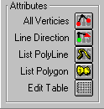
By selecting the “All Vertices” button all of the Nodes and vertices in the current view frame will be displayed. Nodes will be displayed with a RED dot and the vertices will be shown with a smaller black dot. This will be very useful for future polyline editing.
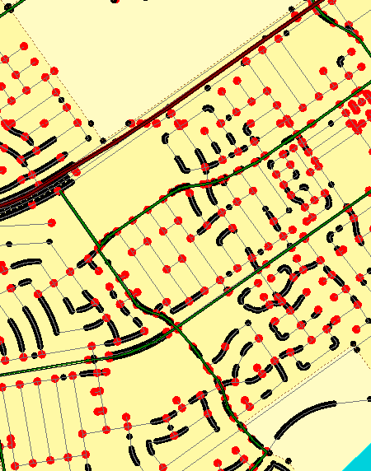

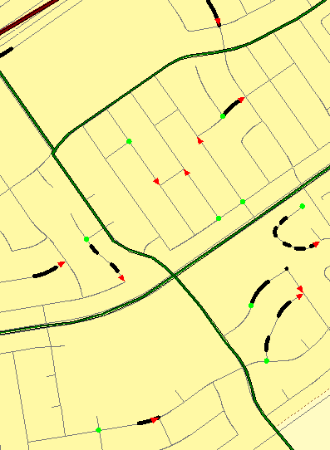
The next selection is “Line Direction”. This is similar to all vertices but displays only selected arcs and identifies arc direction. Pick on the line direction button and then pick on an arc in the view. The arc will be shown with the beginning node as a GREEN CIRCLE and the ending node in a RED ARROWHEAD. All of the interior vertices will be displayed as a black dot.
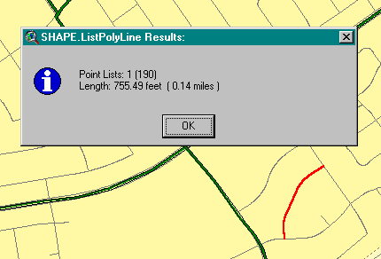

The remaining three buttons are for querying the database of selected entities.

List polyline highlights the selected polyline, displays the point list, calculates and displays the length of the polyline in the user defined units (feet, meters or miles).
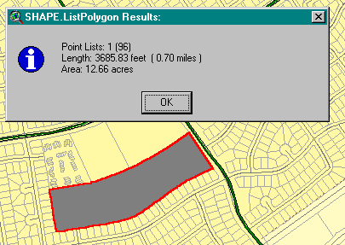
List polygon highlights the selected polygon , displays the point list, calculates and displays the area and perimeter in the user defined units (acres, feet, meters or miles).

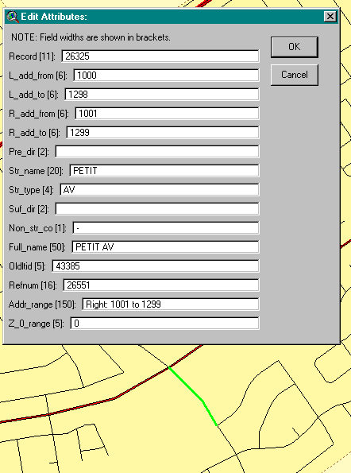

Edit table creates a simple input screen for each field in the current edit theme’s feature table. The theme must be in edit mode.

Select the “Edit Table” button, Then select entity, the object will be highlighted and the database (table) will be displayed. You can then make additions or deletions as you wish.

POLYLINE EDITING
When the “Shape Edit Tools” button is selected from the “Shape” menu as described previously. The menu has two main sections, “Polylines” and “Vertices. By default the polylines section is displayed first.

The follow section will describe these editing functions in detail.
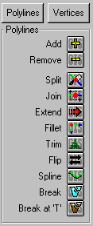
Adds a new arc that if selected can be an extension of an existing arc.
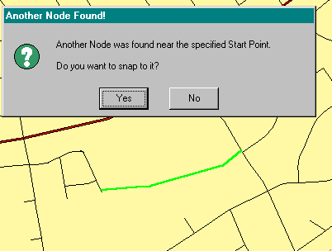
Select the “Add” button. To add to an existing arc, pick near the endpoint of said arc. Continue digitizing. To connect to the end point of another arc, finish with your last digitize near the end of the arc you wish to connect to.

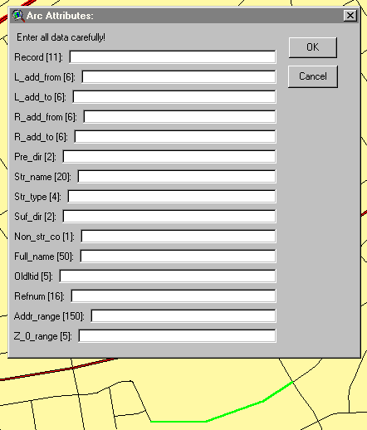
After the last digitize you will be asked if this arc should be started at the endpoint of the first arc that you digitized near.

Answer YES or NO

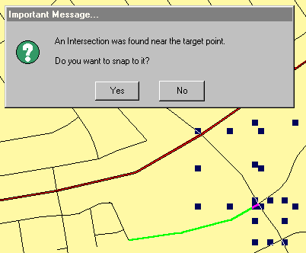
The next box to appear is an input screen so that you may fill in the attributes that are associated with the shape file that you have in edit mode.

The last part is to verify that you want to connect to a node found near your last digitize.

Answer YES or NO.

If you are satisfied with the results, the arc can now be added to the existing file that you are editing.
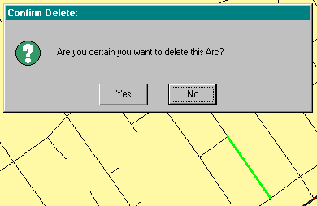
Allows the user to delete a single arc by picking it on the screen.
Advantage, arc is highlighted on the screen instead of by the boxes showing it’s limits
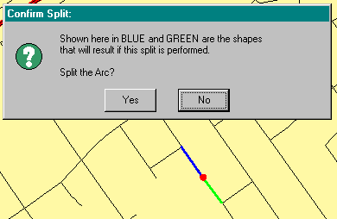
Allows the user to draw a line across an existing Arc Causing a split at the point of intersection.
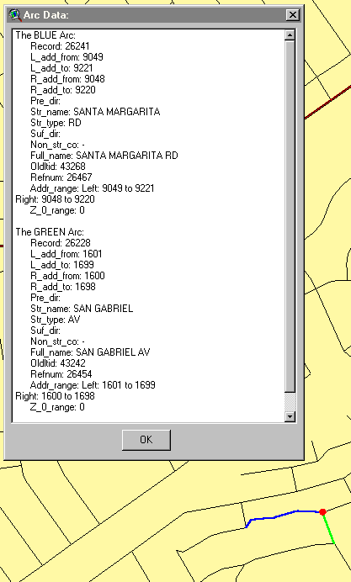
Advantage, shows where split will occur and prompts user to accept or not.
Combines two existing arcs into a single arc. Drag a rectangle around the endpoints of two polylines that you would like to make one arc. You will be asked which set of attributes you would like to keep. If you are unsure select “View Data” to have both sets displayed.

Pick which set keep and hit OK.

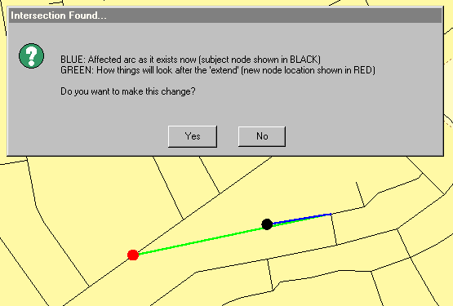
Extends the endpoint of the selected arc to the intersection with another shape in the same theme.

The Black Dot with the Blue Line shows the current geometry of the arc. The Red dot with Green Line shows how the arc will look if accepted.

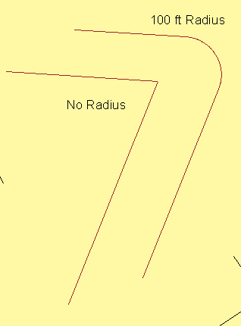
Extends two polylines toward each other until they meet. A tangent curve will be used to make the connection if the fillet radius is not zero.

Pick on the “Fillet” button, you may now enter the value for the creation of the radius. If you select zero the lines will be trimmed to each other at a sharp angle.

As an example if 100 ft is entered the lines will be extended and a 100 ft radius arc will be created at their intersection point.

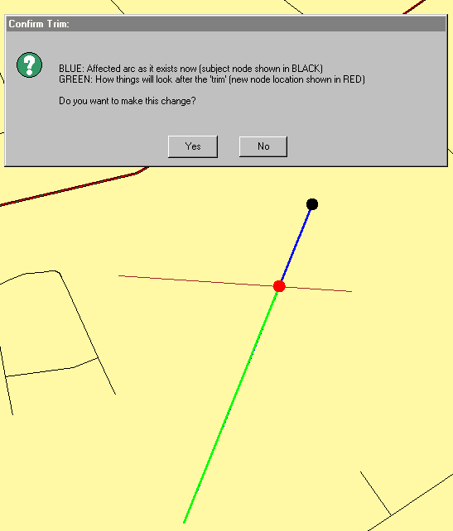
Removes that portion of an arc from the picked node back to the nearest intersection with another arc in the same shapefile.
Pick the end of the arc that needs to be trimmed. The system will calculate what arc it intersects and prompt the user to accept this change or not.

The Black Dot with the Blue Line shows the current geometry of the arc. The Red dot with Green Line shows how the arc will look if accepted.

Reverses the geometry of the selected arc.

Modifies the shape of each selected polyline in the current theme with a smoother, rounder look.
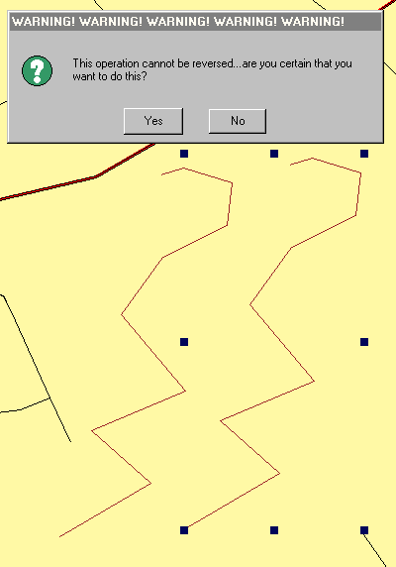
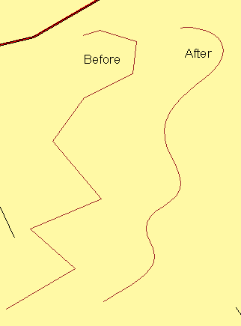
Select arc to be modified. Pick on the “Spline” button, a box will be displayed warning the user that this operation cannot be reversed.

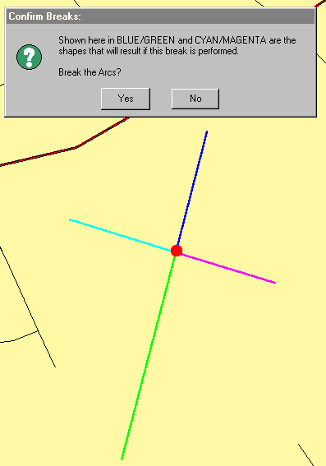
Breaks both arcs at the chosen intersection. Pick on the “Break ” button, next digitize at the location for the beak to occur. The four new lines will be displayed in different color. Accept YES or NO

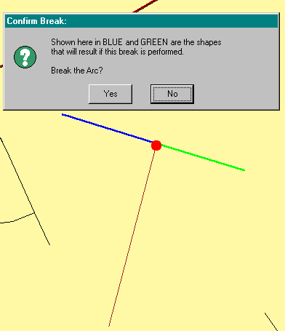

Breaks single arc at the intersection point of adjacent arc.
Pick on the “Break at ‘T’” button, , next digitize at the location for the beak to occur. The two new lines will be displayed in different color. Accept YES or NO

POLYLINE EDITING
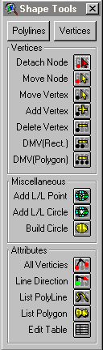
When the “Shape Edit Tools” button is selected from the “Shape” menu as described previously. The menu has two main sections, “Polylines” and “Vertices. The following section will describe the “Vertices” functions.

From the “Attribute” section select “All Vertices”, this will display all of the nodes in the view and will help with your selection. Use this for all of the Vertices functions.

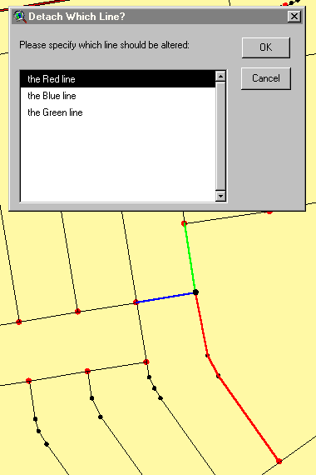
Pick on the node that will be moved and while holding down the mouse button drag to it’s new location. A message box will appear and ask you which node you wish to move. Each polyline will be displayed in a different color.
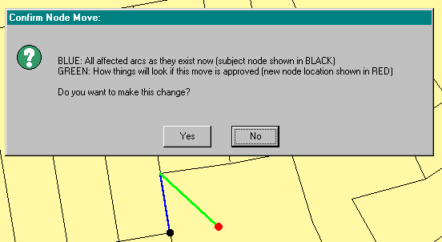
After your selection the display will be changed to show the new geometry layout and this can be accepted or denied.

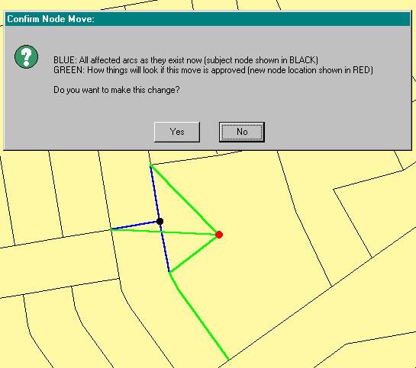
Moves the node from it’s current location to a user digitized spot.
Pick on the node that will be moved and while holding down the mouse button drag to it’s new location. A message box will appear and ask you if you wish to accept the move. The original geometry will be displayed in Blue with the new look in Green.

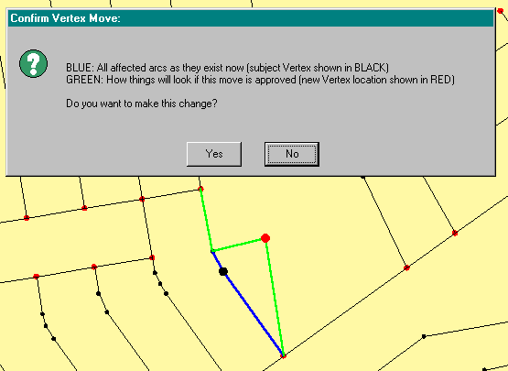
Pick on the vertex that will be moved and while holding down the mouse button drag to it’s new location. A message box will appear and ask you which node you wish to move. The original geometry will be displayed in Blue with the new look in Green.

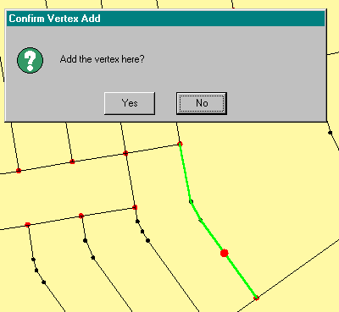
Adds a vertex to an existing arc at the intersection of the existing arc and a user line.

Drag a line across an existing polyline and the line will be highlighted with a Red Dot at the new vertex location.

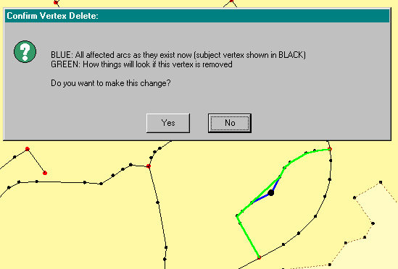
Eliminates a vertex from an existing shape. WILL NOT delete a NODE!
Pick on a vertex that for removal. The original geometry will be displayed in Blue with the new look in Green.

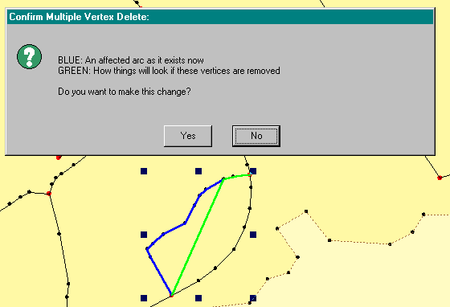
Delete Multiple Vertices – Rectangle: Eliminates all vertices falling within a user created rectangle.
WILL NOT delete a NODE!

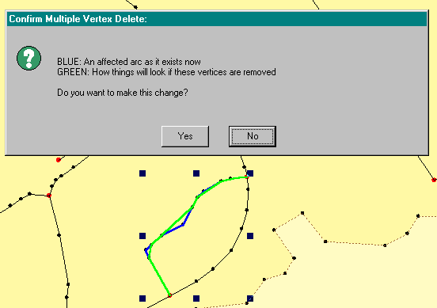

Delete Multiple Vertices – Polygon: Eliminates all vertices falling within a user created polygon.
WILL NOT delete a NODE!

Shape Manipulation

When the “Polygons”, Polylines, “Points or “Circle” “button is selected from the “Shape” menu as described previously each menu is expanded to show functions that may apply to all of the ArcView entity types or some that are unique to each one.

The follow sections will describe these functions in detail.
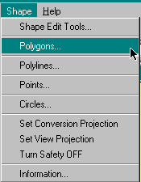

The first section to be worked with is “Polygons”.

Click on the “Shape” menu and then the “Polygons” button. The menu will be dismissed. Again pick on the “Shape” menu and the “Polygons” button will be expanded to show additional functions.

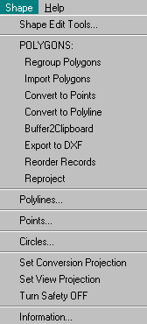

Selects all polygons in the current edit theme and performs a UNION FEATURE resulting in a single feature

Adds the polygons of a chosen theme to the theme currently being edited. When the “Import Polygons” button is selected a text box is displayed with all of the same type of features active in the view. Pick the file to be imported and answer YES or NO if unmatched fields should also be added to the theme table.

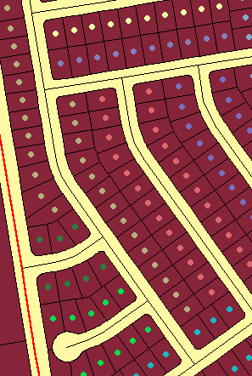
Converts selected polygons (or entire theme if none are selected) into a new point theme with all of the original polygon attributes

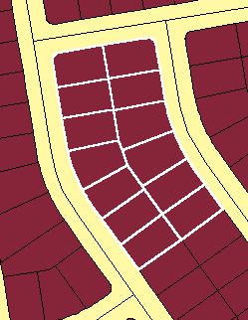
Converts selected polygons (or entire theme if none are selected) into a new polygon theme with all of the original polygon attributes

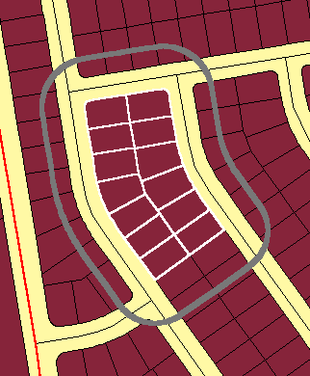
Buffers (at a user-specified radius) selected features or graphic shapes into a single polygon and places this shape into the clipboard.

Stores the geometry of selected polygons as lines in a simple DXF file

Edits the Shape File, re-ordering the actual records just as they would appear after a field sort.

Reprojects selected features polygons (or entire theme if none are selected) from and to user selected projections.

The second section to be worked with is “Polylines”.

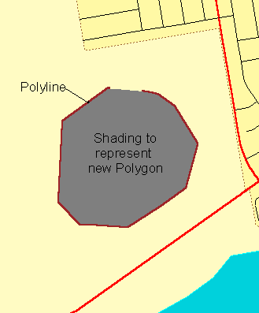
Click on the “Shape” menu and then the “Polylines” button. The menu will be dismissed. Again pick on the “Shape” menu and the “Polylines” button will be expanded to show additional functions.

Paints the screen with the polygon equivalent of a user selected polyline theme. Use this to preview the “Convert to Polygon” results.
Pick on “Polygon Preview”, a box will be displayed with all of the polyline themes in the project. Select which polyline theme is to be converted into a polygon theme. A gray shading will be displayed. This is the look of the new polygon.
Note: The endpoint will be connected to the starting point of the polyline with a straight line.

Creates a polygon theme from an existing theme.
Pick on “Convert to Polygon”, a box will be displayed with all of the polyline themes in the project. Select which polyline theme is to be converted into a polygon theme. Identify a name and location for this new theme to reside. The polygon will be added to your current view.

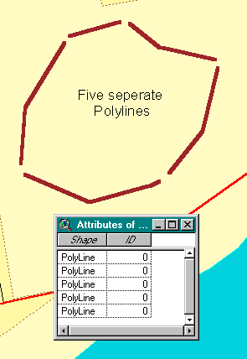
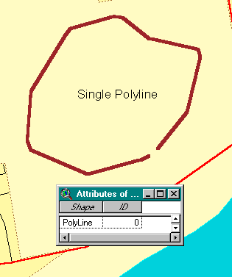
Fills all gaps in a polyline shape until only ONE point list remains.

Adds the polylines of a chosen theme to the theme currently being edited. When the “Import Polylines” button is selected a text box is displayed with all of the same type of features active in the view. Pick the file to be imported and answer YES or NO if unmatched fields should also be added to the theme table.

Modifies the shape of each selected polyline in the current theme with a smoother, rounder look.
Select arc to be modified. Pick on the “Spline” button, a box will be displayed warning the user that this operation cannot be reversed. Answer YES to continue NO to stop.
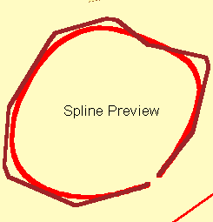
Paints the screen with a smoother version of each feature in a user selected polyline theme. Use this to preview the “Spline Polyline” results.

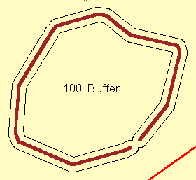
Buffers (at a user-specified radius) selected features or graphic shapes into a single polygon and places this shape into the clipboard.

Stores the geometry of selected polygons as lines in a simple DXF file

Edits the Shape File, re-ordering the actual records just as they would appear after a field sort.

Scans the entire shape file for polyline shapes consisting of zero or more than one list of points. If a bad record is encountered in the file, it will be highlighted and can be deleted by the user.

Reprojects selected features polylines (or entire theme if none are selected) from and to user selected projections.

The Third section to be worked with is “Points”

Click on the “Shape” menu and then the “Points” button. The menu will be dismissed. Again pick on the “Shape” menu and the “Points” button will be expanded to show additional functions.

Adds the points of a chosen theme to the theme currently being edited. When the “Import Points” button is selected a text box is displayed with all of the same type of features active in the view. Pick the file to be imported and answer YES or NO if unmatched fields should also be added to the theme table.
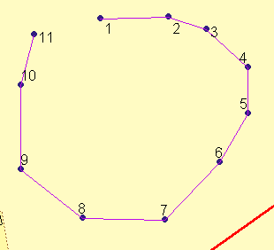
Converts selected points (or entire theme if none are selected) into a new polyline theme. Polyline is constructed based on the order of the points in the database.

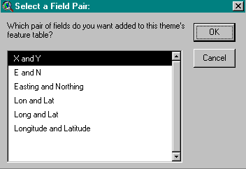
Adds and/or recalculates Lat/Lon coordinate fields in the theme database. Six different display format are available. Three in a X/Y or Easting/Northing format and three in a Lat/Lon format.
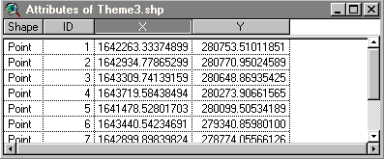
X and Y

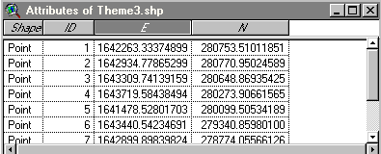
E and N

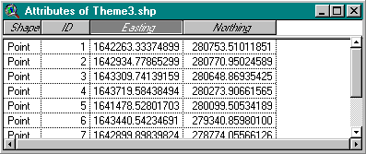
Easting and Northing

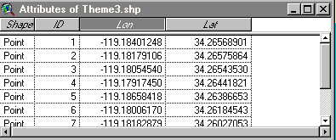

Lon and Lat

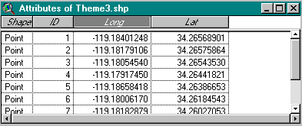

Long and Lat

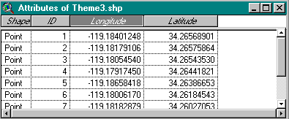

Longitude and Latitude

Edits the Shape File, re-ordering the actual records just as they would appear after a field sort.

Reprojects selected features polylines (or entire theme if none are selected) from and to user selected projections.

