Planning for the Scientific Exploration
of Mars by Humans

By the MEPAG Human Exploration of Mars Science Analysis Group

MEPAG Human Exploration of Mars Science Analysis Group (HEM-SAG)
James B. Garvin (co-chair), Joel S. Levine (co-chair), David W. Beaty, Ariel D. Anbar, Mary Sue Bell, R. Todd Clancy, Charles S. Cockrell, Jack E. Connerney, Peter T. Doran, Gregory Delory, Jay T. Dickson, Richard C. Elphic, Dean B. Eppler, David C. Fernandez-Remolar, John E. Gruener, James W. Head, Mark Helper, Jennifer Heldmann, Victoria Hipkin, Melissa D. Lane, Joseph Levy, Jeff Moersch, Gain Gabriele Ori, Lewis Peach, Francois Poulet, James W. Rice, Kelly J. Snook, Steven W. Squyres and James R. Zimbelman

January 31, 2008

Review Copy

Recommended bibliographic citation:
MEPAG HEM-SAG (2008). Planning for the Scientific Exploration of Mars by Humans,
Unpublished white paper, TBD p, posted March 2008 by the Mars Exploration
Program Analysis Group (MEPAG) at http://mepag.jpl.nasa.gov/reports/index.html.

Correspondence authors:
Inquiries should be directed to James B. Garvin (james.b.garvin@nasa.gov, 301-286-5154),
Joel S. Levine (joel.s.levine@nasa.gov, 757-864-5692),
or David W. Beaty (David.Beaty@jpl.nasa.gov, 818-354-7968)

Contents

Executive Summary 1
Introduction 2
Why Mars? 3
Why Humans? 3
General Conclusions 5
Geology: Human Exploration Goals and Objectives 6
Geophysics: Human Exploration Goals and Objectives 18
Atmosphere/Climate: Human Exploration Goals and Objectives 30
Biology/Life: Human Exploration Goals and Objectives 42
Conclusions 58
Appendices 61
A. Candidate Human Exploration Sites 61
B. Atmosphere/Climate: Human Exploration Goals and Objectives 68
C. The Human Exploration of Mars: Lessons Learned from Apollo (James W. Head) 83
References 85

Executive Summary
Mars will remain an attractive destination for science for decades to come and the pace of discoveries about the workings of the Red Planet could be dramatically accelerated by means of human-based exploration at any time it becomes possible. In the context of a set of three initial human expeditions to Mars at some time beyond the current event horizon (i.e., in ~25 years, meaning 2030s or 2040s), a team of experienced planetary scientists with diverse scientific backgrounds has analyzed scientific priorities and scenarios for such missions, under the overarching precept that scientific discovery is a major aspect of such missions. The Human Exploration of Mars Scientific Analysis Group (HEM-SAG) derived human science reference missions using constraints provided by engineers affiliated with the 2007 Mars Architecture Team (B. Drake et al., NASA JSC) as well as the current scientific priorities for Mars exploration summarized in the 2007 MEPAG Goals and Objectives reference document as well as recent National Academy of Sciences Solar System Decadal Survey recommendations (New Frontiers, NRC, 2003). After initial evaluation of the state of knowledge about Mars today (circa 2007), the HEM-SAG projected this state of knowledge forward to ~2030, under the assumption that a robotic Mars sample return mission must be accomplished prior to Human scientific activities on the martian surface. The HEM-SAG concluded that in any science-driven or science-guided program of human exploration, each of three baselined human missions must visit independent and distinct “exploration sites” for maximal periods of time, as dictated by the realities of flight dynamics and celestial mechanics. Thus, the overarching conclusion of the HEM-SAG is for three human exploration missions to scientifically (i.e, in terms of surface age of materials and scientific problem focus) target different regions for periods of up to 500 days on the surface, enabled by means of moderate-to-long range human mobility (100’s of km) and multi-100m scale subsurface access. Scientific priorities at the time of the first HEM missions (2030s or 2040s) would likely remain similar to those of today, in spite of major progress underway from the current US and International robotic Mars programs (NASA’s MEP, ESA’s science programme). In addition, there are “pass-backs” from what we need to be able to accomplish on Mars for science that could be validated and optimized via human exploration activities on the Moon, including unique aspects of sample acquisition and handling, in situ characterization, deep subsurface access, and long-range surface mobility, potentially with pressurized human roving vehicles. Mars, in the view of the HEM-SAG, represents an ideal target for intensive human-based and enabled surface scientific operations for the next 50 years.

HEM-SAG Introduction
To prepare for the exploration of Mars by humans, as outlined in the new national Vision for Space Exploration (VSE), the Mars Exploration Program Analysis Group (MEPAG), formed a Human Exploration of Mars Science Analysis Group (HEM-SAG) in March 2007. The goal of HEM-SAG is to develop the scientific goals and objectives for the scientific exploration of Mars by humans. The HEM-SAG is one several parallel NASA humans to Mars scientific, engineering and mission architecture studies going on in 2007 to support NASA’s planning for the VSE. The HEM-SAG consists of about 30 Mars scientists representing the disciplines of Mars geology, geophysics, atmospheric/climate science and biology/life science from the U.S., Canada, England, France, Italy and Spain (It was decided very early that the international Mars community should be represented on HEM-SAG). Drs. James B. Garvin (NASA Goddard) and Joel S. Levine (NASA Langley) were appointed co-chairs of HEM-SAG. The HEM-SAG team conducted 20 telecons beginning on March 21, 2007. HEM-SAG convened three face-to-face meetings: 1. May 3-4, 2007, at USRA Headquarters, Columbia, MD, 2. July 8, 2007 at the Pasadena Hilton, and 3. October 23-24, 2007, at USRA Headquarters, Columbia, MD, On May 17, the interim HEM-SAG interim findings were reported to MEPAG management (Drs. Ray Arvidson, past MEPAG Chair and Jack Mustard, MEPAG Chair) and MEP management (Drs. Michael Meyer, MEP, NASA Headquarters and Rich Zurek, MEP, JPL) via telecon.
The scientific goals and objectives for the human exploration of Mars discussed in this report are based on the Mars Scientific Goals, Objectives, and Priorities: 2006, (MEPAG, 2006) (J. Grant, editor, 31 page white paper posted February, 2006, by the Mars Exploration Program Analysis Group (MEPAG) at http://mepag.jpl.nasa.gov/reports/index.html.

HEM-SAG Starting Assumptions
- The first human mission to Mars may be scheduled for launch as early as 2030, and as late as 2040. In this study, only consider the first three human missions to Mars.
- Assume that the scientific objectives for the first human mission to Mars would be set based on cumulative knowledge and priorities as of about 5 years before launch.
- Assume that the robotic exploration of Mars would continuously operate from now until the first human mission.
- Because the timing of the second human mission to Mars relative to the first is subject to large uncertainties, for the purpose of this planning exercise, the HEM-SAG should focus on to develop inputs into the planning the baseline architecture for the first, and possibly subsequent, human missions to the Martian surface.

HEM-SAG Requested Tasks
- Starting from the current version of the MEPAG (2006), develop an analysis of the probable/possible evolution of our scientific goals and objectives for Mars over the next three decades. The scientific goals and objectives of a future human mission would need to be based on this projection, not on today’s list.
  - Which of MEPAG’s current scientific goals, objectives and investigations would have been met, all or in part?
  - Since the nature of science is that investigations not only answer questions, but almost always also raise new ones, how are the current objectives and investigations likely to evolve into future ones?
- Develop an analysis of the spectrum of possible scientific objectives that would be appropriate for a future human mission to Mars.
  - Evaluate the advantage to an implementation involving humans for different kinds of scientific investigations
  - Analyze the opportunity to take scientific advantage of the engineering aspects of a human mission.
- Based on the above considerations, develop an analysis of the probable/possible relative priority of the identified candidate scientific objectives.

Why Mars?
Mars is a unique and complex world. Many of the same processes/mechanisms operate/operated on both Earth and Mars, e.g., early heavy bombardment, impact craters, planetary dipole magnetic field, widespread and extensive volcanism, the presence of liquid water on the surface, geochemical cycles, the condensation of atmospheric gases forming polar caps, etc. Mars, like the Earth, is a terrestrial planet with a very diverse and complex surface features and processes. Like the Earth, Mars is also a possible abode for past and/or present life. The geological record suggests that the atmosphere/climate of Mars has changed significantly over its history. Early Mars may have possessed a denser atmosphere, perhaps with a surface atmospheric pressure in excess of 1000 millibars, the surface pressure of the Earth’s atmosphere. A denser atmosphere on Mars would have permitted liquid water on its surface. Present-day Mars has a thin (6 millibars) cold atmosphere, devoid of any surface liquid water. Why has Mars changed so drastically over its history? How and why has the habitability of Mars changed over its history? Is there a message in the history of Mars to better understand the future of the Earth?

Why Humans?
Humans have unique capabilities for performing scientific measurements, observations and sample collecting. Human attributes to exploration include: intelligence, adaptability, agility, dexterity, cognition, patience, problem solving in real-time, in situ analyses - more science in less time!
Humans are unique scientific explorers. Humans could obtain previously unobtainable scientific measurements on the surface of Mars. Humans possess the abilities to adapt to new and unexpected situations in new and strange environments, they can make real-time decisions, have strong recognition abilities and are intelligent. Humans could perform detailed and precise measurements of the surface, subsurface and atmosphere while on the surface of Mars with state-of–the-art scientific equipment and instrumentation brought from Earth. The increased laboratory ability on Mars that humans offer, would allow for dramatically more scientific return within the established sample return limits. The HEM-SAG envisions that the scientific exploration of Mars by humans would be performed as a synergistic partnership between humans and robotic probes, controlled by the human explorers on the surface of Mars. Robotic probes could explore terrains and features not suitable or too risky for human exploration. Under human control, robotic probes could traverse great distances from the human habitat covering distances/terrain too risky for human exploration and return rock and dust samples to the habitat from great distances.
An important element of the HEM-SAG study has been to identity the unique capabilities that humans would bring to the process of exploring Mars. As a result, a common set of human traits emerged that would apply to exploration relating to the MEPAG Goal III science disciplines which include Geology, Geophysics, Atmosphere/Climate, and Biology/Life,. These characteristics include: speed and efficiency to optimize field work; agility and dexterity to go places difficult for robotic access and to exceed currently limited degrees-of-freedom robotic manipulation capabilities; and most importantly the innate intelligence, ingenuity, and adaptability to evaluate real-time and improvise to overcome surprises while ensuring that the correct sampling strategy is in place to acquire the appropriate sample set.
The unique capabilities that humans would provide for each of the MEPAG Goal III science disciplines mentioned above are summarized as follows:

Geology
Intelligent sample selection, real time assessment of site sampling progress and strategy development to optimize science return.
Drilling in environments difficult for core recovery (ice, sediments, other unconsolidated materials) without human involvement.
Rapid assessment of subsurface and sampling/trenching (efficiency factor).

Geophysics
Humans are likely to be far more efficient and skilled than robots in carrying out the careful emplacement of instruments, networks, and site surveys required to meet geophysical investigation goals and objectives. Even if rover-borne instrumentation is deployed tele-robotically, that would require human oversight from the habitat. Some geophysics instrumentation must be deployed and then recovered following measurements (e.g., active seismic systems, or EM sensors). Humans would make this deployment/recovery process more efficient and perhaps even more carefully done, as well as providing instant gratification on the health and performance of the instruments.

Atmosphere/Climate
Human enabled investigations on Mars would benefit atmospheric, polar cap, and ancient climate science objectives in a variety of ways. Human dexterity and efficiency would be important qualities for micrometeorological investigations where activities such as radiosonde preparation and release are not yet automated on Earth due to the dynamic interaction with surface turbulence and winds. Cognitive ability, dexterity and efficiency would be necessary attributes in the search for relevant rock outcrops and samples, providing the ability to identify sources of trace gases for studies of current climate on Mars as well as locating pristine impact glasses containing trapped gasses for the study of ancient Mars climate. These unique human capabilities would be vital to deep drilling and coring activities. Touch and sound would be used to monitor the drill performance and respond rapidly to changing subsurface conditions.

Biology/Life
Earth-based investigations into the purported evidence for life in Martian meteorite ALH84001 have involved a great number of scientists utilizing many sophisticated instruments and techniques but remain controversial. Evidence of life on Mars, both past and present may be quite subtle. The selection of relevant samples and sampling environments would require the unique capabilities of humans (e.g., ingenuity, flexibility, efficiency) to interpret available clues in real time and to strategically execute a plan for investigation of hypotheses in situ. Humans bring to planetary exploration the ability to quickly analyze and assess samples before they degrade locally or on return. Samples should still be returned to Earth because of the advanced analytical capabilities of terrestrial laboratories, but the increased capabilities humans would provide on Mars, and the remarkable advances that have and would continue to be made in lab instrument miniaturization mean more science reaped without the restrictions of sample weight on return and a greater likelihood of satisfying the goals and objectives of the mission.
We believe that the human element is value added to all aspects of the MEPAG Goals and Objectives. Technology development in the decades leading up to a human mission to Mars would determine the best synergistic fit between human and robotic exploration and perhaps technology challenges would be overcome to shift the balance of physical activity toward robotic assignment. However, certain uniquely human attributes could not be duplicated by or relegated to robots or to operations remotely operated by humans on a planet substantially separated in time and space from Earth. Only a human presence in Mars mission surface operations activities could facilitate and achieve the ambitious scientific goals and objectives of MEPAG.

some HEM-SAG General Conclusions

For the first three human missions: three different sites or the same site?
Three independent sites.

For the first three human missions should they be: “short stay (~30 days)” or “long Stay (~500 days)”?
Three long-stay (~500 days) missions to maximize scientific return.

How much surface mobility, in terms of radial distance from landing site, would be required to perform the required science?
Human mobility (horizontal)/pressurized human rover >200 km radial (Perhaps >500 km).

What would be the subsurface access requirements?
Vertical subsurface access (drilling) ~300 m at one site for access to subsurface liquid water zones, if available; less (5-50 m) at multiple sites on traverses. Selective recoverable coring, e.g., polar climate coring to depth of 300 m.

How would we implement a search for extant life vs. a search for fossil life? (Assessing the human of human explorers on the search for extant life)
Very carefully. The search for extant biology must be an important scientific goal/objective of human exploration. Humans have a great deal of experience in carrying out aseptic sampling of exteme environments on Earth to carry forward in this endeavor
Human in-situ analyses on Mars vs. returning samples to Earth for analyses (Mass of instrumentation/equipment transported from Earth to Mars for in situ analyses on Mars versus amount of sample mass to be returned to Earth)
Human habitat/work station: In situ sample analysis and cataloging: Analyses that could not be performed on Earth, e.g., tests for extant life.
Samples would include rocks, drill cores, surface/atmospheric dust, ice, atmospheric gas.
Sample conditioning and preservation would be essential.
Human habitat LAB instruments for multiple objectives: Geology, Atmosphere/Climate and Biology/Life.
Emplacement of network stations for Geophysics, Atmosphere/Climate and even Biology/Life would be essential beyond initial landing site (200-400 km radial from landing site) to be operated during and after humans return to Earth.

How much sample mass should be returned to Earth?
Mass of samples returned to Earth >250 kg.

Geology: Human Exploration Goals and Objectives

What Would Be the Key Scientific Goals and Objectives of Human Exploration of Mars In Geology and What Would be the Sample Human Science Reference Missions (HSRM) In Geology?
While current and future robotic Mars missions would provide insight regarding the geology of Mars, HEM-SAG concluded that the fundamental top-level questions with regard to Mars would likely remain broadly the same over the next 20 years. Among those questions are:
- What is the volcanic history of the planet, and is Mars volcanically active today?
- What was the nature and evolution of the Martian magnetic field?
- What is the climate history of Mars?
- What is the hydrologic history of Mars?
- Is Mars hydrologically active at the present time?
These questions have wide-ranging implications with regard to the evolution of the Solar System, the nature and evolution of Earth’s surface and climate, and the feasibility and likelihood of biology on another planetary body. The complex history of the Mars, and the evolution of Mars from the potentially “warm and wet” periods of its early Noachian history to the later “cold and dry” period of the Amazonian, strongly suggest that an exploration strategy that addresses the characteristics and processes of the three major periods would be required (Figure 1).

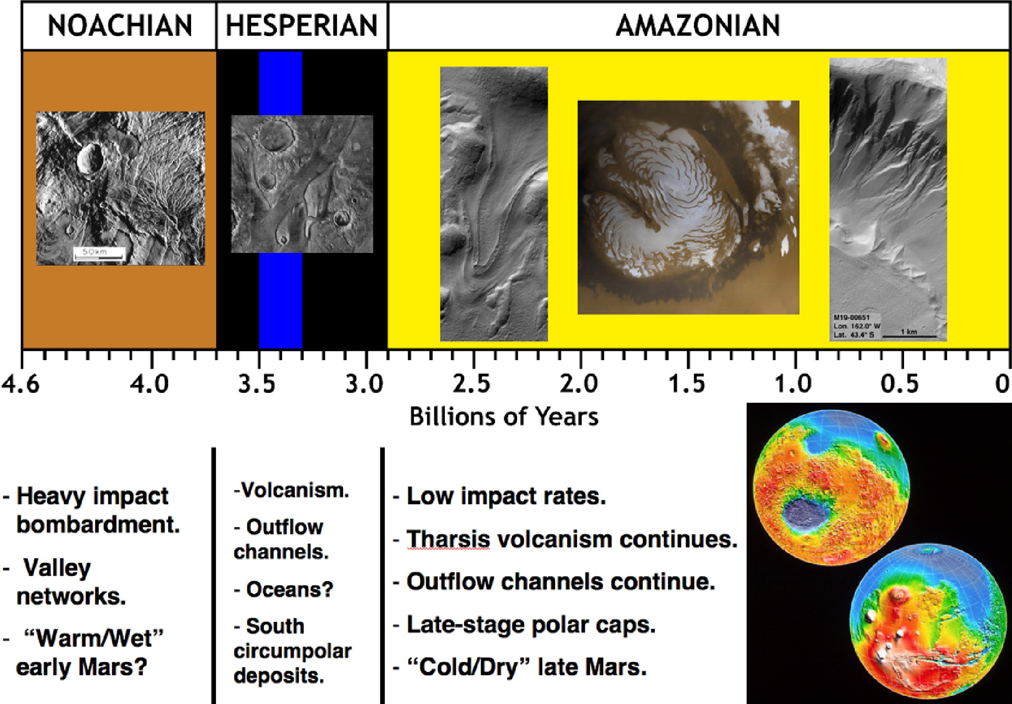
Figure 1. Geological history of Mars with the major periods and significant events and processes.

Thus, none of these questions could be answered by a focused study on just one landing site. The diversity of surface morphology and composition of the Martian surface demands an array of landing sites that spans the geologic history of Mars. As a preliminary exercise, we specified 58 distinct landing sites that would address these issues and would specifically benefit from the presence of human explorers (Figure 2). A brief discussion of each of the 58 landing sites is found in Appendix 1. From these 58 sites, we chose 3 sample sites for more detailed examination and traverse selection, which we plan to use as reference missions after further outlining the major questions with regard to the geology of Mars.

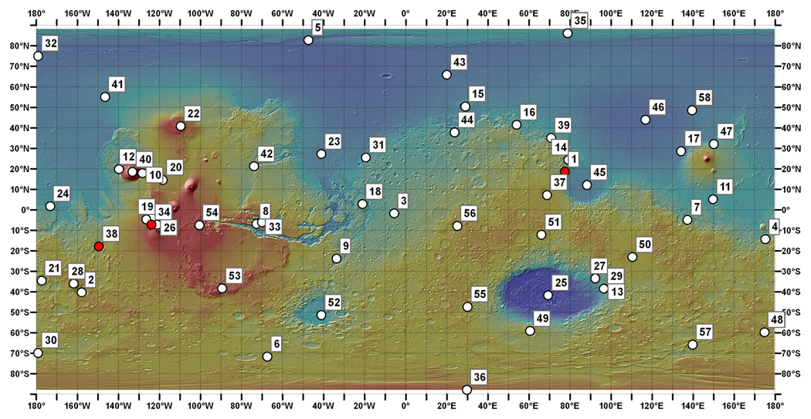
Figure 2. Location map for the 58 potential exploration sites on Mars.
The three proposed reference mission sites are indicated in red.

Planetary-Scale Geologic Processes that Could be Addressed by Human Exploration
The absolute ages of surface units on Mars has been deciphered through indirect methods; samples returned from the Moon in the Apollo Program were used to provide constraints on the crater-size-frequency distribution of the lunar surface, and this has been applied to Mars, among other terrestrial planetary bodies. While this has provided a general history of Martian surface processes (Figure 1), it does not allow for detailed study of specific Martian periods, in particular the Hesperian and Amazonian, when the impact flux greatly decreased. While Martian meteorites have been analyzed and dated, not knowing their geologic context makes their incorporation into the geologic history of Mars difficult. And while a Mars Sample Return mission would yield surface samples with known context, a robotic mission would not yield the array of optimal samples that would address a wide range of fundamental questions. A human mission would allow for greater access to samples that a robotic rover might not get to, and the capacity for real-time analysis and decision-making would ensure that the samples obtained would be the optimal samples available.
Human explorers would also have greater access to the near-subsurface of Mars, which would yield insights into climate and surface evolution, geophysics, and potentially biology. Humans would be able to navigate more effectively through blocky ejecta deposits that would provide samples that were excavated from great depth and provide a window into the deeper subsurface. Humans could trench in dozens of targeted locations and operate sophisticated drilling equipment that could sample the top ~1 km of the crust. Our current understanding of the crust of Mars is limited to the top meter of the surface, so drilling experiments would yield unprecedented and immediate data. Drilling in areas of gully formation could also test the groundwater model by searching for a confined aquifer at depth.

Human Science Reference Mission (HSRM): Geology
We have analyzed three different exploration sites in detail as potential reference missions for the first program of human Mars exploration. The sites would span the geologic history of Mars (one site for each period of Martian history; Figure 1) and allow for exploration traverses that would examine a variety of surface morphologies, textures and mineralogies to address the fundamental questions posed by MEPAG.

Jezero Crater. Jezero crater is a ~45 km impact crater on the northwest margin of the Isidis impact basin, in the Nili Fossae region of Mars (Figures 3 and 4). This region is a very important area for understanding the formation of the Isidis basin, the alteration and erosion of this Noachain basement, and subsequent volcanism and modification (e.g., Mustard et al., 2007; Mangold et al., 2007). The rim has been breached in three places: twice where channels from the neighboring highlands to the west have drained into the crater from the northwest (Figures 3, 4), and once on the eastern margin where the crater has drained eastward towards the Isidis basin (Fassett and Head, 2005) (Figure 5). Each input channel deposited deltas on the crater floor that have been preserved and reveal sedimentary structures (Figure 6) and clay deposits (Figure 7) in high-resolution images and spectral data (Fassett et al., 2007; Ehlmann et al., 2007). Other parts of the crater floor appear to have been resurfaced by lava.

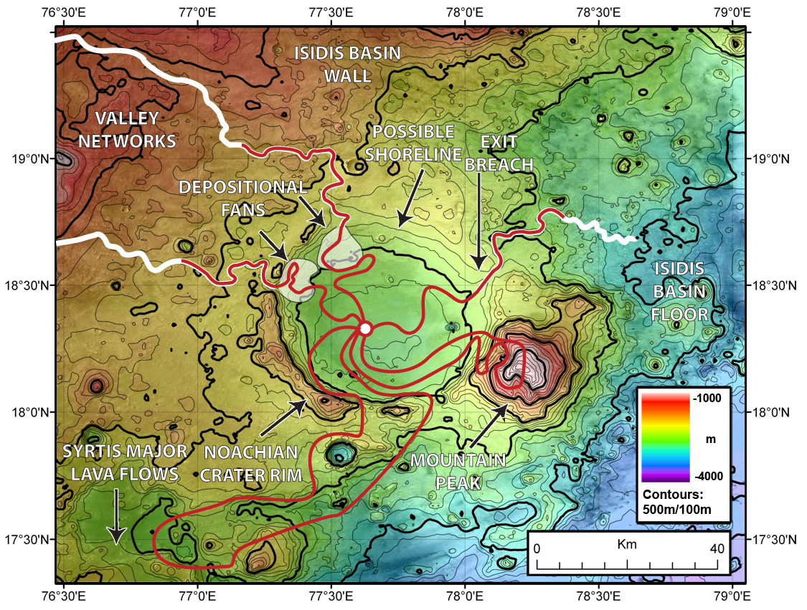
Figure 3. Potential traverses for human explorers in and around Jezero Crater.

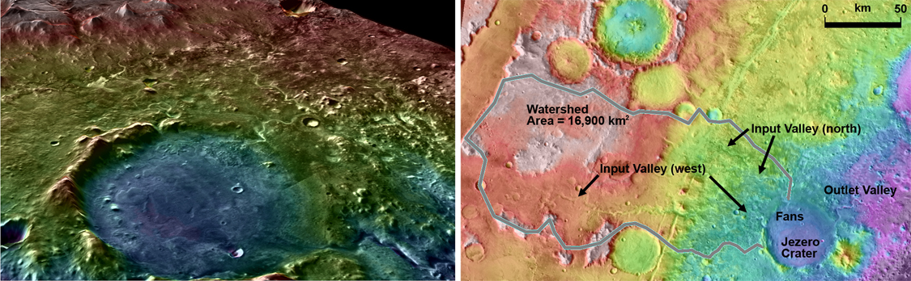
Figure 4. Jezero Crater in perspective view showing Isidis Basin rim and watershed area.

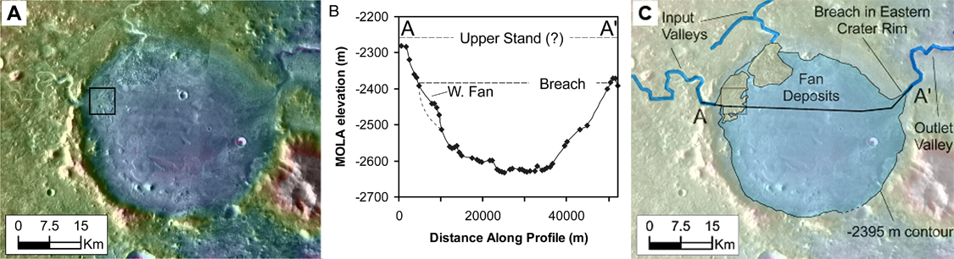
Figure 5. Topography of Jezero Crater.

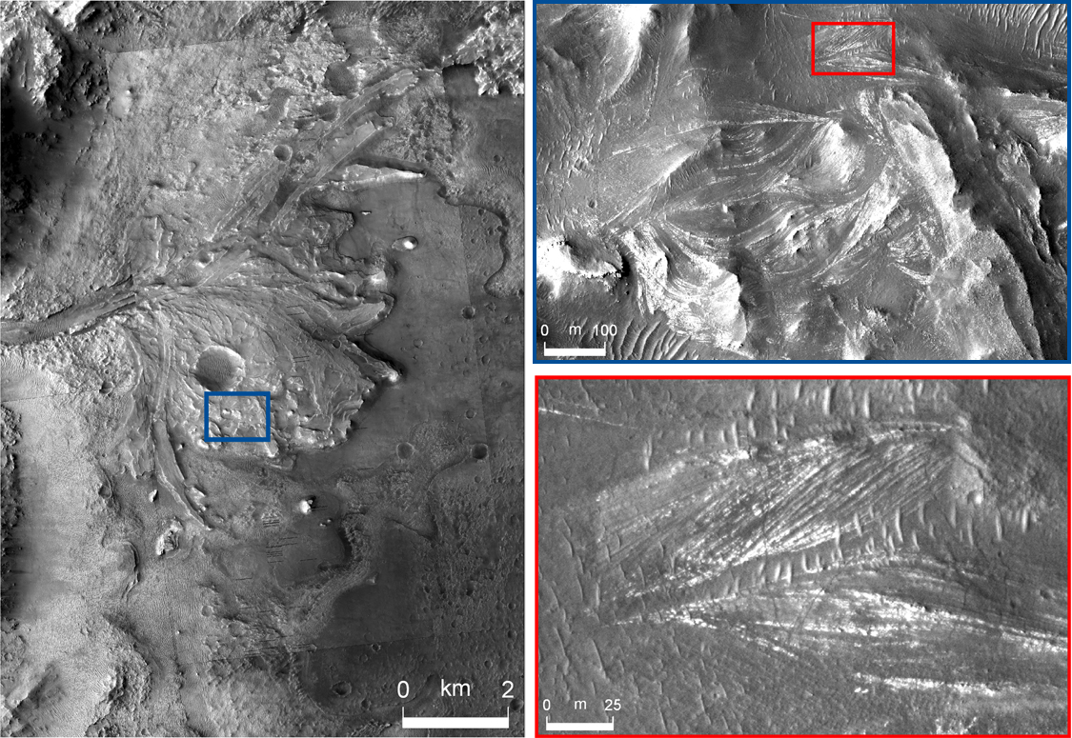
Figure 6. HiRISE image of delta deposit and layering in scroll bar.

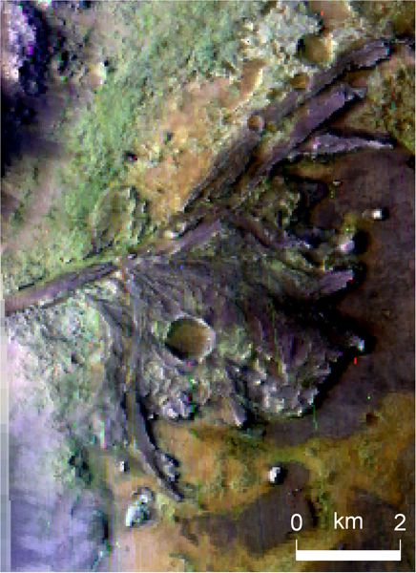
Figure 7. CRISM multi-spectral map of delta:
Green, phyllosilicates; Orange, olivine; Purple, neutral or weak bands.

A 500-day mission at this site would reveal considerable data regarding the early Martian environment. Jezero crater itself is Noachian in age and the preserved rim would provide access to ancient bedrock material (rich in low-calcium pyroxene) exposed by the impact. The delta deposits are likely to be Noachian in age and HiRISE data show that the sedimentary record in the deposit has been preserved as a series of thin layers (Figure 6). On the basis of the fact that a standing body of water existed within the crater for an extended period of time, this would be an ideal site to search for extinct biology. Humans would also be able to examine the structure and deposits within the channels associated with the deltas, which would be applicable to the other vast valley networks on Mars.
Extended traverses would be able to access and study the entire Jezero crater system (Figure 3). To the southwest of Jezero are Hesperian lava flows from Syrtis Major, a principle volcano in the northern hemisphere of Mars providing a key constraint on the geological timescale of the region. This would also shed light on the evolution of magma composition on Mars. To the east of Jezero is the floor of Isidis basin, which is topographically connected to the northern plains and which would allow for detailed study of major impact events. Samples collected from all of these sites would allow for enhanced geochronology and a more detailed understanding of the hydrology, sedimetology, volcanology, and habitablity of the region.
Mangala Valles. Mangala Valles is an Hesperian-aged outflow channel which has received considerable attention on account of its role in global cryosphere/hydrosphere interactions, as well as the possibility that it contains icy near-surface deposits (Levy and Head, 2005; Leask et al., 2007a,b; Hanna and Phillips, 2006; Ghatan et al., 2005; Wilson and Head, 2004; Head et al., 2004; Hanna and Phillips, 2007; Leask et al., 2007). Mangala Valles emanates from a graben that is radial to the Tharsis volcanic complex (Figure 8). Massive release of water from the ground at the graben was accompanied by phreatomagmatic eruptions (Wilson and Head, 2004) and caused catastrophic flow of water to the north, carving streamlined islands. There are also young glacial deposits along the rim of the graben (Head et al., 2004) and evidence for glacial scour having modified the surface of the outflow channel.
This site shows evidence for fluvial, volcanic, tectonic and glacial activity and complicated interactions among them. A landing site in the smooth terrain at the center of the outflow channel would provide access to a variety of sites of interest. Traverses to the channel head and the graben would allow direct observation of cryosphere-breaching geological activity. Traverses along the floor of the outflow channel, as well as on the scoured plains would provide insight into outflow flood hydrology and erosion processes, as well as provide an opportunity for sampling ice-rich deposits which may contain ancient flood residue. A traverse to the vent-rim glacial deposits would provide access to landforms created by volcano-ice interactions, as well as to samples of distal Tharsis volcanic deposits. On the basis of the likelihood that if life exists on Mars, it is most likely to inhabit the subsurface, a site such as Mangala would offer a unique opportunity to sample for evidence of such activity.

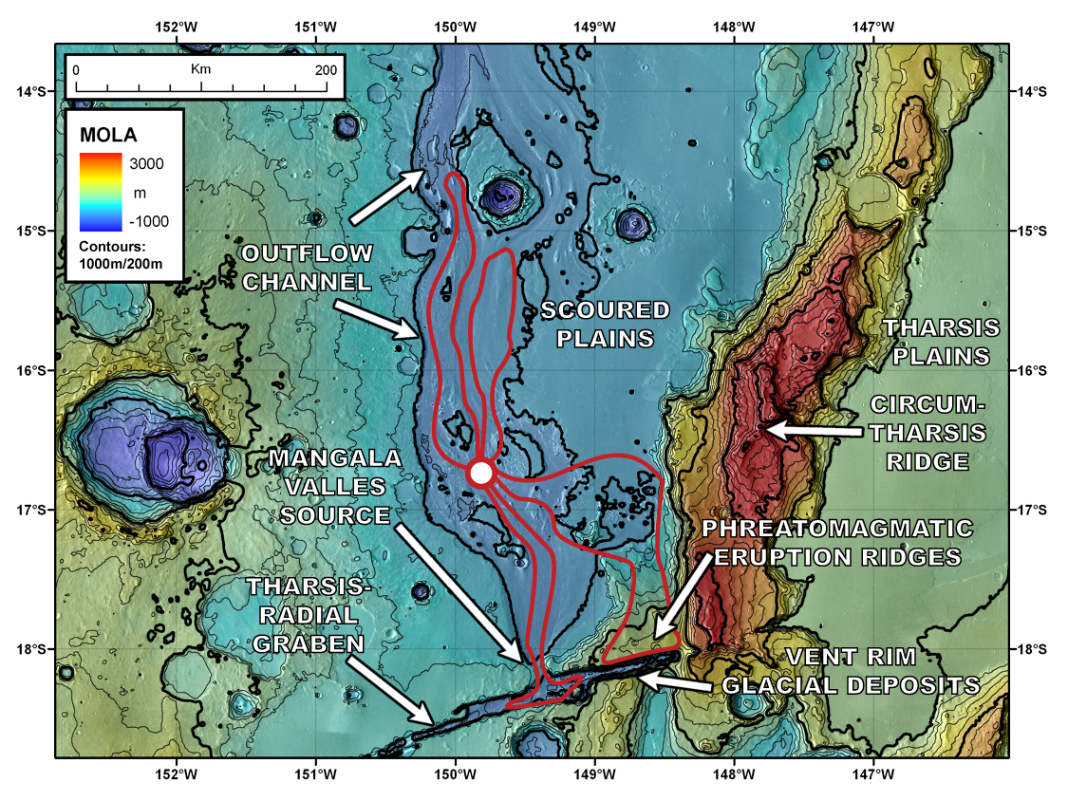
Figure 8. Potential traverses for human explorers in and around Mangala Valles.

Arsia Mons Graben. All three of the major Tharsis Montes shield volcanoes and Olympus Mons exhibit expansive late-Amazonian glacial deposits on their northwestern flanks. The broadest of these deposits are the ones found on Arsia Mons, which show glacial deposits ~400 km to the west of the accumulation zone and cover an area of about 170,000 km³ (Head and Marchant, 2003). These glacial deposits are found among classic volcanic and tectonic structures, so an extended mission at this location would provide a wealth of information concerning several of the fundamental questions of Martian geology during the Amazonian period.
We designed several traverses from a potential base camp set up at 8°S, 124°W (Figure 9) that would analyze the glacial and volcanic deposits, and the complicated relationship between them. Using extended rovers human explorers would be able to ascend the western flank of the shield and systematically obtain targeted samples that elucidate the recent volcanic history of Arsia. Another traverse from the same base camp would provide access to a ~5 km wide graben that appears to have been a major accumulation zone for much of the observed glacial deposits (Shean et al., 2007). A systematic sampling strategy at this location would provide a history of the flow regime at this site, and drilling at targeted locations could provide the recent climate record for Mars.

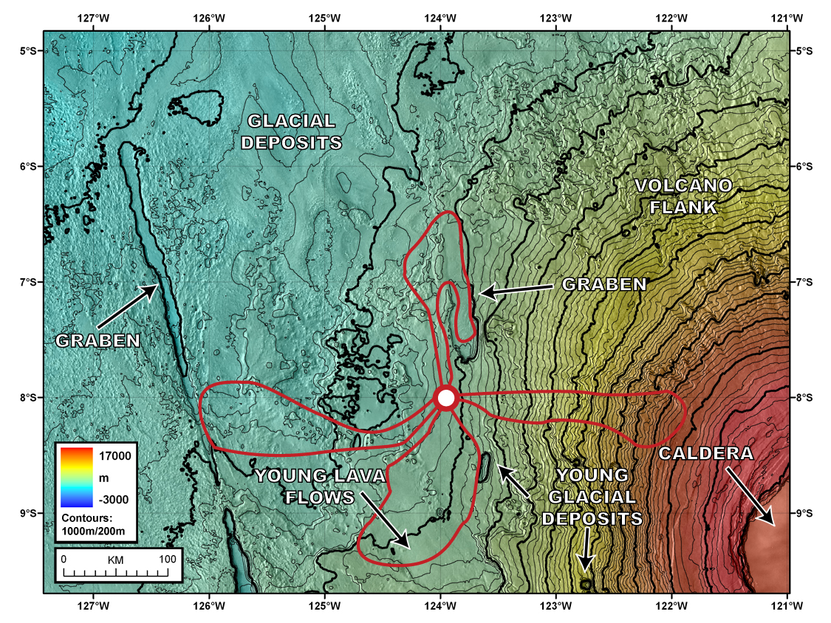
Figure 9. Potential traverses for human explorers in and around the Arsia Mons glacial deposits.

Recent General Circulation Models (GCMs) based upon global topography have revealed the Tharsis Montes to be significant cold traps for the accumulation of volatiles on the surface (Forget et al., 2006). Fieldwork at this site used in conjunction with remote sensing data would have global implications for recent climate change on Mars.
Below we assess the detailed activities that might be undertaken during these extended exploration periods, and show how they might link to MEPAG Goals and Objectives.

Graben and Surrounding Smooth Plains — 5 months
Geological Analysis. Analysis of glacial landforms and glacial and climatic history. Analyze the multiple drop moraines and assess sedimentary fabric, lithologic variations, search for erratics from further up the volcano. Study the processes producing drop moraines and assess similarities and differences between moraines. Dig for buried ice for ancient ice samples, and assess for ice cores for climate history. Examine the relationship to any exposed bedrock, searching for any evidence that the glacier was ever wet-based (scou in rock, drumlins, etc.). Examine thickness and fabrics of sublimation tills. Enter the major graben from the north, and traverse the ridges to the apparent base of the accumulation zone. Sample the volcanic rock suite and look for diversity and evidence of different eruption styles. Assess wall stratigraphy and gather representative samples in sequence for radiometric dating. (MEPAG investigations IA1, IA2, IA3, IIA2, IIB4, IIB5, IIIA1, IIIA3, IIIA4, IIIA5, IIIA6).
Shallow Seismic Survey. Measure thickness of sublimation tills and graben fill deposit at distal and proximal locations; assess presence of ice beneath till on graben floor. (MEPAG investigations IA1, IA2, IIB5, IIIA1, IIIA2).
Sediment Drilling. Analyze contributions from Arsia (tephra and bedrock) and from regional climate system (dust and ice) (MEPAG investigations IA1, IA2, IIB5, IIIA1, IIIA2).
GPR Ice-sounding. Determine high-resolution layering of valley-ill deposit, and document lenses of near-surface ice. (MEPAG investigations IA1, IA2, IIB5, IIIA1, IIIA2).
Shallow Excavations. Sample near-surface ice and permafrost deposits. (MEPAG investigations IA1, IA2, IIB5, IIIA1, IIIA2).
Electrical Resistivity. Determine permafrost depth in valley fill deposit and on surrounding plains. (MEPAG investigations IA1, IA2, IIB5, IIIA1, IIIA2)
Rock Sampling. Systematic sampling to provide constraints on flow rates and evolution with implications for recent climate change. (MEPAG investigations IA3, IIIA2)
Mapping. Features of interest would include accumulation zone at the south-eastern extent of the graben and parallel ridges throughout the graben. Detailed maps of the extent of each of the major drop moraines. (MEPAG investigations IA1, IA2, IIB5, IIIA1, IIIA2)

Eastern Flank of Arsia Mons — 3 months
Geological Investigations of the Flank of a Major Shield Volcano on Mars. Anaysis of mineralogy and petrology of lava flows, pyroclastic edifices and tephra deposits. Examine evidence for volcano-ice interactions and document geologic effects and chemical/mineralogic alterations. Look for evidence of the highest topographic levels of ice accumulation on the edifice and document the nature of such deposits. (MEPAG investigations IIIA4)
Mapping of the Flanks of a Representative Tharsis Volcano. (MEPAG investigations IA1, IA2, IIB5, IIIA1, IIIA2)
Installation of sensitive seismometers to detect current magmatic and deeper subsurface activity and to study the internal structure of the volcanic edifice. (MEPAG investigations IA1, IA2, IIB5, IIIA1, IIIA2)
Rock Sampling. Systematic sampling of Amazonian volcanic units to provide insight into present Mars composition. (MEPAG investigations IA3, IIIA2)

Southern Young Glacial Deposits — 3 months
Geological Analysis. Study the nature of the youngest glacial deposits in and around the small graben and assess the drop moraines and their stratigraphic relationships. Assess the ages of these in relation to the rest of the Arsia tropical mountain glacier deposits. Traverse the broad Arsia lava flows that appear to be superposed on the glacial deposit and assess their ages in detail, sampling for radiometric ages. Look for evidence for volcano-ice interactions and document these effects, including generation and fate of any meltwater. Assess impact craters for deeper material and subglacial deposits. (MEPAG investigations IIIA3, IIIA4).
Shallow Seismic Survey. Determine relative contributions of glacial and volcanic deposits. (MEPAG investigations IA1, IA2, IIB5, IIIA1, IIIA2).
Sediment Drilling. Examine sediment for compositional analysis. (MEPAG investigations IA1, IA2, IIB5, IIIA1, IIIA2).
GPR Ice-sounding. Determine high-resolution layering of smooth glacial units, and document lenses of near-surface ice. (MEPAG investigations IA1, IA2, IIB5, IIIA1, IIIA2).
Shallow Excavations. Sample near-surface ice and permafrost deposits. (MEPAG investigations IA1, IA2, IIB5, IIIA1, IIIA2).
Electrical Resistivity. Determine permafrost depth in young glacial deposits. (MEPAG investigations IA1, IA2, IIB5, IIIA1, IIIA2).
Ice Coring. Drill to reveal ice composition and trapped atmosphere for recent climate change analysis.

Western Deposits — 4 months
Geologic Analysis. Traverse to major graben within the fan-shaped tropical mountain glacier deposit. Compare these glacial deposits to relatively younger deposits higher on the edifice. Assess proportions of sediment sources and determine depth to ice. Look for evidence of wet-based glacial activity. Traverse to graben: Analyze theories of origin. Compare evidence for simple glacial-passive graben interaction and the possibility of dike intrusion into the ice and phreatomagmatic explosions and eruptions. Look for country rock blocks and juvenile magmatic material on the rim and floor of the graben. Assess wall stratigraphy. (MEPAG investigations IA1, IIIA4, IIIA7).
Detailed Mapping of Glacial/Volcanic Interactions. (MEPAG investigations IIIA4, IIIA6, IIIA7).
Shallow Seismic. Record depth measurements of distal smooth facies. (MEPAG investigations IIIA4, IIIA5, IIIA6, IIIA7).
Rock Sampling. Dating of distal units to provide context for duration of glacial flow. (MEPAG investigations IIIA4, IIIA5, IIIA6, IIIA7).
Application to MEPAG Goal III. Determine the evolution of the surface and interior of Mars.
All of the investigations outlined by MEPAG Goal III could be addressed by human exploration at carefully chosen exploration sites, such as those at the here proposed reference missions outlined above. The following table shows the methods and instrumentation that would be used at the various exploration sites.

Table 1. Objective: Determine the Nature and Evolution of the Geologic Processes that Have Created and Modified the Martian Crust and Surface (Investigations In Priority Order)

Investigation | Geology Approaches
1. Determine the present state, 3-dimensional distribution, and cycling of water on Mars. | - Drilling  - Surveying for groundwater seeps  - GPR  - MET Stations
2. Evaluate fluvial, subaqueous, pyroclastic, subaerial, and other sedimentary processes and their evolution and distribution through time, up to and including the present. | - Sampling along traverses  - MET stations  - In-situ composition analysis
3. Calibrate the cratering record and absolute ages for Mars. | - Thorough sampling of diverse rocks  - Cosmogenic age dating of samples
4. Evaluate igneous processes and their evolution through time, including the present. | - Extensive sampling traverses  - In-situ composition analysis
5. Characterize surface-atmosphere interactions on Mars, including polar, Aeolian, chemical, weathering, mass-wasting and other processes. | - MET stations  - Traverse sampling along glaciers  - Sampling of diverse mineralogy
6. Determine the large-scale vertical structure and chemical and mineralogical composition of the crust and its regional variations. This includes, for example, the structure and origin of hemispheric dichotomy. | - Drilling.  - Seismic stations  - GPR  - Compositional comparison of fresh/weathered samples
7. Document the tectonic history of the Martian crust, including present activity. | - Seismic stations  - Observations of graben and other tectonic features
8. Evaluate the distribution and intensity of hydrothermal processes through time, up to and including the present. | - Stratigraphic sample collection  - Compositional analysis at multiple sites
9. Determine the processes of regolith formation and subsequent modification, including weathering and diagenetic processes. | - Sample collection at multiple latitudes/environments  - MET stations
10. Determine the nature of crustal magnetization and its origin. | - In-situ magnetometer analysis.  - Traverses in areas of magnetic anomalies
11. Evaluate the effect of impacts on the evolution of the Martian crust. | - Ejecta sampling  - Mapping of crater-wall outcrops

GEOPHYSICS: HUMAN EXPLORATION GOALS AND OBJECTIVES

What are the key scientific goals and objectives of human exploration of Mars in geophysics and what are sample Human Science Reference Missions (HSRM) in geophysics?
Mars geophysics science objectives fall into two broad categories: planetary scale geophysics (1000s of km), and what might be called “exploration geophysics,” which addresses regional (10s-100s km) or local scales (<10 km). The first involves characterizing the structure, composition, dynamics and evolution of the Martian interior, while the second addresses the structure, composition and state of the crust, cryosphere, hydrologic systems, and upper mantle. Here we describe how these objectives could be met through investigations carried out on human missions. The MEPAG Goal III science investigations relevant to Mars geophysics are listed in Tables 2 and 3.

Table 2. Proposed Planetary Scale Geophysics: Investigations & Approaches

Investigation | Geophysics approaches
1. Characterize the structure and dynamics of the interior. | - Seismology  - Heat flow  - Gravity  - ULF EM induction (conductivity profile)  - High-precision geodesy
2. Determine the origin and history of the magnetic field. | - High-precision, high-resolution magnetic field measurements  - Measurements of the magnetic properties of samples
3. Determine the chemical and thermal evolution of the planet. | - Seismology  - Heat flow  - ULF EM induction (conductivity profile)  - Gravity  - High-precision geodesy  - High-precision, high-resolution magnetic field measurements

Table 3. Proposed Regional and Local Scale Geophysics: Investigations & Approaches

Investigation | Geophysics approaches
1. Evaluate fluvial, subaqueous, pyroclastic, subaerial, and other sedimentary processes and their evolution and distribution through time, up to and including the present. | - Reflection seismology  - Ground Penetrating Radar  - Gravity  - EM induction (conductivity profile)  - Neutron spectroscopy
2. Characterize the composition and dynamics of the polar layered deposits. | - Reflection seismology  - Ground Penetrating Radar  - Gravity  - EM sounding (conductivity profile)
3. Evaluate igneous processes and their evolution through time. | - Reflection seismology  - Ground Penetrating Radar  - Gravity  - EM induction (conductivity profile)
4. Characterize surface-atmosphere interactions on Mars, including polar, aeolian, chemical, weathering, mass-wasting and other processes. | Requires active seismic, EM, NS
5. Determine the large-scale vertical and horizontal structure and chemical and mineralogical composition of the crust. This includes, for example, the structure and origin of hemispheric dichotomy. | Requires passive, active seismic, gravity, active EM, passive low-frequency EM, what else.
6. Determine the present state, 3-dimensional distribution, and cycling of water on Mars. | Requires active seismic, active EM, passive low-frequency EM, instrumented drilling or wireline sensors.
7. Document the tectonic history of the Martian crust, including present activity. | Requires gravity, passive and active seismic, active EM, passive low-frequency EM, instrumented drilling or wireline sensors.
8. Evaluate the distribution and intensity of hydrothermal processes through time, up to and including the present. | Requires passive and active seismic, active EM, passive low-frequency EM, instrumented drilling or wireline sensors (maybe robotic since there is astrobiological potential in hydrothermal systems).
9. Determine the processes of regolith formation and subsequent modification, including weathering and diagenetic processes. | Requires passive, active seismic, active EM, passive low-frequency EM, NS for hydrogen?
10. Determine the nature of crustal magnetization and its origin. | Requires mobile magnetometry, heat flow, passive low-frequency EM (multi-point? A network?). Does this require a borehole, so we'd need drilling capability?
11. Evaluate the effect of impacts on the evolution of the Martian crust. | Subsurface mapping via active seismic, EM sounding, other?

We assume here that no robotic missions to Mars before 2025 address the science issues in a complete way. For example, we assume that no network mission such as ML3N would be flown. We do this to be conservative, in order to make as complete a set of human exploration-related geoscience investigations and activities as possible. Clearly if future robotic missions address Mars geophysics topics, the human mission activities must be revisited.
In general, Mars geophysics would be well served by landing sites and traverses identified by the Geology panel. Figure 10 shows four of the 58 sites considered by the HEM-SAG. These sites would span the planet, and offer a sampling of Mars’ remarkable geologic diversity. The Chasma Boreale site (CB) offers access to an immense stratigraphic column of polar layered deposits presumably stretching far back into the Amazonian. The Nili Fossae site (NF) sits on the edge of the hemispheric dichotomy boundary and provides access to Noachian/Hesperian-age fluvial features. The Centauri Montes site (CM), on the eastern rim of the giant Hellas impact basin, contains features ranging from Noachian basin rim materials to Amazonian/Hesperian outflow channels to Amazonian debris aprons and recent gully changes, hinting at the possibility of near-surface water. The Arsia Mons site (AM) sits on the western flank of the volcano and provides access to putative Amazonian-age glacial deposits and comparatively young lava flows. Each site offers the opportunity to address multiple geophysics investigations. We will revisit these sites and plausible geophysical exploration strategies later.

Planetary Scale Geophysics: Structure, Composition, Dynamics, and Evolution of the Martian Interior.
To characterize the structure and dynamics of Mars’ interior and determine the chemical and thermal evolution of the planet, physical quantities such as density and temperature with depth, composition and phase changes within the mantle, the core/mantle boundary location, thermal conductivity profile and the three-dimensional mass distribution of the planet must be determined. To determine the origin and history of the planet’s magnetic field, we must discover the mineralogy responsible for today’s observed remanent magnetization, and understand how and when the rocks bearing these minerals were emplaced.
The measurement requirements for planetary scale geophysics present some drivers for Mars Exploration architectures. A key driver is the need to instrument the planet at appropriate scales: for example, global seismic studies rely on widely separated stations so that seismic ray paths passing through the deep mantle and core could be observed. This need would translate into multiple, widely separated landing sites for the first human missions. If only a single landing site would be selected and revisited, then far less information about the planet’s interior would be obtained. As can be seen in Figure 10, the three low-latitude sites would provide a reasonable planetary-scale network, and would also enable heat flow measurements in diverse crustal/lithospheric settings: the volcanic Tharsis rise, the Isidis wall/dichotomy boundary, and the rim of the Hellas basin. However, these sites do not fall into the region of intense remnant crustal magnetization, so it is important to consider a location in the mid- to high latitudes of the southern hemisphere near 180E longitude.

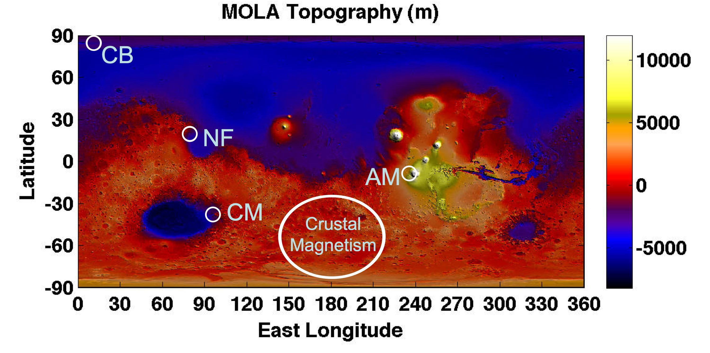
Figure 10. Map of MOLA topography, with possible human exploration landing sites indicated: Chasma Boreale (CB), Nili Fossae/Isidis (NF), Centauri Montes (CM), and Arsia Mons (AM) sites. Also indicated is a broad region spanning Terra Cimmeria and Terra Sirenum with intense remnant crustal magnetization.

Exploration Geophysics: Structure, Composition, State of Near-Surface Crust
To characterize the structure, composition, and state of Mars’ near-surface crust both local and regional subsurface information must be obtained. A wide variety of exploration geophysics techniques exist that provide such information. For example, sounding for aquifers could be accomplished through electromagnetic techniques, and layering in sedimentary units could be determined through reflection seismology. Magnetic surveys carried out at landing sites tell us about the spatial scales of crustal magnetization, and tie in to local and regional geology for context.

Human Science Reference Mission (HSRM): Geophysics
Geophysics measurement requirements span three disparate spatial scales, depending on the science to be done. At the largest scales (1000s of km), characterizing the interior of Mars would require a widely spaced network of at least 3 emplaced central geophysics stations, one at each landing site. At regional scales (10s-100s km), characterizing crustal structure, magnetism, and other objectives require mobility to emplace local networks around a landing site. Finally, at local scales (~10 km), mobility is key to performing traverse geophysics, and in carrying out investigations (such as seismic or EM sounding) at specific stations along a traverse. The central geophysics stations and the regional scale networks would be emplaced and left to operate autonomously after the human crew departs. Traverse and station geophysics would be carried out only during the human mission, unless this can be done robotically after completion of the human mission.
Central geophysical stations at each landing site would include passive broadband seismic, heat flow, precision geodesy, and passive low-frequency electromagnetic instrumentation. Satellite geophysics stations would include the nodes of a regional seismic array and vector magnetometers. Along the traverses, experiments would be performed at sites of interest. These would include active EM sounding for subsurface aquifers, active seismic profiling to establish structure with depth, and gravity measurements. Ground penetrating radar and neutron spectroscopy along the traverse track would help map out subsurface structure and hydration state/ice content for the near-subsurface.
Based on the geophysics science objectives, multiple sites would meet the investigation needs and geologic settings. A list of these sites is captured in Table 4; three sites at widely separated locations would be required to address global questions concerning the interior of Mars. Table 5 lists instrumentation relevant to geophysics investigations, and provides estimates of mass and power.

Table 4. Suggested Combinations for 3-site Visit Scenarios

Site 1 | Site 2 | Site 3 (Antipodal)
19. Arsia Mons Glacial/ Volcanism: (4.8°S, 126.3°W)  26. Northeast flanks of Arsia Mons: (7.4°S, 121.2°W)  34. Arsia lobate glacial deposit: (7.4°S, 123.8°W) | 23. Chryse Planitia: (27.0°N, 41.0°W)  24. Medusae Fossae Formation:  (1.6°N, 173.2°W)  28. Terra Sirenum: (39.3°S, 161.7°W) or location near magnetization reversal  38. Mangala Valles: (18.0°S, 149.4°W) | 1. Impact Crater Near Nili Fossae (18.4°N, 77.7°E)  14. Nili Fossae:  (24.2°N, 79.4°E)  25. Hellas Basin Floor:  (41.9°S, 69.6°E)  27. Walls of Dao Vallis: (33.7°S, 92.5°E)  29. Centauri Montes:  (38.7°S, 96.7°E)  37. Syrtis Major Planum: (7.0°N, 69.0°E)  45. Isidis Basin Floor:  (12.0°N, 88.5°E)  46. Utopia Basin Floor:  (43.8°N, 117.0°E)
Notes:
For a single site stay, regions near Arsia Mons are of high priority (listed under Site 1).
Restricting Site 2 to 38 and Site 3 to 14, 37, 45 may yield better combinations of geophysical diversity (tectonic activity, heat flow, crustal magnetization).
Sites 23, 25-29, and 46 may have higher probability of near-surface recent activity and thus of high priority for groundwater studies.

Table 5. Proposed Geophysics Instrumentation

Instrument/system | Mass | Power | Capabilities/details | Heritage
Seismometer | 1.75 kg | 0.3 W | 3-axis system, two long-period and 1 MEMS-based short period | NetLander
Geophones | 0.2 kg | 0.01 W | High frequency magnetic-coil based seismometers (3-4 units) | Apollo,  commercial systems
Active seismic sources | ~20 kg | N/A | Various explosive sources and assemblies (thumper, mortars, bombs) | Apollo,  commercial systems
Ground-Penetrating Radar (GPR) | 0.4 kg | 0.15 W | Monopole 2-6 MHz. Bi-static modes possible with additional GPRs. | NetLander, MIDP
Fluxgate Magnetometer | 0.3 kg | 0.1 W | Range ±10⁴ nT with 0.02 nT resolution, noise ~10 pT (0.01 to 10 Hz) | MGS, NetLander, countless terrestrial space and commercial systems
Searchcoil Magnetometer | 0.6 kg | 0.1 W | Broadband 10⁻² Hz to 100 kHz, sensitivity 10⁻⁴ to 10⁻⁶ nT/Hz^{1/2} | Terrestrial space and commercial systems, MIDP
Electric Field Probes | 0.5 kg | 0.1 W | Set of 4 Broadband 10⁻⁴ Hz to 10 kHz, sensitivity >0.01 uV/m/Hz^{1/2} | MIDP and commercial systems
Active EM source | ~20 kg | 40 A-hr battery | Various flexible loops/dipoles deployed 5m-100m baselines | Commercial systems
Precision radio receiver/transmitter | 0.5 kg | 5-35 W | Doppler measurements accurate to 0.1 mm/s. UHF and X-band transceiver. | NetLander Niege experiment
Temperature Probes | 5 kg | 50 mW | Small (cm) to large (1m) temperature probes | NetLander, Phoenix, MVACS, Apollo
Neutron Spectrometer | 1 kg | 2 W | Continuous hydrogen assessment along traverses. | Mars Odyssey, Lunar Prospector, MIDP
Data handling/storage | 1 kg | 1 W | 8, 12, and 24 bit precision ADCs, digital interfaces and 1-2 Gbyte memory storage | FAST, THEMIS and various commercial equivalents

Centauri Montes Site
Figure 11 shows the Centauri Montes mission landing site and traverses. The permanent, autonomous, central landing site geophysics station is shown by the green square. During traverses, permanent satellite geophysics stations (red triangles) are emplaced. The active gully location is denoted by the cyan diamond. At selected points along a traverse, gravity, EM sounding, active seismic experiments would be done (crosses).

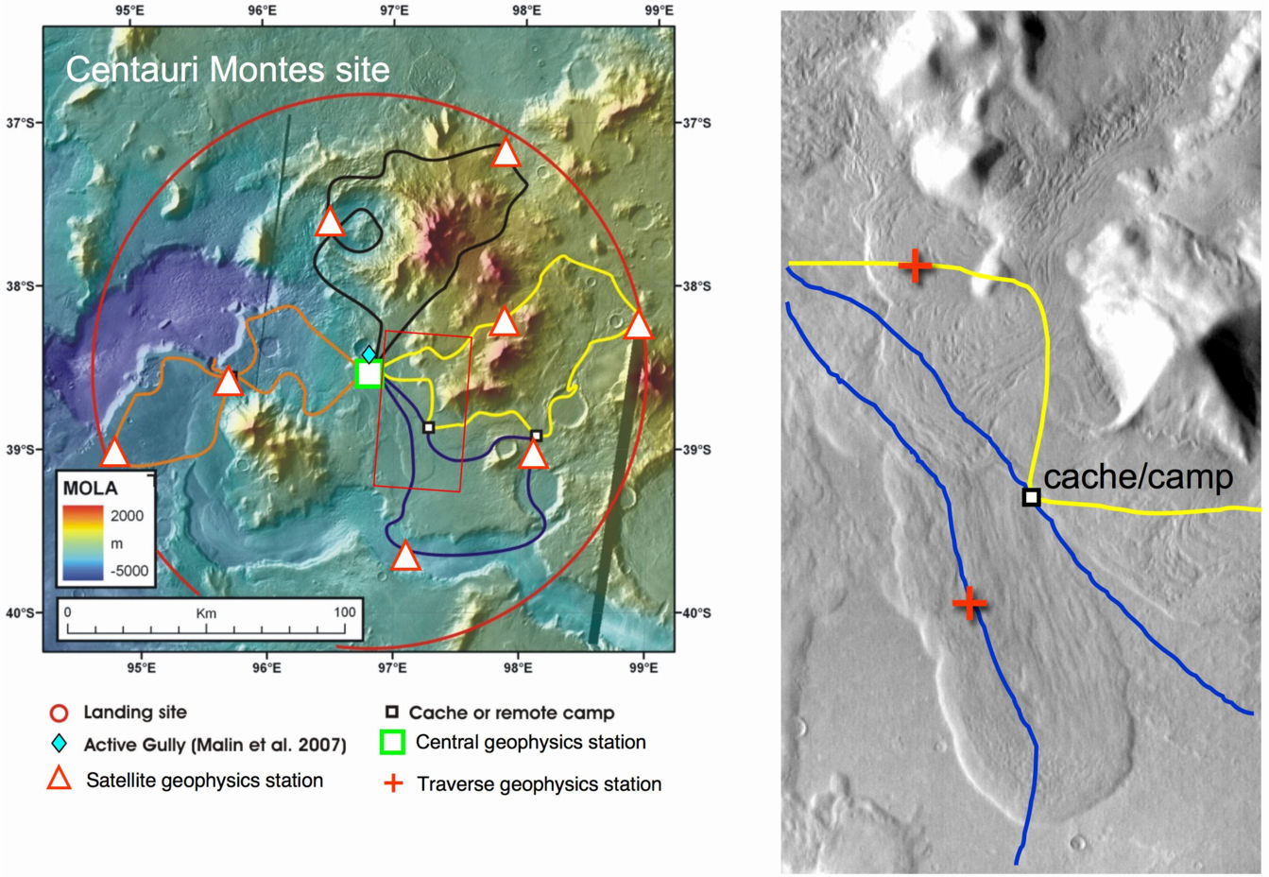
Figure 11. Centauri Montes mission landing site and traverses.

The Centauri Montes site would provide a location for addressing multiple geophysics objectives. First, it is one of three sites for global seismic monitoring. Heat flow measurements for this highlands site could be compared to, for example, such measurements in the large volcanic Tharsis province, if the Arsia site is also chosen.
Figure 12 shows the Centauri Montes site geologic traverse plan with superposed symbols denoting geophysics central station (green square), and satellite stations (red triangles) forming part of the local/regional seismic network and locations of electromagnetic observatories. Exploration targets at this site would include recent gullies (possibly liquid water), ancient Noachian Hellas basin rim constructs, Amazonian debris aprons, and other features associated with geologically recent climate change. The figure shows several traverses, each requiring an extended period of exploration. During these traverses, specific sites would be selected for in-depth geophysical exploration. The right panel zooms in on one part of the blue traverse, showing two stations (red crosses) where detailed geophysical exploration could be done. Active reflection seismology and EM sounding, for example, might be carried out to explore in detail the subsurface structure of these lobate debris aprons.

Figure 12. Centauri Montes site geologic traverse plan.

While traversing, some kinds of measurements could be made to map out subsurface structure and state. For example, ground penetrating radar and neutron spectroscopy would provide cuts of near surface layering (with sufficient dielectric contrast) and bulk hydrogen estimates as a function of position along the traverse. Perhaps most important, geophysical methods could be used to sound the subsurface along the rim of the gullied crater, thus providing information about the presence or absence of an aquifer as a potential gully source. This combination of surface prospecting during traverse and fixed, temporary sounding sites is illustrated in Figure 13. Here the rover team first would explore the crater rim, stopping at promising sites to temporarily emplace geophysics instrumentation such as EM sounding and active seismic systems to characterize the subsurface. Results from these surveys would help determine the most promising location(s) to drill.

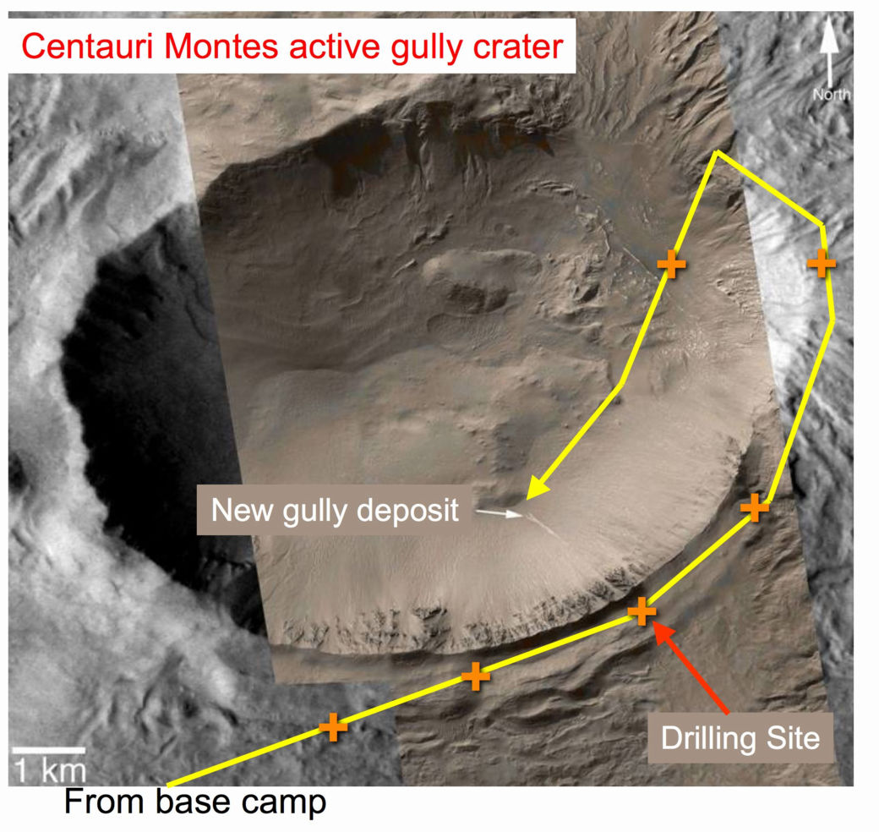
Figure 13. Exploration of the rim and interior of the gullied crater near Centauri Montes.
Crosses show geophysical sounding station sites along the traverse (yellow).

Nili Fossae — Isidis Site
The Nili Fossae site would be another location for addressing multiple geophysics objectives. Again, it is one of three sites for global seismic monitoring. Heat flow measurements for this dichotomy boundary site, far from late Amazonian volcanic activity, provide another important tie-point for interior structure, composition and dynamics. The stratigraphy of depositional fans, possible lake-bottom deposits, shoreline breaches and other features could be explored.
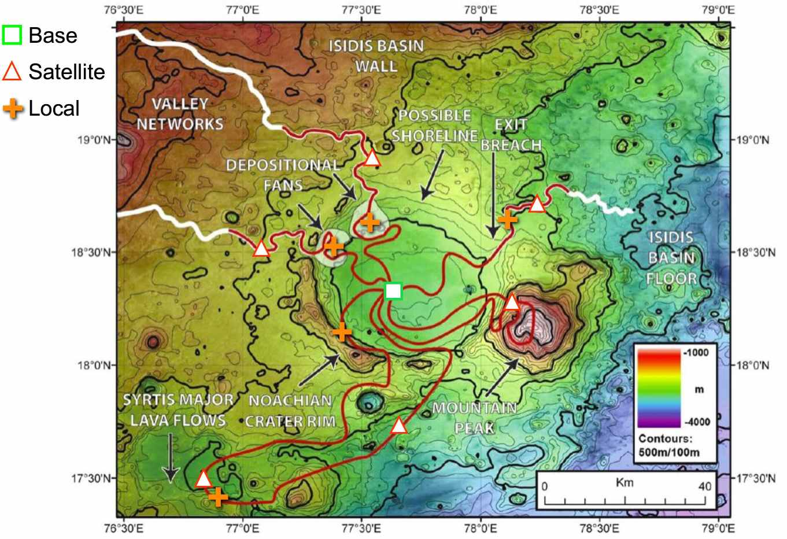
Figure 14. The Nili Fossae site on the western wall of Isidis basin. Base (green square) and satellite (red triangle) geophysics stations are shown. Possible local sites for detailed subsurface exploration are also shown (crosses).

Arsia Mons Site
The Arsia Mons site would open the exploration of the most important volcanic province on Mars. Again, it would be one of three sites for global seismic monitoring. Heat flow measurements for this Tharsis rise site, where extensive volcanism has occurred since the Noachian, would certainly improve our knowledge of interior structure, composition and dynamics. Figure 15 shows the proposed locations of the base and satellite stations for geophysics investigations. In this case the satellite stations may include additional heat flow experiments, searching for evidence of late stage dike intrusion, if cooling time is not too short (<10⁵ yr). With a local seismic network, identify seismic velocity anomalies associated with deep magmatic bodies. Active (reflection) seismic studies at many local sites along the traverses would help reveal the history of ash deposits and lava flows. They may also reveal the presence of ice at depths consistent with Late Amazonian deposition and subsequent sublimation in current obliquity and climate conditions.
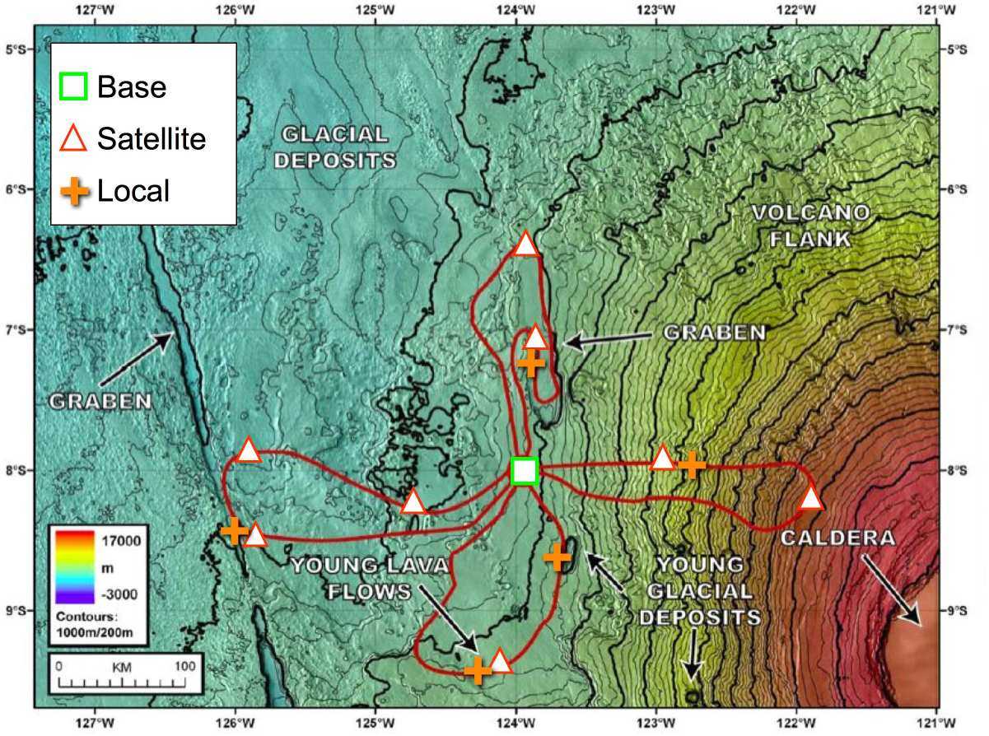
Figure 15. The Arsia Mons site.

Crustal Magnetism Site
The most intense remnant crustal magnetic fields are found in the region between Terra Sirenum and Terra Cimmeria, at mid- to high southern latitudes centered on 180E. This region is thus a prime target for shedding light on the history of an early Mars dynamo, the nature of the crustal magnetization process, and attendant implications for Mars’ early thermal history. The left panel of Figure 16 shows the filtered radial magnetic field component observed by Mars Global Surveyor at the mapping altitude of 400 km. Superposed on this map are the locations of gullies identified in MGS/MOC and MRO/HiRISE images by HEM-SAG member Jennifer Heldmann. The right panel shows a HiRISE image of one of these gullies (outlined by a black circle in the left panel, 47.2S 176.8E), on a south-facing interior crater wall. This crater is within ~100 km of a radial magnetic field reversal seen in MGS/MAG-ER aerobraking data. The region of intense crustal magnetization contains many gullies; like the Centauri Montes site, it affords many opportunities for study of plausibly ice-cored formations and episodic surface water flow (if this is the operative gully formation mechanism). Thus, a landing site in the vicinity of these features would permit investigation of diverse science areas: crustal magnetism (including possibly the identification of magnetic minerals in ancient Noachian rocks), gullies and their relationship to a (once) ice-rich mantle or subsurface aquifer, a record of Amazonian climate change in the mantle deposits, and the astrobiological potential of subsurface habitats.
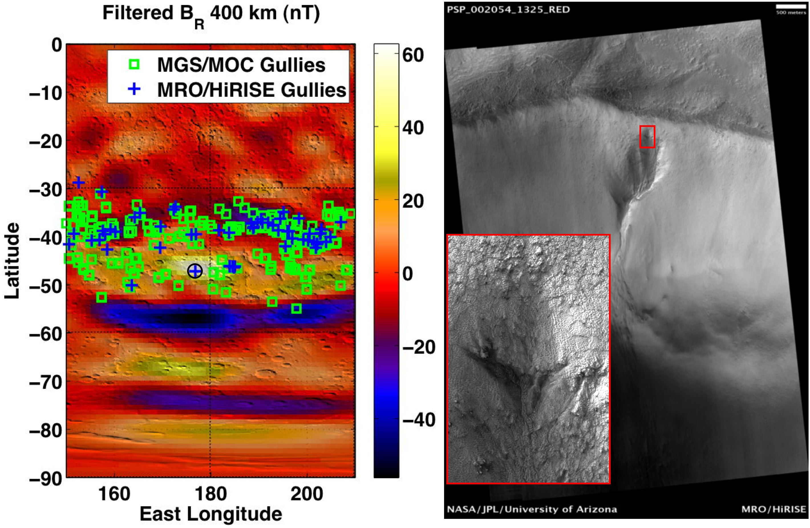
Figure 16. (Left) Map of MGS/MAG-ER radial magnetic field measured at 400-km altitude, with locations of gullies found in MGS/MOC (squares) and MRO/HiRISE (crosses) images. (Right) HiRISE image of an interior crater wall gully (located at black circle in left panel). (Inset) Detail of the gully headwall, with suncup-like texture in the superposed mantle deposit possibly indicating a once-ice-rich composition.

Landing Site Prioritization
Table 4 indicates some combinations of landing sites that would serve geophysics objectives, both global and regional/local.

MEPAG Geophysics Investigations
In the following table, the first column lists the MEPAG Goal III investigations, the second column identifies the relevant geophysics techniques (in no particular order) used to address the objectives of each investigation. For example, a seismic network provides S and P wave travel times, from which ray paths and velocities are determined. Models of interior composition and structure must be consistent with these measurables.

Atmosphere/Climate: Human Exploration Goals and Objectives

What are the key scientific goals and objectives of human exploration of Mars atmosphere/climate and what are sample Human Science Reference Missions (HSRM) in atmosphere/climate?

Summary
Atmosphere and Climate goals and objectives are less site-specific than geology or biology, with the notable exception of climate studies associated with polar ice cap drilling.
In Appendix B, we emphasize updated atmospheric and climate objectives and the degree to which they may be advanced by general rather than site-specific human exploration activities on Mars.
Key scientific goals and objectives of Human Exploration for Mars (HEM) for the atmosphere/climate are summarized in Table 6.

Table 6. Proposed MEPAG Atmospheric Goals and Objectives

MEPAG 2030 Goal II | Key objectives for human missions
Atmospheric objectives | Surface-atmosphere interactions: dynamics, heat and mass balance, non-equilibrium trace gases
Atmospheric objectives | Search for sources of volatiles and trace gases
Polar Cap objectives | Baseline chronology and charactersation of the climate history of the north polar dome (deep core)
Polar Cap objectives | Horizontal sampling of the NPLD
Early climate evolution | Long-term climatic evolution of the planet (billion-year temporal scale); implications of early climatic conditions in the emergence of early potential habitats and/or Life, which includes inference in the atmosphere chemical state
Early climate evolution | Sampling of Noachian to Amazonian deposits through soft drilling (around 1 meter deep) along outcrops or deep drilling to capture information in the sedimentary record

HEM Atmospheric Objectives focus on processes within the Planetary Boundary Layer (PBL, surface to ~10 km), where surface-atmosphere interactions impart fundamental influences on the dynamical, chemical, and aerosol characters of the global Mars atmosphere. Orbital remote sensing for this region remains difficult and lander/rover atmospheric payloads limited such that sufficiently detailed measurements of the PBL are unlikely to be returned from Mars science missions prior to 2030. Field study of the PBL on Earth remains the preferred method of advancing understanding, with intensive campaigns using combinations of automatic weather stations, mobile surface-based atmospheric sounders, and balloon borne sonde platforms. HEM atmospheric observations could provide optimum in situ and remote access to the PBL important not only to the understanding of global Mars Atmosphere and Climate, but also to the support of HEM operations and as environmental characterization essential to the interpretation of many biology and geology objectives.
HEM Polar Cap objectives are included as of high scientific value, but are understood to be challenging due to polar night considerations.
A third class of activity is associated with the early evolution of climate and would benefit from the return of samples containing gas inclusions to Earth.
In the following sections two nominal reference missions are identified: an atmospheric reference mission and a reference mission to the north polar dome for deep drilling, in order to define the more site-specific human-enabled mission activities necessary to sample the critical volatile records contained within the polar ice caps. Atmospheric reference mission activities are anticipated to be included in all human missions.

Nominal Atmospheric Human Science Reference Mission (HSRM)

Science Goals And Approach
The nominal atmospheric reference mission would address the goals described in Appendix B: “Quantitative understanding of atmospheric processes” and “Microclimates.” These goals would require similar investigations, however a microclimate objective would be more specific, requiring additional planning to optimize site selection for meteorological stations, and time-phasing of investigations relative to relevant seasonal cycles. Site selection considerations are described under “location” below.
A proposed baseline is one central station (could be close to hab, but see constraints on fetch under location section) plus remote stations either to broadly characterize the region (co-sited with major geology/biology investigations) or arranged to give three-dimensional information on specific flows associated with microclimate. The microclimate objective would also require (a) reference meteorological station(s) to provide regional context.
The HSRM scientific capabilities are summarized in Table 7.
Table 7. Proposed HSRM Atmospheric/Climate Goals and Approach

Quantitative Understanding of Atmospheric Dynamics | Micro-climates | Approach
Surface-atmosphere interactions: Dynamics/heat and mass balance |  | 1. Monitor basic atmospheric state (temperature, wind vector, pressure, humidity, radiation) at reference height above surface (2 m?)  2. Monitor temperature, wind, dust and cloud through the depth of the boundary layer (2 scale heights ~ 20 km)  3. Monitor the radiation and heat balance for surface-atmospheric exchange and solar forcing  4. Monitor the mass balance for dust and volatile components, especially considering dust lifting processes and also considering electrical effects  5. Assess the impact of latitude, longitude, season and local time
Search for sources of volatiles and trace gases |  | 1. Measure atmospheric composition (trace,isotopes)  2. Measure physical and chemical properties of the regolith  3. Measure the deposition of chemically-active gases, such as ozone and hydrogen peroxide, to the Mars surface.  4. Search for gases of biogenic (methane, ammonia, etc.) and volcanic (sulfur dioxide, hydrogen sulfide, etc.) origin and determine their source(s).  5. Search for sources of atmospheric water vapor.  6. Assess the impact of latitude, longitude, season and local time on atmospheric composition and on the photochemistry of trace atmospheric gases.

Location
Siting of a meteorological station as part of a global network or for regional context should consider an unobscured fetch in the direction of the prevailing wind. For boundary layer studies on Earth, 1km is considered the upwind requirement that would ensure the met station is representative of its surroundings. Booms holding sensors should be directed into the wind in order that the boom doesn't interfere with measurements. As the prevailing wind may not be known at the specific site, adjustment may be needed during the mission.
Siting with respect to topography should take into consideration phenomena such as katabatic flows, gravity waves, and cloud base height. Downslope evolution is generally of interest, but cross slope information is useful for 3d information on eg gravity wave direction. Horizontal thermal gradients through eg albedo differences, can also drive local atmospheric circulations.

Research Plan and Schedule
Atmospheric reference mission activities would take place as part of a multi-disciplinary mission. Frequency and timing of atmospheric activities would be important. Activities would be scheduled at regular intervals in order to sample diurnal and seasonal cycles usefully, but some flexibility is required for response to interesting weather conditions or results.
The estimates below are given for atmospheric activities only, and assume that general site acclimatization and survey and traverse activities are planned in addition. For example, if a crew would be investigating a site of biological interest, 1 sol/2 people would be added to the plan in order to install a met station installed in the vicinity, 2 sols/2 people may be added to the plan to perform campaigns at the site using portable instrumentation.
Site characterization and planning — 2 people @ 10 sols
Installation of met stations — 2 people @ 1 sol per site — assume minimum of 5 sites
Maintenance — 1 person @ 1 sol per 30 sols
6 times over course of 500 sol mission – once per season + 2 to respond to weather events:
- 2 people @ 3 sols
- Tethered balloon campaigns (3 sols, one profile per two hours)
- Radiosonde releases (1 sol, midnight, midday)
- Campaigns with portable lidar instrumentation — 3 sols
6 times over course of 500 sol mission, 2 people @ 3 sols:
- Chemistry campaign — collection of samples for study of seasonal change, traverse activities to search for sources

Vertical Mobility Requirements
There are requirements to access both the subsurface and the atmosphere. Subsurface requirements are modest, with depths to <2 m to install heat flow, temperature and conductivity probes. Atmospheric vertical access would be required for detailed profiles of the bottom two scale heights (~20 km) of the atmosphere. The lower boundary layer may be accessed by tethered balloon (a balloon and winch system <1 km), the higher levels would require release of balloons with a radio-tracking system. These systems are outlined under science capabilities required.

Horizontal Mobility Requirements
For microclimate reasons, there would be high value in atmospheric investigations taking place at many sites of biological and geological interest. Access to those sites would follow the same mobility requirements as biology/geology. Additional mobility around the site would be required for atmospheric studies to follow topography, for topography-related and upwind/downwind types of investigations, or following gradients in trace species. This additional mobility requirement is of order 1-10 km, and would be required to transport equipment including for example a balloon winch, or a met station, and 2 people.

Science Capabilities Required
The HSRM Atmosphere/Climate Scientific Capabilities are summarized in Table 8.
Table 8. Proposed HSRM Atmosphere/Climate Scientific Capabilities

1. Atmosphere-surface interactions: Dynamics, heat and mass balance
1.1 | Monitor basic atmospheric state at reference height above surface ( 2m?) | MET station:  Instrumented mast –sonic anemometer (3 heights), temperature (3 heights), pressure, humidity, radiation (net,LW,SW), dust particle counter  Soil heat and conductivity probes  Soil temperature profile
1.2 | Monitor the radiation and heat balance for surface-atmospheric exchange and solar forcing
1.3 | Monitor temperature, wind, dust and cloud through the depth of the boundary layer (2 scale heights ~20 km) | Upward looking thermal IR spectroscopic sounder (water vapor, dust, temperature)  Tethered balloon & winch & gondola – sonic anemometer, temperature, pressure, humidity, camera  Radiosonde balloon – temperature, pressure, wind, humidity  Portable doppler lidar (wind)  Portable Raman/imaging lidar (dust)  DC electric field sensors  Portable DIAL (water vapour)  Surface accumulation measurements (dust/ice)  Microscope analysis of dust
1.4 | Monitor the mass balance for dust and volatile components
1.5 | Investigate processes that influence the mass balance for dust and volatile components
1.5 | Assess the impact of latitude, longitude, season and local time | Diurnal cycle campaign: tethered balloon sounding each two hours, portable instrumentation deployment  Seasonal cycle campaign: 3 days of diurnal cycle campaigns, 6 times over mission, radiosonde release midday/midnight
2. Atmosphere-surface interactions: Atmospheric volatiles & chemistry
2.1 | Measure atmospheric composition (trace,isotopes) |  | Isotope mass spectrometer (2-10 0amu)  Sample processing system  pH, wet chemistry, microscope
2.2 | Measure physical and chemical properties of the regolith
2.3 | Measure the deposition of chemically-active gases, such as ozone and hydrogen peroxide, to the Mars surface.
2.4 | Search for gases of biogenic (methane, ammonia, etc.) and volcanic (sulfur dioxide, hydrogen sulfide, etc.) origin and determine their source(s). |  | Portable laser diode system or FTIR for ~100 pptv detection limits
2.5 | Search for sources of atmospheric water vapor.
2.6 | Assess the impact of latitude, longitude, season and local time on atmospheric composition and on the photochemistry of trace atmospheric gases. |  | Chemistry campaign: 3 days, 6 times over mission

In Rover
Meteorological sounding equipment would be deployed at specific locations/grids during initial roving operations (deployed MET station and upward looking spectroscopic remote sounders). These stations would be self-operating once positioned. Requirements would be of order 5 sites at <10 kg each.

With Astronauts on Eva
In addition to the autonomous meteorological stations indicate above (IN ROVER), a program of tethered balloon campaigns and radiosondes are envisioned to be released at the landing site with a specific frequency. Tethered balloons + winch system ~15 kg. On the earth, radiosonde balloon and sonde packages are of order several kg each for stratospheric sounding.With the Marian low atmospheric pressure, larger balloons may be necessary to reach desired 5-10 km altitudes (although lower gravity and higher CO₂ mass density help). Of order 12 such released balloon sondes would be desired, with two releases (midday, midnight) each on 6 days spaced throughout the mission.

HAB “lab” Capabilities
Atmospheric gas/subsurface volatile laboratory capabilities include isotopic and trace gas analysis. Microscope for dust size, shape and mineralogy.
Capability to receive and process daily meteorological data from concurrent orbiters.

Issues Identified That Would Require Handling Prior to Human Arrival
Design of easy-to-assemble mast equipment.
Miniaturisation of instrumentation.
Radiosonde balloon design, gas fill, and communications infrastructure.
Planetary protection considerations for released radiosonde balloons.

Nominal Deep Drilling Polar Reference Mission
The high scientific value of a mission to the polar regions of Mars is outlined in section 1.3. The polar regions pose unique technical challenges due to cold temperatures and polar night which may be somewhat offset by access to a ready supply of water and radiation shielding material (ice).
The north polar dome is the proposed target for a first human polar mission. A deep drilling phase is described followed by traverse to lower latitudes for launch at the onset of polar night. This reference mission does not include explicit biology investigations related to access to ancient ice, or geology investigations related to crossing the NPLD, both of which are anticipated to be of high interest.

Scientific Goals and Approach
Scientific Goals and Approaches for Deep Drilling Polar Reference Mission are shown in
Table 9.

Table 9. Proposed Scientific Goals and Approach for Deep Drilling Polar Reference Mission

Scientific goal | Approach
Baseline chronology and characterization of the climate history of the north polar dome | Deep core preferably to bedrock and baseline chronology
 | Polar cap mass and energy balance for current climate state and seasonal cap formation processes
 | Shallow cores to investigate heterogenuity
 | Emplacement of geophysical sensors (heat probe and seismic sensors)

Location
Selecting a bore site would follow common practice on Earth where remote sensing and local surveys are used to investigate a site before a drill site is chosen. Important parameters are depth of bedrock, topography of bedrock (a drill site should be close to a divide to minimize flow effects), thickness of ice layers (thicker gives more sensitivity for a chronology), quality of ice layers (distortion, density, temperature), and accumulation rate and local meteorology (want to minimize highly variable locales and local effects in selecting a site for a baseline chronology). High resolution gridded aerogeophysical surveys are used to map these parameters on Earth (e.g., Morse et al, 2002).
For Mars north polar dome site selection, extensive precursor orbital geophysical and laser altimeter survey would be required to localize the drill site as far as possible to make most efficient use of the human team once they land. High-resolution orbiter laser altimeter measurements over several seasons would aid in understanding surface accumulation. On arrival, limited in situ geophysical survey could be used to pinpoint a drill site, to avoid small-scale distortions and embedded pebbles, as far as these can be detected.

Research Plan and Schedule
The Research Plan and Schedule is driven by the limitations imposed by polar night. In the worst case of a site at the geographical north pole, the sun will be at or above horizon at cap dome for only 372 sols (vernal equinox: autumnal equinox Ls 0:180). For a 500 sol mission this would infer that landing or launch are either done in darkness or migration of the team to a lower latitude rendezvous with the launch vehicle would b required. In the schedule below, a traverse to lower latitudes is described on the understanding that it presents additional risk and challenge.

First phase: set up/test (40 sols)
Land on cap dome within 2 km of bore site as selected from precursor orbital surveys

Site selection: 30 sols
- Set up local network of 5 met stations to capture initial season: 5 traverses<5 km @ 1 sol, 2 people
- Geophysical survey: 5 traverses < 2km @ 1 sol, 2 people <2 km to pinpoint drill site
Set up and test of deep drill: 10 sols (4 people)

Second phase: drilling (22 0sols)
Figure 17 shows a timeline for EPICA deep drilling at Dome C.
Figure 18 shows a timeline for an EPICA associated surface campaign.

- Drilling: goal of 12 m/sol
- Lab analyses for climate and biology
- Surface heat and mass balance campaigns
- Local traverses <10 km, shallow cores by hand auger, emplacement of heat probes and a seismic sensor for long term analysis
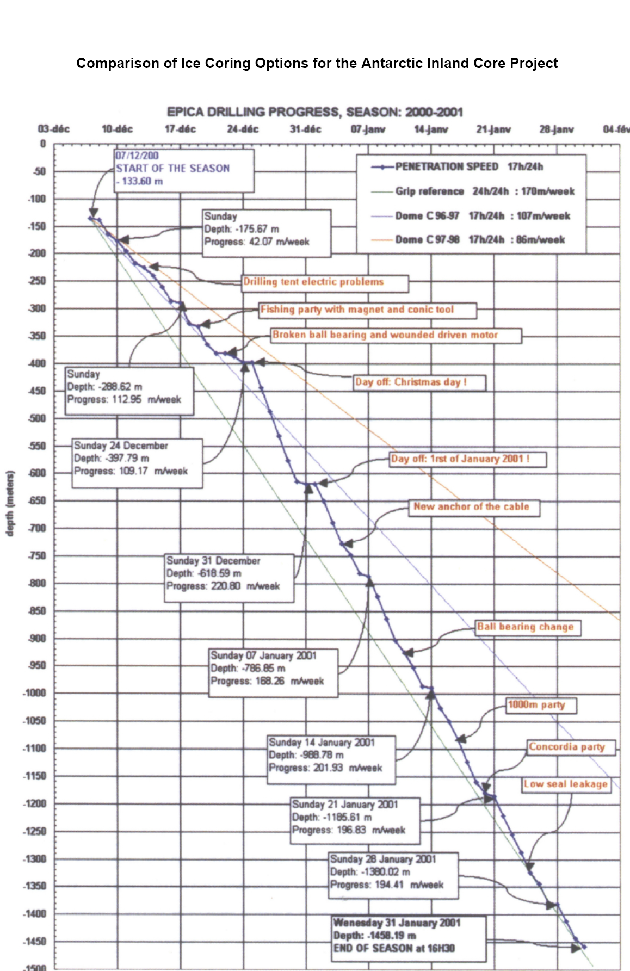
Figure 17. Depth days at Dome C (Augustin and Antonelli, 2002).
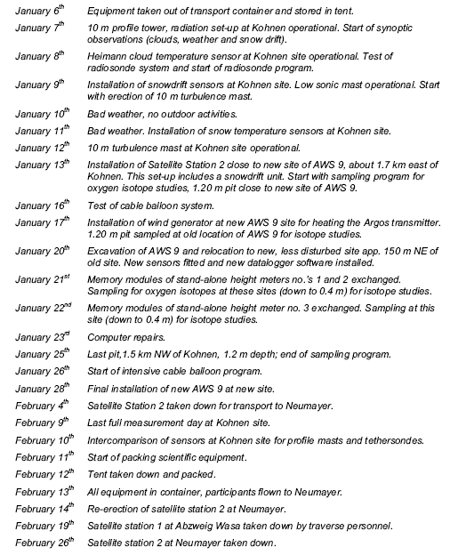
Figure 18. Timeline for a 2-month campaign for in situ surface heat and mass balance experiments associated with EPICA polar coring (Van de Broeke et al, 2002).

Third phase: grand traverse (200 sols)
Leave drill rig in situ and traverse NPD scarp southwards to rendezvous with launch vehicle for depart. Emplacement of additional seismic sensors with baseline of 500 km. Investigation of sites of biological and geological interest.

Vertical Mobility Requirements
Vertical mobility requirements for a Mars Polar dome core are:
- Depth ~2 km (base of north polar dome).
- Diameter of core such that enough mass is generated to meet sensitivity needs for in situ investigations TBD >3 in.
- Ability to drill through dirty ice and lag deposits. MARSIS data indicates that the dust content of the NPLD is <2% (Picardi et al, 2005).
- Low contamination for biology purposes (ancient ice deposits).
Reviews of terrestrial deep drilling techniques can be found in NSF ICWG (2003b) and Bentley and Koci (2006). Tethered mechanical deep drilling remains the most popular technique on Earth (NSF ICWG, 2003b). These systems have a Bottom Hole Assembly whose weight relates to length of the core section and includes the weight of the core section to be raised to the surface. For a 3.5 m section, the BHA mass is ~200 kg, e.g., EPICA. Maintaining core quality still remains challenging (NSF ICWG, 2003a). However, extraction of an ice core on Mars may not be necessary from a science requirements perspective as Continuous Flow Analysis (CFA) is becoming increasingly used for analysis of ice core composition (Svensson et al, 2005). In this case the core is melted and a continuous flow of meltwater is analysed, giving high spatial resolution. Thermal drills can generate meltwater directly which could be pumped out of the drill hole under pressure along heated tubing to analysis instrumentation. Borehole instrumentation captures the stratigraphy while isotope and dust grain analysis are done from the meltwater. Atmospheric inclusions can be captured through control of pressure in a surface reservoir to allow dissolved gases to collect. Visual survey of the core stratigraphy can be achieved via a down borehole multispectral imager/microscope (Carsey et al, 2003). Thermal drill developments for Mars polar work have already begun (Cardell et al, 2006). High power would be required for a deep drilling mission — of around 1Wm⁻¹ to keep the tether from freezing, with potentially multi-stage pumps to lift the meltwater from the hole. An insulated tether would be around 100 kg/km. Power required to drill and heat flow lines would be very challenging at depth — one possibility would be an RTG device in the bore-head. (personal communication, Michael Hecht and CHRONOS team).
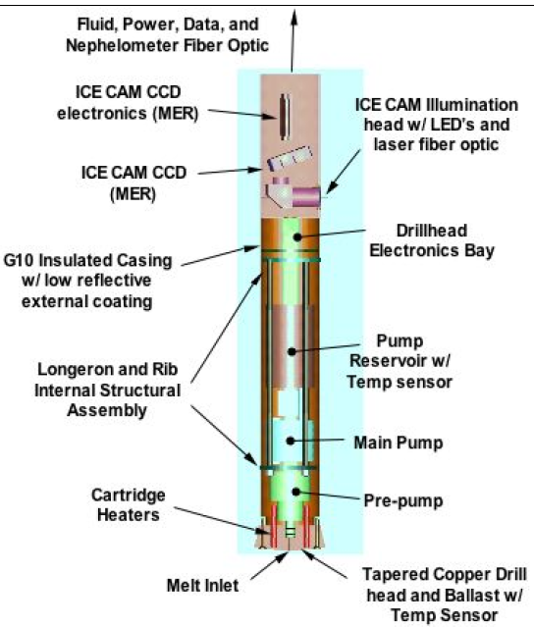
Figure 19. Thermal drill from Chronos Scout mission concept (Hecht and Chronos team, 2006).

Horizontal Mobility Requirements
To site drill rig – 2 km distance
- For geophysical survey to select site and characterize local region; in situ investigations of current heat and mass balance and polar processes — 2 person roving capability (<10 km)
- To traverse off cap to below polar circle launch site – 1500 km, full crew.

Science Capabilities Required
Required scientific capabilities are shown in Table 10.

Table 10. Science Capabilities Required.

Deep core to provide baseline chronology and characterization of major climatic events in past 5M years
Deep core and baseline chronology | Continuous Flow Analysis equipment (see Hab capabilities) for dating and composition
Deep core and baseline chronology | Borehole instrumentation: Multispectral imager <0.1 mm resolution; Microscopic imager; Thermometer
Deep core and baseline chronology | Returned samples of dust from signficant lag deposits
Polar cap mass and energy balance for current climate state and seasonal cap formation processes | Requirements as for nominal atmospheric mission
Shallow cores to investigate heterogenuity | Hand auger
Emplacement of geophysical sensors | Heat probes, seismic sensors

Hab “Lab” Capabilities
Continuous Flow Analysis equipment (pressurized and temperature regulated)
- Isotope mass spectrometer
- Chromatograph
- Particle size analyzer
- Biology instrumentation
The laboratory would need to be sited in the near vicinity of the drill to minimize the transport of cores or the distance of flow tubing to be heated.

Sample Return Requirements
Dust collected from within the core would be of high scientific value to return to Earth for analysis. Could be subsampled, with samples only returned from significant lag deposits.

Issues Identified that Will Require Handling Prior to Human Arrival
Feasiblity of a mid-length mission at the north polar cap
- Deep drilling capability
- Planetary protection issues — deep drilling meltwater would generate a special region under current definition.

Biology/Life: Human Exploration Goals and Objectives

What are the key scientific goals and objectives of human exploration of Mars in biology/life and what are sample Human Science Reference Missions (HSRM) in biology/life?

Human enabled biological investigations on Mars would focus on taking samples and making measurements to Determine if Life Ever Arose on Mars. This goal is consistent with the 2006 Mars Exploration Program Analysis Group (MEPAG) goals and priorities, and we do not see this goal changing in the next 30 year period.
The search for life on Mars can be generally broken into two broad categories: 1) the search for past (extinct) life on Mars and 2) the search for present (extant) life. Both have been, and will continue to be based on a search for water, since all life on Earth requires water for survival. Abundant evidence on the Martian surface of past water activity (e.g. rivers, lakes, groundwater discharge) has lead to Mars becoming a strong candidate as a second planet in our solar system with a history of life. With increasing knowledge of the extremes under which organisms can survive on Earth, especially in the deep subsurface, whether Martian life is still present today has become a compelling and legitimate scientific question.
The National Research Council (NRC) was recently commissioned to do a study to develop “an up-to-date integrated astrobiology strategy for Mars exploration that brings together all the threads of this diverse topic into a single source for science mission planning” (Jakosky et al 2007). This report did not consider how to do science with humans, but we rely heavily on it and earlier MEPAG documents here as snapshots of the current community thinking on astrobiological investigations on Mars.
As pointed out by Jakosky et al (2007), the search for life on Mars requires a very broad understanding of Mars as an integrated planetary system. Such an integrated understanding requires investigation of the following:

- The geological and geophysical evolution of Mars;
- The history of Mars’s volatiles and climate;
- The nature of the surface and the subsurface environments;
- The temporal and geographical distribution of liquid water;
- The availability of other resources (e.g., energy) that are necessary to support life; and
- An understanding of the processes that controlled each of the factors listed above.
Many of these investigations are well underway robotically and would be much further advanced through further robotic missions and sample return. However, a human presence would…

The Search for Extant Life
Jakosky et al (2007) suggested a number of high priority targets based on evidence for present-day or geologically recent water near the surface:

- The surface, interior, and margins of the polar caps;
- Cold, warm, or hot springs or underground hydrothermal systems; and
- Source or outflow regions associated with near-surface aquifers that might be responsible for the “gullies” that have been observed.
SR-SAG noted that sites where recent water may have occurred would also include mid-latitude deposits indicative of shallow ground ice.
Conditions in the top 5 m of the Martian surface are considered extremely limiting for life. Limiting conditions include high levels of ultraviolet radiation and purported oxidants as well as most of the surface being below the limits of water activity and temperature for life on Earth For these reasons, finding evidence of extant life near the surface would likely be difficult and the search would almost certainly require subsurface access. This was also a key recommendation of Jakosky et al (2007).

The Search for Extinct Life
Jakosky et al (2007) list sites pertinent to geologically ancient water (and by association past life) include the following:

- Source or outflow regions for the catastrophic flood channels;
- Ancient highlands that formed at a time when surface water might have been widespread (e.g., in the Noachian); and
- Deposits of minerals that are associated with surface or subsurface water or with ancient
- hydrothermal systems or cold, warm, or hot springs.

Human Science Reference Mission to Address Biological Goals
As a demonstration of how HEM-SAG envisions carrying out the biological goals, a human science reference mission was designed to the Centauri Montes region. This region has drawn attention from astrobiologists as a result of the discovery by Malin et al (2006) that a flow feature (gully) inside a crater wall has apparently been active in the last decade, thereby providing the intriguing prospect of liquid water at or near the surface (Figure 20). This region has also been well documented for its concentration of young, volatile-rich deposits and figures prominently in recent GCM simulations at different obliquities, which indicate that the eastern-Hellas region should be receiving significant amounts of water-ice from the south pole (Forget et al, 2006). Centauri Montes is also at the head of major Amazonian/Hesperian outflow channels.
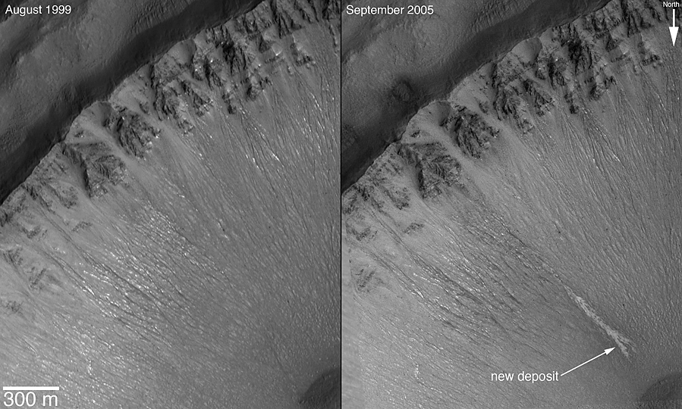
Figure 20. Southeast wall of an unnamed crater in the Centauri Montes region, as it appeared in August 1999, and later in September 2005 (MGS MOC Release No. MOC2-1619, 6 December 2006).

The indicators of ice deposits and liquid water today, as well as the region being associated with outflow channels, provide ample local targets for the search for extant and extinct life. For geological investigations, this region has the attraction of all three epochs being represented in close proximity. We understand that the connection between the active gully features and liquid water is controversial (e.g. McEwen et al. 2007). This site was chosen because at the time of writing, it was one of the two most promising sites on the planet for finding liquid water near the surface. If other more promising sites are discovered, site selection for addressing biological goals should follow these new discoveries.

Science Goals To Be Addressed
Research at Centauri Montes would be focused on MEPAG goal number 1: “Determine If Life Ever Arose on Mars.” Specific investigations are summarized in Table 11.
Table 11. Proposed MEPAG Investigations at Centauri Montes and Approach.

Investigations | Approach
Characterize complex organics. | - Use of raman and GC MS  - Screening for biomolecules (electron transport molecules, various key proteins, phospholipids, etc.) using life marker chips and other lab on a chip assays  - Equipment for nucleic acid extraction (assuming any life has nucleic acids) and some sequencing capability  - Basic microscopic staining for biomolecules
2. Characterize the spatial distribution of chemical and/or isotopic signatures. | - Use of isotope mass specs and GC’s  - Tabletop SEM
3. Characterize the morphology or morphological distribution of mineralogical signatures. | - XRD, LIBS  - FTIR + Raman  - Bright field microscopy  - SEM
4. Identify temporal chemical variations requiring life. | - Basic metabolic analysis (Viking style experiments, but using non-organic redox couples and other anaerobic media)  - Analysis of major cations and anions and metals associated with redox couples.

Other Disciplinary Science
Besides the biological targets, a number of sites of interest exist from a geological perspective within 100 km of the target crater. Of particular note is that geological units from all three major epochs are accessible from this site, including:

- Noachian Hellas basin rim material
- Hesperian Smooth Plains sedimentary deposits modified by fluvial, periglacial processes
- Amazonian Debris Aprons (ice-rich material, rock glaciers)
- Amazonian/Hesperian Pitted Plains deflated ice rich materials
- Amazonian/Hesperian Outflow Channel material of Reull Vallis
Geophysical surveys could search for near surface liquid water. The close proximity of active gullies within the Centauri Montes region is suggestive of possible subsurface aqueous activity which should be explored to provide a more complete understanding of the hydrologic system in this area. Such data may allow for the detection of a subsurface aquifer if it exists and we could map out its planar extent (Antol et al. 2005). The size of the aquifer could place constraints on the amount of water available to form the gullies. Such information is valuable for understanding the nature and extent of the hydrological cycle on Mars as well as selecting drill sites. This information would also be used to compare the amount of water potentially available in an aquifer (which is dependent upon the aquifer size) with combined modeling and geomorphology of predicted amounts of water that have run through the gullies to assess the consistency of such independent estimates of water volumes.

Climate and meteorology studies focused at Centauri Montes would provide insight into the unique process of water ice transport to this region from the south pole. As the area shows a huge geological record spanning from Noachian to Hesperian, a long-term climatic evolution of the planet could be inferred through the integration of geological, sedimentological and geochemical data recovered from these old deposits. In addition, meteorology studies would likely be conducted at any site of human investigation on Mars and thus are not intrinsically site-specific.

Location
Centauri Montes is located on the rim of Hellas Basin (Figures 21 and 22). The Centauri and Hellas Montes region is characterized by remnant massifs interpreted to be crustal uplifts and ejecta from the Hellas impact which occurred early in Mars’ history (Lehmann et al.). Subsequently, several geologic processes have worked to alter the landscape. Lobate debris aprons formed which are characterized by viscous creep and deformation and are attributed to the movement of rock glaciers (Squyres 1978, 1979; Squyres and Carr 1986; Crown and Stewart 1995). Volcanic processes formed several volcanic edifices in the region (Greeley and Crown 1990; Crown 1991). Outflow activity worked to move large volumes of water and debris in association with Dao, Niger, Harmakhis, and Reull Valles (Price 1992; Bleamaster and Crown 2004). Therefore the Centauri Montes region has a rich and complex geologic history.

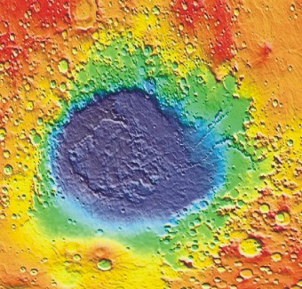

Figure 21. Mola scene of Helles Basin showing location of Centauri Montes region (inside white square).

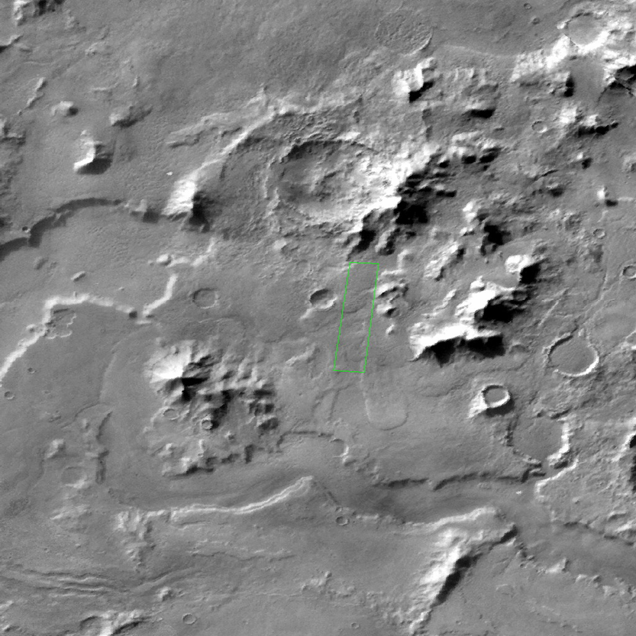

Figure 22. Viking context image of active gully crater (shown in Figure 1) at Centauri Montes (inside red square).

A crater within this region located near 38.7°S, 263.3°W is the site of recent gully activity (Malin et al. 2006). This crater (hereforth referred to as the active gully crater) is shown in Figure 23. Sometime between August 1999 and September 2005, a light-toned material was transported downslope through a gully channel and deposited along the crater wall (Malin et al. 2006). The new deposit has extended branches, a digitate terminus, diverts around obstacles, and has low relief. These observations have been interpreted as suggestive of fluid (aqueous) flow (Malin et al. 2006). Due to the scientific interest in studying this site extensively with humans, the human landing site would be adjacent to this active gully crater.

Research Plan At Centauri Montes
Two modes of research would be carried out at CM:

Mode 1 — Active gully investigations and local drilling
This mode of research is primarily focused on assessing the recently active gully and other fresh gullies as potential sites of recently water activity, and hence extant life (Figure 23).

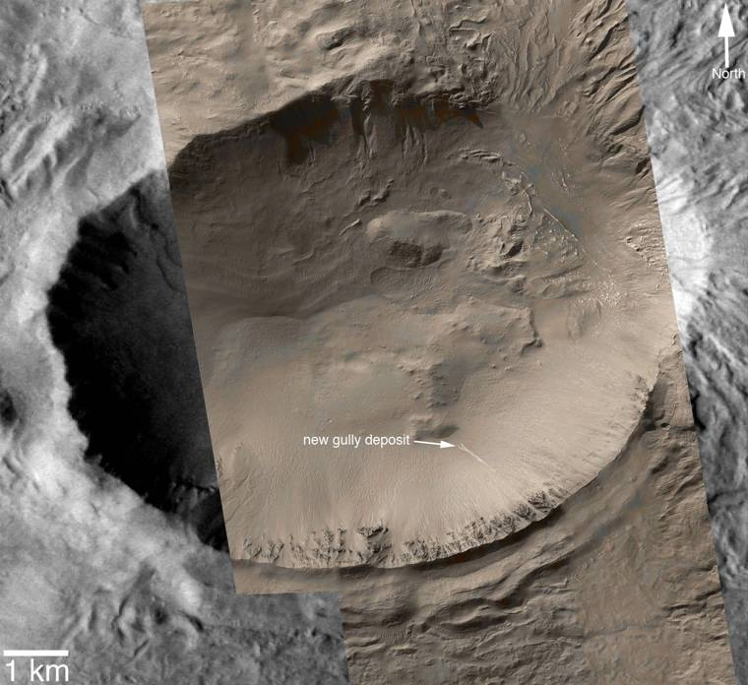
Drill here
From base camp

Figure 23. Mosaic of MOC images M04-04175, M20-00028, R14-02285, S10-00142, S11-00332, and S16-01250, colorized using a look-up table derived from Mars Reconnaissance Orbiter HiRISE color data and overlain on a sub-frame of Mars Odyssey Thermal Emission Imaging System (THEMIS) image V16997005.To study the active Malin et al gully, we would: a) Traverse to a site on the crater rim (red X) immediately above the gully and use a deep drill to access the potential volatile reservoir, b) Deploy a human or a “cliffbot” from above to repel to the gully site (blur line) for direct excavation/sampling, and c)Traverse to a point in the crater just below the gully and access the deposits by climbing up to them for direct excavation/sampling. A second drill site on the crater floor would be desirable.

1. Drilling. For this activity horizontal mobility would be minimal, largely dependent on how close to the active gully crater a suitable landing ellipse could be placed. The drill rig would need to be portable enough to be moved from the landing site, to the drill site. Alternatively, it could be moved from the landing site on the rover in pieces and assembled at the drill site. We envision the drill site and landing site to be close enough together that daily commuting could occur between the two. Drill samples (cores and or cuttings) would need to be acquired without drilling fluids (or with clean and sterile fluids) to protect against contamination and alteration and would require suitable on-site storage to keep them protected (as close to their ambient conditions as possible) until such time that they could be moved back to base (presumably the end of each work shift). Once back at base, cataloging, sub sampling and analyses would be done in the hab lab. If there is suitable interest from other disciplines (e.g., geophysics, geology), other (not necessarily as deep) holes could be drilled in the local area for specific goals of geology, geophysics and climate studies. Drill cores would be processed on site for analysis of organics or potential biota by subcoring the main core and maintaining the subcores in sterile conditions. These subcoring methods are similar to those used in deep biosphere research on Earth. Processing on site would minimize the chances of contamination during the transfer of the cores from the field site to the hab or rover lab.
2. Direct measurements and sampling from the active gully. Based on available data, this seems to be achieved most easily by descending to the gully site from above. Samples would be gathered both inside and outside the gully to assess potential for organic/biological enrichment in and under the gully, particularly if it is determined that water was involved in gully formation.
3. Sampling of sediments on the crater floor. The available imagery of the active gully crater (Figure 23) suggests a history of fluid flow through this crater, possibly associated with the gullies. Drilling on the crater floor into some of these sediments, even to shallow depths would be useful for seeking out evidence of past life. Multiple samples would be collected from promising locations.

Mode 2 — Sampling Traverses
The second half of the expedition would be spent traversing out to a radius of 50 km away from the landing site to access materials from the three different epochs and collect samples for investigation of past life. Samples would include short cores or grab samples of sediment or rock. For the astrobiology work we would only do minimal analysis in the field and would return many samples to the hab lab for detailed analysis. The main focus is to look for samples which may have preserved biosignatures (e.g., old ice, evaporites, etc.)

Horizontal Mobility Requirements
A comparison was done in the region of CM between the scientific benefits of traversing 50 km to a 100 km radial distance from the landing site (Figure 24). In this region, 50 km horizontal mobility seems to be an adequate range given the great diversity of sample sites within this distance. Increasing the horizontal mobility to 100 km does not provide a dramatic increase in new types of terrain. The most significant new terrain type that could be accessed by extending the traverse distance greater than 50 km is the Hesperian Ridged Plains (HRPs). These materials outcrop north of the rim massifs shown in Figure 24 and to access the HRPs the astronauts would likely need to drive around the massif blocks, requiring greater than 50 km driving distance. In addition, the preferred landing site shown in Figure 24 is purposely centrally located. If this landing site is shifted in any direction, a traverse distance of greater than 50 km may be required to access the highest priority science sites. Nonetheless, due to the high concentration of scientifically compelling sites within the 50 km radius, this degree of horizontal mobility would be sufficient for this mission. Furthermore, only half of the mission would be dedicated to traversing, and so a 50 km range should provide ample sampling targets in the limited time. We also recognize a safety constraint on the distance of the traverse. If there are no additional terrain types that are of high priority beyond 50 km then rescue and safety considerations make a 100 km traverse less desirable.

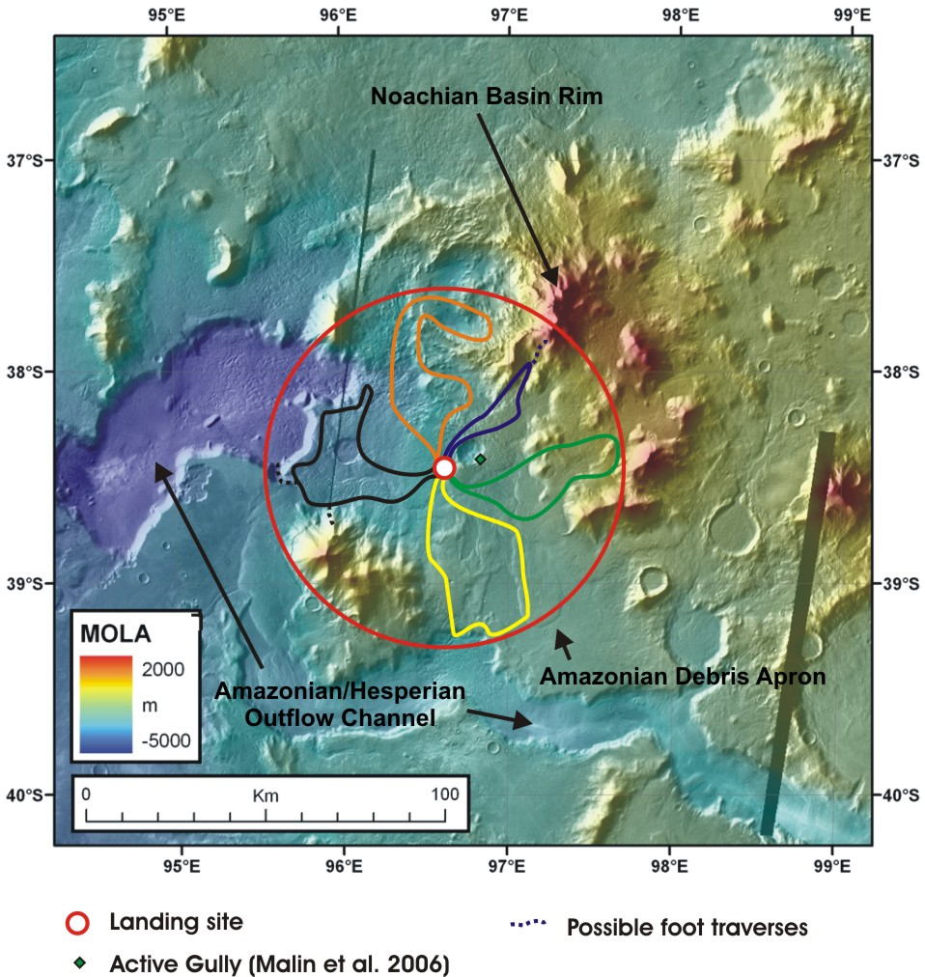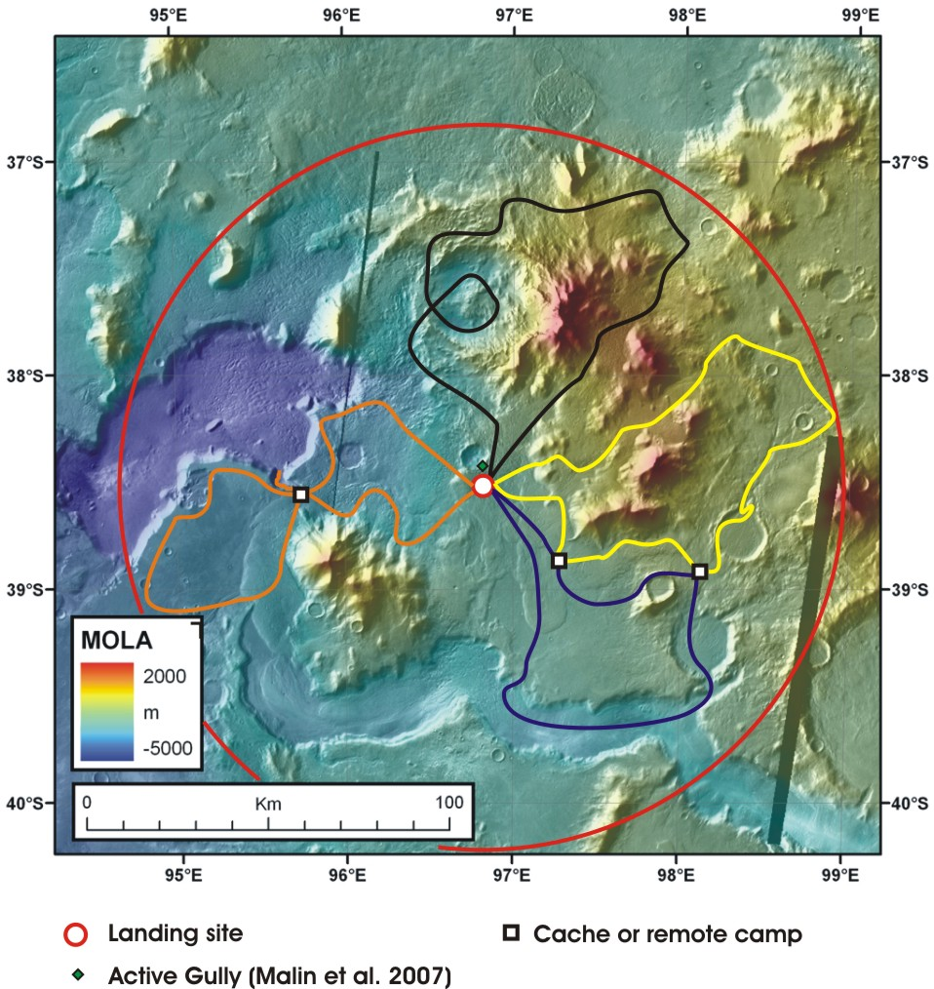
Figure 24. Comparison of possible traverses with a 50 km (left) and 100 km (right) radius from base camp. Both provide access to numerous deposits/features associated with water (e.g. debris aprons and outflow channels). Both provide access to a similar diversity of terrain types of interest, and most importantly, to deposits from all three major epochs of Martian geology.

Vertical Mobility Requirements

For biological investigations we would need vertical mobility to:
a) Investigate the groundwater hypothesis for recently reported active gullies on Mars (Malin et al. 2006). Several researchers have suggested that a shallow subsurface aquifer may be the source of the liquid water feeding the martian gullies (Malin and Edgett 2000; Mellon and Phillips 2002; Heldmann and Mellon 2004; Heldmann et al. 2007). In this scenario, a liquid water aquifer exists beneath the upslope plateau behind the gullies at a depth coincident with (or near to) the gully alcove base depth. The average alcove base depth in the southern hemisphere is ~200 meters poleward of ~40° and thus a drill capable of reaching several hundred meters depth would be required in order to reach the subsurface aquifer. To account for any uncertainties and/or heterogeneities in the subsurface as well as the natural variation in alcove depths within different gully systems, a drill capable of reaching greater than 250 m depth (preferably 400-500 m) would be desirable.
b) Investigate other fresh gully sites (Heldmann unpublished) near the landing site. Likely the same penetration depths as a) are required here.
c) Drill directly into gully sites to 5 m.
d) Drill (5-50 m) while doing longer traverses to collect samples from below the high radiation and oxidant surface region for ancient or dormant life in ground ice and other water lain deposits.
We envision two drills to achieve these goals. One would be heavy and not very portable (for a and b). The second would be more portable and lightweight with the option to be mounted on the rover for the deeper penetrations, and detached and manipulated directly by astronauts for the shallower work in rough terrain. Examples of this type of arrangement already exist for terrestrial prospecting (Figure 25).

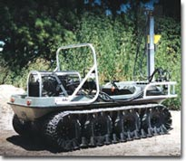
Figure 25. Image of ARGO vehicle that can be equipped with either a hydraulic or pneumatic drill mast that can drill 2-4 in. diameter holes up to 60 m deep in rock formations ranging from sedimentary to metamorphic. And for further flexibility, the drill can be detached from the ARGO and used in man-portable mode. From http://argoatv.com.

Science Capabilities Required
The investigation of field samples can be split broadly into two levels of analysis: 1) basic analyses in the field and measurements that need to be accomplished in-situ, and 2) more detailed analysis using a full suite of laboratory equipment.
To accomplish level 1 the rover should offer basic mobile laboratory capabilities. However, the logistics of operation in a confined rover space in the field probably militate against including large quantities of equipment. Further, from a purely logistical standpoint, field experiments should be limited to those required on site to select samples etc. Considerations of safety and limited time in the field mean that carrying out detailed laboratory investigations in a rover would likely to be undesirable.
Level 2 should be accomplished at the habitat. In a fixed location free of the constraints of EVA activity much more detailed and painstaking analysis of samples could be accomplished. For example, precise dating of samples, which wouldl be extremely helpful in determining the geological and environment history of sampling sites and hence guiding sample selection, would be best done on isolated mineral phases physically separated from hand specimens. Such separation would be most efficiently done by astronauts. The quality of data for some isotope systems would also be enhanced by sample preparation procedures that couild be difficult to automate and package for robotic exploration.
Two laboratories would likely be needed. A medical/planetary protection laboratory would be used for human health monitoring and medical treatment as well as monitoring of the microbial ecology of the habitat and the region around it as part of a general planetary protection protocol/survey. However, to minimize the chances of cross-contamination this lab should be separated from a second laboratory used for extant/extinct life investigations. Separating the two laboratories would help prevent false positive detection of martian life and it would reduce the chances of astronauts coming into contact with organic material from Mars.
The human laboratory could either be physically separated from the science laboratory within the habitat or alternatively a science laboratory might be erected separately from the habitat and accessed either in EVA suit or airlocked pressurized walkway. From a back contamination point of view this option may be attractive to reduce contact between Martian materials and people. Additionally, samples of interest should be subdivided so that a portion of each sample could be brought into the examination facility and the other portion could be stored outside or in the “shed” and not brought into an area where contamination may occur. These stored samples could then be reserved for return to Earth and further detailed examination.

Rover

- Rover mounted drill
- Seismic sounding equipment (to facilitate local sounding and locate the most promising drill targets)
- Field microscope
- LIBs and field tele-raman (if a portable package could be made for rovers to carry this would be better)
- Ability to monitor the effectiveness of separation between humans and the environment
- Ability to monitor bioload — contamination of the environment or tools to ensure sample integrity. Basic biological ‘dipstick’ tests for major groups of human-derived organisms
- GPR
- Equipment to measure major cations and anions in water extracts.
- Portable XRF and XRD
- Radiation measurement tools (UV-Vis spectrometers and dosimeters)
- pH and Eh meters (to examine water extracts of soils and rocks)
- Sample containers and handling tools
- Basic meteorology equipment (temp, pressure, light)
Carried by astronauts (location)

- Multispectral imager
- Rock hammer and sample bags
- Hand lens and/or lens imager
- Digital camera
- Handheld XRF/XRD
- Portable field microscope with camera
- Hand-held spectrometer — Raman (available at the moment)
- Soil water/ice content measurement device
- Sample logging equipment — preferably automated in some fashion.
- A portable microarray system
- Shovel
Down hole instruments (borehole inspection tools and sampling tools with the optimistic assumption that we will encounter a brine at depth):

- Panoramic camera
- Microscopic camera
- Raman spectrometer for mineralogy logging
- Magnetic susceptibility detector
- Environment physicochemical subsurface probes (pH, eH, T, C, ions)
- Gas-meter in subsurface
- Subsurface water sampler (is important to maintain the water sample under the original P conditions)
Hab “lab” capabilities

- Lab isolation unit to allow astronauts to work on samples (probably separate from hab) — ability to sterilize certain work areas I.e. laminar flow hoods for biological investigations
- Basic lab equipment for planned and spontaneous research (drying oven, furnace, scales, etc.)
- High-end raman spectrometer with mapping capability — multiwavelength perhaps combined with same spot laser induced fluorescence or FTIR
- Tabletop SEM
- High precision mass spectrometers for isotopic analyses of possible biosignatures, environmental indicators and for geochronology
- GC and GC mass spec (plus auto-extraction system) and laser ablation ToF
- Bright field and fluorescence microscopy
- Confocal raman microscopy
- XRD/XRF eventually coupled to SEM
- Equipment for sample prep (rock saws, mills, etc.)
- General chemistry equipment for sample preperation and analysis.
- Equipment for nucleic acid extraction (assuming any Martian life have nucleic acids) and some sequencing capability (note this same equipment is need for human health monitoring and microbial ecology analysis of habitat)
- Screening for biomolecules (electron transport molecules, various key proteins, phospholipids, etc.) using microarray assays and other lab on a chip/miniaturized biomolecule detection instruments
- Basic metabolic analysis/culturing equipment (Viking style experiments, but using non-organic redox couples)
- Basic and fluorescence staining for biomolecules
We note that the equipment required for the investigation of extant and extinct Martian life wouldl be similar to that required for human medical analysis (microscopes, scales, molecular biology, etc.) as well as some geological investigations. Although we recommend that the human health and science laboratories should be kept separate there should be redundancy in the consumables required for both labs thus reducing the total mass penalty in having two labs. Furthermore, in the worst case equipment (e.g., microscopes) could be cleaned and transferred between labs for redundancy in the case of equipment failure.

Benefits of Maximizing Lab Work on Mars

Advantage of doing as much as possible in situ or in Mars lab:

- There is a scientific advantage to being able to do as much science as possible on the planet and portable lab devices would be well advanced in the next 30 years
- Reduces risk of sample loss on return.
- From a biological perspective, best to keep sample at ambient conditions which would be tough to do on sample return. As organics and biological material is subject to degradation over time, real time analysis would increase the chances of successful detection and characterization
- Could include separation facilities to remove e.g. solids, dissolved substances and gases from ice (after thorough characterization) to process on site and then send the different factions home for more sophisticated analysis
- Respond to discoveries made in real-time by carrying out a second round of more detailed and thorough collection in areas that show high potential
- Could monitor environmental effects of inhabitation.
- Ensure sample sterility and integrity
Earth-based investigations into the purported evidence for life in Martian meteorite ALH84001 have involved a great number of scientists utilizing many sophisticated instruments and techniques but remain contentious. Evidence of life on Mars, both past and present may be quite subtle. The selection of relevant samples and sampling environments would require the unique capabilities of humans (e.g., ingenuity, flexibility, efficiency) to interpret available clues in real time and to strategically execute a plan for investigation of hypotheses in situ (i.e., on Mars). Samples should still be returned to Earth because of the advanced analytical capabilities of terrestrial laboratories, but the more ability we have on Mars means more science done without the restrictions of sample weight on return and a greater likelihood of satisfying the goals and objectives of the mission.

Planetary Protection Issues at the HSRM Locality and Potential Mitigation
To achieve the biology goals, especially the search for extant life, we would almost certainly need to enter special regions (e.g., gully sites and the subsurface) with humans. We feel that a biologically focused mission would need to include a search for extant life, so technological developments would be needed to prevent forward contamination and provide a safe barrier for astronauts working on samples. Other potential mitigation:

- Carry out repeated analysis of microbial populations in soils to quantify contamination around station for planetary protection analysis. This might be undertaken every 100 days, but this time period could be changed in response to detection of contaminants and/or during periods of intense EVA activity.
- Monitor microbial presence in an ever increasing perimeter around the station, or a set of perimeters to ascertain spread. Same tools used for microbial identification could be used for health monitoring and to check sterility of sampling tools if techniques to verify cleanliness and contamination control protocols are robust.
- Any rover that would be developed needs a compartment which would be open to the outside only and not to inside contamination. This compartment could be used to store samples for their return to the habitat base, thus minimizing the escape of microbial contaminants from the habitat
- The Hab lab should also be environmentally separate from crew habitation spaces
- The possible development or designation of special EVA suits with high biological containment specification and cleanliness protocols that would only be used to access special regions.

Precursor Science Measurements Needed to Maximize Value of This Site

- High resolution visible coverage of region, especially crater and valley walls for scientific evaluation as well as traverse planning
- Radar sounding to understand the subsurface and facilitate planning of drilling operations (depth and location). Transient ElectroMagnetic Sounding (TEM) or Vertical Electrical Sounding (VES) should provide additional information on the subsurface relevant to this mission
- High resolution altimetry to evaluate traverse challenges
- Continued repeat observations of gullies to monitor for additional changes within the gully system indicative of ongoing activity

Issues Identified That Will Require Handling Prior To Human Arrival

- Feasibility of drilling several hundred meters without fluids and within reasonable weight and size limits
- Blow out protection when drilling into potential aquifers
- Feasibility of getting humans and/or robots doing science (including shallow drilling) on scree slopes
- Development of robust contamination control protocols for all sample handling systems.

Biology Mission Timeline

A phased approach to the biology program is suggested with the following key milestones/phases

Phase I
A period of ~30 days at the beginning of the mission for acclimation and operations around the station with no long-range vehicle mobility. This early stage would be used for local sample acquisition, shallow drilling and planetary protection surveys around the base (to gather baseline data on soils). Familiarity with operations in the field site would be gained. Safety would be maximized.

Phase II
A second period where mobility is extended to ~5 km using pressurized/unpressurized rovers. This would allow access to the drill sites and the deep drilling can commence. This phase would last 200 days. Mobility could be extended over time for personnel not required on the drill site so that they may set out caches and do some preliminary reconnaissance for the Phase III traverses.

Phase III
Phase III would lasts for the remainder of mission. Samples would be collected from most promising sites and initial analysis undertaken in the laboratory. Iterative process would begin of further sample collection from most promising sites. The drill rig could be used during this phase if time and personnel permit.

Conclusions
On the basis of about 12 months of scientific analyses and focused discussions in partnership with Mars Architecture Team (MAT) engineers and via the guidance of the Mars Architectural Working Group (MAWG), the following “consensus findings,” in bullet form, have been generated by the HEM-SAG.
These initial “cross-cutting” findings related to specific attributes of potential human missions required to enable the science priorities described in detail above, can be listed as follows:

Sample mass to Earth and return mechanism

- Sample conditioning and preservation essential for some
- 250 kg+ driver (Science) …[400 kg max] → 250 EVA days at 1-1.5 kg/EVA-sol vs Apollo 17 threshold
- Biology requirements are subset of 250kg+ minima (must-have)
- Biology hab-lab requirements on Mars are essential for sample selection (for in situ analysis)
- Atmospheric/ice samples as well (subset of total for Earth return)
- Independent robotic return path to Earth would be required for some samples
Horizontal Mobility: 100’s km required (pressurized human rover)

- Science theme dependent — Biology deep drilling would be least horizontal mobility, but remains in ~100 km class
- Geophysics station spacing requirements dictate (antipodal node emplaced): 200-400 km radial from initial landing position
- Affects regional lithospheric structure, seismicity, thermal structure via geophyscial stations
- Spacing from orbit of magnetic striations now 200 km — rove to ensure high magnetization > 200 km
- Supports require atmosphere/climate network sampling
- Biology/life requires geology-related context mobility (for sampling)
Vertical Subsurface Access (drilling)

- Astrobiology (extant life): ~300 m for access to subsurface liquid water zones (if available)
- 5-50 m for traverse sampling
- Ionizing radiation/super-oxidant zone is 2-5 m → minima is 2 m from neutron interaction path length
- Geology/climate > 100 m access is likely essential (site dependent)
- Selective Coring (recoverable) vs pure drilling to depth z (cuttings recovered)
- Polar climate coring-recovery also at 300 m depth (anywhere deep ice)
Hab-lab requirements (sample analysis requirements): [all multidisciplinary]

- Facilitates high-grading of Sample return to Earth mass
- Enables biology-unique (and climate) measurements that cannot be done on Earth
- Examples of key aspects include: i.e, extant life tests (productivity, labeled radio-C etc.)
- Monitor environmental isolation (contamination and hab isolation, curation…)
- Decisions on basis of samples analysis and directs future sample collections and science
Emplacement for network stations (geophysical-meteorological/climate stations): requirement

- Some to be left and operated after human departure (i.e., ALSEP-like, LDEF-like, etc.)
Emplacement of short-lived monitoring assets

- For critical climate/atmospheric sampling and analysis (human deployed)
Robotic assistants/adjuncts
- “Science mule” for information capture and lugging and transport of samples, equipment, etc.
- Next-generation versions … UAVs, and others
Telecom support for science (getting the data back)

- Navigation: This includes GPS-like or inertial reference…for science documentation: 10m x,y,z is baseline requirements
Ensure separation of biology experiments from human life sciences biology for crew (hab-lab)

There are specific “pass-backs” to the Lunar human exploration program that would enable the Mars-related science activities described above, including validation of some of the cross-cutting findings listed above.

In addition, the following generalized conclusions are essential for any science-driven program of human exploration:

- Multiple, independent sites for long-stay required for science-driven HEM missions (500 day, 250 day EVA)
- Sample mass to Earth > 250 kg, however achieved (could include robotic & human return approaches that separate the sample masses)
- Human horizontal mobility is > 200 km radial (may be up to 500 km radial)
- Vertical mobility must be capable of ~ 300 m (at one site, less at multiple sites on traverses)
- Extant biology is not off-limits (can go after it), including in situ analysis via special lab equipment
- Habitat lab instruments for multiple objectives, including biology, geology, climate, etc.
- Emplacement of network stations for interior, meteorological, climate and even biology essential beyond initial landing site (to be operated during HEM missions and after human return)
- Science after humans return to Earth essential for monitoring climate and interior (and even biology if discovered)
- Some key human science activities on Mars must be demonstrated on the Moon (validation, practice, science value), and maybe some on Earth in Mars analogue settings
- Navigational and telecom infrastructure needed to support human science
- Humans on site (on Mars) bring scientific improvisation, adaptability, agility, and increased cognition for solving major problems (more science in less time and ultimately results faster, better, cheaper)
- Humans must have equipment to conduct analyses so they can iterate to perform well-adapted science to what they discover as they go
- HEM missions to Mars are not apollo-like (less rush, more time to think and adapt) – consider 500 day versions of Apollo missions as test cases
- Careful consideration of contamination control and isolation for biology-relevant samples would be essential to prevent a “false positive” [separate human life sciences from fundamental astrobiology investigations]
- There are HEM mission science precursors that would enable better, smarter, and less costly science that need to be developed [some pragmatic knowledge of dust, radiation, sub-meter geo, terrain, etc.]
- Deep Drilling and long-range pressurized mobility are essential for science-driven HEM missions to Mars in the 2030s
- Require use of robotic assistants on field traverse and short-lived monitoring assets (balloons, etc.)
- There may be programmatic reasons for a sustained, stable MEP with related research and analysis, field analogues, etc. to keep HEM missions on track for the 2030s after an era of Human Lunar Exploration (20s)
- The public must be engaged in the scientific exploration of Mars by humans! EPO strategy leading to humans on Mars (HEM missions) must start now
In summary, the HEM-SAG believe human exploration of the Martian surface would be required (when possible in terms of space transportation, life sciences and related engineering for human safety) to fully address the range of science priorities currently summarized in the MEPAG goals and objectives document.

appendices

Appendix A. Candidate Mars Human Exploration Sites: MEPAG Goal III: Determine the Evolution of the Surface and Interior

Compiled by HEM-SAG with specific site suggestions and contributions by Jim Head, James Dickson, Caleb Fassett, Joseph Levy, Jim Rice, Francois Poulet, Jeff Moersch, Jen Heldmann, Charles Cockell, Peter Doran, Ralph Milliken and Rick Elphic. Initial biology prioritization also included: (Score: 1- 5. EL = Extinct Life, PL = Present life. WG = biologist’s ‘wild guess’). See map for locations, separate entries at each site description for GRS/NS data on hydrogen/water content. **RM** is one of three Reference mission sites (red dots on map). All sites would include full complement of geophysical instrumentation (active and passive seismometers, magnetometers, heat flow probes, etc.) and the selection of sites should consider how the selection would contribute to the most effective seismic networks, obtaining heat flow measurements from different terrains and terrains of different ages, and be sure to sample the full range of known magnetic anomalies. Most sites contain the average Water Equivalent Hydrogen (WEH) in weight %, courtesy of Rick Elphic. Three reference mission sites provide seismic profile from edge to middle of Tharsis (38 and 34) and opposite sides of the globe for deep seismic structure (38/34 and 1). Primary goal maps and suggested traverses are provided for the three reference mission sites and a detailed exploration scenario is provided as an example for the Mangala site (38).
1. Impact Crater Near Nili Fossae: (18.4°N, 77.7°E) (WEH wt% = 4.02) Valley networks forming deltas and water-filled impact crater near edge of Isidis Basin. Valley networks, layered sediments, ancient crater walls, Isidis basin deposits, volcano or basin peak ring structure near crater rim, mineralogical alteration revealed by OMEGA and CRISM (phyllosilicates, olivine). EL 5 (valley network means water - and ancient crater might have ponded water). PL1 (unless there is geological activity there now, this looks like a place most promising for past life). **RM**
2. Newton Crater gully sites: (40.5°S, 157.9°W) (WEH wt% = 4.03) Potentially ice-rich lineated valley fill on crater floor, gullies, crater stratigraphy. Highest concentration of gullies in one region anywhere on Mars. EL4 (crater hydrothermal systems?). Crater might have hosted life in hydrothermal system. PL5 gullies might be sites of present-day water seeps and therefore extant life.
3. Meridiani Region: (2.0°S, 5.5°W) (WEH wt% = 7.67) MER site to investigate context and the nature of early water-rich deposits. Easily traversable terrain would enhance regional study. Mineralogically unique region of the planet. EL5 early sediments/water suggest site of high priority for early life. PL1 Now dry and geologically inactive – not so likely to harbour present-day life
4. Gusev Crater-Columbia Hills: (14.6°S, 175.4°E) (WEH wt% = 8.42) Complex stratigraphy and explosive volcanic deposits in Columbia Hills, at the MER Gusev site. Lies on the crustal dichotomy, with fluvial input from the southern highlands and volcanic deposits related to Hr (Hesperian ridged plains). EL3 crater may have hosted hydrothermal systems/ponded water for early life, although it is a large crater and the site would have to be selected carefully. PL1 Doesn’t look very geologically active for present-day life.
5. Chasma Boreale: (82.6°N, 47.3°W) (WEH wt% = 41.45) North polar layered deposits and pre-PLD basal unit. Assessment of polar stratigraphy and relations to pre-polar deposits; orgin of Chasma Boreale and relationship to the northern extent of Vastitas Borealis. EL5 – If chasma was formed by water flood may be site of potential habitability early on and site of sustained water. Ice cap may have provided water. PL4 Near water ice (polar cap). Changes in obliquity may have created regions suitable for life even in recent times with oases sustained today?
6. South polar layered deposits and the Dorsa Argentea Formation: (71.8°S, 67.3°W) (WEH wt% = 35.71) Polar stratigraphy, comparison to MARSIS radar data showing ice-like layering, exploration of Hesperian DAF and possible ancient ice record. Close proximity to Amazonian ice flow features along the margins of the present day polar cap. EL5 – ancient terrains may have hosted water during the Noachian. PL4 Site of ancient permafrost – possible preservation/habitats of recent life?
7. Gale Crater: (5.1°S, 137.5°E) (WEH wt% = 6.48) Ancient crust, valley networks, central mound of volatiles. Stratigraphic analyses of crater wall material as well as sedimentary layers within the central mound, possibly of fluvial origin. EL4 Crater may have hosted hydrothermal systems/ponded water for life, particularly given evidence for volatiles. PL1 If it’s not geologically active now it’s unlikely to be a site for present life.
8. Floor of Valles Marineris: (7.0°S, 72.7W) (WEH wt% = 4.49) Interior layered deposits, stratigraphy and mineralogy; VM wall talus and stratigraphy. Examination of regional connection to circum-Chryse outflow channels. EL3 May have layers of sediments with early biology? PL3 Depth may create pressures suitable for transient liquid water even today?
9. Holden-Eberswalde Craters: (24.0°S, 33.6°W) (WEH wt% = 2.47) Late Noachian-Early Hesperian Valley network deltas and stratigraphy. Well-preserved and accessible sedimentary deposits. Ancient crust preserved along crater walls. EL4 See site 7 – same rationale. PL1.
10. Eastern Olympus Mons: (17.7°N, 128.2°W) (WEH wt% = 4.34) Recent volcanic, tectonic and fluvial activity, perhaps within the last few tens of millions of years. EL3 Not clear what the potential is for fossil life, but fluvial activity and volcanic activity would be promising. PL4 recent tectonic activity may suggest geothermal hot spots for present-day life?
11. Elysium Planitia: (5.0°N, 150°E) (WEH wt% = 3.05) Late Amazonian volcanic lava flows and outflow channels deposits. High biological interest. Testing of pack-ice hypothesis for platy units; could yield recent ice activity in the equatorial region of Mars. EL5 Sustained liquid water and lava, i.e. geochemically active and nutrients. PL2 Not geologically/aqueous today.
12. Western Olympus Mons Scarp: (19.6°N, 139.7°W) (WEH wt% = 5.79) Late Amazonian piedmont glacial deposits, stratigraphy of Olympus Mons lava flows and talus deposits. Access to Olympus Mons aureole deposits. EL4 Glacial deposits may be places for early life – if they had melted and provided liquid water. PL2 Not geologically active today to provide habitats for extant life.
13. Eastern Hellas Basin Massifs: (38.7°S, 97.0°E) (WEH wt% = 4.21) Hellas basin rim mountain rings for Noachian stratigraphy; Late Amazonian ice-rich deposits. Late Amazonian gullies, including the Centauri Montes “active gully” site (See 29), EL3 Ice and noachian terrains may have been good for early life – no obvious sustained habitats though? PL2 Not geologically active today?
14. Nili Fossae: (24.2°N, 79.4°E) (WEH wt% = 3.75) Hesperian ridged plains, OMEGA mineralogical anomalies (clays), possible ancient basin impact melt and olivine deposits. EL5 clays and impact melts suggest weathering/water/geochemical activity. May be good microenvironments for life. PL1 Not geologically active today and not obvious where extant life would be sustained.
15. Lyot Crater central deposits: (50.3°N, 29.1°E) (WEH wt% = 4.62) Largest crater in the northern lowlands, crustal stratigraphy, evidence for penetration of the cryosphere. Potential access to Late Amazonian high-latitude volatile-rich mantling deposits. EL5 Penetration of cryosphere may have provided conduit for liquid water into crater hydrothermal system. Good habitat for life. PL2 Not geologically active now, but the crater is in permafrost and contains ice – may have basal ice habitats for life?
16. Coloe Fossae Dichotomy Boundary: (41.3°N, 54.2°E) (WEH wt% = 3.86) Stratigraphy of dichotomy boundary scarp, Amazonian lobate debris aprons and lineated valley fill. Accessing the plateaus that are interspersed amongst the lineated valley fill can allow for testing as to whether potential glaciation was local or regional. WG EL3 Not a site of ancient water, but there was obviously geological activity, which may benefit life?? PL1 Not geologically active/water rich now??
17. Utopia Planitia: (28.5°N, 134.4°E) (WEH wt% = 5.49) Examine the deposits on the floor of Utopia, including the lahar-like deposits and related materials. Access to volcanic and fluvial deposits; high concentration of polygonally patterned ground in Utopia. EL2 Dead desert in the past? May have been more water rich in the very early history of Mars? PL1 Dead today
18. Aram Chaos: (2.6°N, 21°W) (WEH wt% = 4.35) Outflow channel processes. Examine the nature of a range of mineralogical anomalies and investigate the OMEGA-based mineralogy sequence, testing the stratigraphic relationships. EL3 Outflow channels may have been good for life, but probably very transient water availabilities? PL1 Not a geologically active site today for life
19. Arsia Mons Glacial/Volcanism: (4.8°S, 126.3°W) (WEH wt% = 5..41) Examine site of late stage volcanism extruded from dikes cutting Late Amazonian glacial deposit on the northwest flank of Arsia Mons. Meteorological analysis of local climate at high elevations. EL2 If the volcanism wasn’t in an environment of high water content maybe not interesting? PL1 Not active today?
20. Slope Streaks: (14.4°N, 118.2°W) (WEH wt% = 4.31) Examine the nature and origin of slopes streaks and their characteristics, including searching for subsurface water, springs, landslide deposits, etc. EL4 Possible regions of past water, springs etc. PL4 Possible regions of present-day water, springs etc?
21. Atlantis Chaos: (34.8°S, 177.4°W) (WEH wt% = 4.99) Examine the nature of Atlantis Chaos and assess the large pluvial lake hypothesis. Extended traverses to assess the major magnetic anomalies in this area. Access to Noachian stratigraphy and fluvial processes, with potential connection to deposition within Gusev Crater. EL4 Area of water ponding??? PL1 Not very geologically active today?
22. Central Alba Patera: (40.7°N, 109.6°W) (WEH wt% = 6.85) Examine the range of Hesperian and Amazonian volcanic activity associated with Alba Patera, the young (Late Amazonian) latitude-dependent mantle deposit, and ancient (Hesperian) valley networks on the northern flanks. EL4 Valley networks and volcanism suggest strong potential for habitats for life (water/mineral supplies). PL1 Geologically inactive today.
23. Chryse Planitia: (27.0°N, 41.0°W) (WEH wt% = 3.35) Examine over a wide area the mineralogy, petrology and biology of outflow channel effluent. Examine the "oceans" hypothesis. Study underlying Hesperian ridged plains at impact craters. Provide greater context for the results from Viking Lander 1 and Pathfinder. EL3 Outflow channels may provide transient water availability, but not sustained for life. Impact craters of potential biological interest. PL1 Geologically inactive today.
24. Medusae Fossae Formation: (1.6°N, 173.2°W) (WEH wt% = 6.39) Examine the areas where interfingering of Tharsis lava flows and the MFF are observed. Establish nature and origin of MFF and stratigraphy, age and interactions with lava flows. WG EL4 Lava flows and past water? PL1 Geologically inactive today.
25. Hellas Basin Floor: (41.9°S, 69.6°E) (WEH wt% = 3.92) Study the effluent of the Eastern Hellas outflow channels, and assess the Hellas "ocean" hypothesis. Meteorologic analyses could address the unique climate of Hellas at a low elevation and relatively high pressure. Very important site for biology. EL5 depth of hellas and evidence of sediments suggests sustained liquid water. PL3 May be a place where transient liquid water (above triple point) could be sustained today at bottom of basin?
26. Northeast flanks of Arsia Mons: (7.4°S, 121.2°W) Cave skylight site (see Cushing et al., 2007 – LPSC #1371). Site of high biologic interest if subsurface water resources are available. Accessiblity to Arsia lava flows. From Melissa Lane.
27. Walls of Dao Vallis: (33.7°S, 92.5°E) These are classic, well-developed gully systems and also some of the gullies are associated with the “pasted-on” terrain which Christensen (2003) has hypothesized to be melting snowpacks. High relief throughout the valley could yield excellent insight into local micro-climate-related surface processes. From Jen Heldmann.
28. Terra Sirenum: (39.3°S, 161.7°W) Site of high-albedo deposit that formed within the last decade in the proximity of gullies (Malin et al., 2006). Classic Noachian highland terrain with Hesperian lava flows and small-scale Amazonian fluvial activity.
29. Centauri Montes: (38.7°S, 96.7°E) Site of high-albedo deposit that formed within the last decade in the proximity of gullies and more extensive volatile-rich deposits (see site 13) (Malin et al., 2006). Meteorologic stations could provide insight into the local climate of eastern Hellas and the regional climate of Hellas as a whole.
30. Terra Cimmeria: (70.0°S, 180.0°E) A suggested drill target is at 180W between 60-80S which is a region of preserved crustal magnetism (indicating old terrain) and ground ice (GRS measurement, but also crater morphology indicative of underlying deeper ice). From Jen Heldmann.
31. Mawrth Vallis: (25.3°N, 19.3°W) Fluvial geomorphology with heavy weathering. Stratigraphic analysis and access to the northern lowlands. From Francois Poulet.
32. Olympia Planitia: (75.0°N, 180.0°E) Sulfate-rich dunes around the north pole (very recent alteration product(?)). Access to the southern-most extent of the residual polar caps, and access to polar troughs to reveal Amazonian climate history. From Francois Poulet.
33. Valles Marineris: (6.2°S, 70°W) Sulfate-rich deposits only accessible by human operations. Extensive stratigraphic analysis and access to landslides/talus piles. From Francois Poulet.
34. Arsia lobate glacial deposit: (7.4°S, 123.8°W) Evidence for Late-Amazonian glacial activity. Assess the interaction of late-stage glaciation and volcanism, analyze climate history and sample possible residual ice. Assess various moraines, obtain ice cores, sample lava flow stratigraphy to assess volcano and glacial chronology. **RM**
35. North Polar Cap: (86.0°N, 79.0°E) Accessibility to Late-Amazonian ice deposits, through drilling and stratigraphic analysis of polar troughs. From Joe Levy.
36. South Polar Cap: (88.0°S, 30.0°E) Accessibility to Late-Amazonian ice deposits, through drilling and stratigraphic analysis of polar troughs. From Joe Levy.
37. Syrtis Major Planum: (7.0°N, 69.0°E) Possible SNC-meteorite ejection locale, Hesperian lava flows and silicate-rich deposits in caldera. Interactions with Isidis and the northern lowlands. From Joe Levy.
38. Mangala Valles: (18.0°S, 149.4°W) Outflow Channel Floor: Residual ice-rich deposits remaining on the floor of an outflow channel. Hesperian-aged (?) outflow channel. Dike-related vents; evidence for phreatomagmatic eruption and rim glacial deposits at the graben. Examine floor and evidence for multiple events and role of groundwater. Possible residual ice on the floor of the channel. From Joe Levy. **RM**
39. Nilosyrtis Mensae: (35.0°N, 71.0°E) Complex LVF/LDA stratigraphy along the dichotomy boundary. Evidence for multi-stage formation of extensive glacial deposits; sampling could provide chronology for recent climate change and resulting glacial landforms. From Joe Levy.
40. Olympus Mons Caldera Floor: (18.3°N, 133.0°W) Age of Tharsis volcanism; Caldera wall stratigraphy, chronology, atmospheric dust stratigraphy, ash deposition. Landslide deposits along the caldera wall. Seismic studies and mass spectrometer for possible gas venting.
41. Milankovic Crater: (55°N, 146.5°W) Rare large impact crater within the northern lowlands (> 40 km); Analysis of excavated material from the northern lowlands and adjacent high-latitude volatile-rich mantling and related deposits.
42. Kasei Valles: (21.0°N, 73.8°W) Massive streamlined morphology gives access to Noachian/Hesperian fluvial deposits; Stratigraphic analysis of channel walls; Channel is sourced from the northern extent of Vallis Marineris, which could yield insight into more regional processes. Evidence for fluvial activity, glacial scour, and subsequent lava flows.
43. Vastitas Borealis Formation: (65.7°N, 20.2°E) Classic northern lowlands terrain; Possible sublimation residue for outflow channel effluent; extensive polygon development; Latitude-dependent mantling deposits; Context for Mars Phoenix analysis.
44. T-Shaped Valley: (37.6°N, 24.0°E) Massive glacial deposits along the dichotomy boundary; Multiple converging flows from various localized sources; Meteorological study could address the recent conditions along the dichotomy boundary; Possible Late Amazonian glacial ice preserved.
45. Isidis Basin Floor: (12.0°N, 88.5°E) Possible flooding remnants from a Noachian and Hesperian northern ocean; Volcanic input from Syrtis Major; Was this a major part of a northern lowlands ocean?
46. Utopia Basin Floor: (43.8°N, 117.0°E) Extensive access to patterned ground and near-surface volatiles; Examine distal parts of the Elysium lahar deposits; Corroborative studies to go along with VL2 analyses; Possible preserved ice from Early Amazonian.
47. Hecates Tholus: (32.0°N, 150.3°E) Unique concentration of young (Hesperian/Amazonian) valley networks, in the proximity of extensive Hesperian volcanic activity; Access to nearby northern lowlands; Some volcanism may be Amazonian.
48. Peak Magnetic Anomalies: (60.0°S, 175.0°E) Geophysical analysis could reveal details of an early Martian magnetic field; classic Noachian cratered terrain could yield insight into the composition of Mars in its first billion years; Major goal would be to link surface geology to any evidence of subsurface magnetism and magnetic carriers.
49. Hesperian Calderas: (59.4°S, 60.7°E) Volcanic record for middle-Mars history; Meteorological study could document interaction between Hellas and South Pole; Examine key part of martian timeline; understand Hesperian volcanic processes and related valley networks.
50. Hesperia Planum: (23.3°S, 110.6°E) Potential comparison with classic lunar mare terrain; Structural investigation of wrinkle-ridge formation; Examination of classic unit of the Mars timeline.
51. Huygens Ridge: (12.3°S, 66.3°E) Access to exhumed dike/Potential Hesperian Ridged terrain; Geochemical analyses of intrusive volcanic material; This dike system may be feeder for major Hesperian ridged plains volcanism.
52. Argyre floor deposits: (51.5°S, 41°W) Potential analyses of volatile deposits from south polar ice sheet; primary impact record for large impact basin/large impact melt-sheet; Amazonian formation of small-scale fluvial features. Possible eskers in southern part of basin; Assess evidence for aqueous flooding and shorelines.
53. Thaumasia Valley Networks (Warrego): (38.6°S, 89.4°W) Post-emplacement modification of classic Noachian valley networks; Access to ice-rich crater-fill material; Geophysically probe classic thrust-like structure at edge of Tharsis rise.
54. Syria Planum: (7.7°S, 100.5°W) Structural evolution of Tharsis; Close proximity to western most extent of Valles Marineris; This region is highest point on Tharsis and key to its early volcanic evolution.
55. Proctor Crater: (47.5°S, 30.2°E) Extensive dune field on crater floor; Study of recent dune formation and migration and relation to climate change; Stratigraphic analysis of Noachian crust.
56. White Rock: (8.0°S, 25.2°E) Field analysis of high-albedo crater floor deposit; Eolian modification history of enigmatic surface unit; Thought to be key to early mineralogy and resurfacing.
57. Complex tectonic ridges: (66.0°S, 140.0°E) Structural analysis of Noachian terrain; Potential exposure of deep-crust from massive faulting; Enigmatic part of Noachian crustal deformation; Geophysical analyses.
58. Mie Crater: (48.5°N, 139.7°E) Rare large crater within the northern lowlands provides vertical sampling and stratigraphy; Fifty-year in-situ comparison of high-latitude present-day surface processes and climatic activity; Examination of condition of Viking 2 lander after ~50 years; Ground truth for major mid-latitude site that illustrates periglacial processes.

Appendix B. Goal II (Climate): Objectives and Investigations for Human Exploration of Mars

Overview of Updated Goals and Objectives
In the human era of exploration, atmospheric measurements at all sites will be seen as important not only to the understanding Mars atmosphere and climate, but also as environmental characterization essential to the interpretation of many biology and geology objectives. The trend towards system science called out in MEPAG 2006 Goal II Objective A “ground-to-exosphere approach to monitoring the Martian atmospheric structure and dynamics,” will continue with more emphasis on the mass, heat and momentum fluxes between the three Mars climate components: atmosphere, cryosphere, and planetary surface.
This systems approach will be enabled by advances in Mars Global Circulation Models (GCMs), a doubling in length of global time-series derived from monitoring Mars surface and atmosphere from orbit, new atmospheric vertical structure information from Mars Express and MRO, new anticipated global data sets on aeronomy, atmospheric composition and winds, and by network science and coordinated lander-orbiter campaigns, such as that planned with Phoenix-MRO. In 2007, trends in Mars GCM development are towards coupling of upper and lower atmosphere (e.g., Angelats i Coll et al [2005]), coupling with regolith models [Bottger et al (2005)], integrating models of atmospheric chemistry and dynamics (Lefevre et al, 2004; Moudden and McConnell [2007]), multiscale, nested models — where small scale surface-atmosphere interactions could be studied within the context of global transport (Richardson et al [2007], Moudden and McConnell [2005]), and data assimilation (Montabone et al [2007]). Models have not yet been successful in reproducing the observed Martian dust cycle with active dust transport [Newman et al. (2002a, 2002b); Basu et al. (2004); Kahre et al. (2006)]. Temperature and wind profile information from heights between the top of instrumented masts and the free atmosphere would likely remain sparse or non-existent.
Understanding of Mars past climate (MEPAG 2006 Goal II Objective B), will benefit from anticipated new knowledge of current atmospheric escape rates from the 2011 Mars Aeronomy Scout. However, significant advance in the key area of access to the polar stratigraphic record is not expected in the decades before human exploration. In 2030, this will remain one of the highest priorities for MEPAG Goal II. On the other hand, the study of the paleoclimatic parameters imprinted in the ancient geological record (e.g. Noachian to Amazonian) also concerns the high priorities of the MEPAG Goal II Objective B, which directly relates to unlock the ancient climatic conditions of Mars through the physical (e.g., geomorphic and/or sedimentary), petrological, mineral and geochemical (including isotopic) material characterization.
While recognizing that the MEPAG 2006 Goal II objectives are sufficiently general that they will all remain largely valid, some updating relevant to 2030 is captured in the following four subsections.

Quantitative Understanding of Mars Atmospheric Processes
Characterizing the basic state and critical processes of the current Martian atmosphere constitutes 2006 MEPAG Goal IIA. Here we describe globally active physical processes that determine the basic state and variability of the Mars atmosphere, and so are most important to resolve. These processes are inherently global in character such that relevant measurements might be obtained from HEM activities at all sites visited, There are, however, large scale atmospheric provinces which exhibit distinctive dynamical, aerosol (dust and clouds), surface and potential subsurface volatile conditions. Consequently, although site selection is unlikely to be driven by atmospheric science, the specific complement of atmospheric experiments and measurement goals is likely to vary according to site selection.
The emphasis of HEM atmospheric science would likely focus on processes within the planetary boundary layer (PBL, surface to ~2 km), where surface-atmosphere interactions impart fundamental influences on the dynamical, chemical, and aerosol characters of the global Mars atmosphere, Orbital remote sensing for this region remains difficult and lander/rover atmospheric payloads limited such that sufficiently detailed measurements of the PBL may not be returned from Mars science missions prior to 2030. HEM atmospheric observations can provide optimum in situ and remote access to the PBL and, in turn, characterize local environmental conditions in support of HEM operations.
Atmospheric dynamics, in concert with radiative forcing, determines the basic thermal structure of the Mars atmosphere, the global transport of volatiles (CO₂, water, dust), and the maintenance of Mars polar ice caps, all of which vary on seasonal and interannual timescales. Current understanding of Mars atmospheric dynamics is based to a large extent on remotely sounded atmospheric temperature profiles, analyzed in the context of Mars general circulation models (MGCM). Recent Mars missions (MGS, MER, Mars Express, MCO) have extended the vertical, global, and temporal coverages of atmospheric temperature and aerosol (cloud and dust) distributions towards enhanced constraints on MGCM dynamical simulations. The planned MSO mission would further complement improved thermal and aerosol profiling with direct wind profile measurements for the first time. The dynamical state of the upper Mars atmosphere (altitudes above 80 km), which carries additional significance in terms of spacecraft aerobraking and atmospheric escape rates, has been inferred from in-situ density measurements associated with aerobraking (e.g., Withers [2006]). Dedicated, global observations from the 2011 Mars Aeronomy Scout mission.would greatly expand our understanding of Mars upper atmospheric dynamics. Within the near-surface atmosphere, atmospheric observational constraints remain sparse. This reflects both the limitations of orbital remote sensing and the geological focus of lander/rover operations to date. Viking lander in situ observations of surface pressure and winds reflect active planetary wave systems and storm fronts (e.g., Barnes [1980] and Murphy et al [1990]). MER-based thermal and dust-aerosol profiling within the lower (<5 km) atmosphere also indicate strong PBL variability over local turbulent to diurnal to seasonal timescales (Smith et al. [2006]). MSL and Phoenix will conduct limited meteorological measurements as constrained by the primary surface science objectives of these missions. Dedicated observations of surface pressure and temperature-wind-dust profiles of the PBL from distributed surface stations constitutes a key priority for HEM investigations of Mars atmospheric dynamics.

Atmospheric Dust
Radiative forcing of the Mars atmosphere may be represented roughly as an energy balance between cooling through CO₂ thermal infrared emission and heating through absorption of solar flux by suspended dust particles. Atmospheric heating associated with atmospheric dust intensifies global atmospheric circulation and near surface winds, which in turn increases lifting of surface dust into the atmosphere. A dramatic result of this dust radiative-dynamic feedback is ubiquitous aeolian activity on Mars, with significant dust lofting and transport occurring over a wide range of spatial and temporal scales. These range from nearly continuous dust devil activity, to regional dust storms in every Mars year, to global dust storms that may occur once every three or four Mars years (Martin and Zurek [1993], Cantor et al [2001]). As a consequence, atmospheric dust plays a major role in the spatial, seasonal, and interannual variability of Mars atmospheric thermal structure and circulation. Global imaging and thermal IR dust abundance observations of Mars atmospheric dust extend from the Mariner 9 mission to Viking, MGS, and current MER, Mars Express, and MCO missions, providing an accumulating timeline of Mars dust storm activity. Current mission observations have also substantially advanced vertical profile and dust radiative property definitions (McCleese et al [2007], Wolff and Clancy [2003]), with further progress in these areas would be contributed by MSO. Both of these factors are critical to understanding the radiative-dynamical relationships associated with Mars dust storm activity. A key element yet to be addressed regards the particle size dependent flux of dust at the surface-atmosphere boundary as a function of atmospheric and surface conditions. Hence, our understanding of dust lifting rates from the Mars surface is characterized by relatively simple surface wind parameterizations, and it remains uncertain as to whether global surface dust distributions limit or are influenced by atmospheric dust transport. In-situ observations of dust surface flux (lifting and deposition), particle sizes, radiative properties, and vertical profiles within the PBL constitute primary objectives for HEM atmospheric dust studies.

Atmospheric Water
Atmospheric water, in the form of vapor and ice clouds, plays significant roles in atmospheric chemistry, dust radiative forcing, and climate balance. The photolysis products of atmospheric water vapor determine Mars trace specie abundances (e.g., Nair et al [1994]) and regulate current escape rates for the atmosphere (Liu and Donahue [1976]). Water ice clouds have long been associated with major topographic features, autumnal polar hoods, and a variety of cloud wave structures (Kahn [1984]). The existence of an aphelion, low latitude cloud belt is identified as a significant influence on the vertical distribution of atmospheric dust and water vapor, as well as meridional transport of atmospheric water (Clancy et al [1996]). Atmospheric exchange with polar cap water ice deposits dominates the seasonal variation of atmospheric water vapor (Jakosky and Farmer [1983]), whereas atmospheric exchange with subsurface ice and adsorbed water at lower latitudes remains uncertain (e.g., Montmessin et al [2004]). Recent spacecraft observations of atmospheric water vapor (Smith [2002]), subsurface water ice (Feldman et al [2004]), and polar cap water ice (Langevin et al [2005]) from MGS, Odyssesy and Mars Express have begun to illuminate surface-atmospheric exchanges of Mars water over seasonal, interannual, and possibly longer timescales. MCO supports dedicated vertical profiling of atmospheric water vapor and ice clouds (McCleese et al [2007]), which are likely to be augmented by high sensitivity MSO limb profiling observations. The Phoenix lander (Smith [2006]) will excavate and analyze subsurface water ice on Mars for the first time, and MSL will provide measurements of surface humidity and the water content of surface materials over the course of a Martian year. HEM studies of atmospheric water are likely to focus on vertical profile measurements within the PBL, which are not easily addressed from orbital remote sensing. Subsurface core sampling of adsorbed water and water ice water deposits (site-dependent in this case) also constitutes a key Mars water objective that is uniquely facilitated by HEM operations.

Atmospheric Chemistry
The trace chemical composition of the current Mars atmosphere reflects photochemical cycles associated with the major atmospheric constituents CO₂, H₂O, and N₂; and perhaps non-equilibrium chemistry associated with potential subsurface sources-sinks of methane (), SO₂ (), and peroxide (H₂O₂). Some of these compounds can be essential to sustain a Mars cryptic biosphere through direct or indirect (bio)chemical pathways (e.g., atmospheric oxidants can be used as electron acceptors for microbial metabolism, whereas reducing gases –CH₄- can be electron donors). Existing measurements of the Mars trace species CO, O₂, O₃, and H₂O₂ appear to confirm the dominant HO_{x} catalytic cycle proposed to prevent buildup of large CO and O₂ concentrations from photolysis of the primary CO₂ constituent (Parkinson and Hunten [1972], McElroy and Donahue [1972]). Hence, atmospheric water vapor, as the primary photolytic source of atmospheric HOx species, plays a dominant role in Mars atmospheric chemistry. Definitions of spatial and seasonal variations in atmospheric trace composition remain tentative, with the exception of Mars ozone which exhibits large increases towards winter high latitudes (Barth, ). The detailed seasonal variation of Mars ozone also suggests that heterogeneous HO_{x} chemistry may occur on the surface of Mars water ice clouds (Lefevre et al [2004]). Vertical gradients in trace specie abundances, associated with a saturation-dependent water mixing profile (Clancy and Nair [1996]) or vertical variations in photolysis rates (Nair et al [1994]), are inferred but not definitively measured. The most problematic trace specie measurements, on both observational and modeling grounds, are the recent reported detections of significant atmospheric methane abundances (Formasano et al [2004], Krasnopolsky et al [2004]). Methane is not photochemically produced and is not stable in the current Mars atmosphere such that detectable amounts (parts per billion) require a source from the subsurface (Krasnopolsky et al [2004]). Reported variations in methane abundance versus time and space (Mumma et al [2007]) place further requirements on atmospheric loss rates for methane, which remain extremely challenging. Subsurface sources for sulfur bearing gases such as SO₂ (Krasnopolsky [2005]), and triboelectric sources for enhanced production of peroxide (Atreya et al [2007])) remain unsubstantiated by observations and so unconstrained. MSL, the Mars Aeronomy Scout mission, and MSO should address many of the above questions regarding Mars atmospheric chemistry, including the degree to which subsurface sources of non-equilibrium gases are significant globally. HEM observations of atmospheric chemistry are likely to focus on detections of locally enhanced methane, SO₂, H₂S, HCN, or peroxide concentrations associated with confined source regions specific to the geophysics (or biology) of the HEM site.

Existing measurements of the Mars trace species CO, O₂, O₃, and H₂O₂ appear to confirm the dominant HO_{x} catalytic cycle proposed to prevent buildup of large CO and O₂ concentrations from photolysis of the primary CO₂ constituent (Parkinson and Hunten [1972], McElroy and Donahue [1972]). Hence, atmospheric water vapor, as the primary photolytic source of atmospheric HOx species, plays a dominant role in Mars atmospheric chemistry. Definitions of spatial and seasonal variations in atmospheric trace composition remain tentative, with the exception of Mars ozone which exhibits large increases towards winter high latitudes (Barth, ). The detailed seasonal variation of Mars ozone also suggests that heterogeneous HO_{x} chemistry may occur on the surface of Mars water ice clouds (Lefevre et al [2004]). Vertical gradients in trace specie abundances, associated with a saturation-dependent water mixing profile (Clancy and Nair [1996]) or vertical variations in photolysis rates (Nair et al [1994]), are inferred but not definitively measured. The most problematic trace specie measurements, on both observational and modeling grounds, are the recent reported detections of significant atmospheric methane abundances (Formasano et al [2004], Krasnopolsky et al [2004]). Methane is not photochemically produced and is not stable in the current Mars atmosphere such that detectable amounts (parts per billion) require a source from the subsurface (Krasnopolsky et al [2004]). Reported variations in methane abundance versus time and space (Mumma et al [2007]) place further requirements on atmospheric loss rates for methane, which remain extremely challenging. Subsurface sources for sulfur bearing gases such as SO₂ (Krasnopolsky [2005]), and triboelectric sources for enhanced production of peroxide (Atreya et al [2007])) remain unsubstantiated by observations and so unconstrained. MSL, the Mars Aeronomy Scout mission, and MSO should address many of the above questions regarding Mars atmospheric chemistry, including the degree to which subsurface sources of non-equilibrium gases are significant globally. HEM observations of atmospheric chemistry are likely to focus on detections of locally enhanced methane, SO₂, H₂S, HCN, or peroxide concentrations associated with confined source regions specific to the geophysics (or biology) of the HEM site.

Electrical Effects
Experimental and theoretical investigations of frictional charging mechanisms in both small- and large-scale meteorological phenomena suggest that Mars very likely possesses an electrically active atmosphere as a result of dust-lifting processes of all scales, including dust devils and dust storms. Naturally occurring dust activity is nearly always associated with significant electrification via the process of triboelectricity — the frictional charging of dust grains in contact with one another or the surface as they are transported by wind or convective circulations. Based on the results of terrestrial experiments and their implications for the presence of electrification processes on Mars, Melnick and Parrot (1998) used a particle-in-cell numerical model to show that electric fields up to the breakdown potential of 25 kV/m can easily occur near the martian surface. A large-scale electric dipole moment can be generated by nearly any process with a vertical lifting component, as the smaller, negatively charged grains are transported to higher altitudes than the heavier, positively charged grains. In dust devils and dust storms, the vertical stratification of grains based on size and mass will create a stratification of charge, which creates an electric dipole moment with a spatial scale on the order of the storm size (Figure 1).
Electrical effects have impact on human exploration and on the environment of Mars as a source of both continual and episodic energy. Differential charging between separate objects in the presence of electrified dust that then come into contact and cause a discharge, directly damaging electronics or interfering with radio communications. Suspended electrified dust presents a hazard for launch operations (an example is the Apollo 12 launch, struck by lightning due to the short-to-ground caused by the vehicle exhaust trail). Dust adhesion may also be dominated by electrical effects — with implications in terms of its transport into the hab/human environment where other effects may take over (toxicity, friction in seals/machinery, etc.)
Currently, measurements of electric charging within the Mars atmosphere do not exist and experiments necessary for such measurements are not incorporated in the Phoenix lander or MSL missions. For operational safety concerns alone, basic measurements of martian surface charging conditions should be obtained prior to HEM activities. HEM measurements of atmospheric charging within active dust devils are especially relevant to the dynamic response times associated with dust devil occurrences and motions.
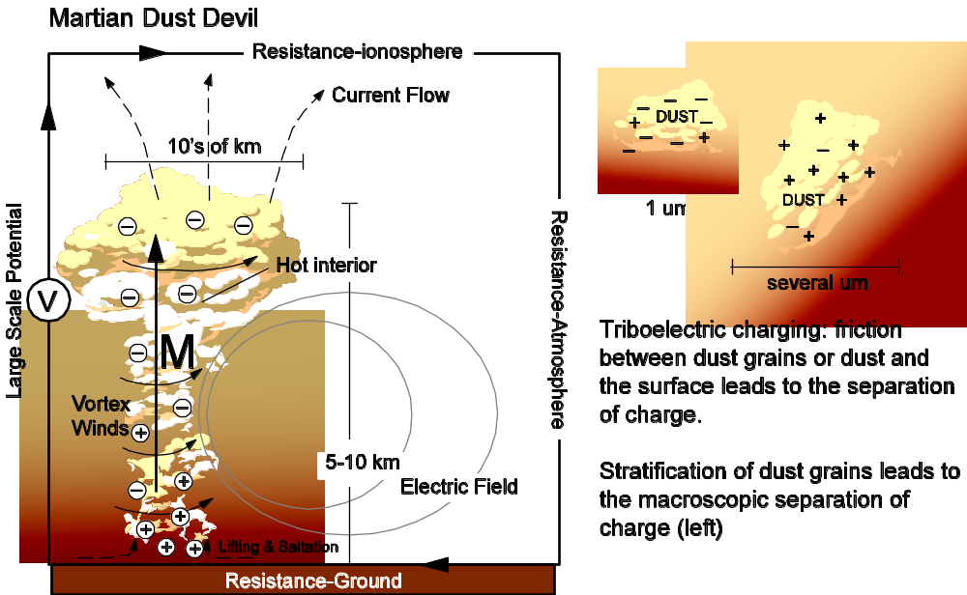
Delory et al, 2006
Figure 1. Caption.

Desired Precursor Measurements
Dynamics — global direct wind measurements, network measurements of near-surface pressure, temperature and winds, improved definitions of upper atmospheric thermal tides, circulation, and aerosol loading
Dust Storms — The vertical distributions of dust radiative properties, particle sizes, and number densities versus time and space; improved characterizations of dust lifting rates and localities, and dust deposition localities, dust charging levels
Water Vapor and Ice Clouds — Improved water vapor, cloud opacity and particle size vertical profiling (in vertical and global coverage), lander/rover based measurements of surface ice fogs and frosts, diurnal coverages for water vapour and cloud vertical profiles

Atmospheric Chemistry — Further definition of Mars atmospheric methane, in abundance and spatial/temporal variability. Global, temporal, and vertical variations in CO₂ ozone, and H₂O₂ abundances. Dependence of trace gas species with seasonal ice cap growth and recession.

Electrical Effects — Identification of dust charging in dust devils and storms.

Investigations for the Human Era of Exploration
Surface-atmosphere interactions: dynamics, heat and mass balance.

- Dynamics — near surface wind vectors and temperatures with high temp resolution (minutes) and extent (diurnal, daily, seasonal) at multiple sites separated by at least 10 km. (ground weather stations)
- Lower (0-10 km altitude) atmospheric temperature, wind, dust profiling (tethered balloon — borne thermocouples, nephelometers, thermal IR spectrometers, surface-based DIAL lidar)
Ground heat and moisture flux (heat and conductivity probes)
- Dust storms — measurement of vertically integrated dust column optical depths, dust particle composition, size distribution, radiative properties. Same for surface dust (solar extinction spectroscopy, dust collection for microscopic imaging and compositional analysis). Measurements of surface dust lifting, lower atmospheric profiling of dust opacity and particle sizes, (backscatter lidar, visible-to-thermal IR spectroscopy, tethered balloon borne nephelometer, thermal IR spectrometer), coincident temperature measurements
- Water vapor and Ice Clouds — Monitoring column optical depths, whole sky imaging for cloud forms and drift velocities. (solar extinction spectroscopy, backscatter lidar, visible wide-angle imaging, visible-to-thermal IR spectroscopy, tethered balloon borne nephelometer, thermal IR spectrometer). Surface temperatures, thermal gradients and humidity versus time (diurnal, dailiy, and seasonal). Subsurface water adsorption and ice contents (thermocouples, drilling/trenching with laboratory evolved gas chromatography and nms).
- Electrical Effects — Dust particle charges, Dc electric field monitoring, warning of both distant and local dust electrification. Portable electrometers, on site hazard assessment
Search for sources of volatiles and trace gases
- Atmospheric Chemistry- surface trace gas compositions versus space and time (gas chromatography and nms), water vapor and ozone vertical profiling (surface and balloon borne UV to IR spectroscopy),

Microclimates
Microclimates are defined in 2006 MEPAG Goal II as “exceptionally or recently wet or warm locales, exceptionally cold localities, and areas of significant change in surface accumulations of volatiles or dust” “identified through local surface properties (e.g., geomorphic evidence, topography, local thermal properties, albedo) or changes in volatile (especially H₂O) distributions.” Definitions for Earth typically also include a spatial scale varying from centimeters to hundreds of metres (eg. Geiger et al, 2003). Microclimates, by definition regions of extremes and exceptions, are fascinating and important targets for study. An exceptionally warm and wet locale could correspond to the proposed new definition for a Mars Special Region (Beaty et al, 2006) and hence be of great interest for extant biology. A region of change in surface accumulation of volatiles or dust identifies a source or sink region for global atmospheric volatile and dust transport. The climate objective relevant to these sites is to understand local heat, mass and momentum balance and transport of dust and volatiles. Whereas the 2006 MEPAG Goal II investigation focused on detecting these locales, a 2030 objective will be to carry out in situ studies to understand the processes responsible for generation of the microclimate. Several locales that would qualify as interesting microclimates have already been detected and some examples are given here.
Topographically controlled microclimates (small scale to large scale)

- Gully systems (Malin and Edgett, 2000; Dickson et al, 2007)
- Deep pits or caves (Cushing et al, 2007)
- Polar cap edge (eg Siili et al, 1999)
- Tharsis volcanoes (Noe Dobrea and Bell (2005), Benson et al (2003), Rafkin et al, (2002))
Locales where changes in volatile distributions are observed (both spatial and temporal change; small scale to large scale)

- Bright deposits in gully systems (McEwen et al, 2007)
- Possible sources of methane and other volatiles (local sources have not yet been identified)
- Polygons (e.g., van Gasselt et al, 2005)
- Remnant ice e.g., Louth crater (Roush et al, 2007)
- Possible glacial deposits (Shean et al, 2007)
- Polar dune fields (eg. Kossacki and Leliwa-Kopystynski (2004))
- Seasonal polar caps
- Equatorial region — Aphelion cloud belt (Clancy et al, 1996)
Locales where significant changes in dust distribution are observed (e.g., Szwast et al, 2006)

- Solis
- Daedalia Planum
- Northern Syrtis
- Hellas
Exceptionally cold locales

- Cold spots on polar caps (e.g., Pocock and Calvin, 2007)

Desired Precursor Measurements
Ideally, meteorological stations would be emplaced at each of the HEM sites by precursor missions for long term (multi-annual) monitoring to record in situ climate variables over diurnal and seasonal cycles.

- Temperature, wind speed and direction
- Optical depth (water vapor and dust)
- Water vapor
- Long wave and short wave radiation
Continual monitoring from orbit for mulitannual variability and seasonal change

- Global daily maps of surface temperature, pressure, dust, ice, water vapor optical depth
- Atmospheric profiles of temperature, pressure, dust, water vapor

Investigations for the human era of exploration
Surface-atmosphere interactions: dynamics, heat and mass balance.
In situ investigations to meet microclimate objectives require micrometeorology measurements at the microclimate site, preferably in conjunction with upwind reference stations outside its boundary to give regional context. Emphasis on instrumentation may vary depending on characteristics and focus of site.

Search for sources of volatiles and trace gases
A search would involve characterizing the chemical environment (surface and atmospheric) and using portable instrumentation to follow local gradients in trace and volatile gases.

Polar Processes and Formation of the Polar Cap
MEPAG 2006 Goal II-Objective B Investigation 5 lists four objectives for polar cap measurements: (i) the relative and absolute ages of the layers, (ii) their thickness, extent and continuity, (iii) their petrologic/geochemical characteristics (including both isotopic and chemical composition), and (iv) the environmental conditions and processes that were necessary to produce them. Progress on (iv) is very much tied to progress on global atmospheric dynamics (section 1.1) as the poles comprise a key element in the global annual cycle of volatiles and dust. Orbital geophysical sounding is currently proving information at ~100 m resolution (Figure 2) in the vertical to address (ii), and early results indicate the existence of non-continuous layers in the Polar Layered Deposits (PLD) suggesting periods of retreat and advance of the residualcaps over climate time scales (Figure 3). The Phoenix mission will provide the first information on Mars ice grain and dust characteristics using microscopy, wet chemistry and thermal evolved gas analysis (Smith, 2006), and will provide meteorological information from its landing site on Vastitas Borealis, the vast plains which surround the north pole. The return of a sample from within the PLD could provide an important snapshot of absolute age, isotopic and chemical composition for that segment of the PLD record, but unraveling the complex climate history evidenced in the PLD would require access to the full stratigraphic record through deep drilling or sustained sampling through exposed scarps. Understanding the asymmetries between north and south polar caps would require access to the stratigraphic record at both poles.
In 2030, it is anticipated that access to the climate record held in the PLD would remain one of the most exciting and important challenges in the scientific exploration of Mars.
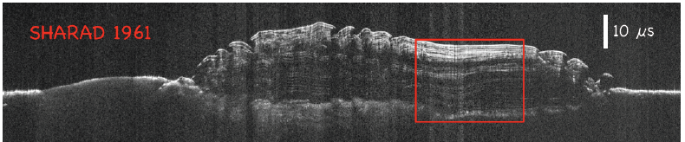
Figure 2. Cross section of the north polar cap showing extent of cap and layering. Vertical depth is ~2km (Putzig et al, 2007, 7th Int Conference, Abstract #3295) Red box indicates a target region for a drill site where SHARAD shows homogenous layering on a macro scale.

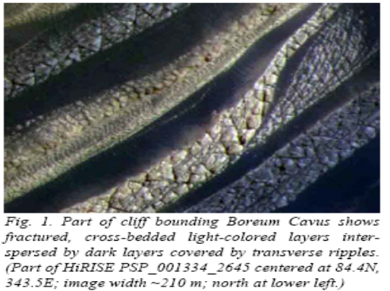
Figure 3. Detail of complex cross-bedding. Horizontal scale of image is ~210 m (Tanaka, 2007, LPSC).

Planum Boreum baseline recent climate record and constraint on maximum obliquity
Estimates of the age of the North Polar Layered Deposits based on crater counts vary significantly from 3 x 10⁵ – 10 x 10⁶ years, with the South Polar Layered Deposits appearing significantly older, 7-15 x 10⁶ years (Fishbaugh and Head, 2001 and references therein). The North Polar Layered deposits show evidence of at least one retreat due to topographical features in the Vastitas Borealis (Fishbaugh and Head, 2001) and complex cross-bedding (Tanaka, 2007) — see Figure 3. Chaotic solutions for Mars climate history, based on uncertainities in orbital parameters, can show obliquity constrained between 15 and 35 degrees for the past 100M years (Folkner et al., 1997) or a significant change of state 5M years ago towards a high obliquity state of ~60 degrees (Laskar et al, 2002; Laskar et al, 2004). Models have shown that a change to a high obliquity state of >40 degrees can cause the loss of North Polar Dome ice at a rate of 10cm/year with preferential deposition in the equatorial region (Haberle et al, 2003; Mischna et al, 2003).
Another approach to understanding the age and formation processes of the North Polar Layered Deposits has been to associate the layered structure with precession-related (51,000 years) or obliquity-related (120,000 years) polar insolation cycles with varying amounts of ice and dust deposited in each cycle. The dustier layers are hypothesized as lag deposits associated with higher insolation phase (e.g., Levrard et al, 2007). From Fourier transform analysis of imaged stratigraphy in north polar dome troughs in the upper 800 m, a dominant wavelength is found for the layered structure of ~30 m (Laskar et al, 2004; Milkovitch and Head, 2005).
A paradox arises with the combination of insolation information, observed layer thickness and the North Polar Dome depth of ~2 km observed by MARSIS and SHARAD (Picardi et al, 2005 (check), Putzig et la, 2007). Modelled polar insolation is clearly driven by obliquity rather than precession (eg. Levrard et al, 2007) with insolation values first reaching the modeled threshold value (300 Wm⁻²) that would produce net loss of water vapour and formation of lag deposits around 0.5M years ago, and with around 34 insolation cycles crossing the threshold value in the last 5M years. As has been pointed out by both Levrard et al (2007) and Milkovich and Head (2005), there are many more layers observed in PLD troughs, with various interpretations: more than one layer is laid down each obliquity cycle with unknown process, the polar layered deposits survived the large obliquity change at ~5M years, or the obliquity range has not exceeded 40 degrees over a period significantly longer than 5M years. A key scientific goal to address this paradox is to access the stratigraphic record from the current residual cap through to the base of the PLD.
Dome sites are chosen on Earth to give baseline climate records via an extracted ice core. Figure 4 shows that most deep drill sites in Antarctica (Vostok aside) are associated with dome features. Typically dome sites are selected as they represent regions of net accumulation, close to a flow divide, and where flow distortion of the ice sheet is minimal and well understood (Morse et al, 2002). An alternative approach to accessing the ancient ice at the base of the PLD is to sample from the scarp face, using mobility to access scarps of different ages, with shallow core segments pieced together using stratigraphic markers and flow modeling to provide the ancient climate history. As the north polar dome has been hypothesized to have undergone at least one retreat (eg. Fishbaugh and Head, 2001), and major dust lag unconformities can be predicted from climate modeling (Levrard et al, 2007), sampling from the base may be difficult to interpret in terms of chronology and local versus regional effects.

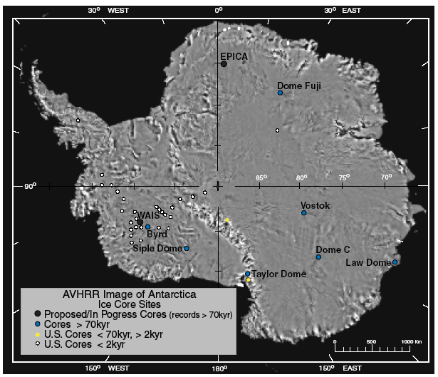
Figure 4. Deep drill sites in Antarctica mainly associated with dome features. (ICWG, 2003).

Horizontal Sampling of the NPD
Horizontal sampling (shallow drilling at several sites along a transect) of the NPD could be complementary to deep drilling as a way of investigating heterogeneity across a polar dome (Mayewski et al, 2005), or trying to understand specific local episodes of cap retreat evidenced by e.g., cross-bedding. Sampling overlapping stratigraphies along a descending transect may be an alternative means of reconstructing the long-term climate record.

Stratigraphic Markers and Dating
Due to the expectation of uncomformities described above, a visual dating of stratigraphy would best be supported by an absolute dating method. The nuclear-decay modulated Ar⁴⁰/Ar³⁹, or atmospheric loss modulated N¹⁵/N¹⁴ have been suggested as Martian chronometers (Doran et al, 2005) with values sampled from atmospheric inclusions and calibration of δ¹⁵N from absolute dating of rocks which contain inclusions by other methods.
Cosmogenic nuclides in trapped dust may also be used for dating (eg. ⁵³Mn (half life 3.7My), ¹⁰Be (1.5 My), ²⁶Al (0.705 My) and ¹⁴C (5730 years) (Doran et al, 2005)) but due to high background cosmogenic radiation it may be necessary to return selected samples of dust to Earth for sensitive analysis. ²⁶Al is deposited on a planet directly from supernovae ejecta and can be used also to identify pre-solar condensates (Cole et al, 2006). On the basis of a model of Mars ice reservoirs and isotope fractionisation, Fisher (2006) has suggested that the D/H ratio may provide a very effective chronometer for the polar cap, with obliquity cycle variations (120,000 years) appearing as a variation of 1000 to 2000 per mil, and an additional small component of variability at 2500 years detectable with precision of 1 per mil. Exchange with subpolar reservoirs is suggested to appear as a trend in D/H superimposed on the above mentioned avrialbility. Lacelle et al (in preparation) have proposed that a measure of molar ratios of the set of occluded gases CO₂, O₂/Ar, N₂/Ar and N₂/O₂ could additionally discriminate between vapour and water deposited ice and perhaps indicate the presence of microbes.
Composition (atmospheric gases and dust) and dating of lag deposits found would be especially interesting, to understand extremes of global dust and volatile cycles. Measurements of ice composition, mass concentrations of ionic species and electrical conductivity, associated with stratigraphy could help with the detection and interpretation of recent impacts or volcanic events.
Visual stratigraphic markers could include gas bubbles as well as dust. On Mars, dust is expected to dominate. Expected grain and crystal sizes would determine imaging needs.

Desired precursor measurements

- Long term global network of meteorological stations — with good representation across and around the poles — coordinated with orbital monitoring of weather. (called out in 3rd mars polar conf).
- Orbital imaging and geophysical survey applied to site selection: Monitoring of accumulation over dome area over several seasons from high resolution orbital measurements (e.g., lidar).
- Return of a sample from a future deep drilling site to establish net rate of surface accumulation (confirm zero level).
- Return of a sample from the PLD base to provide information about the absolute age and for sensitive cosmochemistry.

Investigations for the human era of exploration

Deep core and baseline chronology

- Relative and absolute age of layers as a function of stratigraphic position, D/H, Ar⁴⁰/Ar³⁹ cosmogenic isotopes.
- Composition: occluded gases (CO₂, Ar, N₂, O₂), ions, dust grain composition, mass, particle size distribution
- Visual survey: crystal size, detection of lag deposits
- Geophysical survey
Polar cap mass and energy balance for current climate state and seasonal cap formation processes

- Present surface displacement rate
- Local accumulation (temporal and spatial variability)
- Incident, reflected, emitted, transmitted radiation
- Local wind, temperature, dust, water vapor profiles
- Near surface temperature profile for correlation with observed grain sizes
- Surface-atmosphere heat flux
Geophysical investigation

- Embed heat probes and seismometers in bore hole for long term monitoring of cap

Early Atmospheric Evolution
The early evolution of the Mars atmosphere, as discussed here, refers to the first 1-2 billion years of coupled exchanges among Mars interior, surface, and atmospheric volatile inventories and subsequent loss of these volatiles to space. Key measurement objectives, as developed in MEPAG 2006 Goals IIB, are gas and ice isotopic ratios, current atmospheric escape processes and rates, and surface morphological and chemical records of early Mars climate. A number of these objectives will have been substantially addressed prior to HEM activities. However, HEM in situ measurements should play an especially important role in the study of the early Mars atmospheric environment, given the Archean-Hesperian ages presented over much of the current Mars surface.

Impact Breccias
Sample return might target impact breccias of different ages, which are good sources of fluid inclusions.

Inferring the Paleoclimatic Conditions of Mars: the Geological Record of the Ancient Atmospheric State
The paleoclimatic — paleoatmospheric (this would be quite much complicated) — conditions that reigned during earlier atmospheric episodes of Mars can be inferred through several types of geological evidence ranging from planetary/regional to molecular scale. As on Earth, wet climate episodes, under interplay with geological processes, produced different geomorphic and sedimentological imprints that are related to the occurrence of quiet or running water bodies. Fan-shaped structures or meandering to braiding channels, but also fluvial-like terrace deposits or fine-grained continuous deposits are evidence for an active and stable hydrosphere. Some other sedimentary record as evaporites (i.e. Mars sulfates are a good example) can be used to determine the thermal regime of the paleoclimate, whereas some fine-grained deposits–mainly composed by phyllosilicates- can denote wet and temperate ancient climates. Stratigraphy and geochemical analysis of very peculiar materials formed in-situ or deposited as paleosoils, gossans/laterites, sulfide orebodies –sedimentary or hydrothermal- and red beds are geological markers of the chemical state of Mars ancient atmosphere.
Oxygen and silicon stable isotopes of chemical sediments — e.g. silica-rich, sulfates, carbonates — can be used to estimate the temperature of waters that generated them. Moreover, other chemical tracers of sediments have a great importance to the evaluation of the redox state of the waters interplaying the ancient Mars atmosphere – bearing in mind that an oxidizing atmosphere does not mean in this case an O₂ -enriched atmosphere. On Earth several trace elements (U, Ce, Mo), but also isotopes of Fe and S (mass independent fractionation) are been used to determine the oxidizing potential of solutions in contact with the atmosphere, as well as of the atmosphere directly.

Desired precursor measurements
- Orbital imaging, remote sensing and surface robotic exploration of early Mars geomorphic structures and deposits focusing in recognizing the major composition, stratigraphic framework (relationships between different kind of structures/deposits) and chronostratigraphy, in order to determine the ancient surface environments and its temporal succession at least in a relative aging succession.
- Sample return would be required to make some mineral and geochemical analyses that shed light in characterizing paleoclimatic parameters, chemical state of ancient paleoatmospheres and aging of deposits.

Investigations for the Human Era of Exploration
- Field work for searching weathering profiles (gossan, laterites, etc), paleosoils, layered materials and sedimentary deposits sensible to paleoclimate record
- Surface sampling/soft drilling to deep drilling (to 200-500 m?)
- Characterization of paleoenvironments and/or paleoclimates
- Composition: petrological, mineralogical and geochemical determination of sediments.
- Building the stratigraphical framework, chonostratigraphy and geochronology. This would result in obtaining the succession of climatic stages along the time through the sedimentary/deposit bodies.

Appendix C. The Human Exploration of Mars: Lessons Learned from Apollo (Written by James W. Head)

Born from international competition with the Soviet Union at the height of the Cold War, the Apollo Lunar Exploration Program accomplished the first significant and sustained scientific exploration of another planetary body by human explorers. Following the precursor missions Apollo 7-10, Apollo 11 touched down at Tranquility Base on July 20th, 1969, accomplishing for all humankind U.S. President John F. Kennedy's goal of sending humans to the Moon and returning them safely by the end of the decade. Why did human exploration of the Moon continue past this major milestone? U.S. national political, scientific and engineering leadership understood that this huge investment in exploration infrastructure could pay fundamental dividends in terms of inspiration, scientific results, technological and economic competitiveness, and international leadership.
Having understood this from the outset, participants ensured that the capabilities built into the exploration architecture and engineering infrastructure were much more than what was simply required to place humans on the Moon and return them safely. Thus, with each successive Apollo mission, expanding confidence in rendezvous and docking, landing site accuracy, astronaut mobility, human capability, and systems engineering of a hugely complex task, led to increased capabilities and ever more profound scientific results. Apollo 12 was targeted to the western lunar nearside to make a pinpoint landing near the Surveyor III spacecraft and performed an additional EVA. Apollo 13/14 were targeted to rough terrain of the Fra Mauro Formation in order to sample the ejecta of the Imbrium Basin. Astronauts carried a wheelbarrow-like Mobile Equipment Transporter (MET) to the top of the ridges. Apollo 15 was targeted to high latitudes at the edge of Hadley Rille nestled in the Apennine Mountains, undertook three EVAs and a SEVA (Standup EVA; involved suiting up, depressurization of the LM, opening of top hatch, and regional description of the landing site), and deployed a satellite in lunar orbit. A Lunar Roving Vehicle (LRV) provided access to important scientific sites separated by almost 15 kilometers. Apollo 16 was targeted to the rough and varied lunar highlands and revealed the mysteries and complexities of the lunar crust and the processes that shaped it. Apollo 17 carried the first geologist to another planetary body and landed in a narrow box canyon at the edge of the Serenitatis Basin, unlocking many of the secrets of impact basin formation and subsequent lava filling. Apollo 18-22 were to involve ever more complex and capable exploration capabilities, and development of the human-robotic partnership. Such efforts included DM-LRVs (Dual-Mode Lunar Roving Vehicles) that the astronauts, at the end of their mission, would set to automated mode. Controllers and scientists in Houston would then undertake scientific exploration traverses hundreds of kilometers in length, ending at the next human landing site, to provide scientific interpolation between different key regions explored in detail by human. Loss of national will and the financial burdens of the Viet Nam war resulted in the termination of the Apollo Lunar Exploration Program following Apollo 17.
There are several important lessons to be learned from these events relevant to the human exploration of Mars. First, landing humans on the Moon was a fundamental accomplishment that brought tremendous pride and prestige to the United States. The lasting legacy, however, was not just this historical event, but what humans actually accomplished during this period of exploration. Wise leaders ensured that the capability was built into the system so that what was learned along each step of the way could be folded back into the system to improve its capability. Apollo was an Exploration Program, not just a single landing. And exploration was not just "flags and footprints", but indeed was fundamental scientific exploration. The true and lasting legacy of the Apollo Exploration Program is the wealth of scientific observations made by the astronaut explorers, the materials that they collected and the instruments that they deployed. The results of this exploration fundamentally changed, and continues to change to this day, the way in which we view Earth, our own Home Planet, and its place in the Solar System.
Therefore, when humans explore Mars, it would be prudent to follow our experience in the first great wave of the human exploration of other planetary bodies, the Apollo Lunar Exploration Program. We should plan for a program, not a single landing. We should build in broad capabilities from the start, to take advantage of what we learn at each step along the way. We should understand that the true lasting legacy is not just going to Mars, but what can actually be accomplished by humans when they are there, and the scientific results that they can obtain. Using these simple guidelines as a broad compass will lead us to a successful human exploration of Mars, and a legacy that will outlast us all.
In addition to these broad guidelines, a host of individual lessons were learned from the Apollo Lunar Exploration Program that provide guidance for the task of visualizing and planning for the human exploration of Mars. These lessons are documented in numerous publications, some of which are referenced below. For landing site selection, it would be important to develop science and engineering synergism, so that scientific goals and crew safety can be optimized. Single landing sites should provide the capability to access multiple broad scientific objectives, in order to optimize the scientific return. System engineering concepts should be applied to the planning of surface exploration activities, in order to optimize the wide range of human surface exploration capabilities. Astronauts should be trained in fundamental scientific exploration capabilities (e.g., geological observations), so that they are prepared for both the expected, and can deal intelligently with the unexpected. Astronauts should be involved in planning at all steps in the process. Infrastructure should be developed to take advantage of the human capability for in situ analysis and on-site decision making and scientific traverse planning adjustments. The human-robotic partnership should be explored to its fullest, with robotic capabilities providing for scouting and scientific interpolation, as well as performance of analysis tasks in order to optimize the utility of human insight, analysis and decision-making. There should be sufficient payload capability to return abundant samples and related materials from Mars to undertake measurements that would always be more capable on Earth than in situ analyses. Returning astronauts should be involved in the post-mission analysis of the data at all stages. These guidelines, together with more detailed operational experience, provide a basis for successful planning for the human exploration of Mars.

Sample Reference:
Heiken, G. et al., eds., Lunar Sourcebook, Cambridge University Press, 736 p. (1991).
Heiken, G. and Jones, E., On the Moon, The Apollo Journals, Springer, 492 p. (2007).
Jolliff, B. et al., eds., New Views of the Moon, Min. Soc. Am., 60, 721 p. (2006).

References
Alley, R. B., et al. (1997b), Visual-stratigraphic dating of the GISP2 ice core: Basic, reproducibility, and application, J. Geophys. Res., 102(C12), 26, 367-26,381.
Angelats i Coll, M., F. Forget, M. A. Lopez- Valverde, and F. Gonzalez-Galindo (2005), The first Mars thermospheric general circulation model: The Martian atmosphere from the ground to 240 km, Geophys. Res. Lett., 32, L04201, doi:10.1029/2004GL021368.
Antol, J., Woodard, S., Hajos, G., Heldmann, J., Taylor, B. Using Wind Driven Tumbleweed Rovers to Explore Martian Gulley Features. AIAA-2005-245, 43rd AIAA Aerospace Sciences Meeting and Exhibit, Reno, Nevada, Jan. 10-13, 2005.
Augustin, L. and Antonelli, A. (2002) “The EPICA deep drilling program.” Memoirs of National Institute of Polar Research, Special Issue No. 56, 226-244, 2002.
Barnes, J. R., (1980) Time spectral analysis of midlatitude disturbances in the Martian atmosphere, J. Atmos. Sci, 37, 2002-2015.
Beaty, D, K. Buxbaum, M. Meyer, N. Barlow, W. Boynton, B. Clark, J. Deming, P.T. Doran, K. Edgett, S. Hancock, J. Head, M. Hecht, V. Hipkin, T. Kieft, R. Mancinelli, E. McDonald, C. McKay, M. Mellon, H. Newsom, G. Ori, D. Paige, A.C. Schuerger, M. Sogin, J.A. Spry, A. Steele, K. Tanaka, and M. Voytek (2006) Findings of the Mars Special Regions Science Analysis Group, Astrobiology, 6(5), 677-732, doi:10.1089/ast.2006.6.677
Benson, J. L., B. P. Bonev, P. B. James, K. J. Shan, B. A. Cantor, and M. A. Caplinger (2003), The seasonal behavior of water ice clouds in the Tharsis and Valles Marineris regions of Mars: Mars Orbiter Camera Observations, Icarus, 165, 34–52.
Bentley, C. R., and Koci, B. R. (2006) Drilling to the beds of ice sheets: a review. SALE Workshop 2006, Vol. 2 – Append., 71-80.
Bleamaster, III, L. F., Crown, D. A., 2004. Morphologic Development of Harmakhis Vallis, Mars. In: Mackwell, S., Stansbery, E. (Eds.), Lunar and Planetary Institute Conference Abstracts. p. 1825.
Cardell, G., M. Smith, M. Hecht, R. Kowalczyk, C. Mogensen, and A. Behar (2006) A Field Demonstration of Thermal Drilling Technology for the Chronos Scout 2011 Mission, 4th International Mars Polar Conference , Abstract 8088
Carsey, F., et al., Science goals for a Mars polar-cap subsurface mission: optical approaches for investigations of inclusions in ice. Annals of Glaciology 37, p. 357-362 (2003)
Clancy, R. T. and H. Nair (1996) Annual (perihelion-aphelion) cycles in the photochemical behavior of the Mars atmosphere, J Geophys Res, 101, 12785-12790.
Cantor, B. A., P. B. James, M. Caplinger, and M. J. Wolff (2001) Martian dust storms: 1999 Mars Orbiter Camera observations, J. Geopyhs Res, 106, E10, 23653-23688.
Clancy, R. T., A. W. Grossman, M. J. Wolff, P. B. James, D. J. Rudy, Y. N. Billawala, B. J. Sandor, S. W. Lee, and D. O. Muhleman (1996) Water vapor saturation at low altitudes around aphelion: A key to Mars climate?, Icarus, 122, 36–62
Cole A. L. et al, (2006) The search for supernova grains in an ice core, Astrophysical Journal, 652, 1763-1767.
Crown, D. A., 1991. Volcanism in the eastern Hellas region of Mars: The geology of Hadriaca and Tyrrhena Paterae. Ph.D Thesis.
Crown, D. A., Stewart, K. H., 1995. Debris aprons in the eastern Hellas region of Mars. In: Lun. Planet. Sci. Conf. Abstracts. Vol. 26. pp. 301–302.
Cushing, G. E., T. N. Titus, J. J. Wynne, and P. R. Christensen (2007), THEMIS observes possible cave skylights on Mars, Geophys. Res. Lett., 34, L17201, doi:10.1029/2007GL030709.
Dickson, J. L., C. I. Fassett, J. W. Head, M. A. Kreslavsky, J. B. Madeleine, M. A. Ivanov, 2006. Deltas and related ponded sedimentary deposits: A key class of landing sites for the Mars Science Laboratory Mission, 1st Landing Site Workshop for MSL.
Dickson, J. L., J. W. Head, M. Kreslavsky (2007) Martian gullies in the southern mid-latitudes of Mars: Evidence for climate-controlled formation of young fluvial features based upon local and global topography, Icarus 188 (2007) 315–323, doi:10.1016/j.icarus.2006.11.020
Doran, P. T., S. M. Clifford, S. L. Forman, L. Nyquist, D. A. Papanastassioud, B. W. Stewart, N. C. Sturchio, T. D. Swindle, T. Cerling, J. Kargel, G. McDonald, K. Nishiizumi, R. Poreda, J. W. Rice, K. Tanaka (2004) Earth Science Reviews, 67, 313-337.
Fassett, C. I., B. L. Ehlmann, J.W. Head, J. F. Mustard, S. C. Schon and S. L. Murchie, 2007. Sedimentary fan deposits in Jezero Crater Lake, in the Nili Fossae Region, Mars: Meter-scale layering and phyllosilicate-bearing sediments, AGU Fall Meeting, abstract.
Fassett, C.I., B. L. Ehlmann, J.W. Head, J.F. Mustard, S.C. Schon and S.L. Murchie, 2007. Sedimentary fan deposits in Jezero Crater Lake, in the Nili Fossae Region, Mars: Meter-scale layering and phyllosilicate-bearing sediments, Brown-Vernadsky Micro., 46, abstract.
Fassett, C. I. and J. W. Head, 2004. Lacustrine deltas in a crater lake in the Nili Fossae region: New evidence for persistent flow of water on the surface of Mars, Brown-Vernadsky Micro., 40, abstract.
Fassett, C. I. and J. W. Head, 2005. Fluvial sedimentary deposits on Mars: Ancient deltas in a crater lake in the Nili Fossae region, Geophys. Res. Lett., 32, doi: 10.1029/2005GL023456.
Fassett, C. I. and J. W. Head, 2005. New evidence for fluvial sedimentary deposits on Mars: Deltas formed in a crater lake in the Nili Fossae region, 36th Lunar Planet. Sci. Conf., #1098.
Feldman, W. C., T. H. Prettyman, S. Maurice, J. J. Plaut, D. L. Bish, D. T. Vaniman, M. T. Mellon, A. E. Metzger, S. Squyres, S. Karunatillake, W. V. Boynton, E. C. Elphic, H. O. Funsten, D. J. Lawrence, and R. L. Tokar (2004) Global distribution of near-surface hydrogen on Mars, J Geophys Res, 109, E09006, doi:10.1029/2003JE002160.
Fishbaugh, K. E. and J. W. Head (2001) Comparison of the North and South Polar Caps of Mars: New Observations from MOLA Data and Discussion of Some Outstanding Questions, Icarus 154, 145–161, doi:10.1006/icar.2001.6666
Fishbaugh, K. E., and J. W. Head III (2005), Origin and characteristics of the Mars north polar basal unit and implications for polar geologic history, Icarus, 174, 444– 474.
Fisher, D. A., Koerner R. M. 1986. On the rheological properties of ancient microparticle-ladden northern hemisphere ice as derived from bore hole-hole and core measurements. Journal of Glaciology 32, 501-510.
Fisher, D. A. (2007) Mars' water isotope (D/H) history in the strata of the North Polar Cap: Inferences about the water cycle, Icarus, 187(2), 430-441
Folkner, W .M., Yoder, D. N., Yuan, E. M., Standish, E. M. and Preston, R. A.: 1997, Interior structure and seasonal mass redistribution of Mars from radio tracking of Viking, Science, 278, 1749–1752
Forget, F., Haberle, R. M., Montmessin, F., Levrard, B., and Head, J. W., 2006. Formation of Glaciers on Mars by Atmospheric Precipitation at High Obliquity, Science 311, 368-371.
Formisano, V, S. Atreya, T. Encrenaz, N. Ignatiev, and M. Giuranna (2004) Methane on Mars, 306, 1758-1761.
Geiger, R., R. H. Aron and P. Todhunter (2003) The climate near the ground, Rowman & Littlefield, 600 pp.
Ghatan, G. J., J. W. Head and L. Wilson, 2005. Mangala Valles, Mars: Assessment of early stages of flooding and downstream flood evolution, Earth, Moon and Planets, 96, 1-57.
Greeley, R., and J.E. Guest, Geologic map of the eastern equatorial region of Mars, U.S.G.S. Misc. Invest. Series Map I-1802-B, 1987.
Greeley, R., Crown, D. A., 1990. Volcanic geology of Tyrrhena Patera, Mars. J. Geophys. Res. 95, 7133–7149.
Hanna, J. C. and R .J. Phillips, 2006. Tectonic pressurization of aquifers in the formation of Mangala and Athabasca Valles, Mars, J. Geophys. Res., 111, doi: 10.1029/2005JE002546.
Head, J. W. and D. R. Marchant, 2003. Cold-based mountain glaciers on Mars: Western Arsia Mons, Geology, 31 (7), 641.
Head, J. W., D. R. Marchant and G.J. Ghatan, 2004. Glacial deposits on the rim of a Hesperian-Amazonian outflow channel source trough: Mangala Valles, Mars, Geophys. Res. Lett., 31, doi: 10.1029/2004GL020294.
Head, J. W., III, and S. Pratt (2001), Extensive Hesperian-aged south polar ice sheet on Mars: Evidence for massive melting and retreat, and lateral flow and ponding of meltwater, J. Geophys. Res., 106(E6), 12,275–12,300.
Heldmann, J. L. and Mellon, M. T., 2004. Observations of martian gullies and constraints on potential formation mechanisms. Icarus 168, 285-304.
Heldmann, J. L., Carlsson, E., Johansson, H., Mellon, M. T. and Toon, O.B., 2007. Observations of Martian Gullies and Constraints on Potential Formation Mechanisms, Part II: The Northern Hemisphere. Icarus 188, 324-344.
Hecht, M and CHRONOS team (2006) CHRONOS: A journey through Martian History, 4th International Mars Polar Conference.
Huber, T. M., M. Schwikowski, H. W. Gaggeler (2001) Continuous melting and ion chromatographic analyses of ice cores, Journal of Chromatography A, 920, 193–200
Jakosky, B. M. and C. B. Farmer (1982) The seasonal and global behavior of water vapor in the Mars atmosphere- Complete results of the Viking atmospheric water detector experiment, J Geophys Res, 87, 2999-3019.
Kahn, R. (1984) The spatial and seasonal distribution of Martian clouds and some meteorological implications, J Geophys Res, 89, 6671-6688.
Kahre, M. A., J. R. Murphy, and R. M. Haberle (2006), Modeling the Martian dust cycle and surface dust reservoirs with the NASA Ames general circulation model, J. Geophys. Res., 111, E06008, doi:10.1029/2005JE002588
Kossacki, K.J. and J. Leliwa-Kopystynski (2004) Non-uniform seasonal defrosting of subpolar dune field on Mars, Icarus, 168(1), 201-204, doi:10.1016/j.icarus.2003.11.010
Krasnopolsky, V. A., J. P. Maillard, and T. C. Owen (2004) Detection of methane in the martian atmosphere: evidence of life?, Icarus, 172, 537-547.
Lacelle, D., D. A. Fisher, A. Berinstain (in preparation) Distinguishing between vapor- and liquid- formed ground ice in the northern Martian regolith: implications regarding the history of water and the presence of microbial life, to be submitted to Icarus.
Langevin, Y., F. Poulet, J. P. Bibring, B. Schmidt, S. Doute, and B. Gondet (2005) Summer evolution of the north polar cap of Mars as observed by OMEGA/Mars Express, Science, 307, 1576-1581.
Laskar, J., Levrard, B., Mustard, J. : 2002, Orbital forcing of the Martian polar layered deposits, Nature, 419, 375-377.
Laskar J., Correia A. C. M., Gastineau M., Joutel F., Levrard B., and Robutel P. 2004. Long-term evolution and chaotic diffusion of the insolation quantities of Mars. Icarus 170:343–364.
Leask, H. J., L. Wilson and K. L Mitchell, 2007a. Formation of Mangala Fossa, the source of the Mangala Valles, Mars: Morphological development as a result of volcano-cryosphere interactions, J. Geophys. Res., 112, doi: 10.1029/2005JE002644.
Leask, H. J., L. Wilson and K. L. Mitchell, 2007b. Formation of Mangala Valles outflow channel, Mars: Morphological development and water discharge and duration estimates, J. Geophys. Res., 112, doi: 10.1029/2006JE002851.
Lefevre, F., S. Lebonnois, F. Montmessin, and F. Forget (2004), Three-dimensional modeling of ozone on Mars, J. Geophys. Res., 109, E07004, doi:10.1029/2004JE002268.
Lehmann, H., van Gasselt, S., Gehrke, S., Albertz, J., Neukum, G. and the HRSC Co-Investigator Team, 2006. Combined Topographic-Thematic Map of the Centauri and Hellas Montes Area, Mars. International Archives of Photogrammetry and Remote Sensing (IAPRS), Vol. XXVI, Goa, Part B4.
Levrard, B., F. Forget, F. Montmessin, and J. Laskar (2007), Recent formation and evolution of northern Martian polarlayered deposits as inferred from a Global Climate Model, J. Geophys. Res., 112, E06012, doi:10.1029/2006JE002772.
Levy, J. S. and J. W. Head, 2005. Evidence for remnants of ancient ice-rich deposits: Mangala Valles outflow channel, Mars, Terra Nova, 17, 503-509.
Liu, S. C. and T. m. Donahue (1976) The regulation of hydrogen and oxygen escape from Mars, Icarus, 28, 231-246.
Malin, M.C. and Edgett, K. S., 2000. Evidence for recent groundwater seepage and surface runoff on Mars. Science 288, 2330-2335.
Malin, M. C., K. S. Edgett, L. V. Posiolova, S .M. McColley and E. Z. N. Dobrea, 2006. Present-day impact cratering rate and contemporary gully activity on Mars, Science, 314, 1573-1577.
Mangold, N., F. Poulet, J.F. Mustard, J. P. Bibring, B. Gondet, Y. Langevinn, V. Ansan, Ph. Masson, C.I. Fassett, J.W. Head, H. Hoffmann and G. Neukum, Mineralogy of the Nili Fossae region with OMEGA/Mars Express data: 2. Aqueous alteration of the crust, J. Geophys. Res., 112, doi: 10.1029/2006JE002835.
Mayewski, P.A.; Frezzotti, M.; Bertler, N.; Van Ommen, T.; Hamilton, G.; Jacka, T.H.; Welch, B.; Frey, M.; Dahe, Q.; Jiawen, R.; Simöes, J.; Fily, M.; Oerter, H.; Nishio, F.; Isaksson, E.; Mulvaney, R.; Holmund, P.; Lipenkov, V.; Goodwin, I., 2005, The International Trans-Antarctic Scientific Expedition (ITASE): an overview, Annals of Glaciology 41, 180-185
McCleese, D. J., J. T. Schofiled, F. W. Taylor, S. B. Calcutt, M. C. Foote, D. M. Kass, C. B. Leovy, D. A. Paige, P. L. Read, and R. W. Zurek (2006), Mars Climate Sounder: An investigation of thermal and water vapor, dust and condensate distributions in the atmosphere, and energy balance of the polar regions, J. Geophys Res., 112, E05S06, doi:10.1029/2006JE002790
McElroy, M. B. and T. M. Donahue (1972) Stability of the Mars atmosphere, Science, 177, 986-988.
McEwen, A. S., et al. (2007), A closer look at water-related geologic activity on Mars, Science, 317, 1706-1709.
McEwen, A. S., C. J. Hansen, W. A. Delamere, E. M. Eliason, K. E. Herkenhoff, L. Keszthelyi, V. C. Gulick, R. L. Kirk, M. T. Mellon, J. A. Grant, N. Thomas, C. M. Weitz, S. W. Squyres, N. T. Bridges, S. L. Murchie, F. Seelos, K. Seelos, C. H. Okubo, M. P. Milazzo, L. L. Tornabene, W. L. Jaeger,S. Byrne, P. S. Russell, J. L. Griffes, S. Martínez-Alonso, A. Davatzes, F. C. Chuang, B. J. Thomson, K. E. Fishbaugh, C. M. Dundas, K. J. Kolb, M. E. Banks, J. J. Wray (2007) A Closer Look at Water-Related Geologic Activity on Mars, Science, 317 (5845), 1706 – 1709, DOI: 10.1126/science.1143987
Milkovich, S. M., and J. W. Head III (2005), North polar cap of Mars: Polar layered deposit characterization and identification of a fundamental climate signal, J. Geophys. Res., 110, E01005, doi:10.1029/2004JE002349.
Mischna, M. A., M. I. Richardson, R. J. Wilson, and D. J. McCleese (2003), On the orbital forcing of Martian water and CO2 cycles: A general circulation model study with simplified volatile schemes, J. Geophys. Res., 108(E6), 11, 5062, doi:10.1029/2003JE002051.
Montabone, L., Lewis, S.R., Read, P.L. & Hinson, D.P.,(2005) “Validation of martian meteorological data assimilation for MGS/TES using radio occultation measurements,” Icarus, 185(1), 113-132 doi:10.1016/j.icarus.2006.07.012
Morse D.L., D.D. Blankenship, E.D. Waddington and T.A. Neumann, 2002. A site for deep icecoring in West Antarctica: Results from aerogeophysical surveys and thermo-kinematic modelling. Annals Glaciol., 35, 36-44.
Moudden, Y., and J. C. McConnell (2005), A new model for multiscale modeling of the Martian atmosphere, GM3, J. Geophys. Res., 110, E04001, doi:10.1029/2004JE002354.
Moudden, Y., and J. C. McConnell (2007) Three-dimensional on-line chemical modeling in a Mars general circulation model, Icarus, 188(1), 18-34, doi:10.1016/j.icarus.2006.11.005.
Mumma, M. J., G. L. Villanueva, R. E. Novak, T. Hewagama, B. P. Bonev, M. A. DiSanti, and M. D. Smith (2007) Absolute measurements of methane on Mars: The current status, AAS Bulletin, 39, p. 370.
Murphy, J. R., C. B. Leovy, and J. E. Tillman (1990) Observations of Martian surface winds at the Viking Lander 1 site, J. Geophys. Res. 95, 14555-14576.
Mustard, J. F., F. Poulet, J. W. Head, N. Mangold, J. P. Bibring, S.M. Pelkey, C.I. Fassett, Y. Langevin and G. Neukum, 2007. Mineralogy of the Nili Fossae region with OMEGA/Mars Express data: 1. Ancient impact melt in the Isidis Basin and implications for the transition from the Noachian to Hesperian, J. Geophys. Res., 112, doi: 10.1029/2006JE002834.
Nair, H., M. Allen, A. D. Anbar, Y. L. Yung, and R. T Clancy (1994) A photochemical model of the martian atmosphere, Icarus, 111, 124-150.
Newman, C. E., S. R. Lewis, P. L. Read, and F. Forget (2002) Modeling the Martian dust cycle, 1, Representations of dust transport processes, J. Geophys. Res., 107, doi:10.1029/2002JE001910.
Newman, C. E., S. R. Lewis, P. L. Read, and F. Forget, (2002) Modeling the Martian dust cycle, 2, Multiannual radiatively active dust transport simulations, J. Geophys. Res., 107(E12), 5124, doi:10.1029/2002JE001920.
Noe Dobrea, E. Z., and J. F. Bell III (2005), TES spectroscopic identification of a region of persistent water ice clouds on the flanks of Arsia Mons Volcano, Mars, J. Geophys. Res., 110, E05002, doi:10.1029/2003JE002221.
NSF ICWG (2003a) US Ice core science: recommendations for the future. Report 48pp.
NSF ICWG (2003b) Comparison of ice coring options for the Antarctic Inland Core Project, Report 96pp.
Parkinson, T. M. and D. M. Hunten (1972) Spectroscopy and aeronomy of O2 on Mars, J. Atmos Sci, 29, 1380-1390
Picardi, G., et al. (2005), Radar soundings of the subsurface of Mars, Science, 310, 1225-1228.
Pocock, J. M., and W. M. Calvin (2007) Factors influencing the location of sustained cold, bright spots in the north residual cap of Mars, 7th International Conference on Mars, 3210.
Price, K. H., 1992. Geologic Mapping of Part of Harmakhis Vallis Region, Mars: Evidence of Multiple Drainage Events. In: Lunar and Planetary Institute Conference Abstracts. p. 1107.
Putzig N. E., R. J. Phillips, R. Seu, A. Safaeinili, J. J. Plaut, D. Biccari, B. A. Campbell, L. M. Carter, J. W. Holt, C. J. Leuschen, S. Byrne, R. Orosei, G. Picardi, S. E. Smrekar, F. Fois, A. F. Egan, F. Bernardini, D. C. Nunes, SHARAD Team, 2007, Internal Structure of the North Polar Layered Deposits from Radar Sounding, 7th International Conference on Mars, held July 9-13, 2007 in Pasadena, California, Abstract #3295
Richardson, M. I., A. D. Toigo, and C. E. Newman (2007), PlanetWRF: A general purpose, local to global numerical model for planetary atmospheric and climate dynamics, J. Geophys. Res., 112, E09001, doi:10.1029/2006JE002825.
Schon, S .C., C. I. Fassett, J. W. Head, 2007. Jezero Crater deltas: Insights from terrestrial analogs, Brown-Vernadsky Micro., 46, abstract.
Severinghaus, J. P., A. Grachev, B. Luz, N. Caillon (2003) A method for precise measurement of argon 40/36 and krypton/argon ratios in trapped air in polar ice with applications to past firn thickness and abrupt climate change in Greenland and at Siple Dome, Antarctica, Geochimica et Cosmochimica Acta, 67(3), 325–343
Shean, D. E., J. W. Head, J. L. Fastook and D. R. Marchant, 2007. Recent glaciation at high elevations on Arsia Mons, Mars: Implications for the formation and evolution of large tropical mountain glaciers, J. Geophys. Res., 112, doi: 10.1029/2006JE002761.
Siili, T., R. M. Haberle, J. R. Murphy, and H. Savijärvi, (1999) Modelling of the combined late-winter ice cap edge and slope winds in Mars' Hellas and Argyre regions, Planet. Space Sci., 47, 951–970
Smith, M. D. (2002) The annual cycle of water vapor on Mars as observed by the Thermal Emission Spectrometer, J Geophys Res, 107, E11, 1-25, doi:10.1029/2001JE001522.
Smith, M. D., M. J. Wolff, N. Spanovich, A. Amitabha, D. Banfield, P. R. Christensen, G. A. Landis, and S. W. Squyres (2006) One Martian year of atmospheric observations using MER Mini-TES, J. Geophys. Res., 111, E12S13, doi:10.1029/2006JE002770
Smith, P. H. and the Phoenix Science Team (2006) Overview of the Phoenix Mars Lander Mission, Fourth International Conference on Mars Polar Science and Exploration, Oct 2-6, 2006, Davos, Switzerland, LPI Contribution No. 12323, p. 8010.
Squyres, S. W., 1978. Martian fretted terrain – Flow of erosional debris. Icarus 34, 600–613.
Squyres, S. W., 1979. The distribution of lobate debris aprons and similar flows on Mars. J. Geophys. Res. 84, 8087–8096.
Squyres, S. W., Carr, M. H., 1986. Geomorphic evidence for the distribution of ground ice on Mars. Science 231, 249–252.
Svensson, A., S. W. Nielsen, S. Kipfstuhl, S. J. Johnsen, J. P. Steffensen, M. Bigler, U. Ruth, and R. Ro¨thlisberger (2005), Visual stratigraphy of the North Greenland Ice Core Project (NorthGRIP) ice core during the last glacial period, J. Geophys. Res., 110, D02108, doi:10.1029/2004JD005134.
Szwast, M. A., M. I. Richardson, and A. R. Vasavada (2006), Surface dust redistribution on Mars as observed by the Mars Global Surveyor and Viking orbiters, J. Geophys. Res., 111, E11008, doi:10.1029/2005JE002485.
Thomas, P.C., M.C. Malin, P.B. James, B.A. Cantor, R.M.E. Williams, P. Gierasch (2005) South polar cap of Mars: features, stratigraphy and changes, Icarus, 174(2), 535-599.
van Gasselt, S., D. Reiss, A. K. Thorpe, and G. Neukum (2005), Seasonal variations of polygonal thermal contraction crack patterns in a south polar trough, Mars, J. Geophys. Res., 110, E08002, doi:10.1029/2004JE002385
Wilson, L. and J. W. Head, 2004. Evidence for a massive phreatomagmatic eruption in the initial stages of formation of the Mangala Valles outflow channel, Mars, Geophys. Res. Lett., 31, doi: 10.1029/2004GL020322.
Withers, P., (2006) Mars Global Surveyor and Mars Odyssey Accelerometer observations of the Mars atmosphere during aerobraking, Geophys. Res. Lett., 33, L02201.doi: 10.1029/2005GL024447
Wolff, M. J., and R. T. Clancy (2003) Constraints on the size of Martian aerosols from the Thermal Emission Spectrometer observations, J. Geophys Res, 108, E9, doi:10.1029/203JE002057.

