30 August 2005

To: Paul Philp, DOE Project Manager, Run IIb D-Zero Detector Project

From: Vivian O’Dell, Project Manager, Run IIb D-Zero Detector Project

Subject: Run IIb D-Zero Detector Project Report for July 2005

Attached is the monthly report summarizing the July 2005 activities and progress for the Fermilab RunIIb D-Zero Detector Project.

cc:
M. Abolins
J. Appel
E. Arroyo
L. Bagby
E. Barberis
A. Bean
J. Blazey
A. Bross
J. Butler
W. Cooper
M. Demarteau
D. Edmunds
T. Erickson
H. Evans
S. Fuess
G. Ginther
U. Heintz
M. Hildreth
R. Hirosky
D. Hoffer
K. Johns
M. Johnson
- Knapp
R. Lipton
J. Livengood
P. Lukens
R. McCarthy
H. Montgomery
M. Narain
A. Nomerotski
V. O’Dell
P. Oddone
P. Padley
R. Partridge
V. Pavlicek
TJ Sarlina
R. Sidwell
P. Slattery
K. Stanfield
RP Smith
J. Strait
L. Stutte
E. Temple
C. Trimby
V. White
D. Wood
T. Wyatt
C. Yoshikawa
Fermi National Accelerator Laboratory
Run IIb D-Zero Detector Project
Fermilab Experiment Number E925

Progress Report No. 32
July 2005

- Project Description

The Tevatron Collider at Fermilab offers a unique capability to elucidate many of the major issues currently facing particle physics. Its high center-of-mass energy and recently upgraded luminosity offer us the capability of shedding light on the Higgs mechanism - which has the potential of offering insight into the origin of mass - and pushing the boundaries of searches for supersymmetry and other new phenomena beyond the Standard Model. It also makes accessible improved precision measurements of the W boson and top quark properties that, by further constraining the Standard Model, provide increasingly stringent tests of its precepts. The Tevatron offers the most cogent experimental probes of Standard Model physics, and beyond, during the coming 3+ years.

The Run IIb D-Zero Detector Project has been designed to allow the D-Zero Experiment to continue operating in the high intensity Tevatron environment for the remainder of the coming decade. The integrated exposure of the D-Zero Detector to colliding beam will result in radiation damage to the silicon detector that will compromise its efficiency. Adequate b-tagging is an essential ingredient of the Run II physics program. In order to maintain adequate b-tagging, D-Zero is adding an inner layer detector of radiation-hard silicon to enhance tracking efficiency as the Run IIa detector ages. In addition, the trigger system must be upgraded in order to provide sufficient rejection and to limit the dead time at the higher instantaneous rates that will be delivered by the Tevatron as the run progresses. The Run IIb D-Zero Detector Project provides for the additional D-Zero Layer 0 silicon detector and the upgrade of the D-Zero trigger, DAQ, and online systems in order to enable the continued efficient running of the experiment, and the acquisition of forefront physics data, for the foreseeable lifetime of the Tevatron collider program.

- Overview of Project Status

In July, work continued on testing and integrating the RunIIb L1Cal system at Fermilab. Tests of BER, data integrity, trigger performance and timing were all begun during July and are well advanced. The prototype ADF Transition Cards were tested and released for production. The error rate between the TAB and L2/L3 was found to be caused by a faulty VTM and FIC input channel (neither of which are part of the new boards for the L1Cal). A project review for the L1Cal trigger has been scheduled for late August.

The L1 Cal-Track Match trigger was successfully tested in the DZero system with a full vertical slice and in its final configuration. All of the boards for the system have been bench tested except for 2/6 of the crate managers (which are actually spares). Testing with the L1Cal inputs is expected to happen in August.

Two full crates of DFEA2’s for the L1CTT have been powered all month and individual boards have been tested. 1 board at FNAL had powerup problems and is dead awaiting a power converter, however there are still plenty of working boards for the full system. A Technical Readiness Review was held July 29, and the review was very positive.

For the L2Betas work continues mainly on software tools to run on the L2 processors. The L2 b-tagging algorithm has been coded so that it can be used online or the trigger simulator and a D0note has been released describing the tool. In addition work continues on L2 vertexing studies and a D0note is in progress. Delivery of the hardware has been delayed to early August.

For the L2STT project, the remaining Buffer Controller Cards have now been tested and the hardware is complete. Work continues on testing and modifying the firmware for RunIIb.

The functionality of the L1Cal simulator is now complete and integrated into the D0 trigger simulator. The L1CalTrack simulator was also integrated into the D0 trigger simulator during July and work is ongoing to optimize the CalTrack algorithms both with Monte Carlo and data. Not much progress was made with the L1CTT simulation during July, but work is ramping up in August for this.

The 128 L3 nodes arrived at the end of July and were installed by the vendor. The next step is to burn in the nodes for 30 days, which should be completed by the end of August. As reported in June, the only outstanding purchase for the RunIIb online upgrade is for a server for the DAQ event data-logging chain and this is being ordered now and is expected to be delivered around the end of August.

The testing strategy for the production TripT chips has been further defined, and the prototype TripT’s have been tested in much more detail, indicating that the prototype chips meet specifications. The robot testing hardware has been built but work on the FPGA and tester code was behind. The AFEIIt prototype design and layout were completed and the files sent to the board manufacturer. Parts orders began early to ensure that the parts would be available to the stuffing house as soon as the boards were there.

- Project Milestone Summary (as of 31 July 2005)

The DOE baseline milestones, defined in the modified DOE Project Execution Plan, are shown in Figure 1 as solid diamonds. Open are the Project’s forecast dates for achieving the milestones. Actual dates of achieving milestones are shown as solid stars. The Trigger, Online, Layer 0 Silicon, and AFE milestones are shown separately and sorted by current forecast date.

Table 1 lists approved DOE milestone dates along with the project’s current, and previous month’s, forecast for achieving them. Milestones with forecast dates that have changed significantly in the last month are discussed in Section X of this report.

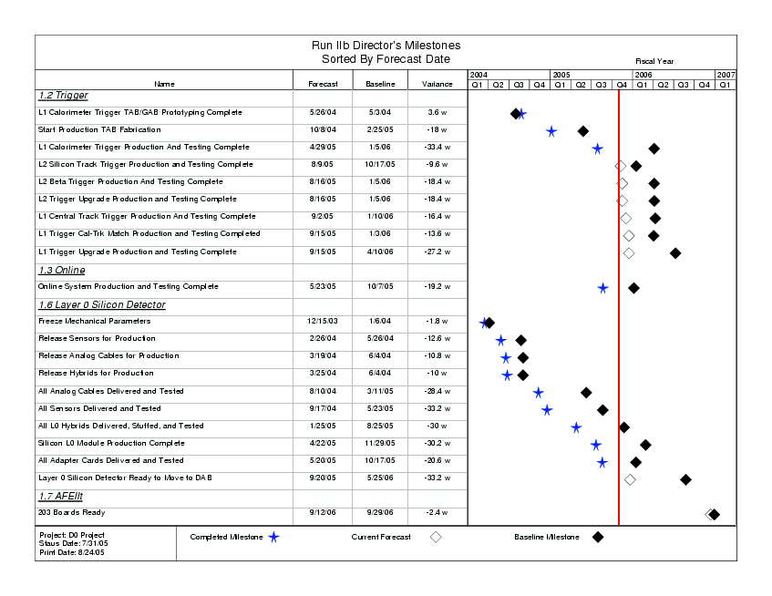
Figure 1: Run IIb D-Zero Detector Project DOE Level 2/Director’s Milestones. Closed (open) diamonds represent baseline (current forecast) dates. Closed stars represent completed milestones.

L2/Director's Milestones vs Current Forecast
(Sorted by L2/Director's Baseline Date)
Milestone Description | L2/Director's Baseline (7/05) | Last Month's Forecast (6/05) | This Month's Forecast (7/05) | L2/Director's Variance in work days | Monthly Variance in work days | Notes
WBS 1.2 Trigger
L1 Calorimeter Trigger TAB/GAB Prototyping Complete | 05/03/04 | 05/26/04 | 05/26/04 | 18 | 0 | Complete
Start Production TAB Fabrication | 02/25/05 | 10/08/04 | 10/08/04 | (90) | 0 | Complete
L2 Silicon Track Trigger Production and Testing Complete | 10/17/05 | 08/09/05 | 08/09/05 | (48) | 0
L1 Trigger Cal-Trk Match Production and Testing Completed | 01/03/06 | 08/16/05 | 09/15/05 | (68) | 21
L1 Calorimeter Trigger Production And Testing Complete | 01/05/06 | 04/29/05 | 04/29/05 | (167) | 0 | Complete
L2 Beta Trigger Production And Testing Complete | 01/05/06 | 08/16/05 | 08/16/05 | (92) | 0
L2 Trigger Upgrade Production and Testing Complete | 01/05/06 | 08/16/05 | 08/16/05 | (92) | 0
L1 Central Track Trigger Production And Testing Complete | 01/10/06 | 07/29/05 | 09/02/05 | (82) | 25
L1 Trigger Upgrade Production and Testing Complete | 04/10/06 | 08/16/05 | 09/15/05 | (136) | 21
WBS 1.3 Online/DAQ
Online System Production and Testing Complete | 10/07/05 | 05/23/05 | 05/23/05 | (96) | 0 | Complete
WBS 1.6 Layer 0 Silicon Detector
Freeze Mechanical Parameters | 01/06/04 | 12/15/03 | 12/15/03 | (9) | 0 | Complete
Release Sensors for Production | 05/26/04 | 02/26/04 | 02/26/04 | (63) | 0 | Complete
Release Hybrids for Production | 06/04/04 | 03/25/04 | 03/25/04 | (50) | 0 | Complete
Release Analog Cables for Production | 06/04/04 | 03/19/04 | 03/19/04 | (54) | 0 | Complete
All Analog Cables Delivered and Tested | 03/11/05 | 08/10/04 | 08/10/04 | (141) | 0 | Complete
All Sensors Delivered and Tested | 05/23/05 | 09/28/04 | 09/28/04 | (159) | 0 | Complete
All L0 Hybrids Delivered, Stuffed, and Tested | 08/25/05 | 01/25/05 | 01/25/05 | (150) | 0 | Complete
All Adapter Cards Delivered and Tested | 10/17/05 | 05/20/05 | 05/20/05 | (98) | 0 | Complete
Silicon L0 Module Production Complete | 11/29/05 | 04/22/05 | 04/22/05 | (151) | 0 | Complete
Layer 0 Silicon Detector Ready to Move to DAB | 05/25/06 | 09/16/05 | 09/20/05 | (166) | 2
WBS 1.7 AFEIIt
AFEII Boards Complete | 09/29/06 | 08/17/06 | 09/12/06 | (12) | 17
 |  |  |  |  | status date: | 7/31/2005

Table 1: Run IIb D-Zero Detector Project DOE Level 2/Director’s Milestones vs. Current Month forecast. Monthly variances are also provided.

- Management Highlights – V. O’Dell

The project has begun holding “Technical Readiness Reviews” which are reviews of subprojects to assess their readiness to install in the DZero detector. The review covers online and some offline software (an example is subproject unpacking code), maintenance, full system tests and commissioning plans. The first subproject to be reviewed was the L1CTT. Although the review report is not yet public, the review was overall very positive.

A similar review for the L1 Calorimeter Trigger will be held in August/September. The review of the Silicon L0 will likely be held in September.

- Procurement Highlights – V. O’Dell

All of the large procurements are now over for the IIb project except for the AFEII-t part of the project. The TripT requisition has gone out and represents about a $200k cost to the project. The next large purchase will be for the production order of parts and boards for the AFEIIt. The parts are scheduled to be ordered in October ’05 (~$300k), the boards in December ’05 (~60k) and the boards will be stuffed early February ’06 (~$100k).

- Trigger Highlights (WBS 1.2) – B. P. Padley, D. Wood

At this point, almost all of the remaining work in the trigger upgrade consists of system tests at Fermilab with bench-tested production components. The purpose of these tests is to learn as much as possible about the integrated functioning of the systems before installation and to exercise the tools that will be used in the installation and final commissioning of the systems.

Of special note is the Technical Readiness Review (TRR) for the L1CTT upgrade which was held on July 29th. While each of the major components of the L1CTT (crates, crate controllers, DFEA2) had been reviewed individually (with Production Readiness Reviews) before production, this review was a final opportunity to confirm that the system worked together as an integrated whole, and that all necessary testing had been done in preparation for installation. The full results of the L1CTT TRR should appear in next month's report, but it was already clear that the review was quite positive. A TRR for the L1Cal upgrade is scheduled for late August.

  - Level 1 Calorimeter Trigger (WBS 1.2.1) – M. Abolins, H. Evans

The focus of work on the L1Cal system has shifted almost entirely to Fermilab. Work at MSU and Nevis has continued, but is mainly in response to features observed during the integration process and is described below.

Design and testing of the ADF transition system prototypes were finished during the month of July. The remaining card, the ATC, was released for production after successful transmission of pseudo-random ADF data to a TAB was accomplished. (Extensive tests of the BLS-to-ADF input path through this card were completed in June) Some warping has been observed on approximately half of the first round of ATC cards received from the producer. This is understood as being due to an oversight in the fabrication process and will be corrected for the next round of boards being made.

The design of a continuity/short tester for the transition system was reviewed successfully and is now being fabricated. Finally, a proposal for testing the transition system, involving minimal mechanical manipulations of the boards and ADF crates, has been drafted and is being reviewed by the group. Several sets of transition system components have been tested following this procedure and are now being installed in the Test Area.

On the system testing side, significant progress has been made on the following output paths.
1) TAB to L2/L3
a) The presumed loss of sync and protocol errors observed on the TAB G-Link outputs to L2 and L3 turned out to be due to a combination of a bad VTM and problems with the FIC input channel number 0.
b) Sending data to VTM/FIC (L2) and VTM/VRB (L3) has now been accomplished with no sync-loss or data errors reported by the receiving boards.
c) BER tests have been performed on the L2 data transmission using an L1Accept rate of 6 kHz and transmitting data for ~1/2 hour. No parity errors were observed leading to a BER of <10^-9. Longer tests of this transmission are planned.
2) First GAB to L2/L3 data transmission tests were made. No sync-loss or data errors were observed in runs of many minutes. This transmission mechanism is working well.
3) A coherent strategy for adjusted the timing of the TABs and GAB has developed and is being pursued. The TAB and GAB have now been timed in and are ready for offline tests comparing TT Et's to those found using the precision readout.
4) Trigger terms from the GAB were successfully sent to the TFW with the correct timing.
5) Modifications are being made to the VRB firmware to allow BER tests be on the TAB and GAB data transmissions to L3.
6) Special triggers allowing us to compare precision readout and TT efficiently are being prepared.
7) Final preparation of documents for the L1Cal Test Area ORC are being made.
8) Daily meetings are now being held at Fermilab to coordinate work at the Test Area for the next 24 hours.

At MSU, work continued on integrating the TAB/GAB control software into the final L1Cal online framework. Work was also done on this at Fermilab by MSU and Columbia people.

At Nevis, most of the month was devoted to developing possible solutions to the presumed G-Link data transmission problems. Based on this work a slightly modified version of the VME/SCL card has been designed, which provides several mechanisms for reducing sources of jitter in the distribution of clocks used for G-Link data transmission. Even though there is now no indication that these improvements are needed, several new VME/SCL boards are being made since more spares were required anyway. These boards have now been received and the first one is being assembled at Nevis for testing next week.

In order to more easily diagnose any problems with the optics that may arise in the future, a small G-Link Receiver Test Card has also been designed, produced and assembled. It is under test at Nevis now. This card will allow quick measurements of loss of sync and of BERs on data transmission from the TAB and GAB. It can be used at either Nevis or Fermilab and will provide a good way of cross-checking results obtained at the two sites.

  - Level 1 Calorimeter/Track Matching (WBS 1.2.2) – K. Johns

We successfully tested the L1CalTrack system in its final configuration. Namely, triggers were generated in the trigger crate and sent to the manager crate. There they were further processed and sent to the trigger framework. Both crates were readout into level 3.

All cables needed by the L1CTT system were terminated by Fermilab technicians.

We bench tested 16/16 MTCxx's including two spares for the L1Mu system. We bench tested 14/14 UFB's. We bench tested 4/6 MTCM's. Two of these six are spares for the L1Mu system though. There are a few minor problems to fix on a couple of boards but we have enough boards successfully tested to populate the full L1CalTrack system.

  - Level 1 Track Trigger (WBS 1.2.3) – D. Lincoln, M. Narain

July was a productive month in the CTT project saga. Two full crates of DFEA2's have been powered all month. Individual boards have been tested. A total of 49 boards were tested extensively again at FNAL. Each board was fed about 20K random vectors (3-4 hrs run). With the tests at FNAL, 1 board had powerup problems. Thus we now have 56 working boards. This board will be recovered in the next month, as the power converter has to be ordered.

BER tests at BU gave expected rates. With short cables errors, the bit error rate has been shown to be less than 10E-16. As of last report, with long cables, a specific cable has seen a bit error rate of less than 10E-16. Larger statistics tests need the infrastructure on the platform.

Software has been written that will help us look at the singlet efficiencies. The final debugging of this software is underway.

On July 29th, the L1CTT upgrade had its Technical Readiness Review (TRR). This was the final internal project review for the L1CTT, and it should declare the upgrade to be technically complete and functioning as a system and ready for installation. The review report is not yet available, but the review was very positive. Only a few issues were raised by the reviewers, and these should be able to be resolved quickly.

  - Level 2 Beta (WBS 1.2.4) – R. Hirosky

In algorithm development, work continued on L2 vertexing studies. Track selection studies are completed and a D0NOte is in progress. The L2 b-tagging algorithm has been coded into a new level-2 tool that may be run online or in the trigger simulator. A D0Note has been released describing the tool.

On the hardware side, the Run2b Single Board Computers (SBCs) did not arrive as expected in July. However, we spoke to the company and the board did arrive in the California office and were being test prior to shipment at the end of July. Expected deliver is now early August.

  - Silicon Track Trigger (WBS 1.2.5) – U. Heintz

In July the STT hardware production was completed. At the end of June, the only task remaining was the test of the Buffer Controllers. These were all tested by July 15. This completes the STT hardware production complete milestone (1.2.5.15) as of 7/15/2005.

STC firmware tests proceeded (slowly – as allowed by data taking) at Fermilab.

  - Trigger Simulation (WBS 1.2.6) – E. Barberis, M. Hildreth

Functionality of the L1CAL simulator is complete. The L1CAL simulator is integrated in the D0 trigger simulator, outputs correctly to the data flow, counts the objects passing each trigger defined so far, and sets the corresponding trigger bits. Extra parameters have been defined to specify the pedestals for the Inter-Cryostat Region towers, which, in the hardware, are treated differently from the rest of the CAL trigger towers. Testing and optimization of the L1CAL simulator will continue within the current D0 trigger groups, in preparation for a final Run IIb trigger list. The L1CAL simulator is used as input by the L1CalTrack simulator.

The L1CalTrack simulator is integrated in the D0 trigger simulator, and work has now concentrated in the optimization, both with Monte Carlo and data, of the L1CalTrack electron and Tau algorithms.

There is nothing new to report this month for the L1CTT simulator (for which we need to extend the completion date from July 15th to August 15th). By the second week in August we expect to see, for the L1CTT simulator: implementation of the Run IIb equation parser (which has been written), implementation of the track terms, and first rate estimates.

- DAQ/Online Highlights (WBS 1.3) – S. Fuess

  - Level 3 Systems (WBS 1.3.1) D. Chapin, G. Watts

The complete order of 128 Level 3 nodes arrived during the last week of July and was installed by the vendor. We are now at the beginning of a 30-day burn-in period. We expect this period to complete at the end of August. By this time, the new Level 3 nodes should be completely integrated into the running DAQ system.

  - Network and Host Systems (WBS 1.3.2) – J. Fitzmaurice, S. Krzywdzinski
Online/DAQ Network: 1.3.2.1
An order, managed by the Computing Division Network Group, for a new Supervisor module and a 48-port Gigabit module for the Online Cisco 6509 was placed 7/7/2005, but has not yet been delivered. This upgrade expands the gigabit networking capacity for the core servers. In the interim, several host servers are supported on a Gigabit capable satellite switch.

Control and Monitoring systems: 1.3.2.2, 1.3.2.3
The upgrade of the interactive control room and the event monitoring systems is a DØ operations task, and is part of the operations budget. A requisition to add 10 new nodes was submitted at the end of July. We are in the process of evaluating systems for Control Room replacements, and expect to requisition several during August.

Storage, DAQ Host, ORACLE, & File Server Systems: 1.3.2.4, 1.3.2.6, 1.3.2.7, 1.3.2.8
The RunIIb plan calls for a single additional quad-processor system to be purchased as a principal node in the DAQ event data-logging chain. An evaluation of the performance of newly installed systems has determined that dual-processor systems are adequate and much less expensive. A requisition for these remaining systems has been submitted [a purchase order was placed 8/3/2005, with an expected delivery of 8/29/2005], which will complete the only outstanding purchase to be made for the Online/DAQ portion of the RunIIb upgrade.

  - Control Systems (WBS 1.3.3) – F. Bartlett, G. Savage, V. Sirotenko

The MVME5500 processor purchase for the control system upgrade is complete. We continue the process of installing the new processors. There are no outstanding issues.

- Silicon Detector Layer 0 Highlights (WBS 1.6) – A. Bean, R. Lipton

The 50% test of the Layer 0 “A” layer was completed this month, and while some noise was found, it appears to be coherent pickup noise which can be corrected for by real time pedestal subtraction. There may also be other ways of reducing the noise, and these ideas will be explored with the full detector. All the parts were assembled this month for reading out the full detector.

  - Readout (WBS 1.6.2) – R. Sidwell, K. Hanagaki

Testing of fully populated A-layer was performed. All the 24 modules were successfully read out simultaneously. The total noise is typically between 3 and 4 ADC counts, while the differential noise is 2 ADC counts. The excess is attributed to coherent pickup noise, which can be eliminated by real time pedestal subtraction. The bandwidth scan was performed. The result is as expected. The sparse read out was tested and worked without problems.

Using the electrical testing support structure, we investigated the source of the coherent pickup noise. There are two findings, 1) the smaller the isolating resistance between the SVX4 and common ground, the smaller the noise , and 2) putting ferrite onto SVX4 power lines significantly reduces the noise. These are the clues to improve the noise for the real detector.

The preparation for testing the remaining half of the detectors, i.e. full read out test, was in progress. We received 18 junction cards and 5 adaptor cards from KSU. This gives us enough readout parts for the full testing with spares.

Some minor modifications of the adaptor card were proposed, discussed and tested. This includes removal of the inverter for change mode, which latches the mode 0 and mode 1, and results in the proper timing of control signals. The other is proper termination of the change mode lines. The modified adaptor card worked without causing read out failures.

The prototype modules in the platform, with a mixture of SVX2 and SVX4 chips, were successfully read out by the global DAQ.

  - Mechanical Design and Fabrication (WBS 1.6.3) – W. Cooper

Sensor – hybrid module installation on the Layer 0 structure continued under coordinate measuring machine control of placement. At the end of the month, two modules remained to be installed. Measurements made as each module was installed suggested good placement precision. Final measurements of module positions and orientations will be made after Layer 0 electrical testing has been completed.

“Long” and “short” tools for Layer 0 installation were completed by the University of Washington and delivered to Fermilab. CMM inspection of the long tool remains to be made, but visual examination and partial inspections by the University of Washington indicate that both tools meet tolerances should be fine. “Intermediate” tools (extensions to Layer 0 on which cables would be dressed) are being fabricated by both the University of Washington and Lab 3.

Preparations continued for a Layer 0 installation test at Lab 3 using mock-ups of the solenoid and calorimeter ends and a mechanical prototype of the Layer 0 structure. Lab 3 is adding “dummy” sensors, hybrids, and cables to the prototype Layer 0 structure, so that its profile and weight will reasonably represent those of a completed Layer 0.

  - Detector Modules and Final Detector Integration (WBS 1.6.4, 1.6.5) – L. Bagby

Unattended operation of the L0 detector was decided to be unnecessary. All safety review issues have been addressed. All hardware is in place to instrument the remaining 50% of the detector for reading out. The operation of the interlock system was confirmed after cooling system modifications were implemented. RTD cable adapter cards have been manufactured. Arrangements are being made to have the connectors installed.

- Analog Front End Highlights (WBS 1.7) – A. Bross, P. Rubinov

- TripT (WBS 1.7.4) – L. Bellantoni

This month's activity was about testing and the preparation therefore. We are taking a two-pronged approach: detailed manual (bench) testing of ~5 chips on a bench, and qualification (robot) testing for the full sample. The bench test was done; we have data for the turn on thresholds for 5 chips, in addition to the 2 that were tested earlier sans packages. The
data indicate that the spec will be met. The automatic test facility was under development in July. The mechanical socket clamp was installed and the testing board was received and stuffed. Some hardware modifications have proven to be necessary, but not difficult. As of the end of June, work on the FPGA and tester code had not begun, and this was a bit of an issue. There has been subsequent progress on this front. The board intended for automatic testing was also used for a simple but hopefully effective check of prototype chips for use in the prototype
boards.

- AFEII-t board (WBS 1.7.5) – P. Rubinov

AFEIIt prototypes design and layout were completed, design files were send to the manufacturer of the boards and work has started on the necessary documentation for the assembly of the boards. Part orders are in progress and on track to have all parts on hand in time for the arrival of the bare PCBs, so the boards can move to assembly phase as quickly as possible.

- Code Development (WBS 1.7.6)
A number of meetings were held with relevant personnel to plan the work and finalize the specifications. Some of the required documentation was produced.

- Schedule Variance Analysis (as of 31 July 2005)

Schedule variances are reported against director’s milestones in section III. Thirteen milestones have been successfully achieved. All remaining milestones are projected ahead of the DOE baseline dates.

  - D-Zero Run IIb Trigger Upgrade (WBS 1.2)

The L1CTT lost 25 days in the last month due to increased testing at Fermilab. Although the boards as sent to FNAL are working, more time has been devoted for testing at FNAL than originally planned. Some of this testing will help shorten the overall time needed for installation and commissioning the L1CTT into the D0 detector. Note that the Technical Readiness Review for the L1CTT stated that the L1CTT was reading to install.

The Cal-Track Match has lost 21 days in the last month due to manpower shortage for testing the system. However a full vertical slice is being installed into the D0 detector and trigger system and all the boards and associated hardware have been bench tested and are ready to test in situ. This 21 days is what drives the “L1 Trigger Upgrade Production and Testing Complete” which is also delayed by 21 days in the last month.

  - D-Zero Run IIb Online (WBS 1.3)

There is no unfavorable schedule variance for this subproject and its milestone has been met.

  - D-Zero Run IIb Layer 0 Upgrade (WBS 1.6)

There is no unfavorable schedule variance for this subproject.

  - D-Zero Run IIb AFEII Upgrade (WBS 1.7)

The AFEII has lost 17 days in the last month due to delays in the design of the hardware/software for the robotic chip tester. This should be caught up by the time the devices arrive.

- Department of Energy Milestones (as of 31 July 2005)

No DOE milestones were predicted or achieved during the month of July. Table 2 (below) shows the status of all DOE Milestones.

L1 DOE Milestones vs Current Forecast
(Sorted by L1 Baseline Date)
Milestone Description | L1 Milestone (7/05) | Last Month's Forecast (6/05) | This Month's Forecast (7/05) | L2/Director's Variance (work days) | Monthly Variance (work days) | Notes
WBS 1.2 Trigger
L2 Trigger Upgrade Production and Testing Complete | 01/05/06 | 08/16/05 | 08/16/05 | (92) | 0
L1 Trigger Upgrade Production and Testing Complete | 04/10/06 | 08/16/05 | 09/15/05 | (136) | 21
WBS 1.3 Online/DAQ
Online System Production and Testing Complete | 10/07/05 | 05/23/05 | 05/23/05 | (96) | 0 | Complete
WBS 1.6 Layer 0 Silicon Detector
Layer 0 Silicon Detector Ready to Move to DAB | 05/25/06 | 09/16/05 | 09/20/05 | (166) | 2
WBS 1.7 AFEIIt
AFEII Boards Complete | 09/29/06 | 08/17/06 | 09/12/06 | (12) | 17
 |  |  |  |  | status date: | 7/31/2005

Table 2: Run IIb D-Zero Detector Project DOE Level 1 Milestones vs. Current Month and Previous Month’s forecast. Entries are sorted by DOE L1 Milestone date. Monthly variances are also provided.

- Cost Performance Report (as of 31 July 2005)

This report is generated from COBRA and provides a summary of the WBS 1.2-1.4 costs of the Project down to Level 3 of the Work Breakdown Structure. Silicon detector subproject closeout costs are not tracked here. Input data originates with the status (% Complete) of the Project schedules as reported by the Level 2 managers and actual costs extracted from the Fermilab accounting system. Where possible, costs are accrued for items that have been delivered, but not yet invoiced. Financial summaries are shown for this reporting period (columns 2-6) as well as the project to date (columns 7-11). Column 12 contains our baseline BAC, and will only be changed after the formal implementation of the Change Control process. Column 13 is the projected BAC, based on the current month’s schedule.

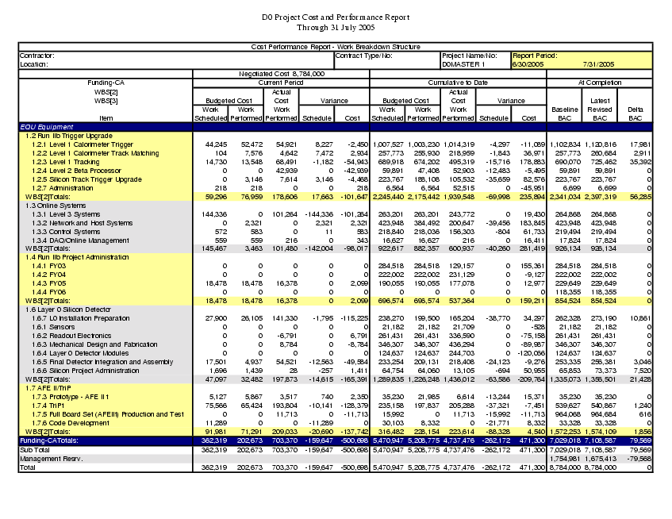

- Obligation Reports (as of 31 July 2005)

The DZero Obligation Reports can be found below. The first report shows total obligations without the cost of the original Run IIb Silicon and related closeout costs. The second report shows all obligations.

