10 Years of SOHO

Bernhard Fleck, Daniel Müller, Stein V.H. Haugan, Luis Sánchez Duarte, Tero Siili
Solar and Solar-Terrestrial Missions Division, ESA Research and Scientific Support Department, c/o NASA Goddard Space Flight Center, Greenbelt, MD, USA

Joseph B. Gurman
NASA/GSFC, Greenbelt, MD, USA

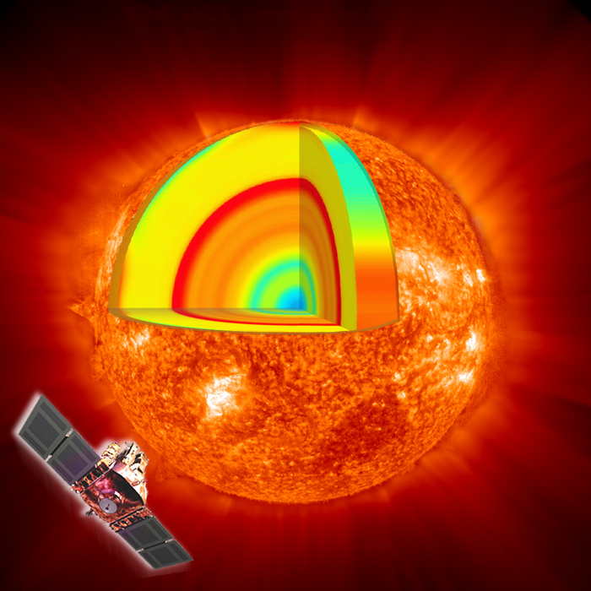

Abstract

Since its launch on 2 December 1995, SOHO has revolutionized our understanding of the Sun. SOHO has provided the first images of structures and flows below the Sun’s surface and of activity on the far side of the Sun. It has discovered sunquakes, mapped the evolution of large-scale flow patterns below the surface, and eliminated uncertainties in the internal structure of the Sun as a possible explanation for the “neutrino problem”. SOHO has revealed the Sun’s extremely dynamic atmosphere, provided evidence for upward transfer of magnetic energy from the surface to the corona [technical term; try “outer solar atmosphere, the corona?”] through a “magnetic carpet”, and identified the source regions of the fast solar wind. Furthermore, it has revolutionized our understanding of solar-terrestrial relations and dramatically boosted our space weather forecasting capabilities by providing a continuous stream of images covering the dynamic atmosphere, extended corona, and activity on the far side of the Sun. The findings have been documented in an impressive and continuously growing number of scientific publications: over 2,500 papers in refereed journals since launch, representing the work of over 2,300 individual scientists. At the same time, SOHO’s easily accessible, spectacular data and fundamental scientific results have captured the imagination of the space science community and the general public alike. SOHO images and movies have become stock footage for news organizations around the world. As a byproduct of the efforts to provide real-time data to the public, amateurs have come to dominate SOHO’s discovery of over 1000 Sun-grazing comets.

Introduction

We live in the extended atmosphere of a magnetically active star. While sunlight enables and sustains life, the Sun’s variability produces streams of high-energy particles and radiation that can affect life. Understanding the changing Sun and its effects on the solar system has become one of the main goals of the SOHO mission, which originally was launched to address three fundamental science questions: what is the structure and dynamics of the solar interior, how is the corona heated, and how is the solar wind accelerated.
A consortium of European space companies led by prime contractor Matra Marconi Space (now EADS Astrium) built SOHO under overall management by ESA, and twelve international consortia developed its suite of twelve instruments. NASA launched SOHO on 2 December 1995, and it was inserted into a halo orbit around the Lagrangian point L1 in February 1996.
The SOHO Experiment Operations Facility (EOF), located at NASA's Goddard Space Flight Center, serves as the focal point for mission science planning and instrument operations. Six of the twelve SOHO Principal Investigator Teams are represented by teams resident at the EOF, where they receive telemetry, process these data to determine instrument commands, and send commands directly from their workstations through the ground system to their instruments.

In a short popular article such as this it is impossible to do justice to the more than 2500 articles published in the refereed literature and an even bigger number in conference proceedings and other publications. Here we can only touch upon a few selected results. Highlights from the first four years of SOHO have been described in ESA Bulletin 102 (May 2000).

Making the Sun Transparent

Just as seismology reveals the Earth's interior by studying earthquake waves, solar physicists probe the interior of the Sun using a technique called helioseismology. The oscillations detectable at the visible surface are due to sound waves reverberating through the Sun's inner layers. These oscillations are usually described in terms of normal modes. By precisely measuring the mode frequencies, one can infer the Sun’s temperature, density, atomic abundances, interior structure, and the age of the solar system, and even pursue such esoteric matters as testing the constancy of the gravitational constant.

One of the most productive instruments on SOHO, the Michelson Doppler Imager (MDI), delivers high-quality data from which the global resonant acoustic modes [sounds very “technical;” say “oscillations of the whole Sun?”] of the Sun can be measured with exceptional accuracy. MDI observations have revealed strong variations in the velocity of the plasma [and a plasma is….] flows at both the base and the top of the convection zone. [Need sentence here explaining that energy is transported radiatively in the innermost ~ 2/3 of the Sun, but by convection Researchers found a strong shear [might have to explain shear] layer at the base of the convection zone, called the ‘tachocline’, which connects the differentially rotating [differential rotation you are definitely going to have to explain] outer part of the Sun with the nearly uniformly rotating interior (Fig. 1).

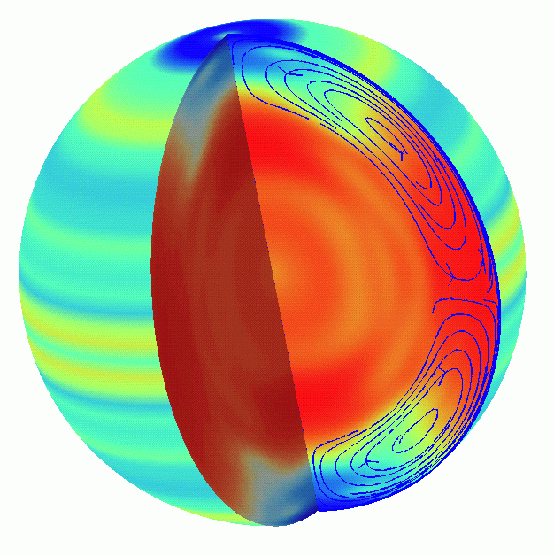

Figure 1: Solar rotation and polar flows of the Sun as deduced from measurements by MDI. The left side of the image represents the difference in rotation speed between various areas on the Sun. Red-yellow is faster than average and blue is slower than average. The light orange bands are zones that are moving slightly faster than their surroundings. The cutaway reveals rotation speed inside the Sun. The large dark red band is a massive fast flow of hot, electrically charged gas called plasma beneath the solar equator. Finally, the blue lines in the cutaway at the right represent the surface flow from the equator to the poles of the Sun. The return flow indicated at the bottom of the convection zone is from a simple model and has not been observed yet. [Do the MDI people still believe this diagram?]

MDI data has revealed a fascinating picture of the large-scale, subsurface dynamics of the Sun, with dramatic changes with the solar cycle. We all know of the crucial importance of large-scale streams in our atmosphere (e.g. jet stream) and in the oceans (e.g. gulf stream) for Earth’s climate. MDI has for the first time enabled scientists to observe such large-scale streams and flows inside the Sun. Researchers discovered transient storms, high and low pressure zones, and swirling wind flows near active regions that vary from day to day like weather patterns on Earth’s surface (Fig. 2).

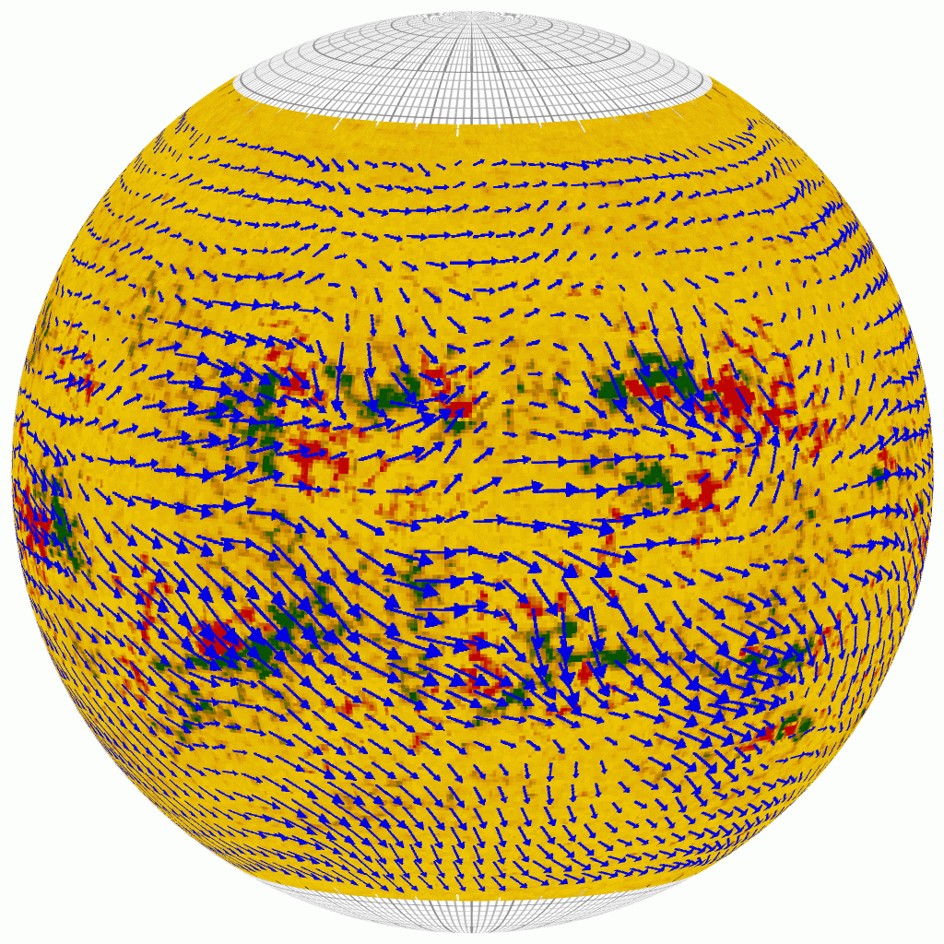

Figure 2: “Solar Subsurface Weather” map, showing magnetic field (black/red) and average “wind” flow (blue arrows) under the solar surface.

Since MDI started to deliver helioseismic information at finer spatial scales than previously available, the new field of “local area helioseismology” has developed rapidly. The new methods allowed the construction of the first true 3-D images and flow maps of the interior of a star, and even first images of the far side of our Sun. Applying a novel method called acoustic tomography to MDI data, scientists could for the first time study the structure of sunspots below the Sun’s surface and thus were able to answer two long-standing puzzles [which are… what and what?] about these blemishes on the Sun that have been a source of wonder to mankind ever since they were described (and drawn in painstaking detail) by Galileo Galilei: How deep do the spots extend below the surface, and….? (Fig. 3) . The MDI team found strong, converging downflows, which stabilize the structure, and that sunspots are a relatively shallow phenomenon.

Just a little over four years after the launch of SOHO, scientists published an astonishing result: the first successful holographic reconstruction of features on the far side of the Sun (Fig. 4). An active region on the Sun’s far side reveals itself because it possesses strong magnetic fields that speed up the sound waves. The difference becomes evident when sound waves shuttling back and forth get out of step with one another. In the meantime, the astonishing has become routine, and SOHO MDI offers daily far-side images online. Violent solar activity occasionally disrupts satellites, radio communication, and power systems. Advance warning of magnetic storms brewing on the far side that could rotate with the Sun and threaten Earth is therefore of vital importance for space weather forecasting.

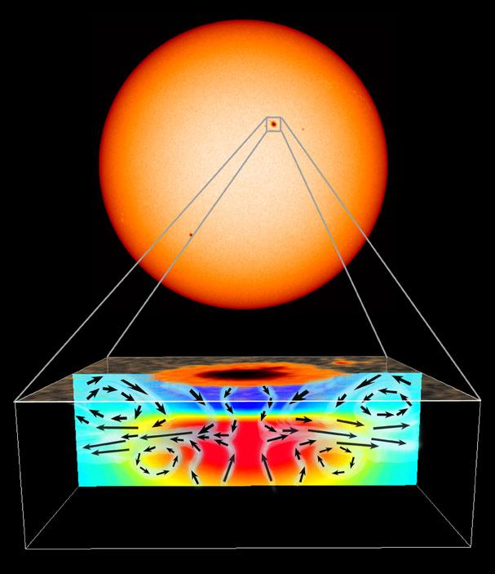

Figure 3: Using advanced analysis techniques, SOHO's MDI instrument can reveal the temperature and flow structure beneath sunspots.

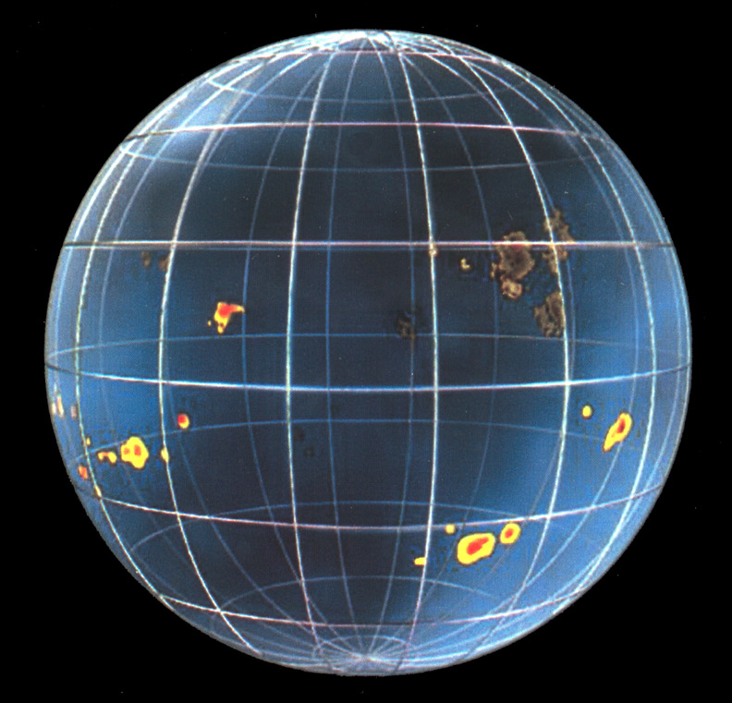

Figure 4: Acoustic waves make the Sun transparent (artist’s concept). [I would show this and a near side sunspot image side by side.]
The Sun’s Dynamic Corona

The outer atmosphere of the Sun, the so-called corona, has a typical temperature of about 1 million C° [presume the C is for opinion makers….] and emits light mainly in the ultraviolet (UV) part of the spectrum. It is this radiation from the Sun’s hot corona that controls the composition and dynamics of Earth’s upper atmosphere. Water vapour and ozone are especially sensitive to changes in the Sun’s UV radiation. Fortunately, Earth’s atmosphere protects us from this harmful radiation. On the other hand, this also means that we cannot observe the Sun in these wavelengths from Earth. In order to understand the Sun’s EUV output and variations thereof, we have to leave Earth’s atmosphere behind and observe the Sun from space.

SOHO’s Extreme ultraviolet Imaging Telescope (EIT) has provided us with stunning images of the Sun’s corona, showing delicate coronal loops, bright flares, and intriguing coronal holes (Fig. 5). EIT and the UV spectrometers SUMER and CDS have demonstrated that the outer solar atmosphere is extremely dynamic and time variable in nature and that plasma flows play an extremely important role. One-dimensional, static models have become obsolete. [….which we knew from Skylab….]

[No real result here. I would simply mention the dynamics in passing in the space weather discussion, and describe how EIT can tell us whether the disturbance is earth-directed or not.]

Figure 5: Composite image of the solar corona with three wavelengths (171 Å as blue, 195 Å as yellow and 284 Å as red) combined to show solar features unique to each wavelength. The 171 Å filter shows Fe IX/X emission at about 1 million degrees, the 195 Å filter shows Fe XII at about 1.5 million degrees, and the 284 Å filter shows Fe XIV at about 2.5 million degrees.
Gone With the Solar Wind

The solar wind is a stream of particles, primarily electrons and protons, flowing outward from the Sun at speeds of over 3 million km/h. The solar wind is essentially the hot solar corona expanding into interplanetary and interstellar space. It deforms our planet’s magnetosphere and ionizes atoms in the upper Earth’s atmosphere, causing beautiful aurorae.

Interpreting data from the Ultraviolet Coronagraph Spectrometer (UVCS), scientists found evidence for the solar wind streaming out of the Sun by “surfing” waves produced by vibrating magnetic field lines, which give solar wind particles a push just like an ocean wave gives a surfer a ride.

Using SOHO’s SUMER spectrometer, scientists were able to map the outflow of plasma from coronal holes, and found a clear relationship between the outflow velocity and the network structure of the chromosphere, a lower-lying layer of the solar atmosphere. This can be considered the first direct spectroscopic determination of the source regions of the fast solar wind in coronal holes [and a coronal hol eis what?]. In a later study, using SUMER and MDI data, a Chinese-German team of scientists has located the source region of the fast solar wind between 5,000 and 20,000 km above the surface in magnetic funnels (Fig. 6). According to their new model, the solar wind plasma is supplied by closed magnetic loops that are swept by convection to funnel regions where they undergo reconnection with existing open field lines. Thereby plasma previously confined within closed loops is released and accelerated to form the solar wind. [Collapse this entire paragraph in a single sentence about how Chinese/German team has used MDI and SUMER data to show that the solar wind escapes from the Sun in funnels of “open” magnetic field.]

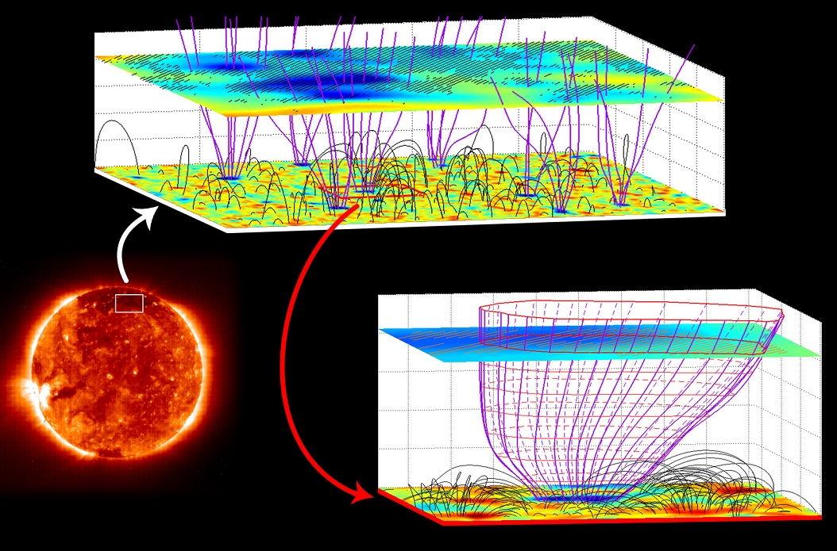

Figure 6: The solar wind emerges from coronal funnels: The magenta curves illustrate open magnetic field lines, dark grey arches show closed ones. The lower plane shows the magnetic field vertical component measured by MDI (blue to red). The upper plane shows Ne VIII Doppler shifts from SUMER (hatched regions have large outflows), together with the inclination of the magnetic field (blue to red) as extrapolated from the MDI measurements.
[I think this figure and the last section of the discussion, above, is way too technical for your audience.]
SOHO, the Space Weather Watchdog

While the Sun’s total radiative output is reassuringly constant, it is a dynamic and violent star. Besides emitting a continuous stream of plasma in the solar wind, the Sun periodically releases huge amounts of matter in what are called coronal mass ejections (CMEs; Fig. 7). CMEs are the most powerful eruptions in the solar system, with thousands of millions of tons of electrified gas being propelled from the Sun's atmosphere into space at millions of kilometers per hour. These immense clouds of material, when directed towards Earth, can cause large magnetic storms in the magnetosphere and the upper atmosphere. Researchers believe that CMEs are launched when solar magnetic fields become strained and suddenly 'snap' into a new configuration, like a rubber band that has been twisted to the breaking point.

Figure 7: This fiery coronal mass ejection shows stunning details in the ejected material. This image was taken by SOHO’s LASCO coronograph. The direct sunlight is blocked by an occulter (red disk), revealing the surrounding faint corona. The white circle represents the approximate size of the Sun.

Apart from causing beautiful aurorae borealis, the disturbances associated with CMEs can damage satellites, disturb telecommunication devices, pose a radiation hazard to orbiting astronauts, lead to corrosion in oil pile lines and cause current surges in power lines. As our society becomes increasingly dependent on space-based technologies, our vulnerability to “space weather” becomes more obvious, and the need to understand it and mitigate its effects becomes more urgent. In recent years, forecasting the conditions in the near-earth environment and the “geo-effectiveness” of CMEs and solar flares has become one of the key research areas in solar and solar-terrestrial physics, and SOHO is playing a pioneering and leading role in this new discipline. While satellites that perform in-situ measurements in near-earth orbits can only give a roughly two hour alert for solar storms, SOHO’s coronographs and EUV imager observe the source of CMEs and flares and are thus able to give up to three days warning, sufficient time to make provisions to save costly equipment. SOHO LASCO and EIT have become the primary source of operational information on the location of origin, speed, and heading of CMEs from the earth-facing hemisphere of the Sun. These remote sensing observations are complemented by the CELIAS, COSTEP, and ERNE in situ measurements of the arrival of the CME and energetic particles at the L1 Lagrangian point.

The LASCO team has compiled an extensive catalog summarizing the properties (mass, speed, acceleration, angular width and position, etc.) of the more than 10000 CMEs observed since launch. This catalog has been used in numerous studies, including investigations about solar cycle variations of CMEs. The rate of CMEs increases by more than an order of magnitude from 0.5 CMEs per day during solar minimum to over 6 CMEs per day during solar maximum. Using LASCO data, scientist can also for the first time reconstruct volumetric images of CME structures (Fig. 8). When combined with additional views from the coronagraphs on the STEREO spacecraft to be launched later this year, this technique should significantly reduce ambiguities in the reconstruction of interplanetary CME morphology.

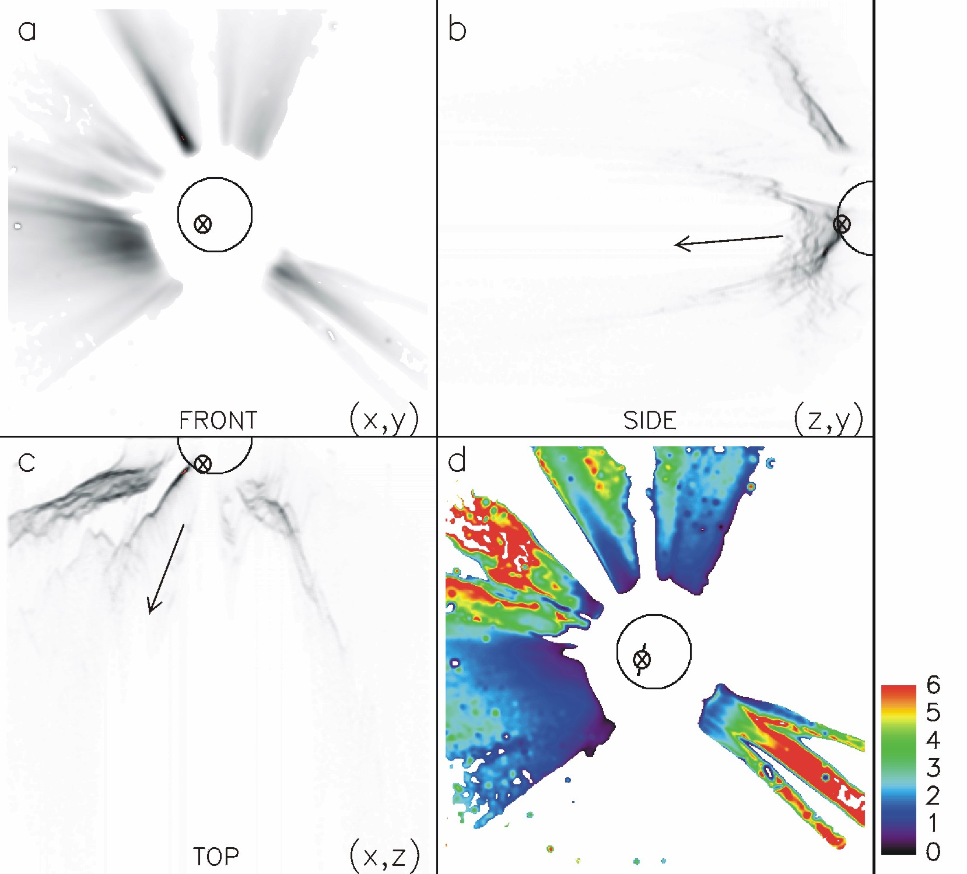

Figure 8: A Coronal Mass Ejection heading almost directly towards Earth, observed by SOHO’S LASCO C2. The size of the Sun is indicated by a circle, and the x-marked circle on the Sun shows the origin of the CME. Panel a shows the total intensity (darker means more intensity) as imaged directly by LASCO. Panel d is a topographic map of the material shown in panel a. The distance from the plane of the Sun to the material is colour coded - the scale in units of solar radii is shown on the side. Panels b and c show the intensity as it would have appeared to an observer positioned to the side of the Sun or directly above it, respectively.

Over two weeks in October/November 2003, the Sun featured three unusually large sunspot groups which gave rise to 11 X-class flares (including the strongest ever recorded), numerous CMEs and two significant proton storms (Fig. 9). Satellites, power grids, radio communication and navigation systems were significantly affected. The events, among the best-observed ever, will be the subject of analysis for years to come. The events caused unprecedented attention from the media and the public. Images from SOHO appeared in nearly every major news outlet. Furthermore, the great public interest wiped out all existing SOHO web traffic records, with the SOHO web server serving over 31 million page requests and 4.3 Terabyte of data in just one month.

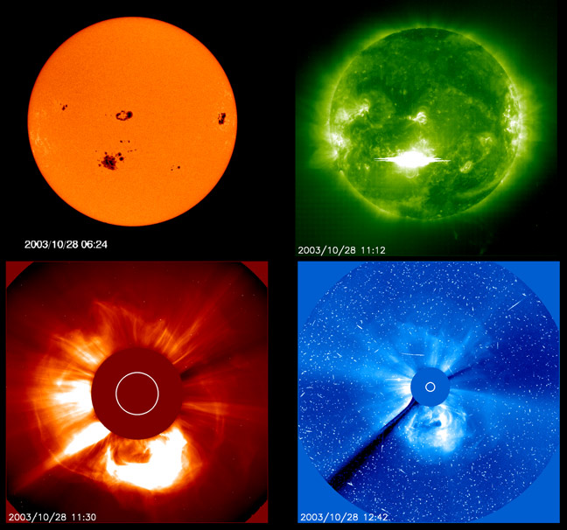

Figure 9: Active Region 10486 unleashed a spectacular show on 28 October 2003: An X 17.2 flare, a fast-moving coronal mass ejection and a strong solar energetic particle event. From top left: Giant sunspot groups seen by MDI in white light. Flare as seen by EIT in 195 Å emission. The fast-moving CME in the LASCO C2 coronagraph, then in the LASCO C3 coronagraph with the particle shower becoming visible as "snow" in the image. The fast-moving cloud impacted Earth's magnetosphere a mere 19 hours later, almost a record speed.
Measuring the Total Solar Irradiance

Because of its broad social and political impacts as governments make decisions on their responses (if any) to global worming, a crucial question is whether the Sun’s total irradiance is changing on a long time scale, SOHO’s VIRGO instrument is monitoring the total solar irradiance (TSI), also known as the solar constant. Using sophisticated calibration models, the VIRGO team has constructed composites of TSI measurements from SOHO and other spacecraft over the last 26 years (Fig. 10). From this composite record, it now appears that there is no evidence for a long-term trend in the TSI, i.e. the total radiation from the Sun does not show any systematic brightness increase or decrease on long time scales. However, while the total solar irradiance varies by less than 0.1% over the 11-year solar cycle, the irradiance in the extreme ultraviolet (EUV) part of the spectrum changes by as much as 30% on the time scale of weeks. Detailed knowledge of the solar spectral irradiance is of critical importance for understanding climate variability, and to disentangle natural variations from anthropogenic climate changes.

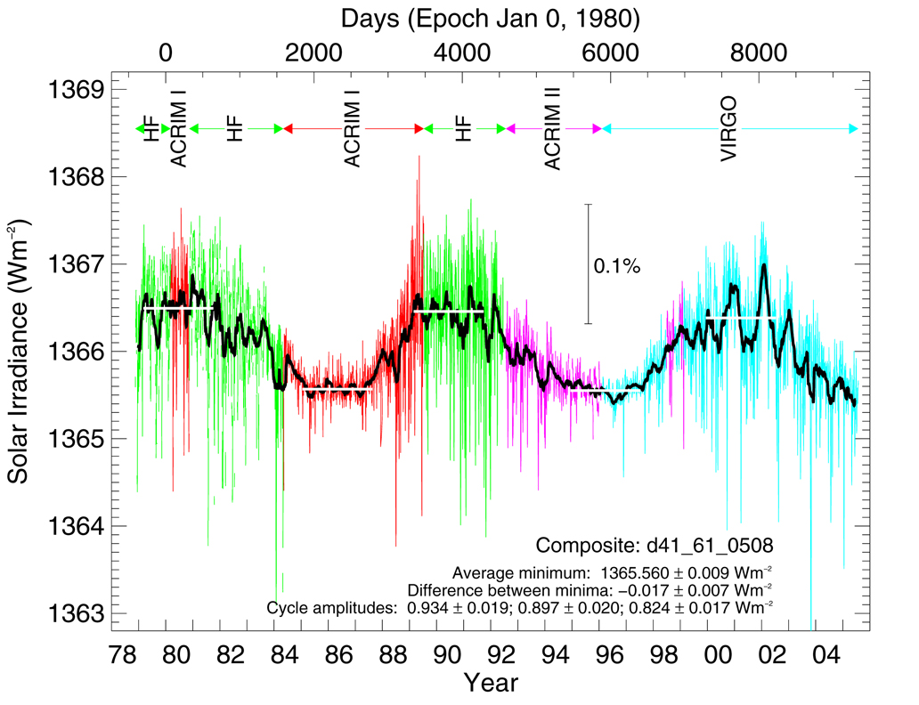
Figure 10: The composite total solar irradiance (TSI) for over two solar cycles, combining data from multiple spacecraft instruments. Different colors indicate different data sources. The data in blue is from SOHO’s VIRGO instrument.

SOHO, the Comet Finder

SOHO is providing new measurements not only about the Sun. On 5 August 2005, Toni Scarmato, a high school teacher from Calabria, Italy, discovered SOHO's 999th and 1000th comet. As of February 2006, the LASCO instrument has detected over 1100 comets, most of them so-called sun-grazers. These comets pass by very close to the Sun and acquire a prominent tail as the Sun heats their icy cores. Nearly half of all comets for which orbital elements have been determined (since 1761) were discovered by SOHO, over two thirds of those by amateurs accessing LASCO data via the Web. This is a field where amateurs can actively [redundant]contribute to scientific research, and each day, numerous people from all over the world download the near real-time data to search for new comets.

As the brightest, most spectacular comet ever observed by SOHO, Comet NEAT (C/2002 V1) provided some enticing data for further study, thanks to a grazing encounter with a coronal mass ejection (Fig. 11). The LASCO C3 observations during 16-20 February 2003 suggest an interaction between the comet's ion tail and other magnetic fields in the outer corona at the time of the oblique impact with the CME. This is the first time that imaging of such an interaction has been made. It is also the closest to the Sun that a comet has been directly observed, and the first time a comet's ion tail has been imaged crossing the heliospheric current sheet. [Is that like a sheet on a bed? Really, who will know what you mean?]

Figure 11: Perihelion passage of comet NEAT (C/2002 V1) in February 2003, as imaged by the LASCO C3 coronagraph.

The analysis of high-resolution spectroscopic observations of comet C/2002 X5 (Kudo-Fujikawa) from UVCS has revealed a quasi-spherical cloud of neutral hydrogen and a variable tail of ionized carbon (C+ and C2+) that disconnected from the comet and subsequently regenerated (Fig. 12).

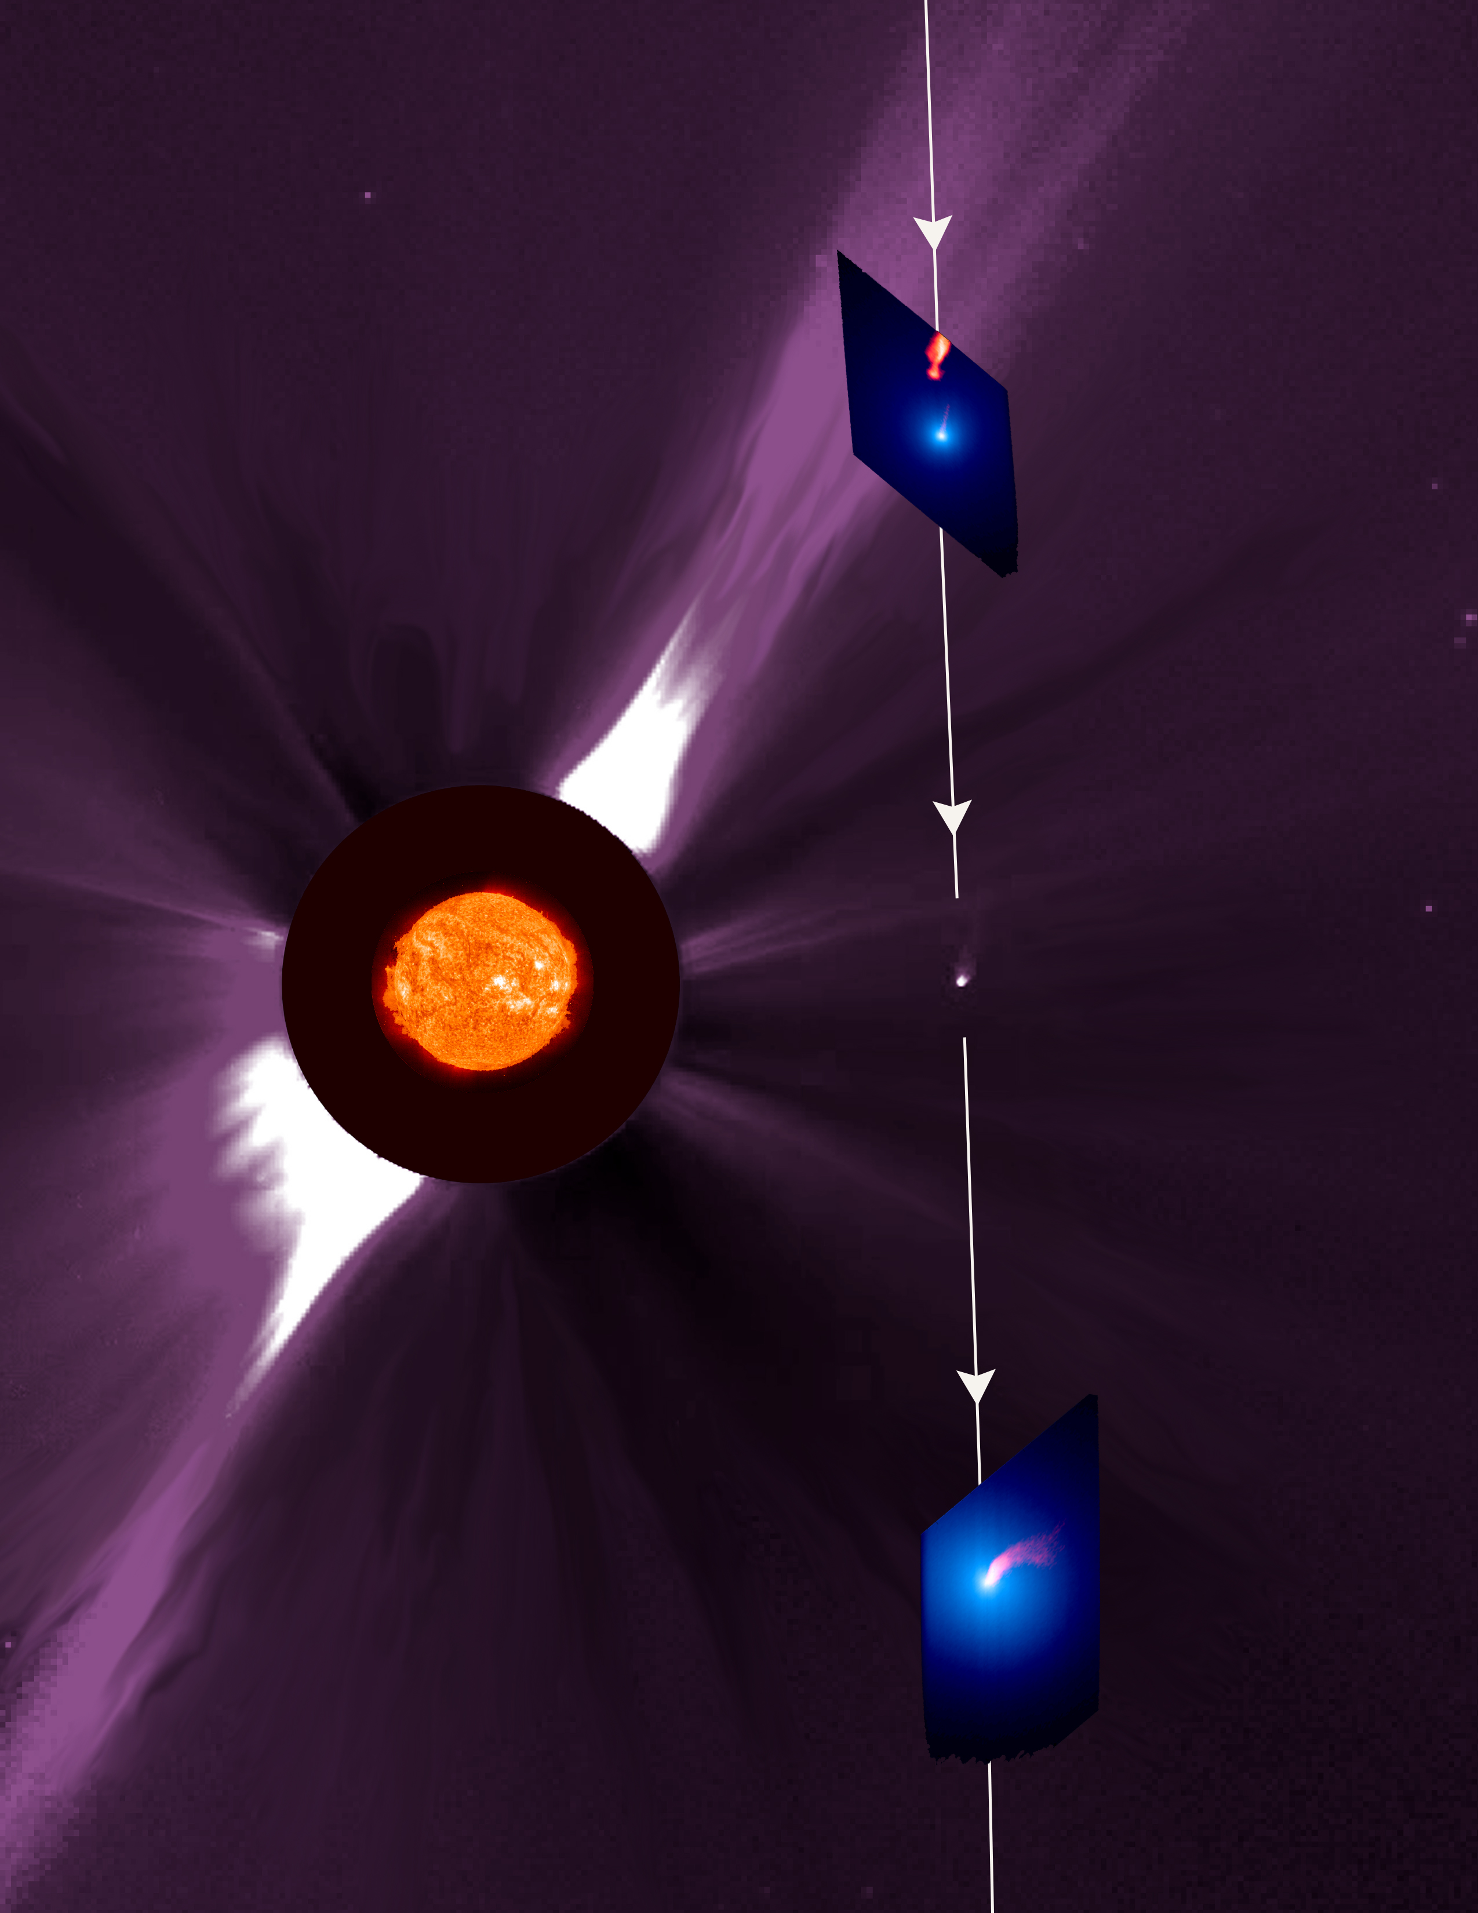

Figure 12: Composite image showing comet C/2002 X5 (Kudo-Fujikawa) as it passed within 0.2 AU of the Sun in late January 2003. The path of the comet is drawn in white, with arrows indicating the direction of the orbital motion. The solar disk is shown as an EIT 304 Å image. The background is a combination of SOHO’s LASCO C2 and C3 images of the corona in visible light, and the blank annulus around the Sun represents the occulting disk of the C2 camera. The LASCO image also reveals the comet in the optical, visible as the fuzzy white dot to the right of the Sun. The zoomed-in images in the upper right and lower right depict the comet in the H I Lyman α 1216 Å line (blue) and the C III 977 Å line (red-orange). The C III emission has never before been observed in a comet. In the upper right image, the main plasma tail has disconnected from the nucleus of the comet and is drifting anti-sunward even as a new, dim plasma tail is born from the nucleus. By the time the second UVCS image was taken, the new plasma tail has become quite bright and is beginning to turn as the comet prepares to leave the vicinity of the Sun.
SOHO’s SWAN instrument monitored the break-up of comet LINEAR C/1999 S4. The total amount of water vapor observed by SWAN from 25 May to 12 August 2000 has been estimated at 3.3 million tons. Only about 1% of this was left on 6 August, when observations by the Hubble Space Telescope of the dying comet's fragments gave an estimate of the total volume of the fragments. Combining the two numbers give a remarkably low value for the density - about 15 kg/m³, compared with 917 kg/ m³ for familiar non-porous ice. Even allowing for an equal amount of dust grains, 30 kg/m³ is far less than the 500 kg/ m³ often assumed by comet scientists.

Conclusions and SOHO’s Future

The going has not always been easy. An unexpected loss of contact occurred on 25 June 1998. Fortunately, the mission was completely recovered in one of the most dramatic rescue efforts in space, and normal operations could be resumed in mid-November 1998 after the successful recommissioning of the spacecraft and all twelve instruments. Despite subsequent failures of all three gyroscopes (the last in December 1998), new gyroless control software installed by February 1999 allowed the spacecraft to return to normal scientific operations, providing an even greater margin of safety for the spacecraft. This made SOHO the first three-axis-stabilized spacecraft to be operated without a gyroscope. A third crisis occurred in June 2003, when SOHO’s main antenna became stuck. Using the secondary antenna and software for intermittent recording, however, even this problem could be overcome and the observations continue.

In complex areas of research such as solar physics, progress is not made by just a few people. The scientific achievements of the SOHO mission are the results of a concerted, multi-disciplinary effort by a large international community of solar scientists, involving sound investment in space hardware coupled with a vigorous and well-coordinated scientific operation and interpretation effort. The interplay between theory and observations has delivered many new insights and will continue to do so for many years.

In the 10 years since launch, SOHO has provided an unparalleled breadth and depth of information about the Sun, from its interior, through the hot and dynamic atmosphere, to the solar wind and its interaction with the interstellar medium. Research using SOHO observations has revolutionized our understanding of the Sun and space weather research. The coming years promise to be similarly exciting and rewarding, when SOHO observations will be complemented and enhanced by those from STEREO and Solar-B, affording new opportunities for improved understanding of the Sun-heliosphere system. After the launch of the Solar Dynamics Observatory, SOHO’s lineal descendant, the capabilities of some SOHO instruments will be eclipsed, but not all. In particular the LASCO coronagraph observations and VIRGO total solar irradiance measurements will continue to be critical and unique contributions to the International Living With a Star (ILWS) programme. [some “strategic” sentence about Solar Orbiter???]

[Is it worth it labeling STEREO, Solar-B, and SDO with the space agencies that build them, so as to drop an unsubtle hint?]

Acknowledgements

The great success of the SOHO mission is a tribute to the many people – too many to name here – who designed and built this exquisite spacecraft and these excellent instruments, to the engineers who brought it back from the dead (twice), and to the many people who diligently work behind the scenes to keep it up and running.

