PORTLAND STATE UNIVERSITY
DEPARTMENT OF CIVIL & ENVIRONMENTAL ENGINEERING
CENTER FOR TRANSPORTATION STUDIES

ENHANCING THE OREGON CRASH REPORTING PROCESS: A FEASIBILITY ASSESSMENT

Christopher M. Monsere
Erin Wilson
Amber Springberg

FINAL REPORT

Sponsored by

OREGON DEPARTMENT OF TRANSPORTATION
TRANSPORTATION NORTHWEST (TransNow)

In cooperation with

U.S. Department of Transportation
Federal Highway Administration

Research Report

May 2006

1. Report No. | 2. Government Accession No. |  |  | 3. Recipient’s Catalog No.
4. Title and Subtitle  ENHANCING THE OREGON CRASH REPORTING PROCESS: A FEASIBILITY ASSESSMENT |  |  |  | 5. Report Date  May 2006
 |  |  |  | 6. Performing Organization Code
7. Author(s)  C. M. Monsere, E. Wilson, A. Springberg |  |  |  | 8. Performing Organization Report No.
9. Performing Organization Name and Address  Transportation Northwest Regional Center X (TransNow)  Box 352700, 123 More Hall  University of Washington  Seattle, WA 98195-2700 |  |  |  | 10. Work Unit No. (trais)
 |  |  |  | 11. Contract or Grant No.
12. Sponsoring Agency Name and Address  United States Department of Transportation  Office of the Secretary of Transportation  400 Seventh St. SW  Washington, DC 20590 |  |  |  | 13. Type of Report and Period Covered  Final Report
 |  |  |  | 14. Sponsoring Agency Code
15. Supplementary Notes

16. Abstract

In most states, police officers and trained investigators complete crash reports for nearly all reportable crashes that occur on public roads. Many states have made significant improvements in the quality and timeliness of their crash data systems by implementing, in addition to other improvements, electronic filing of these reports by police officers. Oregon relies on citizen reports for a majority of their crash data and paper forms must be submitted to the responsible state agency and are then manually coded into the crash data system. Police reports are also paper based. This process limits the improvements that can be made in both the quality and timeliness of data unless enhancements can be made to the reporting process. This report summarizes the results of a study on the feasibility of implementing a web-based system for reporting crashes, with a focus on citizen reporting and to a lesser extent police reporting. Feasibility was defined by acceptance of general public to electronic crash reporting, limited institutional or technical barriers to implementation, potential benefits and cost. The research found that the current use of online services for transactions with Driver and Motor Vehicle Services is fairly low but that nearly half of those surveyed indicated that they would file a crash report electronically. No institutional barriers were identified and high-level benefits were estimated to be between $0.8 and $1.1 million dollars over a 10 year period, primarily labor savings to the state. The main challenge to implementation would be identifying available resources in the current budgetary climate.
17. Key Words  accident data, crash data, benefits, costs, data collection, electronic government, crash reporting |  | 18. Distribution Statement  Copies available from
19. Security Classification (of this report)  Unclassified | 20. Security Classification (of this page)  unclassified |  | 21. No. of Pages  55 |  | 22. Price
Technical Report Form dot f 1700.7 (8-72) Reproduction of completed page authorize

Acknowledgements

The authors gratefully acknowledge the assistance provided by the Oregon Department of Transportation, particularly the staff at the Crash Analysis and Reporting Unit and Driver and Motor Vehicle Services Division. The contents of this report reflect the views and opinions of the authors, who are responsible for the facts and the accuracy of the data presented here. Anonymous reviewers from the TransNOW process as well as Oregon DOT Technical Advisory Committee members (Kathy Hansen, DMV Processing Services; Rod Rosenkranz, DMV Driver Programs; Mark Wills, TDD Transportation Data; Tim Burks, Traffic Engineering) provided valuable review and input. Finally, the Oregon DOT and the USDOT Region 10 University Transportation Center TransNOW is acknowledged for funding support of this research.

Disclaimer

The contents of this report reflect the views of the authors, who are responsible for the facts and the accuracy of the data presented herein. This document is disseminated through the Transportation Northwest (TransNow) Regional Center under the sponsorship of the U.S. Department of Transportation UTC Grant Program and through the Oregon Department of Transportation. The U.S. government assumes no liability for the contents or use thereof. Sponsorship for the local match portion of this research project was provided by the Oregon State Department of Transportation. The contents do not necessarily reflect the official views or policies of the U.S. Department of Transportation, Washington State Department of Transportation, or the Oregon Department of Transportation. This report does not constitute a standard, specification, or regulation.

table of contents

1.0 INTRODUCTION 1
1.1 RESEARCH objectives 1
1.2 organization of Report 1

2.0 Literature Review 3
2.1 MOTOR VEHICLE CRASH REPORTING 3
2.2 Collecting information over the Internet 7
2.3 Summary 10

3.0 oregon MOTOR VEHICLE CRASH REPORTING process 11
3.1 Reporting Process 11
3.2 Reporting Forms 12
3.3 Processing Crash Reports 12

4.0 ANALYSIS OF COMMON CITIZEN ERRORS 15
4.1 Crash Report REVIEW 15
4.2 FInDINGs: TYPES OF ERRORS 17
4.3 FIndings: Potential Improvements 21
4.4 Summary 21

5.0 ASSESSMENT OF CITIZEN interest 23
5.1 CURRent Usage of DMV Online Services 23
5.2 Survey 24
5.3 Summary 28

6.0 FEASIBILITY Analysis 29
6.1 Proposed System 29
6.2 INSTITUTIONAL AND TECHNICAL ISSUES 30
6.3 Benefits 31
6.4 COST ASSESSMENT 36
6.5 Summary 37

7.0 conclusions 38

8.0 References 40

9.0 APPENdix 43
9.1 Oregon Citizen report form 43
9.2 oregon POlice crash report 46
9.3 SURVEY 48

List of tables
Table 1 Summary of Crash Reports Reviewed in the Analysis 16
Table 2 Crash Error Summary, Multiple Report Crashes 19
Table 3 Crash Error Summary, Single Report Crashes 19
Table 4 Current Usage of DMV Online Services 23
Table 5 Survey Results 26
Table 6 Types and Combinations of Reports Received by ODOT, 2001-2003 32
Table 7 Estimated Savings for Electronically Filed Crash Reports 34
Table 8 Estimated Benefits to Oregon DMV – ARIV Unit 35
Table 9 Estimated Benefits to Oregon DOT – CAR Unit 35

List of figures
Figure 1 States Using Citizen Reports of Motor Vehicle Crashes for Data 4
Figure 2 Screen Capture of Colorado’s Online Report System and GhostCycle.org Report Form. 5
Figure 3 TraCS States, July 2004 6
Figure 4 Oregon DOT Crash Reporting and Coding Process 13
Figure 5 Number of Crash Reports Coded by Year, 1995-2004 14
Figure 6 Errors per Report, by Category 20
Figure 7 Current DMV Online Services 24
Figure 8 Counties with Survey Responses 25
Figure 9 Survey Results 27
Figure 10 Proposed System for Electronic Crash Report Filing 30
Figure 11 Adoption Rates for Citizens for Filing Electronic Crash Reports 33
Figure 12 Estimated Annual Benefits for ODOT CAR and DMV ARIV (2006 Dollars) 36

INTRODUCTION
Improving highway safety is a stated goal of many transportation agencies. All safety improvement activities, whether an engineering, education, or enforcement approach is taken, are enhanced with more accurate, timely, and robust crash data. Crash data have traditionally been plagued with missing information, inaccurate or incomplete location data, and various other errors which are both systematic and random. The collection, compiling and management of crash data is a labor intensive process although many states are moving towards electronic capture, transmission, and management of these data (Delucia and Scopatz, 2005). In most states, the primary source of data for crashes is a report completed by police officers. Oregon is unique, however, in relying on citizens reports for data on the majority (70%) of the approximately 50,000 crashes that are coded each year by Oregon Department of Transportation (ODOT).
In the near term, it is unlikely that additional reporting burden will be shifted to police agencies and citizen’s reports will remain the primary source of data. This high level of citizen reporting and the paper-based records system used at ODOT presents unique challenges to improving data quality and timeliness. As one can imagine, reconciling literal text description provided by citizens makes systematic, accurate characterization of a crash on the roadway network a challenge, even when reviewed by experienced coders at ODOT. The sheer level of effort required to compile, code, and maintain the hard-copy crash data affects both the timeliness of the data and the efficiency of process. A possible solution to these data challenges is a more integrated, electronic process for collecting crash data. The feasibility of this solution is the focus of this research.

RESEARCH objectives
The objective of this research was to determine the feasibility of deploying an improved system for self-reporting of motor vehicle crashes by citizens. The project focused on Oregon, since a majority of Oregon motor vehicles crashes are reported by citizens, although there may be applications to other states that require citizen reporting. Feasibility was defined by acceptance of general public to electronic crash reporting, limited institutional or technical barriers to implementation, potential benefits and cost. The objectives of the project were met by completing a comprehensive review of the literature and practice, developing a research strategy to determine common reporting errors made by the public, conducting a survey to determine acceptance of an electronic form, and making a final recommendation of the feasibility of such a system.

organization of Report
This report documents the results of a feasibility study of implementing a web-based system for reporting crashes, with a focus on citizen reporting and to a lesser extent police reporting. The report begins with a practice and literature review of crash reporting. First is an assessment of programs used around the country to facilitate crash reporting by citizens and police officers. The review is not intended to be conclusive given the difficulty in obtaining information about such systems. Following that is a summary of research relating to Internet usage, form design, online data collection and e-government. The next chapter documents the current Oregon crash reporting process. It includes a description of how each form is processed through ODOT at the Driver and Motor Vehicle Services Division (DMV) and Crash Analysis and Reporting Unit (CAR) before the information is available as crash data. This is followed by a chapter analyzing common errors in citizen reports. This chapter details the results of the audit process that was developed to quantify errors, as well as discussing the areas with the most potential for improvement. The next chapter discusses the assessment of citizen interest in online crash reporting. A survey was administered to drivers who had recently completed a crash report. This is followed by a chapter containing the feasibility analysis of this project. This section includes a discussion of barriers (both institutional and technological) and the costs and benefits of the project. Finally, the last chapter includes conclusions, recommendations and a brief discussion of suggestions for future work.

Literature Review
In this chapter, recent literature focusing on electronic methods of collecting and processing crash data are reviewed. First, a state of the practice review of citizen reporting for motor vehicle crashes is presented. The review found that while many states allow citizens to submit some data, only one was found to allow an Internet based submission, and most forms do not appear to be a major source of crash data. In addition, a brief review of states that have moved towards electronic collection of crash and traffic citation information from police agencies is documented. Finally, since many state procedures have moved towards e-commerce functions to improve efficiency and service for the public. This review includes success and failures from other similar e-government efforts. Because electronic crash reporting is a fairly new technology, the research review was expanded to include form design, data collection by different mediums and Internet access to draw conclusions about the potential for success of this program in Oregon.

MOTOR VEHICLE CRASH REPORTING
Crash data is essential for safety programs. However, current state data programs may not be keeping up with technology for many reasons. A recent report by the Federal Highway Administration and the US Department of Transportation uncovered a trend towards data quality problems within many states’ data collection programs. Specifically, the report found that a smaller number of crashes are being reporting, data entry backlogs mean that data is outdated by the time it can be evaluated, and reporting errors combined with data entry errors reduce the quality of the data (FHWA/US DOT, 2004). In order to rectify these problems, government agencies and private companies are developing better ways to collect, store, and evaluate data. This problem extends beyond the US, with many other nations exploring the same need for higher data quality. A recent NCHRP synthesis report also documents the state of the US crash records system ((Delucia and Scopatz, 2005). The following sections describes literature and practice for citizen reporting and police reporting.

Citizen Reporting
As part of the research, a state of the practice review was conducted to identify states that allow or require citizen reporting of motor vehicle crashes. For each state, the driver manuals posted on the Internet were reviewed for the current state law regarding motor vehicle crashes. Surprisingly, it appears that in almost every state some citizen reporting is allowed. In many cases these forms are available for when no police officer completes or submits a report. However, the amount of information required on the forms varies. Most citizen report forms that were obtained were short and only collect basic information about the crash and insurance status. For purposes of this research, it was assumed that if detailed information is requested, then it is more likely the state is collecting crash data from the citizen report forms. Based on these criteria, eight states appear to use the citizen reports for data purposes. These states have extensive crash report forms similar to Oregon’s and are shown in Figure 1. However, the researchers’ understanding of the crash data systems in these states is that these states do not rely on citizen reports for much data.
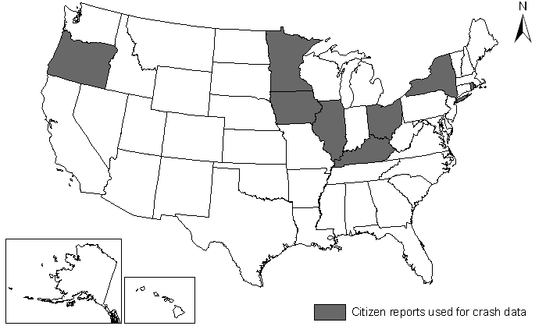
Figure 1 States Using Citizen Reports of Motor Vehicle Crashes for Data

In terms of web-based forms, the review found that seventeen states make their citizen crash report forms available online, usually in PDF. Those states are: Arkansas, California, Colorado, Delaware, Iowa, Kentucky, Maine, Minnesota, Missouri, Nevada, New York, Ohio, Oregon, Rhode Island, Vermont, Virginia, and Wisconsin. In most states it must be printed and filled out by hand before returning it to the appropriate agency. Only Colorado allows reports to be submitted via the Internet as shown in the left panel of Figure 2. Citizens in Colorado have the option of filing a crash report but the state does not rely heavily on their information for crash data. Colorado receives most of their crash data from police, and utilizes electronic reporting for law enforcement (Conner, 2005). Iowa is considering looking at the creation of a web-based system that would enable citizens to submit reports online (Jensen, 2004).
Although states using online forms for motor vehicle reporting are rare, the bicycling community has recently started using online report forms to collect information about locations of bicycle crashes (most likely in reaction to the apparent lack of bicycle crash data). Although the systems for bicycle crash collection are not as sophisticated as the system for auto crashes would be, they may provide a useful model.
- GhostCycle.org (http://www.ghostcycle.org/reportanaccident.php): Uses a form to collect information from drivers. Fields include: Street location, time of day, date, were traffic laws obeyed, was accident infrastructure related or a vehicle collision, vehicle type, hit and run, driver’s approximate speed, injuries and damages, was report filed with authority, was helmet worn, were lights used on bike, description in own words. A screen capture from GhostCycle is shown in the right panel of Figure 2.
- BikePortland.org (http://bikeportland.org/2005/08/09/wanted-your-close-calls/): Collects open form letters from people over the Internet. Asks for cross-streets, description, and neighborhood of residence of the person involved in the crash.
- Hawaii Bicycling League (http://www.hbl.org/road_hazards.html): Uses a form to collect information from drivers. Fields include: community, street name, cross street, hazard description, corrective action.

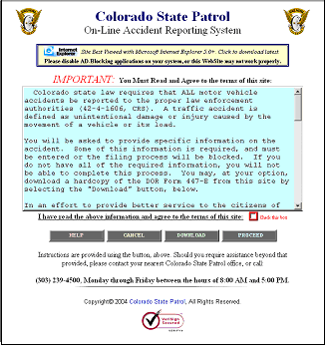 | 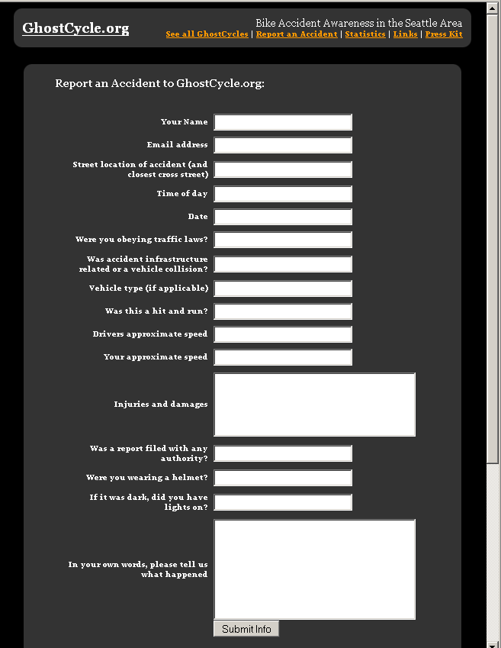
Figure 2 Screen Capture of Colorado’s Online Report System and GhostCycle.org Report Form.

Electronic Crash Reports for Police Agencies
Many states with police agencies as their primary reporting data source have made significant improvements in their crash data systems by incorporating electronic crash forms. The following subsections describe a few nationwide and local initiatives.
TraCS (Traffic and Criminal Software) is a customizable data collection system created in Iowa that can be used by law enforcement and motor vehicle agencies nationwide. Currently, 23 states are using or testing the TraCS software and are shown in Figure 3. TraCS programs can be integrated with laptop computers and other hardware, can integrate image files and geographic information systems, can emulate paper reports, and can be distributed without user intervention. TraCS Mobile is a wireless reporting software that allows data to be easily entered and transferred to a larger database. The data fields can be customized to meet the reporting needs of the agency and can display information similar to a paper report. TraCS Mobile allows officers to enter information electronically in their vehicle, eliminating the need for another agency to enter the same information. TraCS can be used for the following purposes: crash reporting, citation issuance, incident reporting, motor carrier inspection reporting, and operating while intoxicated reporting. Transmitting citation information to court systems is easily integrated into the TraCS model. (Traffic and Criminal Software, 2005)
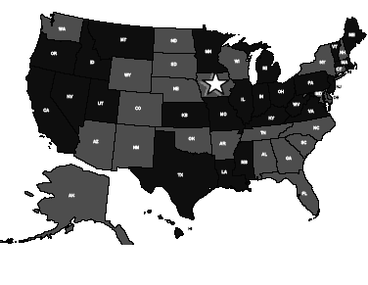Light gray -TraCS states.
Figure 3 TraCS States, July 2004

ReportBeam is a commercial software that is also used by police agencies in 16 states, and it “provides an automated Internet-based distribution system to remove the burden from the records departments” (ReportBeam, 2005). Some of the states with agencies currently using this system include: Arizona, California, Mississippi, North Carolina, Nebraska, New Jersey, New York, and Washington State. ReportBeam automatically submits collision records to the state data archives, while providing a secure method to distribute these reports to the public. It reduces the amount of walk-in report requests because citizens are now able to download their report from the Internet.
Kentucky was recently recognized by the Association of Transportation Safety Information Professionals for its crash data collection and analysis program. The program is known as KyOPS: Kentucky’s Open Portal Solution. This program involved the coordination of law enforcement agencies across the state. KyOPS is used to collect electronic input of collision data. Through the Internet, authorized users have access to all of the collision data, GIS maps, and copies of crash reports. This central collection of crash data has been very successful, although there is still room for improvement. Currently, police officers can file their reports online through the Electronic Collision Reporting Component known as E-Crash. The database is then automatically populated with the data from the police officer’s forms. Kentucky’s system is 90% compliant with the Model Minimum Uniform Crash Criteria (MMUCC), and in 2004 41.7% of police collision reports were submitted using E-Crash (an increase from 0% in 2000) (Association of Transportation Safety Information Professionals, 2004). Kentucky is one of seventeen states that offer the citizen report online as a PDF form, so it seems that it would be possible to collect the citizen data online as well.
Technology that can collect crash data continues to emerge, even within individual vehicles. The use of Event Data Recorder (EDR) Technology, or ‘black boxes,’ is increasingly common. These devices collect information about the performance of a vehicle in the seconds leading up to a crash and immediately after. The information has already been used in the court system, and some states are beginning to collect it as crash data. Although there are some significant barriers to the data collection, particularly from people who are concerned about legal ramifications, it is already being done in many places. This data could be very valuable, especially as more cars are equipped with the devices. According to one report, in 2004, 40 million passenger vehicles were equipped with EDR, and as people replace old vehicles with new that number will increase (Gabler, 2005).

Collecting information over the Internet
There is limited published research available on the topic of online motor vehicle crash reporting for citizens. Therefore, the literature review was focused on the areas of data collection, form design with respect to error reduction, Internet access, and e-government. It is apparent that government agencies are increasingly using the Internet to deliver services. DOTs are included in this movement, as they use data more within their programs. James Hall from the University of Illinois summarized in a TRB peer exchange that “Technologies for the acquisition, analysis, and distribution of data are advancing rapidly. Public expectations for data access and delivery also are increasing. The Internet provides the means for global information access. These trends emphasize that information is important and that information system delivery systems provide value to the agency” (TRB, 2005). This section describes some of the findings related to collecting data via the Internet.

Data Collection and Form Design
Although there is no research on the accuracy of online crash reports versus paper crash reports, there is some research about survey and test results from different mediums. Most of the research comparing traditional paper and pencil surveys to Internet surveys shows that the method of data collection does not significantly affect the answers given, and that there is no statistical difference between the two sets (Ballard & Prine, 2002; Pettit, 2002; Gosling & Vaxire & Srivastava & John 2004; Knapp 2003). Additionally, the literature shows that response times to online surveys is faster than mail surveys, and completeness is higher as well (Truell & Bartlett & Alexander, 2002). Research of testing online versus traditional paper tests shows that online tests measure the same constructs as traditional tests. However, the research also shows that there can be differences between Internet and traditional tests based on an individual’s familiarity with using the Internet (Buchanan, 2003).
Regarding differences in form design between online and traditional forms, the research shows that questionnaires that are reliable and valid for self reporting with paper are most likely to be valid over the Internet. However, some individuals are not familiar with using the Internet and the forms should be adjusted for their benefit (Strickland et al, 2003). Reliable and valid quantitative data collection over the Internet requires that respondents have the ability to navigate the Internet to the extent that they can access and use the web site.
Collecting data over the Internet is much less expensive than paper data collection. This is due to elimination of the costs of paper, stamps, and processing time (Cobanoglu, 2002; Pettit, 2002). Additional savings also come from the ease with which forms and templates can be updated (Pettit, 2002). Also, electronic archives can replace the need for paper archives and storage. Electronic archives have many benefits, but do require effort and cost to design, populate, and maintain.
Besides cost savings, Internet data collection can eliminate the errors that occur from manual coding. Errors associated with manual coding multiply as data passes through additional agencies where it is manually coded at each (Griffith, 2003; Pettit, 2002). New technology also makes it possible for data to be collected and disseminated to multiple agencies quickly and at a much lower cost than paper transfer (Griffith, 2003). Forms can be set up so that the data is directly sent to data management programs at one or more agencies at the same time (Pettit, 2002).

Internet Access
Americans are increasingly using the Internet to make transactions and use services. According to the Pew Institute, 70% of American households owned a home computer in 2002, and nearly half used the Internet (Ballard & Prine, 2002). However, even as access grows, it is important to consider that there are segments of the population that lag behind in Internet access. Education and income are the most important indicators of Internet access (Best & Krueger & Hubbard & Smith, 2001; Lloyd & Hellwig, 2000; Briggs 2004).
Although nearly half of the population uses the Internet, 24% have no direct or indirect experience with the Internet (Lenhart, 2003). The Internet may be misleading in the impression that anyone can access it anywhere. Importantly, there is a portion of the population who may never be able to access it for a wide variety of reasons, including disabilities and education level (West, 2000).
Publicly available Internet, such as through libraries, can help alleviate some of this disparity. According to the Pew Institute, 60% of non-users know of a place in their community where Internet access is publicly available. Among Internet users, 76% knew of a public access site, which indicates that there is still a large gap in public accessibility between users and non-users (Lenhart, 2003).
Among those without Internet access, Americans with disabilities have the lowest levels of access. The Pew Institute has quantified that 58% of all Americans are online, but only 38% of Americans with disabilities are online. 28% of Americans with disabilities say that their disability makes it difficult or impossible for them to go online (Lenhart, 2003). The Internet can offer valuable services and resources to people with disabilities, but their specific needs must be taken into account when government is considering policies related to Internet access and communication (Borchert, 1998).

E-Government
As Internet use becomes more prevalent, the use of the Internet by government agencies to deliver resources and services is increasing. This is known as e-government. David McClure, an Associate Director of the US General Accounting Office defines e-government as “government’s use of technology, particularly web-based Internet applications to enhance the access to and delivery of government information and service to citizens, business partners, employees, other agencies, and government entities” (West, 2000).
The government is already a major provider of Internet content, and offering more services is the next step (Brannen, 2001). Processing transactions electronically may create a more efficient and cost effective method than the traditional paper process. However, in order to reach the potential of e-government, government must make sites more user friendly (Information Management Journal, 2004).
E-government has the potential to help build better relationships between government and the public by making interaction with citizens smoother, easier, and more efficient (West, 2000). In surveys conducted by the Pew Institute and other groups, citizens and businesses say they want information access and transaction support from the government. The Pew Institute has also found that 77% of Internet users have gone online to search for government info or communicate with government. Government agencies already use the Internet for electronic commerce and information delivery. According to Information Impacts Magazine, the two most common initiatives for e-government are providing information and facilitation of general compliance (Cook, LaVigne, Pagano,Dawes & Pardo, 2002).
Of course, there are limitations to e-government that include technological investments, personal preferences, and the wide range of services the government provides (West, 2003). Some literature found that experiences with e-government initiatives have been chaotic and unmanageable. E-government presents some unique challenges for administrators, including how to provide universal access, privacy and confidentiality, and a citizen focus in government management. Other major barriers to e-government are lack of finances, technical support, and personnel capacity (West, 2000; Kaylor et al, 2001; Edmiston, 2003; Cook et al, 2000).
Besides the barriers within government, there are barriers to citizen use of e-government due to concerns about security and privacy (Dawes, 2002). Other societal barriers to e-government include: affordability, accessibility, and anonymity. If citizens have a low trust in government they are less likely to want to use the Internet as a means of communication with various government agencies (Edmiston, 2003). E-government must also be easy for the average citizen to use, which means that the reading level must suit most Americans. Additional improvements should include disability access, clear privacy policies, and translations (Pardo, 2000).
Acceptance of e-government is growing and becoming accepted by all levels of government. The US Census Bureau is now mandated by law to make web-based data collection an available alternative to more traditional collection techniques. The Census Bureau experimented with online reporting in its 2000 Census of Population and Housing (Richard & Hancock, 2002). Additionally, more than half of all Americans filed their 2005 taxes online (IRS, 2005).

Summary
Although electronic crash reporting is currently only used by a handful of states, the literature review reveals that it is a technology with great potential. Given the significant benefits and improvements in data quality, it is highly likely that more states will begin using some form of electronic data collection and transfer as the technology continues to develop. In Oregon, citizens are likely to become more familiar with using the Internet to conduct business with government agencies. Most importantly, the literature revealed no major problems in data quality with Internet data versus paper data. Indeed, data collected over the Internet may be of higher quality due to the potential for better form design and safeguards placed on the information provided before submittal is possible. If Oregon’s citizen reporting continues, it is logical that the Internet is a viable method to collect the data. In the following chapter, the Oregon motor vehicle crash reporting process is described.

oregon MOTOR VEHICLE CRASH REPORTING process
In order to evaluate potential improvements to the crash reporting process it was important to understand the current system. Detailed interviews with staff and managers with responsibility and oversight of crash reporting at the Driver and Motor Vehicle Services Division (DMV) and the Crash Analysis and Reporting Unit (CAR) were conducted to develop a process chart of the current system. Through these interviews, internal and legal barriers to an enhanced system were identified (and documented in Chapter 6.0). The following sections describe the process for collecting and coding motor vehicle crash data.

Reporting Process
The legal authority to require drivers to file a report rests with DMV. Current Oregon law requires drivers involved in a crash that results in injury, death, more than $1,500 damage to their vehicle, or more than $1,500 damage to and towing of another vehicle to file an Oregon Traffic Accident and Insurance Report within 72 hours. This reporting requirement was recently changed in 2004. In addition to raising the damage value, the change in law eliminated the need to file a report for some drivers. If a police officer responds to the scene, he or she completes the Oregon Police Traffic Crash Report which is more detailed than the citizen report. Police officers are not required to file a report. A citizen must file a report even if a police officer is present and completes a form. Citizens must submit the form to a DMV field office or mail to the DMV headquarters in Salem. Interestingly, Oregon law does not allow citizens to receive a copy of their crash form once it has been submitted for privacy concerns.
The policies and procedures for police officers to appear at a crash scene and file a report varies considerably by agency. This research did not attempt to assess these current practices. Based on the review of actual crash reports (in Chapter 5.0) and discussions with police officers, there are a number of methods by which police agencies complete and submit crash reports. Most reports are still filled out by hand. A few agencies have begun to use a fillable PDF form developed by the ODOT Transportation Safety Division. This increases the readability of the form since the data fields are typed. It was also evident that a number of agencies used internal records management software to produce a narrative and summary report to the crash report. As such, a few agencies are considering electronic crash reports that can be filled out in the patrol car, but the incentive is limited since DMV currently has no means of accepting these data. The difference in data quality between agencies, and even between different officers, can be attributed to the varying standards for reports, as well as the fact that some agencies offer additional training for their officers. Police who are trained in crash reconstruction or have access to technology to help them diagram the crashes are likely to submit the highest quality information to the crash coders.

Reporting Forms
DMV and CAR have different data needs. DMV is primarily interested in making sure drivers comply with Oregon law requiring motor vehicle insurance and filing of a report. CAR needs the information on the form to populate the statewide crash file. As such, the form is designed to capture both insurance information and details about the crash. The form, Oregon Traffic Accident and Insurance Report, is shown in the Appendix, section 9.1. The form has two pages of instructions, and three pages of requested information. The two pages about the crash are front-to-back and the third page is supplemental if more than 2 vehicles are involved. The form has a place for a narrative and numerous check boxes to characterize what happened in the crash. One required field is that drivers submitting the form must list the other drivers involved. The police version of the form is more detailed and is shown in the Appendix, section 9.2. It should be noted that the police form aligns with the data entered into the state’s crash data system while the citizen form currently does not directly ask for many of the variables that are coded in the database.

Processing Crash Reports
The Oregon process for compiling, processing, and transferring forms is entirely manual and described in the next few paragraphs as well as represented graphically in the flowchart shown in Figure 4. When a driver or police officer submits the crash report form to DMV, the form is placed in a central filing system by county and month. Sometime later, DMV staff in the Accident Reporting and Insurance Verification (ARIV) unit begin the process of manually assembling reports that describe the same crash into a unique case. A case file cover sheet is prepared listing the drivers involved and insurance information is verified using the Automobile Liability Insurance Reporting (ALIR) system or the insurance company. If there is a violation of insurance law or one driver has failed to file the required report, suspension action is taken against the driver. There are currently twenty-one staff working in the DMV Accident Reporting and Insurance Verification unit. At any given time, there are three years of crash reports kept in the office - two additional years of private vehicle crashes and seven additional years of commercial vehicle crashes kept in an offsite storage unit.

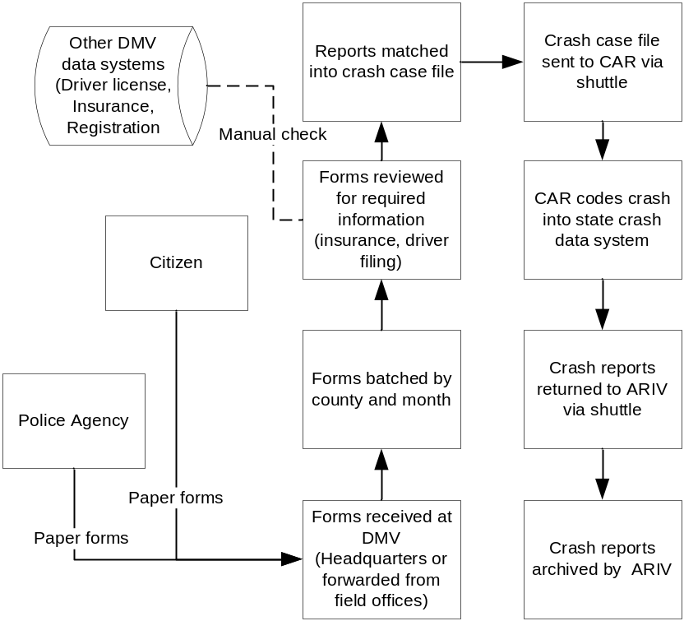
Figure 4 Oregon DOT Crash Reporting and Coding Process

When a set of crash forms is considered complete, the forms are sent in batches to the Crash Analysis and Reporting (CAR) Unit by shuttle to synthesize the data into one comprehensive crash. It is interesting to note that there are a number of crash cases that do not get sent to CAR for coding because the file is not complete or was not received by DMV in a timely manner. CAR is interested in recording all of the information from the form, except for the insurance information. Essentially, CAR is interested in everything that DMV is not. When forms arrive at CAR, the coders verify that it is reportable in the statewide file. Examples of incidents that are not reportable include those that occurred on private property or intentional crashes. These non-reportable crashes are sent back to the DMV and not entered in crash database. Next, the crash coder must weave together the citizen and police reports into composite picture of a crash. There are frequent discrepancies between the information given by the police and the information given by the drivers which forces the coders to use discretion to sort out the details of the incident. Experience is very useful and coders use online and paper maps to pinpoint the location of an incident.
As one would expect, creating useable data completed by essentially untrained citizens can be a challenge. Fourteen staff at CAR work on coding the approximately 50,000 crash records each year in Oregon. In Figure 5, the annual numbers of crash reports that end up being coded as a crash in the state crash data system (CDS) are shown. The chart shows 3 counts: 1) when the crash is coded from citizen reports only (CITIZEN ONLY), 2) when the citizen’s report indicates the police were on scene but no report was received (POLICE ON SCENE, NO REPORT), and 3) when the crash was coded with an accompanying police report (POLICE REPORT). Both category 1 and 2 are based on citizen crash reports. The decline in total reports in 2004 can be partially attributed to a change in the reporting threshold. Finally, it is also shown in the figure that there has been a declining trend for officers who respond to a crash scene but do not complete a report. This could be that fewer police are attending to minor crashes or that there has been an increase in the number of police filing reports. Finally, it should be noted that there is an additional process for crashes involving motor carriers (commercial trucks) that has additional data requirements and forms. There is a form that is submitted directly to the Crash Analysis and Reporting unit. These motor carrier crashes are not included in this research.
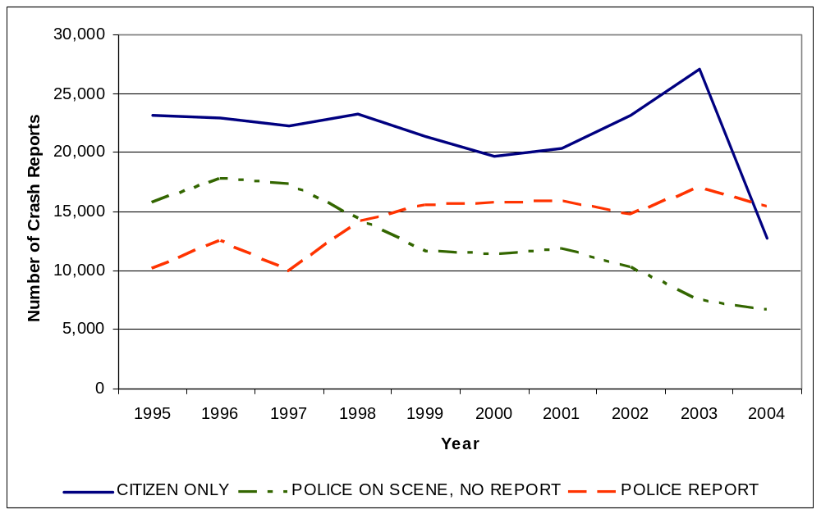
Figure 5 Number of Crash Reports Coded by Year, 1995-2004

ANALYSIS OF COMMON CITIZEN ERRORS
In order to quantify the potential accuracy improvements generated by an improved crash reporting process, a system to compare police reports to citizen reports for a sample of crashes was developed. Case files were obtained from ODOT for just over 200 crashes. The original research goal was to compare police reports to citizen reports with the working assumption that a trained officer’s report is more likely to be accurate. The crash coder’s interpretation of the crash report was also available to confirm errors, but the crash coder’s results were not evaluated for error. In reality, since police officers are not required to report to the scene of crashes in Oregon, many files do not include a police report. The reports were therefore compared to other citizen reports in those cases. The reports selected did include a small number of single vehicle crashes with no police reports, which were only evaluated for completion.

Crash Report REVIEW
One of the goals of this research is to quantify the potential improvements in accuracy if the crash report were a web-based form. The literature certainly implies that most information captured over the Internet is as good as or better than paper-based collection. A research method to compare citizen reports to police reports was developed to establish where errors (both incomplete and inaccurate information) were frequently occurring in citizen reports. The possibility of reducing these errors with a web-based system is then estimated and quantified. As discussed in the introduction, the method was also used to compare citizen reports to other citizen reports when no police report was available.
In order to quantify common mistakes, an audit form was designed to evaluate the information provided in citizen reports. 207 crash files were provided by ODOT for analysis. The files reviewed represented four counties and occurred during the month of August 2005. The eleven most important categories of information reported by citizens were selected. The audit form was then designed to assess these areas:
- Form completion | - Light
- Location | - Direction of movement
- Type of crash | - Injury
- Date/Time | - Safety equipment (Seat belts, airbags)
- Weather | - Diagram (Schematic drawing of crash)
- Road Conditions
Additionally, the crash ID number, county of incident, urban or rural location, intersection or segment location and, if applicable, responding police agency were collected so that forms could be contrasted. Each area was evaluated for completion of information as well as consistency between citizen reports and police reports. In situations where no police report was available, the citizen forms were only compared to each other. When it was a single vehicle crash and no police report was available, the form was evaluated for completion and for errors in categories that were mutually exclusive (i.e., weather: raining, road: wet). Table 1 summarizes the number of crash reports reviewed as well as the information collected about the county, urban or rural location, whether the crash occurred at an intersection or segment, and police agency. Multiple reports indicate crash files where more than one citizen or at least one citizen and a police officer filed a report form. Single reports indicate crash files where only one citizen report, and no police report, was available.
Because crashes are processed by Crash Analysis and Reporting Unit at ODOT in monthly, county batches the sample was restricted to a four counties (Lane, Malhuer, Marion, and Washington). The sample, however, is a fairly good cross section of urban and rural environments typical in Oregon. It was also important to observe the difference between reports filed by persons who were involved in crashes within 25 miles of their home versus people who were farther away from home. The conjecture was that people close to home would file more accurate reports, especially with regard to location. However, as Table 1 shows, about 85% of the crash reports came from people within 25 miles of home. It is also unknown how much, if at all, errors might have a seasonal variation since only one month was sampled.
Table 1 Summary of Crash Reports Reviewed in the Analysis
Data Field | Multiple reports | Single Reports
Number of citizen reports reviewed | 297 | 52
Number of crashes | 155 | 52
Sex of Driver
Male | 162 | 32
Female | 135 | 19
Residency of Driver
Oregon resident w/in 25 miles of home | 256 | 47
Oregon resident 25+ miles from home | 23 | 1
Non-resident | 17 | 2
Unknown | 1 | 1
Reports Per County
Lane | 111 | 28
Malheur | 35 | 2
Marion | 63 | 3
Washington | 88 | 18
Road Character
Urban | 183 | 11
Rural | 59 | 39
Location of Crash
Intersection | 130 | 24
Segment | 125 | 27
Police Response (Agency)
City | 59
County | 27
State | 39
Total with Police | 125 | n/a

FInDINGs: TYPES OF ERRORS
Two types of errors were identified: inconsistencies, which are pieces of information that conflict with other pieces of information on the same report or on another report, and incompleteness, which is when the information was not provided. The evaluation was not an effort to decide which driver was ‘correct’ in the cases of inconsistencies, it was only noted that there was a difference. Inconsistencies and incompletes were counted for each of the reports reviewed. Pages 1, 2, and 3 were evaluated first for completion. Completion was determined if the driver had attempted to fill out any information on the page. Page 1 must be completed or else the form will not be accepted by the DMV, so no incompletes were recorded. Page 2 of the form collects specific information about the conditions and cause of the crash: weather, road conditions, light, direction of movement, injury, safety equipment, and the diagram. This information is very important for the crash data, but in 19 cases the page was skipped altogether. Drivers may not be aware that there is a second page of the form, or may be frustrated by the amount of information requested. It should be noted that page 3 of the accident report form is optional unless more than two drivers were involved in the crash. The vast majority of the crashes reviewed involved one or two drivers, so page 3 was unnecessary. The percentage of incompletes for pages 2 and 3 are comparable, which implies that these extra pages are easy to skip when they are required. Table 2 summarizes the audit results.
The location of the crash is one of the first pieces of information collected on the form, and it was usually filled out. It was not possible to determine the true location of the crash in order to evaluate the ‘correctness’ of the location since the “true” location is unknown. It was possible to determine that there were a large number of inconsistencies on location. For example, when a crash was located near an intersection, sometimes different drivers would record it on different streets. Other drivers provided minimal or confusing information about their location. In contrast to the number of errors in location were the numbers of highly specific locations given that matched with police descriptions. Although it was impossible to determine exactly in most cases, anecdotal evidence indicates that the responding police officers frequently provide the citizens information for their reports. It is suspected that this happened whenever a citizen’s report gave precise milepost numbers that matched the police report and other drivers’ reports verbatim.
Considering that date and time should be the least emotional or precise part of the report, there were a surprising number of inconsistencies. The time was considered to be inconsistent if it was more than 30 minutes different from the other driver or police report form. A surprising number were several hours off. Additionally, there were cases where the date was different between reports. The errors for weather, light, and road conditions were comparable in numbers. These are ‘judgment calls’ in some cases. A driver may have to determine if an early morning crash occurred at dawn or full daylight. The errors that are most important occurred when drivers checked conditions that could not happen at the same time, such as “raining” for weather condition and “dry” for road condition.
Direction of movement was the most problematic of all the fields. People appear to not be comfortable using compass directions. Frequently, different drivers would report conflicting directions of travel. Complicating the comparison, the police report form does not ask for direction of movement as a data field but is included in narrative or sketch if given. Therefore, the inconsistencies reported come from comparison with the other citizen reports, or with details in the police narrative when available. The large number of mistakes indicates a problem, as does the large number of incomplete responses, and may not reflect the true magnitude of the problem.
The most difficult part of the citizen reporting form to decipher is the box on page 2 that collects information about injuries and safety equipment (see Appendix). Citizens must use two different lists of codes to fill in small boxes indicating level of injury and safety equipment used for all passengers. The code system is not the same for injury and safety equipment, and it may be difficult to decipher for many people. It was the most frequently skipped part of the form. Following closely in number of skipped responses was the diagram. Although many drivers clearly spent much time working on their diagrams, in some cases the driver did not fill in the diagram. A notable number of the reviewed diagrams were inconsistent with other information given in the form, such as direction of travel, or other citizen or police report forms.
Table 2 and Table 3 summarize the total number of incomplete versus inconsistent errors. Table 2 summarizes all crashes that had more than one form filed (one citizen and police, more than one driver and police, more than one driver). Table 3 summarizes the results for crashes where only one report was filed by a citizen and no police report was filed which represent 52 of the 207 crashes reviewed. Although these reports were reviewed mostly for completion (since there was not another form to compare them to) there were some clear inconsistencies within the report. The results indicate that incompleteness is more of a problem than inconsistency, but it is much easier to determine incompleteness than inconsistency. Inconsistency may be a more significant problem than the review was able to assess.
Table 2 Crash Error Summary, Multiple Report Crashes
 | Incomplete Count | Incomplete %  of reports | Inconsistent Count | Inconsistent %  of reports | Total Error
Page 1 | 0 | 0% | n/a | n/a | 0
Page 2 | 19 | 6.40% | n/a | n/a | 19
Page 3 | 4 | 6.78%* | n/a | n/a | 4
Location | 5 | 1.68% | 31 | 10.44% | 36
Type of crash | 7 | 2.36% | 2 | .67% | 9
Date/Time | 11 | 3.70% | 23 | 7.74% | 34
Weather | 17 | 5.72% | 8 | 2.69% | 25
Road Conditions | 19 | 6.40% | 3 | 1.01% | 22
Light | 26 | 8.75% | 16 | 5.39% | 42
Direction  of movement | 26 | 8.75% | 50 | 16.84% | 76
Injury | 60 | 20.20% | 5 | 1.68% | 65
Safety equipment | 63 | 21.21% | 4 | 1.35% | 67
Diagram | 59 | 19.87% | 23 | 7.74% | 82
Total | 316 |  | 165 |  | 418
* only required for 18 crashes, 59 drivers reports
Table 3 Crash Error Summary, Single Report Crashes
 | Incomplete Count | Incomplete %  of reports | Inconsistent  Count | Inconsistent %  of reports | Total Error
Page 1 | 0 | 0% | n/a | n/a | 0
Page 2 | 4 | 7.69% | n/a | n/a | 4
Page 3 | n/a | n/a | n/a | n/a | n/a
Location | 0 | 0% | 2 | 3.85% | 2
Type of crash | 4 | 7.69% | 0 | 0% | 4
Date/Time | 0 | 0% | 4 | 7.69% | 4
Weather | 5 | 9.62% | 2 | 3.85% | 7
Road Conditions | 5 | 9.62% | 1 | 1.92% | 6
Light | 6 | 11.54% | 1 | 1.92% | 7
Direction  of movement | 10 | 19.23% | 2 | 3.85% | 12
Injury | 12 | 23.08% | 0 | 0% | 12
Safety equipment | 14 | 26.92% | 0 | 0% | 14
Diagram | 11 | 21.15% | 0 | 0% | 11
Total | 71 |  | 12 |  | 83
Figure 6 summarizes that total number of errors per report. The average number of mistakes per form was approximately 1.6, out of 13 areas, which means there is approximately a 12% error rate. As shown in Table 2, errors are occurring at a high frequency in certain places on the forms. Different groups were evaluated to see if there was a difference in the error rate: counties, gender, distance of residence, and presence of police report.
The lowest number of errors came from Lane County, at 1.3 errors per form. The most came from Marion County, at 2.3 errors per form. All other groups fell in this range, which is not a significant difference. The means for each subgroup were tested for a statistically significant difference using a one sample t-test. The p-value among the counties, which had the greatest variance from the mean among the subgroups, is 0.660, so the means of the counties are not statistically different from the overall mean number of errors. The p-values for the other subgroups were not significant either, and their variance from the mean is smaller. For gender the p-value is 0.940, for distance from home it is 0.563 and for police report filed it is 0.834 which are all much greater than 0.05. It is of particular interest that people who were more than 25 miles from home had only slightly more errors than people who were close to home. More errors were expected, particularly in location and direction. A connection between having a police officer file a report and form completion was investigated as well, but showed only a slight difference whether or not a police officer was involved. There were slightly more errors noted when the police report was filed, but this is probably because it was easier to detect errors when the police report was available for comparison.

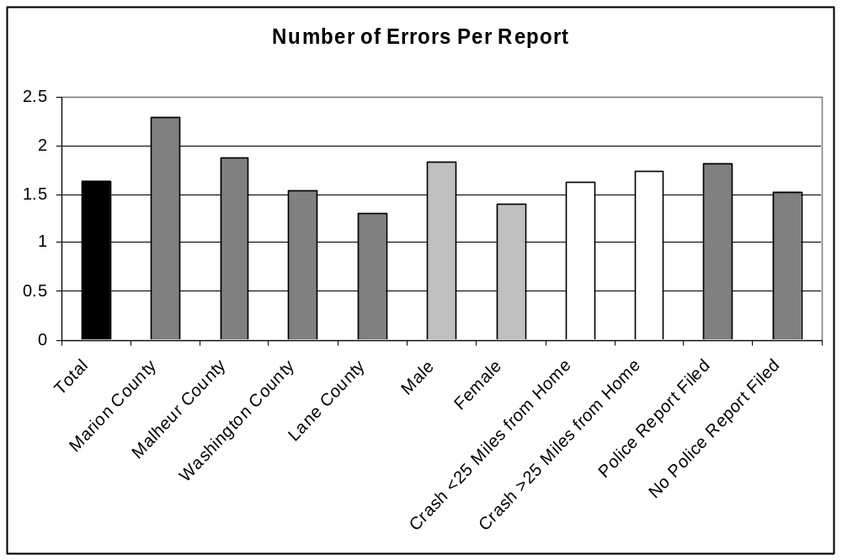
Figure 6 Errors per Report, by Category

FIndings: Potential Improvements
The review of reports indicates that there could be substantial improvements in data quality from a web-based form. An online form will not reduce simple human error, but it could contain safeguards that ensure more information will be captured and it could contain more information to help drivers report accurate information. First, an online report could require that information be completed before the form can be submitted. This function could reduce most, if not all, of the missing information. This would have the largest impact on the detail information on page 2 that is frequently skipped. Automated fields could also be created to reduce citizen burden. For example, the injury and safety equipment box on the form requires the driver to record the names of everyone in the car, even though they have already filled out their own name and information on page 1.
The location data could be improved using a map-based location tool. Internet map sites, particularly Google, are extremely accurate now and many citizens (who use the Internet) are accustomed to using them for directions. Using a similar site to locate a car crash would not be much different. There would still be potential for errors, but no more so than now when drivers are asked for a literal description of crash location. Some date/time errors may occur no matter what format is used to collect the data, but it would be possible to use a pop-up style calendar to help drivers select the date. This would also prevent against discrepancies between the date and day of the week fields. Time of crash errors are more difficult to fix, and will probably occur with any system.
Weather, road conditions, and light fields could easily be programmed so that opposite selections (raining and dry) could not be selected at the same time. Drivers could still make a mistake and report inaccurate information (as long as it was reasonable), but this would cut down on the number of errors. If drivers could access the Internet form faster than waiting to go to the DMV a few days later to pick up a form they may have a clearer memory of the event. It may be difficult to rectify the direction of movement error, but if drivers were offered a better location and diagram tool then direction of movement may not be necessary at all. The injury and safety equipment information could be made more user friendly (and should be- even if the paper form is kept as the primary reporting system) with an online system. The diagram box could be greatly improved by sample crash sketches for drivers to select from. For example, all rear-end crashes can be represented the same way, and with a good location and narrative it might provide the crash coders the most accurate characterization of the crash. The sample sketches could also be adaptable to allow the driver to provide more detail about his or her specific crash. Anecdotally, it seems that a large number of people who filled out reports had trouble describing the crash in the narrative section. Some forms were even filled out in Spanish. Although an online form would probably not help an underserved population (since they are less likely to have access to the Internet), this does indicate that there are many different needs that are currently not served by the English language paper form.

Summary
The data collection method used police forms as a comparison and did not evaluate or quantify errors made there; however, mistakes were discovered. This report has mostly focused on improving the citizen report since they are the source of the majority of Oregon’s data, but the police forms could use the same improvements. Police officers are perceived to generally be more accurate than citizens because they are more used to their forms and the information required, but they can still make mistakes and an electronic form could greatly reduce the time it takes them to file.
It should be noted that the quality of crash data reported by citizens was a major concern behind this research project. After reviewing the actual crash files, it was noted that most drivers are actually very good about filling out the crash report form. Even when drivers make mistakes, the coders are frequently able to determine the true events based on the other reports, or based on other information provided by the driver. In conclusion, there are clearly many areas where improvements can be made to facilitate citizen reporting. Specifically, making it easier for drivers to fill out all fields (and being made aware of the second page of the report) would most likely result in improved data. Also, providing drivers with more assistance for filling out location and direction movement would be helpful.

ASSESSMENT OF CITIZEN interest
In this chapter, the general level of acceptability of using the Internet for transactions with the Driver and Motor Vehicle Services Division are investigated. Two areas were studied to illuminate this issue. First, the DMV already provides a number of services online and the level of use is reported. Second, a simple mailed survey was developed and sent to drivers who have recently filed a crash report to assess the interest in online filing. These two reviews are documented below.

CURRent Usage of DMV Online Services
The DMV already uses online services for address changes (required by law in 30 days after moving) and for vehicle registration renewals in areas without a vehicle inspection requirement. Figure 7 shows a screen capture of the current DMV website for online transactions (www.oregondmv.com). These online transactions can also be accomplished in person at DMV field offices, by mail at DMV headquarters, or in the case of vehicle registrations, at DEQ vehicle inspection stations when required. The percentage of transactions, according to DMV, done by each method is shown in Table 4.
The number of transactions that are done via the Internet is not large, with only about 10% of drivers renewing their driver’s licenses and about 7% of vehicle registration renewals. For vehicle registrations, the online feature cannot be used in Multnomah, most of Clackamas, most of Washington, or Jackson Counties where cars must be inspected by the Department of Environmental Quality. These counties account for approximately 48% of the 2004 population in Oregon and clearly contribute to relatively low usage of these online service. For address changes, the number of transactions is also surprising low, given that this service is available for all Oregon residents. As shown in the survey (next section), many people are unaware that these transactions can be done online. Traditionally, most transactions with DMV are paper-based and many require an in-person transaction. People may just expect to do these transactions with DMV in-person or may be reluctant to use the Internet for services. As the literature review and survey shows a strong interest in using Internet-based interactions with government, the lack of participation may be a marketing issue.
Table 4 Current Usage of DMV Online Services
 | Address Change | Vehicle renewal
Submitted at Field Office | 60% | 35%
Submitted to DMV Headquarters | 29% | 31%
Submitted Online | 10% | 7%
Submitted by Electronic Vehicle Registration (Dealers) | 1% | -
In person at DEQ | - | 26%

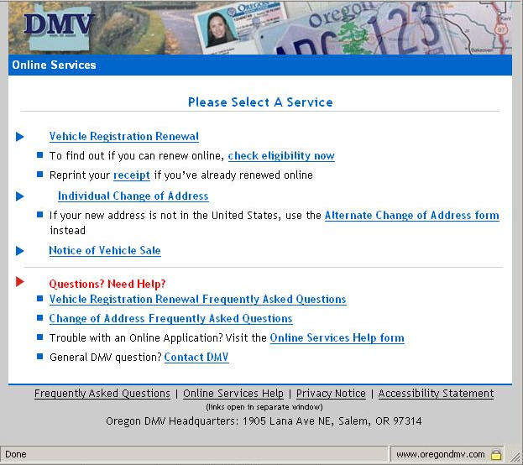
Figure 7 Current DMV Online Services

Survey
In order to gauge the public acceptance of filing legally required crash reports over the Internet, a simple mailed survey was administered. The recruitment list of citizens who have filed crash reports was provided by DMV, with the permission of their internal driver records manager. To create the survey mailing list, the 8,000 potential respondents were reviewed. Obviously incorrect or missing addresses were removed and a random number was assigned to the remaining entries. These were sorted in ascending order and the first 1,000 were selected for mailing.
The survey included a letter of consent informing respondents of their rights, the nature of the survey, and instructions. The actual survey was on a postage-paid postcard with the survey questions on the reverse side. Each postcard was stamped with a unique identification number so that further analysis pertaining to location (urban/rural, county) could be completed. No attempt was made to link responses to the individual’s name in any way to protect confidentiality. Both the letter of consent and survey form were placed in a 6” x 9” manila envelope for mailing. The return address on each envelope indicated “Department of Civil and Environmental Engineering, Portland State University.” There was no indication on the outside of the envelope that it contained a survey. A sample of the informed consent letter and the survey is contained in the Appendix, section 9.3.
The survey was mailed to 1,000 addresses which included a small number of out-of-state residents. Out of the 1,000 surveys, 62 were returned as undeliverable, and 146 were returned completed. The response rate for the survey then, neglecting those returned as undeliverable, was 15%. Based on past experiences, this level of response is reasonable and was within the expectations of the researchers. As shown in Figure 8, surveys were returned from a majority of the state, from both mainly rural and mainly urban counties.
After a period where no further surveys were returned in the mail, the survey responses were summarized and are shown in tabular format in Table 5 and graphically in Figure 9. The results show that 86% indicated that they were aware that there was a legal requirement to file a crash report with the DMV. As the survey pool only included those that have filed a report, this may not reflect the whole population. Also, the wording of the question or the impression that the survey was being shared with enforcement may have biased respondents to report that they knew of this requirement. The results also show that the vast majority of people still use paper forms, which they indicate were obtained from the DMV (55%) or from the police officer at the crash scene (15%). Only 16% obtained the form from the DMV’s website in PDF format. One hypothesis is that using an online form may allow people to more accurately define the location of the event. A strong majority of people (77%) had personal knowledge of their crash location, which they used to fill out the form. Most survey respondents found the form easy to use (68%). Nearly equal percentages of respondents prefer to use paper or the Internet to file an accident report. Most people were not aware that they could use the Internet to do other services with the DMV. Analysis of the location of the respondents and their answers was conducted but did not find any conclusive links between city of residence and opinions of accident report forms.
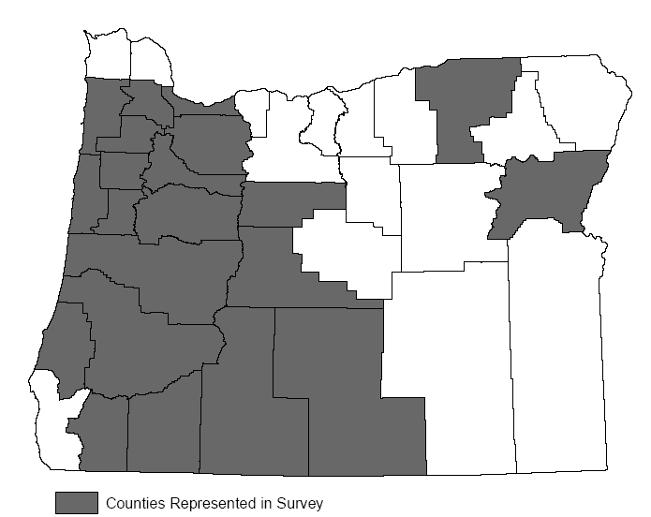
Figure 8 Counties with Survey Responses
The survey shows that there is interest in using the Internet to file accident reports. Although the percentage in favor was 47% (compared to 49% not in favor), this is consistent with the findings in the literature review that about half of Americans have access to the Internet. It is reasonable that people with access to the Internet would be more interested in filing online than people without. In retrospect, it would have been useful to ask survey respondents if they have access to the Internet to highlight whether the issue was access to or reluctance to use the Internet for DMV transactions.
It appears that many people are not informed about how much DMV business is available online. Nearly 68% indicated that they were not aware of this service. This may be due to the fact that e-government is still fairly new, or perhaps that the DMV could better inform customers about how they can take advantage of online tools. Additionally, most people reported that they found the form easy to use, but the survey did not ask more specific questions about the form. The analysis of crash report errors in the following chapter showed that there are clearly parts of the form that are easier than others.
Table 5 Survey Results
Survey Question | Response |  | Number | Percent
Were you aware of Oregon’s requirement that you file an accident report form after a car accident? | Yes  No  No answer |  | 126  34  3 | 86%  23%  0.02%
If you completed an accident report, where did you get the form? | PDF from DMV website  Paper form from DMV  Paper form from police officer  Other  No answer |  | 24  81  20  19  2 | 16%  55%  15%  13%  0.01%
If you completed an accident report form, how did you determine your location? | Map  Police officer  Personal knowledge of location  Other  No answer |  | 6  14  113  5  8 | 0.04%  10%  77%  0.03%  0.05%
Did you find the accident report form easy to use? | Yes  No  No answer |  | 99  40  7 | 68%  27%  48%
Would you prefer to use the Internet to file an accident report form? | Yes  No  No answer |  | 69  72  5 | 47%  49%  0.03%
Are you aware that you can change your address and renew your registration (in some counties) online at oregondmv.com? | Yes  No  No answer |  | 46  99  1 | 32%  68%  0.01%
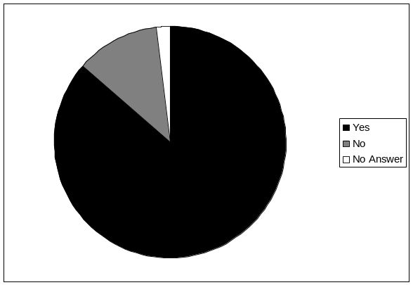 |  | 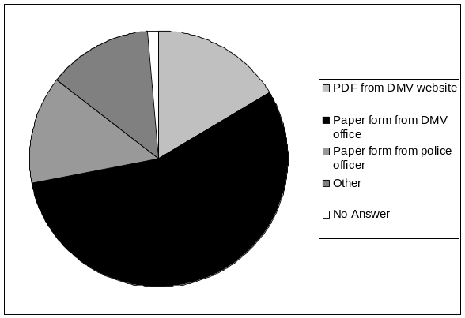
Were you aware of Oregon’s requirement that you file an accident report form after a crash? |  | If you completed an accident report, where did you get the form?
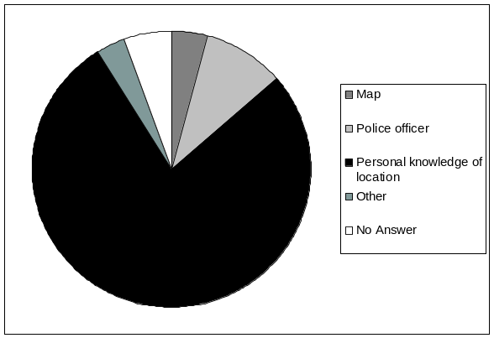 |  | 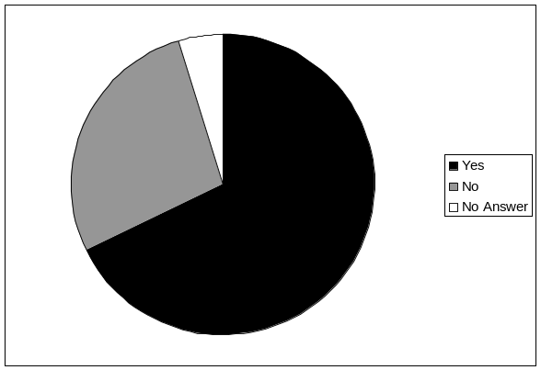
If you completed an accident report form, how did you determine your location? |  | Did you find the accident report form easy to use?
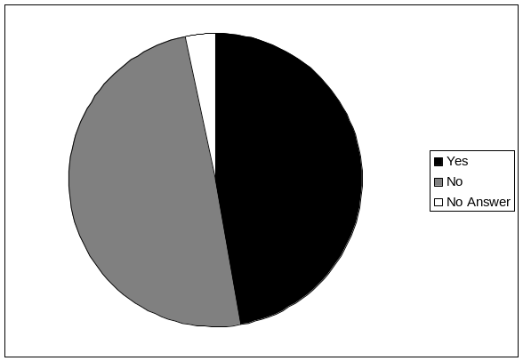 |  | 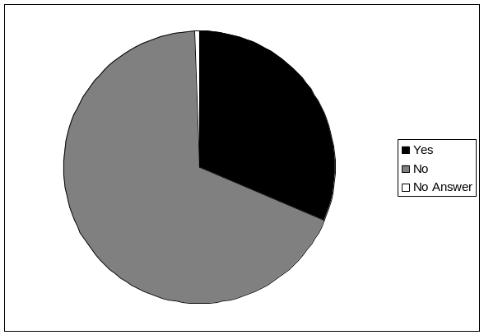
Would you prefer to use the Internet to file an accident report form? |  | Are you aware that you can change your address and renew your registration (in some counties) online at oregondmv.com?
Figure 9 Survey Results

Summary
Given the ease and convenience of Internet transactions, a surprisingly small number of DMV transactions are conducted in that manner. It appears that the existing DMV online services for vehicle registration renewal and address change are under utilized given the ease and potential time savings they represent. The survey may yield some insight for public outreach since most people were unaware that they could conduct this business online. Additional “marketing” of these services may increase their use. Alternatively, people may prefer to conduct their transactions in paper or in person, since many DMV transactions have a legal requirement. The survey indicated that people are generally comfortable with the existing process, finding both the form easy to use and the process satisfactory. According to the survey, nearly 50% (but not the majority) of respondents would prefer to file a crash report over the Internet. The following chapter will use the information from this assessment and estimate the feasibility of implementing an electronic crash reporting system for Oregon.

FEASIBILITY Analysis
This chapter presents the feasibility of implementing a web-based system of crash reports. The chapter also documents potential efficiency increases and estimates the high-level benefits that could be accrued if such a system were to be implemented. The benefits estimated in this chapter do not address the value of increased data quality, timelines, or other advantages an electronic reporting process is likely to bring. Finally, a brief discussion of system costs is presented.

Proposed System
Prior to the detailed discussion about feasibility of an electronic crash reporting system, it is necessary to briefly describe how such a system might work. The challenge of a system in Oregon is that it would have to integrate with the existing process and legal requirements. As shown in Figure 10, a dual paper and electronic system is likely to be needed for some time since some citizens and police agencies may still file paper reports. It is envisioned that if the portal for electronic citizen reporting is opened, some police agencies may elect to submit forms via the portal or through another means via their individual agency information networks. There are a number of existing systems in use that could be modified for an electronic crash reporting system. Another option would be to use the fillable PDF form developed by the Transportation Safety Division at ODOT that includes a database interface (data input in the form can be exported to a database format).
With an electronic crash reporting system all reports would first go to the ARIV unit at DMV. Crash reports from multiple drivers and police agencies would still need to be assembled into one “file” for review. This process could be substantially automated by matching reports based on a number of fields (date, county, driver name, road). There would still need to be a manual review of the matched forms, with some requiring more time than others. A potential issue is that many drivers and police agencies wait until much later than the legally required 72 hour reporting period after a crash to file reports. This would result in some time delay before reports could be matched. This problem exists in the current process as well. All information from the paper-based forms would still be coded manually into the developed database system. This would result in slightly more coding effort than is currently done at ARIV (but would reduce this coding at the CAR unit).
At this step, all forms would be available in the system database for review by ARIV for legal and insurance compliance. It would be possible to integrate the system with other data systems such as insurance, driver records, and registration to increase data accuracy (although that level of integration would require an entirely separate analysis).
Finally, when the assembled crash reports are approved they would be sent to CAR for coding review. Single driver crash forms would require very limited review except for location and crash description. Depending upon the software design or changes to the form, some fields could be automatically populated in the states’ crash data system. The system would allow coders to easily view where reports were in agreement on a number of fields which could then be automatically entered in the crash data system. Inconsistent fields would have to be reviewed by coders prior to being entered in the system.
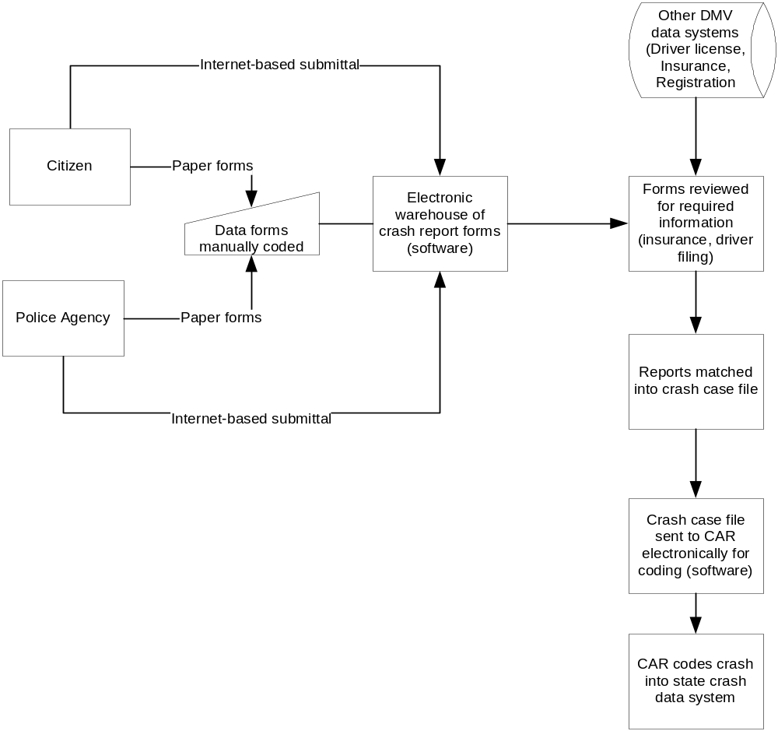
Figure 10 Proposed System for Electronic Crash Report Filing

INSTITUTIONAL AND TECHNICAL ISSUES
Institutional barriers can include legal restrictions, process restrictions, or staff restrictions. In terms of legal restrictions, the interviews did not reveal any barrier to allowing citizens to file reports over the Internet. If an issue is discovered in statute or administrative rule, the perception is that changes would not be difficult to implement. As with any system that transitions to electronic format from paper, there is the perception of increased risk for loss of data. However these concerns are minimized with a well designed system. Oregon’s strong privacy laws relating to DMV records would need to be adequately addressed with a secure system and strong protocols for handling data records.
Technical barriers include those related to existing or required technology that must be modified. Clearly, the notion of using the Internet to allow citizens to submit and complete forms is a mature technology. The major technical challenge would be integrating a system into the current process consistent with the reporting laws. As a major state agency with a number of similar technical projects, the Oregon Department of Transportation is well equipped to handle the technical challenges of developing a web-based crash reporting system. As shown in the previous chapter, DMV currently accepts a number of transactions from their drivers integration system. There are a number of examples within DMV as to how to incorporate or accept the transfer of information from an outside agency or company. However, DMV’s IT staff is currently overloaded with work from other projects mandated by federal legislation and it could be some time before this effort would receive priority for development.

Benefits
The benefits of full scale implementation could include improved data accuracy, improved timeliness, and reduced data entry burden on ODOT units that handle crash reports, the Accident Reporting and Insurance Verification (ARIV) and the Crash Analysis and Reporting (CAR) units. Essentially, the benefits are cost reductions that result from the improvements in the existing process. The cost reductions are primarily in labor savings to the ARIV and CAR units. There would be additional benefits from improved data for users of the system but these are not quantified in this report. In this analysis, it was assumed that time savings translate into a cost-savings for ODOT as a means to estimate the feasibility of an electronic system. In reality, the labor savings of the electronic process may simply be redistributed to other units that are currently understaffed. Other cost reductions such as storage costs or paper form printing costs are not estimated. The analysis does not include any benefits that may accrue to citizens in terms of time savings (not having to report in person or mail crash report to DMV). It also does not include any labor or cost savings that are likely to accrue to police agencies that currently file reports via paper. Finally, a 10 year period was used to evaluate the potential benefits, with an assumed deployment year of 2006 is used in this analysis.
In order to estimate the potential benefits, a forecast of the number of reports filed electronically was made. Using the statewide crash data system, the total number of reports per crash was determined for the three year period of 2000-2003. Data from 2004 were not used due to a change in reporting threshold that became effective in 2004 which affected the number of reports filed. The law change was confusing and the number of reported crashes will likely continue to follow the previous year’s trend. This assumption is based on historical analysis of past reporting threshold changes. In nearly every instance where the threshold has been raised, there were initial declines in the number of reported crashes but they returned to the trend observed before the changes in a short number of years. The statewide crash data system (CDS) records if a public safety agency filed a report, whether they were on scene but did not file a report, or if there was no public safety report. Also included in the CDS is the total number of vehicles involved in the crash. For the purposes of this analysis, it was assumed that every driver in the crash filed a report. However, it is known from interviews and research that the CDS is only an estimate of the number of reports that are filed. In some cases, CAR may enter information about another vehicle even if they do not have that driver’s report (since not all drivers are legally required to file). In other cases, ARIV may receive a driver’s form but not send them to DMV for a number of reasons (legal, time delay, record keeping). The CDS, however, appear to be the best estimate of the number of crash reports filed each year.
Reports are categorized based on the number of forms filed per crash. As shown in Table 6, the number of reports with only one crash report form is relatively few (8%). All other reporting combinations were considered as multiple reports with 2 reports, either by a driver and police officer in a single vehicle crash (10%) or by two reports from citizens (56%). The remaining reports with 3 or more reports per crash make up the remaining 26% of crash reports filed. The 2001-2003 data were averaged for all reporting scenarios. It should be noted that based on interviews with ARIV, approximately 20% of the reports received are not transmitted to CAR. Accordingly, the number of forms received by ARIV is increased by 20% over what is indicated in the CAR data.
Table 6 Types and Combinations of Reports Received by ODOT, 2001-2003
Report Filing Combination | 2001 | 2002 | 2003 | Average
1 Report | 3,838 | 3,840 | 3,640 | 3,773
2 Reports, Police One Driver | 5,010 | 4,675 | 5,315 | 5,000
2 Reports, Citizens | 26,316 | 27,494 | 28,937 | 27,582
3 Reports, Police, 2+ Drivers | 10,887 | 10,093 | 11,720 | 10,900
3 Reports, 3+ Drivers | 2,087 | 2,180 | 2,095 | 2,121
Total | 48,138 | 48,282 | 51,707 | 49,376
Note: Estimated from the statewide crash data system (CDS)
Given the rapidly changing technology and uncertainty of the use of a web-based system by drivers (despite the results of the survey), two scenarios were evaluated to estimate the number of crash reports that would be received by ODOT in electronic form, one conservative and the other optimistic. The only difference in these two scenarios is the percent of crash reports that arrive electronically. In the conservative scenario, initially 10% of all crash reports are estimated to be received electronically. This includes reports from police agencies and citizens. As more agencies and citizens become aware of the process, the number of reports is assumed to increase at a linear rate of an additional 5% per year. The optimistic scenario is identical except initially 25% of the reports are estimated to be received in the first year. These scenarios are shown graphically in Figure 11. These numbers are assumptions as there are no other crash reporting models involving such heavy citizen involvement to be studied. However, as noted in Chapter 5.0 approximately 10% of eligible online transactions available are actually processed in that manner. In Kentucky’s electronic crash reporting system approximately 30% of crash reports were submitted electronically three years after the system was deployed (ASTIP, 2004). However, Kentucky accepts reports from police who have a much stronger incentive to file reports electronically. It should be noted that these assumptions are particularly sensitive to the final estimates of benefits (i.e. a higher assumed number of electronic crash reports translates to higher benefits). Finally, based on the 10-year average of the number of crash reports received, the annual growth in crash reports is very nearly flat. A 0.008% annual increase in the total number of crash reports was assumed.
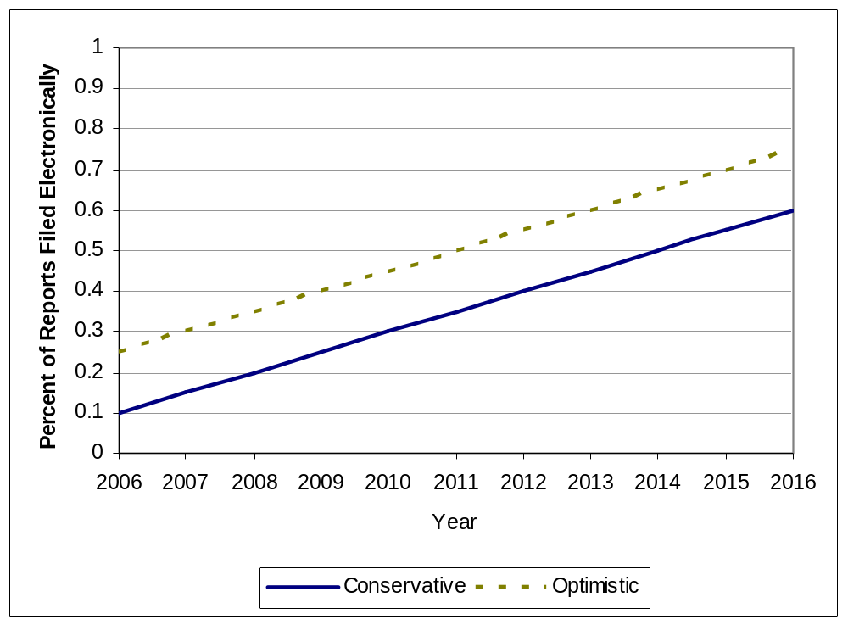
Figure 11 Adoption Rates for Citizens for Filing Electronic Crash Reports

To estimate the potential labor savings, the current time per form was determined. For this analysis, it was assumed that single form crashes take 10 minutes per crash to code and multiple crash forms take 20 minutes (on average). Interviews with CAR revealed that the goal is for 4 crashes per hour to be coded and that coders typically achieve that process rate. Similar estimates were not available from ARIV because of the aggregate manner in which forms are processed. However, based on the total number of forms received and processed and the available staff (20 full-time persons), the 10 minute per single crash and 20 minute for multiple crash report appears reasonable for ARIV as well.
To estimate the potential cost saved per transaction that moves from paper to electronic form using current staffing and workload, a percent of the workload reduction was forecast based on knowledge of the existing process, the proposed process and judgment. The results of this exercise are shown in Table 7. For ARIV, much of the insurance verification process would be automated, greatly reducing the workload for processing these forms. Single form processing is estimated to take 25% of the existing process time resulting in an 8 minute savings. The remaining forms would also likely benefit from increased legibility and reduced errors from an electronic system. Multiple forms would take approximately 50% of the current time because of the additional review and verification required.
For CAR, the coders must still translate citizen reports to the format required by the CDS. Assuming the citizen report remains largely unchanged the forms would still require some interpretation by trained crash coders. Although the electronic process would automate much of the process, the primary time savings would be in the reduction of time spent in coding the forms into the database. Accordingly, single reports would take 60% of the current time, resulting in a 4 minute savings per form. Multiple forms were assumed to have the same labor savings. The time per form saved was translated into a dollar value by estimating the average loaded wage rate for a coder in ARIV and CAR. This estimate was made using employee classifications and published salary rates with an assumed 40% fringe benefit to reflect the true agency cost. This resulted in an average hourly rate of $16.09.
Table 7 Estimated Savings for Electronically Filed Crash Reports
Single Crash Form Only | DMV - Accident Reporting and Insurance Verification | ODOT - Crash Analysis and Reporting
Average minutes to process | 10 | 10
Percent of existing time with E-process | 25% | 60%
Estimated minutes with E-process | 3 | 6
Minutes saved per form | 8 | 4
Multiple Forms
Average minutes to process | 20 | 20
Percent of existing time with E-process | 50% | 60%
Estimated minutes with E-process | 10 | 12
Minutes saved per form | 10 | 8
Labor Costs
Average loaded wage, annual | $33,475 | $33,475
Hourly rate | $16.09 | $16.09
Total Labor Savings Per Crash
Single Forms | $2.01 | $1.07
Multiple Forms | $2.68 | $2.15

To forecast the annual benefits over a ten year period, the number of crash reports estimated to be filed electronically (single and multiple) were multiplied by the total labor savings estimated per report. This was done each year for ten years for both the ARIV and CAR units. The total value for each year was discounted to the present year (2006) using an assumed discount rate of 4%. The results of this analysis is shown in Table 8 and Table 9 and summarized in Figure 12. The total estimated discounted benefits for ODOT are approximately $815,000 for the conservative scenario and $1,180,800 for the optimistic scenario. This appears to be a very conservative estimate given the simplicity of the benefits model and the benefits not estimated (citizen time, police time, paper, mailing, storage, improved data quality). In this analysis methodology, there are slightly more labor savings to the ARIV unit because in the citizen reporting model, CAR coders will still have to interpret the values on each form.

Table 8 Estimated Benefits to Oregon DMV – ARIV Unit
 | Crash Report Forms |  | Percent of Crash Reports Submitted Electronically |  | Labor Savings |  | Total Discounted Benefits
Year | Single | Multiple | Conservative | Optimistic | Conservative | Optimistic | Conservative | Optimistic
2006 | 4,528 | 54,724 | 10% | 25% | 15,589 | 38,973 | 15,600 | 39,000
2007 | 4,564 | 55,161 | 15% | 30% | 23,571 | 47,142 | 22,700 | 45,300
2008 | 4,600 | 55,603 | 20% | 35% | 31,679 | 55,439 | 29,300 | 51,300
2009 | 4,637 | 56,048 | 25% | 40% | 39,916 | 63,866 | 35,500 | 56,800
2010 | 4,674 | 56,496 | 30% | 45% | 48,283 | 72,424 | 41,300 | 61,900
2011 | 4,712 | 56,948 | 35% | 50% | 56,780 | 81,115 | 46,700 | 66,700
2012 | 4,749 | 57,403 | 40% | 55% | 65,411 | 89,940 | 51,700 | 71,100
2013 | 4,787 | 57,863 | 45% | 60% | 74,176 | 98,901 | 56,400 | 75,200
2014 | 4,826 | 58,326 | 50% | 65% | 83,077 | 108,000 | 60,700 | 78,900
2015 | 4,864 | 58,792 | 55% | 70% | 92,116 | 117,238 | 64,700 | 82,400
2016 | 4,903 | 59,263 | 60% | 75% | 101,294 | 126,617 | 68,400 | 85,500
 |  |  |  |  | Present Worth |  | $493,000 | $714,100

Table 9 Estimated Benefits to Oregon DOT – CAR Unit
 | Crash Report Forms |  | Percent of Crash Reports Submitted Electronically |  | Labor Savings |  | Total Discounted Benefits
Year | Single | Multiple | Conservative | Optimistic | Conservative | Optimistic | Conservative | Optimistic
2006 | 3,773 | 45,603 | 10% | 25% | 10,190 | 25,476 | 10,200 | 25,500
2007 | 3,803 | 45,968 | 15% | 30% | 15,408 | 30,816 | 14,800 | 29,600
2008 | 3,834 | 46,336 | 20% | 35% | 20,708 | 36,240 | 19,100 | 33,500
2009 | 3,864 | 46,706 | 25% | 40% | 26,092 | 41,748 | 23,200 | 37,100
2010 | 3,895 | 47,080 | 30% | 45% | 31,561 | 47,342 | 27,000 | 40,500
2011 | 3,926 | 47,457 | 35% | 50% | 37,116 | 53,023 | 30,500 | 43,600
2012 | 3,958 | 47,836 | 40% | 55% | 42,758 | 58,792 | 33,800 | 46,500
2013 | 3,989 | 48,219 | 45% | 60% | 48,488 | 64,650 | 36,800 | 49,100
2014 | 4,021 | 48,605 | 50% | 65% | 54,306 | 70,598 | 39,700 | 51,600
2015 | 4,054 | 48,993 | 55% | 70% | 60,214 | 76,637 | 42,300 | 53,800
2016 | 4,086 | 49,385 | 60% | 75% | 66,214 | 82,768 | 44,700 | 55,900
 |  |  |  |  | Present Worth |  | $322,100 | $466,700

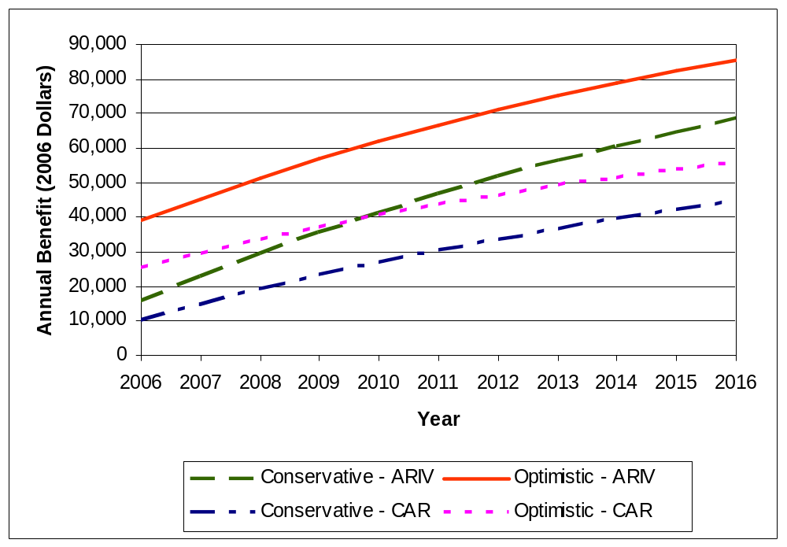
Figure 12 Estimated Annual Benefits for ODOT CAR and DMV ARIV (2006 Dollars)

COST ASSESSMENT
Estimating the costs of a proposed system is a non-trivial task. First, the system in Oregon would have to be uniquely developed to work within the existing process. An enhancement of legacy type systems can be complicated and extremely challenging. The system would have to work with ODOT’s internal data systems for both ARIV and CAR, which are currently on separate systems. An interface would need to be developed that would allow data fields in the electronic forms to automatically populate the two information systems to achieve the primary benefits. These customized requirements serve to increase the cost.
A similar system proposed to accept electronic citations from Oregon courts at the DMV has been estimated in internal DMV documents to cost approximately $250,000 with $12,000 in annual maintenance. However, those providing the estimate indicate that it is very preliminary and has a high degree of uncertainty associated. Further, the estimate is not immediately transferable to the crash reporting project which would be substantial more complicated. Kentucky’s deployment of the electronic crash reporting for police agencies was reported to cost approximately $1,000,000 in 2000. The proposed system for crash reports is no more technical than the court project, but would be slightly more complicated from a overall process viewpoint. As such, it would be reasonable to expect costs to be close to $500,000-$1,000,000. In addition to development costs, the start-up costs for the new system would include staff time for development, staff time for training and staff time for reorganization of the existing crash units. Additionally, the public would require information about using the new system, which could be delivered through a public education campaign.

Summary
This simple analysis indicates that an electronic crash reporting system is entirely feasible within the current motor vehicle crash reporting process and structure. No legal or other issues were identified that would preclude ODOT from moving or developing an online form. Interviews with both divisions revealed that there would be substantial improvement in process flow and accuracy if Oregon moved to some form of electronic capture of crash reports. Currently, staff time is duplicated at CAR and DMV since information is coded from paper forms at both agencies.
The crash reporting system that would be developed to handle these reports in Oregon would be a custom effort since the Oregon process is so unique. However, the process is not so complicated that it could not be replicated or improved with an automated system. The estimate of benefits was based entirely on the time savings to the ODOT units that process crash reports. It was assumed that the time-savings are a suitable measure of the “benefit” for the public agency. In reality, the labor costs may not be eliminated but rather redistributed to other units in the agency that are currently understaffed. In addition, the assumptions used about the number of forms filed electronically and the amount of effort saved per form could have significant impact on the final benefit estimate. As such, the benefits calculated should be viewed as a general estimate of feasibility. Further, not all benefits were quantified. Data improvement is valuable in itself and police agencies are likely to take advantage of the electronic process as the larger agencies move more towards these technologies. Finally, costs of the proposed system are difficult estimate to although it appears that the costs are less than or equal to the estimated benefits.

conclusions
Oregon is one of only a few states that rely on citizen reporting for crash information. Accurate crash data is essential to continued improvement of highway safety in Oregon. Major issues with the current system include efficiencies, data quality, data capture, and timeliness of crash reporting. There are three major areas for improvement in the system: errors made on the report by a police officer or citizen; errors occurring during manual coding processes; and the delay in receiving crash data because of the amount of time required for the manual coding process.
This research indicates that web-based capture of citizen reports would need to be integrated with a completely new electronic process to be most efficient. However, just having an electronic copy of the crash report would provide many benefits. Electronic forms would eliminate manual shuttle transfer of records and result in a more predictable work flow, which now requires overtime by the CAR coders each year. It would eliminate the need to manually track all form movements and store the crash form. Additionally, it would allow more data capture since it would allow DMV to release “incomplete” crash records where not all drivers have filed or had an insurance violation to CAR. CAR does not need a complete case to record data into their system.
This project could save money in the long run, through the elimination of paper, mailing costs, transportation costs for paper records, and staff time. Implementing a new system for crash reporting would require development and implementation of a new system. The start-up costs for the new system would include software and hardware purchases and staff time for development, training, and reorganization of the existing crash units. Additionally, the public would need information about using the new system, which could be delivered through a public education campaign. Security and privacy concerns of citizens would have to be dealt with as well. A pilot project in a few jurisdictions may be the best way to test this program. A new system could not entirely phase out the paper method. Some citizens will still use paper, which will require manual coding by the DMV and CAR. An alternative or complement to an online reporting system could be a scanning system to facilitate the processing of paper forms.
The overall benefits of the proposed enhanced system include higher data quality due to less opportunity for error, ease of collection, ease of information transfer between agencies, and improved customer service. There are additional enhancements available that could improve the data collection and handling such as GPS devices in police cars, in-vehicle reporting for police, a simplified form for citizens, online reporting for citizens, scanning for paper forms, and electronic transfer and archiving of forms between DMV and CAR. As the Internet becomes more accessible and people become more comfortable using it, there is no reason to think that an online crash report would not be at least as or more effective than the current paper report. Oregon places a large burden on citizens to report data.

As a future consideration, Oregon should review the feasibility of shifting the primary data reporting burden from citizens to trained police officers. An electronic system would be much easier to deploy with police as the only ones submitting reports. Crash reporting systems integrated with the patrol car and records management systems would significantly reduce the overall burden of reporting. Since officers receive training based on crash data, their information should be much more accurate. However, there are clear resource issues with this approach which would have to be weighed heavily prior to implementation.

References
Association of Transportation Safety Information Professionals. (2004). Application for Best Practices Recognition 2004.
Ballard, Chet and Rudy Prine. (2002). Citizen Perceptions of community policing: Comparing Internet and mail survey responses. Social Science Computer Review, 20 (4), 485-493.
Best, Samuel, Brian Krueger, Clark Hubbard, & Andrew Smith. (2001). An Assessment of the Generalizability of Internet Surveys.” Social Science Computer Review, 19 (2), 131-145
Borchert, Mark (1998). The challenge of cyberspace: Internet access and persons with disabilities. Cyberghetto or cybertopia?: Race, class, and gender on the Internet. Westport, CT, US: Praeger Publishers/Greenwood Publishing Group, Inc.
Brannen, Anna (2001). E-Government in California: Providing Services to Citizens through the Internet. Spectrum: Journal of State Government, Spring 2001, Vol. 74 Issue 2, p6, 5p
Briggs, Kara. (2004, November 22). Housing, Internet connect for poor. The Oregonian.
Buchanan, Tom. (2003). Internet-based Questionnaire Assessment: Appropriate Use in Clinical Contexts. Cognitive Behaviour Therapy, 32 (3), p100, 10p
Bureau of Justice Assistance, Office of Justice Programs, and the US Department of Transportation. (2003). The Use of Electronic Citations: A Nationwide Assessment.
Cobanoglu, C., Warde, B., & Moreo, P. J. (2001). A comparison of mail, fax, and web-based survey methods. International Journal of Market Research, 43 (4), 441-452.
Conner, Al (2005), Personal interview, April 12, 2005.
Cook, Meghan E. & Mark F. LaVigne & Christina M. Pagano & Sharon S. Dawes & Theresa A. Pardo. (2002) Making a Case for Local E-Government. Center for Technology in Government, University at Albany/SUNY. Albany, NY: Center for Technology in Government.
Cook, Meghan E. (2000) What Citizens Want from E-Government: Current Practice Research. Center for Technology in Government, University at Albany/SUNY. Albany, NY: Center for Technology in Government.
Dawes, Sharon S. (2002). The Future of E-Government. Center for Technology in Government, University at Albany/SUNY. Albany, NY: Center for Technology in Government.
Delucia, B. and R. Scopatz (2005). Crash Records Systems: A Synthesis of Practice. National Cooperative Highway Research Program Synthesis 350, Transportation Research Board, Washington D.C.
Edmiston, K.D. (2003). State And Local E-Government: Prospects and Challenges. The American Review of Public Administration, 33 (1), 20-45.
E-Gov Slowly Gaining Acceptance, but Must Mature. (2004). Information Management Journal, 38 (4), 16.
FHWA/US DOT. (2004). Traffic Safety Information Systems in Europe and Australia. Washington DC.
Gosling, Samuel D., Simine Vaxire, Sanjay Srivastava, & Oliver John. (2004). Should We Trust Web-Based Studies?: A Comparative Analysis of Six Preconceptions About Internet Questionnaires. American Psychologist, 59 (2), 93-104.
Griffith, Michael S. (2003). Data is key to understanding and improving road safety. Public Roads, US Department of Transportation, Vol. 66 (4). Retrieved April 21st, 2005 from http://www.tfhrc.gov/pubrds/03jan/09.htm
Internal Revenue Service, United States Government, Retrieved May 5, 2005 from http://www.irs.gov/newsroom/article/0,,id=138112,00.html
Jensen, Mary (2004) Personal email, November 14, 2004.
Kaylor, Charles, Randy Deshazo, and David Van Eck. (2001). Gauging e-government: A report on implementing services among American cities. Government Information Quarterly, 18, 293-307.
Knapp, Herschel et al. “Using pencil and paper, Internet and touch-tone phones for self-administered surveys: does methodology matter?” Computers in Human Behavior. Jan2003, Vol. 19 Issue 1, p117, 18p
Lenhart, Amanda (2003, April 16). The Ever-Shifting Internet Population. The Pew Institute & American Life Project. Retrieved April 21, 2005 from http://www.pewinternet.org/pdfs/PIP_Shifting_Net_Pop_Report.pdf
Lloyd, Rachel & Otto Hellwig. (2000). Barriers to the Take-Up of New Technology. National Centre for Social and Economic Modeling, University of Canberra. Discussion Paper no. 53.
Gabler, Hampton C. et al. “Use of Event Data Recorder (EDR) Technology for Highway Crash Data Analysis.” (2205). Research Results Digest 298. National Cooperative Highway Research Program. Washington DC: Transportation Research Board.
Office of Justice Programs, Bureau of Justice Assistance and the Department Of Transportation (2003), The Use of Electronic Citations :A Nationwide Assessment
Pardo, Theresa A. (2000 October). Realizing the Promise of Digital Government: It’s More than Building a Web Site. Information Impacts Magazine, 10.
Pettit, Frances Anne (2002). A Comparison of World-Wide Web and paper-and-pencil personality questionnaires. Behavior Research Methods, Instruments, & Computers, 34 (1), 50-54.
ReportBeam Electronic Reporting System for Law Enforcement. Retrieved May 5, 2005 from http://www.reportbeam.com/
Richard, W and Charles Hancock. (2002) Data collection through web-based technology. Swartz Statistical Journal of the UN Economic Commission for Europe, 19 (3) p153, 7p
Strickland, Ora L et al. (2003) Measurement Issues Related to Data Collection on the World Wide Web. Advances in Nursing Science, 26 (4), p246, 11p
TraCS National Model Traffic and Criminal Software. Retrieved May 5, 2005 from http://www.dot.state.ia.us/natmodel/tracs.htm
Hall, James P. “Enhancing the Value of Data Programs: A Peer Exchange.” (2005). Transportation Research Circular Number E-C077. Vale, Colorado: Transportation Research Board.
Truell, Allen D., James E. Bartlett II, & Melody W. Alexander. (2002). Response rate, speed, and completeness: A comparison of internet-based and mail surveys. Behavior Research Methods, Instruments & Computers, 34 (1), 46-49.
West, Darrell M (2000). Assessing E-government: The Internet, Democracy, and Service Delivery by State and Federal Governments. Retrieved April 21, 2005 from http://www1.worldbank.org/publicsector/egov/EGovReportUS00.htm
West, Darrell M. (2003). Global E-Government, 2003. Center for Public Policy Brown University. Providence, RI.
West, Darrell M. (2003). State and Federal E-Government in the United States, 2003. Center for Public Policy Brown University. Providence, RI.

APPENdix

Oregon Citizen report form
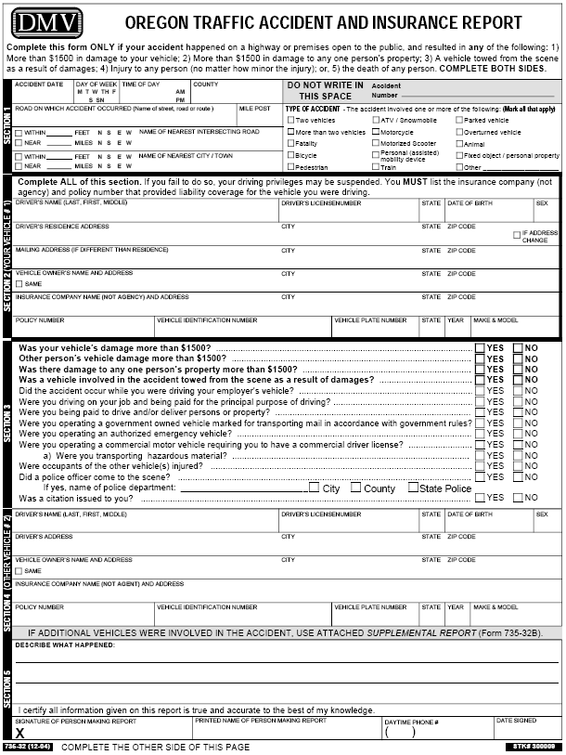
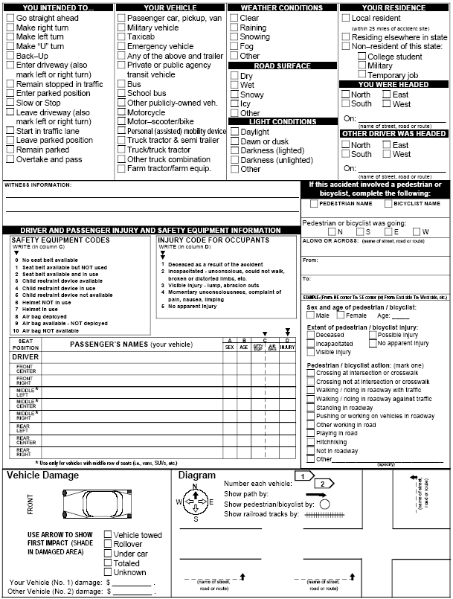
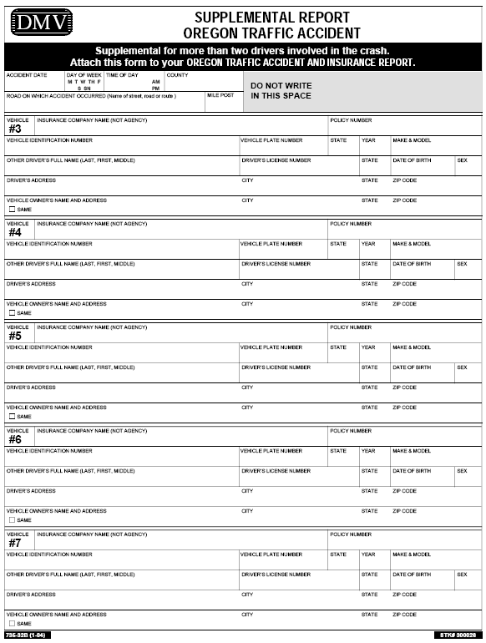

oregon POlice crash report
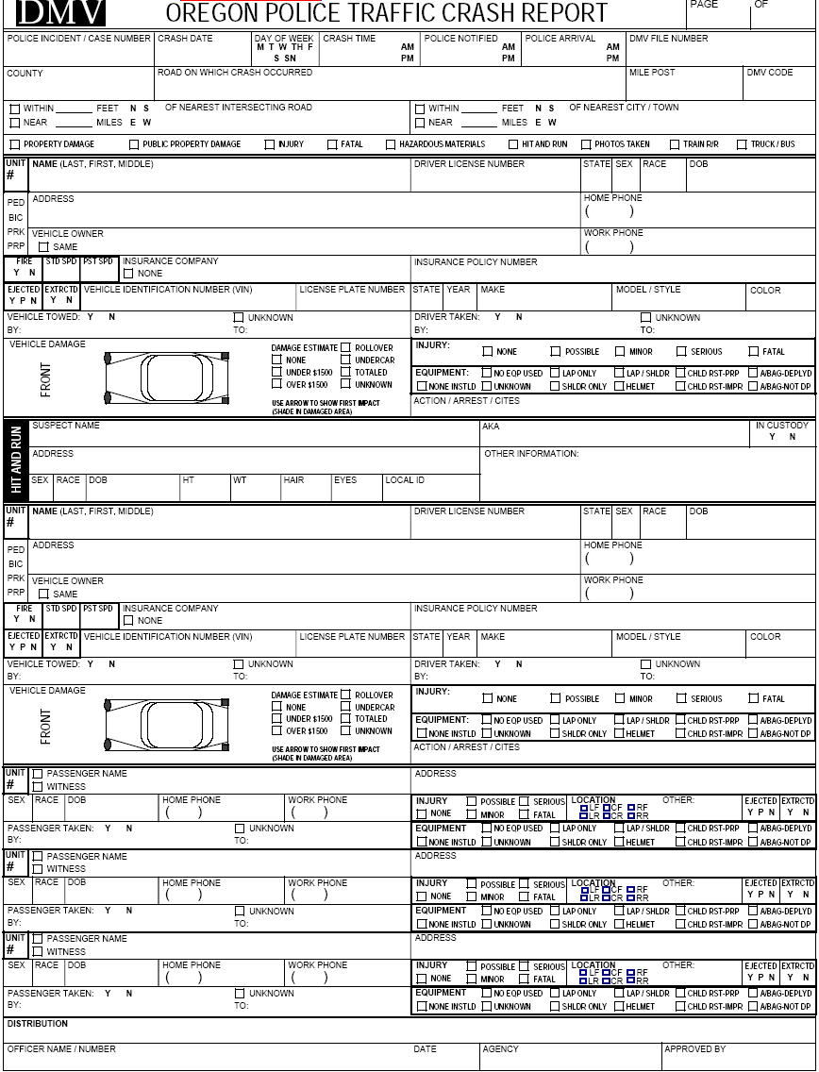
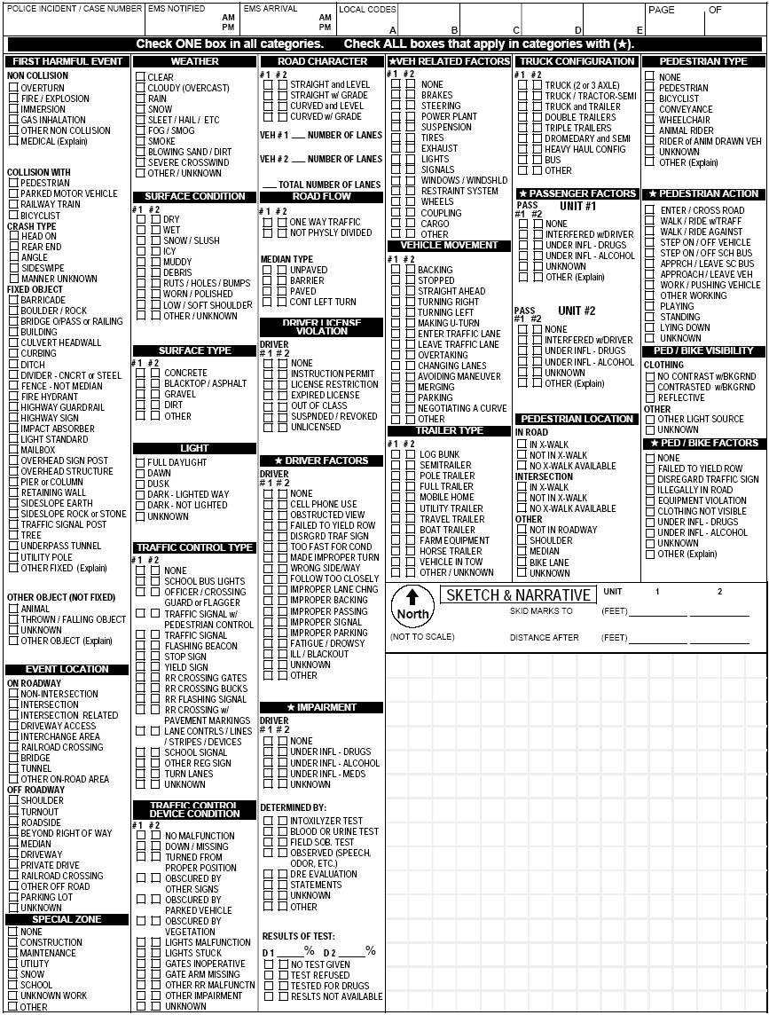

SURVEY


