GPS Fault Slip Sensors

K. W. Hudnut, G. J. Anderson, A. Aspiotes, N. E. King, R. A. Moffitt, K. F. Stark

U.S. Geological Survey - SCIGN
525 South Wilson Avenue, Pasadena, California 91106 USA
(e-mail: hudnut@usgs.gov)

Introduction

GPS can be used in real-time for potentially important emergency response applications as well as many scientific research uses, although scientific uses typically do not require real-time results. Here, we present a new concept to include GPS fault slip sensors into earthquake early warning systems, as an augmentation to seismic inertial sensors. We have successfully tested this GPS fault slip sensor in a prototype deployment on the San Andreas fault as of 15 November 2002.

Of course, the potential for issuing a warning of imminent strong shaking was initially proposed by J. D. Cooper in 1868. The idea has been further developed more recently (e.g., Heaton, 1985; Ellsworth & Heaton, 1994), and seismic systems for this have now been demonstrated and implemented, for example, the Urgent Earthquake Detection and Alarm System (UrEDAS) system in Japan (Nakamura and Tucker, 1988). Some limitations in the robustness and trustworthiness of the systems, as well as costs, may explain why these arrays are not more widespread. To our knowledge, before now, only seismic sensors have been previously considered in designing solutions to this problem. We will describe, and also show test results from, the first deployment of a GPS-based augmentation to earthquake alert systems. GPS can be used to detect surface slip on a fault in real-time. Thus, adding GPS can improve response time and robustness of the system, and can decrease the chance that a small event (without surface rupture) is somehow interpreted by the seismic sensors as being a large event.

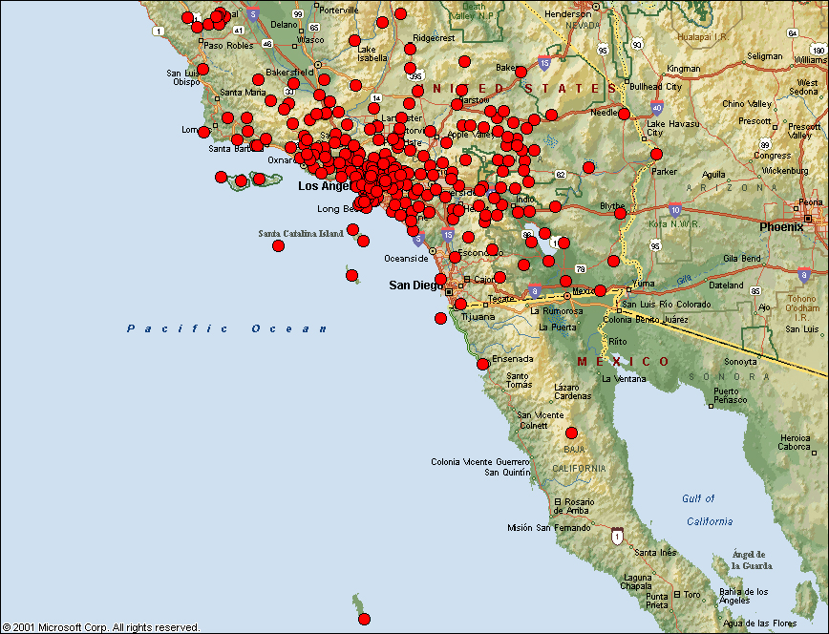
Our system will robustly detect slip on a fault, in real-time, if slip exceeds a few centimeters. Where two SCIGN stations straddle the San Andreas fault near Gorman, the fault is not known to creep, so detected displacement would be a clear indication that a large event has begun. Slip at the ground surface would likely occur within seconds after a large event has begun, conceivably well before the seismic array data alone can yet be relied upon to assess whether the event is large or small. With this, and several other specific cases where we are deploying this instrumentation, we feel that GPS data acquired and processed in real-time can significantly add to earthquake alert systems. Along with real-time use of GPS for monitoring large engineered structures, the potential for providing earthquake information rapidly after future earthquakes, from a variety of real-time GPS systems, is considerable. The GPS slip sensor concept relies upon high sampling-rate data, acquired and processed in real-time. Preferably, the data would be from a braced array that is located close to, and spanning, the main strands of an active fault. Such arrays are not likely to be included in projects that are intended to study longer wavelength deformation of the crust, so may require special 'zipper' deployments along hazardous active faults. Observations from such near-field GPS and broad-band seismic sensor arrays, associated with future large earthquakes, could well provide unique and vitally important data for gaining insight into aspects of the rupture process and earthquake source physics in general.
Figure 1. Map of the operational Southern California Integrated GPS Network (SCIGN)

Methods

Normally, we telemeter data from SCIGN stations once every 4 hours by dial-up telephone line service, or by dial-up through a spread-spectrum radio network. We have upgraded SCIGN standard telephone line telemetry to two stations on either side of the San Andreas fault near Gorman, California. In this case, we made the upgrade to real-time telemetry by using Frame Relay, through device servers to convert the serial protocol data to TCP/IP protocol before streaming the data back through the TriNet seismic telemetry system. Frame Relay service is generally available outside of the Los Angeles metropolitan region, for remote sites, for approximately $200 (US) per month. Figure 2 shows how we do an upgrade from our standard telephone line telemetry system to incorporate and make use of the digital service line (DSL). DSL is generally available in the Los Angeles metropolitan region for approximately $50 (US) per month.

Once the data have been received at the USGS in Pasadena, our main office, we split the real-time data stream and provide these data to multiple computers. We then are able to process the data in real-time, on each computer separately, using one of the several commercially available software packages. Currently two of these are being evaluated as part of no-cost trial demonstration agreement with each of the software vendors. In the future we will also concurrently be testing three or four commercially available real-time GPS processing codes. We then compare the results of the different systems. Our intent is to take real-time ascii output of station position changes from each commercial software package, and then combine those results to produce a single real-time output for use in providing earthquake response information to the public and to other government agencies for their use in emergency operations, etc. This system is only working partly at this time, but the concept is illustrated in Figure 3. At the APEC Symposium we will report on the current status and progress on ongoing development of this system.

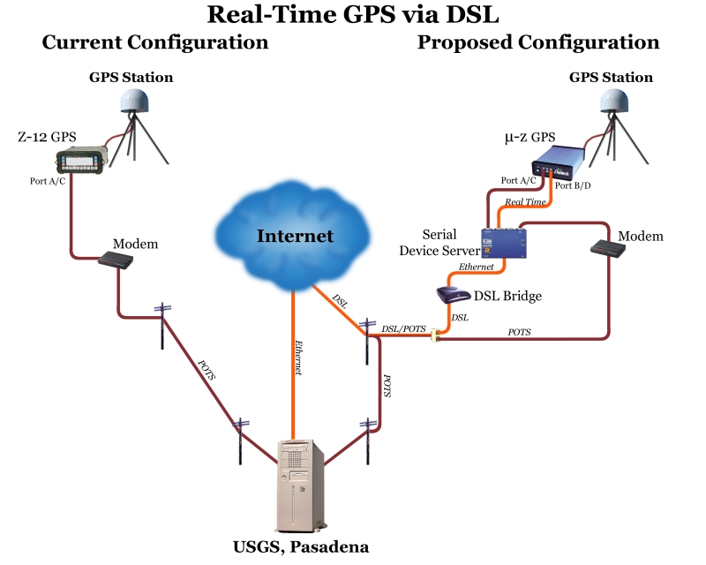
Figure 2. Upgrade from standard SCIGN telephone line dial-up telemetry system to real-time

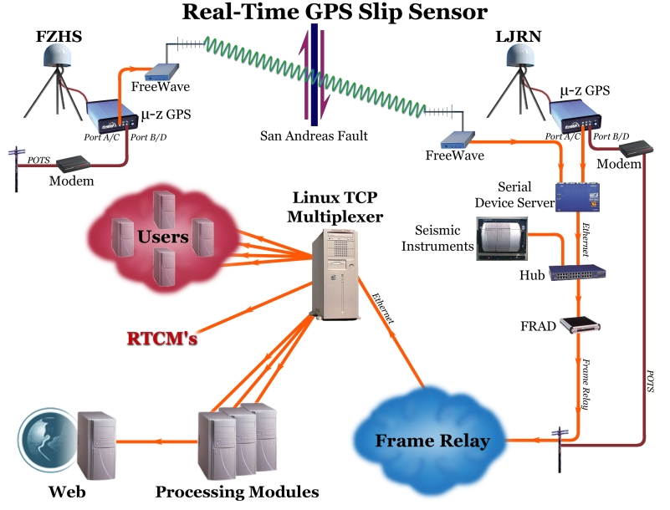
Figure 3. Overall system diagram illustrating the GPS Fault Slip Sensor concept. The prototype system across the San Andreas fault, by the USGS-SCIGN group, was tested successfully for the first time on 15 November 2002.

References

Ellsworth, William L., and Thomas H. Heaton (April, 1994) Real-Time Analysis of Earthquakes: Early Warning Systems and Rapid Damage Assessment, Sensors.
Heaton, T. H. (1985) A Model for a Seismic Computerized Alert Network, Science 228, 987-990.
Nakamura, Y., and B. E. Tucker (1988) Japan's Earthquake Warning System: Should it Be Imported To California?, California Geology, pp. 33-40.

