Fermi National Accelerator Laboratory

P.O. Box 500 – Batavia, Illinois - 60510

TD-00-06
02/01/00

LHC INTERACTION REGION QUADRUPOLE BUS-BARS

TEST-SERIES 2

P. Bauer, L. Chiesa, S. Feher, M. Lamm, A. Zlobin
Fermilab, Technical Division, T&D Department

Keywords: bus-bar, LHC, quadrupoles, quench, superconducting magnets

Superconducting quadrupole magnets with nominal field gradient of 215 T/m in a 70 mm bore, operating in superfluid helium at 1.9K, are being developed at Fermilab and KEK in the framework of the CERN-US-KEK LHC Accelerator Project for the interaction regions (IR) of the Large Hadron Collider (LHC).
This note reports the results of a test of bus-bar prototypes for the interaction region (IR) quadrupoles. The bus-bar design consists of a superconducting cable used as well for the inner layer of the Fermilab IR quadrupoles, soldered to similar Rutherford-type cables as stabilizers. The stabilizers in this test-series were NbTi/Cu composite cables with the same characteristics as the main superconducting bus-cable. In one case the superconducting cable was stabilized with one, in another with two stabilizers. The different designs are motivated by the attempt to find a compromise between
- maximum stability against quenching during normal operation
- minimum temperature rise in the bus-bar after a quench
- maximum quench propagation velocity to accelerate detection of quench
The samples were submitted to operational conditions and characterized with respect to quench propagation velocity and voltage profile during normal zone growth. Additionally, unlike test-series 1, the bus-bars in test-series 2 were tested together with the magnet.
The following note presents the measurement results and a quantitative analysis of the data.

1) Scope of IR QUADRUPOLE Bus-Bar Measurement-Series 2

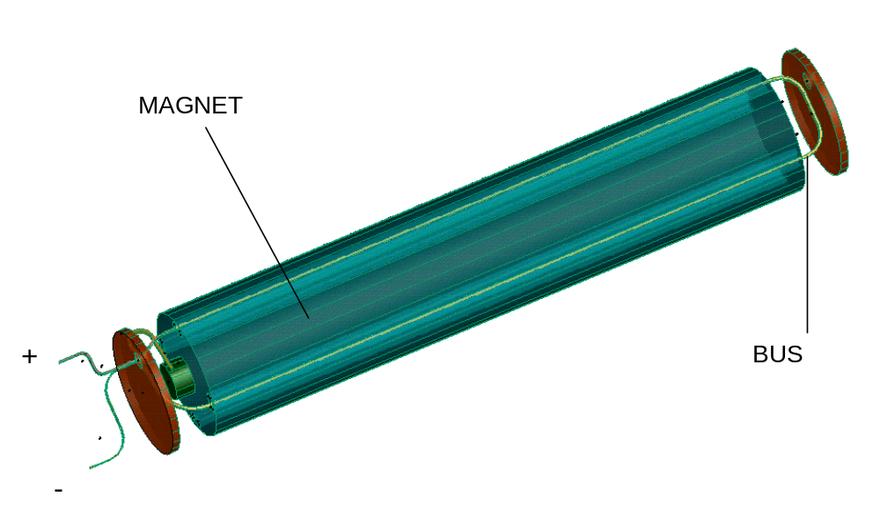The bus-bar test-series 1 was mainly conceived to test 2 different bus-bar prototypes, which had emerged as possible candidates from a design study. The design study and the results of these tests are reported in the note TD-99-059. The bus-bar protoypes in test-series 1 consisted of one superconducting cable stabilized with two similar superconducting cables – in one case the three cables were soldered together, in the other the superconductor was insulated from the stabilizer (except in the ends) with a polyimide sheet. The hope, that at equal level of heating after a quench, the quench would propagate faster in the “segregated” case was deceived (the quench propagation velocity was equal for both types). Since the fully soldered sample is more stable against thermomechanical disturbances, and sufficiently flexible to allow strong bending (extension loops), it was decided to retain a fully soldered design for test-series 2. A lack of space as well as lower operation current (8 kA vs 11 kA) in the KEK IR quadrupoles are more appropriately addressed with a thinner bus-bar, consisting of one superconductor and one stabilizer. Therefore test-series 2 was conducted with a combined bus-bar using a so called 2-bus (1 stabilizer) for one branch (+) and a 3-bus (2 stabilizer) for the other (-). Furthermore, unlike test 1 in which the bus-bars were tested alone, the main purpose of test 2 was the test of the bus together together with the magnet. Figure 1 shows how the bus was assembled into model magnet HGQ08.
 | # of stab. | A (mm²) | A_{Cu} (mm²) | Cu/Sc ratio
2-bus | 1 | 40.8 | 23.07 | 1.3
3-bus | 2 | 61.2 | 34.60 | 1.3
Table 1: Geometry of bus-bar-samples in test 2.

Figure 1: LHC IR model quadrupole with bus-bar assembly for test 2. Before connecting to the magnet (left end) the bus runs a full loop through the bus slots in the magnet yoke.
This allowed not only to practice the installation of the bus-bar into the magnet but also to check eventual magnetic coupling between the bus and the magnet. To obtain sufficient length to measure the quench propagation and to test length related mechanical behavior, the bus-bar was extended by one full turn around the magnet. It was first inserted into one of the instrumentation slots in the magnet yoke, bent at the magnet return end and reinserted into the bus channel, such that it formed a 2.5 m long loop. The bus-bar was mechanically supported only in the magnet ends. Within the magnet the bus-bar assembly was free to move.

3) EXPERIMENTAL SET-UP

Figure 2 shows the cross-section of the bus-bar assembly. The 2-bus (go-) and 3-bus (return-) were separately insulated with a single 50% overlap wrap of 75 μm adhesive Kapton®, followed by a shrink-sleeve wrap and firmly attached together with a tight wrap of Kevlar® string (~ 1 knot per inch). The repulsive force (see equation (1)) between 2 bus-bars (distance d=1 mm) carrying I=11 kA in opposite direction is estimated to be 2⋅12 kN/m, which is ~140 lbs/inch.

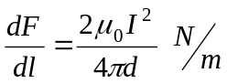 (1)

An additional Nomex® wrap protected the bus-assembly during insertion into the magnet.

Figure 2: Test series 2 LHC IR bus-bar assembly: The so called 2-bus and 3-bus form the positive and negative branch of the magnet power leads.
Superconductor
Cu-Stabilizer
Nomex Protection
Kapton Insulation
Kevlar - Wrap

On the side closer to the magnet connection (left side in Figure 1) both bus-bars were equipped with a set of 2 spot-heaters (one active, one as a reserve) to trigger quenches, and voltage taps along four 4-inch long segments to monitor quench propagation. The spot heaters were pressed against the superconductor with a simple clamp consisting of 2 plates and bolts ( Figure 3). Voltage taps were attached to the ends of the bus-bars to measure the voltage over the total length in both branches.

Figure 3: Exploded view of quench measurement instrumentation on bus-bar assembly. Each bus-bar is equipped with a spot heater and voltage taps that delimit 4 segments (–1 to +2). The heaters (in segment 0) are pressed against the bus-bars with two plates which are bolted together with the bus-bars and heaters in between.
CLAMP – upper plate
CLAMP – lower plate
BUS A
BUS B
HEATER
VOLTAGE TAPS
-1
+2
+1
0

3) QUENCH PROPAGATION VELOCITY MEASUREMENTS

The quench propagation velocity is measured using the time of flight method. The magnet is ramped to the chosen current and a quench is initiated in a voltage segment (segment 0) with the spot heater. The quench propagates to neighboring segments. The quench propagation velocity is calculated from the known length of the voltage segment and the time it takes the voltage onset in the conductor to travel through the voltage taps delimiting this particular segment. Figure 4 and Figure 5 show the voltage traces following a quench for 2 particular cases (7 kA in 2-bus and 11 kA in 3-bus). The error inherent to this method can be estimated from the difference in the segment +/-1 signals, which are mainly caused by asymmetric quench propagation (v_{q}^{left}≠v_{q}^{right}) and differences in voltage segment length. The error range is typically ± 10 %.
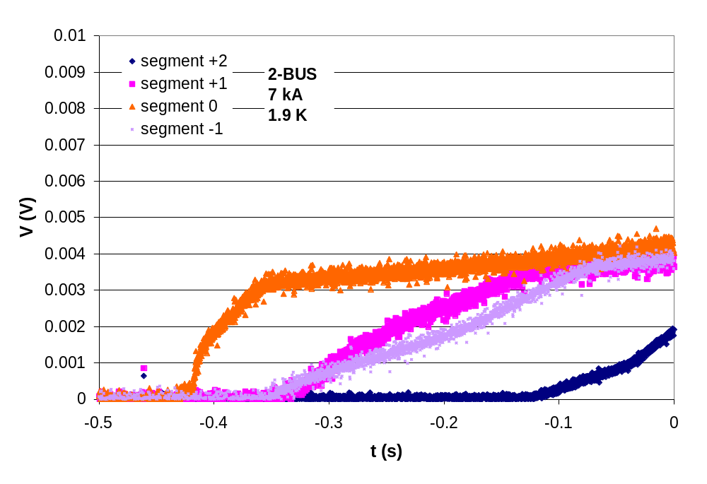
Figure 4: Quench Propagation in 2-bus, current ~7 kA. The heater initiates a quench in segment 0, segments +/-1 are adjacent to 0, segment 2 is next to 1. The segments are 4 inches long.

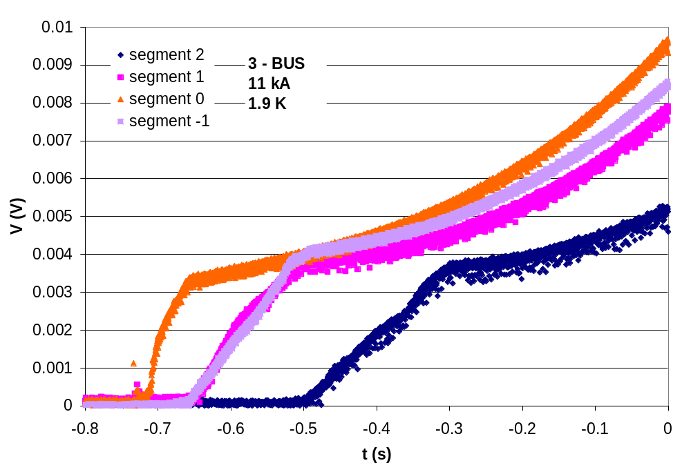
Figure 5: Quench Propagation in 3-bus, current ~11 kA. The heater initiates a quench in segment 0, segments +/-1 are adjacent to 0, segment 2 is next to 1. The segments are 4 inches long.

The measured quench propagation velocity data for both bus prototypes at different currents are shown in Figure 6.
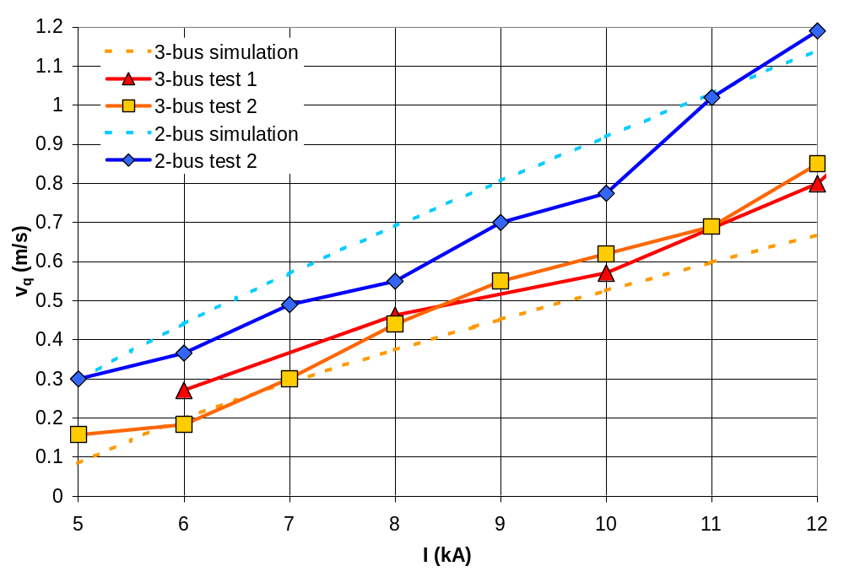
Figure 6: Quench propagation velocity measurements on 2-bus and 3-bus (test-series 1 and 2). Calculated results were obtained with Dresner’s formula.

The fits of the experimental curves in Figure 6 (dashed) were obtained with Dresner’s quench propagation velocity formula [].

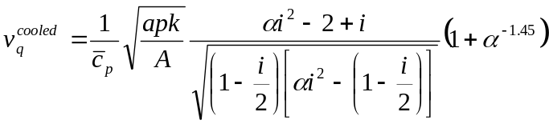 (2)

where “i” refers to the ratio of transport current I_{t} and critical current I_{c} and α is:

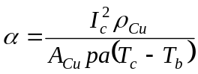 (3)

The purpose of fitting the experiment with (2) is to obtain a reliable quench propagation formula that can be used in the exploration of other possible bus-bar designs in the future.
To obtain a reasonable agreement with the measured data the following set of values was used in the calculation:

Material Properties: | symbol | unit | 2-bus | 3-bus
Average specific heat between T_{b} and T_{c} | c_{p} | J/K/m³ | 10000 | 11000
Linear heat transfer coefficient | a | W/m²/K | 350 | 350
Average heat conductivity | k | W/m/K | 40 | 40
Critical current @ 0 T | I_{c} | kA | 300 | 450
Critical temperature | T_{c} | K | 9.2 | 9.2
Residual Copper resistivity | ρ_{Cu} | nΩm | 0.17 | 0.17

Operating Conditions
Magnetic field | B | T | 0.25 | 0.25
Bath temperature | T_{b} | K | 1.9 | 1.9

Geometrical Data
Cu/Sc ratio | λ | - | 1.3 | 1.3
Total cross-sectional area | A | mm² | 40.8 | 61.2
Area of superconductor in cross-section | A_{sc} | mm² | 17.73 | 26.6
Area of copper (+solder) in cross-section | A_{cu} | mm² | 23.07 | 34.6
Cooled perimeter (~50% of total perimeter) | p | mm | 18 | 20
Table 2: Input parameters for quench propagation velocity calculation.
The critical current was calculated with a j_{c}-parametrization found in literature []. However, at very low fields, the parametrization is not very accurate. The magnetic field was kept constant in the calculation (0.25 T), thus the critical current was not varied with the transport current (and hence the self-field). The average specific heat (c_{p}) numbers required to obtain good agreement are reasonable, except that a 30% difference in c_{p} between 2 and 3 bus (=30% difference in conductor volume) produced a greater gap between the 2 curves than the gap found in the experiment. Therefore the c_{p} difference in the calculation had to be reduced to 10%. The linear cooling coefficient a=350 W/m²/K (Table 2), required for the fit, corresponds to modest cooling conditions, as for example in the case of conduction through the Kapton insulation or heat transfer to gaseous helium and is thus within the expected range. The measured RRR (to obtain the residual copper resistivity ρ_{Cu}) of both samples is 100.

4) QUENCH INTEGRAL vs TEMPERATURE MEASUREMENTS

The calculated peak temperatures as a function of quench integral (QI) were compared to experimental data obtained during a series of tests in which the quench detection threshold was increased such, that the bus-bar could operate at higher quench integrals and rise to higher peak temperatures. The formalism used in the calculation of the quench integral is presented in the following.
The quench integral is defined in equation 4. Equation 4 was obtained from the space independent and adiabatic form of the heat balance equation describing heat generation due to current flowing in the normal matrix in an infinitely thin wire, thus relating the c_{p}dT term to the Joule heat generation by the current in the normal-conducting matrix. The peak temperature obtained from the quench integral calculation is therefore overestimating the real case, where cooling and conduction to the sides will result in reduced peak temperatures compared to the calculated, adiabatic case.

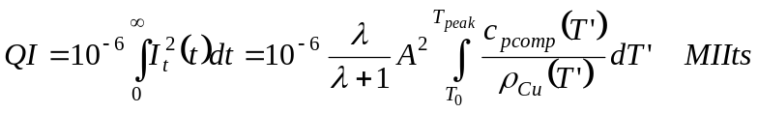 (4)

The quench integral can be calculated either from the temporal current profile (middle term in equation 4) or from basic material parameters (right term in equation 4). In the case of the bus-bar test the current remained constant during the measurement process. With the quench starting at time t₀ the quench integral in the experimental case becomes

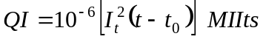 (5)

where, for convenience, the quench integral is given in units of 10⁶, the so called MIIts. The following formulas and data are used in the calculation of the quench integral from the material properties. The specific heat per unit of volume c_{p} [J/K/m³] of a NbTi/Cu composite (subscript low refers to the low temperature range) is given with:

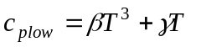 (6)

In the normal (subscript n) state the low temperature c_{p} of the composite is calculated from the specific heat functions of the matrix material (here Cu) and the superconductor weighed with α (volume ratio of superconductor versus total volume (α=1/(1+λ)):

(7)

ρ is the density in kg/m³. The specific heat over the whole temperature range is obtained through fitting the function to the (known) low temperature and high temperature data (c_{p300} is a known data-point at 300 K using the rule of mixture to compute the room-temperature value for the composite) with:

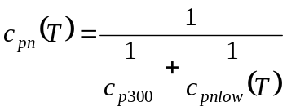 (8)

The specific heat of NbTi in the superconducting state c_{ps}(T,B) affects the specific heat of the composite only in a negligible temperature range (T_{b} to T_{c}), and is therefore neglected. The specific heat parameters for the above formulas are given in Table 3.

Parameter | Unit | NbTi_{(46.5%)} | OFHC Copper
γ | [J/K²/kg] | 0.1450 | 0.011
β | [J/K⁴/kg] | 0.0023 | 0.000744
ρ | [kg/m³] | 6000 | 8960
c_{p300} | [J/K/m³] | 2.304⋅10^{6*} | 3.454⋅10⁶
B₀ | [T] | 14.5 | -
T_{sc0} | [K] | 9.09 | -
Table 3: Cp parameters from Dresner [] (*calculated from c_{p} of elemental Nb_{0.54} and Ti_{0.46}).
T_{sc0} is the critical temperature of the superconductor at B = 0 T, B_{c0} is the critical magnetic field at T = 0 K.
The normal matrix (Cu-) resistivity function ⁽⁾ is given in equations 9-13:

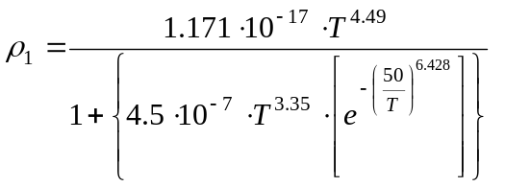 (9)

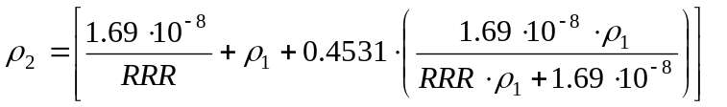 (10)

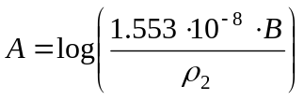 (11)

(12)

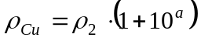 (13)

The normal state resistivity of NbTi at 4.2K is approximately 6⋅10⁻⁷Ωm ⁽⁾ - three orders of magnitude above that of copper. It is therefore a reasonable approach to neglect current transport in the NbTi-branch after super- to normal-conducting transition.

To convert the experimental voltage vs. time data to temperature vs. quench integral data the following procedure was followed: The voltage data of the segment quenched originally by the spot heater were converted into a resistivity (knowing current , Cu cross-sectional area and the length of the segment), assuming that the segment was
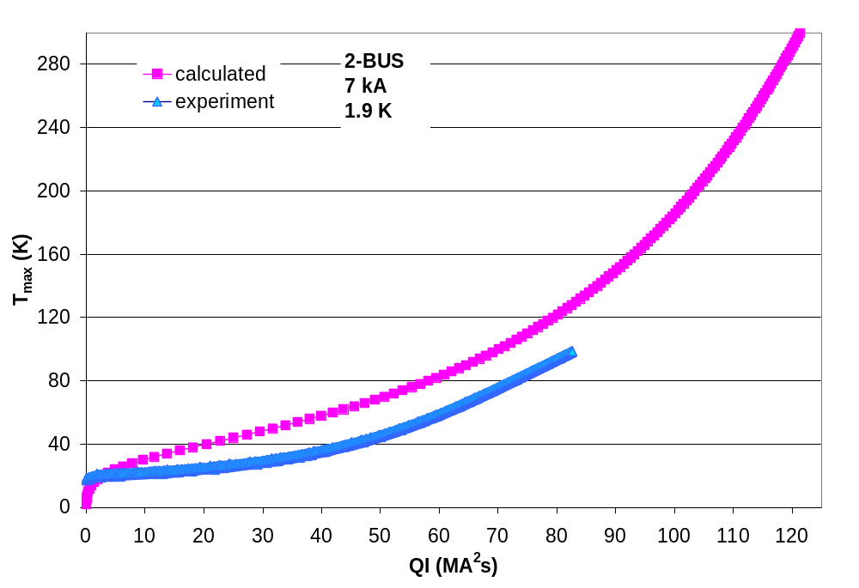
Figure 7: Comparison of experimental and calculated T_{max} vs. MIIts relations for 2-bus at 7 kA.
isothermal over its full length. The resistivity was normalized to the residual resistivity (here ~ 1.7⋅10⁻¹⁰Ωm) and converted to temperature by comparison with the known temperature dependence of the equally normalized resistivity function in equation 9. The experimental MIIts data are calculated from current and time with equation 5.
Figure 7 and Figure 9 show the comparisons for both bus-bar samples in their operational conditions: 7 kA in the KEK- and 11 kA in the FNAL IR quadrupole cases. The comparison indicates a good agreement between measured data and data calculated from the material parameters. In general it was found, that the higher the current the better the agreement between the adiabatic model and the experimental data. In the 7 kA 2-bus case the adiabatic model overestimates the peak temperatures. Figure 8 shows T_{max} vs. QI plots for the 2-bus, derived from two measurements at different currents. A plot of the variation of the T_{max} vs. QI for quenches at different currents is given as well for the 3-bus in Figure 10.
It seems that with decreasing currents the peak temperatures for a given number of MIIts decrease (and thus the T_{max} vs. QI curve diverges from the adiabatic limit the lower the current). The current dependence of the above mentioned effect hints toward a cooling effect. This result is consistent with the fact that cooling (even if only a modest amount) is required to approximate the experimental quench propagation velocity data with Dresner’s formula. The effect of cooling was also noted in the analysis of test-series 1.

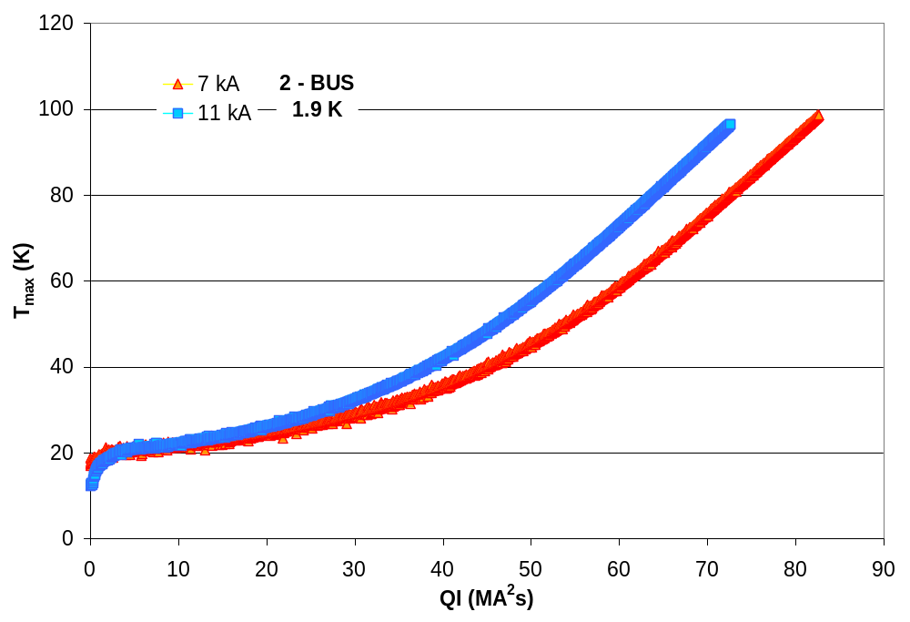
Figure 8: Peak temperatures versus MIIts plots for the 2-bus, measured after quenches at magnet currents 7 and 11 kA.
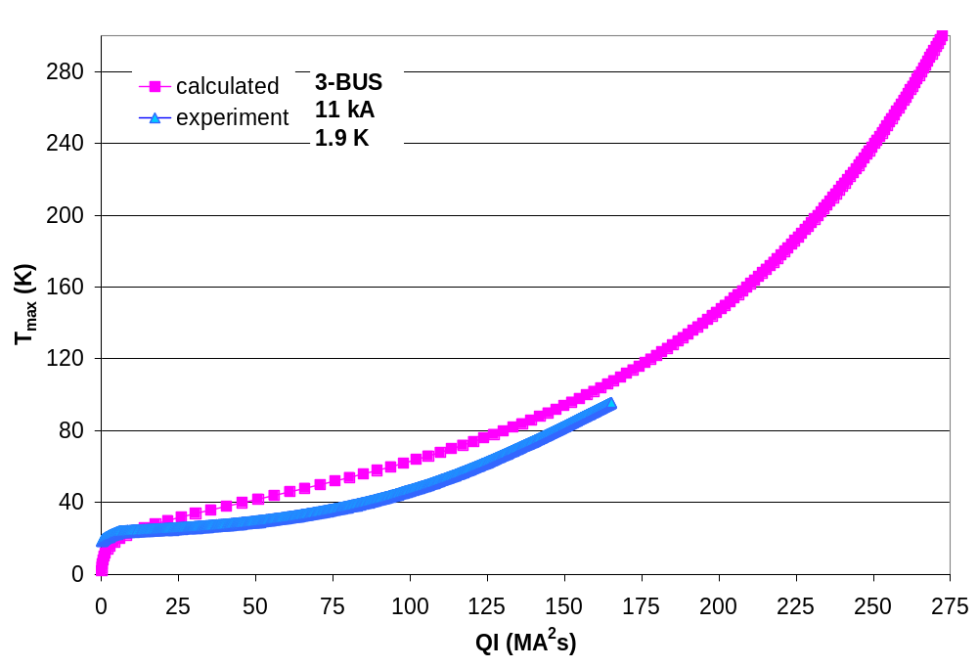
Figure 9: Comparison of experimental and calculated T_{max} vs. MIIts relations for 3-bus at 11 kA.
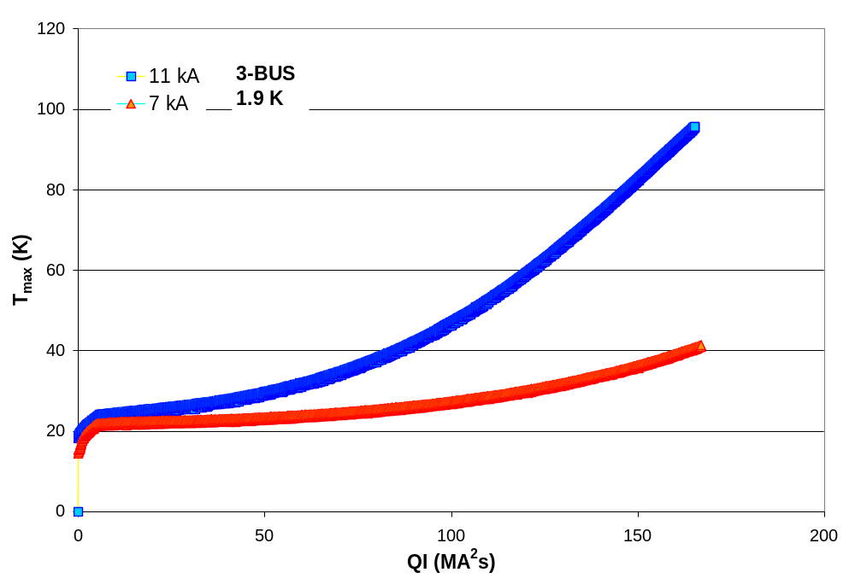
Figure 10: Peak temperatures versus MIIts plots for the 3-bus, measured after quenches at magnet currents 7 and 11 kA.

4) QUENCH DETECTION VOLTAGE VS QUENCH INTEGRAL

Based on the quench propagation model presented in the test-series 1 report (TD-99-059), the voltage generated along the bus as a function of quench integral is given by:

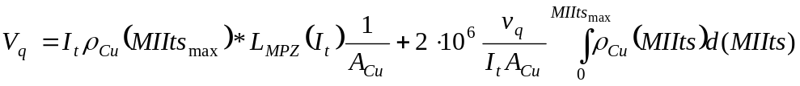 (14)

The voltage in equation 14 is a superposition of:
- the voltage generated in the initially quenched zone of length L_{MPZ} (Minimum Propagating Zone) and
- the voltage rise generated in the rest of the bus through quench propagation.
The MPZ becomes shorter with rising current. Only the central zone experiences the full MIIts number (MIIts_{max}), whereas the MIIts accumulation in the other parts of the bus starts only upon quench arrival. In test–report 1 (TD-99-059) the main interest was focused on the minimum quench propagation velocity v_{q} required to obtain a given threshold detection voltage at a given MIIts budget (MIIts_{max} was set to 270, which corresponds to a calculated temperature limit of 160 K for the 3-bus). It was found that the range of experimental quench propagation velocities (0.3-0.6 m/s) was compatible with the stipulated MIIts limit (270) and typical magnet protection system threshold voltages (100 – 500 mV). The MIIts accumulation tests in test-series 2 allow a more precise determination of the quench detection voltage as a function of MIIts and peak temperature. To obtain this result, the experimental voltage vs. time traces of the intitially quenched segment during a quench, at a given current, were transformed into resistivity versus quench integral curves in a procedure similar to the one described in chapter 3) and fitted with polynomes. These polynomial ρ_{Cu}(MIIts) relations were inserted together with the experimental quench propagation velocities into equation 14 to calculate the quench voltage. This procedure allows to extrapolate the voltage-temperature relation beyond the experimental range. The results for both bus samples in near operating conditions are presented in Figure 11 and Figure 12. In the plots the calculations are compared to the actual voltage measured on the total bus. In the calculations the MPZ was assumed to be 0.05 m at 11 kA and 0.1 m at 7 kA, which is of the same order as the MPZ length calculated in test-report 1.
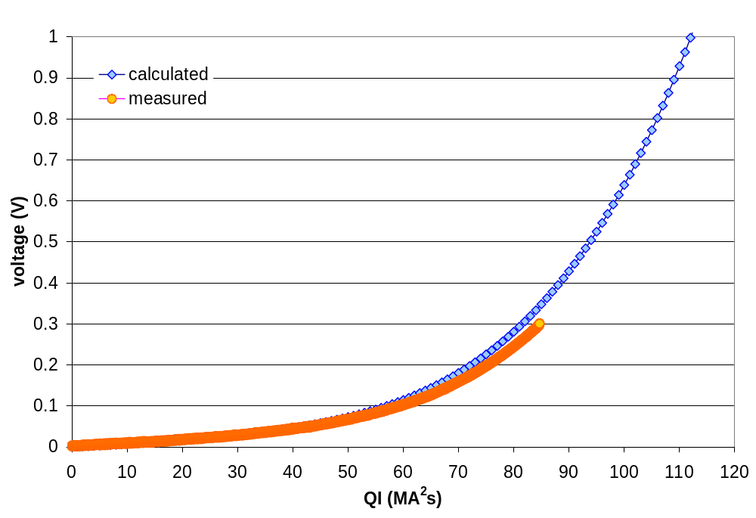
Figure 11: Comparison of calculated and measured voltage development during a quench. 2-bus, 7 kA, 1.9 K.
Figures 11-13 can easily be interpreted in terms of peak temperatures refering to the T_{max} vs. quench integral plots in chapter 4. For the cases presented in the plots above the peak temperatures for a 0.5 V quench detection voltage would be <100 K for the 2-bus at 7 kA and <120 K for the 3-bus at 11 kA. Overall, these temperature indications are only approximate because the actual magnet quench process, which adds another ~20 MIIts to the process, is not considered. Nevertheless, these temperature data show that the bus-bars are well protected in case of a quench.
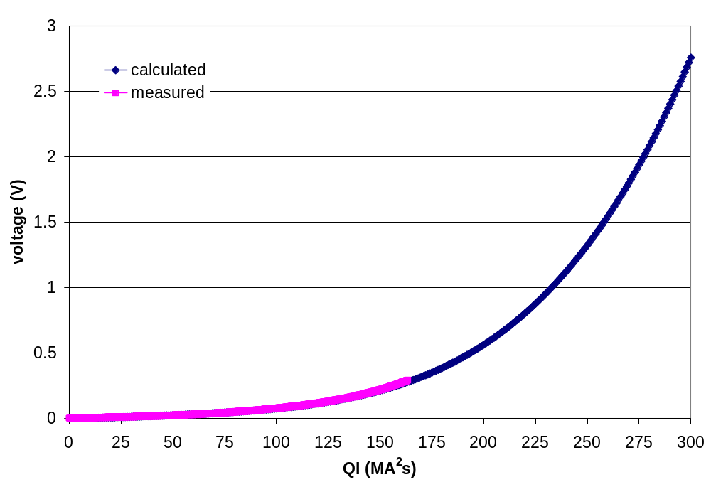
Figure 12: Comparison of calculated and measured voltage development during a quench. 3-bus, 11 kA, 1.9 K.

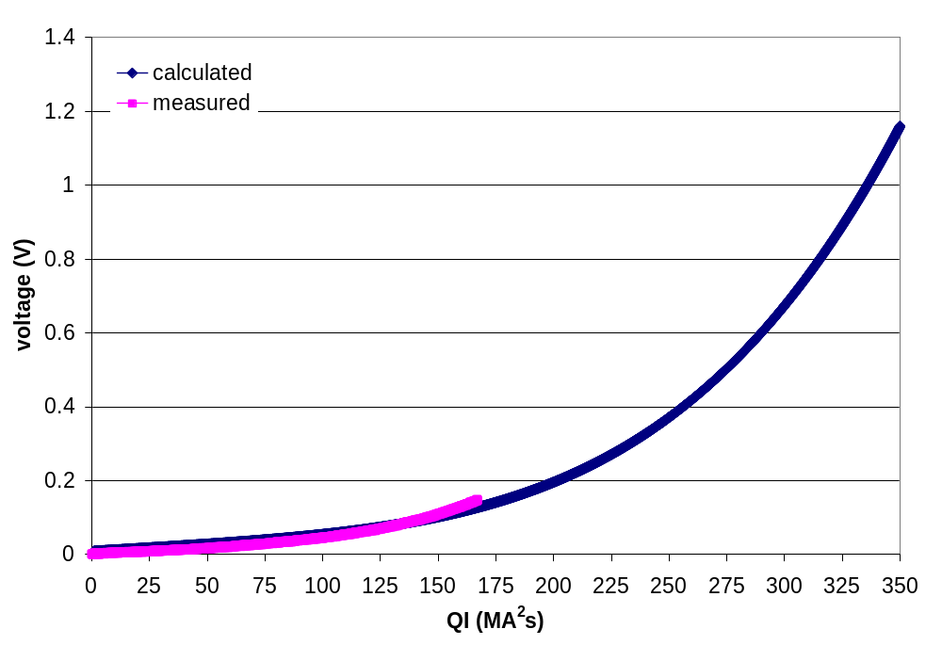
Figure 13: Comparison of calculated and measured voltage development during a quench. 3-bus, 7 kA, 1.9 K.

5) CONCLUSIONS

The bus-bar samples tested in this test-series are suited for operation in the LHC interaction region environment. The bus-bars did not quench spontaneously during the entire test of the magnet, which involved accelerator type current cycles as well as long dwell times at operation current. The amount of copper-stabilizer in the bus cross-section is adequate for the quench detection threshold voltages foreseen for the LHC IR quadrupole quench protection system. The bus- bar stays within less than 200 K after a quench.

6) Acknowledgments

Many thanks to Don Nurczyk, Paul Mayer, Jim Rife, Jesus Alvarez, Roger Bossert for the sampleholder preparation, Kerry Ewald for drawings and Daryl Orris as well as the cryogenic support team for their assistance in the measurements.

“Stability of Superconductors”, L. Dresner, Plenum Press NY, 1995
“NbTi alloy superconductor – present status and potential for improvement”, D. Larbalestier, Adv. in Cryog. Eng. Mat., Vol. 26, ICMC 1979
L. Dresner, “Stability of Superconductors”, Plenum Press, NY, 1995
N. Simon, R. Reed, “Cryogenic properties of Copper and Copper Aloy”, NIST, 1997
M. Wilson,“Superconducting magnets”, Oxford Press 1983

