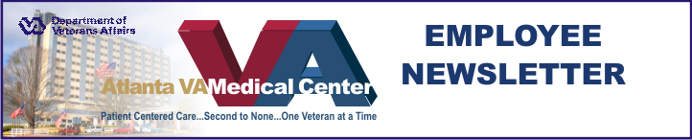

November 26, 2008
Apri

Atlanta VA Medical Center Cancer Program Earns Commendation
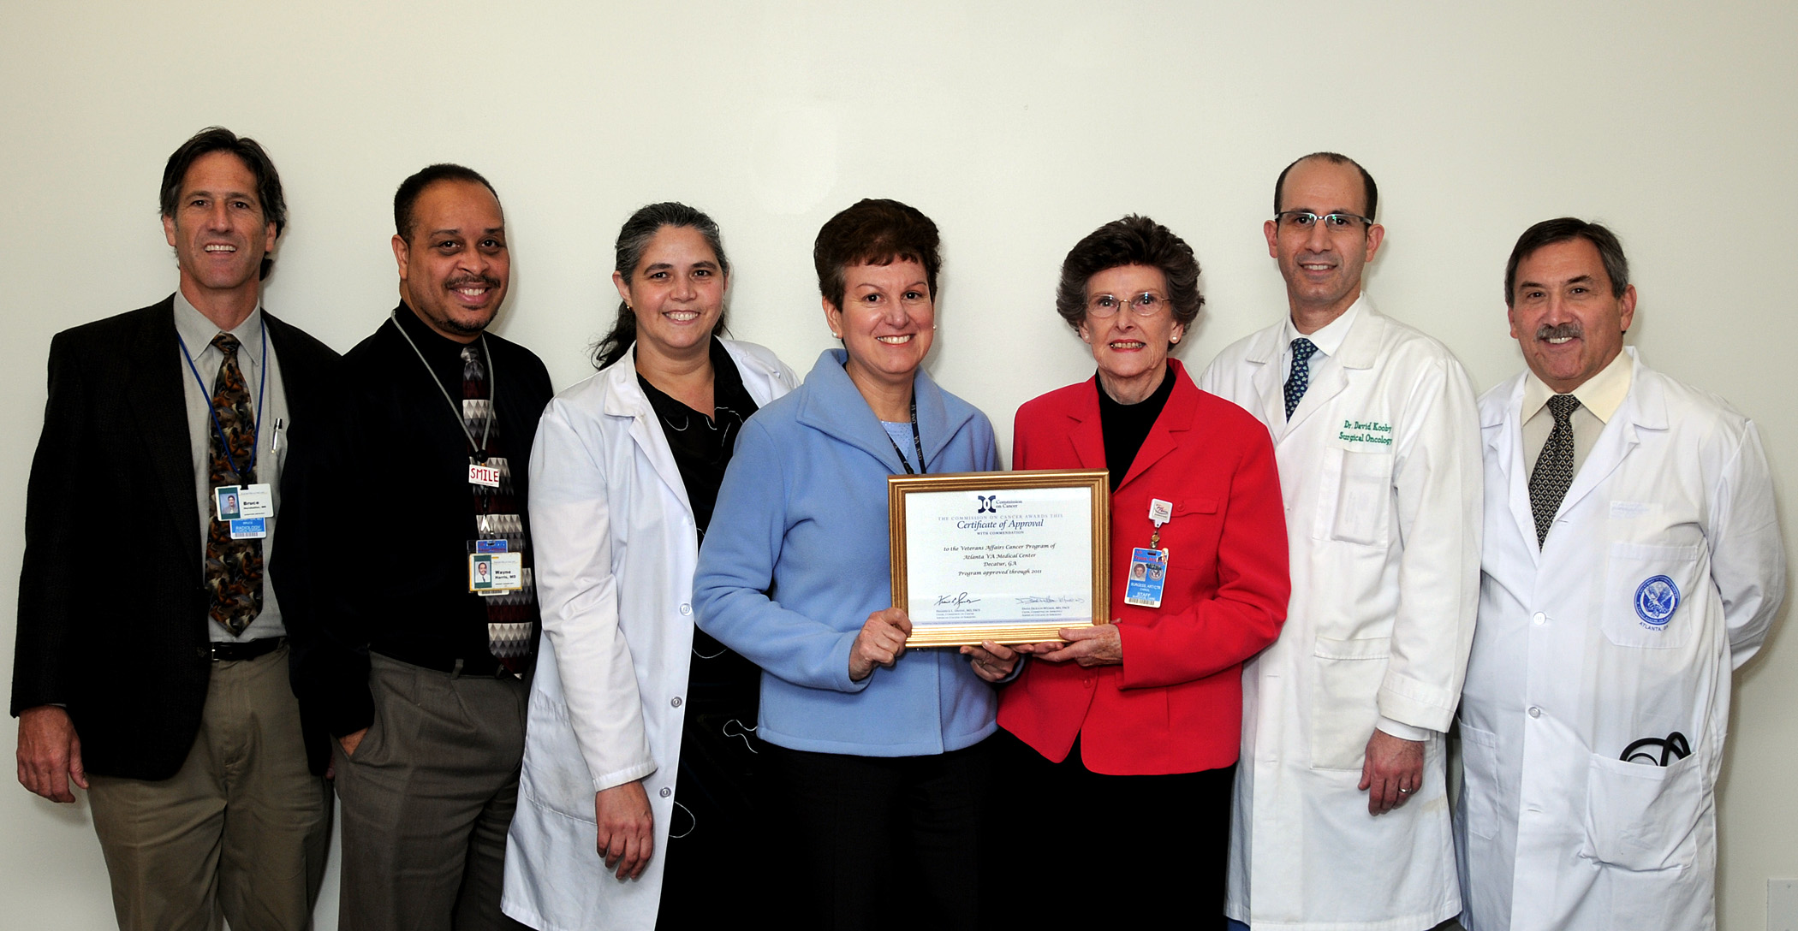
Left to Right: Dr Bruce Hershatter, Dr Wayne Harris, Dr Maria Ribeiro, Jenise Spil, Carol Burgess, Dr David Kooby, and Dr Aaron Fink.

The Commission on Cancer (CoC) of the American College of Surgeons has granted its Three-Year Approval with Commendation to the Cancer Program at the Atlanta Veterans Affairs Medical Center (VAMC). Approval was received following an on-site evaluation by the Commission. Just one in four cancer programs at hospitals across the US receive this approval and commendation.
In addition, the VAMC Cancer Program was awarded six commendations from the CoC for the quality of their annual report, data collection, clinical trial accrual, cancer prevention and early detection, quality improvement studies, and staging reports.
The VAMC is a teaching hospital affiliated with Emory University School of Medicine and a series of other colleges and universities. The Cancer Committee Chair, Maria Ribeiro, MD, chief of medical oncology, supervises the cancer program. David Kooby, MD, assistant professor of surgical oncology at Emory’s Winship Cancer Institute, serves as the Cancer Liaison Physician. The committee oversees all aspects of the hospital’s cancer program including patient care quality and outcome studies, improvement studies and palliative care.
The Cancer Registry, under the administrative leadership of Aaron Fink, MD, manager of the Surgical and Perioperative Care Service Line at the VAMC, centralizes the
See Commendation on page 2

News Briefs

Happy Thanksgiving, Atlanta VAMC- Thanksgiving Day has come to mean many things to many people. For some it marks the beginning of the holiday season; others look at it as a time to be with family and friends to feast on turkey and watch football. Among the many blessings the Atlanta VAMC staff can be thankful for is that every day, we have the opportunity to serve the brave men and women who willingly go into harm's way to defend our freedom.
Director’s Town Hall Meeting- Pathology/Laboratory will host the Director’s Town Hall meeting Dec 15 at 2pm in the Pete Wheeler Auditorium.
Welcome back - Ms. Sandy Leake has officially returned from her 3 month detail in the Office of Nursing Services in VA Central Office to resume her role as Atlanta VAMC Associate Director for Nursing/Patient Care Services. Welcome back, Ms. Leake!!
Stockbridge Clinic Dedication ceremony – will take place Friday, Dec 19, at 1pm. The clinic is located at 175 Medical Boulevard Stockbridge, Georgia 30281.
Did you know you have a direct line to the Medical Center Director? Would you like to send an anonymous email to the Medical Center Director to share your concerns and suggestions? To send an anonymous vista email:
Access Code: ATL1997
Verify Code: ATLANTA1
Joint Commission- For patient safety concerns, contact Quality Management at ext. 6243; to file a complaint, contact the Office of Inspector General at (800) 488-8244 or VA IG at 53E/P.O. Box 50410, Washington, DC 20091 or contact Joint Commission at (800) 994-6610 or email complaint@jointcommission.org. No adverse action will be taken against those who report safety or quality of care concerns.
Voluntary Leave Transfer Program – The following are approved participants in the VLTP and are eligible to receive annual leave donations:
Health Administration Service-Carol Mabry
Surgical-John Robinson; Atlanta Vet Center-Anita Salamon
Police-Bobby Keener; Primary Care- Malanese Sterkins
Nursing Service (Tennessee Health Care)-Terri Dotson
If you wish to make a leave donation, call Freida Philpotts at ext 6306 or Marie Robinson at ext. 4376 to complete form OF-630A.
Dial-A-Prayer- VAMC’s Chaplain Service offers a Dial-A-Prayer service/ministry. Dial-A-Prayer is available all day and every day. If you are calling from an outside telephone, dial 404-321-6111, ext 4161.

Commendation from page one
facility’s cancer data into one location. The registry provides data to residents and fellows for research projects and publications, and provides research teams with an updated list of possible candidates for inclusion in clinical trials and grants.
The Commission on Cancer sets national standards for quality and patient care, surveying facilities to evaluate compliance and collecting quality data from approved facilities to develop effective educational interventions and improve cancer care outcomes at the national, state and local levels.
The American Cancer Society estimates that more than 1.4 million cases of cancer will be diagnosed in 2008. There are currently more than 1,400 CoC-approved cancer programs in the US and Puerto Rico, representing close to 25 percent of all hospitals. This 25 percent of hospitals diagnose and/or treat 80 percent of newly diagnosed cancer patients each year. In addition, a national network of more than 1,600

volunteer Cancer Liaison Physicians provides
leadership and support for the CoC Approvals Program and other CoC activities at these local facilities.
Cancer patient data are reported annually to the CoC’s National Cancer Data Base (NCDB), a joint CoC/American Cancer Society program. The NCDB currently contains patient demographics, tumor characteristics, and treatment and outcomes information for more than 18 million cancer patients diagnosed and treated at hospital cancer programs in the US between 1985 and 2004. These data account for approximately two-thirds of newly diagnosed cancer cases in the US each year.
“This approval and commendation represents hard work by many people here at the VAMC,” said Dr. Ribiero. “We are proud of the commendations and appreciate the fact that the CoC recognizes our quality improvement initiatives, and our drive to provide exceptional cancer care to each and every patient here.”

Decatur Clinic Patient Appreciation Day and Two Year Anniversary 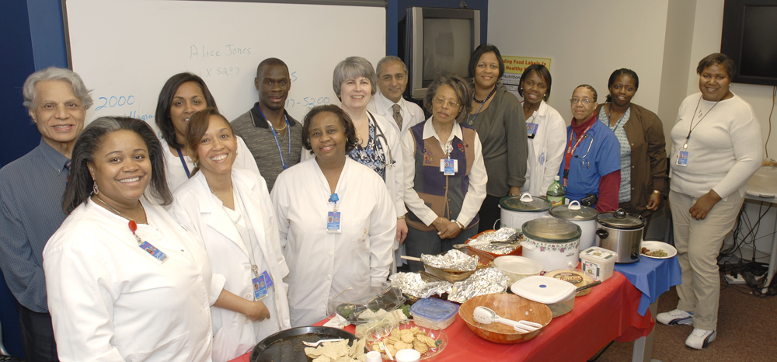
Something to smile about: The Decatur Clinic staff celebrates Customer Appreciation Month and their second year anniversary.

The Decatur Clinic staff recently took time out to celebrate Customer Appreciation Month and their second year anniversary. The Decatur Team embodies the Mission of the VA and strives to bring excellent customer Service to our Veterans. The success of the clinic is attributed to the dedication, commitment, and professionalism of the nurses, providers and the ancillary staff.
Charge Nurse Angela Freeman coordinated the events of the day while Team Leader Dr. Platt and other clinic providers contributed "specialty dishes" from home.
Both events were successful and the veterans were very appreciative of this recognition.

Women's Wellness Spirituality Group celebrate Thanksgiving
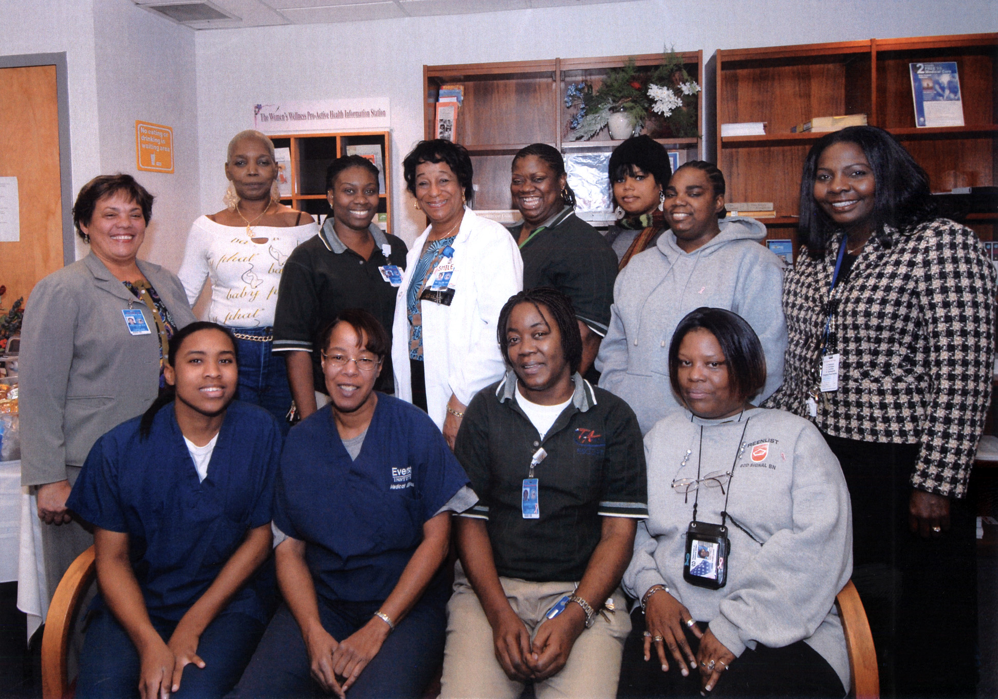
Atlanta VAMC Women's Wellness Spirituality Group.

The Atlanta VAMC Women's Wellness Spirituality Group held a Thanksgiving celebration on Nov 21. Women veterans gathered for a session of thanksgiving and reflection on this special day.
The Women's Wellness Spirituality Group, along with female chaplains, assists patients in reflecting on the meaning of spirituality as a resource for coping with physical illness, emotional trauma, healing and growth. Veterans are encouraged to share their spiritual beliefs or practices that might affect their medical treatment.

Calling it a historic occasion, the President of the Morehouse School of Medicine Dr. John E, Maupin Jr. and other senior leaders from the college visited Atlanta VAMC recently to recognize the two Morehouse psychiatry residents who started their internships at VAMC earlier last month.

