Central Training Division

Environment, Safety, and Health

Training Center (CT-2)

Mail Stop J-596

Los Alamos, NM 87545

Document Title: Listening Assistance Equipment

Document Number: CT-2-PRO-007, R.1

Document Date:____January 2006
Next Review Date:_______________________

Signatures where indicated below are on the controlled document hard copy in CT-2 Records.

Owner Signature Date
L. Berrigan |  | 1/20/06

Authors Signature Date
L. Berrigan |  | 1/20/06

Document Review Board Signature Date
M. Chochoms |  | 2/8/06

CT-2 Group Leader Signature Date
R. Reynolds |  | 7/6/06

You are responsible for verifying that you are working to the most current version of this document.

History of Revisions

Document Number | Issue Date | Action | Description
None | November 1998 | N/A | Original document
PS13-PRO-007,R.0 | August 2004 | Procedure revision | Format revision
PS13-PRO-007, R.1 | January 2006 | Procedure revision | Changes to equipment (earphones) reflected in text of procedure.
CT-2-PRO-007, R1 | June 2006 | Changed document number | Organizational change

Table of Contents

1.0 Purpose/Overview 3
2.0 Scope 3
3.0 Definitions and Acronyms 3
4.0 Precautions and Limitations 3
5.0 Materials and Equipment 4
5.1 List of Equipment 4
5.2 Description of Equipment 4
6.0 Roles, Responsibilities, and Procedures 5
6.1 Receptionist Responsibilities and Procedures for Equipment Checkout and Use 5
6.2 Receptionist Record-Keeping Responsibilities 6
6.3 Receptionist Cleaning Instructions for Listening Assistance Equipment – Microphone and Receiver Sets 6
6.4 Speaker (Instructor)Responsibilities and Procedure for Equipment
Check-out/Use/Check-in 7
6.4.1 Speaker (Instructor) Responsibilities 7
6.4.2 Speaker (Instructor) Listening Equipment Instructions 7
Figure 1. Speaker (Instructor) Equipment 8
6.5 Listener Responsibilities, Equipment Instruction, and Procedure for Equipment Checkout/Use/Check-in 9
Figure 2. Listener Equipment 11
7.0 Records 12
8.0 References 12
Appendix 1: Listening Assistance Equipment Acknowledgement Form 14
APPENDIX 2. LISTENING ASSISTANCE EQUIPMENT USER CHECKOUT LOG 16
Appendix 3: Warning Sign 18
ATTACHMENT 1: WILLIAMS SOUND SET-UP GUIDE AND USER MANUAL (MA072C)

1.0 Purpose/Overview

The CT-2 Training Center has FM listening-assistance equipment available to amplify instruction for hearing-impaired listeners. The equipment consists of a transmitter with a microphone and a receiver with headphones. A Williams Sound Neckloop, a device that connects the receiver with a hearing aid, is also available. The equipment is available from the receptionist at the front desk.
The speaker wears a transmitter and a clip-on microphone. The speaker’s voice is broadcast as an FM radio signal over a distance of 100–150 ft (30–40 m). Listeners use a receiver with earphones or headphone to hear the speaker’s voice directly, with reduced background noise. A hearing-impaired listener must request listening-assistance equipment at the time of registration for a course.

2.0 Scope

This equipment has been justified for use ONLY at the CT-2 Training Center in White Rock. It is not to be lent to any other organizations or used anywhere except the CT-2 Training Center.

3.0 Definitions and Acronyms

N/A

4.0 Precautions and Limitations

DOE and the LANL Security Division consider listening-assistance equipment to be potential technical surveillance equipment. Strict controls and accountability are required for all users. For this reason, listening-assistance equipment must be turned OFF at all times when not in use, including breaks and lunch, and must be kept in the possession of the person who checked it out at ALL times.

5.0 Materials and Equipment

5.1 List of Equipment
Three (3) Williams Sound Model PFM 350 T30 transmitters
Six (6) Williams Sound Model PFM 350 R31 receivers
Four (4) Williams Sound headphones HEDO21
Five (5) sets of Ear 008 replaceable earphones
Bag of replaceable foam ear pads.
Four (4) Williams Sound Neckloop telecoil couplers (for use with hearing aids)
Three (3) transmitter microphones (MIC 081)
Three (3) laminated ‘WARNING” signs
Sterile storage bags
Clean-Gear II cleaning solution
Cleaning pads
Nitrile or latex gloves

5.2 Description of Equipment

There are three matched sets of listening equipment, with each set consisting of two receivers and a transmitter. The sets are labeled A, B, and C. For set A, the receivers are labeled A1, and A2, and the transmitter is labeled A3. The equipment for sets B and C are respectively labeled B1, B2, and B3, and C1, C2, and C3. The clip pouches of each unit are marked with a letter A, B, or C to signify compatibility.

Note: The designation letter for the transmitter must be the same as the designation for the receiver, i.e., if the speaker is using an “A” transmitter, the listener(s) must use an “A” receiver.

The Neckloop is designed to magnetically couple the audio output from a Williams Sound unit into a hearing aid equipped with a telephone coil. The Neckloop works only with hearing aids equipped with a telephone coil (T-switch).

6.0 Roles, Responsibilities, and Procedures

6.1 Receptionist Responsibilities and Procedures for Equipment Checkout and Use

6.1.1 Receptionist Responsibilities
- Inventory listening assistance equipment monthly.
- Maintain inventory file in reception area cabinet.
- Prepare listening assistance equipment for use.
- Check out and check in the equipment to speakers and listeners.
- Maintain the equipment in useable order.
- Clean the equipment as necessary.
- Secure the equipment when not in use.
- Maintain all applicable records.

6.1.2 Receptionist Check-in/Check-out Procedures

[1] Check out and Check in Equipment to the Speaker (Instructor).
- Perform a pre-check of the equipment to ensure that it is working properly.
- Using the right switch on the back panel of R31, ensure that the R31 receiver is set to the correct channel. If the transmitter is on and tuned to channel 1, the FM indicator light on the R31 will light up, indicating that the receiver is set to the correct channel.
- Ensure that the speaker (instructor) reads and signs the acknowledgement form (Appendix 1) and the checkout log (Appendix 2).
- Provide the speaker (instructor) with a transmitter and microphone.
- Provide the speaker (instructor) with a copy of the warning sign (Appendix 3).
- Provide the speaker (instructor) with a copy of the speaker listening equipment instructions (pages 7–8).
- Ensure that the “time in” is entered on the checkout log (Appendix 2) when the equipment is checked in.
- Remove the batteries from the equipment.
- Clean the equipment as indicated on page 6.
- If the equipment is damaged upon return or is not returned, notify the building manager.
- Return the equipment to the cabinet and lock it up.

[2] Check out and Check in Equipment to the Listener.

- Ensure that the listener reads and signs the acknowledgement form (Appendix 1) and the equipment checkout log (Appendix 2).
2. Give the listener a receiver and headphones with fresh batteries and foam
earphone pads. (Students may use their own headsets if they wish.)
3. Give the student a copy of the equipment instructions on pages 9–12.
4. Enter the “time in” on the equipment checkout log (Appendix 2) when the
equipment is checked in.
5. Remove the batteries from the equipment.
6. If equipment is dirty, follow the cleaning procedure on this page (Section 6.3).
7. If equipment is damaged upon return or is not returned, notify the building
manager.
8. Return the equipment to the cabinet and lock it up.

6.2 Receptionist Record-Keeping Responsibilities
Store all completed acknowledgement forms (Appendix 1) and all completed equipment checkout logs (Appendix 2) in the three-ring binder labeled Listening Assistance Equipment Procedures in the equipment cabinet of the receptionist area.

6.3 Receptionist Cleaning Instructions for Listening Assistance Equipment – Microphone and Receiver Sets
1. Don blue nitrile or latex exam gloves.
2. Remove foam earphone pads and discard.
3. Moisten a clean pad sparingly with full strength Clean Gear II liquid by placing a pad on top of the open bottle and tilting the bottle until the pad is slightly moistened.
Note: Do not use a spray bottle!
4. Wipe off stains, fingerprints, or other material using the moistened pad.
5. Gently rub the liquid onto the exterior surface of the earpiece and let remain for 10 minutes.
6. If any liquid is still visible after 10 minutes, wipe off remaining liquid with a clean, dry wipe.
7. Place the headset into a sterile storage bag, seal, and place the headset back into the box.
8. Discard gloves and wipes in the trash.
9. Notify the building manager when any of the following cleaning materials are needed:
- Georgia Steel, Clean-Gear II Spray Disinfectant Kit, Part No. CG742, OR
- Fisher Scientific, Clean Gear Kit, standard size, Part No. 17-987-163B.
- Latex or nitrile gloves.

6.4 Speaker (Instructor) Responsibilities and Procedure for Equipment Check-out/Use/Check-in

6.4.1 Speaker (Instructor) Responsibilities
- Turn the unit OFF at all times when not in use including breaks and lunch.
- Keep the unit in your possession at ALL times.
- For multispeaker (multi-instructor) classes, transfer the unit to the subsequent speaker (instructor) using the equipment checkout log (Appendix 2).
- The microphone cord is the transmitter antenna. DO not bunch up the cord or wrap it around the transmitter. For maximum range, the cord should hang as straight as possible.

6.4.2 Speaker (Instructor) Listening Equipment Instructions
1. Sign the acknowledgement form (Appendix 1) and fill out the equipment checkout log (Appendix 2).
2. Place the laminated warning sign (Appendix 3) in the room to be used to inform persons that listening-assistance equipment is to be used.
3. Plug the microphone into the “Mic” jack on top of the transmitter.
4. Place the transmitter in the belt clip pouch provided and turn the power switch to on. The belt clip can be placed in a pants pocket, shirt pocket or clipped to a belt.
- Clip the microphone onto a collar, lapel, or tie as shown.
- At the beginning of class, point to the laminated warning sign and inform the trainees that a listening assistance device is in use and to refrain from discussions of a classified nature.
- Transfer the use of the unit in writing using the equipment checkout log (Appendix 2).
- Return the unit to the receptionist at the end of the class, at the end of the day, or if the equipment is not functioning properly. Or, for multispeaker (multi-instructor) classes, transfer the unit to the subsequent speaker (instructor) at the receptionist desk using the equipment checkout log (Appendix 2) to document the transfer of the unit.

Figure 1. Speaker (Instructor) Equipment

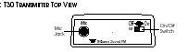

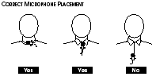

6.5 Listener Responsibilities, Equipment Instruction, and Procedure for Equipment Checkout/Use/Check-in

6.5.1 Listener Responsibilities
- Keep the equipment in your personal possession at ALL times.
- Turn the equipment OFF at all times when not in use (including breaks and lunch) to avoid transmission of classified or offensive conversations or noises.
- DO NOT remove the equipment from the CT-2 premises.
- Return the equipment to the reception desk immediately after class or at the day’s end.

6.5.2 Listener Equipment Instruction and Responsibilities

- Fill out and sign the acknowledgement form (Appendix 1).
- Fill out and sign the equipment checkout log (Appendix 2).
- To use the Neckloop with your hearing aid (diagram on page 11),
- Place the Neckloop over your head and around your neck.
- Slide the cord lock upwards to a comfortable position. This helps keep the Neckloop in optimal position for coupling with your hearing aid.
- Plug the Neckloop into the earphone jack on the Williams Sound unit. Turn the unit on and set the volume control to “3,” or about half of full volume.
- Turn the switch on your hearing aid to the “T” position and adjust the volume for comfortable listening.
- If the sound is weak, increase the volume on the Williams Sound unit, then increase it on your hearing aid.
- Install the plug-mount microphone into the “Mic” jack on top of the receiver.
- Plug the headphones into the “Ear” jack on top of the receiver and don the headphones.
- Turn the power ON by rotating the taller FM volume control on top of the receiver.
- Adjust the volume of the speaker’s (instructor’s) voice by using the “FM” knob, and the volume of the environmental sounds using the “Mic” knob. Adjust the two volumes for a comfortable mix of sound levels.
- Adjust the receiver tone control to your needs. Lo—more low frequencies; Mid—some low frequencies; Hi—maximum low-frequency cut, emphasizes higher frequencies.
- Place the transmitter in the belt clip pouch provided. The belt clip can be placed in a pants pocket or shirt pocket, or clipped to a belt.
- Return the unit to the receptionist at the end of the class or at the end of the day.
Note: If the equipment is not functioning properly, notify the receptionist.

A neck-loop telecoil coupler allows the system to be used with telecoil (T-Switch)-equipped hearing aids. The headset cord is the receiver antenna. DO NOT bunch up the cord or wrap it around the receiver. For maximum range, the cord should hang as straight as possible.

Figure 2. Listener Equipment

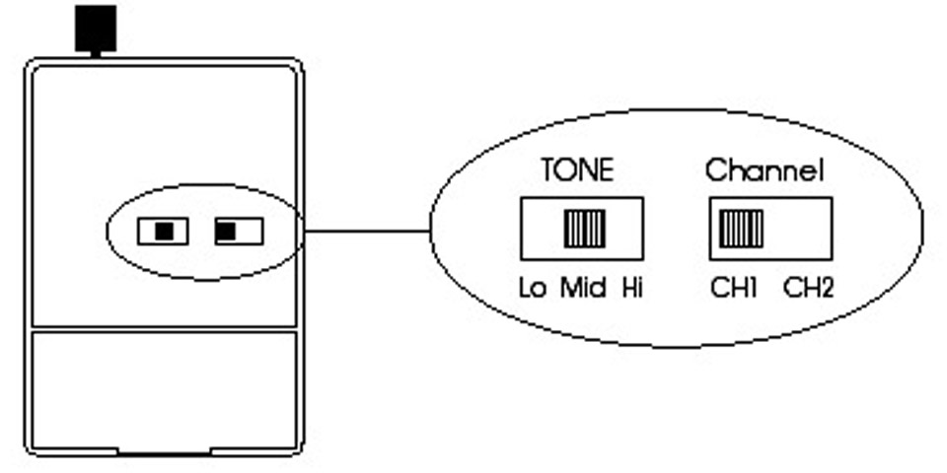

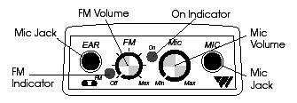

Off Max. Min. Max.

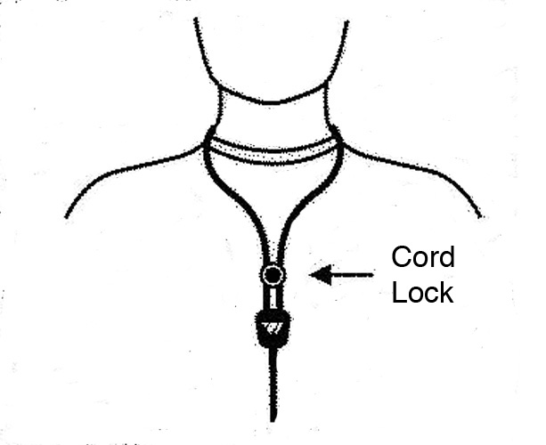

NeckLoop for Use with Hearing Aid

7.0 Records

Appendix 1, Listening Assistance Equipment Acknowledgement Form, CT-2-FORM-014, R.0, and Appendix 2, Listening Equipment User Checkout Log, CT-2-FORM-015, R.0, shall be kept with the "CT-2 Listening Equipment Procedures and Forms" section of the three-ring binder that is kept locked in the cabinet with the equipment in the receptionist's area.

The forms are not official records and will be kept with the equipment as needed.

8.0 References

Williams Sound Set-Up Guide and User Manual (MA072C)

Getting Credit for Reading This Document

To receive credit for reading this document, go to the following URL:

https://tvprod.lanl.gov/tv_server.asp?ls_action=trng&ls_course=38228

Note: You will need a CryptoCard and Administrative Integrated Computing Network (ICN) access to access the URL above.

(This page intentionally left blank.)

Appendix 1: Listening Assistance Equipment Acknowledgement Form

The CT-2 Training Center has FM listening-assistance equipment available to amplify instruction for hearing-impaired listeners. The equipment consists of a transmitter with a microphone and a receiver with headphones.

DOE and the LANL Security Division consider listening-assistance equipment to be potential technical surveillance equipment. Strict controls and accountability are required for all users.

This equipment has been justified for use ONLY at the CT-2 Training Center in White Rock. It is not to be loaned to any other organizations or used anywhere except the CT-2 Training Center.

All persons (both speakers and listeners) who check out CT-2 listening assistance equipment are required to
- Keep the equipment in their personal possession at ALL times.
- Turn the equipment OFF at all times when not in use (including breaks and lunch) to avoid transmission of classified or offensive conversations or noises.
- DO NOT remove the equipment from the CT-2 premises.
- Return the equipment to the reception desk immediately following the class or at the day’s end.

Before using listening assistance equipment at the CT-2 Training Center, your signature is required on this form. Signing this form indicates that you understand and you will abide by the requirements above.

I have read, understand, and agree to follow the above precautions and limitations regarding the use of listening assistance equipment at CT-2.

________________________ _________ _____________________ _______
Printed name Z# Signature Date

________________________ _________ _____________________
Organization Phone email

CT-2-FORM-014,R.0

(This page intentionally left blank.)

*Appendix 2: Listening Assistance Equipment User Checkout Log

Speakers see note below

Date | User Name | User Z# | User Signature | Speaker Listener  (check one) |  | Equipment ID# (s) | Time Out | Time In
 |  |  |  | √ |  |  | 0730 | 1645

Note: For multi-speaker classes, transfer the unit to the subsequent speaker at the receptionist desk using this form to document the transfer of the unit.
CT-2-FORM-015, R.0

(This page intentionally left blank.)

Appendix 3: Warning Sign
WARNING

WIRELESS MICROPHONE IN USE

Be aware that all discussions within 50 feet of microphone may be within audio range for wireless transmission.

If you have any questions or concerns, please contact the CT-2 receptionist at the front desk.

Getting Credit for Reading This Document

To receive credit for reading this document, go to the following URL:

https://tvprod.lanl.gov/tv_server.asp?ls_action=trng&ls_course=38228

Note: You will need a CryptoCard and Administrative Integrated Computing Network (ICN) access to access the URL above.

